Kinematic Profiles and Performance Insights of National-Level Speed Climbers
Simon Briley¹, Nicola Taylor¹, Tom Outram¹, Joel Chidley¹, Jamie Vardy² and James Mitchell¹
¹ School of Sport and Exercise Sciences, University of Derby
²Great Britain Speed Climbing

Introduction

Speed climbing, introduced as an Olympic sport in Tokyo 2020, uses a race format, where athletes ascend a standardised 15-meter wall as quickly as possible. The sport's recent growth underscores the need for a thorough understanding of the factors that influence success. Current knowledge characterises speed climbing as a rapid acceleration during the start phase, maintenance of high average velocities during the middle phase and concludes with a dyno, and a final jump to stop the timer [1]. This study investigates the relationship between performance and velocity, and acceleration profiles, aiming to elucidate techniques used by elite climbers and factors contributing to optimal performance.

Methods

Two male national squad speed climbers participated in this case study. One Blue Trident IMU (Vicon, Motion Systems Ltd. Oxford, United Kingdom) was placed on the upper back of each climber. The athletes after a starting beep, climbed as quickly as possible on an internationally standard wall of 15.5 m with 31 holds (20 hand holds and 11 feet holds) and a touch pad to stop the timer. The IMUs tri-axial accelerometer (x = vertical, y = lateral, z = anterior-posterior) time series was used to calculate velocity and displacement.

Results & Discussion

Athlete A completed the speed climbing ascent in 8.72 seconds compared to 9.97 seconds for Athlete B. Athlete A demonstrated a peak acceleration of 20.6 m/s² during the start phase but experienced a notable drop from 2.9 m/s to 0.3 m/s over 0.4 seconds (Figure 1). Throughout the climb, Athlete A maintained relatively high velocities, peaking at 2.39 m/s in the mid phase and 1.47 m/s in the final stage. Athlete B achieved a peak acceleration of 17.0 m/s² during the start phase but did not exceed 0.5 m/s between 2.99- and 4.28-seconds. Athlete A’s superior start phase compared to Athlete B, indicating effective utilisation of handholds and lower limb power and emphasises the significance of generating high initial propulsion for rapid ascent [2].

During the mid and final phase, Athlete A demonstrated greater consistency in maintaining velocities. Athlete B experienced pronounced velocity drops, indicating challenges in velocity management and maintaining momentum. This is consistent with observations in climbing fluency literature, which suggests that deviations from the optimal climbing path and inefficient movement patterns can lead to energy loss and decreased performance [3].

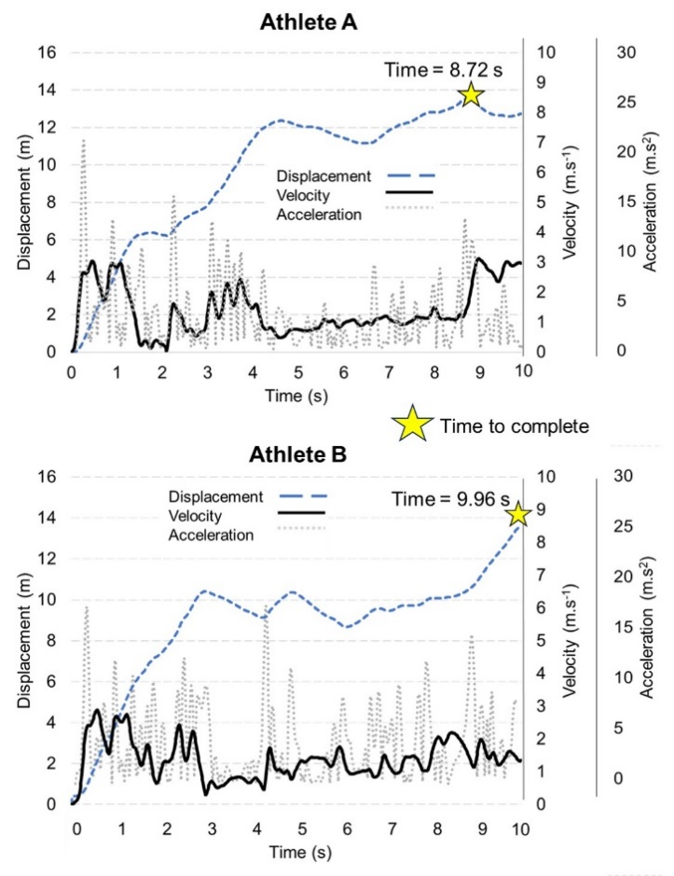
Figure 1: Resultant displacement, velocity and acceleration during a training speed climb.

Conclusion
This study highlights the critical role of acceleration and velocity management in speed climbing success. By integrating insights from this study and leveraging IMU technology, athletes and coaches can develop targeted training strategies to enhance performance in speed climbing competitions.

References
- Legreneur P., et al. Comput Methods Biomech Biomed Engin. 22: 264–266, 2019. [doi: 10.1080/10255842.2020.1714907]
- Askari Hosseini S., et al. Front Sports Act Living 22, 5, 2023. [doi: 10.3389/fspor.2023.1304403]
- Orth, D., et al. Sports Medicine, 46, 255-268, 2016. [https://doi.org/10.1007/s40279-015-0417-5]

