Measuring the Financial Impact of Equipment Performance Improvement: ISB and IEB Metrics

Abstract

Purpose
Equipment performance helps the manufacturing sector achieve operational and financial improvements despite process variations. However, the literature lacks a clear index or metric to quantify the monetary advantages of enhanced equipment performance. Thus, the paper presents two innovative monetary performance measures to estimate the financial advantages of enhancing equipment performance by isolating the effect of manufacturing fluctuations such as product mix price, direct and indirect characteristics, and cost changes.

Design/methodology/approach
The research provides two measures, ISB (Improvement Saving Benefits) and IEB (Improvement Earning Benefits), to assess equipment performance improvements. The effectiveness of the metrics is validated through a three stages approach, namely: (1) experts' binary opinion, (2) sample, and (3) actual cases. The relevant data may be collected through accounting systems, purpose-built software, or electronic spreadsheets.

Findings
The findings suggest that both measures provide an effective cost-benefit analysis of equipment performance enhancement. The measure ISB indicates savings from performance increases when equipment capacity is greater than product demand. IEB is utilised when equipment capacity is less than product demand. Both measurements may replace the unitary cost variation, which is subject to manufacturing changes.

Practical Implications
Manufacturing businesses may utilise the ISB and IEB metrics to conduct a systematic analysis of equipment performance and to appreciate the financial savings perspective in order to emphasise profitability in the short and long term.

Originality
The study introduces two novel financial equipment performance improvement indicators that distinguish the effects of manufacturing variations. Manufacturing variations cause cost advantages from operational improvements to be misrepresented. There is currently no approach for manufacturing organisations to calculate the financial advantages of enhancing equipment performance while isolating production irregularities.

Keywords: operational excellence; equipment performance; monetary benefit; equipment improvement; financial impact.

Introduction
Increasing competition and growing production capacity demand more resources (Nadeem et al., 2018; Garza-Reyes et al., 2019) and consequently, the cost of resources keeps increasing, creating a direct impact on both the producer and consumers (Gólcher-Barguil et al., 2019). Consumer demand for low prices leads to thin profit margins (Andersson and Bellgran, 2015) and businesses face extreme pressure to deal with such challenges. Subsequently, businesses need to formulate better operational excellence strategies (Olhager and Persson, 2006; Wudhikarn, 2016) to reduce their costs. To do so, businesses use performance measurement tools to analyse their operations and processes to achieve efficiency and effectiveness (Garza-Reyes et al., 2010; Olivella and Gregorio, 2015). Such measurement data is crucial in today’s dynamic and competitive manufacturing environment (Gólcher-Barguil et al., 2019) as decisions cannot be based on experiences and feelings (Tan and Noble, 2007).

Although continuous improvement of equipment performance is critical, there is a lack of metrics to show its monetary impact on the manufacturing cost (Gólcher-Barguil et al., 2019). Financial departments periodically calculate product unitary costs but do not establish a direct relationship with equipment improvement on the shop floor. Their main concern is to determine the cost per produced unit; establishing the monetary benefits of equipment performance improvement is usually left aside since subsequently it is reflected in the product unitary cost. Financial departments use various management accounting systems to determine product unitary costs, such as activity-based costing (ABC) (Özbayrak et al., 2004), throughput accounting (Dugdale and Jones, 1998), traditional accounting (Wells, 2018), target costing (Sharafoddin, 2016), life cycle costing, kaizen costing (Monden and Hamada, 1991) and many others.

Numerous approaches and systems are in place to measure the performance of equipment (Braglia et al., 2008; Gólcher-Barguil et al., 2019). However, they are typically deficient in explicitly reflecting the financial benefits (Grünberg, 2004). These performance metrics fail to directly measure the financial benefits through equipment performance improvement.

There are extensive cost accounting models that are particular to manufacturing processes. However, these models do not provide clear metrics that illustrate the financial gains that may be achieved via improvements in the performance of the equipment. The objective of those methods is to provide a relationship between cost per part and process parameters. Özbayrak et al., (2004) have published an ABC model for a flexible manufacturing system (FMS) cell. Their objective is to calculate the cost per part by taking process parameters into the calculations; this provides a relationship between process parameters such as processing time, scrapping and rework as well as product unitary cost. Yamashina and Kubo, (2002) proposed manufacturing cost deployment, a cost accounting model where costs are divided into fixed and variable costs. These costs are then related to production losses with cost formulas based on cost per part. The authors also proposed five metrics, each with a specific function to solve issues. Manufacturing cost deployment is an instrument to recognise production losses and reduce costs; nonetheless, the framework does not provide metrics that could directly calculate monetary benefits due to equipment performance improvements. Kono and Ichikizaki (2015) presented an economic evaluation scheme focused on yield improvement activities from the perspective of savings and additional sales. This evaluation scheme lacks insights when there is a capacity surplus and it is also sensitive to manufacturing fluctuations.

The challenge is to find a set of metrics to estimate the monetary benefits of improving equipment performance. Gólcher-Barguil et al., (2019) proposed the OEP (Operational Excellence Profitability) indicators as an approach to measure savings but it also is deficient in providing a general indicator. Based on the aforementioned limitations of metrics commonly used in manufacturing environments, this paper contributes to the manufacturing management literature, and particularly manufacturing performance measurement systems, by proposing two novel metrics, Improvement Saving Benefits (ISB) and Improvement Earning Benefits (IEB), which isolate the impact generated by manufacturing fluctuations such as prices in raw materials, labour costs, production mix and overhead cost variations. Thus, both metrics will effectively estimate the financial benefits due to equipment performance improvement.

The overall structure of the paper consists of five sections. The introduction and the justification for the study are presented in Section 1, whereas a literature review of previous research on the topic of measuring the performance of equipment is discussed in Section 2. The research methodology followed by the present study is introduced in Section 3, which describes the suggested ISB and IEB metrics and their validation using a three-phase strategy. Section 4 provides a brief discussion of the study. Finally, the conclusions of the study are provided in Section 5, along with suggestions for further research directions based on the findings of this study.

Literature review
The demand for strictly specified performance-measurement systems for industrial processes has arisen as a result of the effort to improve productivity in the contemporary world of global competition (Muchiri and Pintelon, 2008). The broad view on organisational longevity is that initiatives must be devised to achieve a leg up on the competition (Nyambane and Bett, 2018). In a chaotic environment where businesses are forced to meet consumer demands for quality, affordability, flexibility, and delivery dates (Haddad et al., 2021), coupling proactive requirements to the early advantage is vital for a firm's survival (Abdulkareem et al., 2013).
Customers' demands and environmental and social concerns put pressure on businesses to build quality items and produce effectively as quantity is also important (Ahmed and Pise, 2019). To tackle this challenge, manufacturing firms must examine their operational constraint areas to attain lean and agile operations (Stamatis, 2010). For example, Stamatis (2010) suggests that Total preventive maintenance (TPM) is a phenomenon that explains how to eradicate various wastes and addresses the effectiveness of equipment. Therefore, the metrics that evaluate how well a piece of equipment is used are valuable, as it is usually these efficiency measures that lead to the discovery and eradication of concealed production losses (Zammori, 2014).
For quantifying the productivity of separate machines in a plant, Nakajima (1988) established a quantitative indicator termed overall equipment effectiveness (OEE). It analyses and quantifies losses in key manufacturing parameters such as availability, performance, and quality. This enhances the efficiency of equipment and, as a result, its productivity. The OEE idea is gaining traction and has been widely adopted as a quantitative method for measuring productivity (Tsarouhas, 2012). However, despite its broad industrial application, the topic of how one should accurately evaluate OEE has not been successfully addressed (Zammori, 2014). Its because all occurrences that can degrade an equipment's performance must be divided into six 'major losses', which include breakdowns, set-ups, idling, reduced speed, defects, and lower yield. However, various past scholars such as Tsarouhas (2013), Tsarouhas (2012), Ron and Rooda (2006), and Bulent et al. (2000) used OEE as a tool to measure and track equipment performance over a period of time. Nevertheless, OEE can not be used as a measuring tool/ philosophy/metric to evaluate the financial benefit of equipment effectiveness.
Both academics and practitioners are still debating how to properly evaluate the financial influence on managerial outputs (Kono and Ichikizaki, 2015). Improvements in operating procedures result, for example, in a reduction in the number of man-hours, which is essential for efficient everyday operations. Therefore, businesses should devise approaches to maximise the flexibility and efficiency of their operations. Furthermore, manufacturing companies should also concentrate on lowering the cost of production, profit growth, and boosting the efficiency and productivity of manufacturing processes simultaneously (Godina et al., 2018; Abdul Rasib et al., 2019).

Apart from productivity, manufacturing cost or product unitary cost is also an important key measure of performance (Andersson and Bellgran, 2015). These costs are the summation of various costs, such as raw material costs (Huang and Yang, 2016), direct labour costs (Wacker et al., 2006), spare parts costs (Hu et al., 2018), and other overhead costs (Gólcher-Barguil et al., 2019).

The product unitary cost varies due to manufacturing fluctuations and equipment performance (Gólcher-Barguil et al., 2019). Manufacturing fluctuations are variances that are external to the shop floor and are normally the result of labour costs, raw and packaging materials prices, production mix, production demand and parameters of direct and indirect costs (Gólcher-Barguil et al., 2019). Although the product unitary cost is significantly impacted by equipment performance (Taleb et al., 2014; Andersson and Bellgran, 2015) and can vary over time, equipment performance is still not considered a manufacturing fluctuation as it is inherent to the shop floor. Just as the process efficiency and yield impact the operational/equipment performance (Jaeger et al., 2014), similarly the product unitary cost is impacted by process losses in materials and time. Any loss in semi-finished and/or finished products will require more materials and time to match the production output with the required quantity of finished goods.

Multiple factors can impact the variation in the price of raw and packaging materials at any given time (Grünberg, 2004; Liu and Yang, 2015). These factors could be fluctuation in price from suppliers, market price fluctuation of different elements, using different vendors’ materials etc. (Gólcher-Barguil et al., 2019). Likewise, labour costs can vary (Garza-Reyes, 2015; Huang and Yang, 2016) due to an increase in salaries for the workforce, new labour, new strategies for employee retention etc. Variations in overhead costs can make a significant impact on production costs; for instance, variation in the electricity price per kWh, the cost of extra hours by maintenance experts, bunker price per kg plus other factors.

Production mix denotes the number of types of finished goods produced per interval of time (Fernandes et al., 2012). The variation in the production mix is completely dependent on product demand and the decisions of management. A company may choose to produce a certain product in low or high quantity at the interval of their choice; it might produce product A in less quantity than product B during the first month and vice versa in the second. Production mix variation directly impacts the product unitary cost as the raw material composition and resource (e.g. packaging materials, labour cost, consumable cost) requirements might be different as the equipment might process each product with different theoretical rates.

The product unitary cost commonly fluctuates each week or month due to equipment performance and manufacturing fluctuations. To the best of the authors’ knowledge, till present, there is no known method for manufacturing companies to determine the monetary benefits gained through equipment performance improvement while isolating the variations of manufacturing fluctuations.

Past scholars have developed some metrics for measuring the performance of various sections of the production cycle. For instance, OLE (overall line effectiveness) was proposed by Nachiappan and Anantharaman (2006) to assess the continuous line manufacturing system performance with the assumption that OEE can only be used for individual machines rather than the overall machine assembly. Similarly, Garza-Reyes (2015) developed ORE (overall resource effectiveness) after realising that OEE does not account for the efficient use of resources and materials. Some other studies, such as that of Ron and Rooda (2006) introduced (E) equipment effectiveness as a method for determining the efficacy of separate equipment. A brief history of various propositions for performance measurement metrics is provided in Table 1.

Table 1. Propositions of performance measurement metrics
S.No. | Metrics | Measurement | Reference
1. | OPE (overall process effectiveness) | Considers losses to the overall process rather than just individual equipment | Al-Najjar, 1997
2. | OFE (overall factory effectiveness) | It measures the efficiency of procedures that involve several machines or operations | Scott and Pisa, 1998
3. | OFE (overall fab effectiveness) | It considers specific manufacturing equipment's operation with respect to other operational equipment | Oechsner et al., 2002
4. | OLE (overall line effectiveness) | OLE assesses the continuous line manufacturing system performance | Nachiappan and Anantharaman, 2006
5. | (E) equipment effectiveness | It determines the separate equipment efficiency | Ron and Rooda, 2006
6. | OTE (overall throughput effectiveness | OTE quantifies performance at the plant level | Muthiah and Huang, 2007
7. | OEEML (overall equipment effectiveness of the manufacturing line) | Rather than focusing on individual pieces of equipment, OEEML evaluates the overall performance of a manufacturing system | Braglia et al., 2008
8. | SOEE (stochastic overall equipment effectiveness) | It discovers the hidden losses that constitute the majority of the variation and assesses the efficiency and efficacy consequences of various corrective measures | Zammori et al., 2011
9. | FOEE (fuzzy overall equipment effectiveness) | FOEE looks into the fundamental causes of production losses and modeling them as LR fuzzy numbers to monitor daily swings in manufacturing performance | Zammori, 2014
10. | ORE (overall resource effectiveness) | ORE assesses total effectiveness, the classic OEE metric was amended by incorporating material efficiency and material and operation cost | Garza-Reyes, 2015
11. | OME (overall material usage effectiveness) | OME does not only understand but also spots potential cures to material-related concerns | Braglia et al., 2018
Based on the literature review conducted and the aforementioned discussion, the following research gaps were identified:

- There is no research conducted that explores the financial benefits of a more effectively managed equipment performance.
- Although past studies are available to determine and track the effectiveness of equipment/machinery, no past studies are available in the field of metric development to assess the direct or indirect financial benefits of equipment performance.

Therefore, ISB and IEB metrics have been designed for this purpose to identify the financial benefits of improving equipment performance while isolating the impact of manufacturing fluctuations.

Research Methodology
The detailed research flow of the current study is illustrated in Figure 1. First of all, a comprehensive literature review was conducted to search the existing work done in the field of equipment performance assessment. All of the authors of this paper have significant industry knowledge and experience. Additionally, the authors are involved in consultancy projects in the manufacturing industry related to equipment assessment. Based on their industry experience and knowledge, two metrics (ISB and IEB) were theoretically proposed to measure the monetary benefit of better equipment performance. The proposed metrics are based on the authors’ knowledge and industrial experience.

Since there could have been some biases in the development of the metrics owing to the propositions coming from the knowledge and experience of individuals, it was necessary to validate the metrics qualitatively and quantitatively to provide a strong foundation for the proposed idea. Thus, the current research followed a three-phase validation approach to support the development of the ISB and IEB metrics. The first phase involved the binary opinion of the industry experts for introducing these two metrics. The binary opinions were recorded as simple “Yes” and “No” for the acceptance or rejection of the proposed metrics. After the qualitative validation of both metrics, the research proceeded into the quantitative validation of the metrics through a sample and real cases.
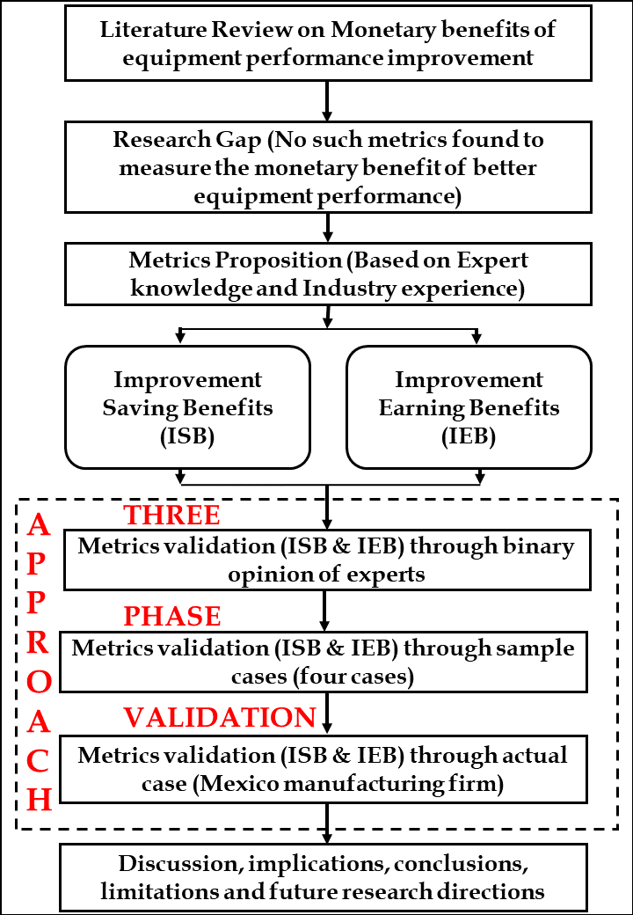
Figure 1. Research flow diagram

3.1 Proposition of ISB and IEB metrics
ISB (Improvement Saving Benefits) metric is developed to measure the monetary saving benefits of improving equipment performance when the equipment production capacity is higher than the product demand while separating the impact of manufacturing fluctuations.

Consider the equipment in Figure 2. It processes the resources into outputs as produced and rejected parts. Resources contemplate raw materials, packaging materials, labour, electrical energy, water and other consumables. To establish saving benefits, the ISB metric compares the equipment’s current time period unitary resource consumption with the unitary resource consumption of a base time period. The unitary resource consumption for a specific period is defined as the resource consumption divided by the production. For example, if during a period of time a piece of equipment had a 7 kWh electrical energy consumption and a production of 14 kg, then the unitary electrical resource consumption is 0.5 kWh per kg.

Figure 2. Equipment model.

ISB is calculated for every resource consumption of the equipment. If during the current period there have been unitary resource consumption savings compared to the base period, then the value of the ISB metric is a positive number, in currency units. Quite the reverse, if during the current period there have been unitary resource consumption losses in comparison with the base period, then the value of the ISB metric is a negative number, in currency units. In Figure 3, ISB shows positive savings during four periods while there has been a loss during the fifth period. The periods could be time intervals such as days, weeks, months and/or years.

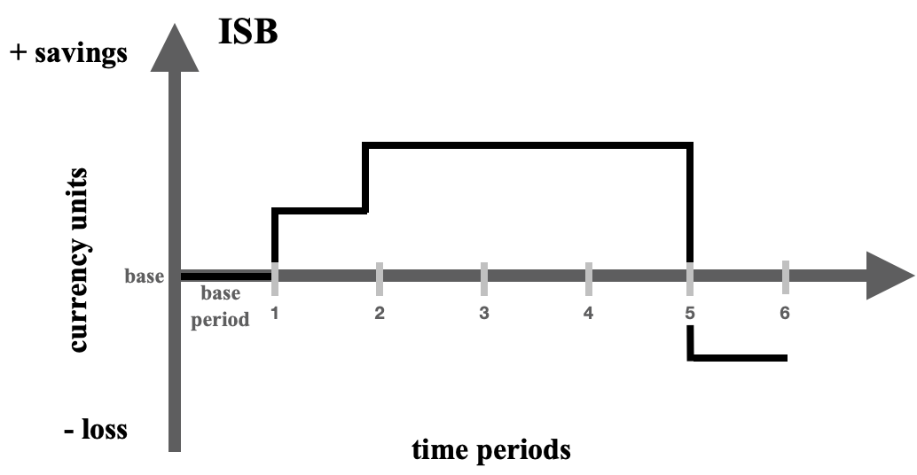

Figure 3. ISB savings-loss graph.

The metric is a monetary performance indicator. ISB determines if a piece of specific equipment is monetarily performing better based on its unitary resource consumption. It is defined for the current period as:

$$ISB=\left(\frac{\left(\begin{aligned}base resource \\ consumption\end{aligned}\right)}{\left(\begin{aligned}base \\ production \end{aligned}\right)}- \frac{\left(factor B \right)×\left(\begin{aligned}current resource \\ consumption\end{aligned}\right)}{\left(factor A \right)×\left(\begin{aligned}current \\ production\end{aligned}\right)}\right)×\left(\begin{aligned}current \\ production\end{aligned}\right) ×\left(\begin{aligned}current unitary \\ resource cost\end{aligned}\right)$$ | (1)

The ISB expression is constituted by three terms. The first term is the difference between the unitary resource consumption of the base and current periods. These unitary resource consumptions are firstly subtracted with the result multiplied by the current unitary resource consumption cost; the price cost variation between time periods is thus mitigated, as well as the overhead cost parameter variations.

The resource consumption is the amount that the equipment consumes of a specific resource for the period and shall preferably be expressed in technical units of measure instead of currency units; for example, kWh if the resource consumption is electrical energy. The production is the number of produced units for the period and could be expressed in counting, volume or mass units of measure; for example, the number of kilograms of finished products in the food industry. The current unitary resource cost is the current consumption cost per current resource consumption in technical units of measure, for example, USD$ per kWh.

Factors A and B are introduced in the ISB expression to better compare the base and current unitary resource consumptions. The intention is that these factors balance out the production-mix manufacturing fluctuation. Figure 4 shows the expressions of factor A and factor B that are used depending on the type of relation between the resource consumption rate and the equipment production rate.

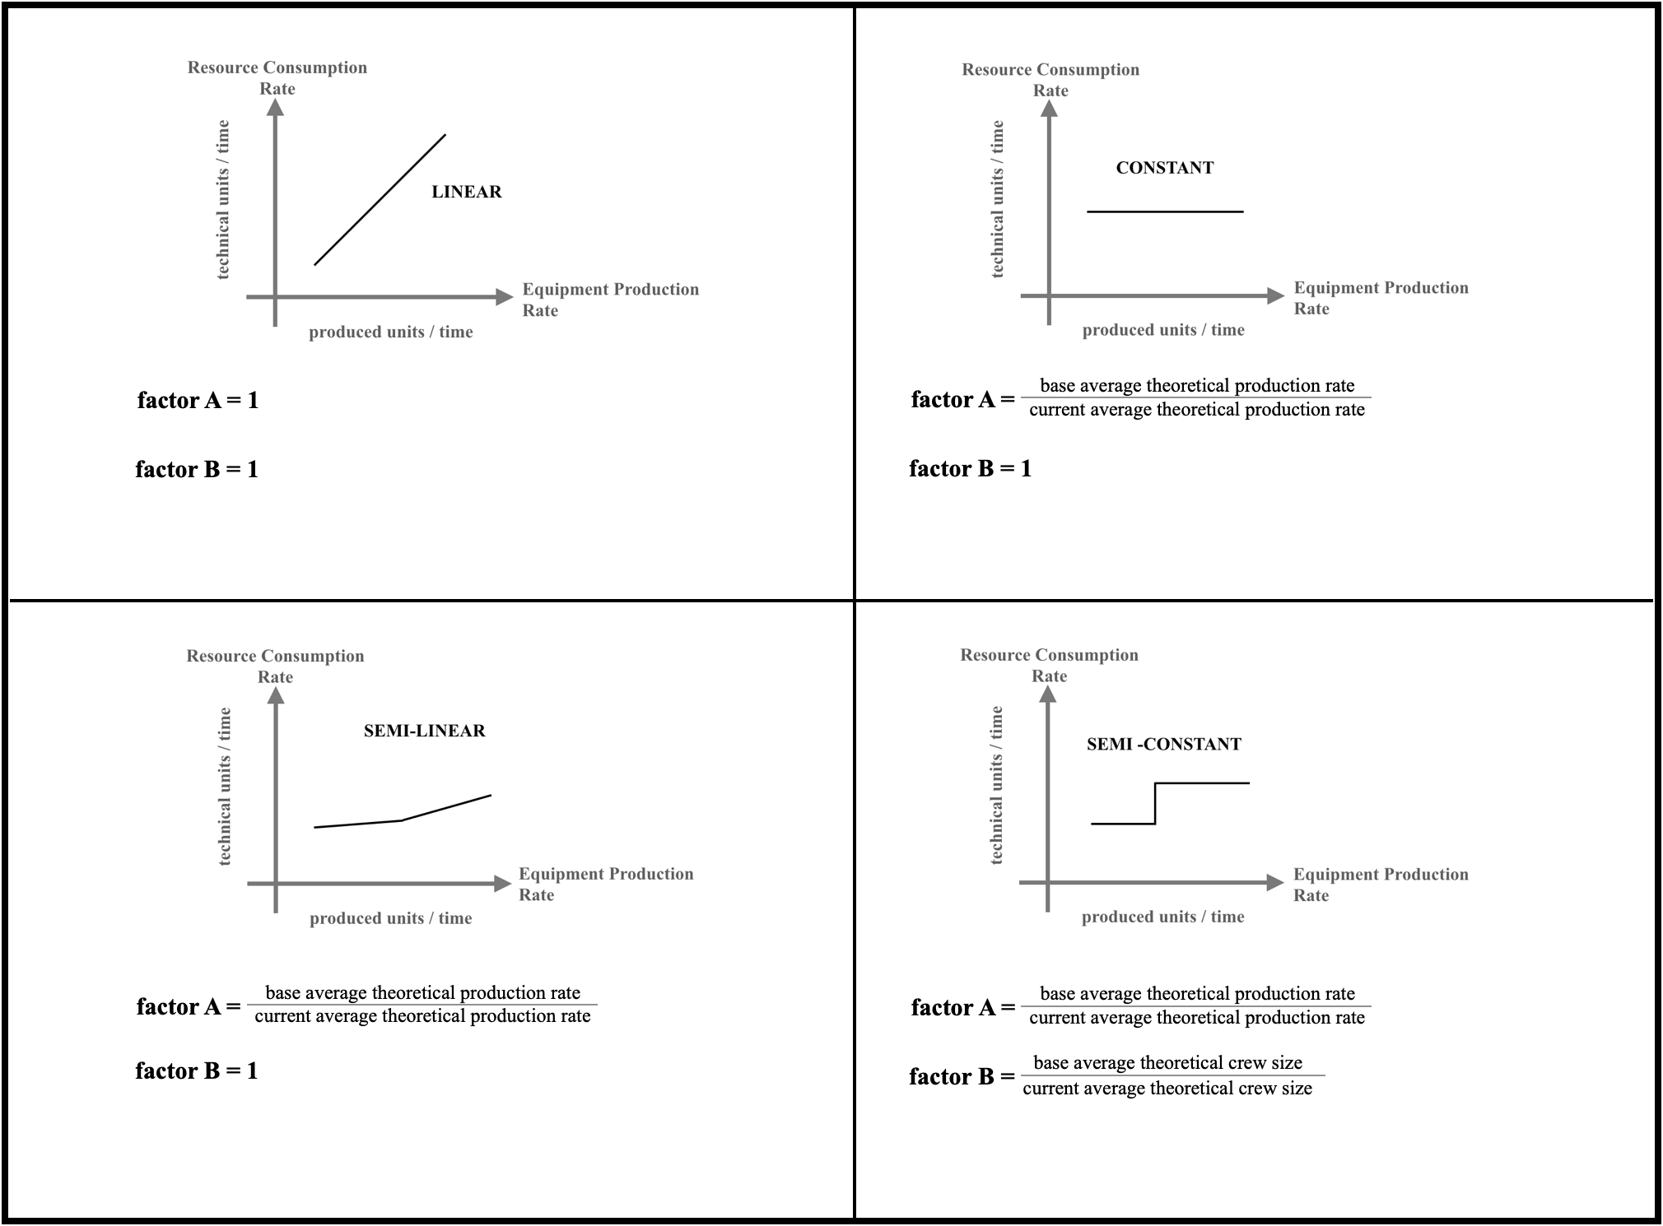

Figure 4. Factors A and B for each resource consumption rate type

There are four types of resource consumption rates as portrayed in Figure 3 and their definition is provided below. These are novel classifications proposed to better compare productions between periods:

- Linear: when resource consumption rate is proportional to equipment production rate.
- Constant: when resource consumption rate does not vary with equipment production rate.
- Semi-Linear: when resource consumption rate in relation to the equipment production rate is piece-wise proportional.
- Semi-Constant: when resource consumption rate in relation to the equipment production rate is piece-wise constant.

Typical linear type resources are raw materials, primary packaging materials and secondary packaging materials. If the equipment scrap is thought of as an input, then raw material losses and packaging material losses are considered linear resources. The core understanding here is that the equipment needs raw material and output scrap to process output units. This concept allows the application of ISB to scrap losses, either from raw or packaging materials.

Resources such as electricity, diesel, oil, gas or steam are typically considered to be semi-linear type resources. If the equipment’s production rate is increased, semi-linear resources tend to slightly increase their consumption rate in a relatively small proportion. In essence, it can be conceptualised as if the semi-linear resources have two elements, fixed and variable. The fixed element of the consumption rate represents a constant consumption irrespective of the equipment production rate, while the variable element is proportional to the production rate of the equipment. In practice, the fixed element is more predominant than the variable element. As the equipment is run at higher production rates, the resource consumption rate will slightly increase. A production mix, producing finished products with a higher rate of production is likely to indicate just a minor increase in the rate of resource consumption. Thus, the unitary resource consumption will tend to decline with a higher production rate since the minor rise in resource consumption is overwhelmed by the rise in production units.

Other resources that are typically considered semi-linear types are maintenance labour extra time, corrective/preventive maintenance of spare parts and material handling since their consumption rates can also be related to production speed.

Constant type resources are the ones whose consumption rates do not depend on the equipment production rate. Typical constant resources are equipment depreciation and maintenance labour. Semi-constant resources are those whose consumption rate does not depend on the equipment’s production rate but the constant value itself changes regardless of the equipment’s production speed. A common semi-constant resource is direct labour in highly automated processes. The equipment might be operated with a bigger crew size for specific products to handle a special production condition or when overtime wages result from a task.

There are resources whose consumption rate type varies per industry. Water is a linear type if the resource is only used as part of the finished product; but if water is also used for cleaning or wash-ups, then it is a semi-linear resource because the fixed consumption overwhelms the variable consumption component. Additionally, water is a constant-type resource if it is only used for cleaning and wash-ups. Another example is direct labour. Direct labour is usually a semi-constant resource but there are some factories where direct labour is paid per produced unit; in this case, direct labour is a linear type of resource.

Before calculating the ISB for any resource, its consumption rate behaviour must be determined to assign it to the correct resource consumption rate type as shown in Figure 4.

The average theoretical production mix rate characterises the production mix for the given time interval; it is an effective figure of merit that measures the production mix. By incorporating factor A, the current unitary resource consumption is compared in a more logical way to the base unitary resource consumption. Factor A is defined as:

$$factor A=\left(\frac{base average theoretical production mix rate}{current average theoretical production mix rate}\right)$$ | (2)
If the base average theoretical production mix rate is lower than the current average theoretical production mix rate, then factor A will decrease the production outputs for the current time interval. If the base average theoretical production mix rate is higher than the current average theoretical production mix rate, then factor A will increase the production output for the current time interval. Thus, the effect of the production mix is compensated.

If the equipment runs only one product, then factor A is equal to one since it always runs with the same theoretical rate during any given period. But if the equipment runs multiple products with the same theoretical production rate, then factor A is also equal to one since it always runs with the same theoretical rate during any given period.

Factor B is similar to factor A. It compensates for crew size variations using the required theoretical crew size for each product run in the equipment. It is specifically used for labour resource consumption. Factor B is defined as:

$$factor B=\left(\frac{base average theoretical crew size}{current average theoretical crew size}\right)$$ | (3)
The ISB metric does not consider the earnings from additional sales that an equipment improvement might attain when the product demand is higher than the equipment’s current capacity. ISB metric only takes into account savings when the product demand is lower than the total capacity. The manufacturing fluctuations are mitigated by using ISB. It enables manufacturing organisations to effectively measure the monetary savings of improving equipment performance.

IEB (Improvement Earning Benefits) metric is developed to measure the monetary earning benefits of improving equipment performance when the equipment production capacity is less than the product demand. While ISB is calculated for resources, the IEB metric is based on the earnings coming from the additional sales obtained from the added production due to equipment performance improvement. IEB is expressed as:

$$IEB=\left(\left(factor A \right)\left(\begin{aligned}current \\ production\end{aligned}\right)-\left(\begin{aligned}base \\ production \end{aligned}\right)\right) ×\left(\left(\begin{aligned}current unitary \\ sales price\end{aligned}\right)-\left(\begin{aligned}current unitary \\ variable cost\end{aligned}\right)\right)$$ | (4)

The IEB expression is constituted by two terms; the first is the additional production due to performance improvement while the second is the unitary earnings. Factor A balances out the production mix. The current unitary sales price and the current unitary variable cost are usually an average of all finished products.

The current unitary variable costs should only take into account the variable costs that were required for the additional production. For example, if the equipment production crew size during the current period is the same as that of the base period, then the direct labour costs must not be included in the current unitary variable cost because the additional production did not require more personnel. Since the fixed costs remain constant during the base and current periods, these costs are not considered in the second term of the IEB equation. In other words, the additional production occurs under the same fixed costs.

In factories with multiple pieces of equipment, it is recommended to calculate ISB/IEB for entire production lines using the line bottleneck equipment rates for factor A. This will ease the number of calculations, avoid the interdependence of individual equipment and will help to include all resource consumption. It is also preferable not to mix batch, continuous and discrete type processes in the same consolidated production lines; for example, a batch process will be treated separately from a packaging line. When a production process has a main production line with multiple entries of sub-assembly lines, then it is recommended to calculate ISB/IEB only on the main production line, considering the multiple entries as incoming raw materials; nonetheless, the ISB/IEB metrics could also be applied for each individual sub-assembly line.

To provide a more comprehensive understanding of ISB and IEB, the following two sections present their applications through sample and empirical cases.

3.2 Validation of ISB and IEB metrics
A three-phase validation approach was followed to support a robust validation of the proposed metrics. The validation phases are discussed in the following sections.

3.2.2 Phase 1: The binary opinion of the experts
Phase 1 involved 13 shop floor experts with a minimum industry experience of 15 years. A questionnaire was prepared with the objective of acceptance or rejection opinion for the validation of both metrics. The questionnaire was distributed to the industry experts, and their binary responses “Yes” or “No” were recorded. The decision for accepting or rejecting the ISB and IEB metrics was made as per the experts’ response. If the majority of responses led to “No”, then, the rejection of metrics would have been decided or vice-versa. A summary of the experts’ profiles is provided in Table 2.
Table 2: Experts' profile summary
S.No. | Field of specialisation | Industry experience (in years) | Total number of responses received | Percentage of individual field response with respect to the overall response
1. | Lean experts | 17-22 | 4 | 30.77%
2. | Total Productive Maintenance (TPM) Consultant | 19-27 | 6 | 46.15%
3. | Shop floor supervisor | 15-21 | 3 | 23.07%

Table 2 illustrates the diversity in the profile of the industry experts, which reduced the possibilities of bias. Furthermore, Table 3 shows the binary opinion of the experts on the acceptance and rejection of ISB and IEB metrics.

Table 3. Binary responses from experts for the acceptance/rejection of ISB and IEB
S.No. | Field specialisation | Industry experience (in years) | Total number of responses received | Experts’ responses for ISB “Metrics” |  |  | Experts’ responses for IEB “Metrics”
 |  |  |  | Yes | No | Majority Trend (Towards) | Yes | No | Majority Trend (Towards)
1. | Lean experts | 17-22 | 4 | 3 | 1 | Yes (75%) | 4 | 0 | Yes (100%)
2. | Total Productive Maintenance (TPM) Consultant | 19-27 | 6 | 5 | 1 | Yes (83.33%) | 4 | 2 | Yes (66.67%)
3. | Shop floor supervisor | 15-21 | 3 | 3 | 0 | Yes (100%) | 2 | 1 | Yes (66.67%)

Table 3 presents the responses of the participant shop floor experts. The experts’ responses suggested the majority trend by selecting the “Yes” or “No” option on the effectiveness of both metrics. Table 3 indicates that the majority of experts responded “Yes”, i.e. positively, to both metrics (ISB and IEB). This meant that the experts’ opinion validated both metrics as an effective approach for measuring the monetary benefit of equipment performance.

3.2.2 Phase 2: Sample Cases
Phase 2 presents a total of four sample cases for the equipment condition where the current equipment capacity is higher than the product demand. The first case illustrates the practicality of the proposed ISB metric in determining the savings benefits due to equipment performance improvement. The second case shows the efficacy of ISB in isolating the impact of the manufacturing fluctuation product mix and presents the actual savings benefits attained through equipment performance improvement. The third case shows the savings benefits of increasing throughput with the same resource consumption.

Sample Case 1
Consider equipment whose current production is equal to the base production period. Its current resource consumption is ninety per cent of the base resource consumption. The specific resource to be evaluated is a linear type, thus factor A and factor B are equal to one. The current-period ISB for the specific resource is calculated as:

$$ISB=\left(\frac{\left(\begin{aligned}base resource \\ consumption\end{aligned}\right)}{\left(\begin{aligned}base \\ production \end{aligned}\right)}- \frac{\left(factor B \right)×\left(\begin{aligned}current resource \\ consumption\end{aligned}\right)}{\left(factor A \right)×\left(\begin{aligned}current \\ production\end{aligned}\right)}\right)×\left(\begin{aligned}current \\ production\end{aligned}\right) ×\left({\begin{aligned}current unitary \\ resource\end{aligned} \atop cost}\right)$$ | (5)
$$ISB=\left(\frac{\left(\begin{aligned}base resource \\ consumption\end{aligned}\right)}{\left(\begin{aligned}current \\ production \end{aligned}\right)}- \frac{\left(1\right)×0.9\left(\begin{aligned}base resource \\ consumption\end{aligned}\right)}{\left(1\right)×\left(\begin{aligned}current \\ production\end{aligned}\right)}\right)×\left(\begin{aligned}current \\ production\end{aligned}\right) ×\left(\begin{aligned}current unitary \\ resource cost\end{aligned}\right)$$

$$ISB=\left(0.1\left(\begin{aligned}base resource \\ consumption\end{aligned}\right)\right)×\left(\begin{aligned}current unitary \\ resource cost\end{aligned}\right)$$

$$ISB=0.1\left(\begin{aligned}base resource \\ consumption cost\end{aligned}\right)$$

In this case, the ISB indicates that due to equipment performance improvement the savings are equal to ten per cent of the base resource consumption cost.

Sample Case 2
Consider equipment whose current production is equal to the base production period. Its current resource consumption is ten per cent more than the base resource consumption. The specific resource to be evaluated is a constant type with factor B set to 1 and factor A at 1.1 since the equipment was running products with a theoretical speed ten per cent higher during the base period than during the current period. The current-period ISB for the specific resource is calculated as:

$$ISB=\left(\frac{\left(\begin{aligned}base resource \\ consumption\end{aligned}\right)}{\left(\begin{aligned}base \\ production \end{aligned}\right)}- \frac{\left(factor B \right)×\left(\begin{aligned}current resource \\ consumption\end{aligned}\right)}{\left(factor A \right)×\left(\begin{aligned}current \\ production\end{aligned}\right)}\right)×\left(\begin{aligned}current \\ production\end{aligned}\right) ×\left({\begin{aligned}current unitary \\ resource\end{aligned} \atop cost}\right)$$ | (6)
$$ISB=\left(\frac{\left(\begin{aligned}base resource \\ consumption\end{aligned}\right)}{\left(\begin{aligned}current \\ production \end{aligned}\right)}- \frac{\left(1\right)×\left(1.1\right)×\left(\begin{aligned}base resource \\ consumption\end{aligned}\right)}{\left(1.1\right)×\left(\begin{aligned}current \\ production\end{aligned}\right)}\right)×\left(\begin{aligned}current \\ production\end{aligned}\right) ×\left({\begin{aligned}current unitary \\ resource\end{aligned} \atop cost}\right)$$

$$ISB=\left(0\right)×\left({\begin{aligned}current unitary \\ resource\end{aligned} \atop cost}\right)$$

$$ISB=0$$

In this case, the ISB indicates that due to equipment performance improvement there are no savings since during the base period the equipment was running ten per cent faster than the average theoretical speed.

Sample Case 3
Consider equipment whose current production is five per cent more than the base production period. Its current resource consumption is the same as the base resource consumption. The specific resource to be evaluated is a linear type, thus factor A and factor B are equal to one. The current-period ISB for the specific resource is calculated as:

$$ISB=\left(\frac{\left(\begin{aligned}base resource \\ consumption\end{aligned}\right)}{\left(\begin{aligned}base \\ production \end{aligned}\right)}- \frac{\left(factor B \right)×\left(\begin{aligned}current resource \\ consumption\end{aligned}\right)}{\left(factor A \right)×\left(\begin{aligned}current \\ production\end{aligned}\right)}\right)×\left(\begin{aligned}current \\ production\end{aligned}\right) ×\left({\begin{aligned}current unitary \\ resource\end{aligned} \atop cost}\right)$$ | (7)
$$ISB=\left(\frac{\left(\begin{aligned}base resource \\ consumption\end{aligned}\right)}{\frac{1}{1.05}\left(\begin{aligned}current \\ production \end{aligned}\right)}- \frac{\left(1\right)×\left(\begin{aligned}base resource \\ consumption\end{aligned}\right)}{\left(1\right)×\left(\begin{aligned}current \\ production\end{aligned}\right)}\right)×\left(\begin{aligned}current \\ production\end{aligned}\right) ×\left({\begin{aligned}current unitary \\ resource\end{aligned} \atop cost}\right)$$

$$ISB=0.05\left(\begin{aligned}base resource \\ consumption\end{aligned}\right)×\left({\begin{aligned}current unitary \\ resource\end{aligned} \atop cost}\right)$$

$$ISB=0.05\left(base resource consumption cost\right)$$

In this case, the ISB indicates that due to equipment performance improvement the savings are equal to five per cent of the base resource consumption cost.

An additional sample case is presented for the equipment condition where the current equipment capacity is lower than the product demand.

Sample Case 4
Consider equipment whose current production is five per cent more than that of the base production period. Factor A is 1.1 since the equipment was running with a theoretical speed ten per cent higher during the base period than during the current period. The current-period IEB is calculated as:

$IEB=\left(\left(factor A \right)\left(\begin{aligned}current \\ production\end{aligned}\right)-\left(\begin{aligned}base \\ production \end{aligned}\right)\right) ×\left(\left(\begin{aligned}current unitary \\ sales price\end{aligned}\right)-\left(\begin{aligned}current unitary \\ variable cost\end{aligned}\right)\right)$ (8)
$$IEB=\left(\left(1.1\right)\left(\left(1.05\right)\left(\begin{aligned}base \\ production \end{aligned}\right)\right)-\left(\begin{aligned}base \\ production \end{aligned}\right)\right) ×\left(\left(\begin{aligned}current unitary \\ sales price\end{aligned}\right)-\left(\begin{aligned}current unitary \\ variable cost\end{aligned}\right)\right)$$
$$IEB=\left(\left(1.155\right)\left(\begin{aligned}base \\ production \end{aligned}\right)-\left(\begin{aligned}base \\ production \end{aligned}\right)\right) ×\left(\left(\begin{aligned}current unitary \\ sales price\end{aligned}\right)-\left(\begin{aligned}current unitary \\ variable cost\end{aligned}\right)\right)$$
$$IEB=\left(0.155\right)\left(\begin{aligned}base \\ production \end{aligned}\right) ×\left(\left(\begin{aligned}current unitary \\ sales price\end{aligned}\right)-\left(\begin{aligned}current unitary \\ variable cost\end{aligned}\right)\right)$$

In this case, the IEB indicates that due to equipment performance improvement, the earnings are equal to 0.155 times the base production multiplied by its current unitary earnings.

3.2.2 Phase 3: Empirical Case
Phase 3 presents an empirical case in a specific production line of a major food and beverage manufacturing company in Mexico. The manufacturing facility has eight production lines. Each packaging line has a preparation and mixing area that feeds the product into the filler machine. Figure 5 shows the typical production line layout.

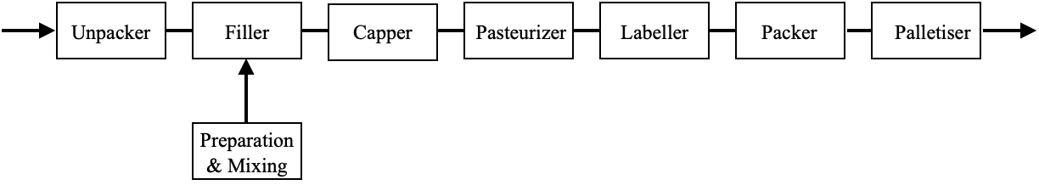
Figure 5. Typical production line layout

The line bottleneck is the filler machine, which has a capacity bigger than the product demand. Hence, the ISB metric can be used to determine the savings benefits due to performance improvement. The company has trained its plant floor personnel in operational excellence initiatives. It was determined to measure ISB in one packaging line, considering the product input to the filler machine as incoming raw material. ISB was calculated for two months. The base month is January while the current month is February. This line processes almost thirty finished products with different theoretical production rates. The theoretical production rates of the bottleneck vary due to primary packaging container size and product viscosity requirements.

In this packaging line, the company produced 394,205.40 kg of the finished product during the base period, with an average theoretical production rate of 40.57 kg/min at the bottleneck. During the current time interval, the equipment’s production output was 558,391.62 kg of finished product with an average theoretical production rate of 39.22 kg/min at the bottleneck. All accounting data was taken from the factory ERP (Enterprise Resource Planning) and the bottleneck theoretical production rates came from a spreadsheet.

The packaging line consumes the resources of electricity, water, bunker, raw material scrap, packaging material scrap, maintenance spare parts and extra time for maintenance labour. The ISB metric is calculated for each one of these resources. Equipment depreciation was not considered as the depreciation period had already ended. Direct labour was not considered because the factory did not record the number of direct labour personnel on the plant floor at any given time. Other resources consumed at the production line were not taken into account.

The value of factor A is 1.03 and is calculated as follows:

$$factor A= \frac{base average theoratical production mix rate}{current average theoretical production mix rate}= \frac{40.57}{39.22}=1.03 (9)$$

The ISB is used to establish the performance improvement savings benefits for the electrical energy resource. The electrical energy resource is a semi-linear type in the factory, therefore factor B is equalled to one. The factory provided the electrical resource consumption for the equipment in kWh at a current unitary electrical cost of USD $0.09 per kWh. The ISB for the electrical energy resource is calculated as follows:

$$ISB=\left(\frac{base electrical consumption}{base production }- \frac{current electrical consumption}{factor A ×current production}\right)×\left(\begin{aligned}current \\ production\end{aligned}\right) ×\left({current unitary \atop electrical cost}\right) (10)$$

using the factory provided data:

$$ISB \left(electrical\right)=\left[\frac{34,652.00 KWh}{394,205.40 Kg}- \frac{47,891.78 KWh}{1.03×558,391.62 Kg}\right] \left(558,391.62 Kg\right)\left(0.09 USD\$/KWh\right)= +USD \$232.89$$

The ISB is used also to establish the performance improvement savings benefits for the water resource. In this factory, the water resource is considered a constant type, hence factor B is equalled to one. The factory provided the water resource consumption for the equipment in m³ at a current unitary water cost of USD $1.14 per m³. The ISB for the water resource is calculated as follows:

$ISB=\left(\frac{base waterconsumption}{base production }- \frac{current water consumption}{factor A ×current production}\right)×\left(\begin{aligned}current \\ production\end{aligned}\right) ×\left({current unitary \atop water cost}\right)$ (11)

using the factory provided data:

$$ISB \left(water\right)=\left[\frac{4,134.25 m^{3}}{394,205.40 Kg}- \frac{4,790.35 m^{3}}{1.03×558,391.62 Kg}\right] \left(558,391.62 Kg\right)\left(1.14 USD\$/m^{3}\right)= +USD \$1,374.08$$

Now, the ISB is used to establish the performance improvement saving benefits for the bunker resource. In this factory, the bunker resource is considered a semi-linear type, hence factor B is equalled to one. The factory provided the bunker resource consumption in kilograms at a current unitary bunker cost of USD $1.77 per kg. The ISB for the bunker resource is calculated as follows:

$ISB=\left(\frac{base bunker cost consumption}{base production }- \frac{current bunker cost consumption}{\left(factor A \right)×\left(current production\right)}\right)×\left(\begin{aligned}current \\ production\end{aligned}\right) ×\left({current unitary \atop bunker cost}\right)$ (12)

using the factory provided data:

$$ISB \left(bunker\right)=\left[\frac{18,692.40 Kg}{394,205.40 Kg}- \frac{24,353.15 Kg}{1.03×558,391.62 Kg}\right] \left(558,391.62 Kg\right)\left(1.77 USD\$/Kg\right)= +USD \$5,016.06$$

The ISB is used similarly to establish the packaging line performance improvement savings benefits for the raw material scrap resource. Since the raw material scrap resource is a linear type, both factors A and B are equalled to one. The factory provided the raw material scrap in kilograms at an average current unitary raw material cost of USD $1.14 per kg. The ISB for the raw material scrap resource is calculated as follows:

$ISB=\left(\frac{base raw material scrap}{base production }- \frac{current raw material scrap}{current production}\right)×\left(\begin{aligned}current \\ production\end{aligned}\right) ×\left({current average unitary \atop raw material cost}\right)$ (13)

using the factory provided data:

$$ISB \left(raw material scrap\right)=\left[\frac{24,449.71 Kg}{394,205.40 Kg}- \frac{41,254.08 Kg}{558,391.62 Kg}\right] \left(558,391.62 Kg\right)\left(1.14 USD\$/Kg\right)= -USD \$7,548.05$$

Additionally, the ISB is used to establish the performance improvement savings benefits for the packaging material scrap resource. Since the packaging material scrap resource is a linear type, both factors A and B are equalled to one. The factory provided the packaging material scrap resource consumption in currency units instead of counting units; thus the term (current unitary consumption cost) is dropped from the ISB formula. This makes the metric sensitive to manufacturing fluctuation price variations. The ISB for the raw material scrap resource is calculated as follows:

$ISB=\left(\frac{\left(\begin{aligned}base packaging \\ material scrap cost consumption\end{aligned}\right)}{base production }- \frac{\left(\begin{aligned}current packaging \\ material scrap cost consumption\end{aligned}\right)}{current production}\right)×\left(\begin{aligned}current \\ production\end{aligned}\right)$ (14)

using the factory provided data:

$$ISB \left(packaging material scrap\right)=\left[\frac{USD \$6,684.44}{394,205.40 Kg}- \frac{USD \$11,601.79}{558,391.62 Kg}\right] \left(558,391.62 Kg\right)= -USD \$2,133.13$$

The ISB is now used to establish the performance improvement savings benefits for the maintenance labour extra time resource. Since this resource is a semi-linear type, factor B is equalled to one. Thus, the ISB for the maintenance labour extra time resource is:

$ISB=\left(\frac{\left(\begin{aligned}base maintenance labour \\ extra time consumption\end{aligned}\right)}{\left(base production \right)}- \frac{\left(\begin{aligned}current maintenance labour \\ extra time consumption\end{aligned}\right)}{\left(factor A \right)×\left(current production\right)}\right)×\left(\begin{aligned}current \\ production\end{aligned}\right) ×\left({current unitary \atop consumption cost}\right)$ (15)

using the factory provided data:

$$ISB \left(maintenance labour extra time\right)=\left[\frac{17.0 man hours}{394,205.40 Kg}- \frac{33.1 man hours}{1.03×558,391.62 Kg}\right] \left(558,391.62 Kg\right)\left(4.03 USD\$/ man hour\right)= -USD \$32.46$$

The ISB is used to establish the performance improvement savings benefits for the maintenance spare parts resource. Since the maintenance spare parts resource is a semi-linear type, factor B is equalled to one. The factory provided the maintenance spare parts resource consumption for the equipment in currency; thus the term (current unitary consumption cost) is dropped from the ISB formula. This makes the metric sensitive to manufacturing fluctuation price variations. Hence, the ISB for the maintenance spare parts resource is calculated as follows:

$ISB=\left(\frac{base maintenace spare parts cost consumption}{base production }- \frac{current maintenace spare parts cost consumption}{current production}\right)×\left(\begin{aligned}current \\ production\end{aligned}\right)$ (16)

using the factory provided data:

$$ISB \left(maintenace spare parts\right)=\left[\frac{USD \$3,118.43}{394,205.40 Kg}- \frac{USD \$4,968.29}{1.03×558,391.62 Kg}\right] \left(558,391.62 Kg\right)= -USD \$406.33$$

The total ISB for the various resources consumed in the equipment is:

Total ISB = ISB(electrical) + ISB(water) + ISB(bunker) + ISB(raw material scrap) +
ISB(packaging material scrap) + ISB(maintenance labour extra time) +
ISB(maintenance spare parts) = - USD $3,496.94

The total ISB shows that there are negative saving benefits due to line performance improvement. Some individual ISBs show losses, in particular, scrap generation due to raw and packaging materials. It is here where Ferdows and De Meyer's (1990) Sand Cone model might become useful to determine if factory personnel are following the right order of improvement.

The electrical, water and bunker ISBs exhibit saving benefits. It is likely that during the current period, there were fewer downtime or speed losses. Nonetheless, the raw material and packaging material scrap ISBs show losses; hence, this means that during the current period, there were more out-of-specification products. The root causes could be diverse; it could mean incorrect labelling of finished products, product attributes not acceptable, more scrap due to higher velocities etc.

The factory now has a metric to determine if its operational excellence initiatives are financially beneficial and can pinpoint where exactly the equipment losses are coming from.

4. Discussion

The ISB and IEB metrics were developed to specifically calculate the actual financial benefits gained due to equipment performance improvement, which other metrics are not able to do (Grünberg, 2004). The ISB and IEB metrics effectively isolate the impact due to manufacturing fluctuations such as prices in raw materials, labour costs, production mix and overhead cost variations, which other metrics such as the economic evaluation scheme (Kono and Ichikizaki, 2015) are not able to do. Calculations are made by comparing the current period with a base time interval.

The impact of manufacturing fluctuations is compensated by using factors A and B (see Section 3) and by subtracting first the technical unitary resource consumptions prior to multiplying them by monetary numbers. Through this compensation, the ISB and IEB metrics specifically analyse and indicate if there are benefits due to implementing improvement strategies. Other metrics such as manufacturing cost deployment (Yamashina and Kubo, 2002) are not able to differentiate the benefits as it relates the cost to production losses.

It is generally assumed that equipment performance improvement will result in saving benefits, particularly in monetary terms. However, that may not be always the case. For example, while a manufacturing facility may improve its equipment’s overall effectiveness, this may not be translated into better financial performance. In this regard, the empirical case presented in Section 5 shows that the performance improvements resulted in saving benefits in terms of time. However, the ISB reported negative saving benefits due to losses in packaging and raw materials yield levels. Without the ISB, such differentiation to specify the origin of losses would not have been possible.

Similarly, the sample cases exemplify the practical utilisation of the ISB metric to determine the saving benefits owing to equipment performance improvement (see sample case 1). Furthermore, the second sample case illustrates how the impact of the manufacturing fluctuation product mix can be isolated to clearly define the actual saving benefits achieved as a result of the improvement in equipment performance. Without isolating the impact of manufacturing fluctuations, the true value of saving benefits can go undetected. Therefore, the ISB’s ability to specifically isolate this impact helps determine the actual saving benefits which other metrics are not capable of.

While the ISB metric is useful to understand the improvement benefits from the resources perspective, the IEB metric determines the earnings coming from the additional sales due to added production as a result of equipment performance improvement. The IEB metric is exemplified through sample case 4.

In practical terms, as reflected in the empirical case (see Section 5), the data needed for the ISB and IEB metrics are easily available and collectable from the accounting system and/or purpose-built software or electronic spreadsheets. This makes the proposed metrics even more attractive and useful for the manufacturing sector to analyse performance improvement in their production equipment as an alternative to using the variance in the product unitary cost, since this is highly sensitive to manufacturing fluctuations. The ISB and IEB metrics can easily be adopted into a firm’s existing system of analysis that feeds into the information platform for management’s strategic decision making. Moreover, managers can use this data to improve their production processes and operations.

5. Conclusions, Limitations, and Further Research Directions
5.1 Conclusions
Present-day businesses are under immense pressure to continuously evolve performance improvement to remain competitive in a rapidly growing industrial era. For this, managers need to make decisions that result in adding value through the optimisation of operations and processes. To do so, managers need precise data to understand how their performance improvement strategies contribute to the firm’s monetary success and likewise make better-informed decisions to formulate the right course of operational improvement.

The proposed novel ISB and IEB metrics were developed to measure the benefits achieved through the improvement of operations in manufacturing equipment. These unique metrics cover the missing elements (gap) identified in Section 1. The major contributions of each metric, and hence the present work, are as follows:

- Manufacturing variations may be identified using this innovative new metric. It is impossible to establish the real cost-benefit of operations optimisation without separating production variations.
- The proposed metrics are useful for manufacturing companies to use in order to methodically conduct an in-depth analysis of the performance of their equipment, through the lens of an understanding of the monetary benefits, in order to explicitly highlight their profitability in both the short term and the long term.
- Case studies, both hypothetical and empirical, are presented to facilitate a greater comprehension and the generation of new information about the optimal method by which to evaluate the advantages gained through operations improvement in manufacturing equipment.

Several manufacturing industries, including food and beverage, pharmaceuticals, cosmetics, CPG (consumer packaged goods), aerospace and automotive, as well as electronics, plastics and textiles, may benefit from the ISB and IEB metrics that have been presented.

It is important to emphasise that the suggested metrics are not an extension of performance measures such as Overall Equipment Effectiveness, which quantify the effectiveness and yield of processes. Instead, the ISB and IEB metrics assess the monetary advantages of increasing equipment performance by isolating the influence of manufacturing changes. This is done so that the metrics may be compared directly with one another. The ISB and IEB metrics are not meant to be a substitute for other overall efficiency measures, nor do they distort the current analyses, or vice versa. Instead, they are designed for practical use and are not intended to be used instead of such measurements. It is up to the management judgments to decide if the ISB and IEB metrics should be used together or separately from one another.

The ISB and IEB metrics mark a return to the use of financial measures for equipment performance improvements as conceptualised by Ghalayini and Noble (1996). The ISB and IEB measures have the following major characteristics:

- They are lagging indicators since they show the results of past decisions and actions.
- They can be used for corporate strategies to minimise production costs.
- They are relevant to manufacturing practice as they quantify performance improvement efforts in financial terms.
- They are flexible as their format can accommodate different data types.
- They are non-expensive since their calculation only requires standard data that is easy to obtain.
- They are intelligible since currency metrics are easily understood.
- They are an aggregate productivity measure as they do not over-emphasise any resource nor neglect others.
- They do not compare to maximums or standards that may cope with continuous improvement. Thus, they do not lead to dealing with discrepancies between actual and standard. This protects against sub-optimisation by not using standards in its definition.

5.2 Limitations, and Further Research Directions
This research has explicitly identified the gap in presently available operational measurement tools. It has further pointed to the need for more enhanced and in-depth measurements that will unequivocally present potential monetary benefits. In these results, a novel approach using ISB and IEB metrics has been proposed to facilitate an enhanced understanding of and for performance improvement in business operations. The authors strongly believe that the proposed metrics will be of great use and significance to both practitioners and academics for application and further research.

The sample and empirical cases, presented in Sections 4 and 5 respectively, establish the effectiveness of the metrics; however, this can be interpreted as a limitation and may guide future research to further confirm the robustness of the proposed metrics in the manufacturing industry. Further validation can be pivotal in expanding the scope and depth of these metrics.

References
Abdulkareem, S. A., Adel, A. A. and John, R. A. (2013), “Competitive Priorities and Competitive Advantage in Jordanian Manufacturing”, Journal of Service Science and Management, pp. 69-79. [CrossRef]
Abdul Rasib, A. H., Ebrahim, Zuhriah, A., Rohana, A. and Zubaidi, F. (2019), “Improvement of Overall Equipment Effectiveness through Application of Single-Minute Exchange of Die in Automotive Manufacturing”, Test Engineering and Management, Vol. 81, pp. 3650-3659.
Ahmed, A. and Pise, U. V. (2019), “Overall Equipment Effectiveness Analysis and improvement of the Selected Company”, 1st International Conference on Manufacturing, Material Science And Engineering (ICMMSE-2019).
Al-Najjar, B. (1997), “Condition-Based Maintenance: Selection and Improvement of a Cost-Effective Vibration-Based Maintenance Policy for Rolling Element Bearings”, Lund University. http://www.lunduniversity.lu.se/lup/publication/8658b1ad-5fab-4739-a449-b2f4tan [CrossRef]
Andersson, C. and Bellgran, M. (2015), “On the complexity of using performance measures: Enhancing sustained production improvement capability by combining OEE and productivity”, Journal of Manufacturing Systems, Vol. 35, pp. 144–154.
Braglia, M., Castellano, D., Frosolini, M. and Gallo, M. (2018), “Overall Material Usage Effectiveness (OME): a Structured Indicator to Measure the Effective Material Usage within Manufacturing Processes”, Production Planning and Control, Vol. 29 No. 2, pp. 143–157. [CrossRef]

Braglia, M., Frosolini, M. and Zammori, F. (2008), “Overall Equipment Effectiveness of a Manufacturing Line (OEEML): an Integrated Approach to Assess Systems Performance”, Journal of Manufacturing Technology Management, Vol. 20, No.1, pp. 8–29.
Bulent, D., Tugwell, P. and Greatbanks, R. (2000), "Overall Equipment Effectiveness as a Measure of Operational Improvements – a Practical Analysis", International Journal of Opererations & Production Management, Vol. 20, pp. 1488–1502.
Dugdale, D. and Jones, T.C. (1998), “Throughput Accounting: Transforming Practices?”, The British Accounting Review, Vol. 30 No. 3, pp. 203–220.
Ferdows, K. and De Meyer, A. (1990), “Lasting improvements in manufacturing performance: In search of a new theory”, Journal of Operations Management, Vol. 9 No. 2, pp. 168–184.
Fernandes, R., Gouveia, J.B. and Pinho, C. (2012), “Product mix strategy and manufacturing flexibility”, Journal of Manufacturing Systems, Vol. 31 No. 3, pp. 301–311.
Garza-Reyes, J.A. (2015), “From measuring overall equipment effectiveness (OEE) to overall resource effectiveness (ORE)”, Journal of Quality in Maintenance Engineering, Vol. 21 No. 4, pp. 506–527.
Garza-Reyes, J.A., Eldridge, S., Barber, K.D. and Soriano‐Meier, H. (2010), “Overall equipment effectiveness (OEE) and process capability (PC) measures: A relationship analysis”, International Journal of Quality & Reliability Management, Vol. 27 No. 1, pp. 48–62.
Garza-Reyes, J.A., Salomé Valls, A., Nadeem, S.P., Anosike, A. and Kumar, V. (2019), “A circularity measurement toolkit for manufacturing SMEs”, International Journal of Production Research, Vol. 57 No. 23, pp. 7319–7343.
Ghalayini, A.M. and Noble, J.S. (1996), “The changing basis of performance measurement”, International Journal of Operations and Production Management, Vol. 16 No. 8, pp. 63–80.
Godina, R., Pimentel, C., Silva, F. J. G. and Matias, J. C. O. (2018), "A structural literature review of the Single Minute Exchange of Die: The Latest Trends", Procedia Manufacturing, Vol. 17, pp. 783–790.
Gólcher-Barguil, L.A., Nadeem, S.P. and Garza-Reyes, J.A. (2019), “Measuring operational excellence: an operational excellence profitability (OEP) approach”, Production Planning and Control, Taylor & Francis, p. In press.
Grünberg, T. (2004), “Performance improvement: Towards a method for finding and prioritising potential performance improvement areas in manufacturing operations”, International Journal of Productivity and Performance Management, Vol. 53 No. 1, pp. 52–71.
Haddad, T., Shaheen, B. W. and Németh, I. (2021), "Improving overall equipment effectiveness (OEE) of extrusion machine using lean manufacturing approach", Manufacturing Technology, Vol. 21 No. 1, pp. 56–64. https://doi.org/10.21062/mft.2021.006
Huang, S. and Yang, J. (2016), “Information acquisition and transparency in a supply chain with asymmetric production cost information”, International Journal of Production Economics, Vol. 182, pp. 449–464.
Hu, Q., Boylan, J. E., Huijing, C. and Labib, A. (2018), “Or in Spare Parts Management: A Review”, European Journal of Operational Research, Vol. 266 No. 2, pp. 395–314.

Kono, H. and Ichikizaki, O. (2015), “method and Procedure for Economic Evaluation of Improvement Activties”, Industrial Engineering & Management Systems, Vol. 14 No. 2, pp. 122–128.
Liu, Y. and Yang, J. (2015), “Joint pricing-procurement control under fluctuating raw material costs”, International Journal of Production Economics, Vol. 168, pp. 91–104.
Monden, Y. and Hamada, K. (1991), “Target Costing and Kaizen Costing in Japanese Automobile Companies”, Journal of Management Accounting Research, Vol. 3, pp. 16–34.
Muchiri, P. and Pintelon, L. (2008), "Performance measurement using overall equipment effectiveness (OEE): Literature review and practical application discussion", International Journal of Production Research, Vol. 46, No. 13, pp. 3517–3535. https://doi.org/10.1080/00207540601142645
Muthiah, K. M. N., and Huang, S. H. (2007), “Overall Throughput Effectiveness (OTE) Metric for Factory-Level Performance Monitoring and Bottleneck Detection”, International Journal of Production Research, Vol. 45 No. 20, pp. 4753–4769. [CrossRef]
Nachiappan, R. M., and Anantharaman, N. (2006), “Evaluation of Overall Line Effectiveness (OLE) in a Continuous Product Line Manufacturing System”, Journal of Manufacturing Technology Management, Vol. 17 No. 7, pp. 987–1008.
Nadeem, S.P., Garza-Reyes, J.A. and Glanville, D. (2018), “The Challenges of the Circular Economy”, in Conway, E. and Byrne, D. (Eds.), Contemporary Issues in Accounting, Palgrave Macmillan, pp. 37–60.
Nakajima, S. (1988), "Introduction to TPM: Total Productive Maintenance", Cambridge, MA: Productivity Press.
Nyambane, J. M. and Bett, S. (2018), "Competitive advantage and performance of heavy construction equipment suppliers in Kenya: Case of Nairobi County", International Academic Journal of Human Resource and Business Administration, Vol. 3 No. 1, pp. 476-502
Oechsner, R., Pfeffer M., Pfitzner L., Binder, Müller E., and Vonderstrass T. (2002), “From Overall Equipment Efficiency (OEE) to Overall Fab Effectiveness (OFE)”, Materials Science in Semiconductor Processing, Vol. 5 No. (4–5), pp. 333–339. [CrossRef]
Olhager, J. and Persson, F. (2006), “Simulating production and inventory control systems: A learning approach to operational excellence”, Production Planning and Control, Vol. 17 No. 2, pp. 113–127.
Olivella, J.and Gregorio, R. (2015), "A case study of an integrated manufacturing performance measurement and meeting system", Journal of Manufacturing Technology Management, Vol. 26 No. 4, pp. 515-535.
Özbayrak, M., Akgün, M. and Türker, A.K. (2004), “Activity-based cost estimation in a push/pull advanced manufacturing system”, International Journal of Production Economics, Vol. 87 No. 1, pp. 49–65.
Ron, A. J. and Rooda, J. E. (2006), "OEE and Equipment Effectiveness: An Evaluation", International Journal of Production Research, Vol. 44 No. 23, pp. 4987–5003.
Scott, D., and Pisa R. (1998), “Can Overall Factory Effectiveness Prolong Moore’s Law?”, Solid State Technology, Vol. 41 No. 3, pp. 75–82. [CrossRef]
Sharafoddin, S. (2016), “The Utilization of Target Costing and its Implementation Method in Iran”, Procedia Economics and Finance, Vol. 36, pp. 123–127.
Stamatis, D. H. (2010), "The OEE primer: Understanding Overall Equipment Effectiveness, reliability, and maintainability", CRC Taylor & Francis.
Taleb, A., Maine, E. and Kjeang, E. (2014), "Technical-economic cost modeling as a technology management tool: A case study of membranes for PEM fuel cells", Journal of Manufacturing Technology Management, Vol. 25 No. 2, pp. 279-298.
Tan, K.H. and Noble, J. (2007), “Plug and play (PnP) modelling approach to throughput analysis”, Journal of Manufacturing Technology Management, Vol. 18 No. 7, pp. 807–817.
Tsarouhas, P. H. (2012), "Evaluation of overall equipment effectiveness in the beverage industry: A case study", International Journal of Production Research, Vol. 51 No. 2, pp. 515–523.
Tsarouhas, P. H. (2013), "Equipment Performance Evaluation in a production plant of traditional Italian cheese", International Journal of Production Research, Vol. 51 No. 19, pp. 5897–5907.
Wacker, J. G., Yang, C. L. and Sheu, C. (2006), “Productivity of Production Labor, Non-Production Labor, and Capital: An International Study”, International Journal of Production Economics, Vol. 103 No. 2, pp. 863–872.
Wells, P.K. (2018), “How well do our introductory accounting text books reflect current accounting practice?”, Journal of Accounting Education, Vol. 42, pp. 40–48.
Wudhikarn, R. (2016), “Implementation of the overall equipment cost loss (OECL) methodology for comparison with overall equipment effectiveness (OEE)”, Journal of Quality in Maintenance Engineering, Vol. 22 No. 1, pp. 81–93.
Yamashina, H. and Kubo, T. (2002), “Manufacturing cost deployment”, International Journal of Production Research, Vol. 40 No. 16, pp. 4077–4091.
Zammori, F., Braglia, M. and Frosolini, M. (2011), “Stochastic Overall Equipment Effectiveness”, International Journal of Production Research, Vol. 49 No. 21, pp. 6469–6490. [CrossRef]
Zammori, F. (2014), “Fuzzy overall equipment effectiveness (FOEE): Capturing performance fluctuations through LR fuzzy numbers”, Production Planning & Control, Vol. 26 No. 6, pp. 451–466.

