‘COPS AND CLOBBERS’: AN ATTEMPTED “KNOCK-OUT FOR POLITICS” BETWEEN INTER-WAR BRITAIN AND GERMANY
By
Tom Andrews and Michael Haunschild

In a series of reciprocal visits in 1935 and 1936, police officers from Nottingham in England, and Stuttgart in Germany faced-off in a series of boxing competitions, drawing crowds of thousands. With a detailed examination of the circumstances surrounding these exchanges and the details of each event, the story of this local attempt at using sport to foster peace in the run-up to the outbreak of the Second World War is detailed in its entirety for the first time. Using contemporary newspaper sources, secondary material, personal recollections and unprecedented access to the Stuttgart Police archives, this article looks at both perspectives of the encounters. The result is the discovery of the only known image of the Swastika flag flying alongside the Union flag on the UK mainland, on the Nottingham County Hotel, from October 1936.
In compiling this, the authors wish to acknowledge the help and support of the Polizeihistorischer Verein Stuttgart e.V. (Stuttgart Police Historical Association) and the Polizeisportverein Stuttgart e.V. (Police Sports Club Stuttgart) for finding and allowing the reproduction of their material. Special thanks are due to Michael Kühner, Chairman of the Stuttgart Police Historical Association, for his meticulous research in the archive of the Stuttgart Police Sports Club, and to Hans-Peter Schühlen, who discovered photographs of the 1936 visit to Stuttgart.
On 28 October 1936 the Nazi Swastika flag was raised over Nottingham, flying adjacent to the British Union flag; possibly the only time, and certainly the only known occasion caught on camera, such a juxtaposition occurred on the British mainland. What prompted this unique situation was, of all things, a visit by a German local police force boxing team to take on the Nottingham City Police fighters. This was in fact the fourth such encounter between the Stuttgart and Nottingham police teams, with reciprocal visits in both 1935 and this being the return leg of 1936. The events leading up to this unique situation and what followed are indicative of the climate in the immediate pre-war era and also possibly led to an increased national readiness in Britain regarding Nazi militarisation.
Quite exactly what led the Nottingham and Stuttgart teams to one another remains shrouded in mystery. There were regular international police boxing championships during this period: notably in Berlin in 1933 and London in 1934 and 1935. Nottingham City Police’s boxers featured heavily in the line-up of the British parties on each occasion. Following the 1934 event at London’s Albert Hall, several of the German contingent from the Berlin Police travelled to Nottingham for an event at the Victoria Ballroom, specifically to fight the local officers, alongside others who had fought in London the previous week. These were far from one-off events, with various international tournaments taking place between national police teams on a regular basis.
The reason for Nottingham appearing to be such a Mecca for police boxing resulted from the passion for the sport of the Nottingham City Police’s Chief Constable, Capt. Athelstan Popkess. Popkess, a veteran of the South Africa campaign in the First World War, had been recruited directly to the commanding role of the Nottingham force from the position of Assistant Provost Marshall at Aldershot. His preceding career had seen him also working in military intelligence in Ireland during the War of Independence, and a posting in the Palestine Gendarmerie. Sport was his passion, with his application for the chief constable role (at the age of just thirty-seven) listing ‘Qualified boxing referee and judge’, and ‘Rugby Football v. England in 1913’ amongst his ‘Qualifications’. His own autobiography Sweat in My Eyes also details how, whilst he served in the Legion of Frontiersmen during the War, disputes were often resolved by a bout of ‘Queensberry Rules’. Humbly, he proclaimed that his colleagues praised his abilities at the sport.
On taking over the helm of the Nottingham City Police in 1930, Popkess brought his passions and many like-minded individuals to the force. He was known to ‘head-hunt’ boxers of talent from the military, even being prepared to bend national entry requirements to accommodate significantly shorter officers who were fighters of renown; in spite of his own overwhelming preference for exceptionally tall officers. The Nottingham City Police boxing team was recognised as the best amateur team in the country, and the officers were permitted whatever time off they wished from duty for sparring practice. This helped members of the City force win fourteen International Police Boxing championships (at different weights) and boast ‘three Welsh, three English, and two Scottish Amateur Boxing Association (A.B.A) boxing champions. As well as two British Empire Games representatives’.
Boxing was at this time a fundamental part of initial police training, as a result of the need for officers patrolling alone in slum districts to be tougher than those they were looking to arrest. Nowhere was the success of using boxing to train officers more evident than in the town of Colchester, where ‘a force of about four-dozen constables was able to put out a successful boxing team, against that of Colchester Garrison, which must have numbered many thousands of hardened soldiers’. Popkess would have been well aware of the Colchester fights from his time in Aldershot, no doubt recognising the worth of the tough police officers. Arriving in Nottingham, he must have realised the benefits of such officers patrolling slum districts, most notably Nottingham’s notorious Narrow Marsh area. Indeed, his future deputy chief constable, and leader of one of the travelling contingents to Stuttgart, George Downs, had cut his teeth as a constable patrolling exactly that area.
As soon into his tenure as 1933 Popkess’ force made up a large contingent of the British national police team that travelled to Berlin for the international police boxing tournament held there in November. The Nottingham team were singled out for particular praise for their prowess by rival cities. The same was true of the London events in 1934 and 1935, where the Colchester force also featured prominently.
It is unclear whether anyone from the Stuttgart Police represented their country at any of the international events. Most the German officers named hailed from Berlin. Several of their officers were, however, regional or national champions, including Helmut Endreß (Endries / Endresz in English newspapers), lightweight champion of Bavaria in 1934-35; Bruno Loibl who had held the Bavarian mantle for the middleweight category for the preceding three years; Karl Leiser who was two-time heavyweight champion of Württenberg; and Hans Bernlöhr (Bernloehr) who was the German national heavyweight champion four years in a row, and represented Germany at the Los Angeles Olympics in 1932. It must therefore be assumed that at least some of these officers were present at the European police championships, albeit their names are not listed in surviving documents that can be located. The Stuttgart Police Sports Club (Polizeisportverein) was also incredibly active; their president, Polizeioberinspektor (Chief Inspector) Christian Walther, was particularly passionate about boxing. Their quarterly newsletters detailing the various sporting teams achievements run to several dozen pages each and carry countless adverts suggesting a wide readership. It appears to have been Walther who initiated the exchange visits, perhaps after witnessing the Nottingham officers in Berlin or hearing about subsequent performances.
Whatever machinations took place behind the scenes, the Nottingham City Police boxing team travelled to Stuttgart, departing early on 28 October 1935, with a team of twelve PCs (Table 1) and was led by Superintendent George Downs; Inspector Albert West, secretary of the boxing team; and PC Joe Rostron the trainer.
Heavyweights | Cruiserweight | Middleweights | Lightweights
Gerry Beaves | Jimmy Gibbons | Jack Lewis | Jim Rolland
Jack Fenner | George Holton | George Scott | John (Chalkie) White
Cyril Pollock

Table 1: The Nottingham City Police Team in Stuttgart, 1935.
Their journey by rail took some twenty-four hours, with them arriving in Stuttgart in the early hours of 29 October. After a chance to rest and recuperate, the team were welcomed that evening by the sports club of the host force. The following day the visitors were officially welcomed to the city at the Rathaus (city hall) by Polizeipräsident (police chief) Rudolf Klaiber, Dr Karl Strölin the Oberburgmeister (lord mayor), and Hugo Häussler, deputy sports leader for the Nazi party of the Württemberg district. Each visiting boxer was presented with a commemorative plaque, and both sides toasted the good health of the other. Indicative of the tensions already apparent as early as 1935, there was specific mention of a strong desire for peace between the two nations, with Dr Strölin explicitly stating that ‘there were many false impressions abroad of Germany’ and that the ‘only desire of the German people was to be at peace with the rest of the world’.

The main event was that evening, with a crowd of some 8000 at the town hall to watch the nine fights, which lasted until midnight. They were joined there by the minister of the interior Dr Jonathan Schmidt, General Alois Ritter von Molo, along with Dr. Eugen Klett, Sportbereichsführer (sport commissioner of the Nazi party for Württemberg) and his deputy, Hugo Häussler. Before the beginning of the matches the visiting team performed a ‘Nazi salute’ in the ring, to respect their hosts. The visitors narrowly lost overall four to three, with two draws. Bernlöhr, the German national heavyweight champion was absent from the contests as a result of representing the German national team in a bout against France (Table 2).

Bout | Weight | Result
1 | Lightweight | White (w) – Endreß
2 | Heavyweight | Pollock (w) – Engelhardt
3 | Cruiserweight | Gibbons (w) – Holz
4 | Lightweight | Rolland – Leitner (d)
5 | Middleweight | Scott – Held (d)
6 | Middleweight | Lewis – Loibl (w)
7 | Cruiserweight | Holton – Glaser (w)
8 | Heavyweight | Beaves – Bubeck (w)
9 | Heavyweight | Fenner – Leiser (w)

Table 2: Results of the Stuttgart bouts, 30 October 1935.
The following day (whilst all present were no doubt slightly hungover, after celebrations which lasted well into the morning) the visitors were treated to a motor tour of the countryside surrounding the city (Figure 1) and to the nearby Schloß Solitude where photographs were taken. Following this, a sombre moment followed as the visitors attended the Forest Cemetery, where Supt. Downs laid a wreath in honour of the 8000 German soldiers buried there. Downs was a First World War veteran, and the ethos of both teams was one of respect and honour to fallen combatants of both sides, which was to be further demonstrated on the German’s return visits to Nottingham.
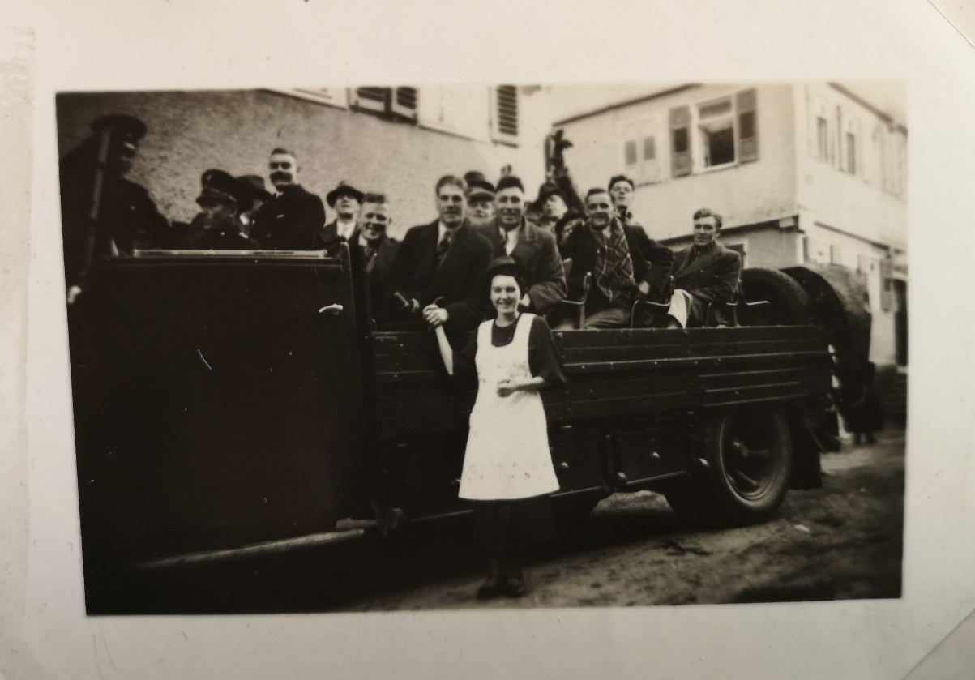
Figure 1. The boxers on the motor tour. Collection of John White (holding the woman’s hand). Courtesy of Peter and Ina White
Boxing was not the only sport undertaken, with the two teams also undertaking a pistol shooting match (Figure 2) and a swimming relay race over the coming days, in which the hosts also triumphed.
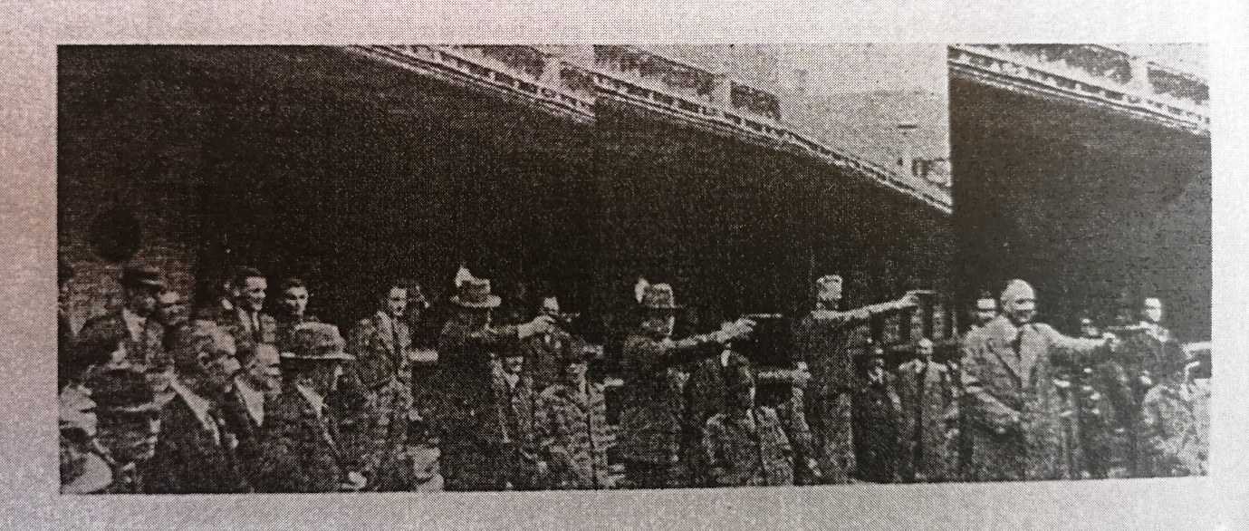
Figure 2. Pistol shooting in the mountains of Stuttgart.

On Saturday 2 November the Nottingham team travelled to the nearby town of Ulm, where once again they were welcomed by local dignitaries and marched into the city in a large procession. Peace was another key talking point there, with both the deputy mayor and local MP citing the locals’ desire for good relations. In recognition of this friendship, the Nottingham deputation was presented with an oil painting of the city, which Nottinghamshire Police still possess to this day (Figure 3). The Nottingham team were triumphant on this occasion, even though the town’s boxers were reinforced by Stuttgart colleagues. Another celebration was held that evening, followed the next day by a tour of the town including its cathedral, before heading back to Stuttgart where the British then set off home.
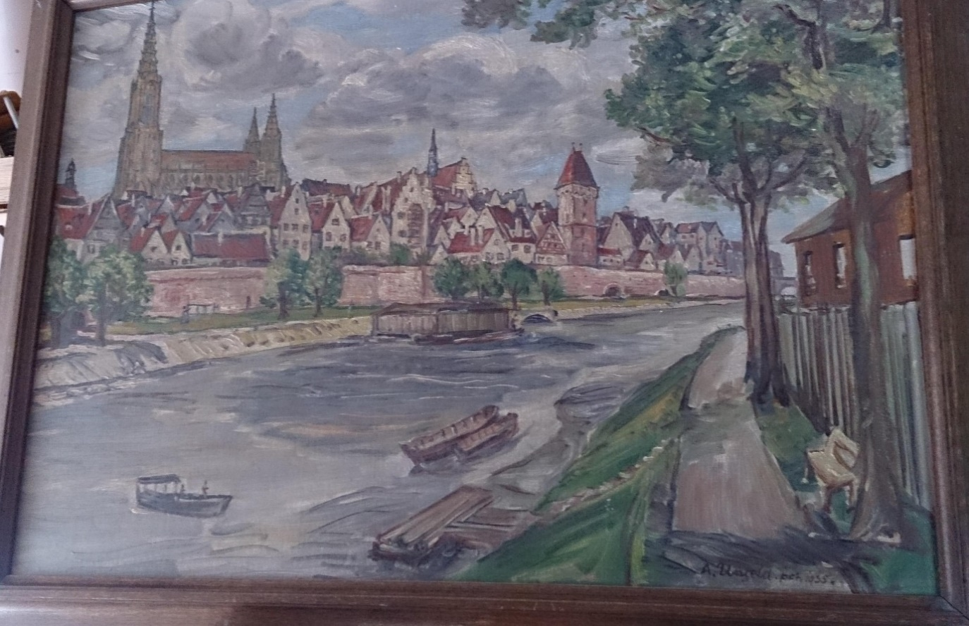
Figure 3. Oil Painting of Ulm. An inscription on a plaque on the painting reads ‘Der englischen Polizei-Boxermannschaft von Nottingham zum 2nd November 1935 die Stadt ULM an der Donau’ (“To the English Police boxing team from Nottingham on 2nd November 1935 from the City of Ulm on the Danube”). Photograph © author.
The Nottinghamians did not have to wait long to seek to turn the tables on their rivals from Baden-Württemberg, who arrived in their city just before midnight on Saturday 14 December, bringing with them an entire Christmas tree as a gift! After a night at the County Hotel, it was the Germans’ turn for a motor tour of their host city on the Sunday, which included at stop at the Victoria Embankment War Memorial where they too laid a wreath in memory of their former enemies. There, the Germans performed the Nazi salute and paid tribute to ‘those who gave their lives for their country, and especially the Lord Mayor’s son Albert Ball V.C. We hope there will never again be war between Germany and Britain’.
The importance of this was reinforced when in a ‘remarkable coincidence’ it was discovered that Hugo Häussler, who had travelled with the visitors, had been wounded in the First World War on 20 November 1917 at Cambrai, by a bullet fired from a tank in the centre of the British line. As a result he had been taken prisoner and transported to England for the remainder of the war. It transpired that driving a tank at the centre of the British advance had been Inspector West and ‘it would not be stretching the long arm of coincidence much further to question whether it was not a bullet from Inspector West’s tank which laid low Herr Häussler’. The two men, in perhaps the most explicit example of the desire for peace, were both able to laugh about this serendipity which had reunited former enemies through a shared love of sport. Indeed Capt. Popkess who hosted the visitors at the reception on their first evening had observed that ‘where there was sport there could never be bad feeling’; sentiments echoed by Herr Häussler who said ‘I am delighted to think that sport is further cementing the good feeling between the two races’.
In a sign of perhaps the true beliefs of the British nation, however, and those of Popkess himself, only the day before the arrival of the Germans, a meeting had been held at the city’s Council House to discuss air raid precautions. Convened by the Home Office, and presided over by the city’s Lord Mayor Sir Albert Ball, the meeting was attended by representatives from across the Midlands to examine the methodology being employed by Nottingham’s ‘model scheme’ and share this as best practice. It was in fact Capt. Popkess who was primarily responsible for organising and developing this model, even organising real-life practice drills in 1938 involving the Royal Air Force (RAF) as ‘enemy planes’ in a slum area of the city which was due for demolition. Reassurances were provided by Wing Commander Hodsoll, who was leading on the event for the RAF, that
‘we are not holding this because we think there is going to be a war. We all, naturally, hope that these precautions will never be wanted. But if we ever were attacked by air, and we had done nothing about it, there would be considerable loss of life and disorganisation’.
This was remarkable prescience given that the first major bombing of a civilian centre, at Guernica in Spain, was still eighteen months away at this time. The lord mayor was to play an integral role on the German’s visit to Nottingham the following year.
The main event for which the Stuttgart officers had travelled took place on the evening of Monday 16 November at the Victoria Ballroom at the bottom of St Ann’s Well Road opposite Bath Street. This time the Nottingham team was victorious, defeating their visitors by seven matches to two, albeit many of them were reportedly very close points victories (Table 3). The crowds in Nottingham were smaller, comprising some 3000 spectators, but still large for a police boxing tournament. The results were as follows:
Bout | Weight | Result
1 | Lightweight | Rolland (w) – Leitner
2 | Lightweight | White (w) – Endreß
3 | Middleweight | Lewis (w) – Loibl
4 | Light heavy weight | Holton (w) – Glaser
5 | Heavyweight | Beaves (w) – Leifer
6 | Heavyweight | Pollock – Hölz (w)
7 | Heavyweight | Scott(w) – Held
8 | Heavyweight | Gibbons – Bernlöhr (w)
9 | Heavyweight | Fenner (w) – Bubeck

Table 3: Results of the Nottingham bouts, 16 November 1935.
The following day both host and touring parties were welcomed by the lord mayor to the Nottingham Council House for a civic luncheon. There too, all senior parties including Ball, Popkess and Walther expressed a desire to become more united through the medium of sport, the friendships this ‘rivalry’ had created, and the respect the people of Nottingham had gained for their visitors’ sportsmanship. After a tour of the city’s John Player cigarette factory, the Germans’ visit was wrapped up in the evening when there was a reception for both teams hosted by the Nottingham City Police Athletics Club. The entertainment was provided by the City Police band who played a mix of British and German composers. A notable feature of the event was ‘a large Christmas tree which occupied a prominent position on the floor’; no doubt as much a symbol of a good sense of humour on the part of Supt. Downs as much as to demonstrate his appreciation of the gift.
Both teams had clearly enjoyed the exchange, as too had the spectators in both nations. In July 1936 Nottingham City Police sought permission from the Amateur Boxing Association (ABA) to undertake reciprocal events again, which was granted, despite the ABA being very busy with final preparations for the Olympic Games in Berlin that year. The first visit of 1936 was once again of Nottingham to Stuttgart, with the English team departing Nottingham on 5 October. This time the travelling team comprised thirteen, with The Nottingham Journal making much of the travellers’ disdain for this superstitious number. The party was led by Popkess himself, along with PC Joe Rostron the trainer, Insp. West, and Sergeant Richardson, members of the team’s committee (Table 4).
Heavyweights | Cruiserweight | Middleweights | Welterweights | Lightweights
Gerry Beaves | George Holton | Jack Lewis | John White | Steve Keely
Jack Fenner | George Scott | Frank Taylor | Vince Evans

Table 4: The Nottingham City Police Team in Stuttgart and Heilbronn, 1936.
On this occasion the team would be fighting at Stuttgart but this time also at Heilbronn, not Ulm. As before, the team based themselves in Stuttgart and were hosted at a civic reception on the Thursday night by Gauleiter Wilhelm Murr the NSDAP (Nazi Party) district leader, and the Bürgermeister (mayor) Walter Hirzel. Once again, the Germans raised a toast to this new annual bond of friendship between the two teams. There was clearly some heavy advertising of the match taking place, with promotional pictures being arranged and distributed in the run up to the event (Figure 4).

Figure 4. Mannequins pose in an advertising picture for the boxing match in Stuttgart. Collection of John White, Courtesy of Peter and Ina White.

Around this the team undertook further sightseeing, including numerous photo opportunities at Schloß Liechtenstein. This led to another likely unique photograph series, of British ‘Bobbies’ (albeit out of uniform) smiling happily, and even arm-in-arm, with uniformed Nazi officials (Figures 5 and 6). There was also to be a repeat of the wreath laying, this time by Popkess, on the German Soldier’s Cenotaph in Stuttgart. In a further demonstration of the importance of this gesture, Nottingham’s Lord Mayor Sir Albert Ball had sent a letter to the Stuttgart officials in advance of the visit, apologising for being unable to attend, but stating his respect for their people. ‘My son, Britain’s famous [WWI] airman [Captain Albert Ball DSO & two bars, MC] V.C.’ he wrote ‘is buried in the German cemetery at Annoeuillin. I have been asked for his body to be moved to England, but I have always believed it would be better for him to rest among his foes, for whom he had the greatest respect.’ ‘England and Germany should play a great part in preserving the peace of the world’ he opined, perhaps optimistically, given the machinations behind the scenes.
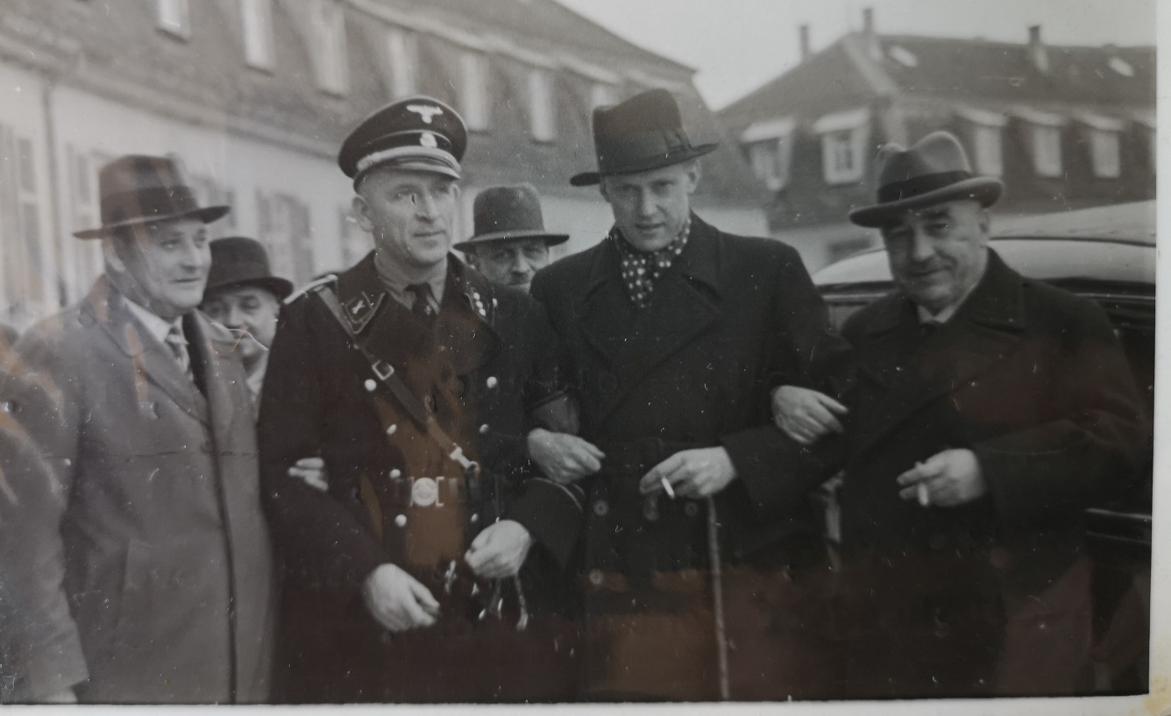Figure 5. (left to right) Polizeioberinspektor Walther; Hugo Häussler; Chief Constable Popkess (with walking cane), and Polizeipräsident (police chief) Rudolf Klaiber. Stuttgart 1936. Collection of John White. Courtesy of Peter and Ina White
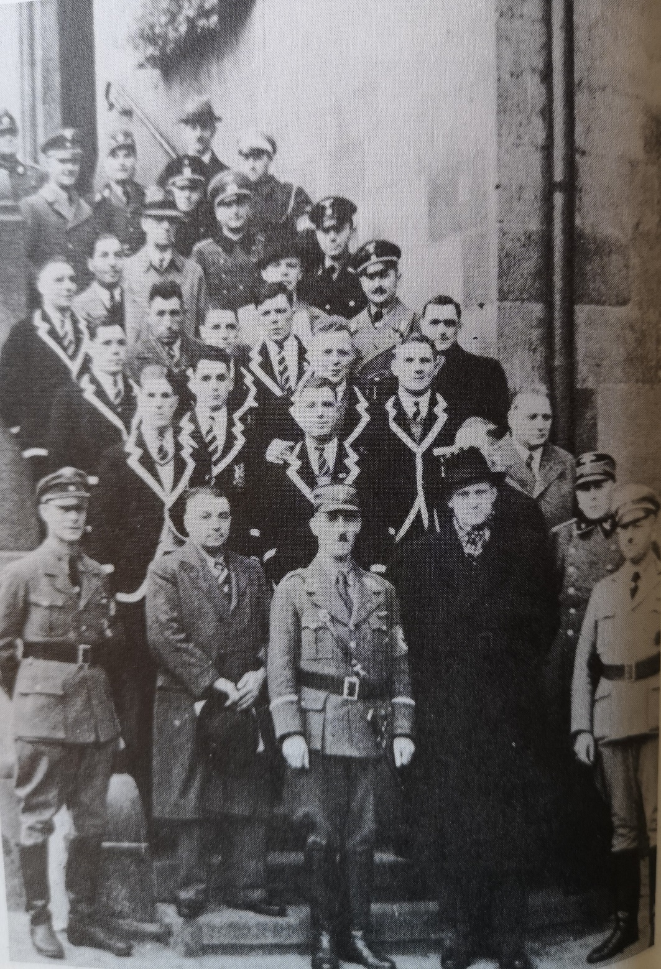
Figure 6. The Nottingham City Police boxing team (in blazers, CC Popkess with cravat centre-right) with their hosts. Heilbronn 1936. Collection of John White. Courtesy of Peter and Ina White
On this occasion, Popkess intended to broadcast the bout live from ring-side on longwave frequency, so that the residents of Nottingham could listen live to the event. This was to be ‘received with great satisfaction by the large number of people who are interested in the fistic achievements of our local policemen and are eagerly awaiting the result of this international contest. Unfortunately this was not to be, as ‘it had not been found possible to fit in a running commentary of the boxing programme.’ Peace was once again a key theme. Popkess, who after opening with ‘Hello Nottingham’ continued that ‘what a lot of good this meeting will do to create friendship between our two peoples.’ This was evidenced by the fact that once again senior officials were present, including the German minister of the interior and the Minister-präsidenten (governor) of Württemberg Herr Mergenthaler. Mergenthaler donated a bronze statuette of a fighter for the winning team (Figure 7). Popkess also performed a Nazi salute prior to the outset of the fighting, another moment that was caught for posterity by the photographers (Figure 8).
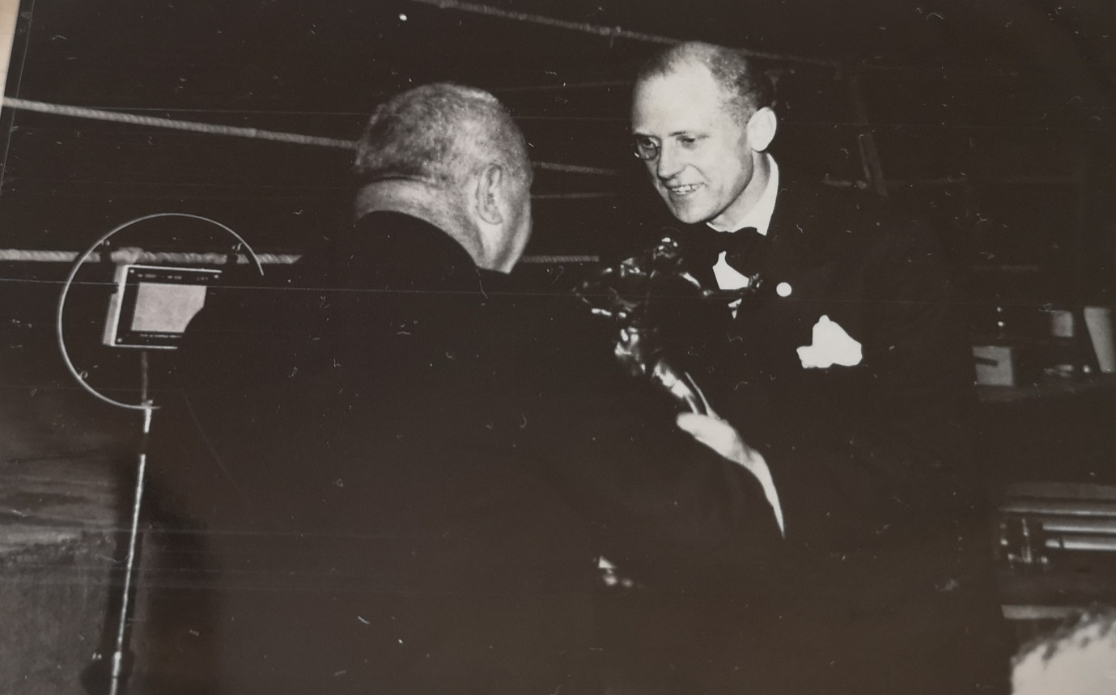

Figure 7. Popkess (facing camera) and Klaiber handing him a statuette of a boxer, with Popkess’ radio mic evident ringside. Collection of John White. Courtesy of Peter and Ina White
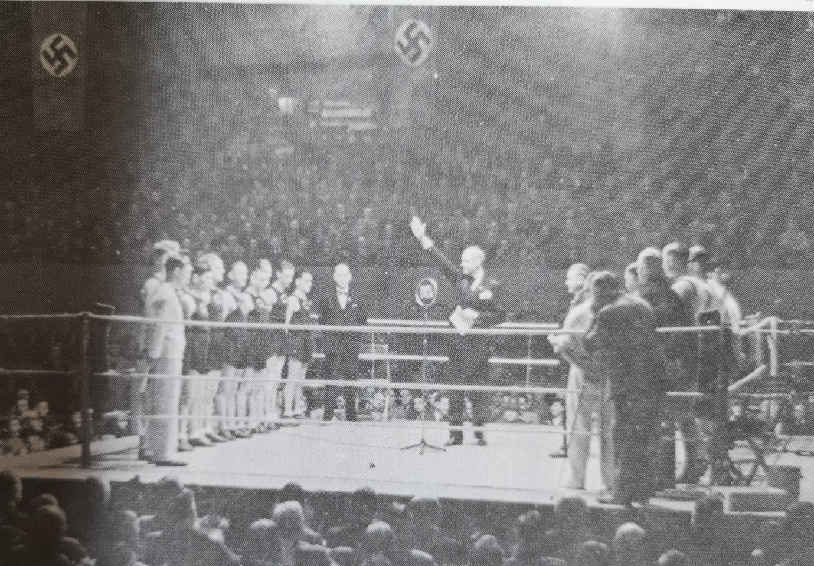
Figure 8. Popkess performs a Nazi salute after addressing the crowds at Stuttgart. Collection of John White. Courtesy of Peter and Ina White
The home advantage was once again evident, albeit a lot closer than previous meetings, with the hosts winning by five matches to three with one draw (Table 5). All were decided on points, with Jack ‘Killer’ Lewis reportedly holding his own very well against the German Olympian, ‘pounding him with tremendous energy, right up to Bernlöhr … who let the technique play out without shying away from the Englishman. Lewis didn’t budge until the end, trying to turn the tide with a decisive strike.’ The crowd of between 10,000 or 4000, depending on the source, was much entertained, rising to their feet to sing ‘God save the king’ in German to honour their visitors.

Bout | Weight | Result
1 | Lightweight | Keely (d) – Pfanner
2 | Welterweight | Evans – Endreß (w)
3 | Welterweight | White – Leitner (w)
4 | Middleweight | Taylor – Loibl (w)
5 | Middleweight | Lewis – Bernlöhr (w)
6 | Light heavyweight | Hilton (w) – Leiser
7 | Light heavyweight | Scott – Schöllkopf (w)
8 | Heavyweight | Fenner (w) – Raff
9 | Heavyweight | Beaves (w) – Schedler

Table 5. Results of the Stuttgart bouts, 10 October 1936.
The following day (11 October) the visitors travelled to nearby Heilbronn where they engaged that local team (supported again by Stuttgart men), in front of a crowd of between 2 - 3000. They received a hearty welcome here too, with the entire town council convening to officially welcome the touring party, and the union flag was prominently displayed on the town hall. After the fights, the pugilists were hosted at the town hall with the party lasting until 4am! The result on this occasion was an easy victory for the visitors, winning five to one, the only German victory being, perhaps unsurprisingly, for Bernlöhr, with this fight again providing the best spectacle. Holton on this occasion put up the same spirited attempt to overcome the Olympian as Lewis had the previous day, drawing significant acclaim from the watching crowd. (Table 6)
Bout | Weight | Result
1 | Lightweight | Keely (w) – Wagner
2 | Welterweight | Evans (d) – Zeller
3 | Welterweight | White (d) – Endreß
4 | Middleweight | Lewis (w) – Wolsantel
5 | Light heavyweight | Holton – Bernlöhr (w)
6 | Light heavyweight | Scott (w) – Leiser
7 | Heavyweight | Beaves (w) – Raff
8 | Heavyweight | Fenner (w) – Schedler

Table 6: Results of the Heilbonn bouts, 11 October 1936.
The Nottinghamians returned to Stuttgart and then back to England on the 13 October. Large crowds cheered for them and sang ‘Auld Lang Syne’ as their train departed, such had been the esteem the locals had come to hold them in. Popkess provided an interview for the Nottingham Evening Post upon his return, again espousing the virtues of peace between the two groups hoping to ‘obviate misunderstandings amongst the men in the street’. The subsequent irony of the juxtaposition on the front page would not have been known to ‘The Captain’; his interview appeared under the lead story of the day concerning King Leopold of Belgium’s withdrawal from mutual defence pacts and the reclamation of neutrality, throwing ‘into the melting-pot the entire post-war European system’ causing significant consternation to Britain and France, and ‘quiet jubilation’ in Germany. War may still not have been inevitable, but it was by now at least a very strong possibility.
The return of the Germans to England took place only a fortnight later, with the visiting party arriving on 27 October. They again made the County Hotel their base, and it was on this occasion the Swastika flag flew alongside the Union flag, from the poles on top of the hotel (Figure 9). Their visit was not entirely welcome in the city however, as a troop of communists marched past in protest that afternoon.
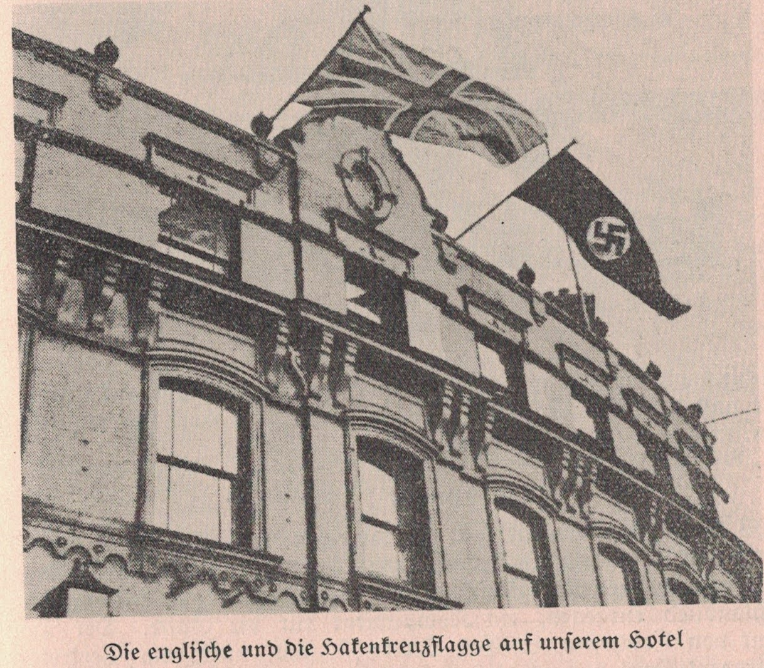
Figure 9. The Union flag and the Swastika flag fly alongside one another from the roof of Nottingham’s County Hotel. The Stuttgart Police Newsletter incorrectly identifies it as being a hotel in Colchester, but comparison of the buildings confirms it is the County Hotel in Nottingham.
The Germans were once again hosted at a civic reception at the council house at lunch on 28 October led by the Sheriff of Nottingham, Councillor F. Mitchell. The health of all was celebrated with a toast to ‘King and Country’ drunk by the Germans, with a reciprocal toast to ‘the Führer and the German people’ drunk by the hosts, which was greeted with a Nazi salute by the visitors. With comments that might appear crass in hindsight, peace and friendship was once again the theme, notably in spite of ‘silly little wars’ ‘such as such troubles were besetting Spain’.
The following day, the visitors once again paid their respects to the war dead, this time attending both the Victoria Embankment and the memorial to Capt. Albert Ball (Jr.) VC, DSO & two bars, MC in the Nottingham Castle grounds where they laid a wreath with Swastika flags set into it, and performed a Nazi salute to honour him. This was especially poignant, given that the lord mayor, who had welcomed the visitors so openly on both occasions, was Ball’s father. Before they left Nottingham a few days later, Ball Snr presented each boxer with a framed portrait of his son, inspired he said, by a letter from Baroness Richthofen, mother of the famous German airman in which she had sent him a portrait of her son, and requested one of his. This had prompted Ball Snr to reflect once again on the mutual respect between former enemies and the hope of fostering good relations if this shared esteem were maintained.
That evening was the main event, held at the drill hall on Derby Road, Canning Circus, this time with crowds of up to 4000 watching the spectacle, introduced by Sir Albert Ball. The theme was once again friendship and respect for each other, with this featuring heavily in the opening words by Sir Albert, and large parts of the crowd performing Nazi salutes to the guests when they paraded on. The aim of this friendly rivalry was clearly to achieve a ‘knock-out for politics’, as one national paper described it. The home field advantage was once again evident, as the hosts trounced their visitors by seven to two. As the Nottingham team had won, the challenge trophy - which had been donated by the Prime Minister of Württemberg - was handed over by Walther to Popkess.

Bout | Weight | Result
1 | Middleweight | Garside – Held (w)
2 | Welterweight | White – Leitner (w)
3 | Light heavyweight | Scott (w) – Rosenkranz
4 | Lightweight | Keely (w) – Pfanner
5 | Heavyweight | Beaves (w) – Schedler
6 | Middleweight | Davies (w) – Wolfangel
7 | Welterweight | Evans (w) – Endreß
8 | Light heavyweight | Holton (w) – Schöllkopf
9 | Heavyweight | Fenner (w - K.O) – Reinke

Table 6: Results of the Nottingham bouts, 29 October 1936.
The following day the combined group of British and Germans took a day-trip to, of all places, the Dunlop rubber factory in Birmingham, where they had a photo for posterity, returning to Nottingham that evening. The 31 October saw another luncheon hosted by Sir Albert Ball, followed by spectating the Nottingham County versus Milwall football match. A bizarre incident occurred at the luncheon, with Sir Albert handing a German bible to the Stuttgarters that he had been given by a Canadian soldier who had fought at Ypres. The Canadian had told him he had bent down to pick up the bible from a dead German soldier, causing him to dodge a burst of gunfire that went over his head. He had given it to Ball in the hope that the Germans could seek to reunite it with the deceased’s family; seemingly in response to a similar request made of DCC Downs with an English prayer book the previous year. The evening closed with a private soirée for the two boxing clubs at the police gymnasium decorated with the Union and Swastika flags, at which Christian Walter, sports club president of the Stuttgart team, was appointed an honorary board member of the Nottingham City Police sports society, and given an athletics society blazer; Chief Constable Klaiber was made honorary president (Figure 10). The Stuttgart officers departed Nottingham on 2 November, bound for Colchester, after having spent the previous day touring ‘the mountains of central England’.
Figure 10. Christian Walther, chairman of the Stuttgart Police Sports Club, sports his new Nottingham City Police athletics club blazer, after being made an honourary president of the society.
Upon arrival in Colchester, the visitors were welcomed by the deputy chief constable and other members of the Colchester Borough Police boxing team. The Stuttgart team had sought to extend their tour this time with the other nationally renowned British police boxing team. That evening they were taken to a local cinema at the invitation of the general manager there, where they watched a Laurel and Hardy (‘Dick und Dof’) movie dubbed into German, followed by a roller-skating event.
The 3 November was a busy day for the guests, as they attended yet another civic reception, organised by the deputy mayor and attended by the Chief Constable, Lt. Col. Stockwell. The Colchester dignitaries seemed less inclined to skirt the main issue of the times, with the deputy mayor addressing the visitors that there were grave ‘concerns about the next war. Everything must help to prevent the war that seems inevitable.’ Stockwell appeared more upbeat, however, along the lines of Popkess, presenting matching tankards to both host and visiting pugilists so that ‘you may all feel when you look at them that there are English and German houses which have the same tokens’’; and that they were doing ‘something noteworthy and outstanding in this country to help develop a feeling of international friendship’. The Stuttgarters laid a wreath at the Colchester war memorial as they had in Nottingham, and visited the Colchester Castle museum. There was talk of a recurring partnership between these two sides, along the lines of the Nottingham one, but a suitably large venue could not be agreed in the British city.
That evening was the boxing match, with the Colchester City Police team reinforced by soldiers from the garrison. The Germans triumphed in front of the 1500 spectators though, winning ten bouts to six. The evening was finished off with a soirée at the hotel between the two teams. The German team returned to Stuttgart on 4 November, via a quick stop-over in London to look round Westminster Abbey.
In spite of suggestions by both Nottingham and Stuttgart teams to continue with the friendly rivalry, and even recommendations for German consulate officials to travel and use the event to promote tourism to Germany, no further exchanges took place. It is almost certain that by this time relations between the two countries were at a point where war was all-but inevitable, and ‘friendly’ exchanges, especially by an ‘enemy’ police force, were no longer politically viable in either country. Following the occupation of the Rhineland in March 1936 it was perhaps surprising that the reciprocal visits had taken place that year; albeit the Berlin Olympics had no doubt ensured that sport obtained a politically neutral position at least temporarily. Christian Walther, the Stuttgart sports club president and original organiser of the exchanges, also retired in August 1937, which must have also contributed significantly to there not being any further visits. Chief Constable Athelstan Popkess sent his regrets at being unable to attend Walther’s leaving party.
It was clear from his actions in developing a ‘model’ example of air-raid precautions in Nottingham, as early as 1935, that Popkess was fully aware of the escalating situation in Germany and the deteriorating political situation. Whilst he was no doubt using the boxing exchanges in an attempt to foster better understanding between the two peoples, there is also a strong likelihood that he was using the opportunities of the visits to Germany to gauge the lie of the land to inform his planning. It was clear in the repeated speeches from officials of both countries at the various tournaments that all, at least outwardly, sought peace. This was, of course, in line with both countries’ stated positions at this time, especially as Adolf Hitler perceived the British as his blood-relatives or kindred-spirits; a statement repeated often by the German boxing leaders, even directly attributing this position to the Führer. The attempted ‘knock-out for politics’ however never fully materialised, and the relationship was not maintained after the war. It is indeed a shame that the optimism demonstrated by both sets of officials that ‘where there is sport there could never be bad feeling’ and that ‘it cemented the good feeling between the two races’ did not hold true.
The idea of using popular sport to encourage friendship and good relations espoused by Walther, Klaiber, Popkess, and Ball was later proven to be pioneering and the notion revived in a different but more widespread form a decade later, after the cessation of hostilities. The West German post-war Allied Control Authority was to use the initiative of organising sporting events to achieve the goals of the Potsdam Declaration: ‘denazification, demilitarisation, decentralisation, and democratisation’. Their reasoning followed the same lines as their predecessors in that sport ‘became a highly effective instrument of public diplomacy because of its broad appeal and also because it allow[ed] for a public display of national capabilities’. It is therefore evident that the principles underlying the boxing exchanges to foster friendships and peace were sound. It is highly likely, however, that the motives driving both sides pre-war, particularly from the Nazi party officials, may have been much more nationalistic in nature; seeking to demonstrate German (Aryan) prowess in the same vein as at the Berlin Olympics. Some pre-war sports were indeed used in the Nazi Third Reich to display ‘one’s Germanness through demonstrations of militarism and hyper-masculinity’, no doubt boxing being principal amongst these as perhaps the pinnacle alpha-male sport; especially through the culture of the time perceiving it as indicative of white male dominance. Sport, however, held a place largely separate from politics at this time, and the exchanges allowed the participants and their audiences to forget, albeit briefly, about the increasingly hostile rhetoric and militarisation, focusing purely on the action.
As with so many other aspects of his tenure as chief constable, it has been demonstrated that Popkess (aided by the efforts of others) was a visionary police officer with a forward-thinking mentality. His use of a sporting rivalry in an attempt to break down potential barriers and foster good relations was clearly a well-founded theory as demonstrated by its post-war use by the Allied powers to reinvigorate the defeated Germany. The reciprocal wreath-laying to honour a previous enemy’s war dead also had significant public relations benefits for both sides, in attempting to show that the past was behind them. Popkess’ visit to Germany and their visits to Nottingham may also have gained him valuable insight into the mindset of the Nazi state and encouraged his nationally exemplary air-raid precautions. Whilst such a local attempt to break down distrust and animosity was doomed to fail where even the international Olympics could not succeed in the face of one tyrant’s mentality, it was demonstrative that certainly at this time not everyone wanted a war; and that sport held universal appeal. The actions of these two provincial police forces are to be applauded for their noble intent.

Nottingham Evening Post 28th October 1936 p.11; Nachrichtenblatt des Polizeisportvereins Stuttgart 1st February 1937 p.15
Watson, Greig (12th September 2021) ‘The chilling day the swastika flew beside the union jack’ BBC News Online available at: https://www.bbc.co.uk/news/uk-england-nottinghamshire-58341335 [accessed 29th January 2022]
Nottingham Journal 29th October 1936 p. 4
Sheffield Independent 25th November 1933 p. 12; Nottingham Journal 9th February 1934 p. 10; Nottingham Evening Post 7th February 1935 p.10
Nottingham Evening Post 3rd February 1934 p. 7
Belfast Newsletter 9th July 1934 p. 10;
Andrews, Tom (2020) The Greatest Policeman? A biography of Capt Athelstan Popkess CBE OStJ London: Blue Lamp Books
The National Archives HO 45/24711 Appointment for Chief Constable: Form of Application Capt Athelstan Popkess
Popkess, Athelstan (1952) Sweat in My Eyes Leicester: Edgar Backus p.126
Peter White, son of John White Discussion with Author and memories of his uncle Fred White in family scrap book in author’s possession. Nottingham Journal 29th October 1935 p. 11
Andrews The Greatest Policeman pp. 107 – 109, 122; Hyndman, Dan Nottingham City Police: A Pictorial History 1930–1960 Newark: Davage Printing Ltd p.15
Ibid.
Rosamund, Bob (former officer) Discussion with author
Popkess, Athelstan (1945) Nottingham City Police: Centenary 1935: Transcript of a paper read to the Nottingham Thoroton Society Nottingham: Nottingham City Police Press
Birmingham Gazette 12th February 1934 p.6
Emsley, Clive (2005) The English and Violence since 1750 London: Hambledon and London
Feather, Fred (2021) ‘A Hard Garrison Town’s Police Boxers’ Newsletter of the Police History Society 109 pp.29-30
Nottingham Evening Post 5th December 1952 p. 7
Nottingham Post 4th December 2018
Sheffield Independent 25th November 1933 p. 12
Birmingham Gazette 12th February 1934 p.6
Nottingham Journal 9th February 1934 p. 10; Nottingham Evening Post 7th February 1935 p.10
Nottingham Evening Post 17th December 1935 p. 9; The Nottingham Journal 6th October 1936 p.11
Nachrichtenblatt des Polizeisportvereins Stuttgart
Nachrichtenblatt des Polizeisportvereins Stuttgart (15th October 1935) 20 pp.1 & 28; Nachrichtenblatt des Polizeisportvereins Stuttgart, (15th January 1937) 9(2), p. 26 Popkess addresses Walther at a luncheon and says “through your initiative we got to know and appreciate one another”.
Nottingham Journal 29th October 1935 p. 11; Hyndman Nottingham City Police p. 11
Cyril Pollock replaced PC Ernest Shotbolt who was a new member of the force and former British Army heavyweight champion in India, due to injury.
Nottingham Evening Post 7th November 1935 p. 8
Ibid.
Stuttgarter Neues Tagblatt – Morgenausgabe 31st October 1935
Nachrichtenblatt des Polizeisportvereins Stuttgart, (December 1935) 7(1) Series 23, p. 7
Nottingham Evening Post 17th December 1935 p. 9
Nottingham Journal 31st October 1935 p. 11; Nachrichtenblatt des Polizeisportvereins Stuttgart 7 (1935), p. 15-18. It is telling that British sources spell many of the German names incorrectly, and the same is true of the Germans in reverse. Glaser, Bubeck and Leiser feature as Slaser, Bubect ad Leifer respectively.
Nottingham Evening Post 7th November 1935 p. 8
Nachrichtenblatt des Polizeisportvereins Stuttgart, 7(1). (December 1935), Folge 23, p. 9
Nachrichtenblatt des Polizeisportvereins Stuttgart, 7. Jg., 1. Julmond (December) 1935, Volume 23, p. 9
Nottingham Evening Post 7th November 1935 p. 8
Ibid.
Nottingham Evening Post 16th December 1935 p. 10
Nottingham Journal 16th December 1935 p. 7
Nottingham Journal 16th December 1935 p. 7
Nottingham Evening Post 16th December 1935 p. 10
Nottingham Journal 13th December 1935 p. 7
Needham, David (2009) Battle of the Flames: Nottinghamshire’s fight for survival in WWII Ashbourne, Derbyshire: The Horizon Press; Andrews The Greatest Policeman?
Mace Archives ARP: A Practical Demonstration of Nottingham Precautions [online] accessed 3rd March 2022 https://www.macearchive.org/films/arp-practical-demonstration-nottingham-precautions
Nottingham Journal 13th December 1935 p. 7
Nottingham Journal 17th December 1935 p. 11
Nottingham Evening Post 17th December 1935 p. 9
Nottingham Journal 18th December 1935 p. 11
Ibid p. 10
Nottingham Evening Post 17th December 1935 p. 9; Nachrichtenblatt des Polizeisportvereins Stuttgart e.V., 7. (1935) p. 15-19
Nottingham Evening Post 10th July 1936 p. 13
The Nottingham Journal 6th October 1936 p.11
Nachrichtenblatt des Polizeisportvereins Stuttgart (15th October 1936) 8(20) p. 28
Grantham Journal 17th October 1936 p. 8
Nottingham Evening Post 9th October 1936 p. 8; unknown clipping from scrapbook of John White, c/o Peter and Ina White.
Nottingham Evening Post 10th October 1936 p. 7
Nachrichtenblatt des Polizeisportvereins Stuttgart (15th October 1936) 8(20), p. 29
Andrews The Greatest Policeman p. 122
Nachrichtenblatt des Polizeisportvereins Stuttgart (15th October 1936) 8(20), pp. 30 - 31
Nottingham Evening Post 15th October 1936 p. 1 for the higher figures, Nachrichtenblatt des Polizeisportvereins Stuttgart 8. Jg, Folge 20 (15. Oktober 1936), pp. 29 – 31 for the lower.
Nottingham Evening Post 10th October 1936 p. 7; Nachrichtenblatt des Polizeisportvereins Stuttgart (15th October 1936) 8(20), pp. 29 – 31
Ibid.; Nottingham Journal 12th October 1936 p. 11; Nachrichtenblatt des Polizeisportvereins Stuttgart 8. Jg, Folge 20 (15. Oktober 1936), pp. 29 – 31 for the lower figures.
Nottingham Journal 12th October 1936 p. 11
Hyndman Nottingham City Police p. 11; Nottingham Evening Post 15th October 1936
Nottingham Evening Post 15th October 1936 p. 1
Nachrichtenblatt des Polizeisportvereins Stuttgart, (1st January 1937) 9(1) pp. 24-26
Nachrichtenblatt des Polizeisportvereins Stuttgart, (1st February 1937) 9(3), p. 15
Nottingham Journal 29th October 1936 p. 4
Nachrichtenblatt des Polizeisportvereins Stuttgart, (1st January 1937) 9(1) pp. 24-26; Nottingham Evening Post 29th October 1936 p. 7
Nottingham Journal 2nd November 1936 p. 4; Nachrichtenblatt des Polizeisportvereins Stuttgart, (15th January 1937) 9(2), p. 24
News Chronicle 29th October 1936 p.5
Nachrichtenblatt des Polizeisportvereins Stuttgart, 9. Jg., Folge 1 (1. Januar 1937), p. 17-18
Nottingham Evening Post 30th October 1936
Nachrichtenblatt des Polizeisportvereins Stuttgart, (15th January 1937) 9(2), pp. 20 – 21.
Ibid. p. 23; Nottingham Journal 2nd November 1936 p. 4
Ibid. p. 27
Nachrichtenblatt des Polizeisportvereins Stuttgart, (15th January 1937) 9(2), p. 27
Kinematograph Weekly 5th November 1936 p. 62
Nachrichtenblatt des Polizeisportvereins Stuttgart, (1st February 1937) 9(3) pp. 14 – 15; Colchester Gazette November 4th 1936 p. 11
Essex Records Office X318/21 “Police work in pamphlets”, number 9, December 1936 pp. 31 – 32
Nachrichtenblatt des Polizeisportvereins Stuttgart, (1st February 1937) 9(3) pp. 17 – 18.
Nachrichtenblatt des Polizeisportvereins Stuttgart, (1st February 1937) 9(3) pp. 17 – 18.
Nottingham Journal 2nd November 1936; Nachrichtenblatt des Polizeisportvereins Stuttgart, (1st February 1937) 9(3) pp. 23 – 4
Nachrichtenblatt des Polizeisportvereins Stuttgart, (1st September 1937) 9(17), pp. 2-15
Nottingham Journal 2nd November 1936 p. 4
News Chronicle 29th October 1936 p.5
Nottingham Evening Post 16th December 1935 p. 10
Ditcher, Heather (2008) Sporting Democracy: The Western Allies’ Reconstruction of Germany through Sport 1944 – 1952 [PhD Thesis] Toronto: University of Toronto [online] https://central.bac-lac.gc.ca/.item?id=TC-OTU-16768&op=pdf&app=Library&oclc_number=1033213396 accessed 15th March 2022 p. ii
Ibid.
Woodward, Kath (2007) Boxing, Masculinity and Identity: The ‘I’ of the Tiger London: Routledge
Cooley, Will (2010) ‘ “Vanilla Thrillas”: Modern Boxing and White-Ethnic Masculinity’ Journal of Sport and Social Issues 34(4) pp. 418 - 437
Ibid. p. iii
Andrews The Greatest Policeman?

