Assessing Self-Reported Mood in Aphasia Following Stroke:

Challenges, Innovations and Future Directions

Paul D. Barrows^{1, 2}, Shirley A. Thomas¹ and William Van Gordon²
¹ University of Nottingham, Medical School, Nottingham, NG7 2UH, UK
² Human Sciences Research Centre, University of Derby, Kedleston Road, Derby, DE22 1GB, UK

Corresponding author:
Paul Barrows, Human Sciences Research Centre. University of Derby, Bridge Street,
Derby. DE1 3LD
email: P.Barrows@derby.ac.uk
Tel: +44 (7512) 155933.

Author Details:
Paul D Barrows, PhD, PGDip, BSc(Hons); email p.barrows@derby.acuk; TEL: +44 (0) 7512 155933; ORCID: 0000-0003-0596-4442
Shirley A Thomas, PhD, BSc(Hons): Shirley.Thomas@nottingham.ac.uk; TEL: +44 (0) 115 8467484; ORCID: 0000-0003-0704-9387
William Van Gordon: PhD, MSc, BSc: w.vangordon@derby.ac.uk; TEL: +44 (0) 1332 597826; ORCID: 0000-0002-5648-3043

Keywords: Aphasia, stroke, mood, assessment, neuropsychology, scales
Funding: The authors received no financial support for the research, authorship, or publication of this article.

Abstract
Assessment of mood is critical in determining rehabilitation outcomes for stroke and other acquired brain injury, yet a common consequence of such injuries is aphasia, where language is impaired. Consequently, the use of language-based measures in this population is often not possible. Following a critical review of the neuropsychological aspects of self-reported mood, this paper evaluates the problems in reporting mood after stroke due to aphasia, and discusses implications for the design of adapted instruments. The paper then appraises the construction and psychometric properties of existing, adapted self-report measures developed to try and address these problems, and evaluates their utility and limitations. This includes a focus on the recently validated tablet-based Dynamic Visual Analog Mood Scales (D-VAMS), which uses innovative non-verbal assessment methods based on facial expression modulated via a slider control on a touch screen-interface. Currently, most studies evaluating recovery interventions simply omit individuals with aphasia because of the difficulty of assessing mood and quality of life in this population. However, adapted scales such as the D-VAMS appear to represent an important step forward in assessing mood in people with language impairments, with the use of interactive modulated imagery having wider applications for nonverbal communication as well as the quantification of subjective phenomena.

Keywords: Aphasia, stroke, mood, assessment, neuropsychology, scales

Introduction
Stroke survivors are prone to depression (1, 2), which typically increases with the severity of neurological impairment (1, 3). Depression screening instruments often use dysphoria or low mood as a proxy assessment means, particularly in patients with medical conditions involving physical symptoms that may mask or mimic symptoms of depression (4). However, impairment of language presents challenges to assessing and tracking mood, with many studies examining outcomes in stroke survivors electing to omit people with aphasia (5, 6). Aphasia, which occurs in around a third of stroke survivors (7), typically involves difficulty with or absence of speech (expressive aphasia), impaired comprehension of spoken language (receptive aphasia), and impaired comprehension and expression of written language. Without the ability to monitor mood in this population, it is difficult to screen for depression or examine health outcomes for interventions to improve quality of life in people recovering from stroke. This both hampers the treatment of depression in stroke survivors with aphasia and impairs the quality of research into interventions to improve quality of life.
Due to the problems posed by using traditional self-report measures in people with communication problems, some studies have employed observer-rated measures (8-11) or adapted self-report measures based on simple drawings (12-15). However, assessing the validity of an adapted, self-report measure introduces a methodological paradox. In order to validate such measures, the tool should ideally be tested on the specific population for which it is intended, and validation should involve testing the performance of the adapted method against an existing, validated measure of mood, which are invariably language-based. This is problematic because aphasia will necessarily impair an individual’s ability to complete a language-based criterion measure. Therefore, any correlation between measures could reflect the language impairment of the group as a whole, rather than the criterion validity of the adapted instrument under investigation.
In the absence of a robust method of validating such instruments, reasonable deductions and inferences can be made regarding which methods may prove most likely to work based on existing knowledge of the neuropathology of aphasia, the neuropsychology of language, and the visual, cognitive and affective processes underpinning self-reported mood. For example, because the right hemisphere is believed to be mainly responsible for visual processing, people with aphasia probably process images more similarly to those who are neurologically unimpaired than survivors of right-hemisphere strokes, which would account for the relatively preserved visual processing skills of people with aphasia (16).
Although much work has been done on adapted measures to address communications problems following stroke, there has been limited detailed examination of the process of self-reported mood in terms of the neuroanatomical regions involved as well as the likely impact of stroke on processes relating to the experience and expression of emotion. Therefore, the present paper undertakes a critical review of the neuropsychological aspects of self-reported mood, evaluates the problems in reporting mood after stroke due to aphasia and other impairments, and discusses the implications for the design of adapted instruments. The paper then appraises the construction and psychometric properties of existing, adapted self-report measures developed to try and address these problems, and evaluates their utility and limitations. This includes a focus on the recently validated tablet-based Dynamic Visual Analog Mood Scales (D-VAMS), which uses innovative non-verbal assessment methods based on facial expression modulated via a slider control on a touch screen-interface.

The Process of Self-Reporting Mood
Reporting mood, or any other subjective phenomena, can be divided into three stages: comprehension, evaluation and response. In the first stage, an individual may be asked questions about the phenomena under investigation, and instructed to rate the severity or frequency of particular features; this may take the form of a questionnaire, as with the many rating scales designed to assess depression or psychological wellbeing (4, 17-21). In adapted measures, the instrument may be more complex, involving tasks which allow internal states to be reported indirectly. Such measures may employ a Visual Analogue Scale (VAS) or Likert scale using affect-bearing images as endpoints (15, 22), or a series of images representing different intensities of a subjective state (23, 24). In either scenario, the respondent must understand what they are being asked, whether verbally or in writing.
The respondent then needs to organise a response to the question, reflecting on their inner state in light of any constraints or conditions, such as the period of time over which the question applies (e.g., “over the last week”). In mood assessment, this stage can be complex as it involves the engagement of many functions. For example, as well as reflecting on and appraising their affective state, the respondent must be able to convert this judgement into a scalar quantity that can be expressed numerically. Finally, the individual provides a response, either verbally, in writing, or as a marking or option selection along a scale of possible reactions.

Neurological Impairment and Self-Reported Mood
Stroke, like any acquired brain injury (ABI), may present various psychological or physical impairments depending on the site and extent of neurological damage. The affected individual may have difficulties understanding or expressing spoken language (aphasia), and with reading and writing (alexia and agraphia, respectively). They may also have cognitive impairments, such as problems with memory, attention or executive function (25), and exhibit movement disorders (26). Given that stroke usually affects only one side of the brain, unilateral deficits are common with sensory or motor impairments contralateral to the affected hemisphere (26). Furthermore, there may be blindness or unilateral visual field deficits (hemianopsia) or hemispatial neglect, involving diminished consciousness of space on one side. The individual may also exhibit weakness or paralysis on one side of the body (hemiplegia or hemiparesis), or numbness or diminished sensation (27).
For self-reported mood, four key areas of neurological impairment are of particular relevance to the challenges posed for individuals with aphasia, namely (i) aphasia, (ii) visuospatial and cognitive deficits, (iii) emotional awareness, and (iv) physical impairment.

Aphasia
Language function is usually based in the left hemisphere and only 4% of strong right-handers and 27% of strong left-handers have right-hemisphere language dominance (i.e., with the remainder of people being left-side dominant or with functioning divided between both hemispheres) (28). The language functions of expression and comprehension are understood to be centred around the Broca’s and Wernicke’s areas of the left temporal lobe (Figure 1).

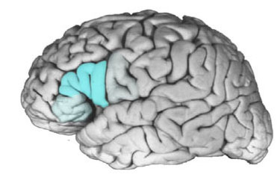  A | 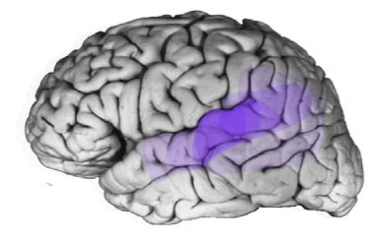  B

Figure 1. Summary from survey of experts and areas they classify as Broca’s (A) and Wernicke’s (B) areas respectively. From (Tremblay & Dick, 2016). Illustrations were overlaid and transparencies applied corresponding to percentage of experts identifying neuroanatomical regions as belonging to respective areas. Please refer to the online version of this document to see the respective colours marking these regions.

If language comprehension is severely impaired, then non-verbal means must be used. However, given that brain areas associated with language functioning tend to be lateralised, it is often possible to make use of functions that are predominately supported by the contralateral hemisphere, which is typically unimpaired following stroke (29). For this reason, the use of imagery has historically played an important role in supporting communication for people with aphasia (30). Support systems have invariably employed formats in which icons, photographs and printed words are displayed in orderly grids as part of augmentative and alternative communication (AAC) systems (31, 32). More recently, visual scene displays (VSD) have been developed which incorporate high-context imagery to support communication in people with aphasia by creating a shared communication space (33, 34). Such systems have been found to improve communication (35, 36) and their success is due to the largely intact visuospatial abilities of people even where aphasia is severe (29, 37).
Visual cues provided by an instrument, along with the use of gestures and demonstration can therefore assist in communicating the instrument’s purpose and what is being asked. Pictorial symbols such as emoticons (“smileys” etc.) used in conjunction with rating scales (e.g., the Likert-based VAS) may allow people to communicate themselves even if language expression is significantly impaired.

Visuospatial and cognitive deficits
Visual field deficits are common and can take the form of unilateral blindness (hemianopsia), or visual neglect, where patients fail to detect or respond to stimuli to one side of their visual field. In both instances, the affected field is contralateral to the location of the lesion. Neglect may occur in the acute stage in up to 82% of right hemisphere stroke patients (38) and persists in around 50% of cases (39). Though neglect may also follow left hemisphere lesions, it is much rarer, with one study putting this figure at 10-13% of patients (40). Lesions in the right parietal lobe – particularly the dorsal frontoparietal region (41) – may impact on the patient’s ability to properly scale space, impair processes involving the representation of an abstract quantity (“sadness” etc.) as a spatial distance or quantity, and impair the ability to assign a numeric or spatial value to subjective phenomena.
Besides language and visuospatial deficits, other domains of cognition may also be affected. For example, of stroke patients in the acute stage, 83% showed impairment in at least one cognitive domain, and 50% showed impairment in multiple (≥3) domains (25). Even after clinical recovery at three months poststroke, 71% of patients showed significant deficits. As well as visuospatial deficits, memory and executive function were most frequently impaired (25). Notably, people with aphasia have been found to perform more poorly in the domains of working memory and sustained attention (42). Therefore, the prevalence of such cognitive impairment has led to questions as to whether stroke patients are too cognitively impaired to use a VAS properly because the fine balance of cognitive functions required may be particularly susceptible to stroke-related damage (43).

Affect awareness and interoception
One consequence of stroke is alexithymia, an inability to experience, identify and describe emotions, and to recognise them in others through perception of facial expressions and other affective cues. Notably, alexithymia appears much more prevalent in patients with right-hemisphere lesions (48%) compared to those with left-hemisphere lesions (22%) (43). This compares with a reported prevalence of 13% in the general population (44).
A number of key regions have been implicated in both self-experienced emotion and its perception in external stimuli. According to popular psychological constructionist accounts of emotion, the somatovisceral processes underpinning the conscious representation of our bodily sensations – interoceptive awareness – is key to experiencing and assessing one’s emotional state. Interoceptive awareness is also the source of a basic emotional space known as core affect. As described in the Circumplex Model of Affect (45-47), core affect consists of a simple combination of hedonic tone or valence (pleasant or unpleasant) along with the degree of physiological activation. From these fundamental dimensions, more complex “basic” emotions are constructed from high-level modelling of the environment and its affective markers. If a particular circumstance has a motivational salience and presents an external threat or opportunity, then approach or avoidance strategies are implemented. The totality of this affective response, the accompanying cognitive processes, and the behavioural response effectively constitute the “emotion” (45, 48).
Thus, while primary affective experiences rely only upon intact interoceptive awareness, complex secondary emotions require more advanced cognitions necessary to monitor the environment and identify elements with motivational salience (i.e., “conceptualisation”; (49)). The implications of this for self-reported mood following stroke require an understanding of the neuroanatomy underpinning both interoceptive processes, as well as the higher-level cognitive synthesis where affective qualities and motivational markers are identified.
Consistent with models suggesting a relationship between laterality of lesion and experienced emotion, it is important with unilateral stroke to discern whether either hemisphere is differentially associated with experienced affect. Two main competing theories exist in this respect: the valence hypothesis and right-hemisphere hypothesis. In the valence hypothesis, the right hemisphere is viewed as more heavily involved with negative affect, and the left hemisphere more so with positive affect. Conversely, the right-hemisphere hypothesis asserts that the right hemisphere is generally the most involved in the processing of emotion (50, 51). Studies of depression following stroke have formed much of the research examining the role of lesion location in changes of emotional experience. A prominent view has been that the proximity of lesions to the frontal pole of the left hemisphere was related to depression prevalence following stroke (52-54). However, a number of extensive meta-analyses examining the role of lesion location have failed to yield consistent findings in this respect (55-58).
In recent years, a picture has emerged in which the anterior cingulate cortex (ACC) and anterior insula (AI) have been implicated as the seat of conscious experience of emotion (59, 60). These structures have been suggested to be vital to interoceptive awareness. For example, in line with current theories of emotion, evidence from brain imaging supports the view that central integrated feedback from the whole body plays a role in emotional experience (61). Hornak et al. (62) showed evidence that an “affective division” of the ACC and medial aspects of Brodman’s area 9 (BA 9) are heavily involved in affect recognition, with lesions in these areas substantially changing perceived affect in facial expressions and voices, but also in the subjective experience of emotion. However, there was little evidence of differences of impaired subjective emotion between patients with left-side versus right-side lesions.
More recent studies have cast further doubt on the existence of hemispheric lateralisation in experienced emotion. In a comprehensive meta-analysis of 397 fMRI and PET studies involving experienced positive and negative affect based on neuroimaging data, Lindquist et al. (63) found little evidence for experienced positive or negative affect being differentially associated with activity of any particular region. Instead, their findings suggested a bilaterally distributed network of areas which appeared to work together to appraise and consolidate experienced emotion. Likewise, Riquelme et al. (64) found that people with right hemisphere lesions were equally able to experience both positive and negative affect, while another study examining brain activity for five basic emotions (fear, anger, disgust, happiness and sadness) added support for a bilaterally-distributed model of experienced emotion (65).
In an earlier meta-analytic review covering 15 years of neuroimaging studies of emotion, Linquist et al. (49) examined the experience of emotion from a psychological constructionist perspective. They described in detail the network of areas which they believe work together to appraise affect. Challenging locationist accounts, where discrete emotions are viewed as based in the activity of particular structures, Linquist et al.(49) suggested a neural reference space in which many structures independent of emotion type communicate to build our conscious experience of affective states. In this context the authors proposed, the ACC, AI, amygdala, insula, medial orbitofrontal cortex (mOFC), inferior orbitofrontal cortex (lOFC), thalamus, hypothalamus, basal forebrain, and grey matter of the periaqueductal duct form a network representing core affect, while the ventromedial prefrontal cortex ( VMPFC), dorsomedial prefrontal cortex (DMPFC), and medial temporal lobe (mTL) form a closely connected network involved in the psychological construction of complex emotions and related-cognitions (Figure 2).

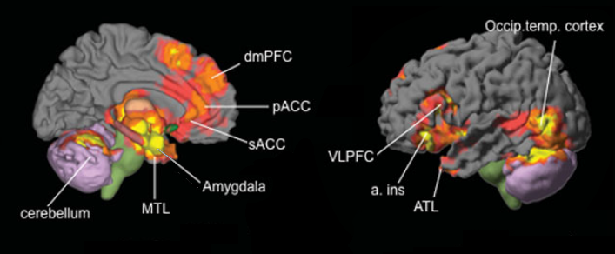
Figure 2. Neural reference space common to experience or perception of all emotions: dmPFC, pACC (pregenual), sACC (subgenual), anterior insula, amygdala, and to a lesser extent VLPFC and ATL. Core Affect: amygdala, insula, mOFC, lOFC, ACC, thalamus, hypothalamus, basal forebrain, PAG; Conceptualisation: VMPFC, DMPFC, mTL. From Linquist et al. (2012).

This notion of a more widely distributed, affect network is supported by case studies casting doubt on the notion of the AI and ACC as the central hub of emotional experience. For example, two patients whose ACC and AI were mostly destroyed by an infection were apparently completely unaffected in their ability to perceive, experience, and express emotions (66). Thus, rather than being focussed on a few cortical structures in the immediate proximity of the brain stem, increasingly it appears that conscious experience of emotion is supported by complex bilateral networks that are extremely resilient to damage.
The notion of experienced affect being supported bilaterally, with relatively little evidence of lateralisation may seem counterintuitive, as emotion is traditionally viewed as underpinned by right-hemisphere processes. However, experiencing affective states, and perceiving affect in external stimuli – such as facial expressions or vocal intonations – are entirely different processes. Indeed, when the recognition of emotion in facial expressions is examined, a very different picture emerges. In contrast to the bilaterally networked regions underpinning experienced emotions, the evidence suggests that recognition of emotion in facial expressions is primarily mediated by right hemisphere processes, with unilateral brain injuries resulting in corresponding impairment (67-72) (Figure 3). Since most aphasic patients have left hemisphere lesions, recognition of facial expression is unlikely to be impaired in this group.

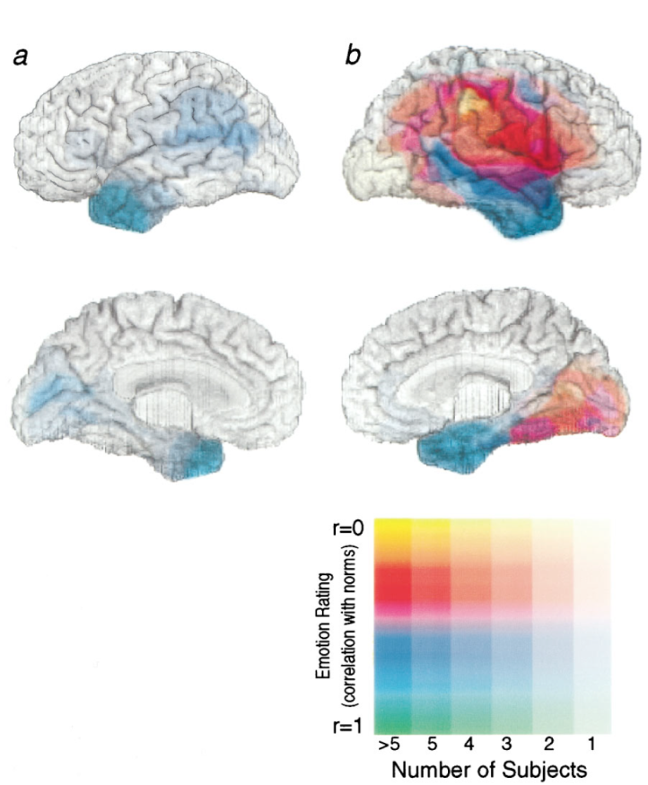

Figure 3. Impact of lesion location in left (a) and right (b) hemispheres on recognition of emotion in facial expressions. From Adolphs et al. (1996).

Physical impairment
The physical disabilities that accompany stroke typically include numbness, weakness (hemiparesis) or paralysis (hemiplegia) on the side of the body contralateral to the stroke (73). Poor coordination, such as in dyspraxia, or impaired movement, as in other kinetic disorders such bradykinesia, may also impact on a respondent’s ability to use traditional pen-and-paper measures, especially those requiring fine motor coordination (73).

Lesion Location and Patterns of Impairment Due to Stroke
The most important issue in adapting measures for people with aphasia is the fact that aphasia is most often due to left-brain lesions. Because spatial neglect occurs primarily in those with right-brain lesions, visuospatial defects are rare in people with aphasia. Of particular interest is the fact that recognition of emotion in faces has proven particularly resilient, and is generally impaired only by specific types of right hemisphere lesions (72). This means that most people with aphasia are unlikely to be impaired in their ability to recognise emotions in facial expressions.
For stroke survivors in general, interoceptive processes may be affected to some degree, and with it, the ability to experience or describe emotional states. However, these impairments do not appear related to the side on which the stroke occurs, and so presence of aphasia should have little relevance in this respect (27). Cognitive impairments, such as deficits in executive function, may make understanding a self-report measure and organising a response difficult, even where a patient is perfectly conscious of their mood. The presence of aphasia may also mean problems with working memory and attention.
However, though this means that many stroke survivors have problems with any form of self-reported assessment, it should be possible to ameliorate these problems by employing a design that will reduce cognitive burden, communicate affective information in more detail and enable emotions to be more easily reported and more finely quantified (27). If language comprehension is very poor, then the instrument must also have good face validity, that is, it should be self-evident from the appearance and the context of the assessment instrument what it is that is being asked of the respondent.
Finally, it is important to bear in mind that those with aphasia are more likely to have right-side weakness or paralysis; since most people are right-handed, a respondent may have difficulty with responses requiring fine coordination, whereby marking off a specific distance on a scale such as a VAS becomes problematic.

Implications for the Design and Development of Adapted, Self-Report Mood Scales

Existing adapted measures
The most obvious design feature for adapted self-report mood scales for stroke-related aphasia patients is to have a format in which emotions or mood states are represented pictorially. This is the main approach that existing adapted scales have adopted. For example, Stern and Bachman (22) used a simple, bipolar VAS in which they accounted for visual neglect by orienting the VAS vertically. It consists of a vertical 100mm line, at the ends of which are simple, smiley pictograms denoting bipolar, “happy” and “sad” endpoints, labelled with corresponding descriptors. This was named the Visual Analogue Dysphoria Scale, or VADS (Figure 4a).

Figure 4a. Impression of the Visual Analogue Dysphoria Scale (VADS) as described in Stern and Bachman (1991)

Stern et al. (15, 74) later expanded this to produce seven unipolar scales each representing a single mood state. The scales consist of items for “sad”, “happy”, “afraid”, “angry”, “tired”, “energetic”, and “confused”, and were named the Visual Analogue Mood Scales, or VAMS. As with the VADS, simplified cartoon faces are used to denote endpoints on a 100mm, vertical VAS. However, unlike the VADS, these scales are in a unipolar format, with “happy” and “sad” items existing as separate scales alongside those for the other mood states. At the top of each scale is a “neutral” face, and at the bottom is a face graphic depicting the respective mood, accompanied by descriptors at each end (Figure 4b).

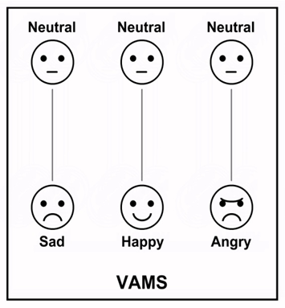

Figure 4b. The ‘sad’, ‘happy’, and ‘angry’ items from the seven-item Visual Analogue Mood Scales (VAMS) (Stern et al., 1997)

This key, pictorial format approach was also followed by Brumfitt and Sheeran (13) in their Visual Analogue Self Esteem Scales (VASES). In this case, ten items from the authors’ Semantic Differential Measure of Self-Esteem (SDMSE) were rendered as dichotomous pairs of line-drawn pictures illustrating relevant concepts (such as “confident/unconfident”, “talkative/quiet” etc.) (Figure 5). These pictures were presented side-by-side above a four-point rating scale, upon which the respondent marks their score.

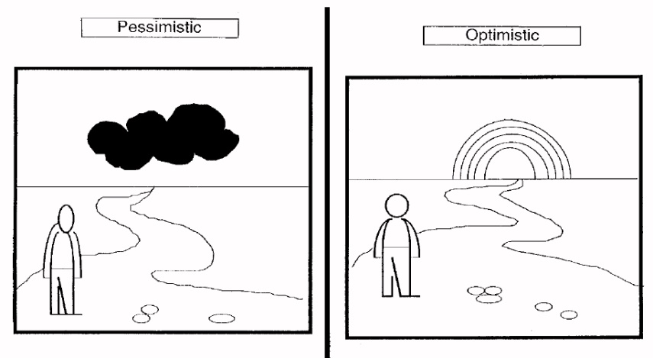

Figure 5. An impression of the VASES ‘pessimistic/optimistic’ scale (Brumfitt & Sheeran, 1999)

The Depression Intensity Scale Circles (DISCs) (14) took this pictorial approach further. Noting the problems that some stroke patients have using a graphic rating scale (such as a Likert scale) or VAS response format, the authors developed a six-point, vertical scale comprising six circles, each with a progressively larger area of dark grey shading (Figure 6). The fully shaded circle at the top represents the most depressed state, while the empty circle at the bottom represents a state of no depression. As well as providing support for people with communication problems, the aim of this tool was to help overcome the common visuospatial or cognitive impairments that often accompany ABI, and which might impact upon a person’s ability to scale abstract quantities into numeric scores.

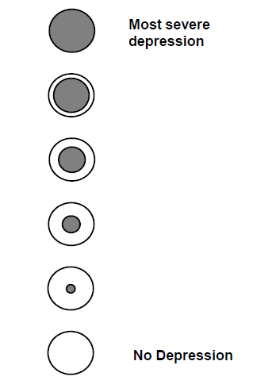

Figure 6. The Depression Intensity Scale Circles (DISCs) (Turner-Stokes et al., 2005)

Utility and limitations
Of these instruments, the VAMS (or its “sad” item) and the VASES have been most widely employed to assess mood in neurologically impaired patients. While studies have revealed some encouraging though mixed findings regarding the validity of the VAMS (12, 15, 75-78), the evidence base for its utility in stroke survivors is limited. For example, a key validation study in people with aphasia (12) was flawed due to the use of the standard version of VAMS, which included mood words on the scales (Figure 4). The sample of stroke survivors had intact, single-word recognition, which allowed participants to identify the moods represented by the scales by simply reading their labels (12). Therefore, comparing measures on these scales to corresponding mood descriptor words on the Profile of Mood States (POMS) offered little evidence of their utility in people too language-impaired to understand the labels.
In a study of poststroke depression, Berg et al. (79) likewise judged the VAMS unsuitable for people with aphasia and cognitive impairments, citing poor sensitivity and/or specificity. This is consistent with the findings of Bennett et al. (80), who concluded that the VAMS was more useful as an indication of severity of low mood than as a screening measure. Furthermore, Townend et al. (5) noted “very poor” completion rates in studies in which the VAMS was used with people with “unlimited” aphasia. Similarly, Gainotti et al. (81) reported that only nine out of 23 participants could use the VADS, and that participants were unable to understand nonverbal gestures used to communicate how the scales should be used.
The evidence base for VASES is also limited because although it showed moderate to high correlations with the HADS in two groups of aphasic patients (13), sensitivity and specificity were poor (80). Furthermore, Cobley et al. (82) found no significant correlation between the VASES “depression” item and the SADQ in people with aphasia, despite a weak, but highly significant correlation with the VAMS “sad” item.
The DISCs also falls short in this respect because although it demonstrated fair to good criterion validity against the BDI-II (83) based on DSM-IV diagnostic criteria (84) in patients with ABI, sensitivity was marginal (i.e., it is possible that people with severe language-impairment may find it difficult to understand its purpose). It has also not been independently assessed beyond the initial validation study (14), so cannot be recommended owing to its slim evidence base.

Reconceptualising Visual Analogue Mood Scales
Despite the aforementioned limitations of the VAMS, the underlying principle is sound: If there is impaired ability to use language following a stroke, other modes of communication that remain largely intact must be utilised. As previously noted, given that vision is usually unimpaired in people with left-hemisphere lesions associated with aphasia, it makes sense to use affect-bearing imagery in place of the language normally used to communicate emotional states. The VAMS reflects a rudimentary attempt to do this, but it has some key shortcomings that must be addressed in the design of an improved instrument:

Poor realism of faces
Firstly, there is the simplistic nature of the images used in the VAMS. Some of the graphics denoting mood states on the VAMS lack clarity, as suggested by the marked differences between results for the VAMS which included mood words and those which did not (15).
A substantial body of evidence indicates that facial expressions are the most effective means of conveying information about emotions non-verbally, with studies demonstrating consistently high recognition rates of posed facial expressions (85-87). For example, Ekman (88) reported recognition rates for posed facial expression of 78%–94.7% in western cultures, and cross-cultural recognition rates of 59%–87.8%. Even allowing for the weaker recognition rates of some cross-cultural studies, it is generally accepted that Ekman’s “basic” emotions are universal across cultures, and that facial expressions represent a shared human language for key affective states (86, 88-93).
Therefore, the use of genuine facial expressions images may be one way to improve accuracy. Actual facial expressions, with their complex underlying musculature, carry nuances of detail which simple graphics cannot convey. Given the cognitive impairments that often accompany stroke, and the apparent preference for photographs over line drawings shown in language support for people with aphasia (29), it would seem sensible to adopt this “common currency” of affective imagery with little change, using validated images of mood states posed by actors as a basis for the scales.
While recognition of facial expression is unlikely to be impaired in aphasic patients, the presence of depression has implications for the interpretation of facial expressions. For example,
a major review reported a general response bias whereby compared to non-depressed individuals, individuals with depression tend to attend selectively to sadder expressions (98), with similar biases having been observed in depressed stroke patients (94). Thus, although there are clearly good reasons for incorporating facial expression images in the design of new scales for the target population, it is important to bear these factors in mind and consider how their combined effects might influence the responses of depressed patients.

Limitations of the VAS format
Concerns have also been raised about using VAS-based measures with cognitively impaired patients. There is evidence to suggest that many people with cognitive impairments following a stroke are simply not capable of using a conventional VAS (95). Transposing abstract concepts into numerical values or proportions of physical distance is a complex and cognitively intensive process, and it was this very concern about the impairment of a stroke patient’s ability to make these judgements that gave rise to the aforementioned DISCs (14).
Instead of relying on a respondent to mentally scale constructs relating to their mood (cognitive interpolation), some of the present authors previously developed the option of using a tablet-based process of explicit interpolation, whereby the intensities of emotion types are embodied in corresponding images of facial expressions (96). The rationale for this approach (described in more detail below) was to address the limitations of a traditional VAS while allowing the medium of facial expression to be used to its fullest effect, employing the benefits of widespread tablet technology. The software design utilised a new, dynamic form of VAS, where a reference image dynamically changes in response to the position of a slider control on a touch-screen interface. Using this design, any position along the length of a VAS would be explicitly interpolated and displayed as an image corresponding to a particular scale value. This interface, along with suitable images of facial expressions formed the basis of a new set of mood scales known as the Dynamic Visual Analogue Mood Scales (D-VAMS), designed to run on modern, multi-function electronic devices (96).
For a typical VAS, a user must respond to a static image consisting of a 100mm line with endpoints representing concepts represented by words or pictures. They must interpret what the scale represents and then respond by transposing a notional quantity of some abstract concept into a scalar distance, usually by placing a mark somewhere along a line. This process is complex, little-understood and cognitively intensive. With the D-VAMS, however, the process is interactive, consisting of multiple iterations in which the user can adjust a slider and view an image depicting a notional quantity (represented by the value of the current slider position). Self-report thereby becomes an iterative process of refinement and adjustment, where a range of subtly different intensities of facial expression can be examined, and from which one is eventually selected as the score value. Highly detailed transitions between facial expressions on finely graded continua would afford the greatest fidelity, and minimise variance due to cognitive scaling. With each affective state being anchored to corresponding images, variance due to error in scaling and reporting of mood should be minimised, though some error due to interpersonal variation in interpreting intensity of affective images will remain.

Lack of underlying theory of affect
The VAMS are not separate subscales of a single scale, but a collection of discrete scales measuring qualitatively distinct mood states which are not united by any underlying theory. Therefore, it is difficult to arrive at a meaningful VAMS “total score”. In studies where the VAMS scales were used in their entirety, the scales have been used simply to give a broad measure of valence, either by excluding the positively valenced “happy” and “energetic” items (80) or by reversing them (97), thus allowing a composite score and measure of internal consistency (Cronbach’s α) to be used. However, because the mood most relevant to the assessment of depression comprises just a single scale – the “sad” item – most studies employing the VAMS for this purpose have only used this one scale.
In order to address this limitation, once the basic scale structure has been established, that is, a layout involving the use of images of facial expression which can be morphed with the movement of a slider, an overarching theory of affect can be used to inform scale content and cohesiveness. In this regard, the Circumplex Model of Affect (CMA), with its two-factor structure of valence and activation detailed earlier, has amassed a substantial evidence base (46, 47, 98) and, along with its concept of core affect and its substantive role in psychological constructionist accounts, has become a central fixture of affect theory (45, 48, 99). This model, along with alternative rotational schemes (100, 101), has formed the basis of a number of prominent mood assessment instruments (102-105) (Figure 7).

Figure 7. Four variations on the Circumplex Model of Affect: (A) Russell’s (1980) original Affect Circumplex; (B) Thayer’s (1967) four factors, subsequently reduced to two: Energetic and Tense Arousal; (C) The Positive Affect (PA) and Negative Affect (NA) factors of Watson et al. (1985); (D) The Self-Report Affect Circumplex (Larsen & Diener, 1992).

Therefore, the CMA offers a sound theoretical way of creating, conceptualising, and organising scales for the measurement of mood, including guiding the content of an adapted instrument. Having established that the CMA can adequately form the basis of a number of bipolar scales, the structure of the CMA itself provides a framework for the individual scales which it would comprise. By using different trajectories across affect space, with endpoints from complementary sides of the circumplex, a reasonably representative selection of scales could be assembled which – as well as including emotions frequently seen as discrete categories – would also be unified by these underlying affective factors.

Creating the Dynamic Visual Analogue Mood Scales (D-VAMS)
As part of developing the D-VAMS (96), photographic sittings were firstly conducted employing 20 student actors who each posed facial expressions in response to a total of 26 mood words. A judgement study was then conducted in which 44 respondents rated the extent to which each of the 26 mood words corresponded to each facial expression on a scale of 1 ("not at all") to 7 ("very much"). A total of 100 datasets were collected comprising 67,600 responses, and these were subjected to a principal components analysis (PCA). Two factors, consistent with valence and activation emerged, and a plot of factor loadings revealed a clear circular structure consistent with the CMA. Based on summary data, 12 mood words most strongly associated with their corresponding facial expressions were selected, and the study was then repeated using these words only with an independent sample of 64 participants. In this second study, a total of 540 datasets comprising 77,760 responses were collected and again subjected to PCA, revealing similar findings. A plot of factor loadings from this second study were used as a basis of seven bipolar mood scales, each representing different trajectories across affect space: 1) Miserable-Satisfied, 2) Sad-Happy, 3) Distressed-Peaceful, 4) Bored-Excited, 5) Afraid-Calm, 6) Angry-Peaceful, and 7) Sleepy-Alert (Figure 8) (96, 106).

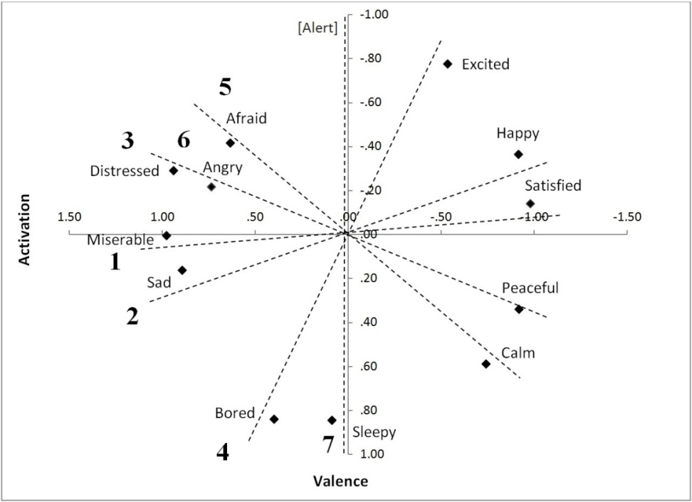
Figure 8. The seven bipolar scales of the D-VAMS charted as trajectories across affect space, as delineated by a plot of factor loadings from a judgement study of facial expressions (Barrows & Thomas, 2018)

Two, high scoring actors – one male, one female – were then identified as candidates to pose expressions for the final, dynamic form of these scales. Each actor posed a number of transitional expressions spanning the lengths of each scale from one endpoint to the other. Following a further study in which the perceived, scale positions of these transitional images were quantified, morphed images were generated to fill in the gaps (106) such that each scale has images corresponding to scores in the range of 0–100 , where 0 marks the negatively-valenced end of the scale, and 100 marks the positively-valenced end; in the case of the Sleepy-Alert scale, 0 marks the “Sleepy” end of the scale while 100 marks the “Alert” end.
These pages were then assembled into an interface that could be operated using a browser or dedicated app. In the D-VAMS software, each of the scales is presented, in turn, on a separate page. Since evidence suggests that a combination of images and text appear beneficial in augmenting communication in aphasia (32), the scale images were included along with corresponding mood words. The mood words for the scale (e.g., “Sad” and “Happy”) appear at the top and bottom of each page. On the right of each page is a vertical slider set to the midpoint position, while on the left a facial expression image is displayed corresponding to the midpoint of the scale. To help communicate the purpose of the device, the vertical slider is marked with graduated increments like those along the edge of a ruler (Figure 9a). To operate the scale, the user operates the slider, moving it up or down. As the slider is moved, the face morphs towards the mood state represented by the scale endpoints. To accommodate physical disabilities, the slider can be operated by repeatedly swiping the image up or down in the case of a tablet, or by using the mouse wheel in the case of a PC. The system can also allow for the connection of gesture detection interfaces such as the Leap Motion for those with more severe physical disabilities. Once the respondent is satisfied by the facial expression returned by the slider position, they or an assistant can press the green, “next” button to proceed to the next scale. Once all seven scales are completed, a results screen is presented displaying the images chosen and detailing the scores on the scales and their mean (Figure 9b).

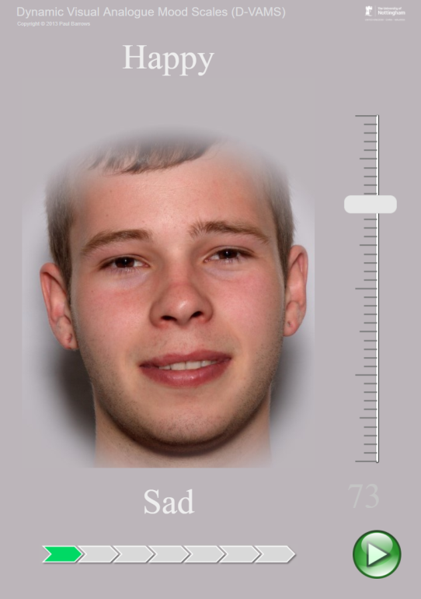
Figure 9a. The D-VAMS interface (Scale “: ‘Sad-Happy’; male face). A slider (right) is adjusted to select an expression that most closely reflects a user’s mood during the previous week.

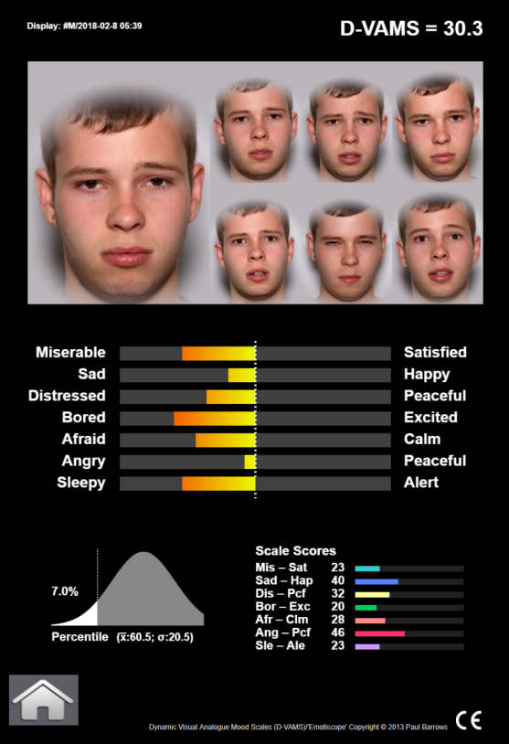
Figure 9b. The D-VAMS results page. The mean score is presented top right, underneath which faces selected from the seven scales are displayed. Scores are represented on bipolar bar displays with coloured gradations from red (negative) through to yellow (neutral) and green (positive). Unipolar score values are displayed as bar charts (bottom right). A bell curve offers normative guidance based on configurable population means and SD.

A validation study of the D-VAMS in a community sample of 46 stroke survivors (24% with some degree of aphasia) yielded encouraging findings (96). Exploratory factor analysis revealed one main factor accounting for 80% percent of the variance, and Cronbach’s alpha was very high (0.95) suggesting that the scales primarily measure affective valence. Therefore, the D-VAMS mean score represents pleasantness of mood on a scale of 0 –100. Criterion validity of the D-VAMS means score against the Hospital Anxiety and Depression Scales (HADS) was also high (r=0.8), as was test-retest reliability, which exceeded 0.9. The D-VAMS also demonstrated good sensitivity and specificity against the HADS (the HADS was deemed to be the most suitable language-based criterion measure for the construct under investigation [i.e., low mood]). Thus, early findings in stroke survivors suggest that the psychometric properties of D-VAMS appear likely to be at least comparable to other non-verbal mood assessment instruments in screening for low mood.
Should the findings in the aforementioned sample of stroke survivors be generalisable to those with more severe aphasia, then this instrument may present a significant advance in nonverbal mood assessment methods, and help clinicians better assess the low mood often symptomatic of depression.

Discussion
Evidence suggests that the interface design of devices to support communication in people with aphasia plays a major role in their communicative success (29). Therefore, the strong rationale and systematic approach employed in designing and constructing the D-VAMS is promising in this respect. However, the issue of validating the D-VAMS in exclusively aphasic stroke patients raises a perplexing methodological paradox. In order to validate an instrument, it must be assessed in its target population, yet a key method of validation is to compare an instrument to a criterion measure that is language-based. By definition, though, people with severe aphasia are unlikely to be able to use such measures. Similarly, it is impossible to apply the gold standard for a diagnosis of depression (through structured interview by a psychiatrist using DSM-V criteria) to people who cannot communicate verbally. The value of including people with limited aphasia as a compromise position, although appealing, is also debatable. The presence of aphasia will make it more difficult for a patient to complete a criterion measure, and the central paradox remains: It would appear impossible to distinguish between poor correlations due to poorer performance on a language-based criterion measure, and those due to shortcomings of the instrument under investigation. This problem goes some way to explaining why the evidence base for adapted self-report measures has generally been reported as weaker than that of observer-rated methods (5, 107), and that although screening measures for low mood after stroke are satisfactory, “measures suitable for those with communication problems are less robust” (108) p. 328.
While the use of observer-rated methods (8, 10, 11, 109) as a criterion measure also seems appealing, the correlation between self-report and observer-rated measures have proven unreliable (79, 82, 110). This is perhaps not surprising given the indirect nature of inferring a person’s inner state through observable behaviour. Though observer-rated measures are an important alternative source of information in the absence of any other means, enabling people with communication problems to directly report their mood is vital for improving the validity and reliability of mood assessment in this population.
Aside from the validation issues common with other self-reported instruments, the method employed in D-VAMS is not without its shortcomings. Although the use of interval-graded facial expression images may help people to more easily quantify how they feel, notable variations were found where transient facial expressions were judged to fall along the scales distance-wise in the scaling studies in which the instrument was developed (106). This attests to the variations in people’s sensitivity to particular facial expressions in individuals with and without stroke.
The presence of depression in a respondent, particularly, may introduce scaling biases due to oversensitivity to negative valence in facial expressions. This may cause them to underreport the intensity of negative facial expressions using the D-VAMS (27). However, neurological patients may also experience selective insensitivity to certain types of facial expressions, causing them to over-report on some face-based scales, but not others.
In alexithymia, a person’s self-experienced emotion or ability to recognise emotion in others will be impaired, but a diminished capacity for affective experience may also mean a diminished capacity for emotional distress; the need for assessment and monitoring of mood would therefore be less important for these people. The lack of apparent lateralisation for interoceptive awareness means that people with aphasia are unlikely to be more or less prone to this condition. However, the predominant, right-hemispheric lateralisation of facial expression suggests that this is less likely to be impaired due to strong tendency of aphasia to stem from left-hemisphere lesions, thereby making the use of faces particularly suitable for this population.
As for the methodological difficulties in assessing criterion and construct validity in this population, other psychometric properties such as face validity, internal consistency and test-retest reliability should carry some weight in deciding the likely effectiveness of such instrumentation. This, coupled with a detailed explication of the underlying neuropsychological, cognitive, and affective processes, should permit reasonable suppositions to be drawn about whether findings in stroke patients without significant severe language impairments can be generalised to those with such impairments. The present authors would argue this is not likely to be a significant obstacle to the use of D-VAMS providing the patient is lucid enough to discern the meaning and intended purpose of the instrument.

Summary
A novel scale known as the D-VAMS (96) appears to represent an important step forward in assessing mood in people with language impairments, and the innovations included in this system – particularly the use of interactive modulated imagery – can be incorporated more widely as part of instrumentation to nonverbally communicate and quantify other subjective phenomena or abstract concepts. In assessing the likely utility of D-VAMS in people with aphasia, it is important to bear in mind limitations inherent to the validation of measures in this population. The aforementioned methodological paradox prevents criterion validity in its strictest sense, so it is important instead to look to the evidence regarding the processes underpinning self-reported mood. When this is understood in the light of its psychometric properties as a whole, reasonable assessments can then be made as to whether such adapted measures might be generalisable to those with even the most severe aphasia.

Funding
The authors received no financial support for the research, authorship, or publication of this article.

Conflict of Interests
The authors declare no potential conflicts of interest with respect to the research, authorship, or publication of this article.

References
1. Kutlubaev M, Hackett ML. Part II: predictors of depression after stroke and impact of depression on stroke outcome: an updated systematic review of observational studies. Int J Stroke. 2014;9(8):1026-36.
2. Salter K, Teasell R, Bitensky J, Foley N, Bhogal S. Chapter 18: Post-Stroke Depression. The Evidence Based Review of Stroke Rehabilitation: www.ebrsr.com; 2009.
3. Ayerbe L, Ayis S, Rudd AG, Heuschmann PU, Wolfe CD. Natural history, predictors, and associations of depression 5 years after stroke: the South London Stroke Register. Stroke. 2011;42(7):1907-11.
4. Zigmond AS, Snaith RP. The hospital anxiety and depression scale. Acta Psychiatrica Scandinavica. 1983;67(6):361-70.
5. Townend E, Brady M, McLaughlan K. A systematic evaluation of the adaptation of depression diagnostic methods for stroke survivors who have aphasia. Stroke. 2007;38(11):3076-83.
6. Hackett ML, Anderson CS. Predictors of depression after stroke: a systematic review of observational studies. Stroke. 2005;36(10):2296-301.
7. Hackett ML, Pickles K. Part I: frequency of depression after stroke: an updated systematic review and meta-analysis of observational studies. Int J Stroke. 2014;9(8):1017-25.
8. Benaim C, Cailly B, Perennou D, Pelissier J. Validation of the aphasic depression rating scale. Stroke. 2004;35(7):1692-6.
9. Benaim C, Decavel P, Bentabet M, Froger J, Pelissier J, Perennou D. Sensitivity to change of two depression rating scales for stroke patients. Clinical Rehabilitation. 2010;24(3):251-7.
10. Watkins C, Leathley M, Daniels L, Dickinson H, Lightbody CE, van den Broek M, et al. The signs of depression scale in stroke: How useful are nurses' observations? Clinical Rehabilitation. 2001;15:447.
11. Sutcliffe LM, Lincoln NB. The assessment of depression in aphasic stroke patients: the development of the Stroke Aphasic Depression Questionnaire. Clinical Rehabilitation. 1998;12(6):506-13.
12. Arruda JE, Stern RA, Somerville JA. Measurement of mood states in stroke patients: validation of the visual analog mood scales. Arch Phys Med Rehabil. 1999;80(6):676-80.
13. Brumfitt SM, Sheeran P. The development and validation of the Visual Analogue Self-Esteem Scale (VASES). Brit J Clin Psychol. 1999;38:387-400.
14. Turner-Stokes L, Kalmus M, Hirani D, Clegg F. The Depression Intensity Scale Circles (DISCs): a first evaluation of a simple assessment tool for depression in the context of brain injury. J Neurol Neurosurg Psychiatry. 2005;76(9):1273-8.
15. Stern RA, Arruda JE, Hooper CR, Wolfner GD, Morey CE. Visual analogue mood scales to measure internal mood state in neurologically impaired patients : description and initial validity evidence. Aphasiology. 1997;11(1):59-71.
16. Brown J, Thiessen A. Using Images With Individuals With Aphasia: Current Research and Clinical Trends. American Journal of Speech-Language Pathology. 2018;27(1S):504-15.
17. Beck AT, Ward CH, Mendelson M, Mock J, Erbaugh J. An inventory for measuring depression. Arch Gen Psychiatry. 1961;4:561-71.
18. Zung WW. A self-rating depression scale. Arch Gen Psychiatry. 1965;12:63-70.
19. Hamilton M. A rating scale for depression. J Neurol Neurosurg Psychiatry. 1960;23:56-62.
20. Montgomery SA, Asberg M. A new depression scale designed to be sensitive to change. Brit J Psychiatry. 1979;134:382-9.
21. Goldberg DP, Williams P, D.P.M. A user's guide to the General Health Questionnaire: NFER-Nelson; 1988.
22. Stern RA, Bachman DL. Depressive symptoms following stroke. Amer J Psychiatry. 1991;148(3):351-6.
23. Wong DL, Baker CM. Pain in children: comparison of assessment scales. Pediatric Nursing. 1988;14(1):9-17.
24. Lorish CD, Maisiak R. The face scale: A brief, nonverbal method for assessing patient mood Arthritis Rheum. 1986;29(7):906-9.
25. Jokinen H, Melkas S, Ylikoski R, Pohjasvaara T, Kaste M, Erkinjuntti T, et al. Post-stroke cognitive impairment is common even after successful clinical recovery. Eur J Neurol. 2015;22(9):1288-94.
26. Handley A, Medcalf P, Hellier K, Dutta D. Movement disorders after stroke. Age and Ageing. 2009;38(3):260-6.
27. Barrows P, Thomas S. Assessing mood in aphasia: psychometric properties of the Dynamic Visual Analogue Mood Scales (D-VAMS). International Journal of Stroke. 2016;11(45):61.
28. Knecht S, Drager B, Deppe M, Bobe L, Lohmann H, Floel A, et al. Handedness and hemispheric language dominance in healthy humans. Brain. 2000;123 Pt 12:2512-8.
29. Griffith J, Dietz A, Weissling K. Supporting Narrative Retells for People With Aphasia Using Augmentative and Alternative Communication: Photographs or Line Drawings? Text or No Text?2014.
30. Lyon JG. Drawing: Its value as a communication aid for adults with aphasia. Aphasiology. 1995;9(1):33-50.
31. Hough M, Johnson R. Use of AAC to enhance linguistic communication skills in an adult with chronic severe aphasia2009. 965-76 p.
32. Dietz A, Weissling K, Griffith J, McKelvey M. Personalizing AAC for People with Aphasia: The Role of Text and Pictures2013.
33. Dietz A, McKelvey M, Beukelman DR. Visual Scene Displays (VSD): New AAC Interfaces for Persons With Aphasia. Perspectives on Augmentative and Alternative Communication. 2006;15(1):13-7.
34. McKelvey M, Dietz A, Hux K, Weissling K, Beukelman D. Performance of a person with chronic aphasia using personal and contextual pictures in a visual scene display prototype2007. 305-17 p.
35. Hux K, Buechter M, Wallace S, Weissling K. Using visual scene displays to create a shared communication space for a person with aphasia2010. 643-60 p.
36. Wallace SE, Hux K, Brown J, Knollman-Porter K. High-context images: Comprehension of main, background, and inferential information by people with aphasia. Aphasiology. 2014;28(6):713-30.
37. Beukelman DR, Hux K, Dietz A, McKelvey M, Weissling K. Using Visual Scene Displays as Communication Support Options for People with Chronic, Severe Aphasia: A Summary of AAC Research and Future Research Directions. Augmentative and Alternative Communication. 2015;31(3):234-45.
38. Stone SP, Halligan PW, Greenwood RJ. The incidence of neglect phenomena and related disorders in patients with an acute right or left hemisphere stroke. Age Ageing. 1993;22(1):46-52.
39. Buxbaum LJ, Ferraro MK, Veramonti T, Farne A, Whyte J, Ladavas E, et al. Hemispatial neglect: Subtypes, neuroanatomy, and disability. Neurology. 2004;62(5):749-56.
40. Beis JM, Keller C, Morin N, Bartolomeo P, Bernati T, Chokron S, et al. Right spatial neglect after left hemisphere stroke: qualitative and quantitative study. Neurology. 2004;63(9):1600-5.
41. Vossel S, Geng JJ, Fink GR. Dorsal and ventral attention systems: distinct neural circuits but collaborative roles. The Neuroscientist : a review journal bringing neurobiology, neurology and psychiatry. 2014;20(2):150-9.
42. Lee B, Pyun S-B. Characteristics of Cognitive Impairment in Patients With Post-stroke Aphasia. Ann Rehabil Med. 2014;38(6):759-65.
43. Spalletta G, Pasini A, Costa A, De Angelis D, Ramundo N, Paolucci S, et al. Alexithymic features in stroke: effects of laterality and gender. Psychosom Med. 2001;63(6):944-50.
44. Salminen JK, Saarijarvi S, Aarela E, Toikka T, Kauhanen J. Prevalence of alexithymia and its association with sociodemographic variables in the general population of Finland. J Psychosom Res. 1999;46(1):75-82.
45. Russell JA. Core affect and the psychological construction of emotion. Psychological Review. 2003;110(1):145-72.
46. Russell JA. A circumplex model of affect. J Pers Soc Psychol. 1980;39(6):1161-78.
47. Larsen RJ, Diener E. Promises and problems with the circumplex model of emotion. In: Clark MS, editor. Emotion: Review of personality & social psychology. Newbury Park: Sage; 1992. p. 25-9.
48. Russell JA. Emotion, core affect, and psychological construction. Cognition and Emotion. 2009;23(7):1259-83.
49. Lindquist KA, Wager TD, Kober H, Bliss-Moreau E, Barrett LF. The brain basis of emotion: a meta-analytic review. Behav Brain Sci. 2012;35(3):121-43.
50. Prete G, Laeng B, Fabri M, Foschi N, Tommasi L. Right hemisphere or valence hypothesis, or both? The processing of hybrid faces in the intact and callosotomized brain. Neuropsychologia. 2015;68:94-106.
51. Killgore WDS, Yurgelun-Todd DA. The right-hemisphere and valence hypotheses: could they both be right (and sometimes left)? Soc Cogn Affect Neurosci. 2007;2(3):240-50.
52. Robinson RG, Szetela B. Mood change following left hemispheric brain injury. Annals of Neurology. 1981;9(5):447-53.
53. Robinson RG, Starr LB, Lipsey JR, Rao K, Price TR. A two-year longitudinal study of post-stroke mood disorders: dynamic changes in associated variables over the first six months of follow-up. Stroke. 1984;15(3):510-7.
54. Robinson RG, Kubos KL, Starr LB, Rao K, Price TR. Mood disorders in stroke patients. Importance of location of lesion. Brain. 1984;107 ( Pt 1):81-93.
55. Singh A, Herrmann N, Black SE. The importance of lesion location in poststroke depression: a critical review. Can J Psychiatry. 1998;43(9):921-7.
56. Carson AJ, MacHale S, Allen K, Lawrie SM, Dennis M, House A, et al. Depression after stroke and lesion location: a systematic review. Lancet. 2000;356(9224):122-6.
57. Narushima K, Kosier JT, Robinson RG. A reappraisal of poststroke depression, intra- and inter-hemispheric lesion location using meta-analysis. J Neuropsychiatry Clin Neurosci. 2003;15(4):422-30.
58. Bhogal SK, Teasell R, Foley N, Speechley M. Lesion location and poststroke depression: systematic review of the methodological limitations in the literature. Stroke. 2004;35(3):794-802.
59. Garfinkel SN, Critchley HD. Interoception, emotion and brain: new insights link internal physiology to social behaviour. Commentary on: "Anterior insular cortex mediates bodily sensibility and social anxiety" by Terasawa et al. (2012). Soc Cogn Affect Neurosci. 2013;8(3):231-4.
60. Simmons WK, Avery JA, Barcalow JC, Bodurka J, Drevets WC, Bellgowan P. Keeping the body in mind: insula functional organization and functional connectivity integrate interoceptive, exteroceptive, and emotional awareness. Hum Brain Mapp. 2013;34(11):2944-58.
61. Wiens S. Interoception in emotional experience. Curr Opin Neurol. 2005;18(4):442-7.
62. Hornak J, Bramham J, Rolls ET, Morris RG, O'Doherty J, Bullock PR, et al. Changes in emotion after circumscribed surgical lesions of the orbitofrontal and cingulate cortices. Brain. 2003;126(Pt 7):1691-712.
63. Lindquist KA, Satpute AB, Wager TD, Weber J, Barrett LF. The Brain Basis of Positive and Negative Affect: Evidence from a Meta-Analysis of the Human Neuroimaging Literature. Cereb Cortex. 2016;26(5):1910-22.
64. Salas Riquelme CE, Radovic D, Castro O, Turnbull OH. Internally and externally generated emotions in people with acquired brain injury: preservation of emotional experience after right hemisphere lesions. Front Psychol. 2015;6.
65. Wager TD, Kang J, Johnson TD, Nichols TE, Satpute AB, Barrett LF. A Bayesian model of category-specific emotional brain responses. PLoS computational biology. 2015;11(4):e1004066.
66. Feinstein JS. Lesion studies of human emotion and feeling. Current opinion in neurobiology. 2013;23(3):304-9.
67. Borod JC, Koff E, Perlman Lorch M, Nicholas M. The expression and perception of facial emotion in brain-damaged patients. Neuropsychologia. 1986;24(2):169-80.
68. Moreno CR, Borod JC, Welkowitz J, Alpert M. Lateralization for the expression and perception of facial emotion as a function of age. Neuropsychologia. 1990;28(2):199-209.
69. Adolphs R, Damasio H, Tranel D, Damasio R. Cortical systems for the recognition of emotion in facial expressions. J Neurosci. 1996;16(23):7678-87.
70. Borod JC, Cicero BA, Obler LK, Whalen JR. Right hemisphere emotional perception: evidence across multiple channels. Neuropsychology. 1998;12(3):446-58.
71. Kucharska-Pietura K, Phillips ML, Gernand W, David AS. Perception of emotions from faces and voices following unilateral brain damage. Neuropsychologia. 2003;41(8):1082-90.
72. Philippi CL, Mehta S, Grabowski T, Adolphs R, Rudrauf D. Damage to association fiber tracts impairs recognition of the facial expression of emotion. J Neurosci. 2009;29(48):15089-99.
73. Stern RA. Assessment of mood states in aphasia. Semin Speech Lang. 1999;20(1):33-49; quiz -50.
74. Stern RA, Hooper CR, Morey CE. Development of visual analogue scales to measure mood in aphasia. The Clinical Neuropsychologist. 1990;4:300.
75. Arruda JE, Stern RA, Legendre SA. Assessment of mood state in patients undergoing electroconvulsive therapy: the utility of visual analog mood scales developed for cognitively impaired patients. Convuls Ther. 1997;12(4):207-12.
76. Nyenhuis DL, Stern RA, Yamamoto C, Luchetta T, Arruda JE. Standardization and Validation of the Visual Analogue Mood Scales. The Clinical Neuropsychologist. 1997;11(4):407-15.
77. Temple RO, Stern RA, Latham J, Ruffolo JS, Arruda JE, Tremont G. Assessment of mood state in dementia by use of the visual analog mood scales (VAMS). American Journal of Geriatric Psychiatry. 2004;12(5):527-30.
78. Haley KL, Womack JL, Harmon TG, Williams SW. Visual analog rating of mood by people with aphasia. Top Stroke Rehabil. 2015;22(4):239-45.
79. Berg A, Lonnqvist J, Palomaki H, Kaste M. Assessment of depression after stroke: a comparison of different screening instruments. Stroke. 2009;40(2):523-9.
80. Bennett HE, Thomas SA, Austen R, Morris AM, Lincoln NB. Validation of screening measures for assessing mood in stroke patients. Brit J Clin Psychol. 2006;45(Pt 3):367-76.
81. Gainotti G, Azzoni A, Gasparini F, Marra C, Razzano C. Relation of lesion location to verbal and nonverbal mood measures in stroke patients. Stroke. 1997;28(11):2145-9.
82. Cobley CS, Thomas SA, Lincoln NB, Walker MF. The assessment of low mood in stroke patients with aphasia: reliability and validity of the 10-item Hospital version of the Stroke Aphasic Depression Questionnaire (SADQH-10). Clinical Rehabilitation. 2012;26(4):372-81.
83. Beck AT, Steer RA, Carbin MG. Psychometric properties of the Beck Depression Inventory: Twenty-five years of evaluation. Clin Psychol Rev. 1988;8(1):77-100.
84. American Psychiatric Association. Diagnostic and statistical manual of mental disorders (4th ed.). Washington, DC: Author. 1994.
85. Ekman P, Friesen WV. Constants across cultures in the face and emotion. J Pers Soc Psychol. 1971;17(2):124-9.
86. Ekman P. Facial expression and emotion. American Psychologist. 1993;48(4):384-92.
87. Izard CE. Innate and universal facial expressions: evidence from developmental and cross-cultural research. Psychol Bull. 1994;115(2):288-99.
88. Ekman P. Strong evidence for universals in facial expressions: a reply to Russell's mistaken critique. Psychological Bulletin. 1994;115(2):268-87.
89. Ekman P, Friesen WV, O'Sullivan M, Chan A, Diacoyanni-Tarlatzis I, Heider K, et al. Universals and cultural differences in the judgments of facial expressions of emotion. J Pers Soc Psychol. 1987;53(4):712-7.
90. Ekman P. Facial expressions of emotion: an old controversy and new findings. Philosophical Transactions of The Royal Society B Biological Sciences. 1992;335(1273):63-9.
91. Russell JA. Facial expressions of emotion: what lies beyond minimal universality? Psych Bull. 1995;118(3):379-91.
92. Elfenbein HA, Ambady N. On the universality and cultural specificity of emotion recognition: a meta-analysis. Psychological Bulletin. 2002;128(2):203-35.
93. Ekman P. Facial Expressions. In: Dalgleish T, Power MJ, editors. Handbook of Cognition and Emotion Chichester, UK: John Wiley & Sons, Ltd; 2005.
94. Montagne B, Nys GM, Zandvoort MJE, Kappelle LJ, De Haan EH, Kessels RP. The perception of emotional facial expressions in stroke patients with and without depression. Acta Neuropsychiatrica. 2007;19(5):279-83.
95. Price CI, Curless RH, Rodgers H. Can stroke patients use visual analogue scales? Stroke. 1999;30(7):1357-61.
96. Barrows PD, Thomas SA. Assessment of mood in aphasia following stroke: validation of the Dynamic Visual Analogue Mood Scales (D-VAMS). Clinical Rehabilitation. 2018;32(1):94-102.
97. Kontou E, Thomas SA, Lincoln NB. Psychometric properties of a revised version of the Visual Analog Mood Scales. Clinical Rehabilitation. 2012;26(12):1133-40.
98. Yik MSM, Russell JA, Steiger JH. A 12-point circumplex structure of Core Affect. Emotion. 2011;11(4):705-31.
99. Russell JA, Barrett LF. Core affect, prototypical emotional episodes, and other things called emotion: Dissecting the elephant. J Pers Soc Psychol. 1999;76(5):805-19.
100. Watson D, Tellegen A. Toward a consensual structure of mood. Psych Bull. 1985;98(2):219-35.
101. Thayer RE. The biopsychology of mood and arousal. New York: Oxford University Press; 1989. xi, 234 p. p.
102. Thayer RE. Activation-deactivation adjective check list: current overview and structural analysis. Psychological Reports. 1986;58(2):607-14.
103. Watson D, Clark LA, Tellegen A. Development and validation of brief measures of positive and negative affect: The PANAS. J Pers Soc Psychol. 1988;54:1063-70.
104. Watson D, Clark LA. Manual for the Positive and Negative Affect Schedule (expanded form). Unpublished Manuscript1994.
105. Russell JA. Affect grid: A single-item scale of pleasure and arousal. J Pers Soc Psychol. 1989;57(3):493-502.
106. Barrows PD. The development and validation of mood scales suitable for use with stroke patients with aphasia. University of Nottingham ePrints: University of Nottingham; 2016.
107. van Dijk MJ, de Man-van Ginkel JM, B. HT, Schuurmans MJ. Identifying depression post-stroke in patients with aphasia: A systematic review of the reliability, validity and feasibility of available instruments. Clin Rehabil. 2016;30(8):795-810.
108. Lincoln NB, Kneebone II, Macniven AB, Morris RC. Psychological Management of Stroke. Chichester: John Wiley & Sons, Ltd. ; 2012.
109. Hacker VL, Stark D, Thomas S. Validation of the stroke aphasic depression questionnaire using the brief assessment schedule depression cards in an acute stroke sample. Brit J Clin Psychol. 2010;49(Pt 1):123-7.
110. Williams L, Bakas T, Brizendine E, Plue L, Wanzhu T, Hendrie H, et al. How valid are family proxy assessments of stroke patients’ health-related quality of life? Stroke. 2006;37(8):2081-5.

