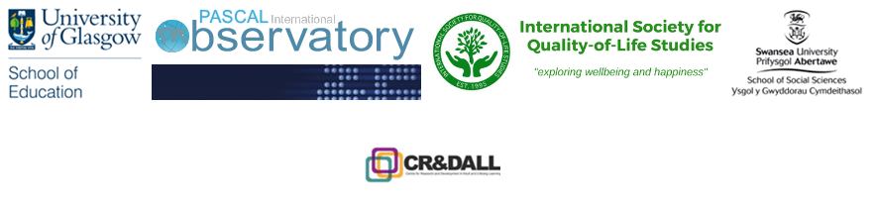

**WEBINAR - FAITH AND SPIRITUALITY IN LEARNING CITIES:**

*Spirituality on a Spectrum – from Religion to Art in Learning Cities*

25th September 2024, 12:30 am, London (GMT)

Join Zoom Meeting

https://swanseauniversity.zoom.us/j/92183413931?pwd=V0ZUQlExSkhjM0FwdVRIa1BOMXcxUT09

Meeting ID: 921 8341 3931

Passcode: 983261

The PASCAL Learning Cities Networks (LCN) ‘Faith-based Learning City Development' and the International Society for Quality-of-Life Studies (ISQOLS), in partnership with Swansea University, Derby University and Glasgow University are very happy to invite you to this open access WEBINAR on the spirituality in learning cities, where we will discuss faith-related institutions as a starting point for a wide variety of creative work helping cities through various vantage points on the spirituality spectrum in a learning city.

The round table of the WEBINAR will offer two expert interventions followed by a Q&A session. Each speaker will have 20 minutes to introduce us her contribution to the discussion:

• **John Meredith (Diocesan Director of Education, Swansea, UK) –** will talk about his work with 14 schools in his Diocese studying ‘Theology for Life’ with St Padarn’s and the philosophy of *CANAWEN* – the idea of togetherness in harmony which is educated to the diverse classrooms of the local schools through their religious education curriculum.

**• Dr Rhiannon Jones, Associate Professor Civic Practice (CEO S.H.E.D, Derby University, Derby, UK)** –*will talk about**how the creative place-making and social design project*S.H.E.D helped for community equality improvements in Derby and especially the reintegration of marginalized youth in the community through partnership working with the Royal Society of Arts, University of Derby, Derby Museums; and the creative and cultural industry sector in partnership with Derby Cathedral.

Our round table discussants will help us appreciate the multifaceted role of religious communities, with focus on work with young people, and their institution for the healthy life-long learning and spiritual integrity in the learning cities of the future, helping young people build milieus that recognize and facilitate the equality for all. The vital collaborations between religious communities, centres and the art sector as well as other public good agents within the community will be showcased and discussed. How can communities be more creative in using their various forms of contribution to the healthy and sustainable spiritual and wellbeing milieu of the community beyond the narrow traditional religious service? How do healthier, happier and more inclusive societies grow as spirit through the collaboration of the religious institutions (from biggest ones (Churches) to smallest one (local religious community centres)) and the arts? Why art is a powerful channel for influencing many spectrums of spiritual life of cities and their sustainable openness to breeding learning and inclusivity? If you want to hear the answers to these questions and ask your own questions – join us on the day of the webinar. You can watch the recording on the International PASCAL Observatory later on too on our PASCAL website, although the interactive component of the Q&A part will be available only for those who join us live.

You can register for the event HERE.