Article
A Multi-Country Study Assessing the Mechanisms of Natural Elements and Sociodemographics behind the Impact of Forest Bathing on Well-being
Montse Subirana-Malaret ^{1,}*,†, Alexandre Miró ²,†, Aracely Camacho ³, Alex Gesse ⁴ and Kirsten McEwan ⁵
¹ Faculty of Psychology, Universitat de Barcelona, Pg. Vall d’Hebron 171, 08035 Barcelona, Spain
² Highland Amphibian and Reptile Project, c/o Woodlands, Brae of Kinkell, Dingwall IV7 8HZ, UK;
alexestanys@gmail.com
³ Instituto de Ciencias Agropecuarias y Rurales, Universidad Autónoma del Estado de México, El Cerrillo Piedras Blancas, Toluca 50090, Mexico; aracelycamachog@yahoo.com
⁴ Forest Therapy Hub, Nature and Human Health Research, Av. D. João I 21, 2800-100 Almada, Portugal; alex@foresttherapyhub.com
⁵ University of Derby, College of Health, Psychology and Social Care, Kedleston Road, Derby DE22 1GB, UK; k.mcewan@derby.ac.uk
* Correspondence: msubiranam@ub.edu; Tel.: +34-933-125-132
† These authors contributed equally to this work.
Citation: Subirana-Malaret, M.; Miró, A.; Camacho, A.; Gesse, A.; McEwan, K. A Multi-Country Study Assessing the Mechanisms of
Natural Elements and
Sociodemographics behind the
Impact of Forest Bathing on
Well-being. Forests 2023, 14, x. https://doi.org/10.3390/xxxxx
Academic Editor(s):
Received: 20 February 2023
Revised: 6 April 2023
Accepted: 12 April 2023
Published: date
Copyright: © 2023 by the authors. Submitted for possible open access publication under the terms and conditions of the Creative Commons Attribution (CC BY) license (https://creativecommons.org/licenses/by/4.0/).
Abstract: Interventions such as forest bathing (slow, mindful nature walks) have been shown to increase our connection to nature and be an effective intervention for improving health and well-being. However, there is variation in the activities delivered during forest bathing and the guidance given. Few researchers have evaluated which activities, elements of nature, and senses are responsible for improvements in well-being. The current evaluation addresses this gap and also monitors the emotional state and nature connection following guided forest bathing walks. Participants (N = 1142) across 35 countries completed post-walk evaluation surveys online. Results suggest that well-being and nature connection were rated very highly following forest bathing activities. Experiencing happy feelings and trusting emotions were especially highly rated. The natural elements perceived as contributing the most to well-being were sound-related elements. In terms of sociodemographics, women had higher well-being and nature connection ratings than men; ratings were higher in specialised nature resort areas, with little difference between natural and urban park areas; higher scores were seen in the southern hemisphere and during hot or long-day seasons. This has implications for forest bathing, forest therapy, and nature-based training organisations and their guides who want to improve their method of intervention delivery, maximise well-being, and enhance nature connection.
Keywords: forest bathing; forest therapy; well-being; emotional state; nature connection; feelings; self-reported; natural elements; senses; sociodemographic

1. Introduction
Spending time in nature has consistently been demonstrated to offer multiple public health and well-being benefits. While mere exposure to nature has been shown to improve health and well-being [1–3], more active engagement with nature, or ‘nature connection,’ offers even greater benefits to well-being [4,5]. Nature connection (NC) has a long history in ecology and ecopsychology, with theories such as Biophilia [6] describing how human affinity for nature is innate and emerged from centuries spent living in and relying on nature for survival. NC as an area of study has recently generated a great deal of interest and empirical research [7]. In a wider sense, the human–nature connection is an umbrella concept that may differ according to the discipline and/or the application. In a recent multidisciplinary review of 345 papers featuring umbrella terms of NC, Ives et al. (2017) [8] found cognitive, experiential, emotional, and philosophical connections to nature, highlighting the need to specify the characteristics of nature that people are connected to in order to formulate appropriate policies and decisions for increasing NC and hopefully thereby improving sustainability and pro-environmental behaviours. NC has also been described as an individual’s subjective sense of their relationship with the natural world [5], which can manifest as two distinct types of well-being: eudaimonic well-being (where NC offers a sense of purpose and meaning in life) and hedonic well-being (where NC offers a sense of momentary pleasure and appreciation of beauty). NC can fluctuate over a person’s lifetime and tends to be higher in people who experience nature in their childhoods [9] and those who visit nature more frequently [10]. NC can also differ culturally and was found to differ among countries [11]. NC, therefore, has plasticity and can be malleable, signifying that NC interventions, such as forest bathing, can be effective in improving NC and pro-environmental attitudes [12], in addition to having physical [13] and mental health [14] benefits, offering a promising preventative health solution.
Forest bathing (FB) is a slow, mindful guided nature walk that emerged from a national public health intervention delivered in Japan to address work-related stress and illnesses [15,16]. Although in its beginnings FB was conceived for walking unguided in silence, in recent years FB has included a range of guided proactive nature connection activities to enhance the positive effects on health and NC [17]. Forest Therapy (FT) is a FB nature-based intervention experienced with a Forest Therapy practitioner to help restore mental, physical, and social health associated with specific problems and needs [18–20]. FB guides and FT practitioners have become aware of the research literature on NC and how this can be an important mediating factor between spending time in nature and positive emotions [5]. In this sense, FB walks encourage participants to pay close attention to their surroundings using all their senses. In a guided session on FB, a trained guide might offer participants activities on how to engage their senses (e.g., noticing the colours of leaves, the texture of bark, the sound of a bird’s song, and the smell of soil, among others). Furthermore, the FB guide or FT practitioner might also offer opportunities for the group to share sensations, emotions, and thoughts they experienced as a nature exposure-response, providing a peer-learning experience and an opportunity for empathy and social interaction [18–20].
At present, FB intervention delivery is increasing internationally, while research activity is increasing across Korea (e.g., [21]), Taiwan (e.g., [22,23]), China (e.g., [24,25]), and Europe (e.g., [12,26–31]). Meanwhile, NC activities supported by research evidence have begun to be incorporated into nature-based interventions. For example, the “three good things in nature” activity (i.e., where participants notice and journal three good things in nature daily) has been shown to improve positive emotions, well-being, and NC in non-clinical and clinical populations [32,33]. In addition, many nature-based and FB organisations and guides have begun to adopt the “five pathways to nature connection” [34] as a framework to inspire their interventions. The five pathways approach includes (1) sensory contact with the natural world; (2) finding an emotional bond with and love for nature; (3) taking time to appreciate the beauty of nature; (4) thinking about the meaning and signs of nature; and (5) showing compassion and care for nature. In the same way, Richardson et al. (2016) [35] suggested that the “three circle model” could provide a useful framework for interpreting the benefits of spending time in nature. This model takes into consideration the three types of emotion: drive (joy—pursue), contentment (calm, connect), and threat (anxiety—avoid) that exposure to nature may evoke.
FB guides and FT practitioners from the large international training organisation Forest Therapy Hub (FTHub) have been incorporating NC research and practises such as the three good things in nature and the five pathways to nature connection. In addition, they incorporate elements of the “socioecological model of health” [36], signifying that they take into account individual, relationship [28], community, and societal factors as well as their interplay. Furthermore, they apply a “health map” model of health determinants [37], considering individual lifestyle factors, social and community networks, and cultural and environmental conditions, along with scientific evidence of the pathways by which exposure to natural environments promotes health and well-being [38]. Thus, their FB sessions follow the FTHub method and the “liquid interactions model” (LIM). The FTHub method is a practical tool for designing mindful activities in natural environments and planning them in various sequences to promote nature connectedness [18–20]. The LIM refers to an integrative and interactional theoretical model that understands health and well-being as dynamic, relative, and variable phenomena that go beyond inherited biological conditions: health is the result of an adaptive process of human beings to their physical and social environments [18–20,39]. This wide theoretical basis gives the LIM flexibility to put into practise and adjust the different activities of the FTHub method to the characteristics and specific needs of different groups.
To the best of our knowledge, few research papers have examined the relative impact of different FB activities and engagement with the different senses on participants. Despite the fact that engaging with nature is a multisensory experience [40], humans do not process—that is, perceive—all sensations for two reasons: not everything is relevant, and they do not have the cognitive resources to process all these stimuli [41]. Additionally, according to Bentley et al. (2023) [40] and Gaviria et al. (2009) [41], sensations are a process of capturing stimuli, and perception is a psychological process in which the environment is interpreted and given meaning. Through an active cognitive process and the involvement of the motor system, humans build their “reality,” which is conditioned, among other things, by their characteristics, the socio-cultural context, and the physical environment itself. In one forest bathing study, McEwan et al. (2021) [12] surveyed participants to ask which of their senses they engaged with the most during the session. This revealed that participants prioritised their senses in the following order: vision, sound, smell, touch, and taste.
While there has not been much research directly comparing the relative impact of different sensory activities in FB, there has been a wealth of research concerning contact with nature through different senses. For example, in terms of visual sensory activities, much of the FB research from Japan has measured participants’ responses to viewing a forest scene for 15 min and consistently found reductions in anxiety, depression, anger, fatigue, and confusion [14]. In a now-famous study, Ulrich (1984) [42] found that merely having a view of nature from a hospital window resulted in less pain medication being needed, less anxiety, and faster recovery and discharge in hospital patients. Further studies have found that viewing nature-based slideshows increased pro-sociality [43], while viewing nature videos reduced anxiety during the COVID-19 lockdowns [44]. A review by Antonelli et al. (2019) [45] of the effects of FB on reducing inflammatory markers, such as cortisol, found that visual activities appeared to have the greatest impact.
There is extensive evidence in terms of listening sensory activities; for example, a meta-analysis of 18 research papers studying the impact of natural sounds on well-being revealed evidence for decreased stress and annoyance, decreased pain, and improved mood and cognitive performance [46]. Studies also found that the physiological impacts of listening to natural sounds [12,47], such as running water, resulted in increased heart rate variability, indicating a good balance between the fight/flight (sympathetic nervous system) and the rest and digest (parasympathetic nervous system). Stobbe et al. (2022) [48] have found that a highly diverse birdsong soundscape decreases depressive states, alleviates anxiety, and lowers paranoia. Moreover, beneficial effects concerning mood and attention restoration have been observed [48,49]. In addition, being silent in nature and listening to natural sounds fostered a stronger present orientation (experiencing the moment) and a reduced past orientation (referring to memories), accompanied by more relaxation and less boredom [50].
In terms of smelling activities, there is some evidence that breathing in the wood essential oils emitted by trees, called phytoncides, has beneficial effects on mood, cognition, and the immune system. In this line, it has been documented that merely breathing in the chemicals from the forest can result in an immune boost and contribute to preventing infections [51,52]. For example, a review by Antonelli et al. (2020) [53] found that breathing in phytoncides can result in antioxidant and anti-inflammatory effects on the airways and decrease mental fatigue, improve cognitive performance and mood, and induce relaxation. Studies of on how phytoncides impact the immune system have consistently shown a 50% increase in anti-cancer proteins (specifically natural killer cells) and a 28%–48% increase in different anti-cancer proteins after a three-day forest bathing retreat, with these benefits lasting one month [54–56]. A recent qualitative study found that following nature scavenger hunt workshops in woodland, participants reported that natural smells evoked childhood memories (e.g., gardening with a parent), cleared their minds, allowed them increased awareness of their surroundings, and made them feel relaxed and rejuvenated [40].
There has been far less research examining the impact of touch activities, and to our knowledge, the only study to specifically examine the impact of touch has been Ikei et al. (2017) [57], who found that touching oak with the palm of the hand significantly decreased activity in the prefrontal cortex and increased heart rate variability, which is indicative of parasympathetic nervous activity and physiological relaxation. There is also evidence about the benefits of being in contact with the soil and microbiota within the soil [58], which can have immune-regulating effects and protect against allergy and inflammatory disorders [59]. Finally, to our knowledge, there has been no research examining activities that explore the sense of taste within a forest bathing or foraging context.
The main aim of this study was to investigate the effect of guided FB with nature connection activities (NCA) on the participants’ self-reported well-being and to assess the relative contribution of the natural elements perceived to the participants’ well-being. This assessment will inform FB guides and FT practitioners’ training frameworks and future delivery of NCA, targeting maximum well-being benefits for participants and nature connectedness. Our specific objectives were: (1) to assess which emotional and nature connection indicators were rated higher following forest bathing walks; (2) to investigate which of the natural elements perceived during the forest bathing session were rated highest in terms of contributing to well-being; (3) to investigate possible associations between well-being and natural elements perceived during the forest bathing session; and (4) to test any effects of sociodemographic and temporal factors on well-being.

2. Materials and Methods

2.1. Nature Connection Activities and Forest Bathing Session
Interventions were carried out by trained guides or practitioners trained by FTHub, following the FTHub method and the LIM for designing NC activities that consider how natural elements perceived can impact health and well-being, maximising participants benefit from nature exposure [18–20].
Each session involved a specific sequence of non-intrusive NCA of contact with the surrounding nature aimed at fostering nature connectedness and the use of the five senses. The sequence or process of FB was customised in terms of time (nature dose), routes, and characteristics of the natural environment. For example, the guides helped the participants through reflective activities, which included expressive arts to identify and share their sensations, emotions, and thoughts.
All participants experienced the same NCA following a sequence of three parts: the “initial phase,” which focuses on senses; the “intermediate phase,” which is centred on connecting with the environment; and the “final phase,” which aims to integrate all the experiences [19,39]. The time spent in the FB with NCA session was about two hours.

2.2. Participants and Data Collection
Data were collected from a non-random sample of multi-country general population participants following a guided FB session, including NCA from 2021 to 2022. The FB session and NCA were delivered by trained guides of the FTHub. Inclusion criteria were being able to understand the questionnaire, which was delivered in English, Spanish, French, Italian, Polish, and Portuguese; being 18 years of age or older; and participating in a completed session of FB and NCA.
The online questionnaire was developed using Google Forms and posted online following approval by the FTHub committee. After the forest bathing session, each guide explained the aims of the study, the instructions to complete the survey, and guaranteed anonymity and confidentiality to participants. The questionnaire was distributed online after the forest bathing session and remained open for 24 h after the session.
The final sample of this study comprised 1142 participants (74.8% women; 24.3% men; 0.9% non-binary). Their mean age was 45.5 years old (SD = 13.6; min. 18; max. 88). Participants came from 47 different nationalities and completed the anonymous online questionnaire following a FB and NCA session that took place in 35 different countries.
With regards to the language of the questionnaire, of the 1142 respondents, 937 (82%) filled it out in the native language of their country. The other 205 participants used a different language, mostly English. When the native language could not be used, the questionnaires were filled out in English by respondents who had adequate language skills. Where a questionnaire had already been validated for a particular language, that version was selected. The remaining surveys were translated into each of the participating countries’ languages by guides who spoke those languages, using forward/backward translation procedures.

2.3. Instruments
The anonymous online survey consisted of 29 closed-ended questions divided into three sections:
(a) Sociodemographic characteristics were assessed through six closed-ended items that were converted into six factors: gender, age, setting (environment in which the FB was performed), number of walks (number of sessions in which the participant had been previously involved), nationality (nationality of the respondent), and country (country in which the session was run). Additionally, four new factors were created post-hoc: (1) The world area (Latin America, North America, Asia, Mediterranean Europe, NW Europe, and others) was derived from a country in order to group the participants in a geographically interpretable way, which means that the nationality/country was not used in our analyses to avoid potential issues due to different sample sizes. Three temporal factors were built to catch possible temporal patterns: (2) season (in which the session was run), (3) month week (week of the month), and (4) weekday (day of the week). Table 1 shows the different factors’ categories and their share percentages. The membership of each country within the categories of the world area can be seen in Table S2 in the Supplementary Materials. Table S3 in the Supplementary Materials shows detailed data for the six categories of the world area factor, with detailed information for the native language, gender and age of the respondents, and the setting where the activity was performed.
(b) Well-being was assessed by seven self-reported indicators, including three feelings (happy, calm, and important), three emotions (trust, hope, and surprise), and one nature connection index. Adjectives for feelings and emotions were selected according to the FTHub criteria based on the professional’s experience. Feelings were measured through the self-assessment manikin five-item scale (SAM) [60], which uses a 1–9 Likert scale and provides Emojis as examples to clarify scoring (a detailed explanation of the questions can be seen in Table 2). Emotions were measured through a self-assessment using a 1–10 Likert scale designed for the purpose of this study and based on the characteristics of a standard FB session within the LIM framework [19,39] (Table 2). Nature connection was measured through the single item “inclusion of nature in self” scale (INS) [61], where the participant selects an image of two overlapping circles representing self and nature rated 0–6 (6 means the highest nature connection) (Table 2).
(c) The well-being-related sensations caused by nature and perceived during the FB with NCA sessions were explored through 16 self-assessments using a 0–10 Likert scale with indicators of natural elements, which had been previously highlighted and described by the LIM methodology [19,39] (Table 2) and is based on the three good things in nature, the five pathways to nature connection [32–34], and the practical experience gained through direct observation of sensations caused by nature in previous interventions. To facilitate the interpretation of the results, we associated some of the natural elements with four of the five human senses: vision, sound, smell, and touch (a detailed explanation for each natural element can be seen in Table 2).
Table 1. Sociodemographic characteristics of the respondents and their share (%). The detailed lists for nationality and country factors are given in Tables S1 and S2, respectively, in the Supplementary Materials.
Factor | N | Share (%)
Gender
Women | 854 | 74.8
Men | 278 | 24.3
Non-binary | 10 | 0.9
Age
18–31 | 202 | 17.7
32–45 | 385 | 33.7
46–59 | 341 | 29.9
60–79 | 197 | 17.3
Unknown | 17 | 1.5
Setting
Natural | 850 | 74.4
Urban park | 239 | 20.9
Other | 53 | 4.6
Number of walks
First | 953 | 83.5
Second | 109 | 9.5
More than two | 80 | 7.0
Nationality
Total of Nationalities | 47 | 100.0
Country
Total of Countries | 35 | 100.0
World area
Latin America | 310 | 27.1
North America | 144 | 12.6
Asia | 31 | 2.7
Mediterranean Europe | 425 | 37.2
NW Europe | 225 | 19.7
Other | 7 | 0.6
Season
Winter | 421 | 36.9
Spring | 275 | 24.1
Summer | 299 | 26.2
Autumn | 147 | 12.9
Month week
1st | 123 | 10.8
2nd | 309 | 27.1
3rd | 291 | 25.5
4th | 215 | 18.8
5th | 175 | 15.3
6th | 29 | 2.5
Weekday
Monday | 81 | 7.1
Tuesday | 88 | 7.7
Wednesday | 102 | 8.9
Thursday | 103 | 9.0
Friday | 79 | 6.9
Saturday | 328 | 28.7
Sunday | 361 | 31.6
Table 2. Description of the outcomes collected through the study questionnaires, which included 7 estimators of self-reported subjective well-being after attending a forest bathing session and 16 estimators of natural elements perceived during the session. In the column outcome name and between brackets, we emphasise the human senses associated with some of the natural elements.
Outcome Type | Outcome Name | Questionnaire Text
Feelings experienced |  | On a scale of 1 to 9, how did you feel at the end of your walk?
 | happy | From unhappy, sad to happy, pleased
 | calm | From nervous to calm, relaxed? Exceptionally, this item was scored from 9 to 1 and then reversed before being used.
 | important | From uncontrollable, unimportant to controllable, important, a leader
Emotions experienced |  | How much did you notice any of the following emotions (on a scale of 1 (not at all) to 10 (completely)?
 | trust | Trust
 | hope | Hope
 | surprise | Surprise/amazement
Nature connection | INS (inclusion of nature in self) | During your walk, how connected did you feel with nature (on a scale of 0 (not connected at all) to 6 (completely connected)?
Natural elements perceived |  | On a scale of 0 (not at all) to 10 (completely), if you had any of the following experiences, did you feel that they supported your well-being?
 | sounds (sound) | Sounds of nature (birds, water, breeze, etc.)
 | uniqueness | Appreciating the uniqueness of nature and the lived experience
 | contact (touch) | Experiencing the joy of contact with nature
 | positive  (vision) | Environments favourable to positive feelings, emotions, and thoughts
 | landscape | Appreciation of beauty in nature on a large scale (harmony in landscapes, mountains, oceans, etc.)
 | harmony | Integrating into the harmony of nature
 | colours  (vision) | Colour and colour shades
 | discovering (all senses) | Discovering new aspects of nature
 | scents (smell) | Scents from flowers, plants, soil, or other smells
 | home | Nature as part of home
 | textures (touch, vision) | Textures of natural objects
 | meteorology (vision, sound, smell) | Dynamic and specific aspects of meteorology: rain, breeze, sun, clouds, etc.
 | shines (vision) | Shines and shadows
 | shapes (vision) | Shapes and geometries (trees, spider webs, leaf shapes, etc.)
 | sharing | Sharing and integrating nature experiences in circles and their dynamics
 | animals (vision, sound) | Presence of mammals, birds, or insects

2.4. Statistical Analyses
We carried out different statistical analyses to test each of the four specific objectives. First, we assessed which self-reported well-being indicator was rated higher following forest bathing and tested which of the 16 natural elements perceived during the forest bathing were rated highest in terms of contributing to subjective well-being (objectives 1 and 2) by means of three non-parametric Kruskal–Wallis analyses [62], which we applied separately on the three feelings, the three emotions, and the 16 natural elements perceived. After obtaining significant results, we performed post-hoc Dunn tests [63]. P-values were adjusted for multiple testing by applying the Benjamini−Hochberg correction, which controls the false discovery rate [64]. To investigate the associations between subjective well-being and the natural elements perceived during forest bathing (objective 3), we computed non-parametric Spearman rho correlations between the seven emotional and nature connection indicators and the 16 natural elements perceived. Effects of sociodemographic and temporal factors (objective 4) were tested by means of Kruskal–Wallis analysis and post-hoc Dunn tests among factor categories for the scores of the seven well-being indicators and the 16 natural elements perceived. Bar graphs were drawn to show the direction of the results. In the case of the factor gender, the category non-binary was joined to the category women before performing statistical analyses because of the low number of cases (10 non-binary respondents) and the lack of statistical differences shown between both categories in preliminary analyses. All analyses were carried out with R statistical software [65], using the basic functions and the packages vioplot [66], dunn.test [67], Rmisc [68], psych [69], and corrplot [70]. The level of statistical significance considered was α = 0.05.

3. Results

3.1. Self-Reported Well-being Indicators and Natural Elements that Benefit Subjective Well-being
The ratings of participants were very high across positive feelings and emotions, NC, and the impact of natural elements on well-being after the guided forest bathing with NCA (Figure 1). However, the data showed slight but significant score gradients within each group of indicators. The feeling rated highest [range 1, 9] was happy (median = 9, mean = 8.6), followed by calm (median = 9, mean = 7.9) and important (i.e., feeling that you are in control, important, a leader) (median = 8, mean = 7.3) (Kruskal–Wallis χ² = 591.09, p < 0.001) (Figure 1.1). The emotion rated highest [range 1, 10] was trust (median = 10, mean = 9.2), followed by hope (median = 9, mean = 8.7) and surprise (median = 8, mean = 7.8) (Kruskal–Wallis χ² = 411.79, p < 0.001) (Figure 1.2). The indicator for nature connection INS [range 0, 6] had a median of 5 and a mean of 4.8 (Figure 1.3).
Within the group of natural elements perceived to benefit subjective well-being [range 0, 10], participants rated the indicator sounds highest (median = 10, mean = 9.5), described as “sounds of nature (birds, water, breeze, etc.);” followed in descending order by uniqueness (median = 10, mean = 9.4), defined as “appreciating the uniqueness of nature and the lived experience,” contact (median = 10, mean = 9.4), meaning “experiencing the joy of contact with nature;” positive (median = 10, mean = 9.3), defined as “environments favourable to positive feelings, emotions, and thoughts:” landscape (median = 10, mean = 9.3), referring to “appreciation of beauty in nature on a large scale (harmony in landscapes, mountains, oceans, etc.);” harmony (integrating into the harmony of nature) (median = 10, mean = 9.2), colours (median = 10, mean = 9.2), conceived as “colour and colour shades;” discovering (median = 10, mean = 9.1), as “discovering new aspects of nature;” scents (median = 10, mean = 9.0), related to “scents from flowers, plants, soil, or other smells;” home (median = 10, mean = 9.0), meaning “nature as part of home;” textures (median = 10, mean = 8.9), defined as “textures of natural objects;” meteorology (median = 10, mean = 8.9), chartered as “dynamic and specific aspects of meteorology: rain, breeze, sun, clouds, etc.;” shines (median = 10, mean = 8.8), described as “light and shadows;” shapes (median = 9, mean = 8.8), referring to “shapes and fractal geometries (tree branch shapes, spider webs, leaf shapes, etc.);” sharing (median = 9, mean = 8.8), meaning “sharing and integrating nature experiences in circles and their dynamics;” and animals (median = 9, mean = 8.3) (Kruskal–Wallis χ² = 571.59, p < 0.001) (Figure 1.4), as “presence of mammals, birds, or insects.”
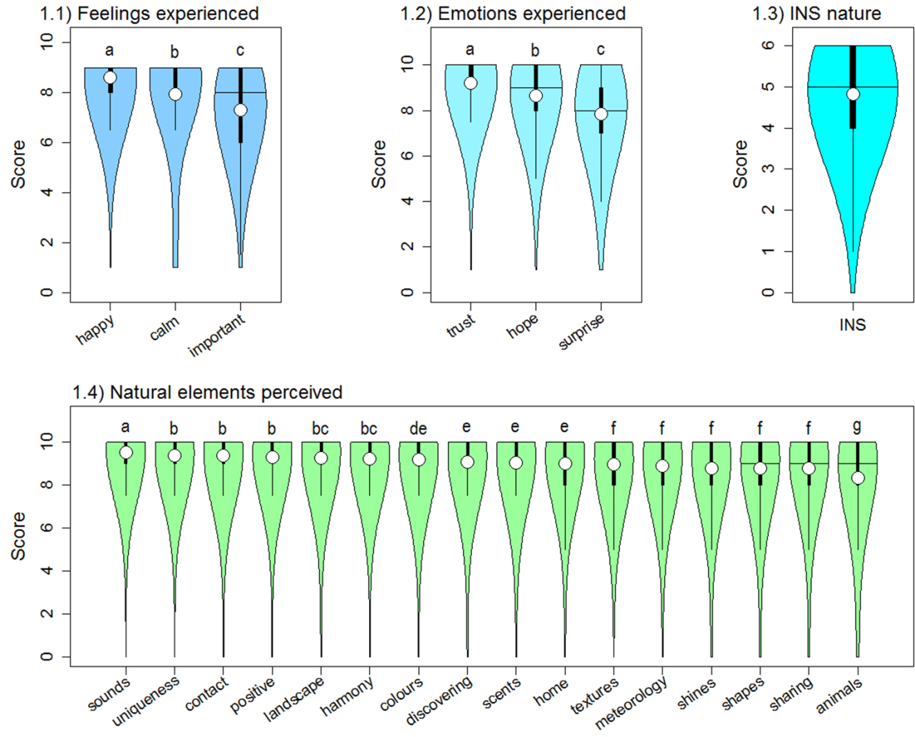
Figure 1. Violin plots showing the scores of the seven well-being indicators (upper panel) and the 16 natural elements perceived to benefit subjective well-being (lower panel) surveyed following forest bathing walks. Horizontal lines within violins indicate medians, and circles indicate means. Kruskal–Wallis tests for the three groups of indicators were significant (p-values < 0.001). Different letters above the violins show significant differences in the post-hoc Dunn tests (see the materials and methods section for further details).
Regarding the associations between well-being indicators and natural elements perceived to benefit subjective well-being, we found that the highest positive Spearman rho correlations with natural elements perceived [range −1, 1] were shown by the emotions hope (median = 0.40, mean = 0.39, range 0.27, 0.46) and trust (median = 0.36, mean = 0.35, range 0.23, 0.41), the indicator for nature connection INS (median = 0.37, mean = 0.37, range 0.25, 0.48), and feeling happy (median = 0.33, mean = 0.34, range 0.21, 0.43) (Kruskal–Wallis χ² = 65.819, p < 0.001) (Figure 2.1; Table S4 in the Supplementary Materials). The other three well-being indicators showed positive but lower correlations with natural elements perceived to benefit subjective well-being, i.e., the emotion of surprise (median = 0.31, mean = 0.31, range 0.26, 0.39), feeling calm (median = 0.24, mean = 0.24, range 0.15, 0.31), and feeling important (median = 0.25, mean = 0.25, range 0.20, 0.32) (Figure 2.1; Table S4).
The detailed correlation matrix (Figure 2.2; Table S4 in the Supplementary Materials) highlighted a few specificities linked to some of the natural elements perceived to benefit subjective well-being that did not follow the overall patterns. Some of the natural elements that had been scored the highest by the participants showed a lower association with well-being indicators in comparison with others, such as sounds, landscape, and scents (mean Spearman rho correlations = 0.28, 0.29, and 0.29, respectively, in comparison to the overall mean for all the 16 natural elements = 0.32) (Figure 2.2 and Table S4). In contrast, other natural elements that had been scored lower by the participants, such as home and sharing, showed a higher association with well-being indicators (mean Spearman rho correlations = 0.34 and 0.34, respectively, in comparison to the overall mean = 0.32) (Figure 2.2; Table S4). The natural element animals, which had been rated the lowest by the participants (Figure 1.4), also showed the lowest association with well-being indicators (mean Spearman rho correlation = 0.23, in comparison to the overall mean = 0.32) (Figure 2.2; Table S4). Actually, the natural element animals showed the poorest association of the dataset with feeling calm or relaxed (Spearman rho correlation = 0.15), hence the highest with feeling nervous (see indicators definition in Table 2). All Spearman rho correlations computed were significant (p-value < 0.001; Table S5).
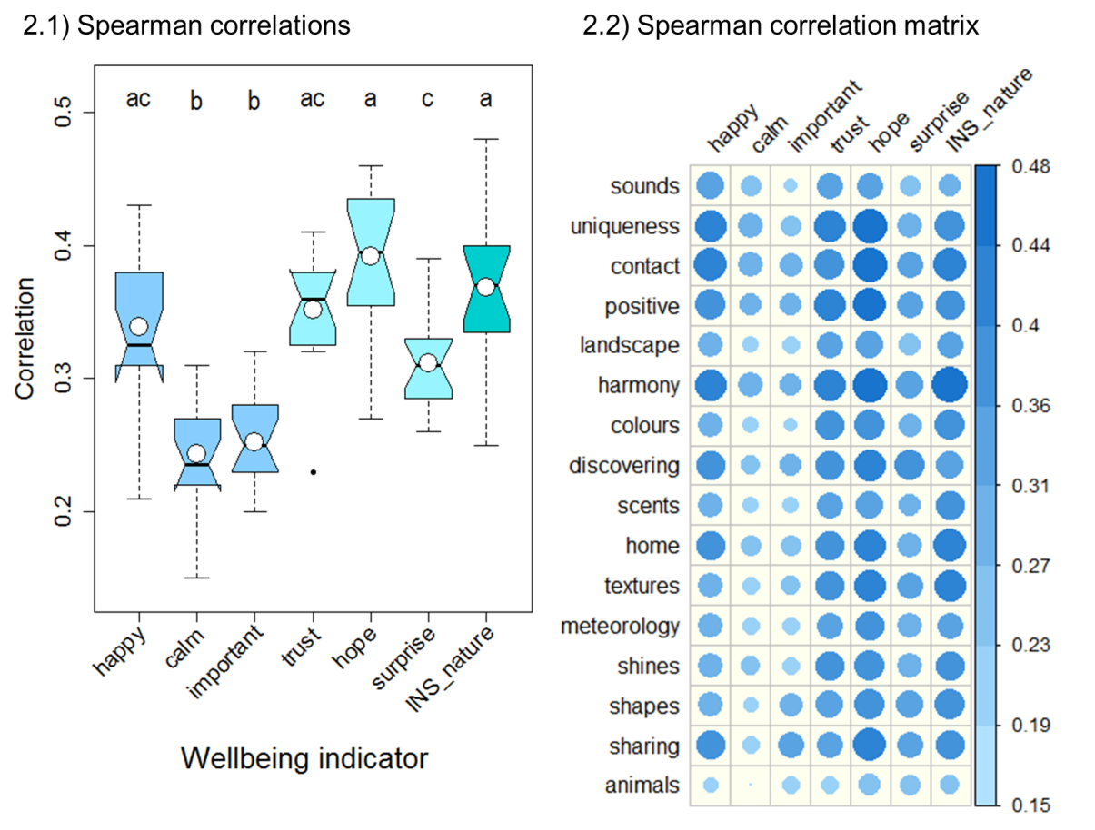
Figure 2. Graphics illustrating the correlation patterns between the seven well-being indicators and the 16 natural elements perceived in forest bathing walks. The boxplot in the left panel (2.1) shows non-parametric Spearman rho correlation values for the seven well-being indicators. Horizontal lines within boxes indicate medians and white circles indicate means; the bottom and top of each box indicate the first and third quartiles (the 25th and 75th percentiles), and the whiskers below and above each box indicate the furthest data without counting outliers, which, in case there are any, will be represented with black circles (outliers are data greater than the third quartile + 1.5 × third quartile–first quartile or smaller than the first quartile + 1.5 × third quartile–first quartile). Different letters above the boxes show significant differences in the post-hoc Dunn tests after a significant Kruskal–Wallis test. A notch is drawn on each side of the indicator. If the notches of two plots do not overlap, this is “strong evidence” that the two medians differ [71]. Right panel (2.2) displays the detailed correlation matrix among well-being indicators (top horizontal axis) and natural elements perceived (left vertical axis). The circle size and colour gradient indicate the length of the correlation (as shown in the right scale bar). The complete set of correlation scores and p-values for all indicators can be seen in Tables S4 and S5, respectively, in the Supplementary Materials.

3.2. Sociodemographic and Temporal Factors Contributing to Subjective Well-being
Regarding the effect of sociodemographic and temporal factors, we found four clear patterns shown by the significant Kruskal–Wallis analyses and linked to factors such as gender, setting, world area, and season (Figure 3 and Table S6 in the Supplementary Materials). The dataset showed a strong pattern by gender since this factor was significant for 20 of the 23 indicators of well-being and natural elements perceived (Figure 3 and Table S6). Women scored higher than men for all 20 indicators found to be statistically significant (Figure 4.1 and Figure S1 in the Supplementary Materials).
There was also a clear pattern linked to the setting factor, with significant Kruskal–Wallis results for 17 of the 23 indicators analysed (Figure 3 and Table S6 in the Supplementary Materials). Among the different categories of the factor, no differences were found between natural settings and urban parks for emotions, feelings, and natural elements perceived in general, with the exception of the nature connection indicator INS, which was lower in urban parks in comparison to natural settings (Figure 4.2 and Figure S2 in the Supplementary Materials). Furthermore, the “other” category, which mostly included forest bathing sessions developed in high-standing holiday resorts or in rural villas/cottages, was rated higher in comparison with the other two categories (Figure 4.2 and S2).
The strongest sociodemographic pattern was geographical since the factor world area was significant for all 23 indicators (Figure 3 and Table S6 in the Supplementary Materials). Feelings, emotions, and natural elements perceived showed, in general, higher scores in Latin America and then lower scores in Asia, North America, Mediterranean Europe, and North Western Europe (Figure 4.3 and Figure S3 in the Supplementary Materials). There were a few exceptions for Asia, which showed the lowest scores for the emotion of trust, the nature connection indicator INS, and the higher scores for the perceived natural elements in animals (Figure 4.3 and S3).
Results also showed a quite clear pattern associated with the factor season, with significant Kruskal–Wallis tests for 12 of the 23 indicators analysed (Figure 3 and Table S6 in the Supplementary Materials). Among the four categories of the factor, in general, winter and autumn (hot or long-day seasons in the southern hemisphere) were scored higher, and spring and summer (cold or short-day seasons in the southern hemisphere) were scored lower. The exception, in this case, was the perceived natural element sounds, which were rated the lowest in autumn (Figure 4.4 and Figure S4 in the Supplementary Materials).
Finally, the dataset did not show any or a clear pattern for the ages of participants (factor age), the number of FB sessions previously performed (number of walks), the week of the month when the session was performed (month week), or the weekday when the session was performed (weekday) (Figure 3 and Table S6 in the Supplementary Materials).
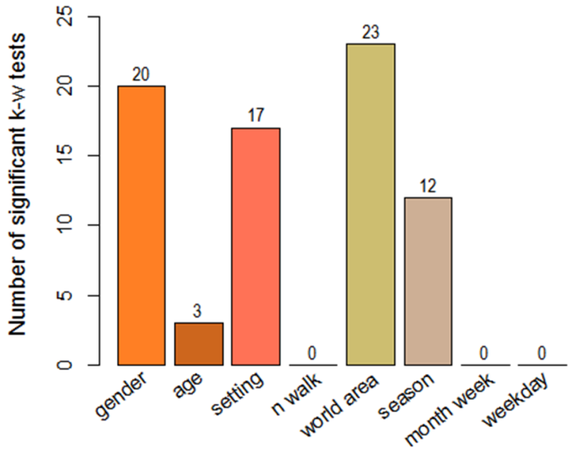
Figure 3. Bar plot illustrating the sociodemographic patterns within the dataset of 23 indicators collected following forest bathing walks. Bars show the number of significant tests obtained after performing Kruskal–Wallis tests on the 23 indicators, by eight sociodemographic and temporal factors. Factors such as nationality and country were excluded because of the low numbers of cases in many categories; then, geographic patterns were investigated by the world area factor (see Section 2 for detailed explanations).
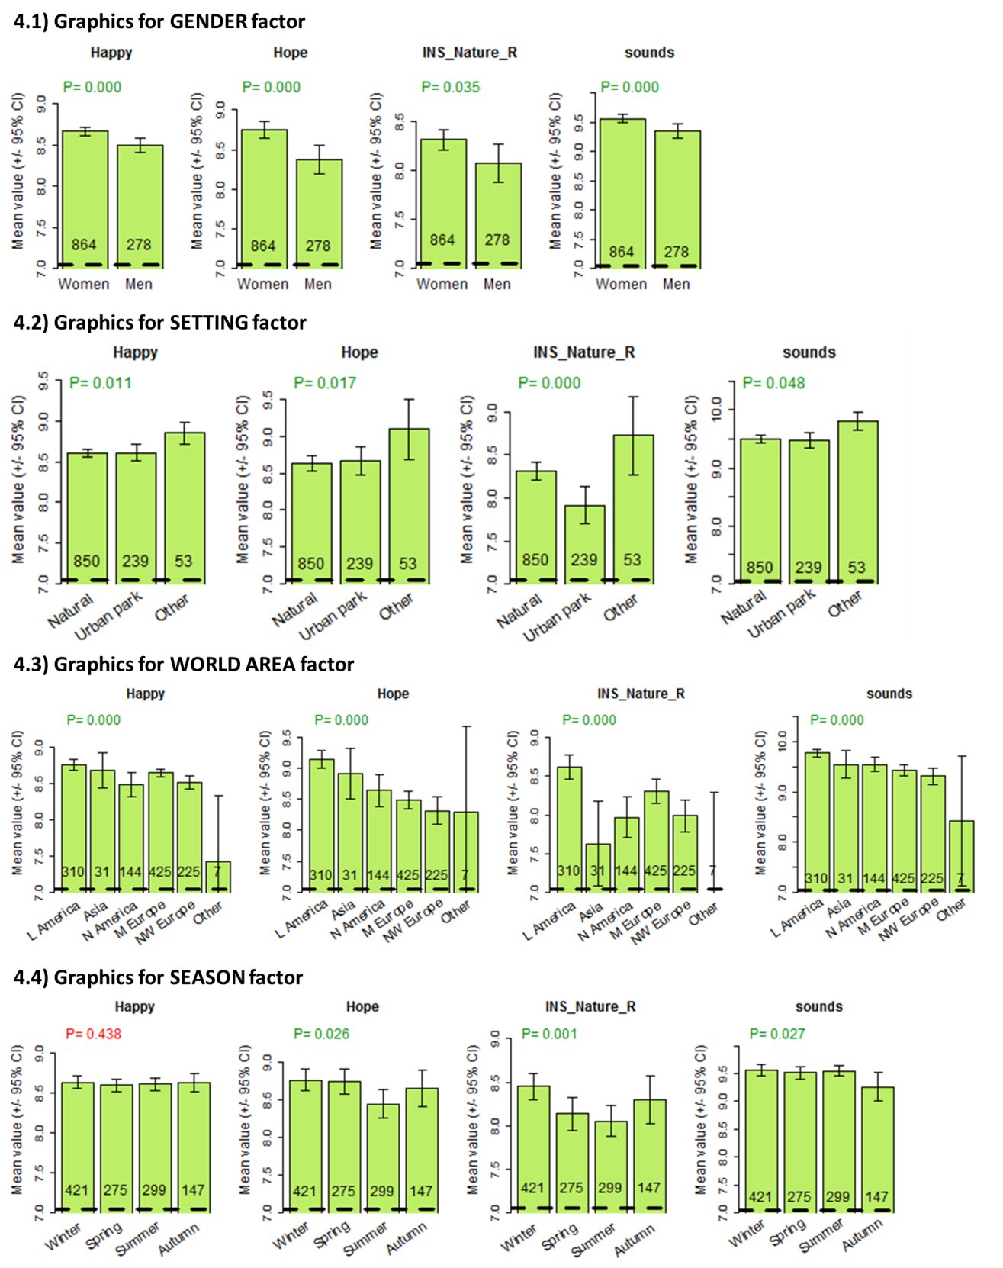
Figure 4. Examples of sociodemographic patterns found within the dataset. We represented the feeling happy, the emotion of hope, the nature connection indicator INS, and the perceived natural element sounds for the sociodemographic factors that showed strong patterns: gender, setting, world area, and season (see Tables 1 and 2 for detailed definitions). Upper bar lines show the mean score and error bars represent the 95% CI to visually reveal statistical differences among categories. Sample sizes are given at the bar’s base. The p-values obtained in the Kruskal–Wallis tests are shown below the indicator name (green = significant, red = non-significant). For this representation, the nature connection indicator INS was rescaled from 0–6 to 1–10 to bring it to a similar range as the other indicators (INS_Nature_R). Detailed p-values of Kruskal–Wallis analyses for all indicators by all factors can be seen in Table S6 in the Supplementary Materials. Bar plots for all 23 indicators against the four sociodemographic factors gender, setting, world area, and season can be seen in Figure S1, S2, S4, and S5, respectively, in the Supplementary Materials.

4. Discussion

4.1. Rating Emotional and Nature Connection Indicators of Well-being
With regards to the first objective of this study, our results indicate that after FB walks, the emotional and nature connection indicators that were rated the highest were trust, followed by hope, and surprise with respect to emotions. In the same way, the feelings that were rated the highest were happy, followed by calm and important. This finding is consistent with existing literature that has largely highlighted that nature and connecting with nature can elicit two distinct types of positive emotions: low arousal, or eudaimonic (feelings of calm, emotions of trust and hope), and high arousal, or hedonic (feelings of happiness and surprise), and also help regulate emotions through soothing and calming the parasympathetic system [5,12,35]. For example, McEwan et al. (2021) [12] assessed the impact of FB on different types of positive emotions and found that low arousal positive emotions, such as relaxation, increased to a greater extent than high arousal positive emotions, such as feeling excited. Likewise, Pritchard et al. (2020) [5] found that low arousal eudaimonic well-being (having purpose and meaning in life) showed a greater association with NC than high arousal hedonic well-being (momentary pleasure). According to Kappas (2011) [72], the analysis of emotions should include their regulation properties in terms of how balance is kept between different types of positive and negative emotions. The three circle model of emotional regulation [73,74] presents a model that distinguishes between two types of positive affect and describes their ability to regulate the threat (fight-or-flight) system. The threat system can be downregulated by either increasing drive (motivation and high arousal positive emotions) relating to accruing status and resources or, in contrast, by increasing soothing low arousal positive emotions, which are related to mammalian-attachment behaviours such as bonding and affiliation. Richardson et al. (2016) [35] suggested that the three circle model could provide a useful framework for interpreting the benefits of spending time in nature. In the systematic review and meta-analysis conducted by Kotera et al. (2022) [14] on the impact of forest bathing on mental well-being, they found that although not explicitly explored, findings accord with the three emotion regulatory systems model [73,74]. In general, our results support previous research underlining the association between spending time in nature and experiencing low arousal or eudaimonic positive emotions (i.e., [5,12,14]).
With respect to NC, our study found high ratings of the NC indicator INS following a FB with an NCA session. This result is consistent with previous research that has found associations between forest bathing and high scores in nature connection [75,76]. Furthermore, and with reference to the correlation between NC and a low arousal positive effect, our results contribute to existing research showing that connecting with nature elicits low arousal positive emotions. In this way and supporting our findings, despite obtaining a small but significant size effect, the results of the meta-analysis conducted by Capaldi et al. (2014) [77], including 30 samples (n = 8523), highlight that those who are more connected to nature tend to experience more positive effects, vitality, and life satisfaction, compared to those who are less connected to nature.

4.2. Natural Elements Contributing to Well-being
The second objective of our study was to examine which natural elements contributed the most to well-being. In terms of which natural elements contributed the most to well-being, the highest ratings were for sounds (sounds of nature: birds, water, breeze, etc.), followed in descending order by uniqueness (appreciating the uniqueness of nature and the lived experience), contact (experiencing the joy of contact with nature), positive (environments favourable to positive feelings, emotions, and thoughts), landscape (appreciation of beauty in nature on a large scale: harmony in landscapes, mountains, oceans, etc.), harmony (integrating into the harmony of nature), colours (colour and colour shades), discovering (discovering new aspects of nature), scents (scents from flowers, plants, soil, or other smells), home (nature as part of home), textures (textures of natural objects), meteorology (dynamic and specific aspects of meteorology: rain, breeze, sun, clouds, etc.), shines (light and shadows), shapes (shapes and fractal geometries: trees, spider webs, leaf shapes, etc.), sharing (sharing and integrating nature experiences in circles and their dynamics), and animals (presence of mammals, birds, or insects). It is noteworthy that the majority of natural features were highly rated by participants. The highest positive correlations with natural elements were with the emotions hope and trust and the indicator for nature connection (INS) and feeling happy, indicating that the perception of these natural elements contributed strongly to low and high arousal positive emotions and nature connection. Well-being indicators of surprise, calm, and important showed positive but lower correlations with the natural elements contributing to well-being.
Some of the natural elements that were scored highest by the participants, such as sounds (sounds of nature, birds, water, breeze, etc.), landscape (appreciation of beauty in nature on a large scale: harmony in landscapes, mountains, oceans, etc.), and scents (scents from flowers, plants, soil, or other smells), showed lower associations with well-being indicators in comparison with others (i.e., uniqueness (appreciating the uniqueness of nature and the lived experience), contact (experienced the joy of contact with nature), and harmony (integrating into the harmony of nature). In contrast, other natural elements rated lower by the participants, such as home (nature as part of home) and sharing (sharing and integrating nature experiences in circles and their dynamics), showed higher associations with well-being. We think that this result may be attributable to a variety of reasons, for instance, a merely given definition of the natural elements in this study (e.g., meteorology as dynamic and specific aspects of meteorology: rain, breeze, sun, clouds) and the subjective interpretation of them, or the tendency to rate higher the elements that are easier to perceive. Additionally, this result could be congruent with the existing evidence of the multifactorial therapeutic benefit of FB [78]. Therefore, well-being is not induced by a single specific factor but by the complex ecosystem as a whole, such as the green scenery, fresh air, sunlight, clean water, rocks, soil, soothing sounds of streams, waterfalls, and birds, and the natural aromas of trees, plants, and flowers [38]. In addition, forest features, sensorial dimensions of the forest, and the participants’ individual traits and reactions to these [79].
With regards to animals, it was unexpected to find this indicator to obtain the lowest score and even to correlate with a nervous feeling. On the one hand, this result could be interpreted taking into consideration that participants mostly did not encounter animals during the FB session. Smith et al. (2016) [80] indicated that a visible element may mostly include large (size of individuals) sedentary species, and less visible elements may include species that are shy, cryptic (mostly hidden from sight even if they are large), very small, etc. Furthermore, they considered them to be best viewed at the optimum time of day for the component species (e.g., birds may be best seen early in the morning). Alternatively, the result might be explained by biophobia, where animals are seen more as a danger than a well-being resource. It is important to note that the research took place across 35 countries, and in some of these countries, dangerous animals (e.g., snakes) or annoying animals (e.g., mosquitoes) might be encountered more frequently. Previous studies performed in areas where the presence of dangerous animals is not a concern have shown that animals may be an important source of well-being. As illustrative examples, residents in Ottawa, Canada, showed that their neighbourhood satisfaction was positively related to the bird species richness nearby [81], and visitors of urban green spaces in Sheffield, UK, showed that positive emotional responses were directly correlated with levels of bird biodiversity within the green space [82].
Immersing with nature while paying attention to the five senses are common interventions in forest bathing (Miyazaki (2018) [16] and Li (2019) [83]). Therefore, we examined the relationship between natural elements contributing to well-being and which senses participants rated as contributing the most to well-being. In our study, the majority of natural elements are highly rated by participants, and sound (e.g., sounds of nature as birds, water, breeze, etc.) would precede vision (e.g., appreciation of beauty in nature on a large scale; colour and colour shades), followed by smell (e.g., scents from flowers, plants, soil, or other smells) and touch (e.g., textures of natural objects). This is in slight contrast to previous research, which found that vision was the most highly rated sense, followed by sound, smell, touch, and taste [12]. However, the importance of sound has been largely documented to improve mood and cognitive performance and decrease stress and annoyance [46]. In addition, sound has been linked to feeling more in the present moment, more relaxed, and less bored [50].

4.3. Effects of Sociodemographic and Temporal Factors
Concerning the last objective of our study, which examined the contribution of sociodemographics to well-being and nature connection, results revealed significant associations for gender, setting (environment in which the FB was performed: natural, urban park, other), world area (Latin America, North America, Asia, Mediterranean Europe, NW Europe, others), and season (in which the session was run). No significant associations were found for age, number of walks (number of sessions in which the participant had previously been involved), weekday (day of the week), and month week (week of the month). Gender, setting, world area, and season showed strong relationships with well-being. In terms of gender, women showed higher scores for the contribution of natural elements to well-being. This is consistent with a review conducted by Kotera et al. (2022) [14], in which females experienced greater benefits of FB on mental health. In addition, in our study, it is worth mentioning that in terms of NC, females generally had higher connection scores than males, findings that are consistent with Hughes et al. (2019) [75]. With regards to the setting, differences were found between natural settings and urban parks for emotions, feelings, and natural elements perceived in general. In this sense, greater autonomic relaxation related to parasympathetic and sympathetic nervous activity has been observed during walking in forest environments compared with walking in urban environments [84]. However, it seems that more expensive nature sessions (including staying in villas and rural cottages) give higher returns in terms of well-being, according to our results. In this sense, it must be taken into consideration that no further information about the duration of stay in the villas compared with the duration of a FB walk in a natural or urban setting was collected. On the other hand, differences in nature and parks among the 35 countries should have a minor influence on the results. First, countries were not used directly in the analyses. We used groups of countries (the world area factor) where countries in large areas similar to continents were joined. In addition, although the places where nature activities were performed may differ among countries or world areas involved, this study is not based on the biological characteristics of the ecosystems but rather on outputs mostly present everywhere (natural elements perceived, Table 2) linked to human senses. Besides and with regards to NC, our results indicate that the nature connection indicator INS was lower in urban parks in comparison to natural settings. In a broader sense, it has been found that people feel closer and more connected to nature when they are more frequently exposed to natural environments [9].
In terms of world areas, there were higher ratings from Latin America, followed by North America, Asia, Mediterranean Europe, and North Western Europe, with higher ratings overall in the Southern Hemisphere compared with the Northern Hemisphere. These results are consistent with our finding that, in terms of the season, winter was associated with the highest well-being ratings. It must be recalled that winter in the southern hemisphere is equivalent to summer in the northern hemisphere, with longer days and more sunshine hours.
With regard to the number of walks, most participants in this study engaged in only one walk. A limitation of previous forest bathing research is that it often only examines the impact of one walk and does not explore the cumulative effects of engaging in multiple walks. Therefore, although this study is unique in assessing whether participants have engaged in more than one walk, there is not enough data on cumulative walks to examine the impact of multiple walks on well-being. Further research on the practise of longer-term FB should be carried out to examine the impact of the practise in the mid- and long-term. Despite that, it has been reported that high-frequency users of forest environments are less stressed than low-frequency users [79].
Our results did not show differences in well-being experienced on different weeks of the month or different days of engaging with FB. To the knowledge of the authors, there is scarce research that has explored the difference in well-being outcomes according to the day of the week or the week of the month; hence, this is another unique quality of our research, and there is no previous data with which to compare our findings.
Despite our efforts, some limitations are acknowledged. First, there is a lack of prior research studies on the topics addressed in this paper in terms of emotions, feelings, natural elements, and sociodemographics. In this sense, we acknowledge deficiencies with the instruments used to collect the data. Further studies could include more detailed key natural elements to determine their impact on well-being. For instance, in our assessment of different settings, the setting that had the greatest contribution to well-being was a villa. However, this finding could be due to a longer duration of exposure to natural settings rather than the setting itself (i.e., one does not stay in a villa for 2 h but rather several days). Future research should directly compare different settings, ranging from managed to unmanaged, for the same duration to determine which setting is most beneficial. Secondly, with regards to NC and its evaluation, we used the INS only following the FB with NCA sessions and not at baseline, meaning it was not possible to identify the change in connectedness. It would have been interesting to include a pre- and post-design evaluation study to assess it.
5. Conclusions
Despite its limitations, this multi-country study has been one of the first attempts to examine the possible associations between well-being and the natural elements perceived during the forest bathing session. We showed that some elements, such as sounds of nature (birds, water, breeze, etc.), are perceived as most important to participants. Further studies could encourage FB, FT, and nature-based organizations and trainers to develop more enhanced interventions in natural environments. As seen from the above discussion, sound was identified as the sense that contributed the most to well-being; therefore, FB guides should prioritise opportunities to notice sounds in their sessions and conduct sessions in areas that have many opportunities to engage with natural sounds, such as bird songs and running water. Appreciating the uniqueness of nature and the lived experience, experiencing the joy of contact with nature, and integrating into the harmony of nature were rated as providing the greatest contribution to well-being, and therefore sessions should direct the participant’s attention to these elements. Finally, ratings were higher in specialised nature resort areas, indicating that providing opportunities for forest bathing ‘retreats’ in wilder, more biodiverse areas and perhaps with longer durations could provide optimum well-being benefits.
Supplementary Materials: The following supporting information can be downloaded at: www.mdpi.com/xxx/s1.
Author Contributions: Conceptualization, M.S.-M.; A.M.; K.M., and A.G.; methodology, A.M.; software, A.M.; validation, A.M. and M.S.-M.; formal analysis, A.M.; investigation, A.G. and A.C.; resources, A.G.; data curation, A.C.; A.G., and A.M.; writing—original draft preparation, K.M.; M.S.-M., and A.M.; writing—review and editing, K.M. and M.S.-M.; visualization, A.G. and M.S.-M.; supervision, K.M.; project administration, A.G. All authors have read and agreed to the published version of the manuscript.
Funding: This research received no external funding.
Data Availability Statement: Database has still pending analyses and other articles in projects. It will be provided in the last article when applicable.
Acknowledgments: We would especially like to acknowledge and thank all the FB participants, and especially all the FB guides and FT practitioners that provided their time and expertise to ensure the feasibility and success of the FB with NCA sessions.
Conflicts of Interest: The authors declare no conflicts of interest.

References
- Douglas, I. Urban ecology and urban ecosystems: Understanding the links to human health and well-being. Curr. Opin. Environ. Sustain. 2012, 4, 385–392.
- Jimenez, M.P.; DeVille, N.V.; Elliott, E.G.; Schiff, J.E.; Wilt, G.E.; Hart, J.E.; James, P. Associations between nature exposure and health: A review of the evidence. Int. J. Environ. Res. Public Health 2021, 18, 4790.
- Wood, L.; Hooper, P.; Foster, S.; Bull, F. Public green spaces and positive mental health—Investigating the relationship between access, quantity and types of parks and mental wellbeing. Health Place 2017, 48, 63–71.
- Martin, L.; White, M.P.; Hunt, A.; Richardson, M.; Pahl, S.; Burt, J. Nature contact, nature connectedness and associations with health, wellbeing and pro-environmental behaviours. J. Environ. Psychol. 2020, 68, 101389.
- Pritchard, A.; Richardson, M.; Sheffield, D.; McEwan, K. The relationship between nature connectedness and eudaimonic well-being: A meta-analysis. J. Happiness Stud. 2020, 21, 1145–1167.
- Wilson, E.O. Biophilia: The Human Bond with Other Species; Harvard University Press: Cambridge, MA, USA, 1986.
- McPherson Frantz, C.; Mayer, F.S. The importance of connection to nature in assessing environmental education programs. Stud. Educ. Eval. 2014, 41, 85–89.
- Ives, C.D.; Giusti, M.; Fischer, J.; Abson, D.J.; Klaniecki, K.; Dorninger, C.; Laudan, J.; Barthel, S.; Abernethy, P.; Martín-López, B.; et al. Human–nature connection: A multidisciplinary review. Curr. Opin. Environ. Sustain. 2017, 26, 106–113.
- Hinds, J.; Sparks, P. Engaging with the natural environment: The role of affective connection and identity. J. Environ. Psychol. 2008, 28, 109–120.
- Mayer, F.S.; Frantz, C.M. The connectedness to nature scale: A measure of individuals’ feeling in community with nature. J. Environ. Psychol. 2004, 24, 503–515.
- Richardson, M.; Hamlin, I.; Elliott, L.R.; White, M.P. Country-level factors in a failing relationship with nature: Nature connectedness as a key metric for a sustainable future. Ambio 2022, 51, 2201–2213.
- McEwan, K.; Giles, D.; Clarke, F.; Kotera, Y.; Evans, G.; Terebenina, O.; Minou, L.; Teeling, C.; Basran, J.; Wood, W.; et al. A pragmatic controlled trial of forest bathing compared with compassionate mind training in the UK: Impacts on self-reported wellbeing and heart rate variability. Sustainability 2021, 13, 1380.
- Wen, Y.; Yan, Q.; Pan, Y.; Gu, X.; Liu, Y. Medical empirical research on forest bathing (shinrin-yoku): A systematic review. Environ. Health Prev. Med. 2019, 24, 70.
- Kotera, Y.; Richardson, M.; Sheffield, D. Effects of shinrin-yoku (forest bathing) and nature therapy on mental health: A systematic review and meta-analysis. Int. J. Ment. Health Addict. 2022, 20, 337–361.
- Li, Q. Shinrin-yoku: The art and science of forest bathing. In Forest Bathing: How Trees Can Help You Find Health and Happiness; Penguin Random House: London, UK, 2018; p 224.
- Miyazaki, Y. Shinrin-Yoku: The Japanese Way of Forest Bathing for Health and Relaxation; Aster: London, UK, 2018; p 192.
- Forest Therapy Society, Forest Therapy. 2022. Available online: https://www.fo-society.jp/en/ (accessed on 23 October 2022).
- Forest Therapy Hub, What are Forest Bathing and Forest Therapy? 2022. Available online: https://foresttherapyhub.com/ (accessed on 23 October 2022).
- Gesse, A. Sentir el Bosque: La Experiencia del Shinrin-Yoku (Baño de Bosque); Grijalbo: Barcelona, Spain, 2018; p. 224.
- Gesse, A.; Altuna, G.; Camacho, A.; Ayats, M.; Ferraro, R.; Filgueira, L. Standard of Essential Characteristics of Healthy Green Spaces. Conclusions of the Study on the Characteristics of Forest Bathing and Forest Therapy Itineraries; Forest Therapy Hub: 2022; p. 55.
- Chun, M.H.; Chang, M.C.; Lee, S.-J. The effects of forest therapy on depression and anxiety in patients with chronic stroke. Int. J. Neurosci. 2017, 127, 199–203.
- Chen, H.-T.; Yu, C.-P.; Lee, H.-Y. The effects of forest bathing on stress recovery: Evidence from middle-aged females of Taiwan. Forests 2018, 9, 403.
- Yau, K.K.-Y.; Loke, A.Y. Effects of forest bathing on pre-hypertensive and hypertensive adults: A review of the literature. Environ. Health Prev. Med. 2020, 25, 23.
- Mao, G.X.; Lan, X.G.; Cao, Y.B.; Chen, Z.M.; He, Z.H.; Lv, Y.D.; Wang, Y.Z.; Hu, X.L.; Wang, G.F.; Yan, J. Effects of short-term forest bathing on human health in a broad-leaved evergreen forest in Zhejiang province, China. Biomed. Environ. Sci. 2012, 25, 317–324.
- Zhou, C.; Yan, L.; Yu, L.; Wei, H.; Guan, H.; Shang, C.; Chen, F.; Bao, J. Effect of short-term forest bathing in urban parks on perceived anxiety of young-adults: A pilot study in Guiyang, southwest China. Chin. Geogr. Sci. 2019, 29, 139–150.
- Bielinis, E.; Takayama, N.; Boiko, S.; Omelan, A.; Bielinis, L. The effect of winter forest bathing on psychological relaxation of young Polish adults. Urban For. Urban Green. 2018, 29, 276–283.
- Markwell, N.; Gladwin, T.E. Shinrin-yoku (forest bathing) reduces stress and increases people's positive affect and well-being in comparison with its digital counterpart. Ecopsychology 2020, 12, 247–256.
- Muro, A.; Mateo, C.; Parrado, E.; Subirana-Malaret, M.; Moya, M.; Garriga, A.; Canals, J.; Chamarro, A.; Sanz, A. Forest bathing and hiking benefits for mental health during the COVID-19 pandemic in Mediterranean regions. Eur. J. For. Res. 2023, 142, 415–426.
- Peterfalvi, A.; Meggyes, M.; Makszin, L.; Farkas, N.; Miko, E.; Miseta, A.; Szereday, L. Forest bathing always makes sense: Blood pressure-lowering and immune system-balancing effects in late spring and winter in central Europe. Int. J. Environ. Res. Public Health 2021, 18, 2067.
- Roviello, V.; Roviello, G. Less COVID-19 deaths in southern and insular Italy explained by forest bathing, Mediterranean environment, and antiviral plant volatile organic compounds. Environ. Chem. Lett. 2021, 20, 3.
- Vujcic, M.; Tomicevic-Dubljevic, J. Urban forest benefits to the younger population: The case study of the city of Belgrade, Serbia. For. Policy Econ. 2018, 96, 54–62.
- McEwan, K.; Ferguson, F.J.; Richardson, M.; Cameron, R. The good things in urban nature: A thematic framework for optimising urban planning for nature connectedness. Landsc. Urban Plan. 2020, 194, 103687.
- McEwan, K.; Richardson, M.; Sheffield, D.; Ferguson, F.J.; Brindley, P. A smartphone app for improving mental health through connecting with urban nature. Int. J. Environ. Res. Public Health 2019, 16, 3373.
- Lumber, R.; Richardson, M.; Sheffield, D. Beyond knowing nature: Contact, emotion, compassion, meaning, and beauty are pathways to nature connection. PLoS ONE 2017, 12, e0177186.
- Richardson, M.; McEwan, K.; Maratos, F.; Sheffield, D. Joy and calm: How an evolutionary functional model of affect regulation informs positive emotions in nature. Evol. Psychol. Sci. 2016, 2, 308–320.
- Dahlgren, G.; Whitehead, M. Policies and Strategies to Promote Social Equity in Health. Background Document to WHO—Strategy Paper for Europe; Institute for Futures Studies: Stockholm, Sweden, 1991; p. 69.
- Barton, H.; Grant, M. A health map for the local human habitat. J. R. Soc. Promot. Health 2006, 126, 252–253.
- Kuo, M. How might contact with nature promote human health? Promising mechanisms and a possible central pathway. Front. Psychol. 2015, 6, 1093.
- Bermejo-Martins, E.; Pueyo-Garrigues, M.; Casas, M.; Bermejo-Orduna, R.; Villarroya, A. A forest bathing intervention in adults with intellectual disabilities: A feasibility study protocol. Int. J. Environ. Res. Public Health 2022, 19, 13589.
- Bentley, P.R.; Fisher, J.C.; Dallimer, M.; Fish, R.D.; Austen, G.E.; Irvine, K.N.; Davies, Z.G. Nature, smells, and human wellbeing. Ambio 2023, 52, 1–14.
- Gaviria, J.; Rey, G.; Bolton, T.; Delgado, J.; Van De Ville, D.; Vuilleumier, P. Brain functional connectivity dynamics at rest in the aftermath of affective and cognitive challenges. Hum. Brain Mapp. 2021, 42, 1054–1069.
- Ulrich, R.S. View through a window may influence recovery from surgery. Science 1984, 224, 420–421.
- Weinstein, N.; Przybylski, A.K.; Ryan, R.M. Can nature make us more caring? Effects of immersion in nature on intrinsic aspirations and generosity. Pers. Soc. Psychol. Bull. 2009, 35, 1315–1329.
- Zabini, F.; Albanese, L.; Becheri, F.R.; Gavazzi, G.; Giganti, F.; Giovanelli, F.; Gronchi, G.; Guazzini, A.; Laurino, M.; Li, Q.; et al. Comparative study of the restorative effects of forest and urban videos during covid-19 lockdown: Intrinsic and benchmark values. Int. J. Environ. Res. Public Health 2020, 17, 8011.
- Antonelli, M.; Barbieri, G.; Donelli, D. Effects of forest bathing (shinrin-Yoku) on levels of cortisol as a stress biomarker: A systematic review and meta-analysis. Int. J. Biometeorol. 2019, 63, 1117–1134.
- Buxton, R.T.; Pearson, A.L.; Allou, C.; Fristrup, K.; Wittemyer, G. A synthesis of health benefits of natural sounds and their distribution in national parks. Proc. Natl. Acad. Sci. USA 2021, 118, e2013097118.
- Gould van Praag, C.D.; Garfinkel, S.N.; Sparasci, O.; Mees, A.; Philippides, A.O.; Ware, M.; Ottaviani, C.; Critchley, H.D. Mind-wandering and alterations to default mode network connectivity when listening to naturalistic versus artificial sounds. Sci. Rep. 2017, 7, 45273.
- Stobbe, E.; Sundermann, J.; Ascone, L.; Kühn, S. Birdsongs alleviate anxiety and paranoia in healthy participants. Sci. Rep. 2022, 12, 16414.
- Ratcliffe, E.; Gatersleben, B.; Sowden, P.T. Bird sounds and their contributions to perceived attention restoration and stress recovery. J. Environ. Psychol. 2013, 36, 221–228.
- Pfeifer, E.; Fiedler, H.; Wittmann, M. Increased relaxation and present orientation after a period of silence in a natural surrounding. Nord. J. Music Ther. 2020, 29, 75–92.
- Chae, Y.; Lee, S.; Jo, Y.; Kang, S.; Park, S.; Kang, H. The effects of forest therapy on immune function. Int. J. Environ. Res. Public Health 2021, 18, 8440.
- Andersen, L.; Corazon, S.S.; Stigsdotter, U.K. Nature exposure and its effects on immune system functioning: A systematic review. Int. J. Environ. Res. Public Health 2021, 18, 1416.
- Antonelli, M.; Donelli, D.; Barbieri, G.; Valussi, M.; Maggini, V.; Firenzuoli, F. Forest volatile organic compounds and their effects on human health: A state-of-the-art review. Int. J. Environ. Res. Public Health 2020, 17, 6506.
- Li, Q.; Morimoto, K.; Nakadai, A.; Inagaki, H.; Katsumata, M.; Shimizu, T.; Hirata, Y.; Hirata, K.; Suzuki, H.; Miyazaki, Y.; et al. Forest bathing enhances human natural killer activity and expression of anti-cancer proteins. Int. J. Immunopathol. Pharmacol. 2007, 20 (Suppl. 2), 3–8.
- Li, Q.; Morimoto, K.; Kobayashi, M.; Inagaki, H.; Katsumata, M.; Hirata, Y.; Hirata, K.; Shimizu, T.; Li, Y.J.; Wakayama, Y.; et al. A forest bathing trip increases human natural killer activity and expression of anti-cancer proteins in female subjects. J. Biol. Regul. Homeost. Agents 2008, 22, 45–55.
- Li, Q.; Kobayashi, M.; Wakayama, Y.; Inagaki, H.; Katsumata, M.; Hirata, Y.; Hirata, K.; Shimizu, T.; Kawada, T.; Park, B.J.; et al. Effect of phytoncide from trees on human natural killer cell function. Int. J. Immunopathol. Pharmacol. 2009, 22, 951–959.
- Ikei, H.; Song, C.; Miyazaki, Y. Physiological effects of touching wood. Int. J. Environ. Res. Public Health 2017, 14, 801.
- Nielsen, C.C.; Gascon, M.; Osornio-Vargas, A.R.; Shier, C.; Guttman, D.S.; Becker, A.B.; Azad, M.B.; Sears, M.R.; Lefebvre, D.L.; Moraes, T.J.; et al. Natural environments in the urban context and gut microbiota in infants. Environ. Int. 2020, 142, 105881.
- Haahtela, T. A biodiversity hypothesis. Allergy 2019, 74, 1445–1456.
- Bradley, M.M.; Lang, P.J. Measuring emotion: The self-assessment manikin and the semantic differential. J. Behav. Ther. Exp. Psychiatry 1994, 25, 49–59.
- Wesley Schultz, P. The structure of environmental concern: Concern for self, other people, and the biosphere. J. Environ. Psychol. 2001, 21, 327–339.
- Kruskal, W.H.; Wallis, W.A. Use of ranks in one-criterion variance analysis. J. Am. Stat. Assoc. 1952, 47, 583–621.
- Dunn, O.J. Multiple comparisons using rank sums. Technometrics 1964, 6, 241–252.
- Benjamini, Y.; Hochberg, Y. Controlling the false discovery rate: A practical and powerful approach to multiple testing. J. R. Stat. Soc. Ser. B Methodol. 1995, 57, 289–300.
- R Core Team. R: A Language and Environment for Statistical Computing; R Foundation for Statistical Computing: Vienna, Austria, 2021. Available online: http://www.R-project.org/ (accessed on).
- Adler, D.; Kelly, S.T. Vioplot: Violin plot. R Package Version 0.3.7. 2020. Available online: https://github.com/TomKellyGenetics/vioplot (accessed on).
- Dinno, A. Dunn.Test: Dunn’s Test of Multiple Comparisons Using Rank Sums. R Package Version 1.3.5. 2017. Available online: https://CRAN.R-project.org/package=dunn.test (accessed on).
- Hope, R.M. Rmisc: Ryan Miscellaneous. R Package Version 1.5. 2013. Available online: https://CRAN.R-project.org/package=Rmisc (accessed on).
- Revelle, W. Psych: Procedures for Personality and Psychological Research; R Package Version 2.1.9; Northwestern University: Evanston, IL, USA, 2021. Available online: https://CRAN.R-project.org/package=psych (accessed on).
- Wei, T.; Simko, V. R Package ‘Corrplot’: Visualization of A Correlation Matrix, Version 0.92. 2021. Available online: https://github.com/taiyun/corrplot (accessed on).
- Chambers, J.M.; Cleveland, W.S.; Kleiner, B.; Tukey, P.A. Graphical Methods for Data Analysis; Wadsworth & Brooks/Cole: Belmont, MA, USA, 1983.
- Kappas, A. Emotion is not just an alarm bell—It’s the whole tootin’ fire truck. Cogn. Emot. 2011, 25, 785–788.
- Morrone-Strupinsky, J.V.; Lane, R.D. Parsing positive emotion in relation to agentic and affiliative components of extraversion. Pers. Individ. Differ. 2007, 42, 1267–1278.
- Gilbert, P. The Compassionate Mind: A New Approach to Life's Challenges; Constable & Robinson: London, UK, 2009; p. 544.
- Hughes, J.; Rogerson, M.; Barton, J.; Bragg, R. Age and connection to nature: When is engagement critical? Front. Ecol. Environ. 2019, 17, 265–269.
- McEwan, K.; Potter, V.; Kotera, Y.; Jackson, J.E.; Greaves, S. This is what the colour green smells like!’: Urban forest bathing improved adolescent nature connection and wellbeing. Int. J. Environ. Res. Public Health 2022, 19, 15594.
- Capaldi, C.A.; Dopko, R.L.; Zelenski, J.M. The relationship between nature connectedness and happiness: A meta-analysis. Front. Psychol. 2014, 5, 976–976.
- Oh, B.; Lee, K.J.; Zaslawski, C.; Yeung, A.; Rosenthal, D.; Larkey, L.; Back, M. Health and well-being benefits of spending time in forests: Systematic review. Environ. Health Prev. Med. 2017, 22, 71.
- Doimo, I.; Masiero, M.; Gatto, P. Forest and wellbeing: Bridging medical and forest research for effective forest-based initiatives. Forests 2020, 11, 791.
- Smith, M.J.; Wagner, C.; Wallace, K.J.; Pourabdollah, A.; Lewis, L. The contribution of nature to people: Applying concepts of values and properties to rate the management importance of natural elements. J. Environ. Manag. 2016, 175, 76–86.
- Hepburn, L.; Smith, A.C.; Zelenski, J.; Fahrig, L. Bird diversity unconsciously increases people’s satisfaction with where they live. Land 2021, 10, 153.
- Cameron, R.W.F.; Brindley, P.; Mears, M.; McEwan, K.; Ferguson, F.; Sheffield, D.; Jorgensen, A.; Riley, J.; Goodrick, J.; Ballard, L.; et al. Where the wild things are! Do urban green spaces with greater avian biodiversity promote more positive emotions in humans? Urban Ecosyst. 2020, 23, 301–317.
- Li, Q. Forest medicine: The secret power of shinrin-yoku. The art and science of japanese forest bathing. Вестник Международной академии наук. Русская секция 2019, 1, 82–84.
- Kobayashi, H.; Song, C.; Ikei, H.; Park, B.-J.; Lee, J.; Kagawa, T.; Miyazaki, Y. Forest walking affects autonomic nervous activity: A population-based study. Front. Public Health 2018, 6, 278.
Disclaimer/Publisher’s Note: The statements, opinions and data contained in all publications are solely those of the individual author(s) and contributor(s) and not of MDPI and/or the editor(s). MDPI and/or the editor(s) disclaim responsibility for any injury to people or property resulting from any ideas, methods, instructions or products referred to in the content.

