Blockchain application in supply chain chemical substance reporting
Sukhraj S. Takhar ª, Kapila Liyanage ^{b}
ª Assent Compliance, Ottawa, Canada and University of Derby, College of Engineering and Technology, United Kingdom.
^{b} University of Derby, College of Engineering and Technology, United Kingdom.
ª Raj.Takhar@assentcompliance.com, ^{b} K.Liyanage@derby.ac.uk

Abstract
Cryptocurrencies have gained prominence in recent years due to: (1) potential large increase in values; (2) transferability between different users, and (3) security and; (4) traceability of data enabled by blockchain methods. Blockchains utilize an underlying digital ledger system which enables data to be encrypted, recorded and traced in a more efficient manner than traditional paper and electronic based systems. Chemical regulations impose the need on industry to record the use of hazardous chemicals, which can vary from: (1) simple reporting, through to; (2) permits to continue the use substances, until alternative substances are identified; or even (3) substances become restricted for use, within specific use cases, or restricted from use outright. The importance of obtaining supply chain chemical substance reporting cannot be understated, without accurate supply chain data, and concise internal product definitions, the process of identifying chemical substances: (1) where used; (2) if they appear on the finished part, or; (3) only used in the process of manufacture, or (4) used in maintenance and repair of parts. The process of collating supply chain chemical substance reporting is lengthy process as data needs to be requested, collated, checked, verified and rolled up to assess potential business continuity risks, as well as varying levels of reporting activity back to employees, consumers and chemical regulators.
Keywords: Supply chain chemical substance reporting, blockchain, chemical regulations, business continuity risks, automating data processing and validation.

- Introduction
Classical economists (Smith and Skinner, 1982) argued economies emerged from the process of exchanging one product for another product to achieve some form of gain. The forms of exchange ranged from simple bartering exchanging one product for another, evolving to products exchanged for precious metals such as gold and silver. Modern industry is built on the need to achieve some form of economic gain from the exchange of products and services, for monetary exchange (Scott, 2016).
Modern technological advances have the seen a move away from paper-based exchanges, credit card payments, towards on-line transaction based systems such as PayPal, and more recently Bitcoin. At the heart of the bitcoin phenomenon lies the blockchain. A block can be considered as some form of data record. The term blockchain implies a chain of blocks (data records).
A supply chain (Takhar and Liyanage, 2017) can be considered a collection of organizations / elements, selling / flowing articles and services, downstream and upstream across a supply chain. The underlying aims of any supply chain are to (1) improve operational efficiency; (2) profitability; (3) achieve competitive advantage over competitors within the supply chain (Min and Zhou, 2002). A simple supply chain is shown in Figure 1:
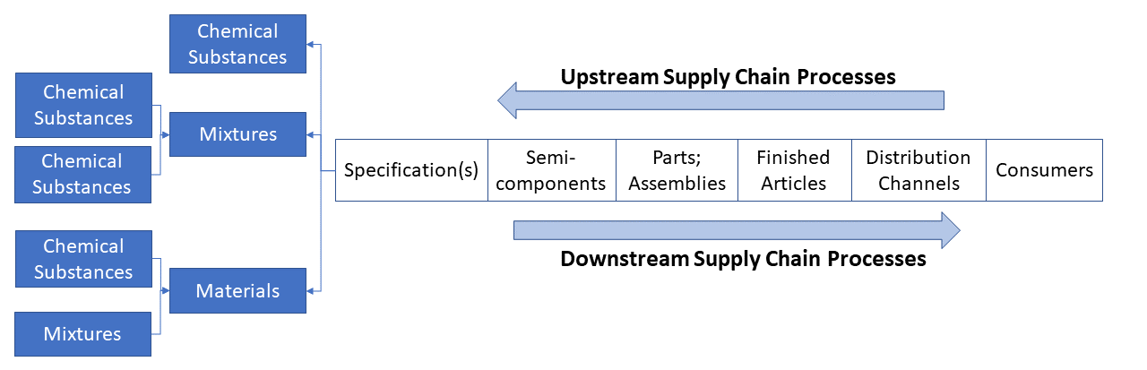
Figure 1: A simple supply chain (Sources: Takhar and Liyanage, 2017; Min and Zhou, 2002)
Articles, the name for a product within most chemical regulations are produced according to engineering definitions, which state: (1) required geometry sizes; (2) machining data; (3) material (on finished part) or process (used in the process of manufacture) specification(s) which state required substance(s), mixture(s) or material(s). Dependent on the industry context, specifications may be either highly defined (unique substance / mixture / material to a specification) or loosely defined (multiple options) (Takhar and Liyanage, 2017).
Regulations exist to impose a consistent set of norm/behaviours upon society. Chemical regulations first appeared in the 1960’s (European Commission, 1967) following the Thalidomide and Asbestos scandals. Chemical regulations ensure chemical substance usage is identified, tracked and where applicable controlled or restricted (Regulation of Chemicals Wiki, 2017). The evolution of chemical regulations such as: (1) European Union (EU) Restriction of Hazardous Substances (RoHS) (European Commission, 2002; European Commission 2011), and; (2) EU Registration Evaluation Authorisation and restriction of CHemicals (REACH) (European Commission, 2006) and other international regulations have facilitated the need to record, store and process increasingly large amounts of chemical substance related information (Selin, 2011; Molander and Rudén, 2012; Sivaprakash et al, 2009).
Regulatory substance(s) lists (European Commission 2011; ECHAa, 2018; ECHAb, 2018; ECHAc, 2018) define the substances that need to be traced and reported above a certain threshold level within supplied article(s). The regulatory substance lists define specific actions needed to be undertaken: (1) notifications to regulators; (2) material declarations from the supply chain; (3) declarations to consumers; (4) safe use guidance for anyone using supplied product(s); (5) request authorized use of a substance request; (6) even prohibit the use of a substance. This requires substance identification at the article level (Ashby, 2009; Molander et al, 2012).
- Purpose
This paper identifies a research gap between the potential application of blockchains in the field of supply chain chemical substance reporting (SCCSR). SCCSR refers to requesting substance data from the supply chain in relation to procured products. Not understanding internal product definitions and external supply chain usage of substances has the potential to cause supply disruption, in the event of additional controls or restrictions on substances.
Different chemical regulations exist globally, wherever a product is manufactured, distributed, purchased or even disposed / recycled. This results in industry needing to adhere to those applicable regional chemical regulations. A declarable chemical substance list will define the substances a supply chain is required to state compliance against, a material declaration template is used to collate the required information. Requesting the information is a very manually intensive process involving a lot of manual effort to transmit, receipt and verify data. The level of resources needed with increase depending on product complexity, supply chain size and locations.
Blockchains provide the potential to automate the requesting process, basic validation checks taking place, ahead of any possible manual data checking, allowing data to be ingested expediently into higher level internal systems.
- Design/methodology/approach
This study follows a two-step approach to conduct the literature review. The research consisted of (1) initial literature search against ‘Blockchain’, ‘Digital Ledger Technology’ (DLT) and ‘Hyperledger’ appearing within the title of an article. selecting the most relevant articles; (2) cross-referencing supply chain management articles; (3) application of previous work experience to derive a logical blockchain model for chemical substance reporting system.
The literature review is based on the (1) down selected articles, and additional research on (2) supply chain management, and (3) chemical substance reporting needs.
- Findings
  - Bitcoin highlight the potential for blockchains
Cryptocurrencies are digital currencies which are: (1) generated on a public network using encryption techniques to enable secure receipt and transactions; (2) not regulated by central banks (Cambridge, 2018; Oxford, 2018). Bitcoin is a cryptocurrency.
Bitgold (Szabo, 1994; Szabo, 1997) and bitcoin (Nakamoto, 2008) conceptualized the notion of virtual currencies, where the value of a non-physical digital items, due to a scarcity value, could achieve a similar intrinsic value as physical money. Economists predicted the impact of e-cash technologies as being akin to cash transactions, could potentially exploited by criminals (Friedman, 1999). Bitcoin facilitated the ability to transfer non-physical digital items between users in a secure manner, where change of ownership can be traced, verified and authenticated. In doing so, bitcoin caused a shift in users using traditional centralized financial system to a def-centralized financial system. The value of bitcoins has soared in recent times. By the same token economic instability (banking crisis, Brexit, stagnant stock exchanges) has seen the value of major currencies fall in in value over the same time frame (2010-2017) (99bitcoins, 2018; X-Rates, 2018; Statista, 2018; Investing, 2018), peaking at over $15K in Q4, 2017. Bitcoin is the most widely referenced application of blockchain technology.
  - Blockchain structure
Blockchains are “Peer to Peer” (P2P) networks (Techterms, 2018) consisting of computers connected across the internet with the ability to share data. P2P networks allow data to flow across computers without the need for a central server performing a management role.
The core elements, as shown in Figure 2, of a blockchain are: (1) timestamping; (2) hash algorithm; (3) cryptography; (4) digital ledger (5) distributed network. Blockchains can be considered decentralized systems for managing data, authenticating changes, thereby enabling traceability of changes to data. Blockchain networks are automated, with no human intervention, as such they benefit from not being prone to any human error (data entry, data processing, etc).
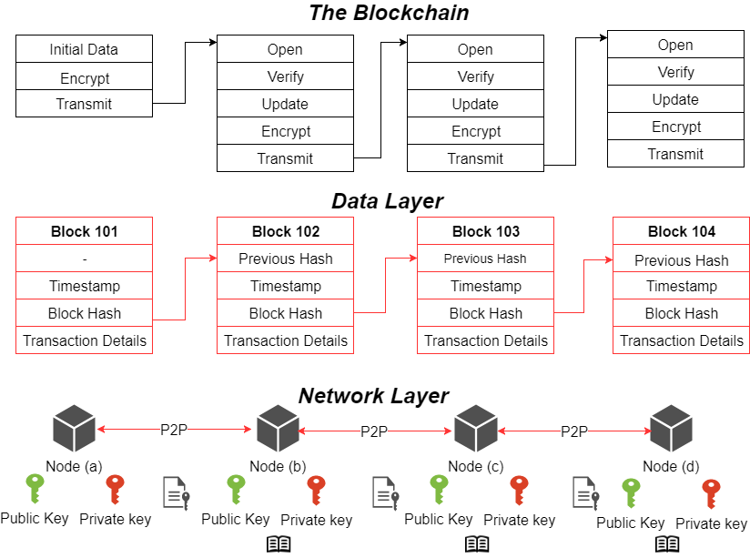
Figure 2: Blockchain structure high-level view (Sources: Szabo, 1997; Techterms, 2018; Haber and Stronetta, 1991)

Timestamping
Traditional paper system approaches for tracking changes to data, note down changes in notebooks and ledgers; with manual cross-checking and verification activities. Digital timestamping (Haber and Stronetta, 1991) is a method of applying a date and time to an electronic record to enable identification of when a record has been opened, viewed, changed or even deleted.

Hash algorithm
The hash algorithm can be described as a digital fingerprint system. The data record is traceable within a blockchain, via the use of a hash algorithm, which consists of a unique 32-digit number to identify and trace data. If the data is altered in any way then the 32-digit number is also altered. By maintaining a unique 32-digit number to a specific set of data, traceability can be achieved. Having a digital timestamp and hash algorithm enables the consensus, a state of agreement to be reached within the ledger.

Cryptographic keys
Cryptography forms a pivotal role within the blockchain, ensuring data records can be transmitted, receipted, amended in an encrypted manner. Public and private keys are used to maintain integrity. Where messages are encrypted with public keys, only users with a private key can decrypt and read the message.

Digital ledger
Traditional financial systems record financial transactions in a ledger format, detailing values flowing in and out of an account. These systems range from paper-based systems, to fully automated systems, there is usually an additional element of manual intervention which takes place to audit and verify data. A digital ledger records all the transactions, dependent on the blockchain type the records via the distributed network, updated, checked and verified by applicable nodes.

Distributed network
A distributed network in the context of a blockchain consists of: (1) computer (nodes); (2) nodes connect to other nodes via the internet and behave like a real network; (3) data is stored across nodes within the network, each node within the network has a copy of the digital ledger; (4) as transactions occur, each node within the network will receive a request message; (5) each node opening the request message updates their copy of the digital ledger; (6) as a node completes the update of their copy of the digital ledger, a message is passed onto other nearby nodes; (7) process of passing messages is repeated until all copies of ledger are updated and consensus is reached; (8) depending on whether the blockchain is public or private, certain features may be enabled/disabled dependent on the role of a specific node within a network.

Public and private blockchains
Public blockchains, see Figure 3 are open and anyone can participate within the network. Private blockchains are created by a network starter, who will invite other nodes being invited to participate. Examples include companies working together: (1) looking at replacement technologies for substances at risk of regulation; (2) design collaborations.
Private blockchains could co-exist with legal frameworks (Savelyev, 2017). Private blockchains can create features (via smart contracts) such as user acceptance signatures to confirm compliance to an agreement, in a public blockchain you would have the notion of a data record being opened, read and potentially updated, with consensus across the entire public blockchain implying agreement.
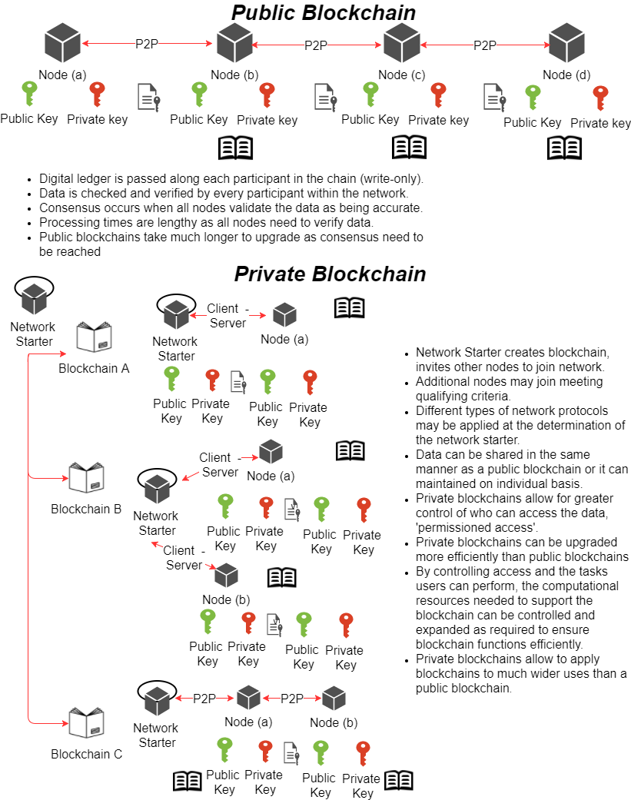
Figure 3: Public and Private blockchain comparison (Source: Savelyev, 2017)
  - Beyond blockchains

Standardised code
Public blockchains use open source code, as new blockchains have appeared, the original open source code has been extended with additional functionality. Issues arise in public blockchains when: (1) maintaining consistent code baselines across blockchains; (2) code changes must be agreed in each public blockchain by all parties which can take time, and any coding errors, could manifest quickly and take time to correct.
Private blockchains behaviours are less well known as: (1) most of the private blockchains are in a proof of concept mode; (2) organizations do not wish to release detailed data for fear of negative actions (hacking, competitor awareness). The correct methodology for private blockchains is to use standard open source code from a known code authority, where a specific set of attributes (data elements) can be parsed using standard open source code (Ethereum 2018; Corda, 2018).
Use of standardized code will enable greater adoption, as the code is known and not something completely new, or untested. In the future standards may define specific codes for certain blockchain behaviours to enable some form of blockchain code standardization.

Smart contracts
Smart contracts (Szabo, 1994; Szabo, 1996; Szabo, 1997) can be defined as business contracts which can be translated easily into computer code (Ethereum 2018; Corda, 2018) to enable digital contracts to be processed without human interaction the ability to observe, action, verify, enforce the terms of the original business contract.
(Hart and Holmström, 2016) heavily influenced smart contract theory to define processing and typical contract states (complete / incomplete). Early smart contract design focused on the use of digital cash payments using cryptography, enabling reduced transaction times and costs, suggesting smart property as the object which potentially changed ownership, via digital means (Szabo, 1994; Szabo, 1996; Szabo, 1997). It was argued existing paper-based contracts could be managed (1) more efficiently that using smart contracts which avoided the potential for human error; (2) more cost effectively using computational transaction costs versus manual input costs (Szabo, 1997). A conceptual flow of a smart contract originating from a normal contract (University of Oxford, 2016; TheFundsChain, 2017) is derived in Figure 4:
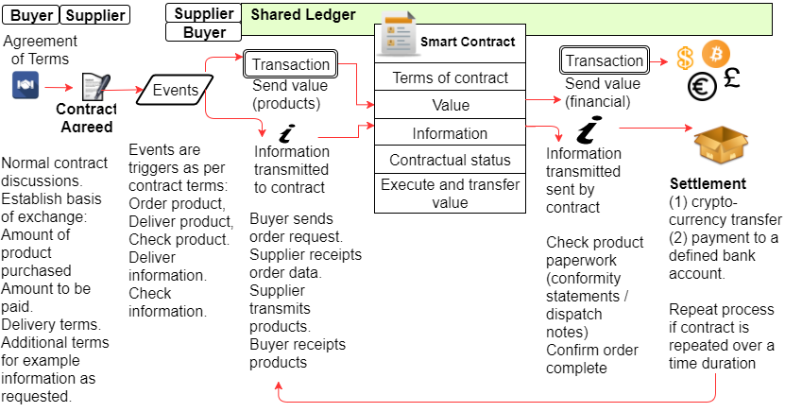
Figure 4: High level smart contract flow (Sources: Szabo, 1994; Szabo, 1996)
Smart contracts applied to a blockchains results in a reduced third-party intervention, using smart contracts allows blockchains to enforce contractual agreements in an automated manner.
  - Supply chain management (SCM)
SCM pertains to observing and managing the end-to-end flow of substances, mixtures and materials, through the article transformation (from raw materials to finished products) and distribution cycles (distributor; warehouse; marketing and retailing) to the finished consumer. At each step of the supply chain, value is being generated, the goal of SCM is to ensure optimal efficiency, whilst allowing: (1) economic gain for all the participants; (2) increasing integration between customers and supplier organizations; (3) management of supply chain pull (demand) and supply (push) needs; (4) management of global distribution networks; (5) measuring supply chain performance (Porter, 1980; Holland, 1995; Wang et al, 2016; Gibson et al, 2013). The resultant supply chain networks produce a lot of supply chain data. Early theorists compared data processing in SCM being akin to manufacturing processes, (Wang et al, 1995: Wang et al, 2016) provided a simple process flow model for data processes, as shown in Figure 5:
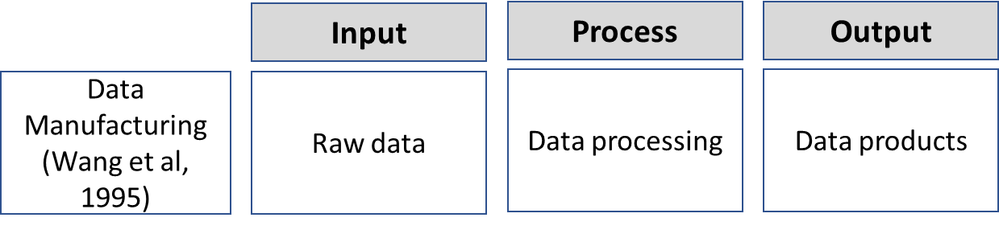
Figure 5: SCM Model (Source: Wang et al, 1995)
Increasing use of outsourced manufacturing facilitated the growth of SCM, whilst increasing chemical regulations require an enhanced level of chemical substance reporting. SCM research shows a correlation in increasing SCM practices resulting in increasingly larger volumes of data being generated (Tiwari et al, 2018). This data has the potential to cause issues when poor quality data enters SCM systems (Hazen et al, 2016; Tan et al, 2015; Wang et al, 2016).
Additional resources are required to examine data for issues which could affect SCM reporting: (1) good quality supply chain data, aiding SCM decision making; (3) poor quality data causing issues analysing data and making informed decisions (Wang et al, 2016; Hazen et al, 2016; Kwon et al, 2014; Chen et al, 2012; Opresnik and Taisch, 2015).
Six Sigma is a set of tools designed to optimize process improvement (Six Sigma Wiki, 2018). The ‘Define, Measure, Analyze, Improve, Control’ (DMAIC) methods extends the SCM model to become ‘Supplier, Input, Process, Output, Customer’ (SIPOC) which facilitates process flow analysis. Understanding the use of data in terms of supplier and customer, extends the analysis greatly. SIPOC logic applied to SCM is shown in Figure 6:
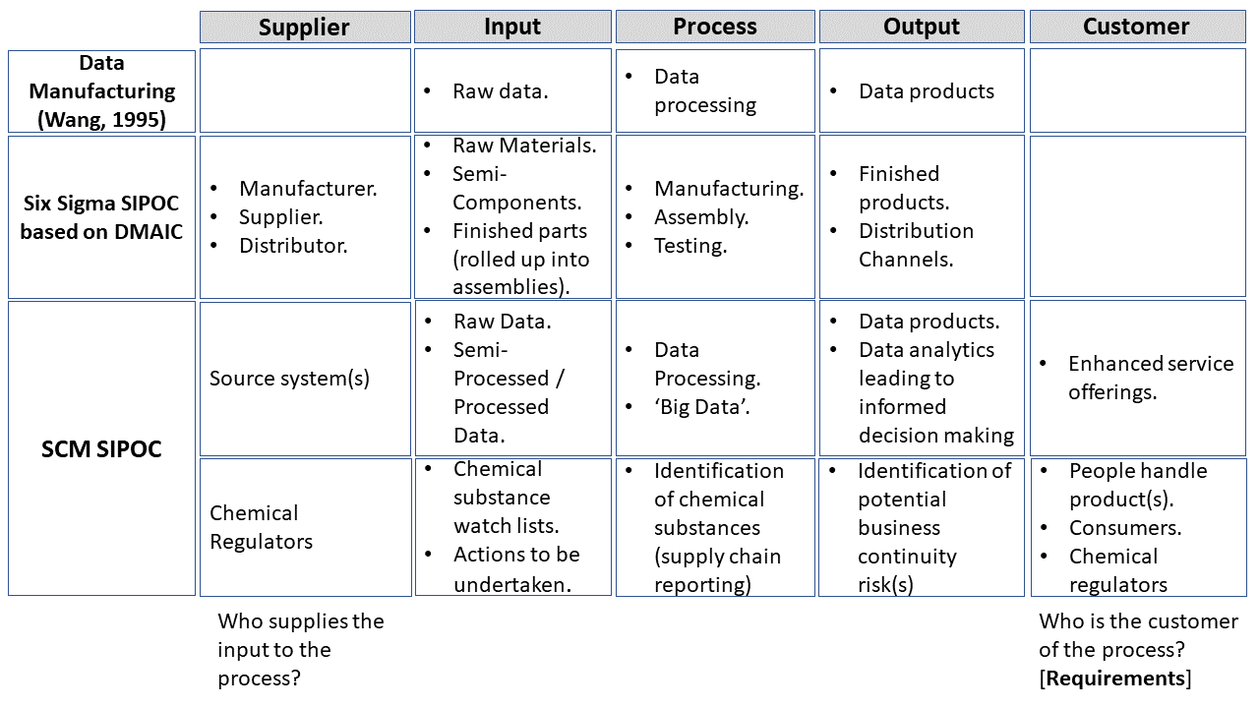
Figure 6: IPO, DMAIC SIPOC and SCM SIPOC (Sources: Wang et al, 1995; Szabo, 1997; Nakamoto, 2008)
  - Sustainable supply chain management (SSCM)
The need for sustainable development was first mentioned in the Brundtland report (WCED, 1987). A major concern was ensuring current needs of society could be achieved without diminishing resources and capabilities for future generations. The core concepts of SSCM built on the Brundtland report covered social, economic and environmental needs. SCM and SSCM researchers point to increasing collaboration occurring between companies within the same and / or different industries to develop supply chains to achieve common goals (Kleindorfer et al, 2005; Carter and Rodgers, 2008; Chen et al, 2017; Hong et al, 2018). Corporate Social Responsibility (CSR) has emerged recently, to extend SSCM further by introducing corporate self-regulation where companies regulate internal practices to be in line with national and international ethical standards (Zhang et al, 2018). SSCM has been presented to show the potential for corporate behaviours to change and embrace new reporting behaviours.
  - Chemical substance reporting
To implement reporting systems, organizations need to understand the flows of materials, monetary items and material information, between suppliers, manufacturers, distributors to end consumers as shown in Figure 7:
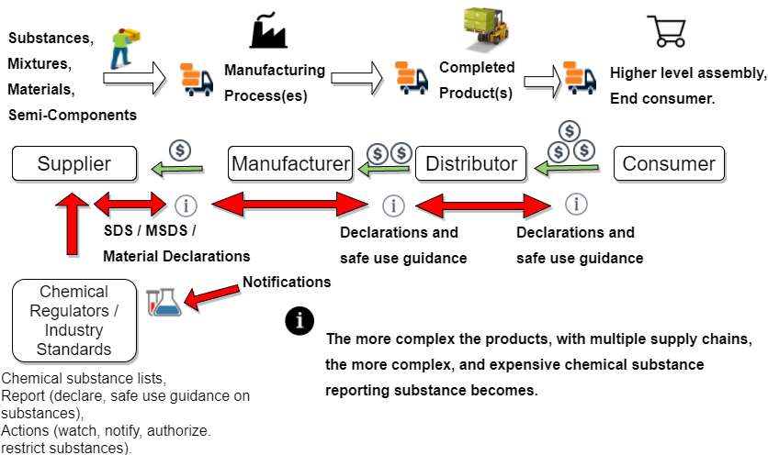
Figure 7: Chemical substance reporting flow
The roles of actors within the system needs is defined in Table 1:
Table 1: Chemical substances reporting actors and actions
Actor(s) | Action(s)
Chemical Regulators | Generate substance lists that define:  - Substances that need to be watched;  - Substances that require authorizations;  - Substances that are restricted completely or in certain use scenarios.
Receive notifications and requests:
- Notifications - substance use; import threshold values; etc.
- Authorization request for continued use, if the substance is on an Authorization list.
Original Equipment Manufacturer(s) / Supply Chain | Need to ascertain:  - Identify substances used: (i) on their own; (ii) in mixtures / formulations; (iii) materials.  - Identify substances: (i) physically on hand; (ii) internally defined in products; (iii) from externally sourced products.  - Substances that (i) appear on finished products; (ii) used in the process of manufacture.
Report:
- Notifications and requests to chemical regulators;
- Declarations to customers relating to the presence of chemicals substances of concern.
Customer(s) | Require declaration(s) / statements detailing substance presence, above a threshold level and any applicable safe use guidance to enable customers take appropriate safety precautions.

Data flows are shown in Figure 8:
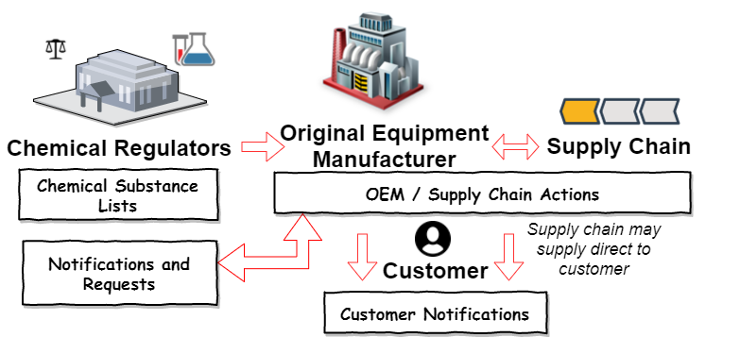
Figure 8: Flow of chemical substance reporting information
Chemical reporting systems need to be able to capture substance data substance data from design, manufacturing and distribution of articles (Hong et al, 2018). To ensure supply chains provide chemical substance reporting data, clear contractual language is required: (1) define the regions where the materials and products flow across, this will dictate the regulatory reporting required, reliance on specific global regulations may result in regulations being missed; (2) desired reporting formats, which range from custom to industry standard templates, use of a common template will ensure a quicker response from the supply chain as opposed to a custom template adding additional processing from the supply chain; (3) desired frequency of reporting, the more frequent the reporting the larger the burden; (4) penalties for non-reporting, as shown in Figure 9:
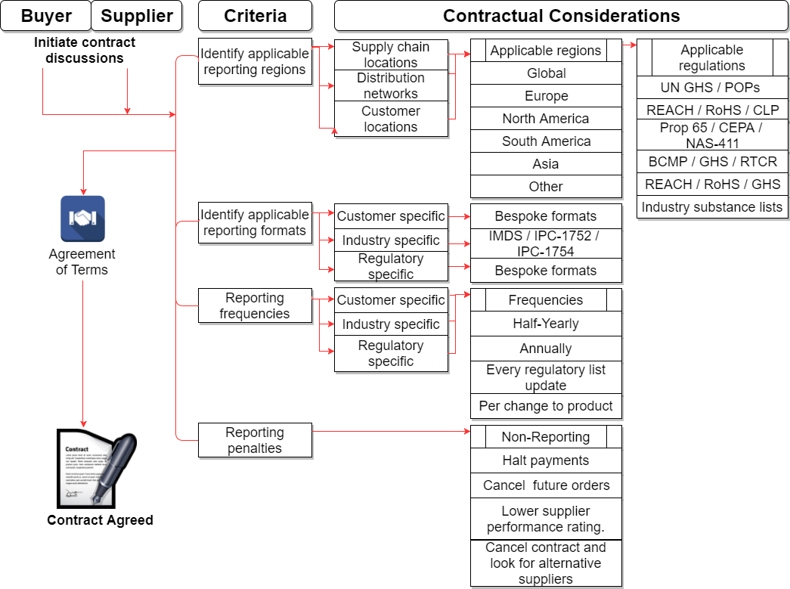
Figure 9: Chemical substance reporting contract features
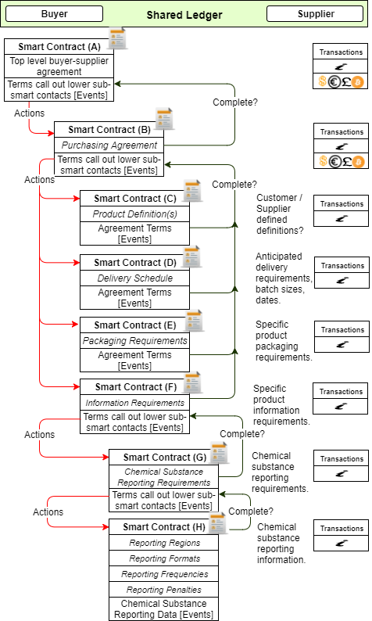
Figure 10: Top-Level buyer-supplier smart contract
  - Supply chain chemical substance reporting (SCCSR) Blockchain
An initial smart contract as shown in Figure 10, establishes a generic top level buyer-supplier agreement (University of Oxford, 2016) from which: (1) an initial shared ledger can be established and maintained via a private blockchain; (2) additional sub-smart contracts may be introduced to establish lower level processing needs, each potentially using additional lower level shared ledgers and sub-blockchains; (3) the SCCSR blockchain is a sub-smart contract feeding into the top-level initial smart contract, fulfilling the need of a chemical substance reporting contract as shown in Figure 9.
To execute some actions of the smart contract may require human intervention to perform specific tasks such as checking products, validating information received is correct, these can be managed via off-line information flow tasks, feeding back into the smart contract for execution of remaining actions.
The SCCSR blockchain requires: (1) requirements to be defined; (2) deliverables to be known; (3) basic contractual terms agreed; (4) smart contract established defining contractual agreement between two parties; (5) smart contract conversion into code; (6) smart contract managed via a private blockchain and shared ledger between the buyer and supplier; (7) blockchain processes tasks based on events, transactions, information flows, execution, change in state, through to settlement.
A supplier may need to arrange additional smart contracts for compliance reporting from their respective supply chains, automating the request for chemical substance reporting down to the lowest tier within a supply chain as shown in Figure 11:
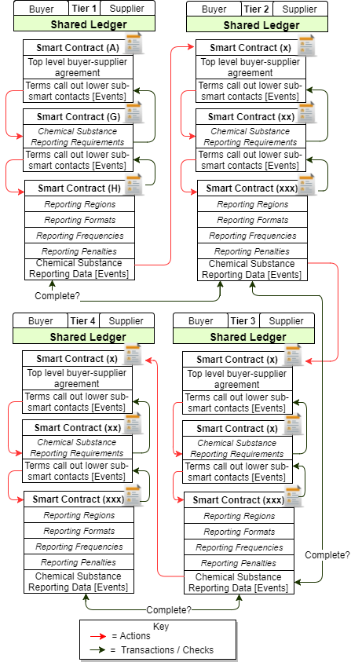
Figure 11: Multi-tier SCCSR data requests
- Conclusions
The cryptocurrency phenomenon highlighted the potential of a blockchain, to record and trace changes to data records, in an automated computerized manner.
The potential of a blockchain goes beyond the large scale simple shared ledger concept. Utilizing smart contracts in conjunction with blockchains, enables organizations to realize process efficiencies by reducing the amount of manual data processing tasks being undertaken by automating manually intensive tasks, using events, transactions and information flows. Some tasks may still require manual checking of products and data, but the clear majority of tasks can be automated such as request, transmit, receipt and basic verification.
As products flow from the supplier to a buyer, information requests can be automatically generated and transmitted, with penalties enforced for non-conformance. Data from a blockchain could potentially be used to feed into supplier scorecards, to monitor supplier performance.
The SCCSR blockchain is intended to conceptualize a multi-tier supply chain model, for chemical substance reporting, that allows for data to be more robustly controlled, allowing agreement to reporting needs, possibly further additional sub-smart contracts to manage specific reporting needs such as EU RoHS, EU REACH, etc.
The SCCSR blockchain mimics internal business behaviours, this will enable organisations to create their own private blockchains utilising an internal ledger, where suppliers can receipt and transmit data, enable quicker adoption based on existing practices.
Future extensions to this research include: (1) multi-blockchain analysis based on the input-output production model (Leontief, 1986) conceptualized the inputs and outputs from one industrial sector affecting another, for example raw material supply of one commodity affecting the industries which consume the materials, and vice versa demand from consuming industries affecting which supplying industries; (2) sustainability by identifying chemical substances used within articles, industry can focus on initial high yield activities (reuse, repurpose, recycle articles which have the most scarce substances). Blockchain for Good (B4G) (Adams et al. 2017) aligns blockchains to the UN Sustainable Development Goals (UN SDGs), blending this research paper with B4G offers strong potential.
The next step of the research includes verification of this model and validation using real case study (action research), via a PhD Delphi study project, scheduled to take place during October 2018.
- Acknowledgments
Many thanks to the early researchers in the fields of cryptography, blockchains, contract theory and smart contracts (Haber and Stronetta, 1991; Szabo, 1994; Szabo, 1996; Szabo, 1997; Nakamoto, 2008; Hart and Holmström, 2016) as they effectively set out the blue print for wider adoption of blockchains, which led to this research being undertaken.
References
99bitcoins.com, (2018), “Bitcoin price chart with historic event”, [Online] Available from: https://99bitcoins.com/price-chart-history/.
Adams, R., Kewell, B., Parry, G., (2017), “Blockchain for good? digital ledger technology and sustainable development goals”, [Online] Available from: https://link.springer.com/book/10.1007/978-3-319-67122-2#about.
Ashby, M.F., (2009), “Materials and the Environment Eco-Informed Material Choice”, Oxford: Butterworth-Heinemann imprint of Elsevier Inc., pp. 85-99.
Cambridge Dictionary, (2018). “Definition of a Cryptocurrency”, [Online] Available from: https://dictionary.cambridge.org/dictionary/english/cryptocurrency.
Carter, C.R., Rogers, D.S., (2008), “A framework of sustainable supply chain management: moving toward new theory”, International Journal of Physical Distribution & Logistics Management, Vol. 38, No. 5-6, pp. 360-387.
Chen, H., Chiang, R.H.L., Storey, V.C., (2012), “Business intelligence and analytics: From big data to big impact”, MIS Quarterly, Vol. 36, No.4, pp. 1165-1188.
Chen, L., Zhao, X., Tang, O., Price, L., Zhang, S., Zhu, W., (2017), “Supply chain collaboration for sustainability: A literature review and future research agenda”, International Journal od Production Economics, Vol. 194, pp. 73-87.
Corda.net, (2018), “Blockchain for business”, [Online] Available from: https://www.corda.net/.
ECHAa, (2018), “ECHA candidate list”, [Online] Available from: https://echa.europa.eu/candidate-list-table.
ECHAb, (2018), “ECHA authorisations list”, [Online] Available from: https://echa.europa.eu/authorisation-list.
ECHAc, (2018),“ECHA restriction list”, [Online] Available from: https://echa.europa.eu/substances-restricted-under-reach.
Etherum.org, (2018), “Etherum greeter”, [Online] Available from: https://www.ethereum.org/greeter.
European Commission, (1967), “Dangerous Substances Directive 67/548/EEC”, [Online] Available from: http://eur-lex.europa.eu/legal-content/EN/TXT/?uri=celex:31967L0548.
European Commission, (2002), “EU RoHS Directive 2002/95/EC”, [Online] Available from: http://eur-lex.europa.eu/legal-content/EN/TXT/?uri=CELEX:32002L0095.
European Commission, (2006), “EC REACH Regulation EC 1907/2006”, [Online] Available from: http://eur-lex.europa.eu/legal-content/EN/TXT/?uri=CELEX:32006R1907.
European Commission, (2011), “EU RoHS recast Directive 2011/65/EU”, [Online] Available from: http://eur-lex.europa.eu/legal-content/EN/TXT/?uri=CELEX:32011L0065.
Friedman, M., (1999), “Milton Friedman predicts the rise of bitcoin in 1999!”, [Online] Available from: https://www.youtube.com/watch?v=6MnQJFEVY7s&feature=youtu.be.
Gibson, B.J, Hanna, J.B., Defoe, C.C., Chen, H., (2013), “Definitive guide to integrated supply chain management, the: optimize the interaction between supply chain processes, tools, and technologies”, Council of Supply Chain Management Professionals (CSCMP).
Haber, S., Stronetta, W.C., (1991), “How to time-stamp a digital document”, Journal of Cryptology, Vol. 3, No. 2, pp. 99-111.
Hazen, T., Skipper, J.B., Ezell, J.D., Boone, C.A., (2016), “Big data and predictive analytics for supply chain sustainability: A theory-driven research agenda”, Computers and Industrial Engineering, Vol. 101, pp. 592.598.
Holland, C.P., (1995), “Cooperative supply chain management: the impact of interorganizational information systems”, The Journal of Strategic Information Systems, Vol. 4, No. 2, pp. 117-133.
Hong, J., Zhang, Y., Ding, M., (2018), “Sustainable supply chain management practices, supply chain dynamics capabilities, and enterprise performance”, Journal of Cleaner Production, Vol. 172, pp. 3508-3519.
Investing.com, (2018) “BTC/USD - bitcoin US dollar” [Online]. Available from: https://uk.investing.com/currencies/btc-usd-historical-data.
Leontief, W., (1986), “Input-Output Economics”, New York: Oxford University Press.
Kleindorfer, P.R., K. Singhal, K., Van Wassenove, L.N., (2005), “Sustainable operations management”, Production and Operations Management, Vol. 14, No. 4, pp. 482-492.
Kwon, O., Lee, N., Shin, B., (2014), “Data quality management, data usage experience and acquisition intention of big data analytics”, International Journal of Information Management, Vol. 34, No. 3, pp. 387-394.
Min, H., Zhou, G., (2002), “Supply Chain modelling: past, present and future” Computers & Industrial Engineering, Vol. 43, No. 1-2, pp. 231-249.
Molander, L., Rudén, C.L., (2012), “Narrow-and-sharp or broad-and-blunt – regulations of hazardous chemicals in consumer products in the European Union”, Regulatory Toxicology and Pharmacology, Vol. 62, No. 3, pp. 523-531.
Molander, L., Breitholtz, M., Anderssson, P.L., Rybacka, A., Rudén, C.L., (2012), “Are chemicals in articles an obstacle for reaching environmental goals? — missing links in EU chemical management”, Science of The Total Environment, Vol. 435–436, pp. 280-289.
Nakamoto, S., (2008), “Bitcoin: a peer-to-peer electronic cash system”, [Online], Available from: https://bitcoin.org/bitcoin.pdf.
Opresnik, D., Taisch, M., (2015), “The value of big data in servitization”, International Journal of Production Economics, Vol. 165, pp. 174-184.
Oxford University Press, (2018). “Definition of a Cryptocurrency”, [Online], Available from: https://en.oxforddictionaries.com/definition/cryptocurrency.
Porter, M.E., (1980). “Competitive strategy – technologies for analyzing industries and competitors”, New York: The Free Press.
Regulation of chemicals wiki (2017), [Online], Available from: https://en.wikipedia.org/wiki/Regulation_of_chemicals.
Savelyev, A., (2017), “Copyright in the blockchain era: promises and challenges”, Computer Law and Security and Review, December 2017.
Scott, B. (2016), “How can cryptocurrency and blockchain technology Play a role in building social and solidarity finance?” United Nations Research Institute for Social Development, Working Paper 2016-1, [Online] Available from http://www.unrisd.org/brett-scott.
Selin, H. (2011), “Global governance and regional centers: multilevel management of hazardous chemicals and wastes”, Procedia - Social and Behavioral Sciences, Vol. 14, pp. 40-43.
Sivaprakash, P., Karthikeyan, L.M., Joseph, S., (2014), “A Study on Handling of Hazardous Chemicals in Engineering Industries”, APCBEE Procedia, Vol. 9, pp.187-191.
Six Sigma Wiki, (2018), “Six Sigma”, [Online], Available from: https://en.wikipedia.org/wiki/Six_Sigma.
Smith, A, Skinner, A (ed) (1982), “The wealth of nations: books I-III”. London: Penguin books, pp. 150-158.
Statista.com, (2018) “Bitcoin price index from January 2016 to June 2018 (in U.S. dollars)”, [Online] Available from: https://www.statista.com/statistics/326707/bitcoin-price-index/.
Szabo, N., (1994), “Smart contracts”, [Online] Available from: http://www.fon.hum.uva.nl/rob/Courses/InformationInSpeech/CDROM/Literature/LOTwinterschool2006/szabo.best.vwh.net/smart.contracts.html.
Szabo, N., (1996), “Smart contracts: building blocks for digital markets”, [Online] Available from: http://www.fon.hum.uva.nl/rob/Courses/InformationInSpeech/CDROM/Literature/LOTwinterschool2006/szabo.best.vwh.net/smart_contracts_2.html.
Szabo, N., (1997), “Formalizing and securing relationships on public networks”, [Online] Available from: http://firstmonday.org/ojs/index.php/fm/article/view/548/469-publisher=First.
Takhar, S, Liyanage, K. (2017) “Top down or Bottom up? - Supply chain engagement for material compliance reporting”, Advances in Transdisciplinary Engineering, Vol. 6, pp. 77-83.
Tan, K.H., Zhan, Y.Z., Ji, G., Yes, F., Chang, C., (2015), “Harvesting big data to enhance supply chain innovation capabilities: An analytic infrastructure based on deduction graph”, International Journal of Production Economics, Vol 165, pp. 223-233.
Techterms.com, (2018), “P2P definition” [Online], Available from: https://techterms.com/definition/p2p.
Tiwari, S., Wee, H.M., Daryanto, Y., (2018), “Big data analytics in supply chain management between 2010 and 2016: insights to industries” Computers and Industrial Engineering, Vol. 115, pp. 319-330.
TheFundsChain.com, (2017), “TheFundChain white paper extract#4: smart contracts”, [Online], Available from: https://www.thefundschain.com/single-post/2017/01/02/TheFundsChain-White-Paper-extract-4-Smart-Contracts.
The Royal Swedish Academy of Sciences, (2016), “The prize in economic science 2016: contract theory by Oliver Hart and Bengt Holmström”, [Online] Available from: https://www.nobelprize.org/nobel_prizes/economic-sciences/laureates/2016/popular-economicsciences2016.pdf.
University of Oxford Faculty of Law, (2016), “Smart contracts: bridging the gap between expectation and reality”, [Online] Available from: https://www.law.ox.ac.uk/business-law-blog/blog/2016/07/smart-contracts-bridging-gap-between-expectation-and-reality.
Wang, R.Y., Storey, V.C., Firth, C.P., (1995). “A Framework for Analysis of Data Quality Research” IEEE Transactions on Knowledge and Data Engineering, Vol. 7, No. 4, pp. 623-640.
Wang, G., Gunasekaran, A., Ngai, E.W.T., Papadopoulos, T., (2016), “Big data analytics in logistics and supply chain management: certain investigations for research and applications”, International Journal of Production Economics, Vol. 176, pp. 98-110.
World Commission on Environment and Development (WCED), (1987), “Our Common Future” (referenced as Brundtland Report), Oxford University Press: Oxford and New York.
X-rates.com, (2018), “Currency rate tracker”, [Online] Available from: http://www.x-rates.com/average/.
Zhang, M., Tse, Y.K., Doherty, B., Li, S., Akhtar, P., (2018), “Sustainable supply chain management: Confirmation of a higher-order model”, Resources, Conservation and Recycling, Vol. 128, pp. 206-221.

