Design for the Environment: An Ontology-based Knowledge Management Model for Green Product Development

Abstract
Through appropriate operations and policies, such as green processes and product development (PDP), companies can respond to environmental sustainability. To remain competitive, one such approach, Design for X (DFX), involves considering different environment and sustainable strategies through different factors Xs. With regards to the availability of different DFX techniques that consider environmental issues, the decision as to which approach needs to be adopted remains absent. This paper aims at presenting an overview from 1980 to 2020 of the developed research, applications, and DFX techniques for assessing green issues. Selected DFX techniques are linked with strategies used in organizations. Following a literature analysis, a collaborative knowledge-based framework that addresses the design concepts needed to assess environmental, safety, and health concerns in the development of green products is proposed. Furthermore, as a pillar for considering the Semantic Web and an evolving approach linked with Natural language processing (NLP) and Artificial Intelligence (AI), an ontology-based knowledge management model for green assessment is developed for the representation, acquisition, organization and capitalization of knowledge in a computer interpretable manner. The findings are useful for both managers and practitioners as they provide a coherent domain ontology that can help them manage knowledge, improve teamwork, and make decisions in a collaborative green PDP. Besides, an understanding of the essential design considerations that are required to implement environmental, safety, and health issues, as well as competencies used in the PDP is presented. Key barriers, managerial and strategic implications and mitigation actions are also identified in this paper.
Keywords: Design for X; ontology; knowledge management; green product design, design for the environment; business strategy.

1. Introduction
The range of products depends highly on our lives today as the cars drove, the devices used and the food consumed. Depending on the conduct of the consumer, several products can be recycled or reused or end up in landfills (De Bomfim et al., 2021). Undeniably, landfill offers greater short-term benefits. Indeed, it requires the lowest expense compared with other alternatives, such as plans for resource regeneration that involve the costly commitment in manpower and infrastructure (Yadav et al., 2020). However, the fast-growing global landfill trend has contributed to countless environmental considerations like pollution of greenhouse gases and contamination (Markham, 2019). In the long term, these techniques are not sustainable, and closing a product life cycle loop using a concurrent strategy is the safest option (Benabdellah et al., 2020a; Shen et al., 2019). In other words, there is a need for urgent intervention to implement technologies that promote sustainable innovation in technology, society, and organization (Ahmad et al., 2018; Benabdellah et al., 2019; Çop et al., 2021; Melander, 2017; Qiu et al., 2020; Siegel et al., 2019). In this respect, in comparison with the conventional ‘end-of-pipe-control’ method, green product development (GPD) receives tremendous carefulness from governments, companies, and consumers around the world (Awan et al., 2021; Calza et al., 2021; Siegel et al., 2019). Thus, the focus of corporate environmental protection has changed from simple environmental impact assessment such as defensive compliance and minimization of waste towards more sophisticated eco-efficiency to pollution reduction and overall product management of sustainable product which is green product design (Çop et al., 2021; Cubas-Díaz and Martinez Sedano, 2018; Du et al., 2020; Markham, 2019; Shen et al., 2019). Therefore, as the minimization of the use of energy and resources, waste generation, risks to health and safety threats and environmental degradation are the environmental requirements in the product development process (PDP), there is a need to design with a green perspective to create a green product (Awan et al., 2021; Calza et al., 2021; Du et al., 2020). A 'green product' is intended to mitigate the impacts on the environment during its life cycle (Bhattacharya et al., 2019; Cherrafi et al., 2018). Over the last decade, the product design terminology incorporating environmental issues has changed, replacing green product design with ecological design, sustainable design, eco-design, and Design For Environment (Du et al., 2020; Melander, 2017; Shen et al., 2019). Such evolving terminologies represent a different perspective of time and provide a context for how the topic has arisen.
In the United States, as a corporate strategy first used in 1989, Concurrent Engineering (CE) means of achieving multiple goals through cooperative multidisciplinary teams which consider all interactive problems in product, system and process design through the whole PDP (Benabdellah et al., 2020b). The implementation of Design for X (DFX) is one of the most powerful strategies for incorporating and solving these problems for various factors X’s (Benabdellah et al., 2020b). Particularly, relevant techniques such as Design for Recycle, Design for Environment (DFE), Design for Disassembly, Design for Remanufacture can be implemented in the industries to achieve sustainability and environmental concerns (Benabdellah et al., 2020a, 2019; Shen et al., 2019).
Unfortunately, even though developers have in mind designing for simplicity in a concurrent engineering model, what they have to do is inherently complicated. Moreover, decisions on which DFX technique should be applied are directly affected by the suitable policy undertaken by firms (Benabdellah et al., 2019). Besides, previous researches lack a design tool that offers an exact response to the requirements of the designer and enables the internal exchange of data and outcomes within the project of product development while taking greenness into account. To do so, the practices of knowledge management (KM) provide a conceptual and analytical context that allows these issues to be considered (Abbas and Sağsan, 2019; Martins et al., 2019). More clearly, to get the correct information in the right format and at the right time, KM takes the form of knowledge traceability, feedback and different forms of communication processes and channels (Benabdellah et al., 2020a; Song et al., 2020). Therefore, as a pillar for considering the Semantic Web and an evolving approach linked with Natural language processing (NLP) and Artificial Intelligence (AI), ontology is considered as a relevant method to address KM issues(Kendall and McGuinness, 2019a).
However, from the literature analysis, no systematic review is analyzed in which the key benefits, implications, and barriers for an integrated model of DFX approach, green practice, and ontology-based knowledge management are analysed. Some authors have presented a literature review on the different DFX techniques found in the literature by linking them with product lifecycle management and sustainability dimensions (Benabdellah et al., 2020c; Sassanelli et al., 2020). Other authors have proposed frameworks and models for the consideration of green practices (Albino et al., 2009; Chen et al., 2020; Guo et al., 2020; Song et al., 2020; Zhu and He, 2017). Further ones have developed ontologies for green assessment based on Life Cycle Assessment (LCA) (Hong et al., 2019; Lin et al., 2013; Song et al., 2020). Others have proposed several guidelines for assessing environmental issues using DFE) (Benabdellah et al., 2020a; Mendoza et al., 2017).
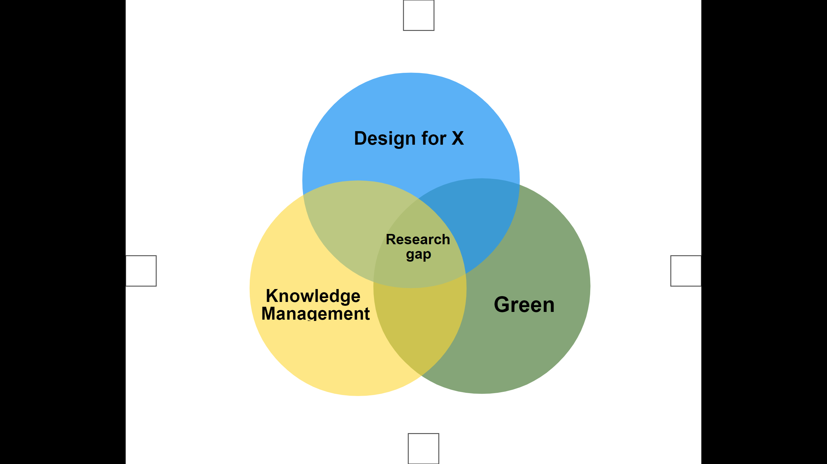
Figure 1. Research gap
Therefore, from this lack of knowledge (figure 1), we present an overview from 1980 to 2020 of the most developed research, applications, and DFX techniques for the assessment of green issues. Second, we linked the selected DFX techniques with strategies used in organizations. Third, following the literature analysis, a collaborative knowledge-based framework that addresses the design concepts needed to assess environmental, safety, and health concerns in the development of a green product is presented. Furthermore, an ontology-based knowledge management model for the integration of green practice and DFX techniques is developed for the representation, acquisition, organization and capitalization of knowledge in a computer interpretable manner. A discussion of the key implications and barriers for researchers and managers is also presented. More clearly, the paper's main contributions can be summed up in the provision of six aspects:

- An analysis of the most needed DFX techniques.
- A categorization of the DFX techniques in terms of environmental differentiation strategy.
- A knowledge-based framework for the integration of DFX concepts and green practice for environmental, safety and health design concepts implementation.
- An ontology-based knowledge management development for the acquisition and capitalization of the proposed knowledge-based framework.
- Identification of key barriers and mitigation actions to green product development.
- Managerial and strategic implications.

The rest of this paper is organized as follows. Section 2 analyses the literature review relevant to the subject field. Section 3 presents the methodological approach followed by the present research while Section 4 presents the descriptive analysis. Section 5 contains the discussion of the results. Section 6 introduces the knowledge-based framework and the ontology-based knowledge-based model. Section 7 discusses the main barriers and their mitigation actions for green product development. Similarly, the theoretical, managerial and strategic implications of this study are also presented in this section. In the final section (Section 8), the conclusions and proposed future research directions are presented.

2. Literature review

In this section, key terms are defined to prepare the foundation for the subsequent literature review.

  - Design for X
Diverging markets, complexity and cost pressure, changing industrial environment, and labor expenses are among the many issues that organizations must deal with to stay competitive (Benabdellah et al., 2018). Nevertheless, the reality of new product development necessitates a far more practical approach that employs approaches to ensure that design processes match customer and social goals from conception through end-of-life. As a business strategy used the first time in the US in 1989, Concurrent Engineering (CE) includes the consideration of several factors such as manufacturing, assembly, quality, logistics, packaging, environment, reliability and service in the whole product lifecycle (Benabdellah et al., 2020a). Therefore, one of the most effective approaches to implement and to address these challenges for different factors is by implementing Design for X (DFX). In DFX refers to product design in the context of X, where X denotes: (1) a specific virtue or property (cost, lead-time, quality, efficiency, risk, safety, or environmental impact); (2) a product's life-cycle phase (assembly, manufacturing, service or disassembly, distribution, etc.). The benefits of applying DFX can be related to productivity stages (better quality, reduced cycle time, decreased life-cycle cost, higher flexibility, enhanced productivity) or be connected to improving and simplifying products, processes, and resource design decisions (Sassanelli et al., 2020). It can also be linked to a negative impact on product manufacturing operating performance.
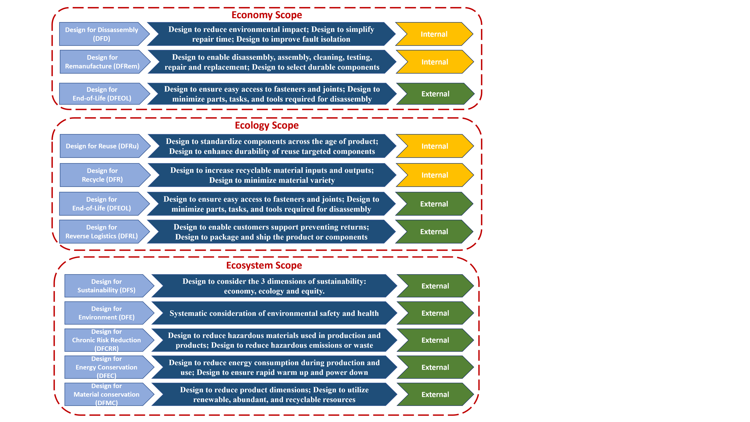
Figure 2. DFX techniques categorization according to design consideration, focus and scope
Advances in technology and computing have led to a fast-changing world. Similarly, to meet changing customer, manufacturing, and public regulatory requirements, new DFX methodologies have been proposed (Arnette et al., 2014; Benabdellah et al., 2019; Shen et al., 2020). In this respect, relevant design techniques such as DFE, Design for Recycle (DFR), Design for Disassembly (DFD), Design for Remanufacture (DFRem), and Design for End of Life (DFEOL) have been introduced in industries driven by corporate interest in cost reduction, profit benefit, and pressure to reach sustainability and environmental issues. To have an outline of the most common and applicable DFX techniques in the literature that deal with environmental issues, figure 2 classifies each of these DFX techniques by considering: (1) abbreviations, (2) design considerations, (3) scope, and (4) focus. The scope is linked to where DFX techniques are implemented with regards to which sustainability dimension. Thus, twelve different DFX techniques have been developed to address green issues in PDP; some focus on new concepts that have yet to be implemented or incorporated into existing design methods. Besides, other techniques apply only to particular industries for a particular product. A review of a wide range of DFX techniques as well as the different DFX applications found in the literature from 1980 to 2019 is presented and discussed in Benabdellah et al. (2019).

  - Green product development
Corporate environmental management has recently shifted its focus from clean technology and pollution control to products (Wang, 2020). This transition is the result of a range of causes, including the fact that products can be considered sources of environmental burden, and their environmental attributes are determined by several stakeholders (Melander, 2017). As a result, comprehensive green product development is critical for developing effective environmental policies and assisting organizations and economies in achieving environmental sustainability (Shah and Soomro, 2021). Green products are then replicated by many sorts of environmental rules imposed by governments across the world, and they come from the demand-pull of customers with changing views about environmental values (Zhao et al., 2021).
Therefore, the number of firms focusing on their products' environmental performance and tackling their environmental efforts early in the development process is rising (Shah and Soomro, 2021). Several environmental techniques have been proposed in this regard, starting from basic environmental effect assessments such as defensive compliance and waste minimization to more advanced eco-efficiency to pollution prevention and, finally, whole product management of sustainable products, or green product creation. Table 1 present the characteristics of each strategy taken by organizations towards sustainability to well understand the difference between them.

Table 1. Characteristics of the green strategies
Strategies | Characteristics
Defensive compliance (Çop et al., 2021) | Companies allocate minimum resources to environmental management to comply with environmental laws that do not avoid any of the environmental impact causes. Thus, environmental issues are perceived to be a regulatory nuisance that can only be met since severe financial penalties will arise from non-compliance.
Waste minimization  (Bumble, 2020) | Companies can deal with waste after it has been generated and minimize its environmental effects or directly decrease the level of waste created by reducing the level of mitigation expected at the completion of the process. By doing so, companies are achieving significant improvements in waste management without changing the process of pollution generation to avoid the occurrence of waste.
Eco-Efficiency  (Ceylan and Aydın, 2021) | Companies maximize the value creation by minimizing the intensity of material intensity of products, eliminating toxic dispersion; enhancing the recyclability of materials, increasing the service intensity of services and products, optimizing the sustainable usage of renewable resources and expanding the durability of the products.
Green product development  (Du et al., 2020) | Companies minimize the environmental impacts of the product design over its whole life-cycle by reducing non-renewable resource and avoiding hazardous materials.

Despite the growing area of theoretical and empirical research, there is a lack of a general, practical, and well-structured definition of what green design is. In this paper and according to Chen and Chang (2013), “GPD is the development performance of products that have less of an impact on the environment, are less detrimental to human health, are formed or performed from recycled components, are manufactured in a more energy‐conservative way, or are supplied to the market with less packaging”. Therefore, green may be defined as a business strategy that helps companies enhance their environmental performance while still reaching their business goals (Garza-Reyes, 2015; Gholami et al., 2020). While eco-design is used to help industrial organizations apply the environmental notion, it is also used to consider and include environmental factors into the product development process (ISO 2011) via the use of various techniques across the product life cycle (Calza et al., 2021).

3. Research methodology
Research has strengthened the understanding and proven various design challenges for more than 50 years (Benabdellah et al., 2019). Therefore, an extensive literature review is required. In fact, a literature review enables authors to examine and interpret papers, recognize the field’s conceptual material and contribute to the advancement of theory (Zekhnini et al., 2020). Hence, the objective of this review was not to include a thorough classification of all prior studies, but rather to provide a helpful summary of methods. To address these research objectives, the search was conducted using several databases such as Scopus (www.scopus.com), Taylor & Francis (http://www.taylorandfrancis.com), Springer (https://www.springer.com/gp), IEEE (https://ieeexplore.ieee.org/), Emerald (http://www.emeraldinsight.com), and Google Scholar. Using a combination (and/or) of several keywords such as ‘design’, ‘design for X’, ‘environment’, ‘design for environment’, ‘eco-design’, ‘green product design’, ‘ecological design’, ‘environmentally responsible design’, different papers are selected from 1980 to 2020. More clearly, the methodology used in this paper is shown in figure 3.

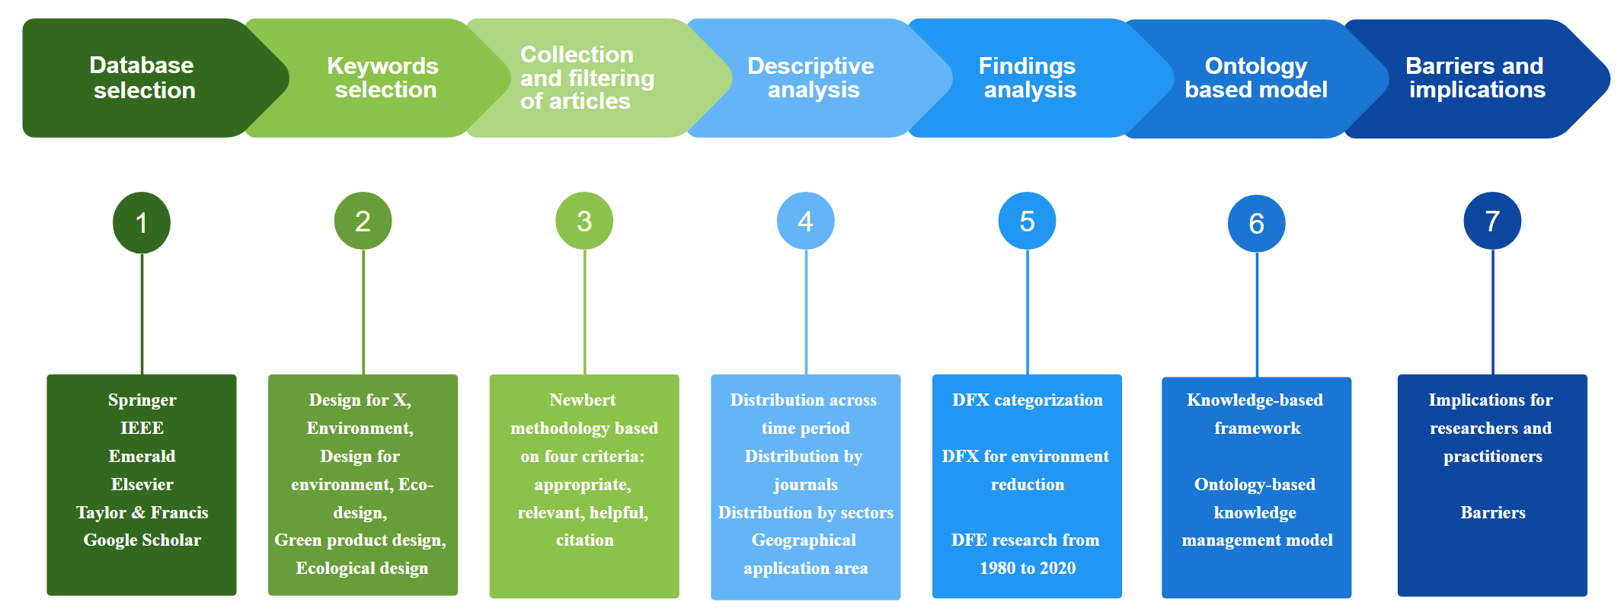
Figure 3. The adopted methodology

For the development of the ontology-based knowledge management model, we have considered the methodology proposed by Noy and McGuinness as it is referenced in a variety of research papers and is the only one that discusses naming conventions (Noy and McGuinness, 2001). It consists of six different phases that include the integration of existing ontology in the early phases of ontology development and presents a detailed definition to each step (Noy and McGuinness, 2001).

4. Descriptive analysis
Using various sources that contain different conferences proceeding and scientific journal papers with high impact factors, 211 papers were identified in the preliminary search from 1980 to 2020. Figure 4 illustrates the papers according to their distribution over thirty-nine years. The graphical representation of figure 4 clearly shows the growing number of research papers published in the last decade of the period: between 2008 and 2020, 72.2 percent of the papers were published. Besides, a keyword-based analysis shows that this step contains more than 10 DFX techniques that deal with environmental issues (for more details see section 5).
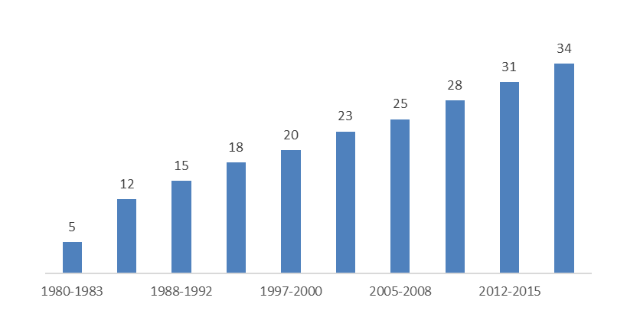
Figure 4. Distribution of 211 papers across the period of time

Moreover, by reading the papers' abstracts and keywords with the consideration of Newbert criteria (Newbert, 2007), we repeated the process until new references were exhausted. This enabled us to start with the latest research and finish with the valuable papers that provided the basis for DFX research. As a result, the review was comprehensive, resulting in more than 62 papers being analysed in this paper with the selection of the most important DFX techniques to be used in the design of the product while considering the environmental issues.
The 64 studied papers were extracted from various journals focused on engineering areas, as well as business areas, with a focus on research and/or management operations. There were also publications from other fields, such as computer science and environmental studies. Figure 5 shows the top six journal sources cited in this paper. The first included paper was from 1980, with the final one published in 2021.
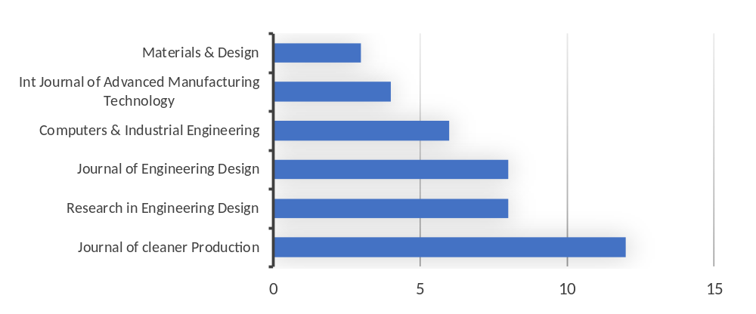
Figure 5. Distribution of papers by journal (top six journal sources)
In the selected papers, concerning the applications, several studies illustrate the advantages of using DFX techniques. Some authors applied it to the manufacture of bottles (Kuo et al., 2001). Others to Resin transfer molding (RTM) products(Prabhakaran et al., 2006). While further ones illustrated its advantages for the automobile door (Amezquita et al., 1995). With an analysis of all these distinct DFX applications, we offer some helpful benefits for applying DFX methods to obtain an enhanced efficiency for professionals and particularly designers and we present the sector-specific distribution of applications.
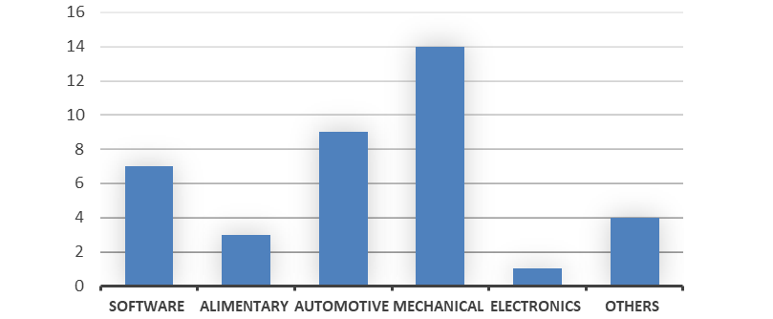
Figure 6. Distribution of papers by journal (top six journal sources)
Figure 6 demonstrates that most applications involve mechanical products (41%), followed by automotive products (34%) and software products (22%). The allocation also suggests that the number of applications released in other industries was limited (3%). The mechanical product's dominance could be explained by the reality that in this industry DFX was initiated.

- Discussion
Green product development has become an extensive field of research interest in the literature. The focus of business environmental policies is shifting from cleaner processes toward the overall nature of green products. It has evolved through four phases: “1) from opportunistic to realistic research; 2) from a product to a systems perspective; 3) from an environmental to a sustainability context, and 4) from concept development to technology transfer and commercialization” (Awan et al., 2021). Following these transitions, several terms have been used to describe attempts to make items more environmentally friendly. Qualitative and quantitative approaches and techniques have been used, e.g. “Computer-Aided Design” (Chu et al., 2009; Mathieux et al., 2008) and Life Cycle Assessment (Herrmann and Moltesen, 2015; Mendoza-Fong et al., 2019) to implement green issues. Other researchers have emphasized the significance of the development process, management system, organization, motivation, and competencies (Awan et al., 2021; Bhatia, 2021; Chen et al., 2020). Furthermore, authors have linked Industry 4.0 and sustainability benefits to fully use green processes to meet sustainability objectives (Asiimwe and de Kock, 2019; Mendoza-Fong et al., 2019).
Therefore, as presented previously, to optimize unique product requirements, the Design for X model was developed with the main objective of fulfilling customer needs and responding to the high market demand for product competitiveness from different perspectives (Benabdellah et al., 2020b; Sassanelli et al., 2020; Shen et al., 2020). The specificity of these techniques makes them accessible to the design team's product-specific solutions, where many Design for X approaches can be found, e.g. Design for Disassembly, Design for Environment, Design for remanufacturing, Design for recovery, and material recycling, and the Design for Energy Efficiency. Design for Disassembly (Bonvoisin et al., 2010; Gungor and Gupta, 1999) emphasizes the need to encourage content recycling and comply with end-of-life legislation (Favi et al., 2019; Luttropp, 2000; Sassanelli et al., 2020). In the category of Design for Remanufacturing, Hatcher et al. (2011) presented a study and stated that there are many issues in practice with Design for Remanufacturing techniques, which can be summarized as a lack of designer expertise and understanding, and very few products are remanufactured or remanufactured. Zhang and Zwolinski (2017) developed a computer-aided technique to integrate remanufacturing at the early design stages. In the Design for Recovery and Design for Energy Efficiency categories, Ljungberg (2007) provided recommendations for sustainable product design, with a specific emphasis on the choice of materials. Domingo et al. (2013) suggested a scenario model to accurately quantify the environmental effect of the use process, particularly for energy-intensive components, by including all occurrences that might or would occur during a typical user's usage of the product. Finally, Abramovici et al. (2014) created a technique to assist designers in conducting energy analyses of mass-produced ERP design choices and ensuring compliance with energy-related limit-value restrictions. With the same perspective, Rossi et al. (2016) presented an analysis of the key barriers that prevent the implementation of eco-design approaches in industrial companies.
Notwithstanding, the ultimate aim of green design is designing products that, over their life cycle, will have minimal negative environmental effects (Du et al., 2020). However, based on our literature analysis, eco-design or green design is known as DFE. This claim is justified also by the fact that in designing a product, the product’s lifecycle phases influence each other, thus certainly the DFX techniques influence each other too (Benabdellah et al., 2020a). Therefore, to facilitate the understanding of these relationships, we use a graphic that shows the categories as squares while the subcategories are presented as a circle. Figure 7a presents the relationships between DFEOL, DFRL, and DFE. To simplify the graph, if there is an impact between two techniques, then that impact goes through the rest of the hierarchical relationships (Arnette et al., 2014). DFRem, DFD, and DFR, for instance, affect each other, so DFRL and DFEOL are affected by DFE targets and have an effect on them. Thus, when considering the DFE technique we already consider both the DFRL and the DFEOL. Figure 7b provides a categorization of the various DFX techniques that consider environmental differentiation strategy. The percentage of each DFX represents the number of related reviewed papers in the studied period. As a result, when considering DFE, we already consider holistically DFD, DFRem, DFR, DFRL and all the others green DFX techniques.
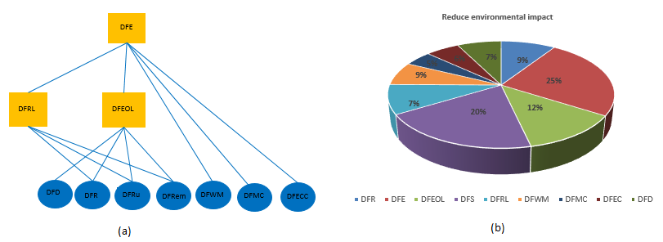
Figure 7. (a) Relationships between DFX techniques for reducing environmental impact and (b) distribution of paper from 1980 to 2019 concerning the environment differentiation strategy
As a “systematic consideration during new product and process development of design issues associated with environmental safety and health over the full product life cycle”; DFE tools facilitate PDP decisions associated with products, plants, and systems (Shen et al., 2020). In this respect, many guidelines, techniques, and checklists have been developed to make environmentally sustainable design choices.
For the consideration of customer requirements and environmental issues, some researchers used techniques such as ‘TRIZ’, ‘Life Cycle Analysis’ and ‘Quality Function Deployment’ through the consideration of the DFE technique (Fitch and Cooper, 2005a, 2005b; Francis, 2009; Herrmann and Moltesen, 2015; Kuo et al., 2001; Madu and Madu, 2002; Moore, 1990; Zhang et al., 2011). Hong et al. (2019) developed ontologies for green assessment based on Life Cycle Assessment (LCA) without considering the DFX approach. Other ones, studied fuzzy logic in the early design process to manage imprecise and ambiguous information (Kuo et al., 2001; Li et al., 2008). A variety of tools for evaluating product design concerning environmental standards have been produced by other researchers (Blanchini and Miani, 1999; Harjula et al., 1996; Kirst et al., 2009; Tuck and Hague, 2006). Further researchers have proposed several guidelines for assessing environmental issues (Abramovici et al., 2014; Benabdellah et al., 2020; Bonvoisin et al., 2010; Feldman, 1999b; Hatcher et al., 2011; Korpalski, 1996; Ljungberg, 2007; Luttropp, 2000; Rose, 2000). Others linked DFE with Industry 4.0 technologies to achieve greenness (Asiimwe and de Kock, 2019; Mendoza et al., 2017).
In summary, organizations must be prepared to help overcome environmental problems by establishing the ability to access environmental issues regarding products; technologies, and regulations and to examine environmental issues too (Shah and Soomro, 2021). In other words, Green product innovation gives businesses the chance to be pioneers, enabling them to stand out and achieve a competitive edge (Bhatia, 2021). Consistent product development is necessary for companies that strive to keep up with marketplace changes and trends for ensuring their future profitability and success. A competitive product development strategy should include a company‐wide commitment to creating items that satisfy particular consumer needs or characteristics. However, the DFE's biggest change is the comprehensive consideration of design success over the whole product and process life cycle while considering environmental, safety, and health goals. Furthermore, to ensure an efficient and green solution, there is a need to answer the questions of what are the main design factors required to incorporate green issues, as well as how designers can effectively exchange, capitalize, and reuse information. The next section responds to these questions by providing first a collaborative knowledge-based framework with the main design factors needed. Second, an ontology-based knowledge management model for the implementation of the proposed knowledge-based framework and the capitalization of the design factors is also presented.

- An ontology-based knowledge management model
A scientific consensus on the importance of sustainability has continued to exist over the past decade, both at the national, global, and organizational levels (Clayton and Radcliffe, 2018). Thus, organizations are not only supposed to be viable, but it is also in their interest to be so. New business models and opportunities are emerging, both linked to the sustainable push and technological growth, as well as to changes in mindsets and society. In this respect, the main of this evolution is knowledge (Benabdellah et al., 2019). In reality, we use numerous professional specialities to design and develop products in a concurrent project; each professional actor with his specialization brings many competencies to solve certain tasks jointly. Moreover, ‘for experienced actors, it is difficult to provide an outline of a project or to recall the collaborative work of previous projects. The key information to store can only be specified by experiment teams’ (Benabdellah et al., 2020a; Song et al., 2020). As a result, designers must consider the experience of previous systems, deal with documents ‘draft, information’, and check the veracity of knowledge without experiencing it. Thus, to reuse and capitalize knowledge through DFX approaches, Knowledge Management practices is the best answer (Abbas and Sağsan, 2019; Benabdellah et al., 2020b; Dayan et al., 2017; Martins et al., 2019; Monticolo et al., 2015). In this respect, the objective of this section is first to establish a series of design factors needed to implement DFE concerns while integrating environmental, health and safety concerns. Second, through the use of an ontology-based model, these design factors are implemented for the representation, acquisition, organization and capitalization of knowledge in a computer interpretable manner. This help practitioners and managers managing and reusing knowledge easily and improve teamwork collaboration in the whole green PDP.

  - Design for Environment knowledge-based framework
To achieve flexibility and sustainability, the DFE needs to be decomposed into homogeneous modules on which each one is further decomposed into different design factors that must be taken in the design of that particular module. Hence, the proposed DFE knowledge-based framework includes four modules which are:

- Environmental consideration that considers mainly all the consideration needed for choosing recyclable, reused, sustainable materials for decreasing air pollution, energy used in manufacturing and maintainability as well as emittance while considering country legislations.
- Environmental issues that consider all the factors needed to be reduced or avoided when developing a product such as human toxicity, physical ecosystem degradation, acidification, abiotic resources and global warming.
- Environmental requirements that contain all the materials, processes, products requirements to achieve safety, environmental and health concerns while developing a product.
- Environmental indicators that consider all the key indicators needed to measure the environmental aspects when developing a product.
- Recycling & disassembly criteria that contains all the criteria needed to recover the product including remanufacturing, reuse, disassembly and recycling operations.

More clearly, the design concepts associated with the DFE knowledge-based framework are presented in figure 8. By considering the proposed framework, during the PDP, designers can minimize harmful and hazardous emissions, decrease the energy that is utilized during extraction, increase the recyclability of parts, and also the transport quality. The series of knowledge considered in this framework has been validated with different experts working on different companies (Design for Manufacture and Assembly specialist, Project Manager, and consultant and trainer in Quality Management).

Figure 8. Design for Environment knowledge-based framework
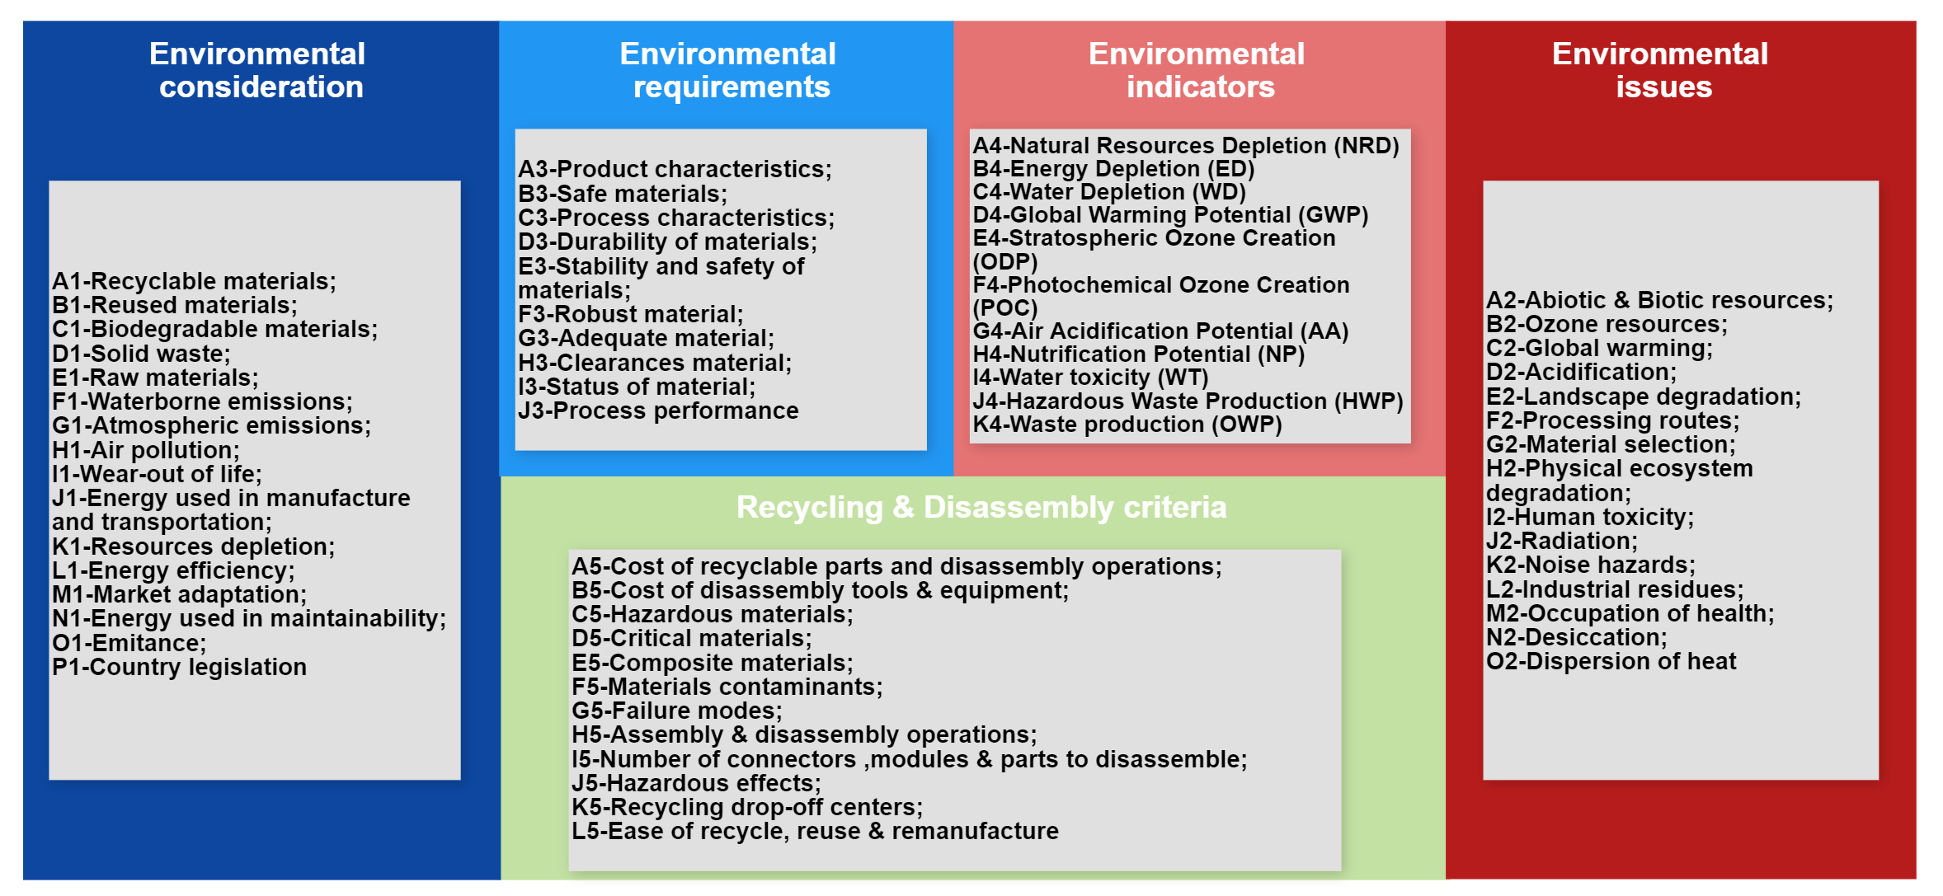
  - Ontology-based knowledge management model
Information today represents significant capital for companies (Hong et al., 2019). It is a strategic resource for increasing productivity; a factor of stability in an unstable and dynamic environment; and it is a decisive competitive advantage (Hong et al., 2019). Thus, it is, therefore, important for any organization to master the management of its intellectual capital because, as Maret confirms, “knowledge and know-how are the two inseparable aspects of knowledge (Diefenbach et al., 2018). As long as they are not controlled, they constitute fragile capital because they are neither shareable nor persistent, that is to say, not reusable in the absence of their holder" (Diefenbach et al., 2018).
In this context, the capitalization of knowledge aims to promote the growth, transmission, and conservation of business knowledge to facilitate its access and reuse (Benabdellah et al., 2019; Kendall and McGuinness, 2019b). One such approach to address these challenges is the use of Ontologies (Kendall and McGuinness, 2019a; Noy and McGuinness, 2001).
During the last decade, the development of ontologies has moved from Artificial Intelligence laboratories to the IT positions of domain experts. Ontologies have become very common in the World Wide Web. The scope of ontologies on the web varies from broad taxonomies used to categorize websites (such as in Yahoo) to categorizations of products for sale and their characteristics (such as in Amazon.com) (Noy and McGuinness, 2001). Thus, ontologies are useful for building knowledge management systems(Kendall and McGuinness, 2019a; Noy and McGuinness, 2001). Indeed, they can share the common understanding of the information structure between the actors of the project; to allow the reuse of knowledge in a domain; to explain what is considered implicit in a domain; to distinguish knowledge about a domain from operational knowledge and also to analyse knowledge about a domain. However, by following the methodology of (Noy and McGuinness, 2001), we proposed an ontology-based model for the automatic classification, capitalization, and reuse of knowledge using Semantic Web principles to assist designers and teams to be collaborative during the PDP while considering green purposes. Figure 9 presents the proposed ontology taxonomy implemented in Protégé software that allows us to visualize, validate and build the ontology in the OWL language respecting W3C recommendations.
The ability of the framework to interact with other applications that have already been committed is one of the key reasons for using ontology. Reusing existing ontologies is required for this, particularly since there are libraries of reusable ontologies available on the Web and in the literature. In this respect, we have selected the main terms that guide our conceptualization from the existing ontologies for the PDP such as TOVE (Fox, 2005), ENTREPRISE (Uschold, 1998) and ONTODESIGN (Monticolo, 2009).
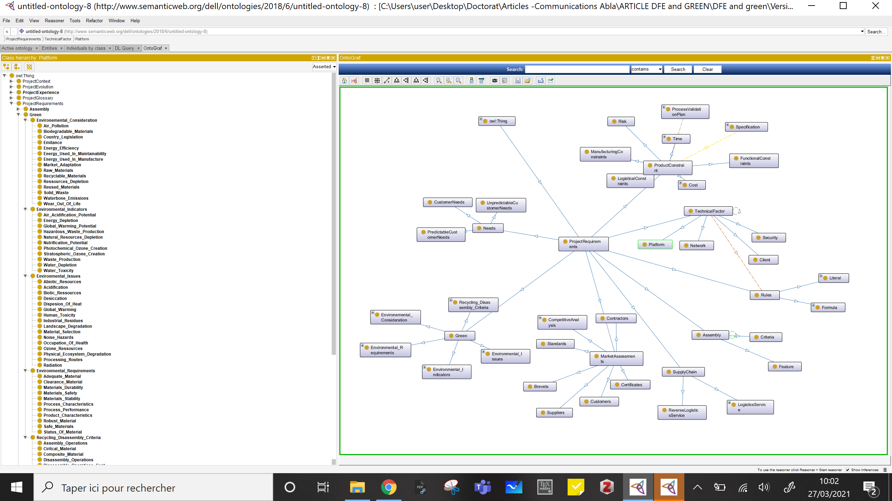
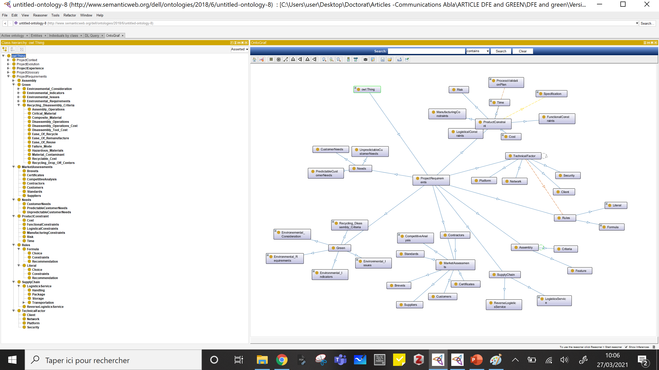
Figure 9. Ontology-based knowledge management model

Therefore, once the key terms are included, the hierarchy classes are defined using a combination of the top-down and bottom-up approaches and have been submitted to the professional actors. We notice here that we have also included the key design factors defined in the previous DFE knowledge framework for the consideration of environmental, health, and safety concerns while developing a product. However, as in each design project, we need to capitalize the project context, project experience, project evolution, project glossary, and so on. More clearly, we have considered the following classes that contain several other subclasses (figure 9):

- The project experience that describes all the failures, difficulties, and errors while developing a product;
- The project context that brings all the knowledge characterizing a project in terms of the product itself and organization;
- The project evolution that describes all the project stages in terms of phases followed, their actual progress, and the activities needed to achieve each product lifecycle phase;
- The project glossary that considers all the vocabulary needed during the project development;
- The project requirements that contain all the capabilities, needs and rules needed to achieve green product design in terms of assembly, market assessments, supply chain issues while taking into account product constraints and technical factors.

After that, we defined the ontology concepts and their relationships using the methodology suggested by Gandon et al., (2002) once the information classification in the form of hierarchy was realized. Finally, after assessing the identification of all major components of our ontology and implementing it in Protégé, we have provided managers with an integrated conceptual model for sharing and capitalizing knowledge through the entire product development process while taking environmental, health, and safety issues into account.
- Barriers, mitigation actions and implications for researchers and practitioners

7.1 Barriers to green product development

The emerging trend in the development of green products is not without challenges and pitfalls. First, many environmental characteristics, namely ‘recyclability’ and ‘fuel-economy’, have effects opposing the characteristics or performance of traditional products, such as protection, quality of materials, and satisfaction. For producers, the integration of both green and traditional attributes into one commodity is one of the main challenges. Second, due to performance and cost considerations, many customers remain with classic products of low environmental quality instead of dealing with green products. Third, GPD is, like most engineering practices, a task that is characterized by high uncertainty and risk levels. Investment in R&D is always expensive and its return is extremely unpredictable. As a consequence, the consideration of green products has several barriers. Table 2 presents a classification of the different barriers according to four categories (Karuppiah et al., 2020; Zekhnini et al., 2020b): (1) economic barriers; (2) technology barriers, (3) informational barriers; and (4) organizational barriers.

Table 2. Classification of green product and Design for environmental barriers
Categories | Barriers
Economic  (Luthra et al., 2011; Siegel et al., 2019) | Cost implication
Economic  (Luthra et al., 2011; Siegel et al., 2019) | No bank to encourage green product
Economic  (Luthra et al., 2011; Siegel et al., 2019) | Disposal cost
Economic  (Luthra et al., 2011; Siegel et al., 2019) | Hazardous products cost
Economic  (Luthra et al., 2011; Siegel et al., 2019) | Lack of foreign direct investment
Economic  (Luthra et al., 2011; Siegel et al., 2019) | High investments
Economic  (Luthra et al., 2011; Siegel et al., 2019) | Design cost
Economic  (Luthra et al., 2011; Siegel et al., 2019) | Loss of suppliers
Economic  (Luthra et al., 2011; Siegel et al., 2019) | Limited financial resources
Economic  (Luthra et al., 2011; Siegel et al., 2019) | Limited access to investment funds
Technology  (Büyüközkan and Göçer, 2018; Zekhnini et al., 2020) | Lack of technologies
 | Resistance to advanced implementation of technology
 | Lack of technical expertise
 | Complexity of design to reduce energy consumption
 | Lack of appropriate measures for the environment
 | Failure of fear
 | Cyber-security
 | Lack of technological skills
 | Technological immaturity
 | Less familiarity with advanced technologies
Informational  (Karuppiah et al., 2020; Rossi et al., 2016) | Lack of courses for training
Informational  (Karuppiah et al., 2020; Rossi et al., 2016) | Lack of sustainability certification
Informational  (Karuppiah et al., 2020; Rossi et al., 2016) | Lack of awareness on implementing reverse logistics
Informational  (Karuppiah et al., 2020; Rossi et al., 2016) | Lack of green practice knowledge
Informational  (Karuppiah et al., 2020; Rossi et al., 2016) | Lack of green products awareness
Informational  (Karuppiah et al., 2020; Rossi et al., 2016) | Lack of accreditation
Informational  (Karuppiah et al., 2020; Rossi et al., 2016) | Lack of guidelines
Informational  (Karuppiah et al., 2020; Rossi et al., 2016) | Privacy and security of data
Informational  (Karuppiah et al., 2020; Rossi et al., 2016) | Insufficient communication
Organizational  (Karuppiah et al., 2020; Rossi et al., 2016) | Lack of organizational readiness or technical expertise
Organizational  (Karuppiah et al., 2020; Rossi et al., 2016) | Lack of organizational culture in adopting green products
Organizational  (Karuppiah et al., 2020; Rossi et al., 2016) | Lack of organizational recycling and re-use attempts
Organizational  (Karuppiah et al., 2020; Rossi et al., 2016) | Market competition
Organizational  (Karuppiah et al., 2020; Rossi et al., 2016) | Lack of social responsibility
Organizational  (Karuppiah et al., 2020; Rossi et al., 2016) | Lack of a green disposal system
Organizational  (Karuppiah et al., 2020; Rossi et al., 2016) | Lack of R& D structures
Organizational  (Karuppiah et al., 2020; Rossi et al., 2016) | Lack of internal knowledge
Organizational  (Karuppiah et al., 2020; Rossi et al., 2016) | Limited human resources
Organizational  (Karuppiah et al., 2020; Rossi et al., 2016) | Complexity of supply chain

7.2 Mitigation actions
The key barriers raised in Table 2 indicate that both researchers and practitioners need to perform studies helping to explain the green product design and sustainable management concepts. The aim is to create real alternatives to barriers to green efforts and to expose the advantages of environmental efforts. To do this, practitioners and researchers should take different steps to strengthen and encourage the transition towards an environmentally conscious society as follows:

- Specifying the environmental action criteria
- Specifying the positions in leveraging environmental efforts of government agencies, community groups, and other entities.
- Capitalizing and sharing all the information needed while developing a product
- Suggesting solutions to the obstacles and challenges that business entities face in implementing environmental policies.
- Raising awareness of the meaning and role of environmental management
- Having a well-defined crisis management plan and strategy
- Developing environmental education
- Developing a resilient GPD process
- Training for environmental Management
- Designing of acceptable regulations
- Developing guidelines and models
- Developing data protection strategies
- Developing information systems to assist managers while developing product
- Adapting new technologies to environmental management

In a summary, environmental concerns are a significant concern for organizations. Thus, successful policies and standards should be set-up to overcome these challenges. Proper understanding of sustainability measures, barriers, and challenges of greenness are required to have a proper design of these policies. Besides, a great deal of research and efforts needs to be undertaken to enhance the economic and ecologic growth of the enterprise.

  - Theoretical managerial and strategic implications
Industries are in the midst of a period marked by unpredictably, changing market conditions and a turbulent competitive climate. In such a situation, achieving high levels of responsiveness through high versatility and rapid reconfiguration capabilities is critical. Besides, to achieve both competitiveness and environmental performance, there is a need to consider several business strategies such as continuous innovation, shared vision, information technology and strategic proactivity. In this respect, the integration of modular solutions that integrates “The project experience”, “The project context”, “The project evolution”, “The project glossary” and “The project requirements capabilities” earlier in the design phase into an ontology model is part of the solution to these problems.

7.3.1 Theoretical implications

From a theoretical perspective, this study contributes by providing a context for determining which DFX techniques are appropriate for a given product design while considering environmental, health, and safety issues. This paper makes also a significant move forward by incorporating DFX techniques into product design with green capability in an ontology-based model. It involves efforts to implement a large amount of knowledge covering green dynamic capability with PDP that define a design for green-oriented product development. The proposed ontology helps to systematize knowledge of the selected set of design factors and to represent knowledge structurally. This knowledge may then be used to communicate with any knowledge base, database, or information system of the organization as it and categorizes the disparate information about design for green-oriented product development into a systematic hierarchy. Finally, we see the importance of DFX for design teams who can implement techniques uniquely for their particular needs. New product development should be able to reach new levels of success, bringing goods to consumers that add value in unexpected ways. Thus, as researchers, we must use the rigor of our profession to ensure that we contribute to this endeavor of developing PDP with this capability.

7.3.2 Managerial implications

From a managerial perspective, when developing a new product or reconfiguring an existing one, semantic modeling and ontologies can reflect the required information representation to support the flexibility and modularity of production systems. Second, designers may also make a final decision by reviewing historical data, understanding how the decision was made, and why certain solutions or options were omitted while others were included in the decision. Third, ontology provides the necessary knowledge for developing green products. It gives managers the DFX principles and general instructions for the PDP, as well as the design tools and specifications they need. Fourth, it provides the possibility of transdisciplinary conditions for system collaboration. Besides, managers will also be able to reconstruct the model and update it with data from information systems. It could also help with the creation of information systems for domain-wide assessment, allowing for automation, visibility, collaboration and accountability. Fourth, it may also serve as a dynamic model for integrating and designing information as well as other features-based information systems. Fifth, the findings highlight the role of a company's engagement with its designers in promoting green innovation through the assimilation and development of information capital as positive factors behind technologies to improve and sustain their product, market, and process strategies. Finally, since it considers a common ownership vision and ensures cleaner production practices, the proposed ontology will meet the goals of decreasing pollution in manufacturing and strengthening firms' capacity to minimize their environmental effects, reduce hazardous chemicals, and decrease resource consumptions and recovery components from end-of-life products. As a result, the proposed knowledge framework has the potential to offer cost and differentiation competitive advantage as it provides managers with insight to embed environmental, health and safety concerns into their strategic planning by building pre-required capabilities.

7.3.3 Strategic implications

The results of this study have strategic implications for the managers, allowing their companies to boost both environmental and competitiveness. Based on the Resource-based view perspective (Verona, 1999), this study shows the critical role of shared vision, information technology, strategic proactivity, and continuous creativity in increasing benefit and making the environment the central organizing principle of their business. The shared vision which is defined “as the members’ collective value and beliefs regarding a firm’s objectives and mission” (Song et al., 2020) helps in identifying environmental goals and seeking employee’s contribution. Information technology is a measurement of a company's ability to develop technological and business awareness, promote “cross-functional” communication, build information and technology, and enable external and internal communication among all PDP participants. Strategic proactivity is another significant environmental capability, which is defined as a firm’s ability to actively seize and capitalize on new opportunities rather than merely react to change, is imperative to respond to environmental opportunities and threats. Finally, the Design for Environment is supported by continuous creativity, which is described as the capacity to continually produce improvements in order to effectively introduce new concepts, goods, technologies and processes. As a result, the study advises managers who are attempting to integrate sustainability at a strategic level to invest in improving and applying these environmental capabilities in order to solve new obstacles and simulatenoeusly achieve competitiveness. Furthermore, as focus shifts from the behavior of isolated people to the behavior of organizations of the same individuals in organizations, decision-making and problem-solving shifts. People adjust to the goals and ideals of their roles as they take on organizational perspective. In this regard, learning, which is a crucial benefit of ontology, is critical for effective adaptation to a constantly evolving world and needs to be more incorporated in decision-making.
8. Conclusion and perspectives
Corporate environmental management has recently changed its focus from renewable technology and emissions reduction to products. This change is due to numerous factors, including the fact that products may be viewed as environmental pressure sources and that several different stakeholders influence their environmental characteristics. However, the quantity of the article devoted to developing the product with embedded factors is still comparatively low in terms of the multiplicity of methods observed in the literature. Besides, the DFX methods developed to determine environmental requirements vary widely in their sophistication, consistency, and time were taken to be implemented. Besides, no specific classification has been considered to permit the selection of the most suitable method for each implementation.
As a result of the study, we conclude that to deal with such issues, we need to consider environmental, health, and safety concerns earlier in the design phase by using a DFX approach when managing and capitalizing on knowledge. In light of this need and contrast to previous studies, this paper provides a unique response to the lack of research by implementing DFX approach in the whole PDP with a KM perspective (Ontology). Several important contributions from this study add to the existing body of information on how to link manufacturing products to environmental outcomes.
First, the understanding of the DFX meaning has been discussed using papers, books, and conference articles published over the previous 38 years. To do so, two steps have been considered. The first step obtains sufficiently suitable publications related to sustainable aspects related to DFX methods. While the second step considers the Newbert methodology criteria, the choice of literature was extensive and the assessment of over 62 articles resulted. The descriptive analysis of these papers has been presented and analysed thoroughly. Second, by presenting the DFX techniques that deal purely with environmental consideration strategy, we have categorized more than 11 DFX. Afterwards, motivated by the fact that in developing a product, the product’s lifecycle phases influence each other, thus the selected DFX techniques influence each other too. Therefore, to facilitate the understanding of these relationships, we have used a graphic that shows the categories as squares while the subcategories are presented as a circle. Based on this, we claim that DFE is a suitable technique for our concerns.
Third, the past, current researches and applications of DFE were thoroughly analysed and discussed from 1980 to 2020. Fourth, following this literature analysis, a DFE knowledge-based framework was presented. It identifies five modules that include design concerns needed to develop a green product concerning environmental issues. The idea behind modularity is that managers or designers find it simpler to support modular system design and alter, grow or contract than the monolithic system. Fifth, due to its modular architecture and organizational perspective, ontology constitutes a significant bridge for companies to integrate DFX techniques in the area of product development to develop safe and environmental products that are economically viable. Besides, the proposed ontology-based knowledge management model provides a formal and shared vocabulary for the domain of product development as well as the use of the collaborative and integrated model to design products while considering different issues. In addition, this study shows the crucial role of the shared vision, information technology, strategic proactivity and continuous innovation business strategies to increase profit and improve both environmental performance as well as organization competitiveness.

On careful examination, we note that many potential path studies need to be addressed regardless of how a new theory is developed. First, despite the broad range of DFE resources created, its implementation is scarce for incorporating the environmental aspect into the PDP, and the majority of case studies are theoretical examples. Second, in DFX development, the use of smart DFX systems can play an important part. In fact, ‘the merging field of Artificial Intelligence and the expertise that engineering offers will enable developers to generate symbolic reasoning based on computer. Using these methods could hold the key to transforming factories in the near future, making the design method more reliable, more flexible, and improving productivity”. Third, the implementation of DFX should be studied concurrently for a better understanding of product design and integration of the Industry 4.0 revolution's main concepts drivers. This effort can illuminate several critical problems presently rare in Design literature within DFX. It allows businesses to meet the difficulties of creating ever more personalized products with a brief lead-time, sustainable consideration and greater quality. In addition to that, due to the unexpected exchange rates, supply volatility, volatile markets, political uncertainty, unpredictable demand, pandemic situations (COVID-19) and natural disasters, there is a need to establish methods and tools that make the green process resilient, sustainable and smart. Finally, integration of the context of ontologies with high-level ontologies would be critical to promote interoperability between different domain ontologies and actors, as well as to improve contact and collaboration.

References
Abbas, J., Sağsan, M., 2019. Impact of knowledge management practices on green innovation and corporate sustainable development: A structural analysis. J. Clean. Prod. 229, 611–620. https://doi.org/10.1016/j.jclepro.2019.05.024
Abramovici, M., Quezada, A., Schindler, T., 2014. Methodical Approach for Rough Energy Assessment and Compliance Checking of Energy-related Product Design Options. Procedia CIRP, 24th CIRP Design Conference 21, 421–426. https://doi.org/10.1016/j.procir.2014.03.135
Ahmad, S., Wong, K.Y., Tseng, M.L., Wong, W.P., 2018. Sustainable product design and development: A review of tools, applications and research prospects. Resour. Conserv. Recycl. 132, 49–61.
Albino, V., Balice, A., Dangelico, R.M., 2009. Environmental strategies and green product development: an overview on sustainability-driven companies. Bus. Strategy Environ. 18, 83–96. https://doi.org/10.1002/bse.638
Amezquita, T., Hammond, R., Salazar, M., Bras, B., 1995. Characterizing the remanufacturability of engineering systems, in: ASME Advances in Design Automation Conference. Citeseer, pp. 271–278.
Arnette, A.N., Brewer, B.L., Choal, T., 2014. Design for sustainability (DFS): the intersection of supply chain and environment. J. Clean. Prod. 83, 374–390. https://doi.org/10.1016/j.jclepro.2014.07.021
Asiimwe, M.M., de Kock, I.H., 2019. An Analysis of the Extent to Which Industry 4.0 has been Considered in Sustainability or Socio-technical Transitions. South Afr. J. Ind. Eng. 30, 41–51. https://doi.org/10.7166/30-3-2245
Awan, U., Arnold, M.G., Gölgeci, I., 2021. Enhancing green product and process innovation: Towards an integrative framework of knowledge acquisition and environmental investment. Bus. Strategy Environ. 30, 1283–1295. https://doi.org/10.1002/bse.2684
Benabdellah, A.C., Benghabrit, A., Bouhaddou, I., Benghabrit, O., 2020a. Design for relevance concurrent engineering approach: integration of IATF 16949 requirements and design for X techniques. Res. Eng. Des. 1–29.
Benabdellah, A.C., Bouhaddou, I., Benghabrit, A., 2020b. SmartDFRelevance: A Holonic Agent Based System for Engineering Industrial Projects in Concurrent Engineering Context, in: International Conference on Artificial Intelligence & Industrial Applications. Springer, pp. 103–123.
Benabdellah, A.C., Bouhaddou, I., Benghabrit, A., 2018. Supply chain challenges with complex adaptive system perspective, in: World Conference on Information Systems and Technologies. Springer, pp. 1081–1093.
Benabdellah, A.C., Bouhaddou, I., Benghabrit, A., Benghabrit, O., 2019. A systematic review of design for X techniques from 1980 to 2018: concepts, applications, and perspectives. Int. J. Adv. Manuf. Technol. 102, 3473–3502.
Bhatia, M.S., 2021. Green process innovation and operational performance: The role of proactive environment strategy, technological capabilities, and organizational learning. Bus. Strategy Environ.
Bhattacharya, A., Nand, A., Castka, P., 2019. Lean-green integration and its impact on sustainability performance: A critical review. J. Clean. Prod. 236, 117697. https://doi.org/10.1016/j.jclepro.2019.117697
Bhetja, A.K., Babbar, R., 2011. Study of green supply chain management in the Indian manufacturing industries: a literature review cum an analytical approach for the measurement of performance.
Blanchini, F., Miani, S., 1999. A new class of universal Lyapunov functions for the control of uncertain linear systems. IEEE Trans. Autom. Control 44, 641–647.
Bonvoisin, J., Mathieux, F., Domingo, L., Brissaud, D., 2010. Design for energy efficiency : proposition of a guidelines-based tool., in: International Design Conference - DESIGN 2010. Dubrovnik, France.
Bumble, S., 2020. Computer simulated plant design for waste minimization/pollution prevention. CRC Press.
Büyüközkan, G., Göçer, F., 2018. Digital Supply Chain: Literature review and a proposed framework for future research. Comput. Ind. 97, 157–177. https://doi.org/10.1016/j.compind.2018.02.010
Calza, F., Parmentola, A., Tutore, I., 2021. For green or not for green? The effect of cooperation goals and type on environmental performance. Bus. Strategy Environ. 30, 267–281. https://doi.org/10.1002/bse.2620
Ceylan, Z., Aydın, Ş.D., 2021. Green production-clean technology and eco-efficiency keys for sustainability. Period. Eng. Nat. Sci. PEN 9, 347–358.
Chen, Y., Lin, S., Lin, C., Hung, S., Chang, C., Huang, C., 2020. Improving green product development performance from green vision and organizational culture perspectives. Corp. Soc. Responsib. Environ. Manag. 27, 222–231. https://doi.org/10.1002/csr.1794
Chen, Y.-S., Chang, C.-H., 2013. The determinants of green product development performance: Green dynamic capabilities, green transformational leadership, and green creativity. J. Bus. Ethics 116, 107–119.
Cherrafi, A., Garza-Reyes, J.A., Kumar, V., Mishra, N., Ghobadian, A., Elfezazi, S., 2018. Lean, green practices and process innovation: A model for green supply chain performance. Int. J. Prod. Econ. 206, 79–92.
Chu, C.-H., Luh, Y.-P., Li, T.-C., Chen, H., 2009. Economical green product design based on simplified computer-aided product structure variation. Comput. Ind. 60, 485–500. https://doi.org/10.1016/j.compind.2009.02.003
Clayton, T., Radcliffe, N., 2018. Sustainability: a systems approach. Routledge.
Çop, S., Olorunsola, V.O., Alola, U.V., 2021. Achieving environmental sustainability through green transformational leadership policy: Can green team resilience help? Bus. Strategy Environ. 30, 671–682. https://doi.org/10.1002/bse.2646
Cubas-Díaz, M., Martinez Sedano, M.A., 2018. Measures for sustainable investment decisions and business strategy–a triple bottom line approach. Bus. Strategy Environ. 27, 16–38.
Davenport, T.H., Prusak, L., 1998. Working knowledge: How organizations manage what they know. Harvard Business Press.
Dayan, R., Heisig, P., Matos, F., 2017. Knowledge management as a factor for the formulation and implementation of organization strategy. J. Knowl. Manag.
de Bomfim, A.S.C., Voorwald, H.J.C., de Carvalho Benini, K.C.C., de Oliveira, D.M., Fernandes, M.F., Cioffi, M.O.H., 2021. Sustainable application of recycled espresso coffee capsules: natural composite development for a home composter product. J. Clean. Prod. 126647.
Diefenbach, D., Lopez, V., Singh, K., Maret, P., 2018. Core techniques of question answering systems over knowledge bases: a survey. Knowl. Inf. Syst. 55, 529–569. https://doi.org/10.1007/s10115-017-1100-y
Du, P., Yang, X., Xu, L., Tan, Y., Li, H., 2020. Green design strategies of competing manufacturers in a sustainable supply chain. J. Clean. Prod. 265, 121853. https://doi.org/10.1016/j.jclepro.2020.121853
Favi, C., Marconi, M., Germani, M., Mandolini, M., 2019. A design for disassembly tool oriented to mechatronic product de-manufacturing and recycling. Adv. Eng. Inform. 39, 62–79. https://doi.org/10.1016/j.aei.2018.11.008
Feldman, M., 1999. The Defensive Uses of Compliance. Psychoanal. Inq. 19, 22–39. https://doi.org/10.1080/07351699109534228
Fiksel, J.R., 1996. Design for environment.
Fitch, P., Cooper, J.S., 2005a. Life cycle modeling for adaptive and variant design part 2: case study. Res. Eng. Des. 15, 229–241.
Fitch, P., Cooper, J.S., 2005b. Life-cycle modeling for adaptive and variant design. Part 1: Methodology. Res. Eng. Des. 15, 216–228.
Francis, F., 2009. Environmentally conscious quality function deployment - A new approach for green manufacturing, in: 2009 International Conference on Advances in Computational Tools for Engineering Applications. Presented at the 2009 International Conference on Advances in Computational Tools for Engineering Applications (ACTEA), IEEE, Beirut, Lebanon, pp. 340–343. https://doi.org/10.1109/ACTEA.2009.5227936
Gandon, F., Poggi, A., Rimassa, G., Turci, P., 2002. Multi-agent corporate memory management system. Appl. Artif. Intell. 16, 699–720.
Garza-Reyes, J.A., 2015. Lean and green – a systematic review of the state of the art literature. J. Clean. Prod. 102, 18–29. https://doi.org/10.1016/j.jclepro.2015.04.064
Gholami, H., Jamil, N., Mat Saman, M.Z., Streimikiene, D., Sharif, S., Zakuan, N., n.d. The application of Green Lean Six Sigma. Bus. Strategy Environ.
Ghrab, S., Saad, I., Gargouri, F., Kassel, G., 2014. A decision support system for identifying and representing likely crucial organizational know-how and knowing that. J. Decis. Syst. 23, 266–284. https://doi.org/10.1080/12460125.2014.886500
Gungor, A., Gupta, S.M., 1999. Issues in environmentally conscious manufacturing and product recovery: a survey. Comput. Ind. Eng. 36, 811–853. https://doi.org/10.1016/S0360-8352(99)00167-9
Guo, S., Choi, T.-M., Shen, B., 2020. Green product development under competition: A study of the fashion apparel industry. Eur. J. Oper. Res. 280, 523–538. https://doi.org/10.1016/j.ejor.2019.07.050
Harjula, T., Rapoza, B., Knight, W.A., Boothroyd, G., 1996. Design for disassembly and the environment. CIRP Ann. 45, 109–114.
Hatcher, G.D., Ijomah, W.L., Windmill, J.F.C., 2011. Design for remanufacture: a literature review and future research needs. J. Clean. Prod. 19, 2004–2014. https://doi.org/10.1016/j.jclepro.2011.06.019
Herrmann, I.T., Moltesen, A., 2015. Does it matter which Life Cycle Assessment (LCA) tool you choose? – a comparative assessment of SimaPro and GaBi. J. Clean. Prod. 86, 163–169. https://doi.org/10.1016/j.jclepro.2014.08.004
Hong, S.-H., Lee, S.-K., Yu, J.-H., 2019. Automated management of green building material information using web crawling and ontology. Autom. Constr. 102, 230–244.
Karuppiah, K., Sankaranarayanan, B., Ali, S.M., Chowdhury, P., Paul, S.K., 2020. An integrated approach to modeling the barriers in implementing green manufacturing practices in SMEs. J. Clean. Prod. 265, 121737. https://doi.org/10.1016/j.jclepro.2020.121737
Kendall, E.F., McGuinness, D.L., 2019a. Ontology Engineering. Synth. Lect. Semantic Web Theory Technol. 9, i–102. https://doi.org/10.2200/S00834ED1V01Y201802WBE018
Kendall, E.F., McGuinness, D.L., 2019b. Ontology engineering. Synth. Lect. Semantic Web Theory Technol. 9, i–102.
Kirst, C., Geisel, T., Timme, M., 2009. Sequential desynchronization in networks of spiking neurons with partial reset. Phys. Rev. Lett. 102, 068101.
Korpalski, T., 1996. The role of the" product steward" in advancing design for environment in Hewlett-Packard’s Computer Products Organization, in: Proceedings of the 1996 IEEE International Symposium on Electronics and the Environment. ISEE-1996. IEEE, pp. 37–41.
Kuo, T.-C., Huang, S.H., Zhang, H.-C., 2001. Design for manufacture and design for ‘X’: concepts, applications, and perspectives. Comput. Ind. Eng. 41, 241–260.
Lahoud, I., 2013. Un système multi-agents pour la gestion des connaissances hétérogènes et distribuées (PhD Thesis). Université de Technologie de Belfort-Montbeliard.
Li, J., Zhang, H.-C., Gonzalez, M.A., Yu, S., 2008. A multi-objective fuzzy graph approach for modular formulation considering end-of-life issues. Int. J. Prod. Res. 46, 4011–4033.
Lin, J.-S., Hsu, W.-L., Chang, J.-H., 2013. An ontology-based product development framework considering eco-design, in: Proceedings of the International MultiConference of Engineers and Computer Scientists.
Ljungberg, L.Y., 2007. Materials selection and design for development of sustainable products. Mater. Des. 28, 466–479.
Luthra, S., Kumar, V., Kumar, S., Haleem, A., 2011. Barriers to implement green supply chain management in automobile industry using interpretive structural modeling technique: An Indian perspective. J. Ind. Eng. Manag. JIEM 4, 231–257.
Luttropp, C., 2000. Design for disassembly: Environmentally adapted product development based on prepared disassembly and sorting.
Madu, C.N., Madu, A.A., 2002. Dimensions of e-quality. Int. J. Qual. Reliab. Manag.
Markham, A.C., 2019. A brief history of pollution. Routledge.
Martins, V.W.B., Rampasso, I.S., Anholon, R., Quelhas, O.L.G., Leal Filho, W., 2019. Knowledge management in the context of sustainability: Literature review and opportunities for future research. J. Clean. Prod. 229, 489–500. https://doi.org/10.1016/j.jclepro.2019.04.354
Mathieux, F., Froelich, D., Moszkowicz, P., 2008. ReSICLED: a new recovery-conscious design method for complex products based on a multicriteria assessment of the recoverability. J. Clean. Prod. 16, 277–298. https://doi.org/10.1016/j.jclepro.2006.07.026
Melander, L., 2017. Achieving sustainable development by collaborating in green product innovation. Bus. Strategy Environ. 26, 1095–1109.
Mendoza, J.M.F., Sharmina, M., Gallego‐Schmid, A., Heyes, G., Azapagic, A., 2017. Integrating Backcasting and Eco-Design for the Circular Economy: The BECE Framework. J. Ind. Ecol. 21, 526–544. https://doi.org/10.1111/jiec.12590
Mendoza-Fong, J.R., García-Alcaraz, J.L., Díaz-Reza, J.R., Jiménez-Macías, E., Blanco-Fernández, J., 2019. The Role of Green Attributes in Production Processes as Well as Their Impact on Operational, Commercial, and Economic Benefits. Sustainability 11, 1294. https://doi.org/10.3390/su11051294
Monticolo, D., Badin, J., Gomes, S., Bonjour, E., Chamoret, D., 2015. A meta-model for knowledge configuration management to support collaborative engineering. Comput. Ind. 66, 11–20. https://doi.org/10.1016/j.compind.2014.08.001
Moore, C., 1990. Unpredictability and undecidability in dynamical systems. Phys. Rev. Lett. 64, 2354.
Newbert, S.L., 2007. Empirical research on the resource-based view of the firm: an assessment and suggestions for future research. Strateg. Manag. J. 28, 121–146.
Noy, N.F., McGuinness, D.L., 2001. Ontology development 101: A guide to creating your first ontology. Stanford knowledge systems laboratory technical report KSL-01-05 and ….
Prabhakaran, R.T.D., Babu, B.J.C., Agrawal, V.P., 2006. Design for ‘X’-abilities of RTM Products - A Graph Theoretic Approach. Concurr. Eng. 14, 151–161. https://doi.org/10.1177/1063293X06065542
Qiu, L., Hu, D., Wang, Y., 2020. How do firms achieve sustainability through green innovation under external pressures of environmental regulation and market turbulence? Bus. Strategy Environ. 29, 2695–2714. https://doi.org/10.1002/bse.2530
Rose, C.M., 2000. Design for environment: a method for formulating product end-of-life strategies. Stanford University Stanford, CA, USA.
Rossi, M., Germani, M., Zamagni, A., 2016. Review of ecodesign methods and tools. Barriers and strategies for an effective implementation in industrial companies. J. Clean. Prod. 129, 361–373. https://doi.org/10.1016/j.jclepro.2016.04.051
Salvioni, D.M., Gennari, F., Bosetti, L., 2016. Sustainability and convergence: the future of corporate governance systems? Sustainability 8, 1203.
Sassanelli, C., Urbinati, A., Rosa, P., Chiaroni, D., Terzi, S., 2020. Addressing circular economy through design for X approaches: A systematic literature review. Comput. Ind. 120, 103245.
Shah, N., Soomro, B.A., 2021. Internal green integration and environmental performance: The predictive power of proactive environmental strategy, greening the supplier, and environmental collaboration with the supplier. Bus. Strategy Environ. 30, 1333–1344.
Shen, B., Cao, Y., Xu, X., 2020. Product line design and quality differentiation for green and non-green products in a supply chain. Int. J. Prod. Res. 58, 148–164. https://doi.org/10.1080/00207543.2019.1656843
Shen, J., Peng, L., Zhang, Y., Zhang, Z., 2019. Design Merged X for Eco-product Development, in: International Conference on Sustainable Design and Manufacturing. Springer, pp. 13–21.
Siegel, R., Antony, J., Garza-Reyes, J.A., Cherrafi, A., Lameijer, B., 2019. Integrated green lean approach and sustainability for SMEs: From literature review to a conceptual framework. J. Clean. Prod. 240, 118205.
Song, W., Wang, G., Ma, X., 2020. Environmental innovation practices and green product innovation performance: A perspective from organizational climate. Sustain. Dev. 28, 224–234. https://doi.org/10.1002/sd.1990
Tuck, C., Hague, R., 2006. Management and implementation of rapid manufacturing. Rapid Manuf. 159–173.
Verona, G., 1999. A Resource-Based View of Product Development. Acad. Manage. Rev. 24, 132–142. https://doi.org/10.5465/amr.1999.1580445
Wang, C.H., 2020. An environmental perspective extends market orientation: Green innovation sustainability. Bus. Strategy Environ. 29, 3123–3134. https://doi.org/10.1002/bse.2561
Yadav, V., Sherly, M.A., Ranjan, P., Tinoco, R.O., Boldrin, A., Damgaard, A., Laurent, A., 2020. Framework for quantifying environmental losses of plastics from landfills. Resour. Conserv. Recycl. 161, 104914.
Zekhnini, K., Cherrafi, A., Bouhaddou, I., Benghabrit, Y., Garza-Reyes, J.A., 2020. Supply chain management 4.0: a literature review and research framework. Benchmarking Int. J.
Zhang, F., Zwolinski, P., 2017. Integrating environmental considerations into companies: A network of actions to define environmental roadmaps. J. Clean. Prod. 140, 1699–1718. https://doi.org/10.1016/j.jclepro.2016.09.072
Zhang, L., Zhan, Y., Liu, Z.F., Zhang, H.C., Li, B.B., 2011. Development and analysis of design for environment oriented design parameters. J. Clean. Prod. 19, 1723–1733. https://doi.org/10.1016/j.jclepro.2011.06.012
Zhao, W., Feng, T., Xin, X., Hao, G., 2021. How to respond to competitors’ green success for improving performance: The moderating role of organizational ambidexterity. Bus. Strategy Environ. 30, 489–506.
Zhu, W., He, Y., 2017. Green product design in supply chains under competition. Eur. J. Oper. Res. 258, 165–180.

