Completing the life cycle of a broadcast spawning coral in a closed mesocosm.

Craggs, Jamie^{a,b} (ORCiDs 0000-0002-3787-2203) , Guest, James^{c}, Davis, Michelle ^{b}, Sweet, Michaelª
ªAquatic Research Facility, Environmental Sustainability Research Centre, University of Derby, UK.
^{b}Horniman Museum and Gardens, London, UK.
^{c}School of Natural & Environmental Sciences, Newcastle University, Newcastle upon Tyne, UK.

Introduction

Research into broadcast coral spawning started in the mid-1980s (Harrison et al. 1984) after the discovery of large synchronous spawning events, involving many colonies and species. Such predictable events have since provided the opportunity for a number of experimental studies focused on the embryos, larvae and early life history stages of corals (Omori et al. 2006; Humanes et al. 2016; Conlan et al. 2017). However, these have historically relied on gamete collection either in situ or from broodstock colonies brought into aquaria from the reef just prior to spawning (Pollock et al. 2017). This therefore restricts such studies to sites with adjacent reefs. Furthermore, the majority of studies focus on early life-history stages because of the challenges involved rearing corals from eggs to adults (i.e., very high early post-settlement mortality). Rearing corals from eggs to spawning F1 adults has only been achieved a handful of times, and only three documented cases for species form the genera Acropora – a dominant reef building coral across the majority of the Indo-Pacific (Baria et al. 2012; Guest et al. 2014; Chamberland et al. 2016). Following a coral to F2 generations (what is referred to as closing the life cycle) has been recorded in even less cases, two that we know of and both in situ (Baria, de la Cruz pers. comm). Recent advancements in ex situ system design now make it possible for gametogenic cycles of broadcast spawning corals to be completed in enclosed mesocosms (Craggs et al. 2017). Whilst this is acknowledged as a technological advancement, there have been no reports of any mesocosm reared coral being taken to the F2 generation. Here we document, for the first time, the production of an F2 generation of the broadcast spawning coral Acropora millepora (Ehrenberg 1834). We further discuss the potential research avenues this advance offers.
Materials and methods

Mass coral spawning on the Great Barrier Reef (GBR) occurs annually, 4-6 NAFM in October/November (Babcock et al. 1986). To establish an ex situ breeding group, five gravid A. millepora colony fragments (F0) (diameter: <20cm) were transported from the GBR (CITES import permit number: 537547/02) to the Horniman Museum, UK in September 2015. These were housed in a mesocosm that enabled accurate ex situ replication of natural environmental parameters associated with inducing broadcast spawning (seasonal temperature, solar irradiation, photoperiod and lunar cycle) (Craggs et al. 2017). Commencing on 29th November 2015, three nights after full moon (NAFM) and 30 mins prior to predicted spawning time 21.00-22.30 (Babcock et al. 1986), mesocosm pumps were turned off, leaving the water static. Gamete collection rings were positioned above each colony fragment and nightly observations continued until spawning night. Following successful spawning, gametes were surface collected, mixed in a 6 litre bowl and periodically stirred for 1.5 hrs to aid bundle dissociation and fertilisation. Following fertilisation, sperm was siphoned off and washed prior to transferring to an embryo culturing vessel which was itself placed in a water bath at the same temperature as the F0 colonies (27.7 ± 0.1ºC). During the four day embryological development, period culture vessels received 80% daily water changes until free swimming planula larvae were formed. Larvae were then settled on preconditioned coral settlement plugs (Ocean Wonders) covered with a biofilm to facilitate settlement (Webster et al. 2004). Following settlement, plugs were transferred to the broodstock mesocosm where the resultant F1 generation (38 colonies) were left for three years to grow into adult corals. During these three years 32 colonies died leaving six remaining F1 colonies. Two months prior to the predicted 2018 wild spawning date (27th and 28th November 2018), the F1 colonies were sampled for the presence of gametes and to ascertain the stage of development. Samples were taken two to four days before full moon and based on the oocyte development, the expected ex situ spawning date of each colony was determined (see Craggs et al. 2017 for more detailed methods). Gametes were collected from these F1 colonies as above (F0) in order to produce the F2 generation.

Results and Discussion

Here we report (for the first time), the closing of the life cycle of Acropora millepora in a fully closed ex situ mesocsom. Spawning of broodstock colonies (F0 generation) occurred at the Horniman Museum and Gardens, London on 7th December 2015, 11 NAFM (Fig. 1A). Following in vitro fertilisation, six juveniles survived (Fig. 1B, representative 7 month old F1 generation). These were grown-out for three years. In 2018, two of these six exhibited sexual maturity, producing pigmented oocytes (Fig. 1C). Sexual maturity in broadcast spawning corals is believed to be governed by colony size and polyp maturity. For example, tagged and monitored three year old A. millepora were witnessed to spawn in situ from a mean colony diameter of ≥12.3 cm (Baria et al. 2012). Our colonies were of the same age, however smaller in size (9.9 and 11.6 cm mean diameter), whilst the four non gravid colonies were smaller (5.7 to 9.4 cm).

The spawning of the F1 corals synchronised with wild colonies on the GBR like the original F0 colonies (based on spawning observations at the Australian Institute of Marine Science, National Sea Simulator as the proxy for wild), 21.00-21.15 on 27th - 28th November 2018, 4-5 NAFM (Fig 1D). Gametes were subsequently collected from both colonies and cross fertilisation was carried out to produce the F2 generation. Mean fertilisation rates were recorded at 89.74 (± 0.35% s.d) (Fig. 1E) and 95.64 (± 0.97% s.d) (Fig. 1F), which is in accordance with rates of fertilisation previously recorded from wild crosses (Humphrey et al. 2008).

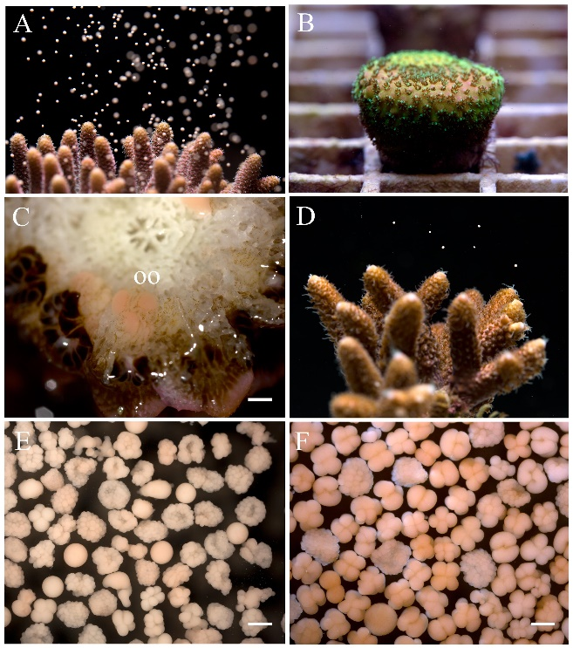
Figure 1. Closing the life cycle of Acropora millepora ex-situ. A Broodstock colony spawning ex-situ; B Seven month old F1 colony; C Three year old F1 colony with pigmented oocytes (oo); D Three year old F1 colony spawning ex-situ; E & F F2 embryos from F1 pair wise crosses. Scale = 1mm.
This is the first case of rearing an F2 generation of a broadcast spawning coral in a fully closed ex situ mesocosm. Closing the life cycle of corals under controlled conditions has a number of implications for studies focused on coral biology and reef restoration. Such a breakthrough increases the opportunities and possibilities researchers have to study trans- or intergenerational genetic effects on corals for example. These can include exploration of the heritability of resilience traits such as thermotolerance and/or disease resistance (van Oppen et al. 2015). This would allow for a greater understanding in what are more genetic expressed traits and those, which are governed more by the surrounding environment. Such ex situ spawning also offers possible cost cutting advantages and reduces the reliance on in situ spawning and collection of broodstock from dwindling wild colonies. This breakthrough will thus advance the field of coral biology and further research into ex situ mesocosm designs and husbandry approaches can only build on this foundation.

Acknowledgements
We would like to thank EcoTech Marine, Triton Applied Reef Biosciences, SEAWORLD and Busch Gardens Conservation Grant.
References
Babcock RC, Bull GD, Harrison PL, Heyward AJ, Oliver JK, Wallace CC, Willis BL (1986) Synchronous spawn- ings of 105 scleractinian coral species on the Great Barrier Reef. Mar Biol 90:379–394
Baria MVB, Dela Cruz DW, Villanueva RD, Guest JR (2012) Spawning of three-year-old Acropora millepora corals reared from larvae in northwestern philippines. Bull Mar Sci 88:61–62
Chamberland VF, Petersen D, Latijnhouwers KRW, Snowden S, Mueller B, Vermeij MJA (2016) Four-year-old Caribbean Acropora colonies reared from field-collected gametes are sexually mature. Bull Mar Sci 92:263–264
Conlan JA, Humphrey CA, Severati A, Francis DS (2017) Influence of different feeding regimes on the survival, growth, and biochemical composition of Acropora coral recruits. PLoS One 12:e0188568
Craggs J, Guest JR, Davis M, Simmons J, Dashti E, Sweet M (2017) Inducing broadcast coral spawning ex situ: Closed system mesocosm design and husbandry protocol. Ecol Evol 1–13
Guest JR, Baria M V., Gomez ED, Heyward AJ, Edwards AJ (2014) Closing the circle: Is it feasible to rehabilitate reefs with sexually propagated corals? Coral Reefs 33:45–55
Harrison PL, Babcock RC, Bull GD, Oliver JK, Wallace CC, Willis BL (1984) Mass spawning in tropical reef corals. Science 223:1186–9
Humanes A, Noonan SHC, Willis BL, Fabricius KE, Negri AP (2016) Cumulative Effects of Nutrient Enrichment and Elevated Temperature Compromise the Early Life History Stages of the Coral Acropora tenuis. PLoS One 11:e0161616
Humphrey C, Weber M, Lott C, Cooper T, Fabricius K (2008) Effects of suspended sediments, dissolved inorganic nutrients and salinity on fertilisation and embryo development in the coral Acropora millepora (Ehrenberg, 1834). Coral Reefs 27:837–850
Omori M, Kubo H, Kajiwara K, Matsumoto H, Watanuki A (2006) Rapid recruitment of corals on top shell snail aquaculture structures. Coral Reefs 25:280
van Oppen MJH, Oliver JK, Putnam HM, Gates RD (2015) Building coral reef resilience through assisted evolution. Proc Natl Acad Sci 112:2307–2313
Pollock FJ, Katz SM, Davies S, Hein M, Torda G, Matz M V., Beltran VH, Buerger P, Puill-stephan E, Abrego D, Bourne DG, Willis BL (2017) Coral larvae for restoration and research : a large-scale method for rearing Acropora millepora larvae , inducing settlement , and establishing symbiosis. PeerJ 5:e3732
Webster NS, Smith LD, Heyward AJ, Watts EM, Webb RI, Blackall LL, Negri P, Watts JEM, Negri AP (2004) Metamorphosis of a Scleractinian Coral in Response to Microbial Biofilms Metamorphosis of a Scleractinian Coral in Response to Microbial Biofilms. Appl Environ Microbiol 70:1213–1221

