#RemoteForensicCSI: Enriching Teaching, Training and Learning through Networking and Timely CPD
Rachel S. Bolton-King¹, Leisa J. Nichols-Drew² and Ian J. Turner^{3*}

¹ Department of Society, Crime & Environment, School of Justice, Security & Sustainability, Staffordshire University, Stoke-on-Trent, ST4 2DF, England. r.bolton-king@staffs.ac.uk
² Forensic Science Department, Leicester School of Pharmacy, Faculty of Health and Life Science, De Montfort University, Leicester, England. leisa.nichols-drew@dmu.ac.uk
³ Provost, Learning & Teaching: Student Performance & Engagement, University of Derby, Kedleston Road, DE21 1GB, England. I.turner@derby.ac.uk
* Corresponding author. Email address: I.turner@derby.ac.uk. Provost, Learning & Teaching: Student Performance & Engagement, University of Derby, Kedleston Road, DE21 1GB, England.

CRediT author statement:
Rachel Bolton-King: Conceptualisation; Data curation; Formal analysis; Investigation; Methodology; Project administration; Resources; Validation; Visualisation; Writing - original draft; Writing - review & editing. Leisa Nichols-Drew: Conceptualisation; Formal analysis; Investigation; Methodology; Validation; Visualisation; Writing - original draft; Writing - review & editing. Ian Turner: Conceptualisation; Formal analysis; Investigation; Methodology; Validation; Visualisation; Writing - original draft; Writing - review & editing.

Keywords:
continuous professional development; COVID-19 pandemic; criminal justice; court; crime scene; forensic; knowledge exchange; networking; policing

Graphical Abstract
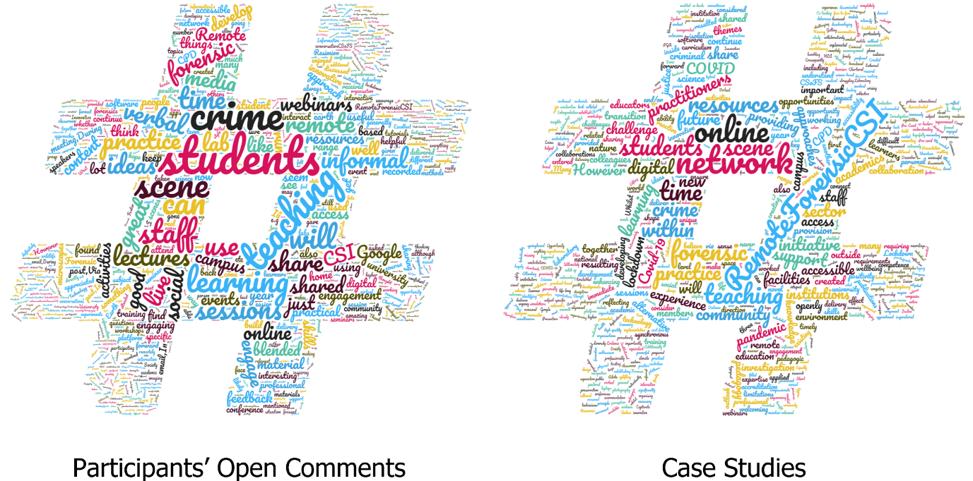

Abstract
The COVID-19 pandemic brought about rapid, transformational change to pedagogic practice on a global scale. During this time, educators across all levels needed to significantly broaden and upskill their digital skills and competence to instantaneously turn face-to-face content into remote, online provision, particularly during periods of national lockdown. Whilst there was significant e-content available in some subject domains, there were limited e-resources available to those working within the criminal justice sector. The #RemoteForensicCSI network was established in attempts to fill this gap and support both practitioner and learner transition within further and higher education and industry.
This article evaluates the value and impact that the #RemoteForensicCSI initiative had on the personal development of network participants, their peers and learners, whilst considering, reflecting on and recommending how remote delivery may influence the future of teaching, training and learning within education and the wider criminal justice sector.

Introduction
The COVID-19 virus was declared a pandemic by the World Health Organization in March 2020 [1]. The pandemic severely disrupted all aspects of society, especially the education system. Schools, College and University campuses were closed for extended periods to minimise transmission of the virus [2]. However, almost all providers continued to educate students during this time, resulting in a rapid, transformational change as they transitioned from face-to-face to online delivery [3-5].
The rapid transition presented a challenge to educators who were required to significantly upskill their digital literacy, whilst remodelling their face-to-face content and approaches to online delivery. Whilst there was significant e-content already available within some legal and traditional scientific domains through commercial platforms like Labster [6,7] and Learning Science [8,9], there were limited existing resources specifically for forensic contexts. As a result, educators working in higher education (HE), further education (FE) and the criminal justice sector needed to reconsider, innovate, design and implement new approaches for learners to develop their subject specific theoretical and practical skills. Identifying this need and realising that the delivery mode of education and training was unlikely to change in the immediate future, the authors established the #RemoteForensicCSI network as a mechanism to support educators across the sector both nationally and internationally.
The aim of the network was to share and discuss new ideas, innovations, best practice, resources and experiences of remote (synchronous and asynchronous) teaching, training and learning through free-to-access monthly e-seminars (subsequently referred to as seminars). At the time of this study (May 2021), the membership comprised of 166 individuals working in FE and HE institutions and the wider criminal justice sector, residing in 13 countries across 5 continents, although predominantly based in the United Kingdom (UK). Seminars were shared publicly on social media with recorded presentations hosted openly on YouTube [10] reaching 1,390 views, and associated open-access resources accessible through the Lecturemotely website [11] reaching 15,300 views.
This article evaluates and reflects on the impact that the #RemoteForensicCSI initiative has had on the personal development of network participants, their peers and learners, whilst considering, and recommending how remote delivery may influence the future of teaching, training and learning within education and the wider criminal justice sector.

Method
This study was approved by the <REDACTED FOR PEER-REVIEW> institutional ethics committee. Data was collected electronically using three research methods: 1) participant questionnaire, 2) social media analysis and 3) network facilitator case studies.

Participant Questionnaire
The questionnaire (Supplementary Material 1) was designed using Qualtrics software (version May 2021) [12] to remotely gather anonymised data on the perceptions and experiences of #RemoteForensicCSI participants. The questionnaire asked participants to self-report and evaluate the resources, initiatives, ideas and pedagogic approaches shared through the network. Social media platforms including Twitter, LinkedIn and Facebook, were used for dissemination as well as announcements during two synchronous #RemoteForensicCSI seminars between April and June 2021. Announcements were also shared on recordings hosted on Lecturemotely [11] and YouTube [10].
Open comments within the cleaned dataset were manually coded and thematically analysed in Microsoft Excel v1910 using a grounded theory approach [13] by the first author and validated independently by the co-authors. Where responses were quantitative, descriptive statistics were calculated with Spearman’s rank ρ correlation performed when relevant due to use of ordinal, paired and monotonic data which was not typically normally distributed and exhibited some outliers [14], using IBM SPSS v27. Qualtrics (version August 2021), SPSS and wordclouds.co.uk were also used to visually present the data.

Social Media Analysis
Qualitative feedback was sourced from publicly available posts on three social media platforms LinkedIn, Twitter and Facebook. These platforms were searched using the keywords “RemoteForensicCSI” and “RemoteForensiCSI” to identify any additional comments, mentions and/or responses to gauge independent, unsolicited public perception on the #RemoteForensicCSI initiative. The authors checked that all participants were over 18 and any such statements were subsequently anonymised for storage and analysis during this research.

Network Facilitator Case Studies
Each network facilitator wrote an independent unstructured case study (457, 509 and 712 words in length) to summarise and reflect on their personal experiences of initiating, hosting and actively engaging with the network. Case studies were subsequently coded in Microsoft Word v1910 and thematically analysed by the first author. Independent validation was conducted by the co-authors. Facilitators’ perspectives and themes where then compared to those generated by the study participants. When writing the case studies informal communications about the network received via email and direct messages were considered to try to validate or refute any potential biases and negate any emotional attachment to the initiative.

Results and Discussion
The findings for all three methodological approaches are interlinked and presented in this section through six overarching areas; engagement with (section 3.2), evaluation of (section 3.3), continuous professional development (CPD, section 3.4) and digital skills (section 3.5) developed through, and the application of (section 3.6) #RemoteForensicCSI.

Survey Response Demographics
In total, 38 responses were received, two contained no data, one only provided consent, and three did not reach question (Q) 10. As a result, these six responses were cleaned from the dataset and were not included in any subsequent data analysis. The 32 remaining participants all provided consent to contribute to the research and were 18 or over. Of these 32, 23 reached the end of the questionnaire (Q28/29), four answered up to Q11 and five recorded a partial response with their last answered question being Q15 (3), 17 (1) or 19 (1).
Respondents were primarily based in the UK (22), with two from Belgium and eight who did not disclose their geographic location. The majority were primarily employed by HEI (H; 22), although some were employed by FEI (F; 3), forensic science providers (S; 3), police or law enforcement agencies (P; 2) and other business-related organisations (O; 2).
Of the 166 named individuals (excluding the authors) in the membership list at the time of this survey, 61% were known to work in HE (47%) or FE (14%), 15% were criminal justice practitioners, 7% students or doctoral researchers, 4% other and 2% working in professional bodies. The remaining 11% were unknown. Based on this membership list, a survey return rate of 19% was achieved. However, appreciating that the #RemoteForensicCSI network is comprised of open access resources, the exact number of individuals who are aware of #RemoteForensicCSI or have accessed materials is unknown. It is likely that this low response rate was a result of members not being directly emailed to invite them to participate in the research. As a result, the authors are aware that the evaluation in this article may not accurately reflect the view of all members or participants and therefore, these aspects will be critically considered within the discussions (sections 3.2).

Engagement with #RemoteForensicCSI
Most participants became aware of #RemoteForensicCSI network through social media platforms (18; 14 Twitter and 4 LinkedIn) with a quarter (8) hearing directly from a facilitator. A further four learnt about the network from a colleague, and one through the Lecturemotely website [11]. This supports existing research on the importance of using social media to share and raise awareness of professional CPD opportunities [15-17]. However, reliance on specific platforms and social media more generally are potential barriers to awareness of and access to the network [18]. The lower engagement in the network by FE practitioners for example, is an indication of the challenges of professional social media profiles in this sector [19] or local social media policies [20]. The authors were cognisant of these barriers and targeted specific FE Forensic Facebook groups to promote the network, although a greater variety of outreach mechanisms could be adopted in the future to increase awareness and engagement within underrepresented groups. Authors were also aware of accessibility issues, preferences and availabilities of different audiences, so seminars were scheduled at variable times during the working day. Typically, attendee numbers halved when seminars were held during core teaching times (term-time between 9am and 3pm), most likely due to the higher proportion of FE and HE attendees.
After the initial access there was frequent engagement with the network from more than half (20) of the participants (Figure 1) and through a variety of mechanisms (Figure 2). Spearman’s ρ (two-tailed) correlations suggested a statistically significant relationship (r_{s}(32) = 0.493, p = 0.004, α = 0.01) albeit a low-moderate positive correlation [21] between the number and diversity of engagements. Whilst it is impossible to gauge the order of participants’ engagement or the extent of interaction from questionnaire data, the type and range of engagement suggests that respondents were more likely to be active learners and participants in the network rather than passive lurkers [22]. This would also further support the positive evaluation and overall view of the network [22] as discussed in section 3.2.
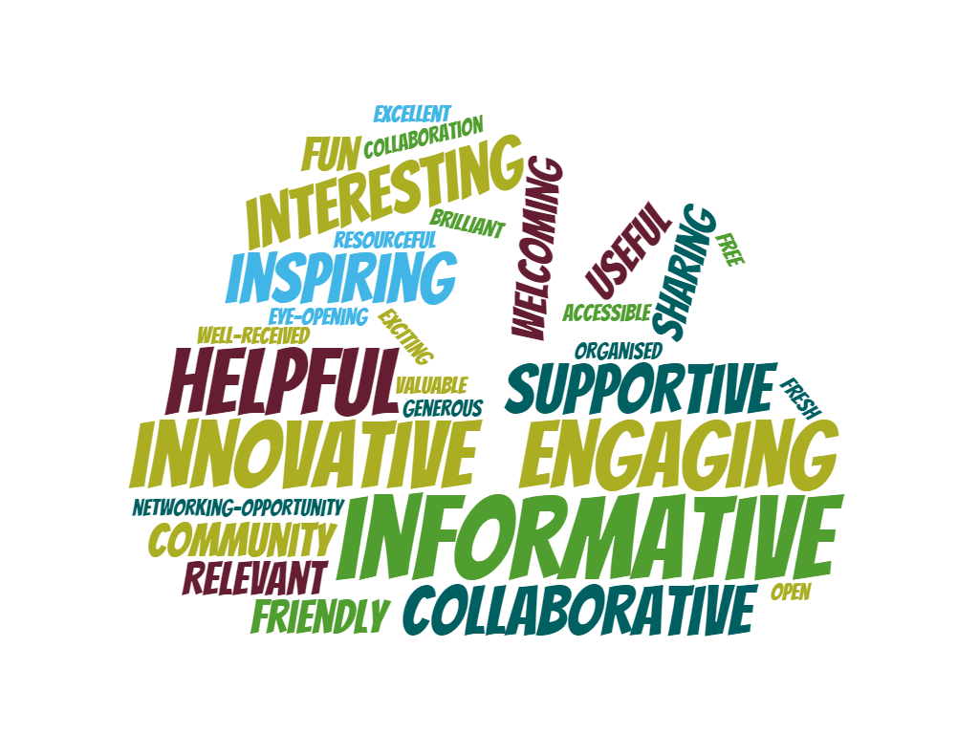
Figure 1 – Word cloud (generated using www.wordclouds.co.uk) indicating the most frequent words used by participants in describing the #RemoteForensicCSI network. The larger the word, the more frequently that word appeared in Q15 responses (maximum frequency 6 and minimum frequency 1).
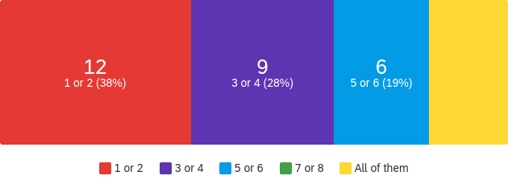
Figure 2 – Number of synchronous or asynchronous seminars that questionnaire respondents engaged with (Q10).

Evaluation of #RemoteForensicCSI
Participants expressed strong positive feedback on the overall value and effectiveness of the #RemoteForensicCSI network through independent questionnaire responses, public social media posts and personal email communications received by the co-founders/facilitators. Specifically, within questionnaire responses #RemoteForensicCSI was reported as being informative (6), innovative (5) and engaging (4), providing an accessible mechanism (6) for their personal and/or professional development (Figure 3).
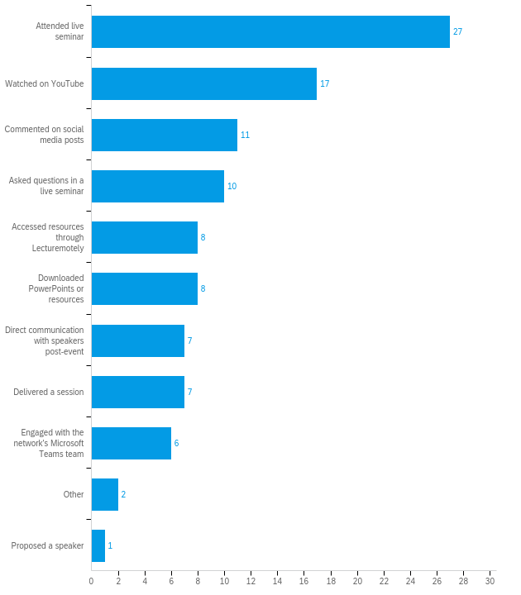
Figure 3 – Diversity of #RemoteForensicCSI engagement by the 32 respondents (Q9).

Participants overwhelmingly thought that #RemoteForensicCSI seminars, and its associated community provided real support to them during the COVID-19 pandemic:
“I am so glad to be involved with something that encourages innovative thinking and good practice focused on forensic science” [H20]
“This is a valuable resource that brings together forensic academic institutions and practitioners” [S1]
“You have created a shared community of practice, which has been a reassurance during a time of isolation and separation. Thank you” [H15]
with two openly commenting (Q29) they would like to see the initiative continue (further discussed in section 3.4);
“I would love for the network to continue as there’s a real gap in terms of sharing forensic teaching etc (everything is primarily focused on research)” [H9].
Similar points also emerged within the case studies with authors and respondents highlighting how the network had enabled them to connect with other professionals in the sector that they were previously unaware of:
“I have connected with people I wouldn’t have crossed paths with and I think it’s so useful for forensic academics and practitioners to have a platform like this.” [H20]
The feedback received is reflective of the participant-led approach employed in shaping #RemoteForensicCSI network, the levels of participant engagement (section 3.2), its status as an online learning community [23] and the opportunities it created for their CPD (section 3.3). The natural evolution of the network has seemingly created a rhizomatic learning environment; the strong social context (online provision), has enabled participants to learn with and from each other as producers, creating resources in a holistic and altruistic manner [24]. This flexibility allows the learning opportunity to be shaped by the educators for particular student’s/trainee’s needs. In #RemoteForensicCSI, rhizomatic learning is intertwined with a connectivism approach, learning within an (initially enforced) digital environment through social networking, online communities and embracing technology [25]. Both rhizomatic theory and connectivism celebrate the benefit of peer support within a community, and this theme was clearly identified by #RemoteForensicCSI facilitators and participants [26].
The themes emerging from the facilitators’ reflective case studies further echoed this feedback, albeit that their personal involvement in establishing the network and evaluating the initiative could be considered potentially biasing [27]. If this evaluation had in fact resulted in neutral or negative responses the authors would be proposing to discontinue the network rather than consider how to evolve and expand the initiative (section 4).
Analysis of posts on social media platforms also informed our evaluation of #RemoteForensicCSI. Overall, 38 individuals (excluding the authors) were responsible for posting 114 comments regarding their views of and experience with #RemoteForensicCSI seminars and/or the network on Twitter (63), LinkedIn (37) and Facebook (14) indicating repeat engagement and by these participants. Like with our questionnaire responses, most individuals were based in HE (28), with smaller numbers of criminal justice practitioners (5), those working within FEI (2) or in organisations that supplied technological solutions (3).
Only positive viewpoints were publicly reported through social media and the themes from these comments echoed those obtained through the questionnaire. Whilst one may believe that those experiencing customer dissatisfaction are more likely to post negative comments on social media, consumer surveys undertaken by the Sitel Group [28] over recent years suggest the opposite. As a result, our findings may be positively biased as we may not have been able to appropriately capture views of a neutral or more negative nature. General comments posted by the #RemoteForensicCSI community included:
“Fantastic exchange of ideas from all over the globe” [M1, Twitter, 2020]
“… always good to maintain contact with colleagues and share good practice during these challenging times” [M2, Linked In, 2021]
“great to see the strengthening of the forensic teaching community” [M3, Twitter, 2020].
There was also correlation in the timeliness of the comments being posted alongside their live participation in seminars, thereby suggesting that participants are acknowledging their attendance post-event and actively sharing the network with other platform users (section 3.2).
It must be recognised that the number of individuals posting on social media may also be the same individuals as those who responded to our questionnaire (section 3.1) and therefore could be repeated rather than additional views. Unfortunately, we were unable to capture the views of those accessing the post-event recordings and resources online, which given the extensive numbers (15,300 Lecturemotely views), could provide a viable data source for future evaluation. However, in our opinion, this research has demonstrated the need for and potential value of such a network (section 3.4 to 3.6) due to the level of engagement demonstrated by these respondents (section 3.2).

CPD through #RemoteForensicCSI
When COVID-19 restrictions came into force, educators sort expertise in the sector that would support their developmental requirements. Participants (19) used a combination of internal (5) and/or externally (9) hosted events for their CPD. Primarily these were in the form of webinars and other e-events, for example those offered by professional bodies such as the Chartered Society of Forensic Sciences (5), Royal Society of Chemistry (2) and Royal Society of Biology (1), and technology companies such as Foster+Freeman (2) and West Technology Forensics (2). Only two respondents indicated they used other internet-based resources, such as YouTube videos (1), suggesting that participants preferred bespoke, contemporary events. Two respondents also gained CPD through the teaching-related qualifications on which they were enrolled. The value of CPD is unquestionable, but there is also recognition that the current cyclical model of (often) annual events with their associated costs and professional membership requirements prior to access pose potential barriers, limiting CPD timeliness, effectiveness and accessibility.
Existing CPD opportunities at the time when #RemoteForensicCSI was initiated were therefore insufficient in supporting discipline practitioners who were struggling with the best ways of delivering their high-quality learning and teaching in this new and volatile environment. The greatest areas of concern were mapped to the three core elements that underpin educational and training programmes in the sector; crime scene analysis, forensic laboratories, and court room practice. Participants felt delivering crime scenes (11) and laboratory (11) classes were of greatest concern, with three indicating concern across more than one strand (Figure 4). This finding is indicative as learners’ practical skills development in these two areas were predominantly taught face-to-face prior to the COVID-19 pandemic and typically occupy large proportions of the curricula. Using specialist equipment, and the development of psychomotor and technical skills are principal reasons for this rationale [29]. However, other authors also show that traditional face-to-face practicals can restrict critical thinking [30,31] and this highlights the need for diverse pedagogies within the curricula.
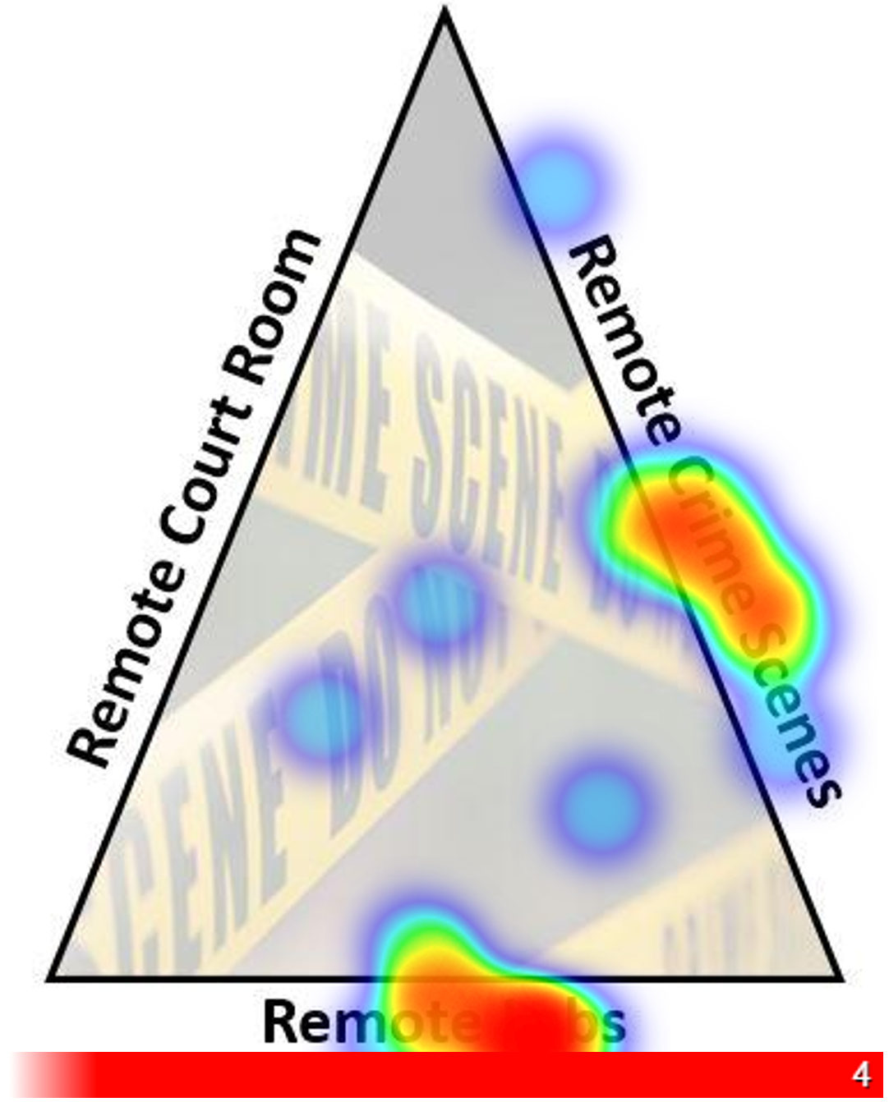

Figure 4 – Hot spot visualisation demonstrating the strand (crime scene, laboratories or court room) participants felt was their biggest area of concern when considering the move to online or remote teaching/training (Q15).

Participants typically rated the network higher (8.7 ± 0.9) than other CPD events (7.0 ± 1.44) providing 33 different justifications (codes) for their score (Q14), although it is acknowledged there may be a positive reporting bias in those who elected to respond to complete the questionnaire. There was strong focus on the role of the network as an informal form of CPD and when CPD-related codes were grouped, five themes emerged: personal CPD outcomes (15), network design (11), speaker attributes (10), resource accessibility (6) and sector impact (1). The most frequent codes mentioned subject relevance (9), ease of accessibility (6) with provision of on-demand recordings (5), the value of seminars (5) with shared ideas (4), and the opportunity to bring educators and practitioners together to create a community of practice (4) as drivers for its importance as a CPD tool. For example:
“Excellent organisation and instructions on how to access the webinars and materials makes it very easy to access. Recordings ready quickly and easy to use. Eagerness by contributors to share teaching materials. Relevance of topics. Simple straightforward cheap experiments which I can adapt.” [H3]
The flexibility in location (how accessed) and scheduling (when accessed), together with the opportunities for collaborating, experimenting and reflection are key benefits of informal CPD [32] and online learning communities [23]. This offers participants a contemporary vocational experience where they can translate experiences from a digital learning environment to their own virtual and face-to-face education activities [33].
“I found this a comfortable and encouraging place to share ideas and ask questions. All of the hosts are so lovely and accommodating and put me at ease when I presented …” [H20]
“Other [CPD] activities have been good for more general learning, but not all have the forensic context that would make them directly applicable” [H4].
In addition, Binmohsen and Abrahams [34] evidenced online CPD to be as effective as face-to-face as a delivery mechanism, with remote methods overcoming the geographic barriers often associated with face-to-face events. Evaluative research such as theirs, is often supported as part of a funded programme. However, this network was established through the authors’ standard institutional infrastructure with no additional resources and seminars were free for everyone to attend. Whilst there are clear notable benefits to this low-budget model and voluntary community of practice that has been established, there are key challenges relating to the sustainability and diversity of the network as we transition out of the COVID-19 pandemic.
At present, the facilitators, known network participants and speakers are predominantly white from developed countries. Whist current participants highlight the openness, accessibility and inclusivity of the network, the authors are very aware that the lack of social, cultural and ethnically diverse populations within the network clearly evidences this is not the case. Whilst the co-founders of #RemoteForensicCSI may be seen as necessary custodians to lead, manage and sustain the network [35], it is vital that participants take an active role in promoting and expanding diversity [36] by reaching out, inviting and sharing their experience of the network across their global professional networks. Such active inclusive practices will make us aware not only of the wider innovative practices developed and challenges faced by international educators, it will identify new opportunities and highlight important gaps existing within education and training provision.
In addition, it is important to consider the type and mechanism of event delivery. To date, seminars we primarily delivered through the broadcasting service Microsoft Teams Live Event, with attendees’ chat-based questions asked by the hosts and answered in real-time by speakers. However, using a meeting-focused service and alternative modes of delivery within the schedule would provide greater variety, inclusivity and more active opportunities for networking [37]. Suggestions include more live discussion events, online conferences, an on-demand resource hosting platform, in-person practical workshops, and regional formalised CPD events (like those organised by Professional Membership Societies) with support of sector stakeholders.
Co-creation, collaboration and communication have been integral to this multidimensional iteration [38]; horizontal within the HE sector and vertical across FE and professional operational environments. Whilst questionnaire responses from FE educators and criminal justice practitioners were limited, informal communications received by email further support our claim that the network provides a bridge between education and training. Thereby providing individuals with the opportunity for informal CPD, in an expertise interchange between participants, which is accessible, flexible, timely and cost efficient, compared to traditional conference delivery. Additionally, the heutagogic principles of #RemoteForensicCSI; in enabling and taking ownership of participants’ self-determined learning [33], could also provide practitioners with a useful repository for training and showcase novel contemporary mechanisms and technology-assisted platforms on which to bring their professional training into the 21st Century. Such approaches could be applied to the design and delivery of competency and proficiency assessments, for example, which are integral components of ISO accreditation and the UK Forensic Science Regulator Codes of Conduct and Practice.
The original ethos underpinning #RemoteForensicCSI was initially a reactive response to the pandemic, in sharing best practice and creating a support mechanism. In the authors’ view, the future and focus of the network should continuously evolve, based on the needs of the sector. Research has shown that online communities take time to develop and grow [35] and these are more successful with specific resources and investment allocated to further the initiative [39]. Such network evolution may result in some loss of community involvement, but over time it could significantly strengthen the value and impact of the network on its participants, their organisations and the wider practice within the justice system. However, as with other similar subject-specific initiatives, such as Research4Justice [40], significant stakeholder buy-in and continuous dissemination is necessary for the network to be sustainable, of value and reach its full potential impact in the sector. Due to the need for significant resourcing and infrastructure, the Research4Justice repository is still in development and is being considered by the Forensic Capability Network (FCN) [41] as part of a more extensive proposal to create a subject-specific data repository.
To further strengthen academia-industry relationships and bridge the transnational gaps and communication deficits that exist between forensic science, policing and the court [42], #RemoteForensicCSI could be an essential interconnecting solution. Expanding and raising awareness of this innovative platform could further empower educators and practitioners to exchange their expertise in practice, pedagogy and subject-specific research, fundamentally underpinning, enriching and delivering cutting-edge teaching and training experiences to learners globally across the sector, both now and into the future.
With this in mind, should we and how do we get #RemoteForensicCSI recognised as a formal CPD tool? There may be clear opportunities to achieve this in collaboration with professional bodies, such as the Chartered Society of Forensic Sciences and the FCN to ensure that the focus of the network remains on the justice system and has direct linkage between forensic science and law enforcement provision. However, wider dissemination and linkage could be exploited through other professional bodies in chemistry, biology, policing and a range of international organisations and bodies across the sector. The significant impact that the COVID-19 pandemic has also had on workplace digitisation and increasing the demand for digital skills [43,44] (section 3.5) could also present new cross-organisational opportunities to formalise the network and provide novel participant-led, co-created and intercontinental CPD within the sector.

Digital Skills through #RemoteForensicCSI
The development of digital skills was a key challenge during COVID-19, staff were expected to fully migrate to remote delivery in a short period of time [45]. Concerns have been raised over the pedagogical and literacy to support this transition, and the fact that many educators had never taught in this mode with little time available for meaningful training [46]. Participants here used #RemoteForensicCSI as one form of CPD for bridging this skill gap. In the educational sector it is evident that staffs’ technical and digital skills have improved (25) since this transition and changes implemented with respect to course structure (27) and the range of pedagogical approaches (28) used. Others acknowledge the psychological pressures caused by this disruption; the impact of changing traditional pedagogic constructs, the ‘normal’ life cycles of education and the labour market have all had effects on staff mental wellbeing [47].
Half of the participants (16) directly applied one of the pedagogic approaches seen through #RemoteForensicCSI with their learners during the pandemic. Interestingly, there were statistically significant, moderate (r_{s} = 0.5 to 0.7) or high (r_{s} = 0.7 to 0.9) positive correlations [21] between their mean ratings and their self-reported assessments of competence in the following aspects:
- Developing materials for remote delivery (r_{s}(15) = 0.773, p = 0.001, α = 0.01)
- Delivering live (synchronous) online material (r_{s}(15) = 0.704, p = 0.003, α = 0.01)
- Producing offline (asynchronous) materials (r_{s}(15) = 0.698, p = 0.004, α = 0.01)
- Assessing learners’ knowledge (r_{s}(14) = 0.666, p = 0.009, α = 0.01)
- Assessing learners’ understanding (r_{s}(14) = 0.664, p = 0.010, α = 0.01)
- Delivery of remote ‘laboratory’ practicals (r_{s}(14) = 0.570, p = 0.033, α = 0.05).
There was however no significant Spearman’s ρ (two-tailed) correlation between the number of approaches the individuals tested and the average rating given for a particular approach tested (Figure 5; r_{s}(15) = 0.188, p = 0.503, α = 0.05). Nor were there statistically significant correlations observed between the mean user experience rating given by an individual when using new approaches with their learners and their perceived change in competence (Figure 6) of their overall remote teaching delivery (r_{s}(15) = 0.438, p = 0.103, α = 0.05), delivery of remote CSI (r_{s}(14) = -0.192, p = 0.511, α = 0.05) or courtroom (r_{s}(10) = 0.571, p = 0.085, α = 0.05) content.
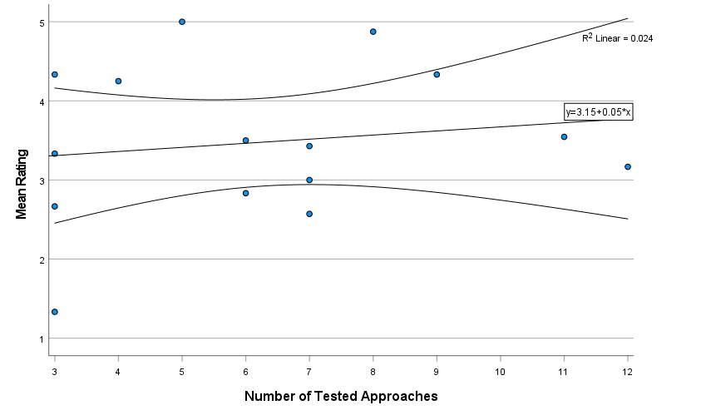
Figure 5 - Scatterplot demonstrating no significant correlation between the number of new approaches that participants tested with their learners and the mean ratings participants gave to the approaches used.

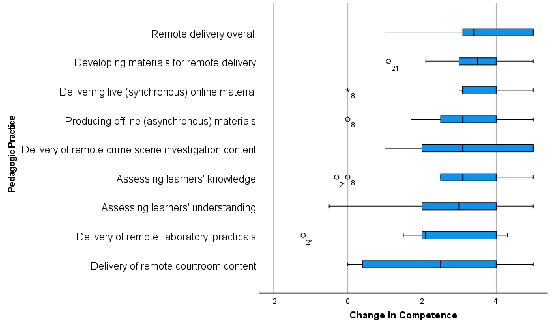
Figure 6 – Boxplot indicating participants’ self-assessment of their change in competence between the start of 2020 and the point of questionnaire completion in a range of pedagogic practices related to remote teaching/training (Q16). Rating scale ranged from -5 to +5, with zero indicating no perceived change in competence, more negative values indicating greater reduction in competence and more positive values indicating higher levels competence.

Particularly within HE, educators did their upmost to continue to provide face-to-face contact to develop key practical skills within crime scene and laboratory contexts if permitted by legislation, Government and HEI guidelines [48]. Whilst a range of remote methods were adopted (section 3.6), discussions with seminar attendees suggested that educators primarily viewed remote mechanisms as supplementary opportunities to develop learners’ observation, data analysis and critical evaluation skills [49]. Also, developing their dexterity in less hazardous environments and build learners’ confidence in the use and understanding of professional equipment prior to face-to-face delivery in specialist environments during this time [50]. Additionally, introduction to these remote methods exposed both learners and those in industry to the potential power of embracing digital platforms, for example video conferencing platforms like Microsoft Teams, in professional practice [51].
Whilst the digital skills and CPD of criminal justice practitioners increased from a professional meeting perspective, anecdotally crime scene and forensic science practitioners typically employed by law enforcement agencies and forensic laboratories either rescheduled their hands-on practical training or continued to perform training face-to-face. Legal professionals on the other hand were required to develop their digital competency to operate through virtual courts. Hearings were conducted remotely using an internet-based video platform such as Cloud Video Platform (CVP) [52] to keep the criminal justice system running and reduce backlogs as much as possible in England and Wales [53]. However, law enforcement agencies have been reported to miss an opportunity in adopting new technologies, such as CVP to conduct virtual remand hearings [53]. In the authors’ opinion such opportunities have also been missed with respect to revisioning the training in crime scene and forensic science practice (section 3.6).

Applications of #RemoteForensicCSI
A range of pedagogical tools were used by participants as a direct result of experiencing them as part of #RemoteForensicCSI. Figure 7 shows that the most frequent solutions applied by participants involved hands-on, home-based crime scene and laboratory practicals, and resources that learners and practitioners could access from home, including Google Earth and online laboratory simulations. Participants commented that the more relevant, user-centered or accessible the approach, the more likely they were to adopt it for use. However, the user experience typically attained higher ratings when the approaches employed had higher technological intuition [54]. These findings further support the informal CPD value of #RemoteForensicCSI to the engaged community who were able to quickly implement the ideas shared directly by seminar speakers.
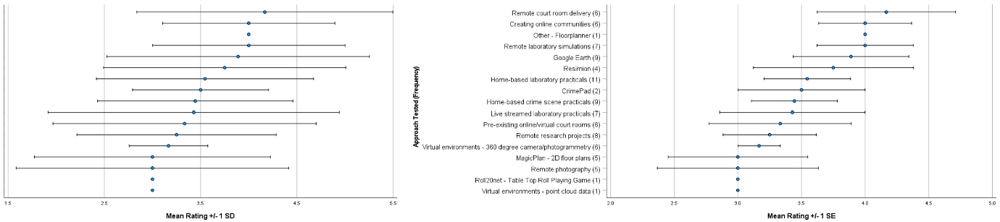
Figure 7 – User experience rating (mean ± [left] standard deviation and [right] standard error) attributed by participants who applied remote teaching practice(s) with their learners.

A change in pedagogic practice was identified as a key network output for multiple participants, through creating, incorporating and/or considering implementation of new tools (9) and raising awareness of the wide range of interactive software, activities and materials on offer (8). At least eight different tools were specifically named in Q18 open comments, for example digital microscopes (3), Google Earth (2) and Crime Scene Assist (1). When specifically asked about future adoption (Q22), Google Earth (5), digital microscopes (4) and 360-degree virtual environments (4) were most frequently mentioned with Resimion (2) and remote/simulated courts (2) also featuring. Most participants (28) mentioned sharing the outputs of #RemoteForensicCSI with others (Q11, Figure 8). Due to the questionnaire’s focus on personal practice we are unsure as to the full extent to which the network and the practices have impacted the sector.
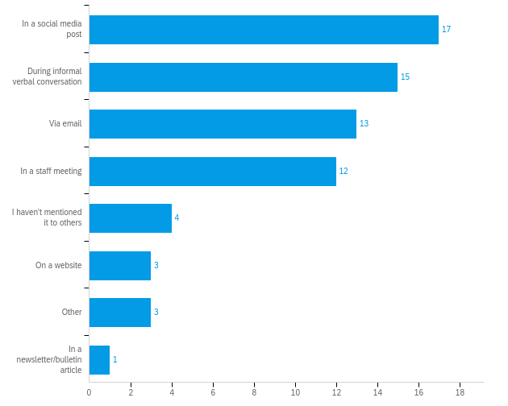
Figure 8 – Number of participants who have mentioned #RemoteForensicCSI to others and the mechanism of sharing this information (Q11).

The use of new pedagogical tools and approaches in teaching forensic science has grown exponentially during the transition to remote teaching. The use of specific tools like those shared in #RemoteForensicCSI has seen rise of innovative practice in virtual and remote laboratories [55-57], instrument analysis [58], home practicals [59,60] and discipline specific teaching [61]. The facilitators’ cases studies highlight the importance of applying the appropriate context to maximize the use of a new tool. Resimion for example, could be used to support practitioner training to enable assessment of decision making as a source of feedback in their training provision, likewise Crime Pad would provide learners in FE or HE with direct experience of software becoming increasingly used by crime scene investigators (CSI) in the UK and internationally.
The rhizomatic learning culture of #RemoteForensicCSI further supported respondents by providing useful ideas, giving them the confidence to try something new, validating their own experience, demonstrating technological advancements, and challenging the mindset of traditional pedagogic practice:
“Developed more engaging remote sessions.” [F3]
“I have developed some new resources using googlemaps for our crime scenes (as demonstrated in one of the sessions), but also general tips on ensuring students are engaging/understanding” [H17]
“Used many ideas discussed in teaching.” [H9]
“By researching recommended programmes and resources from people attending the sessions, learning about innovative ways to adapt teaching methods, thinking outside the box with forms of assessment and feedback.” [H20]
“Use of different resources to engage students with material. Taking a leap of faith and trying something new.” [S2]
“Different viewpoints have broken me out of my mindset. Or where they have coincided with my experience they have been reassuring.” [H15].
The impact of remote curriculum delivery on students are only beginning to be evaluated [62], but research has reported impacts on student experience [63,64], personal wellbeing [65], mental health [66], motivation [29] and overall performance [67]. However, we need to remember that even before the pandemic, educators experienced challenges with getting students onto campus and engaging with all learners during face-to-face curriculum delivery.
Post-pandemic, the appreciation and/or acceptance of remote delivery by learners in FE and HE may however be relatively short-lived, when a conventional return to campus ‘normal’ style delivery is proposed [68], and with consideration of student expectations [69]. In professional practice, however, it is hoped that changes brought about by the recent pandemic may be more long-standing and have a positive impact on the ability to increase the accessibility to vocational training and educational opportunities [70] in a hybrid learning framework iteration [29].
It is also important to consider that practitioner confidence and competence in applying new or remote pedagogic practices and technologies is likely to impact on their sustained use post-pandemic [71]. Those who have positively engaged, adapted and embraced new ways of working are more likely to continue to, or want to, apply these methods in the future [71]. Whilst organisations’ strategic priorities and resourcing constraints (of institutions) and learners being able to access the curriculum (digital divide) may also either facilitate or limit novel pedagogic practices that emerged. Consequently, there may be even more diverse learning experiences offered by educators within and between providers post-pandemic, which may enhance or limit the skillsets developed by learners and create greater disparity in expectation of (graduate) employers [72], and ultimately a requirement for upskilling.

Conclusion

The COVID-19 pandemic brought about rapid, transformational change on a global scale. Whilst in some geographic locations there may have been little change to crime scene and forensic laboratory training practices, there were significant changes to teaching, learning and pedagogic practice within the FE and HE sectors across the globe [73]. Those educators who needed to deliver remote teaching and/or training needed to significantly upskill and broaden their digital skills and competence, whilst often also needing to upgrade their IT (information technology) infrastructure to deliver online.
This research has evidenced the value of the #RemoteForensicCSI network for its active participants and critically evaluated this novel initiative as a viable platform for informal CPD. The network was instrumental in sharing innovative solutions and subject-specific pedagogic practices through a co-operative online learning environment and generating a valuable community of practice to support both practitioner and learner transitions across the criminal justice sector.
Whilst the network and its innovative community were brought together as a result of the COVID-19 pandemic, this experience has resulted in a cultural change in forensic science education. We have started to realise the potential value and applicability of blended learning frameworks within the criminal justice sector and have created a platform for timely, relevant and evolutionary CPD opportunities post-pandemic.
With respect to the future of #RemoteForensicCSI, we propose to continue the network by:
- Disseminating the format of #RemoteForensicCSI with other subject disciplines
- Continuing to promote the network to prospective participants as informal CPD
- Growing and adapting the network to be an ongoing resource repository
- Creating a sustainable network model for the future.

References

[1] World Health Organisation, WHO Director-General's opening remarks at the media briefing on COVID-19 - 11 March 2020. https://www.who.int/director-general/speeches/detail/who-director-general-s-opening-remarks-at-the-media-briefing-on-covid-19---11-march-2020, 11 March 2020 (accessed 19 September 2021).
[2] E.M. Onyema, N.C. Eucheria, F.A. Obafemi, S. Sen, F.G. Atonye, A. Sharma, A.O. Alsayed, Impact of Coronavirus pandemic on education, J. Educ. Prac. 11, 13 (2020) 108-121.
[3] G. Marinoni, H. van’t Land, T. Jensen, The impact of Covid-19 on higher education around the world: IAU Global Survey Report, International Association of Universities, Paris, 2020. https://www.iau-aiu.net/IMG/pdf/iau_covid19_and_he_survey_report_final_may_2020.pdf (accessed 19 September 2021).
[4] A. Aristovnik, D. Keržič, D. Ravšelj, N. Tomaževič, L. Umek, Impacts of the COVID-19 pandemic on life of higher education students: A global perspective, Sustainability 12, 20 (2020), 8438. https://doi.org/10.3390/su12208438.
[5] D. Turnbull, R. Chugh, J. Luck, Transitioning to E-Learning during the COVID-19 pandemic: How have Higher Education Institutions responded to the challenge?, Educ. Inf. Technol. 26 (2021) 6401-6419. https://doi.org/10.1007/s10639-021-10633-w.
[6] S. Stauffer, A. Gardner, D.A.K. Ungu, A. López-Córdoba, M. Heim, Labster Virtual Lab Experiments: Basic Biology, Springer Spektrum, Berlin, 2018.
[7] A. Gardner, W. Duprez, S. Stauffer, D.A.K. Ungu, F. Clauson-Kaas, Labster Virtual Lab Experiments: Basic Biochemistry, Springer Spektrum, Berlin, 2019.
[8] E. Coyte, 2019/20 releases from Learning Science: Bioscience interactive resources. https://learningscience.co.uk/blog/2020/3/6/new-from-learning-science-bioscience-interactive-resources, March 6, 2020 (accessed 10 July 2021).
[9] E. Coyte, 2019/20 releases from Learning Science: Chemistry interactive resources. https://learningscience.co.uk/blog/2020/3/6/new-from-learning-science-chemistry-interactive-resources, March 6, 2020 (accessed 6 September 2021).
[10] #RemoteForensicCSI. (n.d.) @DocWithTheSocs Video Playlist [YouTubeChannel]. https://www.youtube.com/channel/UCfaeTpe0bwG6N3zh2ewUryQ/videos, 2020 (accessed 27 August 2021).
[11] J. Rushworth, T.J. Moore, B. Rogoyski, Lecturemotely Lab Science Resources. https://www.lecturemotely.com/labcourses, 2021 (accessed 11 September 2021).
[12] Qualtrics, Qualtrics Version May 2021, 2021. Available at: http://www.qualtrics.com.
[13] I. Dey, Grounded theory, in: C. Seale, G. Gobo, J.F. Gubrium, D. Silverman (Eds.), Qualitative Research Practice, SAGE Publications Ltd., London, 2004, pp. 80-93.
[14] T.D. Gauthier, Detecting trends using Spearman's rank correlation coefficient, Environ. Forensics, 2, 4 (2001) 359-362. https://doi.org/10.1080/713848278.
[15] S. Beckingham, C. Nerantzi, Scaling-up open CPD for teachers in higher education using a snowballing approach, Journal of Perspectives in Applied Academic Practices 3, 1 (2015) 109-121. https://doi.org/10.14297/jpaap.v3i1.148.
[16] K. Murray, K. Ward, Attitudes to social media use as a platform for Continuing Professional Development (CPD) within occupational therapy, J. Furth. High. Educ. 43, 4 (2019) 545-559. https://doi.org/10.1080/0309877X.2017.1378313.
[17] B. Millar, K. Ho, A.M. Carvalho, Social media to support physician practice and CPD: Opportunities, issues, and an emergency medicine case study, B. C. Med. J. 58, 2, (2016) 94-96.
[18] M. Au, J. Lam, R. Chan, Social media education: Barriers and critical issues, in: K.C. Li, T-L. Wong, S.K.S. Cheung, J. Lam, K.K. Ng (Eds.), Technology in Education. Transforming educational practices with technology. Communications in Computer and Information Science, 494. Springer, Berlin, Heidelberg, 2015, pp. 199-205. https://doi.org/10.1007/978-3-662-46158-7_20.
[19] A. Fox, T. Bird, The challenge to professionals of using social media: Teachers in England negotiating personal-professional identities, Educ. Inf. Technol. 22, 2, (2017) 647-675. https://doi.org/10.1007/s10639-015-9442-0.
[20] L. Rodesiler, Local Social Media Policies Governing Teachers' Professionally Oriented Participation Online: a Content Analysis, TechTrends 61, 3, (2017) 293-300. https://doi.org/10.1007/s11528-016-0139-z.
[21] D.E. Hinkle, W. Wiersma, S.G. Jurs, Applied Statistics for the Behavioral Sciences, fifth ed.. Houghton Mifflin, Boston, 2003.
[22] J. Alley, K. Greenhaus, Turning lurkers into learners: increasing participation in your online discussions, Learn. Lead. Technol. 35, 1 (2007) 18-21.
[23] B. Holmes, School Teachers’ Continuous Professional Development in an Online Learning Community: Lessons from a case study of an eTwinning Learning Event, Eur. J. Educ. 48, 1 (2013) 97-112. https://doi.org/10.1111/ejed.12015.
[24] D. Cormier, Rhizomatic education: Community as curriculum, Innovate: Journal of online education, 4, 5 (2008) Article 2.
[25] E. Brieger, V. Arghode, G. McLean, Connecting theory and practice: reviewing six learning theories to inform online instruction. Eur. J. of Train. Dev. 44, 4/5 (2020) 321-339. https://doi.org/10.1108/EJTD-07-2019-0116.
[26] K. Oddone, H. Hughes, M. Lupton, Teachers as connected professionals: A model to support professional learning through personal learning networks, Int. Rev. Res. Open Dis. Learn. 20, 3 (2019) 102-120.
[27] P.T. Ross, N.L. Bibler Zaidi, Limited by our limitations, Perspect. Med. Educ., 8 (2019) 261–264. https://doi.org/10.1007/s40037-019-00530-x.
[28] Sitel Group, 2020 Customer Experience Index Survey: Understanding Brand Loyalty & Consumer Engagement. Sitel Group, Miami, 2020. https://www.sitel.com/wp-content/uploads/2020/07/COVID-19-CX-Index-2020-Survey-Data-Report-Sitel-Group.pdf (accessed 16 September 2021).
[29] T.J.U. Thompson, A.J. Collings, H. Earwaker, G. Horsman, S. Nakhaeizadeh, U. Parekh, Forensic undergraduate education during and after the COVID-19 imposed lockdown: Strategies and reflections from India and the UK, Forensic Sci. Int. 316, (2020) 110500. https://doi.org/10.1016/j.forsciint.2020.110500.
[30] T. Karakasidis, Virtual and remote labs in higher education distance learning of physical and engineering sciences, 2013 IEEE Global Engineering Education Conference (EDUCON); IEEE (2013) 798–807. https://doi.org/10.1109/EduCon.2013.6530198.
[31] J.V. Nickerson, J.E. Corter, S.K. Esche, C. Chassapis, A model for evaluating the effectiveness of remote engineering laboratories and simulations in education. Comput. Educ. 49, 3 (2007) 708–725. https://doi.org/10.1016/j.compedu.2005.11.019.
[32] E. Kyndt, D. Gijbels, I. Grosemans, V. Donche, Teachers’ everyday professional development: Mapping informal learning activities, antecedents, and learning outcomes. Rev. Educ. Res. 86, 4 (2016) 1111-1150. https://doi.org/10.3102/0034654315627864.
[33] L.M. Blaschke, The dynamic mix of heutagogy and technology: Preparing learners for lifelong learning, B. J. Educ. Technol. 52, 4 (2021) 1629–1645. https://doi.org/10.1111/bjet.13105.
[34] S.A Binmohsen, I. Abrahams, Science teachers’ continuing professional development: online vs face-to-face, Res. Sci. Technol. Educ. (2020). https://doi.org/10.1080/02635143.2020.1785857.
[35] V. Charalambos, Z. Michalinos, R. Chamberlain, The design of online learning communities: Critical issues, Educ. Med. Int. 41, 2 (2004) 135-143. https://doi.org/10.1080/09523980410001678593.
[36] F. Bottanelli, B. Cadot, F. Campelo, S. Curran, P.M. Davidson, G. Dey, I. Raote, A. Straube, M.P. Swaffer, Science during lockdown–from virtual seminars to sustainable online communities, J. Cell Sci. 133, 15 (2020) 1-5. https://doi.org/10.1242/jcs.249607.
[37] D. Sharma, The World of Virtual Conferencing: Is the Pandemic Paving the Path?, J. Neurosurg. Anesthesiol. 33, 1 (2021) 7-9. https://doi.org/10.1097/ANA.0000000000000737
[38] T. Schaefer, J. Rahn, T. Kopp, C.M. Fabian, A. Brown, Fostering online learning at the workplace: A scheme to identify and analyse collaboration processes in asynchronous discussions, B. J. Educ. Technol. 50, 3 (2019) 1354-1367. https://doi.org/10.1111/bjet.12617.
[39] S.W.P. Knight, Establishing professional online communities for world language educators, Foreign Lang. Ann. 53, 2 (2020) 298-305. https://doi.org/10.1111/flan.12458.
[40] R.S. Bolton-King, H. Kara, J.P. Cassella, B.W.J. Rankin, R.M. Morgan, S. Burke, D. Fripp, J.P. Kayne, Increasing the accessibility and impact of justice-related student and practitioner research, Forensic Sci. Int.: Synergy 20, 2 (2020) 60-71. https://doi.org/10.1016/j.fsisyn.2019.09.009.
[41] FCN, Forensic Capability Network. https://www.fcn.police.uk/, 2021 (accessed 8 September 2021).
[42] L. Hackman, Communication, forensic science, and the law. WIREs Forensic Sci. 3 (2021) e1396. https://doi.org/10.1002/wfs2.1396.
[43] Skills Panorama, Digital skills: Challenges and opportunities, February, 2021. https://skillspanorama.cedefop.europa.eu/en/analytical_highlights/digital-skills-challenges-and-opportunities (accessed 17 September 2021).
[44] Deloitte, Criminal justice and the technological revolution. Deloitte, London, 2021. https://www2.deloitte.com/content/dam/Deloitte/global/Documents/Public-Sector/gx-deloitte-criminal-justice-and-technological-revolution-report.pdf (accessed 17 September 2021).
[45] M.A. Khan, COVID-19’s Impact on Higher Education: A Rapid Review of Early Reactive Literature, Educ. Sci. 11, 8 (2021) 421-435. https://doi.org/10.3390/educsci11080421.
[46] E. Dill, K. Fisher, B. McMurtrie, B. Supiano, As Coronavirus Spreads, the Decision to Move Classes Online Is the First Step. What Comes Next. https://www.chronicle.com/article/as-coronavirus-spreads-the-decision-to-move-classes-online-is-the-first-step-what-comes-next/, 6 March 2020 (accessed 10 September 2021).
[47] R. Watermeyer, T. Crick, C. Knight, J. Goodall, COVID-19 and Digital Disruption in UK Universities: Afflictions and Affordances of Emergency Online Migration, High. Educ. 81 (2020) 623–641. https://doi.org/10.1007/s10734-020-00561-y.
[48] S. Bailey, JISC: Ensuring continuity of learning during enforced absence. https://www.jisc.ac.uk/guides/ensuring-continuity-of-learning-during-enforced-absence, 6 March 2020 (accessed 8 September 2021).
[49] L.S. Neuwirth, S. Jović, B.R. Mukherji, Reimagining higher education during and post-COVID-19: Challenges and opportunities, J. Adult Contin. Educ. (2020) 1477971420947738. https://doi.org/10.1177/1477971420947738.
[50] M. Seifan, N. Robertson, A. Berenjian, Use of virtual learning to increase key laboratory skills and essential non-cognitive characteristics, Educ. Chem. Eng. 33, (2020) 66-75. https://doi.org/10.1016/j.ece.2020.07.006.
[51] T. Sourdin, B. Li, D.M. McNamara, 2020. Court innovations and access to justice in times of crisis, Health Policy Technol. 9, 4 (2020) 447-453. https://doi.org/10.1016/j.hlpt.2020.08.020.
[52] Crown, HMCTS services: Remote hearing channels (crime). https://www.gov.uk/guidance/hmcts-services-remote-hearing-channels-crime, May 14, 2021 (accessed 17 September 2021).
[53] House of Lords, COVID-19 and the Courts, HL Paper 257, Select Committee on the Constitution, March 2021.
[54] N. Gordon, Flexible pedagogies: Technology-enhanced learning, The Higher Education Academy, York, January 2014. https://www.advance-he.ac.uk/knowledge-hub/flexible-pedagogies-technology-enhanced-learning (accessed on 19 September 2021).
[55] R. Morales-Menendez, R.A. Ramírez-Mendoza, A. Vallejo-Guevara, Virtual/remote labs for automation teaching: A cost effective approach, IFAC-PapersOnLine, 52, 9 (2019) 266-271. https://doi.org/10.1016/j.ifacol.2019.08.219.
[56] P. Trentsios, M. Wolf, S. Frerich, Remote Lab meets Virtual Reality–Enabling immersive access to high tech laboratories from afar. Procedia Manuf. 43 (2020) 25-31. https://doi.org/10.1016/j.promfg.2020.02.104.
[57] T. Bassindale, R.J. LeSuer, D.P. Smith, Perceptions of a program approach to virtual laboratory provision for analytical and bioanalytical sciences, J. Forensic Sci. Educ. 3, 1 (2021).
[58] C. Tran, M. Lamar, Fostering Small Group Discussion in an Online Instrumental Analysis Course using Google Docs, J. Forensic Sci. Educ. 2, 2 (2020).
[59] D.J. Caruana, C.G. Salzmann, A. Sella, Practical science at home in a pandemic world, Nat. Chem. (2020) 780-783. https://doi.org/10.1038/s41557-020-0543-z.
[60] H. Tidy, I. Parker, A Break from the Zoom-Using a Students Home Environment to Teach Forensic Science Interpretation during the Covid-19 pandemic, J. Forensic Sci. Educ. 3, 1 (2021).
[61] K.M. Elkins, C. Zeller, Approaches for teaching forensic body fluids analysis for remote learning, J. Forensic Sci. Educ. 3, 1 (2021).
[62] P. Stanistreet, M. Elfert, D. Atchoarena, Education in the age of COVID-19: Understanding the consequences, Int. Rev. Educ. 66 (2021) 627-633. https://doi.org/10.1007/s11159-020-09880-9.
[63] C. Killen, M. Langer-Crame, Learner digital experience insights survey 2020/21 UK further education (FE) survey findings, JISC, Bristol, 7 September 2021. https://www.jisc.ac.uk/reports/learner-digital-experience-insights-survey-2020-21-further-education-findings (accessed 19 September 2021).
[64] C. Killen, M. Langer-Crame, Learner digital experience insights survey 2020/21 UK higher education (HE) survey findings, JISC, Bristol, 7 September 2021. https://www.jisc.ac.uk/reports/student-digital-experience-insights-survey-2020-21-uk-higher-education-findings (accessed 19 September 2021).
[65] Office for National Statistics, Coronavirus and the impact on students in higher education in England: September to December 2020. https://www.ons.gov.uk/peoplepopulationandcommunity/educationandchildcare/articles/coronavirusandtheimpactonstudentsinhighereducationinenglandseptembertodecember2020/2020-12-21, 2021 (accessed 14 August 2021).
[66] Office for National Statistics, Coronavirus and Higher Education Students: England 24th May to 2nd June 2021. https://www.ons.gov.uk/peoplepopulationandcommunity/healthandsocialcare/healthandwellbeing/bulletins/coronavirusandhighereducationstudents/england24mayto2june2021, 2021 (accessed 30 August 2021).
[67] R. Gopal, V. Singh, A. Aggarwal, Impact of online classes on the satisfaction and performance of students during the pandemic period of COVID 19, Educ. Inf. Technol. (2021) 1-25. https://doi.org/10.1007/s10639-021-10523-1.
[68] V.M. Kumar, Z. Limei, T. Xianzhang, Z. Bensi, COVID-19 and Online Learning: A Student Perception Survey, Am. J. Educ. Res. 9, 5 (2021) 272-277. https://doi.org/10.12691/education-9-5-4.
[69] A. Jackson, The expectation gap: Students’ experience of learning during Covid-19 and their expectations for next year, WONKHE, London. https://wonkhe.com/blogs/the-expectation-gap-students-experience-of-learning-during-covid-19-and-their-expectations-for-next-year/, 15 July 2020 (accessed 19 September 2021).
[70] Organisation for Economic Co-operation and Development (OECD), The potential of online learning for adults: Early lessons from the COVID-19 crisis, OECD Publishing, Paris, 2020. https://read.oecd-ilibrary.org/view/?ref=135_135358-ool6fisocq&title=The-potential-of-Online-Learning-for-adults-Early-lessons-from-the-COVID-19-crisis&_ga=2.18009145.1601739727.1632069374-1432573682.1632069374 (accessed 30 August 2021).
[71] R. Saboowala, P. Manghirmalani Mishra, Readiness of in-service teachers toward a blended learning approach as a learning pedagogy in the post-COVID-19 Era, J. Educ. Technol. Syst., 50, 1 (2021) 9-23. https://doi.org/10.1177/00472395211015232.
[72] A. Webb, R.W. McQuaid, C.W.R. Webster, Moving learning online and the COVID-19 pandemic: A university response, World Journal of Science, Technology and Sustainable Development 18, 1 (2021) 1-19. https://doi.org/10.1108/wjstsd-11-2020-0090.
[73] T. Karakose, The impact of the COVID-19 epidemic on higher education: Opportunities and implications for policy and practice, Ed. Process: Int. J. 10, 1 (2021) 7-12. http://dx.doi.org/10.22521/edupij.2021.101.1.

Funding:
This research did not receive any specific grant from funding agencies in the public, commercial, or not-for-profit sectors.

Acknowledgements:
The authors would like to thank everyone who has engaged with the #RemoteForensicCSI network to date, particularly the seminar speakers and those who participated in the research. We have all learnt so much from each other and we thank you for your support both personally and professionally through this challenging pandemic; long may it continue.

Supplementary Material 1

Q1 Participant Information
Title: Evaluating the Impact of #RemoteForensicCSI
Professor Ian Turner (University of Derby), Associate Professors Rachel Bolton-King (Staffordshire University) and Associate Professor Leisa Nichols-Drew (De Montfort University) are the co-founders of the #RemoteForensicCSI network. We are conducting research to assess and evaluate the impact that #RemoteForensicCSI may have had on professionals working in further and higher education institutions and criminal justice systems around the world.

Purpose of the research:
This research aims to assess and evaluate the impact that the #RemoteForensicCSI seminars and publicly available resources have had on the personal development of individuals, their peers and their learners. The research also aims to establish how respondents’ experiences of remote delivery may influence the future of teaching, training and learning within their own practice and that of the wider education and criminal justice sectors.
Participation in this project will require:
Your participation in this research will involve you voluntarily answering an electronic Qualtrics questionnaire, which focuses on your experiences of attending, watching, engaging and/or contributing to the #RemoteForensicCSI network. It is estimated that it will take you approximately 15 minutes to complete the questionnaire. You are able to save the questionnaire partway through and return to it within one week of starting the questionnaire if you use the same internet browser and the same computer, however, this is not advisable if completing the questionnaire on a shared device. After one week any partially completed questionnaire data will be automatically submitted for data analysis. The questionnaire has been designed to be answered by a wide range of professionals to understand how #RemoteForensicCSI may have impacted within the education and criminal justice sectors. You reserve the right to not answer any of the questions during the questionnaire if you feel that it is inappropriate to do so. Your IP address and location data is immediately and automatically removed from your questionnaire data upon submission to ensure your anonymity. However, you are given the option to provide your country of residence within your questionnaire response, and to give you the opportunity to withdraw your data, you can provide a personal code word at the start of your questionnaire. If you need to withdraw consent you can contact Rachel by telephone (details below) indicating your code word before the 1st June 2021 and we can delete your response prior to data analysis commencing. If you cannot recollect your code word or our data analysis has already commenced, unfortunately you will not be able to withdraw your consent or your data.
What will happen with your data obtained from this research?
The raw data gathered from you will be automatically anonymised in Qualtrics as soon as the questionnaire has been submitted so your identity should not be disclosed. Your identity would only be disclosed if you contacted us by email with your code word to request for us to delete your data prior to 1st June 2021. All raw data will be kept confidential and will only be accessible to the researchers. Your data will be used solely for research purposes and analysed to establish key outcomes associated with this project. All raw data will be safely and securely stored on a secure Staffordshire University computer and OneDrive system by either the project supervisor or the university department for a minimum of 10 years in compliance with the University Guidelines and GDPR Principles. After this time, all data will be deleted. If you have any further questions, please get in touch with Rachel (details below) before continuing with the questionnaire.
Researchers' names:
Rachel Bolton-King, Leisa Nichols-Drew & Ian Turner
Researchers' contact details:
Rachel’s email: r.bolton-king@staffs.ac.uk
Rachel's direct telephone number: +44 (0)1782 294367
Leisa’s email: Leisa.Nichols-Drew@dmu.ac.uk
Ian’s email: i.turner@derby.ac.uk

Q2 Participant Consent
I have read the information provided and understand all the information that is included in it.
I have had the opportunity to ask any questions about my involvement in the project.
My participation is voluntary, and I understand that I am only able to withdraw my data from the research if I contact the researchers and provide my personal code word by telephone before 1st June 2021.
I understand that the information provided by me will be seen by the researchers in an anonymised format and my IP address and specific location data will not be stored with my response.
Any personal information will not be identified in the final report or published materials that arise from this research.
- I have read the information provided and agree to participate in this questionnaire
- I no longer wish to participate

Q3 If you would like the option to withdraw your consent before 1st June 2021, please provide a personal code word below that enables us to identify your questionnaire response and delete the data.

Q4 How old are you (in years)?
- Under 18
- 18 or over

Q5 In which country do you currently reside?

Q6 Which type of organisation do you primarily work for?
- Further education institution
- Higher education institution
- Police force/law enforcement agency
- Forensic laboratory/service provider
- Law firm
- Other ________________________________________________

Q7 How long have you worked in or with the education and/or criminal justice sector?
- Under 5 years
- 5 to 10 years
- 11 to 15 years
- 16 to 20 years
- 21 to 25 years
- 26 to 30 years
- Over 30 years

Q8 How did you first hear about #RemoteForensicCSI?
- Directly from Leisa, Rachel or Ian
- Twitter
- LinkedIn
- Colleague
- Lecturemotely website
- YouTube search
- Search engine search
- Blog post
- Other ________________________________________________
Q9 How have you engaged with #RemoteForensicCSI to date? Select as many as apply.
- Attended live seminar
- Watched on YouTube
- Accessed resources through Lecturemotely
- Downloaded PowerPoints or resources
- Asked questions in a live seminar
- Commented on social media posts
- Direct communication with speakers post-event
- Delivered a session
- Proposed a speaker
- Engaged with the network's Microsoft Teams team
- Other ________________________________________________

Q10 Of our monthly seminars held to date, how many have you engaged with (either live/synchronously or recorded/asynchronously)?
- 1 or 2
- 3 or 4
- 5 or 6
- 7 or 8
- All of them

Q11 How have you mentioned #RemoteForensicCSI to others? Select as many as apply.
- I haven't mentioned it to others
- In a social media post
- Via email
- In a staff meeting
- In a newsletter/bulletin article
- In a blog post
- On a website
- During informal verbal conversation
- Other ________________________________________________

Q12 Other than the resources shared during #RemoteForensicCSI, what other resources, events or activities you have engaged with to support your teaching, training or learning since March 2020?
________________________________________________________________
________________________________________________________________

Q13 How would you rate #RemoteForensicCSI and other forms of continual professional development (CPD) that you have engaged with since March 2020? A value of zero is a very poor rating and a value of 10 is an exceptional rating.
 | 0 | 1 | 2 | 3 | 4 | 5 | 6 | 7 | 8 | 9 | 10

#RemoteForensicCSI ()
Other forms of teaching/training focused CPD ()

Q14 Please briefly explain why you gave the ratings you provided above for the forms of CPD you have engaged with since March 2020.
________________________________________________________________
________________________________________________________________
Q15 Of our three main seminar strands (crime scene, labs or court room-based), which one was your biggest area of concern when considering the move to online or remote teaching/training? Click on the name of the strand within the image below to indicate your answer.
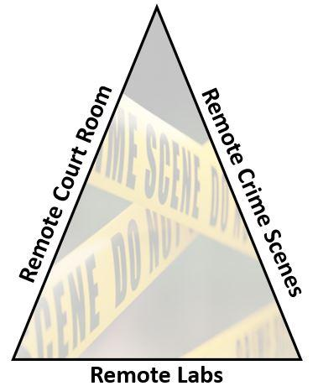

Q16 Compared to how you felt at the start of 2020, how competent do you now feel when developing and delivering different types of remote teaching/training? A value of zero indicates you feel your competence is comparable, a negative value means you now feel less competent and a positive values indicates you now feel more competent.

 | Less competent | Comparable level of competence | More competent | Not Applicable

 | -5 | -4 | -3 | -2 | -1 | 0 | 1 | 2 | 3 | 4 | 5

Remote delivery overall ()
Developing materials for remote delivery ()
Delivering live (synchronous) online material ()
Producing offline (asynchronous) materials ()
Delivery of remote crime scene investigation content ()
Delivery of remote 'laboratory' practicals ()
Delivery of remote courtroom content ()
Assessing learners' knowledge ()
Assessing learners' understanding ()

Q17 Has engaging with #RemoteForensicCSI caused you to develop your own and/or your colleagues’ approach(es) to or practice(s) in teaching, training or learning?
- Yes
- No

Q18 How have you or your colleagues developed your approach(es) or practice(s) in teaching, training or learning as a direct result of engaging with #RemoteForensicCSI?
________________________________________________________________
________________________________________________________________

Q19 As a result of seeing the resources or approaches showcased in or referred to through #RemoteForensicCSI, have you used any directly with your learners?
- Yes
- No

Q20 As a direct result of #RemoteForensicCSI, how would you rate your experience of using the resource or approach in teaching, training or learning? A rating of 1 is very poor and a rating of 5 is excellent.

 | Never Used (0) | 1 | 2 | 3 | 4 | 5
Google Earth
Resimion
CrimePad
Roll20net - Table Top Roll Playing Game
Pre-existing online/virtual court rooms
Creating online communities
Remote photograph
MagicPlan - 2D floor plans
Virtual lab/court/scene environments - 360 degree camera/photogrammetry
Virtual lab/court/scene environments - point cloud data
Home-based crime scene practicals
Home-based laboratory practicals
Remote laboratory simulations
Remote court room delivery
Remote research projects
Live streamed laboratory practicals
Other

Q21 Please share with us below any feedback you have received from learners about the impact of your remote teaching/training practice on their learning experience.
________________________________________________________________
________________________________________________________________
Q22 If there are resources/approaches you have identified through #RemoteForensicCSI that you have yet to use, but intend to in the future please list these below.
________________________________________________________________
________________________________________________________________
Q23 If there any themes/areas that we could feature in a future #RemoteForensicCSI seminar, please list these below.
________________________________________________________________
________________________________________________________________

Q24 Post COVID-19 pandemic, do you think you will continue to use remote methods of teaching/training in your future practice?
- Yes
- Unsure
- No

Q25 Please comment on how and why you think you will use remote methods of teaching/training in your future practice post-pandemic?
________________________________________________________________
________________________________________________________________

Q26 Why do you think you will stop or are unsure about using remote methods of teaching/training in your future practice post-pandemic?
________________________________________________________________
________________________________________________________________

Q27 Using three words, how would you describe the #RemoteForensicCSI network?
________________________________________________________________
Q28 Would you like to make any other comments related to your experience of #RemoteForensicCSI and/or the future of remote teaching, training and learning in the education and/or criminal justice sectors?
- Yes
- No

Q29 Please provide any other comments related to your experience of #RemoteForensicCSI and/or the future of remote teaching, training and learning in the education and/or criminal justice sectors here.
________________________________________________________________
________________________________________________________________

