**8mm Cine Workshop**

**Exposure Photography Festival**

**Proposed date: Monday, 3rd February**

**Delivered by: Dr Philip Harris**

**Outline of workshop:**

Now considered obsolete, these old Bolex 8mm cine cameras were produced in the 1950s and promoted to families and amateur film makers. They are simple to use, fully manual, powered by a clockwork motor, with excellent build quality and optics. With care and application of basic cameras/photo skills and knowledge, they are capable of very good image quality.

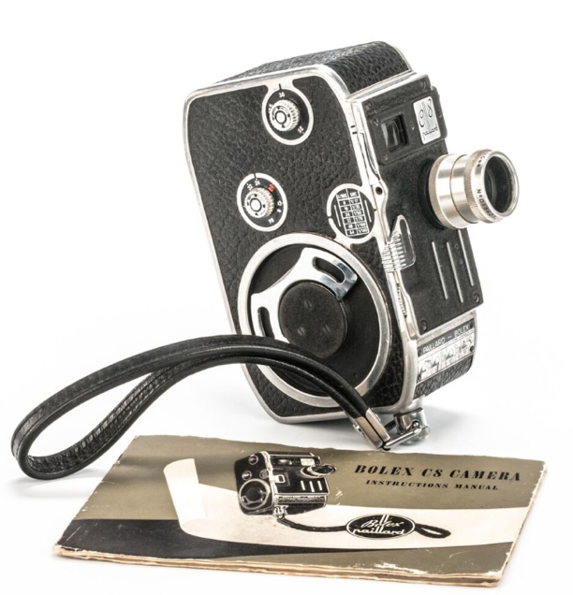

Being a physical medium, cine film allows the user capacity to experiment, in a very hands-on way, with editing, looping and use of multiple projectors to create montages of footage and images.

The workshop can be based around a brief that explores the identities of Calgary – the physical, regional and cultural identities of the city. Users will be taught and guided in the camera controls, exposure settings, use of a handheld lightmeter (It would be very useful if the Uni can provide these. Sekonic 308 will suffice), and methods for handheld filming in a range of circumstances. They will then use this knowledge to produce film footage that interprets their response to Calgary.

The scope of delivery and support will depend on how much time the Photo/Art department can dedicate to the workshop. A practical workshop on basic use can be delivered in 2 hours, including a visual presentation on my own work to present a rationale for the workshop. It would work best if this can then be supplemented by an hour or so of practical support with using the cameras and exposing film for the brief.

Delivery at a time of day when there is daylight is a must due to technical limitations with exposure (the film is 50 ISO!). So mid-late afternoon would not be so useful.

I am happy to deliver the workshop on the Monday and allow the students to return the cameras to the department on Wednesday (we leave on Thursday). This will allow students to consider how and what they will film and facilitate a degree of travel around the city to explore subjects, sites, etc (hopefully). Just let me know if you think this is wise or not as the cameras are my own resources (most have been purchased for around £10-£15 and brought back into working condition by myself)

My intention is to process the films when I return to the UK. I will then create a multi-projector installation, video it, and forward the digital video files to the department.

**Resources provided by myself**:

3 to 4 x Bolex 8mm cameras

8 x rolls of 8mm film

Film processing

Production of video files

**Resources to be provided by the Photo dept:**

Sekonic 308 lightmeters (or similar)

**Group size:**

8 – 12 maybe…? Two or three students per camera.

Links to my own work, to see how I use and present this media, are as follows:

vimeo.com/349094205

vimeo.com/360749732

vimeo.com/348370932

vimeo.com/344585718

Let me know what you think and what might be most realistic.