**Analyzing Leading Countries and Research Networks in Advancing Cleaner Production and Environmental Sustainability in Southeast Asia**

**Abstract**

**Purpose:** This investigation assesses the Association of Southeast Asian Nations (ASEAN) response to cleaner production and environmental sustainability, with a specific focus on identifying the leading countries and research networks driving progress in this field.

**Design/methodology/approach:** A benchmarking journal was chosen, and a comprehensive examination of the journal's archive followed. To construct the dataset, a conventional keyword search technique was applied in February 2023, filtering for ASEAN affiliations. The study utilized hybrid bibliometric analyses and multi-criteria decision analysis (MCDA) to analyse the collected data and addressing the research purpose.

**Findings:** The data analysis revealed a rising research trend, particularly after 2014. Malaysia had the most publications, followed by Thailand and Singapore, and their publications had the most cumulative citations among ASEAN countries. Collaborations between Malaysia, Thailand, and Singapore were potent but participation from other countries was low. The ASEAN members' focusing research topics were also identified, but it became apparent that they are not coordinated. Very few collaborations observed involving more than two countries, thus the MCDA analysis conclude the absence of research leadership in ASEAN.

**Originality:** This study contributes insights to the existing literature, offering valuable overview of the research direction and existing collaboration status for cleaner production and environmental sustainability in the ASEAN region, benefiting policy makers. Additionally, the study introduces a novel approach that combines bibliometrics analysis with MCDA to assess research collaboration, providing a novel methodology for future research policy evaluations.

**Keywords:** Cleaner Production; Environmental Sustainability; Association of Southeast Asian Nations (ASEAN); Bibliometric Analysis; Multi-Criteria Decision Analysis (MCDA).

**1. Introduction**

The Association of Southeast Asian Nations (ASEAN) has launched a number of initiatives and programs to promote cleaner production and environmental sustainability (Mehmood et al., 2022). However, to the best of the authors’ knowledge, there is currently a lack of full awareness of the countries that are scientifically leading the efforts to achieve these goals in practice. As a result, the reason for this study is to fill this important gap in the existing literature by identifying the key contributors to the field of cleaner production and environmental sustainability. The study aims to assess the ASEAN in its response to cleaner production and environmental sustainability by conducting a systematic review of the literature published in this field and by the union members. Furthermore, the study intends to track progress over time, share valuable knowledge and best practices, and raise awareness of the region's efforts in this critical area. The novel approach of systematically mapping the contribution and evolution of research on cleaner production and environmental sustainability within the ASEAN region will allow the union's significant strides in addressing this pressing issue to be captured. As a result, the findings of this study will not only shed light on ASEAN's development, growth, and new advances in cleaner production and environmental sustainability but will also serve as a valuable resource to inform future paths toward achieving sustainable and environmentally conscious practices for international policy-makers.

**2. Literature review**

As the global economy becomes increasingly interconnected and interdependent, the role of environmental sustainability in economic development has become widely acknowledged as a crucial factor for long-term growth and prosperity. Many of existing ecosystem's issues, however, have become worse in recent years, to the point that they could likely result in a serious environmental crisis for the whole globe (Khan et al, 2022; Khan et al, 2022). This was first predicted in the 1987 United Nations report on sustainable development and has since been supported by numerous studies and reports (OECD, 2011). The degradation of ecosystems, such as forests, rivers, and fertile lands, due to pollution and overuse, creates barriers to economic progress and exacerbates poverty, particularly in rural areas (Garg, 2020). In addition, environmental issues such as health problems and food insecurity caused by pollution can have significant impacts on communities and further worsen poverty in areas where it is already difficult to earn a living or receive an education (Tan et al., 2019; Kopittke et al., 2019; Abideen et al., 2021). There is a significant legislative and standard gaps that are impeding the implementation of the highlighted changes and reflects on the serious problems that plastic trash in Asian waterways poses (Leal Filho et al., 2022a).The adoption of the United Nation’s sustainable development goals in 2015 evoked a sense of optimism regarding their achievable implementation by the year 2030 (Leal Filho, 2023). International partnership for createing synergies is a means for the world sustainability development (Leal Filho et al, 2022).

Association of Southeast Asian Nations (ASEAN) was established on August 8, 1967, in Bangkok, Thailand, as a political and economic organization of ten countries: Indonesia, Malaysia, Philippines, Singapore, Thailand, Brunei Darussalam, Vietnam, Lao PDR, Myanmar, and Cambodia (ASEAN, 2022), and over the past five decades, it has experienced impressive economic growth and has become a major contributor to the global economy (Khan, 2021). However, this growth has not come without its challenges, particularly in terms of environmental sustainability (Kasa, 2021). In recognition of the importance of environmentally sustainable growth, ASEAN Member States have adopted various declarations and implementation plans, including the ASEAN Socio-Cultural Community Blueprint (2009) and the State of the Environment Report (2007, 2009) based on their public report (ASEAN, 2016). These initiatives emphasize the economic importance of environmental protection and demonstrate ASEAN's commitment to sustainable development. Furthermore, subregional initiatives, such as the Indonesia-Malaysia-Thailand Growth Triangle, have been established to address the environmental and social challenges faced by these countries and promote sustainable growth (ASEAN, 2016). ASEAN is now promoting environmental cooperation among its members for sustainable development and regional integration. This cooperation is guided by the ASEAN Socio-Cultural Community Blueprint 2025 (ASEAN, 2016), which aims to create a dynamic and inclusive community that is sustainable, resilient, and dynamic. This cooperation seeks to conserve and sustainably manage biodiversity and natural resources, promote environmentally sustainable cities, and encourage sustainable consumption and production. Besides, each ASEAN member state has demonstrated a tremendous commitment to advancing environmentally responsible growth in the ASEAN economy (Han et al., 2022).

Still, to sustain its sustainable growth as a major player in the global economy, ASEAN requires crucial ecosystem services, such as clean water, arable land, and unpolluted air. ASEAN Member States must continue to prioritize environmental sustainability in their economic development strategies (ASEAN, 2016, Lord et al., 2016) and work together to create a more sustainable future for the region and the world. It is directed for research to investigate better collaborations involving sustainability movements among several stakeholders (khan et al 2023).

ASEAN, as a region of rich biodiversity, hosts approximately 20% of all known diverse species of living creatures (ASEAN, 2022), underscoring its deep environmental concern and commitment to sustainability. Although ASEAN is experiencing rapid economic growth, it consequently faces serious challenges in the area of environmental protection (Han et al., 2022). Environmental deterioration is a critical issue for ASEAN's future development and its sustainable integration (Ahmed et al., 2017). ASEAN is trying to address the United Nations' sustainable development goals and its environmental challenges, including water management, waste management, deforestation and land degradation, sea and air pollution, and climate change (Agus, 2020). However, urbanization and excessive consumption of food, water, and energy have led to environmental and economic challenges (Dey et al., 2020).

ASEAN nations are now focusing on cleaner production in various industries, such as poultry, agriculture, and food, and are also promoting the commercial production of biofuels from palm oil (Dey et al., 2021). Indonesia and Malaysia are shifting their focus to the global natural gas market while reducing the use of non-renewable energy and promoting environmentally friendly economic changes through green funding and financing (Raihan, 2022). ASEAN countries are striving to decarbonize and reduce their greenhouse gas emissions and become world leaders in green energy innovation and development (Nepal et al., 2021). Budget tagging for climate change has been implemented in Indonesia to promote sustainability (Gonguet et al., 2021). Yet, in order to achieve long-term financial and environmental goals, it is important for ASEAN to emphasize the need to combining efforts and resources (Kahn et al., 2022).

Nonetheless, despite the environmental sustainability goals and efforts, for one, several ASEAN members, including the Philippines, Malaysia, Indonesia, Vietnam, and Thailand, are among the top 10 ocean polluters, with uncollected and illegally discarded plastic waste contributing thousands of tons to ocean pollution each year (ASEAN, 2022). This alone poses a hazardous impact on marine life, including the presence of microplastics that can enter the food chain and potentially harm human health (Guzman, 2022). Last, but not least, addressing the environmental challenges remains crucial for the stability and future prosperity of the ASEAN region (ASEAN, 2022).

The rise of sustainability concerns has motivated research on cleaner production and environmental sustainability practices and their financial consequences ,globally (Khan et al, 2023; Gracia, 2021). However, according to Leal Filho et al. (2022c), there are significant differences among Asian nations when it comes to sustainability practices in higher education institutions. These institutions in far-eastern nations like Indonesia, Malaysia, and Thailand are thought to exhibit higher sustainability practices (Leal Filho et al., 2022d). Leal Filho et al. (2023) emphasizes the value of encouraging global cooperation initiatives to promote declarations and develop the sustainable development movement However, Leal Filho et al. (2022e) note the existing knowledge gaps to enable countries to pursue sunstainable development goals. For ASEAN's goal to promote sustainability, related scientific contributions plays a crucial role in evaluating the results of these efforts and programs Upadhyaya & Rajasekharan Pillai (2019) both point to the importance of research in bolstering a reign’s economy and improving its sustainability. Research's direct, indirect, and flow-on effects, which increase value-added, production and technology capacity, and consumer surplus, and many other (Sukoco et al., 2023). Besides, there have been dramatic shifts in scientific inquiry throughout ASEAN countries over the past few decades, coinciding with the region's rapid development (Ho-Le & Nguyen, 2018). As a result, this research seeks to explore the extent of research efforts and collaborations among ASEAN members in addressing cleaner production and environmental sustainability movement.

**3. Method**

This study's overarching goal is to learn more about the level of cooperation between ASEAN scholars working on sustainability issues. In order to accomplish this, it requires a benchmark by which to evaluate the results of our scientific investigations and identifying such a standardization framework is an interim goal. This is accomplished qualitatively by consulting relevant literature and conducting a survey of a representative ASEAN scholars. At a sustainability-related conference, its 50 participants were approached. Ensuring participants' voluntary and anonymous responses to maintain confidentiality and respect their choices, the aim was to determine highly regarded journals within the ASEAN research community.

Then, utilizing the identified benchmark platform, to achieve our research's objective of evaluating the relative importance and interconnections among countries in the field, the authors employed a two-pronged approach: (1) A systematic literature review with bibliometric analysis support, and (2) a systematic modeling with Multi-Criteria Decision Analysis (MCDA) support. The combination of bibliometric analysis and MCDA in this work stands out as a methodological novelty that contributes significantly to the body of knowledge.

This study adheres to systematic review successful practices to ensure the validity and reliability of the finding (Sorooshian et al., 2023a; Sorooshian et al., 2023b; Abideen et al., 2023). Accordingly, below five steps are taken to ensure repeatable data collection:

1. Reviewing available databases and identifying relevant one
2. Defining search formula and data collection
3. Clearly defining underlying data-analysing steps and their objectives
4. Constructing valid inclusion/exclusion criteria
5. Recording the outcomes for the analysis

Even though bibliometrics tools indicate the number of publications, international collaboration, and contributing researchers, these doesn't mean that the country is taking the lead in its own field in terms of mentoring and guiding researchers within ASEAN. It's possible that the country publishes a lot of research with other countries, but it's not necessarily the leader in ASEAN research in the topic. Therefore, to see so, beside bibliometrics analysis, the study utilized the Decision-Making Trial and Evaluation Laboratory (DEMATEL) method from MCDA to analyze the data. The bibliometrics software was used to create visual charts by uploading data from the database, while the DEMATEL methodology was used to create a causal network model that represents the causal relationships between different variables (Ali et al., 2016; Falatoonitoosi et al., 2012). DEMATEL is based on graph theory (Ali et al., 2016) and can be implemented using Excel software; it is capable for analysing the structure of complex network problems in real-world situations (Falatoonitoosi et al., 2014; Sorooshian et al, 2023). The phases involved in the utilizing the DEMATEL method are (Falatoonitoosi et al., 2014; Ali et al., 2016; Sorooshian et al, 2023):

1. Data Collection: Information was extracted from the benchmark platform and included publication numbers for each ASEAN country.
2. Data Analysis: The data was analysed and processed to identify relationships between countries in terms of the number of publications. The analysis parts also has steps:

Initially, construction of the direct-relation matrix is made via equation 1, where *X* refers to the number of publications and *n* is a country repetitive.

$Z=\left[\begin{matrix}0 & x_{12} & ⋯ & x_{1n} \\ x_{21} & 0 & ⋯ & x_{2n} \\ ⋮ & ⋮ & ⋱ & ⋮ \\ x_{n1} & x_{n2} & … & 0\end{matrix}\right]$ (1)

Normalizing of the matrix is next. This is accomplished by dividing each element by the largest row sum of the *Z* matrix. Equation 2 gives the total direct effect of the factor with the greatest direct impact on the other variables. Equations 3 and 4 show how to co mpute the matrix.

$\max_{0≤x≤1}{\sum_{j=1}^{n}{z_{ji}}}.$ (2)

$S=\max_{0≤x≤1}{\sum_{j=1}^{n}{z_{ji}}}.$ (3)

$D=\frac{Z}{S}$ (4)

Projecting the total relation matrix *T*, causal relationship matrix, is next. This step will be to calculate whether each system factor pair has a total or direct/indirect relationship. As shown in equation 5, the matrix of indirect influence converges to the null matrix based on the assumptions. When 0 is the null matrix ( *I* ) is an ana *n×n* identity matrix, equation 6 holds. However, equation 7 will be used to define the matrix of total relation *T*.

$\lim_{k→∞}{D^{k}=0}.$ (5)

$\lim_{k→∞}{{\left(I+D+D^{2}+…+D^{K}\right)}^{=}}{(I-D)}^{-1}.$ (6)

$T=D{\left(1-D\right)}^{-1}.$ (7)

Sums of rows and columns of matrix *T* is needed then. The vectors *R* and *C* represent the sums of the rows and columns in the matrix *T*. Contemplate vector *R* to be *n×1*, and vector *C* to be *1×n*. When *i=j*, the prominence is defined as *(Ri+Cj)*, and illustrates the impact of element and the total extent to which one is influenced. The degree of an element's influence and being influenced is represented by the *(Ri+Cj)* term prominence.

The DEMATEL result defines a cutoff and depicts a causal chain. Setting a threshold value for filtering out the negligible effects in matrix *T* is essential to explain the structural relationship among the criteria while maintaining the complexity of the system to a manageable level. The cutoff value, denoted by the mean of all the cell values in matrix *T*, is used in cases of accusation. However, the benchmark, as noted (Chen, 2012; Hsieh, Lee, & Lin, 2016), is something that the decision maker can set. If it is too low, the resulting diagram will be too complicated to provide meaningful insight into which course of action to take. If the threshold is set too high, many elements will be given in isolation, without any indication of how they relate to one another. Obtaining a useful cause-and-effect diagram and sufficient data for making decisions requires setting an acceptable threshold value .

1. Causal Network Model Creation: The DEMATEL methodology create a causal network model that represents the causal relationships between countries.
2. Identification of Critical Elements: The DEMATEL model was utilized to identify the critical country in the system.
3. Evaluation of Performance: The DEMATEL model was used to evaluate the performance of each country, the degree of interdependence between countries, and the most critical country in the system.

As a result, with a two-pronged approach, combined this study provides a comprehensive analysis of the data using bibliometrics approach hybridized with the DEMATEL MCDA to determine the relative importance and interconnections among countries in the field.

**4. Results and Discussion**

The results of the study are broken down into three distinct parts: the selection of a benchmark platform; the bibliometric analysis; and the DEMATEL outputs.

**4.1. Identification of a benchmark platform**

Fifty experts in the ASEAN region were polled to determine which academic journals they consider to be the most relevant for this study. Eleven of the fifty researchers responded to the question; responded that the 'Journal of Cleaner Production' is among their well-regarded journals in their field. It is noteworthy that the 'Sustainability (Switzerland)' journal attained the second position in their ranking of preferences. It is important to note, however, that this is a small sample size and may not represent the views of all researchers in the field. Yet, overall, the fact that the sample ASEAN researchers named the ‘Journal of Cleaner Production’ as a well-regarded and influential journal in their field indicates that it is among benchmarks overviewing research outputs in this field. The ‘Journal of Cleaner Production’, with International Standard Serial Number (ISSN): 0959-6526, serves as a benchmark for measuring the scientific performance and research collaborations in sustainability and waste management among ASEAN members (Hamner, 1999; Yuan et al., 2023; Geng et al., 2019). In the field of sustainability research, the ‘Journal of Cleaner Production’ is a reputable publication that is widely recognized. The journal is particularly noteworthy for its emphasis on clean production and sustainable manufacturing, broad scope, prestigious editorial board, and rigorous peer-review process. As a result, it is a feasible, reliable, and valid benchmark for researchers interested in contributing to sustainable practices and technologies. ASEAN researchers are particularly linked to this journal through its focus on sustainability issues in the region, the high number of articles authored by ASEAN researchers, and the potential for its research to inform policy and practice in the ASEAN region. The journal's high impact factor also indicates the widespread recognition and influence of its research, making it a strong benchmark for sustainability researchers around the world. Overall, the ‘Journal of Cleaner Production’ is a respected and influential publication that provides a valuable benchmark for researchers interested in advancing sustainability research in the field of clean production and sustainable manufacturing. The journal is well-regarded, focuses on theoretical and practical research in cleaner production, embracing environmental and sustainability challenges faced by businesses, governments, educational institutions, regions, and societies.

Thus, the authors have chosen the ‘Journal of Cleaner Production’ as their baseline due to its large volume of publications in Asia and its position as one of the leading journals in the field of environment, sustainability, and sustainable development (Yuan et al., 2023; Fichter et al., 2022; Lima et al., 2023; Francisco et al., 2023; Haba et al., 2023). As a result, the objective of this paper is to assess ASEAN's response to cleaner production by surveying relevant literature that has been peer-reviewed and published by the chosen benchmark journal. Since the benchmark journal is a Scopus-indexed journal, the SCOPUS ([www.scopus.com](http://www.scopus.com)) database is selected for collecting the data following literature suggestions (Sorooshian et al., 2023; Sorooshian, Jamali, Ale Ebrahim, 2023; Sorooshian et al., 2022).

**4.2. Bibliometric analysis**

Scopus search formula of *‘( ISSN ( 0959-6526 ) AND AFFIL ( brunei OR cambodia OR indonesia OR laos OR malaysia OR myanmar OR philippines OR singapore OR thailand OR vietnam ) )*’, was used that resulted in a total of 1847 documents containing information on publication and citation, authors and affiliations, as well as title, abstract and keywords. To gain a more in-depth understanding of the collected data, the study also uses bibliometrics approach and R studio solution was used were for analyze the data collected from the SCOPUS database of the ‘Journal of Cleaner Production’ on February 4, 2023, and the time span for the keyword retrieval was set between 1996 to 2022. Articles, conference papers, and reviews account for 99.4% of all documents. Remaining 13 documents were erratum (2 documents), letter (5 documents) and editorial (6 documents), that were excluded. Due to data collection timetable, the publication and indexing for the year 2023 are not yet complete. The 2023 indexed 28 documents, however, were kept for analysis. Table 1 projectes screen analysis of the collected data.

**Table 1.** Description of the collected data

|  |  |
| --- | --- |
| **Description** | **Results** |
| **MAIN INFORMATION ABOUT DATA** |  |
| Timespan | 1996:2022 |
| Sources (Journals, Books, etc) | 1 |
| Documents | 1847 |
| Annual Growth Rate % | 21.89 |
| Document Average Age | 4.91 |
| Average citations per doc | 40.15 |
| References | 110887 |
| **DOCUMENT CONTENTS** |  |
| Keywords Plus (ID) | 11869 |
| Author's Keywords (DE) | 6146 |
| **AUTHORS** |  |
| Authors | 5615 |
| Authors of single-authored docs | 26 |
| **AUTHORS COLLABORATION** |  |
| Single-authored docs | 26 |
| Co-Authors per Doc | 4.87 |
| International co-authorships % | 62.26 |
| **DOCUMENT TYPES** |  |
| Article | 1607 |
| conference paper | 19 |
| Editorial | 6 |
| Erratum | 2 |
| Letter | 5 |
| Review | 208 |

From the data, the trend in the publication clearly shows there was not much importance given to research publication in the ASEAN region before 2014. However, a significant rise in research in this area is seen from 2015 to 2021. Malaysia is leading contribution 63 % of the document, followed by Thailand 17 %, Singapore 15%, Indonesia 4%, and (Brunei, Cambodia, Loas, and Myanmar) with just 1%. From the data, the research area (denoted by keywords) shows Malaysia has mainly focused on Palm oil, Carbon dioxide reduction, greenhouse emissions and life cycle assessment, and more on sustainable development. Thailand has focused more on the life cycle assessment and carbon reduction along with Singapore which has focused more on energy utilization, and pollution control. Indonesia being the largest ASEAN country has also palm oil related research and other elements that govern environmental impact.

Analysis of the data on total cumulative citations and average per article citation value country wise is projected in Figure 1, showing the impact of the research outcomes on the global perspective.

**Figure 1.** Total and average citations (country wise)

Malaysia and Thailand’s publications are cited 87% of the total cumulative citations among the ASEAN nations. The cumulative occurrences of top keywords over a timespan are also portrayed in Figure 2.

**Figure 2.** Development of research topics

Next, the betweenness and closeness centrality of the research topics (keywords) were measured and portrayed. Centrality Index and Research Cluster Analysis is to further examine the strength, activity, and interaction between the research topics in accordance with the theory of social networks based on nodal links, writers concentrated on network node centrality measurements. Due to the fact that it identifies which node occupies a crucial location within a network as a whole, centrality is a significant metric. Degree centrality, betweenness centrality, and closeness centrality are a few examples of degree centrality measurements. A network's "mediation" role is measured by a node's "betweenness centrality. If one node is the sole point of connection, transportation, or transaction for other nodes, then this node should be significant and most likely have a high betweenness centrality. The higher the betweenness centrality, the more frequently a node lies between any pairs of other nodes on the network's shortest pathways of all connections. If the length of node *N*'s shortest routes with other nodes in the network is low, then node *N* has a high closeness centrality, whereas closeness centrality is to measure one node to the others nodes' sum distances. It refers to how easily and conveniently connections may be made between the targeted node and other nodes. Consequently, betweenness centrality demonstrates how a node functions as a middleman between numerous other nodes, and closeness centrality measures how similar the study themes in terms of keywords are too many other indirectly as shown in Figure 3. The words column represent the number of keywords (single and double worded).

s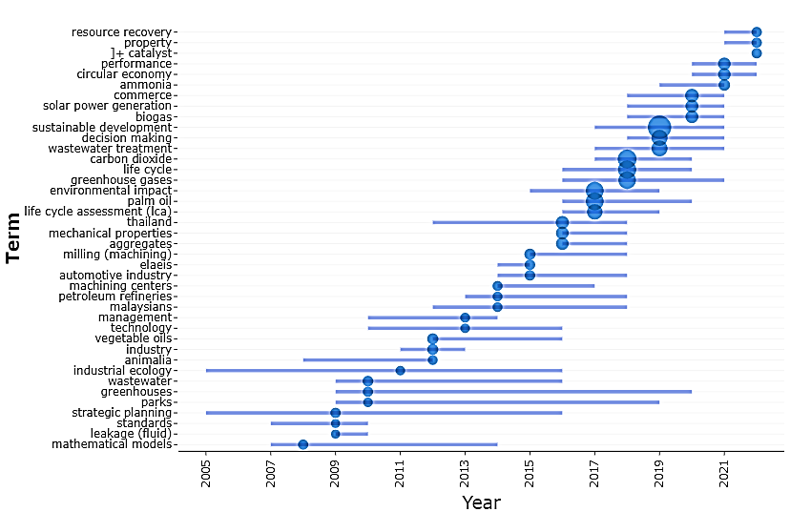

**Figure 3.** Centrality measures of keywords over the years

Table 2 and 3, however, are the quantitative description in terms of clusters and keyword occurrences; color scales here is used to visualize how those utilized measures for each cluster or occurrence are ranked in comparison to other clusters or occurrences.

**Table 2.** Betweenness and closeness measures based on clusters

|  |  |  |  |
| --- | --- | --- | --- |
| **Node** | **Cluster** | **Betweenness**  (colour scale) | **Closeness**  (colour scale) |
| 179 | palm oil | 39,30505 | 0,00214 |
| 115 | wastewater treatment | 147,88142 | 0,00226 |
| 83 | recycling | 113,42973 | 0,00224 |
| 79 | biodiesel | 46,84975 | 0,00215 |
| 76 | effluents | 113,49424 | 0,00226 |
| 71 | scanning electron microscopy | 94,84252 | 0,00223 |
| 66 | efficiency | 270,79408 | 0,00237 |
| 55 | catalysts | 76,14047 | 0,00221 |
| 53 | adsorption | 44,73262 | 0,00215 |
| 54 | fuels | 152,36547 | 0,00230 |
| 53 | oil shale | 181,98128 | 0,00230 |
| 49 | waste incineration | 99,92967 | 0,00224 |
| 47 | waste disposal | 164,39965 | 0,00230 |
| 45 | construction industry | 186,12546 | 0,00228 |
| 41 | pollution | 152,50284 | 0,00229 |
| 40 | chemical oxygen demand | 131,45006 | 0,00227 |
| 39 | diesel engines | 45,63466 | 0,00216 |
| 41 | fourier transform infrared spectroscopy | 102,73276 | 0,00225 |
| 40 | response surface methodology | 68,27012 | 0,00219 |
| 39 | water pollution | 149,58232 | 0,00230 |

**Table 3.** Betweenness and closeness centrality based on occurrences

|  |  |  |
| --- | --- | --- |
| **Occurrences** | **betweenness centrality**  (colour scale) | **closeness centrality**  (colour scale) |
| carbon dioxide | 40,16009 | 0,02041 |
| palm oil | 27,42811 | 0,01887 |
| wastewater treatment | 6,82167 | 0,01639 |
| recycling | 2,56991 | 0,01639 |
| biomass | 1,69019 | 0,01639 |
| biodiesel | 2,37425 | 0,01613 |
| effluents | 1,97820 | 0,01493 |
| compressive strength | 0,45777 | 0,01235 |
| scanning electron microscopy | 2,79395 | 0,01333 |
| optimization | 2,10897 | 0,01786 |
| cost effectiveness | 4,09345 | 0,01724 |
| concretes | 1,59210 | 0,01370 |
| efficiency | 1,55518 | 0,01563 |
| cements | 1,11176 | 0,01370 |
| catalysts | 0,27747 | 0,01299 |
| adsorption | 0,09684 | 0,01205 |
| fuels | 2,03815 | 0,01538 |
| oil shale | 2,77175 | 0,01538 |
| sustainable development | 83,37804 | 0,02000 |
| life cycle | 10,48215 | 0,01887 |
| environmental impact | 13,95684 | 0,01961 |
| greenhouse gases | 14,34490 | 0,02000 |
| global warming | 8,18532 | 0,01923 |
| energy utilization | 4,32164 | 0,01852 |
| decision making | 3,32531 | 0,01818 |
| pollution control | 6,09330 | 0,01923 |
| energy efficiency | 4,59847 | 0,01786 |
| environmental management | 2,91828 | 0,01786 |
| carbon | 9,71671 | 0,02000 |
| climate change | 2,14433 | 0,01724 |
| costs | 10,64422 | 0,02000 |
| life cycle assessment (lca) | 3,23963 | 0,01786 |
| economics | 1,23318 | 0,01695 |
| gas emissions | 2,58690 | 0,01786 |
| economic and social effects | 2,50678 | 0,01786 |
| emission control | 2,41942 | 0,01786 |
| investments | 0,50641 | 0,01538 |
| fossil fuels | 2,21306 | 0,01724 |
| economic analysis | 1,35452 | 0,01695 |
| waste management | 2,00613 | 0,01786 |
| developing countries | 0,69501 | 0,01639 |
| surveys | 0,25989 | 0,01493 |
| renewable energy resources | 0,78108 | 0,01613 |
| manufacture | 0,10003 | 0,01333 |
| sensitivity analysis | 0,78926 | 0,01639 |
| cost benefit analysis | 0,69199 | 0,01563 |
| planning | 0,04611 | 0,01370 |
| supply chains | 0,77712 | 0,01563 |
| commerce | 0,21155 | 0,01515 |
| environmental sustainability | 0,55263 | 0,01587 |

The time span within which his research retrieve the Scopus data set was divided equally into two phases (I and II) for thematic development. Reviewing of the research theme evolution at the first phase (I) and the second phase (II) were also utilized with the aid of time slice evolution map analysis. Research areas are system generated and segregated into basic themes, motor themes, niche themes and emerging themes.

Motor Themes that are in quadrant I suggests those themes that are developed and formed important pillars that shape the field of research. Furthermore, niche themes in Quadrant II reflected highly developed but isolated themes. Emerging or declining themes at Quadrant III portrays only weak and marginalization of the research field. Finally, basic themes at quadrant IV picks and places topics that are less developed, but still important (Zhang et al. 2022). Here, Biodiesels were in the niche theme, sustainable development (environment impact), and carbon footprint (pollution control) are projected on the basic themes in phase I. According to this analysis, the Motor themes-based keywords are the area of research that act as a supporting element Over the years solar power and renewable energy have appeared as emerging themes. This theme-based cluster is based on the development density versus centrality index with the R-studio software as shown in Figure 4.

|  |  |
| --- | --- |
| Phase I |  |
| Phase II |  |

**Figure 4.** Time slice evolution map of research themes

Moreover, the data set was analyzed to determine the country-wise collaboration in the area of cleaner production, The analysis was carried out using Vosviewer software. Figure 5 illustrates the keyword relations since 2016, indicating the top keywords of research, Initially, the most researched themes were Carbon Footprint, CO2 reduction, Greenhouse emissions, and Water treatment. Later, research shifted to themes such as Waste Management, Life Cycle Assessment, Circular Economy, Biodiesel, Palm Oil, and Energy Management.

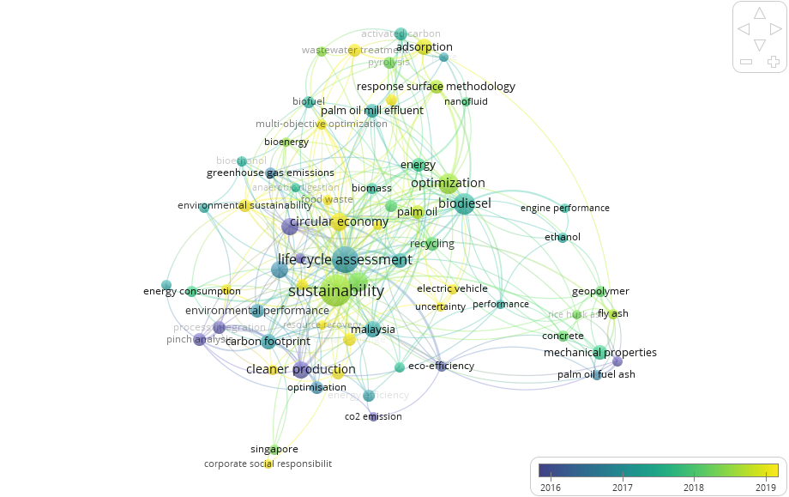

**Figure 5.**  The keyword relation network

Figure 6, moreover, is a visual representation of the nodal relationships between countries, highlighting the volume of their publication. According to Van Eck et al, (2014), a larger node indicates a greater volume of publication, while a smaller node signifies a minimal volume of publication. The analysis reveals three major clusters in blue, green, and yellow, with Malaysia having the broadest collaboration with other ASEAN members, including Thailand and Singapore.

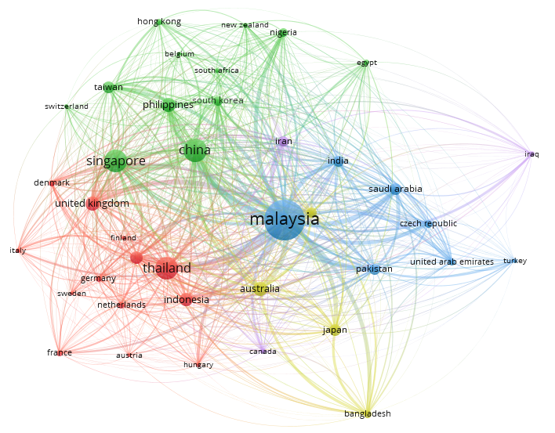

**Figure 6.** Visual representation of the nodal relationships between countries

Nonetheless, the visualized data is not fully showing how the research mentorship and leadership performed it the union and witch county has the cause role and which one is the effect role. The visualization may suggest that a particular country, such as Malaysia in this instance, has a high volume of publication with the world researchers, but it does not necessarily indicate that the country is playing a significant role in research mentorship and leadership within its own union. The country may be publishing a large volume of research in collaboration with other countries but not necessarily leading ASEAN research in the field, DEMATEL will response to this.

**4.3. Result of Decision-Making Trial and Evaluation Laboratory**

Table 4 presents the relationship between countries over citations, highlighting the collaboration between countries through DEMATEL analysis using data collected through the Scopus search. An input matrix was constructed based on pairwise country collaboration data. For example, the search formula used to retrieve data on Malaysia-Indonesia country collaboration was " ( ISSN ( 0959-6526 ) AND AFFILCOUNTRY( Malaysia ) AND AFFILCOUNTRY ( Indonesia) ) ". On the other hand, the search formula used to retrieve data on Malaysia-Malaysia collaboration was " ( ISSN ( 0959-6526 ) AND AFFILCOUNTRY( Malaysia ) AND AFFILCOUNTRY ( Malaysia) ) ". The search results are presented in Table 4.

**Table 4.** Country collaboration matrix

|  |  |  |  |  |  |  |  |  |  |  |
| --- | --- | --- | --- | --- | --- | --- | --- | --- | --- | --- |
|  | Malaysia | Indonesia | Thailand | Vietnam | Singapore | Philippine | Cambodia | Laos | Myanmar | Brunei |
| Malaysia | 1067 | 35 | 16 | 0 | 13 | 0 | 2 | 0 | 0 | 8 |
| Indonesia | 35 | 128 | 5 | 0 | 2 | 0 | 0 | 0 | 0 | 2 |
| Thailand | 16 | 5 | 330 | 0 | 3 | 0 | 1 | 0 | 0 | 0 |
| Vietnam | 0 | 0 | 0 | 0 | 0 | 0 | 0 | 0 | 0 | 0 |
| Singapore | 13 | 2 | 3 | 0 | 346 | 0 | 0 | 0 | 0 | 0 |
| Philippine | 0 | 0 | 0 | 0 | 0 | 0 | 0 | 0 | 0 | 0 |
| Cambodia | 2 | 0 | 1 | 0 | 0 | 0 | 3 | 0 | 0 | 0 |
| Laos | 0 | 0 | 0 | 0 | 0 | 0 | 0 | 2 | 0 | 0 |
| Myanmar | 0 | 0 | 0 | 0 | 0 | 0 | 0 | 0 | 0 | 0 |
| Brunei | 8 | 2 | 0 | 0 | 0 | 0 | 0 | 0 | 0 | 14 |

Initial screening of the collaborations from table 4, indicates that some countries, such as Laos, Vietnam, Myanmar, and the Philippines, need more motivation to join with other ASEAN researchers and contribute more to the field. Although Cambodia and Brunei, and Vietnam have research collaboration with other ASEAN countries, their network is limited to two other ASEANs. This observation, however, is defined as direct network between counties, DEMATEL is a means to illustrate the transitive networking. Within the research collaboration network, a transitive relationship is observed, where Country A and Country C are indirectly connected through an intermediary node, Country B. The presence of an indirect connection between Country A and Country C indicates that there is a path in the network that links these countries through shared collaborations, demonstrating a transitive relationship in the collaboration patterns among the countries. Such transitive connections are common in network analysis and can provide insights into the structure and dynamics of collaborative relationships within a given system, such as research collaborations between countries in this case. For the DEMATEL analysis, the matrix *T* was is calculations and presented in Table 5.

**Table 5.** Causal relationship matrix

The average value of all cell values of matrix *T* was 0.18. However, considering the high volume of publications from Malaysia, a threshold value of 0.01 was used to ensure that collaborative countries with fewer publications were not missed. Figure 7, presents the *R+D* results, which show that, among ASEANs, Malaysia is more active in terms of research collaboration, followed by Indonesia, Thailand, and Singapore with a significant distance.

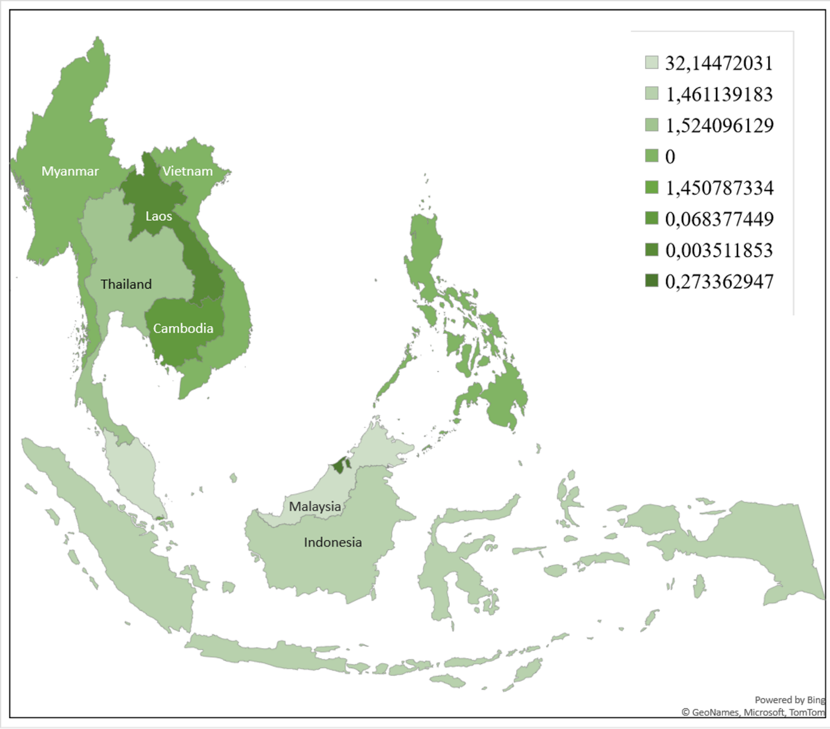

**Figure 7,** Map of countries total impact

The interrelationships or publication collaborations resulting from this threshold value are shown in Figure 7, The figure indicates that some countries, such as Laos, Vietnam, Myanmar, and the Philippines, need more motivation to join research collaborations and contribute more to the field. Figure 8, driven from the causal relationship matrix, however, shows that there is no research network indicated, meaning that very few collaborations involve more than two countries, and no leading country is detected. Although a few countries have established some research collaborations with other ASEAN countries, the network is not fully encompassing the entire ASEAN region, Four countries (40% of ASEAN members) have no direct or even transitive research collaborations. Hence, this finding highlights the need to consider ways to foster research collaborations and establish a more connected research network among countries in the region.



**Figure 8,** Research connected countries (direct or transitive)

When country A's researchers influence country B's research, their collaborations may enable country B's researchers to indirectly influence country C's research, despite no direct contact between researchers from A and C. This transitive network allows the flow of research leadership from country A, passing through B, and potentially impacting the scientific advancements in country C. As a result, to bridge the existing gap, it is crucial for ASEAN policymakers to define research leadership and promote research networking.

**5, Conclusion**

This research presents a comprehensive overview of ASEAN's progress in cleaner production through a systematic literature analysis, It identifies the level of attention and collaboration in this field, along with emerging trends. While ASEAN has made strides in sustainability, challenges persist, indicating a need for greater awareness of sustainable practices. The findings align with previous studies and reveal distinct research focuses among ASEAN countries. Yusup et al (2015), for example, discovered that while Malaysia has made some progress toward sustainable manufacturing practices, there is still a need for greater awareness among businesses about the benefits of such practices. Similarly, a study from Indonesia (Ricardiantoet al,, 2022) discovered that, while Indonesia has implemented a variety of policies aimed at encouraging sustainable manufacturing practices, these policies have not been effectively enforced. Qureshi et al, (2020) classified sustainable production in ASEAN. In the Thai manufacturing sector, Piyathanavong et al (2019) have reported existing barriers for adoption of production sustainability. They discovered a significant increase in research on this topic in recent years, with a focus on topics such as green supply chain management and the circular economy. They, however, stated that more research on the implementation and effectiveness of sustainable manufacturing practices in ASEAN is required.

Besides, collaboration gaps call for enhanced coordination to address regional environmental challenges effectively. Strong research leadership can guide efforts toward regional priorities, reduce redundancy, and promote growth and learning. Policymakers and industry leaders must collaborate to enforce sustainable policies effectively. Financial support for research on sustainable manufacturing practices is essential, encouraging their implementation. Sustainability integration into research strategies and policy enforcement will drive long-term benefits. The study's implications extend to the scientific community, offering a roadmap for assessing ASEAN's contributions to cleaner production, It emphasizes the significance of region-wide collaboration to tackle sustainability challenges. By encouraging greater cooperation, the ASEAN region can promote cleaner production and sustainable development more effectively, While the study relied on secondary data, it provides valuable insights into ASEAN's progress. Future research could incorporate primary data and investigate technology's role in research practices, Defining a research policy in the region could further enhance collaboration. Overall, this research contributes to understanding ASEAN's role in cleaner production and seeks to encourage further research and awareness in this crucial field.

**References**

Abideen, A.Z., Sundram, V.P.K. and Sorooshian, S., 2023. 'Scope for Sustainable Development of Small Holder Farmers in the Palm Oil Supply Chain—A Systematic Literature Review and Thematic Scientific Mapping', Logistics, 7(1), p.6.

Abideen, A.Z., Mohamad, F.B. and Fernando, Y., 2021. 'Lean simulations in production and operations management – a systematic literature review and bibliometric analysis', Journal of Modelling in Management, 16(2), pp.623-650.

Ahmed, S., Downs, S. and Fanzo, J., 2019. 'Advancing an integrative framework to evaluate sustainability in national dietary guidelines', Frontiers in Sustainable Food Systems, 3, p.76.

Agus, C., Putra, P.B., Kusumaningrum, A.P., Hasanah, N.A.I. and Cahyanti, P.A.B., 2020. 'Climate Change and Sustainable Development Goals Program in Indonesia', Handbook of Climate Change Management: Research, Leadership, Transformation, pp.1-22.

Ahmed, K., Bhattacharya, M., Shaikh, Z., Ramzan, M. and Ozturk, I., 2017. 'Emission intensive growth and trade in the era of the Association of Southeast Asian Nations (ASEAN) integration: An empirical investigation from ASEAN-8', Journal of Cleaner Production, 154, pp.530-540.

Ali, S.A.M., Sorooshian, S. and Kie, C.J., 2016. 'Modelling for causal interrelationships by DEMATEL', Contemporary Engineering Sciences, 9(9), pp.403-412.

ASEAN, 2016. ASEANSOCIO-CULTURAL COMMUNITY BLUEPRINT 2025. [Online] Available at: <https://asean.org/book/asean-socio-cultural-community-blueprint-2025/> [Accessed 27 November 2022].

ASEAN Economic Community, 2022. ASEAN Investment. [Online] Available at: <https://investasean.asean.org/index.php/page/view/asean-economic-community/> [Accessed 5 February 2023].

Chen, C.-A., 2012. 'Using DEMATEL method for medical tourism development in Taiwan', American Journal of Tourism Research, 1(1), pp.26-32.

Dey, P.K., Malesios, C., De, D., Budhwar, P., Chowdhury, S. and Cheffi, W., 2020. 'Circular economy to enhance sustainability of small and medium‐sized enterprises', Business Strategy and the Environment, 29(6), pp.2145-2169.

Dey, S., Reang, N.M., Das, P.K. and Deb, M., 2021. 'A comprehensive study on prospects of economy, environment, and efficiency of palm oil biodiesel as a renewable fuel', Journal of Cleaner Production, 286, p.124981.

Falatoonitoosi, E., Ahmed, S. and Sorooshian, S., 2014. 'Expanded DEMATEL for determining cause and effect group in bidirectional relations', The Scientific World Journal, 2014.

Falatoonitoosi, E., Leman, Z. and Sorooshian, S., 2012. 'Casual strategy mapping using integrated BSC and MCDM-DEMATEL', Journal of American Science, 8(1), pp.125-155.

Fichter, K., Lüdeke-Freund, F., Schaltegger, S. and Schillebeeckx, S.J., 2022. 'Sustainability impact assessment of new ventures: An emerging field of research', Journal of Cleaner Production.

Francisco, É.C., de Arruda Ignácio, P.S., Piolli, A.L. and Dal Poz, M.E.S., 2023. 'Food-energy-water (FEW) nexus: Sustainable food production governance through system dynamics modeling', Journal of Cleaner Production, 386, p.135825.

Garg, S., 2020. 'Impact of overpopulation on land use pattern', In Environmental and Agricultural Informatics: Concepts, Methodologies, Tools, and Applications, pp.1517-1534.

Geng, Y., Fujita, T., Bleischwitz, R., Chiu, A. and Sarkis, J., 2019. 'Accelerating the transition to equitable, sustainable, and livable cities: Toward post-fossil carbon societies', Journal of Cleaner Production, 239, p.118020.

Gonguet, M.F., Wendling, M.C.P., Sakrak, O.A. and Battersby, B., 2021. 'Climate-Sensitive Management of Public Finances—" Green PFM”', International Monetary Fund.

Gracia, O. and Siregar, S.V., 2021. 'Sustainability practices and the cost of debt: Evidence from ASEAN countries', Journal of Cleaner Production, 300, p.126942.

Guzman, R., 2022. 'Marine Plastic Pollution and Climate Change: Regional and'. [Online] Available at: <https://th.boell.org/en/2022/03/07/marine-plastic-pollution-seasia> [Accessed 28 November 2022].

Haba, H.F., Bredillet, C. and Dastane, O., 2022. 'Green consumer research: Trends and way forward based on bibliometric analysis', Cleaner and Responsible Consumption, p.100089.

Hamner, B., 1999. 'Cleaner production training in Asia: experience from the ASEAN Environmental Improvement Project', Journal of Cleaner Production, 7(1), pp.75-81.

Han, M.S., Yuan, Q., Fahad, S. and Ma, T., 2022. 'Dynamic evaluation of green development level of ASEAN region and its spatio-temporal patterns', Journal of Cleaner Production, 362, p.132402.

Hsieh, Y.-F., Lee, Y.-C. and Lin, S.-B., 2016. 'Rebuilding DEMATEL threshold value: an example of a food and beverage information system', SpringerPlus, 5(1), pp.1-13.

KASA, 2021. 'Malaysia Plastics Sustainability Roadmap 2021 - 2030'. [Online] Available at: <https://www.kasa.gov.my/resources/malaysia-plastics-sustainability-roadmap-2021-2030/51/> [Accessed 1 December 2022].

Khan, S.A.R., 2021. 'Sustainable Development Goals in Southeast Asia and ASEAN: National and Regional Approaches', Pacific Affairs, 94(3), pp.623-625.

Kopittke, P.M., Menzies, N.W., Wang, P., McKenna, B.A., & Lombi, E., 2019. 'Soil and the intensification of agriculture for global food security', Environment International, 132, p.105078.

Lima, C.D.S., Kieling, D.L., Veiga Ávila, L., Paço, A., & Zonatto, V.C.D.S., 2023. 'Towards sustainable development: a systematic review of the past decade’s literature on the social, environment and governance and universities in Latin America', International Journal of Sustainability in Higher Education, 24(2), pp.279-298.

Lord, M.J., & Tangtrongjita, P., 2016. 'Scoping Study for the Special Border Economic Zone (SBEZ) in the Indonesia-Malaysia-Thailand Growth Triangle (IMT-GT)'.

Mehmood, U., Askari, M.U., & Saleem, M., 2022. 'The assessment of environmental sustainability: The role of research and development in ASEAN countries', Integrated Environmental Assessment and Management, 18(5), pp.1313-1320.

Nepal, R., Phoumin, H., & Khatri, A., 2021. 'Green technological development and deployment in the association of southeast Asian economies (ASEAN)—At crossroads or roundabout?', Sustainability, 13(2), p.758.

OECD, 2011. 'Invention and Transfer of Environmental Technologies', OECD Publishing, Paris. Available at: <http://dx.doi.org/10.1787/9789264115620-en>.

Piyathanavong, V., Garza-Reyes, J.A., Kumar, V., Maldonado-Guzmán, G., & Mangla, S.K., 2019. 'The adoption of operational environmental sustainability approaches in the Thai manufacturing sector', Journal of Cleaner Production, 220, pp.507-528.

Qureshi, M.I., Khan, N., Qayyum, S., Malik, S., Hishan, S.S., & Ramayah, T., 2020. 'Classifications of sustainable manufacturing practices in ASEAN region: A systematic review and bibliometric analysis of the past decade of research', Sustainability, 12(21), p.8950.

Raihan, A., & Tuspekova, A., 2022. 'Toward a sustainable environment: Nexus between economic growth, renewable energy use, forested area, and carbon emissions in Malaysia', Resources, Conservation & Recycling Advances, 15, p.200096.

Ricardianto, P., Kholdun, A., Fachrey, K., Nofrisel, N., Agusinta, L., Setiawan, E., ... & Endri, E., 2022. 'Building green supply chain management in pharmaceutical companies in Indonesia', Uncertain Supply Chain Management, 10(2), pp.453-462.

S.E.A.N.S., 2021. 'ASEAN Regional Action Plan for Combating Marine Debris in the ASEAN Member States (2021 – 2025)'. [Online] Available at: <https://asean.org/launch-of-the-asean-regional-action-plan-for-combating-marine-debris-in-the-asean-member-states-2021-2025/> [Accessed 27 December 2022].

Sorooshian, S., Jamali, S.M., & Ale Ebrahim, N., 2023. 'Performance of the decision-making trial and evaluation laboratory', AIMS Mathematics, 8(3), pp.7490-7514.

Sorooshian, S., Tavana, M., & Ribeiro-Navarrete, S., 2023. 'From classical interpretive structural modeling to total interpretive structural modeling and beyond: A half-century of business research', Journal of Business Research, 157, p.113642.

Tan, S.Y.L. and Kamaruddin, H., 2019. Environmental challenges within ASEAN: Contemporary legal issues and future considerations. In ASEAN Post-50 (pp. 155-176). Palgrave Macmillan, Singapore.

Upadhyaya, P. and Rajasekharan Pillai, K., 2019. Management research outcome: A comparative assessment of BRICS nations. Studies in Higher Education, 44(9), pp.1567–1578.

Yuan, B.Z., & Sun, J., 2023. Research Trend of Rice and Greenhouse Gases Based on Web of Science: A Bibliometric Analysis. All Earth, (just-accepted).

Yusup, M.Z., Mahmood, W.H.W., Salleh, M.R., & Ab Rahman, M.N., 2015. The implementation of cleaner production practices from Malaysian manufacturers' perspectives. Journal of Cleaner Production, 108, pp.659-672.

Leal Filho, W.L. et al., 2022a. The economics of the UN Sustainable Development Goals: does sustainability make financial sense?. Discover Sustainability, 3(1), p.20.

Leal Filho, W. et al., 2022b. Commentary-empty promises: why declarations and international cooperation on sustainable development often fail to deliver. International Journal of Sustainable Development & World Ecology, 29(8), pp.850-857.

Leal Filho, W. et al., 2022c. Sustainability practices at higher education institutions in Asia. International Journal of Sustainability in Higher Education, 23(6), pp.1250-1276.

Leal Filho, W. et al., 2022d. An assessment of requirements in investments, new technologies, and infrastructures to achieve the SDGs. Environmental Sciences Europe, 34(1), p.1.

Leal Filho, W. et al., 2022e. Riverine plastic pollution in Asia: Results from a bibliometric assessment. Land, 11(7), p.1117.

Leal Filho, W. et al., 2022f. Relevance of international partnerships in the implementation of the UN Sustainable Development Goals. Nature Communications, 13(1), p.613.

Leal Filho, W. et al., 2023. When the alarm bells ring: Why the UN sustainable development goals may not be achieved by 2030. Journal of Cleaner Production, 407, p.137108.

Khan, S.A.R., Piprani, A.Z., & Yu, Z., 2022g. Digital technology and circular economy practices: future of supply chains. Operations Management Research, 15(3-4), pp.676-688.

Khan, S.A.R., Yu, Z., & Farooq, K., 2023a. Green capabilities, green purchasing, and triple bottom line performance: Leading toward environmental sustainability. Business Strategy and the Environment, 32(4), pp.2022-2034.

Khan, S.A.R., Umar, M., Asadov, A., Tanveer, M., & Yu, Z., 2022b. Technological revolution and circular economy practices: a mechanism of green economy. Sustainability, 14(8), p.4524.

Khan, S.A.R., Tabish, M., & Yu, Z., 2023b. Investigating recycling decisions of internet recyclers: A step towards zero waste economy. Journal of Environmental Management, 340, p.117968.

Chen, C.-A., 2012. Using DEMATEL method for medical tourism development in Taiwan. American Journal of Tourism Research, 1(1), pp.26-32.

Ho-Le, T.P. & Nguyen, T.V., 2018. Mathematics research in association of southeast asian nations countries: a scientometric analysis of Patterns and impacts. Frontiers in Research Metrics and Analytics, 3, p.3.

Hsieh, Y.-F., Lee, Y.-C., & Lin, S.-B., 2016. Rebuilding DEMATEL threshold value: an example of a food and beverage information system. SpringerPlus, 5(1), p.1.

Sombatsompop, N., Markpin, T., Ratchatahirun, P., Yochai, W., Ittiritmeechai, S., Premkamolnetr, N., & Wongkaew, C., 2011. Research productivity and impact of ASEAN countries and universities in the field of energy and fuel. Malaysian Journal of Library & Information Science, 16(1), pp.35-46.

Sukoco, B.M., Putra, R.A., Muqaffi, H.N., Lutfian, M.V., & Wicaksono, H., 2023. Comparative Study of ASEAN Research Productivity. SAGE Open, 13(1), p.21582440221145157.

Yusup, M.Z., Mahmood, W.H.W., Salleh, M.R., & Ab Rahman, M.N., 2015. The implementation of cleaner production practices from Malaysian manufacturers' perspectives. Journal of Cleaner Production, 108, pp.659-672.

Zhang, M., Wang, X., Chen, X., Song, Z., Wang, Y., Zhou, Y. and Zhang, D., 2022. A scientometric analysis and visualization discovery of enhanced recovery after surgery. Frontiers in Surgery, 9, p.894083.