Regenerating the Logistics Industry through the Physical Internet Paradigm: A Systematic Literature Review and Future Research Orchestration

Abstract: The operations of other businesses rely heavily on the logistics sector, making logistics the most crucial industry. There are multiple issues available in the existing logistics sector including the lack of logistics optimization and unsustainability operations. To deal with these issues, the concept of the Physical Internet (PI) has arisen. For this reason, the current study conducts a comprehensive literature review to determine how PI has emerged within the logistics sector to improve its condition. In this research, we present a comprehensive and in-depth analysis of the present situation of the PI in the logistics literature by conducting a systematic review of 114 publications published in 39 top journals on the topic between 2007 and 2022. This paper makes three significant contributions to the existing literature using such an analysis. To begin with, it provides an overarching context for the part played by the PI in the overall logistics industry. Second, it provides a road layout of the breadth and depth of the research on PI and the overall logistics, including the approaches taken by researchers, regions covered, sectors examined, and theoretical stances taken by those who have explored the topic thus far. Finally, it addresses the conclusions based on the different clusters discovered and the issues of existing logistics systems along with the moderators of influencing the PI and its outcomes. Given the rising significance of PI and channels for sustainability in the logistics sector, this is the first time that an effort has been made to investigate the function of the PI within the context of overall logistics performance. The paper identifies crucial gaps in research and brings to light different factors that have the potential to shed light on this essential subject. Furthermore, we argue that there is an immediate need to build new business models for enhanced adaptation and execution of the PI strategy, and we urge business managers, academics, and regulators to consider it. In addition, we advocate that professionals scrutinize ways in which the PI approach may be applied to the existing business structures.
Keywords: Physical internet; sustainability; logistics; sustainable logistics; freight; transportation.

1. Introduction
Recent years have seen a rise in the prevalence of severe ecological and energy concerns, prompting all nations to adopt sustainable growth as a shared growth priority (Ding et al., 2022). The logistics business plays a critical role in sustaining overall economic expansion. It has deep roots in agriculture and the service industry, bridges the gap between production and consumption, cuts across many fields, and has enormous expansion opportunities (Ding et al., 2022). But the logistics activities in the supply chain are a major contributor to waste and the loss of natural resources (Zaman & Shamsuddin, 2017). Firms in the logistics industry need to implement additional sustainability measures due to the detrimental effects their activities have on the economy, the climate, and society (Jayarathna et al., 2021). Today's methods of shipping, warehousing, production, distribution, and consumption of material goods are unsustainable on several fronts: financial, ecological, and social (Montreuil, 2011). Current logistics practices are neither eco-friendly nor socially responsible (Sternberg & Norrman, 2017). Fig. 1. illustrates the CO₂ emissions caused by various freight transportation modes throughout the globe.
Figure 1. Global CO₂ discharge (in millions of tonnes) caused by various freight transportation (Adapted from ITF, 2019)

Most of the time, cost efficiency is accomplished by having drivers operate in deplorable social circumstances (Hilal, 2008). The processes involved in freight shipping are characterized by a poor degree of innovation, and inefficiencies are caused by uncertainty in a number of different macro and micro aspects (European Commission, 2011). In the same year (2011), 13 unsustainability symptoms in logistics sectors are identified and classified by Montreuil (2011), shown in Table 1.
Table 1. Unsustainability symptoms (Adapted from Montreuil, 2011)
Unsustainability Symptoms |  | Economical | Environmental | Social
1. | We are shipping air and packaging.
2. | Empty travel is the norm rather than the exception.
3. | Truckers have become modern cowboys.
4. | Products mostly sit idle, stored were unneeded, yet so often unavailable fast where needed.
5. | Production and storage facilities are poorly used.
6. | So many products are never sold, never used.
7. | Products do not reach those who need them the most.
8. | Products unnecessarily move, crisscrossing the world.
9. | Fast & reliable intermodal transport is still a dream or a joke.
10. | Getting products in and out of cities is a nightmare.
11. | Networks are neither secure nor robust.
12. | Smart automation & technology are hard to justify.
13. | Innovation is strangled.

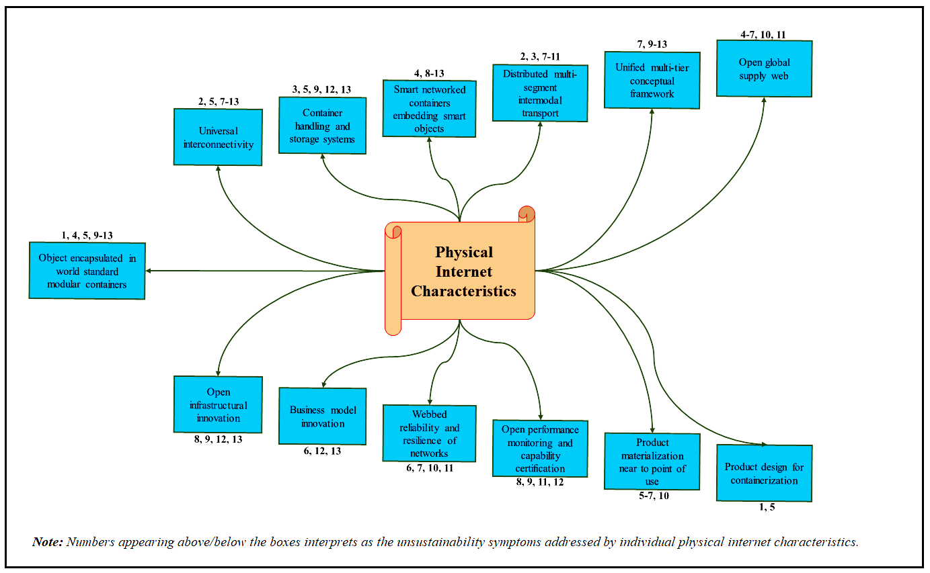
The notion of the Physical Internet (PI), which is built on an analogy of the digital internet and serves as the primary focus of this article, has been presented as an original idea that may help reverse the unsustainable condition that exists in the present-day logistical infrastructure (Montreuil, 2011). In PI, the commodities are contained in PI-containers, which are smart containers with simple interlocking dimensions that are meant to effectively flow across hyperconnected infrastructures of logistical operations, similar to how packets of data are enclosed (Sallez et al., 2016). Since it will not be managing or holding items per se, the widespread adoption of PI-containers enables any shipping business to manage and keep the goods of any firm (Sallez et al., 2016). The phrase “Physical Internet” was first used in a prominent title in the June 2006 issue of The Economist. This issue offered a comprehensive look at logistics, with pieces that were both high value and accessible, surveying topics including supply chain management and transportation (The Economist, 2006). But the actual thrust of the PI research came after the visionary article by Montreuil (2011) entitled “Toward a Physical Internet: meeting the global logistics sustainability grand challenge”. The article offered 13 characteristics of PI to tackle the unsustainability symptoms of the logistics sector (see Fig. 2). It could be said that, from here on, the research on the role of PI in ‘logistics’ or ‘sustainability’ or ‘sustainable logistics (SL)’ has gained momentum. Apart from Montreuil (2011), some other past researchers have also initiated to offer their perceptions towards the PI overlook. Ballot et al. (2014) define PI as “A global logistics system based on the interconnection of logistics networks by a standardized set of collaboration protocols, modular containers and smart interfaces for increased efficiency and sustainability”.
Figure 2. Physical internet characteristics addressing unsustainability symptoms (Adapted from Montreuil, 2011)
According to Mervis (2014), “The Physical Internet would move goods the way its namesake moves data”. There are defined protocols that the internet uses to transport data (Sternberg & Norrman, 2017). To carry goods, the PI would make use of containers with the designation π-containers. Whatever shape the products take, they could all be packaged in the same way around the globe using these containers (Sternberg & Norrman, 2017). For the next step in logistics, the idea focuses on modularity, encompassing framework, interfaces, and industry standards (Salvador, 2007). For the Digital Internet, all providers are completely able to interoperate; for the PI, decentralized public and private entities collaborate using common technological protocols (Nickerson & Muehlen, 2006). There has been an uptick in recent years in the number of individuals and organizations dedicated to furthering and promoting the PI's goal (Pan et al., 2017; Meyer et al., 2019), especially in logistics (Peng et al., 2021; Qiao et al., 2020). Research on PI is still at the nascent stage, but the possibility and potential of PI in sustainable logistics and other logistics performance indicators have pulled the attention of various researchers in the past (Peng et al., 2021; Qiao et al., 2020). Therefore, we have investigated the past work done in the field of PI, especially the systematic literature review. During the initial investigation of this article, we found 8 prominent literature reviews on PI. These eight literature papers are presented in Table 2 along with their details, and the gaps identified from them.

Table 2. Prominent review studies on Physical Internet (PI) and logistics
S. No. | Author (s) | Article Title | Journal | Theme | Duration of review | Articles review | Gaps
1 | Chen et al. (2022) | "Physical Internet deployment in industry: literature review and research opportunities" | Industrial Management & Data Systems | Implementation of PI in industries. | 2011-2021 | 88 | The overall article was around the PI implementation, and the focus was not on sustainable logistics.
2 | Cortes-Murcia et al. (2022) | "Supply Chain Management, Game-Changing Technologies, and Physical Internet: A Systematic Meta-Review of Literature" | IEEE Access | Identification of PI's role in supply chain management. | 2016-2022 | 74 | The study was much more generic and focused on the PI's role in supply chain management.
3 | Nguyen et al. (2022) | "Knowledge mapping of digital twin and physical internet in Supply Chain Management: A systematic literature review" | International Journal of Production Economics | Exploring the role of digital twin and PI in supply chain management. | 2013-2021 | 518 | The only focus was identifying the research on digital twins and PI in the supply chain management area.
4 | Paliwal et al. (2020) | "Blockchain Technology for Sustainable Supply Chain Management: A Systematic Literature Review and a Classification Framework" | Sustainability | Exploring the role of blockchain technology in sustainable supply chain management. | 2015-2022 | 187 | The focus was not on PI and sustainability in logistics.
5 | Treiblmaier et al. (2020) | "The physical internet as a new supply chain paradigm: a systematic literature review and a comprehensive framework" | International Journal of Logistics Management | Looking into how the PI could change the logistics sector. | 2008-2019 | 148 | The study explored PI in the logistics industry and supply chain management. But there is no discussion on sustainability.
6 | Pan et al. (2019) | "Horizontal collaborative transport: survey of solutions and practical implementation issues" | International Journal of Production Research | Implementing Horizontal collaborative transport (HCT) and its role in logistics firms. | 2007-2017 | 120 | The article emphasises the increasing interest in PI. But it does not focus on the role of PI in logistics or sustainability.
7 | Kong et al. (2018) | "Physical-internet-enabled auction logistics in perishable supply chain trading State-of-the-art and research opportunities" | Industrial Management & Data Systems | Analyse how dynamic transactions for perishable goods are affected by auction logistics (AL) choices and procedures made possible by the use of PI. | 1990-2017 | 220 | The focus of the article was mainly on the performance of auction logistics (AL).
8 | Sternberg et al. (2017) | "The Physical Internet - review, analysis and future research agenda" | International Journal of Physical Distribution & Logistics Management | Adoption of PI in logistics. | 2011-2017 | 46 | This article focuses to offer a fresh look at PI work from the viewpoint of an outsider and a user of new technologies.

The present research formulated some research questions to offer the central focus of this article, which are as follows-
RQ1: How PI has practically emerged in the logistics industry throughout the years?
RQ2: What are the factors available in the literature that influence the relationship between PI and its outcomes in the logistics sector?
A bibliometric and content analysis of previously published research on this subject was part of our two-tiered systematic literature review (SLR). It was possible to compile an exhaustive mapping of the field's current state of understanding thanks to the earlier studies, which allowed us to do a fair, rigorous, and repeatable SLR of the existing studies (Maseda et al., 2022). We used bibliometric analysis to identify the literature on the relationship between PI and the logistics sector and then did a content analysis to look at whatever has been reported about it so far (Zahoor et al., 2022). Our bibliometric and content analyses worked together to give us a strong basis that was well suited to identifying the important components of the PI and logistics connection, as well as to offer comprehensive and holistic views on new prospects for upcoming studies (Vallaster et al., 2019).
As a result of our investigation, we discovered 114 papers that were published in 39 reputable journals, which indicates that a significant amount of study has been conducted about the relationship between PI and the logistics sector. In addition, we identified the aspects that contribute to the strengthened connection between PI and the performance of the logistics sector. The results of this research also demonstrate that the most recent digital technologies, such as the Internet of things (IoT) and wireless communications, play a crucial role in helping to facilitate the effective adoption and deployment of PI within the logistics industry. The results of this review represent an important and novel addition to the subject of PI applications in logistics, particularly the topic of sustainability in logistics, in a number of different ways. First, previous literature reviews on PI had focused on the PI assessment, PI concept building, and PI use in logistics in general (see Table 1). As a result, they failed to illustrate the singularity of PI and its implications for sustainable logistics, despite the fact that these reviews contained valuable and insightful information. Because of this, our review makes a contribution to the current understanding of PI by digging deeper into how PI, with its various factors, facilitates the improvement of logistics operations in relation to economic, environmental, and social sustainability, which is one of the important questions for the logistics sector that has, up until now, received insufficient exposure.
This review does more than just introduce the reader to the PI and sustainable logistics research field; it also synthesises and highlights recent findings. The results of our current analysis will be helpful to scholars in revealing the boundaries of currently held conceptual ideas and methodological methods, the current topics of the inquiry, and the gaps in service now provided. Although a significant number of studies have been conducted on the topic of PI and sustainable logistics, our work goes beyond merely synthesising these studies to create a cluster-based framework and integrative framework for discussing future research directions that identify the most important aspects and outcomes of the relationship between PI and logistics, explain the connections between the two, and build on the framework.
2. Methodology
SLRs have surpassed conventional assessments in popularity due to the perception that they are distinguished by higher levels of rigour, accuracy, and universal applicability than regular reviews (Buchanan & Bryman, 2009). SLRs are an excellent method that successfully provides responses that are both sturdy and relevant to targeted review questions (Mallett et al., 2012). Therefore, an SLR has been carried out to answer the research questions raised in the earlier section. Some other following reasons were identified for conducting the SLR as follows-
- Firstly, doing a literature study makes it easier to establish a theory (Webster & Watson, 2002).
- The second benefit of doing a literature review is that it assists us in locating the areas of study that have been conducted in abundance (Webster & Watson, 2002).
- Thirdly, a study of the relevant literature assists us in determining the areas in which more investigation is required (Webster & Watson, 2002).
- At last, doing a systematic examination of the relevant literature may assist in retracing the steps that led to the evolution of the concept, which, in turn, can assist in determining the theoretical and actual applications of the concept (Hart, 1998).
2.1 Research flow
We have followed a three-part literature review in this study, which are planning, conducting, and documenting the literature review, to offer the step-by-step procedure for conducting and reporting the review (see Fig. 3). The process of research was adapted from the study of Grover et al. (2020). The three-part research process offered nine steps which have been altered according to the requirements of the present study.
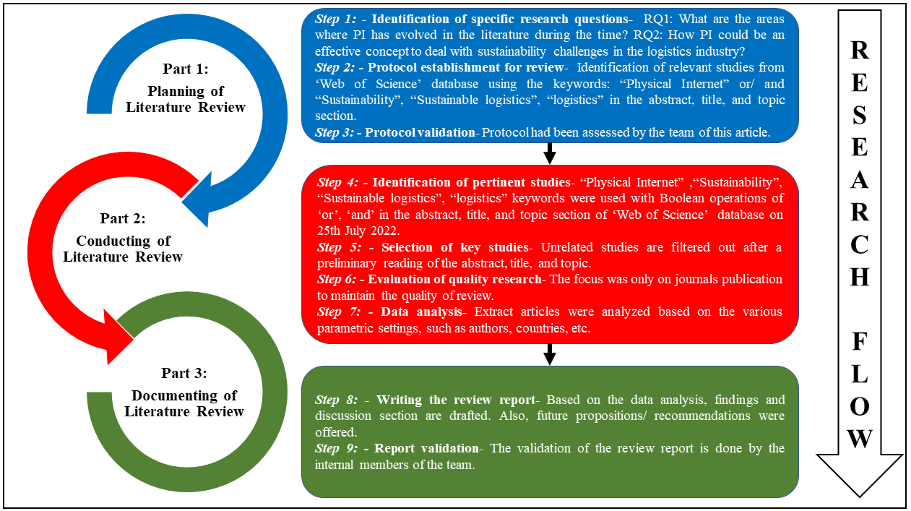Figure 3. Research flow for conducting the study
2.2 Screening of articles
The process of screening the articles used in this study is given in Fig. 4, which indicates that the ‘Web of Science’ database was used to finalize the articles for this study. Still, before the implementation of the screening process, we selected the inclusion-exclusion criteria and keywords for this study. This way, the scope and objective of the study will be clear, and our search could be narrowed in the focused direction to offer more productive output from this research.
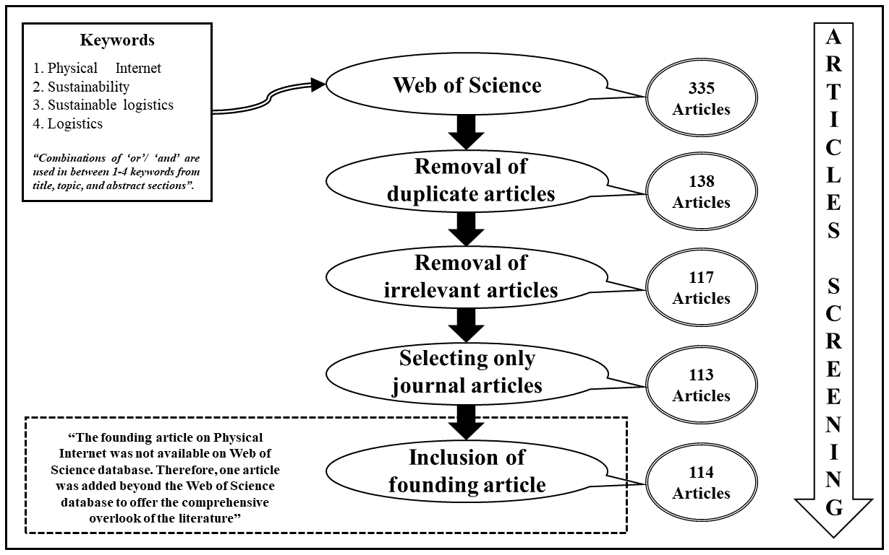Figure 4. Process of screening the articles selected for the paper

2.2.1 Inclusion-exclusion criteria
In light of current SLR research (Vrontis & Christofi, 2021), we selected articles for our review based on whether or not they satisfied the following inclusion/exclusion criteria:
- Theoretical limits- To begin, we set out to determine the theoretical limits that surround the core concepts of physical internet, logistics, and sustainable logistics. The term “physical internet” has been defined in the literature as “A new boundary-spanning area of research and practice that seeks to address this worldwide global logistics sustainability grand challenge” (Treiblmaier et al., 2020). Another definition of PI by Treiblmaier (2019) is “a comprehensive and measurable supply chain framework which is based on a network of physical components. These components are standardized as well as optimized and exchange information to improve the effectiveness, efficiency, and sustainability of supply chain management operations”.
Further, sustainable logistics is defined in the literature as “supply chain management practices and strategies that reduce the ecological and energy footprints of the distribution of goods which focuses on material handling, waste management, packaging and transport” (Seroka-Stolka & Ociepa-Kubicka, 2019).
- Publication category- For this study, we only included scholarly journal papers released in English, omitting anything else like book chapters, conference papers, and book critiques that were not academic in nature (Debellis et al., 2021).
- Stated period- We chose the period beginning in January 2007 and ending in July 2022 to serve as our study window. One of the main reasons for choosing this period is the extensive use of the ‘Physical Internet’ word in 2006 (The Economist). This way, we have covered almost the total period of research done in the PI area.
- Search bounds- We limited our investigation to the resources provided by Clarivate Analytics' Web of Science due to the fact that it is the preeminent portal for conducting scientific citation searches and providing detailed information (Li et al., 2017).
- Keywords- We arrived at our keyword list through a combination of conversations with academics and a review of the relevant literature. The focus of our keywords is “physical internet”, “logistics sector”, and “sustainable logistics”. The other details of using keywords are given in the next subsection.
2.2.2 Query usage
We have used a single keyword under the ‘title’, topic’ and ‘abstract’ sections in the ‘Web of Science’ database as well as a combination of keywords. We have also used the Boolean operators, such as ‘or’/ ‘and’ within the keywords to offer more focused articles for this study. The keywords/ queries used in the ‘Web of Science’ database are as follows:
- “Physical Internet”
- “Sustainable logistics”
- “Physical Internet” or “Sustainable logistics”
- “Physical Internet” and “Sustainable logistics”
- “Physical Internet” and “Sustainability in logistics”
- “Physical Internet” and “Sustainability”
- “Physical Internet” and “Freight”
- “Physical Internet” and “Transportation”
- “Physical Internet” and “Logistics”

2.2.3 Selection of related studies
To begin, we did a literature search in the ‘Web of Science’ database, using our query clusters (which are listed in subsection 2.2.2) to locate the pertinent publications that were issued between 2007 and 2022. Following this exercise, we identified 335 articles as having a possibility of being related to our investigation. Then, these 335 articles were loaded into bibliometric software. The uploading of articles on EndNote X9 led us to identify duplicate articles. After, removing the duplicate articles, the filtered number of papers was 140. We examined the remaining 140 articles using the “fit-for-purpose” criteria, which examines whether or not an article is pertinent to the goal that an SLR is supposed to accomplish (Boaz & Ashby, 2003). The “fit-for-purpose” helped us to remove the irrelevant studies. As a result of these processes, the total number of articles that were available for consideration in the selection stage was decreased to 117. After this, we used a filter of journal publications only, which has given the next number of articles as 113. At last, we manually checked the reference list and important articles relevant to our objective and found that one of the founding articles on PI was not available in the ‘Web of Science’ database. This led us in dilemma to include or not include that article for our review, because that article was from outside of the ‘Web of Science’ database. Finally, we consulted with the academicians and included that article in our study. The final number of articles for this study was selected as 114.
2.2.4 Data analysis
We exposed our selected 114 publications to bibliometric and qualitative content analyses. Statistics and descriptive trends in space and time were discovered via the aforementioned investigations (Luo et al., 2019). The characteristics of all of our study populations, such as the publishing source, the year of publication, the regional place of the author, the spatial scope, and the major results, were reported using an information extraction method (Vrontis & Christofi, 2021). We then undertook a content analysis in an attempt to uncover the major spectrums and themes. Eventually, a framework is suggested to provide the entire view of the interaction between PI and the overall logistics industry. Overall, we were able to create a complete review by combining our individual ideas and exploring any unresolved but crucial topics via the use of bibliometric and content analysis. Ultimately, the use of these approaches enabled us to build a complete study by integrating the pooled thoughts and examining any largely unexplored but significant themes (Gaur & Kumar, 2018).
3. Bibliometric findings
In this part, the bibliometric results are shown in terms of the publishing source, the publishing period, the corresponding and first author's location, and the most prominent author (s) and nations.
3.1 Article trends
Fig. 5 shows the year-by-year distribution of the publications in our sample. After the paper was published on PI in 2006, there were not a lot of studies done in that field until 2010. This is shown in Fig. 5, which indicates that there was little research done until 2010. However, with the publication of the paper in 2011, the primary focus in subsequent articles is now clear. After 2011, researchers' interest in PI research has risen, as seen by the linear trend line, which is shown as a red dotted line.
Figure 5. Publications on the physical internet and logistics throughout the period
Three distinct time periods may be used to examine the publishing of articles; they are 2007-2011, 2012-2016, and 2017-2022 respectively. During the initial period of time (2007-2011), there were a total of 2 articles published. The number of articles that were published during the second time period (2012-2016) was 14, representing an increase of 85.71% over the first-time span. In end, during the third time period (2017-2022), the total number of papers published was 98, and the rate of rising was once again 85.71%. Therefore, the ultimate meaning that can be drawn from Fig.6 is that there has been a significant increase in the number of published articles on PI and sustainability in logistics among scholars.

3.2 Publishing source
The number of articles published that were published between 2007 and 2022 in a variety of journals is shown in Table 3. "International Journal of Production Research" (27), "International Journal of Production Economics" (10), "Journal of Business Logistics" (7), "Computers in Industry" (7), and "Industrial Management & Data Systems" (7) are the top five journals that publish the most papers overall.

Table 3. Journal-wise number of published articles on the physical internet and logistics
S. No. | Journal Name | No. of papers
1 | International Journal of Production Research | 27
2 | International Journal of Production Economics | 10
3 | Journal of Business Logistics | 7
4 | Computers in Industry | 7
5 | Industrial Management & Data Systems | 7
6 | Sustainability | 7
7 | Computers & Industrial Engineering | 6
8 | IEEE Access | 4
9 | International Journal of Advanced Manufacturing Technology | 3
10 | International Journal of Logistics Management | 2
11 | Transportation Research Part E-Logistics and Transportation Review | 2
12 | Transportation Research Part C-Emerging Technologies | 2
13 | Journal of Intelligent Manufacturing | 2
14 | European Transport Research Review | 2
15 | Omega-International Journal of Management Science | 2
16 | Journal of Business Logistics | 1
17 | International Journal of Advanced Manufacturing Technology | 1
18 | Sustainability | 1
19 | International Journal of Production Economics | 1
20 | Journal of Business Logistics | 1
21 | IEEE Transactions on Intelligent Transportation Systems | 1
22 | IEEE Network | 1
23 | IEEE Transactions on Automation Science and Engineering | 1
24 | IEEE Transactions on Control Systems Technology | 1
25 | IEEE Transactions on Industrial Informatics | 1
26 | IEEE Transactions on Intelligent Transportation Systems | 1
27 | Futures | 1
28 | Environmental Science and Pollution Research | 1
29 | Journal of Cleaner Production | 1
30 | Sensors | 1
31 | Advanced Engineering Informatics | 1
32 | International Journal of Physical Distribution & Logistics Management | 1
33 | International Journal of Computer Integrated Manufacturing | 1
34 | International Transactions in Operational Research | 1
35 | Kybernetes | 1
36 | Physical Review E | 1
37 | Computer Communications | 1
38 | Physical Review E | 1
39 | Logistics Research | 1

In addition to this, the journal "Sustainability" has published 7 papers on the subject, the journal "Computers & Industrial Engineering" has published 6 articles, and the journal “IEEE access” has published four articles on the subject. As a result, 8 initial journals (see table 3) are among the top five journals that publish the most papers on PI and sustainability in logistics. This is determined by the number of articles that they produce. In addition to that, there are also 31 additional journals that may be accessed, each of which has contributed with three, two, or one article to the publication of papers on the topic that is relevant.

3.3 Highly recognized articles
The study of PI and sustainability in logistics is still at an early stage, though. Theoretically and practically, there has been a great deal of acclaimed work.
Table 4. Top cited publications on the physical internet
Author Name | Article Title | Times Cited
Montreuil  (2011) | “Toward a Physical Internet: meeting the global logistics sustainability grand challenge” | 293
Zhong et al. (2017) | "Big Data Analytics for Physical Internet-based intelligent manufacturing shop floors" | 193
Yang et al. (2017) | "Mitigating supply chain disruptions through interconnected logistics services in the Physical Internet" | 107
Pan et al.  (2017) | "Physical Internet and interconnected logistics services: research and applications" | 80
Li et al.  (2018) | "Energy-Efficient Resource Allocation for Industrial Cyber-Physical IoT Systems in 5G Era" | 79

This field's most widely referenced research, Montreuil (2011), was one of the first to demonstrate the PI idea in sustainable logistics. The study began by identifying the 13 signs of unsustainability, which were then divided into three groups based on their influences under the economy, society, and environment categories. Aside from that, Montreuil (2011) has provided a remedy for the symptoms of unsustainability by outlining 13 features of PI (see Fig. 2). The impactful initiative research of Montreuil (2011) has led him to become the top cited author with 293 citations. The second most cited work is offered by Zhong et al. (2017) with 193 citations. For their research, they used PI principles to construct an “RFID-enabled” smart shop floor ecosystem employing the Internet of Things (IoT) and wireless technologies to transform standard logistical assets into “smart manufacturing objects” (SMOs). The third most appreciated work is that by Yang et al. (2017) with 107 citations. They conducted research on the robustness of inventory models by utilizing networked logistics operations found in PI. The study by Pan et al. (2017) has been cited by 80 articles and placed their research fourth place based on the citation number. As a ground-breaking invention, the PI is the focus of their research, with the goal of improving the effectiveness and sustainability of the movement, deployment, realization, supply, design, and usage of tangible goods by a scale of amplitude. At last, the most appreciated study is conducted by Li et al. (2018) with 79 citations. Li et al. (2018) introduced a communication channel architecture based on 5G technology for a "Cyber-physical Internet of Things" system, as well as a power resource assignment method that maximized both power and channel management independently.

3.4 Collaboration across authors and countries
We determined the total number of authors that worked together on the study that focused on PI and sustainability in the logistics industry (see Fig. 6). In terms of the number of authors, our investigation revealed that some publications (3%) had been written by a single researcher, while other articles (11%) had been written and published by a pair of researchers. According to the data, a great proportion of articles had been authored by three scholars (which accounts for 34% of the total) or four scholars or more (52%). After then, a list of the nations that have worked together on previous research of this kind is compiled (see Fig. 7). In terms of who authored the articles, our research shows that a few of them (13%) were authored by a single nation, but the great proportion of them (24%) were authored by two or three or more countries working together (63%).

Figure 6. Published articles with the collaboration of a number of authors throughout the world

Figure 7. Published articles with the collaboration of a number of countries throughout the world

3.5 Publications by corresponding and first authors throughout the world
In this section, the geographic zone of the corresponding author as well as the first author is provided. In addition, the results provided information on the countries and regions of the world that differed in terms of the publications made by the first and corresponding authors (see Fig. 8 & 9). Fig. 8 indicates that China (32, 31), France (24, 25), the USA (18, 14), the UK (7, 7), and Belgium (5, 5) are the top five countries from where the researchers (corresponding and first authors) have authored the maximum number of articles. In addition, the data shown in Fig. 8 indicates that China is responsible for writing and communicating the greatest number of research articles on PI and sustainability in logistics. This suggests that China is ahead of other nations in terms of both the beginning of research on PI and sustainability in logistics as well as the intensity of such a study.

Figure 8. Country-wise number of published articles by corresponding/ first author

Following that, we have provided a similarity between the papers that were initiated by the corresponding authors and the first authors located in the various geographic locations of the globe (see Fig. 9). According to the facts, Europe (54, 52) is at the top of the list when it comes to creating and communicating articles about PI and sustainability in the logistics industry. This suggests that the frequency with which people in Europe write and communicate articles on this subject is higher than it is in other geographic areas.

Fig. 9. Geographic region-wise number of published articles by corresponding/first author

4. Content analysis
In this part, we provide a cluster analysis that is based on the results as well as the region of implementation for PI and its related technologies. In this case, the clusters have been separated into two distinct types: Type 1 clusters and Type 2 clusters.
- Type 1: Clusters that fall under the category of Type 1 are those in which the PI contribution may be seen directly in the scholarly literature. There are four different types of clusters that fall under the Type 1 category. These are logistics initiatives, supply chain initiatives, sustainability initiatives, and PI assessment initiatives respectively.
- Type 2: Clusters that fall under the category of Type 2 are those in which the function of the PI cannot be immediately gleaned from the relevant academic literature. The collection of articles that fall under the Type 2 category is grouped together because they discuss the function of PI-associated technologies or PI-integrated technologies. There is just one cluster with the name PI-associated technologies initiatives in the Type 2 category.
Fig. 10 is an illustration of the clusters-based framework, which has been derived from the available research and then pieced together in accordance with the findings. In this manner, first, the data were analyzed, and then the synthesis was performed to produce the clusters-based framework. This framework delivers the articles in many categories, as well as the major outcomes from the various clusters.

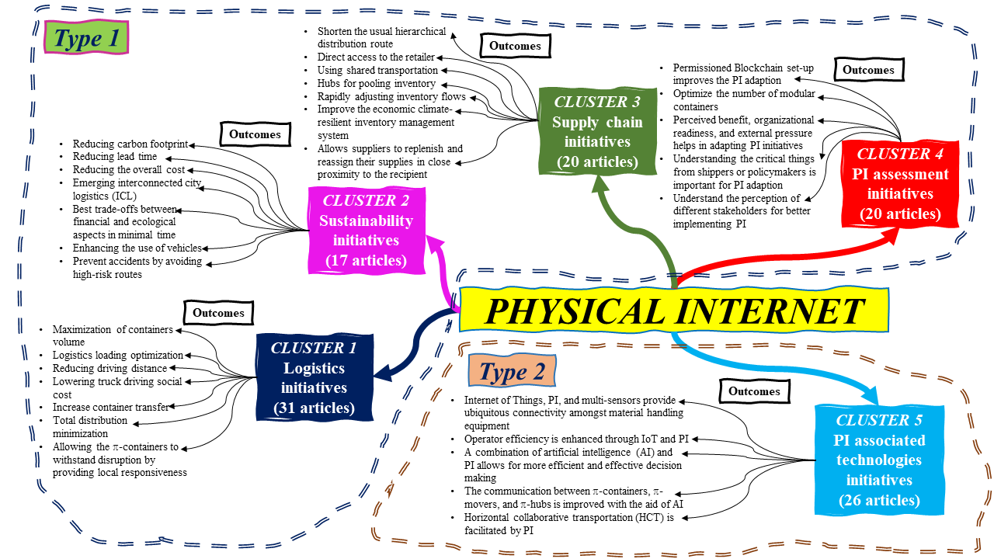

Figure 10. Clusters-based framework

4.1 CLUSTER 1: Logistics initiatives
Cluster 1 has the most articles out of all of the clusters, which makes it the biggest cluster. The fact that the PI idea was first developed for the logistics industry is the most evident reason why this cluster has the greatest number of articles. Within this cluster, we have selected articles based on PI activities in enhancing the operational performance of the logistics sector. These initiatives include but are not limited to, increasing logistics efficiency, and making the best use of logistical resources. In this section, we will talk about some of the most notable articles that belong to this cluster.
The article “Physical Internet and interconnected logistics services: research and applications” authored by Pan et al. (2017) has received a total of 80 citations, making it the most widely referenced piece in this collection. The study provides a glimpse into the work done by “Professor Benoit Montreuil,” who introduced the PI concept in a very brief manner by identifying the unsustainable symptoms of the logistics industry and proposing PI as a concept of solution for those unsustainable symptoms. In addition, Pan et al. (2017) provide a summary of the function that PI plays in the logistics business as well as how PI is becoming an increasingly popular topic in the field of logistics. Last but not least, they came to the conclusion that “PI is still in its infancy stage” after doing their research. However, PI is now receiving a great deal of interest as well as attention from scholars and practitioners.
The second most well-appreciated study of this cluster is conducted by Zhang et al. (2016) with 67 citations. The study was entitled “Smart box-enabled product–service system for cloud logistics”. Zhang et al. (2016) have developed a way for optimizing actual-time information data-driven logistics activities by building a cloud logistics infrastructure that is reliant on cloud computing. This optimization approach is applied to PI to tackle the problems that are plaguing the logistics business, such as a lack of shared, standard, cost-effective, and environmentally friendly packaging, and an effective optimization approach for the allocation of logistical activities. Finally, Zhang et al. (2016) used a case study simulation for the possibility and potential of the proposed optimization method. The results of their research indicate that the capacity of containers should be increased to its maximum, that the loading of logistics should be optimized, and that the overall distribution should be reduced to its minimum.
The research done by Sallez et al. (2016), which received 50 citations, is the third most noteworthy paper associated with this cluster. They identified the importance of π-containers to fulfil the objectives of PI in the logistics industry. Therefore, they have concentrated on the architecture of π-containers and their related activity. They have looked at what's documented about π-containers. Then, they came up with the idea of π-container activity. After a brief overview of the concept of activeness in general, they proposed a framework for describing activeness that can endorse a multi-layered approach. Lastly, a simulation of a clustering implementation of π-containers in a π -hub was used to show how the concept of activeness works in real life and what value it adds.
Another significant piece of study on this cluster was published by Fazili et al. (2017), which was cited 42 times. They have contrasted the performance of the PI-based logistics system with that of the traditional logistics system and highlighted the significance of the former over the latter. The comparison of PI-based logistics and conventional logistics was done in an attempt to measure the benefits and drawbacks of PI from the point of view of truck and driver routing, taking into account an unequivocal limitation on the highest amount of time that drivers are required to be away from their trucks. Their research shows that PI lowers travel distance (as well as time), greenhouse gas releases, and the societal price of truck transportation. However, it increases the number of container movements at the PI logistics hubs. Furthermore, the paper's second important contribution is a confirmation of the notion that the number of PI drivers who may return home at the conclusion of a workday stays constant, independent of the traffic volume.
The study of Sarraj et al. (2014a) investigates the potential parallels and substitutions that may be made across computer networks, specifically the Internet, and logistic networks. They seem to indicate that these networks have a number of striking parallels, despite the fundamental distinctions in the types of objects that preclude an integral transposition from being possible. They have used a simplified model to demonstrate how interconnections may be made inside logistics networks in order to demonstrate the relevance of the comparison they have just presented. Due to the exploratory character of their study, an analytical model that was based on a technique of continuous approximations was used in order to do the evaluation of this influence.
In addition, we have included a summary of the overall research direction, and the challenges for this cluster, as well as a suggestion of the research questions which could be addressed in subsequent research in Table 5.

Table 5. Research questions for future studies emanate from the challenges in cluster 1
Research direction of cluster 1 | Challenges in cluster 1 | Proposed research questions
Involvement of PI in improving the logistics efficiency, such as reducing emissions and ship time as well as improving the operational parameters. | - Less understanding of PI-oriented business models.  - Lack of infrastructure, budget, and technology to adapt the PI to the existing logistics system.  - Entangled with the hierarchy of the existing logistics system.  - Most of the work is based on the simulation and proposed optimisation method.  - Perspective of shippers and policymakers is ignored.  - Perspective of different stakeholders has been avoided.  - Still unable to differentiate much between conventional and PI-enabled logistics systems due to lack of adapting ability.  - The concept of open logistics and global interconnectivity is not clear to many stakeholders.  - Lack of trust and leadership issues due to the use of the latest technologies. | PRQ1: What business strategies are already in place that can be used to readily adjust the availability of PI in the logistics industry?  PRQ2: How existing theories, such as natural resource based-view (NRBV), resource-based view (RBV), dynamic capability view (DCV), and diffusion of innovations theory (DIT) can improve the academic literature on PI's role in logistics?  PRQ3: How the views of different stakeholders can influence the adaptability and implementation of PI in the logistics sector?  PRQ4: How the different operational parameters and efficiency of the logistics system can be prioritised to implement the PI in logistics on a priority basis?  PRQ5: What are the educational and training initiatives, which can be useful to remove the scepticism about implementing PI in the existing logistics?  PRQ6: How digital technologies can play an effective role in developing trust and leadership throughout PI-enabled logistics?  PRQ7: How can the concept of open logistics be offered in a more simplistic manner?  PRQ8: How PI initiatives could be more cost-effective in terms of their adaption and implementation?

4.2 CLUSTER 2: Sustainability initiatives
Cluster 2 bundles the collection of academic literature, especially oriented on the PI contribution in the triple bottom line (TBL) sustainability (economic, environmental, and social). It offers 17 articles authored by worldwide authors during 2007-2022. The most notable study of this cluster was conducted by Montreuil (2011) with the highest number of citations (293) among all clusters. Montreuil (2011) was the first author who recognized the PI as an effective tool for addressing the unsustainability issues in the logistics industry. Initially, he identified the 13 unsustainability symptoms (see Table 1) and categorized them under the economic, environmental, and social kinds of unsustainable activity. After that, Montreuil (2011) proposed 13 characteristics of PI (see Fig. 2) to tackle all 13 unsustainability symptoms. The categorization of PI characteristics offered the potential of individual characteristics to handle certain unsustainability symptoms. The research of Montreuil (2011) on PI has been widely accepted as a standard reference, and numerous researchers have done their own studies based on his findings (Pan et al., 2015; Peng et al. (2020)).
Another prominent study of this cluster was conducted by Sarraj et al. (2014b) with 71 citations. They have identified that no prior research is conducted to support the idea that integrating container movements may increase efficiency. Therefore, their objective was to simulate the asynchronous shipping and manufacturing of containers inside a network of linked services in order to obtain this potentiality evaluation. The discovery of their study provides the best possible route for each container and minimizes the usage of transportation methods. They've utilized real-world data from the rapidly moving consumer products industry in France to conduct the simulation and examine the related risks. They put a number of different mobility regulations and situations to the test and found some hopeful outcomes for efficiency metrics. The study by Ambra et al. (2019) has been cited 59 times, making it the third most cited study in this group. They studied the designs, methodology, and conclusions put forward in the research literature for the most recent synchromodal and PI models. Their study's major goal was to evaluate and investigate the relationships between these two ideas in order to comprehend how they may support one another. The findings indicate no association in the literature between PI and synchromodal since they just exist in tandem and tackle various dimensions, sizes, and degrees of conception. Their analysis indicates possible overlaps, prospective research fields, and important problems that designers, developers, and policymakers should take into consideration.
The studies of Ben Mohamed et al. (2017) with 35 citations and Tran-Dang et al. (2017) with 22 citations are the other two most acknowledged research of this cluster. Ben Mohamed et al. (2017) investigated the functional urban mobility challenge of π-containers considering interconnected city logistics (ICL) concerns. They identified some of the important elements of this version, which is based on the diversity of urban depots and their interconnectedness. It is created to cope with the problem's solvability difficulties while dealing with concrete examples of the issue. To achieve the greatest possible economic/environmental balance in a short period of computing time, this is done in this manner. They tested the method by creating a collection of real-world examples, based on city freight flows in France. Finally, the model's solvability and the efficacy of their heuristic method are reviewed.
Tran-Dang et al. (2017) suggested a system that automatically generates and maintains a virtual three-dimensional arrangement of π-containers. Intelligent π-containers incorporating wireless sensor nodes are the basis of this concept. π-containers were also positioned with respect to one another based on the sensor node’s proximity to one another (Tran-Dang et al., 2017). Finally, as a confirmation, they devised a methodology and provided computer experiments. The findings suggest that the approach that they recommended produces positive outcomes in a reasonable amount of time.
Further Table 6 summarizes the research direction of this cluster along with research challenges and emerging future research questions.

Table 6. Research questions for future studies emanate from the challenges in cluster 2
Research direction of cluster 2 | Challenges in cluster 2 | Proposed research questions
Initiatives towards improving the sustainability performance of the logistics industry through the implementation of PI. | - Instead of addressing the whole supply chain, many projects seem to focus on a single company or a small group of network partners.  - Social sustainability aspect has not been addressed well.  - Sustainability objectives are mostly achieved in simulation-based research or concept-based research.  - No broad generalisation has occurred yet due to the fact that only a small number of implementations are really in use.  - Using a lot of open or shared nodes and a multi-segment strategy among them.  - Need of revising the overall supply chain for effective implementation of PI.  - The disruption in the synchronisation of physical and data flows is caused by the physical internet's abundance of tracking and transformation activities.  - Dependency on wireless technology and localisation methods. | PRQ9: How the focus on achieving sustainability through PI could be a shift on the overall global supply chain rather than the various small segments of the supply chain?  PRQ10: What are the sustainability measures which can be addressed while implementing PI?  PRQ11: How does TBL sustainability behave with each other in the presence of PI?  PRQ12: How to prioritise the measures of achieving sustainability while deploying PI?  PRQ13: What degree of impact does PI have on all sustainability performances?  PRQ14: How PI be a feasible tool for sustainable outcomes in small-level logistics?  PRQ15: What are initiatives and measures needed to maintain the synchronisation between physical and digital flow?  PRQ16: How PI can offer a competition-free environment for social, economic, and ecological sustainability?  PRQ17: How PI can be an effective approach in other industries to offer sustainable material handling operations?  PRQ18: What other measures are needed to integrate into PI for achieving fast and efficient sustainable outcomes?  PRQ19: How PI can be integrated with the existing supply chain without its disruption?  PRQ20: How the adaption and implementation of PI can be generalised?  PRQ21: How can PI promote circular economy (CE) practices?  PRQ22: What are the initiatives needed to incorporate the net zero deliverables, such as decarbonisation?  PRQ23: Is it possible to bring PI under the umbrella of CE practices?  PRQ24: Is it possible to bring PI under the net zero umbrella?  PRQ25: Does the route of SL through PI go via CE practices and net zero emission?

4.3 CLUSTER 3: Supply chain initiatives
Cluster 3 keeps the collection of 20 scholarly articles with a focus on PI implementation in supply chain operations. Zhong et al. (2017) have offered the most notable study of this cluster with 193 citations. In their study, Big Data Analytics (BDA) for Radio-frequency identification (RFID) logistics data was presented by identifying the varied traits of smart manufacturing objects (SMOs). The RFID-enabled smart climate PI idea had been implemented. The study indicates that with the use of PI concepts, the learnings here may be applied to other manufacturing organizations, as shown by this instance. After that, a BDA framework for processing the RFID-enabled shop floor logistics data is presented. Also, several Key Performance Indicators are established to assess various production items from the RFID-enabled Big Data under the PI-based shop floor freight administration.
The next most appreciated work from this cluster was conducted by Yang et al. (2016) with 107 citations. Their research looked at how PI-based stock systems handle disturbances at nodes and units. An individual product stock issue with ambiguous consumption and stochastic supply interruptions was examined in order to achieve this. Yang et al. (2016) presented a simulation-based optimization approach for inventory control in their research. The findings of their study indicate that the PI stock system beats the existing traditional stock systems in terms of durability since it is more agile and flexible. Furthermore, the performance gap widens when item worth, compensation payments, and interruption rate rise. In their research, they found a new way to construct a robust supply chain. The next most prominent research is conducted by Chen et al. (2017) with 50 citations. They came up with a novel way to revert back e-commerce returned products to merchants from the end user sites. Rather than relying on conventional methods, they have turned to this. Using taxis that were previously allocated to carry people, may deliver the returned items and customers in an integrative manner by making use of the additional loading capacity and continual mobility. Reverse flow administration has negative monetary, ecological, and social implications that might be mitigated by their study. They first performed a qualitative and quantitative investigation, and then examined the practicability and validity of the remedy premised on three actual datasets, which include the spots of shops, a road web, and large-scale route information obtained by more than 7000 taxis in Hangzhou, China, for a month in the year. There was a lot of experimentation in their research, but the conclusions they produced are relevant to the industry as a whole.
The last two pioneering research of this cluster are Yang et al. (2017) with 50 citations and Pan et al. (2015) with 39 citations. As part of Yang et al. (2017) research, they looked at a scenario where vendors may employ PI-enabled vendor-managed inventory (VMI) strategies to optimize inventory levels throughout the whole system while still meeting the needs of local buyers' requests. A simulation-based optimization approach was designed to help vendors employing PI manage inventory issues since replenishment choices in PI are very dynamic. A supplier selection process was also used to improve inventory management choices. Next, a simulation was run to verify the optimal outcomes. PI-enabled stock systems and conventional stock systems were also compared numerically in a study. According to the findings, the PI stock system outperforms the standard stock systems in terms of performance while achieving equivalent or superior customer service. The study's advantages were mostly attributable to three aspects: the versatility of the system structure as PI allows for more procurement and warehousing alternatives in comparison to standard stock systems and more straight paths to merchants, pooling of mobility and stock sharing between nodes.
Pan et al. (2015) suggest that Physical Internet-based Inventory Control Models (PIICMs) are a set of inventory management models that have been developed to better understand how inventory is routed via the PI network. In their study, the models were tested in a real FMCG distribution system using a simulation technique. The results of their analysis demonstrate that PI activities may lower inventory levels and overall logistics expenses provided that suitable inventory management methods are used. According to the findings, in an open logistics system, various criteria may perform better than expected.
Further, table 7 offers a glimpse of the research directions and research challenges of this cluster. Also, some future research questions are proposed which are drawn from this cluster’s
challenges.

Table 7. Research questions for future studies emanate from the challenges in cluster 3
Research direction of cluster 3 | Challenges in cluster 3 | Proposed research questions
The focus is to improve the supply chain through PI than the traditional supply chain. | - Unsatisfactory decision-making in inventory management.  - Efforts are done primarily in consideration of the transportation and holding inventory costs rather than overall supply chain costs.  - Lack of optimisation model.  - Decision-making complexity in PI-enabled inventory system.  - Management of inventory is in the hand of both vendors and buyers.  - The time needed to handle the material takes longer than the time needed to transport it. | PRQ26: What are the factors which can reduce the material handling time?  PRQ27: What are the best inventory control models in the PI-enabled environment?  PRQ28: How does PI initiative can lead to supply chain sustainability?  PRQ29: How the unambiguity of inventory could be reduced while maintaining the control of inventory by both vendors and buyers?  PRQ30: How the initiatives towards developing an optimisation model can enhance the performance of PI in the overall supply chain?  PRQ31: How the complexity in decision-making could be reduced in PI enabled environment?  PRQ32: What are the efforts required to consider reducing the cost of the overall supply chain?  PRQ33: How the initiatives towards minimising the overall supply chain cost in PI ambience will affect the other factors of supply chain performance?

4.4 CLUSTER 4: PI assessment initiatives
This cluster primarily bundles the academic research related to the adaption and assessment of the PI approach within the industry. The cluster contains 20 articles published in highly reputed journals from 2007 to 2022. The most prominent research of this cluster was conducted by Zhou et al. (2012) with 70 citations. They used an experimental study where they looked at the issue of diagnosing leakage faults in a physical internet-based three-tank system (PITTS). Due to the restricted capacity of the communication route, data from devices located in various locations connect with each other over the Internet, causing delays and/or dropouts in transmission. Therefore, they have created a networked control system from the partial signals generated consequently, which may be used for both control and diagnostics. After that, they used a robust filter approach to address the detection issue, and the residual contributing degree is used to separate the leaking defects of various tanks. The recommended strategies are shown to be successful and useful by conducting experiments. The next study in line is led by Sternberg and Norrman (2017) with 41 citations. They have published a comprehensive assessment of the current literature on the PI in order to help academics and policymakers in their prospective attempts to design effective logistics networks. Scientific articles, project reports, requirements, and other PI-related publications served as the basis for their literature review. They've completed 46 articles for the assessment of the literature. For this study, they looked at four factors: “organizational preparation (technology blueprints), external pressure (promised impacts), perceived advantages (business model) and adoption.” The results show that more and more methods, schematics, and requirements have been made for PI, but no models have been made that show how the existing transportation enterprise models could be changed to work with PI. Further, their study suggests that there isn't a clear idea of the business models needed to get key players involved and help spread the PI idea.
The next prominent research from this cluster is provided by Lin et al. (2014) with 37 citations. They devised a mathematical model to determine the optimal set of modular containers to use while packing a given assortment of goods in order to make the most efficient use of available storage space. Further, they have devised and provided a decomposition-based solution approach to accomplish this goal. Their research suggests that a higher unit load storage usage is seen when conventional modular containers are used.
The other two in-line research from this cluster are Meyer et al. (2019) and Treiblmaier et al. (2020), with citations 29 each. Meyer et al. (2019) presented a decentralized method built on Blockchain technology and described in detail the construction of the Blockchain and its incorporation into the dispersed network architecture of the Physical Internet. In addition, they used a case study from the sector and the literature on the Physical Internet and Blockchain. Their investigation led them to create a four-tiered structure, which they then presented as an application use case. The findings of their study suggest that the four-tiered system served as a guide for academics interested in doing more research and practitioners looking into adoption potential.
Treiblmaier et al. (2020) have conducted a comprehensive literature study on PI, including book chapters, conference articles and proceedings, corporate reports, and white papers and journal articles. They suggested a comprehensive framework that organizes the PI field and specifies upcoming prospects for logistics and supply chain management scholars. This proposal was predicated on their examination and analysis of the relevant literature. Their findings were primarily based on the evolution of PI throughout the period.
Further, Table 8 offers the research direction of academic literature in cluster 4 and the challenges. Finally, for future researchers, some research questions are proposed.

Table 8. Research questions for future studies emanate from the challenges in cluster 4
The research direction of cluster 4 | Challenges in cluster 4 | Proposed research questions
The research was focused on the two aspects as follows:  First, is the adoption of PI in industries. Second, is the assessment of PI performance where PI is already deployed. | - Data dropout due to narrow internet bandwidth and spectrum.  - Latency in communication that is entirely random.  - Problem with the quantization of the signal.  - Lack of perceived benefits and organizational readiness.  - Lack of perception development for PI from different stakeholders.  - Lack of business model to adopt and implement PI approach.  - Inability to modify existing infrastructure.  - Insufficiency in terms of notion assurance's stability, adaptability, and consistency.  - Inability to construct a network in which all parties have equal authority and profit from the relationship.  - A failure to recognize and incentivize the sharing of reliable data. | PRQ34: How the PI-enabled environment could be sustained in a low bandwidth internet network?  PRQ35: How could innovation be an effective strategy to offer some low technological solutions for the broader adaptability of PI approaches?  PRQ36: What initiatives are required to offer better-perceived benefits and organizational readiness to improve the performance of PI activities?  PRQ37: How could PI fit into the existing business models to offer the easiness in PI operations?  PRQ38: What are the existing robust business models available that can facilitate PI operations and reduce the adoption time?  PRQ39: How a reliable network can be established to offer a trusted platform to run PI-oriented activities?  PRQ40: What are the efforts required to assure the robustness and durability of PI ambience?  PRQ41: How the inputs of different stakeholders can play a significant role in improving the PI operations?  PRQ42: What initiatives are required to reduce the latency of signals during the live supervision of PI operations?  PRQ43: What initiatives are required to improve the stability of networked control systems (NCS)?  PRQ44: What initiatives are required to tackle the issues of networked control systems (NCS)?  PRQ45: How do the blueprints for implementing PI apply to every scale industry?  PRQ46: How can a low technology and less infrastructure company adapt and implement the PI approach?  PRQ47: What are the benefits/ drawbacks of introducing customized π-containers, π-hubs, and π-warehouses?

4.5 CLUSTER 5: PI-associated technologies initiatives
This cluster offers scholarly literature on the role of PI and its associated digital technologies in the logistics industry. This cluster provides a total of 26 articles published in many reputed journals during 2007-2022. The pioneered research in terms of citations from this cluster is conducted by Li et al. (2018) with 79 citations. They introduced a 5G-based communication network architecture for a Cyber-physical Internet of things system (CPIoTS) that supports several sensors, various actuators, and a centralized controller with full-duplex transmission capabilities. In addition, based on this communication network architecture, they devised an algorithm for energy-efficient asset distribution in which both the energy distribution and bandwidth distribution were individually optimized. The simulation outcomes of their investigation demonstrated that the suggested algorithm for asset distribution exceeded the province standards and closely matched the efficacy of the comprehensive searching approach. Other prominent studies of this cluster are Cohen et al. (2019) with 67 citations, Hopkins and Hawking (2018) with 65 citations, Pan et al. (2019) with 63 citations, and Nikitas et al. (2020) with 55 citations.
Cohen et al. (2019) investigated the effects that typical new technologies for Industry 4.0 (I4.0) might have on Assembly 4.0 (A4.0) networks. They first looked at the design of the goods, the operation, and the assembly method. In addition, their study looked at how these new technologies may affect assembly design. Then, they looked at the influence of policies and procedures on the design of assembly lines. Finally, they looked at how these additional features would affect component routing and planning, as well as scenarios of machine breakdowns. It has been evaluated subjectively in terms of total flow time and the capacity to handle a broad range of finished goods. Finally, some examples of how the new technologies are projected to increase performance were listed.
The research of Hopkins and Hawking (2018) highlighted the role that Big Data Analytics (BDA) and the Internet of Things (IoT) played in supporting the goal of a major logistics company to enhance driver protection, minimize operational expenses, and lower the ecological effect of their trucks. In doing so, the case approach was used, and data were gathered from a circumstance that was considered to be “real life,” in order to provide fresh information on this developing phenomenon. Truck communications and spatial have been combined to provide drivers notifications about potential risks before they occur. Camera-based technology has also been utilized to enhance driver safety and exhaustion control, recording proof of crucial driving incidents and archiving data straight to the cloud. As a final step, BDA was utilized to enhance truck routes, identify ideal fuel purchase times/locations, and estimate forecast and preventive maintenance plans.
Pan et al. (2019) have done a 10-year review of horizontal collaborative transport (HCT) to uncover patterns and shortfalls in research and then proposed some research prospects. There are suggestions for logistics organizations that are interested in implementing HCT, so they may pick the best HCT solution for their business needs. Using this approach, they may analyze and place each article according to two axes: "HCT solutions and implementation issues." According to their findings, carrier alliances and flow controller collaborations were the most often investigated HCT solutions. Their study further suggests that pooling and the PI as innovative solutions, on the other hand, are garnering increasing attention. Finally, their findings indicate that management and technology have gotten less consideration.
Nikitas et al. (2020) made a groundbreaking conceptual contribution by discussing in depth how AI, mobility, and intelligent society are intertwined. There was a focus on “connected and autonomous vehicles, personal and unmanned aerial vehicles (PAVs and UAVs), mobility as a service (MaaS), and mobility as a platform,” but also interventions that could serve as enablers for transportation, such as the IoT and the PI, or portray wider transitions like Industry 4.0 were discussed. Their findings suggest that scholars and urban strategists may use this work as a reference because it gives clear and systematic explanations of the uncertain terminology of tomorrow's smart transportation and outlines their personal and communal responsibilities in supporting the nexus's reach.
Further, Table 9 offers the concise research direction and challenges of this cluster along with some proposed research questions for future scholars.

Table 9. Research questions for future studies emanate from the challenges in cluster 5
The research direction of cluster 5 | Challenges in cluster 5 | Proposed research questions
The research was focused on exploring the role of technology implementation in the logistics industry that is integrated with PI or associated with PI. | - Contemporary poor wireless communication technologies are currently being researched in order to achieve the energy efficiency criterion while maintaining high system stability.  - Practical implication of CPIoTS is still under question.  - Most countries are still lacking in the effective implementation of a 5G network.  - Device-to-device communication (D2D) and full-duplex communication are still under investigation.  - Although many new I4.0 techniques have already been integrated into A4.0 systems, their effects on assembly operations and structures have  - not yet been completely understood.  - Lack of business model to adopt and implement PI approach.  - Data capture is critical to many of the I4.0 techniques since they are all based on digitalization and the computerized environment.  - Storing and retrieving this data poses certain difficulties.  - Problems that arise while attempting to derive significance and purpose from the data collection. | PRQ48: What are the alternatives for sustaining and better performing digital technologies in the ambience of poor digital networks?  PRQ49: How could the practicality of the latest technologies be improved in the logistics sector?  PRQ50: How to prioritize the implementation of particular digital technology in general logistics context?  PRQ51: How could innovation play a role in providing a low-technology platform where these digital techniques could be adapted and implemented?  PRQ52: What is the need for low technology platform in the generalization of adapting and implementing PI and its associated technologies?  PRQ53: How do existing digital business models adapt to the new digital technologies?  PRQ54: How can the size of data be reduced to offer smooth live operations?  PRQ55: How material handling and assembly line functionality could be improved?  PRQ56: Why there is so much emphasis on adapting and implementing the latest digital tools in the logistics sector?

5. Discussion
The present research started with three research questions, and we have offered bibliometric and content analysis to answer them. Also, to offer a more comprehensive look, we have proposed an integrative framework that is partially adopted from the studies of Shahbaz and Parker (2022). The framework (see Fig. 11) has been drawn from past literature. Further, the framework is structured as the issues of past logistics, PI characteristics, and positive and negative moderators across the PI and its outcomes.

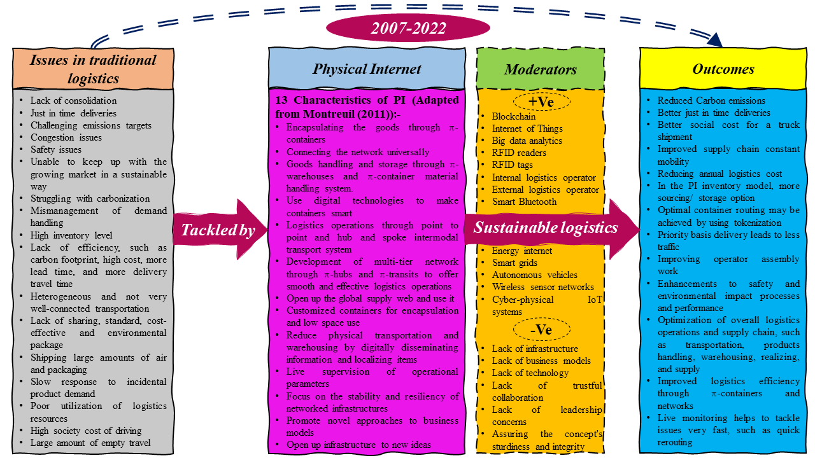
Figure 11. Integrative framework for sustainable logistics through implementing Physical Internet (PI).
5.1 Issues in traditional logistics
To begin, it was essential to determine the reasons for the urgent need for the logistics business to begin using PI. In our investigation into the possible answers to this question, we first determined the issues that already existed in traditional logistics, which in turn led to the development of PI as a means of resolving those problems. The following discussion will help to understand the potential issues of the conventional logistics system.
In the existing structure of distribution networks, the productivity of logistics is constrained by the pursuit of two contrary aims. The first is just-in-time shipments and the second is to employ the most environmentally friendly transportation methods possible (Sarraj et al., 2014b). Logistics system effectiveness has been a long-running ad never-ending endeavour since the dawn of time (Sarraj et al., 2014b). Ecological issues and just-in-time distribution of short orders are not mutually exclusive (Sarraj et al., 2014b). However, this conflict may need considerable supply chain management and design adjustments due to additional goals such as reducing greenhouse gas emissions (Sarraj et al., 2014b). Within the fast-moving consumer goods (FMCG) industry, in particular, the disconnected web of facilities, storage facilities, delivery hubs, and retail outlets emphasizes the segmentation of logistics. It's incredibly inefficient because there's no sharing of resources (Sarraj et al., 2014a). The freight sector’s contribution to total transportation greenhouse gas emissions is expected to rise from 42% in 2010 to 60% in 2050, which will make it a significant challenge to decarbonize the freight transport industry (OECD, 2015). Furthermore, the instruments that are used in the approach known as “business as usual” are insufficient to deal with the broadening business in a manner that is sustainable and responsible (EC, 2011).
Online shopping and mass customization have led to a reduced quantity per delivery and more dispatches per day in cities, but the level of service has been raised to communicate it in hours rather than days because of this. ‘Last-mile deliveries,’ as they are referred to in the setting of urban shipments, must be reinvented in order to reach the right amount of financial efficiency while simultaneously including ecological and social considerations (Ben Mohamed et al., 2017). These issues are becoming more important to practitioners, yet a number of data show that present transportation corporations are unable to deliver effective urban supply networks (Montreuil, 2011; Crainic, 2014).
The manner in which commodities are transported is becoming more unproductive, which has a significant negative effect on the surrounding environment (Tran-Dang et al., 2017). 13 symptoms (see Table 1) were identified in Montreuil (2011), which demonstrates that the existing supply chain and logistics methods are not sustainable. The outdated model of logistics is ineffective at this point and is unable to satisfy the needs of contemporary society. There are some measures being done to address these unsustainable symptoms, however, these programs are frequently focused on a single company or a small number of network collaborators, rather than the whole distribution chain. An entirely new integrated logistics paradigm is needed in this environment, one that incorporates all supply-chain players and ties financial, environmental, and social factors together (Tran-Dang et al., 2017).
Prior to this conversation, it was pointed out that the current logistics industry was offering unsustainably poor practices, and that this sector's future was being questioned due to the shifting landscape.
5.2 Physical Internet
The PI is emerging as a potentially game-changing answer to the formidable problem of ensuring the continued sustainability of global supply chains (Tran-Dang et al., 2017). This concept seeks to develop a system that will transfer, manage, preserve, realize, distribute, and utilize physical goods all across the globe in a way that concurrently enhances productivity, efficacy, and sustainability (Ballot et al., 2014). This change in paradigm is mostly based on the connectivity of logistic networks and the idea of encapsulation, in a manner that is analogous to the operation of the internet and the transportation of packages on the digital internet. This latter method wraps data in standardized packages before transmitting it (Tran-Dang et al., 2017). Due to this encapsulation, all interfaces and protocols have been created and evolved separately. For instance, data bundles may be managed by gateways or switches and transported over multiple channels employing different media. When it comes to real items, the PI is not manipulating them explicitly, but rather π-containers that store physical commodities and composite π-containers that may be constructed of a number of relatively small π-containers (Sarraj et al., 2014a). The PI infrastructure creates the interfaces and conventions to provide efficient and long-lasting global interconnectedness (Sarraj et al., 2014a).
This concept will demand a rethinking of the global supply chain, which will include the manipulation of modular π-containers throughout the course of time, as well as the possibility that their component pieces may be swapped out among the many nodes that make up the Physical Internet network. This method of composing and decomposing π-containers is an essential component in the creation of an effective and environmentally responsible global supply chain (Meller et al., 2012). In addition to this, it is anticipated that PI will make as extensive use of the characteristics of intelligent containers as is humanly feasible in order to allow decision-making procedures to take place on the site, which will provide new options such as actual-time navigation (Sallez et al., 2016). For example, π-containers might modify their navigation strategies inside every π-hub in response to the newly available knowledge of the existing possibilities and limitations. Maintaining the traceability of the π-container within a transport and transportation system that is extremely dynamic is, as a consequence, one of the most important challenges that might be faced.
Further Montreuil (2011) introduces 13 characteristics (see Fig. 2) of PI to tackle the unsustainability symptoms. Further, Montreuil (2011) suggests that the purpose of PI is to maximize the use of the functionality of intelligent π-containers that are linked to the IoT as well as the intelligent devices that are integrated within those containers in order to improve both the performance that is interpreted by customers as well as the total productivity of logistics structures and the PI as a whole. The π-container is able to perform an “active” part in the PI administration on its own if it increases its persuasive and decision-making skills. Therefore, PI has played a vital role in resolving traditional logistics challenges as well as concerns of unsustainability via its 13 features in the literature over a period of time. This has occurred over the course of many years. It is possible to comprehend the importance of PI by looking at how quickly it has emerged in the academic literature.
5.3 Moderators
The effect of the moderator on the link between the PI and the outcomes has been regarded to represent the moderator's function in the context of the current research investigation. Both a positive (which would strengthen the relationship) and a negative (which would weaken the relationship) influence of moderators on the association between PI and outcomes is possible. As a result, we have divided the moderators into two categories: those that have a positive impact on the link between PI and outcomes, and those that have a negative influence.
The PI transports items from their point of origin to their final location in the same manner as the internet transfers data (Mervis, 2014), which is not straight from the sender to the receiver but instead via a series of many nodes that are linked to a variety of different networks. This makes it possible for data packets that have been encapsulated or encrypted to go via an open platform from any place in the globe to any additional location on the planet (Meyer et al., 2019). As interest in this PI grows, there are still important challenges that prevent transporters and freight organizations from switching to PI from their present autonomous delivery channels, which are difficult to believe and trustworthy (Meyer et al., 2019). The majority of the investigation on the PI is constructed on a centralized interface solution and centralized information leadership that relies on a belief in a third party (Sallez et al., 2016). This is done in an attempt to communicate with all respondents in the PI while simultaneously handling concerns relating to faith, cooperation, and cross-organizational procedure effectiveness (Crainic and Montreuil, 2016).
Meyer et al. (2019) suggest that decentralization, reliability, and interconnectedness of the Blockchain (BC) technology might be used to circumvent the present impediments to the PI concept's acceptance. Further, the findings of Meyer et al. (2019)’s research indicate that the implementation of BC and the PI in a synergistic manner might give awakening to independent and decentralized logistical flows, which function with the highest cost-effectiveness while operating within a system that is trustworthy, clear, and inclusive. Tran-Dang et al. (2020) suggest that PI is a crucial factor that is well-positioned to profit from the transformation brought about by the IoT because it has the ability to enable end-to-end transparency of PI items, processes, and networks by means of pervasive data interchange. Specifically, the utilization of RFID technology, big data analytics, and cloud-oriented platforms may allow actual-time tracking of items and synchronization of assets, leading to enhanced scheduling and monitoring across the supply chain (Núñez-Merino et al., 2020; Fatorachian and Kazemi, 2021). This way, the different moderators work as enablers and barriers to PI performance.
5.4 Outcomes
Montreuil (2011) indicates the proposed sustainable outcomes of PI deployment in the logistics industry. After that, many researchers published articles on the various outcomes of PI implementation. Sarraj et al. (2014) reveal some hopeful findings on many metrics of logistics efficiency, including CO₂ emissions, expense, lead time, and delivery commute time. Also, their study indicates that PI-enabled logistics systems improve just-in-time deliveries. Zhang et al. (2016) suggest that using a PI for encapsulating customer orders (COs) that are meant to be reusable may minimize the consumption of natural assets as well as the cost of transportation. In addition, the outcomes of their research show that the actual-time data-driven optimization technique for logistics orders (LOs) is offered as a way to maximize the capacity of containers, optimize transportation loading, and limit overall transmission.
The study that was conducted by Fazili et al. (2017) examines the differences and similarities between the performance of conventional logistics systems and PI-enabled logistics systems. The authors compared the outcomes by employing a Monte Carlo simulation that was carried out within the framework of a sequential three-phase optimization strategy. These data provide evidence in favour of the hypothesis that PI reduces the total journey distance, the number of pollutants produced, and the cost to society associated with truck commuting. In addition, the research that was conducted by Yang et al. (2017) reveals that the PI stock model is more robust than the traditional stock models since it is more agile and adaptable than the traditional stock models. Additionally, the difference in productivity widens as the value of the item, the cost of the penalties, and the number of interruptions all rise. In this regard, the papers that have been published in the past provide the impression that the findings of PI are more focused on the effectiveness of logistics and the viability of their operations. The discussion on the integrative framework (see Figure 11) demonstrates how PI has been involved in the literature to confront the challenges of conventional logistics and gives sustainable solutions that are matched with enhanced logistics productivity. Moreover, PI has been able to provide these solutions. In addition, PI has been successful in offering these kinds of solutions.
6. Conclusions
The present literature review provides an evaluation of recent research, as well as an analytical discussion and some proposals for the direction of future studies, for the many contributions that PI has made to the logistics industry. This study applies a combined synthesize-analyze strategy, such as cluster-based frameworks and integrative frameworks, to obtain conclusions from the aforementioned body of research. These frameworks were chosen due to their ability to integrate different types of information. We argue to business managers, academics, and politicians that there is an immediate need to build new business models for enhanced adaptation and execution of the PI plan. These new business models should be established as soon as possible. In addition, we propose that professionals study various means by which the PI approach may be implemented into the business models that are currently in place. This recommendation comes as a result of the fact that we believe that this could be beneficial to organisations. The majority of the work on PI is completed using a method that is based on simulation, and there is a need to construct further optimising models in addition to performing actual investigations to offer a more in-depth look at the topic.
It is quite likely that any growing notion that has not yet been put to the test in the form of empirical research will come with a number of challenging barriers that will need to be overcome before the thought can reach widespread acceptance. Since a number of challenges of this kind have emerged in more recent times, this research into the body of literature that bolsters the PI hypothesis is beneficial to the eventual adoption of the concept. In addition, the viewpoints of a variety of stakeholders are quite vital for the improvement of PI's adaptability in various sectors. The findings of our analysis bring to light a variety of issues, all of which ought to be looked at in greater depth in future studies. If the current obstacles of PI's conceptual development, which are outlined here, were to be addressed, it would certainly provide a sound platform for analysing real deployments of PI in terms of the impacts it was meant to have in order to tackle the overarching problem of sustainability. If this were to happen, it would be a significant step forward in the fight against climate change.
References
Ambra, T., Caris, A., & Macharis, C. (2019). Towards freight transport system unification: Reviewing and combining the advancements in the physical internet and synchromodal transport research. International Journal of Production Research. 57(6), 1606-1623.
Ballot, É., Montreuil, B., & Meller, R. D. (2014). The Physical Internet: The network of logistics networks.
Ben Mohamed, I., Klibi, W., Labarthe, O., Deschamps, J., & Babai, M. Z. (2017). Modelling and solution approaches for the interconnected city logistics. International Journal of Production Research. 55(9), 2664-2684.
Boaz, A., & Ashby, D. (2003). Fit for purpose?: assessing research quality for evidence based policy and practice (Vol. 11). London: ESRC UK Centre for Evidence Based Policy and Practice.
Buchanan, P. D., & Bryman, P. A. (2009). The sage handbook of organizational research methods. SAGE Publications.
Chen, C., Pan, S., Wang, Z., & Zhong, R. Y. (2017). Using taxis to collect citywide e-Commerce reverse flows: A crowdsourcing solution. International Journal of Production Research. 55(7), 1833-1844.
Cohen, Y., Naseraldin, H., Chaudhuri, A., & Pilati, F. (2019). Assembly systems in industry 4.0 era: A road map to understand assembly 4.0. The International Journal of Advanced Manufacturing Technology. 105(9), 4037-4054.
Crainic, T. G. (2014), “City Logistics.” INFORMS Tutorials in Operations Research null(null):181-212.
Crainic, T. G., & Montreuil, B. (2016). Physical internet enabled hyperconnected city logistics. Transportation Research Procedia. 12, 383-398.
Debellis, F., Rondi, E., Plakoyiannaki, E., & De Massis, A. (2021). Riding the waves of family firm internationalization: A systematic literature review, integrative framework, and research agenda. Journal of World Business, 56(1), 101144.
Ding, H., Liu, Y., Zhang, Y., Wang, S., Guo, Y., Zhou, S., & Liu, C. (2022). Data-driven evaluation and optimization of the sustainable development of the logistics industry: Case study of the Yangtze River Delta in China. Environmental Science and Pollution Research. https://doi.org/10.1007/s11356-022-20624-0
EC. (2011), “White Paper on Transport: Roadmap to a Single European Transport Area: Towards a Competitive and Resource-Efficient Transport System,” Brussels: Publications Office of the European Union.
European Commission (2011), “Roadmap to a Single European Transport Area – Towards a competitive and resource efficient transport system”, European Commission. Accessed 03 August, 2022. https://eur-lex.europa.eu/LexUriServ/LexUriServ.do?uri=COM:2011:0144:FIN:EN:PDF
Fatorachian, H., & Kazemi, H. (2021). Impact of Industry 4.0 on supply chain performance, Production Planning & Control. 32 (1), 63-81.
Fazili, M., Venkatadri, U., Cyrus, P., & Tajbakhsh, M. (2017). Physical internet, conventional and hybrid logistic systems: A routing optimisation-based comparison using the Eastern Canada road network case study. International Journal of Production Research. 55(9), 2703-2730.
Gaur, A., & Kumar, M. (2018). A systematic approach to conducting review studies: An assessment of content analysis in 25 years of IB research. Journal of World Business, 53(2), 280-289.
Grover, P., Kar, A. K., & Dwivedi, Y. K. (2020). Understanding artificial intelligence adoption in operations management: Insights from the review of academic literature and social media discussions. Annals of Operations Research, 308(1-2), 177-213.
Hart, C. (1998). Doing a literature review: Releasing the social science research imagination. SAGE.
Hilal, N. (2008). Unintended effects of deregulation in the European Union: The case of road freight transport. Sociologie du Travail, 50, e19-e29.
Hopkins, J., & Hawking, P. (2018). Big data analytics and IoT in logistics: A case study. The International Journal of Logistics Management. 29(2), 575-591.
ITF (2019). ITF Transport Outlook 2019, OECD Publishing, Paris. https://doi.org/10.1787/transp_outlook-en-2019-en.
Jayarathna, C. P., Agdas, D., Dawes, L., & Miska, M. (2021). Exploring sector-specific sustainability indicators: A content analysis of sustainability reports in the logistics sector. European Business Review, 34(3), 321–343.
Li, K., Rollins, J., & Yan, E. (2017). Web of science use in published research and review papers 1997–2017: A selective, dynamic, cross-domain, content-based analysis. Scientometrics, 115(1), 1-20.
Li, S., Ni, Q., Sun, Y., Min, G., & Al-Rubaye, S. (2018). Energy-efficient resource allocation for industrial cyber-physical IoT systems in 5G era. IEEE Transactions on Industrial Informatics. 14(6), 2618-2628.
Lin, Y., Meller, R. D., Ellis, K. P., Thomas, L. M., & Lombardi, B. J. (2014). A decomposition-based approach for the selection of standardized modular containers. International Journal of Production Research. 52(15), 4660-4672.
Luo, Y., Zhang, H., & Bu, J. (2019). Developed country MNEs investing in developing economies: Progress and prospect. Journal of International Business Studies, 50(4), 633-667.
Mallett, R., Hagen-Zanker, J., Slater, R., & Duvendack, M. (2012). The benefits and challenges of using systematic reviews in international development research. Journal of Development Effectiveness, 4(3), 445-455.
Mervis, J. (2014). The information highway gets physical. Science, 344 (6188), 1104-1107.
Maseda, A., Iturralde, T., Cooper, S., & Aparicio, G. (2022). Mapping women's involvement in family firms: A review based on bibliographic coupling analysis. International Journal of Management Reviews, 24(2), 279-305.
Meller, R., Lin, Y., & Ellis, K. (2012). The Impact of Standardized Metric Physical Internet Containers on the Shipping Volume of Manufacturers. In Proceedings of 14th IFAC Symposium on Information Control Problems in Manufacturing, 364–371. Bucharest, Romania.
Meyer, T., Kuhn, M., & Hartmann, E. (2019). Blockchain technology enabling the physical internet: A synergetic application framework. Computers & Industrial Engineering, 136, 5-17.
Montreuil, B. (2011). Toward a physical internet: Meeting the global logistics sustainability grand challenge. Logistics Research, 3(2-3), 71-87.
Nickerson, & Muehlen. (2006). The ecology of standards processes: Insights from internet standard making. MIS Quarterly, 30, 467.
Nikitas, A., Michalakopoulou, K., Njoya, E. T., & Karampatzakis, D. (2020). Artificial intelligence, transport and the smart city: Definitions and dimensions of a new mobility era. Sustainability. 12(7), 2789.
Núñez-Merino, M., Maqueira-Marín, J. M., Moyano-Fuentes, J., & Martínez-Jurado, P. J. (2020). Information and digital technologies of industry 4.0 and lean supply chain management: A systematic literature review. International Journal of Production Research. 58(16), 5034-5061.
OECD. (2015), “ITF Transport Outlook 2015.” Accessed 08 August, 2022. http://www.oecd.org/publications/itf-transport-outlook-2015-9789282107782-en.htm.
Pan, S., Trentesaux, D., Ballot, E., & Huang, G. Q. (2019). Horizontal collaborative transport: Survey of solutions and practical implementation issues. International Journal of Production Research. 57(15-16), 5340-5361.
Pan, S., Ballot, E., Huang, G. Q., & Montreuil, B. (2017). Physical internet and interconnected logistics services: Research and applications. International Journal of Production Research, 55(9), 2603-2609.
Pan, S., Nigrelli, M., Ballot, E., Sarraj, R., & Yang, Y. (2015). Perspectives of inventory control models in the physical internet: A simulation study. Computers & Industrial Engineering. 84, 122-132.
Peng, X., Ji, S., & Ji, T. (2020). Promoting sustainability of the integrated production-inventory-distribution system through the physical internet. International Journal of Production Research. 58(22), 6985-7004.
Peng, X., Ji, S., Thompson, R. G., & Zhang, L. (2021). Resilience planning for physical internet enabled hyperconnected production-inventory-distribution systems. Computers & Industrial Engineering, 158, 107413.
Qiao, B., Pan, S., & Ballot, E. (2020). Revenue optimization for less-than-truckload carriers in the physical internet: Dynamic pricing and request selection. Computers & Industrial Engineering, 139, 105563.
Sallez, Y., Pan, S., Montreuil, B., Berger, T., & Ballot, E. (2016). On the activeness of intelligent physical internet containers. Computers in Industry, 81, 96-104.
Salvador, F. (2007). Toward a product system modularity construct: Literature review and reconceptualization. IEEE Transactions on Engineering Management, 54(2), 219-240.
Sarraj, R., Ballot, E., Pan, S., & Montreuil, B. (2014a). Analogies between internet network and logistics service networks: Challenges involved in the interconnection. Journal of Intelligent Manufacturing. 25(6), 1207-1219.
Sarraj, R., Ballot, E., Pan, S., Hakimi, D., & Montreuil, B. (2014b). Interconnected logistic networks and protocols: Simulation-based efficiency assessment. International Journal of Production Research. 52(11), 3185-3208.
Seroka-Stolka, O., & Ociepa-Kubicka, A. (2019). Green logistics and circular economy. Transportation Research Procedia, 39, 471–479.
Shahbaz, W., & Parker, J. (2022). Workplace mindfulness: An integrative review of antecedents, mediators, and moderators. Human Resource Management Review. 32(3), 100849.
Sternberg, H., & Norrman, A. (2017). The physical internet – review, analysis and future research agenda. International Journal of Physical Distribution & Logistics Management, 47(8), 736-762.
The Economist. (2006, June 17). The physical internet. Accessed 03 August, 2022. https://www.economist.com/special-report/2006/06/17/the-physical-internet
Tran-Dang, H., Krommenacker, N., & Charpentier, P. (2017). Containers monitoring through the physical internet: A spatial 3D model based on wireless sensor networks. International Journal of Production Research. 55(9), 2650-2663.
Tran-Dang, H., Krommenacker, N., Charpentier, P., & Kim, D. (2020). Toward the Internet of things for physical internet: Perspectives and challenges. IEEE Internet of Things Journal. 7(6), 4711-4736.
Treiblmaier, H. (2019). Combining blockchain technology and the physical internet to achieve triple bottom line sustainability: A comprehensive research agenda for modern logistics and supply chain management. Logistics. https://doi.org/10.20944/preprints201902.0002.v1
Treiblmaier, H., Mirkovski, K., Lowry, P. B., & Zacharia, Z. G. (2020). The physical internet as a new supply chain paradigm: A systematic literature review and a comprehensive framework. The International Journal of Logistics Management, 31(2), 239-287.
Vallaster, C., Kraus, S., Merigó Lindahl, J. M., & Nielsen, A. (2019). Ethics and entrepreneurship: A bibliometric study and literature review. Journal of Business Research, 99, 226-237.
Vrontis, D., & Christofi, M. (2021). R&D internationalization and innovation: A systematic review, integrative framework and future research directions. Journal of Business Research, 128, 812-823.
Webster, J., & Watson, R.T. (2002). Analyzing the past to prepare for the future: Writing a literature review. MIS Quarterly, 26(2), iii–xiii.
Yang, Y., Pan, S., & Ballot, E. (2016). Mitigating supply chain disruptions through interconnected logistics services in the physical internet. International Journal of Production Research. 55(14), 3970-3983.
Yang, Y., Pan, S., & Ballot, E. (2017). Innovative vendor-managed inventory strategy exploiting interconnected logistics services in the physical internet. International Journal of Production Research. 55(9), 2685-2702.
Zahoor, N., Khan, Z., Wu, J., Tarba, S. Y., Donbesuur, F., & Khan, H. (2022). Vertical alliances and innovation: A systematic review of the literature and a future research agenda. Technovation, 102588.
Zaman, K., & Shamsuddin, S. (2017). Green logistics and national scale economic indicators: Evidence from a panel of selected European countries. Journal of Cleaner Production, 143, 51–63.
Zhang, Y., Liu, S., Liu, Y., & Li, R. (2016). Smart box-enabled product–service system for cloud logistics. International Journal of Production Research. 54(22), 6693-6706.
Zhong, R. Y., Xu, C., Chen, C., & Huang, G. Q. (2017). Big data analytics for physical internet-based intelligent manufacturing shop floors. International Journal of Production Research. 55(9), 2610-2621.
Zhou, D. H., He, X., Wang, Z., Liu, G., & Ji, Y. D. (2012). Leakage fault diagnosis for an internet-based three-tank system: An experimental study. IEEE Transactions on Control Systems Technology. 20(4), 857-870.

