Enhancing Robotics Learning using Imitation Learning through Visual-based Behaviour Cloning
Yagna Jadeja¹, Mahmoud Shafik¹, Paul Wood¹ and Aaisha Makkar¹
¹University of Derby, Markeaton Street, Derby DE22 3AW, UK
Abstract. The development of behaviour cloning technique allows robots to mimic human experts behaviour by observation. The technique is mainly based on model architecture's design and associated training mechanisms. İt is believed that such approach will impact on the importance of robotics applications in the coming future. The ongoing research presented in this paper has investigated the use of behaviour cloning with image and video data streaming to improve robots learning using imitation of human experts behaviour. The investigation has focused on the methodology, algorithms, and challenges associated with training robots to imitate human actions solely based on visual data inputs. An overview of the process of collecting diverse and annotated image and video datasets depicting various human actions and behaviours is presented. To provide efficient and consistent data representation, the preprocessing process includes feature extraction using convolutional neural networks (CNN) and normalization techniques. The CNN model for learning action mappings from visual inputs is described. These models' training focuses on optimization algorithms and loss functions. A thorough examination of data quality, overfitting, and model generalization issues is addressed and presented. The research initial results showed the effectiveness of image and video-based behaviour cloning, and how it is leading to more sophisticated and adaptive robotic systems. The limitations of the research are also discussed and presented in this paper.
Keywords: Behaviour Cloning, Imitation Learning, CNN, Visual Data, Robotics.
- Introduction
Imitation learning is the process of observing, and action and then repeating it. İt is learning from demonstration (LfD) process and is renowned for its extensive range of Artificial İntelligence technology (Ravichandar, Polydoros, Chernova, & Billard, 2020). Imitation learning has its roots in mimicking experts behaviour and will significantly transform robotics into the realms of human-like functionality (Argall, Chernova, Veloso, & Browning, 2009). It enhances universal robotic advancements by displaying robots that mimic expert behaviour, indicating a transformation in robotics (Billard, Calinon, Dillmann, & Schaal, 2008). Robots have traditionally learnt by trial and error in controlled situations, progressively evolving within a reward function (Kober, Bagnell , & Peters, 2013). However, imitation learning is characterised by its reliance on datasets containing demonstrations mostly selected by human experts (Hussein , Gaber , Elyan, & Jayne, 2017). These demonstrations serve as a blueprint for robots to follow, with the aim of replicating the expert's actions in similar situations or scenarios (Argall, Chernova, Veloso, & Browning, 2009). The relevance of this finding is not only based on the mimicking of same behaviours of expert, but also on the extraction and comprehension of the underlying patterns (Billard, Calinon, Dillmann, & Schaal, 2008). Robots with imitation learning capabilities go above the basic replication by observing and learning from these demonstrations. Robots acquire the core and complexity of human behaviour, which enhances their ability to adapt and engage in a manner that is more human-like in efficiency and comprehension (Hussein , Gaber , Elyan, & Jayne, 2017).

A key component of imitation learning is behaviour cloning, which is a bridge for robots to learn, incorporate and replicate human actions scenarios (Argall, Chernova, Veloso, & Browning, 2009). The use of visual data, such as images and videos, increases this imitation process by collecting accurate data that is necessary for producing complex human patterns (Finn , Goodfellow , & Levine, 2016). This study focuses on the combination of behaviour cloning and visual data inputs to improve robots' ability to mimic human actions (Pavlakos, Zhou, Derpanis, & Daniilidis, 2017). In addition, tries to identify the potential and limitations of this developing subject by scrutinizing approaches, algorithms, and issues related to training robots only from visual data (Finn , Goodfellow , & Levine, 2016).

The robotics operating environment is changing, and this study using visual-based behaviour cloning for task acquisition is an important step towards enhancing the synergy between imitation learning and robotics (Pavlakos, Zhou, Derpanis, & Daniilidis, 2017). It explores the potential and limitations of training robots specially from visual data by examining methodologies, algorithms, and challenges associated with this emerging field. (Finn , Goodfellow , & Levine, 2016). The field of robotics is in constant evolution, and this exploration into visual-based behaviour cloning for task acquisition marks a significant advancement in fostering improved synergy between imitation learning and robots (Pavlakos, Zhou, Derpanis, & Daniilidis, 2017).
- State of the Art of Imitation Learning and Robotics
This research explores the state-of-the-art in imitation learning and robotics, focusing on its significant contributions and methodological innovations, particularly in visual-based behaviour cloning methods, which are crucial for improving robot capabilities. AI, imitation learning, big data, and distributed computing are key tools in digital and smart manufacturing. Challenges include AI algorithms, complex coding, and updating manufacturing facilities. Imitation learning can simplify these issues, while deep imitation learning can help develop self-learning robotic systems. Collaboration between self-learning robotic cells enhances the manufacturing environment (Jadeja, Shafik, & Wood, 2022).

The Integrated Architecture for Situated Learning initiates speech-supported imitation learning, enabling flexible grasping by replicating human hand positions (Steil, Rothling, Haschke, & Ritter, 2004). The interdisciplinary project for Goal-Directed Imitation explores into goal-directed imitation, allowing robots to imitate observed grasping-placing sequences from human models (Duch, Kacprzyk, Oja, & Zadrożny, 2005). Human-Like movement generation makes a significant step forward by developing a framework that completes humanoid robots with real-time human-like motions, combining motion imitation learning with database-driven generation (Park, Ra, Kim, & Song, 2008). The Kernel Treatment of Imitation Learning proposes a revolutionary kernel-based technique that provides robots with adaptability and flexibility, which are important attributes in complicated situations (Huang, Rozo, Silvério, & Caldwell, 2019). Self-Imitation Learning pioneers SILCR, a practical alternative to reinforcement learning that is suited for contexts with few incentives (Chen & Lin, 2021). Further advancement is made possible using unstructured natural language in imitation learning (Stepputtis, et al., 2020), which is influenced by human teaching techniques and aims to bridge communication gaps between experts and robots (Stepputtis, et al., 2020).

Imitation Learning for Robot therapy expands the application range by demonstrating how imitation learning contributes to mental health therapy by learning human behaviour responses (Ompico, Bugtai, & Munsayac Jr., 2021). Visual Imitation Learning enables robots to learn manipulation tasks simply from human demonstrations, overcoming state estimation problems in the absence of prior object knowledge (Johns, 2021). Deep Imitation Learning for Autonomous Manipulation pushes for the incorporation of deep learning into autonomous manipulation, utilising gaze prediction for memory-dependent tasks (Kim, Ohmura, & Kuniyoshi, 2022). Finally, Interaction Warping for Robotic Manipulation demonstrates effective object rearrangement tasks by introducing SE3 robotic manipulation strategies via one-shot imitation learning. These methodologies represent the ongoing growth of imitation learning, moving robots towards greater flexibility, learning efficiency, and real-world application (Biza, et al., 2023).

In the realm of advancements and methodological innovations within imitation learning, several pivotal contributions have emerged. A benchmark aimed at Behaviour Cloning Scalability was introduced, shedding light on crucial aspects such as dataset bias, overfitting, and training instabilities, thereby bringing further research into these areas (Codevilla, Santana, Lopez, & Gaidon, 2019). This reformulated representation learning as a bi-level optimization problem, bolstering robustness in imitation learning setups by tackling challenges in joint representation learning (Zhu & Zhao, 2021) (Arora, Du, Kakade, Luo, & Saunshi, 2020). (Galashov, Merel, & Heess, 2022) proposed an innovative imitation learning algorithm capable of learning from noisy demonstrations without direct environment interactions or annotations, significantly increasing the applicability of imitation learning. It demonstrated a novel data-augmentation approach that facilitated data-efficient learning from parametric experts, particularly in reinforcement and imitation learning situations. (Wang, Dasari, Srirama, Tulsiani, & Gupta, 2023) contributed by revealing a scalable method for directly inferring robot actions from visual representations, emphasising the distinction between generic visual representations and task-specific robot action inference. (Shukla, Kesari, Goel, Wright, & Sinapov, 2023) developed a framework for few-shot policy transfer between domains via observation mapping and behaviour cloning, showing adaptability even in tasks with semantic dissimilarities. This delved into the robustness challenges inherent in learning from incomplete trajectories. (Yan, Schwing, & Wang, 2023) proposal, Trajectory-Aware Imitation Learning from Observations (TAILO), aims to foster more stable learning in such scenarios. Finally, (Seo, Hwang, Yang, & Kim, 2023) addressed catastrophic failures in behaviour cloning due to past action leakage by proposing Past Action Leakage Regularization (PALR), a principled approach enhancing the stability of imitation learning methods. These diverse contributions collectively mark significant strides in refining imitation learning methodologies, tackling challenges related to scalability, robustness, data efficiency, and stability, thereby paving the way for more resilient and adaptable learning frameworks in artificial intelligence. This comprehensive investigation underscores the evolution of imitation learning within robotics, elucidating foundational approaches, innovative methodologies, and key advancements. From speech-supported imitation to novel approaches addressing learning challenges, these studies collectively highlight the strides made in leveraging visual data for behaviour cloning. As robotics continues to evolve, these insights pave the way for more adaptable, responsive, and sophisticated robotic systems through imitation learning paradigms.
- Behaviour Cloning for Robotics Systems
Behaviour cloning is an imitation learning approach in which a robot learns to mimic a desired behaviour by observing demonstrations rather than receiving specific instructions or rewards (Pomerleau, 1989) (Studies in Systems, Decision and Control, 2015). In the context of visual datasets, this means learning a mapping between visual inputs such as images or video frames to actions performed by an expert (Bojarski, et al., 2016). Behaviour cloning, in a mathematical formulation, involves modelling a mapping function $f$ that learns to replicate a behaviour (Hussein , Gaber , Elyan, & Jayne, 2017). In a simple form, if you have expert demonstrations represented as input-output pairs $\left(x_{i} - a_{i}\right)$. where $(x_{i})$ is the input as sensory data, state information and $\left(a_{i}\right)$ is the corresponding desired output as an action or behaviour, behaviour cloning aims to learn a mapping function $f$ such that $f\left(x_{i}\right)$ approximates $\left(a_{i}\right)$. This can be represented as a supervised learning problem where aim to minimize the discrepancy between the predicted output $f\left(x_{i}\right)$ and the expert demonstration $\left(a_{i}\right)$. Mathematically, express this as a loss function (Zhang, 2004) (Deng, Zhu, Duan, Fu, & Liu, 2022):
$$L(θ) = \sum_{i=1}^{N}{L\left(f\left(x_{i}\right),a_{i}\right)}$$
Where L is a loss function that indicates the difference between the predicted output and the actual demonstration for each input-output pair. Commonly used loss functions include mean squared error (MSE), categorical cross-entropy, or other task-specific loss functions (Qin, Ye, Li, & Juang, 2019). The goal during training is to find the parameters (weights and biases) of the function $f_{θ}$ that minimize this loss function (Nguyen, Thi Nguyen, Ho, & Nguyen, 2023). This is typically achieved through optimization techniques such as gradient descent or its variants, where the parameters are updated iteratively to reduce the overall loss (Goodfellow, Bengio, & Courville, 2016). The mathematical equation for behaviour cloning lies in optimizing the parameters of the function $f_{θ}$ to approximate the expert behaviour by minimizing the loss function associated with the disparity between predicted outputs and expert demonstrations (Ross & Bagnell, 2010).
- Behaviour Cloning Implementation using CNN
As shown in Figure 1 the Convolutional Neural Networks (CNNs) are particularly advantageous in behaviour cloning due to their adeptness in handling spatial relationships within data.

In tasks like behaviour cloning, where understanding visual inputs such as images or video frames is crucial, CNNs excel. Their architecture, built on convolutional layers that extract features hierarchically, enables them to discern patterns, textures, and shapes in the input data. This capability is pivotal in tasks like robotics, where replicating human behaviour from visual cues is essential. CNNs' ability to automatically learn and generalize from visual data makes them a robust choice for behaviour cloning applications, facilitating the replication of complex behaviours by learning from demonstrations.

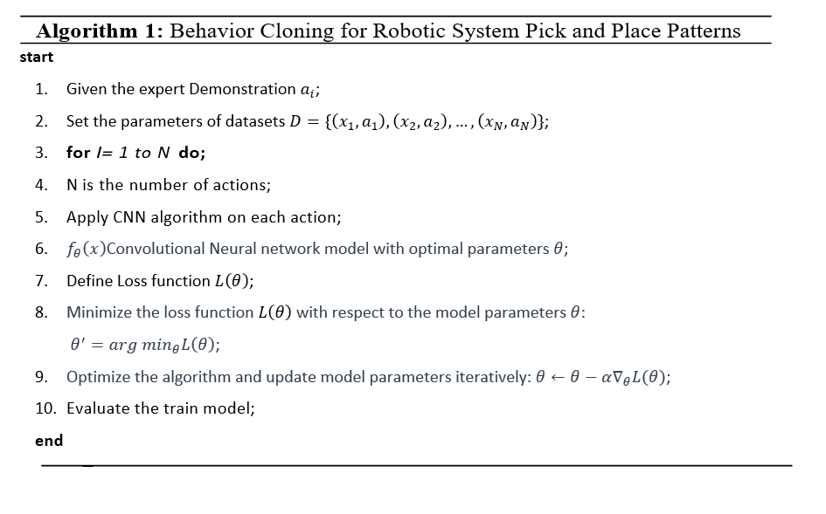
Figure. 1. Algorithm of Behaviour Cloning for Robotic System Pick and Place
  - Dataset Collection and Processing

The Integrated Architecture for Situated Learning initiates speech-supported imitation learning, To initiate the behaviour cloning process for the robotic arm's tasks (i.e., pick and place), an extensive dataset acquisition phase is fundamental. This involves capturing a diverse array of images or videos showcasing the robotic arm executing pick and place manoeuvres from multiple perspectives and environmental conditions. Gathering around 500 images and 20 videos to ensures the model comprehensively learns to generalize across various scenarios. Once collected, preprocessing steps become critical. These encompass meticulous actions such as cropping images to focus solely on the arm and object, resizing to a uniform dimension, and standardising the images to ensure consistency in colour, lighting, and orientation. The labelling process is crucial, where each image or video frame is paired with the corresponding action performed by the robotic arm for pick an object, placing it at a designated location, or other relevant manoeuvres (Peng, 2023). This annotated dataset forms the basis for training the convolution neural network to accurately simulate the robotic arm's behaviour.
  - CNN Model Architecture and Design
The designed convolutional neural network (CNN) begins by accommodating 480x480 RGB images in the input layer, processing them through two convolutional layers. The first layer employs 32 filters sized 3x3 with ReLU activation, maintaining the spatial dimensions through same padding. Subsequently, a max pooling layer with a 2x2 pool size and stride of 2 downsamples the features. The process continues with a second convolutional layer using 64 filters of the same size and activation, followed by another max pooling layer (Arvanitidis, Valdez, & Alamaniotis, 2023). The resulting feature maps are then flattened into a 1D vector. This information feeds into a fully connected layer comprising 128 neurons activated by ReLU. Finally, the output layer, determined by the specific classification or action task, employs SoftMax activation for classifying the output into respective classes or actions. This architecture helps in hierarchical feature extraction, downsampling, and interpretation, crucial for tasks like image classification or action recognition.
  - Training CNN Model
During the training phase, the first step involves splitting the dataset into distinct training and validation sets, a crucial aspect for evaluating model performance. Once the data is partitioned, the CNN begins its training journey. Input data, images and or sensor data, are fed into the CNN architecture, initiating the optimization process. CNN’s primary objective lies in minimizing the Mean Squared Error (MSE) measuring the average squared difference between the predicted actions by the model and the expert actions in the dataset. In training, the CNN's parameters are adjusted to minimize the MSE. The network intends to generate predictions that are as close to the expert actions observed in the training data.
  - CNN Model Deployment on Robotic System
The deployment process for robotics involves two primary stages. Initially, the trained model undergoes a precise conversion to align with the technical specifications of the Jetson Nano-based robot, ensuring harmonious integration and optimal functionality within the system. Subsequently, a meticulous interfacing procedure is executed between the adapted model and the robotic arm, consolidating diverse datasets. This integration serves to fortify the model's capacity in efficiently processing incoming data and issuing precise directives to control the actions of the robotic arm. Consequently, this facilitates a cohesive and responsive operational framework within the robotic system. Figure 2 shows the flowchart of the processing.

Start: Represents beginning of the process. Expert Demonstration: Demonstrate the action by human experts. Input Layer: This rectangle signifies the initial input data, typically images in this case, with dimensions of 480x480 pixels and 3 channels (RGB). Convolutional Layer 1: This layer applies 32 filters of size 3x3 to the input data using Rectified Linear Unit (ReLU) activation and same padding, extracting features from the input image. It's connected from the Input Layer. Max Pooling Layer 1: Following Convolutional Layer 1, this layer performs max pooling with a 2x2 window size and a stride of 2, reducing the spatial dimensions of the features while retaining important information (Nurfarahin, Akamam, & Norliza, 2023). Convolutional Layer 2: The second convolutional layer applies 64 filters of size 3x3 with ReLU activation and same padding, further extracting higher-level features from the output of Max Pooling Layer 1. Max Pooling Layer 2: Similar to Max Pooling Layer 1, this layer reduces the spatial dimensions of the features obtained from Convolutional Layer 2 using a 2x2 window size and a stride of 2. Flatten Layer: This layer reshapes the output from the previous layers into a one-dimensional vector, preparing it for the fully connected layers. Fully Connected Layer 1: A dense layer with 128 neurons and ReLU activation. It processes the flattened output to further extract intricate patterns and features. Output Layer: The final layer of the network, which is customized based on the specific task—possibly the number of classes or actions needed. It uses a SoftMax activation function for classification purposes. Behaviour Cloning Process: A diamond-shaped box indicating the process of training the CNN model using behaviour cloning techniques. This involves feeding input data and corresponding desired actions or behaviours to teach the network to replicate those actions. End: End of the process as shown in figure 2.

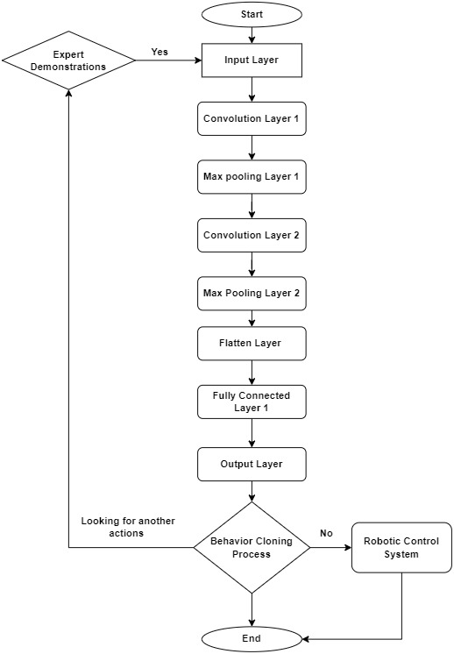
Figure. 2. Flowchart of Behaviour Cloning for Robotic System Pick and Place

- CNN Model Testing, Validation, Result and Analysis
The model is trained using CNN architecture and fed with the CIFAR-10 dataset to train the robotic system at various levels, enhancing its capabilities to imitate. Based on this training, the robotic system can learn about several common objects. As the model has been previously described in the above sections, its training accuracy is 92.86%, while its validation accuracy stands at 88.2% as shown in figure 3.

The model undergoes training using custom datasets comprising a diverse range of data types, including RGB images, shapes, and real-time objects such as pens, pencils, balls, cubes, fruits, vegetables, ...etc. This comprehensive dataset encompasses approximately 500 images and 20 videos, providing a rich and varied set of visual information for the model to learn from. As a result of this training regimen, the model attains varying levels of accuracy across different categories. It achieves an accuracy as stated in figure 4 of 69% in recognizing certain objects, 85% in identifying specific shapes, and 67% in classifying various real-time items. This broad array of accuracies reflects the model's proficiency in differentiating and understanding distinct classes within the custom dataset, showcasing its ability to learn and generalize across multiple categories.
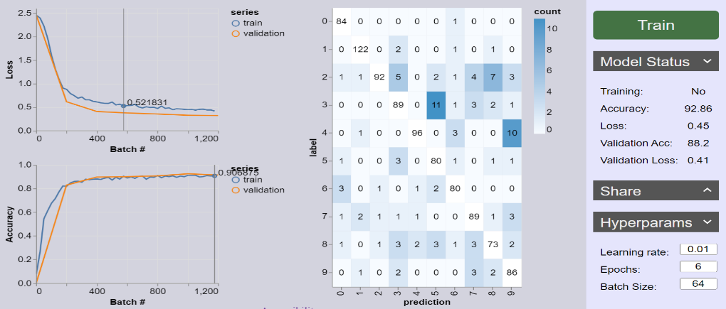
Figure. 3. Training model using CIFAR10 Datasets

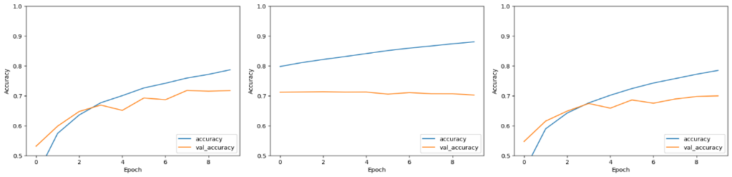
Figure. 4. Testing model Customise Datasets
- Conclusion
This ongoing research programme intial outcomes highlights the crucial role of convolutional neural networks in enabling robots to imitate and learn from various human behaviours depicted in visual datasets. Despite obstacles such as overfitting or underfitting, the study's meticulous approach emphasizes the potential of visual-based behaviour cloning in shaping more sophisticated and adaptable robotic systems. The work shown promsing results and considerable contribution to the advancement of robotics, paving the way for enhanced human-like cognitive learning in robots.

References
- Argall, B. D., Chernova, S., Veloso, M., & Browning, B. (2009). A survey of robot learning from demonstration. Robotics and Autonomous Systems, 57(5), 469-483.
- Arora, S., Du, S., Kakade, S., Luo, Y., & Saunshi, N. U. (2020). Provable Representation Learning for Imitation Learning Via Bi-level Optimization. 37 th International Conference on Machine Learning. Vienna, Austria.
- Arvanitidis, A. I., Valdez, L. A., & Alamaniotis, M. (2023). A Quantum Machine Learning Methodology for Precise Appliance Identification in Smart Grids. 14th International Conference on Information, Intelligence, Systems & Applications.
- Billard, A., Calinon, S., Dillmann, R., & Schaal, S. (2008). Robot Programming by Demonstration. Springer Handbook of Robotics, 1371–1394.
- Biza, O., Thompson, S., Pagidi, K. R., Kumar, A., Pol, E., Walters, R., . . . Platt, R. (2023). One-shot Imitation Learning via Interaction Warping. ARXIV.
- Bojarski, M., Testa, D. D., Dworakowski, D., Firner, B., Flepp, B., Goyal, P., . . . Zieba, K. (2016). End to End Learning for Self-Driving Cars. ARXIV.
- Chen, Z., & Lin, M. (2021). Self-Imitation Learning for Robot Tasks with Sparse and Delayed Rewards. ArXIV.
- Codevilla, F., Santana, E., Lopez, A. M., & Gaidon, A. (2019). Exploring the Limitations of Behavior Cloning for Autonomous Driving. Proceedings of the IEEE/CVF International Conference on Computer Vision (ICCV).
- Deng, S., Zhu, Y., Duan, S., Fu, Z., & Liu, Z. (2022). Stock Price Crash Warning in the Chinese Security Market Using a Machine Learning-Based Method and Financial Indicators. Systems, 10(4).
- Duch, W., Kacprzyk, J., Oja, E., & Zadrożny, S. (2005). Action Understanding and Imitation Learning in a Robot-Human Task. International Conference on Artificial Neural Networks, (pp. 261-268). Warsaw, Poland.
- Finn , C., Goodfellow , I., & Levine, S. (2016). Unsupervised Learning for Physical Interaction through Video Prediction. 30th Conference on Neural Information Processing Systems (NIPS 2016). Barcelona, Spain.
- Galashov, A., Merel, J., & Heess, N. (2022). Data Augmentation for Efficient Learning from Parametric Experts. 36th Conference on Neural Information Processing Systems .
- Goodfellow, I., Bengio, Y., & Courville, A. (2016). Deep Learning. MIT Press.
- Huang, Y., Rozo, L., Silvério, J., & Caldwell, D. G. (2019). Non-parametric Imitation Learning of Robot Motor Skills. 2019 International Conference on Robotics and Automation (ICRA). Montreal, QC, Canada.
- Hussein , A., Gaber , M. M., Elyan, E., & Jayne, C. (2017). Imitation Learning: A Survey of Learning Methods. ACM Computing Surveys, 50(2), 1-35.
- Jadeja, Y., Shafik, M., & Wood, P. (2022). Computer Aided Design of Self-Learning Robotic System Using Imitation Learning. International Conference of Manufacturing and Research. Derby.
- Johns, E. (2021). Coarse-to-Fine Imitation Learning: Robot Manipulation from a Single Demonstration. ArXIV.
- Kim, H., Ohmura, Y., & Kuniyoshi, Y. (2022). Memory-based Gaze Prediction in Deep Imitation Learning for Robot Manipulation. ArXIV.
- Kober, J., Bagnell , J., & Peters, J. (2013). Reinforcement learning in robotics: A survey. The International Journal of Robotics Research, 32(11), 1238-1274.
- Nguyen, T.-H., Thi Nguyen, K.-V., Ho, V.-C., & Nguyen, D. (2023). Efficient hybrid machine learning model for calculating load-bearing capacity of driven piles. Asian Journal of Civil Engineering.
- Nurfarahin, A. A., Akamam, D. R., & Norliza, M. N. (2023). Transfer Learning with pre-trained CNNS for MRI brain tumor Multi-classification: A Comparative Study of VGG16, VGG19, and Inception Models. 2023 IEEE 2nd National Biomedical Engineering Conference (NBEC).
- Ompico, C. D., Bugtai, N. M., & Munsayac Jr., F. E. (2021). Recent Developments on Social Robots and Imitation Learning for Robotic Therapy. Journal of Physics Conference Series, 2071.
- Park, G., Ra, S., Kim, C., & Song, J. (2008). Imitation Learning of Robot Movement Using Evolutionary Algorithm. 17th World Congress The International Federation of Automatic Control, (pp. 730-735). Seoul, Korea.
- Pavlakos, G., Zhou, X., Derpanis, K. G., & Daniilidis, K. (2017). Coarse-to-Fine Volumetric Prediction for Single-Image 3D Human Pose. IEEE Conference on Computer Vision and Pattern Recognition (CVPR). Honolulu, HI, USA.
- Peng, A. (2023). Leveraging Humans to Detect and Fix Representation Misalignment. MASSACHUSETTS INSTITUTE OF TECHNOLOGY .
- Pomerleau, D. (1989). ALVINN: Autonomous Land Vehicle In a Neural Network. Proceedings of (NeurIPS) Neural Information Processing Systems.
- Qin, Z., Ye, H., Li, G. Y., & Juang, B.-H. F. (2019). Deep Learning in Physical Layer Communications. IEEE Wireless Communications, 26(2), 93-99.
- Ravichandar, H., Polydoros, A. S., Chernova, S., & Billard, A. (2020). Recent Advances in Robot Learning from Demonstration. Annual Review of Control, Robotics, and Autonomous Systems, 3, 297-330.
- Ross, S., & Bagnell, D. (2010). Efficient Reductions for Imitation Learning. International Conference on Artificial Intelligence and Statistics.
- Seo, S., Hwang, H., Yang, H., & Kim, K.-E. (2023). Regularized Behavior Cloning for Blocking The Leakage of Past Action Information. Neural Information Processing Systems.
- Shukla, Y., Kesari, B., Goel, S., Wright, R., & Sinapov, J. (2023). A Framework for Few-Shot Policy Transfer through Observation Mapping and Behavior Cloning. IEEE/RSJ International Conference on Intelligent Robots and Systems (IROS).
- Steil, J. J., Rothling, F., Haschke, R., & Ritter, H. (2004). Situated robot learning for multi-modal instruction and imitation of grasping. Robotics and Autonomous Systems, 47(2-3), 129-141.
- Stepputtis, S., Campbell, J., Phielipp, M., Lee, S., Baral, C., & Amor, H. B. (2020). Language-conditioned imitation learning for robot manipulation tasks. 34th International Conference on Neural Information Processing Systems. Vancouver, Canada.
- Studies in Systems, Decision and Control. (2015). Springer.
- Wang, J., Dasari, S., Srirama, M. K., Tulsiani, S., & Gupta, A. (2023). Manipulate By Seeing: Creating Manipulation Controllers from Pre-Trained Representations. nternational Conference on Computer Vision (ICCV), 2023.
- Yan, K., Schwing, A., & Wang, Y.-X. (2023). A Simple Solution for Offline Imitation from Observations and Examples with Possibly Incomplete Trajectories. Neural Information Processing Systems (NeurIPS).
- Zhang, T. (2004). Solving large scale linear prediction problems using stochastic gradient descent algorithms. 21st International conference on Machine learning.
- Zhu, Z., & Zhao, H. (2021). A Survey of Deep RL and IL for Autonomous Driving Policy Learning. IEEE Transactions on Intelligent Transportation Systems .

Corresponding author: yagnatechnologies@outlook.com

