Journals and CPD

Introduction

One of the significant tools for supporting continuing professional development (CPD) is the Institute of Medical Illustrators (IMI) publication the Journal of Visual Communication in Medicine as well as other journals for example the Journal Biological Photography, British Journal of Photography, British Medical Journal and specialist journals associated with specific areas of medicine, education and illustration.

The aim of this paper is to look at journals and CPD together with specific activities to help you engage with current literature, practice and research. The paper is divided into three sections 'Writing for a journal', 'Peer review' and 'Using the journal'.

If you look at the examples of CPD activities suggested by both IMI and the Health Professions Council (HPC) one of the recurring themes is the role of journals, see Table 1. Journals, alongside conferences, regional and national meetings, are one of the key means of dissemination of research and supports for professional development.

|  |  |
| --- | --- |
| Activity type | Activities |
| Work based learning | Peer review, journal club |
| Professional activities | Organising journal clubs or other specialist groups journal club |
| Formal/educational | Writing articles or papers |
| Self-directed learning | Reading journals or articles, reviewing books or articles |
|  |  |

Table List of activities in CPD related to journals (http://www.imi.org.uk/file/download/2598/ExamplesofCPDactivity.pdf)

Writing for a journal

Writing for a journal can be much more than an academic exercise. If you look at any edition of thetas journal the range of writing includes many different styles and types of material. Table 2 shows the journal headings for publications and short descriptions of what they cover.

The worst thing you could do would be to write just because you feel it is something you ought to do. Writing for the journal should come from your personal or departmental practice, a personal interest, research even a hobby that is related to this or another journal. Like any journal when you look at an edition of there are bound to be some papers that you find more interesting than others, some that intrigue or fascinate, even some where we think we could improve or do it better.

The journal is where you can add to the body of knowledge, voice your own ideas and thoughts about present and future practice. It is the visual voice of the medical illustration community. If you are stuck for ideas have a look and see what others have written about in recent copies or even back issues which go back as far as 1978 for this Journal, previously called the Journal of Audiovisual Media in Medicine (1978-2004), and in its previous incarnation as Medical and Biological Illustration back to 1951.

It is also worth looking at the Aims and Scope of the journal which are published in the journals webpages (http://www.tandfonline.com/action/journalInformation?show=aimsScope&journalCode=ijau#.VuneGmNavso) About this journal>Aims & scope and reproduced below.

*The Journal of Visual Communication in Medicine* aims to provide a multidisciplinary forum for the interchange of information and ideas on the development, implementation and use of communications media for educational, record and research purposes in all areas of the Health Sciences. A particular emphasis is placed on multimedia and computer-based advancements.

*The Journal of Visual Communication in Medicine* is an international, peer-reviewed publication that promotes the effective use of communications media to improve healthcare through education, clinical practice and research.

**The Journal of Visual Communication in Medicine**;

* Attaches equal importance to all aspects of communications media, including: photography and diagnostic imaging; video and multi dimensional animation; videoconferencing and telemedicine; graphic and web design, medical and forensic art and illustration; multimedia; and printed media.
* Encourages the sharing of information and knowledge about the latest ideas, techniques and practical methods of the application of communications media.
* Encourages the sharing of case-studies and best practice of the application of communications media.
* Showcases outstanding examples of all aspects of communications media.
* Promotes the Visual Communications profession and its practitioners to all those involved in healthcare, including: educators, practitioners, providers and users.
* Promotes the further development of the Visual Communications profession through support for education and research.

**Task 1 What kind of topics could you write about?**

This is a three-stage process. First, take time to look at previous editions of the journal and make short notes about the kind of articles that you enjoyed reading and re-reading, that intrigued you or that challenged the way you work. Secondly, alongside the list of things you enjoy reading about, make a list of things you feel passionate about in your work or practice. Thirdly, have a go at writing just half a page about one of the topics from the second list.

Then as a additional step if the words flow easily and you feel you could write more why not try writing a full paper for the journal. As you can see, as in Table 2, your first piece of writing doesn’t have to be a full-blown research paper there are plenty of alternatives.

|  |  |
| --- | --- |
| Publication in the journal | What do they cover? |
| Research articles | Evidence based practice: From clinical practice through to teaching Traditional research papers |
| Case reports | Clinical cases combining photographs and background about the clinical condition |
| Galleries | Series or individual photographs, illustrations, graphic designs or other artefacts that show the skill of medical illustrators or artists examining medical themes. |
| Professional development | Papers that encourage engagement in learning and continuing professional development, these can be How to…, reflecting on ethical issues, maintaining standards, |
| Backward glance | Historical research articles, 25 years ago, recent finds in the archives. |
| Editorial | The includes the editor’s views but also your views and opinions and responses to these. |
| Book reviews | Reviews of new publications |
|  |  |

Table Publications in the journal and what they cover from recent issues of the Journal of Visual Communication in Medicine.

Peer review

**What is peer review?**

A useful guide to peer review has been published by ‘sense about science’ (http://www.senseaboutscience.org/data/files/resources/99/Peer-review_The-nuts-and-bolts.pdf) its definition is “Peer review is the system used to assess the quality of scientific research before it is published. Independent researchers in the same field scrutinise research papers for validity, significance and originality to help editors assess whether research papers should be published in their journal."

Peer review is a key part of the publication process. In this journal papers are sent out for peer review and the reviews or reviewers feedback with one of 4 ‘Recommendations’ see Table 3, 'Comments to the Author’, 'Confidential comments to the editor’. The aim of the peer reviewers is to not to be judgemental but to think how the paper could be improved. Sometimes a paper is just right and needs little work other than the inevitable grammar and typographic changes other times more work may be needed to reshape and develop the paper further.

As part of developing support materials the editorial team have started to develop a series of learning videos and other materials see our YouTube channel at (https://www.youtube.com/channel/UC8RU2JMXSvPCS1huICjz58Q). As the channel describes in its aims "The jviscomm channel is designed to let anyone who would like to write for the Journal of Visual Communication in Medicine know more about the journal, the editorial team, its history, how to go about writing, submitting and the publication process. In providing this support for writers we hope that more of our readers will aim to publish their work and ideas with us.” More about the editorial team and other supporting materials are available through a website http://www.jviscomm.org.uk.

|  |
| --- |
| Recommendation |
| Accept with minor revision |
| Accept subject to editorial changes |
| Major revision required -resubmit |
| Reject - not suitable for JVCM |
|  |

Table Table of possible recommendations from peer reviews for Journal of Visual Communication in Medicine.

As we know that writing papers can be daunting the editorial team are also offering tutorial support for any who wants feedback on their work before submitting online to the journal for further details please look at the website or e-mail the journal at viscomm@imi.org.uk.

**Task 2 Practicing reviewing**

This is a straightforward activity that could easily be added into your CPD portfolio. Select a paper from the journal that covers an area that you are interested in or that you specialise in and review it. Reviewing is more than reading it is starting to analyse the contents. Once you have read through carefully and thoughtfully; then name three things you like about the paper and three things you think could be improved. As a further guide use the questions in Table 4 to help you with your review.

|  |  |  |
| --- | --- | --- |
| **Content and depth of research** | **Organization of material** | **Accuracy of references and citations** |
| Is it interesting? | Are the sections appropriate and well organized? | Are citations in the text matched by correct references? |
| Is it intelligible? | Is the title reflected by the contents? | Is there a good range of evidence from references including papers? |
| Has a logical argument been built up from the introduction through to conclusion? | Is the abstract really an abstract? | How appropriate are the range of sources used to support the research paper? |
| Is the discussion sufficiently developed? | Is the introduction appropriate i.e. doesn't include results? |  |
|  | Do the sections and headings flow through the paper or do part appear out of order? |  |
|  |  |  |

Table Questions to help you review the quality of a paper.

**Capturing your peer reviews for the Journal as part of your CPD**

One of the recent additions to web services is the provision of peer review websites. These are sites allow you to automate the process of recording your peer reviews. An example of one of these services is Publons, (http://publons.com). This service can automatically add your peer review once you forward the thank you email received after completing your peer review. You can then in your own profile add extra details about yourself, see Figure 1, and the journals that used you as a peer reviewer, see Figure 2. You can also control and what others can and can’t see about your reviews.

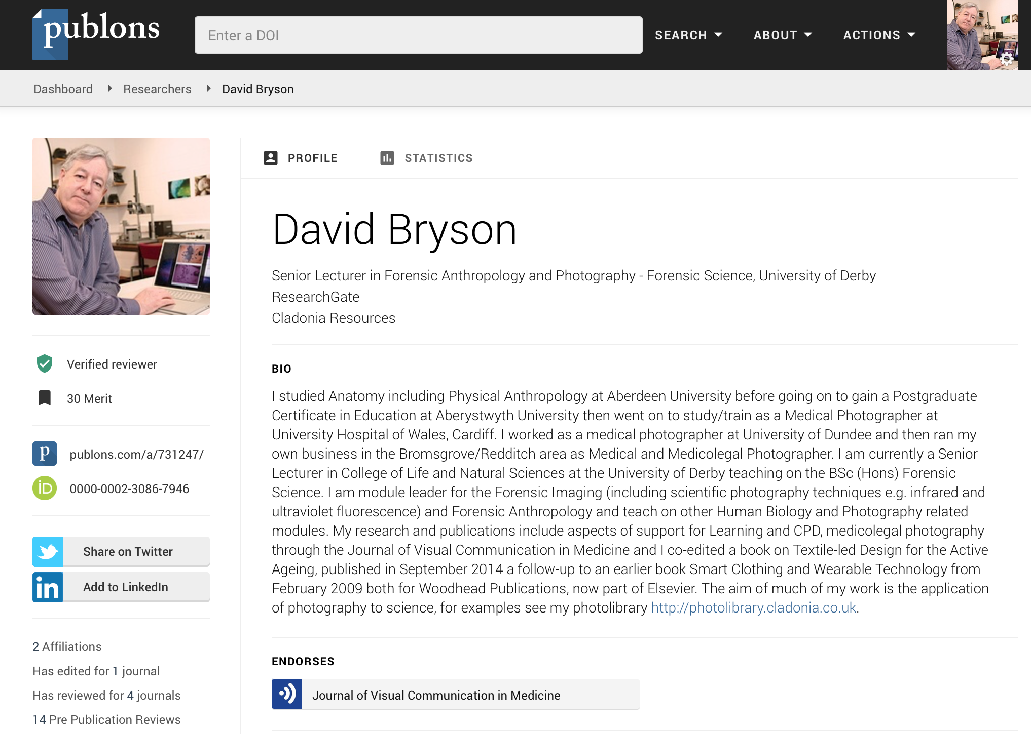

Figure Biographical aspect of publons peer review profile.

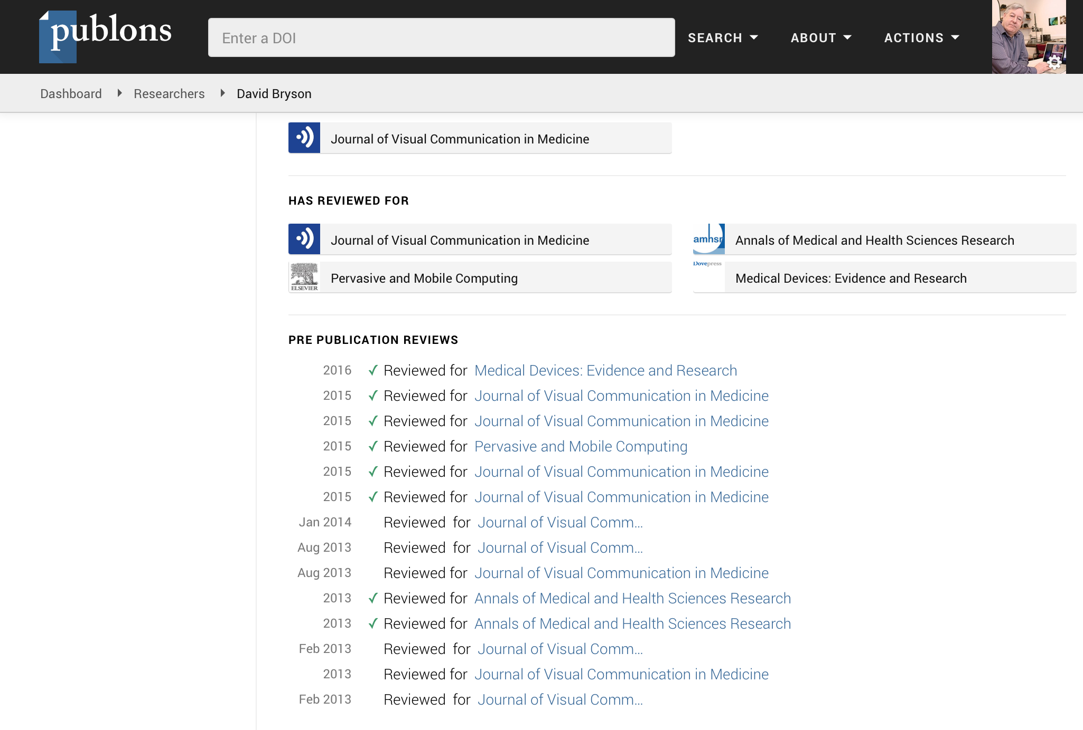

Figure Profile showing journals and pre publication reviews.

This kind of information could then be used as evidence of peer review as part of a CPD submission. If you have undertaken a peer review it is important to keep a copy of what you have written as that should be included in your CPD portfolio.

**Task 3 Record your peer reviews as part of your CPD**

If you have already undertaken a peer review add details of this to your CPD portfolio and take the time to sign on to Publons and create your own personal profile.

Using the journal

Reading the journal on you own is likely to be the commonest activity we all do when a new issue arrives through our letter box or pigeonhole. What we don’t often do is discuss the journal with colleagues in our department or other departments. The response to the last sentence should be “Well why not?”. Journal clubs where a group of individuals meet to discuss recent articles in the literature or discuss a defined subject have been around since the mid 19th century and are very much alive and thriving today. A journal club whether purely made up of medical illustrators or joining in with other healthcare professionals can be a valuable tool in developing and sharing good practice.

There are several papers that can help you develop a journal club for example “What makes evidence-based journal clubs succeed(1) and a brief guide produced by Health Information East London (2). There are also online journal clubs for example http://www.ctisus.com/learning/journalclub in a website dedicated to Computed Tomography Scanning (CT scanning). Information on how to set up an online journal club has been discussed by Chan et al in their ten step guide
(3).

**Task 4 Investigate journal clubs as a way of sharing good practice**

First, see if there is a journal club that’s already established in your hospital or University that you could join certainly larger hospitals are likely to have one or more journal clubs. Ask your library or information services for journal clubs as they often provide links to these and support for establishing clubs. If not think about setting up your own journal club whether online or over a cup of coffee as organising a club can become one of your regular professional activities, see Table 1.

References

1. Phillips RS, Glasziou P. What makes evidence-based journal clubs succeed? Evidence Based Medicine [Internet]. 2004 Mar 1;9(2):36–7. Available from: http://ebm.bmj.com/content/9/2/36.full

2. London HIE. Running a successful journal club. londonlinks.nhs.uk [Internet]. Available from: http://www.londonlinks.nhs.uk/groups/clinical-librarians-information-skills-trainers-group/clist/trainers-toolkit/Running%20a%20successful%20journal%20club.pdf

3. Chan TM, Thoma B, Radecki R, Topf J, Woo HH, Kao LS, et al. Ten Steps for Setting Up an Online Journal Club. Journal of Continuing Education in the Health Professions [Internet]. 2015 Jun 26;35(2):148–54. Available from: http://doi.wiley.com/10.1002/chp.21275