A C-Lean Framework for Deploying Circular Economy in Manufacturing SMEs

Simon Peter Nadeem*
Centre for Supply Chain Improvement,
The University of Derby, Kedleston Road, Derby, UK.
E-mail: S.Nadeem@derby.ac.uk

Jose Arturo Garza-Reyes
Centre for Supply Chain Improvement,
The University of Derby, Kedleston Road, Derby, UK.
and
Department of Management Studies
Graphic Era Deemed to be Univesity,
Dehradum, India

E-mail: J.Reyes@derby.ac.uk

Anthony I. Anosike
Centre for Supply Chain Improvement,
The University of Derby, Kedleston Road, Derby, UK.
E-mail: J.Reyes@derby.ac.uk

* Corresponding Author

A C-Lean Framework for Deploying Circular Economy in Manufacturing SMEs

Abstract

The adoption of Circular Economy (CE) is challenging, especially for manufacturing SMEs. Without SMEs, CE’s full spectrum cannot be realised, since they contribute to around 50% of the national GDP, globally. This research proposes a novel framework (C-Lean) to facilitate the implementation of CE in manufacturing SMEs by combining the principles of CE and Lean, as both foci on waste elimination and value creation/preservation. The framework utilises Lean tools/methods mingled with CE principles to achieve circularity, efficiency and effectiveness in manufacturing SMEs. The proposed framework was conceptually developed based on an extensive review of the existing scholarly literature and verified by a panel of field experts, through a Delphi study, from academia and industry. The model was further validated to assess its practical relevance through a case study approach in an SME manufacturing company. The results derived from the verification and validation of the proposed C-Lean framework suggest that CE can be effectively and efficiently adopted through its amalgamation with Lean. The C-Lean framework provides a systematic approach for manufacturing SMEs to simultaneously adopt CE and Lean practices in their existing operations. The proposed C-Lean framework can support and guide managers in the concurrent deployment of CE and Lean for their organisations to enhance both their operational and sustainability performance. This research provides a novel framework that converges CE and Lean as no such framework exists to date. C-Lean is attractive for manufacturing SMEs due to its dual nature of achieving operations excellence in a sustainable circular manner.

Keywords: Circular Economy, Lean, Operations Management, Manufacturing, Sustainability.

Introduction
Growing population and fast pace of production/consumption have caused the rapid depletion of natural resources (Lieder and Rashid, 2016, Garza-Reyes et al., 2019) and environmental damages (Cai and Choi, 2021; Lai et al., 2013). Webster (2015) argues that the current economic system is no more than a race for the remaining resources. To address this challenge, a relatively recent development is the notion of Circular Economy (CE) (Govindan and Hasanagic, 2018; Kirchherr et al., 2017). In the scholarly literature, the concept of CE has been mainly discussed with a major focus on policy development (Korhonen et al., 2018). However, scientific research on its implementation is at early stage and is limited (Millar et al., 2019, Kreye, M.E. 2023). Korhonen et al. (2018) suggest that “CE offers fruitful ideas, but that its implementation in practice remains an open question”. Several large organisations have joined hands to support the CE initiative, e.g. Apple, Dell, HP, H&M, IKEA, etc. However, the scope of what these and other companies have done remains unclear (Millar et al., 2019), as scholars do acknowledge that the transition to CE is easier said than done (Zhang et al., 2023).
According to a recently published Circularity Gap Report, a mere 7.2% of the world's economy operates within a circular framework (Circle Economy, 2023). This limited progress in the implementation of CE has been attributed to the lack of comprehensive business models (Bocken et al., 2017; Reike et al., 2018) and methodologies/frameworks (Sassanelli and Terzi, 2023) with practical steps to systematically assess the company’s activities (Hine et al., 2023) and guide them to effectively implement CE (Murray et al., 2017, Shaikh et al., 2022). In this line, scholars have acknowledged the limited academic research (Manninen et al., 2018; Merli et al., 2018; Lahane et al., 2023), which has led to the lack of business models (Abreu and Ceglia, 2018) and implementation methods/tools (Ghisellini et al., 2016; Pieroni et al., 2019; Zils, M., et al., 2023) as well as to the inability to adapt existing business operations to become circular (Urbinati et al., 2017). Scholarly literature lacks in CE design, production and use phases, thereby hindering the transition to CE (Johansen et al., 2022).
The objective of this study is therefore to address the existing void in academic research, by exploring the concept of CE and potential possibilities to streamline its implementation by developing methodologies and models to facilitate the transition to CE (Zils, M., et al., 2023; Atanasovska et al., 2022). In this context, the development of a comprehensive framework to guide users can lead to the effective adoption of CE (Sassanelli and Terzi, 2023) in the manufacturing sector, especially in SMEs, which often have limited resources (Oliveira et al., 2018), both human and financial (Ormazabal et al., 2018). However, it is noteworthy that SMEs account for 60-70% industrial population in Europe (Santolin et al., 2023), while in OECD countries SMEs provide 60-70% of jobs (OECD 2018). Therefore, the motivation to move towards the adoption of CE should include the consideration of currently existing successful approaches/concepts as that would facilitate SMEs to adopt CE implementation (Ghosh et al., 2023). For this purpose, this study explores the amalgamating of CE with an existing operations management concept that shares similar values in its essence but lacks the environmental orientation of CE.
Lean is a well-established operations management approach that has provided effective results to organisations in various industrial sectors (Azevedo et al., 2012). Recent research suggests that the Lean philosophy promotes eco-design practices right from the initial design stage, fostering better integration between environmental and economic performance (Paula e Silva et al., 2022), thus, enabling the advancement of circularity (Ciliberto et al., 2021). Lean shares the same core principle of waste reduction and value creation as CE. Lean’s focus on ‘waste elimination’ and ‘value creation’ (Jadhav et al., 2014) has similarities to the core emphasis of CE of disposing of products after the end of their life cycle. However, the Lean approach is not as holistic and lacks the closed-loop systems element, see Table 1, which is CE’s distinguishing feature/characteristic.

Table 1. Waste and Value - comparison between Lean and CE
 | Lean approach | CE approach
Waste | - Is an activity that does not add value for the customers (Campos and Vazquez-Brust, 2016)  - “anything other than the minimum amount of equipment, materials, parts, space and time which are absolutely essential to add value to the product” (Russell and Taylor III, 2011)  - Is inefficiency and is measured by KPIs (Sternberg et al., 2013) | - Waste = food (raw material) (Ellen MacArthur Foundation, 2015a; Webster, 2015)  - Is seen in 4 dimensions: wasted resources, wasted life cycles, wasted capability, and wasted embedded values (Lacy and Rutqvist, 2015).
Value | - Value is perceived from a customer’s perspective (Martínez León and Calvo-Amodio, 2017)  - Customer requirements (Hines et al., 2004) | - Reduce waste by recycling and sourcing from waste to prevent resources from exiting the economy (Buren et al., 2016)  - Has 4 dimensions: Cost reduction, revenue generation, resiliency, legitimacy and image (Park et al., 2010).

The implementation of Lean has been widely adopted by manufacturing companies (Seifullina et al., 2018), thus, its amalgamation with CE would result in achieving circularity, which otherwise might not become a point of attraction for manufacturing industries. Figure 1 portrays the interrelated nature of the core principles of both concepts, i.e. CE and Lean.

Circular Economy Principles |  | Lean Principles
- Preserve and enhance natural capital  - Optimise resource yields  - Foster systems effectiveness |  | - Identify value  - Map the value stream  - Create flow  - Establish pull  - Seek perfection
Figure 1. Interrelatedness of Circular Economy and Lean Principles

The interrelated nature of these principles can be observed by expanding the scope of Lean principles under the bigger perspective of systems thinking proposed by CE. Lean’s focus on process optimisation limits itself to a specific organisation and the product’s supply chains. However, under the CE’s perspective of systems effectiveness and thinking, the supply chain is expanded to a much bigger perspective, where value identification and the value stream are not limited to one life-cycle of the product or supply chain but continue to evolve.
CE’s focus on preserving and enhancing natural capital can be achieved by Lean’s principle of mapping the value stream to identify value in the resource and creating a flow that is within the closed loop as well as to seek perfection through continuous improvement. Similarly, resource yield optimisation can be achieved by establishing pull by producing only what is demanded, and again creating a closed-loop flow. Based on these similarities, this paper proposes a novel framework (C-Lean) that combines their principles to facilitate the implementation of CE in manufacturing SMEs. The paper offers a comprehensive perspective by making valuable contributions in both theory and practice. It combines two theoretical concepts and presents a practical roadmap for the industry to implement.
The rest of the paper is structured as follows, Section 2 presents the research methodology; Section 3 focuses on the conceptual development of C-Lean, whereas Section 4 presents its verification. Furthermore, Section 5 introduces the verified C-Lean framework while Section 6 presents its validation through a case study. Finally, Section 7 concludes with the theoretical and practical contributions as well as the limitations and future research directions derived from this research.

Research Methodology
The development of the proposed C-Lean framework was underpinned by the abduction research method as it bridges the gap between fundamental research and practical applications, encouraging exploration and leveraging opportunities in a fresh and inventive manner (Patokorpi and Ahvenainen, 2009). Overall, the research was conducted in three stages as illustrated in Figure 2, which represents the research methodology adopted under each stage.

Stage |  | Method/ Tools |  | Strategy/ Approach | Related section
1 – Conceptual Development of C-Lean framework |  | - Literature review |  | In-depth literature review and merging the two concepts of CE and Lean adopting abductive approach with a dominance of the deductive approach. | Section 3
 |  | - Authors' experience/ knowledge
2 – Verification of the C-Lean framework |  | - Delphi Study |  | Sampling Method: Purposive Sampling  Data collection method: Online Questionaire  Analysis type: Quantitative & Qualitative | Section 4
3 – Validation of C-Lean framework  (Case Study) |  | - Circularity Measurement Toolkit |  | Sampling Method: Volunteer Sampling (for case studies)  Data collection method: In-depth semi-structured interviews  Analysis type: Qualitative with some Quantitative aspects | Section 6
 |  | - Semi-structured in-depth interviews
 |  | - Gemba Walk
Figure 2. Research stages, methods and approaches adopted in this research

Stage 1 of the study first explores the literature to examine the relationship between Lean and CE. This served as a basis for the conceptual development of the C-Lean framework. The framework was developed based on an extensive literature review and the authors’ experience and knowledge as academics, researchers, industrialists and consultants (Garza-Reyes et al., 2016). Due to the length of this paper, the entire literature review is not included in this paper.

In Stage 2, as the conceptual framework is a novel development and given the lack of research in a given area, the Delphi method was deemed most appropriate for the verification of a conceptually developed framework (McMillan et al., 2016). Section 4 provided further justification for the utilisation of Delphi for this research. The Delphi study yielded valuable feedback and substantial improvements, ultimately leading to consensus among the participants. This consensus validated the conceptually developed framework, integrating Lean and CE into a cohesive approach. The intended purpose of this framework is to facilitate the successful implementation of CE within manufacturing small and medium-sized enterprises (SMEs).

In Stage 3, the verified framework was validated through the assessment of its practical capabilities and limitations. For validation, a case study approach was adopted, where a partial implementation of the verified framework was conducted in a manufacturing SME operating in Pakistan, see Section 6. Figure 2 provides an overview of the data collection and analysis approach followed during each of the research stages.

Conceptual Framework Development
The development of the conceptual framework consisted of two major steps, i.e. comprehension and conception, see Figure 3, also known as intelligence and conception (Moreira et al., 2015).

C O M P R E H E N S I O N
Figure 3. Steps for developing the C- Lean conceptual framework

At the comprehension step, a literature review was conducted to explore and adopt the most current and relevant theoretical knowledge (Chen and Lyu, 2009). It examined the characteristics and principles of both CE and Lean, their theoretical development, interrelated nature, and synergetic characteristics. The literature review was combined with the authors’ experience and knowledge in managing business operations, which honed the conception of the proposed framework.
The proposed framework merged CE and Lean principles, combining their characteristics and tools, to propose a holistic approach to deal with the present-day challenges of resource scarcity and environmental damage. The framework was developed using a phase-by-phase approach adapted from Cherrafi et al. (2017) and Garza-Reyes et al. (2015, 2016). It consisted of 6 phases, see Figure 4, which were subdivided into 14 steps/activities. The phase-by-phase approach identified and segmented key activities necessary to reach the aim/objectives of the framework. At each phase, its completion/output became an input for the next phase. The phases were adapted from the DMAIC problem-solving methodology. However, there are fundamental differences in their core purpose. DMAIC’s focus is on problem-solving (Garza-Reyes et al., 2014) while the proposed C- Lean framework was focused on facilitating the adoption of CE in existing manufacturing operations. Thus, the system does not necessarily need to have a problem per se, although that could be one source of motivation to apply the proposed C- Lean framework.

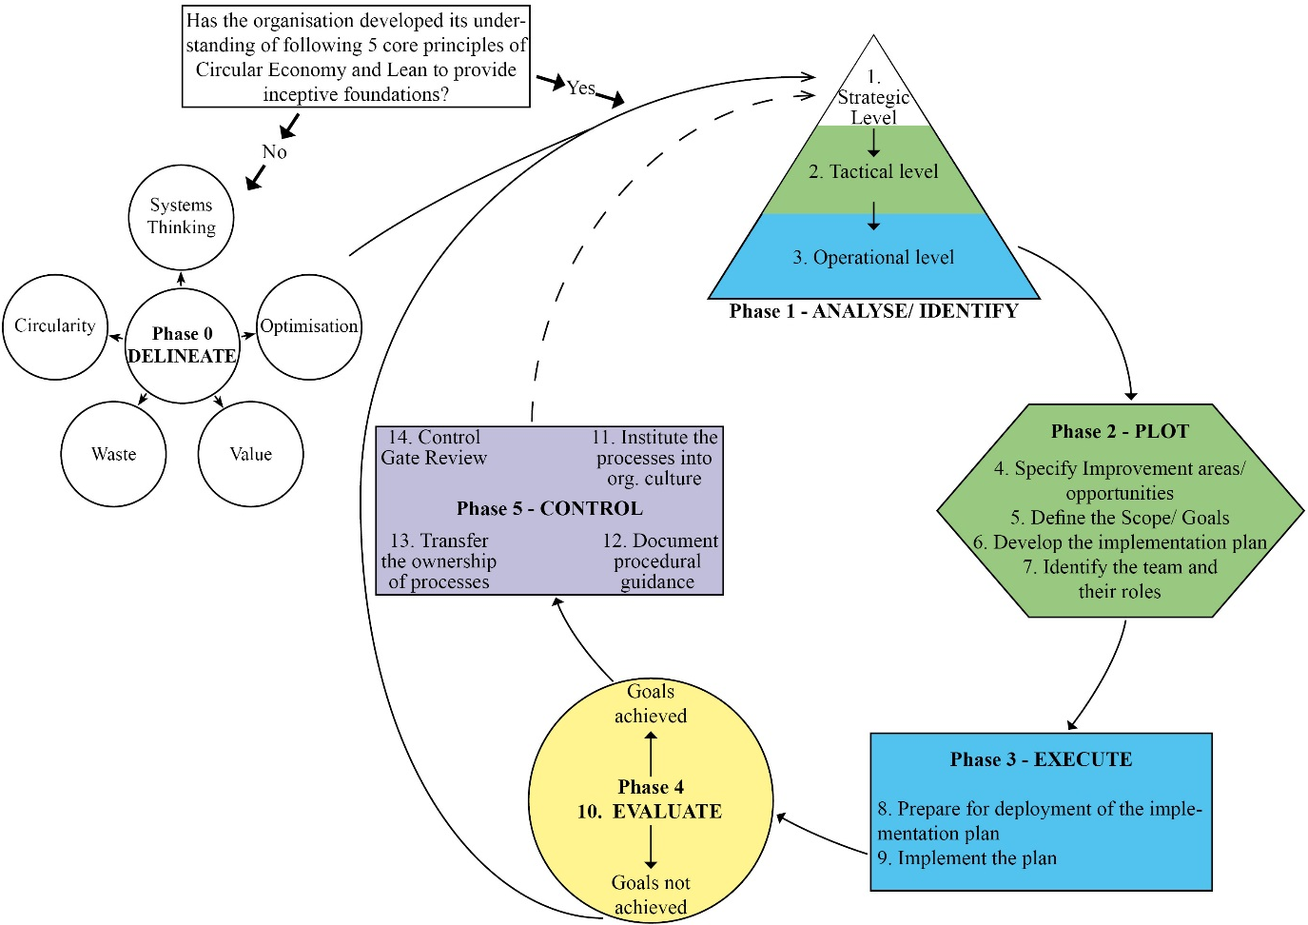
Figure 4. C- Lean conceptual framework

C-Lean Conceptual Framework Verification – Delphi Method
Once the conceptual framework was developed, the next stage consisted of its verification (see Figure 2). Under the Delphi method experts are asked to express their opinion, criticism, and suggestions (Reguant-Álvarez and Torrado-Fonseca, 2016; AlMalki, H.A. and Durugbo, C.M. 2022) to improve a novel development to be of sound theoretical and practical relevance. Since the practical utilisation of Delphi differs in terms of the number of reiterations, criteria for the experts' selection, size, the makeup of the expert panel, and evaluation methods (MacCarthy and Atthirawong, 2003), it is essential to define the criteria for consensus, stopping and dropping out, and selection of experts.

Definition of consensus, stopping and dropping-out criteria for this study
For the verification of the C-Lean conceptual framework through the Delphi method, 80% of participants' agreement was considered as a consensus and stopping point. Consequently, if disagreement on a specific element continued after two re-iterations, then that element was dropped out.
For qualitative analysis, where a respondent chose the option of ‘Can’t Answer’ or ‘Unable to say’ and ‘Undecided’, such responses were not considered in the accumulation of results. A respondent could provide a different opinion than the given options by choosing ‘Other’. These suggestions, comments and recommendations were analysed with NVivo software through Emergent Thematic Coding (Castleberry and Nolen, 2018). To systematically analyse the data, the five-step process proposed by Castleberry and Nolen (2018) was followed, namely: (1) Compiling, (2) Disassembling, (3) Reassembling, (4) Interpreting, (5) Concluding, see Figure 5.

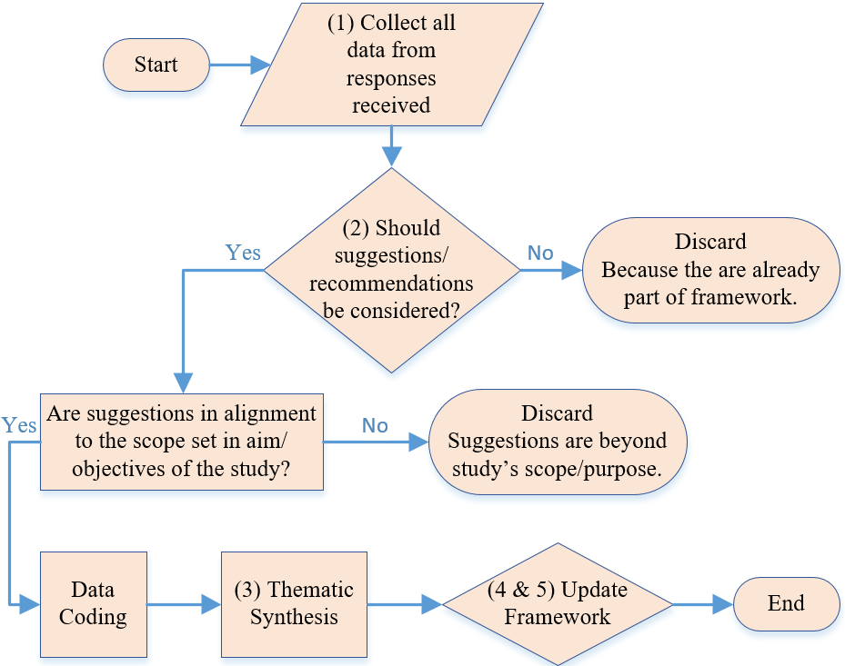
Figure 5. Qualitative data analysis process

Selection of Delphi-study participants
Purposive sampling was used to select the experts as per the criteria defined in Table 2. A total of 64 experts were invited to participate, from which 19 responded in the first and 16 in the second rounds. The number of participants was considered acceptable for a Delphi study (Landeta, 1999). Table 3 presents the profile of the participants while Figure 6 illustrates the process followed to conduct the Delphi study.

Table 2. Criteria for sample selection
Study sample | A minimum of 15 but ideally 20 participating respondents
Sampling method | Purposive Sampling
Covering selection | Experts in the era of Operations Management with knowledge/experience in sustainability; from both the academic and practitioners’ sides.
Sample profile and inclusion/ exclusion criteria | The participant must have at least 3 years of working or teaching experience in managing sustainability in operations management. Candidates not meeting the above criterion will only be accepted with the following exceptions:  - If the participant is one of the founding/pioneering members of the initiatives of Circular Economy implementation,  - If the participant has an active engagement and has gained considerable repute in the field of Circular Economy.  Candidates not meeting the above criteria will be excluded.
Recruitment | The sample will be recruited through a formal invitation via email.

Table 3. Participants’ profile

 | Position | Affiliation | Academic/ Practitioner | Country
1 | Sustainability expert, IT Specialist - Supply Chain | Beverage Company | P | Mexico
2 | Strategy Director, Principal Teaching Fellow | University | A | UK
3 | Supplier Development Engineer | Manufacturer | P | UK
4 | Research Associate | University | A | UK
5 | Business Engagement Manager | University | P | UK
6 | Researcher | University | A | Morocco
7 | Director, Global Logistics Education | Foundation | Both | Germany
8 | Head | NGO | P | UK
9 | Sustainable Development Educator | University | P | Netherlands
10 | Professor | University | A | Mexico
11 | Director, Industrial Engineering department | University | A | Costa Rica
12 | Education Management Specialist | University/ NGO | Both | Kyrgyzstan
13 | Professor | University | A | UK
14 | Founder | NGO | P | UK
15 | Professor/ President | University/ NGO | Both | USA
16 | Academic Director in Engineering Management | University | A | Mexico
17 | Coordinator | University | A | Mexico
18 | Senior Management Staff | NGO | P | U. K.
19 | Sustainable Supply Chain and Operations Manager | Production Company | P | Kyrgyzstan

Figure 6. Delphi study process

Delphi study results
The Delphi study consisted of 2 rounds of iterations.
First-round
The first Questionnaire consisted of 10 sections. The responses led to 23 key recommendations/suggestions, which were then coded, see Figure 7, as per each section of the framework, using NVivo software.

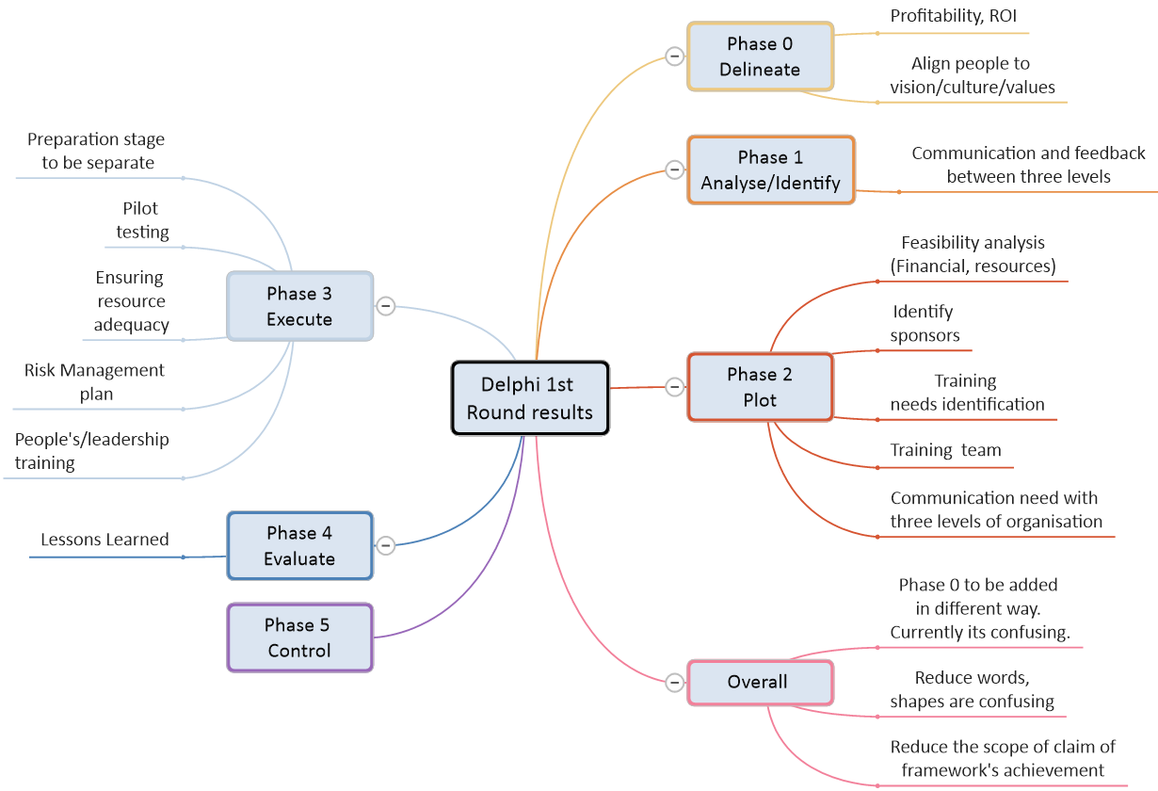
Figure 7. Coding of recommendations/suggestions in Delphi Round 1

The coded data were then reassembled in context with each other (Castleberry and Nolen, 2018) to create themes, see Figure 8, which were interpreted and included in the framework. Based on this, changes related to the overall structure, sequencing and adding/re-locating some of the phases/steps. One of the major changes was to bring out earlier phase 0 of the conceptual framework, as the surrounding principles of the C-Lean framework. This provided a more comprehensive understanding as the C-Lean’s application must be carried out within the parameters of the five surrounding principles (see Section 5.1). These changes resulted in an improved version of the C-Lean framework. Since consensus was not reached through the first iteration, a second iteration was conducted.

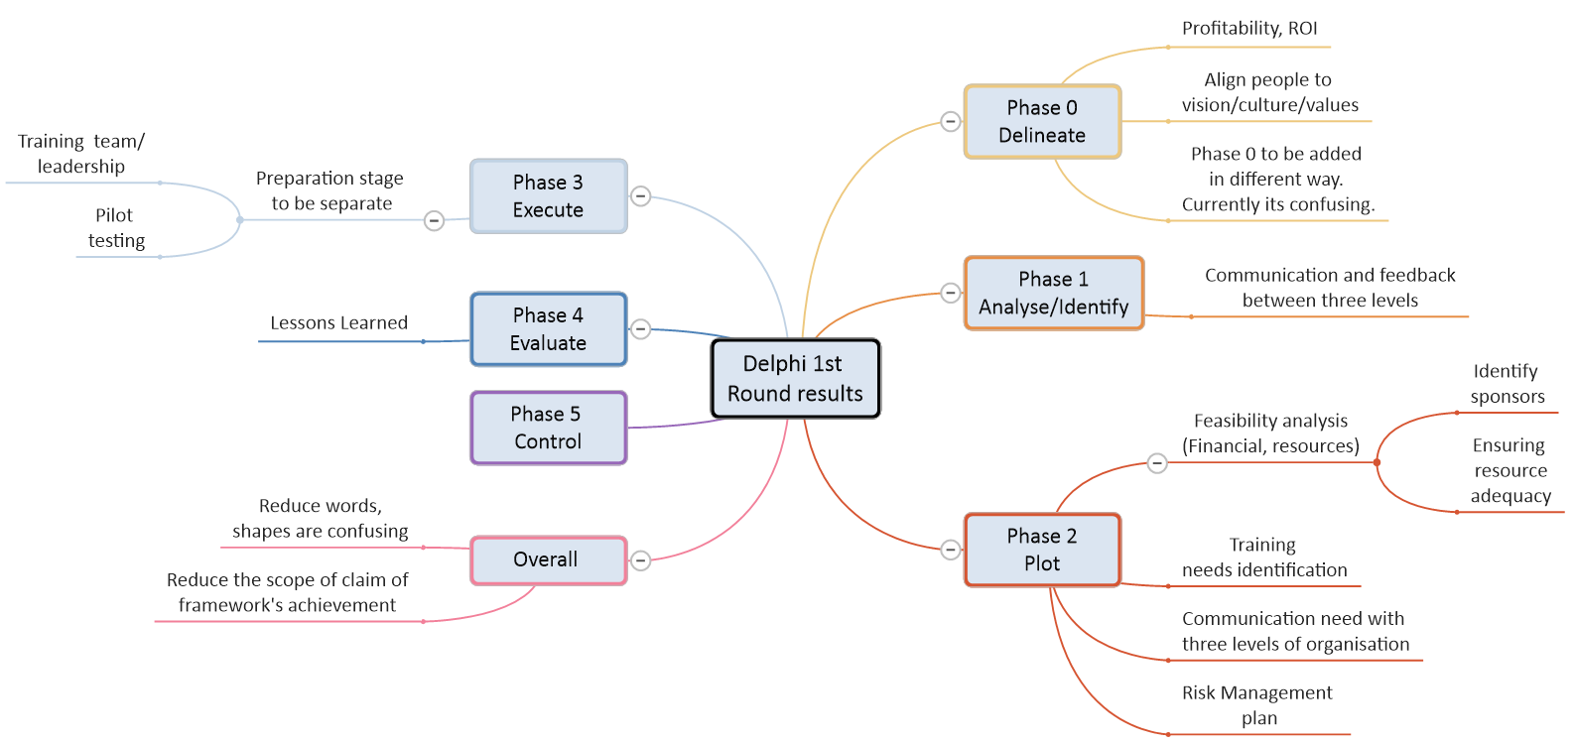
Figure 8. Thematic synthesis of Delphi study's 1st round results

Second-round
In the second iteration of the Delphi study, participants were provided with the results of the first round along with an updated framework. The questionnaire used in the second iteration consisted of 4 sections with 10 questions. Consensus was achieved in this iteration, thus no further iterations of the Delphi were required. The final verified C-Lean framework is presented in Figure 9.

C-Lean - Verified Framework
The verified C-Lean framework consists of five surrounding principles and six phases that comprise 18 steps, see Figure 9.
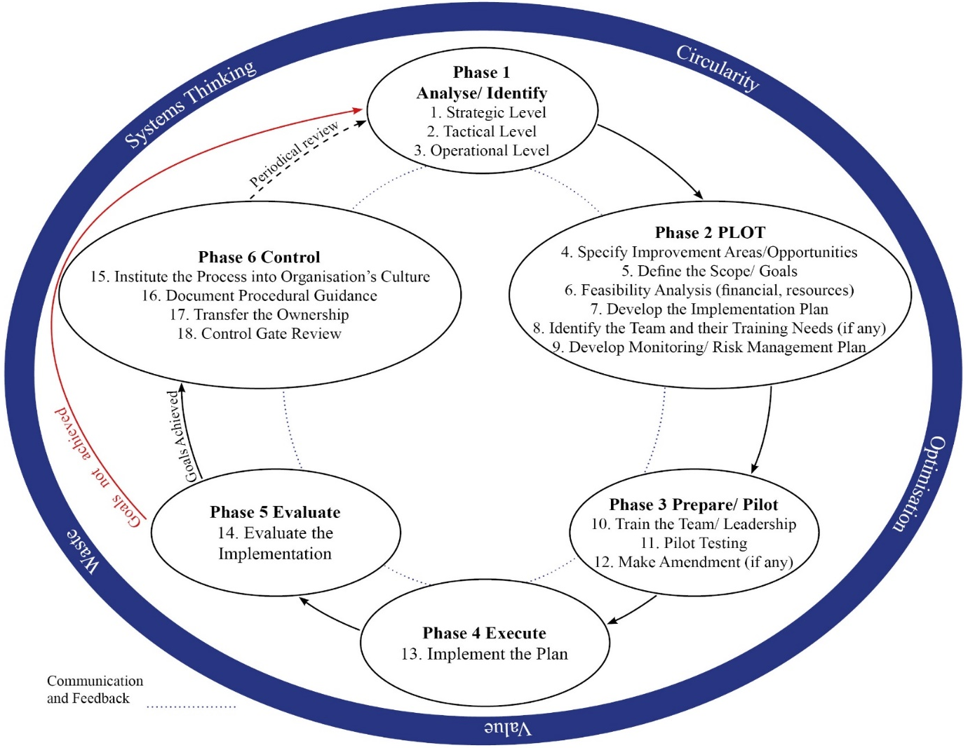
Figure 9. Verified C- Lean framework

Surrounding principles
The C-Lean framework merges the five core principles of CE and Lean, i.e. Systems Thinking, Optimisation, Value, Waste, and Circularity. These principles define the boundaries and the ground rules for the implementation of the C-Lean framework. As this research merges these principles, a hybrid version of definitions for these was developed, which further contributes to the existing Circular Economy and Lean theories. In the C-Lean framework, these principles bear equal importance, hence no sequential order is defined in the framework itself, see Figure 9.

Systems thinking
In the purview of systems thinking, the identification of stakeholders is necessary (Soma and Vatn, 2014). In the broad spectrum of C-Lean, stakeholders' selection criteria are suggested to be within the bounds of who is and/or can be affected/impacted and/or might be interested in the activities of the business (Colvin et al., 2016). In this context, the following stakeholders are identified in their broader spectrum.

- People – Stakeholders would commonly refer to people who are directly (e.g. customers, suppliers) or indirectly (e.g. community around) impacted and/or interested in a business and its activities. C-Lean further expands these boundaries to people who are not born yet, i.e. future generations. Businesses today are impacting future generations by either adding value and/or increasing depletion/scarcity of resources.

- Planet – Identifying planet Earth and its environment as a stakeholder is necessary as all resources are extracted from it, so in that sense, Earth is the supplier and any development in business activity and its outputs directly affect it in the short/long run.

Optimisation
The concepts of CE and Lean have common elements of optimisation. CE aims to optimise resources and products' life-cycle (Jabbour et al., 2019). Lean, on the other hand, focuses on process optimisation (Hu et al., 2015) by minimising variation in processes (Tokola et al., 2017) and creating flow (Mehrsai et al., 2014). The contrasting difference is Lean’s focus on the immediate usage of resources within a specific process, whereas CE takes a holistic approach focusing on optimising resources' utility, even after one life-cycle of the product. Thus, optimisation is redefined as “Making every effort to maximise the output/utility of a given resource (material, time, energy, and creativity) at all different stages of the life-cycle in a closed-loop system, while eliminating/minimising any non-value-adding impacts, throughout the life-cycle of any resource.”

Value
Lean’s definition of value is subjective, as it highly denotes owners’/customers’ needs and willingness/desire to acquire a product or material (Lucato et al., 2014). On the other hand, CE defines value as the highest utility of the resource at all times (Ellen MacArthur Foundation, 2015b), by caring for, contributing to, and expanding the natural system (Greyson, 2015). Mostly, the value of a product is only assumed from the perspective of one life-cycle with no regard to the residual value in the resources utilised in that product. Therefore, Value is re-define as“Any activity/output that utilises its required resources in a manner that maximises its utility at all stages of its life-cycle, including the afterlife, as well as to ensure the longevity of its life-cycle while satisfying the needs/demands of the stakeholders (People [present and future] and Planet) while making economic benefit for all.”

Waste
Waste as per Lean is anything that does not add value (Banawi and Bilec, 2014). On the other hand, CE defines waste as food where waste from one product becomes food (e.g. raw material) for others (Webster, 2015). Considering these two broad spectrums, waste can be re-defined as“Any activity that leads to harmful outputs for the stakeholders (People [present and future] and Planet) and does not incorporate the sustainability of the two in the long-term, is a wasteful activity.”

Circularity
CE endeavours to develop a closed-loop system, where resources are used but not used up (Webster, 2015). For this purpose, businesses need to understand and revisit the concept of the Product Life Cycle (PLC). Traditionally, at the end of the PLC, products are doomed to be disposed of. C- Lean proposes a new approach (see Figure 10) to be utilised at the design stage of products. This approach makes the following additions/modifications to the existing two stages of the PLC model.
- At the ‘introduction’ stage of the product, sourcing is redefined.
  - Material for production is sourced from the re-utilisation of recovered products/materials.
  - Degraded material from another industry that still meets or exceeds the quality standards required for the product under consideration is re-purposed/re-utilised.
  - When and only if earlier two sources are not possible to be utilised virgin raw material is to be extracted.
- The ‘Decline’ stage is renamed as‘Extended Maturity/Decline’ stage. At this stage, the product has three possibilities, i.e.
  - Extending the life-cycle of the product/material through innovative approaches.
  - Degradation of resources/materials used in a product to be re-utilised as raw material for the same or other types of products.
  - The materials/products that can not be re-utilised and are considered as having no value must be disposed of carefully while differentiating technical and biological waste, and that is also to be specified and thought of at the design stage.

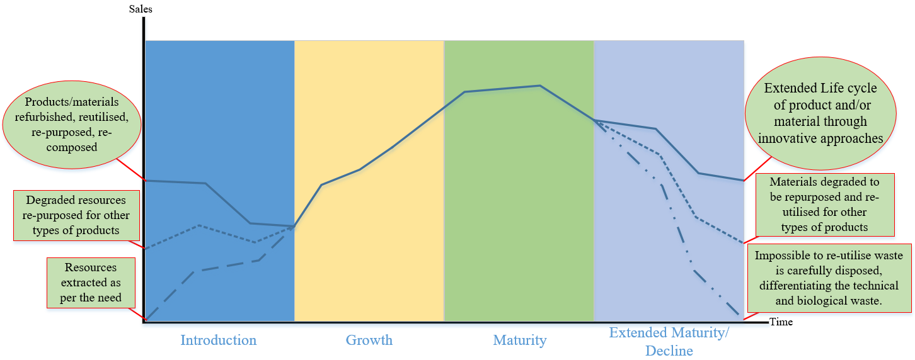
Figure 10. Re-defined Product Life Cycle according to the C- Lean framework

Once the adopting company has developed a sound understanding of these C-Lean five principles, it can then move on to Phase-1 of the framework, see Figure 9.

Table 4 provides an overview of each phase of C-Lean, alongside the different Lean and other tools/methods and techniques that are suggested to be employed in every phase. The deployment of C-Lean should not, however, be restricted to these tools only but its systematic approach needs to be adopted under the mindset of continuous improvement/utility.

Table 4. C-Lean Framework's phases
Phase | Steps | Description | Suggested tools
Phase 1 – Analyse/identify | Step 1 – Analysis/ identification at the strategic level | For this purpose, the company’s vision and mission statement, as well as the strategic plan, needs to be analysed. Besides, the interviews with CEO/board member/other top-level management can be conducted to get an in-depth view of its strategic level. | - Balance Scorecard  - Strategy Map  - PEST Analysis  - CMT
 | Step 2 – Analysis/ identification at the tactical level | The tactical level of an organisation serves as a bridge between the strategic and operational levels. Here the organisation’s strategy and goals are analysed | - Force Field Analysis  - Strategic Planning Gap  - SWOT Analysis
 | Step 3 – Analysis/ identification at the operational level | The operational level serves as the hands and feet of the organisation, as it brings the vision/mission from virtual to physical existence. At this step organisation’s operational activities are analysed | - Value Stream Mapping  - Causes and Effects Relationship  - Root Cause Analysis
Phase 2 – PLOT | Step 4 – Specify improvement areas/ opportunities | The documented list of areas requiring improvements needs to be reviewed by the coordinator and the team. They then need to prioritise the identified areas/aspects requiring changes/modifications/improvements. | - Pareto Analysis  - Action Priority Matrix  - Project Selection Matrix  - Eisenhower's Urgent/ Important Principle
 | Step 5 – Define the scope/goals | Having a clear idea of which areas of the organisation to improve, the team needs to define the scope of improvements by defining what changes, modifications and interventions to work on and specifying goals for their achievement. | - SMART
 | Step 6 – Feasibility analysis | A feasibility analysis will help determine if the required resources are available or can be made available for the set goals. This analysis would greatly help to identify sponsors (if needed). | - TELOS  - Mullin’s Seven Domains
 | Step 7 – Develop the implementation plan | This step aims to develop the implementation plan (process map) along with the clearly defined Lean (including any extension e.g. Lean Six Sigma) and CE tools/techniques for intervention. | project management tools such as Gantt chart, resource planning etc. are highly recommended
 | Step 8 – Identify the team and their training needs (if any) | At this step when the process map has been developed an important bit is to identify the right person who will take the lead on the implementation. Some important features to consider while choosing the team are  - Availability of the person(s)  - Skills of the personnel and their ability to take responsibilities  - Knowledge of the relevant functions and the organisation  - Ability to be a team player and share knowledge with others  - Willingness/motivation for CE  - Ideally, the experience of participation in change management projects
 | Step 9 – Develop a monitoring/risk management plan | At this step when the implementation plan is in place and the team is recruited, the coordinator along with the team needs to develop a monitoring and risk management plan. | - FMEA
Phase 3 – Prepare/pilot | Step 10 – Train the team/leadership | Based on an assessment of the need for training, the coordinator/manager needs to decide on the following  - Ensure the availability of place, materials, and other needed resources  - Decide the content of training, schedule and mode of delivery  - Preparing for delivering or recruiting the personnel to deliver the training  - Ensure that the training objectives have been met
 | Step 11 – Pilot testing | It is always best to conduct pilot testing to ensure practical rollout. For this purpose, small-scale pilot testing needs to be done and evaluated. Any discrepancies/weaknesses to be documented and improvements to be made through amendments.
 | Step 12 – Make amendments (if any) | All necessary amendments are to be made to address any discrepancies identified. Once the amendments are made, the coordinator can decide whether to re-do the pilot testing or move ahead with the full-scale implementation.
Phase 4 – Execute | Step 13 – Implement the plan | With all the resources in place and preparation, the implementation step must begin. The coordinator must oversee all the processes and provide full support and guidance to the implementation team. S/he must also ensure to record the progress regularly. | - 5S  - Kaizen  - KPIs to monitor  - Poka Yoke
Phase 5 -  Evaluate | Step 14 – Evaluate the implementation | For evaluation, it is highly recommended to deploy Circularity Measurement Toolkit (CMT) (Garza-Reyes et al., 2019) along with the benchmarking against the earlier set goals.
Phase 6 – Control | Step 15 – Institute the processes into organisational culture | Since the CE’s actual potential cannot be fully realised without systems thinking, therefore it is important to begin within the company first by embedding and replicating the CE’s adaptation throughout the organisation.
 | Step 16 – Document procedural guidance | Documenting the procedural guidance in contextualised form would greatly benefit the future utilisation of the C-Lean framework within the organisation. It will also serve as evidence of success achieved, and lessons learned and would be a great point of reference to build on for future improvements and adaptation.
 | Step 17 – Transfer the ownership of processes | All the documented details and procedural guidance are to be handed over to the right personnel for the continuity of its implementation at the organisational level. All three levels (Strategic, Tactical and Operational) of the organisation are to be involved on an as-needed basis and the process of transferring the ownership of the processes is to be documented for future reference.
 | Step 18 – Control gate review | The DMAIC process of control gate review will highly benefit to ensure the sustainability of the framework and its outputs. The coordinator needs to ensure that  - Reports of before and after scenarios are documented and made available to the right personnel  - Process maps, control plans and procedural guidance are documented and in place  - Process owners as well as the management have taken over the process and are committed to its implementation  - A summary of lessons learned is developed  - Any issues/opportunities for future implementation are documented  A celebration to encourage the team and report the success is done.

6. C-Lean Framework Validation – A Case Study Approach
A case study approach is commonly utilised to validate a framework’s reliability (Burns, 2000) and affirm its suitability, competence and limitations. The validation phase aimed at assessing the practical capabilities and limitations of the C-Lean framework by implementing it. For this, a case study approach in a manufacturing company operating in Pakistan was conducted (Yin, 2014). Table 5 presents the tools utilised to collect data from the organisations and their relevance to each of the three levels of the company.

Table 5. Case study tools used to collect data
Input Level  Tool | Strategic | Tactical | Operational
Semi-structured interviews | X | X | X
Circularity Measurement Toolkit | X | X | X
Gemba Walk |  |  | X

Sargent (2013) suggests that achieving full validity is often too costly and time-consuming. In the case of this research, as the full-scale implementation of C- Lean would require time, changes in the existing procedures, and capital investments, a partial implementation of its first 2 phases was carried out. The remaining four phases were validated in the form of projected scenarios.

6.1 The Case Company
Established in the 1950s, the case company is a family-owned private limited company, specialising in a very niche market of Electrical Engineering, producing transmission and distribution products (e.g. CT [current transformers], PT [potential transformers], control panels, short circuit security). The company employs 66 people and supplies its products to the national power authority of Pakistan (WAPDA) and other international companies such as Siemens and Schneider Electric. Besides national certifications, the company has also obtained ISO9001-2008, 14001, and 18001 certifications. The company maintains a professional work environment and claims the following as its core values: ‘Work Ethic, Safety, Quality, People, Environmentally Conscious, Integrity, Innovation, Excellence, Teamwork, and Customer Focus’. The following subsections demonstrate the application, i.e. validation, of the proposed C-Lean framework.

6.1.1 Phase 1 – Analyse/ identify

Step 1 - Strategic level analysis
The company’s MD (Managing Director) was interviewed utilising a semi-structured questionnaire. In terms of the company’s strategic goals for the next 3-5 years, the company aspired to expand internationally, especially in the Middle East and Asia, add another technical product (i.e. switchgear, transformer), buy insulator of the capacity of 11kva and update testing facility to the capacity of 95kva.
When asked about the company’s strategic goals regarding Circular/Environmental initiatives, the company only strived to comply with the requirements to maintain ISO certification and did not know CE. The MD showed a keen interest in exploring Lean due to the potential efficiency that he anticipated from its implementation. Table 6 summarises the response regarding priorities while doing strategic/operational planning.

Table 6. Company A’s priorities while defining the strategic direction
 | N/A | Never | Rarely | Sometimes | Often | Almost always
Reduce Carbon Emission | X
Reduce negative environmental damage |  |  |  |  |  | X
Longevity of product |  |  |  |  |  | X
Longevity of Resources | X
Re-utilise resources | X
Financial Growth/ Stability |  |  |  |  |  | X
CSR activities |  |  |  |  |  | X

Further analysis through a Circularity measurement toolkit (CMT) (Garza-Reyes et al., 2019) was conducted. Table 7 presents an overview of the CMT assessment.

Table 7. Summary of CMT results for Company A
Rating \ Factors | A | B | D | E | F | G | H | I | Result | RANGE  Min Max
1. Circular developer | 1 | 0 | 0 | 0 | 0 | 0.5 | 0 | 0 | 1.50 | 6.5 | 8
2. Circular Promoter | 1 | 0 | 0 | 0 | 0 | 0.5 |  |  | 1.50 | 5.5 | 6
3. Circular | 1 | 0 | 0 | 0 | 0 |  |  |  | 1.00 | 3.5 | 5
4. Waved | 1 | 0 | 0 |  |  |  |  |  | 1.00 | 2.5 | 3
5. Curved  (where A = 1 and B = 1) | 1 | 0 |  |  |  |  |  |  | 0.00 | 2 | 2
6. Saw tooth  (where A = 0.5 to 1 and B = 0.5 to 1) | 1 | 0 |  |  |  |  |  |  | 0.00 | 1 | 1.5
7. V-shape up  (where A=0 and B = 0.5 to 1) | 1 | 0 |  |  |  |  |  |  | 0.00 | 0.5 | 1
8. ˄-shape down  (where A - 0.5 to 1 and B = 0) | 1 | 0 |  |  |  |  |  |  | 1.00 | 0.5 | 1
9. Linear | 1 | 0 | 0 | 0 | 0 | 0.5 | 0 | 0 | 1.50 | 0 | 0

Company A’s rating is ‘˄-shape down’, (see Table 7). This rating is defined as, “Organisations that without noticing, are already applying some internal CE practices generally related to the resource consumption, utilisation and efficiency. They are not aware of CE, however, they realised that economic benefits can be obtained with the adoption of certain practices.” (Garza-Reyes et al., 2019). A further analysis was conducted at the tactical level to gain a deeper insight.

Step 2 - Tactical level analysis
The company’s Production Manager (PM) was interviewed in this step. The tactical level was aware of Sustainable and Environment-friendly initiatives, mainly due to the compliance requirements to maintain ISO certification. However, it was completely unaware of CE.
All the major raw material was imported either directly and/or through a third-party supplier. PM identified ‘electrical silicon steel’ as a resource that could become scarce in the coming decades. However, the only way to re-utilise it from their products was by downgrading it to be used in other products (e.g. fans, water pump motors). To be environment-friendly, the company ensured that the fumes from the chemical mixing unit and fine dust from the grinding of resin were detained through a specially designed exhaust system where the outflow was not disposed of in the air but secured to be disposed of responsibly.
The average product life-cycle for its product was 12-15 years. The company did not offer any buy-back or take-back options nor did it provide any responsible disposal services at the end of the product life-cycle. Likewise, there was no system to monitor the resource life cycle.
When shared about CE and asked about potential barriers/challenges to the implementation of CE initiatives, the following points surfaced:

- The company’s major product was CT/PT, which was all covered in epoxy resin. Therefore, to extract materials, the Epoxy resin was to be removed.
- This resin was hardened to the level that it could not be broken without specialised equipment.
- Epoxy can be burnt to extract the inside materials (e.g. copper, steel) but burning epoxy can release highly hazardous emissions.

Step 3 - Operational level analysis
The production manager and shop floor staff were interviewed in this step. The current annual company’s output was 14,000 units, of which around 10–15% were faulty products. Each electricity transformer was sold for approximately £36,000 (GBP) and contained 3 units of CT/PT. Each of the three units contains the following materials: Copper = 2.5 – 13kg, Brass = quantity was very little, and Steel = 7 – 8 kg. This composition did not include the outer body of an electricity transformer. Given the above calculation, each ready transformer on average contained 22kg of steel and 30kg of copper, which went into waste after the average product life-cycle of 12 years.
The company followed a strict maintenance schedule, twice a week, to ensure that all equipment was calibrated as per industry standards. In the past 2 years, the company had innovated two of its major processes by introducing a mixing plant for epoxy resin and an authentic CT/PT testing unit. There was no specific operations management strategy (e.g. Lean, Six Sigma), however, the company did utilise some aspects of such concepts. For instance, reducing inventory, continuous improvement, and maintenance schedules.
The organisation utilised 3D drawing technology to minimise the wastage of raw materials. However, it had direct and indirect waste. Direct wastage of copper ranged between 250-300 kg/year. This waste was sold to scrap dealers. Indirect wastage came from multiple factors, e.g. no refurbishment of facilities due to faulty products and/or returned items from customers, and no end-of-life-cycle management results in loss of residual value of resources that could either be reutilised/downgraded in other products. The annual waste was estimated to be 140,000kg for copper and 112,000kg for steel. Gemba walks allowed to obtain further insights into the company’s production process and environmental practices.

Figure 11 summarises the results obtained from phase 1 through a thematic analysis.

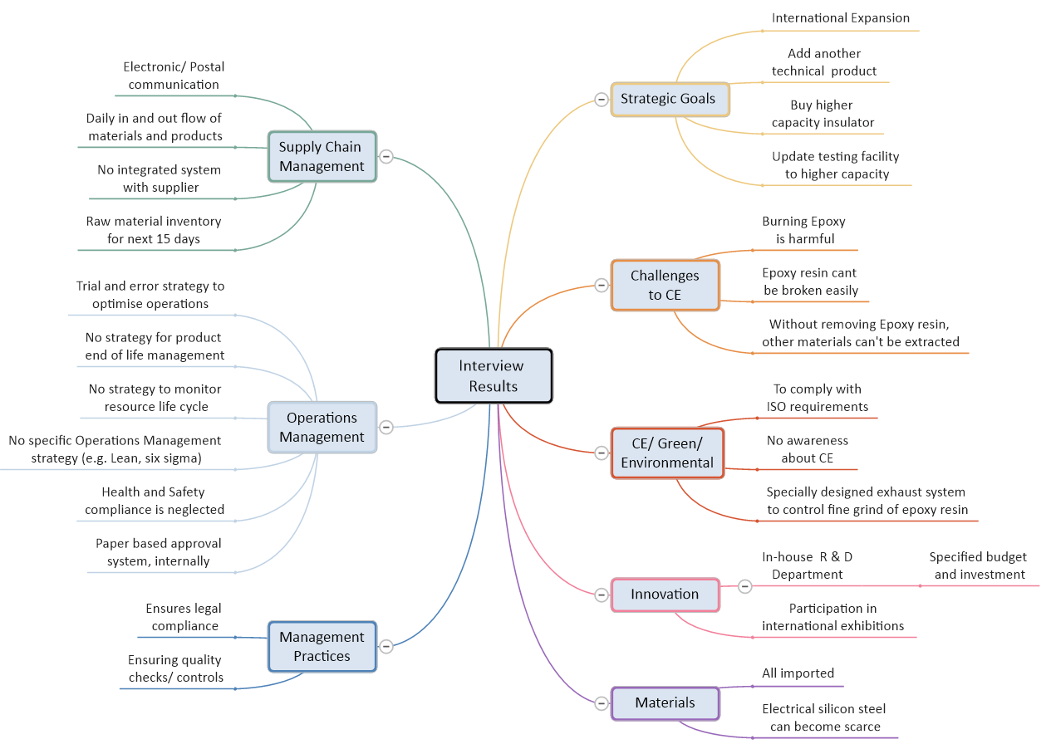
Figure 11. Summary of interview results (phase 1) for the case company

With the inputs from Phase 1, the next phase of the framework, PLOT, led to the selection of areas for improvement.

6.1.2 Phase 2 – Plot
To systematically identify improvement areas and plan them, the steps provided in Phase 2 were followed, see Figure 9.

Step 4 - Specify improvement areas/opportunities
Table 8 presents the improvement areas/opportunities identified for the case company.

Table 8. Improvement areas/opportunities for the company
Improvement  Areas | Improvement Opportunities
Strategic | - To include environment and resource preservation/enhancement into the overall mission and vision of the company
Tactical | - Deploy Lean as an operations management strategy  - Develop an integrated Supply Chain System and require SC members to engage in CE adoption
Operational | - Change the layout of the floor  - Train current staff for CE and Green initiatives  - Introduce new machinery/ procedures for CE initiatives

While all the above-mentioned improvement areas/opportunities were worthwhile pursuing, not all of these were possible to be addressed at the same time due to factors such as cost, ease, time requirement, etc. To prioritise these, the prioritisation matrix/approach developed by the Lean Methods Group (2018) was employed, see Table 9.

Table 9. Prioritisation matrix
 |  | Ease of Implementation | Circular Economy Initiative |  | Green/ Environment friendliness | Cost-Effective | Resource Availability | Cultural Acceptance
 |  |  |  |  |  |  |  |  | Attribute Criteria Weight | Per cent of Total Criteria
Ease of Implementation |  |  | 10.0 |  | 5.0 | 5.0 | 1.0 | 1.0 | 22.00 | 38.4%
Circular Economy Initiative |  | 0.1 |  |  | 1.0 | 5.0 | 1.0 | 5.0 | 12.10 | 21.1%
Green/Environment friendliness |  | 0.2 | 1.0 |  |  | 0.2 | 1.0 | 5.0 | 7.40 | 12.9%
Cost Effective |  | 0.2 | 0.2 |  | 5.0 |  | 1.0 | 1.0 | 7.40 | 12.9%
Resource Availability |  | 1.0 | 1.0 |  | 1.0 | 1.0 |  | 1.0 | 5.00 | 8.7%
Cultural Acceptance |  | 1.0 | 0.2 |  | 0.2 | 1.0 | 1.0 |  | 3.40 | 5.9%
 |  |  |  |  |  |  |  |  |  | 100.0%
10 | Attribute in the white column is extremely more important than the attribute in green column
5 | Attribute in the white column is slightly more important than the attribute in green column
1 | Attributes are equal in importance
0.2 | Attribute in the white column is slightly less important than the attribute in green column
0.1 | Attribute in the white column is extremely less important than the attribute in green column

As a result of the priority matrix, the top four interventions were selected to be deployed. These four interventions referred to (1) including environment and resource preservation/ enhancement into the overall mission and vision of the company, (2) training staff for CE and Green Initiatives, (3) introducing new machinery/procedure for CE initiative, and (4) change the layout of the floor. With these initiatives, the scope and goals were defined.

Step 5 - Define the scope/goals
From the earlier-mentioned interventions, the following SMART goals were formulated:

Goal 1: Modify the vision and mission statement and quality policy to include environment and resource preservation as the company’s strategic elements.
Goal 2: Develop a plan for the organisation-wide training to increase awareness and knowledge about CE and the environmental aspect of business and their implications for the company operations.
Goal 3: To innovate in the current operations by introducing new equipment and procedures to integrate CE principles.
Goal 4: Redesign the layout of the shop floor to develop flow and avoid unnecessary movement of people, parts and/or semi-finished products between or within the processes, a waste identified by Lean.

Step 6 - Feasibility analysis (financial, resources)
The two factors of cost-effectiveness and resource availability were included as the selection criteria in the prioritisation matrix, see Table 9. Moreover, the company was recommended to revisit the goals to make any changes, should they find that financial and/or resource feasibility was not in favour.

Step 7 - Develop the implementation plan
To achieve each of the four goals defined earlier, the following action plan was defined.

Implementation plan for Goal 1:
Step 1 – Develop a draft proposal to incorporate CE and Environmental initiatives into the company’s corporate strategy and circulate it to the company board of directors.
Step 2 – Based on the feedback from the board members, a summary of feedback is to be shared with all board members along with a call for a meeting.
Step 3 – A board meeting to further discuss and officially incorporate CE and Environmental initiatives in the company’s corporate strategy.

Implementation plan for Goal 2:
Step 1 – Sort the list of potential training providers (e.g. university, consulting firm).
Step 2 – Choose the training provider and develop a plan to run an organisation-wide training at different intervals.
Step 3 – Arrange 3-4 full-day training seminars over the weekends to create general awareness about the issues.
Step 4 – Conduct workshops to share ideas of CE integration in production operations and seek employees' feedback.
Step 5 - Periodical refresher training days to be organised regularly.

Implementation plan for Goal 3:
Step 1 – Request call for quotations from the suppliers of equipment needed to break/melt the epoxy resin.
Step 2 – Select suppliers that provide good quality equipment that matches the requirement criteria.
Step 3 – Purchase equipment to allow for the extraction of reusable raw material at the end of the product life-cycle.
Step 4 – For future production, upgrade to the utilisation of epoxy resin that can be deformed into jelly form through the application of heat and allow for the extraction of metals inside.
Step 6 – Create awareness among customers and offer the take-back option to existing and future customers for responsible disposal/repurposing of the resources at the end of the product’s life.

Implementation plan for Goal 4:
To identify the flow of products and people, a Spaghetti Flow Diagram was utilised and a restructure of the facilities’ layout was proposed to enable a smoother flow of operations that would result in less movement to achieve time and cost savings.
Appendix 1 presents the current shop floor layout and the product flow in the case company while Appendix 2 illustrates the proposed layout. Given the fact that most of the space was an open area, it would only take a few days and a small capital investment to re-configure the layout. The current structure and product flow on the second floor was appropriate in its current form, therefore, no changes were proposed for it.

Step 1 – Make plans with a construction company and the staff of Company A
Step 2 – Develop a contingency plan for the worst-case scenario
Step 3 – Plan for the change implementation schedule and prepare by having enough ready products in storage to meet the demand while the production is stopped.
Step 4 – Initiate the change and closely monitor the timely completion
Step 5 – Upon completion, ensure that all staff are aware of the new structure and that everything is marked (e.g. tools, section) for easy and smooth resuming of production operations.

As a result of this restructuring, an estimated product travel time, collectively between different processes would be reduced by 90% also providing better utilisation of the workforce.

Step 8 - Identify the team and their training needs (if any)
For each goal, the personnel that was involved and their training needs are specified below.

Goal 1: Top Management and managerial level staff
Training needs – none, except for awareness
Goal 2: External organisation and company staff
Training needs – Good coordination and planning for training
Goal 3: The production manager needed to identify 3-5 shop floor staff who could be trained to operate the machinery that can be used to break the resin and/or to melt it. Moreover, the adoption of utilising resin that could be melted in the jelly form required training for employees engaged in that functional division as well as the operations manual made available for reference purposes.
Goal 4: Construction company personnel, production manager, MD, and supervisors of functional divisions
Training needs – Good coordination and planning

Step 9 - Develop a monitoring/ risk management plan
The company’s production manager along with Technical Director should monitor the responsible staff and have a twice-per-week report on the progress during implementation. Thereafter, monitoring is recommended to be bi-weekly to ensure that the implemented changes and their compliance are progressing well with sound outcomes.
No plan is completely free of risk, therefore, it is best to identify potential risks and have a plan to manage them to avoid any delays and problems. For risk management, the FMEA (Failure Modes and Effect Analysis) approach is suggested to be utilised. For the case company, an FMEA analysis was conducted, see Appendix 3.

6.1.3 Phase 3 Prepare/Pilot
The company’s Technical Director and Production Manager took the leading role as change coordinators, to closely monitor this phase.

Step 10 - Train the team/leadership
The chosen team should be trained for the training needs identified in Step 8 of Phase 2. The core purpose of the training is to ensure that everyone involved is aware of the expected outcome.

Step 11 - Pilot testing
Pilot testing’s purpose is to detect any pitfalls/errors at an early stage and take corrective actions. However, given the interventions recommended for the company, not all interventions could be pilot tested. Therefore, a forecasted scenario analysis (sort of simulation) with key shop floor staff would supplement pilot testing.

Step 12 - Make amendments (if any)
At this stage, the change coordinators need to make a final check and make amendments for any errors/pitfalls identified during the process of training and forecasted scenario analysis.

6.1.4 Phase 4 Execute, Phase 5 Evaluate and Phase 6 Control
The change coordinator, team and leadership of the company are advised to follow the steps and guidance provided in the description of the framework, see Table 4. Once all has been completed successfully, a celebration of success is important to mark the achievement as well as to acknowledge the team effort and encourage the staff.

6.1.5 Expected Outcomes for the case company
Given the successful implementation of the four improvements discussed earlier, the case company can cherish being a pioneer in adopting CE and can inspire others within its supply chain to replicate such initiatives. To understand the impact of these improvements, the major outcomes are presented in the form of ‘before’ and ‘after’ scenarios in Table 10 below.

Table 10. ‘Before’ and ‘After’ scenario of Company A
Before | After
Company A’s leadership and staff were not aware of CE and its implications for their operations | Company A’s staff and leadership are well aware of CE and have taken necessary actions to become key players in making CE a reality and have become responsible global citizens by caring for resources and the environment.
Company A had no CE practice | Company A has adopted CE in its corporate strategy and taken serious initiatives to integrate CE into its operations
The equipment/practices did not exist to responsibly manage the product at the end of its life-cycle | Company A is offering the take-back option for the end of life-cycle/faulty/damaged products and is extracting metal materials to be re-used in the different forms of production (downgrading).
Product flow was not established well and lots of unnecessary movement existed, resulting in a lack of efficiency. | Company A has restructured its shop floor and now has a remarkable production flow layout which makes the operations smooth and efficient.

7. Conclusions, limitations and future research directions
CE is at its developing stage and has attracted considerable attention from both academics and practitioners. As a result, much research on the concept of CE has been conducted over the last decade. Many large firms, e.g. Dell, Apple and P&G, have adopted CE. However, the results are yet to be seen from this adoption. There is limited research regarding practical implementation strategies and tools for CE, especially among manufacturing SMEs.
This paper proposes a novel framework, C-Lean, by merging CE and Lean as both concepts focus on waste elimination and value creation. The framework provides a mechanism to systematically adopt CE principles in manufacturing operations. The framework and its criteria are non-prescriptive. The criteria heavily focus on continuous development and heading towards the future in a proactive manner rather than reactive. The goal is for organisations to embrace circularity in their manufacturing practices, throughout their operations while achieving economic, social and environmental growth.
With the utilisation of the C-Lean framework, manufacturing SMEs can become the best-in-class practice and role model of CE practices leading to economic growth mingled with the holistic sustainable approach. This will lead to an increase in market share and productivity as well as allow us to be ready to become part of the supply chains of larger firms whose core values include environmental and CE principles.

Theoretical contributions of this research
In terms of theoretical contribution, the research has expanded the knowledge base by coalescing the concepts of CE and the well-established existing concept of Lean. An in-depth review has led to the identification of their common aims of eliminating waste and creating value. Both concepts have a different approach to their common aims and thus the need for their amalgamation arose, under which the proposed framework, C-Lean, has been developed.
In essence, this research has the following major theoretical contributions. Firstly the alignment of the two concepts of CE and Lean through an in-depth analysis of the literature. CE focuses on creating a circular loop where no resources go to waste. On the other hand, the Lean approach is purely from the economic and operational point of view, where optimisation is achieved linearly to satisfy the value desired by the customer. Lean’s approach to value creation and waste elimination does not incorporate issues such as resource depletion and environmental degradation. CE does address these issues, nevertheless, its adoption in the manufacturing sector requires the development of a solid pathway that would be both practical and attractive for the manufacturing sector.
With this, the second major theoretical contribution of this research is the development and proposal of the C-Lean framework. In the purview of the proposed framework, 5 principles (Systems thinking, Circularity, Optimisation, Value, and Waste) are defined by combining the core principles of both concepts of CE and Lean. The framework defines the pathway that a company can utilise to achieve circularity in its existing operations while benefitting from Lean tools.
Another novelty of this research framework is that a company/organisation does not necessarily have to have a problem deploying the C-Lean framework. It might be that a company’s operations are running effectively and do not necessarily have any operational issues. However, C-Lean can be adapted to move towards circularity, which perhaps was not part of the company’s priorities due to a lack of awareness, skills, etc.

Managerial contributions of this research
In terms of the practical contribution, this research provides a roadmap for the manufacturing sector, but especially SMEs, to achieve circularity in their operations. The manufacturing sector is more open to Lean since it closely resembles its core aims of efficiency and effectiveness while achieving economic growth. Therefore, an integrated approach in the proposed framework, C-Lean, makes it attractive for companies to adopt.
Another major managerial contribution of this paper and its proposed framework C-Lean is that it provides a comprehensive method that is easy to understand, and utilise, at the same time does not necessarily require radical changes to existing operations. SMEs that usually are constrained on resources, can benefit by adopting C-Lean in their operations to achieve circularity. This will also benefit SMEs to become supply chain members for larger firms that are more conscious of CE practices and require their suppliers to comply with its principles. Furthermore, it is noteworthy that SMEs benefit from the qualitative approach proposed under the C-Lean Framework as it presents greater epistemological and methodological diversity (Hlady‐rispal and Jouison‐laffitte, 2014).

Limitations and future research directions
Like any other research, this research is no exception to limitations. A major limitation in this research is the lack of a quantitative approach since the research is primarily qualitative with few basic quantitative elements. The utilisation of increased quantitative methods such as developing performance metrics and measures specifically relating to the industry, conducting controlled experiments to analyse the impact that C-Lean can make, and likewise financial analysis would further strengthen and validate the reliability of the proposed C-Lean framework.
Another limitation of this research is that the proposed C-Lean framework has been validated only through a single case study in one country. This limits the exploration of other potential challenges that could occur in the implementation of the framework, which can point to the requirement of potential additions for further flexibility and enrichment of the framework to make it more practical for users.
Furthermore, the validation of the developed C-Lean framework was done employing part of the framework (only the first two phases) with the remaining phases presented as a projected scenario for the case company. A full-scale implementation could help expose areas requiring improvements/modifications in the construction of the framework from a practical point of view. It also would lead to further identification of its limitations.

References
Abreu, M.C.S. de and Ceglia, D. (2018), “On the implementation of a circular economy: the role of institutional capacity-building through industrial symbiosis”, Resource Conservation and Recycling, Vol. 138, pp. 99–109.
AlMalki, H.A. and Durugbo, C.M. (2023), "Institutionalising Industry 4.0: a Delphi study of institutional change readiness for the fourth industrial revolution in an emerging economy", Production Planning and Control, In Press
Atanasovska, I., Choudhary, S., Koh, L., Ketikidis, P.H., Solomon, A. (2022), "Research gaps and future directions on social value stemming from circular economy practices in agri-food industrial parks: Insights from a systematic literature review" Journal of Cleaner Production, Vol. 354, 131753
Azevedo, S.G., Carvalho, H., Duarte, S. and Cruz-Machado, V. (2012), “Influence of green and lean upstream supply chain management practices on business sustainability”, IEEE Transactions on Engineering Management, Vol. 59 No. 4, pp. 753–765.
Banawi, A. and Bilec, M.M. (2014), “A framework to improve construction processes: Integrating lean, green and six sigma”, International Journal of Construction Management, Taylor & Francis, Vol. 14 No. 1, pp. 45–55.
Bocken, N.M.P., Olivetti, E.A., Cullen, J.M., Potting, J. and Lifset, R. (2017), “Taking the Circularity to the Next Level: A Special Issue on the Circular Economy”, Journal of Industrial Ecology, Vol. 21 No. 3, pp. 476–482.
Buren, N. Van, Demmers, M., Heijden, R. Van Der and Witlox, F. (2016), “Towards a Circular Economy: The Role of Dutch Logistics Industries and Governments”, Sustainability, Vol. 8 No. 647, pp. 1–17.
Burns, R.B. (2000), Introduction to Research Methods, 4th ed., Sage Publications Ltd., London.
Cai, Y.J. and Choi, T.M. (2021), “Extended Producer Responsibility: A Systematic Review and Innovative Proposals for Improving Sustainability”, IEEE Transactions on Engineering Management, Vol. 68 No. 1, pp. 272–288.
Campos, L.M.S. and Vazquez-Brust, D.A. (2016), “Lean and green synergies in supply chain management”, Supply Chain Management: An International Journal, Vol. 21 No. 5, pp. 627–641.
Garza-Reyes, J.A., Al-Balushi, M., Antony, J., Kumar, V. (2016), “A Lean Six Sigma framework for the reduction of ship loading commercial time in the Iron Ore Pelletising industry”, Production Planning and Control: The Management of Operations, Vol. 27, No. 13, pp. 1092-1111.
Castleberry, A. and Nolen, A. (2018), “Thematic analysis of qualitative research data: Is it as easy as it sounds?”, Currents in Pharmacy Teaching and Learning, Elsevier, No. xxxx, available at:https://doi.org/10.1016/j.cptl.2018.03.019.
Chen, M. and Lyu, J. (2009), “A Lean Six-Sigma approach to touch panel quality improvement”, Production Planning and Control, Vol. 20 No. 5, pp. 445–454.
Cherrafi, A., Elfezazi, S., Govindan, K., Garza-Reyes, J.A., Benhida, K. and Mokhlis, A. (2017), “A framework for the integration of Green and Lean Six Sigma for superior sustainability performance”, International Journal of Production Research, Taylor & Francis, Vol. 55 No. 15, pp. 4481–4515.
Ciliberto, C., Szopik-Depczyńska, K., Tarczyńska-Łuniewska, M., Ruggieri, A., Ioppolo, G. (2021), "Enabling the Circular Economy transition: a sustainable lean manufacturing recipe for Industry 4.0", Business Strategy and the Environment, Vol. 30 No. 7, pp 3255-3272
Circle Economy (2023), "The Circularity Gap Report 2023", accessed on 20th May 2023, available on https://www.circularity-gap.world/2023
Colvin, R.M., Witt, G.B. and Lacey, J. (2016), “Approaches to identifying stakeholders in environmental management: Insights from practitioners to go beyond the ‘usual suspects’”, Land Use Policy, Elsevier Ltd, Vol. 52, pp. 266–276.
Ellen MacArthur Foundation. (2015a), Towards the Circular Economy: Economic and Business Rationale for an Accelerated Transition, Isle of Wight, available at:https://doi.org/10.1162/108819806775545321.
Ellen MacArthur Foundation. (2015b), Delivering the Circular Economy - A Toolkit for Policymakers, Ellen MacArthur Foundation, Isle of Wight.
Garza-Reyes, J.A., Al-Balushi, M., Antony, J. and Kumar, V. (2016), “A Lean Six Sigma framework for the reduction of ship loading commercial time in the iron ore pelletising industry”, Production Planning and Control, Taylor & Francis, Vol. 27 No. 13, pp. 1092–1111.
Garza-Reyes, J.A., Flint, A., Kumar, V., Antony, J. and Soriano-Meier, H. (2014), “A DMAIRC approach to lead time reduction in an aerospace engine assembly process”, Journal of Manufacturing Technology Management, Vol. 25 No. 1, pp. 27–48.
Garza-Reyes, J.A., Rocha-Lona, L. and Kumar, V. (2015), “A conceptual framework for the implementation of quality management systems”, Total Quality Management & Business Excellence, Taylor & Francis, Vol. 26 No. 11–12, pp. 1298–1310.
Garza-Reyes, J.A., Salomé Valls, A., Nadeem, S.P., Anosike, A. and Kumar, V. (2019), “A circularity measurement toolkit for manufacturing SMEs”, International Journal of Production Research, Vol. 57 No. 23, pp. 7319–7343.
Ghisellini, P., Cialani, C. and Ulgiati, S. (2016), “A review on circular economy: The expected transition to a balanced interplay of environmental and economic systems”, Journal of Cleaner Production, Vol. 114, pp. 11–32.
Ghosh, S., Raut, R.D., Mandal, M.C., Ray, A. (2023), "Are the Small- and Medium-Sized Enterprises in Developing Countries Ready to Implement Circular Economy Practices? An Empirical Quest for Key Readiness Factors", IEEE Transactions on Engineering Management, In Press
Gordon, T.J. (1994), The Delphi Method, Futures Research Methodology, available at: http://www.gerenciamento.ufba.br/downloads/delphi_method.pdf.
Govindan, K. and Hasanagic, M. (2018), “A systematic review on drivers, barriers, and practices towards circular economy: a supply chain perspective”, International Journal of Production Research, Taylor & Francis, Vol. 7543, pp. 1–34.
Gregson, N., Crang, M., Fuller, S., Holmes, H., Gregson, N., Crang, M., Fuller, S., et al. (2015), “Interrogating the circular economy: the moral economy of resource recovery in the EU”, Economy and Society, Vol. 44 No. 2, pp. 218–243.
Greyson, J. (2015), “A Glance at Waste-Free Economy”, available at: http://www.ecomena.org/tag/linear-economy/ (accessed 8 May 2016).
Hina, M., Chauhan, C., Sharma, R., Dhir, A. (2023) "Circular economy business models as pillars of sustainability: Where are we now, and where are we heading?", Business Strategy and the Environment, In Press.
Hines, P., Holweg, M. and Rich, N. (2004), “Learning to Evolve”, International Journal of Operations & Production Management, Vol. 24 No. 10, pp. 994–1011.
Hu, Q., Mason, R., Williams, S.J. and Found, P. (2015), “Lean implementation within SMEs: a literature review”, Journal of Manufacturing Technology Management, Vol. 26 No. 7, pp. 980–1012.
Jabbour, C.J.C., Jabbour, A.B.L. de S., Sarkis, J. and Filho, M.G. (2019), “Unlocking the circular economy through new business models based on large-scale data: An integrative framework and research agenda”, Technological Forecasting & Social Change, Elsevier, Vol. 144, pp. 546–552.
Jadhav, J.R., Mantha, S.S. and Rane, S.B. (2014), “Exploring barriers in lean implementation”, International Journal of Lean Six Sigma, Vol. 5 No. 2, pp. 122–148.
Johansen, M.R., Christensen, T.B., Ramos, T.M., Syberg, K. (2022), "A review of the plastic value chain from a circular economy perspective", Journal of Environmental Management, Vol. 302 Part A, 113975
Kirchherr, J., Reike, D. and Hekkert, M. (2017), “Conceptualizing the circular economy: An analysis of 114 definitions”, Resources, Conservation and Recycling, Vol. 127 No. September, pp. 221–232.
Korhonen, J., Honkasalo, A. and Seppälä, J. (2018), “Circular Economy: The Concept and its Limitations”, Ecological Economics, Elsevier B.V., Vol. 143, pp. 37–46.
Kreye, M. E. (2023), "Manufacturer’s service relationships as a gateway to circular supply chains: merging insights from two literature fields", Production Planning and Control, In Press
Lacy, P. and Rutqvist, J. (2015), Waste to Wealth, Palgrave Macmillan, Basingstoke, U.K.
Lahane, S., Kant, R., Shankar, R., and Patil, S. K. (2023) "Circular supply chain implementation performance measurement framework: a comparative case analysis", Production Planning and Control, In press
Lai, K.H., Wu, S.J. and Wong, C.W.Y. (2013), “Did reverse logistics practices hit the triple bottom line of Chinese manufacturers?”, International Journal of Production Economics, Elsevier, Vol. 146 No. 1, pp. 106–117.
Landeta, R.J. (1999), El Método Delphi. Una Técnica de Previsión Para La Incertidumbre, Ariel, Barcelona.
Lean Methods Group. (2018), “Prioritization Matrix”, available at: https://www.leanmethods.com/resources/tools-templates/prioritization-matrix/ (accessed 8 December 2018).
Lieder, M. and Rashid, A. (2016), “Towards circular economy implementation: A comprehensive review in context of manufacturing industry”, Journal of Cleaner Production, Vol. 115, pp. 36–51.
Linstone, H.A. and Turoff, M. (Eds.). (1975), The Delphi Method: Techniques and Applications, Addison-Wesley Educational Publishers Inc, MA.
Lucato, W.C., Calarge, F.A., Junior, M.L. and Calado, R.D. (2014), “Performance evaluation of lean manufacturing implementation in Brazil”, International Journal of Productivity and Performance Management, Vol. 63 No. 5, pp. 529–549.
MacCarthy, B.L. and Atthirawong, W. (2003), “Factors affecting location decisions in international operations – a Delphi study”, International Journal of Operations & Production Management, Vol. 23 No. 7, pp. 794–818.
Manninen, K., Koskela, S., Antikainen, R., Bocken, N., Dahlbo, H. and Aminoff, A. (2018), “Do circular economy business models capture intended environmental value propositions?”, Journal of Cleaner Production, Elsevier Ltd, Vol. 171, pp. 413–422.
Martine Hlady‐rispal & Estèle Jouison‐laffitte (2014), Qualitative Research Methods and Epistemological Frameworks: A Review of Publication Trends in Entrepreneurship, Journal of Small Business Management, 52:4, 594-614, DOI: 10.1111/jsbm.12123
Martínez León, H.C. and Calvo-Amodio, J. (2017), “Towards lean for sustainability: Understanding the interrelationships between lean and sustainability from a systems thinking perspective”, Journal of Cleaner Production.
Mehrsai, A., Thoben, K.-D. and Scholz-Reiter, B. (2014), “Bridging lean to agile production logistics using autonomous carriers in pull flow”, International Journal of Production Research, Taylor & Francis, Vol. 52 No. 16, pp. 4711–4730.
Merli, R., Preziosi, M. and Acampora, A. (2018), “How do scholars approach the circular economy? A systematic literature review”, Journal of Cleaner Production, Elsevier Ltd, Vol. 178, pp. 703–722.
Millar, N., Mclaughlin, E. and Börger, T. (2019), “The Circular Economy: Swings and Roundabouts?”, Ecological Economics, Vol. 158, pp. 11–19.
Moreira, N., De Santa-Eulalia, L.A., Aït-Kadi, D., Wood-Harper, T. and Wang, Y. (2015), “A conceptual framework to develop green textiles in the aeronautic completion industry: A case study in a large manufacturing company”, Journal of Cleaner Production, Elsevier Ltd, Vol. 105, pp. 371–388.
Mostafa, S., Dumrak, J. and Soltan, H. (2013), “A framework for lean manufacturing implementation”, Production and Manufacturing Research, Taylor & Francis, Vol. 1 No. 1, pp. 44–64.
Murray, A., Skene, K., Haynes, K., Murray, A., Skene, K. and Haynes, K. (2017), “The Circular Economy : An Interdisciplinary Exploration of the Concept and Application in a Global Context”, Journal of Business Ethics, Springer Netherlands, Vol. 140, pp. 369–380.
OECD (2018), Environmental Policy Toolkit for SME Greening in EU Eastern Partnership Countries, OECD Green Growth Studies, OECD Publishing, Paris
Oliveira, G.A., Tan, K.H. and Guedes, B.T. (2018), “Lean and green approach: An evaluation tool for new product development focused on small and medium enterprises”, International Journal of Production Economics, Vol. 205, pp. 62–73.
Ormazabal, M., Prieto-Sandoval, V., Puga-Leal, R., Jaca, C. (2018), "Circular Economy in Spanish SMEs: Challenges and opportunities", Journal of Cleaner Production, Vol. 185, 1, pp 157-167
Park, J., Sarkis, J. and Wu, Z. (2010), “Creating integrated business and environmental value within the context of China ’ s circular economy and ecological modernization”, Journal of Cleaner Production, Elsevier Ltd, Vol. 18 No. 15, pp. 1494–1501.
Patokorpi, E., Ahvenainen, M. (2009), "Developing an abduction-based method for futures research", Futures, Vol. 41 No. 3, pp 126-139

Paula e Silva, M.H., Barretti, J.W., Mergulhão, R.C., Silva D.A.L. (2022), "Integration of the concepts of lean manufacturing and circular economy: systematic literature review", Latin American Journal of Management for Sustainable Development, Vol. 5 No. 3, pp 222-241
Pieroni, M.P.P., McAloone, T.C. and Pigosso, D.C.A. (2019), “Business model innovation for circular economy and sustainability: A review of approaches”, Journal of Cleaner Production, Vol. 215, pp. 198–216.
Reguant-Álvarez, M. and Torrado-Fonseca, M. (2016), “El método Delphi”, Revista d’ Innovació i Recerca Em Educació, Vol. 9 No. 1, pp. 87–102.
Reike, D., Vermeulen, W.J.V. and Witjes, S. (2018), “The circular economy: New or Refurbished as CE 3.0? — Exploring Controversies in the Conceptualization of the Circular Economy through a Focus on History and Resource Value Retention Options”, Resources, Conservation and Recycling, Elsevier, Vol. 135, pp. 246–264.
Russell, R.S. and Taylor III, B.W. (2011), Operations Management, 7th ed., John Wiley & Sons, Inc., New Jersey, USA.
Santolin, R.B., Hameed H.B., Urbinati, A., Lazzarotti, V. (2023), Exploiting circular economy enablers for SMEs to advance towards a more sustainable development: An empirical study in the post COVID-19 era", Resources, Conservation & Recycling Advances, Vol. 19, 200164
Sargent, R.G. (2013), “Verification and validation of simulation models”, Journal of Simulation, Vol. 7 No. 1, pp. 12–24.
Sassanelli, C. and Terzi, S. (2023), “Circular Economy and Sustainable Business Performance Management”, Sustainability, MDPI AG, Vol. 15 No. 11, p. 8619.
Seifullina, A., Er, A., Nadeem, S.P., Garza-Reyes, J.A. and Kumar, V. (2018), “A Lean Implementation Framework for the Mining Industry”, in Macchi, M., Monostori, L. and Pinto, R. (Eds.), 16th IFAC Symposium on Information Control Problems in Manufacturing INCOM 2018: Bergamo, Italy, 11–13 June 2018, Vol. 51, Bergamo, pp. 1149–1154.
Shaikh, A. R., Qazi, A. A. and Appolloni, A. (2022), "Identification and evaluation of the contextual relationship among barriers to the circular supply chain in the Pakistani context – an interpretive structural modelling approach", Production Planning and Control. In Press
Soma, K. and Vatn, A. (2014), “Representing the common goods - Stakeholders vs. citizens”, Land Use Policy, Vol. 41, pp. 325–333.
Sternberg, H., Stefansson, G., Westernberg, E., Gennas, R.B. af, Allenstrom, E. and Nauska, M.L. (2013), “Applying a lean approach to identify waste in motor carrier operations”, International Journal of Productivity and Performance Management, Vol. 62 No. 1, pp. 47–65.
Tokola, H., Niemi, E. and Kyrenius, P. (2017), “How Lean transformation affects scheduling”, Robotics and Computer Integrated Manufacturing, Elsevier, Vol. 43, pp. 171–178.
Urbinati, A., Chiaroni, D. and Chiesa, V. (2017), “Towards a new taxonomy of circular economy business models”, Journal of Cleaner Production, Vol. 168, pp. 487–498.
Webster, K. (2015), The Circular Economy A Wealth of Flows, Ellen MacArthur Foundation Publishing, UK.
Yin, R.K. (2014), Case Study Research: Design and Methods, 5th ed., Sage Publications Ltd., London.
Zhang, A., Seuring, S. and Hartley, J.L. (2023), "Guest editorial: Empirically grounded research in logistics and supply chain management for a circular economy", The International Journal of Logistics Management, Vol. 34 No. 3, pp. 517-522.
Zils, M., Howard, M., and Hopkinson, P. (2023), “Circular economy implementation in operations & supply chain management: Building a pathway to business transformation”, Production Planning and Control, In Press

