Shape optimisation of cold roll formed sections considering effects of cold working

S.J. Qadir¹, V.B. Nguyen¹*, I. Hajirasouliha², B. Ceranic¹, E. Tracada¹, M.A. English³
¹ College of Science and Engineering, University of Derby, Markeaton Street, Derby, DE22 3AW, United Kingdom
² Department of Civil and Structural Engineering, The University of Sheffield, Sir Frederick Mappin Building, Mappin Street, Sheffield, S1 3JD, United Kingdom
³ Hadley Industries plc, PO Box 92, Downing Street, Smethwick, West Midlands, B66 2PA, United Kingdom

* Corresponding author.
Tel: +44 1332 593587 1330.
Email: VB.Nguyen@derby.ac.uk (V.B. Nguyen)

Abstract
The design development of new cold roll formed sections can lead to a significant reduction in material costs if the sections are optimised for strength performance considering the effect of shapes and change of material properties by cold working during the manufacturing process. In this paper, the buckling and ultimate strengths of cold roll formed channel and zed sections with intermediate stiffeners under distortional bending were studied using experimentally validated Finite Element (FE) models. The section strength was optimised using FE modelling and optimisation based on Design Of Experiments (DOE) and response surface methodology. A nonlinear FE model was first developed for a referenced section subject to four-point bending tests and the section’s dimensions and material properties were defined as geometric parameters using the DOE technique. A response surface was then used to determine the influences of the stiffeners’ location, shape, size, and cold working at the section corners and stiffener bends during the manufacturing process. A multi-objective genetic algorithm method was deployed to obtain optimal shapes for the sections with maximum buckling and ultimate strengths while keeping the same amount of material used. The results revealed that the ultimate bending moment capacities could be enhanced up to 17% and 25% for the channel and zed sections, respectively. Including the cold working effect had considerable enhancement in the ultimate moment capacities, with a maximum increase of 5%. The results of this study clearly demonstrated an efficient and effective approach to optimise design for strength performance of cold roll formed sections.
Keywords
Optimisation; cold roll formed steel; distortional buckling; ultimate strength; cold working effect; finite element modelling; design of experiments; response surface.

Introduction
Cold rolled formed steel (CFS) structural sections have been used in a large range of applications. They have been used as secondary and primary members in building structures, both traditional and modular. Examples of secondary members are purlin, lintels, side rail, and gable systems, and of primary members are structural beams and columns. CFS profile systems are generally produced by cold roll forming and press-braking processes. The cold roll forming process is generally the most economic method. The number of roll stands required to form a section depends on the complexity of its cross sectional shape; this number can vary from 5 to in excess of 30 stands. It has the ability to design and manufacturing sections with various cross sectional shapes thereby meeting exact functional and structural requirements and making the construction process easier and faster. A critical requirement of the cold roll forming process is to reduce the initial steel strip width to a minimum, whilst maintaining the structural performance, leading to a minimum in the material cost.
Cold roll formed steel sections, as shown in Fig. 1 for typical structural members, are generally thin-walled structures provided high strength-to-weight ratios, whilst they are susceptible to different modes of buckling failure even at small loads. To improve the structural performance of cold roll formed sections such as buckling and ultimate strength, additional bends including ‘intermediate stiffeners’ or ribs were introduced in the sections [1-5], as also illustrated in Fig. 1. The use of longitudinal stiffeners subdivided the plate elements into smaller sub-elements with smaller width-to-thickness ratios and that significantly improved the buckling strength of the sections subject to compressive stresses or bending stresses. Usually, web stiffeners had angle shape whilst flange stiffeners had arc or semi-circular shapes. The new zed section with longitudinal complicated stiffeners in the web was developed [6] which suggested by placing the stiffeners about one fifth of the web, it could eliminate the problem of local buckling. This innovative web stiffener arrangement (as illustrated in Fig. 1(c)) was later applied for developing the longitudinally stiffened web channel section at Hadley Industries plc [7] to improve the buckling strength of channel sections [8]. The innovative shapes of web stiffeners added in the channel and zed sections generated further degree of cold working that enhanced the material yield strength in these locations.
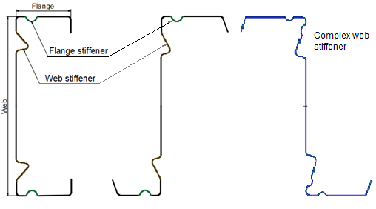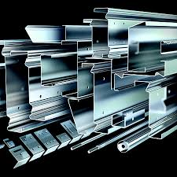
(d)
(d)
(c)
(b)
(a)
Fig. 1. Typical cold roll formed steel sections for structural members: channel section with stiffeners (a), zed section with stiffeners (b), zed section with complex stiffeners (c), and photo of different cold rolled formed sections (d) [7].
In recent years, a significant amount of studies has been conducted on the strength and design of CFS sections with web stiffeners [1-5]. However, there are limited investigations on optimal design of a section, accounting for the influence of the shape and position of stiffeners on the section subject to flexural stresses. Previous studies on the optimisation of CFS sections have primarily been limited to using analytical formulas or the methods available in the codes of design and specifications [9-11] to calculate the elastic buckling load and flexural strength of the structural members. In the studies [12, 13] the analytical equations were only used to maximize the second moment of area and minimize the cross-sectional area of CFS beams. The results provided an optimal shape obtained from arbitrary selected cross-sections. Similarly, the effective width method in AISI specification [9] was used to develop an optimal design of predefined orthodox CFS cross-sections including hat, I-, and zed- beams [14], lipped channel beams [15], hat-shape beams with and without the edge stiffeners [16]. These studies then proposed optimal design curves for various load levels. In the studies [17, 18] the effective width method available in Eurocode 3 [11] was also used to calculate local, distortional, and global buckling strengths of flexural structural members. The strength capacities of different cross-sectional prototypes were optimised using genetic algorithms and particle swarm optimisation. A similar approach has been also used to optimise CFS beams for maximum stiffness to satisfy serviceability limit states [19]. Whilst this resulted in some innovative new cross section shapes, the optimal design sections were verified against Finite Element models which only accounted for material and geometric nonlinearities and imperfections. This method was feasible for rather conventional sections which had a distinction between web, flanges and lips and hence need to satisfy the dimensional limits required by the design standards [9,11]. However, this method could not be adopted when the aim was to generate novel, previously undiscovered shapes in a free-shape optimisation, as the conventional standards were typically not applicable.
The combination between numerical and design methods, such as the Finite Strip Method [20] and the Direct Strength Method (DSM) [9], were used as an alternative in some of the recent optimisation studies of CFS structural members [21-31]. The DSM can be used to calculate the strength capacity based on the elastic critical local, distortional, and global buckling stresses and could therefore, in principle, be applied to any shapes subjected to the availability of experimental test data. The elastic buckling stresses could thereby be obtained from the Finite Strip Method. This method, however, has some shortcomings. For instance, the DSM equations have been generally developed based on the statistical correlation between a cross-sectional slenderness parameter and the ultimate strength capacity. This may exhibit a significant coefficient of variation that makes the results significantly cross-sectional dependent, resulted in providing less accurate predictions for certain cross-sections. The DSM does not also include distortional-global or local-distortional interactions [32], and therefore, that may lead to incorrect optimisation results when these buckling modes are dominant.
To accurately predict the strength of CFS sections with complex intermediate stiffeners design rules available in standards and specifications could not be applied, it was due to complicated geometries and material properties at the stiffeners which were changed during section forming. These, however, could be overcome by utilising FE simulations which were capable of modelling complex process and sections [33, 34]. This could allow the reduction of the product material or improve the structural performance by optimising the process and subsequent products. However, there have been so far only few optimisation studies in which the optimisation of beams under bending was performed using Finite Element method accounting for geometric and material non-linearity and initial imperfections [35, 36]. A Simulated Annealing algorithm was combined with detailed nonlinear FE models to obtain hot-rolled H-beams with optimal flange shapes that could significantly improve the energy dissipation capacity [35]. In another relevant study, a Particle Swarm Optimisation algorithm was combined with detailed FE models to perform size optimisation of 15 CFS cross-sectional prototypes [36]. The optimised cross-sectional shapes were dissipated up to 60% more energy compared to commercially available lipped channel. However, these studies were reported to be substantially computationally expensive, and they were performed on high-performance computing systems. Besides, the FE models in [35] were not validated against experimental testing before using them for the optimisation process. The models used in the later study [36] were validated against four-point beam bending tests, whereas it was used for the optimisation of a cantilever beam. Most recently, a new practical approach that combined the Finite Element modelling and optimisation utilising Design Of Experiment (DOE) was developed by Nguyen et al. [37]. This was used to investigate a longitudinally stiffened channel section (the maximum buckling load was considered as the target for the optimisation) and a complex grating system (the maximum stresses were considered as the target for the optimisation).
Regarding optimisation, there have been very limited studies on the stiffener’s geometric effects including shape and position of the stiffeners to the section strength under bending [17, 18, 38]. In these numerical studies, it was generally assumed that the material properties at corner and bends of the intermediate stiffeners were the same with those at flat sections. This indicates that the effect of the cold working by the cold roll forming manufacturing process in enhancing the material properties at the stiffener’s corners was not considered. To the best of the authors’ knowledge, there are no optimal design studies on cold roll formed sections that took into account the effects of both the stiffeners’ geometry and the cold working effect on the strength of the sections.
In this paper, Finite Element analysis and optimisation using Design Of Experiments (DOE) and response surface methodology were combined as a new approach for finding optimal sections in flexural strength. In particular, the optimisation of cold roll formed channel and zed sections with longitudinal intermediate stiffeners in the flanges and web under bending was obtained, whilst considering both the stiffeners’ geometry and cold working influences on their buckling and ultimate bending strength. To replicate four-point bending tests of industrial channel and zed sections in generating distortional buckling failure modes, a Finite Element model was developed and validated against the experimental data. The sections were then parameterized in terms of geometric dimensions and material properties at section’s stiffener bends and corners using the DOE technique. In this approach, the dimensions, the initial imperfections, and the cold working effect induced by cold roll forming were defined as input parameters in the Finite Element modelling. In the design of the experiments, a range of values were given to these parameters to determine sampling points. The values of the buckling and flexural developed stresses were defined as output parameters. Response surfaces were then constructed using these sampling points which combined DOE methods and mathematical statistics, continuously testing the specified points until the relationship between parameters was solved. The Kriging response surface was used to determine the influences of the stiffener’s properties on the section distortional buckling and flexural strength including its location, shape, size, and enhanced material properties by the cold working at the section corners and stiffener bends. Response surface optimisation was finally used to determine the geometric dimensions and material properties that obtained satisfied the objectives of maximising buckling loads and minimising flexural stresses (sections under the same applied loads), consequently leading to the optimal design of the channel and zed sections with the target performance of a maximum strength to weight ratio. The details of the process are explained in the following sections.

Finite element modelling and validation
They were tested in four-point bending testing setup in the experimental testing programme carried out in Nguyen et al. [39] and the results were used for validation of the FE analysis. The original shapes of the selected channel and zed sections had two stiffeners positioned at an equal distance to the web centre, as shown in Fig. 2 with their cross sections and general dimensions. These sections are referred as the “reference sections” in this study. A pair of 2920 mm long channel or zed sections placing in parallel with a central span of 2691 mm was assembled in the test. Bracings were provided by attaching the steel angles 45×45 mm to the top and bottom flanges of two specimens; the bracing length was about 900 mm, symmetrical to the mid-span, that was similar to practical bracing distance in real applications. More detailed information about the reference experimental tests can be found in Nguyen et al. [39].
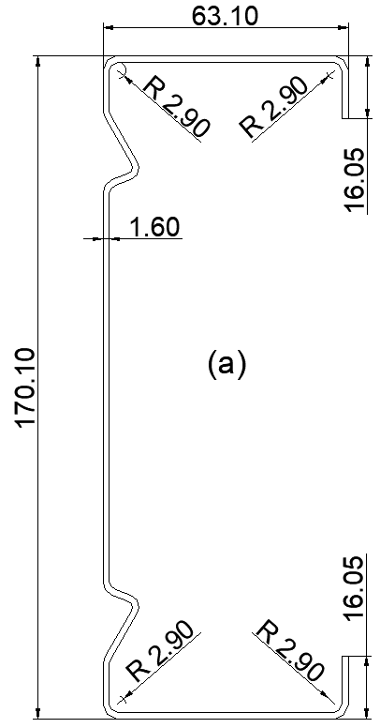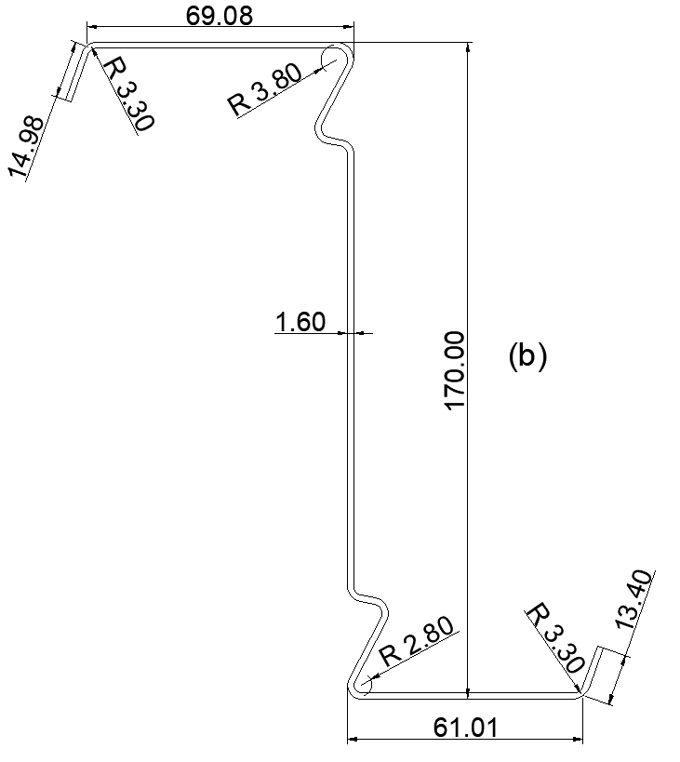

Fig. 2. The beam cross sections and dimensions (in mm) of (a) channel section, and (b) zed section used in experimental bending tests.

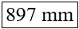
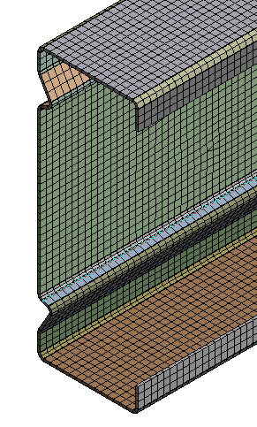
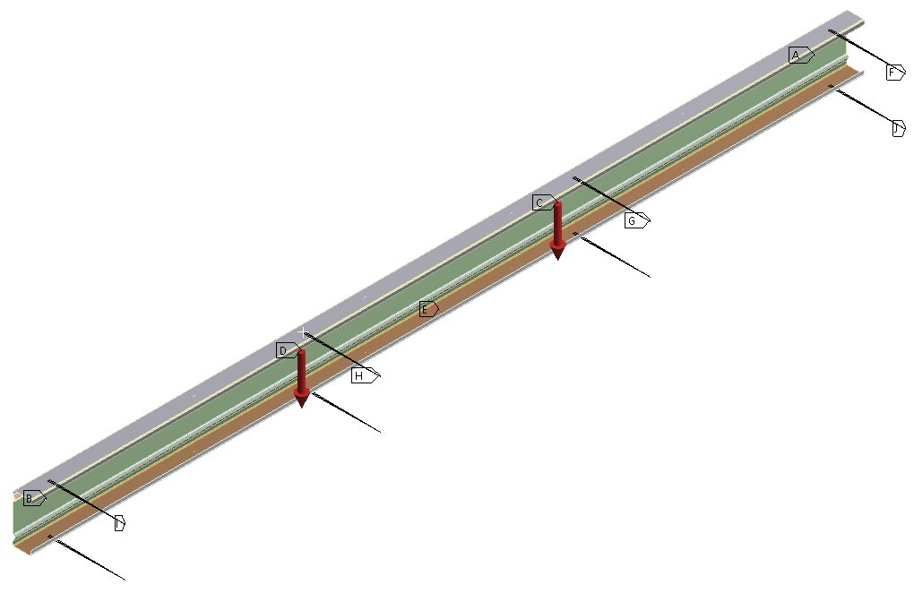
Load support
Load support
End support
End support

Fig. 3. FE symmetry model setup which shows boundary conditions and the mesh of the section in closer view (presented in the rectangular box). An example of the channel section.
To model the four-point bending test of the sections, FE analysis was performed using ANSYS (Version 18.1, ANSYS, Inc.) [40]. The FE model setup including point load locations and boundary conditions is illustrated in Fig. 3. Only half of the test system was simulated due to symmetry. The connection positions of the angle-to-beam screws (in the actual test provided for the lateral bracing) were modelled using tie nodes at the central of the connection. These tie nodes were rigidly connected to three nodes from the compression / tension flanges and they were constrained to prevent from movement against the transverse direction. The connections of cleats attached to the web of the section were also modelled by sets of nodes at supports and loading points. Rigid connections were used to tie these nodes together by reference points at the centre of the nodes. These reference points at end supports were used to restrict against all the movements such as vertical, transverse and out-of-plane movements that included torsional rotations. The reference points at one-third of the beams were used to apply vertical loads. Additional restraints in longitudinal directions were also provided at nodes in their tension flanges at the mid-span line to restrict the sections from longitudinal movement. Hence, the beam specimens were simulated as four-point bending test simply supported at both ends. To retain the mesh size when the location and size of the web or flange stiffeners were changed, the mesh of the beam was assigned as a function of the section width and element size. The reference channel section was simulated using 70810 elements. The element type selected was SHELL181 which they are thin-shell elements having global displacements and rotations as degrees of freedom. More detailed information about FE nonlinear analysis were described in Qadir et al. [41].
The shape and amplitude of initial geometric imperfection with the value of 1.55t, where t is section thickness, was employed for the FE analysis in this study as suggested in [41] (using the imperfection value of 1.55t in the FE analysis was seen to provide the closest agreement in the initial stiffness and strength values compared to the experimental results with less than 1% difference). The material properties at flat regions and at corners and stiffener’s bends of the beam sections were assigned in the FE modelling. The material tensile tests performed in [39] were utilised for the flat regions, whilst the AISI North American specification’s model [10] was used to calculate the enhanced yield strength of material at corners and stiffener’s bends based on the flat regions material properties. The AISI model for determining the tensile yield strength, $f_{yc },$ of the corner was based on the Equation (1) below.
$F_{yc}$= $\frac{B_{c} F_{yv}}{{\left(\frac{R}{t}\right)}^{m}}$ $(1)$
In which
$m=0.192\frac{F_{uv}}{F_{yv }}-0.068$and$B_{c}=3.69\frac{F_{uv}}{F_{yv}} -0.819 {\left(\frac{F_{uv}}{F_{yv}}\right)}^{2}-1.79$
Where:$F_{yv} and F_{uv}$ are yield stress and ultimate strength of the flat region material, R is inside corner/bend radius and t is the plate thickness. For cold roll formed sections, modest levels of strength enhancement of around 2.5% over the virgin coil material were observed in samples taken from web and flange elements [42]. Therefore, the changes of the mechanical properties of the material in the flat parts of the cold roll formed sections were negligible in this study.
The flat region material properties of channel and zed sections were as follows: Poison’s ratio (ѵ) was equal to 0.3, a Young’s modulus (E) was equal to 205 $Gpa$, yield and ultimate strengths were equal to 519.40 $MPa$ and 550.00$MPa$ respectively. As an example, 12 various corners and bends were defined in the FE modelling for the upper and lower part of the channel section because the section had a different radius at bends and corners. By taking advantage of symmetry, only six enhanced yield strengths were calculated at six corners and bends in the upper part of the section as shown in Table 1, which the values of $m, B_{c} , F_{yv}$and various corners radius yield strength $F_{ycR}$ are also shown, in which $m and B_{c}$are parameters,$F_{yv}$ is the yield strength of the flat regions material, and R is inside corner/bend radius, as described in [41].
Table 1 Values of enhanced yield stresses due to cold working at corners and stiffener’s bends using theoretical formulae [10].
$$m$$ | $$B_{c}$$ | $F_{yv}$ $\left(MPa\right)$ | $F_{ycR}$ $\left(MPa\right)$ | $F_{ycR}$ $\left(MPa\right)$ | $F_{ycR}$ $\left(MPa\right)$ | $F_{ycR}$ $\left(MPa\right)$ | $F_{ycR}$ $\left(MPa\right)$
 |  |  | R = 2.5 mm | R = 2.6 mm | R = 2.9 mm | R = 5 mm | R = 7.5 mm
0.14 | 1.20 | 519.40 | 586.29 | 583.19 | 573.57 | 533.8 | 519.40
A separate study was conducted to calibrate the AISI model for determining the tensile yield strength, $f_{yc },$ of the section corners and the stiffeners’ bends of the section entity. In this investigation, the yield and tensile strengths of the section corners and the stiffeners’ bends were obtained from tensile testing on curved coupons extracted from different section corners and stiffener bends’ positions. This was done on 12 different channel and zed sections (6 for each section) with the inside corner/bend radius R taken values from 2 mm to 5 mm, and the experimental measurements were compared with the tensile yield strength, $f_{yc }$, obtained by the AISI model (Equation (1)). It was found that the AISI model’s predicted values were comparable with the measured values, with a mean difference of 12% and a standard deviation of 4%. Therefore, the AISI model was used in this paper for the optimisation study.
In this study, a straight line with a constant slope of E/50 was used to model the inelastic region of the stress-strain curve as suggested in [43], where E is taken from the elastic modulus of the flat regions of the material tests. Fig. 4 shows the stress-strain curves obtained from corners and stiffeners’ bends of the section by using the suggested models [43] and were implemented in the FE simulations. The load-displacement curves obtained from using the stress-strain data obtained from the tensile tests [39] and the suggested stress-strain model, as shown in Fig. 4, were compared for the validation purpose. It was observed that the difference in the stiffness and ultimate load capacity was insignificant (less than 0.8%). Therefore, the proposed stress-strain model obtained in Fig. 4 was employed for the optimisation study in this paper.
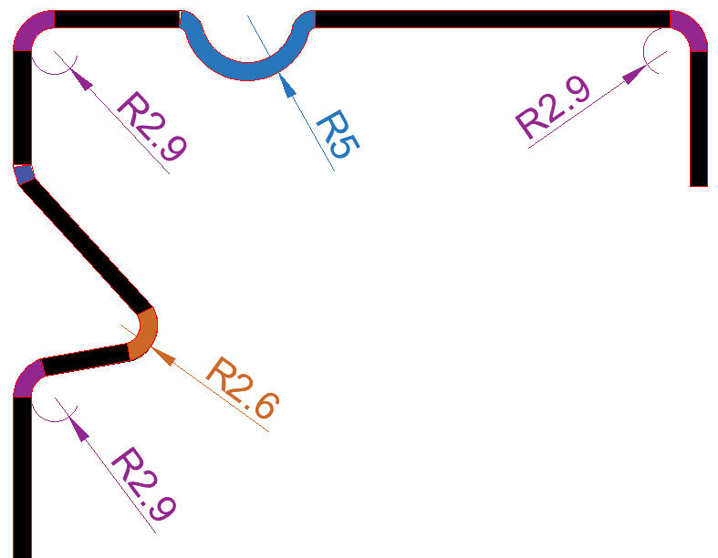
Fig. 4. Finite Element stress-strain curves for materials at section corners and stiffeners’ bends. An example of the channel section.
The validation process showed that that the stiffness and ultimate strength of the sections obtained by the FE models agreed very well with those of the experimental test for both channel and zed sections, as shown in Fig. 5. In addition, typical deformation shapes at failure obtained by experimental tests and FE modelling results were compared in Fig. 6 for the channel section. It was observed that the distortional buckling mode shape of the failed specimens was well represented by the FE models. In particular, the horizontal movement of the compressed web-flange corner $d_{y}$ and the inward compressed flange-lip motion $d_{z}$ in post buckling state of the channel cross section were 0 mm and 11 mm at failure, respectively; this clearly indicated the distortional buckling mode of failure of the section. Overall, the FE model showed a slightly higher stiffness in comparison to the experimental one before peak load. The maximum difference in the peak load between FE and experiment results was 1% conservative, whilst for the displacement was 4% nonconservative. It was found that cold working influence on stiffness and strength of the channel beam was insignificant because the distortional buckling slenderness in the section was very high and the beam failed by distortional buckling stress before it reached its yield strength capacity. If the buckling stresses reached the yield strength, then the cold working effect would be more significant.

Fig. 5. The comparison of load-displacement curves between experimental results and Finite Element models for sections with and without cold working effect (a) channel section, and (b) zed section.
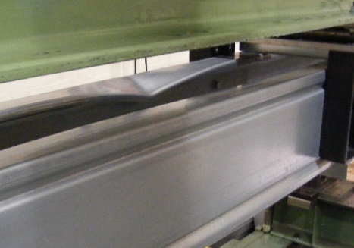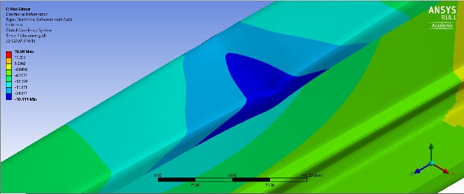
(b)
(a)
(d)
(c)
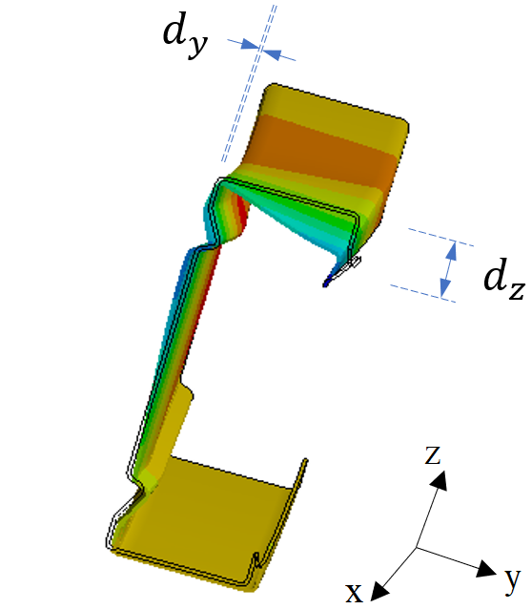
(e)
Fig. 6. The comparison of deformed shapes between experimental results and Finite Element models: (a) Failure deformed shapes for the channel sections captured from experimental tests; (b) isometric view, (c) front view, and (d) back view of Finite Element models), and un-deformed and deformed cross sections (e). Values of deformation presented as per colour contour and arranged from green to blue with lowest values in green region

Optimisation method
An optimisation study was performed to investigate the effect of changing flange and web stiffeners’ positions, sizes, shapes, and increased material yield strength at corners and stiffeners’ bends on the section’s structural performance including buckling load and ultimate bending strengths. The optimisation was carried out by implementing the validated FE models in Section 2. The FE results obtained when varying the parameters and they were arranged in a way that the entire positive effects on the section flexural strengths could be obtained, resulted in an optimum design of the sections. The “reference sections” implied the channel and zed sections that utilised in the experimental testing together with their bending setup in Section 2. In the optimisation process, the height $h$ and thickness $t$ of the section were not changed, and the total length of the channel and zed sections were also fixed. This was to maintain the same weight of the section, whilst seeking the maximum buckling loads and the maximum flexural strength of the beams. The stress-strain curves at the flat regions were assumed to be the same, while they varied at corner locations and at the stiffeners’ bend regions to account for the cold working influence. The reference sections had the stress-strain curves at flat, stiffener’s bend and corner regions determined in Section 2 as well as a value of 1.55$t$ for the initial geometric imperfection amplitude. Other material properties include an elastic modulus E of 205 GPa and a Poisson’s ratio ѵ of 0.3
Fig. 7(a) and Fig. 7(b) show the channel section without and with flange stiffeners, respectively, with all the design parameters. The channel reference section had the values of 170.10 mm and 1.60 mm for $h$ and $t$, respectively. In these figures $p_{1}$ and $p_{2}$ are the location of the stiffener at the web away from the flange-web junction, $p_{3}$ is the width (size) of web stiffener, $p_{4}$ is the lip length (the edge stiffener width), $p_{5}$is the radius of the section corners, $p_{6}$ and $p_{7}$are the angle of rotation of the web stiffener, $p_{8}$ is the flange width, $p_{15}$ is the location of the flange stiffener moved away from the flange-web junction, and $p_{16}$ and $p_{17}$ are the flange stiffener size (a circular shape was assumed for the flange stiffener). The reference section had $p_{1}= p_{2}$ = 10.53 mm, $p_{3}=$ 13.61 mm, $p_{4}=$ 12.35 mm, $p_{5} = 2.90$ mm, $p_{6}$ = 0º and $p_{7}=$ 360º. There was a total of 270 combinations between $p_{1}$, $p_{2}$, $p_{3},$ $p_{4},$ $p_{5}$, $p_{6}$, and $p_{7}$, considering values between lower bound of 1.00 mm and upper bound of 40.53 mm for $p_{1}$ and $p_{2}$, lower bound of 5.61 mm and upper bound of 23.61 mm for $p_{3}$, lower bound of 2.90 mm and upper bound of 7.50 mm for $p_{5}$, lower bound of 0º and upper bound of 20º degrees for $p_{6}$ and lower bound of 340º degrees and upper bound of 360º degrees (equivalent of 0º) for $p_{7}$. Hence, the buckling load and flexural strength values by accounting for the cold working effect were obtained for each change of the parameters and the results were compared to investigate the influence of these parameters. Table 2 lists the ranges of values considered for the optimisation of channel sections.
The design parameters for zed sections without and with flange stiffeners are shown in Fig. 7(c) and Fig. 7(d), respectively. The reference zed section had the values of 170.0 mm and 1.6 mm for $h$ and $t$, respectively. $p_{1}$ and $p_{2}$ are the location of the web stiffeners from the flange-web junctions, $p_{3}$ and $p_{4}$ are the width of the edge stiffeners, $p_{5}$is the radius of the section corners assumed to be constant, $p_{6}$ and $p_{7}$are the width (size) of the web stiffeners, $p_{8}$ and $p_{9}$ are the angle of rotation of the web stiffeners, $p_{10}$ and $p_{11}$ are the angle of rotation of the edge stiffeners, $p_{12}$ and $p_{13}$ are the width of flanges for the zed section without flange stiffeners, whereas $p_{12}$ and $p_{13}$ represent the position of the flange stiffeners moved away from flange-web junction for the zed section with flange stiffeners, $p_{14}$ and $p_{15}$ denote the size of the flange stiffeners (a circular shape was assumed for the flange stiffener), and finally $p_{16}$ and $p_{17}$ are the width of flanges. Ranges of parameter values considered for the optimisation of zed sections are shown in Table 2.
The buckling loads ($p_{13}$) and the flexural developed stresses ($p_{14}$) are the output parameters for the channel section, and the buckling loads ($p_{18}$) and the flexural developed stresses ($p_{19}$) are the output parameters for the zed section.
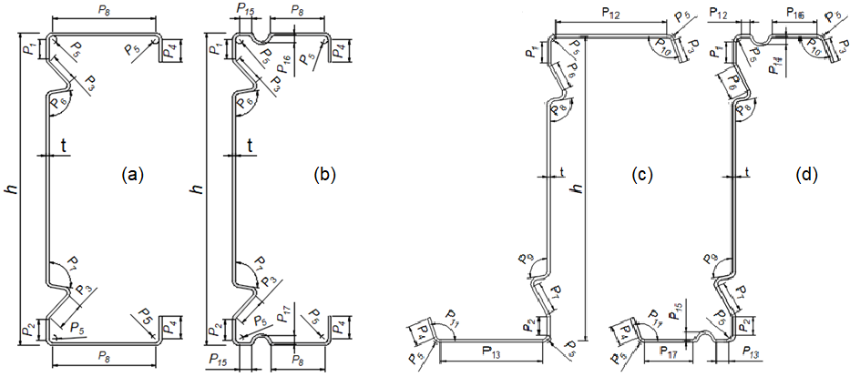
Fig. 7. Dimension parameters used in the Design Of Experiments and optimization process, of the channel sections (a) sections have no flange stiffeners and (b) sections have flange stiffeners, and of the zed sections (c) sections have no flange stiffeners and (d) sections have flange stiffeners.
Table 2 Ranges of values considered for the optimisation process (in mm for length parameters and degrees for angle parameters).
Parameter | Lower bound | Upper bound | Parameter | Lower bound | Upper bound
Channel section without flange stiffeners |  |  | Channel section with flange stiffeners
$$p_{1}$$ | 1.0 | 40.5 | $$p_{1}$$ | 1.0 | 40.5
$$p_{2}$$ | 1.0 | 40.5 | $$p_{2}$$ | 1.0 | 40.5
$$p_{3}$$ | 5.6 | 23.6 | $$p_{3}$$ | 5.6 | 23.6
$$p_{4}$$ | 12.4 | 18.4 | $$p_{4}$$ | 12.4 | 18.4
$$p_{5}$$ | 2.9 | 7.5 | $$p_{5}$$ | 2.9 | 7.5
$$p_{6}$$ | 0° | 20° | $$p_{6}$$ | 0° | 20°
$$p_{7}$$ | 340° | 360° | $$p_{7}$$ | 340° | 360°
- | - | - | $$p_{15}$$ | 5.0 | 20.0
- | - | - | $$p_{16}$$ | 1.0 | 5.0
- | - | - | $$p_{17}$$ | 1.0 | 5.0
Zed section without flange stiffeners |  |  | Zed section with flange stiffeners
$$p_{1}$$ | 1.0 | 50.0 | $$p_{1}$$ | 1.0 | 50.0
$$p_{2}$$ | 1.0 | 50.0 | $$p_{2}$$ | 1.0 | 50.0
$$p_{3}$$ | 12.6 | 24.6 | $$p_{3}$$ | 12.6 | 24.6
$$p_{4}$$ | 11.1 | 23.1 | $$p_{4}$$ | 11.1 | 23.1
$$p_{5}$$ | 3.3 | 3.3 | $$p_{5}$$ | 3.3 | 3.3
$$p_{6}$$ | 11.2 | 21.2 | $$p_{6}$$ | 11.2 | 21.2
$$p_{7}$$ | 12.6 | 22.6 | $$p_{7}$$ | 12.6 | 22.6
$$p_{8}$$ | 0.0° | 30° | $$p_{8}$$ | 0° | 40°
$$p_{9}$$ | 0.0° | 30° | $$p_{9}$$ | 0° | 40°
$$p_{10}$$ | 0.0° | 20° | $$p_{10}$$ | 0° | 20°
$$p_{11}$$ | 0.0° | 20° | $$p_{11}$$ | 0° | 20°
- | - | - | $$p_{12}$$ | 5.0 | 20.0
- | - | - | $$p_{13}$$ | 5.0 | 20.0
- | - | - | $$p_{14}$$ | 1.0 | 5.0
- | - | - | $$p_{15}$$ | 1.0 | 5.0

Flow chart for FE modelling and optimisation
Fig. 8 shows the calculation procedures performed in this study. First, the 3-D geometry of the section was built, allowing for the dimensions of the stiffeners and section to be parameterised (the positions, size and shape of web stiffeners, the size of edge stiffeners and section corners, the positions of flange stiffener, and the size of flange stiffener). Next, the Finite Element model was built and linear buckling analysis was carried out on the perfect beam with the reference dimensions before conducting eigenvalue buckling analysis to obtain its buckling mode shapes. Then, the nonlinear post-buckling analysis was performed including geometry and material nonlinearity, initial geometric imperfections, and the cold working effect at section corners and stiffeners’ bends assigned via material properties at corners as described in Section 2. This linked setup in ANSYS allowed the three analysis systems to share the same resources such as material data, geometry, and boundary condition type definitions. The process of varying all the parameters was carried out with Design Of Experiments in which each parameter was assigned three different values in the range from lower bound to upper bound values. The target responses selected in this study were maximum buckling loads and minimum stresses in the sections while keeping the weight of sections constant. Finally, response surfaces were calculated, where each response was a response surface function of all the selected parameters and was treated as an objective. The best design candidates (sections) were selected using a multi-objective genetic algorithm.

Establishing the geometry of the reference section and parameterising the dimensions to be investigated
Finite Element
Analysis Systems

Nonlinear post-buckling analysis with reference dimensions
Eigenvalue analysis to obtain its buckling mode shapes
Building FE model and conducting linear buckling analysis at initial dimensions

Design Of Experiments’ points, solving output of every points and generating response surfaces

Design of Experiments and Optimisation System
Adding random
verification points and
checking goodness of fit

Turning verification points to refinement points for improving response surface
Good fit
Performing optimisation and obtaining the best design candidates
Bad fit

Fig. 8. The flowchart of the FE modelling and optimisation processes.

Design of Experiment
Design Of Experiments (DoE) can be defined as a technique used for planning experiments and obtaining the information for analysing the influence of input parameters on output parameters. A number of experiments is performed by the DoE technique to obtain sufficient information from varying several experimental parameters systematically and simultaneously. The input variables for each of experiments can be changed purposefully in a series of runs, or tests. Collecting the data at each run to be used for identifying the process conditions and product components which influence the investigated quantities, and then determine the factor settings that optimise results. In this study, design points of the DOE were manually added to the design points table by introducing the parameters and the desired levels into which they required to be divided (using the Custom DOE in ANSYS). This was used with enough points entered to fill sampling space efficiently so that a good fitting could be created for the response surface. It was therefore possible to efficiently determine the location of sampling points for the geometries of the channel and zed sections with complex immediate stiffeners.
In this approach, the dimensions of the channel and zed sections were parameterised to be used in the FE models and these parameters were given a range of values, as shown in Table 2, to obtain output parameter values that could achieve the target objectives in the optimisation process. This was performed under different level of applied loads, searching for the sections that could withstand maximum loads before they failed. In the DOE method, the cross-sectional shapes that resisted maximum applied load were selected as the best design candidates.

Response Surface
In general, Response Surfaces (RS) are defined as functions in which the output parameters are described in terms of the input parameters. In this study, the sampling points obtained from DOE method were used to construct a Response Surface, which combined DOE methods and mathematical statistics, continuously testing the specified points until the relationship between the input parameters was solved. This was used to construct the approximation of target parameters in a global design space through estimating the set of input parameters and yield an optimal response. In this study, Kriging-based response surface method [44, 45] was used as an accurate multidimensional interpolation that combines a polynomial model, which provides a “global” model of the design space and local deviation; this enables efficiently interpolating the DOE points. This method is a meta-modelling algorithm that provides an improved response quality and fits higher order variations of the output parameter. It is efficient in numerous cases particularly when the output response is highly nonlinear. The method can be expressed as:
$Y\left(x\right)=f\left(x\right)+Z\left(x\right)$ (2)
where $Y\left(x\right)$ is the unknown function of interest, $f\left(x\right)$ is a known function (usually polynomial) of $x$, and$Z\left(x\right)$ is the realization of a normally distributed Gaussian random process with mean zero, variance $σ^{2}$, and non-zero covariance. The $f\left(x\right)$ term is similar to the polynomial model in a response surface and provides a "global" model of the design space. While $f\left(x\right)$ "globally" approximates the design space, $Z\left(x\right)$ creates "localized" deviations so that the Kriging model interpolates the $N$ sample data points. The covariance matrix of $Z\left(x\right)$ is given by:
$Cov\left[Z\left(x^{i}\right), Z\left(x^{j}\right)\right]= σ^{2}R\left(\left[r\left(x^{i}, x^{j}\right)\right]\right)$ (3)
where $R$ is the correlation matrix and $r\left(x^{i}, x^{j}\right)$ is the spatial correlation of the function between any two of the $N$ sample points. The correlation function $r\left(x^{i}, x^{j}\right)$ is a Gaussian correlation function:
$$r\left(x^{i}, x^{j}\right)=exp⁡\left(-\sum_{k=1}^{M}{θ_{k}} {\left|\left.x_{k}^{i}- x_{k}^{j}\right|\right.}^{2}\right) (4)$$
The unknown parameters $θ_{k}$ used to fit the model are found by maximizing the following equation in which both ${\hat{σ}}^{2}$ and $\left|r\right|$ are functions of $θ_{k}$:
$-\frac{\left[Nln\left({\hat{σ}}^{2}\right)+ln\left|r\right|\right]}{2}$ (5)
While any values for $θ_{k}$create an interpolative model, the “best” Kriging model is found by solving the k-dimensional unconstrained non-linear optimization problem given by Eqn. (5). The effectiveness of the RS is generally verified by Goodness of Fit metrics and Verification Points in the optimisation processes. Kriging fits the RS through all design points, which cannot be verified by only Goodness of Fit metrics. Thus, a randomly generated verification points was used with Goodness of Fit to verify the effectiveness of the RS in this study. It should be noted that the verification points were used to ensure the response surface approximates the output parameter values accurately. After the response surface was obtained, the verification points were placed in the ANSYS software, manually or through a CSV file, in the locations to maximise the distance from refinement points and their corresponding DOE points. These points were then compared with the predicted response surface values to calculate the difference and assess the accuracy of the predictions.
The RS was then used to plot the response (output) versus each of the input parameters (i.e. single and double) and to perform sensitivity analyses. This could allow the selection of a single parameter to which the outputs (buckling load and flexural stresses) were sensitive. All the input parameters were found to be sensitive to the outputs in this study. Therefore, all the input parameters were included to conduct the optimisation.

Optimisation process
Once the response surfaces were generated and the correlations between input and output parameters were obtained, the final step was to optimise the channel and zed sections under bending for the objectives of maximum buckling loads and minimum flexural stresses. In this study, the Response Surface Optimisation using Multi-Objective Genetic Algorithm (MOGA) was adopted to determine the most suitable candidates and ultimately identify the optimal design of the sections. Genetic Algorithm (GA) is an efficient evolutionary optimisation method for finding global optimal solutions in a large domain space [46-48]. It begins with a random selection of population of solutions, whose individuals are represented in the form of chromosomes and progressed through a simulated evolution to obtain the global optimum. It involves chromosome representation, genetic operations and the fitness evaluation to efficiently select, crossover and mutate chromosomes, in order to form a new and improved population. The value of fitness function, which is identified by the objective function (the objective function in this research was to maximise buckling loads and minimise the flexural stresses), was used for generation of improved off-springs from the current generation, with the GA operations depending on its value to evaluate the population members performance. The new population replaces previous one in the next iteration and over successive generations, the population evolves toward an optimal solution or Pareto frontier. Multi-objective Genetic Algorithm (MOGA) means optimising several objectives simultaneously. A multi-objective problem is solved to achieve one of the important goals of determining a ‘Pareto frontier’. The set of the best design points is shown by ‘Pareto frontier’ that each point provides an optimal design. Mathematically, the objective function of parameters $\vec{X}= \left[x_{1} , x_{2} , x_{3} , …, x_{n}\right]$ $∈ D^{n}$ for the $α^{th}$ application can be expressed as $f_{kα}\left(\vec{X} ∈ D^{n}\right)$ with $k=1, 2, 3,…,L_{α}$ and $α=1, 2, 3,…, A$. The best feasible solution for one single objective can be found by $Min f_{kα}\left(\vec{X} ∈ D^{n}\right)$ with the constraint${ g}_{jα,min} ≤f_{kα}\left(\vec{X} ∈ D^{n}\right)≤g_{jα,max}$ , $j=1, 2, 3,…,m_{α}$. In which, $n$ is the total number of design parameters, $L_{α}$ is the total number of objective functions, $m_{α}$ is the total number of parameters (ANSYS Documents, Version 18.1, ANSYS, Inc.).
In this study, the multi-objective optimisation functions were established as: $Min F\left(x\right)=\left(f_{1}\left(x\right),f_{2}\left(x\right)\right)$ with the constraint ${ a}_{k} ≤x_{k}≤b_{k} , k=1,2,…,L$, in which $f_{1}\left(x\right)$ and $f_{2}\left(x\right)$ are the maximum buckling load and the minimum flexural stress of the sections, respectively; $x_{k}$, constrained between the lower bound, $a_{k}$ , and the upper bound, $b_{k}$ , was the kth design variable. As it was assumed that all objective functions were to be minimised, to maximise an objective function it could be multiplied by minus, or be inversed.

Results and discussion
This section reports the results obtained from changing the parameters in the optimisation process. These include the effects of the intermediate flange and web stiffeners’ locations, sizes, shapes, and enhanced material yield strength due to cold working at corners and stiffeners’ bends on the section buckling and flexural strengths. DOEs were performed to determine the optimal configuration of channel and zed sections. Once the DOEs had completed, the Kriging-based model was used to construct the response surface without refinement. Subsequently, 30 verification points were simulated and used, along with the DOE points, to check the quality of DOE predictions. Once the optimal DOE was selected, by changing the aforementioned design parameters their influence on the section buckling loads and flexural stresses was investigated. Finally, Response Surface Optimisation was performed using the MOGA method to determine the design candidates that led to the maximum buckling loads and minimum flexural stresses of the channel and zed sections.

Design Of Experiment quality metrics
Fig.9 presents the comparison between the value of the buckling loads (Total Deformation Load Multiplier $p_{18}$) and flexural developed stresses (Equivalent Stress Maximum $p_{19}$) of design points as well as the predicted values from response surface for zed sections. Verification points simulated to check the quality of DOE predictions are also shown in this figure. The black line shows the line in which the points could have a predicted value from response surface equal to the observed one in the design points. It could be seen that the generated response surface could provide relatively accurate results. Hence, the response surface can be efficiently used for future analysis in the proposed optimisation process.
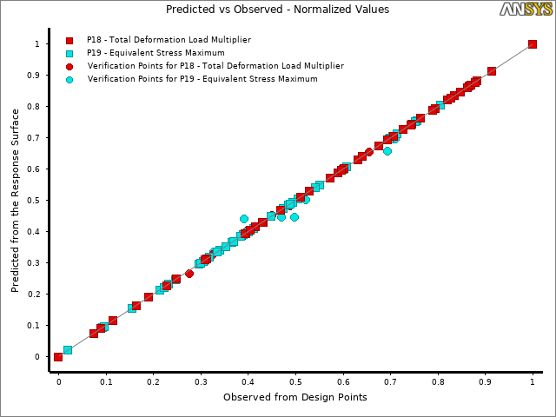
Fig. 9. Normalised charts of the predicted values versus observed values of the section’s buckling load and maximum flexural stress for DOE configuration obtained for the zed section with flange and web stiffeners. Square points are the DOE points and circular ones are the verification points.

DOE and response surface results
The buckling loads (Total Deformation Load Multiplier) and flexural developed stresses (Equivalent Stress Maximum) results obtained from changing the key parameters are presented in this section. The parameters investigated include the flange and web intermediate stiffeners’ locations, sizes, shapes and cold working influence at corners and stiffeners’ bends. The results were obtained from performing Eigenvalue buckling analysis under a unite applied load and performing non-linear buckling analysis under applied load of 46 kN (different values of applied load were tested ranging from 40 to 60 kN in the optimisation process for channel and zed sections, but the applied load of 46 kN was selected to obtain results in this study because most of sections were able to withstand this load level just before approaching the ultimate strength and failed). Under this applied load, the sections developed smaller flexural stresses in comparison with those developed greater flexural stresses, indicating that they had higher ultimate loads when the applied load was continuously increased until the sections failed. As an example, Table 3 shows the typical results of the response surfaces of the single parameter p₁ with initial values for the channel and zed sections with web and flange stiffeners, showing the effect of this parameter to the objective values of buckling loads and flexural stresses.
Table 3 Single parameter response for different positions of web stiffeners $p_{1}$ of channel and zed sections.
Parameter $p_{1}$ (mm) | Buckling load (kN) |  | Developed stress (MPa)
 | channel | zed | channel | zed
1.0 | 15.5 | 12.9 | 512.5 | 530.8
5.0 | 15.4 | 12.9 | 512.9 | 530.8
10.0 | 15.3 | 12.8 | 513.6 | 530.7
20.0 | 15.2 | 12.8 | 515.3 | 530.6
30.0 | 15.1 | 12.9 | 517.3 | 530.8
40.0 | 15.0 | 13.1 | 519.1 | 531.4
50.0 | - | 13.3 | - | 532.3

It could be seen from Table 3 that buckling loads gradually decreased to their lowest point and flexural stresses increased gradually to their highest point around $p_{1}=40 mm$ and $50 mm$ for the channel and zed section, respectively. Increasing $p_{1}$ was the same as moving the stiffeners away from the flange-web junction of the section. The reduction in the buckling loads and increasing in the flexural developed stresses was because increasing $p_{1}$ produced new channel sections with a reduction in the section modulus $S_{xx}$ and an increase in the buckling slenderness ${}_{d}$. In combination, the buckling loads were reduced by 4% and the stresses were increased by 6%. However, the increasing in the buckling loads and flexural stresses in the zed section was because it produced new zed sections with a reduction in both the buckling slenderness ${}_{d}$ and in the section modulus $S_{xx}$, and consequently a reduction in the product form of these quantities. Therefore, the buckling loads were increased by 4% and the flexural stresses were slightly increased when increasing $p_{1}$.
In general, the local sensitivity reflects the change of the outputs in association of the change of inputs independently. In this study, the local sensitivities were calculated based on the difference between the minimum and maximum value obtained by varying one input parameter while holding all other input parameters constant. A positive value of the sensitivity indicates that as the input parameter value increases, the output value increases as well. A negative value however means that increasing the input parameter value decreases the output value. Figs. 10 (a-b) show the sensitivities of the output parameters that included the buckling load ($p_{13}$) and the flexural developed stress ($p_{14}$) that were based on the input parameters for channel section with flange stiffeners: $p_{1}$, $p_{2}$, $p_{3}$, $p_{4}$, $p_{5}$, $p_{6}$, $p_{7}$, $p_{15}$, $p_{16}$, and $p_{17}$ (see Figs. 7(a) and 7(b)). Figs. 10 (c-d) show the sensitivities of the output parameters that included the buckling load ($p_{18}$) and the flexural developed stress ($p_{19}$) that were based on the input parameters for zed section with flange stiffeners: $p_{1}$, $p_{2}$, $p_{3}$, $p_{4}$, $p_{6}$, $p_{7}$, $p_{8}$, $p_{9}$, $p_{10}$, and $p_{11}$ (see Figs. 7(c) and 7(d)).
It could be seen that for channel sections, increasing the web stiffener’s positions from the web-flange junction ($p_{1}$ and $p_{2}$) reduced the buckling loads with a sensitivity of around 4% and increased the flexural stresses with a sensitivity of up to 24%. This meant that placing the stiffeners as much close as possible to the web-flange junction was the effective way to increase the buckling and ultimate strengths of the section. Regarding the section corner’s radius ($p_{5}$), which is linked to the cold working effect, it was observed that reducing the corner’s radius values could also be an effective way to increase the section strengths. However, it was revealed that increasing the web stiffener’s sizes and shapes (through the web stiffener’s sizes ($p_{3})$ and the web stiffener’s shapes ($p_{6}$ and $p_{7}$)) was the most effective way to increase the section strengths, with up to 38% effect on the buckling loads and 20% effect on the flexural developed stresses. Increasing the edge stiffener ($p_{4}$) was also one of the most effective solutions, with up to 38% and 25% effect on increasing the buckling loads and decreasing the flexural stresses, respectively.
For zed sections, increasing the web stiffener’s positions from the web-flange junction ($p_{1}$ and $p_{2}$) increased the buckling loads with a sensitivity of around 5% and increased the flexural stresses with a sensitivity of up to 9%. It could be seen that increasing the web stiffener’s sizes and shapes (through the web stiffener’s sizes ($p_{6}$ and $p_{7}$) and the web stiffener’s shapes ($p_{8}$)) was one of the most effective ways to increase the section strengths, with up to 5% effect on increasing the buckling loads and 12% effect on decreasing the flexural stresses. However, increasing the edge stiffener’s sizes ($p_{3}$ and $p_{4}$) was the most effective solution, with up to 15% and 17% positive effect on the buckling loads and the flexural stresses, respectively. The sensitivity effect of the angle between the edge stiffeners and flanges ($p_{10}$ and $p_{11}$) shows that reducing the angle values was also an efficient way to increase the section strength.

Fig. 10. The local sensitivity bar chart of single parameters obtained for the channel section with flange stiffeners (a) buckling loads and (b) flexural developed stresses, and for the zed section with flange stiffeners (c) buckling loads, and (d) flexural developed stresses.
Fig. 11 shows the typical 3-D response surfaces of the buckling loads and flexural stresses for channel sections, which are used to quantify the effect of different combinations of any two input parameters on the buckling loads (denoted by p₁₃) and flexural stresses (denoted by p₁₄). With the decrease of the values of the parameters p₁ and p₂, the buckling loads increased (see Fig. 11(a)), while the flexural stresses decreased (see Fig. 11(b)). It can be also noted that by increasing the values of the parameters, p₃ and p₆, the buckling loads increased as shown in Fig. 11(c), while the flexural stresses decreased as illustrated in Fig. 11(d).
Fig. 12 shows the typical 3-D response surfaces of the buckling loads and flexural stresses for zed sections. These results can quantify the effect of different combinations of any two input parameters on the buckling loads (denoted by p₁₈) and flexural stresses (denoted by p₁₉). As shown in Fig. 12(a), by decreasing the values of the parameters p₁ and p₂, particularly from 20 mm, the buckling loads increased. Fig. 12(b) shows that this also results in a decrease in the flexural stresses. By increasing the values of the parameters p₆ and p₈, the buckling loads decreased as shown in Fig. 12(c), and the flexural stresses also decreased as depicted in Fig. 12(d).
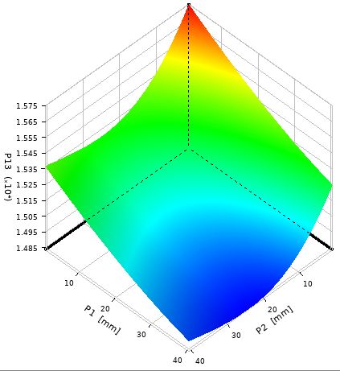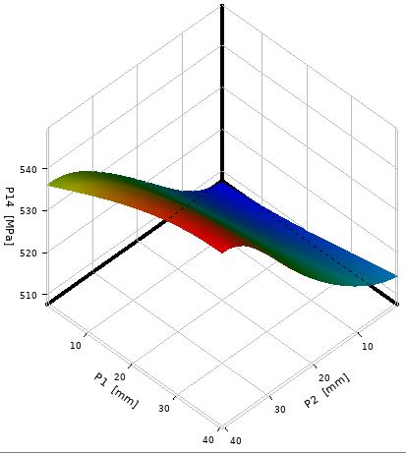
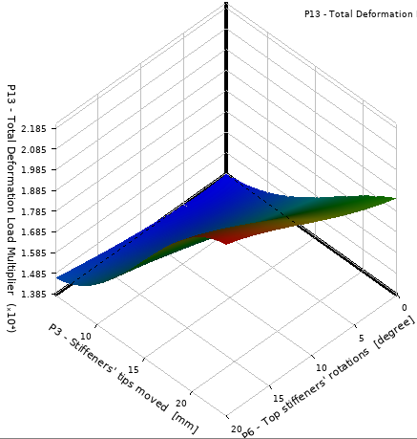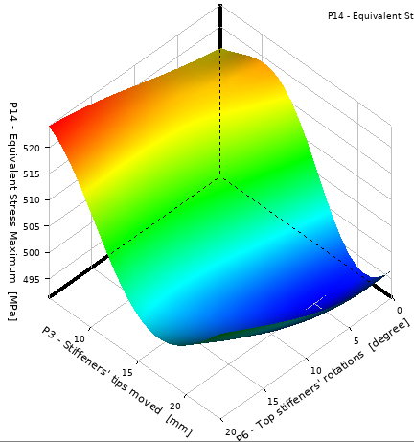
Fig. 11. Double parameters response of the channel sections for different positions of web stiffeners $p_{1}$ and $p_{2}$ on (a) buckling loads and (b) flexural developed stresses, and for different sizes of edge and web stiffeners $p_{3}$ and $p_{6}$ on (c) buckling loads and (d) flexural developed stresses.
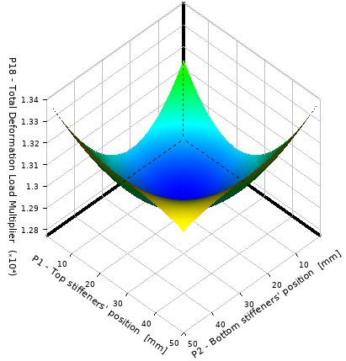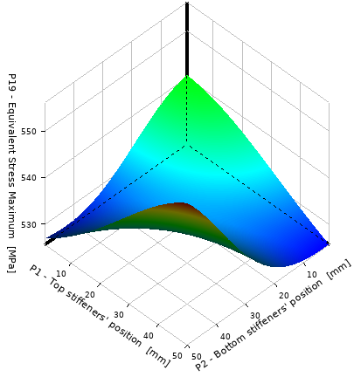

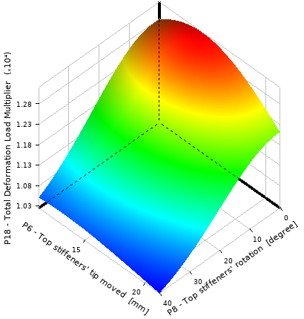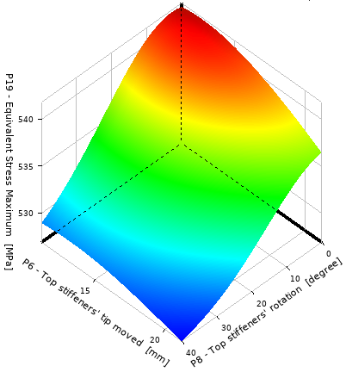
Fig. 12. Double parameters response of the zed sections for different positions of web stiffeners $p_{1}$ and $p_{2}$ on (a) buckling loads and (b) flexural developed stresses, and for different sizes of web stiffeners through the angle parameters $p_{6}$ and $p_{8}$ on (c) buckling loads and (d) flexural developed stresses.

MOGA optimisation results
Based on the results of the response surface analysis, the Multi-Objective Genetic Algorithm (MOGA) was used as the search engine to find the candidate optimal results to minimise the selected multi-objective function. In this study, for channel sections, the design variables: $p_{1}$, $p_{2}$, $p_{3}$, $p_{4}$, $p_{5}$, $p_{6}$, $p_{7}$, $p_{15}$, $p_{16}$, and $p_{17}$, were chosen as the input parameters of the MOGA, the output parameters were the maximum buckling load, p₁₃, and the minimum flexural developed stress, p₁₄. For zed sections, the design variables were $p_{1}$, $p_{2}$, $p_{3}$, $p_{4}$, $p_{6}$, $p_{7}$, $p_{8}$, $p_{9}$, $p_{10}$, and $p_{11}$, and the output parameters were the maximum buckling load, p₁₈, and the minimum flexural developed stress, p₁₉. Several different scenarios were used to determine optimal design candidates. These included (1) minimising the flexural developed stresses (largest flexural stress in a single analysis), (2) maximising buckling loads, and (3) minimising the flexural developed stresses and maximising buckling loads at the same time. Table 4 shows an example of these scenarios for zed sections with flange stiffeners, where the goal was to maximise the buckling loads ($p_{18}$) and minimise the flexural developed stresses ($p_{19}$). Table 5 presents the root mean square error which was the square root of the average square of the residuals at the DOE points. The best value was 0. In general, the closer the value was to 0, the better quality of the response surface. Fig. 13 shows the results of MOGA (pareto frontier) in a scatter plot between the two goal functions (p₁₈ and p₁₉₎. The two axes represent two output parameters with conflicting objectives: the X axis represents Maximize ($p_{18}$), and the Y axis represents Minimize ($p_{19}$). The chart shows two optimal solutions, point (1) and point (2). These solutions were non-dominated, which means that both points were equally good in terms of Pareto optimality, but for different objectives. Point (1) was the better solution for Minimize ($p_{19}$) and point (2) was the better solution for Maximize ($p_{18}$). Neither point was strictly dominated by any other point, so both were included on the first Pareto front.
As a result, three design candidates were found with the same design variables. The design candidate was then loaded up to failure to obtain collapse load-displacement curves as indicated in Fig. 15 for channel sections and Fig. 18 for zed sections. This process repeated to obtain other design candidate results for the zed sections (i.e. Candidates 1-5), and for the channel sections (i.e. Candidates 1-6).
Table 6 presents the buckling loads and ultimate bending strengths of the channel and zed sections obtained from the MOGA optimisation process (with input parameters shown in Fig. 7 and Table 2). The results in this table were compared with those of the standard lipped channel and zed sections having the same amount of material and the same section height. Candidates 1 and 4 were obtained when the ‘Goal’ was minimising the flexural developed stresses, Candidates 2 and 5 were obtained when the ‘Goal’ was maximising the buckling loads, and Candidates 3 and 6 were obtained when the ‘Goal’ was maximising the buckling and minimising the flexural developed stresses under bending for distortional buckling.
Table 4 Candidate design when the target objectives were maximising buckling and minimising flexural developed stresses (Candidate 6).
Table of Schematic D4: Optimisation
Optimisation Study
Minimise $p_{19}$ | Goal, Minimise $p_{19}$ (High importance)
Maximise $p_{18}$ | Goal, Maximise $p_{18}$ (Low importance)
Optimisation Method
MOGA | “The MOGA method (Multi-Objective Genetic Algorithm) is a variant of the popular NSGA-II (Non-dominated Sorted Genetic Algorithm-II) based on controlled elitism concepts. It supports multiple objectives and constrains and aims at finding the global optimum”.
Configuration | “Generate 100 samples initially, 100 samples per iteration and find 3 candidates in a maximum of 100 iterations.”
Status | Converged after 2740 evaluations.
Candidate Points
 | Candidate point 1 | Candidate point 2 | Candidate point 3
$p_{1}$ - Top stiffeners' position (mm) | 7.55 | 7.38 | 7.40
$p_{2}$ - Bottom stiffeners' position (mm) | 3.09 | 3.29 | 3.29
$p_{3}$ - Top edge stiffeners' width (mm) | 18.18 | 18.18 | 18.20
$p_{4}$ - Bottom edge stiffeners' width (mm) | 16.15 | 16.19 | 16.19
$p_{6}$ - Top stiffeners' tip moved (mm) | 12.81 | 12.82 | 12.82
$p_{7}$ - Bottom stiffeners' tip moved (mm) | 13.12 | 13.61 | 13.60
$p_{8}$ - Top stiffeners' rotation (degree) | 1.32 | 1.07 | 1.09
$p_{9}$ - Bottom stiffeners' rotation (degree) | 0.87 | 1.36 | 3.13
$p_{10}$ - Top edge stiffeners' rotation (degree) | 0.71 | 0.71 | 0.73
$p_{11}$ - Bottom edge stiffeners' rotation (degree) | 0.71 | 0.02 | 0.05
$p_{16}$ - Top flange width (mm) | 35.51 | 35.31 | 35.50
$p_{17}$ - Bottom flange width (mm) | 28.86 | 29.12 | 29.12
$p_{18}$ - Total deformation Load Multiplier | ⁂ 20.63 | ⁂ 21.04 | ⁂ 20.85
$p_{19}$ - Equivalent Stress Maximum (MPa) | ⁂ 453.59 | ⁂ 453.90 | ⁂ 453.78

Table 5 The root mean square errors for the buckling load and flexural developed stresses (p₁₈ and p₁₉₎.
Table of Schematic D3: Response Surface
 | Buckling load ($p_{18}$) | Flexural developed stresses ($p_{19}$)
Root Mean Square Error (Best Vale = 0%)
Learning Points | 0.168 | 5.52 E-04
Verification Points | 0.043 | 9.22 E-04

(2)
Fig. 13. The results of MOGA (pareto frontier) in a scatter plot between the two goal functions (p₁₈ and p₁₉)
In this study, Maximum Allowable Pareto Percentage and Convergence Stability Percentage were used as the convergence criteria in the MOGA-based multi-objective optimization. The Maximum Allowable Pareto Percentage represents a specified ratio of Pareto points per number of samples per iteration, while the Convergence Stability Percentage criterion looks for population stability, based on mean and standard deviation of the output parameters.

Table 6 The results of buckling load ($P_{b}$), flexural developed stresses ($σ)$, ultimate moment capacity without the cold working effect $M_{u}$, and ultimate moment capacity with the cold working effect $M_{uc}$. The term “standard” stands for commercially available standard channel and zed sections, Reference (a) is longitudinally stiffened web sections, and Reference (b) is longitudinally stiffened web and flange sections.
Section type | $P_{b}$ (kN) | $σ$ (MPa) | $M_{u}$ (kNm) | $M_{uc}$ (kNm) | $M_{uc}$/$M_{u}$ | $M_{uc}$/  $$M_{uc}^{standard}$$
Channel
Standard | 11.7 | 553.8 | 10.34 | 10.34 | 1.00 | 1.00
Reference (a) | 13.4 | 546.5 | 10.64 | 10.69 | 1.01 | 1.03
Candidate 1 | 22.9 | 455.3 | 11.30 | 11.58 | 1.03 | 1.12
Candidate 2 | 23.5 | 484.5 | 10.94 | 11.07 | 1.02 | 1.07
Candidate 3 | 23.3 | 460.0 | 11.34 | 11.59 | 1.03 | 1.12
Reference (b) | 15.3 | 513.8 | 10.88 | 11.12 | 1.02 | 1.07
Candidate 4 | 20.8 | 455.0 | 11.60 | 11.87 | 1.03 | 1.15
Candidate 5 | 23.1 | 517.0 | 10.96 | 11.20 | 1.03 | 1.08
Candidate 6 | 21.5 | 458.0 | 11.90 | 12.09 | 1.02 | 1.17
Zed
Standard | 9.6 | - | 9.98 | 9.98 | 1.00 | 1.00
Reference (c) | 11.6 | 570.0 | 10.66 | 10.86 | 1.02 | 1.09
Candidate 1 | 19.7 | 466.2 | 11.81 | 12.29 | 1.05 | 1.23
Candidate 2 | 21.1 | 496.4 | 10.76 | 10.88 | 1.02 | 1.09
Candidate 3 | 20.2 | 462.8 | 12.34 | 12.45 | 1.01 | 1.25
Reference (d) | 13.3 | 542.2 | 11.38 | 11.51 | 1.02 | 1.15
Candidate 4 | 18.8 | 449.8 | 11.81 | 12.13 | 1.03 | 1.21
Candidate 5 | 20.3 | 460.6 | 11.73 | 12.23 | 1.05 | 1.22
Candidate 6 | 19.8 | 450.4 | 11.97 | 12.35 | 1.04 | 1.24
The optimal shapes and the comparison between their flexural strength capacities are shown in Figs. 14-19. In which $M_{y}$ is the yield bending moment of the whole cross section; $M$ is the bending moment capacity (when the cold working effect is not included $M$ equals $M_{u}$, and when the cold working effect is included $M$ equals $M_{uc}$); and $M_{b}$ is the buckling moment capacity. The buckling and ultimate strength results were obtained by FE nonlinear analysis as described in Section 2, which is called “FEM” model. The buckling modes were obtained from linear buckling analysis that was conducted with the conventional Finite Element Method (FEM). In addition, another model was developed, in which the desired linear buckling modes obtained from Finite Strip Method using CUFSM software [49] were transferred to the FE analysis, to conduct the nonlinear analysis. This model is called “CUFSM-FEM” model. Both “FEM” and ““CUFSM-FEM” models’ results are shown in Figs. 14-19. Fig. 17 compares the FEM strength capacity results of the optimised sections with the results obtained by transferring buckling mode shapes from CUFSM to the FEM. Using this approach, the effects of geometric imperfections are taken into account in the analyses [50, 51]. It was seen that both FEM and CUFSM-FEM methods provided the same trend with an average difference of 12% and 5% in the buckling and ultimate bending moment capacities, respectively.
(a)
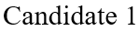
(a)
(b)
(b)
Fig. 14. Strength results of standard, reference and optimised channel sections for (a) buckling and (b) ultimate moment capacity with the cold working effect included.
Fig. 15. Load-displacement curves for the channel reference and design Candidate 6 sections.
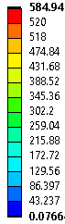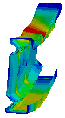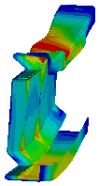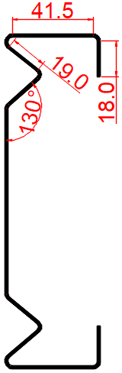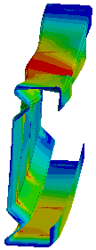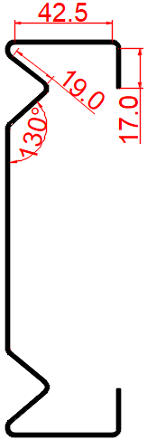
Candiate 1 Candidate 2 Candidate 3

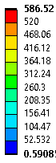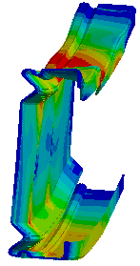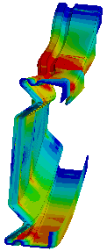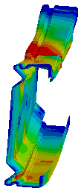
Candidate 4 Candidate 5 Candidate 6
Fig. 16. Dimensions, deformed shapes, and von Mises stress distribution for all design candidates of channel sections.

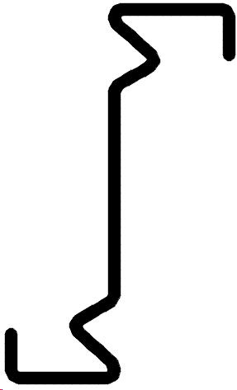
(a)
(a)
(b)
(b)
Fig. 17. Strength results of standard, reference and optimised of the zed sections for (a) buckling and (b) ultimate moment capacities with the cold working effect included.

Reference
Candidate 6
Fig. 18. Load-displacement curves for the zed reference and design Candidate 6 sections.

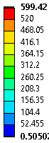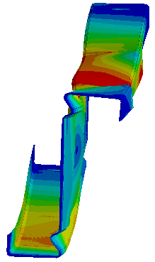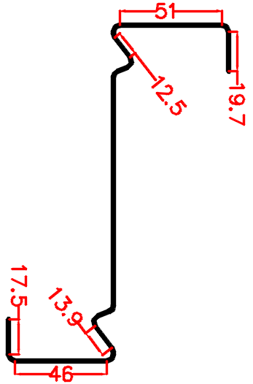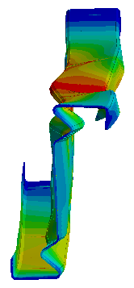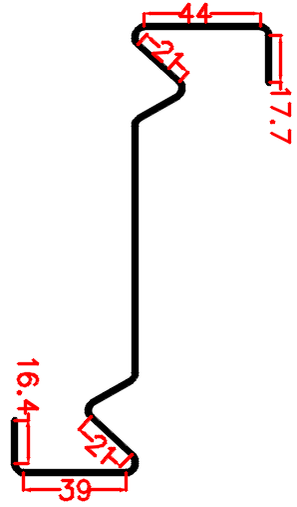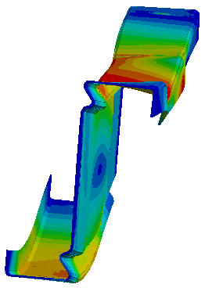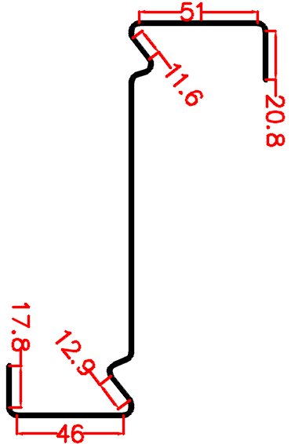
Candiate 1 Candidate 2 Candidate 3
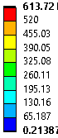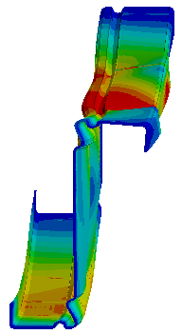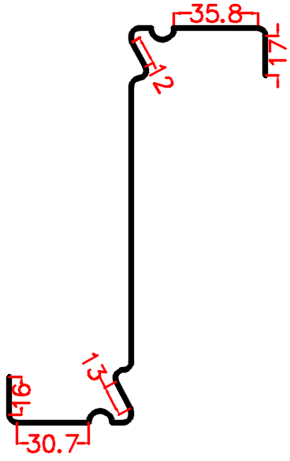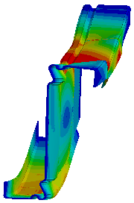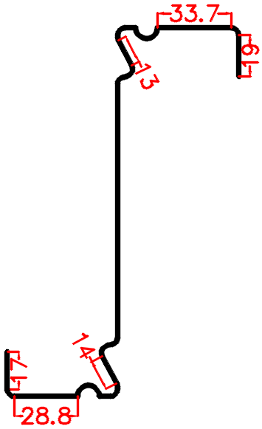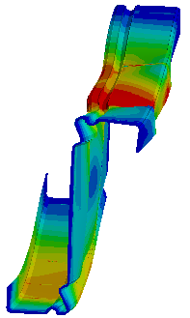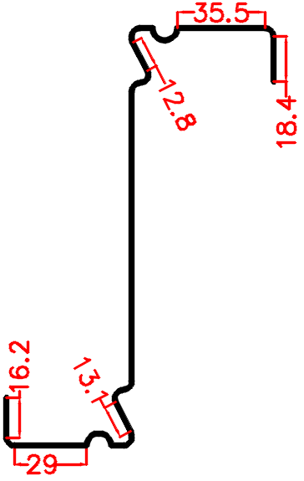
Candidate 4 Candidate 5 Candidate 6
Fig. 19. Dimensions, deformed shapes, and von Mises stress distribution for all design candidates of zed sections.
Several observations could be made from Figs. 14-19 and Tables 4-6 as follows:
- The reference channel and zed sections provided considerably greater buckling capacities when compared to the standard lipped channel and standard lipped zed sections by 15% and 21%, respectively, whereas the ultimate moment capacities were also improved by 3% and 9%, respectively.
- Adding flange stiffeners to the reference sections further enhanced the buckling and ultimate moment capacities of the channel section by16% and 4%, and of the zed section by 15% and 6%, respectively.
- By changing the position, size and shape of web stiffeners, lip’s length, and section corners’ radii as well as including the cold working effect at the sections’ corners and stiffeners’ bends of the reference channel and zed sections, optimal sections with maximum buckling strengths could be obtained (Candidates 1-3). The gains in buckling strength for the channel Candidates of 1, 2 and 3 were up to 2 times, in comparison with the standard lipped channel, and up to 2.1 times, when compared to the standard lipped zed sections. At the same time, the ultimate moment capacities were also improved by 12%, 7% and 12% for the channel sections, and by 23%, 9% and 25% for the zed sections, respectively.
- The optimal design of the channel and zed sections was obtained by changing the position, size and shape of web stiffeners, the position and size of flange stiffeners, lip’s length, and section corners’ radii as well as including the cold working effect at the sections’ corners and stiffeners’ bends of the reference sections having flange stiffeners (Candidates 4-6). The significant increases in buckling loads for the Candidates 4, 5 and 6 were up to 2 times, in comparison with the standard lipped channel, and up to 2.1 times, when compared to the standard lipped zed sections. At the same time, the ultimate moment capacities were also significantly increased by 15%, 8% and 17% for the channel sections, respectively, and 21%, 22% and 24% for the zed sections, respectively.
- For all design Candidates (1-6), the channel sections strived to increase their buckling and ultimate moment capacities by: (1) decreasing the position of web stiffeners (converged to minimum defined vales of $p_{1}$= 1.0 mm and $p_{2}$ = 1.0 mm) or moving web stiffeners toward the web flange junctions as much as possible, (2) reducing the section corners’ radiuses to minimum defined value of $p_{5}$= 2.9 mm, and (3) increasing the angle between the web stiffeners and the web ($p_{6}$= 15 degrees and $p_{7}$= 345 degrees). Similarly, the zed sections strived to increase their buckling and ultimate moment capacities by: (1) decreasing the position of web stiffeners (converged to minimum defined vales of $p_{1}$= 1.0 mm and $p_{2}$ = 1.0 mm) or moving web stiffeners toward the web flange junctions as much as possible, (2) reducing the section corners’ radiuses to minimum defined value of $p_{5}$= 3.3 mm, (3) keeping the angle between the web stiffeners and the web the same as the reference one ($p_{6}$= 0 degrees and $p_{7}$= 0 degrees), and (4) reducing the angle between the lip stiffener and the flange (the optimal angles obtained from the process were all close to 90 degrees). This was due to the combined effect of (1) increasing the sectional modulus, (2) reducing the distortional buckling slenderness, and (3) the cold working effect in the section corners (smaller corner radius had greater strength enhancement). In general, these observations are consistent with the results presented in [37].
- As shown in Fig. 16 for design Candidates (1-3), while the channel sections converged to the same web stiffeners size ($p_{3}$= 19.0 mm), the optimised sections had different lip’s lengths and flange widths depending on the target objectives (noted that the total developed length of the channel section and the section height remained constant). For instance, the section tended to converge at shorter lips and wider flanges ($p_{3}$= 16.0 mm and $p_{8}$= 43.5) when the target was to minimise flexural developed stresses in the section (Candidate 1), whereas the sections tended to take longer lips and smaller flange widths ($p_{3}$= 18.0 mm and $p_{8}$= 41.5) when the target was to maximise buckling loads (Candidate 2).
- It is shown in Fig. 19 that for design Candidates (1-3), the optimised zed sections had different web stiffener’s sizes, and lip and flange widths depending on the target objectives (note that the total developed length of the zed section and the section height remain constant). For instance, the sections tended to converge to smaller web stiffener’s size and longer lips and larger flange widths ($p_{3}$= 19.7 mm, $p_{4}$= 17.5 mm, $p_{6}$= 12.5 mm, $p_{7}$ = 13.9 mm, $p_{12}$= 51.0 mm and $p_{13}$ = 46.0 mm) when the target was to minimise flexural developed stresses in the section (Candidate 1), whereas the section tended to take larger web stiffener’s size and shorter lips and smaller flange widths ($p_{3}$= 17.7 mm, $p_{4}$= 16.4 mm, $p_{6}$= 21.0 mm, $p_{7}$ = 21.0 mm, $p_{12}$= 44.0 mm and $p_{13}$ = 39.0 mm) when the target was changed to maximise buckling loads (Candidate 2). However, the section had smaller web stiffener’s size and longer lips and larger flange widths ($p_{3}$= 20.8 mm, $p_{4}$= 17.8 mm, $p_{6}$= 11.6 mm, $p_{7}$ = 12.9 mm, $p_{12}$= 51.0 mm and $p_{13}$ = 46.0 mm) when the targets were maximising buckling loads and minimising flexural developed stresses (Candidate 3).
- As depicted in Fig. 16 for design Candidates (4-6), while the channel sections tended to have the same position and size of flange stiffeners ($p_{15}$= 5.0 mm and $p_{16}$= $p_{17}$ = 43.5), the sections had various web stiffeners sizes, lip lengths, and flange widths based on target objectives. Candidate 4 obtained from minimising flexural developed stress had web stiffener size, lip length and flange width of 14.4 mm, 13.5 mm, and 28.7 mm, respectively. However, Candidate 5 obtained from maximising buckling loads had web stiffener size, lip length and flange width of 22.0 mm, 18.0 mm, and 23.0 mm, respectively.
- Considering the design Candidates (4-6) shown in Fig. 19, while the zed sections tended to have the same position and size of flange stiffeners ($p_{12}$= $p_{13}$ = 5.0 mm and $p_{14}$= $p_{15}$ = 5.0), the sections had various web stiffeners sizes, lip lengths, and flange widths based on target objectives. Candidate 4 obtained from minimising flexural developed stresses had the web stiffener size, lip length and flange width of 12.0 mm, 17.0 mm, and 35.8 mm, respectively, for the upper part of the section as well as the web stiffener size, lip length and flange width of 13.0 mm, 16.0 mm, and 30.7 mm, respectively, for the lower part of the section. However, Candidate 5 obtained from maximising buckling loads had web stiffener size, lip width and flange width of 13.0 mm, 19.0 mm, and 33.7 mm, respectively, for the upper part of the section as well as the web stiffener size, lip length and flange width of 14.0 mm, 17.0 mm, and 28.8 mm, respectively, for the lower part of the section.
- For all design Candidates (1-6), increasing the web stiffener size and lip length up to certain limit significantly improved the buckling capacities of both channel and zed sections which was effective in suppressing section instability, resulting in significantly increased ultimate moment capacities (see Table 6). These sections also exhibited a considerably higher stiffnesses (as shown in Figs. 15 and 18), which is a direct result of the stiffeners delaying and mitigating the stiffness degradation due to buckling. It was noted that increasing the stiffeners’ size was accounting for the total length of the section, and therefore, the flange width of the design candidates was smaller than that of the reference section. Nevertheless, increasing the stiffeners’ sizes beyond a certain limit (Candidates 2 and 5) still considerably improved distortional buckling capacities of the channel and zed sections, whereas it did not have a significant effect on the ultimate moment capacity and it actually noticeably reduced the ultimate moment capacities in design Candidates 2 and 5 when compared to Candidates 1 and 4. This was a result of a significant reduction of the sectional modulus in the minor axis which made these sections prone to the failure due to distortional-global interaction buckling and consequently led to lower ultimate moment capacities for the beam sections. These observations were consistent with those in the previous study [37].
- The optimal shapes of the channel and zed sections could be obtained when the target objectives were to both minimising the flexural developed stress and maximising the buckling loads in the sections. This led to an optimal design solution (Candidate 6) which had significant increase in bending and ultimate strengths.
- Including the cold working effect in the sections’ corners and stiffeners’ bends led to noticeable enhancement in the ultimate moment capacities of the optimised channel and zed sections (as indicated in Table 6), despite the insignificant effect for the cases where the cold working effect was only present in the sections’ corners. The maximum percentage of increase in the ultimate moment capacities with the cold working effect was up to 5%, confirming that the influence of the cold working effect could be significant.
- Fig. 17 compares the FEM strength capacity results of the optimised sections with the results obtained by transferring buckling mode shapes from CUFSM to the FEM. It was seen that both FEM and CUFSM-FEM methods provided the same trend with an average difference of 12% and 5% in the buckling and ultimate bending moment capacities, respectively.

Conclusions
This paper presents a practical method to obtain efficient cold roll formed steel channel and zed sections in bending, using FE modelling integrated with Design Of Experiments (DOE) and response surface optimisation. The FE models were first developed to replicate four-point beam bending tests of distortional buckling failure configuration of the channel and zed sections, which included geometrically and materially nonlinear analysis with initial geometric imperfections and the cold working effect. These validated FE models were then utilised to optimise the buckling and ultimate flexural strengths of the sections. In the optimisation process, each section was parameterised in terms of geometric dimensions, imperfections and material properties using DOE technique to determine the buckling loads and flexural stresses at the design points. Kriging-based response surfaces were generated based on the DOE results to study the influences of the stiffener’s geometric and material properties on the section buckling loads and flexural stresses including its location, size, shape and enhanced material properties by the cold working at the corners and stiffeners bend regions of the section. Optimal designs of the channel and zed sections were finally obtained using the multi-objective genetic algorithm method (MOGA). The following conclusions were drawn based on the results of this study:
- By considering both geometry and the cold working effect in the optimisation process, optimal designs of the channel and zed sections could be obtained with significant gain in buckling and ultimate bending strengths. The gains in buckling strength were up to 2 times for the channel sections, and up to 2.1 times for the zed sections, when compared to the standard sections using the same amount of material. The optimum positions of the web and flange stiffeners was found to be moving towards the web-flange junctions as close as possible during the optimisation process for both channel and zed sections. This was a result of the intermediate stiffeners position increasing the sectional modulus and decreasing the distortional buckling slenderness, which ultimately enhanced the distortional buckling and ultimate strength capacities as well as mitigating the post-buckling stiffness degradation of the optimised sections.
- For the channel and zed sections, the entire sections with decreasing section corners radii resulted in optimal solutions. This was because when reducing the corners radii, the distortional buckling slenderness of the section and the strength enhancement of the corners increased, and consequently the buckling and ultimate bending strength was enhanced. Comparisons between the design candidates indicated that by increasing the size of intermediate web, flange and edge stiffeners, a turning point was reached where increasing the stiffeners size reduced the ultimate moment capacities, while marginally improved the distortional buckling loads, resulting in sections fail in distortional-global interactive buckling modes.
- The cold working influence generated from the cold roll forming process was found to be considerable in the optimised zed sections, suggesting that the FE models need to include the cold working effect for accurately obtaining the ultimate moment capacity of the sections. The cold working effect was most significant when the sections were less prone to buckling, especially for distortional and global-distortional interactive buckling modes.
- It was found that both target objective functions, which were maximising buckling loads and minimising flexural developed stresses, had to be deployed in order to obtain the optimal sections with significantly increasing both bending strength capacities and the cold working effect. The adequacy of the optimised sections obtained from FEM optimisation process was verified by the results obtained from transferring the CUFSM buckling mode shapes into the FEM using the CUFSM-FEM model. It was found that the FEM results closely followed the trends in the buckling and flexural strength capacities obtained by the CUFSM-FEM results. This demonstrated the reliability of the proposed optimisation procedure using the direct FEM optimisation.
Acknowledgments
This work is sponsored by the University of Derby [PGTA Studentship - E&T_14_PGTA_0717]. We would like to thank the University of Derby for providing the fund of the project.

References
[1] T. Desmond, T. Pekoz, G. Winter, Local and overall buckling of cold formed compression members, Department of Structural Engineering Report, Cornell University (1978).
[2] R. Papazian, R. Schuster, M. Sommerstein, Multiple stiffened deck profiles, Proceedings of the Twelfth International Specialty Conference on Cold-Formed Steel Structures, 1994, pp. 217-228.
[3] B. Schafer, T. Peköz, The behavior and design of longitudinally stiffened thin-walled compression elements, Thin-walled structures 27(1) (1997) 65-78.
[4] B. Young, J. Chen, Design of cold-formed steel built-up closed sections with intermediate stiffeners, Journal of Structural Engineering 134(5) (2008) 727-737.
[5] J.-H. Zhang, B. Young, Compression tests of cold-formed steel I-shaped open sections with edge and web stiffeners, Thin-Walled Structures 52 (2012) 1-11.
[6] J. Rhodes, J. Zaras, Development and design analysis of a new purlin system, (1988).
[7] Hadley Industries plc, P.O. Box 92, Downing Street, Smethwick, West Midlands, B66 2PA, UK. URL: https://www.hadleygroup.com (latest updated 2021).
[8] M. Castellucci, I. Pillinger, P. Hartleya, G. Deeley, The optimisation of cold rolled formed products, Thin-Walled Structures 29(1-4) (1997) 159-174.
[9] AISI. North American specification for the design of cold-formed steel structural
members. AISI S100-16. Washington, DC; 2016.
[10] B.S. BSI, Structural use of steelwork in building, Part 5: Code of practice for design of cold formed thin gauge sections, British Standard Institution (1998).
[11] E. CEN, 1-3 Eurocode 3: Design of steel structures-Part 1-3: General rules-Supplementary rules for cold-formed members and sheeting, European Committee for Standardization, Brussels (2006).
[12] B.P. Gilbert, L.H. Teh, H. Guan, Self-shape optimisation principles: Optimisation of section capacity for thin-walled profiles, Thin-Walled Structures 60 (2012) 194-204.
[13] P. Sharafi, L.H. Teh, M.N. Hadi, Shape optimization of thin-walled steel sections using graph theory and ACO algorithm, Journal of Constructional Steel Research 101 (2014) 331-341.
[14] H. Adeli, A. Karim, Neural network model for optimization of cold-formed steel beams, Journal of Structural Engineering 123(11) (1997) 1535-1543.
[15] J. Lee, S.-M. Kim, H.-S. Park, B.-H. Woo, Optimum design of cold-formed steel channel beams using micro Genetic Algorithm, Engineering Structures 27(1) (2005) 17-24.
[16] J. Lee, S.-M. Kim, H.S. Park, Optimum design of cold-formed steel columns by using micro genetic algorithms, Thin-Walled Structures 44(9) (2006) 952-960.
[17] J. Ye, I. Hajirasouliha, J. Becque, A. Eslami, Optimum design of cold-formed steel beams using Particle Swarm Optimisation method, Journal of constructional steel research 122 (2016) 80-93.
[18] J. Ye, I. Hajirasouliha, J. Becque, K. Pilakoutas, Development of more efficient cold-formed steel channel sections in bending, Thin-walled structures 101 (2016) 1-13.
[19] S.M. Mojtabaei, J. Ye, I. Hajirasouliha, Development of optimum cold-formed steel beams for serviceability and ultimate limit states using Big Bang-Big Crunch optimisation, Engineering Structures 195 (2019) 172-181.
[20] Y.K. Cheung, Finite strip method in structural analysis, Elsevier2013.
[21] B.P. Gilbert, T.J.-M. Savoyat, L.H. Teh, Self-shape optimisation application: Optimisation of cold-formed steel columns, Thin-walled structures 60 (2012) 173-184.
[22] J. Leng, J.K. Guest, B.W. Schafer, Shape optimization of cold-formed steel columns, Thin-Walled Structures 49(12) (2011) 1492-1503.
[23] H. Liu, T. Igusa, B. Schafer, Knowledge-based global optimization of cold-formed steel columns, Thin-Walled Structures 42(6) (2004) 785-801.
[24] J. Madeira, J. Dias, N. Silvestre, Multiobjective optimization of cold-formed steel columns, Thin-walled structures 96 (2015) 29-38.
[25] M. Moharrami, A. Louhghalam, M. Tootkaboni, Optimal folding of cold formed steel cross sections under compression, Thin-Walled Structures 76 (2014) 145-156.
[26] J.M.S. Franco, J.P. Duarte, E. de Miranda Batista, A. Landesmann, Shape Grammar of steel cold-formed sections based on manufacturing rules, Thin-Walled Structures 79 (2014) 218-232.
[27] J. Leng, Z. Li, J.K. Guest, B.W. Schafer, Shape optimization of cold-formed steel columns with fabrication and geometric end-use constraints, Thin-Walled Structures 85 (2014) 271-290.
[28] B. Wang, B.P. Gilbert, A.M. Molinier, H. Guan, L.H. Teh, Shape optimisation of cold-formed steel columns with manufacturing constraints using the Hough transform, Thin-Walled Structures 106 (2016) 75-92.
[29] Z. Li, J. Leng, J.K. Guest, B.W. Schafer, Two-level optimization for a new family of cold-formed steel lipped channel sections against local and distortional buckling, Thin-Walled Structures 108 (2016) 64-74.
[30] H. Parastesh, I. Hajirasouliha, H. Taji, A.B. Sabbagh, Shape optimization of cold-formed steel beam-columns with practical and manufacturing constraints, Journal of Constructional Steel Research 155 (2019) 249-259.
[31] B. Wang, G.L. Bosco, B.P. Gilbert, H. Guan, L.H. Teh, Unconstrained shape optimisation of singly-symmetric and open cold-formed steel beams and beam-columns, Thin-Walled Structures 104 (2016) 54-61.
[32] B.W. Schafer, The direct strength method of cold-formed steel member design, Journal of constructional steel research 64(7-8) (2008) 766-778.
[33] V. Nguyen, C. Wang, D. Mynors, M. Castellucci, M. English, Finite element simulation on mechanical and structural properties of cold-formed dimpled steel, Thin-Walled Structures 64 (2013) 13-22.
[34] V.B. Nguyen, C. Wang, D. Mynors, M. English, M. Castellucci, Dimpling process in cold roll metal forming by finite element modelling and experimental validation, Journal of Manufacturing Processes 16(3) (2014) 363-372.
[35] P. Pan, M. Ohsaki, H. Tagawa, Shape optimization of H-beam flange for maximum plastic energy dissipation, Journal of Structural Engineering 133(8) (2007) 1176-1179.
[36] J. Ye, J. Becque, I. Hajirasouliha, S.M. Mojtabaei, J.B. Lim, Development of optimum cold-formed steel sections for maximum energy dissipation in uniaxial bending, Engineering structures 161 (2018) 55-67.
[37] V.B. Nguyen, M. English, The optimization of thin-walled cold rolled products using Finite Element modelling and Design of Experiments, The 8th International Conference on Thin-Walled Structures (ICTWS 2018), , Lisbon, Portugal, 2018.
[38] W. Ma, J. Becque, I. Hajirasouliha, J. Ye, Cross-sectional optimization of cold-formed steel channels to Eurocode 3, Engineering structures 101 (2015) 641-651.
[39] V.B. Nguyen, C.H. Pham, B. Cartwright, M. English, Design of new cold rolled purlins by experimental testing and Direct Strength Method, Thin-Walled Structures 118 (2017) 105-112.
[40] ANSYS Mechanical 18.1.
[41] S. Qadir, V.B. Nguyen, I. Hajirasouliha, B. Cartwright, M. English, Optimal design of cold roll formed steel channel sections under bending considering both geometry and cold working effects, Thin-Walled Structures 157 (2020) 107020.
[42] V.B. Nguyen, C. Wang, D. Mynors, M. English, M. Castellucci, Compression tests of cold-formed plain and dimpled steel columns, Journal of Constructional Steel Research 69(1) (2012) 20-29.
[43] M.R. Haidarali, D.A. Nethercot, Finite element modelling of cold-formed steel beams under local buckling or combined local/distortional buckling, Thin-Walled Structures 49(12) (2011) 1554-1562.
[44] D.G. Krige, A statistical approach to some basic mine valuation problems on the Witwatersrand, Journal of the Southern African Institute of Mining and Metallurgy 52(6) (1951) 119-139.
[45] G. Matheron, Principles of geostatistics, Economic geology 58(8) (1963) 1246-1266.
[46] J. Sacks, W.J. Welch, T.J. Mitchell, H.P. Wynn, Design and analysis of computer experiments, Statistical science (1989) 409-423.
[47] D.E. Goldberg, Genetic algorithms in search, Optimization, and MachineLearning (1989).
[48] K. Deb, Multi-objective optimisation using evolutionary algorithms: an introduction, Multi-objective evolutionary optimisation for product design and manufacturing, Springer 2011, pp. 3-34.
[49] CUFSM Version 5.04, Department of Civil Engineering, Johns Hopkins University, 2020. URL: 〈http://www.ce.jhu.edu/bschafer/cufsm/〉
[50] J. Ye, S.M. Mojtabaei, I. Hajirasouliha, P. Shepherd, K. Pilakoutas, Strength and deflection behaviour of cold-formed steel back-to-back channels, Engineering Structures 177, (2018) 641-654.
[51] S.M. Mojtabaei, J. Becque, I. Hajirasouliha, Behavior and design of cold-formed steel bolted connections subjected to combined actions. Journal of Structural Engineering, 147(4) (2021) 04021013.

