**Balancing priorities: A configurational Framework to achieve strategic benefits from Sustainable Industry 4.0 enablers in Operations and Supply Chain**

**Abstract:** This study delves into the intricate integration of Industry 4.0 (I4.0) and sustainability within the realm of Operations and Supply Chain Management (OSCM), introducing a pioneering Sustainable I4.0-enabled OSCM (S-OSCM4.0) framework. From the lens of the dynamic capabilities view (DCV) and social exchange theory (SET), this research proposes a configurational framework using the CIMO logic—Context, Intervention, Mechanism, and Outcome— to achieve strategic benefits from S-OSCM4.0 enablers, specifically focusing on developing countries. Employing an empirical study with hybrid fuzzy multi-criteria decision-making methods, the study endeavours to delineate the prioritisation sequence for implementing pivotal enablers and subsequently realising the benefits of S-OSCM4.0, aligned with the 2030 agenda. The proposed framework offers a novel, integrative approach by combining DCV and SET within the CIMO logic, providing a robust, context-specific roadmap for Sustainable I4.0-enabled OSCM. It advances theory by bridging I4.0 and sustainability in OSCM for the digital transformation of developing countries.

**Keywords:** digital transformation; industry 4.0; Sustainable Development Goals; Multi-Criteria Decision Making; supply chain

# Introduction

The confluence of Industry 4.0 (I4.0) and sustainability in Operations and Supply Chain Management (OSCM) constitutes a transformative paradigm, redefining the landscape of intelligent, efficient, and sustainable industrial processes(Caiado et al., 2021). As Kamble et al.(2018) underscored, I4.0 introduces innovative technologies that reshape value chains, providing unprecedented opportunities for knowledge and structural advancements in OSCM(Koh et al., 2019). This fusion presents a theoretical and structural shift, necessitating exploration to comprehend its nuanced implications for sustainable digital transformation (Caiado et al., 2021).

Black swan events, such as global disruptions, underscore the necessity for OSCM to evolve dynamically to ensure resilience and sustainability(Luthra & Mangla, 2018). The concept of Sustainable Industry 4.0 emerges in this context (Caiado et al., 2023), integrating sustainable practices within I4.0 frameworks to meet the 2030 Agenda for Sustainable Development and the Sustainable Development Goals (SDGs) (Nhamo et al., 2020). This integration presents significant opportunities but also requires overcoming critical gaps in understanding the systematic integration of key enablers and benefits within Sustainable I4.0-enabled OSCM (S-OSCM4.0) (Gerged, 2021). Current frameworks often lack a cohesive link between key enablers and benefits(Bag et al., 2018; Luthra, et al., 2020). Furthermore, the absence of empirical studies, particularly in developing nations, hinders a comprehensive understanding of sustainable practices in dynamic global supply chains susceptible to unforeseen disruptions(Abd et al., 2024). Recent research emphasises the need for a configurational framework to achieve strategic benefits from sustainable I4.0 enablers in OSCM, especially in developing countries (Caiado et al., 2024a).

The intricate nature of Sustainable I4.0 presents both challenges and opportunities. The absence of resources and the need for innovative solutions beyond conventional perspectives further compound these challenges(Manavalan & Jayakrishna, 2019; Mastos et al., 2020). Developing new capabilities becomes imperative, requiring organisations to shift their approach to sustainable practices in OSCM(de Sousa Jabbour et al., 2018). Identifying key enablers for integrating I4.0 and sustainability into supply chains is crucial but insufficient; prioritising these enablers is essential, particularly in developing economies(Luthra et al., 2020a). Factors such as circular economy practices and increased supply chain visibility drive sustainable business models (Junaid et al., 2024). This alignment not only addresses climate challenges but also fosters eco-efficient production systems (Ghobakhloo et al., 2021), setting new standards for global competitiveness and environmental responsibility. The multifaceted nature of Sustainable I4.0 necessitates a systematic approach to decision-making. Multi-criteria decision-making (or Aid) (MCDM/A) methods emerge as valuable tools for systematising complex problems from a multiperspective view, particularly in the prioritisation of benefits and enablers within OSCM. MCDM/A methods can help OSCM organisations towards sustainable I4.0 by modelling problems and designing decision support systems(Kouhizadeh et al., 2021; Machado et al., 2021; Quezada et al., 2017). Developing a methodology combining MCDM/A methods is crucial for ensuring sustainable digitisation through informed decisions and efficient resource allocation in S-OSCM 4.0 organisations(Torbacki, 2021).

Existing research lacks comprehensive frameworks that link key enablers with benefits through hybrid MCDM/A methods, which are essential for managing trade-offs and prioritising enablers effectively (Gerged, 2021). In this vein, the primary research objective of this study is to develop and empirically validate a comprehensive framework that prioritises and aligns the key enablers of S-OSCM 4.0 with their associated benefits in the context of developing countries. To achieve this, the study focuses on integrating key enablers and benefits of S-OSCM4.0, determining which benefits are associated with these enablers, developing a prioritisation framework using hybrid MCDM methods, and validating the framework empirically in the context of developing countries. The specific research question guiding this study is: What is the sequence of prioritisation for implementing the key enablers and leveraging the benefits of S-OSCM 4.0?

This study adopts the Dynamic Capabilities View (DCV) and Social Exchange Theory (SET) as theoretical anchors to navigate these challenges and capitalise on opportunities. DCV, emphasising adaptability and innovation in response to radical discontinuous change, aligns with the need for OSCM to evolve dynamically in the I4.0 era (Bueno et al., 2023). SET, focusing on balancing trade-offs in decision-making, guides individuals and groups through the complexities of prioritising key enablers and realising benefits in a collaborative setting (Beier et al., 2020; Lima et al., 2023; Matos et al., 2020).

The interplay between SET and MCDM/A becomes significant as decision-makers, influenced by social exchange principles, navigate trade-offs and weigh benefits in a collaborative setting. By leveraging DCV and SET within the CIMO logic—Context, Intervention, Mechanism, and Outcome, we can propose context-specific design propositions that address these gaps (Denyer et al., 2008). Therefore, this paper aims to fill critical gaps by exploring how the combined effect of different mechanisms and interventions can lead to sustainable outcomes in OSCM.

Hence, this study strives to bridge the gap between the key enablers and the benefits of integrating sustainability I4.0, particularly in the context of developing countries. Building upon this foundation, our specific focus on Brazilian organisations in a developing country adds a crucial dimension, considering the unique challenges and opportunities in such contexts. A pioneering lens combining the DCV and SET was employed to provide a nuanced understanding of the implementation of S-OSCM 4.0. The emphasis on a configurational approach recognises the dynamic nature of OSCM, requiring strategic frameworks that adapt to the changing landscape of global supply chains. This study offers several contributions. Practically, it introduces a new decision support framework and provides empirical evidence that offers actionable guidance for organisations to prioritise and implement key enablers effectively, ensuring sustainable digital transformation(Luthra et al., 2020b). Theoretically, by linking DCV and SET to S-OSCM4.0, this research extends the understanding of sustainable digital transformation in OSCM, particularly in developing countries(Caiado et al., 2021). Methodologically, the combination of group MCDM/A methods with fuzzy logic and the CIMO framework introduces a novel approach to developing a configurational framework and deriving context-specific propositions (Machado et al., 2021).

The originality of this research lies in its integrative approach, combining DCV and SET within the CIMO logic to create a comprehensive and context-specific framework for S-OSCM 4.0. Combining these theories with CIMO offers a robust framework for understanding the integration of I4.0 and sustainability in OSCM. This combination addresses the need for a configurational framework to guide decision-making processes in a structured manner, especially in developing countries. This approach not only addresses existing research gaps but also provides a strategic roadmap for organisations in developing countries to navigate the complexities of sustainable digital transformation in the I4.0 era. By adopting this innovative methodology, the study aims to make significant contributions to the field of sustainable OSCM, offering new insights and practical solutions for leveraging the synergies between I4.0 technologies and sustainability goals(Bag et al., 2018). Finally, this new decision support framework facilitates sustainable digital transformation(Venâncio et al., 2022), prioritising key enablers. It is easily applicable in organisations in developing nations and could guide future research on fuzzy MCDM/A methods for S-OSCM 4.0.

This study is structured in five sections. Following the introduction, Section 2 presents the key enablers and the benefits of integrating I4.0 sustainability into OSCM, and explains the theoretical underpinnings – DCV, SET and CIMO - that serve as foundational pillars for the conceptual framework. Section 3 outlines the empirical research methodology. Section 4 details the results, including the empirically validated decision support framework for S-OSCM4.0, highlighting some propositions to balance priorities and SDG implications. Section 5 presents conclusions and possible directions for future research.

# 2. Theoretical background

This section introduces the key enablers and benefits of S-OSCM4.0, along with the DCV and SET theories, CIMO logic, and the conceptual framework. These theoretical underpinnings serve as foundational pillars for crafting a configurational framework to strategically harness benefits from S-OSCM4.0 enablers, specifically focusing on developing countries.

*2.1 Sustainable Industry 4.0 key enablers and benefits* *aligned with the SDGs*

This subsection introduces the key enablers and benefits of S-OSCM4.0.

*2.1.1 Key enablers to S-OSCM4.0*

The key enablers to S-OSCM 4.0 were identified in Caiado et al. (2023), through a content analysis of 131 papers selected in a SLR, and a Delphi survey combining fuzzy logic to solicit experts' perceptions from a developing country to analyse and determine the most pertinent enablers, resulting in a list of 10 key enablers for S-OSCM4.0. These key enablers are shown in Table 1.

Enabler #1 emphasises the need for companies to adopt a sustainable culture (philosophy) aligned with their objectives to achieve truly sustainable OSCM(May et al., 2016). Increasing customer awareness of sustainability concepts is crucial for higher adoption rates(Yadav et al., 2020). The integration of circular economy practices, supported by industrial ecology initiatives, is recommended for improved sustainability(Yadav et al., 2020). Enabler #2 suggests integrating I4.0 with the SDGs to enhance efficiency and effectively utilise both non-renewable and renewable resources(Bonilla et al., 2018).

Enabler #3 posits that consistent data flow, through scalability and modular business models, is essential, driving efficiency in I4.0 systems for financial benefits in OSCM (Gu et al., 2018). Enabler #4 states that achieving transparency and security in information, especially through digital technologies like Blockchain, is crucial for improving internal and external transparency in social responsibility reporting initiatives in OSCM(Birkel et al., 2019; May et al., 2016). Blockchain technologies are considered valuable tools for distributing data and enhancing security in the context of sustainable supply chains(Stock et al., 2018).

Enabler #5 posits that the transition to I4.0 is driven by an intentional internal innovation process guided by sustainable principles(Braccini & Margherita, 2019). Companies with strong innovation capabilities are positioned to develop environmentally friendly products, enhancing overall performance(Bag et al., 2020). Moreover, according to Enabler #6, it is essential to have Innovative business models. For example, Open innovation with a focus on sustainability in manufacturing systems is a significant and increasingly important aspect, emphasising the interactive process between companies and their environment to access diverse knowledge and solutions(Shim et al., 2018). The adoption of I4.0 requires effective change management practices, impacting organisational structure, systems, and policies. The DCV posits that dynamic capabilities are vital for a company's sustainability in a complex environment, emphasising continuous renewal through resource detection, exploitation, and(Gupta et al., 2020; Teece et al., 1997).

Enable #7 states that knowledge sharing and effective communication are critical in industrial work, playing a pivotal role in S-OSCM4.0. Information technology, including virtual reality (VR) and augmented reality (AR), plays a crucial role in generating meta-knowledge, fostering team performance improvement, and forming the foundation for environmentally sustainable manufacturing decisions(Kaasinen et al., 2020). Modern communication technologies such as mobile internet and industrial internet are essential for realising increased productivity and cost reduction(de Sousa Jabbour et al., 2018). Additionally, efficient communication marked by transparency, surveillance, and control brings various benefits to S-OSCM 4.0, including reduced downtime, waste, defects, and risks in processes(Ghobakhloo, 2020).

Moreover, employee empowerment and innovative incentive schemes are identified as key factors influencing sustainable performance(de Sousa Jabbour et al., 2018; Kaasinen et al., 2020). Emphasising managerial practices that promote autonomy and responsibility, along with the use of personal health technologies, contributes positively to employee well-being and innovation (Kaasinen et al., 2020). The digital age demands comprehensive education and training, including developing a diverse skill set for decision-makers, encompassing traditional technical expertise and new skills such as programming, BDA, and robotics(Ozkan-Ozen et al., 2020). Transformational leadership is identified as crucial for integrating I4.0 principles and enhancing sustainability performance, with top management commitment (Enabler #8) playing a key role in driving the sustainable digital revolution in OSCM(Muñoz-La Rivera et al., 2020).

A sustainable approach in OSCM involves integrating products with ancillary services, reducing resource usage, and leveraging digital technologies BDA to engage customers in environmentally friendly practices. Supplier collaboration and control, especially in sustainable purchasing, are also critical for a seamless sustainable supply chain. Involving unconventional partners, such as research institutes and startups with sustainable approaches, enhances the application of I4.0 technologies too. Thus, according to Enabler #9, it is critical to have collaborative networks in OSCM. Finally, Enabler #10 posits the importance of Strategic alignment. For example, integrated with I4.0, Agile operations respond effectively to market changes, while strategic budget allocation guided by the IoT enables global progress tracking (Wong et al., 2024).

**Table 1.** Key enablers of S-OSCM4.0

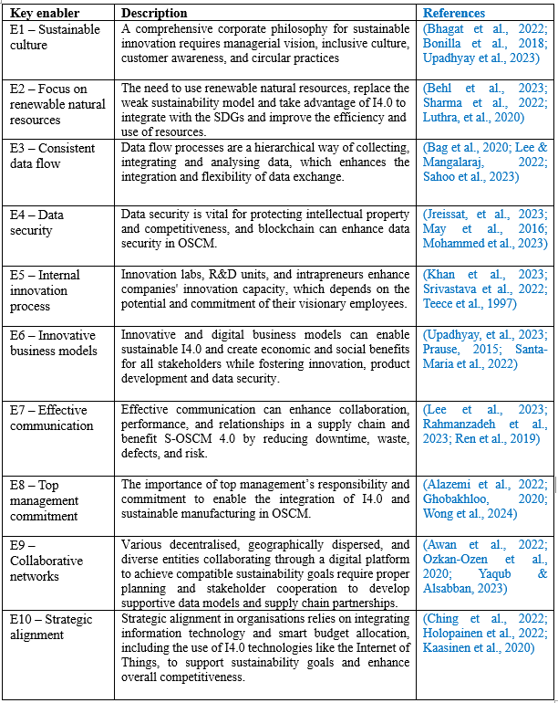

*2.1.2 Benefits to S-OSCM4.0*

The benefits of integrating sustainability and I4.0 in OSCM were identified by Caiado et al. (2022a), through a content analysis of 48 articles that complied with the selection criteria of a systematic review, and comprised energy reduction, lower consumption of resources, sustainable design, increase the production flexibility, shortening of time-to-market cycles, increase the quality of products and services, cost decreasing (or profit improvements), increase job quality, improves workers’ capability, and improve social conditions (e.g. creating employment opportunities for disabled and elderly employees). The benefits of S-OSCM4.0 integration, as shown in Table 2, are aligned with the 2030 agenda, which is considered a plan of action for people, the planet and prosperity.

**Table 2.** Benefits of S-OSCM4.0

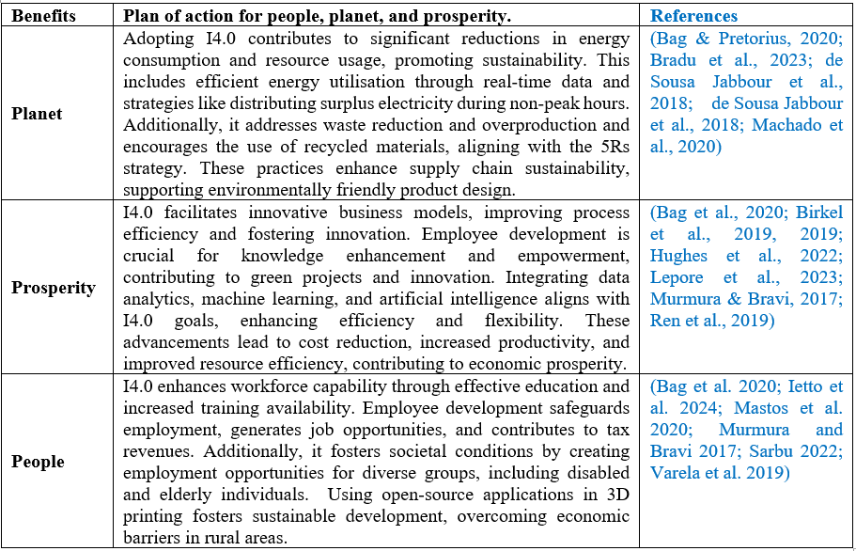

Table 2 reflects the benefits of implementing I4.0, which are aligned with the objectives of Agenda 2030 and is considered a comprehensive action plan for the dimensions of people, planet, and prosperity. On the planetary front, I4.0 shows the potential to significantly reduce energy and resource consumption, emphasising energy efficiency through real-time data and waste reduction through process simulation and the adoption of recycled materials (Machado et al., 2020; Stock et al., 2018). In terms of prosperity, the adoption of digital technologies such as BDA and machine learning is associated with improved efficiency, cost reduction, and increased productivity, thereby contributing to economic development(Elmas et al., 2023; Ghobakhloo, 2020; Kaiser et al., 2022; Li et al., 2020; Pinzone et al., 2020). Concerning people, the integration of I4.0 is linked to enhancing workforce capabilities through effective education, job development, and inclusive employment opportunities, demonstrating a commitment to social and economic sustainability(de Sousa Jabbour et al., 2018).

*2.2 Dynamic Capabilities Theory: Adapting to Radical Discontinuous Change*

The Dynamic Capabilities View emerges as a crucial lens in comprehending a firm's capacity to sense, seize, and transform opportunities, particularly when faced with radical discontinuous change. Kιrcι & Seifert (2015) underscore the essence of DCV in enabling firms to adapt and innovate in response to evolving market conditions. This adaptability is achieved through developing specific routines and strategies(Eisenhardt & Martin, 2000), allowing firms to reconfigure resources and secure a competitive advantage.

In the context of Sustainable I4.0 in supply chain management, DCV takes on added significance as it emphasises the necessity for firms to develop new capabilities to navigate and thrive amidst disruptive changes brought about by I4.0 technologies. Roozbeh Nia et al. (2020) extend DCV's application by proposing a dynamic framework for Sustainable Supply Chain 4.0, integrating technology enablers that become instrumental in addressing discontinuities. Felsberger & Reiner (2020) further explore the impact of I4.0 on the reconciliation of dynamic capabilities, stressing the imperative for firms to strengthen these capabilities continually. The ability to adapt to radical, discontinuous change positions firms to ensure competitiveness within the ever-evolving landscape of Sustainable I4.0.

Recent research emphasises the duality between routines and improvisation (Carvalho, 2023), highlighting the need to balance stability and flexibility to overcome organisational inertia (Keller et al., 2022). Developing dynamic capabilities involves simultaneously renewing multiple competencies (Zeng et al., 2017) and incorporating creative actions (MacLean et al., 2015), which is crucial in rapidly evolving industries like automotive (Kim et al., 2022). This approach has demonstrated its value across various sectors, from media companies facing digital disruptions (Alkaraan et al., 2024; Murschetz et al., 2020) to small businesses in post-disaster environments (Battisti & Deakins, 2017). Recent conceptualisations emphasise dynamic capabilities as regular actions to modify organisational resources, highlighting the role of individual agencies (Kurtmollaiev, 2020; Quayson et al., 2023). Diaz Schery et al. (2024) expand on this by proposing a multilevel framework that integrates incremental, renewing, and regenerative dimensions of the DCV for digital transformation in construction. Existing research on DCV has primarily focused on their development as unified constructs, often overlooking the need to prioritise and balance different capabilities that may be developed separately or jointly, depending on a firm's specific competencies and sustainable goals. This gap underscores the necessity for a more nuanced approach that considers multiple interests and sustainable dimensions, allowing for differentiated prioritisation based on organisational strengths and strategic objectives.

*2.3 Social Exchange Theory: Balancing Trade-Offs in Decision Making*

The Social Exchange Theory is crucial in understanding the behaviour of decision-makers, particularly when individuals must navigate trade-offs. As proposed by (Blau, 1964), SET emphasises the importance of relationships and interactions in creating value. In the context of Sustainable I4.0, SET influences decision-making processes by guiding individuals to weigh benefits and risks systematically. Cutovoi (2020) explore the role of SET in enhancing environmental collaboration and increasing integrations in the remanufactured reverse chain. Lin et al.(2017) provide a comparative analysis of innovation policy in China and Taiwan, shedding light on the different approaches to environmental policy. These studies underscore the importance of considering SET in the context of I4.0 and sustainability and the need for further research in this area.

Influenced by SET, decision-makers engage in a process of first assessing benefits and risks and subsequently striving to maximise the former. Davis-Sramek et al. (2020) highlight the potential for SET to enhance environmental collaboration and integration within the supply chain, emphasising the role of relationships in driving sustainable practices. Bag et al.(2018) underscore the significance of top management support and collaborative platforms aligned with SET principles to drive the sustainability agenda within the supply chain.

From the perspective of S-OSCM4.0, SET becomes instrumental in guiding decision-makers as they navigate the complexities of prioritising enablers and balancing trade-offs in the pursuit of strategic benefits. The interplay between benefits and risks, inherent in SET becomes particularly relevant in the dynamic landscape of Sustainable I4.0, where decision-makers must make informed choices to maximise sustainable outcomes. Decision-makers within organisations often engage in collaborative efforts, where SET plays a pivotal role in shaping relationships and interactions within the group. The emphasis on value creation through relationships, as posited by SET (Blau, 1964), becomes particularly pertinent in group decision-making. Group decision-making introduces a collective dimension to prioritising sustainable benefits within OSCM. Cutovoi (2020) and Davis-Sramek et al. (2020) highlight how SET can foster environmental collaboration and integration within the supply chain, especially when decisions involve multiple stakeholders. The dynamics of group interactions, guided by SET principles, become instrumental in shaping consensus on sustainable practices.

In this context of group decision-making and collaboration in the supply chain, it is pertinent to consider a broader perspective of SET. SET has demonstrated its versatility in various fields, ranging from supply chain management (Holthausen, 2010) to the internationalisation of higher education (Romani-Dias & Carneiro, 2019). Grounded in principles of rationality, self-interest, and interdependence (Stafford & Kuiper, 2021), SET has expanded its reach through integration with neuroscience for studying social decision-making (Sanfey, 2007). Nevertheless, it faces criticism for its lack of theoretical precision, including the overlap of constructs and imprecise predictions (Cropanzano et al., 2017; Cropanzano & Mitchell, 2005). To address these limitations and enhance its explanatory and predictive power, scholars propose expanding the theory by incorporating additional dimensions, such as activity (Cropanzano et al., 2017). This expansion is particularly relevant in the context of S-OSCM4.0, where it is still crucial to prioritize the key enablers, especially in developing economies (Yadav et al., 2020).

*2.4 Integrating Dynamic Capabilities and Social Exchange*

DCV refers to the ability of firms to adapt and innovate in response to changing market conditions(Kodama, 2018), which is achieved through the development of specific routines and strategies that enable the firm to reconfigure its resources and achieve a competitive advantage. On the other hand, the SET emphasises the importance of relationships and interactions in creating value(Blau, 1964). When applied to the dynamic capabilities view, this theory suggests that the development of these capabilities is influenced by the firm's interactions with its stakeholders, such as customers, suppliers, and partners. This can lead to creating collaborative dynamic capabilities, which are essential for building business ecosystems and achieving sustainable growth (Kodama, 2018).

Integrating DCV and the SET is crucial for forming SSCM (Lee et al., 2017) This is particularly relevant in the context of I4.0, where implementing new technologies and processes can significantly impact the sustainability of supply chains(Herbert-Hansen & Pietro, 2017). To develop a sustainable supply chain strategy, managers need to understand and adapt to new sustainability issues, especially in the face of global, international, and fragmented supply chains(Cuthbertson et al., 2011). The concept of a "dynamic on-demand supply chain" can further enhance the capabilities of supply chain leaders, particularly when combined with process improvement frameworks and on-demand technology (Schlegel & Trent, 2014).

Current research delves into its practical application, revealing new dimensions of the interaction between dynamic capabilities and social exchange in the context of I4.0 and supply chain sustainability. The convergence of dynamic capabilities (Teece et al., 1997) and social exchange theory (Blau, 1964; Homans, 1958) within the I4.0 and sustainability framework provides a robust theoretical foundation for OSCM in the digital era. Eisenhardt & Martin (2000) suggest that this synergy allows organisations to proactively anticipate market changes, facilitating agile reconfiguration of competencies and strategic relationship management. This integrated approach positions companies to cultivate sustainable competitive advantages, especially in developing countries, by effectively integrating advanced technologies and sustainable practices in their operations and supply chains.

Recent studies by Davis-Sramek et al. (2022), and Huang et al. (2023) delve deeper into this integration, highlighting the importance of top management commitment and IT infrastructure in the implementation of I4.0 for sustainable development. Mihardjo et al. (2020) emphasise co-creation strategies for digital transformation in supply chains, while Bag & Pretorius (2020) and Sousa Jabbour et al. (2022) indicate how adopting I4.0 technologies can enhance sustainable manufacturing capabilities and circular economy. Sartori et al. (2022) underline the critical role of organisational knowledge management in Supply Chain 4.0, and Zekhnini et al. (2022) show that integrating efficient and green practices can lead to viable, sustainable, and digital supply chain performance. Collectively, these studies emphasise the need for a holistic approach to OSCM, incorporating technological innovation, sustainability, and human-centred strategies in the I4.0 era.

*2.5 The CIMO logic*

The CIMO logic, originally rooted in Bunge's (1967) technological rule and expanded by Pawson and Tilley (1997), can be reinterpreted through the lens of DCV and SET to understand S-OSCM 4.0. In this context, the formula "context + mechanisms = outcomes" takes on a new meaning. The context (C) represents the dynamic technological landscape and complex stakeholder networks in developing countries. Interventions (I) are strategic actions to implement S-OSCM 4.0 enablers. Mechanisms (M) become the firm's ability to sense and seize opportunities, transform assets, and manage sustainable social exchanges within the supply chain. Outcomes (O) are the strategic benefits resulting from these dynamic capabilities and relational strategies. This reframed CIMO logic can be expressed as: "To achieve strategic benefits O in the context of developing countries C, implement S-OSCM 4.0 enablers I that leverage dynamic capabilities and sustainable social exchange mechanisms Y and Z." This approach provides a framework for designing solutions to navigate the complexities of sustainable digital transformation in OSCM.

The CIMO logic, viewed through DCV and SET, offers insights into achieving strategic benefits from S-OSCM 4.0 enablers. Context (C) represents the evolving technological and sustainability landscape in developing countries, including their unique challenges and opportunities (Caiado et al., 2024). Interventions (I) are the implementation of key S-OSCM 4.0 enablers(Bag et al., 2018; Luthra & Mangla, 2018), prioritised based on their potential impact. These interventions activate mechanisms (M) rooted in the firm's ability to reconfigure its capabilities for sustainable operations and manage collaborative relationships across the supply chain. The outcomes (O) are the realised strategic benefits aligned with the 2030 agenda, such as improved operational efficiency, reduced environmental impact, and enhanced stakeholder value(Elmas et al., 2023; Ghobakhloo, 2020; Kaiser et al., 2022; Li et al., 2020; Machado et al., 2024; Pinzone et al., 2020).

This theoretical approach contributes to the literature by applying DCV and SET to understand the enablers and benefits of S-OSCM 4.0, particularly in the context of developing countries. It addresses the need for a configurational framework that can guide organisations in prioritizing and implementing S-OSCM 4.0 enablers. By focusing on dynamic capabilities and sustainable social exchanges, this framework offers insights into how organisations can develop the adaptability and collaborative networks necessary for successful sustainable digital transformation in their operations and supply chains. The resulting decision support framework provides actionable guidance for organisations navigating the complex intersection of Industry 4.0 technologies and sustainability imperatives in OSCM.

*2.6 Conceptual framework*

The ongoing debate within S-OSCM 4.0 has shifted from traditional contingency variables to a more dynamic and relational perspective. This study leverages the DCV and SET to understand the mechanisms enabling S-OSCM 4.0 in developing countries. The DCV guides our exploration of how organisations reconfigure their resources and capabilities to integrate I4.0 technologies sustainably, while SET provides insights into the collaborative relationships necessary for successful implementation across the supply chain.

Inspired by the contextual nature of the CIMO logic, we anticipate that different mechanisms and interventions will produce varied outcomes in different contexts in a developing country(Pfaff, 2023). This expectation guided our sampling strategy, which included experts from different types and sizes of organisations in a developing country. Figure 1 synthesises this paper's approach and offers a theoretical underpinning of the research.

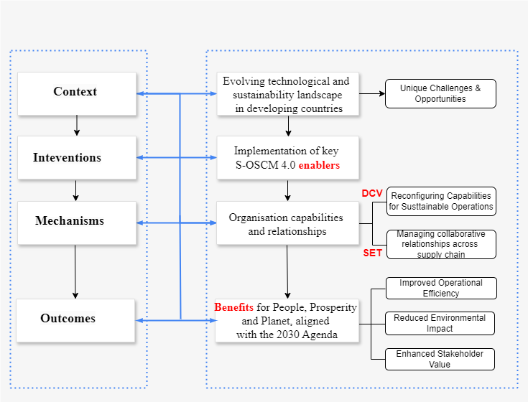

Figure 1: Theoretical underpinning of the research

Combining DCV and SET with the CIMO logic provides a powerful analytical framework for understanding S-OSCM 4.0 enablers and benefits(Lee et al., 2017). This integrated approach informed the selection of our research methodology: a panel of experts analysed through the FAHP and FVIKOR methods. These methods were chosen to identify and prioritise the enablers of S-OSCM 4.0 in selected organisations within developing countries, based on a comprehensive set of enablers derived from the literature.

The analysis of results was guided by the CIMO logic, scrutinising how dynamic capabilities and social exchange mechanisms in different developing country contexts interact to generate interventions resulting in various strategic benefits. This approach allows us to set roadmaps for implementing S-OSCM 4.0 enablers and realising their benefits in alignment with the 2030 agenda.

By integrating DCV and SET with the CIMO logic, our research contributes to the growing body of literature on sustainable digital transformation in OSCM, particularly in the context of developing countries. This theoretical framework enables a nuanced understanding of how organisations can develop the necessary capabilities and relationships to successfully implement S-OSCM 4.0 enablers and achieve strategic benefits.

The next section of this paper provides details on the research methodology adopted, followed by the presentation of results and their discussion in the context of our theoretical framework.

**3. Research Methodology**

The research methodology employs a multimethod approach that combines empirical and conceptual methods to construct a novel artefact(Bueno et al., 2023). This study employed a two-step approach. The first step is theoretical research, directed towards the construction of the conceptual framework that considers the key enablers and benefits of S-OSCM4.0. It builds upon previous studies (Caiado et al., 2022b, 2023) and employs a comprehensive methodology to ensure a robust and thorough exploration of the research topic. The conceptual framework covers the link between the DCV, SET, and CIMO logic to achieve sustainable digitalisation according to the SDGs. This is based on the alignment between I4.0 and sustainability in OSCM. The second step is empirical and consists of developing the decision support framework. This stage seeks the opinion of industry professionals to incorporate suggestions, determine the weights of benefits, and evaluate the criticality of the key enablers to construct the decision support framework. The analysis employed cutting-edge methods in fuzzy multi-criteria decision-making. The integration of the Fuzzy Analytical Hierarchy Process with Fuzzy VIKOR (Višekriterijumska Optimizacija I Kompromisno Rješenje), inspired by the innovative work of Jain et al. (2018), enabled sophisticated prioritisation of key enablers and benefits within the S-OSCM 4.0 framework. This hybrid approach not only addressed the inherent complexity of the topic but also set a new standard in sustainability research in the digital age.

*3.1 Data collection and sample*

This exploratory study employed a triangulated methodology, combining qualitative and quantitative data collection mechanisms to operationalise the research questions and constructs(Yusuf et al., 2013). Triangulation, which involves the use of multiple methods for data gathering, was also implemented. The use of multiple information sources, including content analysis of scientific articles and contributions from the expert panel, strengthens the construct validity of the research (Eisenhardt, 1989). This multifaceted approach provides a more robust and holistic understanding of the studied phenomenon, allowing for triangulation of perspectives and cross-validation of findings.

*3.1.1 Theoretical data*

Systematic literature reviews shown in Caiado et al. (2022a) and Caiado et al. (2023), as the first mechanism of the triangulated methodology, formed the foundation of our research approach. This comprehensive review process was structured to ensure a thorough and unbiased examination of the existing literature on S-OSCM 4.0. The focus was on identifying and prioritising the key enablers (Caiado et al., 2023) and benefits (Caiado et al., 2022a) associated with S-OSCM 4.0. In both reviews the keywords were selected based on previous relevant studies in the field (Kamble et al., 2018; Luthra & Mangla, 2018). These keywords aim to capture the three main concepts of the research, prioritising the key enablers (Caiado et al., 2023) and benefits (Caiado et al., 2022a). Terms such as “Industry 4.0” and “smart manufacturing” were chosen as keywords due to their direct relevance to our research. Smart manufacturing is a key component of I4.0 (Osterrieder et al., 2020), which is the central theme of our study. It encompasses the use of advanced digital technologies to improve manufacturing processes, which aligns with our objective of proposing a framework for integrating sustainability into I4.0. While terms like digital and emerging technologies are related to general technological evolution, their scope is considerably broad (Zhong et al., 2017). These concepts, although relevant, encompass a diverse range of innovations that extend beyond the specific realm of industrial production. In contrast, our focus on smart manufacturing allows us to delve into a more specific and pertinent area of interest, facilitating a detailed analysis of the technologies, methodologies, and systems that are redefining manufacturing in the digital age (Xu et al., 2018).

Additionally, it is crucial to incorporate concepts related to sustainability and the UN's SDGs into our search string (Wackernagel et al., 2017). Although these terms are distinct, they are intrinsically linked within the context of our research. Specifically, sustainability refers to the broader principle of ensuring long-term environmental, social, and economic viability, whereas the UN SDGs provide specific targets and indicators that guide the application of these principles (Bebbington & Unerman, 2018). The inclusion of these terms allows us to explore the intersection of I4.0 technologies with sustainable development practices, a growing area of research interest (Bai et al., 2020). Moreover, this approach enables us to capture studies that investigate how smart manufacturing can contribute to achieving sustainability goals, thus providing a more comprehensive view of the evolving industrial landscape (Ghobakhloo, 2020).

*3.1.2 Empirical data*

Online interviews were conducted using an innovative theoretical sampling approach inspired by the pioneering vision of Gioia et al. (2013). This method, far from static, evolved organically with the accumulation of data, allowing for a deep exploration of the inherent complexities of S-OSCM 4.0. The selection of experts was governed by strict criteria that exceeded traditional conventions. In accordance with the reasoning presented by Bai et al. (2020), we established a minimum requirement of 5 years of experience in sustainability and OSCM, along with a 2-year experience threshold in I4.0. These criteria were further supplemented by a stringent evaluation of the participants’ current relevance in the field and their proactive engagement. This screening process reduced an initial group of 25 candidates to an elite panel of 15 experts, each representing an invaluable source of knowledge at the intersection of sustainability and I4.0. Table 1 provides an overview of the selected experts' profiles, including their experience levels, and areas of expertise.

The interviews, true forums of intellectual exchange, were structured into four strategic segments: professional profile, conceptualization of S-OSCM 4.0, analysis of the qualitative evaluation of enablers and benefits, and analysis of quantitative evaluation of enablers and benefits. The implementation of a fuzzy linguistic scale, inspired by the work of Luthra et al. (2020a) and Caiado et al. (2021), allowed for capturing the subtleties and ambiguities inherent in human judgments in the context of sustainability and digital transformation.

The methodological rigour was reflected in the extended duration of the interviews (30-60 minutes) and the presence of multiple researchers, a strategy supported by Eisenhardt and Graebner (2007) to enhance interpretative robustness. Additionally, following the approach of Dubey et al. (2019), strict independence between interviews was maintained to preserve the authenticity of each expert perspective.

**Table 1.** Professional characteristics of expert panel members

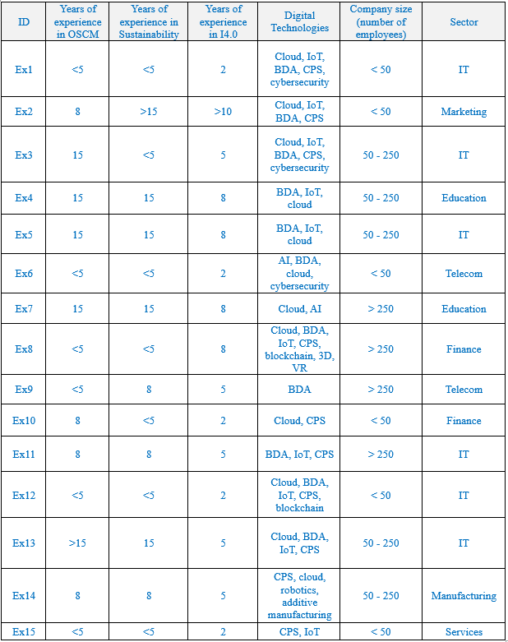

To provide context for these experts' environments, it's important to highlight the diversity and richness of experience represented by the participating professionals in Brazilian organizations. Our analysis encompasses a wide spectrum of sectors, including Information Technologies (IT), finance, telecommunications, education, microbiology, and specialized services. The experts come from a variety of companies, ranging from large banks and telecom operators to small and medium-sized enterprises (SMEs), consultancies, and educational institutions. This diverse group includes entrepreneurs, consultants, IT managers, developers, university professors, and directors, each bringing a unique perspective to the research.

Their commitment to sustainable practices is evidenced by various initiatives, such as electronic waste management, energy efficiency programs, social responsibility projects, and alignment with the UN Sustainable Development Goals. The I4.0 technologies adopted include cloud computing, the Internet of Things (IoT), big data analytics (BDA), cyber-physical systems (CPS), artificial intelligence (AI), and blockchain, among others. This unique combination of sectoral diversity, extensive experience, and dual emphasis on technological advancement and sustainability makes this group ideal for research on S-OSCM4.0, offering valuable insights into how different industries are integrating these concepts into their operations and strategies within the Brazilian business context.

Moreover, 12 of them hold postgraduate academic credentials (MBAs and specialised master's degrees), and the remaining 3 have undergraduate education related to the researched areas. Regarding their professional performance, although the minimum required was 5 years in the company, on average, they have accumulated 11 years in strategic and technical roles, and 9 have previously held managerial positions in the sector. Thus, their education level and extensive tenure in the organisation and industry ensure that this team of experts possesses the skills, practical knowledge, and outstanding background to make highly valuable contributions to the study.

*3.2 Data analysis*

The dynamics of power and dependence play a crucial role in Social Exchange Theory. Within SET, power is conceptualised in terms of resources and their exchanges(Young-Ybarra & Wiersema, 1999). By integrating SET with the Multi-criteria Decision Making (MCDM/A) approach, the relevance of these dynamics becomes evident. According to Young-Ybarra and Wiersema (1999), in SET, power and resulting dependence enable the exploitation of some individuals by others. Similarly, in MCDM/A, certain criteria may wield greater power and influence over the final decision due to their relative importance, akin to a partner with valuable and scarce resources. However, this situation may lead to an excessive dependence on that criterion, potentially biasing the decision, much like dependence on a powerful partner can negatively impact a social exchange relationship. Thus, by unifying SET and MCDM/A, the analysis of the underlying dynamics of power and dependence becomes crucial for a comprehensive understanding of fair and robust multi-criteria decision-making.

*3.2.1 MCDM/A approaches*

The MCDM/A method is a crucial problem-solving approach that integrates quantitative and qualitative analyses across various criteria(Sitorus et al., 2019). According to Roy (1996), the MCDM can be applied to four types of problems: I. Choice problem: defining the best option or action in a series of alternatives; II. Classification problem: to allocate each of the options in previously established categories, according to common characteristics that you want to group them for decision making; III. Ordering problem: ranks the alternatives in a descending preference ranking; IV. Description problem: helps decision-makers to systematically evaluate alternatives, comparison criteria and consequences of their actions.

The study employs group decision-making approaches, including the fuzzy Analytical Hierarchy Process (FAHP) and fuzzy VlseKriterijumska Optimizacija I Kompromisno Resenje (FVIKOR). These methods were carefully selected to align with the research objective of prioritising key enablers and benefits within the complex, multi-stakeholder context of S-OSCM4.0. FAHP, integrating traditional AHP and fuzzy theory, is utilised to determine the weight values for sustainable development (SD) benefits through expert interviews(Hsu et al., 2010). This method was chosen for its ability to handle the inherent uncertainty and vagueness in human judgments when dealing with complex sustainability issues (Govindan et al., 2013). FAHP's hierarchical structure aligns well with the multi-tiered nature of sustainability benefits in S-OSCM4.0, allowing for a systematic decomposition of the problem (Luthra et al., 2017). Additionally, FVIKOR, applied with input from 15 experts, addresses ranking problems in supply chain management (SCM) and sustainability (Rostamzadeh et al., 2015). FVIKOR was selected for its ability to provide compromise solutions in complex multi-criteria scenarios, which is particularly relevant in balancing the often conflicting objectives of sustainability and operational efficiency in Industry 4.0 contexts (Mardani et al., 2016). Its focus on ranking alternatives aligns with our objective of prioritizing key enablers.

Notably, both AHP and VIKOR incorporate fuzzy set theory to reduce subjectivity in the applications of FAHP and FVIKOR(Cunha et al., 2021). This integration of fuzzy logic addresses the research objective of managing uncertainty in expert judgments, a critical aspect when dealing with emerging and complex fields like S-OSCM4.0 (Zavadskas et al., 2014). The combination of FAHP and FVIKOR in a hybrid approach offers several advantages that align with our research objectives. Firstly, it allows for a comprehensive evaluation that captures both the hierarchical nature of sustainability benefits (through FAHP) and the nuanced ranking of enablers (through FVIKOR). Secondly, this hybrid method enhances the robustness of the decision-making process by incorporating multiple perspectives and dealing with the inherent fuzziness of sustainability assessments(Wang et al., 2021). Lastly, integrating these methods facilitates a more holistic understanding of the interrelationships between enablers and benefits in S-OSCM4.0, supporting our aim to develop a comprehensive framework (Padhi et al., 2018).

The following sections describe the methods and their steps. These analyses were performed with R software(Team, 2021).

* + 1. *Fuzzy AHP*

Analytic Hierarchy Process (AHP) is one of the most used MCDM methods in literature(da Cruz et al., 2022; de Paula Vidal et al., 2022; Vidal et al., 2020; Yang et al., 2017) due to its attractive resources, such as the possibility to evaluate the consistency of the decision problem. However, this approach has shortcomings related to the use of an unbalanced judgment scale that is often imprecise and subjective(Sun, 2010). These can be improved through the combination of AHP with fuzzy logic(Zadeh, 1965, 1972), known as FAHP. In this study, FAHP was used due to its well-organised approach for determining the criteria weights and for the justification of multi-criteria group decision-making problems using fuzzy set theory(Cunha et al., 2021). The FAHP was composed of five steps as follows:

1. *Determining the criteria and establishing a hierarchical structure.*

The first step of the FAHP consists of defining the criteria and organising them in a hierarchical structure, the established criteria and the alternatives that need to be ranked(Rezaie et al., 2014).

1. *Collecting expert judgments in fuzzy parity comparison matrices (PCM).*

The second step consists of establishing the pairwise comparisons between the criteria by decision-makers, following the fuzzified Saaty fundamental scale (Saaty, 1982). The evaluation is performed on linguistic variables, which are associated with triangular fuzzy numbers (TFNs), and the evaluations are therefore converted into three parity comparison matrices (PCMs). Table 3 represents each linguistic variable with their respective positive and negative TFNs.

**Table 3.** Triangular fuzzy numbers

Source: Chiou et al.(2012)

The three evaluations are then aggregated into a single PCM, using the geometric mean method proposed by Buckley(1984) as illustrated in:

|  |  |  |
| --- | --- | --- |
|  | $${\tilde{a}}_{i,j}={({\tilde{a}}_{i,j}^{1}⊗{\tilde{a}}_{i,j}^{2}⊗{\tilde{a}}_{i,j}^{3})}^{1/3}$$ | **(1)** |

1. *Calculation of consistency ratio (CR).*

In the third step, the consistency of the judgments made is evaluated. To calculate the consistency of the FAHP, the method proposed by (Gogus & Boucher, 1998) was used, which consists of calculating two CRs, one with the mean values of each TFN (component m) and the other with the geometric mean of the smaller and larger values (l and u components). Firstly, the method consists of forming two new PCMs, one of which we call $A^{m}$, formed by the mean values of the aggregate matrix and the second we call $A^{g}$ and will be formed by the geometric mean of the smallest and largest values. The next process follows the Saaty method for crisp numbers, in which for each of the matrices the weight vectors or eigenvectors $w^{m}$ and $w^{g}$ are calculated, according to:

|  |  |  |
| --- | --- | --- |
|  | $w^{m}=\left[w_{i}^{m}\right]$ where $w_{i}^{m}=1/n×\sum_{j=1}^{n}{\frac{a_{i,j,m}}{\sum_{i=1}^{n}{a_{i,j,m}}}}$ $w^{g}=\left[w_{i}^{g}\right]$ where $w_{i}^{g}=1/n×\sum_{j=1}^{n}{\frac{{\left(a_{i,j,u}×a_{i,j,l}\right)}^{1/2}}{\sum_{i=1}^{n}{{(a}_{i,j,u}×}a_{i,j,l)}}}$ | **(2)** |

From the weight vectors, the mean eigenvalue of each of the matrices is calculated, according to:

|  |  |  |
| --- | --- | --- |
|  | $$λ_{med}^{m}=1/n×\sum_{i=1}^{n}{\sum_{j=1}^{n}{a_{i,j,m}×\left(w_{j}^{m}/w_{i}^{m}\right)}}$$ $$λ_{med}^{g}=1/n×\sum_{i=1}^{n}{\sum_{j=1}^{n}{{\left(a_{i,j,u}×a_{i,j,l}\right)}^{1/2}×\left(w_{j}^{g}/w_{i}^{g}\right)}}$$ | **(3)** |

Following the procedure, the next step is to calculate the consistency indices (CI) from:

|  |  |  |
| --- | --- | --- |
|  | $${CI}^{m}=\frac{\left(λ_{med}^{m}-n\right)}{\left(n-1\right)}$$ $${CI}^{g}=\frac{\left(λ_{med}^{g}-n\right)}{\left(n-1\right)}$$ | **(4)** |

Then, to calculate the consistency ratio (CR), the CI is divided by the random index (RI). Gogus & Boucher (1998) developed an RI table as a function of the matrix size, that is, the number of criteria used, illustrated in Table 4.

**Table 4.** Random indexes (RI)

Source: Adapted from (Gogus & Boucher, 1998)

1. *Calculation of fuzzy weights*

The fourth step of the FAHP is to define the fuzzy weights of each criterion in the TFN format, which is denoted by (*l,m,u*), where *l* corresponds to the smallest possible value, *m* the most probable value and *u* the largest possible value. For the calculation, the geometric mean method of Buckley(1984) is used, represented by the following equations, where ${\tilde{w}}_{i}$ represents the fuzzy weight of criterion i.

|  |  |  |
| --- | --- | --- |
|  | $${\tilde{r}}_{i}={\left[{\tilde{a}}_{i,1}⊗⋯⊗{\tilde{a}}_{i,j}⊗⋯⊗{\tilde{a}}_{i,n}\right]}^{1/n}$$ $${\tilde{w}}_{i}={{\tilde{r}}_{i}⊗\left[{\tilde{r}}_{1}⊕⋯⊕{\tilde{r}}_{i}⊕⋯⊕{\tilde{r}}_{n}\right]}^{-1}$$ | **(5)** |

1. *PCM defuzzification and calculation of crisp weights*

In the fifth step, the fuzzy weights are converted to crisp numbers. For this, the Center of Area (COA) method was used. First, the crisp weights are calculated by the COA method, and then, the normalised weights of each criterion are calculated (Kilic et al., 2014).

|  |  |  |
| --- | --- | --- |
|  | $$M_{i}=\frac{{lw}_{i}+{mw}_{i}+{uw}_{i}}{3}$$ $${\tilde{N}}_{i}=\frac{M_{i}}{\sum_{i=1}^{n}{M_{i}}}$$ | **(6)** |

This section presents a fuzzy extension of VIKOR that is based on the methodology proposed by (Opricovic, 2011), which uses triangular fuzzy numbers (TFN) to solve a discrete fuzzy multi-criteria problem with non-commensurable and conflicting criteria (Serafim Opricovic, 2011). Thus, the FMCDM/A linguistic terms are utilised to calculate that vagueness with ratings. The steps of the procedure proposed are (Papathanasiou & Ploskas, 2018):

1. *Identify the Objectives of the Decision-Making Process and Define the Problem Scope* In this step, the decision goals and the scope of the problem are defined. In this step, the objective is to evaluate the key enablers regarding the criteria.
2. *Arrange the Decision Making Group and Define and Describe a Finite Set of Relevant Attributes.* In this step, a group of decision-makers is formed to identify the criteria and their evaluation scales. In this study, there are three criteria, ten sub-criteria and ten different alternatives.
3. *Identify the Appropriate Linguistic Variables.* In this step,the appropriate linguistic variables for the ratings of alternatives concerning the criteria are chosen. The decision-makers used TFN linguistic variables shown in Table 5 to evaluate the ratings of alternatives concerning qualitative criteria.

**Table 5.** The correspondence of linguistic terms and values. (FVIKOR)

1. *Pull the Decision Makers’ Opinions to Get the Aggregated Fuzzy Weight of Criteria and Aggregated Fuzzy Rating of Alternatives, and Construct a Fuzzy Decision Matrix.* The aggregated fuzzy ratings $({\tilde{x}}_{ij}$) of alternatives with respect to each criterion can be calculated as:

${\tilde{x}}_{ij}=\left(x_{ij1},{ x}_{ij2},{ x}_{ij3}\right)$**(7)**

Where

$x_{ij1}= \min_{k}\left\{x_{ijk1}\right\}$, $x_{ij2}= \frac{1}{K}\sum_{k=1}^{K}{x_{ijk2}}$, $x_{ij3}= \max_{k}\left\{x_{ijk3}\right\}$

The problem can be concisely expressed in matrix format as follows:

$\tilde{D}=\begin{matrix}{\tilde{x}}_{11} & {\tilde{x}}_{12}…. & {\tilde{x}}_{1n} \\ {\tilde{x}}_{21} & {\tilde{x}}_{22}…. & {\tilde{x}}_{2n} \\ {\tilde{x}}_{m1} & {\tilde{x}}_{m2}…. & {\tilde{x}}_{mn}\end{matrix}$**(8)**

And the vector of the criteria as:

$\tilde{W}=\left[{\tilde{w}}_{1},{\tilde{w}}_{2},…..{\tilde{w}}_{n}\right]$**(9)**

Where ${\tilde{x}}_{ij}$ and ${\tilde{w}}_{j}$, $i=1,2, ⋯,m, j=1,2,⋯, n$, are linguistic variables according to the third step and can be approximated by TFN:

1. *Defuzzify the Fuzzy Decision Matrix and Fuzzy Weight of Each Criterion into Crisp Values* In this step, there is the Deffuzzification of the fuzzy decision matrix into crisp values using COA defuzzification relation.
2. *Determine the Best and the Worst Values of All Criteria Functions.*

Determine the best $f_{j}^{*}$ and the worst $f_{j}^{-}$ values of all the criteria functions

$f_{j}^{*}=\max_{i}f_{ij}, f_{j}^{-}=\min_{i}f_{ij}, i=1,2,…,m,j=1,2,…,n$**(10)**

If the jth function is to be maximised (benefit) and

$f_{j}^{*}=\min_{i}f_{ij}, f_{j}^{-}=\max_{i}f_{ij}, i=1,2,…,m,j=1,2,…,n$**(11)**

If the jth function is to be minimised (cost).

1. *Compute the Values Si and Ri.* Compute the values *Si* and *Ri* by the relations

$S_{i}=\sum_{j=1}^{n}{w_{i}}\frac{\left(f_{j}^{*}-f_{ij}\right)}{\left(f_{j}^{*}-f_{j}^{-}\right)},i=1,2….,m,j=1,2,…..,n$**(12)**

$$R_{i}=\max_{i}\left[w_{j}\frac{\left(f_{j}^{*}-f_{ij}\right)}{\left(f_{j}^{*}-f_{j}^{-}\right)},i=1,2….,m,j=1,2,…..,n\right]$$

1. *Compute the Values Qi.* Compute the *values* *Qi* by the relation

$Q_{i}=v\frac{\left(S_{i}-S^{*}\right)}{S^{-}-S^{*}}+\left(1-v\right)\frac{\left(R_{i}-R^{*}\right)}{R^{-}-R^{*}},i=1,2….,m$**(13)**

Where $S^{*}= \min_{i}S_{i}$; $S^{-}= \max_{i}S_{i}$; $R^{*}= \min_{i}R_{i}$; $R^{-}= \max_{i}R_{i}$; and $υ$ is introduced as a weight for the strategy of the “maximum group utility”, whereas $1-υ$ is the weight of the individual regret.

1. Rank the Alternatives. Rank the alternatives, sorted by the values S, R, and Q in ascending order. The results are three ranking lists.
2. *Propose a Compromise Solution* Propose as a compromise solution the alternative [$A^{(1)}$], which is the best ranked by the measure *Q* (minimum) if the following two conditions are satisfied:

C1 - Acceptable advantage:

$Q\left(A^{(2)}\right)-Q\left(A^{\left(1\right)}\right)≥DQ$**(14)**

Where $A^{(2)}$ is the second-ranked alternative by the measure Q and $DQ= 1/{(m-1)}$

C2 - Acceptable stability in decision-making:

The alternative *A(*1*)* must also be the best ranked by *S* and/or *R*. This compromise solution is stable within a decision-making process, which could be the strategy of maximum group utility (*v >* 0*.*5), or “by consensus” (*v* ≈ 0*.*5), or “with veto” (*v <* 0*.*5). If one of the conditions is not satisfied, then a set of compromise solutions is proposed, which consists of:

* Alternatives $A^{(1)}$ and $A^{(2)}$ if only the condition C2 is not satisfied, or
* Alternatives $A^{(1)}$, $A^{(2)}$, $⋯$, $A^{(l)}$ if the condition C1 is not satisfied; $A^{(l)}$ is determined by the relation $QA^{(l)}- {QA}^{\left(l\right)} <DQ$ for the maximum $l$ (the positions of these alternatives are “in closeness”).

**4. Results and Discussion**

This section presents the findings of the analysis of the qualitative (insights) and quantitative (prioritization and ranking) evaluation of enablers and benefits, as well as A configurational Framework to achieve strategic benefits from Sustainable Industry 4.0 enablers in OSCM, and a CIMO-driven roadmap to implement Sustainable I4.0.

*4.1 Empirical insights from qualitative data*

The qualitative data collected from interviews allowed us to identify some insights regarding the inter-relationships between enablers and benefits. Firstly, the emphasis on sustainable culture and renewable natural resources emerges as foundational in modern organisational strategies. A sustainable culture and a focus on renewable resources significantly influence elements such as innovative business models and internal innovation processes. Integrating sustainable practices and resource management into the core organisational philosophy is essential for fostering innovation and resilience. The high impact of sustainable culture and renewable resources on energy consumption, resource consumption, and sustainable design highlights their crucial role in driving environmental benefits. Moreover, closed-loop systems, which focus on recycling, reusing, and reducing waste, align perfectly with a sustainable culture. These systems contribute significantly to reducing resource consumption and enhancing overall sustainability.

Data security and consistent data flow are key enablers for effective communication and strategic alignment. Secure and reliable data management underpins effective communication channels and the alignment of strategic goals across the organization. This highlights the importance of robust IT infrastructure and data governance policies to facilitate seamless information exchange and coordination. For instance, Blockchain, with its decentralised ledger, offers enhanced data security, ensuring that information remains tamper-proof and transparent, thus mitigating risks associated with data breaches. This is crucial for improving operational efficiency and profitability by safeguarding sensitive data and ensuring reliable information flow.

Internal innovation processes and innovative business models are pivotal across various benefits. Fostering an innovative environment internally enhances performance across energy efficiency, resource management, and profitability. Innovative business models that incorporate circular principles not only drive profitability but also contribute to sustainability, although their impact on flexibility and job quality may require more targeted strategies to directly enhance operational flexibility and workforce engagement.

Top management commitment and collaborative networks play a crucial role in implementing sustainable and innovative practices. Commitment from top management provides the necessary leadership and resources, while collaborative networks offer diverse perspectives and shared knowledge, driving effective implementation and continuous improvement. Top management commitment is vital for ensuring high quality and profitability, indicating its essential role in supporting sustainable and innovative practices.

Strategic alignment and effective communication are high to very high enablers for most benefits. Aligning organisational strategies with market demands and internal capabilities is essential for achieving high-quality, profit, and timely market responses. Effective communication ensures that organisational efforts are well-coordinated to achieve strategic goals. For instance, by providing a transparent and secure communication platform, Blockchain enhances strategic alignment by ensuring that all stakeholders have access to accurate and up-to-date information. Both factors highlight the importance of aligning internal processes and communication channels with broader organisational strategies to achieve superior outcomes.

Lastly, collaborative networks show moderate to high influence, particularly in enhancing workforce capability and societal conditions. Partnerships and external collaborations play vital roles in driving societal benefits and enhancing the overall capability of the workforce. While external partnerships are essential, they must be strategically integrated with internal processes to maximise their effectiveness.

Hence, the combined analysis of organisational factors and their impacts on benefits reveals that sustainable practices and innovation are central to achieving comprehensive benefits across environmental, operational, and societal dimensions. Robust data management and security are critical for operational efficiency and quality, while effective communication and top management support are indispensable for fostering an environment conducive to innovation and sustainability. Strategic alignment and collaborative networks further complement these enablers, ensuring that the organisation’s strategies are well-integrated and supported by both internal and external stakeholders. This holistic approach enables organisations to adapt and thrive in a rapidly evolving market landscape.

*4.2 Empirical findings: prioritisation and ranking*

To evaluate the criticality of deploying these 10 key enablers, there was also the need to prioritise the ten sustainable development benefits accomplished by the S-OSCM4.0 implementation. To resolve the clarity and vagueness of human thinking (compared with AHP), FAHP was used by adopting the column geometric mean method(Buckley, 1984). FAHP involves steps of establishing fuzzy linguistics, defuzzification, and normalisation. The resulting integrated fuzzy-weighted decision matrices are shown in Table 8. All CR (CRm and CRg) values were lower than 0.1; thus, all the judgments are considered consistent, representing the accuracy of the results of the group of respondents interviewed.

**Table 8.** Integrated Fuzzy Comparison Matrix

Table 8 indicates that the experts were most concerned with the Planet's benefits. The maximum weight obtained by combining global priority is the Planet aspect (0.399) through FAHP, and secondly are the People aspect (0.323) and Prosperity aspect (0.278). Within the “Planet” dimension, experts were most concerned with Energy consumption. Within the “People” dimension, the Society conditions was the most important. Within the “Prosperity” dimension, experts were most concerned with Quality.

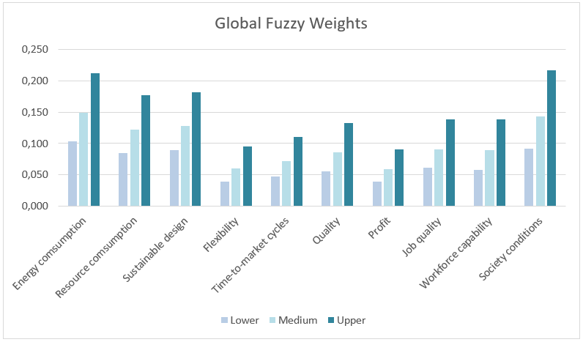

**Figure 1.** Global fuzzy weights

The results illustrated in Figure 1 indicate that the sequence of the four benefits with the highest weights of all the SD benefits of S-OSCM4.0 were Energy consumption, Society conditions, Sustainable design, and Resource consumption. The total weight for these four benefits was 0.5405. The least important items among the factors considered by experts when prioritising benefits were “Quality”, “Time-to-market cycles”, “Flexibility”, and “Profit”. The total weight for these four aspects was 0.2847, as illustrated in Table 9.

**Table 9.** Evaluation of benefits weights using FAHP with ten experts (Buckley’s method)

After applying FAHP to determine the weights for the benefits that are the criteria and subcriteria, this study also considered the uncertainty to explore the level of impact of the key enablers to achieve the benefits. Thus, in this section, a hybrid FMCDM/A method - combining fuzzy weights of FAHP and the performance of the ten key enablers in relation to the benefits through FVIKOR – was proposed, as illustrated in Figure 2. This application had the participation of five more experts in addition to the ten who participated in the interviews in the previous round, totalling a panel of 15 respondents. This proposed hybrid method can allow decision analysts to better understand the entire assessment process and provide a more accurate and systematic decision support tool(Sun, 2010).

.

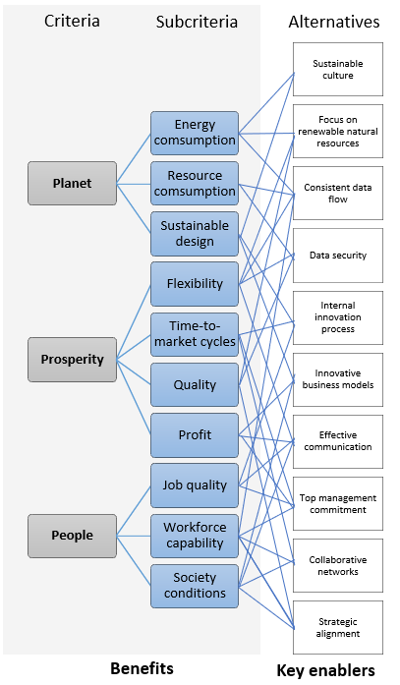

**Figure 2.** Hierarchy of benefits x key enablers

The integration of Fuzzy set theory(Zadeh, 1965) with VIKOR, a compensatory MCDM method that focuses on ranking and sorting a set of alternatives against various decision criteria, aims to resolve the lack of precision in the evaluation (Opricovic, 2011) of the key enablers against the benefits weighted previously. Unlike TOPSIS, VIKOR introduces the ranking index based on the particular measure of closeness to the ideal solution and uses linear normalisation to eliminate units of criterion functions (Cunha et al., 2021). The most considerable advantage of the VIKOR technique consists of its capacity to obtain a “*compromise solution with the maximum group utility of a majority whilst maintaining a minimum of an individual regret for the opponent*” (Opricovic & Tzeng, 2004). Table 10 exemplifies the assessment of one of the fifteen decision-makers.

**Table 10.** Criticality of key enablers (one expert’s rating is given as an example)

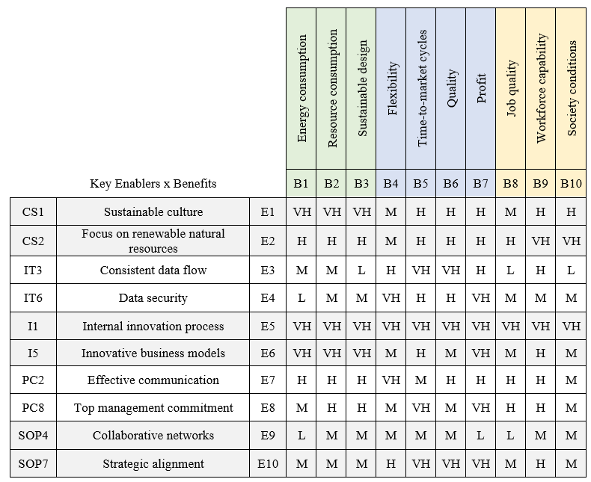

Table 11 presents the aggregated fuzzy values of expert rates and subjective importance weights obtained through this Fuzzy MCDM method.

**Table 11.** Integrated Matrix (FAHP-FVIKOR) and the best and the worst fuzzy values

Then, Table 12 presents the fuzzified results, which include the maximum group utility (*Si*, “majority”), the minimum of the individual regret (*Ri*) of the “opponent”, and the strategy parameter (*Qi*). This study used the constant value as $ν=0,5$, which implies *consensus* among decision-makers, decreasing the discrepancy among decision-makers (Tian et al., 2019)

**Table 12.** The fuzzy values of S, R and Q for each key enabler (FVIKOR)

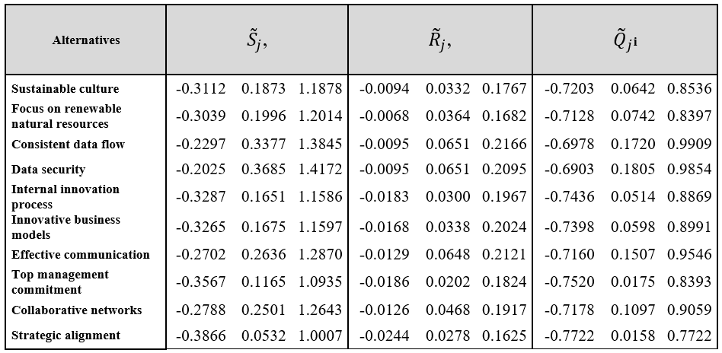

Crisp values (by defuzzification) of ${\tilde{S}}_{j}$, ${\tilde{R}}_{j}$, ${\tilde{Q}}_{j}$, j = 1, 2, …, J are presented in Table 13. Ranking by crisp values are ${\left\{A\right\}}_{S}=A10, A8, A5, A6, A1, A2, A9, A7, A3, A4; {\left\{A\right\}}_{R}=A10, A8, A2, A1, A5, A6, A9, A7, A4, A3;{ \left\{A\right\}}_{Q}=A10, A8, A5, A1, A2, A6, A9, A7, A3, A4.$ Thus, considering DQ = 0.1111, the compromise solution is $A10,$ which is: Strategic alignment, satisfying the two conditions (acceptable advantage and stability in decision-making).

**Table 13**. The defuzzified values of S, R and Q for each key enabler

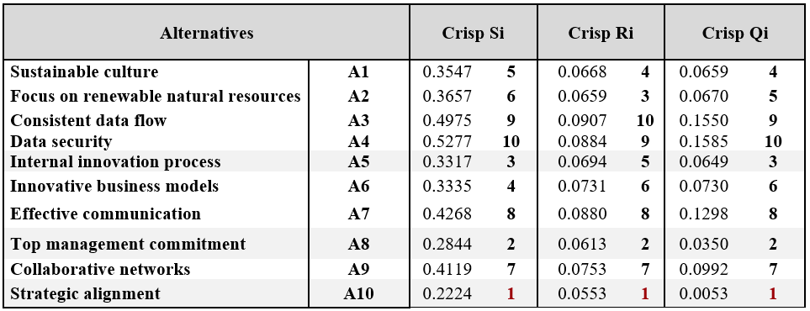

As can be seen from the results shown in Table 13, strategic alignment is the most relevant enabler, followed closely by Top management commitment. Although all enablers should be leveraged for S-OSCM 4.0, it is clear that without a supporting managerial strategy, this can prove to be a difficult task.

*4.3 Framework proposal and discussion*

Recent studies indicate that adopting I4.0 significantly impacts the sustainability aspects of supply chain networks(Meng et al., 2018). Core companies in the supply chain need to develop dynamic capabilities to innovate and meet the changing demands of I4.0, leading to sustainability. However, given power dynamics and dependencies, new technologies must be integrated and implemented ethically and equitably without exploiting or harming weaker participants in the chain. In other words, the innovation and agility emphasised by dynamic capabilities must be balanced with an MCDM/A approach that considers the needs and interests of multiple stakeholders, considering underlying power relationships, for robust and fair decision-making. This is an essential consideration to ensure that the transition to I4.0 is inclusive and beneficial for all participants in the supply chain. Thus, a framework for S-OSCM4.0 has been proposed, enabling organisations to achieve sustainability and I4.0 in line with the 2030 Agenda. This framework is an innovative tool that highlights the potential contributions of S-OSCM4.0 to the SDGs.

The proposed S-OSCM4.0 framework focuses on integrating sustainability across company operations and the supply chain. In our framework, we integrate sustainability into I4.0 by aligning the key enablers and benefits with the relevant SDGs. This approach allows us to demonstrate how I4.0 can contribute to achieving the 2030 Agenda, particularly in the context of developing countries like Brazil. This approach aligns organisational strategy to benefit people, the planet, society and customers through quality employment, social conditions, flexibility, reduced time to market and sustainable practices. The framework facilitates collaboration to drive innovation and effective communication in line with the 2030 Agenda. A key aspect is the decision support model connecting benefits and enablers. This framework built on expert input has versatile applications, providing unique results based on each company's context. As stated, there is no one-size-fits-all measurement system - organisational acceptance matters. Strategic Alignment and Top Management Commitment are two vital enablers to incorporate I4.0 and sustainability. This underscores that sustainable organisations strategically design operations and supply chains. It also shows the crucial role of the leading company in developing the chain and disseminating innovations across the ecosystem. In addition, dynamic capabilities are critical to address changing demands and reconfigure competencies amid disruption. By identifying changes, like the evolving technological landscape, and opportunities to innovate (sensing dimension of DCV), companies can exploit these opportunities, for instance, leveraging the enablers (seizing dimension of DCV), making the necessary adaptations to its resources and processes (reconfiguring dimension of DCV). This leads to perceived benefits in both economic and social exchange relationships, like improved operational efficiency (economic) and increased stakeholder value (socioenvironmental). This, in turn, aligns with the 2030 Agenda and the broader concept of the sustainability tripod. By integrating key digital technologies into operations and collaborating across the value chain, companies can enhance access to information and environmental practices (Caiado et al., 2024b). Core strategy links sustainability to supply chain digitisation. The framework synthesises DCV and SET to develop adaptive, mutually beneficial partnerships that effectively balance trade-offs in pursuing sustainable transformation.

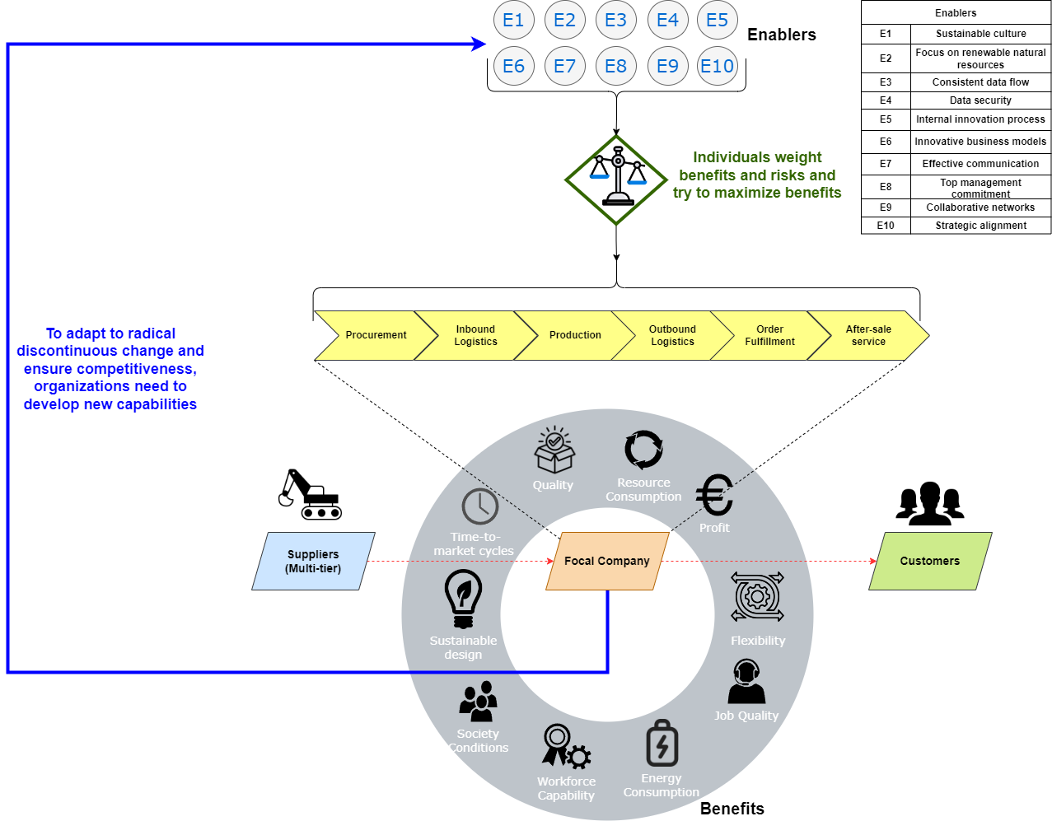

**Figure 3.** A configurational Framework to achieve strategic benefits from Sustainable Industry 4.0 enablers in Operations and Supply Chain.

The proposed framework highlights the relations between the value chain and the enablers and benefits of S-OSCM 4.0. Organisations strive to optimise their advantages, including sustainable outcomes, by harnessing the power of I4.0 enablers. This not only leads to the preservation and enhancement of existing enablers but also fosters the development of new ones, all of which are derived from these sustainable benefits. This process forms a virtuous cycle of continuous improvement towards achieving Sustainable I4.0 benefits. On the other hand, suppliers and customers, e.g., the ends of the value chain can also reap the benefits such as better job quality and more flexibility.

The framework establishes a scientific connection between I4.0 and sustainability, offering a global vision emphasising inclusive and sustainable digital transformation for the industry(Govindan et al., 2018). The focus is not solely on the positive impact I4.0 may have on sustainable development but also the concrete implementation of technologies and critical factors within I4.0 as a platform for achieving the SDGs (Beier et al., 2020). This approach aims to shape OSCM so that organisations can balance operational excellence in production and services while upholding commitments to environmental concerns and social justice. Thus, this artefact contributes to the ongoing discourse on digitally activated sustainable operations and supply chains by presenting an S-OSCM4.0 framework.

Methodologically, this research also introduces a decision support model for enhancing sustainable digitalisation in OSCM. The model, utilising a hybrid MCDM/A tool, evaluates enablers. These enablers are prioritised to achieve SD benefits aligned with the 2030 agenda, emphasising I4.0 technologies. The study illustrates how I4.0 and its technologies contribute to various sustainability dimensions. The decision support framework aids in continuous improvement by defining priority actions for incremental progress in implementing S-OSCM4.0. This research addresses the need for sustainable performance measures aligned with the I4.0 principles. The objective is to provide comprehensive support for decision-making, considering economic, environmental, and social dimensions of sustainability. The proposed decision support framework is suggested to be of interest to governments and public organisations due to their pivotal role in investment, legislation, and management of sustainable performance. The S-OSCM4.0 framework could be facilitated by government initiatives, promoting the adoption of sustainable strategies in both public and private sectors.

The synthesis of DCV and SET within the S-OSCM4.0 framework represents a strategic convergence that goes beyond mere theoretical integration. The dynamic capabilities developed under the influence of DCV enable firms to adapt and innovate in response to radical discontinuous changes, securing competitiveness. Simultaneously, SET guides decision-makers in the complex landscape of Sustainable I4.0, ensuring that relationships and interactions are leveraged to balance trade-offs effectively.

The configurational aspect of S-OSCM4.0 is designed to harness the synergies between these theories, offering decision support that aligns benefits with risks in the pursuit of sustainable digital transformation. This framework not only provides substantive insights into the interplay of DCV and SET in Sustainable I4.0 but also offers actionable guidance for organisations navigating the intricate dynamics of OSCM.

Therefore, the convergence of SET, group decision-making, and MCDM/A in the prioritisation of Sustainable I4.0 benefits and key enablers offers a comprehensive approach to decision support within OSCM. SET influences the relationships and interactions within the decision-making group, fostering a collaborative environment. This collaborative context, in turn, aligns with group decision-making dynamics, where collective wisdom shapes the prioritisation process. MCDM/A methods serve as the systematic structure through which the complexities of Sustainable I4.0 are unravelled. Considering multiple criteria and perspectives, these methods provide decision-makers with a structured approach to weigh the importance of key enablers and benefits. The group decision-making environment, underpinned by SET, becomes enriched through the systematic application of MCDM/A, ensuring a multiperspective view in the decision-making process. In the context of S-OSCM4.0, the synthesis of SET, group decision-making, and MCDM/A creates a robust foundation for prioritising key enablers that drive sustainable benefits within OSCM. The resulting decision support framework not only captures the intricacies of individual and collective decision-making but also aligns with the multifaceted nature of Sustainable I4.0, offering organisations actionable insights and a strategic roadmap for navigating the dynamic landscape of OSCM. It is a managerial artefact that helps organisations to achieve benefits aligned with the 2030 Agenda. Specifically, the benefits perceived for the Planet, Prosperity and People that arise as outcomes of the framework align with the SDGs, as shown in Table 14. Lastly, the CIMO logic to attain the configurational framework can be restructured as a roadmap departing from the Context to reap the benefits as Outcomes. The redesigned CIMO incorporating this logic is shown in Figure 4.

**Table 14**. Summary of benefits aligned with the 2030 Agenda

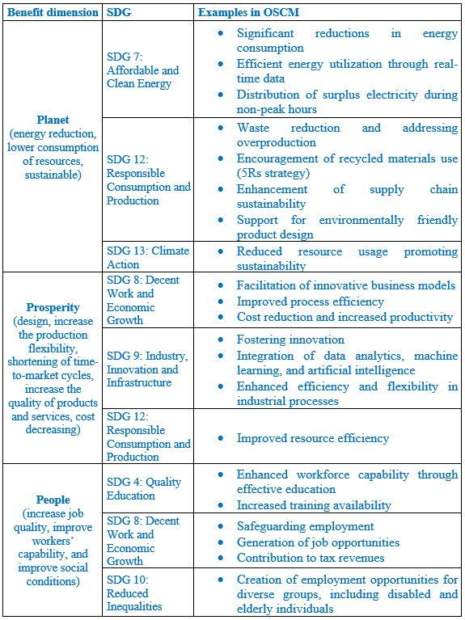

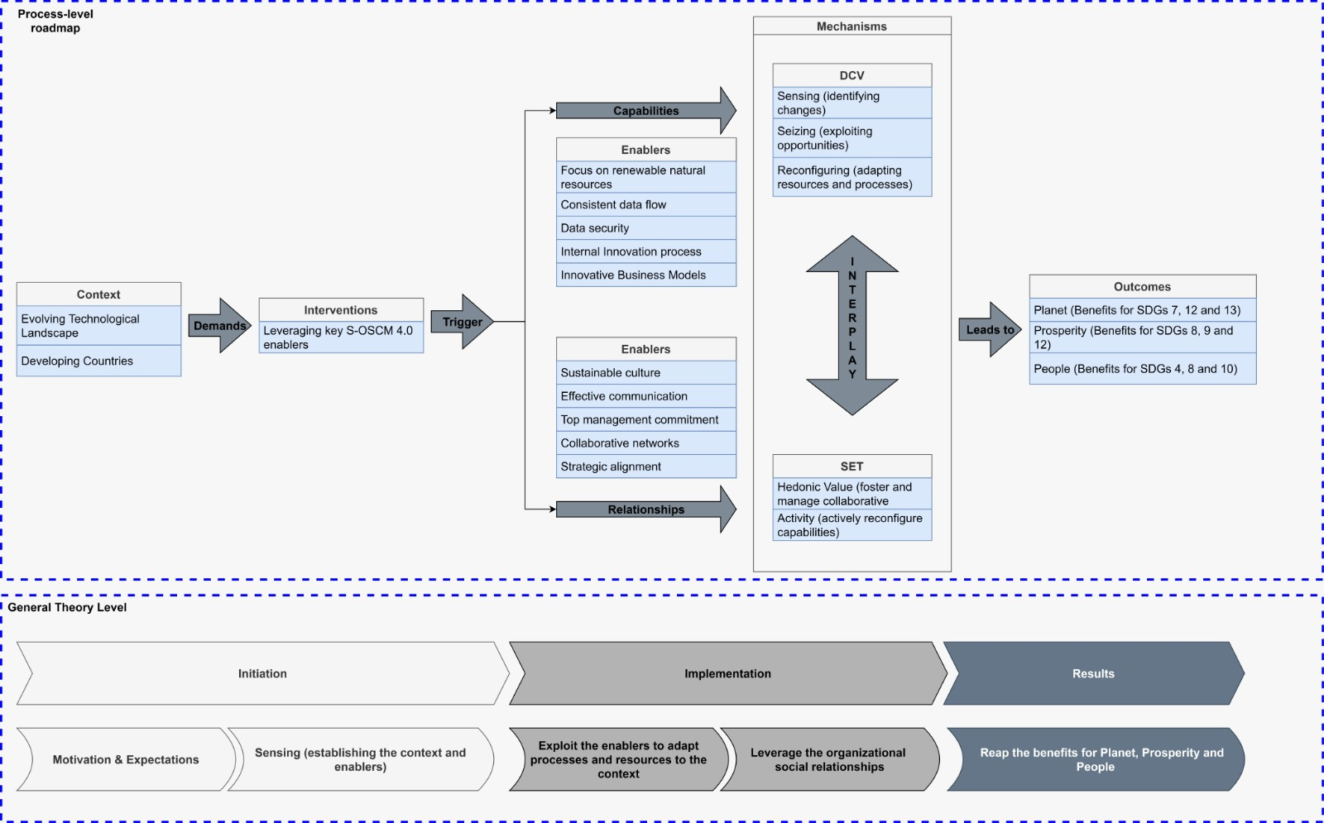

**Figure 4.** A CIMO-driven roadmap to implement Sustainable I4.0 enablers and achieve strategic benefits in OSCM.

The logic is structured as follows: the context of the evolving technological landscape in developing countries demands that organisations intervene to reap benefits for Planet, Prosperity and People, aligned with the 2030 Agenda. Thus, they must leverage the enablers of S-OSCM4.0. both DCV and SET offer mechanisms to help in this task, enabling organisations to perceive the opportunities and actively reconfigure accordingly. Also, these mechanisms do not act alone but in a combined way since the enablers related to capabilities depend on the enablers regarding relationships and vice-versa. For instance, top management commitment is fundamental to guarantee that the needed resources to seize the opportunities will be provided. In a similar fashion, a consistent data flow is of utmost importance to foster positive relationships among different actors in the organisation. By strategically using these mechanisms, organisations can, as an outcome, reap the benefits of S-OSCM4.0.

**5.** **Conclusions, Implications and Future Perspectives**

This study culminates in developing a pioneering S-OSCM4.0 framework, strategically aligning enablers and benefits with the imperatives of the 2030 agenda. The proposed framework contributes to delineating the prioritisation sequence for implementing pivotal enablers and subsequently realising the benefits of S-OSCM4.0.

*5.1 Theoretical Implications*

This research underscores the theoretical significance of the proposed configurational framework through the lens of DCV and SET. The integration of DCV emphasises adaptability and innovation, crucial for navigating the dynamic changes inherent in the I4.0 era. Concurrently, SET guides the understanding of trade-offs and collaborative decision-making dynamics within the framework. The articulation of key enablers and benefits within the theoretical underpinnings enhances the specificity of interventions, fostering replicability, implementation, and evidence synthesis in the realm of S-OSCM4.0.

This research aims to contribute to the scientific community by presenting a representative selection of international research in an interdisciplinary area. In summary, the distinctive features of this article are: i) expanding the literature on sustainable I4.0; ii) proposing an S-OSCM4.0 framework with an empirical study approach and the application of a decision support methods to enhance the applicability of the developed framework(Yadav, et al., 2020); iii) providing a tool to assess key enablers to achieve social and environmental benefits outlined in the 2030 Agenda resulting from integrating I4.0 and sustainability for OSCM. Also, by leveraging a conceptual framework (the CIMO logic) explicitly showing how the interventions (the enablers), trigger the mechanisms of the DCV and SET to achieve the benefits aligned with the 20230 Agenda. Therefore, this study is expected to inspire new research and exploration in the areas of sustainable I4.0 and fuzzy group decision-making in SCM.

*5.2 Managerial Implications*

Practically, the proposed framework serves as a strategic guide for professionals in OSCM, directing them towards the sustainable digitalisation paradigm of S-OSCM4.0. Recognising the critical role of enablers in integrating I4.0 and sustainability, the framework offers a tangible tool for decision-making. The importance of evaluating enablers to obtain SD benefits in OSCM is emphasised, laying the foundation for a transformative approach. The framework provides a starting point for implementing S-OSCM4.0, aligning business strategy with sustainability objectives, thus contributing to the corporate realisation of the SDGs.

*5.3 Limitations and Suggestions for Further Research*

Acknowledging limitations, such as database restrictions and language biases, this study calls for caution in interpreting results. The research's focus on Brazilian organisations within a developing country context prompts a recommendation for cross-cultural application to highlight cultural aspects and implementation challenges. Additionally, the temporal limitation necessitates continuous exploration of new research studies.

As an avenue for future research, the proposed framework opens possibilities for developing measurement constructs for S-OSCM4.0. Structural equation modelling could scrutinise the relationships between enablers and benefits. Expanding the proposals through qualitative research or transforming them into testable hypotheses with quantitative methods presents avenues for exploration. Further research should delve into additional relationships within the S-OSCM4.0 framework, examining the interaction between enablers and challenges and the delicate balance between challenges and benefits to achieve sustainable digital transformation. The call extends to researchers to explore and deepen the understanding of S-OSCM4.0 across diverse contexts and industries.

The study conducted panels and interviews with expert managers in OSCM, sustainability, and I4.0, following the approach outlined by Nonaka and Takeuchi (2007), who consider them knowledge engineers responsible for translating strategy into practice. The focus was on proposing a framework. The research was limited to Brazilian organisations within a developing country context. The recommendation is to apply the framework across different cultures, nations, and continents to highlight cultural aspects and implementation challenges. Additionally, in-depth case studies exploring the qualitative aspects of integrating I4.0 and sustainability in OSCM are suggested. This qualitative understanding complements quantitative studies' results(de Sousa Jabbour et al., 2018), derived from the step-by-step framework, contributing to promoting and adopting these findings.

This framework merges the principles of I4.0 and sustainability applied to SCM and OM, offering a practical hybrid self-assessment framework. The proposed enablers can be translated into a set of measures or recommended actions to support decision-making in the realm of OSCM. Moreover, it paves the way for future research exploring other hybrid fuzzy methods to aid the decision-making process regarding the choice of sustainable technological solutions.

**Conflict of Interest**

No Declaration of Interest applies to this article.

**Acknowledgement**

The authors of this paper are thankful to all the organisations and their managers who enabled the empirical part of this research. The authors are also thankful for the different research agencies that supported the research. This work was supported by the **National Council for Scientific and Technological Development** [Grant numbers: 310578/2022-1, 307173/2022-4, 405734/2023-9, 442384/2023-8], **Carlos Chagas Filho Foundation for Research Support in Rio de Janeiro State** [Grant numbers: E-26/201.363/2021 (260426), E-26/200.451.2023, E-26/204.408/2024 (297945)], and **Coordination of Higher Education Personnel Improvement**[Grant number: Finance Code 001]. We also thank the Tecgraf Institute of Technical-Scientific Software Development of PUC-Rio (Tecgraf/PUC-Rio).

**References**

Abd, S. K., Ali, M. H., Jaber, M. M., Abosinnee, A. S., Kareem, Z. H., Wahab, A. N. A., Hassan, R., & Jassim, M. M. (2024). Secured finance handling for supply chain integrated business intelligence using blockchain application scenarios. *Intell. Data Anal.*, *28*(2), 553–571.https://doi.org/10.3233/IDA-227445

Alazemi, F. K. A. O. H., Ariffin, M. K. A. B. M., Mustapha, F. B., & Supeni, E. E. B. (2022). A New Fuzzy TOPSIS-Based Machine Learning Framework for Minimizing Completion Time in Supply Chains. *International Journal of Fuzzy Systems*, *24*(3), 1669–1695.https://doi.org/10.1007/s40815-021-01226-3

Alkaraan, F., Elmarzouky, M., Hussainey, K., Venkatesh, V. G., Shi, Y., & Gulko, N. (2024). Reinforcing green business strategies with Industry 4.0 and governance towards sustainability: Natural-resource-based view and dynamic capability. *Business Strategy and the Environment*, *33*(4), 3588–3606. https://doi.org/10.1002/bse.3665

Awan, U., Sroufe, R., & Bozan, K. (2022). Designing Value Chains for Industry 4.0 and a Circular Economy: A Review of the Literature. *Sustainability*, *14*(12), Article 12.https://doi.org/10.3390/su14127084

Bag, S., & Pretorius, J. H. C. (2020). Relationships between industry 4.0, sustainable manufacturing and circular economy: Proposal of a research framework. *International Journal of Organizational Analysis*, *30*(4), 864–898.https://doi.org/10.1108/IJOA-04-2020-2120

Bag, S., Telukdarie, A., Pretorius, J. H. C., & Gupta, S. (2018). Industry 4.0 and supply chain sustainability: Framework and future research directions. *Benchmarking: An International Journal*, *28*(5), 1410–1450.https://doi.org/10.1108/BIJ-03-2018-0056

Bag, S., Wood, L. C., Xu, L., Dhamija, P., & Kayikci, Y. (2020). Big data analytics as an operational excellence approach to enhance sustainable supply chain performance. *Resources, Conservation and Recycling*, *153*, 104559.https://doi.org/10.1016/j.resconrec.2019.104559

Bai, C., Dallasega, P., Orzes, G., & Sarkis, J. (2020). Industry 4.0 technologies assessment: A sustainability perspective. *International Journal of Production Economics*, *229*, 107776.https://doi.org/10.1016/j.ijpe.2020.107776

Battisti, M., & Deakins, D. (2017). The relationship between dynamic capabilities, the firm’s resource base and performance in a post-disaster environment. *International Small Business Journal*, *35*(1), 78–98.https://doi.org/10.1177/0266242615611471

Bebbington, J., & Unerman, J. (2018). Achieving the United Nations Sustainable Development Goals: An enabling role for accounting research. *Accounting, Auditing & Accountability Journal*, *31*(1), 2–24.https://doi.org/10.1108/AAAJ-05-2017-2929

Behl, A., Singh, R., Pereira, V., & Laker, B. (2023). Analysis of Industry 4.0 and circular economy enablers: A step towards resilient sustainable operations management. *Technological Forecasting and Social Change*, *189*, 122363.https://doi.org/10.1016/j.techfore.2023.122363

Beier, G., Ullrich, A., Niehoff, S., Reißig, M., & Habich, M. (2020). Industry 4.0: How it is defined from a sociotechnical perspective and how much sustainability it includes – A literature review. *Journal of Cleaner Production*, *259*, 120856.https://doi.org/10.1016/j.jclepro.2020.120856

Bhagat, P. R., Naz, F., & Magda, R. (2022). Role of Industry 4.0 Technologies in Enhancing Sustainable Firm Performance and Green Practices. *Acta Polytechnica Hungarica*, *19*(8), 229–248. https://doi.org/10.12700/APH.19.8.2022.8.13

Birkel, H. S., Veile, J. W., Mueller, J. M., Hartmann, E., & Voigt, K.-I. (2019). Development of a Risk Framework for Industry 4.0 in the Context of Sustainability for Established Manufacturers. In *SUSTAINABILITY* (Vol. 11, Issue 2). MDPI. https://doi.org/10.3390/su11020384

Blau, P. M. (1964). Justice in Social Exchange. *Sociological Inquiry*, *34*(2), 193–206. https://doi.org/10.1111/j.1475-682X.1964.tb00583.x

Bonilla, S. H., Silva, H. R. O., Terra da Silva, M., Franco Gonçalves, R., & Sacomano, J. B. (2018). Industry 4.0 and Sustainability Implications: A Scenario-Based Analysis of the Impacts and Challenges. *Sustainability*, *10*(10), Article 10. https://doi.org/10.3390/su10103740

Braccini, A. M., & Margherita, E. G. (2019). Exploring Organizational Sustainability of Industry 4.0 under the Triple Bottom Line: The Case of a Manufacturing Company. In *SUSTAINABILITY* (Vol. 11, Issue 1). MDPI. https://doi.org/10.3390/su11010036

Bradu, P., Biswas, A., Nair, C., Sreevalsakumar, S., Patil, M., Kannampuzha, S., Mukherjee, A. G., Wanjari, U. R., Renu, K., Vellingiri, B., & Gopalakrishnan, A. V. (2023). RETRACTED ARTICLE: Recent advances in green technology and Industrial Revolution 4.0 for a sustainable future. *Environmental Science and Pollution Research*, *30*(60), 124488–124519.https://doi.org/10.1007/s11356-022-20024-4

Buckley, J. J. (1984). The multiple judge, multiple criteria ranking problem: A fuzzy set approach. *Fuzzy Sets and Systems*, *13*(1), 25–37. https://doi.org/10.1016/0165-0114(84)90024-1

Bueno, A., Goyannes Gusmão Caiado, R., Guedes de Oliveira, T. L., Scavarda, L. F., Filho, M. G., & Tortorella, G. L. (2023). Lean 4.0 implementation framework: Proposition using a multi-method research approach. *International Journal of Production Economics*, *264*, 108988.https://doi.org/10.1016/j.ijpe.2023.108988

Bunge, M. (1967). The Structure and Content of a Physical Theory. In M. Bunge (Ed.), *Delaware Seminar in the Foundations of Physics* (Vol. 1, pp. 15–27). Springer Berlin Heidelberg. https://doi.org/10.1007/978-3-642-86102-4_2

Caiado, R. G. G., Scavarda, L. F., Azevedo, B. D., de Mattos Nascimento, D. L., & Quelhas, O. L. G. (2022a). Challenges and Benefits of Sustainable Industry 4.0 for Operations and Supply Chain Management—A Framework Headed toward the 2030 Agenda. *Sustainability*, *14*(2), Article 2. https://doi.org/10.3390/su14020830

Caiado, R. G. G., Scavarda, L. F., Gavião, L. O., Ivson, P., Nascimento, D. L. de M., & Garza-Reyes, J. A. (2021). A fuzzy rule-based industry 4.0 maturity model for operations and supply chain management. *International Journal of Production Economics*, *231*, 107883.https://doi.org/10.1016/j.ijpe.2020.107883

Caiado, R. G. G., Scavarda, L. F., Vidal, G., de Mattos Nascimento, D. L., & Garza-Reyes, J. A. (2023). A taxonomy of critical factors towards sustainable operations and supply chain management 4.0 in developing countries. *Operations Management Research*.https://doi.org/10.1007/s12063-023-00430-8

Caiado, R., Scavarda, L. F., Vidal, G., de Mattos Nascimento, D. L., & Garza-Reyes, J. A. (2024a). A taxonomy of critical factors towards sustainable operations and supply chain management 4.0 in developing countries. *Springer Nature*.

Caiado, R. G. G., Machado, E., Santos, R. S., Thomé, A. M. T., & Scavarda, L. F. (2024b). Sustainable I4. 0 integration and transition to I5. 0 in traditional and digital technological organisations. Technological Forecasting and Social Change, 207, 123582. https://doi.org/10.1016/j.techfore.2024.123582

Carvalho, A. (2023). A Duality Model of Dynamic Capabilities: Combining Routines and Improvisation. *Administrative Sciences*, *13*(3), Article 3.https://doi.org/10.3390/admsci13030084

Ching, N. T., Ghobakhloo, M., Iranmanesh, M., Maroufkhani, P., & Asadi, S. (2022). Industry 4.0 applications for sustainable manufacturing: A systematic literature review and a roadmap to sustainable development. *Journal of Cleaner Production*, *334*, 130133.https://doi.org/10.1016/j.jclepro.2021.130133

Chiou, J.-S., Tsai, S.-H., & Liu, M.-T. (2012). A PSO-based adaptive fuzzy PID-controllers. *Simulation Modelling Practice and Theory*, *26*, 49–59. https://doi.org/10.1016/j.simpat.2012.04.001

Cropanzano, R., Anthony, E. L., Daniels, S. R., & Hall, A. V. (2017). Social Exchange Theory: A Critical Review with Theoretical Remedies. *Academy of Management Annals*, *11*(1), 479–516.https://doi.org/10.5465/annals.2015.0099

Cropanzano, R., & Mitchell, M. S. (2005). Social Exchange Theory: An Interdisciplinary Review. *Journal of Management*, *31*(6), 874–900.https://doi.org/10.1177/0149206305279602

Cunha, V. H. C., Caiado, R. G. G., Corseuil, E. T., Neves, H. F., & Bacoccoli, L. (2021). Automated compliance checking in the context of Industry 4.0: From a systematic review to an empirical fuzzy multi-criteria approach. *Soft Computing*, *25*(8), 6055–6074.https://doi.org/10.1007/s00500-021-05599-3

Cuthbertson, R., Cetinkaya, B., Ewer, G., Klaas-Wissing, T., Piotrowicz, W., & Tyssen, C. (2011). *Sustainable Supply Chain Management* [Springer Books]. Springer. https://econpapers.repec.org/bookchap/sprsprbok/978-3-642-12023-7.htm

Cutovoi, I. T. M. (2020). Social Exchange Theory perspective applied in reverse logistic relationships under a remanufacturing perspective / Perspectiva da Teoria de Intercâmbio Social aplicada em relações de logística reversa sob uma perspectiva de remanufatura. *Brazilian Applied Science Review*, *4*(6), 3324–3342.https://doi.org/10.34115/basrv4n6-003

da Cruz, M. M., Caiado, R. G. G., & Santos, R. S. (2022). Industrial Packaging Performance Indicator Using a Group Multicriteria Approach: An Automaker Reverse Operations Case. *Logistics*, *6*(3), Article 3.https://doi.org/10.3390/logistics6030058

Davis-Sramek, B., Hopkins, C. D., Richey, R. G., & Morgan, T. R. (2022). Leveraging supplier relationships for sustainable supply chain management: Insights from social exchange theory. *International Journal of Logistics Research and Applications*, *25*(1), 101–118.https://doi.org/10.1080/13675567.2020.1797654

Davis-Sramek, B., Robinson, J. L., Darby, J. L., & Thomas, R. W. (2020). Exploring the differential roles of environmental and social sustainability in carrier selection decisions. *International Journal of Production Economics*, *227*, 107660.https://doi.org/10.1016/j.ijpe.2020.107660

de Paula Vidal, G. H., Caiado, R. G. G., Scavarda, L. F., Ivson, P., & Garza-Reyes, J. A. (2022). Decision support framework for inventory management combining fuzzy multicriteria methods, genetic algorithm, and artificial neural network. *Computers & Industrial Engineering*, *174*, 108777.

de Sousa Jabbour, A. B. L., Jabbour, C. J. C., Foropon, C., & Godinho Filho, M. (2018). When titans meet – Can industry 4.0 revolutionise the environmentally-sustainable manufacturing wave? The role of critical success factors. *Technological Forecasting and Social Change*, *132*, 18–25.https://doi.org/10.1016/j.techfore.2018.01.017

de Sousa Jabbour, A. B., Jabbour, C. J. C., Godinho Filho, M., & Roubaud, D. (2018). Industry 4.0 and the circular economy: A proposed research agenda and original roadmap for sustainable operations. *Annals of Operations Research*, *270*(1), 273–286.https://doi.org/10.1007/s10479-018-2772-8

Diaz Schery, C., Caiado, R., Aguilar Vargas, S., & Rodriguez Vignon, Y. (2024). Paths to BIM-based digital transformation: A bibliometric and systematic review of critical factors. *Engineering, Construction and Architectural Management*, *720153*. https://doi.org/10.1108/ECAM-12-2023-1230

Dubey, R., Gunasekaran, A., Childe, S. J., Papadopoulos, T., Luo, Z., Wamba, S. F., & Roubaud, D. (2019). Can big data and predictive analytics improve social and environmental sustainability? *Technological Forecasting and Social Change*, *144*, 534–545. https://doi.org/10.1016/j.techfore.2017.06.020

Eisenhardt, K. M. (1989). Building Theories from Case Study Research. *Academy of Management Review*, *14*(4), 532–550.https://doi.org/10.5465/amr.1989.4308385

Eisenhardt, K. M., & Graebner, M. E. (2007). Theory Building From Cases: Opportunities And Challenges. *Academy of Management Journal*, *50*(1), 25–32.https://doi.org/10.5465/amj.2007.24160888

Eisenhardt, K. M., & Martin, J. A. (2000). Dynamic capabilities: What are they? *Strategic Management Journal*, *21*(10–11), 1105–1121.https://doi.org/10.1002/1097-0266(200010/11)21:10/11<1105::AID-SMJ133>3.0.CO;2-E

Elmas, F. R., Rios, M. P., Lima, E. R. de A., Caiado, R. G. G., & Santos, R. S. (2023). Prediction of external corrosion rate in Oil and Gas platforms using ensemble learning: A Maintenance 4.0 approach. *Brazilian Journal of Operations & Production Management*, *20*(3), Article 3.https://doi.org/10.14488/BJOPM.1952.2023

Felsberger, A., & Reiner, G. (2020). Sustainable Industry 4.0 in Production and Operations Management: A Systematic Literature Review. *Sustainability*, *12*(19), Article 19.https://doi.org/10.3390/su12197982

Gerged, A. M. (2021). Factors affecting corporate environmental disclosure in emerging markets: The role of corporate governance structures. *Business Strategy and the Environment*, *30*(1), 609–629.https://doi.org/10.1002/bse.2642

Ghobakhloo, M. (2020). Industry 4.0, digitization, and opportunities for sustainability. *Journal of Cleaner Production*, *252*, 119869.https://doi.org/10.1016/j.jclepro.2019.119869

Ghobakhloo, M., Iranmanesh, M., Grybauskas, A., Vilkas, M., & Petraitė, M. (2021). Industry 4.0, innovation, and sustainable development: A systematic review and a roadmap to sustainable innovation. *Business Strategy and the Environment*, *30*(8), 4237–4257.https://doi.org/10.1002/bse.2867

Gioia, D. A., Corley, K. G., & Hamilton, A. L. (2013). Seeking Qualitative Rigor in Inductive Research: Notes on the Gioia Methodology. *Organizational Research Methods*, *16*(1), 15–31.https://doi.org/10.1177/1094428112452151

Gogus, O., & Boucher, T. O. (1998). Strong transitivity, rationality and weak monotonicity in fuzzy pairwise comparisons. *Fuzzy Sets and Systems*, *94*(1), 133–144.https://doi.org/10.1016/S0165-0114(96)00184-4

Govindan, K., Cheng, T. C. E., Mishra, N., & Shukla, N. (2018). Big data analytics and application for logistics and supply chain management. *Transportation Research Part E: Logistics and Transportation Review*, *114*, 343–349.https://doi.org/10.1016/j.tre.2018.03.011

Govindan, K., Khodaverdi, R., & Jafarian, A. (2013). A fuzzy multi criteria approach for measuring sustainability performance of a supplier based on triple bottom line approach. *Journal of Cleaner Production*, *47*, 345–354.https://doi.org/10.1016/j.jclepro.2012.04.014

Gupta, S., Meissonier, R., Drave, V. A., & Roubaud, D. (2020). Examining the impact of Cloud ERP on sustainable performance: A dynamic capability view. *International Journal of Information Management*, *51*, 102028. https://doi.org/10.1016/j.ijinfomgt.2019.10.013

Herbert-Hansen, Z. N. L., & Pietro, E. D. (2017). Sustainable supply chains in the world of industry 4.0: 22nd International Symposium on Logistics. *Proceedings of the 22nd International Symposium on Logistics (ISL 2017)*, 306–313.

Holopainen, M., Ukko, J., & Saunila, M. (2022). Managing the strategic readiness of industrial companies for digital operations. *Digital Business*, *2*(2), 100039. https://doi.org/10.1016/j.digbus.2022.100039

Holthausen, J. (2010). *Scientific review of the Social Exchange Theory and its contribution to solving purchasers’ decision making issues*.https://www.semanticscholar.org/paper/Scientific-review-of-the-Social-Exchange-Theory-and-Holthausen/37ed60d4554e49e0498422fd630131205f7bbaf4

Homans, G. C. (1958). Social Behavior as Exchange. *American Journal of Sociology*, *63*(6), 597–606.https://doi.org/10.1086/222355

Hsu, Y.-L., Lee, C.-H., & Kreng, V. B. (2010). The application of Fuzzy Delphi Method and Fuzzy AHP in lubricant regenerative technology selection. *Expert Systems with Applications*, *37*(1), 419–425.https://doi.org/10.1016/j.eswa.2009.05.068

Huang, K., Wang, K., Lee, P. K. C., & Yeung, A. C. L. (2023). The impact of industry 4.0 on supply chain capability and supply chain resilience: A dynamic resource-based view. *International Journal of Production Economics*, *262*, 108913. https://doi.org/10.1016/j.ijpe.2023.108913

Hughes, L., Dwivedi, Y. K., Rana, N. P., Williams, M. D., & Raghavan, V. (2022). Perspectives on the future of manufacturing within the Industry 4.0 era. *Production Planning & Control*, *33*(2–3), 138–158.https://doi.org/10.1080/09537287.2020.1810762

Ietto, B., Ancillai, C., Sabatini, A., Carayannis, E. G., & Gregori, G. L. (2024). The Role of External Actors in SMEs’ Human-Centered Industry 4.0 Adoption: An Empirical Perspective on Italian Competence Centers. *IEEE Transactions on Engineering Management*, *71*, 1057–1072. IEEE Transactions on Engineering Management. https://doi.org/10.1109/TEM.2022.3144881

Jain, V., Sangaiah, A. K., Sakhuja, S., Thoduka, N., & Aggarwal, R. (2018). Supplier selection using fuzzy AHP and TOPSIS: A case study in the Indian automotive industry. *Neural Computing and Applications*, *29*(7), 555–564.https://doi.org/10.1007/s00521-016-2533-z

Jraisat, L., Jreissat, M., Upadhyay, A., & Kumar, A. (2023). Blockchain Technology: The Role of Integrated Reverse Supply Chain Networks in Sustainability. *Supply Chain Forum: An International Journal*, *24*(1), 17–30.https://doi.org/10.1080/16258312.2022.2090853

Jraisat, L., Upadhyay, A., Ghalia, T., Jresseit, M., Kumar, V., & Sarpong, D. (2023). Triads in sustainable supply-chain perspective: Why is a collaboration mechanism needed? *International Journal of Production Research*, *61*(14), 4725–4741. https://doi.org/10.1080/00207543.2021.1936263

Junaid, M., Du, J., Mubarik, M. S., & Shahzad, F. (2024). Creating a sustainable future through Industry 4.0 technologies: Untying the role of circular economy practices and supply chain visibility. *Business Strategy and the Environment*, *n/a*(n/a), 1–23.https://doi.org/10.1002/bse.3777

Kaasinen, E., Schmalfuß, F., Özturk, C., Aromaa, S., Boubekeur, M., Heilala, J., Heikkilä, P., Kuula, T., Liinasuo, M., Mach, S., Mehta, R., Petäjä, E., & Walter, T. (2020). Empowering and engaging industrial workers with Operator 4.0 solutions. *Computers & Industrial Engineering*, *139*, 105678.https://doi.org/10.1016/j.cie.2019.01.052

Kaiser, B. C. S., Santos, R. S., Caiado, R. G. G., Scavarda, L. F., & Netto, P. I. (2022). Efficiency Assessment of Public Transport Vehicles Using Machine Learning and Non-parametric Models. In V. M. López Sánchez, F. G. Mendonça Freires, J. C. Gonçalves dos Reis, & J. M. Costa Martins das Dores (Eds.), *Industrial Engineering and Operations Management* (pp. 207–220). Springer International Publishing. https://doi.org/10.1007/978-3-031-14763-0_17

Kamble, S. S., Gunasekaran, A., & Gawankar, S. A. (2018). Sustainable Industry 4.0 framework: A systematic literature review identifying the current trends and future perspectives. *Process Safety and Environmental Protection*, *117*, 408–425.https://doi.org/10.1016/j.psep.2018.05.009

Keller, A., Konlechner, S., Güttel, W. H., & Reischauer, G. (2022). Overcoming path-dependent dynamic capabilities. *Strategic Organization*, 147612702211258.https://doi.org/10.1177/14761270221125807

Khan, I. S., Ahmad, M. O., & Majava, J. (2023). Industry 4.0 innovations and their implications: An evaluation from sustainable development perspective. *Journal of Cleaner Production*, *405*, 137006.https://doi.org/10.1016/j.jclepro.2023.137006

Kilic, H. S., Zaim, S., & Delen, D. (2014). Development of a hybrid methodology for ERP system selection: The case of Turkish Airlines. *Decision Support Systems*, *66*, 82–92.https://doi.org/10.1016/j.dss.2014.06.011

Kim, J., Paek, B., & Lee, H. (2022). Exploring Innovation Ecosystem of Incumbents in the Face of Technological Discontinuities: Automobile Firms. *Sustainability*, *14*(3), Article 3.https://doi.org/10.3390/su14031606

Kodama, M. (2018). Collaborative Dynamic Capabilities: The Dynamic Capabilities View. In M. Kodama (Ed.), *Collaborative Dynamic Capabilities for Service Innovation: Creating a New Healthcare Ecosystem* (pp. 1–45). Springer International Publishing.https://doi.org/10.1007/978-3-319-77240-0_1

Kouhizadeh, M., Saberi, S., & Sarkis, J. (2021). Blockchain technology and the sustainable supply chain: Theoretically exploring adoption barriers. *International Journal of Production Economics*, *231*, 107831.https://doi.org/10.1016/j.ijpe.2020.107831

Kurtmollaiev, S. (2020). Dynamic Capabilities and Where to Find Them. *Journal of Management Inquiry*, *29*(1), 3–16. https://doi.org/10.1177/1056492617730126

Kιrcι, M., & Seifert, R. (2015). Dynamic Capabilities in Sustainable Supply Chain Management: A Theoretical Framework. *Supply Chain Forum: An International Journal*, *16*(4), 2–15.https://doi.org/10.1080/16258312.2015.11728690

Lee, H.-Y., Kwak, D.-W., & Park, J.-Y. (2017). Corporate Social Responsibility in Supply Chains of Small and Medium-Sized Enterprises. *Corporate Social Responsibility and Environmental Management*, *24*(6), 634–647.https://doi.org/10.1002/csr.1433

Lee, I., & Mangalaraj, G. (2022). Big Data Analytics in Supply Chain Management: A Systematic Literature Review and Research Directions. *Big Data and Cognitive Computing*, *6*(1), Article 1.https://doi.org/10.3390/bdcc6010017

Lee, K. L., Wong, S. Y., Alzoubi, H. M., Al Kurdi, B., Alshurideh, M. T., & El Khatib, M. (2023). Adopting smart supply chain and smart technologies to improve operational performance in manufacturing industry. *International Journal of Engineering Business Management*, *15*, 18479790231200614. https://doi.org/10.1177/18479790231200614

Lepore, D., Vecciolini, C., Micozzi, A., & Spigarelli, F. (2023). Developing technological capabilities for Industry 4.0 adoption: An analysis of the role of inbound open innovation in small and medium-sized enterprises. *Creativity and Innovation Management*, *32*(2), 249–265.https://doi.org/10.1111/caim.12551

Li, Y., Dai, J., & Cui, L. (2020). The impact of digital technologies on economic and environmental performance in the context of industry 4.0: A moderated mediation model. *International Journal of Production Economics*, *229*, 107777. https://doi.org/10.1016/j.ijpe.2020.107777

Lima, B. F., Neto, J. V., Santos, R. S., & Caiado, R. G. G. (2023). A Socio-Technical Framework for Lean Project Management Implementation towards Sustainable Value in the Digital Transformation Context. *Sustainability*, *15*(3), Article 3.https://doi.org/10.3390/su15031756

Lin, K. C., Shyu, J. Z., & Ding, K. (2017). A Cross-Strait Comparison of Innovation Policy under Industry 4.0 and Sustainability Development Transition. *Sustainability*, *9*(5), Article 5.https://doi.org/10.3390/su9050786

Lopes De Sousa Jabbour, A. B., Chiappetta Jabbour, C. J., Choi, T.-M., & Latan, H. (2022). ‘Better together’: Evidence on the joint adoption of circular economy and industry 4.0 technologies. *International Journal of Production Economics*, *252*, 108581.https://doi.org/10.1016/j.ijpe.2022.108581

Luthra, S., Govindan, K., & Mangla, S. K. (2017). Structural model for sustainable consumption and production adoption—A grey-DEMATEL based approach. *Resources, Conservation and Recycling*, *125*, 198–207.https://doi.org/10.1016/j.resconrec.2017.02.018

Luthra, S., Kumar, A., Zavadskas, E. K., Mangla, S. K., & Garza-Reyes, J. A. (2020a). Industry 4.0 as an enabler of sustainability diffusion in supply chain: An analysis of influential strength of drivers in an emerging economy. *International Journal of Production Research*, *58*(5), 1505–1521.https://doi.org/10.1080/00207543.2019.1660828

Luthra, S., Kumar, A., Zavadskas, E. K., Mangla, S. K., & Garza-Reyes, J. A. (2020b). Industry 4.0 as an enabler of sustainability diffusion in supply chain: An analysis of influential strength of drivers in an emerging economy. *International Journal of Production Research*, *58*(5), 1505–1521.https://doi.org/10.1080/00207543.2019.1660828

Luthra, S., & Mangla, S. K. (2018). Evaluating challenges to Industry 4.0 initiatives for supply chain sustainability in emerging economies. *Process Safety and Environmental Protection*, *117*, 168–179.https://doi.org/10.1016/j.psep.2018.04.018

Machado, C. G., Winroth, M. P., & Ribeiro da Silva, E. H. D. (2020). Sustainable manufacturing in Industry 4.0: An emerging research agenda. *International Journal of Production Research*, *58*(5), 1462–1484.https://doi.org/10.1080/00207543.2019.1652777

Machado, E. A., Scavarda, L. F., Caiado, R. G. G., & Santos, R. S. (2024). Industry 4.0 and Sustainability Integration in the Supply Chains of Micro, Small, and Medium Enterprises through People, Process, and Technology within the Triple Bottom Line Perspective. *Sustainability*, *16*(3), Article 3.https://doi.org/10.3390/su16031141

Machado, E., Scavarda, L. F., Caiado, R. G. G., & Thomé, A. M. T. (2021). Barriers and Enablers for the Integration of Industry 4.0 and Sustainability in Supply Chains of MSMEs. *Sustainability*, *13*(21), Article 21.

MacLean, D., MacIntosh, R., & Seidl, D. (2015). Rethinking dynamic capabilities from a creative action perspective. *Strategic Organization*, *13*(4), 340–352.https://doi.org/10.1177/1476127015593274

Manavalan, E., & Jayakrishna, K. (2019). A review of Internet of Things (IoT) embedded sustainable supply chain for industry 4.0 requirements. *Computers & Industrial Engineering*, *127*, 925–953.https://doi.org/10.1016/j.cie.2018.11.030

Mardani, A., Zavadskas, E. K., Govindan, K., Amat Senin, A., & Jusoh, A. (2016). VIKOR Technique: A Systematic Review of the State of the Art Literature on Methodologies and Applications. *Sustainability*, *8*(1), Article 1.https://doi.org/10.3390/su8010037

Mastos, T. D., Nizamis, A., Vafeiadis, T., Alexopoulos, N., Ntinas, C., Gkortzis, D., Papadopoulos, A., Ioannidis, D., & Tzovaras, D. (2020). Industry 4.0 sustainable supply chains: An application of an IoT enabled scrap metal management solution. *Journal of Cleaner Production*, *269*, 122377.https://doi.org/10.1016/j.jclepro.2020.122377

Matos, S. V., Schleper, M. C., Gold, S., & Hall, J. K. (2020). The hidden side of sustainable operations and supply chain management: Unanticipated outcomes, trade-offs and tensions. *International Journal of Operations & Production Management*, *40*(12), 1749–1770.https://doi.org/10.1108/IJOPM-12-2020-833

May, G., Stahl, B., & Taisch, M. (2016). Energy management in manufacturing: Toward eco-factories of the future – A focus group study. *Applied Energy*, *164*, 628–638.https://doi.org/10.1016/j.apenergy.2015.11.044

Meng, Y., Yang, Y., Chung, H., Lee, P.-H., & Shao, C. (2018). Enhancing Sustainability and Energy Efficiency in Smart Factories: A Review. *Sustainability*, *10*(12), Article 12.https://doi.org/10.3390/su10124779

Mihardjo, L. W. W., Sasmoko, S., Alamsyah, F., & Elidjen, E. (2020). Maximising co-creation strategy through integration of distinctive capabilities and customer experiences in supply chain management. *Uncertain Supply Chain Management*, 187–196.https://doi.org/10.5267/j.uscm.2019.7.005

Mohammed, A., Potdar, V., Quaddus, M., & Hui, W. (2023). Blockchain Adoption in Food Supply Chains: A Systematic Literature Review on Enablers, Benefits, and Barriers. *IEEE Access*, *11*, 14236–14255. IEEE Access. https://doi.org/10.1109/ACCESS.2023.3236666

Muñoz-La Rivera, F., Hermosilla, P., Delgadillo, J., & Echeverría, D. (2020). The Sustainable Development Goals (SDGs) as a Basis for Innovation Skills for Engineers in the Industry 4.0 Context. *Sustainability*, *12*(16), Article 16. https://doi.org/10.3390/su12166622

Murmura, F., & Bravi, L. (2017). Additive manufacturing in the wood-furniture sector: Sustainability of the technology, benefits and limitations of adoption. *Journal of Manufacturing Technology Management*, *29*(2), 350–371. https://doi.org/10.1108/JMTM-08-2017-0175

Murschetz, P. C., Omidi, A., Oliver, J. J., Kamali Saraji, M., & Javed, S. (2020). Dynamic capabilities in media management research: A literature review. *Journal of Strategy and Management*, *13*(2), 278–296.https://doi.org/10.1108/JSMA-01-2019-0010

Nhamo, G., Nhemachena, C., & Nhamo, S. (2020). Using ICT indicators to measure readiness of countries to implement Industry 4.0 and the SDGs. *Environmental Economics and Policy Studies*, *22*(2), 315–337.https://doi.org/10.1007/s10018-019-00259-1

Nonaka, I., & Takeuchi, H. (2007). The knowledge‐creating company. *Harvard Business Review*, *85*(7), 162.

Opricovic, S. (2011). Fuzzy VIKOR with an application to water resources planning. *Expert Systems with Applications*, *38*(10), 12983–12990.

Opricovic, S., & Tzeng, G.-H. (2004). Compromise solution by MCDM methods: A comparative analysis of VIKOR and TOPSIS. *European Journal of Operational Research*, *156*(2), 445–455. https://doi.org/10.1016/S0377-2217(03)00020-1

Osterrieder, P., Budde, L., & Friedli, T. (2020). The smart factory as a key construct of industry 4.0: A systematic literature review. *International Journal of Production Economics*, *221*, 107476.https://doi.org/10.1016/j.ijpe.2019.08.011

Ozkan-Ozen, Y. D., Kazancoglu, Y., & Kumar Mangla, S. (2020). SYNCHRONIZED BARRIERS FOR CIRCULAR SUPPLY CHAINS IN INDUSTRY 3.5/INDUSTRY 4.0 TRANSITION FOR SUSTAINABLE RESOURCE MANAGEMENT. *Resources, Conservation and Recycling*, *161*, 104986.https://doi.org/10.1016/j.resconrec.2020.104986

Padhi, S. S., Pati, R. K., & Rajeev, A. (2018). Framework for selecting sustainable supply chain processes and industries using an integrated approach. *Journal of Cleaner Production*, *184*, 969–984.https://doi.org/10.1016/j.jclepro.2018.02.306

Papathanasiou, J., & Ploskas, N. (2018). *Multiple criteria decision aid. In Methods, Examples and Python Implementations* (Vol. 136). In Springer Optimization and Its Applications.

Pawson, R., & Tilley, N. (1997). An introduction to scientific realist evaluation. In *Evaluation for the 21st century: A handbook* (pp. 405–418). Sage Publications, Inc.https://doi.org/10.4135/9781483348896.n29

Pfaff, Y. M. (2023). Agility and digitalization: Why strategic agility is a success factor for mastering digitalization – evidence from Industry 4.0 implementations across a supply chain. *International Journal of Physical Distribution & Logistics Management*, *53*(5/6), 660–684.https://doi.org/10.1108/IJPDLM-06-2022-0200

Pinzone, M., Albè, F., Orlandelli, D., Barletta, I., Berlin, C., Johansson, B., & Taisch, M. (2020). A framework for operative and social sustainability functionalities in Human-Centric Cyber-Physical Production Systems. *Computers & Industrial Engineering*, *139*, 105132.https://doi.org/10.1016/j.cie.2018.03.028

Prause, G. (2015). Sustainable Business Models and Structures for Industry 4.0. *Journal of Security and Sustainability Issues*, *5*(2), 159–169. https://doi.org/10.9770/jssi.2015.5.2(3)

Quayson, M., Bai, C., Sun, L., & Sarkis, J. (2023). Building blockchain-driven dynamic capabilities for developing circular supply chain: Rethinking the role of sensing, seizing, and reconfiguring. *Business Strategy and the Environment*, *32*(7), 4821–4840. https://doi.org/10.1002/bse.3395

Quezada, L., Chiu, A. S. F., Costa, S. G. da, & Tan, K. H. (2017). Operational excellence towards sustainable development goals through industry 4.0. *International Journal of Production Economics*, *190*, 1–2. https://doi.org/10.1016/j.ijpe.2017.06.014

Rahmanzadeh, S., Pishvaee, M. S., & Govindan, K. (2023). Emergence of open supply chain management: The role of open innovation in the future smart industry using digital twin network. *Annals of Operations Research*, *329*(1), 979–1007.https://doi.org/10.1007/s10479-021-04254-2

Ren, S., Zhang, Y., Liu, Y., Sakao, T., Huisingh, D., & Almeida, C. M. V. B. (2019). A comprehensive review of big data analytics throughout product lifecycle to support sustainable smart manufacturing: A framework, challenges and future research directions. *Journal of Cleaner Production*, *210*, 1343–1365.https://doi.org/10.1016/j.jclepro.2018.11.025

Rezaie, K., Ramiyani, S. S., Nazari-Shirkouhi, S., & Badizadeh, A. (2014). Evaluating performance of Iranian cement firms using an integrated fuzzy AHP–VIKOR method. *Applied Mathematical Modelling*, *38*(21), 5033–5046.https://doi.org/10.1016/j.apm.2014.04.003

Romani-Dias, M., & Carneiro, J. (2019). Internationalization in higher education: Faculty tradeoffs under the social exchange theory. *International Journal of Educational Management*, *34*(3), 461–476.https://doi.org/10.1108/IJEM-04-2019-0142

Roozbeh Nia, A., Awasthi, A., & Bhuiyan, N. (2020). Management of Sustainable Supply Chain and Industry 4.0: A Literature Review. In U. Ramanathan & R. Ramanathan (Eds.), *Sustainable Supply Chains: Strategies, Issues, and Models* (pp. 1–47). Springer International Publishing.https://doi.org/10.1007/978-3-030-48876-5_1

Rostamzadeh, R., Govindan, K., Esmaeili, A., & Sabaghi, M. (2015). Application of fuzzy VIKOR for evaluation of green supply chain management practices. *Ecological Indicators*, *49*, 188–203.https://doi.org/10.1016/j.ecolind.2014.09.045

Roy, B. (1996). *Multicriteria Methodology for Decision Aiding*. Springer Science & Business Media.

Saaty, T. L. (1982). The Analytic Hierarchy Process: A New Approach to Deal with Fuzziness in Architecture. *Architectural Science Review*, *25*(3), 64–69. https://doi.org/10.1080/00038628.1982.9696499

Sahoo, S., Upadhyay, A., & Kumar, A. (2023). Circular economy practices and environmental performance: Analysing the role of big data analytics capability and responsible research and innovation. *Business Strategy and the Environment*, *32*(8), 6029–6046. https://doi.org/10.1002/bse.3471

Sanfey, A. G. (2007). Social Decision-Making: Insights from Game Theory and Neuroscience. *Science*, *318*(5850), 598–602. https://doi.org/10.1126/science.1142996

Santa-Maria, T., Vermeulen, W. J. V., & Baumgartner, R. J. (2022). How do incumbent firms innovate their business models for the circular economy? Identifying micro-foundations of dynamic capabilities. *Business Strategy and the Environment*, *31*(4), 1308–1333.https://doi.org/10.1002/bse.2956

Sarbu, M. (2022). The impact of industry 4.0 on innovation performance: Insights from German manufacturing and service firms. *Technovation*, *113*, 102415.https://doi.org/10.1016/j.technovation.2021.102415

Sartori, J. T. D., Frederico, G. F., & De Fátima Nunes Silva, H. (2022). Organizational knowledge management in the context of supply chain 4.0: A systematic literature review and conceptual model proposal. *Knowledge and Process Management*, *29*(2), 147–161. https://doi.org/10.1002/kpm.1682

Schlegel, G. L., & Trent, R. J. (2014). *Supply Chain Risk Management: An Emerging Discipline*. CRC Press.

Sharma, M., Kumar, A., Luthra, S., Joshi, S., & Upadhyay, A. (2022). The impact of environmental dynamism on low-carbon practices and digital supply chain networks to enhance sustainable performance: An empirical analysis. *Business Strategy and the Environment*, *31*(4), 1776–1788.https://doi.org/10.1002/bse.2983

Shim, S.-O., Park, K., & Choi, S. (2018). Sustainable Production Scheduling in Open Innovation Perspective under the Fourth Industrial Revolution. *Journal of Open Innovation: Technology, Market, and Complexity*, *4*(4), 42. https://doi.org/10.3390/joitmc4040042

Sitorus, F., Cilliers, J. J., & Brito-Parada, P. R. (2019). Multi-criteria decision making for the choice problem in mining and mineral processing: Applications and trends. *Expert Systems with Applications*, *121*, 393–417. https://doi.org/10.1016/j.eswa.2018.12.001

Srivastava, D. K., Kumar, V., Ekren, B. Y., Upadhyay, A., Tyagi, M., & Kumari, A. (2022). Adopting Industry 4.0 by leveraging organisational factors. *Technological Forecasting and Social Change*, *176*, 121439. https://doi.org/10.1016/j.techfore.2021.121439

Stafford, L., & Kuiper, K. (2021). Social Exchange Theories: Calculating the Rewards and Costs of Personal Relationships. In *Engaging Theories in Interpersonal Communication* (3rd ed.). Routledge.

Stock, T., Obenaus, M., Kunz, S., & Kohl, H. (2018). Industry 4.0 as enabler for a sustainable development: A qualitative assessment of its ecological and social potential. *Process Safety and Environmental Protection*, *118*, 254–267. https://doi.org/10.1016/j.psep.2018.06.026

Sun, C.-C. (2010). A performance evaluation model by integrating fuzzy AHP and fuzzy TOPSIS methods. *Expert Systems with Applications*, *37*(12), 7745–7754. https://doi.org/10.1016/j.eswa.2010.04.066

Team, R. C. (2021). R: A language and environment for statistical computing. *R Foundation for Statistical Computing, Vienna, Austria*. https://cir.nii.ac.jp/crid/1370013168792282134

Teece, D. J., Pisano, G., & Shuen, A. (1997). Dynamic capabilities and strategic management. *Strategic Management Journal*, *18*(7), 509–533. https://doi.org/10.1002/(SICI)1097-0266(199708)18:7<509::AID-SMJ882>3.0.CO;2-Z

Tian, C., Chen, Y., Zhang, J., & Cox, R. F. (2019). *Global Building Information Modeling Maturity*. 82–92. https://doi.org/10.1061/9780784482308.009

Torbacki, W. (2021). A Hybrid MCDM Model Combining DANP and PROMETHEE II Methods for the Assessment of Cybersecurity in Industry 4.0. *Sustainability*, *13*(16), Article 16. https://doi.org/10.3390/su13168833

Upadhyay, A., Balodi, K. C., Naz, F., Di Nardo, M., & Jraisat, L. (2023). Implementing industry 4.0 in the manufacturing sector: Circular economy as a societal solution. *Computers & Industrial Engineering*, *177*, 109072. https://doi.org/10.1016/j.cie.2023.109072

Venâncio, A. L. A. C., Loures, E. de F. R., Deschamps, F., Justus, A. dos S., Lumikoski, A. F., & Brezinski, G. L. (2022). Technology prioritization framework to adapt maintenance legacy systems for Industry 4.0 requirement: An interoperability approach. *Production*, *32*, e20210035.https://doi.org/10.1590/0103-6513.20210035

Vidal, G. H. D. P., Carmo, L. F. R. R. S. D., & Caiado, R. G. G. (2020, November 4). *Métodos de apoio multicritério à decisão e modelos de machine learning na gestão de estoques: Fundamentos e aplicabilidade*. ENEGEP 2020 - Encontro Nacional de Engenharia de Produção, Online. https://doi.org/10.14488/ENEGEP2020_TN_STO_343_1758_40438

Wackernagel, M., Hanscom, L., & Lin, D. (2017). Making the Sustainable Development Goals Consistent with Sustainability. *Frontiers in Energy Research*, *5*, 18.https://doi.org/10.3389/fenrg.2017.00018

Wang, C.-N., Nguyen, N.-A.-T., Dang, T.-T., & Lu, C.-M. (2021). A Compromised Decision-Making Approach to Third-Party Logistics Selection in Sustainable Supply Chain Using Fuzzy AHP and Fuzzy VIKOR Methods. *Mathematics*, *9*(8), Article 8. https://doi.org/10.3390/math9080886

Wong, L.-W., Tan, G. W.-H., Ooi, K.-B., Lin, B., & Dwivedi, Y. K. (2024). Artificial intelligence-driven risk management for enhancing supply chain agility: A deep-learning-based dual-stage PLS-SEM-ANN analysis. *International Journal of Production Research*, *62*(15), 5535–5555. https://doi.org/10.1080/00207543.2022.2063089

Xu, L. D., Xu, E. L., & Li, L. (2018). Industry 4.0: State of the art and future trends. *International Journal of Production Research*, *56*(8), 2941–2962.https://doi.org/10.1080/00207543.2018.1444806

Yadav, G., Kumar, A., Luthra, S., Garza-Reyes, J. A., Kumar, V., & Batista, L. (2020). A framework to achieve sustainability in manufacturing organisations of developing economies using industry 4.0 technologies’ enablers. *Computers in Industry*, *122*, 103280. https://doi.org/10.1016/j.compind.2020.103280

Yadav, G., Luthra, S., Jakhar, S. K., Mangla, S. K., & Rai, D. P. (2020). A framework to overcome sustainable supply chain challenges through solution measures of industry 4.0 and circular economy: An automotive case. *Journal of Cleaner Production*, *254*, 120112.https://doi.org/10.1016/j.jclepro.2020.120112

Yang, J., Tang, Z., Jiao, T., & Malik Muhammad, A. (2017). Combining AHP and genetic algorithms approaches to modify DRASTIC model to assess groundwater vulnerability: A case study from Jianghan Plain, China. *Environmental Earth Sciences*, *76*(12), 426. https://doi.org/10.1007/s12665-017-6759-6

Yaqub, M. Z., & Alsabban, A. (2023). Industry-4.0-Enabled Digital Transformation: Prospects, Instruments, Challenges, and Implications for Business Strategies. *Sustainability*, *15*(11), Article 11.https://doi.org/10.3390/su15118553

Young-Ybarra, C., & Wiersema, M. (1999). Strategic Flexibility in Information Technology Alliances: The Influence of Transaction Cost Economics and Social Exchange Theory. *Organization Science*, *10*(4), 439–459.https://doi.org/10.1287/orsc.10.4.439

Yusuf, Y. Y., Gunasekaran, A., Musa, A., El-Berishy, N. M., Abubakar, T., & Ambursa, H. M. (2013). The UK oil and gas supply chains: An empirical analysis of adoption of sustainable measures and performance outcomes. *International Journal of Production Economics*, *146*(2), 501–514. https://doi.org/10.1016/j.ijpe.2012.09.021

Zadeh, L. A. (1965). Fuzzy sets. *Information and Control*, *8*(3), 338–353.https://doi.org/10.1016/S0019-9958(65)90241-X

Zadeh, L. A. (1972). A Fuzzy-Set-Theoretic Interpretation of Linguistic Hedges. *Journal of Cybernetics*, *2*(3), 4–34.https://doi.org/10.1080/01969727208542910

Zavadskas, E. K., Turskis, Z., & Kildienė, S. (2014). State of art surveys of overviews on MCDM/MADM methods. *Technological and Economic Development of Economy*, *20*(1), 165–179.https://doi.org/10.3846/20294913.2014.892037

Zekhnini, K., Cherrafi, A., Bouhaddou, I., Chaouni Benabdellah, A., & Bag, S. (2022). A model integrating lean and green practices for viable, sustainable, and digital supply chain performance. *International Journal of Production Research*, *60*(21), 6529–6555.https://doi.org/10.1080/00207543.2021.1994164

Zeng, J., Simpson, C., & Dang, B.-L. (2017). A Process Model of Dynamic Capability Development: Evidence from the Chinese Manufacturing Sector. *Management and Organization Review*, *13*(3), 643–673.https://doi.org/10.1017/mor.2016.42

Zhong, R. Y., Xu, X., Klotz, E., & Newman, S. T. (2017). Intelligent Manufacturing in the Context of Industry 4.0: A Review. *Engineering*, *3*(5), 616–630.https://doi.org/10.1016/J.ENG.2017.05.015