**Creative Ageing Research Cluster Upcoming Seminars**

**(Arts & Health Centre of Excellence)**

**#TalkCreativeAgeing Seminar Series 2018/19**

**Ang Bartram (University of Derby): Dogs and the Elderly (9th April)**

We seek comfort from other beings, which in the absence of other humans often finds a solution in relationships with dogs. The positivity for health is particularly relevant to the elderly, who may be especially isolated and emotionally vulnerable. Although sharing one’s life with a dog gives purpose and comfort, it also brings anxieties regarding care and separation should that relationship change or cease. For the elderly, this concerns being worried for the dog’s fate should they be separated by entering housing or care facilities, or by illness or death.

This seminar discusses the dilemma of leaving a ‘burden’ through the art project ‘Dogs and the Elderly,’ which analyses the importance of the interspecies relationships for physical and emotional health and wellbeing.

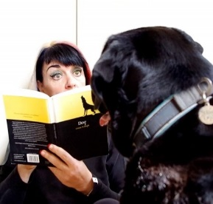Ang works in expanded sculpture including objects, video, event and text. Her practice concerns threshold and ‘in-between’ spaces of the human body, gallery, museum, definitions of the human and animal within companion species relationships and alternative strategies for documenting the ephemeral. She is principle investigator for the Alternative Document, a large-scale project that analyses alternative strategies for documenting ephemeral artworks that includes exhibitions, symposia and text. Ang completed a PhD at Middlesex University and is Head of the Arts Research Centre and Associate Professor at the University of Derby.

**David Bryson (University of Derby):**

**The adoption and non-adoption of new technologies by the active ageing (4th June)**

There are a large number of papers and research projects looking at how the active ageing are or are not engaging with digital technologies. However, far too many of the approaches are using digital technologies as if all old people require constant monitoring i.e. as if old age were a disease to be treated. The best papers and projects are those that are trying to look at why the active agers who use technology are using it and following their lead i.e. that using technology is more about social inclusion, enjoying life and leisure activities than worrying about health issues.

This seminar looks at the current state of research into digital engagement by the active ageing and not just engagement but more critically availability and ease of access to digital technologies.

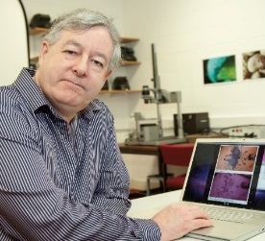

David studied Anatomy at Aberdeen University before completing PGCert in Education at Aberystwyth University. After training as a clinical photographer at University Hospital of Wales, he worked at University of Dundee and in Bromsgrove and Redditch. David returned to teach the HNC Medical and Technical Photography at Berkshire College of Art & Design and then moved to the University of Derby as the programme leader for BSc (Hons) Biological Imaging. David is currently Senior Lecturer Forensic Anthropology and Photography in Biomedical and Forensic Sciences, School of Human Sciences, College of Life and Natural Sciences. View his research on the application of photography to science: [http://photolibrary.cladonia.co.uk](http://photolibrary.cladonia.co.uk/)