GOING WITH THE FLOW: HOW CORALS IN HIGH-FLOW ENVIRONMENTS CAN BEAT THE HEAT

James Fifer^{13*}, Bastian Bentlage¹, Sarah Lemer¹, Atsushi G. Fujimura¹, Michael Sweet², and Laurie J. Raymundo¹
1 University of Guam Marine Laboratory, UOG Station, Mangilao, GU 96923, USA
2 Aquatic Research Facility, Environmental Sustainability Research Centre, University of Derby, Derby, DE22 1GB, UK
3 Boston University Department of Biology, Boston, Massachusetts, USA
*Corresponding author: james.e.fifer@gmail.com

Abstract

Coral reefs are experiencing unprecedented declines in health on a global scale leading to severe reductions in coral cover. One major cause of this decline is increasing sea surface temperature. However, conspecific colonies separated by even small spatial distances appear to show varying responses to this global stressor. One factor contributing to differential responses to heat stress is variability in the coral’s micro-environment, such as the amount of water flow a coral experiences. High flow provides corals with a variety of health benefits, including heat stress mitigation. Here, we investigate how water flow affects coral gene expression and provides resilience to increasing temperatures. We examined host and photosymbiont gene expression of Acropora cf. pulchra colonies in discrete in situ flow environments during a natural bleaching event. In addition, we conducted controlled ex situ tank experiments where we exposed A. cf. pulchra to different flow regimes and acute heat stress. Notably, we observed distinct flow-driven transcriptomic signatures related to energy expenditure, growth, heterotrophy and a healthy coral host-photosymbiont relationship. We also observed disparate transcriptomic responses during bleaching recovery between the high- and low-flow sites. Additionally, corals exposed to high flow showed “frontloading” of specific heat-stress related genes such as heat shock proteins, antioxidant enzymes, genes involved in apoptosis regulation, innate immunity, and cell adhesion. We posit that frontloading is a result of increased oxidative metabolism generated by the increased water movement. Gene frontloading may at least partially explain the observation that colonies in high-flow environments show higher survival and/or faster recovery in response to bleaching events.

Key words: coral bleaching; heat stress; water flow; transcriptomics; gene expression; frontloading, Acropora, staghorn coral

1. Introduction

Many of the world’s coral reefs are restricted to the shallow littoral, a habitat frequently exposed to variable levels of irradiance, extreme tidal fluxes, varying sea surface temperatures (SST), sedimentation, and eutrophication (Guilcher, 1988). Furthermore, due to the proximity of the majority of coral reefs to the shoreline, coral habitats are under increasing pressure from anthropogenic stressors such as pollution and physical damage (Hughes, 1994; Thiel et al., 2013). Until recently, Guam (Mariana Islands, Micronesia), and many other Pacific islands, avoided large-scale decline (Burdick et al., 2008; Paulay, 1999). However, recent bleaching events, and their projected increase in frequency (Logan, Dunne, Eakin, & Donner, 2014), bring into question the future of coral populations in Guam and the rest of the tropical Pacific. Guam experienced temperature-triggered coral bleaching events in 2013 and 2014, exacerbated by extreme low tides in 2015 (Raymundo, Burdick, Lapacek, Miller, & Brown, 2017) and two more bleaching events in 2016 and 2017 (Maynard et al. 2018; Raymundo et al., 2019). Total mortality for thicket-forming staghorn Acropora populations, in particular, was estimated at 52% after the 2013-2015 events, with a total of 17.8 ha of coral cover lost (Raymundo et al., 2017). Staghorn acroporids disproportionally contribute to reef accretion and form extensive, rugose thickets across shallow reef flats, making them biological pillars for the ecosystem functions delivered by coral reefs (Wild, 2011). Despite such devastating losses, staghorn coral death was not uniform across habitats and a distinctive spatial pattern of resilience to bleaching conditions was observed (Raymundo et al., 2017). Communities closer to the well-flushed reef crests, for example, showed significantly less bleaching-related mortality than those in more stagnant waters closer to shore (Raymundo et al., 2017). In both individual colonies, and thickets formed by multiple colonies, post-bleaching survival was limited to the edges, with extensive mortality in colony and thicket centers. Such spatial variation (at both intra- and inter-colony scales) suggests that local processes (such as water flow, which can vary at both the reef (Johansen, 2014) and colony level (Hench & Rosman, 2013)) may mitigate the effect of increased sea surface temperatures (Bayraktarov, Pizarro, Eidens, Wilke, & Wild, 2013; Nakamura & Van Woesik, 2001). Indeed, high flow and even intermittent high flow can reduce the bleaching susceptibility of corals (Fujimura & Riegl, 2017; Smith & Birkeland, 2007). In addition, bleached corals in high-flow environments appear to recover faster once temperatures return to normal levels (Nakamura, Yamasaki, & van Woesik, 2003).
Water flow mediates physiological changes in various coral species, which may explain its mitigating effect on heat stress. High flow causes a thinning of the diffusive boundary layer (DBL), facilitating efficient transport of solutes between coral tissues and the surrounding water (Finelli, Helmuth, Pentcheff, & Wethey, 2007; Nakamura & Van Woesik, 2001). This leads to increased nutrient uptake (Atkinson & Bilger, 1992; Badgley, Lipschultz, & Sebens, 2006; Falter, Atkinson, & Merrifield, 2004) and availability (Rosset, D’Angelo, & Wiedenmann, 2015; Rosset, Wiedenmann, Reed, & D’Angelo, 2017), as well as greater gas exchange rates (Finelli, Helmuth, Pentcheff, & Wethey, 2006), thus impacting respiration (Osinga, Derksen-Hooijberg, Wijgerde, & Verreth, 2017). Greater oxygen efflux under higher flow can potentially increase photosynthesis by reducing photorespiration in the coral photo-symbiont (Kremien, Shavit, Mass, & Genin, 2013; Mass et al., 2010). Additionally, flow-mediated increase in the influx of dissolved inorganic carbon can promote calcification rates and photosynthesis (Dennison & Barnes, 1988). Although several studies have highlighted the beneficial role of high flow in heat stress mitigation, the inherent molecular processes driving bleaching resistance vs. susceptibility in the presence of high vs. low flow remain unexplored. Here, we investigate cellular responses to thermal stress, via transcriptomic analysis, of the staghorn coral Acropora cf. pulchra originating from different water flow environments.

2. Materials and Methods
2.1. Characterization of Study Sites
Our field site was located on the reef flat of West Hagåtña Bay, Guam (Fig. 1). At this site, the major currents are determined primarily by wind direction, which is easterly for ~80% of the year (NOAA National Centers for Environmental information, 2017). This results in a strong westerly current across the reef flat for the majority of the year. We examined flow dynamics at two contrasting positions (northeast and southwest edges) of an extensive staghorn thicket (200m long). The northeast coral community averaged 23% live coral cover during the first mass bleaching episode of 2013 (Raymundo et al., 2017). Colonies on the northeast edge of the thicket (hereafter referred to as ‘high-flow’; Fig. 1) experience higher flow than those on the southwest edge (‘low-flow’; Fig. 1) likely due to buffering from surrounding colonies. The high-flow site was approximately 0.5 m shallower than the low-flow site, which averaged 35% live coral cover in 2013 (Raymundo et al., 2017). Both sites share similar-sized isolated staghorn colonies (~6 m²), which allows for a standardized comparison of the effects of flow rates on individual colonies (Edmunds & Burgess, 2018). Finally, the two sites showed distinct differences in the scale of mortality from the 2013-2015 bleaching events, with an estimated > 80% and < 20% mortality for low and high-flow sites, respectively (Raymundo et al., 2017).
To characterize the in situ environment, all environmental parameters were measured at both the edge and center of all coral colonies sampled for sequencing. Temperature was measured with HOBO (Onset Corp., Bourne, MA) temperature loggers, deployed at 0.25 m from the substrate, at a depth of 1.25 m with a tidal range of 0.5 m to 1 m. Temperature data were taken for six months at thirty-minute intervals, spanning both rainy and dry seasons. To test for differences in temperature between the two sites during daily extremes, tidal data for Apra Harbor (retrieved from https://tidesandcurrents.noaa.gov/waterlevels.html) were compared with available temperature data at the nearest half hour. A Kolmogorov-Smirnov test was used to look for temperature differences between the high flow and low sites and both high and low tides. Phosphate and ammonia concentrations were analyzed by the Water and Environmental Research Institute of the Western Pacific (WERI) (Mangilao, GU) at both sites to rule out possible persistent nutrient pollution of field sites as a confounding variable influencing coral responses to bleaching stress. Flow data were collected for 6 hours on three days during the summer where winds were reflective of annual averages (both speed and direction), using clod cards, which provide a dimensionless measure of water motion (Jokiel & Morrissey 1993). Clod cards were attached to three different coral branches (branch replicate) both in the center and on the edge of each sampled colony (six clod cards total per colony; three colonies per site). Mean dissolution of clod cards was calculated using the protocol from Reidenbach, Koseff, Monismith, Steinbuck, and Genin (2006). This was done to estimate short-term mass transfer rates, as a proxy for water flow rates. Dissolution measurements for each day were standardized (mean = 0, SD = 1) and averaged. A linear mixed- effects model was fit using the lme4 package (Bates, Machler, Bolker, & Walker, 2015) in R (R Development Core Team, 2018) to determine differences in dissolution between high-flow and low-flow sites and edge vs. center of colonies; appropriate models were selected using the Akaike Information Criterion (AIC). Our model had one fixed factor (colony position) and two nested random factors (colony number, branch replicate). Residuals were tested for normality using the Shapiro-Wilk test. There was less than 4% variance in the dissolution rate of the still water control (see Reidenbach et al., 2006) between sites, indicating that neither water temperature nor salinity were causing differences in dissolution at low-flow vs. high-flow sites. The difference in flow speeds of the high flow and low flow site was checked by post-measurement with two acoustic Doppler current profilers deployed in August-September 2020. Profilers were deployed at 1.22 m and 1.37 m depth at high- and low-flow sites respectively and were within 2 m of a sampled colony. Only 12 out of 20 cells (cell size=10cm) were used to avoid measurements exposed to air or benthic floor and to adjust to comparable depths between sites. Data was recorded at 10 minute intervals.
2.2. In situ flow experiment
The in situ experiment was conducted during the summer of 2017, which was characterized by temperatures above the annual maximum monthly mean SST from June until November, resulting in 48% of surviving corals impacted by this bleaching season (Raymundo et al., 2019). In order to characterize differential gene expression in corals growing in different flow environments under heat stress but before bleaching was apparent (i.e. no obvious paling), fragments (~2 cm in length) were collected from six non-bleached Acropora cf. pulchra colonies (three colonies from the high-flow and three from low-flow sites) at least 5 m apart from each other in August, 2017. To determine the influence of colony-scale water flow differences (edge vs. center) and differences across sites (high-flow vs low-flow) on gene expression, coral fragments were sampled from both the edge and center of Acropora coral colonies (three colonies per site, 2 fragments per colony for a total of six fragments per site; n=12) for whole transcriptome shotgun sequencing and endosymbiotic Symbiodiniaceae counts.
To examine differential gene expression between different flow environments during a bleaching event, the same coral colonies were sampled again at the end of summer in September 2017 (Supplemental Fig. 1) (Island-wide NOAA Bleaching Alert level 2, NOAA Coral Reef Watch (2017)). Only branches from the edge (n=6) of colonies sampled previously in August were collected for transcriptome sequencing and symbiont counts due to high bleaching-related mortality, resulting in a scarcity of live coral tissue in the center of low-flow site colonies.
2.3. Ex situ flow experiment
To examine the influence of water flow regime on gene expression in acutely heat- stressed corals, we sampled four unbranched (~4 cm) fragments of branch tips from the edge of four high-flow colonies (the same colonies sampled during August and September, plus one additional colony). Fragments were acclimated for two weeks in a flow-through seawater raceway with high water circulation (8-16 cm/s) at control temperatures (29.0 - 29.5 °C) and shaded natural light levels (mean=68.7 SD= 157.7 μmol photons m⁻² s⁻¹ during the daytime). After acclimation, 16 fragments were divided into four uni-directional flow tanks (built using guidelines from Denny, 1988), followed by 11 days of acclimation at control temperature and ambient light. Each tank was divided into two flow regimes: low-flow (4 cm/s; approximately 25% dissolution rate) or high-flow (16 cm/s; approximately 45% dissolution rate) each of which was within the range of the measured in situ flow rate. Four replicates of each flow regime were run (with four fragments in each treatment; one from each source colony, using a clonal design). Flow velocity was determined using a FlowTracker Acoustic Doppler Velocimeter (SonTek, San Diego, CA). At the end of day 10, half of the fragments within each flow treatment were switched to a different tank of the same flow treatment to account for possible tank effects. On day 11 of the experiment, temperature in two of the tanks was increased to 35°C, over a 3-hr period and then maintained at 35°C for 45 min. before being lowered back to 29.5°C over a 2-hr period. These temperatures were based on the highest temperature and greatest range recorded in situ from our data loggers in the field (Supplemental Fig. 1). Temperature was regulated with a Tank TK-3000 Aquarium chiller (TECO, Ravenna, Italy) and a HC-810M water temperature controller (Finnex, Countryside, IL). The other two tank systems were maintained at control temperature for the same period. A ~2 cm sample from each fragment (n=16) was collected for RNA extraction and sequencing immediately after temperatures were lowered to 29.5°C.
2.4. RNA extraction, library preparation and sequencing
Samples for both in situ and ex situ experiments (n=34) were approximately 2 cm long and cut from below the branch tips to avoid biasing sequencing libraries toward general growth-related RNAs (Hemond, Kaluziak & Vollmer, 2014). All tissue samples were immediately placed in RNAlater (Sigma-Aldrich, St. Louis, MO) and stored frozen at -80°C until extraction. Total RNA was extracted from half the fragment (~ 1 cm) using a RNeasy kit (Qiagen, Hildenheim, Germany) on a QIAcube DNA/RNA extraction robot (Qiagen, Hildenheim, Germany) following the manufacturers’ protocol. RNA was quantified using a Qubit 4 fluorometer (Life Technologies, Carlsbad, CA) and RNA integrity was determined using a Bioanalyzer (Agilent Technologies, Santa Clara, CA). An Illumina NeoPrep system (Illumina, San Diego, CA) was used to prepare sequencing libraries that were normalized, pooled and sequenced in two multiplexed runs on a NextSeq500 sequencer (Illumina, San Diego, CA), generating 2 x 75bp paired end sequences.
2.5. Reference transcriptome assembly and annotation
Sequences were trimmed using Trimmomatic (Bolger, Lohse, & Usadel, 2014), removing low-quality nucleotides (> 30 quality score) and sequencing adapters, retaining properly paired sequences ≥35 bp and clipping low quality nucleotides at both ends of each read (up to 3bp) (ILLUMINACLIP:TruSeq3-PE.fa:2:30:10 LEADING:3 TRAILING:3 SLIDINGWINDOW:4:15 MINLEN:35:-phred33). All quality-filtered paired reads were aligned against the publicly available A. digitifera genome (Shinzato et al., 2011) and Cladocopium goreaui genome (Liu et al, 2018), using the splice-junction mapper TopHat2 (Kim et al., 2013). Using the resulting BAM files, two reference transcriptomes, one for A. cf. pulchra and one for Cladocopium sp. were assembled via the genome-guided version of the Trinity transcriptome assembler (Haas et al., 2013), with the A. digitifera genome (Shinzato et al., 2011) or C. goreaui genome (Liu et al, 2018) as a guide.
BLASTN searches were performed of assembled contigs ≥300 bp against NCBI’s nt database (https://www.ncbi.nlm.nih.gov/) with an e-value 1×10⁻⁵, retaining only scleractinian and matches. For the symbiont transcriptome BLASTX searches were performed against the nr database, retaining only dinoflagellate matches. Ribosomal RNA contaminants were identified through BLASTN (e-value ≤ 1×10⁻⁸) searches against the SILVA LSU and SSU rRNA databases (http://www.arb-silva.de), and removed from further analysis. BLASTX searches of the assembled coral reference transcriptome (e-value cutoff 1×10⁻⁵) were run against the cnidarian sequences contained in the UniProt database (The UniProt Consortium, 2019) to annotate the taxonomically filtered reference transcriptome. For the assembled symbiont transcripts, BLASTX searches were run against the entire UniProt database due to the relative scarcity of dinoflagellate sequences in the UniProt database. Transcriptome sequences were assigned gene ontology (GO) terms (Ashburner et al., 2000) using the UniProt to GO mapping provided by the UniProt consortium. One sample from the ex situ experiment (control temperature and low-flow condition) was removed from downstream analyses due to a pump failure during the experiment that artificially altered gene expression in this fragment. Clone detection was carried out using hierarchical clustering of samples based on pairwise identity by state (IBS) distance calculated in ANGSD v0.921 (Korneliussen, Albrechtsen, & Nielsen, 2014). Samples were mapped to the host reference transcriptome, retaining loci that were present in at least 80% of individuals with the following criteria: minimum mapping quality score of 30, minimum quality score of 35, strand bias p value >0.05, non triallelic, singular best hit, coverage > 6 reads, minor allele frequency (MAF) > 0.05, and snp p value >0.05. Fragments from the same colony were used to identify appropriate height cutoff.
2.6. Differential gene expression
Quality-filtered sequences were mapped against the reference transcriptome of A. cf. pulchra for the coral host and Cladocopium sp. for the symbiont and gene expression was estimated using the expectation maximization algorithm implemented in RSEM (Li & Dewey, 2011). The arrayQualityMetrics package (Kauffmann et al. 2009) was used to detect outliers and one symbiont library (in situ low-flow; heat event; edge; colony 2) was removed. Differentially expressed genes (DEG) between treatments were identified using the R package Deseq2 (Love, Huber, & Anders, 2014). P values for significance of contrasts between flow and heat treatments were based on Wald statistics and adjusted for multiple testing using the Benjamini-Hochberg method (Benjamini & Hochberg, 1995), with a cutoff of p < 0.05. For the ex situ experiment, comparisons were carried out using the model ~ treatment + genotype, where treatment was one of four terms (high-flow no heat, high-flow heat, low-flow no heat or low-flow heat). For the in situ experiment, the model ~ site + O.I was used, where site and O.I both had two terms (high-flow or low-flow; edge or center). Heat maps were created for functional groups of interest, examining only genes that passed FDR corrected p value (<0.05). Additionally, we conducted GO enrichment analyses using Mann–Whitney U tests on rank-based adaptive clustering of GO terms with the R script GO_MWU (Wright, Aglyamova, Meyer, & Matz, 2015; https://github.com/z0on/GO_MWU). The GO_MWU analysis creates delta ranks, which are the difference in the mean rank for the GO term and the mean rank for all other genes. Plotting delta ranks for GO terms allows a determination of similarity in functional responses between comparisons (in this case between ex situ high-flow vs low-flow and in situ high-flow vs low-flow comparisons). Keeping only the GO terms that were significant in at least one of the two comparisons (p_{adj} <0.05), we examined Pearson’s correlation between the delta ranks. Gene counts were rlog transformed for principal coordinate analysis, which was performed with the R package vegan (Oksanen et al., 2017) using Manhattan distances between samples. The function Adonis (from the R package vegan) was used to determine if there was clustering according to treatment. Finally, in the ex situ experiment we looked for genes exhibiting a frontloading expression profile following the methods outlined in Barshis et al (2013). In short, we selected a subset of genes that were upregulated (defined as a 2-fold log change, p_{adj} <0.05) either a) under low-flow heated compared to low-flow no heat, or b) high-flow heated compared to high-flow no heat (see script Frontloading_figure.R). We then compared the fold change when heated to the expression differences between high-flow and low-flow treatments without heat (paralleling the baseline comparison from Barshis et al. 2013).
2.7. Symbiodiniaceae endosymbiont community
To evaluate the severity of bleaching in sampled populations, Symbiodiniaceae densities were determined for all samples taken for gene expression analysis (half of each fragment was used for Symbiodiniaceae counts; n=18 fragments). Two additional fragments for each of the 18 discrete sampling times/positions described in 2.2. ( i.e. 36 extra replicates) were also sampled and used for Symbiodiniaceae counts only (i.e. n=54 total fragments). Coral tissue was removed using an airbrush with filtered seawater (0.25 µm), and Symbiodiniaceae were counted with a hemocytometer using the protocol from Marsh (1970). A linear mixed-effects model was fit using the lme4 package (Bates et al., 2015) in R (R Development Core Team, 2018) to determine differences in Symbiodiniaceae counts between high-flow and low-flow sites, edge vs. center of colonies, and heat stress vs. bleaching events; appropriate models were selected using the Akaike Information Criterion (AIC). Comparisons were made within and between the heat stress and bleaching events. For within event comparisons, the model had one fixed factor (colony position or site) and two nested random factors (colony number, branch replicate). For between event comparisons, the model had two fixed factors (event type (bleaching or heat stress) and site) and two nested random factors (colony number, branch replicate). Residuals were tested for normality using the Shapiro-Wilk test. Symbiodiniaceae identity was determined via a pipeline adapted from Davies et al. (2018) using ITS2 as a marker. Phylogenetic relationships were inferred to determine differences in Symbiodiniaceae between treatments (see Supplementary Methods for further details).

3. Results
3.1. Field site environmental data
According to clod card dissolution, mean flow at the high flow site was more than two times greater at the high flow site (33% dissolution rate) compared to the low flow site (13% dissolution rate) (Fig. 2). The difference in flow speeds of the two areas (12.17 ± 7.61 cm/s for high-flow, 9.02 ± 5.08 cm/s for low-flow; p < 0.0001) was confirmed by post-measurement with two acoustic Doppler current profilers deployed in August-September 2020 (Supplemental Fig. 2). At the colony level, flow differences between the edge and center of colonies were insignificant at the high-flow site (p > 0.05, SE=0.29, df=8) but significant at the low-flow site, with flow being higher along colony edges (p < 0.05, SE=0.184, df=8) (Fig. 2). During both the August and September sampling periods, temperature ranges differed little between high- and low-flow sites (Supplemental Fig. 1 and Supplemental Table 1). From May-December 2017, there was no significant difference in temperature between the high flow and low flow sites during both high (D = 0.075419, p-value = 0.26) and low (D = 0.078594, p-value = 0.23) tides. Phosphate in the water column was below the detection limit (< 0.01 mg/L) at both sites; ammonia was present in trace amounts (0.013 - 0.10 mg/L).
3.2. Acropora cf. pulchra and Cladocopium sp. reference transcriptome assembly and differential gene expression
After adapter trimming and quality filtering, library sizes ranged from ~5 to ~60 million paired-end reads for ex situ and ~14 to ~235 for in situ (Supplemental Figs. 3-4). The host’s first draft transcriptome assembly comprised 150,719 contigs, 34,231 of which were determined to be of scleractinian origin with an average length of 779 bp and an N50 of 923. Annotations were obtained for 21,265 genes (Supplementary Table 2). Clone detection revealed all colonies sampled at the high flow site were likely clones and all colonies from the low flow site belonged to one of two genotypes (Supplemental Fig. 5). The symbiont first draft transcriptome assembly comprised 115,457 contigs, 37,462 of which were determined to be of dinoflagellate origin with an average length of 580 bp and an N50 of 603. Annotations were obtained for 12,898 genes (Supplementary Table 2).
3.2.1 Differential gene expression analysis, ex situ
For the host, principal coordinate analysis for the ex situ experiment revealed clustering according to flow on principal coordinate one and heat on principal coordinate two, which explain 50.9% and 11.2% of the variation, respectively (Fig. 3). The separation according to both flow (p <0.05) and heat (p <0.05) was statistically significant. For the symbiont, principal coordinate analysis for the ex situ experiment revealed clustering according to flow on principal coordinate one and two. Separation was only significant according to flow (p <0.05) (Supplemental Fig. 6).
3.2.2 Differential gene expression analysis, in situ
For both host and symbiont, principal coordinate analysis for the in situ experiment revealed clustering according to site on principal component one and two, and a more variable response among low-flow site samples relative to a more consistent pattern of gene expression among high-flow site samples (Supplemental Fig. 7). The separation according to site was significant (p <0.05), while the separation between the center and edge of colonies was not for both high flow site (p=0.83) and low flow site (p=0.308). We also ran Adonis (from the R package vegan) with models Site:bleach.state (location x time) and also Site:O.I (location x fragment location) to test for significance of interactions, but found none (p>0.05).
3.2.3. Ex situ high flow vs. low flow at control temperatures
Host: In the high-flow treatment, genes related to cilium movement, glycolysis, phosphorylation, fatty acid metabolism, tricarboxylic acid cycle, nitrogen compound transport, cell-matrix adhesion, cellular amino acid biosynthesis, mitochondrial organization and preribosomes were upregulated. We also found a subset of ribosome genes that were downregulated under high flow and several genes related to oxidative stress (e.g., glutathione genes) and immune response (e.g., TRAF genes) upregulated in the high-flow treatment (Supplemental Fig. 8).
Symbiont: In the high-flow treatment, genes related to photosynthesis, carbon transport, nitrogen transport, ABC transport, and nitrate and nitrite reductase were differentially expressed. We also found several genes related to oxidative stress upregulated in the high-flow treatment (Supplemental Fig. 9).
3.2.4. In situ high-flow vs. low-flow sites during pre-bleaching heat stress
Host: We found functional groups of genes upregulated in situ under high-flow conditions that were also upregulated in the ex situ high-flow treatment (Supplemental Fig. 10). These groups included genes involved in glycolysis, tricarboxylic acid cycle, cell-matrix adhesion, cellular amino acid biosynthesis, and preribosome and mitochondrial organization. Stress-related genes were also upregulated under the in situ high-flow condition including genes related to oxidative stress and immune response. A subset of immune response genes were upregulated at the low-flow site.
Symbiont: We also found functional overlap in expression patterns between in situ high-flow and ex situ high-flow conditions for the symbiont (Supplemental Fig. 11). These included genes involved in photosynthesis, carbon transport, nitrogen transport, ABC transport, nitrate reductase and oxidative stress. We also found photosystem I reactor center genes to be upregulated under both in situ and ex situ low-flow conditions.
3.2.5. Overlap of flow response between ex situ and in situ experiments
Host: We found 129 annotated differentially expressed genes shared between both ex situ and in situ high-flow vs low-flow experiments (under control and non-bleaching conditions, respectively). Of these genes, 120 exhibited the same expression pattern in their respective flow condition across experiments. These included genes involved in the immune response, the tricarboxylic acid cycle, stress and cellular stress response, lipid transport and cellular component organization (Supplemental file 1). The GO delta ranks also showed a positive relationship between these two comparisons (p <0.05, Fig. 4A).
Symbiont: We found 16 annotated differentially expressed genes were shared between ex situ and in situ flow experiments, all of which exhibited the same expression pattern in their respective flow condition across experiments. These genes were involved in lipid catabolism, glucose metabolism, mRNA splicing, rRNA processing and translation regulation (Supplemental file 1). The GO delta ranks also showed a positive relationship between these two comparisons (p <0.05, Fig. 4B).
3.2.6. Frontloading
Host: In the ex situ experiment, we found evidence of frontloading under high flow (Fig. 5A). The genes that exhibited this pattern included many stress related genes. TNF receptor associated factor (TRAF) 3, 97kDa HSP 110, and HSP 70 were among the most strongly frontloaded genes. Other stress related genes also exhibited frontloading, including serine/threonine-protein kinase, TRAF 2, TRAF 6, universal stress protein A-like protein, and heat shock cognate 71 kDa protein (Supplemental file 1).
Symbiont: We also found evidence of frontloading in the ex situ experiment under high flow for the symbiont (Fig. 5B). The genes that exhibit this pattern included stress related genes such as Chaperone protein DnaJ 1, Apoptosis-inducing factor homolog B, Death-associated protein kinase 1, and E3 ubiquitin-protein ligase (Supplemental file 1).
3.2.7. Differential bleaching response between high-flow and low-flow sites
Host: Colonies at the high-flow site showed a different shift in expression between the heat stress event and bleaching event compared to the response of colonies at the low-flow site. Within the high-flow site bleached colonies showed upregulation of ribosomal biogenesis and mitochondrial parts and protein folding, and downregulation of calcium ion binding, cell-cell adhesion and response to oxidative stress compared to their expression during the heat stress event. Within the low-flow site, bleached colonies showed upregulation of microtubule-based process, Rho protein signal transduction, calcium ion binding and cell-cell adhesion and downregulation of structural constituent of ribosome, immune effector process, protein folding and mitochondrion (Fig. 6). Additionally, we observed a negative relationship between the GO delta ranks for these comparisons (p<0.05; Supplemental Fig. 12). We were unable to make this comparison for symbiont reads because one high-flow colony sampled during the heat stress event was identified as an outlier and removed from the symbiont analysis (described in 2.6, leaving only n=2 for this treatment).
3.3. Symbiodiniaceae abundance and diversity
Symbiodiniaceae counts did not differ significantly between the edge and center of colonies during the heat stress event at both the high-flow (p >0.05, SE= 154899.4.4, df=6) and low-flow (p >0.05, SE=177822.0. df=7) sites (Supplemental Fig. 13). There was a trend (p <0.1), however, toward higher Symbiodiniaceae abundances in colonies growing at the high-flow site compared to the low-flow site during both the heat stress (average cells per branch: 1.28x10⁶ and 9.6x10⁵, respectively; SE= 171480.4, df=4) and bleaching events (average cells per branch: 8.7x10⁵ and 2.7x10⁵, respectively; SE= 246626.6, df=4) (Supplemental Fig. 14). There was also significantly increased Symbiodiniaceae abundance during the heat stress event compared to the bleaching event (p<0.05, SE=120076.8, df=26; average cells per branch: 1.1 x10⁶ and 6.7 x10⁵, respectively) (Supplemental Fig. 15), confirming these samples were in fact bleaching. Cladocopium sp. was the dominant taxon in these Symbiodiniaceae communities. Phylogenetic analysis revealed no clustering of lineages by flow environment (Supplemental Fig. 16).

4. Discussion
Here, we highlight water flow-driven differences in the transcriptomic response of Acropora cf. pulchra and its symbiont Cladocopium sp., both under a natural heat stress event and in an experimental setting. We find evidence for molecular mechanisms that are consistent with the current understanding of the beneficial impacts of water movement on coral health. We also find a frontloading effect of flow on heat stress genes, possibly demonstrating that higher flow mediates the ability of corals to respond to heat stress quickly, providing increased resilience. Finally, we discuss differences in responses during bleaching recovery in discrete flow environments.
4.1. Flow-driven transcriptomic response
For our ex situ high-flow treatment, genes relating to glycolysis, phosphorylation, fatty acid metabolism and tricarboxylic acid cycle were upregulated under the no-heat, high-flow treatment compared to no-heat, low-flow, suggesting elevated energy expenditure by the coral host (Hemond et al., 2014). We also found a strong signal of upregulation for all these processes, except for phosphorylation and fatty acid metabolism, at the high-flow site in our in situ experiment, albeit not always the same genes. Elevated energy expenditure could be a reflection of the increased gas exchange (Mass et al., 2010) and higher growth rates (Schutter et al., 2010) that often accompany corals living in high-flow environments. We saw examples of both in our dataset. Genes related to mitochondrial reorganization were upregulated under high flow in both experiments, suggesting increased respiration (Brown, 1992). We also saw upregulation of preribosomes, indicators of accelerated growth (Elser et al., 2003; Vrede, Dobberfuhl, Kooijman, & Elser, 2004). Additionally, in both ex situ and in situ high-flow conditions, we found upregulation of specific genes encoding for skeletal organic matrix proteins and cell-matrix adhesion, suggesting possible increased calcification. Indeed, we saw overlapping upregulation of functions previously associated with higher calcification rates, including precursor metabolites, extracellular matrix, oxidative stress, response to stimulus, lipid transporters and fatty acid metabolism (Bertucci et al., 2015). It is possible that the increase of these growth-related terms was a direct manifestation of the flow-mediated uptake in building blocks for coral growth, such as inorganic nutrients, organic food and calcium and carbonate ions (Osinga et al., 2011). Alternatively, since our comparison was between high flow and low flow, this observed response under high flow could be viewed as an overall transcriptional dampening under low-flow conditions, perhaps due to the provision of energy savings necessary for efficient stress responses (Gust et al., 2014).
High flow can enable elevated energy expenditure and growth either via increased heterotrophy or an increase in productivity of the symbiont and a greater subsequent transport of amino acids and photosynthates. Upregulation of cilia genes, which we observed in the host under high flow, is reflective of corals exhibiting higher heterotrophy (Malik et al., 2020). Higher water flow increases feeding via increased contact between food sources in the water column and coral tentacles (Sebens et al, 2003); this, in turn, supplies corals with organic sources of carbon, nitrogen, and phosphorous (Osinga et al, 2011). The upregulation of several genes putatively important in nitrate reductase and carbohydrate transport between host and symbiont (Maor-Landow, van Oppen, McFadden, 2019) under high flow could be provisioning the host with sugars and essential amino acids. The ammonium generated by these nitrate reductases is assimilated into amino acids and essential amino acids are then translocated to the host (Wang & Douglas, 1999). The upregulation of nitrate reductase could be due to a high flow-mediated increased flux of inorganic nutrients (Atkinson et al., 2001) or organic nitrogen from greater heterotrophic input. It thus appears that a combination of increased host heterotrophy and translocation from the symbiont can explain increased energy production potential under high flow.
We expected that the increase in transport between symbiont and host would be due to an increase in productivity of the symbiont. However, although we found many genes related to photosynthesis upregulated under high flow, we also observed downregulation of several photosystem reaction center I genes. This initially appeared contradictory given the higher symbiont count at the high-flow site and previous work showing increased photosynthesis under high flow (Mass et al., 2010). While we acknowledge that the relatively understudied nature of Symbiodiniaceae expression and the dearth of physiological measurements for the symbiont in our experiment limits our interpretations, we offer one possible explanation here. Upregulation in Photosystem I (PSI) genes could be a signature of increased electron flow through the Mehler reaction (Roberty, Bailleul, Berne, Franck & Cardol, 2014) under low flow. It has been theorized that low flow would lead to the need for costly photo-protective mechanisms (Schutter et al., 2011) possibly due to decreased CO₂ flux (Wooldridge et al., 2010). Appropriately, upregulation of Photosystem II repair protein and Photosystem II 12 kDa extrinsic protein under low flow suggests PSII requires photoprotection. Furthermore, while we did not measure photosynthesis, our finding that genes associated with ATP and NADPH turnover were upregulated under high flow suggests a functioning photosynthetic electron transport chain. Thus, our overall interpretation was greater productivity of the symbiont under high flow and impairment of photosynthetic function under low flow.
4.2. Comparing in situ and ex situ experiments
Given several confounding factors, including possible adaptation of colonies to their respective sites, recent high selection pressure from previous bleaching events and the multitude of unaccounted variables in the field, the degree of overlap observed between the responses of the high-flow ex situ and in situ experiments points to a strong signal of flow. The similar direction of shared GO terms and genes across the two experiments suggests flow has a consistent signature of gene expression in this coral. The lack of overlap between the high- and low-flow comparisons during the “heat stress” ex situ experiment and the in situ “heat stress event” are likely a consequence of our more extreme heat stress ex situ. In situ colonies experienced a more gradual increase of temperatures over weeks and in situ sampling took place late morning at pre-peak temperatures, whereas in the ex situ experiment sampling occurred directly after the heat stress event. This led to the signal of heat stress overwhelming the signature of flow in the ex situ experiment and very few genes differentially expressed between the high-flow and low-flow treatments. Our ex situ heat stress succeeded in identifying heat stress responsive genes but failed in providing a comparable treatment to the in situ heat stress comparison.

4.3. High flow induces upregulation of stress GO terms and genes
We found upregulation of stress-related genes under high flow compared to low-flow conditions, both in situ and at control temperatures ex situ. Given that increased expression of stress terms is a common biproduct of increased calcification (Bertucci et al., 2015), photosynthesis (Malik et al., 2020), and morphogenesis (Reyes-Bermudez et al., 2009) it follows that high flow should also elicit this response. Such an increase in stress-related genes, in ex situ corals which were under no apparent stress, is highly likely to be a function of increased oxidative metabolism which, in turn, appears directly linked with high flow. Reactive oxygen species (ROS) are well known to increase during photosynthesis and respiration (Apel & Hirt, 2004; Halliwell, Clement, & Long, 2000; Pamatmat, 1997) and have also been shown to increase in high-flow environments (Armoza-Zvuloni & Shaked, 2014). As high flow facilitates greater gas exchange (Mass et al., 2010) it is possible ROS are also moved out of the coral tissue faster (Armoza-Zvuloni & Shaked, 2014), which could explain why high flow does not negatively impact coral health long-term.
Reyes-Bermudez et al. (2009) also found upregulation of heat-stress and oxidative-stress genes, and enrichment of cytoskeleton restructuring functional terms, in coral planulae under normal conditions. They attributed this response to processes involved in morphogenesis. Additionally, our results show that cell adhesion genes, which are involved in tissue morphogenesis (Magie & Martindale, 2008), were upregulated under no-heat, high-flow conditions. As coral morphology can vary according to the flow environment (Mass & Genin, 2008), it is possible that the upregulation of these groups of genes is reflective of hydraulic stress-inducing morphogenesis under high flow.

4.3. Host frontloading of stress genes under high flow
Several mechanisms have been proposed by which increased flow could mitigate heat stress. These include the alteration of the thermal boundary layer (Jimenez et al., 2011), increased toxic solute efflux (Nakamura, 2010), or manipulation of the tissue concentration of ultraviolet-absorbing compounds (Jokiel, Lesser, & Ondrusek, 1997). Additionally, enduring health benefits for the coral via the thinning of the DBL could facilitate faster bleaching recovery under high-flow scenarios. Any combination of these factors might explain the higher survivorship observed at the in situ high-flow site after successive bleaching events (Raymundo et al. 2017). Here we present an additional mechanism that could explain flow-mediated bleaching resistance: “frontloading”.
The phenomenon known as “frontloading”, i.e. the upregulation of stress-related genes under baseline conditions, is associated with resilience to heat stress events (Barshis et al., 2013; Bay & Palumbi, 2017). The absence of a true baseline sampling point in the in situ experiment necessitated using only the ex situ experiment for examining frontloading. In the ex situ experiment we saw frontloading for many of the same genes frontloaded in the Barshis et al., (2013) and Bay and Palumbi (2017) experiments: genes encoding for heat shock proteins and antioxidant enzymes, and genes involved in apoptosis regulation, innate immunity, and cell adhesion. Such frontloading theoretically promotes rapid rates of protein translation and could facilitate a coral’s acclimation to stressors by allowing it to respond faster (Gates & Edmunds, 1999). Corals exhibit an environmental stress response (ESR) (Dixon, Abbott & Matz, 2020), a common pattern of gene expression induced by diverse environmental stressors. Activating the ESR in response to acute stress can serve a protective role against future stress (Berry & Gasch, 2008). Harboring the thermotolerant symbiont Durusdinium trenchii, compared to the thermally sensitive Cladocopium (Cunning & Baker, 2020), and exposure to higher non-lethal temperatures (Bellantuono et al., 2012; Palumbi, Barshis, Traylor-Knowles & Bay, 2014; Rose, Seneca & Palumbi, 2016) can prompt frontloading in corals. We show here that flow induces similar frontloading. Coral resilience against bleaching provided by higher flow is, at least in part, due to frontloading of genes implicated in the heat stress response.
4.4. Symbiont frontloading and stress indicator genes
No study addressing frontloading in corals has posed this question to the symbiont, yet here we found expression patterns suggestive of frontloading in our symbiont expression data as well as in the host. Some genes previously associated with stress responses that were frontloaded in the symbiont include DnaJ chaperone protein, an apoptosis factor-inducing homolog, Ras-related protein Rab, ubiquitin protein ligase, and death-associated protein kinase 1. It is possible that the frontloading of these genes allows the symbiont to mount a more effective response against temperature stress. The absence of a transcriptional change under heat stress has been previously documented for in hospite Symbiodiniaceae (Barshis, Ladner, Oliver, & Palumbi, 2014; Davies et al., 2018) and attributed to “host buffering” either via a suppression of transcriptional expression or through protection of Symbiodiniaceae cells. Given the relatively large transcriptional shift for the Symbiodiniaceae under heat stress that were exposed to low flow compared to high flow, it is possible flow mediates the ability of the host to provide this buffering activity.
It is interesting that genes associated with photoprotection are not frontloaded in symbionts, considering that these genes are often associated with temperature stress (Dang, Pierangelini, Roberty & Cardol, 2019; Rosset, Koster, Brandsma, Hunt, Postle & D’Angelo, 2019). Instead, some photoprotection genes show a different pattern: they are expressed at higher levels under low-flow, no-heat conditions and show greater fold expression increases when subjected to higher temperatures under low flow (“stress indicators” sensu Barshis et al., 2013). This heightened level of photosystem repair under low flow may come at the cost of pushing these repair mechanisms closer to their limit prior to the onset of stress. Damage to PSII can then outpace repair mechanisms under thermal stress, leading to damage to the photosystems and eventually photoinhibition (Warner, Fitt, & Schmidt, 1999). This expression pattern offers a complement to the host expression for why corals under low flow fare worse under heat stress.
4.5. Differential in situ bleaching response between high-flow and low-flow environments
Corals under high flow bleach less often and recover faster when bleached (Nakamura et al., 2003; Bayraktarov et al., 2013). The lower mortality observed previously in colonies growing in high-flow areas may have been the result of increased recovery rates rather than reduced bleaching. The fact that all in situ colonies showed signs of bleaching regardless of their level of flow exposure supports this scenario. While there were very few genes differentially expressed between the heating event and bleaching event within sites, GO enrichment analysis offers a method of elucidating expression trends that might not be evident in expression profiles of individual genes. This is important given our small sample size and natural variation in situ that was likely responsible for the low number of differentially expressed genes. GO enrichment analyses suggested high- and low-flow sites differed in recovery dynamics. The low-flow colonies exhibited a suppression of immune system functions while the high-flow colonies did not. Such a suppression is often exhibited by bleached corals (Pinzon et al., 2015), possibly due to coral microbial community restructuring or functional changes in allelopathic activity (Mydlarz et al., 2009). High-flow colonies, on the other hand, exhibited enrichment of functions that are associated with resilience, including ribosome biogenesis (Wright, Kenkel, Dunn, Shilling, Bay & Matz, 2017) and calcium ion binding, which was previously shown to be significantly enriched during bleaching recovery (Thomas & Palumbi, 2017).
4.6. Symbiodiniaceae diversity and abundance
The lack of obvious clustering of Symbiodiniaceae COI genes according to flow environment demonstrates that the dominant Symbiodiniaceae do not differ between flow environments. Thus, it is unlikely that Symbiodiniaceae diversity played a role in the observed discrete host transcriptomic responses under different flow regimes. Furthermore, no significant difference in Symbiodiniaceae abundances was evident based on colony position, which is counterintuitive given the flow differences observed on the edge vs. the center of the low-flow site colonies. In unidirectional flow there can be asymmetry in Symbiodiniaceae distribution and skeleton mass between the flow-facing side of a colony vs. its downstream side (Mass & Genin, 2008). This is likely induced by asymmetric nutrient concentrations and boundary layer thicknesses (Chang, Iaccarino, Elkins, Eaton, & Monismith, 2004). However, these findings could be exclusive to unidirectional flow (Mass & Genin, 2008), which differs from the flow experienced by corals in situ.
4.7 Limitations and Conclusions
Clone detection revealed the presence of clones at both the high-flow and low-flow sites, reducing the number of discrete genotypes for study. It is possible that the results reported here could be site specific, considering that the high-flow site samples are clonal, a caveat that should be taken into consideration prior to extrapolating the findings herein to other sites. Further, low BUSCO scores (Supplementary Table 2) for both host and symbiont transcriptomes indicate missing genes and the presence of fragmented genes. The latter, in particular, can cause issues if different samples map to different fragments of the same gene, thus biasing gene expression results. Low library quality for a few samples could also be biasing our results. To reduce and mitigate potential biases introduced by incomplete assemblies and some low quality libraries, we removed outliers detected by the arrayQualityMetrics Bioconductor package (Kauffmann et al., 2009). We further discarded contigs that were lowly expressed and focused the study on contigs which were successfully annotated. By doing so, we limited the bias induced by transcript fragmentation and provide more robust estimates for those genes that remained in the analysis (Freedman, Clamp & Sackton, 2021), but we acknowledge that incomplete assemblies could bias our gene expression results.
As coral communities continue to be impacted by increasingly severe and complex acoustic combinations of local and global stressors, conservation and restoration of remaining populations becomes paramount. Despite considerable research effort, the nuanced interactions between corals and their environment remain poorly understood and controlled studies are limited in their capacity for examining multiple environmental attributes. However, there is strong evidence that high flow provides corals with greater resilience to heat stress (Mass et al., 2011; Nakamura, 2010). Results from this study show a flow-induced transcriptomic response in the coral host and its photosymbionts under both laboratory and field conditions. Importantly, our study provides flow induced gene frontloading as a novel mechanism for coral resilience to bleaching. In essence, our results demonstrate a physiological basis for the in situ responses we observed across repeated bleaching events and identify a potential role for the consideration of ambient water motion, wave energy, and flushing in the selection of sites for conservation and restoration. Currently, efforts to genetically enhance corals for greater resilience to rapid environmental change provide an intriguing potential avenue for their survival (van Oppen, Oliver, Putnam, & Gates, 2015) and assisting the evolution of resistant corals through selective breeding show promise for a limited number of species (Baums et al., 2019). However, such options are currently limited in scope and are unlikely to be applied at an ecologically meaningful scale in the near future. In contrast, an improved ability to identify environmental attributes directly linked with higher coral survival could immediately be put to use on a global scale as a criterion in the selection of sites for enhanced management or conservation, as well as active restoration. Selecting sites that provide higher natural flushing could be incorporated into the “toolbox” of any management plan and would be particularly useful for countries with limited capacity for molecular and physiological research on coral species of concern.

Acknowledgements
We are thankful to Casey Te Beest, Victoria Moscato, Vince Fabian, Sarai Vega and Devin Resko who assisted with field and lab work. We acknowledge David Combosch, Peter Houk, Val Lapacek, Jordan Gault, Jill Grose-Fifer, Lucas Fifer and all members of the Davies Marine Population Genomics Lab for their insight on the project. We would like to thank Casey Te Beest and UOG Marine Lab technician Jason Miller for their help building the ex situ raceway. Thanks to Dan Lindstrom for loaning the FlowTracker. This work was supported by Hawai’i-Pacific Islands Cooperative Ecosystems Unit, under Task Agreement P16AC01681 of Cooperative Agreement P14AC00637, between the U.S. Department of the Interior's National Park Service, and the University of Guam, the University of Guam SeaGrant Master's Thesis Research Supplemental Grants in Coastal Community Development (2017-2018) and the National Science Foundation (OIA-1457769).
References
Apel, K., & Hirt, H. (2004). Reactive Oxygen Species: Metabolism, Oxidative Stress, and Signal Transduction. Annual Review of Plant Biology, 55(1), 373–399. https://doi.org/10.1146/annurev.arplant.55.031903.141701
Armoza-Zvuloni, R., & Shaked, Y. (2014). Release of hydrogen peroxide and antioxidants by the coral Stylophora pistillata to its external milieu. Biogeosciences, 11(17), 4587–4598. https://doi.org/10.5194/bg-11-4587-2014
Ashburner, M., Ball, C. A., Blake, J. A., Botstein, D., Butler, H., Cherry, J. M., … Sherlock, G. (2000). Gene ontology: Tool for the unification of biology. Nature Genetics, 25(1), 25–29. https://doi.org/10.1038/75556.Gene
Atkinson, M. J., & Bilger, R. W. (1992). Effects of water velocity on phosphate uptake in coral reef-flat communities. Limnol. Oceanogr., 37(2), 273–279. https://doi.org/10.4319/lo.1992.37.2.0273
Badgley, B. D., Lipschultz, F., & Sebens, K. P. (2006). Nitrate uptake by the reef coral Diploria strigosa: Effects of concentration, water flow, and irradiance. Marine Biology, 149(2), 327–338. https://doi.org/10.1007/s00227-005-0180-5
Barshis, D. J., Ladner, J. T., Oliver, T. A., Seneca, F. O., Traylor-Knowles, N., & Palumbi, S. R. (2013). Genomic basis for coral resilience to climate change. Proceedings of the National Academy of Sciences of the United States of America, 110(4), 1387–92. https://doi.org/10.1073/pnas.1210224110
Barshis, D. J., Ladner, J. T., Oliver, T. A., & Palumbi, S. R. (2014). Lineage-specific transcriptional profiles of Symbiodinium spp. unaltered by heat stress in a coral host. Molecular Biology and Evolution, 31(6), 1343-1352. https://doi.org/10.1093/molbev/msu107
Bates, D., Mächler, M., Bolker, B., & Walker, S. (2015). Fitting linear mixed- effects models using lme4. Journal of Statistical Software, 67, 1–48. http://10.0.72.205/jss.v067.i01
Baums, I. B., Baker, A. C., Davies, S. W., Grottoli, A. G., Kenkel, C. D., Kitchen, S. A., ... & Parkinson, J. E. (2019). Considerations for maximizing the adaptive potential of restored coral populations in the western Atlantic. Ecological Applications, 29(8), e01978.
Bay, R. A., & Palumbi, S. R. (2017). Transcriptome predictors of coral survival and growth in a highly variable environment. Ecology and evolution, 7(13), 4794-4803. https://doi.org/10.1002/ece3.2685
Bayraktarov, E., Pizarro, V., Eidens, C., Wilke, T., & Wild, C. (2013). Bleaching susceptibility and recovery of Colombian Caribbean corals in response to water current exposure and seasonal upwelling. PLoS ONE, 8(11), 1–12. https://doi.org/10.1371/journal.pone.0080536
Bellantuono, A. J., Granados-Cifuentes, C., Miller, D. J., Hoegh-Guldberg, O., & Rodriguez-Lanetty, M. (2012). Coral thermal tolerance: tuning gene expression to resist thermal stress. PloS one, 7(11), e50685. https://doi.org/10.1371/annotation/2b623dcd-9413-47b0-990d-c46c8e662ad4
Benjamini, Y. & Hochberg, Y. (1995). Controlling the False Discovery Rate: A Practical and Powerful Approach to Multiple Testing. J. R. Stat. Soc. Ser. B 57, 289–300. https:// doi/10.1111/j.2517-6161.1995.tb02031.x
Bertucci, A., Foret, S., Ball, E. E., & Miller, D. J. (2015). Transcriptomic differences between day and night in Acropora millepora provide new insights into metabolite exchange and light‐enhanced calcification in corals. Molecular ecology, 24(17), 4489-4504. https://doi.org/10.1111/mec.13328
Berry, D. B., & Gasch, A. P. (2008). Stress-activated genomic expression changes serve a preparative role for impending stress in yeast. Molecular biology of the cell, 19(11), 4580-4587. https://doi.org/10.1091/mbc.e07-07-0680
Bolger, A. M., Lohse, M., & Usadel, B. (2014). Trimmomatic: A flexible trimmer for Illumina sequence data. Bioinformatics, 30(15), 2114–2120. https://doi.org/10.1093/bioinformatics/btu170
Brown, G. C. (1992). Control of respiration and ATP synthesis in mammalian mitochondria and cells. Biochemical Journal, 284(1), 1-13. https://doi.org/10.1042/bj2840001
Bruckner, A. W. (2002). Potential application of the US Endangered Species Act as a conservation strategy. Proceedings of the Caribbean Acropora Workshop, Silver Spring, MD, (January), 184.
Burdick D., Brown V., Asher J., Gawel M., …(2008). The state of coral reef ecosystems of Guam. In: Waddell, J.E., Clarke, A.M. (eds) The state of coral reef ecosystems of the United States and Pacific Freely Associated States. NOAA/NCCOS Center for Coastal Monitoring and Assessment’s Biogeography Team, Silver Spring, MD, 465–510. http://aquaticcommons.org/14919/
Chang, S., Iaccarino, G., Elkins, C., Eaton, J., & Monismith, S. (2004). A computational and experimental investigation of flow inside branched coral colony. Archiv F, 92(1–3), II–II. https://doi.org/10.1007/BF01929939
Cunning, R., & Baker, A. C. (2020). Thermotolerant coral symbionts modulate heat stress‐responsive genes in their hosts. Molecular ecology, 29(15), 2940-2950. https://doi.org/10.1111/mec.15526
Dang, K. V., Pierangelini, M., Roberty, S., & Cardol, P. (2019). Alternative photosynthetic electron transfers and bleaching phenotypes upon acute heat stress in Symbiodinium and Breviolum spp.(Symbiodiniaceae) in culture. Frontiers in Marine Science, 6, 656. https://doi.org/10.3389/fmars.2019.00656
Davies, S. W., Ries, J. B., Marchetti, A., & Castillo, K. D. (2018). Symbiodinium functional diversity in the coral Siderastrea siderea is influenced by thermal stress and reef environment, but not ocean acidification. Frontiers in Marine Science, 5(April), 150. https://doi.org/10.3389/FMARS.2018.00150
Dennison, W. C., & Barnes, D. J. (1988). Effect of water motion on coral photosynthesis and calcification. Journal of Experimental Marine Biology and Ecology, 115, 67–71. https://doi.org/10.1016/0022-0981(88)90190-6
Denny, M. W. (1988). Biology and the mechanics of the wave-swept environment. (Vol. 197). Princeton, NJ: Princeton University Press.
Dixon, G. B., Davies, S. W., Aglayamova, G., Meyer, E., Bay, L. K., & Matz, M. V. (2015). Genomic determinants of coral heat tolerance across latitudes. Science 348(6242), 1460-1462. https://doi.org/10.1126/science.1261224
Dixon, G., Abbott, E., & Matz, M. (2020). Meta‐analysis of the coral environmental stress response: Acropora corals show opposing responses depending on stress intensity. Molecular Ecology, 29(15), 2855-2870. https://doi.org/10.1111/mec.15535
Edmunds, P. J., & Burgess, S. C. (2018). Colony size and turbulent flow speed modulate the calcification response of the coral Pocillopora verrucosa to temperature. Marine Biology, 165(1), 13. https://doi.org/10.1007/s00227-017-3257-z
Elser, J. J., Acharya, K., Kyle, M., Cotner, J., Makino, W., Markow, T., … Sterner, R. W. (2003). Growth rate-stoichiometry couplings in diverse biota. Ecology Letters, 6(10), 936–943. https://doi.org/10.1046/j.1461-0248.2003.00518.x
Falter, J. L., Atkinson, M. J., & Merrifield, M. A. (2004). Mass-transfer limitation of nutrient uptake by a wave-dominated reef flat community. Limnology and Oceanography, 49(5), 1820–1831. https://doi.org/10.4319/lo.2004.49.5.1820
Finelli, C. M., Helmuth, B. S. T., Pentcheff, N. D., & Wethey, D. S. (2006). Water flow influences oxygen transport and photosynthetic efficiency in corals. Coral Reefs, 25(1), 47–57. https://doi.org/10.1007/s00338-005-0055-8
Finelli, C. M., Helmuth, B. S., Pentcheff, N. D., & Wethey, D. S. (2007). Intracolony variability in photosynthesis by corals is affected by water flow: role of oxygen flux. Marine Ecology Progress Series, 349, 103–110. https://doi.org/10.3354/meps07101
Freedman, A. H., Clamp, M., & Sackton, T. B. (2021). Error, noise and bias in de novo transcriptome assemblies. Molecular ecology resources, 21(1), 18-29.
Fujimura, A. G., & Riegl, B. M. (2017). Effects of water flow on intra- and intercolonial variability in bleaching of the zoanthid, Palythoa caribaeorum. Journal of Experimental Marine Biology and Ecology, 490, 29–33. https://doi.org/10.1016/j.jembe.2017.02.006
Gates, R. D., & Edmunds, P. (1999). The physiological mechanisms of acclimatization in tropical reef corals. American Zoologist, 43(June), 30–43. https://doi.org/10.1093/icb/39.1.30
Guilcher, A. (1988). Coral Reef Geomorphology. Chichester, New York, Brisbance, Toronto, Singapore: John Wiley & Sons.
Gust, K. A., Najar, F. Z., Habib, T., Lotufo, G. R., Piggot, A. M., Fouke, B. W., … Perkins, E. J. (2014). Coral-zooxanthellae meta-transcriptomics reveals integrated response to pollutant stress. BMC Genomics, 15(1), 1–18. https://doi.org/10.1186/1471-2164-15-591
Haas, B. J., Papanicolaou, A., Yassour, M., Grabherr, M., Philip, D., Bowden, J., … Pochet, N. (2014). Reference generation and analysis with Trinity. Nat Protocols, 8, 1494–1512. https://doi.org/10.1038/nprot.2013.084.De
Halliwell, B., Clement, M. V., & Long, L. H. (2000). Hydrogen peroxide in the human body. FEBS Letters, 486(1), 10–13. https://doi.org/10.1016/S0014-5793(00)02197-9
Hemond, E. M., Kaluziak, S. T., & Vollmer, S. V. (2014). The genetics of colony form and function in Caribbean Acropora corals. BMC genomics, 15(1), 1133. https:// 10.1186/1471-2164-15-1133
Hughes, T. P. (1994). Catastrophes, Phase Shifts, and Large-Scale Degradation of a Caribbean Coral Reef. Science, 265(5178), 1547–1551. https://doi.org/10.1126/science.265.5178.1547
Jimenez, I. M., Kühl, M., Larkum, A. W., & Ralph, P. J. (2011). Effects of flow and colony morphology on the thermal boundary layer of corals. Journal of The Royal Society Interface, 8(65), 1785-1795. https://doi.org/10.1098/rsif.2011.0144
Jokiel, P. L., Lesser, M. P., & Ondrusek, M. E. (1997). UV‐absorbing compounds in the coral Pocillopora damicornis: Interactive effects of UV radiation, photosynthetically active radiation, and water flow. Limnology and oceanography, 42(6), 1468-1473. https://doi.org/10.4319/lo.1997.42.6.1468
Jokiel PL, Morrissey JI (1993). Water motion on coral reefs: evaluation of the “clod card” technique. Marine Ecology Progress Series 93:175–181. https://doi.org/10.3354/meps093175
Kim, D., Pertea, G., Trapnell, C., Pimentel, H., Kelley, R., & Salzberg L., S. (2013). TopHat2: accurate alignment of transcriptomes in the presence of insertions, deletions and gene fusions. Genome Biology, 14(4). https://doi.org/10.1101/000851
Korneliussen, T. S., Albrechtsen, A., & Nielsen, R. (2014). ANGSD: analysis of next generation sequencing data. BMC bioinformatics, 15(1), 356.
Kremien, M., Shavit, U., Mass, T., & Genin, A. (2013). Beneft of pulsation in soft corals. Proceedings of the National Academy of Sciences of The United States of America, 110(22), 8978–8983. https://doi.org/10.1073/pnas.1301826110/-/DCSupplemental.www.pnas.org/cgi/doi/10.1073/pnas.1301826110
Maor‐Landaw, K., van Oppen, M. J., & McFadden, G. I. (2020). Symbiotic lifestyle triggers drastic changes in the gene expression of the algal endosymbiont Breviolum minutum (Symbiodiniaceae). Ecology and Evolution, 10(1), 451-466. https://doi.org/10.1002/ece3.5910
Li, B., & Dewey, C. N. (2011). RSEM: accurate transcript quantification from RNA-Seq data with or without a reference genome. BMC Bioinformatics, 12(1), 323. https://doi.org/10.1186/1471-2105-12-323
Logan, C. A., Dunne, J. P., Eakin, C. M., & Donner, S. D. (2014). Incorporating adaptive responses into future projections of coral bleaching. Global Change Biology, 20(1), 125–139. https://doi.org/10.1111/gcb.12390
Love, M. I., Huber, W., & Anders, S. (2014). Moderated estimation of fold change and dispersion for RNA-seq data with DESeq2. Genome Biology, 15(12), 1–21. https://doi.org/10.1186/s13059-014-0550-8
Magie, C. R., & Martindale, M. Q. (2008). Cell-cell adhesion in the cnidaria: insights into the evolution of tissue morphogenesis. The Biological Bulletin, 214(3), 218-232. https://doi.org/10.2307/25470665
Malik, A., Einbinder, S., Martinez, S., Tchernov, D., Haviv, S., Almuly, R., ... & Mass, T. (2020). Molecular and skeletal fingerprints of scleractinian coral biomineralization: from the sea surface to mesophotic depths. Acta Biomaterialia.
Marsh, J. A. (1970). Primary Productivity of Reef-Building Calcareous Red Algae. Ecological Society of America, 7(3), 737–750. https://doi.org/10.2307/1933661
Mass, T., & Genin, A. (2008). Environmental versus intrinsic determination of colony symmetry in the coral Pocillopora verrucosa. Marine Ecology Progress Series, 369, 131–137. https://doi.org/10.3354/meps07578
Mass, T., Genin, A., Shavit, U., Grinstein, M., Tchernov, D., Paul, G., … Tchernovab, D. (2010). Flow Enhances Photosynthesis in Marine Benthic Autotrophs by Increasing the Efflux of Oxygen from the Organism to the Water. National Academy of Sciences, 106(6), 2527–2531. https://doi.org/10.1073/pnas.0912348107
Mass, T., Brickner, I., Hendy, E., & Genin, A. (2011). Enduring physiological and reproductive benefits of enhanced flow for a stony coral. Limnology and Oceanography, 56(6), 2176-2188. https://doi.org/10.4319/lo.2011.56.6.2176
Nakamura, T., & Van Woesik, R. (2001). Water-flow rates and passive diffusion partially explain differential survival of corals during the 1998 bleaching event. Marine Ecology Progress Series, 212(2), 301–304. https://doi.org/10.3354/meps212301
Nakamura, T., Yamasaki, H., & Van Woesik, R. (2003). Water flow facilitates recovery from bleaching in the coral Stylophora pistillata. Marine Ecology Progress Series, 256, 287–291. https://doi.org/10.3354/meps256287
Nakamura, T. (2010). Importance of water-flow on the physiological responses of reef-building corals. Galaxea, Journal of Coral Reef Studies, 12(1), 1–14. https://doi.org/10.3755/galaxea.12.1
NOAA Coral Reef Watch (2017), updated daily. NOAA Coral Reef Watch Daily Global 5-km Satellite Virtual Station Time Series Data for Southeast Florida, Mar. 12, 2013-Mar. 11, 2014. College Park, Maryland, USA: NOAA Coral Reef Watch. http://coralreefwatch.noaa.gov/vs/index.php
NOAA National Centers for Environmental information. (2017). Climate Data Online. Retrieved from https://www.ncdc.noaa.gov/cdo-web/datasets#GHCND
Oksanen, J., Blanchet, F. G., Friendly, M. Kindt, R., Legendre, P., McGlinn, D., .. . Wagner, H. (2017). vegan: Community Ecology Pack- age. R package version 2.4-0. Available at: http://CRAN.R-project. org/package=vegan.
Osinga, R., Derksen-Hooijberg, M., Wijgerde, T., & Verreth, J. A. J. (2017). Interactive effects of oxygen, carbon dioxide and flow on photosynthesis and respiration in the scleractinian coral Galaxea fascicularis. The Journal of Experimental Biology, 220, 2236-2242 https://doi.org/10.1242/jeb.140509
Osinga, R., Schutter, M., Griffioen, B., Wijffels, R. H., Verreth, J. A. J., Shafir, S., … Lavorano, S. (2011). The Biology and Economics of Coral Growth. Marine Biotechnology, 13(4), 658–671. https://doi.org/10.1007/s10126-011-9382-7
Palumbi, S. R., Barshis, D. J., Traylor-Knowles, N., & Bay, R. A. (2014). Mechanisms of reef coral resistance to future climate change. Science, 344(6186), 895-898. https://doi.org/ 10.1126/science.1251336
Pamatmat, M. M. (1997). Non-photosynthetic oxygen production and non-respiratory oxygen uptake in the dark: A theory of oxygen dynamics in plankton communities. Marine Biology, 129(4), 735–746. https://doi.org/10.1007/s002270050216
Paulay, G. (1999). Patterns and consequences of coral bleaching in Micronesia (Majuro and Guam) in 1992-1994. Micronesica, 31(2), 109–124. Retrieved from http://octocoralresearch.com/PDF Files/Bleaching in octocorals.pdf
Pinzón, J. H., Kamel, B., Burge, C. A., Harvell, C. D., Medina, M., Weil, E., & Mydlarz, L. D. (2015). Whole transcriptome analysis reveals changes in expression of immune-related genes during and after bleaching in a reef-building coral. Royal Society open science, 2(4), 140214. https://dx.doi.org/10.1098/rsos.140214
Maynard, J., Johnson, S.M., Burdick, D.R., Jarrett, A., Gault, J., Idechong, J., Miller, R., Williams, G.J., Heron, S.F., Raymundo, L. (2017). Coral reef resilience to climate change in Guam in 2016. NOAA Coral Reef Conservation Program. NOAA Technical Memorandum CRCP, 29-51. https://repository.library.noaa.gov/view/noaa/16988
R Development Core Team. (2018). R: A language and environment for statistical computing. R Foundation for Statistical Computing. Vienna, Austria.
Raymundo, L. J., Burdick, D., Hoot, W. C., Miller, R. M., Brown, V., Reynolds, T., Gault J., Idechong J., Fifer J., & Williams, A. (2019). Successive bleaching events cause mass coral mortality in Guam, Micronesia. Coral Reefs, 38(4), 677-700. https://doi.org/10.1007/s00338-019-01836-2
Raymundo, L., Burdick, D., Lapacek, V., Miller, R., & Brown, V. (2017). Anomalous temperatures and extreme tides: Guam staghorn Acropora succumb to a double threat. Marine Ecology Progress Series, 564, 47–55. https://doi.org/10.3354/meps12005
Reidenbach, M. A., Koseff, J. R., Monismith, S. G., Steinbuck, J. V., & Genin, A. (2006). The effects of waves and morphology on mass transfer within branched reef corals. Limnology and Oceanography, 51(2), 1134–1141. https://doi.org/10.4319/lo.2006.51.2.1134
Reyes-Bermudez, A., DeSalvo, M. K., Voolstra, C. R., Sunagawa, S., Szmant, A. M., Iglesias-Prieto, R., & Medina, M. (2009). Gene expression microarray analysis encompassing metamorphosis and the onset of calcification in the scleractinian coral Montastraea faveolata. Marine Genomics, 2(3–4), 149–159. https://doi.org/10.1016/j.margen.2009.07.002
Roberty, S., Bailleul, B., Berne, N., Franck, F., & Cardol, P. (2014). PSI Mehler reaction is the main alternative photosynthetic electron pathway in Symbiodinium sp., symbiotic dinoflagellates of cnidarians. New Phytologist, 204(1), 81-91. https://doi.org/10.1111/nph.12903
Robinson, M. D., Mccarthy, D. J., & Smyth, G. K. (2010). edgeR: a Bioconductor package for differential expression analysis of digital gene expression data. Bioinformatics, 26(1), 139–140. https://doi.org/10.1093/bioinformatics/btp616
Rose, N. H., Seneca, F. O., and Palumbi, S. R. (2016). Gene networks in the wild : identifying transcriptional modules that mediate coral resistance to experimental heat stress. Genome Biol. Evol. 8, 243–252. https://doi.org/10.1093/gbe/evv258
Rosset, S., D’Angelo, C., & Wiedenmann, J. (2015). Ultrastructural Biomarkers in Symbiotic Algae Reflect the Availability of Dissolved Inorganic Nutrients and Particulate Food to the Reef Coral Holobiont. Frontiers in Marine Science, 26. https://doi.org/10.3389/fmars.2015.00103
Rosset, S., Wiedenmann, J., Reed, A. J., & D’Angelo, C. (2017). Phosphate deficiency promotes coral bleaching and is reflected by the ultrastructure of symbiotic dinoflagellates. Marine Pollution Bulletin. https://doi.org/10.1016/j.marpolbul.2017.02.044
Rosset, S., Koster, G., Brandsma, J., Hunt, A. N., Postle, A. D., & D’Angelo, C. (2019). Lipidome analysis of Symbiodiniaceae reveals possible mechanisms of heat stress tolerance in reef coral symbionts. Coral Reefs, 38(6), 1241-1253. https://doi.org/10.1007/s00338-019-01865-x
Shinzato, C., Shoguchi, E., Kawashima, T., Hamada, M., Hisata, K., Tanaka, M., … Satoh, N. (2011). Using the Acropora digitifera genome to understand coral responses to environmental change. Nature, 476(7360), 320–323. https://doi.org/10.1038/nature10249
Smith, L. W., & Birkeland, C. (2007). Effects of intermittent flow and irradiance level on back reef Porites corals at elevated seawater temperatures. Journal of Experimental Marine Biology and Ecology, 341(2), 282–294. https://doi.org/10.1016/j.jembe.2006.10.053
The UniProt Consortium (2019). UniProt: a worldwide hub of protein knowledge
Nucleic Acids Res. 47: D506-515. https://doi.org/10.1093/nar/gky1049
Thiel, M., Hinojosa, I. A., Miranda, L., Pantoja, J. F., Rivadeneira, M. M., & Vásquez, N. (2013). Anthropogenic marine debris in the coastal environment: A multi-year comparison between coastal waters and local shores. Marine Pollution Bulletin, 71(1–2), 307–316. https://doi.org/10.1016/j.marpolbul.2013.01.005
Thomas, L., & Palumbi, S. R. (2017). The genomics of recovery from coral bleaching. Proceedings of the Royal Society B: Biological Sciences, 284(1865), 20171790. https://doi.org/10.1098/rspb.2017.1790
van Oppen, M. J., Oliver, J. K., Putnam, H. M., & Gates, R. D. (2015). Building coral reef resilience through assisted evolution. Proceedings of the National Academy of Sciences, 112(8), 2307-2313. https://doi.org/10.1073/pnas.1422301112
Vrede, T., Dobberfuhl, D. R., Kooijman, S. A. L. M., & Elser, J. J. (2004). Fundamental Connections among Organism C : N : P Stoichiometry , Macromolecular Composition , and Growth, 85(5), 1217–1229. https://doi.org/10.1890/02-0249
Warner, M. E., Fitt, W. K., & Schmidt, G. W. (1999). Damage to photosystem II in symbiotic dinoflagellates: a determinant of coral bleaching. Proceedings of the National Academy of Sciences, 96(14), 8007-8012. https://doi.org/10.1073/pnas.96.14.8007
Wild, C. (2011). Climate change impedes scleractinian corals as primary reef ecosystem engineers. Marine and Freshwater Research, 62(2), 205–215. https://doi.org/10.1071/MF10254
Wright, R. M., Aglyamova, G. V., Meyer, E., & Matz, M. V. (2015). Gene expression associated with white syndromes in a reef building coral, Acropora hyacinthus. BMC Genomics, 16(1), 1–12. https://doi.org/10.1186/s12864-015-1540-2
Wright, R. M., Kenkel, C. D., Dunn, C. E., Shilling, E. N., Bay, L. K., & Matz, M. V. (2017). Intraspecific differences in molecular stress responses and coral pathobiome contribute to mortality under bacterial challenge in Acropora millepora. Scientific Reports, 7(1), 1-13.

Author contributions

J.F., L. J. R, B.B., S.L., A.G.F. and M.S. conceived of this project. J.F. performed field experiments. J.F. and S.L. performed laboratory experiments. J.F. and B.B. analyzed the data. J.F. created the figures. J.F. drafted the manuscript. All authors contributed to the writing and critical revisions.

Data accessibility

Accession Numbers: Raw data: NCBI’s BioSample, accession SAMN10979964- SAMN10979997.

Transcriptomes and annotations are available at https://doi:10.5061/dryad.bzkh18971
All scripts for the study are available at https://github.com/jamesfifer/StaghornFlow
Tables and figures
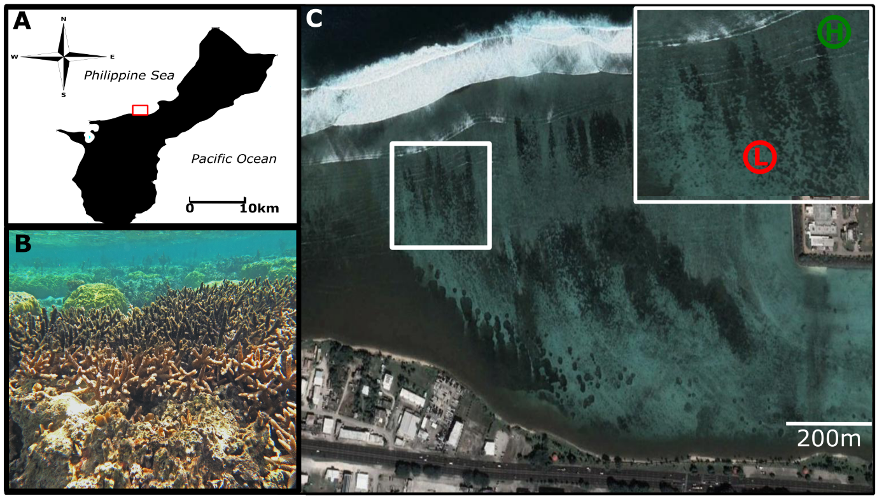Figure 1 A) Location of West Hagåtña Bay (red rectangle), Guam. B) Staghorn colony with survivorship limited to colony edge. C) Study Area (white square) N13°28’55.2” E144°44’42.72”. Abbreviations in white square insert: high-flow (H) and low-flow (L).

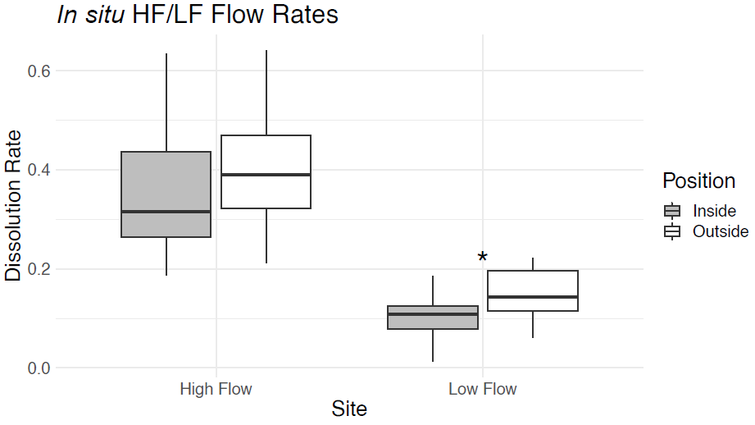
Figure 2 Average percent dissolution of clod cards per 6 hours measured on the inside and outside of colonies for both high flow and low flow site conditions. Box plot shows distribution of % clod card dissolution for individuals (n = 88) by treatment. The box represents the inter-quartile range (IQR) between the upper and lower quartile. The whiskers maximally extend 1 time beyond the IQR. Effect significances are represented by (*) = p <0.05.

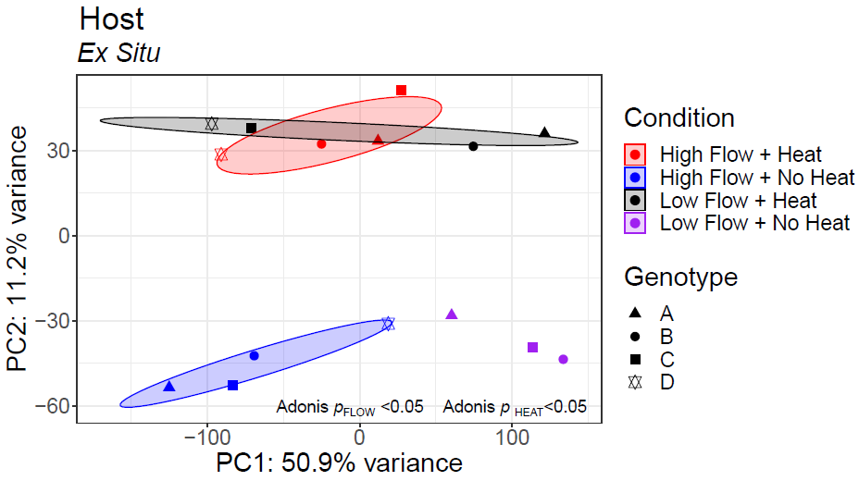
Figure 3 Principal coordinate analysis of ex situ host rlog transformed gene counts.
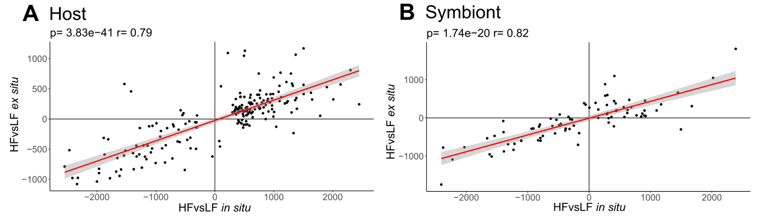
Figure 4 A) Host GO delta ranks between ex situ no heat high-flow versus low-flow and in situ heat stress event high-flow versus low-flow. B) Symbiont GO delta ranks between ex situ no heat high-flow versus low-flow and in situ heat stress event high-flow versus low-flow.

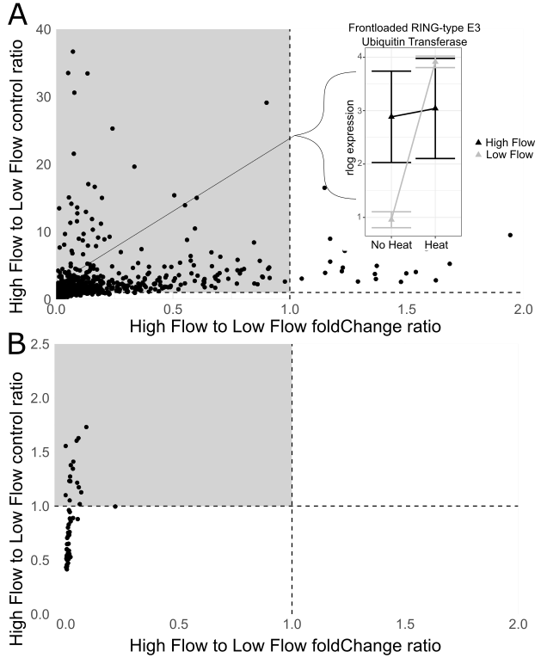
Figure 5 A) Host frontloading. Light grey panel represents putative frontloading genes. Inset shows gene expression reaction norm for one frontloaded gene B) Symbiont frontloading. Panel below light grey panel are “stress indicators” (sensu Barshis et al., 2013)
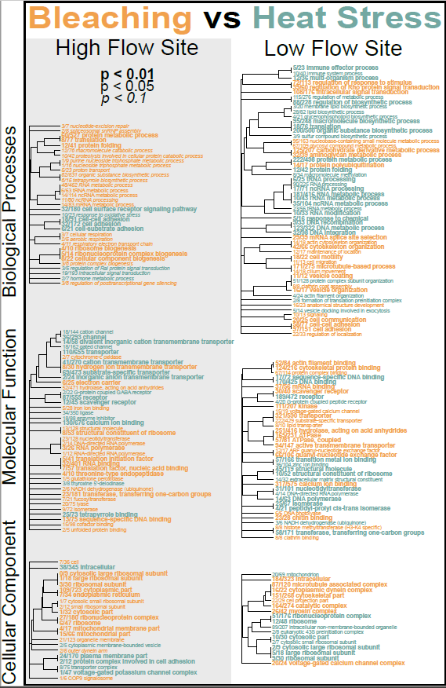
Figure 6 Host in situ GO_MWU plot between heat stress and bleaching event within high-flow and low-flow sites.

