Can playing table-top role-play games help children learn?
Dungeons and Dragons is a game many people have heard of but perhaps few people thought has a place in an educational environment, at least until now! D&D, which has its origins in the 1970s, is a game where the players ‘play’ a character and move around a fictious world undertaking quests and having adventures. One player takes on the role of a games master, describing the world and acting as all the other people and creatures in the world. The game at its heart is a collaborative story telling game, which has been shown to inspire creativity, social connection, and many other personal skills (Daniau, 2016). In its early life, D&D was wrongly labelled as a source of delinquency and then plagued with stereotypes about the types of people who play such games. Thankfully, popular D&D shows like Critical Role have changed the landscape, launching the game to a new audience, in part due to their massive reach on social media platforms YouTube and Twitch (120 million viewers + 150 million hours of content viewed). Shows like this, alongside a company refresh, have made D&D very attractive, with the game now more popular than any other point in its history (based on Google Trend data). There are a reported 40 million D&D players worldwide with a healthier balance of gender and ages amongst players than in its recent past.
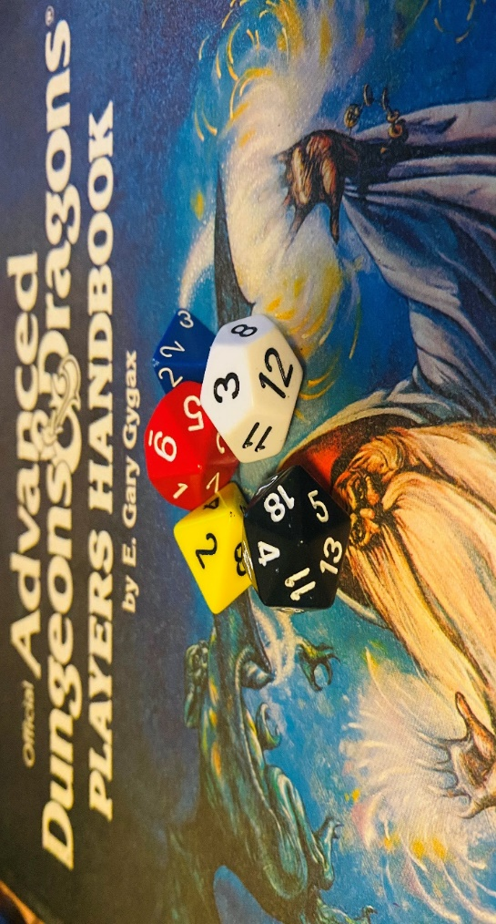
Dungeons and Dragons, really?
Dungeons and Dragons is classified as a table top role-playing game (TTRPG) and it will not surprise you that TTRPG’s exist for every genre and period you can possibly imagine. I will talk more generally about TTRPG’s from herein, as I do not wish the fictional fantasy setting in D&D to be a barrier to their use. TTRPG’s are, as the name suggested, played around a table and benefits from not relying on some of the potential barriers players may perceive when playing role play games. Although welcome, players do not need to dress up, act or use alternative voices thus making the game appeal to a broader spectrum of people. It differs from traditional roleplaying activities, which often employ actual characterisation, in that the game is driven by discussion and imagination. TTRPG often require some planning, especially by the games master, but requires very accessible resources such as paper, a pencil and dice.
This article aims to explore how the principles of Dungeons and Dragons, and many other TTRPG, can be applied and introduced within the primary curriculum.
Creativity
Creativity, contrary to the thoughts of some, is not a skill exclusive to “The Arts” and is a highly desirable skill for many scientists. One of the main attractions to those who play TTRPG is its narrative and the creation of a collective story. A TTRPG is incredibly creative. The players create whole worlds in their minds that include not just place names but landmarks, political systems, languages and even the menu in fictitious cafés. They need to create characters for themselves and characters to interact with complete with appearance, background information and in-game motivations. Have you have ever wondered how George R R Martin comes up with the types of stories you see in the Game of Thrones? Guess what, he is a D&D player and this is testament to the story creation and characterisation required to play these games. Though the links may not be obvious, the development of creativity skills through such activities has been widely reported in the academic literature (e.g. Carter, 2011; Daniau, 2016; Smith and Cole, 2019).
Below, I have set out where creativity can enhance the Primary Science Curriculum.
National Curriculum Science Objective | Classroom idea
LKS2 Plants  - explore the part that flowers play in the life cycle of flowering plants, including pollination, seed formation and seed dispersal. | Life cycle of a plant dramatic performance  After learning about the life cycle of a plant, children can act out this cycle using their creativity. Children can start as seeds and use physical movements to show them bursting through the soil and reaching high. Children can act as bees and insects to show different elements of pollination and then how the seeds can be dispersed.  At each stage in the cycle, children can talk about and present the processes the seed is undergoing.
LKS2 Light  - recognise that light from the sun can be dangerous and that there are ways to protect their eyes | TV advert  Producing an advert selling sunglasses is a great way for children to show the benefits of sunglasses and the dangers of the sun without having to be discouraged by writing anything down. Creativity plays a key part in how they create their advert.
LKS2 Light  - recognise that shadows are formed when the light from a light source is blocked by an opaque object  find patterns in the way that the size of shadows change. | Puppet show  Children can design and create their own shadow puppets using a variety of art materials and techniques. Tying this to their writing is also a great idea because the can act out, discuss, explore their story before writing it down.

Teamwork
Another great quality that is developed through playing TTRPG is teamwork. Working together is an essential part of the game. This can be as simple as deciding which way to go or more complex like trying to understand the best way to achieve a goal or overcome the problems the game presents. In TTRPG, everyone has in-game strengths that need to be combined to succeed. This skill is not only essential in Primary Science but is a fundamental that is developed and worked on each day in every primary classroom. When we explore the Working Scientifically strand of the Primary Science curriculum, many of the skills asked of the children centre around working as a team. Take “performing simple tests” from the KS1 Working Scientifically objectives. Any number of simple scientific tests, which should be carried out in all primary schools to teach the specific skills of being a scientist, require working together. For example, when testing what is the best tissue paper to help dry up the flood in the school kitchen, children begin the whole process by sharing ideas, working together, being part of a team to decide what is the best method. The actual setting up of the experiment, collecting the water, getting the pipette, attaching the paper to an empty cup etc. all rely on teamwork or else the experiment won’t take place.
Communication
Communication is at the heart of TTRPG. Being able to describe what you see or what you want to do so that it can be visualised in everyone’s mind is a real skill. You also have to learn to communicate with players from backgrounds different from your own and with people who may have different views. Telling stories is important, not just for our education and future career, but research shows it is also important in connecting with new people. It also helps our brains be empathetic and more empathetic individuals are known to me more generous, compassionate, and charitable.
TTRPG are also great for helping to understand situations where there is no right answer. Imagine a situation when the superheroes encounter an angry looking enemy. What could they do? They could attack, try and calm them down or run-away. Each of these options can be carried out in 100 ways all of which have in game consequences. When we look inside a primary science classroom, opportunities where effective communication is key are abundant. Sharing opinions and views to collaboratively reach an agreed goal is one of the cornerstones of science. At the beginning of an investigation, the possible directions it can take are numerous. Children often don’t have the luxury of working alone due to resources and space so often work in small groups. Each member of that group arrives with their own ideas and thoughts about how to reach the final destination. It is up to the children to effectively present their method and persuade the rest of the group about which direction to take. This skill and process is reflected greatly in the role of the leader in Dungeons and Dragons.
Critical Thinking
Critical thinking and problem solving is another skill desirable in science and one that is integral to TTRPG. Though the traditional D&D image of fighting adversaries and rolling dice is part of the game, the main attraction to many is the story telling and the journey that is shaped by different decisions being made. In fact, the game rewards non-conflict based solutions as well as if not better than those involving fighting. Critical thinking is a skill that is worked on in almost every lesson in a Primary School. Science allows the children to apply their critical thinking skills and then see the results in a safe and controlled environment. When setting up their investigations, they get the opportunity to shape the direction that study goes. Many children have to figure out what is the best way to answer a certain question and then how best to present the results.
TTRPG in the classroom
The use of games in the classroom is an under used but powerful tool to all teachers. The fundamentals of games opens up the opportunity to design a world centred on the subject knowledge you need to teach. Within the topic “Animals and Living things” your game can be based around the different habitats of living things with each character making adaptations to suit this. The topic “Electricity” would allow you to reward your characters with subject knowledge from the topic, like controlling the current, creating switches or turning non-conductors to conductors. The TTRPG adventure itself can be set in the realm of science, perhaps the heroes are a group of climate superheroes trying to come up with solutions to reduce the world carbon footprint or clear the plastic in the ocean. The players could even meet famous scientists from history like Marie Curie or Rosalind Franklin and hear about them first-hand, or even work with them on their discoveries. The only limit in a TTRPG is imagination.
How about using TTRPG where do you start? There are several useful websites such as Teaching with D&D (see sources) which contain pre-made lesson plans, there are also many blogs and talks that provide starting ideas on how to get started. For those who are after a more complete review of the use of role play the article by McSharry and Jones (2000) include a range of interesting approaches for using science roleplay. In my opinion the easy way to start and test out a TTRPG is get the pupils to create their heroes, give them a ‘challenge’ and just let them run with it.
Next Steps
https://www.teachingwithdnd.com/classroom/lessons/
Bugaj, C. (2018) Use Dungeons & Dragons to engage all students!. International Society for Technology in Education (ISTE) https://www.iste.org/explore/In-the-classroom/Use-Dungeons-
Heller, E. (2019) A beginner’s guide to playing Dungeons and Dragons. The Polygon. [online] https://www.polygon.com/deals/21294556/dnd-how-to-play-dungeons-dragons-5e-guide-spells-dice-character-sheets-dm
References
Carter, A. (2011) Using Dungeons and Dragons to integrate curricula in an elementary classroom. In Ma, M. et (eds.), Serious Games and Educational Applications, Springer-Verlag (London).
Daniau, S. (2016). The transformative potential of role-playing games: From play skills to human skills. Simulation & Gaming, 47(4), 423-444. doi:10.1177/1046878116650765
McSharry, G. and Jones, S. (2000). Role-play in science teaching and learning. School Science Review, 82(298), 73-82
Smith, M., & Cole, A (2019). Teacher as Game Master: Using Tabletop Role-Playing Games in the Classroom. Presented at DiGRAA Conference.

