Research developments in Sustainable Supply Chain Management considering Optimization and Industry 4.0 Techniques: A Systematic Review

Abstract
Purpose – The literature that is presently available on sustainable supply chain management (SSCM) combining Optimization and Industry 4.0 techniques falls short in its depictions of the recent developments, budding pertinent areas, and the importance of SSCM in the growth of industrial economies around the world. This article's main objective is to analyze current trends, highlight the latest initiatives, and perform a meta-analysis of the literature that is currently accessible in the SSCM area with a special focus on optimization and Industry 4.0 techniques. The paper also proposes a conceptual framework that will assist in illuminating how the ideas of optimization and Industry 4.0 may contribute to realizing sustainability in supply chains.
Design/methodology/approach – The proposed study systematically reviews 85 research publications published between 2010 and 2022 in referenced peer-reviewed journals in diverse fields, including engineering, business and management, services, and healthcare. Numerous categories are considered throughout the examination of the literature, including year-wise publications, prominent journals, type of research design, concerned industry, and research technique used.
Findings – The study demonstrates a deeper comprehension of the literature in the field and its evolution throughout numerous industry sectors, which is helpful for both practitioners and academics. The results from the content analysis highlight various future research opportunities in the domain.
Originality/value – This is one of the first research articles that have attempted to establish, analyse, and highlight the current trends and initiatives in the SSCM domain from an optimization and Industry 4.0 techniques viewpoint. The cluster-based future research propositions also enhance the novelty of the study.
Keywords: Sustainable Supply Chain Management; Optimization; Industry 4.0.

1. Introduction
Supply chain management is concerned with the movement of goods, finances, and information through all value chain phases, including suppliers, manufacturers, distributors, retailers, and consumers. Managing demand, product design and development, supplier management (Wu et al., 2020), raw material procurement, production planning and control, warehouse management, inventory planning, supply chain network design, distribution management, and last-mile delivery management are all essential subsystems that are involved in supply chain management. Within the system, elements such as risks (Munir et al., 2020), disruptions, delays, and uncertainties significantly influence the performance of the supply chain.
Incorporating sustainable practices into a company's operations is necessary to remain relevant and thriving in today's market (Gracia and Quezada, 2016). The concept of sustainability refers to meeting the present generation's demands without jeopardizing future generations' capacity to meet their demands (Dumitrascu et al., 2020). Social, economic, and environmental factors are the primary factors when we refer to sustainable supply chain management (SSCM).
In recent years, emerging technology has enabled organizations to address difficulties associated with supply chains in a manner that was impossible before. Despite this, companies are continuing their search for an effective balance of technology-driven solutions that would assist them in successfully adopting sustainability into their operations. Enabling factors for sustainable supply chain management include Industry 4.0 (I4) and optimization methodologies (SSCM). Even though various research (Hall et al., 2012a; Souza et al., 2019; Tautenhain et al., 2019) have addressed the topic of sustainable supply chain management and the significance of the subject, relatively few of these studies have addressed the role that Industry 4.0 and optimization approaches play in sustainable supply chain management (SSCM).
Through an analysis of the current body of literature, this study aims to investigate the underlying trends and important research themes as well as the role that Industry 4.0 and optimization play in sustainable enterprises. In content analysis, we have presented future research views in the field by enumerating proposed research questions drawn from research gaps in the existing body of literature. In addition, one of our goals is to develop a conceptual framework that will assist in explaining how the ideas of optimization and Industry 4.0 may contribute to achieving sustainability in the supply chain.
This article is divided into seven sections, including one that serves as an ongoing introduction. The second part provides an overview of the historical context of the literature. The methodology used for our systematic review is discussed in the third section. In the next section (four), an analysis will be used to demonstrate the categorization of the articles that made the shortlist. In the fifth section, we present the cluster-based content analysis that outlines future research propositions. The sixth section offers the theoretical framework we developed based on literature classification and content analysis results. In the concluding part, we discuss the most important discoveries and our work's limitations.

2. Background of Literature on SSCM

This section will describe the theoretical backdrop of SSCM research, including optimization and Industry 4.0. It is crucial to optimize the supply chain since doing so may help businesses improve their efficiency, lower their expenses, and elevate the level of satisfaction experienced by their customers. Companies can optimize their supply chain processes, such as production scheduling, inventory management, and transportation planning, with the help of mathematical modeling and algorithms (Nagurney and Nagurney, 2010). This allows companies to use resources more efficiently and improve their overall performance. In addition, optimization may assist businesses in recognizing and mitigating risks, such as interruptions in supply chain operations, and in coming to better-informed choices about future expenditures and growth (Sitek and Wikarek, 2015). Optimization may be a handy tool for establishing sustainability in the supply chain. Companies can optimize the processes in their supply chains via mathematical modeling and algorithms, which helps them have a more negligible effect on the environment, consume fewer resources and energy, and enhance their overall sustainability (Kaboli Chalmardi and Camacho-Vallejo, 2019). Optimization can be helpful for businesses, helping them become more profitable, competitive, and sustainable.

Table 1. Summary of past review-based studies in the SSCM domain
Authors | Study focus | Study Type
(Brandenburg and Rebs, 2015) | Analyzes past literature that formalizes issues related to SSCM in quantitative models | Review
(Borregan-Alvarado et al., 2020) | Examines literature in the field of SSCM, keeping I4 and advanced manufacturing together | Bibliometric Review
(Dutta et al., 2022) | Investigates the role of blockchain and the Internet of Things (IoT) individually on SSCM | Review
(Faramarzi-Oghani et al., 2022) | Analyzes meta-heuristic algorithms applied in SSCM | Review
(Jayarathna et al., 2021) | Investigates literature to assist in selecting suitable multi-objective optimization in SSC logistic modeling | Review
(Paul et al., 2021) | Performs a systematic literature review for identifying various Multi-Criteria Decision Making (MCDM) techniques applied in the field of SSCM. | Systematic Literature Review
(Cañas et al., 2020) | Conducts a review to assess the current state of knowledge of the supply chain from a sustainability perspective | Review
(Chalmeta and Santos-deLeón, 2020) | Analyzes the existing literature on sustainability, Industry 4.0, and supply chain management | Bibliometric Review

The term "Industry 4.0," which is often referred to as the "fourth industrial revolution," describes the incorporation of modern technologies such as the Internet of Things (IoT), big data, and artificial intelligence into the operations of manufacturing and logistics. Technologies from the fourth industrial revolution may play an essential part in achieving sustainability in the supply chain. These techniques enable businesses to improve the efficiency of their operations and make smarter decisions (Quariguasi Frota Neto et al., 2010). For instance, innovations from Industry 4.0, such as the Internet of Things (IoT), may be used to track and control the energy used across the entire manufacturing process. This enables businesses to discover and cut down on waste and inefficiencies. By identifying the routes and modes of transportation that are the most time- and resource-effective, improvement of logistics operations and mitigation of the adverse effects of transportation on the environment are both possible with the help of technologies such as blockchain (Varriale et al., 2021). Inventory management can be improved with artificial intelligence, which can also help reduce waste by ensuring that the appropriate inventory quantity is held at any given time.

Previously, several studies based on literature reviews have been carried out to add to the theoretical understanding of SSCM research. Table 1 contains information from previous research conducted in this field. To give a complete overview of the status of research in this field, we have also provided the study's focus. Although the earlier literature review studies provided an overview of SSCM research across specific parameters, they omitted the systematic literature evaluation over numerous parameters in a single study, which would be of great use to academics and practitioners. Additionally, there was no conceptual framework explaining how optimization and I4 applications fit into SSCM, presented based on a literature review.

3. Data and Methodology
The literature review is a crucial component of any research pursuit since it aids in assessing current trends and active areas in a particular field of research. This study employs a systematic approach to reviewing the existing, first screening the papers to be reviewed and then classifying and analyzing those articles to better understand the SSCM in the context of Optimization and Industry 4.0. A stepwise methodology for systematic literature review is shown in Figure 1.

3.1 Database and screening of articles
The fundamental objective of this study is to explore the research threads and advancements in the field of SSCM domain considering optimization and Industry 4.0 (I4) techniques. For this purpose, the Scopus database was chosen. We targeted all articles published in top peer-reviewed journals with the following keywords in their title and abstract, namely: “Sustainable Supply chain Management,” “Optimization,” and “Industry 4.0”. The search terms for this study produced 147 SSCM articles across 59 journals, which were further analyzed based on different perspectives through a classification framework. Articles featured during 2010–2022 were considered for review as the SSCM field started to gain popularity in the early 2000s. Subsequently, other documents such as conference papers, book chapters, editorial notes, and short notes were excluded during the screening stage. We also omitted documents from psychology, the arts, and neuroscience, and as a result, we obtained 104 documents. We then reviewed the abstracts and screened the articles based on the scope of our study. We narrowed it down to 85 articles for our final literature review.
Figure 1 Methodology for Systematic Literature Review
The compilation of screened material includes research articles on an SSCM domain with several applications across diverse disciplines, including management, engineering, social sciences, health care, etc. Although the authors took care when choosing the final set of articles for the review, any pertinent article might have been left out. The authors believe the categorization framework, identified research themes, and analytical findings would be helpful to both scholars and practitioners.

3.2 Classification Criteria
Before beginning the evaluation of chosen research material, it is vital to specify the classification framework based on which the articles will be assessed. Consequently, for this study, we have analyzed the articles based on six broad categories that will facilitate a better grasp of research in SSCM coupled with Optimization and Industry 4.0 techniques. The study will also enable researchers and practitioners to investigate potential future research paths. The criteria for presenting research taxonomy are described below-
- Year of Publication
- Prominent Journals and Publishers
- Country of Publication
- Research Method Used
- Industry under Consideration
- Prominent Authors
This presented classification will help offer a roadmap for a thorough understanding of the field by providing promising research trends, sequential growth, noteworthy research sources, application areas, and exciting aspects of SSCM concerning optimization and industry 4.0 techniques.
Furthermore, we conducted a cluster-based content analysis of the selected documents. This analysis was backed by future research propositions for each cluster. Based on the results of the classification of research material and content analysis, we developed a conceptual framework that explains the integration of optimization and Industry 4.0 techniques to achieve sustainability in supply chain operations. We conclude our study by highlighting the key outcomes and limitations of the study.

4. Analysis of the Literature

4.1 Year-wise trend of publications
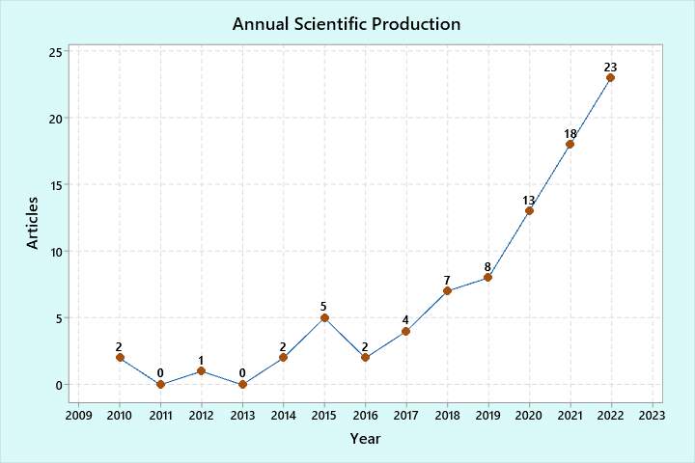
The variation of “Sustainable Supply Chain Optimization and Industry 4.0” articles based on the year of publication is indicated in Figure 2, spanning over 13 years (2010–2022). In the early phases, there is very low or no interest shown by researchers and practitioners when it comes to integrating optimization and I4 techniques with SSCM. Later around 2017, both developed and developing economies realized the importance of sustainability in supply chain operations and showed their willingness to integrate optimization and I4 techniques with sustainable supply chain management practices. Since 2017, the frequency of publishing articles has considerably increased. Reference to integrating optimization and I4 in SSCM may be found in the manufacturing (Yadav et al., 2020), IT & services, food sector, healthcare (Daú et al., 2019), and construction industries. Alongside these, it is notable that the number of SSCM publications has also increased significantly in several other disciplines.
Figure 2 Year-wise trend of publications

4.2 Top Journals and Publishers
When discussing optimization and I4 approaches in the context of SSCM, there are several journals from diverse areas such as engineering, computer science, management, decision-making, and services. Among these esteemed indexed journal sources, the Journal of Cleaner Production has the most significant portion of articles (11.76%). This journal has continuously published a wide range of articles since 2010 to raise the degree of familiarity with the area among scholars and other stakeholders. The International Journal of Production Research has obtained the second largest percentage (9.41%), indicating a reasonably high consideration of sustainability in manufacturing practices across industries.
Table 2 Classification based on journals and publishers
Sources | Publishers | h-Index | Articles | Percentage
Journal of Cleaner Production | Elsevier | 232 | 10 | 11.76
International Journal of Production Research | Taylor and Francis | 153 | 8 | 9.41
Sustainability (Switzerland) | MDPI | 109 | 6 | 7.06
Computers and Industrial Engineering | Elsevier | 136 | 6 | 7.06
Resources, Conservation, and Recycling | Elsevier | 150 | 4 | 4.71
Annals of Operations Research | Springer | 111 | 3 | 3.53
Advances in Intelligent Systems and Computing | Springer | 48 | 2 | 2.35
Chemical Engineering Transactions | Italian Association of Chemical Engineering - AIDIC | 39 | 2 | 2.35
Operations Management Research | Springer | 31 | 2 | 2.35
Production Planning and Control | Taylor and Francis | 85 | 2 | 2.35
International Journal of Logistics Management | Emerald Insight | 80 | 1 | 1.18
European Journal of Operational Research | Elsevier | 274 | 1 | 1.18
Business Strategy and The Environment | John Wiley | 115 | 1 | 1.18
Computers and Chemical Engineering | Elsevier | 144 | 1 | 1.18
Journal of Manufacturing Technology Management | Emerald Insight | 76 | 1 | 1.18
Electronics (Switzerland) | MDPI | 49 | 1 | 1.18
EMJ - Engineering Management Journal | Taylor and Francis | 39 | 1 | 1.18
Others | N/A | N/A | 33 | 38.82
Total | N/A | N/A | 85 | 100.00
Sustainability (Switzerland) is ranked third on the list with a 7.06% share of articles. In addition, the supply chains across various businesses have seen substantial investment in optimizing and digitizing processes, as evidenced by the fourth-highest proportion (7.06%) of SSCM research publications published in the Computers and Industrial Engineering Journal. It is followed at places five and six by Resources, Conservation, and Recycling (4.71%) and Annals of Operations Research (3.53%). In Table 2, we have provided a detailed breakdown of how reviewed publications are categorized depending on journals and publishers.
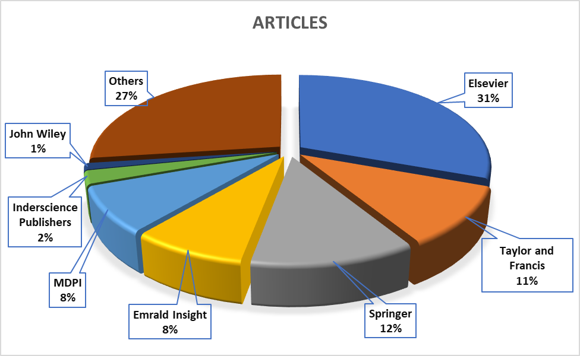
However, when we talk about the publisher-wise distribution of articles, Elsevier contributed the maximum number of articles (31%) in the SSCM field, followed by Taylor & Francis (11%), SpringerLink (12%), Emerald Insight (8%), MDPI (8%) and Inderscience Publishers (2%). The involvement of these publishers can be examined using Figure 3. A vast range of research areas under the SSCM field was discovered through the literature search from these publishers.
Elsevier (Martín-Gómez et al., 2019; Vivas et al., 2020) included documents in various fields, primarily engineering, services, management, and manufacturing. The main topics addressed by different academics in SpringerLink (Rizzoli et al., 2015; Zeng et al., 2022a) include conceptual foundation-based papers impacting manufacturing sectors and survey-centric and framework-based publications. Articles from Taylor & Francis (He et al., 2021) publications are primarily case study-based techniques covering service and safety-related issues. In contrast, Emerald Insight's publications focused mainly on the manufacturing and process industries. However, many papers tried to integrate optimization and industry 4.0 methodologies into the knowledge of sustainable supply chains.
Figure 3 Pie chart-based distribution of publishers

4.3 Distribution based on country of publication
The study of the shortlisted articles demonstrates that the SSCM research, optimization, and Industry 4.0 have extensive publishing coverage in 25 countries worldwide. Table 3 indicates a thorough breakdown of research articles based on the country. China, with a total of 13 publications, has produced most of the research in the field among the 85 documents that were selected. In addition to India, Brazil, Iran, the UK, Korea, Turkey, and the USA are the prominent nations that contribute to synthesizing and reinforcing the theoretical underpinnings of SSCM research work incorporating optimization and industry 4.0. At the same time, the adoption of Optimization and Industry 4.0 in the context of SSCM was found to be extremely low in several countries, including Greece, Morocco, Netherlands, Switzerland, and Thailand.
However, there are many scenarios for SSCM research in various developing countries. These are considered outsourcing destinations because they can provide an affordable workforce, which is the most crucial component of supply chain planning. China, India, and Brazil provided 31% of all research publications. China and India (Hei et al., 2019; Yadav, Kumari, and Kumar, 2021) made the most extensive contributions to building a theoretical foundation and case study-based studies in SSCM; on the other hand, Brazil & UK made the largest contributions to quantitative applications, including mathematical and optimization-based studies. The groundwork for the implementation of optimization and I4 techniques in SSCM was developed with the aid of research articles from China and the UK.
Table 3 Country-wise breakdown of articles
Country | Articles | Percentage | SCP | MCP
China | 13 | 15.29 | 9 | 4
India | 8 | 9.41 | 5 | 3
Brazil | 5 | 5.88 | 2 | 3
Iran | 5 | 5.88 | 2 | 3
United Kingdom | 5 | 5.88 | 2 | 3
Korea | 4 | 4.71 | 2 | 2
Turkey | 4 | 4.71 | 2 | 2
USA | 3 | 3.53 | 3 | 0
Canada | 2 | 2.35 | 1 | 1
France | 2 | 2.35 | 0 | 2
Germany | 2 | 2.35 | 1 | 1
Italy | 2 | 2.35 | 2 | 0
Mexico | 2 | 2.35 | 1 | 1
Poland | 2 | 2.35 | 2 | 0
Portugal | 2 | 2.35 | 2 | 0
Spain | 2 | 2.35 | 2 | 0
Australia | 1 | 1.18 | 0 | 1
Bulgaria | 1 | 1.18 | 1 | 0
Colombia | 1 | 1.18 | 1 | 0
Denmark | 1 | 1.18 | 0 | 1
Greece | 1 | 1.18 | 1 | 0
Morocco | 1 | 1.18 | 1 | 0
Netherlands | 1 | 1.18 | 0 | 1
Switzerland | 1 | 1.18 | 1 | 0
Thailand | 1 | 1.18 | 0 | 1
Total | 85 | 100.00 | 50 | 35
SCP- Single Country Production; MCP- Multiple Country Production

4.4 Research Method Used
We have analyzed and noted the research method used for each shortlisted article. The research methods used in the literature include case studies, surveys, mathematical models, conceptual and theoretical models, interviews, other research methods such as systematic literature review, and industry focus. The distribution of research articles based on the research method is shown in Figure 4. From the analysis, it’s evident that case study-based papers have got the highest contribution. It's intriguing to see that industry practitioners and academic researchers have expressed a strong concern in thoroughly examining the case applications within these case studies. As the primary research method, case studies are used in about 27% of papers, followed by articles based on mathematical models (21%) and conceptual model studies (17%). Even though conceptual models are found in 17% of the studies, there is a vast scope for improvement in this area because there is no standard model for optimization and I4 implementation in SSCM. Researchers may create a model by combining optimization with I4-based decision-making strategies.
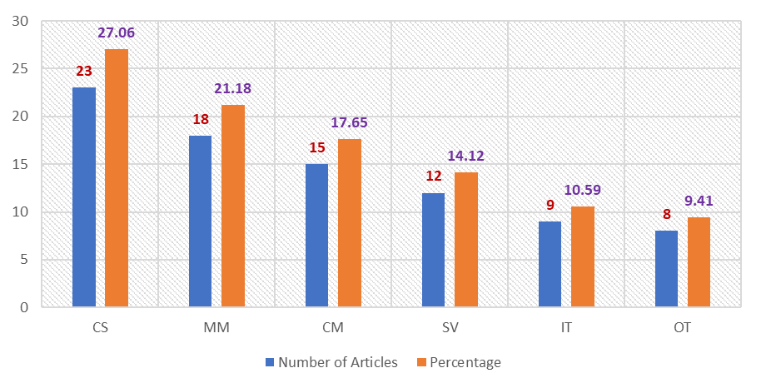
Several situations (Quariguasi Frota Neto et al., 2010b; Tsai et al., 2021) described in the literature illustrate the advantages of adopting optimization and I4 methods by integrating decision-making methodologies. Other studies (Barbosa-Povoa et al., 2018) have contributed to the development of the theoretical underpinning and frameworks that are equally useful for practitioners and researchers.
Figure 4 Classification based on the research method used
CS- Case Study; MM- Mathematical Model; CM-Conceptual Model; SV- Survey; IT-Interview; OT-Others

4.5 Industry under consideration
Every study looks incomplete until its applications are evident and it helps the growth of the national economy. The contribution of industries to a nation's economy is of crucial importance. Similarly, it becomes critical to find the applications of optimization and I4 in SSCM across various businesses.
This evaluation will encourage industry practitioners to implement optimization and I4 strategies inside their process system to achieve organizational sustainability. According to the categories in the preceding subsections, it is possible to conclude that case study-based studies are of great relevance to academics. The sector-wise distribution of selected research material is shown in Table 5.
The manufacturing industry has the most considerable number of published case application articles, followed by the food industry and the IT & services sector. Practitioners of the modern supply chain are confronted with obstacles such as shorter product life cycles, rapid delivery needs, and sustainable product design and disposal. In addition to these industries, the healthcare, pharmaceutical, process, electronics, and construction sectors have profited from using optimization, and I4 approaches in SSCM.
Table 5 Industry-wise distribution
S. No. | Industry Sector | Number of Articles
1 | Manufacturing | 15
2 | Food Industry | 13
3 | IT & Services | 10
4 | Healthcare | 9
5 | Pharmaceutical | 8
6 | Process | 7
7 | Electronics | 7
8 | Construction | 6
9 | Textile | 4
10 | Others | 6

4.6 Prominent Authors
For every classification study, it is critical to learn about the authors actively adding to the knowledge through their research. An early-stage researcher might find exploring a specific domain's most renowned research undertakings and perspectives very challenging. Therefore, it would be simpler for the new generation of researchers to investigate the most prominent studies published by the top authors, which could be identified. They can also utilize it to uncover new research ideas as well. A total of 293 writers accounted for 85 articles analyzed in the current literature review. Here by ‘author,’ we mean authors as well as co-authors.
Table 6 highlights the list of top authors contributing to SSCM research considering optimization and I4. Among these contributors is Barbosa-Povoa AP, with a total of 4 articles leading the list of researchers who helped create the theoretical basis, application-oriented studies, and conceptual framework. Zhang Y also sits at the top, contributing four articles in almost all research dimensions. Further, Bui T-D, Lim MK, Mota B, and Tseng M-L are among the top contributors with high research credentials.
Table 6: Most Prominent Authors
Authors | Articles | h-index | i10-index
Barbosa-Povoa AP | 4 | 58 | 157
Zhang Y | 4 | 31 | 38
Bui T-D | 3 | 13 | 15
Lim MK | 3 | 17 | 20
Mota B | 3 | 9 | 6
Tseng M-L | 3 | 76 | 255
Carvalho A | 2 | 61 | 260
Chan FTS | 2 | 5 | 3
Ehtesham Rasi R | 2 | 7 | 7
Gao J | 2 | 62 | 146
Govindan K | 2 | 112 | 296
Gunasekaran A | 2 | 135 | 461
Guo Y | 2 | 62 | 253
Kumar N | 2 | 105 | 526
Kumari R | 2 | 14 | 19
Lewi S | 2 | 80 | 147
Lin C | 2 | 71 | 167
Liu W | 2 | 15 | 15
Mangla SK | 2 | 62 | 128
Nascimento MCV | 2 | 16 | 19
Sarkar B | 2 | 58 | 199
Sitek P | 2 | 16 | 20
Tautenhain CPS | 2 | 4 | 2

5. Content analysis
After comprehensively classifying screened articles, we describe the literature through a cluster-based content analysis. Our content analysis was built around three major clusters- Optimization, Industry 4.0, and Sustainability aspects. In each cluster, we summarized the contributions of the most cited documents and proposed future research questions under each cluster.

5.1 Cluster 1: Optimization
Optimization techniques such as multi-objective optimization, stochastic programming, linear programming, supply chain network design, and route optimization have helped businesses cut costs and improve their performance. We identified 45 documents under this cluster.(Govindan et al., 2014), which has received 434 citations, developed a multi-objective optimization model that integrates sustainability in decision-making for distribution in a perishable food supply chain network. The proposed technique aims to optimize environmental and economic objectives in a perishable food supply chain network by assessing the number and location of facilities and optimum products delivered to downstream stages and routes at each level. Additionally, the article offers a novel multi-objective hybrid technique called MHPV that integrates two recognizable multi-objective algorithms (MOPSO and AMOVNS) to solve the problem. The study results imply that the proposed MHPV technique achieves better results than other methods. (Mota et al., 2018), with 101 citations, proposed a standard model for planning and designing closed-loop sustainable supply chains. It also considers interrelated problems such as facility location, supplier selection, capacity determination, purchase levels definition, intermodal and unimodal transportation network options, technology selection and allocation, supply planning, remanufacturing, and product recovery. The authors have addressed three dimensions of sustainability through objective functions like Life Cycle Analysis methodology, Net Present Value, and GDP-based metric. (Liu et al., 2021), which received 29 citations, presents an integrated model which solves the location-inventory-routing problem for perishable products considering carbon emissions, economic cost, and product freshness. The authors have developed a multi-objective planning-based model with constraints based on the real location-inventory-routing scenario. Table 7 shows the identified research gaps and corresponding future research propositions.
Table 7 Proposed research questions enumerated from cluster 1.
Research Gap | Proposed Research Questions (PRQs)
- No studies have been conducted to compare the performance of different multi-objective optimization algorithms for sustainable supply chain network design. | - How does the performance of different multi-objective optimization algorithms vary for sustainable supply chain network design?
- Optimization models should incorporate other aspects of social sustainability for the design and planning of a sustainable supply chain. | - How can factors such as labor rights and human capital development, be incorporated into the sustainable supply chain network optimization model?
- Consider some additional factors in the optimization model concerning decisions on location inventory routing in the supply chain of perishable products. | - What is the effect of factors such as customer demand and product availability in optimizing the location inventory routing process?  - What is the effect of vehicle speed on carbon emissions and economic cost in perishable goods supply chain operations?

5.2 Cluster 2: Industry 4.0
This cluster highlights the application of Industry 4.0 techniques in the context of SSCM. A total of 40 documents were identified under this cluster. (Manavalan and Jayakrishna, 2019), with 376 citations, proposed a framework for reviewing the preparedness of supply chain organizations from numerous perspectives to fulfill the conditions of Industry 4.0 transformation. The article also emphasizes the significance of sustainability and technology deployment, such as the Internet of Things, in attaining organizational goals. (Mastos et al., 2020), which attracted 85 citations, demonstrates the impact of an Internet of Things-based solution on sustainable supply chain management (SSCM) performance. It also investigates how implementing a state-of-the-art industry 4.0 technique can improve sustainability both at the organization and supply chain levels. The study attempts to bridge the gap between theoretical advancements and real-world application cases concerned with Industry 4.0 and sustainable supply chain management.
With 42 citations, (Jiao et al., 2018), suggest data-driven techniques to facilitate a robust closed-loop supply chain design that alleviates greenhouse gas emissions and uncertainties in the system. The authors developed two models - an adaptive robust model (ARO) and a distributed robust optimization model (DRO) - for designing waste disposal facilities and carryings of closed-loop supply chains. (Balaman et al., 2018), which has obtained 40 citations, developed an innovative bi-level decision support system (DSS) to assist the optimization and modeling of multi-product, multi-technology supply chains and co-modal transportation networks for biomass-based production, uniting two multi-objective optimization models. The authors designed a regional supply chain transportation network utilizing the UK’s complete West Midlands (WM) region as a testing space to investigate the feasibility of the proposed solution methodology and solutions. They also conducted sensitivity and scenario analyses to deliver further comprehension into the optimization and design of biomass-based supply chains. Table 8 highlights the identified research gaps and corresponding future research questions.
Table 8 Proposed research questions enumerated from cluster 2.
Research Gap | Proposed Research Questions (PRQs)
- Few studies evaluate the business's readiness for adopting Industry 4.0 for sustainable supply chains. | - What criteria should be used when assessing a company's readiness for Industry 4.0 transformation, and how could those criteria vary depending on different industries or organizations?
- The existing literature provides little or no insights into potential challenges or risks associated with implementing Industry 4.0 technologies on an industrial scale. | - What challenges or risks are associated with implementing Industry 4.0 techniques in medium- and large-scale industries?
- There is a lack of understanding regarding which data-driven approaches would work best when dealing with multi-uncertainties such as buyers’ expectations, demands, and recovery uncertainties in a closed-loop supply chain. | - Which data-driven approaches would work best when dealing with multiple uncertainties in a closed-loop supply chain?
- There is a need for an effective decision support system (DSS) that can aid in modeling and optimizing multi-technology, multi-product supply chains, and co-modal transportation networks while considering economic and environmental considerations within the same framework. | - How to incorporate sustainability in a decision support system that aids in modeling and optimizing multi-technology and multi-product supply chain operations?

5.3 Cluster 3: Sustainability aspects
Major themes under this cluster include social, economic, and environmental sustainability, circular economy, energy conservation, and Greenhouse gas (GHGs) monitoring and control. 85 documents in the literature discussed these themes of sustainable supply chain management. (Jabbarzadeh et al., 2018), with a maximum of 155 citations in this cluster, provided intuition into the interplay between sustainability and resilience in supply chains. The article distinguishes tactics that businesses can utilize to enhance their performance in both aspects. The study underlines the importance of information sharing and collaboration among supply chain stakeholders. With 111 citations, the article by (Kumar et al., 2017) demonstrated how to optimize orders among suppliers while factoring in all three dimensions of sustainable performance. They devised a methodology for assessing various aspects such as lead time, quality, cost, waste minimization, energy usage, social contribution, and emission utilizing fuzzy AHP. The authors proposed a fuzzy multi-objective linear programming technique allocating orders among suppliers.
(Zhang et al., 2014), with 91 citations, recommended a framework that aids decisions concerning supply chain planning, design, and expansion problems, and visibly computes the trade-offs between environmental, economic, and responsiveness performance. The recommended framework facilitates us in deciding trade-off interactions between different objectives such as GHG emissions, total cost, and lead time. The framework was verified in an industrial test case via real-world data extracted from a Dow Chemical organization. The results revealed visible trade-offs between the three distinct objectives.
(Dubey et al., 2015), which accounted for 74 citations, developed a responsive, sustainable supply chain network that can react to a handful of degrees of uncertainty due to unavoidable forces. The study shows a comparative analysis that is based on three formulations performing different parameter-sensitive analyses and test scenarios in terms of CPU time, final output, degree of closeness towards the ideal solution, level of conservatism, degree of satisfaction, and degree of balance involved in developing a compromise solution. (Yadav, Kumari, Kumar, et al., 2021), with 57 citations, developed an SSCM model that considers carbon emissions and wastage reduction. The article proposes an optimization technique to attain the optimal values of batch size, production rate, preservation investment, and the number of shipments to maximize the total profit of the system. The study also identifies potential product combinations that can lead to profitability based on the cross-price elasticity of demand. Table 9 underlines this cluster's identified research gaps and respective future research questions.
Table 9 Proposed research questions enumerated from cluster 3.
Research Gap | Proposed Research Questions (PRQs)
- There is a lack of understanding about how resilience and sustainability interact with each other in the context of the supply chain. | - How do resilience and sustainability interact in a supply chain environment? What is the industry-wise comparison between these two dimensions?
- There is no discussion on how different businesses and countries have adopted sustainable supply chain management practices. | - What strategies should companies employ to ensure sustainability across their value chain?
- Future studies should focus on developing new indicators to help quantify sustainability performance more accurately in a supply chain. | - What are the potential indicators to quantify sustainability performance in a supply chain?
- There is limited exploration of environmental and social dimensions regarding large commercial corporations' sustainability initiatives. | - How to simultaneously integrate sustainability's environmental and social dimensions into large-scale commercial businesses?
- More data must be collected regarding the effects of preservation technology investments on reducing waste in large-scale businesses. | - What is the effect of preservation technology investments on reducing waste in large-scale businesses?

6. Discussion

6.1 Conceptual Framework
After presenting a comprehensive classification of the research material, and cluster-wise content analysis, we propose a conceptual framework, as shown in Figure 5. This framework helps in understanding the outcomes of the use of Industry 4.0 and optimization techniques which later directs toward achieving sustainability in supply chain management.
Frequently occurring themes coming under Industry 4.0 cluster include Artificial Intelligence (Ethirajan et al., 2020) & Big Data Analytics (Jain et al., 2022), Internet of things (IoT) (Manavalan and Jayakrishna, 2019), Blockchain (Mangla et al., 2022), Digitalization (Belhadi et al., 2022) and Data-driven decision-making (Zhang et al., 2017).
Similarly, the other ‘optimization’ cluster includes articles discussing the application of techniques such as Linear Programming (Lee and Chung, 2022), Stochastic Modeling (Fattahi et al., 2021), Fuzzy Mathematics (Tseng et al., 2021), Multi-objective optimization (Abbassi et al., 2022; Tautenhain et al., 2021), Supply Chain Network Design (Sundarakani et al., 2021), Spatially Explicit Modeling, and Route optimization (Peng et al., 2022).
The adoption of optimization and Industry 4.0 techniques have offered numerous advantages to businesses, some of which include- monitoring and control of the use of resources in production processes, smart and efficient logistic operations (Esmaeilian et al., 2020), transportation planning to reduce carbon footprint, and efficient use of raw materials and energy in production processes (Sarkar et al., 2021), smart inventory management. Our analysis also suggests that the use of optimization and I4.0 techniques has contributed to the areas such as environmental, social & economic sustainability (Hall et al., 2012b), circular economy (Kazancoglu et al., 2021; Mahroof et al., 2021; Mishra et al., 2023), closed-loop supply chain (Bisheh et al., 2018), energy conservation, life cycle assessment (Gao and You, 2017), and Greenhouse gas (GHGs) emission monitoring & control (Zeng et al., 2022b). This is a testament that optimization and Industry 4.0 are potential enablers for achieving sustainability in supply chain operations.

6.2 Theoretical and Managerial Implications
This study extensively reviews the existing sustainable supply chain management literature at the interface between optimization and Industry 4.0 techniques. The trend analysis revealed that it is a growing research area and continues to be a major field of work for researchers. The further country-specific analysis highlighted that Asian countries are leading the research in this domain while European and some African countries are underrepresented. The cluster-wise content analysis results revealed ample opportunities for researchers to explore in the future. The proposed research questions identified under each cluster can potentially become a starting point for future studies in the field.
Furthermore, a conceptual framework that explains the types and optimization and industry 4.0 techniques that have helped businesses incorporate aspects of sustainability into their businesses was proposed. This framework will guide policymakers and stakeholders in decision-making and resource allocation. Intending to review the existing literature thoroughly, this piece of work derives valuable insights into financial literacy. Overall, this study serves as a reference excerpt of major trends, key themes, directions for future research, and a theoretical guideline for exploring research on integrating optimization and Industry 4.0 for sustainable supply chain management (SSCM).

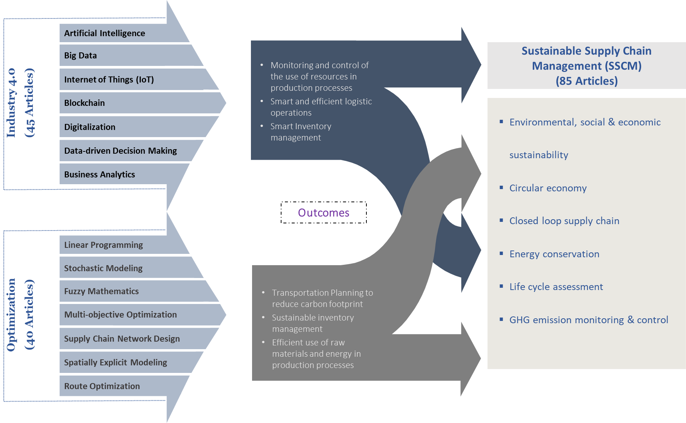
Figure 5 Framework for the use of optimization and Industry 4.0 techniques in SSC

7. Conclusion

7.1 Key Outcomes
One of the key goals of this study was to conduct a systemic literature review of existing literature that examines the use of optimization and I4 techniques in sustainable supply chain management. We investigated research articles from 2010 to 2022 in the Scopus database. Then we performed a screening of available literature based on numerous parameters, and finally, we were left with 85 documents which we analyzed for further literature evaluation. These 85 articles were then put under scrutiny based on several classification categories. The prominent highlights of the classification include the following- there has been a remarkable growth of research in the area since the year 2017; the Journal of Cleaner Production, and International Journal of Production Research and Sustainability are among the top sources of publications in the area, similarly if we talk about the countries, developing economies such as China, India, and Brazil are leading the chart and case study based articles are highest when we speak about classification based on research method. After presenting this classification, we have developed a conceptual framework explaining how optimization and I4 techniques enable businesses to incorporate sustainability into their supply chain operations. The proposed classification study and the developed framework will be helpful for practitioners and researchers belonging to all areas since it underlines the best practices in the context of applying optimization and I4 in SSCM. Given the massive growth of research in the area, we also believe there are numerous research opportunities that researchers can explore in the future.

7.2 Limitations
Future research pursuits require the studies to add to the body of knowledge. Still, at the same time, they are expected to align with existing studies while contributing to identified research gaps. We believe the three sustainability dimensions- social, economic, and environmental- are not new to researchers or practitioners. Still, it’s necessary to remember that we need to incorporate the balance between these three dimensions while pursuing our future research.
This study attempts to explain the recent advances in sustainable supply chain management research with particular attention to optimization and industry 4.0 techniques. We have classified our shortlisted research articles based on year of publication, top journals and publisher, country of 1st author, the research method used concerned industry, and most contributing authors to develop a better understanding of the area. This study will facilitate the practitioners to undertake and redirect their future research better. Despite our best efforts, this study comes with its own set of limitations which we have described below -
- We have obtained the articles for our study using search keywords such as ‘optimization,’ ‘industry 4.0’, and ‘sustainable supply chain.’ This is quite possible that we missed some of the articles which do not have these keywords in the title or abstract but still talk about these themes.
- We have not used several categories of classification, such as top affiliations, classification based on the research design, etc. These can be included in future studies.
- The presented framework is based on the classification results in findings and our understanding of the research material. This framework can be subjected to testing and validation in future research endeavors.

References
Abbassi, M., Chaabani, A., Absi, N. and ben Said, L. (2022), “An elitist cooperative evolutionary bi-level multi-objective decomposition-based algorithm for sustainable supply chain”, International Journal of Production Research, Vol. 60 No. 23, pp. 7013–7032, doi: 10.1080/00207543.2021.1999523.
Balaman, Ş.Y., Matopoulos, A., Wright, D.G. and Scott, J. (2018), “Integrated optimization of sustainable supply chains and transportation networks for multi technology bio-based production: A decision support system based on fuzzy ε-constraint method”, Journal of Cleaner Production, Vol. 172, pp. 2594–2617, doi: 10.1016/j.jclepro.2017.11.150.
Barbosa-Povoa, A.P., Mota, B. and Carvalho, A. (2018), “HOW TO DESIGN AND PLAN SUSTAINABLE SUPPLY CHAINS THROUGH OPTIMIZATION MODELS?”, Pesquisa Operacional, Vol. 38 No. 3, pp. 363–388, doi: 10.1590/0101-7438.2018.038.03.0363.
Belhadi, A., Kamble, S., Gunasekaran, A. and Mani, V. (2022), “Analyzing the mediating role of organizational ambidexterity and digital business transformation on industry 4.0 capabilities and sustainable supply chain performance”, Supply Chain Management: An International Journal, Vol. 27 No. 6, pp. 696–711, doi: 10.1108/SCM-04-2021-0152.
Bisheh, M.N., Delavari, M. and Malmir, B. (2018), “Role of third-party companies in a sustainable supply chain design”, International Journal of Logistics Systems and Management, Vol. 30 No. 1, p. 95, doi: 10.1504/IJLSM.2018.091449.
Borregan-Alvarado, J., Alvarez-Meaza, I., Cilleruelo-Carrasco, E. and Garechana-Anacabe, G. (2020), “A Bibliometric Analysis in Industry 4.0 and Advanced Manufacturing: What about the Sustainable Supply Chain?”, Sustainability, Vol. 12 No. 19, p. 7840, doi: 10.3390/su12197840.
Brandenburg, M. and Rebs, T. (2015), “Sustainable supply chain management: a modeling perspective”, Annals of Operations Research, Vol. 229 No. 1, pp. 213–252, doi: 10.1007/s10479-015-1853-1.
Cañas, H., Mula, J. and Campuzano-Bolarín, F. (2020), “A General Outline of a Sustainable Supply Chain 4.0”, Sustainability, Vol. 12 No. 19, p. 7978, doi: 10.3390/su12197978.
Chalmeta, R. and Santos-deLeón, N.J. (2020), “Sustainable Supply Chain in the Era of Industry 4.0 and Big Data: A Systematic Analysis of Literature and Research”, Sustainability, Vol. 12 No. 10, p. 4108, doi: 10.3390/su12104108.
Daú, G., Scavarda, A., Scavarda, L.F. and Portugal, V.J.T. (2019), “The Healthcare Sustainable Supply Chain 4.0: The Circular Economy Transition Conceptual Framework with the Corporate Social Responsibility Mirror”, Sustainability, Vol. 11 No. 12, p. 3259, doi: 10.3390/su11123259.
Dubey, R., Gunasekaran, A. and Childe, S.J. (2015), “The design of a responsive sustainable supply chain network under uncertainty”, The International Journal of Advanced Manufacturing Technology, Vol. 80 No. 1–4, pp. 427–445, doi: 10.1007/s00170-015-6967-8.
Dumitrascu, O., Dumitrascu, M. and Dobrotǎ, D. (2020), “Performance evaluation for a sustainable supply chain management system in the automotive industry using artificial intelligence”, Processes, Vol. 8 No. 11, pp. 1–20, doi: 10.3390/pr8111384.
Dutta, P., Chavhan, R., Gowtham, P. and Singh, A. (2022), “The individual and integrated impact of Blockchain and IoT on sustainable supply chains:a systematic review”, Supply Chain Forum: An International Journal, pp. 1–24, doi: 10.1080/16258312.2022.2082851.
Esmaeilian, B., Sarkis, J., Lewis, K. and Behdad, S. (2020), “Blockchain for the future of sustainable supply chain management in Industry 4.0”, Resources, Conservation and Recycling, Vol. 163, p. 105064, doi: 10.1016/j.resconrec.2020.105064.
Ethirajan, M., Kandasamy, J. and Kumaraguru, S. (2020), “Connecting Engineering Technology with Enterprise Systems for Sustainable Supply Chain Management”, Smart and Sustainable Manufacturing Systems, Vol. 4 No. 1, p. 20190037, doi: 10.1520/SSMS20190037.
Faramarzi-Oghani, S., Dolati Neghabadi, P., Talbi, E.-G. and Tavakkoli-Moghaddam, R. (2022), “Meta-heuristics for sustainable supply chain management: a review”, International Journal of Production Research, pp. 1–31, doi: 10.1080/00207543.2022.2045377.
Fattahi, M., Govindan, K. and Farhadkhani, M. (2021), “Sustainable supply chain planning for biomass-based power generation with environmental risk and supply uncertainty considerations: a real-life case study”, International Journal of Production Research, Vol. 59 No. 10, pp. 3084–3108, doi: 10.1080/00207543.2020.1746427.
Gao, J. and You, F. (2017), “Modeling framework and computational algorithm for hedging against uncertainty in sustainable supply chain design using functional-unit-based life cycle optimization”, Computers & Chemical Engineering, Vol. 107, pp. 221–236, doi: 10.1016/j.compchemeng.2017.05.021.
Govindan, K., Jafarian, A., Khodaverdi, R. and Devika, K. (2014), “Two-echelon multiple-vehicle location–routing problem with time windows for optimization of sustainable supply chain network of perishable food”, International Journal of Production Economics, Vol. 152, pp. 9–28, doi: 10.1016/j.ijpe.2013.12.028.
Gracia, M.D. and Quezada, L.E. (2016), “A framework for strategy formulation in sustainable supply chains: a case study in the electric industry”, NETNOMICS: Economic Research and Electronic Networking, Vol. 17 No. 1, pp. 3–27, doi: 10.1007/s11066-015-9098-3.
Hall, J., Matos, S. and Silvestre, B. (2012a), “Understanding why firms should invest in sustainable supply chains: a complexity approach”, International Journal of Production Research, Vol. 50 No. 5, pp. 1332–1348, doi: 10.1080/00207543.2011.571930.
Hall, J., Matos, S. and Silvestre, B. (2012b), “Understanding why firms should invest in sustainable supply chains: a complexity approach”, International Journal of Production Research, Vol. 50 No. 5, pp. 1332–1348, doi: 10.1080/00207543.2011.571930.
He, L., Wu, Z., Xiang, W., Goh, M., Xu, Z., Song, W., Ming, X., et al. (2021), “A novel Kano-QFD-DEMATEL approach to optimise the risk resilience solution for sustainable supply chain”, International Journal of Production Research, Vol. 59 No. 6, pp. 1714–1735, doi: 10.1080/00207543.2020.1724343.
Hei, P., Yang, T., Song, J., Zhang, J., Liu, W., Zhou, G., Yang, J., et al. (2019), “Integration of cleaner production (CP) and sustainable supply chain management (SSCM):CP + SSCM → CPSSCM –Inspired from impacts of Cleaner production on China’s macrophyte-dominated eutrophic lakes”, Journal of Cleaner Production, Vol. 234, pp. 1446–1458, doi: 10.1016/j.jclepro.2019.06.223.
Jabbarzadeh, A., Fahimnia, B. and Sabouhi, F. (2018), “Resilient and sustainable supply chain design: sustainability analysis under disruption risks”, International Journal of Production Research, Vol. 56 No. 17, pp. 5945–5968, doi: 10.1080/00207543.2018.1461950.
Jain, P., Tambuskar, D.P. and Narwane, V. (2022), “Identification of critical factors for big data analytics implementation in sustainable supply chain in emerging economies”, Journal of Engineering, Design and Technology, doi: 10.1108/JEDT-12-2021-0739.
Jayarathna, C.P., Agdas, D., Dawes, L. and Yigitcanlar, T. (2021), “Multi-Objective Optimization for Sustainable Supply Chain and Logistics: A Review”, Sustainability, Vol. 13 No. 24, p. 13617, doi: 10.3390/su132413617.
Jiao, Z., Ran, L., Zhang, Y., Li, Z. and Zhang, W. (2018), “Data-driven approaches to integrated closed-loop sustainable supply chain design under multi-uncertainties”, Journal of Cleaner Production, Vol. 185, pp. 105–127, doi: 10.1016/j.jclepro.2018.02.255.
Kaboli Chalmardi, M. and Camacho-Vallejo, J.-F. (2019), “A bi-level programming model for sustainable supply chain network design that considers incentives for using cleaner technologies”, Journal of Cleaner Production, Vol. 213, pp. 1035–1050, doi: 10.1016/j.jclepro.2018.12.197.
Kazancoglu, Y., Ozkan-Ozen, Y.D., Sagnak, M., Kazancoglu, I. and Dora, M. (2021), “Framework for a sustainable supply chain to overcome risks in transition to a circular economy through Industry 4.0”, Production Planning & Control, pp. 1–16, doi: 10.1080/09537287.2021.1980910.
Kumar, D., Rahman, Z. and Chan, F.T.S. (2017), “A fuzzy AHP and fuzzy multi-objective linear programming model for order allocation in a sustainable supply chain: A case study”, International Journal of Computer Integrated Manufacturing, Vol. 30 No. 6, pp. 535–551, doi: 10.1080/0951192X.2016.1145813.
Lee, J.S. and Chung, B. do. (2022), “Effects of government subsidy programs on job creation for sustainable supply chain management”, Socio-Economic Planning Sciences, Vol. 82, p. 101261, doi: 10.1016/j.seps.2022.101261.
Liu, A., Zhu, Q., Xu, L., Lu, Q. and Fan, Y. (2021), “Sustainable supply chain management for perishable products in emerging markets: An integrated location-inventory-routing model”, Transportation Research Part E: Logistics and Transportation Review, Vol. 150, p. 102319, doi: 10.1016/j.tre.2021.102319.
Mahroof, K., Omar, A., Rana, N.P., Sivarajah, U. and Weerakkody, V. (2021), “Drone as a Service (DaaS) in promoting cleaner agricultural production and Circular Economy for ethical Sustainable Supply Chain development”, Journal of Cleaner Production, Vol. 287, p. 125522, doi: 10.1016/j.jclepro.2020.125522.
Manavalan, E. and Jayakrishna, K. (2019), “A review of Internet of Things (IoT) embedded sustainable supply chain for industry 4.0 requirements”, Computers & Industrial Engineering, Vol. 127, pp. 925–953, doi: 10.1016/j.cie.2018.11.030.
Mangla, S.K., Kazançoğlu, Y., Yıldızbaşı, A., Öztürk, C. and Çalık, A. (2022), “A conceptual framework for blockchain‐based sustainable supply chain and evaluating implementation barriers: A case of the tea supply chain”, Business Strategy and the Environment, Vol. 31 No. 8, pp. 3693–3716, doi: 10.1002/bse.3027.
Martín-Gómez, A., Aguayo-González, F. and Luque, A. (2019), “A holonic framework for managing the sustainable supply chain in emerging economies with smart connected metabolism”, Resources, Conservation and Recycling, Vol. 141, pp. 219–232, doi: 10.1016/j.resconrec.2018.10.035.
Mastos, T.D., Nizamis, A., Vafeiadis, T., Alexopoulos, N., Ntinas, C., Gkortzis, D., Papadopoulos, A., et al. (2020), “Industry 4.0 sustainable supply chains: An application of an IoT enabled scrap metal management solution”, Journal of Cleaner Production, Vol. 269, p. 122377, doi: 10.1016/j.jclepro.2020.122377.
Mishra, A., Badhotiya, G.K., Patil, A., Siddh, M.M. and Ram, M. (2023), “Servitization in the circular supply chain: delineating current research and setting future research plan”, Management of Environmental Quality: An International Journal, doi: 10.1108/MEQ-03-2022-0093.
Mota, B., Gomes, M.I., Carvalho, A. and Barbosa-Povoa, A.P. (2018), “Sustainable supply chains: An integrated modeling approach under uncertainty”, Omega, Vol. 77, pp. 32–57, doi: 10.1016/j.omega.2017.05.006.
Munir, M., Jajja, M.S.S., Chatha, K.A. and Farooq, S. (2020), “Supply chain risk management and operational performance: The enabling role of supply chain integration”, International Journal of Production Economics, Vol. 227, p. 107667, doi: 10.1016/j.ijpe.2020.107667.
Nagurney, A. and Nagurney, L.S. (2010), “Sustainable supply chain network design: a multicriteria perspective”, International Journal of Sustainable Engineering, Vol. 3 No. 3, pp. 189–197, doi: 10.1080/19397038.2010.491562.
Paul, A., Shukla, N., Paul, S.K. and Trianni, A. (2021), “Sustainable Supply Chain Management and Multi-Criteria Decision-Making Methods: A Systematic Review”, Sustainability, Vol. 13 No. 13, p. 7104, doi: 10.3390/su13137104.
Peng, J., Chen, L. and Zhang, B. (2022), “Transportation planning for sustainable supply chain network using big data technology”, Information Sciences, Vol. 609, pp. 781–798, doi: 10.1016/j.ins.2022.07.112.
Quariguasi Frota Neto, J., Walther, G., Bloemhof, J., van Nunen, J.A.E.E. and Spengler, T. (2010), “From closed-loop to sustainable supply chains: the WEEE case”, International Journal of Production Research, Vol. 48 No. 15, pp. 4463–4481, doi: 10.1080/00207540902906151.
Rizzoli, A.E., Montemanni, R., Bettoni, A. and Canetta, L. (2015), “Software Support for Sustainable Supply Chain Configuration and Management”, pp. 271–283, doi: 10.1007/978-3-319-09228-7_16.
Sarkar, B., Mridha, B., Pareek, S., Sarkar, M. and Thangavelu, L. (2021), “A flexible biofuel and bioenergy production system with transportation disruption under a sustainable supply chain network”, Journal of Cleaner Production, Vol. 317, p. 128079, doi: 10.1016/j.jclepro.2021.128079.
Sitek, P. and Wikarek, J. (2015), “A hybrid framework for the modelling and optimisation of decision problems in sustainable supply chain management”, International Journal of Production Research, Vol. 53 No. 21, pp. 6611–6628, doi: 10.1080/00207543.2015.1005762.
Souza, V. de, Ruwaard, J.B. and Borsato, M. (2019), “Exploring ecosystem network analysis to balance resilience and performance in sustainable supply chain design”, International Journal of Advanced Operations Management, Vol. 11 No. 1/2, p. 26, doi: 10.1504/IJAOM.2019.098525.
Sundarakani, B., Pereira, V. and Ishizaka, A. (2021), “Robust facility location decisions for resilient sustainable supply chain performance in the face of disruptions”, The International Journal of Logistics Management, Vol. 32 No. 2, pp. 357–385, doi: 10.1108/IJLM-12-2019-0333.
Tautenhain, C.P.S., Barbosa-Povoa, A.P., Mota, B. and Nascimento, M.C.V. (2021), “An efficient Lagrangian-based heuristic to solve a multi-objective sustainable supply chain problem”, European Journal of Operational Research, Vol. 294 No. 1, pp. 70–90, doi: 10.1016/j.ejor.2021.01.008.
Tautenhain, C.P.S., Barbosa-Povoa, A.P. and Nascimento, M.C.V. (2019), “A multi-objective matheuristic for designing and planning sustainable supply chains”, Computers & Industrial Engineering, Vol. 135, pp. 1203–1223, doi: 10.1016/j.cie.2018.12.062.
Tseng, M.-L., Bui, T.-D., Lim, M.K. and Lewi, S. (2021), “A Cause and Effect Model for Digital Sustainable Supply Chain Competitiveness under Uncertainties: Enhancing Digital Platform”, Sustainability, Vol. 13 No. 18, p. 10150, doi: 10.3390/su131810150.
Varriale, V., Cammarano, A., Michelino, F. and Caputo, M. (2021), “Sustainable Supply Chains with Blockchain, IoT and RFID: A Simulation on Order Management”, Sustainability, Vol. 13 No. 11, p. 6372, doi: 10.3390/su13116372.
Vivas, R. de C., Sant’Anna, A.M.O., Esquerre, K.P.S.O. and Freires, F.G.M. (2020), “Integrated method combining analytical and mathematical models for the evaluation and optimization of sustainable supply chains: A Brazilian case study”, Computers & Industrial Engineering, Vol. 139, p. 105670, doi: 10.1016/j.cie.2019.01.044.
Wu, C., Zhang, Y., Pun, H. and Lin, C. (2020), “Construction of partner selection criteria in sustainable supply chains: A systematic optimization model”, Expert Systems with Applications, Vol. 158, p. 113643, doi: 10.1016/j.eswa.2020.113643.
Yadav, D., Kumari, R. and Kumar, N. (2021), “Sustainable Supply Chain Model for Multi-stage Manufacturing with Partial Backlogging Under the Fuzzy Environment with the Effect of Learning in Screening Process”, International Journal of Applied and Computational Mathematics, Vol. 7 No. 2, p. 40, doi: 10.1007/s40819-021-00951-5.
Yadav, D., Kumari, R., Kumar, N. and Sarkar, B. (2021), “Reduction of waste and carbon emission through the selection of items with cross-price elasticity of demand to form a sustainable supply chain with preservation technology”, Journal of Cleaner Production, Vol. 297, p. 126298, doi: 10.1016/j.jclepro.2021.126298.
Yadav, G., Luthra, S., Jakhar, S.K., Mangla, S.K. and Rai, D.P. (2020), “A framework to overcome sustainable supply chain challenges through solution measures of industry 4.0 and circular economy: An automotive case”, Journal of Cleaner Production, Vol. 254, p. 120112, doi: 10.1016/j.jclepro.2020.120112.
Zeng, M., Sadeghzadeh, K. and Xiong, T. (2022a), “A three-echelon based sustainable supply chain scheduling decision-making framework under the blockchain environment”, International Journal of Production Research, pp. 1–21, doi: 10.1080/00207543.2022.2059719.
Zeng, M., Sadeghzadeh, K. and Xiong, T. (2022b), “A three-echelon based sustainable supply chain scheduling decision-making framework under the blockchain environment”, International Journal of Production Research, pp. 1–21, doi: 10.1080/00207543.2022.2059719.
Zhang, Q., Shah, N., Wassick, J., Helling, R. and van Egerschot, P. (2014), “Sustainable supply chain optimisation: An industrial case study”, Computers & Industrial Engineering, Vol. 74, pp. 68–83, doi: 10.1016/j.cie.2014.05.002.
Zhang, X., Adamatzky, A., Chan, F.T.S., Mahadevan, S. and Deng, Y. (2017), “Physarum solver: a bio-inspired method for sustainable supply chain network design problem”, Annals of Operations Research, Vol. 254 No. 1–2, pp. 533–552, doi: 10.1007/s10479-017-2410-x.

