Supporting materials
Appendix A. Data employed in this study. There are 337 lower tier local authorities reporting daily COVID-19 cases across 759 day. All data assembled in this study are included as supplementary information. This data was compiled from a range of publicly available sources as noted in the manuscript. They are provided as the following files: Regions.csv and COVID19Cases.csv.
Appendix B. All R code is available to replicate all the methods in this study along with the results obtained in the COVID-19 example. All R-scripts to assemble and analysis the data are included as supplementary information. This has been provided as BGLRModel.R, BNRModel.R, SNRModel.R, timeseriesResults.R, and GLDIllustrations.R.
Appendix C. Gelman and Rubin’s convergence diagnostics.
(a)
$$β_{0}$$
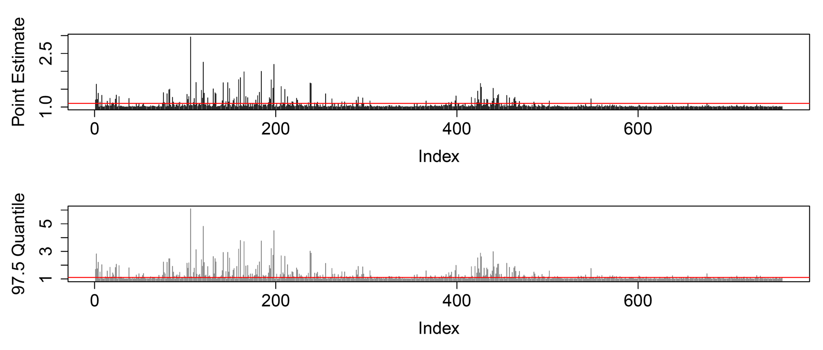
(b)
$$β_{1}$$
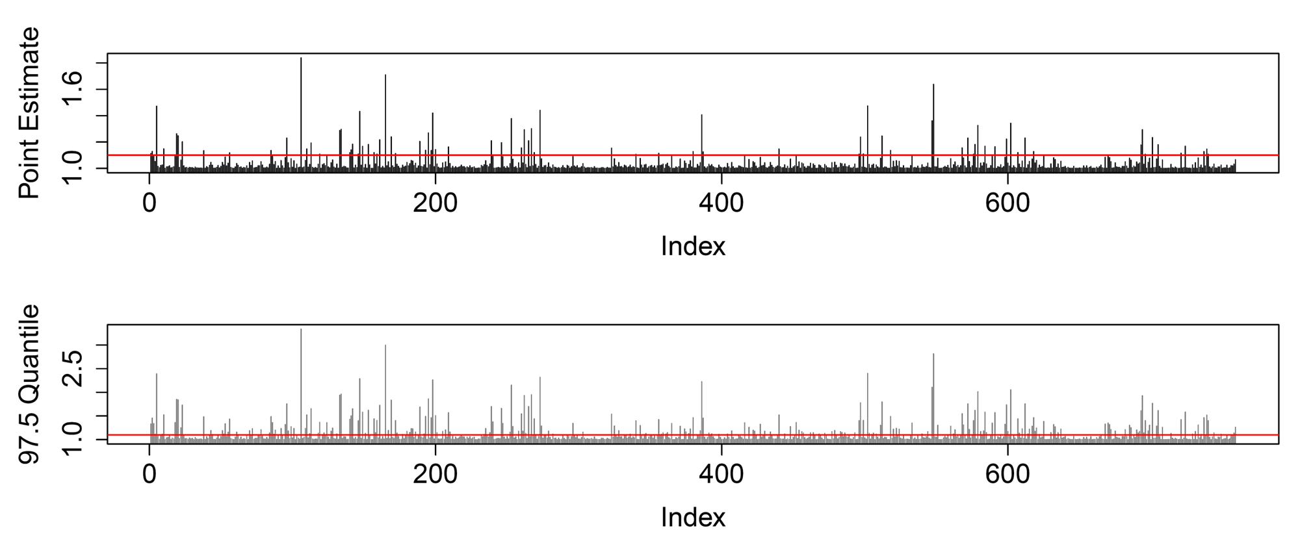
(c)
$$β_{0}^{'}$$
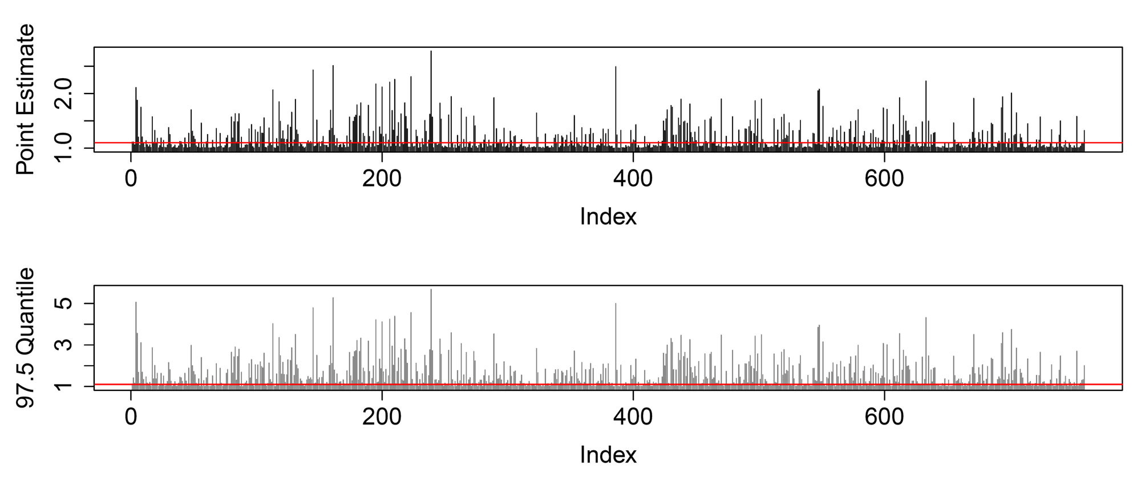
(d)
$$β_{1}^{'}$$
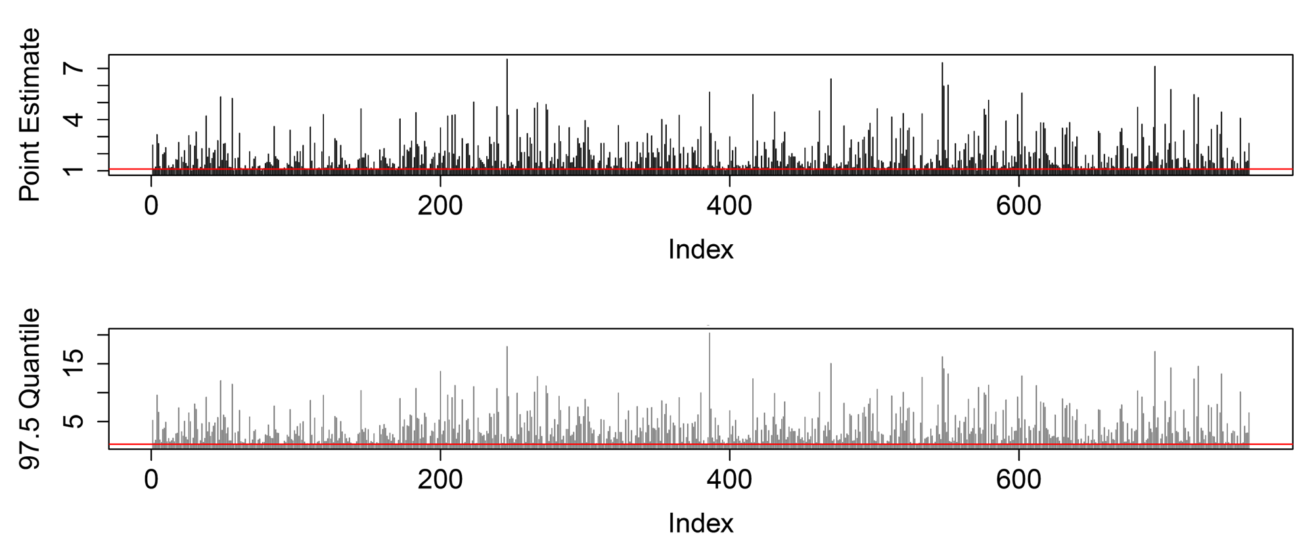
(e)
$$α$$
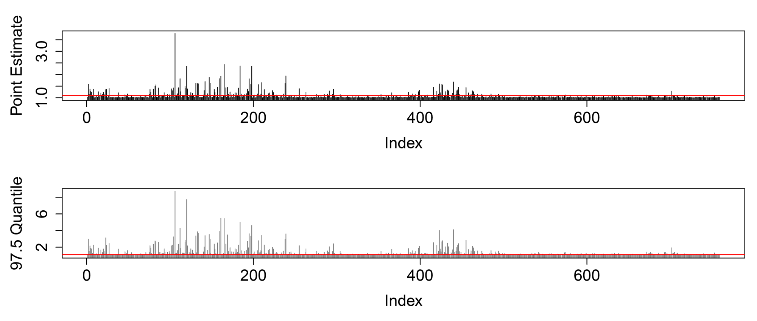
Figure S1. Daily Gelman and Rubin’s R statistic over 20000 iterations for the parameter vector $ψ$ for the COVID-19 daily data set. Values less than 1.1 (represented by the horizonal solid red line) suggest that the MCMC chains converge.

