ThisIsDerby #Reimagine Year 2 Report

Alexander Nunn
Royce Turner
Tamsin Bowers-Brown

University of Derby

October 2021

Contents
Introduction 3
Background – the Story so Far 4
Theory of Change 5
Activities in Year 2 11
Central Activities 11
Hub Activities 12
Overall Monitoring Data 16
Outcomes 17
Summary and Conclusion 21

Index of Tables and Figures
Table 1: Project and Programme Outcomes 6
Table 2: YPF and Reimagine Outcomes 9
Table 3: Summary Monitoring Data Year 2 16

Figure 1: The Future Creatives taking part in a lighting workshop 12
Figure 2: Deda Hip Hop Residency in Action 13
Figure 3: SEND Hub Co-Created Videos 14
Figure 4: Underpass in Sinfin, transformed through Young-People's Graffiti expression 15
Figure 5: Preparing visual arts for the Abbey-Hub Animated Videos 16
Figure 6: Word Cloud of One-Word Reflections of Primary School Participants in an Arts Workshop 17
Figure 7: Feedback on learning from primary aged participants in arts Workshops 19

Acknowledgements
The evaluation team are extremely grateful to the partners, coordinators and artists involved in the Reimagine project who have helped to provide updates on activities and collect data on participation and outcomes. particularly Alix Manning-Jones, Charlotte Hodkinson, Lauren Barkes and Katie Turner and Tom Craig at Derby Theatre; Clair Limb and Simon Marshall at Deda, Marianne Baraclough at Sinfonia Viva, Julian Butt and Jessica Martin at Baby People; Sandra Greatorex and Abbie Canning at Quad and Ruchita Shaik and Catriona Kelly at Artcore.

Introduction
Reimagine is a performance arts participation programme for young people in Derby and Derbyshire. The programme is funded for three years by the Arts Council for England’s Youth Performance Fund and is a continuation of activities and ways of working piloted in Derby Theatre’s Plus One scheme and the 12 month #ThisIsDerby programme, both of which involve significant partnership working among arts organisations in the City.
The programme is organised around five Hubs, four of them spatial and one cross-city working with children and young people with Special Educational Needs and Disabilities. Each hub is led by a single partner organisation, though often partners will lead one hub and deliver activities in several others. Each hub has a range of organisations – partners and others – delivering activities. Activities are organised through schools, in community and other settings. Some projects within the programme involve multiple hubs, while others are discrete to that hub. Activities involve taster and developmental sessions as well as projects which culminate in sharing performances within the Hub and at city-wide events.
In addition to the Hubs, the programme envisages the establishment of a series of production companies. These will act as artistic steering groups as well as vehicles for young people engaged through the programme to gain a more in-depth understanding of creative production and to develop core skills. It is envisaged that production companies will produce more formal productions and allow those engaged to develop skills in performance and the technical support skills involved in professional productions.

Background – the Story so Far
#Reimagine commenced at the end of 2019, and some activity was delivered through the five hubs from autumn of that year. However, the plan for year 1 was to scale up activity gradually through the spring into more intensive half term programmes, the recruitment of a company of Future Creatives and a series of outdoor summer performances. These plans were severely constrained as the Covid 19 pandemic hit in March 2020. As a result of the pandemic, a large part of the programme for 2019-20 was moved online.
Despite the problems posed by the pandemic the first year of the Reimagine programme did manage to support cultural participation among young people and develop cultural and artistic partnerships in the city. Partners were continuing to work through the pathway to social outcomes established in the theory of change. While not helpful to the broader theory of change, or to targeting some groups of vulnerable young people, the sudden move to online delivery did have the unanticipated benefit of developing a range of new skills for both artists and young people in online engagement and delivery. It spurred new forms of creativity and in some cases provided a much needed distraction from and mitigation for isolation, helping to support resilience among participants. The range of activities on offer engaged the participants, developed a sense of self and place, and highlighted many prominent localised issues and concerns by giving young people a vehicle to express their voice. The initial needs analysis identified there was a strong demand for cultural and artistic activities that can draw different sections of the community together and there is evidence that these goals were, at least partially, realised. In year 1 the programme engaged diverse artists with a broadly balanced gender profile, a mix of ages and ethnicities.
As this report demonstrates, activities in Year 2 were also hit by the second and third wave of the Covid 19 pandemic, being interrupted from autumn 2020 through to Spring 2021. Again, online activities helped to bridge the gap but by now the initial programme intentions have been severely disrupted, despite largely successful attempts to sustain delivery throughout the year.

Theory of Change
ThisisDerby #Reimagine is seeking to promote a series of Learning Outcomes for young people, schools and communities, and the culture and arts sector involving artistic and creative engagement as a mechanism to promote social change that will enhance opportunities available to young people and concomitantly reduce the economic, educational, and social inequalities currently so clearly evident in Derby. A ‘theory of change’ approach to understanding the progress of an initiative such as this envisions an ‘outcomes pathway’ to achieving social change. Illustrative links between Reimagine programme level outcomes and where they are developed in each of the Hub projects are set out in Table 4. Links between the Youth Performance Fund outcomes and those relevant to Reimagine are in Table 5.
The Theory of Change narrative suggests that through participation in arts and sports young people gain an enhanced sense of wellbeing and develop a series of soft non-cognitive skills (e.g. confidence, communication, social empathy) as well as hard technical skills related to art practice and production. Because the thematic focus of much of the arts is (a) targeted at inclusion and diversity (e.g. the SEND hub) or operates with a view to letting young people gradually assume control of the artistic process, there is a participatory ladder of engagement toward co-creation that is assumed to build and amplify voice and empowerment. There may be tensions between artistic quality and empowerment at times but the values/ethos of the programme is to sacrifice the former for the latter where that is relevant, but with the hope that working with professional artists helps young people to develop their skills to mitigate this. Schools are engaged through young people’s participation being based partly at schools, through sharing performances and CPD activities targeted at teachers. Communities are engaged through parental engagement with young participants and performances at community events and with the hope that young people direct artistic activity toward ‘issues’ of relevance to the community or young people’s place in the community. The arts sector itself is to be transformed as young people form production companies that develop performances for mainstage shows and direct wider cultural programming in the partner organisations as young producers and creatives.

Table 1: Project and Programme Outcomes
Outcomes | Ward(s) | Lead org. | Rationale
LO1 Develop improved key life skills, specifically in relation to confidence, resilience and communication | Abbey | Derby Theatre | Resilience – taking part and committing to the project for the entire year
 | Arboretum and Normanton | Artcore | Participation and performance
 | Derwent and Chaddesden | Déda | Creating a utopian version of young people’s surroundings, using dance and shadow puppetry.
LO2 Develop improved leadership skills | Derwent and Chaddesden | Déda | Creating a utopian version of young people’s surroundings, using dance and shadow puppetry.
LO3 Develop young people’s voice | Abbey
 | Arboretum and Normanton | Artcore | Identifying and transforming several local environments – a roundabout, a park, a library.
 | Derwent and Chaddesden | Déda | Creating a utopian version of young people’s surroundings, using dance and shadow puppetry.
LO4 Develop improved sense of well-being | Abbey | Derby Theatre | Being part of something bigger than school, culminating in a show
 | Derwent and Chaddesden | Déda | Creating a utopian version of young people’s surroundings, using dance and shadow puppetry.
LO5 Develop technical and professional skills relative to the creative industries | Abbey | Derby Theatre | Access to the creative industries, exploring job roles and possibilities, via interaction with professional creatives
 | Arboretum and Normanton | Artcore | Developing artistic skills
 | Sinfin | Baby People | Writing, graffiti, music production and design skills
LO6 Increased awareness of, and participation in, sports and arts activities | all | All Hub leads | All hubs are based on participation in arts activities.
 | All | All Hub Leads | Participation and performance
LO7 Improved awareness of career options, particularly in the sports and creative industries sessions | All | All Hub Leads | Participating in arts, working with artistic professionals who play a role model example, some specific discussions of artistic and technical roles.
LO8 Better informed and more positive choices about their futures | Arboretum and Normanton | Artcore | Participation and performance
LO9 More engaged with social action | Abbey | Derby Theatre | Taking place on youth steering group. Engaging with Bramblebrook fun day.
 | Arboretum and Normanton | Artcore | Participation and performance
 | Derwent and Chaddesden | Déda | Creating a utopian version of young people’s surroundings, using dance and shadow puppetry.
For schools and communities…
LO10 Schools have a deeper or more meaningful engagement with cultural and sports partners | Arboretum and Normanton | Artcore | Participation and performance
LO11 Schools and families have improved understanding of a range of careers and pathways to other opportunities | Abbey | Derby Theatre | Families involved and engaging with project and performances. Using collection times and family days to engage families with wider cultural opportunities in Derby.
LO12 Teachers are more confident about delivering theatre-making and performance skills and using these approaches to develop a wider set e.g. speech and language development, STEAM, and literacy | All | All Hub Leads | Training activities run centrally for teachers
LO13 Communities are more confident and have increased capacity | Abbey | Derby Theatre | Schools engaging with community fun days and community centre
LO14 The creative and sporting sector has an improved and sustained ability/capacity to deliver city-wide projects | Abbey | Derby Theatre | Project continues to deliver in the schools and funding allocated to do so
 | Arboretum and Normanton | Artcore | Participation and performance
LO15 The city has a better understanding of the needs of young people in Derby and reflects that through strategy, reports, events and performance work, telling the stories of young people and their communities | Abbey | Derby Theatre | Continue to deliver, evaluate and reflect, in order to deliver best practice, not only practically but data forms wider context socially and city-wide
 | Arboretum and Normanton | Artcore | Participation and performance
LO16 Young people’s voices are more embedded in the partner organisations | Young Producers Companies | Derby Theatre | Young producers will set the creative direction of the project in years 2 and 3.

Table 2: YPF and Reimagine Outcomes
National Programme Outcome | Local outcomes for #Reimagine
 | Young People | Schools & Comms | Sector
NP1 Non-cognitive skills  Young people develop self-expression, agency and self-efficacy through artistic development and performance. | LO1, LO2, LO4 | LO13, | LO14
NP2 Transferable/Technical Skills  Young people improve their professional, performance and performance making skills. | LO5 | LO12
NP3 Access  More children, families and schools from deprived and lower-engaged areas are experiencing and appreciating performances. | LO6,
NP4 Engagement  Schools and cultural organisations improve their abilities to engage broad and diverse participants and audiences. |  | LO10, LO11, LO12, | LO16
NP5 Valuing Culture etc  Communities (ie. schools, families and broad publics) and young people feel better connected to their locality through high quality performance experiences. |  | LO9, LO13, | LO15
NP6 Partnerships  LCEPs establish new and innovative models of partnerships which are locally effective. |  |  | LO14, LO15

Activities in Year 2

Central Activities
Hub activities in Year 2 were supported via a strong central artistic theme focussing on Home Girl, a novel for young adults by Alex Wheatle which documents the experiences of a young girl in the care system. The book explores themes of race, sexuality and identity, love and family life, mental health and bullying. During Reimagine 2020 a weekly online book club and reading sessions, including Alex Wheatle, were used to stimulate creative responses from young people, and they chose the book as the central creative theme for 2021. This group evolved to become ‘the Future Creatives’.
The central activity for 2021 commenced with a commission, issued by the Future Creatives, to recruit professional writers and a young person to create a stage adaptation of the book. The young people chose the professional and youth writer. The commission was targeted in particular at people from under-represented backgrounds, including those with experience of the care system.
The Future Creatives group was also expanded by targeted recruitment aimed at young people aged between 14-25 who were entitled to free school meals, pupil premium, were care experienced, disabled or had English as a Second Language. Reimagine partners and their schools’ networks distributed the call which targeted young people interested in performance but also the range of technical skills and roles that surround performance art. The group is now made up of 24 young people including 14 performers, 1 writer, 2 stage managers a sound designer, a lighting designer, a marketing officer, a producer, a set designer, a costume designer and a production manager. The young people were offered initial insight into the variety of roles available and then chose which they would like to undertake. Each young person has an industry mentor and the group worked together over 60 sessions between March and July to develop the performance of Home Girl for the main stage of Derby Theatre in July 2021. Young people gained insights into all aspects of the creative process that leads to a professional theatre performance as well as developing their skills in the specific role that they performed. The performance was to be by a mixture of the Future Creatives actors and professional actors recruited to work with them. In the event, the performance had to be cancelled because of Covid cases among the young participants.
Figure 1: The Future Creatives taking part in a lighting workshop
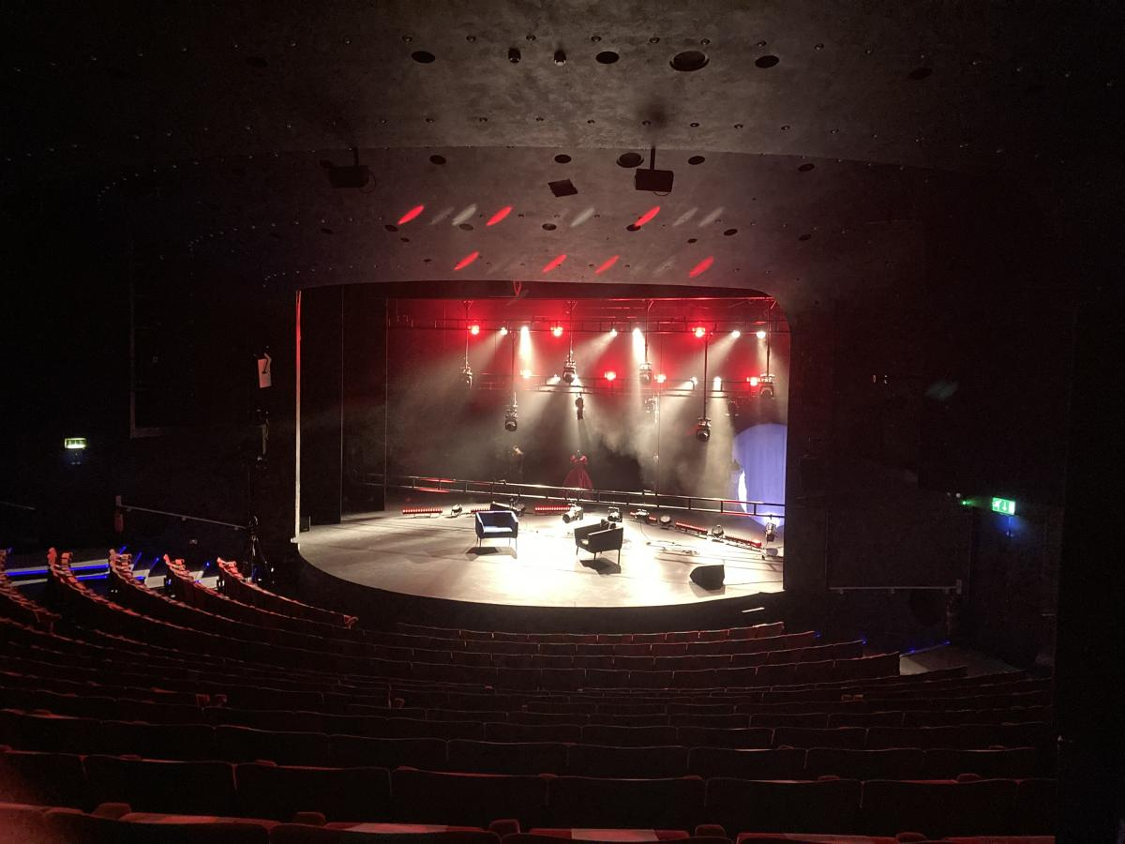

Hub Activities
All hubs continued to deliver activities during autumn 2020 and through the second lockdown from Xmas through to Summer 2021. The creative theme for all these activities was provided by the Alex Wheatle novel for young adults Home Girl. Some activities ‘reimagined’ scenes, characters or aspects of the plot, while others created art that might accompany performances of the story.
They experienced difficulties accessing schools physically due to pandemic control measures, and many activities were delivered online as a result. For example, having used a model of distributing art kits to families and then providing daily Zoom sessions to use the kits for arts activities, Artcore ran a similar model with schools and then again with families when schools closed. Deda also continued their previous practice of making Youtube videos focussing on emotional resilience and exercise. They also conducted more targeted work to support schools’ online home learning with 30 minutes of videos focussed on creative writing and movement each week in the spring term. Sinfonia Viva supported schools to engage online delivering to multiple groups 3 times a week in several schools.
Activity has also been delivered face-to-face, however, especially in the early autumn of 2020 and from early spring 2021 onwards. In the autumn of 2020, Deda ran dance activities in the October Half Term in the form of a Hip Hop ‘residency’. This offered the young people the opportunity to work with professional dance artists and to create an original performance.
Figure 2: Deda Hip Hop Residency in Action
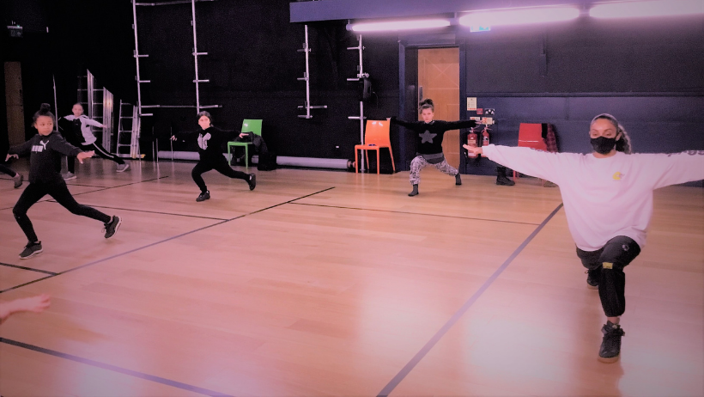

They also ran an after-school performance club at a secondary school. This centred on co-creation and included multiple artists and performance art forms, as well as wellness support. This was particularly valuable as the school does not have any drama, dance or performing arts provision. Taking themes of mental health and identity from Home Girl, the group worked together to create performances that responded to the challenges identified by the young people themselves. Further creative residencies in spring and summer enabled the group to film and then show their videos to a small invited audience in August. Deda also worked in two primary schools to co-create group poetry. This led up to a sharing day where co-created posters and banners were also shown.
From spring 2021 Sinfonia Viva ran activities in five schools alongside Hubbub Theatre company and Quad. The children worked together to make short videos featuring original music and songs, alongside digital and craft animations, as well as performance and dance.
Figure 3: SEND Hub Co-Created Videos
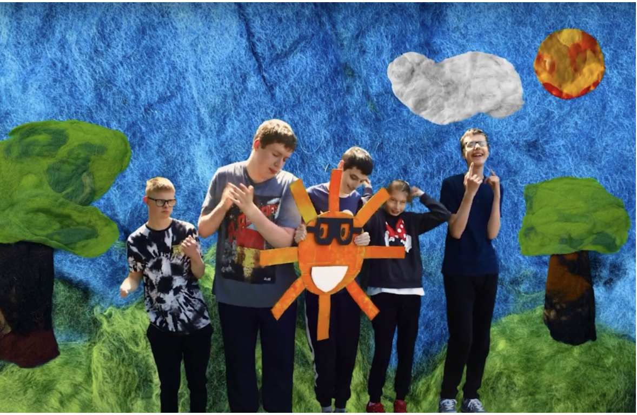
Baby People were able to continue to deliver face-to-face sessions in Sinfin focussed on Dance and Graffiti. Graffiti work was particularly useful because it was outside, and resulted in a large scale public artwork on an underpass on the theme of Covid safety. The artwork and featured on the national news. A music and dance performance was also staged at the site, helping to ‘reimagine’ this part of the area temporarily as performance space and permanently through the graffiti.

Figure 4: Underpass in Sinfin, transformed through Young-People's Graffiti expression
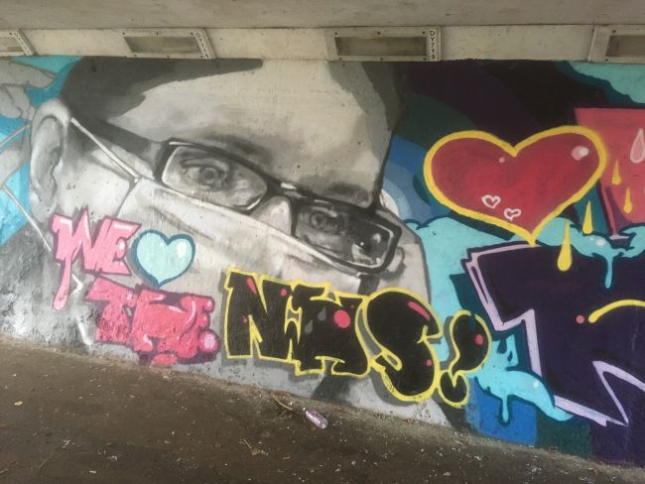

Derby Theatre was able to recommence work in schools from the beginning of March to co-create stories and performances between young people from different schools. The young people also worked on visual arts and animation and produced three animated films. Once the full lock-down was lifted in July, a community celebration event was held where the films were launched. The families that attended were also able to engage with performance and story writing workshops and eat together. A documentary film recorded the experience of the participants and audiences.
Figure 5: Preparing visual arts for the Abbey-Hub Animated Videos
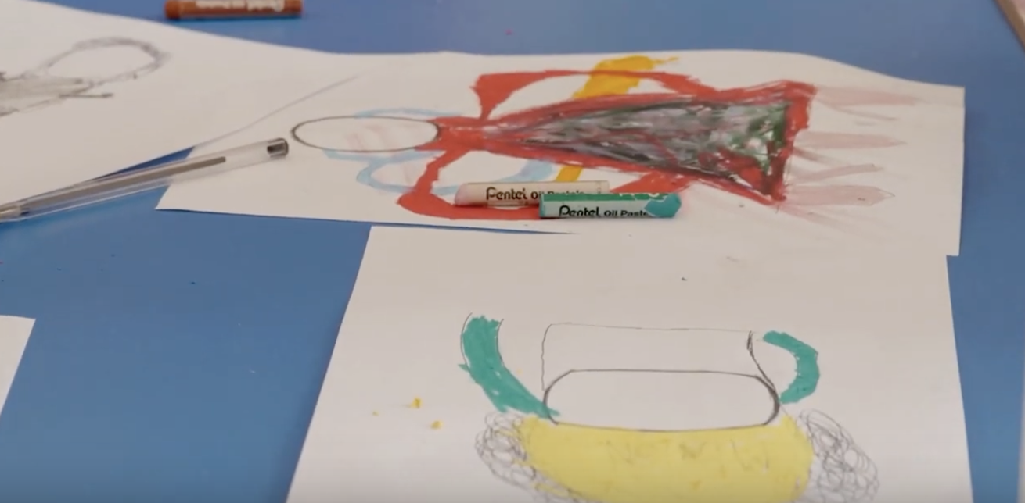

Overall Monitoring Data
Table 3: Summary Monitoring Data Year 2
 | Central | Abbey | Sinfin | Norm. / Arbtum | Derwent/ Chad. | SEND | Total
No. of performances | 1 | 1 | 2 | 12 | 3 | 6 | 24
No. of performance venues / sites | 1 | 1 |  | 12 | 3 | 1 | 17
No. of audiences engaged - CYP |  | 20 | 1 | 403 | 129 |  | 553
No. of audiences engaged - adults |  | 60 |  | 88 | 6 |  | 154
No. of artists or creative practitioners employed | 19 | 8 | 9 | 2 | 8 | 14 | 41
No. of schools engaged | 18 | 4 | 10 (est) |  | 7 | 6 | 17
No of Schools engaged | 1 | 4 | 13 | 5 | 5 | 9 | n/a
No. of new partnerships established |  | 2 | 0 | 1 | 3 | 1 | 7
Non-performance activities: Total no. of hours of sessions (Note: feel free to report data broken down by strands of work) | 209 | 45 | 24 | 66 | 48 | 83 | 266
Non-performance activities: Total no. of engagements (attendance) | 74 | 45 | 200 | 135 | 19 | 700 | 1099
Non-performance activities: Total no. of unique participants |  | 20 | 59 | 135 | 129 | 190 | 533

Outcomes
Across the central and hub activities we were able to see evidence of outcomes based on live and recorded observations of activities and feedback from young people, their families and the artists involved in delivering the programme.
Young people evidently enjoyed the activities that they engaged in. For example, a word cloud produced by primary school participants in an online in-school arts workshop with Artcore emphasises fun as the most prominent one-word reflection:
Figure 6: Word Cloud of One-Word Reflections of Primary School Participants in an Arts Workshop

This was particularly the case in the context of ongoing lockdowns. Young people in several hubs reported enhanced anxiety and depression and engaging online and through physical activities helped them to experience enjoyment at a time when other experiences were limited:
“Like everyone, I’m excited to get out the house and do something creative” Shannon, Future Creatives performer.
“That was sick”, Bardia, a primary-aged participant in Derwent on hearing a co-created poem.
Young people also suggested that they welcomed the chance to process their experiences and reflect on their wellbeing, identity and challenges. For instance, the Deda United Squad (after school club). One young person said that they suddenly felt like they were:
“on a motorway with the road ahead, when before I’d felt swampy” (Andrew, Participant in the Deda, United Squad).
In a similar vein, young people also enjoyed being able to meet new people and socialise with people their own age:
“I enjoyed meeting new people and having the opportunity to do and try something new. It gave me new experience”. Future Creatives Marketing Officer
“[I enjoyed] Being able to meet people who share the same goals and passions as me.” Future Creatives Producer
Young people also identified performance as a means of sharing experiences with others and challenging inequalities and perceptions. For example, the three videos created by the SEND hub have a message of inclusion and kindness, as expressed in the title of their work: Belonging Together, and the content of the music and performance that they created. Another young person involved in the Future Creatives said that their adaptation of Home Girl made:
“Being in care…relatable, it gets rid of the negative stereotypes that people have of the care system” Bry, Future Creatives Performer.
Another young person reflected on their learning in this way:
“I think I’m going to be more open-minded towards people, know about people’s journeys and their lives and be more accepting and kind towards other people because you never know what they’re going through in their lives” Primrose, Future Creatives Performer.
Younger participants also welcomed the positive message that was reinforced within their participation and that they felt that they had developed their ability to deal with challenging situations:
"Is to always be kind and to treat people the way you want to be treated" Ayesha, Primary aged participant in an Artcore Workshop.
“Tell someone and get it off your chest [if you are being bullied]. Tell people you trust, go and defend yourself because they are jealous” Jay, Primary Aged participant in Artcore Workshop.

Figure 7: Feedback on learning from primary aged participants in arts Workshops

Co-creation was also clearly present throughout the programme. For example, young people involved in story writing and developing animated films said:
“It seems like they wanted our personalities to shine through”, Primary aged participant in Abbey Ward.
“Writing the script was fun; we got to be who we wanted to be”, Primary aged participant in Abbey Ward.

Participation also developed young people’s skills and attributes. Parents of children involved in the Abbey Ward production workshops reported that their children had become noticeably more confident. A Future Creative performer reinforced this point:
“I improved on my skill of self-confidence, something I used to struggle with a lot. Really being in that space with so many supportive people and being around others who wanted to act too really just gave me such a positive mindset and made me feel so good about what I do.” Future Creative Performer.

As a by-product of confidence and developing resilience in producing outputs, young people were evidently proud of what they had achieved:
“I’m excited to see my piece of creative art on stage and thinking, I did that” Emma, Future Creatives Set Designer.
“I feel really proud that from me sending a letter to the headteacher, this has all happened. It's not what I expected, but its better. We’ve achieved so much”, Jess, United Squad, Chaddesden and Derwent.

Young people also gained technical skills in performance and associated roles. This is clear in the performance videos produced by several of the hubs. It is also evident in feedback from the Future Creatives:
“How to create a lighting plan and the different types of lights.” Lighting Designer
“I learnt to be able to lead a zoom call, and be able to confidently communicate with the people around me.” Production Manager
“I learnt different ways of building a set and work with a professional to broaden my learning. I learnt to speak out and represent the work I had done. I also learnt skills on how to create a set design.” Set Designer
“My improved acting skills” Performer
Aside from these individual-level outcomes, it was noticeable that the programme also developed skills among others involved. For example, teachers involved in the CPD activity reported that they had developed their technical skills and confidence in delivering performance and drama lessons in school. Teachers were also supported in delivering online during the pandemic, gaining ideas and inspiration (as well as time to prepare other work) while Reimagine activities were delivered to their pupils over the internet.
There were also positive community-level outcomes. For example, the public art created by participants working with Baby People in Sinfin improved the public realm. Both Deda and Derby Theatre worked in and with community centres, helping to sustain community infrastructure. Celebration and sharing events had contributed to community engagement and pride. By helping young people to work together across primary schools in years 5 and 6 the project was also supporting their transition to high school.
Finally, artists involved in the programme had improved their ability and experience in co-creation. This was challenging, with one artist involved reflecting on the difficulties of embedding deeper co-creation methods at the same time as working online. This particularly so because co-creation of meaningful artistic outputs was thought to require sustained engagement and the pandemic and online access meant that engagement was often disrupted.

Summary and Conclusion
For the second year, the Reimagine project has been severely interrupted by the Covid 19 pandemic, making it difficult to sustain activities as envisaged, and particularly to hold public performances. Engagement and activities were often paused and several performances – notably the main stage production of Home Girl – were cancelled or postponed. Despite this, partners had been able to sustain engagement online during the lockdown and all Hubs had been able to undertake face-to-face sessions either side of the lockdown. Some performances had now been possible and there was a success in recruiting the Future Creatives performance company.
In line with the philosophy underpinning the Theory of Change, outcomes reported here link to those established at the outset of the project as objectives. There was good evidence of individual-level outcomes in relation to confidence, resilience and communication and that young people were developing their voice through effective (and scaffolded) co-creation. Activities had pivoted in some cases to a more explicit focus on wellbeing, in the context of isolation reported by young people in lockdown. Young people – as well as artists and other professionals – had developed their skills through the project, including in unexpected ways through online delivery. All activities had engaged young people with professional artists, helping to showcase creative careers and offer meaningful interactions with effective creative role models. In the Future Creatives in particular this is also sustained, detailed and explicitly focussed on developing career awareness and skills, and young people noted this in their feedback. Community and school-level outcomes had also been achieved.
The extent to which outcomes were realised was certainly held back by the pandemic. However, it is widely noted that lockdown and isolation have had negative impacts on young people and participants in this programme commented that it had helped them to cope with isolation and renew social relationships after lockdown. Like last year, it is positive that Reimagine has continued to sustain social ties and creativity among young people in such a challenging context and, as the programme rolls into the penultimate year, the face-to-face provision that was possible throughout spring and summer 2021 has laid a strong foundation for activities to create the outcomes anticipated at the outset.

https://www.derbytheatre.co.uk/news/call-out-writing-commission-opportunity-to-adapt-home-girl-by-alex-wheatle
https://www.derbytheatre.co.uk/news/introducing-our-future-creatives-young-theatre-makers-working-on-home-girl
https://www.derbytheatre.co.uk/news/home-girl-creative-mentors-call-out
https://www.derbytheatre.co.uk/news/cast-announced-derby-theatres-production-home-girl
https://www.derbytheatre.co.uk/home-girl
https://www.deda.uk.com/news/2021/childrens-mental-health-week-emotional-toolkit-series
https://www.deda.uk.com/news/2021/spotlight-on-3-4
https://www.deda.uk.com/news/2021/spotlight-on-derwent-and-chaddesden-hubs-xzibit-residency-with-d%C3%A9da-2-4
https://thisisderby.org/reimagine-2021-belonging-together/
https://www.youtube.com/watch?v=i90ICtBbAvc https://www.youtube.com/watch?v=z45vfvqBZG4 https://www.youtube.com/watch?v=eK3xXeuLu3o
https://www.youtube.com/watch?v=7xh3gPMZqD0

