Tailor-Made Hygroscopic Photothermal Organogels for Moisture Management and Evaporative Cooling through a 1D-to-3D Design
Yue Wang,ª Shuai Li,ª Jingjing Li,ª Yuke Sun,ª Zhaojun Li,^{b} Petri Murto,^{c,d} Zhihang Wang,*^{,e,f} & Xiaofeng Xu*^{,a}
ª College of Materials Science and Engineering, Ocean University of China, Qingdao 266100, China.
^{b} Solid State Physics Division, Department of Materials Science and Engineering, Uppsala University, Lägerhyddsvägen 1, 751 03 Uppsala, Sweden.
^{c} Yusuf Hamied Department of Chemistry, University of Cambridge, Cambridge, CB2 1EW, United Kingdom.
^{d} Department of Chemistry and Materials Science, Aalto University, Kemistintie 1, 02150 Espoo, Finland.
^{e} Department of Materials Science and Metallurgy, University of Cambridge, Cambridge, CB3 0FS, United Kingdom.
^{f} School of Engineering, College of Science and Engineering, University of Derby, Markeaton Street, Derby DE22 3AW, United Kingdom.

* Corresponding authors: X. Xu, email: xuxiaofeng@ouc.edu.cn
Z. Wang, email: z.wang@derby.ac.uk

Keywords: evaporative cooling, hygroscopic polymers, organogels, personal thermal management, water vapor sorption, water desorption

ABSTRACT
Sorption-based moisture management and evaporative cooling are emerging technologies with significant potential for energy-efficient personal thermal management (PTM). However, developing customized hygroscopic composites that combine effective humidity control, heat dissipation, and wearer comfort remains a key challenge. This work introduces multidimensional organogels (1D to 3D) that synergize hygroscopic, photothermal, mechanical and processing properties for user-defined PTM applications. Selected polycations, polyanions, zwitterionic polymers and glycerol are properly cross-linked within 1D fibers through continuous wet-spinning, preventing the need for hygroscopic salts and moisture-induced structural degradation. 2D blended fabrics integrate the hygroscopicity and flexibility of organogel-based fibers with the strength and wear resistance of synthetic fibers, enabling two passive heating methods to enhance solar-powered water release. Optimized fabrics demonstrate reliable and reversible moisture sorption/desorption, enduring up to six cycles per day under outdoor conditions. The efficient evaporative cooling and heat stress dissipation make them ideal for PTM textile and clothing. Furthermore, 3D printed hierarchical matrices expand the organogels’ potential to PTM insoles. With exceptional moisture control, scalability and processing ease, these organogels rank among the best-performing and highly customizable hygroscopic materials. This work represents one of the few hygroscopic photothermal organogels offering self-contained and application-specific functions through 1D to 3D designs.

1. Introduction
Environmental heat exposure represents a serious occupational safety and health hazard, limiting athletic performance, physical work capacity, and overall labor productivity.¹ The combined effects of heat and humidity can lead to unexpected health issues, including fatigue, dehydration, heat stroke, and skin problems.² Active cooling systems are commonly used to regulate humidity and temperature in buildings and industrial facilities. However, these solutions are highly dependent on electricity, thermal energy, and water to dissipate heat. As demand for cooling continues to rise, this reliance is expected to remain one of the main drivers of global electricity consumption and greenhouse gas emissions in the coming decades.³ Moreover, conventional cooling systems are poorly suited for outdoor activities, making it difficult to fully address individual thermal comfort needs.⁴
Given this health-energy dilemma, personal thermal management (PTM) is gaining attention for its potential to improve energy efficiency and sustainability.⁵⁻⁸ PTM technologies are centered on adaptive thermal regulation through smart wearables, textiles, aerogels and matrices, providing customized thermoregulation, zero emissions, broad applicability, and enhanced aesthetic integration.⁹⁻¹⁵ Once metabolic heat reaches the skin, it can dissipate into the surrounding environment through several mechanisms: convection, conduction, radiation, and evaporation. In thermally comfortable environments with minimal air movement, conventional fabrics facilitate the dissipation of ∼15% of body heat via convection.¹⁶ However, this effect varies based on fabric structure and thermal gradients.¹⁷ Heat conduction contributes only ∼3% of heat loss between textiles and skin.¹⁶ Recent innovations have incorporated conductive materials into fabrics, enhancing thermal conductivity for improved conductive cooling.^{18,19} Radiative heat loss, particularly in the mid-infrared (7−14 µm) range, accounts for ∼60% of total heat loss in calm indoor conditions.¹⁶ Radiative cooling leverages thermal radiation to dissipate heat from an object to its surrounding environment, offering a passive and energy-efficient approach to temperature regulation.²⁰⁻²² Recent studies on radiative cooling materials and photon-engineered textiles have explored mid-IR transparency, mid-IR emission, and solar reflection.²³⁻²⁸ However, the practical efficacy of radiative cooling materials remains largely dependent on specific weather conditions and geographic location.
Evaporative heat loss occurs through two primary mechanisms: insensible water loss and sweating.¹⁶ Insensible water loss involves the diffusion and ventilation of water vapor and operates without regulatory control, indicating it is not actively modulated to aid in temperature regulation. On the other hand, the heat loss associated with sweating can be precisely regulated through the modulation of sweating rates. In trained athletes, sweating rates can reach up to 3.5 L h⁻¹. Each milliliter of evaporated sweat dissipates ∼2.4 kJ of heat from the body.¹⁶ Under thermally comfortable conditions, evaporation is theoretically responsible for ∼25% of total heat loss, functioning as a primary mechanism that far surpasses dry heat exchange processes such as convection and conduction. However, we point out that this proportion can be significantly changed during physical exertion, particularly when the ambient temperature approaches or exceeds the body’s core temperature.²⁹ Recent developments in evaporative cooling textiles have focused on improving fiber structures, surface treatments, and garment design to enhance air permeability, moisture-wicking, evaporation efficiency and wet comfort.³⁰⁻³² However, under excessive perspiration, these textiles reach their absorption limit and struggle to keep pace with sweat production. This leads to elevated humidity between skin and fabric, reduced cooling efficiency, and increased friction, resulting in discomfort.
Addressing this challenge requires the development of moisture-engineered and sorption-based cooling textiles to fully exploit the cooling potential of sweat evaporation. These textiles efficiently lower humidity within the microenvironment between the skin and fabric, reducing barriers to sweat evaporation and enhancing heat dissipation.³³⁻³⁵ Notably, the incorporation of emerging desiccants (i.e., hygroscopic salts, metal−organic complex, metal−organic frameworks and covalent organic frameworks) into porous matrices (i.e., films, aerogels, hydrogels and foams) with multiscale hierarchical structures has attracted growing interest.³⁶⁻⁴⁸ These systems hold significant promise for applications including sorption-based atmospheric water harvesting, clean water production, passive cooling, protective packaging, and sustainable agricuture.⁴⁹⁻⁶⁸
Despite advancements in hygroscopic hybrid composites, the development of hygroscopic materials and adjustable structural scales specifically designed for sorption-based PTM applications remain constrained.⁶⁹⁻⁷¹ The following challenges persist regarding the leak-proof components, cross-linking strategies, processing methods and integrated functions of hygroscopic composites: (i) Deliquescence and leakage of hygroscopic salts cause performance degradation, skin irritation or corrosion, and environmental risks.⁷² A promising solution is the design of "all-organic" hygroscopic composites, using biopolymers and polyelectrolytes, to effectively prevent sorbent dissolution and leakage.^{38,73-75} However, many natural polysaccharides and synthetic polyelectrolytes face challenges in forming well-defined and robust structures due to pronounced electrostatic repulsion. In the absence of effective cross-linking strategies, these polymers are highly susceptible to water-induced deformation.⁷⁶ (ii) while bulk hygroscopic polymers exhibit high water uptake, their slow moisture sorption and desorption kinetics limit their cooling effectiveness during moisture sorption−desorption cycles. (iii) The significant advantages of polymers in tunability, processability and customization have yet to be fully exploited in the fabrication of polymer-based hygroscopic composites. Achieving scalable fabrication of hygroscopic photothermal fibers and textiles via wet-spinning and electrospinning remains a significant challenge.^{64,70,77-79} The precise fabrication of 3D hygroscopic photothermal composites tailored for highly adaptable PTM applications continues to be elusive.^{52,71}
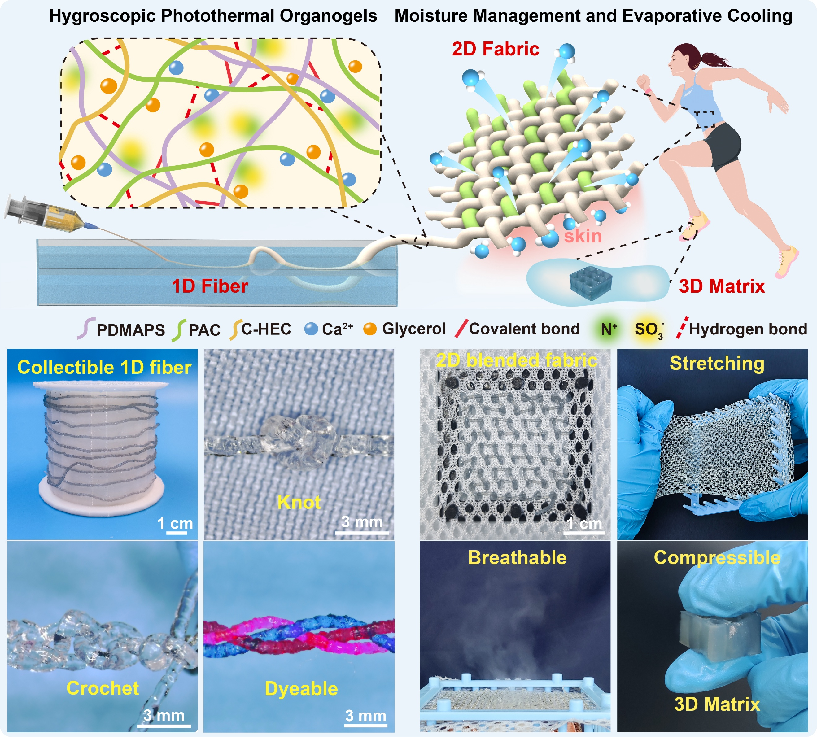
Fig. 1 Schematic illustration, digital photographs and self-contained properties of hygroscopic photothermal organogels based on 1D fabers, 2D blended fabrics and 3D matrices.
In this contribution, hygroscopic photothermal organogels were developed through synergistic engineering of all-organic hygroscopic components, cross-linking reactions and diverse processing techniques, delivering 1D to 3D structures (Fig. 1). Mild thermal treatment, ultraviolet (UV) curing and solvent exchange were employed to induce covalent bonding and electrostatic interactions among polycations, polyanions and zwitterionic polymers. This cross-linking strategy effectively stabilized the four hygroscopic organic components (polycations, polyanions, zwitterionic polymers and glycerol) during continuous wet-spinning and reinforced the 1D fibers under humid conditions. The organogel-based fibers successfully prevented the moisture-induced sorbent leaks, fiber solvation and structural deformation. Moreover, the knotting, crocheting and dyeing properties exhibited by these fibers are rare, particularly in the context of hygroscopic photothermal fibers to date. 2D blended fabrics were further developed by integrating the hygroscopicity and flexibility of organogels with the strength and wear resistance of polyester. These fabrics, designed with distinct weaving patterns, introducing two photothermal conversion and passive heating strategies to accelerate solar-powered water release. Comprehensive experiments evaluated the fabrics' moisture sorption/desorption, permeability, dehumidification, evaporative cooling and thermal sensation regulation. The optimized blended fabrics demonstrated reliable and reversible moisture sorption and release, enduring six sorption/desorption cycles per day while providing efficient evaporative cooling, thereby making them ideal for PTM clothing applications. Furthermore, we achieved rapid and precise fabrication of 3D matrices through direct-ink writing, further expanding the potential of the hygroscopic photothermal organogels for moisture, heat and apparent temperature regulation in customized PTM applications.
2. Results and discussion
2.1 Preparation and Characterization of 1D Hygroscopic Fibers
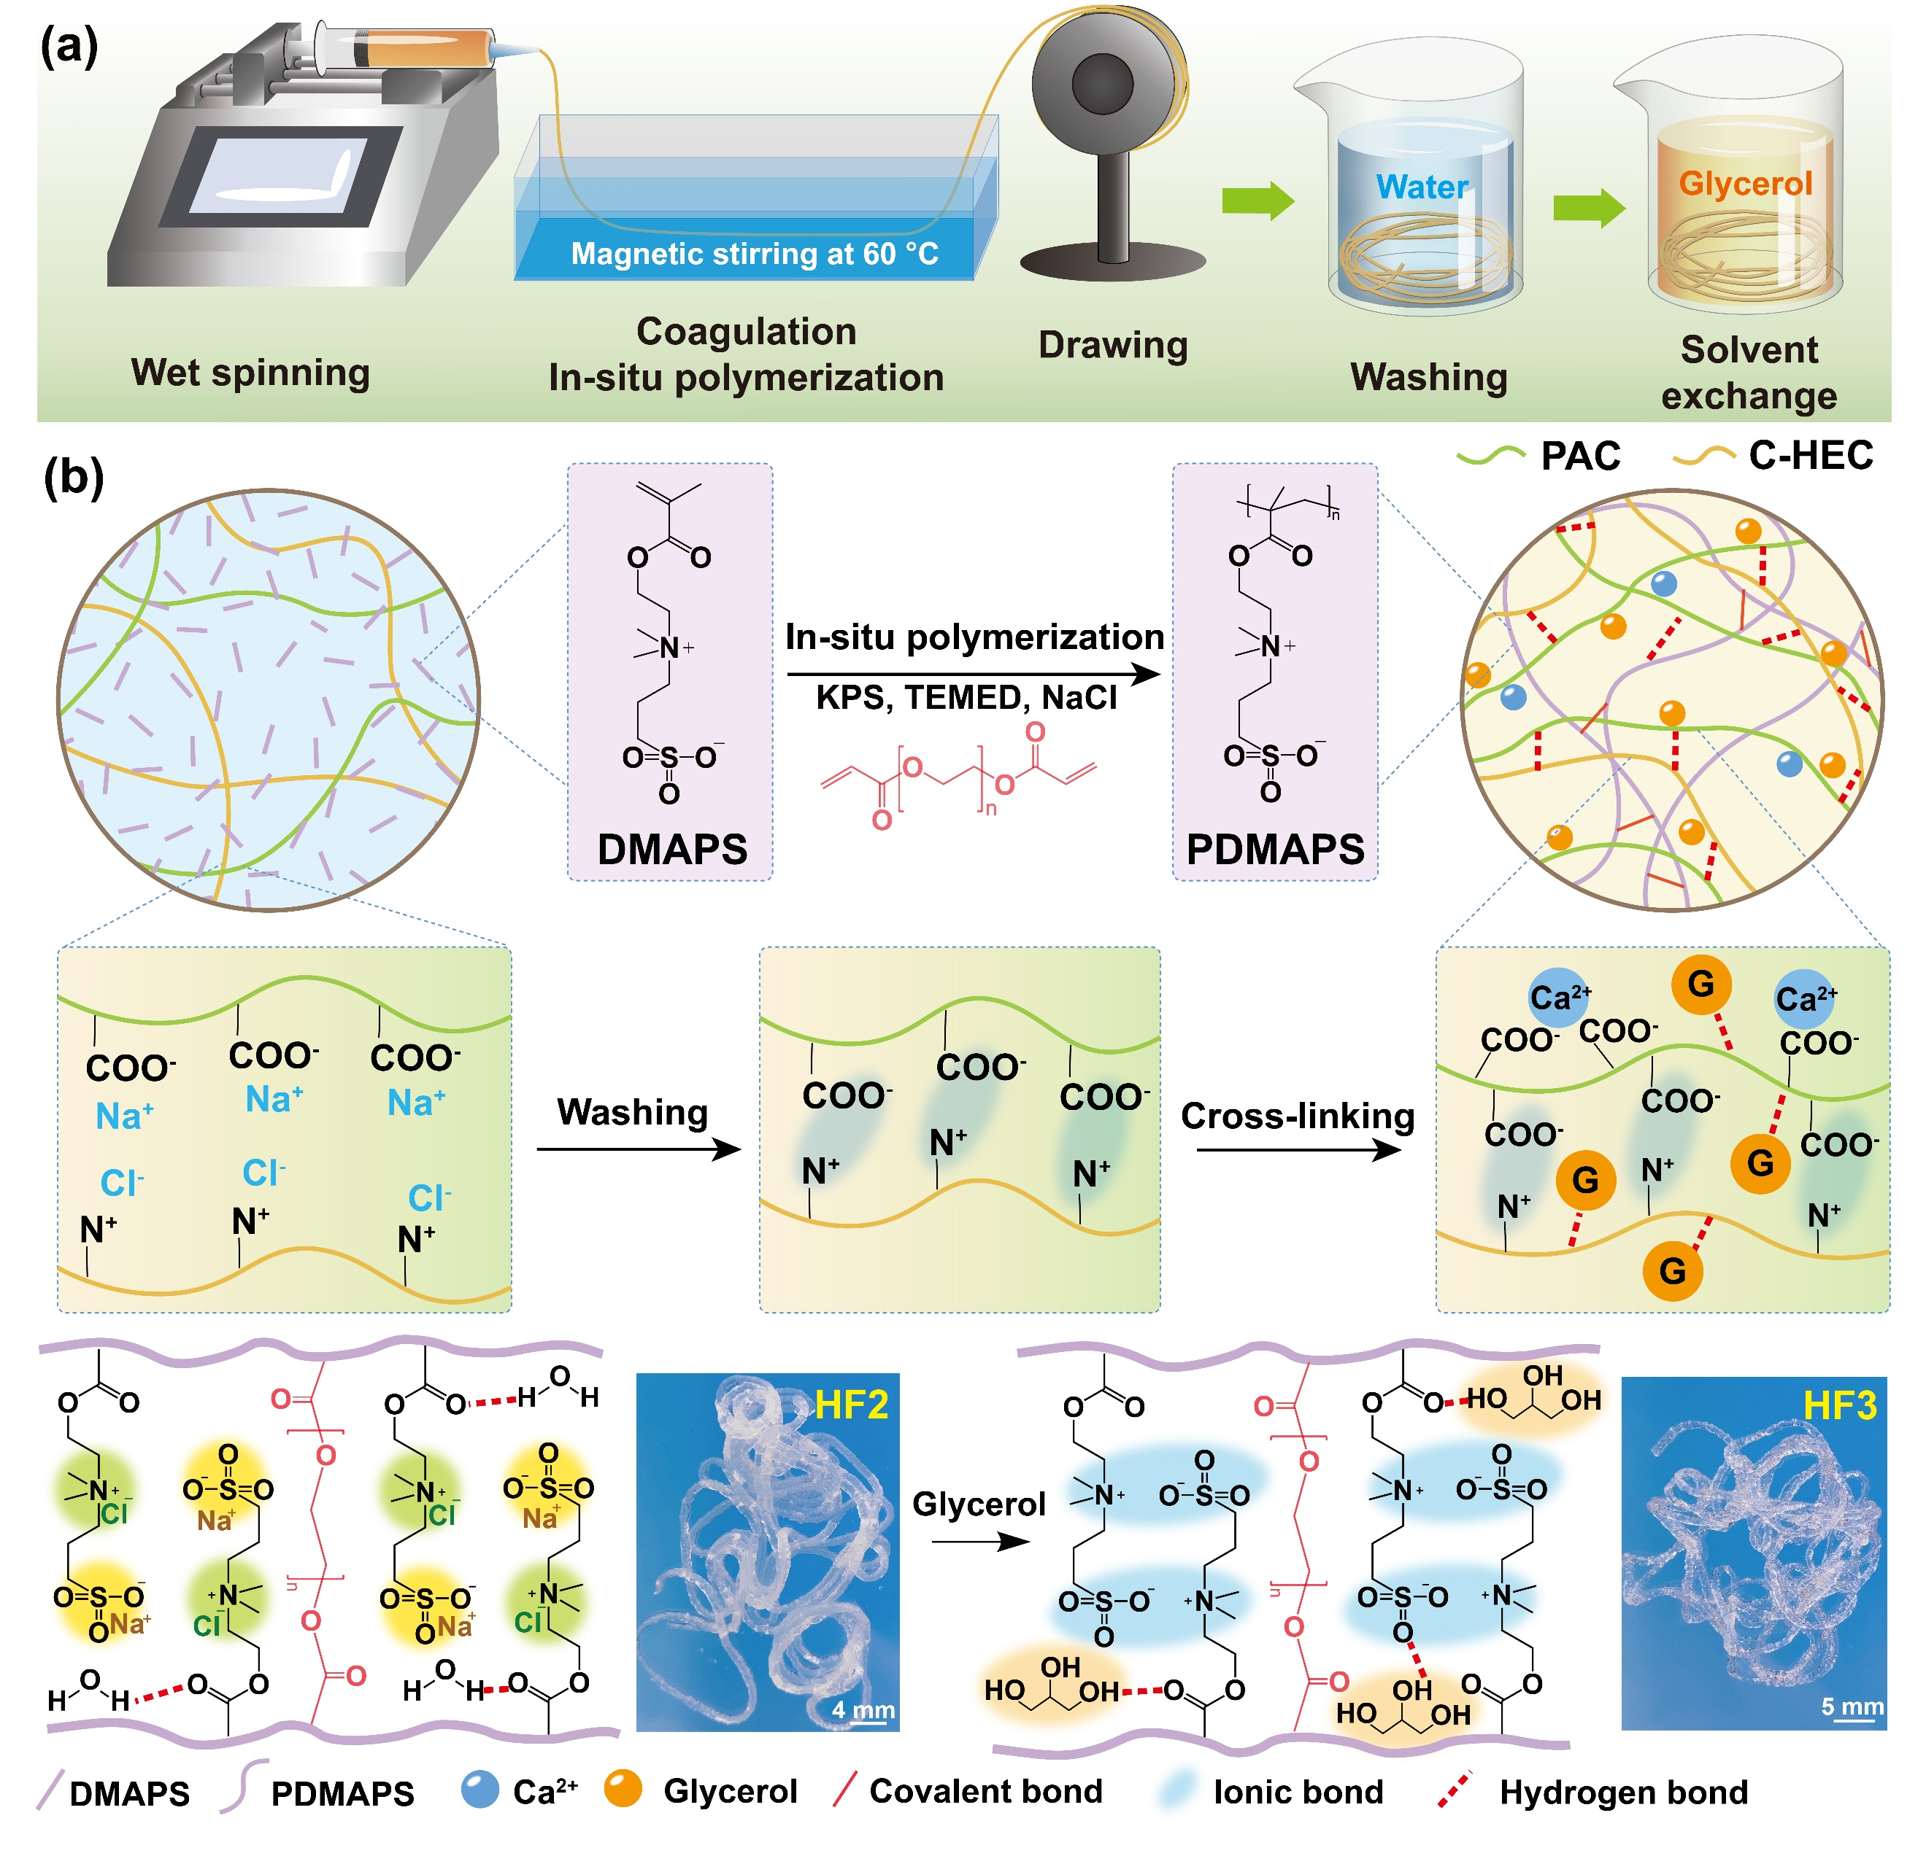
Fig. 2 (a) A flow chart for the preparation of hygroscopic fibers, and (b) synthetic routes, cross-linking reactions and digital photographs of hygroscopic fibers.
Hygroscopic 1D fibers were fabricated via a wet-spinning technique based on composite dopes (Fig. 2a and Fig. S1, ESI†). This process integrates extrusion, coagulation, drawing and washing, enabling continuous and scalable fiber production (Supporting Video S1). Chemical structures of the main material components and cross-linking reactions within both spinning dopes and hygroscopic fibers are drawn in Fig. 2b and Fig. S2, ESI†. The spinning dopes incorporated two hygroscopic polymers: polyanionic cellulose (PAC, 0 − 2.0 wt%) and cationic hydroxyethyl cellulose (C-HEC, 0 − 2.0 wt%). PAC is composed of β-1,4-linked D-glucose units, each containing three hydroxyl groups (−OH). Chemical modification introduces a high degree of sodium carboxymethyl substitution (DS = ∼1.4) onto the glucose backbone (−CH₂COO⁻Na⁺), imparting water solubility and enhanced hygroscopicity — properties uncommon in traditional cellulose-based materials. Neat PAC powder afforded moisture uptake of 0.92 g g⁻¹ after 48 h under 90% relative humidity (RH), representing one of the highest water absorption capacities among cellulose-based materials (i.e., cellulose nanofiber and cellulose nanocrystals) (Fig. S3a, ESI†). In addition, the aqueous PAC solutions showed tunable apparent viscosities ranging from 44.0 to 3.8×10⁴ cP, strongly correlated with the varying mass concentrations in water (1.0 − 8.0 wt%) (Fig. S4a, ESI†). The high viscosity of PAC was crucial in facilitating the extrusion and coagulation processes of the fibers. Consequently, PAC was incorporated as one of the hygroscopic components in the fibers.
C-HEC was employed as the secondary hygroscopic component, consisting of a cellulose backbone modified with quaternary ammonium salt groups. C-HEC is synthesized by reacting hydroxyethyl cellulose with trimethylammonium-substituted epoxide, yielding a high DS up to ∼0.44. The abundant quaternary ammonium groups endow C-HEC with inherent hygroscopic properties under humid conditions. Neat C-HEC powder afforded moisture uptake of 0.62 g g⁻¹ after 48 h under 90% RH (Fig. S3a, ESI†). Moreover, the apparent viscosities of C-HEC were highly tunable with concentration variations in water (1.0 − 8.0 wt%), ranging from 24.0 to 3.4×10⁴ cP (Fig. S4b, ESI†). Due to the absence of strong cross-linking networks, neither PAC nor C-HEC gels were able to form stable 1D fibers during coagulation, as the structure was solely based on polymer chain entanglement and hydrogen bonding.
To overcome this limitation, PAC and C-HEC were mixed to introduce additional electrostatic interaction between the polycations and polyanions, enhancing the processing and mechanical properties of the fibers. However, the strong electrostatic interaction resulted in spontaneous flocculation in the precursor solution when the oppositely charged polymers were mixed. To avoid the formation of white precipitates, sodium chloride (NaCl, ∼2.0 wt%) was incorporated as charge shielding agent, facilitating the complete dissolution of PAC and C-HEC in all spinning dopes. Apart from PAC and C-HEC, the spinning dopes were modified with a monomer [2-(methacryloyloxy)ethyl]dimethyl-(3-sulfopropyl)ammonium hydroxide, (DMAPS, 20.0 wt%), a co-initiator N,N,N′,N′-tetramethylethylenediamine (TEMED) and a crosslinker poly(ethylene glycol) diacrylate (PEGDA), enabling in-situ polymerization during coagulation. The DMAPS monomer, rich in sulfonate and quaternary ammonium groups, also exhibited high hygroscopicity. After polymerization, neat PDMAPS powder afforded moisture uptake of 0.57 g g⁻¹ after 48 h under 90% RH (Fig. S3b, ESI†).
The as-prepared spinning dopes were loaded in a syringe and continuously extruded into a warm coagulation bath (∼60 °C) at a controlled extrusion rate (40.0 µL min⁻¹). The bath contained calcium chloride (CaCl₂) as a cross-linking agent for PAC and potassium peroxydisulfate (KPS) as an initiator for in-situ polymerization. These reagents initiated multiple reactions within the as-extruded fibers upon contact with the bath. Poly[2-(methacryloyloxy)ethyl]dimethyl-(3-sulfopropyl)ammonium hydroxide (PDMAPS) was synthesized via heat-initiated free radical polymerization, forming poly(ionic liquid) as the third polymer networks within the fibers. Beyond covalent cross-linking by PEGDA, zwitterionic PDMAPS introduced additional electrostatic interactions throughout the fibers. Moreover, coordination bonds formed between carboxyl groups and Ca²⁺ enabled to cross-link some segments within the PAC backbones. A rotating drum with controlled speed ensured that the time from extrusion to fiber collection remained within 2 min, allowing for proper drawing the newly formed hydrogel fibers (denoted as HF1). Generally, stretching rearranges the polymer chains within the fiber, enhancing its mechanical strength.⁸⁰
After collection, HF1 was thoroughly rinsed with deionized (DI) water to remove unreacted reagents, salts and impurities. The remove of NaCl regenerated electrostatic interactions throughout PAC, C-HEC and PDMAPS, leading to the formation of ionically cross-linked networks within the hydrogel fibers (denoted as HF2). Subsequently, solvent exchange was performed to replace initial water with glycerol, yielding organogel-based fibers (denoted as HF3). In this process, the hydrogen bonds between the structural components (PAC, C-HE, and PDMAPS) and water were substituted by hydrogen bonds between the same components and glycerol. Glycerol’s hydroxyl groups (−OH) allow it to form hydrogen bonds with water, making it highly effective at absorbing moisture. It was measured that neat glycerol afforded moisture uptake of 1.95 g g⁻¹ after 48 h under 90% RH (Fig. S2a, ESI†). In this study, four organic components (PAC, C-HEC, PDMAPS and glycerol) with high hygroscopicity were incorporated into 1D fibers through a continuous wet-spinning process, eliminating the need for conventional hygroscopic salts. Importantly, the incorporation of biopolymers (PAC and C-HEC) and biocompatible materials (PDMAPS and glycerol) reduced environmental impact, making the organogel-based fibers suitable for clothing applications.
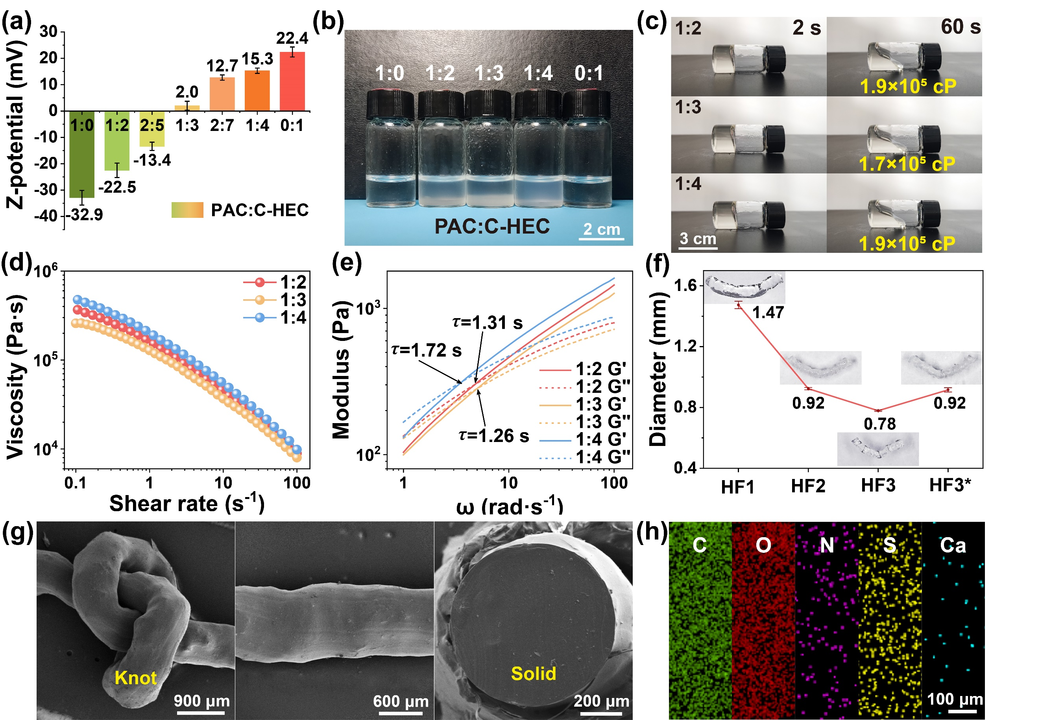
Fig. 3 (a) Zeta potentials, (b) digital photographs and (c) apparent viscosities of different PAC and C-HEC solutions. Rheological properties of different spinning dopes: (d) shear viscosities under shear rate sweep and (e) G′ and G″ under angular frequency sweep (τ: sol−gel relaxation time). (f) Changes of fiber diameters through post-treatment. Morphological characterization: (g) surface and cross-sectional SEM and (h) EDS mapping of HF3.
Compositions and concentrations of the spinning dopes were systematically modulated to optimize primary fiber characteristics such as strength, uniformity and texture. Seven solutions were prepared by varying mass ratios between PAC and C-HEC (PAC:C-HEC = 1:2, 2:5, 1:3, 2:7 and 1:4), with neat PAC and C-HEC solutions serving as control groups. To evaluate the electrostatic interactions between the PAC and C-HEC, no charge-shielding agent (NaCl) was incorporation and the spinning dopes were diluted 50-fold for Zeta potential measurements. The neat PAC solution exhibited a negative Zeta potential of −32.9 mV, while the neat C-HEC solution displayed an opposite Zeta potential of 22.4 mV (Fig. 3a). The mixture of PAC and C-HEC decreased the Zeta potentials in the solutions, indicating the backbones of PAC and C-HEC spontaneously interacted through electrostatic bonds. Notably, at a PAC:C-HEC mass ratio of 1:3, the Zeta potential was minimized to 2.0 mV, nearing the isoelectric point. This result indicates that the optimized PAC:C-HEC ratio maximized the electrostatic interactions between PAC and C-HEC.
Tensile tests were performed on both HF1 and HF2. The as-spun HF1 with different PAC:C-HEC mass ratios of 1:2, 1:3 and 1:4 showed comparable tensile strengths of ∼47.5 kPa (Fig. S5a, ESI†). Upon NaCl removal, both tensile strength and fracture strain increased across all samples (Fig. S5b, ESI†). Notably, HF2 with a PAC:C-HEC mass ratio of 1:3 attained the highest tensile strength of 108.4 kPa, due to the maximized electrostatic interactions within this fiber. The tensile stress−strain results are in good agreement with the Zeta potential measurements, indicating that the enhanced electrostatic interactions between PAC and C-HEC significantly contribute to the improved mechanical properties of these fibers.
Image sequence Fig. 3b illustrates that neat PAC and C-HEC were highly soluble in water, forming transparent gels. However, all mixed solutions exhibited spontaneous flocculation, due to the strong electrostatic interactions between the carboxylic groups of PAC and the tertiary amine groups of C-HEC. These interactions induced ionic cross-linking, which increased the molecular weights of the polymers while reducing their solubility, thereby leading to white precipitates in the mixed solutions. This flocculation behavior aligns with the Zeta potential measurements. Previous studies have evidenced similar phenomena, where the turbidity of mixed solutions reached its maximum when the measured Zeta potential approached zero. Under these conditions, the electrostatic interactions between positive and negative complexes were maximized, resulting to the extensive formation of aggregates.^{81,82} As a result, NaCl was introduced as a charge-shielding agent, effectively preventing flocculation in all composite dopes. For spinning dopes prepared with a PAC:C-HEC mass ratios of 1:3, the weight concentrations of NaCl varied from 0 to 4% (Fig. S6, ESI†). Compared to the pristine solution, the incorporation of NaCl significantly mitigated flocculation in the spinning dopes, with all precipitates being eliminated at a NaCl concentration of 2%.
Another challenge to address was the significant disparity in viscosity between PAC and C-HEC at equivalent concentrations. Specifically, the viscosities of the mixed solutions decreased progressively with increasing C-HEC content, assuming constant solute concentrations. To ensure consistent high viscosities, the total mass contents (7.2 − 8.0 wt%) of the spinning dopes (PAC:C-HEC = 1:2, 1:3, and 1:4) were carefully adjusted (Table S1, ESI†). As a result, the apparent viscosities of the spinning dopes remained controlled within a narrow range of 1.7 − 1.9×10⁵ cP (Fig. 3c).
Rheological properties of spinning dopes play an important role in the pultrusion process. The shear viscosity profiles of the spinning dopes as a function of shear rate are presented in Fig. 3d. All samples displayed pronounced shear-thinning behavior, with viscosities decreasing markedly from 3.7×10⁵ to 8.5×10³ Pa s as the shear rate increased from 0.1 to 100 s⁻¹. In the absence of shear stress, the spinning dopes exhibited solid-like characteristics, but transitioned significantly to fluid-like states under elevated shear stress. This transformative behavior facilitated their seamless extrusion through fine nozzles, enabling the production of continuous microfibers. Furthermore, the storage modulus (G′) and loss modulus (G″) as a function of angular frequency (ω) are plotted in Fig. 3e. All spinning dopes underwent rapid transitions from viscous fluids to solid-like gels within remarkably short timescales. The sol−gel relaxation times (τ), ranging from 1.26 to 1.72 s, were determined from the crossover points where G′ and G″ showed an identical value. These results highlight the suitability of the spinning dopes for continuous pultrusion and fiber fabrication.
The diameters of the as-spun HF1 were highly tunable (0.5−2.0 mm), depending on the nozzle diameters and the rotational speed of the collection frame. In principle, the fibers could be continuously spun to infinite lengths, provided an uninterrupted supply of dope. For reliable comparison, a fixed moderate rotation rate (30.0 mm s⁻¹) was applied to collect and stretch HF1. The water rising process reduced the average fiber diameter from 1.47 mm in HF1 to 0.92 mm in HF2 by removing excess NaCl, thereby facilitating ionic cross-linking within the polycations, polyanions and zwitterionic polymers of HF2 (Fig. 3f). HF2 retained 47.2% of the weight of HF1, following the removal of excess NaCl. The subsequent solvent exchange from water to glycerin further reduced the average fiber diameter to 0.78 mm in HF3. The reduction in diameter from HF2 to HF3 was limited to ∼15%. The weight ratio of HF3 decreased to 31.3% relative to HF1. During water vapor sorption, minimal weight increase (weight ratio: 46.8% relative to HF1) and swelling were observed in HF3, while well-defined fibers with an average diameter of 0.92 mm were presented in a water-saturated state. In addition, the average diameters of HF3 were adjustable between 0.23 and 0.89 mm by reducing the rotational speed of the collection frame from 36.0 to 28.5 cm min⁻¹, indicating the controlled fabrication of fibers through the wet-spinning approach (Fig. S7, ESI†).
Scanning electron microscope (SEM) images of the surface and fractured cross-sections reveal a defect-free, solid structure within HF3. This compact fiber demonstrates robustness and flexibility, enabling easy knotting (Fig. 3g). Energy dispersive X-ray spectroscopy (EDS) reveals a homogeneous distribution of C, O, N, Ca and S on the surface of HF3 (Fig. 3h). In addition, the cross-sectional EDS images depicts that these elements were uniformly distributed throughout HF3 (Fig. S8, ESI†). Specifically, the consistent distribution of S and Ca both on the surface and within the interior of HF3 demonstrates that the in-situ polymerization and ionic cross-linking reactions occurred uniformly during the fiber coagulation. In addition, chemical compositions within HF3 were analyzed using Fourier transform infrared (FTIR) spectroscopy (Fig. S9, ESI†), exhibiting characteristic transmittance peaks of the PDMAPS, PAC and C-HEC components in HF3. Specifically, the peaks at 1169 and 1032 cm⁻¹ corresponded to the symmetric and asymmetric vibrations of S=O in PDMAPS, respectively. The peaks at 1414 and 1323 cm⁻¹ corresponded to the stretching vibrations of −OH and C−O−C in PAC, respectively. The broad peak at 3347 cm⁻¹ corresponded to the stretching vibrations of −OH in C-HEC. The morphological and compositional results reveal the well-integrated structural components, uniformly distributed cross-linking points, and the high-quality composition within HF3.
2.2 Water Vapor Sorption Characterization
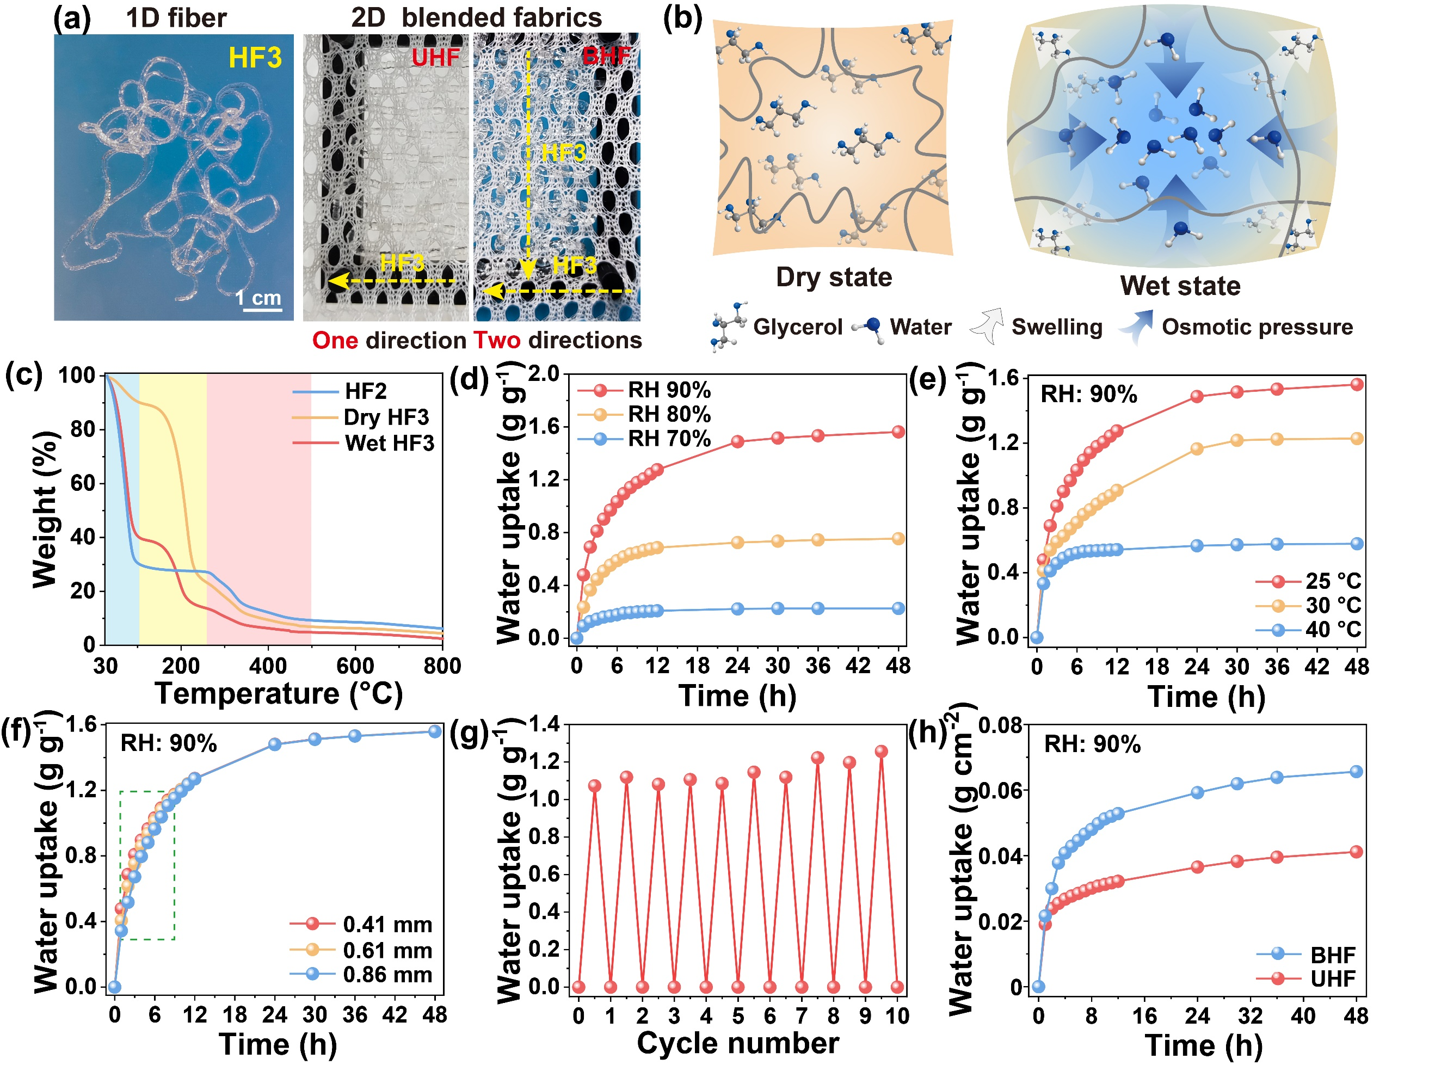
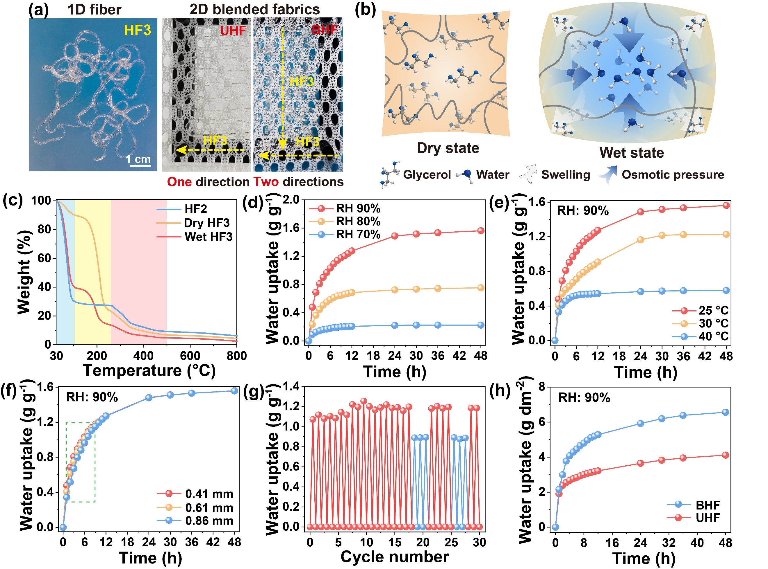
Fig. 4 (a) Digital photographs of 1D fiber (HF3) and 2D blended fabrics (UHF and BHF). (b) Schematic illustration of water vapor sorption of HF3. (c) TGA characterization of HF2 and HF3. Water vapor sorption characterization of HF3 under varying (d) ambient RHs, (e) ambient temperatures and (f) fiber dimensions. (g) Water uptake and release characterization in 30 moisture sorption−desorption cycles. (h) Water vapor sorption characterization of blended fabrics.
The superior mechanical properties of HF3 not only facilitated its processability but also enhanced its weaving characteristics, making HF3 suitable for textile applications. In general, 2D blended fabrics are extensively used in the textile industry and are more prevalent in everyday clothing than single-fiber textiles. These fabrics are produced by combining two or more fiber types, allowing for the customization of textiles to achieve specific performance and comfort characteristics. In this study, HF3-polyester fiber blends were fabricated using a lap loom (Fig. 4a). This process leveraged the hygroscopicity and flexibility of HF3 in conjunction with the strength and wear resistance of polyester. The polyester-base textile was employed as the anchoring structure for weaving, while HF3 was interwoven with alternating polyester threads using a tapestry needle. Both unidirectional and bidirectional HF3 configurations were integrated into the polyester fabric, resulting in two types of blended fabrics, designated as HF3-UHF and HF3-BHF, respectively. HF3-UHF contained hygroscopic fibers (HF3) with a density of 2.6 g dm⁻², while HF3-BHF featured a higher HF3 density of 4.4 g dm⁻². The water vapor sorption of HF3, UHF and BHF was systematically characterized.
Hygroscopic hydrogels and organogels made from organic materials exhibited diverse mechanisms for harvesting water vapor.⁵³ These mechanisms primarily included surface adsorption (chemisorption and physisorption), and liquid diffusion (absorption) (Fig. 4b). Particularly, the cross-linked polymers (PAC, C-HEC and PDMAPS) exhibited water-insolubility, indicting enhanced durability in aqueous environments. The hygroscopic components (PAC, C-HEC, PDMAPS and glycerol) introduced abundant hydrophilic groups (i.e., −OH, −COO⁻Na⁺, −SO₃⁻ and −N⁺) into the fibers, enabling the formation of hydrogen bonds and van der Waals force with water molecules.⁸³ Adsorbed water molecules organized into ordered configurations with dipole moments on the HF3 surfaces, promoting multilayer adsorption of surrounding water molecules. The high density of hydrophilic groups and the extensive surface area of the 2D blended fabrics significantly enhanced the moisture sorption capacity. Osmotic pressure facilitated water penetration into the 1D fiber interior, while glycerol further supported water retention and diffusion. During this process, HF3 underwent water-induced plasticization and swelling, ensuring sustained water storage and preventing glycerol leakage.
Thermogravimetric analysis (TGA) was performed to determine the composition ratios of 1D fibers. The TGA profiles exhibit three distinct phases of mass loss: dehydration (30−120 °C), glycerol decomposition (120−260 °C) and polymer decomposition (260−500 °C) (Fig. 4c). HF2 comprised ∼72.3% of water and ∼27.7% of polymers (Fig. S10, ESI†). Following solvent exchange and dehydration, dry HF3 exhibited a significantly reduced water content (∼10.9%) and a predominant glycerol fraction (∼63.8%). Upon water vapor sorption, water-saturated HF3 demonstrated a significant increase in water content to ∼61.4%, highlighting its efficient water vapor uptake capacity. In addition, the water contact angle on the surface of HF2 and HF3 reached zero within 1 s, indicating the efficient water retention capability of the fiber (Fig. S11, ESI†). Furthermore, longitudinal water diffusion in dehydrated HF3 was characterized. The image sequence depicts that the dyed water permeated the entire length of HF3 (length: ∼10 cm) within 5 min, indicating the rapid water diffusion within this fiber (Fig. S12, ESI†).
Indoor water vapor sorption of HF3 was evaluated across varying RH levels and ambient temperatures. To ensure consistency, 1.0 g of dry HF3 was used in all measurements. Water uptake kinetics of HF3 were characterized at 25 °C within an RH range of 70% to 90% (Fig. 4d). HF3 exhibited rapid initial water uptake in the first 12 h, reaching relatively steady states in 24 h. After 24 h, equilibrated water uptake of 0.22 and 0.73 g g⁻¹ were achieved at 70% and 80% RH. Under 90% RH, a higher equilibrated water uptake of 1.56 g g⁻¹ was attained after 48 h. In addition, the water vapor sorption of HF3 with varying proportions of PAC and C-HEC (1:2, 1:3 and 1:4) was measured. All three fibers exhibited comparable equilibrated water uptake after 48 h under 90% RH (Fig. S13, ESI†). Given that both PAC and HEC are inherently hygroscopic polymers, variations in their respective ratios within HF3 had a negligible impact on moisture sorption.
Elevated ambient temperatures from 25 to 40 °C gradually reduced water uptake of HF3, since increased water evaporation counteracted water vapor sorption (Fig. 4e). Encouragingly, a moderate equilibrated water uptake of 0.57 g g⁻¹ was obtained at 40 °C after 24 h under 90% RH. Moreover, water vapor sorption isotherms of HF3 were measured at varying RHs (50−90%) and constant temperature conditions (25 °C) (Fig. S14, ESI†). As RH increased from 50% to 90%, the equilibrium water content of HF3 progressively rose, due to the higher availability of water molecules for sorption. In addition, the water vapor sorption of HF3 with varying diameters (0.86, 0.61 and 0.41 mm) was characterized (Fig. S15, ESI†). Reducing the diameters of HF3 enhanced the initial water uptake kinetics in the first 12 h, as smaller diameters of HF3 provided a larger surface area per unit mass (Fig. 4f). At 90% RH, the equilibrated water uptake gradually reached 1.56 g g⁻¹ over 48 h, given the consistent weight of all samples. For comparison, water vapor sorption of pre-dried HF2 was evaluated following the same protocol. A moderate equilibrated water uptake of 0.5 g g⁻¹ was recorded after 48 h under 90% RH (Fig. S16, ESI†). The result discloses that the fabrication of organogel-based fibers via solvent exchange from water to glycerin significantly enhanced water vapor sorption compared to hydrogel-based fibers.
A cyclic moisture sorption−desorption experiment was performed to evaluate the stability of HF3 (Fig. 4g). Under 90% RH, HF3 exhibited a water content of 1.09 g g⁻¹ in the first 12 h. Subsequent water desorption occurred in a hot-air oven at ∼40 °C, resulting in a minimized water content of 0.01 g g⁻¹ after 3 h. Sorption durations were set at 6 h (blue curve) and 12 h (red curve), while corresponding desorption durations were assigned as 3 h (blue curve) and 6 h (red curve). This experimental design aims to evaluate HF3’s response during moisture uptake and release under varying time scales. Throughout 30 sorption−desorption cycles, no significant degradation in water sorption/release capacity was observed. HF3 retained average water contents of 0.88 and 1.19 g g⁻¹ for 6 and 12 h sorption durations, respectively. No sorbent leakage or structural collapse was presented over these cycles, underscoring one of the main advantages of the all-polymer hygroscopic composites. These results demonstrate the reliable performance, rapid response and durability of HF3 during cyclic moisture sorption and desorption.
The water uptake kinetics of two blended fabrics (HF3-UHF and HF3-BHF) were characterized at 25 °C and 90% RH (Fig. 4h). Both UHF and BHF showed a gradual increase in water content over time. HF3-UHF afforded a water uptake of 4.11 g dm⁻² after 48 h. Notably, HF3-BHF attained a higher water uptake of 6.56 g dm⁻² after 48 h, due to its increased HF3 content. The result highlights the efficient water vapor sorption of blended fabrics due to the incorporation of hygroscopic fibers. Moisture regain (MR) is a critical parameter in the textile industry, representing the amount of moisture a textile material can absorb under standardized conditions (65% RH and 20 °C), which can be expressed using equation 1,⁷¹
(1)
where m (g) is the weight of the hydrated fabric after 24 h and m₀ (g) is the weight of the dry fabric. Dehydrated HF3-BHF afforded equilibrated water uptake of 0.23 g g⁻¹ under 65% RH after 24 h. The MR value of HF3-BHF was measured at 23.0% (Fig. S17, ESI†). To enable a comparative analysis with commercially available textiles, this study compiles MR values for a range of fibers commonly used in technical textiles (Table S2, ESI†). The result reveals that the MR value of HF3-BHF outperforms the vast majority of commercially available textile materials.
2.3 Water Desorption via Passive Heating Mechanisms
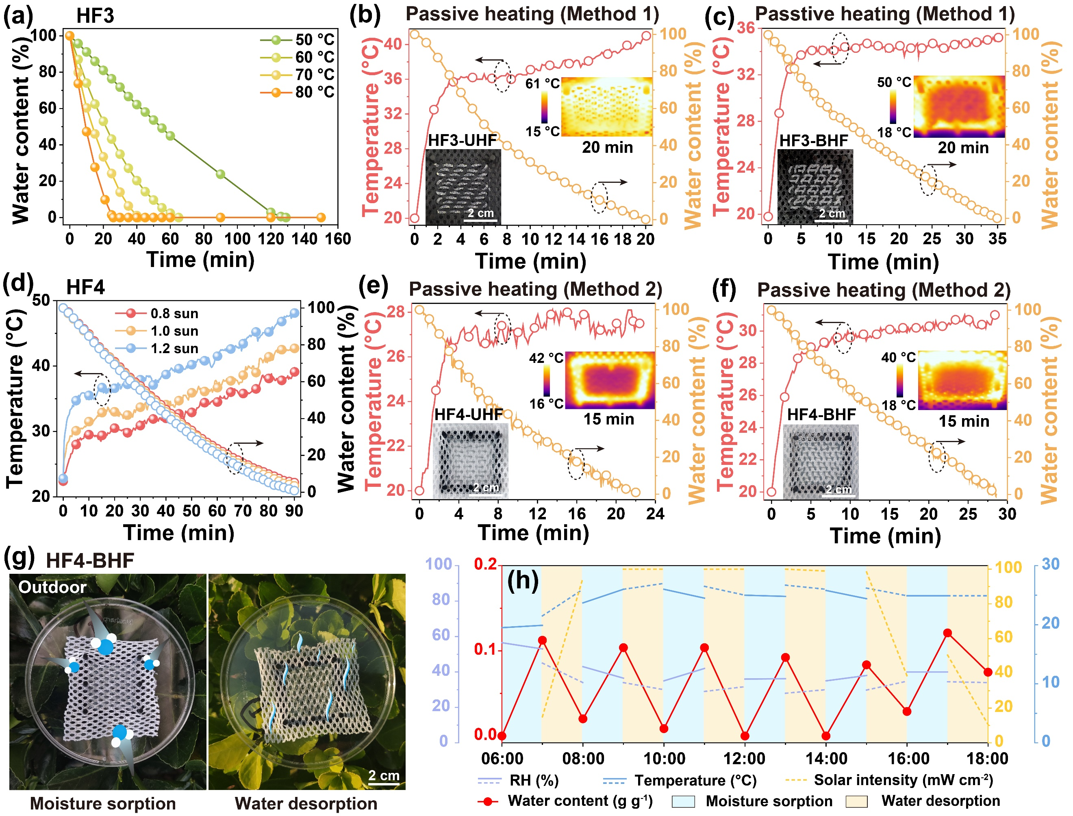
Fig. 5 (a) Water desorption characterization of HF3 at varying temperatures. Water desorption characterization of HF3-based blended fabrics under 1 sun: (b) HF3-UHF and (c) HF3-BHF. (d) Water desorption characterization of HF4 under 1 sun. Water desorption characterization of HF4-based blended fabrics under 1 sun: (e) HF4-UHF and (f) HF4-BHF. (g) Sequence photography of HF4-BHF in a moisture sorption−desorption cycle, and (h) plot of water uptake, solar intensity, ambient temperature and RH versus time in outdoor measurements.
Indoor water desorption of 1D fibers and 2D fabrics was facilitated through solar irradiance and hot-air drying apparatus. The mass losses and surface temperatures of all samples over time were quantified. Water desorption kinetics of fibers or fabrics can be expressed using equation 2,⁵⁶
(2)
where R_{d} (h⁻¹) is the water desorption rate, m_{s} (g) represents the weight of the water-saturated sample, m (g) denotes the weight of the sample at time t (h) and m₀ (g) is the weight of the dehydrated sample. Without incorporating any photothermal components, the temperature-driven water release of water-saturated HF3 (∼99% water content) was preliminarily characterized across a broad temperature range of 50 − 80 °C (Fig. 5a). The initial water content of all HF3 samples was standardized to be 1.5 g g⁻¹ (∼99% water content) to ensure consistency in comparative analysis. At 50 °C, near 100% of absorbed water was discharged from HF3 in 129 min, affording a high R_{d} of 0.74 h⁻¹. Elevated temperatures significantly improved both the capacity and kinetics of water release. The time threshold decreased to 65 and 41 min at 60 and 70 °C, respectively. Wet HF3 required only 26 min to release nearly all absorbed water at 80 °C, further increasing R_{d} to 3.63 h⁻¹. The result highlights the feasibility of efficiently releasing water from wet fibers via mild heating processes. Nevertheless, the water release from HF3 exhibited a limited rate under sunlight exposure, due to the absence of any photothermal component.
In 2D blended fabrics, both unidirectional and bidirectional HF3 configurations were incorporated into black polyester fabrics. The black fabrics enhanced the photothermal effect within HF3-UHF and HF3-BHF by increasing visible light absorption, facilitating a “passive” heating mechanism for water desorption from wet fabrics (denoted as Method 1). Under 1 sun, near 100% of absorbed water was expelled from HF3-UHF in 20 min, resulting in a high R_{d} of 4.29 h⁻¹ (Fig. 5b). Notably, its surface temperature steadily increased to over 43 °C. On the other hand, wet HF3-BHF required 35 min to release nearly all absorbed water under 1 sun, yielding a reduced R_{d} of 2.66 h⁻¹, while maintaining a moderate surface temperature of ∼34 °C for over 25 min (Fig. 5c). High R_{d} of HF3-UHF mainly stemmed from the low friction of the hygroscopic fibers within the fabric. Despite high R_{d}, the surface temperature of HF3-UHF rapidly exceeded the upper limit of core body temperature (40 °C), posing a major risk of heat exhaustion and heatstroke. These results demonstrate that the solar-powered water release of hygroscopic fibers can be enhanced by blending them with photothermal fibers via a passive heating method, and the water release rate and surface temperature can be modulated by altering the fabric’s weaving patterns.
HF3-based blended fabrics effectively harnessed visible sunlight, converting it into thermal energy for passive heating. To convert the largely underutilized near-infrared (NIR) spectrum of sunlight, this study introduced additional photothermal components and proposed an alternative passive heating strategy. In this regard, a small amount of antimony-doped tin oxide (ATO, 0.5 wt%) was incorporated into HF3, leading to photothermal hygroscopic fibers (denoted as HF4). ATO nanoparticles feature high transmittance across the visible spectrum and high absorptance in the near-infrared range, driven by their intrinsic localized surface plasmon resonance (LSPR).⁸⁴ Owing to their spectrum-selective properties, ATO-based composites have been widely employed as light-absorbing components in photothermal membranes and as thermal-insulating materials in energy-efficient windows.⁸⁵ The absorptance spectrum of HF4 was measured via UV−Vis−NIR spectroscopy (Fig. S18, ESI†). HF4 exhibited effective absorptance of 59.3% in the visible range (400 − 780 nm), contributing to its near-white appearance due to high visible transmission. Its absorptance increased significantly in the near-infrared range (780 − 2500 nm), reaching a high value of 87.1%. Furthermore, SEM images reveal that HF4 retained the defect-free, solid structure observed in HF3, with a comparable fiber diameter (Fig. S19, ESI†). EDS mapping depicts a uniform elemental distribution of Sn and Sb within HF4, confirming the homogeneous incorporation of ATO throughout this fiber (Fig. S20, ESI†). Notably, HF4 nearly retained the moisture sorption of HF3, exhibiting an equilibrated water uptake of 1.40 g g⁻¹ after 48 h under 90% RH (Fig. S21, ESI†). Unlike the passive heating observed in HF3-based fabrics, the introduction of ATO into HF4 induced another passive heating strategy (denoted as Method 2) within the both 1D fibers and 2D blended fabrics for solar-powered water desorption. Understanding the cost-effectiveness of hygroscopic fibers is essential for evaluating their practical feasibility in the textile industry. The production cost of HF4 was estimated based on its chemical consumption, as detailed in Table S3, ESI†. The result indicates the fiber's potential as a cost-efficient fiber component for blended textiles, with the possibility of cost reduction through large-scale production.
Solar-powered dehydration of HF4 was conducted under varying solar intensities across 0.8, 1.0 and 1.2 sun (Fig. 5d). A progressive increase in the surface temperature of HF4 was observed duo to photothermal heating. Under moderate sunlight (0.8 sun), over 95% of the adsorbed water was released from HF4 within 90 min, exhibiting a R_{d} of 0.88 h⁻¹. The desorption rate gradually accelerated with increased solar intensity. Under 1.2 sun , nearly complete desorption was achieved within 90 min, yielding a higher R_{d} of 0.99 h⁻¹. The result highlights the great potential of HF4 for active photothermal heating and facile regeneration using low-grade natural sunlight.
Building on HF3-based blended fabrics, two types of HF4-configured blended fabrics were developed in undyed, pristine polyester, incorporating unidirectional and bidirectional designs. The photothermal conversion, passive heating and solar-driven water release were systematically investigated. Under 1 sun, near 100% of absorbed water was expelled from HF4-UHF within 22 min, achieving a high R_{d} of 4.00 h⁻¹ (Fig. 5e). Wet HF4-BHF took 28 min to release nearly all absorbed water, resulting in a lower R_{d} of 2.46 h⁻¹ (Fig. 5f). Higher R_{d} of HF4-UHF is attributed to the reduced friction of hygroscopic fibers in this fabric, compared to BHF. Although R_{d} of HF4-based blended fabrics were lower than those of HF3-based blended fabrics, the surface temperatures of HF4-UHF and HF4-BHF remained ∼27 and ∼31 °C, respectively, throughout the water adsorption process — well below the critical body temperature limit (∼40 °C) — thus mitigating the risk of heat exhaustion and heatstroke. These results demonstrate that water release in hygroscopic fibers and fabrics can be effectively driven by direct integration of photothermal components and passive heating, while the release rates and surface temperatures were influenced by the fabric’s weaving patterns. Owing to its rapid water release and moderate surface temperature, HF4-BHF was selected to characterize the water vapor sorption−desorption under outdoor conditions, and its impact on humidity management and heat stress dissipation.
Outdoor experiments were performed to investigate the atmospheric water sorption and solar-powered water desorption of HF4-BHF. A piece of pre-dried BHF (6.25 cm²) was placed under shade (solar intensity: ∼0.09 mW cm⁻²) for water vapor sorption, while it was placed under direct sunlight (solar intensity: ∼100 mW cm⁻²) for water desorption (Fig. 5g). Each cycle was adjusted to have 1 h for moisture sorption and 1 h for desorption. The changes of water contents, RH, ambient temperatures and solar intensity in the daytime are summered in Fig. 5h. The water content of BHF increased to 0.11 g g⁻¹ after 1 h. Subsequently, wet BHF was exposed to direct sunlight. Over 82% of absorbed water was removed in 1 h, indicating its efficient outdoor drying. Taking the benefits of the rapid moisture sorption and solar-powered water desorption, nearly six moisture sorption−desorption cycles were achieved in the daytime (6:00 to 18:00), yielding average water uptake of ∼0.11 g g⁻¹ after 1 h of moisture sorption followed by near-complete drying within 1 h of dehydration. The rapid sequence of moisture sorption and desorption offers a ratcheting strategy for accelerate water uptake and release within the textile, enhancing its potential for evaporative cooling applications.^{71,86} The outdoor experiments underscore the high efficiency of HF4-based BHF in moisture management under a real sky.
2.4 Evaporative Cooling Characterization
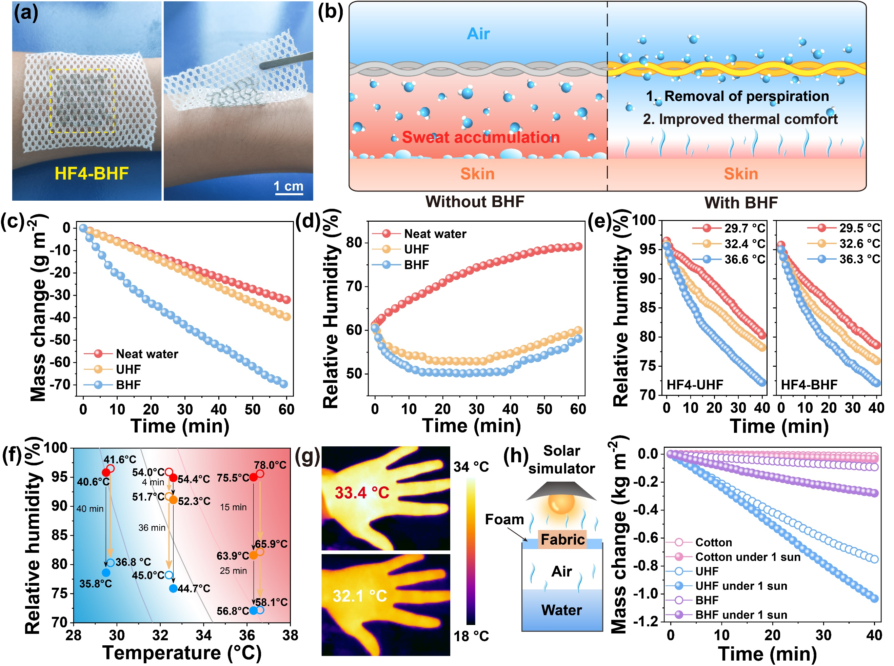
Fig. 6 (a) Digital photographs of HF4-BHF applied to skin and (b) schematic illustration of the the evaporative cooling mechanism and its role in thermal management. (c) Mass changes of water and (d) RH changes of the surrounding air during fabric-driven dehumidification. (e) Characterization of fabric-driven dehumidification at varying temperatures and (f) corresponding changes of the heat index chart. (g) IR images of the hand before (top) and after (botton) exposure to a BHF-contained chamber. (h) Characterization of water vapor release through different 2D fabrics.
The development of photothermal hygroscopic fabrics offers distinct advantages for PTM applications when applied to human skin (Fig. 6a). The evaporative cooling mechanism and the benefits of HF4-BHF are illustrated in Fig. 6b. This fabric plays a role in regulating thermal comfort by sorption-based moisture removal, reducing humidity within the microenvironment between the skin and the textile, thereby lowering resistance to sweat evaporation. Consequently, it effectively mitigates the heat index and improves thermal comfort. Notably, evaporative cooling textiles provide the added benefit of not requiring direct contact with moist skin to optimize PTM functionality, thus avoiding both the thermal and tactile discomfort typically associated with wet fabrics in contact with the skin. Water release and dehydration can be driven by photothermal conversion and passive heating under natural sunlight. Additionally, the rapid cycle of moisture absorption and desorption during the daytime boosts the evaporative cooling effect, making it highly applicable in real-world scenarios.
The effects of HF4-UHF and HF4-BHF on evaporation cooling and heat stress dissipation were studied. A Petri dish (diameter: 6.5 cm) of water was placed into an anti-draft weighing chamber (25×20×20 cm³) of a high-precision balance. Initial RH was set at 60% to ensure reliable comparison. Simultaneous water evaporation simulated the RH changes of the surrounding air through sweating within the microenvironment between the skin and the textile, mimicking sweat-induced humidity fluctuations. Water mass loss and RH variations in the sealed environment were continuously monitored using an analytical balance and a digital hygrometer. For neat water, natural evaporation resulted in a gradual water loss over 60 min, with an average evaporation rate of 32.0 g m⁻² h⁻¹ (Fig. 6c). Simultaneously, RH in the weighing chamber increased progressively from 61.2% to 79.2% during this period (Fig. 6d). To assess RH management, pre-dried fabric samples (sizes: 6.25 cm²) were placed on the chamber’s walls. The fabric rapidly adsorbed moisture and reduced RH. The decrease in water vapor pressure spontaneously accelerated water evaporation. As RH approached its minimum, further increases in water vapor content gradually raised RH again. Notably, the BHF structure demonstrated a higher water sorption capacity than UHF, leading to a more rapid RH decrease and a prolonged period of low RH. The average water evaporation rates were 39.6 and 69.9 g m⁻² h⁻¹ for HF4-UHF and HF4-BHF, respectively, representing 1.2 and 2.2 times the rate of natural evaporation from neat water. After 1 h, final RH (60.0%) in the chamber controlled by HF4-UHF was comparable to initial RH, while HF4-BHF achieved an even lower RH (58.1%). This result highlights the significant potential of HF4-based fabrics for promoting perspiration in enclosed environments.
A dehumidification experiment was conducted to evaluate the RH management of HF4-based blended fabrics. Pre-dried HF4-UHF and HF4-BHF samples (size: 12.5 cm²) were placed in a sealed, transparent chamber (10×10×10 cm³). The chamber was initially set at ∼96% RH to ensure reliable comparison for all measurements. For each sample, the RH variations were monitored at typical skin temperatures (29 − 37°C) and plotted over time. For pre-dried HF4-UHF at 29.7 ℃, RH gradually decreased from 96.5% to 80.3% after 40 min (Fig. 6e). As the air temperature increased, the same initial RH led to higher absolute humidity, enabling the fabric to absorb more water vapor. At 32.4 and 36.6 ℃, decreased RH values of 78.2% and 72.2% were recorded after 40 min, respectively. A similar decreasing trend was observed with HF4-BHF under identical conditions, where its superior moisture sorption capability resulted in slightly lower RH at each temperature. The result discloses that the high hygroscopic efficiency of HF4-based fabrics in reducing RH across a wide range of body temperatures.
The heat index (apparent temperature) is generally used to estimate the human-perceived equivalent temperature, accounting for the combined effects of air temperatures, RH and other environmental factors over time (Section S20, ESI†). At different air temperatures (∼29, ∼32 and ∼36 °C), the variations in heat indices generated by HF4-UHF and HF4-BHF were derived from Fig. 6e and are summarized in Fig. 6f. The variations in the heat indices over time are presented in Fig. S22, ESI†. A high RH (∼96%) coupled with high ambient temperatures (∼32 and ∼36 °C) results in extreme heat indices of 54.4 and 75.5 °C, presenting severe risks of heat-related illnesses. Associated with the substantial reduction in RH, the use of dehydrated HF4-based fabrics significantly reduced heat indices within 40 min. Specifically, the downward yellow and black arrows represent the reduction in heat indices driven by these fabrics, respectively. Notably, the heat indices were reduced by ∼4.8 °C when dry HF4-based blended fabrics were used at ∼29 °C. More significant decreases (∼9.3 and ∼19.3 °C) were recorded at higher temperatures of ∼32 °C and ∼36 °C. The presence of airflow over the fabrics and sweaty skin could further reduce the heat indexes.
Practical sweating experiments were performed to display heat stress dissipation using these fabrics. Hands were exposed to chambers with and without HF4-BHF to simulate sweaty conditions. Two palms showed comparable temperatures at the beginning. As initial RH was ∼96% in the empty chamber, the sweat evaporation was inhibited and the skin temperature was as high as 33.4 °C (Fig. 6g). On the other hand, the BHF-contained chamber with reduced RH below 80% facilitated sweat evaporation, lowering the skin temperature to 32.1 °C. These results demonstrate that the HF4-based blended fabrics can alleviate discomforts caused by high RHs and temperatures, and potentially reduce energy consumption compared to typical electricity-powered humidity management, such as air conditioners and dehumidifiers.
Water vapor transmission experiments were performed to evaluate the water vapor release through HF4-based blended fabrics. Cotton is one of the most breathable fabrics and its open weave allows air to circulate through the fabrics, exhibiting excellent moisture-wicking and quick-drying properties to evaporate moisture away from the skin. Consequently, a commercial cotton fabric was measured for comparison. The moisture permeability of fabrics was evaluated by measuring the vapor transmission (WVT) rate, which was expressed by using equation 3,^{87,88}
(3)
where WVT was moisture transmission rate (kg m⁻² day⁻¹), ∆m was the mass difference between the initial and final fabric, S was effective area of the fabric and t was the test time. The cotton fabric afforded a WVT rate of 0.58 kg m⁻² day⁻¹. Owing to the higher porosity induced by the weaving patterns, HF4-UHF and HF4-BHF exhibited increased WVT rates of 27.0 and 3.3 kg m⁻² day⁻¹, respectively.
Furthermore, each fabric (size: 6.25 cm²) was placed over a beaker containing 60 mL of water and the mass change of water was recorded via a high-precision balance. The continuous water evaporation caused the weight loss of water in the beaker. Without light irradiation, a water evaporation rate of 24.2 g m⁻² h⁻¹ was obtained from cotton fabric (Fig. 6h). For HF4-based blended fabrics, dark evaporation from the hydrated fibers allowed more water to dissipate into the atmosphere, leading to increased water evaporation rates of 1127.0 and 137.8 g m⁻² h⁻¹ for HF4-UHF and HF4-BHF, respectively. On the other hand, cotton fabric and HF4-based fabrics were warmed under 1 sun. The mass loss of water under the cotton fabric increased to 52.8 g m⁻² h⁻¹. Significantly enhanced water evaporation rates were generated by HF4-UHF and HF4-BHF, achieving 1549.4 and 418.8 g m⁻² h⁻¹, respectively. In this case, the hygroscopic fibers within HF4-UHF and HF4-BHF captured water vapor and reduced RH beneath the fabrics, promoting the water evaporation of bulk water. Meanwhile, adsorbed water within fabrics was rapidly warmed through passive heating and vaporized by the sunlight. In contrast, no water vapor can escape from the polyolefin film, resulting in negligible water weight losses in both light and dark conditions (Fig. S23, ESI†). The result reveals that the moisture-wicking property of these fabrics through moisture sorption and photothermal heating, exhibiting the potential to transport a larger amount of sweat to the outer layer of clothes.
2.5 3D Printing and Characterization of Hygroscopic Photothermal Matrices
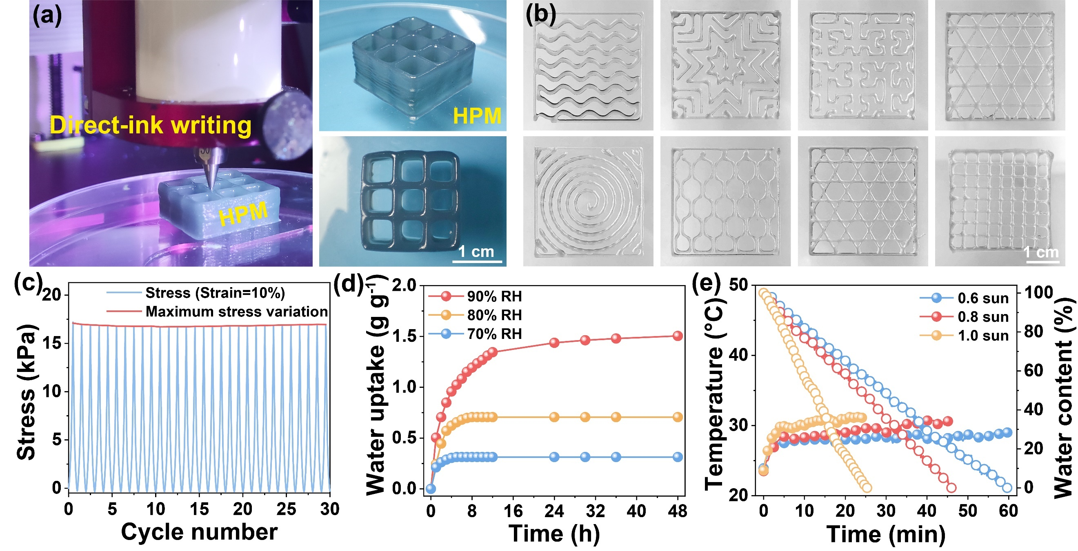
Fig. 7 (a) Digital photographs of direct-ink writing setup and 3D-printed HPM. (b) Printing precision characterization. (c) Cyclic compression testing of HPM. (d) Water vapor sorption characterization of HPM under varying ambient RHs. (e) Water desorption characterization of HPM under different solar intensity.
Wearable textiles incorporating 3D-printed fibers present a promising solution for fulfilling customized PTM requirements.⁸⁹ Based on the well-designed organogels, we not only fabricated 2D fabrics but also developed 3D hygroscopic photothermal matrices (denoted as HPM) using a direct-ink writing technique (Fig. 7a). The printable ink was formed using the fundamental components of the spinning dope for HF4, with the incorporation of a UV initiator to enable photocuring. The non-Newtonian behavior (shear thinning property) of the spinning dope ensured smooth extrusion through the printing nozzle, forming a continuous microfilament. The as-prepared microfilaments can be mechanically self-supporting upon the UV-induced gelation and layer-by-layer deposition, leading to stable 3D lattice structures. The result highlights the benefits of the spinning dope in facilitating the fabrication of both 2D and 3D structures of organogels. Various 2D patterns (i.e., grids, triangles, honeycombs and so on) can be directly printed, exhibting high printing precision at a 0.1 mm scale (Fig. 7b).
A cyclic compression test was performed to evaluate the mechanical durability of 3D-printed HPM under repeated loading. The loading and unloading cycles were applied at a constant strain of 10%. The compressive stress−time curve exhibited minimal reductions in both compressive stress and strain over 30 load−unload cycles (Fig. 7c and Fig. S24, ESI†). 3D HPM retained its maximum stress and showed limited plastic deformation below 2.0% throughout the cyclic testing. The result indicates the outstanding deformation resistance and rapid self-recovering ability of 3D-printed HPMs.
Water vapor sorption of 3D-printed HPMs (size: 20×20×10 mm³) was evaluated under different RHs at 25 °C. Pre-dried HPM attained a maximum water content of 1.50 g g⁻¹ under 90% RH after 48 h (Fig. 7d). Equilibrated water uptake was reached under 80% and 70% RH, yielding saturated water contents of 0.71 and 0.31 g g⁻¹, respectively. Solar-powered dehydration of water-saturated HPMs was conducted under varying solar intensities across 0.6, 0.8 and 1.0 sun (Fig. 7e). Photothermal heating led to a progressive increase in the surface temperature of HPMs. Under moderate sunlight (0.6 sun), 100% of the adsorbed water was released from HF3 within 60 min, exhibiting a R_{d} of 1.51 h⁻¹. The desorption rates increased with higher solar intensities. Under 1.0 sun, complete desorption was achieved within 25 min, yielding a higher R_{d} of 2.37 h⁻¹. Notably, the 3D-printed lattice structures significantly enhanced the surface area of HPMs, promoting greater water vapor sorption and release compared to 3D bulk structures. The result highlights the significant potential of 3D-printed HPM for active photothermal heating and facile regeneration under natural sunlight.
To evaluate the dehumidification capability of 3D-printed HPM, a commercially available silicone shoe cover (shoe size: 28 cm) was used to replicate the interior condition of a typical shoe (Fig. S25a, ESI†). A commercial ethylene vinyl acetate (EVA) insole served as the control group. Initial RH was precisely controlled at 96.8% using a calibrated humidification system to standardize the experimental conditions. Notably, the HPM-integrated insole significantly reduced RH within the simulated shoe environment, reaching 78.2% RH after 30 min (Fig. S25b, ESI†). In contrast, the commercial insole maintained consistently high RH levels. This result highlights the significant potential of using minimal amounts of hygroscopic organogels to boost moisture sorption, and the broader applicability of 3D-printed hygroscopic matrices in PTM applications.
The primary properties of the recently developed hygroscopic fabrics for humidity control, passive cooling, and heat dissipation are summarized in Table S4, ESI†. The radar chart (Fig. S26, ESI†) reveals the promising performance of these organogels in terms of moisture sorption/desorption, permeability, ease of processing, and scalability, positioning them among the best-performing and highly application-specific hygroscopic materials. Notably, these organogels represent one of the few hygroscopic photothermal composites offering self-contained properties and user-define functions based on 1D to 3D fabrication.
3. Conclusion
In summary, hygroscopic photothermal organogels were successfully fabricated through synergistic engineering of all-organic hygroscopic components, cross-linking reactions and diverse processing techniques within 1D to 3D structures, demonstrating efficient moisture sorption/desorption, evaporation cooling and heat stress dissipation for various PTM applications. The main advantages of our design are summarized as follows (i−iv): (i) Fabrication of hygroscopic salt-free 1D fibers: Through in-situ engineering of multiple cross-linked networks, four hygroscopic organic components (PAC, C-HEC, PDMAPS, and glycerol) were stabilized within the spinning dopes and fibers during continuous wet-spinning and solvent exchange. Without incorporating hygroscopic salt, organogel-derived HF3 achieved a high equilibrated water uptake of 1.56 g g⁻¹ under 90% RH. (ii) Design of hygroscopic 2D blended fabrics through passive heating mechanisms: Diverse blended fabrics were developed by combining the hygroscopicity and flexibility of organogels with the strength and wear resistance of polyester, employing two distinct weaving patterns (UHF and BHF). The HF4-BHF pattern maximized water uptake, reaching 6.56 g dm⁻² over 48 h under 90% RH. Two passive heating strategies incorporated within the blended fabrics significantly accelerated solar-powered water release, expelling nearly 100% of absorbed water from both UHF and BHF within 35 min. (iii) Multiple-cycle hydration and dehydration: HF4-BHF demonstrated reliable and reversible moisture sorption and release, enduring six sorption/desorption cycles per day under real-world conditions. The hygroscopicity, breathability and durability of HF4-BHF ensured efficient evaporative cooling, significantly reducing apparent temperatures for PTM clothing applications. (iv) 3D printing of hygroscopic photothermal matrices: 3D hierarchical matrices were printed via direct-ink writing based on a hygroscopic photothermal ink, showcasing sorption-based moisture and heat regulation, particularly suited for PTM insole applications. The organogels exhibited exceptional performance in moisture sorption/desorption, processability and scalability, positioning them among the top-performing hygroscopic photothermal materials. This work opens new avenues for the development of hygroscopic photothermal organogels across 1D to 3D geometries, tailored for customized PTM applications.
4. Experimental section
4.1 Preparation of spinning dopes
PAC (1.6−2.4 wt%), C-HEC (4.8−6.4 wt%), DMAPS (20 wt%), PEGDA (1 g relative to 10 g DMAPS), TEMED (1 μL relative to 0.06 g DMAPS), and ATO (0.5 wt%) were dissolved in NaCl aqueous solutions (0.5 mol L⁻¹), leading to homogeneous viscous gels. Air bubbles in all spinning dopes were removed through vacuum degassing.
4.2 Fabrication of 1D fibers and 2D fabrics
The spinning dope was loaded in a 30 mL syringe and spun into the coagulation bath through a nozzle (diameter: 0.41, 0.61 and 0.86 mm) at an extrusion rate of 40 µl min⁻¹. In-situ polymerization and cross-linking reactions of the fibers was initiated under a coagulation bath at 60°C for 2 min. HF1 was collected through a rotating drum with controlled speed of 30 cm min⁻¹. To remove NaCl and unreacted reagents, HF1 was immersed in deionized water until the conductivity of the washed aqueous solution dropped to 10 μS cm⁻¹. After washing, HF2 was obtained. HF2 was soaked in glycerol for solvent exchange and then dried in an oven at 40°C, resulting in HF3. HF4 was fabricated by incorporating 0.5 wt% ATO into the original spinning dope of HF3, followed by identical wet-spinning and solvent exchange procedures. 2D blended fabrics were fabricated using a lap loom. A polyester-based textile served as the anchoring structure, while hygroscopic fibers were interwoven with alternating polyester threads using a tapestry needle. Both unidirectional and bidirectional configurations were incorporated into the polyester matrix, yielding two distinct types of blended fabrics, referred to as UHF and BHF.
4.3 3D printing of hygroscopic photothermal matrices
PAC (1.9 wt%), C-HEC (5.7 wt%), DMAPS (20 wt%), α-Ketoglutaric acid (0.8 wt%), PEGDA (1 g relative to 10 g DMAPS), TEMED (1 μL relative to 0.06 g DMAPS) and ATO (0.5 wt%) were dissolved in NaCl aqueous solutions (0.5 mol L⁻¹), resulting in a homogeneous ink. Air bubbles in the ink were removed through vacuum degassing. 3D structures were modeled by Materialise Magics. The ink was loaded into a syringe (10 mL) and printed using an Allevi 2 bioprinter through a metal nozzle (diameter: 0.3 mm) at a printing speed of 3 mm s⁻¹. Ink extrusion was controlled by a syringe pump with a pressure of 9.0 psi. The printed 3D structure was soaked in a 10 wt% CaCl₂ solution for 30 min, and then washed with DI water. Then the printed structures were soaked in glycerol for solvent displacement and dried in an oven at 40°C.
4.4 Water vapor sorption and desorption characterization
Water vapor sorption was evaluated in an artificial climate chamber (RGC-160D, Youke) at controlled temperatures and RHs. The weights of all samples and corresponding water uptake were recorded and plotted as a function of time. Solar-powered dehydration was conducted at ∼20°C and ∼50% RH using a xenon lamp (CEL-S500, CEAULIGHT) with an AM 1.5G optical filter. The solar flux was calibrated using a thermopile connected to a power meter (CEL-NP2000, CEAULIGHT). Surface temperature distribution was monitored by an IR camera (223s-L19, Fotric Precision Instruments). Mass changes of water were real-time monitored via a high-precision electronic balance (QUINTIX224-1CN, Sartorius, accuracy: 0.1 mg). Outdoor experiments were conducted in June at Ocean University of China, Qingdao, China.
Authorship contributions
Yue Wang: Methodology, Investigation, Formal analysis, Writing - original draft. Shuai Li: Investigation, Software. Jingjing Li: Methodology, Investigation, Formal analysis. Yuke Sun: Investigation, Formal analysis, Data Curation. Zhaojun Li: Investigation, Data Curation. Petri Murto: Writing - Review & Editing, Methodology, Visualization. Zhihang Wang: Writing - Review & Editing, Methodology, Formal analysis. Xiaofeng Xu: Conceptualization, Writing - original draft, Project administration, Supervision.
Conflicts of interest
The authors declare no competing financial interest.
Acknowledgements
The authors acknowledge the financial support from the National Natural Science Foundation of China (Grant No. 22379133), the Fundamental Research Funds for the Central Universities, China (Grant No. 842461106), the Taishan Scholar Program of Shandong Province, China (Grant No. tsqn201812026), the Natural Science Foundation of Shandong Province, China (Grant No. ZR2023MB087), the Natural Science Foundation of Qingdao, China (Grant No. 23-2-1-243-zyyd-jch) and the Open Fund of the State Key Laboratory of Luminescent Materials and Devices, South China University of Technology (Grant No. 2023-skllmd-01).
Notes and references
1. T. Kjellstrom, D. Briggs, C. Freyberg, B. Lemke, M. Otto and O. Hyatt, Annual Review of Public Health, 2016, 37, 97-112.
2. C. Raymond, T. Matthews and R. M. Horton, Sci. Adv., 2020, 6, eaaw1838.
3. L. T. Biardeau, L. W. Davis, P. Gertler and C. Wolfram, Nat. Sustain., 2020, 3, 25-28.
4. A. Deroubaix, I. Labuhn, M. Camredon, B. Gaubert, P.-A. Monerie, M. Popp, J. Ramarohetra, Y. Ruprich-Robert, L. G. Silvers and G. Siour, Nat. Commun., 2021, 12, 5197.
5. R. Hu, Y. Liu, S. Shin, S. Huang, X. Ren, W. Shu, J. Cheng, G. Tao, W. Xu, R. Chen and X. Luo, Adv. Energy Mater., 2020, 10, 1903921.
6. M. Guan, G. Wang, J. Li, R. M. Rossi and M. Zhu, Prog. Mater Sci., 2023, 139, 101172.
7. B. Wu, Q. Qi, L. Liu, Y. Liu and J. Wang, ACS Nano, 2024, 18, 9798-9822.
8. Y. Peng and Y. Cui, Natl. Sci. Rev., 2024, 11, nwae295.
9. Z. Ma, D. Zhao, C. She, Y. Yang and R. Yang, Mater. Today Phys., 2021, 20, 100465.
10. T. Tat, G. Chen, X. Zhao, Y. Zhou, J. Xu and J. Chen, ACS Nano, 2022, 16, 13301-13313.
11. Y. Jung, M. Kim, T. Kim, J. Ahn, J. Lee and S. H. Ko, Nanomicro Lett., 2023, 15, 160.
12. J. Chang, L. Shi, M. Zhang, R. Li, Y. Shi, X. Yu, K. Pang, L. Qu, P. Wang and J. Yuan, Adv. Mater., 2023, 35, 2209215.
13. L. Lei, S. Shi, D. Wang, S. Meng, J.-G. Dai, S. Fu and J. Hu, ACS Nano, 2023, 17, 1803-1830.
14. F. Li, S. Wang, Z. Wang, K. Jiang, X. Zhao, L. Shao and Y. Pan, Adv. Funct. Mater., 2023, 33, 2210769.
15. D. Xu, Z. Chen, Y. Liu, C. Ge, C. Gao, L. Jiao, W. Guo, Q. Zhang, J. Fang and W. Xu, Adv. Funct. Mater., 2023, 33, 2212626.
16. D. Wendt, L. J. C. van Loon and W. D. Marken Lichtenbelt, Sports Medicine, 2007, 37, 669-682.
17. Y. Lin, C. Wang, D. Miao, N. Cheng, N. Meng, A. A. Babar, X. Wang, B. Ding and J. Yu, ACS Appl. Mater. Interfaces, 2022, 14, 18944-18953.
18. X. Yu, Y. Li, X. Wang, Y. Si, J. Yu and B. Ding, ACS Appl. Mater. Interfaces, 2020, 12, 32078-32089.
19. Y. Peng, W. Li, B. Liu, W. Jin, J. Schaadt, J. Tang, G. Zhou, G. Wang, J. Zhou, C. Zhang, Y. Zhu, W. Huang, T. Wu, K. E. Goodson, C. Dames, R. Prasher, S. Fan and Y. Cui, Nat. Commun., 2021, 12, 6122.
20. R. Liu, S. Wang, Z. Zhou, K. Zhang, G. Wang, C. Chen and Y. Long, Adv. Mater., 2024, 36, 2401577.
21. J.-W. Ma, F.-R. Zeng, X.-C. Lin, Y.-Q. Wang, Y.-H. Ma, X.-X. Jia, J.-C. Zhang, B.-W. Liu, Y.-Z. Wang and H.-B. Zhao, Science, 2024, 385, 68-74.
22. R. Wu, C. Sui, T.-H. Chen, Z. Zhou, Q. Li, G. Yan, Y. Han, J. Liang, P.-J. Hung, E. Luo, D. V. Talapin and P.-C. Hsu, Science, 2024, 384, 1203-1212.
23. Y. Peng, J. Chen, A. Y. Song, P. B. Catrysse, P.-C. Hsu, L. Cai, B. Liu, Y. Zhu, G. Zhou, D. S. Wu, H. R. Lee, S. Fan and Y. Cui, Nat. Sustain., 2018, 1, 105-112.
24. L. Cai, Y. Peng, J. Xu, C. Zhou, C. Zhou, P. Wu, D. Lin, S. Fan and Y. Cui, Joule, 2019, 3, 1478-1486.
25. P.-C. Hsu and X. Li, Science, 2020, 370, 784-785.
26. M. Alberghini, S. Hong, L. M. Lozano, V. Korolovych, Y. Huang, F. Signorato, S. H. Zandavi, C. Fucetola, I. Uluturk, M. Y. Tolstorukov, G. Chen, P. Asinari, R. M. Osgood, M. Fasano and S. V. Boriskina, Nat. Sustain., 2021, 4, 715-724.
27. X. Wang, Q. Zhang, S. Wang, C. Jin, B. Zhu, Y. Su, X. Dong, J. Liang, Z. Lu, L. Zhou, W. Li, S. Zhu and J. Zhu, Sci. Bull., 2022, 67, 1874-1881.
28. S. Jiang, K. Zhang, C.-F. Wang, Q. Li, L. Zhu and S. Chen, J. Mater. Chem. A, 2024, 12, 14866-14884.
29. G. Brooks, T. Fahey and K. M. Baldwin, Exercise Physiology: Human Bioenergetics and Its Application, 2005.
30. Q. Zhang, M. Wang, T. Chen, Z. Chen, D. Liu, Z. Zhang, L. Zhuo, Y. Wang, X. Xiao, B. Zhu, L. Li and W. Xu, Adv. Funct. Mater., 2024, 34, 2409807.
31. Y. Wang, Z. Wang, H. Huang, Y. Li and W. Zhai, Adv. Sci., 2024, 11, 2407260.
32. Y. Li, W. Huang, J. Chen, S. Xiang, S. Zhao, F. Fu and X. Liu, Chem. Eng. J., 2024, 488, 150873.
33. J. Li, X. Wang, D. Liang, N. Xu, B. Zhu, W. Li, P. Yao, Y. Jiang, X. Min, Z. Huang, S. Zhu, S. Fan and J. Zhu, Sci. Adv., 2022, 8, eabq0411.
34. R. Li, W. Wang, Y. Shi, C.-t. Wang and P. Wang, Adv. Mater., 2023, 35, 2209460.
35. K. Zhang, X. Lei, C. Mo, J. Huang, M. Wang, E.-T. Kang and L. Xu, Adv. Sci., 2023, 10, 2206925.
36. Y. Guo, J. Bae, Z. Fang, P. Li, F. Zhao and G. Yu, Chem. Rev., 2020, 120, 7642-7707.
37. M. Wu, R. Li, Y. Shi, M. Altunkaya, S. Aleid, C. Zhang, W. Wang and P. Wang, Mater. Horiz., 2021, 8, 1518-1527.
38. F. Deng, Z. Chen, C. Wang, C. Xiang, P. Poredoš and R. Wang, Adv. Sci., 2022, 9, 2204724.
39. Z. Zhang, H. Fu, Z. Li, J. Huang, Z. Xu, Y. Lai, X. Qian and S. Zhang, Chem. Eng. J., 2022, 439, 135756.
40. F. Ni, P. Xiao, C. Zhang and T. Chen, Matter, 2022, 5, 2624-2658.
41. S. Aleid, M. Wu, R. Li, W. Wang, C. Zhang, L. Zhang and P. Wang, ACS Mater. Lett., 2022, 4, 511-520.
42. C. Lei, Y. Guo, W. Guan, H. Lu, W. Shi and G. Yu, Angew. Chem. Int. Ed., 2022, 61, e202200271.
43. Q. Li, F. Wang, Y. Zhang, M. Shi, Y. Zhang, H. Yu, S. Liu, J. Li, S. C. Tan and W. Chen, Adv. Mater., 2023, 35, 2209479.
44. T. Li, T. Yan, P. Wang, J. Xu, X. Huo, Z. Bai, W. Shi, G. Yu and R. Wang, Nat. Water, 2023, 1, 971-981.
45. P. Zhu, Z. Yu, H. Sun, D. Zheng, Y. Zheng, Y. Qian, Y. Wei, J. Lee, S. Srebnik, W. Chen, G. Chen and F. Jiang, Adv. Mater., 2024, 36, 2306653.
46. J. Sun, F. Ni, J. Gu, M. Si, D. Liu, C. Zhang, X. Shui, P. Xiao and T. Chen, Adv. Mater., 2024, 36, 2314175.
47. H. Shan, P. Poredoš, H. Qu, X. Yang, M. Zhou, L. Bai, J. Shi, W. Chen, R. Wang and S. C. Tan, Adv. Funct. Mater., 2024, 34, 2402839.
48. C. Cai, Y. Chen, F. Cheng, Z. Wei, W. Zhou and Y. Fu, ACS Nano, 2024, 18, 4376-4387.
49. X. Zhou, P. Zhang, F. Zhao and G. Yu, ACS Mater. Lett., 2020, 2, 1419-1422.
50. D. K. Nandakumar, J. V. Vaghasiya, L. Yang, Y. Zhang and S. C. Tan, Nano Energy, 2020, 68, 104263.
51. Y. Zhang, L. Wu, X. Wang, J. Yu and B. Ding, Nat. Commun., 2020, 11, 3302.
52. X. Zhang, J. Yang, R. Borayek, H. Qu, D. K. Nandakumar, Q. Zhang, J. Ding and S. C. Tan, Nano Energy, 2020, 75, 104873.
53. K. Yang, T. Pan, Q. Lei, X. Dong, Q. Cheng and Y. Han, Environ. Sci. Technol., 2021, 55, 6542-6560.
54. Y. Feng, R. Wang and T. Ge, Adv. Sci., 2022, 9, 2204508.
55. J. He, N. Li, S. Wang, S. Li, C. Wang, L. Yu, P. Murto and X. Xu, J. Mater. Chem. A, 2022, 10, 8556-8567.
56. X. Chang, S. Li, N. Li, S. Wang, J. Li, C. Guo, L. Yu, P. Murto and X. Xu, J. Mater. Chem. A, 2022, 10, 18170-18184.
57. P. Poredoš, H. Shan, C. Wang, F. Deng and R. Wang, Energy Environ. Sci., 2022, 15, 3223-3235.
58. Y. Hou, Z. Sheng, C. Fu, J. Kong and X. Zhang, Nat. Commun., 2022, 13, 1227.
59. J. Wang, L. Hua, C. Li and R. Wang, Energy Environ. Sci., 2022, 15, 4867-4871.
60. M. Dai, F. Zhao, J. Fan, Q. Li, Y. Yang, Z. Fan, S. Ling, H. Yu, S. Liu, J. Li, W. Chen and G. Yu, Adv. Mater., 2022, 34, 2200865.
61. J. Yang, X. Zhang, J. J. Koh, R. Deng, S. Kumarasamy, Y. X. Xu, H. Qu, S. Zhang, Y. Zhang and S. C. Tan, Small, 2022, 18, 2107636.
62. W. Lu, W. L. Ong and G. W. Ho, J. Mater. Chem. A, 2023, 11, 12456-12481.
63. Y. Song, M. Zeng, X. Wang, P. Shi, M. Fei and J. Zhu, Adv. Mater., 2023, 35, 2209134.
64. M. Xia, D. Cai, J. Feng, P. Zhao, J. Li, R. Lv, G. Li, L. Yan, W. Huang, Y. Li, Z. Sui, M. Li, H. Wu, Y. Shen, J. Xiao, D. Wang and Q. Chen, Adv. Funct. Mater., 2023, 33, 2214813.
65. K. Yang, T. Pan, N. Ferhat, A. I. Felix, R. E. Waller, P.-Y. Hong, J. S. Vrouwenvelder, Q. Gan and Y. Han, Nat. Commun., 2024, 15, 6260.
66. Y. Lu, Z. Li, Y. Xie, Y. Liu, J. Zhang and L. Zong, ACS Mater. Lett., 2024, 6, 976-984.
67. H. Zhou, L. Yan, D. Tang, T. Xu, L. Dai, C. Li, W. Chen and C. Si, Adv. Mater., 2024, 36, 2403876.
68. X. Zhang, H. Qu, X. Li, L. Zhang, Y. Zhang, J. Yang, M. Zhou, L. Suresh, S. Liu and S. C. Tan, Adv. Mater., 2024, 36, 2310219.
69. X. Liu, P. Li, J. Chen, P. Jiang, Y.-W. Mai and X. Huang, Sci. Bull., 2022, 67, 1991-2000.
70. C. Zhang, P. Xiao, D. Zhang, F. Ni, J. Gu, Q. Liu, S.-W. Kuo and T. Chen, Advanced Fiber Materials, 2023, 5, 588-602.
71. S. Li, K. Shao, X. Wu, S. Wang, J. Li, C. Guo, L. Yu, P. Murto and X. Xu, Adv. Funct. Mater., 2024, 34, 2310020.
72. A. Feng, Y. Shi, C. Onggowarsito, X. S. Zhang, S. Mao, M. A. H. Johir, Q. Fu and L. D. Nghiem, ChemSusChem, 2024, 17, e202301905.
73. Y. Lin, K. Shao, S. Li, N. Li, S. Wang, X. Wu, C. Guo, L. Yu, P. Murto and X. Xu, ACS Appl. Mater. Interfaces, 2023, 15, 10084-10097.
74. M. Wu, Y. Zhou, S. Aleid, X. Tang, Y. Zhao, R. Li and P. Wang, ACS Sustainable Chem. Eng., 2024, 12, 1255-1264.
75. R. H. Galib, Y. Tian, Y. Lei, S. Dang, X. Li, A. Yudhanto, G. Lubineau and Q. Gan, Nat. Commun., 2023, 14, 6707.
76. Y. Zhan, W. Fu, Y. Xing, X. Ma and C. Chen, Materials Science and Engineering: C, 2021, 127, 112208.
77. Y. Zhang, L. Wu, A. A. Babar, X. Zhao, X. Wang, J. Yu and B. Ding, Small Methods, 2021, 5, 2101011.
78. Y. Hu, W. Yang, W. Wei, Z. Sun, B. Wu, K. Li, Y. Li, Q. Zhang, R. Xiao, C. Hou and H. Wang, Sci. Adv., 2024, 10, eadk4620.
79. Z. Yu, S. Li, J. Zhang, C. Tang, Z. Qin, X. Liu, Z. Zhou, Y. Lai and S. Fu, Nano Lett., 2024, 24, 2629-2636.
80. S. Zhu, S. Wang, Y. Huang, Q. Tang, T. Fu, R. Su, C. Fan, S. Xia, P. S. Lee and Y. Lin, Nat. Commun., 2024, 15, 118.
81. J. Li, N. Li, X. Wu, S. Wang, S. Li, C. Guo, L. Yu, Z. Wang, P. Murto and X. Xu, ACS Appl. Mater. Interfaces, 2022, 14, 50266-50279.
82. Z. Zhou, J. Xu, S. Zhu, B. Wang, J. Li, G. Ying and K. Chen, J. Clean. Prod., 2024, 452, 142201.
83. X. Zhou, H. Lu, F. Zhao and G. Yu, ACS Mater. Lett., 2020, 2, 671-684.
84. Z. Yang, M. Zhang, X. Zhao, Z. Guo, S. Zeb, W. Jiang, T. Liu, R. Hu and X. Jiang, Chem. Eng. J., 2024, 479, 147442.
85. S. Shi, N. Zhu, Y. Li and Y. Song, Renewable Energy, 2024, 235, 121178.
86. H. Park, I. Haechler, G. Schnoering, M. D. Ponte, T. M. Schutzius and D. Poulikakos, ACS Appl. Mater. Interfaces, 2022, 14, 2237-2245.
87. H. Guo, B. Ma, J. Yu, X. Wang and Y. Si, Adv. Fiber Mater., 2024, DOI: 10.1007/s42765-024-00467-9.
88. M. Liu, Y. Sun, K. Shao, N. Li, J. Li, P. Murto, Z. Wang, J. Chen and X. Xu, Nano Energy, 2024, 119, 109074.
89. T. Gao, Z. Yang, C. Chen, Y. Li, K. Fu, J. Dai, E. M. Hitz, H. Xie, B. Liu, J. Song, B. Yang and L. Hu, ACS Nano, 2017, 11, 11513-11520.

