Simulink model for a Hydrogen PEM fuel cell for automotive applications.

David Wilson1*, Amar Bousbaine1, Jose Andrade1

1College of Engineering and Technology, Universtiy of Derby, UK   
  
*D.Wilson@Derby.ac.uk

**Keywords**: FUEL CELLS, MATLAB/SIMULINK, BALLARD MK-V, AUTOMOTIVE

Abstract

Fuel cells have a relatively high energy density and use hydrogen as a renewable energy source. Fuel cells are one of the future promising renewable and sustainable power sources that can be used as a clean power source for various applications such as transportation. In conjunction with large supercapacitors, fuel cells can generate high power density with a fast dynamic response, which is ideal for automotive applications. In order to design a highly efficient fuel cell system for automotive applications, an optimised model for a multi-level DC-DC converter, fuel cell and supercapapcitor is required. The analytical model for the fuel cell has been developed in order to model the interface of the fuel cell, supercapacitor and drive train to the interleaved DC-DC converter. This paper deals with the development of a detailed fuel cell model using Matlab/ Simulink where the parameters for a Ballard Mk-V fuel cell stack are used. The simulation results have been presented and discussed and the validity of the developed model is ascertained.

1 Introduction

According to the RAC Foundation at the end of September 2018, there were 38.4 million vehicles licensed for use on the roads in Great Britain, of which 31.6 million were cars [1]. The majority of these vehicles are fossil fuel driven and make an ever increasing demand on the planets finite supply of fossil fuels and a need to reduce the amount of pollution not only in the densely populated cities and towns but also for the planet as a whole.

Some of the solutions to date include the introduction of pure electric vehicles (EV), hybrid electric vehicles (HEV) and fuel cell hybrid electric vehicles (FCHEV) to the market.

Fuel cells (FC) are widely recognized as one of the most promising technologies to meet future power requirements of vehicular applications[2]. Not only for their zero emissions but also due to their low operating temperature [3,4].

Unfortunately fuel cells have relatively poor dynamic response. However, with the emergence of large supercapacitors with high power density and the shift to hybridization in the vehicle technology, fuel cell/supercapacitor hybrid fuel cell vehicles are gaining more attention [5].

$$H_{2}+1/2O_{2}→H_{2}O+Heat (1)$$

To ensure a system level simulation, fuel cell stack model should be able to reflect fuel cell characteristics accurately.

The advantages of using a fuel cell stack for testing are numerous including; fuel cell stack power can be configured to different settings using the same emulator, depending on the specific fuel cell stack to be emulated; the limit operating scenario, such as stack short circuits, stack overheats, can be emulated during the tests, without damaging a real fuel cell stack. Additionally this model can then be used in conjunction with supercapacitor models to investigate other interfaces such as power converters and energy recovery systems on an electric vehicle for maximum efficiency.

Consequently, this paper concentrates on the FCHEV and in particular the development of a fuel cell model which can be used to model the vehicle dynamics and performance.

* 1. *Fuel Cell Principles*

A fuel cell, Figure. 1, is a device that uses hydrogen as a fuel to produce electrons and protons; and heat and water as by products of the of the simple combustion reaction given below;

Through the chemical reaction , the hydrogen is split into electrons and protons and each takes a different path to the cathode.

The electrons travel externally through the load. The protons pass through the electrolyte and are then reunited with the electrons at the cathode. The electron, proton, and oxygen (from the air) combine to form the harmless by-products of water and heat.

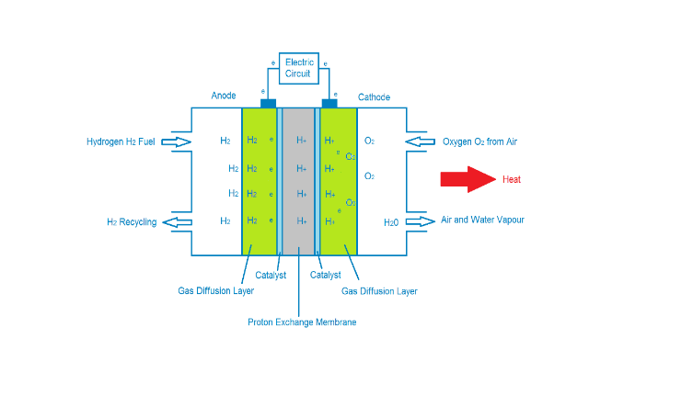

Figure 1 Fuel Cell

The hydrogen fuel is supplied to the anode of the fuel cell while oxygen is supplied to the cathode of the fuel cell. The electrodes consist of a catalytic layer of great superficial area permeable to gases. Electrocatalyst materials are necessary to obtain a good operation, increasing the speed of the chemical reaction. In this way, the gases can react with a lower energy of activation, allowing the reaction to take place at a lower temperature. The electrocatalyst used in PEMFC is platinum, which is one of the major drawbacks of this technology because of its high cost.

1. Energies in Fuel Cells

Figure 1 also shows the fuel cell system in terms of the input chemicals (products), the resulting output chemicals (reactants) and the output current and heat.

In order to calculate the output energy from the fuel cell, it is necessary to first calculate the input energy and then account for any inefficiencies and other unwanted by products in the system.

*2.1 Chemical Energies*

There are several terms used to describe ‘chemical energy’;

Internal Energy (U) – is the total energy and includes the energy of the molecular structure and activity.

Enthalpy (H) - combines the internal energy and the product of pressure and volume.

Entropy (S) - represents the unavailability of a system's thermal energy for conversion into work.

When dealing with chemical reactions it is often more useful to know the change in enthalpy. The enthalpy change defines the useful energy exchange of the system when it undergoes any energy interaction such as work and heat transfer.

The standard enthalpy of reaction occurs in a system when one mole of matter is transformed by a chemical reaction and is defined as;

*Enthalpy of reaction = Enthalpy of formation of products - Enthalpy of formation of reactants.*

In terms of a PEM fuel cell this becomes

$$∆H=\left(h_{f}\right)H_{2}O-\left(h_{f}\right)H_{2}-1/2\left(h_{f}\right)O_{2} (2)$$

The enthalpy of formation values are sourced from standard thermodynamic properties of chemical substances tables and those used are shown in Table1.

Table 1. Values of *h*f and *Sf* at 298.15 K, 1 ATM

|  |  |  |
| --- | --- | --- |
|  | Enthalpy of formation *hf* (J mol−1 ) | Entropy of formation *Sf*(J mol−1 K−1) |
| H2O (liquid) | −285,838 | 70.05 |
| H2O (steam) | −241,827 | 188.83 |
| H2 | 0 | 130.59 |
| O2 | 0 | 205.14 |

Using these coefficients, equation (2) gives,

Not all of this energy is available as some of it used in facilitating the actual chemical reaction itself. The amount of useable energy is termed the ‘Gibbs free energy’ and was developed by Josiah Willard Gibbs. His paper published in 1873, “Graphical Methods in the Thermodynamics of Fluids,” outlined how Gibbs free energy, denoted, ∆G, combines into a single value. The change in free energy, ΔG, is equal to the sum of the enthalpy ΔH plus the product of the temperature and entropy ΔS of the system.

$∆H=-286kJ{mol}^{-1}$

These quantities are defined as follows;

$$∆G=∆H-T∆S \left(3\right) \\ ∆S=\left(s_{f}\right)H_{2}O-\left(s_{f}\right)H_{2}-1/2\left(s_{f}\right)O_{2}$$ Again using the coefficeints in table 1, leads to;

$$∴∆S=-163.11 \\ ∴∆G=-237kJmol^{-1}$$

*2.2. Electrical Energies.*

Each hydrogen molecule used produces 2 electrons which pass through the external electric circuit.

For 1 mol of Hydrogen 2N electrons flow. N is Avagadro’s number and equal to 6.022140857×1023. If e is the charge on one electron:-

-2Ne=-2F coulombs (*4*)

Where e= charge on one electron = 1.602×10−19C

F = Faraday’s Constant (the magnitude of electric charge per mole of electrons)

And

Electrical work = charge x voltage = -2FE

Where E = fuel cell voltage

If there are no losses then this is also equal to the Gibbs free energy released, therefore

$$∆G=-2FE (4) \\ ∴E=\frac{∆G}{-2F}=\frac{237}{2x96485}=1.229V$$

This value corresponds to T=298.5K and partial pressures of oxygen and hydrogen are equal to 1 atm.

However, since both the anode and cathode gases are saturated with water vapour in a humidifier before entering the gas diffusion layers of the fuel cell the saturated vapour pressure of water needs to be modelled before going on to model the individual partial pressures of Hydrogen and Oxygen.

There is no exact equation for modelling the saturated vapour pressure of water instead various researchers have proposed different empirical equations based on best curve fitting of experimentally recorded data. Popular approximations included here are the three presented by Spiegel [6], Goth-Gratch [7] and A Buck [8].

As expected all of these models follow closely to the experimentally observed values of vapour pressure.

To further inform the choice as to which equation to use, a comparison of the error between the measured and calculated values for each of the equations presented was carried out. The results from this can be seen in Figure 2.

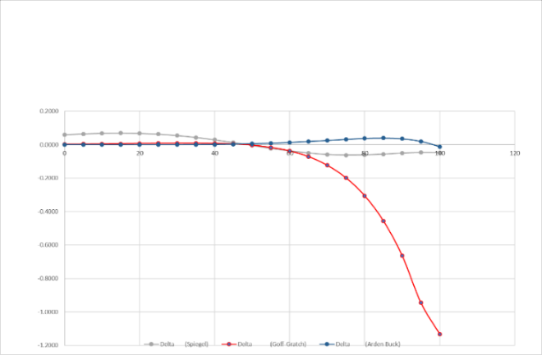

Figure 2 Comparison of Errors for Water Vapour Pressure

The Arden Buck approximation was chosen as it seemed to have the closest fit around the operating temperature of the PEM fuel cells in this investigation i.e. around 60 - 90°C range. The Simulink implementation can been seen in Figure 3.

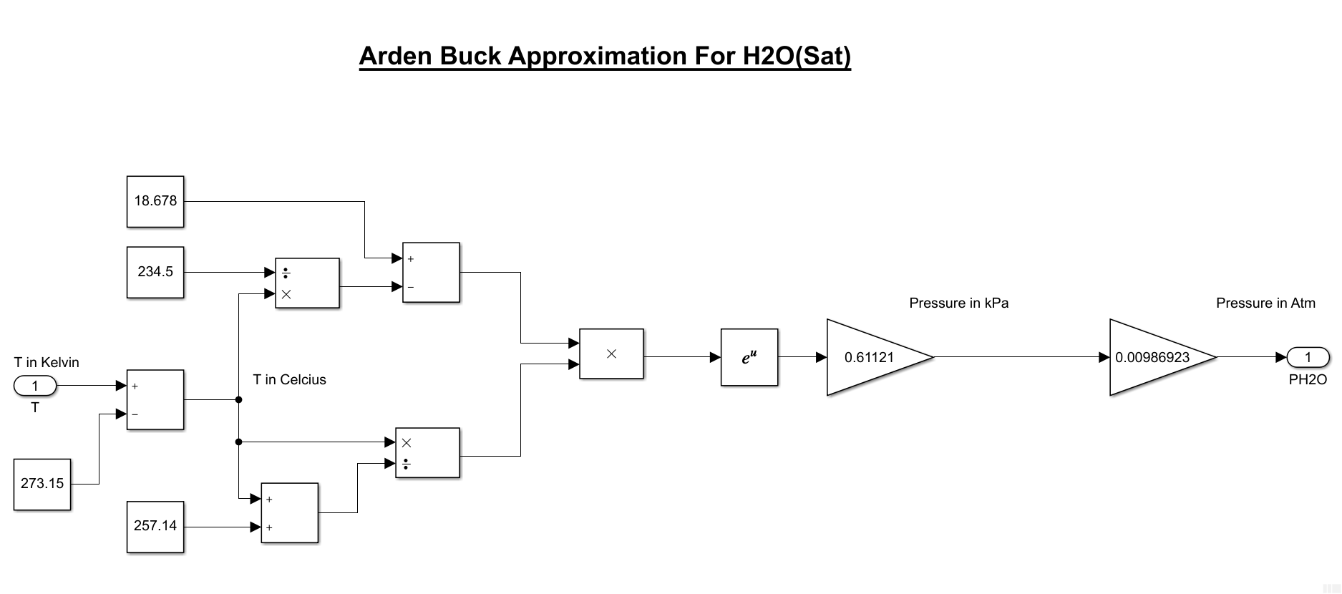Figure 3 Arden Buck Approximation

# *2.2.1 Thermodynamic potential – Enernst*

From equation(4), the output voltage of a single fuel cell can be defined as 1.229V. However, this assumes the partial pressures of both the Hydrogen and Oxygen are at 1 atm. In practice, however, these fuels are often diluted e.g. air as a source of Oxygen which contains Nitrogen. Additionally, fuel cells can operate at different temperatures and pressures. The open circuit voltage for the fuel cell can therefore be further defined as by [9] to give the following expression for the open circuit voltage of a single fuel cell, equation (5) and fig. 4 shows its Simulink model implementation.

$$E_{Nernst}= E_{oc}+\frac{RT}{2F}\left[\ln{{(P}_{H_{2}})+\frac{1}{2}}\ln{{(P}_{O_{2}})}\right] (5)$$

Where;

$$P_{H_{2}}=Partial Pressure of Hydrogen \\ P_{O_{2}}=Partial Pressure of Oxygen$$

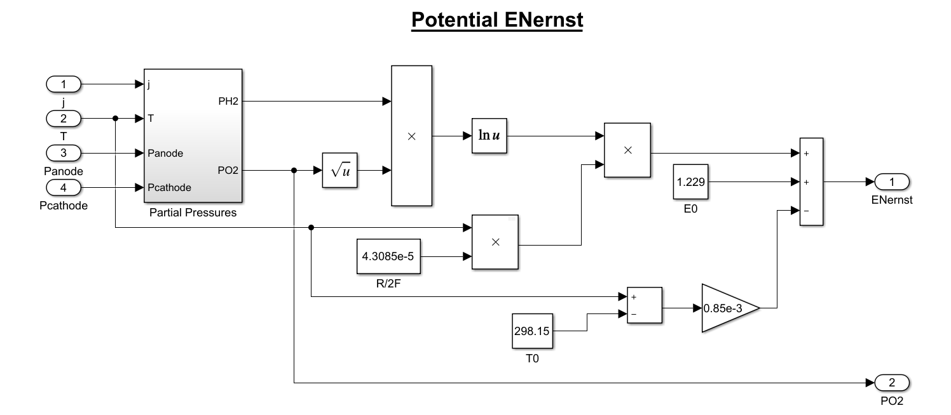

Figure 4. Simulink model for Nernst Voltage

**3 Fuel Cell Losses**

Practical fuel cell potential is lower than the theoretical potential because of a number of internal losses – namely activation losses, Ohmic losses and concentration (or mass transport) losses. In electrochemical systems, inefficiencies are termed overpotentials, because they result in a loss of the voltage that the system can achieve at a given current density.

In order to model a fuel cell many parameters are required in order to ensure the best fit between the model and the actual physical fuel cell. Although most of these parameters are available from manufacturer’s datasheets, several are still required from either experimentation or other sources of literature.

# *3.1 Activation Losses.*

The activation losses occur because a portion of the generated voltage is required to start and maintain the chemical process of the electrons to breaking and forming new chemicals bonds. As such, these losses occur at both the anode and cathode catalysts. This produces a voltage drop in both electrodes of the cell. These losses are most prevalent at lower current densities as shown in fig 6. The parametric equation for the over voltage from empirical analysis is given by [8]

$$V_{act}=-\left[ξ_{1}+ξ_{2}T+ξ_{3}T\ln\left(C_{O_{2}}\right)+ξ_{4}T\ln\left(i\right)\right] (6)$$

The values of ξn are determined from the experimental data table developed by 10]

Where

ξ1 = -0.944 V, ξ2 = 3.54 9 10-3 V/K

ξ3 = 7.6 10-5 V/K, ξ4 = -1.96 9 10-4 V/K

The value of $C_{O_{2}}$ can be determined based on Henry’s Law which is commonly stated as

$$P=k_{H}C (7)$$

Where P – pressure

C - concentration

kH- Henry’s constant

This basic form does not take into account the effect of changing temperature. One popular method of doing this is to incorporate a form of the Van’t Hoff equation;

$$k_{H}=k_{H}^{0}exp\left[-C\left(\frac{1}{T}-\frac{1}{T^{0}}\right)\right] (8)$$

Rearranging this making P and C related to the oxygen content gives:

$$C_{O_{2}}=\frac{P_{O_{2}}}{5.08x{10}^{6}e^{\frac{-498}{T}}} (10)$$

Fig. 5 below shows this equation as implemented in Simulink with Fig. 6 showing the predicted activation voltage.

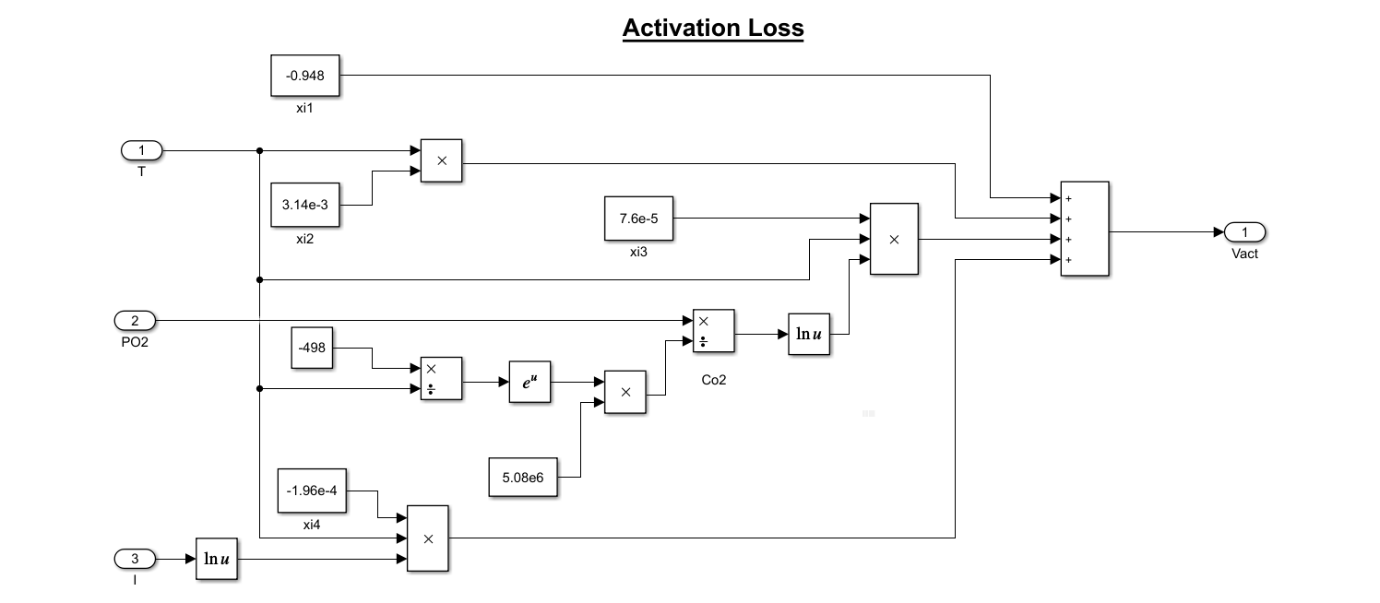Figure 5. Simulink model for activation loss

# 

Figure 6. Model prediction for activation loss

# *3.2 Ohmic Losses.*

The Ohmic losses results from the resistance to the flow of ions in the electrolyte and electrons through the cell hardware and interconnections. It is essentially proportional to current density. This forms the central linear region shown on the polarisation curve, Fig. 12. The value of this ohmic overpotential can be modelled as [6]

$$V_{ohm}=iR_{proton} (11)$$

$$R_{proton}=\frac{r_{m}l}{A} (12)$$

$$r_{m}=\frac{181.6\left[1+0.03\left(\frac{i}{A}\right)+0.062{\left(\frac{T}{303}\right)}^{2}{\left(\frac{i}{A}\right)}^{2.5}\right]}{\left[λ-0.634-3\left(\frac{i}{A}\right)exp\left(4.18\left[\frac{T-303}{T}\right]\right)\right]} (13)$$

Where

*rm* – membrane specific resistivity for proton flow

l – membrane thickness

A – active membrane area

The value of λ is influenced by the membrane fabrication processes, operation time (i.e. time being in service), cell relative humidity, and the stoichiometric ratio of the supplied gases [10]. Values of λ are taken equal to zero for a dry membrane, 14 for saturated, and 23 for supersaturated membrane [11,12]. Fig. 7 below shows this equation as implemented in Simulink with Fig. 8 showing the predicted activation voltage.

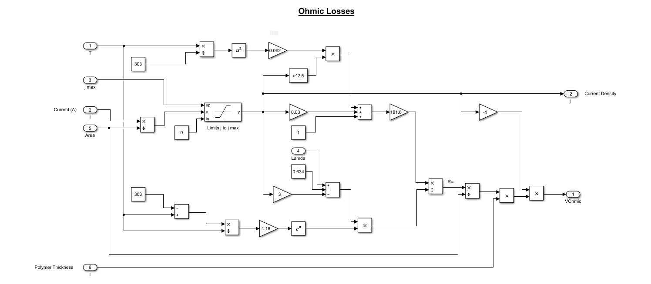Figure 7. Simulink model for ohmic loss

# 

Figure 8. Model prediction for ohmic loss

# *3.3 Concentration Losses.*

As the hydrogen supplied to the anode is used during the production of current, there will be a resulting loss in the pressure at the anode. The reduction in pressure will be dependent upon both the current being drawn from the cell and the physical construction of the hydrogen supply system such as pipe diameter.

$$E_{Nernst}= E_{oc}+\frac{RT}{2F}\left[\ln{{(P}_{H_{2}})+\frac{1}{2}}\ln{{(P}_{O_{2}})}\right] (14)$$

The first assumption made is that the major contributing factor to the output voltage is the change in the partial pressure of the hydrogen supplied. The second assumption is that the partial pressure of the Oxygen in the air supplied is relatively constant.

With these assumptions, equation (14) can be rewritten to give a change in voltage as a result of the partial pressure of Hydrogen changing from P1 to P2.

If a further assumption is made such that the relationship between current density and partial pressure is linear, gives:

$$P_{2}=-\frac{P_{1}}{j_{max}}+P_{1} \\ \frac{P_{2}}{P_{1}}=\left(1-\frac{j}{j_{max}}\right) \\ ∴ΔV=\frac{RT}{2F}\ln\left(1-\frac{j}{j_{max}}\right) (16)$$

Where *j*= current density

The simulnk model for the concentration loss described by Equation (16) is shown in Fig. 9 . The corresponding output is shown in Figure 10.

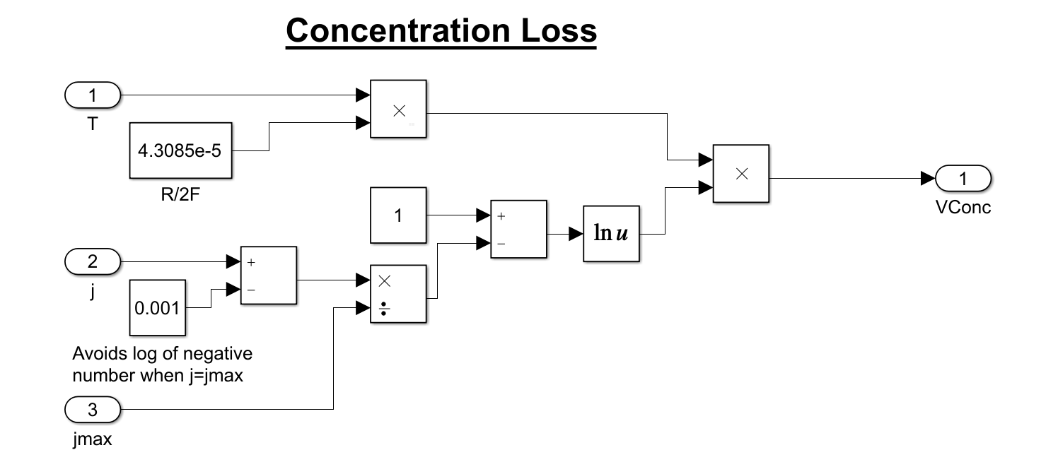Figure 9. Simulink model for concentration loss

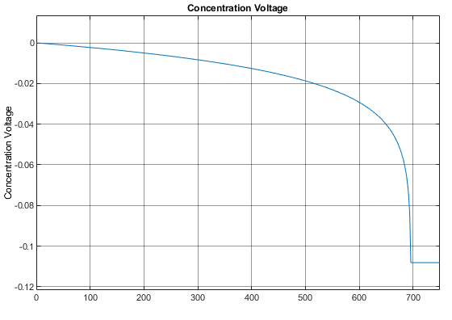

Figure 10. Model prediction for concentration loss

**4 Full Steady State Fuel Cell Model**

In order to model a fuel cell many parameters are required in order to ensure the best fit between the model and the actual physical fuel cell. Although most of these parameters are available from manufacturer’s datasheets, several are still required from either experimentation or other sources of literature.The output from a single cell is defined as [6]

$$V_{fc}=E_{Nernst}-V_{act}-V_{ohm}-V_{con} (17)$$

The full steady state model for a single fuel cell Simulink implementation is shown in fig. 11. The full predicted fuel cell polarisation curve can be seen in fig. 12.

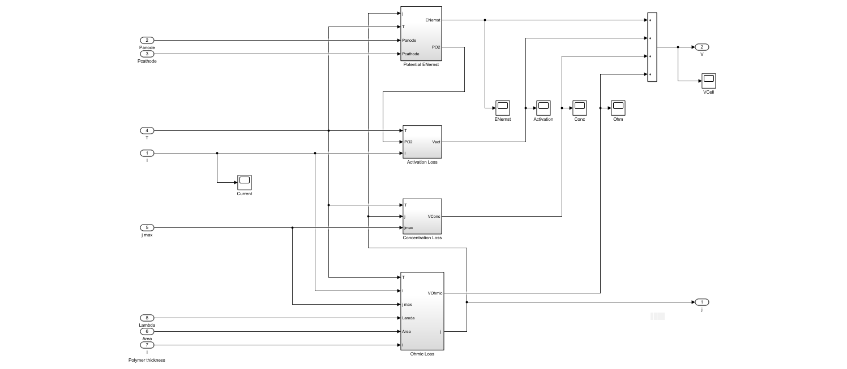

Figure 11 Simulink model for single fuel cell



Figure 12 Model Prediction for single fuel cell

Validation of the model has been against similar models found in literature such as in [14] as an actual fuel cell is not available at present.

5 Dynamic Fuel Cell Model.

Any collection of charges, e.g. hydrogen ions (in the electrolyte) and electrons (in the electrodes), will generate an electrical voltage. When this layer of charge forms at the surface of the electrode and electrolyte, it will represent a store of electrical charges similar to a capacitor. This electrochemical phenomenon linking the cell voltage to load current variations is the double layer charging effect.

Since the two electrodes are, as shown in Fig. 1, membrane two oppositely charged layers form across the porous boundary between the cathode and the membrane.

With the current changes, the charge will change during a certain time and hence, the voltage will not immediately follow the current changes unlike the ohmic voltage drop.

Considering the effect of the double layer while building the PEM fuel cell dynamic model will give the model more accuracy when describing the dynamic performance. Thus, it is quite reasonable to use a capacitor to model the capacitance effect resulting from the charge double layer [13]. This phenomenon is represented in Fig. 13 as an equivalent electrical circuit.

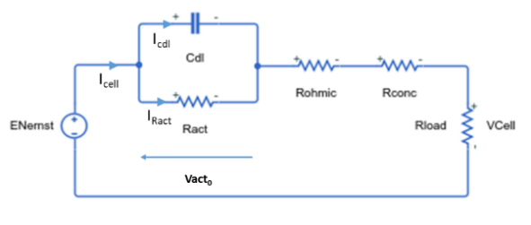Where the term $C_{dl}$ denotes the double layer capacitance of a single cell.

Figure 13 Equivalent circuit for dynamic model of fuel cell.

Equation (18) describe the first order dynamics of the activation voltage and current with reference to Fig. 12

$$\frac{dV_{act}}{dt}=\frac{I_{cell}}{C_{dl}}-\frac{V_{act0}}{R_{act}C_{dl}} (18)$$

The activation voltage model shown in Fig. 5 was further modified to take $C_{dl}$ into account as shown in Fig. 14

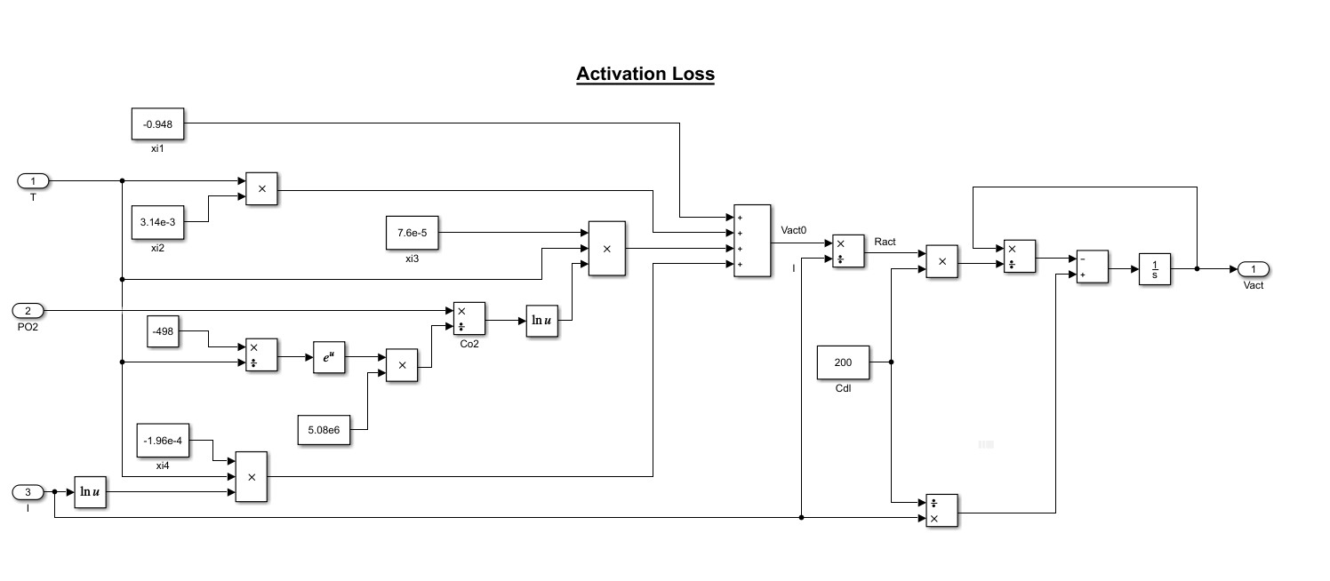Figure 14 Dynamic Model for Activation Loss

*5.1 Validation of Dynamic Model*

In order to test the dynamic response of the fuel cell model the current demand took the form of a square wave as opposed to the ramp input used to validate the steady state model.

Validation consisted of comparing the model with those found in literature as done previously for the steady state model

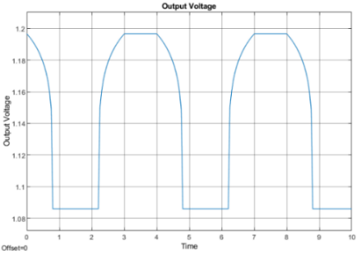

Figure 15 Output Characteristics of Dynamic Model

**6 Conclusion**

A mathematical model of PEM fuel cell has been developed based on a Ballard-Mark-V 35-cell 5-kW fuel cell stack by modelling the major electric and thermodynamic variables and parameters involved in the operation of the PEM fuel cell with the association of the influence of the environment and conditions of the fuel cell operation. The results compare with those found in literature such as [14].

Each individual fuel cell can only output just over 1 volt under open circuit condition. Increasing the number of cells in a stack increases the voltage, while increasing the surface area of the cells increases the current.

7 References

**Journal articles**

[2] Soltani M, Dadkhah A.(2014) Mathematical modeling of PEM Fuel Cell power module and Ultra-Capacitor for Vehicular Power System. J Mathematics & Computer Science 9, 408-425

[3] Hengbing Z, Burke A. (2010) Fuel Cell Powered Vehicles Using Supercapacitors: Institute of Transport Studies.

[4] Gaux S,Lachaize J, Fadel M, et al (2005). Modelling and Control of fuel cell system and storage elements in transport applications. J Process Control 15:481-91

[5] Benyahia N, Denoune H, Badji A, et al (2014). MPPT Controller for an interleaved boost dc dc converter used in fuel cell electric vehicles. Int J Hydrogen Energy 39:15196-205.

[6] Spiegel, Colleen (2008) PEM Fuel Cell Modelling and Simulation using Matlab: Elsevier

[7] Goff J.A. & Gratch S. (1946) Low-pressure properties of water from-160 to 212 F. In: Transactions of the American Society of Heating and Ventilating Engineers, pp. 125-164, New York

[8] Buck, A. L.(1981) , New equations for computing vapor pressure and enhancement factor, J. Appl. Meteorol., 20, 1527-1532, 1981

[9] Larminie J, Dicks A. Fuel cell system explained. 2nd ed. (2003): John Wiley & Sons Publication.

[10] Saleh IMM, Ali R, Zhang H.(2016) Simplified mathematical model of proton exchange membrane fuel cell based on horizon fuel stack. J Power Systems and Clean Energy 4(4):668-679.

[11] Springer TE, Zawodzinski TA, Gottesfeld S (1991) Polymer electrolyte fuel cell model. J Electrochem Soc 138(8):2334–2342

[12] Pasaogullari U, Wang CY (2005) Modeling polymer electrolyte fuel cells with large density and velocity changes. J Electrochem Soc 152(2):A445–A453

[13] Monem A, et al (2014) Dynamic Modelling of Proton Exchange Membrane Fuel Cells for Electric Vehicle Applications. J Petroleum & Environmental Biology 5:2

[14] Chien-Hsing Lee (2010),Modeling of the Ballard-Mark-V proton exchange membrane fuel cell with power converters for applications in autonomous underwater vehicles. Journal of Power Sources 196 (2011) 3810–3823

**Websites**

[1] Motoring FAQs, https://www.racfoundation.org/motoring-faqs/mobility#a1, accessed 29th December 2019