a pHILOSOPHICAL cOMPARISON OF cHINESE AND EUROPEAN mODELS OF COMPUTER SCIENCE EDUCATION.  
(a DISCUSSION PAPER)

|  |
| --- |
| Dr. C.C.H. Rosen  School of Computing and Mathematics,  University of Derby，Derby, UK |

***ABSTRACT***This paper applies a model of the learning process to a case study of teaching a Masters’ level, industry oriented software development project management course to a mixed group of Chinese and European students. By comparing levels of engagement of each group, the paper postulates the influence of the two academic cultures in their ability to deliver students capable of critical evaluation in an industry oriented environment. The paper concludes that both cultures face obstacles in dealing with academic administrations that adhere to traditional values and have failed to fully adjust to a new, contemporary paradigm.

***KEY WORDS***

Epistemology, Models of learning, Educational culture, Learning and teaching strategy.

# 1 introduction

In May 2014, I was fortunate enough to be invited to a Chinese university to deliver a software development project management course to a mixed group of Chinese and European students on an international master’s programme. The student cohort consisted of around 8 European students and 20 Chinese students and was taught over a two week period. The learning and teaching strategy consisted of a mixture of lectures, tutorial exercises, an investigation of a work related case study and guided reading typical of a European style master’s programme.

This paper treats this experience as a case study presenting my observations, analysing and comparing the differing responses of the student groups and their acceptance of the teaching style. This is not a scientific or even a quasi-scientific study. There are far too few data points to make such a claim. Rather it is a personal interpretation. My aim is to postulate some general conclusions and stimulate discussion on the challenges faced in delivering a trans-cultural, industry oriented, software development programme and the cultural influences on higher education. I hope to avoid a doctrinal or judgemental account of my experiences. However, I am conscious of my own cultural influences and recognise how these might have biased my own thoughts. For this reason, I invite colleagues to contribute their own observations and consider how these might further the aims of CEISSE.

# 2. learning and teaching philosophy

Before reporting and reflecting on my observations, I think that it is important to establish my learning and teaching objectives. This provides the basis and a benchmark against which any evaluation can be made. There is a clear danger in a study of this nature that the epistemological models of the observer lead to a self-reinforcing hermeneutic cycle that merely justifies the original epistemological model of the observer. Whilst I am conscious of this danger, it is one I cannot avoid other than by inviting criticism from peers. This I readily do.

The model of learning I ascribe to is represented in figure 1 below. This identifies three intersecting circles representing models of student learning which result in a highly industry oriented model of the purpose of higher education, although it could be used to position any learning and teaching strategy.

The three circles represent “content”, “context” and “process”. These circles intersect in a “Venn” style diagram because there are no clear boundaries between the three forms of knowledge. I do not wish to go into these in detail as this is not the purpose of this paper. The following paragraph therefore provides a brief overview of the model.

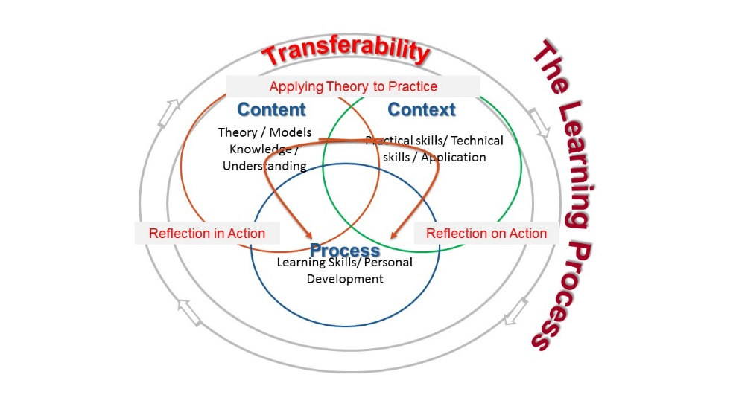

Figure 1: Model of the Learning Process (Rosen & Schofield 2011)

“Content” comprises of the theories pertinent to an academic domain, abstract knowledge associated with it and accumulated experience concerning the subject area. It is abstracted from any given situation. Content can normally be found in text books, journal papers etc. and is often delivered in HE settings through formal classes. Content is the domain that academia traditionally focused on delivering and, more particularly, developing, through on-going research.

“Context” is the application of a particular theory to a given context and requires practical / implementation skills. Vocational subjects generally give more emphasis in this sphere than the humanities, as, being able to deliver is an essential element of success. Context is situated in real world problems and encompasses knowledge and experience associated with practical problem solving. When employers complain about the lack of readiness of graduates to work, it is often issues associated with this sphere that they complain about.

The association of context with competency contrasts with the association of content with understanding. An example of the difference between the two within the computing domain would be the capability of a student to program in a particular language (context) compared to an understanding of the principles of programming languages (content). In reality, both are needed. Students struggle to understand programming principles without knowing how to solve problems in a given language, yet they must understand the principles to be able to learn the range of languages they may be confronted with when they leave university. Most courses contain elements of both content and context. Examples and case studies are often used in teaching for just this purpose. Without context / application, abstract knowledge is interesting, but essentially unproductive.

An industry oriented approach to higher education is neither pure understanding nor technical excellence. It is the capability of transferring knowledge from one context to another. This requires the third sphere, “process”.

Students need to develop their ability to learn independently, to use their knowledge and understanding to solve unfamiliar problems, to understand the processes and standards involved in learning and to recognise which tools and techniques are applicable to a particular context. In other words, students need the problem solving skills of logical reasoning, deduction, research and critical evaluation. These capabilities do not automatically emerge from content and context, but need to be nurtured and encouraged in equal measure through reflective practice.

In practice these components of the learning process overlap. This model suggests that learning activities contribute to the learning process by developing “reflection in action” and “reflection on action” (Schön 1991).

My aim as a lecturer is to maximise students’ recognition of the importance of process, even at the expense of content and context. This is in contrast to more traditional models of teaching which tend to prize content. This is not to devalue either content or context. Research, and hence new knowledge are situated in the content sphere and are clearly essential. Highly skilled practitioners, particularly reflective practitioners, feed back to theorists where models diverge from the real world. This points the way to further research. For me, in the institution I work in, developing the capabilities of observation, analysis and problem solving are core requirements for long term success in the knowledge economy. The learning and teaching style I adopt therefore (and this becomes particularly evident in the assessment methods) emphasises process. I expect students (particularly at Masters’ level) to research content largely by themselves. Becoming skilled practitioners demands that they put in the practice hours. I can help with both of these, pointing the way to particular texts and suggesting alternative approaches to particular problems, but asking questions such as “why did you do that that way?” or “what alternatives did you consider?” encourages students to reflect on their own practice and develop meta-learning skills. To be consistent, assessment practice must reinforce this emphasis. The quality of the argument becomes more important than the content. Assessing this quality is problematic. This is the point at which academic cultures diverge. This can be identified by the level of student engagement in the process.

# 3. Student Engagement

Computing students tend to like solutions. Many like to be told the “right answer”. If there are only optimised solutions and the critical questions are what to optimise and how, students tend to feel insecure. This appears to be true whatever their cultural background. Developing a sufficient sense of security to feel comfortable enough to challenge received wisdom is itself challenging. The established academic culture needs to support a process that encourages academic staff to support student transition from passive consumers of knowledge to active, self-motivated, independent learners. In the UK and across Europe demands for accountability have eroded this support, but it does nevertheless, still exist, at least in principle. My experience in China (and from discussions I have held with Chinese academics) suggests that this process is not as well understood. The objective of education authorities is to develop truly creative problem solvers, but they are unclear how the learning process and the learning and teaching approach required to achieve this outcome is inhibited by the existing academic culture.

The Chinese students I encountered (in general) were often confused by the demands I placed upon them in contrast to the European students who relished the opportunity to debate and argue. A few of the Chinese students did appreciate the chance to debate alternative and unorthodox perspectives, but the majority were more concerned to know what I believed so that they could give the “right” answer. The result was that, for this group of Chinese students, I found it difficult to engage them other than at a surface level. In the context of the course, this should not be considered surprising. The process required to facilitate student capability to engage and learn from this learning and teaching approach is extensive. Students need to develop confidence in the use of both intellectual and academic tools such as research skills, critical analysis and self-reflection to feel confident enough to challenge the authority of the teacher. And academic staff need to firstly provide the opportunity to allow students to engage in this way and also support them to do so by encouraging (and guiding) challenging responses.

Reference to the model illustrated in figure 1 may help to understand this phenomenon in more depth. I will refer to the UK education system as this is the one I know best, but this analysis may apply equally to most of Western and Northern Europe. Traditionally, British Secondary Education was split into two streams. One stream concentrated on knowledge acquisition (the content sphere) and was seen as a preparation for tertiary education. The other focused on practical skills (context) and minimised the demands of knowledge beyond the needs of the occupational domain. The objective of this education was utilitarian; providing sufficient resource for the economy. It was not designed to facilitate further study.

Tertiary education adopted a Socratic approach, building on the knowledge acquired at the secondary level to develop the link between content and process. Context was seen as lower status in the UK (less so in other European countries.) As the complexity of the work environment increased, the requirements of content in vocational education increased, but a binary divide still existed between the vocational stream and the academic stream until the demands of the knowledge economy outpaced the returns from a manufacturing economy. This led to a greater need to integrate all three spheres (content, context and process). As the UK did have a tradition of developing pure academic skill (process), and the interaction of context and content had already been established, it was not too difficult to graft on process skills to vocational (industry oriented) educational practice (although arguments continue over whether, and if so, how much process knowledge is required, and the status of this style of education remains lower than “pure” knowledge in the UK.)

The impression I have received is that in China, knowledge (content) is valued above other forms of academic attainment. This tradition is well established and inculcated into the education system. Both students and educationalists respect knowledge and find it difficult to accept that other forms of learning are at least as valuable if not more so. Questioning this perspective may be acceptable, but introducing the changes to support a different approach is more challenging. The assessment process needs to be consistent with the learning and teaching approach so provides a useful medium for observation and analysis.

Evidence supporting this observation regarding the significance of knowledge can be seen in the assessment regime. An assessment methodology that rewards knowledge over academic reasoning fails to support the Socratic process. It is easier, and there is less scope to discriminate between students, to test knowledge, but it is inconsistent with the objectives of developing the critical capabilities of students. Determining the academic capability of students on the grounds of the strength of the argument they present is much more subjective, and therefore a far less reliable instrument. This presents a dilemma for all academic administrations. In Europe it has led to discussion about the accountability of academic staff. How can management systems discriminate between good academic staff and those that fail to deliver? What constitutes a good member of academic staff? What are the assessment criteria? How do we improve our international standing if we cannot systematically identify poor performing staff?

My perception is that the connection between academic objectives and assessment policy is less well understood within the Chinese academic community than in Europe. For example, the use of multiple choice questions used on the course I taught on imply that there must be a correct answer. This form of assessment tests knowledge and the ability to recall that knowledge. Questions of this type cannot test a student’s ability to use this knowledge or her / his understanding of the relative importance of it in different contexts. I would contend that an assessment method consistent with an industry oriented approach needs to test these latter skills rather than the former. To facilitate a transition from knowledge based learning to the development of critical evaluation skills, both the learning and teaching approach and the assessment methodology need to provide sufficient scope for the student to present their learning.

# 4. Conclusions

My experience of teaching in China last year has helped me to clarify my own objectives as a teacher. I have become more concerned with imparting to my students a regard for the learning process and the ability to reason with logic, based on valid evidence. I am less concerned to delivering content or even teach technical skills to them. As access to information becomes more widespread, quicker and more reliable, the need to deliver content diminishes. Much better, more professional and more eloquent resources exist at the touch of a button than I can hope to replicate. The need to understand this information, interrogate it and establish its value, escalates. Academic cultures, whether in Europe or in Asia, seem reluctant to accept the consequences of this technological change. An industry oriented approach must find ways of integrating content, context and process and of valuing each equally. In this paper I have not discussed how this might be achieved as this has been the subject of innumerable previous papers to this conference, including some of my own papers. This paper has sought, by comparing European and Chinese student response to my academic input, to identify some of the underlying difficulties inherent in the academic cultures we work in and to articulate how some of the preconceptions concerning academic value have arisen. I have presented an academic model which I hope helps to illuminate the academic process. Whilst European academic systems struggle to integrate content, context and process and have not recognised the constraints on accountability this results in, the Chinese system continues to value content in the expectation that this will of itself deliver innovation. Academics in both systems recognise the limitations resulting from the existing cultures, but seem more prepared to live with the contradictions than support the changes required to achieve innovative industry orientation. If this analysis is valid, then it presents those of us who wish to promote industry orientation with a dilemma. How do we reconcile genuine industry oriented approaches with the demands of prevailing academic processes? I would argue that the first step is to recognise that the dilemma exists, then to identify methodologies that might resolve the differences.

# references

1. Rosen, C. C. H. and R. Schofield (). Reliability and Validity in Work-Based Learning, 2011. Work Based Learning Futures V, Derby
2. Schön D. The Reflective Practitioner : How Professionals Think in Action, 1991 Aldershot, Arena.