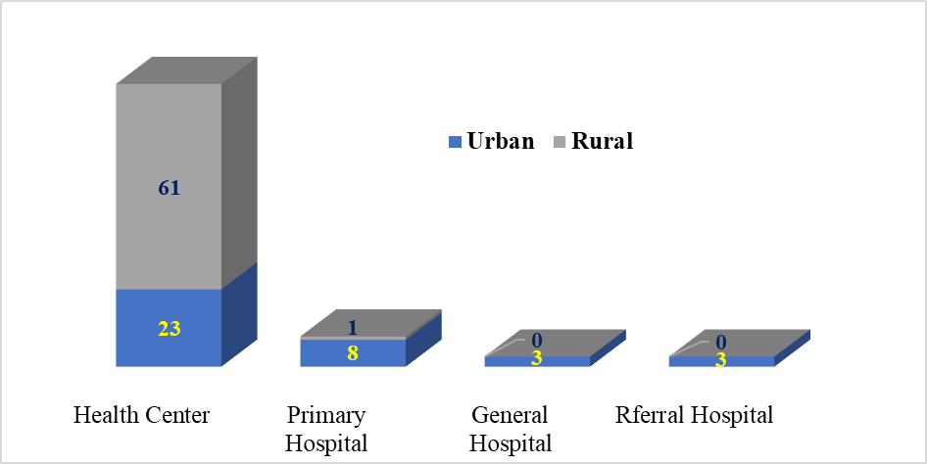

Figure 1: Levels and location of public health facilities surveyed, Amhara Region, Ethiopia; March 2022

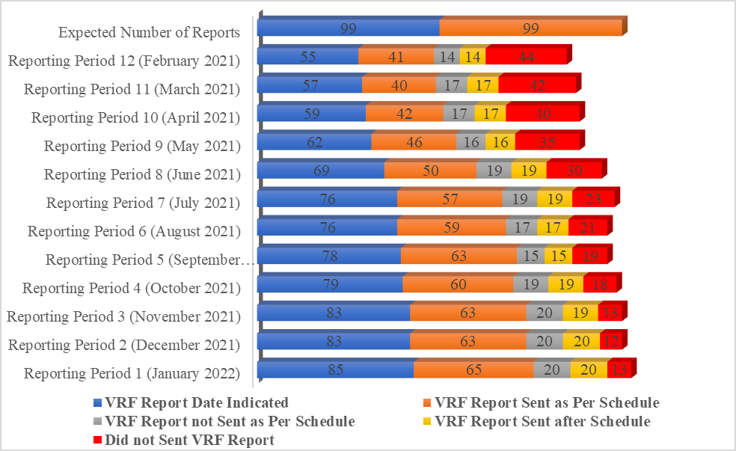

Figure 2: Timeliness of monthly Vaccine Request Form (VRF) reports among public health facilities of Amhara region, Ethiopia; March 2022. [*Reporting schedule: Until the 10th Day after the end of the month*]

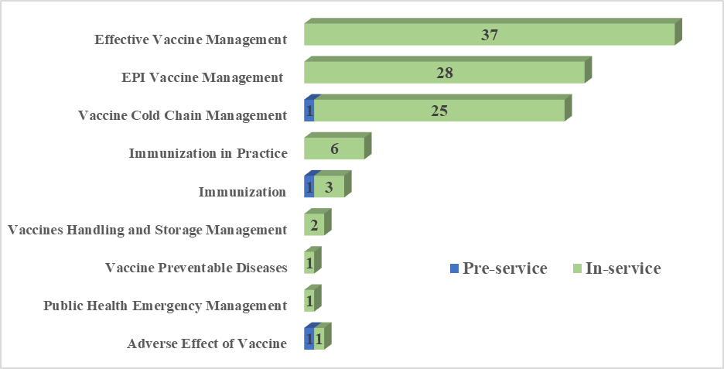

Figure 3: List of vaccine and cold chain logistics management-related training provided for Expanded Program for Immunization focal persons at public health facilities of Amhara Region, Ethiopia; March 2022 (N=83).

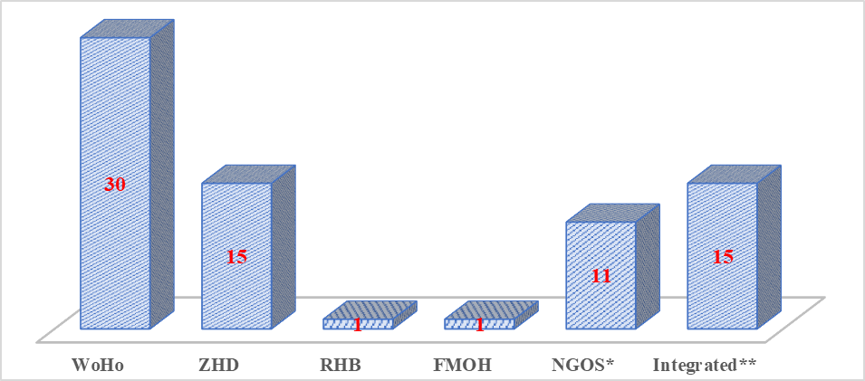

*\* UNICEF(1) & WHO (9) \*\* RHB+WHO (1), UNICEF+WoHO+RHB (1), WHO+UNICEF (1), RHB+WHO (1), WoHO+ZHD (8), WoHO+ZHD+RHB (1), ZHD+RHB (1), ZHD+RHB+FMOH+WHO (1)*

*UNICEF- United Nations Children's Fund; WHO-World Health Organization; RHB-Regional Health Bureau; ZHD-Zonal health Department; WoHO-Woreda Health Office; FMOH-Federal Ministry of Health*

Figure 4: Organizations that provided supportive supervision on vaccine logistics for Expanded Program for Immunization focal persons at public health facilities of Amhara Region, Ethiopia; March 2022 (N=73).