Empowering digital supply chain transformation by utilizing Industry 4.0, Smart Factories, Standards, Smart Contracts and Blockchains
Eur Ing. Raj Takhar MSc, CEng, MIET, MBCS. Senior Subject Matter Expert, Assent Compliance Inc, 525 Coventry Road, Ottawa, Ontario, K1K 2C5, Canada. PhD Researcher, University of Derby, Kedleston Road, Derby, DE22 1GB.
Abstract
Companies that place products onto the marketplace, whether they are internally manufactured or sourced from a supply chain, are often faced with ever increasing demands for data from a diverse set of stakeholders, requiring a multitude of different data reporting needs to be identified and requested from suppliers, ranging from: the identification of raw materials; number of products in WIP state within facilities; finished stock levels in storage; demand needs from customers; numerous what-if scenarios; exposure analysis; safe use and disposal instructions; through to obligatory reporting data under chemical regulation to identify the presence of any hazardous chemicals on finished products; through to the emerging Environmental, Social, and Governance data reporting needs in order to gain access to future sources of funding.
Blockchains are often mistakenly viewed as being solely related to recording transactional data related to some form of electronic payment mechanism. Smart contracts enable contracts between buyers and suppliers to create contract terms in an electronic manner and processed in an efficient and automated manner.
This paper contributes to existing literature by identifying a research gap in transforming the currently diverse manually intensive data collection tasks, via digital technologies such as supply chain collection of reporting tasks embedded into smart contracts, with digital data flows supporting IPC-CFX and IPC technical standards, recording data collection requests and responses in real-time within a blockchain, which is then verified by applicable supply chain actors, to ensure data consistency, accuracy and verification.
The proposed design enables companies to address existing state supply chain data collection tasks using as structured framework, enabling appropriate risks to be identified and managed accordingly in a more timely and consistent manner. The design may then be expanded in a consistent manner as new supply chain reporting needs arise.
Keywords: AI, Automation, Blockchain, Supply Chain Data Collection, Supply Chain Management, Smart Contracts, Smart Ledger, IoT, Internet of Record, IPC-CFX, IPC-2591, IPC-175x.

Introduction
Classic economic theory [1] presents the view that economies emerged from simple bartering, exchanging one article for another article, evolving to articles being exchanged for precious metals such as gold and silver. Modern industry is built on the need to achieve some form of economic gain for stakeholders which has intensified over the course of four key industrial revolutions, each bringing advances in technology, manufacturing capabilities, new product offerings, with a resultant change in workforce skills [2], [3], [4].
The first industrial revolution saw the introduction of steam powered machinery performing the role of manual workers. The advent of electricity, more complex machinery, division of labour gave rise to mass production which was the cornerstone of the second industrial revolution. The third industrial revolution emerged from the post WWII reconstruction era, resulting in: (1) continual linear economic model of mass production at the lowest cost, with limited recycling activities being undertaken; (2) ever increasing new manufacturing technological advances such as microprocessors, printed circuit boards, PLC, automated computers, servers, network devices, networks, the internet; (2) manufacturing technology advances have resulted in new products and new product sectors with increasing consumer demand for products thereof; (3) advances in software design have seen a shift away of bespoke heavily customised software systems towards common languages such as C++, Java, XML, Python utilising common object oriented programming logic, in turn led to the cross software system integration via the adoption of common Application Protocol Interface (API) calls between requestor and requestee systems; (4) the advent of the internet during the 1990’s saw further interconnected systems; (5) globalisation emerged as the mobility of goods, services, commodities, information resulted in disparate global manufacturing supply chains where products are now available multiple sources [5]. The fourth industrial revolution or Industry 4.0 as it is more commonly known, has evolved from 2010, presenting a vision of a unified platform where multiple intelligent (smart) systems operate communicating between multiple interconnected Internet of Things (IoT) devices, capable of transmitting and collecting vast amounts of real-time data in an automated manner with scarce human interactions [6], [7], [8], [9]. The advent of industry 4.0 has seen disruption to the traditional manufacturing sector model, the emergence of smart factories being able to exchange data internally and across supply chains supporting further supply chain integrations. As advances in infrastructure design have occurred, smart factory standards have emerged to support harmonized data collection between emerging technologies [10], [11]. Industry 4.0 appeals to industry and governments as a basis for achieving future competitive advantage, in a similar manner to the evolution of ecommerce at the beginning of the internet era.
The technological advances made during the third and fourth industrial revolutions, saw increasing regulatory control measures emerge requiring industry to identify the use of hazardous chemicals, reporting accordingly, wherever a product is manufactured, distributed, purchased or even disposed / recycled. This results in industry needing to adhere to applicable regulatory reporting obligations by collating information on internally defined and externally procured products. This is often a very manual resource intensive task involving a lot of effort to transmit, receipt and verify data. The level of resources needed with increase depending on product complexity, supply chain size and locations. Industry cannot afford to be non-compliant to their regulatory reporting obligations as they have the potential to result in supply chain disruption, in the event of additional control measures being implemented by future regulations, which could prevent access to a given marketplace [12], [13].
Blockchains are a disruptive technology which has the potential to transform traditional business processes. Blockchains provide the basis to automate tasks which are traditionally manual resource intensive activities such as requesting, receipting, ingesting, processing and provisioning data [14].

Purpose
The goal of this technical paper is to examine how a potentially diverse set of manually intensive data collection tasks could potentially be automated via digital technologies, incorporating data exchange standards, to both provide industry with greater efficiencies in data collection tasks and potentially provide new insights on product design, manufacturing, quality. This technical paper is organized to address the following research questions:
- What is Industry 4.0 and smart manufacturing?
- What are standards?
- What are blockchain technologies?
- How could standards connect to blockchain technologies?

This paper is structured as follows: research methodology section defines the research approaches undertaken; findings section shows the outcomes from the literature review; discussion section outlines proposed models for integrating IPC standards to blockchains; conclusions show the main outcomes of this technical paper and areas for potential further research.

Research Methodology
The research methodology adopted for this technical paper consisted of: (1) identification of literature in scope [15], [16], resulting in the identification of keywords, performing a literature review; (2) the subsequent literature review conducted using specific search terms ‘blockchain’, ‘smart factories’, ‘smart factory standards’ and ‘data exchange standards’, where the results were filtered down, analysed and results presented in the findings section; (3) application of previous research papers published as part of authors PhD research study on ‘the effects of chemical regulations on the Aerospace and Defence sector’. The authors previous research papers outlined: (i) the potential for blockchain technologies to manage supply chain contracts [12]; (ii) examination of digital labelling technologies to capture hazardous chemical substance related data [17], and; (iii) a Delphi study examining a proposed blockchain for supply chain chemical substance reporting [18].

Findings
The fourth industrial revolution or Industry 4.0 describes a transition towards cyber physical systems [19]. Industry 4.0 encompasses several key technologies and themes which facilitate the transition: (1) automated sourcing, manufacture, distribution, sales, maintenance and recycling activities. Increasing automation will result in more efficient processing of both manufacturing and back-office data processing; (2) cloud computing, the movement from on-premises computing systems to remote computing services offering hardware and software platforms ‘leased’ by users and managed by third party providers; (3) Internet of Things (IoT) devices designed to collate data via sensors (QR Code, RFID, motion, heat, power, light, etc.) which may then be shared with other IoT devices [20], [21], [7], [8]; (4) Industrial Internet of Things (IIoT), the application of IoT devices and software within an industrial setting; (5) interoperability, the underlying ability for devices, systems and software located across multiple networks and domains sharing data between one another [6], [7], [8]; (6) Cyber-Physical Systems (CPS) the interconnectivity between the digital and physical worlds. CPS 5C architectural concept model describes design methodologies and measures to implement and maintain strong design and security control measures over CPS systems [22], [23], [24]; (7) digital transformation, the process of moving from existing traditional multiple IT systems towards a more unified digital business model covering all areas of a business. A key aim of digital transformation is to examine how an organization operates and then delivers its customers value [23], [24]; (8) digital twin, a by-product of digital transformation, a replicated digital model of existing systems and processes. The replicated digital model is utilised to test areas for increasing operational performances prior to implementing in the rea-world systems. Overtime the digital twin should reflect the unified business model applied to the real-world systems [23], [24]; (9) smart manufacturing encompasses all of the above elements in a unified model capable rapid adaption to changing needs such as a decrease in demand, changes to existing products and new product implementations.
Standards play a pivotal role in establishing harmonised levels, quality level, norms, measures, behaviours and models to support the establishment of a common baseline for a given physical or non-physical object(s). Figure [1] depicts the common features of standards. Regional and National standards are developed via standards committees where different stakeholders from industry, trade associations and software solution providers work in a voluntary manner to achieve consensus to enable industry adoption of a standard.
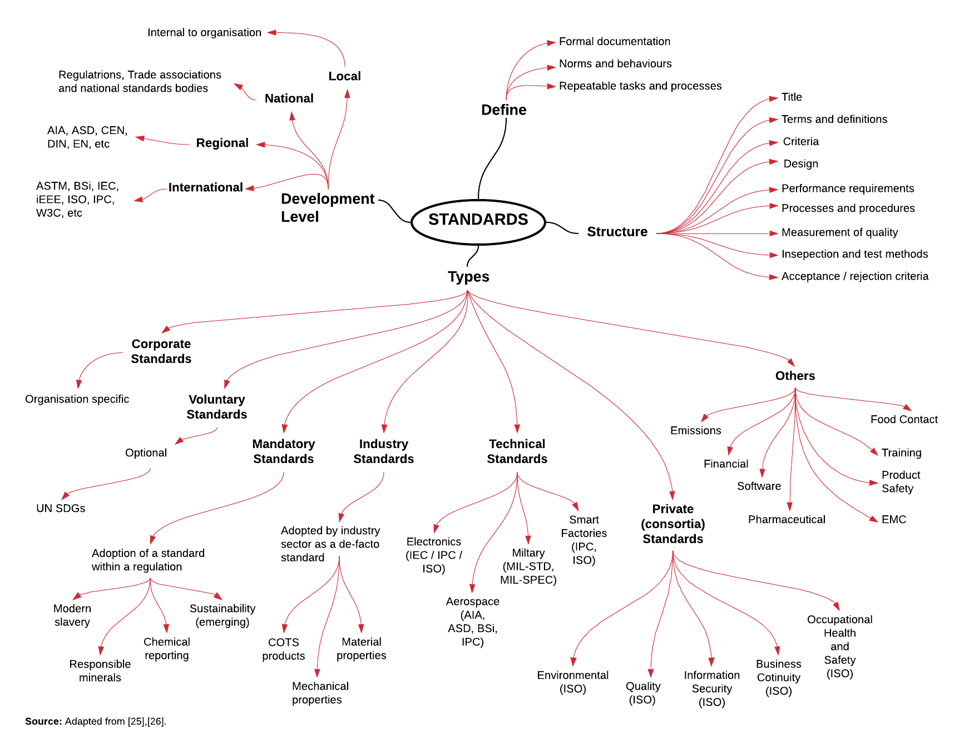
Figure 1: Common Elements of Standards

Following the publication of a standard, internal and external (3rd party solution providers) data collection systems emerge to collect data across applicable supply chain actors, using the data model and harmonized data collection formats to support the generation of the reporting defined the applicable standard.
Smart manufacturing embraces Industry 4.0 fundamentals leading to potentially reconfigurable centralized manufacturing systems capable of supporting multiple industry sectors and products. Several standards have emerged in the context of smart factories to support the interconnectivity and data flows, notably: (1) IPC Connected Factory Exchange (IPC-CFX) [27] outlines a framework for connected devices to exchange data in Electronics manufacturing sector setting, using a harmonized data structure and listing qualified products, which can readily exchange data against IPC-CFX [28]; (2) conversely DIN [11] identified over 680 standards in existence which pertain to Industry 4.0, which cover a very broad application of tasks and activities across several industry sectors.
Traditional business systems entail as combination of people, processes and systems, performing specific functional roles within an organisation. These systems entail a significant amount of manual data processing and computational resources. Overtime, manual paper-based systems can lead to operational inefficiencies due to: (1) manual labour costs need to support the traditional systems; (2) increased costs due to data processing times; (3) potential for human error further increasing (1) and (2).
Following the emergence of the internet and associated technologies in the early 1990’s, Nick Szabo conceptualized an environment in which paper based transactions could potentially be replaced by digital technologies, through a series of on-line discussions, which became the basis for modern day blockchains [29], [30], [31]. Szabo focused on the potential to exchange physical objects as digital assets, in three distinct methods: (1) a digital ledger to record data; (2) a smart contract to replicate existing paper-based contracts; (3) a suggested digital currency which evolved to become bitcoin. The most fascinating elements were (1) and (2) which proposed a shift away from paper-based systems towards digital transformation via a blockchain to: (1) digitally store transactional data; (2) utilization of smart contracts to expand functionality. In the simplest of terms, a block refers to a data record, which a sequence of records is termed the blockchain. Figure [2] presents the key elements of a blockchain.

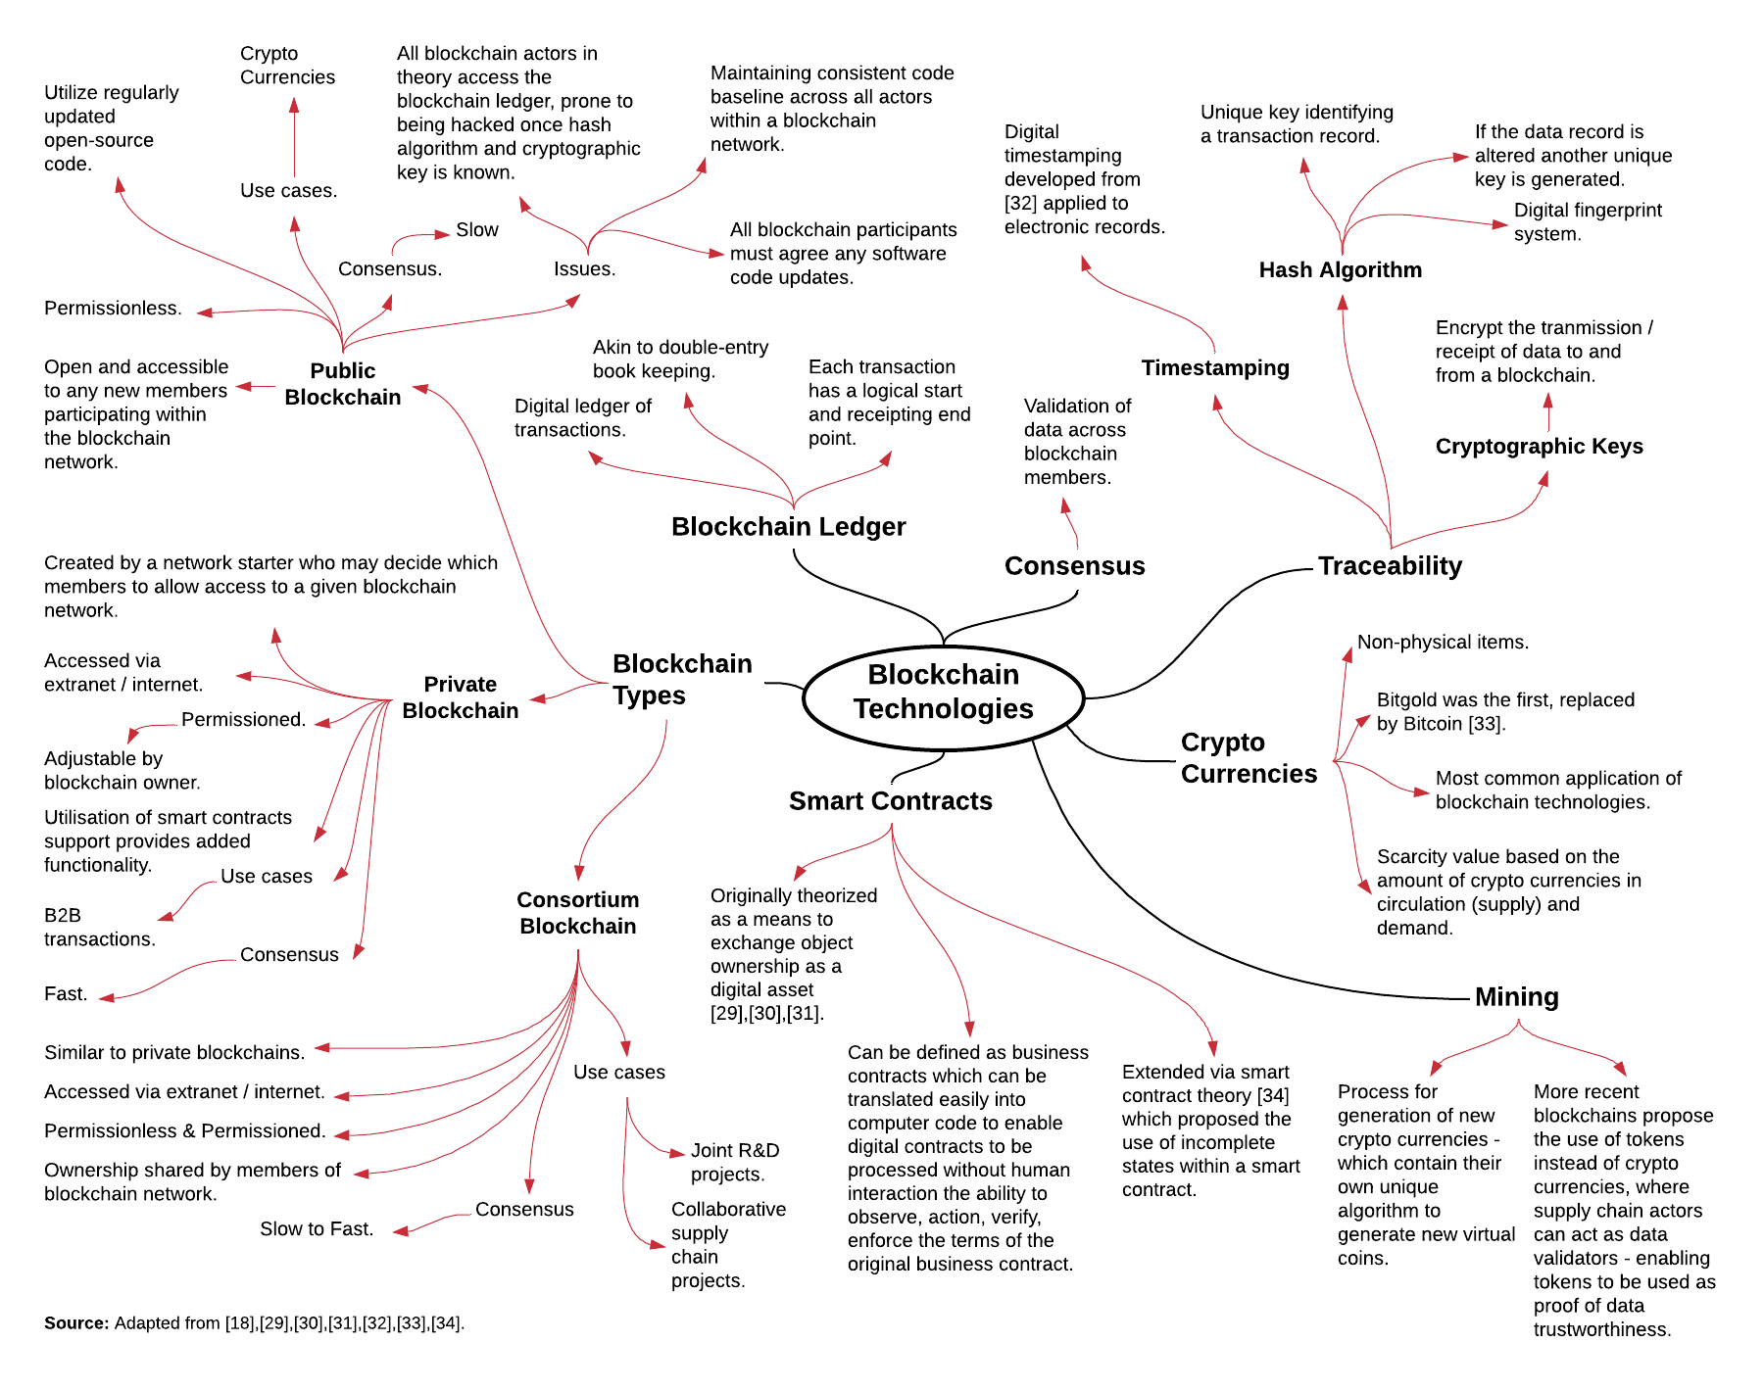
Figure 2 - Blockchain elements

Figure [3] presents a conceptual connectivity framework supporting digital transformation: (1) standard contractual terms which are invoked by a smart contract running against a blockchain; (2) the process of data block containing data and traceability elements (timestamping, encryption and hash algorithm) being transmitted to a blockchain, which is managed via a smart contract; (3) potential standards connectivity via a PAS outlining transactions and states from standards reporting converted into logical data block and smart contracts by the a given blockchain owner.

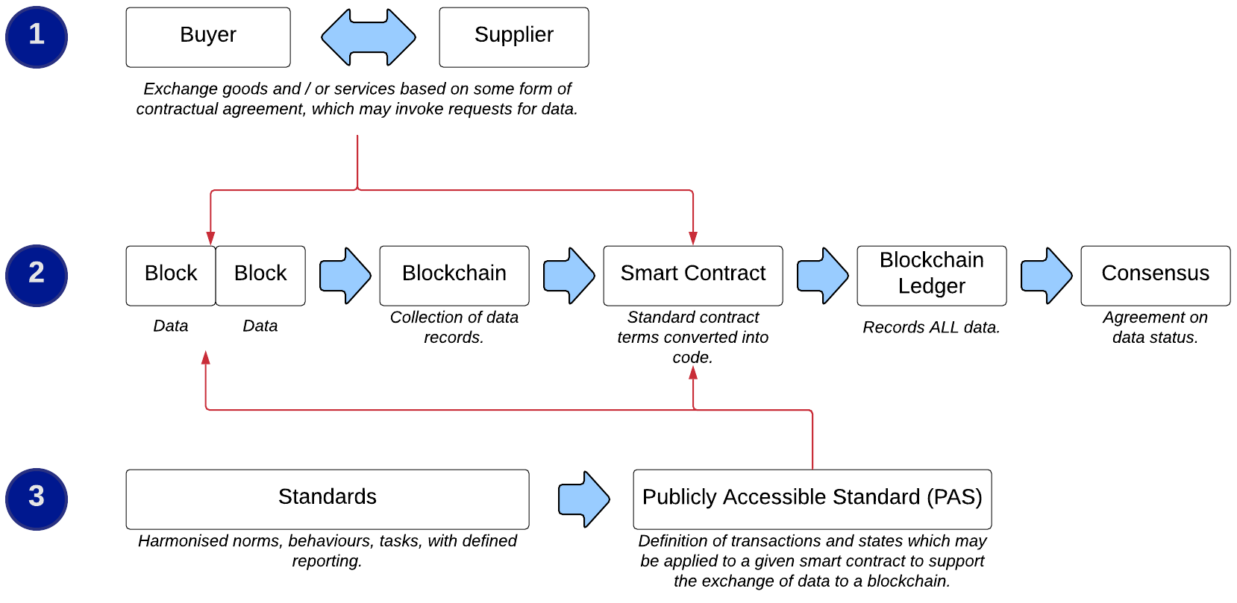
Figure 3: Conceptual connectivity framework

Discussion
The conceptual connectivity framework has been applied against IPC-2591, in terms of logical IPC-CFX messages [27] which could be translated into transactional data which could be managed in the form of logical smart contracts, as shown in Figure [4].
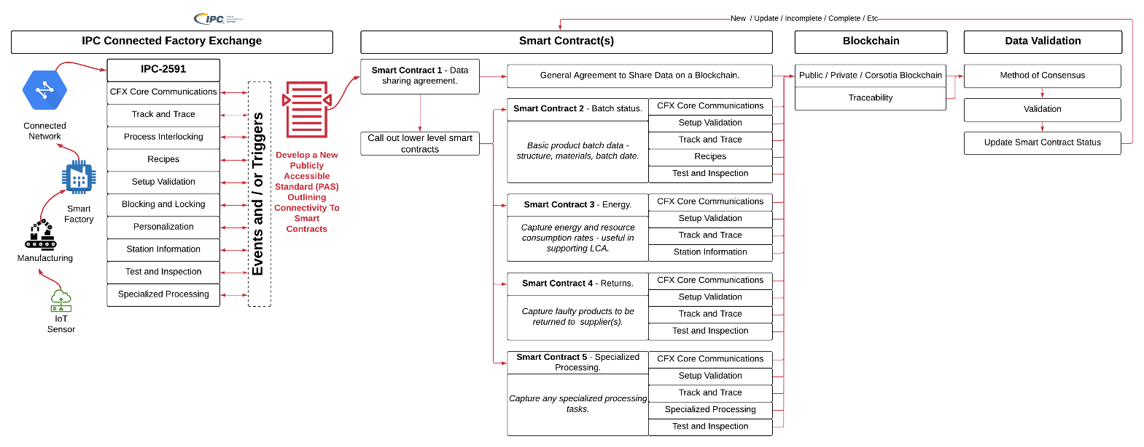
Figure 4: Conceptual IPC-2591 data collection and reporting to a blockchain

Whilst IPC-2591 provides a basis for automated intra-company data collection via utilisation of smart contract(s) to manage data collection and reporting in an automated manner, where data is transmitted, shared and updated based on how the blockchain type (public, private or consortia).
The prescribed logic for any given IPC standards committee would be to maintain the existing status quo within the standards development process. Where the PAS is considered a working document detailing potential transactions and messages from the standard, which may then be applied as discrete smart contracts managing discrete sets of data for a specific purpose. The PAS would provide the basis for a data dictionary to support blockchain owners, whom in turn, would be responsible for the design and maintenance of a given blockchain, including smart contracts and / or potential payment mechanisms.
Extending on from IPC-2591, the same logic may be extended to other IPC standards, such as the IPC-175x family as shown Figure [5]. The IPC-175x family of standards, through IPC-1751, provides the basis for potential data sharing agreement type smart contract, with the specific IPC-175x reporting defined as sub-smart contracts.
As specific supply chain reporting blockchains emerge, additional functionality within the blockchain, such as applications to upload both transactional messages and / or other documents may be addressed by the blockchain owners depending on funding models (free / fee based), enabling 3rd party solution providers to provide services to the blockchain, as well main whilst maintaining their existing status quo in the standards development process.
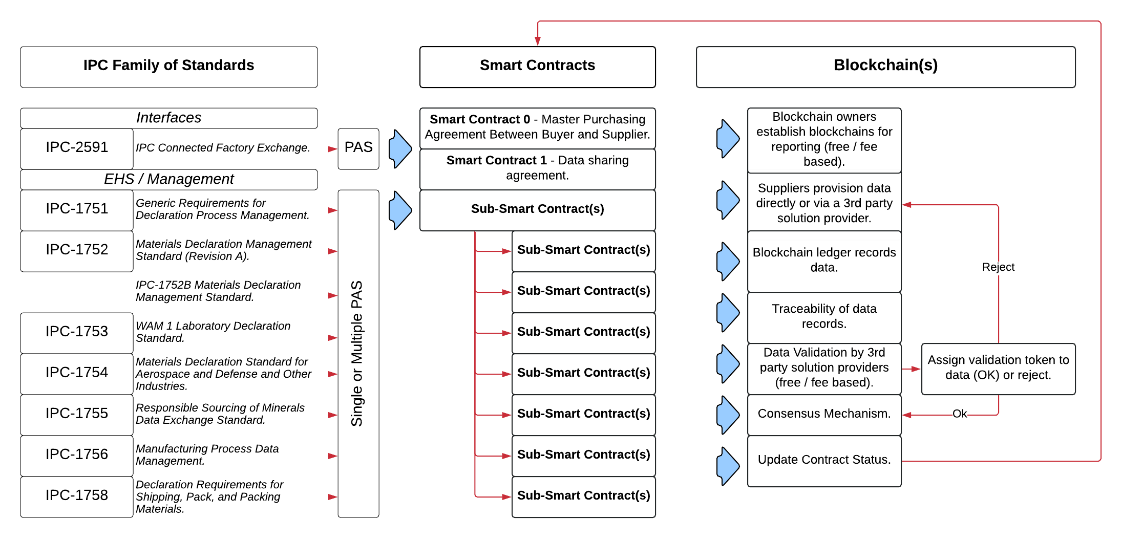
Figure 5: Extending blockchain connectivity across additional (example) IPC standards

Conclusions
Industry 4.0 covers a very broad range of interconnected devices exchanging real-time data communications, data collection and data analytics. Standards have emerged because of requirements placed on industry by regulations (product safety, hazardous chemical, sustainability, human slavery, etc.).
Standards provide for harmonised data collection and reporting, however the process of requesting and collecting the required data, may still entail an element of manual activity. As new reporting requirements emerge, some form of standard will emerge to support data collection and reporting needs.
The cryptocurrency phenomenon highlighted the potential usage of a blockchain, to record and trace changes to data records, in an automated computerized manner. Blockchains provide enhanced reporting functionality when used in conjunction with smart contracts.
IPC-2591 is a standard that supports automation of data reporting by establishing a communication interface with clearly defined protocols and transaction messaging between devices, machinery, manufacturing facilities and communication between several actors within the Electronics supply chain.
Whilst IPC-CFX reporting applications show the real-time status values for products in the manufacturing cycle, there is the strong potential for the IPC-2591 transactional messaging to be applied to different potential reporting states which were defined as the simple five smart contracts as shown in Figure [4] to record discrete data records.
In the future as products flow between suppliers to buyers, information requests may then be automatically invoked by the smart contracts, which could potentially monitor supplier performance and apply remedial actions via additional smart contract types such penalties as rejecting data types of financial penalties enforced for non-reporting. The proposed models presented in Figures [4] and [5] intentionally do not contain contractual payment obligations, these can be implemented either via a blockchain owner or invoked upon completion of a given smart contract.
Combining standards, PAS documents as a standard to smart contract definition, with the smart contracts managing the blockchains provides as basis for vastly enhanced digital transformation encompassing both the automation of data collation, ingestion, validation and reporting tasks, as well as providing an auditable chain of custody for the data captured, compared to existing approaches using a mixture of manual and semi-automated processing via internal / external systems and actors.
The findings from this paper should be forming a starting point from which: (1) PAS documents are created in the context of a given standard to identify transactions and potential status values which may be applied to a smart contract; (2) generation of smart contract coding language is further developed using established platforms such as Ethereum [35]; (3) development and testing of the smart contract code against a blockchain; (4) pilot testing with a limited number of users to test overall functionality.

Acknowledgements
A sincere thank you to the early researchers in the fields of cryptography, blockchains and smart contracts [29], [31], [31], [32], [33], as they effectively set out the blueprint for wider adoption of blockchains, which led to this research being undertaken.

References
[1] Smith, A., Cannan, E. (2003). The wealth of nations. New York, N.Y: Bantam Classic.
[2] Scott, B., (2016). How can cryptocurrency and blockchain technology Play a role in building social and solidarity finance?, United Nations Research Institute for Social Development, Working Paper 2016-1. Available from http://www.unrisd.org/brett-scott, accessed: 20th October 2021.
[3] Yongxin, L., Deschamps, F., Loures, E., Ramos, L.F.P., (2017). Past, Present and Future of Industry 4.0: a systematic literature review research agenda proposal. International Journal of Production Research,. 55(12), pp. 3609-3629.
[4] Hecklau, F., Galeitzke, M., Flachs, S., Kohl, H., (2016). Holistic approach for human resource management in Industry 4.0. 6th CIRP Conference on Learning Factories, 54, pp. 1-6.
[5] Hopper, T., Lassoud, P., Soobaroyen, T., (2017). Globalisation, accounting and developing countries. Critical Perspectives on Accounting, 43, March 2017, pp.125-148.
[6] McKinsey and Company, (2015). Industry 4.0: How to navigate digitization of the manufacturing sector. Available from: https://www.mckinsey.com/business-functions/operations/our-insights/industry-four-point-o-how-to-navigae-the-digitization-of-the-manufacturing-sector, accessed: 4th November 2021.
[7] Witkowski, K., (2017). The Internet of Things, Big Data, Industry 4.0 – Innovative Solutions in Logistics and Supply Chains Management. Procedia Engineering, 182, pp. 763-764.
[8] Zhong, R.Y., Xu, X., Klotz, E., Newman, S.T., (2017). Intelligent Manufacturing in the Context of Industry 4.0: A Review. Engineering, 3, pp. 616-630.
[9] Erol, S., Jäger, A., Hold, P., Ott, K., Sihn, W., (2016). Tangible industry 4.0: a scenario-based approach to learning for the future of production. 6th CIRP Conference on Learning Factories, 54, pp. 13-1.
[10] IPC-CFX, (2021). IPC-2591 Connected Factory Exchange (CFX). Available from: https://www.ipc.org/ipc-cfx, accessed: 15th October 2021.
[11] DIN, (2021). DIN Collection: Standards concerning Industry 4.0. Available from: https://www.din.de/en/innovation-and-research/industry-4-0/standards, accessed: 20th October 2021.
[12] Takhar, S, Liyanage, K. (2019). Understanding the Implications of Chemical Regulations, Circular Economy and Corporate Social Responsibility for Product Stewardship. 17th International Conference on Manufacturing Research (ICMR) 2019, Queens University (Belfast), DOI: https://doi.org/10.3233/ATDE190093
[13] Takhar, S, Liyanage, K. (2020). The impact of Industry 4.0 on sustainability and the circular economy reporting requirements. International Journal of Integrated Supply Management, 13(2-3), DOI: https://doi.org/10.1504/IJISM.2020.107845.
[14] Takhar, S, Liyanage, K. (2018). Blockchain Application in Supply Chain Chemical Substance Reporting, 22nd Cambridge International Management Symposium (CIMS) 2018, University of Cambridge, DOI: https://doi.org/10.17863/CAM.31724.
[15] Tranfield, D., Denyer, D., Smart, P., (2003). Towards a methodology for developing evidence-informed management knowledge by means of systematic review. British Journal of Management. 14(3), pp. 207–222.
[16] Kable, A.K., Pich, J., Maslin-Prothero, S.E., (2012). A structured approach to documenting a search strategy for publication: a 12 step guideline for authors. Nursing Education Today, 32(8), pp. 878-886.
[17] Takhar, S, Liyanage, K. (2021a). Transforming product labels using digital technologies to enable enhanced traceability and management of hazardous chemicals. International Journal of Supply Chain and Operations Resilience, 5(1), DOI: https://doi.org/10.1504/IJSCOR.2021.115550.
[18] Takhar, S, Liyanage, K. (2021b). Blockchain application in supply chain chemical substance reporting - a Delphi study. International Journal of Internet Technology and Secured Transactions, 11(1), DOI: https://doi.org/10.1504/IJITST.2021.112871.
[19] Kagermann, H., Lukas, W-D., Wahlster, W., (2011). Industry 4.0: With the Internet of Things on the way to the 4th industrial revolution. Available from: https://web.archive.org/web/20130304101009/http://www.vdi-nachrichten.com/artikel/Industrie-4-0-Mit-dem-Internet-der-Dinge-auf-dem-Weg-zur-4-industriellen-Revolution/52570/1, accessed: 20th November 2021.
[20] Zanella, A., Bui, N., Castellani, A., Vangelista, L., Zorzi, M., (2014). Internet of Things for smart cities. IEEE Internet Things 2014, 1(1), pp. 22–32.
[21] Xu, L., He, W., Li, S., (2014). IoT in industries: a survey. IEEE Transactions on Industrial Informatics, 10(4), pp. 2233–2243.
[22] Davies, J., Edgar, T., Porter, J., Bernaden, J., Sarli, M., (2012). Smart manufacturing, manufacturing intelligence and demand-dynamic performance, Computers and Chemical Engineering, 47, pp. 145-156.
[23] Lee, J., Bagheri, B., Kao, H.A., (2015). A cyber-physical systems architecture for Industry 4.0 based manufacturing systems. Manufacturing Letters, 3, pp. 18-23.
[24] Wang, L., Törngren, M., Onori, M., (2015). Current status and advancement of cyber-physical systems in manufacturing. Journal of Manufacturing Systems, 37(2), pp. 517-527.
[25] Wikipedia, (2021). Technical Standards. Available from: https://en.wikipedia.org/wiki/Technical_standard, accessed: 27th November 2021.
[26] IPC, (2021a). IPC Standards Related Resources. Available from: https://www.ipc.org/ipc-standards-related-resources, accessed: 27th November 2021.
[27] IPC, (2021b). IPC CFX. Available from: https://www.ipc.org/ipc-cfx, accessed 28th October 2021.
[28] IPC, (2021c). IPC-CFX-2591 Qualified Products List (QPL). Available from: https://www.ipc.org/ipc-cfx-2591-qualified-products-list-qpl accessed: 28th October 2021.
[29] Szabo, N., (1994). Smart contracts. Available from: http://www.fon.hum.uva.nl/rob/Courses/InformationInSpeech/CDROM/Literature/LOTwinterschool2006/szabo.best.vwh.net/smart.contracts.html, accessed: 15th October 2021.
[30] Szabo, N., (1996). Smart contracts: building blocks for digital markets. Available from: http://www.fon.hum.uva.nl/rob/Courses/InformationInSpeech/CDROM/Literature/LOTwinterschool2006/szabo.best.vwh.net/smart_contracts_2.html, accessed: 15th October 2021.
[31] Szabo, N., (1997). Formalizing and securing relationships on public networks. Available from: http://firstmonday.org/ojs/index.php/fm/article/view/548/469-publisher=First, accessed: 15th October 2021.
[32] Haber, S., Stronetta, W.C., (1991). How to time-stamp a digital document. Journal of Cryptology, 3(2), pp. 99-111.
[33] Nakamoto, S., (2008). Bitcoin: a peer-to-peer electronic cash system. Available from: https://bitcoin.org/bitcoin.pdf, accessed: 5th November 2021.
[34] Hart, O., Holmström, B., (2016). The Royal Swedish Academy of Sciences, (2016), “The prize in economic science 2016: contract theory by Oliver Hart and Bengt Holmström. Available from: https://www.nobelprize.org/nobel_prizes/economic-sciences/laureates/2016/popular-economicsciences2016.pdf, accessed: 5th November 2021.
[35] Ethereum, (2021). Introduction to smart contracts. Available from: https://ethereum.org/en/developers/docs/smart-contracts/, accessed: 20th November 2021.

