**Credit Supply Conditions and Business Cycles: New Evidence from Bank Lending Survey Data**

Nicholas Apergis1, [1]*, Ioannis Chatziantoniou2

1*University of Derby, United Kingdom,* [*n.apergis@derby.ac.uk*](mailto:n.apergis@derby.ac.uk)

2*University of Portsmouth, Economics and Finance Subject Group, Portsmouth Business School, United Kingdom,* [*ioannis.chatziantoniou@port.ac.uk*](mailto:ioannis.chatziantoniou@port.ac.uk)

**Credit Supply Conditions and Business Cycles: New Evidence from Bank Lending Survey Data**

**Abstract**

In this study, we utilize an Autoregressive Distributed Lag (ARDL) model in order to investigate the impact of changing lending standards on aggregate economic activity, considering the period 2000-2017 and five major economies, that is, Canada, Germany, Japan, the UK, and the US. We capture lending conditions using bank lending survey data that help extract the credit-supply side of the shock and, thus, direct the focus onto loan supply-factors. The main findings document that shocks associated with changes in lending standards play a substantial role in determining changes in real economic activity within each country. It should also be noted that these results remain robust even when we consider a structural break in our data and investigate these effects separately for the period immediately after the outbreak of the Global Financial Crisis of 2007-09. Overall, the findings suggest that bank lending survey data provide important informational content and deepen our understanding regarding changes in real economic activity. On a final note, we provide further insights regarding the relationship of both price and non-price elements of bank lending, particularly considering the risk-taking channel of monetary policy.

**Keywords**: Lending conditions; Bank lending surveys; Business cycles; ARDL model

**JEL: C32, E32, E5, F44**

**1. Introduction**

The Global Financial Crisis (GFC) of 2007-09 is a striking example of how quickly volatility in financial markets can lead to severe macroeconomic crises. In the aftermath of the GFC 2007-09, the development of macroprudential policies that prevent the build-up of financial imbalances received urgent attention by researchers and decision makers around the world. Strengthening the banking sector and mitigating procyclicality in the financial system became an important priority, while at the same time, particular interest was vested in the interconnection between credit conditions, financial stability, as well as, macroeconomic performance. Within this framework, investigating credit supply and demand conditions in the banking sector becomes a rather crucial topic that deserves further investigation.

To be more explicit, authors, such as Jensen et al. (2018), emphasize that, in recent years, global capital markets have been markedly deregulated bringing about considerable upsurges in loan-to-value ratios for both firms and households. The deregulation of capital markets can, therefore, significantly affect business cycles, leading to output variations. The link between real economic activity and corporate debt has also been stressed in the work of Graham et al. (2014) who further highlight that the dramatic increase in US corporate debt in the past century is not so much a consequence of changing firm-characteristics, as it is a result of changing conditions in the financial sector. At the same time, periods of weak economic growth could be attributed to periods when bank lending is relatively poor (see, *inter alia*, Bijsterbosch and Falagiarda, 2015). It follows that, the underlying credit standards adopted each time by financial intermediaries play an important role in this framework of analysis as they determine access to credit and hence, aggregate economic activity.

In relation to the above, investigating the bank lending channel of monetary policy, whereby changes in credit standards affect both the level of credit supply of financial institutions and the borrowing capacity of households and firms (see, *inter alia*, Ciccarelli et al., 2015), becomes equally relevant. The particular mechanisms through which credit availability affects real economic activity have been extensively investigated in existing literature (see, *inter alia*, Bernanke and Blinder, 1992; Bernanke and Gertler, 1995; Mishkin, 1996). More particularly, relevant literature not only underscores the role of credit availability as an integral part of the implementation of an effective monetary policy (Bernanke and Gertler, 1995; Kashyap and Stein, 2000; Boivin et al., 2010; Mora, 2014; among others), but also maintains that credit itself might very well affect conditions in the real economy (Blinder and Stiglitz, 1983). At the same time, credit availability is characterized by the presence of asymmetric information, which is conducive to rationing conditions (Stiglitz and Weiss, 1981).

In this study we concentrate on credit supply conditions deriving from Bank Lending Surveys (BLS) in order to investigate the effect of changing credit standards on the business cycle. According to authors such as Anastasiou and Drakos (2019), the investigation of bank lending conditions can be facilitated by methods that rely on “soft” data collection, such as Bank Lending Surveys (BLS) that practically make use of bank loan officers’ responses relating both to past experience and future expectations in connection with the standards of credit. Besides, Ciccarelli et al. (2015) argue that BLS provides a reliable way of collecting information on lending conditions in order to shed additional light on the effect of the credit channel of monetary policy on aggregate economic activity. Given the importance of availability of credit for output within a given country, BLS indicators that predicate upon the relevant surveys that investigate credit conditions, could potentially lead innovations in other important economic indicators, thus, providing useful information regarding output growth (ECB, 2016).

Despite the importance of BLS data for the investigation of the effects of changing credit conditions on real economic activity, the current literature is rather scarce. Indicatively, we quote the recent studies by de Bond et al. (2010), Del Giovane et al. (2011), and Ciccarelli et al. (2015). On general principles, the results in all aforementioned studies show that a tightening of lending standards leads to a deterioration in GDP growth.

With these in mind, the overriding objective of this paper is to empirically investigate the association between changes in lending standards and business cycles for certain developed economies. In particular, we make use of very recent BLS data, spanning the period 2000-2017, for Canada, Germany, Japan, the UK and the US. In this regard, we add to existing literature in connection with the investigation of the impact of lending standards on aggregate economic performance, that is, an area which is rather under-researched. A further contribution is that the analysis is carried out considering both the full sample and two distinct periods, i.e. the period before and after the GFC. In this regard, given that our study considers both price (e.g., policy rates) and non-price (i.e., BLS-related) elements of bank lending, we also contribute to the ongoing discussion regarding the bank risk-taking channel of monetary policy.

In order to successfully accomplish the aim of this study, the analysis makes use of the Autoregressive Distributed Lag (ARDL) method. Main findings show that lending standards have a dominant role in the determination of real business cycles, while results remain consistent across different time-horizons and countries. Notably, loan standards gain additional prominence in explaining changes in real GDP following the GFC. It follows that we provide evidence that loan (credit) surveys contain significant information about the evolution of real business cycles. On a parallel note, we put forward the argument that tighter non-price lending standards act as a counterweight in a period of lower interest rates, thus, helping to offset a potential rise of the risk-taking channel of monetary policy.

The remainder of the study is organized as follows. In Section 2 we provide a succinct summary of the existing relevant literature. Then, in Section 3 we describe the data and the adopted methods. In turn, results are presented in Section 4, along with discussion. Finally, Section 5 concludes the study.

**2. Literature Review**

*2.1 Credit Availability and Business Cycles.*

It should be noted that the relevant literature can be classified into four distinct strands. The first strand consists of seminal studies that concentrate on the link between the effectiveness of monetary policy and the availability of credit (see, *inter alia*, Blanchard and Fischer, 1989; Fuerst, 1994). This first strand of the literature highlights the role of credit rationing in shaping credit availability. In particular, Blanchard and Fischer (1989) identify two types of credit rationing; that is, one related to individuals who are unable to borrow even if they are willing to pay higher interest rates and another, which implies that indistinguishable borrowers are being treated differently in credit markets. Fuerst (1994) maintains that credit rationing, together with monetary policy decision making, play a key role in the determination of credit availability per se.

The second strand focuses on lending standards. Notably, Schreft and Owens (1991) point out that as the cost of credit availability escalates, banks tend to tighten the non-price terms of their loans first (e.g., collateral, total available amount, maturity), implying that interest rate appreciations only tend to follow. Furthermore, Bernanke and Blinder (1992) document that cutting back on credit availability induces banks to sell off securities in the short-run, which subsequently affects the level of interest rates, while Lown et al. (2000) provide evidence that tightening credit availability by 1% reduces both commercial and industrial loans by 2.5%. Along a similar vein, Lown and Morgan (2006) illustrate that a tightening of the Fed’s credit availability leads to an 8% tightening of lending standards, while output declines by 0.5% at its trough. What is more, Swiston (2008) reports that tighter lending standards have a negative impact on economic activity, even after accounting for forward-looking financial market information; that is, high-yield bond spreads. Finally, Guichard and Turner (2008) report similar results for the US.

Another, closely related, strand investigates the impact of credit shocks across real sectors of different economies. According to Duttegupta and Barrera (2010), US credit shocks largely affect the Canadian economy. On a parallel note, considering also the unequivocally close association of the Euro area economies, Cappiello et al. (2010) provide empirical evidence for the presence of a bank lending channel in the Euro area. To be more explicit, they show that changes in the supply of credit have significant effects on real economic activity, thus, highlighting the importance of monitoring credit developments as a tool for monetary policy and justifying the high priority of both monetary and credit analysis in the strategy of the European Central Bank (ECB). Cappiello et al. (2010) further stress the potential negative repercussions on real economic growth due to bank balance sheet impairments. The latter, emerged as a consequence of the Global Financial Crisis of 2007-09, whereupon, banks were required to deliver their balance sheets and possibly to reduce their loan supply.

Finally, from a theoretical modelling point of view, we could identify two main frameworks that explore the effectiveness of loan loss provision regulatory regimes. The first one, by Bouvatier and Lepetit (2012), presents an analytical partial equilibrium model with monopolistic banking. These authors document that statistical provisions, defined through accounting rules to cover for expected losses, can eliminate or, at least, mitigate, procyclicality in lending standards induced primarily by specific provisions. The second, provided by Agenor and Zilberman (2013), presents a standard medium-scale calibrated Dynamic Stochastic General Equilibrium (DSGE) model. Agenor and Zilberman (2013) illustrate that forward looking provisioning systems could mitigate both financial and real sector volatility, especially when implemented in tandem with a credit-gap augmented monetary policy rule.

*2.2 Bank Lending Surveys and Credit Supply Conditions.*

Within the framework of macroprudential policy, investigating the impact of changing lending standards on business cycles through the level of borrowing, although very topical, is a rather under-researched topic (see, van der Veer and Hoeberichts, 2016). Considering the impact of low levels of bank lending on the real economy and also that low levels of borrowing are more likely the result of credit supply conditions rather than the result of insufficient demand, decomposing bank lending shocks into supply-side and demand-side shocks, seems to be rather crucial. Bijsterbosch and Falagiarda (2015) explain that authors so far have employed two approaches in order to address the identification of credit supply issue; that is, (i) models that impose sign restrictions and (ii) models that make use of bank lending surveys. The latter, facilitate the requisite distinction by incorporating questions that refer directly to the changes in the lending standards adopted by the banking sector.

In this regard, studies that apply BLS indices to investigate the impact of changing credit supply conditions include authors such as de Bond et al. (2010), Del Giovane et al. (2011) and Ciccarelli et al. (2015) who provide evidence that tighter lending conditions have a negative impact on output. Furthermore, Bijsterbosch and Falagiarda (2015) adopt both sign restrictions and a BLS index approach for a set of European countries and provide evidence of (i) supply credit tightening during the period of the GFG 2007-09 and (ii) more relaxed credit supply conditions in the period 2012 – 2013. Finally, van der Veer and Hoeberichts (2016) utilizing BLS data for the Netherlands, show that tighter lending conditions reduce business lending, although they report no asymmetry between the pre- and the post-GFC 2007-09 period. It would be instructive at this point to note that our study predicates upon, and also supplements studies such as Duttagupta and Barrera (2009) - who focus on the US and Canada, and van der Veer and Hoeberichts (2016) - who focus on the Netherlands. More particularly, the structure of our empirical approach draws from the work of Duttagupta and Barrera (2009) who do however focus more closely on the interaction across the two countries; while, van der Veer and Hoeberichts (2016) also highlight the severity of changing lending standards for the economy although these authors primarily focus on the effect of a tightening of lending standards on business lending.

***2.3 Empirical Framework and the Underlying Hypotheses of the Study.***

Based on the aforementioned analysis, the framework of our study can be described as follows: We focus on the empirical investigation of the link between changes in credit standards and business cycles, considering both price and non-price terms and focusing on a set of developed economies. Considering the international character of the banking and financial sector, the underlying hypothesis is that the impact from changes in lending standards on economic performance in the countries under investigation should be relatively similar. In other words, we expect developed economies to be closely linked and as such to exhibit no considerable differences when it comes to responding to changing lending standards. Clearly, the choice of countries to be included in this study is mainly driven by the availability of BLS data and the corresponding similarities of the relevant surveys.

Furthermore, we distinguish between two time intervals in order to capture the period before and the period following the onset of the GFC 2007-09. The underlying hypothesis in this case is that changing (non-price) lending standards should have a more prominent role to play when it comes to real GDP growth within the countries of interest. To be more explicit, considering that in the light of the GFC 2007-09, interest rates plunged to very low levels for a rather prolonged period, it is the non-price elements of lending that should have a more pronounced impact on the business cycle. In effect, we would like to investigate the hypothesis that in all countries of interest, a tightening of lending standards leads to a deterioration in GDP growth and that this deterioration is more pronounced in recent years. This line of investigation is also very important with regard to the risk-taking channel of monetary policy. If lower interest rates facilitate a process whereby financial institutions assume higher levels of unnecessary risk then tighter non-price lending standards would indeed have a role in mitigating this issue.

With regard to the choice of variables, the fact that this study considers effects on business cycles, essentially implies that we have to consider both macroeconomic and financial variables. Drawing from the work of Duttagupta and Barrera (2009) we formulate a structure which considers a broad set of variables, both exogenous and endogenous. More particularly, we utilize one exogenous variable (i.e., international commodity prices approximated by the price of oil) as well as, a set of endogenous variables including lending standards, the policy rate, the GDP deflator, the term spread, as well as, the real GDP. Subsequently, our assumption regarding the interrelations across these variables is that innovations in the price of oil will feed into lending standards and policy rate decisions which in turn, affect GDP growth through market interest rates. Note that in line with Duttagupta and Barrera (2009) we also assume that market interest rates are contemporaneously affected both by lending standards and by the policy rate.

In retrospect, our study adds to this particular strand of the literature by considering recent BLS data for a set of major economies, thus providing new evidence on the link between credit conditions and aggregate economic activity.

**3. Data and methodology**

*3.1 The Bank Lending Survey (BLS) Index.*

The empirical analysis considers a number of countries in which surveys of bank officials from a number of banks have responded to the following question (the question below constitutes the summary of what the central banks ask within the surveys, since these surveys are very well comparable to each other, but they are not identical):

‘Over the past three months, how have your bank’s credit standards for approving applications for commercial and industrial loans or credit lines changed?’ Responses are classified as: 1 = tightened considerably, 2 = tightened somewhat, 3 = remained basically unchanged, 4 = eased somewhat, and, 5 = eased considerably. An increase of the respective index indicates easiness in credit standards and vice versa.

Such surveys are a valuable source of information of why banks change their lending standards as a response to various factors, such as macroeconomic factors, bank-specific factors and/or borrower-specific factors. Based on the availability of such surveys, the countries included in our sample are the U.S. (Senior Loan Officer Opinion Survey-data come from the Federal Reserve Board, spanning the period 2000q1-2017q4, 150 participating banks), Canada (Senior Loan Officer Survey-data come from the Central bank of Canada, spanning the period 2000q1-2017q4, 45 participating banks), UK (Credit Conditions Survey-data come from the Bank of England, spanning the period 2007q2-2017q4, 22 participating banks), Japan (Senior Loan Officer Opinion Survey on Bank Lending Practices at Large Japanese Banks-data come from the Bank of Japan, spanning the period 2001q1-2017q4, 48 participating banks), and Germany (Bank Lending Survey for Germany-data come from Deutsche Bundesbank, spanning the period 2002:q4-2017q4, 34 participating banks). The index represents a diffusion index of tighter or easier lending conditions compared to the previous period. Following Bassett et al. (2014), the index is calculated as ΔSit = ISit where:

-1 if bank i reported easing standards on loans in quarter t

ISit = 0 if bank i reported no change in standards on loans in quarter t

1. if bank i reported tightening standards on loans in quarter t

The index takes continuous values between -1 and 1, while its interpretation relates to the value of the extended loans that appear on bank i’s balance sheet for which the bank reported changing lending standards over the survey period.

*3.2 Impact of supply credit on business cycles.*

In addition, we collect quarterly data, spanning the period 2000-2017, from Bloomberg on policy rates (the fund rate for the US, the overnight rate for Canada, the bank rate for the UK, the 3-month interest rate for Japan, and the Main Refinancing Operation rate for Germany), real GDP growth (calculated via a chain-linked volume approach in order to afford comparisons of the dynamics of economic growth both over time and across economies of various dimensions), GDP deflator, oil prices (proxied by Brent crude prices per barrel), and the term spread (measured as the difference between the 3-month commercial paper bills and the 10-year Treasury notes).

Next, we account for stationarity by employing the Elliot et al. (1996) DF-GLS test. With the exception of the term spread and real GDP, the remaining variables are integrated of order one. This result is consistent across all five countries in our sample. It follows that we further process the integrated variables by considering the first difference functional form. Both descriptive statistics and stationarity results are provided in Table 1.

**[Insert Table 1 around here]**

In turn, we apply the Autoregressive Distributed Lag (ARDL) bounds test method, developed by Pesaran et al. (2001), which determines the cointegration between the variables under investigation. The Akaike Information Criterion (AIC) determines the number of lags specified in the modelling equations. The main advantage of ARDL modelling lies in its flexibility when the variables are of different order of integration, which is our case here (Pesaran and Pesaran, 1997).

Moreover, a dynamic error correction model (ECM) can be derived from ARDL through a simple linear transformation (Banerjee et al., 1993). The ECM integrates the short-run dynamics with the long-run equilibrium without losing long-run information. The ARDL bounds test method makes use of F-statistics, as well as Wald tests to explore whether the null hypothesis of no cointegration is accepted. The estimated F-statistic is compared with two sets of critical values of the upper- and lower-bounds. If the F-statistic is higher than the upper- and lower-bound critical values, then the null hypothesis of no cointegration is rejected, otherwise no evidence is present. By contrast, if the F statistic is lower that the critical values, then the null hypothesis is accepted.

Under the presence of a long-run association between economic growth and the set of the five variables considered, the analysis can also investigate Granger causality which can identify the direction of causality between these two variables. In addition, the Error Correction (EC) version of the model we can really detect both short- and long-run Granger causality across the variables under study.

On a final note, we include the recommended variables by Woodford (2003), Bayoumi and Melander (2008), Wheelock and Wohar (2009), Cappiello et al. (2010), Duttagupta and Barrera (2010), Gertler and Kiyotaki (2010), Borio (2011), Katircioglu et al. (2015), while the vector yt contains (in an order also following Duttagupta and Barrera, 2010): real GDP, the GDP deflator, commodity prices (i.e., approximated by oil prices), the policy rate, the credit standards survey indicator, and the term spread. The decision about how many lags to be included depends upon the model selection criterion, that is determined by minimizing the Schwartz Bayesian Information Criterion (BIC) and/or the Akaike Information Criterion (AIC) with lags being dropped until the last lag is statistically significant.

**4. Empirical Analysis**

*4.1 Investigating the effects of lending standards on real economic activity.*

The fundamental shocks in the model are originated from the GDP deflator, commodity (oil) prices, the policy rate, the credit standards survey indicator, and the term spread. Table 2 reports the estimated F-statistics values for the model under consideration. The second row represents the optimal lag length, which is selected via the Akaike criterion. The findings provide evidence for the presence of cointegration and a long-run relationship across the variables under study. In particular, the estimated F-statistic value turns out to be 8.59, which is above the upper bound critical values provided by Pesaran et al. (2001) at 1%. Finally, the diagnostics reported clearly indicate the statistical acceptance of the model in terms of serial correlation, heteroskedasticity, normality and Ramsey’s model-adequacy.

**[Insert Table 2 about here]**

Based on the cointegration results from Table 2, variance decompositions of GDP growth to the structural shocks are generated. Table 3 reports the results of variance decompositions in four-time horizons, e.g. 1, 4, 12 and 20 quarters. In particular, these findings clearly illustrate the dominance of the credit surveys in explaining a substantial portion of the variance of real GDP, with the results remaining consistent across both short- and long-term horizons, as well as across all countries under study. In addition, the role of those credit surveys seems to be the largest in the cases of the US and Canada. It is also worth noting that monetary policy, as reflected by the policy rates, does have a substantial effect on real GDP, with this finding remaining robust across countries.

**[Insert Table 3 around here]**

Impulse response functions measure the effect of a one-standard-deviation innovation of the variables considered on GDP. This part of the empirical analysis constructs impulse response functions that examine the causal relationships between GDP and the eight variables under study. Figures 1 to 5 present cumulated impulse response functions of one-standard-deviation innovations for 20 quarters ahead for the cases of the US, Canada, the UK, Japan and Germany, respectively. In addition, standard-error bands of two standard deviations, representing the statistical significance of the responses, are also shown. The impulse response functions indicate that a shock to domestic prices, the policy rate, oil prices, and the term spread at various stages of processing are negatively transmitted forward to GDP. By contrast, a shock to loan standards causes an increase in the country’s GDP. To put differently, easing the credit supply has a positive impact on GDP. What is more, these findings remain consistently similar across all five country cases during the period under investigation.

**[Insert Figures 1 through 5 around here]**

*4.2 Causality tests*

The causality tests were performed under the error correction model. Three types of causalities are applied: i) short-run causality, i.e. the Wald test is applied across all independent variables using the joint F test, ii) long-run causality, i.e. investigated by verifying the significance of the loading factors in relevance to the error correction terms, which implies the convergence of the system back to its long-run equilibrium position, and iii) joint (short- and long-run) causality, i.e. the Wald test is applied to both the lagged independent variables and the error correction term using the joint F test. Table 4 reports the results from the causality tests. Focusing on the primary target of this work, they clearly document the presence of short-run bivariate causality between lending conditions and economic growth. These findings remain robust across all five economies under consideration. When it comes to long-run causality, the findings cannot be directly based on the EC coefficient, but on the loading factors test. In particular, consider the following 6-variable ECVAR model:

*yt = A(L) yt-s-1 + Πp yt-s + εt,*

where y = [real GDP, inflation, oil prices, policy rate, term spread, lending conditions]’

and A(L) is a 6×6 polynomial matrix in the lag operator of order s, with Π = τ ψ’ where τ and ψ are 6×1 matrices of loading factors and cointegrating coefficients, respectively. Finally, ε = [ε1, ε2, ε3, ε4, ε5, ε6]’ is a 6×1 vector of white noise errors with properties:

E(εt) = 0 and E(εt, εt-s) = Σ when t = s, and zero otherwise, with Σ denoting the variance-covariance matrix of residuals. The restrictions related to the (long-run) causality tests are examined by testing the restriction that the loading factor (in each equation) is statistically different from zero. These long-run causality tests, also reported in Table 4, illustrate the likelihood ratio (LR) restriction tests that the loading factors are zero, which are expected to shed light on the long-run causal relationships under investigation.

**[Insert Table 4 around here]**

Once again, focusing on our target variable, we can see the presence of a bivariate (long-run) causality between real GDP and lending conditions. Finally, in terms of the joint F-tests, also reported in Table 4, the findings also confirm the bidirectional causality between the variables of interest.

*4.3 The role of the Global Financial Crisis*

The above set of empirical findings confirms the significant role of loan standards in determining real business cycles. In other words, the analysis has provided strong evidence that loan (credit) surveys contain significant information in explaining real business cycles. In order to test the robustness of these results, we also consider the specific role of the Global Financial Crisis (GFC) of 2007-09. In particular, it has been accepted in the literature that this financial crisis severely weakened the majority of the banking industry (Abiad et al., 2009; Albertazzi and Marchetti, 2010). On a global scale, the crisis affected all the large banking systems, although the impact varied because of different starting cyclical conditions and structural vulnerabilities. While banks in the Euro area, the UK and the US suffered large losses at the height of the crisis, those in Canada fared better and needed less government capital support. However, a stronger banking sector has resumed the supply of intermediation services to the real economy in the majority of economies, albeit with some changes in the balance of activities (Claessens and Van Horen, 2014).

In the crisis event, the number of bank failures skyrocketed, while bank stocks plummeted. In response to both the great economic recession and the dire conditions of the banking industry, banks tightened their lending terms and standards to unprecedented levels. The tightening in bank lending delayed the economic recovery. There are relatively a few studies quantifying the extent of bank tightening in loan rates or explaining how and why banks tightened their credit. In particular, Jiangli et al. (2008) study whether lending relationships benefit firms by making credit more available during periods of financial stress during the Asian financial crisis. They find that such relationships have had positive effects on credit availability for Korean and Thai firms, but not for Indonesian and Philippine ones. In this part of the empirical analysis, we repeat the baseline research to explore how the lending standards impact the business cycle prior and after the financial crisis.

The papers that are more closely related to this robustness part of our study include Murfin (2012) and Chava and Purnanandam (2009). More specifically, Murfin (2012) studies the supply-side effects on loan covenants and finds evidence that banks write tighter loan contracts after suffering defaults to their own portfolios, even when defaulting borrowers were in different industries and geographic regions than current borrowers. Chava and Purnanandam (2009) find that banks with exposure to the 1998 Russian default subsequently cut back on lending. More extensively, Bernanke and Gertler (1995) and Paravisini (2008) study various shocks to lenders on credit availability in the economy.

In turn, Table 5 presents the variance decompositions findings prior and after the 2008 financial crisis event, while focusing on the lending standards variable. The findings clearly indicate the more significant role of the changes in lending standards in business cycles after the crisis event. More specifically, these findings clearly indicate that after the financial crisis, banks became more selective in lending to customers, probably by forcing banks to retain larger portions of loans, which weakened the bank lending mechanism and the effect of credit on business cycles. These results are in accordance with those provided by Ivashina and Scharfstein (2008), Gambacorta and Marques (2011), as well as Borio and Gambacorta (2017) who point out that the bank lending channel changed a great deal after the financial crisis episode and how monetary policy turns out to be less effective in a financial crisis, usually through the change in the lending behavior set by banks.

More importantly, the findings of the study closely relate to the ongoing discussion regarding the impact of monetary policy decision-making on bank risk-taking. In particular, on the premise that lower interest rates could help promote economic growth (especially in the aftermath of the GFC), a bank risk-taking channel of monetary policy is in effect when these low interest rates result in banks assuming higher levels of risk – thereby, undermining the economy instead of fostering its recovery (see, *inter alia*, Borio and Zhu, 2012; Dell’ Ariccia et al., 2016; Delis et al., 2017). In this regard, results presented in Table 3 are indicative of the fact that in the period that followed the GFC, tighter lending criteria (i.e., credit supply) were rather crucial in determining the business cycle, implying that the low interest rates of that period did not give rise to the risk-taking channel of the monetary policy. This finding resonates with Delis et al. (2017) who in their study of the US market for corporate loans cast doubt on whether the risk-taking channel of monetary policy was actually in effect in the years that followed the GFC.

**[Insert Table 5 around here]**

Finally, given the subjective nature of the data, along with the treatment of the Likert scale, raises the necessity of specific robustness tests (a point raised by a referee of this journal). In particular, the analysis considers running the same tests, but this time including objective data, such as the level of collateral required, bank specific interest rates on new loans, and non-interest rate charges, to test the model effectively. To this end, these objective conditions and terms capture non-price loan supply-related factors. Data on collateral requirements, measured as the percentage of loans that are collateralized, on short-term interest rates on new loans, measured as a weighted average of short-term rates on mortgage, consumer and business rates, with the weights being the contribution of each loan category to total loans, and on non-interest rate charges, measured as non-interest income fees (fees and commission income – fees and commission expenses) to total assets, are obtained from the Orbis database.

Table 6 reports again the F-statistics for the extended model with the objective bank data. The new findings clearly illustrate the presence of cointegration and a long-run relationship across the (new) variables under study. All estimated F-statistics (when each objective bank data is inserted at a time) turn out to be above the upper bound critical values provided by Pesaran et al. (2001) at 1%. Once again, the reported diagnostics document the statistical acceptance of the model in terms of serial correlation, heteroskedasticity, normality and Ramsey’s model-adequacy.

**[Insert Table 6 about here]**

Based on the cointegration results from Table 6, variance decompositions of GDP growth to the new structural shocks are generated. Table 7 reports the new variance decompositions in four-time horizons, e.g. 1, 4, 12 and 20 quarters. The robustness findings clearly lend support to the previous results on the dominance of the credit surveys in explaining a substantial portion of the variance of real GDP, with the results remaining consistent across all countries under consideration.

**[Insert Table 7 around here]**

**5. Conclusion**

This empirical paper utilized bank lending survey data in order to investigate how changes in lending standards affected developments in real economic activity for a sample of advanced economies, consisting of the U.S., Canada, the U.K., Japan and Germany. The study spanned the period between 2000 and 2017 and made use of quarterly data.

The main findings documented that shocks associated with changes in lending standards played a substantial role in determining changes in real economic activity within each country. What is more, bank lending survey data allowed us to disentangle the credit-supply side of the shock. It should also be noted that these results remained robust even when we investigated these effects in the light of the GFC and broke down the analysis into two different time periods. Overall, the findings provided strong support to relevant arguments in the current literature, while in addition, they underscored the important informational content of bank lending survey data for obtaining a deeper understanding of the changes in real economic activity within each country under investigation. Moreover, the results remained consistently robust even when objective bank data were explicitly introduced into the modelling approach. On a final note, the findings provide further insights regarding the effect of both price and non-price elements of bank lending, in connection with the risk-taking channel of monetary policy.

A potential venue for future research could be to extend the analysis to include more countries, both developed and developing/emerging economies that operate under different exchange rate regimes or different regulatory frameworks in their financial sectors.

**References**

Abiad, A, Balakrishnan, R., Koeva Brooks, P., Leigh, D. and Tytell, I. 2009. *What’s the damage? Medium-term output dynamics after banking crises.* IMF Working Paper, No. 245.

Agenor, P.R., Zilberman, R. 2013. *Loan loss provisioning rules, procyclicality, and financial volatility. Center for Growth and Business Cycle Research*. Working Paper, No. 184, University of Manchester.

Albertazzi, U., and Marchetti, D. 2010. *Credit supply, flight to quality and ever greening: an analysis of bank-firm relationships after Lehman*. Bank of Italy, Discussion Paper, No. 756.

Anastasiou, D., and Drakos, K. 2019. A note on bank loan officers’ expectations for credit standards: Evidence from the European bank lending survey. *International Journal of Finance and Economics, 24*(1), 49-53.

Banerjee, A., Dolado, J., Galbraith, J., and Hendry, D. 1993. *Co-Integration, Error Correction, and the Econometric Analysis of Non-stationary Data*. Oxford, Oxford University Press.

Bassett, W., Chosak, M.B., Driscoll, J.C., and Zakrajsek, E. 2014. Changes in bank lending standards and the macroeconomy. *Journal of Monetary Economics, 62*, 23-40.

Bayoumi, T., Melander, O. 2008. *Credit matters: empirical evidence on U.S. macro financial linkages*. IMF Working Paper, No. 08-169.

Bernanke, B.S., Gertler, M. 1995. Inside the black box: the credit channel of monetary policy transmission. *Journal of Economic Perspectives, 9*, 27-48.

Bernanke, B.S., Blinder, S. 1992. The federal funds rate and the channels of monetary transmission. *American Economic Review, 83*, 901-921.

Bijsterbosch, M. and Falagiarda, M. 2015. The macroeconomic impact of financial fragmentation in the euro area: Which role for credit supply? *Journal of International Money and Finance, 54*, 93-115.

Blancard, O.J., Fischer, S. 1989. *Lectures on Macroeconomics*, Cambridge: The MIT Press.

Blinder, A., Stiglitz, J. 1983. Money, credit constraints, and economic activity. *American Economic Review, 73*, 297-302.

Boivin, J., Kiley, M.T., Mishkin, F.S. 2010. *How has the monetary transmission channels evolved over time*? NBER Working Paper, No. 15879.

Borio, C. 2011. *Rediscovering the macroeconomic roots of financial stability policy: journey, challenges and a way forward*. BIS Working Paper, No 354.

Borio, C., and Zhu, H. 2012. Capital regulation, risk-taking and monetary policy: A missing link in the transmission mechanism? *Journal of Financial Stability, 8*(4), 236-251.

Borio, C., and Gambacorta, L. 2017. Monetary policy and bank lending in a low interest rate environment: Diminishing effectiveness? *Journal of Macroeconomics, 54*(B), 217-231.

Bouvatier, V., Lepetit, L. 2012. Provisioning rules and bank lending: a theoretical model. *Journal of Financial Stability 8*, 25-31.

Cappiello, L., Kadareja, A., Sørensen, C.K., Protopapa, M. 2010. *Do bank loans and credit standards have an effect on output? A panel approach for the Euro area*. European Central Bank, Working Paper, No. 1150.

Chava, S., Purnanandam, A.K. 2009. *The effect of banking crisis on bank-dependent*

*Borrowers.* Working Paper, No. 2010, FDIC Center for Financial Research.

Ciccarelli, M., Maddaloni, A., and Peydro, J-L. 2015. Trusting the bankers: A new look at the credit channel of monetary policy. *Review of Economic Dynamics, 18*(4), 979-1002.

Claessens, S., van Horen, N. 2014. The impact of the global financial crisis on banking globalization. *IMF Economic Review 63*, 868-918.

De Bond, G., Maddaloni, A., Peydro, J-L., and Scopel, S. 2010. *The Euro-area bank lending survey matters: Empirical evidence for credit and output growth.* European Central Bank Working Paper No. 1160.

Del Giovane, P.D., Eramo, G., and Nobili, A. 2011. Disentangling demand and supply in credit developments: A survey-based analysis for Italy. *Journal of Banking and Finance, 35*(10), 2719-2732.

Delis, M., Hasan, I., and Mylonidis, N. 2017. The risk-taking channel of monetary policy in the US: Evidence from corporate loan data. *Journal of Money, Credit and Banking, 49*(1), 187-213.

Dell' Ariccia, G., Laeven, L., and Suarez, G.A. 2017. Bank leverage and monetary policy's risk‐ taking channel: Evidence from the United States. *Journal of Finance, 72*, 613-654.

Duttagupta, R., Barrera, N. 2010. *The impact of the global crisis on Canada-what do the macro-financial linkages tell us*? IMF Working Paper, No. 10-5.

European Central Bank (ECB). 2016. *The euro area bank lending survey*. Occasional Paper Series, No 179 / September 2016.

Elliott, G., Rothenberg, T.J. and Stock, J.H. 1996. Efficient tests for an autoregressive unit root. *Econometrica, 64*, 813-836.

Fuerst, T.S. 1994. The availability doctrine. *Journal of Monetary Economics, 34*, 429-443.

Gambacorta, L., Marques, D. 2011. *The bank lending channel: lessons from the crisis*. Basel: Bank of International Settlements, Working Paper, No. 345.

Gertler, M., Kiyotaki, 2010. *Financial intermediation and credit policy in business cycle analysis*. In the Handbook of Monetary Economics, *3*, 547-599.

Guichard, S., Turner, D. 2008. *Quantifying the effects of financial conditions on US activity*. OECD Working Paper, No. 635.

Graham, J.R., Leary, M.T., and Roberts, M.R. 2015. A century of capital structure: The leveraging of corporate America. *Journal of Financial Economics, 118*(3), 658-683.

Ivashina, V., Scharfstein, D. 2008. *Bank lending during the financial crisis of 2008*. Mimeo.

Jiangli, W., Unal, H., Yom, C. 2008. Relationship lending, accounting disclosure, and credit availability during the Asian financial crisis. *Journal of Money, Credit, and Banking, 40*, 25-55.

Jensen, H., Ravn, S.H., and Santoro, E. 2018. Changing credit limits, changing business cycles. *European Economic Review, 102*, 211-239.

Kashyap, A.K., Stein, J.C. 2000. What do a million observations on banks say about the transmission of monetary policy? *American Economic Review, 90*, 407-428.

Katircioglu, S.T., Sertoglu, K., Candemir, M., Mercan, M. 2015. Oil price movements and macroeconomic performance: evidence from twenty-six OECD countries. *Renewable and Sustainable Energy Reviews, 44*, 257-270.

Lown, C., Morgan, D.P. 2006. The credit cycle and the business cycle: new findings using the loan officer opinion survey. *Journal of Money, Credit and Banking, 38*, 1575-1597.

Lown, C., Morgan, D.P., Rohatgi, S. 2000. *Listening to loan officers: the impact of commercial credit standards on lending and output*. Federal Reserve Bank of New York Economic Policy Review 6.

Mishkin, F. 1996. *The channels of monetary transmission: Lessons for monetary policy.* NBER Working Paper Series, Working Paper 5464.

Mora, N. 2014. The weakened transmission of monetary policy to consumer loan rates. Federal Reserve Bank of Kansas City, *Economic Review, 99*, 93-117.

Murfin, J. 2012. *The supply side determinants of loan contract strictness*. Working Paper, No. 1, FDIC Center for Financial Research.

Paravisini, D. 2008. Local bank financial constraints and firm access to external finance. *Journal of Finance, 63*, 2161-2193.

Pesaran, M.H., and Pesaran, B. 1997. *Working with Microfit 4.0: Interactive Econometric Analysis*. Oxford, Oxford University Press.

Pesaran, M.H., Y. Shin and R.J. Smith. 2001. Bound testing approaches to the analysis of level relationships. *Journal of Applied Econometrics,* 16, 289-326.

Schreft, S.L., Owens, R.E. 1991. Survey evidence on tighter credit conditions: what does it mean? *Economic Review, 77*, 29-34.

Stiglitz, J. E., Weiss, A. 1981. Credit rationing in markets with imperfect information. *American Economic Review, 71*, 393-410.

Swiston, A. 2008. *A U.S. financial conditions index: putting credit where credit is due.* IMF Working Paper, No. 161.

van der Veer, K.J.M., and Hoeberichts, M.M. 2016. The level effect of bank lending standards on business lending. *Journal of Banking and Finance, 66*, 79-88.

Wheelock, D.C., Wohar, M.E. 2009. *Can the term spread predict output growth and recessions? A survey of the literature*. Federal Reserve Bank of St. Louis Review, 419-440.

Woodford, M. 2003. Interest and Prices: *Foundations of a Theory of Monetary Policy*. Princeton University Press, Princeton.

**Table 1.** Descriptive statistics and stationarity

____________________________________________________________________

Variable Mean SD DF-GLS

(First diffs)

_____________________________________________________________________

Oil prices (US$ per Barrel) 44.94 27.48 -6.48(2)***

**US**

Survey loan opinions 14.25 28.91 -5.74(2)***

Policy rate 2.91 2.19 -5.85(2)***

GDP deflator 2.12 0.75 -5.98(2)***

Term spread (Levels) 0.42 0.40 -6.29(2)***

Real GDP growth 2.24 2.17 -6.17(1)***

**Canada**

Survey loan opinions 10.19 29.62 -5.88(1)***

Policy rate 3.18 2.46 -5.71(2)***

GDP deflator (changes) 2.39 2.69 -5.74(1)***

Term spread (Levels) 0.34 0.39 -6.44(1)***

Real GDP growth 2.42 2.25 -6.36(2)***

**U.K.**

Survey loan opinions 14.53 26.28 -5.58(2)***

Policy rate 4.08 1.67 -5.62(1)***

GDP deflator (changes) 0.21 0.22 -5.75(2)***

Term spread (Levels) 1.12 1.24 -6.08(2)***

Real GDP growth 1.90 1.77 -6.49(1)***

**Japan**

Survey loan opinions 1.93 3.88 -5.52(1)***

Policy rate 0.24 0.41 -5.68(1)***

GDP deflator (changes) -0.67 0.37 -5.73(2)***

Term spread (Levels) 0.12 0.28 -6.17(2)***

Real GDP growth 2.11 2.59 -6.28(2)***

**Germany**

Survey loan opinions 11.62 34.17 -5.66(1)***

Policy rate 0.24 0.41 -5.71(2)***

GDP deflator (changes) 0.56 0.21 -6.11(1)***

Term spread (Levels) 1.88 1.61 -6.37(2)***

Real GDP growth 1.33 2.27 -6.37(1)***

_____________________________________________________________________

Note: With respect to the stationarity test, all variables have been transformed into first differences, with the exception of the term spread and the expected real growth. In addition, numbers in parentheses denote lags. The order of lags for the computation of the test was chosen according to the modified Akaike information criterion. ***: p≤0.01.

**Table 2.** ARDL bounds test results of cointegration

_____________________________________________________________________

Optimal lag length: 2

F-statistic (Bounds test): 8.59***

Critical values 1% 5% 10%

______________________________

Lower bounds 6.10 4.68 4.05

Upper bounds 6.73 5.15 4.49

Adjusted R-squared: 0.73

Serial correlation: [0.26]

Heteroskedasticity: [0.19]

Normality: [0.27]

Ramsey’s reset test: [0.33]

_____________________________________________________________________

***: p-value≤0.01. The Akaike Information Criterion (AIC) criterion was used to determine the optimal lag length. The critical values are taken from Pesaran et al. (2001). Figures in brackets denote p-values.

**Table 3.** Variance decompositions-Real GDP.

___________________________________________________________________________________

Period Real GDP GDP deflator Oil prices Policy rate Term spread Credit surveys

___________________________________________________________________________________

**US (Lags=1)**

1 100.00 0.00 0.00 0.00 0.00 0.00

(0.00) (0.00) (0.00) (0.00) (0.00) (0.00)

4 52.25 5.32 0.55 14.24 5.73 10.91

(7.19) (4.48) (1.62) (3.08) (2.98) (1.77)

12 33.51 10.24 0.91 21.62 9.84 23.88

(7.83) (6.19) (1.69) (5.18) (6.73) (4.68)

20 12.26 11.09 1.23 27.46 17.79 30.17

(4.58) (7.92) (2.38) (5.61) (8.59) (5.66)

**Canada (Lags=2)**

1 100.00 0.00 0.00 0.00 0.00 0.00

(0.00) (0.00) (0.00) (0.00) (0.00) (0.00)

4 52.71 8.74 0.93 10.73 7.82 19.07

(6.36) (4.18) (1.25) (3.36) (3.84) (3.21)

12 34.72 10.36 1.52 14.26 10.52 28.62

(6.83) (6.48) (1.24) (5.49) (5.38) (5.07)

20 13.71 10.93 1.96 18.95 12.74 35.71

(4.36) (6.65) (2.03) (5.28) (6.58) (5.82)

**UK (Lags=1)**

1 100.00 0.00 0.00 0.00 0.00 0.00

(0.00) (0.00) (0.00) (0.00) (0.00) (0.00)

4 55.68 3.61 0.97 14.96 9.71 15.07

(6.85) (3.52) (1.01) (2.45) (2.64) (3.68)

12 32.48 6.72 1.26 19.14 14.29 26.11

(6.14) (4.40) (1.03) (5.18) (4.13) (4.52)

20 20.18 9.35 1.68 23.52 19.62 25.65

(4.25) (4.71) (2.19) (5.03) (6.83) (5.42)

**Japan (Lags=1)**

1 100.00 0.00 0.00 0.00 0.00 0.00

(0.00) (0.00) (0.00) (0.00) (0.00) (0.00)

4 52.37 4.49 0.46 5.95 6.49 30.24

(6.11) (2.30) (1.73) (2.19) (2.71) (3.84)

12 33.61 9.82 1.03 19.06 9.95 26.53

(5.83) (5.05) (1.14) (4.25) (3.84) (4.29)

20 21.55 14.73 2.14 21.37 17.81 22.40

(5.04) (5.26) (2.19) (5.26) (5.41) (5.11)

**Germany (Lags=1)**

1 100.00 0.00 0.00 0.00 0.00 0.00

(0.00) (0.00) (0.00) (0.00) (0.00) (0.00)

4 58.16 4.92 0.53 10.31 6.49 19.59

(5.84) (1.48) (1.04) (2.37) (2.62) (4.37)

12 34.26 8.38 1.08 17.25 14.82 24.21

(6.11) (3.27) (0.78) (4.16) (4.25) (6.51)

20 25.62 10.31 1.79 19.34 18.84 24.10

(4.78) (4.51) (1.16) (4.83) (5.27) (5.19)

___________________________________________________________________________________

Note: Figures in parentheses denote standard errors at each forecasting step. Lags in the VAR modeling processes were determined through the Akaike criterion.

**Table 4.** Causality tests results

____________________________________________________________________________________________________________________

Dependent variable F-statistic (short-run)

____________________________________________________________________________________________________________________

**US**

Real GDP Inflation Policy rate Term spread Lending conditions Oil prices

Real GDP __ [0.02] [0.00] [0.02] [0.00] [0.08]

Inflation [0.01] __ [0.00] [0.04] [0.01] [0.05]

Policy rate [0.03] [0.00] __ [0.11] [0.01] [0.13]

Term spread [0.10] [0.05] [0.10] __ [0.06] [0.12]

Lending conditions [0.00] [0.15] [0.01] [0.09] __ [0.15]

Oil prices [0.10] [0.05] [0.13] [0.26] [0.019] __

**Canada**

Real GDP Inflation Policy rate Term spread Lending conditions Oil prices

Real GDP __ [0.04] [0.00] [0.01] [0.00] [0.04]

Inflation [0.01] __ [0.00] [0.05] [0.01] [0.11]

Policy rate [0.02] [0.00] __ [0.17] [0.02] [0.14]

Term spread [0.15] [0.06] [0.14] __ [0.08] [0.18]

Lending conditions [0.00] [0.20] [0.01] [0.12] __ [0.15]

Oil prices [0.13] [0.17] [0.21] [0.19] [0.24] __

**UK**

Real GDP Inflation Policy rate Term spread Lending conditions Oil prices

Real GDP __ [0.00] [0.00] [0.01] [0.00] [0.04]

Inflation [0.01] __ [0.00] [0.05] [0.00] [0.02]

Policy rate [0.01] [0.00] __ [0.16] [0.00] [0.05]

Term spread [0.12] [0.08] [0.14] __ [0.05] [0.10]

Lending conditions [0.00] [0.12] [0.00] [0.10] __ [0.23]

Oil prices [0.14] [0.16] [0.26] [0.24] [0.19] __

**Japan**

Real GDP Inflation Policy rate Term spread Lending conditions Oil prices

Real GDP __ [0.00] [0.06] [0.03] [0.00] [0.03]

Inflation [0.12] __ [0.10] [0.10] [0.01] [0.09]

Policy rate [0.16] [0.12] __ [0.21] [0.01] [0.05]

Term spread [0.17] [0.13] [0.20] __ [0.05] [0.11]

Lending conditions [0.01] [0.16] [0.10] [0.17] __ [0.13]

Oil prices [0.18] [0.15] [0.24] [0.27] [0.25] __

**Germany**

Real GDP Inflation Policy rate Term spread Lending conditions Oil prices

Real GDP __ [0.00] [0.00] [0.00] [0.00] [0.05]

Inflation [0.00] __ [0.00] [0.02] [0.00] [0.02]

Policy rate [0.05] [0.00] __ [0.10] [0.00] [0.02]

Term spread [0.14] [0.05] [0.03] __ [0.03] [0.10]

Lending conditions [0.00] [0.07] [0.00] [0.08] __ [0.16]

Oil prices [0.23] [0.19] [0.20] [0.26] [0.27] __

Dependent variable Loading factors of the EC term (t-statistic, long run)-LR tests, χ2 tests

____________________________________________________________________________________________________________________

**US**

Real GDP Inflation Policy rate Term spread Lending conditions Oil prices

Real GDP __ 28.55[0.00] 36.59[0.00] 29.82[0.00] 42.19[0.00] 14.58[0.03]

Inflation 24.39[0.00] __ 26.79[0.00] 19.85[0.00] 29.84[0.00] 13.77[0.05]

Policy rate 21.38[0.00] 39.75[0.00] __ 3.75[0.25] 20.19[0.00] 13.26[0.05]

Term spread 18.74[0.00] 23.47[0.00] 2.85[0.31] __ 9.83[0.06] 8.94[0.10]

Lending conditions 26.71[0.00] 14.35[0.01] 27.36[0.00] 3.44[0.22] __ 9.25[0.09]

Oil prices 3.55[0.24] 2.71[0.30] 1.88[0.39] 1.94[0.37] 1.13[0.48] __

**Canada**

Real GDP Inflation Policy rate Term spread Lending conditions Oil prices

Real GDP __ 23.19[0.00] 32.84[0.00] 24.71[0.00] 35.46[0.00] 28.71[0.00]

Inflation 21.52[0.00] __ 20.93[0.00] 15.66[0.00] 24.71[0.00] 19.54[0.00]

Policy rate 18.72[0.00] 33.81[0.00] __ 2.91[0.32] 18.64[0.00] 14.39[0.01]

Term spread 12.33[0.01] 17.92[0.00] 2.44[0.34] __ 7.49[0.08] 9.83[0.04]

Lending conditions 22.83[0.00] 10.62[0.03] 21.50[0.00] 3.02[0.27] __ 4.16[0.19]

Oil prices 2.48[0.32] 2.77[0.30] 3.03[0.27] 1.76[0.42] 1.09[0.53] __

**UK**

Real GDP Inflation Policy rate Term spread Lending conditions Oil prices

Real GDP __ 31.84[0.00] 39.52[0.00] 26.74[0.00] 45.62[0.00] 26.59[0.00]

Inflation 29.57[0.00] __ 29.62[0.00] 23.54[0.00] 32.71[0.00] 23.47[0.00]

Policy rate 23.66[0.00] 34.51[0.00] __ 6.48[0.12] 23.62[0.00] 19.20[0.00]

Term spread 15.41[0.00] 20.36[0.00] 2.52[0.37] __ 12.64[0.03] 13.29[0.01]

Lending conditions 24.83[0.00] 17.48[0.01] 30.63[0.00] 3.71[0.21] __ 3.94[0.20]

Oil prices 2.76[0.31] 2.09[0.38] 1.58[0.43] 1.24[0.52] 1.93[0.36] __

**Japan**

Real GDP Inflation Policy rate Term spread Lending conditions Oil prices

Real GDP __ 14.62[0.01] 12.83[0.05] 16.27[0.01] 34.58[0.00] 28.51[0.00]

Inflation 11.71[0.10] __ 10.36[0.10] 13.57[0.01] 24.38[0.00] 22.49[0.00]

Policy rate 14.86[0.01] 13.58[0.02] __ 1.64[0.0.40] 15.92[0.02] 19.84[0.00]

Term spread 8.49[0.12] 5.89[0.17] 1.69[0.39] __ 9.35[0.07] 13.28[0.01]

Lending conditions 22.36[0.00] 12.59[0.03] 21.73[0.00] 2.28[0.29] __ 4.14[0.17]

Oil prices 2.82[0.30] 2.26[0.35] 1.90[0.44] 1.41[0.51] 1.37[0.54] __

**Germany**

Real GDP Inflation Policy rate Term spread Lending conditions Oil prices

Real GDP __ 32.73[0.00] 39.92[0.00] 32.29[0.00] 46.74[0.00] 39.85[0.00]

Inflation 28.72[0.00] __ 28.94[0.00] 23.56[0.00] 33.72[0.00] 36.58[0.00]

Policy rate 23.81[0.00] 42.39[0.00] __ 9.52[0.09] 28.74[0.00] 24.38[0.00]

Term spread 21.46[0.00] 25.76[0.00] 5.68[0.20] __ 16.39[0.01] 16.62[0.00]

Lending conditions 29.18[0.00] 20.47[0.00] 30.62[0.00] 8.74[0.14] __ 3.87[0.29]

Oil prices 3.10[0.35] 2.67[0.42] 2.24[0.46] 2.58[0.44] 1.93[0.53] __

Dependent variable Joint test F-statistic (short- and long-run)

____________________________________________________________________________________________________________________

**US**

Real GDP, EC Inflation, EC Policy rate, EC Term spread, EC Lending conditions, EC Oil prices, EC

Real GDP __ [0.00] [0.00] [0.01] [0.00] [0.00]

Inflation [0.00] __ [0.00] [0.02] [0.00] [0.00]

Policy rate [0.01] [0.00] __ [0.08] [0.00] [0.00]

Term spread [0.09] [0.03] [0.08] __ [0.05] [0.06]

Lending conditions [0.00] [0.12] [0.00] [0.06] __ [0.12]

Oil prices [0.14] [0.17] [0.25] [0.29] [0.24] __

**Canada**

Real GDP, EC Inflation, EC Policy rate, EC Term spread, EC Lending conditions, EC Oil prices, EC

Real GDP __ [0.02] [0.00] [0.00] [0.00] [0.00]

Inflation [0.00] __ [0.00] [0.03] [0.00] [0.00]

Policy rate [0.01] [0.00] __ [0.13] [0.00] [0.00]

Term spread [0.13] [0.05] [0.12] __ [0.06] [0.10]

Lending conditions [0.00] [0.16] [0.00] [0.10] __ [0.19]

Oil prices [0.18] [0.22] [0.29] [0.33] [0.26] __

**UK**

Real GDP, EC Inflation, EC Policy rate, EC Term spread, EC Lending conditions, EC Oil prices, EC

Real GDP __ [0.00] [0.00] [0.00] [0.00] [0.00]

Inflation [0.00] __ [0.00] [0.03] [0.00] [0.00]

Policy rate [0.00] [0.00] __ [0.13] [0.00] [0.00]

Term spread [0.10] [0.05] [0.11] __ [0.03] [0.08]

Lending conditions [0.00] [0.10] [0.00] [0.08] __ [0.13]

Oil prices [0.12] [0.19] [0.23] [0.25] [0.30] __

**Japan**

Real GDP, EC Inflation, EC Policy rate, EC Term spread, EC Lending conditions, EC Oil prices, EC

Real GDP __ [0.00] [0.05] [0.03] [0.00] [0.00]

Inflation [0.11] __ [0.09] [0.10] [0.00] [0.00]

Policy rate [0.14] [0.11] __ [0.18] [0.01] [0.00]

Term spread [0.15] [0.12] [0.16] __ [0.04] [0.13]

Lending conditions [0.00] [0.14] [0.09] [0.15] __ [0.19]

Oil prices [0.18] [0.21] [0.26] [0.32] [0.27] __

**Germany**

Real GDP, EC Inflation, EC Policy rate, EC Term spread, EC Lending conditions, EC Oil prices, EC

Real GDP __ [0.00] [0.00] [0.00] [0.00] [0.00]

Inflation [0.00] __ [0.00] [0.01] [0.00] [0.00]

Policy rate [0.03] [0.00] __ [0.08] [0.00] [0.01]

Term spread [0.12] [0.04] [0.02] __ [0.01] [0.11]

Lending conditions [0.00] [0.06] [0.00] [0.06] __ [0.23]

Oil prices [0.20] [0.19] [0.21] [0.34] [0.27] __

____________________________________________________________________________________________________________________

Figures in brackets denote p-values. LR denotes the Likelihood Ratio test.

**Table 5.** Variance decompositions-Real GDP (The role of the 2007 Global Financial Crisis)

___________________________________________________________________________________

Period Real GDP Credit surveys Real GDP Credit surveys

___________________________________________________________________________________

**US**

Prior to the 2007 crisis (Lags = 1) After the 2007 crisis (Lags =1)

1 100.00 0.00 100.00 0.00

(0.00) (0.00) (0.00) (0.00)

4 69.85 14.27 64.13 20.19

(10.28) (3.74) (8.54) (4.57)

12 60.38 18.04 42.33 26.48

(12.35) (4.16) (8.39) (5.16)

20 32.26 21.17 17.52 30.28

(8.13) (5.92) (5.91) (5.84)

**Canada**

Prior to the 2007 crisis (Lags = 2) After the 2007 crisis (Lags =1)

1 100.00 0.00 100.00 0.00

(0.00) (0.00) (0.00) (0.00)

4 80.14 9.28 65.32 15.93

(10.53) (2.79) (10.25) (4.85)

12 65.36 14.19 45.26 23.58

(10.57) (3.60) (6.92) (6.46)

20 30.74 18.91 29.81 32.57

(6.52) (6.79) (5.71) (6.73)

**UK**

Prior to the 2007 crisis (Lags = 1) After the 2007 crisis (Lags =1)

1 100.00 0.00 100.00 0.00

(0.00) (0.00) (0.00) (0.00)

4 71.24 12.66 62.53 20.49

(8.46) (3.48) (8.26) (4.33)

12 57.25 17.36 37.85 28.45

(11.27) (4.35) (6.52) (5.71)

20 26.27 21.53 23.06 34.19

(5.91) (5.62) (5.51) (6.47)

**Japan**

Prior to the 2007 crisis (Lags = 1) After the 2007 crisis (Lags =1)

1 100.00 0.00 100.00 0.00

(0.00) (0.00) (0.00) (0.00)

4 69.16 10.97 55.26 18.46

(8.92) (2.64) (5.39) (5.21)

12 57.39 14.71 43.62 24.57

(9.26) (4.55) (6.11) (6.24)

20 27.38 19.51 25.48 28.51

(7.10) (5.57) (6.29) (7.42)

**Germany**

Prior to the 2007 crisis (Lags = 2) After the 2007 crisis (Lags =1)

1 100.00 0.00 100.00 0.00

(0.00) (0.00) (0.00) (0.00)

4 65.26 7.49 52.49 26.32

(7.58) (2.16) (6.62) (4.36)

12 50.19 17.33 38.72 36.29

(8.35) (4.92) (7.36) (5.47)

20 30.24 22.19 20.51 41.09

(6.41) (5.57) (7.62) (6.72)

___________________________________________________________________________________

Note: Figures in parentheses denote standard errors at each forecasting step. Lags in the VAR modeling processes were determined through the Akaike criterion.

**Table 6.** ARDL bounds test results of cointegration (inclusion of objective loan data)

_____________________________________________________________________

**Collateral requirements**

Optimal lag length: 3

F-statistic (Bounds test): 10.48***

Critical values 1% 5% 10%

______________________________

Lower bounds 6.10 4.68 4.05

Upper bounds 6.73 5.15 4.49

Adjusted R-squared: 0.77

Serial correlation: [0.33]

Heteroskedasticity: [0.24]

Normality: [0.38]

Ramsey’s reset test: [0.40]

**Interest rates on new loans**

Optimal lag length: 2

F-statistic (Bounds test): 12.31***

Critical values 1% 5% 10%

______________________________

Lower bounds 6.10 4.68 4.05

Upper bounds 6.73 5.15 4.49

Adjusted R-squared: 0.75

Serial correlation: [0.31]

Heteroskedasticity: [0.26]

Normality: [0.35]

Ramsey’s reset test: [0.38]

**Non-interest fees**

Optimal lag length: 2

F-statistic (Bounds test): 9.41***

Critical values 1% 5% 10%

______________________________

Lower bounds 6.10 4.68 4.05

Upper bounds 6.73 5.15 4.49

Adjusted R-squared: 0.76

Serial correlation: [0.36]

Heteroskedasticity: [0.28]

Normality: [0.41]

Ramsey’s reset test: [0.43]

_____________________________________________________________________

***: p-value≤0.01. The Akaike Information Criterion (AIC) criterion was used to determine the optimal lag length. The critical values are taken from Pesaran et al. (2001). Figures in brackets denote p-values.

**Table 7.** Variance decompositions-Real GDP (objective drivers are included).

___________________________________________________________________________________________________________________________________________

Period Real GDP GDP deflator Oil prices Policy rate Term spread **Credit surveys** Collateral Interest rates on new loans Non-interest fees

___________________________________________________________________________________________________________________________________________

**US (Lags=2)**

1 100.00 0.00 0.00 0.00 0.00 0.00 0.00 0.00 0.00

(0.00) (0.00) (0.00) (0.00) (0.00) (0.00) (0.00) (0.00) (0.00)

4 47.38 4.71 0.28 15.52 8.28 14.44 4.09 2.29 3.01

(6.84) (4.22) (1.79) (2.84) (2.63) (1.53) (0.98) (0.65) (1.24)

12 27.38 8.51 0.65 17.95 7.59 25.14 5.68 1.45 5.65

(7.47) (5.74) (1.38) (4.09) (5.84) (4.83) (1.33) (0.74) (1.68)

20 10.55 10.13 1.27 23.62 11.24 27.85 7.01 1.61 6.72

(4.67) (7.58) (2.25) (6.09) (8.11) (5.97) (1.52) (0.82) (2.49)

**Canada (Lags=2)**

1 100.00 0.00 0.00 0.00 0.00 0.00 0.00 0.00 0.00

(0.00) (0.00) (0.00) (0.00) (0.00) (0.00) (0.00) (0.00) (0.00)

4 44.27 7.42 1.64 11.02 6.39 18.24 3.14 3.48 4.40

(6.59) (4.36) (1.32) (3.27) (3.55) (3.46) (1.13) (0.84) (1.42)

12 30.24 9.03 1.95 12.64 9.14 24.37 2.63 2.91 7.09

(6.51) (6.13) (1.38) (5.61) (5.19) (5.26) (1.39) (1.05) (1.74)

20 12.24 10.26 2.13 15.48 11.38 31.13 2.88 5.18 9.32

(4.58) (6.52) (1.89) (5.35) (6.02) (6.01) (1.62) (1.30) (3.14)

**UK (Lags=1)**

1 100.00 0.00 0.00 0.00 0.00 0.00 0.00 0.00 0.00

(0.00) (0.00) (0.00) (0.00) (0.00) (0.00) (0.00) (0.00) (0.00)

4 49.82 3.44 1.24 12.65 8.26 14.83 3.13 3.51 3.12

(7.13) (3.38) (1.17) (2.74) (2.45) (3.95) (1.12) (1.42) (1.10)

12 30.14 6.49 1.12 16.49 12.73 22.62 2.89 3.66 3.86`

(6.40) (4.48) (1.14) (5.37) (4.39) (5.41) (1.49) (1.84) (1.28)

20 18.73 9.11 1.79 19.18 14.38 24.10 3.12 5.02 4.57

(4.57) (4.95) (2.30) (5.62) (7.05) (5.73) (1.78) (2.11) (1.56)

**Japan (Lags=1)**

1 100.00 0.00 0.00 0.00 0.00 0.00 0.00 0.00 0.00

(0.00) (0.00) (0.00) (0.00) (0.00) (0.00) (0.00) (0.00) (0.00)

4 46.72 4.13 0.40 4.71 8.14 28.46 3.21 1.09 3.14

(6.35) (2.26) (1.78) (2.03) (2.42) (4.42) (1.14) (1.30) (1.58)

12 29.15 7.55 1.14 14.68 9.28 28.21 3.78 1.86 4.35

(6.24) (5.14) (1.26) (5.26) (3.60) (5.87) (1.48) (1.53) (1.98)

20 16.48 10.37 2.25 17.75 11.26 30.16 4.09 2.12 5.52

(5.43) (5.64) (2.37) (5.68) (5.74) (6.09) (1.70) (1.68) (2.52)

**Germany (Lags=1)**

1 100.00 0.00 0.00 0.00 0.00 0.00 0.00 0.00 0.00

(0.00) (0.00) (0.00) (0.00) (0.00) (0.00) (0.00) (0.00) (0.00)

4 52.64 4.65 0.50 10.14 5.73 17.85 2.85 2.26 3.38

(5.91) (1.53) (1.07) (2.59) (2.51) (4.68) (1.12) (0.96) (1.19)

12 31.73 7.42 1.13 15.42 12.27 21.47 3.02 2.72 4.82

(6.24) (3.11) (0.91) (4.65) (4.56) (6.83) (1.30) (1.21) (1.53)

20 22.38 10.13 1.65 16.42 14.43 22.73 3.86 3.02 5.38

(4.83) (4.39) (1.09) (4.50) (5.75) (5.58) (1.48) (1.40) (2.02)

___________________________________________________________________________________________________________________________________________

Note: Figures in parentheses denote standard errors at each forecasting step. Lags in the VAR modeling processes were determined through the Akaike criterion.

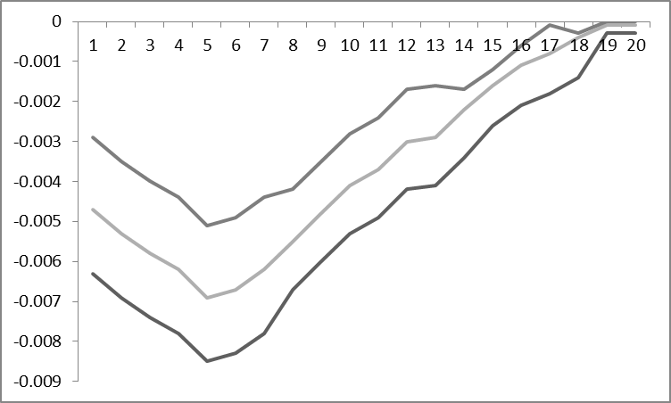 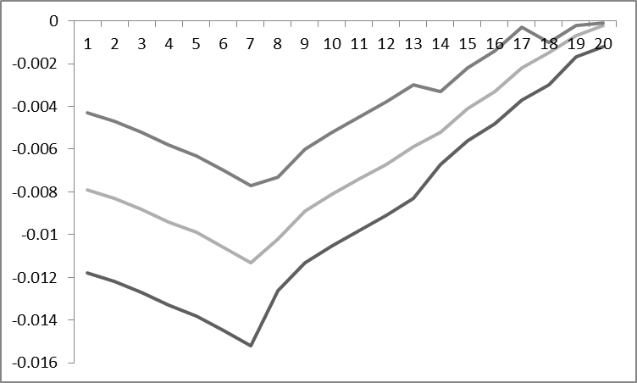

GDP-GDP deflator GDP-Funds rate

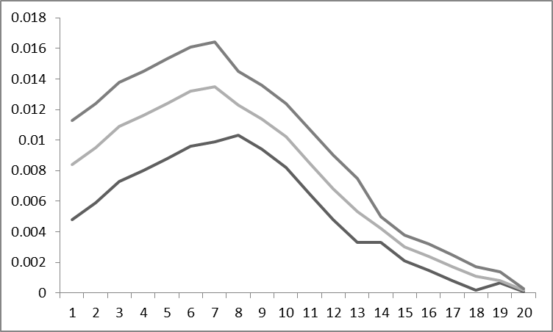 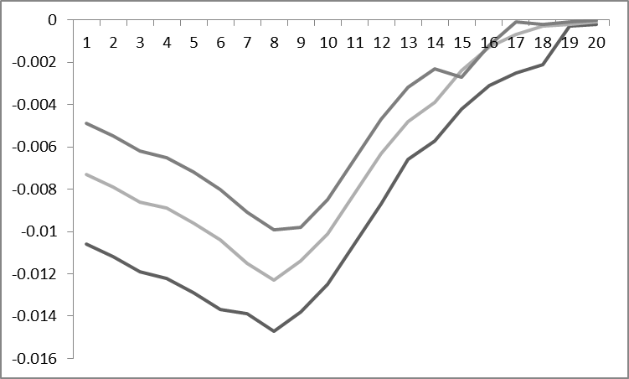

GDP-Loan standards GDP-Term spread

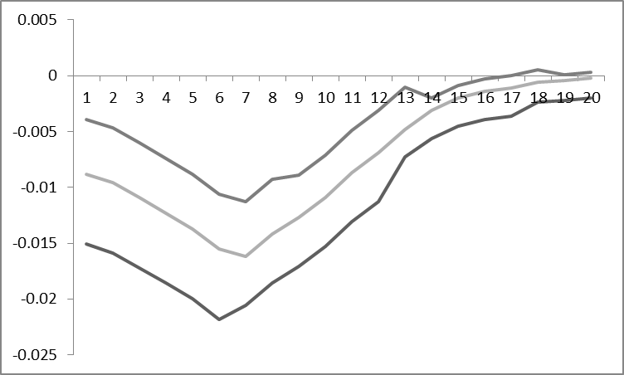

GDP-Oil prices

Figure 1. VAR impulse responses functions (US)

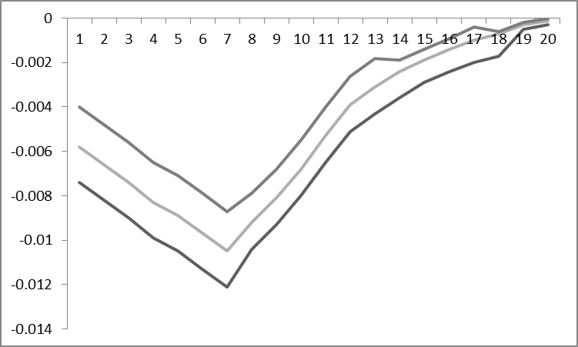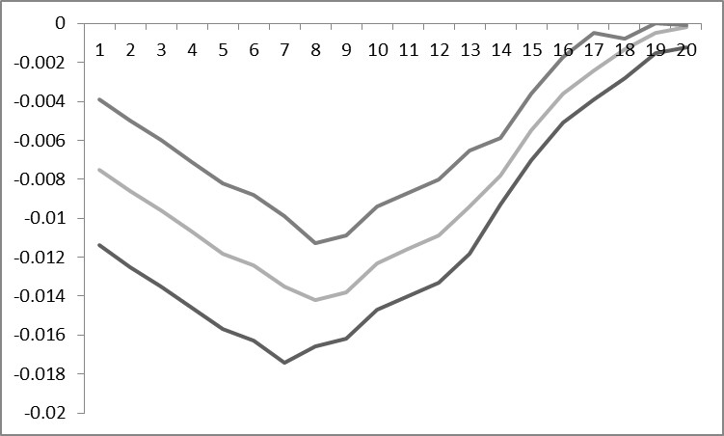

GDP-GDP deflator GDP-Funds rate

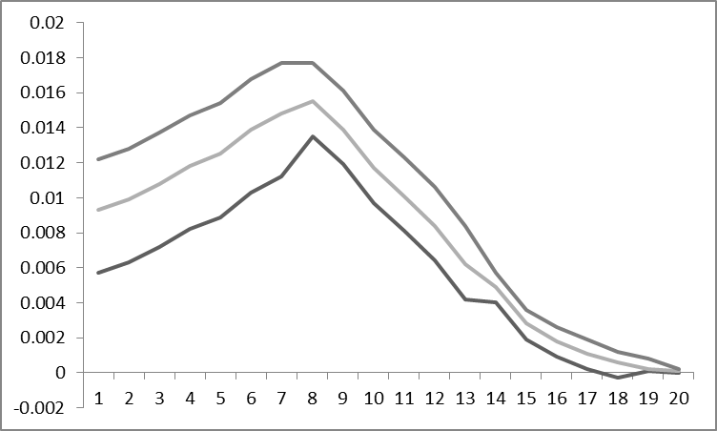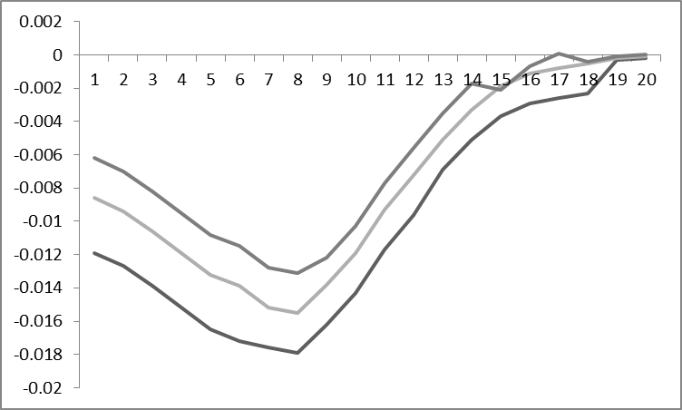

GDP-Loan standards GDP-Term spread

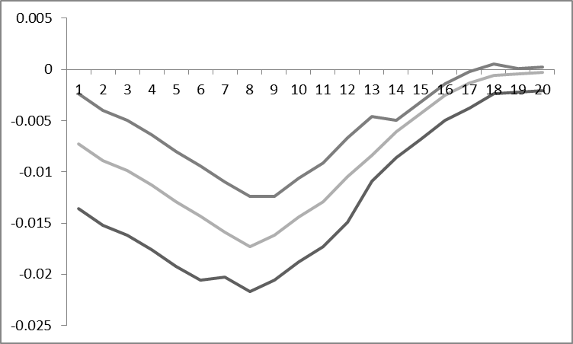

GDP-Oil prices

Figure 2. VAR impulse responses functions (Canada)

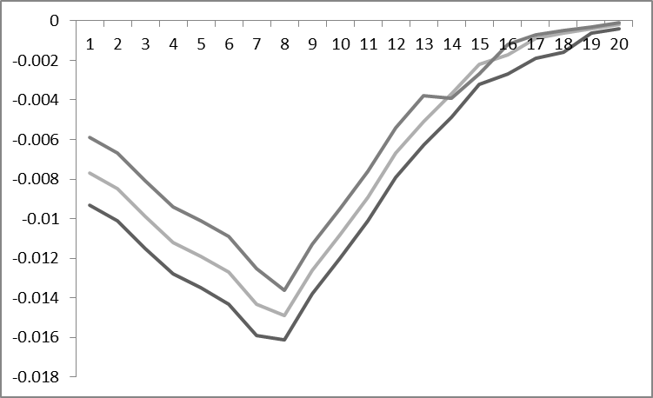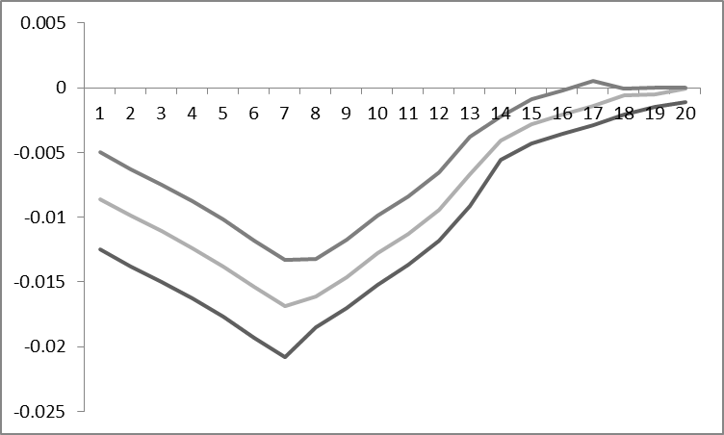

GDP-GDP deflator GDP-Funds rate

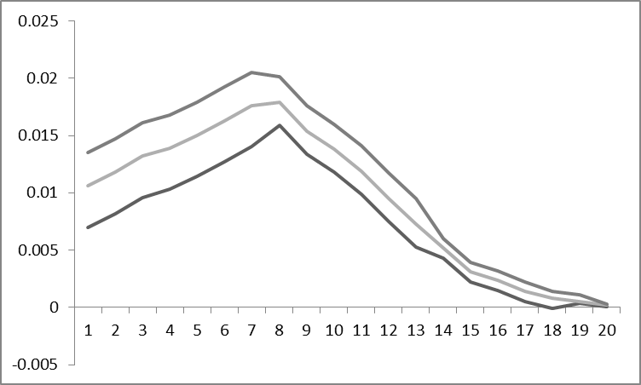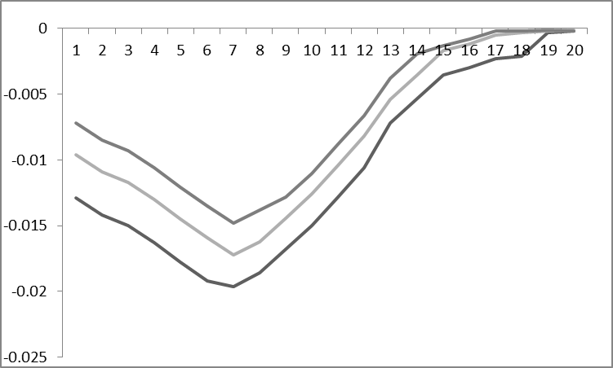

GDP-Loan standards GDP-Term spread

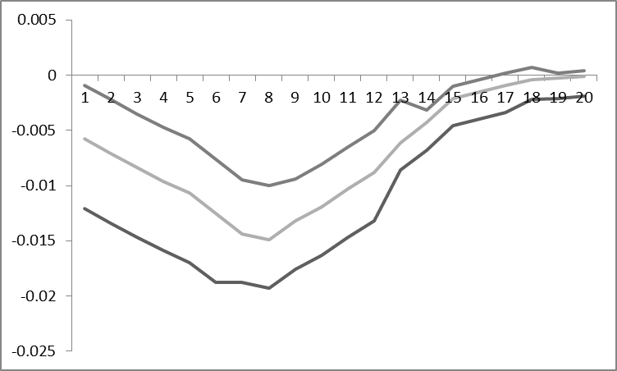

GDP-Oil prices

Figure 3. VAR impulse responses functions (UK)

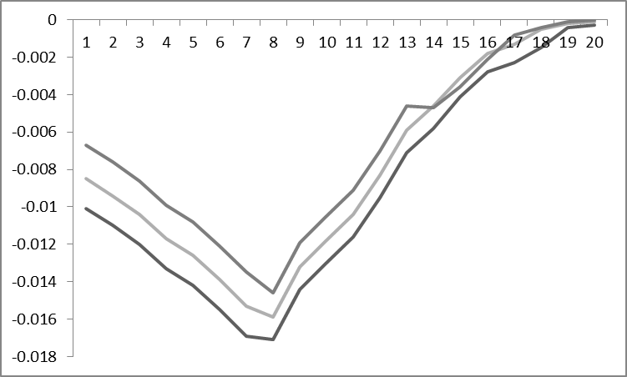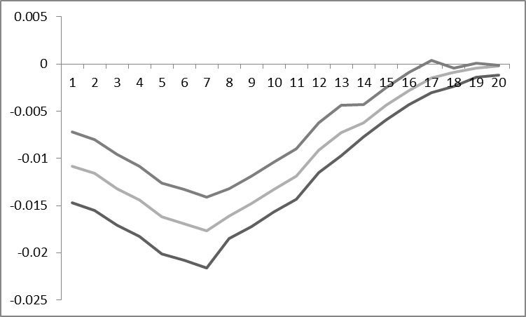

GDP-GDP deflator GDP-Funds rate

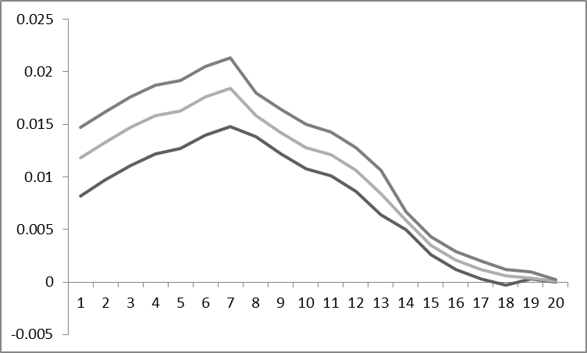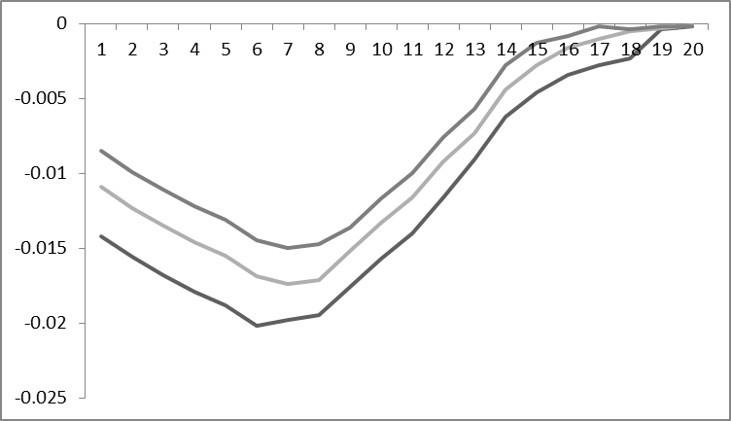

GDP-Loan standards GDP-Term spread

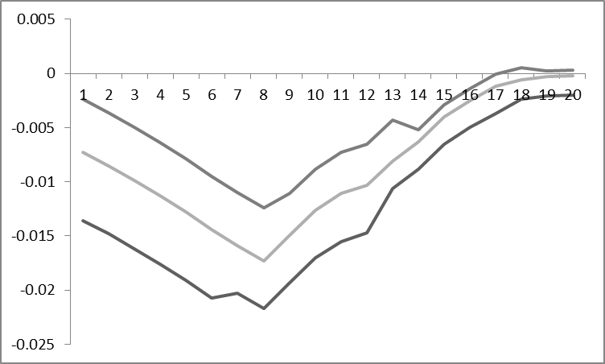

GDP-Oil prices

Figure 4. VAR impulse responses functions (Japan)

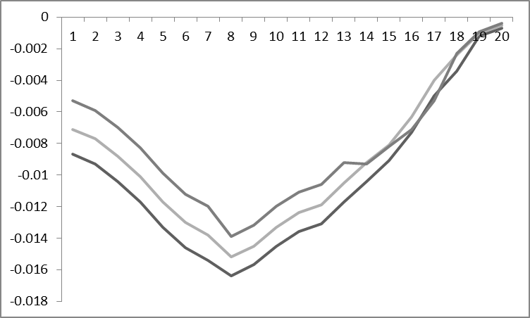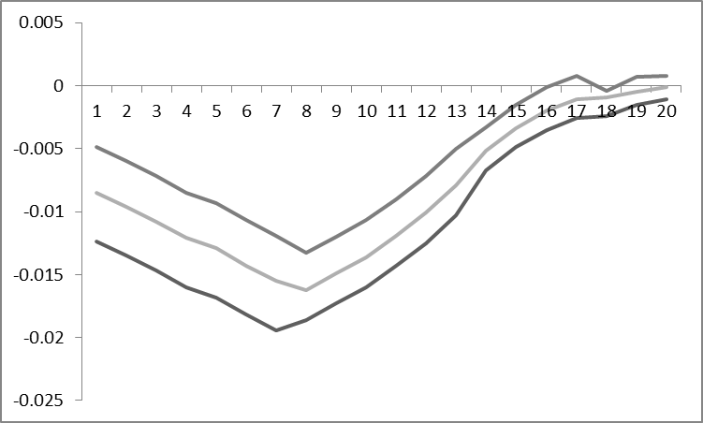

GDP-GDP deflator GDP-Funds rate

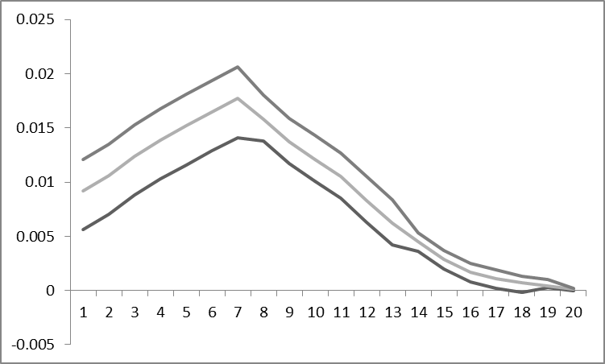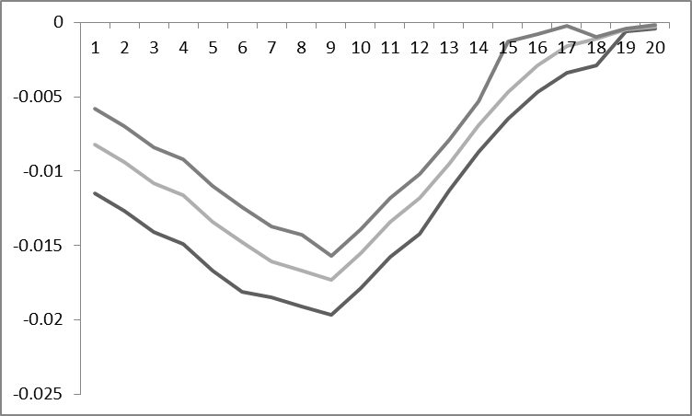

GDP-Loan standards GDP-Term spread

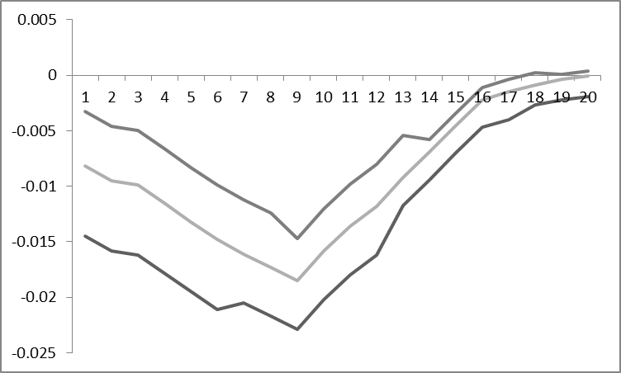

GDP-Oil prices

Figure 5. VAR impulse responses functions (Germany)

1. *Corresponding author at: University of Derby.

   Email Addresses: [n.apergis@derby.ac.uk](mailto:n.apergis@derby.ac.uk) (Nicholas Apergis), [ioannis.chatziantoniou@port.ac.uk](mailto:ioannis.chatziantoniou@port.ac.uk) (Ioannis Chatziantoniou).