**Hallam. J., Gallagher, L., and Harvey C. (2021) ‘I don’t wanna go. I’m staying. This is my home now.’ Analysis of an intervention for connecting young people to urban nature. *Urban Forestry and Urban Greening* Vol. 65, November** <https://doi.org/10.1016/j.ufug.2021.127341>

**Abstract**

This paper uses ethnography to explore young people’s engagement with a UK based intervention designed to promote a meaningful connection to locally accessible urban nature. During the intervention seven young people (aged between 11 and 12 years old) from a socially disadvantaged area, took part in three two-hour sessions held in a patch of urban nature close to their school. During the sessions, facilitators and teachers worked collaboratively with the young people as they explored the space and took part in den building activities. All sessions were recorded using audio and video equipment and a case study approach was utilised to explore the experiences of two young people involved in the project as they worked with practitioners and each other to develop a meaningful connection to the space. Analysis highlights the importance of youth centred interventions which use practical activities to develop a sense of belonging and wellbeing. These issues are discussed in relation to traditional nature engagement interventions and recommendations for practitioners are put forward.

**Key words** – urban nature, social disadvantage, qualitative methods

**Introduction**

Nature contact has been associated with many aspects of young people’s health and wellbeing (Chawla, 2015) as well as encouraging pro-environmental behaviours (Richardson et al., 2015). However, in recent years rapidly increasing levels of urbanisation and declining access to nature have resulted in people from industrialised nations spending more time indoors and a growing disconnect from nature (MacKerron & Mourato, 2013; Matz, Stieb, Davis, Egyed, Rose, Chou & Brion, 2014). For children, access to nature is further restricted due to parental fears relating to safety and concerns about traffic (Karsten & van Vliet, 2006; Prezza et al., 2005; Villanueva et al., 2012). Children in low socioeconomic status (SES) areas can face additional barriers to engaging with nature as families within these communities have limited access to locally based green spaces (Public Health England, 2014) tend not to own a garden (Noonan, Boddy, Knowles, & Fairclough, 2015) and may not have the resources in terms of time, transport access and money, to visit wildlife reserves and rural areas (Harvey and Holland, 2017). This is particularly poignant because evidence suggests that people who live in areas of high social deprivation are more at risk of mental health issues (World Health Organization, 2014; Stafford & Marmot, 2003) and children who grow up in these areas are particularly vulnerable to emotional disturbance which can result in poor mental health in their adult life (Caspi, Taylor, Moffitt & Plomin, 2000).

In response, this paper explores a nature-based intervention run by Feral Spaces in a low SES area based in the UK. The intervention was funded by the Canal and River Trust and was designed to encourage young people to reclaim a local, disused place through engagement with urban nature. Ethnographic methods were used to document the intervention and investigate how through collaborative activity relating to den building activities, a growing sense of connection to urban nature was developed.

*The importance of nature contact and issues surrounding nature connectedness*

The wide-ranging benefits that nature contact has for children are well documented. In terms of wellbeing access to nature has been linked to improved physical health (Markevych, Thiering, et al., 2014), cognitive functioning (Wells, 2000), emotional wellbeing (Schein, 2014) as well as self-image and social skills (Prezza et al., 2001). Significantly, it has also been argued that nature contact also has lifelong benefits (Wells & Lekies, 2006) in terms of establishing a bi-directional relationship between children and nature that encourages pro environmental behaviours (Myers & Saunder, 2002). This relationship between nature contact and wellbeing is explained by the biophilia hypothesis which suggests human beings have an innate need to be connected to nature (Fromm, 1964 & Wilson, 1984). It is also reflected in the concept of nature connectedness which captures the feelings that people have towards nature in terms of emotion connection and a sense of self within nature (Mayer and Franz, 2004). However, despite these benefits, children’s contact with nature and wild spaces is decreasing with fewer than a quarter of children regularly using their local patch of nature and less than one in ten children regularly playing in wild spaces (Natural England, 2009).

Within an international context Louv’s (2006, 2010) concept of nature-deficit disorder has drawn attention to the reasons why children and young people are spending less time outdoors and the consequences this has in relation to children’s health and wellbeing. For Louv, increasing the opportunities for children to access nature is vital to promoting wellbeing as it has an impact on everything from a positive effect on the attention span, to stress reduction, creativity, cognitive development, and a sense of wonder and connection to the earth. Whilst nature deficit disorder is not a diagnostic label, it has prompted a worldwide movement to connect children and their families to natural environments (Freeman, Stein, Hand & van Heezik, 2015).

These concerns have sparked a growing number of interventions which aim to foster children’s connection to nature through adult led educational activities such as school trips or visits to nature reserves (Freeman, Stein, Hand, van Heezik, 2017). However, researchers such as Dickinson (2013) have been critical of these interventions which typically involve children being taken out of their local area to engage in activities centering on plant and animal identification led by park rangers. Dickinson (2013) argued that this focus serves to normalise and privilege a white middle class understanding of nature and extend it unproblematically to *all* children by encouraging them to go out into the woods and engage in activities such as bird watching to reconnect with nature. Consequently, traditional nature interventions are shaped within a neoliberalist ideology of ‘choice’ which assumes that all children have equal access to the specific type of nature promoted within Louv’s work and overlooks the safety issues faced by some groups when seeking to access remote places (E**v**ans, 2002). Furthermore, Dickinson (2013) has promblematised the practice of connecting children to nature through science and the identification of plant and animal species by arguing that this limits emotional and spiritual connections.

Some of the issues raised by Dickinson (2013) have been addressed in a more recent model designed to explain the facilitation of an emotional connection to nature (Lumber, Richardson, Sheffield, 2017). However, this model was created by asking adult populations to reflect upon their experiences of nature activities and a walking intervention. Whilst there is evidence to suggest that this adult-centric model has some relevance for young people (Hallam et al., 2019), children do not necessarily share the same concerns as adults (Kellett, 2005). Therefore, further research is needed to examine the kinds of activities in nature which young people can benefit from.

Other guidance for practitioners has drawn upon children’s views and perspectives to understand what children value in nature (Harvey et al., 2020). Significantly, this study revealed that when asked about good things in nature, young people listed experiences in ‘the great outdoors’ as well as experiences in their home and garden. This demonstrated the broad understanding of nature that children involved in the study had and highlighted the relevance and importance of urban nature. This research identified several themes which reflected the good things children noticed in nature. These themes were then combined with Lumber et al.’s (2017) pathways to nature connection, resulting in a framework for practitioners, which suggested potential activities that might be used to help connect children with nature, guided by the themes emerging directly from the children themselves. Whilst this is a positive move the quasi-experimental design utilised within the research outlined above is not without limitation. Such approaches embody an individualistic, reductionist focus which centres on how the ‘child’ can be connected to ‘nature’ and therefore diverts and obscures attention from wider issues pertaining to power, class and culture (Dickinson, 2013). Children’s access to nature is situated within a complex range of social and environmental factors (Freeman, Stein, Hand, van Heezik, 2017) and for many children living in socially deprived urban areas, nature is often seen as out of reach (Wells & Evans, 2003).

*Urban nature*

Within the research literature there is a growing evidence base which demonstrates that ethnic minority groups and low-income communities have less access to green space compared to white or more affluent groups (Wolch, Bryne & Newell, 2014). This lack of accessible green space and concerns relating to safety results in low income and ethnic minority children having less nature contact than white middle-class children (Rigolon & Flohr, 2014). Given the reported benefits of nature contact this disparity further contributes to social and health inequalities (Mitchell & Popham, 2008). More specifically, green space near to children’s homes has been associated with children’s physical health whereby reductions in blood pressure were observed (Markevych et al. 2014), vigorous levels of physical activity were encouraged (Coombes, van Sluijs, & Jones 2013) and asthma levels appeared to reduce (Maas et al. 2009). In addition to this, children with access to nearby nature appear to deal more effectively with stressful events and have better mental health (Wells & Evans, 2003). Consequently, it has been argued that nature has a buffering effect which supports wellbeing by promoting effective coping strategies (Corraliza, Passiatore, Pirchio, & Scopelliti, 2012) which can result in fewer behavioural issues in children (Markevych et al., 2014). In line with these findings, the lack green space available to ethnic minority children and children in low-income urban areas results in fewer opportunities for physical activity and they could be at increased risk of behavioral problems (Bates, Bohnert & Gerstein, 2018).

Intervention based research has addressed this issue somewhat by investigating the ways in which green spaces within school yards can be developed to provide access to nature for children from low-income communities. Bates, Bohnert & Gerstein’s (2018) longitudinal mixed methods research examined the impact of renovations designed to increase access to green space within three elementary schools based in low-income areas of Chicago. Data gathered using observation methods, behavioural mapping and survey data from adult caregivers and teachers revealed several positive outcomes centering on increased opportunity for physical activity and more positive social interactions within the green space. Teachers and caregivers reported positive long-lasting outcomes relating to less play related injuries and anti-social behaviour such as bullying and gang related activities in the space. These findings further built upon Chawla, Keena and Stanley’s (2014) ethnographic research which reported that elementary and high school students who had access to green school yards used the space to create supportive groups and demonstrated less anger and behavioural problems. This points towards the importance of understanding human relationships within nature, something which is largely absent from research that seeks to quantify and measure concepts such as nature connection and wellbeing.

Green school yard interventions go some way to addressing reported inequality relating to nature access, but a limitation of this approach is that children only have access to the benefits offered by the areas during the school day. As such it is important to understand the access that low-income communities have to urban nature, which can be visited from their home environment. Rigolon and Floher’s (2014) research, which used a geographic information system to compare park access of children in different neighbourhoods based in Denver, USA, illustrated that communities situated in lower income areas had the lowest access to parks and the parks that they could access had limited informal play spaces and lacked natural elements such as water, rocks and sand. This further evidenced claims that parks in low-income areas had poorer quality amenities (Loukaitou-Sideris & Stieglitz 2002), lower quality play equipment (Ellaway, Kirk, Macintyre, Mutrie, 2004), were less well maintained (Smoyer-Tomic, Hewko & Hodgson, 2004), and perceived as overcrowded (Loukaitou-Sideris & Stieglitz 2002). When reflecting upon these findings, Rigolon and Floher, (2014) proposed that a collaborative approach between local non-profit organisations, universities, and community members could be effective in tackling inequal access to parks and green spaces. Within this action orientated model collaborative action is required in the local area to consider whether existing parks could be renovated or if plans need to be drawn up for new areas such as community gardens. When making these decisions, issues such as land ownership, suitability criteria, and park design features need to be carefully considered to ensure that the planned development is fit for purpose and that the community’s vision can be achieved.

Given the wide-reaching benefits that nature contact has for wellbeing and the health inequalities created by access to nature the current paper explores an intervention, funded by the Canal and River Trust, which encouraged young people (aged between 11 and 12 years old) living in an area of social deprivation to engage with locally accessible urban nature. The intervention was run by Feral Spaces, a not-for-profit organisation which aims to connect young people to urban nature through placemaking, in partnership with an academised school situated within the 10% most deprived areas in the UK. During the intervention seven young people worked with Feral Spaces facilitators in a disused patch of urban nature close to their school shown in figure 1. The land is managed by a Heritage organisation run by volunteers. The group gave permission for the invention to run on the land as part of their focus on regeneration.

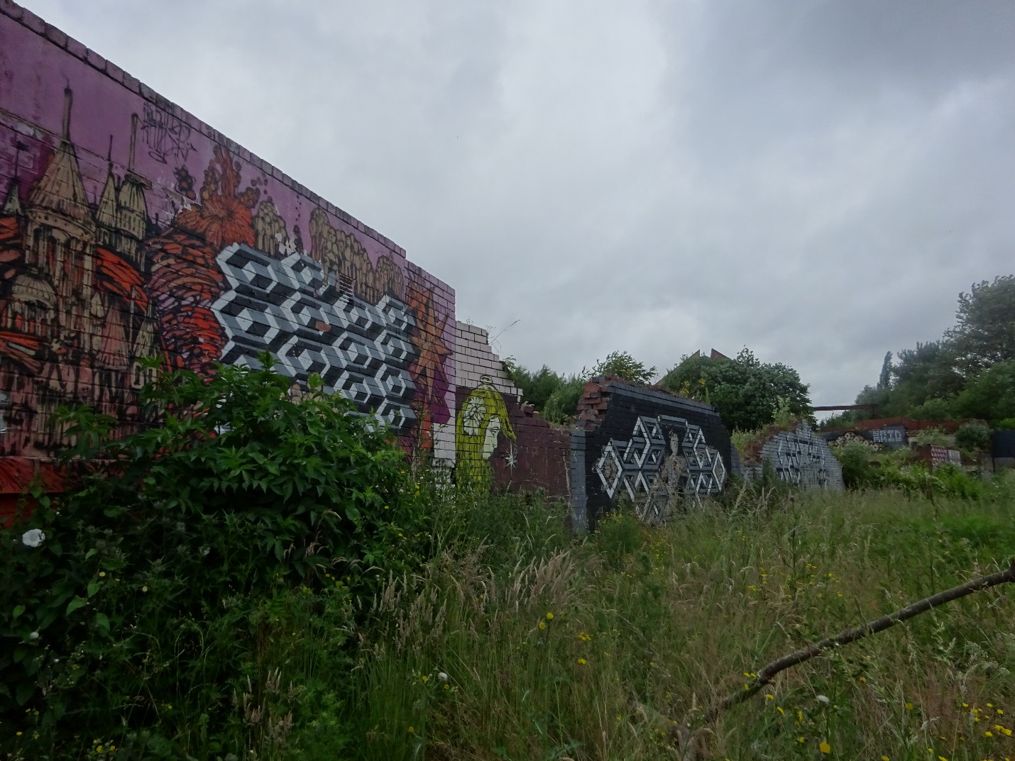

Figure 1: Photograph of the space the intervention took place in taken by a young person involved in the intervention

The intervention ran over the course of three morning sessions on the 20th June, 27th June and 4th July 2018. Each session lasted for two hours and took place during school time and the school organised a minibus to take pupils to and from the site. In the first session the young people identified specific areas that they wanted to work in and requested to make what they termed ‘dens’. At this point three different places were identified, and the young people spilt into smaller groups to set about clearing the spaces and mapping out their vision for each area. The second session centred on construction. In the final session activities turned to collecting clay like mud to make den creatures and using spray paints to create signs for the den areas. Consequently, the intervention was designed to support the benefits of nature contact relating to increased physical activity, improved emotional wellbeing, cognitive functioning and social skills. The ways in which the intervention supported nature connection through Lumber et al’s pathways to nature connection is reported elsewhere (Hallam et al., 2019).

This collaborative approach echoes the action orientated model outlined by Rigolon and Floher (2014) and further extends their research by exploring how this model can be put into practice. Furthermore, analysis explores the interactions which took place during the sessions. This focus on process rather than outcomes is significant as it deepens an understanding of the importance of positive social interaction (Bates, Bohnert & Gerstein, 2018) and human relationships within nature (Chawla et al, 2014). A specific concern is to explore the collaboration between the young people and adult practitioners within the intervention in order to consider issues relevant for practitioners who seek to connect young people to urban nature.

**Methods**

*Participant information and recruitment*

Naturalistic data were collected from all sessions of the intervention outlined above. This specific intervention is part of a long-term collaboration between Feral Spaces and the school established to support young people’s involvement with local community projects. As part of this collaboration Feral Spaces meet with the school 2-4 times a year to discuss projects that they are running and possible pupil involvement.

Places on the intervention were limited to seven young people (aged between 11 and 12) and the school took responsibility for selecting who participated (see table 1). The school chose pupils who they felt would particularly benefit from the intervention. Feral Spaces did not meet the students or conduct any work with them until the first day of the intervention.

|  |  |  |
| --- | --- | --- |
| Chosen name of young person | Gender | Reason for selection |
| Mia | Female | Academic high achiever |
| Indigo | Female | Academic high achiever |
| Latte | Female | Low in confidence and shy |
| Cabbie | Female | Low in confidence and shy |
| Omega | Male | Local to the area and had participated in Feral Spaces activities before |
| Carbide | Male | Local to the area and had participated in Feral Spaces activities before |
| Fortex warrior | Male | Local to the area and had participated in Feral Spaces activities before |

Table 1: Summary of participant information

The sessions were led by three Feral Spaces facilitators, see table two, and two teachers were present to observe and assist if needed.

|  |  |  |
| --- | --- | --- |
|  | **Gender** | **Role** |
| Feral spaces facilitator 1 | Female | Co-director and photographer, primary role was to document the intervention using photography and support the young people as they worked |
| Feral Spaces facilitator 2 | Female | Co-director and trained teacher. Primary role was to support the young people as they worked |
| Feral Spaces facilitator 2 | Male | Collaborative partner and trained in wood work. Primary role was to support the building activity. |

Table 2 Feral Spaces facilitators

*Ethical concerns*

Before the intervention started, informed consent was obtained from the parents of the young people involved, the young people themselves and all adult participants. Participants were advised that all data collected from them would be stored securely, and the young people created their own pseudonyms to protect their identities. Following Heng’s (2017) guidance on visual data collection all photos were framed as much as possible to exclude faces and any faces captured were blurred out. This compromised the quality of the data but it was an important ethical concession (Lomax, 2019). All participants were debriefed after the study and no one chose to withdraw. The project was approved by the University ethics committee and complied with the BPS code of ethics (2018).

*Data collection*

Data collection was guided by the principles of ethnography - an approach characterised by the researcher joining a community and using a range of data collection methods such as interviews, field notes and photography to explore people’s lived experiences of the world (Mannay, Fink & Lomax, 2019). Furthermore, the project was informed by a community psychology approach in which the researcher is positioned as a resource collaborator working *with* a community rather than working *on* them (Smith, 1994). As such the research was informed by a collaborative relationship between academics (first and third authors) and practitioners (represented by the second author). This partnership aimed to capture and examine the practices utilised by Feral Spaces within their planned intervention.

In line with a focus on collaboration there was a conscious move away from researcher led data collection which Harper (2012) has argued limits participant involvement. Instead, a participatory approach was adopted in which all data was collected by the participants themselves (Pauwels, 2011). Feral Spaces facilitators attached small go pro cameras to their tops and recording equipment was set up in strategic, non-intrusive points to capture events as they happened. The young people were also provided with digital cameras and iPads to capture and reflect on experiences significant to them. The first author took part in the last activity run as part of the intervention from the position of participant observer. In this role the researcher assisted the Feral Spaces team and worked alongside the young people during the session. Consequently. care was taken throughout the project to minimise researcher impact and facilitate the collection of naturalistic (rather than natural) data (Potter, 2002).

On completion of the project all data were collated, and audio recordings were transcribed verbatim. During transcription, the participants’ chosen names were used to protect their identities.

*Analytic approach*

Braun and Clarke’s (2006) 6 stage approach to thematic analysis was used to organise the data from the intervention for analysis. During this process the ‘outsider’ status of the first author facilitated the inductive coding of the data corpus as it could be approached without a specific hypothesis in mind (Vail, 2001). Extracts relating to each code, identified during the immersion process, were copied from the data set and pasted into a document. This ensured that all the extracts for each code were collated together and enabled the validity of each code to be reviewed. Mind maps were used to cluster codes together into themes. At this point the second author reviewed the structure of the thematic map, her ‘insider’ status helped to validate the thematic structure, based on the entire data corpus, by ensuring that it fairly represented the experiences documented during the intervention. During this process two key narratives were identified – one which mapped out a growing connection to nature (reported elsewhere, Hallam et al., 2019) and another which focused on the development of skills and how this contributed to a growing sense of wellbeing, community and belonging.

Themes relating to each of the two narratives, outlined above, were separated out and extracts which best exemplified how the young people developed their skills, a sense of wellbeing, community and belonging were chosen for analysis. At this point a case study approach, informed by interpretive ethnography, was used to specifically explore the experiences of Mia and Indigo, as these participants benefited most from the development of skills and confidence during the intervention. As such the case study approach allowed close examination of the changes which occurred over the course of the three sessions and ensured that the analysis had a clear narrative which represented wider experiences observed during the intervention (Willig, 2001).

**Results**

The following analysis focuses specifically on Mia and Indigo’s experiences of the intervention and maps out the creation of their den space.

*Using a youth centred focus to develop a concept for the space*

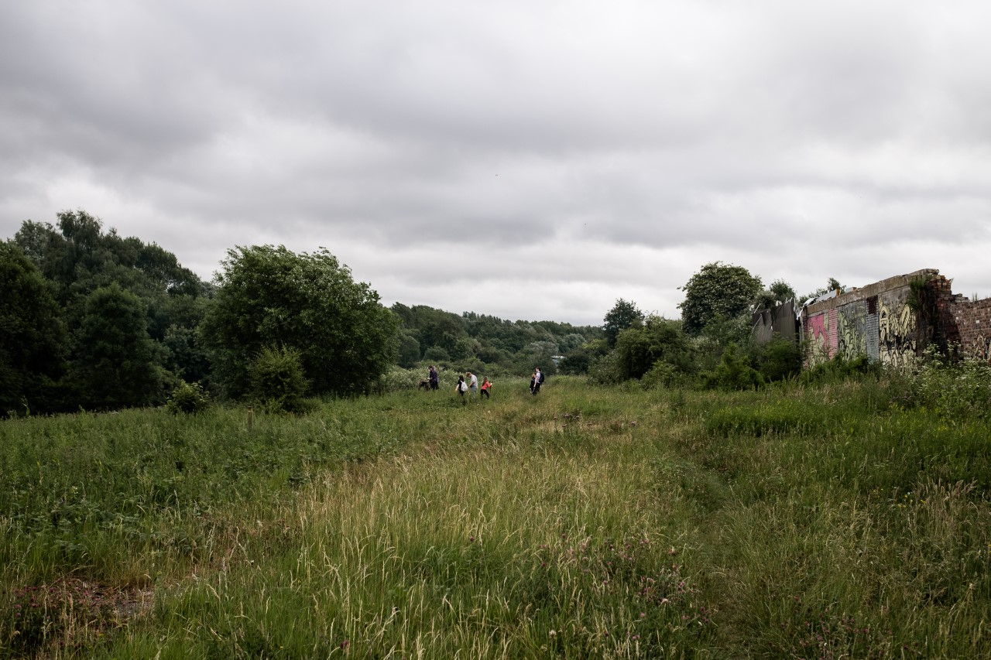

Figure 2: Photograph taken by one of the young people whilst the others explore the space.

At the start of the project the young people were invited to lead an exploration of the space (see figure 2) and consider how they wanted to develop it into an area that could be used positively by the local community. This youth centred approach was integral to the intervention it facilitated conversations with the young people which helped the Feral Spaces team to understand their access to and familiarity with outdoor space.

1. **Feral spaces facilitator 1:** Do your parents let you go out and play?
2. **Mia:** No my parents don’t let me play.
3. **Feral spaces facilitator 1:** They don’t let you go out and play?
4. **Mia:** No.
5. **Indigo:** Mine do I got to the park.
6. **Feral Spaces facilitator 1:** So you are allowed to go to the park.
7. **Indigo:** Yes ’cause it’s only down the road.

Mia and Indigo’s experiences drew out the significance that parental concerns can have upon access to outside space documented in the research literature (Karsten & van Vliet, 2006; Prezza et al., 2005; Villanueva et al., 2012). Consequently, it was important for facilitators to understand the young people’s differing confidence levels and address specific concerns that either the children and/or their parents might have about urban nature at the start of the intervention. This enabled facilitators to offer appropriate and relevant support, centring on risk management and identifying harmful plants such as nettles, which addressed the young people’s needs. This support enabled the young people to engage safely with the space during the intervention and equipped them with the skills required to safely return to the space in the future.

The youth centred aspect of the project, which presented a blank canvas and invited the young people to decide how the space should be developed, also motivated the young people to engage meaningfully with urban nature by taking a youth centred approach. During the first session, Mia and Indigo’s exploration led them to focus on a large tree and they identified this as a space they wanted to develop. With support from her teacher Mia started the process of examining the tree and considering the possibilities it had to offer.

* 1. **Female Teacher:** That looks comfy there. Wow.
  2. **Mia:** Imagine if you could use that tarpaulin you could do a hammock if it was
  3. strong enough
  4. **Female Teacher:** What a brilliant idea
  5. **Mia:** But we need to think of somewhere that we can climb and then chill in it
  6. **Female Teacher:** So looking at it where do you think would be the best place?
  7. **Mia:** Mmm I say from that second branch

Consistent use of progressive questioning (Edwards & Mercer, 1987), which grounds the discussion in the learner’s interests, created a collaborative learning environment and allowed Mia to take the lead in creating her vision for the space. This disrupted traditional power dynamics between teacher and learner that are embodied in questions such as ‘what type of tree is this?’ These questions assert the teacher’s power to direct learning towards what they consider relevant and confirm their expert status by testing the learner’s knowledge (Edwards & Mercer, 1987). As such the approach taken was a significant departure from the traditional nature connection interventions critiqued by Dickinson (2013) in which the adult sets the agenda from an expert position.

Consistent use of progressive questioning demonstrated in the teacher’s use of statements which encouraged reflection on experience (line 1), gave positive feedback (line 4) and invited deeper thought and clarification (line 6) provided Mia with space to develop and share her ideas, put forward creative uses for the materials she saw around her and make decisions about the space from a position of control. Consequently, Mia started to take ownership of the space and provide direction on how it was going to be used. Significantly, her request was for a ‘comfy’ space that could be used to ‘chill’.. The tree was conceptualised as a space that could support wellbeing and potentially a place that she could return to in the future to relax. In line with Rigolon and Floher’s (2014) action orientated model this period of consultation with community members who would go on to use the space was important. It helped to ensure that the area was developed into a space that fulfilled the needs of section of the community who would go on to use it.

This initial discussion prompted Mia and Indigo to investigate their chosen tree to further develop their plans and ensure they were viable (see figure 3).

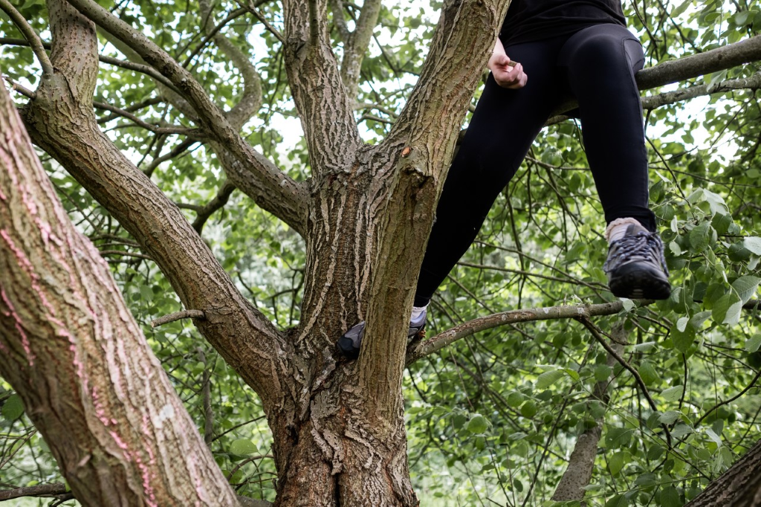

Figure 3: Mia and Indigo investigate their chosen tree

1. **Female teacher:** Mia you have soon zoomed up there.
2. **Mia:** Teacher can I got to the top?

The practical aspects of the den building activity encouraged the young people to connect physically with the tree. Mia, for example climbed to the top of the tree to see if a swing and hammock could be constructed in the branches. Consequently, the practical activity of den building provided the requirement for climbing skills to be developed and potentially opened up new ways of connecting to urban nature.

Mia and Indigo’s exploration of the tree led to them planning a den space which incorporated a swing and a hammock. Once, they had cleared the space their activity turned towards communicating their ideas with facilitators.

* 1. **Feral Spaces Facilitator 3:** We, we were going to build a platform here so what
  2. was thinking from here going across
  3. **Mia:**  You might do a hammock as well
  4. **Indigo:** I thought with the tarpaulin. We could turn it into a hammock hanging
  5. from that second branch. Near you from that second branch to that bendy one
  6. with the tarpaulin
  7. **Feral Spaces Facilitator 3:**  Yeah
  8. **Mia:** And then we just need a way to climb up to it

From the outset of this discussion the inclusive function of the word ‘we’ positions the den building activity as a collaborative process. To a certain extent this also relinquishes the practitioner’s expert status and invites the young people to provide direction. This approach establishes a dynamic in which Mia and Indigo are required to work together and engage in the type of thinking required from an expert such as identifying the materials that will be used and considering any access issues. By scaffolding the building process in this way, the Feral Spaces facilitator enabled the young people to align themselves with the facilitators.

This theme has explored the importance of taking a youth centred approach for practitioners who seek to encourage urban nature contact in young people and the impact that progressive questioning has for building positive relationships between the young people themselves and between the young people and practitioners. It has also highlighted the importance that practical activities have in encouraging young people to connect to urban nature. The next theme builds upon this further by demonstrating how a youth centred approach focused on practical activity as the potential to support wellbeing.

*Supporting skill development and facilitating positive emotions*

During the second session of the intervention Mia and Indigo’s attention turned to construction and they worked with facilitators to develop the skills needed to create their den space. Both Mia and Indigo had been referred to the project because teachers felt that they were too focused on academic subjects and would therefore benefit from broadening their horizons and developing more practical skills. A lack of practical experience presented itself in different ways as facilitators worked with the young people to develop the sawing skills required to create space for the swing and cut a piece of wood down to size for the swing seat.

* 1. **Feral Spaces Facilitator 3:** Yeah that's it there. Pull it back towards you all the
  2. way back. Do that 3 or 4 times and then you have a nice groove to start sawing
  3. into. Now you can go backwards and forwards.
  4. **Mia:** If feel like I need to kneel down
  5. **Feral Spaces Facilitator 3:** Teacher can? Do you want to just put your knee
  6. down there for us? Try not to push too hard just go nice and steady, that’s it

The facilitator and teacher responded to Mia’s need for guidance on how to saw by offering the physical support and verbal instruction required to scaffold her learning process. The adult facilitator created a safe and encouraging environment in which gentle guidance enabled Mia to take the physical control required to develop her skills and confidence in sawing. This combination of technical knowledge and support resulted in Mia successfully mastering the skills needed to construct the den. Later in the construction process her interactions with other young people demonstrated increased levels of confidence.

* 1. **Mia:** Fortex warrior can I have the saw? Thanks mate
  2. **Fortex warrior:** Do you want me to do it for you?
  3. **Mia:** It’s all right. Can you hold that though?

Mia was able to take a lead in the construction work and her rejection of help further asserted her position as a competent craftsperson. It is from this position that she assigned Fortex warrior the job of supporting her and these delegation skills suggested a newfound level of confidence.

Support and encouragement were also important for Indigo’s skill development but a different focus was needed.

* 1. **Feral Spaces Facilitator 3:** Hold both of the. By the handle that’s it. The rubber
  2. should be on the palm.
  3. *Inaudible comment from Indigo*
  4. **Feral Spaces Facilitator 3:** What she means Miss is can you saw while she
  5. Directs?
  6. **Female Teacher:**  I’m not falling for that one
  7. **Feral Spaces Facilitator 3:** Come on Indigo you are nearly there
  8. **Female Teacher:** It’s in the groove.
  9. **Male Teacher:** You won’t get the sense of satisfaction if Miss does it.

For Indigo engaging with a physical activity proved to be challenging and she demonstrated resistance completing a sawing task. A combination of refusing help (line 5) and providing encouragement (line 6) is used by facilitators to counter this and keep Indigo on task so that she can experience a sense of ‘satisfaction’ (line 8). This combined intervention is noteworthy as it gave Indigo chance to learn the importance of sticking to a challenging task. This had the potential to boost Indigo’s self -esteem through feelings of accomplishment.

The different approaches to support were effective in providing the young people with the skills and confidence needed to complete construction of their den space. Mia was keen to showcase her den space and share it with adult facilitators.

1. **Mia:** Miss do you want to sit on it?
2. **Feral Spaces Facilitator 1:** I don’t want to in case my weight snaps
3. **Mia:**  Go on sit down
4. **Feral Spaces Facilitator 1:** Ohh wow. It’s really good isn’t it

Mia’s invitation to the facilitator indicates pride in her achievements and confidence in the strength of the swing she has constructed. This is met with praise and validation from the facilitator which points to a growing sense of community. The shared sense of admiration and enjoyment of the swing appears to bond everyone present. There is no sense of division and this informal interaction points towards a growing relationship which places the Feral Spaces facilitator on the same ‘level’ as Mia.

This theme has further explored the ways in which teachers and facilitators used a youth centred approach to work collaboratively with Mia and Indigo and support skill development. The sensitive, youth centred focus evidenced in this section of the analysis potentially contributed to the young people’s wellbeing by providing opportunities for feelings of satisfaction and accomplishment which could boost confidence and self-esteem. The final theme explores this further and examines the ways in which the den building activity developed a meaningful connection between the young people and urban nature through their development of an attachment to that space.

*Creating attachment to the space*

Once Mia and Indigo finished construction of the den area, they had the opportunity to test out their swing and hammock areas (see figure 4).

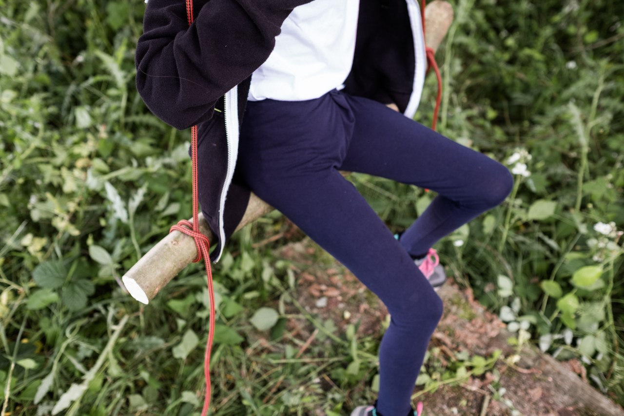

Figure 4: Mia and Indigo test out the swing

* 1. **Mia:** I’ve just been playing around on the swing
  2. **Feral spaces facilitator 2**: Arr this is relaxing
  3. **Mia:** Yeah

The swing became an important site of connection and provided the young people with opportunities to experience and share positive emotions. There was laughter as the young people took turns to push each other and a sense of release during the ‘play’ they shared. This fun and freedom was enjoyed by the young people and it also provided opportunity for them to bond and develop their friendship. Discussions with the school, which took place 6 months after the intervention as part of the regular meetings with Feral Spaces, revealed that these bonds continued after the project and resulted in a strong friendship. Mia and Indigo’s hammock also provided opportunity for the young people to relax and share their den with adult facilitators.

* 1. **Female teacher:** That’s it you are in
  2. **Feral spaces facilitator 2:** So comfy
  3. **Mia:** It looks nice I want to get in now
  4. **Indigo:** Oh yeah
  5. **Female teacher:** Do you watch I’m a celebrity get me out of here? It looks like
  6. you are in one of their beds.

*Laughter from Mia and Indigo*

This informal interaction points towards the ways in which the hammock facilitated the development of positive relationships between the young people and their teacher. Discussions with the school, which took place 6 months after the intervention had taken place. revealed that this relationship continued within the school environment. Furthermore, a focus on comfort and relaxation strongly mirrors Mia’s original plan for the space and suggested that her vision for the den to be a site which promoted wellbeing had been realised. A sense of ownership of the space and confidence in their newly developed construction skills provided a reason for the young people to return to the space.

1. **Feral Spaces faci1itator**: So what would you do if you can here just the 2 of you?
2. **Mia:** We’d probably just sit here.
3. **Indigo:** We’ll have to build a table won’t we? We need some more wood so we can build a table.

Indigo’s suggestion that she could return to the space with Mia and continue to develop it suggested the start of an on-going relationship with this patch of urban nature. Furthermore, it highlighted the importance of locating the intervention in a site that can be easily accessed by the young people involved. The locality of this site to the young people meant that it was easy for them to return after the intervention if they wished. In visits made to the site in October 2019 the first and second author observed further development of the den area with the construction of new swings and climbing areas. There was also evidence of impact upon the wider community as a local family, who had heard about the project, where using the area for wild camping experiences.

A sense of a new connection and attachment to the space was also reflected in Mia’s reluctance to leave the space at the end of the intervention.

* 1. **Mia:** I don’t wanna go. I’m staying. This is my home now. This is my
  2. permanent home. See ya. One last swing. Oh yeah, oh gosh, don’t hit my head.
  3. Have you seen the spray paints I’ve done?
  4. **Feral Spaces Facilitator 1**: Yeah, it's great
  5. **Mia:**  Bye bye favourite tree
  6. **Feral Spaces Facilitator 1:** Do you think you’ll be back?
  7. **Mia:** Yeah if my dad will let me come

Mia’s conceptualisation of the space as a ‘permanent home’ presents an emotional connection and a sense of belonging to the space. Indeed, her statement that ‘I don’t wanna go’ expressed resistance towards the requirement to leave the den and return to school. This tension was resolved by the facilitator's suggestion that the space can be returned to outside of the sessions thus removing a sense of finality. Discussions with Mia in the final session of the intervention and the school 6 months after the intervention revealed that a longer-term connection to the space had been established. Mia’s father and uncle had grown up in the area and had played in this patch of urban nature together as children. A family visit to the area enabled them to share their memories of the space and create new, shared experiences with Mia.

This theme has highlighted the ways in which the creation of the den space promoted feelings of wellbeing and supported the development of positive relationships. Furthermore, the young people’s active involvement in planning and creating the den space laid the foundations for a longer-term relationship with urban nature built upon a sense of belonging.

**Discussion**

This analysis explored ways in which two young people actively engaged with locally accessible urban nature through a community-based intervention. The analysis highlighted several positive outcomes which supported the young people’s wellbeing in different ways. The sense of connection to place was evidenced through the reluctance to leave the place and the subsequent return visits of Mia and her family. This has the potential to pave the way for Mia and the other young people to develop a sense of connection to nature they might not have experienced otherwise and the associated wellbeing benefits this can bring (e.g., Windhurst and Williams, 2015; Capaldi et al., 2017). In addition, the young people’s tree climbing activity led to increased levels of physical activity, the development of practical skills such as sawing provided opportunity to develop confidence and the planning and construction of the den space promoted creative thinking and a sense of pride and achievement. These outcomes offer further support for the benefits of nature contact such as improved physical health (Markevych, Thiering, et al., 2014), cognitive functioning (Wells. 2000), emotional wellbeing (Schein, 2014) as well as self-image and social skills (Prezza et al., 2001) as outlined in the literature. Consequently, the intervention demonstrated the potential value that urban nature has for young people in low SES areas who may view the types of nature visited in traditional nature interventions such as national parks (Dickinson, 2013) as being out of reach (Wells & Evans, 2003).

These positive outcomes also evidence the benefits of the community-based approach to nature connection which acknowledges the social and environmental factors which Freeman, Stein, Hand, van Heezik, (2017) have argued shape children’s nature access. Within this intervention a site of local urban nature, rather than a nature reserve, was purposefully chosen because removed potential barriers to access such as transport and money (Harvey and Holland, 2017). As such the location of the site provided the opportunity for the young people to develop a space that they could return to and be used by the wider community. This maximized the potential impact the project could potentially have in addressing social and health inequalities related to lack of safe green space for low-income communities (Mitchell & Popham, 2008; Wolch, 2014). Within this project there was a significant shift away from an individualist focus on connecting the ‘child’ to ‘nature’ which informs traditional nature-based interventions outlined by Dickinson (2013) in which nature experts such as park rangers lead educationally based activities in national parks which are designed to promote nature connection through plant and animal identification.

Throughout the intervention Feral Spaces facilitators took their lead from the young people, responded sensitively to their needs and acted on their suggestions relating to how the space should be developed. This relinquishing of ‘expert’ status disrupted traditional power relations and consistent use of progressive questioning enabled the young people’s curiosity and agenda drive the sessions. Furthermore, it enabled positive relationships centring on empowerment to be developed between the young people and the facilitators.

This further builds upon Bates, Bohnert & Gerstein’s (2018) green school yard research by demonstrating that the positive outcomes for young people reported in this context – such as increased physical activity and more positive social interactions – are also evident in urban nature. Furthermore, it illustrated how these outcomes were supported and encouraged thus emphasising the importance of moving beyond measurement and quantification towards understanding human relationships within nature. During this intervention the relationship between the young people and facilitators was central to the young people’s transition from novices, who lacked the confidence and skills such as tree climbing required to engage in outdoor play, to experts who were able to successfully manage risk and develop an area of urban nature space into a space that they could return to. Therefore, a youth-led collaborative approach was an integral part of developing a sense of connection and belonging to the area.

The bottom-up approach adopted evidenced elements of practice which may be of relevance for practitioners who seek to implement Rigolon and Floher’s (2014) community action model. Within this project many of the principles of this model, such as working with communities, considering the suitability of the space and the design of the play areas, were put into practice. The young people’s development of the area contributed to the wider community by providing accessible social and play spaces located in a largely disused area of urban nature and highlights the importance that such areas have for the people living in those communities. In line with the research literature this could help support issues relating to wellbeing and mental health that have been identified within socially disadvantaged communities (Caspi, Taylor, Moffitt & Plomin, 2000; Stafford & Marmot, 2003; World Health Organization, 2014). More specifically, the developed space could encourage visits to accessible urban nature. This is significant as it has been suggested that children with access to nature have better mental health (Wells & Evans, 2003) because nature buffers the effects of stress and promotes effective coping strategies (Corraliza et al., 2012).

Within this specific research project constraints relating to time and funding prevented longitudinal data from being collected. This meant that the long-term impacts of the intervention could not be assessed. Furthermore, wider members of the community were not consulted on the proposed development. This raises important issues to consider in relation to future research collaboration with Feral Spaces. In line with Rigolon and Floher (2014)’s action model a longer period of consultation with different community groups would be implemented. A more inclusive approach has the potential to further widen the impact of future interventions and contribute to sustainability. Furthermore, a mixed methods approach which seeks to measure impact through people’s experiences of the space as well pre and post measures would be beneficial.

*Conclusion*

The analysis of a youth centred intervention has illustrated the importance of community along with the ways in which urban nature can support personal wellbeing and lead to an increase in connection to place and urban nature. It has also highlighted the benefits of moving beyond a research approach which adopts an individualist focus and uses self-report measures to examine a direct one to one relationship between the child and nature. This project has shown an alternative approach to traditional nature engagement interventions and demonstrates how a growing sense of connection to urban nature was developed through the den building activity. Exploration of the collaboration between the young people and practitioners has provided insight into how this facilitated the personal and social development of the young people, something which may prove beneficial for practitioners wishing to put an action-oriented model into practice. An exploration of what young people do in nature has also enabled insight into good practice that could inform future interventions which seek to address health inequalities possibly created by a lack of access to nature.

**References**

Bates, C. Bohnert, A. and Gerstein, D. (2018) Green schoolyards in low-income urban neighbourhoods: Natural spaces for positive youth outcomes. *Frontiers in psychology* <https://doi.org/10.3389/fpsyg.2018.00805>

Braun, V. and Clarke, V. (2006). Using thematic analysis in psychology. *Qualitative Research in Psychology*, 3 (2). pp. 77-101. ISSN 1478-0887

British Psychological Society (2018). *Code of Ethics and Conduct.* Leicester: British Psychological Society.

Capaldi, C. A., Passmore, H. A., Ishii, R., Christopoolskaya, K. A., Vowinckel, J., Nikolaev, E. L. and Semikin, G. I. (2017). Engaging with natural beauty may be related to well-being because it connects people to nature: Evidence from three cultures. Ecopsychology, 9(4). https://doi.org/1089/eco.2017.0008

Carrus, G., Passiatore, Y., Pirchio, S., and Scopelliti, M. (2015). Contact with nature in educational settings might help cognitive functioning and promote positive social behavior. *Psyecology* 6, 191–212. doi: 10.1080/21711976.2015.1026079

Caspi, A., Taylor, A., Moffitt, T.E. & Plomin, R. (2000). Neighborhood deprivation affects children’s mental health: Environmental risks identified in a genetic design. *Psychological Science, 11(4),* 338-342.

Chawla, L. (2015). Benefits of nature contact for children. *Journal of Planning Literature*. vol 30(4) 433-452.

Chawla, L., Keena, K., Pevec, I., and Stanley, E. (2014). Green school yards as havens from stress and resources for resilience in childhood and adolescence. *Health Place* 28,1–13.doi:10.1016/j.healthplace.2014.03.00

Coombes, E., van Sluijs, E and Jones, A. (2013). Is Environmental Setting Associated with the Intensity and Duration of Children’s Physical Activity? Findings from the SPEEDY GPS Study. *Health and Place* 20:62–65.

Dickinson. E. (2013) The Misdiagnosis: Rethinking “Nature-deficit Disorder”, *Environmental Communication: A Journal of Nature and Culture*, 7:3, 315-335, DOI: 10.1080/17524032.2013.802704

Edwards, D. & Mercer, N., (1987). *Common Knowledge. The Development of* *Understanding in the Classroom.* Routledge: London.

Ellaway, A., Kirk, A.,Macintyre, S., Mutrie, N. (2007) Nowhere to play? The relationship between the location of outdoor play areas and deprivation in Glasgow. *Health Place,* 13, 557–561.

Evans, M. M. (2002). ‘‘Nature’’ and environmental justice. In J. Adamson, M. M. Evans, & R. Stein (Eds.), *The environmental justice reader: Politics, poetics, and pedagogy* (pp. 181–193). Tucson: University of Arizona Press

Freeman, C., Stein, A., Hand K., and van Heezik, Y. (2017). City children’s nature contact knoweldge and contact: Its not just about biodiversity provision. E*nvironment and behavior.* Vol 50(10) 1145-1171

Freeman, C., Stein, A., Hand K., and van Heezik, Y. (2015). *Natural Neighbourhoods for City Children: Report on Research Findings*. Published by the Department of Geography, University of Otago, Dunedin, 2015ISBN: 978-0-473-31872-7

Frith, H. & Gleeson, K. (2004). Clothing and embodiment: men managing body image and appearance. *Psychology of Men and Masculinity*, *5*(1), 40-48.

Fromm, E. (1964) *The Heart of Man*. Harper and Row.

Hallam, J., Gallagher, L. & Harvey, C. (2019). “We’ve been exploring and adventuring”: An investigation into young people’s engagement with a semiwild, disused space. The Humanistic Psychologist. Advance online publication <https://doi.org/10.1037/hum0000158>

Harper, D. (2012). *Visual sociology*. London: Routledge.

Harvey, C., Hallam, J., Richardson, M. & Wells, R. (2020). The good things children notice in nature: An extended framework for reconnecting children with nature. *Urban Forestry and Urban Greening, 49.* <https://doi.org/10.1016/j.ufug.2019.126573>

Harvey, C. & Holland, F. (2017). *Play Wild evaluation report*. Derby, UK: University of Derby.

Heng, T. (2017) *Visual methods in the field: photograph for the social sciences*. Routledge: Oxford

Karsten, L., & van Vliet, W. (2006). Increasing children’s freedom of movement. Children, Youth and Environments, 16(1), 69-73. Retrieved from http://www. Jstor.org/stable/10.7721/chilyoutenvi.16.1.0069

Kellett, M. (2005) *How to develop young children as researchers: A step by step guide to teaching the research process*. London, U.K.: Sage. <http://dx.doi.org/10.4135/9781446212288>

Lomax, H. (2019). Consuming Images, Ethics, and Integrity in Visual Social Research chapter in Iphofen, R. (ed.) *Handbook of Research Ethics and Scientific Integrity.* Springer: Cham

Loukaitou-Sideris, A.; Stieglitz, O. (2002) Children in Los Angeles parks: A study of equity, quality and children’s satisfaction with neighbourhood parks. *Town Plan,* *73*, 467–488.

Louv, R. (2006, 2010). *Last child in the woods: saving our children from nature-deficit disorder*. *Revised and updated.* London: Atlantic.

Maas, J., Verheij, R.A., de Vries, S., Spreeuwenberg, P.,Schellevis, F. G., and Groenewegen, P.P. (2009). ‘Morbidity Is Related to a Green Living Environment. *Journal of Epidemiology and Community Health* 63 (12): 967–73

Markevych, I., E. Thiering, E. Fuertes, D. Sugin, D. Berdel, S. Koletzko, A. von Berg, C.-P. Bauer, and J. Heinrich. (2014). A Cross-sectional Analysis of the Effects of Residential Greenness on Blood Pressure in 10-year Old Children. *BMC Public Health* 14:477.

MacKerron, G., & Mourato, S. (2013). Happiness is greater in natural environments. *Global Environmental Change*, *23*, 992-1000 <http://dx.doi.org/10.1016/j.gloenvcha.2013.03.010>

Mannay, D., Fink, J., & Lomax, H. (2019) Visual Ethnography, chapter in P. Atkinson, S. Delamont, M.A. Hardy, & M. Williams (eds.), *SAGE Research Methods Foundations*. Sage: London

Markevych, I., E. Thiering, E. Fuertes, D. Sugin, D. Berdel, S. Koletzko, A. von Berg, C.-P. Bauer, and J. Heinrich. (2014). A Cross-sectional Analysis of the Effects of Residential Greenness on Blood Pressure in 10-year Old Children. *BMC Public Health* 14:477.

Matz, C. J., Stieb, D. M., Davis, K., Egyed, M., Rose, A., Chou, B., & Brion, O. (2014). Effects of age, season, gender and urban rural status on timeactivity: Canadian Human Activity Pattern Survey 2 (CHAPS 2). *International Journal of Environmental Research and Public Health,* *11,* 2109-2124

Mayer, F., & Frantz, C. (2004). The connectedness to nature scale: A measure of individuals feeling in community with nature. *Journal of Environmental Psychology*, 24: 503-515.

Mitchell, R., and Popham, F. (2008). Effect of exposure to natural environment on health inequalities: an observational population study. *Lancet* 372, 1655–1660.doi: 10.1016/S0140-6736(08)61689-X

Myers, O. E., Jr., & Saunders, C. (2002). Animals as links to developing caring relationships with the natural world. In P. H. Kahn Jr. & S. R. Kellert (Eds.), Children and nature: Psychological, sociocultural and evolutionary investigations (pp. 153-178). Cambridge, MA: MIT Press.

Natural England (2009) Childhood and Nature: a survey on changing relationships with nature across generations. www.naturalengland.org.uk/Images/Childhood%20 and%20Nature%20Survey_tcm6-10515.pdf

Noonan, R.J., Boddy, L.M., Knowles, Z.R. & Fairclough, S.J. (2015). Cross-sectional associations between high-deprivation home and neighbourhood environments, and health-related variables among Liverpool children. *BMJ Open, 6,* 1-11.

Pauwels, L. (2011). An integrated conceptual framework for visual social research. In E. Margolis, & L. Pauwels (Eds.), *The Sage Handbook of visual research methods* (pp. 3-23). Thousand Oaks, CA: Sage.

Potter, J. (2002) 'Two kinds of natural', *Discourse Studies*, 4 (4): 539–42.

Prezza, M., Alparone, F. R., Cristallo, C., & Luigi, S. (2005). Parental perception of social risk and of positive potentiality of outdoor autonomy for children: The development of two instruments. Journal of environmental psychology, 25(4), 437-453.

Prezza, M., Pilloni, S., Morabito, C., Sersante, C., Alparone, F. R., & Giuliani, M. V. (2001). The influence of psychosocial and environmental factors on children’s independent mobility and relationship to peer frequentation. *Journal of Community and Applied Social Psychology*, 450, 435-450. doi:10.1002/casp.64

Public Health England (2014). Local action on health inequalities: Improving access to green spaces. Review 8. PHE publications gateway number: 2014334.

Richardson, M., Sheffield, D., Harvey, C. & Petronzi, D. (2015). *The impact of Children’s Connection to Nature. A Report for the Royal Society of the Protection of Birds (RSPB)*. University of Derby and RSPB.

Rigolon, A and Floher, T. (2014). Access to Parks for Youth as an Environmental Justice Issue: Access Inequalities and Possible Solutions. *Buildings* 4, pp. 69-94; doi:10.3390/buildings4020069

Schein, D. (2014). Nature’s role in children’s spiritual development. Children, Youth and Environments, 24, 78-101.

Smoyer-Tomic, K.E.; Hewko, J.N.; Hodgson, M.J. (2004). Spatial accessibility and equity of playgrounds in Edmonton, Canada. *Can. Geogr.* 48, 287–302.

Stafford, M. and Marmot, M. (2003). Neighbourhood deprivation and health: Does it affect us all equally? *International Journal of Epidemiology, 32(3),* 357-366.

Suecoff, S.A.; Avner, J.R.; Chou, K.J.; Crain, E.F. A comparison of New York City playground hazards in high-and low-income areas. Arch. Pediatr. Adolesc. Med.1999, 153, 363–366.

Vail, D. (2001). Researching from afar. Distance ethnograph, and testing the edge. *Journal of Contemporary Ethnography*. Vol 30(6) pp. 704- 725.

Villanueva, K., Giles-Corti, B., Bulsara, M., McCormack, G. R., Timperio, A., & Middleton Trapp, G. (2012). How far do children travel from their homes? Exploring children’s activity spaces in their neighborhood. Health and Place, 18, 263-273. doi:10.1016/j.healthplace.2011.09.019

Wells,N.M.(2000). At home with nature: The effects of nearby nature on children’s cognitive functioning. *Environment & Behavior*, 32, 775-795.

Wells, N., and Evans. G. (2003). Nearby Nature: A Buffer of Life Stress among Rural Children. *Environment and Behavior* 35 (3): 311–3

Wells, N. M., & Lekies, K. S. (2006). Nature and the life course: Pathways from childhood nature experiences to adult environmentalism. Children Youth Environments, 16(1), 1-24.

Wenger, E. (1998). *Communities of Practice. Learning, Meaning and Identity*. Cambridge: Cambridge University Press. doi: 10.1017/CBO9780511803932

Wells, N. and Evans, G. (2003). Nearby nature. A buffer of life stress amongst rural children. *Environment and behavior 35*(3) 311-330

Willig, C. (2001). *Introducing Qualitative Research in Psychology. Adventures in Theory and Method*. Maidenhead: Open University Press

Wilson, E.O. (1984) *Biophilia: The Human Bond with Other Species*. Cambridge: Harvard University Press.

Windhorst, E. and Williams, A. (2015). Growing up naturally: the mental health legacy of early nature affiliation. *Ecopsychology, 7*(3), 115-125. https://doi.org/10.1089/eco.2015.0040

Wolch, J., Bryne J., & Newell, J. (2014). Urban green space, public health, and environmental justice: The challenge of making cities 'just green enough'. *Landscape and Urban Planning* vol 125 pp. 234-244 10.1016/j.landurbplan.2014.01.017

World Health Organization (2014). Social determinants of mental health. Geneva, World Health Organization. ISBN 978 92 4 150680 9.