UNIVERSITY OF DERBY

A CRITICAL ANALYSIS OF THE CONTINUED USE OF GEORGIAN BUILDINGS:

A CASE STUDY OF DARLEY ABBEY MILLS, DERBYSHIRE

Emmie Louise Deakin

Doctor of Philosophy 2015
List of Contents

Preface viii

Abstract ix

Acknowledgements xi

Chapter 1 Introduction
- Introduction 1
  - Context 2
  - Aim and Objectives 5
  - Structure of Chapters 5
  - Conclusion 11

Chapter 2 Darley Abbey Mills as a Historic Artefact
- Introduction 12
  - The Industrial Revolution 16
    - The Industrial Revolution and Economic Expansion 17
    - Technological Development 19
  - Enlightenment 23
  - Industrial Communities 26
  - Industrial Architecture 29
  - Evaluating the Historical Significance of Darley Abbey Mills
as a Historic Artifact 33
    - The Evans Family 38
2.6 Conclusion 40

Chapter 3 The Role of Industrial Georgian Buildings Within Contemporary Urban Design
- Introduction 41
  - The emergence of the contemporary post-industrial
globalised urban landscape. 42
  - Regeneration 45
  - Culture and the Role of Historic Buildings within Regeneration 50
  - Heritage as a Tool for Urban Regeneration 52
  - Creative Industries 58
  - The Rise of Creative Industries 60
  - Hard and Soft Location Factors 63
  - Reuse of Historic Buildings as a Sustainable Alternative 65
3.9 The Sustainable City 66
3.10 The Four Dimensions of Sustainable Development 70
3.11 The Role of the Sustainable Historic Industrial Buildings 75
3.12 Conclusion 79

Chapter 4 Principles, Protectionism And The Ethics Of Conservation
- Introduction 82
  - The Development of Statutory Control 83
  - Conservation Defined 89
  - Significance and Value 91
    - Character 95
    - Listed Buildings, Conservation Areas and, World
Heritage Sites 96
  - Managing Change and Physical Intervention 99
  - Principles and Ethics of Conservation 102
    - Degrees of Physical Intervention 104
    - Preservation 104
    - Restoration 105
    - Repair 106
    - Restoration 108
    - Minimum Intervention 108
    - Reversibility 109
  - The Protective Umbrella of Conservation 109
  - Resistance and Spatial Reflexivity 110
  - Conclusion 118

Chapter 5 Philosophical Groundings Of The Research
- Introduction 119
  - Ontological Positioning 123
  - Epistemological Considerations 124
  - Axiology 125
  - Paradigm, Worldview or Philosophical Perspective? 128
  - Positivism: The Euro-American Conservation Doctrine 130
  - Interpretivism 133
  - Cultural Heritage as a Social Construction 138
  - Conclusion 140

Chapter 6 Research Strategy and Data Collection Methods
- Introduction 141
  - Inductive Reasoning 143
  - Areas of Enquiry 144
  - Case Study Research 145
  - Rationalisation For A Single Case Approach 148
  - Preliminary Theory and Data Collection Methods 156
  - Data Collection Techniques 157
    - Semi-structured Interviews 157
    - Condition and Usage Survey 161
    - Documentary Analysis 163
  - Conclusion 165

Chapter 7 Findings
- Introduction 167
  - Historical and Architectural Context of Site 167
  - Economic Sustainability 169
    - Economic Viability 169
    - Heritage Costs 176
    - Condition of the Georgian buildings at Darley Abbey Mills 179
    - Tourism 197
    - Compliance with Statutory Regulations 200
    - Maintenance and Repair 219
  - Social and Cultural Sustainability 224
    - Sense of Place, Community Cohesion and Identity 224
    - Creative Community 224
    - Darley Community and Stakeholders 225
    - Neighbour and Representative Comments
Contained in Planning Applications 226
  - Conclusion 237

Chapter 8 Assessing the Continued Use and Sustainability of Darley Abbey Mills
- Introduction 238
  - The Historical and Architectural Significance of Darley
Abbey Mills 240
  - Economic Sustainability 241
    - Economic Viability 241
    - Job Creation 243
    - Tourism 243
    - Compliance with Statutory Regulations 244
  - Social and Cultural Sustainability 248
    - Sense of Place, Identity and Continuity of Social Life 248
    - Social Cohesion and Inclusiveness 249
  - Environmental and Physical Sustainability 251
    - Environmental Performance 251
    - Retention of Historical Setting, Townscape and
Urban Pattern 252
  - Political Sustainability 253
    - Community Participation, Transparency and
Accountability 253
    - Supportive Policies 256
  - Conclusion 259

Chapter 9 Conclusion
- Summary 263
  - Reflection on the Objectives of the Thesis 265
  - Contribution to Knowledge 268
  - Future Research 269
  - Limitations 270
  - Conclusion 272

Bibliography 273

Appendices 332
Appendix 1 A Review of Planning Applications Submitted for Darley 333
Abbey Mills 1997-2012
Appendix 1a A Review of Planning Applications Submitted for Darley 340
Abbey Mills 2013-2015
Appendix 2 Neighbour and Representative Responses to 370
Planning Applications
Appendix 3 Condition Survey of Darley Abbey Mills 441
Appendix 4 Interview Transcripts 470

List of Figures

Figure 2.1 Long Mill. Metal plating on attic wall 35
Figure 2.2 Long Mill. Metal plating on roof trusses 35
Figure 2.3 North Mill Trusses 36
Figure 2.4 Rafter to Purlin Connections with Lime Mortar Torching
in Place 36
Figure 2.5 Fire proof tiling with Lime Mortar Torching removed 37
Figure 3.1 ‘Circles of Cultural and Creative Activity within the
European Community’ 62
Figure 4.1 Graph detailing the age range of listed buildings in the UK 99
Figure 5.1 Differences Among Key Methodological Positions and
Implications for Choice of Research Design and
Implications, (Azzopardi and Nash 2014:153) 120
Figure 5.2 Defining the Field of Historic Preservation Through
Dichotomous Values (Wells 2014:1) 136
Figure 5.3 The Regulators, Conservators, Interpreters and Stewards
(Wells 2012:1) 137
Figure 7.1 Site Plan of Darley Abbey Mills (Atkins 2010:9) 168
Figure 7.2 Listed Georgian buildings including those placed on
English Heritage’s Building at Risk Register 178
Figure 7.3 The Watch House 2006 220
Figure 7.4 The Watch House 2013 220
Figure 7.5 Gassing Shed 221
Figure 7.6 Polishing Shop 221
Figure 7.7 Engine and Boiler House 221
Figure 7.8 Coppice Barn A 221
Figure 7.9 Signage on front façade of the North Mill 2013 222
Figure 7.10 Signage on front façade of the North Mill 2013 222
Figure 7.11 Broken pipe in 2006 225
Figure 7.12 Broken pipe in 2013 223
Figure 7.13 Replacement tiles on Sawmill range of buildings 223
List of Tables

Table 3.1 ‘Significant sustainability adaptive reuse criteria 71
identified in the literature and verified by project participants’.
(Yung and Chan 2012:359)
Table 4.1 Categories of listed buildings 97
Table 5.1 The Core Ontological Assumptions Guiding Positivism
And Subjectivism Evely et al. (2008:55) 129
Table 6.1 Adoption of a Constructivist Philosophical Positions
and Implications for Choice of Research Design.
(Adapted from Azzopardi and Nash 2014:153) 142
Table 6.2 Rationale of a Single Site Case Study Approach
(Adapted from Yin 2009) 150
Table 6.3 Identification of Stakeholders (adapted from Wells 2010) 158
Table 7.1 Occupancy Levels at Darley Abbey Mills 2006-2013 170
Table 7.2: Use Of The Buildings Within the Complex 172
Table 7.3 Morphology and Significance of Darley Abbey Mills 177
Table 7.4 A Summary of the Planning Applications Submitted
For Work Within Darley Abbey Mills Between 2013-2015 201
Table 7.5 A Summary of the Planning Applications Submitted
For Work Within Darley Abbey Mills Between 1997-2012 213

Preface
This work makes a number of contributions to knowledge within the field of the conservation of the historic built environment.

- This work provides a longitudinal insight into the morphology of an Industrial World Heritage Site, and charts the evolution and, factors that have informed this morphology. What makes this unique is that most studies take a snapshot of a site without charting the transformation that occurs over time, and the impact the changes in stakeholder can have on the site, and ultimately its sustainable continued use.

- There is an assumption that if a building or site is Grade 1 or Grade 2* listed, is part of a Conservation Area and possesses World Heritage Status, then its future is guaranteed, that it will be protected and that people will not be able to alter, repair or not maintain the site. Although this may be the case if the site is managed by a Charity (as reflected in the literature) as they have certain legal responsibilities, and are more likely to form formal partnerships with the organisation that fund and protect heritage sites. However, as a result of this research it is clear that if the site is under private ownership, the ‘umbrella of protection’ and the statutory legislation provides little protection.

- The work also questions if truly sustainable development is possible in privately owned historic sites, Yung and Chan’s (2012) criteria for assessing the sustainable adaptive reuse of historic buildings, provides a clear framework that reflects the various contemporary discourses that define sustainability within the field of heritage conservation. Although, a utopian ideal, it is almost impossible to ensure that all four criteria (social, economic, political and environmental) are met for sustainability to take place. In the case of Darley Abbey Mills as presented within this thesis, in order for the site to become economically, politically and environmentally sustainable the social sustainability of the Darley Abbey Community was sacrificed.

Abstract

This thesis undertakes a critical assessment of the impact of Statutory Legislation and, UNESCO World Heritage Designation, upon the sustainability and continued use of the late 18th Century Georgian Industrial Buildings of Darley Abbey Mills, Derby. This thesis provides a longitudinal analysis of the morphology and evolution of Darley Abbey Mills between 2006-2015; this was undertaken in order to assess how physical intervention and the umbrella of protection which includes Listed Building status, Conservation Area designation and World Heritage Site inscription has impacted upon the Conservation, continued use and sustainability of the site. The ability to achieve this was reliant upon undertaking a series of site surveys that provided an in-depth understanding of the effects of the cycle of industrialisation, de-industrialisation and, the shift to a service based and creative economy has had upon the buildings of Darley Abbey Mills. The study is also underpinned by an exploration of the various architectural and historical factors that cement the significance of the site and, how the site is contextualised within contemporary social, cultural, economic and sustainable priorities. These factors were also measured against the established principles and ethics of Heritage Conservation in conjunction with Statutory Regulations and guidance. The longitudinal study identified that changes in economic and cultural priorities, ownership and, an overall co-ordinated change of use of the site led to three distinct periods: the first from 2006-2010 witnessed the on-going dilapidation of the site; the second, 2010-2013 saw a change in ownership and economic priorities that led to a form of, what Douglas (2014:6) defined as ‘aspirational urbanism’ where some repairs and unauthorised alterations were made to the buildings; the third, 2013-2015 witnessed a consolidation of ownership, the rise of creative industries within the site and, the conversion from light industrial multiple occupation to a co-ordinated service based use which enabled the move towards creating a sustainable future for the site. As a result of this, this thesis contains three contributions to knowledge these are: Firstly, that this work has filled the gap in the existing literature by providing an insight into the morphology and evolution of privately owned historic industrial sites that have been granted World Heritage Site status and the impact of designation upon them; Secondly, this work has major implications upon the understanding and practice of the system of protection of historic buildings and how it operates within the UK; Thirdly, it contributes to the understanding the challenges in finding truly sustainable options and the continued use and re-development of privately owned historic industrial sites.

Acknowledgements

I would like to thank all of those at the University of Derby who have provided help and support throughout my research journey, in particular this goes to the supervisory team, Brian Counter and, Professor Michael Okoroh but, especially to Eleni Tracada, who has been an invaluable tower of strength over the recent months. For those who provided information and access to Darley Abbey Mills, I am grateful for their time, expertise, experience and knowledge. I also need to say thank you to my family and friends, you have kept me grounded and, always provided love, support, and, encouragement throughout this lengthy process without question or judgment. Finally, to Richard who has always had the courage to tell me to get a grip when the going got tough and, without your continued and unconditional support I would never have been in a position to complete this.

Chapter 1

Introduction

1.0 Introduction

This thesis undertakes a critical assessment of the sustainability and continued use of historic industrial buildings utilising a case study of Darley Abbey Mills, located in Derby. The Mills complex forms part of the Derwent Valley Mills, which was designated as a UNESCO World Heritage Site in 2001. Darley Abbey Mills is one of the lesser-known Derwent Valley Mills and is usually overshadowed by Arkwright’s Mill at Cromford and Strutt’s Mill at Belper, however it’s historical and architectural importance is no less significant. What makes Darley Abbey Mills noteworthy is that the complex remains a genuine contemporary working environment, rather than, a historical representation of past industries that form the basis of many heritage tourism experiences. The fact that it is a working environment precludes the site from the development of meaningful tourism activities that could secure the long-term future of the site. Thus, Darley Abbey Mills has to have a contemporary context and usage, however because of the significance of the site any adaptation or refurbishment is perceived to be difficult, time consuming and costly, resultantly, the sustainable future and continued use of the site is questionable. In order to understand the issues facing Darley Abbey Mills a longitudinal piece of research was undertaken between the period 2006 and 2015, this enabled the following investigations: to understand the extent to which the usage of the buildings had changed; to consider whether repairs, adaptations or refurbishment had been undertaken and the extent of these intervention; to evaluate whether the condition of each of the buildings on the site deteriorated or improved; to understand the role of the various decision makers had upon the continued use of the site; to consider the impact legislation and designation has had in promoting the sustainable and continued use of one of the world’s most important heritage sites.

  - Context

In examining the sustainability and continued use of historic industrial buildings, the use of Darley Abbey Mills provides an unusual if not unique example of continued use. The mills complex, as part of the Derwent Valley Mills UNESCO World Heritage site, it forms only 1 of 122 designated industrial properties within the world, out of these is probably the only former industrial site or complex that possess the resources for commercial income generation, it is occupied by mixed use mainly light industrial, engineering and creative industries but it does not employ heritage tourism as an income generator. As a result of their historical, architectural and cultural significance, Darley Abbey Mills is protected by three layers of designation: the site contains a number of Grade 1 and Grade 2* and Grade 2; it is located within the Darley Abbey Mills Conservation Area; is part of the Derwent Valley Mills Heritage Corridor, it is also possesses UNESCO World Heritage Designation and, is subject to large body of statutory legislative protection. This level of protection should afford Darley Abbey Mills a sustainable and protected future, however the protective umbrella that surrounds sites such as Darley Abbey Mills, may be seen as over restrictive, prescriptive, lacking consistency (Highfield and Gorse, 2009; Cooper, 2010; Mansfield, 2011; Paixão, Costa and Gonçalves, 2013) and being overly bureaucratic (Negussie, 2001). The consequence of this is that, the protective environment that surrounds these historic buildings may encourage developers and owners to leave buildings to fall in dereliction or disrepair (Ahlfeldt et al., 2013) or undertake unauthorised adaptation, repairs (Negussie, 2001; Mondini and Re, 2012; Jasme, Mydin and Sani, 2014) and even their demolition (Williams, 2010). Therefore, the relationship between continued use, and the protection of the historic built environment are sometimes at odds with each other, according to Crockford (2014), there is a fine line that needs to be carefully managed, whereby historic buildings are protected, but it is still possible to adapt and refurbish them to meet the needs of today. The continued use of former industrial buildings usually entails some form of adaptation or refurbishment, yet often the bodies that oversee the protection of the historic built environment are seen to be anti-development and pro-preservation (van der Valk, 2010).

In order to ensure the sustainability of former industrial sites, they have to find a contemporary context and usage, although the legislation and designation is imposed upon buildings and sites it rarely is accompanied by economic support, thus the owners or custodians of sites have to generate external income streams to make the site economically sustainable. There is an increasing recognition, that the continued use of historic former industrial buildings such as Darley Abbey Mills, can make an important contribution to the contemporary social, economic, environmental and cultural environment. Many strategies of continued use for historic buildings focus around the adaptation and their development for heritage tourism, a number of benefits including the diversification of the local and regional economy, generate employment opportunities (Licciardi and Amirtahmasebi, 2012; Rogerson, 2012; Behnnaz and Dadras, 2013; Said et al., 2013; Light, 2014; Yong-Ki, 2014) and can have a positive impact upon people’s interpretation of place image (Tweed and Sutherland, 2007). Additionally, the creation of new tourism sites creates a spiral of development that aids the regeneration of former industrial communities (O’Brian, 2007) whilst protecting and preserving the historic built environment (Lowenthal, 1985; Yale, 1991; Urry, 2011). Additionally, the flexible space, natural light and intangible soft factors such as ‘feel’ and ‘atmosphere’, make them particularly well suited for the newly emerging creative industries (Paddison, 2005; Francesco and Van Oers, 2012; Colomb, 2012; O’Connor and Gu, 2010). The utilisation of former industrial buildings is also seen as a sustainable option rather than constructing new buildings (Conejos, Langston and Smith, 2012; Bullen and Love, 2010) enabling environmental targets to be met (Yung and Chan, 2012). However, despite this, the number of historic buildings on English Heritage’s at Risk Register is still significant with 1,115 Grade 1 and II* listed buildings across the country, and includes Grade 2 listed buildings in London. It is identified that in terms of those buildings on the Register 45% are deemed to possess the capability of finding a contemporary economic use. English Heritage (2015) identify that:

…over the past year, we had hoped that the improving economic climate might have encouraged fuller use of the country's building stock. We hoped to see more buildings coming off the Register as people chose to invest in development schemes reusing historic buildings. Disappointingly, there are more potentially income-generating buildings on the Register now than at the height of the recession, when money to invest was in scarcer supply.

With regards to Darley Abbey Mills, the listed building status of many of the buildings within the site, the fact that the mill site is within a Conservation Area and forms part of the Derwent Valley Mills UNESCO World Heritage site should ensure their future, however there are still a number of buildings on the site that are deemed to be at ‘risk’. Although there is a great deal of literature that explores the management, impacts of designation, roles of decision makers and issues facing UNESCO World Heritage Sites, there has been no research undertaken that assesses the longitudinal morphology of former industrial sites, the impact of legislation and designation, the role of stakeholders and the process of finding contemporary context for sites such as Darley Abbey Mills.

This thesis is underpinned by a constructivist and interpretivistic approach, these approaches reflect both the emerging movement led by Azzopardi and Nash (20140; Groat and Wang (2013); Wells (2010); Wong (2014); Zancheti et al. (2009) undertaken within the area of Heritage Conservation and, they also reflect the researcher’s epistemological and ontological leanings towards the interpretivistic tradition. In order to understand the evolution and morphology of the historic built environment, the author believes that it is important to gather the stories that surround the history and subsequent development of the site. Further to this, the author believes that, in order to understand the phenomenon from the point of the stakeholders and to truly interpret the contemporary context of the site, this can only be achieved by immersing themselves in the phenomenon and to gather, interpret and data and discourses can we truly understand the phenomenon of Heritage Conservation and, most importantly, to understand Darley Abbey Mills.

1.2 Aim and Objectives

Aim and Objectives

Aim

To undertake a critical assessment of the impact of Statutory Legislation and UNESCO World Heritage Designation upon the sustainability and continued use of the late 18th Century Georgian Industrial Buildings of Darley Abbey Mills, Derby.

Objectives

Objective 1: To assess the historical and architectural significance of Darley Abbey Mills.

Objective 2: To critically analyse the contemporary context of historic former industrial buildings and their possible contribution to present day social, cultural, economic and sustainable priorities.

Objective 3: To investigate the various layers of protection afforded to sites such as Darley Abbey Mills and to critically assess the impact of these on the continued use and sustainability of such sites.

Objective 4: To undertake a longitudinal investigation of Darley Abbey Mills and to critically explore the morphology of the site within the protective environment of World Heritage Site Status in order to chart and examine the impact of designation upon the continued use and sustainability of the site.

  - Structure of Chapters

This thesis is broken into nine Chapters; each one augments the understanding and analysis of Darley Abbey Mills, thus allowing the critical assessment of the sustainability and continued use of such sites. Chapters 2 and 3 provide an understanding of the historical and architectural significance of the site and the available options for their contemporary context, continued use and sustainability; Chapter 4 explores the various types of protection that surround former industrial buildings based within British UNESCO World Heritage Sites and whether this protection has secured the future of sites such as Darley Abbey Mills; Chapters 5 and 6 provide the philosophical groundings and methodology utilised within this thesis; Chapter 7 and 8 provide the findings and analysis, with Chapter 9 providing conclusions, recommendations and the contribution to knowledge this thesis makes.

Chapter 2 Darley Abbey Mills as a Historic Artefact: In order to understand the significance of Darley Abbey Mills, it is important to assess its historical worth and contribution to the worlds heritage stock. The significance of the Mills can be measured in a number of different ways, although Darley Abbey Mills may not have the historical significance of Arkwright’s Mill at Cromford, or their architectural aesthetics. The Derwent Valley Mills played an important role in the British Industrial Revolution specifically in terms of utilising new technologies and the development of the factory system as such they still act as important industrial archaeological artefact. The importance of this technological innovation at Derwent Valley Mills is recognised by UNESCO in their designation criteria when awarding World Heritage Site status. There are two buildings on the north of the site, the Long Mill and the North Mill which are partly fire-proofed and is only one of two known surviving instances of a type of proto-fireproof construction pioneered by the William Strutt in the 1790s (Meangue, 2006). Although these are important factors, in order assess the full significance of the Derwent Valley Mills and Darley Abbey Mills it is important to examine the relationship between the Mills and the Communities that were built to support them. The historical and cultural significance of these communities is also recognised by UNESCO and form part of their World Heritage Site status designation criteria. Most of Darley Abbey village remains as it was developed in the 18th and 19th Centuries and there is still much evidence of the impact of the Evans family’s influence and patronage. Like their Mills, the Evans family were historically overshadowed by the more famous Arkwright and Strutt families, but they were intertwined with the Strutts’ and Arkwright’s as Bankers, Friends, Partners, Innovators and membership to clubs and societies such as The Derby Philosophers (Fitton and Wadsworth, 1969, Sturges, 2013) and ultimately by marriage. This Chapter identifies the significance of the site in historical, archaeological, technological and contemporary terms. It is clear from English Heritage’s Buildings At Risk register that the historic significance of a site is not enough to guarantee its future, but also that it must have some form of contemporary context and usage in order to survive. The next Chapter explores the available options and ways in which Darley Abbey Mils may find a contemporary context.

Chapter 3 The Contemporary Contextualisation and Usage of Historic Former Industrial Buildings: This Chapter explored how historic buildings and in particular how industrial buildings may find both use and context within contemporary society. This Chapter identifies four possible strategies within which to provide context and ultimately the sustainability of the site:
- Positive Place Image: Historic buildings, their significance and their design contribute to, ‘the economics of uniqueness’ (Licciardi and Amirtahmasebi, 2012), by reinforcing the characteristics of the people, the history and the architecture of cities. Such buildings enable cities to differentiate themselves from other places and can be seen as a tool to counteract the homogenisation and ‘cloning’ of towns. Heritage thus can be utilised, as a strategic tool to attract people, businesses, tourists and prosperity to a locality.

- Contribution to the Tourist Economy. The development of the Tourist economy has become an important strategic tool for both Governments and Regional Councils within their regeneration policies. Historic buildings play a major role in attracting visitors to cities by providing them with high levels of ‘Cultural Capital’ that can be traded within the tourist economy. Tourism has been the most highly adapted strategy for the ongoing sustainable preservation of historic buildings. Tourism attracts external income generation not only for the maintenance and preservation of historic buildings, while simultaneously creating a ‘Spiral of Development’ that benefits the wider region and city (Urry 2011).

- The Relationship between Historic industrial sites and the new Creative Industries. The spaces, aesthetics and the locational factors of sites such as Darley Abbey Mills have found favour with the significantly growing Creative Industries Sector. It is not only ‘hard’ factors such as space but also, also the ‘feel’ of the place in terms of linking back to the artisanal skills of their forbearers who built and worked in the buildings. Such buildings were built in the 18th Century to support the new technologies, innovation and philosophy of the British Industrial Revolution, however it may also be argued, that these buildings are now supporting a new creative, technological and innovative revolution in the 21st Century.

- The Sustainability Agenda. The continued use of Historic Industrial Buildings can offer a sustainable alternative to the construction of new buildings. Continued use enables companies to reduce the waste climate changing pollution associated with the demolition and construction of new sites, it is a matter of recognising the possible usage, adaptability and existing stock of Historic Buildings that can find contemporary usage and context. This approach not only helps protect the historic environment, but also enables Companies, Governments and Local Authorities to partially meet their sustainable targets.

Sites such, as Darley Abbey Mills are significant in terms of both their historical and contemporary context. This significance is recognised by a number of organisations such as, English Heritage and UNESCO etc. The result of this recognition is that the site becomes legally protected through processes such as the Historic Building Listing System; such a designation is there to protect and preserve buildings and sites. However, although it protects the buildings, the system also places barriers for owners, developers and councils when assessing the possible reuse or continued strategies. The next Chapter in this thesis defines and explores how the legislation and principles of conservation both protect sites such as Darley Abbey Mills, but also can prevent development, maintenance and their continued use.

Chapter 4 The Umbrella of Protection: This Chapter explores how sites such as Darley Abbey Mills are protected by various regulations, principles and designation. Although these are there to protect the buildings, the rigidity of these regulations often have the opposite effect and lead to in-action, unauthorised development and sometimes dereliction. Darley Abbey Mills is one of only a very small number of former industrial sites that attract all of the highest possible level of protection that can be assigned to historic buildings. These can be identified as:

- The body of Legislation that has developed over the past 150 years and provides the statutory protection of the site.
- UNESCO World Heritage Site Designation and with a number of the buildings being categorised as Grade 1 and Grade 2* Listed Buildings, have the highest possible levels of protection.
- In addition to legislation and designation there are also Underlying Principles of Heritage Conservation, that should be applied to any repair, adaptation or refurbishment
These three elements create a thorough and comprehensive umbrella of protection for these sites, however many owners do not possess the resources to continually engage with the legislative bodies and to go through the full planning process every time they have to undertake any form of repair or small adaptation. In the current restrictive environment, there is a danger of encouraging in-action or unauthorised adaptation by owners and the subsequent dereliction or obsolescence of buildings. The alternative would be to adopt a more practical lighter touch in a less protectionist and restrictive ethos that encourages developers and owners of historic sites to reuse them and thus, protect their sustainable future. In order to attempt to understand this dichotomy it is also important to explore the value systems that drive action, interpretation and the differing value systems individuals and organisations adopt in the conservation and reuse of Historic Industrial Buildings.
Chapter 5 Philosophical Questions: This Chapter provides the philosophical grounding of the research and assesses the benefits of this approach within the field of Heritage Conservation. Traditionally the subject area of Heritage Conservation has adopted a Positivistic approach, however it has been recognised that this approach no longer fully reflects the shifting philosophical position of the subject area to a more subjectivist one, and that this can have a positive impact upon the preservation and continued use of the Historic Built Environment (van der Valk, 2010). The philosophical grounding of this thesis within a constructivist, interpretivistic paradigm allows for the recognition that, heritage, history and the built environment cannot solely be measured utilising a quantitatively orientated positivistic orientated approach. Our understanding of the significance, role, context and protection of Darley Abbey Mills is socially constructed and such open to multiple and often contrary interpretations. The identification of the philosophical school of thought also informs the research approach and the methods to be utilised within this thesis.
Chapter 6 Research Methods: This thesis adopts a case study approach that utilises a number of interpretivistic methods. The inductive reasoning that accompanies the constructivist research philosophy has allowed for the identification of a number of ‘areas of enquiry’ that are underpinned by both sustainable principles and themes that have emerged from the analysis of the surrounding literature contained in Chapters 2, 3 and 4. These ‘areas of enquiry’, will form both the development of the case study element and underpin the application appropriate research methods for each question. The questions have been drawn from the literature and recognised debates that surround heritage conservation, and through their investigation will enable the aim and objectives of the thesis to be met by providing data that informs the critical assessment of the Sustainability and continued use of historic industrial buildings at Darley Abbey Mills. The case study was undertaken between 2006 and 2015, this enabled the researcher to chart the evolution or morphology of the site and to monitor issues such as usage, maintenance or adaptation and how the ‘umbrella of protection’ provided by the legislation and designation has impacted upon the continued use and sustainability of the site.

Chapter 7 Presentation of Findings: The findings from the case study are presented in relation to the specific ‘areas of enquiry’ generated from the literature review. The ‘areas of enquiry’ revolve around Darley Abbey Mills and their historical and architectural significance, their contemporary usage and context, the type of protection that surrounds the site and the impact of this on the site, its continued use and sustainability.

Chapter 8 Analysis: The analysis of the data generated in Chapter 7 is explored and analysed in relation to current thinking and the surrounding literature. The ‘areas of enquiry’ will inform judgements as to the predicted future of the site, its continued use and sustainability.

Chapter 9 Conclusion: This final Chapter summarises the major findings generated within this thesis, how the aim and objectives have been met and the contribution this work makes to the field of heritage conservation.

1.4 Conclusion
This thesis in undertaking a critical assessment of the sustainability and continued use of Darley Abbey Mills, it is important that the historical, cultural and architectural significance of the site is charted, as this outlines the value of the site and consequently the impact this has on the role of stakeholders in the determining the sustainable and continued use of the site.

Chapter 2
Darley Abbey Mills as a Historic Artefact
2.0 Introduction
This Chapter explores the historical significance of Darley Abbey Mills, in terms of the Industrial Revolution. Both the mills and the Evans family were at the centre of the technological and philosophical developments, which led to the Midlands region of England becoming the powerhouse of industrial production. The Industrial Revolution was one of the most important points in history and whose significance is still felt today, as De Vries (1949:249) states:
History is full of historiographical landmarks: elaborate, ideal constructions
that give structure and coherence to our historical narratives and define the significant research questions. In western history such concepts as the Reformation and the French Revolution, or the scientific revolution and the Enlightenment, quickly come to mind as examples. They are all, to be sure, based on things that really happened, but have come to lead a life of their own. By far the most important such monument in economic history is the Industrial Revolution-the British Industrial Revolution.

This view is also supported by Hobsbawm (1999:3), who declared that the ‘Industrial Revolution marks the most fundamental transformation of human life in the history of the world recorded in written document’. It is largely accepted that the Industrial Revolution occurred somewhere between the 1750’s and the 1840’s (Toynbee, 1882; Hobsbawm, 1999; Mokyr, 1990). Although this period is generally felt to be correct some academics chart the start of the industrial revolution to an earlier era. As Allan (2006:1) asserts:

The Industrial Revolution is one of the most celebrated watersheds in human history. It is no longer regarded as the abrupt discontinuity that its name suggests, for it was the result of an economic expansion that started in the sixteenth century. Nevertheless, the eighteenth century does represent a decisive break in the history of technology and the economy. The famous inventions–the spinning jenny, the steam engine, coke smelting, and so forth–deserve their renown, for they mark the start of a process that has carried the West, at least, to the mass prosperity of the twenty-first century.
The American economist Rostow (1991) identified that previous proto-industrial, structural and technological development, such as investments in the infrastructure such as canals, individual social mobility, changing social and philosophical perspectives (see Allen, 2009) up until 1780 had created the pre-conditions for economic ‘take-off’. For Rostow, the characteristics of the Industrial Revolution that existed in Britain between 1783 and 1802 including, increased urbanisation, on-going technological advancements and innovation and the intensified production of secondary goods such as cotton were markers of the ‘take-off’ phase within his historic model of economic growth. According to Bellaby, Flynn and Ricci (2010) in their examination of the development of the factory system in Britain or, as they phrase it, the ‘take-off and diffusion’ of the early factory system, they identify two rival but dominant historical accounts of take-off and diffusion of the factory system.
- According to the first account, Enlightenment science propelled the factory system. It was an application of Newtonian mechanics. The steam engine is typically depicted as the immediate driver.
- In a second account, the factory system was preceded by the breakdown of an agrarian society based on the class relation of landlord and peasant and the growth of trade. It led to an industrial society dominated by the class relation of capital and wage labour.
According to Bellaby, Flynn and Ricci (2010:335), the first of these points may be seen as a form of technological determinism, ‘The second finds its classical expression in Marx’s Capital: here innovation is bottom-up (as opposed to state- or corporate-driven) but also macro’. However, they also proffer a third version that is bottom-up but micro and, is of particular significance for the Darley Abbey Mills and the wider context of Derwent Valley Mills. This third account identifies how people created and seized opportunities and, negotiated risks they encountered in the locality in which the factory or mill became established. A good example of this is how the Evans family radically reorganised the way in which workers, lived and worked, by bringing them into Darley Abbey, providing education, religion and housing (Leivers, 2009) in order to create an industrial community that could resource Darley Abbey Mills. The on-going influence of the Evans family continued through the 19th Century, their significance is identified by Lindsay (1960:278) who stated: “The Darley Abbey community was moulded by their own paternalistic ideas and by personal supervision which continued into the twentieth century”
There have been many discussions to the linguistic origins of the phrase Industrial Revolution, it was certainly not used during the actual period, but was a later reflective phrase. The confusion and malaise surrounding the origins of the phrase is best summed up by Bezanson (1922:323) who states:
As late as 1910, then, writers were saying that the use of the term dated from about 1884. In 1914, Professor Rappard pointed out some earlier uses, notably that by Karl Marx in Das Kapital in 1867, and the rather general use by John Stuart Mill in the first edition of his Principles in 1848…. He concludes by naming 1845 as the date of the first printed form of the term and Engels as the accredited user.
Within this text, while commenting on the condition of the working classes in Britain in 1844, Engels (1845:1) states:
The history of the proletariat in England begins with the second half of the last century, with the invention of the steam-engine and of machinery for working cotton. These inventions gave rise, as it is well known, to an industrial revolution, a revolution that altered the whole civil society; one, the historical important of which is now beginning to be recognised.
However, Bezanson goes on to clarify the geneses of the phrase as originating from the debates of the French Chamber of Deputies from August 17th 1827 relating to an article from the Journal des Artistes, which:
In the centre of the page in italics were the words "Grande Revolution Industrielle." The article is an important one. It is significant that the term is there used technically to describe the change in arts, manufactures and social institutions. The author sets out to examine "jusqu'a quel point les arts ont pu exercer leur influence dans cette grande revolution industrielle." (1922:243-4)
What is important about this quote is that fact that it identifies that the Revolution as not merely a technological one, but also involves changes in the arts, manufacturing and social institutions. As such it is still difficult to define exactly what is meant be the phrase Industrial Revolution.
In attempting answer this question Mokyr (2008:5-6) provides a useful and interesting analysis of the four dominant theoretical views that seek to explain the major motivating factors and of which each contributes to our understanding of the Industrial Revolution:
1. The Social Change School. The Industrial Revolution is regarded by this school of thought as being first and foremost a change in the way economic transactions between people took place. The emergence of formal, competitive, and impersonal markets in goods and factors of production is the basis of this view…
2. The Industrial Organisation School. Here the emphasis is on the structure and scale of the firm, in other words, on the rise of capitalist employment and eventually the factory system. The focal point is the emergence of large firms, such as industrial mills, mines, railroads, and even large retail stores, in which production was managed and supervised and where workers were usually concentrated under one roof, subject to discipline and quality control…
3. The Macroeconomic School. The macroeconomic school is heavily influenced by the writings of Walther Hoffmann and Simon Kuznets. Here the emphasis is on aggregate variables, such as the growth of national income, the rate of capital formation or the aggregate investment ratio, or the growth and composition of the labour force…
4. The Technological School. The technological school considers changes in technology to be primary to all other changes and thus focuses on invention and the diffusion of new technical knowledge. Technology is more than just "gadgets," of course: It encompasses techniques used for the organization of labour, consumer manipulation, marketing and distribution techniques, and so forth…
Although these schools of thought focus largely on the causes of the Industrial Revolution in Britain, there was a blurring of boundaries between these schools with economic development, new social networks and the ideological thinking alongside technological developments, which collectively created an environment in which a form of ‘Revolution’ was possible. In order to chart and assess the contemporary historical significance, it is important to understand how the Darley Abbey Mills site and the Evans family were part of the story of the Industrial Revolution. The next section explores in more detail some of the above themes.
2.1 The Industrial Revolution.
Allen (2006) and Mokyr’s (2008; 2010) work suggests three significant areas of interest which include economic change, ideological and social change and finally, technological advancement. In the context of Darley Abbey Mills and specifically the village itself it is also possible to add a fourth, that is patronage and paternalism. This may be seen a physical manifestation of ideological and social change, the significance of this patronage and paternalism has shaped the development of settlements and villages all along the Derwent Valley Mills heritage corridor, and which include villages such as Cromford, Lea Bridge and Darley Abbey (Hughes, 2005).
2.1.1 The Industrial Revolution and Economic Expansion

Robert Allen (2006; 2009) has argued that the Industrial Revolution in 18th Century Britain occurred as a consequence of economic expansion and other economic factors including the price of labour, coal and other raw materials. As he states:

The Industrial Revolution is one of the most celebrated watersheds in human history. It is no longer regarded as the abrupt discontinuity that its name suggests, for it was the result of an economic expansion that started in the sixteenth century. Nevertheless, the eighteenth century does represent a decisive break in the history of technology and the economy. The famous inventions–the spinning jenny, the steam engine, coke smelting, and so forth–deserve their renown, for they mark the start of a process that has carried the West, at least, to the mass prosperity of the twenty-first century. (2006:1-2)

Allen explains why and how the Industrial Revolution happened and where and when it happened by examining what roused the technological breakthroughs associated with prominent inventions that then initiated a succession of technological progress. According to Crafts (2010), Allen’s conclusion was deceptively simple:

“The Industrial Revolution, in short, was invented in Britain in the eighteenth century because it paid to invent it there” (Allen, 2009:2).

The idea that ‘it paid to invent it here’ is underpinned by a number important factors that are identified in Allen’s work by Crafts (2010). Firstly, that “Britain’s unique price and wage structure was the pivot around which the Industrial Revolution turned” (Allen, 2009:15). In Allen’s work (2006; 2009) there are a number of studies that show that in comparison with countries such as France, Italy, China and the Netherlands, Britain had relatively high wages but cheap capital and extremely cheap energy. Secondly, Allen points to the high costs of developing ‘macro-inventions’ into financially viable technologies through research and development, Allen (2006) argues that the cost of research and development will only be met where the technology will be profitable to adopt, a decision which turns on relative factor prices. However, for Allen (2006) the industrial revolution was primarily a technological revolution that was underpinned by various sources of invention, but remains resolute that the search for new technologies was stimulated by economic necessity incentives faced by inventors and the context in which they worked, as he states:

…the industrial revolution happened in Britain, in the eighteenth and nineteenth centuries, was not because of luck or British genius or culture or the rise of science. Rather it was Britain’s success in the international economy that set in train economic developments that presented Britain’s inventors with unique and highly remunerative possibilities. The industrial revolution was a response to the opportunity (2006:11).

The famous inventions of the industrial revolution were made in Britain rather than elsewhere in the world because the necessary research and development was profitable in Britain under British conditions, but unprofitable elsewhere (Allen 2006). Research and development was expensive, and it was fundamental to inventing in the 18th Century (Allen, 2006). Consequently, inventions were undertaken only when the research and development benefits exceeded the costs. A clear example of this is proffered through Arkwright’s development of ‘Roller Spinning’, in order to generate economic income, he needed first to patent the invention which he did in 1769. Subsequently, he had to secure funding to fully develop the technology through the development of a partnership with ‘projectors’ John Smalley and David Thornley, with each partner committing to finance one third of the research and development costs in exchange for joint patent rights. As the costs of development continued to escalate they need further funding to complete the project, at this point Samuel Need and Jedediah Strutt also became investors. According to Strutt a total £13,000 had been invested in making Arkwright’s device functional, developing the buildings and finding a solution to power transmission (Fitton and Wadsworth, 1969). Thirdly, the profitability of adopting several inventions including the Spinning Jenny, Arkwright’s Mill and coke smelting would not be profitable in countries such as France, because of its high prices of coal thus making these technological advances non profitable or viable, therefore in countries such as France innovation was stifled. Engels (1845:2) outlined the benefits and impacts of technological development in 1845 while commenting on Hargreaves’ 1764 Spinning Jenny:
This invention made it possible to deliver more yarn than heretofore. Whereas, though one weaver had employed three spinners, there had never been enough yarn, and the weaver had often been obliged to wait for it, there was now more yarn to be had than could be woven by the available workers... Now that the weaver could earn more at his loom, he gradually abandoned his farming, and gave his whole time to weaving... By degrees the class of farming weavers wholly disappeared, and was merged in the newly arising class of weavers who lived This process was accelerated by a series of subsequent inventions. The spinning jenny was quickly followed by Richards Arkwright’s spinning throstle and carding engine, Crompton’s mule, Cartwright’s power loom, and James Watt’s steam-engine, and this succession of inventions led in turn to the industrial revolution – the victory of machine-work over hand-work.
The Spinning Jenny made good economic sense in Britain, but with cheap labour and expensive fuel in France the Spinning Jenny was economically obsolete as cost reductions were greatest at British factor prices, so the new technologies were adopted in Britain and not on the continent (Fremdling 2000). Consequently, a technology gap emerged between Britain and the rest of the world, as often the technological advancements in Britain could not be translated to the continent. For example, coke smelting was not profitable in France or Germany before the mid-nineteenth century (Fremdling 2000). Continuing with charcoal was rational behavior in view of continental factor prices whereby British technology and its adoption was not cost-effective at continental input prices. (Note: Gragnolati, et al., (2010) disagree with Allen’s assertion on the grounds that increased production did make the Spinning Jenny profitable in some regions of France). It is within this environment that the Derwent Valley Mills flourished, as did the wealth of the Arkwright’s, Strutt’s and the Evans families, this initial wealth provided them with the ability to invest in further development and construction of mill and factory sites.

2.1.2 Technological Development

The Derwent Valley Mills can be defined as one of the major centres of technological development from the 1760’s onwards. For Mokyr (2009:5), the Industrial Revolution can be defined as a “…set of events that placed technology in the position of the main engine of economic change”. In short, he saw that it was not so much that the economic environment drove the Revolution in Britain, but rather that technological innovation undertaken by a particular group of, inventors, engineers, scientists supported by entrepreneurs and skilled craftsmen which led to a technological revolution that has become defined as the Industrial revolution. As Mokyr (2009:122-3) states:

Britain became the leader of the Industrial Revolution because, more than any other European economy, it was able to take advantage of its endowment of human and physical resources thanks to the great synergy of the Enlightenment: the combination of the Baconian program (see section 2.2 for further discussion) in useful knowledge and the recognition that better institutions created better incentives.

One of the key words in the quote above is ‘incentives’ and to a certain degree makes both Allen’s and Mokyr’s views of the Industrial Revolution mutually reliant on each other. If technology did not create better incentives for the investors and entrepreneurs in terms of efficiency, increased production and ultimately profit, then a great deal of the research and development needed to fully develop technologies would not have been funded. For the successful industrialists the rewards were enormous, according to Moykr (2010:198):

…John Marshall, the Leeds flax spinner, left at his death in 1845 about £2,000,000; he inherited from his father exactly exactly £ 9,000…The only manufacturer who left a known sum larger than that was William Crawshay, the iron-master, but he was of course born into a successful business…

In the cotton industry vast fortunes were generated along the Derwent Valley Mills with Richard Arkwright leaving in his will the sum of £500,000 (Fitton, 1989) while Jedediah Strutt left £160,000 in 1797. John Horrocks estate amounted to £150,000, with a number of lesser-known spinners left estates valued at £40,000 or more (Moykr 2010:198). The result was, above all, the growth of a small but significant economic elite that carried the Industrial Revolution. This elite consisted of a number of subgroups, not all of which can be described as ‘“entrepreneurs” stricto sensu’ (Ashworth, 2014:9).

However, all of these fortunes rested upon innovation and invention Meisenzahl and Mokyr (2010:446) identify that there were three levels of activity that drove innovation during the Industrial Revolution, if we are to assess the significance of the actors involved in developing the Derwent Valley Mills and Darley Abbey Mills, these levels provide a framework in which to assess the significance of their role within the industrial revolution. These are designated as follows:

- The development of Macro-inventions and other major breakthroughs that were developed by the renowned inventors of the British Industrial revolution, or as Meisenzahl and Mokyr (2010:445) refer to them ‘superstar inventors’. According to both Craft (2010:3) and Allen (2009:252) this group consisted of 10 inventors, Richard Arkwright, Edmund Cartwright, Samuel Crompton, Henry Cort, Abraham Darby, James Hargreaves, Thomas Newcomen, John Smeaton, James Watt and Josiah Wedgwood.

- Another was the myriad of small and medium cumulative micro-inventions that improved and debugged existing inventions, adapted them to new uses, and combined them in new applications. The people engaged in those will be referred to as tweakers in the sense that they improved and debugged an existing invention. Some of the more important advances among those may have been worth patenting, but clearly this was not uniformly the case. For the self-employed artisans and independent engineers who would be in the group of tweakers and implementers, the reward was first and fore-most a reputation for competence that led to customers and commissions, and in some cases, the patronage of a rich or powerful person (Meisenzahl and Mokyr, 2010:467).

- A third group, and perhaps the least recognised, is the existence of a substantial number of skilled workmen capable of building, installing, operating, and maintaining new and complex equipment. Meisenzahl and Mokyr (2010) refer to this group as implementers, there is often a blurring of boundaries between tweakers and implementers in terms of their impact upon the technology.

At this point, a fourth group can be introduced, this includes scientists, investors, entrepreneurs and philosophers that became important members of the Enlightenment project. Honeyman (1982:1) forwards that:

The fluid structure of many industries, particularly the new ones apparently encouraged the diversity of personnel type involved in manufacturing processes: ‘investors, contrivors, industrialists and entrepreneurs (it is not easy to distinguish one from another at a period of rapid change) came from every social class and from all parts of the country.

Entrepreneurship, invention and the skills to develop and to use technology macro or micro inventions were complimentary, the bringing together of these three elements were complementary and mutually reliant. In commenting on the British Industrial Revolution, Ashworth (2014:9) states that:

…a country that was good at producing hardware (and the people that could use it) provided unique opportunities to those who could take advantage of them. Boulton found his Watt, Clegg his Murdoch, Marshall his Murray, and Cooke his Wheatstone. The couplings of individuals with technical skill and those with commercial acumen personalize the great advantage that Britain enjoyed in this dimension, namely the complementarity of human capital and favorable institutions.

In ‘The First Industrialists’ (1985), Crouzet explores the origins of this group of industrialists and entrepreneurs in some detail. For many of these entrepreneurial figures, the motivation was to become a ‘country gentleman’, but few entrepreneurs actually achieved this with the exception of ‘…wealthy cotton masters Richard Arkwright, Jedediah Strutt, John Horrocks, linen manufacturer John Marshall, engineer John Braithwaite, and a few others notwithstanding…’ (Ashworth, 2014:15). For the purposes of this thesis, it is important to explore the role the Evans family played as their position as bankers as well as industrialists. Crouzet (1985:75) identifies that Thomas Evans as a Gentleman and who came from a landed Derbyshire family and at that time, the only industrialist to have been educated at Trinity College Cambridge. Ultimately his role as banker to Richard Arkwright cemented Evans’ position in English Industrial history through supporting and guiding the financial foundations of the Derwent Valley Mills and, through this relationship with Arkwright that Evans was persuaded to build Darley Abbey Mills and to move from being just a financier to a Mill owner and industrialist.

2.2 Enlightenment

According to Hampson (1990:10), it is not possible to provide a definition for the Enlightenment as it’s meaning differs across singular aspect of the arts, science, philosophy and economics, yet he does proffer that Enlightenment can be associated is a set of way of thinking and behaving. Although it may be difficult to define the term, Summerson (1986:105) states that the:

Enlightenment was not an all-pervading floodlight. It was a question of the formation of new attitudes by the acceptance of ideas filtering down from the philosophers to levels where they engaged with the practical business of living.

This definition is also supported by Donnachie and Lavin (2003) who envisage that, the Enlightenment was a constant theme in western thought and culture from the middle of the 18th Century and which resulted in a philosophical movement, which came to underpin major revolutions in science, philosophy, society and politics. The physical impacts of this philosophical movement, culminated in a number of significant historic events, which include the French Revolution, whereby, hierarchical political and social orders were replaced by a political and social order informed by the Enlightenment ideals of freedom and equality for all; and the British Industrial Revolution, which largely adopted Bacon's (1620) empiricist conception of ‘new science’, whereby the revolution Bacon undertook to effect in the sciences inspires and influences Enlightenment thinkers, inventors and industrialists. For Porter (2001:18): “Promoters of enlightened rationality did not need to storm the barricades, for doors swung open within the system”, giving some plausibility to Bacon’s oft-quoted maxim: faber suae quisque fortuna (‘each man [is] the maker of his own fortune’). The Enlightenment, can be seen as the age in which experimental natural science matures and comes into its own (Hampson 1990). Bacon’s ‘new science’ was grounded in the following principles:

- Science based upon empirical observation and experimentation
- Arrived at through the method of induction
- Ultimately aiming at, and as confirmed by, enhanced practical capacities

This influence of Bacon’s principles supported the idea of research based upon a scientific methodology that was utilised to find practical solutions and making the findings widely available through discussion and selling technological expertise. According to Ashworth (2014) this ‘new science’ led to favorable impacts in terms of improving not only technological capabilities but also institutional quality. Mokyr concedes that the influence of the Enlightenment on institutions is difficult to measure but argues that the ‘success of its ideology promoted competitive markets’ (2009:63).
However, for Porter (2001:19) this led to a ‘buoyant pragmatism’ in England that led to action, the Enlightenment was more than philosophical treaties, it was a ‘philosophy of expediency’. The result of this for Ashworth (2014:184) is that, ‘Britain became characterised by ‘thrusting achievers, sold on science, dedicated to the diffusion of rational knowledge and eager for innovation be it practical, artisan or intellectual’. Although it is clear that the Enlightenment influenced all spheres of art, science and society the Derwent Valley Mills and Darley Abbey Mills were the direct result of what Mokyr (2002) calls the ‘Industrial Enlightenment’, where by science, commerce and notions of social cohesion (in terms of building communities around the Mills) were played out by Strutt, Arkwright, Wright and Thomas Evans in Derbyshire.

The relationships and partnerships that were built between the industrial luminaries of the 17th and 18th Centuries was also strengthened through informal institutions such as the Lunar Society (Uglow, 2002), the Derby Philosophers (Eliott 2000; 2003) and the Royal Societies, these associations created and reinforced ‘…social norms that favoured gentlemanly capitalism rather than opportunistic behavior.’ (Crafts, 2010:3). Although many of these societies were no more than gentleman’s clubs (Elliott, 2003), they were ideologically formulated and influenced by the rising popularity of the philosophical musings of writers such as David Hume, Jean-Jacques Rousseau, Francis Bacon, Adam Smith, Emmanuel Kant and Johann Goethe (For full list of notable writers see Hampson (1990:268)). For Zafirovski (2010:144), the Enlightenment is the source of critical ideas, including the centrality of freedom, democracy and would lead to the market mechanism and capitalism, the scientific method, religious tolerance, In this view, the tendency of the philosophes in particular to apply to every problem is considered the essential change and the adoption of this rationality encourage widespread innovation and technological development. As Elliott Comments (2000:69):

Under the impact of technological change evident in Britain from the eighteenth century and including both technical apparatus and social process, the individualistic rationality that had been proclaimed and asserted during the humanistic period was transformed into technological rationality. In the capitalist system, individuals were motivated, guided and measured by external standards, being rewarded according to efficiency and technical proficiency, forces which undermined the revolutionary rationalism of the Enlightenment, but also sprang in part from it.

This idea of rationalism emerged with some strength from the informal societies that emerged from out of the Enlightenment. The most famous of these was the Lunar Society that met in Birmingham between 1765 and 1813, Uglow (2002) identifies the major luminaires or Principal Lunar Men as consisting of Matthew Boulton, Erasmus Darwin, Thomas Day, Richard Lovell Edgeworth, Samuel Galton, James Keir, Joseph Priestley, William Small, James Watt, Josiah Wedgwood, John Whitehurst and William Withering. Porter (2001:97) defines the historical significance of this group of men and likens them in the following terms:

There are many Englands, but one was at the stage of thrusting achievers, sold on science, dedicated to the diffusion of ration knowledge and eager for innovation – be it practical, artistic or intellectual. These were men devoted to the promotion of a new material well-being and leisure; aspiring provincials, Dissenters, sceptics and political realists…Such Moderns it was who were the fomenters of the Enlightenment.

In addition to these Principal Lunar men there is also evidence that there was a large number of what may be determined associate members who visited infrequently, but played an important role through sharing regular correspondences with member of the group. This group included people such as Benjamin Franklin, John Smeaton, John Wyatt to name just a few (Uglow, 2002). Some of the notable members included Erasmus Darwin, William and Jedediah Strutt, William Brookes Johnson and Thomas Evans (for full list see Sturges, 1978), later notable members included Josiah Wedgwood, William George Spencer and the Philosopher Herbert Spencer. There was a clear link between the Lunar Society and the Derby Philosophers through a certain degree of shared membership and geographical links with the likes of Josiah Wedgwood (Musson and Robinson, 1969), John Whitehurst (Elliott, 2010), Joseph Wright and Erasmus Darwin (Graciano, 2012). What is important about these societies was that they were not merely a platform for discussion, the members were men of action who wanted to change the world whether that be politically, technologically or paternalistically. For example, in terms of the Derby Philosophers, Elliott (2000:71) explains that:

Darwin was instrumental in the foundation of the Derby Philosophical Society in 1783, which functioned as something of a regional society during his lifetime... Most of the group championed town improvements, employing the rhetoric of Enlightenment discourse on social and intellectual progress to justify development and political reform, inspired by Newtonian natural philosophy.

This championing of improvements was also supported by the patronage of people such as, Thomas Gisborne, the Strutts, Arkwrights and Evanses. This vision of improving society can be seen as one of the major achievements of the Enlightenment movement and led influencing and driving the development of the Derbyshire Royal Infirmary and the Derby Arboretum (Elliott, 2009).

2.3 Industrial Communities

One of the major contributions the Derby industrialists made to both the factory system and society was the development of communities and facilities for the new industrial workers. As the Derwent Valley Mills became established Arkwright, Strutt and Evans all developed industrial housing around them, in addition:

They built farms to serve the needs of local communities that were no longer principally involved in farming, Sunday schools to educate their children and places of worship. All this is consistent with an aim to establish a permanent labor force on the site of each mill and to reproduce that labor power, day to day and over generations. Few landowners in the locale took a similar role in its industrialization (Bellaby, Flynn and Ricci, 2010:341).

Although some may say that the building and development of these communities maybe self-serving (Hawkins, 2002), as Elliott asserts (2000:66):

The socio-economic changes of the eighteenth century, evident in the population growth and the urban flowering of Georgian Britain, provided new problems of power for the emergent bourgeoisie, requiring more efficacious utilization and control of urban space for politico-economic ends.

However, although there was a socio-economic need to attract workers to the new industrial sites there still existed a paternalistic undertone to the new communities, for example, Strutt, Evans and Arkwright all included other community resources that would foster community, as well as keeping the workers healthy in both mind and body. For example the Arkwrights placed a great emphasis on community sprit, created a number of societies including a ‘Cow club’ as well as providing gardens for their tenants and workers (Leivers, 2009). This idea of community building was also important for the Strutts, although they did not have to build a community from scratch, as was the case at Darley Abbey and Cromford they still invested heavily in providing resources for their workers, as Leivers states (2009:55):

One of the first buildings Jedediah Strutt erected was a chapel near Short Rows in 1788; by 1817 both day and Sunday schools were in operation – with the Strutts insisting that all employees under twenty should attend Sunday school. Provisions such as milk, vegetables and coal were all made available to the workforce with appropriate deductions made from wages.

Like Arkwright’s community at Cromford, the provision of gardens and allotments together with good housing was once again a vital part of the development and maintenance of the Strutt community in Belper.

The Evans family were also at the forefront of building industrial communities, the first workers houses being ready for occupancy in 1783 a year after the first Mill opened (Peters, 1974; Leivers, 2009). By 1787 the Evans family was advertising for labour, the Derby Mercury ran an advert encouraging families particularly women and children to work at Darley Abbey Mills, the advert stated that as an incentive that ‘they may be provided with comfortable houses and every convenience at Darley or Allestree: a milking cow to each family and offering 'comfortable houses with every convenience'. Among the conveniences was 'a milking cow for each family', which suggests a reasonable patch of land attached to each cottage or available nearby (Armstrong, 2014). By 1795 the village contained over 60 houses, two-thirds of which had been built by the Evans family, and this number had virtually tripled by 1831. By 1829 between 500 and 600 people were employed in the mills and in the 1840s the Evans family owned 112 houses in the village (Peters, 1974). Additionally, a number of allotments were provided for each of the houses on Brick Row, by 1900 the Ordnance survey map for the area shows four allotment sites, including a site near to the houses on Lavender Row and Mile Ash Lane. On a plan of land belonging to William Evans in 1838, this same piece of land is described as 'cottages and gardens' and totalled about an acre and three-quarters The second site lies to the rear of Lavender Row, whilst a third is behind Brick Row, and a fourth is on the outskirts of the village beyond the church (Leivers, 2009).

Apart from the provision of housing and gardens or allotments, the mill owners adopted a rationalistic and paternalistic overview of their workers, providing many resources and facilities and reflected the idea that, ‘Enlightenment architecture became more concerned with the problems of population, health and urban living’ (Elliott, 2000:66), whilst simultaneously developing a healthy, skilled and educated industrial workforce. As with Cromford and Belper, the Evans at Darley Abbey provided day and Sunday schools. In 1796, eighty children employed in the mill were attending Sunday school and a day school was in existence a year later. Walter Evans built a church at Darley Abbey in 1818. In 1826 a schoolroom with a house at each end for the teachers was erected at his expense (Peters 1974). Walter also left £7,000 to nephews William and Samuel to invest for the teaching of poor children aged from 4-12 (Lindsay, 1960; Leivers, 2009). Some elements of health care were provided, with children inoculated against smallpox in 1797 and 1800, and foodstuffs were bought by the mill owners and sold at cost to the workforce (Lindsay, 1960). In short “The Darley Abbey community was moulded by their [Evans Family] own paternalistic ideas and by personal supervision which continued into the twentieth century” (Lindsay, 1960:278). Although it is easy to be critical of the 18th and 19th Century mill owners and industrialists in terms of the exploitation of workers and in particular children, what can be seen through the activities of the Derbyshire mill owners is a concern for the population and workers. Apart from the provision of housing, a limited degree of health care and education, they were also at the ‘…forefront of moves to found a County Hospital…’ in Derby, that was not just for those who could pay, but also for workers, the building of the Derby infirmary also incorporated many of the technological developments that were first used in the Derwent Valley Mills (Elliott, 2000:71).

2.4 Industrial Architecture

The development of the Derwent Valley Mills and Darley Abbey Mills are both a result of new technologies and may be seen as an exemplar of new technologies in their own right. The structure, design and functionality of the Mills can be seen as a direct result of the philosophy that pervaded the enlightenment period. For Summerson (1986), it was evident that from the mid-eighteenth century the ideas and philosophies coming out of the Enlightenment were filtering into the attitudes of some of the country’s major architects. The result of this for Summerson, was the creation of what he labels ‘Enlightenment Architecture’. Traditionally, the study of architecture during the Georgian Hanoverian reign is distinctly split by Architectural Historians into eras or categories and which are defined both temporally and stylistically. For example, Banister Fletcher (1946) takes a broad approach to the Georgian era and deals within temporal terms links the architectural directly to the reign of George I to George IV (1714-1830). Whereas, Calloway (1996) provides a useful distinction based upon the stylistic trends occurring in architecture by dividing the Georgian period into architectural categories, Early Georgian (1714-65), Late Georgian (1765-1811) and Regency (1811-1837). While in contrast Richardson (2008) splits the period into two main phases: the first corresponds with the reigns of George I and George II (1714-1727 and 1727-1760) and marks the transition from Baroque architecture to Palladianism; the second phase includes the prolific building during the long reign of George III (1760-1820) and, the Regency style associated with Prince Regent, later George IV (1820-1830). However, most of these distinctions are made in terms of public buildings, grand houses and larger domestic properties, yet none of these architectural historians explore the architectural significance of industrial buildings or the technologically advanced mills as being a significant movement in British architectural history. This is particularly poignant when considering Banham’s view that; ‘Architecture must move with the times because it helps to create the times…’ (1975:3). It may also be argued, that all Georgian architecture was a result of the Enlightenment, but actually represented different schools of thought and function of the buildings.

If it is accepted that the Enlightenment began sometime after Descartes’ Discourse on Method in 1637 or even the publication of Isaac Newton's Principia Mathematica in 1687, it is possible that the Enlightenment movement in some way influenced all Georgian architecture. Cole (2003:274) writes about the desire among the Whig aristocracy in the early part of the 18th century to:

…reintroduce architectural standards not in isolated instances, but as part of a national movement substituting the individual and fanciful values of the baroque for true and absolute values found in antiquity.

For Ashworth (2004), this reintroduction of architectural standards, led to a Georgian architectural design that was “self-consciously anti-European”, and reflected both British and Protestant norms and values and that stood apart from the rest of Europe. Norwich (1975:106) suggests that the initial transition from Baroque to Palladianism was signalled by the fact that at the beginning of George I’s reign where:

Men (sic) were conscious of the dawn of a new age – the age of reason, of a quiet, logical order in which there was no place for these vain, unmanly, continental fripperies. And so, suddenly, English men of taste stopped dead in their tracks, looked around, shuddered, and executed a sharp about turn.

This “sharp about turn” resulted in, looking back to the work of Inigo Jones who had endeavoured to introduce classicism within the court circle in the sixteenth century and ‘… to antiquity and the writings of Vitruvius’ (Norwich, 1975:107). Just as with the scientific endeavours of the enlightenment, the Georgian architects also looked to the past for stylistic and functional clues. Probably the most significant influence at this time came from the work of Andrea Palladio (1508-1580), a retrospective of his work was published in Campbell’s, ‘Vitruvius Britannicus’ of 1715 (Norwich 1975, Summerson 1986). Palladio was described by Norwich as ”…antiquity’s most brilliant sixteenth century interpreter… (1975:07). Palladio had two main theories: classical antiquity; the three laws of nature, namely, symmetry, harmony and proportion (Norwich, 1975).

Cruickshank (1985) suggests that Palladianism in the eighteenth century became more of a religion than purely an architectural style, and he claims that the man responsible for the elevation of Palladianism was Richard Boyle, the third Earl of Burlington. Strong (1999) is in agreement with Cruickshank when he states that Lord Burlington had an “…incalculable influence on eighteenth century culture” (1999:346) and Norwich (1975) advises that by the 1720’s, Burlington saw himself as the leader of a new classical renaissance in English taste. Strong (1999) suggests that Burlington’s Palladian revival was more than just imitation and pastiche and that originality and invention was where Burlington’s strengths lay. Strong (1999:350) states: “Under Burlington’s aegis Palladianism was to become a national style…”. The return to classicism and its focus upon: symmetry; harmony; regularity; proportion; the five orders (Doric, Ionic, Corinthian, Composite and Tuscan) soon became the accepted style for the grand houses (Calloway, 2004; Gloag, 1956). It was only the upper classes of society who at that time were considered to have taste, and so, acquiring what was considered to be the latest fashion was important to them. It must also be remembered that these grand houses were status symbols, they were an outward manifestation of the owner’s wealth and social standing, thus adopting Palladianism signalled their status to others. Although this type of architecture, represents for many the idea and concept of ‘Georgianism’, this could be down to the continued popularity and presence of Georgian architecture in cities and the Great Houses of Britain. However, the industrial buildings that emerged out of the Enlightenment are probably historically more important and significant, on the grounds of the impact they had upon the Industrial Revolution and as the origin of factory systems. Yet the significance of their architecture has been largely ignored (Mellor, 2013), as Powell (1984:16) states:

‘…industrial buildings have suffered from nearly half a century of social ostracism which is only recently – but rapidly –going into reverse. They have suffered from identification with poor working conditions and exploitation of labour…Buildings that were once a major source of civic pride have been seen as giving industrial towns an out-of-date, and indeed depressed, image.”

The Mills and factories of the British Industrial Revolution had little to do with: ‘…a new classical renaissance in English taste’, but rather represented a functionality and logic that was required to house the new inventions of Arkwright and Strutt.

The new industrialised buildings of the industrial revolution were not designed by architects (Pierson, 1949), but were designed by the scientists, inventors and industrialists to house their new machinery and created what can be known as ‘Rational Factory Architecture’ (Roy, 1997). Thomas Lombe's silk mill, built at Derby in 1718, therefore marks a radical departure for the typical pre-industrial factory. Five stories high, it contained complex throwing machinery driven by waterpower from the River Derwent. The expiration of Lombe’s patent and his death in 1739 opened others to introduce mills on the ‘Derby Principle’ (Jones, 1987). The ‘Derby Principle’ saw factories being multi-storeyed establishments that contained machinery driven by a central power source. The likes of Arkwright and Strutt took this principle and through scientific investigation developed and perfected the technological systems within them. This link to science and rationalism links to the definition of ‘mill architecture’ as a ‘science of recent origin’ (Schatzberg, 2012:559). Although Darley Abbey Mills, have some design cues from the Georgian styles such as the regular rhythm of the long windows in the North Mill, this could be attributed to allowing maximum light into the factory space rather than for aesthetic purposes. According to Pierson (1949:2-4):

If the factory was to function as a productive unit, its design had to begin with the requirements of power-driven machinery…The arrangement of mass and interior space was determined by the engineers on the basis of what they knew about the machines… The impact of new technology was more strongly felt in the factory than in any other form of architecture. As a building type it was a direct result of the industrial revolution, for it not only owed its structure to science; its form was determined by the specific requirements of the machines it was built to contain.

Pierson’s view above is also supported by Kincaid (2006:126) who believes that, the development of the factories of the Industrial Revolution were developed and designed: ‘…in order to accommodate and produce a new economic model: corporate, efficient, industrial, and competitive.’ Garner (1992) explores a number of plans and designs for these new buildings, one of his major conclusions is that the plans and schemata, concentrate on the rationalist world of housing machinery and exploring how space can lead to efficiency of production methods, while ignoring the social requirements of the workforce. The Derwent Valley Mills and in particular the Silk Mill in Derby act as significant examples of industrial architecture that reflect the philosophy and scientific development of Georgian Britain and in particular the Enlightenment.

2.5 Evaluating the Historical Significance of Darley Abbey Mills as A Historic Artifact

The significance of Darley Abbey Mills can be measured in a number of different ways, although Darley Abbey Mills may not have the historical significance of Arkwright’s Mill at Cromford, or their architectural aesthetics, however, it is not possible to ignore the significance of Darley Abbey Mill’s. The Mills played an important role in the British Industrial Revolution specifically in terms of utilising new technologies and the development of the factory system as such they still act as important industrial archaeological artefact. As Hawkins asserts in the Introduction of Pevsner’s Buildings of England: Derbyshire (2002:48-9):

It is not in architectural terms that the significance of the Derbyshire mills may be assessed, but in their contribution to the social and economic development of the factory system of manufacture, and in advances made by William Strutt, Jedediah’s son, in the development of metal framing as a means of constructing industrial buildings, and of fire-proofing techniques to protect vulnerable cotton mills…’.

The importance of this technological innovation at Derwent Valley Mills is recognised by UNESCO in their designation criteria when awarding the Derwent Valley Mills, World Heritage Site status, in their designation report they state (2014:1):

The four principal industrial settlements of Cromford, Belper, Milford, and Darley Abbey are articulated by the river Derwent, the waters of which provided the power to drive the cotton mills. Much of the landscape setting of the mills and the industrial communities, which was much admired in the 18th and early 19th centuries, has survived. In terms of industrial buildings the Derwent valley mills may be considered to be sui generis in the sense that they were the first of what was to become the model for factories throughout the world in subsequent centuries

Although Darley Abbey Mills are not as well known as say the Cromford and Belper Mills, many of the significant technological developments undertaken in the 18th Century are still visible today. The Long Mill and the North Mill which are partly fire-proofed and, is only one of two known surviving instances of a type of proto-fireproof construction pioneered by the William Strutt in the 1790s (Meangue, 2006). The original 1782 Long Mill was extensively damaged by fire in 1788 but was rebuilt the following year. The roof structure is timber metal sheathed for fire protection with Lime Mortar Torching to the underneath of the stone roofing (See Figures: 2.4 and 2.5). The use of metal plates to protect structural timbers from fire was patented by David Hartley in 1773 and was adopted by the Navy Board in 1782 (Goodman and Chant, 1999).

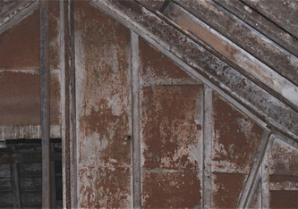
Figure 2.1: Long Mill. Metal plating on attic wall

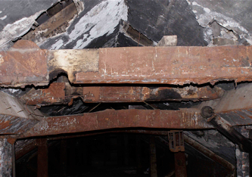
Figure 2.2: Long Mill metal plating on the roof trusses

The North Mill (Dye House) roof structure is entirely cast iron (See Figures: 2.2 and 2.1) and is believed to date from c.1820. They are of particular interest. In view of the close association William Strutt had with the Evans family, there is the possibility that this was also his work (Meangue, 2006). The main roof has thirteen bays of trusses composed of inverted tee section cast iron elements including principle rafters and a single set of struts and a square section wrought iron king rod. The fish bellied purlins, ridge and common rafters are also inverted tee section cast iron (See Figure: 2.4). The purlins incorporate cast-in seatings for the rafters and the backs of the rafters are cast with small cleats for wrought iron battens. The parapet gutters to north and south are lined with bolted cast iron and a cast iron gutter in the fourth bay from the east carries rainwater through the roof-space from north to south.

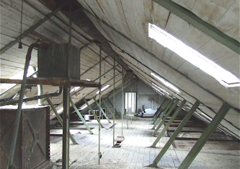
Figure 2.3: North Mill Trusses

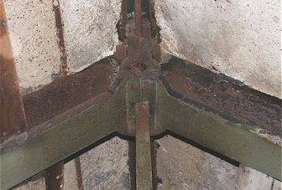
Figure 2.4 Rafter to purlin connections with Lime Mortar Torching in place

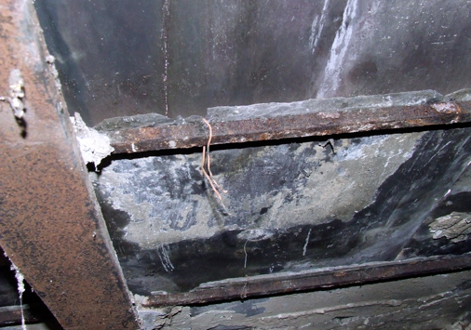
Figure 2.5 Fire-proof tiling with Lime Mortar Torching removed

In assessing the architectural or industrial archaeological significance of Darley Abbey Mills it is possible to identify various factors that underpin and elevate the significance of the site;

- The site importance of the design and technology utilised in the buildings (or in Mokyr’s terms micro-inventions) in terms of the rarity of in-situ examples of fireproofing and the link back to other notable families of the Industrial Revolution such as the Arkwright’s, Strutt’s and William Strutt in particular.

- The site is recognised by UNESCO as being one of the four major Mill complexes that make up the world heritage site and represent ‘…the model for factories throughout the world in subsequent centuries. (Unesco, 2014:1)

Although these are important factors, these points only focus upon the industrial buildings, in order assess the full significance of the Derwent Valley Mills and Darley Abbey Mills sites it is important to examine the relationship between the Mills and the Communities that were built to support the Mills. Hawkins (2002:49) states that these are the:

earliest form of the factory-based community, which together with the pit villages of the coalfields, are still the most emotive symbols of the social effects of industrialization. Cromford Dwellings built by Arkwright at North Street, Cromford by, Nightingale at Lea Bridge, by Strutt at Long Row, Belper and Hopping Mill, Milford, and Evans at Darley Abbey (Derby), all of which survive, are more than the industrial form of the tied cottage; they represent an enlightened, if self-interested approach to the need to provide adequate planned housing as an inducement for potential employees. These early terraces…set a standard for industrial housing rarely surpassed by 18th century housing of similar type.

The historical and cultural significance of these communities is also recognised by UNESCO and form part of their World Heritage Site status designation criteria. As the document states:

Criterion (iv): In the Derwent Valley for the first time there was large-scale industrial production in a hitherto rural landscape. The need to provide housing and other facilities for workers and managers resulted in the creation of the first modern industrial settlements.

Most of Darley Abbey village remains as it was developed in the 18th and 19th Centuries and there is still much evidence of the impact of the Evans family’s influence and patronage. In assessing the factory system is not good enough to merely assess the Mills, as the provision made for workers and the link between this and the late 18th Century Enlightenment informed Industrial model created new forms of community that had never been witnessed before.

2.5.1 The Evans Family

In assessing the historical significance of the Darley Abbey Mill’s site it is impossible to ignore the significance of the Evans family and their relationships with the other Derbyshire Industrialists and inventors. Like their Mills, the Evans family were historically overshadowed by the more famous Arkwright and Strutt families, yet the impact of the Evans family can not be overlooked or underappreciated as they were intertwined with the Strutts’ and Arkwright’s as bankers, friends, partners, innovators and by marriage. The Evans family are one of the most unappreciated great families of the Industrial Revolution whose impact and significance goes way beyond the Darley Abbey Mills. Thomas Evans was the major protagonist and to a certain degree the founder of the Darley Abbey industrial community and mills, came from an ‘old Derbyshire County family and owned land’ (Crouzet, 2008) was well educated and on leaving University established a lead merchants in the city (Armitage, 2014). However, it was Alderman William Evans who acquired a fulling mill and dye house in 1746 and it was not until 1751 when Thomas Evans married Sarah Evans, the daughter of Alderman William Evans, that Thomas Evans had a formal link with Darley Abbey (Peters, 1974; Armitage, 2014). In 1771 Thomas Evans established the Compton and Evans Bank, it was at this point that he became banker to Richard Arkwright. Thomas Evans and his brother (Reverend Edmund Evans) began to purchase further land holdings and in early 1770’s there were five separate water-powered mills; a paper mill a corn mill, two flint mills and a leather mill. In 1782 Thomas Evans and his son William built a cotton mill at Darley Abbey in partnership with Richard Arkwright and Jedidiah Strutt, although it traded as Thomas Evans & Son, from 1786 until Thomas’s death in 1814 he was treasurer of the county, he had extensive estates in Derbyshire and his fortune was thought to be worth £800,000.

However, it was Thomas’s son William who fully developed the family’s interest in Darley Abbey, William established his home there, living at Darley House (Porter, 1974). William also forged an important dynastic link with the Strutt family when, in 1785 he married Jedediah’s daughter Elizabeth. After being widowed in 1796, Elizabeth married her late husband’s half brother Walter Evans in 1798. It was during Walter’s period in charge of the Darley Abbey enterprise that the massive expansion of the mills between 1818 and 1821 took, place bringing with it a substantial increase in the size of the community. Walter’s sister Barbara had, in 1793, married William Strutt, Jedediah’s eldest son, thus forming a double alliance between the Evans’ and the Strutts (Fitton and Wadsworth, 1969). In 1839 when Walter died, his two nephews William and Samuel, whom he had earlier brought into the business, mainly inherited his interests in Darley Abbey. Samuel, who lived in Darley Hall, took over the running of both the paper and the cotton mill businesses. William increasingly led the life of a landed gentleman, moving to nearby Allestree Hall (Derwent Valley Mills, 2014). When Samuel died in 1874 responsibility for running the business fell on the shoulders of his eldest son Walter. Towards the end of his life Walter, while he retained ownership, passed on the day-to-day management to others, and ultimately to the Mill manager John Peacock (Armitage, 2014) who, on Walter’s death in 1903, purchased the mills. Alliances and partnerships were also formed by the Evans through religious connections and membership to clubs and societies such as The Derby Philosophers (Fitton and Wadsworth, 1969; Sturges, 2013).

2.6 Conclusion

The ‘Superstars’ of the British Industrial Revolution overshadow both the family and the Mills, yet as supporting actors their historical significance and impact cannot be ignored. The Darley Abbey Mills are a direct result of being in the right place at the right time and being part of a group of men and women that changed the world forever. The mills are important historical artefacts and are externally recognised as being so not only by historians and cultural commentators, but also by UNESCO and as such, are worthy of both study and preservation. The major impact of the Evans has been the development of Darley abbey Village, which still remains very much as it did in the 19th Century, and stands as a testament of the paternalism and patronage of the Evans family as well as a living exemplar of one of the first industrial communities. Additionally, the Evans family were at the centre of the Industrial revolution, philosophising, financing, marrying, partnering and adopting new technologies and ways of living at Darley Abbey. Both the Village and the Mills stand today as a monument to both the Evans family and the role Derby and the Midlands of Britain played in the industrialisation of the world.

Chapter 3

The Role of Industrial Georgian Buildings Within Contemporary Urban Design

3.0 Introduction

Darley Abbey Mills has a claim to be of national and historical significance, however, this alone is not enough to guarantee the sustainability and future of the site, evidence of this can be found in the English Heritage’s Buildings at Risk Register. One of the most important aspects of the conservation of sites such as Darley Abbey Mills is to ensure that they still have relevance, use and context within contemporary society. In order to remain viable, towns and cities, as well as smaller sites such as Darley Abbey Mills complex, need to be able to compete locally, nationally and globally, therefore, a balance has to be reached between retaining that which people identify with, whilst still being capable of attracting investment (Madanipour, 2006; Tallon, 2010). The competitive strength of a place is derived from the mix of attributes that promote commercial success, and so, some towns and cities have a better mix of these attributes than others (Jones and Evans, 2008; Drake, 2003; Tallon, 2010). Madanipour (2006:181) suggests that design becomes an important factor in achieving a competitive edge; it is a means of ‘differentiation’, a way of distinguishing one place from another (see also Musterd and Murie, 2010; Dainov and Sauka, 2010). Tallon (2010) maintains that competitiveness is not necessarily solely judged on economic grounds but is also judged by character and measures such as, how the built environment supports quality of life, living standards and, the quality of the environment. In order to understand the contemporary context of Darley Abbey Mills it is important to explore some of the strategic options that are available and the contribution the re-use of historic industrial buildings to notions of economic development and sustainability. Therefore, the following three themes will be explored within this Chapter:

- The relationship between Darley Abbey Mills, and the contemporary post-industrial globalised urban landscape.
- How historic industrial buildings such as Darley Abbey Mills can make a positive contribution to the contemporary economic, social and environmental sustainability of towns and cities such as Derby.
- The Role of historic industrial buildings within urban regeneration strategies.

  - The emergence of the contemporary post-industrial globalised urban landscape.

Darley Abbey Mills provide a unique historical environment but also consists of a mixture of different types and styles of buildings that creates a unique historical environment. Factors such as the available materials, technology, craftsmanship and local variations, as well as, the original intended use have all helped to shape and influence the original design of the buildings (McGhuire and Schiffer, 1983). The Mills complex, like many towns and cities are not just of a particular time, but rather are an accumulation of building types and styles that illustrates how the area has been shaped by the geographical assets as well as their inhabitants over time (Porter, 1974). Therefore, areas such as Darley Abbey, as well as other towns and cities become readable documents, which demonstrate the changing pattern of how people have both lived and worked through the ages. Slater (1997) talks about the ‘Geography of difference’ where he suggests that the local environment, the economic base and the historical development all contribute to the local character of the place. So, continued use coupled with technological advances; the changing attitudes towards urban design; economic, political and social positioning; the ability to maintain economic viability in an increasingly competitive marketplace, further shapes not only individual buildings over time but our towns and cities as a whole (McGhuire and Schiffer, 1983; Madanipour, 2006). All of these factors collectively contribute to the identity of the place, its character, and why it is different from its neighbours. Knox (2005) suggests that ‘sense of place’ is a social construct not only by those who inhabit it but also by those ‘external’ to it, i.e. visitors and stakeholders. Subsequently, as sense of place is a social construct, it is thus subject to constant modification or adjustment by those who live, work and visit it, and as Knox (2005:3) states:

As people live and work in places, they gradually impose themselves on their environment, modifying and adjusting it to suit their needs and express their values. At the same time, they gradually accommodate both to their physical and to the values, attitudes and comportment of people around them; the classic socio-spatial dialectic. People are constantly modifying and reshaping places, and places are constantly coping with change and influencing their inhabitants.

Madanipour (2006:185) is of the opinion that: ‘Urban spaces are multi-purpose places, and the more they meet these diverse purposes, the more successful they tend to be’. However, the ‘continued consumption’ (Strange, 1997) of historic towns and sites as tourist destinations puts pressure on the very features that makes the city or locality what it is, therefore, when evaluating how sites such as Darley Abbey Mills are reused, managed or developed, an equilibrium needs to be achieved between retaining the local identity or the distinctiveness and significance of the place, whilst ensuring it remains commercially viable. Knox (2005) acknowledges that globalisation has prompted communities to become more conscious of how they are perceived by consumers, businesses and tourists. The inevitable result of this is that places are re-packaged, reinterpreted, and marketed, Knox (2005) questions who undertakes this re-imaging and on whose terms? Although it is undeniably important to encourage income into historic environments to ensure their viability and vibrancy, these places by their very nature are vulnerable to being reduced to ‘Disneyfied’ (Bryman 2004a), hyper-real attractions if the marketing and management of them is not handled with sensitivity and understanding as to the significance and value of the place.

Darley Abbey Mills alongside Derwent Valley Mills and, in particular Derby Silk Mill, are an important historic artefact that, locate Derby and Derbyshire at the heart of the British Industrial Revolution (see Chapter 2). Although their initial use has become redundant with the advent of new technologies, they still play an important role in the contemporary world. Over the 20th Century, with an acceleration from the 1950’s onwards, Britain’s traditional manufacturing and extraction base rapidly declined, for Jones and Evans (2008), Middleton and Freestone (2008) and Tallon (2010), this was a result of a combination of increased global competition, a greater level of automation and out-dated sites. This had a devastating impact upon those cities that were overly reliant upon their manufacturing base. The consequences of this sudden loss of industry included: massive unemployment coupled with economic and social problems. By the end of the 20th Century the economy of the UK was being characterised as entering into a phase of post-industrial (Urry, 2011) or post-Fordist (Harvey, 1991) this was characterised by a dramatic shift from a manufacturing to a service-based economy that heavily relied upon the consumption and the provision of services (Middleton and Freestone, 2008; Pratt, 2009; Tallon, 2010). This new economy centres around the information and knowledge intensive activities, for example, the provision of banking and financial services, but also the more ‘creative, technology-intensive industries’ (Hutton, 2009:988) such as, the development of computer software and hardware, game production, graphic design, digital photography etc. (Hutton, 2009; Middleton and Freestone, 2008; Tallon, 2010). With the advent of the era of post-industrialisation, there has been a shift from large scale manufacturing within the Western economies, to a more knowledge based economy underpinned by innovative forms of technology and communication, Castells (2011:407-8) goes on to state that:
Both space and time are being transformed under the combined effect of information technology paradigm, and of social forms and processes induced by the process of historical…the information age is ushering in a new urban form, the informational city.
For Lash and Urry (1994:220), the shift from the industrial to post-industrial city is characterised by the fact, that rather than exchanging tangible goods, cities are becoming places to trade and produce ‘information, knowledge, images and symbols’ and as such the spaces of industrialisation for a short time became redundant. However, the availability of large open industrial spaces in the city were recognised has having certain hard and soft characteristics that encouraged the adoption of these spaces by a group of creative users. This transformation in the usage of space was explored in Sharon Zukin’s seminal book, ‘Loft Living’ (1988) where she investigated the idea of ‘social-spatialization’. Zukin discovers an interesting relationship between former industrial loft buildings and artists. The book charts how artists in New York used the space as a maker or statement of their identity and the artistic movement in which they were immersed, they found that they were motivated and inspired by the building’s historical and aesthetic qualities and their urban context. The relationship between historic industrial buildings and the creative and artistic community still remains today (Champion, 2010; Heebels, 2012). This view, is explored by Helbrecht (1998:16) in her analysis of the marketing and advertising sectors, she goes on to state:

The layout and design of space matters a great deal to them because it is part and parcel of their personal and professional vision. Creative people are ‘space people’ who resent living or working just anywhere.

The urban environment for this group of people is more than merely a place to live and work, the built environment acts as a visually stimulating and inspirational space. Helbrecht (1998:27) in assessing the role of the built environment for creative workers goes on to declare:

In order to attach the material world of consumer goods with aesthetic values and meaning, they thrive on very specific notions of urbanity, embodied with emotions and aesthetics.

Although Helbrecht’s research was limited to only advertising and design workers, it uncovers a special connection between the aesthetics of the space and the city and creative workers. The author also argues that these creative people have strong relationship with the urban context, which boosts their visual reflexivity.
3.2 Regeneration
The impact of post-industrialisation has radically altered the social and economic structures of cities, leaving many long standing industrial communities shattered and, many industrial buildings empty and abandoned (Jones and Evans, 2008; Tallon, 2010; Urry, 2011). The result of this has been development and utilisation of many and varied urban regeneration strategies, as Carpenter (2011:228) states:

The past decade has seen a boom in regeneration, with significant investment in many of Britain’s towns and cities. Following a period of decline in the 1980s, many cities have seen considerable regeneration and renaissance of their centres, with economic growth driven by the finance and service industries, and investment in new retail developments, city-centre housing and the public realm.

However, Roberts and Sykes (2005, citied in Lovering, 2007:344) make the point that the idea of regeneration is something that is on going in each generation:

…‘regeneration’ is merely the latest in a series of words beginning with R that can be used to describe (British) urban strategy over the past half century: Reconstruction in the 1950s was followed by Revitalization in the 1960s, Renewal in the 1970s, and Redevelopment in the 1980s.

Urban regeneration can be seen as political strategy that shifts with the political priorities of successive governments (Jones and Evans, 2008; Carpenter, 2011). This shift in political priorities can also explain the myriad of definitions that surround the concept of regeneration. Jones and Evans (2008:2) define urban regeneration as, ‘The large scale process of adapting the existing built environment’, whilst Meecham (2005:1), regards regeneration as ‘...the positive transformation of a place’. Both of these definitions intimate different strategies and approaches, the first advocating large scale adaptation, whilst the latter concentrates upon place image. However, successful and sustainable regeneration should be holistic in nature, i.e. that it involves an understanding and contextualisation in terms of existing and desired image, the environment, local and regional needs etc. Tallon (2010) advances a more rounded definition of regeneration by suggesting that there are three elements involved when transforming run-down areas, namely, people, business and place. For Tallon, one of the major aims of regeneration is to enhance people’s skills and improve the competitiveness of businesses, this in turn will help create jobs and the prosperity of the area, and as consequence the will be increased appeal of the locality, consequently attracting new people and businesses. In a similar vein, Jones and Evans (2008) forward the idea that regeneration is more than just redevelopment, but that it brings about the re-birth of an area, an act of healing, where the run-down areas are cut out and replaced with something new. Colantonio and Dixon (2011) take this idea of healing a step further by identifying that any regeneration project should also have a social and cultural sustainability element to it. Evidence of the need for this social element of regeneration, is identified by Mah (2012) in her research of de-industrialised cities. Mah found that many of those individuals were effected by the de-industrialisation of their region, and that the impact of de-industrialisation was still negatively informing their ‘everyday lived experience’, and they perceived that any benefits of regeneration were passing them by. Regeneration is a multifaceted entity that has different meanings for different communities in different localities. As such, there is no generic strategy that can be implemented in everyplace, rather regeneration should take a carefully tailored approach that analyses the site or area in a holistic manner and includes communities, workers, the nature of the environment and buildings, the local and regional economy and, the possible positive and negative impacts. A good example of the failure to take a holistic approach to regeneration and the failure to incorporate ‘heritage’ effectively into regeneration plans may be seen in Derby. The centre of Derby City Councils current regeneration plan was the building of a ‘Westfield’ Shopping Mall (now Intu Derby) on the Eastern side of the City Centre. As a result of this development the entire stock of major branded stores such as Debenhams, Marks & Spencer’s, Ernest Jones, Argos etc. relocated to the new Mall. These stores were initially spread throughout the City Centre bringing footfall to all areas, including the historic Georgian centre and the branded Cathedral Quarter. These areas of Derby City Centre contained a great array of small independent traders who were selling goods and services that could not be sourced in the branded stores, the mixture of the branded stores and the independent retailors created a vibrant and unique environment. However, the centralising of branded stores left a vacuum in the historic areas, with former retail sites remaining empty, the reduction of footfall led to a major decrease in the passing trade (Derby Cathedral Quarter 2013) that the independent traders relied upon. This decline has been charted by local news networks since the construction of the ‘Westfield Centre’, below are four quotes in chronological order:

The future of independent retailers in the city centre is being threatened by the recent opening of the Westfield Centre. Several shops have had to make staff redundant and claim they will have to close in a matter of weeks. They are calling for a rescue package including a decrease in council rates to help traders hurt by a drop in business (BBC, 17/12/2007).

Shopkeepers on Sadler Gate claimed they have been badly affected by the new Westfield Centre, which opened in 2007. About a third of shops on the street are empty and traders have called for help from the city council. The council said it was aware of the pressures and would look at ways to help, such as extra signs and revised parking charges. (One trader stated that) ‘Unless the council do something for us Sadler Gate is not going to survive. Three shops closed down in the last week. There used to be a premium to be on Sadler Gate, now you can't give them away.’ (BBC, 19/10/2009).

Jewellery shop H L Brown, which has been in Derby for 75 years, has blamed the Westfield shopping centre for its decision to close its Victoria Street store in the Cathedral Quarter and has launched a closing-down sale. The Sheffield-based business claims the Derby shop has suffered a drop in trade since the Westfield Derby centre opened in October 2007. H L Brown, founded in 1861, has seven outlets, predominantly in Yorkshire. The Derby shop will close on March 18. In a letter to customers about the sale, the managing director said, ‘The advent of the Westfield centre has drawn trade away from us and the Cathedral Quarter is not of the caliber it once was’ … A report by the Local Data Company claimed the number of vacant shops in Derby city centre had risen. The report said the percentage of Derby's 745 shops currently empty stands at 16.9%, a rise of 3.4% from its last report, in June 2009. (Derby Telegraph, 18/2/2009)

… following the expansion of Westfield in 2007, about 58% of the outlets - predominantly independent businesses - became vacant. (Principal advisor for the regeneration scheme stated :) “Derby City Council was struggling to find a way to reverse the fortunes of the city centre, which was looking pretty dreadful. It was in danger of being an environment that was quite blighted. The expansion of the Westfield coincided with the wider economic downturn. A lot of city centre retailers left or went bust… (BBC, 29/8/13)

The result of the regeneration of Derby City Centre has been a partial regeneration around the ‘Westfield Centre’, but the formally vibrant historic centre is now subject to many initiatives to regenerate this area and to ensure there is a link between the contemporary and historical sites of Derby (Derby City Council, 2012; Derby Cathedral Quarter, 2013) including the Silk Mill and Darley Abbey Mills to reinforce the significance of Derby’s heritage base. To an extent Derby has lost it’s distinctiveness and is in danger of becoming another ‘Clone Town’ as a direct result of failing to effectively utilise its inventory of historic buildings and it’s heritage as identified in Licciardi and Amirtahmasebi’s (2012) ‘the economics of uniqueness’ (See Section 3.4 for further details).

From the case of Derby as outlined above, the regeneration sector has been hit hard by the economic recession with many ongoing projects delayed, and sites planned for redevelopment being mothballed. While the North of England and the Midlands have been hardest hit (Carpenter, 2011), Derby, like most cities has invested heavily (socially, culturally and politically) in the regeneration of the City Centre, with the compulsory purchasing of large areas of the City Centre for the building of new urban communities, social and cultural resources and shopping (Derby City Council, 2012). However, these revivals like many other projects have:

…been built on a model that relies heavily on rising land values and easily available finance, both of which have been called into question by the current financial crisis and deepest recession since the 1920s. With the economy only just out of official recession, this has had an impact on both the public and private sectors’ ability and willingness to finance regeneration projects, either already in progress or in the pipeline (Carpenter, 2011:228).

The result in Derby is that much of the initial regeneration plan has been put on hold, with many projects incomplete or even cancelled. The significance of this is that the regeneration of the local economy cannot only rely on the building of new communities, but has to explore its existing resources such as the Darley Abbey Mills site. The use of historic buildings and sites to support the regeneration of localities is also supported by Taylor (2014:72) who, when examining the various roles historic landscapes can play in regenerating cities and towns, states that:

…the possible application of the Historic Urban Landscape approach to complex urban conservation situations is widespread. Its main point of concern is the construction of significance in urban places, as well as how urban heritage can become a resource to foster rehabilitation and regeneration of the modern city.

Similarly, Liebmann and Kuder (2012) identify that history and historic sites is one of four strategic factors that can give de-industrialised small cities a means and opportunity to regenerate and, a competitive advantage over their neighbours. As such, part of any regeneration plan should include, ‘…the continued maintenance and renewal of specific industrial pasts, which are enabled to continue through processes of re-structuring and modernization’ (Liebmann and Kuder, 2012:1170). The next section of this thesis will explore in more detail the relationship between regeneration and the role historic buildings and sites can make to contemporary urban development and the sustainability of cities.

3.3 Culture and the Role of Historic Buildings Within Regeneration

As can be seen from the work of Liebmann and Kuder (2012) and, Taylor (2014), historic buildings can form an important element in the regeneration of contemporary cities and, has been adopted by many National and Local Governments, as Rautenberg (2012:78) states:

In west-European countries, public policies often argue that heritage – and in particular industrial heritage – could be an effective resource for economic and social development in areas that have been severely affected by de-industrialisation.

Historic industrial buildings offer flexible space etc. but they also represent something that is not tangible in the form of ‘soft’ location factors (Musterd and Murie, 2011). Buildings such as the Derwent Valley Mills and Darley Abbey Mills are an expression of the ethos of a locality, region or country, they are material forms of culture, which not only reflect the time they were built or conceived, but also they are also a cultural expression of the region today. Darley Abbey Mills represent an exemplar of a material form of culture that was the product of the British Industrial Revolution and the Enlightenment, however as Darley Abbey Mills stands today, its modifications, usage and even its status as part of a UNESCO World Heritage Site, it is also a material form of contemporary post-modern/post-industrial culture. This view of culture is reinforced by Miles and Paddison (2005) and Roberts and Sykes (2005), who emphasise that, the definition of ‘culture’ is not a static one, but rather it evolves over time to reflect social, economic and cultural development. Jones and Evans (2008) highlights the ambiguity of the term ‘culture’, as it is not only used to label individuals, groups and communities as belonging to a particular cultural category, but that it is also used to symbolise a city, nation or region. Tallon (2010) also sees culture as a means of classifying various aspects of the contemporary world, he suggests that ‘culture’ classifies the way people think, speak, act, dress and engage with others, but that ‘culture’ also contributes to our understanding of place. Meecham (2005) and Montgomery (2004) both stress that ‘culture’ encompasses design, heritage and the historic environment. If it is accepted that material expressions of culture are ‘soft’ location factors, then material expressions of culture such as Derwent Valley Mills denotes the meanings and values of the city or region to visitors, residents or prospective investors (Wansborough and Mageean, 2000). The idea of heritage signifies, tradition and a link to the past that is less fleeting than contemporary society (Urry, 2011).

Evans and Jones (2008) view cultural regeneration, as a means to transform the image of a city by creating new historic quarters, which in turn transform the physical appearance as well as the cultural identity of the place. For Vehbi and Hoskara (2009:716) ‘Historic Quarters’ are ‘...part of our overall environment, it is the historical dimension, recognisable through the physical fabric of places’, what appears to be one of the major factors for success for this type of project, is the ‘distinctiveness’ of the site. According to Vehbi and Hoskara (2009), the distinctiveness of a historic quarter is forged by a mixture of the physical fabric of the past, such as the historic buildings, the street patterns and the public space etc. but equally important is evidence of past human activity, all of which have contributed to the historical identity of the place.
3.4 Heritage as a Tool for Urban Regeneration
Licciardi and Amirtahmasebi (2012) identify the use of heritage for regeneration as ‘the economics of uniqueness’. The book explores how investment in historic city cores and cultural heritage assets can lead to on-going sustainable development. They go on to state:
As cities expand rapidly, conservation and continued use of heritage can provide crucially needed continuity and stability. In other words, the past can become a foundation for the future.... Cities that are the most successful at attracting investment and businesses to meet the aspirations of their citizens, while alleviating poverty and promoting inclusion, are those that harness all of their resources, including their heritage. In addition, heritage anchors people to their roots, builds self-esteem, and restores dignity (2012:viii).
In illustrating this sentiment, O’Brian (2007) presents a case study of Dublin, which focuses upon how the use of the Georgian historic townscape created a spiral of development and regeneration within the city. In support of Licciardi and Amirtahmasebi’s identification of the relationship between the utilisation of heritage and economic development, UNESCO envisage that the designation of an area or artefact as a World Heritage Site, will act as an economic driver for regeneration of both the surrounding area and the protection of the site itself (Ryan et al., 2014). However, a great deal of the surrounding literature that considers the use of heritage in economic development adopts tourism as the primary strategy for economic and social development. The role of tourism within economic development has been recognised for some time, for example, De Kadt’s seminal book, ‘Tourism: Passport to Development’ (1979) became the definitive piece of academic work on the relationship between tourism and economic development and the benefits it can bring to communities (see Jenkins and Henry, 1982; Cohen, 1985; Gössling and Scott, 2012; Garcia, 2014). In the post-industrial era, heritage tourism is still seen as a means to gain economic growth within the de-industrialised urban areas of the world (Rogerson, 2012; Behnnaz and Dadras, 2013; Said et al., 2013; Light, 2014; Yong-Ki, 2014). For Henderson and Weisgrau (2012), heritage tourism, is a seduction of history whereby heritage and the built environment is molded and shaped to meet the desires and needs of tourists in a global world.

Post-industrialisation has led to a re-structuring of society, whereby globalisation has impacted upon the way in which individuals view the world, that it has led to a fleeting culture that is depthless and transient (Harvey, 1991). The result of this is it has become more apparent that, ‘a global society is emerging’ that is largely dominated by the homogeneity created by brands and the mass media (Lash and Urry, 1994; Clark, 2003; Knox, 2005; Madanipour, 2006). According to ‘The New Economics Foundation’ (2002:10) globalisation has led to:

... a world of growing homogeneity and blandness, where local difference, flavour and colour is erased in the pursuit of uniformity, and where big business sets the aesthetic agenda – be it in architecture, physical appearances, fashion or foodstuffs. Clone towns and clone cultures are spreading across the globe.
As a result of this homogeneity, Evans (1997) proposed that the increased dominance of the High Street by large corporations over individual retailers has led to 'boring, predictable, over commercialised places devoid of local cultural significance'. However, this shift is not restricted just to the High Street. Kunstler (1993) suggests, that this sameness has resulted in: 'an urban geography of ‘nowhere’', or in other terms: '…with a sense of 'placelessness' and dislocation, a loss of territorial identity' (Knox and Mayer, 2013:23). This can be seen whilst driving through British towns and cities that all share the same industrial and residential architecture, this ‘geography of nowhere’ is evident all around. For Strange (1997), this process is exacerbated by the diminishment of spatial and temporal barriers in an increasingly competitive global market. The consequence of these removal of barriers, is that the, '…extreme homogenising pressures of globalisation' (Tweed and Sutherland, 2007:62), results in the local distinctiveness, or identity of a locality becoming more important, both in economic and cultural terms (Licciardi and Amirtahmasebi, 2012). Ryan et al. (2014:747) in assessing the role of tourism in the regeneration process recognise that: '…the use of tourism as a tool for social, economic and cultural development…and the development of glocalisation as a response to globalisation' (Ryan et al., 2014:747).
Although there is a clear identified link between tourism, regeneration, history and heritage some authors still argue that it is dangerous to continually look to the past. Hoskins and Tallon (2003) contend that within contemporary design that there is a preoccupation with history and, that this preoccupation is a reaction to the transient and fragmented lifestyles of contemporary society and it becomes a means of finding roots in a rootless society. In their evaluation of the UK’s regenerated dockland areas in Liverpool and Bristol are assessed as, ‘shallow parodies of their cities previous global role in trade and industry’ (2003:4), they further question the purpose of these ‘relics’, and ask whether the docks simply acknowledge their historical role and significance, whilst avoiding any political debates which surrounds their post-industrial obsolescence. However, the regeneration of the Albert Dock in Liverpool was innovative in the 1980’s, when the abandoned historically and architecturally important dock was redeveloped. By 1900, Liverpool was home to the largest port in the world, but due to the decline in industry by middle of the century the seven acre site of the Albert docks and its associated warehouses fell into disrepair and were eventually abandoned in 1972 despite them being designated as the largest collection of Grade 1 listed buildings in Britain in 1952. Over the last thirty years the site has continued to develop and now includes shops, offices, apartments, bar and restaurants. Not only are the buildings a visual and prominent testament to Liverpool’s history but the docks also house the Maritime museum, the Museum of slavery and also Tate Liverpool. In 2004 the Albert Dock was included as one of the six parts of the city, which was designated as a World Heritage site by UNESCO in 2004, this was due to the city’s role in the growth of the British Empire and for the development of pioneering dock technology. The Albert Docks continue to bring economic growth, jobs and play a major role in the Visitor economy of the city (English Heritage, 2014). Thus, the use of historic buildings can play a significant contemporary role in the regeneration of urban areas, and that through their social, cultural and economic re-contextualisation can secure their future.
As can be seen from above, the role of culture in a post-industrial society has grown in significance, the use of historic buildings forms a central element within cultural and heritage tourism industries. As a consequence, these industries have used tourism as an effective strategy for the maintenance and conservation of historic buildings and sites throughout the world (Lowenthal, 1985; Yale, 1991; Urry, 2011). Tourism has the added benefit of being extremely cost effective and produced employment at a lower economic rate than traditional manufacturing jobs (Goodall, 1994; Falk, 2000; Urry, 2011). However, for Urry (2011), although tourism can create cost effective employment opportunities, he questions the nature and quality of many of the jobs created in terms that they are, often seasonal, low paid, unskilled and menial. In addition to creating jobs, tourism is also identified as one of the major strategic tools to provide historic building with a contemporary role and context; this leads to the conservation and development of historic buildings for touristic purposes (Hospers, 2010). It is also clear that sites that are designated as a UNESCO World Heritage Site are provided with an economic advantage over non-designated sites (Ryan et al., 2014). For example, Van Blarcom and Kayahan (2011) in their analysis of the Grand Pre Historic site in Nova Scotia identified that 6.2% of visitors were due to its World Heritage Site designation and, that this alone would generate an additional $200,000 in the local economy. Similarly, Rebanks Consulting (2012) in their evaluation of the impact of World Heritage Site status on the Derwent Valley Mills, found that in the case of Strutt’s Mill and the former Mill housing in Belper the securing ‘…£3,940,000 of external funding…’ was a direct result of the UNESCO designation, and without designation it would have been ‘highly unlikely’ that submitted regeneration bids would have been successful (Rebanks Consulting, 2012:67). They also identified that:

The real difference made by WHS status in Belper was the galvanizing effect that the designation had on stakeholders, including the community (many of whom understood for the first time because of the WHS validation the global importance of their community) and the leverage it gave the town with funders. Stakeholders in the town believe that being a WHS gave them an advantage over competitors for the investment – being a WHS sent a signal to the local authorities and funders that this was a priority place for investment. The result has been a scheme that has benefited the town in ways that residents can all recognize with 4 public realm projects, 12 commercial properties and 53 residential properties restored to their original glory with a mixture of private and public investment (Ibid. 2012:68).

It is interesting to note that the research by Rebanks Consulting 2012 only measured the economic impact in terms of funding that had been attracted and did not consider factors such as income generation from tourism or visitors and jobs created etc. In assessing the impact of World Heritage status for the remainder of the Derwent Valley Mills they state (Ibid. 2012:68):

Whilst it is too early to prove that this has changed the long-term economic trajectory of the Derwent Valley, stakeholders believe that the town has been affected positively with changed perceptions of this as a place to live, work and invest. In the wider valley stakeholders have witnessed the WHS OUV provide them with a collective identity and purpose which, at its best, stops them acting as disparate visitor attractions and communities, and instead focuses minds on their collective product and identity.

Thus, the relationship between the historic credentials of Darley Abbey Mills and its World Heritage status should enable its development as a tourism site. Nevertheless, designation is not a guarantee of success and, the suitability of the site for tourism development needs to be further assessed. Xie (2006) identifies six attributes to be used in assessing the feasibility for developing an industrial heritage site for tourism, these include:
- The potential of the site.
- The role of stakeholders.
- How the space can be adapted.
- Are the necessary economic funds in place?
- Can it be seen as different and authentic in relation to the rest of the city?
- The perceptions of all of the decision makers.
However, even if the site meets all of these attributes, success is not guaranteed. A major piece of research by Alan and Shipley (2014), examined 16 heritage projects in the UK that had received regeneration based funding over a 12-year period (survey undertaken 2000; 2006; 2011), monitoring and appraising the impacts of investment on a range of themes, including quality of life, economic activity, confidence and appearance. They found that at the data collection points of 2000 and 2006, the projects were doing well and were be supported not only by visitors and rental of facilities, but were also attracting both public and private sources of funding. However, their findings demonstrated that the sustainability of projects was dependent upon external funding, and with the advent of the economic recession in 2008, by 2011 many of the sites struggled to survive, with many identifying that the long terms sustainability of the project was in jeopardy. Similar economic conclusions were also found by Powell et al. (2011) in their analysis of heritage-based projects in Merthyr Tydfil. Although tourism may be seen as the panacea for all of the issues facing the conservation and maintenance of historic sites, there needs to be a degree of caution. Hospers (2010) identifies the significance of tourism, he also states that it is dangerous to only consider one strategy, and that sites should move towards mixed use. This view is further supported by Firth (2011) who in exploring the effectiveness of tourism as a means to heritage conservation developed a case study of Woolloomooloo Finger Wharf, an industrial heritage site in Sydney, identified that tourism did play an important role in the conservation of the built heritage. However, the lack of facilities and resources such as parking and food outlets limited the success of the site as a tourist attraction. In conclusion, Firth recognised that if the site had adopted a mixed-use strategy, its chances of success would have been much greater.
As tourism may not be the solution for the sustainable future of Darley Abbey Mills, it is important to consider alternative or complementary strategies for the sustainable future of the mills complex. Since the early 1990’s there has been an increasing emergence of clusters of the new service-economy based businesses located within former industrialised segments of cities within Britain. Hutton (2009) likens this re-industrialisation of de-industrialised areas to a phoenix rising from the ashes, where new life for old buildings and areas are found. Therefore, the consequence of this is the conservation, adaptation and re-use of historic buildings, sites and districts, this is in part due to the look and feel of the historic buildings being in line with the image these creative industries wish to portray, which is afforded by the ‘space, place and form’ of the historic industrial buildings and areas (Hutton 2006). Hutton (2006) uses Clerkenwell and Shoreditch as examples of areas both located on the fringe of the inner city of London, where these new industry clusters have subsequently led to the regeneration of these areas. Montgomery (2007) points out that the creative industries contribute not only to the economic development of an area, but also plays a significant role within the regeneration and sustainability agendas as these creative industries are linked to the image of the cities they are located in, and subsequently impacts upon the quality of life for those who live, work and visit them. Montgomery (2007) includes: The Custard Factory at Digbeth, the Cultural Industries quarter at Sheffield, The Chocolate Factory in Wood Green London, and the Chapter Workshops in Cardiff as examples of successful refurbishment and re-use of historic industrial sites, in order to highlight the contribution refurbished former industrialised sites can make within contemporary society.
3.5 Creative Industries
With the advent of the post-industrial era, historic sites such as Darley Abbey Mills have struggled to find a contemporary context and use. Many sites have resorted to becoming tourist attraction or museums, although Darley Abbey Mills are identified as a tourist attraction by Derwent Valley Mills and the Local Council, the nature of the buildings, the ownership, the current mixed use and lack of parking preclude this option. Additionally, although a small amount of manufacturing takes place there the buildings do not really suit modern production methods. The significance of protecting, and re-creating the identity of towns and cities and encouraging post-industrial jobs is explored by Miles and Paddison (2005:23) in their analysis of Stoke-on-Trent. They state:
Unlike many other Western cities, Stoke-on-Trent remains overly dominated by working-class production and consumption cultures. The city is thus, in a sense, rendered illegible to post-industrial businesses, tourists and to the many young people who leave the city in search of the more dynamic economic and cultural opportunities offered in other cities.
The failure to find contemporary context for towns and cities can have a devastating effect upon them. Thus, the historic built environment becomes a means of expressing difference and differentiation between cities and regions, it enables the locality to stand out from other towns and cities, attract investment and jobs through the utilisation of ‘Cultural Capital’. According to Sklair (2014:176), the material, ideological, and symbolic roles of architecture are important in the formation and expression of local or national urban identity. He goes on to state (2014:176):
The historical context of this argument is the hypothesis that the production and representation of architectural icons in the pre-global era roughly before the 1950’s) were mainly driven by those who controlled the state…whereas the dominant forms of architectural iconicity for the era of capitalist globalization are increasingly driven by those who control or own the corporate sector. This implies that state driven icons help form and express certain types of identities, while corporate-driven icons form and express other types of identity.
Therefore, the continued use and conservation of historical buildings such as Darley Abbey Mills, can act as a juxtaposition to this homogenisation by providing a foundational link back to the history and heritage of a place, and reinforcing the individual character and identity of Derby and it’s perceived ‘place image’. Additionally, the attraction of creative industries to Darley Abbey Mills is significant in ensuring its continued survival. According to Miles and Paddison (2005) historical industrial buildings are suited and attractive for the new technologically advanced creative industries (see also Francesco and Van Oers, 2012; Colomb, 2012). Similarly, O’Connor and Gu (2010) examined how the creative industry sector in Manchester, helped to re-invent the city in the wake of post-industrialisation. For Anderson (2012:17) we are at the start of a new Industrial Revolution, and that is driven by the use of computer technology and more specifically ‘…when the Web generation turns to the real world’ he goes on to state:
This is not just speculation or wishful thinking – it can already be felt in a movement that’s gathering steam at the rate that rivals the First Industrial Revolution and hasn’t been seen since, well, the Web itself (Anderson 2012:18).

Although Anderson concentrates on the way in which individuals can come together as global workers, each being located in their own countries, cities or even villages and using technology to form companies, partnerships and co-operatives, his quote can be seen to evaluate the role of creative industries as an alternative to traditional manufacturing. Since the 1990’s, there has been a steady growth in this sector of the economy, according to Scott (2004:482) the contribution of the creative industries to economic development and the competiveness of towns and cities has led to a ‘…substantial share of income and employment in a wide range of countries.’ In a piece of significant research undertaken for the European Union on the ‘Economy of Culture in Europe’ (DGEC 2006:1) it was identified that the research:
…shows how culture drives economic and social development, as well as innovation and cohesion. The cultural and creative sector is a growing sector, developing at a higher pace than the rest of the economy. The same applies to employment. Indeed this sector provides many different and often highly skilled possibilities, and again the sector’s growth in terms of jobs out-performs the rest of the economy. It also drives many other sectors of the European economy, and in particular innovation and ICT sectors.
What is significant for the Derwent Valley Mills and Darley Abbey Mills and their continued use, is that there is evidence that the setting, space and structure of historic industrial buildings, meets the ‘needs’ of this group of workers (Drake, 2003; Newman and Smith, 2010; Smit, 2011; Francesco and Van Oers, 2012), (discussed further later in this Chapter).

  - The Rise of Creative Industries

The scale and nature of the Creative Industries in the UK was recently explored by the Culture, Media and Sport Committee (2013:1), the report stated that:

- The creative industries contributed 2.9% of the UK's Gross Value Added in 2009, equivalent to £36.3 billion (GVA + taxes on products - subsidies on products = Gross Domestic Product)
- 1.5 million people are employed in the creative industries or in creative roles in other industries, 5.1% of the UK's employment
- Exports of services by the creative industries accounted for 10.6% of the UK's exports of services, equivalent to £8.9 billion (2009 figures)
- There were an estimated 106,700 businesses in the creative industries on the Inter-Departmental Business Register (IDBR) in 2011, representing 5.1% of all companies on the IDBR.

In gathering this data the Culture, Media and Sport Committee (2013:1) define the Creative Industries as:

Those industries which have their origin in individual creativity, skill and talent and which have a potential for wealth and job creation through the generation and exploitation of intellectual property.

This definition provides a fairly broad understanding of the sector and that it includes many areas ranging from Opera to Web Designers. The vagueness of this definition has been criticised by a number of authors (Pratt, 2005; Graham, 2005; O’Connor, 2007) who claim that the merging of the Creative and Cultural sectors has made it possible to re-direct funding from the Arts budget to the support on new industries. In order to unpack this definition it is useful to explore the DGEC’s, ‘Circles of Activity’ (2007) (see Figure 3.1). Within this chart, they make a clear distinction between the ‘Cultural Sector’ and the ‘Creative Sector(s)’, although they still define them within the broad ambit of Creative Industries. DECG (2007) identify four distinct areas, the first two representing the cultural sector, with the last two representing the creative sector:

- Core Art fields: which includes visual and performing arts and heritage.
- Cultural Industries: which includes the technology surrounding video, television, books etc.
- Creative Industries and Activities: design, advertising and architecture.
- Related Industries: Small independent producers

Figure 3.1 ‘Circles of Cultural and Creative Activity within the European Community’ (DGEC 2006:48)
Content removed for copyright reasons

Please see: DGEC (2006) Priority Sector Report: Creative and cultural industries; Available from: ec.europa.eu/enterprise/newsroom/cf/_getdocument.cfm?doc_id.

Although at first, Creative Industries may be seen as the answer to the gap left in many cities by the de-industrialisation of their economies, Breitbart (2013:306) provides a thoughtful assessment of the sector:
Art, cultural production and creative industries can boost economies and contribute to the quality of life . . . However, there is no simple panacea for the economic and social challenges that post-industrial cities face . . . Just as post-industrial cities recognize the importance of economic diversification,
there is a parallel need to recognize the importance of a diversity of creative economy initiatives, and to see the creative economy as only one component of community regeneration within a larger sustainable cities agenda
Although there is evidence that the creative industries are attracted to historic heritage buildings it is important to explore some of the factors that make sites such as Derwent Valley Mills and Darley Abbey Mills so attractive as a proposition.

3.7 Hard and Soft Location Factors

One of the ways in which it is possible to understand the creative industry's attraction to historic industrial buildings is by exploring the 'hard' and 'soft' location factors that exist at each site. Hard factors represent the tangible physical attributes of a locality, these include workable space, access (Ball, 1999; 2002), proximity to City Centres (Hutton, 2009), flexibility of space (Montgomery 2003), transport links (Sykora and Bouzakovski, 2012) and rental price per metre (Murphy and Redmond, 2009), these factors are easy to identify and quantify. Soft factors are the intangible characteristics of a site, the feel (Helbrecht, 1998), the creative atmosphere (Zukin, 1989), or the aesthetics of place (Smit, 2011) etc., however these characteristics are subjective and are difficult to measure. According to Musterd et al. (2007:17):

While the ‘hard’ and more classic location factors are still very important in explaining the location patterns of companies, the academic debate has shifted towards a growing emphasis on ‘soft’ location factors…this potential shift in location preferences of companies from ‘hard’ to ‘soft’ with the global transformation from a Fordist, production-based economy to a post-Fordist, knowledge-based economy.

However, it may still be argued that both hard and soft factors play a significant role in a company’s location choice (Musterd and Murie, 2010; Dainov and Sauka, 2010).

There is much evidence that those working in the creative industries are attracted to historic industrial buildings (Zukin, 1989; Drake, 2003; Hutton, 2006; Heebels and van Aalst, 2010; Smit, 2011), this attraction can be seen to be driven by two major factors or characteristics. For Champion (2010) it is a ‘hard factor’ in terms of an economic prerogative, generally the cost of renting a unit in a former industrial building is more cost effective than renting newly constructed units. As Champion states (2010:14):

Underlying this is the idea that cheap space and corresponding cultural diversity are vital ingredients for developing creative businesses. Low-cost space offers opportunities for flexibility and grow-on space, which is especially important in high-risk, undercapitalised industries.

The second factor is the design and architecture of the buildings in terms of the availability of large open spaces, their high ceilings and large windows that flood the space with natural light. Hutton (2006:1834) asserts that older building structures are attractive for new industrial enterprises with their, ‘physical configuration, durability and embedded construction qualities…material attraction…external building scale and style and internal building configuration’. These characteristics or attributes of the buildings are as important now for the new creative industries as they were in the 18th Century when the Strutt and Arkwright adapted Lombe's design. For Landry (2005), the combination of the hard and soft characteristics of many former industrial sites, once conjoined, generate what Landry (2005:2) defines as a ‘creative infrastructure’ and that this infrastructure supports innovation, incubation of businesses and the development of communities of creativity. In assessing the continued re-use of Darley Abbey Mills it is important not only to assess the ‘hard’ location factors, but also to assess the significance of the unquantifiable subjective ‘soft factors’ of the site. The ‘soft factors’ are particular to an individual site, an individual tenant, or an individual owner or worker.

In assessing the ‘soft factors’ of a site it is important not only to examine the site itself, but also it’s setting and the nature of the community that surrounds it. In assessing the impressions of the buildings, there tends to exist an overtly artisanal sensation or feeling to historical industrial buildings, especially those within the Derwent Valley Mills, the bricks, the steel frames, the wooden beams, stone lintels etc. all have been largely formed and shaped by hand. Although they were originally designed and constructed as industrial buildings, and remain as such today, they still represent the values of the past and, the philosophy and values of the ‘Enlightenment’. Many of these values and philosophical links between the arts, science and innovation are still relevant today, historical industrial buildings can be seen not only as an artefact, but are ‘living’ expressions of the workers and the innovators that designed and created the buildings. Zukin (1989:59) in her assessment of the contemporary attraction to historic industrial buildings states: ‘Their facades are often adorned with archaic emblems and sculpture, apparently showing the equally archaic skills of masons and carvers’. Although Darley Abbey Mills may be seen as more significant in terms of function rather than aesthetics, as the buildings illustrate little adornment, the evidence of fireproofing and roof structures, the skills of the craftsmen are still to be admired. According to Smit (2011), the aesthetic qualities of the surrounding area are as important as those of the buildings themselves, in her research she found that the ‘visual distinctiveness’ of the surrounding areas was one of the significant consideration factors in the decision making process undertaken by prospective tenants and owners. In assessing the contemporary context of Darley Abbey Mills, it is also important to identify the remaining ‘soft factors’ which are it’s geographical setting, in other words the ‘look and feel’ of the surrounding area (Helbrecht, 1989; Musterd et al., 2007; Heebels and van Aalst, 2010). In Smit’s (2011:178) research, this resulted in interviewees utilising phrases such as, ‘A sense of history’, or the ‘district’s visual character’, in response to the question of what factors attracted them to former industrial building. These sentiments were also identified by Drake (2003:519), in her research of Sheffield’s creative industries, it was found that there was a particular connection between ‘locality as a resource of visual raw materials and stimuli’ and, the significance of ‘locality as a brand, based on reputation and tradition’, and almost a pressure to live up to the reputation of those who proceeded them. For Drake (2003:517) there is also a clear link between the nature of the space in terms of its ‘soft factors’, and it’s ability to inspire creativity and innovation ‘signs, ideas and prompts’ that remain in former industrial buildings. Newman and Smith (2000:10) go as far as to state that, ‘…place can also be the raw material of cultural production, a text of signs that are open to reinterpretation.’

3.8 Reuse of Historic Buildings as a Sustainable Alternative

The final contemporary contribution historic industrial buildings may make, is in terms of their continued use and how they provide a sustainable alternative to new build projects. The sustainable regeneration of cities is a long-held aspiration (ODPM, 2006). Actions taken now in the name of sustainability are many and varied – from water-efficient fittings (Shirley-Smith and Butler, 2008) to mixed use development (Bramley and Power, 2009), from providing bat boxes (Donovan et al., 2005) to brownfield regeneration, and much current research is assessing the sustainability of those actions (Cooper et al., 2009; Fenner et al., 2006; Leach et al., 2010; Lombardi et al., 2008; 2011a; Moncaster et al., 2010). In every case, they consider the benefits for what is in place now and how things might develop on the basis of current trends and predictions. While this is a classic and valid engineering approach, what if the future is different to what we anticipate? ‘That there will be change, uncertainty and unpredictability in the future, are perhaps, the only future certainties’ (Alexander, 2009:6). How can we make robust decisions to achieve the lofty goals of sustainability and resilience when we truly do not know what the future will bring? (Rogers et al., 2012). Increasingly, there have been debates surrounding the relationship between architecture, the built environment and, the continued use of historic buildings.

3.9 The Sustainable City

The concept of low carbon cities is closely linked to sustainable development and is arguably one of the most critical sustainability challenges facing the world in recent decades. Reduction of carbon emissions is important, as they are also part of the sustainable development concept. The Brundtland Commission provided the often-quoted definition of sustainable development as ‘development that meets the needs of the present without compromising the ability of future generations to meet their own needs’ (WCED, 1987). Since the adoption of Local Agenda 21 strategies after 1992, the term has extended from the environmental sphere to economic, social and even cultural spheres. Conejos, Langston and Smith (2012:38) declare that ‘the goal of sustainability in a city is the reduction of its use of non-renewable natural resources and production of wastes whilst simultaneously improving its liveability.’ The concept of sustainable development is often characterised by issues such as the protection of the natural environment, minimal use of non-renewable resources, economic vitality and diversity, community self-reliance, individual wellbeing, and satisfaction of basic human needs (Choguill, 1996; Hardoy, Mitlin, and Satterthwaite, 1992). The building sector is seen as a major producer of waste, according to Bullen and Love (2010), the construction of new buildings consumes significant amounts of raw materials and energy, and generates high carbon emissions. Construction and building account for approximately ‘136 million tonnes of waste annually, nearly half of which is from demolition’ (Bullen and Love, 2010:216). The significance of these figures are also recognised by Berardi (2015:164), but he also identifies that, ‘…the building sector has the highest energy saving and pollution reduction potential, given the flexibility of its demands.’ This sentiment is supported by Conejos, Langston and Smith (2012:47) who identify that:

…the built environment is the major contributor to global greenhouse gas emissions (GGE), where 45 per cent of carbon dioxide emissions can be directly or indirectly connected to construction and building operation. The demand for energy, land and materials resulting from new developments needs to be tempered with taking better care of existing buildings, extending their life expectancy and using less energy.

As such, the reuse or adaptation of older building or in the case of Daley Abbey Mills, historic industrial sites can reduce waste, pollution and contribute to Government targets that were agreed in the 1992 Kyoto Protocol on climate change. The Protocol was signed in 2005, and required the developed nations to reduce GHG emissions to 5.2% below the 1990 level. According Yung and Chan (2012) the development of a strategy of reuse can drastically help Governments reach their agreed Kyoto targets.
However, the literature surrounding the issue of sustainability illustrates a lack of a definitive definition of both sustainability and sustainable development, although reduction in waste and greenhouse gases is the most widely discussed and legislated areas of sustainability, other categories such as social, cultural and economic sustainability cannot be ignored. Fahy and Cinneide (2008:366) state that: ‘Sustainable development is an attractive but vague and highly contested concept’, this view is reinforced by Finco and Nijkamp (2001:295) who maintain that, ‘In recent years, the notion of urban sustainability has become popular, but it’s meaning is rather vague’. Strange (1999:301) highlights the lack of general agreement when he states that ‘... a consensus on what constitutes a sustainable development approach (and how it can be implemented), is notably absent’. The result of this is vagueness around the concept, this means that companies or individual can make claims that they are being sustainable, yet in reality may not be fulfilling all of their claims. According to Delmas and Burbano (2011:65), ‘… firms are engaging in ‘greenwashing’, misleading consumers about firm environmental performance or the environmental benefits of a product or service.’ In an analysis of 1018 products or services, Alves (2009) found that over 95% of them committed at least one of the ‘Seven Sins of Greenwashing’, these ranged from vagueness, claims that are unsubstantiated, to blatantly lying about their green credentials. Thus, if we are to move to a measurable notion of sustainability there needs to be a definitive and agreed upon definition of sustainability. In reflecting upon this quandary, Giddings, Hopwood and O’Brien (2002) offer an alternative approach that is worthy of consideration. They suggest that the individual and organisation’s perception of sustainability will differ according to their own worldview, they also assert that due to the multiple interpretations of sustainable development that there is ‘no such thing as sustainable development-ism’ (2002:188) but rather that:
When examining an interpretation of sustainable development it is important to bear in mind the philosophy underlying the proponent’s point of view. Concern with sustainable development, as with any other way of looking at the world, inevitably involves abstractions, which are themselves shaped by the observers’ outlook. These underlying worldviews influence what are considered the main priorities and choices about what policies should be implemented and actions taken.

This is a key point to consider, not only when examining issues surrounding sustainability, but also, when examining issues surrounding the conservation of built heritage where there will be multiple decision makers involved.

The notion of sustainability is now embedded and established within architectural practice (Minke, 2012; Edwards and Naboni, 2013; Sharifi and Behnoud, 2013) and for the purpose of this thesis the continued use of historic sites (Reinar and Miller, 2013; Young, 2014; Elsorady, 2014; Lianping, Shih, and McKercher, 2014; Bernardi, 2015). Within the surrounding literature it appears that the Brundtland definition was the starting point from which others have since developed this idea further. Basiago (1999:148) in reflecting upon the significance of the Brundtland definition of sustainability he evaluated the status as being ‘…widely circulated and accepted as authoritative’. However, critically, the Brundtland definition lacks specificity and utilises a certain degree of vagueness in some of the major principles. Tweed and Sutherland (2007) argue that the Brundtland definition survives, because it is the least contentious of the numerous sustainability definitions produced by Governments and non-Governmental orgianisations, and that its lack of detail leaves it open to interpretation by the different stakeholders. Crucially however, as Giddings, Hopwood and O’Brien (2002) have pointed out that, the proponent’s worldview, which may lie hidden behind his/her interpretation, should also be considered, in other words ‘the angle they are coming from’. The research undertaken in this thesis clearly supports Giddings, Hopwood and O’Brien’s view and, it is clear that the stakeholders involved in the management and development of the Darley Abbey Mills sites interpret the significance and utilisation of the site in a number of differing and sometimes incompatible ways. However, what is agreed upon is that there must be a departure from current trends that are unsustainable, as Fahy and Cinneide (2008:366) state:
What is clear is that current development paths are generally not sustainable and that remedial measures are required to redress current trends. This places the goal of sustainable development central stage.

This view is supported by Hart (1996: 67), he asserts that; ‘The simple fact is this: in meeting our needs, we are destroying the ability of future generations to meet theirs’. Darley Abbey Mills has been continually used for over two hundred years, the site has adapted to the challenges of various new technologies, approaches and economic restructuring. The mills can be considered capable of providing a sustainable alternative to new builds and, its historical significance adds an additional aspect to its sustainable credentials. Therefore, Darley Abbey Mills meets our needs today and, if managed and conserved correctly will also meet the needs of the future, currently however, the site is at a crossroads and it’s future will be directly decided by a number of judgements that will be made by stakeholders. Nevertheless, before we can fully examine the sustainable debates that surround the site we need to further explore the various aspects of sustainable development.

3.10 The Four Dimensions of Sustainable Development

Three sectors or dimensions to sustainable development: economic, environmental and social (Giddings, Hopwood and O’Brien 1999, Tweed and Sutherland 2007) are generally recognised, however, Bullen and Love (2012) and Yung and Chan (2012) add a fourth dimension in terms of political sustainability. Yung and Chan (2012) develop a theoretical model that assesses the various elements of sustainability that should be considered when assessing the reuse of historic sites (See Table 3.1). Although this model is well thought through and supported by their collection of data, it does not recognise the conflicts that exist between the various dimensions of sustainability, for example the economic priorities verses the historical or, architectural significance of the site etc. However, all of the four identified dimensions are significant in assessing the sustainable future of Darley Abbey Mills. The environmental dimension focuses upon reducing the use of depleting natural resources, reducing environmental impacts such as pollution levels and carbon dioxide emissions, whist promoting energy efficiency, the use of alternate and renewable sources of energy (English Heritage, 2008; Tweed and Sutherland, 2007). The built environment is a major contributor to global greenhouse gas emissions, with 45% of the total carbon dioxide emissions connected to construction and building operations, together with new construction having higher embodied energy costs than adaptively reused historic buildings (Conejos, Langston and Smith, 2004). Therefore, promoting the continued use of under utilised or unused historic buildings such as those at Darley Abbey Mills in preference to new construction is a sustainable use of invested resources as this ensures that the embodied energy with previously expanded to construct the building is retained (TKD, 2013; Australian Government, 2004). Rodwell (2003) suggests that where the concepts of sustainability and conservation are treated as complimentary to one another they produce harmony. Using precious natural resources wisely to ensure continuity of supply and, the minimum intervention to both the fabric and the identity of the building will result in constructive evolution of buildings rather than their ultimate destruction.

Content removed for copyright reasons.

Please see: Yung, E.H. and Chan, E.H. (2012) ‘Implementation challenges to the adaptive reuse of heritage buildings: Towards the goals of sustainable, low carbon cities’. Habitat International, 36(3), pp.352-361

Content removed for copyright reasons.

Please see: Yung, E.H. and Chan, E.H. (2012) ‘Implementation challenges to the adaptive reuse of heritage buildings: Towards the goals of sustainable, low carbon cities’. Habitat International, 36(3), pp.352-361

Table 3.1 ‘Significant sustainability adaptive reuse criteria identified in the literature and verified by project participants’. (Yung and Chan 2012:359)

The social element of sustainability, within the context of the sustainable city, revolves around improving the quality of life of residents, similar to the phrase ‘sustainable’ it is vague and unspecific, but this lack of specificity is necessary as ‘quality of life’ will differ according to each individual, social or cultural group or
even between nations. There are a number of definitions that are being expressed within the heritage community; Cutter (1985, cited in Fahy and Cinneide, 2008:371) defines ‘quality of life’ as:

…an individual’s happiness or satisfaction with life and environment including needs and desires and other tangible and intangible factors which determine overall well being.

Built heritage plays an important role in fulfilling some of the more basic needs of warmth and shelter and, Naess (2001) suggests that meeting vital needs is a key element of sustainable development. However, what historic buildings such as Darley Abbey Mills mean to the individual is also relevant in the meeting of higher needs such as belonging to part of a community, a place or a sense of achievement and/or fulfilment. Tweed and Sutherland (2007) suggest that heritage is a major component of quality of life and that our ‘…cultural heritage is an important part of societal and community well being’ (2007:62). Although this thesis specifically focuses on the Mills site, we cannot ignore its role in providing a dramatic backdrop to the Darley Abbey Conservation Area and Darley Park. Although this has been discussed in a previous section in terms of attracting creative industries to the site (see 3.5), it is also necessary to think about it in wider sustainability terms and reinforces the interrelationship between Darley Abbey Village and the Mills and visa versa. Tweed and Sutherland (2007) explore this idea by recognising that it is not just the tangible elements of the built environment such as the buildings and monuments which add to the well being and sustainability of the society, but also the less physical elements such as the street patterns which contribute and afford the city with ‘...its unique character that provide the sense of belonging that lies at the core of the cultural identity (Tweed and Sutherland, 2007:62). Therefore:

The preservation of heritage not only contributes to the state of health of the built environment but also crucially to community and cultural identity and helps to define the character of a place (Renewal.net, 2005).

The meaning each person attaches to towns and cities are an important consideration here, as each of the decision makers will attach different meanings to the Darley Abbey Mill site. Tweed and Sutherland suggest that ‘...the built environment carries important meaning form one generation to the next, and serves as one repository of cultural meanings.’ (2007:65). Every Individual will have associations with towns and cities, whether this be where they grew up, where they worked, those places associated with childhood memories, it is these associations which are ‘...soaked in memories and meanings’ (Lynch, 1960 cited in Tweed and Sutherland, 2007:65). Rapoport (1982) is of the opinion that the built heritage conveys different meanings to different groups of people, this sense of place we attribute to the built environment we interact with as part of our daily lives, but these meanings need to be appreciated and understood prior to further development as it is these meanings and associations which help to breathe life in to the towns and cities.

The economic dimension of sustainability is regarded by some, as the most important dimension of sustainability, Giddings Hopwood and O’Brien (2002:190) state that ‘the reality of life today is that the economy dominates environment and society’. For Darley Abbey Mills, many of the decisions that have been made, or more importantly have not been made, have been heavily influenced by current and historical economic considerations and constraints. As such, the relationship between the economy and the conservation of heritage can be seen one of the most important influences in explaining the current condition of the site (see Chapter 7 for analysis of stakeholders and strategy documents and the role of the economy in the decision making process). Although Yung and Chan (2012) separate the political and economic elements within their model, it is difficult to separate them fully or, consider them as isolated dimensions as they directly influence each other, as often policy is driven primarily by economic and political imperatives. For example, if exploring the notion of sustainable development, sustainability has been embedded in Government planning policy for some time, The Planning Policy Statement 4 (PPS4) (Communities and Local Government Act, 2009:3) states that: ‘The Government’s overarching objective is sustainable economic growth’, although this Policy Statement has now been superseded by the National Planning Policy Framework (Communities and Local Government Act, 2012), sustainable development is now regarded as one of the major purposes of the British planning system. Tweed and Sutherland (2007:63) point out that: ‘It is no longer satisfactory to attend to economic growth in isolation from all other aspects of development’, this sentiment is also reflected by Giddings, Hopwood and O’Brien (2002) who propose that whilst the economic dimension is often prioritised in policies, all four dimensions are interconnected and it is acknowledged in the National Planning Policy Framework that ‘they are mutually dependent’ (2012:2). Thus, when assessing the idea of sustainability and how this is transferred into practice, some thought as to the conception of sustainability in a holistic manner, whereby the social, cultural, economic and historical impact of the site must be considered. In assessing the significance of the Darley Abbey Mills site and how it can be located within the sustainable agenda, we need to understand it in terms of it’s contemporary context, it’s contribution to the cityscape, its historical value, it’s continued re-use rather than re-development and how it contributes to the economy of the region as an identified tourist attraction.

3.11 The Role of the Sustainable Historic Industrial Building

It is clear that historic industrial buildings can still play an important role in the contemporary world, as their design in terms of space and light still provides flexible and efficient spaces in which to work and live. The continued use of sites such as Darley Abbey Mills provides a green and sustainable alternative to new build options and, as a result, provides an important resource that is sometimes overlooked. Accordingly, it is important that we assess how the mills can contribute to Derby’s sustainable future. Rogers (2005:4) stresses the importance of cities within political, social and economic terms when he states that: ‘Today, cities are seen as assets rather than liabilities’ and furthers that they are ‘engines of economic growth’. Finco and Nijkamp (2001:300) also focus on the contribution of cities when they state that: ‘The city is the theatre of social cohesion and dialectics, it is the cradle of civilization and the temple of cultural, economic, technological and scientific progress...’ Finco and Nijkamp also identify that there are a number of issues challenges facing the regeneration and development of cities: ‘A major challenge to modern cities is the need to ensure economic, social and ecological sustainability now and in the medium and long-term future’ (2001:294). The construction industry is associated with the depletion of natural resources as well as high energy use in terms of extraction, manufacturing and transportation of materials to build, these environmental impacts are intensified when demolishing buildings and clearing sites in order to re-build (Alker and Stone, 2005; Kua and Lee, 2002). In assessing the current agenda for ‘Sustainable Cities’, Gosling and Scott (2012:45) reflects upon the role the building industry has to play in creating a sustainable city. He states that:

The current environmental, social and economic sustainability agendas influence all streams of life. In relation to the building industry, the UK government has formulated a Strategy for Sustainable Construction (BERR, 2008). This promotes minimising the carbon, waste, water use and environmental impact associated with buildings and material resources, while preserving and enhancing biodiversity…Ultimately, buildings should have an improved whole life value, be buildable, fit for purpose, resource efficient, sustainable, resilient, adaptable and attractive. The strategy aims to reduce the immediate impacts associated with building activities as well as those associated with the future operation, maintenance and disposal of buildings, which could be in 50, 100 or more years.

An important element of this strategy is the continued use or adaptive re-use of former industrial buildings; Conejos, Langston, and Smith (2012:34) state that:
Making better use of existing buildings is a major contribution to climate change adaptation and encourages ‘a culture of reuse’ where the impacts of a changing climate can be minimised as much as practicable. Building adaptive reuse has a major role to play in the sustainable development of communities, limiting potential demolition and reconstruction wastes. It also provides benefits of conserving green space, improving the microclimate air quality, and maintaining habitat, ecosystem and water quality.
Therefore, retaining old buildings in favour of constructing new ones plays an important role within the concept of sustainable development and is both outlined and supported by many authors (Ball, 2002; Bon and Hutchinson, 2000; Caccavelli and Gugerli, 2002; De Valence, 2004; Gallant and Blickle, 2005; Kohler 2006; Bradley and Kohler 2007; Van Beuren and de Jong 2007; Wilkinson et al., 2009; Bullen and Love 2012). Equipping historic buildings with the capability of extending their useful life by a careful and appropriate programme of maintenance, repair, refurbishment and adaptation not only lowers costs to the end user when compared to new construction but it also enables the style and character of buildings within areas to be retained whilst not quantitatively adding to the building stock (Vanegas et al., 1995; Ball, 2002; Kua and Lee ,2002; Department of Environment and Heritage, 2004; Alker and Stone, 2005; Gregory, 2004; and Pearce, 2004). Rogers (2005:4) stresses that if:

Done well, urban development can help us live within the limits of environmental resources and slow demand for energy and materials through efficiency measures and recycling.

However, Rogers (2005) goes on to warn that if urban development is ‘Done wrong, development can increase pollution, widen social and economic inequalities and deprive future generations of environmental assets’.

It is clear that the continued use of sites such as Darley Abbey Mills have an important role to play in the development of the contemporary sustainable city. This view is supported to a certain extent by Basiago (1999:145), who argues that:

There is no universal archetype of ‘the sustainable city’, but rather thousands of possible ‘sustainable cities’, for each city has unique historical cultural, political and environmental circumstances.

Although some historic buildings such as the Mills may offer the potential for adaptation and re-use, this is an area that is not without its constraints in terms of possible problems connected to access, usage, the ability to meet current regulations (planning, health and safety and fire prevention), image and the buildings capability for re-use. Historic buildings are demolished or, are left to fall into disrepair and ruin because they are perceived no longer have any value economic value (Kohler and Yang, 2007) and, little consideration is given to the other less tangible values of the buildings usually as a result of incomplete information about the site. However, many historic buildings contain a number of ‘soft factors’ that should also be seen terms of values rather than just the economic value of the individual building or buildings. In this vein, Douglas (2006) argues that there is substantial value attached to preserving the style, character and the build qualities of older buildings, Ball (2002) also asserts that it is usually better to repair a building than replace it as the location and quality of a new build is not automatically improved. Thus, if historic buildings are thought of not just in terms of economic capital, but also the cultural capital of a country, region or city, then the idea of value becomes more tangible, for example, Bullen and Love (2011:38) maintain that:

…debates concerning sustainable development raise the importance of the building stock as economic, social and cultural capital that should not be wasted.

As a consequence:

The reuse of buildings has a major role to play in the sustainable development of communities, circumventing the wasteful processes of demolition and reconstruction. This alone sells the benefits of adaptive reuse.

In assessing what are the appropriate forms of reuse for sites such as Darley Abbey Mills it in interesting to examine the differing academic perceptions of what reuse means, and the consequence of these on applicability. Bullen and Love (2011) identify four significant variations that are associated with the phrase ‘reuse’:

- An activity that preserves as much of the original building as possible while improving the performance to meet contemporary standards and user requirements, this view is proffered by Latham (2000).
- Adaptation of a building to support a modified change of use for new or existing owners (Douglas 2002).
- Rehabilitation or renovation of buildings for any other use than the present one. (Dolnick and Davidson 1999).
- A process that changes a disused or ineffective item into a new item that can be used for a different purpose (DEH 2004).
The utilisation of all of these concepts of reuse is dependent upon the nature, location, significance and statutory frameworks that influence regeneration at any given time. The idea of the sustainable city through regeneration does not just involve the development of new buildings and technologies, but is it also informed by identifying how historic buildings and sites can be successfully incorporated into development plans and strategies (This will be explored in some detail in Chapter 4). Cities are dynamic entities that are continually changing and reflect a collage of social, cultural and economic movements, as Jones and Evans (2008:1) state that, ‘Cities are never finished objects; land uses change, plots are redeveloped, the urban area itself and, occasionally shrinks’. This continual evolution of the built environment is accompanied by the re-definition and re-use of historic buildings to meet the needs of the contemporary, thus in order to assess the significance of historic buildings we need to think about how they are re-used or adapted and how this contributes to the sustainability objectives and targets of Governments and International Protocols.

3.12 Conclusion

This Chapter has explored how historic buildings and in particular how industrial buildings may find both use and context within contemporary society. Contemporary context, significance and usage of historic buildings can be justified and underpinned by the analysis of the following categories of usage:

Positive Place Image: It is clear that Historic buildings, their significance and their design contribute to, ‘the economics of uniqueness’ (Licciardi and Amirtahmasebi, 2012), by reinforcing the characteristics of the people, the history and the architecture of cities. Such buildings enable cities to differentiate themselves from other places and can be seen as a tool to counteract the homogenisation and ‘cloning’ of towns. Heritage thus can be utilised, as a strategic tool to attract people, businesses, tourists and prosperity to a locality.

Contribution to the Tourist Economy. The development of the Tourist economy has become an important strategic tool for both Governments and Regional Councils within their regeneration policies. Historic buildings play a major role in attracting visitors to cities by providing them with high levels of ‘Cultural Capital’ that can be traded within the tourist economy. Tourism has been the most highly adapted strategy for the ongoing sustainable preservation of historic buildings. Tourism attracts external income generation not only for the maintenance and preservation of historic buildings, while simultaneously creating a ‘Spiral of Development’ that benefits the wider region and city (Urry, 2011).

The Relationship between Historic industrial sites and the new Creative Industries. The spaces, aesthetics and the locational factors of sites such as Darley Abbey Mills have found favour with the significantly growing creative industries sector. It is not only ‘hard’ factors such as space but also, also the ‘feel’ of the place in terms of linking back to the artisanal skills of their forbearers who built and worked in the buildings. These buildings were constructed in the 18th Century to support the new technologies, innovation and philosophy of the British Industrial Revolution, however, these buildings are now supporting a new creative, technological and innovative revolution in the 21st Century.

The Sustainability Agenda. The continued use of historic industrial buildings can offer a sustainable alternative to the construction of new buildings. Continued use enables companies to reduce the waste climate changing pollution associated with the demolition and construction of new sites, it is a matter of recognising the possible usage, adaptability and existing stock of Historic Buildings that can find contemporary usage and context. This approach not only helps protect the historic environment, but also enables Companies, Governments and Local Authorities to partially meet their sustainable targets.
Sites such, as Darley Abbey Mills are significant site in terms of both their historical and contemporary context. This significance is recognised by a number of organisations such as, English Heritage and UNESCO etc. The result of this recognition is that the site becomes legally protected through processes such as the Historic Building Listing System; such a designation is there to protect and preserve buildings and sites. However, although it protects the buildings, it also places barriers for owners, developers and councils when assessing the possible reuse or continued strategies. The next Chapter in this thesis defines and explores how the legislation and principles of conservation can be seen to both protect sites such as Darley Abbey Mills, but also can prevent development, maintenance and their continued use.

Chapter 4

Principles, Protectionism and the Ethics of Conservation

4.0 Introduction

As can be seen from the previous two Chapters, Darley Abbey Mills is historically, culturally, socially and, architecturally significant. This significance is recognised by various bodies such as UNESCO and English Heritage, the designation that accompanies this significance, places layers of legislative protection around the site, thus protecting the site from ‘inappropriate’ development or adaptation. However, the restrictive nature of the legislation, although protecting the site may place barriers for the owners, tenants or even Governments when adapting, maintaining or attempting to reuse designated sites. This Chapter explores the conservation of historic buildings, the concept of conservation is similar to both sustainability and regeneration discussed in the previous Chapter, in the sense that none of these concepts are static, but rather, have evolved over time and will continue to do so. This Chapter concentrates upon the key debates that surround the issues relating to the conservation of historic buildings, and includes a historical overview of how protective legislative control and guidance has evolved and adapted over the past 120 years. This includes an analysis of the phraseology of legislation and the guidance notes as this reflects the focus, intentions, knowledge and understanding of those who formulate the policy and guidance. It is this body of knowledge that informs the users of these buildings, as well as planning officials, conservation officers and architects, all of whom play a role in the making of key decisions in relation to the continued use and maintenance of historic buildings.

Recognising, understanding and retaining the characteristics that have made a building/place special or significant, is vital to the effective conservation of buildings or areas, especially if they are to undergo some form of adaptation or development. Therefore, the conservation concepts of ‘significance’, ‘value’ and ‘character’ are each defined and examined in turn within this Chapter. If the conservation of historic buildings is focussed upon ‘protecting’ what we have inherited, then during the buildings lifetime there will have been, and there will continue to be adaptations, even if this is only in the form of maintenance. However, in order for historic buildings to be safeguarded for the future, they have to be useable spaces within a contemporary context so as to society to avoid obsolescence, abandonment and dereliction. Thus, in order to explore the contemporary context and continued usage of historic buildings some form of adaptation is expected and probably required, yet what level and type of adaptation is acceptable before the historic integrity of the building is lost? For conservationists this is an on-going ethical debate that informs the development of both practice and legislation and is consequently worthy of exploration within this thesis. The legislation that surrounds the conservation of historic buildings is necessary in order to preserve them for future generations, however it is these rules that can also prevent contemporary reuse because of their restrictive nature (Ahlfeldt et al., 2013). As such, this Chapter will define and explore what may be termed, an ‘umbrella of conservation’ that surround sites such as Derwent Valley Mills and Darley Abbey Mills, this consists of three different layers of protection:
- Legislation
- Designation and Listing
- The Underlying Principles, Philosophies and Ethics of Heritage Conservation
In addition, this Chapter also explores how this ‘umbrella’ may also threaten the future of historic sites and their adaptation, maintenance and continued and sustainable reuse.

4.1 The Development of Statutory Control

Statutory control for the protection of the historic environment has continually evolved and developed over the last one hundred and twenty years, looking back at the historical development of legislation illustrates not only the current thinking of the day, but also shows how priorities have changed. In 1892 the first piece of legislation was passed to offer some degree of protection for ancient monuments (Fawcett, 1976), the Act was introduced after the defacement of a number of the ‘Eleanor Crosses’ in 1881. According to Saunders (1983:11), Lord Carnarvon in assessing ‘The Act for the Better Protection of Ancient Monuments’, at his Anniversary Speech to the Fellowship on St George’s Day 1883:

Gentlemen, I am sure you will agree with me that one of the first subjects on which I ought to congratulate both this Society and the archaeological world of England is the passing into law of the Bill for the Protection of Ancient Monuments to which successive Presidents of this Society have so often, during the last ten years, wished success from this place. Perhaps I ought rather to have said a Bill than the Bill, for we all know, and so knowing we all regret…in what a mutilated condition, shorn of many of its original provisions, crippled in its powers and limited in its scope that measure finally become the law of the land. For these untoward results we must thank the supineness of the public, the prejudices of Parliament and perhaps I may add the all absorbing pressure of Irish Measures.

The frustration shown by Lord Carnarvon was a direct result of the dilution of the initial Act by Parliament (Fawcett, 1976; Saunders, 1983; Brown, 2011), according to Chippindale (1983:11), by the late 1880’s the act was in danger of ‘becoming itself an ancient monument’. Although The Ancient Monument Protection Act of 1900 extended the provision of the 1882 Act, by offering protection to medieval buildings as well as prehistoric remains (Fawcett, 1976), its scope and power were still piecemeal and ineffective (Schofield, Carman, and Belford, 2011). However, the Ancient Monuments Consolidation and Amendment Act 1913 introduced two significant changes: Firstly, lists of monuments whose preservation was considered to be of national importance were created and, secondly, the owner of a listed monument was under an obligation to apply for permission to alter or demolish his property (Fawcett, 1976). For Cushman and Howe (2014), this Act was also significant as it was the ‘first time cultural resource management’ was identified and formalised. Although this was a significant step forward, the Act was still very limited and did not extend beyond the monument itself. By 1931 the Ancient Monuments Act was the first statue to recognise the importance of the setting surrounding the monument rather than just the monument itself and, it was the Town and Country Planning Act in 1932, which took the first step in protecting buildings other than ancient monuments, even though the powers of protection remained fairly weak. After the 1932 Act, local authorities could impose building preservation orders to prevent the demolition of buildings of architectural or historic interest, but relied upon the owners of buildings to inform local authorities of their intention to demolish (Fawcett, 1976), this information was often not forthcoming leading to the destruction of many important buildings (Craven and Stanley, 2002). The destruction of many historic buildings and the centres of cities and towns during the Second World War highlighted the need for legislation, in which to protect historic buildings from developers who were undertaking mass reconstruction of urban areas. As a consequence, the Town and Country Planning Acts of 1944 and 1947 saw the introduction of comprehensive lists of buildings thought worthy of protection due to their architectural or historic interest (English Heritage, 2012; Fawcett, 1976) and as such, were intended to protect them from demolition. However, although the 1944 and 1947 Acts forwarded an ethos of protectionism, it did contain the required legal sanctions to discourage developers from destroying them to make way for new housing and retail schemes. Although these acts marked an official move to recognising the relationship between urban regeneration and the protection of historic buildings, Larkham (2014:92) notes, ‘…that postwar policies did not arise wholly from the scale of bomb damage. Area-based conservation appears in plans from the offered protection to historic buildings, Larkham (2014) found that town planning was, without legislation starting to produce more integrated plans of the old and the new.

The limitations of the 1944 and 1947 Town and Country Planning Acts were clearly seen in the post war years. The 1950’s and 1960’s, were a time of re-development which not only saw large-scale housing schemes but also road building. For Pendlebury and Townshend (1999), this act was largely concerned with residential civic amenity rather than engaging with wider cultural debates and was a strong step in ‘positive planning for amenity’ (Larkham, 1996:315). However, for Johns (2014) this focus on amenity led to the destruction and demolition of a large number of listed buildings, or, the significant alteration to the character of the area that surrounds them. Even though the Civic Amenities Act in 1967 empowered local authorities to make lists of areas that could be designated as ‘Conservation Areas’, the basis of the designation was, rather than focusing on individual buildings, to focus on whole areas that in terms of amenity were perceived to be of architectural or historic interest (Fawcett, 1976; Larkham, 1996). However, it was not until the Town and Country Planning Act of 1968 when increased the powers of protection for listed buildings were fully introduced; significantly, the 1968 Act introduced the concept of spot listing (Hysler-Rubin, 2013). ‘Spot Listing’ enabled emergency building preservation orders to be quickly issued, thus provided initial and temporary protection for a period of up to six months whilst full listing was considered. Listed building consent was also introduced where owners must apply to the local authorities for the demolition or any alteration to a listed building. Punishments for offences against this new act were real deterrents and rather than a fine of £100, there was now an unlimited fine or imprisonment for up to a year (Fawcett, 1976).

The Town and Country Planning Act 1990 and the Planning (Listed Building and Conservation Areas) Act 1990 subsequently became the primary pieces of current legislation with regards to protection of the historic environment (Crispin, 1991; English Heritage, 2012; Pickard, 1996; Bruton et al., 2013), in addition to this was also Planning Policy Guidance Note 15: Planning and the Historic Environment which aided local planning authorities in their interpretation of the planning law (Fairclough and Taylor, 2001; Ahlfeldt et al., 2013). Planning Policy Statement 5 (PPS5) replaced PPG15 in 2010, under the provisions of 69 and 70 of the Planning Act 1990 (Listed Buildings and Conservation Areas), Conservation areas such as Darley Abbey have been identified as possessing ‘special architectural or historic interest, the character or appearance of which is desirable to preserve or to enhance’ (Section 69). Additionally, The Planning Policy Guidance Note 15 (PPG15) states that a conservation area ‘may form groups of buildings, open spaces, trees, historic street patterns, village greens or features of historic or archaeological interest. It is the character of the areas rather than individual buildings that conservation areas seek to enhance.’ For Ahlfeldt et al. (2013:11):

Conservation areas are designated on the grounds of local and regional criteria. After the designation, the Local Authority has more control over minor developments and the demolition of buildings. However, the protection an area receives when it is designated a conservation area is determined at the national level to reflect the wider interests of society.

With regards to the planning system, the first two pieces of legislation that bring significant change in the twenty-first century are the Localism Act 2011 and the National Planning Policy Framework 2012. The Localism Act 2011 centres around the decentralisation of Governmental power, thus, power has devolved from central government and has been handed back to local authorities and the communities they serve (City of Bradford Metropolitan District Council, 2012; Department for Communities and Local Government, 2010). The main objectives of the Localism Act can be summarised as, removing unnecessary bureaucracy which slowed down and restricted local action; providing local authorities with new flexibilities and, an increased control of public finances; enabling community involvement in shaping and developing their communities; reforming the planning system to ensure that the system is more democratic and effective and, that decisions are taken locally rather than nationally (Department for Communities and Local Government, 2010; Bentley and Pugalis ,2013).

The National Planning Policy Framework (NPPF) published on 27th March 2012 may be seen as a contrast to the Localism Act (Field and Colenutt 2011), the purpose of the NPPF was to deliver a simplified and more accessible planning system, which protects the environment and promotes sustainable growth (City of Bradford Metropolitan District Council, 2012; Nathan and Overman, 2011). In the ministerial forward of the National Planning Policy Framework (NPPF), the Minister for Planning, Greg Clark MP, sets the scene for what is to follow in the new policy when he states that: ‘The purpose of planning is to help achieve sustainable development’ (Department for communities and local Government, 2012:i). He furthers by defining sustainable development as: ‘Sustainable means ensuring that better lives for ourselves don’t mean worse lives for future generations’, and defines development as ‘growth’. Clark goes on to suggest that sustainable development is focused upon changing things for the better thus: ‘sustainable development is about positive growth – making economic, environmental and social progress for this and future generations’, this appears to be a broadly re-worked version of the Brundlant definition of sustainability as discussed in Chapter 3. However, the concept of sustainable development is a dominant theme which runs through the NPPF, this can be witnessed from the declaration that:
At the heart of the National Planning Policy Framework is a presumption in favour of sustainable development, which should be seen as a golden thread running through both plan-making and decision-taking. (Communities and Local Government 2012a:4)
The consequences of this presumption is that proposals for development will be granted without delay as long as they are in accordance to the policies set out in the local authorities local plan (Communities and Local Government, 2012a; Nathan and Overman, 2011) however, this is a potential area of conflict. There are three hundred and forty two local authorities in England; a hundred and eighty five of those still have not adopted an updated local plan after the one-year grace period from March 2012 up to 1st April 2013 (Bury, 2013). The consequences of this is that the local authorities without up to date and adopted local plans after 1st April 2013, of which Derby City Council remains one of, are exposing themselves to an increased risk of applications being presumed being in favour of sustainable development (Bury, 2013; Nathan and Overman, 2011). In a different vein, Field and Colenutt (2011:2), argue that although the framework talks of sustainability, it is underpinned by economic sustainability rather than prioritising heritage or the environment, this is illustrated in the following quote in which they assert that:
…the emphasis of the Framework is ‘a presumption’ in favour of sustainable development, and the clear emphasis on growth and economic factors as a policy imperative, may run up against the Government’s simultaneous commitment to both Localism and Community Rights and the presentation notes two very clear differences in tone within the one document.
In terms of assessing the contemporary context of historic industrial buildings, there seems to be a shift under the Coalition towards an economic orientated primacy of sustainability, thus the impact of this is for the reuse of historic buildings is that they must be financially sustainable (Noonan and Krupka, 2011; Ahlfeldt et al., 2013). However, should the economic sustainability be valued more highly than the inherent historical and aesthetic ‘values’ of a building or site? If historic industrial buildings are to be protected and conserved, it is important to consider what conservation actually is and the variation of approaches available to owners, tenants and developers.

4.2 Conservation Defined
Whilst reviewing the literature it became evident that the terms conservation, restoration and preservation recur, each of these terms will be discussed within this Chapter in turn, but the first to be considered is ‘conservation’. This is a term that has not only been used within discussions surrounding legislation and guidance but it is also referred to within the principles, philosophies and ethics of conservation. The wording of the following definitions highlight that conservation has continued to progress and respond to change, this reflects not only the changing dynamics within the conservation field but that it is an area influenced by political priorities and focus.
Section 4.3 of British Standard 7913 (1998) defines conservation as an: ‘Action to secure the survival or preservation of buildings, cultural artefacts, natural resources, energy or any other thing of acknowledged value for the future’. However, Article 1.2 of the Burra charter 1999 (ICOMOS 1999:2), states that, ‘…conservation means all the processes of looking after a place so as to retain its cultural significance. Taylor (2000) states that conservation is all encompassing which can include: ‘... all actions that are required to ensure the survival of the building in the long term including where necessary, sympathetic alterations’. Clark (2003:12) defines conservation as:

...a process which seeks both to question change and to reconcile modern needs with the significance of what we have inherited in order to safeguard the interests of future generations.

However, English Heritage (2008:71) states that conservation is:

The process for managing change to a significant place in its setting in ways that will best sustain its heritage values, while recognising opportunities to reveal or reinforce those values for present and future generations.

It can be seen from the above definitions that three themes emerge, the first is the discussion surrounding what is being conserved, the second is recognising that conservation will at some stage include a form of physical intervention and, thirdly, that protecting a building for the future has to be reconciled with managing change.

Before debates about managing change and physical intervention can be considered, the first thing that needs to be established is what exactly is being conserved? The definitions include a number of different terms to determine this, at first this may seem confusing but when they are considered more closely it can be seen that they are interlinked. Section 4.3 British standards 7913 (1998:2) defines conservation as: ‘the action to secure the survival or preservation of buildings, cultural artefacts, natural resources, energy or any other thing of acknowledge value for the future’. This thesis centres around the decisions made in relation to the continued use of Georgian buildings, and so, this definition is a little broad as this research will be concentrating on buildings rather than energy or natural resources.

But is it just the building alone that is important within conservation? The Burra charter (ICOMOS 1999:1) makes reference to ‘places of cultural significance’ rather than just buildings, whilst English Heritage (2008) uses the phrase ‘significant place in its setting’ both of these will be further unpacked within this section. The Burra Charter defines place as ‘a site, area, land, landscape, building or other work, group of buildings or other works, and may include components, contents, spaces and views’ (ICOMOS 1999:2). Whilst English Heritage (2008:72) defines place as: ‘Any part of the historic environment, of any scale, that has a distinctive identity perceived by people’. Therefore ‘conservation’ focuses upon more than the historic building alone, the surrounding buildings, street pattern, landscape, views and vistas all play a contributing role because they contextualise the building and the building and its locality cannot be separated. Thus, the setting or ‘area, around a place’ (ICOMOS 1999:2) is a fundamental element and, as English Heritage suggest, it is the ‘Surroundings in which a place is experienced, its local context, embracing present, and past relationships to the adjacent landscape (2008:72). The Planning and Policy Statement 5 (PPS5) introduced the phrase ‘Heritage Asset’ and defined this term as:

A building, monument, site, place, area or landscape positively identified as having a degree of significance meriting consideration in planning decisions. Heritage assets are the valued components of the historic environment (Communities and Local Government, 2010:13).

Although PPS5 has now been replaced with the National Planning Policy Framework 2012, the term ‘heritage asset’ remains. This definition recognises that historic buildings and their settings are to be regarded as assets worthy of protection as it ‘holds meaning for society over and above its functional utility’ (Communities and local Government, 2010:7).

4.3 Significance and Value

From the definitions of conservation discussed above, two further concepts have emerged which need further consideration, first is the idea that historic buildings are of significance and, secondly, that there is value and values attached to these buildings. It is evident that both are interlinked and relevant when considering the adaptive reuse of historic buildings. In assessing the significance of Darley Abbey Mills and other historic sites it is important at this point to make the distinction between ‘value’ and ‘values’ of the buildings. The ‘value’ of the building may be seen in economic terms such as rental income, contribution to local economies, the worth of the land etc. and link to ‘hard location factors’ as discussed in Chapter 3. Whereas ‘values’ may be seen as what the buildings stand for or represent, this is much more subjective and non-tangible and links directly to ‘soft location factors’. This distinction is embedded in varying terms in many heritage orientated documents and Charters, for example, The Burra Charter (ICOMOS, 1999:2) identified cultural significance as, the ‘Aesthetic, scientific, social or spiritual value for past, present, future generations’ and, went on further to clarify that cultural significance is embedded within the place itself, not only in its fabric but also within its setting, usage, associations and meaning. Chapter 12 of the NPPF focuses upon conserving and enhancing the historic environment (Communities and Local Government, 2012a), and suggests that heritage assets should be conserved in a way that is, appropriate to their significance and it should be remembered that these assets are an ‘irreplaceable resource’ (Communities and Local Government, 2012:30). The NPPF states that it is the responsibility of the local planning authorities to:

…set out in their local plan a positive strategy for the conservation and enjoyment of the historic environment, including heritage assets most at risk through neglect, decay or other threats (Communities and Local Government, 2012:30).
English Heritage (2008:72) defines significance of a place as, 'The sum of the cultural and natural heritage values of a place' (English Heritage, 2008:72). Gaining an understanding of the significance of a building prior to any proposed changes is vital, not only in terms of its architectural form, function and fabric but also, how the building has evolved over time and, who values it and why (English Heritage, 2008). Without this initial understanding, it is difficult to judge the impact of any planned subsequent alterations or adaptation upon the buildings significance or value. This is echoed by Avrami, Mason and de la Torre (2000:1) when they state that ‘In the field of cultural heritage conservation, values are critical to deciding what to conserve’, they further that values are a ‘Determining factor in current practices and future prospects’. From the literature it appears that what is considered to be of significance is also considered to be of value. English Heritage group the heritage values into 4 categories: aesthetic, communal, evidential and historical:

- The aesthetic value, which is defined as: the ‘value deriving from the ways in which people draw sensory and intellectual stimulation from a place’ (English Heritage, 2008:72). This value centres around design, this includes not only the composition of the building, structure or landscape i.e. form, proportions, materials, decoration and details but also how it sits within its landscapes and views and vistas of it. Sustaining this value depends on maintaining the integrity of the building, enabling this may result in the decision to keep changes to the fabric of buildings to a minimum. If extensions to the building were sought, conservation ethics would call for any additions to be of materials that contrast with the original i.e. glass and metal, rather than mimic the original.

- Communal value is defined by the ‘value deriving from the meanings of a place for the people who relate to it or for whom it figures in their collective experience or memory’ (2008:72). Communal value centres on how people identify with the historic building, their emotional links to it, what it means to them. This value is not only subjective but also emotive, as it is linked to the meanings people associate with historic buildings, whether this is collectively or individual. Although this value may be less tangible than other values, conflict could arise if the communal values are threatened. For example, conflict is inevitable where planning permission is being sought to build houses within a garden in a conservation area, on the local authorities part this could be seen as an attempt as fulfilling it’s targets for building new houses, but for the residents, this may go deeper than garden grabbing and ‘nimybism’, the spacious character and street layout of the area could be central to the resident’s identity and pride of that area and so their objections would be less about amenity and more to do with an attempt of protecting what they value as their heritage (Edwards, 2009).

- Evidential value is the ‘value deriving from the potential a place has to yield evidence about past human activity’ (English Heritage, 2008:72). Whether this be whole buildings, ruins or archaeological remains, all will provide evidence as to how places have evolved and been used. The more complete and the less distorted by subsequent alterations/restoration/removal will all contribute to its readability as an historic document.

- Historical value is the: ‘value deriving from the ways in which past people, events and aspects of life can be connected through a place to the present’ (English Heritage, 2008:72). Historical value can be either illustrative or associative. ‘Illustrative value has the power to aid interpretation of the past through making connections with, and providing insights into past communities and their activities through shared experience of a place’ (English Heritage, 2008:72). One example of this would be the activities of Richard Arkwright at Cromford, Derbyshire, although the mill complex at Cromford alone has evidential value but, when looked at together with the miller’s houses, the school, the street layout it also has historical value as the visitor can see not only where the workers would have worked but how they would have lived. Chatsworth house on the other hand is an example of the how a building can have a strong associative value cue to its long connection with the Devonshire family. The authenticity of the Chatsworth house and gardens lies not only in the architecture of the house and the layout of the gardens but also ‘the visible evidence of change’ (English Heritage, 2008:29).
One thing that is not clear from the surrounding literature is whose values are being referred to? English Heritage (2008:72) define value as, ‘an aspect of worth or importance, attached by people to qualities of places’, therefore, value or importance is a subjective concept, each person will attribute their own value or importance to the heritage around them. Conserving a building will therefore involve different stakeholders, including owners/occupiers, planning officials and conservation officers, architects, it neighbours. Subsequently there are multiple views and therefore multiple values at play depending upon the person’s relationship, knowledge and understanding with that historic building. It is also likely that because of this ‘plurality of views’ (HELM, 2010:6), some views will be in direct conflict with one another, this may be especially evident when change to the historic building or it’s setting is being considered. Avrami, Mason and de la Torre (2000) suggest that the value assigned to that building results in a different approach when protecting its future. For example, a historic house that has a historical cultural value will be protected in a way that will maximise its educational function. However, if the historic house is a tourist destination then it will be conserved in a way to maximise income generation and meet the needs of visitors in terms of parking, cafe, shops etc. But, can the building’s value change over time? For example, would new information revealing a previously unknown an historic association with a person or event result in a change in the value of that building and thus subsequent adjustment in how that building is perceived and protected? What is also unclear is whether there is a priority for values; will one stakeholder’s values take precedence over others? Also, a historic building may fit into more than one category of values, for example, a historic house such as Chatsworth House in Derbyshire would have aesthetic value because of its architecture but it would also have historical value not only because of its age but also its connection with the Devonshire family and, the community around it would value it because of Devonshire family connections to the wider community in terms of providing housing and employment.

4.3.1 Character

One further significant term that recurs within literature that surrounds the field of conservation, and which is associated with value and significance, is that of ‘character’. But what is character when associated with historic buildings and their settings? HELM (2010), differentiates between the static visual characteristics of a place and those, which provide the place with movement or life. The visual characteristics include elements such the building materials used, the architectural style, type and function of the building and, the layout of the plots. Sounds, smells, views when navigating through the landscape, variations throughout the seasons and even day to night, all provide a sense of movement through area. HELM (2010:2) states that ‘Every place has its own character’, therefore places within the same geographical area will share some characteristics but due to the mix of the above ingredients each place will have its own identity, as HELM (2010:5) states: ‘The character of a place, therefore, is a mixture of what places share with others and of what makes them distinct’ (HELM 2010:5). Holder (2001) poses the question: ‘can a building really be ‘compromised’, its ‘integrity’ questioned, its ‘character’ altered?’ Accepting this proposition would signal the transference of human characteristics onto a building where they are treated less like an inanimate object and more like ‘...people, as living breathing beings, whose fate we care about, and not simply as bricks and mortar’ (Holder 2001).

However, Conservation is an emotive subject based around the identity, character and values of historic buildings and areas, therefore, this transference may not be so strange. We expect a person’s character to be ‘fixed and stable’, if their character changes beyond recognition then we would no longer know who they really were. Holder (2001) suggests that it is the same for buildings as ‘We believe that we know them, their age, their history, their appearance’ and so any alterations to their appearance will need to be carefully balanced with the perceived character and values of it. Holder (2001) also questions which character are we seeking to conserve? This is a key question that is pertinent to the conservation of historic buildings as the answer influences the treatment of the buildings. Is it the original character, as it was built or, how the building has evolved over time, including ‘all the complex accretions’ that it has acquired over its lifetime? If it is the original character that is to be protected, then is it right that later additions or alterations that have been made to sites such as Darley Abbey Mills are removed?

4.3.2 Listed Buildings, Conservation Areas and, World Heritage Sites

The Designation and Listing of the Derwent Valley Mills is recognition of their significance and value socially, culturally, historically and architecturally, and as such they are all protected to varying levels according to their perceived significance. According to English Heritage (www.english-heritage.org.uk):

Listing helps us acknowledge and understand our shared history. It marks and celebrates a buildings special architectural and historic interest and also brings it under the consideration of the planning system so that some thought will be taken about its future.

The process of listing currently operates under the auspices of The Town and Country Planning Act 1990 and the Planning (Listed Building and Conservation Areas) Act 1990, the practical listing of building and maintenance of the register of Listed Buildings is overseen by English Heritage who are the Government’s principal adviser’s on the historic environment. English Heritage asserts, that the listing process does not prevent change, but that it identifies those buildings that possess special architectural or historic interest. English Heritage (www.english-heritage.org.uk) state that:

Designation is a celebration of special interest, intended to ensure that the significance and character of the asset in question are protected through the planning system, to ensure they are passed on to future generations.

English Heritage (www.english-heritage.org.uk) maintains that:

Listing does not freeze a building in time, it simply means that listed building consent must be applied for in order to make any changes to that building which might affect its special interest.

Currently, in England alone, there are approximately 374,081 listed building entries (www.english-heritage.org.uk). Figure 4.1 below illustrates that 31% of all listed buildings were constructed in the 18th century and a further 32% from the 19th century.
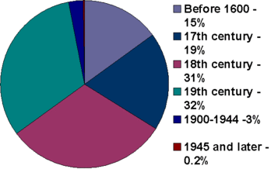
Figure 4.1: Graph detailing the age range of listed buildings in the UK
Source: www.english-heritage.org.uk

Table 4.1 below illustrates the grading system for listed buildings; each Grade denotes a different level or degree of ‘interest’. So, for example the largest category of listed buildings, where 92% of all listed buildings in England have been designated as Grade 2, this grading signifies that they are of special interest. However, only 2.5% of all buildings within England have been listed as Grade 1 which denotes that they are of exceptional interest.

Table 4.1: Categories of listed buildings
Grade | What this means | Percentage
1 | These buildings are considered to be of Exceptional interest, sometimes, they are considered to be internationally important | 2.5% of all listed buildings are Grade 1
2* | These are particularly important buildings of more than special interest | 5.5% of all listed buildings are Grade 2*
2 | These buildings are nationally important and of special interest | 92% of all listed buildings fall into this category.

The inclusion of a site onto UNESCO’s world Heritage list forms another layer of protection (Leask, 2006), although for Jones and Munday (2001) there has to be a trade off in in terms of adaptation, local communities and protective legislation to make former industrial buildings economically sustainable (Noonan and Krupka, 2011). The World Heritage Site designation list includes 962 properties of cultural and/or natural heritage in 190 countries. There are 28 sites within the United Kingdom which have been inscribed onto the list, 24 were considered to be cultural properties, 4 natural and 1 mixed (whc.unesco.org). As stated in Chapter 2, to be included on the World Heritage Site list, each property must be considered to be of ‘outstanding universal value’, and meet at least one of the ten criteria set. (whc.unesco.org). For example, Darley Valley Mills was inscribed onto the World Heritage in 2001 and met criterion II and IV. In order to meet criterion II the site must:

…exhibit an important interchange of human values, over a span of time or within a cultural area of the world, on developments in architecture or technology, monumental arts, town-planning or landscape design.

The Derwent Valley Mills site fulfilled this criteria as it witnessed the birth of the factory system, where new types of building were erected to house the new technology for spinning cotton developed by Richard Arkwright in the late eighteenth century. The Derwent Valley Mills also met Criterion IV:

…to bare a unique or at least exceptional testimony to a cultural tradition or to a civilization which is living or which has disappeared; to be an outstanding example of a type of building, architectural or technological ensemble or landscape which illustrates (a) significant stage(s) in human history.

As discussed in Chapter 2, the site fulfilled this criterion because of it’s significance in historical and technological terms and its role in the British Industrial Revolution, additionally, the site is of international importance as a result of the industrial communities that were built to house workers and still remain today.

4.4 Managing Change and Physical Intervention

Change is an inevitable part of the human lifecycle; the ability to anticipate and manage change is crucial to our long-term survival, as failure to adapt may result in extinction (Stubbs, 2009). This concept can also be extended to historic buildings, as Darley Abbey Mills illustrates, they are designed and built to fulfil a specific purpose, once that purpose has ceased, there is the risk of them becoming obsolete, redundant and, ultimately their future is at risk unless they are capable of being adapted to provide a new viable use (Stubbs, 2009). As explored in Chapter 3, the continued use of buildings can create new economic communities and contribute to the sustainability of cities. However, this new use needs to be dynamic and continually evolving to find a contemporary context, Brisbane and Wood (1996:14) maintain that, ‘Tastes and ideas change from generation to generation and these changes are reflected in the physical environment we live in’. For Isall (2008), in the context of the continued use of historic buildings, the needs and standards of the occupants, and users of buildings continually evolve, the functionality of the building needs to reflect this. If this evolution does not take place then buildings quickly become obsolete, in this context Langston (2008) identifies that buildings may fall into various forms of obsolescence, these include physical, economic, functional, technological and social. Therefore, the continued survivals of historic buildings rely upon the building’s functionality and context within contemporary society, critically; conservation becomes a balancing act of protecting what we have inherited and, effective change management (Stratton, 2000; Clarke, 2003; Ahlfeldt et al., 2013; Larkham, 2014). Whilst English Heritage (2008) accept that changes in historic buildings are an inevitable result of owners and occupiers response to social, economic and technological change, they also point out that change can be a natural consequences of a building ageing i.e. weathering and degradation of materials, structural movement, failure of building components and, the everyday wear and tear associated with use. Therefore, irrespective of whether the changes are natural or man made, there comes a time within the life-span of any building which necessitates some degree of physical intervention in order to repair a failing element, or to facilitate the continued use of the historic building.

The degree of intervention necessary will vary but it can range from preventative maintenance to complete refurbishment that enables adaptive re-use (ICOMOS, 1999). Although components will eventually fail and need replacing at stages within a buildings’ lifespan, continuous and systematic inspection and care which includes proactive as well as reactive maintenance will not only uphold the appearance of the building and its value, but also, keep the fabric in good order and thus avoid failure and the subsequent expense of repairs or replacement (ICOMOS, 1999; English Heritage, 2008; English Heritage, 2010; Forster, 2009; Maintain our Heritage, 2004). Therefore, routine care such as regular re-painting of exterior woodwork, ensuring that rain water good run free and clear or, replacing a missing slipped tile not only enhances the appearance of the building but are vital and practical safeguards against water ingress (IHBC, 2002). Although Forster and Kayan (2009) consider that maintenance is a critical factor for the in-service use, and ultimately, the survival of any building, maintenance is often ignored by those who own or care for historic buildings, the failure to maintain buildings can be motivated by a number of factors. Save our Heritage (2004) and Forster and Kayan (2009) both suggest the reasons for this include, the lack of owner’s knowledge and skill, the addition of value added tax (VAT) upon maintenance and repair costs, while alterations or new build does not attract (VAT), as such there is little incentive to invest in maintenance, when a new build option may be the more cost effective alternative. In addition, there is a lack of support and education from a single source, this results in owners being unaware, that the prevention of major faults and failure is a benefit of on-going continued maintenance. If routine maintenance continues to be ignored by those who care for historic buildings, this could ultimately lead to the loss of culturally significant buildings, which would be directly at odds with the intentions of conservation. According to Ahlfeldt et al. (2013) another possible cause of inaction by owners of historic buildings is the cost, the time, the bureaucratic procedures and the restrictions on repair and maintenance imposed by the Planning Legislation and the Listing Process. For example a listed building or a building in a Conservation Area, planning permission should be sought for the replacement of a window, the application usually requires photographic evidence of exiting windows and architect drawings of the replacement windows and their design, even if the replacement is like for like, this is also the case if you wish to repaint a door in a different colour or prune a tree that is becoming dangerously close to the property.

Where the building’s original or subsequent purpose and use has ceased, some alterations or adaptations may be necessary in order for the vacant building to attract new occupants, however reuse or adapted reuse can mean many different things:

- Firstly, it is important to consider the connotations behind the wording, ‘adaptive’ implies some degree of change and, ‘reuse’ implies that the building is used for a new purpose or function where the former use became obsolete (Conejos, Langston and Smith, 2011; Smallwood, 2011).

- Secondly, there is the view that reusing historic buildings is a form of architectural recycling (Australian Government, 2004; Ball, 2002; Cantell, 2005). Breathing new life into existing buildings has sustainable impacts at the environmental, social and economic levels (See Chapter 3 for further discussion). The result of this for Strange and Whitney (2003) and, Langston and Orbasli (2008) is that it makes sense to use what is already in existence rather than constructing new buildings, and thus, contributing further to the carbon footprint of the construction industry.

- Thirdly, historic buildings are an intrinsic part of the built environment, they help promote local distinctiveness and identity, they are historic assets, thus redeveloping them for new economically viable uses helps protect the historical significance of not only the building but also, its wider context. (Orbasli, 2008; Strange and Whitney, 2003; Cantell, 2005; Snyder, 2005).
Significantly however, Ball (2002); Langston (2008); and Conejos, Langston, and Smith (2011) all identify that there are various levels and types of adaptation, these range from ‘no refurbishment’, to ‘marginal refurbishment’ and ‘high refurbishment’. Sites such as Arkwright’s Mill at Cromford, and the North Mill at Belper have undergone ‘marginal refurbishment’ that largely involved the consolidation of the buildings and the installation of new electrics and the re-painting of the interiors. Therefore, there is more to architectural Conservation than simply arresting or impeding physical decay, it is a process which encompasses understanding the significance and value of the building as well as accommodating change (Stubbs 2009), however, any degree of change to a historic building entails a number of ethical considerations.
4.5 Principles and Ethics of Conservation

This Chapter has asserted that the protection of significant assets is at the core of conservation and, it is also accepted that the continued use of historic buildings necessitates some degree of alteration or modification at some point(s) throughout the buildings life span. This Chapter now focuses upon the ethical dilemmas and debates that emerge when physical intervention upon the fabric of a historic building is considered. There are two areas of concern: the ethical conduct of those tasked with making decisions regarding the continued use of historic buildings; the ethical issues which surround the physical intervention or treatment of historic buildings that must be considered. Before moving onto both of these in turn, it is important to firstly clarify what ethics are and why they play a role within this thesis.

Vee and Skitmore (2003:1), define ethics as, ‘...a system of moral principles, by which human actions and proposals may be judged good or bad, right or wrong.’ Scott and Marshall (2005) suggest that what each of us considers as being the truth is internal and thus relative to our culture, experience, social and political status. Therefore, each individual will have their own set of morals, beliefs or values shaped by their own worldview. Vee and Skitmore (2003) suggest that ethics go beyond this moral compass, and, that good ethical practice is an important organisational goal, where sound business ethics ensures equality and good practice in decision-making and thus preventing poor performance or misconduct. Rahman, Karim, Danuri et al. (2007:3) defines professional ethics as:

…a system of norms to deal with both the morality and behaviour of professions in their day-to-day practice, and ascribes moral responsibility not to an individual but to all professionals practicing in a particular profession.
The Conservation of historic buildings necessitates input from a number of different professions and professional bodies, many of which have codes of practice which are embedded within their constitution and daily practice. For example, the Institute of Historic Building conservation (IHBC, 2003) code of conduct states that their member should act with ‘Competence, honesty and integrity, providing informed professional advice on the behalf of the historic environment’. The Royal Town Planners Institute state that all members of the RTPI are bound by a Code of Professional Conduct which states that every member acts with ‘competence, honesty and integrity, and exercises independent professional judgement at all times’ (RTPI, 2007).

Architecture and design centres around human habitation (Levine, Miller and Taylor, 2004) therefore, buildings whether new or old, play a central role in our lives not only as places of shelter and safety but also for education, entertainment or leisure and, worship. Laquex (2004) suggests that, architects are responsible for the existence of buildings that continuously affect the lives of users, thus every decision has considerable impact on people’s lives not just in terms of building’s type but also the style, materials, ornamentation, use and, layout. However, it is not only the health and safety of human life at stake here but also, the useful life of historic buildings, the significance of which should not be unnecessarily distorted by inappropriate treatment. Further to this, as this research illustrates, with regard to the conservation and continued use of historic buildings, there are a number of decision makers who are collectively involved shaping the buildings future. If, as Levine, Miller and Taylor (2004) suggest that design is linked to desires, needs and values, it is inevitable that architecture and design both evolve due to social, political and economic shifts. It is also inevitable that as a result of these shifts, owners and occupiers of historic buildings will require a useable space capable of housing the latest technological advances. Technology continually evolves, thus a constantly moving target, and therefore one, which calls for sensitivity and imagination to ensure that historic buildings provide contemporary spaces whilst not jeopardising its historic fabric.

4.5.1 Degrees of Physical Intervention

At some point in the lifecycle of any building, some degree of physical intervention, whether this be repair, replacement, alterations or additions, becomes necessary to extend useful life. Due to the values and significance associated with historic buildings, physical intervention becomes a highly sensitive arena. Mansfield (2008:273) states that if a structure is ‘...considered as an historical ‘document’, any work may alter the ‘document’ forever, even though genuine efforts may be made to reduce this impact’. Therefore, any physical intervention, adaptation or new use should be assessed against the ethics, philosophy and principles of building conservation. According to Yao (2014), the success of any form of reuse of historic buildings should be judged in direct relation to these principles. Within building Conservation the use of the terms, ‘Conservation’, ‘Restoration’ and ‘Preservation’ all have different meanings and connotations (Jokilehto, 2007). Although the definitions of ‘Conservation’ have already been considered earlier in this Chapter, it is important to explore the definitions of ‘Preservation’ and ‘Restoration’, as these terms are often seen as inaccurately interchangeable (Feilden, 2007; Jokilehto, 2007; Clavir, 2012), however, these terms are quite distinct and separate and should not be confused with one another.

4.5.2 Preservation

Just as there are various definitions for Conservation, the same can be said for the term Preservation. Section 4.10 of the British Standards 7913 (1998) defines Preservation as the ‘State of survival of a building or artefact, whether by historical accident or as combination of protection and active conservation’. In a similar vein, Section 1.6 of Article 1 of the Burra Charter (ICOMOS, 1999), defines Preservation as, ‘...maintaining the fabric of a place in its existing state and retarding deterioration’. For Taylor (2000:48), Preservation is more limited than Conservation and states that: ‘…only those actions which prevent change or protect a building from change, and therefore excludes all alterations, no matter how essential’, these fairly restrictive definitions of Preservation are also supported widely within the field (see Feilden, 2007; Jokilehto, 2007; Clavir, 2012). It could be concluded from this, that whilst Conservation centres on actively managing necessary change in order to achieve a careful balance between prolonging useful life of the building whilst protecting it for future generations, Preservation is more about preventing change and, freezing the building in a particular moment in time. One example of how to ‘Preserve’ a building is Calke Abbey in Derbyshire, where the National Trust have taken the decision to keep the building and the collections held within as they were when they took custodianship of the estate in 1985. As the National Trust (2010) states, Calke Abbey is ‘A place poised somewhere between gentle neglect and downright dereliction’. They further that it is ‘A country house and estate preserved in 20th Century decline’. The National Trust took the decision to show the visitor Calke Abbey as they found it, therefore the peeling wall paper is left for all to see, but this decision helps to inform the visitor of the realities, practicalities and challenges facing the families who were tasked with looking after a large country house in the second half of the 20th Century, a time when abandonment, dereliction and subsequent ruin or demolition were very real threats for many country houses (Craven and Stanley, 2002). The condition of Calke Abbey has been consolidated and preserved, therefore, providing a snapshot of how the last of the Harpur-Crewe family lived, but it is also a historical artefact that demonstrates, the economic difficulties owners faced and continue to face when tasked with maintaining and caring for large historical buildings (see Sambrook, 2013). Although the main house of Calke Abbey has been Preserved, in order to support the tourism potential of the site, the stable annex has been adapted into retail units, a café and restaurant, whilst the riding school has been converted into a space for events. The idea of Preservation is much easier to evoke and sustain if it is part of a larger organisation or site that can provide on-going economic support (Jones and Munday, 2001; Noonan and Krupka ,2011; Carpenter, 2011; Elsorady, 2014).

4.5.3 Restoration

Just like ‘Preservation’, the literature demonstrates that ‘Restoration’ has also been subject to various definitions (Feilden, 2007; Jokilehto, 2007; Clavir, 2012). Article 9 of the 1964 Venice Charter suggests that Restoration is based on respect for original materials, and should only be undertaken where authentic documentary evidence exists. Similarly, Section 1.7 of Article 1 of the Burra Charter (ICOMOS, 1999), defines Restoration as, ‘... returning the existing fabric of a place to a known earlier state by removing accretions or by reassembling existing components without the introduction of new material’. Taylor (2000) describes Restoration as ‘action taken to reverse more recent alterations and is thus very much a process of change, removing later alterations and often putting back features based on the design elements removed in the past’. Whilst ‘Preservation’ could be considered as stopping the clock at a particular point in time, ‘Restoration’ is more about turning the clock back and returning features to their original design, whilst ‘Conservation’ centres, upon the safeguarding of what we have inherited for those who will follow us. However, Murzyn-Kupisz and Dzialek (2013) reason that, preservation should be seen as an all-encapsulating phrase, which includes the principles of both conservation and restoration, as without preservation neither conservation nor restoration is possible.
4.5.4 Repair

There are recurring issues associated with the ethical repairing of historic buildings within the literature, these centre around retaining as much of the historic fabric as possible, so as to ensure authenticity of the historic artefact. Brereton (1995:2) states that:

The primary purpose of repair is to restrain the processes of decay without damaging the character of the buildings or monuments altering the features which give them historic or architectural importance or unnecessarily disturbing or destroying historic fabric

Pickard (1991) concurs that, holding back decay is the primary purpose of repair, as this enables the historic fabric to be stabilised, thus allowing long-term use to continue. However, there are questions as to the extent of a repair, British Standards (1998:9) for example, stresses that, ‘A conservative repair is fundamental to good conservation’, therefore buildings or parts of it should only be repaired when strictly necessary. English Heritage (2008:52) suggest, ‘a do no more than is necessary approach’, so repair is limited to ‘what is reasonable necessary to make failing elements sound and capable of continuing to fulfil their intended focus’. Earl (2003) suggests that, although repair may be both more expensive and time consuming than replacement, it should enable retention of the historic fabric of the building. The Venice Charter (1964) states that:

Replacements of missing parts (of fabric) must integrate harmoniously with the whole, but at the same time must be distinguishable from the original so that restoration does not falsify the artistic or historic evidence.

Earl (2003) also points out, that the building should tell a true story, repairs and replacement are an inevitable part of a buildings lifecycle, but the repairs and replacements should be harmonious with the historic building. Within the British Standards 7913 (1998) this idea of ‘harmoniousness’, is promoted through a craft-based approach to repairs, where like for like materials that match colour, appearance and composition are utilised. Adam (2003) points out that the introduction of new materials rather than reclaimed materials may disturb the ‘visual coherence’ of the design, however the insistence of utilising like for like materials as stated in British Standards 7913 (1998), makes the assumption, that although the new material i.e. new stone blocks inserted into the facade of a building may be stark in appearance at first, they should weather in over time. The selection of material for a repair requires careful choice, new innovative materials may be untested, and therefore carry an unknown risk of causing damage in the future, but some original repair techniques have been proved to destroy the remaining original fabric of the building. Forster (2010b) points out that:

Repairs selected, based on the ethical concepts and a combination of the principles, should be defensible and should in theory lead to naturally ‘good’, well founded conservation interventions.... it is also important to understand that there are no absolutes in conservative repair, only greater levels of defence for selected repairs.

The requirement that repairs should be in harmony with the remainder of the building, has led to a resurgence of specialist craftsmen and women and who possess the technological understanding of the both the materials and techniques required to undertake sensitive harmonious repairs.

4.5.5 Restoration

As discussed earlier in this Chapter, Restoration is defined by some as returning the building to a previous point in time, reversing later alterations so that the building is as original as is possible (ICOMOS, 1999; Taylor, 2000). Earl (2003:74) warns against trying to improve on the past as this ‘varnishing of history’ distorts the story of the building. Section 7.1.2 British Standards 7913 (ICOMOS 1999) state that ‘...a presumption against restoration is fundamental to good conservation. The stock of historic buildings is finite and every loss significant’. The British Standards further assert that, the ‘…presumption against restoration is a hallmark of the British approach to building conservation’, as it diminishes the authenticity as well as the historic and aesthetic values of buildings. Although a case for restoration can be made under certain circumstances (ICOMOS 1999), however there is a strong feeling that restoration must be based on sound evidence, and should be neither conjectural, nor speculative (Earl, 2003; English Heritage, 2008; Pickard, 1996). When Restoration is considered, the authenticity of the building is again brought into question, Lowenthal (1999 cited in Mansfield, 2008:276) when distinguishing between what is genuine, and what is pastiche, he states that:

…in the wider sense, authenticity denotes the true as opposed the false, the real rather than the fake, the original not a copy, the honest against the corrupt.

Therefore, there should be no attempt to deceive as to either the age or the authenticity of any part of the building, thus, new work should blend with the old, but should be ‘distinguishable’ so as to avoid claims of deception, while the retention of the historic fabric should be maximised (ICOMOS, 1999).

4.5.6 Minimum intervention

In the repair and maintenance of historic buildings there is a general agreement that as little material repairs should be made as possible. The more original fabric that is removed during repair, conservation or restoration will obviously result in less of the original building remains, this not only goes again the principles of conservation, but also may reduce the significance and value of the building. Therefore, minimum intervention is advocated, where ‘as much as necessary’ (Brereton, 1995:7) is done but, as ‘little as possible’ (Fieldon, 2003:235).

4.5.7 Reversibility

In defining historic buildings as artefacts, it is important that any adaptations made to meet contemporary needs and promoting continued use are ‘reversible’, and it is possible to revert the building back to its original state, and thus, preserving the authenticity and originality of the artefact. However, what is considered to be best practice regarding techniques and materials within conservation also evolves over time in conjunction with social, economic and cultural pressures to adapt usage are problematic for owners and custodians of historic buildings, as both of these factors will result in some degree of change. However, the conservation philosophy of reversibility dictates that, ‘…intervention should be carried out in a way that it can be reversed at some future time, without any significant damage having been done’ (s.4.16 British Standards 7913). Therefore, new work should be inserted in such a way that it can be later removed without it causing a lasting impact upon the significance of the building (Clark, 2001).

4.6 The Protective Umbrella of Conservation

The principles and guidance discussed above are laid down by Government and professional bodies, international charters and academics, this body of knowledge is intended to offer guidance, advice and best practice to those responsible for protecting the historic environment. For example, there is a presumption within current conservation philosophies, that work is to be truthful and honest, therefore, extensions to a historic building using modern materials, such as glass and steel, in a style which contrasts to the original, is considered more acceptable, as it clearly distinguishes old from new, rather than simply mimicking the past which could distort the readability of the building in the future. The idea of reversibility within Conservation is a sound principle, Conservation is an evolving process rather, evidence of the buildings history and use can be uncovered gradually over a period of time, which can alter its story and therefore its significance and value. Technology and best practice also develops and therefore actions, which mean some degree of intervention, can also change, reversibility is therefore important to avoid any unnecessary loss or damage. With regards to reversibility and continued use, modern consumers require modern technology (sanitation, lighting, heating, wireless connectivity) but these needs will continue to change. For example, freestanding pods installed in the Pitcher and Piano in Nottingham enables a dis-used church to become a major entertainment venue whilst minimising the impact upon the fabric of the historic stonework and stained glass.

‘Conservation’ is not a single process but rather an umbrella under which sits a number of factors, these include physical treatment, policymaking, planning and research. Similarly, conservation does not involve a single profession but rather a range of disciplines, which include specialist craftsmen but also conservation officers, architects and planners. Therefore, there is a range of advice and guidance available to multiple practitioners to both interpret and apply. As Mansfield (2008:274) states:

There is a plurality of competing interpretations of conservation value between the various professional consultants engaged in conservation work and the general public’s perceptions.

Where there are multiple parties involved, each with their own worldview as well as their knowledge and experience of their particular field, it is inevitable that conflict and dilemmas can occur. As Mansfield (2008:278) states, ‘choice is central to the practice of architecture’, it is also central to conserving the historic environment. But as Mansfield also states, ‘choice creates dilemmas’, as such, choices and options will cloud and encroach on the decision making process (Worthing and Dann, 2000), some of these will be as a result of contradiction between philosophical approaches, but some will be as a result of contradicting approaches from the parties and stakeholders involved. What the literature currently lacks is a mechanism for enabling the guidance to objectively and consistently applied.

4.7 Resistance and Spatial Reflexivity

Sites that are deemed to be of historical and architectural significance are protected through English Heritage’s Listing process, additional protection is provided for sites such as Derwent Valley Mills as a result of their designation as a World Heritage Site by UNESCO, furthermore such historic sites are procedurally, and legally protected through the various Town Planning and Historical Building legislation, in the form of enforceable Acts and Guidance Notes. The practice of protecting and preserving the historic built environment is also underpinned by an established set of principles and practices that are informed by the philosophy and ethics of conservation. All of these combine to create a legislative and practical umbrella that protects Britain’s stock of historical buildings and sites. However, this umbrella can also be seen as over restrictive, prescriptive, lacking in consistency (Highfield and Gorse, 2009; Cooper, 2010; Mansfield, 2011; Paixão, Costa and Gonçalves, 2013) and being overly bureaucratic (Negussie, 2001). The consequence of this is that the over protective environment that surrounds historic buildings encourages developers and owners to leave buildings to fall in dereliction or disrepair and in danger of being lost forever (Ahlfeldt et al., 2013), not to invest in the adaptation and continued use of historic buildings, or undertake unauthorised adaptation (Negussie, 2001; Mondini and Re, 2012; Jasme, Mydin and Sani, 2014), or repairs (Williams, 2010). In assessing the impact of such barriers and constraints Smith (2014:116) provides a case study of the refurbishment of New Court, Trinity College, Cambridge. Smith found that, the college was so frustrated that a ‘normal heritage’ approach so constrained the scope of refurbishment, that it had to employ architects, engineers, building physicists, building conditions surveyors, and industry experts to challenge the Local Authority’s decision. The cost of undertaking this type of challenge would be prohibitive for most individuals or developers, and without such adaptation it could be argued that New Court would have lost it’s contemporary context. According to Forsyth (2013:16):

In the present ultra-conservatist climate, it is arguable that conservation legislation has gone too far in certain situations. Conservation laws can have the opposite effect to what was intended, and some relaxation of guidelines would sometimes serve the better interests of a building. The blanket refusal to allow any change is artificial and can ultimately be damaging to a building. Throughout history, buildings have adapted to changing needs and situations. Sometimes a local authority’s refusal to grant listed building consent may be an excuse for doing nothing.

This sentiment is also reflected by Heath and Tiesdell (2013:4) who state that:

In new conservation legislation very little attention has been given to the problem of utilizing the existing stock of conserved space, especially once the overall demand for space in the city has eased off. Using negative powers of control, planners have found it easier to prevent undesirable uses for occupying buildings that to attract more desirable uses.

There are many examples of buildings that are being lost because it has not been possible to find a contemporary context as a result of the failure to get Listed Building consent or the ability to change the use of the site (Quigley and Shaw, 2010). In short, according to Allison and Peters (2010:16), we should be asking, the ‘…planning profession to account for destroying what it was supposed to be improving.’ In addition, although there are legislative regulations are in place, there is a lack of resources and planning staff to enforce or monitor sites, there is a resistance to prosecute offenders, with many planners taking an overly pragmatic and subjective interpretation of legislation in order to protect the buildings from dereliction and obsolescence (Rush et al., 2012).
The designation of Derwent Valley Mills as a UNESCO World Heritage Site is a major achievement in recognition of their historical and architectural significance; although this designation provides another layer of protection the impacts of designation are not always positive. For Pendlebury, Short and While (2009), the management plans that accompany World Heritage Site status, can be detrimental both to the site and the surrounding area, whereby the designation makes it more difficult to get any form of planning permission or development granted. The foundations of this negative view:
…is reflected in the tenor of the management plan, where the term ‘development’ is often equated with ‘threat’ and there are references to the superficial understanding of the WHS, it is argued, held by developers’. All WHS have a particularly complex set of governance arrangements. We have noted the potential for conflict between the international regulatory bodies and local decision-makers. In the case of urban WHS this complexity is magnified. (Pendlebury, Short and While, 2009:354)
Where elements of a World Heritage Site are located in urban areas Pendlebury, Short and While (ibid.), identify that the impact of designation can be much greater for a larger geographical area and as impacting on many more people’s lives than those just living within the boundaries of the designated site boundaries. Wall (2014) identifies in his research, that, groups of people and small communities in China had been displaced, in order to improve the authenticity of the heritage environment and to increase the chances of successful designation, this practice was also identified by Ekern et al. in their analysis of the designation process in Vietnam (2012). The impact upon the wider communities is also highlighted, in Pendlebury and Short’s (2011:379) analysis of World Heritage Designation in Liverpool. They identified that:
The designation attracted the general support of the many agencies and government bodies involved in regenerating the city, yet there is concern within the business community that the World Heritage Site has stifled investment.
For Byrne (2009:261), this type of reallocation of funding and support to World Heritage Sites ‘…is a ‘mechanism of social control’ and that actors on local and regional levels utilise the existence to exert social and political control…’ In support of this view According to King (2012:vi), the designation of sites by UNESCO has ‘…become a highly politicised project to do with identity and conflicts over its character and trajectory.
In Byrne’s (2009) analysis of the Cologne’s World Heritage Site, which is largely based around the Cathedral Quarter, he found numerous cases of development being refused on the basis that new buildings would change ‘the vista’ of the site, and that this was an identified, and core criterion in the designation document. In one case permission was granted for the building of new houses along the banks of the Rhine, permission was initially granted and the first house was built, however on appeal and intervention by local groups with support from UNESCO the site was put on the ‘Red List’ (In Danger), the development was stopped and the new house was torn down. What is significant about this is that the development was outside of the designated area, but it was felt that changes in the city would alter ‘the vista’ and thus, endanger the designation status. The failure to limit development was identified as the reason for the subsequent removal of World Heritage Site status from Dresden Elbe Valley in 2009, in a press statement issued by UNESCO (2009), it was stated that:

"Every time we fail to preserve a site, we share the pain of the State Party," declared María Jesús San Segundo, the Ambassador and Permanent Delegate of Spain to UNESCO who is chairing the 33rd session of the World Heritage Committee presently underway in Seville on Thursday.
The World Heritage Committee decided to remove Germany's Dresden Elbe Valley from UNESCO's World Heritage List due to the building of a four-lane bridge in the heart of the cultural landscape which meant that the property failed to keep its "outstanding universal value as inscribed."
Similarly, Pendlebury, Short and While (2009:357) note that in the UK, UNESCO designation is often used as a means to curb urban development:
In the UK this tends to mean powerful local interests pursuing pro-development strategies within the context of an often relatively weak regulatory regime. Weaker local conservation interests resist perceived threats to the integrity and authenticity of place, calling in UNESCO as an ally with their infrequently used, but politically powerfully, potential sanction to classify a site as ‘in danger’ or, in extremis, to remove sites from the list.
Designation creates a number of conflicts that are a result of the magnitude of World Heritage Site boundaries and buffer zones, this is of particular significance in the Derwent Valley Mills in terms of the identification of a ‘heritage corridor’ that includes a large numbers of landowners and stakeholders. According to Pendlebury, Short and While (2009:350), World Heritage Site status leads to a
…level of complexity and difficulty in making meaningful decisions about conservation, management and development within this context will continue to result in friction between the different scales of governance.
Additionally, according to Pendlebury and Strange (2011:379) in their analysis of the impact of designation on Liverpool, they found that investment was directed away from other areas of economic development and the city to support the World Heritage Site, this led to economic support being taken away from local business development, and the protection of historic buildings that are located outside of the UNESCO designation zone and has ultimately resulted in their loss. They go on to state that:
Furthermore, it is evident that such concerns are not restricted to the development community, with wider local resentment over the interventions of external bodies such as ICOMOS and UNESCO in World Heritage site issues. For example, Michael Short reports senior Council officers commenting that the designation should never have been sought if it stymied proposals such as the (now abandoned) scheme for a tower at Lime Street.
The impact of UNESCO designation and Listed Building status can have a major impact on the ability of owners to update and introduce technological innovations that will ensure the long-term survival and usage of Historic Buildings.
In Chapter 3, a case was made that the continued use of historic industrial buildings could contribute to the reduction in the carbon footprint of the construction industry and to contribute to national and regional environmental targets. In short the reuse of historic buildings is a viable and sustainable option. However, the designation and listing process can have a major impact on the ability of historic buildings to become truly sustainable (Marie-Stuart, 2014). Crockford (2014:196) identified that historic buildings can and should be sustainable, however as Crockford points out:
Typically, a historic building consists of what today would be considered traditional features, such as fireplaces and chimney stacks, as well as cellular room plans with high ceilings and draught lobbies which reduce air infiltration and heat loss and increase its thermal mass. Such inherent properties should not be overlooked when considering a historic building’s future thermal performance, as they may be able to make a valid contribution to improving its energy efficiency… fine balance to be achieved when managing change in refurbishment projects of heritage value. In addition, recent additions or alterations of less heritage value may still form part of the fabric of historic dwellings and must be managed or rectified so as not to detract from the overall character or functionality of the building. This brings to the forefront the role of conservation principles and guidelines as well as energy-efficiency standards and building regulations, and the effect of governmental policy on piecemeal change, in light of the high level of importance given to the sustainability agenda.

However, Mansfield (2011) identified that the ability to adapt historic buildings so that they are more thermally efficient, is severely hindered by the current regulatory framework that is guiding refurbishment practice with regard to improving energy efficiency and reducing carbon emissions. For Marie-Stuart (2014), this is one of the most significant challenges to the adaptive reuse, refurbishment and sustainability of historic buildings. For example, the replacement of exiting windows with double gazing in Conservation areas is burdensome as involves a great deal of bureaucracy and cost to get permission, if the property is Listed it is almost impossible. In the case of Grade 1 Listed Buildings such as the Long Mill at Darley Abbey it is not possible to introduce even simple measures such as fitting insulation in the roof space. If historic buildings are to find a contemporary context and usage, there has to be flexibility in the ability to introduce new technologies, it is only then that they become truly a sustainable option (Marie-Stuart 2014). The result of the current regulatory framework is that owner’s by-pass the system in order to make the buildings operational.

As stated previously in this section, a number of authors see the overly protectionist nature of the Designation and Listing systems are leading to various types of resistance (Demovic, 2013), and is often manifested in the unauthorised adaptation, repair and maintenance of historic buildings (Negussie, 2001; Williams, 2010; Mondini and Re, 2012; Jasme, Mydin and Sani, 2014). However, there is little, if any research that explores the motivations behind people undertaking unauthorised action, Douglas (2014:8) comments that there is a growing ‘social practice’ that when people find elements of their buildings or locality that are in:

…need of fixing, improving, or enlivening, choose to do it themselves without asking permission…these increasingly visible yet often unattributed practices complicate common assumptions and have received little attention from social scientists or urban policy and planning professionals.

The conservation and planning literature deals with the issue of unauthorised adaptation and repair in terms of enforcement (Marie-Stuart, 2014), impact, legislation (Williams, 2010) and examples of unauthorised adaptations (Mondini and Re, 2012). Douglas (2014:12) in searching the wider surrounding literature states:

As for academic social science, there are relatively few focused studies of urban intervention practices, let alone relevant analyses of any collected meaning. Among what has been written, however, three main perspectives or categories of interpretation can be identified, dependent largely on the particular subjects in question and the theoretical or disciplinary background of the scholars.

Douglas (2014:6) in exploring the social practice of unauthorised urban improvement, defines such practices as, ‘intentionally functional and civic-minded “contributions” or “improvements” to urban spaces’, and from these it is possible to identify three distinct trends (2014:6)

- ‘Guerrilla Greening’: This involves improving the environment through planting or functionally converting unused land, infrastructure, or facades.
- ‘Spontaneous Streetscaping’: This includes activities such as, painting traffic markings or installing design elements such as signage, ramps, and seating on streets or structures.
- ‘Aspirational Urbanism’: This incorporates unauthorised promotional signs, public notices, or other informational installations by which community members express their own commercial activities, or policy and development ideas or alternatives.
The protective nature of UNESCO Designation, Town and Country Planning legislation and the Listing process at first sight may be seen as a comprehensive set of actions that will protect and enhance the sustainability of historic buildings. However, the over protection and the rigidity of both the legislation and the practical process of gaining permission leads to individual’s acting in a way that they believe will enable the contemporary continued use, context and sustainability of their buildings or sites and without such actions buildings are in danger of becoming derelict or obsolete. As Crockford (2014) suggests, there is a fine line that needs to be carefully managed, whereby historic buildings are protected, but it is possible to adapt and refurbish them to meet the needs of today.

4.8 Conclusion

There are various levels of protection for sites such as Darley Abbey Mills. These can be identified as:
- Legislation
- Designation and Listing
- The Underlying Principles of Heritage Conservation
These create a thorough and comprehensive umbrella of protection for the sites, however, historic buildings have to find a contemporary context and usage, and in order to achieve this, it will usually mean that there needs to be some form of adaptation or refurbishment, alongside an on-going programme of maintenance and repair. Many owners do not possess the resources to continually engage with the legislative bodies and to go through the full planning process every time they have to undertake any form of repair or small adaptation. This raises the question of whether it is better to have a less protectionist and restrictive environment in which there is a danger of encouraging inaction by owners and the subsequent dereliction or obsolescence of buildings or to take a more practical lighter touch that encourages developers and owners of historic sites to reuse them and thus, protect their sustainable future. As outlined above in this Chapter, the designation and listing of a building or site does not guarantee its future and in some cases designation has a negative impact upon the environment? In order to attempt to understand this dichotomy it is also important to explore the value systems that drive action, interpretation and the differing value systems individuals and organisations adopt in the conservation and reuse of Historic Industrial Buildings.
Chapter 5

Philosophical Groundings of the Research

5.0 Introduction

This Chapter explores and develops the philosophical principles and considerations, which underpin the research undertaken within this thesis. This Chapter also goes on to explain and justifies the ‘Constructivist’, ‘Interpretivistic’ methodological position that has been adopted to underpin this research. The sustainable and continued use of sites such as Darley Abbey Mills relies upon how the site is understood and interpreted by policy makers, communities, organisations and individuals, and ultimately how historical, social, cultural and value is assigned and evaluated, and how the interpretation of policy guidance, site designation and regulations impact upon the historic built environment. The adoption of a constructivist approach also reflects the ontological and epistemological beliefs of the researcher. The historic built environment is a dynamic social construct that is open to numerous and various value based interpretations that differs according to each actor. In assessing the sustainable future of sites such as Darley Abbey Mills, it is important to recognise that all of those involved in their management, use and protection, all interpret the site in differing ways and, these reflect their individual or/and organisation’s philosophical grounding. Likewise, any judgments as to the aesthetic, historical, cultural or social merits and significance of the site are formed on an individual basis and as a consequence will underpin physical actions of stakeholders.

Azzopardi and Nash (2014) provide a useful identification of the various philosophical aspects that need to be considered in the development of a philosophical stance, and how these aspects in-turn, inform the method and the analytical instruments associated with that positioning (see Figure 5.1). For Azzopardi and Nash (ibid.) it is important to recognise that each methodological or philosophical stance holds differing philosophical assumptions about the nature of reality (ontology), knowledge (epistemology), values (axiology), research strategies (methodology), and procedures (methods).
Content removed for copyright reasons.

Please see: Azzopardi, E. and Nash, R. (2014) ‘An examination of philosophical paradigms and a rational for adopting a mixed methods approach’, Tourism Analysis, 19, pp. 151-159
Content removed for copyright reasons.

Please see: Azzopardi, E. and Nash, R. (2014) ‘An examination of philosophical paradigms and a rational for adopting a mixed methods approach’, Tourism Analysis, 19, pp. 151-159

Figure 5.1 Differences Among Key Methodological Positions & Implications for Choice of Research Design and Implication Azzopardi and Nash (2014:153)
Likewise, according to Moon and Blackman (2014:1), there are three fundamental elements that need to be considered which should underpin the research process, namely:

- Ontology: What exists in the human world that researchers can acquire knowledge about.
- Epistemology: How knowing is created.
- The philosophical orientation of the researcher that guides their action.

Moon and Blackman (2014) also recognise that ontology and epistemology are intimately linked with one another, they go on to state that:

…ontology is concerned with what exists for people to know about and epistemology is concerned with how people create knowledge and what is possible to know. (2014:4).

Moon and Blackman then suggest that from this relationship stems the third element: philosophical perspectives, which are ‘…a system of generalised views of the world which form beliefs and guide action’ (2014:4). This is of importance when understanding how different philosophical perspectives will assign different values and markers of significance in the analysis and assessment of the historic built environment. The implications of recognising these philosophical assumptions, are identified by Creswell and Hanson et al. (2007:238) when they go further to assert that:

Researchers should begin their inquiry process with philosophical assumptions about the nature of reality (ontology), how they know what is known (epistemology), the inclusion of their values (axiology), the nature in which their research emerges (methodology), and their writing structures.

Although Denscombe (2010) suggests that the researcher makes strategic choices, but Creswell and Hanson et al. (2007) and, Moon and Blackman (2014) emphasise, that it is more of an interlinked reaction to the researcher’s overall philosophical stance. This interconnection is evident when Moon and Blackman (2014) concludes, that the researcher’s ontological position can not only influence the nature of the research, but that the epistemological position can support the legitimacy of different types of knowledge. Therefore, the philosophical perspective shapes the researcher’s choice of methods and consequently affects interpretation, communication and application of results, this is evidenced by Azzopardi and Nash (2014:153) in their analysis of the relationship between the various philosophical and methodologies available to the researcher and the impact upon chosen methods (see Figure 5.1). This Chapter now turns to examining and justifying some of the approaches available to the researcher, why a positivistic approach has been dismissed and, more importantly, why an interpretative subjectivist approach in the form of constructionism has been adopted.

5.1 Ontological Positioning

Moon and Blackman (2014:4) define ontology as ‘the study of being’, Bryman (2004) narrows this down further by suggesting that ontology focuses upon the form and nature of reality. There are many ontological positions upon the spectrum, including naïve realism, critical realism, relativism and pragmatism, each of which revolves around truth claims about reality (Azzopardi and Nash, 2014; Moon and Blackman, 2014). Where a naïve realist ontological stance accepts that: there is one single reality that can be studied, understood, and experienced as ‘truth’; the real world exists independent of human experience (Moon and Blackman, 2014); that an organisation would therefore be considered to be a tangible object with a reality that is separate from those who are employed within it (Bryman, 2004). However, the author is more aligned with a relativist ontological stance, which is of the belief that no one true reality exists, but rather, ‘that truth is based on individuals’ perceptions of reality (Wong, 2014:131). Consequently, the author is aligned with the concept of truth being a subjective construction, where reality is relative, therefore, multiple realities exist as they are constructed within the human mind, thus each individual creates his or her own version (Azzopardi and Nash, 2014; Moon and Blackman, 2014; Wong, 2014). Azzopardi and Nash (2014:153), in their analysis of the key methodological positions and the impact each of these positions have upon the research design (see Figure 5.1), have provided an overview and theoretical ‘unpacking’ of them. From this it has been possible to chart the nature of the object of the research (heritage conservation and the historic built environment), the philosophical beliefs of the researcher and, the recognition of the actors in assigning multiple meanings, interpretations and assignment of significance of Darley Abbey Mills within a constructivist paradigm.

5.2 Epistemological Considerations

Where ontology centres around the ‘nature of reality, being and truth’ (Azzopardi and Nash, 2014:153), epistemology focuses upon ‘The study of knowledge’ (Moon and Blackman, 2014:4), or as Lincoln, Lynham and Guba (2011) defines it as the process of thinking. The relationship between what we know and what we see’. Moon and Blackman’s (2014:5) definition of epistemology appears to build from that of Lincoln, Lynham and Guba when they suggest that ontology involves:

…all aspects of the validity, scope, and methods of acquiring knowledge, such as, with what constitutes a knowledge claim; how knowledge can be produced or acquired; and how the extent of its applicability can be determined.

Just as with ontology, there are many epistemological positions but as can be seen from Azzopardi and Nash, the defining component between them is the ‘diverse assumptions about the nature of knowledge and its justification (objectivity vs. subjectivity)’ (2014:152). Forwarding the idea of objectivity vs. subjectivity raised by Azzopardi and Nash (2014), with an objectivist epistemology, there is the assumption that reality exists outside of, or independent from the individual mind. Therefore, an objectivist would argue that ‘…they can discover an objective ‘truth’ that is empirically verifiable valid, generalizable, and independent of social thought and social conditions’ (Moon and Blackman, 2014:5). Following the notion of objectivity, the researcher would remain detached from their research subjects and, the researcher’s values and interpretation would not bias the research (Moon and Blackman 2014). Conversely, with a subjectivist epistemology, knowledge is what is accordant with people’s perception of and understanding of reality, therefore, reality is pluralistic rather than an objective truth (Moon and Blackman, 2014).

However, the author is more allied with a third concept, that of a constructivist epistemology (also referred to as constructionist) which rejects the idea that ‘objective truth’ is waiting to be discovered but rather that: ‘Truth or meaning comes into existence in and out of our engagement with the realities in our world’ (Moon and Blackman, 2014:6). From a constructivist epistemological stance, it is the individual who constructs knowledge as they both engage with and, interpret the world they live in (Azzopardi and Nash, 2014). Different individuals construct meanings about the same object or phenomenon in different ways and, the way in which an individual engages and understands their world is based on their cultural, historical and social perspectives (Moon and Blackman, 2014). According to Baxter and Jack (2008:544) constructivism ‘recognizes the importance of the subjective human creation of meaning…’, Guba and Lincoln (2000), further the idea of meaning when they point out that constructivists are interested in ‘meaning-making’, as it is these meaning-making or sense-making qualities that shape both action and interaction. Wong (2014) appears to agree with Guba and Lincoln when he suggests that, as constructivism is concerned with the values that lie behind a particular finding, then meaning has more value than measurement. Baxter and Jack (2008) proffers that this type of research promotes a close collaboration between the researcher and the participants, this closeness allows the participants to tell their own stories and, it is from these stories that the researcher is better able to understand the actions of the participants.

5.3 Axiology

Denzin and Lincoln (2003:265) define axiology as ‘the branch of philosophy dealing with ethics, aesthetics and religion’, it is a concept readily associated with values and in particularly the degree influence of the researcher’s values within research (Azzopardi and Nash, 2014). Both Corbetta (2003) and Denzin and Lincoln (2003) suggest that there is an inextricable link between values and ‘basic belief’s’ (ontological, epistemological and methodological) as both influence each stage of the research process from the choice of problem to the way findings are presented. Azzopardi and Nash (2014:153) accept that’ ‘…values are an integral part of social life’, and also that, ‘no values are wrong only different’. Although terms such as ‘value-free’ and ‘unbiased’ are discussed within the methodological literature, these terms are more readily associated with positivism. Where constructivism is adopted it, neither of these are achievable as the researcher applies their preconceptions to guide the research process, there is not one universal truth but rather that, the research involves the interpretation of the actions of multiple actors involved, consequently there are multiple socially constructed realities are at play (Azzopardi and Nash, 2014; Creswell and Plano Clark, 2007; Walsham, 1995). Consequently Wells (2014:1) stated that, with regards to the assignment of values upon historical buildings, places and their landscapes:

…there has been a growing dissatisfaction with the dominance of positivistic, expert/objective values used in traditional assessments of historical significance

Wells (2014:1) is also of the opinion that in understanding the range of values people attribute to these historic places:

…requires the perspective of social scientists, such as anthropologists and sociologists, who are familiar with studying the subjective realm of human experience.

When considering the conservation of the historic built environment, Wells (2014:2) defines this field of study by utilizing two value dichotomies that have existed, in Well’s opinion, for more than fifty years:

The first is a tension between community values and the values of preservation (conservation) experts: the second dichotomy is a tension between the retention of the evidence of age in the historic environment (age value) and a desire to make aesthetic improvements to the historic environment (design value).

Wells (2014) concludes that by applying these two value dichotomies, the different specialisms within conservation of the historic built environment can be placed into four categories, these include: ‘the regulators, the conservators, the interpreters and the stewards’ (2014:1). Each of these categories, are based on the values encompassed by those professionals within each category. This needs to be considered when interpreting their decision making process within this research, as according to Wells, each has come to the decision making process with a set of inherent values based on their role.

Walsham (2006) discusses how the level of involvement by the researcher in the data gathering process may be informed by their values, this is an important element to consider as the level of involvement can be linked to the researcher’s basic belief system and consequently, their axiological stance. Walsham suggests that there is a spectrum of involvement with the ‘neutral’ observer’ at one end of the spectrum and the full action researcher at the other. Walsham points out that the ‘neutral’ observer:

…does not mean unbiased. We are all biased by own background, knowledge and prejudices to see things in certain ways and not others. I mean by neutral that the people in the field situation do not perceive the researcher as being aligned with a particular individual or group within the organization…

In a similar vein, Creswell and Plano-Clark (2007) and, Azzopardi and Nash (2014), both point out the necessity for the researcher not only to accept that bias is inevitably involved, but also to actively discuss this within their research. The author approached this research from a long-term interest in how the historic environment is shaped and, the influences behind this shaping process, together with a personal association with both living in and maintaining historic buildings in terms of the author’s own habitat. This passion was supplemented by undergraduate study in architectural and heritage conservation, which further developed the interest in how historic buildings are continually used by successive generations. Therefore, the research was originally approached with this background as supplementary grounding, but also from the approach that the guiding principles and ethics of Conservation (as discussed in Chapter 4) was the axis upon which this research would revolve. As can be seen later in this thesis, it is identified that although the principles and ethics of Conservation remain important, it is much more complex and involves the motivations, interpretation and actions (and inactions) of the decision makers, thus values along with the other basic beliefs are a vital part of the theoretical underpinning of this research.

5.4 Paradigm, Worldview or Philosophical Perspective?

Within the literature regarding research methodology, there is reference to paradigms, worldviews and, philosophical perspectives, it seems that these terms are used interchangeably between various authors (which include Guba and Lincoln, 1994; Creswell and , 2007). Therefore, this section will first examine definitions of each term before selecting one term to be used for the purposes of consistency within this thesis. Guba and Lincoln (1994:105) define a paradigm as ‘a basic belief system or worldview that guides the investigator’, whilst Payne and Cavaye (2004:2 cited in Wong 2014), accept that a paradigm illustrates a particular way of understanding the world, a specific view of the world or interpretation of it, they go further when they state that a paradigm is also, …used to determine what problems are worthy of research exploration as well as what methods are available to contend with these research problems. Guba and Lincoln (1994), identify that the set of beliefs represents the individual’s worldview, and these beliefs define not only the nature of the world but also, their place within it and their relationship to it. As such, Creswell and Clark (2007) suggest, that each researcher’s worldview will guide their enquiries, and thus, influence how their research is both designed and undertaken, and in turn supports Payne and Cavaye assertions (2004). For Creswell and Clark (2007), each person’s worldview is deeply rooted within his or her own experiences, their life history and culture, consequently, the researcher’s worldview influences their ontological, epistemological and methodological position. Critically, Creswell and Clark (ibid.) recognise that the individual’s worldview is not static; it is a dynamic process that is likely to be altered, or shaped by new experiences and thoughts. For Burrell and Morgan (1979, cited in Wong 2014) these new experiences or thoughts, suggest that there are three interlinked levels to consider: the philosophical level which reflects the basic beliefs about the world; the social level, which guides the way in which the researcher conducts their research; technical level which involves the selection of specific methods and techniques to be adopted. According to Moon and Blackman (2014), ‘philosophical perspectives’, are also referred to as paradigms and worldviews, they suggest that these terms can be collectively defined as ‘a basic set of beliefs that guide action’. Moon and Blackman (2014:7) define a philosophical perspective as:

…something personal that drives the way research is conducted; it is underpinned by the ontological and epistemological leanings and influences how a researcher creates knowledge and derives meaning from their data.

For the purposes of this thesis, this definition of philosophical perspective has been adopted as an overall term to signify a set of assumptions that structure the approach to research.
The philosophical orientation of the researcher, guides both their actions and research, within the philosophical and research arena there are a number of identified schools of thought, these include philosophical stances such as, positivism, post-positivism, constructivism, advocacy/participatory, pragmatism and feminism (Azzopardi and Nash, 2014; Creswell and Hanson et al., 2007; Wells, 2014; Moon and Blackman, 2014). Although this is not a definitive list, it does illustrate the multiple options available, it is also recognised that each one of these positions, by their very nature, has different implications for both research design and implementation. In exploring the dichotomy that exists between the positivistic and subjective schools of thought within conservation Evely et al. (2008), assess how these schools impact upon the researcher or practitioner’s interpretation of the world in which conservation, practice and policy take place (See Table 5.1 below).
Table 5.1 The Core Ontological Assumptions Guiding Positivism And Subjectivism Evely et al. (2008:55)
Extreme Subjectivism Extreme Positivism
Perspective on Reality | The social world and what passes as ‘reality’ are a projection of human perception and an act of people’s creative imagination. In its extreme, there may be nothing outside of oneself: a person’s mind is the world | The social world is a concrete, real thing that affects everyone. It can be thought of as a structure composed of a network of causal relationships between its essential parts. The social world is as concrete and real as the natural world.
Perspective on the Researcher | Reality cannot be fully understood, as human processes interpret events in consciousness before fully understanding its structure or meaning. The researcher will explicitly state what they believe to be their influence on the results of the research, taking into account that they cannot be objective. | Reality is an objective phenomenon that lends itself to accurate or inaccurate—depending on variance— observation and measurement. ‘Any aspect of the world that is not in some form of observable activity or behaviour must be regarded as being of questionable status’.
Perspective on Humans | Humans use their intuition and experience to make the world into a meaningful form. Human beings shape the world using their own immediate experience. | Human beings behave and respond to stimuli in predictable ways. Although perception may play some role in response, behaviour remains lawful and rule governed and is a product of the world (and stimuli to which they are exposed).

As may be seen from Table 5.1, the adoption of either positivistic or subjective based approaches to research, will impact heavily upon the way in which research is instigated, constructed, approached, formalised and analysed. The next section will evaluate the positivistic tradition with Heritage and Conservation studies.

5.5 Positivism: The Euro-American Conservation Doctrine
For Wells (2010), unlike most built environment professions, the practice of architectural conservation in Europe is determined, by an assortment of International and National conservation doctrines (as identified in Chapter 4). Wells (2010) goes on to state:
This Euro-American architectural conservation doctrine dictates how interventions are conducted in the built environment and how historical buildings and places are valued. The act of codifying these beliefs into written documents prevents, by intentional design, the natural evolution of meaning over time.
Wells (ibid) actually traces this traditions origins back to the 19th Century cultural values of white, European men, such as William Morris and Philip Webb whose architectural doctrines of conservation were reflected within the 1877 Society for the Protection of Ancient Buildings (SPAB), Manifesto. The Manifesto was produced as a consequence of what Morris saw as the, destructive restoration of ancient buildings (Donovan, 2007). Morris was particularly concerned about the practice, which he described as ‘forgery’, of attempting to return buildings to an idealised state from the distant past, which often involved the removal of elements added in their later development, and which Morris saw as contributing to their interest as documents of the past. Instead, he proposed that ancient buildings should be repaired, not restored, so that their entire history would be protected as cultural heritage (Miele, 2005). Today, SPAB still operates according to Morris's original manifesto. (Donovan, 2007) The result is that the practice of architectural conservation retains its nineteenth century epistemological and ontological foundations and which are based on antiquated notions of meaning, value, and truth (Muñoz Viñas, 2005; Wells, 2007; Tainter and Lucas, 1983). From a pragmatic perspective, the contemporary Western practice of architectural conservation, is therefore dominated by the positivistic values of experts, with little consideration given to the values of ordinary, everyday people who use and value historic places.
In understanding the different schools of thought within Heritage Conservation it is important to start with the positivistic tradition as this dominated the field for some time (Binfield, 2003; van der Valk, 2010; Amarilla and Conti, 2012; Wells, 2014). Robson (2002, cited in Azzopradi and Nash, 2014:152) argues that positivism reflects the ‘standard view of science’, where there is the ontological assumption of a single rather than multiple reality, but also from an epistemological standpoint, knowledge is not only objective, but that it is also gained through using natural scientific (quantitative) methods, thus creating a set of findings that are value free and generalisable (Azzopardi and Nash, 2014; Crotty, 1998; Wong, 2014). As such, Evely et al. (2008:52) state that:
Positivism assumes that an objective reality exists that is independent of human behaviour and is, therefore, not a creation of the human mind. To a positivist, science provides the observer with an objective account of the world as a concrete entity, one that is separate from human intention and purpose…
According to van der Valk (2010), the heritage industry takes a positivistic view because of ‘objectively’ mapping out and valuing objects of concern, they are viewed as relics that can be valued on the basis of their rarity, representational value and uniqueness, and are considered a stock of objects that is diminishing because of obsolescence, contemporary pressures on the utilisation of urban space and changes in policy and technology. In a similar vein, Binfield (2003) ascribes the dominance of the positivistic tradition within the heritage industry, as a direct consequence of the requirement to monitor, measure and quantify progress and impacts of heritage projects in terms buildings saved, jobs created, income generated, number of tourists attracted etc. The production of this type of data, is required by external funding bodies such as UNESCO, English Heritage or Regional and National Development Organisations as part of their annual reporting structure. In his assessment of the positivistic tradition, van der Valk (2010:29) argues that:

In this school of thought, that archeological-cultural heritage must be preserved by preventing new development as much as possible. The primary characteristic of the positivistic school of thought is ‘hard’ preferable quantifiable values are allocated to historical objects.

As such, methodologically, this leads to large-scale surveys and selection projects in order the check the effect on ‘stock levels of Heritage’, for Brough and Scott (2014) this approach is still vital when assessing and protecting World Heritage Sites as there must be quantifiable Key Performance Indicators (KPIs) to chart progression or regression of targets. However, the impact of the use of KPIs within heritage conservation for van der Valk (2010:30), is that: ‘This puts the guardians of cultural history on the defensive position with respect to the supporters of other interests that have demand on space’ as it is not possible to measure the intangible aspects or contributions the preservation of sites make. This view of the positivistic privileging of the traditional conservation community, is also explored by Wells (2007:7), he argues that the preservation doctrine developed in the 1964 Venice Charter perpetuated and legitimated the positivistic approach to assessing and valuing heritage, he asserts that:
… the Venice Charter engages in a positivist truth based on the substantiation of material fetishes. These early doctrines imbue the materiality of the object with truth as an absolute rather than relative truths existing in the realm of cultural meanings and values. In other words, the object communicates the one, single reality in which it should exist.
However, since the publication of ‘The Burra Charter’ in 1979, there was an, ‘unselfconscious shift' toward post-modern relativism (Zancheti et al., 2009), this paradigmatic shift was also witnessed in the 1994 ‘Nara Document’, which explored the concept of authenticity through a cultural relativistic lens (Wells, 2007; 2010). The Nara Document expresses a robust aspiration of the authors to respect diversity, as embodied in the defining semiotic act of understanding expressions of heritage conservation and authenticity. Critically, the document avoided judging and defining the authenticity of heritage artefacts as a static, generic concept, and in its place encourages a new evaluative practice that is contextualised within individual cultures.
5.6 Interpretivism
In contrast to the positivistic tradition, the subjectivist view of reality emphasises the importance of understanding the process through which human beings fix their relationship to the world (Morgan and Smircich, 1980; Evely et al., 2008). The adoption of more interpretivistic and subjective approaches to research offer a contrasting position to positivism, and one that is more sympathetic to the researcher’s own philosophical positioning and grounding. Interpretivists criticise the application of scientific methods in analysing aspects of the social world, they argue that as the focus of the social sciences is concentrated upon people and their institutions, there is a fundamental difference to that of the natural sciences and as such positivistic approaches cannot be applied effectively (Bryman, 2004; Moon and Blackman, 2014). It is this fundamental difference which necessitates the employment of alternative research procedures, which ‘…reflect the distinctiveness of humans’ (Bryman, 2004:13), and enables the researcher to develop insights which would not have been possible where a positivist approach to the research had been adopted (Shah and Corley, 2006). According to Shah and Corley (2006:1823)
Interpretive research is based on the belief that a deeper understanding of a phenomenon is only possible through understanding the interpretations of that phenomenon from those experiencing it.

Therefore, within interpretive research, it is believed that, through the researcher placing them directly within the context where the phenomenon occurs, a deeper level of understanding and interpretation is possible, as the research develops insights which would not have been possible utilising other methods (Shah and Corley, 2006). In exploring the idea of how people ‘authentically’ interact and interpret the historic built environment, Wells (2010) identifies that the adoption of interpretivistic approaches enables the research to be grounded in both highly personal, individual experience in the ‘lifeworld’ of both the researcher and the research subject, creating a social authenticity that identifies the individual’s experience of being in and relating to the world. As seen in Table 5.1, the subjectivist tradition is underpinned by the view that individuals generate their own reality, one shaped by their emotions and experience, and that this social world is in continual flux as people create and recreate their reality in relation to an on-going interchange of perceptions, meanings, feelings, emotions, and motives (Kuhn, 1977; Dyson and Brown, 2006; Evely et al., 2008). To the subjectivist, it is an individual’s view of the world that is important, as this drives his or her behaviour. Emphasis is placed on trying to understand the depth, variety, and qualities of an individual’s experience and perceptions. If the views of authors such as Pereira (2007); Wells (2010); Amarilla and Conti (2012) and De la Torre (2013) are accepted, the historic built environment is a social construct (see Section 5.7 for discussion), then we also have to accept that people interact with the built environment, they interpret it and negotiate it and find meaning through both tangible and non-tangible or unquantifiable factors. Evely et al. (2008, cited in Moon and Blackman, 2014:2) state, that where the research is studying and understanding human action, positivism cannot, ‘…fully account for the subjective nature of human reasoning and choices’.

Although it is clear that positivistic methods still have their place within contemporary heritage conservation (Brough and Scott, 2014) however, if it is accepted that the historic built environment is a social construction and that individuals and communities, subjectively interpret, interact and find meaning in them, the application of a positivistic approach may be questioned, and its application may lead to results that make little sense in relation to the research question (Wells, 2007). Interpretive research focuses upon theory building rather than theory testing, it is also based upon understanding the phenomenon being researched rather than replication of the research process itself, therefore, each researcher will have their own unique interpretation. According to Shah and Corley (2006:1823) whilst it is important that ‘…the results are representative of the interpretations of those experiencing the phenomenon under study. Shah and Corley (2006:1823), further state that:

…data analysis cannot be judged on whether or not the results are replicable by another researcher. Interpretive data analysis is assessed on its ability to provide reasonable and plausible insight into a phenomenon such that a deeper understanding of the phenomenon can be gained.

The interpretative school of thought defines, inherited objects and their corresponding values, as being ‘soft’ mental constructs. The result of this is that, values are allocated in a process of assigning meaning, which can differ temporally by reflecting the zeitgeist or ‘sprit of the age’; additionally assignment of meaning will differ between individuals, groups and communities (van der Valk, 2010). Consequently, socio-cultural objects such as Darley Abbey Mills may be defined within the interpretivistic tradition, as dynamic mental and subjective constructs and whose context, significance and value continually changes and evolves. Within this dynamic context, residents, designers and politicians should have the option of creating new forms of sustainability and reuse. For van der Valk (2010:30):

This interpretative school of thought poses new questions such as:
- Is it sensible to prevent the further decline of remains from the ‘milieu de memoire’, that characterises an area?
- Is it better to continue the regional tradition in a new spirit?
- Do we choose to give shape to places with new notions and associations?

Perhaps the strongest argument for a subjectivist approach to Conservation issues is the fact that Conservation is concerned with human choices and actions, not just with mechanistically dependent relationships, as such is informed by different agendas and value systems. Wells (2014:1) identifies that the study and practice of Heritage Conservation is continually informed by differing worldviews, the result is that a set of diverse value systems (see Figure 5.2) are in conflict when interpreting the significance, contemporary context or social value, and ultimately defining the sustainably future of historic sites or buildings.

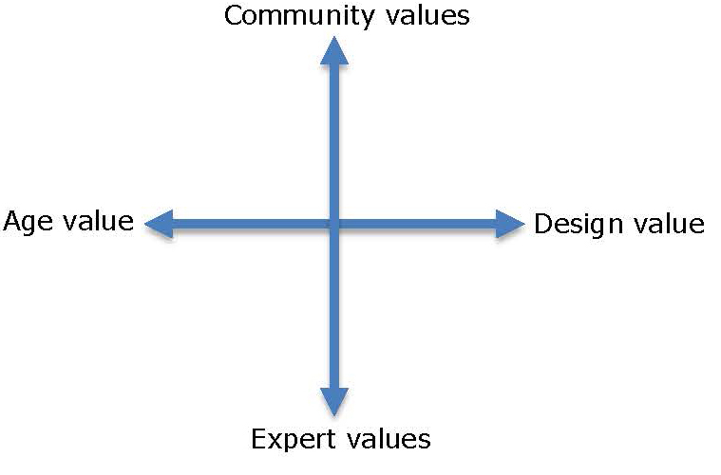
Figure 5.2 Defining the Field of Historic Preservation through Dichotomous Values (Wells 2014:1)

For Wells, there are four major value sets, these include;

- Age Value: Generally, the more the significant the age and historical foundations of the site the more value and protection a site is given.
- Design Value: Judgments are made as to the architectural and technological significance, does it have a particular importance within a movement, style or is an exemplar of a technological innovation. Like age value, the more important the site the higher the protection and perceived social and cultural significance.
- Expert Values: Experts will bring with them a set of personal and organizational values that have been informed by their education, aesthetic preferences and Worldview etc. This directly will inform their interaction and interpretation of sites.
- Community Values: The various community members and type of communities will bring with them various sets of values according to whether they are communities of interest (For example The Georgian Society etc.), geographical communities or non-engaging or apathetic communities.
These differing value systems and notions of value are often in conflict with each other as they underpin multiple interpretations of sites, as Mansfield (2008:274) states:

There is a plurality of competing interpretations of conservation value between the various professional consultants engaged in conservation work and the general public’s perceptions.

The result of this is that buildings and sites are often in a state of stasis, whereby, the conflicting parties argue through the various perceived value of age, design, adaptation or designation in various committees, courts and public enquiries, often this values driven process takes years to resolve while the building or site deteriorates further. Wells (2014:1) in Figure 5.3, outlines the complexity of the value positioning of the various actors involved in Heritage Conservation and how they interact with both each other and the different values and value propositions.

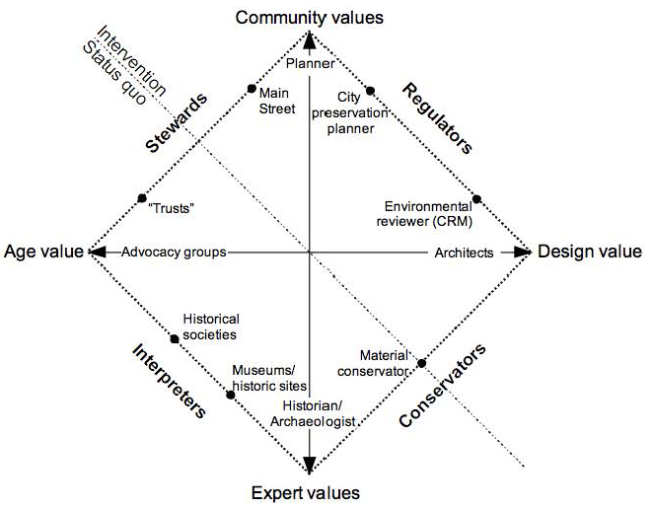Figure 5.3 The Regulators, Conservators, Interpreters and Stewards (Wells 2012:1)

5.7 Cultural Heritage as a Social Construction
Since the re-evaluation of the suitability of positivism as the only appropriate or reliable paradigm to adopt within heritage conservation, and the formalisation of this view within the ‘Burra Charter’ and ‘The Nara Document’, the study and analysis of heritage sites and historical buildings have started to become informed by a more subjectivist approach (Wells, 2010). This paradigm recognises Heritage as a shifting process that is informed by cultural, political and social issues and pressures, instead of static and idealistic set of objects with fixed meanings that underpins the positivistic tradition of conservation (Pereira, 2007). Pereira maintains that:

Conservation practice involves not only technical and scientific matters, but social and subjective ones such as interests, feelings, memories, preferences and even taste. As a consequence, contemporary approaches on conservation stress the importance of negotiation and democratic participation on decision-making processes, as to define what should be conserved and how, why and whom the conservation is made for. (ibid:20)
Consequently, for Pereira, conservation should be framed as a social activity or construction, not only as a technical one, but to recognise that it is shaped by a multitude of social processes (see also Evely et al., 2008; Amarilla and Conti, 2012). In understanding the juxtaposition between heritage artefacts such as Darley Abbey Mills and their cultural significance. Avrami, Mason and De La Torre (2000) assert that Heritage objects and places are not what is significant about Cultural Heritage, but rather that they are significant because of the meanings and uses that people attach to these material artifacts and the values they represent. According to Wells (2010:465), the work of theorists such Avrami, Mason And De La Torre has led to:
A recent movement in architectural conservation is to emphasize the role of contemporary social, cultural, and personal meanings in valuing historic places and the processes in which places develop these values over time. This pluralistic perspective recognizes that different populations and cultures will have diverse ways of valuing historic places.
The multiple meanings, uses, and values that people organisations and communities ascribe to particular places must be understood as part of the larger sphere of sociocultural processes. As such, for De La Torre (2013:6):
At the heart of contemporary, interdisciplinary, critical research on heritage is the notion that cultural heritage is a social construction; which is to say that it results from social processes specific to time and place. As noted, scholarship on culture in the past generation or so reinforces the notion that culture is a set of processes, not a collection of things. Artefacts are not static embodiments of culture but are rather a medium through which identity, power and society are produced and reproduced. Objects, collections, buildings, and places become recognised as ‘heritage’ through conscious decisions and unspoken values of particular people and institutions, and for reasons that are strongly shaped by social context and processes.
As with all other social activities, Conservation is not objective, it is cognitively constructed and informed by the values and perspectives of individuals, institutions, and communities. The notion of cultural heritage encompasses each and every facet of everyday lived experience, which individuals, in their various social groups, consider explicitly or implicitly to be a part of their self-definition (Wells, 2010; De la Torre, 2013). For Amarilla and Conti (2012:150), this social turn within heritage and conservation further questions the appropriateness of positivistic paradigms within the subject area, as they state:
…there is some agreement in the fact that the scientific positivism is incapable of answering by itself the political and cultural variables that lead the action to a sustainable development. The evidence resulting from the science domains, from sociology, philosophy, economy and law suggests that the conventional regulatory-positivist approach is not suitable from the epistemological point of view.
This view reinforces the adoption of an interpretivistic methodological stance within this thesis, by espousing a constructivist approach it is possible to acknowledge that heritage sites are social constructions, and a such are subject to multiple interpretations, and that each person involved within the research process will create their own reality and subjective understand of the world. Thus, this enables us to recognise that the value systems of those involved in the management, interpretation, protection and usage of former industrial buildings such as Darley Abbey Mills inform individual notions of significance value etc. (Azzopardi and Nash, 2014:).
5.8 Conclusion
Although traditionally the subject area of heritage conservation adopted a positivistic approach it has been recognised that this approach no longer fully reflects the shifting philosophical position of the subject area to a more subjectivist approach (Avrami, Mason and De La Torre, 2000; Amarilla and Conti, (2012:150); De La Torre, 2013); Wells, 2007; 2010; 2014) and that this can have a positive impact upon the preservation and continued use of the historic built environment (van der Valk, 2010). However, it is not possible to dismiss the positivistic foundations as funding and designation bodies still rely on quantitative data in measuring the success of projects through KPIs (Brough and Scott, 2014). The philosophical grounding of this thesis within a constructivist, interpretivistic paradigm allows for the recognition that, heritage, history and the built environment cannot solely be measured utilising a quantitatively orientated positivistic orientated approach. Our understanding of the significance, role, context and protection of Darley Abbey Mills is socially constructed and such open to multiple and often contrary interpretations. As seen in Figure 5.1, Azzopardi and Nash (2014) identify the methods of research design and implementation that compliment identified Philosophical positions. The next Chapter in this thesis explores the ‘areas of enquiry’ that have emerged from the literature review and the justification of the methods utilised in exploring these areas.

Chapter 6

Research Strategy and Data Collection Methods

6.0 Introduction

A clear link exists between the philosophical positioning and appropriate philosophically orientated research strategies, as this thesis is underpinned by a constructivist philosophical paradigm, consequently, some research methods will be more appropriate than others. The subject area of Heritage Conservation had been largely dominated by the positivistic philosophical tradition (Binfield, 2003; van der Valk, 2010, Amarilla and Conti, 2012; Wells, 2014; Azzopradi and Nash, 2014) and as a consequence, by positivistic methods. Quantitative research relies on numerical evidence in order to test hypotheses and draw conclusions and, a common choice where an answer to the what, who and how many questions, it is therefore explanatory in nature (Wong, 2014) and as such a popular choice for assessing the impact of funding and conservation strategies within heritage conservation (Binfield 2003, van der Valk 2010). However, for the emerging interpretative orientated researchers (Zancheti et al., 2009; Wells, 2007; 2010) who are ‘…attempting to make sense of, or to interpret, phenomena in terms of the meanings people bring to them…’ (Denzin and Lincoln, 2003:4), the aim of qualitative research is to answer the why and how questions, and so is exploratory in nature (Wong, 2014). Denzin and Lincoln further that qualitative researchers, ‘…employ a wide range of interconnected interpretive practices, hoping always to get a better understanding of the subject matter at hand, (2003:4).

Dawson (2002:16) warns against assuming that either methodology is superior to the other, he states that, ‘Neither is better than the other - they are just different and both have their strengths and weaknesses’, however, within the field of Heritage Conservation there is a recognition that interpretative methods will provide meaningful data that will aid the interpretation and understanding of the significance of the site (Wells, 2007; 2010, Shah and Corley, 2006; van der Valk, 2010), the choice of methods should also reflect the researcher’s philosophical and axiological stance. Thorne (2000:1) illustrates this when he states:

What distinguishes the data in a quantitative study from those generated in a qualitatively designed study is a set of assumptions, principles, and even values about truth and reality.

The significance of this view is reinforced by Moon and Blackman (2014:4) who recognise that; ‘How researchers choose their methods demonstrates a commitment to a version of the world and how the researcher can come to know that world…’ they go on to support this assertion, by utilising Hughes’ (1990) view that:

No technique or method of investigation (and this is as true of the natural sciences as it is of the social) is self-validating: its effectiveness, i.e. its very status as a research instrument making the world tractable to investigation is, from a philosophical point of view, ultimately dependent on epistemological justifications. Hughes (1990:11, cited in Moon and Blackman, 2014:4)

Azzopardi and Nash (2014) in Table 5.1 outline the relationship between ‘Differences Among Key Methodological Positions and Implications for Choice of Research Design’. From this table it is possible to identify that through the adoption of a constructivist philosophical stance, and the assertion that Darley Abbey Mills may be conceived as a social construct, then only certain research strategies and methods are suitable. Azzopardi and Nash (2014:153) identify that a constructivist orientated research project will normally adopt or be guided by a set of characteristics, for the purposes of clarity and relevance Table 6.1 is shortened version of Table 5.1 and focuses upon the adopted constructivist stance rather than the other methodological positions discussed by Azzopardi and Nash.

Table 6.1 Adoption of a Constructivist Philosophical Positions and Implications for Choice of Research Design. (Adapted from Azzopardi and Nash, 2014:153)

Logic | Inductive
Typical Studies  Design/techniques | Narratives, phenomenology, case study, ethnography, grounded theory
Possibility of causal links | Impossible to distinguish causes from effects
Sampling | Purposive theoretical
Possible Generalizations | Only ideological statements possible  Transferability issues important
Data collection strategies | All types, typically unstructured.  All types observations, open interviews, focus groups and unobtrusive measures
Form of Data | Typically narrative
Data Analysis | Thematic strategies: categorical and contextualizing
Interpretation | Sense Making
Validity/quality | Credibility, transferability, dependability
Rhetoric | Informal Literary style

Thus, in designing the research strategy and identifying the appropriate research methods, it is a matter of linking research questions or ‘areas of enquiry’ that have emerged through the process of inductive reasoning.

6.1 Inductive Reasoning

In recognising that definitions and interpretations of Darley Abbey Mills are a social construction, then it stands to reason that the actors, stakeholders and individuals will interpret and find significance in multiple unique ways. As there is little, if any literature relating to the sustainable continued use of UNESCO designated former industrial buildings, there is a paucity of research upon which to position the thesis. However, it is possible that by performing a thorough review of the wider Heritage Conservation, tourism and architectural literature, and relevant policy documents it is possible to use inductive reasoning to strengthen our understanding of certain situations or social constructions by generating new ‘areas of enquiry’ (Galland and McDaniels, 2008). In a similar vein, Jebreen (2012:170) states that the purpose of the inductive approach is:
…to allow the result to emerge from the frequent, significant themes discovered in the raw data without applying any structured methodology. Unlike deductive analysis, where the key topics are usually reframed or left aside because a prior hypothesis is imposed on the data, in the hope of obtaining a desired result, inductive approach describes the actual effect of data on the phenomena. In other words, describing the data perhaps give insight about phenomena rather than supporting the result with the data.
In assessing the suitability of this type of reasoning to this thesis there is clear evidence that inductive models are considered to be more spatially-related (de Noronha Vaz et al., 2012), this also corresponds to Norrström (2013) who sees the design process of the built environment as inductive as it considers ‘human wellbeing and stimulation’, and the multiple interactions they have with sites (Willson and McIntosh, 2007; Evely et al., 2008; Flint et al., 2013).
6.2 Areas of Enquiry
Within the inductive process a number of ‘areas of enquiry’ emerged from the literature, for Groat and Wang (2013:352) within the field of architectural research, the analysis of the surrounding literature enables the researcher to develop a preliminary theory, which becomes ‘…a sufficient blueprint for your study’. The collection of data and subsequent analysis of the ‘areas of enquiry’ may be seen as a ‘blueprint’ to assess the sustainability and continued use of Darley Abbey Mills. In a similar vein, Meyer (2001:331) states that, ‘…case study is open to the use of theory or conceptual categories that guide the research and analysis of data’ Both of these quotes highlight, that there is a degree of pre-understanding that guides the stages of research design and data collection, this pre-understanding is an amalgam of the collective knowledge gained from experiences, general knowledge as well as surrounding debates, which have developed during the literature review. As such, the ‘areas of enquiry’ are underpinned by Yung and Chan’s (2012) criteria for assessing the sustainable adaptive reuse of historic buildings, the reason that this model has been used to drive both the data collection and analysis sections is that it offers an identification of the accepted themes of sustainable development, namely, social sustainability, economic sustainability and environmental sustainability. In addition to these three foundational elements of sustainable practice Yung and Chan also introduce a political element, and as the planning and conservation of the historic built environment is also a political activity their criteria provides a structure within the constructivist tradition (see table 6.1).

6.3 Case Study Research

According to Azzopardi and Nash (2014), the adoption of a case study method is a recognised approach within the Constructivist tradition, as this enables the researcher to develop layers of meaning and significance by focusing on a single social construct whose interpretation is understood through the gathering and interpretation of various types of data. In addition to this, Wong (2014) suggests that the aim of case study research is to explain things rather than measure them, he also suggests that this type of research usually addresses problems within the realism paradigm. This again reiterates the link between the researcher’s philosophical stance and the subsequent development of the research strategy. Although case study research originally developed within the social sciences, it is not now solely restricted to this discipline but, is also utilised within practice orientated fields such as management science, environmental studies and education, but that it has also become a dominant methodology within architectural research (Groat and Wang, 2002; Alizadeh, 2006) and Heritage Conservation (Stewart, 1998; Tengberg et al., 2012; Buckley, 2012). While Denzin and Lincoln (2005); Merriam (1998) and Yin (2003) define a case study approach in terms of being an enquiry strategy, a methodology or a comprehensive research strategy. However, although Creswell and Hanson et al. (2007) also see the case study approach as a method or type of design in qualitative research, critically they also envisage the production of a case study as both an object of study and a product of the enquiry. For the purposes of this thesis, it can be argued that Creswell and Hanson et al. (2007) provide a more suitable definition and evaluation of the case study approach as the assessment of Darley Abbey Mill’s ability to find sustainable and continued use, the development of the case study developed within this thesis, may be seen as both object of study and a product of the enquiry. Discussed below are a number of characteristics of case study research which contribute to the justification of both this type of study being selected as the research strategy and also, for the selection of Darley Abbey Mills as being the chosen case, both of these issues will now be addressed.

According to Creswell et al. (2007:245): ‘Case study research builds an in-depth, contextual understanding of the case’, it is this in-context deeper understanding that subsequently facilitates the discovery of factors that explain the phenomenon being researched (Denscombe, 2003; Yin, 2004). Thus, the assessment of the sustainable continued use of former historic buildings is contextualised within a case of a site that holds the highest possible levels of legislative and designated protection. Baxter and Jack (2008) concluded that the process of understanding actions cannot be separated from its context in which the decisions were made, they go onto to state that within the context of decision making and actions within a School of Nursing that:
It would have been impossible for this author to have a true picture of nursing students decision making without considering the context within which it occurred. (2008:545)
Similarly, for the purposes of this research, the protection of Darley Abbey Mills and the impact of legislation, designation, ownership, stakeholders and economics provide the context and social construction of the site. Resultantly, it is not possible to separate these areas from their context, as removal from context will lead to different interpretations, decisions and actions.
The holistic nature of the case study strategy enables the relationships between the context of legislation, designation, ownership, stakeholders and economics etc. to be highlighted, analysed and explored (Groat and Wang, 2013). Additionally, Schramm (1971 cited in Yin, 2009:17) points out that, the key tenant of case study research is ‘…to illuminate a decision or set of decisions: why they were taken, how they were implemented, and with what result’. The adoption of a longitudinal approach in the formation of the Darley Abbey Mills case study will enable the charting of the morphology of the site, the actions of the actors and the impact of decisions to be charted and assessed. In a similar vein, Groat and Wang (2013) build upon Schramm’s ideas, when they stress that, it is not just studying a case in the field, but rather a matter of: ‘…studying a case in relation to the complex dynamics with which it intersects and from which the case itself is inseparable’ (2013:421). This view is also recognised by Alizadeh (2006), who identifies that, the case study approach places the researcher in a position to capture the complexity of the case. As Stake states (1995:xi):

Case study is the study of the particularity and complexity of a single case, coming to understand its activity within important circumstances.

From the above section, it is clear that the adoption of a case study approach is appropriate for the analysis of the historic built environment. According to Johansson (2003), an on-going emphasis and analysis of the contemporary events and actions that occur to a physical artefact, is another major characteristic of case study methodology within the architectural assessment of buildings. Johansson draws a distinction between case study research within the social sciences, compared to the field of architecture and planning when he suggests that an artefact may also serve as the focus of the case study, Johansson further clarifies this point when he states that:

When a physical artefact is the case (houses or housing areas, for instance, instead of an individual or social group) the gap between case study and history tends to diminish. An artefact is a carrier of its history…the context of design and the context of use may be separated in time, but are often equally important to the understanding of the case of an artefact. In architectural research, when the case is a physical artefact, case studies often become more or less historical case studies. (ibid: 2003:5)

In a similar vein, Groat and Wang (2013) critically develop Yin’s (2009) definition of case study to ensure, that it is relevant to architectural research. Where Yin defines case study research as, ‘…an empirical inquiry that investigates a contemporary phenomenon within its real-life context…’. Groat and Wang (2013:418) amend Yin’s definition to, ‘…an empirical inquiry that investigates a phenomenon or setting’. By substituting the word ‘setting’ for ‘contemporary’, the definition now enables either contemporary or historic settings to be the foci of case studies. The Darley Abbey Mills site can be said to be a carrier of its own history, this is evident not only in its form, size and original function but also in the nature of the buildings materials, its relationship to the River Derwent and the nearby workers housing, but also in the subsequent Victorian development of the site and lastly, the effects of de-industrialisation from the latter part of the 20th century. Therefore, both contemporary and historic events have played a part within the site. Although the focus of the research is the assessment of the sustainable continued use of the Mills, the mill buildings can not be separated from its historical elements, such as original design, use and historical associations with not only the Evans family, but also the wider Derwent Valley Mills. For the purpose of this thesis, the adoption of a longitudinal case study approach, allows for a depth of understanding that recognises the dynamic nature of the various physical actions and interactions that take place within the site, but also allows for the influence of dynamic factors such as economic or cultural priorities to be charted and analysed. Such an in depth understanding could not be realised through the adoption of other methods such as mass surveys or quantitative based assessment etc.

6.4 Rationalisation for a Single Case Approach

If, as suggested above by Creswell et al. (2007), Denscombe (2003), and Yin (2004), that the objective of a case study strategy is to maximise the production of relevant information that helps explain the situation being examined, focusing on an in-depth understanding of a phenomenon rather than broad generalisations, thus a case included within a study has to be limited in number, however, it must also be a reasoned, conscious and a considered choice from a larger number of possibilities. Authors such as Bryman (2004), Denscombe (2003), Groat and Wang (2013), Johansson (2003), Stake (2005) and, Yin (2009) all suggest different grounds on which the selection of cases can be based, for example, the typical or representative instance, the intrinsic instance, the extreme or unique instance, the revelatory instance, a test site for theory, the longitudinal case. It is clear from this literature that each type of case has a different focus, therefore the type of case selected for the research must be closely related to the aim and objectives of the research. As will be argued later in this Chapter, Darley Abbey Mills has a unique set of characteristics that set it apart from all other World Heritage Sites and former historic industrial buildings in terms of protection and its contemporary context. As such the mills should be an exemplar of how the heritage conservation process should protect and guarantee the future of the site. In identifying a unique site that has not been researched previously, leads us to Stake’s (2005:5) view that, ‘We do not study a case primarily to understand other cases, our first obligation is to understand this one case”. The in-depth longitudinal case study developed within this piece of research will provide an understanding of the issues facing the sustainable future of potential new World Heritage Sites. Therefore, by focusing on one instance it places a spotlight on that particular instance i.e. Darley Abbey Mills rather than upon a ‘wider spectrum’ (Denscombe, 2006) of all former industrial buildings or even all World Heritage Sites. Stake (2005:5) makes a key point when he states that:

The first criterion should be to maximise what we can learn. Given our purposes, which cases are likely to lead us to understandings, to assertions, perhaps even to modifying of generalisations?

The ‘areas of enquiry’ that that have emerged from the literature, form the basis of the case study and links existing knowledge with an in-depth contextualised understanding of the theory’s impact upon both practice and theoretical development within the filed of heritage conservation.

In justifying the viability of using a single site for the basis of this thesis, it is possible to turn to Yin (2009), who suggests that there are several circumstances where a single case is appropriate. Yin’s five rationales may be summarised as follows:

1 Where a critical case is used to test theory.
2 An extreme case or unique case is chosen because of its rarity.
3 The case is typical or representative example, which encapsulates the issues common to other places, and, lessons learned from this case could be informative within other examples.
4) The revelatory case would allow the research to observe and analyse a phenomenon that has been previously inaccessible to social science enquiry.
5) The longitudinal case where the same case is studied over two or more different points of time.

The uniqueness and significance of Darley Abbey Mills can be justified by analysing the site in relation to Yin’s rationale for single site case studies.

Table 6.2 Rationale of a Single Site Case Study Approach (Adapted from Yin, 2009)
Rationale for Individual Case Study | Site Characteristics
1 Where a critical case is used to test theory | There is a body of literature identified in Chapters 2, 3 and 4 which places a theoretical understanding of the complexity of managing and maintaining the historic built environment. This thesis will test the applicability of this theoretical understanding of the subject area within a unique set of characteristics that define Darley Abbey Mills.
2 An extreme case or unique case is chosen because of its rarity | The site can make claims to being unique on a number of levels.  Firstly, in an analysis of all UNESCO World Heritage Sites only 122 out of 1007 properties are classified as being industrial. Of these 122 properties, 9 are natural landscapes and 112 are cultural sites. Of these 112, 103 have adopted tourism as the sole strategy for continued use, or they possess no buildings, for example, earth works etc., or have no means of developing the site for other uses other than their original usage, for example the Zollverin Coal Mine Industry Complex in Essen, which is designated on the criterion that the mine heads were designed by Bauhaus. As such, Derwent Valley Mills offers a unique set of characteristics in terms of its size, type of landscape, industrial base, history, ownership and usage that distinguishes it from all other UNESCO Industrial World Heritage Sites. With Darley Abbey Mills offering further unique characteristics  Secondly, Darley Abbey Mills is currently the only UNESCO Industrial site solely in private ownership.  Thirdly, Darley Abbey Mills does not adopt tourism as a strategy for it’s continued use.  Fourthly, it holds the highest possible levels of historic protection in the UK, for example Grade 1 Listed Building status, forms part of the Darley Abbey Conservation Area and, it is part of a UNESCO World Heritage Site.
3 The case is typical or a representative example, which encapsulates the issues common to other places, and, lessons learned from this case could be informative within other examples. | The Darley Abbey Mills is not typical but unique, however what is typical is the impacts and barriers placed upon the sites through the listing process, also many sites outside of UNESCO designation are in the same position of finding contemporary context. As such, the lessons learnt from this case study encapsulates the plight of many other sites and for other future industrial World Heritage Sites
4 The revelatory case would allow the research to observe and analyse a phenomenon that has been previously inaccessible to social science enquiry | Not Applicable
5 The longitudinal case where the same case is studied over two or more  different points of time. | The case study adopts a longitudinal study over a period of seven years, this has enabled for the charting of the morphology of the site, for example has usage changed, has repair and maintenance taken place, have any changes or modifications undertaken followed the process, ethics and principles of Heritage Conservation etc.

As can be seen from Table 6.2, Darley Abbey Mills fulfils four of the five factors that identify the suitability of a site for the single case study approach. As the site fulfils more than one factor, the assessment of the continued use and sustainability of Darley Abbey Mills, attracts what Yin (2009) describes as an embedded case study design. Yin (2009:43) states that this is where:

The same single-case study may involve more than one unit of analysis, this occurs when within a single case, attention is also given to a subunit or subunits.

This section examines the criteria that have been applied in order to establish reliability and validity of the research. It is usual that the quality of quantitative research to be judged against the following criteria: objectivity/intersubjectivity, construct validity, internal validity, external validity and reliability (Meyer, 2001; Yin, 2009; Wong, 2014). Although Meyer (2001) suggests that the same criteria could be used to assess the quality of qualitative research, there is the argument that as qualitative research has a different set of epistemological and ontological assumptions, then the traditional notions of validity and reliability cannot apply in the same way, thus calling for an alternative set of criteria to be used (Azzopardi and Nash, 2014; Guba and Lincoln, 1985; Shah and Corley, 2006; Wong, 2014). Wong (2014) suggests that Healy and Perry’s (2000) alternative criteria, which is built upon the realism paradigm: ontological appropriateness, contingent validity, multiple perceptions of participants and or peer researchers, methodological trustworthiness; analytic generalization and construct validity. Guba and Lincoln (1985) suggest the criteria of: credibility, transferability, expendability, and confirmability, whilst, Azzopardi and Nash (2014) propose that for constructivism the criteria for assessing quality is based on credibility, trustworthiness and transferability. The trustworthiness of the research can be tested via triangulation, there are a number of forms of triangulation: data sources, investigators, theory and, methodological (Alizadeh, 2006; Johansson, 2003; Puler, 2008; Wong, 2014). Thus, for the purposes of this research, data source triangulation was incorporated, where several types of sources were used i.e. field notes, interviews, photographs, documents, which allowed the decision making process to be examined from a number of different angles which helped gain a deeper understanding.

Any form of research or research design needs to be able to demonstrate that its construction offers both validity and reliability. Wedawatta, Ingirige and Amaratunga (2011) identify that as case study research is subjected to criticism, it is important that validity and reliability of a case study research is established. Wedawatta, Ingirige and Amaratunga (2011) go on to adapt Yin’s Case study tactics for designs tests, and that by following the four tests of construct validity, internal validity, external validity and reliability it is possible ensure the validity and reliability of the research strategy used. However, for the single case study approach, Kelliher (2011) suggests that a three-prong tactic is adopted by researcher and will ensure the validity of the case study approach.

The first of these tactics concerns the reliability of single case study research and refers to the consistency or stability of a measure. For this measure, Kelliher (2011) adopts Bryant’s (2011:43) definition of reliability, which states that:

…multiple and independent methods should, if reaching the same conclusions, have greater reliability than a single methodological approach to a problem. This combination of methodologies in the study of the same phenomenon is known as triangulation. From an interpretive perspective, Eisenhardt (1989) recommends that the researcher start with a broad research question, establish systematic data collection and ensure case access to create strong triangulated measures. Qualitative research findings can be strengthened in this way by combining participant observation with interviews and documentary sources (Hammersley and Atkinson, 1983) in a single case.

Within this thesis, the reliability of the research is ensured by exploring previous studies, examining documents, policies and the strategic approaches adopted by the various stakeholders involved within the management, use and protection of Darley Abbey Mills. In addition, observation and photographic documenting of the morphology of the site has been undertaken, which have been accompanied by site visits and interviews with stakeholders. In assessing how the validity of the single qualitative case study approach may be met, Kelliher (2011:123) states that:

In terms of validation, qualitative research depends on the presentation of solid descriptive data, so that the researcher leads the reader to an understanding of the meaning of the experience under study (Stake, 1995). In essence, validation is an interpretive understanding of truth (Angen, 2000). Thus, triangulation is not a tool or a strategy of validation, but an alternative to validation in this context (Denzin and Lincoln, 2003). In a single case, data triangulation is particularly important in order to fortify validation in the absence of cross case comparison. Remenyi et al. (1998) suggest using multiple data sources, establishing an identifiable chain of evidence, and having a draft reviewed by the key informants to strengthen construct validity in this regard.

Chapters 2, 3 and 4 of this thesis provide an in-depth contextualisation of the experience under study, namely the continued and sustainable use of historic buildings, how they are protected and how value or worth is assigned to them. This is then supported by additional site-specific analysis of policy and strategy documents and then discussed the impacts of these with the identified stakeholders. The final tactic for Kelliher is the idea of ‘Generalisability’, this is an important factor in justifying the validity of the case study approach, for Yin (2009:43):

The external validity problem has been a major barrier in doing case studies. Critics typically state that single cases offer a poor basis for generalizing. This analogy to sample and universes is incorrect when dealing with case studies. Survey research relies on statistical generalization, where case studies (as with experiments) rely on analytic generalization. In analytic generalization, the investigator is striving to generalize a set of results to some broader theory.

As such, this can be thought of in terms of the extent to which the findings of the enquiry are more generally applicable outside the specifics of the situation studied (Robson, 2004). In qualitative research, the goal is to offer a case description that would allow the reader to repeat the research process in another case (Kidder and Judd, 1986; Vaughan, 1992). Kelliher (2011:124) goes onto state:

Although a single case may not provide sufficient evidence to make robust generalisations, it can establish the existence of a phenomenon (Van Maanen, 1988), which is adequate for the purposes of exploratory research (Remenyi et al., 1998). Thus, a case can be generalizable to theoretical propositions (Yin, 1984), creating a distinction between analytical and statistical generalizability (Yin, 2003).

In a similar vein, Johansson (2003) points out that generalisations are analytical rather than statistical, as such they are based on reasoning, thus one or a combination of the three principles of reasoning (inductive, deductive or abductive) will be used. As this research is inductive, then according to Johansson (2003) generalisations in the form of a set of related concepts emerge from the data in a process of inductive theory-generalisation-conceptualisation. Alizeda (2006) similarly, suggests that theory is inductively generated from the facts of the case, the result of which is a micro -theory, which consists of related concepts, thus generalisations are from the facts of the case to theory. It is Stake’s (2009:7) opinion that based on the small number of cases included within this type of study then, ‘Case study seems a poor basis for generalisation’. However, when discussing generalizations, Stake (1995:8) then goes on to state that:

The real business of case study research is of particularization, not generalization. We take a particular case and come to know it well, not primarily as to how it is different from others but what it is, what it does. There is emphasis on uniqueness, and that implies knowledge of others that the case is different from, but the first emphasis is on understanding the case itself.

It is argued throughout this thesis that it is important that each case should be treated, contextualised and analysed individually, as the different issues, levels of protection, the significance of historic buildings and sites and, the role of stakeholders will have a profound impact upon how the site is assessed and what form of continued use is appropriate. However, in terms of generalisability, the approach adopted within this thesis provides a more holistic method of measuring the impact of protective designation and legislation, assessing value and assessing the sustainability of a site, rather than the positivistic approach that has traditionally been adopted by the heritage conservation community, and which is often decried by authors such as van der Valk (2010) as obstructing the sustainability of the historic built environment (see Chapter 4).

6.5 Preliminary Theory and Data Collection Methods

In order to ensure the validity of the research findings within this thesis, the case study adopts a number of methods, which are deemed appropriate to each of the ‘areas of enquiry’. Denzin and Lincoln state that qualitative researchers ‘…employ a wide range of interconnected interpretive practices, hoping always to get a better understanding of the subject matter at hand’ (2003:4). Furthermore, Angen (2000) highlights that these interpretive practices or approaches rely upon naturalistic methods such as interviews, observations and analysis of existing texts. Utilising a number of different data sources and methods of data collection ensures that the case is examined from a different number of angles, thus allowing the multiple facets of the case to be both revealed and understood (Baxter and Jack, 2008; Denscombe, 2003; Johansson, 2003; Meyer, 2001; Yin, 2009). By adopting this multi-method approach it can be said that this: ‘… ensures that the issue is not explored through one lens, but rather a variety of lenses which allows for multiple facets of the phenomenon to be revealed and understood’ (Baxter and Jack, 2008:544), thus enabling the deeper understanding which is necessary in order to comprehend the decision making process and the effects of these decisions upon the historic mill site. There is also the argument that the incorporation of multiple sources of evidence is not only useful for ‘developing converging lines of enquiry’ (Yin, 2009:115) but also enables corroboration of facts, triangulation of data and therefore, increases the reliability and validity of data. Groat and Wang (2013) suggest that in addition to a case(s) being studied within their context and, the reliance of using multiple sources of data, both which have been discussed in the preceding sections, a further key characteristic is that case study design should be guided by the development of theory. This may first appear to be contrary to the inductive nature of the research where the theory, which explains the phenomenon, emerges after data analysis.

6.6 Data Collection Techniques

The case study presented within this thesis is informed by the adoption of three qualitative research methods that are in synchronisation with the ‘Constructivist Tradition’ as highlighted by Azzopardi and Nash (2014), and subsequently identified within Table 6.1. The methods utilised within this longitudinal study include semi-structured interviews with stakeholders, longitudinal condition and usage surveys, and documentary analysis of policy, process and strategy documents. Additionally, these methods reflect the increasingly qualitative nature within the field of Heritage Conservation (Wells, 2010; van der Valk, 2010), while engaging with the essential elements of qualitative research, as Corbetta (2003:264) simply states, ‘…the three fundamental actions underlying the techniques of qualitative research are observing, asking and reading’.

6.6.1 Semi-structured Interviews

Semi-structured interviews were undertaken with identified stakeholders, the interviewees reflect the four stakeholder roles identified by Wells (2012), as evidenced in Figure 5.3, and consists of regulators, conservators, interpreters and stewards. In addition to Wells’ four categories, the category of ‘Consumers’ has been added, these may be defined as individual’s who interact with, or are tenants on the site.

Table 6.3 Identification of Stakeholders (adapted from Wells 2010)
Stakeholders | Overview | Role
Owner’s | Own, manage and conserve the site and, are responsible for both the economic, environmental, social and, architectural sustainability of Darley Abbey Mills. | Stewards and  Interpreters
Tenants | Utilising the spaces within the mill site for the purposes of running commercial businesses. This group also comes under the category of consumers. | Consumers and Interpreters
Derby City Council | Responsible for the development of environmental, economic and, cultural strategies, which lead to the concept of the sustainable city and the economic prosperity of the region. They monitor and oversee the planning application process and, they actively protect the three layers of designation. Contribute to the strategy for Derwent Valley Mills and maintenance of the World Heritage Site. | Regulators, Interpreters and Conservators
Derbyshire County Council | They contribute to the strategy for Derwent Valley Mills and the maintenance of the World Heritage Site. They monitor all planning applications within the Derwent Valley Mills World Heritage Site and liaise with the Derwent Valley Mills partnership. They also act as the central hub for application for Heritage Lottery funding and Arts Council England funding. They consider the World Heritage Site as a driver for economic and social development, they also promote the development of sustainable forms of tourism. | Regulators, Interpreters and Conservators
Derwent Valley Mills Partnership | Contribute to the strategy for Derwent Valley Mills and maintenance of the World Heritage Site. Conservation and planning, site operation and development, tourism and regeneration and, research. Provide a link to consult World Heritage site partners. Liaise with Derby city council planning and conservation officers. | Regulators,  Interpreters,  Stewards and  Conservator
Darley Abbey Society | They are a voluntary pressure group, where planning and conservation issues are at the heart of their work in order to conserve the character of Darley Abbey as a whole. They monitor all planning applications and, they are represented on committees, which include highways, crime, environment, planning and conservation as well as being members of the Derwent Valley Mills membership and contributing to the Darley Abbey regeneration strategy. | Interpreters,  Stewards and  Consumers
Derby Civic Society | To stimulate public interest and opinion, promote high standards of planning design, architecture and civic pride and to achieve this by securing the preservation, protection, development and improvement of features of beauty, historic and public interest. | Interpreters,  Stewards and  Consumers
General Public | This group includes the wider population that physically engage with Darley Abbey Mills. | Consumers and Interpreters

As a direct result of the economic recession and the resultant reduction in the budgets of government departments and the funding of heritage, the number of stakeholders’ considerably reduced as roles were amalgamated or roles were lost through natural wastage. The result of this is a more generalised understanding and approach with relationships and specialist knowledge bases being lost. In addition, Wells’ (2010) identification of regulators, conservators, interpreters and stewards, is an analysis of the planning system in the USA, there is a greater delineation between the various roles, with specialisms being protected, within the UK there is a blurring of boundaries between roles, for example a single planning officer may undertake roles that fall into all four of Wells’ categories.

The adoption of qualitative interviews within Heritage Conservation allows for the researcher to explore the individual’s relationship to the artefact, understand their values or even their organizations’ or communities values and understanding of the site. For Corbetta (2003:265):

The purpose of qualitative interviewing is to understand how the subjects studied see the world, to learn their terminology and judgments, and to capture the complexities of their individual perceptions and experiences…The fundamental principle of the qualitative interviewing is to provide a framework within which respondents can express their own understandings in their own terms.

The less structured qualitative interview provides a methodological tool that supports the inductive approach (Bryman, 2012) adopted within this thesis, as the interview can become more interactive, and consequently can be adapted around the immediate interaction between the researcher, the interviewee and the environment or context in which the interview takes place. This flexibility that accompanies the adoption of qualitative interview, is identified by Corbetta (2003:270), who states that:

…the interviewer is free to conduct the conversation as he thinks fit, to ask the questions he deems appropriate in the words he considers best, to give explanations and ask for clarification if the answer is not clear, to prompt the respondent to elucidate further if necessary, and to establish his own style of conversation.

According to Bryman (2012), quantitative research interviews are generally more structured, with a clearly specified set of research questions in order to maximise the reliability and validity of the measurements of key concepts. In qualitative research there is a greater generality in the formation of the initial ideas, with a much more focused interest in the interviewees point of view, and the ability of the researcher to explore what the interviewee sees as relevant and important (Denscombe, 2010). Semi-structured interviews are flexible, they enable the interviewer to respond to the direction in which the interviewees take the interview (follow-up questions, probing questions etc.), and may even adjust the emphasis in the research as a result of significant issues, that emerge in the course of the interviews.

Although interviews can be used to collect straightforward data, Denscombe (2010:174) goes on to identify that, ‘…their potential as a data collection method is better exploited when they are applied to the exploration of more complex and subtle phenomena’. As stated previously in this thesis, the individual’s relationship and interpretation of the historic built environment is informed by many differing hard and soft factors, interviews provide the opportunity to explore these factors. Denscombe (2010:175) further states that:

…when the researcher needs to gain insights into things such as people’s opinions, feelings, emotions and experiences, then interviews will almost certainly provide a more suitable method – a method that is attuned to the intricacy of the subject matter.

This view has been particularly important in this research as from the very start it was clear that the interviewees had quite emotive feelings about Darley Abbey Mills and were very open about their relationship and interpretation of the site. However, as predicated by Denscombe (2010), a number of sensitive issues and disclosure of privileged information was communicated by the interviewees during the research process. This lead to a re-evaluation of the ethical presentation of data as often there was a mismatch of the values between the interviewee and the organization they represented, certain processes relating to the ‘umbrella of protection’ were ignored etc. In order to protect the anonymity of the interviewees, the categories of stakeholders identified by Wells (2010) will be utilised in the presentation and analysis of data rather than title and role, all interviews were recorded in the form of contemporaneous notes rather than recordings.

6.6.2 Condition and Usage Survey

The case study is based on a longitudinal condition and usage survey of Darley Abbey Mills, two temporal analysis points will take place. The initial survey in 2006 and the final survey in 2015 will allow for the analysis of the morphology and development of the site, has the condition of the buildings changed, have guidelines been followed, does the usage reflect social and economic transformations. The condition and usage survey adopts the principles and methods for the recording of historic buildings laid down in English Heritage’s 2006 publication, ‘Understanding Historic Buildings: A guide to good recording practice’ and whose principles have helped shaped the monitoring guide in the 2009 British Standard Guide, BS 7913:1998 The Principles of the Conservation of Heritage Assets. The publication provides clear enunciation of the methods to be used and how they should be applied to the contemporary recording practice; it also defines the various levels of recording and the requirements for these. The initial longitudinal condition and usage survey was undertaken utilising the principles of a Level 3 Recording Survey, which is defined by English Heritage (2006:14) as:
Level 3 is an analytical record, and will comprise an introductory description followed by a systematic account of the building’s origins, development and use. The record will include an account of the evidence on which the analysis has been based, allowing the validity of the record to be re-examined in detail. It will also include all drawn and photographic records that may be required to illustrate the building’s appearance and structure and to support an historical analysis.
The information contained in the record will for the most part have been obtained through an examination of the building itself. If documentary sources are used they are likely to be those, which are most readily accessible, such as historic ordnance survey maps, trade directories and other published sources. The record will not normally discuss the building’s broader stylistic or historical context and importance at any length. It may, however, form part of a wider survey – thematic or regional, for example – of a group of buildings, in which additional source material contributes to an overall historical and architectural synthesis. A Level 3 record may also be appropriate when the fabric of a building is under threat but time or resources are insufficient for detailed documentary research, or where the scope for such research is limited.
If other elements of the wider thesis such as data from Chapters 2 and 3 had been included this could have been elevated to a Level 4 survey, which is defined as:
Level 4 provides a comprehensive analytical record and is appropriate for buildings of special importance. Whereas Level 3 analysis and interpretation will clarify the building’s history in so far as it may be deduced from the structure itself, the record at Level 4 will draw on the full range of available resources and discuss the building’s significance in terms of architectural, social, regional or economic history. (English Heritage, 2006:14)
However, for the purposes of this thesis a level 4 survey is not required as the aim of the survey was to chart the morphology, condition and usage as a data reference point on which to make informed judgments about the sustainable and continued use of the site.

6.6.3 Documentary Analysis

An important element in assessing the sustainability and continued use of Darley Abbey Mills is to understand how the site is expressed and understood within its contemporary social, cultural and economic context. The way to appreciate this expression of contemporary context is to explore and analyse the documentary trail that accompanies the development, protection and the various perceptions of the site by stakeholders. Corbetta (2003:287) defines documents as:

…any material that provides information on a given social phenomenon and which exists independently of the researcher’s actions. Documents are produced by individuals or institutions for purposes other than social research, but can be utilised by the researcher for cognitive purposes.

As documents are independent from the researcher’s actions, Corbetta further argues, that they are ‘non-reactive’ as they are ‘not subject to possible distortion due to the interaction between the researcher and the subject studied’. This view is also reflected by Bryman (2012) who sees documents as sources of data that are ‘out there’ waiting to be discovered as opposed to sources produced at the request of the researcher. As a result of this ‘non-reactive’ status, both Atkinson and Coffey (2011) and Bryman (2012) suggest that documents have a distinctive ontological status, in that they form a separate reality, which they refer to as a ‘documentary reality’ and should not be taken to be ‘transparent representations’ of an underlying organization or social reality. Atkinson and Coffey (2011:79) go on to state:

We cannot…learn through written records alone how an organization actually operates day by day. Equally, we cannot treat records – however “official” – as firm evidence of what they report. (cited in Bryman, 2012:555).

In assessing the significance of any documents it is important to recognise the purpose of the document as well as the values and worldview of the producer, they are written for a purpose and do simply reflect reality, thus the utilization of documents as part of a case study needs to be simultaneously balanced against other methods and approaches. As Bryman (2012:555) states:

If the researcher wishes to employ documents as a means of understanding aspects of an organization and its operations, it is likely that he or she will need to buttress an analysis of documents with other sources of data.

As such, the validity of documentary data should not be accepted at face value, the validity of a document needs to be something to be established rather than taken for granted. Platt (1981) and Scott (1990) argue that documents need to be evaluated in relation to four basic criteria:

- Authenticity – Is it genuine, can we be satisfied that the document is what it purports to be?
- Representativeness – Is the document typical of its type? Does it represent a typical instance of the thing it portrays?
- Meaning – Is the meaning of the words clear and unambiguous? Hidden meanings? Are there any meanings which involve ‘reading between the lines)
- Credibility – Is it accurate? Free from errors – this depends on the purpose of the document, who produced the document, when was the document produced?

The documentary data examined in the course of this thesis can be defined as ‘institutional documents’ that reflect the administration, governance, protection and significance of the Darley Abbey site, and are ‘…produced by institutions, or by single individuals within the context of their institutional role’ (Corbetta, 2003:288). Such documents form a bureaucratic ‘genre’ with distinctive styles and conventions (Atkinson and Coffey, 1997). This thesis examines the body of documents that are generated, surround and reflect contemporary practices within the protection of the historic built environment and the field of Heritage Conservation. The analysis of documentary sources will concentrate on two distinct, yet interrelated areas, these are as follows:

- Analysis of policies and strategies. The critical examination of local authority policies and strategies locates Darley Abbey Mills allows for the identification of how the site and the Derwent Valley Mills are impacted upon by the local authority’s strategic direction with regards to conservation and heritage, sustainable development and regeneration. The contents of documentation such as: The Local Development framework; The City Regeneration Framework; The Derby Plan 2011-2026; Derby’s economic Strategy 2011-2026; The Townscape Character Assessment - Darley Ward; Darley Abbey Conservation Area (2003) were all analysed.

- Analysis of Planning Applications for Darley Abbey Mills. Analysis of planning applications made over an eighteen-year period (1997-2015) was undertaken, this was in order to gain an understanding of how the mill complex had been maintained and developed. The eighteen-year time frame, which has been, split into two distinct periods 1997-2012 and 2013-2015, the first period reflects the level of planning application, both pre and post designation as a UNESCO World Heritage Site in 2001. While the second period (2013-2015), reflects the change of ownership of the site and the subsequent shift from light industrial use to a new strategic focus on attracting new creative industries to the site. The analysis of planning applications (see Appendix 1) generates a great deal of data, and evidences any official adaptation, change of use, maintenance or development of the site. Additionally, the analysis of planning applications demonstrates the role of stakeholders in formulating applications, the various values being applied by stakeholders and Derby City Council and evidenced through their support or objections to any proposed developments or actions.

6.7 Conclusion

This Chapter in conjunction with Chapter 5 provides and forms the philosophical and methodological foundations of this research. The identification of Darley Abbey Mills, as a dynamically changing social construction, necessities the adoption of an interpretivistic or constructivist approach, in terms of both the paradigm adopted and the methods utilised. The inductive reasoning process, that accompanies the constructivist approach, has enabled the identification of a number of ‘areas of enquiry’ that will permit the aims and objectives of the thesis to be answered, these have been generated from a review of the literature and accepted conservation practices and as such have been reflected in this method Chapter. The adoption of a case study approach is recognised within both architecture (Groat and Wang, 2002; Alizadeh, 2006) and Heritage Conservation (Stewart, 1998; Tengberg et al., 2012; Buckley, 2012) as an appropriate method, and tool for the analysis of the historic built environment. By adopting a single case study approach it has been possible to undertake a longitudinal study of a unique site that demonstrates and brings together a set of characteristics that act as an exemplar of the contemporary approach to the continued use and protection of historic sites. Although there is some criticism of a single case study approach, Yin (2009) provides a rationale of a single site case study approach that identifies five circumstances where a single case study approach is appropriate, Darley Abbey Mills meets four of these characteristics, and as such the single case study approach is an appropriate and valid method upon which to base this piece of research (see Table 6.2). Additionally, the validity of the approach is also reinforced by the utilisation of various data generating methods that are underpinned by both theory and subject specific practices. The next Chapter in this thesis is the presentation of the data that has been generated from the research process.

Chapter 7

Findings

7.0 Introduction

This Chapter presents the data gathered within the course of this research, it is presented in three general themes, the historical and architectural context of Darley Abbey Mills, factors impacting upon the economic sustainability of the site and social and cultural sustainability. As stated in Chapter 6, the data gathered for this research has been gathered over the period between 2006-2015, the research data has been organised in loose themes that represent the areas of enquiry and the criteria identified by Yung and Chan’s (2012) criteria for assessing the sustainable adaptive reuse of historic buildings. Yung and Chan’s (2012) criteria will be applied more formally in Chapter 8 when the research data is analysed.

7.1 Historical and Architectural Context of the Site

As identified in Chapter 2 and Chapter 4, Darley Abbey Mills is an important historical artefact that is identified as an internationally significant site in terms of it’s pioneering technological innovations, the design and role of the Mills in the British Industrial Revolution and the fact that Darley Abbey Village is an example of one of the world’s first purpose built industrial communities. As identified in Chapter 4, the result of this historical and architectural significance is that the both the Mills and the Village are subject to numerous protective measures and inclusion in regional and local policy documents (see Figure 7.1 for site plan of the Mills).

Darley Abbey Mills are of recognised significance, many of the buildings are listed, the site is included within the Darley Abbey Conservation Area, and together with the Derby Silk Mill form the southern part of the Derwent Valley Mills World Heritage Site. Documents, such as, The Townscape Character Assessment: Darley Ward (Derby City Council, 2009), The Derwent Valley Mills World Heritage Site: Economic Plan (Latham Architects et al., 2005), Darley Abbey Mills and Stables: Strategy Document (Atkins, 2010) all recognise the importance of the Darley Abbey Mills and explore its contemporary context.
Content removed for copyright reasons.

Please see: Atkins (2010) Darley Abbey Mills and Stables: Strategy Document. Available at: http://www.derby.gov.ac.uk/media/derbycity/contentassets/documents.neighbourhoodpartnerships/Darley-Abbey-Regeneration-Strategy-Report-FINAL-part1.pdf

Figure 7.1 Site Plan of Darley Abbey Mills (Atkins 2010:9)

The Townscape Character Assessment: Darley Ward (Derby City Council, 2009a) state that, ‘The historic Darley Abbey Mills complex is a key historic asset’, and that according to Atkins (2010), the mills are not only a key part of the Derwent Valley Mills World Heritage Site, but also an underappreciated asset for Derby. Latham architects et al. (2005) describes the mills as “…an historic asset of the highest order”. The Derby Conservation Area (Derby City Council 2003) highlights that:
The main reason, however, for the designation of the Conservation Area is the continued existence of the majority of the industrial village built by Thomas Evans in the 18th and early 19th centuries.
However, the Townscape Character Assessment: Darley Ward (Derby City Council, 2009a) points out, that although the character and identity of the area is undoubtedly influenced by the historic mills and associated housing, there are other factors which all collectively add to the character of the contemporary Darley Abbey, these include, the River Derwent, the open spaces such as Darley park; the street layout and plot sizes. Section 5.10 of the Development Plan Document: Core Strategy Issues and Ideas Paper (Derby City Council, 2009) suggests that not only is the River Derwent a prominent and natural feature of the city, but that it is of both of environmental importance and cultural value. Therefore, it is clear that the mills, the village, the park and, the river each have their own value and that they are all inextricably linked.
7.2 Economic Sustainability

7.2.1 Economic Viability

As Darley Abbey Mills is in Private ownership it is imperative that it generates a sustainable income source that not only provides a return on investment, but also generates enough income to maintain and adapt the site. Thus, there is a need to generate the maximum income per square metre, this requires full occupancy of buildings and a use that maximises the income generated from them. Table 7.1 shows the occupancy levels both in 2006 and in 2013, from this it can be seen that within the complex some buildings remain at the same level of occupancy while others have changed. Out of all the buildings on site, eleven buildings remain at full occupancy and five are only partly occupied, although one building has gone from full to part occupancy, two buildings, which were previously unoccupied are now fully utilised and, five that were in part use are now full. In addition to this, one building that was only in partial use is now vacant as are two that were in partial use/part storage.

Table 7.1 Occupancy Levels at Darley Abbey Mills 2006-2013
Name of Building | Identifying No | Occupancy level in 2006 | Occupancy Level in 2013
Long Mill | 1 | Part/Storage | Vacant
Middle Mill | 2 | Part | Part
East Mill | 7 | Part | Part
West Mill | 8 | Part/Storage | Vacant
North Mill | 9 | Part | Full
Engine House and Boiler House | 9 | Full | Full
Proto-fireproof building | 4 | Part | Part
Cart Sheds | 5 | Part/Storage | Full
Manager’s House | 3 | Part | Vacant
Fire Station | 20 | Part | Full
Workshop | 14 | Full | Full
The Watch House | 10 | Vacant | Full
Sawmill and Workshop | 12 | Full | Full
Stables | 18 | Part | Part
Offices | 11 | Full | Full
Coppice Barn A | 22 | Full | Full
Coppice Barn B | 23 | Full | Full
Open Fronted Store | 19 | Full | Full
Gassing Shed | 24 | Part | Full
5 Old Lane | 15 | Part | Full
Picking Room | 6 | Full | Full
Dining Room | 17 | Full | Full
Engine House | 26 | Full | Full
Chimney | 27 | N/A | N/A
Polishing Shed | 25 | Part | Full
Cottages | 16 | Full | Full
Works | 35 | Full | Part
Works | 36 | Full | Full
Modern Offices | 33 | Vacant | Full

Key to Table 7.1
Occupancy Level | Justification
Full | The building is fully occupied either by a single occupier or, in the case of the large mill buildings, it usually has multiple occupants.
Part | Not fully occupied, usually indicates that only the lower levels of the building are utilised.
Storage | The building is only used for storage purposes.
Vacant | There are no current occupants within the building.

When focussing upon only the Georgian buildings within the complex the situation is as follows: two remain fully occupied and four are still in partial use; two of the largest buildings on the site, the Long mill and Middle mill, whose lower floors were used but the upper floor were either vacant or used for storage are now both vacant; the North Mill which was previously only in partial use is now in full occupancy; the Watch House that served no previous purpose is now back in use following its repair as discussed in section 7.2.6; the ground floor of the Manager’s House was previously utilised as a café, but now the whole building is vacant. From this analysis it is clear that while the occupancy levels of some of the Georgian buildings have remained stable, others such as the Watch House, North Mill are now fully utilised, three buildings have become vacant which is a cause for concern especially when coupled with their condition as discussed in section 7.2.3.

However, although the occupancy rates have increased from 2006-2013, it can be argued that, in order to make the site economically sustainable, the large significant buildings (Long Mill, Middle Mill, East Mill, West Mill and North Mill) need to have a use that generates significant income, currently only North Mill is fully occupied, with Long Mill and West Mill vacant. The current tenants at North Mill, Middle and East Mill are small space intensive businesses that have been drawn to the site as a result of the large open space and the cheap rents. The new proposal for the redevelopment of Long Mill will create 7 office and gallery units and West Mill will be converted into a wedding venue capable of serving a sit down meal for 165 guests (Derby City Council, 2015). With the remainder of the site being given over to the creative industries. It is possible from Table 7.2 to see that there has now been a shift away from the dominance of engineering and manufacturing activities that was clearly evident in 2006. While some of the buildings are still used for engineering purposes, there are now more service and creative industries based at Darley Abbey Mills, these include photographers, financial services and marketing consultants.

Table 7.2: Use Of The Buildings Within The Complex
Name of Building | Identifying No | Use in 2006 | Use 2013
Long Mill | 1 | Manufacturing | Vacant
Middle Mill | 2 | Leisure/Service | Leisure/Service
East Mill | 7 | Leisure/Service | Leisure/Service
West Mill | 8 | Manufacturing | Vacant
North Mill | 9 | Manufacturing | Leisure/Service
Engine House and Boiler House | 9 | Manufacturing | Service
Proto-fireproof building | 4 | Creative/  Engineering | Creative
Cart Sheds | 5 | Engineering | Service
Manager’s House | 3 | Service | Vacant
Fire Station | 20 | Storage | Service
Workshop | 14 | Engineering/  Manufacturing | Engineering
Bobbin Shop | 21 | Manufacturing | Manufacturing
The Watch House | 10 | Vacant | Service
Sawmill and Workshop | 12 | Engineering/  Service | Engineering/Service
Stables | 18 | Engineering | Engineering
Coppice Barn A | 22 | Engineering | Service
Coppice Barn B | 23 | Engineering | Engineering
Offices | 11 | Service | Creative
Open Fronted Store | 19 | Engineering | Engineering
Gassing Shed | 24 | Storage | Service
5 Old Lane | 15 | Storage | Service
Picking Room | 6 | Accommodation | Accommodation
Dining Room | 17 | Service | Service
Engine House | 26 | Retail | Retail
Chimney | 27 | N/A | N/A
Polishing Shed | 25 | Engineering | Creative
Cottages | 16 | Accommodation | Accommodation
Works | 35 | Engineering/  Service
Works | 36 | Retail/Service
Modern Offices | 33 | Vacant | Service

Key to Table 7.2
Descriptor | Meaning
Accommodation | Private accommodation/housing.
Creative Industries | Service based industries with a creative focus often motivated by new technologies.
Leisure | Recreational spaces that include health, fitness, food and hobbies.
Light Engineering | Small-scale fabrication and engineering.
Manufacturing | Larger production with focus on turning raw materials into finished products.
Retail | Retails units/shops
Service | Service based industries such as insurance, accountancy and holding companies.
Storage | Used for storage purposes only
Vacant | Currently the building is vacant and so serves no current purpose.

According to the owner who was interviewed: “The strategy was always to develop the mills into a space for creative use and not engineering, it was trying to move away from that”. When it was suggested that the image for the contemporary use of the mills is a dramatic shift from the image the mills had a few years ago, it was stated that:

Yes, the image for the mills now is that of young trendy businesses, with a similar demographic, it will be in effect a cluster similar to that seen in Clerkenwell where myself and my brother both worked previously.

When asked the reasoning behind this shift from light engineering to creative use, they stated that:

One reason is noise abatement issues, the two don’t mix well, the light engineering is quite a noisy process, in my experience, the most successful ventures are where the site is within single ownership, which we are slowing achieving and, also that there is one theme which runs through the site, which for here will be more creative industries. The theme includes the co-ordinated paint and signage that we are using throughout, to provide continuity to the site. We have ear-marked, £300,000 for the middle mill roof and also the external fabric and roofs of the Long and West Mill as both of them are leaking

When discussing the plans for the Long and West Mills which were purchased in December of 2012 it emerged that “the idea for this part of the site is for it to become a venue for weddings but also for public access.” They later commented that the “West Mill will be the window to the site, there will be more there for public interest”. Due to the statements about When asked whether the strategy for the Long and West Mills I am interested in the heritage of the buildings…

When asked whether the future for the West Mill included space in which to tell the story of the buildings, the answer was:

Yes, that’s exactly what it is, telling the story, I would like to see guided historic tours here, but I would also like to see the space used for photographic exhibitions, some large photo’s of how the buildings were used would look good displayed alongside the exposed brickwork. I would really like to use part of the space for an art gallery, perhaps even get some Joseph Wright painting here, but that might be a little while in the future for that.

This reply prompted the question as to whether these displays would be taking the visitor through the circle of industrialisation, de-industrialisation and the re-industrialisation without it being a static museum such as that at Belper North Mill, to which the reply was:

No that’s right, it wouldn’t be turning it into a static museum, but it would be a way of showing the historic journey of the site, a visual display of what the buildings were used for, why they are important but also the before and after, how they are used now and for the future. There is a uniqueness here in the Long Mill, the West Mill and buildings such as the Manager’s house.

They stated that the long-term strategy for Darley Abbey Mills:

is to take the mill complex to 100% occupancy…. In the more long-term future we would like to establish a hydro electric plant, to harness the natural power of the river, it would add to the image of re-use and sustainability we are trying to establish here, it would also generate a small revenue stream. The Long Mill will be more creative office space, with glazed partitions which don’t have a huge impact upon the fabric of the building but also look good, we should then be able to get two 1000 square feet units per floor.

One of the questions posed to the one of the tenants of North Mill examine the motivations for the move to Darley Abbey Mills, to which they stated that: “To be honest the main motivation was to get out of the centre of Derby…”. However, it later transpired in the interview that this was not the sol reason for the relocation but that:

…the building didn’t work for us either anymore, it’s layout was higgledy piggledy, it was on different levels, so it was fragmented, it didn’t make sense. It was ok when the business started as we were quite small and it was convenient but for the business moving forward, we needed an open plan studio on one level.

The tenants then expressed that the benefits of moving the business to the North Mill was:
we have room to expand here if and when we need to, it is a nice quiet, peaceful, pleasant environment to work in, you can think. We have an office dog, so it’s nice that we can go and take him a walk to the park in the lunch time and get outside in the fresh air to clear your mind.

This response then prompted the question as to whether the move to the mills was more than just about the space to expand but more to do with the prestige value afforded by the aesthetics of the space and also about the quality of work life balance that this pace afforded to the business? The replied that:

Yes, it is, it is a better environment to work in, the clients love it here, we can have the dog in here, there’s parking just outside for the clients and us. There is a diverse mix of businesses in here now, there are other design companies too.

7.2.2 Heritage Costs

One of the major factors in justifying the adaption of historic buildings is that the costs are less than new build, however this depends upon the condition and status of the buildings. This next section provides a condition survey of the Georgian industrial buildings that form part of the Darley Abbey Mills Site, the condition of the buildings demonstrates how buildings have been repaired, maintained or adapted for commercial purposes and the levels of intervention required to secure their sustainable future.

Table 7.3: Morphology and Significance of Darley Abbey Mills
Building | Time of  Construction | Defining Period | Listed Building Status | Building at Risk? | No on Figure 7.1
Long Mill | 1782-1788 | Georgian | Grade 1 | Yes | 1
Proto-fireproof Building | By 1790 | Georgian | Grade 2* |  | 4
Manager’s House | 1790’s | Georgian | Grade 2 | N/A | 3
Middle Mill | 1796-1801 | Georgian | Grade 1 | No | 2
Cart Sheds | 1811 | Georgian | Grade 2* | Yes | 5
East Mill | 1819-1821 | Georgian | Grade 1 | No | 7
West Mill | 1819-1821 | Georgian | Grade 1 | Yes | 8
Fire Station | 1820’s-30’s | Georgian | Grade 2 | N/A | 20
Workshop | 1820’s-30’s | Georgian | Grade 2 | N/A | 14
North Mill | 1825 | Georgian | Grade 2* | Yes | 9
The Watch House | Late 18th Century | Georgian | Grade 1 | No | 10
Cottages | Late 18th/ early 19th | Georgian | Grade 2 | N/A | 16
Bobbin Shop | 1840 | Victorian | Grade 1 | No | 21
Open Fronted Store | Post 1811 pre 1881 | Victorian | None | N/A | 19
Sawmill and Workshop | By 1881/82 | Victorian | Grade 2 | N/A | 12
Coppice Barn A | By 1881 | Victorian | Grade 1 | No | 22
Coppice Barn B | By 1881 | Victorian | Grade 2 | N/A | 23
Stables | By 1881/82 | Victorian | None | N/A | 18
Offices | Post 1881 pre 1938 | Victorian/  Edwardian | None | N/A | 11
Dining Room | 1881 | Victorian | None | N/A | 17
Engine House | 1881 | Victorian | Grade 1 | No | 26
5 Old Lane | By 1881 | Victorian | None | N/A | 15
Gassing Shed | By 1881/82 | Victorian | None | N/A | 24
Picking Room | By 1881/82 | Victorian | None | N/A | 6
Engine House and Boiler House | By 1884 | Victorian | Grade 2* | Yes | 9
Polishing Shed | 1880’s | Victorian | None | N/A | 25
Chimney | 1890’s | Victorian | Grade 1 | No | 27

Table 7.3 illustrates that there are 12 Georgian buildings remaining on the mill site. However, as illustrated in Figure 7.2, the buildings outlined in red (West Mill, Long Mill, North Mill, the Engine house and Boiler house, the proto-fireproof building and the open-fronted shed) signifies that they are currently on English Heritage’s buildings at risk register as a result of their condition or level of occupancy.

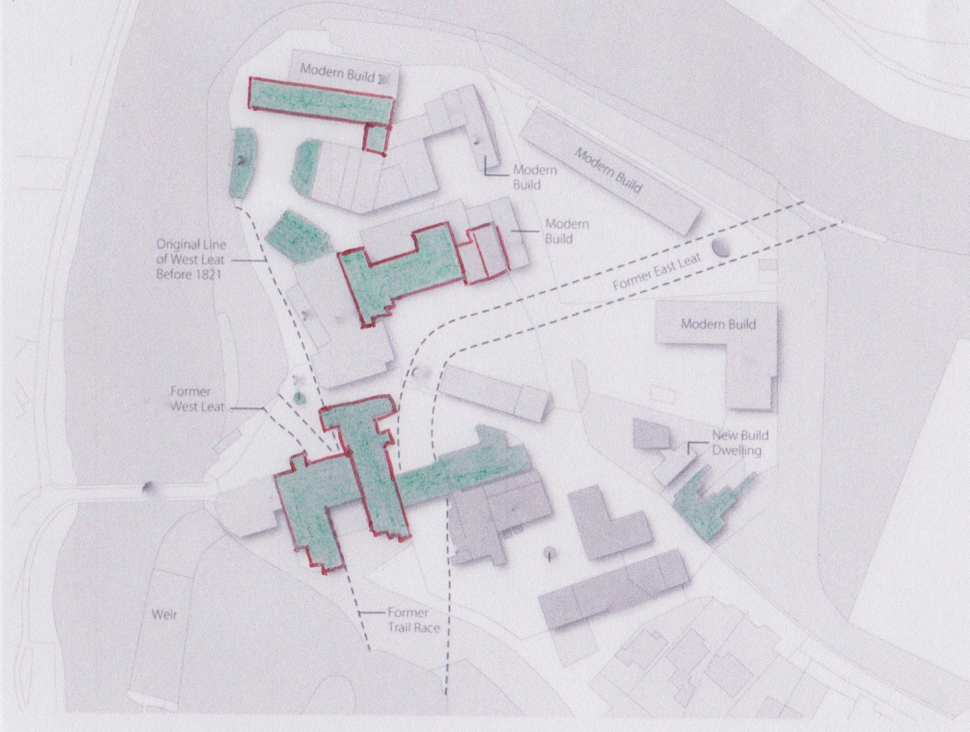
Figure 7.2: Listed Georgian buildings including those placed on English Heritage’s Building at Risk Register

From both Table 7.3 and Figure 7.2 it can be deduced that there are nine Grade 1 listed buildings on the site, five of these are Georgian in origin and two of these five are on the buildings at risk register; there are four Grade 2* listed buildings within the complex, three of which were constructed within the Georgian period and all three of these are on the buildings at risk register; there are six Grade 2 listed buildings, four of which are Georgian. Although Grade 2 listed buildings outside of London are not eligible to be considered for the buildings at risk register, as will be seen later in this Chapter, some of the Grade 2 listed Georgian buildings i.e. the manager’s house is in a very poor state of repair and serves no current purpose as a result.

7.2.3 Condition of the Georgian buildings at Darley Abbey Mills

The full condition survey can be found in Appendix 3, below is the condition and use of the Georgian buildings.
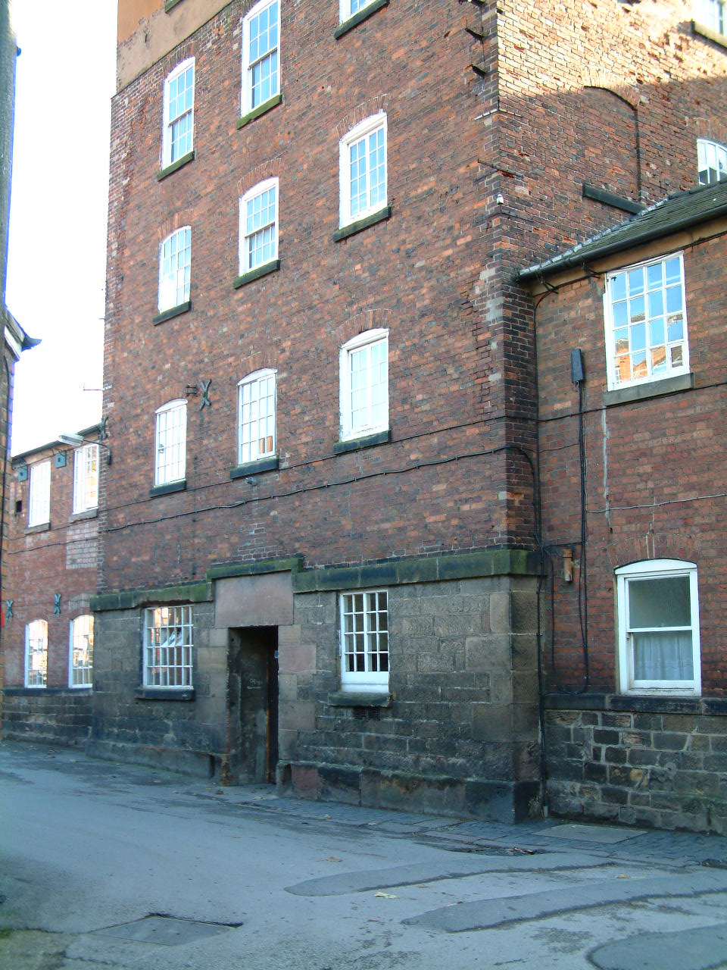 | Building | Long Mill
 | Date of Construction | 1782-88 (Georgian)
 | Listed Building? | Grade 1  On Buildings at Risk Register
 | Owner/Occupier in 2006  Owner in 2013 | Ellison Metal Products  Darley Abbey Properties
Use in 2006 - Ground and 1st floor utilised for the production of metal components and office space. The other 3 floors are unused, parts of them only used for storage.

Use in 2013 – Currently vacant.

Condition in 2006 - Some slipped and missing slates on the roof, although the parapet wall makes is difficult to accurately ascertain the overall condition of the roof covering. Both grey plastic and cast iron rainwater goods are evident but some of the cast iron ones have failed. The parapet wall at some stage has been rendered but has deteriorated and has fallen away in places over time leaving the bricks exposed, which are now showing signs of deterioration. There is evidence of modern brick replacements but there are also instances of mortar repairs on most elevations of the building. Re-pointing is evident in some places but missing pointing can also be seen in others. Failing paintwork on timber windows. Patches of a black oily-tar like substance is visible, this is thought to be historic staining due to the use of oil in the mechanised processes housed within the building. In the corner between the Long Mill and the Middle Mill there is a defective cast iron drainpipe where the bottom section has come away from the rest. This has allowed water onto the surface of the building, plant growth and green moss indicates that this problem occurred some time ago but has not been rectified.

Condition in 2013 – No change to above.

Description and Key Features - This is the earliest of the mills with: 6 storeys including attic; 17 bays; aligned North-South; 38.4 metres long and 10.1 metres wide; masonry ground floor with brick above; conventional construction – timber floors and roof timbers; cast-iron columns remain in the building. There are various patterns of windows all with brick arches above and flat stone lintels below, a couple of modern timber windows.

A form of fire-retardation remains in the building – thin metal sheets nailed over exposed timbers, this is likely to have been added at a later date.

The form of the mill remains largely intact and unaltered. The cast-iron columns and plentiful amount of windows provide large well-lit and uninterrupted floor space capable of offering good open plan accommodation.

The base of the bell cupola remains at the north end of the attic.

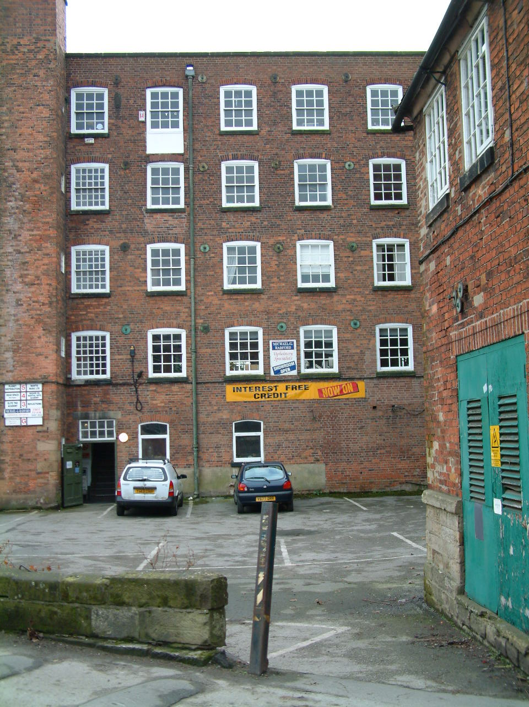 | Building | Middle Mill
 | Date of Construction | 1796-1801 (Georgian)
 | Listed Building? | Grade 1
 | Occupier in 2006  Occupier in 2013 | Multiple  Multiple
Use in 2006 - The ground floor appears not to be in use but the others are occupied by: Michael G. Radford – Upholstery; Reflections – Blinds/Curtains; Martial Arts Academy; Mantis Music Ltd

Use in 2013 – The ground floor and first floor not in current use, the others are occupied by: The Flying Studio; Nigel Tissington Photography; Therapeutic Sports Massage;
Condition in 2006 - Pointing on this building seems sound overall, wall ties are evident, there are areas of modern brick replacements and re-pointing around window openings. At the rear of this building, grey plastic rainwater goods have been fitted ad-hoc to asbestos ones, the plastic has become brittle over time possibly due to exposure to the sun and therefore has broken allowing water onto the masonry surface, there is also dripping water pipes and steam being emitted from another pipe, the result of this is efflorescence and plant growth on the masonry surface at a low level.

Condition in 2013 – Same as above.

Description and Key Features – This buildings is an eastwards extension to Long Mill with: 5 storeys and 6 bays built c.1796-1801; of conventional construction with brick walls, timber floors and roof timbers; a wide stone framed wheel race is still evident at ground level.

The existence of the stone framed wheel race provides historical evidence of the original use even though both the water and the waterwheels have since been removed and the arched openings have been filled in.

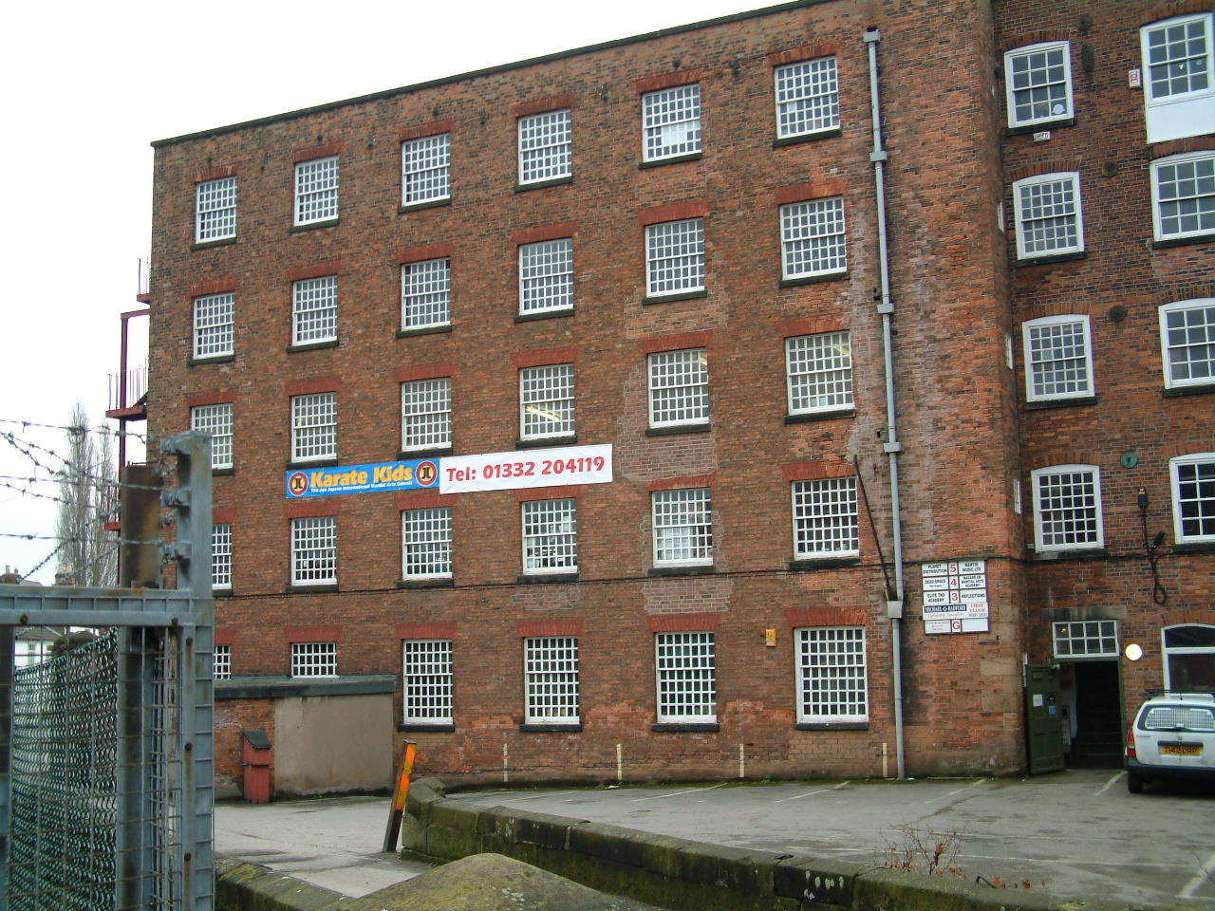 | Building | East Mill
 | Date of Construction | c.1819-21 (Georgian)
 | Listed Building? | Grade 1
 | Occupier in 2006  Occupier in 2013 | Multiple  Multiple
Use in 2006 - Ground Floor – Patterns (Derby) Ltd; 1st Floor – Michael Radford Upholstery; 2nd Floor – Elite Academy; 3rd Floor – Dead space, Mark Hughes; 4th floor – Planet Distribution

Use in 2013 – Patterns (Derby) Ltd; John Jepson Black Belt academy; Results Personal Training

Condition in 2006 - Due to the parapet wall, the condition of the roof covering was impossible to ascertain. There are areas of modern brick replacements around some of the window openings. There are also areas of missing pointing. White efflorescence is evident on the masonry surface around where the grey plastic rainwater goods are located. There are also holes in the masonry at regular intervals which possibly indicates the existence of earlier cast iron fittings which may have failed and were subsequently replaced. There is a damp patch where pipes enter the hopper – defective pipe or inappropriate treatment?

Condition in 2013 – Same as above.

Description and Key Features- A 5 storey and 6 bay eastward continuation of Middle Mill. Evidence of fire-proof construction – cast iron columns and beams, brick jack arches and an iron roof.

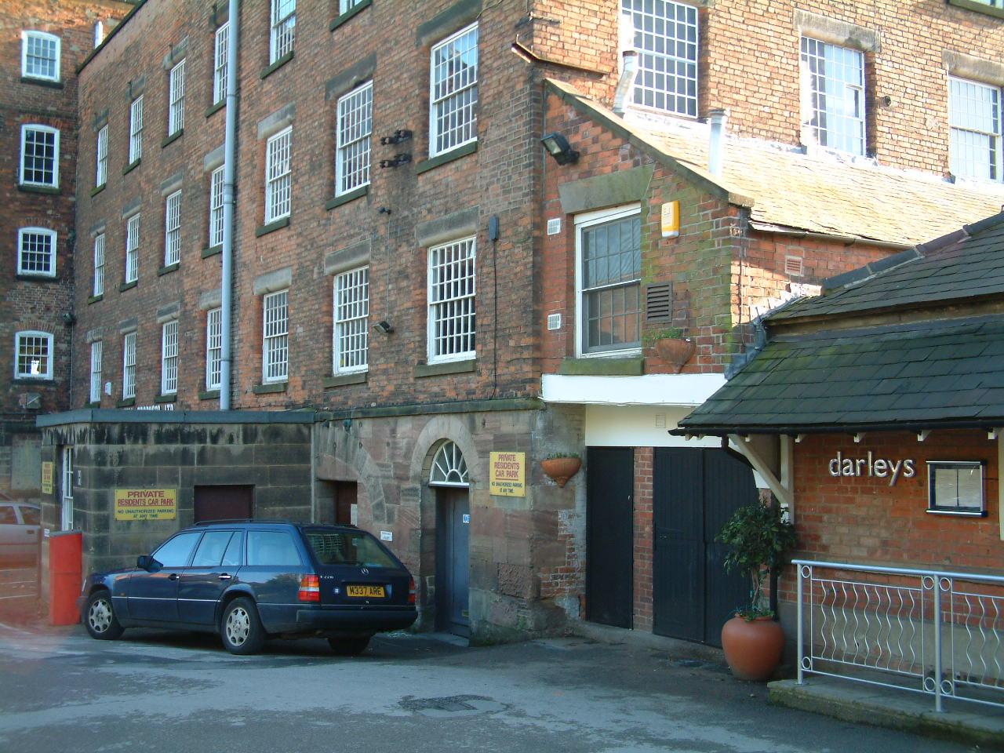 | Building | West Mill (8)
 | Date of Construction | 1819-21 (Georgian)
 | Listed Building? | Grade 1  On Buildings at Risk Register
 | Owner/Occupier 2006  Owner 2013 | Ellison Metal Products  Darley Properties Ltd
Use 2006 - Ground floor and 1st floor appear to be used for the production of metal components and office space, the remaining floors seem unused or perhaps for storage only.

Use 2013 – No current use.
Condition 2006 - Some windows on the side elevation have been boarded over and this has been painted to look like a window opening – has the interior space been altered at this point? Defective bricks on the parapet, possibly due to exposure to the weather. Hopper system so no gutters but there are grey plastic down rites. There are holes on the masonry surface at 1st and 2nd floor level, indicates that something has been removed? A little re-pointing is evident.

Condition 2013 – Same as above.
Description and Key Features - A 5 storey, 7 bay by 7 bay, L-shaped, westwards extension of Long Mill. A wide stone arched wheel race remains visible on the front elevation of the mill. Columns inside the building and plentiful windows provide a well-lit open plan interior space

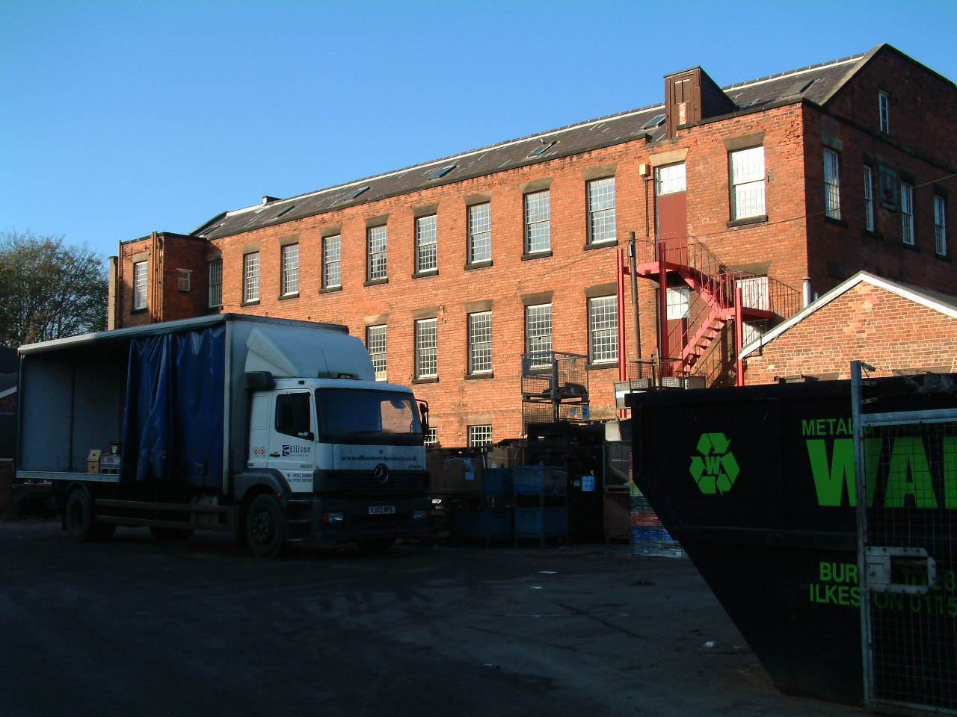 | Building | North Mill
 | Date of Construction | C. 1825 (Georgian)
 | Listed Building? | Grade 2*  On Building at Risk Register
 | Owner/Occupier in 2006  Owner/Occupier in 2013 | Ellison Metal Products  Owned by Darley Abbey Properties with multiple occupants
Use in 2006 - Used as part of Ellison Metal products.

Use in 2013 – Ground Floor – Pure Fitness Gym, 1st Floor – Fluid Ideas Ltd (Graphic Designers), 2nd Floor - Brewer Science (UK Office).

Condition in 2006 - Defective brickwork at parapet level. Some re-pointing. Defective Paintwork on windows. New pointing on ridge, metal strips or tape has been placed over joints in some places perhaps to hold them in place. Deteriorating brickwork at a high level on the stair tower.

Condition in 2013 – Same as above except for the external paintwork which has been re-painted.

Description - A 3 storey, 12 bay building of red brick over grit-stone base and slate roof covering aligned east-west. Although the two projections on the north elevation are original the building was subsequently enlarged in the late 19th century and altered in the early 20th century. The mill would have been powered by the water courses running through the site, but in the last ¼ of the 19th century steam power was introduced and the engine-house and boiler-house still survive at the east end of the building. The building is of fire-proof construction with cylindrical cast iron columns and brick jack arches, the exposed timbers in the ceiling of the 2nd storey and the attic have been protected by metal sheeting, the roof is of cast and wrought iron.

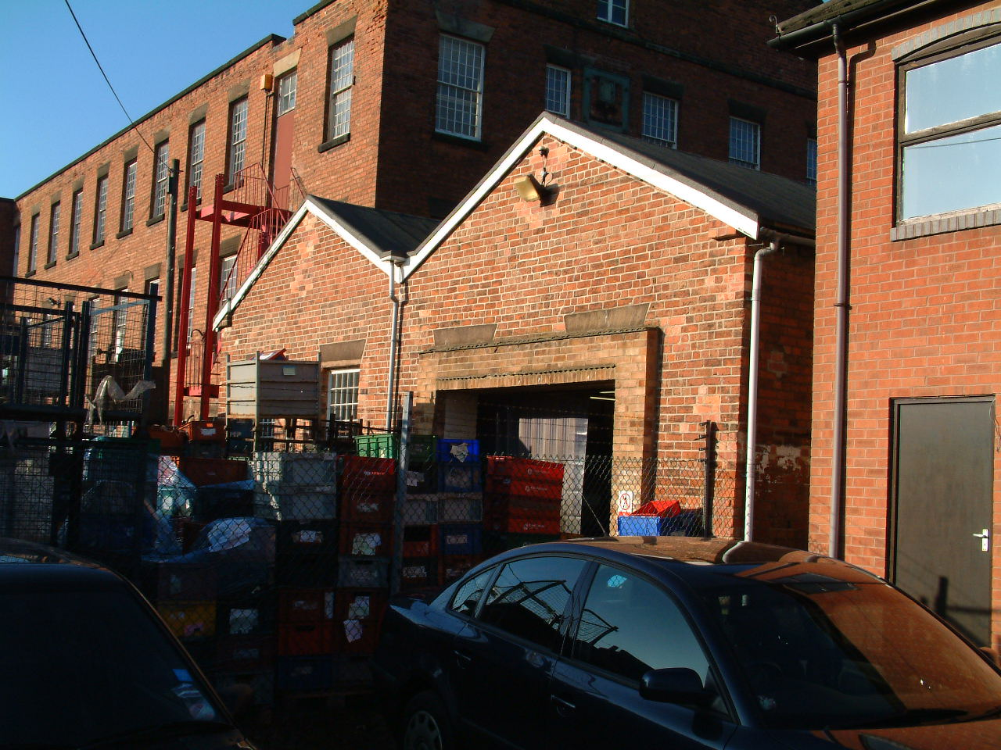 | Building | Engine House  and Boiler House
 | Date of Construction | By 1881 (Victorian)  Buildings at Risk Register with the North Mill.
 | Listed Building? | Grade 2 *
 | Owner/Occupier in 2006  Owner/Occupier in 2013 | Ellison Metal Products  Owned by Darley Abbey Properties Ltd. Occupants are Indigo Sign and Display.
Use in 2006 - Used as part of Ellison Metal Products

Use in 2013 – Offices for Indigo Sign and Display (Sign and nameplate suppliers).

Condition in 2006 - The felt roof covering is an obvious replacement of the original roof covering which would have probably been slate which is in-keeping with the rest of the site. The plastic rainwater goods appear to be in working order. Peeling paint on the wooden eaves. 2 window openings have been removed and a large wide doorway has been installed. There is evidence of some mortar repairs.

Condition in 2013 – Exterior paintwork has been renewed, the large doorway has a half timber/half glass opening door with panels of the same construction either side and non-opening windows above to form the opening for the office space.

Description - The Engine House is 3 bays and the Boiler House is 4 bays, both are of red brick, single storey, both have timber king-post roof structures.

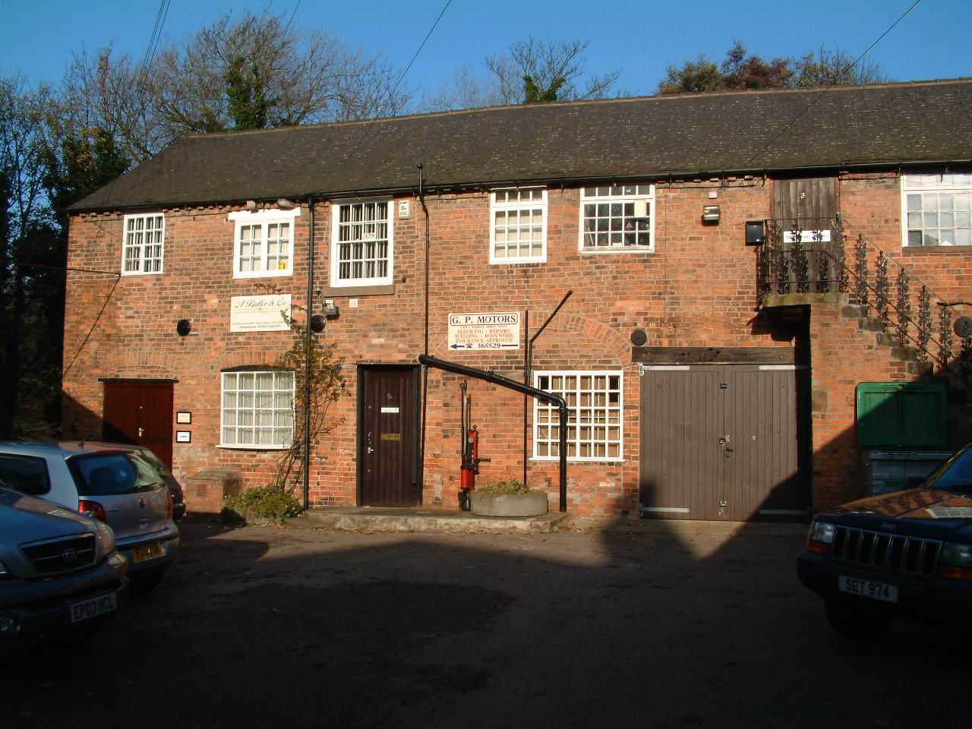 | Building | Proto-fireproof building
 | Date of Construction | c.1790 (Georgian)
 | Listed Building? | Grade 2*  On Buildings at Risk Register
 | Occupier in 2006  Owner/Occupier 2013 | Multiple  Owned by Darley Abbey Properties Ltd. Occupants
Use in 2006 - Used by various small business e.g. A firm of accountants, Abbey Lane Studios, a Software company and the right hand side of the building appears to be used as storage.

Use in 2013 – Used by Abbey Lane Studios

Condition in 2006 - The slate roof covering appears in overall good condition. The plastic gutters are sat on cast iron brackets indicating replacement. Some modern brick replacements have been used and there are inappropriate mortar repairs to areas of brickwork. Wall ties are visible. Peeling paintwork on some windows/doors especially where the units are used for storage. Brick arches denote where openings would have originally been but have been subsequently altered to provide alternative door/window openings. Pipes, signs, security lights and security alarm boxes have been placed on the masonry surface. There are two external staircases, the 1st leads to Abbey Lane UK Studios, this seems to be in sound working order but the fancy wrought iron railings look to be a modern addition. The second staircase has no handrail and seems to in an unusable and dangerous state.

Condition in 2013 – Same as above

Description and Key Features - A 7 bay, 2 storey continuous range constructed of red brick and with slate roof covering, aligned north-west/south-east. The southern elevation contains a number of large arched openings on the ground floor which have since been filled in with windows/doors inserted. There has been a single storey metal framed and clad with corrugated metal sheets built up to the rear of the property.

“The internal structure of the first floor is of great significance” – brick jack arches which spring from timber beams covered in plaster which are supported by cast-iron columns. This fire-retarding construction was “the starting point from which fire-proofing construction developed” and few surviving examples survive. (Statutory List 2003) English Heritage (2000) describe this building as being of “outstanding importance”

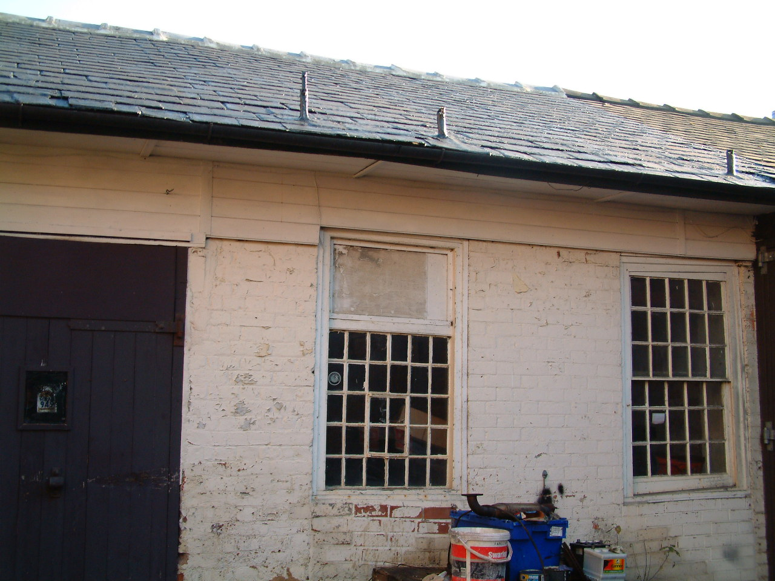 | Building | Cart Shed
 | Date of Construction | By 1811 (Georgian)
 | Listed Building? | Grade 2*  On Buildings at Risk Register
 | Occupier in 2006  Occupier in 2013 | Unknown
Use in 2006 – Storage

Use in 2013 – The River Box Limited (Management Company)

Condition in 2006 - Part of the red brick wall has been painted which is now peeling. Also part of the roof covering has been turnerised possibly to avoid further slippage of slates, At this point there are metal pipes protruding through the roof. When any development of the site takes place, replacement of this section of tiles and replacements should be considered as it visually jarring with the surround roofs.

Condition in 2013 – Unable to assess

Description - Red brick, single storey return to the east-end of the preparation building.

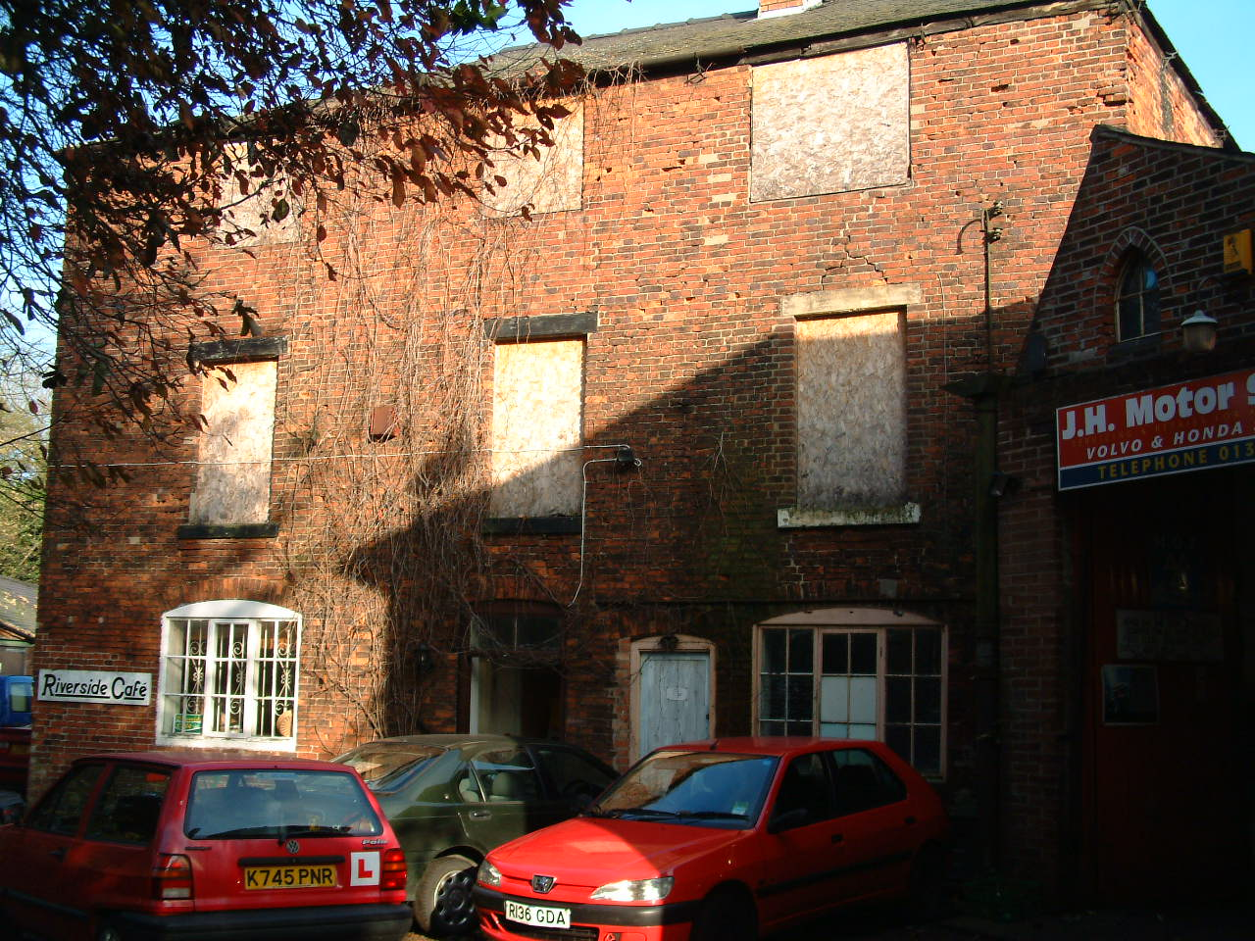 | Building | The Manager’s House
 | Date of Construction | c. 1790’s (Georgian)
 | Listed Building? | Grade 2
 | Current Occupier | Cafe
Use in 2006 - Ground floor used as a café for employees of the site, the upper floors are vacant.

Use in 2013 – Serves no current use.

Condition in 2006 - Slipped roof slates are evident. The rainwater goods are ineffective as some parts are missing and only the brackets remain, in other areas the gutters and downrites have failed which has led to green staining on the surface of the masonry on the side elevation. There are cracks on both front and side walls. Some inappropriate mortar repairs but there is also missing pointing and defective brickwork. Some sort of creeping plant (now dead) has been allowed to grow up the front of the building up to roof level. All 1st and 2nd floor windows are boarded over. Defective paintwork on the ground floor doors and windows. Two chimneys – one has been partly removed.

Condition in 2013 – There are some signs of maintenance and repair to this building, the roof has been repaired and the windows and doors are boarded so the building is water tight although currently serves no purpose.

Description and Key Feature - A 3 bay, 3 storey building constructed of red brick with slate roof covering. The distinguishing feature of this building is that is has concave front and convex rear walls, it also has views o the river from the front of the building.

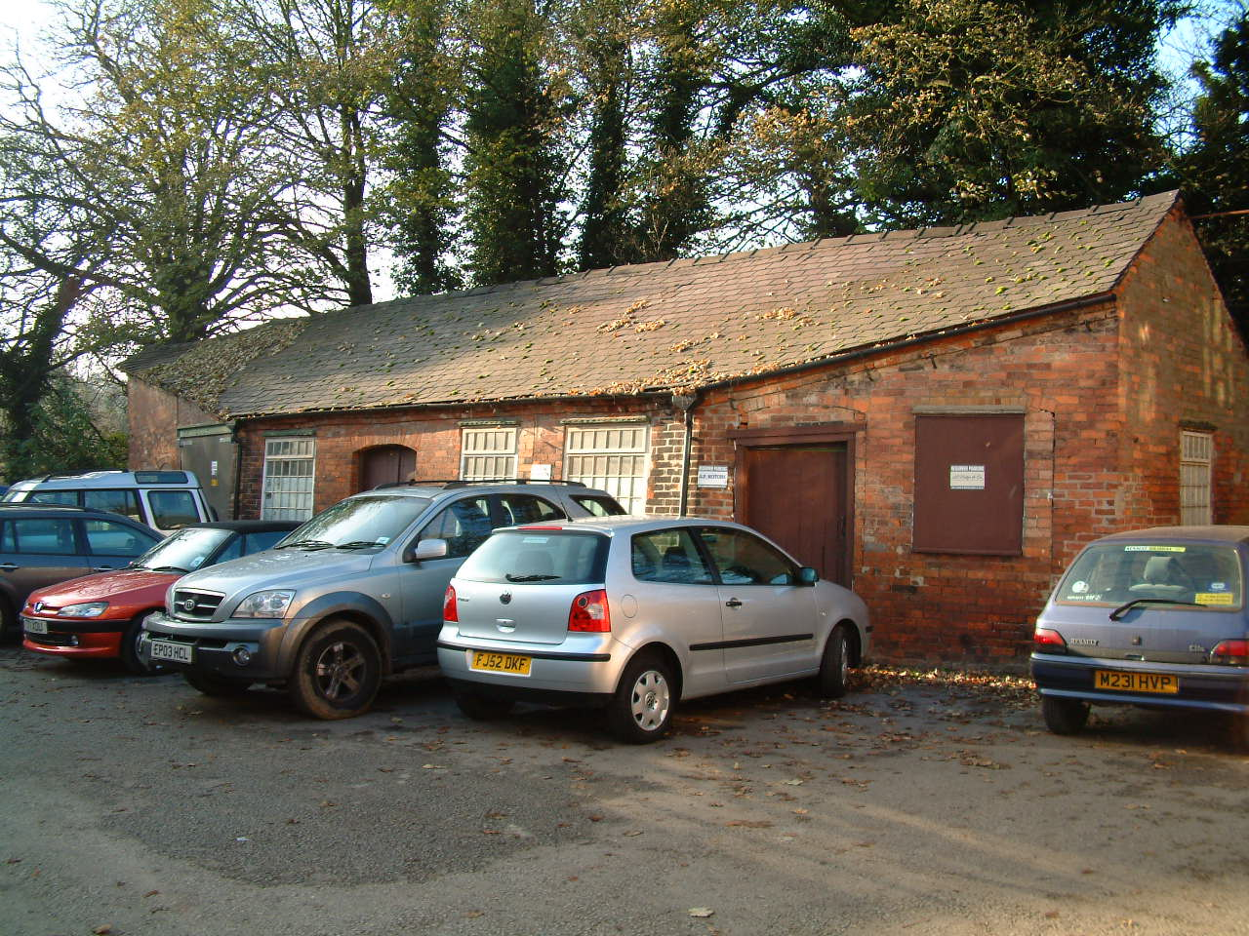 | Building | Fire Station  (20)
 | Date of Construction | 1820’s/1830’s  (G)
 | Listed Building? | Grade 2
 | Occupier in 2006  Occupier in 2013 | Unknown
Use in 2006 - Used as storage.

Use in 2013 – Simplify CIS Ltd (Accountants offering business solutions)
Condition in 2006 - The slate roof covering appears to be in overall good condition, there are a few slipped/lifting slates on the left hand side of the roof. There is a dip in the roof line (right hand side), further investigation by a qualified expert would be necessary to correctly diagnosis the cause of this. The front wall leans inwards but it is unclear whether this has been constructed like this or if an underlying problem is the result. There is some missing pointing and inappropriate mortar repairs. A metal lintel above where a double doorway has been later inserted. Defective paintwork on the timber door and window frames is evident. A round headed doorway has been inexpertly altered and a square topped door frame inserted.

Condition in 2013 – Generally the same as above, new paintwork has been applied to exterior woodwork in line with the colour scheme adopted throughout the site.

Description and Key Features - Originally a 4 bay single storey building constructed from red brick with slate roof covering, the 5th bay at the south end was a mid 19th century addition. This building is of an irregular shape, the Statutory List (2003) and English Heritage (2000) both suggest that its chamfered corners was to this was to ease the movement of traffic around the site.

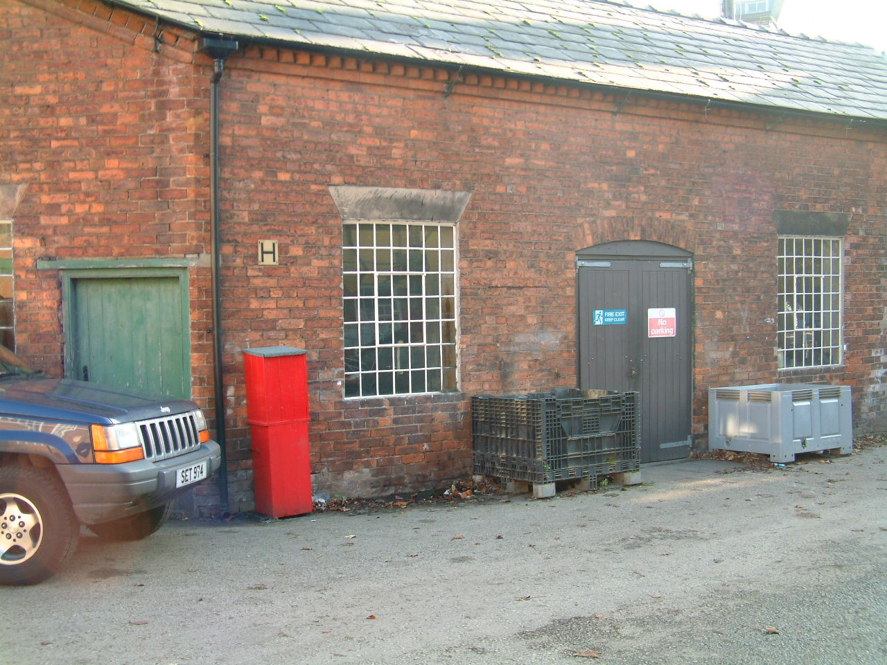 | Building | Workshop
 | Date of Construction | 1820’s-1830’s  (Georgian)
 | Listed Building? | Grade 2
 | Occupier in 2006  Occupiers in 2013 | Multiple – Ellison Metals and, A.G. Griffiths
Use in 2006 - Used for the purposes of metal processing and car repairs.

Use in 2013 - A. G. Griffiths
Condition in 2006 - Large slate roof tiles appear to be in good order, although as they are larger than would be expected they are possible later replacements. The black plastic rainwater goods look to be in good working order but the gutters are sat on cast iron brackets. Large timber double doors on the rear elevation have been inserted but the original brick arch is still visible. In two places on this building there is an oblong section (2 bricks wide and 5 courses high) where modern bricks have been inserted possible where a modern vent has been removed. In both cases, at the side of this repair there is a large metal pipe (possibly some sort of extraction) which exits the building, runs up the side of the building up to just beyond the roof line. Some re-pointing is evident. Defective paintwork on the timber window frames. Efflorescence at a low level, perhaps due to splashing from traffic.

Condition in 2013 – Same as above

Description and Key Features- A block of buildings built in 2 phases, 4 bays, single storey, brick built with slate roof covering. The earlier building has timber roof trusses but the addition is covered by a metal framed roof with cast iron tie-beams and wrought-iron king-rod.

The building has chamfered corners similar to those evident on the fire station which is situated opposite and again is thought to have been constructed like this to aid traffic movement.

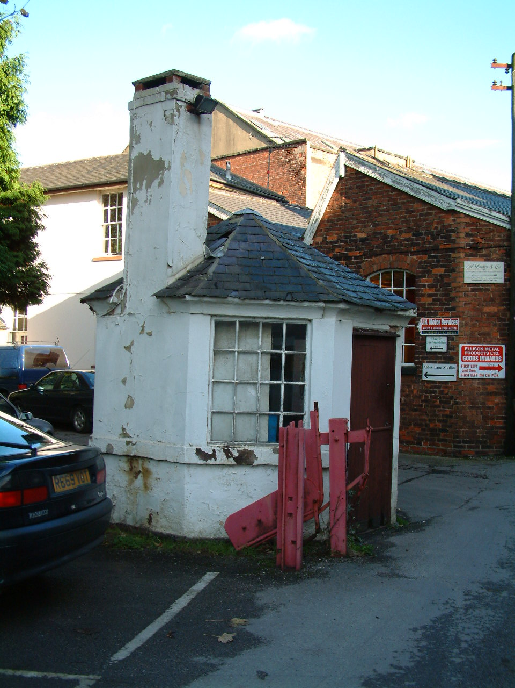 | Building | The Watch House
 | Date of Construction | Late 18th century or early 19th century. (Georgian)
 | Listed Building? | Grade 1
 | Owner in 2006  Owner in 2013 | Ellison Metal Products  Darley Abbey Properties Ltd
Use in 2006 – Used by employees from Ellison Metal products to eat their lunch and, as a base to occasionally used to collect tolls.

Use in 2013 – Used as the Tollhouse at peak times of traffic passing through the site.

Condition in 2006 - This structure although listed is in poor condition, it shows obvious signs of a lack of maintenance and repair programme. Some slates are missing and some have slipped. The paint is largely defective on the walls and much of it is peeling, some brown staining is also evident. The paint covering on the windows is flaking and peeling, and a few panes of glass in the windows are either broken/missing.

Condition in 2013 – There are signs of maintenance, repair and use. The
missing and slipped tiles have been replaced, the broken or missing glass has also been replaced in the windows, the paintwork to windows and doors have been re-applied. There are signs of the brown staining as mentioned above coming through the new paintwork on the render at the base of the building.

Description and Key Features – A single storey, octagonal building with a tall chimney, constructed from brick which has since been rendered and painted, it has slate roof covering and multi-paned windows. As this building is close to the bridge it is one of the first buildings a visitor to the site would see and pass.

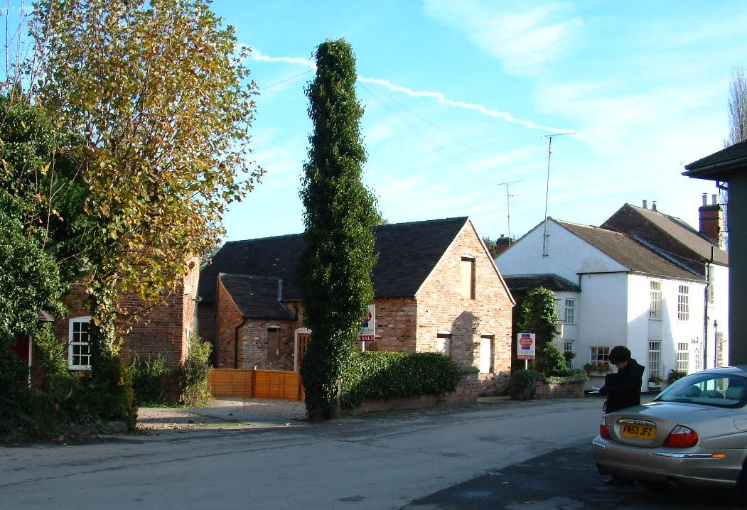 | Building | Cottages 1-4 (16)
 | Date of Construction | 1 = By 1852. 2 and 3 = By 1826. No 4 = c.1792
 | Listed Building? | Grade 2
 | Occupiers | Private Dwellings
Use - All used as separate dwellings.
Condition in 2006

Number 1 – Roof covering appears to be in reasonable condition. The mixture of black plastic and cast iron rainwater goods is in working order. The render is new. The paint covering applied to the brickwork is flaking. The paint which has been applied to the stone cills is flaking. The paint on the windows has also deteriorated but that on the door appears new.

Number 2 – Concrete roof tiles are in sound condition but are not original to the building. Black plastic gutters are sat on wrought iron brackets which indicate that this has replaced the original cast iron guttering, but is in working condition. The painted render on the walls appears sound. Modern replacement window are in good condition.

Number 3 – Concrete roof tiles seem sound but are replacements for the original. The plastic rainwater good look to be in good working condition. Painted render on walls appears sound. Modern doors and windows – sound condition. Ivy is growing up the side of this property and although the owners may consider this to be attractive its roots can be damaging to masonry surfaces and could help block gutters if allowed to grow up to this height.

Number 4 – The plain clay tiles look in good condition. The plastic rainwater goods seem to be working well. The paint covering on door and windows is sound. Some isolated inappropriate mortar repairs to bricks. On the side elevation a structure once attached to the property has been removed and a section of the wall at this point has been rendered, this is in as new condition.
Description and Key Features- Numbers 1-3 are a group of 2 storey terraced houses, brick build, located next to the eastern gateway of the mill complex. Number 1 still retains its slate roof covering but 2 and 3 have concrete pantiles. Numbers 2 and 3 are rendered and painted by Number 1 is rendered only up to the bottom of the ground floor window and painted above. Numbers 1 and 3 retain their sliding sash timber window but Number 2 has modern timber replacements with top opening.

Number 4 is a square brick built property with plain clay tile roof covering and plain ridge tiles and timber vertical sliding sash windows. Although this is now a single dwelling it may once have been split into 2 or more. A large arch now filled in is evident on the side elevation.

This is the only group of cottages within the boundary walls of the mill complex itself, other worker housing is a short walk away across the bridge back into the village but separate from the complex.

Condition in 2013 - Remains largely as above

As can be seen from the above, the Georgian buildings of Darley Abbey are in a poor condition and require intervention in terms of both extensive conservation and maintenance, this will be both costly and time consuming. However, in order to create the correct feel and ambience to the site major investment is required. There is evidence that since 2010 there have been a number of ‘aspirational urbanism’ projects undertaken where buildings have been adapted or repaired without the required planning consent, examples of this include the signage and paintwork which, was noticed when undertaking the 2013 condition survey. During the interview with the owner, they stated that:

there is one theme which runs through the site, which for here will be more creative industries. The theme includes the co-ordinated paint and signage that we are using throughout, to provide continuity to the site.

Although there were no planning applications sought for these actions, when interviewed, the conservation officer was of the opinion that:

That there are always areas of conflict, it is a matter of testing to see what they can get away with, there is a set of agreed standards to which both parties work with, but there is a need to be flexible in approach

What the condition survey does demonstrate is that any development of the site will have to generate a large enough income to generate both profits and the funds to maintain and adapt the site. In a statement presented to Derby City Council as part of the planning process the owners stated that:

…we firmly believe that the proposed ‘change of use’ and subsequent internal and external alterations to Long Mill and West Mill, Darley Abbey Mills are appropriate and sensitive to the buildings significance, character and statutory listing; and are vital to the future sustainability of the buildings. The proposals seek to reverse many of the previous inappropriate conversion works of the last 50 years and to reinstate the buildings original character. Having previously experienced a number of significant changes in both function and fabric, the Mills have proved themselves to be robust and fully capable buildings, whilst also retaining their original and unique historic character. The proposals put forward in this latest Chapter of the ‘complex’ will not detract from this character and will add positively to the future sustainability and conservation of this important heritage asset for generations to come. Furthermore, the proposed development will conserve and protect this heritage asset through its future income generation which will assist in the prevention of the buildings falling into further disrepair; and it will ensure that the special architectural and historic interest of the buildings are both sustainable and preserved. (Derby City Council, 2015:16)

7.2.4 Tourism

As identified in Chapter 3, tourism is continually identified as the dominant strategy for the sustainable and continued use of World Heritage Sites, however, it is not appropriate for Darley Abbey Mills as it does not possess adequate access or currently the resources to support such a strategy. The Derwent Valley Mills World Heritage Site Economic Development Plan 2005 (Latham Architects et al., 2005) indicates that there are both opportunities and challenges with regards to the Derwent Valley Mills World Heritage Site. The survival and uniqueness of its historical and architectural sites, its designation as a World Heritage Site is seen as a strength, as its central location within the United Kingdom, whereby sixteen million people living within an hours drive of it (Oribine, 2011). It is the only World Heritage Site within the East Midlands, and it contains tourist attractions with ‘historical or heritage pull’ (Oribine, 2011), these include: Masson Mill, the Cromford Mill complex and village and, the visitor centre at Belper (Latham Architects et al., 2005). Latham Architects et al. (2005:11) further identify that although the Heritage Corridor have a number of tourist attraction, ‘Darley Abbey and Milford are secondary locations with important stories to tell within the industrial and social history product niche’ and a such do not have the capacity to attract substantial numbers of visitors. Although, the Derwent Valley Mills World are of international significance they face fierce competition for visitor numbers from other local destinations, such as the Peak District, Chatsworth House, Haddon Hall, National Trust properties such as Kedleston Hall and Calke Abbey, Crich Tramway Museum and the Heights of Abraham. In comparison to these attractions, Darley Abbey Mills faces a number of hurdles, it has a niche heritage appeal, the current condition of the buildings are unwelcoming and requires significant investment, it lacks cohesion as an attraction, as the World Heritage Corridor is essentially a group of sites spread over fifteen miles of Derbyshire, it also lacks a clear icon around which the tourism experience can be hung, as such this puts Derwent Valley Mills at a disadvantage with other World Heritage Sites, such as Hadrian’s Wall or Stonehenge (Latham Architects et al., 2005; Oribine, 2011). The accumulating consequences of these factors result in the fact that Derby not currently regarded as a destination for leisure visitors, although with the Westfield shopping centre, the construction of new hotels. As seen in Chapter 3, it is hoped that the regeneration of the Cathedral Quarter and its linking with the Silk Mill and Darley Abbey Mills will increase the number of tourists attracted to the city.
However, Derby’s economic strategy 2011-16 (Derby City Council, 2011) suggests that the World Heritage Status of the Derwent Valley Mills, in conjunction with other heritage and tourism assets, such as Derbyshire’s historic buildings, museums and historical associations with the railway, should be used as an economic driver for the region. However, within the Derwent Valley Management Plan (2000:37), it was acknowledged that there was a need for a balance between the economic benefits brought about by increased tourism, against negative impacts such as increased traffic congestion, interference with residents quiet enjoyment of the area and, subsequently the erosion of the ‘sense of place’. The Derwent Valley Management Plan also identified that in the southern part of the World Heritage Corridor, sites such as, Milford and Darley Abbey, had little experience of managing or supporting visitors and that any increased public awareness of these sites would place greater pressure on already limited tourism infrastructure, and that any increase in traffic or the need for parking could not be supported in the site. This view was also expressed in Section 16.7 of the Development Plan Document: Core Strategy Issues and Ideas Paper (Derby City Council 2009) where it is expressly stated that, ‘Darley Abbey is not currently accessible as a tourist attraction’. This is supported to a certain degree by interviews undertaken with visitors to Darley Abbey Park, who comments on issues such as:
Access
“Well, there’s all sorts of strange little signs about tolls, also there’s been a couple of times when we’ve been standing on the bridge and almost been squashed by a car, it seems private so no’ we don’t bother. Why would we want to when we have this lovely park to use”. (Park User 2)

Traffic and Parking
“…sometimes it can be a bit busy, lots of vans and cars flying about, you have to be careful especially with the dog because you have to walk on the road as there is no footpath a lot of the time, sometimes vans just come flying out without really looking. It’s the same when you have to come across the bridge although there is a little footpath either side.” (Park User 3)
“I know I won’t be able to park at Darley’s, also I feel a bit uncomfortable parking the car there, I’m not sure it’s safe and, the spaces are a bit tight and I hate parking. Also, there are some big bumps there that always seem to catch the bottom of my car so I’d much rather park in the village and then walk down.” (Park User 1)

Ambience
“I don’t like the feel during the day, never mind when it is dark, it just seems really creepy, it’s easier to park there at night-time but I just want to get from the restaurant to the car park as quickly as possible, I don’t like it. If I was on my own, there is no way I would come here at night, it feels a little dangerous, I don’t know there is just a feel, I do not know how to explain it. Even my husband doesn’t like it.” (Park User 1)

“…I always speed up a little bit (when going through the Mills Complex), sometimes there are some dodgy looking people outside some of the buildings. I don’t think it is dangerous, it’s just it makes you a bit more, erm, I suppose aware.” (Park User 3)

For full transcription of interviews see Appendix 4.

7.2.5 Compliance with Statutory Regulations

In assessing the compliance and interaction with the planning system and the statutory regulations that surround the listing and designation process at Darley Abbey Mills it is possible to identify three distinct periods.

- 2006-2010: This period was characterised by mixed ownership and use and the site was slowly becoming increasingly dilapidated, there was a lack of general maintenance and repair, the concern for the buildings had resulted in English Heritage placing a number of the major Georgian buildings on the ‘at risk’ register. A number of the other buildings were in a bad state of affair (See full condition survey, Appendix 3) and the only reason they were not placed upon the at risk register was that they were not Grade 1 or Grade 2* listed buildings.

- 2010-2013: 2010 saw the Mills coming under new single ownership, during the period 2010 and 2013 it is possible to see that option 2 being adopted by the owners of Darley Abbey Mills, and who were investing in what can be defined as small scale ‘aspirational urbanism’, whereby repairs were undertaken, signs were fixed to facades of buildings and small adaptations (as witnessed in Figures 7.5-7.10) were undertaken, that allowed for the habitation of the buildings by small and creative industries.

- 2013-2015: This period has seen a greater engagement with the planning and monitoring authorities as larger more visible projects have been proposed, which have perceived negative impacts for the local community (see Appendix 2 for concerns), but arguably will go some of the way to guaranteeing the economic sustainability, and consequently, the sustainability of the site and buildings themselves. As stated in Option 3, by interacting and engage fully in the planning system, there is the danger that the conditions placed upon the development may be prohibitive in terms of the costs of adaptation and the time required to go through the full planning and construction process. In 2014 the owners applied for planning permission to adapt the Mills to a wedding venue and offices, although this was granted interesting to note that the application for the change of use of Long Mill and West Mill it is stated that: The venue is intended for exclusive use by a single wedding party between the hours of 10:00 to 00:30. It is expected that there will be around 3-4 functions per week, predominately for weddings. The Long Mill of Darley Abbey Mills is proposed as office space over ground to fourth floors, facilitating seven separate units within the form of the existing building. The West Mill is adjoined perpendicular to the Long Mill with access and egress routes between units in their current form. The development proposes to segregate the adjacent spaces as to support proposed occupational uses. – it is this that has generated so many of the objections.
Table 7.4 A Summary of the Planning Applications Submitted for Work Within Darley Abbey Mills Between 2013-2015
Details of application
Date: 05/01/15
Proposed Work: Listed Building Consent for alterations
Location: 3 Mill Cottages, Darley Abbey Mills
Representative and Neighbour Comments: 0
Summary of the proposal | Outcome | Local Authority Notes
Alteration/refurbishment to Grade 2*listed cottage, work to include:  - repairs to rendered brickwork and tiled roof as required.  - Windows to be refurbished/replaced to match existing,  - external doors refurbished or replaced in timber.  - Plaster ceiling repaired as necessary, removal of kitchen rear wall to create larger kitchen.  - Floors to be generally repaired as required.  - Rainwater goods to be replaced in black PVC to match if required.  - Timber fencing to be replaced with similar.  - Vehicle access – gated entry formed with block paving in front of gates and tarmac behind gated. External security lights to be fitted. Damp proof course – injection DPC by specialist contractors  - work to garden and boundary fencing; | Not decided yet | None
Details of application
Date: 23/12/14
Proposed Work: Erection of 1.87 m high freestanding timber fence with 2 gates
Location: Long Mill and West Mill, Darley Abbey Mills
Representative and Neighbour Comments: 0
Summary of the proposal | Outcome | Local Authority Notes
This planning application proposes to erect a 1.87m high freestanding timber fence incorporating 2 large folding ‘concertina’ type gates | Not decided
Details of application
Date: 07/03/14
Proposed Work: Demolition of loading bay, two storey stairwell extension to former `Mechanics Shop` together with repairs to mills
Location: Long Mill and West Mill, Darley Abbey Mills
Representative and Neighbour Comments: 1 in Favour
Summary of the proposal | Outcome | Local Authority Notes
Essential Conservation Fabric Repairs and Demolition of Existing Loading Bay, the removal of which will enhance the south elevation and create an attractive courtyard entrance to the wedding/hospitality venue. 2-Storey ‘Stairwell’ Extension to former ‘Mechanics shop’. | Granted with conditions.  The conditions are summarised here, but for the comprehensive list see Appendix 1. Before work to begin method statements for each of the following need to be submitted in writing and approved by the Local Authority prior to the work commencing:  - Demolition taking place.  - repair of these areas, following removal of the render  - The extent of masonry repairs and repointing works to the buildings,  - details of the mix and finish of the mortar  - Works to Long Mill to undertake "brick beaming" and the removal and treatment of vegetation  - The extent of cleaning of the buildings' elevations and a sample area of cleaning to be undertaken  - details of all new external materials to be used in the buildings  - The extent of any timber replacement to be carried out as part of the approved works,  - Works to repair and replace leadwork on the buildings, to include details of new secret gutter,  - Before installation of new rainwater goods to the buildings, details of colour of the rainwater goods.  - The extent of repairs and re-rendering of the parapet walls to the buildings,  - Before the works to re-roof Long Mill are carried out from above, as approved, a method statement for the works, to safeguard the lath and plaster work in the attic room  - No works shall be carried out until a Written Scheme of Investigation for historic building recording has been submitted to and approved | Recording of any roof structures of interest and published. Advised to consider the provision of attachments to parapet for harness attachments so the roof can be safely surveyed at a future time
Details of application
Date: 03/03/14
Proposed Work: Various works to trees within Darley Abbey Conservation Area
Location: Land between River Derwent and, Darley Abbey Mills, Darley Abbey, Derby
Representative and Neighbour Comments:0
Summary of the proposal | Outcome | Local Authority Notes
Work on 16 including felling, coppicing, removal of ivy (See Appendix 1 for details) | Granted | Draws attention to the applicant's responsibilities in respect minimising impact on protected species under the Wildlife and Countryside Act 1981 and the Countryside and Rights of Way Act 2000, which are present on and around the site.
Details of application
Date: 10/02/14
Proposed Work: Change of use of mill buildings from light industrial use (Use Class B1) to hospitality venue within West Mill (Use Class D2) and office accommodation within Long Mill (Use Class B1)
Location: West Mill and Long Mill, Darley Abbey Mills, Darley Abbey
Representative and Neighbour Comments: 2 in Favour and 26 Objections
Summary of the proposal | Outcome | Local Authority Notes
Proposed change of use and conversion of largely redundant historic mill buildings to create a high quality hospitality venue within the West Mill and high quality office accommodation within the Long Mill.  The ‘West Mill Venue’ is proposed to offer wedding facilities to accommodate up to 165 people; including a third floor civil ceremony hall, second floor banqueting hall and first floor function space.  The Long Mill is proposed as office space over ground to fourth floors, facilitating seven separate units within the form of the existing building. The West Mill is adjoined perpendicular to the Long Mill with access and egress routes between units in their current form. The development proposes to segregate the adjacent spaces as to support proposed occupational uses.  Plant: Mechanical plant is proposed for heating and cooling of both West and Long Mills, with associated heat pumps proposed at two locations east and west of the site. | Granted Conditionally.  The conditions are summarised here, but for the comprehensive list see Appendix 1. Before work to begin schemes of work for each of the following need to be submitted in writing and approved by the Local Authority prior to the work commencing:  - a precise landscaping scheme for the external areas to south and east of West Mill and Long Mill, shall be submitted to and agreed in writing prior to work commencing  - precise details of the design and construction of the path and steps over the flood defences, to include details of the width, levels and surfacing materials  - During the period of construction of the footpath and steps adjacent to river bank, all trees, hedgerows and other vegetation to be retained shall be protected in accordance with BS:5837: 2012 ("Trees in relation to design, demolition and construction  - Before Long Mill and West Mill are brought into use for the uses hereby permitted, a flood evacuation plan shall be prepared and submitted  - The uses hereby permitted shall not be brought into use, until a surface water drainage scheme has been implemented in accordance with details which shall have been submitted and agreed in writing by the Local Planning Authority.  - Before landscaping and surfacing works are undertaken to the external areas to the main entrance area and car parking areas, precise details of an external lighting scheme for the area to the south of West Mill and Long Mill, including car parks, shall be submitted to and agreed  - Before the uses hereby permitted are brought into use, a management plan for the proposed pedestrian access and usage of the area alongside the river bank and protection of biodiversity within that area, adjacent to flood defence bund, shall be submitted and agreed  - Prior to works being carried out to the external areas, including formation of car parking areas to the south and east of the mill buildings, precise details of the design, location and materials to be used on all boundary walls/fences/screen walls and other means of enclosure shall be submitted to and agreed in writing by the Local Planning Authority.  - This permission shall relate solely to the use of the building for office use (B1 Use Class) and hospitality and conference venue, including for the holding of weddings under the D2 only. | The proposed business and leisure uses would be appropriate in this location, which is an identified regeneration area and would protect the historic fabric and special character of the Grade 1 listed buildings, maintain the Outstanding Universal Value of the Derwent Valley Mills World Heritage Site and preserve the character and appearance of the Darley Abbey Conservation Area.  The proposed uses would provide adequate parking and servicing provision and have acceptable traffic implications for the local road network.  In dealing with this application the City Council has worked with the applicant / agent in a positive and proactive manner and has secured appropriate and proportionate improvements to the scheme which relate to the layout and management of the access and car parking areas.
Details of application
Date: 10/02/14
Proposed Work: Internal alterations in connection with change of use of mill
Location: West Mill and Long Mill, Darley Abbey Mills, Darley Abbey
Representative and Neighbour Comments: 2 in Favour and 20 Objections
Summary of the proposal | Outcome | Local Authority Notes
Internal alterations in connection with change of use of mill buildings from light industrial use (Use Class B1) to hospitality venue within West Mill (Use Class D2) and office accommodation within Long Mill (Use Class B1) | Granted conditionally.  The conditions are summarised here, but for the comprehensive list see Appendix 1. Before work to begin details of the following need to be submitted and approved in writing the Local Authority:  - Installation of any windows, doors and their surrounds to the exterior and interior of both mill buildings, including new openings and any internal glazed panels to be installed in the office accommodation in Long Mill  - Any screens and partition walls to the interior of both buildings, precise details of the design and appearance and method of fixing of those screens and partitions  - Precise details of surface treatment and colour to be submitted.  - Precise details of the lift's construction and opening, the making good of walls, floors and ceilings,  - Precise details of the design, materials, sections, fixings to the structure and the method of making good to the floors, walls, etc.  - Any fire protection measures which are to be installed in the buildings shall be implemented in accordance with details of a scheme, to include siting, design and layout,  - A method statement for upgrading, cleaning and repair of existing stone staircases, including handrails in both mill buildings  - Precise details of the appearance, materials and method of fixing of the proposed cladding on the former Mechanics shop,  - An archaeological investigation  - The development shall not be occupied until the site investigation and post investigation assessment has been completed  - Precise details of the design, scale, materials and siting of the freestanding sign shall be submitted  - The development shall not be occupied until the site investigation and post investigation assessment has been completed in accordance with the programme set out in the landscaping method statement and archaeological Written Scheme of Investigation  - Full details of the siting, layout and appearance of the installation of the pipework etc. for the heating,  - The proposed works shall begin before the expiry of three years from the date of this consent.
Date: 10/06/13
Proposed Work: Felling of 19 Sycamore trees within Darley Abbey Conservation Area
Location: Land between River Derwent and, Darley Abbey Mills, Darley Abbey.
Representative and Neighbour Comments: 0
Summary of the proposal | Outcome | Local Authority Notes
Vegetation reinforces the site boundaries, restricts views in and out, particularly from the north and west.  Dense and overgrown vegetation creates areas of heavy shade and limited surveillance.  The proximity of the River Derwent is not evident throughout the site.  The majority of the views from the mills site are therefore inward looking and are detrimental to bringing commercial actively to the site. | Raised Objections  Insufficient arboricultural information supplied in support of the application to justify the proposal.  The proposed felling of the 19 trees, may have a significant adverse impact on the overall visual amenities of this important area, due to their positive contribution to the appearance and character of the Darley Abbey Conservation Area and to the World Heritage Site  The consequent loss of habitat which contribute to the designated Local Wildlife Site along the River Derwent. | It is suggested that the applicant should undertake a full arboricultural assessment in accordance with BS5837:2012 and a proposed tree management plan to include this area of land.
Date: 22/3/13
Proposed Work: Installation of sash window on South elevation and internal alterations to a Listed building including erection of partition walls and door, replacement of ceiling and installation of central heating system.
Location: 1st Floor Middle Mill, Darley Abbey Mills, Darley Abbey
Representative and Neighbour Comments: 0
Summary of the proposal | Outcome | Local Authority Notes
Erection of new partition walls to form new meeting room, comprising of part plaster-boarded stud walls and full height glazing/door centred on existing steel beam/column 'lines'.  Kitchenette on newly built 'Fire Lobby'.  Installation of new plaster-boarded ceiling within 'upright shaft'/proposed store cpd for fire separation.  Installation of new Electrics and Central Heating System. Existing 'modern' timber casement window on South elevation to be replaced with new softwood timber sliding sash window to match existing. | Granted conditionally.  The conditions are summarised here, but for the comprehensive list see Appendix 1. Before work to begin details of the following need to be submitted and approved in writing the Local Authority:  - a sectional drawing clarifying the exact proposed alignment of the location of the new ceiling in relation to existing steels within the shaft.  - Further precise details of the glazed screening, inclusive of how it abuts, or attaches to the floor and masonry wall, and the colour and finish of the glazing, shall be submitted to and approved in writing by the Local Planning Authority.  - Further precise details of the proposed conduits for ceiling lights and lighting units shall be submitted to and approved in writing by the Local Planning Authority.  - Joinery details of the replacement window hereby permitted shall be submitted to and approved in writing by the Local Planning Authority | It is considered that the proposals would protect the special character of this Grade 1 listed building, preserve the character and appearance of the Darley Abbey Conservation Area and the World Heritage Site

Table 7.5 A Summary of the Planning Applications submitted for work within Darley Abbey Mills between 1997-2012

Details of application
Date: 04/08/12
Proposed Work: Erection of a fish pass
Location: Island Adjacent to the weir of the River Derwent
Representative and Neighbour Comments: 1 in favour
Summary of the proposal | Outcome | Local Authority Notes
Various works including digging a 10 m wide x 2m deep trench across the island. Reinstatement works to the existing masonry wall and replacement of existing perimeter fencing. Refurbishment of existing wooden pedestrian access bridge. Suitable landscaping / planting. Erection of an interpretation facility | Conditionally granted.  Conditions related to: the timing, siting and maintenance of landscaping; the materials used; the siting of new/replacement railings | The proposal was considered to an appropriate form of development.  The siting and design of the fish pass would have reasonable impacts on visual amenities to the surrounding area.  No loss of significant trees and no increased risk of flooding  No adverse effects on the setting of nearby listed buildings or on the special character of the World Heritage Site and, helps to preserve the character and appearance of the Conservation Area.
Details of application
Date: 04/07/12
Proposed Work: Felling of 98 trees, 1 bush and the crown lifting of 5 trees
Location: Land between the River Derwent and Darley Abbey Mills
Representative and Neighbour Comments: 0
Summary of the proposal | Outcome | Local Authority Notes
Current levels of dense and overgrown vegetation restricts views in and out of the site, creates heavy shade and limited surveillance. The proximity of the River Derwent is not evident throughout the site. | The Local Authority raised objections on the grounds of insufficient/inaccurate information and, the felling of the trees may have a significant and adverse effect on the visual amenities of this important area and also result in a loss of habitat to local wildlife. | Suggested that the applicant prepare a detailed management plan for the benefit of the trees and the wildlife in the area.
Details of application
Date: 24/04/12
Proposed Work: Installation of gas pipes, relocation of gas meter (Retrospective Application)
Location: Darley’s Restaurant, Darley Abbey Mills
Representative and Neighbour Comments: 0
Summary of the proposal | Outcome | Local Authority Notes
Installation of new external gas service access points. | Granted with conditions  Details of all external materials to be submitted and approved in writing before commencement of works in order to retain the character and integrity of both listed buildings and the conservation area. | The proposed works are acceptable in terms of its design, scale and implications for the character of the Listed Building, Conservation Area and the World Heritage Site and the duties in the Planning (Listed Buildings and Conservation Areas) Act 1990.
Details of application
Date: 05/04/12
Proposed Work: Felling of 5 trees
Location: Entrance to Darley Abbey Mills
Representative and Neighbour Comments: 0
Summary of the proposal | Outcome | Local Authority Notes
Felling of trees to remove a security risk and allow the redesign of the car park | Granted, no objections raised | None made
Details of application
Date: 10/01/11
Proposed Work: Felling of 27 trees and the crown lifting of 40 sycamores
Location: Entrance to Darley Abbey Mills and along the river bank
Representative and Neighbour Comments: 0
Summary of the proposal | Outcome | Local Authority Notes
Crown lifting or complete removal of trees, some trees to remain untouched. | Granted, no objections raised | The proposal was considered to be acceptable. Suitable replacement planting suggested. The crown lifting should be no more than 5 metres off the ground.
Details of application
Date: 17/08/10
Proposed Work: Pruning overhanging branches from trees
Location: Boundary between K & K Fire Protection in Darley Abbey Mills and Mill Cottage
Representative and Neighbour Comments: 0
Summary of the proposal | Outcome | Local Authority Notes
Application made to increase enjoyment of garden and available light for Mill Cottage. | Granted, no objections made | None made
Details of application
Date: 02/04/08
Proposed Work: Change of Use
Location: Unit 11A Darley Abbey Mills
Representative and Neighbour Comments: 0
Summary of the proposal | Outcome | Local Authority Notes
Change of use from retail to a dance studio with small retail outlet | Undetermined application which was subsequently closed down | None made
Details of application
Date: 27/04/07
Proposed Work: Installation of telecommunications mast, 3 antenna, 2 equipment cabinets
Location: Mill Chimney, Darley Abbey Mills
Representative and Neighbour Comments: 11 Against
Summary of the proposal | Outcome | Local Authority Notes
To provide the Darley Abbey are with 2G and 3G communications | Refused | The design and prominent siting of the equipment will have a significant detrimental visual impact on the special character and setting of the Grade 1 listed chimney and surrounding mill buildings and of the Derwent Valley Mills World Heritage Site.
Details of application
Date: 04/02/04
Proposed Work: Change of use
Location: Unit 11A Darley Abbey Mills
Representative and Neighbour Comments: 0
Summary of the proposal | Outcome | Local Authority Notes
Change of use to a restaurant with take away facilities | Refused | Does not preserve or enhance the special character of the conservation area nor does it enhance the Darley Abbey Mills industrial site which is an essential part of the character of the World Heritage site.  It is not listed as an appropriate use in the adopted policy for the Mills complex.  No parking provision is indicated and the area is not well served by public transport.
Details of application
Date: 22/12/13
Proposed Work: Alteration of use
Location: Unit B, Abbey Court, Darley Abbey Mills
Representative and Neighbour Comments: 0
Summary of the proposal | Outcome | Local Authority Notes
Use the premises for dog exercise in hydrotherapy pool in addition to existing use. | Granted | Does not detract from the character of the conservation area
Details of application
Date: 11/06/03
Proposed Work: Work to trees
Location: Abbey Court, Darley Abbey Mills
Representative and Neighbour Comments: 0
Summary of the proposal | Outcome | Local Authority Notes
Crown pruning 5 trees and felling of split trees in car park | Granted | None made
Details of application
Date: 22/10/01
Proposed Work: Construction of a car park
Location: Derwent Valley Fishery, Haslam’s Lane
Representative and Neighbour Comments: 0
Summary of the proposal | Outcome | Local Authority Notes
Construction of a car park | Granted with conditions | Stipulations include (but not limited): the thickness and materials for the construction of the car park surface; current levels will not be raised; excavated material to be removed from the site; the gate shall be retained and kept closed except when immediately required for access and, a suitable notice stating that access is solely for the purposes of angling.
Details of application
Date: 14/04/00
Proposed Work: Insertion of French doors
Location: Darley’s Restaurant, Darley Abbey Mills
Representative and Neighbour Comments: 0
Summary of the proposal | Outcome | Local Authority Notes
Insertion of French door within the restaurant | Granted with conditions:  Details of external materials to be submitted in writing and approved prior to the work being undertaken. | The conditions are necessary to preserve the character and appearance of this Grade 2 listed building and for the avoidance of doubt.
Details of application
Date: 14/05/98
Proposed Work: Erection of Timber structure
Location: Darley’s Restaurant, Darley Abbey Mills
Representative and Neighbour Comments: 0
Summary of the proposal | Outcome | Local Authority Notes
To provide outdoor seating for the restaurant | Granted with conditions:  Details of all external materials and balustrading to be submitted to and be approved in writing by the Local Planning Authority before development is commenced. | The conditions are necessary to ensure that the character and setting of the listed building is protected.
Details of application
Date: 01/07/97
Proposed Work: Internal alterations to factory
Location: Workshop, Unit 16, Darley Abbey Mills
Representative and Neighbour Comments: 0
Summary of the proposal | Outcome | Local Authority Notes
To form washroom facilities, lift shat and external loading area canopy | Granted with conditions:  Details of materials for the lift shaft and internal alterations to be submitted to and approved in writing by the Local Planning Authority before work is undertaken | The conditions are necessary to ensure a satisfactory appearance of the development in the interests of the character of the listed building and for the avoidance of doubt..
Details of application
Date: 20/06/97
Proposed Work: Replacement of doors and windows to existing restaurant and kitchen
Location: Darley’s Restaurant
Representative and Neighbour Comments: 0
Replacement of doors and windows to existing restaurant and kitchen | Granted with conditions:  No work shall begin until precise details of the size of the glazing bars for the replacement windows have been submitted to and approved in writing by the Local Planning Authority. | The conditions are necessary to safeguard the character and integrity of the listed building.

7.2.6 Maintenance and Repair

When visiting the site in order to update the condition survey in 2013 it was evident that there had been some maintenance and repair undertaken between 2006 and 2013, however, due the designation and statutory protection of the Georgian buildings (Listed buildings located within a Conservation Area and part or an inscribed World Heritage Site), any repair or adaptation should be subject to gaining Planning Permission. The Watch House is an example of a building which has been subject to maintenance and repair, as a Grade 1 listed Georgian building it is subject to the highest possible levels of statutory protection possible in England, however, unauthorised work was undertaken on the Watch House and, it was the only building on the site where the condition had improved from poor to good between 2006-2013. Appendix 4 shows that in 2006 this building served little purpose, it was in a poor condition, there were missing and slipped tiles on the roof, the paintwork was defective both on the woodwork and walls, there were signs of rot on some of the window frames and there were some missing panes of glass. This is one of the first buildings a visitor sees on entry to the site from Darley Abbey village, therefore, its appearance is important as it sets the tone for the rest of the site. As Figure 7.4 illustrates, the watch house is now in use as the tollbooth for the mill complex, the roof tiles and the windows are now in good order and, it has been re-painted. The brown staining at the lower levels of the walls witnessed before is still evident through the new paintwork and so should be monitored in the future, both the glass and paint used would not meet the scrutiny of monitoring bodies such as English Heritage as it has changed the character of the building.

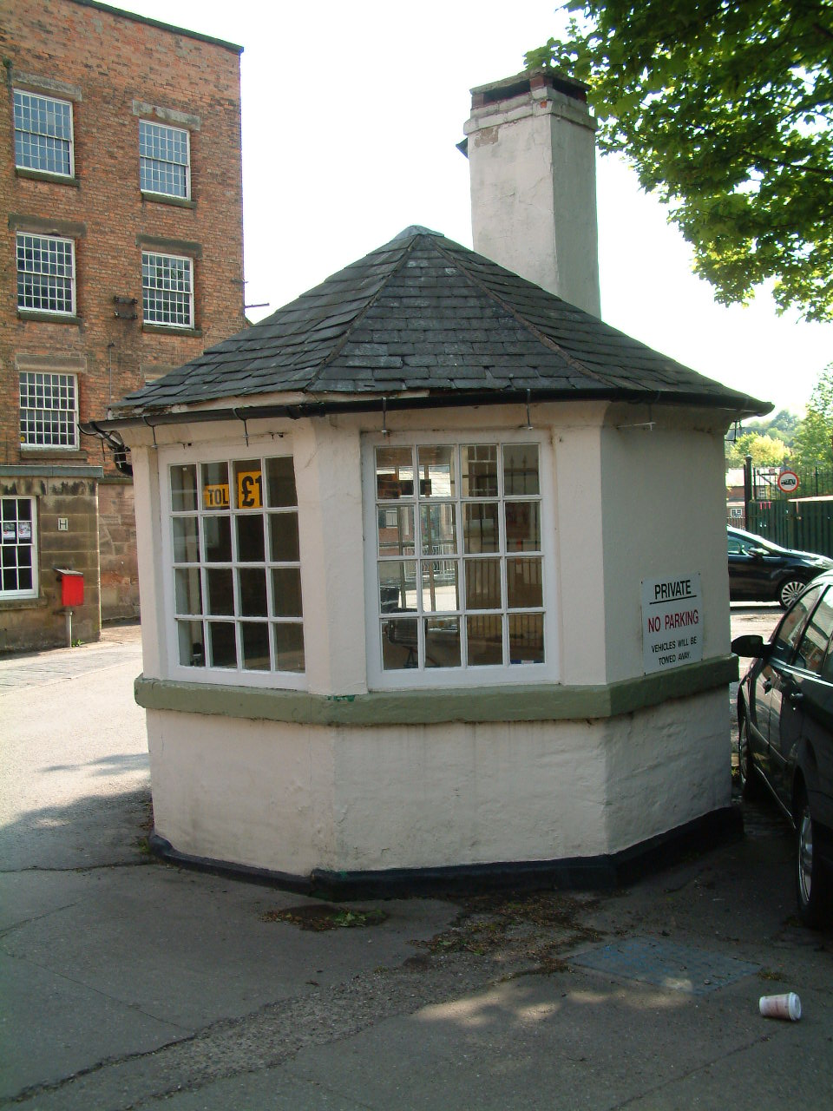
Figure 7.3 The Watch House 2006 Figure 7.4 The Watch House 2013

Another factor, which illustrates that some degree of maintenance and care has been applied within the mill complex over the last three years, is the adoption of a coordinated paintwork and signage scheme. As discussed in Chapter 4, the re-application of paint on exterior woodwork is preventative maintenance, not only is it aesthetically pleasing, it also extended the useful life of the wooden component and, allows for the simultaneous inspection of the door or window to ensure that it is not failing. However, these are examples of ‘aspirational urbanism’, or in other words are examples of unauthorised and arguably illegal repairs and adaptation of historically and architecturally significant buildings. Figure 7.5-7.10 below demonstrate that a scheme of white paint for the windows with a pale green colour for other exterior paintwork such as doors, gates and panelling has been used, this has been used for the majority of the site. Along with the colour scheme for the paint, signage in the form of white lettering placed directly on the brickwork has also been carried out in recent years on some of the buildings. As can been seen from figures 7.5-7.10 below this signage not only identifies the individual buildings but also the businesses housed within them. The figures below also indicate that this signage and colour scheme is the same for the Georgian buildings such as North Mill and Coppice Barn A as it is for the later Victorian buildings such as the Gassing shed and the Polishing shed.

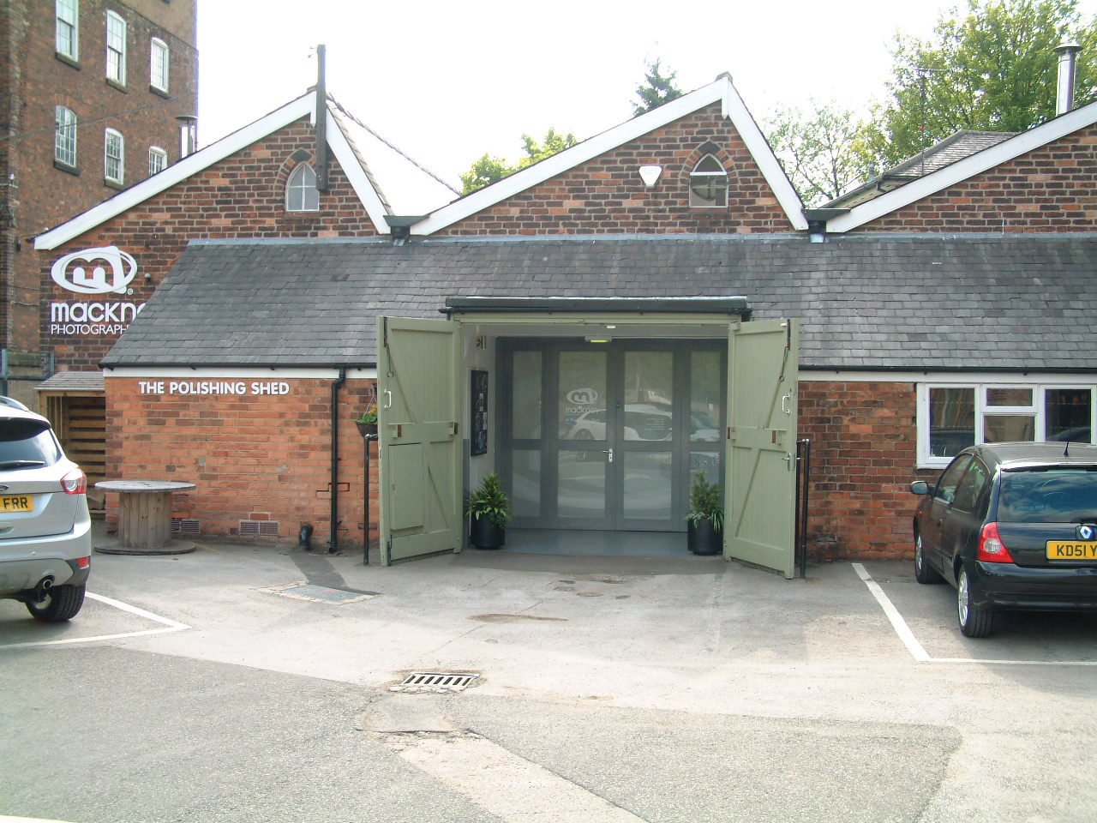
Figure 7.6 Polishing Shop

Figure 7.5 Gassing Shed

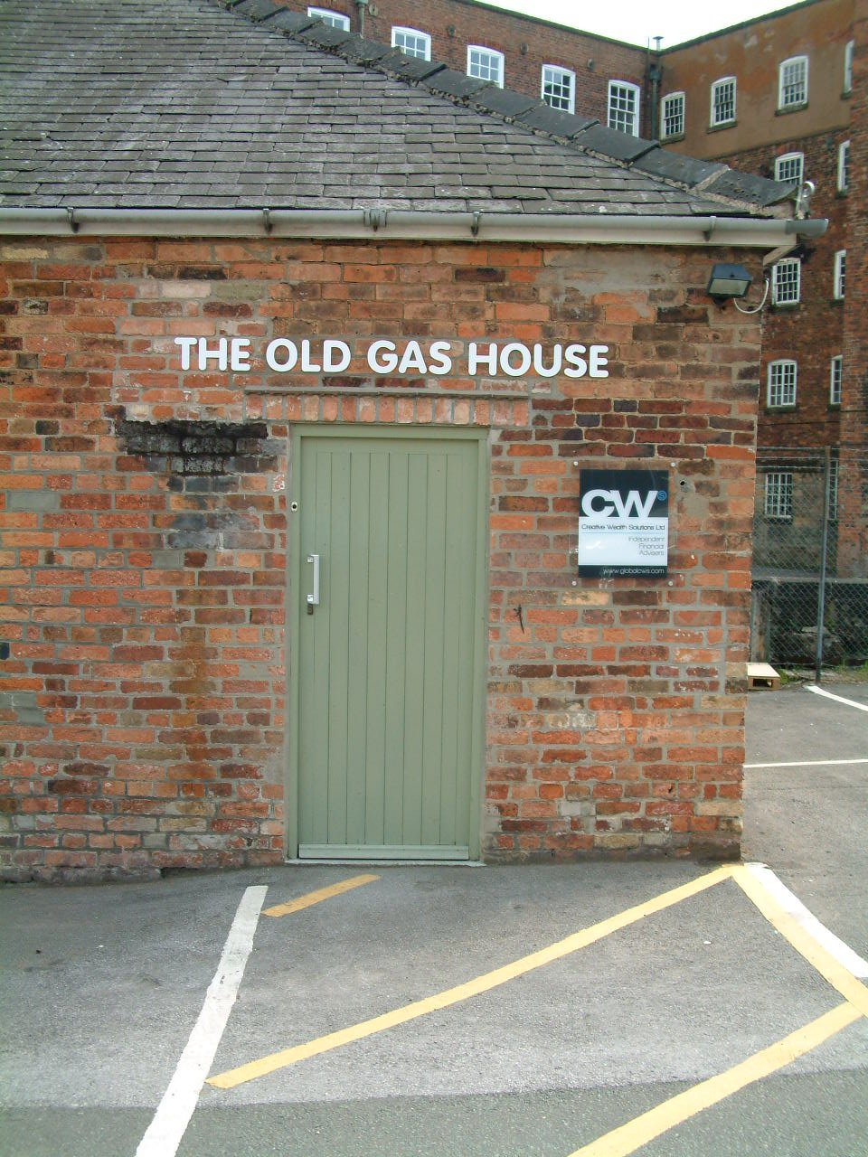
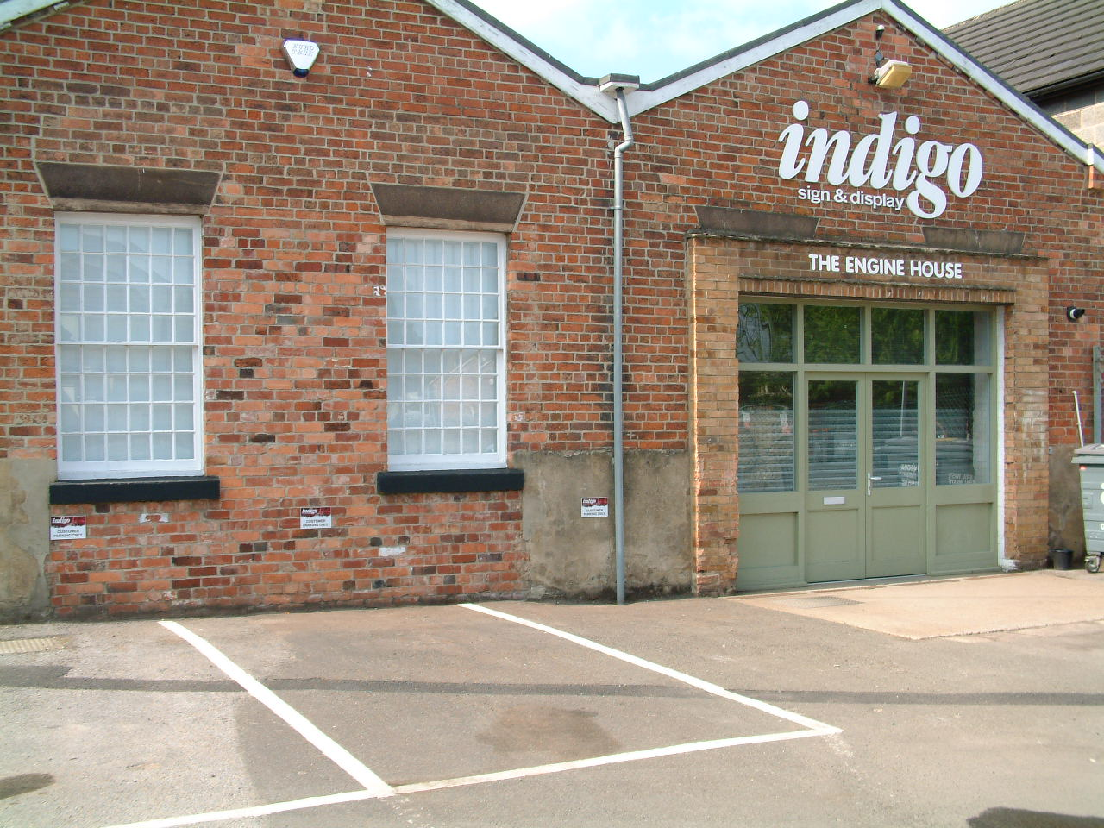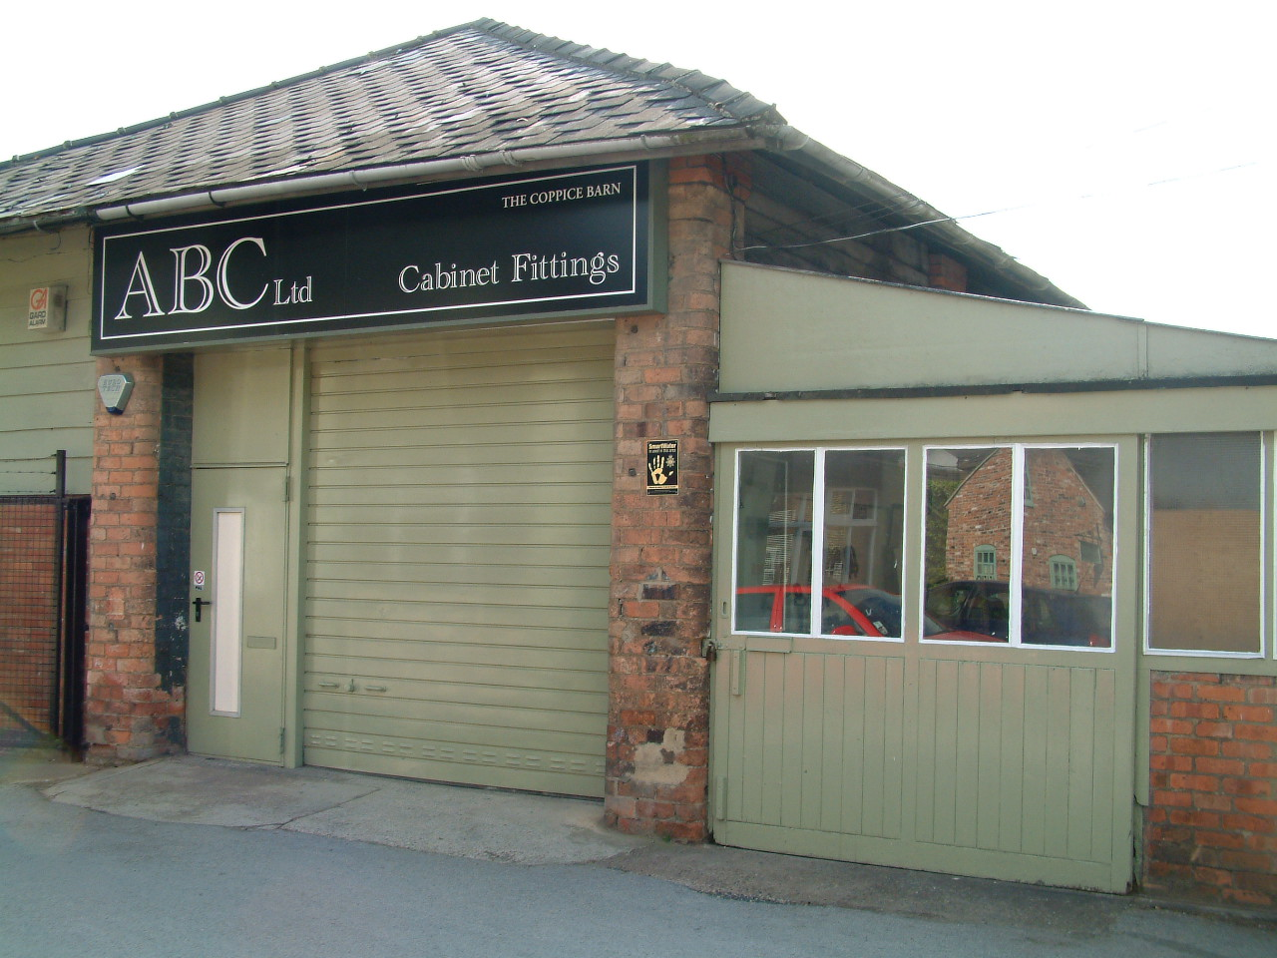
Figure 7.7 Engine and Boiler House Figure 7.8 Coppice Barn A

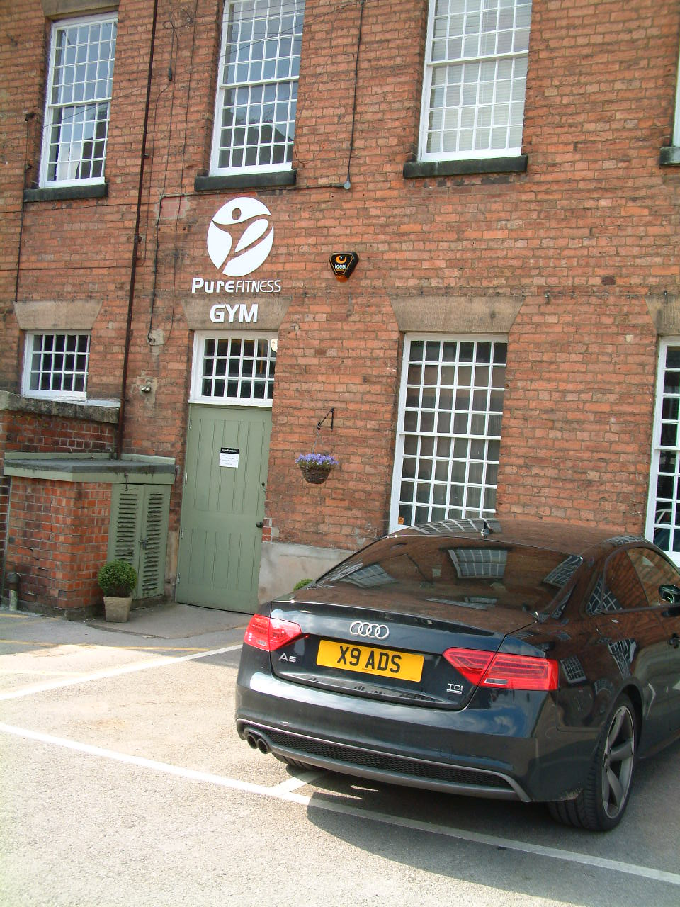
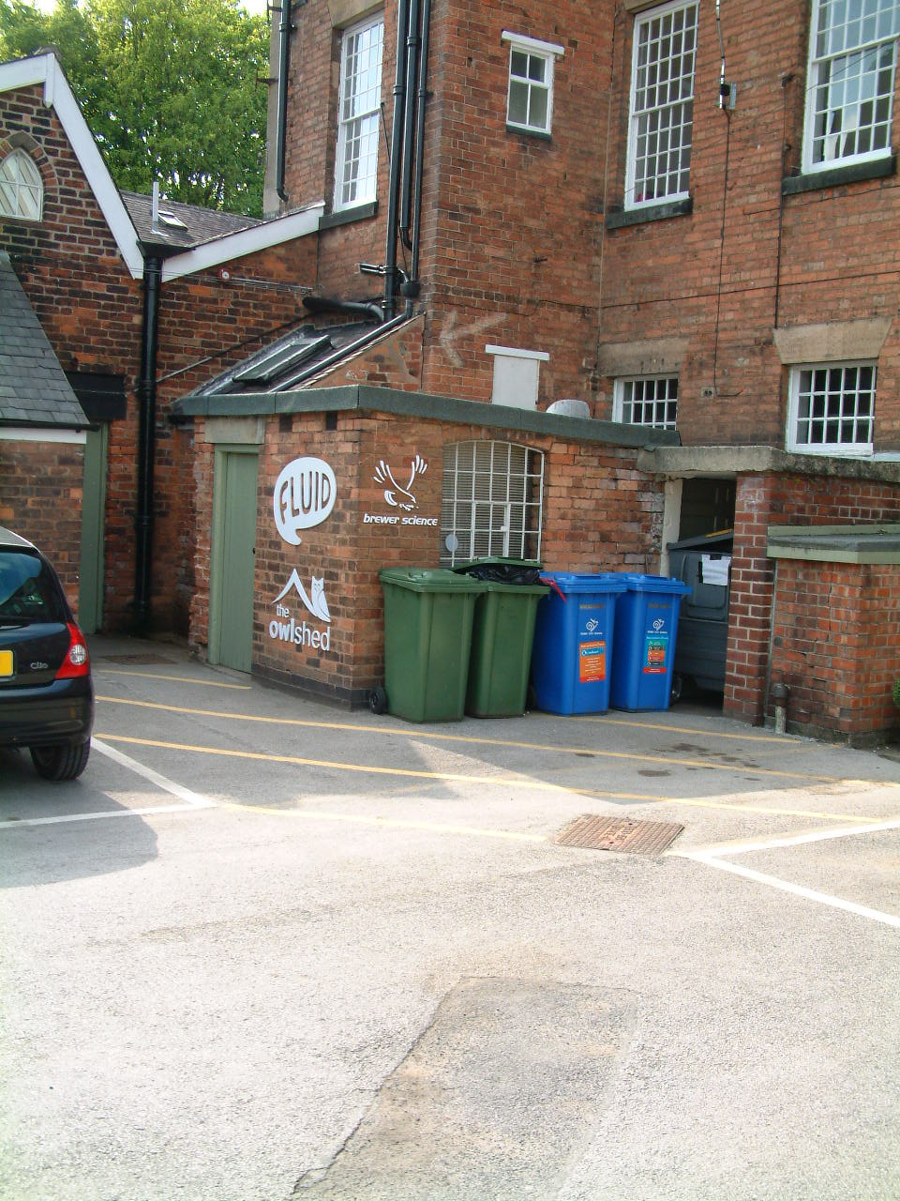
Figures 7.9 and 7.10 Signage on front façade of the North Mill 2013

Although the work carried out on the Watch House and the coordinated paint scheme and signage, which has emerged throughout the site, illustrate improvements in the maintenance and care regime at the site and a degree of ‘aspirational urbanism’ for Darley Abbey Mills, however, as Figures 7.11 and 7.12 show, some elements of basic and fundamental maintenance and repair remain unaddressed. Both of these images below are of the same cast iron down pipe and, rather than the pipe safely carrying water away from the surface of the building, the fractured pipe allows water to escape on to the surface of the brickwork. The plant growth and green discolouration evident in both photographs indicate that this is a continuing problem. This pipe is not located in an area which is isolated and inaccessible for the purposes of inspection and repair, but rather it is on the front façade, in the corner where the Grade 1 listed Long Mill and Middle Mill meet and, it is also opposite to where the site office is now located (5 Old Lane, No 15 on Figure 7.1).

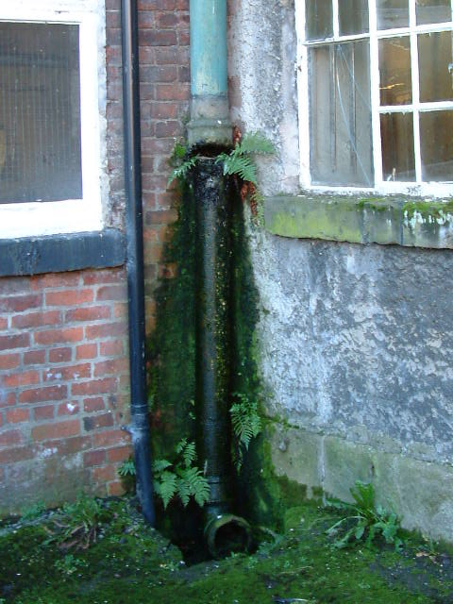
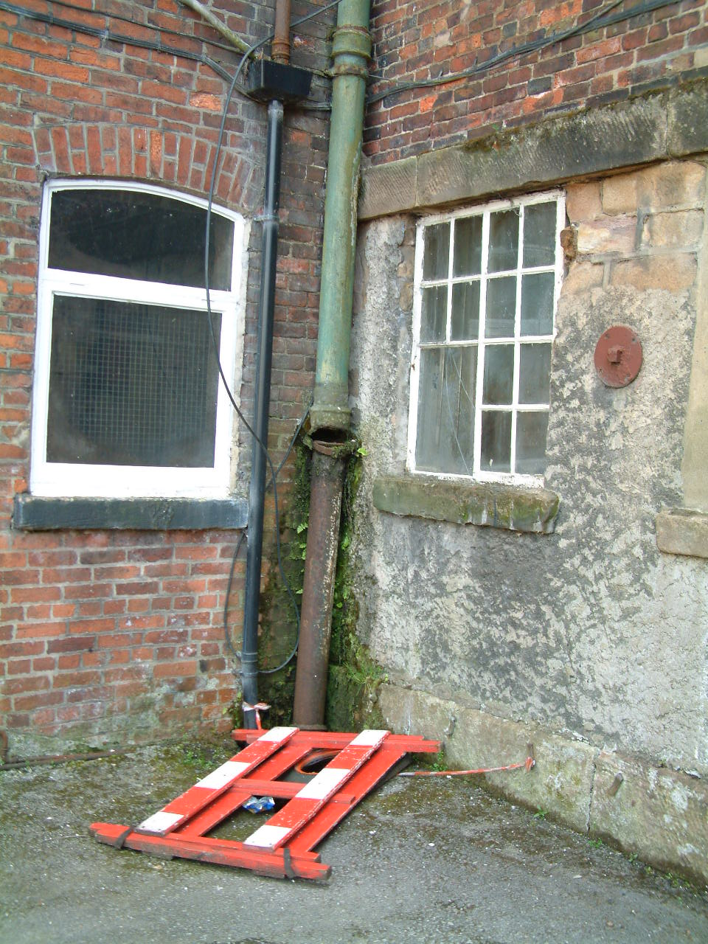
Figure 7.11 Broken pipe in 2006 Figure 7.12 Broken pipe in 2013
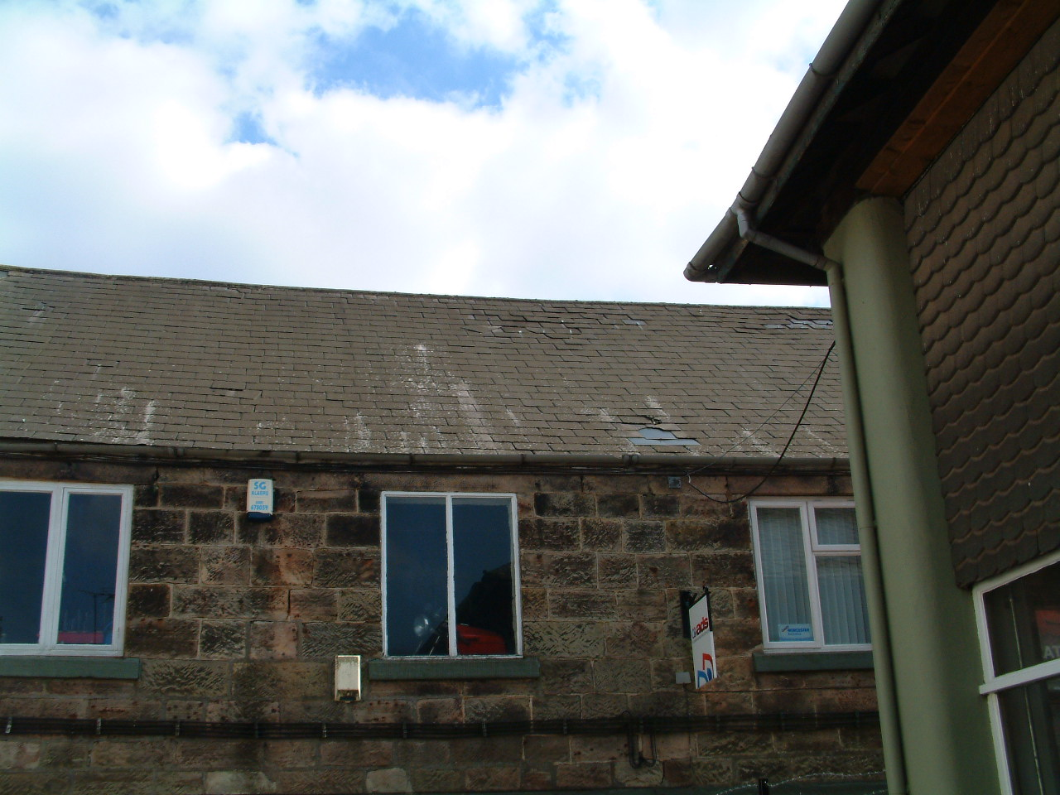
Figure 7.13 Replacement tiles on Sawmill range of buildings

It could be argued that the roof repair on the Sawmills group, a Grade 1I Victorian range of buildings (No 12 on Figure 7.1), as illustrated in Figure 7.13 above, effectively stops rain entering the building and so is better than no intervention as shown in the previous two figures, even though the tiles are of a different size to the rest of the roof, so this is an example of where there has been some attempt at repair but one, which has been inexpertly undertaken. Figure 7.13 also shows that higher up on the roof toward the ridge there is a larger area of tiles, which are slipping and will therefore soon need attention. The owners advertises space at Darley Abbey Mills (darleyabbeymills.com) being ‘sympathetically restored’ at the present time there is little evidence of either the adoption of the ethics or principles and practice of conservation, or compliance with statutory requirements, however this position has changed since planning permission was requested for the large scale adaptation of the site.

7.3 Social and Cultural Sustainability

In assessing the social and cultural sustainability it is important to look at the various communities that are located in and about Darley Abbey Mills, since 2006 that has been a slow shift towards the creative industries, as discussed in Chapter 3, the Mills possess a number of soft factors that attract the creative industries. It is possible to see that the industries have not only located there, but have created their own community. It is also possible to identify two distinct movements, the Darley Abbey Residents 2006-2013, and the Darley Abbey Residents 2013-2015, although these two movements contain largely the same members their roles, values and attitudes have changed.

7.3.1 Sense of Place, Community Cohesion and Identity

There are various examples throughout the research where attachment to Darley Abbey has been expressed, that there is a strong sense of place, and that there is a distinct notion of community cohesion and identity. It can be argued that there are two communities at the site, the tenants at Darley Abbey Mills and the local residents and other non-official stakeholders such as leisure users.

7.3.2 Creative Community

The Darley Abbey Mills is slowly becoming a hub for small creative and artisan based businesses, these are in the early stages of formulating their identity, but they are using the ‘soft’ and historical factors of the site as a central themes of their membership of this community. For example, The Derby Pyclet Company state:

When we set eyes on the Proto-fire building in the beautiful eighteenth Century Darley Abbey Mills (part of the UNESCO Derwent Valley Mills World Heritage site) we knew we had to have it. Barrel vaulted, with bare brick walls, huge oak beams and what English Heritage believe to be the earliest known use of cast iron pillars within a building, two hundred years of industrial history can be read in one glance. It also fits with our sustainable approach to business.

These themes are also carried CGI Derby who in reflecting upon their attraction to the site comment that:

The Mills have been sympathetically restored to create a highly individual stylish working environment and work for us in terms of creative space and location. For staff, not only are the Mills themselves striking, but the office is located in beautiful surroundings, has an onsite gym and avoids heavy traffic coming onto and leaving Pride Park.

While Ben from Blok Knives identifies that there is ‘something very raw about making a knife’ and that the historic industrial heritage of the site links into his ethos. For Ben ‘It’s back to basics’ and for this reason I don’t like to over-complicate my production.

7.3.3 Darley Community and Stakeholders

Throughout the entire period of this research, there has been an on-going expression of identity and examples of community cohesion, much of this has been captured in the personal reflections of residents who have expressed them as part of the planning process and provides a rich source of data. Notable examples of this include: (For full transcript of letters see Appendix 2.2 and 2.3)

7.3.4 Neighbour and Representative Comments Contained in Planning Applications

Planning applications for development of the West and Long Mill – the planning application for the demolition of loading bay, two storey stairwell extension to former ‘Mechanics Shop’ together with repairs to mills (Planning application number: 03/14/00318) where the following comments were made from one neighbour which were in favour of the development:

I strongly support the restoration of this Grade 1 Listed Building in the Derwent Valley Mills World Heritage Site…I also feel the demolition of the modern extension will improve this building’s appearance….I support the ‘proposals to reverse many of the inappropriate repair works and reinstate this building’s character’, as well as the demolition of the adjoining poor quality modern structures. At present these detract from the historic building’s appearance….I feel it is important that Listed Buildings should be used and not fall into disrepair. (Appendix 2.1 Support 1)

However, the application for change of use of mill buildings from light industrial use (Use Class B1) to hospitality venue within West Mill (Use Class D2) and office accommodation within Long Mill (Use Class B1) (Application Number: 12/13/01514) received 26 objections and only 2 in favour. A consecutive planning application for the Long and West Mills for the alterations in connection with change of use of mill buildings from light industrial use (Use Class B1) to hospitality venue within West Mill (Use Class D2) and office accommodation within Long Mill (Use Class B1) (Application Number: 12/13/01515) also received a large number communications with 20 objections and 2 in favour. From the objections of both of these planning applications a number of reoccurring themes emerged:

Inappropriate Development upon Visual Impact of a World Heritage Site

Whilst it is important to maintain our heritage should we do so at any cost? The Atkins report and strategy document 2010 supports that there are major obstacles to be overcome to enhance this site, the proposed applications fail to meet the needs of the WHS and are based purely on commercial interests, who on earth would consider sticking a modern glass and steel lift on the external of such a building concluding that to have an internal lift will reduce available floor space!!! the structure and supporting elements within the building also suggest they are unsuitable for large groups of people without significant internal changes. (Appendix 2.3 Objection 3)

Not in keeping with a conserved, world heritage site, the visual impact on the public and local residents would be unacceptable bearing in mind no glass lift structures existed during this buildings period of historical significance, the traffic survey supplied is speculative and does not reflect real activity within this area. (Appendix 2.3 Objection 9)

Development of a green wedge and Impact on the flood bank
I am not happy with the prospect of a green wedge being turned into a car park for 46 vehicles, which could include buses, for guests attending the Wedding and Hospitality venue.(Appendix 2.2 Objection 8)
The current green wedge and river bank access owned by the applicants have recently been cleared of vegetation, irrespective of the effect on wildlife, in order to create a car park and a paved strolling area for wedding guests to enjoy. The green wedge area proposed as the main car park for the hospitality venue is the only natural drainage area for this site and has been under several inches of floodwater on a number of occasions. ‘Bodpave’ is the nominated surfacing for the car park but this will ultimately compress the subsoil and reduce the raining effect. (Appendix 2.2 Objection 16)
It is unreasonable to turn a Green Wedge into a car park and the area has flooded recently. (Appendix 2.2 Objection 24)
As I feared it looks as though they are trying to get change of use by stealth.
Surely this needs nipping in the bud before the application goes any further.
Development will only be permitted in Green Wedges within the following categories: Agriculture and forestry, Outdoor sport and recreation, including allotments and Nature conservation areas.
None of these criteria apply to this planning application, which is purely a commercial operation. (Appendix 2.3 Objection 1)
The idea of more hard standing car parking within a flood plane will only add to flash flooding risks resulting from poor drainage and run off. (Appendix 2.3 Objection 3)
Risk to wildlife

Furthermore, the Police are advocating a constant level of lighting (controlled by photo-electric cell) for security reasons, which runs contrary to the recommendations of the Bat Conservation Trust and the need to protect the river wildlife corridor. We can only conclude that there is a fundamental flaw in the proposal to locate car parking behind the properties on Haslams Lane, and we ask that this be deleted so as to protect the environment and avoid nuisance to residents.”(Appendix 2.2 Objection 1)

Overlooked/Intrusion into Privacy (mainly residents from Haslams Lane)

We understand that 'overlooking' is a material planning consideration, usually in the context of siting buildings relative to each other. However, at the rear of properties on Haslams Lane is a flood defence embankment of substantial height. Consequently, anyone standing on the top of the bank can overlook our property and invade our privacy, as our garden is very short and the bank is quite close. Whilst this sort of behaviour has not been a concern to date, the current application will change this i.e. the proposed steps and pathway over the embankment will invite visitors on to it, effectively giving them permission to explore along its length and impact detrimentally on the amenity of ourselves and our neighbours (Appendix 2.2 Objection 1)
Please refer to my objection listed against the internal application for Darley Mills.This is a quiet area populated by elderly people, children and wildlife on the edge of a park in a conservation area. Introducing a late night entertainment venue with all the social disruption that would bring, would destroy this area for the animals and people alike. My daughters would not feel safe playing in their own garden, nor would I feel comfortable letting them do so knowing that a large number of strangers are around, consuming alcohol and generally letting loose at the end of our garden. I personally would find the presence of strangers around the back of the house to be alarming and stress-inducing. Currently, I can see the river from the house. If people were around, it would destroy my view and leave the back of my house exposed. I do not have any curtains or blinds in my kitchen but I would feel very threatened knowing that people can see into the house at night. There have been some incidents where strangers have entered the garden because the fence is a simple wire construction which anyone can step over. If you open the area up to strangers you will be encouraging people - drunk people - to cross the boundary into my garden, resulting in myself and my children becoming threatened and feeling exposed. I am incredibly nervous about what this would mean for me and my family. (Appendix 2.2 Objection 25)
Due To The Proximity Of The River And The Proposed Paved Areas There Is A Risk To The Safety Of Guests.
You cannot ignore the fact that guests at events held at these venues, and especially weddings, will spill outside into the areas adjacent to the River Derwent. In itself this poses a risk to the safety of those attending such events, especially as the river is especially fast-flowing in that area. However, if you add in the inevitable fact that many guests will have been drinking, sometimes for an extended period of time, and may be prone to revelry and high-jinx, there is a significantly increased risk that someone may slip into the river and even drown. There have been several instances reported recently of people being found dead in rivers after a night out, no doubt caused in part by the combination of alcohol consumption and being proximate to water. Two factors which would be at play with this redevelopment. (Appendix 2.2 Objection 11)
Light Pollution

Furthermore, the Police are advocating a constant level of lighting (controlled by photo-electric cell) for security reasons, which runs contrary to the recommendations of the Bat Conservation Trust and the need to protect the river wildlife corridor (Appendix 2.2 Objection 1)

Noise pollution

The thought of guests leaving late at night in a merry state, with car doors banging and engines starting up and maybe taxis picking up clients and trying to find the way into the venue is not something to look forward to as all noise within this Heritage site carries and echoes. A quiet evening may be out of the question. (Appendix 2.2 Objection 8)
We encounter at present high volume of private and business traffic all throughout the week. Hospitality and Wedding venue will encourage more traffic in a very narrow lane with all the associated noise. We chose to live in an area which we thought would be reasonably quieter area and also in a world heritage site. (Appendix 2.2 Objection 13)
Noise from events, due to the design of the Mill Yard, travels substantially, as already experienced from events at the rugby club, the brewery and a recording studio which operates from one of the units. Also additional noise of taxis arriving and leaving, people walking past my window and loud voices as people leave the venue and area. (Appendix 2.2 Objection 18)
The proposed car parking will result in an unacceptable loss of amenity to the residents of Haslams Lane and Old Lane, in particular 1, 1a and 1b Haslams Lane where spaces are proposed with feet of neighbouring houses. Thanks to the failure of Derby City Council’s Planning Department, my own amenity has been compromised by 24hr commercial car parking similar to this proposal, and the users of this car park will probably have been drinking. Car lights, radios, people making phone calls, shouting to each other, all of these are things that the residents will have to endure during times when they would want to be relaxing in their own home or garden. (Appendix 2.2 Objection 19)
Whilst I would expect conference not to go on late into the evening, weekend events such as wedding, birthdays and other celebratory events will. With them will come significant noise at the end of the night time activities and it is inevitable that local residents on living on site and nearby will be inconvenienced. Clearly the Human Rights Act Section 8 protects their rights to enjoy their homes without interruptions. Whilst the venue will be seen as having its own rights under the Act, non the less one would argue that in exercising their right they must take into account of the local residents’ entitlement to enjoy their own homes. To subject residents to regular and weekly disturbance cannot in any sense of the Act be considered acceptable and in the public interest. (Appendix 2.2 Objection 21).
We cannot support the potential prospect of a loud environment caused by people and cars coming and going in extended hours. Use of these buildings so late at night involving people leaving licensed premises and the predictable noise levels that this will involve is completely unacceptable in this residential area. The tall historic buildings with little or no vegetation among them cause any sounds to be deflected and amplified so that they carry further and the buildings opposite our house cause a tunnel effect. Since our house is listed, we have no double-glazing and so noise is virtually impossible to block out. (Appendix 2.2 Objection 22)
Noise levels. As a resident who already experiences problems with noise levels from the city centre (music from city centre clubs/pubs as previously reported to the council since 2011), I an extremely worried that the noise levels from this proposed venue will be both intrusive and disruptive. In addition this includes: noises late into the night from people who have been drinking; car radios, people shouting; traffic/car noise as people arrive/depart - all at times when I want to be relaxing in my home, my garden or sleeping. (Appendix 2.2 Objection 26)
The long suffering residents surrounding this WHS will be subjected to yet more disturbance and inconvenience running late into the night should the wedding venue change of use proposal be given the green light. (Appendix 2.3 Objection 3)
Increase in Vehicular Traffic
Whilst in principle we do understand the need for the protection of these mill buildings, we are of the opinion that to develop them to such an extent will inevitably necessitate a massive increase in vehicular traffic. (Appendix 2.2 Objection 2)

The vehicular access to the site, either over the toll bridge or Haslams Lane, is narrow and hazardous given pedestrians, dogs and cyclists (it is a national cycle route). Haslams Lane itself is unadopted, single carriage in certain locations and is in a very poor state of repair. Traffic for events at the rugby club as well as for a wedding reception at Derby Mill does not seem plausible. Even a couple of taxis for Darleys restaurant causes congestion, so how such an increase could be handled is beyond understanding. (Appendix 2.2 Objection 4)

The increased traffic down the lane leading to the mills makes the proposed entrance unsuitable as it is a shared drive, totally unsuitable for a venue open 7 days a week. (Appendix 2.2 Objection 5)
These plans seems be ill thought out and seem to have no regard to the dangerous nature of Haslams Lane, the speed some vehicles go along Haslams Lane is frightening . Offices are not such a problem because people tend to come at 9 and go at 5. I can only imagine the carnage at the weekends when 150 odd people who have no clue about where they are going plus the catering vans and the employees at the venue are trying to get to the same place at the same time, with all the other traffic, pedestrians etc. who use Haslams Lane now. (Appendix 2.2 Objection 9)
I walk up to Church every Sunday and as I am in my eighties find it difficult to negotiate the traffic through the Mill as it is - never mind more vehicles using this throughway. Have we not got enough traffic using and parking along the Mill, Haslams lane and Folly Road - businesses, Rugby Club, restaurant etc and those using it to dodge the A38. (Appendix 2.2 Objection 10)
The road network from Alfreton Road along Haslams Lane and across the river into the bottom of Darley Abbey village is not fit for purpose for existing traffic levels. This makes any redevelopment that increases traffic volumes highly inappropriate. Haslams Lane is essentially a single lane road particularly as it passes through the Darley Abbey Mills complex. Sections of Haslams Lane in and around West Mill and Long Mill are even narrower due to old walls, bridges, etc. which already adversely impacts on traffic flow. There are sections where you cannot easily see whether vehicles are coming from the opposite direction, making driving hazardous and leading to numerous near misses not to mention the daily problems in navigating the single lane bridge over the River Derwent. Haslams Lane is also in a poor state of repair, which means that vehicles sometimes have to stop to allow oncoming vehicles to pass rather than risk driving over a pothole, further impacting on traffic flow and safety. (Appendix 2.2 Objection 11)
The narrow road through the Mill Yard is notorious for congestion on a daily basis, with large delivery vehicles and taxis being the primary culprits, due to lack of drop-off/waiting areas. The application proposes that the pick-up point for departing guests from the hospitality venue using taxis or coaches would be at the secondary exit from the venue, which is next door to Darley’s restaurant entrance, already a congested area. (Appendix 2.2 Objection 16)
The road through the mill site is not designed for an increase in traffic. The road through the mill is very narrow and cannot support large levels of car and coach or bus traffic, particularly during weekends when the mills and park area is busy with families and dog walkers who visit Darley Abbey as a site of special interest. (Appendix 2.2 Objection 26)
Safety Risks To Other Vehicle Users/Pedestrians/Cyclists/Children/Dogs Who Go Through The Site

The speed some people leave the Mill yard towards Alfreton Road is often too fast as they cannot see the concealed entrance/exit. The entrance and exit to the venue should be within the mill at the wide entrance leading to the chimney, where there is ample room and a wide vista giving good vision on all sides. I feel that taking into account the number of cyclists, pedestrians, cars and commercial vehicles that use this road, if the proposed entrance/exit to the venue is allowed, it will just be a matter of time until there is a fatality. (Appendix 2.2 Objection 6)
The increased footfall through the West Mill/Long Mill area at weekends and during the summer will coincide with the peak use periods for weddings yet the Transport Statement makes absolutely no mention of this key issue. The increased traffic flow on roads that are already unfit for purpose combined with the higher volume of walkers, will inevitably lead to more incidents. (Appendix 2.2 Objection 11)
Additional traffic making it unsafe for children walking through the Mill Yard to attend events such as Judo, rugby club or school. (Appendix 2.2 Objection 18)
The road through the Mill site is too narrow to support concentrated levels of car and bus traffic especially at weekends when the area is a magnet for dog walkers and people travelling to the area to enjoy the river and park. (Appendix 2.2 Objection 19)
Any further use of the Mill buildings at night will increase the traffic through the Mill yard, which has no pavement or street lighting this will definitely cause a safety risk. (Appendix 2.2 Objection 22)
At the weekend the road through the mill complex sees very heavy pedestrian footfall, being part of a popular walk through the park on one side and Darley Fields on the other, something I do myself on a regular basis. Existing vehicular traffic levels are already hazardous and any increase would be positively dangerous and completely unacceptable. (Appendix 2.2 Objection 23)
Increased traffic where there is no footpath for pedestrians and the road is narrow will in my view cause serious problems for pedestrians and cyclists. (Appendix 2.2 Objection 24)
Insufficient Car Parking

With four events per week of 165 guests, car parking in the plans seems limited. Folly Road (an adopted road) is already used for parking by walkers in the park, and also as an overflow for the rugby club, in spite of signs requesting no rugby parking beyond this point. Clearly Folly Road would be a natural spot for clients to park. (Appendix 2.2 Objection 4)
There will be insufficient parking spaces taking into account: Darleys and the Wedding Venue so when all the above have functions the customers will do what Darley’s do and that is park on both sides of Old Lane, the stretch alongside the River bank. (Appendix 2.2 Objection 15)
Parking for the West Mill hospitality venue and the Long Mill office accommodation appears to be seriously restricted, even with the proposal to create 30+ spaces on green land behind residential properties on Haslams Lane. The venue overspill/office parking area (the “triangle”) would also be filled, not allowing for the brewing company vehicles using this area and their proposal to use part of the car park space for a marquee for outdoor functions. The applicants own estimated parking requirements suggest maximum capacity, without allowing for incursion by other mill yard tenants. (Appendix 2.2 Objection 16)
Inadequate parking area for a substantial increase of vehicles, which is already evident during evening events such as Judo evenings in the Mill Yard and customers visiting the nearby Darleys restaurant. (Appendix 2.2 Objection 17)
Haslams Lane is an Un-adopted road.

Haslams Lane will be the main access road to this venue, and as an unadopted road of substandard nature it is doubted that the road will be able to cope with such an increase in traffic. (Appendix 2.2 Objection 2)
The traffic on Haslams lane (a private road and thus not council maintained) is already heavy enough with drivers paying no attention to speed limits. This application will only increase those numbers and the risk to pedestrians. Without speed restrictions/widening I do not believe the access is suitable for this type of use. As it is not council maintained, there is no street lighting, and the condition of the road will be adversely affected by the increase in volume of traffic. The road is not designed for this traffic and the proposed entrance is also unsuitable due to lack of vision of cars/pedestrians exiting via the mill. (Appendix 2.2 Objection 7)
The Lane for the entrance for such venue is a blind lane from the Haslams Lane and therefore traffic coming out of the blind lane onto Haslams Lane can contribute to a major accident.(Appendix 2.2 Objection 13)
It is a private road and there are no amenities like footpath, lights etc. We are supposed to pay for any repair for any damages. (Appendix 2.2 Objection 13)
Haslams Lane is a narrow unadopted (unlit) roadway, in a poor state of repair with inadequate walkways and no speed restriction, yet the applicants naively expect all the visitors to the hospitality venue and office accommodation to use Haslams Lane as the preferred access route, including pedestrians using the public bus service. (Appendix 2.2 Objection 16)
General Comments:
This wedding proposal will not be a happy marriage between Darley Abbey Mills and its loving residents and visitors. The trouble with too much traffic, parking, pollution and noise will lead to early divorce proceedings. This will take its toll. No amount of prenuptial settlements will settle this. Wrong couple, wrong place and no future for happy family life. We object to this suggested coupling. Please stop it and publish the banns we want to read.” (Appendix 2.3 Objection 19)
7.4 Conclusion
This Chapter presents an overview of the data gathered during the period 2006-2015, although the data collection was completed initially in 2013, it was felt that the changes that were occurring at the site were so significant that they marked a new Chapter in the history of Darley Abbey Mills, and fundamentally changed the context and consequence of the initial. This data will now be analysed in relation to the aim of the thesis and Yung and Chan’s (2012) criteria for assessing the sustainable adaptive reuse of historic buildings.

Chapter 8

Assessing the Continued Use and Sustainability of Darley Abbey Mills

8.0 Introduction

The aim of this thesis was to assess whether Darley Abbey Mills has a secure and sustainable future through the continued use of the Georgian buildings and the the site as a whole. As identified in Chapter 2, the Mills are a significant historical, cultural and social artefact that are worthy of protection, although Darley Abbey Mills may not have the historical significance of Arkwright’s Mill at Cromford, or possess an architectural aesthetic beauty possessed by many historic buildings, it is not possible to ignore the significance of Darley Abbey Mill’s in the world’s industrial past. This historical and architectural significance is recognised through the formal listing and designation process, in fact Darley Abbey is awarded with the highest degree of protection available in England, with the site being assigned UNESCO World Heritage Site status, Conservation Area status with many of the Georgian buildings being designated as either Grade 1 or Grade 2* Listed Building Status. As such, the sustainable future of the site should be guaranteed, however, the reality is that the historical built environment has to find a contemporary context and usage, this is particularly apposite for Darley Abbey Mills as it is entirely in private ownership, it therefore, has to be able to pay for itself. Many World Heritage Sites are owned and managed by charitable trusts and organisations and, have the option of developing sustainable tourism to provide both context and income. However, from the findings of the condition and usage survey (see Appendix 3) which was undertaken between 2006 and 2013, Darley Abbey Mills’ future was an uncertain one, at that time there was no clear defined contemporary context of the site, with basic maintenance not being undertaken, the ethics and principles of conservation largely were not being followed, the result of this is that a number of the buildings have been placed on English Heritage’s Buildings at Risk Register and still remain so today.

Both the literature and the empirical research undertaken within this thesis, that the idea of sustainability is a complex one, and that a dichotomy exists, between the formal conservation approach of minimum intervention in order to protect the historical and architectural fabric and integrity of the building, and the contemporary requirements of new industries for flexible, thermally dynamic and technologically compatible buildings. However, the planning and designation process has been heavily aligned with the protection and conservation of the historic built environment, that can be seen to be over restrictive, prescriptive, lacking consistency (Highfield and Gorse, 2009; Cooper, 2010; Mansfield, 2011; Paixão, Costa and Gonçalves, 2013) and, being overly bureaucratic (Negussie, 2001). The consequence of this is that the over protective environment that surrounds historic buildings, encourages developers and owners to leave buildings to fall in dereliction or disrepair and in danger of being lost forever (Ahlfeldt et al., 2013). This restrictive and prescriptive approach can be witnessed in the most recent planning applications pertaining to Darley Abbey Mills (See Table 7.4 and Appendix 1a). Although planning consent was given, the nature and number of conditions may be seen to be so restrictive and costly that this may hinder, delay or reduce the extend of the adaptation. So in assessing the sustainability and continued use of Darley Abbey Mills, does the notion of sustainability refer to the conservation and preservation of the buildings? Is it about finding a long-term economically sustainable context for the site? Or does it concern the maintenance of the site as a social and cultural resource? The literature that surrounds the field of heritage conservation has a marked tendency to concentrate on a specific area of conservation, whether, that be on the fabric of buildings, management of visitors or economic impacts etc. The sustainability of a site can only truly be assessed through the adoption of a more holistic approach that takes into consideration all of the elements of sustainable development, namely the environmental, social, cultural and economic aspects of any development. As identified in Chapter 3, Yung and Chan (2012) provides a useful set of criteria for assessing the sustainability of the adaptive re-use of historic buildings, this criterion will be adapted to provide a means of analysing the data. The headings identified by Yung and Chan encompass all the elements of sustainable development with the addition of a category to consider the political sustainability of the project. The data generated from the ‘areas of enquiry’, the review of the both the literature and practices of heritage conservation and the data gathered from other empirical sources and contextualised and analysed within Yung and Chan’s criteria will enable the effective assessment of the sustainable and continued use of Darley Abbey Mills.

8.1 The Historical and Architectural Significance of Darley Abbey Mills

As identified in the introduction to this Chapter (and also in Chapter 2), the Mill site is a historically, culturally and socially significant artefact which worthy of protection. The recognition of this significance is witnessed from the Darley Abbey Mills being awarded with the highest degree of protection available in England, with the site being assigned UNESCO World Heritage Site status, Conservation Area status, and with many of the Georgian Buildings (and subsequent Victorian additions) being designated as either Grade 1 or Grade 2* Listed Building Status (See table 7.3). As much of the legislation that surrounds the protection is open to interpretation, it may be argued that the higher the significance of the site in terms of its age value and design value (Wells, 2010) and are then mediated by one of the stakeholders (as identified in Table 5.3) who will assign their own values to the site. From the research it is clear that the ‘value’ judgements made by consumers, regulators, conservators, stewards or interpreters are fluid and dynamic according to the impact upon age value or design value as well as personally motivated value based judgements. In the case of Darley Abbey Mills, the age value and design value remain consistent, but it is the stakeholders who are making different value based decisions according to self-interest, social and economic climate and platform. For example, stewards, interpreters and regulators, largely ignored the unauthorised installation of signs and instances of general maintenance as seen in the 2013 condition study, this was the result of a pragmatic approach by the stakeholders and in particular the regulators, thus there was a status quo whereby the contemporary use of the site did not offend the ‘values’ of any of the stakeholders. However, in the latest planning applications the large-scale development of the Long and West Mills generated a large number of objections and subsequently conditions whereby stewards, regulators, interpreters and conservators move from a position of status quo to one of intervention. In this instance of large-scale development, the age value and design value and the protection of these the ‘values’ applied change.

8.2 Economic Sustainability

8.2.1 Economic Viability

The research illustrates that one of the major challenges facing the historic built environment is that it must find a contemporary usage that generates a form of economic sustainability, without this, the future of sites, no matter their significance is questionable. The economic viability of Darley Abbey Mills has to be judged in a different manner than many other sites as it is completely in private ownership and does not have the capacity for the development of a meaningful tourism income stream. Thus, where many sites are managed by charities and non profit making organisations, the viability of Darley Abbey Mills rests on the ability of the site not only to generate enough income to pay for its upkeep and maintenance, but also that it needs to generate a profit for the owners. As can be seen from both the theory and the interviews of tenants, one of the major hard factors for attracting new industries to locations such as Darley Abbey Mills are the low rents that such buildings attract. As Champion states (2010:14):

Underlying this is the idea that cheap space and corresponding cultural diversity are vital ingredients for developing creative businesses. Low-cost space offers opportunities for flexibility and grow-on space, which is especially important in high-risk, undercapitalised industries.

Although Darley Abbey Mills is offering space for small companies to develop and grow, it is questionable if this strategy will guarantee the future of the site. This need to attract higher generating businesses to the Mills is evidenced in the most recent Planning Applications, with the proposed conversion of the Long and West Mills to create multiple office spaces and most significantly the creation of a large Wedding/Conference Venue. These types of developments will maximise the rental potential of the site, however, the impacts of such a large expansion of commercial activity could alienate their existing clients and surrounding community. The soft factors that make the site so attractive in terms of the feel of the site, the quietness etc. in conjunction with hard factors such as car parking are all in danger of being lost if the full development of the site takes place.
The economic dimension of sustainability is regarded by some as the most important dimension of sustainability, Giddings Hopwood and O’Brien (2002:190) state that ‘the reality of life today is that the economy dominates environment and society’, for Darley Abbey Mills, many of the decisions that have been made, or more importantly have not been made, can be seen to have been heavily influenced by current and historical economic considerations and constraints. As such, the relationship between the economy and the conservation of heritage can be seen one of the most important influences in explaining the current condition of the site. Although Yung and Chan (2012) separate the political and economic elements within their model, it is difficult to separate them fully or, consider them as isolated dimensions as they directly influence each other, as often policy is driven primarily by economic and political imperatives. For example, if you explore the notion of sustainable development, sustainability has been embedded in Government planning policy for some time, The Planning Policy Statement 4 (PPS4) (Communities and Local Government Act 2009:3) states that: ‘The Government’s overarching objective is sustainable economic growth’, although this Policy Statement has now been superseded by the National Planning Policy Framework (Communities and Local Government Act 2012), sustainable development is now regarded as one of the major purposes of the British planning system. Tweed and Sutherland (2007:63) point out that: ‘It is no longer satisfactory to attend to economic growth in isolation from all other aspects of development’, this sentiment is also reflected by Giddings, Hopwood and O’Brien (2002) who propose that whilst the economic dimension is often prioritised in policies, all four dimensions are interconnected and it is acknowledged in the National Planning Policy Framework that ‘they are mutually dependent’ (2012:2). Thus, when assessing the idea of sustainability and how this is transferred into practice, some thought as to the conception of sustainability in a holistic manner, whereby the social, cultural and, economic impact of the site must be considered. In assessing the significance of the Darley Abbey Mills site and how it can be located within the sustainable agenda, we need to understand it in terms of it’s contemporary context, it’s contribution to the cityscape, its historical value, it’s continued use rather than re-development and if it can contribute to the tourism economy of the region.

8.2.2 Job Creation

Darley Abbey Mills will never generate the same levels of employment as it did in it’s industrial past, however, the flexible space and hard and soft factors of the site will attract the new creative industries, and as the Culture, Media and Sport Committee (2013:1) identified that the creative industries contributed 2.9% of the UK's Gross Value Added in 2009, equivalent to £36.3 billion (GVA + taxes on products - subsidies on products = Gross Domestic Product) and significantly, 1.5 million people are employed in the creative industries or in creative roles in other industries this relates to 5.1% of the UK's employment. What is significant about these types of jobs is that they are often skilled, technologically advanced and permanent, whereas the jobs in the tourism and hospitality service sector although cheap to generate (Urry, 2011) are often low paid, un-skilled and temporary or seasonal. So in measuring the value of jobs within the creative industries created at Darley Abbey Mills are good quality jobs that will bring prosperity and economic diversification to the region and city.

8.2.3 Tourism

Although tourism continues to be seen as one of the low cost economic options for regenerating regions (Goodall, 1994; Falk, 2000; Urry, 2011) and as a means to protect, reuse and provide the historic built environment with a contemporary context, the development of tourism at Darley Abbey Mills is not a viable option. Although Darley Abbey Mills is identified as a tourists site, including brown sign status and inclusion in regional tourism guides, the site possesses no infrastructure for the development of heritage tourism, this includes the lack of parking spaces, facilities expected by visitors (toilets, food and drink outlets, shop) and any interpretation materials. In addition to this, as can be seen from interviews with visitors to Darley Abbey park (See Appendix 4) the site still ‘feels’ industrial, unwelcoming and for some even dangerous. The use of signs around site reinforce and blur of the boundaries as to the nature of the sight, and at certain times of the day and at weekends there is a feeling that as one interviewee stated “you are trespassing”. Until recently there has been a lack of strategic plan that links the various important historic industrial sites with Darley Abbey Mills not being incorporated into city regeneration plans. However, with the decline in the city centre and in particular the Cathedral Quarter there has now been the development of a plan that links Darley Abbey Mills to the Silk Mill and the cultural capital (museums, galleries etc.) that defines the Cathedral Quarter (Derby City Council, 2012; Derby Cathedral Quarter, 2013). Although this may have a benefit in attracting tourists, the economic benefits to Darley Abbey Mills would be extremely limited, as it does not possess the tourism infrastructure and services to generate meaningful income. Additionally, the development of the Mills as a tourist site would not be a financially viable option for the private sector, who do not possess the cost neutral option of using volunteers to manage, maintain and staff the resource on a daily basis.

8.2.4 Compliance with Statutory Regulations

For a number of years there has been little development on the site with only the minimum, or it can be argued, even less than the minimum required maintenance has taken place. Because of the classification and listing of the Georgian buildings as either Grade 2* or Grade 1 any changes to the internal or external fabric of the building requires approval through the planning application process in order for the work to be approved and monitored, this process has largely not taken place. The exception to this is where grant funding via English Heritage for projects such as the repair of the Mill roofs was undertaken resulted in the use of specialist contractors. As identified in Chapter 4, the umbrella of protection provided by statutory protection is often seen as overly restrictive, prescriptive, lacking consistency (Highfield and Gorse, 2009; Cooper, 2010; Mansfield, 2011; Paixão, Costa and Gonçalves, 2013) and of being overly bureaucratic (Negussie, 2001), in the case of Grade 1 or 2* Listed buildings, even the painting or a door or replacement of a pane of glass should be approved. However, to formally engage in the planning system can be very time consuming and costly, as often specialists have to provide reports and research on impacts of repair or adaptation or the identification of correct techniques or materials has on the historic integrity of the buildings (Smith, 2014:116). The consequence of this is that the over protective environment that surrounds historic buildings encourages developers and owners to leave buildings to fall in dereliction or disrepair and in danger of being lost forever (Ahlfeldt et al., 2013), not to invest in the adaptation and reuse of historic buildings, or undertake unauthorised adaptation (Negussie, 2001; Mondini and Re, 2012; Jasme, Mydin and Sani, 2014), repairs and even their demolition (Williams, 2010). The options for the owners of Darley Abbey Mills are simple:

- Do nothing.

- With the financial constraints of owning and running the site in the private sector, to undertake unauthorised remedial repairs and adaptation to prevent the buildings from further dilapidation and provide a contemporary context by making them viable business options for tenants. As such, the financial pressures associated with the umbrella of protection means that the only option is to engage in what Douglas (2014:6) defines as ‘Aspirational Urbanism’.

or,

- Interact and engage fully in the planning system and hope that the costs of using specialists, the time invested in applying for permission and the permissions given are not overly prescriptive and limiting.

It is possible to identify three distinct periods (2006-10; 2010-2013; 2013-2015) in the recent history of Darley Abbey Mills, all of the above options at some point in the period 2006-2015 have been adopted by the owners of the site, and it may be argued, that the various monitoring bodies have vicariously coalesced with the owners, through a process of inaction and lack of enforcement.

Between 2006-2010, option 1 was the dominant position and had been for a number of years prior to this longitudinal case study commencing, the site was slowly becoming increasingly dilapidated, where was a lack of general maintenance and repair, the concern for the buildings had resulted in English Heritage placing a number of the major Georgian buildings on the ‘at risk’ register. A number of the other buildings were in a bad state of affair (See full condition survey, Appendix 3) and the only reason they were not placed upon the at risk register was that they were not Grade 1 or Grade 2* listed buildings. During this period many of the buildings were uninhabitable, being used for storage or still contained the last vestiges of engineering and manufacturing, at this point in the Mills history, their sustainability and continued use was questionable.

However, 2010 saw the beginning of a change of ownership within the site, this was prompted by the liquidation of one of the main owners, Ellisons Metal Products. The new owners had a vision to adapt the site to mirror their previous experience of the continued use of historic buildings at Clarkenwell in London, this project which adopted a mixed-use strategy by creating flexible spaces that would attract businesses from the creative and leisure sectors. During the period 2010 to 2013, option 2, as outlined above, was adopted by the owners of Darley Abbey Mills. Some of the changes within the site can be defined as small scale ‘aspirational urbanism’, whereby repairs were undertaken, signs were fixed to facades of buildings and small adaptations (as witnessed in section 7.2.6) were undertaken, which enabled the habitation of the buildings by small and creative industries. The various protecting bodies took a fairly pragmatic, laissez-faire approach to the situation, recognizing that within the current economic and social climate that the small degrees of intervention were in fact protecting the site and that compared to the strategy adopted by the previous owners the decline of the site slowed and plans for the sustainable continued use of the site were being developed. The only engagement with the planning system was three separate applications to clear trees from the site, all of which were refused (see Appendix1), whereas work undertaken to the buildings was not subject to planning permission, as no permission was sought. At this point that the engagement with the formal planning and conservation processes would have been too expensive and time consuming for the new owners, as they attempted to establish the business and generate an initial income stream from the site. As one of the owners stated the strategy for the site was to:

“The business plan was to get 1 unit done, once there was a tenant for that one then we would move onto the next. The 1st floor of the North Mill was the first unit completed so we used that as a show office to other potential tenants.”

As such, the adoption of ‘aspirational urbanism’ was their only option at this time, and as the repairs and adaptions were causing no real negative impacts to the historic fabric of the site a pragmatic approach was adopted by the enforcement and monitoring authorities. Additionally, stakeholders were relieved to see engineering work cease on the site and repairs being made to visible buildings such as the Watch House, as such there was a lack of any complaints to the local council.

The period between 2013-15 witnessed a greater engagement with the planning and monitoring authorities for the larger more visible projects, which have perceived negative impacts for the local community (see Appendix 2 for concerns), but arguably will go some of the way to guaranteeing the economic sustainability, and consequently, the sustainability of the site and buildings themselves. As stated in Option 3, by interacting and engage fully in the planning system, there is the danger that the conditions placed upon the development may be prohibitive in terms of the costs of adaptation and the time required to go through the full planning and construction process. In 2014, the owners applied for planning permission to adapt the Long and West Mills to a wedding venue and offices, although this was granted the conditions placed upon the development may be considered as overly prohibitive and draconian and, undoubtedly, the result of the conditions will create a great deal of additional expenditure and time engaging with monitoring bodies and sources of appropriate materials and craftspeople to undertake the work (see table 7.4). From the conditions placed upon the planning consent for development of the Long and West Mills (Appendix 1a) the conditions may prolong or curb the full extent of the development. As such, Darley Abbey Mills is a very similar case to the adaptation of New Court, Trinity College, Cambridge that the conditions of the planning application made the development both ineffective and cost excessive (Smith 2014). As Forsyth (2013:16) states:

In the present ultra-conservatist climate, it is arguable that conservation legislation has gone too far in certain situations. Conservation laws can have the opposite effect to what was intended, and some relaxation of guidelines would sometimes serve the better interests of a building.

In conclusion, economic sustainability remains the key to the overall sustainability of the site, this is even more important for Darley Abbey Mills as it is in private ownership, where any costs of adaptation and maintenance of the site have to generate a profit. The adoption of tourism as a strategic tool is not an option for Darley Abbey Mills, although it is capable of attracting the new creative industries, the return from this is limited for the owners and will also not generate enough income to effectively sustain the Mills. In terms of the options available for the owners, doing nothing is not an option as the further degradation of the site will see their assets diminish, and it is possible for a Local Authority to issue ‘emergency works’ notices if any of the buildings become a danger to the public, and the owners would be responsible for any costs accrued. Limited development and the adoption of an aspirational urbanism approach would protect the buildings to a certain degree, however, as the use of historic sustainable buildings is seen as a low cost option by tenants, income generation is possible but this would not be economically sustainable in the long term. Therefore, the only real option for ensuring the long term sustainability of these historic buildings is the undertaking of large scale projects that can maximize the income per square metre. However, adopting such an approach requires full planning permission, by entering into the formal process of planning the owners will have to engage in the full, formal institutional monitoring of any actions taken forthwith and abiding with the principles and practices of heritage conservation, this is costly and time consuming. The economic sustainability of Darley Abbey Mills is whether the cost of adaptation and continued use does not surpass the possible economic return from the investment requires to secure its future.

8.3 Social and Cultural Sustainability

8.3.1 Sense of Place, Identity and Continuity of Social Life

It is clear from the research (see Appendix 2) that the residents of Darley Abbey have feelings of belonging and attachment to the place, this has created a common cultural identity within the community, but not for the reasons envisaged by Licciardi and Amirtahmasebi (2012:viii) who identify that the heritage and identity of places, ‘…anchors people to their roots, builds self-esteem, and restores dignity.’ or, Colantonio and Dixon (2011) who see the regenerating of sites such as Darley Abbey Mills has a healing element to it that makes it socially sustainable and creates community cohesion, while for Meecham (2005:1), the regeneration of buildings and sites is about ‘...the positive transformation of a place’. The community cohesion and communal sense of place identity has been reinforced by the community’s objections to any large scale adaptation or changes to the streetscape, thus peoples sense of community is not enabled by interacting with the site in the traditional sense of using buildings, participating in events or fundraising, but rather, by a set of values that encompasses an understanding of place and their position within this. This is clearly evidenced in the submitted objections to the erection of the mobile phone mast upon the Grade 1 listed Victorian Chimney, the felling of trees and the change of use and adaptation of the Long and West Mills as a wedding venue and office complex. The objections represent an organised and systematic expression of community values and collective power to protect and preserve the environment in which they live, they also express their attachment to Darley Abbey Mills and the social and cultural characteristics that define it. Darley Abbey Village already has a positive place image, it is prosperous, an aspirational place that does not suffer from any of the social problems that accompany the de-industrialisation of cities and communities (Mah 2012). Darley Abbey Mills acts as a back drop to the village, it provides context, identity and meaning, the residents no longer rely on the Mills for their economic survival, however, in order for the social stability of the village community the Mills must be maintained, preserved and policed, but not developed to the level that it may impact upon the local community. Any projects that will ensure the sustainable and continued use of the Mills, as they will create various impacts in terms of noise, traffic and possible anti-social behaviour, and that it could destroy the characteristics of Darley Abbey village that attracted the community to the place.

8.3.2 Social Cohesion and Inclusiveness

As Darley Abbey Mills is a working environment in private ownership there has always been a level of exclusion rather than inclusion. If the Mills are converted into a wedding venue and offices they could provide a greater social resource for the wider community, creating greater engagement with the site, thus ensuring a sustainable future for the Mills. However, the change in the character of the site may alienate the existing tenants who have been attracted by the peace and quite, the setting and the ambience of the site. Additionally, as stated above, the development of the site may also alienate the local community from the Mills as one resident stated:
This wedding proposal will not be a happy marriage between Darley Abbey Mills and its loving residents and visitors. The trouble with too much traffic, parking, pollution and noise will lead to early divorce proceedings. This will take its toll. No amount of prenuptial settlements will settle this. Wrong couple, wrong place and no future for happy family life. We object to this suggested coupling. Please stop it and publish the banns we want to read. (Appendix 2.3, Objection 19)
There has always been an embryotic relationship between the village and the Mills, each define one other, without the village the Mills lose some of their historical and architectural significance (Hawkins 2002:49) and visa versa, in fact, the village is one of the reasons UNESCO World Heritage Status was awarded (see Criterion iv). The development of Darley Abbey Mills will not be creating community spaces in their true sense, neither will it be creating educational opportunities, but rather contemporary commercial spaces where financial exchange is required to access it. Although the site has always been a working environment and as such there has been a lack of inclusion, this will remain the case unless you are willing to pay.

In conclusion, the proposed adaptation and development of Darley Abbey Mills has created social and community cohesion that is underpinned by a sense of place and history. Unfortunately, the motivating factors that create this cohesion, is a wish to stop the proposed development, to freeze the site in time where it remains as an historic backdrop to their lives. In order for the site to be sustainable, freezing it in time is not a realistic long-term option, it needs to be economically sustainable and this requires a change of use to a more populist and public utility, but such a move is considered by the residents as destroying the social relationship between the Mills and the village, making this relationship unsustainable. As stated in 8.2.3, from 2010-2013, the development of the site was small scale and focused on attracting creative industries, there was a unwritten, pragmatic relationship that existed between the owners and the local community, whereby the community were happy for ‘aspirational urbanism’ to take place, as it arrested the decay of the Mills and had little, if any impact upon the community. However, the plans to undertake large scale projects has broken this relationship between the community and the owners, the community have come together in order to protect their environment and sense of place, this will result in careful monitoring of any repairs or adaptations on the site in the future.

8.4 Environmental and Physical Sustainability

The continued use of former industrial buildings and retaining old buildings in favour of constructing new ones plays an important role within the concept of sustainable development (Ball, 2002; Bon and Hutchinson, 2000; Caccavelli and Gugerli, 2002; De Valence, 2004; Gallant and Blickle, 2005; Kohler, 2006; Bradley and Kohler, 2007; Van Beuren and de Jong, 2007; Wilkinson et al., 2009; Bullen and Love, 2012). Equipping historic buildings with the capability of extending their useful life by a careful and appropriate programme of maintenance, repair, refurbishment and adaptation not only lowers costs to the end user when compared to new construction, but it also, enables the style and character of buildings within areas to be retained whilst not quantitatively adding to the building stock (Vanegas et al., 1995; Ball, 2002; Kua and Lee, 2002; Department of Environment and Heritage, 2004; Alker and Stone, 2005; Gregory, 2004; Pearce, 2004). In this vein, Douglas (2006) argues that there is substantial value attached to preserving the style, character and the build qualities of older buildings, Ball (2002) also asserts that it is usually better to repair a building than replace it as the location and quality of a new build is not automatically improved. However, in world that is becoming increasingly concerned about the sustainable use of resources just re-using buildings is not enough, in order to be truly sustainable they need to meet modern standards and expectations of energy and water efficiency. However, when buildings attract either Grade 1 or Grade 2* Listed Buildings Status, incorporating sustainable initiatives into adaptations are extremely difficult.

8.4.1 Environmental Performance

The continued use of historic buildings requires that they find a contemporary context and usage, this means meeting contemporary expectations in terms of energy efficiency. For many of the existing tenants, the flexible and open spaces of the buildings offer a creative space in which they can effectively explore their creativity, however the buildings are difficult and costly to heat in the Winter months (Appendix 4, transcript 2). This in itself challenges the sustainable continued use of the site, as the cost of heating the buildings is not economically sustainable. Although English Heritage (2008), and authors such as, Tweed and Sutherland (2007) promote energy efficiency and the use of alternate and renewable sources of energy for historic buildings, the umbrella of protection that surrounds Darley Abbey Mills precludes the majority, or even the basic forms of energy Conservation. Because all of the buildings on the site are listed and/or in a Conservation Area, it is not possible to have double glazing, thermally efficient glass, solar panels, wind turbines and in the case of the North Mill and Long Mill, even loft/roof insulation, as it may damage the historically important fireproofing, as seen in Chapter 2.5. Consequently, although the continued use and adaptation of historic buildings may be more sustainable than new build (Conejos, Langston and Smith, 2004), the long term use of the buildings, their lack of thermal efficiency and, inability to adopt technological advances severely limits the actual environmental and economic sustainability of the buildings.

8.4.2 Retention of Historical Setting, Townscape and Urban Pattern

Although Darley Abbey Mills has evolved or morphologised over the past 200 years as the result of change of use and new technologies and fashions; the Mills, the village and, the urban pattern and townscape has remained largely unaltered since the Victorian era (Hawkins, 2002). The townscape and the urban pattern have been protected by a raft of legislation over the past 7 decades, the advent of the Town and Country Planning Acts of 1944 and 1947, and the introduction of area based conservation plans, Darley Abbey was awarded some protection from inappropriate development (Larkham, 2014). Further protection was conferred through the Civic Amenities Act in 1967 which empowered local authorities to make lists of areas that could be designated as ‘Conservation Areas’ (Fawcett, 1976, Larkham, 1996), this was reinforced by The Town and Country Planning Act 1990 and the Planning (Listed Building and Conservation Areas) Act Planning Policy Guidance Note 15: Planning and the Historic Environment, which aided local planning authorities in their interpretation of the planning law (Fairclough and Taylor, 2001; Ahlfeldt et al., 2013). Conservation Areas such as Darley Abbey have been identified as possessing ‘special architectural or historic interest, the character or appearance of which is desirable to preserve or to enhance’ (Section 69). Additionally, The Planning Policy Guidance Note 15 (PPG15) states that a conservation area ‘may form groups of buildings, open spaces, trees, historic street patterns, village greens or features of historic or archaeological interest. It is the character of the areas rather than individual buildings that conservation areas seek to enhance.’ This umbrella of protection for Darley Abbey is also enhanced by the identified ‘Buffer Zones’ that extend out from the heritage site to include any development that may affect the visual outlook of the area, in short anything that can be seen to interrupt the existing setting. Evidence of these protective interventions can be seen in the refusal of planning applications to remove trees (see Appendix 1a) or to erect a mobile phone beacon on the top of a chimney at Darley Abbey Mills or change of use (see Appendix 1). In short the retention of the existing historical setting, townscape and urban pattern is largely guaranteed.

8.5 Political Sustainability

8.5.1 Community Participation, Transparency and Accountability

The British planning system incorporates a number of consultation points throughout the process, any changes or adaptations that are made to Darley Abbey Mills, should go through the full planning process (although this is not always the case), this means submitting detailed plans to the City Council, these are then made available for the community to view, initial notification of planned development is provided to local residents by the council in terms of written notification to those living in the vicinity of the development and public notices for the wider stakeholders placed at strategic points around the proposed development and the surrounding area. All stakeholders, including English Heritage, Derwent Valley Mills Partnership and the County Council, are then invited to comment on the proposed development initially in writing and then in person at the Planning Committee where the decision will be made. Thus, there is transparency within the process that is underpinned by a statutory requirement to consult stakeholders. However, a lack of transparency to the decision making process can be argued as this process is often informed by either individual or organizational value judgments. This area of the decision making process within the conservation of the historic built environment is underpinned two value dichotomies, and are expressed by Wells (2014:2) in the following manner:

The first is a tension between community values and the values of preservation (conservation) experts: the second dichotomy is a tension between the retention of the evidence of age in the historic environment (age value) and a desire to make aesthetic improvements to the historic environment (design value).

Wells (2014) concludes that by applying these two value dichotomies, the different specialisms within conservation of the historic built environment can be placed into four categories, these include: ‘the regulators, the conservators, the interpreters and the stewards’ (2014:1). Each of these categories, are based on the values encompassed by those professionals within each category. This needs to be considered when interpreting their decision making process within this research, as according to Wells, each has come to the decision making process with a set of inherent values based on their role. Ultimately, town planning is a political process that is informed current regional and national initiatives, economic necessities and local development needs, these are all dynamic and shift according to various external factors such election dates and the political ‘make-up’ of the local authority.
In assessing the values of the stakeholders and the dichotomous relationship between them at Darley Abbey Mills there appears to be little tension between the values and value of preservation, age value or design value, but rather, the tension is created through the use value of the site. For example, The Derwent Valley Mills Partnership which includes English Heritage and UNESCO identify that the commercial development of Darley Abbey Mills:
…allows for the conversion of existing buildings in the Darley Abbey Mills complex for certain uses to secure the retention, restoration, maintenance and continued use of listed buildings, providing they are compatible with its architectural and historic character, respecting its important contribution to the DVMWHS. There is now an Interim Planning Statement to guide owners at the Darley Abbey Mills Site. In which the Partnership supported the planning application for a wedding venue to be developed in the North Mill. The plans were sympathetic to the existing structure. (DVMS 2015)
This view was also supported by the Derby City Planning Officer, who stated in their support of the application that:
The proposed business and leisure uses would be appropriate in this location, which is an identified regeneration area and would protect the historic fabric and special character of the Grade 1 listed buildings, and maintain the outstanding universal value of the Derwent Valley Mills World Heritage Site and preserve the character and appearance of the Darley Abbey Conservation Area. (Derby City Council 2015)

In support of this, the Planning Committee Chairman, Councillor in an interview with the Derby Telegraph (4/7/14), said they believed the scheme was ‘long overdue’ and was an ‘important scheme in our World Heritage Site’. Additionally, there were no objections from either the Derby Civic Society or the Georgian Society. Thus, when revisiting Wells’ (2012:1) Stakeholder Value System (see Figure 5.3) all of the stakeholders share a value system which fundamentally supports the values and value of preservation, age value and the design value of historic buildings, and in turn the sustainable and continued use of Darley Abbey Mills. The majority of the objections from the local community did not object to the adaptation of the site as such, comments such as: “I strongly support the restoration of this Grade 1 Listed Building in the Derwent Valley Mills World Heritage Site (Support 1 Appendix 2.1) or “we do understand the need for the protection of these mill buildings” (Objection 2 Appendix 2.1) support this, however, the community’s opinion focused on the impact the development would have in terms of their quality of life.

It is clear that there is a transparency to the process and even though there were a large number of objections to the planned development of the site, providing Darley Abbey Mills with a sustainable economic stream would protect a valuable historical resource, provide it with a contemporary context and secure its long term continued use, and thus guaranteeing a sustainable future for the Mills complex. However, a value judgement was made by the stewards, regulators, conservators and interpreters, and that the positive impacts of the development outweighs the social sustainability of the Darley Village and its community.

8.5.2 Supportive Policies

Derby City Council, in justifying the application for the development of the wedding venue made specific reference to and was informed by relevant planning legislation. In justifying the decision, the following legislation was presented:
The Town and Country Planning Act 1990 requires Listed Building Consent to be sought for Internal alterations to Listed Buildings.
In National Planning Policy terms we are guided by the NPPF which sets out a framework based on a presumption in favour of sustainable development. The NPPF supersedes numerous previous separate policies and of relevance to this application the previous Planning Policy Statement 5: Planning for the Historic Environment (PPS5)
In particular NPPF policies paras. 56, 58, 60, 61, 62, 128, 129, 131, 132 and 137 are cited in support of the development proposals as set out in this application.
NPPF paras.56, 58 and 60-62 reinforce the importance of good standards of design, the quality of development, a strong sense of place to ensure developments ‘respond to local character and history, and reflect the identify of local surroundings and materials’; seeking ‘to promote or reinforce local distinctiveness’ by ‘integration of new development into the natural, built and historic environment’;
NPPF para.128 requires the applicant to ‘describe the significance of any heritage assets affected, including any contribution made by their setting...proportionate to the assets’ importance... to understand the potential impact of the proposal on their significance’;
NPPF para.129 requires LPA’s to ‘consider the impact of a proposal on a heritage asset’, based on their assessment of ‘the particular significance...that may be affected...’, including its setting;
NPPF para.131 expects proposals to ‘sustain and enhance the significance of heritage assets’ and to make a ‘positive contribution to maintaining sustainable communities and their economic viability and putting them to viable uses consistent with their conservation’ and looks for proposals that ‘positively contribute to the character and local distinctiveness’ of the historic environment, when determining applications;
NPPF para. 132 requires ‘great weight’ to be given to the asset’s conservation, and requires all proposals involving alteration or development within the setting of a designated heritage asset that might harm its significance to be clearly and convincingly justified;
The relevant adopted Development plan for this application is the City of Derby Local Plan Review 2006. The policies relating to Darley Abbey Mills relate to Listed Building Consent.
NPPF para.137 encourages proposals that preserve the elements, ‘enhance or better reveal’ the significance of heritage assets and their setting, or offer the opportunity to enhance them as part of the process of new development. ‘Proposals that preserve those elements of the setting that make a positive contribution to or better reveal the significance of the asset should be treated favourably’;
The previous PPS5 was supported by a Planning Practice Guide (PPG) which had been jointly produced by the Communities and Local Government Department, the Department for Culture Media and Sport and English Heritage to offer help in the interpretation of national historic environment policies. This guidance remains a relevant and Government endorsed document. Section 6 of this guide sets out more detailed guidance on the repair, restoration and alteration of heritage assets (the application of this guidance is demonstrated in section 4.0 of this report).
Furthermore, the information submitted alongside this application is proportionate to the heritage assets’ importance and no more sufficient to understand the potential impact of the proposal on its significance [NPPF para.128]. Appropriate expertise has been used to assess the heritage asset.
Policy R6 of the Local Plan which makes particular reference to the site, states that ‘Planning Permission will be granted for the conversion of existing buildings for the following uses to secure the retention, restoration, maintenance and continued use of the listed buildings, providing they are compatible with its architectural and historic character’ a) Business use (B1); b) Residential (C3); c) Non-residential institutions (D1).
Policy E19 of the Local Plan states ‘Where proposals for alteration, extension or demolition would affect a listed building, or a locally important building or structure, and could involve a significant impact on the historic plan form or significant loss of historic fabric, applicants will be required to undertake an impact assessment before the application is determined. This should clarify the impact of the proposals on the building’s historic fabric, character, appearance and setting as well as inform the design process’ (see Appendix A of this report).
Para.9.42 of the Local Plan states ‘Listed building consent is needed for the demolition of listed buildings, or to carry out any internal and external alterations that affect the character of a listed building. Once historic features and other characteristics of listed buildings are lost, they cannot be replaced’.
Para.9.42 of the Local Plan states ‘There are also many unlisted buildings of architectural or historic importance in Derby which form a vital part of the City’s heritage and which the City Council will seek to protect from harmful alterations or loss. Although the highest level of protection will be for buildings which are statutorily listed, an appropriate degree of protection will also be given to other buildings which, because of their age or other special qualities, form part of the City’s heritage’.
The proposed change of use/proposals to both Long Mill and West Mill is in line with the core principles of the NPPF that should underpin decision-Making in its support for finding ways to enhance and improve the places in which people live their lives; support sustainable economic development...business...and thriving local places...; ...encourage the reuse...of existing buildings; conserve heritage assets in a manner appropriate to their significance...;
Furthermore, the proposed development will conserve and protect this heritage asset through its future income generation which will assist in the prevention of the buildings falling into further disrepair; and it will ensure that the special architectural and historic interest of the buildings are both sustainable and preserved (Derby City Council 2015:17).
Thus, rather than legislation being seen as anti-development (van der Valk 2010) the relevant legislation was identified and used as a means to protect the historic environment and in the case of Darley Abbey Mills this could only be achieved by supporting the owners plan to create an economically sustainable option.

8.6 Conclusion

In 2013, when the longitudinal study was originally planned to cease (before subsequent extension to 2015), the future of Darley Abbey Mills was bleak, the condition survey showed on-going degradation of the buildings, there was evidence of unauthorised repairs and ‘aspirational urbanism’, and significantly, although the site was beginning to attract the new ‘Creative Industries’, there was still a lack of an economically identifiable sustainable income stream. However, during the period 2013-15 the new owners have developed large scale development plans that will ensure the long term sustainable economically viable continued use of the site through the proposed conversion of the Long Mill and North Mill into an office complex and wedding venue, the economic sustainability and income generated from the site will consequently see the buildings, adapted, reused, repaired, maintained and protected. Such an approach has moved from the initial strategy of ‘aspirational urbanism’ to a more formal and greater engagement with the planning and monitoring authorities. It is clear from the research that there is a general willingness by all parties to ensure that the Darley Abbey Mills complex as an important historical artifact and that this is the primary concern of Derby City Council, English Heritage, Derwent Valley Mills Partnership, UNESCO and by the owners who recognise that the ‘soft and hard factors’ in terms of uniqueness of the site, its character and aesthetics can provide an innovative space that offers a different or unique experience from their competitors. However, the economic sustainability of the mills requires large numbers of people visit, thus causing a number of impacts that effect the social life and quality of life of the community that surrounds the mills complex. Although the Mills complex has been saved and if fully developed will have sustainable continued use, this will be at the cost of the social sustainability of Darley Abbey Village, as the development and its impacts may destroy the ‘hard and soft factors’ that attracted residents there in the first place.

It is clear from Chapter 2 and, the listing and designation process that Darley Abbey Mills is an internationally important historic artefact that is worthy of protection. What makes Darley Abbey Mills unique is that in addition to the listing of its buildings, its Conservation Area status and its UNESCO World Heritage Site designation, is that it is in private ownership. This alters the way in which we need to analyse the site and to recognise the different priorities faced in the management of the Mills to a site that is run and managed as a charity. In addition, the majority of the literature that surrounds the analysis of World Heritage Sites concentrates on the use of tourism as a strategic tool for their continued use, the management of visitors and the minimisation of impacts upon the physical fabric of the buildings or environment. Yung and Chan’s (2012) criteria for assessing the sustainable adaptive reuse of historic buildings, requires that there is sustainability in the social, economic, political and environmental categories, this provides an idealised notion of sustainability that may work in certain World Heritage Sites, but it cannot be fully utilised in assessing the sustainable and continued use of Darley Abbey Mills, as its unique characteristics do not simply fit into such a model. In short, the sustainable continued use of the site requires that it is economically sustainable, in fact as the site is in private ownership it needs to provide the owners with a return upon their investment, the site has to be profitable in order for investment in the buildings to take place. However, this raises a ‘values’ driven dilemma. Does the historical and architectural significance of Darley Abbey Mills and its need to be used preserved and protected at the cost of the social and cultural cohesion of Darley Abbey Village? It probably is, on the grounds that:

- The protection of Darley Abbey Mills for future generations.

- It is an important part of the wider Derwent Valley Mills World Heritage Corridor and without it or through inappropriate adaptation World Heritage Site status could be withdrawn and this would have negative economic impacts for the region in terms of attracting tourists.

- Currently the site is rarely visited or interacted with by the wider community, the conversion of the Long Mill and the West Mill will provide social spaces in which people can interact with the architecture. Even though it is a commercial space it will be more inclusive.

In exploring the idea of the sstainable continued use of Darley Abbey Mills it has become clear that, if historical sites are in private ownership (even World Heritage Sites), they have to be economically sustainable and this will lead to impacts that stop the development being defined as totally sustainable. There is also evidence (Hospers, 2010; Powell et al., 2011; Firth, 2011) that World Heritage Site designation does not guarantee the economic future of sites or the charities that manage then, and that although the status opens up various income streams including tourism and external heritage grant funding, this alone is not enough and that other commercial activities are required to ensure the sustainability of the site.

In conclusion, the proposed development of Darley Abbey Mills in conjunction with the use of the smaller buildings for the new creative industries, is possibly the only way in which the Mills can find a sustainable continued use and context. The Umbrella of protection in this case has been used as an enabling tool, whereby the proposed develop of the office complex and wedding venue, meets both the sustainability and protection of historically important buildings criteria within the relevant legislation. Although the conditions that are attached to the planning approval document may be seen as draconian, costly and time consuming, they follow the ethics and principles of conservation, these are set out in order to ensure the preservation of the historic built environment and to ensure character is not lost, thus, ensuring the sustainability of the buildings. It is possible to see that the umbrella of protection was limited in its overall protection during 2006-2013, but that during the period 2013-2015, once plans had been formalised a pragmatic partnership was formed between the owners, regulators, the conservators, the interpreters and the stewards in which the legislation was used as an enabling device and thus, ensuring the sustainability and continued use of Darley Abbey Mills, but at the cost of community cohesion and their quality of life.

Chapter 9

Conclusion

9.0 Summary

The analysis of the surrounding literature on managing Industrial World Heritage Sites and, issues surrounding the continued sustainable use of the site focused very much on the role of tourism in generating the levels of income to maintain the sites (Hopers, 2010; Van Blarcom and Kayahan, 2011; Ryan et al. 2014). However, it was clear early on that Darley Abbey Mills did not possess the tourism infrastructure to support tourism, and this was widely recognised by the policy makers and monitoring bodies (Latham Architects et al., 2005; Derby City Council, 2009; Oribine, 2011) that the development of tourism at the Mills was not a suitable form of development. Therefore, a contemporary context and usage was required for the site that would provide the site with a sustainable continued use, from 2010 Darley Abbey Mills fell under new ownership, the first strategy employed by the owners was to attract small artisan and creative industries to the site. From the literature (see Chapter 3) this is a clear strategy for former industrial buildings as there is an affiliation between the creative industries, the buildings and the soft and hard factors that surround sites like Darley Abbey Mills (Ball, 1999; 2002; Hutton, 2009; Montgomery, 2003; Sykora and Bouzakovski, 2012; Murphy and Redmond, 2009; Musterd et al., 2007). Although this was a viable option for the Mills, one of the reasons that creative industries are attracted to former industrial buildings, is that they offer an affordable rental option (Sykora and Bouzakovski, 2012). For Darley Abbey Mills, it is imperative that it can generate enough income not only to maintain the site but also to generate a return on the investment made by the owners, thus the only way a sustainable and continued use of the site is guaranteed, is through the large scale development of the larger Mill buildings rather than renting then to small creative or leisure industries.

This thesis provided an in-depth and longitudinal analysis of the morphology and evolution of Darley Abbey Mills between 2006-2015, during this time the assessment of whether the mills would find a sustainable and continued contemporary use has shifted from a concern that the site was slowly disintegrating with the danger of an important historical artefact being lost for ever or, becoming irrevocably damaged through lack of maintenance and repair, to a position where the future of the site is looking promising. What makes Darley Abbey Mills so unusual is that it possesses the highest possible levels of statutory protection and, that is also under private ownership. The initial assumption when commencing this research was that the ‘umbrella of protection’ that surrounded Darley Abbey Mills would provide so many obstacles in terms of bureaucracy, the requirement to follow the principles, ethics and practices of Conservation, that these would create a system that would be too costly in terms of both time and money for the owners, so that ultimately nothing would be done and this would explain the state of the buildings on the site, and consequently their ‘buildings at risk’ status. However, this was not the case, the initial findings in an analysis of policy documents and planning applications between 2006-2010 highlighted that there was limited engagement with the external heritage and Conservations stakeholders or the Local Authority, the ‘umbrella of protection’ was not providing barriers or protecting the site, there was just a lack of action by all parties. This changed during the period 2010-13 when the site came under new unified ownership, the new owners started to make small adaptations and repairs to the site that enabled them to encourage new tenants from the creative and artisan communities to the site, however, not all of this work authorised, nor was planning permission sought. Although there was still a lack of enforcement of what can be seen as ‘aspirational urbanism’, a dialogue was started between the owners and the wider stakeholder community. Between 2013-2015, the relationship between all of the stakeholders became more formalised and an unofficial partnership was formed between the owners and the monitoring bodies that resulted in the successful planning application to adapt the West Mills and Long Mill. The aim of the thesis was:

To undertake a critical assessment of the impact of Statutory Legislation and UNESCO World Heritage Designation upon the sustainability and continued use of the late 18th Century Georgian Industrial Buildings of Darley Abbey Mills, Derby.

This work has explored this aim and as such provides an understanding as to how the relationship between the ‘umbrella of protection’, the pressure of being designated a World Heritage Site and the stakeholders has led to an agreed strategy that, if implemented will secure the long term sustainable and continued use of Darley Abbey Mills. In terms of unpacking the claim that the aim of the thesis has been met, it is important to explore and reflect upon the objectives of the research.

9.1 Reflection on the Objectives of the Thesis

Objective 1: To assess the historical and architectural significance of Darley Abbey Mills.
From the secondary research undertaken in Chapter 2 it is clear that Darley Abbey Mills are internationally historically and architecturally significant, and that this significance is recognised not only by historians and cultural commentators but also through the formal listing and designation process of undertaken by International, national and regionals governmental and Non-governmental organisations. As explored in Chapter 2, the importance of Darley Abbey Mills is developed by a number of layers of significance that revolved around their role in the British Industrial Revolution, the remaining examples of technological innovation, the link between the buildings and the Evans family with the Strutts and Arkwrights, and also the relationship between Darley Abbey Mills and Darley Abbey Village, which stands as a testament of the paternalism and patronage of the Evans family as well as a living exemplar of one of the first Industrial Communities, a such it is late 18th Century Georgian Industrial Buildings and their juxtaposition to Darley Abbey Village that makes the site significant.

Objective 2: To critically analyse the contemporary context of historic former industrial buildings and their possible contribution to present day social, cultural, economic and sustainable priorities.
This objective is met in a number of ways through the thesis, initially Chapter 3 explores how historic industrial buildings such as Darley Abbey Mills can find a contemporary context and contribute to the sustainability agenda, the regional identity of the regions, attract new industries and generally contribute to the service economy. While Chapters 7 and 8 explored the opportunities and the barriers to finding a contemporary context and use and it is only from 2013 that a clear strategy has been developed that will provide Darley Abbey Mills with a sustainable economic future and consequently, the sustainable and continued use of an international significant historical artefact.

Objective 3: To investigate the various layers of protection afforded to sites such as Darley Abbey Mills and to critically assess the impact of these on the continued use and sustainability of such sites.
In recognition of the historical and architectural significance of the site as identified in Chapter 2, the site has attracted the highest possible level of protection available in England (The site consists of Grade 1 and Grade 2* Listed Buildings, it is part of a Conservation Area, and importantly part of a UNESCO World Heritage Site Status) and even without World Heritage Designation only 2% of buildings in England attract either Grade 1 or Grade 2* listings, as such the layers or umbrella of protection should guarantee the future of Darley Abbey Mills and the integrity of the buildings. However, from the research in both Chapter 7 and Chapter 8, it is clear that this is not the case, in fact it is possible to identify three distinct periods, where the umbrella of protection has not adequately protected the site, and alternatively, in other later periods has been used to enable development, adaptation and the prospective continued use of the site.

Objective 4: To undertake a longitudinal investigation of Darley Abbey Mills and to critically explore the morphology of the site within the protective environment of World Heritage Site Status in order to chart and examine the impact of designation upon the continued use and sustainability of the site.

Initially the longitudinal study was undertaken between 2006-2013, however recent significant activity at the site saw the extension of the study to include proposed development submitted to Derby City Council for Planning Permission and the subsequent public consultation process, consequently the longitudinal study was extended to 2015. This longitudinal research is evidenced in Chapter 7 and Chapter 8 and through the analysis of the data it is possible to chart and classify the morphology of the site it into three periods:

- Between 2006-2010 the site was slowly becoming increasingly dilapidated, there was a lack of general maintenance and repair, the concern for the buildings had resulted in English Heritage placing a number of the major Georgian buildings on the ‘at risk’ register.

- During the period 2010 2013 the Mills coming under new ownership, the new ownership the existing industrial base of tenants was slowly replaced by adopting a mixed-use strategy that created flexible spaces suitable for the creative and leisure sectors. The owners also engaged in small scale ‘aspirational urbanism’, whereby unauthorized actions took place including repairs, signs fixed to facades of buildings and small adaptations were undertaken, that allowed for the habitation of the buildings by small and creative industries, but were all undertaken without planning permission.

- 2013-15 has seen a greater engagement with the planning and monitoring authorities as larger more visible projects are planned, and will go some of the way to guaranteeing the economic sustainability, and resultantly, the sustainability of the site and the buildings themselves.

Although it was initially perceived that World Heritage Status would provide extra protection for the site in fact, the Listing and Conservation Area Status provided the major protection. However, as initially identified in Chapter 4 any development or destruction of heritage assets could led to UNESCO revoking the designation, not only for Darley Abbey Mills, but for the whole of the Derwent Valley Mills, thus there was an increased pressure to find a sustainable and continued use for the Mills.

As stated in Chapter 1, Darley Abbey Mill possesses a set of unique characteristics, the most significant of these is that the site is under private ownership, where most World Heritage Sites are managed by charities who have a much greater engagement with stakeholders, and often manage sites in partnership with them, Cromford Mills is a good example of this. However as identified in Chapter 7 and Chapter 8, it is clear that within the case of Darley Abbey Mills, the most significant stakeholder is the owner, it is difficult for the any of the other stakeholders to force repairs to take place unless the site becomes a danger to the public. As can be see from the three periods identified above, the major driver is the owner and their willingness to finance and engage in the protection and conservation of the site. The submission of an application for the adaptation of the Long Mill and the West Mill, all of the significant stakeholders either supported the proposal, or did not enter any objections, it appears that the long list of conditions may be seen as a trade off, the external stakeholders will support the development, in turn the adaptation will follow the principles and practices of heritage conservation. As such, the external stakeholders secure the sustainable continued use of the site, the on-going role of Darley Abbey Mills within the Derwent Valley Mills World Heritage Site and thus UNESCO designation, while the owner funds the project that in turn will create a sustainable economic future for the site, and ultimately the physical protection of the historically significant Darley Abbey Mills. However, there is one group of stakeholders that have ultimately been disenfranchised, and that is the Darley Abbey community, who despite vigorous objections to the development on the grounds of negatively impacting upon the quality of their lives, have been ignored.

9.2 Contribution to Knowledge

This work makes a number of contributions to knowledge with the field of the conservation of the historic built environment.

- As identified in Chapter 1, there is a clear gap in the existing literature relating to the impact of UNESCO World Heritage Site status on the continued use and sustainability of historic industrial buildings. This work has filled that gap by providing an insight into the morphology and evolution of the Darley Abbey Mills site between 2006-2015. From the literature (see chapter 4), it is clear that World Heritage Site Designation is significant for many sites, however, from the longitudinal study (2006-2015) it is clear that the impact of its inscription as part of the Derwent Valley Mills World Heritage Site, has been very limited in terms of the Conservation or, the development of the site. Therefore, this raises questions as to the power and influence of such designation on privately owned historic industrial sites such as Darley Abbey Mills.

- This work has major implications upon the understanding and practice of the system of protection of historic buildings and how it operates within the UK. It is clear that this system is open to multiple interpretations, is fluid and flexible and, is ultimately subject to the vagaries of economic change, ownership and local interests. There is an assumption that if a building or site is Grade 1 or Grade 2* listed, is part of a Conservation Area and possesses World Heritage Status, then its future is guaranteed, that it will be protected and that people will not be able to alter, repair or not maintain the site. Whilst this may be the case if the site is managed by a Charity (as reflected in the literature) as they have certain legal responsibilities, and are more likely to form formal partnerships with the organisation that fund and protect heritage sites. However, as a result of this research it is clear that if the site is under private ownership, the ‘umbrella of protection’ and the statutory legislation provides little protection. Thus, this work questions the significance and effectiveness of the umbrella of protection.

- This work also challenges the notion of the possibility for the redevelopment and continued use of privately owned historic sites to be identified and classified as being a truly sustainable activity. Yung & Chan’s (2012) criteria for assessing the sustainable adaptive reuse of historic buildings, provides a clear framework that reflects the various contemporary discourses that define sustainability within the field of heritage conservation. Although, it can be seen as a utopian ideal, it is almost impossible to ensure that all four criteria (social, economic, political and environmental) are met for sustainability to take place in privately owned sites due to a lack in funding. In the case of Darley Abbey Mills as presented within this thesis, in order for the site to become economically, politically and environmentally sustainable the social sustainability of the Darley Abbey Community was sacrificed.

9.3 Future Research

The research developed within this thesis can help inform and help develop practice, by highlighting the role of stakeholders, the economic reality of managing the historic built environment and the role of pragmatism within the conservation, usage and management of historic sites. It would also be useful to undertake the same process undertaken in this thesis with various other sites that possess different characteristics, for example a World Heritage Site that is managed by a charity. However, in order to complete this research the site needs to be re-visited in another three years, this would enable the story to be completed and to assess fully in the site has found a sustainable long terms continued use that has led to the conservation and maintenance of what is an internationally important historical artefact. It is also hoped that this thesis will also generate a number of academic papers for publication in heritage, tourism and planning journals.

9.4 Limitations

The nature (interpretivistic) and scope of this work (a single case study) can inherently raise questions as to the validity of the work. As identified in Chapter 5, this research was underpinned by a Constructivist, Interpretivistic methodological position, although this approach provides a sound philosophical and methodological base for this research, it does not possess the scientific certainty and replicability of a positivistic approach. Consequently, the methodology adopted within this work requires a major re-contextualisation each time it is applied to a different geographical or temporal setting and, will probably lead to a different set of outcomes dependent upon the context, the role of stakeholder and the nature and use of buildings and site. The choice of a single case study has a number of positive attributes such as placing a spotlight on a particular instance or as Stake (1995:xi) defines it as: ‘…the study of the particularity and complexity of a single case…’ (Stake 1995:xi), however, what it does not provide is a scenario in which comparisons with other phenomena can be made, thus this work is specific to a particular time and space.

The case study method adopted in this research embraced a multi-method approach which employed ‘a wide range of interconnected interpretive practices’ (Denzin and Lincoln (2003:4) which rely upon naturalistic methods (Angen 2000) such as interviews and analysis of existing texts. The purpose of this was to assemble an amalgam of methods that allow the multiple facets of the case to be revealed and understood (Baxter and Jack, 2008; Denscombe, 2003; Johansson, 2003; Meyer, 2001; Yin, 2009). Therefore, the case study approach uses appropriate interconnected methods for the context and focus of a qualitative study, rather than adopting a prescribed and predefined positivistic approach. Thus, the research methodology adopted in this research was informed by the suitability of data collection techniques within the interpretivistic tradition required for the context and purpose of the research rather than the scientific certainty of the positivistic tradition. This interpretive approach also impacted on the size and nature of the sample, the number of cases selected was dictated by the parameters of a case study approach and, was subsequently narrowed further when the single case of Darley Abbey Mills was identified as the single case for the purposes of this study, which inherently limits the requirement for undertaking large scale sampling and data collection practices. Therefore, although the sample may be seen as small and unreflective of larger debates it was suitable for the requirements of this research. The findings generated from this research were site and context specific, the adoption of a larger sample size would have generated more data in which to establish, patterns themes and generalisations, as a result the work is limited by its focus upon Darley Abbey Mills rather than considering all Mill sites within the Derwent Valley Mills World Heritage Site or, all industrial buildings inscribed as UNESCO World Heritage Sites.

As can be seen from this research Darley Abbey Mills is in the midst of a transitional stage whereby large-scale development is currently taking place, this thesis identifies that this development may secure the sustainable future of the site. The temporal limitations of the work whereby this research ceased in 2015 has meant it has not been possible to assess whether the on-going redevelopment site will be successful, sustainable or, ensure the continued maintenance and protection of this architecturally and historically significant site. Upon the commencement of the longitudinal research in 2006, what was being examined was how the ethics and principles of Conservation were being applied in relation to the significance and Conservation of the site. Therefore, once ownership and the overall use of the site transferred from light industrial to a service based creative use this altered the temporal focus of the research and necessitated the extension of the planned period the longitudinal research was to be undertaken. Consequently, within the temporal limitations of the PhD process it has not been possible to fully follow the on-going redevelopment and story of Darley Abbey Mills.

In terms of the practicalities in gathering data, a number of issues relating to the changing nature and occupancy of the site often prohibited revisiting tenants or in some cases engaging with them at all. In addition to this during the initial interview stage of the research many of the stakeholders took a pragmatic or laissez-faire approach to their role in the monitoring and management of the site, this was often counter to the role and mission of their organisations, this material was not included in the thesis on ethical grounds as this data cold have negatively impacted upon the research subjects, consequently it was not possible to report or follow certain line of enquiry.

9.5 Conclusion

When this research journey commenced the research was underpinned by a firm belief and commitment that the only way buildings such as Darley Abbey Mills could be protected and their future continued use guaranteed was through a strict adherence to the ethics, principles and practices of heritage conservation and that the umbrella of protection would ensure that historically significant buildings would without question would be protected and conserved for future generations. However, as the research developed it is clear that the future of the Mills relied totally on finding an economically sustainable use for the site and unless this was found the site was not and could not be protected, as such the ‘umbrella of protection’ was also theoretically sound, but in practice only really worked if investment was being made in the site, if not there was little if any grounds for the umbrella to actually be deployed. The World Heritage Status made no difference to the condition of the mills, but what it probably did achieve was to make adaptation easier as the stakeholders were desperate to make sure it was maintained and did not impact upon the designation of the Derwent Valley Mills World Heritage Status. Finally, all of the stakeholders make claims as to their sustainable credentials, yet all of them were willing to sacrifice the social sustainability of the local community so in again coming back to the aim of this thesis, in assessing if Darley Abbey Mills is sustainable it is possible to state that if the adaptation of West Mill and Long Mill takes place then yes, the site has a sustainable future, but is the project sustainable? The answer to this is probably no, a project cannot be truly sustainable if it causes such an impact, that it threatens the quality of life of an established community.
Bibliography

Adam, J. (2003) ‘Our visual landscape: managing the landscape under special consideration of visual aspects’, Landscape and Urban Planning, 54(1-4), (25th May 2003), pp. 239-254.
Agbota, H., Young, C. and Strlič, M. (2013) ‘Pollution monitoring at heritage sites in developing and emerging economies’, Studies in Conservation, 58(2), pp. 129-144.
Ahlfeldt, G.M., Moeller, K., Waights, S. and Wendland, N. (2013) ‘Game of zones: the economics of conservation areas’, SERC Discussion Papers, SERCDP0143: Spatial Economics Research Centre, London School of Economics and Political Science, London, UK.

Alan, R. and Shipley, R. (2014) ‘Heritage-based regeneration in an age of austerity: Lessons from the Townscape Heritage Initiative’, Journal of Urban Regeneration and Renewal, 7(2), (2014), pp. 122-135.
Alexander, D.K. (2009) ‘The identification and analysis of regional building stock characteristics using map based data’, Building Simulation 2009: 11th International IBPSA Conference, Glasgow July 27th-30th 2009. Available at: http://www.ibpsa.org/proceedings/BS2009/BS09_1421_1428.pdf (Accessed: 03/01/2015)
Alizadeh, P. (2006) ‘Case study as a methodology in architectural research’, International Conference Research Methodologies: Science, Engineering and Technology, 2006, pp. 57-62.
Alker, T. and Stone, T. (2005) ‘Tourism and leisure development on brownfield sites: An opportunity to enhance urban sustainability’, Tourism and Hospitality Planning and Development, 2(1), (April 2005), pp. 27-38.

Allen, C. (2006) The British Industrial Revolution in global perspective: How commerce created the industrial Revolution and modern economic growth. Available at: http://www.nuffield.ox.ac.uk/users/Allen/unpublished/econinvent-3.pdf (Accessed: 21/01/15)

Allen, R.C. (2009) The British industrial revolution in global perspectives. Cambridge: Cambridge University Press

Allen, R.C. (2011) Global economic history: A very short introduction. Oxford: Oxford University Press.

Allison, E. W. and Peters, L. (2010) Historic preservation and the livable city. New Jersey: John Wiley and Sons.

Alves, I. (2009) ‘Green spin everywhere: How greenwashing reveals the limits of the CSR paradigm’, Journal of Global Change and Governance, 2(1), pp. 2-25.

Amarilla, B. and Conti, A. (2012) Built Heritage and Sustainable Tourism: Conceptual, Economic and Social Variables. INTECH Open Access Publisher.
Amescua, C. (ed.) (2013) Anthropological perspectives on intangible cultural heritage. Springer.
Aminzadeh, B. and Rahele D. (2012) ‘Cultural regeneration of Qazvin historical texture based on urban tourism’, Journal of Iranian Architecture Studies, 1(2), pp. 99-108.

Anderson. C. (2012) Makers: The New Industrial Revolution. London: Random House.

Angen, M.J. (2000) ‘Evaluating interpretive inquiry: Reviving the validity debate and opening the dialogue’, Qualitative Health Research, 10(3), pp. 378-395.

Anheier, H.K. and Isar, Y.R. (eds.) (2011) Heritage, memory and identity. London: Sage Publications Ltd. The Cultures and Globalization Series, 4.

Armitage, J. (2014) Derby: A history, Stroud: Amberley Publishing Ltd.
Armstrong, H. (2014) ‘Asian heritage management: contexts, concerns and prospects’, Landscape Research, 3 (5), pp. 602-604.
Ashton, T.S. (1997) The Industrial Revolution, 1760-1830. Oxford: Oxford University Press.

Ashworth, G. (2004) The Georgian city: The compact city as idealised past or future ideal, GBER, 4(3), pp. 40-53.

Ashworth, G.J. and Larkham, P.J. (eds.) (2013) Tourism, culture and identity in the new Europe. London: Routledge

Ashworth, L. (2014) A history of international thought: from the origins of the modern state to academic international relations. Routledge.

Atkins (2010) Darley Abbey Mills and Stables: Strategy Document. Available at: http://www.derby.gov.uk/media/derbycitycouncil/contentassets/documents/neighbourhoodpartnerships/Darley-Abbey-Regeneration-Strategy-Report-FINAL-part1.pdf (Accessed 13/05/2014).

Atkinson, P. and Coffey, A. (2011) ‘Analysing documentary realities’ in Silverman, D. (ed.) Qualitative research: issues of theory, method and practice. 3rd edn. London: Sage.

Australian Government (2004) ‘Ecologically sustainable development and environmental performance’, Annual Report available at: www.defence.gov.au/budget/0506/dar/volume_01/appendices/06_ecologically _sustainable.html (Accessed: 04/05/2014)

Avery, D. (2003) Georgian and Regency Architecture. London: Chaucer Press.

Avrami, E., Mason, R, and de la Torre, M. (2000) Values and heritage conservation: Research Report. Los Angeles: Getty Conservation Institute. Available at: http://hdl.handle.net/10020/gci_pubs/values_heritage_research_report (Accessed: 02/02/2015)

Avrami, Erica C., Randall Mason, and Marta De la Torre. 2000. Values and Heritage Conservation: Research Report. Los Angeles, CA: Getty Conservation Institute. http://hdl.handle.net/10020/gci_pubs/values_heritage_research_report

Azzopardi, E. and Nash, R. (2014) ‘An examination of philosophical paradigms and a rational for adopting a mixed methods approach’, Tourism Analysis, 19, pp. 151-159.
Baarveld, M. Smit, M. and Dewulf, G. (2013) ‘Planning and commitment in cultural heritage projects’, Journal of cultural heritage management and sustainable development, 3(2), pp. 163-174.
Bacon, F. (1779) Novum organum scientiarum. Joh. Jak Stahel.
Ball, R. (1999) ‘Developers, regeneration and sustainability issues in the re-use of vacant industrial buildings’, Building Research and Information, 27(3), pp: 140-148

Ball, R. (2002) ‘Re-use potential and vacant industrial premises: Revisiting the regeneration issue in Stoke-on-Trent’, Journal of Property, 19(2), pp. 93-110.

Bandarin, F. and Van Oers, R. (2012) The historic urban landscape: managing heritage in an urban century. West Sussex: John Wiley & Sons

Bandarin, F and van Oers, R. (eds.) (2014) Reconnecting the City. Oxford, UK: John Wiley & Sons, Ltd.

Banham, R. (1975) Age of the Masters: A personal view of modern architecture. London: Architectural Press

Banister-Fletcher (1946) A history of architecture on the comparitative method. 13th edn. London: B.T. Batsford Ltd

Basiago, A. (1999) ‘Economic, social and environmental sustainability in development theory and urban planning practice’, The Envrionmentalist, 19, pp: 145-161

Baumol, W.J., Landes, D.S. and Joel Mokyr, (eds.) (2006) Entrepreneurs and Entrepreneurship in Economic history, Princeton: Princeton University Press.

Baxter, P. and Jack, S. (2008) ‘Qualitative case study methodology: Study design and implementation for novice researchers’, The Qualitative Report, 13(4), (December 2008), pp. 544-599.

BBC (2009)Shop scheme revives Derby's 'blighted' city centre; available from;
http://www.bbc.co.uk/news/uk-england-derbyshire-23578060

BBC (2009) Gloomy Christmas for businesses; available from: http://news.bbc.co.uk/1/hi/england/derbyshire/7162842.stm

BBC (2013) Battling on amid boarded-up shops; Available from: http://news.bbc.co.uk/1/hi/busines/8177801.stmshops
Behnnaz, A. and Dadras, R. (2013) ‘Cultural regeneration of Qazvin historical texture based on urban tourism. Journal of Iranian Architecture Studies, 1(2), pp. 99-108.
Bellaby, P., Flynn, R. and Ricci, M. (2010) ‘Towards sustainable energy: are there lessons from the history of the early factory system?’, Innovation–The European Journal of Social Science Research, 23(4), pp. 333-348.
Benassi, L. (2013) ‘Reuse of historic buildings in Italy: A conflicting policy based on financial public strategy and heritage preservation’. Available at: http://www.researchgate.net/publication/258266035_Reuse_of_Historic_Buildings_in_Italy._A_Conflicting_Policy_Based_on_Financial_Public_Strategy_and_Heritage_Preservation (Accessed: 12/01/2015).
Bentley, G. and Pugalis, L. (2013) ‘New directions in economic development: Localist policy discourses and the Localism Act’, Local Economy, 28(3), pp. 257-274.

Berardi, U. (2015) ‘Sustainability assessments of buildings, communities, and cities’ in Klemes, J.J (ed.) Accessing and measuring environmental impact and sustainability, Elsevier Inc, pp. 497-545.

Bezanson, A. (1922) ‘The early use of the term Industrial Revolution’, The Quarterly Journal of Economics, pp. 343-349.

Bickman, L. and Rog, D.J (eds.) (2005) Handbook of applied social research methods. Thousand Oaks: Sage.

Binfield, C. (2003) ‘Architecture and history: An introduction’, Transactions of the Royal Historical Society, 13, 187-197.

Blackburn, S. (2005) Oxford dictionary of philosophy. Oxford: Oxford University Press.

Bloemers, T., Kars, H., van der Valk, A. and Wijen, M. (eds). (2010) The Cultural Landscape & Heritage Paradox: Protection and Development of the Dutch Archaeological-historical Landscape and Its European Dimension. Amsterdam University Press.

Bon, R. and Hutchinson, K. (2000) ‘Sustainable construction: some economic challenges’, Building Research & Information, 28(5-6), pp. 310-314.

Borsay, P. (1991) The English Urban Renaissance: Culture and Society in the Provincial Town 1640-1770. Oxford: Clarendon Press.

Bourdieu, P. (1989) Distinction: A social critique of the judgment of taste. Boston: Harvard University Press.

Bradley, P. and Kohler, N. (2007) ‘Methodology for the survival analysis of urban building stocks’, Building Research & Information, 35(5), pp. 529-542.

Bramley, G. and Power, S. (2009) ‘Urban form and social sustainability: the role of density and housing type’, Environment and Planning B Planning and Design, (36), pp. 30-48.
Breitbart, M. (Ed.) (2013) Creative economies in post-industrial cities: manufacturing a (different) scene. Surrey: Ashgate Publishing, Ltd.
Brereton, C. (1995) The Repair of historic buildings: Advice on principles and methods. London: English Heritage.

Brisbane, A. and Wood, G. (1996) Association: or a concise exposition of the practical part of Fourier’s Social Science. Paris: Greeley and McElrath.

British Broadcasting Corporation (eds.) (1975) Spirit of the age: eight centuries of British architecture. British Broadcasting Corporation: London, pp:105-128.

British Standards Institute (1998) British Standard 7913:1998: Guide to the principles of conservation of historic buildings. British Standards Institute.

Brough, D. and Scott, J. (2014) ‘The Frontiers of the Roman Empire World Heritage Site’, in Stone P.G. and Brough, D. (eds.) Managing, Using, and Interpreting Hadrian's Wall as World Heritage. New York: Springer, pp. 115-125.

Brown, G. B. (2011) The care of ancient monuments: An account of Legislative and other measures adopted in European countries for protecting ancient monuments, objects and scenes of natural beauty, and for preserving the aspect of historical cities. Cambridge: Cambridge University Press.

Brown, S. (2008) ‘Mute or mutable? Archaeological significance, research and cultural heritage management in Australia’, Australian Archaeology, 67 (2008).

Brundtland Commission (1987) ‘Our common future (Report for the World commission on Environment and Development, United Nations)’, Our common future: Report for the World Commission on Environment and Development, United Nations (1987).

Bruton, M. J. and Nicholson, D. J. (2013) Local planning in practice. Oxon: Routledge.
Bryant, A. (2011) ‘Re-grounding grounded theory’, Journal of Information Technology Theory and Application, 4(1), pp. 25–42.
Bryman, A. (2004) Social Research Methods. 2nd edn. New York: Oxford University Press Inc.

Bryman, A. (2004a) The Disneyization of Society. London: Sage Publications.

Bryman, A. (2012) Social Research Methods. 4th edn. New York: Oxford University Press Inc.
Buckley, R. (2012) ‘Sustainable tourism: Research and reality’, Annals of Tourism Research, 39(2), pp. 528-546.
Bull, P. (2002) Communication under the microscope: the theory and practice of microanalysis. London: Routledge.

Bullen, P.A. and Love P.E.D. (2010) ‘The rhetoric of adaptive reuse or reality of demolition: views from the field’, Cities, 27(4) (August 2010), pp. 215-224. Doi: 10.1016/j.cities.2009.12.005

Bullen, P.A. and Love, P.E.D. (2011) A new future for the past: a model for adaptive reuse decision-making, Built Environment Project and Asset Management, 1(1), pp. 32-44. doi: http://dx.doi.org/10.1108/20441241111143768

Burrell, G., & Morgan, G. (1979) Sociological paradigms and organisational analysis: elements of the sociology of corporate life. (Vol. 248). London: Heinemann.

Byrne, D. (2009) ‘A critique of unfeeling heritage’ In: Smith, L and Akagawa, N (eds.) Intangible heritage. Oxon: Routledge, pp. 229-252.

Caccavelli, D. and Gugerli, H. (2002) ‘TOBUS—a European diagnosis and decision-making tool for office building upgrading’, Energy and buildings, 34(2), pp. 113-119.

Calloway, S. (ed.) (1996) The elements of style: An encyclopedia of domestic architectural detail. London: Octopus Publishing Ltd.

Cantell, S.F. (2005) The adaptive reuse of historic industrial buildings: Regulation barriers, best practices and case studies. Masters dissertation. Virginia Polytechnic Institute and State University. Available from: http://sig.urbanismosevilla.org/ Sevilla.art/SevLab/r001US2_files/r001_US_1.pdf (Accessed 02/02/2014).
Caple, C. (2000) Conservation Skills: Judgement, Method and Decision Making. London: Routledge.

Carpenter, J. (2011) ‘Money’s too tight to mention? Urban regeneration in a recession and beyond: The case of Oxford’, Journal of urban regeneration and renewal, 4(3) pp. 228.

Carr, E.A.J. (2013) ‘Tourism and heritage: The pressures and challenges of the 1990s, in Ashworth, G.J. and Larkham P.J. (eds.) Building a new heritage: tourism,culture and identity in the new Europe. London: Routledge, pp. 50-69

Castells, M. (2011) The rise of the network society: The information age: Economy, society, and culture (Vol. 1). John Wiley & Sons, London

Cellini, R. (2011) ‘Is UNESCO recognition effective in fostering tourism?’, Tourism management, 32(2), pp. 452-454.

Chalkin. C. W. (1974) The provincial towns of Georgian England: A study of the building process 1740-1820. London: Edward Arnold Ltd.

Champion, K. 2010 ‘Hobson's choice? constraints on accessing spaces of creative production in a transforming industrial conurbation’, Creative Industries Journal, 3(1), pp. 11-28.
Cheng, M.T. and Fu, C.C. (2011) ‘Beyond heritage, towards the possibility of creative economy: The case of the reuse of the industrial heritage in Taiwan’, ICOMOS 17th General Assembly, (27th November - 2nd December 2011), Paris, France, pp. 983-989. Available at: http://openarchive.icomos.org/1321/1/V-1-A-Article3_Cheng_Fu.pdf (Accessed on 02/02/2015).

Chhabra, D. (2012) ‘Management of World Heritage Sites: An integrated sustainable marketing approach’. in: Ordóñez de Pablos, P., Tennyson, R. and Zhao, J. (eds.) Global Hospitality and Tourism Management Technologies (pp. 190-207). Hershey, PA: Business Science Reference. doi:10.4018/978-1-61350-041-5.ch013.

Chilton, E. S., Labadi, S., Holtorf, C., Anderson, J., Labrador, A. M., Kowsz, E. and Torrence, R. (2014) ‘The politics of heritage management in Mali: From UNESCO to Djenné’, Politics, 7(1).

Chippindale, C. (1983) ‘The making of the first Ancient Monuments Act, 1882, and its administration under General Pitt-Rivers’, Journal of the British Archaeological Association, 136(1), pp.1-55. Doi: http://dx.doi.org/10.1179/jba.1983.136.1.1.

Clark, D. (2003) Urban world/global city. 2nd edn. London: Routledge

Clark, K. (2001) Informed conservation: understanding historic buildings and their Landscapes for Conservation. London: English Heritage.

Clavir, M. (2012) Preserving what is valued. Toronto: UBC Press.

Cohen, E. (1985) ‘The tourist guide: The origins, structure and dynamics of a role’, Annals of Tourism Research, 12(1), pp. 5-29.

Colantonio, A. and Dixon, T. (2011) Urban regeneration and social sustainability: best practice from European cities. West Sussex: Wiley

Cole, E. (2003) (ed.) A concise history of architectural styles. London: A & C Black

Colomb, C. (2012) ‘Pushing the urban frontier: Temporary uses of space, city marketing, and the creative city discourse in 2000s Berlin’, Journal of Urban Affairs, 34(2), pp.131–152.
Conejos, S. and Langston, C. (2010) ‘Designing for future building adaptive reuse using adaptSTAR’, International Conference on Sustainable Urbanization: ICSU 2010, Hong Kong.
Conejos, S., Langston, C. and Smith, J. (2004) ‘Designing for better building adaptability: A comparison of adaptSTAR and ARP models’, Habitat International, 41, pp. 85-91.
Conejos, S., Langston, C. and Smith, J. (2011) ‘Improving the implementation of adaptive reuse strategies for historic buildings’, Le Vie dei Mercanti S.A.V.E. HERITAGE: Safeguard of Architectural, Visual, Environmental Heritage. Naples, Italy. Jun. 2011.
Conejos, S., Langston, C. and Smith, J. (2012) ‘Designing for future buildings: Adaptive re-use as a strategy for carbon neutral cities’, The International Journal of Climate Change: Impacts and responses, 3(2), pp. 33.
Conejos, S., Langston, C., & Smith, J. (2014) ‘Designing for better building adaptability: A comparison of adaptSTAR and ARP models’, Habitat International, 41, pp. 85-91.
Conejos, S., Yung, E. H. and Chan, E. H. (2014) ‘Evaluation of urban sustainability and adaptive reuse of built heritage areas: a case study on conservation in Hong Kong's CBD’, Journal of Design Research, 12(4), pp. 260-279.
Cooper, M. A. (2010) ‘Protecting our past: Political philosophy, regulation, and heritage management in England and Scotland’, The Historic Environment, 1(2), pp.143-159.

Corbetta, P. (2003) Social Research: Theory, Methods and Techniques. London: Sage Publications.

Couch, C. and Dennemann, A. (2000) ‘Urban regeneration and sustainable development in Britain: The example of the Liverpool Ropewalks Partnership’, Cities 17(2), pp137-147.

Crafts, N. (2010) ‘Explaining the first Industrial Revolution: two views’, European Review of Economic History, 15(1), pp. 153-168. Doi:10.1017/S1361491610000201
Craven, M. and Stanley, M. (2001) The Derbyshire country house. Landmark Publishing Limited.

Creswell, J.W. (1998) Qualitative Inquiry and research design: choosing among the five traditions; London: Sage Publication Inc.

Creswell, J.W., Hanson, W.E., Plano Clarke, V.L. and Morales, A. (2007) ‘Qualitative research designs: selection and implementation’, The Counselling Psychologist, 35(2), (March 2007), pp. 236-264.

Creswell, J.W. and Plano Clark, V.L. (2007) Designing and conducting mixed methods research. London: Sage Publications, Inc.

Crispin, G. (1991) The distribution of influence at local plan enquiries, Planning Outlook, 33(2).

Crockford, D. (2014) ‘Sustaining our heritage: The way forward for energy-efficient historic housing stock’, The Historic Environment: Policy & Practice, 5(2), pp. 196-209.

Crotty. M. (1998). The foundations of social research: Meaning and perspective in the research process. Sage.

Crouzet, F. (1985) The First Industrialists: The Problems of Origins. Cambridge: Cambridge University Press.

Crouzet, F. (2008) The First Industrialists: The Problems of Origins. 2nd edn. Cambridge: Cambridge University Press.

Cruickshank, D. (1985) A guide to the Georgian buildings of Britain & Ireland. London: Weidenfeld and Nicolson.

Crump, T. (2010) A brief history of how the industrial revolution changed the world. York: Constable Robinson.

Culture, Media and Sport Committee (2013) Third Report: Supporting the creative economy. Available at:http://www.publications.parliament.uk/pa/cm201314/cmselect/ cmcumeds/674/67402.htm (Accessed on 26/01/2015).

Curl, J. S. (2002) Georgian Architecture. London: David & Charles

Cushman, D. and Howe, T. (2012) ‘National-scale cultural resource legislation’. In: Rockman, M. and Flatman, J. (Eds.) Archaeology in Society: Its relevance in the modern world. New York: Springer, pp. 45-56.

Cutter, S.L. (1985) ‘Rating places: a geographers view on quality of life. US: Association of American Geographical Research Publishers’ in Fahy, F. and Cinnéide, M.Ó. (2008) ‘Developing and testing an operational framework for assessing quality of life’, Environmental impact assessment review, 28(6), 366-379.

Dainov, E. an Sauka, A. (2010) ‘Managers and entrepreneurs in creative and knowledge-intensive industries: What determines their location? Toulouse, Helsinki, Budapest, Riga and Sofia’, Making Competitive Cities 38, p. 145.

D'Andrea, A., Niccolucci, F., Bassett, S. and Fernie, K. (2012) ‘3D-ICONS: World Heritage sites for Europeana: Making complex 3D models available to everyone’, Virtual systems and multimedia: 18th International Conference Virtual Systems and Multimedia (VSMM), IEEE. Pp. 517-520.

Dale, K. and Burrell, G. (2002) ‘-aesthetics and architecture’, Journal of critical postmodern organization science, 2(1), pp: 77-90.

David, S., Landes, D., Mokyr, J., William, J. and Baumol, J. (eds.) (2010) The Invention of Enterprise: Entrepreneurship from Ancient Mesopotamia to Modern Times, New Jersey: Princetown University Press

Davis, D.E. and Libertun de Duren, N. (eds.) (2011) Cities and sovereignty: Identity politics in urban spaces. Bloomington, USA: Indiana University Press.

Dawson, C. (2002) Practical research methods: a user-friendly guide to mastering research techniques and projects. Oxford: Oxford University Press.

De Kadt E (1979) Tourism-passport to development?: Perspectives on the social and cultural effects of tourism in developing countries. Oxford: Oxford University Press.

De la Torre, M. (2003) Assessing the Values of Cultural Heritage: Research Report; (Los Angeles: Getty Conservation Institute, 2003);
De la Torre, M. (2013) ‘Values and heritage conservation’, Heritage & Society, 6(2), (November 2013), pp. 155-166.
de Noronha Vaz, E., Cabral, P., Caetano, M., Nijkamp, P. and Paínho, M. (2012) ‘Urban heritage endangerment at the interface of future cities and past heritage: A spatial vulnerability assessment’, Habitat International, 36(2), pp. 287-294.
De Roo, B., Bourgeois, J. and De Maeyer, P. (2013) ‘Conservation of past times: data models for ensuring the future of our heritage’, Built Heritage, pp. 982-988. Available at: http://www.bh2013.polimi.it/papers/bh2013_paper_140.pdf (Accessed on 23/12/2014).
De Valence, G. (2004) The Construction Sector System Approach, CIB Publication No.293, CIB, Rotterdam.
De Vries, J. (1994) ‘The Industrial Revolution and the Industrious Revolution’, The Journal of Economic History, 54(2) pp. 249-270.
De-Frantz (2005) ‘From cultural regeneration to discursive governance: constructing the flagship of the ‘Museumsquartier Vienna” as a plural symbol of change’, International Journal of Urban and Regional Research, 29(1) pp: 50-66.

Delmas, M.A. and Burbano V.C (2011) ‘The drivers of greenwashing’, California Management Review, 54(1), pp. 64.
Demovic, A. (2013) ‘Heritage or homes? Djenné and the Western imagination’, Current Anthropology, 54(1), pp. 107-108.
Denscombe, M. (2003) The Good Research Guide for small-scale social research projects. 2nd edn. Berkshire: Open University Press.

Denscombe, M. (2006). ‘Web-based questionnaires and the mode effect: An evaluation based on completion rates and data contents of near-identical questionnaires delivered in different modes’, Social Science Computer Review, 24(2), pp. 246-254.

Denscombe, M. (2010) The Good Research Guide: for small-scale social research projects. 4th edn. Berkshire: McGraw-Hill Education.

Denzin, N.K. and Lincoln Y.S. (eds.) (1994) The SAGE handbook of qualitative research. 3rd edn. London: Sage Publications Ltd.

Denzin, N.K. and Lincoln, Y.S. (eds) (2003) The landscape of qualitative research: theories and issues. 2nd edn. London: Sage Publications Inc.

Denzin, N.K. and Lincoln, Y.S. (eds.), (2005) The Sage handbook of qualitative research. 3rd edn. Thousand Oaks, CA: Sage, pp. 443-466.

Denzin, N.K. and Lincoln Y.S. (eds) (2011) The Sage handbook of qualitative research. 4th edn. London: Sage Publications Ltd.

Department for Communities and Local Government (2005) Planning Policy Statement 1: Delivering sustainable development. Norwich: HMSO

Department for Communities and Local Government (2009) Planning Policy Statement 4: Planning for sustainable economic growth. Norwich: TSO

Department for Communities and Local Government (2010) Planning Policy Statement 5: Planning for the Historic Environment. Norwich: TSO.

Department for Communities and Local Government (2010) Planning Policy Statement 5: Planning for the Historic Environment. Norwich: TSO.

Department for Communities and Local Government. "National planning policy framework." (2012).

Derby Cathedral Quarter (2013) Business Plan 2013-2018; available from: http://www.derbycathedralquarter.co.uk/thebid/files/CQ-Business-Plan-WEB.pdf

Derby City Council (2003) Derby conservation areas: Darley Abbey. Derby City Council.

Derby City Council (2012) Derby City Regeneration Plan; Available from: http://www.derby.gov.uk/media/derbycitycouncil/contentassets/documents/regenerationframework/DerbyCityCouncil-City-Centre-Regeneration-Framework.pdf

Derby Telegraph (2007) Independent traders in the Cathedral Quarter Suffering; available from: http://www.derbytelegraph.co.uk/ firm-honoured-restoration-work/story-11557717-detail/story.html 18/12/07

Derwent Valley Mills Partnership (2000) Derwent Valley Mills World Heritage Site Derby Valley Mills Partnership.

Dolnick, F. and Davidson, M. (eds.) (1999) ‘A glossary of zoning, development and planning terms’, Planning and Advisory Service Reports Number 491/492. Chicago: American Planning Association.

DGEC (2006) Priority Sector Report: Creative and Cultural Industries; Available from: ec.europa.eu/enterprise/newsroom/cf/_getdocument.cfm?doc_id.

Donnachie, I. and Lavin, C. (Eds.) (2003) From Enlightenment to Romanticism: Anthology II. Manchester: Manchester University Press.

Dong, X., Zhang, J. Zhi,, R. Zhong, S. E. and Li, M. (2011) ‘Measuring recreational value of world heritage sites based on contingent valuation method: A case study of Jiuzhaigou’, Chinese Geographical Science, 21(1), pp.119-128. Doi: 10.1007/s11769-011-0445.5.
Donovan, A. (2007) William Morris and the Society for the Protection of Ancient Buildings. London: Routledge.
Donovan, R.G., Sadler, J.P. and Bryson, J. R. (2005) ‘Urban biodiversity and sustainable development’, Proceedings of the ICE-Engineering Sustainability, 158(2), pp. 105-114.

Douglas, G. C. (2014) ‘Do‐it‐yourself urban design: The social practice of informal “improvement” through unauthorised alteration’, City & Community, 13(1), pp. 5-25.

Douglas, J. (2006) Building adaptation. Woburn: Butterworth-Heinemann.

Drake, G. (2003) ‘This place gives me space: Place and creativity in the creative industries’, Geoforum, 34(4), pp. 511-524.

Draper, J., Oh, C. O. and Harrill, R. (2012). ‘Preferences for heritage tourism development using a choice modeling approach’, Tourism Analysis, 17(6), pp. 747-759.

Dyson, S. and Brown, B. (2005) Social theory and applied health research. McGraw-Hill International.

Earl, J. (2003) Building Conservation Philosophy. 3rd edn. Shaftsbury: Donhead Publishing.

Edwards, B.W. and Naboni, E. (2013) Green buildings pay: design, productivity and ecology. 3rd edn. Abingdon:Routledge.

Edwards, C. (2009) Heritage Values in a Conservation Area. Context 109: May 2009 Available at: Http://www.ihbc.org.uk/context_archive/109/heritage/hertitage.html (Accessed on 07/07/2010).

Ekern, S., Logan, W., Sauge, B. and Sinding-Larsen, A. (2012) ‘Human rights and World Heritage: preserving our common dignity through rights-based approaches to site management’, International journal of heritage studies, 18(3), pp. 213-225.

Elliott, P. (1999) Abraham Bennet F.R.S (1749-1799): A provincial electrician in eighteenth-century England, Notes and Records of the Royal Society of London, 53(1), pp. 59-78. Doi: 10.1098/rsnr.1999.0063.
Elliott, P. (2000) ‘The birth of public science in the English provinces: Natural philosophy in Derby, c. 1690-1760’. Annals of science, 57(1), pp. 61-100.
Elliott, P. (2002) ‘The Derbyshire General Infirmary and the Derby Philosophers: The application of industrial architecture and technology to medical institutions in early nineteen-century England’, Medical History, 46, pp. 65-92. doi: 10.1017/S0025727300068745.
Elliott, P. (2003). ‘The origins of the ‘creative class’: provincial urban society, scientific culture and socio-political marginality in Britain in the eighteenth and nineteenth centuries1’. Social history, 28(3), pp. 361-387.

Elliott. P. (2005) ‘The Derbyshire Darwinians: The persistence of Erasmus Darwin’s influence on a provincial literary and scientific community, c.1780-1850’. In: Smith, C. and Arnott, R. (Eds.), (2005). The Genius of Erasmus Darwin. Harlow: Ashgate Publishing, pp. 179-194.
Elsorady, D. A. (2014) ‘Assessment of the compatibility of new uses for heritage buildings: The example of Alexandria National Museum, Alexandria, Egypt’, Journal of Cultural Heritage, 15(5), pp. 511-521.
Elsorady, D. A. (2014) ‘The economic value of heritage properties in Alexandria, Egypt’, International Journal of Heritage Studies, 20(2), pp.107-122.
Embaby, M. E. (2014) ‘Heritage conservation and architectural education: An educational methodology for design studios’, HBRC Journal, 10(3), pp. 339-350.
Engels, F. (1845) The Condition of the working-class in England in 1844. Hamburg: Tredition.
English Heritage (2006) Understanding Historic Buildings: A Guide to Good Recording Practice. Swindon: English Heritage, Swindon. Available at: http://content.historicengland.org.uk/images-books/publications/understanding-historic-buildings/understandinghistoricbuildings.pdf/ (Accessed on 06/06/2009)

English Heritage (2008) Climate change and the historic environment. London:English Heritage

English Heritage (2008) Conservation Principles Policies and Guidance for the Sustainable management of the historic environment. London: English Heritage.

English Heritage (2010) Understanding Place, Historic Area Assessments: Principles and Practice. London: English Heritage

English Heritage (2012) Heritage at risk 2012: East Midlands. London: English Heritage.

English Heritage (2012) Practical building conservation: Metals. Surrey: Ashgate Publishing.

English Heritage (2015) Understanding historic buildings: A guide to good Recording practice. English Heritage, Swindon; Available at: http://content.historicengland.org.uk/images-books/publications/understanding-historic-buildings/understandinghistoricbuildings.pdf/ (Accessed on 02/01/2015).

English Heritage (2012) Annual report and accounts 2012/12; Available from; https://www.english-heritage.org.uk/.../annual-report-and-accounts-2012...

Evans, R. (1997) Regenerating town centres. Manchester: Manchester University Press

Evely, A. C., Fazey, I. R. A., Pinard, M. and Lambin, X. (2008) ‘The influence of philosophical perspectives in integrative research: a conservation case study in the Cairngorms National Park’, Ecology and Society, 13(2).

Fahy, F. and Cinneide, M.O. (2008) ‘Developing and testing an operational framework for assessing quality of life’, Environmental Impact Assessment Review, 28, pp: 366-379.

Fairclough, A. and Taylor, N. (2001) Ecclesiastical law and the Church of England: A review of the Ecclesiastical Exemption from Listed Building Control. Available at: www.builingconservation.com/articles/ecclesiasticallaw/ecclesiasticallaw.htm (Accessed on 4/06/2008)

Falk. N (2000) ‘New uses for old industrial buildings’ In: Stratton, M. (Ed.) Industrial buildings: Conservation and regeneration, New York: E & FN Spon, pp. 89–102.

Fawcett, A. (1976) Politics and Preservation: A Policy History of the Built Heritage. London: FN Spon.

Fenner, R. A., Ainger, C. M., Cruickshank, H. J. and Guthrie, P. M. (2006) ‘Widening engineering horizons: addressing the complexity of sustainable development’, Proceedings of the ICE-Engineering Sustainability, 159(4), pp. 145-154.
Feilden, B. (2007) Conservation of historic buildings. 3rd edn. Oxford: Elsevier.
Ferretti, V., Bottero, M. and Mondini, G. (2014) ‘Decision making and cultural heritage: An application of the multi-attribute value theory for the reuse of historical buildings’, Journal of cultural heritage, 15(6), pp. 644-655.
Field, M. and Colenutt, B. (2011) ‘Implications for ‘community influence’ following the instigation of the Coalition Government’s National Planning Policy Framework’, UK/Ireland Planning Research Conference: Planning Resilient Communities in Challenging Times, University of Birmingham, 12-14 September 2011. Birmingham: Centre for Urban and Regional Studies (CURS), University of Birmingham.
Finco, A. and Nijkamp, P. (2001) ‘Pathways to urban sustainability’, Journal of Environmental Policy and Planning, 3, pp: 89-302

Firth, T.M. (2011) ‘Tourism as a means to industrial heritage conservation: Achilles heel or saving grace?’, Journal of Heritage Tourism, 6(1) pp. 45-62. doi: 10.1080/1743873x.2010.536233

Fitzgerald, R.S. (1999) New technology in the second iron age. The Buildings Conservation Directory 1999.
Fitton, R. and Wadsworth, A. (1969) Strutts and the Arkwrights, 1759-1830. Cambridge Massachusetts: Harvard University Press.
Fitton, R.S. (1989) The Arkwrights: Spinners of Fortune. Manchester: Manchester University Press
Flint, C. G, Kunze, I., Muhar, A., Yoshida, Y. and Penker, M. (2013) ‘Exploring empirical typologies of human–nature relationships and linkages to the ecosystem services concept’, Landscape and Urban Planning, 120, (December 2013) pp. 208-217. doi:10.101/j.landurbplan.2013.09.002
Florida, R. (2002) ‘The rise of the creative class cities without gays and rock bands are losing the economic development race’, Washington Monthly, 34(5), pp. 15-26.

Flynn, R. and Ricci, M. (2010) ‘Towards sustainable energy: are there lessons from the history of the early factory system?’, Innovation–The European Journal of Social Science Research, 23(4), pp. 333-348.

Forster, A. and Kayan, B. (2009) ‘Maintenance for listed buildings: A current perspective’, Structural Survey, 27(3), pp: 210-229.

Forster, A.M. (2010a) ‘Building construction philosophy for masonry repair: Part 1 – “ethics”’, Structural Survey, 28(2), (2010) pp: 91-107.

Forster, A.M. (2010b) ‘Building construction philosophy for masonry repair: Part 2 – “principles”’, Structural survey, 28(3), (2010) pp: 165-188.

Forsyth, M. (Ed.) (2013) Understanding historic building conservation. West Sussex: John Wiley & Sons.

Fremdling, R. (2000) ‘Transfer patterns of British technology to the continent: The case of the iron industry’, European Review of Economic History, 4(2), pp. 195-222. doi:10.1017/S1361491600000058

Francesco, B. and Van Oers, R. (2012) The historic urban landscape: managing heritage in an urban century. John Wiley & Sons, London.

French, R.A. and Hamilton, F.I. (1979) The socialist city: Spatial structure and urban policy. John Wiley & Sons.
Galland, D. and McDaniels, T. (2008) ‘Are new industry policies precautionary? The case of salmon aquaculture siting policy in British Columbia’, Environmental science & policy, 11(6), pp. 517-532.
Gallant, B.T. and Blickle, F.W. (2005) ‘Managing redevelopment of brownfields with major structures’, Environmental Practice, 7(2), pp. 97-107.

Garcia, F.A. (2014) ‘Tourism Management Perspectives’, Tourism Management, 11, pp. 34-50.

Garner, J. (ed.) (1992) The company town: Architecture and society in the early industrial age. Oxford: Oxford University Press.

Garnham, N.N. (2005) ‘From cultural to creative industries an analysis of the implications of the “creative industries” approach to arts and media policy making in the united kingdom’, International Journal of Cultural Policy, 11(1), pp.15-29.

Geppert, A. (2014) ‘Planning systems facing heritage issues in Europe: from protection to management, in the plural interpretations of the values of the past’, European Spatial Research and Policy, 21(2), pp. 9-12.

Gibson, T.A. and Lowes, M. (eds.) (2006)Urban Communication: Production, Text, Context. Plymouth: Rowman and Littlefield Inc.

Gidding, B., Hopwood, B and O’Brien, G. (2002) ‘Environment, economy and society: Fitting them together into sustainable development’, Sustainable Development, 10, (2002), pp. 187-196. doi: 10.1002/sd.199.

Gloag, J. (1956) Georgian grace: A social history of design from 1660-1830. London: Adam and Charles Black.

Godwin, P.J. (2011) ‘Building Conservation and Sustainability in the United Kingdom’, Procedia Engineering, 20, (2011) pp.12-21. doi:10.1016/j.proeng.2011.11.135
Goodall, B. (1994) ‘Industrial heritage and tourism’, Built Environment, 19(2) (1994), pp. 93–104.
Goodman, D. and Chant, C. (1999) European cities and technology: Industrial to post-industrial city. New York, Routledge.
Gossling, J., Sassib, P., Naima, M and Lark, R. (2012) ‘Adaptable buildings: A systems approach’, Sustainable Cities and Society, 7, 44-51.

Gössling, S. and Scott, D. (2012) ‘Scenario planning for sustainable tourism: an introduction’, Journal of Sustainable Tourism, 20(6), pp. 773-778.

Gossling, S., Scott, D. and Hall, C. M. (2012) Tourism and climate change: Impacts, adaptation and mitigation (Vol. 10). Routledge, London.
Graciano, A. (2012) Joseph Wright Esq. painter and gentleman. Newcastle Upon Tyne: Cambridge Scholars Publishing.

Gragnolati, U., Moschella, D. and Pugliese, E. (2010) ‘The spinning jenny and the industrial revolution: A reappraisal’, LEM Working Paper Series, No.2010/09.

Graham, P. (2005) Building Ecology. Oxford: Blackwell Science.

Gregory, J. (2004), ‘Rehabilitation-new ways for older housing’, New South Wales Department of Housing. Available at: www/housing.nsw.gov.au/rehab.htm (Accessed: 13/012014).

Groat, L. and Wang, D. (2002) Architectural research methods. John Wiley and Sons

Groat, L. and Wang, D. (2002) Architectural research methods. 2nd edn. John Wiley and Sons.

Guba, E. and Lincoln, Y. (1985). Naturalistic inquiry (Vol. 75). (Ed.). Sage.

Guba, E.G. and Lincoln, Y.S. (1994) ‘Competing paradigms in qualitative research’ in, Denzin, N.K. and Lincoln Y.S. (eds) The SAGE handbook of qualitative research. 3rd edn. London: Sage Publications Ltd.
Guidazzoli, A. Liguori, M. C. & Felicori, M. (2013) ‘Open Creative Framework for a Smart Cultural City: Bologna Porticoes and the Involvement of Citizens for a UNESCO Candidacy’, Information Technologies for Performing Arts, Media Access, and Entertainment, Springer Berlin Heidelberg, 7990, (2013), pp. 58-65.
Hall, P. (2000) ‘Creative cities and economic development’, Urban Studies, 37(4), pp. 639-649.

Hampson, N. (1990). The enlightenment (Vol. 1004). Penguin UK.
Hani, U., Azzadina, I., Sianipar, C. P. M., Setyagung, E. H. and Ishii, T. (2012) ‘Preserving cultural heritage through creative industry: A lesson from Saung Angklung Udjo’, Procedia Economics and Finance, 4, (2012) pp. 193-200. doi:10.1016/S2212-5671(12)00334-6
Hansson, S.O. (2005) ‘Aesthetic functionalism’, Contemporary Aesthetics, Available from: http://www.contempaesthetics.org/newvolume/pages/article.php?articleID=324 (Accessed on 15/02/2011).

Hardoy, J.E., Mitlin, D. and Satterthwaite, D. (1992). Environmental problems in Third World cities. Earthscan.

Hart, S. (1996) ‘Beyond Greening: Strategies for a sustainable world’, Harvard Business Review, (January-February 1997), pp: 67-76.

Harvey. D. (1991) The Condition of postmodernity: An enquiry into the origins of cultural change. Oxford: Blackwell Publishers Ltd.

Hawkins, B. (2002) ‘Industrial Archeology’ in Pevsner, N. The Buildings of England: Derbyshire (Vol. 8). London: Yale University Press.

Healy, M. and Perry, C. (2000) ‘Comprehensive criteria to judge validity and reliability of qualitative research within the realism paradigm’, Qualitative Market Research: An international journal, 3(3), pp. 118-126.

Heath, T., Oc, T., and Tiesdell, S. (2013). Revitalising historic urban quarters. Oxon: Routledge.

Heebels, B. (2012) Making places while building networks: an exploration of the role of the urban environment in book publishing. Amsterdam: Amsterdam University Press.

Heebels, B. and van Aalst, I. (2010) ‘Creative clusters in Berlin: Entrepreneurship and the quality of place in Prenzlauer Berg and Kreuzberg’. Geografiska Annaler: Series B, Human Geography, 92(4), (December 2010), pp. 347-363. doi:10.1111/j.1468-0467.2010.00357.x.
Helbrecht, I. (1989) Krisenregion Ruhrgebiet? Alltag, Struktur wandel und Planung. Oldenburg: Bibliotheks- und Informationssystem der Universität Oldenburg.
Helbrecht, I. (1998) The creative metropolis services, symbols and spaces. Zeitschrift Fur Kanada Studien 18, pp. 79-93.

HELM (2012) Heritage at Risk 2012. London: English Heritage

Henderson, C. and Weisgrau, M. (Eds.) (2012) Raj Rhapsodies: Tourism, heritage and the seduction of history. London: Ashgate Publishing, Ltd.
Henderson, J. C., Liew, G., Ong, J. and Quek, B. (2013) ‘The use of urban built heritage for boutique hotels: examples from Malaysia and Singapore’, Tourism Review International, 17(2), pp. 63-74.
Highfield, D. and Gorse, C. (2009) Refurbishment and upgrading of buildings. New York: Spon Press.

Holder, J. (2001) ‘The concept of character in old buildings’, Available at: www.buildingconservation.com/articles/character/character.htm (accessed on 3/12/12)

Hobsbawm, E. (1999) Industry and Empire: from 1750 to the present day. New York: The New Press.

Honeyman, K. (1982) Origin of enterprise: business leadership in the Industrial Revolution. Manchester: Manchester University Press.

Hoskins, G.C, and Tallon, A.R. (2003) ‘Promoting the ‘urban idyll’: policies for city centre living’ in: Johnstone, C. and Whitehead, M. (eds.) New horizons in British urban policy: perspectives on New Labour’s urban renaissance, Aldershot: Ashgate

Hospers. G. (2010) ‘Industrial Heritage Tourism and Regional Restructuring in the European Union’, European Planning Studies, 10(3) pp: 397-404.

Huang, C., H. Tsaur, J. R. and Yang, C. H. (2012) ‘Does the World Heritage List really induce more tourists? Evidence from Macau’, Tourism Management, 33(6), pp. 1450-1457.

Hughes, H. (2008) ‘Your monument… temple, my castle, my home: a theory for historic interiors research and conservation’, 15th Triennial Conference, New Delhi, pp. 889-96.
Hughes, J. (1990) The philosophy of social research. London: Longman, in Moon, K. and Blackman, D. (2014) ‘A guide to understanding social science research for natural scientists’, Conservation Biology, 00(0), pp. 1-11. doi: 10.1111/cobi.12326.
Hughes, K., Bond, N. and Ballantyne, R. (2013) ‘Designing and managing interpretive experiences at religious sites: Visitors' perceptions of Canterbury Cathedral’, Tourism Management, 36, pp. 210-220.

Hughes, S. (2005) ‘Institutional buildings in worker settlements”, Industrial Archaeology Review, 27(1), (01 May 2005), pp. 153-161. Doi: http://dx.doi.org/10.1179/030907205X44448

Hutton, T.A. (2006) ‘Spatiality, built form, and creative industry development in the inner city’, Environment and Planning A, 38(10) pp:1819–1841.

Hutton, T.A. (2009) ‘Trajectories of the new economy: Regeneration and dislocation in the inner city’, Urban Studies, 46(5&6) pp: 987-1001.

Hysler-Rubin, N. (2013). Patrick Geddes and town planning: a critical view. Oxon: Routledge.

ICOMOS (1964) The second international congress of architects and technicians of historic monuments in Venice. May 25-31, 1964 (Venice Charter). ICOMOS

ICOMOS (1999) The Burra Charter: The Australia ICOMOS Charter for Places of Cultural Significance. Australia: ICOMOS

IHBC (2002) A stitch in time: Maintaining your property makes good sense and saes money. IHBC.

IHBC (2003) Code of Conduct. (Available on-line). Available from: www.ihbc.org.uk/resources/A4-Code-of-Conduct.pdf (Accessed on 11/08/12)
Janssen, J., Luiten, E., Renes, H. and Rouwendal, J. (2014) ‘Heritage planning and spatial development in the Netherlands: changing policies and perspectives’, International Journal of Heritage Studies, 20(1), pp. 1-21.
Jasme, N., Mydin, M. O. and Sani, N. M. (2014) ‘Investigation of adaptive reuse of heritage buildings in Penang’, SHS Web of Conferences, EDP Sciences, 11, 01007.
Jebreen, I. (2012) ‘Using Inductive Approach as Research Strategy in Requirements Engineering’, International Journal of Computer and Information Technology, 01(02), (November 2012), pp. 162-173.
Jenkins, C.L. and Henry, B.M (1982) ‘Government involvement in tourism in developing countries’, Annals of Tourism Research, 9(4), pp. 499-521.
Jianhong, F. (2012) ‘The conservation and reuse of industrial heritages based on creative industries’, Industrial Construction, 10, (2012).
Johansson, R. (2003) ‘Case study methodology’, The Qualitative Report, 13(4), pp. 544-559.

Johns, C. (2014) ‘Conservation legislation in the UK, Gardens and Landscapes’, Historic Building Conservation, 261.

Johnstone, C. and Whitehead, M. (2003) (eds.) New horizons in British urban policy: Perspectives on New Labour’s Urban Renaissance, Aldershot: Ashgate

Jokilehto, J. (2007) History of architectural conservation. London: Routledge.

Jones, C. and Munday, M. (2001) ‘Blaenavon and United Nations World Heritage Site status: is conservation of industrial heritage a road to local economic development?’ Regional Studies, 35(6), pp. 585-590.

Jones, P. and Evans, E. (2008) Urban Regeneration in the UK: Theory and Practice. Lonon: Sage Publications.

Jones, S.R.H. (1987) ‘Technology, transactions costs, and the transition to factory production in the British silk industry, 1700-1870’, The Journal of Economic History, 47(1), (March 1987), pp.71-96.

Judd, D.R. and Fainstein, S.S. (1999) The tourist city. New Haven: Yale University Press.

Kadt, E. D. (1979). Tourism. Passport to development? Perspectives on the social and cultural effects of tourism in developing countries. Oxford: Oxford University

Kaltenborn, B. P., Thomassen, J., Wold, L. C., Linnell, J. D. and Skar, B. (2013) ‘World Heritage Status as a foundation for building local futures? A case study from Vega in Central Norway’, Journal of Sustainable Tourism, 21(1), pp. 99-116.
Kelliher, F. (2011) ‘Interpretivism and the pursuit of research legitimisation: an integrated approach to single case design’, Leading Issues in Business Research Methods, 1, pp. 45.
Kincaid, A. (2006) ‘They Stand for All the Things I Hate: Georgian Architecture and Cultural Memory in Contemporary Dublin’, in Gibson, T.A. and Lowes, M. (eds.) Urban Communication: Production, Text, Context. Plymouth: Rowman and Littlefield Inc.

King, S. and Timmins, G. (2001) Making sense of the industrial revolution: English economy and society 1700-1850. Manchester: Manchester University Press.

King, V. T. (2012). ‘Culture, Heritage and Tourism in Southeast Asia’, Pertanika Journal of Social Sciences & Humanities, 20(1), i-vii.

King, V. T. and Parnwell, M. J. (2011) ‘World Heritage Sites and domestic tourism in Thailand: Social change and management implications’, South East Asia Research, 19 (3), pp. 381-420.

Klemes, J.J (ed.) (2015) Accessing and measuring environmental impact and sustainability, Elsevier Inc

Knox, P. (2005) ‘Creating ordinary places: slow cities in a fast world’, The journal of urban design, 10(1) (February 2005), pp:1-11.

Knox. P. and Mayer. H. (2013) Small Town Sustainability. 2nd edn. Basel: Birkhauser Verlag AG.

Kohler, N (2006) ‘A European perspective on the Pearce report: policy and research.’, Building Research and Information, 34(3), pp. 287–294.

Kohler, N and Yang, W. (2007) ‘Long-term management of building stocks’, Building Research & Information, 35(4), pp. 351-362.

Kua, H. and Lee, S. (2002) ‘Demonstration intelligent building – A methodology for the promotion of total sustainability in the built environment’, Building and Environment, 37, pp: 231-240.

Kuhn, T. (1977) The Essential Tension: Selected Studies in Scientific Tradition and Change. Chicago: University of Chicago Press.

Kunstler, J.H. (1993) The geography of nowhere: The rise and decline of America’s man-made landscape. New York: Simon & Schuster
Kurz, P., Ruland, G. and Zech, S. (2014) ‘Towards governance or the management of cultural landscapes’, European Spatial Research and Policy, 21(2), pp. 67-82.
Lacher, R. G., Oh, C. O., Jodice, L.W. and Norman, W. C. (2013) ‘The Role of heritage and cultural elements in coastal tourism destination preferences: A choice modeling–based analysis’, Journal of Travel Research, 52(4), pp. 534-546.
Lagueux, M. (2004) ‘Ethics versus aesthetics in architecture’, The Philosophical Forum, 35(2) (June 2004), pp. 117-133. doi: 10.1111/j.0031-806X.2004.00165.x
Landry, C. (2005) ‘Lineages of the creative city’, Creativity and the City, Netherlands Architecture Institute.

Langston, C. (2008) ‘The sustainability implications of building adaptive reuse’ CRIOCM 2008 International Research Symposium on Advancement of Construction Management and Real Estate, Beijing, China. Available at: http://works.bepress.com/cgi/viewcontent.cgi?article=1000&context=craig_langston (Accessed 20/11/2012).

Laqueux, M. (2004) ‘Ethics versus aesthetics in architecture’, The Philosophical Forum, 35, pp: 117-133. doi: 10.1111/j.0031-806X.2004.00165.x

Larkham, P. (1996) Conservation and the city. London: Routledge.

Larkham, P. J. (1996) ‘Designating conservation areas: patterns in time and space’, Journal of Urban Design, 1(3), pp. 315-327.

Larkham, P. J. (2014) ‘Changing ideas of urban conservation in mid-twentieth-century England’, Change Over Time, 4(1), pp. 92-113.

Lash, S. and Urry, J. (1994) Economies of signs and space. London: Sage.

Latham Architects, Monck, C., ARUP, Feber, S., and Innes England (2005) ‘Derwent Valley Mills World Heritage Site, Economic Development Plan’. Derwent Valley Mills Partnership

Latham, D. (2000) Creative Re-use of Buildings, Dorset: Donhead Press.

Lazzeretti, L., Capone, F. and Boix, R. (2012) ‘Reasons for clustering of creative industries in Italy and Spain’, European Planning Studies, 20(8), pp.1243-1262.

Leach, M., Scoones, I. and Stirling, A. (2010) ‘Governing epidemics in an age of complexity: narratives, politics and pathways to sustainability’, Global Environmental Change, 20(3), pp. 369-377.

Leask, A. (2006). 'World Heritage Site designation'. In: Leask, A and Fyall, A. Managing World Heritage Sites, Oxford, Elsevier Ltd, pp. 5-19.

Leask, A and Fyall, A. (2006) Managing World Heritage Sites. Oxford: Elsevier Ltd
Leask, A. abnd Rihova, I. (2010). ‘The role of heritage tourism in the Shetland Islands’, International Journal of Culture, Tourism and Hospitality Research, 4(2), pp. 118-129.
Lee, Y. K., Lee, C. K., Choi, J. Yoon, S. M. and Hart, R. J. (2014) ‘Tourism's role in urban regeneration: examining the impact of environmental cues on emotion, satisfaction, loyalty, and support for Seoul's revitalised Cheonggyecheon stream district’, Journal of Sustainable Tourism, 22(5), pp.726-749.

Legnér, M., Balksten, K. and Del Curto, D. (2014) ‘Valorization and management of the built heritage of fortified towns: The cases of the UNESCO World Heritage Sites of Sabbioneta, Italy, and Visby, Sweden’, Preventive and Planned Conservation Conference, Politecnico di Milano, Monza-Mantua 5-9 May 2014.

Leivers, C. (2009) ‘The Provision of Allotments in Derbyshire Industrial Communities’, Family & Community History, 12(1), pp.51-64.

Lerner. J, and Stern, S. (eds) (2010) The Rate and Direction of Inventive Activity Revisited. Chicago: University of Chicago Press.

Levine, M.P., Miller, K. and Taylor, W. (2004) ‘Introduction: Ethics and Architecture’, The Philosophical Forum, 35, pp: 103-115.

Li, M. and Bihu, W. (eds.) (2013) Urban Tourism in China. Routledge.

Lianping, R., Shih, L. and McKercher, B. (2014) ‘Revitalization of industrial buildings into hotels: Anatomy of a policy failure’, International Journal of Hospitality Management, 42, pp. 32-38.
Licciardi, G. and Amirtahmasebi, R. (Eds.) (2012) The economics of uniqueness: Investing in historic city cores and cultural heritage assets for sustainable development. The World Bank: Washington DC.
Liebmann, H. and Kuder, T. (2012) Pathways and Strategies of Urban Regeneration - Deindustrialised Cities in Eastern Germany, European Planning Studies, 20(7) doi: 10.1080/09654313.2012.674348

Light, D. (2014) ‘Heritage and tourism: place, encounter, engagement’, International Journal of Heritage Studies, 20(6), pp. 675-677.

Lincoln, Y.S., Lynham, S.A., and Guba, E.G. (2011) ‘Paradigmatic controversies, contradictions and emerging confluences, revisited’, in Denzin, N.K., and Lincoln Y.S. (eds) (2011) The SAGE handbook of qualitative research. 4th edn. London: Sage Publications Ltd.

Lindsay, J. (1960) ‘An early industrial community–The Evans' cotton mill at Darley Abbey Derbyshire, 1783–1810’, Business History Review, 34(03), pp. 277-301.

Lombardi, D.R., Porter, L., Barber, A., and Rogers, C.D. (2011) Conceptualising sustainability in UK urban regeneration: a discursive formation. Urban Studies, 48(2), pp. 273-296.

Lombardi, D.R., Rogers, C.D., Hunt, D.V. and Jefferson, I. (2008) ‘Application of sustainability indicators in decision-making processes for urban regeneration projects’, Proceedings of the ICE-Engineering Sustainability, 161(1), pp.77-91.

Lovering, J. (2007) 'The Relationship Between Urban Regeneration and Neoliberalism: Two Presumptuous Theories and a Research Agenda', International Planning Studies, 12(4), pp.343-366.
Lowenthal. D. (1985) The past is a foreign country. Cambridge: Cambridge University Press.
Lynch, K. (1960) The image of the city. Massachusetts: MIT Press.

Madanipour, A. (2006) ‘Roles and challenges of urban design’, Journal of urban design, 11(2), (June 2006), pp. 173-193.

Mah, A (2012) Industrial ruination, community, and place: Landscapes and legacies of urban decline, Toronto: University of Toronto Press.

Maharjan, M. (2013) ‘Conflict in World Heritage Sites of Kathmandu Valley: A case study on the conservation of private houses in three durbar squares’, Nepal Tourism and Development Review, 2(1), 87-104.

Maintain Our Heritage (2004) Putting it off: How lack of maintenance fails our heritage. Available at: http://www.maintainourheritage.co.uk/pdf/summary/pdf (Accessed on 08/01/2011).

Manco, J. (2009) Researching historic buildings in the British Isles: Georgian Architecture. Available at: http://www.buildinghistory.org/style/georgian.shtml. (Accessed on 15/02/2011).

Mansfield, J. (2008) ‘The ethics on conservation: Some dilemmas in cultural built heritage projects’, Engineering, Construction and Architectural Management, 15(3), pp: 270-281.

Mansfield, J. R. (2011). ‘Sustainable refurbishment: some practical regulatory hurdles’, Structural Survey, 29(2), pp. 120-132.

Marcotte, P. and Bourdeau, L. (2012). ‘Is the World Heritage label used as a promotional argument for sustainable tourism?’, Journal of Cultural Heritage Management and Sustainable Development, 2(1), pp. 80-91.

Marie-Stuart, C. (2014) ‘Managing or driving change? Establishing consensus of opinion on improving the energy efficiency of historic buildings’, The Historic Environment: Policy & Practice, 5(2), pp. 182-195.

Marshall, C. and Rossman G. (2011) Designing Qualitative Research. London: Sage.

Massara, F. and Severino, F. (2013) ‘Psychological distance in the heritage experience’, Annals of Tourism Research, 42, pp. 108-129.

Maxwell, J. A. (2005) ‘Designing a qualitative study’ in Leonard Bickman, L. and Rog, D.J (Eds), Handbook of applied social research methods, pp.69-100. Thousand Oaks: Sage.

McGuire, R. and Schiffer, M. (1983) ‘A Theory of architectural design’, The Journal of Anthropological archaeology, 2, pp:277-303.

Meangue, A. (2006) Boar’s Head Mills, Darley Abbey. A survey and investigation of the cotton mills and ancillary buildings. English Heritage.

Meecham, P. (2005) ‘Rethinking the regeneration industry: Museum for changing lives?’ Regeneration, 17 (Summer 2005).

Meisenzahl, R. and Mokyr, J. (2010) ‘The rate and direction of invention in the British Industrial Revolution: Incentives and institutions’ in Lerner. J, and Stern, S. (eds). The Rate and Direction of Inventive Activity Revisited. Chicago: University of Chicago Press.

Mellor, I. (2013) ‘Space, society and the textile mill’, Industrial Archaeology Review, 27(1), pp.49-56.

Merriam, S.B. (1998) Qualitative research and case study applications in education. revised and expanded from" Case Study Research in Education.". San Francisco: Jossey-Bass Publishers.

Meyer, C.B. (2001) ‘A case in case study methodology’, Field Methods, 13(4), (November 2001) pp. 329–352.

Meyer, H. (2000) ‘ formation in pluralistic societies: The role of rhetorics and institutions’, International sociology, 15(1), March 2000, pp:33-56.

Middleton, C. and Freestone, P. (2008) ‘The Impact of Culture-led Regeneration on Regional Identity in North East England’, Regional Studies Association International Conference The Dilemmas of Integration and Competition Prague, Czech Republic (27-29 May 2008).

Mieg, A.H. and Oevermann, H (Eds.), (2014) Industrial Heritage Sites in Transformation: Clash of Discourses. New York, Routledge.
Miele, C. (ed.), (2005) From William Morris. Building Conservation and the Arts and Crafts Cult of Authenticity 1877-1939. New Haven and London: Yale University Press
Miles, S. and Paddison, R. (2005) ‘Introduction: The Rise and Rise of Culture-led Urban Regeneration’, Urban Studies, 42(5/6), pp. 833–839.
Minke, G. (2012) Building with Earth: Design and Technology of a Sustainable Architecture, 3rd edn. Walter de Gruyter

Mokyr, J. (1990) The lever of riches: Technological creativity and economic progress. Oxford: Oxford University Press.

Mokyr, J. (2006) ‘Entrepreneurship and the Industrial Revolution in Britain’, in Baumol, W.J., Landes, D.S. and Joel Mokyr, (eds.) Entrepreneurs and Entrepreneurship in Economic history, Princeton: Princeton University Press, pp. 183-210.
Mokyr, J. (2008) ‘The institutional origins of the industrial revolution’, Institutions and economic performance, pp. 64-119.
Mokyr, J. (ed.) (2008). Editor’s Introduction: The New Economic History and the Industrial Revolution; in The British Industrial Revolution: An Economic Perspective (2nd edition) Westview Press, pp. 1-84.
Mokyr, J. (2009) The enlightened economy Britain and the industrial revolution 1700-1850. Yale University Press.

Mokyr, J. (2010) ‘Entrepreneurship and the Industrial Revolution in Britain’ in David, S., Landes, D., Mokyr, J., William, J. and Baumol, J. (eds.), The Invention of Enterprise: Entrepreneurship from Ancient Mesopotamia to Modern Times, New Jersey: Princetown University Press, pp. 183-210.

Moncaster, A., Hinds, D., Cruickshank, H., Guthrie, P. M., Crishna, N., Baker, K. and Jowitt, P. W. (2010) ‘Knowledge exchange between academia and industry’, Proceedings of the ICE-Engineering Sustainability, 163(3), pp. 167-174.
Mondini, G. and Re, A. (2012). Monitoring the management’s impacts of UNESCO World Heritage Sites (No. 201205). University of Turin.

Montgomery, J. (2003) Cultural quarters as mechanisms for urban regeneration. Part 1: Conceptualising cultural quarters. Planning, Practice & Research 18 (4), pp. 293-306.
Montgomery, J. (2004). Cultural quarters as mechanisms for urban regeneration. Part 2: A review of four cultural quarters in the UK, Ireland and Australia. Planning, Practice & Research, 19(1), pp. 3-31.
Montgomery, J. (2007) The New Wealth of Cities: City Dynamics and the Fifth Wave. London: Ashgate
Montgomery, J. (2009) ‘Planning for creative cities, Australian planner, 46(3), pp. 22-31.
Moon, K. and Blackman, D. (2014) ‘A guide to understanding social science research for natural scientists’, Conservation Biology, 00(0), pp. 1-11. doi: 10.1111/cobi.12326.
Morgan, G., & Smircich, L. (1980). The case for qualitative research. Academy of management review, 5(4), 491-500.

Mulec, J. (2014) ‘Human impact on underground cultural and natural heritage sites, biological parameters of monitoring and remediation actions for insensitive surfaces: case of Slovenian show caves’, Journal for Nature Conservation, 22(2), pp. 132-141.

Munoz Vinas, S. (2005) Contemporary theory of conservation. Amsterdam: Elsevier.

Murphy, E. and Redmond, D. (2009) ‘The role of ‘hard’ and ‘soft’ factors for accommodating creative knowledge: Insights from Dublin's ‘creative class’’, Irish Geography, 42(1), pp. 69-84.

Murzyn-Kupisz, M. and Dzialek, J. (2013) ‘Cultural heritage in building and enhancing social capital’, Journal of Cultural Heritage Management and Sustainable Development, 3(1), pp. 35-54.

Musterd, S., Bontje, M., Chapain, C., Kovács, Z. and Murie, A. (2007) ‘Accommodating creative knowledge. A literature review from a European perspective’. Available at: http://dare.uva.nl/document/2/60607 (Accessed on -2/-1/2015)

Musterd, S. and Murie, A. (2010) ‘Making competitive cities: debates and challenges.’, Making competitive cities, 38(1).

Naess, P. (2001) ‘Urban planning and sustainable development’, European Planning Studies, 9(4), pp.503-523. doi:10.1080/713666490

Nathan, M. and Oevermann, H. (2011) ‘Assessing the Governments proposals to reform the UK planning system’. SERC Policy Paper 11, November 2011.

National Trust (2010) Calke Abbey: The Unstately home and country estate.

Negussie, E. (2001) ‘Dublin, Ireland’, Management of Historic Centres, 2,133.
Neugebauer, C.S. (2014) ‘Between conflicts and partnerships: Managing the UNESCO World heritage label in peripheral and metropolitan urban regions in Europe, ERSA conference papers European Regional Science Association, Available at: http://www-sre.wu.ac.at/ersa/ersaconfs/ersa14/e140826aFinal00776.pdf (Accessed 03/01/2015).
New Economics Foundation (2002) Clone Town Britain: The Loss of local identity on the national high streets. New Economic Foundation

Newby, P. T. (2013) ‘Support or threat to heritage?’ in Ashworth, G.J. and Larkham, P.J. (eds.) Tourism, culture and identity in the new Europe. London: Routledge, pp. 206-228

Newman, P. and Smith, I. 2000 ‘Cultural production, place and politics on the south bank of the Thames’, International Journal of Urban and Regional Research, 24(1), pp. 9-24.

Newsome, D. Dowling, R. and Leung, Y. F. (2012) ‘The nature and management of geotourism: A case study of two established iconic geotourism destinations’, Tourism Management Perspectives, 2-3, (April-July 2012), pp. 19-27. doi:10.1016/j.tmp.2011.12.009

Noonan, D. S. and Krupka, D. J. (2011) ‘Making or picking winners: evidence of internal and external price effects in historic preservation policies’, Real Estate Economics, 39(2), pp.379-407.
Norrström, H. (2013) ‘Sustainable and Balanced Energy Efficiency and Preservation in Our Built Heritage’, Sustainability, 5(6), pp. 2623-2643.
Norwich, J. J. (1975) ‘A Sense of Proportion’ in British Broadcasting Corporation (eds.) Spirit of the age: eight centuries of British architecture. British Broadcasting Corporation: London, pp. 105-128.

O’Brien, D. (2007) ‘Points of leverage: Maximising host community benefits from a regional surfing festival’, Eurpean Sport Management Quarterly, 7(2), (2007), pp.141-165.

O’Brien, J. (2013) ‘Livable historic city cores: Attracting investment to cities, Building Research and Information, 35(5), pp. 543-556.

O’Brien, P.K. and Quinault, R. (eds.) (1993) The Industrial Revolution and British Society. Cambridge: Cambridge University Press.

O'Connor, J. and Gu, X. (2010) ‘Developing a creative cluster in a postindustrial city: CIDS and Manchester’, The Information Society, 26(2), pp. 124-136.

O’Connor, J. (2007) The cultural and creative industries: A review of the literature. (2nd edn). Creativity, Culture and Education Series. London: Creativity, Culture and Eduction.

ODPM (2006) Creative economy programme: working group reports; Available at: webarchive.nationalarchives.gov.uk/+/.../cepworkinggroupreports.pdf (Accessed on 23/08/2012)

Oevermann, H. and Mieg, H. A. (2014) ‘Industrial Heritage Sites in transformation: clash of discourses’ In: Mieg, A.H. & Oevermann, H (eds.) Industrial Heritage Sites in Transformation: Clash of Discourses. New York, Routledge, 12-29.

Orbasli, A. (2008) Architectural Conservation: Principles and Practice. Oxford: Blackwell Science Ltd.

Ordóñez de Pablos, P., Tennyson, R. and Zhao, J. (eds.) Global Hospitality and Tourism Management Technologies. Hershey, PA: Business Science Reference. doi:10.4018/978-1-61350-041-5.ch013

Oribine, J. (2011) Derwent Valley Mills World Heritage Site: Tourism strategy 2011-2016. Available at: http://field.so/derwent/wp- content/uploads/2014/12/DVM _WHS_Management_MgmtPlanApp17pdf.pdf (Accessed on 03/06/2014).
Paddison, R. (2005) ‘Introduction: The Rise and Rise of Culture-led Urban Regeneration’, Urban Studies, 42(5/6), pp. 833–839.
Paixão, M., Costa, A., & Gonçalves, J. (2013). ‘Historicity: Preservation or Revitalization Planning Tools?’, Journal of Civil Engineering and Architecture, 7(10), pp. 1196-1202.

Palau-Saumell, R., Forgas-Coll, S., Sánchez-García, J. and Prats-Planagumà, L. (2013) ‘Tourist Behavior Intentions and the Moderator Effect of Knowledge of UNESCO World Heritage Sites: The Case of La Sagrada Família’, Journal of Travel Research, 52(3), pp. 364-376.

Pearce, A.R. (2004) ‘Rehabilitation as a strategy to increase the sustainability of the built environment’. Available at: http://maven.gtri.gatech.edu/sfi/resources/pdf. (Accessed on 12/01/2015).

Pearson, R. and Richardson, D. (2001) ‘Business networking in the Industrial Revolution’, The Economic History Review, 54(4) (November 2001), pp.657-679.

Pendlebury, J. and Strange, I. (2011) ‘Urban conservation and the shaping of the English city’, Town Planning Review, 82(4), pp.361-392.

Pendlebury, J., Short, M. and While, A. (2009) ‘Urban World Heritage Sites and the problem of authenticity’, Cities, 26(6), pp.349-358.

Pendlebury, J. and Townshend, T. (1999) ‘The conservation of historic areas and public participation’ Journal of architectural conservation, 5(2), pp. 72-87.
Pevsner, N. (1976) A History of Building Types. London: Thames and Hudson.

Pereira, H.N. (2007) ‘Contemporary trends in conservation: culturaliztion and sustainability’, City & Time, 3(2), pp. 15-25.

Peters, R.S. (1974) ‘ Argument from Design’. Hume and the Enlightenment: Essays Presented to Ernest Campbell Mossner, Edinburgh.

Pevsner, N. (2002) The Buildings of England: Derbyshire (Vol. 8). London: Yale University Press.

Piccolo, F. L. and Todaro, V. (2014) ‘From planning to management of cultural heritage sites: Controversies and conflicts between UNESCO management plans and local spatial planning in South-Eastern Sicily’, European Spatial Research and Policy, 21(2), pp. 47-65.

Pickard, R.D. (1996) Conservation in the Built Environment. Essex: Addison Wesley Longman Ltd.

Pierson Jr, W.H. (1949) ‘Notes on early industrial architecture in England’, Journal of the Society of Architectural Historians, 8(1/2), (January-June 1949), pp. 1-32.

Platt, J. (1981) ‘Evidence and proof in documentary research: 1: Some specific problems of documentary research’, The Sociological Review, 29(1), pp. 31-52.

Poria, Y., Reichel, A. and Cohen, R. (2013) ‘Tourists perceptions of World Heritage Site and its designation’, Tourism Management, 35, (April 2013), pp. 272-274. doi:10.1016/j.tourman.2012.02.011

Porter, R. (2001) Enlightenment: Britain and the creation of the modern world. Penguin UK.

Porter, R.S. (1974) ‘Science, provincial culture and public opinion in Enlightenment England’, Journal for Eighteenth‐Century Studies, 3(1), pp. 20-46.

Powell, K. (1984) ‘Industrial building in retrospect’, Journal of the Royal Society of Arts, 133(5341), December 1984, pp.16-30.

Powell, L., Thomas, S and Thomas, B. (2011) ‘Innovation and heritage entrepreneurship development in the South Wales Valleys’, Annals of Innovation & Entrepreneurship, 2(1) pp.7371. doi: 10.3402/aie.v2i1.7371.

Pratt, A.A.C. (2005) ‘Cultural industries and public policy an oxymoron?’ International Journal of Cultural Policy, 11(1), pp. 31-44. Doi: 10.1080/10286630500067739

Pratt, A.C. (2009) ‘Urban Regeneration: From the Arts `Feel Good' Factor to the Cultural Economy: A Case Study of Hoxton, London’, Urban Studies, 2009 46(5-6), (May 2009), pp.1041-1061. doi: 10.1177/0042098009103854
Preite, M. (2012) Industrial Heritage and Urban Regeneration in Italy: The Formation of New Urban Landscapes. In The XVth International TICCIH (The International Committee for the Conservation of the Industrial Heritage) Congress.
Prihatmanti, R. and Bahauddin, A. (2014) ‘Indoor air quality in adaptively re-used heritage buildings at a UNESCO World Heritage Site, Penang, Malaysia’, Journal of Construction in Developing Countries, 19(1), pp.69-91.
Punter, J. (1986) ‘Aesthetic control within the development process; a case study. Land development studies’, 3(3), pp:197-212. doi: 10.1080/02640828608723914

Quigley, P. and Shaw, M. (2010) ‘Characterization in an urban setting: The experience of the Black Country’, The Historic Environment, 1(1), pp. 27-51.

Rahman, H.A., Karim, S.B.A., Danuri, M.S.M., and Beravi, M.A. (2007) Does Professional Ethics affect Construction Quality? Quantity Surveying International Conference 4-5 Sept 2007 Kuala Lumpur

Rapopport, A. (1982) The meaning of the built environment: A nonverbal communication approach. Tuscon: The University of Arizona Press

Rautenberg, M. (2012) ‘Industrial heritage, regeneration of cities and public policies in the 1990s: elements of a French/British comparison’, International Journal of Heritage Studies, 18(5), pp. 513-525. doi: 1080/13527258.2011.637945

Reed, M. G. and Egunyu, F. (2013) ‘Management effectiveness in UNESCO Biosphere Reserves: Learning from Canadian periodic reviews’, Environmental Science & Policy, 25, (January 2013), pp. 107-117. doi:10.1016/j.envsci.2012.09.008

Reeve, A. and Shipley, R. (2014) ‘Heritage-based regeneration in an age of austerity: Lessons from the Townscape Heritage Initiative’, Journal of Urban Regeneration and Renewal, 7(2), (Winter 2013), pp.122-135.

Reinar, D. A. and Miller, F. (2013) ‘Sustainable historic towns: Urban heritage–good for the climate!’ Project report 2011-12.

Remenyi, D., Williams, B., Money, A. and Swartz, E. (1998) Doing research in business and management, an introduction to process and method. London:Sage Publications.

Ren, L., Shih, L. and McKercher, B. (2014) ‘Revitalisation of industrial buildings into hotels: Anatomy of a policy failure’, International Journal of Hospitality Management, 42, (September 2014), pp. 32-38. doi:10.1016/j.ijhm.2014.06.007.

Richardson, A. (2008) Georgian England. London: JM Classic Editions.

Roberts, P. and Sykes, H. (2005) Urban Regeneration: A Handbook. London: Sage.

Robson, C. (2002) Real world research: a resource for social scientists and practitioner-researchers. 2nd edn. Oxford: Blackwell in Azzopardi, E. and Nash, R. (2014) ‘An examination of philosophical paradigms and a rational for adopting a mixed methods approach’, Tourism Analysis, 19, pp. 151-159.

Rockman, M. and Flatman, J. (Eds.) Archaeology in Society: Its relevance in the modern world. New York: Springer.
Roders, A. P. and Oers, R. V. (2012) ‘Guidance on heritage impact assessments: learning from its application on World Heritage Site management’, Journal of Cultural Heritage Management and Sustainable Development, 2(2), pp. 104-114. doi.org/10.1108/20441261211273671.
Rodwell, D. (2003) ‘Sustainability and the holistic approach to conservation of historic cities’, Journal of Architectural Conservation, 9(1), pp. 58-73.
Doi: 10.1080/13556207.2003.10785335

Rodwell, D. (2006) ‘Managing historic cities: The management plans for the Bath and Edinburgh World Heritage Sites’, Journal of Architectural Conservation,12(2), pp: 41-61. Doi: 10.1080/13556207.2006.10784968
Rodwell, D. (2014). ‘Heritage as a driver for creative cities’, The idea of creative city: The Urban Policy Debate Cracow, 17-18th October 2013, pp.11-27.
Rodzi, N.I.M., Zaki, S. A. and Subli, S.M.H.S. (2013) ‘Between tourism and intangible cultural heritage’ Procedia-Social and Behavioral Sciences, 85, (September 2013), pp. 411-420. doi: 10.1016/j.sbspro.2013.08.370.

Rogers, C.D., Lombardi, D.R., Leach, J.M. and Cooper, R.F. (2012) ‘The urban futures methodology applied to urban regeneration’. Proceedings of ICE Engineering Sustainability, 165(1), pp. 5-20.
Rogers, M. (2005). Social sustainability and the art of engagement—the small towns: Big picture experience. Local Environment, 10(2), 109-124.
Rogers, R. (2005) Towards a strong urban renaissance – A report by Urban Task Force November 2005

Rogerson, C. M. (2012) ‘Urban tourism, economic regeneration and inclusion:
Evidence from South Africa’, Local Economy, 28(2), (November 2012), pp.188-202. doi: 10.1177/0269094212463789

Roy, W.G. (1997) The rise of the large industrial corporations in America. Cambridge: Cambridge University Press.

Rostow, W.W. (1991) The stages of economic growth: A non-communist manifesto. Cambridge: Cambridge University Press.

Rush, D., Macintyre, S., McKay, J. and McKay, S. (2012) ‘Conundrums in conservation: complexity in control’, Urban Studies Research, 2012. doi:10.1155/2012/378326

Ryan, C., Zhang, C. and Deng, Z. (2011) ‘The impacts of tourism at a UNESCO heritage site in China–a need for a meta-narrative? The case of the Kaiping Diaolou’, Journal of Sustainable Tourism, 19(6), pp. 747-765.

Ryan, J. and Silvanto, S. (2014) ‘A study of the key strategic drivers of the use of the world heritage site designation as a destination brand’, Journal of Travel & Tourism Marketing, 31(3), pp. 327-343.

Said, S.Y., Aksah, H. and Ismail, E.D. (2013) ‘Heritage conservation and Regeneration of Historic Areas in Malaysia’, Procedia-Social and Behavioral Sciences, 105, pp. 418-428. doi: 10.1016/j.sbspro.2013.11.044.

Sambrook, P. (2013). Keeping Their Place: Domestic Service in the Country House. Stroud: The History Press.

Saunders, A.D. (1983) ‘A century of ancient monuments legislation 1882–1982’, The Antiquaries Journal , 63(01), pp. 11-33.
Schatzberg, E. (2012) ‘From art to applied science’, Isis, 103(3), (September 2012), pp. 555.563.

Schramm, W. (1974) ‘Notes on case studies of instructional media projects. Working paper for the Academy for Educational Development, Washington, DC’ in Yin. R.K. (2009) Case study research design and methods (4th edn.) California: Sage Publications Inc.

Scott, D. (1990) ‘Practice wisdom: The neglected source of practice research’, Social work, 35(6), pp. 564-568.

Schofield, J., Carman, J. and Belford, P. (2011) ‘A History of archaeology in Great Britain’, Archaeological Practice in Great Britain Springer New York. (pp. 25-40). doi: 10.1007/978-0-387-09453-3_2

Scott, A.A.J. (2001) ‘Capitalism, cities, and the production of symbolic forms’, Transactions of the Institute of British Geographers, 26(1), pp.11-23.

Scott, A.A.J. (2004) ‘Cultural-products industries and urban economic development: Prospects for growth and market contestation in global context’, Urban Affairs Review, 39(4), pp. 461-490.

Scott, J. and Marshall, G. (2005) Oxford dictionary of sociology. 3rd edn. Oxford: Oxford University Press

Scruton, R. (1979) The aesthetics of architecture: Princeton essays on the Arts. New Jersey: Princeton University Press.

Seo, J.K. (2002) ‘Re-urbanisation in regenerated areas of Manchester and Glasgow: New residents and the problems of sustainability’. Cities, 19(2), (April 2002), pp. 113-121 (2002). doi:10.1016/S0264-2751(02)00006-9.

Shah. S. K. and Corley K. G. (2006) ‘Building better theory by bridging the quantitative-qualitative divide’, Journal of Management Studies, 43:8 (December 2006), pp. 1821-1835. doi: 10.1111/j.1467-6486.2006.00662.x

Sharifi, S. and Behnoud, E. (2013) ‘The relation between sustainable development and sustainable architecture’ Life Science Journal, 10(2s), pp.14-117.

Shirley-Smith, C. and Butler, D. (2008) ‘Futures: an exploration of scenarios for sustainable urban water management’, Water Policy, 10(4), pp. 345-373.
Shoup, D. and Zan, L. (2013) ‘Byzantine planning: site management in Istanbul’, Conservation and Management of Archaeological Sites, 15(2), pp.169-194.
Silverman, D. (ed.) (2011) Qualitative research: issues of theory, method and practice. 3rd edn. London: Sage.
Sklair, L. (2011) ‘Iconic architecture and urban, national, and global identities’, in Davis, D.E. and Libertun de Duren, N. (eds.) Cities and sovereignty: Identity politics in urban spaces. Bloomington USA: Indiana University Press, pp. 179-195.

Skora, L. and Bouzarovski, S. (2012) ‘Multiple transformations conceptualising the post-communist urban transition’, Urban Studies, 49(1), pp. 43-60.

Slater, A, I. (1997) Energy efficient lighting in buildings. BRECSU for the Commission of the European Communities, Directorate-General XVII for Energy.

Slater, T. (2006) ‘The eviction of critical perspectives from gentrification research’, International Journal of Urban and Regional Research, 30(4), (December 2006), pp: 737-57.

Smallwood, C. (2011) The Role of Adaptive (Re)use. Available at: http://www.pmi.org/pmief/scholarship/documents/2012_Barrie_Award_paper.pdf (Accessed on 26/07/2013).

Smit, A.J. (2011) ‘The influence of district visual quality on location decisions of creative entrepreneurs’, Journal of the American Planning Association, 77(2), pp. 167-184.

Smith, A. (2005) ‘Conceptualizing City Image Change: The “Re-imagining of Barcelona”’, Tourism Geographies, 7(4), pp.398-423. doi: 10.1080/14616680500291188

Smith, A.J. (2011) ‘The influence of district visual quality on location decisions of creative entrepreneurs’, Journal of the American Planning Association, 77(2), pp. 167-182.

Smith, C. and Arnott, R. (Eds.) (2005) The Genius of Erasmus Darwin. Harlow: Ashgate Publishing.

Smith, O. (2014) ‘Balancing heritage and environmental policies for sustainable refurbishment of historic buildings: The case of New Court, Trinity College, Cambridge’, The Historic Environment: Policy & Practice, 5(2), pp. 116-131.

Smith, R. J. and Hetherington, K. (2013) ‘Urban rhythms: mobilities, space and interaction in the contemporary city’, The Sociological Review, 61, (June 2013), pp. 4–16. doi: 10.1111/1467-954X.12050.

Smith, S., Cutchin, S., Rockwood, A., Saad, A., Smith, N. G. and Levy, T. E. (2012) ‘Virtual and immersive experience presentation of cultural heritage sites’,. Virtual Systems and Multimedia (VSMM): 18th International Conference, IEEE, pp: 645-648.

Snyder. G.H. (2005) Sustainability through adaptive reuse: The conversion of industrial buildings. Masters Dissertation, University of Cincinnati. Available at: https://etd.ohiolink.edu/ap/10?0::NO:10:P10_ACCESSION_NUM:ucin1115644591 (Accessed on: 04/04/2013).

Staiff, R., Bushell, R. and Watson, S. (eds.), (2013) Heritage: Place, Encounter, Engagement. Routledge.

Stake, R.E. (1995) The art of case study research. London: Sage Publications Inc.

Stake, R.E. (2005) ‘Qualitative case studies’ in Denzin, N.K. and Lincoln, Y.S. (eds.), The Sage handbook of qualitative research. 3rd edn. Thousand Oaks, CA: Sage, pp. 443-466.

Stein, S. and McMordie, M. (2002) ‘Beauty and character: values beyond beauty in architecture’, Interchange, 33(2), pp:183-191.

Steiner, L. and Frey, B. S. (2012) ‘Correcting the imbalance of the world heritage list: did the UNESCO strategy work?’, Journal of International Organisational Studies, 3(1), (March 2012), pp. 25-40.
Stephens, J. and Tiwari, R. (2015) ‘Symbolic estates: community identity and empowerment through heritage’, International Journal of Heritage Studies, 21(1), pp. 99-114.
Stewart, E. J., Hayward, B. M., Devlin, P. J. and Kirby, V. G. (1998) ‘The “place” of interpretation: A new approach to the evaluation of interpretation’, Tourism Management, 19(3), pp. 257-266.
Stone, C. (2005) ‘Tourism and leisure development on brownfield sites: An opportunity to enhance urban sustainability’, Tourism and Hospitality and Development, 2(1), pp: 27-28.

Stone P.G. and Brough, D. (eds.) (2014) Managing, Using, and Interpreting Hadrian's Wall as World Heritage. New York: Springer

Strange, I. (1997), 'Planning for change, conserving the past: towards sustainable development policy in historic cities?', Cities, 14, 227–33.

Strange, I. (1997) ‘Urban sustainability, globalisation and the pursuit of the heritage aesthetic’, Planning Practice & Research, 14(3), pp: 301-311.

Strange, I. and Whitney, D. (2003) ‘The changing roles and purposes of heritage conservation in the UK’, Planning Practice and Research 18(2-3), pp. 219-229.

Stratton, M. (ed) (2000) Industrial buildings: Conservation and regeneration. New York: F R Spon.

Strong, R. (1999) The Spirit of Britain: A Narrative History of the Arts. London: Hutchinson

Stubbs, J.H. (2009) Time Honored. A global View of Architectural Conservation. New Jersey: John Wiley & Sons Inc.
Sturges, R.P. (2013) ‘The Membership of the Derby Philosophical Society, 1783-1802’, Midland History, 4(3), (January 1978), pp. 212-229. doi: http://dx.doi.org/10.1179/mdh.1978.4.3.212

Su, M. and Li, B. (2012) ‘Resource management at World Heritage sites in China’, Procedia Environmental Sciences, 12, pp. 293-297. doi: 10.1016/j.proenv.2012.01.280

Su, Q. and Qian, S. W. (2012) ‘Influence relationship and mechanism of tourists' sense of place in world heritage sites: a case study of the classical gardens of Suzhou’ Acta Geographica Sinica, 67(8), pp. 1137-1148. doi:10.11821/xb201208011

Su, X. B. and Huang, C. Y. (2013) ‘The impacts of heritage tourism on public space in historic towns: A case study of Lijiang Ancient Town’, in Li, M. and Bihu, W. (eds.) Urban Tourism in China. Routledge.

Summerson, J. (1986) The Architecture of the Eighteenth Century. London: Thames and Hudson.

Summerson, J. (1991) Georgian London. London: Penguin Books

Tainter, J.A. and Lucas, G.J. (1983) ‘Epistemology of the significance concept’, American Antiquity, 48(4), pp. 707-719/

Tallon, A. (2010) Urban Regeneration in the UK. Oxon: Routledge

Tallon, A.R. and Bromley R.D.F (2004) ‘Exploring the attractions of city centre living: evidence and policy publication in British cities’. Geoforum 35 (2004) pp: 771-787.

Taylor, J. (2000) Nuts and Bolts: An introduction to conservation and repairs. Available at: http://www.buildingconservation.com/articles/nuts/nuts/htm (Accessed on 26/10/10)

Taylor, K. (2014) ‘Cities as Cultural Landscapes’ in: Bandarin, F and van Oers, R. (eds.), Reconnecting the City. Oxford, UK: John Wiley & Sons, Ltd.

Taylor, N. (1980) ‘Planning theory and the philosophy of planning’, Urban studies, 17, pp: 159-172. doi: 10.1080/00420988020080321

Taylor, N. (2009) ‘Legibility and aesthetics in urban design’, Journal of urban design, 14 (2), (May 2009), pp:189-202. Doi: 10.1080/13574800802670929
Tengberg, A., Fredholm, S., Eliasson, I., Knez, I., Saltzman, K. and Wetterberg, O. (2012) ‘Cultural ecosystem services provided by landscapes: assessment of heritage values and identity’ Ecosystem Services, 2, pp. 14-26.
Terzić, A., Bjeljac, Ž., Jovičić, A. and Penjišević, I. (2014) Cultural route and ecomuseum concepts as a synergy of nature, heritage and community oriented sustainable development ecomuseum, Ibar Valley in Serbia. European Journal of Sustainable Development, 3(2), pp. 1-16.
The Glasgow West Conservation Trust (1995) The west end conservation manual: The manufacture of iron. The Glasgow West Conservation Trust.

Thorne, S. (2000) ‘Data analysis in qualitative research’, Evidence-Based Nursing, 3(3) 68. doi: 10.1136/ebn/3/3/68

TKD Architects (2013) Adaptive Reuse; Available from: https://www.tkda.com.au/ research/ adaptive-reuse/

Toman, R. (ed) (2003) Baroque and Rococo. Berlin: Feierabend
Toniolo, L., Boriani, M, and Guidi, G. (Eds.) (2014) Built heritage: monitoring conservation management. Italy: Springer.
Toynbee, A. (1882) Lectures on the Industrial Revolution of the Eighteenth century in England (Reprinted. 1920) pp. 64-73.

Tweed, C. and Sutherland, M. (2007) ‘Built cultural heritage and sustainable urban development’, Landscape and Urban Planning, 83, pp: 62-69.

Uglow. J (2003) The Lunar Men: The Friends who Made the Future 1730-1810. London: Faber and Faber.

UNESCO (2012) World Heritage List. Available from: http://whc.unesco.org/en/list. (Accessed on 5/11/11).

Upton, D. (1991) ‘Architectural history or landscape history?’ Journal of Architectural Education, 44(4), (August 1991), pp:195-199.

Urry, J. (1990) The tourist gaze: Leisure and travel in contemporary societies. London: Sage Publications.

Urry, J. (2011) The tourist gaze: Leisure and travel in contemporary societies. 3rd edn. London: Sage Publications.

Vafadari, A., Cesaro, G., Santana Quintero, M., Van Balen, K. and Vileikis, O. (2012). ‘Risk management at heritage sites: A case study of the Petra world heritage site’ Project Report. UNESCO, Paris; Aman

van Beuren, E. and de Jong, J. (2007) ‘Establishing sustainability: policy successes and failures’, Building Research and Information, 35(5), pp. 543-556. doi: 10.1080/09613210701203874
van Blarcom, B.L. and Kayahan, C. (2011) ‘Assessing the economic impact of a UNESCO World Heritage designation’, Journal of Heritage Tourism, 6(2), pp. 143-164. Doi: 10.1080/1743873X.2011.561858
van der Valk, A. (2010) ‘Planning the past. Lessons to be learned from ‘Protecting and Developing the Dutch Archaeological-Historical Landscape’’, in Bloemers, T., Kars, H., van der Valk, A. and Wijen, M. (eds). The Cultural Landscape & Heritage Paradox: Protection and Development of the Dutch Archaeological-historical Landscape and Its European Dimension. Amsterdam University Press, pp, 21-52.

Van Heur, B. (2009) ‘The Clustering of Creative Networks: Between Myth and Reality’, Urban Studies, 46(8), (July 2009), pp:1531-1552. Doi: 10.1177/0042098009105503

Van Maanen, J. (1988) Tales of the field: on writing ethnography. Chicago: University of Chicago Press.

Van Teijlingen, E. and Hundley. V, (2001) The Importance of Pilot Studies. Social Research Update (35) pp:1-4.

Vanegas, J.A., DuBose, J.R. and Pearce, A.R. (1995) ‘Sustainable technologies for the building construction industry’, Symposium on Design for the Global Environment, Atlanta, GA. (November 2-3 1995).

Vee, C. and Skitmore, M. (2003) ‘Professional ethics in the construction industry’, Engineering Construction and Architectural Management,10(2) pp117-127.

Vehbi, B.O., and Hoşkara, S. Ö. (2009) 'A model for measuring the sustainability level of historic urban quarters', European Planning Studies, 17(5), pp. 715-739.
Vileikis, O., Serruys, E., Dumont, B., Van Balen, K., Santana Quintero, M., De Maeyer, P. and Tigny, V. (2012) ‘Information management systems for monitoring and documenting World Heritage-The Silk Roads CHRIS’, International Archives of the Photogrammetry, Remote Sensing and Spatial Information Sciences, 39, pp. 203-208.
Wall, G. (2014). ‘Heritage management, tourism, and governance in China: managing the past to serve the present’, Journal of Heritage Tourism, 9(2), pp. 185-186.

Walsham, G. (1995) ‘The emergence of interpretivism in IS research’, Information Services Research, 6(4), pp.376-394.

Walsham, G. (2006) ‘Doing interpretive research’, European journal of Information Services, 15, pp. 320-330.

Wang, T. and Zan, L. (2011) ‘Management and presentation of Chinese sites for UNESCO World Heritage List’, Facilities, 29(7/8), pp. 313-325.

Wansborough, M., and Mageean, A. (2000) 'The Role of Urban Design in Cultural Regeneration', Journal of Urban Design, 5(2), pp. 181-197.
WCED (1897) Our Common Future: UN Documents; Available from: www.un-documents.net/our-common-future.pdf
Wedawatta, G., Ingirige, B. and Amaratunga, D. (2011) ‘Case study as a research strategy: Investigating extreme weather resilience of construction SMEs in the UK’, 7th Annual International Conference of International Institute for Infrastructure, Renewal and Reconstruction, 19^{th-21st} November 1995. Available at: http://eprints.aston.ac.uk/23751/1/Investigating_extreme_weather_resilience_of_construction_SMEs_in_the_UK.pdf (Accessed 28/01/2015)
Wells, J.C. (2007) The plurality of truth in culture, context, and heritage: A (mostly) post-structuralist analysis of urban conservation charters, City & Time, 3(2).
Wells, J.C. (2010) ‘Our history is not false: perspectives from the revitalisation culture’, International Journal of Heritage Studies, 16(6), pp. 464-485.
Wells, J.C. (2010) ‘Valuing Historic Places: Traditional and Contemporary Approaches’ Preservation and Rehabilitation of Iraqi City Centers, Baghdad, Iraq, 22nd-27th March 2010.
Wells, J.C. (2011) ‘Historical significance through the lens of contemporary social, cultural, and experiential values’ Available at: http://heritagestudies.org/Wells%20-%20Contemporary%20Values%20in%20HP.pdf (Accessed: 30/12/2014)
Wells, J.C. (2012) ‘The Historic Preservation Network: Changing the ontology of practice’, available at: http://www.edra.org/content/historic-preservation-network—changing-ontology-practice (Accessed: 30/12/2014)
Whelan, Y. (Ed.) (2012) Heritage, memory and the politics of identity: New perspectives on the cultural landscape. London: Ashgate Publishing, Ltd.
Wilkinson, P., Smith, K.R., Davies, M., Adair, H., Armstrong, B.G., Barrett, M. and Chalabi, Z. (2009) ‘Public health benefits of strategies to reduce greenhouse-gas emissions: household energy’, The Lancet, 374(9705), pp. 1917-1929.
Williams, T. (2010) ‘Melaka and World Heritage Status’, Conservation and Management of Archaeological Sites, 12(3), pp. 197-208.
Willson, G.B. and McIntosh, A.J. (2007) Heritage buildings and tourism: An experiential view. Journal of heritage tourism, 2(2), pp. 75-93.
Winter, T. (2011) ‘The political economies of heritage’, in Anheier, H.K. and Isar, Y.R. (eds.) Heritage, memory and identity. London: Sage Publications Ltd. The Cultures and Globalization Series, 4, pp.70-81.

Wong, P.W. (2014) ‘A snap shot on qualitative research method’, Educational Research and Reviews, 9(5), pp.130-140.

Worthing, D. and Dann, N. (2000) ‘Approaches to the repair of traditional timber framed buildings: The application of conservation philosophy in to practice’, Structural Survey, 18(4), pp: 136-147.

Wright, P. (2009) On living in an old country: The National past in contemporary Britain, Oxford: Oxford University Press.
Wrigley, E.A. (2010) Energy and the English Revolution. Cambridge: Cambridge University Press.

Xie, P. (2006) ‘Developing industrial heritage tourism: A case study of the proposed jeep museum in Toledo, Ohio’, Tourism Management, 27(6), (December 2006), pp: 1321-1330.
Xu, H. and Dai, S. (2012) ‘A system dynamics approach to explore sustainable policies for Xidi, the World Heritage village’, Current Issues in Tourism, 15(5), pp. 441-459.
Yale, P. (1991) From Tourist Attractions to Heritage Tourism. Huntingdon: ELM Publications.
Yang, C. H. and Lin, H. Y. (2014) ‘Revisiting the relationship between World Heritage Sites and tourism’ Tourism Economics, 2 (1), pp. 73-86.
Yang, W. B., Cheng, H. M. and Yen, Y. N. (2014) ‘An application of GIS on integrative management for cultural heritage - An example for digital management on Taiwan Kinmen Cultural Heritage’, Springer International Publishing, Digital Heritage: Progress in Cultural Heritage: Documentation, Preservation, and Protection: Lecture notes in Computer Science, 8740.
Yang, Y. and Wong, K. K. (2012) A spatial econometric approach to model spillover effects in tourism flows. Journal of Travel Research, XX(X), pp.1-11. doi: 10.1177/0047287512437855.
Yao, Y. (2014) Towards the methodology for the Re-use of industrial heritage in China, PhD, Politecnico di Torino.
Yin. R. K. (2003) Case study research design and methods (3rd edn.) California: Sage Publications Inc.

Yin. R. K. (2009) Case study research design and methods (4th edn.) California: Sage Publications Inc.

Yong-Ki, L. (2014) ‘Tourism's role in urban regeneration: examining the impact of environmental cues on emotion, satisfaction, loyalty, and support for Seoul's revitalised Cheonggyecheon stream district’, Journal of Sustainable Tourism 22(5) (2014) pp. 726-749.

Young, R.A. (2014) Historic preservation and adaptive use: a significant opportunity for sustainability. ARCC Conference Repository. Available at: http://www.arcc-journal.org/index.php/repository/article/viewFile/365/301 (Accessed: 13/01/2015)

Yung, E.H. and Chan, E. H. (2012) ‘Implementation challenges to the adaptive reuse of heritage buildings: Towards the goals of sustainable, low carbon cities’. Habitat International, 36(3), pp. 352-361.
Yung, E. H., Chan, E. H. and Xu, Y. (2013) ‘Community-initiated adaptive reuse of historic buildings and sustainable development in the inner city of Shanghai’, Journal of Urban Planning and Development, 140(3).
Zancheti, S.M., Hidaka, L.T.F., Ribeiro, C. and Aguiar, B. (2009) ‘Judgement and validation in the Burra Charter process: introducing feedback in assessing the cultural significance of heritage sites’, City & Time, 4(2), pp.47-53.

Zafirovski, M. (2010) The Enlightenment and Its Effects on Modern Society. New York, Springer.

Zamburlini, G. & Egbu, C. (2014) ‘Conservation of Modern Heritage: theories and practice in dealing with intangible values’ The Built & Human Environment Review, 7 (1).

Zhang, C., Fyall, A. and Zheng, Y. (2015) ‚Heritage and tourism conflict within world heritage sites in China: a longitudinal study’, Current Issues in Tourism, 18(2), pp. 110-136.

Zhang. S. (2007) ‘Conservation and adapted reuse of industrial heritage in Shanghai’ Frontiers of Architecture and Civil Engineering in China, 1(4), (October 2007), pp. 481-490.

Zlot, R., Bosse, M., Greenop, K., Jarzab, Z., Juckes, E. and Roberts, J. (2014) ‘Efficiently capturing large, complex cultural heritage sites with a handheld mobile 3D laser mapping system’, Journal of Cultural Heritage, 15(6), pp. 670-678.

Zubir, S.S. and Brebbia, C.A. (eds.) (2013) The Sustainable City VIII (2 Volume Set): Urban Regeneration and Sustainability. Vol. 179. WIT Press.

Zukin, S. (1988). Loft living: culture and capital in urban change. Rutgers University Press.

Appendices
Appendix 1: A Review of Planning Applications Submitted for Darley Abbey Mills 1997-2012
Date | Proposed Work | Description of the proposal | Location | Objections raised? | Outcome | Notes made by the  Local Authority
04/08/12 | Erection of a concrete fish pass | Works will include:  Trench approx 10 m wide x 2 m deep dug across the island.  Reinstatement of the existing masonry wall.  Replacement of existing metal perimeter fencing with wooden fencing  Refurbishment of existing wooden pedestrian access bridge. Suitable landscaping / planting.  Temporary works in the adjoining park area to allow for access and machinery.  Erection of interpretation facility on the south bank of the river -opposite the proposed fish pass entrance. | Island adjacent to weir of River Derwent | 1 in favour | Conditionally granted.  Conditions related to;  - The timing, siting and maintenance of landscaping.  - The materials used and the siting of any new/replacement railings | - The proposal was considered to an appropriate form of development  - The siting and design of the fish pass would have reasonable impacts on visual amenities to the surrounding area.  - There would be no loss of significant trees,  - There was no increased flood risk  - There would be no adverse effects on the setting of nearby listed buildings  - There was no adverse effect on the special character of the World Heritage Site  - Helps to preserve the character and appearance of the Conservation Area.
04/07/12 | Felling of 45 sycamores, 52 willows, 1 holly, 1 holly bush and crown lifting of 5 sycamores within the conservation area | Current levels of vegetation restricts views in and out, particularly from the north and west.  Views from the bridge and village are restricted by trees and shrubs.  Dense and overgrown vegetation creates areas of heavy shade and limited surveillance.  The proximity of the River Derwent is not evident throughout the site.  The works will be carried out on a gradual basis over the course of 12 to 18 months | Land between the River Derwent and Darley Abbey Mills | 0 | The local authority raised objections on the grounds that:  - There is insufficient or inaccurate information to support the application.  - The felling of the trees may have a significant and adverse effect on the visual amenities of this important area and also result in a loss of habitat to local wildlife. | It was suggested that the applicant prepare a detailed management plan for the benefit of the trees and the wildlife in the area.
24/04/12 | Installation of gas pipes, formation of service entrances and re-location of gas meter.  Retrospective planning application | The installation of new external gas service access points which allows the gas supply to be shut off in an emergency without entering the buildings. One new gas pipe is in place and has been painted black and located in accordance with advice of planning officers. The second access point will be created by creating a new pipe entrance below external ground level to ensure that the pipe itself is not visible | Darley’s on the River, Old Lane, Darley Abbey Mills | 0 | Granted with conditions  In order for the character and integrity of both listed buildings and the conservation are:  Works to begin within 3 years of date of consent.  Details of all external materials to be submitted and approved in writing before commencement of works. | The proposed works are acceptable in terms of its design, scale and implications for the character of the Listed Building, Conservation Area and the World Heritage Site and the duties in the Planning (Listed Buildings and Conservation Areas) Act 1990.
05/04/12 | Felling of 5 sycamore trees | To remove the security risk and allow for the redesign of the car park. | Entrance to Darley Abbey Mills | 0 | Granted, no objections raised | None made
10/01/11 | Felling of 17 sycamores, 4 conifers, 6 silver birch and crown lifting of 40 sycamores. | Work to trees will involve either crown lifting or complete removal of trees, some trees to remain untouched. | Entrance to Darley Abbey Mills and along the river bank | 0 | Granted, no objections raised | The proposal was considered to be acceptable.  It was suggested that some suitable replacement replanting for the trees lost on the river bank would be appropriate. It was also recommended that the crown lifting should be no more than 5 metres off the ground.
17/08/10 | Prune back over hanging branches, height reduction by 2 metres of 3 field maple and 5 Norway Maple and prune overhanging branches of 2 Birch trees. | Application made so to be able to increase enjoyment of garden and available light for Mill Cottage. | Boundary between K & K Fire Protection in Darley Abbey Mills and Mill Cottage | 0 | Granted, no objections made | No made
02/04/08 | Change of use. | Change of use from solely retail to a dance studio with small retail outlet. For the purposes of teaching dance classes primarily to 11-18 year olds. | Unit 11A Darley Abbey Mills | 0 | Undetermined application that was subsequently closed down. | None made
27/04/07 | Installation of telecommunications mast involving 3 antennae, 2 equipment cabinets and ancillary development | Application in order to provide communications to the Darley Abbey area in order to meet the 2G 3G capacity and/or coverage requirement | Mill Chimney, Darley Abbey Mills | 11 against | Refused. | The proposed telecommunications equipment would, by reasons of its design and prominent siting, have a significant detrimental visual impact on the special character and setting of the Grade 1 listed chimney and surrounding mill buildings and of the Derwent Valley Mills World Heritage Site. The proposal would result in incongruous features, with an unduly cluttered appearance on and around the chimney with minimal scope for screening, and which would detract from the traditional appearance and character of the mill complex, the Darley Abbey Conservation Area and World Heritage Site.
04/02/04 | Change of use | Change of use to restaurant with take away facilities | Unit 11A Darley Abbey Mils | 0 | Refused | The proposal does not demonstrate that it preserves and enhances the special character of the conservation area nor does it enhance the Darley Abbey Mills industrial site which is an essential part of the character of the World Heritage site.  It is not listed as an appropriate use in the adopted policy for the Mills complex.  No parking provision is indicated and the area is not within an area well served by public transport.
22/12/03 | Alteration of use | Use of premises for dog exercise in hydrotherapy pool in addition to existing use as workshop for dog show equipment. | Unit B, Abbey Court, Darley Abbey Mills | 0 | Granted | The proposal does not detract from the character of the conservation area
11/06/03 | Crown Pruning of 5 sycamores and silver birch trees and other trees, felling of split trees within car park of Abbey Court. |  | Abbey Court, Darley Abbey Mills | 0 | Granted | None made
22/10/01 | Construction of  car park |  | Derwent Valley Fishery, Haslam’s Lane | 0 | Granted with conditions:  Stipulates the thickness and materials for the construction of the car park surface.  Stipulates that current levels will not be raised.  Excavated material to be taken off site and, the manner and site of disposal to be approved by the local planning authority.  The gate shall be retained and kept closed except when immediately required for access and, a suitable notice stating that access is solely for the purposes of angling.  The club or other operator shall take reasonable management measures to ensure that the above limit on vehicles is not exceeded.  All surfacing and associated fencing from the old car park shall be removed, the surface of the ground restored with topsoil and grassed within three months of the date of the construction of the new car park.
14/04/00 | Insertion of French Doors to restaurant |  | Darley’s on the River, Old Lane, Darley Abbey Mills | 0 | Granted with conditions:  Details of external materials to be submitted in writing and approved prior to the work being undertaken. | The conditions are necessary to preserve the character and appearance of this Grade 2 listed building and for the avoidance of doubt.
14/05/98 | Erection of Timber structure | To provide outdoor seating for the restaurant | Darley’s on the River, Old Lane, Darley Abbey Mills | 0 | Granted with conditions:  Details of all external materials and balustrading to be submitted to and be approved in writing by the Local Planning Authority before development is commenced. | The conditions are necessary to ensure that the character and setting of the listed building is protected.
01/07/97 | Internal alterations to factory. | To form wash room facilities, lift shaft and external loading area canopy | Workshop, Unit 16 Darley Abbey Mills | 0 | Granted with conditions:  Details of materials for the lift shaft and internal alterations to be submitted to and approved in writing by the Local Planning Authority before work is undertaken | The conditions are necessary to ensure a satisfactory appearance of the development in the interests of the character of the listed building and for the avoidance of doubt.
20/06/97 | Replacement of doors and windows to existing restaurant and kitchen |  | Darley’s on the River, Old Lane, Darley Abbey Mills | 0 | Granted with conditions:  No work shall begin until precise details of the size of the glazing bars for the replacement windows have been submitted to and approved in writing by the Local Planning Authority. | The conditions are necessary to safeguard the character and integrity of the listed building.

Appendix 1 (a): A Review of Planning Applications Submitted for Darley Abbey Mills 2013-2015
Date | Proposed Work | Description of the proposal | Location | Objections raised? | Outcome | Notes made by the  Local Authority
05/01/15 | Listed building consent – Alterations | Alterations and refurbishment to existing listed cottage (Grade 2*), including drive entry gates, garden and boundary fencing improvements. Repairs to rendered brickwork and tiled roof as required. Refurbish/replace windows to match existing, external doors refurbished of replaced in timber. Plaster ceiling repaired as necessary, removal of kitchen rear wall to create larger kitchen. Floors to be generally repaired as required. Rainwater goods to be replaced in black PVC to match if required. Timber fencing to be replaced with similar. Vehicle access – gated entry formed with block paving in front of gates and tarmac behind gated. External security lights to be fitted. Damp proof course – injection DPC by specialist contractors | 3 Mill Cottages, Darley Abbey Mills, DE22 | 0 | Not Decided
23/12/14 | Erection of 1.87m high freestanding timber fence with 2 gates | The area of hard standing to which the application relates is situated between the existing ‘Engine House’ and ‘Sawmill’ within the ‘chimney yard’, this area is to the south of Long Mill, West Mill and Middle Mill which are all Grade 1 Listed former cotton spinning mills and form part of the Darley Abbey Mills World Heritage Site. The complex is located to the north of Derby city centre beside the River Derwent (fig. 2.a).  This planning application proposes to erect a 1.87m high freestanding timber fence incorporating 2No. large folding ‘concertina’ type gates in relation to the approved planning/Listed Building Consent application (ref: Planning Approval no.DER/12/13/01514/PRI & LBC Approval no.DER/03/14/00318/PIR) for the change of use and conversion of largely redundant historic mill buildings to create a high quality hospitality venue within West Mill. | Long Mill and West Mill, Darley Abbey Mills, Darley Abbey, DE22 | 0 | Not decided
07/03/14 | Demolition of loading bay, two storey stairwell extension to former `Mechanics Shop` together with repairs to mills | Proposed Essential Conservation Fabric Repairs and Demolition of Existing Loading Bay and 2-Storey ‘Stairwell’ Extension to former ‘Mechanics shop’  C20 steel-framed loading bay and brick built stair enclosure to south courtyard of West Mill to be demolished. The West Mill loading bay is a modern structure added, it is thought, in the 1970's which does not contribute positively to the overall character of the Mills. Its removal will enhance the south elevation and create an attractive courtyard entrance to the wedding/hospitality venue. | Long Mill and West Mill Darley Abbey Mills, Darley Abbey, Derby, DE22 | 1 in Favour | Conditionally Granted.  Conditions relate to:  Before any works commence to demolish the loading bay and stairwell extension to south elevation of West Mill hereby permitted, a demolition methodology statement shall be submitted to and approved in writing by the Local Planning Authority, to include a method for making good of the retained structures and implemented in accordance with the agreed details.  In regard to removal of cement render from lower part of the buildings, a method statement for the repair of these areas, following removal of the render shall be submitted and agreed in writing by the Local Planning Authority, prior to repair works being undertaken and in accordance with the agreed method.  The extent of masonry repairs and repointing works to the buildings, hereby permitted, shall be agreed by means of examination on site by the Local Planning Authority, prior to those works being undertaken.  Before any repointing works are commenced on the buildings, details of the mix and finish of the mortar and pointing shall be agreed in writing by the Local Planning Authority and undertaken in accordance with those agreed details.  Works to Long Mill to undertake "brick beaming" and the removal and treatment of vegetation shall be agreed in writing by the Local Planning Authority, before such repairs are undertaken and carried out in accordance with agreed details.  The extent of cleaning of the buildings' elevations and a sample area of cleaning to be undertaken, shall be agreed by means of examination on site by the Local Planning Authority, prior to the cleaning being carried out and undertaken in accordance with the agreed details.  Before works are carried out to re-render the areas identified on the approved drawings, details of the mix and finish of the render shall be submitted to and agreed in writing by the Local Planning Authority and works undertaken in accordance with the agreed details.  Notwithstanding the details of any external materials that may have been submitted with the application, details of all new external materials to be used in the buildings shall be submitted to and be approved in writing by the Local Planning Authority before they are to be used in that part of the scheme. Any materials that may be agreed shall be used in accordance with the approved details.  The extent of any timber replacement to be carried out as part of the approved works, shall be agreed in writing by the Local Planning Authority before this part of the works is undertaken and then carried out in accordance with the agreed details.  Works to repair and replace leadwork on the buildings, to include details of new secret gutter, shall be carried out in accordance with details to be agreed in writing by the Local Planning Authority before works to this part of the scheme are carried out and undertaken in accordance with the agreed details.  Before installation of new rainwater goods to the buildings, details of colour of the rainwater goods shall be submitted to and agreed in writing by the Local Planning Authority and implemented in accordance with the agreed details.  The extent of repairs and re-rendering of the parapet walls to the buildings, shall be agreed in writing by the Local Planning Authority, before the works to the parapet walls are carried out and implemented in accordance with the agreed details.  Before the works to re-roof Long Mill are carried out from above, as approved, a method statement for the works, to safeguard the lath and plaster work in the attic room, shall be submitted to and agreed in writing by the Local Planning Authority and the roof works shall be undertaken in accordance with the agreed details.  No works shall be carried out until a Written Scheme of Investigation for historic building recording has been submitted to and approved in writing by the Local Planning Authority. The scheme shall include an assessment of significance and research questions; and  1. The programme and methodology of site investigation and recording;  2. The programme and provision to be made for post investigation analysis and reporting;  3. Provision to be made for publication and dissemination of the analysis and records of the site investigation;  4. Provision to be made for archive deposition of the analysis and records of the site investigation;  5. Nomination of a competent person or persons/organization to undertake the works set out within the Written Scheme of Investigation.  The approved works shall be carried out in accordance with the agreed Written Scheme of Investigation and the site investigation and post investigation reporting shall be completed in accordance with the agreed programme. The provision shall also be made for publication and dissemination of results and archive deposition shall be secured | Any roof structures of interest should be recorded and published beyond the normal Historic Environment Record and Derby City Local Studies Library and the be placed in the relevant technical journal given the building's importance. In regard to the replacement of access hatches to the roof of the buildings, you may consider whether any attachments should be provided to the parapet for harness attachments so that the roofs can be safely surveyed at a future time
03/03/14 | Various works to trees within Darley Abbey Conservation Area | From the survey and maintenance plan of 16 trees the following work to be undertaken: two trees to be felled, stumps treated; fell two further trees, treat stumps and replace with ornamental trees; crown lift 2 trees; 2 trees to be coppiced; removal of ivy; 1 tree to be reduced to 5 metres; no work needed for 6 trees. | Land between River Derwent and, Darley Abbey Mills, Darley Abbey, Derby | 0 | Granted | The applicant's attention is drawn to their responsibilities in respect of any minimising any impact on protected species under the Wildlife and Countryside Act 1981 and the Countryside and Rights of Way Act 2000, which are present on and around the site. All works shall be carried out only in accordance with the recommendations of the Management Plan, Survey and Recommendations dated 27 February 2014 and Ecological Assessment report dated 16 August 2013.
10/02/14 | Change of use of mill buildings from light industrial use (Use Class B1 ) to hospitality venue within West Mill (Use Class D2) and office accommodation within Long Mill (Use Class B1) | Proposed change of use and conversion of largely redundant historic mill buildings to create a high quality hospitality venue within the West Mill and high quality office accommodation within the Long Mill.  The ‘West Mill Venue’ is proposed to offer wedding facilities to accommodate up to 165 people; including a third floor civil ceremony hall, second floor banqueting hall and first floor function space. The venue is intended for exclusive use by a single wedding party between the hours of 10:00 to 00:30. It is expected that there will be around 3-4 functions per week, predominately for weddings. The Long Mill of Darley Abbey Mills is proposed as office space over ground to fourth floors, facilitating seven separate units within the form of the existing building. The West Mill is adjoined perpendicular to the Long Mill with access and egress routes between units in their current form. The development proposes to segregate the adjacent spaces as to support proposed occupational uses.  Plant: Mechanical plant is proposed for heating and cooling of both West and Long Mills, with associated heat pumps proposed at two locations east and west of the site. | Long Mill and West Mill Darley Abbey Mills, Darley Abbey, Derby | 2 in favour, 26 against. | Granted Conditionally.  Conditions relate to:  The development hereby permitted shall be begun before the expiry of three years from the date of this permission.  Notwithstanding the provisions of the Town and County Planning (Use Classes) Amendment Order 2005, this permission shall relate solely to the use of the building for office use (B1 Use Class) and hospitality and conference venue, including for the holding of weddings under the D2 Use Class and shall not extend to include any other purpose within the same class of that order or in any provision equivalent to that class in any statutory instrument revoking and re-enacting that order.  Notwithstanding submitted details of hard landscaping proposals as shown on drawing no. AL312 Rev G, a precise landscaping scheme for the external areas to south and east of West Mill and Long Mill, including the main entrance to venue and treatment of all the car parking areas, water feature, boundary treatment and any proposed planting areas, with precise details of the layout, design, appearance, changes in levels and surfacing materials, which shall take reference from the historical and archaeological evidence of the former mill leat area and other related historical structures on the site, shall be submitted to and agreed in writing by the Local Planning Authority, before the works to form the external landscaping and parking areas are carried out. The agreed proposals shall then be implemented in their entirety.  Before works commence to form a pathway alongside the river bank, precise details of the design and construction of the path and steps over the flood defences, to include details of the width, levels and surfacing materials of the proposed footpath shall be submitted to and agreed in writing by the Local Planning Authority. The agreed proposals shall then be implemented in their entirety.  The layout and management of the parking and access arrangements at the site shall be undertaken in accordance with drawing no. AL314 Rev E and the applicant' s letter dated the 14 April 2014 submitted in support of the application, unless an alternative arrangement is agreed in writing before the approved D2 Use in West Mill is brought into use.  During the period of construction of the footpath and steps adjacent to river bank, all trees, hedgerows and other vegetation to be retained shall be protected in accordance with BS:5837: 2012 ("Trees in relation to design, demolition and construction"), and in accordance with the following requirements:  a scheme of protection shall be submitted to and agreed in writing before any development commences.  The date of the construction of such protection and of its completion shall be notified in writing to and agreed in writing by the Local Planning Authority before any site works commence.  The agreed protection measures shall be retained in position at all times, with no use of or interference with the land contained within the protection zone, until completion of construction works, unless otherwise agreed in writing by the Local Planning Authority.  Before Long Mill and West Mill are brought into use for the uses hereby permitted, a flood evacuation plan shall be prepared and submitted to and agreed in writing by the Local Planning Authority. The agreed evacuation plan shall be then be brought into operation for the benefit of the occupiers of each building.  The uses hereby permitted shall not be brought into use, until a surface water drainage scheme has been implemented in accordance with details which shall have been submitted and agreed in writing by the Local Planning Authority. The surface water drainage shall include Sustainable Drainage features that shall be in accordance with:  the one in 30year rainfall event retained below normal ground level, the one in 100year plus climate change rainfall event to be retained on the development.  Calculations to that end are to be approved by the local planning authority. The route of outflow from a rainfall event that exceeds that amount shall be made known to the Local Planning Authority.  Excess surface water runoff from the development intended to discharge to a watercourse shall be outlet at a rate with the limiting device in place not exceeding the present or pre-developed rate.  Before landscaping and surfacing works are undertaken to the external areas to the main entrance area and car parking areas, precise details of an external lighting scheme for the area to the south of West Mill and Long Mill, including car parks, shall be submitted to and agreed in writing by the Local Planning Authority. The agreed proposals shall be implemented in their entirety.  Before the uses hereby permitted are brought into use, a management plan for the proposed pedestrian access and usage of the area alongside the river bank and protection of biodiversity within that area, adjacent to flood defence bund, shall be submitted to and agreed in writing by the Local Planning Authority. The agreed management plan shall be brought into operation for the life of the development.  Before works are carried out to the external areas, including formation of car parking areas to the south and east of the mill buildings, precise details of the design, location and materials to be used on all boundary walls/fences/screen walls and other means of enclosure shall be submitted to and agreed in writing by the Local Planning Authority. The boundary treatment shall be carried out in accordance with such details | The proposed business and leisure uses would be appropriate in this location, which is an identified regeneration area and would protect the historic fabric and special character of the Grade 1 listed buildings, maintain the Outstanding Universal Value of the Derwent Valley Mills World Heritage Site and preserve the character and appearance of the Darley Abbey Conservation Area. The proposed uses would provide adequate parking and servicing provision and have acceptable traffic implications for the local road network.  In addition to planning permission, the Environment Agency's prior written consent is required for the proposed steps affecting the flood defence bund in accordance with the Section 109 of the Water Resources Act 1991 and the Midlands Region Land Drainage Byelaws. There is a statutory two month period in which to determine an application for consent and a fee of £50 may be charged subject to the legislation applicable. As part of the consent application, we will require full details of the development proposals to demonstrate that the function of the defence will not be compromised, nor our ability to access and maintain the defence. As a minimum, we will expect the following information with an application for consent: ? Cross sections and engineering drawings of the steps ? Method Statements relating to the construction of the steps. Applicants are advised to engage in early discussion with the Environment Agency to discuss the proposals prior to the submission of the consent application. Please contact Mr. David Turnbull in our Partnerships and Strategic overview Team on 0115 846 2632 and / or Mr Nick Le Mare in our Asset Performance Team on 0115 846 3717. Where an offence under Regulation 41 of the Habitat and Species Regulations 2010 is likely to occur in respect of this permission hereby granted, no works of site clearance, demolition or construction shall take place which are likely to impact on roosting bats unless a licence to affect such species hasbeen granted in accordance with the aforementioned Regulations and a copy thereof or report containing the same information has been submitted to the Local Planning Authority to subsequently be implemented in full.  In dealing with this application the City Council has worked with the applicant / agent in a positive and proactive manner and has secured appropriate and proportionate improvements to the scheme which relate to the layout and management of the access and car parking areas.
10/02/14 | Internal alterations in connection with change of use of mill buildings from light industrial use (Use Class B1) to hospitality venue within West Mill (Use Class D2) and office accommodation within Long Mill (Use Class B1) |  | Long and West Mills, Darley Abbey Mills, Darley Abbey, DE22 | In favour 2  Against 20 | Granted conditionally.  Conditions relate to:  The proposed works hereby permitted shall be begun before the expiry of three years from the date of this consent.  Notwithstanding any details submitted in support of the application, prior to installation of any windows, doors and their surrounds to the exterior and interior of both mill buildings, including new openings and any internal glazed panels to be installed in the office accommodation in Long Mill, details of the appearance and finish of those windows, doors and glazing panels, including samples, shall be submitted to and agreed in writing by the Local Planning Authority. The proposed works shall be carried out in accordance with the agreed details.  Before installation of any screens and partition walls to the interior of both buildings, precise details of the design and appearance and method of fixing of those screens and partitions shall be submitted to and agreed in writing by the Local Planning Authority. The proposed works shall then be carried out in accordance with those agreed details.  Before works are carried out to repair and/or replace internal wall, floor and ceiling finishes, including structural beams and columns, in each part of both mill buildings, precise details of surface treatment and colour to be used shall be submitted to and agreed in writing by the Local Planning Authority. The proposed works shall then be carried out in accordance with the agreed details.  The revised details for the structural strengthening of columns to West Mill,in the letter from Bridgewater consulting Civil and Structural Engineers, dated 10 March 2014 and drawing no. SKW 1, shall be implemented as part of the approved works, unless an alternative method of strengthening is agreed in writing by the Local Planning Authority before the works are undertaken.  Before installation of the each of the lifts, including service lifts/ dumb waiters in Long Mill and West Mill, precise details of the lift's construction and opening, the making good of walls, floors and ceilings, shall be submitted to and agreed in writing by the Local Planning Authority. The lifts shall then be installed in accordance with the agreed details.  Before installation of each of the new staircases to West Mill and the Mechanics Shop, precise details of the design, materials, sections, fixings to the structure and the method of making good to the floors, walls, etc.shall be submitted to and agreed by the Local Planning Authority. Each staircase shall be implemented in accordance with the agreed details.  Any fire protection measures which are to be installed in the buildings shall be implemented in accordance with details of a scheme, to include siting, design and layout, which shall be submitted to and agreed in writing by the Local Planning Authority before the protection measures are installed.  A method statement for upgrading, cleaning and repair of existing stone staircases, including handrails in both mill buildings shall be submitted to and agreed in writing by the Local Planning Authority, before those works are undertaken and implemented in accordance with the agreed statement.  11) Notwithstanding the details of re-facing the former Mechanics Shop submitted in support of the application, precise details of the appearance, materials and method of fixing of the proposed cladding, shall be submitted to and agreed in writing by the Local Planning Authority before any re-facing works to the building are undertaken.  Before any landscaping proposals are implemented in the external areas to the south and east of the mill buildings, an archaeological investigation of those external areas, to include the leat area and any areas to be subject to foundations, shall be carried out, in line with a Written Scheme of Investigation (WSI) and a landscaping method statement, which shall have been submitted to and agreed in writing by the Local Planning Authority, before any external works commence. The final landscaping proposals for the site, shall then take reference from the results of that investigation and be implemented in accordance with the agreed method statement.  The development shall not be occupied until the site investigation and post investigation assessment has been completed in accordance with the programme set out in the landscaping method statement and archaeological Written Scheme of Investigation and provision to be made for analysis, publication and dissemination of results and archive deposition has been secured.  Notwithstanding siting and concept details of a free-standing sign to be sited adjacent to the access, as shown on landscaping drawing AL312 Rev G, submitted with the application, precise details of the design, scale, materials and siting of sign shall be submitted to and agreed in writing by the Local Planning Authority. The sign shall be implemented in accordance with the agreed details.  Before the installation of any extraction grilles and/ or flues into both of the buildings, full details of the design, appearance and siting of the proposed equipment shall be submitted to and agreed in writing by the Local Planning Authority and implemented in accordance with such agreed details.  No development shall take place until a Written Scheme of Investigation for the archaeological recording of all the affected mill buildings has been submitted to and approved by the Local Planning Authority in writing. The scheme shall include an assessment of significance and research questions; and  1. The programme and methodology of site investigation and recording  2. The programme for post investigation assessment  3. Provision to be made for analysis of the site investigation and recording  4. Provision to be made for publication and dissemination of the analysis  and records of the site investigation  5. Provision to be made for archive deposition of the analysis and records  of the site investigation  6. Nomination of a competent person or persons/organization to undertake  the works set out within the Written Scheme of Investigation.  No development shall take place other than in accordance with the archaeological Written Scheme of Investigation. The development shall not be occupied until the site investigation and post investigation assessment has been completed in accordance with the programme set out in the landscaping method statement and archaeological Written Scheme of Investigation and the provision to be made for analysis, publication and dissemination of results and archive deposition has been secured.  Before the installation of the M & E, heating, electrical and data/ communication cabling, pipework and equipment for each part of the building, full details of the siting, layout and appearance of the installation, shall be submitted to and agreed in writing by the Local Planning Authority and implemented in accordance with the agreed details.
10/06/13 | Felling of 19 Sycamore trees within Darley Abbey Conservation Area | Currently succession and other vegetation reinforces the site boundaries, restricts views in and out, particularly from the north and west.  Views from the bridge and village are restricted by self settled trees and shrubs.  Dense and overgrown vegetation creates areas of heavy shade and limited surveillance.  The proximity of the River Derwent is not evident throughout the site.  The majority of the views from the mills site are therefore inward looking and are detrimental to bringing commercial actively to the site.  By improving the public realm in this manner we will addressing the above problems and tackling a key part of our and the wider communities aims.  Our proposal is to fell trees in this location altogether and replant thought-out the site. The works will be carried out on a gradual basis over the course of 6 to 12 months.  This is an amendment to the previous application (see below) where the number of trees to be removed has been reduced from 69 to 19 | Land between River Derwent and, Darley Abbey Mills, Darley Abbey, Derby, | 0 | Raised Objections  There is insufficient arboricultural information supplied in support of the application to justify the proposal. Accordingly the proposed felling of the 19 trees, may have a significant adverse impact on the overall visual amenities of this important area, due to their positive contribution to the appearance and character of the Darley Abbey Conservation Area and to the World Heritage Site and the consequent loss of habitat which contribute to the designated Local Wildlife Site along the River Derwent. | It is suggested that the applicant should undertake a full arboricultural assessment in accordance with BS5837:2012 and a proposed tree management plan to include this area of land. The management plan would need to record the species of trees and their condition, specify a coppice rotation for the willows and and include schedule of appropriate works for the trees within the application area. The management plan should also take into account the sites wildlife interest and where possible any dead trees could be retained and monolithed to house deadwood habitats.
22/03/13 | Installation of sash window on South elevation and internal alterations to Listed Building including erection of partition walls and door, replacement of ceiling and central heating system. | Middle Mill, 1st Floor:  Erection of new partition walls to form new meeting room, comprising of part plaster-boarded stud walls and full height glazing/door centred on existing steel beam/column 'lines'.  Kitchenette on newly built 'Fire Lobby'.  Installation of new plaster-boarded ceiling within 'upright shaft'/proposed store cpd for fire separation.  Installation of new Electrics and Central Heating System.  1no. existing 'modern' timber casement window on South elevation to be replaced with new softwood timber sliding sash window to match existing. | Middle Mills, Darley Abbey Mills, Darley Abbey, DE22 | 0 | Granted conditionally.  The works hereby permitted shall be begun before the expiry of three years from the date of this consent.  Before any work on this part of the proposal is carried out, a sectional drawing clarifying the exact proposed alignment of the location of the new ceiling in relation to existing steels within the shaft, shall be submitted to and approved in writing by the Local Planning Authority. The development shall only be carried out in accordance with the approved details.  Before any work on this part of the proposal is carried out, further precise details of the glazed screening, inclusive of how it abuts, or attaches to the floor and masonry wall, and the colour and finish of the glazing, shall be submitted to and approved in writing by the Local Planning Authority. The development shall only be carried out in accordance with the approved details.  Before any work on this part of the proposal is carried out, further precise details of the proposed conduits for ceiling lights and lighting units shall be submitted to and approved in writing by the Local Planning Authority. The development shall only be carried out in accordance with the approved details.  Before any work on this part of the proposal is carried out, joinery details of the replacement window hereby permitted shall be submitted to and approved in writing by the Local Planning Authority. The development shall only be carried out in accordance with the approved details. | 1) Subject to compliance with the attached conditions, it is considered that the proposals would protect the special character of this Grade 1 listed building, preserve the character and appearance of the Darley Abbey Conservation Area and the World Heritage Site

Appendix 2 – Neighbour and Representative Responses to Planning Applications (1997-2015)

Content removed for copyright reasons
Please see: www.derby.gov.uk/eplanning

Appendix 2 – Neighbour and Representative Responses to Planning Applications (1997-2015)

Content removed for copyright reasons
Please see: www.derby.gov.uk/eplanning

Appendix 2 – Neighbour and Representative Responses to Planning Applications (1997-2015)

Content removed for copyright reasons
Please see: www.derby.gov.uk/eplanning

Appendix 2 – Neighbour and Representative Responses to Planning Applications (1997-2015)

Content removed for copyright reasons
Please see: www.derby.gov.uk/eplanning

Appendix 2 – Neighbour and Representative Responses to Planning Applications (1997-2015)

Content removed for copyright reasons
Please see: www.derby.gov.uk/eplanning

Appendix 2 – Neighbour and Representative Responses to Planning Applications (1997-2015)

Content removed for copyright reasons
Please see: www.derby.gov.uk/eplanning

Appendix 2 – Neighbour and Representative Responses to Planning Applications (1997-2015)

Content removed for copyright reasons
Please see: www.derby.gov.uk/eplanning

Appendix 2 – Neighbour and Representative Responses to Planning Applications (1997-2015)

Content removed for copyright reasons
Please see: www.derby.gov.uk/eplanning

Appendix 2 – Neighbour and Representative Responses to Planning Applications (1997-2015)

Content removed for copyright reasons
Please see: www.derby.gov.uk/eplanning

Appendix 2 – Neighbour and Representative Responses to Planning Applications (1997-2015)

Content removed for copyright reasons
Please see: www.derby.gov.uk/eplanning

Appendix 2 – Neighbour and Representative Responses to Planning Applications (1997-2015)

Content removed for copyright reasons
Please see: www.derby.gov.uk/eplanning

Appendix 2 – Neighbour and Representative Responses to Planning Applications (1997-2015)

Content removed for copyright reasons
Please see: www.derby.gov.uk/eplanning

Appendix 2 – Neighbour and Representative Responses to Planning Applications (1997-2015)

Content removed for copyright reasons
Please see: www.derby.gov.uk/eplanning

Appendix 2 – Neighbour and Representative Responses to Planning Applications (1997-2015)

Content removed for copyright reasons
Please see: www.derby.gov.uk/eplanning

Appendix 2 – Neighbour and Representative Responses to Planning Applications (1997-2015)

Content removed for copyright reasons
Please see: www.derby.gov.uk/eplanning

Appendix 2 – Neighbour and Representative Responses to Planning Applications (1997-2015)

Content removed for copyright reasons
Please see: www.derby.gov.uk/eplanning

Appendix 2 – Neighbour and Representative Responses to Planning Applications (1997-2015)

Content removed for copyright reasons
Please see: www.derby.gov.uk/eplanning

Appendix 2 – Neighbour and Representative Responses to Planning Applications (1997-2015)

Content removed for copyright reasons
Please see: www.derby.gov.uk/eplanning

Appendix 2 – Neighbour and Representative Responses to Planning Applications (1997-2015)

Content removed for copyright reasons
Please see: www.derby.gov.uk/eplanning

Appendix 2 – Neighbour and Representative Responses to Planning Applications (1997-2015)

Content removed for copyright reasons
Please see: www.derby.gov.uk/eplanning

Appendix 2 – Neighbour and Representative Responses to Planning Applications (1997-2015)

Content removed for copyright reasons
Please see: www.derby.gov.uk/eplanning

Appendix 2 – Neighbour and Representative Responses to Planning Applications (1997-2015)

Content removed for copyright reasons
Please see: www.derby.gov.uk/eplanning

Appendix 2 – Neighbour and Representative Responses to Planning Applications (1997-2015)

Content removed for copyright reasons
Please see: www.derby.gov.uk/eplanning

Appendix 2 – Neighbour and Representative Responses to Planning Applications (1997-2015)

Content removed for copyright reasons
Please see: www.derby.gov.uk/eplanning

Appendix 2 – Neighbour and Representative Responses to Planning Applications (1997-2015)

Content removed for copyright reasons
Please see: www.derby.gov.uk/eplanning

Appendix 2 – Neighbour and Representative Responses to Planning Applications (1997-2015)

Content removed for copyright reasons
Please see: www.derby.gov.uk/eplanning

Appendix 2 – Neighbour and Representative Responses to Planning Applications (1997-2015)

Content removed for copyright reasons
Please see: www.derby.gov.uk/eplanning

Appendix 2 – Neighbour and Representative Responses to Planning Applications (1997-2015)

Content removed for copyright reasons
Please see: www.derby.gov.uk/eplanning

Appendix 2 – Neighbour and Representative Responses to Planning Applications (1997-2015)

Content removed for copyright reasons
Please see: www.derby.gov.uk/eplanning

Appendix 2 – Neighbour and Representative Responses to Planning Applications (1997-2015)

Content removed for copyright reasons
Please see: www.derby.gov.uk/eplanning

Appendix 2 – Neighbour and Representative Responses to Planning Applications (1997-2015)

Content removed for copyright reasons
Please see: www.derby.gov.uk/eplanning

Appendix 2 – Neighbour and Representative Responses to Planning Applications (1997-2015)

Content removed for copyright reasons
Please see: www.derby.gov.uk/eplanning

Appendix 2 – Neighbour and Representative Responses to Planning Applications (1997-2015)

Content removed for copyright reasons
Please see: www.derby.gov.uk/eplanning

Appendix 2 – Neighbour and Representative Responses to Planning Applications (1997-2015)

Content removed for copyright reasons
Please see: www.derby.gov.uk/eplanning

Appendix 2 – Neighbour and Representative Responses to Planning Applications (1997-2015)

Content removed for copyright reasons
Please see: www.derby.gov.uk/eplanning

Appendix 2 – Neighbour and Representative Responses to Planning Applications (1997-2015)

Content removed for copyright reasons
Please see: www.derby.gov.uk/eplanning

Appendix 2 – Neighbour and Representative Responses to Planning Applications (1997-2015)

Content removed for copyright reasons
Please see: www.derby.gov.uk/eplanning

Appendix 2 – Neighbour and Representative Responses to Planning Applications (1997-2015)

Content removed for copyright reasons
Please see: www.derby.gov.uk/eplanning

Appendix 2 – Neighbour and Representative Responses to Planning Applications (1997-2015)

Content removed for copyright reasons
Please see: www.derby.gov.uk/eplanning

Appendix 2 – Neighbour and Representative Responses to Planning Applications (1997-2015)

Content removed for copyright reasons
Please see: www.derby.gov.uk/eplanning

Appendix 2 – Neighbour and Representative Responses to Planning Applications (1997-2015)

Content removed for copyright reasons
Please see: www.derby.gov.uk/eplanning

Appendix 2 – Neighbour and Representative Responses to Planning Applications (1997-2015)

Content removed for copyright reasons
Please see: www.derby.gov.uk/eplanning

Appendix 2 – Neighbour and Representative Responses to Planning Applications (1997-2015)

Content removed for copyright reasons
Please see: www.derby.gov.uk/eplanning

Appendix 2 – Neighbour and Representative Responses to Planning Applications (1997-2015)

Content removed for copyright reasons
Please see: www.derby.gov.uk/eplanning

Appendix 2 – Neighbour and Representative Responses to Planning Applications (1997-2015)

Content removed for copyright reasons
Please see: www.derby.gov.uk/eplanning

Appendix 2 – Neighbour and Representative Responses to Planning Applications (1997-2015)

Content removed for copyright reasons
Please see: www.derby.gov.uk/eplanning

Appendix 2 – Neighbour and Representative Responses to Planning Applications (1997-2015)

Content removed for copyright reasons
Please see: www.derby.gov.uk/eplanning

Appendix 2 – Neighbour and Representative Responses to Planning Applications (1997-2015)

Content removed for copyright reasons
Please see: www.derby.gov.uk/eplanning

Appendix 2 – Neighbour and Representative Responses to Planning Applications (1997-2015)

Content removed for copyright reasons
Please see: www.derby.gov.uk/eplanning

Appendix 2 – Neighbour and Representative Responses to Planning Applications (1997-2015)

Content removed for copyright reasons
Please see: www.derby.gov.uk/eplanning

Appendix 2 – Neighbour and Representative Responses to Planning Applications (1997-2015)

Content removed for copyright reasons
Please see: www.derby.gov.uk/eplanning

Appendix 2 – Neighbour and Representative Responses to Planning Applications (1997-2015)

Content removed for copyright reasons
Please see: www.derby.gov.uk/eplanning

Appendix 2 – Neighbour and Representative Responses to Planning Applications (1997-2015)

Content removed for copyright reasons
Please see: www.derby.gov.uk/eplanning

Appendix 2 – Neighbour and Representative Responses to Planning Applications (1997-2015)

Content removed for copyright reasons
Please see: www.derby.gov.uk/eplanning

Appendix 2 – Neighbour and Representative Responses to Planning Applications (1997-2015)

Content removed for copyright reasons
Please see: www.derby.gov.uk/eplanning

Appendix 2 – Neighbour and Representative Responses to Planning Applications (1997-2015)

Content removed for copyright reasons
Please see: www.derby.gov.uk/eplanning

Appendix 2 – Neighbour and Representative Responses to Planning Applications (1997-2015)

Content removed for copyright reasons
Please see: www.derby.gov.uk/eplanning

Appendix 2 – Neighbour and Representative Responses to Planning Applications (1997-2015)

Content removed for copyright reasons
Please see: www.derby.gov.uk/eplanning

Appendix 2 – Neighbour and Representative Responses to Planning Applications (1997-2015)

Content removed for copyright reasons
Please see: www.derby.gov.uk/eplanning

Appendix 2 – Neighbour and Representative Responses to Planning Applications (1997-2015)

Content removed for copyright reasons
Please see: www.derby.gov.uk/eplanning

Appendix 2 – Neighbour and Representative Responses to Planning Applications (1997-2015)

Content removed for copyright reasons
Please see: www.derby.gov.uk/eplanning

Appendix 2 – Neighbour and Representative Responses to Planning Applications (1997-2015)

Content removed for copyright reasons
Please see: www.derby.gov.uk/eplanning

Appendix 2 – Neighbour and Representative Responses to Planning Applications (1997-2015)

Content removed for copyright reasons
Please see: www.derby.gov.uk/eplanning

Appendix 2 – Neighbour and Representative Responses to Planning Applications (1997-2015)

Content removed for copyright reasons
Please see: www.derby.gov.uk/eplanning

Appendix 2 – Neighbour and Representative Responses to Planning Applications (1997-2015)

Content removed for copyright reasons
Please see: www.derby.gov.uk/eplanning

Appendix 2 – Neighbour and Representative Responses to Planning Applications (1997-2015)

Content removed for copyright reasons
Please see: www.derby.gov.uk/eplanning

Appendix 2 – Neighbour and Representative Responses to Planning Applications (1997-2015)

Content removed for copyright reasons
Please see: www.derby.gov.uk/eplanning

Appendix 2 – Neighbour and Representative Responses to Planning Applications (1997-2015)

Content removed for copyright reasons
Please see: www.derby.gov.uk/eplanning

Appendix 2 – Neighbour and Representative Responses to Planning Applications (1997-2015)

Content removed for copyright reasons
Please see: www.derby.gov.uk/eplanning

Appendix 2 – Neighbour and Representative Responses to Planning Applications (1997-2015)

Content removed for copyright reasons
Please see: www.derby.gov.uk/eplanning

Appendix 2 – Neighbour and Representative Responses to Planning Applications (1997-2015)

Content removed for copyright reasons
Please see: www.derby.gov.uk/eplanning

Appendix 3

Condition Survey of Darley Abbey Mills

2006 and 2013

Site Plan of Darley Abbey Mills removed for copyright reasons.

Please see: Atkins (2010) Darley Abbey Mills and Stables: Strategy Document. Available at: http://www.derby.gov.ac.uk/media/derbycity/contentassets/documents.neighbourhoodpartnerships/Darley-Abbey-Regeneration-Strategy-Report-FINAL-part1.pdf

 | Building | Long Mill (1)
 | Date of Construction | 1782-88 (G)
 | Listed Building? | Grade 1 (BAR)
 | Owner/Occupier in 2006  Owner in 2012 | Ellison Metal Products  Darley Abbey Properties
Use in 2006 - Ground and 1st floor utilised for the production of metal components and office space. The other 3 floors are unused, parts of them only used for storage.

Use in 2012 – Currently vacant.

Condition in 2006 - Some slipped and missing slates on the roof, although the parapet wall makes is difficult to accurately ascertain the overall condition of the roof covering. Both grey plastic and cast iron rainwater goods are evident but some of the cast iron ones have failed. The parapet wall at some stage has been rendered but has deteriorated and has fallen away in places over time leaving the bricks exposed, which are now showing signs of deterioration. There is evidence of modern brick replacements but there are also instances of mortar repairs on most elevations of the building. Re-pointing is evident in some places but missing pointing can also be seen in others. Failing paintwork on timber windows. Patches of a black oily-tar like substance is visible, this is thought to be historic staining due to the use of oil in the mechanised processes housed within the building. In the corner between the Long Mill and the Middle Mill there is a defective cast iron drainpipe where the bottom section has come away from the rest. This has allowed water onto the surface of the building, plant growth and green moss indicates that this problem occurred some time ago but has not been rectified.

Condition in 2012 – No change to above.

Description and Key Features - This is the earliest of the mills with: 6 storeys including attic; 17 bays; aligned North-South; 38.4 metres long and 10.1 metres wide; masonry ground floor with brick above; conventional construction – timber floors and roof timbers; cast-iron columns remain in the building. There are various patterns of windows all with brick arches above and flat stone lintels below, a couple of modern timber windows.

A form of fire-retardation remains in the building – thin metal sheets nailed over exposed timbers, this is likely to have been added at a later date.

The form of the mill remains largely intact and unaltered. The cast-iron columns and plentiful amount of windows provide large well-lit and uninterrupted floor space capable of offering good open plan accommodation.

The base of the bell cupola remains at the north end of the attic.

 | Building | Middle Mill (2)
 | Date of Construction | 1796-1801 (G)
 | Listed Building? | Grade 1
 | Occupier in 2006  Occupier in 2012 | Multiple  Multiple
Use in 2006 - The ground floor appears not to be in use but the others are occupied by: Michael G. Radford – Upholstery; Reflections – Blinds/Curtains; Martial Arts Academy; Mantis Music Ltd

Use in 2012 – The ground floor and first floor not in current use, the others are occupied by: The Flying Studio; Nigel Tissington Photography; Therapeutic Sports Massage;
Condition in 2006 - Pointing on this building seems sound overall, wall ties are evident, there are areas of modern brick replacements and re-pointing around window openings. At the rear of this building, grey plastic rainwater goods have been fitted ad-hoc to asbestos ones, the plastic has become brittle over time possibly due to exposure to the sun and therefore has broken allowing water onto the masonry surface, there is also dripping water pipes and steam being emitted from another pipe, the result of this is efflorescence and plant growth on the masonry surface at a low level.

Condition in 2012 – Same as above.

Description and Key Features – This buildings is an eastwards extension to Long Mill with: 5 storeys and 6 bays built c.1796-1801; of conventional construction with brick walls, timber floors and roof timbers; a wide stone framed wheel race is still evident at ground level.

The existence of the stone framed wheel race provides historical evidence of the original use even though both the water and the waterwheels have since been removed and the arched openings have been filled in.

 | Building | East Mill (7)
 | Date of Construction | c.1819-21 (G)
 | Listed Building? | Grade 1
 | Occupier in 2006  Occupier in 2012 | Multiple  Multiple
Use in 2006 - Ground Floor – Patterns (Derby) Ltd; 1st Floor – Michael Radford Upholstery; 2nd Floor – Elite Academy; 3rd Floor – Dead space, Mark Hughes; 4th floor – Planet Distribution

Use in 2012 – Patterns (Derby) Ltd; John Jepson Black Belt academy; Results Personal Training

Condition in 2006 - Due to the parapet wall, the condition of the roof covering was impossible to ascertain. There are areas of modern brick replacements around some of the window openings. There are also areas of missing pointing. White efflorescence is evident on the masonry surface around where the grey plastic rainwater goods are located. There are also holes in the masonry at regular intervals which possibly indicates the existence of earlier cast iron fittings which may have failed and were subsequently replaced. There is a damp patch where pipes enter the hopper – defective pipe or inappropriate treatment?

Condition in 2012 – Same as above.

Description and Key Features- A 5 storey and 6 bay eastward continuation of Middle Mill. Evidence of fire-proof construction – cast iron columns and beams, brick jack arches and an iron roof.

 | Building | West Mill (8)
 | Date of Construction | 1819-21 (G)
 | Listed Building? | Grade 1  (BAR)
 | Owner/Occupier 2006  Owner 2012 | Ellison Metal Products  Darley Properties Ltd
Use 2006 - Ground floor and 1st floor appear to be used for the production of metal components and office space, the remaining floors seem unused or perhaps for storage only.

Use 2012 – No current use.
Condition 2006 - Some windows on the side elevation have been boarded over and this has been painted to look like a window opening – has the interior space been altered at this point? Defective bricks on the parapet, possibly due to exposure to the weather. Hopper system so no gutters but there are grey plastic down rites. There are holes on the masonry surface at 1st and 2nd floor level, indicates that something has been removed? A little re-pointing is evident.

Condition 2012 – Same as above.
Description and Key Features - A 5 storey, 7 bay by 7 bay, L-shaped, westwards extension of Long Mill. A wide stone arched wheel race remains visible on the front elevation of the mill. Columns inside the building and plentiful windows provide a well-lit open plan interior space

 | Building | North Mill (9)
 | Date of Construction | C. 1825 (G)
 | Listed Building? | Grade 2*  (BAR)
 | Owner/Occupier in 2006  Owner/Occupier in 2012 | Ellison Metal Products  Owned by Darley Abbey Properties with multiple occupants
Use in 2006 - Used as part of Ellison Metal products.

Use in 2012 – Ground Floor – Pure Fitness Gym, 1st Floor – Fluid Ideas Ltd (Graphic Designers), 2nd Floor - Brewer Science (UK Office).

Condition in 2006 - Defective brickwork at parapet level. Some re-pointing. Defective Paintwork on windows. New pointing on ridge, metal strips or tape has been placed over joints in some places perhaps to hold them in place. Deteriorating brickwork at a high level on the stair tower.

Condition in 2012 – Same as above except for the external paintwork which has been re-painted.

Description - A 3 storey, 12 bay building of red brick over grit-stone base and slate roof covering aligned east-west. Although the two projections on the north elevation are original the building was subsequently enlarged in the late 19th century and altered in the early 20th century. The mill would have been powered by the water courses running through the site, but in the last ¼ of the 19th century steam power was introduced and the engine-house and boiler-house still survive at the east end of the building. The building is of fire-proof construction with cylindrical cast iron columns and brick jack arches, the exposed timbers in the ceiling of the 2nd storey and the attic have been protected by metal sheeting, the roof is of cast and wrought iron.

 | Building | Engine House  and Boiler House  (9)
 | Date of Construction | By 1881 (V)
 | Listed Building? | Grade 2 *
 | Owner/Occupier in 2006  Owner/Occupier in 2012 | Ellison Metal Products  Owned by Darleyy Abbey Properties Ltd. Occupants are Indigo Sign and Display.
Use in 2006 - Used as part of Ellison Metal Products

Use in 2012 – Offices for Indigo Sign and Display (Sign and nameplate suppliers).

Condition in 2006 - The felt roof covering is an obvious replacement of the original roof covering which would have probably been slate which is in-keeping with the rest of the site. The plastic rainwater goods appear to be in working order. Peeling paint on the wooden eaves. 2 window openings have been removed and a large wide doorway has been installed. There is evidence of some mortar repairs.

Condition in 2012 – Exterior paintwork has been renewed, the large doorway has a half timber/half glass opening door with panels of the same construction either side and non-opening windows above to form the opening for the office space.

Description - The Engine House is 3 bays and the Boiler House is 4 bays, both are of red brick, single storey, both have timber king-post roof structures.

 | Building | Proto-fireproof building (4)
 | Date of Construction | c. 1790 (G)
 | Listed Building? | Grade 2*
 | Occupier in 2006  Owner/Occupier 2012 | Multiple  Owned by Darley Abbey Properties Ltd. Occupants
Use in 2006 - Used by various small business e.g. A firm of accountants, Abbey Lane Studios, a Software company and the right hand side of the building appears to be used as storage.

Use in 2012 – Used by Abbey Lane Studios

Condition in 2006 - The slate roof covering appears in overall good condition. The plastic gutters are sat on cast iron brackets indicating replacement. Some modern brick replacements have been used and there are inappropriate mortar repairs to areas of brickwork. Wall ties are visible. Peeling paintwork on some windows/doors especially where the units are used for storage. Brick arches denote where openings would have originally been but have been subsequently altered to provide alternative door/window openings. Pipes, signs, security lights and security alarm boxes have been placed on the masonry surface. There are two external staircases, the 1st leads to Abbey Lane UK Studios, this seems to be in sound working order but the fancy wrought iron railings look to be a modern addition. The second staircase has no handrail and seems to in an unusable and dangerous state.

Condition in 2012 – Same as above

Description and Key Features - A 7 bay, 2 storey continuous range constructed of red brick and with slate roof covering, aligned north-west/south-east. The southern elevation contains a number of large arched openings on the ground floor which have since been filled in with windows/doors inserted. There has been a single storey metal framed and clad with corrugated metal sheets built up to the rear of the property.

“The internal structure of the first floor is of great significance” – brick jack arches which spring from timber beams covered in plaster which are supported by cast-iron columns. This fire-retarding construction was “the starting point from which fire-proofing construction developed” and few surviving examples survive. (Statutory List 2003) English Heritage (2000) describe this building as being of “outstanding importance”

 | Building | Cart Shed (5)
 | Date of Construction | By 1811 (G)
 | Listed Building? | Grade 2*
 | Occupier in 2006  Occupier in 2012 | Unknown
Use in 2006 – Storage

Use in 2012 – The River Box Limited (Management Company)

Condition in 2006 - Part of the red brick wall has been painted which is now peeling. Also part of the roof covering has been turnerised possibly to avoid further slippage of slates, At this point there are metal pipes protruding through the roof. When any development of the site takes place, replacement of this section of tiles and replacements should be considered as it visually jarring with the surround roofs.

Condition in 2012 – Unable to assess

Description - Red brick, single storey return to the east-end of the preparation building.

 | Building | The Manager’s House (3)
 | Date of Construction | c. 1790’s (G)
 | Listed Building? | Grade 2
 | Current Occupier | Cafe
Use in 2006 - Ground floor used as a café for employees of the site, the upper floors are vacant.

Use in 2012 – Serves no current use.

Condition in 2006 - Slipped roof slates are evident. The rainwater goods are ineffective as some parts are missing and only the brackets remain, in other areas the gutters and downrites have failed which has led to green staining on the surface of the masonry on the side elevation. There are cracks on both front and side walls. Some inappropriate mortar repairs but there is also missing pointing and defective brickwork. Some sort of creeping plant (now dead) has been allowed to grow up the front of the building up to roof level. All 1st and 2nd floor windows are boarded over. Defective paintwork on the ground floor doors and windows. Two chimneys – one has been partly removed.

Condition in 2012 – There are some signs of maintenance and repair to this building, the roof has been repaired and the windows and doors are boarded so the building is water tight although currently serves no purpose.

Description and Key Feature - A 3 bay, 3 storey building constructed of red brick with slate roof covering. The distinguishing feature of this building is that is has concave front and convex rear walls, it also has views o the river from the front of the building.

 | Building | Fire Station  (20)
 | Date of Construction | 1820’s/1830’s  (G)
 | Listed Building? | Grade 2
 | Occupier in 2006  Occupier in 2012 | Unknown
Use in 2006 - Used as storage.

Use in 2012 – Simplify CIS Ltd (Accountants offering business solutions)
Condition in 2006 - The slate roof covering appears to be in overall good condition, there are a few slipped/lifting slates on the left hand side of the roof. There is a dip in the roof line (right hand side), further investigation by a qualified expert would be necessary to correctly diagnosis the cause of this. The front wall leans inwards but it is unclear whether this has been constructed like this or if an underlying problem is the result. There is some missing pointing and inappropriate mortar repairs. A metal lintel above where a double doorway has been later inserted. Defective paintwork on the timber door and window frames is evident. A round headed doorway has been inexpertly altered and a square topped door frame inserted.

Condition in 2012 – Generally the same as above, new paintwork has been applied to exterior woodwork in line with the colour scheme adopted throughout the site.

Description and Key Features - Originally a 4 bay single storey building constructed from red brick with slate roof covering, the 5th bay at the south end was a mid 19th century addition. This building is of an irregular shape, the Statutory List (2003) and English Heritage (2000) both suggest that its chamfered corners was to this was to ease the movement of traffic around the site.

 | Building | Workshop (14)
 | Date of Construction | 1820’s-1830’s  (G)
 | Listed Building? | Grade 2
 | Occupier in 2006  Occupiers in 2012 | Multiple – Ellison Metals and, A.G. Griffiths
Use in 2006 - Used for the purposes of metal processing and car repairs.

Use in 2012 - A G Griffiths

Condition in 2006 - Large slate roof tiles appear to be in good order, although as they are larger than would be expected they are possible later replacements. The black plastic rainwater goods look to be in good working order but the gutters are sat on cast iron brackets. Large timber double doors on the rear elevation have been inserted but the original brick arch is still visible. In two places on this building there is an oblong section (2 bricks wide and 5 courses high) where modern bricks have been inserted possible where a modern vent has been removed. In both cases, at the side of this repair there is a large metal pipe (possibly some sort of extraction) which exits the building, runs up the side of the building up to just beyond the roof line. Some re-pointing is evident. Defective paintwork on the timber window frames. Efflorescence at a low level, perhaps due to splashing from traffic.

Condition in 2012 – Same as above

Description and Key Features- A block of buildings built in 2 phases, 4 bays, single storey, brick built with slate roof covering. The earlier building has timber roof trusses but the addition is covered by a metal framed roof with cast iron tie-beams and wrought-iron king-rod.

The building has chamfered corners similar to those evident on the fire station which is situated opposite and again is thought to have been constructed like this to aid traffic movement.

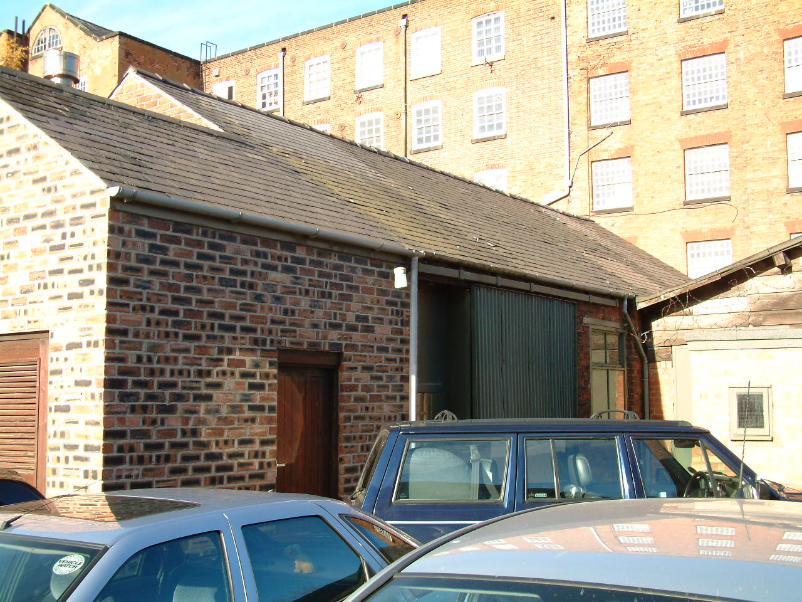 | Building | The Bobbin  Shop (21)
 | Date of Construction | c.1840 (V)
 | Listed? | Grade 1
 | Occupier in 2006  Occupier in 2012 | Patterns (Derby) Ltd
Use in 2006 - Used as workshops for Patterns (Derby) Ltd.

Use in 2012 – Same as above
Condition in 2006 - Areas of the slate roof tiles have been replaced with a non matching slate tile. The replacement tiles, the clips holding tiles in place and, the plastic rainwater goods show that maintenance has been attempted on this building. However, the cast iron downrite located between this building and the Engine House is defective. Plant growth, green staining and white efflorescence was noticed below this defective pipe.

Condition in 2012 – Same as above

Description - 4 bay, single storey building of brick construction with slate roof tiles. A small extension has been added and constructed from modern bricks which do not match the originals on the rest of the building.

 | Building | The Watch House (10)
 | Date of Construction | Late 18th century or early 19th century. (G)
 | Listed Building? | Grade 1
 | Owner in 2006  Owner in 2012 | Ellison Metal Products  Darley Abbey Properties Ltd
Use in 2006 – Used by employees from Ellison Metal products to eat their lunch and, as a base to occasionally used to collect tolls.

Use in 2012 – Used as the Tollhouse at peak times of traffic passing through the site.

Condition in 2006 - This structure although listed is in poor condition, it shows obvious signs of a lack of maintenance and repair programme. Some slates are missing and some have slipped. The paint is largely defective on the walls and much of it is peeling, some brown staining is also evident. The paint covering on the windows is flaking and peeling, and a few panes of glass in the windows are either broken/missing.

Condition in 2012 – There are signs of maintenance, repair and use. The
missing and slipped tiles have been replaced, the broken or missing glass has also been replaced in the windows, the paintwork to windows and doors have been re-applied. There are signs of the brown staining as mentioned above coming through the new paintwork on the render at the base of the building.

Description and Key Features – A single storey, octagonal building with a tall chimney, constructed from brick which has since been rendered and painted, it has slate roof covering and multi-paned windows. As this building is close to the bridge it is one of the first buildings a visitor to the site would see and pass.

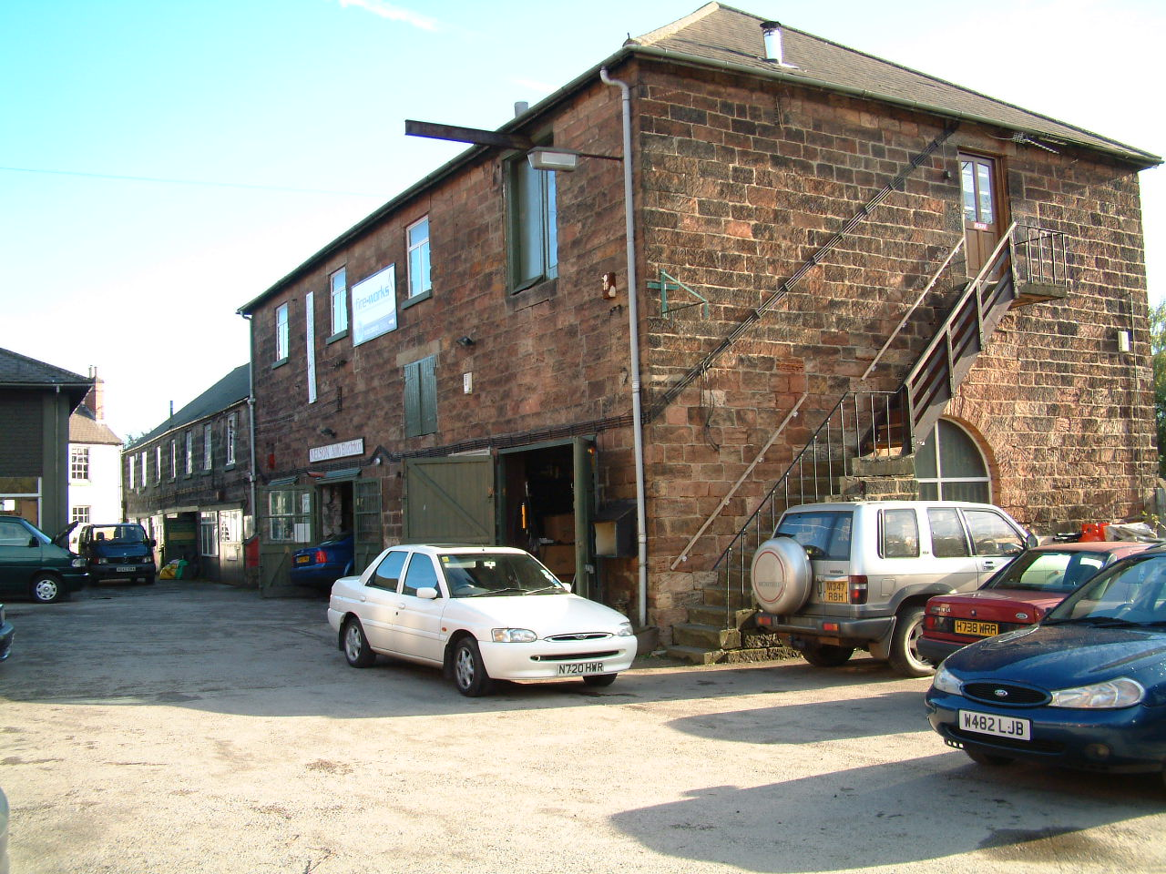 | Building | Sawmill and workshop (12)
 | Date of Construction | By 1881/82  (V)
 | Listed Building? | Grade 2
 | Occupier 2006  Occupier 2012 | Multiple  Multiple
Use in 2006 - Used by: Nelson Auto Electricals, Abbey Restorations, Brian Doleman joinery, Derby Road and Race Ltd.

Used in 2012 – Same as above

Condition in 2006 - Slipped/missing roof tiles in places, clips are also evident. Inappropriate mortar repairs to the stone blocks on the rear elevation. Areas of missing pointing but also some re-pointing with an Ordinary Portland Cement based substance. The is a gap appearing where mortar has fallen away between the sawmill and the workshops. On the side elevation, where the external staircase is located, there is a large crack above the stone arch but below where the wooden fire escape is fixed to the masonry.

Condition in 2012 – Overall the condition is the same as above but, the missing roof tiles have been replaced, although they are of a colour and size which do not match the rest and so the repair is obvious, however, the roof is weather resistant.

Description and Key Features - The Sawmill is 5 bays and 2 Storied, with a hipped roof, a wide opening on the ground floor, a loading door, external stone stair on the west gable and a variety of windows on the upper floor on the eastern elevation.

The workshop is a lower 7 bay building with multi-paned windows with central hinged casements on the northern elevation.

Both sawmill and the workshop are constructed from tooled gritstone blocks with slate roof coverings and neither have windows on the rear elevation. The fact that this range of buildings are constructed from stone rather than red brick distinguishes them from the other buildings on the site. Workings of the sawmill are evident.

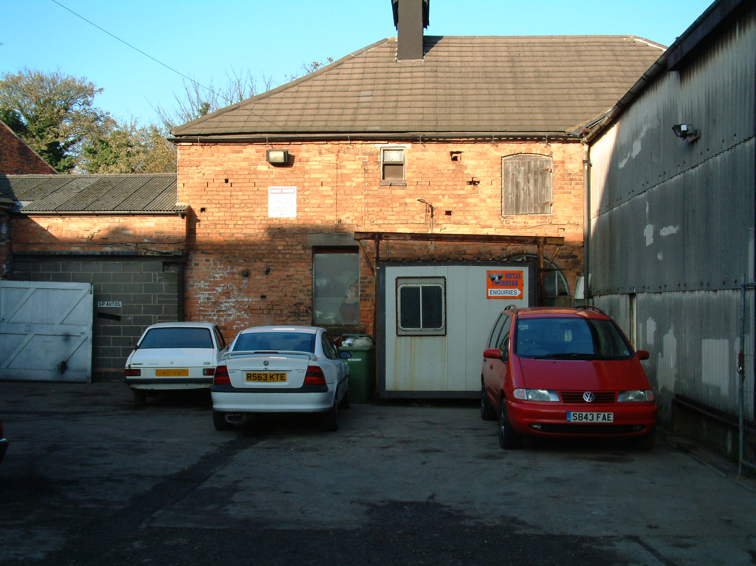 | Building | Stables (18)
 | Date of Construction | By 1881/82  (V)
 | Listed Building? | No
 | Occupier in 2006  Occupier in 2012 | M.H. Annable & Sons Motor Engineers  As above
Use in 2006 – The lower storey is utilised by the occupiers but first floor does not appear to be in use.

Use in 2012 – Same as above.
Condition in 2006 - Large plain concrete roof tiles appear to be in good order but are a heavier replacement for the original slate roof covering. The plastic rain water goods seem to be in working order. The paint on doors/windows has failed. Missing bricks. Efflorescence/green growth at the base of the walls.

Condition in 2012 – As above

Description and Key Features - A 2 Storey structure constructed from red brick with a hipped roof structure currently covered by large concrete tiles. A corrugated structure has been attached to the building at some stage. River view from rear of property

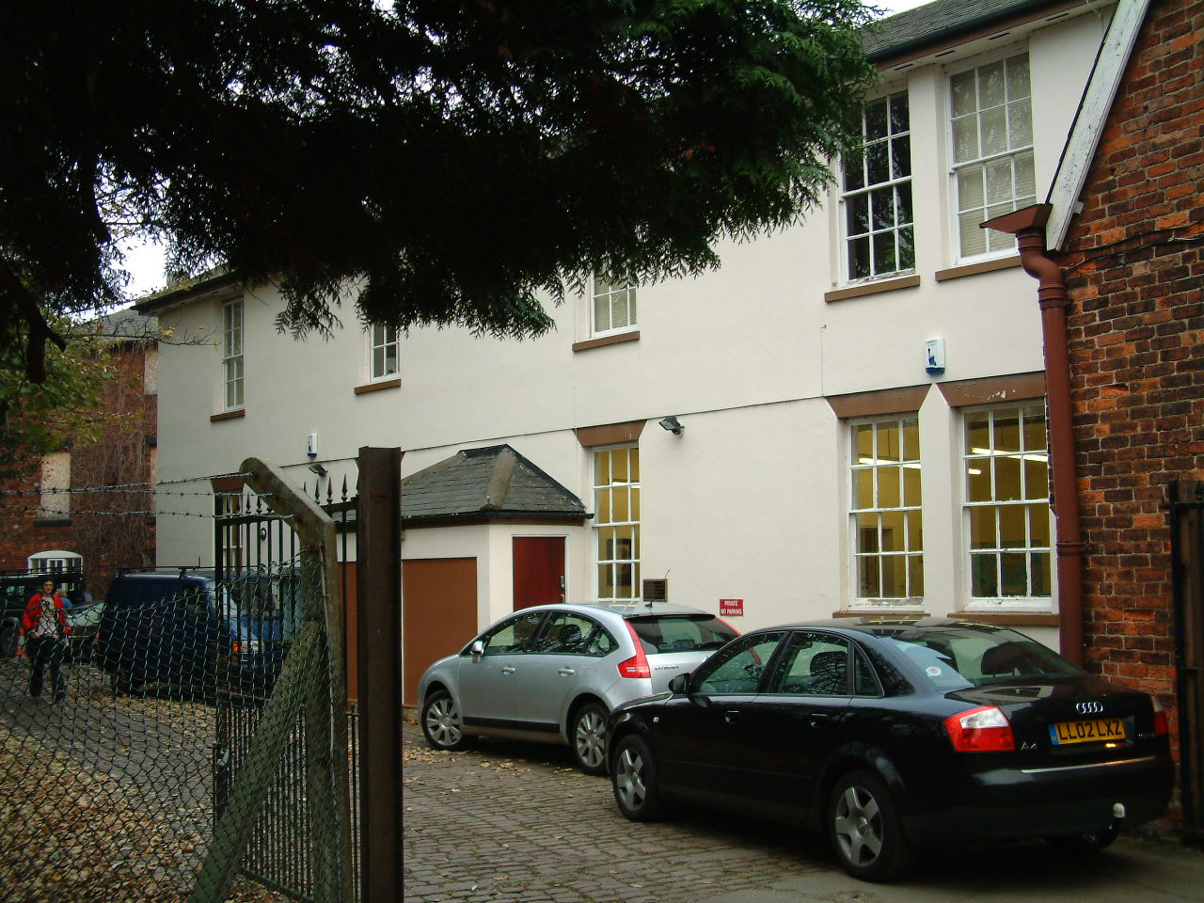 | Building | Offices (11)
 | Date of Construction | Post 1881/82 but pre 1938 (V or later)
 | Listed Building? | No
 | Occupier in 2006  Occupier in 2012 | Multiple
Use in 2006 – Offices for Hiller Investments ltd, Elthorne Investments Ltd and, Fryer Investments Ltd.

Use in 2012 – Mackney Photography
Condition in 2006 - A few slipped tiles. The plastic rainwater goods are in good working order. The painted render wall covering is largely in good condition but there are signs of damp at near ground level. On the side elevation there is a repair which, has been carried out without expertise and, the bricks appear to be placed in the hole with little/no mortar.

Condition in 2012 – Slipped tiles and damp appear to have been rectified, new paint has been applied to render and exterior woodwork in line with colour scheme adopted throughout the site.

Description - A 2 storey rendered building with slate roof covering, a later replacement or infill.

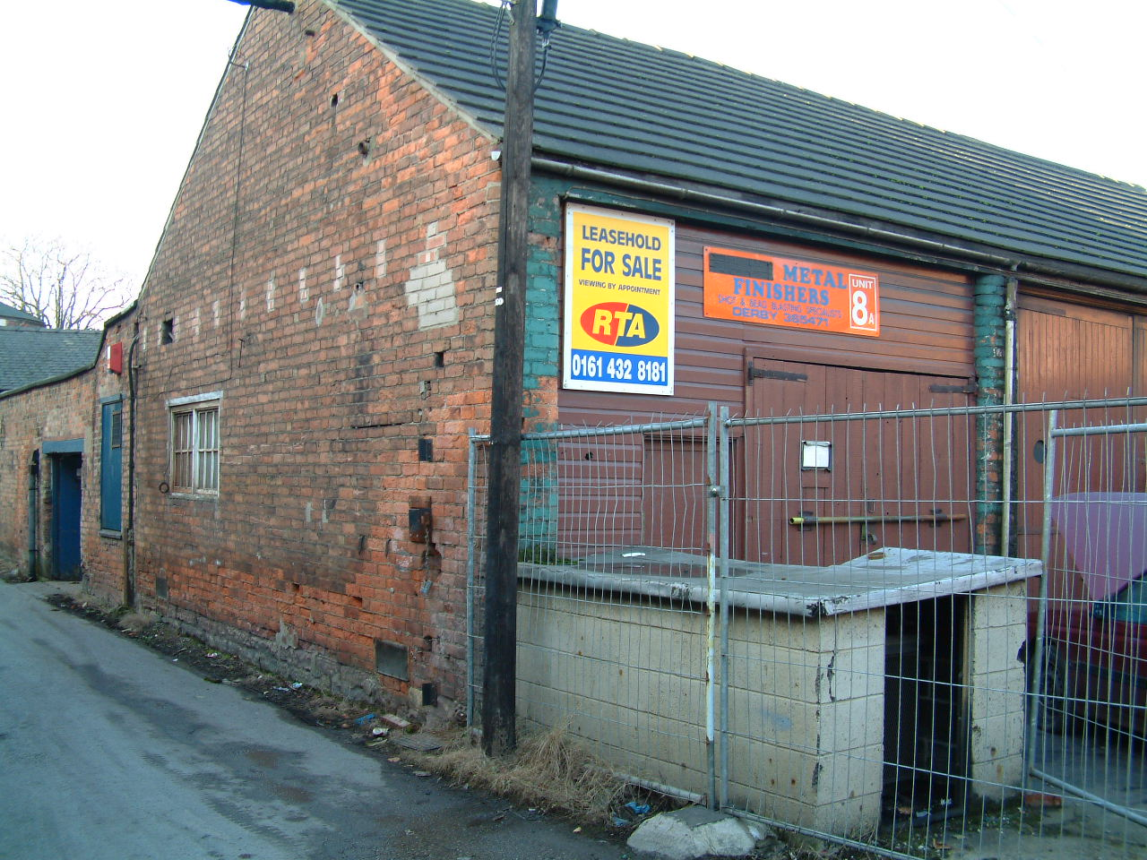 | Building | Open Fronted Store (19)
 | Date of Construction | After 1811 but before 1881/82 (V)
 | Listed Building? | No
 | Occupier in 2006  Occupier in 2012 | S P Auto Services – Metal Finishers  Metal Finishers Ltd
Use in 2006 – Used as workshop space for the repair of vehicles.

Use in 2012 – A above
Condition in 2006 - The large concrete roof tiles are in good condition but are a heavier replacement for the original slate covering. The plastic rainwater goods are old and discoloured but still work. The brick piers have been painted but this is now flaking/peeling. The bottom 2 courses of the side wall are stone and the rest is red brick. Signs of deteriorating brickwork and efflorescence perhaps due to splashing from traffic. There are also areas of inappropriate mortar repair on this wall. Paint covering on the side window has failed but the paintwork on the large timber doors appears largely sound.

Condition in 2012 – As above.

Description - A single storey building which was originally open fronted but has subsequently been filled in to provide workshop space, constructed from red bricks with a roof covering of large concrete tiles which are probably a later substitute for the slate roof covering which is prevalent throughout the site.

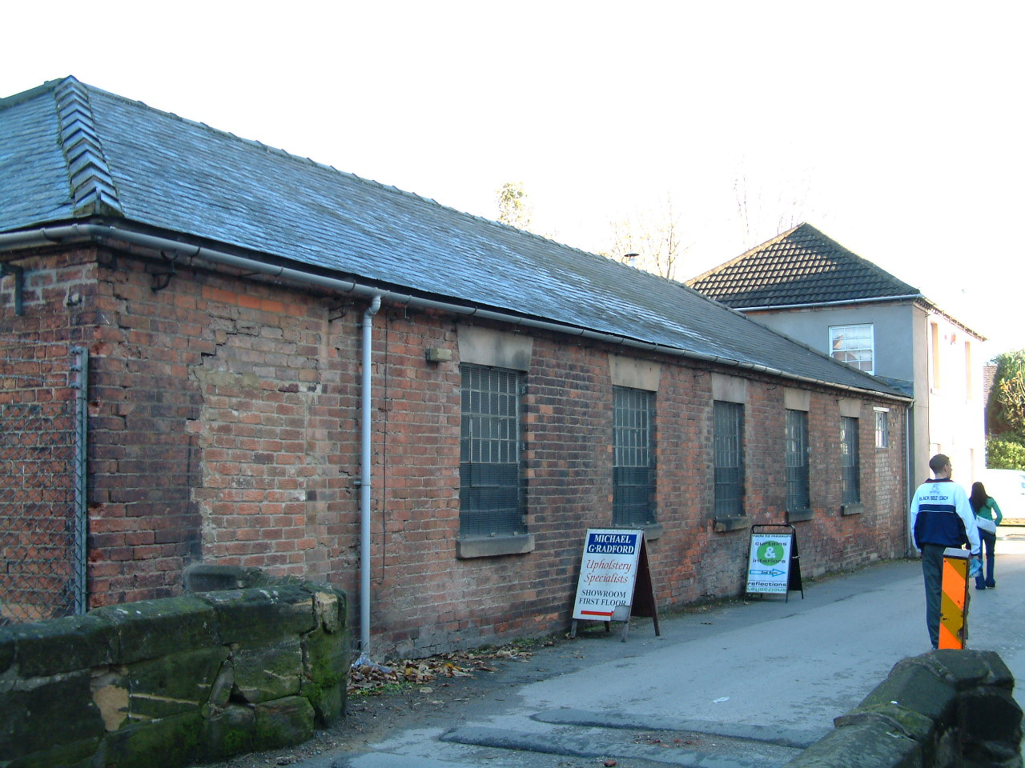 | Building | Gassing Shed (24)
 | Date of Construction | By 1881 (V)
 | Listed Building? | No
 | Occupier in 2006  Occupier in 2012 | Unknown  Creative Wealth Solutions
Use in 2006 - No current use.

Use in 2012 – Office space for Creative Wealth Solutions (Financial Advisors)
Condition in 2006 – Bricked up door openings, failing paintwork on windows, missing pointing, efflorescence along the front elevation of the building due to splashing from the traffic which passes close to it. Roof appears to be in overall good condition.

Condition in 2012 – Same as above, but paintwork on external wood has been renewed to match the colour scheme utilised in much of the site.

Description - A single storey building constructed from red bricks with slate roof covering

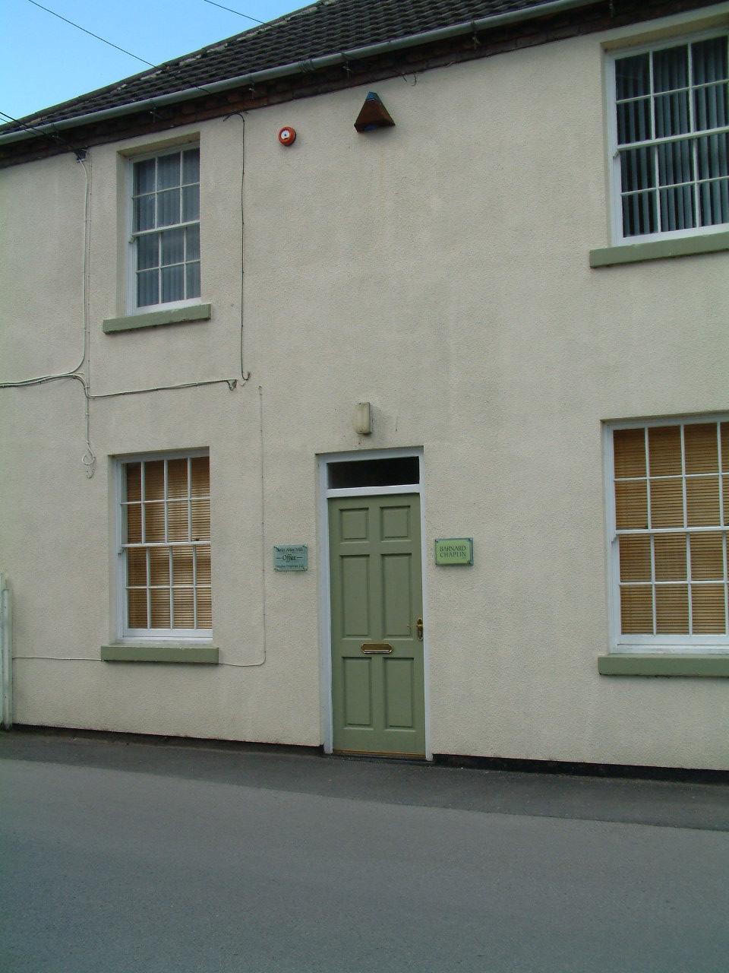 | Building | 5 Old Lane (15)
 | Date of Construction | By 1881 (V)
 | Listed Building? | No
 | Occupier in 2006  Occupier in 2012 | Unknown  Darley Abbey Properties
Use in 2006 - No current use.

Use in 2012 – Office space for Darley Abbey Properties Ltd and Barnard Chaplin
Condition in 2006 - The roof covering appears to be of sound condition as are the plastic rainwater goods and the render and exterior paintwork.

Condition in 2012 – As above, the exterior paintwork and render has been re-painted in the same colour scheme as utilised throughout the site.

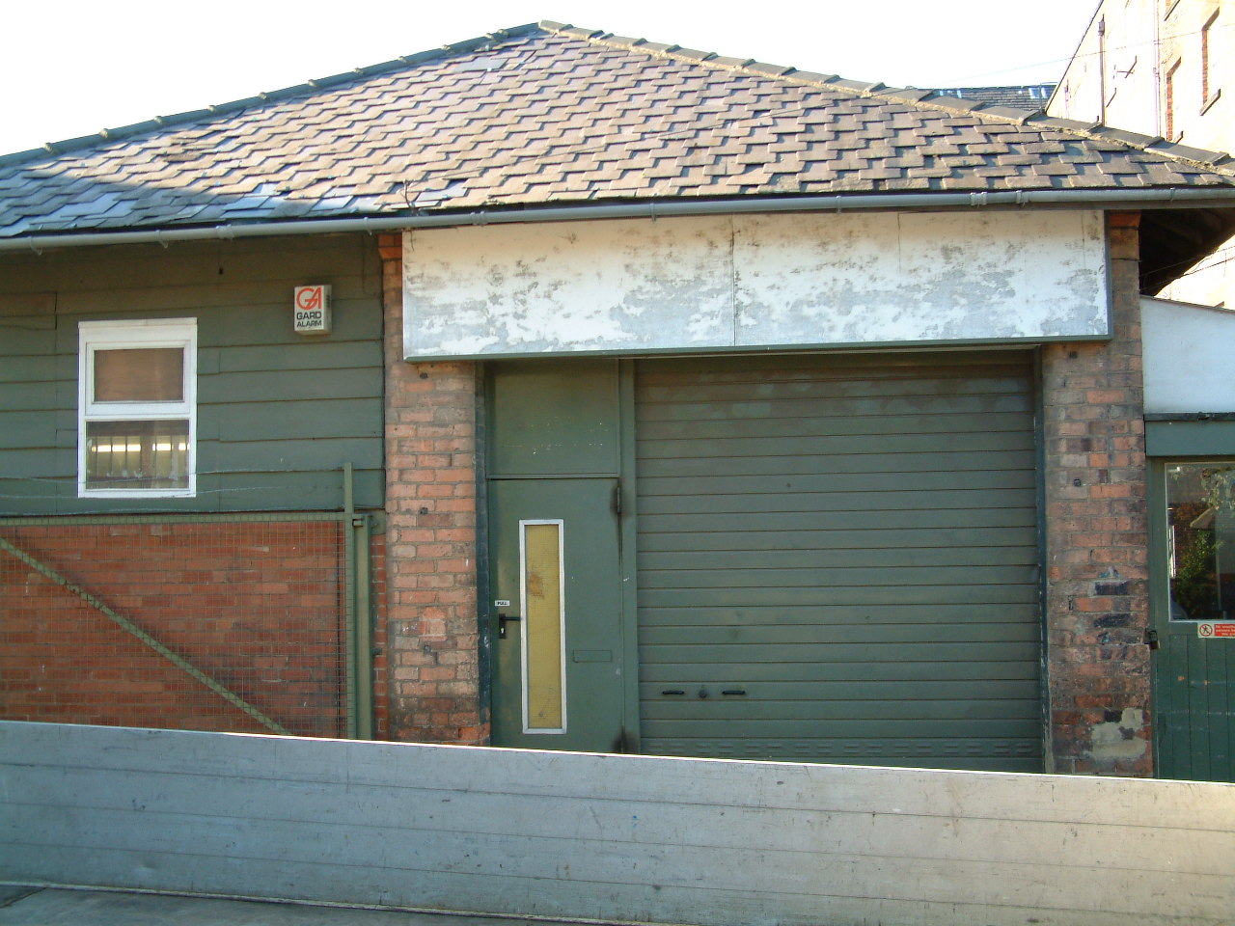 | Building | Coppice Barn A (22)
 | Date of Construction | By 1881 (V)
 | Listed Building? | Grade 1
 | Occupier in 2006  Occupier in 2012 | Patterns (Derby) Ltd  ABC Cabinet Fittings
Use in 2006 – Used for the production of metal components.
Use in 2012 – Used as workshop space for ABC Cabinet Fittings.

Condition in 2006 - Some slipped roof tiles, large tiles added, clips evident. The brick pillars have not been painted but new bricks have been used as replacements and there is also OPC mortar repairs to bricks in places. Plastic rainwater goods appear in working order

Condition in 2012 – As above. Woodwork has been painted to match the colour scheme adopted throughout the site.

Description and Key Features - A tall single storey structure which originally would have had slatted sides, now the brick pillars are evident but the slatted sides have been removed and in-filled with brick and wooden panelling to provide workspace. Ventilated slate roof.

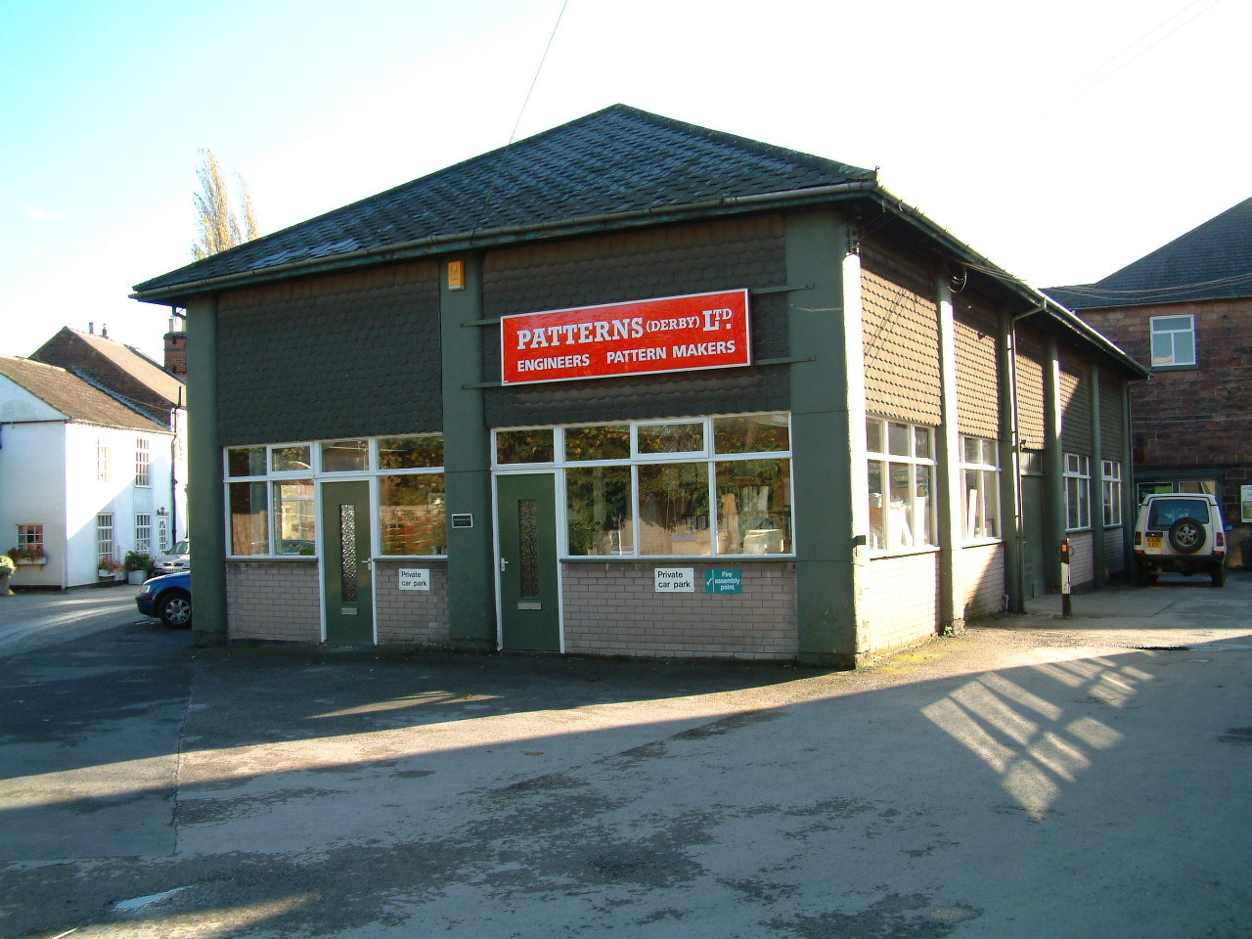 | Building | Coppice Barn B (23)
 | Date of Construction | By 1881 (V)
 | Listed Building? | Grade 2
 | Occupier in 2006  Occupier in 2012 | Patterns (Derby) Ltd  Patterns (Derby) Ltd
Use in 2006 - Used as office and workshop space

Use in 2012 – As above
Condition in 2006 - Some slipped tiles, ad-hoc repairs and clips are all evident. All the brick pillars have been rendered and then painted, this covering is flaking near to the base of most of them. The plastic rainwater goods appear old but working.

Condition in 2012 – As above, render has been re-painted and new sign, both in colour schemes to match that adopted in the rest of the site.

Description - A tall single storey, 5 bay by 5 bay, L shape structure, ventilated roof, brick piers, this building would have originally had slatted sides.

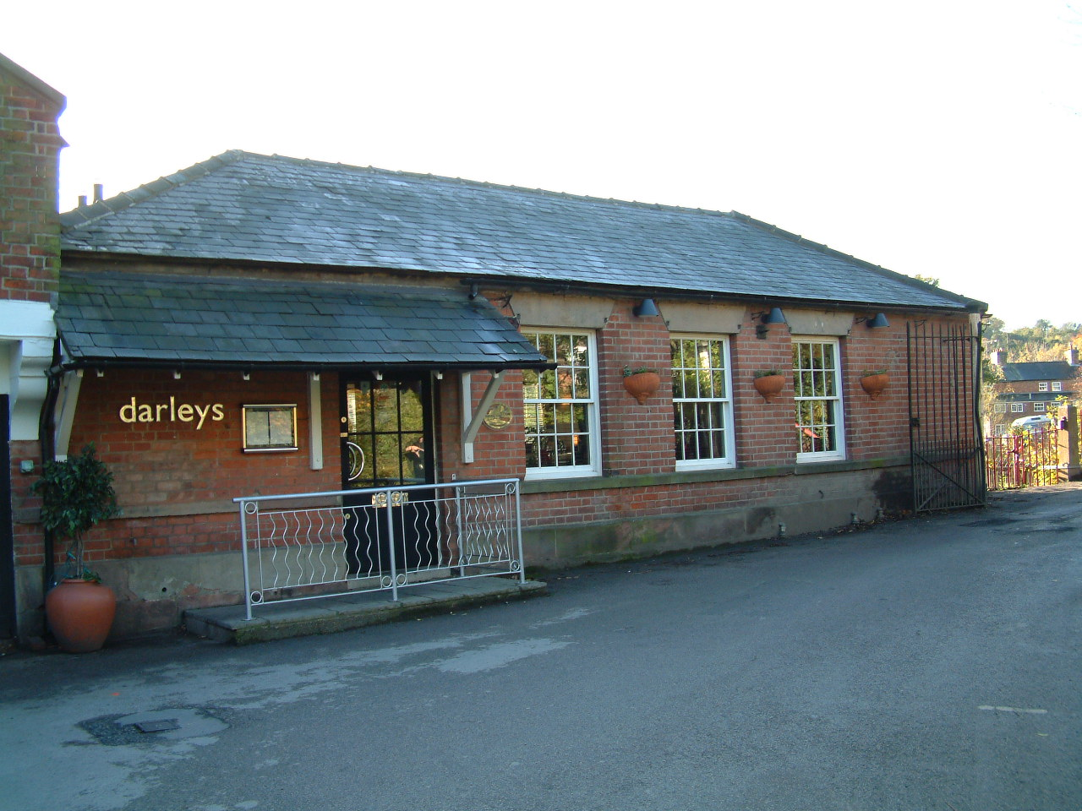 | Building | Canteen (17)
 | Date of Construction | By 1881 (V)
 | Listed Building? | No
 | Occupier in 2006  Occupier in 2012 | Darley’s Restaurant  Same as above
Use in 2006 - Used as a restaurant.

Use in 2012 – Use above continues.
Condition in 2006 - The roof covering appears to be in good condition with no slipped or missing slates. The black plastic rainwater goods are in good order as is the pointing and the paint covering on the windows and doors. There is a patch of green mould on the wall just above the stone 1st course. Underneath the Darleys sign, the bricks are modern and have hoes drilled into them, perhaps due to an earlier sign/name?

Condition in 2012 – Same as above.

Description - A single storey building attached to the west end of West Mill, the bottom 2 courses are stone with red brick above, slate roof covering and vertical sliding sash wooden window with stone string course and lintels. Spectacular river views, situated by the weir, and the first building reached by pedestrian access from the bridge.

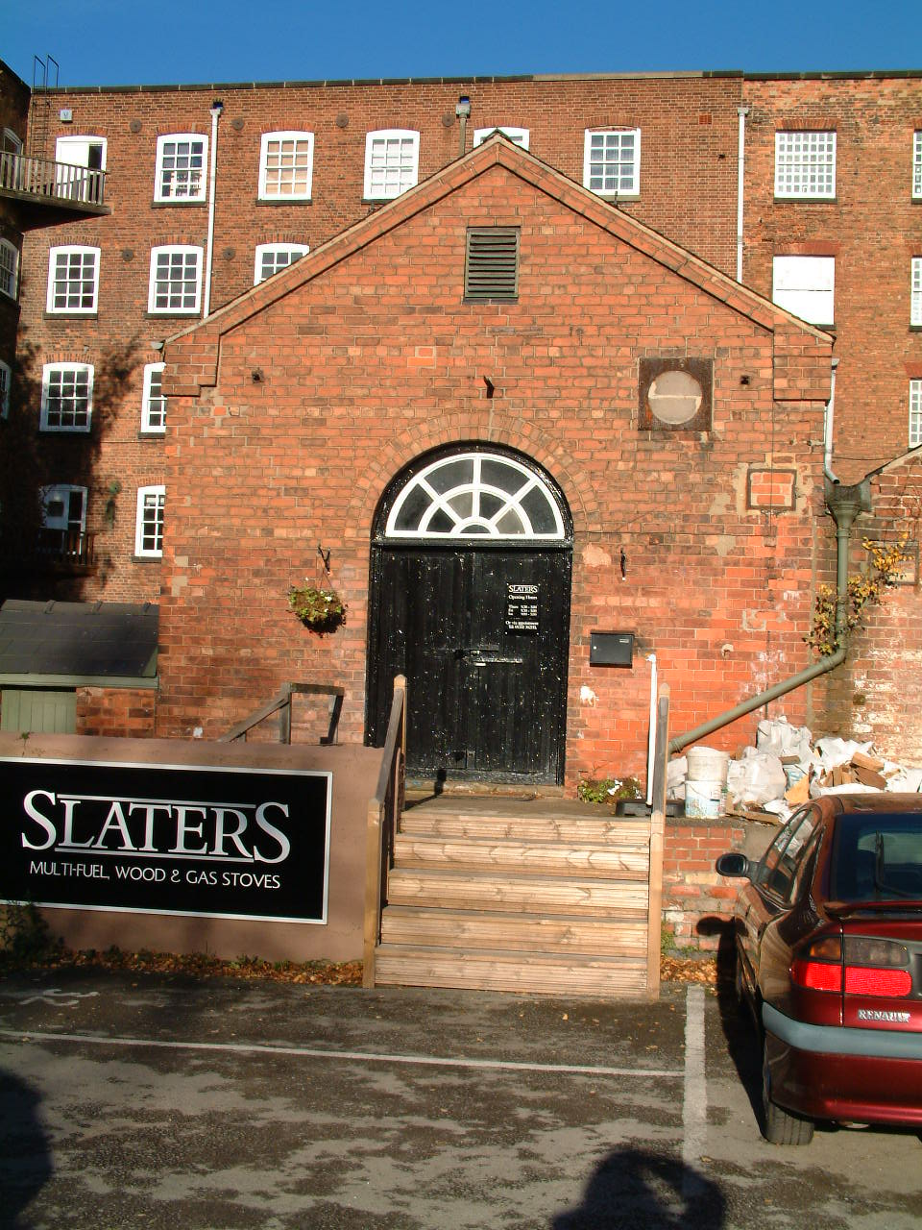 | Building | Engine House (26)
 | Date of Construction | c.1896 (V)
 | Listed Building? | Grade 1
 | Occupier in 2006  Occupier in 2012 | Slaters Multi-fuel, wood and Gas Stoves  As above
Use in 2006 - Used as a showroom and office accommodation.

Use in 2012 – As above.

Condition in 2006 - The slate roof covering seems in overall good condition with 1 or 2 missing slates, ridge tiles appear sound. Inappropriate mortar repairs to brickwork. Old metal frames for possible for some sort of vents have not been removed on the front elevation and are now rusting, the holes have just been roughly filled in. The plastic rain water goods appear working but green staining on the masonry surface indicates failure at some stage. The paintwork is cracked and peeling on the double doorway. 2 windows have been removed, 1 opening has been boarded over, the other opening has been filled in with a piece of timber with 4 panes of glass placed in it, but this has been inset from where the original opening would have set (possibility of moisture ingress to exposed masonry?) Chimneys/vents have been fitted through 3 of the original windows, therefore original glass has been removed to accommodate this. On the side elevation, efflorescence appears on the masonry surface near to the ground.

Condition in 2012 – As above

Description - A single storey, 4 bay by 1 bay southward addition to Middle Mill. Constructed from red brick with slate roof covering. Attractive arch-headed windows on the side elevation with central hinged casements, brick arches above and flat stone lintels below. A double doorway dominates the front elevation and features a semi-circular non-opening fanlight above which mimics the shape and style of the windows.

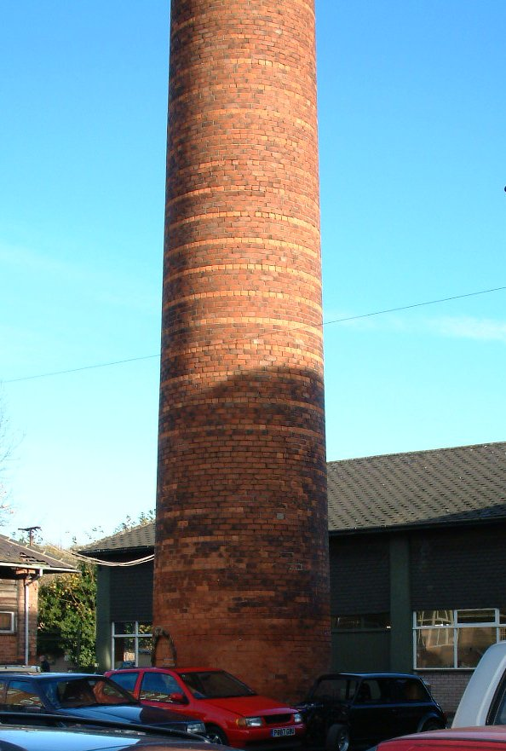 | Building | Chimney (27)
 | Date of Construction | 1890’s (V)
 | Listed Building? | Grade 1
 | Occupier | None
Use - No current use except as a landmark
Condition in 2006 - Missing pointing. Deterioration of bricks towards the top of the chimney. Arched entrance has been filled in with modern bricks. A crack appears above this arch. Efflorescence was noticed towards the bottom of the tower.

Condition in 2012 – As above

Description - Tall, circular chimney constructed from red bricks with different coloured brick on string courses. This is a landmark which is easily seen from either approach to the mill complex and is also visible from Darley Park.

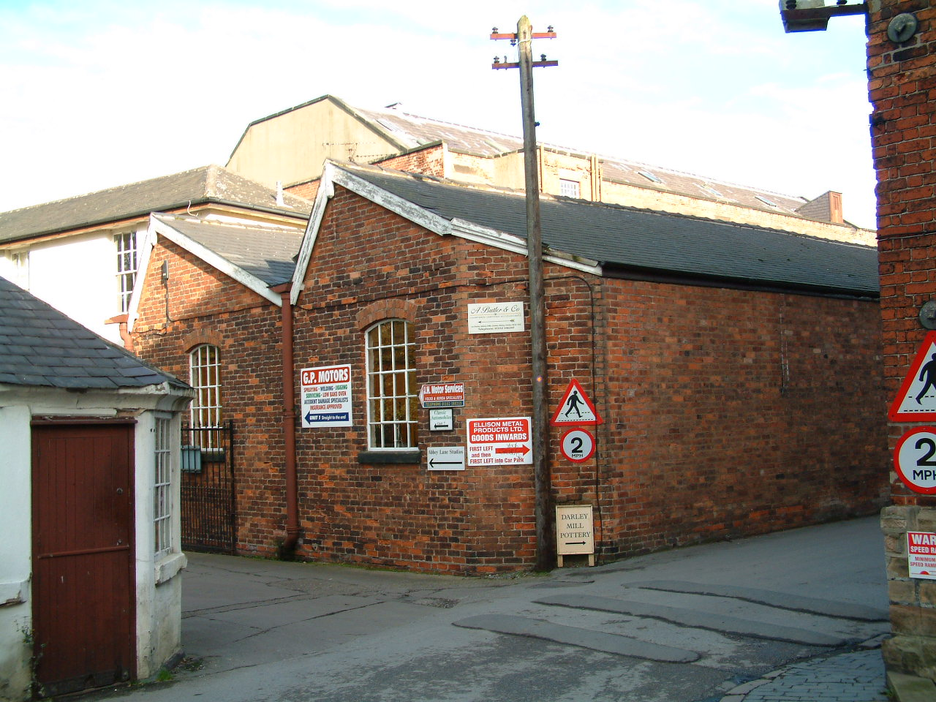 | Building | Polishing Shed (25)
 | Date of Construction | 1880’s (V)
 | Listed Building? | No
 | Occupier 2006  Occupier 2012 | Ellison Metal Products and J.H. Motor Services  Mackney Photography
Use in 2006 - Mainly by Ellison Metal Products but a small section (nearest to the Manager’s House) is used as a garage

Condition in 2006 - Some missing/slipped roof tiles. Flaking/peeling paintwork on timber at eaves level. The cast iron rainwater goods are showing signs of neglect – the foot of 1 drainpipe is missing allowing water onto the masonry surface which has resulted in green mould growth and the bricks appear to be damp. Plant growth either side of another drainpipe is a giveaway that the plastic section of pipe connecting the two cast iron sections is ineffective. Another pipe has come away from the wall, allowing water onto the masonry surface which now appear to be damp at this point.

Condition in 2012 – Render and external woodwork has been painted in accordance with the colour scheme adopted throughout the site.
Description and Key Features - A north lit, Single storey, red brick building with Gothic Gable windows. This property is an awkward shape as it sits behind the offices and butts up to the manager’s house. The north lit roof enables light to penetrate the building and therefore would provide a large, single storey open plan space for workshop/art studios.

 | Building | Cottages 1-4 (16)
 | Date of Construction | 1 = By 1852. 2 and 3 = By 1826. No 4 = c.1792
 | Listed Building? | Grade 2
 | Occupiers | Private Dwellings
Use - All used as separate dwellings.
Condition in 2006

Number 1 – Roof covering appears to be in reasonable condition. The mixture of black plastic and cast iron rainwater goods is in working order. The render is new. The paint covering applied to the brickwork is flaking. The paint which has been applied to the stone cills is flaking. The paint on the windows has also deteriorated but that on the door appears new.

Number 2 – Concrete roof tiles are in sound condition but are not original to the building. Black plastic gutters are sat on wrought iron brackets which indicate that this has replaced the original cast iron guttering, but is in working condition. The painted render on the walls appears sound. Modern replacement window are in good condition.

Number 3 – Concrete roof tiles seem sound but are replacements for the original. The plastic rainwater good look to be in good working condition. Painted render on walls appears sound. Modern doors and windows – sound condition. Ivy is growing up the side of this property and although the owners may consider this to be attractive its roots can be damaging to masonry surfaces and could help block gutters if allowed to grow up to this height.

Number 4 – The plain clay tiles look in good condition. The plastic rainwater goods seem to be working well. The paint covering on door and windows is sound. Some isolated inappropriate mortar repairs to bricks. On the side elevation a structure once attached to the property has been removed and a section of the wall at this point has been rendered, this is in as new condition.

Description and Key Features- Numbers 1-3 are a group of 2 storey terraced houses, brick build, located next to the eastern gateway of the mill complex. Number 1 still retains its slate roof covering but 2 and 3 have concrete pantiles. Numbers 2 and 3 are rendered and painted by Number 1 is rendered only up to the bottom of the ground floor window and painted above. Numbers 1 and 3 retain their sliding sash timber window but Number 2 has modern timber replacements with top opening.

Number 4 is a square brick built property with plain clay tile roof covering and plain ridge tiles and timber vertical sliding sash windows. Although this is now a single dwelling it may once have been split into 2 or more. A large arch now filled in is evident on the side elevation.

This is the only group of cottages within the boundary walls of the mill complex itself, other worker housing is a short walk away across the bridge back into the village but separate from the complex .

Condition in 2012 - Remains largely as above

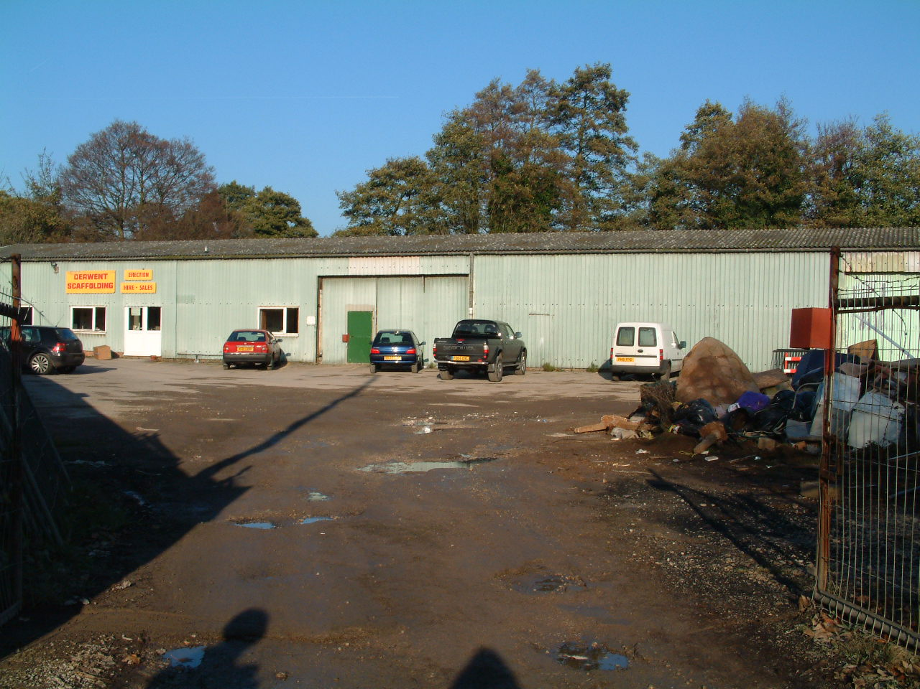 | Building | 26a- Works
 | Date of Construction | Mid-late 20th Century
 | Listed Building? | No
 | Current Occupier | Derwent Scaffolding
Used/Under-used/ Not Used?

Used

Description - A large single storey metal frame structure with corrugated metal sheet cladding and asbestos sheeting for the roof covering.

Notes - This structure is located in a good sized area of land, surrounded by a wall – this perhaps would make an ideal space for a car park.

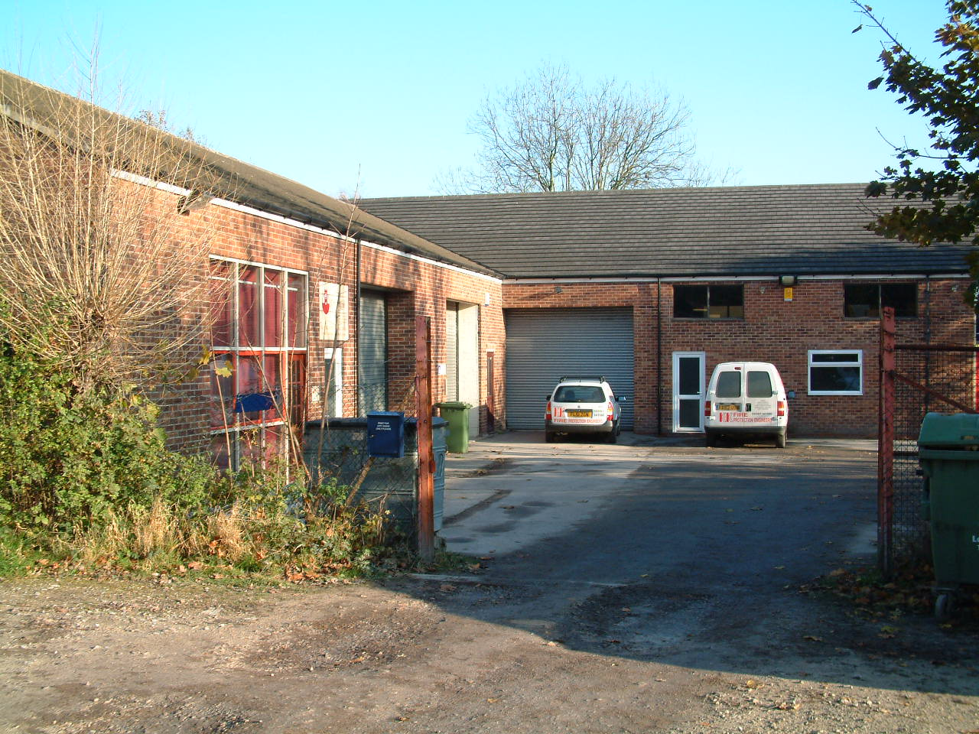 | Building | 26b- Works
 | Date of Construction | Mid-late 20th Century
 | Listed Building? | No
 | Current Occupier | Multiple.
Used/Under-used/ Not Used? | Used by Canine Hydrotherapy, K & K Fire Protection Engineers, City Signs
Description - A single storey range of buildings, constructed from red brick with concrete tile roof covering, metal framed and UPVC windows and doors and black plastic rainwater goods.

Condition - Roof covering, rainwater goods, brickwork, doors and windows etc are all in good condition with little signs of wear and tear, but this is to be expected from a structure of this age

Notes

Strength - Sited next to 26a – and therefore in conjunction with 26a could offer good alternative access and car parking space.

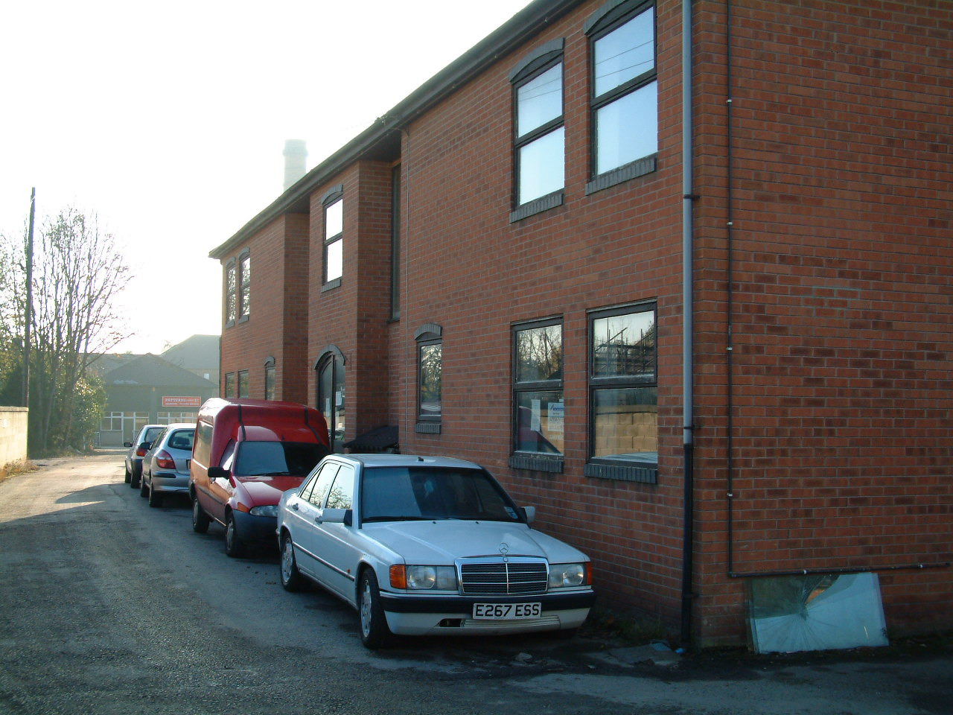 | Building | Modern Offices (33)
 | Date of Construction | Late 20th Century
 | Listed Building? | No
 | Occupier in 2006  Occupier in 2012 | Vacant  A. Butler & Co
Use in 2006 – Not used

Use in 2012 – Office space for a firm of accountants.
Condition in 2006 - Overall this building appears to be in good condition but the paintwork on the door and window is peeling and cracking. The building is currently unoccupied and therefore there are doubts of the existence of a maintenance programme, vandalism could also be a possibility.

Condition in 2012 – Overall this building is in good condition, now in use, with new double wooden entrance doors which replace the previous wooden framed glazed doors.

Description - Two Storey red brick office block with concrete roof tiles, upvc double glazed windows and doors with plastic rainwater goods

Appendix 4: Interview Transcripts

Transcript 1
Owner
I: Could you tell me how Darley Abbey Properties Developed at the Mill site in terms of buildings within the portfolio?

R: Patterns Ltd were established by my grandfather here at the mills in 1969 when they bought the Middle and East Mills, then subsequently the bobbin shop and the Coppice barn.

I: So the family were established in the buildings around the chimney?

R: Yes, that’s right, then when Ellison’s Metal Products went into Administration in 2010, KPMG were handling this and subsequently we bought the North Complex from them after negiotiations

I: So it, was the North Complex first?

R: Yes, just the North buildings first, not the Long or the West Mill at that time, that came afterwards.

I: Did you inherit some tenants along with the buildings in the North Complex?

R: Yes, yes, that’s right, we did inherit a couple of tenants in the proto-fireproof building and there were a couple of car repair workshops too.

I: There is a very different feel to the mills than there was 6 or 7 years ago, what prompted the change?

R: The strategy was always to develop the mills into a space for creative use and not engineering, it was trying to move away from that.

I: I’m interested in the actions and processes which have been undertaken in order to establish re-use, could you tell me a little about this?

R: For the North Mill we received a grant for £35,000, that was just to make it water tight in the first instance. We also installed a high speed fibre optic cable in 2012 which was necessary for the type of businesses we are trying to attract, they need a quick and reliable broadband service.

I: What actions did you have to undertake to get the buildings ready for occupation?

R: It was a fairly light touch, we updated the electrics and painted the interior walls white to give it a fresh feel. The business plan was to get 1 unit done, once there was a tenant for that one then we would move onto the next. The 1st floor of the North Mill was the first unit completed so we used that as a show office to other potential tenants.

I: So then, apart from updating the electrics and painting there was little else done?

R: Yes, we left them blank canvasses for the tenants to then put their own stamp on them and to organize the space as they needed, it was never intended to be overly-prescriptive and lay it out for them.

I: When did you purchase the Long and West Mills and what is the future plans for these buildings ?

R: We managed to purchase the Long and West Mills in December 2012, the idea for this part of the site is for it to become a venue for weddings but also for public access. I am interested in the heritage of the buildings, we have some photos on the wall here look of how these buildings were used.

I: So, although the machinery has been removed, the leats have been filled in and the workforce have gone is it a way of telling the story of the buildings?

R: Yes, that’s exactly what it is, telling the story, I would like to see guided historic tours here, but I would also like to see the space used for photographic exhibitions, some large photo’s of how the buildings were used would look good displayed alongside the exposed brickwork. I would really like to use part of the space for an art gallery, perhaps even get some Joseph Wright painting here, but that might be a little while in the future for that.

I: In a way then displaying paintings and photographs, would be taking the visitor through the circle of industrialization to de-industrialisation and then re-industrialisation without it being a static museum which we already have at Belper?

R: No that’s right, it wouldn’t be turning it into a static museum, but it would be a way of showing the historic journey of the site, a visual display of what the buildings were used for, why they are important but also the before and after, how they are used now and for the future. There is a uniqueness here in the Long Mill, the West Mill and buildings such as the Manager’s house.

I: Could I ask why the move away from engineering just to creative use?

R: One reason is noise abatement issues, the two don’t mix well, the light engineering is quite a noisy process, in my experience, the most successful ventures are where the site is within single ownership, which we are slowing achieving and, also that there is one theme which runs through the site, which for here will be more creative industries. The theme includes the co-ordinated paint and signage that we are using throughout, to provide continuity to the site. We have ear-marked, £300,000 for the middle mill roof and also the external fabric and roofs of the Long and West Mill as both of them are leaking

I: What input did you get form English Heritage and the Conservation team?

R: It has been a positive experience, English they have been very helpful partners the council have been very supportive.

I: What do you see for the future of the Mills? What is the long-term strategic direction?

R: The West will be the window to the site, there will be more there for public interest. The long-term strategy is to take the mill complex to 100% occupancy. We will be submitting planning application in July, hopefully we will get approval by October so that we can turn these spaces into a mix between a venue for Weddings and events, but also art gallery space but also a social space. In the more long-term future we would like to establish a hydro electric plant, to harness the natural power of the river, it would add to the image of re-use and sustainability we are trying to establish here, it would also generate a small revenue stream. The Long Mill will be more creative office space, with glazed partitions which don’t have a huge impact upon the fabric of the building but also look good, we should then be able to get two 1000 square feet units per floor. We would also like to provide co-working space, almost a pay as you go concept, so co-working space and incubation units.

I: In a way then, this is providing a way for new businesses to establish themselves within the site?

R: Yes, they can in effect rent a desk out and then as they grow move into larger spaces if and when they need to. We intend to keep the space as open plan as possible, the charm of these large mill buildings is the fact they offer large open plan spaces and we don’t want to loose that. The unique selling point is the heritage and the environment, I like the regeneration story, helping to preserve for the future. We are in the DE22 catchment area for people to walk to work. These old buildings are running cost efficient, the preserve heat, the windows are good, there is natural ventilation they are cool in summer.

I: The image you wish to portray for the contemporary use of the mills is a dramatic shift from the image the mills had a few years ago?

R: Yes, the image for the mills now is that of young trendy businesses, with a similar demographic, it will be in effect a cluster similar to that seen in Clerkenwell where myself and my brother both worked previously.

I: Was it that previous experience that was the inspiration and catalyst for this shift here in the mills?

R: It was, we envisage that the mills could become a cluster of creative industries, we would like to explore the idea of having some sort of hub-café, a break-out space for the occupiers to mix with each other but also a way of encouraging the public into the mills so they could see the history but also see what is being done at the mills now, be part of it.

Transcript 2
Tenant
Marketing and Digital Agency
Moved into 1st Floor of the North Mill (Grade 2* Listed)

I: When you moved into the North Mill, you were one of the first businesses back into the Northern part of the complex since Ellison’s metals vacated?

R: Yes, that’s right we moved into the North Mill in November of 2011, so we were the first business back into that building

I: What were your motivations for moving into Darley Abbey Mills?

R: To be honest the main motivation was to get out of the centre of Derby, we were located at the bottom of Friar Gate, the location wasn’t great, we were near to a half way house and so had that element hanging around the front door which wasn’t good for the image of the business, it intimidated our clients and visitors, and it intimidated some of the staff entering and exiting the building especially when it was dark in the evenings, they didn’t feel safe.

I: Was that the only motivating factor?

R: No, no, the building didn’t work for us either anymore, it’s layout was higgledy piggledy, it was on different levels, so it was fragmented, it didn’t make sense. It was ok when the business started as we were quite small and it was convenient but for the business moving forward, we needed an open plan studio on one level.

I: What actions did you have to undertake to get your business up and running?

R: When we took the space it was an empty shell in need of renovation, so we put a kitchen in, filled in some holes, and installed a central heating system. We painted the floor too.

I: Why did you paint the floor?

R: Well, the previous tenants had done some strange things to the floor, they had painted part of it red and then in another area they had stuck carpet tiles down on old carpet tiles, which looked a bit odd. We would have liked to have restored the floor to be honest?

I: Would that have been a major restoration project?

R: Yes, that’s right it was more than we wanted to take on at the time as we needed to get moved in and up and running. It was more than we could handle in terms of time and also money. So we painted the wooden floor a sort of white grey colour to get rid of the red, so it was nice and light and then replaced the carpet tiles with new ones.

I: So restoring the floor is more of a future project?

R: Yes, that’s right, we would still like to do that at some stage in the future as it would look good, it’s something that we can come back to.

I: Was the character of the place a major attraction?

R: Yes, the fact that it has character, it was what we were looking for, the open plan nature of the space too. We have down lights which light the exposed bricks up, it looks nice, the sash windows and the natural light all add to it. Nothing changed that much when we came here.

I: So minimal intervention?

R: Yes, we were careful with the work we did, we knew we wanted to be sympathetic to the old mill. It already had a partition for the boardroom and office, so we repainted it but kept it.

I: Did you get what you needed out of the renovation?

R: Yes, we did, we had one problem though, the nature of the business we do and the clients we have we heavily rely on technology. When we were first here we had 4 broadband lines which were shared, we had 2 BT broadband lines and 2 Opal broadband, so in the school holidays or at peak times when the kids come home from school and early evenings, that meant that the whole system was slow which was a problem for the size of files we deal with.

I: Are things improved now with the fibre optic cable that has been installed on the site?

R: Yes, yes, that is much better for us, much more reliable and quick now. The VOIp (Voice over internet protocol) system we have does not work on two of the lines with the fibre optic system but we can work around that.

I: What were the benefits of moving to North Mill for your business?

R: We are very busy so we have room to expand here if and when we need to, it is a nice quiet, peaceful, pleasant environment to work in, you can think. We have an office dog, so it’s nice that we can go and take him a walk to the park in the lunch time and get outside in the fresh air to clear your mind.

I: So is it about quality of life but also prestige value?

R: Yes, it is, it is a better environment to work in, the clients love it here, we can have the dog in here, there’s parking just outside for the clients and us. There is a diverse mix of businesses in here now, there are other design companies too.

I: Now, you have been located within North Mill for a year or so, are there any drawbacks?

R: There was plenty of parking to start with, you could always find a space near to the door whenever you came in. But as there are more business the car park is busier than it was, and so sometimes it is more difficult to park.

I: I see, but that is not a major problem at the moment?

R: No not at the moment, you can usually find somewhere but it might be an issue in the future?

I: Were there any other issues with the building itself:

R: No, no I don’t think so.

I: From experience of living in old buildings, they can have issues with thermal efficiency, I know you said that you had installed a new central heating system, so this is not a problem?

R: Oh, I forgot about that, no it is a bit chilly at times. The first winter we were here we had all that snow at Christmas, do you remember?

I: Yes, it started in at the beginning of December and carried on until January didn’t it?

R: Yes, that right it did, well we had the central heating turned up to 30 degrees so we were nice and warm and then we got a ridiculously large heating bill, which didn’t help when the staff left it on all weekend either.

I: What actions have you taken since?

R: Well they have to turn the heating off before they leave at weekends and, we try not to have it on that high, we wear a jumper instead, luckily it’s not been that cold since.

I: On the whole a positive move overall?

Y: Yes, we had a few teething problems in the beginning but, it is a good environment to work in, it gives us the space we need.

Transcript 3
Park User 1

I: How often do you come to Darley Abbey Park,
R: I don’t really ever come here for the park, I sometimes come maybe once a month to have lunch at with some friends at Darley’s, it is a very good restaurant you know. Have you been?
R: Yes, I have been, only a couple of times.
I: If you don’t mind me asking, if you don’t use the park, why are you here?
R: I always try to find a car parking space in the village or down on the front because I know I won’t be able to park at Darley’s, also I feel a bit uncomfortable parking the car there, I’m not sure it’s safe and, the spaces are a bit tight ad I hate parking. Also, there are some big bumps there that always seem to catch the bottom of my car so I’d much rather park in the village and then walk down. It’s also quite nice to walk through the park after you have had lunch as long as it’s not raining.
I: When you are here, do you have a look around the mill site?
R: No, just go the Darley’s and back and anyway there’s not much to see, it’s a bit like a posh industrial estate really.
I: You say it is like an Industrial estate, but there are some quite interesting businesses there
R: The place is a bit scruffy and also I would feel uncomfortable going any further than Darley’s because it just doesn’t feel right.
I:Do you normally go to Darley’s in the lunchtime or in the evenings?
R:Usually at lunchtimes but if we are having a special celebration then, we’ll go in the evening.
I: Does the place have a different feel at night?
R: I don’t like the feel during the day, never mind when it is dark, it just seems really creepy, it’s easier to park there at night-time but I just want to get from the restaurant to the car park as quickly as possible, I don’t like it. If I was on my own, there is no way I would come here at night. Even my husband doesn’t like it.
I: Do you think that there is anything that they could do to make you feel more comfortable there at night?
R: It could be better lit, but even then it is still a creepy place.
I: Is the history of the mills important to you?
R: I should say yes, but actually I just like the food at Darley’s and in the summer it is really beautiful when you can sit outside and look across the water.
I: That’s great thank you very much for your help.

Transcript 4
Park User 2
I: How often do you come to Darley Abbey Park?
R: We probably come here one, twice a week, in the winter less but in the summer a bit more. Now we’re retired, er, we have plenty of time and it is a bit of a treat.
I: Why do you come here so often?
R: We love it here, the dog loves it, it’s a nice way to spend a couple of hours. We walk around the park, the dog goes for a swim, we sometimes meet up with other people that we have met here with their dogs, have a chat and then we’ll maybe wander up and go and have a cup of tea in the gardens, it’s just a nice place to be, nice views, we all love water, it’s a great resource, you wouldn’t think that you were in the city.
I: How do you usually get here?
R: We usually drive, although it can be a real pain to park, sometimes we have to park, right up the top of the village and walk down, it would be better if we could just park down here, but I suppose the exercise is good for us, especially him as he always a bit tubby (dog).
I: Do you visit the Darley Abbey Mill site?
R: Er, no, it doesn’t seem very welcoming, erm, sometimes we’ll go and stand on the bridge and have a look down the river but that’s about as far as we go, I’m not sure whether we can walk around there if we wanted to.
I: Why do you think that?
R: Well, there’s all sorts of strange little signs about tolls, also there’s been a couple of times when we’ve been standing on the bridge and almost been squashed by a car, it seems private so no’ we don’t bother. Why would we want to when we have this lovely park to use.
I: Do you know the history of the mills?
R: A little bit, I know more about Cromford, we sometimes go there as well, it’s nice to walk along the rive, if it was close we would go there more often, there’s good parking, and it’s actually nice to walk around the site. Oh, you asked me about the history didn’t you, we know a little bit about Cromford and a little bit about Masson because we sometimes go there shopping, all I really know is that it’s part of that lot. Is it something to do with Wright as well, you know the man who has the paintings in the Museum there in Derby.
I: Yes, sort of. So a feeling of history of the mills and the village is not a strong motivation for you?
R: Erm, no not really, the main reason is the park, it has a nice feel to it.
I: That’s great, thank you for all your help.

Transcript 5
Park User 3
I: How often do you use Darley Abbey Park?
R: Twice a day, every day, come rain or shine. We live really close so it is a great place to take the dogs.
I: How far do you have to walk to get here?
R: It takes about 10 minutes but only 5 minutes to get home, the dog has to answer all his wee mails on the way here and wants his biscuit when he gets home so it’s much quicker.
I: Oh I see. So, do you live in Darley Abbey village?
R: I like to think so, but I don’t think this lot over here (nodding towards the village) see anything the other side of the bridge as being part of Darley Abbey.
I: I see, so you come from Haslam’s Lane direction?
R: Erm, yes, that’s right.
I: So you walk through the mill site everyday? What is it like walking through there?
R: Erm, sometimes it can be a bit busy, lots of vans and cars flying about, you have to be careful especially with the dog because you have to walk on the road as there is no footpath a lot of the itme, sometimes vans just come flying out without really looking. It’s the same when you have to come across the bridge although there is a little footpath either side.
I: Do you come through the site when it is dark?
R: In the winter twice a day as I take the dog out before work and then again when I come home.
I: Do the mills feel any different in the dark?
R: Er, actually when I think about it, I always speed up a little bit, sometimes there are some dodgy looking people outside some of the buildings. I don’t think it is dangerous, it’s just it makes you a bit more, erm, I suppose aware.
I: Is the history of the mills important to you?
R: Yes, I see myself as part of the Darley Abbey Community, it is an important site, it is part of what makes Derby Derby.
I: What do you mean by that?
R: Derby is an industrial city, sometimes people forget this, and I think that it is good to remember this.

