**Abstract**

People living with epilepsy are at greater risk of drowning in the bath, though comprehensive statistics are not well recorded and those that are do not include immersion accidents or survival following critical care. Nurses have little formal guidance to support them in exploring or managing bathing risks with patients, and there are currently no suitable disability aids for this purpose in the context of epilepsy. In a collaboration between nurses and engineers, this paper illustrates the development of four design protocols with potential for reducing the risk of drowning in the bath for people with epilepsy. The designs could also serve potential needs of the general public. However, much research remains to be done, and in addition manufacturing companies could apply innovative approaches in the products they develop to reduce the risks discussed, in collaboration with nurse advocates and service user groups.

**Key words**

Epilepsy, drowning, risk, prevention, equipment, new-product development

**Keypoints**

* As the risks of drowning are greater for people with epilepsy than the general population, individuals are advised not to bath without a chaperone.
* People with epilepsy may choose to bath without supervision
* There appears to be no suitable equipment available at present that could reduce the risk of drowning in the bath for people with epilepsy
* Protocol designs for equipment to reduce the risk of drowning in the bath for people with epilepsy have been designed and this could be developed for the general public to meet different needs.
* More needs to be known and understood about where information comes from for people with epilepsy on their risks and how individuals use this information and make decisions.

**Reflective questions**

* What awareness do you have of the causes of death for people with different types of epilepsy and what the risks of bathing might be?
* Do you make assumptions about whether people with epilepsy would take advice available and not bath alone?
* Are you aware of whether anyone you know with epilepsy takes the risk of bathing without supervision?
* What do you think the reasons might be when someone with epilepsy chooses to bath alone without supervision?
* What do you think the key features could be for equipment that could reduce the risk of drowning in the bath?

**New product development for reducing the risk of drowning in the bath for people with epilepsy.**

Introduction

This paper aims to introduce nurses and allied health professionals to a new development that focuses on reducing the risk of drowning in the bath for people with epilepsy. Epilepsy is a neurological condition that affects around 50 million people worldwide (WHO, 2023) with 633,000 of these in the UK (around 9 in 1000 people) (Epilepsy Action 2023). This number is added to by approximately 87 new diagnoses daily, and mortality is estimated to be 21 epilepsy related deaths each week (epilepsy research institute n/d).   Life expectancy is reduced by as much as 10 years for people with symptomatic epilepsy, and this is most acute around the time of diagnosis (Trinka et al 2023). Public Health England (PHE) report that death rates for people with epilepsy rose 70% between 2001 and 2014, compared to a 6% drop in deaths overall (PHE 2018). The Royal Society for the Prevention of Accidents (RoSPA) indicate that 16,000 people die from accidental causes every year in the UK though they report no specific details about epilepsy related deaths (RoSPA n/d, a).  Common causes of death for people with epilepsy include sudden unexpected death in epilepsy (SUDEP), co-morbid conditions and accidents including falls and drowning (Ostler et al. 2014). Cause of death can be misdiagnosed as SUDEP when a person is found in water (Cihan et al 2018), but this paper is concerned not with SUDEP, but with drowning’

It has been estimated that people with epilepsy have a 15-19 times higher chance of drowning than the general population (Bell et al. 2008), but it is difficult to establish accurate figures as the UK office for national statistics (ONS) for example, do not record this kind of detail, and coroner records are inconsistent. The way epilepsy deaths by drowning are described and classified is a matter for the coroner after hearing the evidence with deaths by drowning most commonly recorded as being due to an accident, suicide, unlawful killing or natural causes (L. Holmes, personal communication, 1/8/2023). The words ‘epilepsy’, ‘death’ and ‘drowning’ may be included in the cause of death, but accidental death could be the overall conclusion (P. Asker, personal communication, 1/8/2023). A response to a freedom of information (FOI) request to East Midlands ambulance service in August 2023 indicated that paramedic records can categorise a cause of injury as either ‘convulsions/fitting’ or ‘drowning/near drowning’, but all cases may not be identified due to variation in how ambulance crews record in free text (e.g use of abbreviations, alternative terms and spelling mistakes). The FOI request also indicated that it is possible that incidents may instead be documented as ‘cardiac arrest’ if that was applicable to the patient, even though they drowned.

The RoSPA (n/d, b) UK water incident database (WAID) reported that 67 people drowned in the bath between 2014 and 2022 (this data includes Jacuzzis and hot tubs), though details of how many of these are related to epilepsy is not available. In the 1990s two studies reported statistics on drowning in the bath; 15 of 482 (3%) drowning deaths were due to having seizures in the bath (unsupervised) (Ryan & Dowling 1993) and six people aged 5-18 were found to have died with seizures in the bath in Japan in 1991 (Osamura et al. 1997).  In a more recent Canadian study of autopsies (Ontario 2014-2016), Bain et al (2018) report a 10 times greater incidence of drowning in the bath than the general population, with 11 (44%) of 25 epilepsy drowning deaths occurring (‘unwitnessed’) in the bathtub. Cihan et al.’s (2018) investigation of American medical examiners cases found that 69.4% (n=25) of definite drownings and 81.8% (n=9) of possible drownings happened in a bathtub or hot tub.

Adults (with mental capacity) with epilepsy tend to be responsible for their own management and are generally advised to manage their risks such as being at heights, in traffic, near sources of heat and power or in water (PHE 2018). For people with learning disabilities, a population of people with higher rates of epilepsy (Robertson et al. 2015) this responsibility may lie with parents, guardians, friends, family or carers, potentially in care environments. Chaperones are recommended during bathing, but showers are recommended as safer than baths (Epilepsy Action 2019; NICE 2022). SUDEP (sudden unexplained death in epilepsy) Action (n/d) additionally recommend using a shower with a flat floor (so water does not collect), avoiding times when seizures may be most likely, ensuring someone is nearby in case help is needed, avoiding locking the bathroom door and the use of safety glass or a shower curtain to help minimise the risk of injury should a seizure occur. Using a shower instead of a bath seems to be consistent advice (RCPsych 2017; Epilepsy Action 2019; Nakagawa et al. 2019; NHS 2020), though there does not appear to be any research on the impact of this advice, and there is evidence of people with epilepsy drowning in the shower (Nakagawa et al. 2019).

Information and advice tends to come from Epilepsy Nurse Specialists (ENS), and although the Epilepsy Specialist Nurses Association (ESNA) have no specific guidance in place on this issue, the importance of talking to patients, families and carers about individual risk factors is recognised (P. Tittensor, personal communication, 24/7/2023). Bain et al. (2018) recommend that people with epilepsy should receive counselling on the increased risks of drowning, including information regarding the significant risk associated with bathtub use and that all people with epilepsy remain at an increased risk of drowning regardless of their apparent seizure control. However, a lot of information may be given at a first neurology clinic and details can subsequently be forgotten (Spencer 2016). There may be an assumption that once information is given in epilepsy clinics, people will take account of it, and NICE (2022) recommend repeating information to patients, family members and carers at subsequent times, according to individual needs and circumstances. Nevertheless, some people are taking the risk of bathing (with and without chaperone), without necessarily perceiving their decision to bath alone as a risk themselves (Collier and Grant 2021).

In a widely publicised case in the UK in July 2013 that led to a serious incident review, Connor Sparrowhawk (aged 18) drowned in the bath during a seizure, whilst in a care home (Verita, 2015). This indicates that people can die due to having seizures in a bath even if they live in a supervised environment, particularly if staff are not sufficiently aware of the implications and risks with epilepsy (Verita 2015). No mention is made in the serious incident review of equipment that might help prevent such an accident (Verita, 2015).  To date, despite advances in disability living aides, no equipment appears to exist to reduce the risk of drowning if someone has a seizure in the bath. Available products for seizure detection such as heart rate monitors and electrodes on the skin and also bath seats and other products to aid people with physical disabilities are not specifically designed to address risks of drowning in the bath, therefore, the question of whether a piece of equipment could be developed for this purpose was considered in an interdisciplinary collaboration between nurses and engineers. Initially, a third year Bachelor of Arts (BA) product design student was supervised in developing a piece of equipment to prevent the risk of drowning in the bath for her degree dissertation (Hayes 2021). The remainder of this article outlines this whole process.

New product development

The whole project took place from September 2020 to May 2022. The general design methodology of engineering problems begins with research into the issue of interest, with the aim of defining a product need and a set of criteria which serve to specify the design of an effective solution. The principles of a human centred design approach (Norman 2013) guide development of a solution which seeks to consider the needs of the user as a primary focus. To fully develop an outcome the designer should consider the task from a range of perspectives including functional characteristics (component size, material behaviour, loading requirements), manufacturing requirements (those affected by material choice, production volumes), sustainability factors (materials, product lifecycle, manufacturing processes and location), and economic constraints (market size, demand, customer characteristics, competition). Other factors concern the needs of the user such as ergonomic requirements, aesthetic considerations and the semantic interpretation of the product. The result of this process defines a range of creative ideas, which through development and testing, result in a set of design concepts. These can then be evaluated and refined using a range of techniques such as sketching, model making and computer aided design.

Based on the detailed exploration of issues described above, the conclusion of this phase of the project resulted in the following objectives;

* Prevent or minimise the risk of drowning in the bath
* Be compatible with most common designs of baths
* Fit a wide range of users (5th to 95th percentile adult data used)
* Simple to use (or difficult to misuse)
* Present as little impact as possible on the users’ experience of having a bath
* Economically accessible to all

Hayes (2021) worked on the new product design throughout one academic year (2020-21), gathering research, developing concepts and testing ideas through an iterative process that led to an initial solution at the end of the project (see figure 1).

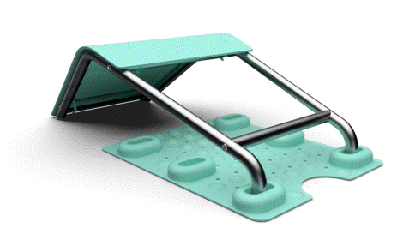

**Figure 1.** Design proposed by Katherine Hayes.

The product shown in figure 1 has two parts, 1) The non-slip mat which slicks to the bottom of the bathtub and provides three location points for users of different heights, and 2) the support frame which is intended to provide support for the user while reclining in the bath and to prevent the body from slipping under the water line if the user loses consciousness. The developed outcome was simple to use (fitting the majority of baths), low cost, easy to keep clean, portable and made from commonly recycled materials.

Due to the project timeline and the expectations of an undergraduate student project, the design remained not fully tested. Therefore, to develop the project further, a subsequent group of second year BA/BSc Product Design students were asked to test and critique the initial prototype, following which, they conducted a new phase of ideation and design development. The primary focus of this phase was to consider the user’s interaction with the product at all stages of engagement from assembly, installation, use, cleaning, maintenance, and disposal.

Two significant challenges were identified;

* When getting in to or out of the bath the position of people’s feet needs to be very close to the location of the product when in use. The initial design made it difficult to get in and out of the bath.
* People like to change position while having a bath. They may move from a sitting position to a reclined position to almost lying down. The initial design would not allow this level of flexibility.

Each student, in the class of twelve, were tasked to develop individual solutions which addressed these issues. From these the students selected four concepts to be developed into functional prototypes, each concept being developed by a group of three students. The computer-generated images of the designs can be seen in figures 2-5.

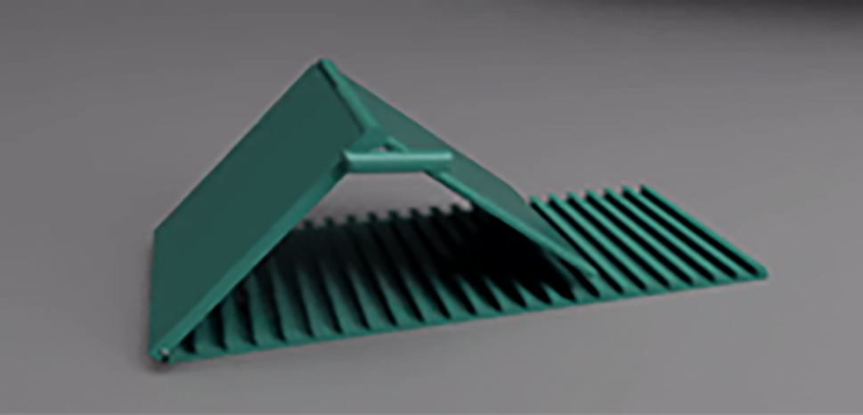

Figure 2. Taheeya Asher developed concept. Hinged support allowing the user to adjust the angle of the support, for example this design could be flattened to make getting into or out of the bath much simpler.

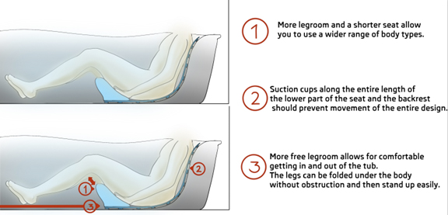

**Figure 3**. Robert Fodora developed concept. Bucket seat style support. The seat which incorporates a back rest has a significant undercut to allow the heels to move backwards under the user’s centre of gravity to make standing up less physically demanding.

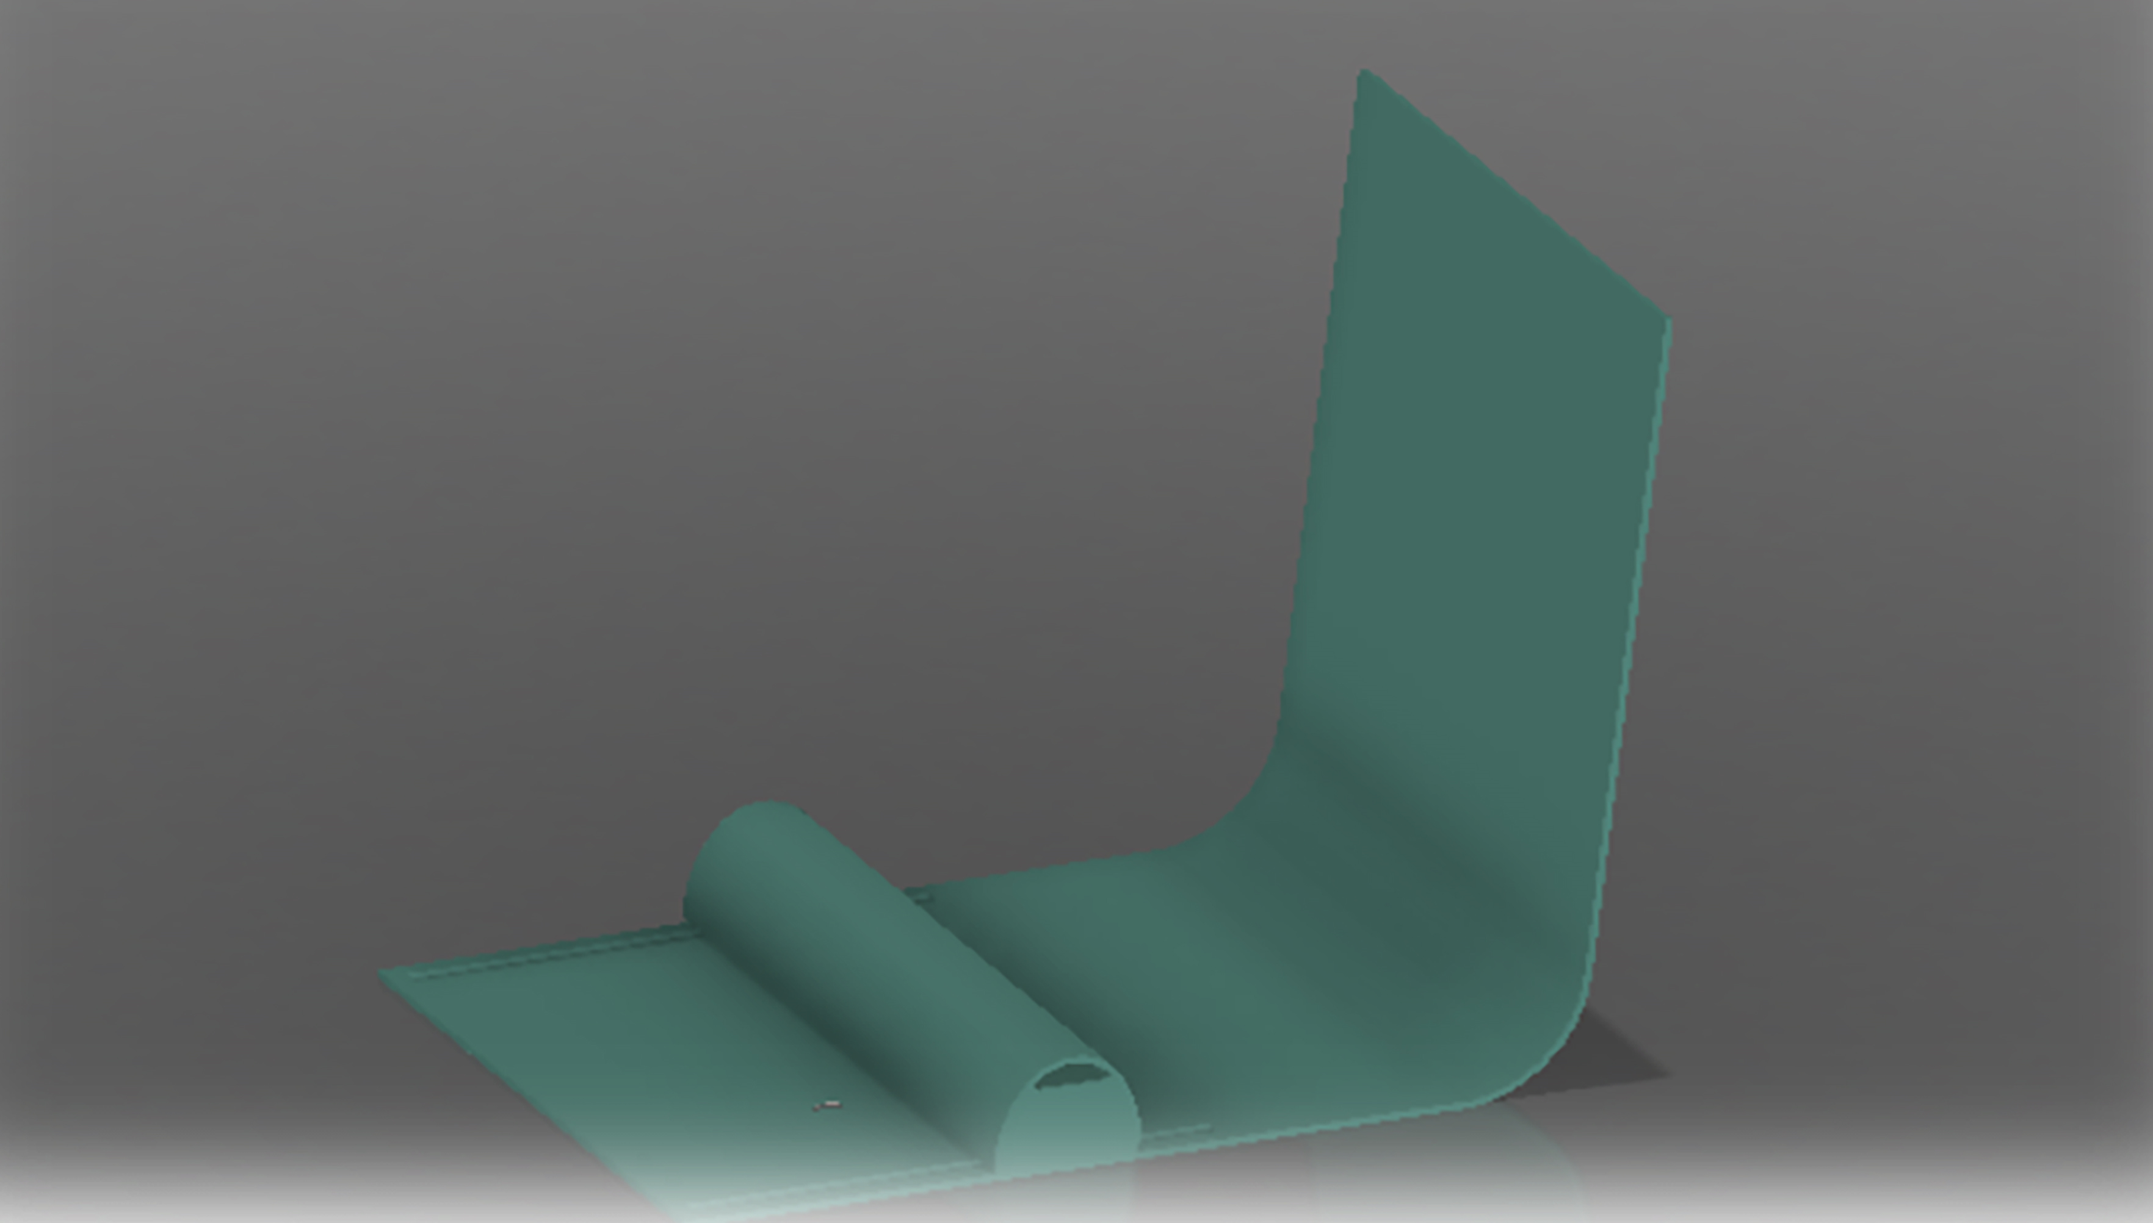

Figure 4. Developed concept from Team 1 (Asher, Harber, Torrant and Gavrilla), the leg support runs on tracks which can be altered while in use enabling the user to configure the product as they change position in the bath.

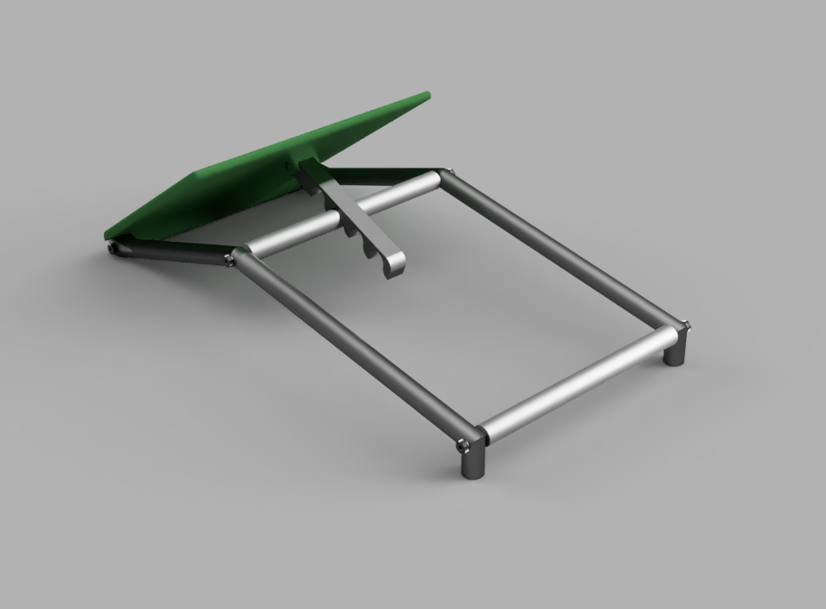

**Figure 5.** Developed concept from Team 2 (Le, Nock, Plavecka, Papanastasiou and Fajana), the rest is hinged to allow different angles to be set. This provides a more configurable product which can make it easier for the user to stand up to get out of the bath.

Table 1 shows an outline of the strengths and limitations for each product design.

**Table 1 Strengths and limitations for each product**

|  |  |  |  |  |  |
| --- | --- | --- | --- | --- | --- |
| **Product** | **Figure 1 Hayes** | **Figure 2 Asher** | **Figure 3 Fodora** | **Figure 4 Team 1** | **Figure 5 Team 2** |
| **Strengths** | -Simple to use  -Low cost  -Easy to keep clean  -Portable  -Commonly recycled materials | -Adjustable leg rest  -Easier to stand up to get out of the bath | -Bucket style seat  -Back rest  -Flexibility to move legs and stand up to get out of the bath | -Leg support can be altered (on tracks)  -Flexibility to change position | -Hinged knee rest  -Changeable knee angles  -Easier to stand to get out of the bath |
| **Limitations** | -Difficult to stand up to get out of the bath.  -Cannot change position easily when in the bath (lack of flexibility) | Not tested.  Potential for user to set an inappropriate angle, which could be less effective in preventing drowning. | Limited adjustability – user constrained to one person | Complex mechanism with potential for lower durability and potentially expensive | Issues with standing up are not fully resolved. A more reliable tilting mechanism needs to be developed |

The outcome of the design process has not yet resulted in a final product, but there is a much clearer definition of what an effective product could be. The conclusions drawn from the project are that the product should be:

* An inclusive product which provides benefits to all users (comfort/safety) but would also specifically reduce the risk of drowning following an epilepsy seizure. This increases the product appeal and reduces any potential negative associations had this been a purely medical device.
* Simple to use. We purposefully avoided technical solutions which rely on electronic devices to monitor and signal responses because of the complexity in resolving issues around false signals or missed episodes. These solutions could also have a limited market.
* A range of styles/finishes should be available to provide more consumer choice.
* Durable, hardwearing and hygienic materials should be used.

**Discussion**

It is important to emphasise that any potential products such as those described are not intended to encourage bath use but to acknowledge that people with epilepsy may choose to bath alone and try to make it safer. It would not guarantee prevention of drowning. It may provide an extra level of risk management where supervision should occur routinely such as in hospitals and care homes and contribute to reducing avoidable deaths (Ashby et al 2014).

The level of risk for drowning during an epilepsy seizure will depend on factors such as seizure type and frequency of seizures. The International League Against Epilepsy (ILAE) (Fisher et al. 2017) classifies seizures according to where in the brain they originate from, the level of awareness of the person, and the effects on motor function. Seizures involving impaired awareness, notable loss of motor function control and protective reflexes are considered to place the person at greater risk of drowning (Cihan et al. 2018). The products designed as shown in figures 2-5 above, may help to prevent the body from slipping under the water line in circumstances where patients lose awareness and motor function is affected, though this is currently untested in the real world.

This project has shown that it may be possible to develop a piece of equipment that could reduce the risk of drowning in the bath for people with epilepsy. However, products which incorporate new technology will be expensive to develop, test and qualify. A higher price will be a barrier to some consumers and a highly specialised product may only be targeted at people with epilepsy which would result in a relatively small market and limited potential for growth. However, it is also possible that such a piece of equipment could be available for the general public to meet different needs. Making such equipment generally available would reduce any stigma attached to epilepsy and normalise its use whereby any customer can choose it for their own purposes. For example, people of short stature may find it difficult to be comfortable and/or safe in conventional baths as their legs may not reach the end of the bath and they may easily slip down, but equipment could prevent this and offer more comfort and safety. A more inclusive product which provides benefit and value to anyone who enjoys taking a bath, while at the same time providing a significant reduction in the risk of drowning, will have greater commercial appeal. If the product can also be simple and cost effective to manufacture (benefitting from economy of scale) then a larger customer base may be reached and there will be a greater overall impact on the potential risks.

A summary of the strengths and limitations of the project can be seen in table 2.

**Table 2. Strengths and limitations of the project.**

|  |  |
| --- | --- |
| **Strengths** | **Limitations** |
| Interdisciplinary collaboration | May not meet the needs for different seizure types |
| Real world project for engineering student education | Untested in real world context |
| Contribution to future research in identifying equipment to reduce risk drowning risks in the bath | Potentially expensive to develop, test and qualify. |
| Potential for wide consumer base, not just people with epilepsy (thus reducing stigma) | No funding |
|  |  |

**Conclusions**

Tables 1 and 2 illustrate a summary of the project outcomes. The value of interdisciplinary collaboration in nursing and engineering needs to be exploited to solve clinical problems such as those explored in this paper. Through increased awareness from the evidence presented in this paper, it is hoped that nurses are inspired to promote future work as advocates for people with epilepsy, and manufacturing companies consider innovation in developing products to reduce the risk of drowning in the bath. What would be beneficial now would be to understand more about the process of information giving (clinical staff) and information receiving (people with epilepsy, parents, guardian, carers), how and why people with epilepsy make decisions about bathing, and a more accurate picture of epilepsy drownings in the bath. Devinsky et al. (2016) stress that accurately estimating epilepsy related mortality is essential if we are to develop preventative intervention, so this is an area of policy that needs attention. However, it is not just mortality details that are needed, but also an accurate picture of how many people receive emergency and/or critical care after surviving immersive events in the bath following a seizure, and their outcomes.

Increased awareness and development of research and equipment could contribute to RoSPAs aims to reduce drowning in the UK by 50% by 2026 (also see NHS right care epilepsy toolkit 2020). For clinicians, it could also be beneficial to reflect on current practice and consider;

* Whether assumptions are made about awareness of risk for people with epilepsy
* To what extent people read or remember any information given about risks
* To what extent people follow risk advice given
* Whether meaningful conversations about patient’s attitudes, awareness and decisions around risk are revisited over time.

**References**

Ashby S, Hanna, J. 2014. Coroners’ rulings on avoidable epilepsy-related deaths. SUDEP Action. Available from sudep.org/sites/default/files/coroners_rulings_on_avoidable_epilepsy-related_deaths_1.pdf

Bain E, Keller, AE, Ho, J, Whiteney, R, Pollanen, MS, Williams, AS, Donner EJ 2018. Drowning in epilepsy: a population-based case series. *Epilepsy Research,* Volume 145: 123-125

Bell GS, Gaitatzis A, Bell CL, Johnson AL, Sander JW. 2008. Drowning in people with epilepsy: how great is the risk? *Neurology,* 71:578–582.

Cihan E, Hesdorffer D, Brandsoy M, Li L, Fowler D, Graham J, Donner E, Devinsky O, Friedman D. 2018. Dead in the water: epilepsy related drowning or sudden unexpected death in epilepsy? *Epilepsia*, 59, 10, 1966-1972

Collier E, Grant A 2021 Enabling safer bathing for people living with epilepsy. Public Involvement Consultation project report. University of Derby. <https://repository.derby.ac.uk/item/925y5/enabling-safer-bathing-for-people-living-with-epilepsy> Last Accessed 28 November 2023

Devinsky O, Spruill T, Thurman D, Friedman D. 2016. Recognizing and preventing epilepsy related mortality. A call for action. *Neurology* 86(8) 779-786

Epilepsy Action 2019. *Practical guidance on staying safe. In the bathroom.* Epilepsy Action, Leeds. Available from [epilepsy.org.uk/info/daily-life/safety/practical-guidance#bathroom](https://www.epilepsy.org.uk/info/daily-life/safety/practical-guidance#bathroom  )

Epilepsy Action 2023. UK epilepsy prevalence and incidence update. Available from [epilepsy.org.uk/uk-epilepsy-prevalence-and-incidence-update](https://www.epilepsy.org.uk/uk-epilepsy-prevalence-and-incidence-update).

Epilepsy Research Insitute UK (n/d) <https://epilepsy-institute.org.uk/eri/about-epilepsy/epilepsy-statistics/> Last accessed 28th November 2023

Fisher R, Cross H, French J, et al. 2017. Operational classification of seizure types by the International League Against Epilepsy: Position Paper of the ILAE Commission for Classification and Terminology. *Epilepsia*, 58, 4, 522–530.

Hayes K. 2021.  *Preventing drowning from epileptic seizures in a bathing environment. Final year BSc dissertation*. College of science and engineering. Unpublished.  University of Derby.

Nakagawa, R, Wataru I, Hitosuq M. 2019. Drowning of a patient with epilepsy while showering. *Environmental Health Preventative medicine* 24, 31 online [10.1186/s12199-019-0792-x](https://doi.org/10.1186%2Fs12199-019-0792-x)

NICE (National Institute for Health and Care Excellence) 2022. *Epilepsies in children, young people and adults.* Available from[nice.org.uk/guidance/ng217/chapter/2-Information-and-support](https://www.nice.org.uk/guidance/ng217/chapter/2-Information-and-support)

NHS 2020. Right care epilepsy toolkit. Optimising a system for people living with epilepsy. Available from [england.nhs.uk/rightcare/wp-content/uploads/sites/40/2020/03/rightcare-epilepsy-toolkit-v2.pdf](https://www.england.nhs.uk/rightcare/wp-content/uploads/sites/40/2020/03/rightcare-epilepsy-toolkit-v2.pdf)

Norman D. 2013. *The design of everyday things*: 2nd revised and expanded edition. New York, The MIT Press.

Osamura T, Fushiki S, Yoshioka K, Yamanaka T, Mizuta R, 1997. An autopsy case of bathtub drowning in epilepsy*. Brain and Development* 19, 499-501

Ostler A, Cousins S, Ridsdale L 2014. The causes of death in epilepsy. A systematic review. *SUDEP Action.* Available from[sudep.org/sites/default/files/the_causes_of_death_in_epilepsy_0.pdf](https://sudep.org/sites/default/files/the_causes_of_death_in_epilepsy_0.pdf)

PHE (Public Health England) 2018. *Deaths associated with neurological conditions in England 2001-2014, PHE, London.*  Available from

[assets.publishing.service.gov.uk/government/uploads/system/uploads/attachment_data/file/683860/Deaths_associated_with_neurological_conditions_data_analysis_report.pdf](https://assets.publishing.service.gov.uk/government/uploads/system/uploads/attachment_data/file/683860/Deaths_associated_with_neurological_conditions_data_analysis_report.pdf)

Robertson J, Hatton C, Emerson E, Baines S. 2015. Prevalence of epilepsy among people with intellectual disabilities: A systematic review. *Seizure* 29:46-62

RoSPA (Royal society for the prevention of accidents) (n/d, a) Available from [rospa.com/campaigns-fundraising/current/injury-data](https://www.rospa.com/campaigns-fundraising/current/injury-data)

RoSPA (Royal society for the prevention of accidents) (n/d b) *Water incident database interactive report.* Available form [nationalwatersafety.org.uk/waid/interactive-report/](https://www.nationalwatersafety.org.uk/waid/interactive-report/)

RCPsych (Royal College of Psychiatrists) 2017. *Report CR203 Management of epilepsy in adults with intellectual disability*. RCPsych, London.

Ryan CA, Dowling G. 1993. Drowning deaths in people with epilepsy. Canadian medical association journal, 148, 5, 781-784

Spencer D. 2016. *Navigating life with epilepsy.* New York, Oxford University Press

SUDEP Action no date *Seizures and injury II.* Available from [sudep.org/seizures-and-injury-ii](https://sudep.org/seizures-and-injury-ii)

Trinka E, Rainer LJ, Granbichler CA, Zimmermann G, Leitinger M. (2023) Mortality, and life expectancy in Epilepsy and Status epilepticus – current trends and future aspects. Frontiers in Epidemiology 3:1081757 DOI 10.3389/fepid.2023.1081757

Verita 2015. *Independent review into issues that may have contributed to the preventable death of Connor Sparrowhawk A report for: NHS England, South Region Oxfordshire Safeguarding Adults Board*. Verita, London.  Available from [england.nhs.uk/wp-content/uploads/2015/10/indpndnt-rev-connor-sparrowhawk.pdf](https://www.england.nhs.uk/wp-content/uploads/2015/10/indpndnt-rev-connor-sparrowhawk.pdf)

WHO (World Health Organisation) 2023. *Epilepsy.* Available from [who.int/en/news-room/fact-sheets/detail/epilepsy](https://www.who.int/en/news-room/fact-sheets/detail/epilepsy)