**Supply Chain Management 4.0: A Literature Review and Research Framework**

**Kamar Zekhnini**

ENSAM- Meknes, Moulay Ismail University

50500 Meknes, Morocco

Email: [kamar.zekhnini@gmail.com](mailto:kamar.zekhnini@gmail.com)

**Anass Cherrafi**

ENSAM- Meknes, Moulay Ismail University

50500 Meknes, Morocco

Email: [a.cherrafi@ensam.umi.ac.ma](mailto:a.cherrafi@ensam.umi.ac.ma)

**Imane Bouhaddou**

ENSAM- Meknes, Moulay Ismail University

50500 Meknes, Morocco

Email: [b_imane@yahoo.fr](mailto:b_imane@yahoo.fr)

**Youssef Benghabrit**

ENSAM- Meknes, Moulay Ismail University

50500 Meknes, Morocco

Email: [you_benghabrit@yahoo.fr](mailto:you_benghabrit@yahoo.fr)

**Jose Arturo Garza-Reyes\***

Centre for Supply Chain Improvement

University of Derby, Derby, UK

Email: J.Reyes@derby.ac.uk

**Supply Chain Management 4.0: A Literature Review and Research Framework**

**Abstract**

**Purpose –** This article presents a review of the existing state-of-the-art literature concerning Supply Chain Management 4.0 (SCM 4.0) and identifies and evaluates the relationship between digital technologies and Supply Chain Management.

**Design/methodology/approach –** A literature review of state-of-the-art publications in the subject field and a bibliometric analysis were conducted.

**Findings –** The paper identifies the impact of novel technologies on the different supply chain processes. Furthermore, the paper develops a roadmap framework for future research and practice.

**Practical implications –** The proposed work is useful for both academics and practitioners as it outlines the pillar components for every supply chain transformation. It also proposes a range of research questions that can be used as a base to guide the future research direction of the field.

**Originality/value –** This paper presents a novel and original literature review-based study on SCM4.0 as no comprehensive review is available where bibliometric analysis, motivations, barriers and technologies’ impact on different SC processes have been considered.

**Keywords**: Industry 4.0; Supply Chain Management 4.0; Digital supply chain; Novel technologies; SCM 4.0 Framework.

1. **Introduction**

Digital technologies have deeply changed the way societies exchange information and interact with each other (Büyüközkan and Göçer, 2018; Nasiri et al., 2020). Technological novelties have altered how people communicate and share information. This novel technology will affect the logistics, supply chains, manufacturing and transportation industries. Therefore, the future of every industry will be opened on innovation and technology. Every industry is going through a rapid transformation that appeared with the fourth industrial revolution.

Changes are rapidly taking place in all business environments and industries. Supply chains can no longer be repositioned overnight to buy, make, move, or sell the right items in the right quantities and the right places (Wu et al., 2016) as today's marketplace is dominated by intense competition, cost pressures, short-term market demand, and volatile patterns of demand (Gilaninia et al. 2011). So, it is necessary to envisage a supply chain in which goods, processes, and structures are easily altered in response to changing conditions. Thus, to deal effectively with the increasing challenges, supply chains need to become intelligent (Wu et al., 2016). In the literature, several distinctive terms have been used to describe supply chain 4.0, these terms include smart supply chain, digital supply chain or intelligent supply chain. In this article, we use both terms supply chain 4.0 and digital supply chain. Supply chain 4.0 is built amid the new digital age created by the fourth industrial revolution (Makris et al., 2019). Industry 4.0 incorporates many technologies, concepts, and methods to enable production systems’ autonomy, flexibility, dynamism, and accuracy (da Silva et al., 2019).

The purpose of the present study is to identify and evaluate the relationship between digital technologies and Supply Chain Management (SCM). Hence, this study is significant due to the following elements: i) SCM 4.0 (Supply Chain Management 4.0) is a complex field (Aryal et al., 2018; da Silva et al., 2018); ii) SCM 4.0 research is a contemporary issue (Büyüközkan and Göçer, 2018; da Silva et al., 2018); and iii) The technological advances made in recent years have had a direct impact on the performance of supply chains (SCs) (Helms and Ettkin, 2011). Moreover, companies need to understand the necessity of using the latest technology solutions with the physical processes to provide visibility and connectivity in their SCs (Raisinghani and Meade, 2005). Hence, it is important to widely discuss the topic.

The implementation of SCM 4.0 has attracted high attention. Many academics and practitioners have contributed to this field’s research, resulting in more than 176 publications. In contrast to this large number of publications, only a few have attempted to evaluate smart SCs or digital SCs (Büyüközkan and Göçer, 2018; Chiappetta Jabbour et al., 2020; da Silva et al., 2019; Wu et al., 2016). Chiappetta Jabbour et al. (2020) explored the implications of big data for sustainable supply chain management through a systematic literature review. Similarly as other studies, Chiappetta Jabbour et al. (2020) work focused on one technology, i.e. big data. In addition, Wu et al. (2016b) conducted a literature review to conceptualize the smart supply chain characteristics and formulate and investigate five key research topics that included information management, IT, process automation, advanced analytics, and supply chain integration. In the same context, da Silva et al. (2019) carried out a review of the literature to contextualize IT in a supply chain 4.0 scenario, focusing on the supply, manufacturing and final consumer stages. Finally, Büyüközkan and Göçer (2018) identified key limitations and prospects in DSCs, summarizing prior research and identifying knowledge gaps by providing advantages, weaknesses and limitations of individual methods and developing a framework for future research and practice. In other words, this study presented a literature review on DSCs and their enablers and proposed a framework. However, the study did not define the enablers’ impact on the different SC processes. The reviewed evidence suggested a lack of concise framework for understanding and developing SCM 4.0.

Studies and researches have focused on traditional SCs and I4.0 (Industry 4.0) separately. Thus, studies on SC4.0 are still very recent and available only on a very small scale on bibliographic databases (da Silva et al., 2018). In this context, no comprehensive review is available where bibliometric analysis, motivations, barriers and technologies’ impact on different SC processes have been considered. Furthermore, there are no academic studies that specifically present a framework for the integration of SCM4.0, taking into account risk management in the digital era. To address these gaps in the academic literature, a literature review has been conducted. Thus, the paper intends to fill the gap of past studies regarding the construction of a complete conceptual framework for the implementation of SCM 4.0. It aims to furnish readers with another point of view on SCM4.0 and present the impact of different technologies on SC processes.

This article is organized as follows: in the following section (Section 2), we describe the review methodology used for the study. Section 3 presents the descriptive results. Section 4 illustrates the bibliometric analysis. Section 5 discusses major enabling technologies in SCM4.0 development, research contributions, motivations, and barriers. Section 6 presents the conceptualized proposed framework. And finally, the last section discusses research gaps, implications for practitioners and directions for future research.

1. **Research method**

A literature review helps authors to evaluate and analyze interesting literature, identify the conceptual content of the field and contribute to theory development (Tranfield et al., 2003). The SC4.0 field emerged only a few years ago and hence related publications are still scattered. Due to the lack of precise keywords that define SCM 4.0, we sorted academic and industrial journals by reviewing their titles, abstracts and manuscripts in traditional and electronic library systems.

To address the research objectives, the review methodology was based on the following content analysis approach and presented in Figure 1 (Kamble, Gunasekaran and Gawankar, 2018):

Figure 1. Review methodology

To identify the widest possible scope of scholarly productions, the following databases were used to search relevant publications:

* Scopus (www.scopus.com),
* Elsevier ([www.sciencedirect.com](http://www.sciencedirect.com)),
* Emerald (<http://www.emeraldinsight.com>),
* Taylor &Francis (<http://www.taylorandfrancis.com>),
* Springer (<https://www.springer.com/gp>)
* IEEE (<https://ieeexplore.ieee.org/>)
* Google Scholar

The keywords and terms used in the searches of the various databases were those that are frequently used to describe and define the use of digital technologies in SCM. The keywords used by the authors are presented in Table 1.

The literature review conducted using different research dissemination sources, including scientific journal papers with high impact factors and indexed conferences proceedings. The inquiry procedure was created by first exploring the relevant information sources. The literature review contained literature from 1994 to 2020, seeing that the notion of machine learning, EDI and AI (Artificial Intelligence) were known from 1994. A summary of the method used is shown in Table 1.

Table 1. Summary of research methods

|  |  |
| --- | --- |
| **Type of analysis** | Qualitative |
| **Period of analysis** | 1994-2020 |
| **Keywords used in the research** | Smart Supply chain management,  Digital Supply chain management,  Intelligent Supply chain management,  Cyber-physical systems (CPS) & Supply chain management,  Big data (BD) & Supply chain management  Cloud manufacturing & Supply chain management,  Internet of things (IoT) & Supply chain management,  Blockchain & Supply chain management,  Augmented reality (AR) & Supply chain management,  3DP (Additive manufacturing) & Supply chain management  Industry 4.0 & Supply chain management |
| **Total number of articles evaluated** | 176 articles |
| **Software tools** | Qlickview  Vosviewer  Nvivo 12  Mendeley |
| **Website tools** | [www.gpsvisualizer.com](http://www.gpsvisualizer.com)  www.wordart.com |

1. **Results**

This section presents the descriptive statistics based on the analysis of the 176 papers identified through the literature review. The section highlights the literature trend in term of the papers publication over time, the geographical application area, the distribution of reviewed papers by journal and enabling technologies in the field.

**3.1 Literature over time**

We began by plotting the number of publications in different time periods to observe the evolution of research interest. The aim of reviewing the literature overtime was to examine the year-by-year progress on SCM 4.0 research. It was observed that SCM 4.0 had become a field of research interest among academics and practitioners in the recent past, see Figure 2. The 176 papers identified were published between 1994 and 2020. SCM 4.0 research was limited from 1994 through 2015 as published papers on SCM 4.0 research was at a stable rate of 1, 2 or 4 articles being published per year. From 2015, there was a significant increase to about 60 papers in 2019. It was noticed that 85.23% of the papers were published between 2016 and 2020. The trend of papers on this topic has, therefore, been of growth in recent years. This shows that SCM 4.0 is an emerging research field due to its increased awareness among researchers and practitioners. Moreover, as an increasing number of organizations are being oriented toward the digitalization of their SCs, research in this field may be expected to continue to growing.

Figure 2. Number of publications per year across the studied period

* 1. **Geographical application area**

Figure 3 shows the identified papers according to the geographical locations of the authors from 1994 to 2020. The geographical analysis shows that SCM 4.0 research covers 37 countries around the globe. The major research on SCM 4.0 is being carried out in the USA (27 articles), followed by UK (22 articles), France (15 articles), China (14 articles), and Germany (12 articles). The ‘others’ category is devoted to countries with less than 3 published articles. Based on this analysis, it can be concluded that the concept of SCM 4.0 is extensively researched in developed rather than emerging countries. Indeed, SCM 4.0 research seem to be quite Europe-centric at the moment. The results indicate that the majority of the studies are conducted and published by countries which are well aware of the importance of the digital transformation. It also reflects the important role of developed nations to promote the integration of digital SC. On the other hand, we observed a lack of interest in many underdeveloped and developing countries.

Figure 3. Country-wise publication details

The free website [www.gpsvisualizer.com](http://www.gpsvisualizer.com) was used to plot data points on the map. Figure 4 shows the geographical locations of the countries’ contribution. The size of the circles indicates the proportional contribution of every country. Greater density of contributing countries can be seen in Western Europe.

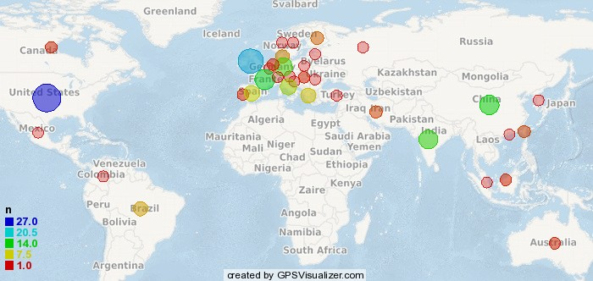

Figure 4. The geographical locations of countries’ contribution

* 1. **Distribution by journal**

The aim of the journal wise distribution analysis was to examine the existing journals which had published SCM 4.0 research articles. The selected 176 articles on SCM 4.0 research were published across 88 journals. The wide range of journal coverage reflects the growth of the SCM 4.0 research area. Figure 5 shows the journals that published SCM 4.0 related articles. The figure only reports journals publishing at least three papers. In order to measure the scientific influence of the journals, we checked the rankings given by the SCImago Journal Rank (SJR) platform. All the listed journals in Figure 5 are listed in the Quartile 1 (Q1) group, except for Procedia Manufacturing (Q2), FAC (Q2) and Procedia Engineering. It can be concluded that research on SCM 4.0 is likely to be published in a range of highly specialized journals (SCM, production, computers industry). Furthermore, the theme is appropriate for publication in journals with a technological focus. This may explain the range of different journals in which SCM 4.0 research papers have been published.

Figure 5. Number of reviewed papers by journal

* 1. **Enabling technologies in the field**

Figure 6 provides information about enabling technologies. In Figure 6, “Many” represents papers discussing more than one technology. In this case, 22 papers dealt with many technologies, which mean that several digital technologies can be used simultaneously in the SC. On the other hand, “None” represents papers discussing no technology. Indeed, 26 papers discussed the need of having digital SC far away from the technical need. According to Figure 6, the most discussed technology is big data analytics (BDA) (30 articles), followed by blockchain (25 articles), AI (16 articles), and IoT (14 articles). The result indicates that there is an important interest in using different novel technologies, but specially BDA. This can be explained by the fact that multinationals have a strong preference for the implementation of such technology (Makris et al., 2019).

Figure 6. Enabling technologies distribution

1. **Bibliometric analysis**

To understand how the studied issues were related, four co-occurrence networks and a full-text analysis were developed. The first network was constructed considering co-authorship. The second network illustrated the title co-occurrence terms. The third one consisted of all the keywords with at least four instances while a fourth co-occurrence network was elaborated based on the abstracts of the analyzed articles.

**4.1 Co-authorship analysis**

To analyze co-authorship, the VOSviewer software was used. It is a tool for creating, visualizing and exploring maps, based on network data. Figure 7 shows the relatedness of items determined based on their number of co-authored documents. The weight of each author determined the size of its label and its circle. In other words, the higher the contribution of the author, the larger its label and circle were. Also, the colors were assigned according to the cluster to which the author belonged. Additionally, the distance between two authors in the visualization indicates the relatedness of authors in terms of co-citation links. Overall, the closer two authors were located to each other, the stronger their relatedness was.

Collaboration between researchers promotes collaboration and productivity within research communities. In this co-authorship of SCM 4.0 work, the authors’ minimum number of publications was set at 2 in VOSviewer. The largest set of connected authors consisted of 49 authors out of 459, see Figure 7. It highlights that collaboration and communication in this field are not well established as all clusters are disconnected. Moreover, many of the 49 items in the network were not connected to each other. The largest set of connected items consisted of 9 items, see Figure 8. It shows that authors can be divided into three clusters. In the blue cluster, research groups are working on blockchain and SCM, the red group is working on big data SCM and the green group is working on internet of things, sustainable data-driven supply chains and blockchain and SCM. We observe that there is a weak link between the authors’ clusters due to the novelty of the subject, which included a lack of continuity in ensuring research works in this field. Therefore, co-authoring publications can greatly promote innovative studies and academic exchange. In addition, collaboration between authors in the digital supply chain domain should be enhanced, in particular for those coming from different industries or countries.

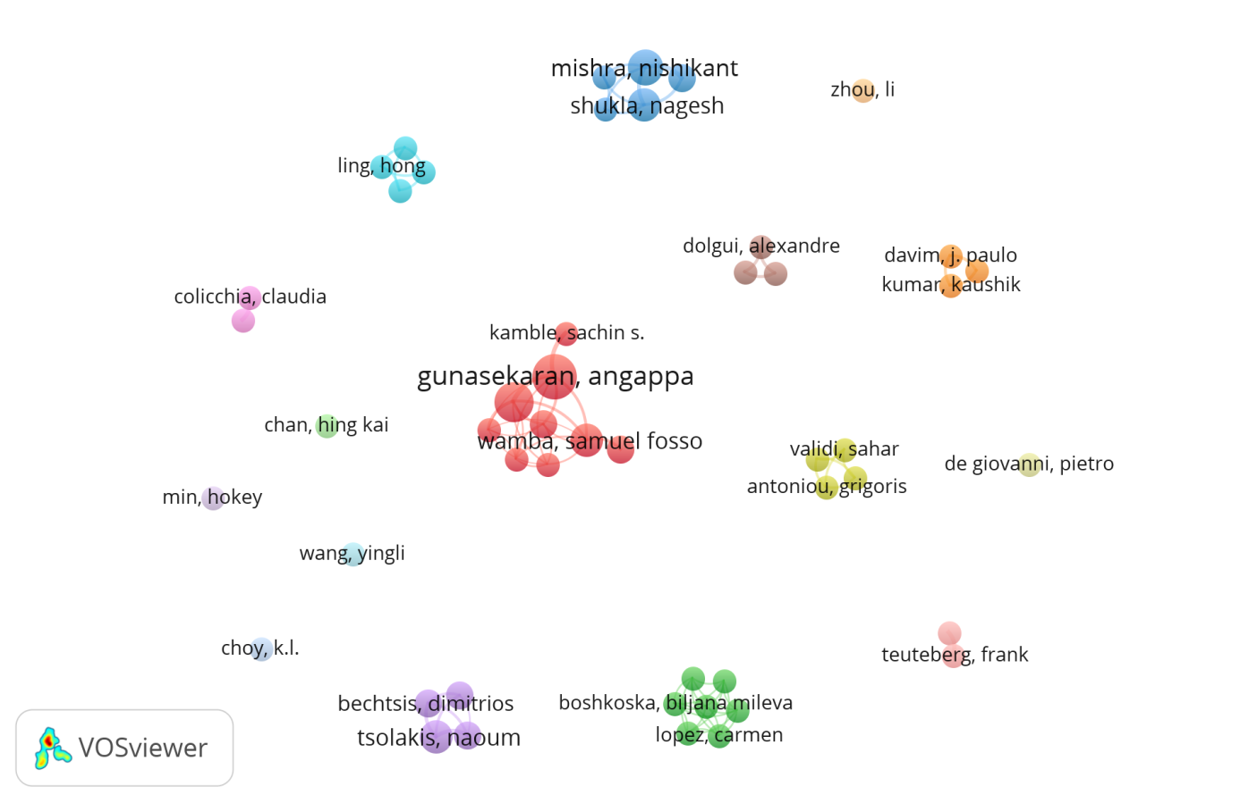Figure 7. Co-authorship network

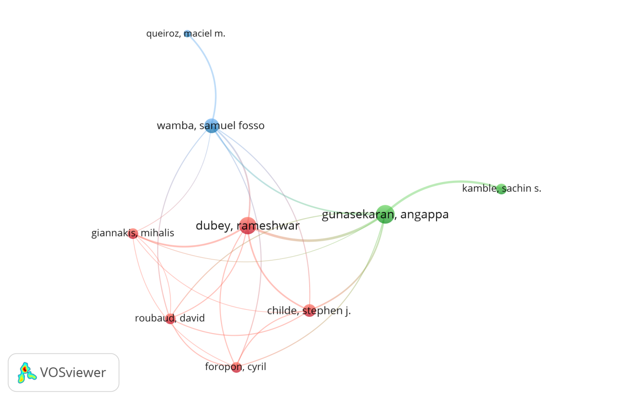

Figure 8 : The largest set of connected authors

* 1. **Title occurrence**

The most commonly used words in the titles of papers related to SCM4.0 were determined through the free open-source online software www.wordart.com. We found that ‘Supply chain’ was the most common word used 157 times, followed by ‘managing’, ’I4.0’, ’technology’, ‘data’, and ‘digital’ used 29 times. Those common words were mapped in the cloud words map presented in Figure 9. This figure illustrates the most common words in bigger fonts, whereas the less common words are represented in smaller fonts. The title can be used to describe the work, to position it in context, or to provide a summary of its contents. It helps to evoke the reader’s attention. We can observe that the titles of the reviewed paper are addressing SCM coupled with I4.0, technology, or data. In other words, the title’s overview indicates the potential of the mixed topic of SCM and novel technologies for the ongoing involvement of the researchers’ community.

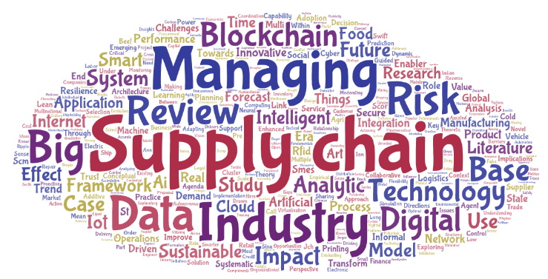

Figure 9. Title most common words

* 1. **Abstract occurrence**

The abstract co-occurrence represented the relatedness of abstract words determined based on their number of documents in which they simultaneously occur. Figure 10 presents the co-occurrence network elaborated based on the abstracts of the papers analyzed. The minimum number of occurrences of a term was 20. Of the 3,310 terms, 31 met the threshold and 23 were filtered. Figure 10 illustrates 4 clusters, i.e the red, blue, green, and yellow. The green cluster includes ‘SCM’, ‘big data’, ‘internet’, ‘IoT’, ‘data’, ‘information’, ‘application’ and ‘product’. The blue cluster includes ‘blockchain’ and ‘technology’. Thus, in the abstract, the presence of digitalization words was found. It can be deduced that there is a focus on the ‘data’ or ‘information’ aspects of supply chains. In other words, the data helps organizations develop new growth opportunities which may explain the interest of studying the use of big data in the SCM.

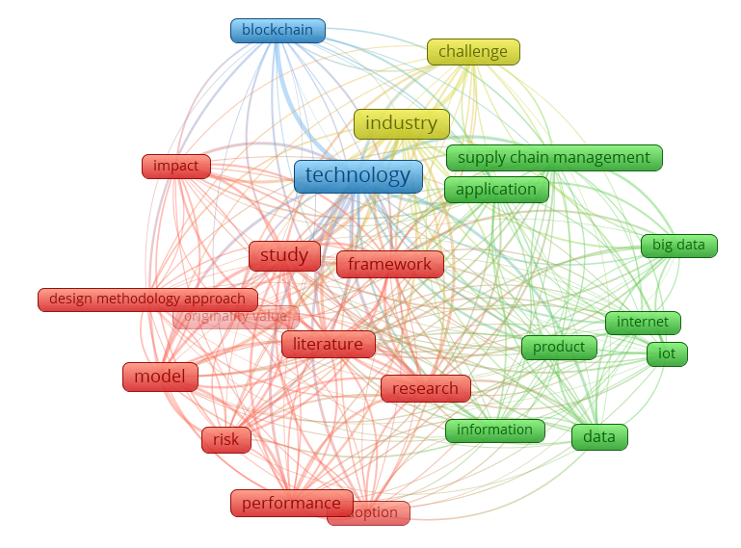

Figure 10. The abstract co-occurrence network

* 1. **Keywords occurrence**

Keywords represent the key content of the papers. The purpose of the keyword review was to identify important research topics in SCM 4.0 studies and direction in the current research domain. The determined keywords were those with at least 5 occurrences. Of the 483 keywords, 29 met this criterion. The keywords analysis identified three clusters, see Table 2. With the cluster density visualization, the density of keywords was displayed separately for each cluster of items. The color of a point in the visualization was obtained by mixing the colors of different clusters as presented in Figure11. Thus, the weight given to the color of a certain cluster was determined by the number of items belonging to that cluster in the neighborhood of the point.

The red cluster relates to the diversity of technologies related to the supply chain management topic. Moreover, sustainability and risk management are highly used topics, which indicates the importance of these notions in digital supply chain integration and logistics. Also, ‘literature review’ belongs to this cluster. The blue cluster highlights the importance of terms like supply chain, value chain and 3D printing (additive manufacturing). Finally, the green cluster shows the relevance of industry 4.0, resulting in smart manufacturing thanks to technologies like blockchain and AI. In addition, the digitalization of operations can result in disruption. Thus, it is necessary to enhance supply chain resilience.

Table 2.Keywords clusters

|  |  |  |
| --- | --- | --- |
| **Cluster 1** | **Cluster 2** | **Cluster 3** |
| 3DP  Additive manufacturing  Supply chain  Value chain | CC  IoT  BD  Machine learning  Risk management  Supply chain integration  Literature review  Logistics  SCM  Sustainability | AI  Operation management  Blockchain  Disruption  Industry 4.0  Smart manufacturing  Supply chain resilience  Supply chain risk management |

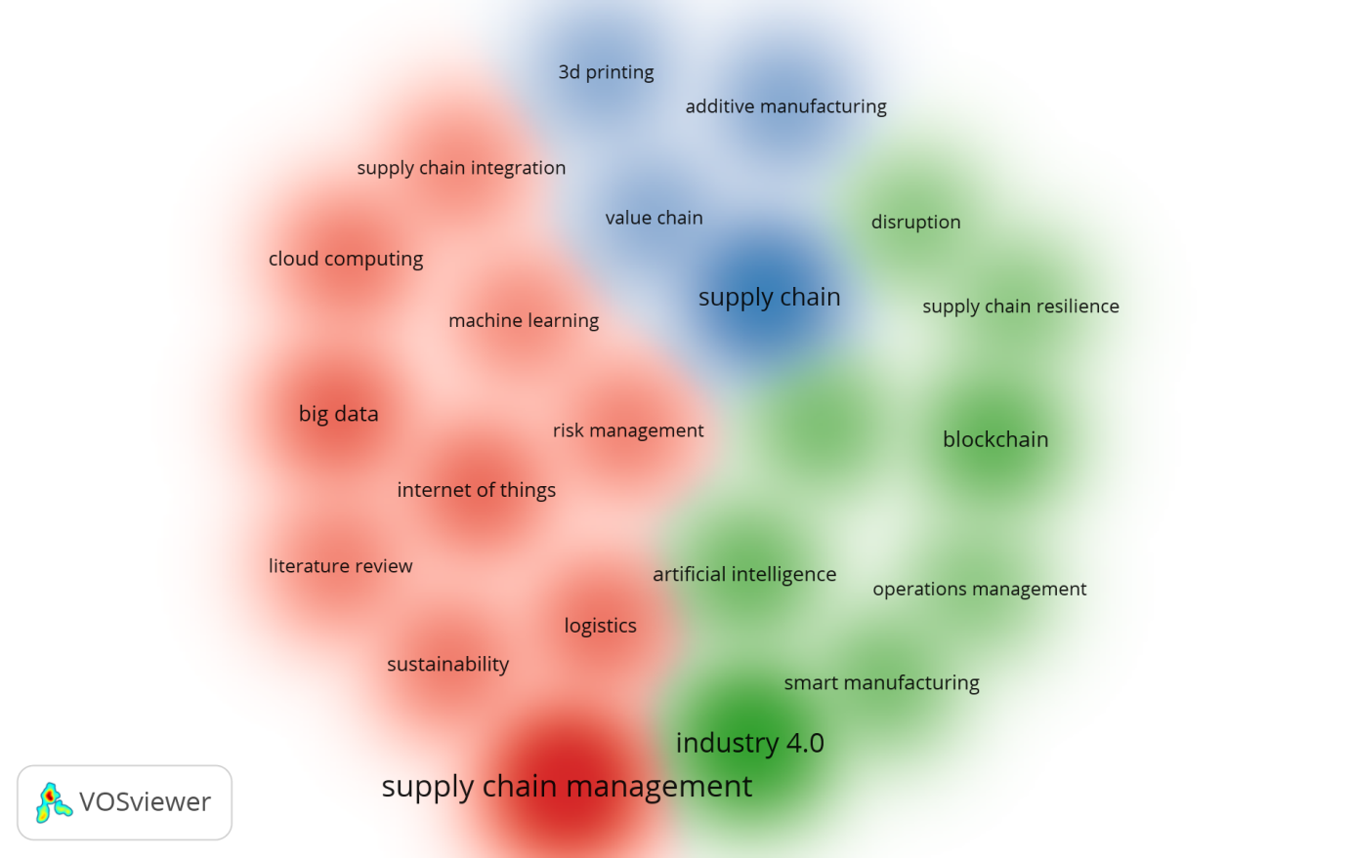

Figure 11 Keywords cluster density visualization

* 1. **Full-text terms co-occurrence**

The study used Nvivo 12 software to identify the most frequent words (limited to the first 50 words) used in the literature. As part of the literature review, a word cluster analysis was conducted. The highlighted terms have a relevant number of occurrences, which show their frequency in the scientific discourse in the SCM 4.0 field. It revealed that the word ‘supply’ was the most frequently used, followed by the words ‘chain and ‘managing’. It is relevant to observe that the articles exhibiting the term ‘big data’, ‘blockchain’ and ‘technology’ are associated with a higher number of occurrences, showing the ability of a combined discussion to build on the continued interest of the research community. Therefore, based on this analysis, it can be seen that the words describing the novel era of digitalization, e.g. ‘IoT’, ‘digital’, ‘smart’, etc. do not have a significant presence compared to the other words, see Figure 12. The modest presence of those words can be attributed to the newness of the studied field and the lack of authorship collaboration.

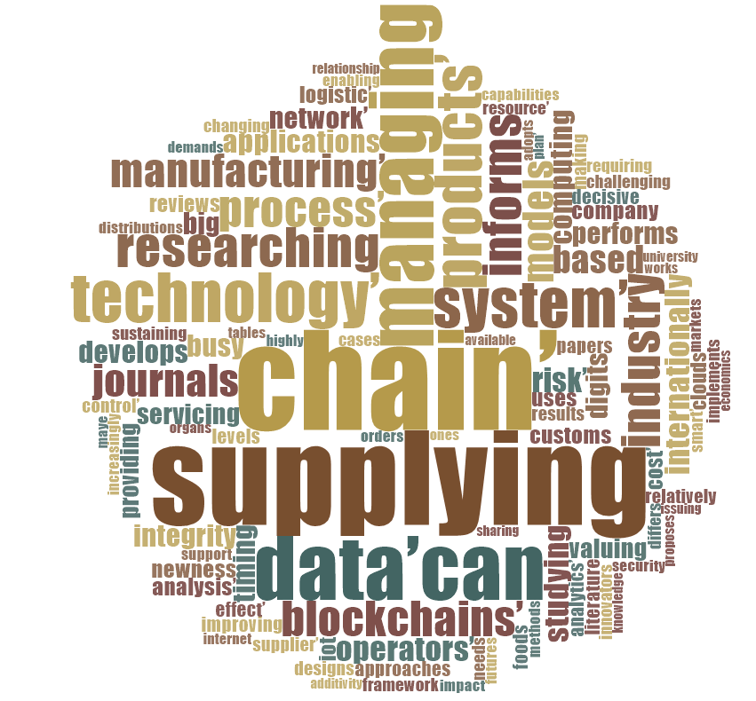

Figure 12. Full texts most common words

1. **Discussion**

In this section, the selected SCM 4.0 works and results of the previous analyses are discussed. The most relevant technologies for SCM 4.0 are analyzed based on the findings of such analyses. Their impact on SC processes is also discussed.

* 1. **Discussion of previous works**

To date, globalization has led to greater income, primarily due to the rapid growth of earnings. However, as supply chains become smarter, businesses will also be able to handle performance issues. In this context, Butner (2010) argued on the necessity of having smart SCs. Ghobakhloo (2020) defined, established and analyzed eleven factors that determine the implementation of smart manufacturing information and digital technologies using Interpretive Structural Modeling. Ghobakhloo (2020) mapped out the contextual interrelationships between factors, which led to a thorough understanding of smart manufacturing transformation processes, and conditions that facilitate the manufacturing digitalisation in the Industry 4.0 era. Moreover, Ivanov et al. (2019) studied the impact of digitalisation and Industry 4.0 on the ripple effect and disruption risk control analytics in the supply chain. They provide a research framework combining the impact of digitalisation on SC management (SCM) and the impact of SCM on the ripple effect control. Furthermore, Makris et al. (2019) explored how multinational companies from five industries have adapted to SC 4.0. They focused on three main emerging technologies, i.e. big data, cloud computing and 3D printing. They also summarised the issues that have been debated concerning Supply Chain 4.0 in a graphical framework.

Our analyses showed that four works are presenting a literature review on SCM 4.0 (Büyüközkan and Göçer, 2018; Chiappetta Jabbour et al., 2020; da Silva et al., 2019; Wu et al., 2016). Büyüközkan and Göçer (2018) present a literature review for DSCs and their enablers and proposed a framework for their integration. In this context, various authors (e.g. Ehie and Ferreira, 2019; Garay-Rondero et al., 2019; Patnayakuni et al., 2002) have established different frameworks for SCM 4.0. For instance, Ehie and Ferreira (2019) presented a conceptual framework that led to the development of a survey instrument investigating the use of novel digital technologies in the core management of supply chains using SCOR model. Patnayakuni et al. (2002) proposed a framework for IT-enabled supply chain integration. Garay-Rondero et al. (2019) conceptualized a model providing a novel and comprehensive overview of the new concepts and components driving nascent and current DSCs.

Some authors have addressed the sustainability challenge through SCM 4.0. For example, Junge and Straube (2020) studied the impact of digital transformation technologies on sustainable supply chains. However, this work focused only on the social and environmental dimensions. On the other hand, Dossou (2018) studied the impact of sustainability on supply chain 4.0 performance. Nevertheless, these two studies are not enough to have a robust overview of the mutual impact of sustainability and SC 4.0. In addition, risk management in the context of SCM 4.0 has not been extensively studied. However, the digitalization of SC risk management has been treated by several authors, e.g. Dawson (2002) and Schlüter and Henke (2017). In other words, they have focused on how to have smart risk management.

It can be seen from the studied literature that the focus on SCM 4.0 has been mainly on its enablers. The contributing existing articles to SCM 4.0 and its technologies that focus on SCs are classified in Appendix I.

* 1. **Enabling technologies on SCM**

Different technologies or techniques can be used to manage SCs 4.0. These technologies include CPS, IoT, CC (cloud computing), blockchain, BD, AR, and AI (Attaran, 2007; Ben-Daya et al., 2017; Büyüközkan and Göçer, 2018b; ElMaraghy, 2019; Min, 2019; Nguyen et al., 2018). Table AII, 1 in Appendix II presents the different definitions of these technologies:

All the technologies above have an impact on the SC. BD has positive effects on supply chain performance and organizational performance (Dubey, Gunasekaran and Childe, 2019). It can influence the production network by advancing operational brilliance, cost reserve funds and consumer loyalty. SC supervisors can use BD to improve the relationship of their organizations with customers and suppliers and upgrade replenishment by advancing stock management (Lamba and Singh, 2017a). BD is useful in terms of helping managers to understand suppliers performance (Kamble et al., 2018). BD provides better forecasts, increase SC visibility and strong SC relationships (Ivanov et al., 2018). Currently, the use of BD in production planning and control is in the development stage (Nguyen et al., 2018). BD is valuable for the SC (Govindan et al., 2018), especially in demand forecasting, procurement, inventory and reverse logistics.

IoT in SCs help to build up the efficiency of warehouse operations, reduce unnecessary processes and gain time in inventorying (Lee et al., 2017). IoT makes the management of SCs more effective and efficient. For example, IoT enables improvements in cost-saving, inventory accuracy and product tracking (Ben-Daya et al., 2017). IoT can also participate in the improvement of products, services, customer experience and security (Addo-Tenkorang and Helo, 2016).

The main areas of efficient use of CC are logistics management, database management, and demand forecasting and planning. The assimilation of CC would encourage cooperation between SC members. It would enhance the sharing of resources and information. It would also improve the adaptability to demand changes (Maqueira et al., 2018).

CPSs are the basis of I4.0 as they enable the digital integration of physical processes using integrated computers and networks to monitor and control such physical processes. In this context, intelligent industries can be created by these systems (da Silva et al., 2018). CPS contribute to the optimization and management of inventory and production control (Lee et al., 2015).

The emergence of blockchain technology introduces a new way of thinking about supply chain management (Liu and Li, 2020). Blockchain is already contributing to remodeling traditional business models and creating new opportunities across the entire supply chain (Wamba and Queiroz, 2020). Due to blockchain technology, following and sharing data becomes quicker, and adaptability can be ensured immediately (Kamble et al., 2018). Through a blockchain empowered inventory network, firms can accomplish real-time exchanges (Kamble, Gunasekaran and Arha, 2018). BT (Bitcoin) assumes a critical job as it tends to be utilized to counteract security breaks while reinforcing SC availability. BT is hack-safe, carefully designed to offer automatic traceability (Min, 2019). Blockchain technology enables the enhancement and tracking of goods and passengers in real-time, from their origins and throughout the overall SCM. It helps to eliminate disclosure and accountability problems (Tönnissen and Teuteberg, 2020).

3D printing is used to create engineering prototypes. It can enable the mass customization of goods on a large scale (Varsha Shree et al., 2020). 3DP contributes to reducing excessive inventory stocking. As a result of the 3DP flexibility, the number of suppliers can be reduced and the quality of products increased. Similarly, product variety, shorter lead time, efficiency and an increase in inventory control can be achieved (Ivanov et al., 2018).

AR alludes to the layering of PC reproduction models over the physical design of a current environment. AR improves the effectiveness of the present SCs processes. Most normal types of AR include a type of glass, visual presentation for a wearer to use during the time spent expanding profitability and execution. Expanded reality is being utilized to give a feeling of scene recognition amid request picking forms (Merlino and Sproge, 2017).

RFID provides real-time identification, real-time material flow and tracing, helping to increase data quality (Ivanov et al., 2018). RFID technology's important promise is to reduce costs and provide a wealth of information that helps companies understand, predict, and respond to customer demand more effectively (Attaran, 2007).

AI techniques are used for scheduling in cellular manufacturing systems (Singh, 2003). Furthermore, AI through machine vision and autonomous applications are used in industrial fields. By using predictive technologies that model future scenarios and also develop a deep understanding of the interactions in the SC drivers, their performance will be enhanced (Nguyen et al., 2018).

* 1. **SCM 4.0**

To help overcome the challenges associated with volatility and uncertainty, organizations need a digital supply chain built on visibility, sustainability, and better customer experiences. In other words, transparency in the supply chain helps to reduce the complexity of its processes via improving the visibility of upstream and downstream supply chain operations (Dubey et al., 2020; Liotine, 2020). So, the entry of CPS in supply chains is one of the most revolutionary changes in the fourth SCM revolution. The meaning of ‘smart’ is the capacity of an item to perceive without anyone else's interruption the reason to be accomplished, to function admirably, and to adaptably react to any changeability (Oh and Jeong, 2019). SC4.0 is an advanced framework with interconnected procedures that grows from detached applications to a wide relationship, coordinated and effective between phases of the SC (Merlino and Sproge, 2017).

The experienced digital transformation has provided a platform from which businesses all over the world can become more efficient from end-to-end. But with that, there is a growing expectation from every SC process to become more efficient, more reliable, and more transparent. Thus, smart SCs leverage data and digital technology’s ability to attain world-class cost, capital and client satisfaction result. It creates competitive advantages and seizes fresh company possibilities. Additionally, smart SCs connect customers, businesses and distributors to generate transparency, reliability and effectiveness through the smart use of data across the demand to the supply value chain. Thanks to the wise use of digital technologies, the following points will be assured according to (Dossou, 2018b):

* Fully integrated SCs: End-to-End (E2E) transparency, dynamically adjustable synchronized network and blockchain global transaction management (Liotine, 2020);
* Holistic intelligent E2E decision-making: Real-time data/predictive analysis, Real-time performance and real-time process management;
* Automated no-touch SC: Instantaneous supply, and demand planning, automated, smart manufacturing, warehousing, logistics and customer service.

**5.3 SCM 4.0 implementation drivers and barriers**

In order to remain competitive and have flexibility in their SCs, companies need to leverage autonomous technologies. As shown by Table AII, 2 located in Appendix II, these motivations drive companies to implement SCM4.0. Thus, to improve systems’ performance and worker productivity, companies prefer to use novel technologies. Making digital investments to decrease expenses and eliminate SC complexity drives income development. Hence, companies take into consideration customer satisfaction, relationships with partners, and production quantities as significant drivers in the SC procedures to implement digitalization.

The advantages of SCM4.0 integration are consistent, but at the same time, it also creates certain difficulties and obstacles. As presented in Table AII, 3 (Appendix II), companies that have chosen or have already applied digital technologies are facing challenges such as the cost of technical set-up and long development time. Lack of coordination and absence of urgency are also important inhibitors to digitalisation implementation. Leaders could support their staff with continuing assistance and a clear strategic vision to overcome these barriers by emphasizing the importance of novel technologies for the SC.

1. **Framework for the development of SCM 4.0**

The SCM 4.0 subject is difficult to comprehend because it includes distinct activity flows, elements, features, and role players. The original framework displayed in Figure 13 conceptualizes a roadmap for better understanding of the topic of SCM4.0. Based on the literature review, the proposed framework decomposes the connection between distinct parts within digital SCs. The framework was created by defining key topics in SCM 4.0, reviewing current SCM categorizations and analyzing existing frameworks. This framework can be used as a guide for researchers and practitioners in the field. The purpose of the framework is to integrate dominant topics and ideas within SCM4.0. The following components were considered for its development:

* SCM
* Digital technologies
* Digitalization
* Risk management

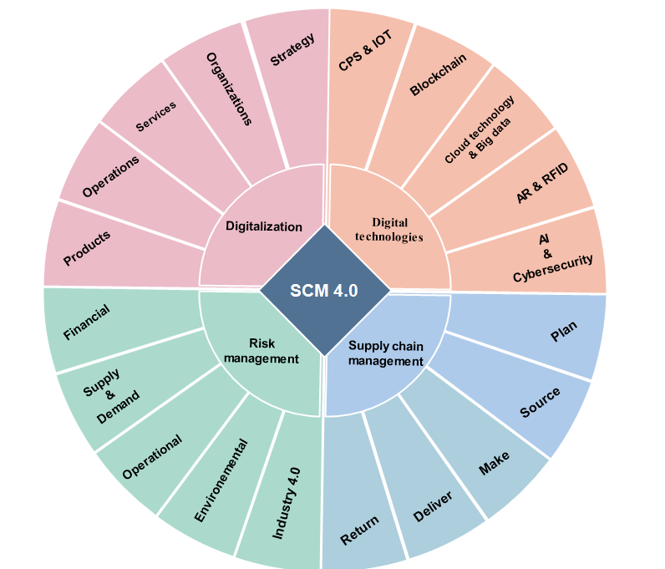

Figure 13. Framework for the development of SCM4.0

**6.1 SCM**

The role of any SC focuses on moving equipment, finished products, capital, and other resources from location to location. SCs consist of various operations, exchanging time, money, data, or physical equipment for some other value unit. In other words, SCs typically involve end-to-end information, products and services, and cash flows (Dwivedi et al., 2020; Patnayakuni et al., 2002). Hence, managing these elements impacts the competitive positioning of an organization in fields such as product pricing, requirements for working capital, speed-to-market, and perception of service. Organizations are exploring creative ways to streamline their SCs to satisfy the changing requirements of consumers. Traditional SCs have been affected in several respects by dramatic technological and digital innovations, such as higher computing power and reduced general expenses, including reducing transaction costs and increasing innovation linked to the manufacturing processes themselves.

SCOR was developed and established in 1996 by the Supply Chain Council (SCC) as a reference model for the design and enhancement of SCs (Chehbi-Gamoura et al., 2020). The SCOR model is a well-known framework that divides the processes of the SC into “plan, source, make, deliver, return and enable” (APICS, 2015). This model is widely accepted in practice, mainly because of its ability to link processes with performance metrics and was therefore used to carry out process-centric views of the literature reviews related to the SC (Ben-Daya et al., 2017). Table 3 illustrated the impact of each technology in the SC process, presented in Section 6.2, according to the SCOR model.

**6.2 Digital technologies**

Digital technologies assist organizations to solve different problems, create new opportunities, gain competitive advantage (Dubey, Gunasekaran, Childe, et al., 2019), and enhance firms’ performance (Chiappetta Jabbour et al., 2020). Applying novel technologies in traditional linear SCs with a discrete movement of “plan, source, make, deliver and return” changes SCs from a static to a dynamic succession (Liotine, 2020). This move from linear, consecutive production network activities to an interconnected, open arrangement of supply tasks is important for organisations to contend later on.

As each supply process turns out to be increasingly proficient and associated, the SC breaks down into a dynamic, incorporated supply arrange. SC4.0 is the reform of SCs using I4.0 technologies. These technologies, which emerged in the 21st century, are mainly introduced by companies in high-income countries. These firms look to maintain competitive SCs.

Table 3. Technologies’ impact on SC with SCOR model





SC4.0 includes deploying modern instruments like the IoT, BDA, Autonomous Robotics, etc (Büyüközkan and Göçer, 2018a; Nasiri et al., 2020). It transforms the SCM model from a linear model (Garay-Rondero et al., 2019), see Figure 13, to a more integrated model (Garay-Rondero et al., 2019) where data flows are omnidirectional, Figure 14. In other words, technological developments are about the conversion of linear SCs into dynamically linked and ongoing digital supply network, transforming the exchange and sharing of data and resources between companies.

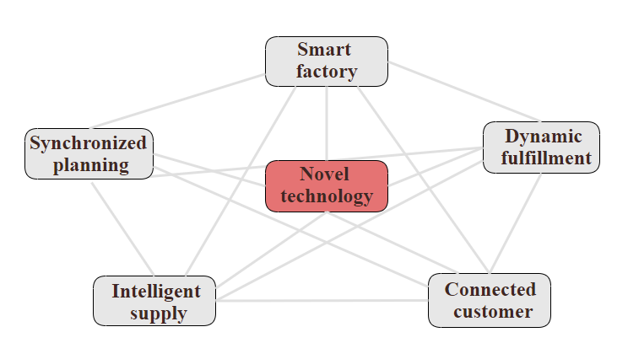

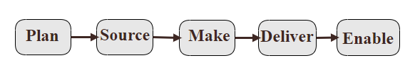

Figure 13. Traditional SC Figure 14. Digital SC

Successful organisations should define the appropriate digital projects aligned with their objectives, learn quickly from their pilot implementation, and be determined and capable of reaching scale. Therefore, to face the double challenge of attracting talent and enhancing employees working on traditional SCs, managers should:

* Look to diversify their recruitment strategy;
* Develop an atmosphere that facilitates learning;
* Develop a clear career route for staff;
* Give talent the authority to conduct change;
* Develop appropriate programs for acquiring new skills.
  1. **Digitalization**

Companies are determined to introduce products, technological and administrative improvements to generate added value for clients as well as for themselves. Digitalization can generate possibilities to achieve these values in order to improve SC procedures (Nasiri et al., 2020; Patnayakuni et al., 2002). Indeed, the fourth SCM revolution is nowadays taking place, and each company needs to rethink how to enforce and do it.

In the field of data leadership, digitization has already altered the way we operate (Singh, 2003). Implementing digital SCs is hampered by heavy investment and significant digitization-related challenges (Ardito et al., 2019). Due to the dangerous nature of digital SC systems, focal companies are required to adapt the external settings and multiple external parties, often beyond their control (Xue et al., 2013).

The digitalization of SC brings out so many advantages. It offers both flexibility and efficiency (Büyüközkan and Göçer, 2018a; Wong et al., 2020). New technology for instrumentation, interconnection, and intelligence can create robust, secure, and sustainable SCs required by companies. Smarter SCs would use smart modelling to analyze only needed information and make sense of it (Tjahjono et al., 2017).

The most relevant benefits are increased flexibility, quality standards, efficiency and productivity. On the other hand, BDA, cloud technology, cybersecurity, IoT, miniaturization of electronics, RFID, robotics, drones and nanotechnology can also be threats for organisations (Liotine, 2020; Lorite et al., 2017).

Furthermore, smarter supply chains advantages do normally translate into an increase in products’ price (ElMaraghy, 2019). An increase in the amount of digitalized data and the expansion of internet companies means that the risk of attacks on their databases is also greater. Hackers may intend to modify, steal or delete data (Ghadimi et al., 2018).

* 1. **Risk management**

Technology investment has become important in strengthening industries ‘competitiveness (Nasiri et al., 2020). However, the factors making these technologies so significant to SCs make them vulnerable. Furthermore, the entire industrial process is currently more open and interconnected, thanks to the enabling technologies (Garay-Rondero et al., 2019). This means that information slowdowns are reduced to close-real-time levels and instances of miscommunication or even missing communications are eliminated. With this openness, the system's confidentiality will be threatened (Chhetri et al., 2017). In other words, interconnecting the different devices and exchanging with external parties of the organisation like customers implies that the firm’s system is opening into a big number and type of attacks, see Table 4. Besides, international networks depend intensely on technology innovations not only for managing SC complexity but also to assure its effectiveness (Hahn, 2019). This reliability will increase their vulnerability to cyber-attacks (Smith and Dhillon, 2019).

When companies embrace digital SC frameworks to coordinate and transact with their accomplices, they confront critical risks (Xue et al., 2013). Moreover, the digital transformation in the fourth industrial revolution age creates a kind of complexity and uncertainty, threatening SCs (Faizal and Palaniappan, 2014). Hence, through the adoption and acceptance of multiple technologies in the SC, particularly, new risks impact the companies (Kumar et al., 2019). These risks include malware, cyberattack, spyware, and data loss that can eventually have a significant impact on the different production procedures (Kumar et al., 2019a). To sum up, companies are facing the challenge of implementing new supply chain technologies. However, securing adequately digital SCs is the real challenge as hackers aim to attack manufacturing activities (Kumar et al., 2019). The consequences of such cyberattacks are economic losses exceeding US $1 trillion in annual revenue losses for the entire industry (Smith and Dhillon, 2019).

Advanced manufacturing techniques, integrated cyber-space systems, complex components and therefore, the various services of outsourcing are the main sources of risks. So, appropriate identification of different risks helps in risk management (Kumar et al., 2019). According to (Colicchia, Creazza and Menachof, 2019), the major information risks in a SC are considered the followings:

* *Risk to information confidentiality*: concerns for the potential loss of control over sensitive information/data throughout the SC. In the digital era, confidentiality loss can be costly for an organization as there is significant information flows that need to be protected;
* *Risk to information privacy*: concerns the possible misuse of information/data in other context than the main purpose set by the information proprietor;
* *Risk to information integrity:* concerns the possible corruption and damage of data/information stored in the SC system. Because of the digitalization of SCs, cyber-attacks can easily affect the integrity of industrial systems.

Consequently, to avoid these risks, the three fundamental security requirements for the next generation of smart SCs are as follows:

* *Confidentiality:* It involves maintaining the privacy of the information flow throughout the horizontal and the vertical value chains of the manufacturing system;
* Availability: Various forms of cyber and physical attacks can cause the manufacturing system to be out of service. In a well-connected I4.0, an attack on the availability may be mitigated due to the distributed architecture;
* *Integrity*: ensures proper modification or destruction.

To build resilient supply chains, there are diverse capabilities that need to be in place (Dubey et al., 2020). Stakeholders should focus on identifying, measuring and analyzing risks to reduce negative impacts (Diaz et al., 2020). Risk control and management in a digital SC will focus specifically on addressing cybersecurity concerning third parties and providing quick organisational reactions to unplanned incidents. Furthermore, the security systems for SCM4.0 need to detect occurrences of security events, to protect critical structures, implement the necessary safeguarding tools, respond to threats in real-time and have the possibility to recover every attack, if it happens (Chhetri et al., 2017). With the new technologies, using a risk monitor system based on BD and warning indicators will help companies to stay one step ahead of their competitors if they have been attacked.

Table 4. SCM 4.0 risks

|  |  |  |  |  |
| --- | --- | --- | --- | --- |
| **Risks** | **Type of risk** | **References** | **Solution** | **References** |
| Macroeconomic fluctuation  SC overall coordination  Operating status of a single enterprise | Financial risks | (Faizal and Palaniappan, 2014) | Perfect the relevant laws and regulations,  Standardize the market behaviour  Establish a risk control system  Giving play to the role of supervision of logistics information.  Introduce the insurance institutions | (Yang et al., 2019) |
| Inbound product quality  Product arrival variability(delays)  Loss of suppliers | Supply risks | (Faizal and Palaniappan, 2014; Yang et al., 2019) | Establish uniform standards in cooperation with the principal players/ industry associations of the SC | (Schröder et al., 2014) |
| Fluctuating clients demands  Demand | Demand risks | (Faizal and Palaniappan, 2014) |  |  |
| Lack of skilled workers    Machine-information security | Operational risks | (Faizal and Palaniappan, 2014) |  |  |
| Natural/man-made disasters. | Environmental risks | (Faizal and Palaniappan, 2014) |  |  |
| |  | | --- | | Confidentiality | | Cyberattack | | Data theft | | Exploitation of maintenance access | | Higher vulnerability to operational accidents | | Information privacy | | Intellectual property | | Lose customer’s data | | Malware and loss of data | | Network vulnerability scans | | Risk to information | | Risk to information integrity | | Specific investment | | Spyware | | The loss of resource control | | Transaction risk | | I4.0 risks | (Colicchia, Creazza and Menachof, 2019; Schröder et al., 2014; Xue et al., 2013) | Identify, measure and analyze risks  Implement appropriate safeguards to protect critical infrastructures,  Detect the occurrence of security events,  Respond to threats,  Recover after an attack has happened  Diversify regarding technological systems | (Arunachalam et al., 2018; Schröder et al., 2014) |

1. **Research gaps, Directions for future research and Implications for practitioners**

This paper is the first to review the existing literature on SCM4.0 published during the period between 1994 and 2020 and to develop a roadmap framework for the implementation of SCM4.0. Hence, to encourage research in the field of digital supply chain management, the following gaps in the existing literature, directions for future research and implication for practitioners are established.

**7.1 Research gaps and directions for future research**

In the present paper, SCM4.0 was analyzed through a literature review. From such an analysis, the following research gaps were identified:

* The field lacks a framework that provides a roadmap for the implementation of SCM 4.0. The existing frameworks do not provide strategic and concrete guidelines to implement a SCM 4.0. It would be helpful for organizations to have a roadmap on how to digitalize their SCs. The roadmap should take into consideration the different needed resources (e.g. financial, human competencies, legal, ethics, environment).
* From the 176 papers identified, no article discussed the SC skills needed in the I4.0 era. With the digitalization of SCs, new jobs will be created. Those jobs will be dedicated to novel competencies. Therefore, this former should be well known in order to be included in the educational system of new graduated generations and to re-orient the labor market.
* There is a lack of articles that deal with SCM4.0 in various industries, e.g. food, fashion, etc. Despite the significant role that the automotive industry commonly plays in the advancement of technology development and its application, no paper studying a real-case implementation of SCM4.0 in this industry was identified;
* From the bibliometric analysis, it was clear that there is a lack of discussion about digital and smart SCs far away from its enablers (novel technologies). In other words, the studies about Digital SCM are not sufficient to well understand all the changes made in the value chain. Moreover, the digitalization of each SC process is not treated in any of the papers;
* A lack of research dealing with SCM4.0’s implementation and sustainment challenges was also identified. Despite the importance of sustainability to retain a competitive advantage, none of the selected papers studied the co-existence of sustainability and the smartness in the SC. Additionally, the impact of digitalization on the different dimensions of SC sustainability is not discussed;
* In the 176 papers studied, authors have not explored the effects of the implementation of SCM 4.0 on human beings performance. Humans are the core of any organisation. Hence, it is of paramount importance to implement technologies that help to improve productivity but without having negative side effects on the health and safety of humans. Moreover, studies dealing with the probability of people losing their jobs have not been conducted. In other words, the fact of replacing human competencies by novel technology or the creation of new jobs thanks to digitalization should be explored;
* The change from a traditional system to an interconnected network differs from one firm to another. Hence, no article has dealt with overcoming the difficulties of SC transformation. Every SC is different from others (e.g. an automotive SC is different from a Food SC). Thus, it is important to study the specific difficulties (e.g. financial, material, social) that firms could face when digitalizing their SCs. Furthermore, guidelines or a roadmap could also be proposed to overcome those difficulties;
* No article dealing with risk management in the different processes of SCM4.0 was identified. Organizations work in environments of significant uncertainties, and especially, with the emergence of the novel technologies in the SCs, new risks have born. Thus, it is important to conduct studies dealing with the way in which risks can be faced while implementing a digital supply chain. Furthermore, each SC process should be studied to establish strategies to defend the different process resources from internal and external risks.

A future research agenda for SCM4.0 is presented below in the form of research questions, see Table 5. It underlines potential routes for future SCM4.0 research.

Table 5. Research questions to guide further research

|  |
| --- |
| **SCM 4.0 implementation** |
| 1. What is the efficient strategy to transform a traditional into a digital SC? 2. What are the barriers and the negative effects of implementing SCM4.0? 3. Can the current transformation from a traditional to an interconnected SC ensure a better SC performance for every network organisation? 4. Can a company’s location affect the implementation of SC4.0? 5. What constitutes an effective digitalization approach? |
| **SCM 4.0 in industry** |
| 1. Is it sufficient to have one roadmap framework for all industries? 2. Can the current implementation framework be adapted to a specific industry? |
| **SCM 4.0 and Human resources** |
| 1. What are the SC skills needed in the SCM 4.0 era? 2. Can SCM4.0 have a negative effect on the employees’ social lives? 3. What is the human contribution in the SCM4.0 performance of an organisation? |
| **Technologies in SCM 4.0** |
| 1. What is the most appropriate technology for each SC process? 2. What may be the main drivers and barriers to implementing a specific technology in the SC? |
| **Risk management in SCM 4.0** |
| 1. What are the new potential risks appearing with SC digitalization? 2. How can the SC4.0 be protected against threats and incidents? 3. What are the characteristics of an effective risk management approach for SC4.0? |

**7.2 Implications for practitioners and managers**

This paper has four main implications for theory and practice. First, it provides a solid background to the subject field of SCM4.0 in the digitalization era. Second, the literature review offers unique insights on the theme and outlines motivations, barriers and technologies impact. Third, it can be a reference for researchers to have an overview of SCM 4.0’s context and issues to work on in future studies. Finally, a conceptualized framework for the implementation of SCM4.0 is developed, which may be followed up as a roadmap in further works. The study contributes to the literature of SCM4.0 by being the first study focusing on both SCM4.0 and its technologies.

Practitioners and managers are exposed to significant information regarding new trends, techniques and methods derived from I4.0. For this reason, they may struggle to implement SCM4.0 and may be confused to select the suitable technologies for their SCs. Moreover, they may find difficult to define the impact of each technology in the SC. Our study offers a framework, see Figure 12, to guide practitioners and managers to implement SCM4.0 and make them aware of possible risks they may face. Our framework distinguishes different components that are essential for every SC transformation.

1. **Conclusions**

This study presents a state-of-the-art literature review on SCM4.0 and proposes a conceptual framework to better understand digital SCM as guidelines for SCM4.0 managers. SCM4.0 refers to the development of SCs, a consequence of the changing innovation scene, and expanding availability between computerised and physical universes.

New access to data, computational capacities, and inventive advancements have fallen and associated with the once direct SC. Presently, real-time data and experiences can be shared over the whole supply system to drive decisions. These changes are going on rapidly. In any case, with change comes opportunity: the capacity of digital SC to assume an indispensable choice-making, modifying numerous supply systems to the particular needs of customers.

The developed framework has various useful components that may encourage scientists and practitioners to use it. It offers a straightforward, easy-to-use graphical representation of SCM4.0. Moreover, it focuses on demonstrating the connection between modules in the field. The framework represents an explanatory instrument and a reference roadmap. Hence, apply the SCM4.0 proposed framework will be deployed in an industrial real-case application such as the digitalization of an automotive SC.

This paper has a number of limitations that offer opportunities for the development of future studies. The suggested understanding framework is designed to support SCM4.0’s explanation overall. Consequently, it does not provide a detailed explanation of the third level of the SCM 4.0’s framework. Thus, future studies can broaden the framework, concentrating on specific components. In other words, the present framework can be expanded and the significance of the various subcomponents and elements can be studied too.

**References**

Abaker, I., Hashem, T., Yaqoob, I., Anuar, B., Mokhtar, S., Gani, A. and Khan, U. (2014), “The rise of ‘big data’ on cloud computing: Review and open research issues”, available at:https://doi.org/10.1016/j.is.2014.07.006.

Accorsi, R., Cholette, S., Manzini, R. and Tufano, A. (2018), “A hierarchical data architecture for sustainable food supply chain management and planning”, *Journal of Cleaner Production*, Elsevier Ltd, Vol. 203, pp. 1039–1054.

Addo-Tenkorang, R. and Helo, P.T. (2016), “Big data applications in operations/supply-chain management: A literature review”, *Computers and Industrial Engineering*, Elsevier Ltd, Vol. 101, pp. 528–543.

Ardalan, A. and Ardalan, R. (2009), “A data structure for supply chain management systems”, *Industrial Management and Data Systems*, Vol. 109 No. 1, pp. 138–150.

Ardito, L., Petruzzelli, A.M., Panniello, U. and Garavelli, A.C. (2019), “Towards Industry 4.0”, *Business Process Management Journal*, Vol. 25 No. 2, pp. 323–346.

Arunachalam, D., Kumar, N. and Kawalek, J.P. (2018), “Understanding big data analytics capabilities in supply chain management: Unravelling the issues, challenges and implications for practice”, *Transportation Research Part E: Logistics and Transportation Review*, Elsevier Ltd, Vol. 114, pp. 416–436.

Aryal, A., Liao, Y., Nattuthurai, P. and Li, B. (2018), “The emerging big data analytics and IoT in supply chain management: a systematic review”, *Supply Chain Management*, available at:https://doi.org/10.1108/SCM-03-2018-0149.

Attaran, M. (2007), “RFID: An enabler of supply chain operations”, *Supply Chain Management*, Vol. 12 No. 4, pp. 249–257.

Bala, P.K. (2012), “Improving inventory performance with clustering based demand forecasts”, *Journal of Modelling in Management*, Vol. 7 No. 1, pp. 23–37.

Baryannis, G., Validi, S., Dani, S. and Antoniou, G. (2018), “Supply chain risk management and artificial intelligence: state of the art and future research directions”, *International Journal of Production Research*, Taylor & Francis, Vol. 0 No. 0, pp. 1–24.

Ben-Daya, M., Hassini, E. and Bahroun, Z. (2017), “Internet of things and supply chain management: a literature review”, *International Journal of Production Research*, Taylor & Francis, Vol. 7543 No. November, pp. 1–24.

Birkel, H.S. and Hartmann, E. (2019), “Impact of IoT challenges and risks for SCM”, *Supply Chain Management*, Vol. 24 No. 1, pp. 39–61.

Butner, K. (2010), “The smarter supply chain of the future”, *Strategy & Leadership*, Vol. 38 No. 1, pp. 22–31.

Büyüközkan, G. and Göçer, F. (2018a), “Digital Supply Chain: Literature review and a proposed framework for future research”, *Computers in Industry*, Vol. 97, pp. 157–177.

Carbonneau, R., Laframboise, K. and Vahidov, R. (2008), “Application of machine learning techniques for supply chain demand forecasting”, *European Journal of Operational Research*, Vol. 184 No. 3, pp. 1140–1154.

Casado-Vara, R., Prieto, J., La Prieta, F. De and Corchado, J.M. (2018), “How blockchain improves the supply chain: Case study alimentary supply chain”, *Procedia Computer Science*, Elsevier B.V., Vol. 134, pp. 393–398.

Chan, H.K., Griffin, J., Lim, J.J., Zeng, F. and Chiu, A.S.F. (2018), “The impact of 3D Printing Technology on the supply chain: Manufacturing and legal perspectives”, *International Journal of Production Economics*, Vol. 205 No. August, pp. 156–162.

Chaudhuri, A., Dukovska-Popovska, I., Subramanian, N., Chan, H.K. and Bai, R. (2018), “Decision-making in cold chain logistics using data analytics: a literature review”, *International Journal of Logistics Management*, Vol. 29 No. 3, pp. 839–861.

Chavez, R., Yu, W., Jacobs, M.A. and Feng, M. (2017), “Data-driven supply chains, manufacturing capability and customer satisfaction”, *Production Planning and Control*, Taylor & Francis, Vol. 28 No. 11–12, pp. 906–918.

Chehbi-Gamoura, S., Derrouiche, R., Damand, D. and Barth, M. (2020), “Insights from big Data Analytics in supply chain management: an all-inclusive literature review using the SCOR model”, *Production Planning & Control*, Vol. 31 No. 5, pp. 355–382.

Chhetri, S.R., Rashid, N., Faezi, S. and Faruque, M.A. Al. (2017), “Security trends and advances in manufacturing systems in the era of industry 4.0”, *IEEE/ACM International Conference on Computer-Aided Design, Digest of Technical Papers, ICCAD*, Vol. 2017-Novem, pp. 1039–1046.

Chiappetta Jabbour, C.J., Fiorini, P.D.C., Ndubisi, N.O., Queiroz, M.M. and Piato, É.L. (2020), “Digitally-enabled sustainable supply chains in the 21st century: A review and a research agenda”, *Science of The Total Environment*, Vol. 725, p. 138177.

Chryssolouris, G., Makris, S., Xanthakis, V. and Mourtzis, D. (2004), “Towards the internet-based supply chain management for the ship repair industry”, *International Journal of Computer Integrated Manufacturing*, Vol. 17 No. 1, pp. 45–57.

De Clercq, D., Jalota, D., Shang, R., Ni, K., Zhang, Z., Khan, A., Wen, Z., et al. (2019), “Machine learning powered software for accurate prediction of biogas production: A case study on industrial-scale Chinese production data”, *Journal of Cleaner Production*, Elsevier Ltd, Vol. 218, pp. 390–399.

Colicchia, C., Creazza, A. and Menachof, D.A. (2019), “Managing cyber and information risks in supply chains: insights from an exploratory analysis”, *Supply Chain Management*, Vol. 24 No. 2, pp. 215–240.

Colicchia, C., Creazza, A., Noè, C. and Strozzi, F. (2019), “Information sharing in supply chains: a review of risks and opportunities using the systematic literature network analysis (SLNA)”, *Supply Chain Management*, Vol. 24 No. 1, pp. 5–21.

Dawson, A. (2002), “Supply chain technology”, *Work Study*, Vol. 51 No. 4, pp. 191–196.

Diaz, R., Smith, K., Landaeta, R. and Padovano, A. (2020), “Shipbuilding Supply Chain Framework and Digital Transformation: A Project Portfolios Risk Evaluation”, *Procedia Manufacturing*, Vol. 42, pp. 173–180.

Dossou, P.-E. (2018), “Impact of Sustainability on the supply chain 4.0 performance”, *Procedia Manufacturing*, Vol. 17, pp. 452–459.

Dubey, R., Gunasekaran, A., Bryde, D.J., Dwivedi, Y.K. and Papadopoulos, T. (2020), “Blockchain technology for enhancing swift-trust, collaboration and resilience within a humanitarian supply chain setting”, *International Journal of Production Research*, Vol. 58 No. 11, pp. 3381–3398.

Dubey, R., Gunasekaran, A. and Childe, S.J. (2019), “Big data analytics capability in supply chain agility: The moderating effect of organizational flexibility”, *Management Decision*, Vol. 57 No. 8, pp. 2092–2112.

Dubey, R., Gunasekaran, A., Childe, S.J., Wamba, S.F., Roubaud, D. and Foropon, C. (2019), “Empirical investigation of data analytics capability and organizational flexibility as complements to supply chain resilience”, *International Journal of Production Research*, pp. 1–19.

Dwivedi, S.K., Amin, R. and Vollala, S. (2020), “Blockchain based secured information sharing protocol in supply chain management system with key distribution mechanism”, *Journal of Information Security and Applications*, Vol. 54, p. 102554.

Ehie, I. and Ferreira, L.M.D.F. (2019), “Conceptual Development of Supply Chain Digitalization Framework”, *IFAC-PapersOnLine*, Vol. 52 No. 13, pp. 2338–2342.

ElMaraghy, H. (2019), “Smart changeable manufacturing systems”, *Procedia Manufacturing*, Elsevier B.V., Vol. 28, pp. 3–9.

Engelseth, P. and Wang, H. (2018), “Big data and connectivity in long-linked supply chains”, *Journal of Business and Industrial Marketing*, Vol. 33 No. 8, pp. 1201–1208.

Faizal, K. and Palaniappan, PL.K. (2014), “Risk Assessment and Management in Supply Chain”, *Global Journal of Researches in Engineering*, Vol. 14 No. 2, pp. 19–30.

Feldmann, C. and Pumpe, A. (2017), “A holistic decision framework for 3D printing investments in global supply chains”, *Transportation Research Procedia*, Elsevier B.V., Vol. 25, pp. 677–694.

Garay-Rondero, C.L., Martinez-Flores, J.L., Smith, N.R., Caballero Morales, S.O. and Aldrette-Malacara, A. (2019), “Digital supply chain model in Industry 4.0”, *Journal of Manufacturing Technology Management*, Vol. ahead-of-print No. ahead-of-print, available at:https://doi.org/10.1108/JMTM-08-2018-0280.

Ghadimi, P., Wang, C., Lim, M.K. and Heavey, C. (2018), “Intelligent sustainable supplier selection using multi-agent technology: Theory and application for Industry 4.0 supply chains”, *Computers and Industrial Engineering*, Elsevier, Vol. 127 No. April 2018, pp. 588–600.

Ghobakhloo, M. (2020), “Determinants of information and digital technology implementation for smart manufacturing”, *International Journal of Production Research*, Vol. 58 No. 8, pp. 2384–2405.

Glas, A.H. and Kleemann, F.C. (2016), “The Impact of Industry 4.0 on procurement and supply management: A conceptual and qualitative analysis”, *International Journal of Business and Management Invention ISSN*, Vol. 5 No. 6, pp. 55–66.

Gonul Kochan, C., Nowicki, D.R., Sauser, B. and Randall, W.S. (2018), “Impact of cloud-based information sharing on hospital supply chain performance: A system dynamics framework”, *International Journal of Production Economics*, Elsevier B.V., Vol. 195, pp. 168–185.

Govindan, K., Cheng, T.C.E., Mishra, N. and Shukla, N. (2018), “Big data analytics and application for logistics and supply chain management”, *Transportation Research Part E: Logistics and Transportation Review*, Vol. 114 No. March, pp. 343–349.

Hahn, G.J. (2019), “Industry 4.0: a supply chain innovation perspective”, *International Journal of Production Research*, Taylor & Francis, Vol. 0 No. 0, pp. 1–17.

Hofmann, E. and Rutschmann, E. (2018), “Big data analytics and demand forecasting in supply chains: a conceptual analysis”, *International Journal of Logistics Management*, Vol. 29 No. 2, pp. 739–766.

Horváth, D. and Szabó, R.Z. (2019), “Driving forces and barriers of Industry 4.0: Do multinational and small and medium-sized companies have equal opportunities?”, *Technological Forecasting and Social Change*, Elsevier, Vol. 146 No. March, pp. 119–132.

Howell, G. (2017), “Real-time supply chain management for industry 4.0”, *EeNews Europe*, pp. 3–5.

Huang, B. and Xue, X. (2012), “An application analysis of cluster supply chain: A case study of JCH”, *Kybernetes*, Vol. 41 No. 1–2, pp. 254–280.

Ivanov, D., Dolgui, A. and Sokolov, B. (2018), “The impact of digital technology and Industry 4.0 on the ripple effect and supply chain risk analytics”, *International Journal of Production Research*, Taylor & Francis, Vol. 0 No. 0, pp. 1–18.

Ivanov, D., Dolgui, A. and Sokolov, B. (2019), “The impact of digital technology and Industry 4.0 on the ripple effect and supply chain risk analytics”, *International Journal of Production Research*, Vol. 57 No. 3, pp. 829–846.

J., W. (1994), “Networks of collaboration or conflict? The development of eletronic data interchange”, *Journal of Strategic Information Systems*, Vol. 4 No. 1, pp. 31–42.

Junge, A.L. and Straube, F. (2020), “Sustainable supply chains – digital transformation technologies’ impact on the social and environmental dimension”, *Procedia Manufacturing*, Vol. 43, pp. 736–742.

Kamble, S., Gunasekaran, A. and Arha, H. (2018), “Understanding the Blockchain technology adoption in supply chains-Indian context”, *International Journal of Production Research*, Taylor & Francis, Vol. 0 No. 0, pp. 1–25.

Kamble, S.S., Gunasekaran, A. and Gawankar, S.A. (2018), “Sustainable Industry 4.0 framework: A systematic literature review identifying the current trends and future perspectives”, *Process Safety and Environmental Protection*, Vol. 117, pp. 408–425.

Kamble, S.S., Gunasekaran, A., Parekh, H. and Joshi, S. (2019), “Modeling the internet of things adoption barriers in food retail supply chains”, *Journal of Retailing and Consumer Services*, Elsevier Ltd, Vol. 48 No. January, pp. 154–168.

Kumar, K., Zindani, D. and Davim, J.P. (2019), “Industry 4.0”, Vol. 0, pp. 35–42.

Lamba, K. and Singh, S.P. (2017), “Big data in operations and supply chain management: current trends and future perspectives”, *Production Planning and Control*, Taylor & Francis, Vol. 28 No. 11–12, pp. 877–890.

Lee, C.K.M., Lv, Y., Ng, K.K.H., Ho, W. and Choy, K.L. (2017), “Design and application of Internet of things-based warehouse management system for smart logistics”, *International Journal of Production Research*, Vol. 7543 No. October, pp. 1–16.

Lee, J., Bagheri, B. and Kao, H.-A. (2015), “A Cyber-Physical Systems architecture for Industry 4.0-based manufacturing systems”, *Manufacturing Letters*, Vol. 3, pp. 18–23.

Lifang Wu Xiaohang Yue Alan Jin David C. Yen, Büyüközkan, G., Göçer, F., Oh, J., Jeong, B., Casado-Vara, R., Prieto, J., et al. (2018), “Supply chain forecasting Collaborative forecasting supports supply chain management Marilyn”, *International Journal of Production Research*, Taylor & Francis, Vol. 0 No. 1, pp. 13–39.

Liotine, M. (2020), “Unlocking digital innovation: guiding principles for driving digital technology in the supply chain”, *Technology in Supply Chain Management and Logistics*, Elsevier, pp. 143–167.

Liu, Z. and Li, Z. (2020), “A blockchain-based framework of cross-border e-commerce supply chain”, *International Journal of Information Management*, Vol. 52, p. 102059.

Lorite, G.S., Selkälä, T., Sipola, T., Palenzuela, J., Jubete, E., Viñuales, A., Cabañero, G., et al. (2017), “Novel, smart and RFID assisted critical temperature indicator for supply chain monitoring”, *Journal of Food Engineering*, Vol. 193, pp. 20–28.

Luthra, S. and Mangla, S.K. (2018), “Evaluating challenges to Industry 4.0 initiatives for supply chain sustainability in emerging economies”, *Process Safety and Environmental Protection*, Institution of Chemical Engineers, Vol. 117, pp. 168–179.

Makris, D., Hansen, Z.N.L. and Khan, O. (2019), “Adapting to supply chain 4.0: an explorative study of multinational companies”, *Supply Chain Forum: An International Journal*, Vol. 00 No. 00, pp. 1–16.

Manuel Maqueira, J., Moyano-Fuentes, J. and Bruque, S. (2018), “Drivers and consequences of an innovative technology assimilation in the supply chain: cloud computing and supply chain integration”, *International Journal of Production Research*, Vol. 7543, available at:https://doi.org/10.1080/00207543.2018.1530473.

Marilyn M. Helms, Lawrence P. Ettkin, S.C. (2011), “Supply chain forecasting Collaborative forecasting supports supply chain management Marilyn”, *Business Process Management Journal,* Vol. 6, p. 392.407.

Merlino, M. and Sproge, I. (2017), “The Augmented Supply Chain”, *Procedia Engineering*, Vol. 178, pp. 308–318.

Min, H. (2010), “Artificial intelligence in supply chain management: Theory and applications”, *International Journal of Logistics Research and Applications*, Vol. 13 No. 1, pp. 13–39.

Min, H. (2019), “Blockchain technology for enhancing supply chain resilience”, *Business Horizons*, “Kelley School of Business, Indiana University”, Vol. 62 No. 1, pp. 35–45.

Mohammadi, V. and Minaei, S. (2019), *Artificial Intelligence in the Production Process*, *Engineering Tools in the Beverage Industry*, Elsevier Inc., available at:https://doi.org/10.1016/B978-0-12-815258-4.00002-0.

Moreira, R.Z.L.M.D.F.F.A.C. (2011), “The influence of supply chain on the innovation process: a systematic literature review”, *Supply Chain Management : An International Journal*, Vol. 16 No. 2004, pp. 474–483.

Müller, J.M. and Voigt, K.I. (2018), “The Impact of Industry 4.0 on Supply Chains in Engineer-to-Order Industries - An Exploratory Case Study”, *IFAC-PapersOnLine*, Elsevier B.V., Vol. 51 No. 11, pp. 122–127.

Nasiri, M., Ukko, J., Saunila, M. and Rantala, T. (2020), “Managing the digital supply chain: The role of smart technologies”, *Technovation*, p. 102121.

Nguyen, T., ZHOU, L., Spiegler, V., Ieromonachou, P. and Lin, Y. (2018), “Big data analytics in supply chain management: A state-of-the-art literature review”, *Computers and Operations Research*, Elsevier Ltd, Vol. 98, pp. 254–264.

Novais, L., Maqueira, J.M. and Ortiz-Bas, Á. (2019), “A systematic literature review of cloud computing use in supply chain integration”, *Computers and Industrial Engineering*, Elsevier Ltd, Vol. 129, pp. 296–314.

Oh, J. and Jeong, B. (2019), “Tactical supply planning in smart manufacturing supply chain”, *Robotics and Computer-Integrated Manufacturing*, Elsevier Ltd, Vol. 55 No. April 2017, pp. 217–233.

Patnayakuni, R., Patnayakuni, N. and Rai, A. (2002), “Towards a Theoretical Framework of Digital Supply Chain Integration”, p. 16.

Piecyk, M.I. and Bjorklund, M. (2015), *International Journal of Physical Distribution & Logistics Management Article Information : To Cite This Document :*, *International Journal of Physical Distribution & Logistics Management*, Vol. 45.

Piramuthu, S. (2005), “Machine learning for dynamic multi-product supply chain formation”, *Expert Systems with Applications*, Vol. 29 No. 4, pp. 985–990.

Queiroz, M.M., Telles, R. and Bonilla, S.H. (2019), “Blockchain and supply chain management integration: a systematic review of the literature”, *Supply Chain Management*, available at:https://doi.org/10.1108/SCM-03-2018-0143.

Raisinghani, M.S. and Meade, L.L. (2005), “Strategic decisions in supply-chain intelligence using knowledge management: An analytic-network-process framework”, *Supply Chain Management*, Vol. 10 No. 2, pp. 114–121.

Rajnai, Z. and Kocsis, I. (2017), “Labor market risks of industry 4.0, digitization, robots and AI”, *SISY 2017 - IEEE 15th International Symposium on Intelligent Systems and Informatics, Proceedings*, pp. 343–346.

Rodriguez Molano, J.I., Contreras Bravo, L.E. and Trujillo, E.R. (2017), “Supply chain architecture model based in the industry 4.0, validated through a mobile application”, *Contemporary Engineering Sciences*, Vol. 10 No. 32, pp. 1581–1594.

Sahay, B.S. and Ranjan, J. (2008), “Real time business intelligence in supply chain analytics”, *Information Management and Computer Security*, Vol. 16 No. 1, pp. 28–48.

Sander, F., Semeijn, J. and Mahr, D. (2018), “The acceptance of blockchain technology in meat traceability and transparency”, *British Food Journal*, Vol. 120 No. 9, pp. 2066–2079.

Scharl, A. (1995), “Applications of Artificial Intelligence in the Sports Sciences”, *Department of Sports Sciences*.

Schlüter, F. and Henke, M. (2017), “Smart Supply Chain Risk Management - A Conceptual Framework”, p. 22.

Schröder, M., Indorf, M. and Kersten, W. (2014), “Industry 4.0 and Its Impact on Supply Chain Risk Management”, No. October, pp. 15–18.

Seo, Y.J., Dinwoodie, J. and Kwak, D.W. (2014), “The impact of innovativeness on supply chain performance: is supply chain integration a missing link?”, *Supply Chain Management*, Vol. 19, pp. 733–746.

da Silva, V.L., Kovaleski, J.L. and Pagani, R.N. (2018), “Technology transfer in the supply chain oriented to industry 4.0: a literature review”, *Technology Analysis and Strategic Management*, Taylor & Francis, Vol. 0 No. 0, pp. 1–17.

da Silva, V.L., Kovaleski, J.L. and Pagani, R.N. (2019), “Technology transfer in the supply chain oriented to industry 4.0: a literature review”, *Technology Analysis & Strategic Management*, Vol. 31 No. 5, pp. 546–562.

Singh, A., Shukla, N. and Mishra, N. (2018), “Social media data analytics to improve supply chain management in food industries”, *Transportation Research Part E: Logistics and Transportation Review*, Elsevier Ltd, Vol. 114, pp. 398–415.

Singh, N. (2003), “Emerging technologies to support supply chain management”, *Communications of the ACM*, Vol. 46 No. 9, p. 243.

Smith, K.J. and Dhillon, G. (2019), *Revisiting Supply Chain Risk*, Vol. 7, Springer International Publishing, available at:https://doi.org/10.1007/978-3-030-03813-7.

Soni, G., Jain, V., Chan, F.T.S., Niu, B. and Prakash, S. (2019), “Swarm intelligence approaches in supply chain management: potentials, challenges and future research directions”, *Supply Chain Management*, Vol. 24 No. 1, pp. 107–123.

Tjahjono, B., Esplugues, C., Ares, E. and Pelaez, G. (2017), “What does Industry 4.0 mean to Supply Chain?”, *Procedia Manufacturing*, Elsevier B.V., Vol. 13, pp. 1175–1182.

Tönnissen, S. and Teuteberg, F. (2020), “Analysing the impact of blockchain-technology for operations and supply chain management: An explanatory model drawn from multiple case studies”, *International Journal of Information Management*, Vol. 52, p. 101953.

Tortorella, G., Miorando, R. and Mac Cawley, A.F. (2019), “The moderating effect of Industry 4.0 on the relationship between lean supply chain management and performance improvement”, *Supply Chain Management: An International Journal*, Vol. 24 No. 2, pp. 301–314.

Tranfield, D., Denyer, D. and Smart, P. (2003), “Towards a Methodology for Developing Evidence-Informed Management Knowledge by Means of Systematic Review”, *British Journal of Management*, September.

Treiblmaier, H. (2018), “The impact of the blockchain on the supply chain: a theory-based research framework and a call for action”, *Supply Chain Management*, Vol. 23 No. 6, pp. 545–559.

Tsang, Y.P., Choy, K.L., Wu, C.H., Ho, G.T.S., Lam, C.H.Y. and Koo, P.S. (2018), “An Internet of Things (IoT)-based risk monitoring system for managing cold supply chain risks”, *Industrial Management and Data Systems*, Vol. 118 No. 7, pp. 1432–1462.

Tu, M., Lim, M. and Yang, M.-F. (2016), “Industrial Management & Data Systems Internet of Things-based production logistics and supply chain system-Part 1: Modeling IoT-based manufacturing supply chain "Internet of Things-based production logistics and supply chain system-Part 1: Modeling IoT-ba”, *Industrial Management & Data Systems*, available at:https://doi.org/10.1108/IMDS-11-2016-0503.

Urciuoli, L. and Hintsa, J. (2017), “Adapting supply chain management strategies to security???an analysis of existing gaps and recommendations for improvement”, *International Journal of Logistics Research and Applications*, Vol. 20 No. 3, pp. 276–295.

Varsha Shree, M., Dhinakaran, V., Rajkumar, V., Bupathi Ram, P.M., Vijayakumar, M.D. and Sathish, T. (2020), “Effect of 3D printing on supply chain management”, *Materials Today: Proceedings*, Vol. 21, pp. 958–963.

Wamba, S.F. and Queiroz, M.M. (2020), “Blockchain in the operations and supply chain management: Benefits, challenges and future research opportunities”, *International Journal of Information Management*, Vol. 52, p. 102064.

Wang, B. and Ha-Brookshire, J.E. (2018), “Exploration of Digital Competency Requirements within the Fashion Supply Chain with an Anticipation of Industry 4.0”, *International Journal of Fashion Design, Technology and Education*, Taylor & Francis, Vol. 11 No. 3, pp. 333–342.

Wang, J. and Yue, H. (2017), “Food safety pre-warning system based on data mining for a sustainable food supply chain”, *Food Control*, Elsevier Ltd, Vol. 73, pp. 223–229.

Wang, Y., Han, J.H. and Beynon-Davies, P. (2019), “Understanding blockchain technology for future supply chains: a systematic literature review and research agenda”, *Supply Chain Management*, Vol. 24 No. 1, pp. 62–84.

Wang, Y., Singgih, M., Wang, J. and Rit, M. (2019), “Making sense of blockchain technology: How will it transform supply chains?”, *International Journal of Production Economics*, Elsevier B.V., Vol. 211, pp. 221–236.

Wong, L.-W., Leong, L.-Y., Hew, J.-J., Tan, G.W.-H. and Ooi, K.-B. (2020), “Time to seize the digital evolution: Adoption of blockchain in operations and supply chain management among Malaysian SMEs”, *International Journal of Information Management*, Vol. 52, p. 101997.

Wu, L., Yue, X., Jin, A. and Yen, D.C. (2016), “Smart supply chain management: a review and implications for future research”, *The International Journal of Logistics Management*, Vol. 27 No. 2, pp. 395–417.

Xue, L., Zhang, C., Ling, H. and Zhao, X. (2013), “Risk Mitigation in Supply Chain Digitization: System Modularity and Information Technology Governance”, *Journal of Management Information Systems*, Vol. 30 No. 1, pp. 325–352.

Yang, Q., Wang, Y. and Ren, Y. (2019), “Research on financial risk management model of internet supply chain based on data science”, *Cognitive Systems Research*, Elsevier B.V., Vol. 56, pp. 50–55.

Yudi Fernando Ika Sari Wahyuni-TD, R.R.M.C. and Article. (2017), “Benchmarking: An International Journal The impact of big data analytics and data security practices on service supply chain performance”, *Benchmarking: An International Journal,* No. June.

Zhu, Y., Zhou, L., Xie, C., Wang, G.J. and Nguyen, T. V. (2019), “Forecasting SMEs’ credit risk in supply chain finance with an enhanced hybrid ensemble machine learning approach”, *International Journal of Production Economics*, Elsevier B.V., Vol. 211, pp. 22–33.

**Appendix I**: Authors contributions in SCM 4.0

|  |  |  |  |
| --- | --- | --- | --- |
| **Authors** | **Year** | **Key contribution** | **Technologies** |
| Chan et al., 2018 | 2018 | Through empirical semi-structured interviews with 3DP businesses in China, it is discovered that many companies have not supplied the 3DP potential as promised. | 3DP |
| Feldmann and Pumpe, 2017 | 2017 | This paper contributes to the creation of a framework for identifying the contribution of a 3DP investment to boost the value of the business. Because of the existence value-based, SCM concepts cannot provide appropriate responses to The use of 3DP. |
| Bala, 2012 | 2012 | The paper presents a forecasting model with the inventory replenishment system leading to a decrease in inventory levels and an increase in the level of customer service. | AI |
| Marilyn M. Helms, Lawrence P. Ettkin, 2011 | 2011 | The paper presents the benefits of collaborative forecasting and the problems of the traditional forecasting process. |
| Mohammadi and Minaei, 2019 | 2019 | Provides an overview of the various AI methods. The concepts, fundamentals, the reported applications of each method, the used structures, algorithms, and functions are presented. |
| Scharl, 1995 | 1995 | Reviews the AI applications for the electricity supply industry with two case studies: an expert system for security monitoring and applications of neural networks to voltage collapse monitoring. |
| Baryannis et al., 2018 | 2018 | Provides a comprehensive review of the SC literature addressing -SC risk management related issues using AI spectrum approaches. |
| Min, 2010 | 2010 | This article explores different AI sub-fields that are ideally suited to overcoming SCM-related practical issues. It defines the most fruitful areas of SCM where AI can be applied. |
| Arunachalam et al., 2018 | 2018 | The article discusses BDA SC capacities and offers direction for future study. It Contributes to the continuing discussion of BDA in this field. | BDA |
| Addo-Tenkorang and Helo, 2016 | 2016 | The article provides initial literature review studies on ‘‘BD” problems, trends and perspectives in SCM in order to provide a framework IOT – Value-adding. |
| Govindan et al., 2018 | 2018 | The paper analyzes a range of possibilities for enhancing BDA for SCM applications with data-driven SCs. |
| Nguyen et al., 2018 | 2018 | It contributes with a new classification framework providing a comprehensive image of current literature on where and how BDA was applied in the SCM context. |
| Lamba and Singh, 2017 | 2017 | This work describes some frameworks that will facilitate the inclusion of the 3 V BD model in some significant undiscussed O&SCM fields. It explores the present status of BD studies in procurement, production, and logistics. |
| Chavez et al., 2017 | 2017 | This research confirms the connection between DDSC and various dimensions of manufacturing capacity. Furthermore, this study provides insight into the relationship between manufacturing capacity and customer satisfaction. It, also, provides a holistic perspective of BDA. |
| Ardalan and Ardalan, 2009 | 2009 | This article discusses the role of data structures in SCM software and develops a data structure that can be used in the scheduling routine of SCM systems. |
| Aryal et al., 2018 | 2018 | This paper presents a text mining analytics method for the literature review. This paper covered the disruptive technologies used in computer science, management science and information systems. |
| Sahay and Ranjan, 2008 | 2008 | This paper discusses the necessity to revisit the traditional BI concept that integrates and consolidates information in an organization in order to support firms looking for customer loyalty and retention. |
| Piecyk and Bjorklund, 2015 | 2015 | The authors discuss the way BD is employed across the SC, uncover BD’s potential to influence SC performance, and detail the obstacles to developing BD’s potential. |
| Wang and Ha-Brookshire, 2018a | 2018 | The article provides academic programs with an up-to date and timely assessment of potential industry workforce needs, allowing educators to make necessary changes to better prepare students with the required skill sets. |
| Hofmann and Rutschmann, 2018 | 2018 | This paper contributes to the literature by analyzing the relation of forecasting methods to BDA. This paper provides advice on how enterprises can employ BDA in their operational, tactical, or strategic demand plans. |
| Accorsi et al., 2018 | 2018 | This paper illustrates a framework for the design of a database aiding the assessment, planning and design of food production and distribution operations over a large scale area and strategic perspective. |
| Engelseth and Wang, 2018 | 2018 | The research project is about to study information technology use in the inherently complex setting and scope of a long linked supply network. This scope of investigation enhances to use BD to mitigate risk in long linked SCs. |
| Chaudhuri et al., 2018 | 2018 | This paper discusses the need for a comprehensive assessment for the adoption and application of data analytics in cold chain management and provides directions for future research. |
| Yudi Fernando Ika Sari Wahyuni-TD and Article, 2017 | 2017 | This paper proposes model service for SC performance by examining the effect of BDA, data security, and SC innovation capabilities. |
| Huang and Xue, 2012 | 2012 | This paper bridges the gap between academic theoretical studies and practical realization through the case study of JCH, which can encourage and lead to avoid deficient or erroneous grounds in the planning, implementation and evaluation of cluster SC. |
| Govindan et al., 2018 | 2018 | The article summarizes the discussions about the BD attributes, effective practices for implementation, and evaluation and implementation methods. |
| Wang, Singgih, et al., 2019 | 2019 | The research offers several valuable insights to SC practitioners for the potential uptake and exploitation of blockchain technology. | Blockchain |
| Casado-Vara et al., 2018 | 2018 | This paper presents a new blockchain approach to improving the current SC. The novelty of this paper lies in applying a real-case study for implementing blockchain technology. |
| Min, 2019 | 2019 | This article discusses ways to leverage blockchain technology to enhance SC resilience. It identifies specific application areas of BT to SC risk management operations. |
| Wang, Han, et al., 2019 | 2019 | This paper is one of the first studies to examine the current state of blockchain diffusion within SCs. It lays a firm foundation for future research. |
| Kamble, Gunasekaran and Arha, 2018 | 2018 | The paper presents a holistic approach for future studies on the adoption of new information science-based technologies. |
| Queiroz et al., 2019 | 2019 | This study sheds light on the disruption caused by the SCM reconfigurations. This study investigated the current state of blockchain applications in the SCM field. |
| Sander et al., 2018 | 2018 | This study investigates current TTSs and certification labels and probes customer perception of a potential BCT-based solution for meat traceability. |
| Treiblmaier, 2018 | 2018 | The article investigates the relationship between SCM and blockchain from a theory-based perspective. |
| Manuel Maqueira et al., 2018 | 2018 | This study reveals the determinant factors of the usage level or assimilation of CC in the SC. | CC |
| Howell, 2017 | 2017 | The article discusses the new system based on the I4.0 concepts of interoperability, machine to IT communication and cloud. |
| Novais et al., 2019 | 2019 | This paper analyzes the current state of research in CC and SC Integration with the objective to identify research gaps and provide guidance for future research. |
| Gonul Kochan et al., 2018 | 2018 | The authors developed a new dynamics approach, feedback-based structure to model and investigate the behaviour of hospital SCs, and to evaluate the impact of cloud-based information sharing systems. |
| Müller and Voigt, 2018 | 2018 | This paper provides a comprehensive overview of the potentials and challenges of I4.0 in the field of Engineer-to-Order industries. Further. It delineates different perspectives between smaller and larger stakeholders of a SC. | CPS |
| Urciuoli and Hintsa, 2017 | 2017 | This paper unveils important security challenges that face SC managers. | Cybersecurity |
| Singh et al., 2018 | 2018 | The paper illustrates the use of the text-mining approach for social media analysis. | Data Mining |
| Wang and Yue, 2017 | 2017 | This paper has proposed a new food safety pre-warning system, to analyze safety risks in food SCs. This infrastructural framework supported by IoT technology and association rule mining aims to improve SC quality sustainability. |
| Tjahjono et al., 2017 | 2017 | The article analyzes the impact of I4.0 on the SC and discusses how to support companies in better understanding the implications of I4.0 and its relevant technologies towards the achievement of the Digital SC or SC4.0. | IoT |
| Chryssolouris et al., 2004 | 2004 | This work demonstrates that the use of XML for the communication implementation in the SC offers advantages due to its simplicity and openness. This paper discusses the implementation of such a mechanism, which enables the communication of heterogeneous systems, by adapting a neutral data format. |
| Ben-Daya et al., 2017 | 2017 | This paper explores the role of IoT and its impact on SCM through an extensive literature review. It provides an informative overview of the latest development in this emerging and growing area. |
| Lee et al., 2017 | 2017 | This paper proposes an IoT-based warehouse management system with an advanced data analytical approach using computational intelligence techniques to enable smart logistics for I4.0. |
| Rodriguez Molano et al., 2017 | 2017 | This article presents proposal architecture for the SC in the I4.0 context, which can be used by each member of SC to optimize the processes in real-time, besides evaluating the architecture through a mobile application. |
| Tsang et al., 2018 | 2018 | The authors propose an IoT Risk Management System to contribute to the area of risk monitoring by IOT application and AI techniques. |
| Kamble et al., 2019 | 2019 | This study identifies the various barriers affecting the adoption of IoT in the retail SC in the Indian context and also investigates the inter-dependences between the factors using ISM and DEMATEL methodology. |
| Birkel and Hartmann, 2019 | 2019 | This study provides a comprehensive view of the challenges and risks of IoT in the field of SCM by conducting a SLR. A framework and classification of the key content is developed to synthesize the fragmented body of literature. |
| Tu et al., 2016 | 2016 | The IoT modelling framework developed in this study is the first in this field which decomposes IoT system design into ontology-, process-, and object-modelling layers. Novel implementation architecture also proposed to transform IoT system design models to implementation logic. |
| Ghadimi et al., 2018 | 2018 | This article adopts the four design principles of I4.0 originally developed in manufacturing and considering the same principles on an SC scenario using a MAS approach. | MAS |
| Raisinghani and Meade, 2005 | 2005 | This paper provides a decision model that assists in determining which construct of KM is most important based on an organization’s performance criteria, dimensions of agility and supply-chain drivers. |
| Zhu et al., 2019 | 2019 | The study discusses the ML approaches used to refine the performance in forecasting enterprises’ credit risk in traditional finance channels. | ML |
| De Clercq et al., 2019 | 2019 | The study presents a design of graphical user interface to ML models capable of predicting biogas output given a set of waste inputs. The aim of the study is to enhance biogas production in industrial facilities. |
| Carbonneau et al., 2008 | 2008 | The paper reviews the background and related work for demand forecasting in the extended SC. It also describes and compares the results of the experiments with different forecasting methods. |
| Piramuthu, 2005 | 2005 | The authors developed a framework for possible application of knowledge discovery methods in automated SC configuration. |
| Lorite et al., 2017b | 2017 | The research presents the design and development of an integrated CTI-RFID in order to monitor the SC of fresh-cut fruits within a critical temperature range. | RFID |
| Attaran, 2007 | 2007 | The paper presents the RFID implementation challenges, adoption phases, and success factors. It also discusses the challenges of how to integrate RFID with existing SCM, customer relationship management, and ERP applications. |

Appendix II

Table AII, 1. Technologies, definition

|  |  |  |
| --- | --- | --- |
| **Technologies** | **Definition** | **References** |
| BD | Description of any large amount of structured or unstructured data having a potential to be mined for information. | (Merlino and Sproge, 2017) |
| IoT | A dynamic global network infrastructure with self-configuring capabilities based on standard and interoperable communication protocols where physical and virtual ‘Things” have identities, physical attributes, virtual personalities and use intelligent interfaces, and are seamlessly integrated into the information network. | (Dossou, 2018b) |
| CC | “CC is a powerful technology to perform massive-scale and complex computing. It eliminates the need to maintain expensive computing hardware, dedicated space, and software.” | (Abaker et al., 2014) |
| Blockchain | A disseminated information structure that is recreated and shared among the individuals from a network. Blockchain is assembled utilizing cryptography. Each block is recognized by its very own cryptographic hash and each block alludes to the hash of the past block. This builds up a connection between the blocks, framing a blockchain. | (Min, 2019) |
| 3DP | It refers to various processes used to synthesize a three-dimensional object. It uses an abstract digital design file that can be transformed into a physical object by using a 3D printer. | (Chan et al., 2018; Ghadimi et al., 2018) |
| AR | Extension of physical reality by adding to the real environment layers of any type of information generated by computers. | (Merlino and Sproge, 2017) |
| CPS | Engineered systems that are built from, and depend upon the seamless integration of computational algorithms and physical component. | (Luthra and Mangla, 2018) |
| Radio-frequency identification (RFID) | Useful to identify and track objects. It consists of an RFID tag that contains the unique identification information of the product, a reader collects the information stored in the tag and a server system stores the data. | (Rodriguez Molano et al., 2017) |
| AI | Concerned the intelligent behaviour in artefacts. It aims to develop machines that can involve perception, reason, learn, communicate and act in a complex environment as human. |  |

Table AII, 2. SCM 4.0 implementation drivers

|  |  |
| --- | --- |
| **Motivations** | **References** |
| Manufacturing improvement | (Chavez et al., 2017; Rodriguez Molano et al., 2017) |
| Autonomous and self-organizing production | (Schröder et al., 2014) |
| End-to end connectivity | (Raisinghani and Meade, 2005; Sahay and Ranjan, 2008; Schröder et al., 2014; Wang and Ha-Brookshire, 2018a) |
| Larger volume information availability in real time | (Ardalan and Ardalan, 2009; Mohammadi and Minaei, 2019a; Piecyk and Bjorklund, 2015; Schröder et al., 2014; Tsang et al., 2018; Wang and Ha-Brookshire, 2018a) |
| Improvement of the SC performance | (Chavez et al., 2017; Glas and Kleemann, 2016; Moreira, 2011; Rodriguez Molano et al., 2017; Tortorella et al., 2019) |
| Real-time and historical production visibility | (Howell, 2017; Lifang Wu Xiaohang Yue Alan Jin David C. Yen et al., 2018; Rajnai and Kocsis, 2017; Sahay and Ranjan, 2008; Tsang et al., 2018) |
| Alerts and notifications for real-time condition monitoring and predictive maintenance for machine | (Chavez et al., 2017; Rajnai and Kocsis, 2017) |
| Elimination of human error and rework | (Chavez et al., 2017; Howell, 2017; Mohammadi and Minaei, 2019b) |
| Direct cost savings | (Bala, 2012; Lifang Wu Xiaohang Yue Alan Jin David C. Yen et al., 2018; Piramuthu, 2005; Raisinghani and Meade, 2005; Seo et al., 2014) |
| Increasing employee productivity | (Kamble et al., 2019) |
| Improving the safety of products and services | (Chavez et al., 2017; Piramuthu, 2005) |
| Customer satisfaction | (Aryal et al., 2018; Bala, 2012; Lifang Wu Xiaohang Yue Alan Jin David C. Yen et al., 2018; Piramuthu, 2005) |
| Greater competitiveness | (Bala, 2012; Colicchia, Creazza, Noè, et al., 2019; J., 1994; Piramuthu, 2005; Soni et al., 2019; Tortorella et al., 2019) |
| High quality | (Lifang Wu Xiaohang Yue Alan Jin David C. Yen et al., 2018; Tsang et al., 2018) |
| Decrease of risk | (Schlüter and Henke, 2017b) |
| Assure transparency and flexibility | (Tortorella et al., 2019; Tsang et al., 2018) |

Table AII, 3. SCM 4.0 barriers

|  |  |
| --- | --- |
| **Barriers** | **References** |
| Lack of internal knowledge | (Horváth and Szabó, 2019; Wang and Ha-Brookshire, 2018b) |
| Limited financial resources | (Kumar et al., 2019a; Min, 2019) |
| Technological immaturity | (Arunachalam et al., 2018) |
| Less familiarity with advanced technologies | (Arunachalam et al., 2018) |
| Limited access to investment funds | (Glas and Kleemann, 2016; Xue et al., 2013) |
| High investment | (Aryal et al., 2018; Glas and Kleemann, 2016; Lorite et al., 2017b; Merlino and Sproge, 2017) |
| Limited human resources | (Arunachalam et al., 2018; ElMaraghy, 2019) |
| Privacy and security of data | (Addo-Tenkorang and Helo, 2016; Arunachalam et al., 2018; Wang, Singgih, et al., 2019) |
| Complexity of the SC | (Aryal et al., 2018; da Silva et al., 2018) |
| Insufficient communication | (da Silva et al., 2018; Wang, Singgih, et al., 2019) |
| Lack of organizational readiness or technical expertise | (Arunachalam et al., 2018; Min, 2019; Wang and Ha-Brookshire, 2018b) |