VALIDATION OF A QUAD-ROTOR HELICOPTER MATLAB/SIMULINK AND SOLIDWORKS MODELS
G. T. Poyi*, M. H. Wu*, A. Bousbaine* and B. Wiggins*
*University of Derby, School of Technology, Derby, UK, G.T.Poyi@derby.ac.uk
*University of Derby, School of Technology, Derby, UK, M.H.Wu@derby.ac.uk
*University of Derby, School of Technology, Derby, UK, A.Bousbaine@derby.ac.uk
*University of Derby, School of Technology, Derby, UK, B.J.Wiggins@derby.ac.uk

Keywords: Quad-rotor, Simulink, CFD, Lift Force, Propeller.

Abstract
Over the years, quad-rotor helicopters have generated considerable interest in the community of Intelligent Control. This can be linked to the fact that they are simple in construction and very agile. Control of the vehicle is achieved by varying the lift forces of the four rotors, which depend on the flow conditions around the propellers and the propeller speeds. In this paper, computations performed with an analytical model of the quad-rotor built in Matlab/Simulink (figure 1) are compared with those obtained using CFD (Computational Fluid Dynamics) from a 3-D Solidworks model (figure 2) of the same helicopter. The two are also compared with results from real experiments (figure 3), with a general agreement between the numerical and experimental results, which can be judged satisfactory. This is enough to validate the use of the simulation results for similar future analysis and prediction of the helicopter movements and effects of wind flow on it.

1 Introduction
Quad-rotor helicopters have continually gained popularity among small rotary wing Unmanned Aerial Vehicles (UAVs). They are widely chosen as platforms for control design experiments because of their low cost, agile dynamics and of course the ever-increasing performance of Micro Electro-Mechanical Systems.

The research community has taken particular interest in UAVs, because of the emergence of a large number of potential civil and military applications. UAVs are important when it comes to situations that require unmanned operations such as performing tasks in dangerous and/or inaccessible environments that could put human lives at risk [3].

The aerodynamics of the helicopter rotor is one of the most interesting and challenging problems facing Aerodynamicists. Understanding the detailed prediction of rotor loads, performance, vibration and acoustics which also interacts with the fuselage, is an important aspect of the study.

There are three possible approaches for the accurate prediction of the wake in the helicopter: conducting experiments (could be real flight situations), theoretical analysis and computational or simulation methods. Results of flight experiments are very reliable, but could be difficult and expensive since it is very hard to measure or visualize the flow around a rotor blade. Theoretical analysis has its confines, because the equations that govern the flow of fluids could also be complex and probably be solved for very simple known cases. The most viable substitute so far is to simulate, using computers. With the rapid increase in computational power and storage in recent times, computer simulation has turned out to be a realistic way of predicting the air flow around the rotor blade. This certainly makes way for accurate prediction and understanding of the aerodynamics of the entire quad-rotor helicopter.

In developing control systems, an adequate dynamic system modelling, which should involve a faithful mathematical representation of the mechanical system is an important factor. Results obtained from a detailed analytical model of the quad-rotor helicopter, simulated in Matlab/Simulink are compared with those obtained using CFD (Computational Fluid Dynamics) from a 3-D Solidworks model of the same helicopter. [1]

2 Quad-rotor Helicopter Aerodynamics
Any air-breathing propulsion system, be it a pure jet, an engine-propeller combination, an engine-rotor combination, or a motor-rotor combination (like the quad-rotor helicopter), derives its net thrust by adding momentum to a volume of air [George Saunders]. Therefore, the production of thrust in helicopters is based solely on the action of the propeller. As the propeller rotates, it causes the air around it to accelerate from one side to the other, which results in the development of thrust in the opposite direction of the flow.

The rotor blades of the quad-rotor helicopter are responsible for three basic functions:
- The generation of a vertical lifting force (thrust) in opposition to the aircraft weight.
- The generation of a horizontal propulsive force for forward flight and sideways flight.
- A means of generating forces and moments to control the attitude and altitude of the helicopter.[2]

2.1 Quad-rotor helicopter basic concepts
The quad-rotor is a helicopter with four rotors mounted at each end of its cross-frame. It does not require complex mechanical control linkages for rotor actuation; instead it relies on its fixed-pitch rotors and uses a variation in motor speed for control of the vehicle. In most cases, each propeller is directly connected to a brushless DC motor. These considerations show that the structure is rigid and control of the vehicle is achieved by slightly changing the rotor speeds because of the high sensitivity of the vehicle to rotor speed changes.

As the rotors spin, they produce lift forces and reaction torques. Normally, the reaction torque tends to make helicopter spin out of control. On the conventional helicopter a small rotor near the tail (called the tail rotor), compensates for this torque. On the quad-rotor helicopter, two of the rotors rotate counter-clockwise, while the other two rotate clockwise such that their reactions cancel each other.

Figure 1 shows the model in stable hover, where all the motors rotate at the same speed, so that all the propellers generate equal lift and all the tilt angles are zero.
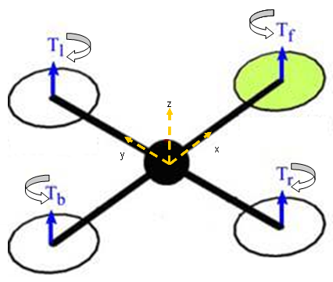
Figure 1: Simplified quad-rotor vehicle in stable hover.

There are four basic commands, which allow the helicopter to reach a certain attitude and altitude.

a) Throttle
This command is provided by simultaneously increasing (or decreasing) all propeller speeds by the same amount and at the same rate. This generates a collective vertical force from the four propellers, with respect to the body-fixed frame. In consequence, the quad-rotor is raised or lowered to a certain altitude.

b) Roll
The roll command is provided by simultaneously increasing (or decreasing) the left propeller speed and by decreasing (or increasing) the right propeller speed at the same rate. It creates a torque with respect to the x axis and this makes the quad-rotor to tilt about the same axis, thereby creating a roll angle. The total vertical thrust is maintained as in hovering, thus this command leads only to a roll angular acceleration.

c) Pitch
The pitch and roll commands are very similar. It is provided by simultaneously increasing (or decreasing) the rear propeller speed and by decreasing (or increasing) the front propeller speed at the same rate. This creates a torque with respect to the y axis which makes the quad-rotor to tilt about the same axis, thereby creating a pitch angle (known as a nose-up or nose-down in a conventional aircraft). Again, there is no loss in the total vertical thrust; hence this command leads only to a pitch angular acceleration.

d) Yaw
This command is provided by simultaneously increasing (or decreasing) the front-rear propellers’ speed and by decreasing (or increasing) that of the left-right duo. This creates a torque imbalance with respect to the z axis, which makes the quad-rotor turn about the same axis. The yaw movement is generated because of the fact that the left-right propellers rotate clockwise while the front-rear pair rotates counter clockwise. Hence, when the total torque is unbalanced, the helicopter turns on itself around z. As obtained in the other movements, the total vertical thrust is still maintained as in hovering; hence this command leads only to a yaw angular acceleration.

2.2 Dynamics of the quad-rotor system
3 Simulation of the quad-rotor helicopter

A good quad-rotor model has to use theory usually applied for helicopters. Having four rotors in close proximity complicates the problem even further. There are interactions between the wakes produced by the rotors and the fuselage, and also between individual rotors. Because the propellers are made of plastic, they are quite flexible and present flapping at translational speeds. They cannot be modelled precisely as propellers and require models similar to helicopter rotors. Except for hover, the expression for the rotor wash induced velocities cannot be obtained in closed-form, creating difficulties when the model is used to design certain types of controllers.

Matlab/ Simulink Approach
Matlab is a high-level technical computing language and interactive environment for algorithm development, data visualization, data analysis and numeric computation. As real-world systems have to respond to both continuous and instantaneous changes, Matlab becomes an invaluable tool because of its features that support such and it is widely used in engineering and science.
Simulink is an extension of Matlab that allows for rapid and accurate building of computer models of dynamical systems using block diagram notation. Using Simulink, new ideas can be easily integrated and tested immediately. The Simulink model in the figure below allows for commands to be sent to the quad-rotor and its sensor data to be received by the model.
The inputs, labelled V₁, V₂, V₃ and V₄ are the voltages, which serve as motor control inputs for the brushless DC motors. Hardware blocks instead of software codes are used in the implementation of the model because it saves a lot of time for the computation and the simulation turns out to be much faster. The equations of motion listed below and obtained from [Altug] have been modelled in Simulink as shown in the figure.

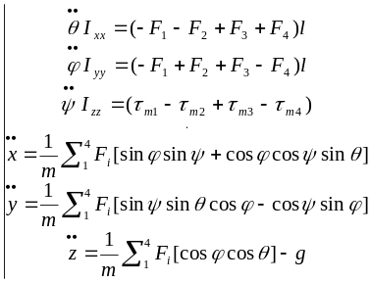
Where F_{i} is the thrust force generated by motor i, l is the length of the quad-rotor arm, 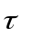is the torque produced by each motor, I’s are the moments of inertia with respect to the axes and m the mass of the helicopter.
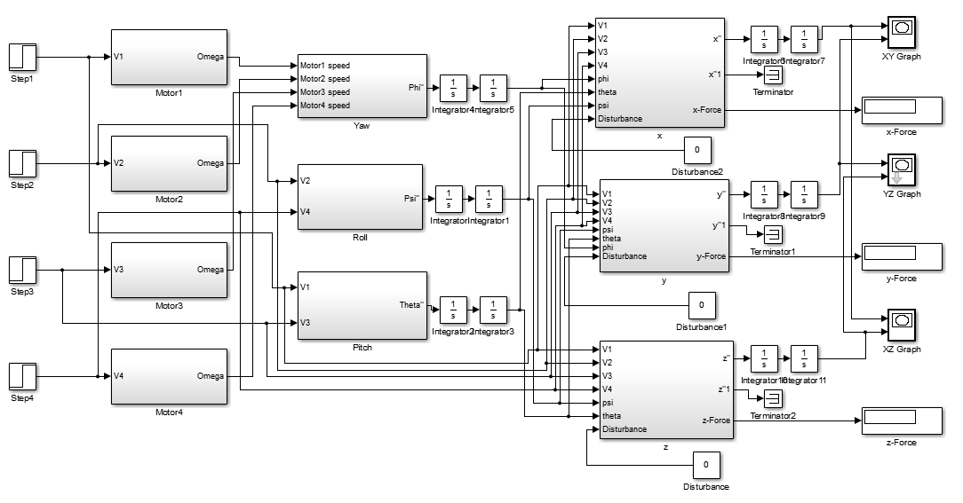

The model as shown in the figure has a total of 10 sub-systems, with four of them simulating the rotor dynamics, another three simulating the angular accelerations and the last three simulating the linear accelerations. The outputs of the rotor dynamics sub-systems are the angular velocities of the propellers. They later serve as inputs to the yaw subsystem, which computes the yaw angular acceleration. The other subsystems labelled roll, pitch, x-motion, y-motion and z-motion are also fed with the same motor speed control inputs.

The set of differential equations describing the dynamics of quad-rotor that were obtained earlier have been modelled and simulated using the Matlab/Simulink software. This is very essential because it will help to verify the correctness of the helicopter dynamic model and to test the control algorithms performance.

Solidworks Model/ CFD Approach
SolidWorks is a computer-aided design software which runs on the Microsoft Windows platform and utilizes a parametric feature-based approach to create models and assemblies. It uses a mouse-driven graphical user interface to enable engineers and designers to visualize and communicate 3D models of manufactured objects. Parameters refer to constraints whose values determine the shape or geometry of the model or assembly. Parameters can be either numeric parameters, such as line lengths or circle diameters, or geometric parameters, such as tangent, parallel, concentric, horizontal or vertical, etc. Numeric parameters can be associated with each other through the use of relations, which allow them to capture design intent. The figure below shows the 3-D SolidWorks model.
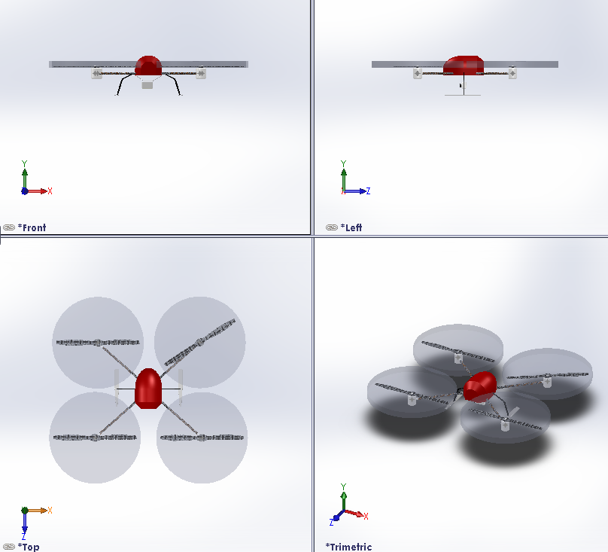

Description of the CFD computation process
The CFD tool used here is SolidWorks Flow Simulation, which is a fluid flow analysis add-in package. In works so as to obtains solutions to the full Navier-Stokes equations that govern the motion of fluids. It is able to compute the forces, velocity and pressure values of flow within any specified domain.
The main objective of conducting the CFD analysis is to simulate the effects of the external environment on the flow patterns of the quad-rotor helicopter.

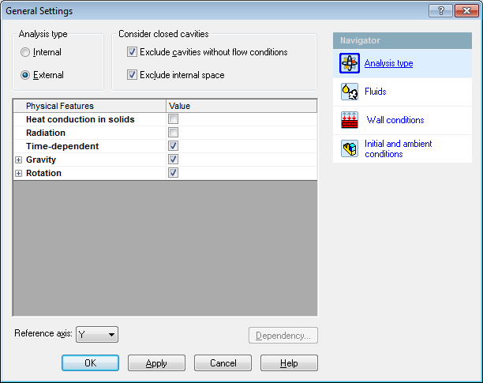

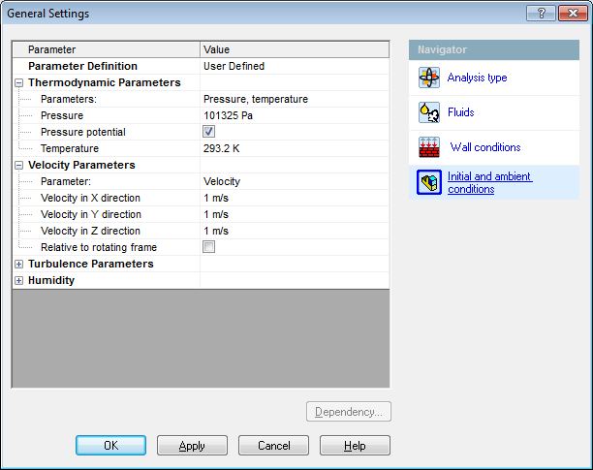

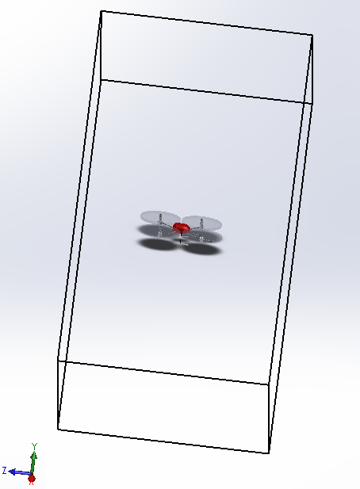

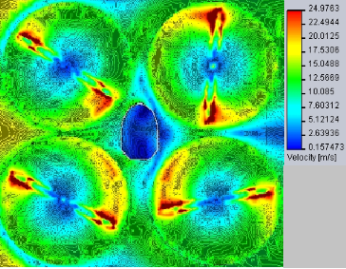

4 Validation of the model
The two are also compared with results from real experiments, with a general agreement between the numerical and experimental results, which can be judged satisfactory. This is enough to validate the use of the simulation results for similar future analysis and prediction of the helicopter movements and effects of wind flow on it.

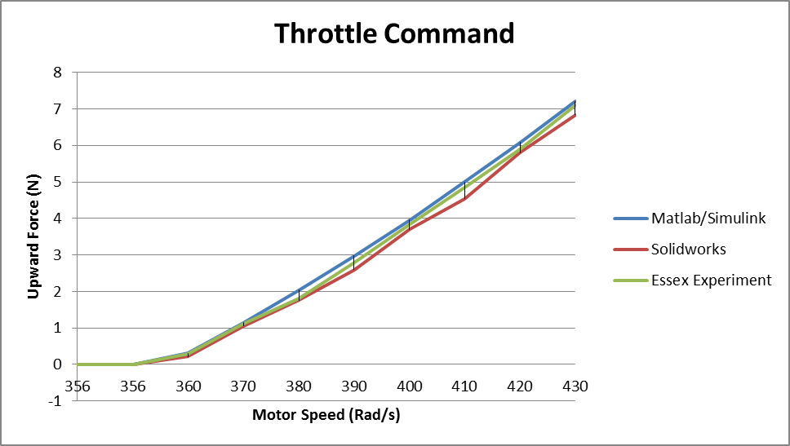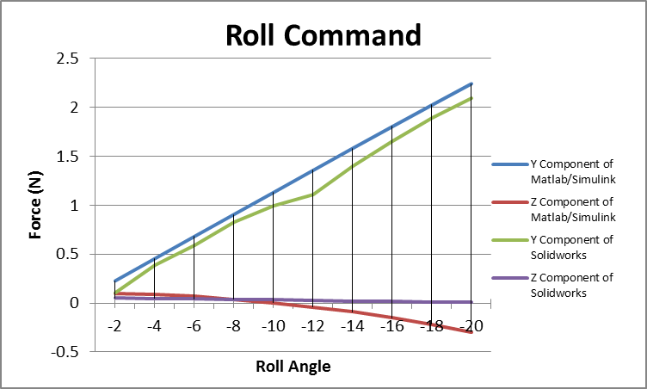

5 Conclusions
The experimental data gathered from actuall flight experiments at Essex University have been compared with the computations performed with an analytical Model, built in Matlab/ Simulink and a 3-D SolidWorks Model. The general agreement between numerical and experimental results can be judged satisfactory. This is good enough to validate the use of the simulation results for similar future analysis and prediction of the helicopter movements and effects of wind flow on it.

References
[1] E. Altug, J. P. Ostrowski, R. Mahony. “Control of a Quad-rotor Helicopter Using Visual Feedback”, International Conference on Robotics and Automation, pp 72-77, (2002).
[2] M. Y. Amir, V. Abbas. “Modeling and Neural Control of Quad rotor Helicopter”, Yanbu Journal of Engineering and Science, volume 2, pp 35-49, (2011).
[3] T. Bresciani. “Modelling, Identification and Control of a Quad rotor Helicopter”, MScThesis, Lund University, (2008).
[4] M. Claudia, C. T. Luminita, K. K. Simon. “Modelling and Control of Autonomous Quad-rotor”, MSc Group Project, University of Aalborg, Denmark, (2010).
[5] R. Czyba. “Attitude Stabilization of an Indoor Quad-rotor”, (2009), http://www.emav09.org/EMAV-final-papers/paper_64.pdf.
[6] A. S. Sanca, P. J. Alsina, J. F. Cerqueira. “Dynamic Modelling of a Quad-rotor Aerial Vehicle with Nonlinear Inputs”, Robotic Symposium, 2008. LARS '08. IEEE Latin America, pp 143-148, (2008).

