Characterising Solder Materials from Random Vibration Response of their Interconnects in BGA Packaging
Joshua A. Depiver^{1, a}, Sabuj Mallik^{1, b} and Emeka H. Amalu^{2, c}
¹School of Mechanical Engineering & the Built Environment, College of Engineering & Technology
University of Derby, Markeaton Street, Derby, DE22 3AW, United Kingdom
²Department of Engineering, School of Computing, Engineering and Digital Technologies, Teesside University, Middlesbrough, Tees Valley, TS1 3BA, United Kingdom
ª100149696@unimail.derby.ac.uk/jdepiver@aol.com, ^{b}s.mallik@derby.ac.uk ^{c}e.amalu@tees.ac.uk

Abstract
Solder interconnection in electronic packaging is the weakest link, thus driving the reliability of electronic modules and systems. Improving interconnection integrity in safety-critical applications is vital in enhancing application reliability. This investigation qualifies the random vibration response of five essential solder compositions in ball grid array (BGA) solder joints used in safety-critical applications. The solder compositions are eutectic Sn63Pb37 and SnAgCu (SAC) 305, 387, 396, and 405. Computer-aided engineering (CAE) employing ANSYS FEA and SolidWorks software is implemented in this investigation. The solder Sn63Pb37 deformed least at 0.43 µm, followed by SAC396 at 0.58 µm, while SAC405 deformed highest at 0.88 µm.
Further analysis demonstrates that possession of higher elastic modulus and mass density culminates in lower solder joint deformation. Stress is concentrated at the periphery of the solder joints in contact with the printed circuit board (PCB). The SAC396 solder accumulates the lowest stress of 14.1 MPa, followed by SAC405 at 17.9 MPa, while eutectic Sn63Pb37 accrues the highest at 34.6 MPa. Similarly, strain concentration is found at the interface between the solder joint and copper pad on PCB. SAC405 acquires the lowest elastic strain magnitude of 0.0011 mm/mm, while SAC305 records the highest strain of 0.002 mm/mm. These results demonstrate that SAC405 solder has maximum and SAC387 solder has minimum fatigue lives.
Keywords: solder joints, electronic packaging, fatigue failure, fatigue life prediction, random vibration, finite element analysis (FEA)

Corresponding author: 100149696@unimail.derby.ac.uk/jdepiver@aol.com

Introduction
The ball grid array (BGA) packages are widely used in electronic modules because they have many advantages over other electronic packages. They have improved re-workability and support component miniaturisation manufacturing trends. In addition, they demonstrate a higher level of solderability while enabling the efficient use of printed circuit boards (PCB). Supporting surface mount technology (SMT), the BGAs have improved thermal and electrical performance and reduced inductance compared to other packages. Their structure supports increased connectivity. Notwithstanding the numerous advantages, the package demonstrates significant reliability challenges when subjected to vibrational loading, especially in elevated ambient and harsh environments.
Thus, a critical understanding of fatigue failure of solder joints in BGA packages caused by vibration is vital owing to the high-reliability demand of the devices operating in mission-critical systems. Electronic devices operating in automobile, military and aerospace vehicles experience harsh mechanical and thermal loads [1]. Automobile engine operations and automobile operations on the road induce random vibration in the electronic components of automobiles. Manufacturing processes, procedures, shipping, and other service life conditions exposed electronics components to random vibrations. American Air Force data reports that more than 20% of electronic products fail prematurely when operating in vibration and shock environments, with 75% of failures caused by temperature and vibration loadings. The challenge is aggravated by the Restriction of Hazardous Substances Directive (RoHS) compliance (Directive 2002/95/E.C.) on electrical and electronic equipment. The miniaturisation of electronic systems coupled with deployment in harsh conditions has increased reliability challenges in the systems.
Thermo-mechanical and vibration loads produce cracks in the solder joints. Damage mechanisms include repeated elastic deformations leading to many load cycles that trigger high cycle fatigue (HCF). Achieving an acceptable level of mechanical reliability in BGA packages requires that the effect of mechanical and thermal loads be fully qualified. Many researchers have contributed to this area. Ref. [2] investigated the sinusoidal vibration tests and harmonic FEA to generate the strain-life (E-N) curves of lead-free (SAC305 and SAC405) solder joints. It assessed the fatigue life of a BGA assembly under random vibration. The work by Ref. [3] carried out a random vibration test. It compares the input power spectral density (PSD) levels with the observed failure modes of SAC305 BGA packages to assess the contribution of HCF to their failure. Their work shows that the higher the random vibration load imposed on the BGA-PCB assembly, the shorter the fatigue life of the BGA. In another investigation, the researcher predicted the fatigue life of BGA solder joints under random vibrations and developed the associated fatigue curves using numerical simulations [4]. Ref. [5] predicted the fatigue life of electronic components exposed to sinusoidal vibration. The work implies that there is room for further research in the area.
Further research investigated the vibration response of BGA solder joints subjected to thermal and mechanical loads. The work by Shen [6] presents a study on random vibration analysis of BGA joints made with different sizes of SAC0307 solder joints. They used FEA to investigate the structural response of the BGA package subject to random vibration. Structural factors studied include the height and radius of the solder joints of the BGA package. Other researchers, including [5]–[11], have studied the effect of vibration load on several solder joints, including lead-based eutectic and lead-free Sn63Pb37 and SAC305 solder joints.
In this study, the authors performed random vibration analysis on lead-based eutectic Sn63Pb37 and lead-free SAC (SAC305, SAC387, SAC396 and SAC405) solder joints in the BGA package using FEA simulation software. Modal tests and simulation techniques are implemented to benchmark the responses from the solder joints to advise on suitable lead-based solder replacement, which has yet to be covered in previous work. The investigation aims to provide new knowledge on the impact of vibration on the fatigue life of the solder joints made from several solder alloys.

2.0 Modal Analysis
Modal analysis is implemented as the key method in the research presented in this article. Modal analysis is a modern method used to study the dynamic characteristics of structural systems in the frequency domain. The mode is the inherent vibration characteristic of mechanical structure. Each mode has a specific natural frequency, damping ratio and modal shape. Vibration mode is the intrinsic and holistic characteristic of an elastic system. This research implements the method to investigate the structural modal attributes of solder joints in a BGA at a particular frequency to predict their vibration response from internal and external disturbances. Underpinning equations of modal analysis are presented in Eqs. (1) and (2), thus:
$\left[K\right]\left\{∅_{i}\right\}=ω_{i}^{2}\left[M\right]\left\{∅_{i}\right\}$ (1)
Where $\left[K\right]$ is a stiffness matrix;$\left[∅_{i}\right]$ is the vibration mode vector (characteristic vector) of the $i$ order mode; $ω_{i}$ is the natural frequency of $i$ the order mode; $ω_{i}^{2}$ is an eigenvalue; $\left[M\right]$ is a mass matrix.
$\left[M\right]\left\{\ddot{u}\right\}+\left[C\right]\left\{\dot{u}\right\}+\left[K\right]\left\{u\right\}=\left\{F\right\}$ (2)
where [M] is a structural mass matrix; $\left\{\ddot{u}\right\}$ is the nodal acceleration on vector; [C] is a structural damping matrix; $\left\{\dot{u}\right\}$ is the nodal velocity vector; [K] is a stiffness matrix; $\left\{u\right\}$ is the nodal displacement vector; [F] is an incentive or applied load vector.

Modal Analysis Procedure
The modal analysis procedure starts by building the model and attaching the geometric and material properties. Utilising the mesh controls, a suitable mesh was defined. Based on the research objectives, appropriate analysis types and options were selected. Supports, constraints and boundary conditions were specified and applied. Simulation outputs were identified, including deformation, stress and strain, and the set-up model was solved. Frequency results were requested, and other effects were reviewed for analysis.

2.2 Fatigue life prediction model for random vibration
Predicting the fatigue lives of the solder joints in the BGA was a vital objective of this investigation. Miner's rule presented in Eq. (3) was employed to compute the accumulated fatigue damage in the joints:
$D=\int_{0}^{+∞}{\frac{n_{s}}{N_{s}}dS=\int_{0}^{+∞}{\frac{Np(S)}{N_{s}}dS}}$ (3)
Where $n_{s}$ is the actual number of cycles under stress amplitude S, $N_{s}$ is the number of cycles to failure under stress amplitude S, N is the total cycle number to failure when the failure occurs, $p(S)$ is the probability density function of stress amplitude S.
Employing strength and stochastic theories, the total damage of a narrow-band random process can be expressed as:
$D=N\int_{0}^{+∞}{\frac{S^{k+1}e^{\left[-\frac{S^{2}}{2σ^{2}}\right]}}{Cσ^{2}}dS=\frac{N{\left(√2σ\right)}^{k}Γ\left(\frac{k}{2}+1\right)}{C}}$ (4)
where $Γ\left(∙\right)$ is the Gamma function. When D = 1, the electronic component fails in theory, but the D values differ for various electronic components. Steinberg [12] recommends D values for various electronics as 0.7 for typical electronic structures and 0.3 for critical life-cycle electronic systems. Implementing a D value of 0.7, the total cycle number (N) of the solder joints is calculated using Eq. (5):
$N=\frac{0.7C}{{\left(√2σ\right)}^{k}Γ\left(\frac{k}{2}+1\right)}$ (5)
While Eq. (6) expresses the fatigue life T of a typical electronic structure under narrow-band random vibration loading as:
$T=\frac{0.7C}{v_{0}{\left(√2σ\right)}^{k}Γ\left(\frac{k}{2}+1\right)}$ (6)
The $v_{0}$ is the expressed positive zero-crossings intensity.
Furthermore, the Weibull distribution [13], represented in Eq. (7), implements a two-parameter function to predict the fatigue life of BGA lead-free solder interconnections subjected to vibration loading. The mean-time-to-failure (MTTF) is described as follows:
$MTTF=\int_{0}^{∞}{tf\left(t\right)dt=η*Γ\left(\frac{1}{β}-1\right)}$ (7)
Where $β$ is the shape parameter, $η (η>0)$ is the scale parameter which is also fatigue life when the failure of BGA lead-free solder joints is 63.2% of the total time [4].

3.0 Materials and Method
The discussion on materials and methods is presented in three sub-sections. These are:

3.1 Materials of the BGA solder joints
Tin-lead (Sn-Pb) based solder alloys have been used in electronic packaging for over three decades until the government legislation on Lead (Pb) usage in electronic assemblies, which came into effect on July 01, 2006. Since then, lead-free solder alloys have been researched for replacement. In this research, both lead-based and lead-free solder alloys are investigated. These include Sn63Pb37, SAC305, SAC387, SAC396 and SAC405. The properties of the solder alloys are obtained from peer-reviewed literature and presented in Table III. The key properties are Young's modulus (GPa), Poisson's ratio, and mass density $\left(g/{{cm}^{3}}\right)$.
The authors are knowledgeable that an intermetallic compound (IMC) is formed when Tin-reach solder is soldered on a copper substrate. However, the effect of IMC is not considered in this study because a follow-up study is designated for that. The current investigation is comparative, and thus the effect of IMC is predicted to be even among the designs researched in this work. A comparison of the results of the current study with published literature presented in Figure 21 supports the claim and validates current results.

Table I: Material and mechanical properties parameters used for the random vibration analysis
Materials | Reference | Young's  Modulus,$E$ (GPa) |  |  | Poisson's  Ratio, $μ$ |  |  | Mass Density, $ρ \left(kg/{m^{3}}\right)$
 |  | $$E_{x}$$ | $$E_{y}$$ | $$E_{z}$$ | $$v_{xy}$$ | $$v_{xz}$$ | $$v_{yz}$$ | ρ
Silicon  Die | [14] | 110.0 |  |  | 0.24 |  |  | 1910
Mask | [15] | 4.14 |  |  | 0.40 |  |  | 1890
Cu Pad | [16] | 129.0 |  |  | 0.34 |  |  | 8940
PCB | [17] | 27.0 | 27.0 | 22.0 | 0.17 | 0.20 | 0.17 | 2340
Epoxy-Resin  (FR-4) | [14] | 29.9 | 25.1 | 70.0 | 0.16 | 0.14 |  | 1850
Sn63Pb37 | [18] | 56.0 |  |  | 0.30 |  |  | 8400
SAC305 | [14] | 51.0 |  |  | 0.40 |  |  | 7400
SAC387 | [19] | 45.0 |  |  | 0.36 |  |  | 7440
SAC396 | [20] | 43.0 |  |  | 0.30 |  |  | 7300
SAC405 | [21] | 44.6 |  |  | 0.42 |  |  | 7440

3.2 Method
The key method this research uses is finite element (F.E.) simulation implemented in ANSYS mechanical package. Simulation results are validated using results published in peer-reviewed journals. The F.E. simulation process flow chart is shown in Figure 1 and discussed in the following sections.

ANSYS FEA simulation process
The simulation procedure implemented in this research is presented in Figure 1. The procedure follows a research design. The F.E. model was created using SolidWorks. In an acceptable format, the model was imported into ANSYS mechanical package software environment where it was set up. This involves assigning properties to the materials, defining mesh, and applying boundary conditions. Key assumptions made to aid simulation is that no time-varying forces, displacement, thermal or pressure load are acting on the structure. Implementing calculated PSD displacement, the first six natural frequency is requested. Displacement measures the amplitude (distance) between the peaks of vibration of the BGA balls. The outputs are inputted into random vibration analysis where deformation, elastic strain and equivalent stress are set up as the simulation outputs. The deformation quantifies the change in the shape of the BGA solder joints. The results of the elastic strain are used to predict the fatigue life of the solder joints in the BGA package. All the simulation outputs are analysed for random vibration's effect on solder joints' reliability.
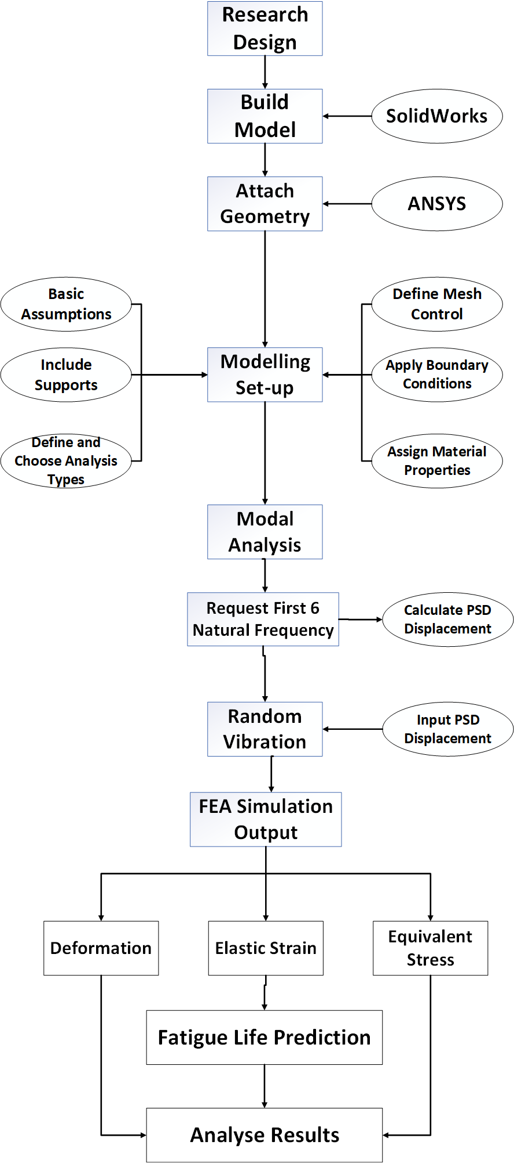
Figure 1: ANSYS FEA simulation process implemented in the investigation

3.2.2 Finite Element modelling of the vibration loading
As presented in Figure 3, Adequate and quality mesh is employed to determine simulation accuracy. Implementing mesh sizing, 67,123 nodes and 19,626 elements are generated and utilised in the modelling. The mesh comprises a hexahedron that is made up of several tetrahedron elements [22]. A sub-model of the full F.E. model is employed to optimise computational time. The 3-D sub-model is implemented in modal analysis within the Ansys environment to characterise the dynamic response of the structure. Natural frequencies and mode shape parameters are computed and correlated with experimental modal analysis from peer-reviewed publications. In setting up the model, key assumptions include the implementation of light damping and no time-varying forces, displacement, pressures, stiffness, damping and mass. No random properties were also assumed. Figure 2 shows the model structure's dimensional aspect, with Figure 4 showing the PCB Land Pattern and Table II showing the PCB dimensions.
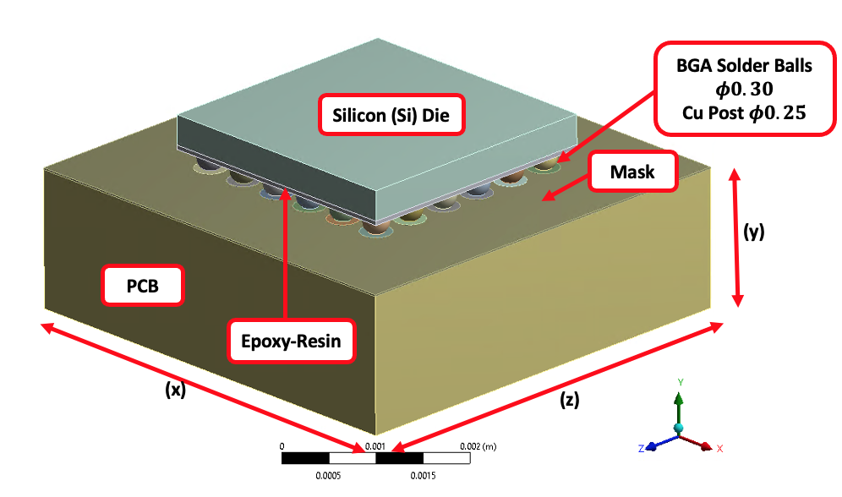
Figure 2: BGA solder alloy soldered on PCB model highlighting the different parts of the test vehicle used for the FEA simulation
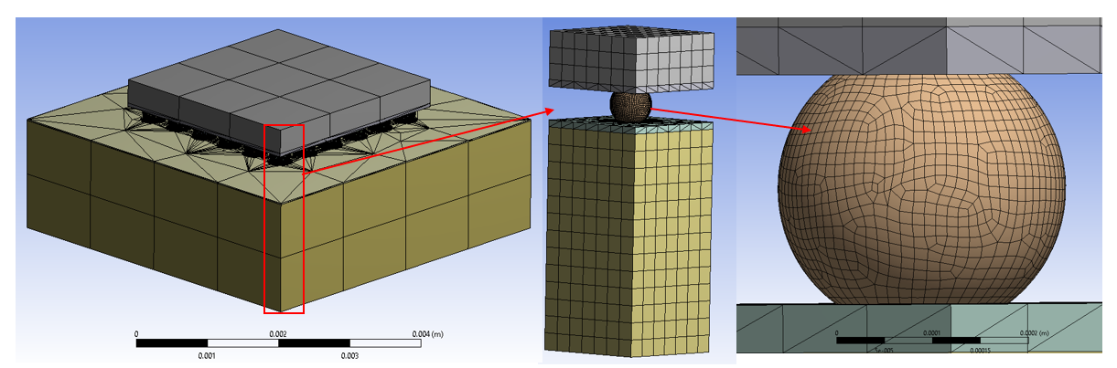
Figure 3: Full component model with a submodel showing adequate mesh of solder joints

Table II: PCB Dimensions
Dimension Table |  |  |  | SMD Pads
 |  |  |  | S1 | D1 | T.I.
Pitch | Ball diameter before reflow |  |  | Mask Opening | Cu Pad Diameter | Cu Trace Max
0.50mm |  | 0.30mm | 11.8mil | 10mil | 14mil | 5mil

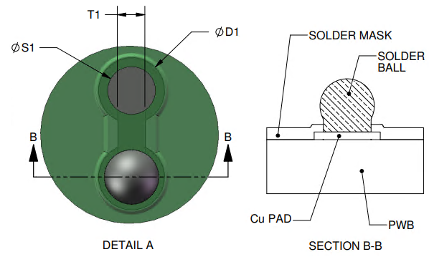
Figure 4: PCB Land Pattern (Solder Mask Defined Pads)

Strain occasioned by the vibration loading is mathematically modelled with Eq. (8).
${∆ε}_{ave}=\frac{\sum_{i}^{n}{{∆ε}_{i}V_{i}}}{\sum_{i}^{n}{V_{i}}}$ (8)
where ${∆ε}_{i}$ is the strain in the $i$-th element, $V_{i}$ is the volume of the $i$-th element and $n$ the number of elements in the chosen area of interest volume.
Basquins's law [23], represented in Eq. (9) is used to model the fatigue induced in the solder joints:
$\frac{{∆ε}_{e}}{2}=\frac{σ_{f}^{'}}{E}{\left({2N}_{f}\right)}^{b}$ (9)
where ${∆ε}_{e}$ is the elastic strain amplitude, ${2N}_{f}$ is the number of reversals to failure, $σ_{f}^{'}$ the fatigue strength coefficient, $E$ the elastic modulus, and $b$ the fatigue strength exponent.
The natural circular frequencies $ω_{i}$ and mode shape parameter $∅_{i}$ of the solder joints under free vibration, is modelled with Eq. (10):
$\left(\left[K\right]-ω_{i}^{2}\left[M\right]\right)\left\{∅_{i}\right\}=0$ (10)
Where K and M are constants.

3.3 Estimation of Fatigue Life of Solder Joints
The fatigue life of solder joints is estimated using the Coffin-Manson empirical method. The method is reported as one of the most effective and efficient techniques used to predict solder joints' fatigue life. Thus, it was adopted, and Eq. (11) is employed to predict the allowable number of cycles of the solder joints through peak ε strain response:
$\frac{{∆ε}_{t}}{2}+\frac{{∆ε}_{e}}{2}+\frac{{∆ε}_{p}}{2}=\frac{σ_{f}^{'}}{E}{\left({2N}_{f}\right)}^{b}+ε_{f}^{'}{\left({2N}_{f}\right)}^{c}$ (11)
Where ${∆ε}_{t}$ is the total strain range; ${∆ε}_{e}$ is the elastic strain range; ${∆ε}_{p}$ is the plastic strain range; $σ_{f}^{'}$ is the fatigue strength coefficient; $E$ is the material elastic modulus; $N_{f}$ is the fatigue life cycle; $b$ is the fatigue strength index; $ε_{f}^{'}$is the fatigue plasticity coefficient, and $c$ is the fatigue plasticity index.
Considering only elastic strain from our simulation outputs, Eq. (11) is reduced to a more usable Eq. (12):
$ε=$ $\frac{{∆ε}_{t}}{2}=3.5\frac{σ_{u}}{2E}N_{f}^{b}$ (12)
Where $ε$ is strain amplitude; $σ_{u}$ is the tensile strength of the material.
Wei and Yingnan [24], [25] conducted a study. Results show that $b=-0.12$ for SAC solder alloys. The tensile strength and elastic modulus values are obtained from Nelco & Triazine [26]. The authors also implemented Miner's cumulative damage model to determine the fatigue failure caused by the vibration loading. The model is represented in Eq. (13).
$D= \sum{\frac{n_{i}}{N_{i}}}$ (13)
Where $n_{i}$ is the number of cycles accumulated at stress, $S_{i}$ and D is the fraction of life consumed by exposure to the cycles at different stress levels. Failure occurs at a damage fraction of circa 1. An improved Palmgren-Miner cycle ratio summation rule, also called Miner's rule, is presented thus:
$\sum{\left[\frac{n_{i}}{N_{i}}\right]=c}$ (14)
Where $n_{i}$ is the number of cycles at stress levels $σi$ and $N_{i}$ is the number of cycles to failure at stress level $σ_{i}$. The parameter $c$ has been determined by experiment; it is usually found in the range $0.7<c<2.2$ with an average value near unity. Using the deterministic formulation as a linear damage rule, it could be written thus:
$D=\sum{\left[\frac{n_{i}}{N_{i}}\right]}$ (15)
Where $D$ is the accumulated damage. When $D=c=1,$ failure ensues [27]. According to the Miner's rule, substituting the allowable number of cycles and the cumulative number of fatigue cycles to calculate the cumulative damage factor, the following simplified Miner's rule is applied as stated thus:
$D=\frac{n_{1σ}}{N_{1σ}}+\frac{n_{2σ}}{N_{2σ}}+\frac{n_{3σ}}{N_{3σ}}$ (16)
The fatigue life of the most critical solder joint most susceptible to failure under vibration is:
$N_{f}=\frac{1}{D}$ (17)

4.0 Results and discussion
The results and discussion are presented in five key sections. These are studies on modal deformation, von Mises stress, elastic stain responses, as well as fatigue life prediction of the solder joints. Full models were used to generate preliminary results in the first instance, and sub-models were employed to generate more precise results.

4.1 Study on the modal response of solder joints subjected to random vibration.
The modal simulation was performed to study the vibration characteristics of the model to estimate the dynamic control parameters. Generation of the first six natural frequencies is important because high-order frequencies do not cause solder joints to resonate or significantly impact their performances. The first six natural frequencies of the solder joints of the model generated from the simulation are presented in Figure 5. At the same time, Table III depicts the magnitude of the deformation and displacement. The first vibration mode shows the model is deformed along the y-axis, the second shows vibration along the x-axis, and the third shows four critical vibrations along the edges of the solder joint in the x and z-axis directions. The fourth vibration mode shows two vibrations along the z and x-axis. Similarly, the fifth vibration mode shows two vibrations around the y-axis in the x and z axes direction, while the sixth vibration mode shows vibrations in the x-axis direction. As the frequency increases, the vibration mode becomes complicated. Plots of frequency (kHz) and deformation (mm) against mode and frequency (kHz) and PSD displacement against mode are presented in Figures 7 and 8, respectively. The deformation and PSD displacement are plotted in the secondary axis. Figure 5 shows that frequency and mode increase while deformation attained the highest magnitude at mode 3. Identical profiles are obtained for Figure 8. Figures 7 and 8 demonstrate that mode 3 is critical, producing resonance in the solder joints and thus should be avoided during device operation in the field. Utilising sub-modelling, the first six vibration modes are generated, and the schematic is presented in Figure 8. The schematics show that the maximum Von-Mises’ stress is at the soldering interface between the solder balls and copper (Cu) pad on the PCB. This finding agrees with the results of several researchers, including Refs. [28]–[32]. That is the site of stress concentration, and at a magnitude close to the yield strength of the solder in the joint, fatigue crack initiates and propagates to drive failure.
The frequency and deformation on the model are ANSYS result outputs shown in Figure 5 and used to compute the PSD of the models. The Power Spectral Density (PSD) contains the loading (in terms of deformation quantity squared) vs frequency. This is used as the load in Random Vibration Analysis. The main principle behind evaluating random vibrations is that their average value remains constant for a given frequency. The output from the dynamic modal analysis is natural frequencies and corresponding mode shapes, including stress/strain profile.
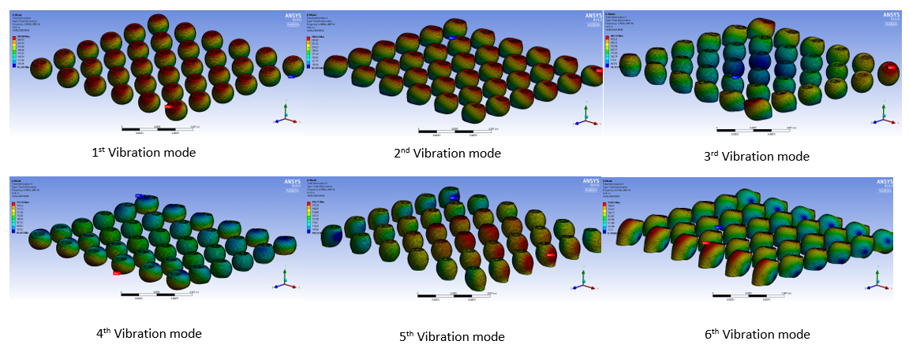

Figure 5: The first six modes of a complete model

Table III: Natural frequency, deformation, and PSD Displacement of the models
Mode | $$Frequency, f$$  $(kHz)$ | $$Deformation, δ$$  $$(mm)$$ | $$PSD Displacement=\frac{δ^{2}}{f}({{mm}^{2}}/{kHz)}$$
1 | 293.8 | 287.08 | 280
2 | 294.0 | 286.61 | 279
3 | 338.5 | 465.13 | 639
4 | 416.8 | 151.32 | 55
5 | 430.7 | 184.75 | 79
6 | 435.8 | 154.01 | 54

Figure 6: First six vibration modes for the sub-model solder joints

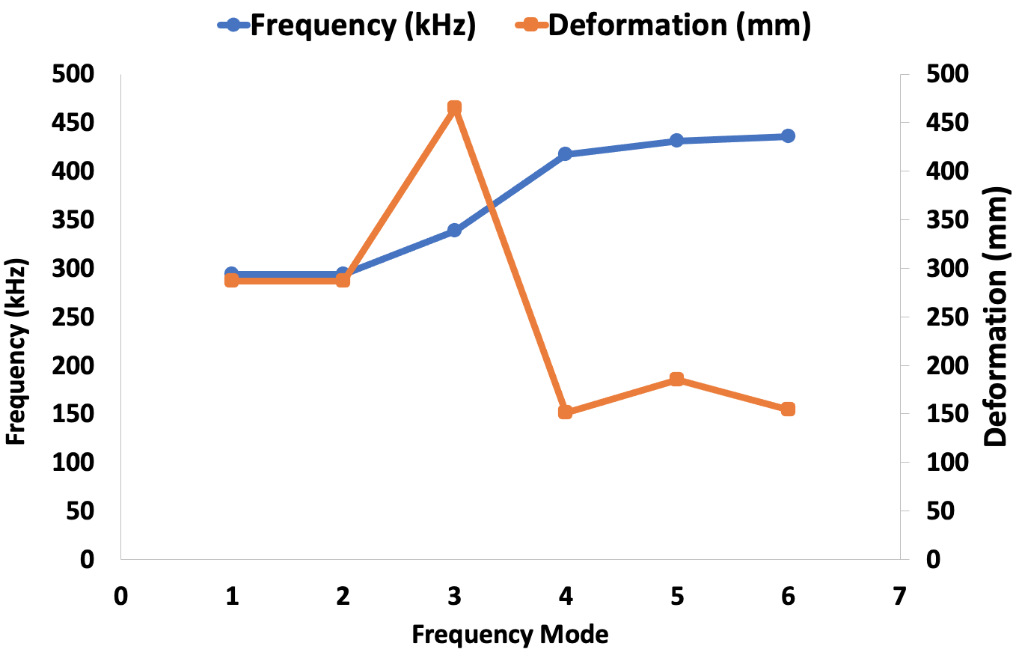
Figure 7: Plot of frequency and deformation against mode for the solder joints subjected to random vibration
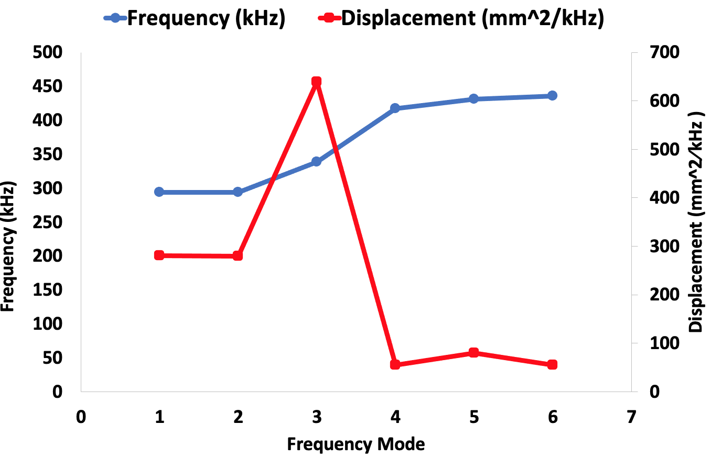
Figure 8: Plot of frequency and PSD displacement against mode for the solder joints subjected to random vibration

4.2. Study on deformation response of solder joints subjected to random vibration
The deformation responses of solder joints of the full models are shown in Figure 9. Random vibration causes the solder joints to deform from the base at the point of attachment to the PCB to the top at the point of attachment to the electronic chip. The results presented in Figure 11 shows that the solder joints at the outermost array experience the highest deformation, which is critical at the solder/PCB interface, as depicted in Figure 9. Strengthening the location will increase the reliability of the solder joints. As reported by Refs, several solder alloys are reported to fail at the solder-PCB interface in many electronic packages [15]–[20]. Utilising the full model results, sub-models of different alloy compositions of the solder joints were simulated. The schematic representations of the results are presented in Figure 10 and statistically in Figure 11. The results show that the lead-based eutectic Sn63Pb37 solder joint has the lowest deformation of 432 mm, while SAC405 solder joints have the highest deformation of 877 mm. With SAC405 alloy having an elastic modulus of 44.6 GPa and Sn63Pb37 alloy having an elastic modulus of 56 GPa, it is found that the higher the elastic modulus and mass density, the better the solder joint resistance to deformation when subjected to random vibration. The deformation of other solder joints under investigation are SAC396 is 576 mm, SAC305 is 579 mm, and SAC387 is 611 mm.

Figure 9: Deformation result for lead-based eutectic Sn63Pb37 showing the top and bottom of Solder joint bumps with areas prone to failure
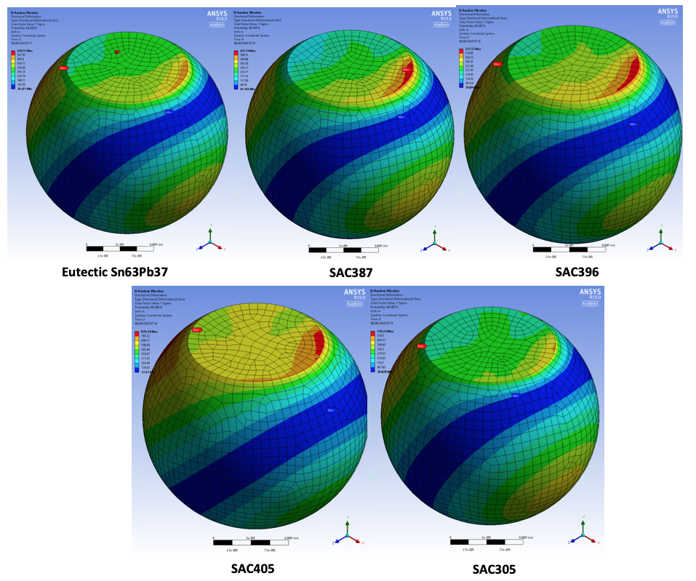
Figure 10: Schematic of the deformation effect for lead-based eutectic Sn63Pb37 and lead-free SAC387, SAC396, SAC405 and SAC305 solder alloys
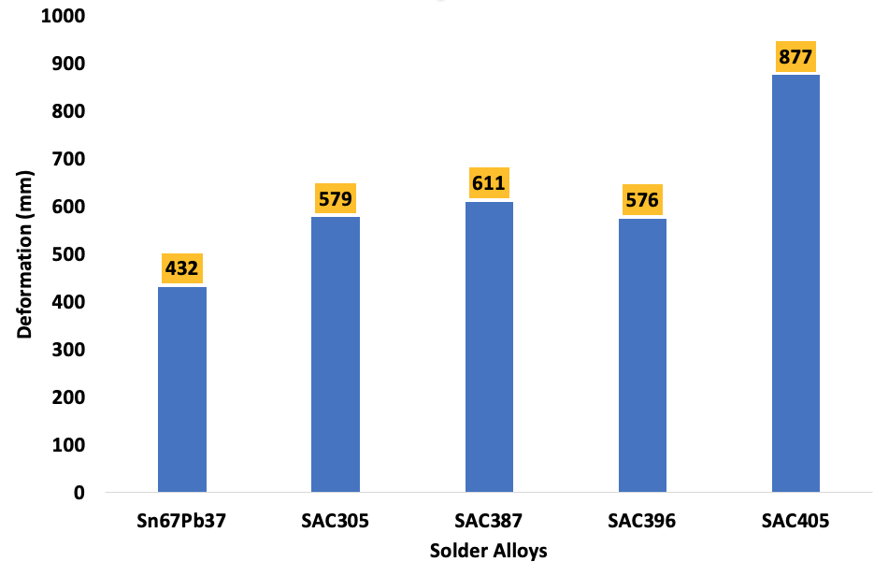
Figure 11: Plot of deformation for solder joint alloys

4.3 Study of Equivalent Stress Response of Solder Joints Subjected to Random Vibration

4.3.1 Study of Equivalent (Von Mises) Stress on Complete Finite Element Model (FEM)
The results of the von Mises stress response of the complete model are shown in Figure 12. The outermost corner solder joints accumulated the maximum stress, which critically indicates the interface between the solder and PCB components. This finding agrees significantly with other research carried out by Refs. [6], [28], [29] identifies the solder joints at the corners of a BGA structure as most susceptible to untimely failure. The findings of the full model are implemented in the sub-modelling of the different solder alloy joints for stress response. The results of the schematic equivalent stress response of the models under random vibration load are presented in Figure 13. Lead-free eutectic Sn63Pb37 solder joint has the highest stress magnitude of 34.62 MPa. In comparison, SAC396 joints have the lowest of 14.1 MPa. The area of tress concentration in all the joints is located at the interface between the Solder and PCB interface, gradually decreasing into the solder bulk. The accumulated stresses on other joints are SAC387 is 28.95 MPa, SAC305 is 30.33 MPa, and SAC405 is 17.92 MPa. The statistical and schematic representations of the stress magnitudes on all the joints are shown in Figures – 14 and 15, respectively.
Figure 12: Equivalent stress distributions on solder balls for lead-based eutectic Sn63Pb37 showing the top and bottom of solder joint bumps
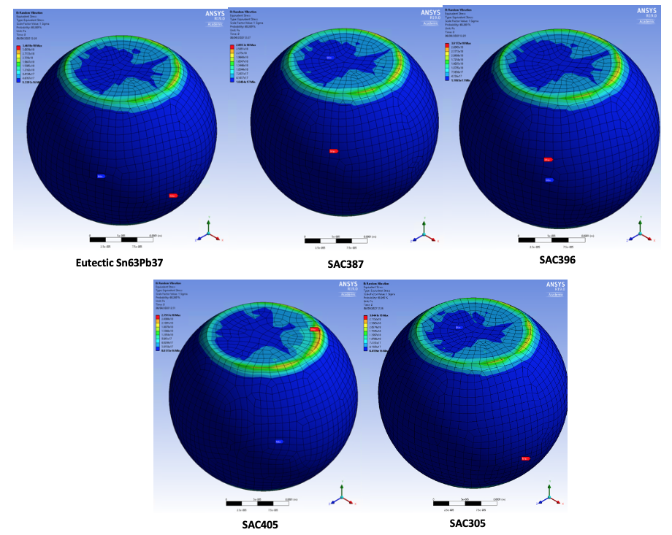
Figure 13: Schematic of the Equivalent stress distributions on solder balls for lead-based eutectic Sn63Pb37 and lead-free SAC387, SAC396, SAC405 and SAC305 solder alloys
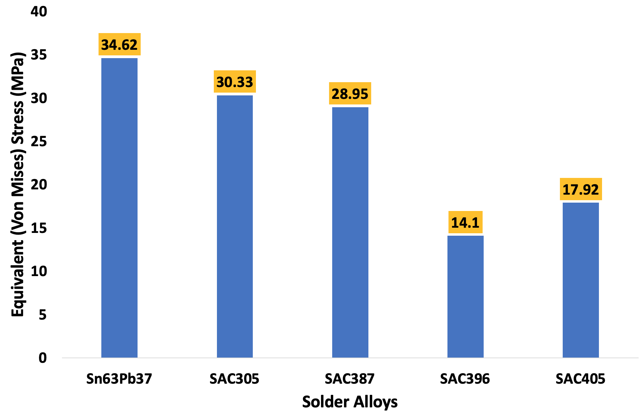
Figure 14: Plot of Von mises stress for solder joint alloys

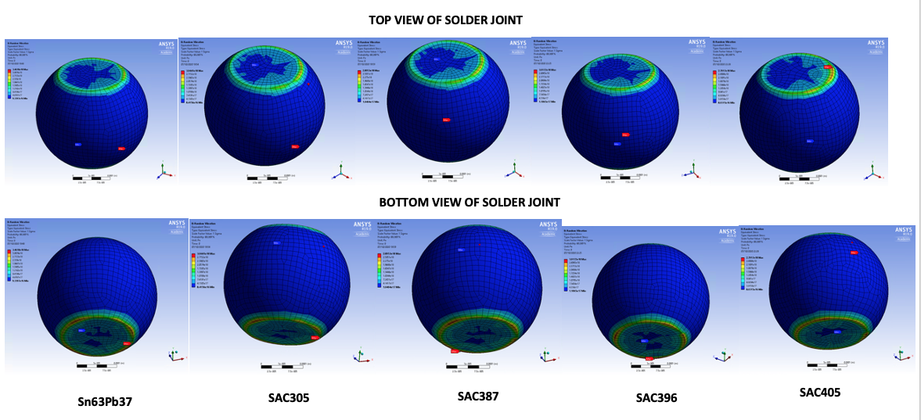

Figure 15: Schematic top and bottom of equivalent stress for lead-based eutectic Sn63Pb37 and lead-free SAC387, SAC396, SAC405 and SAC305 solder alloys

4.4 Study on elastic strain response of solder joints subjected to random vibration
The results of the simulation of the elastic strain response of the full model are presented in Figure 16 for lead-based eutectic Sn63Pb37 solder joints. The results show that the maximum strain is observed at the interface of the solder joint and Cu pad on the PCB. This area is susceptible to damage and failure. The finding agrees with the results from work by Ref. [33]. The results of the full model simulation were implemented in the sub-modelling of the response of the five solder alloys in the solder joints. The modelling results are presented in Figures 17, 18 and 19. Figure 18 shows that SAC305 has the highest strain of 0.00204 mm/mm while SAC405 has the least strain of 0.00112 mm/mm. The schematics in Figures 17 and 19 show that the maximum strain on the solder joints is located at the periphery of the outermost solder joint and its interconnection with the Cu pad on the PCB. This is the site of crack initiation and failure.
The findings strongly agree with published literature reported by Refs. [31], [34]. Other reports by Refs. [30], [32], [35] supporting the findings. Refs. [31], [34] demonstrate validation of the current study using solder marks defined (SMD) and non-solder marks defined (NSMD) pad designs in BGA assembly. Refs. [31], [34], which represents NSMD pad assembly, confirms cracks at the periphery of the joints. In contrast, Refs. [30], [32], [35], which depict SMD pad assembly similar to the pad design in the current study, also confirm cracking at the identical location. Consequently, irrespective of the solder joint pad design in the experimental study, the location of the crack is identical to that obtained by simulation in the current study.
As observed in Refs. [31], [34] and Refs. [30], [32], [35], the location of fatigue crack occurs at either the top, bottom, or both sides of BGA solder joints. This observation accounts for the pad geometric factor, specifically, component standoff height. Many researchers, including Ref. [36], reported the causes and location of fatigue cracks in BGA solder joints. In work, Ref. [36] reported that decreasing standoff height increases the stiffness of BGA joints under shear loading due to decreasing coefficient of stress state in the solder matrix and torque caused by an induced moment of force. They also stated that a decrease in standoff height decreases the concentration of stress and plastic strain energy along the interface of solder and pad in BGA assembly. They observed a fracture location change from the solder matrix's middle to near the SAC305/IMC interface. Another related study, Ref. [37], advised on the effect of bump (component) height on plastics strain range and related it to fatigue life and reliability of Pb-free solder joints in electronic products.
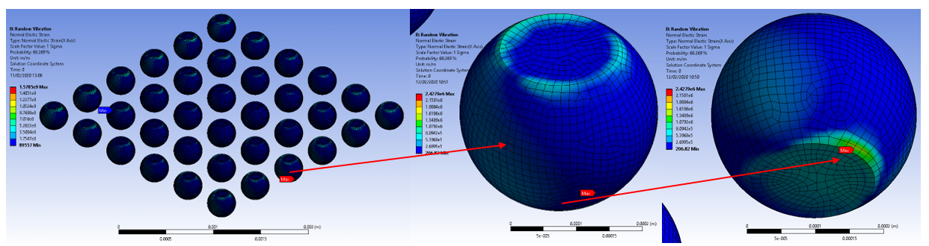
Figure 16: Elastic strain result for lead-based eutectic Sn63Pb37 showing the top and bottom of solder joint bumps
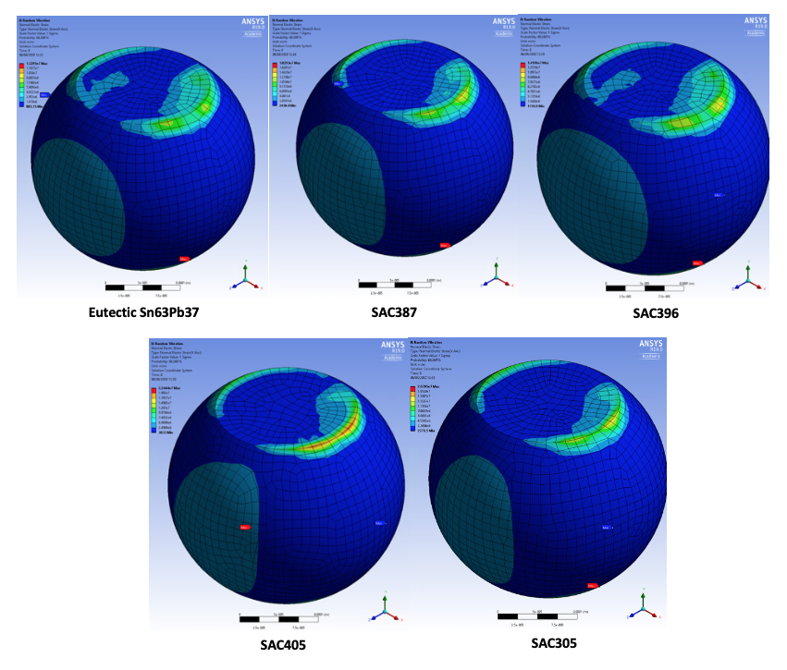
Figure 17: Schematic of the effect of elastic strain for lead-based eutectic Sn63Pb37 and lead-free SAC387, SAC396, SAC405 and SAC305 solder alloys
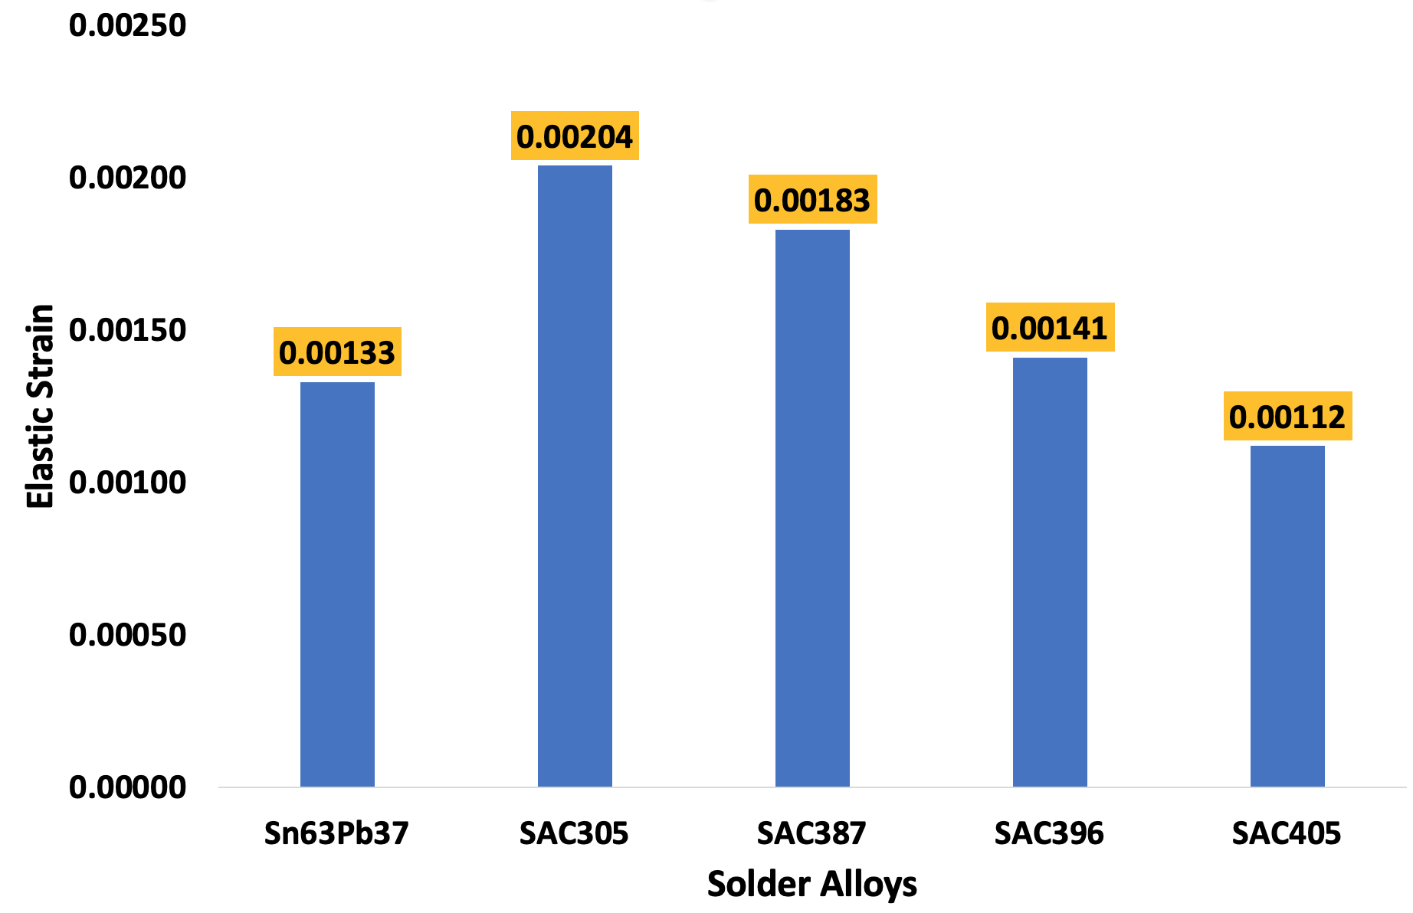
Figure 18: Plot of elastic strain for solder joint alloys
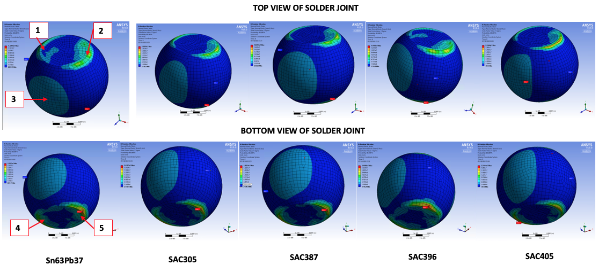
Figure 19: Schematic of top and bottom view of elastic strain for solder joint alloys

4.5 Study on fatigue life prediction of solder joints subjected to random vibration
Fatigue is reported as the primary cause of crack initiation, formation, and propagation in solder joints. Crack propagation leads to solder joint failure. The impact of cracks on solder joints is then used to predict fatigue life. The fatigue life of solder joints for the lead-based eutectic Sn63Pb37 and lead-free SnAgCu (SAC305, SAC387, SAC396 and SAC405) are predicted using fatigue cycle count. The concept is used to estimate the most critical solder joint. Implementing the equations presented in section 2, the allowable cycle count (N) for the solder alloys is computed and shown in Table IV. The cumulative fatigue cycle count is determined and presented in Table V using the Coffin-Manson empirical equation.
Table IV: Computation of Allowable Cycle Count
Solder Alloys |  |  | $$N_{1σ}$$ | $$N_{2σ}$$ | $$N_{3σ}$$
Eutectic  Lead-based |  | Sn63Pb37 | $${5.42×10}^{10}$$ | $${1.08×10}^{8}$$ | $${6.50×10}^{5}$$
Lead-free | SAC305 |  | $${5.43×10}^{8}$$ | $${1.09×10}^{7}$$ | $${6.52×10}^{6}$$
 | SAC405 |  | $${1.63×10}^{11}$$ | $${3.25×10}^{9}$$ | $${1.95×10}^{6}$$
 | SAC387 |  | $${1.35×10}^{9}$$ | $${2.71×10}^{7}$$ | $${1.62×10}^{5}$$
 | SAC396 |  | $${1.44×10}^{10}$$ | $${2.88×10}^{8}$$ | $${1.73×10}^{6}$$

Table V: Cumulative Fatigue Cycle Count Computation
Solder Alloys |  | $$n_{1σ}$$ | $$n_{2σ}$$ | $$n_{3σ}$$
Eutectic Lead-based | Sn63Pb37 | 7769 | 3087 | 493
Lead-free | SAC305 | 17066 | 6780 | 1080
 | SAC405 | 12852 | 5106 | 816
 | SAC387 | 13450 | 5344 | 854
 | SAC396 | 13144 | 5222 | 834

The cumulative damage factors are calculated according to the equations:
$D={n_{1σ}}/{N_{1σ}+{n_{2σ}}/{N_{2σ}+{n_{3σ}}/{N_{3σ}}}}$ (18)
$N_{f}=1/{D (mins)}$ (19)
Statistical analysis of displacement signal by random vibration test yields $N_{0}^{+}=417$ for SAC305, 314 for SAC405, 329 for SAC387, 321 for SAC396 and 190 for Sn63Pb3 solder joints. The number of fatigue cycles accrued per minute at the solder joints is calculated, and results are plotted in Figures 20 and 21. The plot shows that SAC405 has the highest fatigue life of 2,307 minutes, followed by SAC396 with 1,995 mins. The SAC387 has the least life of 183 minutes. These results significantly agree with the experimental results of a similar study by Refs. [2], [7], [32], [38]–[48]. A specific comparison of these results with that of Refs. [32] and [2] on SAC305 are presented in Figure 21. The research results are circa. 86.2% in agreement with Ref. [32] and circa 99.3 % in agreement with Ref. [2].
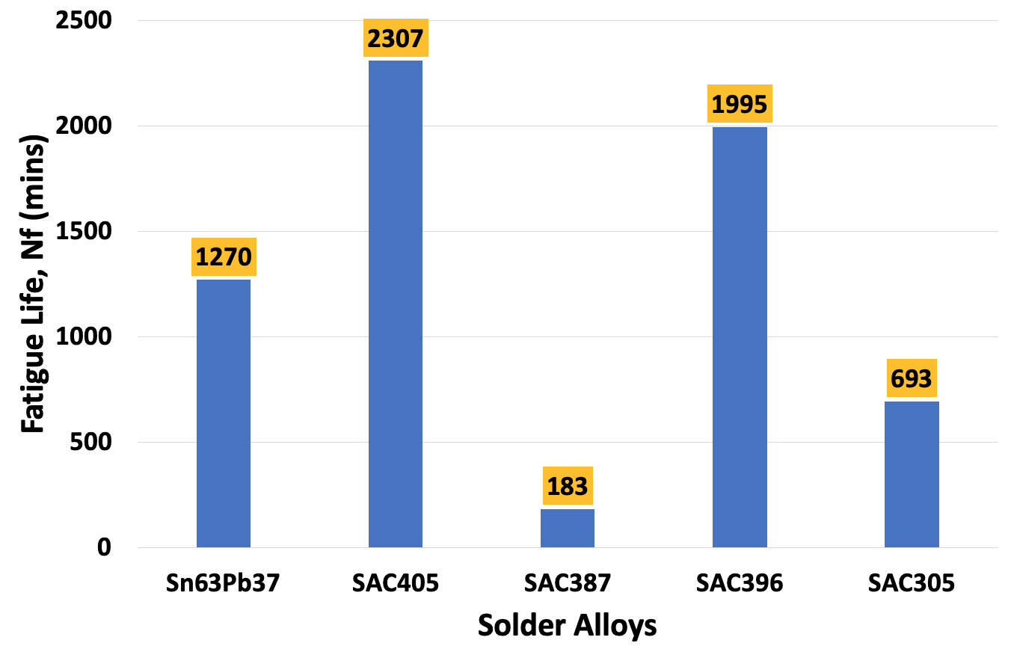
Figure 23: Plots of Fatigue Life for solder joint alloys
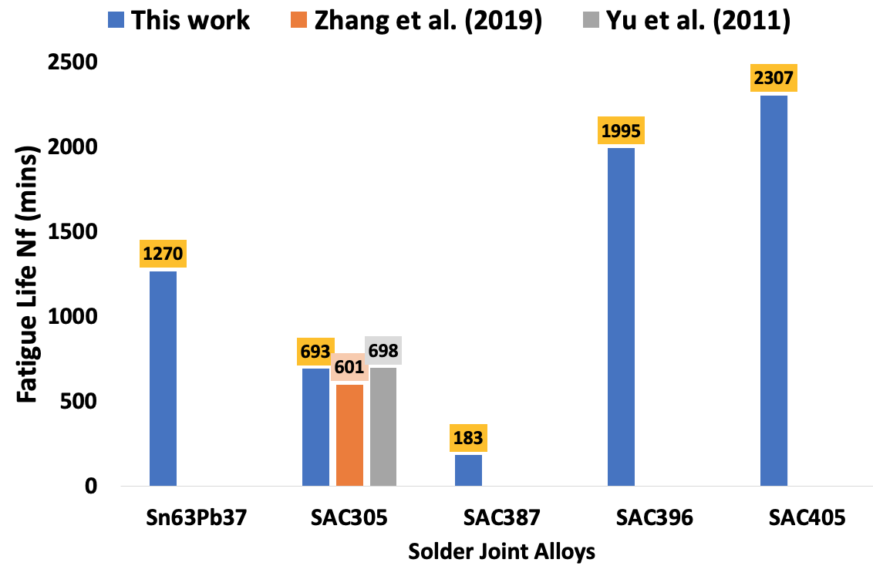
Figure 24: Comparisons of plots of fatigue lives of solder joint alloys from peer-reviewed literature

5.0 Conclusions
Some conclusions can be made based on the results and findings of this investigation. It is found that the effect of random vibration on the mechanical reliability of BGA solder joints is significant. Further results reveal that vibration response magnitude is consistent with the solder composition. These findings validate the implementation of mechanical vibration to characterise deformation, stress, strain, and fatigue life responses of various solders used as interconnection in electronic modules and systems in this research. Comparatively, SAC405 solder is the most reliable solder interconnect material under random vibration based on the magnitude of its response to the damage parameters. It demonstrated the highest magnitude for fatigue life and deformation, the lowest magnitude for elastic strain and the lowest but one for stress magnitude. The findings of this investigation are of high quality because they demonstrate circa 85% agreement with published similar research, as shown in Figure 21. The site results of maximum damage and crack initiation are also consistent with the published literature. The SAC405 is proposed as a suitable replacement for the Eutectic Lead-based solder for applications subjected to random vibration in operation.
Intermetallic compounds (IMCs) associated with soldering involving tin-rich solder on a copper substrate are not considered in this investigation because it is outside the research scope of the present study. As the current study is comparative, the effect of IMCs is uniform across all designs investigated. We are conducting another investigation to evaluate the effect of IMC thickness, configuration, and morphology on the solder joint reliability.

Acknowledgement
The study published in this report is funded by the School of Mechanical Engineering & the Built Environment, College of Engineering & Technology, University of Derby, UK.

Conflict of Interest
The authors declare no conflict of interest.

References
[1] W. Redman-White, ‘Vibration analysis for electronic equipment’, J Sound Vib, 1990, doi: 10.1016/0022-460x(90)90820-p.
[2] D. Yu, A. Al-Yafawi, T. T. Nguyen, S. Park, and S. Chung, ‘High-cycle fatigue life prediction for Pb-free BGA under random vibration loading’, Microelectronics Reliability, 2011, doi: 10.1016/j.microrel.2010.10.003.
[3] F. Liu and G. Meng, ‘Random vibration reliability of BGA lead-free solder joint’, Microelectronics Reliability, 2014, doi: 10.1016/j.microrel.2013.08.020.
[4] F. Liu, Y. Lu, Z. Wang, and Z. Zhang, ‘Numerical simulation and fatigue life estimation of BGA packages under random vibration loading’, Microelectronics Reliability, 2015, doi: 10.1016/j.microrel.2015.08.006.
[5] D. Yu, A. Al-Yafawi, S. Park, and S. Chung, ‘Finite element based fatigue life prediction for electronic components under random vibration loading’, in Proceedings - Electronic Components and Technology Conference, 2010. doi: 10.1109/ECTC.2010.5490900.
[6] L. Shen, C. Chen, and X. Niu, ‘Random vibration analysis of BGA with different size of the SAC0307 solder joint’, in Proceedings - 2018 19th International Conference on Electronic Packaging Technology, ICEPT 2018, 2018. doi: 10.1109/ICEPT.2018.8480474.
[7] S. Hamasha, Y. Jaradat, A. Qasaimeh, M. Obaidat, and P. Borgesen, ‘Assessment of Solder Joint Fatigue Life Under Realistic Service Conditions’, J Electron Mater, 2014, doi: 10.1007/s11664-014-3436-3.
[8] F. X. Che and J. H. L. Pang, ‘Harsh solder joint reliability tests by impact drop and highly accelerated life test (HALT)’, in Proceedings of 6th Electronics Packaging Technology Conference, EPTC 2004, 2004. doi: 10.1109/eptc.2004.1396604.
[9] H. Cui and E. Cheng, ‘Random vibration analysis of QFP with different structure parameters’, Hanjie Xuebao/Transactions of the China Welding Institution, 2015.
[10] S. Liguore and D. Followell, ‘Vibration fatigue of surface mount technology (SMT) solder joints’, in Proceedings of the Annual Reliability and Maintainability Symposium, 1995. doi: 10.1109/rams.1995.513218.
[11] T. An, F. Qin, B. Zhou, P. Chen, and Y. Dai, ‘Vibration lifetime estimation of PBGA solder joints using Steinberg model’, Microelectronics Reliability, 2019, doi: 10.1016/j.microrel.2019.113474.
[12] D.S. Sternberg, Vibration Analysis for Electronic Equipment, 2nd ed. New York, NY: John Wiley & Sons, 1988.
[13] F. X. Che, H. L. J. Pang, F. L. Wong, G. H. Lim, and T. H. Low, ‘Vibration fatigue test and analysis for flip chip solder joints’, in Proceedings of 5th Electronics Packaging Technology Conference, EPTC 2003, 2003. doi: 10.1109/EPTC.2003.1271499.
[14] Topline, ‘BGA’, 2020. https://www.topline.tv/SMD_vrs_NSMD.html (accessed Feb. 20, 2019).
[15] B. A. Zahn, ‘Impact of ball via configurations on solder joint reliability in tape-based, chip-scale packages’, in Proceedings - Electronic Components and Technology Conference, 2002. doi: 10.1109/ectc.2002.1008301.
[16] T. T. Nguyen, D. Lee, J. B. Kwak, and S. Park, ‘Effect of glue on reliability of flip chip BGA packages under thermal cycling’, in Microelectronics Reliability, 2010. doi: 10.1016/j.microrel.2010.04.003.
[17] E. H. Amalu and N. N. Ekere, ‘Modelling evaluation of Garofalo-Arrhenius creep relation for lead-free solder joints in surface mount electronic component assemblies’, J Manuf Syst, vol. 39, 2016, doi: 10.1016/j.jmsy.2016.01.002.
[18] X. Long, Y. Liu, Y. Yao, F. Jia, and C. Zhou, ‘Constitutive behaviour and life evaluation of solder joint under the multi-field loadings’, AIP Adv, 2018, doi: 10.1063/1.5044446.
[19] H. Beyer, V. Sivasubramaniam, M. Bayer, and S. Hartmann, ‘Reliability of Lead-free Large Area Solder Joints in IGBT Modules with Respect to Passive and Active Thermal Cycling’, in CIPS 2016 - 9th International Conference on Integrated Power Electronics Systems, 2019.
[20] S. Stoyanov, C. Bailey, and M. Desmulliez, ‘Optimisation modelling for thermal fatigue reliability of lead-free interconnects in fine-pitch flip-chip packaging’, Soldering and Surface Mount Technology, 2009, doi: 10.1108/09540910910928265.
[21] J. Eckermann, S. Mehmood, H.M. Davies, N.P. Lavery, S.G.R. Brown, J. Sienz, A. Jones, P. Sommerfeld ‘Computational modeling of creep-based fatigue as a means of selecting lead-free solder alloys’, Microelectronics Reliability, 2014, doi: 10.1016/j.microrel.2014.02.017.
[22] M. Okereke and S. Keates, ‘Finite element mesh generation’, in Springer Tracts in Mechanical Engineering, 2018. doi: 10.1007/978-3-319-67125-3_6.
[23] O. H. Basquin, ‘The Exponential Law of Endurance Tests’, in American Society for Testing and Materials Proceedings, 1910, pp. 625–630.
[24] Z. Wei, ‘Study on Lifetime Prediction of Electronic Products Considering Multiple Failure Mechanisms’, National University of Defense Technology, 2014.
[25] G. Yingnan, ‘Reliability Study on Assembly Solder Joints of QFP Devices under Large Temperature Variation’, Master Degree Dissertation, Harbin Institute of Technology, 2016.
[26] P. Nelco and B. Triazine, ‘BGA Material Properties’, TopLine, 2016. https://www.topline.tv/drawings/PDF/BGA Reference/BGA_Material_Properties.pdf
[27] EngineersEdge, ‘Miner’s Rule Linear Damage Rule’, 2020. https://www.engineersedge.com/material_science/miners_rule_linear_damage_rule_15356.htm (accessed Nov. 01, 2020).
[28] T. Lu, B. Zhou, K. Pan, and Y. Gong, ‘Optimal design of PBGA mixed solder joints under random vibration’, in ICRMS 2014 - Proceedings of 2014 10th International Conference on Reliability, Maintainability and Safety: More Reliable Products, More Secure Life, 2014. doi: 10.1109/ICRMS.2014.7107284.
[29] H. Tang, Z. Wu, and Z. Lui, ‘Random vibration simulation and analysis of PoP solder joints with different structure parameters’, in ICEPT-HDP 2012 Proceedings - 2012 13th International Conference on Electronic Packaging Technology and High Density Packaging, 2012. doi: 10.1109/ICEPT-HDP.2012.6474815.
[30] S. Saravanan, S. Prabhu, R. Muthukumar, S. Gowtham Raj, and A. V. Arun Veerabagu, ‘Fatigue failure of pb-free electronic packages under random vibration loads’, International Journal of Computational Methods in Engineering Science and Mechanics, 2018, doi: 10.1080/15502287.2018.1430074.
[31] S. F. Wong, P. Malatkar, C. Rick, V. Kulkami, and I. Chin, ‘Vibration testing and analysis of ball grid array package solder joints’, in Proceedings - Electronic Components and Technology Conference, 2007. doi: 10.1109/ECTC.2007.373825.
[32] Y. Zhang, B. Jing, F. Lu, X. Jiao, J. Hu, and Y. Chen, ‘Study on Failure Simulation and Fatigue Life Prediction of BGA Solder Joint under Random Vibration’, Proceedings - 2018 Prognostics and System Health Management Conference, PHM-Chongqing 2018, pp. 675–681, 2019, doi: 10.1109/PHM-Chongqing.2018.00121.
[33] X. Long, J. Xu, S. Wang, W. Tang, and C. Chang, ‘Understanding the impact response of lead-free solder at high strain rates’, Int J Mech Sci, vol. 172, no. December 2019, 2020, doi: 10.1016/j.ijmecsci.2020.105416.
[34] Z. Zhao, C. Hu, and F. Yin, ‘Failure Analysis for Vibration Stress on Ball Grid Array Solder Joints’, in Proceedings - 2018 19th International Conference on Electronic Packaging Technology, ICEPT 2018, 2018. doi: 10.1109/ICEPT.2018.8480428.
[35] L. Tao, Z. Bin, P. Kailin, E. Yunfei, G. Yubin, and T. Lu, ‘Harmonic vibration analysis and S-N curve estimate of PBGA mixed solder joints’, in Proceedings of the Electronic Packaging Technology Conference, EPTC, 2014. doi: 10.1109/isaf.2014.6917974.
[36] H. B. Qin, X. P. Zhang, M. B. Zhou, X. P. Li, and Y. W. Mai, ‘Geometry effect on mechanical performance and fracture behavior of micro-scale ball grid array structure Cu/Sn–3.0Ag–0.5Cu/Cu solder joints’, Microelectronics Reliability, vol. 55, no. 8, pp. 1214–1225, Jul. 2015, doi: 10.1016/J.MICROREL.2015.05.013.
[37] J. Liang, S. Downes, N. Dariavach, D. Shangguan, and S. M. Heinrich, ‘Effects of load and thermal conditions on Pb-free solder joint reliability’, J Electron Mater, vol. 33, no. 12, pp. 1507–1515, Dec. 2004, doi: 10.1007/s11664-004-0092-z.
[38] T. E. Wong and R. C. Yu, ‘Vibration fatigue evaluation on solder joints of under-filled BGA’, in IPC - Electronic Circuits World Convention, Printed Circuits Expo, Apex, and the Designers Summit 2005, ECWC 10: The Perfect Fit, 2005.
[39] M. Saranik, L. Jézéquel, and D. Lenoir, ‘Experimental and numerical study for fatigue life prediction of bolted connection’, in Procedia Engineering, 2013. doi: 10.1016/j.proeng.2013.12.090.
[40] J. Xia, L. Yang, Q. Liu, Q. Peng, L. X. Cheng, and G. Y. Li, ‘Comparison of fatigue life prediction methods for solder joints under random vibration loading’, Microelectronics Reliability, 2019, doi: 10.1016/j.microrel.2019.02.008.
[41] W. F. Wu, H. Y. Liou, and H. C. Tse, ‘Estimation of fatigue damage and fatigue life of components under random loading’, International Journal of Pressure Vessels and Piping, 1997, doi: 10.1016/S0308-0161(97)00053-7.
[42] T. An, C. Fang, F. Qin, H. Li, T. Tang, and P. Chen, ‘Failure study of Sn37Pb PBGA solder joints using temperature cycling, random vibration and combined temperature cycling and random vibration tests’, Microelectronics Reliability, 2018, doi: 10.1016/j.microrel.2018.10.003.
[43] H. Cui and E. Cheng, ‘Random vibration analysis of different electronic packaging structures’, Hanjie Xuebao/Transactions of the China Welding Institution, 2017, doi: 10.12073/j.hjxb.20150606002.
[44] J. Xia, G. Y. Li, B. Li, L. X. Cheng, and B. Zhou, ‘Fatigue life prediction of Package-on-Package stacking assembly under random vibration loading’, Microelectronics Reliability, 2017, doi: 10.1016/j.microrel.2017.03.005.
[45] F. Xu, C. R. Li, T. M. Jiang, and D. P. Zhang, ‘Fatigue Life Prediction for PBGA under Random Vibration Using Updated Finite Element Models’, Exp Tech, 2016, doi: 10.1007/s40799-016-0141-6.
[46] Y. Li, D. Dong, H. Wang, Y. Wu, L. Dong, and R. Xu, ‘Simulation and Fatigue Damage Prediction for Board Level CBGA Solder Joint of LTCC-based SiP Module under Random Vibration Loading’, in 2019 20th International Conference on Electronic Packaging Technology, ICEPT 2019, 2019. doi: 10.1109/ICEPT47577.2019.245193.
[47] Y. Cinar and G. Jang, ‘Fatigue life estimation of FBGA memory device under vibration’, Journal of Mechanical Science and Technology, 2014, doi: 10.1007/s12206-013-0946-5.
[48] Y. S. Chen, C. S. Wang, and Y. J. Yang, ‘Combining vibration test with finite element analysis for the fatigue life estimation of PBGA components’, Microelectronics Reliability, 2008, doi: 10.1016/j.microrel.2007.11.006.
[49] L. Tao, Z. Bin, P. Kailin, E. Yunfei, and G. Yubin, ‘Harmonic vibration analysis and S-N curve estimate of PBGA mixed solder joints’, 2014. doi: 10.1109/isaf.2014.6917974.

