**An Exploratory Study on the Practice of Operational Excellence in the Automotive Industry in Morocco**

**Abstract**

**Purpose:** This paper explores the implementation of Operational Excellence (OpEx) within the Moroccan automotive industry, focusing on its perception, adoption, and integration into organizational structures.

**Design/Methodology/Approach:** This research employs a qualitative, exploratory design, utilizing semi-structured interviews with eight key experts from various ecosystems within the Moroccan automotive industry. A purposive expert sampling method was used to select participants with significant experience in OpEx, ensuring a deep, context-specific understanding of its implementation.

**Findings:** The study reveals that Moroccan automotive firms adopt OpEx practices in a phased, structured manner, beginning with foundational methodologies such as Lean manufacturing, 5S, and Kaizen, before progressing to advanced tools like Six Sigma. The integration of these practices is typically supported by dedicated teams within engineering and production departments, with some firms establishing specialized OpEx departments reporting directly to plant directors. While notable progress has been made in the adoption of OpEx, significant challenges remain, particularly regarding the technical expertise required for advanced methodologies like Six Sigma. Nevertheless, strong support from international parent companies and Morocco’s highly integrated automotive ecosystem has been identified as key enablers in accelerating the adoption of OpEx best practices.

**Research Limitations/Implications:** The generalizability of this study is constrained by its focus on a specific industry and region. While the qualitative findings provide valuable insights into the Moroccan automotive sector, further research is needed to broaden the scope across different industries and geographical contexts. Future studies could explore the application of OpEx practices in other developing economies or investigate the role of Industry 4.0 technologies in enhancing OpEx outcomes.

**Originality/Value:** This study contributes to the limited body of research on OpEx implementation in developing economies, offering empirical insights from the Moroccan automotive industry. The findings provide practical insights for industry practitioners and theoretical contributions toward understanding how OpEx practices can be adapted and scaled within the unique context of emerging economies.

**Keywords:** Operational Excellence, Automotive Industry, Morocco, Lean Manufacturing, Continuous Improvement, Six Sigma.

**Article Type**: Research paper

1. **Introduction**

In today's rapidly industrializing world, organizations confront escalating global competition that intensifies the pressure to optimize operational performance and sustain a competitive edge (Criscuolo & Lalanne, 2024). This challenge is particularly acute in emerging economies like Morocco, where companies are redoubling efforts to enhance competitiveness and performance by adopting strategic frameworks such as Operational Excellence (OpEx) (Henríquez-Machado et al., 2021; El Affaki et al., 2024). Pursuing OpEx has emerged as both a managerial inspiration and a critical imperative for strengthening business efficiency and competitiveness (Carvalho et al., 2023). The Moroccan automotive sector, characterized by intricate supply chains, rapid technological advancements, and stringent quality standards, provides an ideal context for applying OpEx methodologies (Elboq et al., 2020; El-Khodary et al., 2024).

OpEx is a comprehensive management philosophy centered on continuous improvement and optimizing performance across all levels of an organization (Jaeger et al., 2014; Oakland et al., 2020). It integrates various methodologies such as Lean, Six Sigma, Kaizen, and Total Quality Management to streamline processes, reduce variability, enhance quality, and minimize costs (Found et al., 2018; Carvalho et al., 2019). As highlighted by Bessant and Francis (1999) and later reinforced by Netland and Powell (2016), OpEx represents a paradigm shift in modern management—from the pursuit of perfection to an emphasis on adaptive, ongoing improvement. This shift cultivates a culture of organizational learning, innovation, and adaptability, enabling firms to effectively navigate complex market conditions while simultaneously enhancing short-term performance and ensuring long-term growth (Hines et al., 2020; Haleem et al., 2024)—a particularly relevant consideration in the automotive industry (Tortorella and Fettermann, 2018; Veres (Harea) et al., 2018; Wahab et al., 2024).

Empirical research consistently validates that the implementation of OpEx methodologies yields statistically significant improvements in key operational performance metrics, including process efficiency optimization, waste reduction, and product quality enhancement (Cua et al., 2001; Shah & Ward, 2007; Anand & Kodali, 2008; Skalli et al., 2024). These quantifiable improvements highlight OpEx's transformative potential, enabling organizations to systematically adapt to dynamic market conditions and heightened competitive pressures. A critical determinant of these outcomes lies in the synergistic integration of complementary methodologies—namely Lean, Six Sigma, and Total Quality Management (TQM)—which collectively address inefficiencies across multiple organizational dimensions (Bhasin & Burcher, 2006; Pepper & Spedding, 2010). Systematic analysis reveals distinct yet interconnected contributions of these methodologies: Lean emphasizes the identification and elimination of non-value-adding activities while optimizing resource utilization; Six Sigma employs data-driven analytical frameworks to achieve statistical process control and variability reduction; and TQM fosters an organizational culture of continuous improvement and customer-centric operational strategies. The integration of these approaches amplifies their individual impacts, resulting in significant advancements across efficiency metrics, cost reduction indices, and customer satisfaction parameters (George, 2002; Laureani & Antony, 2012). These synergistic effects are particularly pronounced in manufacturing environments, where the alignment of multiple improvement methodologies enhances operational effectiveness. Studies document measurable gains in supply chain optimization, equipment utilization rates, and product quality metrics (Tjahjono et al., 2010; Kumar Sharma & Gopal Sharma, 2014; Arunrao Shahade & Jha, 2021). Beyond manufacturing, cross-sectoral analyses underscore the adaptability of OpEx methodologies across diverse industries, with variations in implementation protocols reflecting sector-specific priorities. For instance, regulatory compliance frameworks dominate pharmaceutical manufacturing, while safety protocol integration is pivotal in chemical processing operations (Shannon et al., 2023; O’Callaghan et al., 2023; Chubineh et al., 2024).

Despite the clear benefits of OpEx, organizations frequently encounter challenges when selecting suitable practices, determining optimal implementation strategies, and managing associated costs (Antony, 2011; Albliwi et al., 2014; R. Jadhav et al., 2014). Decisions often revolve around whether to adopt Lean, Six Sigma, or a hybrid approach, and whether to begin with foundational methods such as 5S or Kaizen (Liker & Franz, 2011; Imai, 2012). Making these decisions requires a nuanced understanding of how different methodologies can be effectively integrated and tailored to the organization's specific operational context (Hines et al., 2004; Sahoo & Yadav, 2018). The complexity of this decision-making process underscores the need for further exploration into how OpEx methodologies are selected, combined, and prioritized within Morocco's automotive industry (Arabi et al., 2021; Driouach et al., 2023; Skalli et al., 2024).

The efficacy of OpEx initiatives is inextricably linked to the organizational structures that underpin their implementation (Beer, 2003; Antony et al., 2022). Successful OpEx integration frequently necessitates a cross-functional paradigm that fosters interdepartmental collaboration and decentralizes decision-making processes (Chakravorty & Shah, 2012; Suarez et al., 2016; Antony et al., 2024). Organizational architectures that facilitate these dynamics can enhance a firm's agility in addressing operational challenges and cultivate a culture of accountability (Rich & Bateman, 2003; Bessant & Francis, 1999; Galeazzo & Furlan, 2021). However, the determination of an optimal structure for embedding OpEx within an organization remains a complex and nuanced endeavor (De Menezes et al., 2010; Netland & Ferdows, 2016; Found et al., 2017). Empirical studies reveal significant organizational heterogeneity in OpEx implementation strategies. Found et al. (2018) delineate a spectrum of approaches, ranging from the establishment of centralized excellence offices charged with formulating overarching methodologies to more decentralized models that integrate improvement teams within existing functional units. This structural diversity is further illuminated by Brumme et al. (2015), who provide empirical evidence of comprehensive organizational transformations catalyzed by OpEx initiatives. Their case study of Hewlett-Packard exemplifies how the pursuit of OpEx can precipitate a fundamental reorientation of a firm's organizational mission. In this instance, the strategic paradigm shift entailed a recalibration of priorities, with an increased emphasis on cost efficiency and operational dependability as critical performance metrics. The multiplicity of approaches observed in OpEx implementation underscores the contextual nature of organizational design in this domain (Botha, 2016). It suggests that the efficacy of OpEx structures may be contingent upon a variety of factors (Ferdowsian, 2016), including but not limited to, industry dynamics, organizational culture, and strategic objectives. This complexity highlights the need for a nuanced, context-sensitive approach to OpEx implementation, one that considers the unique characteristics and requirements of each organization (Sony, 2019; Henríquez-Machado et al., 2021).

Monitoring and evaluating the effectiveness of OpEx initiatives is another critical aspect (Jaeger et al., 2014; Maulana et al., 2020; Rathi et al., 2024). Establishing clear performance metrics and objectives—such as improving process efficiency and reducing waste—allows organizations to assess their progress and make necessary adjustments over time (Gólcher-Barguil et al., 2019). Tools like dashboards and scorecards enable real-time data analysis, helping firms align their activities with strategic goals and drive continuous improvement (Parmenter, 2010; Carvalho et al., 2019). However, the absence of standardized frameworks for OpEx monitoring presents challenges, particularly when it comes to consistently measuring success across different organizations and contexts (Saeed et al., 2021; Naik et al., 2024)

This research addresses a critical gap in the literature by examining the implementation of OpEx within the emerging economy of Morocco, with a specific focus on its rapidly growing automotive sector. Through in-depth interviews with industry experts from eight organizations, the study provides a rare and valuable perspective on the current state of OpEx practices, offering practical guidance for organizations striving to advance their operational maturity in resource-constrained environments.

The study's originality lies in its threefold objectives: (1) assessing the levels and practices of OpEx implementation within the Moroccan automotive industry, (2) evaluating the adaptation of global methodologies such as Lean, Six Sigma, and Kaizen to the local context, and (3) developing empirically-based insights to enhance OpEx deployment in emerging economies. By leveraging a systematic qualitative approach grounded in semi-structured interviews, this research bridges theoretical constructs with real-world practices, contributing significantly to both academic discourse and practical application. A core contribution of the study is its comprehensive analytical framework, which synthesizes industry expertise with established theoretical paradigms. This framework enables a detailed examination of critical dimensions such as implementation mechanisms, organizational structures, and the synergies among diverse methodologies that underpin successful OpEx adoption. By focusing on Morocco's automotive sector—a pivotal industry for the nation's economic trajectory—the research highlights the unique challenges and opportunities organizations face when implementing OpEx in developing countries. The findings underscore the necessity of adapting global OpEx methodologies to local conditions while ensuring strategic alignment with organizational objectives. Patterns of OpEx implementation revealed through empirical investigation highlight key success factors, including the importance of tailored approaches, cross-functional integration, and robust evaluation protocols. These insights not only deepen the understanding of OpEx practices in emerging economies but also provide actionable strategies for organizations seeking to optimize their operational performance.

This study stands out for its dual contribution to academic and practical domains, offering a rare exploration of OpEx in an underexplored context while delivering actionable insights for practitioners in the automotive industry and beyond. By addressing a significant knowledge gap and providing a roadmap for operational enhancement, this research sets the stage for further academic investigation and practical advancements in the field of Operational Excellence.

The remainder of this paper is organized as follows: Section 2 presents an in-depth review of the existing literature on OpEx practices within the automotive industry, examining both theoretical perspectives and empirical evidence. Section 3 describes the research methodology, detailing the qualitative approach and the design of semi-structured interviews conducted with professionals from the Moroccan automotive sector. Section 4 outlines the key findings from these interviews, providing empirical insights into the application of OpEx practices and the associated organizational structures. Section 5 discusses the theoretical and practical implications of the findings, offering insights for both academic discourse and industry application. Finally, Section 6 concludes by summarizing the key contributions of the study, addressing its limitations, and suggesting directions for future research.

1. **Literature Review**

The extant literature on OpEx reveals a significant lacuna in establishing a universally accepted definition that comprehensively encapsulates its essence. This definitional ambiguity, widely acknowledged across academic and practitioner discourses, presents a paramount challenge for both theoretical advancement and practical application in the field. Jaeger et al. (2014) identified over 30 distinct conceptualizations of OpEx, underscoring the absence of a singular, standardized definition. The authors posit that the semantic content of OpEx has undergone evolutionary changes, exhibiting considerable variability across industrial sectors and organizational contexts, thereby complicating efforts to establish a unified epistemological framework.

Corroborating this observation, Found et al. (2018) note that despite the term's ubiquitous usage in both industry and academia, consensus on its precise denotation remains elusive. This definitional challenge reflects the dynamic and multifaceted nature of OpEx, which has transitioned from a narrow focus on efficiency and cost reduction to a more holistic paradigm encompassing various dimensions of organizational performance and strategy (El Affaki et al., 2024; Tortorella et al., 2024). Despite the lack of a unified definition, researchers have attempted to delineate the core components and objectives of OpEx. Rusev and Salonitis (2016) posit that OpEx aims to streamline processes, enhance efficiency, and promote sustainable growth throughout an organization. Naik et al. (2024) emphasize that OpEx is central to organizational success and transcends the mere application of management tools and techniques. A recurrent theme in the literature is that OpEx is achieved when an organization fully embraces best practices, fostering a shared understanding of customer value creation, proactive improvement initiatives, and collaborative problem-solving to enhance overall performance (Dale et al., 2000; Gólcher-Barguil et al., 2019; Carvalho et al., 2021; Tortorella et al., 2024).

The implementation of OpEx requires a comprehensive approach. Fonseca (2022) asserts that tangible success in OpEx necessitates organizations to focus on the foundational principles underpinning improvement tools, rather than their mechanical application. Năftănăilă et al. (2013) emphasize the importance of integrating Lean principles into operational activities while aligning them with broader strategic objectives. Oakland et al. (2020) conceptualize OpEx as an approach that drives sustained improvements in key performance areas through consistent and efficient task execution.

Leadership plays a crucial role in OpEx implementation. Duggan (2012) underscores the criticality of acquiring requisite skills, establishing clear organizational direction, and implementing effective processes to achieve operational objectives. Sony (2019) posits that successful OpEx implementation is characterized by consistently outperforming competitors through efficient strategy execution and continuous customer satisfaction. Edgeman (2019) further emphasizes the pivotal role of leadership in fostering a culture of continuous improvement, essential for driving OpEx transformation.

The scope of OpEx has expanded over time. Mitchell (2015) observes that OpEx now encompasses broader considerations such as safety, environmental responsibility, profitability, social impact, risk management, asset maintenance, and employee performance. This multidimensional perspective highlights the increasing complexity of OpEx and reinforces the crucial role of leadership in its successful implementation. In an effort to synthesize these various perspectives, Jengwa and Pellissier (2022) conceptualize OpEx as a holistic approach to continuous improvement, integrating Lean management principles, organizational culture, and strategic alignment. They argue that OpEx can be framed as a global strategy aimed at optimizing processes, reducing waste, and enhancing productivity across all organizational levels. This strategy relies on the adoption of best practices, the cultivation of a culture of continuous improvement, and the alignment of organizational objectives to achieve superior performance.

OpEx extends beyond traditional performance metrics by fostering a mindset of continuous improvement that permeates all levels of an organization (Duggan, 2018). Welch et al. (2016) assert that OpEx is distinguished by its capacity to cultivate a culture where employees are continually engaged in problem-solving activities aligned with strategic objectives. This cultural shift necessitates significant changes in human capital management, leadership development, and the creation of processes that support innovation. By integrating methodologies such as Lean, Six Sigma, and TQM, OpEx fosters an environment where continuous learning and incremental improvements become standard practice (Mueller & Mueller, 2020). Empirical studies have shown that organizations adopting OpEx experience substantial benefits, including enhanced operational efficiency, increased customer satisfaction, and improved financial performance (Snee, 2004; Luz Tortorella et al., 2022). However, the success of OpEx initiatives depends heavily on an organization's ability to effectively integrate these methodologies and tailor them to specific business contexts (Rüttimann & Stöckli, 2015). This is particularly relevant in emerging markets like Morocco, where external factors such as market volatility and resource constraints pose unique challenges to OpEx implementation (Boutayeb et al., 2020).

Lean management, a foundational component of OpEx, originated in the Toyota Production System (TPS) developed in the mid-20th century. Lean focuses on the elimination of waste (muda) and seeks to streamline operations by identifying and removing inefficiencies in production processes (Ohno, 1988). The philosophy emphasizes creating more value for customers with fewer resources by systematically identifying and eliminating non-value-added activities (Womack & Jones, 2010). Lean thinking has been widely adopted across various industries, particularly in the automotive sector, due to its demonstrated ability to improve production efficiency, reduce costs, and enhance product quality (Holweg, 2007; Wahab et al., 2024).

In the automotive industry, Lean management optimizes production workflows, reduces inventory levels, and enhances responsiveness to market demands. Numerous studies have demonstrated the effectiveness of Lean practices in reducing lead times and improving supply chain performance in automotive manufacturing (Shah & Ward, 2007; Holweg, 2007). For example, companies that implement Lean principles have reported significant reductions in manufacturing lead times and improvements in overall operational performance (Arumugam et al., 2022; Do Rego Ferreira Lima et al., 2024)

Morocco's automotive sector, though still developing, has begun adopting Lean practices to integrate more effectively into global supply chains. Elboq et al. (2020) observed that Moroccan automotive firms have successfully applied Lean principles to enhance operational capabilities. However, challenges such as insufficient workforce skills, lack of infrastructure, and resistance to change persist. These challenges are further compounded by Morocco's unique position within global value chains, where the country serves both as a manufacturing hub and an export platform for European and North American markets (Bachirat et al., 2013; Benchekroun & Boumane, 2024).

The success of Lean management in Morocco often depends on firms' ability to adapt Lean principles to the local context (Elboq et al., 2020). Although Lean emphasizes just-in-time (JIT) production and minimal inventory levels, supply chain variability in emerging markets like Morocco requires maintaining higher inventory buffers to mitigate disruptions (Elbaz & Batrich, 2013; Belhadi et al., 2018). Consequently, the full potential of Lean practices in Morocco remains partially unrealized due to these context-specific constraints.

Six Sigma, developed by Motorola in the 1980s, is a data-driven methodology focused on reducing defects and variability in production processes (“Ge and Motorola Belt up for Six Sigma Success,” 2002). It aims to achieve near-perfect quality by identifying and eliminating the root causes of defects through a structured process known as DMAIC—Define, Measure, Analyze, Improve, and Control (Kumar & Sosnoski, 2009). The success of Six Sigma in manufacturing environments, particularly in the automotive industry, is well-documented. Several studies highlight that Six Sigma implementation leads to significant improvements in product quality, customer satisfaction, and cost savings by reducing process variability (Snee, 2010; Antony, 2011).

In automotive manufacturing, Six Sigma has been instrumental in enhancing quality control and reducing defect rates in precision manufacturing environments (Noori & Latifi, 2018). For instance, companies like General Electric reported substantial savings during the early years of Six Sigma adoption, largely due to reductions in waste and rework (Gijo et al., 2011; Schmidt et al., 2018). The reliance on statistical tools such as control charts and process capability analysis makes Six Sigma particularly well-suited for industries where tight tolerances and high-quality standards are essential (Antony et al., 2005; Desai et al., 2012; Fadly Habidin & Mohd Yusof, 2013).

In Morocco, however, the application of Six Sigma is less widespread compared to Lean management (Arabi et al., 2024). Barriers to Six Sigma adoption in Morocco's automotive sector include high training costs and the complexity of the methodology. Additionally, many firms lack the statistical expertise necessary for effective implementation, limiting its applicability in less mature manufacturing environments (Karim & Cherkaoui, 2022). Despite these challenges, there is a growing recognition of Six Sigma's potential to improve quality control (Antony et al., 2012), particularly in export-oriented sectors where meeting international quality standards is critical (Achibat et al., 2021).

A hybrid approach known as Lean Six Sigma (LSS) has gained traction globally, combining Lean's focus on waste reduction with Six Sigma's emphasis on quality control (George, 2002; Pepper & Spedding, 2010). By integrating these methodologies, firms can reduce process variability while streamlining operations, resulting in a more robust operational framework capable of withstanding external pressures (Snee, 2010). However, for Lean Six Sigma to be successfully implemented in Morocco, firms must carefully adapt these methodologies to meet the specific needs and constraints of the local automotive industry.

Kaizen, which originated in Japan during the post-war industrial boom, emphasizes continuous, incremental improvement to enhance productivity and quality (Imai, 2012). Unlike methodologies that focus on large-scale overhauls, Kaizen encourages employees at all levels of the organization to identify and eliminate inefficiencies on a daily basis (Paul Brunet & New, 2003). This bottom-up approach fosters a culture of continuous improvement, empowering workers to contribute directly to the organization's overall performance. In the automotive industry, Kaizen promotes operational excellence by fostering a culture of collaboration and learning (Liker & Franz, 2011). Companies that successfully implement Kaizen often experience enhanced employee engagement, operational efficiency, and product quality (Cherrafi et al., 2019). However, the success of Kaizen is highly dependent on cultivating a culture that supports continuous improvement and emphasizes employee involvement (Maarof & Mahmud, 2016; Todorovic et al., 2024).

In Morocco, Kaizen adoption has been slower compared to Lean, partly due to cultural differences and the traditional top-down management structures prevalent in many firms. Nonetheless, there are successful examples of Kaizen implementation in Moroccan automotive companies, particularly those with strong ties to Japanese or European multinationals (Bouazza et al., 2021; Bouazza & Lajjam, 2023). These firms have leveraged Kaizen principles to foster a culture of continuous improvement, engage employees in problem-solving, and address operational inefficiencies. As Morocco's automotive industry continues to grow, Kaizen could serve as a valuable tool for improving productivity and building a more resilient workforce.

While Operational Excellence has been extensively studied and implemented in developed economies, its application in emerging markets like Morocco presents unique challenges and opportunities. Developed economies benefit from advanced technological infrastructure, skilled labor, and well-established supply chains, all of which facilitate the implementation of OpEx methodologies (Bhullar et al., 2014; Carvalho et al., 2021). Conversely, firms in emerging markets often face constraints related to capital investment, workforce skills, and supply chain integration, all of which can hinder successful OpEx deployment (Henriquez et al., 2023). However, despite these challenges, OpEx can serve as a critical enabler of industrial growth in emerging economies, helping firms improve productivity, reduce costs, and meet international quality standards (Tortorella et al., 2019). Morocco's automotive sector, which has experienced rapid growth and increasing integration into global value chains, provides an ideal case for studying the impact of OpEx in an emerging market context. Applying OpEx in Morocco's automotive sector requires careful adaptation to the local context. Wahab et al., 2020 emphasize the importance of tailoring OpEx practices to accommodate the dynamics of local supply chains (Mangla et al., 2020), labor market conditions, and regulatory environments. Furthermore, the success of OpEx initiatives depends heavily on the development of supportive set-ups, such as training programs and technical support systems (Antony et al., 2023), which can facilitate the adoption of methodologies like Lean, Six Sigma, and Kaizen. The following Table 1 presents the synthesized results of a comprehensive literature review on OpEx, systematically organizing findings across seven strategic dimensions crucial for understanding OpEx implementation in automotive manufacturing contexts. The synthesis encompasses fundamental definitions, core elements, sector-specific requirements, implementation frameworks, key dimensions, practical methodologies, and future trajectories. Through the systematic organization of these findings, the table serves as an analytical lens for investigating how theoretical concepts manifest in practical applications, while simultaneously highlighting the multifaceted nature of OpEx and its evolution toward a more comprehensive approach integrating operational, strategic, and technological considerations.

Table 1: Results of the literature review

|  |  |  |  |
| --- | --- | --- | --- |
| **Topic** | **Key Findings** | **Description** | **Literature source** |
| **Definition of OpEx** | No universally accepted definition; often customized to specific organizational contexts | Definitions often emphasize technical aspects. Organizations customize models and definitions to fit specific contexts and goals. | Jaeger et al., 2014 ; Found et al., 2018 ; Tortorella et al., 2024; El Affaki et al., 2024 |
| A holistic approach integrating Lean principles, organizational culture, and strategic management | Transcends mere application of tools and techniques. Focuses on foundational ideas behind tools rather than mechanical application. Involves the entire organization in embracing best practices and principles. | Jengwa & Pellissier, 2022 ; Rusev & Salonitis, 2016 ; Naik et al., 2024 ; Fonseca, 2022 |
| Aims to streamline processes, enhance efficiency, and foster sustainable growth | Consistently performing tasks correctly, efficiently, and timely. Acquiring appropriate skills, establishing clear direction, and implementing efficient processes. | Naik et al., 2024; Oakland et al., 2020; Duggan, 2012 |
| Involves consistently outperforming competitors and delivering desired outcomes | Continuous customer satisfaction through ongoing improvement efforts. Driven by leaders committed to a culture of continual improvement. | Sony, 2019 ; Edgeman, 2019 |
| Expanded beyond operational efficiency | Encompasses safety, environmental responsibility, profitability, social impact, risk management, reliability, asset maintenance, and employee performance. | Mitchell, 2015 |
| **Core Elements of OpEx** | Culture of continuous improvement | Fosters innovation and increases operational efficiency. Essential for sustained growth in a VUCA (Volatile, Uncertain, Complex, Ambiguous) environment. | Matope et al., 2022 ; Jengwa & Pellissier, 2022 |
| Management commitment | Provides strategic support. Encourages involvement of all personnel. | Candea & Gabor, 2024 |
| Strategic alignment | Ensures coherence between operational activities and the company's overarching objectives. | Ozbiltekin-Pala et al., 2024 |
| Process integration | Optimizes workflows and ensures efficiency. | Tichkiewitch & Riel, 2014; Zehra et al., 2024 |
| Use of appropriate tools and techniques (e.g., Lean Six Sigma, TQM) | Implements proven practices to improve processes and organizational performance. | Barsalou & Perkin, 2024; Queiroz et al., 2024 |
| Regular adjustment and continuous improvement | Requires constant monitoring of best practices, policies, and procedures. Periodic audits to detect and correct deviations from established standards. | Rusev & Salonitis, 2016 |
| Elimination of cognitive dissonance | Essential to mobilize the entire organization around operational excellence goals. | Karikalan et al., 2023 |
| **OpEx in the Automotive Sector** | Requires tailoring practices to industry-specific challenges | Unique challenges in implementing OpEx. Need to navigate volatile, uncertain, complex, and ambiguous (VUCA) environments. | Aripin et al., 2023 ; Simonazzi et al., 2020 ; Jengwa & Pellissier, 2022 |
| Adherence to IATF 16949:2016 standard is crucial | Essential for establishing contractual relationships and accessing international automotive markets. Focuses on quality management systems applicable to the automotive supply chain. | International Automotive Task Force, 2016; Neves et al., 2021 |
| Focus on value chain control, quality management system assurance, and overall performance | Attention to IATF 16949:2016 requirements, particularly operations and leadership. Integration of Lean Management tools (5S, standardized work, visual management, TPM, TQM). | Neves et al., 2021 ; El Affaki et al., 2024 |
| **OpEx Implementation Roadmap** | 1. Current State Assessment 2. Future State Alignment 3. Gap Closure and Action Plan Implementation | Phase 1: Evaluate current maturity level and identify gaps Phase 2: Define future state and select appropriate tools and methodologies Phase 3: Develop and implement comprehensive action plan addressing culture, CIP (Continuous Improvement Process), enterprise alignment, and results | El Affaki et al., 2024 ; Rusev & Salonitis, 2016; Edgeman, 2018 |
| **Key Dimensions of OpEx** | Culture | Establish leadership and support structures for OpEx culture. Develop organizational mission statement and principles. | Rusev & Salonitis, 2016; Edgeman, 2018 |
| Continuous Improvement Process (CIP) | Embrace scientific thinking (A3, DMAIC, PDCA). Implement Lean Management tools and Six Sigma methodologies. |
| Enterprise Alignment | Align operations with organizational principles and objectives. Cascade OpEx principles throughout the organization.  Establish a balanced scorecard for performance measurement. |
| Results | Enhance outcomes through data analysis and customer feedback. Continuously involve customers in decisions to improve products and services. |
| **OpEx Practices** | Lean Manufacturing | A systematic approach to minimize waste while maintaining productivity. | Bortolotti et al., 2015 ; Chouiraf & Chafi, 2018 ; Belhadi et al., 2018 ; Cherqaoui & Elhaq, 2020 ; Antony et al., 2021 ; Kamble et al., 2020 ; Wahab et al., 2024 |
| Six Sigma and DMAIC methodology | Data-driven methodology for process improvement and problem-solving. Aims to reduce defects and enhance product/process quality. DMAIC roadmap: Define, Measure, Analyze, Improve, and Control. Aligns with broader business strategies. | Antony et al., 2022 ; Condé et al., 2023 ; Venkatesh et al., 2014 ; Tariq et al., 2021 |
| Lean Six Sigma (LSS) | Integration of Lean and Six Sigma methodologies. Synergistic strengths for enhanced organizational impact. Merges streamlined processes from Lean with rigorous problem-solving of Six Sigma. | Laureani & Antony, 2012 ; Antony et al., 2017 ; Arcidiacono & Pieroni, 2018 ; Tissir et al., 2023 |
| Kaizen and continuous improvement | Management approach of incremental improvements across all organizational facets.  Tools include employee suggestion programs and focused improvement workshops. Empowers employees as proactive problem-solvers. | Singh & Singh, 2018 ; Rewers et al., 2016 ; Berhe et al., 2023 |
| Kaizen event | A focused, short-term improvement event where teams work intensively to solve a specific problem or optimize a process, aiming to implement changes quickly and effectively. | Van Aken et al., 2010 |
| The 5S | 5S is the acronym of five Japanese words which stands for Seiri (sorting), Seiton (set in order), Seiso (sweep), Seiketsu (standardise), Shitsuke (sustain).  A workplace organization method focuses on eliminating unnecessary items, organizing tools, maintaining cleanliness, establishing procedures, and fostering a culture of continuous improvement. | Gapp et al., 2008 ; Gupta & Jain, 2014 |
| Hoshin Kanri | Strategic planning, Policy deployment;  A Japanese strategic planning method that aligns company objectives with its daily operations. It ensures that all employees contribute to the organization's long-term goals. | Melander et al., 2016 ; Wilson et al., 2024 |
| Kosu Measurement | Labor productivity, Work efficiency; A Japanese indicator measuring the actual productivity of a manufacturing cell, considering the number of units produced, the number of workers involved, and time spent. Productivity is often measured in man-seconds. | Suzaki, 1987 |
| Heijunka (Production Leveling) | A lean manufacturing technique that aims to level production by distributing production volume and variety evenly over time, reducing waste and improving efficiency by matching production to customer demand. | Matzka et al., 2012 ; Boutbagha & El Abbadi, 2023 ; Alvarez et al., 2024 |
| Integration of diverse practices | Includes 5S, standardized work, visual management, TQM, and TPM. Foster’s synergy among practices for holistic organizational improvement. Breaks down departmental barriers and facilitates knowledge sharing. | Mitchell, 2015 |
| Customization of practices to organizational context | Considers factors like organizational learning, top management support, and change resistance. Industry-specific customization ensures relevance and effectiveness. | Antony et al., 2023 ; El Affaki et al., 2024 ; Rusev & Salonitis, 2016 |
| **Impact of OpEx** | Enhanced operational performance Improved efficiency and effectiveness Increased competitiveness in the automotive market | Tangible benefits like cost reductions and superior customer experience. Optimizes processes and organizational performance. Drive waste elimination and performance optimization. | El Affaki et al., 2024 ; Rusev & Salonitis, 2016 ; Berhe et al., 2023 |
| **Future Trends** | Integration with Industry 4.0 and digital technologies | New opportunities for refining Six Sigma methodologies. Leveraging data for process analysis and decision-making under DMAIC guidelines. Potential for boosting efficiency and quality in OpEx endeavors. | Chiarini & Kumar, 2021 |
| Achieving OpEx Through AI | AI enhances OpEx functionalities like performance management, process management, and strategy development. Enables small businesses to reduce costs and improve revenues. Facilitates data analytics for insight-driven decision-making; Supports safety and quality analysis in operations. | Tariq et al., 2021 |

The implementation of Operational Excellence (OpEx) methodologies has been extensively examined in developed regions, including Europe, Asia, and North America. However, a notable research gap exists concerning their application and adaptation within the African context, particularly in Morocco’s automotive sector. A comprehensive global study by Antony et al. (2024) provides empirical insights into OpEx implementation across various regions and industries, emphasizing the importance of contextual factors in achieving successful deployment. Antony et al. (2024) quantified the adoption rates of OpEx methodologies, showing that Six Sigma is the most widely adopted (76%), followed by Lean Six Sigma (66%), Lean (53%), and Agile manufacturing (24%). These data underscore a global preference for Six Sigma and its related approaches. However, the adoption patterns and effectiveness of these methodologies in the African context, particularly in Morocco’s automotive industry, remain underexplored. The study further revealed statistically significant regional differences in OpEx performance indicators, with North American companies demonstrating superior outcomes compared to those in Asia and Europe. This suggests variations in OpEx maturity and implementation effectiveness across regions. Within Morocco’s automotive industry, several contextual factors—such as supply chain dynamics, workforce characteristics, and cultural attitudes toward continuous improvement—necessitate a tailored approach to OpEx (Carvalho et al., 2021). The influence of these factors on OpEx success in Morocco has not been empirically investigated. The research highlights the importance of organizational culture, leadership, communication, alignment with strategic objectives, a clear sustainability roadmap, and employee engagement and training. These factors may pose specific challenges in the Moroccan automotive sector due to local cultural and organizational nuances.

Several gaps in the literature have been identified. First, while the synergistic benefits of combining Lean and Six Sigma are well-documented in developed economies (George, 2002; Pepper & Spedding, 2010), there is a lack of research on how these and other methodologies (e.g., Kaizen, TQM) are integrated into Moroccan firms. Second, empirical studies on organizational structures that support OpEx in Morocco are scarce. Research in developed countries highlights the role of cross-functional teams and decentralized decision-making (Zargun & Al-Ashaab, 2013; Khanchanapong et al., 2014), yet the applicability of these structures in Morocco’s more hierarchical management environment is unclear. Finally, the effectiveness of performance measurement tools, such as balanced scorecards and key performance indicators (KPIs), which are closely related to OpEx tools like Lean and are widely utilized in developed economies (Shah et al., 2018; Vijayvargy & Gupta, 2021), has not been evaluated in the Moroccan context.

To address these research gaps, the following questions are proposed:

1. What are the key Operational Excellence (OpEx) practices adopted by automotive firms in Morocco?
2. How do Moroccan automotive firms integrate OpEx methodologies such as Lean, Six Sigma, and Kaizen into their organizational structures?
3. What are the primary challenges and enablers for implementing OpEx in the context of a developing economy like Morocco?
4. What synergies exist between different OpEx methodologies, and how do they contribute to improving operational efficiency in the Moroccan automotive industry?

Based on the research questions, the following sections discuss the outcomes and analysis of the literature review and empirical investigation.

1. **Research Methodology**

This study adopts a qualitative, exploratory research design to investigate the implementation of OpEx within the Moroccan automotive industry. The methodology is systematically structured into three distinct phases, as illustrated in Figure 1, to ensure a comprehensive and iterative approach.

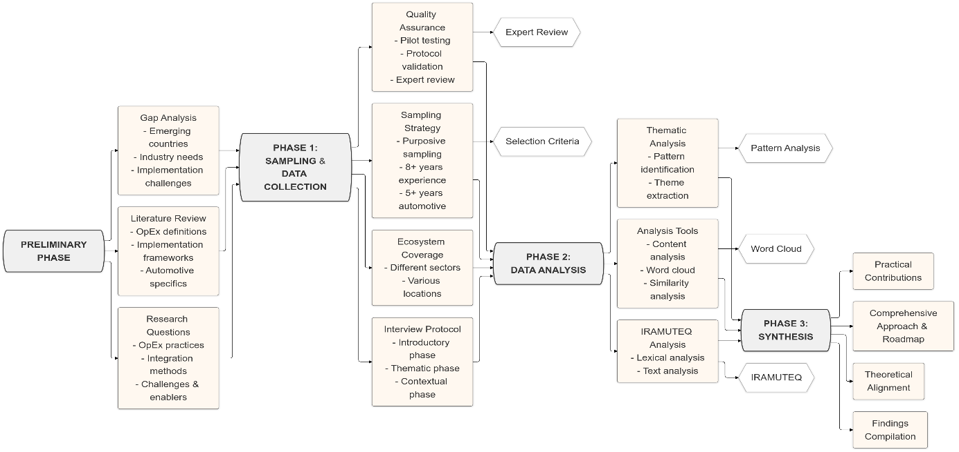

Figure 1: A Comprehensive Research Methodology Framework

**3.1 Research Design and Approach**

This study adopts a qualitative, exploratory research design to investigate the implementation of Operational Excellence (OpEx) within the Moroccan automotive industry. This methodological choice is particularly suited for examining complex, context-specific phenomena, facilitating a nuanced understanding of how OpEx practices are adapted and implemented in an under-researched sector (Creswell & Creswell, 2018). The exploratory nature of the design aligns with the emphasis on achieving qualitative depth in nascent research areas, as advocated by Shields & Rangarajan (2013).

The research design allows for an interpretive analysis of the Moroccan automotive sector’s operational environment, with a particular focus on key Operational Excellence practices adopted by Moroccan automotive firms. It explores how these firms integrate methodologies such as Lean, Six Sigma, and Kaizen, the primary challenges and enablers associated with OpEx implementation in a developing economy like Morocco, and the synergies between different OpEx methodologies that contribute to improving operational efficiency. These OpEx methodologies are contextualized within Morocco’s evolving automotive industry, focusing on aspects of Lean Management, Six Sigma, Kaizen tools, and Quality Management Systems (QMS).

**3.2 Research Context**

The Moroccan automotive industry provides the contextual framework for this research due to its significant economic role and rapid growth. The industry produced 403,000 vehicles in 2021 and exceeded 470,000 in 2022, setting an ambitious target of one million vehicles annually by 2025 with an 80% local integration rate (El-Khodary et al., 2024). Major global automotive manufacturers, including Renault and Stellantis, have established production facilities in key industrial hubs such as Tangier, Kenitra, and Casablanca, creating a fertile environment for investigating OpEx practices. The industry’s organization into interconnected industrial ecosystems fosters sectoral integration and strategic collaborations between large multinational firms and local small and medium-sized enterprises (SMEs) (Loilier & Malherbe, 2010; Teece, 2007). These ecosystems provide an ideal lens through which the adoption and adaptation of OpEx methodologies can be analyzed in the Moroccan automotive industry, focusing on inter-organizational relationships and operational dynamics.

**3.3 Sampling Strategy and Participant Selection**

This research employs purposive sampling, specifically expert sampling, to identify and recruit participants with specialized knowledge of OpEx within the Moroccan automotive industry. This non-probability sampling method is well-suited for the exploratory nature of the study, prioritizing the richness and depth of insight over broad statistical representativeness (Merriam & Tisdell, 2015). Participants were selected based on the following criteria:

1. A minimum of eight years of professional experience in industry-related roles.
2. At least five years of direct involvement within the Moroccan automotive sector.
3. A current or recent position in senior management or roles directly related to operational excellence.

The principle of data saturation was employed to determine the sample size, with interviews conducted until no new themes or insights emerged (Glaser & Strauss, 2017). This approach ensures comprehensive coverage of the research themes and enhances the internal validity of the study. The iterative process of data collection continued until thematic saturation was achieved, reflecting the depth and complexity of the subject matter. The final sample consisted of eight key experts, each with significant experience in various roles across different ecosystems within the Moroccan automotive sector. Table 2 provides a detailed overview of the participants’ roles, locations, and years of experience.

Table 2: Panel of experts

|  |  |  |  |  |
| --- | --- | --- | --- | --- |
| **No.** | **Position** | **Automotive Ecosystem** | **Location** | **Experience** |
| 1 | Logistics Manager | Wiring Ecosystem | Meknes | 8 years |
| 2 | Operational Excellence Director | Metal & Stamping Ecosystem | Casablanca | 17 years |
| 3 | Logistics Manager | Engine and Transmission Ecosystem | Kenitra | 11 years |
| 4 | Plant Manager | Vehicle Interior & Seats Ecosystem | Kenitra | 15 years |
| 5 | Purchasing Manager | Batteries Ecosystem | Mohammedia | 10 years |
| 6 | Sales Manager | Exterior Systems Ecosystem | Casablanca | 9 years |
| 7 | Quality Manager | Vehicle and Seat Ecosystem | Berrechid | 8 years |
| 8 | Inventory Director | Spare Parts Ecosystem | Fes | 12 years |

**3.4 Data Collection Procedures**

The primary data collection method was semi-structured interviews, chosen for their ability to strike a balance between structured questioning and the flexibility needed to explore emergent themes (Flick, 2014; Roberts, 2020). The interviews were conducted over a six-month period in 2024 across various Moroccan cities. Each interview lasted between 60 and 90 minutes, with an average duration of 75 minutes. To address participants' concerns regarding digital recording, detailed manual note-taking was employed during interviews. This method is recognized in qualitative research for its effectiveness in minimizing respondent deference and encouraging honest, candid responses (Duchesne, 2000).

The interviews followed a structured protocol aligned with Hlady Rispal’s (2002) guidelines for qualitative research. Key components of the interview protocol included:

* Thematic questions directly aligned with the research objectives, introduced flexibly to maintain conversational flow while ensuring the exploration of key topics.
* Application of the funnel technique, which began with broad, general questions before narrowing down to more specific inquiries to ensure a comprehensive exploration of the subject matter.
* Use of probing techniques to clarify responses, elicit deeper insights, and explore nuanced aspects of the participants' experiences with OpEx implementation.

A comprehensive thematic interview guide was developed to maintain consistency across interviews while allowing flexibility to accommodate emergent themes. The guide was structured in three primary phases:

1. Introductory Phase: Establishing rapport, explaining the study’s objectives, and outlining ethical considerations.
2. Contextual Phase: Gathering background information on participants’ professional experiences and organizational contexts.
3. Thematic Exploration Phase: Addressing key areas such as OpEx practices, organizational structure, integration mechanisms, and performance monitoring.

The interview guide was validated through a rigorous process that included: Expert review, Methodological review and Pilot testing. The study's ethical framework was constructed in alignment with the guidelines established by the American Psychological Association (2002).

1. **Data Analysis and Findings**

To organize and process the interview data, we combined all responses into one document, organized according to the thematic grid from the interview guide. This preliminary analysis allows us to work on a single document to identify patterns, insights, and suggestions made by participants about the practice of operational excellence (OpEx) in the Moroccan automotive industry. The data was processed using two techniques with the IRAMUTEQ software (Ramos et al., 2019), a tool for textual corpus analysis in R: lexical analysis and text analysis. This approach allowed for an organized thematic categorization according to the interview guide.

From the first step of lexical analysis and the eight responses, the word cloud (Figure 2) brings into focus the most frequently mentioned terms surrounding the central theme of operational excellence, which is emphasized due to its high frequency in semi-structured interviews. Each participant has a distinct view on adopting operational excellence within their specific automotive sector ecosystem in Morocco. Moreover, the compound term (operational excellence) is linked to various related terms, with their importance differing (as shown by word size). These related terms such as Lean, Six Sigma, and continuous improvement were mentioned more frequently than TQM, TPM, or agility.

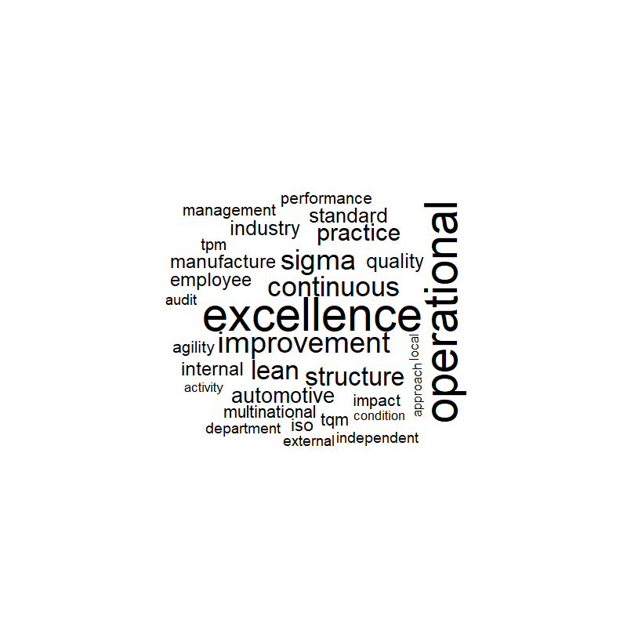

Figure 2. Word Cloud Results Generated by IRAMUTEQ Software

In addition to the frequency of word usage, which is depicted in the word cloud by visually illustrating the frequency of term appearances by all participants, the word cloud does not show the connections between words or the interconnections within word groupings. However, this is precisely where the similarity analysis offered by the software becomes valuable. This analysis complements the interpretation by revealing not only the frequency of word usage but also the structure of their usage and the coherence of participants' responses during the interviews, as shown in the similarity trees in Figure 3.

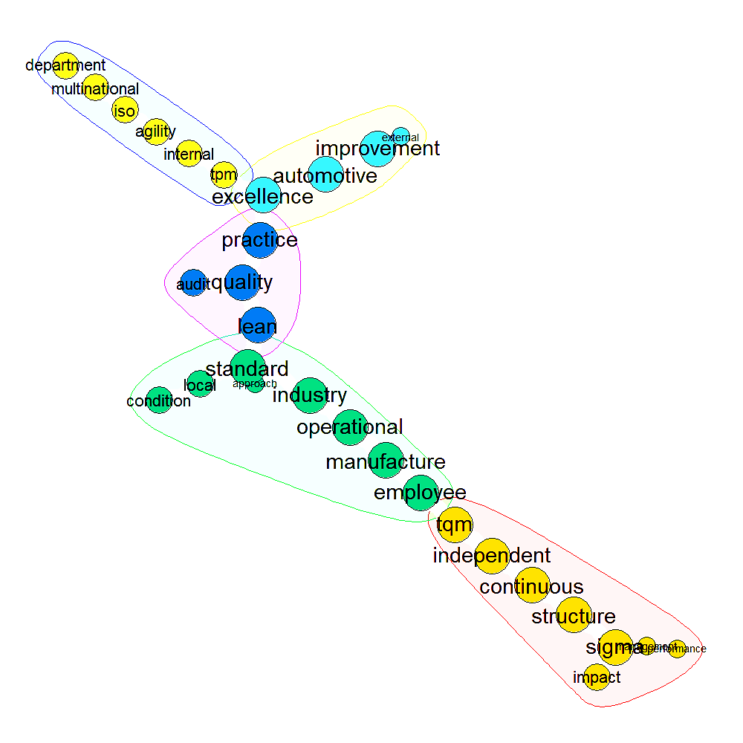

Figure 3. Similarity Analysis Results Generated by IRAMUTEQ Software

Similarity analysis identifies lexical similarities and interconnections within each subnetwork, as well as other similarities that constitute the similarity tree. The findings reveal five similarities within a single network of interconnections, without isolated sets. More significant figures and bold terms represent high-frequency lexemes primarily located within four similarities that define the central structure around the term’s "improvement" and "sigma" (referring to Six Sigma). The term "excellence" (referring to operational excellence) maintains numerous relationships at the intersection of three similarities out of a total of five, presenting a semantic articulation of greater complexity as it is associated with 13 words, three of which belong to the same group of similarities (communities). These findings contribute to a more precise understanding of the interview content by linking operational excellence with other communities such as the automotive industry, standards, employees, lean, and Six Sigma. The integrated perception in a chain structure (without isolated communities/halos) of operational excellence provided by the participants suggests a strong indication that operational excellence in the Moroccan automotive industry has its specificities, which may differ from other sectors.

Therefore, a comprehensive content and thematic analysis was employed. This method allowed for a nuanced capture of participants’ perspectives on OpEx within the Moroccan automotive sector. The thematic analysis facilitated a comparison between the insights gathered and the existing body of scientific literature on OpEx, thereby providing an in-depth understanding of how OpEx practices are adopted, integrated, and managed in this context. The results are organized according to the key themes identified in the interview guide, reflecting the study's primary research areas.

The findings indicate that seven out of the eight participating companies have successfully implemented operational excellence practices. These companies have adopted a range of strategies aimed at fostering environments conducive to improving manufacturing effectiveness, enhancing operational performance, and creating efficient processes. Central to these efforts are task standardization and the development of problem-solving capabilities, supported by a strong customer-centric focus. Participants highlighted that OpEx practices in these companies encompass Lean manufacturing, Kaizen-driven continuous improvement, standardization, and structured problem-solving, as well as advanced methodologies such as Six Sigma and Lean Six Sigma. Lean manufacturing plays a vital role by focusing on waste elimination and process optimization, while Kaizen encourages continuous improvement by empowering employees to actively identify inefficiencies. Six Sigma, through its data-driven methodologies, aims to minimize process variability and improve product quality using the DMAIC framework. This approach is complemented by Lean Six Sigma, which integrates waste reduction principles with structured problem-solving to drive operational efficiency.

One participant, however, reported that their company had not yet adopted OpEx practices. The barriers to implementation in this case were identified as a lack of internal expertise, a perceived lack of necessity, and resistance to change. This suggests that the successful adoption of OpEx practices requires robust internal capabilities, alongside effective change management strategies to mitigate resistance and build organizational readiness.

The organizational structure and integration of OpEx practices varied across the participating firms. Two companies have established dedicated Operational Excellence departments, while others have integrated OpEx initiatives within specialized teams, typically housed within the engineering or production departments. Some participants noted that specific roles, such as Kaizen coordinators or plant power coordinators, were responsible for overseeing OpEx initiatives and reporting directly to senior management. This highlights the importance of clear organizational roles and responsibilities in the successful integration of OpEx methodologies.

A key finding of this study is the role of the parent company in mandating and enforcing the use of OpEx tools, standards, and methodologies. Parent companies provide operational guides, training materials, and opportunities to observe best practices in global plants. This top-down approach ensures that OpEx practices are consistently applied and refined across the organization. Moreover, the implementation of OpEx typically involves a collaborative, project-based approach, with multiple stakeholders contributing to the execution of OpEx initiatives. Project managers, facilitators, sponsors, and financial controllers play critical roles in ensuring that the financial impact of improvements is accurately estimated, tracked, and reported. Monitoring and evaluation of OpEx initiatives are conducted internally, with regular reporting to international parent companies. This involves setting SMART objectives (specific, measurable, achievable, realistic, and time-bound) for each OpEx initiative and continuously tracking performance against these goals. Costs and expected gains are budgeted for each project, with monthly and annual reviews providing ongoing oversight. Detailed reports documenting the outcomes of OpEx projects are generated to capture lessons learned, which are then shared both internally and across the company’s global network.

Participants noted that the primary focus of OpEx practices within their organizations is to drive the continuous improvement process, with an emphasis on achieving measurable operational gains. This reflects the operational maturity of these companies, which are moving beyond basic process improvements to cultivate a culture of excellence. In two of the participating firms, OpEx initiatives were closely aligned with the company’s broader strategic objectives, ensuring that continuous improvement efforts supported long-term corporate goals. This strategic alignment between OpEx initiatives and corporate objectives is crucial for ensuring the sustainability of operational improvements. Implementing OpEx in Morocco’s developing economy presents both challenges and enablers. A significant challenge is the resistance to change, particularly among employees who may be reluctant to adopt new methodologies. Additionally, a lack of internal expertise in specialized methodologies such as Six Sigma can limit the scope and impact of OpEx initiatives. Budgetary constraints also pose a challenge, as companies may struggle to allocate the necessary resources to fully implement OpEx practices.

However, the strong support from international parent companies has been a major enabler of OpEx success. Parent companies provide the resources, training, and global benchmarks necessary to drive OpEx adoption. Cross-functional collaboration within firms has also facilitated the integration of OpEx practices. This collaborative approach, involving departments such as production, quality, and engineering, is key to the effective implementation of OpEx methodologies. Moreover, cultivating a culture of continuous improvement has been identified as a critical factor in embedding OpEx practices within the organizational fabric.

The synergies between OpEx methodologies—particularly Lean, Six Sigma, Kaizen, and Just-in-Time (JIT)—have contributed significantly to operational efficiency. The combination of Lean’s focus on waste reduction with Kaizen’s bottom-up approach to continuous improvement creates a comprehensive strategy for streamlining production processes. Six Sigma and Lean Six Sigma further enhance this by focusing on reducing defects and minimizing process variability. When combined with JIT, which aligns production schedules with real-time demand, these methodologies provide a robust framework for optimizing resource use and ensuring production efficiency. A summary of the key findings on the implementation of OpEx practices across various levels in the Moroccan automotive industry is presented in Table 3.

Table 3: Key Findings on the Implementation of OpEx Practices in the Moroccan Automotive Industry

|  |  |  |  |
| --- | --- | --- | --- |
| **Level** | **Key Characteristics** | **Methodologies and Tools** | **Objectives and Outcomes** |
| **1. Foundational** | Focus on basic operational practices Operator-level implementation | 5S Methodology Standardized Work Practices Visual Management and Quick Response (QR) Systems  Kaizen Kosu Measurement | Establish stable and efficient production processes Improve workflow efficiency Enhance operational safety Create baseline for improvement |
| **2. Intermediate** | Introduction of advanced Lean principles Focus on waste reduction and process optimization | Total Productive Maintenance (TPM) Overall Equipment Effectiveness (OEE) Autonomous Maintenance Just-In-Time (JIT) production Value Stream Mapping (VSM) Andon, Kanban Root Cause Analysis (RCA) | Reduce machine breakdowns and micro-stoppages Minimize waste (Muda) Enhance productivity and machine reliability Optimize inventory and production flow |
| **3. Advanced** | Integration of strategic methodologies Alignment of operational and organizational goals | Hoshin Kanri (with X-Matrix) Advanced JIT Quality-Cost-Delivery-Motivation (QCDM) framework Flow Analysis Heijunka (production leveling) | Synchronize processes with organizational objectives Optimize flow and resource efficiency Enhance quality, cost efficiency, delivery, and motivation |
| **4. Mature** | Highly technical and structured approach Focus on process control and continuous improvement | Six Sigma (DMAIC framework)  LSS Advanced JIT and Flow Analysis Refined Kosu Measurement Continuous Improvement Process (CIP) Kaizen events and Gemba walks PDCA cycle Advanced Hoshin Kanri | Achieve zero defects Optimize production flow and inventory levels Align operational improvements with strategic goals Institutionalize continuous improvement |

The findings from this study underscore that Moroccan automotive firms are actively adopting and integrating OpEx practices. While the level of implementation varies depending on organizational structure and corporate mandates, continuous monitoring, cross-functional collaboration, and strategic alignment are essential for sustaining OpEx initiatives.

The experts interviewed noted that the progression of OpEx adoption often follows a phased approach (Table 3), where companies implement different tools and methodologies based on their operational needs and the maturity of their production systems. This staged implementation is key to ensuring that OpEx practices are integrated systematically and yield sustainable improvements over time.

At the initial stage, companies focus on foundational practices such as the 5S methodology and work standardization. Experts emphasized that these basic practices are critical for creating a stable production environment, as they ensure that workspaces are organized, processes are streamlined, and tasks are performed consistently across production lines. The 5S methodology—Sort, Set in Order, Shine, Standardize, and Sustain—lays the groundwork for more advanced improvement initiatives by eliminating waste and fostering discipline among workers. Work standardization complements 5S by minimizing variability in production processes, thus providing a stable platform for subsequent improvements.

As organizations mature in their OpEx journey, they begin to integrate more advanced practices, such as Kaizen and continuous improvement. Kaizen’s focus on incremental improvements, driven by employee participation, is essential at this stage. The experts noted that the transition from foundational tools to Kaizen marks a significant shift towards a culture of continuous improvement. Operators and managers alike are empowered to identify inefficiencies and propose solutions that can be implemented to enhance both productivity and ergonomics. At this intermediate level, companies often adopt Lean tools to systematically eliminate waste and optimize workflows, while visual management techniques such as Andon systems and Kanban boards are used to monitor and regulate production flows in real-time.

In the more advanced stages of OpEx implementation, companies introduce methodologies such as Six Sigma and Lean Six Sigma to address more complex challenges related to process variability and quality control. According to the experts, Six Sigma’s data-driven approach allows companies to reduce defects and achieve higher precision in manufacturing processes. By employing the DMAIC framework—Define, Measure, Analyze, Improve, Control—firms can target specific inefficiencies and drive significant improvements in product quality and process reliability. At this level, the integration of Lean Six Sigma provides a powerful combination of waste reduction and defect minimization, leading to enhanced operational performance.

Experts further highlighted the role of strategic methodologies like Hoshin Kanri and Just-in-Time (JIT) in aligning operational improvements with broader organizational objectives. At this advanced level, companies use Hoshin Kanri to ensure that their long-term strategic goals—such as cost reduction or sustainability—are translated into actionable tasks at every level of the organization. JIT, on the other hand, is employed to synchronize production schedules with customer demand, thus reducing excess inventory and ensuring that resources are used efficiently.

The level of OpEx implementation varies significantly among firms, with some companies only beginning to adopt basic tools like 5S and standardization, while others have progressed to more sophisticated methodologies like Six Sigma and JIT. According to the experts, the success of OpEx at different stages is closely linked to the organization’s ability to foster a culture of continuous improvement, provide training and development opportunities for employees, and align operational improvements with strategic business objectives. Moreover, the support and guidance provided by parent companies play a critical role in driving OpEx adoption, particularly in companies with international operations.

The insights from the experts underscore the importance of a phased and structured approach to OpEx implementation, where companies gradually introduce more complex tools and methodologies as they advance in their OpEx journey. At each level, the focus shifts from foundational process stabilization to continuous improvement, quality control, and strategic alignment, ensuring that OpEx practices are integrated seamlessly and contribute to long-term operational excellence. This staged approach enables firms to address specific operational challenges at each stage of maturity and ensures that the benefits of OpEx are fully realized throughout the organization. The structured framework shown in Figure 4 highlights the alignment between the research methodology and the results, ensuring coherence and a clear progression from foundational insights to advanced contributions. This approach underscores the study's systematic exploration of OpEx practices within Morocco's automotive sector.

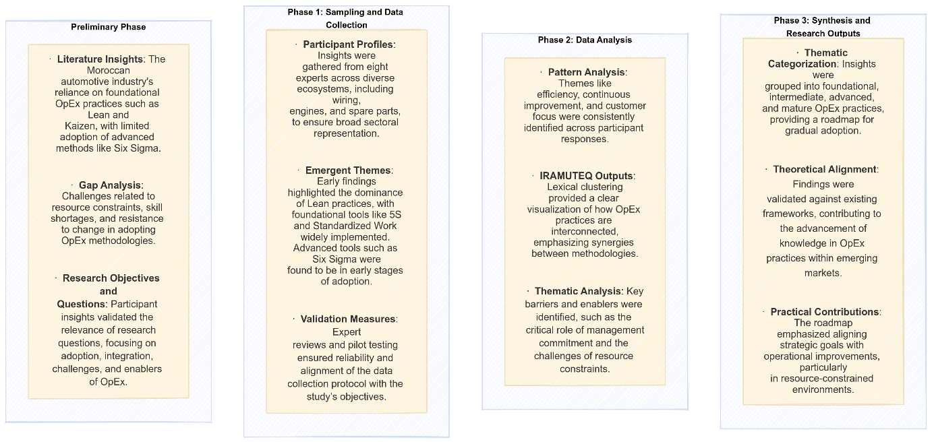

Figure 4: Structured Results Framework

1. **Discussions and Implications**

This study provides a detailed exploration of the implementation of OpEx practices within the Moroccan automotive industry, offering insights into the key practices, integration strategies, challenges, and synergies that underpin the adoption of OpEx methodologies. By analyzing the perspectives of industry experts and aligning them with established theoretical frameworks, this section aims to contribute both to the academic understanding of OpEx in developing economies and to the practical strategies employed by firms to enhance operational efficiency.

At the foundational level, the study highlights the critical role of basic operational practices aimed at creating stable and efficient production environments. One of the cornerstone practices in this phase is the 5S methodology. This methodology fosters workplace organization, cleanliness, and order, which are essential for reducing waste and enhancing productivity. The systematic application of 5S ensures that workspaces remain tidy, well-organized, and free of unnecessary materials, which, in turn, reduces inefficiencies in production processes (Jaeger et al., 2014; El Affaki et al., 2024). The study also identifies visual management systems as another crucial practice at the foundational level. These systems enable real-time monitoring of production processes and provide immediate feedback to operators and managers about deviations from standard operations. This quick-response capability allows for prompt corrective actions, minimizing disruptions and promoting operational stability (Mitchell, 2015; Naik et al., 2024).

Standardized work further strengthens operational stability by ensuring consistency across production processes, minimizing variability, and promoting adherence to best practices. This practice not only improves productivity but also serves as the foundation for Kaizen—the continuous improvement methodology that encourages employee engagement in identifying and solving inefficiencies. The bottom-up nature of Kaizen, which empowers operators to propose incremental improvements to their workstations, reinforces a culture of continuous optimization and process enhancement (Rusev & Salonitis, 2016; Barsalou & Perkin, 2024).

As firms progress to the intermediate level, their focus shifts toward the systematic reduction of inefficiencies and operational waste. This phase marks the integration of Lean methodologies, such as Total Productive Maintenance (TPM) and Overall Equipment Effectiveness (OEE), which aim to enhance machine reliability and reduce equipment breakdowns and micro-stoppages. TPM engages operators directly in maintenance activities, empowering them to perform routine maintenance tasks that prevent costly downtime (Tortorella et al., 2024; Sony, 2019).

The study reveals that the adoption of Just-In-Time (JIT) production is another significant practice at this stage, aligning production schedules with real-time demand and minimizing excess inventory. JIT not only reduces storage costs but also optimizes resource use by ensuring that materials are available when needed, without unnecessary stockpiling (Candea & Gabor, 2024; Rusev & Salonitis, 2016).

In addition to JIT, tools like Value Stream Mapping (VSM) and Andon systems enable firms to visualize the entire production process and quickly identify bottlenecks or inefficiencies. These tools facilitate the smooth flow of production by providing a clear, real-time view of operations, allowing firms to address problems before they escalate (Neves et al., 2021; Fonseca, 2022).

At the advanced level, companies begin to integrate strategic management tools that align operational improvements with long-term organizational goals. The study underscores the significance of Hoshin Kanri, a strategic planning methodology that ensures that high-level corporate objectives are cascaded down to every level of the organization. The X-Matrix framework used in Hoshin Kanri links strategic goals with specific actions, ensuring that day-to-day operational improvements contribute to broader business targets such as cost reduction, quality enhancement, and sustainability (El Affaki et al., 2024; Edgeman, 2018).

The Quality-Cost-Delivery-Motivation (QCDM) framework is also instrumental at this level, providing real-time visibility into key performance indicators related to quality, cost, delivery, and employee engagement. This comprehensive framework ensures that companies maintain a balanced focus on critical operational areas, driving continuous improvement across all dimensions of performance (Jengwa & Pellissier, 2022; Naik et al., 2024). Additionally, Heijunka (production leveling) is highlighted as a key tool for managing production fluctuations and ensuring a steady workflow. By balancing production schedules, firms can mitigate the impact of demand variability, ensuring efficient resource utilization and stable production flows (Rusev & Salonitis, 2016; Sony, 2019). At the mature level, OpEx implementation reaches its most advanced stage, characterized by rigorous process control, data-driven decision-making, and institutionalized continuous improvement. Six Sigma methodologies, particularly the DMAIC framework, are employed to reduce defects, minimize process variability, and achieve zero defects in production (Antony et al., 2021; Barsalou & Perkin, 2024).

The integration of advanced JIT techniques and refined Kosu measurement enables firms to optimize production cycles and ensure that resources are utilized efficiently. Flow analysis techniques, such as spaghetti diagrams, are used to map and optimize material flow, further enhancing production efficiency (El Affaki et al., 2024). The study also emphasizes the importance of fostering a culture of continuous improvement at this level. Kaizen events and Gemba walks engage employees at all levels of the organization, encouraging them to actively participate in identifying inefficiencies and proposing solutions. This bottom-up approach, supported by the PDCA (Plan-Do-Check-Act) cycle, institutionalizes continuous improvement as a core organizational value, ensuring that operational enhancements are sustained over time (Rusev & Salonitis, 2016; Singh & Singh, 2018). The four levels of OpEx implementation in Morocco’s automotive industry present both challenges and enablers. One of the primary challenges is the limited technical expertise within the workforce, particularly in the application of advanced methodologies such as Six Sigma. Although training programs have been initiated to address this gap, the complexity of Six Sigma’s statistical tools requires specialized skills that are not always readily available. This lack of expertise limits the scope and impact of OpEx initiatives, particularly in smaller firms with fewer resources. Another significant challenge is resistance to change, which stems from both organizational inertia and a lack of understanding of the long-term benefits of OpEx practices. Some companies, particularly those that have not yet fully embraced the need for continuous improvement, may perceive OpEx methodologies as unnecessary or disruptive to existing operations.

However, several enablers facilitate the successful implementation of OpEx. The Moroccan automotive industry benefits from its integration into global supply chains, with multinational corporations such as Renault and Stellantis providing guidance, resources, and training to local suppliers. This support from parent companies has been instrumental in driving the adoption of OpEx practices. Additionally, the Moroccan government’s strategic initiatives, including efforts to increase local integration rates to 80% by 2025, have created a favorable environment for the adoption of advanced operational practices. The collaboration between multinational corporations and local SMEs fosters the diffusion of best practices, enhancing the overall competitiveness of the sector. A detailed roadmap specifically designed for automotive companies aiming to achieve OpEx can be developed, as depicted in Figure 5. This comprehensive framework leverages the automotive industry-specific insights provided by El Affaki et al. (2024) while integrating the broader manufacturing implementation strategies outlined by Rusev and Salonitis (2016). Furthermore, it incorporates the four critical dimensions of OpEx identified by Rusev and Salonitis (2016) and Edgeman (2018), ensuring a robust and adaptable approach that addresses both industry-specific challenges and general manufacturing best practices. This integrated framework provides a structured pathway for firms to progressively adopt and refine OpEx methodologies, ensuring alignment with both operational goals and strategic objectives.

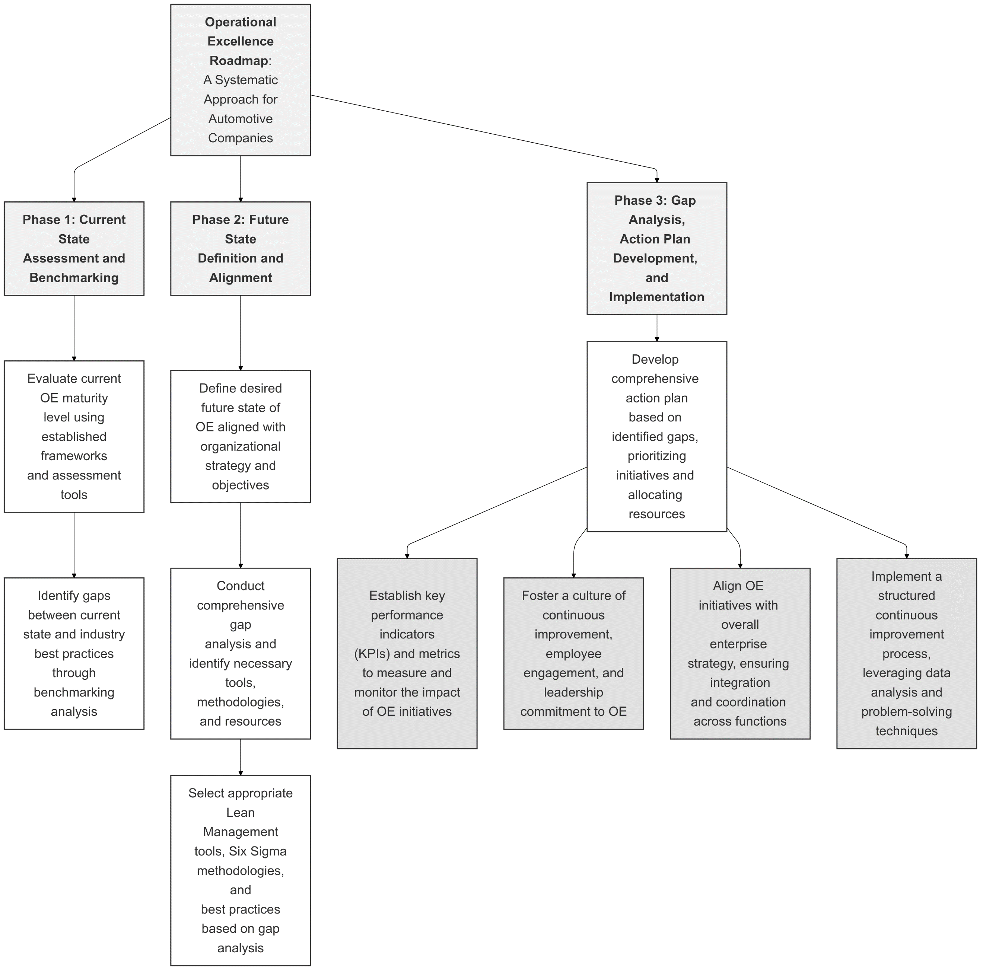

Figure 5: Operational Excellence Implementation Roadmap

The implications of this study are significant for both practitioners and researchers. For practitioners, the findings suggest that adopting a phased approach to OpEx implementation is critical for ensuring sustainable improvements. Each level of implementation builds on the previous one (Table 3), gradually introducing more advanced methodologies and tools (Figure 6). The foundational practices of 5S and standardized work processes lay the groundwork for more advanced practices like Six Sigma and Hoshin Kanri, ensuring that firms can evolve their operational excellence capabilities in a structured and methodical manner (Mitchell, 2015; Naik et al., 2024).

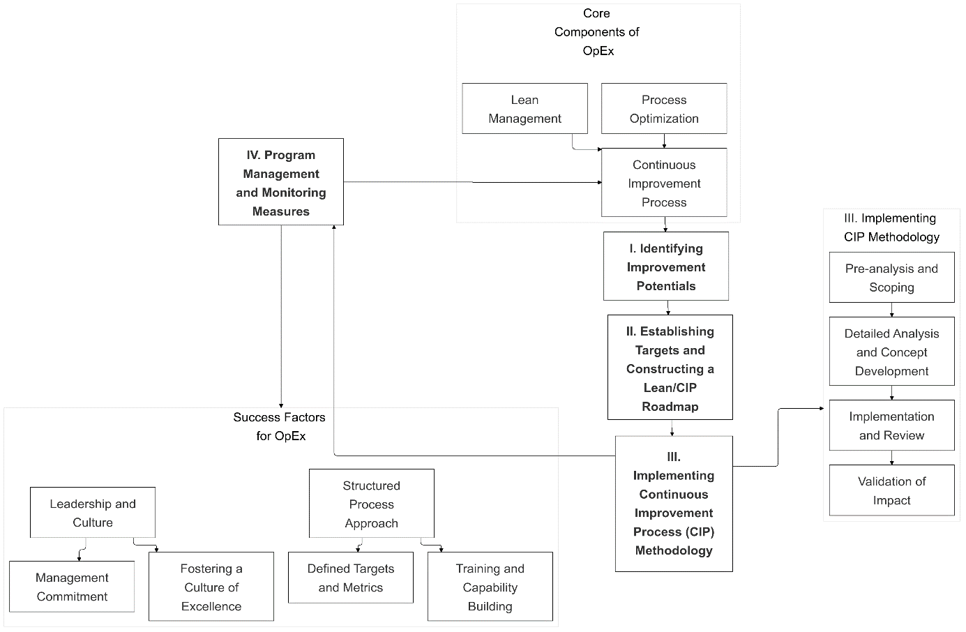

Figure 6: Operational Excellence: A Comprehensive Approach

The study also highlights the importance of cross-functional collaboration and employee engagement in sustaining OpEx practices. Involving employees in continuous improvement initiatives, from Kaizen to TPM, fosters a culture of innovation and operational discipline. Moreover, the support provided by international parent companies, in the form of training, operational guides, and exposure to best practices, plays a crucial role in enabling Moroccan firms to adopt global OpEx standards while adapting them to local contexts (Jaeger et al., 2014; El Affaki et al., 2024). The role of parent companies in supporting the adoption of OpEx practices is also significant. The top-down enforcement of standards, combined with access to global best practices and training resources, has been crucial in fostering a culture of continuous improvement within Moroccan automotive firms. The study underscores the need for cross-functional collaboration in the implementation of OpEx, with input from production, quality, engineering, and senior management teams.

The findings of this study on the implementation of Operational Excellence (OpEx) within Morocco’s automotive industry, presented in *Key Findings on the Implementation of OpEx Practices in the Moroccan Automotive Industry* (Table 3), *Operational Excellence Implementation Roadmap* (Figure 5), and *Operational Excellence: A Comprehensive Approach* (Figure 6), provide a structured, sector-specific framework designed to navigate the unique challenges and opportunities of resource-constrained environments. These outputs emphasize phased progression, contextual adaptability, and the integration of continuous improvement practices to enhance operational efficiency and competitiveness.

The maturity model outlined in Table 3 categorizes OpEx practices into four levels: foundational, intermediate, advanced, and mature. This framework starts with foundational methodologies, such as 5S and standardized work, which establish operational stability and efficiency. It progresses to more advanced practices, such as Six Sigma and Hoshin Kanri, which align operational processes with broader strategic objectives. By addressing challenges like resource constraints and organizational resistance to change, this phased approach supports gradual capability development and sustainable operational improvements.

The *Operational Excellence Implementation Roadmap* outlines a three-phase process: (1) Assessment and Benchmarking, focused on evaluating maturity levels and identifying performance gaps; (2) Strategic Alignment, which defines future states and aligns operational strategies with organizational goals; and (3) Action Plan Implementation, which prioritizes and executes targeted initiatives. This roadmap offers a practical pathway for adapting globally recognized methodologies, such as Lean and Six Sigma, to the realities of the Moroccan automotive sector.

The *Operational Excellence: A Comprehensive Approach* framework complements this by integrating Lean Management, Process Optimization, and Continuous Improvement. It emphasizes the role of leadership, organizational culture, and structured processes as critical enablers of sustained improvement. This approach ensures alignment between technical methodologies and organizational strategies, fostering a culture of continuous improvement and long-term competitiveness.

In comparison, Henriquez-Machado et al. (2024) present a broader roadmap emphasizing sustainability as a core component of operational excellence. Their framework guides organizations through progressive maturity levels, incorporating strategic, economic, environmental, and social dimensions. By transitioning from compliance to champion-level maturity, their approach integrates sustainability into operational strategies. The estimated timeline of 4.5 to 5 years highlights the need for sustained organizational commitment and alignment with long-term sustainability objectives, with a particular focus on the triple bottom line of economic, environmental, and social sustainability.

While both roadmaps prioritize phased progression and incremental development, they focus on different aspects. The framework in this study is tailored to the specific needs of the Moroccan automotive sector, offering detailed, actionable insights that address challenges such as resource constraints and operational dynamics. Henriquez-Machado et al.’s roadmap, on the other hand, provides a broader perspective, emphasizing sustainability and global alignment.

The interplay between these frameworks suggests potential for integration. Sector-specific strategies from this study could incorporate sustainability-focused elements from Henriquez-Machado et al. (2024), creating a comprehensive approach to operational excellence that bridges local insights and global priorities. Such integration could enhance the applicability of OpEx frameworks in emerging markets, supporting organizations in achieving operational efficiency while addressing sustainability goals.

For researchers, this study contributes to the body of knowledge on OpEx implementation in developing economies by addressing challenges such as resistance to change and gaps in technical expertise. The findings underscore the importance of context-specific adaptations and capacity-building strategies. Additionally, the interplay between methodologies like Lean, Six Sigma, and Kaizen provides a basis for future research into their tailored applications in emerging markets. For practitioners, the findings offer a phased approach to implementing OpEx practices, progressing from foundational tools to advanced methodologies. These practices have significantly improved operational efficiency and competitiveness in Morocco’s automotive sector. By addressing barriers and leveraging methodological synergies, organizations can enhance their operational excellence journey and align with long-term strategic objectives.

**6. Conclusions, Limitations, and Future Work**

This study, based on semi-structured interviews with stakeholders from eight distinct ecosystems within the Moroccan automotive sector, sought to analyze the implementation of OpEx practices. It examined how these methodologies are perceived, integrated, and implemented within organizational structures, addressing the key research questions regarding the OpEx practices adopted by automotive firms in Morocco. The findings reveal that Moroccan automotive firms implement OpEx practices through a structured, phased approach. Companies initially adopt foundational methodologies such as 5S, Kaizen, and Lean manufacturing, progressively advancing to more sophisticated practices, including Six Sigma and Hoshin Kanri. The integration of these methodologies is facilitated by dedicated teams within engineering or production departments, with some firms establishing specific operational excellence departments reporting directly to plant directors. This structured implementation highlights the growing maturity of OpEx in the sector.

Despite the progress in implementing OpEx, several challenges persist, particularly in the context of a developing economy like Morocco. A significant barrier is the limited technical expertise, especially in advanced methodologies like Six Sigma. However, support from international parent companies and the highly integrated automotive ecosystem in Morocco serve as key enablers. These factors facilitate knowledge transfer and the adoption of global best practices, which are instrumental in driving operational improvements.

This study’s contribution is twofold. Theoretically, it enriches the relatively limited body of literature on OpEx implementation in the automotive sectors of developing economies. By providing empirical evidence of how OpEx practices are adapted and implemented in Morocco, it addresses a notable gap in existing research. Practically, it offers valuable insights for industry practitioners, outlining a detailed roadmap for OpEx implementation and providing a framework for operational excellence in the Moroccan automotive industry.

The explanatory power of this research is somewhat constrained by the sample size and its focus on automotive manufacturers in Morocco. While the semi-structured interviews yielded rich qualitative insights, the findings may not be easily generalizable across other sectors or geographic regions. As is common with exploratory studies, these findings serve as a starting point for further investigation rather than providing broad generalizations.

Future research could build on these findings by exploring the practical application of OpEx practices in other developing economies and industrial sectors. Comparative studies examining OpEx implementation across African countries such as Egypt, South Africa, and Tunisia would be particularly valuable. Additionally, research into the integration of Industry 4.0 technologies with OpEx practices could offer further insights into how digital transformation enhances operational excellence initiatives. Finally, expanding the scope to other industrial sectors through case studies would improve the generalizability of findings and deepen understanding of OpEx implementation in diverse contexts.**References**

Achibat, F. E., Lebkiri, A., & Aouane, E. M. (2021). Application of six sigma in a company automotive in morocco. *E3S Web of Conferences*, *319*, 01093. <https://doi.org/10.1051/e3sconf/202131901093>

Albliwi, S., Antony, J., Abdul Halim Lim, S., & Van Der Wiele, T. (2014). Critical failure factors of Lean Six Sigma: A systematic literature review. *International Journal of Quality & Reliability Management*, *31*(9), 1012–1030. <https://doi.org/10.1108/IJQRM-09-2013-0147>

Alvarez, L., Avella, L., & Martinez, R. (2024). Impact and critical factors in Heijunka implementation an action research study. *Journal of Industrial Engineering and Management*, *17*(3), 753. <https://doi.org/10.3926/jiem.6292>

American Psychological Association. (2002). Ethical principles of psychologists and code of conduct. *American Psychologist*, *57*(12), 1060–1073. <https://doi.org/10.1037/0003-066X.57.12.1060>

Anand, G., & Kodali, R. (2008). Selection of lean manufacturing systems using the PROMETHEE. *Journal of Modelling in Management*, *3*(1), 40–70. <https://doi.org/10.1108/17465660810860372>

Antony, J. (2011). Six Sigma vs Lean: Some perspectives from leading academics and practitioners. *International Journal of Productivity and Performance Management*, *60*(2), 185–190. https://doi.org/10.1108/17410401111101494

Antony, J., Gijo, E. V., & Childe, S. J. (2012). Case study in Six Sigma methodology: Manufacturing quality improvement and guidance for managers. *Production Planning & Control*, *23*(8), 624–640. <https://doi.org/10.1080/09537287.2011.576404>

Antony, J., Kumar, M., & Tiwari, M. K. (2005). An application of Six Sigma methodology to reduce the engine-overheating problem in an automotive company. *Proceedings of the Institution of Mechanical Engineers, Part B: Journal of Engineering Manufacture*, *219*(8), 633–646. <https://doi.org/10.1243/095440505X32418>

Antony, J., Psomas, E., Garza-Reyes, J. A., & Hines, P. (2021). Practical implications and future research agenda of lean manufacturing: A systematic literature review. *Production Planning & Control*, *32*(11), 889–925. https://doi.org/10.1080/09537287.2020.1776410

Antony, J., Snee, R., & Hoerl, R. (2017). Lean Six Sigma: Yesterday, today and tomorrow. *International Journal of Quality & Reliability Management*, *34*(7), 1073–1093. <https://doi.org/10.1108/IJQRM-03-2016-0035>

Antony, J., Sony, M., & Gutierrez, L. (2022). An empirical study into the limitations and emerging trends of six sigma: Findings from a global survey. *IEEE Transactions on Engineering Management*, *69*(5), 2088–2101. <https://doi.org/10.1109/TEM.2020.2995168>

Antony, J., Sony, M., Jayaraman, R., Swarnakar, V., Tortorella, G. D. L., Garza-Reyes, J. A., Rathi, R., Gutierrez, L., McDermott, O., & Lameijer, B. A. (2024). Global perspectives on operational excellence: Unveiling critical failure factors and sustainable pathways. *International Journal of Quality & Reliability Management*. <https://doi.org/10.1108/IJQRM-01-2024-0013>

Antony, J., Sony, M., McDermott, O., Swarnakar, V., Galli, B., Doulatabadi, M., & Kaul, R. (2022). An empirical study into the reasons for failure of sustaining operational excellence initiatives in organizations. *The TQM Journal*, *35*(7), 1569–1587. <https://doi.org/10.1108/TQM-05-2022-0176>

Antony, J., Swarnakar, V., Gupta, N., Kaur, J., Jayaraman, R., Tortorella, G. L., & Cudney, E. (2023). Critical success factors for operational excellence initiatives in manufacturing: A meta-analysis. *Total Quality Management & Business Excellence*, *34*(9–10), 1152–1172. <https://doi.org/10.1080/14783363.2022.2157714>

Arabi, S., Bajjou, M. S., Chafi, A., & Hammoumi, M. E. (2024). The implementation of lean manufacturing tools in morocco: A study on small and medium-sized enterprises. *2024 4th International Conference on Innovative Research in Applied Science, Engineering and Technology (IRASET)*, 1–6. <https://doi.org/10.1109/IRASET60544.2024.10548803>

Arabi, S., Chafi, A., Bajjou, M. S., & El Hammoumi, M. (2021). Exploring lean production system adoption in the moroccan manufacturing and non-manufacturing industries: Awareness, benefits and barriers. *International Journal of Automotive and Mechanical Engineering*, *18*(4). https://doi.org/10.15282/ijame.18.4.2021.14.0717

Arcidiacono, G., & Pieroni, A. (2018). The revolution lean six sigma 4. 0. *International Journal on Advanced Science, Engineering and Information Technology*, *8*(1), 141. <https://doi.org/10.18517/ijaseit.8.1.4593>

Aripin, N. M., Mezhuyev, V., Nawanir, G., Yusuf, M. F., & Haron, N. R. H. M. (2023). Unveiling key drivers of industry 4. 0 adaptation in ckd automotive manufacturing companies: Evidence from asia and south america. *IEEE Access*, *11*, 136049–136062. <https://doi.org/10.1109/ACCESS.2023.3337426>

Arumugam, V., Kannabiran, G., & Vinodh, S. (2022). Impact of technical and social lean practices on SMEs’ performance in automobile industry: A structural equation modelling (Sem) analysis. *Total Quality Management & Business Excellence*, *33*(1–2), 28–54. https://doi.org/10.1080/14783363.2020.1791067

Arunrao Shahade, A. A., & Jha, U. C. (2021). Development of lean & six sigma integration model through axiomatic design theory. *2021 International Conference on Mechanical, Aerospace and Automotive Engineering*, 324–328. https://doi.org/10.1145/3518781.3519605

Bachirat, B., Boulouadnine, L., & Lembarek, N. (2013). L’industrie automobile au Maroc: Potentiels et dynamiques des relations clients-fournisseurs. *Critique économique*, No 17 (2006). https://doi.org/10.48409/IMIST.PRSM/CE-N17.1512

Barsalou, M., & Perkin, R. (2024). Statistical problem‐solving teams: A case study in a global manufacturing organization in the automotive industry. *Quality and Reliability Engineering International*, *40*(1), 513–523. <https://doi.org/10.1002/qre.3404>

Beer, M. (2003). Why total quality management programs do not persist: The role of management quality and implications for leading a tqm transformation*. *Decision Sciences*, *34*(4), 623–642. https://doi.org/10.1111/j.1540-5414.2003.02640.x

Belhadi, A., Touriki, F. E., & El Fezazi, S. (2018). Lean implementation in small and medium-sized enterprises in less developed countries: Some empirical evidences from north africa: journal of small business management. *Journal of Small Business Management*, *56*, 132–153. https://doi.org/10.1111/jsbm.12396

Benchekroun, M. A., & Boumane, A. (2024). Analysis of the local integration rate relevance as a performance indicator for the Moroccan automotive industry. *Journal of Global Operations and Strategic Sourcing*. https://doi.org/10.1108/JGOSS-09-2022-0103

Berhe, H. H., Gebremichael, H. S., & Beyene, K. T. (2023). Development, validation and verification of innovative integrated Kaizen philosophy (Ci) framework and its implementation procedure for enhancing manufacturing industries sustainable competitiveness. *International Journal of Quality & Reliability Management*, *40*(10), 2463–2518. <https://doi.org/10.1108/IJQRM-08-2022-0258>

Bessant, J., & Francis, D. (1999). Developing strategic continuous improvement capability. *International Journal of Operations & Production Management*, *19*(11), 1106–1119. https://doi.org/10.1108/01443579910291032

Bhasin, S., & Burcher, P. (2006). Lean viewed as a philosophy. *Journal of Manufacturing Technology Management*, *17*(1), 56–72. https://doi.org/10.1108/17410380610639506

Bhullar, A. S., Gan, C. W., Ang, A. J. L., Ma, B., Lim, R. Y. G., & Toh, M. H. (2014). Operational excellence frameworks &#x2014; Case studies and applicability to SMEs in Singapore. *2014 IEEE International Conference on Industrial Engineering and Engineering Management*, 667–671. https://doi.org/10.1109/IEEM.2014.7058722

Bortolotti, T., Boscari, S., & Danese, P. (2015). Successful lean implementation: Organizational culture and soft lean practices. *International Journal of Production Economics*, *160*, 182–201. https://doi.org/10.1016/j.ijpe.2014.10.013

Botha, B. W. (2016). Integrating key engineering processes towards operational excellence. *INSIGHT*, *19*(4), 70–75. https://doi.org/10.1002/inst.12133

Bouazza, Y., & Lajjam, A. (2023). Contribution of lean manufacturing on environmental performance in moroccan industry. *Logistic and Operation Management Research (LOMR)*, *2*(2), 72–86. https://doi.org/10.31098/lomr.v2i2.1921

Bouazza, Y., Lajjam, A., & Dkhissi, B. (2021). Sciendo. *Management Systems in Production Engineering*, *29*(3), 184–192. https://doi.org/10.2478/mspe-2021-0023

Boutayeb, A., Sabbani, Y., Ennadi, A., & Chamat, A. (2020). Contribution of lean management in the moroccan ecosystem: Industrial sector. *2020 IEEE 13th International Colloquium of Logistics and Supply Chain Management (LOGISTIQUA)*, 1–6. https://doi.org/10.1109/LOGISTIQUA49782.2020.9353886

Boutbagha, M., & El Abbadi, L. (2023). Heijunka-levelling customer orders: A systematic literature review. *International Journal of Production Management and Engineering*, *12*(1), 31–41. https://doi.org/10.4995/ijpme.2024.19279

Brumme, H., Simonovich, D., Skinner, W., & Van Wassenhove, L. N. (2015). The strategy‐focused factory in turbulent times. *Production and Operations Management*, *24*(10), 1513–1523. https://doi.org/10.1111/poms.12384

Candea, S., & Gabor, M. R. (2024). Effects of using leadership tools in automotive industry. A case study. In L. Moldovan & A. Gligor (Eds.), *The 17th International Conference Interdisciplinarity in Engineering* (Vol. 926, pp. 348–361). Springer Nature Switzerland. <https://doi.org/10.1007/978-3-031-54664-8_31>

Carvalho, A. M., Sampaio, P., & Rebentisch, E. (2019). On agile metrics for operations management: Measuring and aligning agility with operational excellence. *2019 IEEE International Conference on Industrial Engineering and Engineering Management (IEEM)*, 1601–1605. https://doi.org/10.1109/IEEM44572.2019.8978806

Carvalho, A. M., Sampaio, P., Rebentisch, E., & Saraiva, P. (2021). 35 years of excellence, and perspectives ahead for excellence 4.0. *Total Quality Management & Business Excellence*, *32*(11–12), 1215–1248. <https://doi.org/10.1080/14783363.2019.1691915>

Carvalho, A. M., Sampaio, P., Rebentisch, E., Carvalho, J. Á., & Saraiva, P. (2020). The influence of operational excellence on the culture and agility of organizations: Evidence from industry. *International Journal of Quality & Reliability Management*, *38*(7), 1520–1549. <https://doi.org/10.1108/IJQRM-07-2020-0248>

Carvalho, A. M., Sampaio, P., Rebentisch, E., Carvalho, J. Á., & Saraiva, P. (2019). Operational excellence, organisational culture and agility: The missing link? *Total Quality Management & Business Excellence*, *30*(13–14), 1495–1514. <https://doi.org/10.1080/14783363.2017.1374833>

Carvalho, A. M., Sampaio, P., Rebentisch, E., McManus, H., Carvalho, J. Á., & Saraiva, P. (2023). Operational excellence, organizational culture, and agility: Bridging the gap between quality and adaptability. *Total Quality Management & Business Excellence*, *34*(11–12), 1598–1628. <https://doi.org/10.1080/14783363.2023.2191844>

Chakravorty, S. S., & Shah, A. D. (2012). Lean Six Sigma (Lss): An implementation experience. *European J. of Industrial Engineering*, *6*(1), 118. https://doi.org/10.1504/EJIE.2012.044813

Cherqaoui, F. E., & Elhaq, S. L. (2020). Sustainable framework of Lean manufacturing implementation during supporting programs. *2020 IEEE 13th International Colloquium of Logistics and Supply Chain Management (LOGISTIQUA)*, 1–6. https://doi.org/10.1109/LOGISTIQUA49782.2020.9353904

Cherrafi, A., Elfezazi, S., Hurley, B., Garza-Reyes, J. A., Kumar, V., Anosike, A., & Batista, L. (2019). Green and lean: A Gemba–Kaizen model for sustainability enhancement. *Production Planning & Control*, *30*(5–6), 385–399. https://doi.org/10.1080/09537287.2018.1501808

Chiarini, A., & Kumar, M. (2021). Lean Six Sigma and Industry 4.0 integration for Operational Excellence: Evidence from Italian manufacturing companies. *Production Planning & Control*, *32*(13), 1084–1101. <https://doi.org/10.1080/09537287.2020.1784485>

Chouiraf, F., & Chafi, A. (2018). Lean manufacturing for handicraft production: A new production system to enhance productivity and competitiveness of craft enterprise. *2018 4th International Conference on Optimization and Applications (ICOA)*, 1–6. https://doi.org/10.1109/ICOA.2018.8370562

Chubineh, E., Azami Aghdash, S., Esmaili, A., & Alizadeh, S. S. (2024). Evaluating the status of process safety management in process industries: A systematic review. *Journal of Health and Safety at Work*. <https://doi.org/10.18502/jhsw.v14i2.17148>

Condé, G. C. P., Oprime, P. C., Pimenta, M. L., Sordan, J. E., & Bueno, C. R. (2023). Defect reduction using DMAIC and Lean Six Sigma: A case study in a manufacturing car parts supplier. *International Journal of Quality & Reliability Management*, *40*(9), 2184–2204. <https://doi.org/10.1108/IJQRM-05-2022-0157>

Creswell, J. W., & Creswell, J. D. (2018). *Research design: Qualitative, quantitative, and mixed methods approaches* (Fifth edition). SAGE.

Criscuolo, C., & Lalanne, G. (2024). A new approach for better industrial strategies. *Journal of Industry, Competition and Trade*, *24*(1), 6. <https://doi.org/10.1007/s10842-024-00416-7>

Cua, K. O., McKone, K. E., & Schroeder, R. G. (2001). Relationships between implementation of TQM, JIT, and TPM and manufacturing performance. *Journal of Operations Management*, *19*(6), 675–694. https://doi.org/10.1016/S0272-6963(01)00066-3

Dale, B. G., Zairi, M., Van Der Wiele, A., & Williams, A. R. T. (2000). Quality is dead in Europe – long live excellence ‐ true or false? *Measuring Business Excellence*, *4*(3), 4–10. <https://doi.org/10.1108/13683040010377737>

De Menezes, L. M., Wood, S., & Gelade, G. (2010). The integration of human resource and operation management practices and its link with performance: A longitudinal latent class study. *Journal of Operations Management*, *28*(6), 455–471. https://doi.org/10.1016/j.jom.2010.01.002

Desai, D. A., Antony, J., & Patel, M. B. (2012). An assessment of the critical success factors for Six Sigma implementation in Indian industries. *International Journal of Productivity and Performance Management*, *61*(4), 426–444. https://doi.org/10.1108/17410401211212670

Do Rego Ferreira Lima, M., Wilke Franco, C., & Brittes Benitez, G. (2024). Performance returns from aligning front-end technologies and just-in-time practices: Empirical findings from the brazilian manufacturing industry. *SSRN Electronic Journal*. https://doi.org/10.2139/ssrn.4887494

Driouach, L., Zitouni, B., & Khalid, Z. (2023). Proposing a lean manufacturing framework adapted to very small businesses: Multiple case studies. *International Journal of Technology*, *14*(3), 460. https://doi.org/10.14716/ijtech.v14i3.5417

Duchesne, S. (2000). *Pratique de l’entretien dit “non-directif.”* PUF. https://shs.hal.science/halshs-00841927

Duggan, K. J. (2012). *Design for operational excellence: A breakthrough strategy for business growth*. McGraw-Hill.

Duggan, K. J. (2018). *Creating mixed model value streams: Practical lean techniques for building to demand, second edition*. CRC Press.

Edgeman, R. (2018). Excellence models as complex management systems: An examination of the Shingo operational excellence model. *Business Process Management Journal*, *24*(6), 1321–1338. <https://doi.org/10.1108/BPMJ-02-2018-0049>

Edgeman, R. L. (2019). *Complex management systems and the shingo model: Foundations of operational excellence and supporting tools* (1st ed.). Productivity Press. <https://doi.org/10.1201/b22037>

El Affaki, O., Benhadou, M., & Haddout, A. (2024). Roadmap to achieve operational excellence through Lean Management implementation and quality management system conformance. *Acta Logistica*, *11*(1), 79–86. <https://doi.org/10.22306/al.v11i1.452>

Elbaz, J., & Batrich, H. (2013). Supply chain management strategies of Moroccan firms: A qualitative study. *2013 International Conference on Advanced Logistics and Transport*, 388–393. https://doi.org/10.1109/ICAdLT.2013.6568490

Elboq, R., Hlyal, M., & El Alami, J. (2020). Empirical assessment of critical success factor of lean and six sigma in the Moroccan automotive industry. *IOP Conference Series: Materials Science and Engineering*, *827*(1), 012043. https://doi.org/10.1088/1757-899X/827/1/012043

El-Khodary, M., El Kadri, A., & Dassouli, S. (2024). A comprehensive analysis of the inter-relationships of impact between automotive industry, economic growth, natural resources and environmental degradation: Morocco as an example. *Environment, Development and Sustainability*. <https://doi.org/10.1007/s10668-024-04705-3>

Fadly Habidin, N., & Mohd Yusof, S. (2013). Critical success factors of Lean Six Sigma for the Malaysian automotive industry. *International Journal of Lean Six Sigma*, *4*(1), 60–82. https://doi.org/10.1108/20401461311310526

Ferdowsian, M. C. (2016). Total business excellence – a new management model for operationalizing excellence. *International Journal of Quality & Reliability Management*, *33*(7), 942–984. https://doi.org/10.1108/IJQRM-08-2014-0109

Flick, U. (2014). *The sage handbook of qualitative data analysis*. SAGE Publications, Inc. <https://doi.org/10.4135/9781446282243>

Fonseca, L. (2022). The EFQM 2020 model. A theoretical and critical review. *Total Quality Management & Business Excellence*, *33*(9–10), 1011–1038. <https://doi.org/10.1080/14783363.2021.1915121>

Found, P., Lahy, A., Williams, S., Hu, Q., & Mason, R. (2018). Towards a theory of operational excellence. *Total Quality Management & Business Excellence*, *29*(9–10), 1012–1024. <https://doi.org/10.1080/14783363.2018.1486544>

Found, P., Lahy, A., Williams, S., Hu, Q., & Mason, R. (2018). Towards a theory of operational excellence. *Total Quality Management & Business Excellence*, *29*(9–10), 1012–1024. <https://doi.org/10.1080/14783363.2018.1486544>

Found, P., Samuel, D., & Lyons, J. (2017). From lean production to operational excellence. In *The Routledge Companion to Production and Operations Management*. Routledge.

Galeazzo, A., & Furlan, A. (2021). Developing operational problem solvers: The role of job design decisions. *Total Quality Management & Business Excellence*, *32*(15–16), 1768–1785. <https://doi.org/10.1080/14783363.2020.1771176>

Gapp, R., Fisher, R., & Kobayashi, K. (2008). Implementing 5S within a Japanese context: An integrated management system. *Management Decision*, *46*(4), 565–579. <https://doi.org/10.1108/00251740810865067>

Ge and motorola belt up for six sigma success. (2002). *Measuring Business Excellence*, *6*(3). <https://doi.org/10.1108/mbe.2002.26706cab.006>

George, M. (2002). *Lean six sigma: Combining six sigma quality with lean production speed*. McGraw-Hill Education.

Gijo, E. V., Scaria, J., & Antony, J. (2011). Application of six sigma methodology to reduce defects of a grinding process. *Quality and Reliability Engineering International*, *27*(8), 1221–1234. https://doi.org/10.1002/qre.1212

Glaser, B. G., & Strauss, A. L. (2017). *The discovery of grounded theory: Strategies for qualitative research*. Routledge.

Gólcher-Barguil, L. A., Nadeem, S. P., & Garza-Reyes, J. A. (2019). Measuring operational excellence: An operational excellence profitability (Oep) approach. *Production Planning & Control*, *30*(8), 682–698. <https://doi.org/10.1080/09537287.2019.1580784>

Gupta, S., & Jain, S. K. (2014). The 5S and kaizen concept for overall improvement of the organisation: A case study. *International Journal of Lean Enterprise Research*, *1*(1), 22. <https://doi.org/10.1504/IJLER.2014.062280>

Haleem, A., Javaid, M., & Singh, R. P. (2024). Perspective of leadership 4.0 in the era of fourth industrial revolution: A comprehensive view. *Journal of Industrial Safety*, *1*(1), 100006. https://doi.org/10.1016/j.jinse.2024.100006

Henriquez, R., Muñoz-Villamizar, A., & Santos, J. (2023). Key factors in operational excellence for Industry 4.0: An empirical study and maturity model in emerging countries. *Journal of Manufacturing Technology Management*, *34*(5), 771–792. https://doi.org/10.1108/JMTM-09-2022-0330

Henríquez-Machado, R., Muñoz-Villamizar, A., & Santos, J. (2021). Sustainability through operational excellence: An emerging country perspective. *Sustainability*, *13*(6), 3165. https://doi.org/10.3390/su13063165

Henriquez-Machado, R., Muñoz-Villamizar, A., & Santos, J. (2024). Roadmap to enhance operational excellence in emerging countries. *Heliyon*, *10*(10), e30852. <https://doi.org/10.1016/j.heliyon.2024.e30852>

Hines, P., Holweg, M., & Rich, N. (2004). Learning to evolve: A review of contemporary lean thinking. *International Journal of Operations & Production Management*, *24*(10), 994–1011. <https://doi.org/10.1108/01443570410558049>

Hines, P., Taylor, D., & Walsh, A. (2020). The Lean journey: Have we got it wrong? *Total Quality Management & Business Excellence*, *31*(3–4), 389–406. https://doi.org/10.1080/14783363.2018.1429258

Hlady Rispal, M. (2002). *La méthode des cas*. De Boeck Supérieur. https://doi.org/10.3917/dbu.hlady.2002.01

Holweg, M. (2007). The genealogy of lean production. *Journal of Operations Management*, *25*(2), 420–437. https://doi.org/10.1016/j.jom.2006.04.001

Imai, M. (2012). *Gemba kaizen: A commonsense approach to a continuous improvement strategy, second edition*. McGraw Hill Professional.

International Automotive Task Force. (2016). *IATF 16949: 2016 Automotive quality management system standard*. International Automotive Task Force. <https://www.iatfglobaloversight.org/>

Jaeger, A., Matyas, K., & Sihn, W. (2014). Development of an assessment framework for operations excellence (Ose), based on the paradigm change in operational excellence(Oe). *Procedia CIRP*, *17*, 487–492. https://doi.org/10.1016/j.procir.2014.01.062

Jengwa, E., & Pellissier, R. (2022). An operational excellence strategy implementation model for growth in a volatile, uncertain, complex, and ambiguous environment. *Acta Commercii*, *22*(1). <https://doi.org/10.4102/ac.v22i1.960>

Kamble, S., Gunasekaran, A., & Dhone, N. C. (2020). Industry 4.0 and lean manufacturing practices for sustainable organisational performance in Indian manufacturing companies. *International Journal of Production Research*, *58*(5), 1319–1337. https://doi.org/10.1080/00207543.2019.1630772

Karikalan, R., Sreeharan, B. N., Baalaje, R. A., Nitheeshwar, R. K., & Damodaram, A. K. (2023). *Application of lean thinking for enhancing productivity in an automotive industry*. 030038. <https://doi.org/10.1063/5.0168300>

Karim, Y., & Cherkaoui, A. (2022). Evaluation of the application of six sigma method in moroccan smes using the hybrid swot-fahp model. *2022 8th International Conference on E-Business and Mobile Commerce*, 150–155. https://doi.org/10.1145/3543106.3543132

Khanchanapong, T., Prajogo, D., Sohal, A. S., Cooper, B. K., Yeung, A. C. L., & Cheng, T. C. E. (2014). The unique and complementary effects of manufacturing technologies and lean practices on manufacturing operational performance. *International Journal of Production Economics*, *153*, 191–203. https://doi.org/10.1016/j.ijpe.2014.02.021

Kumar Sharma, R., & Gopal Sharma, R. (2014). Integrating six sigma culture and tpm framework to improve manufacturing performance in smes. *Quality and Reliability Engineering International*, *30*(5), 745–765. <https://doi.org/10.1002/qre.1525>

Kumar, S., & Sosnoski, M. (2009). Using DMAIC Six Sigma to systematically improve shopfloor production quality and costs. *International Journal of Productivity and Performance Management*, *58*(3), 254–273. https://doi.org/10.1108/17410400910938850

Laureani, A., & Antony, J. (2012). Critical success factors for the effective implementation of Lean Sigma: Results from an empirical study and agenda for future research. *International Journal of Lean Six Sigma*, *3*(4), 274–283. <https://doi.org/10.1108/20401461211284743>

Liker, J. K., & Franz, J. K. (2011). *The Toyota way to continuous improvement: Linking strategy and operational excellence to achieve superior performance*. McGraw-Hill.

Loilier, T., & Malherbe, M. (2010). Genèse d’un écosystème d’affaires et approche par les capacités: Les enseignements d’une étude de cas issue du secteur des télécommunications. *Post-Print*. https://ideas.repec.org//p/hal/journl/hal-02149331.html

Luz Tortorella, G., Cauchick-Miguel, P. A., Li, W., Staines, J., & McFarlane, D. (2022). What does operational excellence mean in the Fourth Industrial Revolution era? *International Journal of Production Research*, *60*(9), 2901–2917. https://doi.org/10.1080/00207543.2021.1905903

Maarof, M. G., & Mahmud, F. (2016). A review of contributing factors and challenges in implementing kaizen in small and medium enterprises. *Procedia Economics and Finance*, *35*, 522–531. https://doi.org/10.1016/S2212-5671(16)00065-4

Mangla, S. K., Kusi-Sarpong, S., Luthra, S., Bai, C., Jakhar, S. K., & Khan, S. A. (2020). Operational excellence for improving sustainable supply chain performance. *Resources, Conservation and Recycling*, *162*, 105025. <https://doi.org/10.1016/j.resconrec.2020.105025>

Mangla, S. K., Kusi-Sarpong, S., Luthra, S., Bai, C., Jakhar, S. K., & Khan, S. A. (2020). Operational excellence for improving sustainable supply chain performance. *Resources, Conservation and Recycling*, *162*, 105025. <https://doi.org/10.1016/j.resconrec.2020.105025>

Matope, S., Chirinda, G. P., & Sarema, B. (2022). Continuous improvement for cost savings in the automotive industry. *Sustainability*, *14*(22), 15319. <https://doi.org/10.3390/su142215319>

Matzka, J., Di Mascolo, M., & Furmans, K. (2012). Buffer sizing of a Heijunka Kanban system. *Journal of Intelligent Manufacturing*, *23*(1), 49–60. https://doi.org/10.1007/s10845-009-0317-3

Maulana, M. R., Harjomidjojo, H., & Soetara, A. (2020). Operational excellence implementation in wood industry (Case study: Pt xyz). *IOP Conference Series: Earth and Environmental Science*, *472*(1), 012059. https://doi.org/10.1088/1755-1315/472/1/012059

Melander, A., Löfving, M., Andersson, D., Elgh, F., & Thulin, M. (2016). Introducing the Hoshin Kanri strategic management system in manufacturing SMEs. *Management Decision*, *54*(10), 2507–2523. https://doi.org/10.1108/MD-03-2016-0148

Merriam, S. B., & Tisdell, E. J. (2015). *Qualitative research: A guide to design and implementation* (Fourth edition). John Wiley & Sons.

Mitchell, J. S. (2015). *Operational excellence: Journey to creating sustainable value*. Wiley.

Mueller, K., & Mueller, E. (2020). Developing and analysing different definitions of operational excellence. *Leadership, Education, Personality: An Interdisciplinary Journal*, *2*(2), 75–80. <https://doi.org/10.1365/s42681-020-00017-y>

Năftănăilă, I., Radu, C., & Cioana, G. (2013). Operational excellence – a key to world-class business performance. *Studies in Business and Economics*, *8*, 133–140.

Naik, S., Sony, M., Antony, J., McDermott, O., Tortorella, G. L., & Jayaraman, R. (2024). Operational excellence framework for sustainability in the organisation: A design science approach. *Production Planning & Control*, *35*(11), 1215–1231. <https://doi.org/10.1080/09537287.2023.2165188>

Netland, T. H., & Ferdows, K. (2016). The s‐curve effect of lean implementation. *Production and Operations Management*, *25*(6), 1106–1120. <https://doi.org/10.1111/poms.12539>

Netland, T. H., & Powell, D. J. (Eds.). (2016). *The routledge companion to lean management* (0 ed.). Routledge. <https://doi.org/10.4324/9781315686899>

Neves, F. D. O., Salgado, E. G., Beijo, L. A., Lira, J. M. S., & Ribeiro, L. H. M. D. S. (2021). Analysis of the quality management system for automotive industry- ISO/TS 16949 in the world. *Total Quality Management & Business Excellence*, *32*(1–2), 153–176. <https://doi.org/10.1080/14783363.2018.1538776>

Noori, B., & Latifi, M. (2018). Development of Six Sigma methodology to improve grinding processes: A change management approach. *International Journal of Lean Six Sigma*, *9*(1), 50–63. <https://doi.org/10.1108/IJLSS-11-2016-0074>

O’Callaghan, E., McDermott, O., Walker, G., & Southern, M. (2023). Critical success factors for operational excellence in the pharmaceutical industry: Insights from a qualitative study. In O. McDermott, A. Rosa, J. C. Sá, & A. Toner (Eds.), *Lean, Green and Sustainability* (pp. 193–203). Springer International Publishing. <https://doi.org/10.1007/978-3-031-25741-4_17>

Oakland, J. S., Oakland, R. J., & Turner, M. A. (2020). *Total quality management and operational excellence: Text with cases* (5th ed.). Routledge. <https://doi.org/10.4324/9781315561974>

Ohno, T. (1988). *Toyota production system: Beyond large-scale production*. Productivity Press.

Ozbiltekin-Pala, M., Kazancoglu, Y., Kumar, A., Garza-Reyes, J. A., & Luthra, S. (2024). Analyzing critical factors of strategic alignment between operational excellence and Industry 4.0 technologies in smart manufacturing. *The TQM Journal*, *36*(1), 161–177. <https://doi.org/10.1108/TQM-07-2022-0232>

Parmenter, D. (2010). *Key performance indicators: Developing, implementing, and using winning KPIs* (2nd ed). John Wiley & Sons.

Paul Brunet, A., & New, S. (2003). *kaizen* in japan: An empirical study. *International Journal of Operations & Production Management*, *23*(12), 1426–1446. <https://doi.org/10.1108/01443570310506704>

Pepper, M. P. J., & Spedding, T. A. (2010). The evolution of lean Six Sigma. *International Journal of Quality & Reliability Management*, *27*(2), 138–155. <https://doi.org/10.1108/02656711011014276>

Queiroz, G. A., Filho, A. G. A., Núñez, J. F., Santa-Eulalia, L. A., Delai, I., & Torkomian, A. L. V. (2024). Lean and Green Manufacturing in operations strategy: Cases from the automotive industry. *Operations Management Research*. <https://doi.org/10.1007/s12063-024-00477-1>

R. Jadhav, J., S. Mantha, S., & B. Rane, S. (2014). Exploring barriers in lean implementation. *International Journal of Lean Six Sigma*, *5*(2), 122–148. <https://doi.org/10.1108/IJLSS-12-2012-0014>

Ramos, M. G., do Rosário Lima, V. M., & Amaral-Rosa, M. P. (2019). Iramuteq software and discursive textual analysis: Interpretive possibilities. In A. P. Costa, L. P. Reis, & A. Moreira (Eds.), *Computer Supported Qualitative Research* (pp. 58–72). Springer International Publishing. <https://doi.org/10.1007/978-3-030-01406-3_6>

Rathi, R., Singh, M., Antony, J., Garza-Reyes, J. A., Goyat, R., & Shokri, A. (2024). Integration of blockchain and Lean Six Sigma approach for operational excellence:a proposed model. *International Journal of Lean Six Sigma*, *15*(5), 1043–1064. <https://doi.org/10.1108/IJLSS-07-2022-0148>

Rewers, P., Trojanowska, J., Chabowski, P., & Żywicki, K. (2016). Impact of kaizen solutions on production efficiency. *Modern Management Review*. <https://doi.org/10.7862/rz.2016.mmr.53>

Rich, N., & Bateman, N. (2003). Companies’ perceptions of inhibitors and enablers for process improvement activities. *International Journal of Operations & Production Management*, *23*(2), 185–199. <https://doi.org/10.1108/01443570310458447>

Roberts, R. (2020). Qualitative interview questions: Guidance for novice researchers. *The Qualitative Report*, *25*(9), 3185–3203. <https://doi.org/10.46743/2160-3715/2020.4640>

Rusev, S. J., & Salonitis, K. (2016). Operational excellence assessment framework for manufacturing companies. *Procedia CIRP*, *55*, 272–277. <https://doi.org/10.1016/j.procir.2016.08.026>

Rüttimann, B. G., & Stöckli, M. T. (2015). Reasons for operational excellence deployment failures and how to avoid them. *Journal of Service Science and Management*, *8*(4), 612–618. <https://doi.org/10.4236/jssm.2015.84061>

Saeed, B., Tasmin, R., Mahmood, A., & Hafeez, A. (2021). Development of a multi-item Operational Excellence scale: Exploratory and confirmatory factor analysis. *The TQM Journal*. <https://doi.org/10.1108/TQM-10-2020-0227>

Sahoo, S., & Yadav, S. (2018). Lean implementation in small- and medium-sized enterprises: An empirical study of Indian manufacturing firms. *Benchmarking: An International Journal*, *25*(4), 1121–1147. <https://doi.org/10.1108/BIJ-02-2017-0033>

Schmidt, A., Sousa-Zomer, T. T., Andrietta, J. M., & Cauchick-Miguel, P. A. (2018). Deploying Six Sigma practices to General Electric subsidiaries in a developing economy: An empirical analysis. *International Journal of Quality & Reliability Management*, *35*(2), 446–462. <https://doi.org/10.1108/IJQRM-09-2016-0155>

Shah, R., & Ward, P. T. (2007). Defining and developing measures of lean production. *Journal of Operations Management*, *25*(4), 785–805. <https://doi.org/10.1016/j.jom.2007.01.019>

Shah, S. A., Smith, J. J., & Cochran, D. S. (2018). Guiding manufacturing enterprises to achieve long-term business sustainability using the collective system design approach. *MATEC Web of Conferences*, *223*, 01015. <https://doi.org/10.1051/matecconf/201822301015>

Shannon, N., Trubetskaya, A., Iqbal, J., & McDermott, O. (2023). A total productive maintenance & reliability framework for an active pharmaceutical ingredient plant utilising design for Lean Six Sigma. *Heliyon*, *9*(10), e20516. <https://doi.org/10.1016/j.heliyon.2023.e20516>

Shields, P. M., & Rangarajan, N. (2013). *A playbook for research methods: Integrating conceptual frameworks and project management*. New Forum Press.

Simonazzi, A., Jorge Carreto Sanginés, J., & Russo, M. (2020). The future of the automotive industry: Dangerous challenges or new life for a saturated market? *Institute for New Economic Thinking Working Paper Series*, 1–34. <https://doi.org/10.36687/inetwp141>

Singh, J., & Singh, H. (2018). Enigma of KAIZEN approach in manufacturing industry of Northern India – a case study. *International Journal of Quality & Reliability Management*, *35*(1), 187–207. <https://doi.org/10.1108/IJQRM-12-2016-0220>

Skalli, D., Cherrafi, A., Charkaoui, A., Chiarini, A., Elbaz, J., & Hamani, N. (2024). Select a winning Lean Six Sigma 4.0 project: Best Worst Method based decision making approach. *Total Quality Management & Business Excellence*, *35*(5–6), 503–528. <https://doi.org/10.1080/14783363.2024.2315427>

Skalli, D., Cherrafi, A., Charkaoui, A., Chiarini, A., Shokri, A., Antony, J., Garza-Reyes, J. A., & Foster, M. (2024). Integrating Lean Six Sigma and Industry 4.0: Developing a design science research-based LSS4.0 framework for operational excellence. *Production Planning & Control*, 1–27. <https://doi.org/10.1080/09537287.2024.2341698>

Snee, R. D. (2004). Six-Sigma: The evolution of 100 years of business improvement methodology. *International Journal of Six Sigma and Competitive Advantage*, *1*(1), 4. <https://doi.org/10.1504/IJSSCA.2004.005274>

Snee, R. D. (2010). Lean Six Sigma – getting better all the time. *International Journal of Lean Six Sigma*, *1*(1), 9–29. <https://doi.org/10.1108/20401461011033130>

Sony, M. (2019). Implementing sustainable operational excellence in organizations: An integrative viewpoint. *Production & Manufacturing Research*, *7*(1), 67–87. <https://doi.org/10.1080/21693277.2019.1581674>

Suarez, E., Calvo-Mora, A., & Roldán, J. L. (2016). The role of strategic planning in excellence management systems. *European Journal of Operational Research*, *248*(2), 532–542. <https://doi.org/10.1016/j.ejor.2015.07.008>

Suzaki, K. (1987). *New manufacturing challenge: Techniques for continuous improvement*. Simon and Schuster.

Tariq, M. U., Poulin, M., & Abonamah, A. A. (2021). Achieving operational excellence through artificial intelligence: Driving forces and barriers. *Frontiers in Psychology*, *12*, 686624. <https://doi.org/10.3389/fpsyg.2021.686624>

Teece, D. J. (2007). Explicating dynamic capabilities: The nature and microfoundations of (Sustainable) enterprise performance. *Strategic Management Journal*, *28*(13), 1319–1350. <https://doi.org/10.1002/smj.640>

Tichkiewitch, S., & Riel, A. (2014). Integration to face modern quality challenges in automotive. *Procedia Engineering*, *97*, 1866–1874. <https://doi.org/10.1016/j.proeng.2014.12.340>

Tissir, S., Cherrafi, A., Chiarini, A., Elfezazi, S., & Bag, S. (2023). Lean Six Sigma and Industry 4.0 combination: Scoping review and perspectives. *Total Quality Management & Business Excellence*, *34*(3–4), 261–290. <https://doi.org/10.1080/14783363.2022.2043740>

Tjahjono, B., Ball, P., Vitanov, V. I., Scorzafave, C., Nogueira, J., Calleja, J., Minguet, M., Narasimha, L., Rivas, A., Srivastava, A., Srivastava, S., & Yadav, A. (2010). Six Sigma: A literature review. *International Journal of Lean Six Sigma*, *1*(3), 216–233. <https://doi.org/10.1108/20401461011075017>

Todorovic, M., Cupic, M., & Jovanovic, D. (2024). Managers’ attitudes as a critical success factor of kaizen. *E+M Ekonomie a Management*, *27*(2), 69–86. <https://doi.org/10.15240/tul/001/2024-2-005>

Tortorella, G. L., & Fettermann, D. (2018). Implementation of Industry 4.0 and lean production in Brazilian manufacturing companies. *International Journal of Production Research*, *56*(8), 2975–2987. <https://doi.org/10.1080/00207543.2017.1391420>

Tortorella, G. L., Antony, J., Sony, M., Quelhas, O., Meirino, M. J., Franca, S., Nascimento, D., Caiado, R., Kagioglou, M., & Romero, D. (2024). Why are research and practice on operational excellence still far apart? Ecological knowledge management view. *Total Quality Management & Business Excellence*, *35*(5–6), 606–630. <https://doi.org/10.1080/14783363.2024.2327001>

Tortorella, G. L., Giglio, R., & Van Dun, D. H. (2019). Industry 4.0 adoption as a moderator of the impact of lean production practices on operational performance improvement. *International Journal of Operations & Production Management*, *39*(6/7/8), 860–886. <https://doi.org/10.1108/IJOPM-01-2019-0005>

Van Aken, E. M., Farris, J. A., Glover, W. J., & Letens, G. (2010). A framework for designing, managing, and improving Kaizen event programs. *International Journal of Productivity and Performance Management*, *59*(7), 641–667. <https://doi.org/10.1108/17410401011075648>

Venkatesh, N., Gowrishankar, M. C., & Sumangala, C. (2014). Study and analysis of implementation of Six-Sigma: A case study of an automobile industry. *International Journal of Productivity and Quality Management*, *13*(1), 19. <https://doi.org/10.1504/IJPQM.2014.057958>

Veres (Harea), C., Marian, L., Moica, S., & Al-Akel, K. (2018). Case study concerning 5S method impact in an automotive company. *Procedia Manufacturing*, *22*, 900–905. <https://doi.org/10.1016/j.promfg.2018.03.127>

Vijayvargy, L., & Gupta, S. (2021). An empirical study on lean performance parameters of manufacturing sector. *IOP Conference Series: Materials Science and Engineering*, *1099*(1), 012066. <https://doi.org/10.1088/1757-899X/1099/1/012066>

Wahab, M. H. A. A. A., Ismail, M., & Muhayiddin, M. N. (2020). Critical success factors of operational excellence practices for manufacturing industry. *International Journal of Business Performance and Supply Chain Modelling*, *11*(4), 358. <https://doi.org/10.1504/IJBPSCM.2020.112731>

Wahab, S. N., Othman, N., Hossain Uzir, M. U., & Yanamandra, R. (2024). Revolutionizing operational excellence: Advancing the automotive industry through lean principles. *Environment-Behaviour Proceedings Journal*, *9*(27), 273–279. <https://doi.org/10.21834/e-bpj.v9i27.5568>

Welch, C., Sinha, T., & Ward, N. (2016). Pursuit of operational excellence: A systemic approach. *International Journal of Systems and Society*, *3*(2), 21–34. <https://doi.org/10.4018/IJSS.2016070102>

Wilson, R., Cudney, E. A., & Marley, R. J. (2024). Current status of hoshin kanri. *The TQM Journal*, *36*(2), 460–477. <https://doi.org/10.1108/TQM-07-2022-0216>

Womack, J. P., & Jones, D. T. (2010). *Lean thinking: Banish waste and create wealth in your corporation*. Simon and Schuster.

Zargun, S., & Al-Ashaab, A. (2013). Critical success factors for lean manufacturing: A systematic literature review an international comparison between developing and developed countries. *Advanced Materials Research*, *845*, 668–681. <https://doi.org/10.4028/www.scientific.net/AMR.845.668>

Zehra, K., Mirjat, N. H., Shakih, S. A., Harijan, K., Kumar, L., & El Haj Assad, M. (2024). Optimizing auto manufacturing: A holistic approach integrating overall equipment effectiveness for enhanced efficiency and sustainability. *Sustainability*, *16*(7), 2973. <https://doi.org/10.3390/su16072973>