Thermal Fatigue Life of Ball Grid Array (BGA) Solder Joints Made From Different Alloy Compositions
Joshua A. Depiver^{1, a}, Sabuj Mallik^{1, b} and Emeka H. Amalu^{2, c}
¹School of Mechanical Engineering & the Built Environment, College of Engineering & Technology
University of Derby, Markeaton Street, Derby, DE22 3AW, United Kingdom
²Department of Engineering, School of Computing, Engineering and Digital Technologies, Teesside University, Middlesbrough, Tees Valley, TS1 3BA, United Kingdom
ªj.depiver@derby.ac.uk*, ^{b}s.mallik@derby.ac.uk, ^{c}E.Amalu@tees.ac.uk

Abstract
As temperature cycling drives fatigue failure of solder joints in electronic modules, characterisation of the thermal fatigue response of different solder alloy formulations in BGA solder joints functioning in mission-critical systems has become crucial. Four different lead-free and one eutectic lead-based solder alloys in BGA solder joints are characterised against their thermal fatigue lives (TFLs) to predict their mean-time-to-failure for preventive maintenance advice. Five finite elements (FE) models of the assemblies of the BGAs with the different solder alloy compositions are created with SolidWorks. The models are subjected to standard IEC 60749-25 temperature cycling in ANSYS mechanical package environment. Plastic strain, shear strain, plastic shear strain, and accumulated creep energy density responses of the solder joints are obtained and inputted into established life prediction models – Coffin Manson, Engelmaier, Solomon and Syed – to determine the lives of the models. SAC405 joints have the highest predicted TFL of circa 13.2 years, while SAC387 joints have the least life of circa 1.4 years. The predicted lives are inversely proportional to the magnitude of the areas of stress-strain hysteresis loops of the BGA solder joints. The prediction models are significantly not consistent in predicted magnitudes of TFLs across the solder joints. With circa 838% variation in the magnitudes of TFL predicted for Sn63Pb37, the damage parameters used in the models played a critical role and justifies that a combination of several failure modes drives solder joints damage. This research provides a technique for determining the preventive maintenance time of BGA components in mission-critical systems. It proposes developing a new life prediction model based on a combination of the damage parameters for improved prediction.
Keywords: Thermal fatigue life, Creep, Anand model, life prediction models, solder damage parameters, hysteresis loop, shear strain, fatigue ductility, plastic shear strain.

1.0 Introduction

1.1 Ball Grid Array (BGA)
The ball grid array (BGA) components are an integral part of many electronic modules functioning in mission-critical systems. There are several of them available in the market, which includes MicroBGA, package on package (PoP), tape ball grid array (TBGA), thermally enhanced plastic ball grid array (TEPBGA), plastic ball grid array (PBGA) and moulded array process ball grid array (MAPBGA). The BGA packages are widely used in modules because they have many advantaged over other electronic packages. They have improved re-workability while supporting the miniaturisation manufacturing trend. They enjoy a higher level of solderability while enabling efficient use of printed circuit board (PCB) in addition to supporting surface mount technology (SMT). A vital advantage of the packages is that they have improved thermal and electrical performance and reduced inductance compared to other packages. The packages' structure supports increased connectivity; the BGA design used in this work is explained in section 2.0.
The numerous advantages of the BGAs and their vast application, notwithstanding the modules' reliable operation with BGA components, depending on the thermal fatigue life of solder joints in the BGA.

1.2 Solder joints and Failure of solder joint in BGA
Electronic assemblies functioning in systems have solder joints of the components subjected to thermal, electrical, and mechanical cycling. The exposure induces fatigue loading in the joints of the components. The loading degrades the mechanical strength of the solder joints, which at a critical level leads to failure of the joints. The mode of failure is usually damage accumulation, crack initiation, crack propagation, and failure. Improving the long-term reliability of electronic devices demands a better understanding of fatigue failure of solder interconnects in the assemblies. Reliability of solder joints is measured by the joints' ability to remain in conformance with mechanical, electrical, and visual specifications over a specified duration, under a specific set of operational provisions. Therefore, thermal fatigue occasioned by the difference in the coefficient of thermal expansion (CTE) between the BGA package and PCB and driven by thermal cycling [1]–[6] [7]–[14], is a crucial factor that determines the reliability of solder joints. The fatigue loading of solder joints resulting from CTE mismatch of joined materials is an issue in electronics performance [15][23]. The qualification of thermal fatigue life of solder joints is carried out by conducting an accelerated thermal test based on standard professional bodies specified thermal cycling profile. Also, the reliability of solder joints significantly depends on the alloys' composition in the solder matrix. There is significant progress in developing lead-free solders as a replacement for the conventional lead-based solders for application in the electronics industries [16]–[20]. Amongst the lead-free solders available are Sn-Ag and Sn-Ag-Cu (SAC) based solders. These offer promising characteristics as replacement of lead-based eutectic solder [21], [22].
An extensive understanding of the critical damage drivers of a BGA package's thermal fatigue failure is crucial in accurately predicting the package's life and preventing catastrophe [23] in systems where they are used.

1.3 Damage parameters and life prediction models
The critical damage parameters include plastic strain, shear strain, plastic shear strain, and creep energy density. They are derived from solder joint properties and architecture. The specific properties of solder used in modelling the degradation are the creep and visco-plastic properties. This is because they derive the degradation process. There are several creep models. Garofalo-Arrhenius creep model is used in this work because it has proven to the efficient. Anand model is used to simulate the visco-plastic accumulation in the solder joints. These models are embedded in the ANSYS Finite Element Package. Thus, the damage parameters magnitudes are usually obtained from the assembled BGA package's finite element model's output.
Anand models are used in the ANSYS FEA environment to determine the parameters required to input life prediction models such as the Engelmaier, Coffin-Manson, Solomon (Low cycle Fatigue) and Syed (Accumulated creep energy density) to determine the fatigue life estimation from FEA simulation. The fatigue life of solder joint alloys under thermal cycling is generally predicted by applying life prediction models such as hyperbolic sine constitutive equation. The constitutive equation is a damage mechanism-based life prediction model. The principal damage mechanism for SnAgCu solder alloy materials during thermal cycling is creep, and it is utilised to simulate the material behaviour. Accordingly, the life prediction model must be based on creep deformation. The accumulated creep strain and strain energy density per cycle is shown and employed to predict the fatigue life of solder joints subjected to thermal cycling loading [24], [25]. According to various mechanical parameters, fatigue life prediction models of solder joints can be divided into five categories: stress, plastic strain, creep strain, energy and cumulative damage. Comparative research of fourteen (14) various fatigue life prediction models and their relative benefits and limitations are presented in the authors’ publication [26]. Additionally, the creep response on solder joint was also investigated by Depiver et al., describing the thermo-mechanical properties and the creep parameters of solders of lead-based eutectic Sn63Pb37 and lead-free SnAgCu: SAC305, SAC387, SAC396 and SAC405) [27], [28].
The fatigue on lead-free solder joints has been a subject of various studies. The failure in low-cycle fatigue (LCF) of the solder joint has been essentially due to cyclic plastic deformation. Investigations have revealed that LCF is linked with shorter fatigue life and higher stress, where the stress level usually steps into the plastic strain range. The Coffin-Manson, empirical equation that has been extensively employed to predict the LCF as a function of plastic strain range for solder joint alloys and has been applied to predict the solder alloys' fatigue life in this report. Engelmaier modified the Coffin-Manson model by including parameters such as the solder and substrate temperature into the Engelmaier empirical model equation, as presented in equation 1[29]. Failure in LCF is primarily due to plastic deformation of solder joints. The Engelmaier empirical model equation is the correction of the Coffin-Manson model [6], [30]–[33].
The Anand constitutive model is generally applied to define the deformation behaviour of solder reliability for microelectronic devices. The Anand model, creep, and plasticity is identified and characterised by the same evolution and flow relations. The nine parameters of Anand constitutive models are determined from uniaxial stress-strain tests at different temperatures and strain rates, applying a conventional multistep model determination method. On the other hand, creep data are usually measured for solder joints, but they are not traditionally employed to ascertain Anand model constants. Electronic devices are exposed to various environments, such as vibration, humidity, temperature, dust, and shock. The main reason for the electronic package's failure is temperature fatigue (55%).
Furthermore, vibration (20%), humidity (19%) and dust (6%) contribute in the same way to the failure of electronic devices such as temperature and vibration fatigue [75% in total as presented in Fig. 1] [34]–[39]. Moreover, because of the tremendous variation in the CTE of the various electronic assembled constituents, the authors generated thermal stress in solder joints during the thermal process. The phenomenon of failure in the solder joint alloys will be found in the product use condition. Therefore, the reliability of lead-free solder joints in electronic packaging is investigated during temperature loading.
Investigators have already tried a great deal of effort to the empirical data and the constitutive relations for solder alloys. Several researchers such as Weinbelet et al., Darveaux & Benerji and Cheng et al. [40]–[42] have shown comprehensive empirical data on Tin-Lead solder alloys. There have also been some purely phenomenological constitutive models where the investigators have classified the time-dependent and time-independent inelastic behaviours. A consolidated structure for viscoplastic behaviour of solder joint alloys creep and plasticity is unified and characterised by the same set of flow, and evolutionary equations are profoundly needed [24], [43]–[48]. In their work, a unified viscoplastic constitutive model, recommended by Anand [49], [50] and Brown [51] called the Anand model, was applied to describe the deformation behaviours of 62Sn36Pb2Ag, 92.5Pb5Sn2.5Ag, 60Sn40Pb and 96.5Sn3.5Ag solder alloys. The investigators then utilised the obtained materials parameters to generate the deformation behaviour for verification and comparisons. Furthermore, the unified Anand model was employed in FE simulations by applying the ANSYS software program for the solder joint reliability for actual electronic assemblies [48]. Several researchers such as [62], [64-70] have successfully used non-temperature dependent materials properties such as Young’s Modulus of Elasticity, E for the solder joint alloys considered in this study.
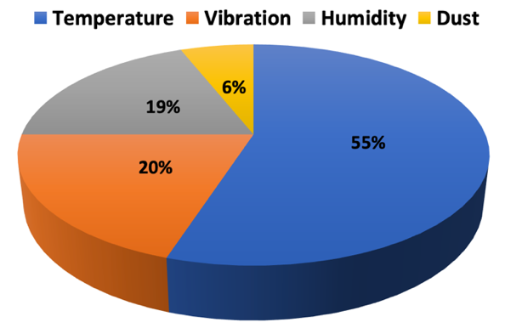
Fig. 1: Primary cause of failure of the electronic package (Adapted from [34])
In this investigation, an Anand viscoplastic constitutive empirical model has been applied to define the FEA simulation's output for plastic shear strain, plastic strain, shear strain, and creep energy density, helpful in predicting the fatigue life estimation of solder joint alloys. Research has shown that the Engelmaier modified fatigue model, a developed version of the Coffin-Manson model, takes the temperature effect, elastic-plastic strain, and thermal cycle frequency. The author used this to ascertain the solder's fatigue life of the solder alloys. Three different life predictive models, such as Solomon, Coffin-Mason, and Syed, were employed in the fatigue life evaluation as the basis of comparison in this study.

Analytical models in electronic manufacturing engineering have several practical applications [52], [53]:
- Accelerated design optimisation during the developing phase of a product.
- Predicting field use limits.
- Failure analysis of product returned from the field or failed in a qualification test.
Four factors govern life prediction: material behaviour, simulation techniques, life prediction methodology, and test data. Either accumulated creep strain or energy density can be employed for life prediction (creep strain has demonstrated to yield better prediction accuracy, and energy density capture high-stress effects better).
Why Predict:
- Life prediction models are required to evaluate reliability at the design state.
- Reduction in the design cycle time limits in the application of testing to evaluate the reliability.
- The industry is fast migrating to SAC solder alloys.
Several researchers have investigated solder joint alloys reliability in electronic devices, including the fatigue life of various solder joints in the hood of an automobile, portable electronic devices (PEDs) in the consumer electronics sector and high-reliability military hardware. No studies have compared and benchmarked the five solder alloys considered in this study. These solder alloys are employed mainly in the manufacture, assembly and modelling of these electronic devices. In the ever-increasing miniaturisation in the manufacturing trend in electronics packaging amidst the advances in its functionality, the knowledge and identification of a proper lead-free solder and its adoption in electronics manufacturing will increase the electronic devices' reliability. The fatigue lives are shown in Fig. 1, presenting the schematics of the fatigue life modelling method employed in this research [54].

1.3.1 Anand Model Equations
As stated earlier, Anand [50] and Brown [51] suggested a constitutive equation for isotropic and viscoplastic deformations in a singular-scalar internal variable. The Anand model combines the time-dependent plastic and viscoplastic phenomenon, where the plastic strain increase depends on the loading rate. Viscoplastic, on the other hand, is determined by consolidating creep and plastic deformations [55]. The model's internal variables described the mechanisms of isotropic hardening such as subgrain and grain size effects, dislocation density, solid solution hardening, and the deformation resistance equated to comparable equivalent stress [56]
Research has shown that Anand's model is employed whenever the material behaviour is very susceptible to strain rate, temperature, strain hardening and softening. The model was developed initially for high-temperature metal forming methods such as deep-drawing and rolling. It has since been shown for predicting the life and response of solder joint alloys in electronic packaging [38]. The equation for the inelastic strain rate is given in equation 1:
$\overline{σ}=cs;c<1$ (1)
Where $\dot{σ}$ the equivalent is stress for steady plastic flow; $s$ is the deformation resistance with stress dimensions. $c$ is a function of strain rate and temperature as expressed as:
$c=\frac{1}{ξ}sinh^{-1}\left\{{\left(\frac{{\dot{ε}}^{p}}{A}exp\left[\frac{Q}{RT}\right]\right)}^{m}\right\}$ (2)
Combining equation 1 and 2
The Anand model employs the following functional form to define the flow equation as:
${\dot{ε}}^{p}=Aexp\left(-\frac{Q}{RT}\right){\left(sinh\left[ξ\frac{\overline{σ}}{s}\right]\right)}^{\frac{1}{m}}$ (3)
Where ${\dot{ε}}^{p}$ is the inelastic strain rate; A is the pre-exponential factor; Q is the activation energy; R is the universal constant; T is the temperature; R is the universal gas constant; $ξ$ stands for the materials constant, and m is the strain rate sensitivity.
Additionally, the evolution equation for the internal variable s is assumed to be in the form as:
$\dot{s}=h\left(\overline{σ}, s, T\right){\dot{ε}}^{p}$ (4)
$h\left(\overline{σ}, s, T\right)$ is associated with dynamic strain hardening and recovery process. A simple form of evolution equation of equation 2 was given by Anand [50] as follows:
where:
$h= h_{0}{\left|1-\frac{s}{s^{*}}\right|}^{a}sinh\left(1-\frac{s}{s^{*}}\right) a≥1$ (5)
Therefore, the evolution equation for the internal variable s is derived from the combined form of equation 2 and 3 as:
$s= \left\{h_{0}{\left|1-\frac{s}{s^{*}}\right|}^{a}sinh\left(1-\frac{s}{s^{*}}\right)\right\}{\dot{ε}}^{p}$ (7)
Where
$s^{*}= \hat{s}{\left(\frac{{\dot{ε}}^{p}}{A}\exp\left[\frac{Q}{RT}\right]\right)}^{n}$ (8)
Where $s^{*}$ describes the saturation value of s associated with a set of given temperature and strain rate; $h_{0}$ represents the hardening/softening constant; $a$ is the strain rate sensitivity of hardening/softening; n stands for the strain rate sensitivity for the saturation value of deformation resistance, and $\hat{s}$ is a coefficient. The viscoplastic model includes two kinds of equations, and the first equation deals with the relationship between saturation stress and strain rate under specific temperature. In contrast, the second equation deals with the relationship between strain and stress under specific strain rate and temperature [38].
From equations 2, 3 and 8 together with $σ^{*}={cs}^{*}$ gives the following equation for saturation stress $σ^{*}$ with a given temperature and strain rate.
$σ^{*}=\frac{\hat{s}}{ξ}{\left[\frac{{\dot{ε}}^{p}}{A}\exp\left(\frac{Q}{RT}\right)\right]}^{n}sinh^{-1}\left\{{\left(\frac{{\dot{ε}}^{p}}{A}exp\left[\frac{Q}{RT}\right]\right)}^{m}\right\}$ (9)
Following relation can be obtained from equations (4) and (9)
$\frac{dσ}{dε_{p}}=ch_{0}{\left|1-\frac{σ}{σ^{*}}\right|}^{a}sign\left(1-\frac{σ}{σ^{*}}\right); >1$ (10)
The integration form of equation (7) is:
$σ=σ^{*}-{\left[{\left(σ^{*}-cs_{0}\right)}^{\left(1-a\right)}+\left(a-1\right)\left\{\left(ch_{0}\right){\left(σ^{*}\right)}^{-a}\right\}ε_{p}\right]}^{1/{\left(1-a\right)}}$ (11)
Where $s_{0}$ is the initial value of$s$.

1.3.1.1 Parameters Analysis
For the Anand constitutive model, nine parameters are compulsory to be tested respectively. These nine materials constants A,$Q/R$,$\hat{s}$,$h_{0}$,$ξ$, m, n, a and $s_{0}$ can be determined using the following standard procedures [57].
- Obtained the saturation stresses from uniaxial tensile tests with constant strain rates and temperature
- Determined the value of $A, Q, m, n, and {\hat{s}}/ξ$ in Eq. (14) from the data acquired in step (1) by a non-linear least-square fit.
- Determine $\hat{s}$ and $ϵ$ from the values obtained in step (2). The parameter $ξ$ was selected such that the constant c in Eq. (8) was less than unity, and $\hat{s}$ was then determined from the combined term ${\hat{s}}/ξ.$
- The combined constants ${ch}_{0}, {cs}_{0 }and a$ in Eq. (16) were determined from the constant strain rate data by the least square fit. With the value of c gotten in step (3), $h_{0} and s_{0 }$were concluded.
Anand's model needs nine separate material constants, determined by curve-fitting a range of isothermal stress-strain tensile experiments at variable strain rates and temperature. The Anand model material constants used in this work for other solder alloys are obtained from peer-reviewed literature. This viscoplastic law uses a consolidated strategy; therefore, the inelastic strain is returned (in ANSYS software via getting the plastic strain output). Moreover, the investigators can get deformation resistance and plastic work per volume. This plastic strain result obtained in ANSYS FEA outcomes can be employed for the fatigue predictions acknowledging the relations linking the different solder alloy materials that show the importance of the accumulated plastic strain (plastic work) that will cause failure. By determining the plastic strain accumulated in one cycle, the author can select the total number of cycles used in the test.
In conclusion, there are various methods to incorporate the impact of rate-dependent inelastic response in FEA. The material empirical model's choice to apply is based on the structure, anticipated response and material data availability of the solder alloy materials [58].

1.4 The programme of work
In this investigation, Anand viscoplastic constitutive model and creep have been used to determine the five solder alloys' parameters using the ANSYS FEA simulation software to determine the fatigue life prediction model Engelmaier, Coffin-Manson, Solomon and Syed. The Engelmaier modified fatigue model, an improved version of the Coffin-Manson model, takes the thermal cycle frequency, temperature effect, and elastic-plastic strain into account and was used to determine the solders' fatigue life considered in this study. Two other predictive models, such as Coffin-Mason and Solomon, were used in the fatigue life evaluation of low cycle fatigue (LCF) because of cyclic plastic deformation, including the accumulated creep energy density as the basis of comparison in this research.
Analytical models in engineering have numerous practical uses [52], [53]:
- Accelerated design optimisation during the developing phase of a product.
- Predicting field use limits.
- Failure analysis of product returned from the field or failed in a qualification test.
Four factors govern life prediction: material behaviour, simulation techniques, life prediction methodology, and test data. Either accumulated creep strain or energy density can be employed for life prediction (creep strain has demonstrated to yield better prediction accuracy, and energy density capture high-stress effects better).
Why Predict [59]:
- Life prediction models are required to evaluate reliability at the design state.
- Reduction in the design cycle time limits in the application of testing to evaluate the reliability.
- The industry is fast migrating to SnAgCu (SAC) solder alloys.
Several scholars have studied several solder joint alloys reliability concerns in electronic devices, including the fatigue life of various solder joints, including high-reliability military hardware and the hood of an automobile and portable electronic devices (PEDs) in the consumer electronics sector. Still, no investigations have benchmarked and compared the five solder joint alloy materials (lead-based eutectic Sn63Pb37 and lead-free SnAgCu: SAC305, SAC387, SAC396 and SAC405) examined in this research, respectively. These lead-free solder alloys mainly applied in the modelling, assembly and manufacture of these devices. In the contemporary ever miniaturisation in the manufacturing trend in electronics packaging amidst the advancing functionality, the knowledge and identification of a proper lead-free solder and its adoption in electronics manufacturing will increase the electronic devices' reliability it's fatigue life and applications in electronic devices. This proposal compels this study and gives further information for the electronic manufacturing industry and engineers about the comparison.
The fatigue modelling process is presented in Fig. 2. The first process is the research design. Through SolidWorks, we built the finite element model and them in this model in ANSYS simulation software. We include the material properties, load and boundary conditions, finite element model, and fundamental assumptions for the modelling setup. In terms of the out from ANSYS software, we obtain the equivalent (von mises) stress, strain energy, creep energy, plastic strain, shear strain and plastic shear strain. These parameters are then used in the Coffin-Manson (plastic strain output), Engelmaier (shear strain output), Solomon (plastic shear strain) and Syed (accumulated creep energy density). We then compare and evaluate the various fatigue life output.

1.5: Aim and objectives of the research
The study aims are to propose the best solder alloys for improved thermo-mechanical reliability of solder joints in a ball grid array (BGA) package soldered on a printed circuit board (PCB) based on fatigue life estimation. The objectives of the research leading to the actualisation of the research aim include:
- Determination of the stress magnitude, strain energy, plastic strain, shear strain, plastic shear strain, creep energy density and its' effects on solder joints alloys.
- The Engelmaier, Coffin-Manson, Solomon (low cycle fatigue) and Syed fatigue life prediction models to obtain the fatigue life estimations of the solder alloys considered in this work.
- Analyse the stress-strain results obtained through the stress-strain hysteresis loop.
- Compare and benchmark the best solder joint alloys based on the fatigue life estimate.
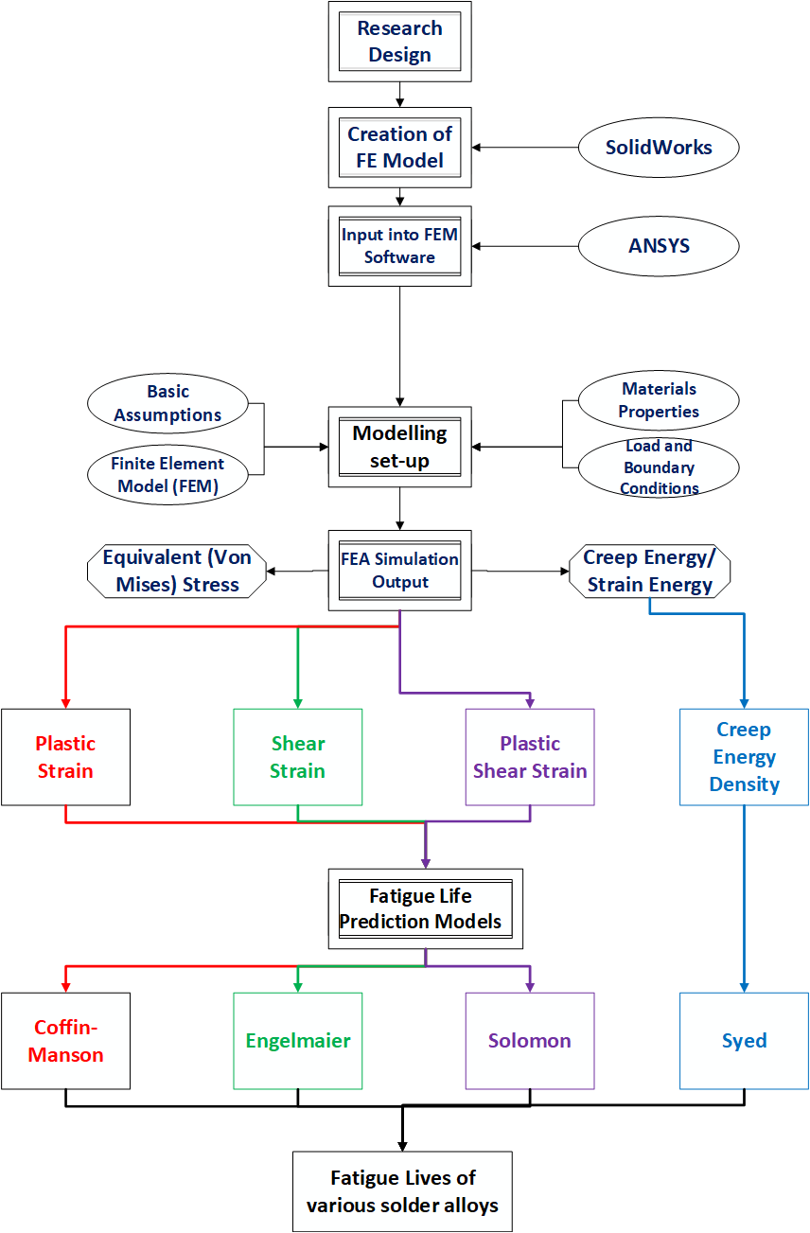
Fig. 2: Schematics of the fatigue life modelling process

2.0 Materials and Methodology

2.1 Materials used in the FEA Simulation Studies
Tin-Lead (Sn-Pb) solder alloy materials have been utilised primarily in electronic applications for over three decades until the government legislation, including the environmental impacts of lead (Pb) on 1st July 2006. The Tin-Silver-Copper (SAC) alloy combination has been considered one of the commonly used lead-free solder alloys. The choice of solder joint alloy depends on one or more of the factors listed below [60]:
- Environmental and service compatibility.
- The wettability on the substrate.
- Temperature capability and consideration for process and service temperature.
- The metallurgical compatibility and evaluation of the possible development of intermetallic compounds (IMC).

2.1.1 Lead-based Sn63Pb37
The lead-based solder is an alloy with high purity, low dross, liquidus $183℃ \left(361℉\right)$, and complies with IPC J-STD-006. The solidus temperature is measure as a point below which the alloy is solid (not melted). On the other hand, the liquidus temperature is the point above which the alloy is completely liquid (melted). The mechanical and physical properties of eutectic Sn63Pb37 is shown in Table I. The solder is corrosion resistant with excellent electrical property. They additionally produce solder joints with higher mechanical strength fit for electronic devices. The solder tends to have a shiny and bright feature correlated to the SAC solder joints with a grainy and dull look.

2.1.2 Sn96.5Ag3.0Cu0.5 (SAC305)
The lead-free SAC305 solder alloy contains 96.5% tin, 3.0% silver, and 0.5% copper. This solder falls under the Japan Electronics Industries Development Association (JEIDA) advice for lead-free soldering. The SAC305 solder alloy has several advantages:
- Excellent fatigue resistance
- Compatibility with all flux types
- Excellent solder joint reliability
- The lowest cost of SnAgCu alloy
- The best wetting SAC alloy
The mechanical and physical properties of SAC305 is shown in Table I.

2.1.3 Sn96.5Ag3.8Cu0.7 (SAC387)
The lead-free SAC387 solder alloy contains 95.5% Tin (Sn), 3.8% Silver (Ag) and 0.7% Copper (Cu), which is an alloy material for BGA and CSP electronics components used in the electronics and electrical manufacturing companies. The SAC387 features include:
- Excellence resistance.
- Excellent solder joint reliability.
- The low melting point for a lead-free alloy and compatible with most flux type.
The physical and mechanical properties of SAC387 is presented in Table I.

2.1.4 Sn96.5Ag3.9Cu0.6 (SAC396)
The lead-free SAC396 solder alloy contains 95.5% Tin (Sn), 3.9% Silver (Ag), and 0.6% Copper (Cu), and it is often written as Sn95.5Ag3.9Cu0.6 solder. According to industry-standard (the first being SAC405), the alloy contains the second-highest silver (Ag) and used by manufacturing companies working with PBGA, LBGA, CSP, BGA, and CBGA electronic components. It has the following features:
- Excellent fatigue resistance
- Perfect solder joint reliability
- Best wetting SAC alloy and compatibility with all flux types
Table I shows the physical and mechanical properties of SAC4396.

2.1.5 Sn95.5Ag4.0Cu0.5 (SAC405)
The lead-free SAC405 solder alloy contains 95.5% Tin (Sn), 4.0% Silver (Ag) and 0.5% Copper (Cu) is usually inscribed as Sn95.5Ag4.0Cu0.5. The SAC405 solder is costlier than SAC305 and used by most electronics manufacturing companies working with the BGA, PBGA, CBGA, LBGA and CSP. Its characteristics include compatibility with all flux types, best solder joint reliability, best wetting SAC alloy and superior fatigue resistance. Presented in Table I is the physical and mechanical properties of the SAC405 solder alloy.

2.1.6 Copper (Cu) Pads
Two generally used pad designs are solder mask and copper defined pad. Nonetheless, numerous benefits and limitations of a non-solder mask defined pad and the soldermask defined pad are presented in this section. The benefits of the copper-defined pad are:
- More accessible design traces.
- Very good solderability.
- The possibility of precisely controlling the pad's position and size.
The limitations include the pad's miniature natures, the padding strength of the pad attached to the circuit board is relatively small, and copper foil can be torn due to external forces. For the soldermask defined pad (SMD), the benefits include an excellent choice for portable electronic devices such as mobile phones, enhances the reliability and strength of BGA, and the pads effectively improving the power of the SMD pads. On the other hand, the SMD pads have several disadvantages: the fabrication process is more complex and needs high precision, thereby raising production costs.

2.1.7 Epoxy-Resin
The use of epoxy-resin in the solder joints helps improve the solder joints' adhesion adding to enhanced insulation and support the strength. Epoxy-resin is simple with high reliability in the chip or package bonding and a lower material cost. They have been broadly employed as a competing bonding solder joint material and profoundly used in electronic packages and automotive cars.

2.1.8 Silicon (Si) Die
A die is a semiconducting material on which a circuit is manufactured. The Silicon dies circuitry performs a specific function necessary for the manufacturing semiconductors found in several electronic devices and is fully functional.
Table I: Physical and Mechanical Properties of Solder Alloys [61], [62]
Solder Alloy | Melting Point, $℃$ Solidus/Liquidus | Density, $g/{{cm}^{3}}$ | Electrical Resistivity, $μΩ.$m | Thermal Conductivity,  W/m.K | Tensile Strength at Break,  $$kgf/{cm}^{2}$$ | Tensile Elongation at Break, % | Brinell, Hardness, HB
Alloys of tin (Sn) and lead (Pb) with and without silver (Ag)
Sn63Pb37 | 183/183 | 8.40 | 0.145 | 50 | 525 | 37 | 17
Alloys of tin (Sn) with a silver (Ag) and /or copper (Cu)
SAC305 | 217/220 | 7.38 | 0.132 | 58 | 500 | 19 | 15
SAC405 | 217/220 | 7.44 | 0.132 | 62 | 530 | 17 | 15
SAC387 | 217/220 | 7.44 | 0.132 | 60 | 600 | 16 | 15
SAC396 | 217/221 | 7.46 | 0.132 | 61 | 550 | 18 | 15

2.2 Methodology
The methodology used in this research is the FE simulation method. It includes the ANSYS simulation features, FE model and analysis and the material properties for the lead-based Sn63Pb37 and lead-free SAC: SAC305, SAC387, SAC396 and SAC405 solder alloys are obtained from peer-reviewed literature. The flow chart of the FE simulation process and method is shown in Fig. 2. For this investigation, ANSYS software was used to simulate and solve the FE model and comprises of:
- CAD (SolidWorks) Connectivity
- Meshing
- Engineering Materials Support
- Boundary Condition Setup
- Solution
- Result Output and Analysis

2.2.1 The FEA Simulation Process
The author carried out FEA simulation utilising ANSYS software. Several procedures are involved in the simulation examined in this study. Fig. 2 shows the simulation processes for failure analysis. The simulation method commences with the research design, production of FE model from SolidWorks, inputting the FE model into ANSYS, a model setup that includes meshing convergence, mesh generation and geometry, material properties input, and application of load and boundary conditions.

2.2.2 Basic Assumptions
- All the materials were modelled as linear elastic and isotropic materials except the solder and PCB, simulated utilising the Garofalo creep relations and orthographic materials.
- All materials, including the solder joint, were assumed, homogeneous at load steps.
- The material characteristic of the solder joint alloy is non-linear and temperature-dependent. In other words, others are linear and temperature independent.
- Every interface of the materials is considered to be in contact with each other.
- The assemblies were assumed to be in a stress-free state at room temperature of $22℃$, which was likewise the thermal cycle loading's starting temperature.
- The assemblies' primary stress accumulated from the reflow soldering process is neglected, and all contacting surfaces are assumed bonded with perfect adhesion.

2.2.3 Geometrical and Mesh Models
The FEA simulation was carried out on a BGA (36 balls, $6×6$ matrix) attached to a Cu padded substrate in this work. The BGA package comprises the solder ball, epoxy-resin, Silicon (Si), Die substrate, and Copper (Cu) pad. The parameters of the BGA solders are presented in Tables I and II. The package dimensions and parameters are given in the authors' publication [27], [63]. The requirement to apply a quarter of the entire model shown in Fig. 5 shows the FEA simulation processes' reduction and solves time. The study examines a BGA solder joint in the electronic packages for thermo-mechanical reliability. It additionally expands functional test design and evaluation because the whole assembly is large and complex; therefore, much time is required to perform an FEA simulation; hence, a quarter symmetry is excellent for operating many FEA simulations.

2.2.4 Finite Element Analysis (FEA) Simulation
The finite element model often provides a more time-efficient way to obtain and understand the behaviour of the assembly solder joints if the material properties have been accurately characterised. The quarter model of BGA and PCB structure was established because of its geometric symmetry, reducing the computational procedure. The linear element is used to meshing all the materials except solder joints, which describes the viscoplastic material behaviour and is utilised to mesh solder joints in FE software. Under consideration, the BGA and PCB structure model consists of lead-based eutectic Sn63Pb37 and lead-free SAC (SAC305, SAC387, SAC396 and SAC405) solder joints presented in Fig. 3. Selective mesh refinement concentrates highly refined elements in the solder joints, most likely to fail, sparse or coarse elements for other materials.
Moreover, zero displacement constraints of the vertical direction of the cross-area were applied to the cross-sections of the quarter model, namely all nodes on the symmetric surface (X=0, Z=0) were fixed in the corresponding directions (X, Z), and the node at the origin (X=Y=Z=0) was fixed in any directions. The author employed the ANSYS software for the finite element model (FEM). A 3D FE model of the BGA assembly on PCB components is shown in Fig. 5, created using SolidWorks software. The meshed components part of the solder balls undergoes mesh convergence to arrive at a converged solution. The microelectronics package model used in this work comprises a PCB, silicon mask and substrate, Cu Pad, Epoxy-Resin (FR-4) Die, solder balls and PCB mask. The details of the package and solder structure are presented in Figs. 4 and 5. Several researchers such as Yang et al. 2008, Stec 2014, Libot et al. 2016 and Jiang et al. 2019 have used comparable bump geometry for solder alloys, such as one used in this study.
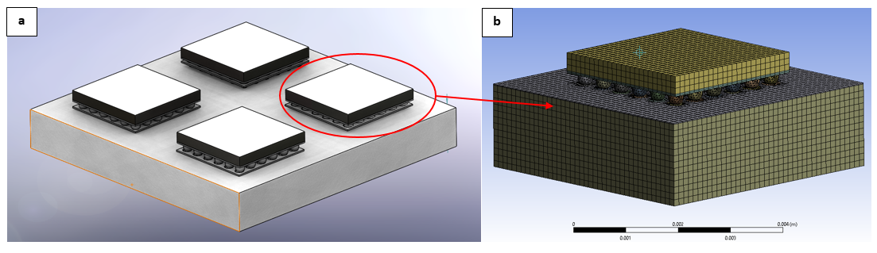
Fig. 3: (a) Full Model of assembly (b) A quarter assembly of the model with meshing on a PCB using the solder joints as the interconnection technology (with 226,252 nodes and 59,105 elements)
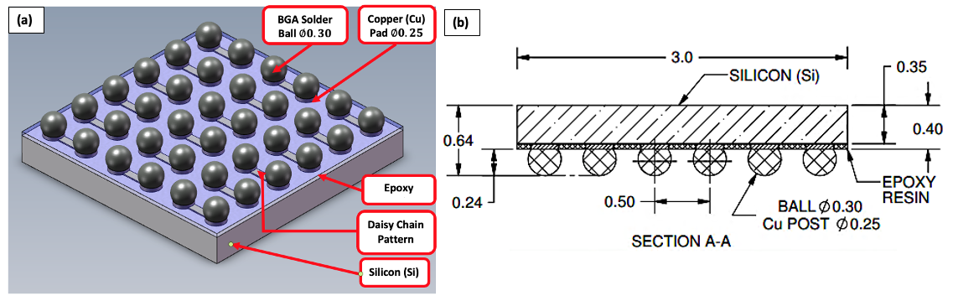
Fig. 4: Details of the package before assembling on a PCB showing: (a) SolidWorks full model (b) Sectional view (measurements in mm) (Adapted from [62])
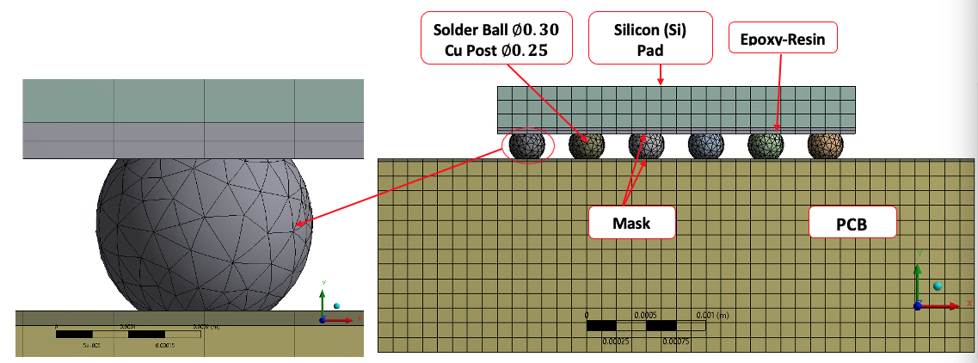
Fig. 5: Solder structure in the FE model with a detailed X Plane- BGA structure in tetrahedrons mesh (measurements in mm)

2.2.5 Material Properties and Parameters
The material properties utilised in this work are sourced from several peer-reviewed works of literature. The properties of all other materials are linear and temperature-dependent, except for the PCB. The significant electronic materials employed in the BGA assembly are solder alloys, Silicon (Si) die, copper pad, epoxy-resin, and mask. All the FEA simulation materials were modelled as linear elastic and isotropic substances except the PCB and the solder joint alloys, simulated using the orthographic materials and Anand empirical models. The material properties utilised for the simulation tests are shown in Tables II and III, which shows the Anand model empirical constant for lead-based Sn63Pb37, and lead-free SAC305, SAC387, SAC396 and SAC405 solder alloys.
Table II: Materials properties for the BGA on PCB Components
Materials | Reference | Young’s  Modulus (GPa) |  |  | CTE  (ppm/$℃)$ |  |  | Poisson’s  Ratio
 |  | $$E_{x}$$ | $$E_{y}$$ | $$E_{z}$$ | $$α_{x}$$ | $$α_{y}$$ | $$α_{z}$$ | $$v_{xy}$$ | $$v_{xz}$$ | $$v_{yz}$$
Silicon (Si)  Die | [62] | 110.0 |  |  | 2.60 |  |  | 0.24
PCB Mask | [64] | 4.14 |  |  | 30.0 |  |  | 0.40
Cu Pad | [65] | 129.0 |  |  | 17.0 |  |  | 0.34
PCB | [66] | 27.0 | 27.0 | 22.0 | 14.0 | 14.0 | 15.0 | 0.17 | 0.20 | 0.17
Epoxy-Resin  (FR-4) | [62] | 29.9 | 25.1 | 70.0 | 12.0 | 15.0 |  | 0.16 | 0.14
Sn63Pb37 | [67] | 56.0 |  |  | 20.0 |  |  | 0.30
SAC305 | [62] | 51.0 |  |  | 23.5 |  |  | 0.40
SAC387 | [68] | 45.0 |  |  | 17.6 |  |  | 0.36
SAC396 | [69] | 43.0 |  |  | 23.2 |  |  | 0.30
SAC405 | [70] | 44.6 |  |  | 20.0 |  |  | 0.42

Table III: Anand model constant for lead-based eutectic Sn63Pb37 and lead-free SAC305, SAC387, SAC396 and SAC405 solder alloys
 | Solder
Anand  Parameters | Sn63Pb37  [71] | SAC305  [72] | SAC405  [73] | SAC387  [74] | SAC396  [75]
$$s_{o}(MPa)$$ | 3.1522 | 45.9 | 20.0 | 39.5 | 3.3
$$\frac{Q}{R} (K^{-1})$$ | 6,526 | 7,460 | 10,561 | 8,710 | 9,883
$$A (s^{-1})$$ | 6,220 | $${5.87×10}^{6}$$ | 325 | 24,300 | $${1.57×10}^{7}$$
$$ξ$$ | 3.33 | 2.00 | 10.00 | 5.8 | 1.06
$$m$$ | 0.27 | 0.0942 | 0.32 | 0.183 | 0.3686
$$h_{o}(MPa)$$ | 60,599 | 9,350 | $${8×10}^{5}$$ | 3,541.2 | 1077
$\hat{s}$ $(MPa)$ | 36.86 | 58.3 | 42.0 | 65.3 | 3.15
$$n$$ | 0.022 | 0.015 | 0.02 | 0.019 | 0.0352
$$a$$ | 1.7811 | 1.5 | 2.57 | 1.9 | 1.6832

2.2.6 Loading and Boundary Conditions
In completing the FE analysis for thermal cycling, the ambient temperature cycle is external loading. The FE models were subjected to six complete ATC’s in 36 steps presented in Fig. 6. The author utilised a thermal cycling temperature from -40$℃$ to +150$℃$ with 15$℃$/min ramp, and 5 mins dwell based on IEC 60749-25 temperature cycling and JEDEC Standard JESD22-A104D [76]–[78] shown in Fig. 6. The quarter assembly components were first heated from room temperature 22$℃$ which is the starting temperature in thermal cycle loading with a constant heating rate. They are also assumed to be at a homologous temperature at loads steps. The temperature loading started from 22$℃$, dwelled at -40$℃$ at the rate of 15$℃$/min, and ramped up to 22$℃$ for the 23 mins and excursion temperature (ET) of 150$℃$ for 31.8 mins where it dwelled for 5 mins. Applications employed for this type of profile are in the automobile under-hood, semiconductors in power supply controllers and the military. The assemblies were supported such that the conditions of the structure at the supports are:
At the PCB base, $y=0,$and$u_{(y)}=0$;
The top surface$u_{\left(y\right)}=0$, $u_{(x)}$and $u_{(z)}$ are free.
The${ u}_{(x)}$, $u_{(y)}$ and $u_{(z)}$ represents the displacement in the $x, y and z directions,$ respectively. The bottom surface of the PCB was fixed in the Y direction and displaced in the X and Z directions.
The application of six temperature cycles is sufficient to get stable results, facilitating a more reliable conclusion of the induced loads' solder joints' response. Furthermore, the electronic engineers and educational communities can use the data obtained from this study for a better-quality innovation and enhanced design of solder joints in BGA assembly for improved thermo-mechanical reliability. Based on the guidelines from standards and peer-reviewed literature, this research's thermal cycle parameters values are presented in Table IV. The duration of one thermal cycle results from the elected parameters is 43 mins. A visual representation of the thermal cycle profile is shown in Fig. 6. The thermal cycling temperature of -40$℃$ to +150$℃$ that was used in this work was according to the IEC standard 60749-25. This part of IEC 60749-25 gives a test method for defining the semiconductor devices' capacity, components and board assemblies to withstand mechanical stresses induced by low- and alternating high-temperature extremes.
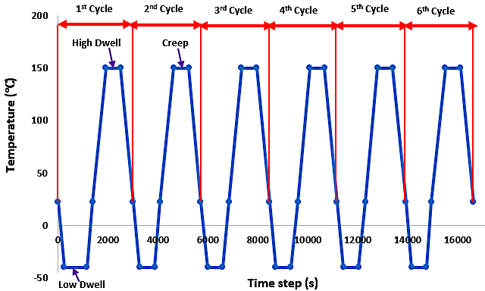
Fig. 6: Thermal Cycling temperatures boundary profile
Table IV: Thermal cycling test parameters
Test Parameters | Values
Low Temperature $(℃)$ | -40
High Temperature $(℃)$ | 150
Ramp Rate $(℃/min)$ | 15
Dwell time $(min)$ | 5
Cycle Period $(min)$ | 43

2.3 Failure criterion used in the fatigue life prediction
The generally used solder-joint failure criteria include those based on classic fracture mechanics [1], plastic strain [79]–[82], creep strain [59], [83]–[85], inelastic work and fracture-calibrated energy [86]. For test failure investigations, resistance is likewise employed as failure criteria. Each failure criterion needs specific material properties and may place the requirements on the numerical solution's nature obtained either by computation or through FEA simulation. For this investigation, the failure criterion is based on the plastic strain range for Coffin-Manson, shear strain range for Engelmaier model, and plastic shear strain range values Solomon model obtained from FEA simulation results. This is then utilised in the Engelmaier, Coffin-Manson and Solomon models' computations to get the five solder joint alloys' fatigue life characteristics with low cycle fatigue (lead-based Sn63Pb37, and lead-free SAC: SAC305, SAC387, SAC396 and SAC405) solder alloys employed in this research.
Failures in electronic devices are defined based on the increase in resistance [85], [87]–[93], resistance thresholds, or electrical discontinuities [94]–[101]. The electronics industry presently employs four principles to outline solder joint failure standards during surface mount technology reliability experiments (SMT). These are IPC-SM-785 [102], JESD22-B111 [103], IPC/JEDEC-9702 [104] and IPC-9701 [105], [106]. The electronics manufacturing industries have frequently utilised these analysis models or customised their standards [107].
- JESD22-B111 [103] specifies solder joint failure guidelines for board-level drop tests.
- Compared to IPC-SM-785, IPC-9701 and IPC/JEDEC-9702, JESD22-B111 specifies in-situ electrical monitoring of daisy chain nets failure throughout the individual drop. It states that a high-speed data acquisition system or event detector should detect every nets' electrical continuity.
- IPC-9701 [105], [106] represents failure criteria based on the computation process chosen. An intermittently measuring resistance model utilising probes is not a desirable alternative for consecutive monitoring of an electrical daisy chain. The failure guidelines advised in IPC/JEDEC-9702 [104] for monotonic bend characterisation of board-level furthermore interconnects at a 20% increase in daisy-chain net resistance.
- IPC-SM-785 [102] suggests continuous monitoring of daisy-chain connection experiment loops to identify a failure. The regulation affirms the polling interval should be 2 s or less.

The solder joint failure is due to crack initiation and propagation through a joint. The cracks' location and nature depend on various determinants such as strain rate, joint configuration, intermetallic structure, and temperature regime rate. Those determinants affect the mechanism of a solder joint failure [86]. The crack begins at the high-stress concentration areas. Results have shown that crack propagation's direction depends on the relative degree of tensile vs loading and joint shape.

3.0 Results and Discussions

3.1 Study on Equivalent (Von Mises) Stress on the solder joints
The thermal cycling simulation results for the lead-based eutectic Sn63Pb37 and four lead-free SAC solder alloys (SAC305, SAC387, SAC396 and SAC405) are presented in Figs. 7 and 8. Fig 7 is the plot of Von-Mises stress against the number of the thermal cycle. The plots show a similar profile for all the solder alloys. The stress starts from zero and increases rapidly within the first temperature cycle. The solder alloys in the joints elastically deform within this range. They are seen to yield between cycles 1 and 2. The SAC387 demonstrate the highest 60 MPa magnitude of yield stress, followed by the lead-based eutectic Sn63Pb37 at 57 MPA. The SAC405 acquired the most negligible yield stress of 23 MPa magnitude, while SAC305 and SAC396 have each 34 MPa and 30 MPa yield stress magnitudes, respectively. After cycle 2, the profile plateaus and remain relatively steady for the remainder of the cycle. The plastic deformation region starts from the yield stress point and covers 75% of the temperature cycling test. This study's inference is that the solder joints experience shock thermal load, making early infant mortality failure mode more critical than any other failure rate mode in the bathtub’s curve failure rate classification. It could be observed from the plot that actual life operations of solder joints are mainly within the plastic range. The distribution of stress in the solder joints is shown in Fig 8. The highest damage is located at the balls' top surface, where they interconnect with the chip. The periphery of the top surface is critical. This is the site for cracks initiation, propagation, and then failure occurs.
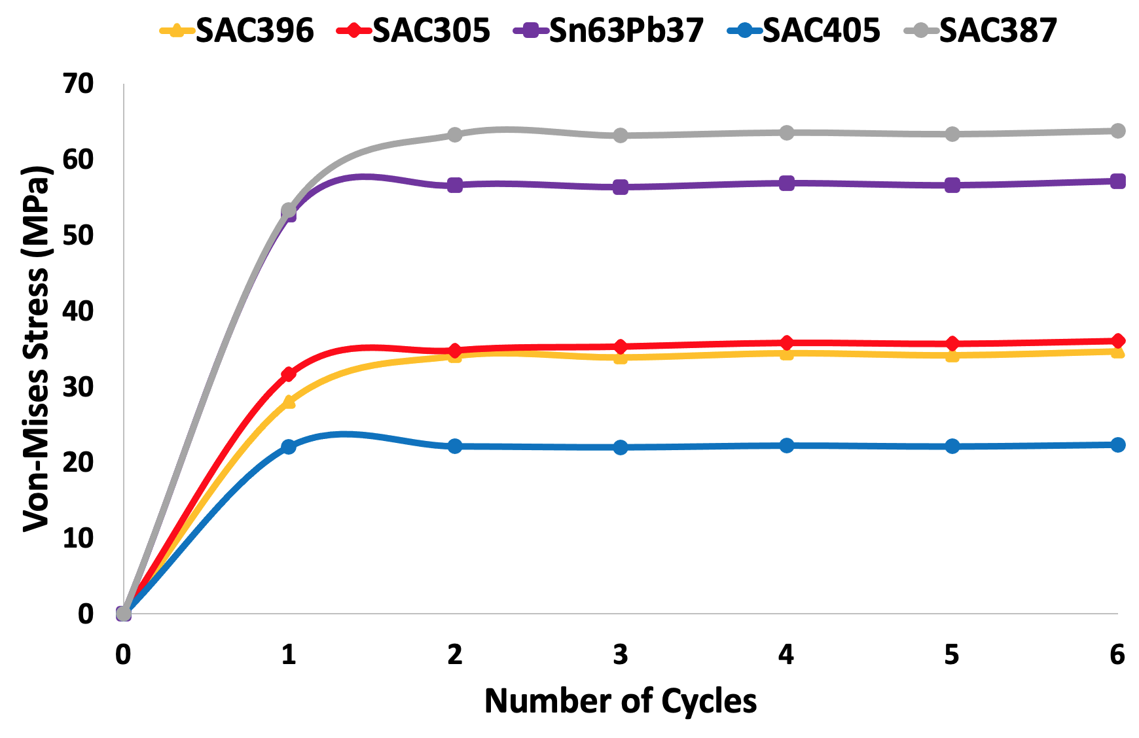
Fig. 7: Plot of Von mises stress vs time for solder alloy materials
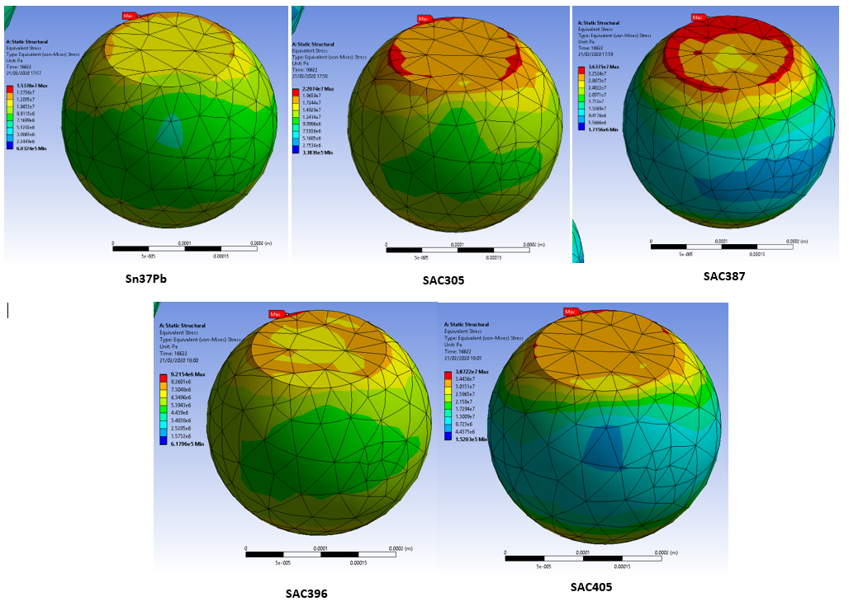
Fig. 8: Schematics showing areas of maximum (Von mises) stress on solder joints

3.2 Study of Plastic Strain on the solder joint
The plastic strain is one of the root causes of cracking of solder joints which culminate in failure. Thus, it is studied in this work. The FE simulation outputs of the five types of solders in the BGA joints to plastic strain are discussed in this session. The simulation output is a plot in Fig. 9, while Figs. 10 and 11 present the damage distribution schematic on the different types of BGA solder joints' critical joint. The plastic strain profile is identical for all the joints up to cycle 2. After cycle 2, a significant difference in the profile is recorded. The plastic strain of SAC387 and SAC405 increase at steady gradients of 0.00305/cycle and 0.000734/cycle, respectively. The SAC305 plastic strain decreases with a slope of - 0.000215/cycle. The plastic strain of eutectic Sn63Pb37 decreases to cycle 4 and increases afterwards with a positive gradient of 0.00168/cycle.
Similarly, the plastic strain of SAC396 decreases up to cycle 5 and increases after that with a positive gradient of 0.00053/cycle. Since damage is driven by the positive slope of plastic strain/cycle cum the rate of energy dissipation (which is quantified in part by the area under the plot), SAC387 joints accumulate the most severe damage with SAC405 solder joint alloys gathering minor degradation. The schematic distribution of damage to the solder joints shown in Figs. 10 and 11 depict significant damage at both the top and bottom interfaces, with the top dominating.
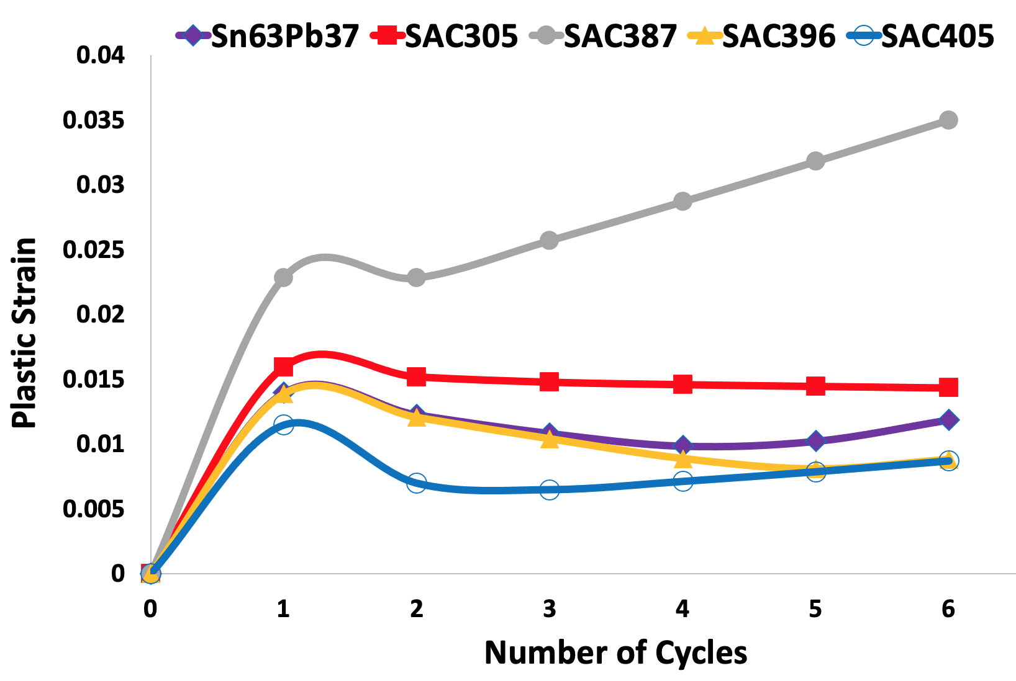
Fig. 9: Plastic strain rate results for six complete cycles of solder joints

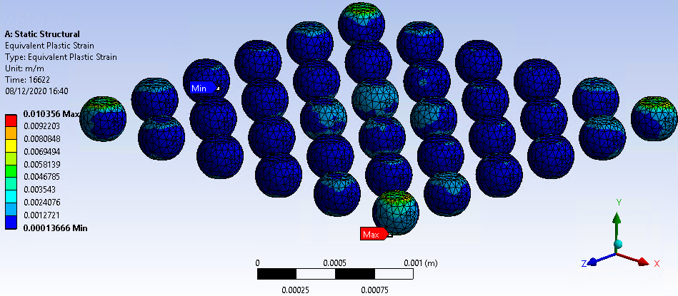
Fig. 10: Schematic of Sn63Pb37 showing solder joint with maximum plastic strain

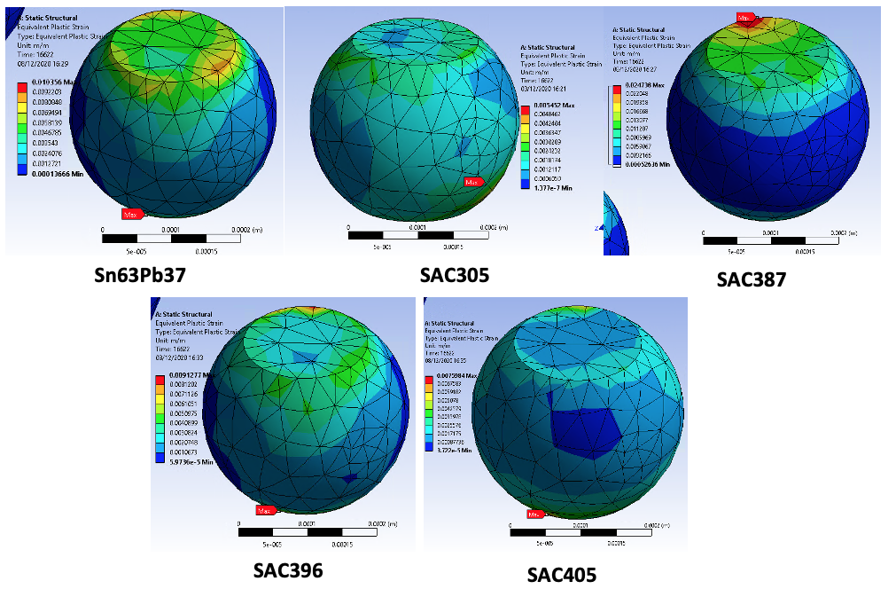
Fig. 11: Schematics showing areas of maximum plastic strain

3.3 Study of Shear Strain on the solder joints
The shear strain of the five solder joint alloys considered in this work are lead-based eutectic Sn63Pb37 (0.001115), SAC305 (0.000609), SAC387 (0.00177), SAC396 (0.000261) and SAC405 (0.00111) respectively. The shear strain is referred to the change in the deformation to its original length of the solder joint alloys perpendicular to the axes as a result of shear stress. The fatigue life of the solder joints is computed using the shear strain value determined from the FEA simulation and inputting the values into equation 1 (Engelmaier) to acquire the fatigue life cycle. The plot presented in Fig. 12 shows that SAC396 has the lowest shear strain, followed by eutectic Sn63Pb37, SAC305, SAC405 and SAC387, respectively. The schematic presented in Fig. 13 shows the areas susceptible to crack on the solder joint near the substrate with the maximum shear strain.
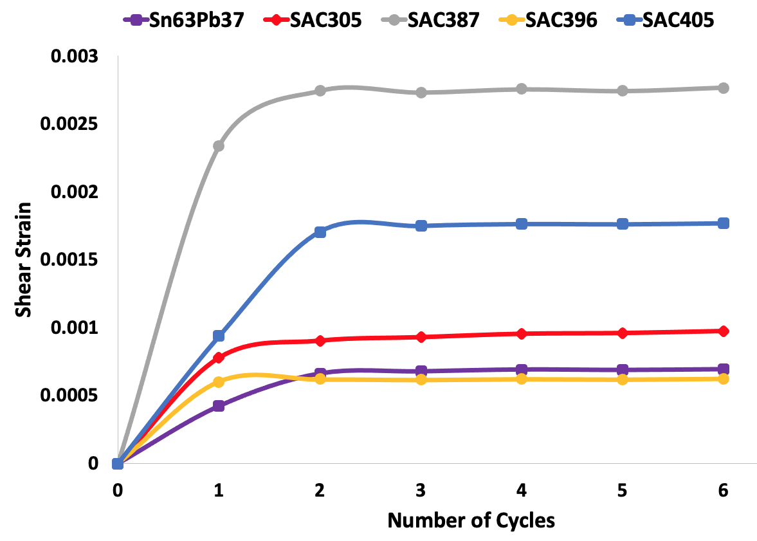
Fig. 12: Shear strain rate results for six complete cycles of solder joint alloys
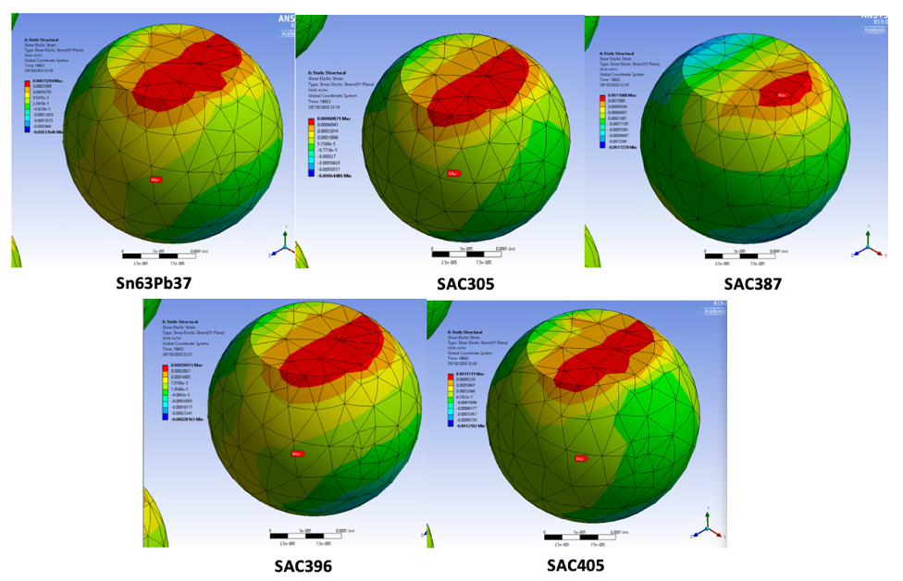
Fig. 13: Schematics showing areas of maximum shear strain

3.4 Study of Plastic Shear Strain on the solder joints
The maximum plastic shear strain of solder joint for eutectic Sn63Pb37 (0.0455), SAC305 (0.0536), SAC387 (0.0909), SAC396 (0.0431) and SAC405 (0.0727) are presented in Fig 14. The Solomon model for low cycle fatigue (LCF) in equation 3 is employed to determine the fatigue life cycle values for the solder joints using the equivalent plastic shear strain in equation 14. The outcome shows that SAC405 has the highest fatigue life, followed by SAC396, SAC305, Sn63Pb37 and SAC387, respectively, using the Engelmaier, Coffin-Manson and Solomon empirical models. The result shows that SAC396 has the lowest plastic shear strain why SAC387 has the highest of all the solder alloys considered in this work, indicating that it will fail first on the solder alloys in BGA electronic components. The schematic is presented in Fig. 15, showing areas of maximum plastic shear strain on the solder joint alloys.
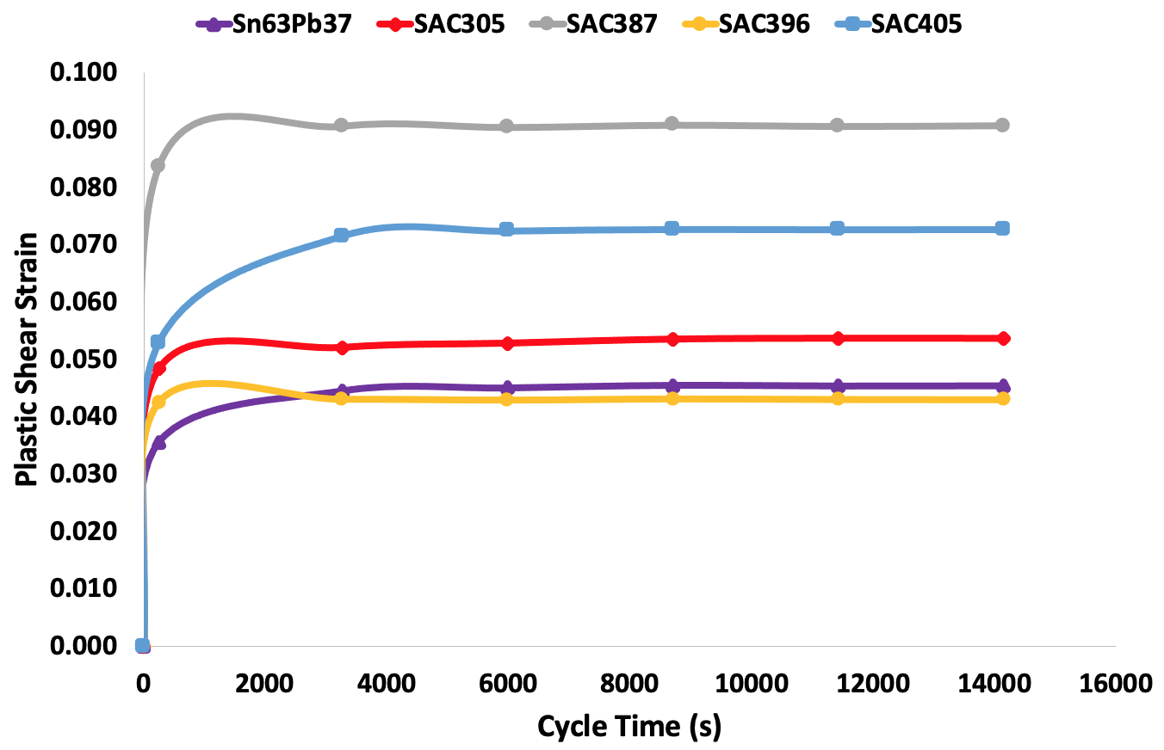
Fig. 14: Plastic shear strain rate results for six complete cycles of solder joints
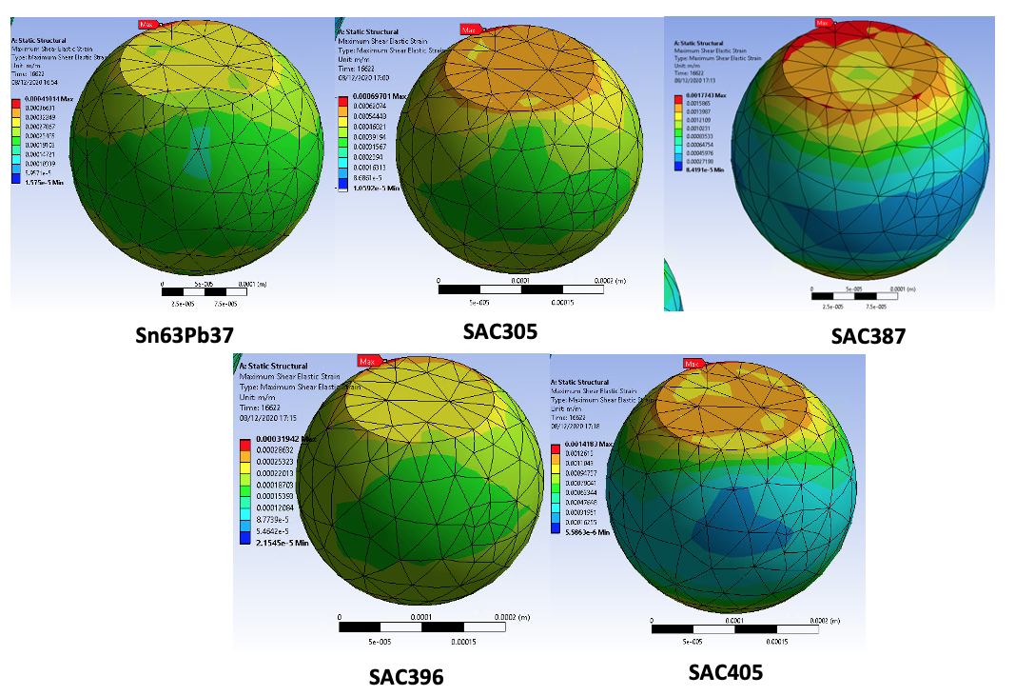
Fig. 15: Schematics showing areas of maximum plastic shear strain

3.5 Study of Creep Energy Density on the Solder Joint Alloys
The creep energy density indicates that eutectic Sn63Pb37 and SAC405 has the lowest strain energy density of ${2.50×10}^{-6}{J/m}^{3}$ and ${2.48×10}^{-7}{J/m}^{3}$ with the highest been on SAC387 $\left({1.33×10}^{-6}{J/m}^{3}\right)$. The other solder alloys are SAC305 $\left({8.76×10}^{-6}{J/m}^{3}\right)$ and SAC396 $\left(2.98{×10}^{-6}{J/m}^{3}\right)$, respectively. The accumulated creep energy density per cycle (${J/m}^{3})$ is calculated using equation 18 – 20 with equation 16 employed in the computation of the number of repetitions or cycles to failure for the solder alloys. The results show that the total energy dissipated is lowest on SAC396 and highest on SAC387. The damage parameter for the life prediction is observed to be highest on SAC405 with ~11.32 years and SAC396 with ~9.7 years. The lowest life prediction was estimated on the SAC387 with ~1.74 years, as presented in Fig. 21. This result is vital in maintaining the solder durability and safety of the BGA electronic components.
The results in Fig. 16 show a stable and identical creep energy density on Sn63Pb37, SAC396 and SAC405 solder alloys. Only the SAC387 increases up cycle 2 and then sharply decrease with a negative gradient of ${1.4×10}^{-8}{J/m}^{3}$ and ${4.08×10}^{-9}{J/m}^{3}$ on the SAC305 solder alloy. The damage on the solder alloy is highest on SAC387 and lowest on the lead-based eutectic Sn63Pb37 and lead-free SAC405 and SAC396, respectively.

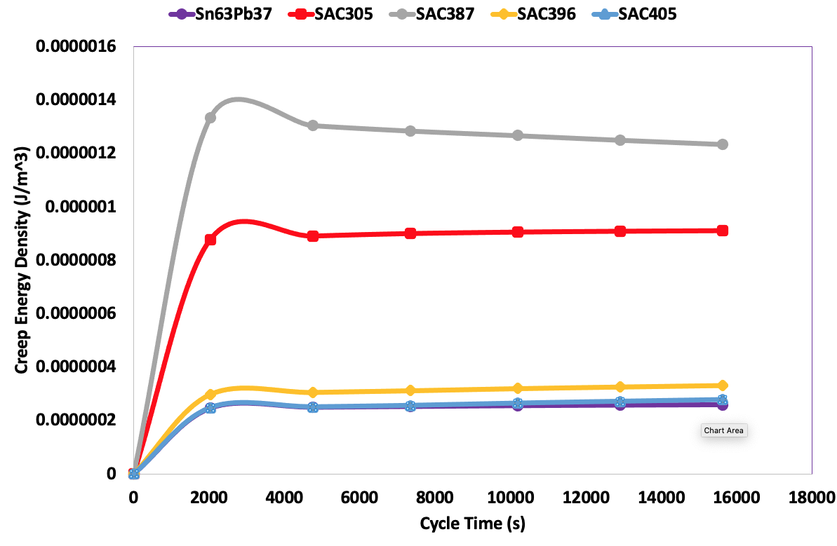
Fig. 16: Creep energy density vs cycle time for solder joint alloys

3.6 Study of Stress and Strain Relationship
The plots for the stress-strain relationships for the lead-based eutectic Sn63Pb37 and four SnAgCu (SAC) solder alloys is presented in Fig. 17. It is vital to assess the stress-strain distribution in the solder joints as the assembly's weakest part. The plot values of eutectic Sn63Pb37 and lead-free SAC305, SAC387, SAC396 and SAC405 solder alloys stress magnitude and strain rate are presented. It is recognised that at the same load and boundary conditions, SAC405 shows the highest stress magnitude, followed by SAC387 with the maximum strain rate. The lowest strain rate was noticed for Sn63Pb37, SAC405, and SAC305, with the highest been SAC387. The stress-strain curve further reveals a concave downward with one tangent. The secant line slope describes a fall in the stress, which shows a decreasing resistance, leading to inevitable failure in the solder joint material. As the induced strain increases, deformation of the solder alloys is likely to occur, and crack initiation begins, especially on the SAC387 and SAC305. The plot also shows that SAC405 has the lowest stress magnitude, followed by SAC396 and eutectic Sn63Pb37. The higher the strain rate these solder materials are subjected beyond its yield strength point sets in plastic deformation in the solder alloys. It could be observed that the maximum stress magnitude and strain rate of the solder alloys investigated are SAC387 (strain rate = 0.09, stress = 63.7 MPa), SAC305 (strain rate = 0.034, stress = 57.1 MPa), eutectic Sn63Pb37 (strain rate = 0.08, stress = 35.7 MPa), SAC396 (strain rate = 0.013, stress = 34.7 MPa) and SAC405 (strain rate = 0.015, stress = 22.3 MPa) respectively.
The plot comparably illustrates that the highest stress magnitude was seen with SAC387 and SAC305 solder alloys and occurred at the outer corner for the solder balls spreading to the centre. The results indicate that SAC387 and SAC305 solder alloys are more vulnerable. The BGA solder balls on the PCB represent an essential function in the failure per component assembly's failure performance. The deformation rate on substrates on the corners edges must be considered in addition to the stress magnitude presented in the ANSYS FEA simulation. The behaviour of solder alloys degradation in the simulation analyses is indisputably different regarding the solder alloys and testing conditions. Accordingly, the more elastoplastic the solder alloy material is, the more acceptable applications where soldering connections are applied to the thermal cycles with small temperature and CTE mismatch of the joining materials. It is concluded that SAC396 and SAC405 represent the best solder alloys, and the results are additionally enhanced with the fatigue life prediction and stress-strain hysteresis loop in section 3.7 and 3.8, respectively.
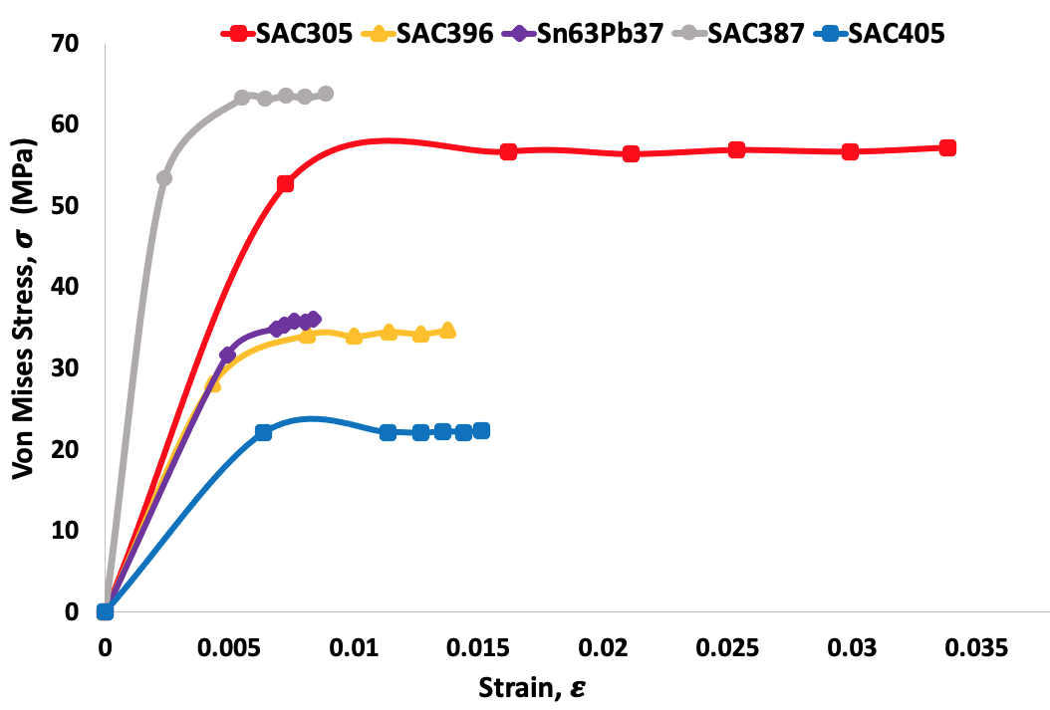
Fig. 17: Stress vs strain plot for solder alloys

3.7 Study of Stress-Strain Hysteresis loop
During thermal loading, the stress-strain hysteresis loop area is the strain energy per unit volume absorbed by the solder alloys. Under other conditions, the unloading curve area is described as the solder alloy materials' energy. During the elastic range on the curve, these areas are equal, and no net energy is consumed. If the material is loaded in the plastic field in a different circumstance, as presented in Fig. 18, the energy utilised surpasses the energy released. Superior elastic materials maintain ideal linear stress-strain properties.
On the other hand, cyclic stress creates a strain in the solder joint alloys, a cyclical variable and phase with the equivalent stress. Solder joint alloy cracking is constrained in loading because cracks will be closed rather than opened by the stress state. The solder alloy materials loaded cyclically, alternating between loading and unloading and show the area in the hysteresis loops because the load is high and sufficient to cause plastic flow (above the yield stress). The hysteresis loop's surface always equals the amount dissipated in the material upon the loading and unloading cycle.
On the contrary, the hysteresis loop yields information on fatigue degree and a stress-strain characteristics curve. This establishes that the solder joint alloy materials stress variations result in increased fatigue degrees and reduced mechanical strength. The stress-strain hysteresis loop shows that SAC405 has the lowest strain energy per unit volume absorbed, followed by SAC396, eutectic Sn63Pb37, and SAC305. SAC387 has the highest strain energy per unit volume. Therefore, it is recommended that SAC405 and SAC396 are the preferred SAC solder alloys to replace lead-based eutectic Sn63Pb37 based on the fatigue degree when subjected to thermo-mechanical loading conditions.
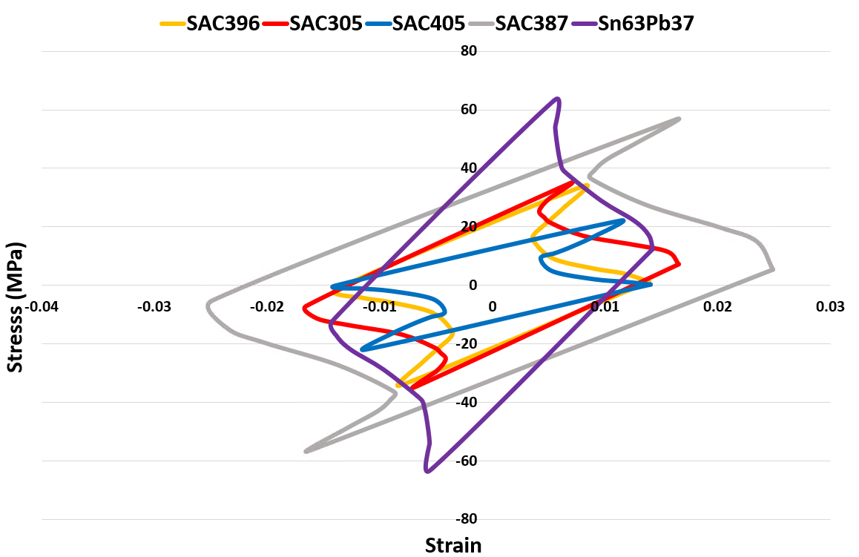
Fig. 18: Stress-strain hysteresis loop for solder alloys
An et al. [108] carried out experimental and simulation analyses which investigated the failure study of lead-based eutectic Sn63Pb37, PBGA solder joints using temperature cycling, random vibration and combined temperature cycling and random vibration tests. Thermal cycling $\left(-55℃ to 125℃ \right)$ and vibration studies conducted for the Sn63Pb37 solder joint. The results from their research demonstrate that the solder joint failure for the combined loading in an electronic device is more for either thermal cycling or pure vibration loading at room temperature. The result also ascertains the primary failure mode as cracking in the bulk solder joint under thermal cycling.
In contrast, the crack propagation path is shown to be along with the IMC layer for vibration loading. Fig. 19 presents a standard failure mode when the components are subjected to thermal cycling loading. The outcomes imply that the investigators located most of the failed solder joints' cracks on the component side. During the thermal cycling phase, the solder joint experiences alternating stresses during the heating and cooling period and this produces accumulated plastic deformation and triggers the cracks to open, mainly since the inelastic strain is a peak near the Silicon die; thus, the solder joint is shown to fail at this critical solder joint.
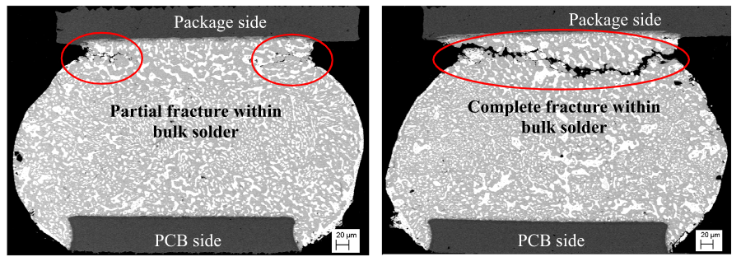
Fig. 19: SEM image of solder joint failure modes of the solder joints during temperature cycling showing cracked at the component interface of lead-based eutectic Sn63Pb37solder (Adapted Ref. [108])
Hsieh and Tzeng [109] investigated the solder joint fatigue life prediction in large size and low-cost wafer-level chip-scale electronic packages. The researchers evaluated the fatigue life of substantial size and low-cost WLCSP with SAC105 solder joint alloy. The board-level reliability (BLR) thermal cycling test follows JEDEC models. The failure results of SAC105 in the BLR thermal cycling test for 185 and 188 cycles are shown in Fig. 20. In summary, the researchers produced a modified Coffin-Manson equation for SAC105 solder joint fatigue life. With the current equations, the solder joint simulations without experimental evaluations can determine fatigue life in a large and low-cost WLCSP can be achieved are essential and valuable if high reliability and cost reduction in large die size and low-cost WLCSP are required. Fig. 20 show the reliability of SEM outcomes for the WLCSPs. By analysing the SEM images, the investigators show that the solder crack initially occurred near the corner of the pad and solder ball. The solder cracks then propagate along with the top IMC layer below the pad and the PCB Cu pad's top surface.
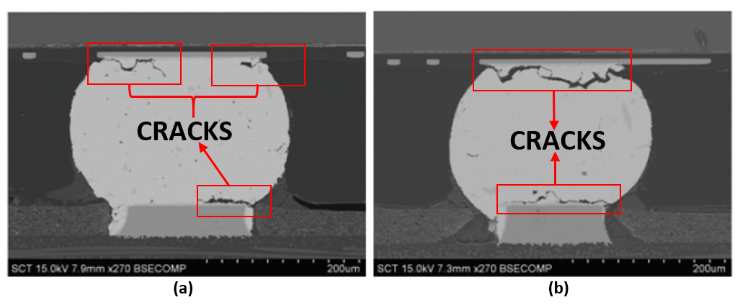
Fig. 20: Failure results of SAC105 solder joint in board-level reliability (BLR) thermal cycling test (TCT) in test vehicle (a) more significant redistribution layer (RDL) pad size and (b) smaller redistribution layer (RDL) pad size (Adapted Ref. [109])

Furthermore, a study conducted by George et al. [110] on the thermal cycling reliability of lead-free solders (SAC305 and Sn3.5Ag) for high-temperature applications presents comparable deformation outcomes. In their research, quad flat packages (QFP), ball grid arrays (BGA), and surface mount resistors assembled with SAC305 and Sn3.5Ag solder pastes were subjected to thermal cycling from $-40℃ to 185℃$. The result of their work shows that the failure was concentrated on the package side of the solder joint, which is comparable to results obtained from FEM. Their study's outcome reveals that the failure was centred on the package side of the solder joint, similar to the results achieved from FEM. Several investigators, such as Xie et al. [111], have published a crack in the specific area except in particular circumstances that fatigue failure is seen on the component's PCB side. The additional investigations by Che, Arulvanan, Lall, Lee and Zhang [112]–[116] described the exact crack location on the electronics package in the components section.

3.8 Prediction of the Fatigue Life of Solder Joints
The fatigue life of various solders considered in this work is presented in Figs. 21 – 24. The figures show the fatigue life cycle of solder joints using four models: Engelmaier, Coffin-Manson, Solomon (low cycle fatigue) and Syed (creep energy density), indicating that SAC405 and SAC396 have the highest number of cycles and duration before been prone to fatigue failure. SAC387 and lead-based eutectic Sn63Pb37 has the lowest fatigue life cycle under thermal cycling. The plot of the number of cycles and duration to failure are presented in Fig. 16. The fatigue failure of the solder joint is vital in the design consideration for various engineering industries. It is also noted that taking a stepwise approach to improve performance are recommended using the fatigue models used in this work. This model takes the temperature and frequency into account, making it easier to get a more accurate result. The relationship is presented in equation 12, and the value of c is obtained from equation 13, which form the Engelmaier equation.
$N_{f}=\frac{1}{2}{\left(\frac{∆γ}{{2ε}_{f}^{'}}\right)}^{\frac{1}{c}}$ (12)
Where $N_{f}$ is the mean cycle to failure, $∆γ$ is the cyclic shear strain range, $ε_{f}^{'}$ is the fatigue ductility coefficient $(2ε_{f}^{'} =0.65$ lead-based eutectic solder alloys and $2ε_{f}^{'} =0.48$ for SAC solder alloys) [117] and c is the fatigue ductility exponent (c = -0.442 for eutectic and 0.5708 for SAC solder alloys).
When solder joints are at extremely high temperature, creep failure dominates; and when exposed to temperature cycling, fatigue failure dominates [7]–[14], [118]. Suppose the failure mechanism is generally referred to as creep-fatigue [119], [120], the creep and fatigue of solder joints are primarily due to the mismatch of thermal extension (CTE) coefficient between electronics component and PCB. LCF is associated with shorter fatigue life and higher stress, where stress level usually steps into the plastic strain range. Coffin-Manson model equation [82] is widely used to predict the low-cycle fatigue life $N_{f}$ as a function of plastic strain range ${∆ε}_{p}$ for solder alloys:
${N_{f}^{m}∆ε}_{p}=c$ (13)
where $m$ is the fatigue exponent, and $c$ is the ductility coefficient.
Solomon proposed an LCF model (Eq. 14) that relates the plastic shear strain to the fatigue life cycles for near eutectic solder joints at four different temperatures $-50℃, 35℃,125℃ and 150℃$ [121], [122].
The equivalent plastic shear strain range [123] is determined by $∆γ=\sqrt{3∆ε}$ (14)
${∆γ}_{p}N_{f}^{α}=θ$ (15)
where ${∆γ}_{p}$ are the plastic shear strain range, and $α$ and $θ$ are constants. For 60/40 Tin-lead solder material from $-50℃ to 150℃$, $α$ and $θ$ are estimated to be 0.51 and 1.14, respectively [118], [124].
$N_{f}={\left(W^{'}ω_{acc}\right)}^{-1}$ (16)
Where $N_{f}$ = number of repetitions or cycles to failure; $ω_{acc}$ = Accumulated creep energy density per cycle; $W^{'}$ = Creep energy density for failure
Equation 16 gives cyclic creep (fatigue) life due to varying and repeated stresses for a single creep mechanism.
The values of $ω_{acc}$ are calculated and used to determine the number of cycles to failure. Syed [125] has determined the values of $W^{'}$ experimentally to be 0.0019, respectively. The mean fatigue life is given as:
$L=\left(\frac{t_{c}}{y}\right)N_{f}$ (17)
Where L is the mean fatigue life (in years), $N_{f}$ is the mean fatigue life (in cycles), $t_{c}$ is the time per cycle (in seconds), and $y$ is one year (in seconds).
The relationship between creep strain energy and creep strain energy density is given as:
$E=\frac{E_{c}}{V}$ (18)
Where E is the maximum creep strain energy density (Pa), $E_{c}$ is the maximum creep strain energy per cycle (Joule) and V is the solder volume $\left(m^{3}\right)$.
The accumulated creep strain energy density (that is a measure of solder damage) is derived from the relationships in equations (19) and (20).
$E_{A}=\sum_{t=1}^{n}{\left|E_{i}-E_{i+1}\right|}$ (19)
$\sum_{t=1}^{n}{\left|E_{i}-E_{i+1}\right|}=\left|E_{1}-E_{2}\right|+\left|E_{2}-E_{3}\right|+\left|E_{3}-E_{4}\right|+…+\left|E_{n-1}-E_{n}\right|$ (20)
Equation 19 and 20 show the accumulated creep strain energy density, where $E_{A}$ summarises the absolute difference between the highest creep strain energy density in a cycle and the successive cycle, and n is the number of cycles.
The results obtained in this work for the four fatigue life models (Engelmaier, Coffin-Manson, Solomon and Syed) investigated for the five solder joint alloys agrees with the study carried out by Ekpu et al. [126] and Hamasha et al. [128] for SAC305 solder alloys (Fig. 24). The outcomes show that SAC305 solder joint alloy has a margin of error $12\%$ higher than those reported by the investigators why SAC387 is within the margin of error of $18.5\%$ lower than the result obtained by Tao et al. [127] for the SAC387 solder alloys in this work [126]–[128]. This investigation results in a new finding for the five solder joint alloys' fatigue life predictions. The author concludes that this research provides a new method for determining BGA components' preventive maintenance time in mission-critical systems such as under the hood of an automobile, aerospace etc.
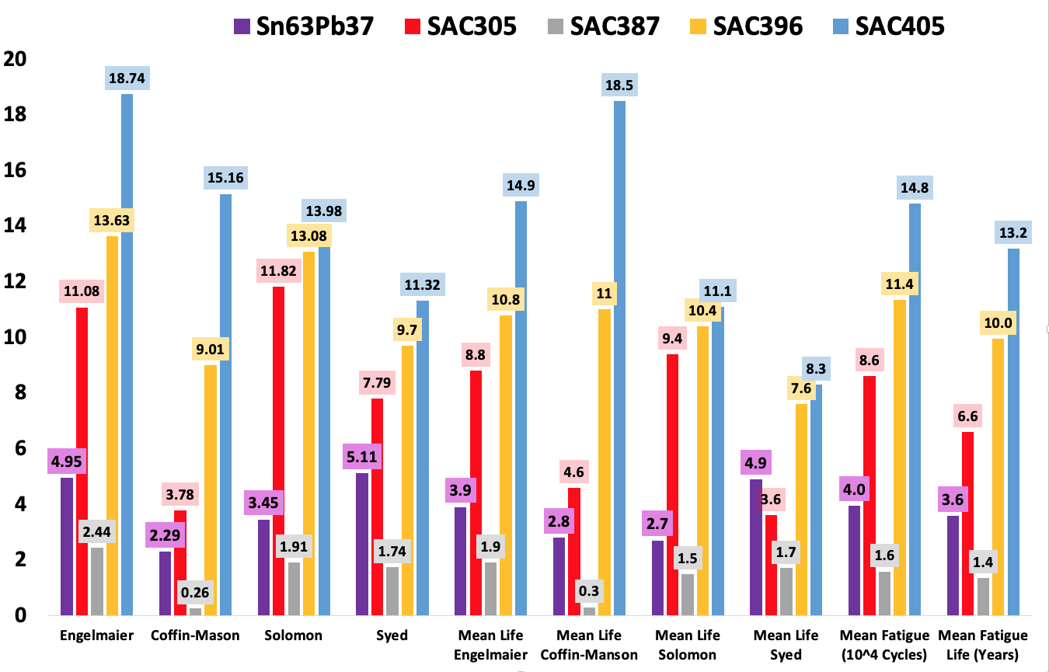
Fig. 21: Fatigue life of BGA solder joints
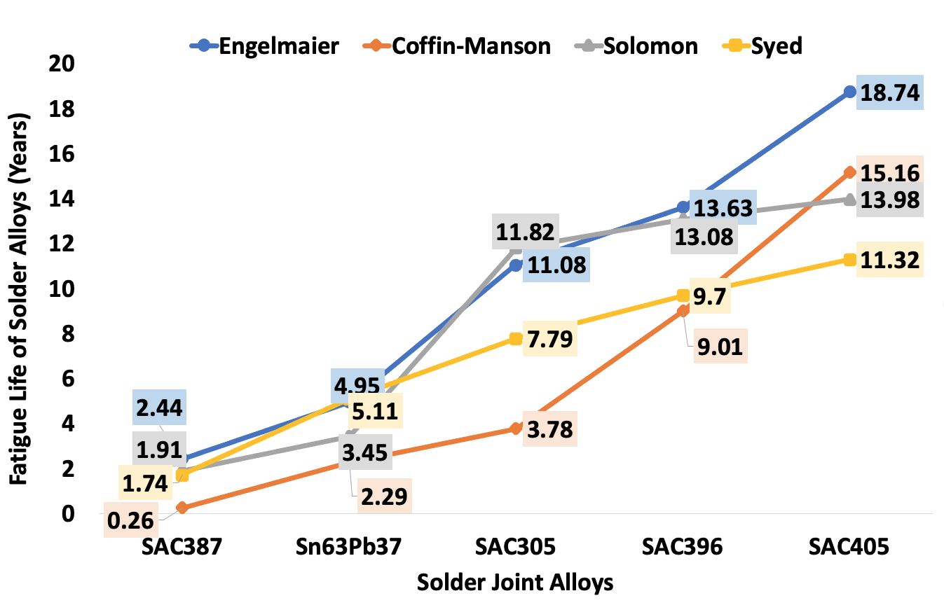
Fig. 22: Plot of fatigue lives of solder joint alloys using the four life prediction models

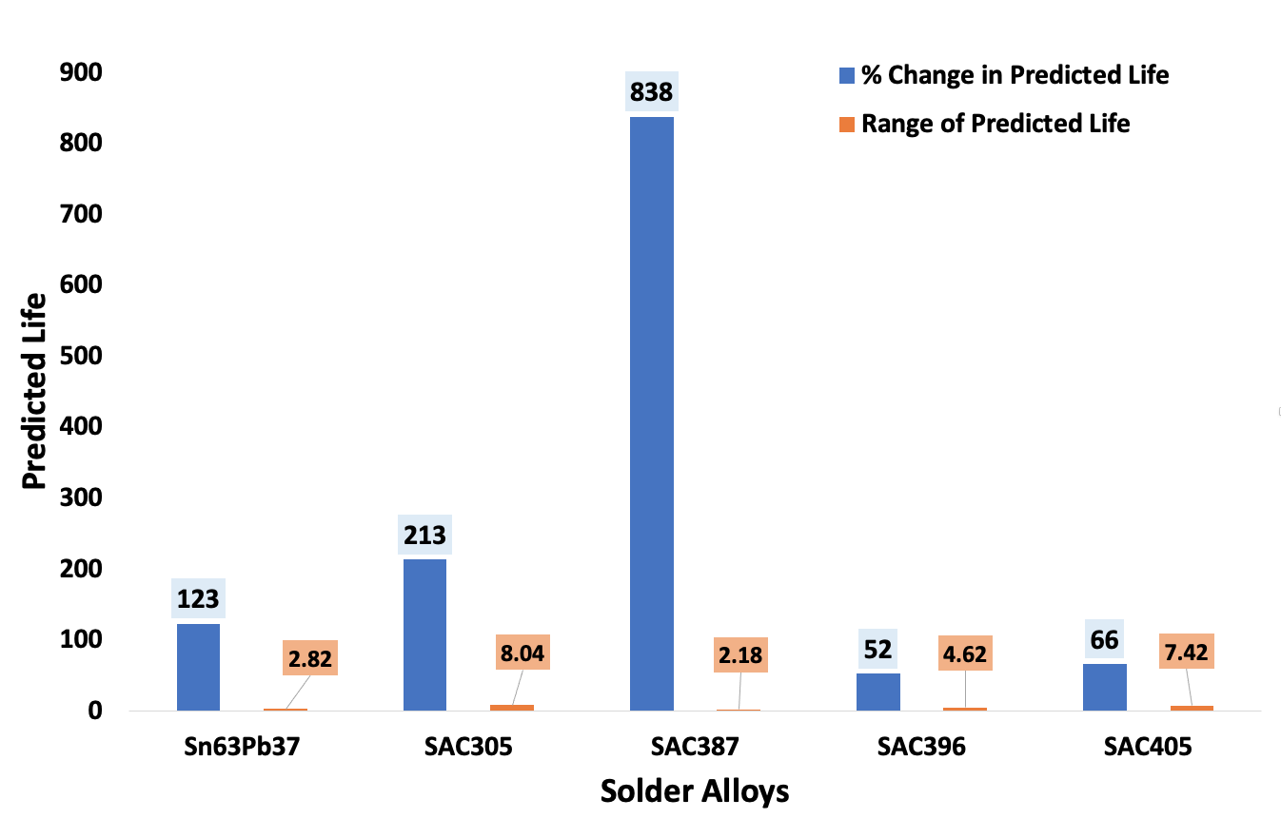
Fig. 23: Plot of the percentage change in predicted life and range of predicted life against solder alloys
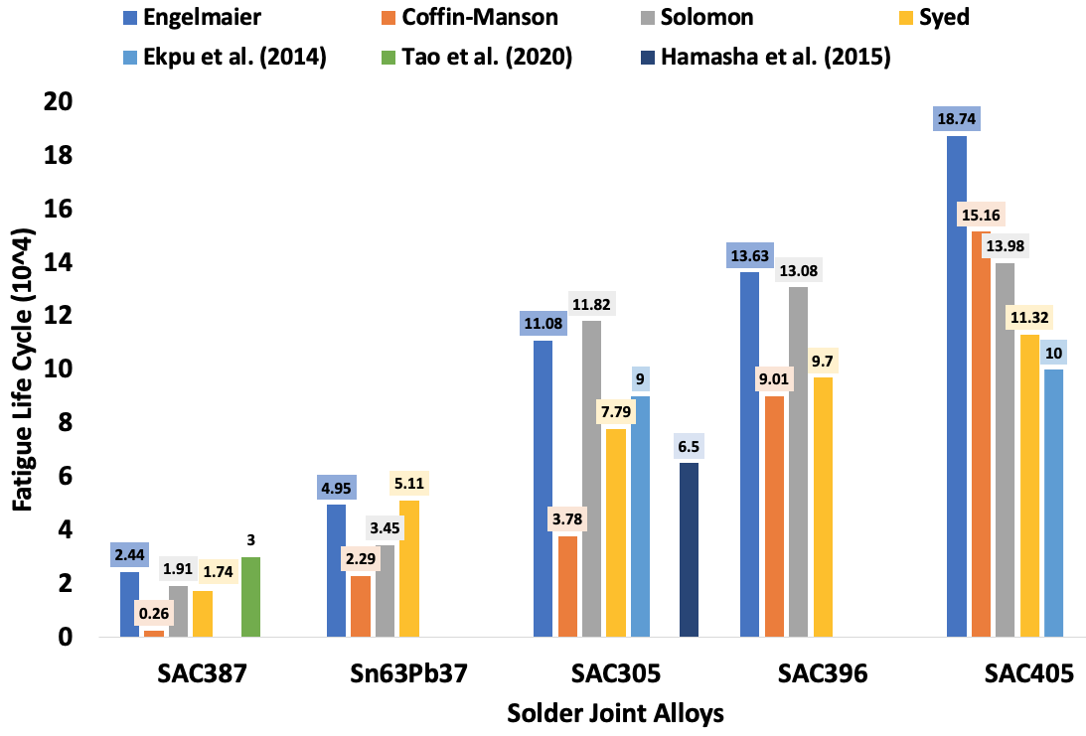
Figure 24: Comparison of the fatigue lives of solder joint alloys from this work with data from peer-reviewed literature

4.0 Conclusions
This research provides a method of determining the preventive maintenance time of BGA components in mission-critical systems. It proposes developing a new life prediction model based on a combination of the damage parameters for improved prediction.
Specific conclusions from this study include:
- BGA joints made of SAC387 solder accumulated the highest stress, strain energy density, plastic strain, shear strain, plastic shear strain, and creep energy density magnitudes. Consequently, it has the lowest fatigue life across all prediction models.
- The SAC405 solder joints accumulated the lowest stress, plastic strain and creep energy density magnitude and the highest fatigue life.
- The SAC405 joints have the highest predicted TFL of circa 13.2 years, while SAC387 joints have the least life of circa 1.4 years. The predicted lives are inversely proportional to the magnitude of the areas of stress-strain hysteresis loops of the solder joints.
- The prediction models are significantly consistent in predicted magnitudes across the solder joints irrespective of the damage parameters used. The observation recognises a significant variation in the models' predicted values - justifying that several failure modes drive solder joints' damage mechanics.
- It is concluded that shear strain range, fatigue ductility, plastic shear strain, accumulated creep energy density, and creep energy density for failure are damage parameters used to determine the solder's thermal fatigue lives joints in electronic assemblies.

Acknowledgement

The study published in part in this report is funded by the School of Mechanical Engineering & the Built Environment, College of Engineering & Technology, University of Derby, UK.

Conflict of Interest
The authors declare that they have no conflict of interest.
References
[1] J. H. Lau and Y. Pao, Solder joint reliability of BGA, CSP, Flip Cip, and fine pitch SMT assemblies. 1997.
[2] Lau John; Wong C P; Lee Ning-Cheng, Electronics Manufacturing: With Lead-Free, Halogen-Free, and Conductive-Adhesive Materials. The McGraw-Hill Companies, Inc., 2003.
[3] J. Wang, Y. Niu, S. Park, and A. Yatskov, “Modeling and design of 2.5D package with mitigated warpage and enhanced thermo-mechanical reliability,” 2018, doi: 10.1109/ECTC.2018.00373.
[4] S. Shao et al., “Comprehensive study on 2.5D package design for board-level reliability in thermal cycling and power cycling,” 2018, doi: 10.1109/ECTC.2018.00251.
[5] X. C. Tong, “Thermal Management Fundamentals and Design Guides in Electronic Packaging,” 2011.
[6] J. Adeniyi Depiver, S. Mallik, and E. H. Amalu, “Comparing and benchmarking fatigue behaviours of various SAC solders under thermo-mechanical loading,” 2020, doi: 10.1109/ESTC48849.2020.9229699.
[7] S. Hamasha, A. Qasaimeh, Y. Jaradat, and P. Borgesen, “Correlation Between Solder Joint Fatigue Life and Accumulated Work in Isothermal Cycling,” IEEE Trans. Components, Packag. Manuf. Technol., 2015, doi: 10.1109/TCPMT.2015.2453989.
[8] A. Qasaimeh, S. Hamasha, Y. Jaradat, and P. Borgesen, “Damage evolution in lead free solder joints in isothermal fatigue,” J. Electron. Packag. Trans. ASME, 2015, doi: 10.1115/1.4029441.
[9] M. Obaidat et al., “Effects of varying amplitudes on the fatigue life of lead free solder joints,” 2013, doi: 10.1109/ECTC.2013.6575741.
[10] F. Batieha, S. Hamasha, Y. Jaradat, L. Wentlent, A. Qasaimeh, and P. Borgesen, “Challenges for the prediction of solder joint life in long term vibration,” 2015, doi: 10.1109/ECTC.2015.7159804.
[11] P. Borgesen et al., “A Mechanistic Thermal Fatigue Model for SnAgCu Solder Joints,” J. Electron. Mater., vol. 47, no. 5, pp. 2526–2544, 2018, doi: 10.1007/s11664-018-6121-0.
[12] S. Hamasha and P. Borgesen, “Effects of strain rate and amplitude variations on solder joint fatigue life in isothermal cycling,” J. Electron. Packag. Trans. ASME, 2016, doi: 10.1115/1.4032881.
[13] S. Hamasha, S. Su, F. Akkara, A. Dawahdeh, P. Borgesen, and A. Qasaimeh, “Solder joint reliability in isothermal varying load cycling,” in Proceedings of the 16th InterSociety Conference on Thermal and Thermomechanical Phenomena in Electronic Systems, ITherm 2017, 2017, pp. 1331–1336, doi: 10.1109/ITHERM.2017.7992636.
[14] S. Su, M. Jian, F. J. Akkara, S. Hamasha, J. Suhling, and P. Lall, “Fatigue and Shear Properties of High Reliable Solder Joints for Harsh Applications Department of Industrial and Systems Engineering Department of Mechanical Engineering,” 2018.
[15] W. B. Green, “A fatigue-free silicon device structure,” Trans. Am. Inst. Electr. Eng. Part I Commun. Electron., vol. 80, no. 2, pp. 186–192, 2013, doi: 10.1109/tce.1961.6373099.
[16] L. Zhang and K. N. Tu, “Structure and properties of lead-free solders bearing micro and nano particles,” Materials Science and Engineering R: Reports. 2014, doi: 10.1016/j.mser.2014.06.001.
[17] K. Kanlayasiri and K. Sukpimai, “Effects of indium on the intermetallic layer between low-Ag SAC0307-xIn lead-free solders and Cu substrate,” J. Alloys Compd., 2016, doi: 10.1016/j.jallcom.2016.01.231.
[18] R. J. Coyle, K. Sweatman, and B. Arfaei, “Thermal Fatigue Evaluation of Pb-Free Solder Joints: Results, Lessons Learned, and Future Trends,” JOM, vol. 67, no. 10, pp. 2394–2415, 2015, doi: 10.1007/s11837-015-1595-1.
[19] R. Schueller et al., “Second Generation Pb-free Alloys,” 2003.
[20] W. J. Plumbridge, “Second generation lead-free solder alloys - A challenge to thermodynamics,” 2005, doi: 10.1007/s00706-005-0377-9.
[21] F. Ji, S. Xue, L. Zhang, L. Gao, Z. Sheng, and W. Dai, “Reliability evaluation of QFN devices soldered joints with creep model,” Chinese J. Mech. Eng. (English Ed., 2011, doi: 10.3901/CJME.2011.03.428.
[22] L. Sun, L. Zhang, S. juan Zhong, J. Ma, and L. Bao, “Reliability study of industry Sn3.0Ag0.5Cu/Cu lead-free soldered joints in electronic packaging,” J. Mater. Sci. Mater. Electron., vol. 26, no. 11, pp. 9164–9170, 2015, doi: 10.1007/s10854-015-3606-y.
[23] J. S. Hwang and R. M. Vargas, “Solder joint reliability—can solder creep?,” Solder. Surf. Mt. Technol., vol. 2, no. 2, pp. 38–45, 1990, doi: 10.1108/eb037718.
[24] A. Syed, “Accumulated creep strain and energy density based thermal fatigue life prediction models for SnAgCu solder joints,” 2004 Proceedings. 54th Electron. Components Technol. Conf. (IEEE Cat. No.04CH37546), no. February, pp. 737–746, 2016, doi: 10.1109/ECTC.2004.1319419.
[25] M. T. Zarmai, N. N. Ekere, C. F. Oduoza, and E. H. Amalu, “Evaluation of thermo-mechanical damage and fatigue life of solar cell solder interconnections,” Robot. Comput. Integr. Manuf., vol. 47, no. December 2015, pp. 37–43, 2017, doi: 10.1016/j.rcim.2016.12.008.
[26] J. a. Depiver, S. Mallik, and D. Harmanto, “Solder joint failures under thermo-mechanical loading conditions–A review,” Advances in Materials and Processing Technologies. 2020, doi: 10.1080/2374068X.2020.1751514.
[27] J. A. Depiver, S. Mallik, and E. H. Amalu, “Creep Response of Various Solders used in Soldering Ball Grid Array ( BGA ) on Printed,” IAENG, vol. 0958, 2019.
[28] J. Depiver, S. Mallik, and D. Harmanto, “Creep Damage of BGA Solder Interconnects Subjected to Thermal Cycling and Isothermal Ageing Creep Damage of BGA Solder Interconnects Subjected to Thermal Cycling and Isothermal Ageing,” Electron. Packag. Technol. Conf. IEEE, no. December, 2019.
[29] P. Chauhan, M. Osterman, S. W. R. Lee, and M. Pecht, “Critical review of the engelmaier model for solder joint creep fatigue reliability,” IEEE Transactions on Components and Packaging Technologies. 2009, doi: 10.1109/TCAPT.2009.2030983.
[30] W. Engelmaier and A. I. Attarwala, “Surface-Mount Attachment Reliability of Clip-Leaded Ceramic Chip Carriers on FR-4 Circuit Boards,” IEEE Trans. Components, Hybrids, Manuf. Technol., 1989, doi: 10.1109/33.31435.
[31] W. Engelmaier, “Solder joints in electronics: Design for Reliability,” 1997.
[32] W. Engelmaier and L. J. Turbini, “Design for reliability in advanced electronic packaging,” SMI Surf. Mt. Int. Adv. Electron. Manufactuting Technol. Proc. Tech. ProgramSMI Surf. Mt. Int. Adv. Electron. Manufactuting Technol. Proc. Tech. Progr., 1995.
[33] W. Engelmaier, “RELIABILITY TEST.,” Circuits Manuf., 1988, doi: 10.1007/978-94-011-1928-3_9.
[34] Q. Guo, M. Zhao, and H. Wang, “SMT solder joint’s semi-experimental fatigue model,” Mech. Res. Commun., 2005, doi: 10.1016/j.mechrescom.2004.03.011.
[35] C. Andersson et al., “Thermal cycling of lead-free Sn-3.8Ag-0.7Cu 388PBGA packages,” Solder. Surf. Mt. Technol., 2009, doi: 10.1108/09540910910947453.
[36] B. Vandevelde, M. Gonzalez, P. Limaye, P. Ratchev, and E. Beyne, “Thermal cycling reliability of SnAgCu and SnPb solder joints: A comparison for several IC-packages,” Microelectron. Reliab., 2007, doi: 10.1016/j.microrel.2006.09.034.
[37] M. Gonzalez, B. Vandevelde, J. Vanfleteren, and D. Manessis, “Thermo-mechanical FEM analysis of lead free and lead containing solder for flip chip applications,” in 15th European Microelectronics and Packaging Conference and Exhibition, EMPC 2005 - Conference Programme and Proceedings, 2005, no. May 2014, pp. 440–445.
[38] L. Zhang, J. G. Han, Y. Guo, and C. W. He, “Anand model and FEM analysis of SnAgCuZn lead-free solder joints in wafer level chip scale packaging devices,” Microelectron. Reliab., 2014, doi: 10.1016/j.microrel.2013.07.100.
[39] R. Al Athamneh, D. B. Hani, H. Ali, and S. Hamasha, “Fatigue Life Degradation Modeling of SnAgCu Solder Joints after Aging,” IEEE Trans. Components, Packag. Manuf. Technol., 2020, doi: 10.1109/TCPMT.2020.3000355.
[40] R. C. Weinbel, J. K. Tien, R. A. Pollak, and S. K. Kang, “Creep-fatigue interaction in eutectic lead-tin solder alloy,” J. Mater. Sci., 1987, doi: 10.1007/BF01133338.
[41] R. Darveaux and K. Banerji, “Constitutive Relations for Tin-Based Solder Joints,” IEEE Trans. Components, Hybrids, Manuf. Technol., 1992, doi: 10.1109/33.206925.
[42] Z. N. Cheng, G. Z. Wang, L. Chen, J. Wilde, and K. Becker, “Viscoelastic tensile and shear properties of the 62wt%Sn-36wt%Pb-2wt%Ag solder alloy,” Solder. Surf. Mt. Technol., vol. 12, no. 2, pp. 31–36, 2000.
[43] S. Knecht and L. R. Fox, “Constitutive Relation and Creep-Fatigue Life Model for Eutectic Tin-Lead Solder,” IEEE Trans. Components, Hybrids, Manuf. Technol., 1990, doi: 10.1109/33.56179.
[44] V. Sarihan, “Temperature dependent viscoplastic simulation of controlled collapse solder joint under thermal cycling,” J. Electron. Packag. Trans. ASME, 1993, doi: 10.1115/1.2909295.
[45] V. Sarihan, “Energy Based Methodology For Damage And Life Prediction Of Solder Joints Under Thermal Cycling,” 1994, doi: 10.1109/96.338733.
[46] Q. Zhang, A. Dasgupta, and P. Haswell, “Viscoplastic constitutive properties and energy-partitioning model of lead-free Sn3.9Ag0.6Cu solder alloy,” 2003, doi: 10.1109/ectc.2003.1216558.
[47] Y. H. Pao, S. Badgley, E. Jih, R. Govila, and J. Browning, “Constitutive behavior and low cycle thermal fatigue of 97Sn-3Cu solder joints,” J. Electron. Packag. Trans. ASME, 1993, doi: 10.1115/1.2909310.
[48] Z. N. Cheng, G. Z. Wang, L. Chen, J. Wilde, and K. Becker, “Viscoplastic Anand model for solder alloys and its application,” Solder. Surf. Mt. Technol., 2000, doi: 10.1108/09540910010331428.
[49] L. Anand, “Constitutive equations for the rate-dependent deformation of metals at elevated temperatures,” J. Eng. Mater. Technol. Trans. ASME, 1982, doi: 10.1115/1.3225028.
[50] L. Anand, “Constitutive equations for hot-working of metals,” Int. J. Plast., 1985, doi: 10.1016/0749-6419(85)90004-X.
[51] S. B. Brown, K. H. Kim, and L. Anand, “An internal variable constitutive model for hot working of metals,” Int. J. Plast., 1989, doi: 10.1016/0749-6419(89)90025-9.
[52] R. Darveaux, “Effect of simulation methodology on solder joint crack growth correlation,” Proc. - Electron. Components Technol. Conf., 2000, doi: 10.1109/ECTC.2000.853299.
[53] R. Darveaux, “Effect of simulation methodology on solder joint crack growth correlation and fatigue life prediction,” J. Electron. Packag. Trans. ASME, 2002, doi: 10.1115/1.1413764.
[54] J. A. Depiver, S. Mallik, and E. H. Amalu, “Effective Solder for Improved Thermo-Mechanical Reliability of Solder Joints in a Ball Grid Array ( BGA ) Soldered on Printed Circuit Board ( PCB ),” J. Electron. Mater., 2020, doi: 10.1007/s11664-020-08525-9.
[55] X. Chen, G. Chen, and M. Sakane, “Modified anand constitutive model for lead-free solder SN-3.5AG,” 2004, doi: 10.1109/itherm.2004.1318317.
[56] J. H. L. Pang, P. T. H. Low, and B. S. Xiong, “Lead-free 95.5Sn-3.8Ag-0.7Cu solder joint reliability analysis for micro-BGA assembly,” 2004, doi: 10.1109/itherm.2004.1318270.
[57] N. Bai, X. Chen, and H. Gao, “Simulation of uniaxial tensile properties for lead-free solders with modified Anand model,” Mater. Des., 2009, doi: 10.1016/j.matdes.2008.04.032.
[58] B. A. Zahn, “Finite element based solder joint fatigue life predictions for a same die size - Stacked - Chip scale - Ball grid array package,” Proc. IEEE/CPMT Int. Electron. Manuf. Technol. Symp., pp. 274–284, 2002, doi: 10.1109/iemt.2002.1032767.
[59] A. Syed, “Accumulated creep strain and energy density based thermal fatigue life prediction models for SnAgCu solder joints,” 2004, doi: 10.1109/ectc.2004.1319419.
[60] J. S. Hwang, “Technology and applications in surface mount, hybrid circuits, and component assembly,” in Solder paste in electronics packaging, Illustrate., Van Nostrand Reinhold, 1989, 1989, p. 456.
[61] P. v. Bolotoff, “Solder Alloys: Physical and Mechanical Properties,” Alasir Enterprises, 1999-2019, 2010. http://alasir.com/reference/solder_alloys/ (accessed Apr. 30, 2020).
[62] Topline, “BGA,” 2020. https://www.topline.tv/SMD_vrs_NSMD.html (accessed Feb. 20, 2019).
[63] J. Depiver, S. Mallik, and D. Harmanto, “Creep Damage of BGA Solder Interconnects Subjected to Thermal Cycling and Isothermal Ageing,” Electron. Packag. Technol. Conf. IEEE, no. December, 2019.
[64] B. A. Zahn, “Impact of ball via configurations on solder joint reliability in tape-based, chip-scale packages,” 2002, doi: 10.1109/ectc.2002.1008301.
[65] T. T. Nguyen, D. Lee, J. B. Kwak, and S. Park, “Effect of glue on reliability of flip chip BGA packages under thermal cycling,” 2010, doi: 10.1016/j.microrel.2010.04.003.
[66] E. H. Amalu and N. N. Ekere, “Modelling evaluation of Garofalo-Arrhenius creep relation for lead-free solder joints in surface mount electronic component assemblies,” J. Manuf. Syst., vol. 39, 2016, doi: 10.1016/j.jmsy.2016.01.002.
[67] X. Long et al., “Constitutive behaviour and life evaluation of solder joint under the multi-field loadings,” AIP Adv., 2018, doi: 10.1063/1.5044446.
[68] H. Beyer, V. Sivasubramaniam, M. Bayer, and S. Hartmann, “Reliability of Lead-free Large Area Solder Joints in IGBT Modules with Respect to Passive and Active Thermal Cycling,” 2019.
[69] S. Stoyanov, C. Bailey, and M. Desmulliez, “Optimisation modelling for thermal fatigue reliability of lead-free interconnects in fine-pitch flip-chip packaging,” Solder. Surf. Mt. Technol., 2009, doi: 10.1108/09540910910928265.
[70] J. Eckermann et al., “Computational modeling of creep-based fatigue as a means of selecting lead-free solder alloys,” Microelectron. Reliab., 2014, doi: 10.1016/j.microrel.2014.02.017.
[71] X. Chen, G. Chen, and M. Sakane, “Prediction of stress-strain relationship with an improved anand constitutive model for lead-free solder Sn-3.5Ag,” IEEE Trans. Components Packag. Technol., vol. 28, no. 1, pp. 111–116, 2005, doi: 10.1109/TCAPT.2004.843157.
[72] J. Chang, L. Wang, J. Dirk, and X. Xie, “Finite element modeling predicts the effects of voids on thermal shock reliability and thermal resistance of power device,” Weld. J. (Miami, Fla), 2006.
[73] Q. Wang et al., “Experimental determination and modification of anand model constants for Pb-free material 95-5Sn4.0Ag0.5Cu,” 2007, doi: 10.1109/ESIME.2007.359957.
[74] L. Zhang et al., “Determination of Anand parameters for SnAgCuCe solder,” Model. Simul. Mater. Sci. Eng., 2009, doi: 10.1088/0965-0393/17/7/075014.
[75] Trina Barua, “A Comparative Study of The Thermo-Mechanical Behavior of WCSP Assembly Due to Difference In PCBs’ Layer Thickness,” vol. 8, no. 3, pp. 1–59, 2016.
[76] JEDEC-JESD22-A104D, “Temperature Cycling,” 2014.
[77] JEDEC Standard, “Power and Temperature Cycling JESD22-A105C,” JEDEC SOLID STATE Technol. Assoc., 2004.
[78] JEDEC Solid State Technology Association and JEDEC, “JEDEC Standard JESD22-A104D, Temperature Cycling,” Jedec.Org, 2009.
[79] S. S. Manson, “Behavior Of Materials Under Conditions Of Thermal Stress,” 1953.
[80] S. Wiese and S. Rzepka, “Time-independent elastic-plastic behaviour of solder materials,” 2004, doi: 10.1016/j.microrel.2004.04.015.
[81] D. R. Shirley, H. R. Ghorbani, and J. K. Spelt, “Effect of primary creep and plasticity in the modeling of thermal fatigue of SnPb and SnAgCu solder joints,” Microelectron. Reliab., 2008, doi: 10.1016/j.microrel.2007.08.002.
[82] L. F. Coffin, “A study of the effects of cyclic thermal stresses on a ductile metal,” Transactions of the American Society of Mechanical Engineers. 1954.
[83] A. R. Syed, “Creep crack growth prediction of solder joints during temperature cycling- an engineering approach,” J. Electron. Packag. Trans. ASME, 1995, doi: 10.1115/1.2792077.
[84] B. Wong, D. E. Helling, and R. W. Clark, “A Creep-Rupture Model for Two-Phase Eutectic Solders,” IEEE Trans. Components, Hybrids, Manuf. Technol., 1988, doi: 10.1109/33.16655.
[85] M. M. Hasnine, J. C. Suhling, B. C. Prorok, and M. J. Bozack, “the Mechanical Behavior of Ceramic,” 2007 Proc. 57th Electron. Components Technol. Conf., vol. 37, no. 7, pp. 49–53, 2014, doi: 10.1109/ECTC.2014.6897315.
[86] R. Darveaux, K. Banerji, A. Mawer, G. Dody, and J. Lau, “Reliability of plastic ball grid array assembly. In Ball grid array technology (Vol. 13, pp. 379-442). McGraw-Hill.,” Ball grid array Technol. McGraw-Hill, vol. 13, pp. 379–442, 1995.
[87] Z. P. Wang, Y. M. Tan, and K. M. Chua, “Board level reliability assessment of chip scale packages,” Microelectron. Reliab., 1999, doi: 10.1016/S0026-2714(99)00057-8.
[88] B. N. Muthuraman and B. Canete, “Board Level Reliability assessment of Wafer Level Chip Scale Packages for SACQ, a lead-free solder with a novel life prediction model,” 2018, doi: 10.1109/ESTC.2018.8546504.
[89] Z. W. Zhong and T. Y. Tee, “Overview of board-level solder joint reliability modeling for single die and stacked die CSPs,” Proceedings of the IEEE. 2009, doi: 10.1109/JPROC.2009.2014657.
[90] S. W. Yoon, J. K. Hong, H. J. Kim, and K. Y. Byun, “Board-level reliability of Pb-free solder joints of TSOP and various CSPs,” IEEE Trans. Electron. Packag. Manuf., 2005, doi: 10.1109/TEPM.2005.847398.
[91] H. Juso, Y. Yamaji, T. Kimura, K. Fujita, and M. Kada, “Board level reliability of CSP,” 1998, doi: 10.1109/ECTC.1998.678743.
[92] V. Solberg, “Board level reliability testing of μbGA® packaging with lead-free solder attachment,” 2000, doi: 10.1109/EPTC.2000.906342.
[93] C. Shen et al., “Packaging reliability effect of ENIG and ENEPIG surface finishes in board level thermal test under Long-term Aging and cycling,” Materials (Basel)., 2017, doi: 10.3390/ma10050451.
[94] C. G. Kuo, S. M. L. Sastry, and K. L. Jerina, “Creep-fatigue life prediction of in situ composite solders,” Metall. Mater. Trans. A, 1995, doi: 10.1007/BF02669454.
[95] G. B. Kromann, D. Gerke, and W. Huang, “the C4 / Ceramic-ball-grid Array Interconnect Technology Freescale Semiconductor , I nc ... Semiconductor Products Sector Freescale Semiconductor , I nc ...,” in In 1995 Proceedings. 45th Electronic Components and Technology Conference, 1995, pp. 1–10.
[96] R. Guha et al., “Plastic ball-grid-arrays (PBGA): Are they ready for environmentally harsh aerospace applications?,” SAE Tech. Pap. 2002-01-3011, 2002, 2002.
[97] D. Barbini and M. Meilunas, “Reliability of lead-free LGAs and BGAs: Effects of solder joint size, cyclic strain and microstructure,” 2013.
[98] M. Meilunas, A. Primavera, and S. S. O. S. Dunford, “Reliability and failure analysis of lead-free solder joints,” Proc. IPC Annu. …, 2002.
[99] S. Chaparala, J. M. Pitarresi, and M. Meilunas, “Effect of dwell times and ramp rates on the thermal cycling reliability of Pb-free wafer- level chip scale packages - Experiments and modeling,” 2006, doi: 10.1115/IMECE2006-13376.
[100] T. Baumann, D. Humphrey, and K. Prodromides, “Underfilled PBGA packages and their board level cycling and vibration performance,” 2002.
[101] D. Popps, A. Mawer, and G. Presas, “Flip chip PBGA solder joint reliability: power cycling versus thermal cycling,” … Semicond. Prod. Sect. …, 2005.
[102] W. Engelmaier, “Guidelines for Accelerated Reliability Testing of Surface Mount Solder Attachments,” IPC Guidel. IPC-SM-785, 1992.
[103] JESD22-B111, “Board level drop test method of components for handheld electronic products,” JEDEC Solid State Technol. Assoc, 2003.
[104] IPC/JEDEC-9702, “Monotonic Bend Characterization of Board-level Interconnections,” Assoc. Connect. Electron. Ind., 2004.
[105] IPC-9701, “Performance Test Methods and Qualification Requirements for Surface Mount Solder Attachments,” Assoc. Connect. Electron. Ind., 2002.
[106] IPC-9701A, “Performance Test Methods and Qualification Requirements for Surface Mount Solder Attachments,” Assoc. Connect. Electron. Ind., 2006.
[107] H. Qi, N. M. Vichare, M. H. Azarian, and M. Pecht, “Analysis of solder joint failure criteria and measurement techniques in the qualification of electronic products,” 2008, doi: 10.1109/TCAPT.2008.921647.
[108] T. An, C. Fang, F. Qin, H. Li, T. Tang, and P. Chen, “Failure study of Sn37Pb PBGA solder joints using temperature cycling, random vibration and combined temperature cycling and random vibration tests,” Microelectron. Reliab., 2018, doi: 10.1016/j.microrel.2018.10.003.
[109] M. C. Hsieh and S. L. Tzeng, “Solder joint fatigue life prediction in large size and low cost wafer-level chip scale packages,” 2014, doi: 10.1109/ICEPT.2014.6922704.
[110] E. George, D. Das, M. Osterman, and M. Pecht, “Thermal cycling reliability of lead-free solders (SAC305 and Sn3.5Ag) for high-temperature applications,” IEEE Trans. Device Mater. Reliab., 2011, doi: 10.1109/TDMR.2011.2134100.
[111] W. Xie, T. K. Lee, K. C. Liu, and J. Xue, “Pb-Free solder joint reliability of fine pitch chip-scale packages,” 2010, doi: 10.1109/ECTC.2010.5490777.
[112] F. X. Che, J. H. L. Pang, and L. H. Xu, “IMC consideration in FEA simulation for PB-free solder joint reliability,” 2006, doi: 10.1109/ITHERM.2006.1645456.
[113] P. Arulvanan, Z. Zhong, and X. Shi, “Effects of process conditions on reliability, microstructure evolution and failure modes of SnAgCu solder joints,” Microelectron. Reliab., 2006, doi: 10.1016/j.microrel.2005.05.005.
[114] P. Lall, V. Yadav, J. Suhling, and D. Locker, “A study on the evolution of the high strain rate mechanical properties of SAC105 lead free alloy at high operating temperatures,” 2015, doi: 10.1115/IPACK2015-48389.
[115] S. W. R. Lee and D. Lau, “Computational model validation with experimental data from temperature cycling tests of PBGA assemblies for the analysis of board level solder joint reliability,” 2004, doi: 10.1109/esime.2004.1304030.
[116] L. Zhang, R. Sitaraman, V. Patwardhan, L. Nguyen, and N. Kelkar, “Solder joint reliability model with modified Darveaux’s equations for the micro SMD wafer level-chip scale package family,” 2003, doi: 10.1109/ectc.2003.1216338.
[117] J. P. M. Clech, R. J. Coyle, and B. Arfaei, “Pb-Free Solder Joint Thermo-Mechanical Modeling: State of the Art and Challenges,” JOM, 2019, doi: 10.1007/s11837-018-3003-0.
[118] S. Su, F. J. J. Akkara, R. Thaper, A. Alkhazali, M. Hamasha, and S. Hamasha, “A state-of-the-art review of fatigue life prediction models for solder joint,” J. Electron. Packag. Trans. ASME, vol. 141, no. 4, 2019, doi: 10.1115/1.4043405.
[119] N. Paydar, Y. Tong, H. Akay, and W. Boehmer, “Finite Element Mesh Generation and Analysis of Solder Joints for Fatigue Life Predictions,” Mech. Eng., p. 179, 1993, [Online]. Available: http://oai.dtic.mil/oai/oai?verb=getRecord&metadataPrefix=html&identifier=ADA271329.
[120] H. U. Akay, N. H. Paydar, and A. Bilgic, “Fatigue life predictions for thermally loaded solder joints using a volume-weighted averaging technique,” J. Electron. Packag. Trans. ASME, 1997, doi: 10.1115/1.2792241.
[121] H. D. Solomon, “Fatigue of 60 / 40 Solder,” vol. C, no. 4, pp. 423–432, 1987.
[122] H. D. Solomon, “The influence of hold time and fatigue cycle wave shape on the-low cycle fatigue of 60:40 solder.pdf,” in 38th Electronics Components Conference 1988., Proceedings, 1988, pp. 7–12.
[123] H. Yang and J. Wu, “Prediction of mechanical properties and fatigue life of nano silver paste in chip interconnection,” pp. 1–14, 2020, doi: 10.21203/rs.2.23255/v1.
[124] Z. Qian and S. Liu, “On the life prediction and accelerated testing of solder joints,” 1998, doi: 10.1109/adhes.1998.742055.
[125] A. Syed, “Updated life prediction models for solder joints with removal of modeling assumptions and effect of constitutive equations,” 2006, doi: 10.1109/ESIME.2006.1644010.
[126] M. Ekpu, R. Bhatti, M. I. Okereke, S. Mallik, and K. Otiaba, “Fatigue life of lead-free solder thermal interface materials at varying bond line thickness in microelectronics,” Microelectron. Reliab., vol. 54, no. 1, pp. 239–244, 2014, doi: 10.1016/j.microrel.2013.08.006.
[127] Q. B. Tao, L. Benabou, V. N. Le, N. N. Anh, and T. N. Hung, “Temperature‐dependent fatigue modelling of a novel Ni, Bi and Sb containing Sn‐3.8Ag‐0.7Cu lead‐free solder alloy,” Fatigue Fract. Eng. Mater. Struct., vol. 43, no. 12, pp. 2883–2891, 2020, doi: https://doi.org/10.1111/ffe.13313.
[128] S. Hamasha, L. Wentlent, and P. Borgesen, “Statistical Variations of Solder Joint Fatigue Life Under Realistic Service Conditions,” IEEE Trans. Components, Packag. Manuf. Technol., 2015, doi: 10.1109/TCPMT.2015.2460244.

