An Integrated Framework for Evaluating the Barriers to Successful Implementation of Reverse Logistics in the Automotive Industry

Abstract
Reverse logistics (RL) strategy can have a positive impact on productivity, and the diminishing resources, along with the strict environmental regulations, have strengthened the need for this strategy. The purpose of this study is to develop an integrated framework for identifying: (1) the critical barriers to the successful implementation of RL in the automotive industry; (2) the importance and implementation priorities of these barriers; and (3) the causal relations among them. The proposed framework is composed of the Delphi method to identify the most relevant barriers, the best-worst method (BWM) to determine their importance, and the weighted influence non-linear gauge system (WINGS) to analyze their causal relationships. The proposed framework is applied to a case study in the automotive industry. The results indicate the economic barriers are the most important, and the knowledge barriers are the least important barriers to the successful implementation of RL in the automotive industry.
Keywords: Reverse logistics; implementation barriers; supply chain; best-worst method; weighted influence non-linear gauge system.

Introduction
An increasing number of environmental issues such as climate change, air pollution, contaminated land, and overusing natural resources has forced companies to be more environmentally conscious (Abdulrahman et al., 2014; Bowen et al., 2018; Panda et al., 2020). Can a company be environmentally conscious and, at the same time, profitable? The answer is, yes! Environmental consciousness and business profit are not mutually exclusive. Most large corporations have shown trade-offs between environmentalism and profitability are not necessary, and the quest for sustainability is often a path to increase in profitability (Tavana et al., 2016a). The increasing environmental and competitive pressure has forced companies to seek out new methods to decrease production costs and survive in competitive markets. Reverse logistics (RL) refers to reusing and remanufacturing defective products to protect the environment and decrease operational expenses. In recent years, several companies have deployed RL to efficiently and effectively manage their resources (Baenas et al., 2011; Kumar & Dixit, 2018; Prajapati et al., 2019a). The underlying research questions in this study are:
- What are the critical barriers that need to be considered in the successful implementation of RL in the automotive industry?
- What are the importance and implementation priorities of these barriers?
- What are the causal relations among these critical barriers?
An integrated framework is proposed to address these research questions. The Delphi method is used to identify the most relevant and critical barriers. The best-worst method (BWM) is used to determine the importance and priorities of these barriers to the successful implementation of RL in the automotive industry. The weighted influence non-linear gauge system (WINGS) is used to analyze the causal relationships among the barriers. The answers to these questions should lead to a better understanding of the RL implementation barriers, which is still in its infancy stage of implementation in the automotive industry.
Waqas et al. (2018) and Abdulrahman et al. (2014) have discussed the need for studies to determine, verify, and evaluate barriers to the successful implementation of RL using quantitative tools and techniques. The integrated Delphi, BWM, and WINGS proposed here is quantitative, structured, and comprehensive. Some of the benefits of Delphi methods are the anonymity of responses, controlled feedback, and statistical analysis of responses. The BWM is a quantitative method used here because its structured approach to pairwise comparisons reduces the number of comparisons and improves the consistency of judgments. The WINGS method is also a quantitative method used here because it is a structural model for analyzing intertwined factors with causal relations. This study addresses additional research gaps in the literature. Mi et al. (2019) show there is still a gap in the literature to combine the BWM with other techniques to solve complex decision-making problems. When facing a multitude of barriers, a logistics manager gains insight by knowing not only the internal importance of a barrier but also their external influence on other barriers.
Several studies have used the Decision making trial and evaluation laboratory (DEMATEL) approach to evaluate the barriers to RL implementation but failed to assess the internal strength (importance) of the barriers (e.g., Xia et al., 2015; Kumar & Dixit, 2018; Chauhan et al., 2018). The reasons for using the WINGS method in this study are fivefold: (1) The WINGS method and its unique structure allow for the internal evaluation of the barriers by considering their strengths in relation to the other barriers in multi-criteria decision making (MCDM) problems. (2) The WINGS method, on the one hand, enriches the DEMATEL approach by evaluating the internal strength (importance); and, on the other hand, allows the researchers to go beyond the limiting assumption of criteria independence by introducing the influence among the concepts involved in the problem. (3) The WINGS method, in comparison to the analytic network process (ANP), has a more intuitive network structure (without clusters) and is much simpler to implement. In addition, there is no need to make complete and cumbersome pairwise comparisons. (4) The WINGS method also has an advantage over the fuzzy cognitive map, as the latter is based on an arbitrary choice of the threshold function, which can distort the results (Penn at al. 2013). (5) Finally, since the WINGS method provides a weighted directed graph of system components for analyzing the dependencies among barriers, enriching this method with a robust tool like the BWM produces a powerful integrated framework.
This study identifies and prioritizes the barriers to the successful implementation of RL in the automotive industry. An initial set of barriers is selected using a literature review and the Delphi method. These barriers are then analyzed with respect to their relevance to the automotive industry using an integrated framework that combines the BWM and the WINGS method. The remainder of this paper is organized as follows. Section 2 presents a review of the RL and its barriers. Section 3 presents the integrated framework proposed in this study. A case study is presented in Section 4 to demonstrate the applicability and efficacy of the proposed method. Section 5 presents conclusions and future research directions.

Literature Review
This section presents an overview of the literature in RL, MCDM methods in RL, and the critical barriers to RL implementation.

Reverse logistics
The top-performing companies have recognized that efficient logistics and supply chain operations are the source of competitive advantage. Wu & Dunn (1995) show an efficient supply chain is the result of an information system that pre-determines consumer satisfaction without bottlenecks during the initial process until delivery. The cost-benefit consideration is part of the goals and an integral part of the corporate strategy. In the sustainable business models, RL is considered as a process that leads to plenty of benefits such as cost reduction, revenue growth, and further profitability for organizations and their supply chains as a whole. On the other hand, having an effective RL empowers enterprises to sustain their competitive advantages with their rivals (Srivastava, 2013). Reviewing the literature on RL implementation procedures reveals that there are a plethora of successful experiences in diverse industries that are promising for end-of-life and end-of-use products. Table 1 presents a summary of these studies.
Insert Table 1 Here
Despite the fact that RL systems have been implemented in different manufacturing companies successfully, reviewing the literature demonstrates that there is still a lack of deep understanding of the benefits of RL implementation in emerging economics (Abdulrahman et al., 2014). Consequently, management awareness plays a crucial role in supporting RL implementation as a strategic decision in developing countries. Although the commitment of the firm’s policymakers is essential in the process of RL implementation, they may have some concerns on how to initiate and implement an RL system (Ho et al., 2012; Govindan & Bouzon, 2018; Ho et al., 2018).
Reviewing the literature shows several studies have justified the need for identifying and exploring the barriers and drivers to the successful implementation of the RL systems. Govindan & Bouzon (2018) conducted a comprehensive study of 36 barriers to the implementation of RL systems and identified the intrinsic barriers which lack management awareness and support. They highlighted the economic, technological, and management structure constraints, which hinders the successful implementation of sustainable processes. Rameezdeen et al. (2016) studied the barriers to RL implementation in the construction industry and identified four critical barriers, including regulations, extra costs, lack of recognition, and additional efforts. Shaharudin et al. (2015) classified the barriers to RL implementation into external and internal factors. Their study revealed financial and resource constraints as internal barriers and customers’ perception and operational performance as external barriers. Xia et al. (2015) investigated the internal barriers in the automotive industry and proposed some solutions to eradicate these barriers. Kapetanopoulou & Tagaras (2011) focused on the adoption of product recovery processes in the Greek manufacturing industry. They found the Greek manufacturing companies engage in product recovery and RL primarily to service to their customers because they are hesitant to complicate their manufacturing processes. The next section presents an overview of the MCDM methods in RL implementation.

Multiple criteria methods in reverse logistics
A large number of RL studies have focused on the investigation of the RL components (Rezaie, 2015b). Most of these studies have focused on barriers and critical success factors for facilitating the implementation of RL systems in terms of classification and prioritization in different industries. For example, Barker & Zabinsky (2011) used the analytic hierarchy process (AHP) method to derive critical decisions about the RL network, based on two criteria (business relationship and cost) and several sub-criteria (production, test cost, scarp shipped, the original facility, proprietary knowledge, and customer interaction). In addition, their model considers eight alternatives. In another study, Bouzon et al. (2018) displayed a method to evaluate RL barriers by grey decision-making. In this research, after extracting barriers, the grey-DEMATEL (decision-making trial and evaluation laboratory) was used to illustrate the relationships among these barriers. The novelty of this research was in discovering which barriers were dominant or dominated. Kumar & Dixit (2018) applied a framework to identify and assess the obstacles in the implementation of RL systems and used the DEMATEL approach to analyze the interactions among them. The review of the literature shows diverse applications of decision-making tools, in particular, MCDM methods, in the RL systems. MCDM has been successfully used to solve RL problems such as third-party RL selection (Tavana et al., 2016b; Bai & Sarkis, 2019), outsourcing RL activities (Tavana et al., 2016a; Zarbakhshnia et al., 2019), performance assessment of RL systems (Han & Trimi, 2018), and critical analysis of the RL barriers (Lamba et al., 2019; Gardas et al., 2019).
The review of the literature also shows several hybrid MCDM approaches such as AHP and TOPSIS (the technique for order of preference by similarity to ideal solution) under a fuzzy environment (Prakash & Barua, 2015; Sirisawat & Kiatcharoenpol, 2018), fuzzy analytic network process (ANP) and VIKOR (the acronym is in Serbian: VlseKriterijumska Optimizacija I Kompromisno Resenje, meaning multi-criteria optimization and compromise solution) (Phochanikorn et al., 2019), ISM (interpretive structural modeling) and MICMAC (matrix-based multiplication applied to a classification) (Gardas et al., 2018), fuzzy Delphi and AHP (Bouzon et al., 2016), and ANP and balanced scorecard (Ravi et al., 2005) are successfully used in RL. Table 2 presents a summary of the recent MCDM techniques applied to RL implementation.
Insert Table 2 Here

Critical barriers in RL implementation
The logistics managers face significant difficulties in implementing end-of-life product collection processes in RL (Ravi & Shankar, 2005; Phochanikorn et al., 2019). According to Da Silva & Gouveia (2020), these difficulties are due to (but are not limited to) drawbacks such as lack of commitment and willingness of top management, lack of technology infrastructure, absence of supportive government regulations, weak coordination among supply chain entities, and lack of trust in the remanufactured products by customers. The end-of-life products refer to those products that have already ended their useful life, and the end-of-use products refer to those products that have the opportunity to return to a particular stage of life (Kongar et al., 2015; Paula et al., 2019).
Above all, the implementation of RL systems runs into numerous barriers that different studies have identified as a management problem (Kumar & Dixit, 2018; Bouzon et al., 2016; Govindan & Bouzon, 2018). Motivated by the research question, “how can we implement RL systems in the Indian electronics industry?” Prakash & Barua (2015) investigated and defined some impediments, including strategic, economic, policy, infrastructural, and market-related barriers to RL implementation. Caiado et al. (2017) considered the lack of governmental support as the main barrier to the implementation of RL. Chileshe et al. (2016) classified the obstacles in the implementation of RL systems into four groups of organizational, operational, social, and environmental barriers.
Govindan & Bouzon (2018) provide a comprehensive study of 36 barriers to the implementation of RL systems and identifies the obstacles that are intrinsic to the organization in terms of lack of awareness or management support. They highlighted the economic, technological, and management structure constraints, which hinders the successful implementation of sustainable processes (Govindan & Bouzon, 2018). On the other hand, the authors point out that there are external barriers, which are related to governmental pressures, whether in the absence of policies, and incentive legislation, that often makes the process expensive for organizations. Table 3 presents the most significant and prevalent barriers to RL implementation. The extracted RL implementation barriers are categorized into seven barriers and sub-barriers as follows:
- Economic-related barriers (X₁)
- Governance and supply chain process barriers (X2)
- Knowledge-related barriers (X₃)
- Competitors- and market-related barriers (X₄)
- Management-related barriers (X₅)
- Policy-related barriers (X₆)
Insert Table 3 Here

The proposed framework
A three-phase framework is intended to evaluate the barriers to the successful implementation of RL in the automotive industry. In Phase I, the Delphia method is used to identify the RL barriers and sub-barriers utilizing the literature review and field experts. In Phase II, the BWM is used to determine the priority weight of the RL barriers and their sub-barriers. In Phase III, the WINGS method is used to determine the cause-and-effect relationship between RL barriers and sub-barriers. Phase I is devoted to reviewing the literature and extracting the relevant barriers to RL implementation. The Delphi method is used to aid experts in assessing the extracted barriers and arriving at a consensus on the barriers and sub-barriers to be considered in Phases II and III. In Phase II, experts are asked to assess the importance of the barriers quantitatively using the BWM. In this phase, the best and the worst barriers are determined, and pairwise comparisons are used to compare the other barriers to the best and the worst barriers in each category. In Phase III, the hidden interactions among the barriers are discovered by using the outputs of the BWM as inputs in the WINGS method. In this phase, comprehensive comparisons among the barriers and sub-barriers are conducted to assess the internal strength of each barrier quantitatively using the WINGS method (see Figure 1).
Insert Figure 1 Here
Next, a brief overview of the methods utilized in the proposed framework, including the Delphi method, the BWM, and the WINGS method, are presented in Sections 3.1, 3.2, and 3.3, respectively.

The Delphi method
The Delphi method is a prevalent systematic method for reaching a consensus among a group of experts (Giannarou & Zervas, 2014). This method is applicable to multilateral and complex studies where a convergence of ideas among the experts is preferred (Giannarou & Zervas, 2014; Grisham, 2009). The experts participating in a Delphi study express their opinions through questionnaires in multiple rounds. Delphi method anonymously circulates the experts’ responses using a facilitator aiming at reaching consensus in several rounds (Okoli & Pawlowski, 2004).
Since its inception, the Delphi technique has been employed in a wide range of applications. In particular, there are many logistics supply chain and management studies in which the Delphi tool has been applied in the empirical part of the research (Govindan et al., 2014, 2019; Kaviani et al., 2019). More interestingly, there are several studies in the literature that have used the Delphi technique along with diverse MCDM methods for assessing barriers related to RL implementation (Bouzon et al., 2016; Waqas et al., 2018). Delphi method is often incorporated in multi-criteria RL problems because it provides a more flexible and comprehensive environment for solving sophisticated RL problems requiring expert judgments and opinions.

The best-worst method
It is often difficult for a decision-maker to select the best alternative when a large number of factors require pairwise comparisons. The BWM helps decision-makers opt for the best and the worst criteria instead of a large number of pairwise comparisons (Rezaei, 2015; Rezaei et al., 2016). In contrast with other MCDM methods like SAW, SMART, and AHP, this method provides more reliable and consistent results. The following are the advantages of using the BWM over other MCDM methods (Rezaei, 2015; Rezaei et al., 2016):
- It provides a flexible decision-making environment.
- It considers the consistency of the decision-makers.
- It uses a limited number of pairwise comparisons in comparison with other methods (e.g., AHP).
The BWM has been used in a wide range of applications including supply chain and sustainability (Ahmad et al., 2017; Ahmadi et al., 2017; Govindan et al., 2019); logistics (Rezaei et al., 2018), and technological innovation (Gupta & Barua, 2016). The mathematical steps required for the BWM are described as follows:
Step 1: Identify a set of barriers through literature review and expert opinions.
Step 2: Identify the best and the worst barrier.
Step 3: Determine the preference of the best barrier over all other barriers using a number between 1 to 9 and construct the best-to-others vector:
(1)
where, denotes the preference of the best barrier B over barrier j.
Step 4: Determine the preference of all barriers over the worst barrier using a number between 1 to 9 and construct the others-to-worst vector:
(2)
where, indicates the preference of barrier j over the worst barrier W.
Step 5: Determine the optimal weight of the barriers :
(3)
s.t.
,
Formulation (3) can be transformed into the following linear programming formulation (4) (Rezaei et al., 2016):
(4)
s.t.
The optimal weights and ξ* are obtained after solving the linear programming formulation (4). Using the consistency index (CI) suggested by Rezaei (2015) (see Appendix A), the consistency ratio (CR) can be obtained by utilizing ξ* and the corresponding CI as given below:
(5)
A value of CR, which is closer to zero, indicates higher consistency. Although there is no threshold value for CR in the BWM, the CR values closer to zero are preferred and recommended as they confirm higher consistency of judgments (Rezaei, 2015; Rezaei et al., 2016; Kumar et al., 2019; Rahimi et al., 2020).

The WINGS method
The WINGS method proposed by Michnik (2013) is an ideographic causal map-based method for the analysis of intertwined factors and their causal relations. This technique has been employed in various contexts like the analysis of key competencies for a position in a medium-size automotive company (Kashi & Franek, 2014), industry risk assessment (Rego Mello & Gomes, 2015), selection of a public relations strategy during a reputation crisis (Michnik & Adamus-Matuszyńska, 2015), supporting decision making in civil engineering (Radziszewska-Zielina & Śladowski, 2017), innovation project selection (Michnik, 2018), classification of multimarket investment funds (Sallum et al., 2018), and prioritization of stock investment funds (Sallum et al., 2019). Recently, a new extended form of WINGS has been introduced and used to evaluate the impact of strategic offers on the financial and strategic health of a company (Banaś & Michnik, 2019) and improve city image building (Adamus-Matuszyńska et al., 2019).
The first stage of the WINGS procedure is devoted to structuring the problem. Initially, the experts identify the primary factors and then examine the causal relations among them that lead to a systemic model of the problem. Such a qualitative picture is usually presented as a digraph, which is a cognitive map of the problem. In the cognitive map, nodes represent factors (also called concepts or system components), and arcs represent existing causal relations (influences or impacts among concepts).
In the WINGS method, the concepts are characterized by internal strength (importance, power). This feature differentiates the role played in the system by different concepts. During the procedure, the experts are asked to verbally assess both: the internal strength and influence. It is advised to use the same scale to represent the internal strength and keep the influences balanced. In the first step of the WINGS procedure, the system, components, and important interdependencies among them are determined. Thereafter, a diagram is obtained where the nodes illustrate components, and the arrows display their joint influences. Continuing the qualitative part of the procedure, a user assesses the strength of all the influences with a verbal scale. Usually, a few positions are used, such as very weak, weak, medium, strong, and very strong. The number of points can be enlarged to express a more precise description. For example, adding four intermediary points between those defined above will result in a 9-point scale.
In the next stage, the analysis of the system under study progresses to the quantitative level. The user is asked to represent the verbal scale developed in the previous stage with a numerical scale. The most convenient way is to use integers, e.g., 1, 2, 3, 4, and 5, that represent the verbal descriptions from very weak to very strong, accordingly. As the method requires the ratio scale, it is essential that this mapping represents the user knowledge about the system and defines the ratios between scale levels as precisely as possible. The first non-zero level serves as a unit, and higher levels are compared to it.
All values – influences and strengths – estimated by the user are inserted into a direct strength-influence matrix in such a way that:
- values expressing strengths of components are inserted into the basic diagonal, i.e., the strength of the component ,
- values demonstrating influences are inserted so that for , the influence of component on the component .
The scale of the Matrix D is computed using the following formula:
(6)
where the scaling factor is given by
(7)
where n is the number of components in the system.
Next, the consecutive powers of the Matrix S are calculated and added together to find the cumulative effect of all direct and indirect impacts. With the scaling defined by Eq. (6) and (7), the following series converges, and Matrix is obtained:
(8)
The measure for the total impact exerted by component i on all the other system components () is derived by summing up the elements from row i.
(9)
The sum of the elements from column i – represents the total impact received by component i from all the other system components and is called total receptivity.
(10)
The total involvement (the sum of total involvement and total receptivity, , and the total role (the difference between total involvement and total receptivity, , are calculated for a more in-depth insight into the relative importance of the system components and their roles.

Application in the automotive industry
This automotive industry is the second largest industry in Iran, after the gas and oil industry, and the most important reason for the fluctuations in the gross domestic product (Govindan et al., 2016). This industry is also responsible for the creation of various automotive-related industries with strong and steady job growth. Domestic automobile companies in Iran have to compete within themselves and with the automotive manufacturing companies worldwide to survive. RL is a manufacturing strategy that can potentially help the automotive industry in Iran gain competitive advantage internally and globally. There are thirteen companies in the Iranian automotive industry, of which two have captured over 75% of the market share. A couple of these companies have tried RL implementation with no success. The main reason for their failure is copying the RL models developed by multinational automotive companies. The Iranian automotive manufacturers have learned RL strategies developed in Europe and North American are not applicable to the automotive industry in Iran.
The barriers to a successful implementation of RL in the automotive industry in developed countries do not apply to the Iranian automotive industry because the industry faces unique difficulties. The Iranian automotive industry has been under growing pressure because of economic, demographic, environmental, and technological challenges. Economic sanctions re-imposed by the U.S. against Iran have been devastating. These sanctions forced foreign automotive companies such as Peugeot and Renault to leave Iran, causing car production to drop by 30 percent. The public’s decreasing access to cars had intersected with the baby boom during the first decade of the revolution when the population almost doubled. Price controls also played a critical role in deepening losses in the automotive industry. Nearly 75 percent of the population lives in urban neighborhoods, increasing the need for cars when public transportation is limited or unavailable. Iran’s demand for cars created unique problems that ranged from dangerous levels of pollution to outdated technology, which continues to complicate the industry. Almost 40 percent of the municipal buses in Iran are between 10 and 20 years old, and nearly 25 percent of trucks in urban areas are more than 20 years old.
The purpose of this study is to provide a clear blueprint for RL implementation in the Iranian automotive industry. The proposed integrated framework is intended to produce a roadmap for RL implementation by identifying the most important barriers to implementation and the dependencies among them.
Phase I – Identifying critical barriers to RL implementation.
The Delphi method is utilized to identify the critical barriers in three steps: (i) forming an expert panel, (ii) identifying the relevant and feasible barriers through literature review, (iii) shortlisting the most significant barriers to RL implementation in the automotive industry through a series of negotiation rounds. The process begins by selecting 35 automotive industry, academic researchers, and government experts with experience in logistics. The selected experts had at least ten years of RL experience in the automotive industry, academic, or government. Table 4 presents some relevant information about the participants in this study.
Insert Table 4 Here
Next, the 34 barriers presented in Table 3 are used in a questionnaire and sent the questionnaire to 35 logistics experts. In the first round, each expert was asked to rate the relevance of each barrier on a 5-point scale. 28 responses (80% response rate) were received during the first round. The experts’ responses were compiled next using a threshold of 3.5 for rejecting the barriers (Okoli & Pawlowski, 2004; Kaviani et al., 2019). If the average score of a barrier was less than 3.5, that barrier was eliminated. After finishing the first round, four barriers of the financial burden of tax, lack of taxation knowledge on returned products, conflicting laws owing to inter-ministerial communication, and abusing environmental laws were removed as the experts found them not important to the automotive industry. The results of the first round of the Delphi study are presented in Table 5.
Insert Table 5 Here
In the second round of Delphi, anonymous responses from round 1 were circulated among the experts, and they were asked to add any missing barrier to the list. During the second round, 16 responses (46% response rate) were received. During the second round, two new barriers of competitors- and market-related barriers and economic-related barriers groups were added to the list. After two rounds of Delphi, no barriers are rejected, and a consensus is reached. Figure 2 presents a flowchart for the Delphi method used in this study. All selected 32 barriers with an average score of more than 3.5 are presented in Table 6:
Insert Figure 2 and Table 6 Here
Phase II - Determining the importance of the RL barriers

In Phase II, a questionnaire was prepared with a 1-9 scale asking the experts to evaluate the barriers. This data was used to select the best and the worst barriers, and each expert compared the selected best and worst barriers with other barriers. Using Eq. (1) to (4), the final weights of the barriers were calculated, and the mean weights of the barriers were computed. The relative importance of the barriers and sub-barriers are shown in Table 7.
Insert Table 7 Here

Next, Eq. (5) was used to check the consistency ratio (CR) of the experts’ judgments (Rezaei, 2015; Gupta & Barua, 2016; Rezaei et al., 2016).
Phase III - Determining the cause and effect relationship among RL barriers. The experts’ evaluations are used next to analyze the effect of the interactions among the barriers with the WINGS method. The five-point verbal scale of very weak (1), weak (3), medium (5), strong (7), and very strong (9) is used in this study. These weights are then rescaled by setting the maximal value to 9 to maintain the balance between the weights and the impacts. Table 6 presents the average experts’ evaluations of the impacts and weights (on the main diagonal) for the main barriers. The impacts and weights for the sub-barriers are presented in Tables B1 to B8 in Appendix B. Data from Tables B1 to B8 are then used to calculate the WINGS outputs presented in Tables C1 to C7 in Appendix C. The information contained in Tables B1 to B8 is depicted graphically in Figures 3 to 10.
Figure 3 presents a map of the relationship between the main barriers. The Economic-related barriers (X₁) and the competitors- and market-related barriers (X₄) were assessed by the experts as the strongest barriers to RL implementation. The knowledge-related barriers (X₃) and the management-related barriers (X₅) are characterized by the largest number of relations with other barriers on the map. The impacts of economic-related barriers (X₁) – the strongest factor – on technology and infrastructure barriers (X₇) and on knowledge-related barriers (X₃) are also perceived as the strongest. These preliminary observations are confirmed by the result of the WINGS method, which includes all the direct and indirect relations between the barriers as well as their internal strengths (e.g., economic-related barriers (X₁) absolutely dominate others in the involvement-role graph presented in Figure 11).
Insert Figure 3 Here
A similar analysis is carried out for the maps of all the categories of sub-barriers. The pressure of the economic sanctions (X₁₆) is given the highest internal strength among the barriers in the economic cluster (X₁) (Figure 4). This concept also has the highest number of relations. However, most of them are incoming arrows (which means it is influenced by other barriers), and they are not very strong in comparison to the other impacts (influences). The lack of economic justification in product recovery activities (X₁₅) is the second strongest barrier, and together with the pressure of the economic sanctions (X₁₆), they have a quite strong impact on the lack of economy of scale (X₁₃). The economy of scale (X₁₃), in turn, strongly influences the lack of funding for training human resources (X₁₁) and the lack of initial capital (X₁₂) and feeds back into the pressure of the economic sanctions (X₁₆). The economic-related barriers (X₁) cluster is a good example of complicated and balanced interrelations.
Insert Figure 4 Here
Among the sub-barriers in the governance cluster (X₂), the complexity to find third party RL provider (X₂₄) is the strongest, while inconsistent product quality compared to the forward logistics (X₂₃) has the highest number of relations. As shown in Figure 5, the moderately strong feedback loops can be observed between the inconsistent product quality compared to the forward logistics (X₂₃) and three other concepts: limited forecasting and planning (X₂₂), complexity to find third party RL provider (X₂₄) and the lack of proper performance management system (X₂₅).
Insert Figure 5 Here
The maps of the next four clusters, including knowledge (X₃), competitors (X₄), and management and policy (X₆) are all relatively simple with a small number of relationships. The lack of knowledge is much stronger than the other two barriers in the knowledge cluster. Each barrier has a feedback loop with other barriers, as shown in Figure 6.
Insert Figure 6 Here
In the competitors (X₄) cluster, the main role is played by monopoly competition (X₄₄), as shown in Figure 7. There is also a single additional link from lack of customers’ trust to the recovered product due to lower quality (X₄₂) to a slight perception of competitive advantage (X₄₃).
Insert Figure 7 Here
The strongest barrier in the management (X₅) cluster, low involvement of top management, and paying not enough attention to RL in the strategic planning (X₅₂) influences two other barriers, which also form a feedback loop, as shown in Figure 8.
Insert Figure 8 Here
A close examination of the map of the policy cluster (X₆), presented in Figure 9, shows a lack of supportive laws (X₆₁) is the strongest barrier. Still, the lack of motivation regulations (X₆₃) has the highest number of strong and moderate relations (with half incoming and half outgoing arrows).
Insert Figure 9 Here
The technology cluster presented in Figure 10 is also a complicated map with a high number of relations. The lack of newest technologies (X₇₃) is the strongest barrier; however, the limitation of technology and research and development barriers related to RL practices (X₇₅) is also strong. Both (X₇₃) and (X₇₅) barriers and the lack of IT systems standards (X₇₂) share the first place in terms of the number of relations.
Insert Figure 10 Here
The position of the concepts on the Involvement-Role plane is the result of implementing the WINGS procedure. The corresponding charts, shown in Figures 11 to 18, facilitate an analysis of the importance and roles of all barriers recognized in the studied problem.
The output presented in Table C1 and Figure 11 shows the Economic-related barriers are considered the most important barriers in the Iranian automotive industry. Both their involvement and influencing roles have the highest scores. It can be concluded that although the barriers related to the implementation of RL have an economic advantage in the moderate and long term, they can still be perceived as barriers consistent with the Ravi & Shankar (2005) and Prakash & Barua (2015) studies. In addition, policy- and management-related barriers belong to the influencing group. The other four main barriers (knowledge-related (X₃), competitors- and market-related (X₄), governance and supply chain process (X₂), and technology and infrastructure (X₇)) pertain to the influenced group. The knowledge-related barriers and competitors- and market-related sub-criteria occupy the second and third place on the involvement scale.
Insert Table C1 and Figure 11 Here
Half of the barriers in the economic cluster (X₁) including the lack of economy of scale (X₁₃), the lack of economic justification in product recovery activities (X₁₅) and the lack of funding for training human resources (X₁₁) belong to the influencing barriers group, while the other half including the pressure of the economic sanctions (X₁₆), the lack of initial capital (X₁₂) and the uncertainty related to economic barriers (X₁₄) belong to the influenced barriers group as shown in Table C2 and Figure 12. However, the last one lies close to zero on the Role scale (its position is almost neutral). The pressure of the economic sanctions (X₁₆) and the lack of economy of scale (X₁₃) is the most involved barriers in the economic cluster.
Insert Table C2 and Figure 12 Here
Similarly, half of the barriers associated with the governance and supply chain process barriers (X₂) including the lack of proper performance management system (X₂₅), the unsuitable organizational cooperation (X₂₆), and the problems with supply chain members (X₂₁) belong to the influencing barriers group as shown in Table C3 and Figure 13. The complexity to find third-party RL provider (X₂₄), the inconsistent product quality compared to the forward logistics (X₂₃) are influenced, but at the same time, they are the two most involved barriers. The limited forecasting and planning (X₂₂) is the remaining influenced barrier.
Insert Table C3 and Figure 13 Here
The knowledge-related cluster (X₃) contains only three barriers (see Table C4 and Figure 14). The lack of knowledge on RL channels (X₃₂) and the lack of knowledge of RL advantages (X₃₃) are influencing barriers, and the lack of information on RL practice (X₃₁) is an influenced barrier. In this cluster, the lack of knowledge on RL channels (X₃₂) has a dominating position being the first in the Involvement and Role.
Insert Table C4 and Figure 14 Here
In the competitors- and market-related (X₄) cluster presented in Table C5 and Figure 15, again half of the barriers: lack of customer’s trust to the recovered product due to lower quality (X₄₂) and difficulties with undeveloped recovery markets (X₄₁) belong to influencing group, while the other half: monopoly competition (X₄₄) and slight perception of competitive advantage are in the influenced group. The monopoly competition (X₄₄) is the first in Involvement and is followed by the lack of customer’s trust in the recovered product due to lower quality (X₄₂).
Insert Table C5 and Figure 15 Here
The management-related barriers (X₅) cluster is dominated by the low involvement of top management and paying not enough attention to RL in the strategic planning (X₅₂) that influences two other barriers of the limited approval of disposal licenses (X₅₃) and the low emphasis on RL comparing to other barriers (X₅₁) as shown in Table C6 and Figure 16.
Insert Table C6 and Figure 16 Here
In the policy-related barriers (X₆) cluster shown in Table C7 and Figure 17, the top position is occupied by the lack of supportive laws (X₆₁), which influence all the others barriers including the lack of motivation regulations (X₆₃), the lack of clear return and waste management policies (X₆₂), and the firm policies against RL (X₆₄).
Insert Table C7 and Figure 17 Here
When considering technology and infrastructure barriers (X₇), the majority of these barriers: the limitation of technology and research and development barriers related to RL practices (X₇₅), the complexity of RL implementation in operation (X₇₆), the lack of industrial infrastructure (X₇₄), and the lack of skilled human resources (X₇₁) in Table C8 and Figure 18 belong to the influencing group, while only the lack of newest technologies (X₇₃), and the lack of IT systems standards (X₇₂) are the influenced ones.
Insert Table C8 and Figure 18 Here

Managerial implications and recommendations
The results of the proposed integrated BWM-WINGS framework allow us to draw a number of conclusions. The analysis of the barriers’ positions on the plane involvement-role facilitates the prioritization and selection of those barriers that play a crucial role in RL implementation.
As discussed in Section 5, economic barriers have a dominant role among the main barriers. Diminishing the economic pressures can have a direct impact on other barriers, such as knowledge-related and competitors- and market-related. Similar inferences can be made concerning barriers in each cluster. Here are some examples of such implications and recommendations that can be deduced from the results.
With regard to the economic barriers, it can be concluded improving the economy of scale, and economic justification in product recovery activities (with high involvement and role) could diminish the pressure of the economic sanctions and the influence of lack of initial capital.
Thanks to the moderate position in involvement and role in governance and supply chain process barriers, improving the performance of the management system would support the consistency of product quality, and finding third-party RL providers.
Increasing knowledge of RL channels would be beneficial in getting more information about RL practices. The lack of knowledge about RL advantages is also a robust influencing factor, but it is very weakly involved in the knowledge cluster, so too much influence cannot be expected from it. This aspect of management is also reflected in González-Torre et al. (2010), together with the lack of commitment of the senior management, as well as the lack of skilled workforce (Diabat et al., 2013).
Raising up the customer’s trust in the quality of recovered products seems to be the most important activity in the competitors- and market-related barriers. It can also be concluded that monopoly competition with its high involvement is an influenced barrier hindering the improvement in this cluster. An analysis of the barrier positions in Figure 15 leads to the conclusion that increasing the involvement of top management in developing RL plays an important role in the management cluster. This is similar to the lack of supportive laws in the policy cluster.
The technology cluster also reveals interesting relations among its components. The limitations of technology and research and development are the most important barrier that can reinforce the knowledge of the newest technologies and help in setting information technology standards. The related literature revealed important information about the lack of adequate technology in relation to RL implementation (Chauhan et al., 2018; Xia et al., 2015).

Sensitivity analysis
A sensitivity analysis was conducted to confirm the managerial implications and demonstrate the robustness of the results. The majority of experts assigned the highest weight to the economic barriers in the Iranian automotive industry. However, some exceptions can be observed in this norm. Some experts valued the economic barriers (X₁) lower, and at the same time, they assigned a higher weight to the competitors- and market-related barriers (X₄). To further study the sensitivity of this phenomenon, a sensitivity analysis was performed by decreasing the importance weight of X₁ to 7 and increasing the importance weight of X₄ to 8 (see Table B1). This change did not have any impact on economic barriers, but both knowledge-related (X₃) and competitors- and market-related barriers received somewhat higher involvement than economic barriers. However, this slight change did not have any impact on the overall conclusion.
Similarly, in the competitors- and market-related barriers cluster monopoly competition (X₄₄) has the highest average weight, and the average weight of the lack of customer’s trust in the recovered product due to lower quality (X₄₂) is about half of the highest importance weight. Despite that, some experts identified X₄₂ as the most substantial barrier. The WINGS’ output was recalculated with the weight of X₄₄ decreased from 9 to 7, and the weight of X₄₂ increased to 6, to check the influence of this view on final results (see Table B5). As can be expected, X₄₂ increased its involvement, but even with such substantial change, the general scheme of the relations in Figure 14 remained unchanged with no impact in the managerial implications.

Conclusions and future research directions
RL systems are integral parts of sustainable operations and cleaner production. There are different barriers to the implementation of RL systems, particularly in developing countries, which inhibit companies from fulfilling their environmental responsibilities. Identifying and eliminating obstacles to RL play a crucial role in clean production. The RL system implementation is of high significance in the context of developing countries in general and high-pollution industries like the automotive industry in particular. This study focused on the automotive industry and evaluated the critical barriers to RL implementation in the automotive sector by proposing and using an integrated BWM-WINGS framework. The literature reports on several published works studying industry- and region-specific barriers to RL implementation. However, there are no one-size-fits-all solutions for RL implementation. This study investigated the barriers to RL implementation in the Iranian automotive industry. The results showed economic-related barriers are the most critical obstacles to RL implementation, while knowledge-related barriers are the least significant among the other considered barriers. Moreover, within the sub-barriers, the pressure of the economic sanctions was the most critical barrier to the implementation of RL systems in the Iranian automotive industry. Aside from the financial sanctions imposed on the Iranian industries that arise from the current political environment, the Iranian government must create and propose comprehensive environmental legislation to mitigate the RL implementation barriers in the automotive industry.
Further studies could attempt to investigate the role of different parameters like moderating influence of the firm size, performance, and efficiency on RL system implementation using diverse hypotheses. Furthermore, the uncertainty of the experts in their assessment of the barriers to the RL implementation can be modeled with tools and techniques such as fuzzy, grey, and intuitionistic fuzzy. Finally, the framework proposed in this study can be applied to explore barriers to RL implementation in other countries and industries.
References
Abbas, H. (2018). Barriers to reverse logistics practices in pharmaceutical supply chains: an ISM approach. International Journal of Business Excellence, 16(1), 47-60.
Abdulrahman, M. D., Gunasekaran, A., & Subramanian, N. (2014). Critical barriers in implementing reverse logistics in the Chinese manufacturing sectors. International Journal of Production Economics, 147, 460–471.
Abraham, N. (2011). The apparel aftermarket in India–a case study focusing on reverse logistics. Journal of Fashion Marketing and Management: An International Journal, 15(2), 211-227.
Adamus-Matuszyńska, A., Michnik, J., & Polok, G. (2019). A Systemic Approach to City Image Building. The Case of Katowice City. Sustainability, 11(16), 4470.
Agrawal, S., Singh, R. K., & Murtaza, Q. (2016). Prioritizing critical success factors for reverse logistics implementation using fuzzy-TOPSIS methodology. Journal of Industrial Engineering International, 12(1), 15-27.
Ahmad, W. N. K. W., Rezaei, J., Sadaghiani, S., & Tavasszy, L. A. (2017). Evaluation of the external forces affecting the sustainability of oil and gas supply chain using Best Worst Method. Journal of cleaner production, 153, 242-252.
Ahmadi, H. B., Kusi-Sarpong, S., & Rezaei, J. (2017). Assessing the social sustainability of supply chains using Best Worst Method. Resources, Conservation and Recycling, 126, 99-106.
Baenas, J. M. H., De Castro, R., Battistelle, R. A. G., & Junior, J. A. G. (2011). A study of reverse logistics flow management in vehicle battery industries in the midwest of the state of São Paulo (Brazil). Journal of Cleaner Production, 19(2), 168–172.
Bai, C., & Sarkis, J. (2019). Integrating and extending data and decision tools for Sustainable third-party reverse logistics provider selection. Computers & Operations Research, 110, 188-207.
Banaś, D., & Michnik, J. (2019). Evaluation of the Impact of Strategic Offers on the Financial and Strategic Health of the Company—A Soft System Dynamics Approach. Mathematics, 7(2), 208.
Bouzon, M., & Govindan, K. (2015). Reverse logistics as a sustainable supply chain practice for the fashion industry: an analysis of drivers and the Brazilian Case. In Sustainable Fashion Supply Chain Management (pp. 85-104). Springer, Cham.
Bouzon, M., Govindan, K., & Rodriguez, C. M. T. (2015). Reducing the extraction of minerals: Reverse logistics in the machinery manufacturing industry sector in Brazil using ISM approach. Resources Policy, 46, 27-36.
Bouzon, M., Govindan, K., Rodriguez, C. M. T., & Campos, L. M. (2016). Identification and analysis of reverse logistics barriers using fuzzy Delphi method and AHP. Resources, Conservation and Recycling, 108, 182-197.
Bouzon, M., Govindan, K., & Rodriguez, C. M. T. (2018). Evaluating barriers for reverse logistics implementation under a multiple stakeholders’ perspective analysis using grey decision making approach. Resources, Conservation and Recycling, 128, 315-335.
Bowen, F. E., Bansal, P., & Slawinski, N. (2018). Scale matters: The scale of environmental issues in corporate collective actions. Strategic Management Journal, 39(5), 1411-1436.
Caiado, N., Guarnieri, P., Xavier, L. H., & Chaves, G. D. L. D. (2017). A characterization of the Brazilian market of reverse logistic credits (RLC) and an analogy with the existing carbon credit market. Resources, Conservation and Recycling, 118, 47-59.
Campos, E.A.R.D., Paula, I.C.D., Pagani, R.N., & Guarnieri, P. (2017). Reverse logistics for the end-of-life and end-of-use products in the pharmaceutical industry: a systematic literature review. Supply Chain Management: An International Journal 22 (4), 375-392.
Chakraborty, K., Mondal, S., & Mukherjee, K. (2019). Critical analysis of enablers and barriers in extension of useful life of automotive products through remanufacturing. Journal of cleaner production, 227, 1117-1135.
Chauhan, A., Singh, A., & Jharkharia, S. (2018). An interpretive structural modeling (ISM) and decision-making trail and evaluation laboratory (DEMATEL) method approach for the analysis of barriers of waste recycling in India. Journal of the Air & Waste Management Association, 68(2), 100-110.
Chileshe, N., Rameezdeen, R., Hosseini, M. R., Lehmann, S., & Udeaja, C. (2016). Analysis of reverse logistics implementation practices by South Australian construction organisations. International Journal of Operations & Production Management, 36(3), 332-356.
Chileshe, N., Rameezdeen, R., Hosseini, M. R., Martek, I., Li, H. X., & Panjehbashi-Aghdam, P. (2018). Factors driving the implementation of reverse logistics: A quantified model for the construction industry. Waste management, 79, 48-57.
D’Adamo, I., Gastaldi, M., & Rosa, P. (2020). Recycling of end-of-life vehicles: Assessing trends and performances in Europe. Technological Forecasting and Social Change, 152, 119887.
Da Silva, F. J. G., & Gouveia, R. M. (2020). Drivers and Barriers to Cleaner Production. In Cleaner Production (pp. 375-399). Springer International Publishing. https://doi.org/10.1007/978-3-030-23165-1.
De Oliveira, C. T., Luna, M. M., & Campos, L. M. (2019). Understanding the Brazilian expanded polystyrene supply chain and its reverse logistics towards circular economy. Journal of Cleaner Production, 235, 562-573.
Dhouib, D. (2014). An extension of MACBETH method for a fuzzy environment to analyze alternatives in reverse logistics for automobile tire wastes. Omega, 42(1), 25–32.
Diabat, A., Khreishah, A., Kannan, G., Panikar, V., & Gunasekaran, A. (2013). Benchmarking the interactions among barriers in third-party logistics implementation: An ISM approach. Benchmarking: An International Journal, 20(6), 805-824.
Gardas, B. B., Raut, R. D., & Narkhede, B. (2018). Reducing the exploration and production of oil: Reverse logistics in the automobile service sector. Sustainable Production and Consumption, 16, 141-153.
Gardas, B. B., Raut, R. D., & Narkhede, B. (2019). Identifying critical success factors to facilitate reusable plastic packaging towards sustainable supply chain management. Journal of environmental management, 236, 81-92.
García-Sánchez, E., Guerrero-Villegas, J., & Aguilera-Caracuel, J. (2019). How Do Technological Skills Improve Reverse Logistics? The Moderating Role of Top Management Support in Information Technology Use and Innovativeness. Sustainability, 11(1), 58.
Giannarou, L., & Zervas, E. (2014). Using Delphi technique to build consensus in practice. International Journal of Business Science & Applied Management (IJBSAM), 9(2), 65-82.
González‐Torre, P., Alvarez, M., Sarkis, J., & Adenso‐Díaz, B. (2010). Barriers to the implementation of environmentally oriented reverse logistics: Evidence from the automotive industry sector. British Journal of Management, 21(4), 889–904.
Govindan, K., & Bouzon, M. (2018). From a literature review to a multi-perspective framework for reverse logistics barriers and drivers. Journal of Cleaner Production, 187,318-337.
Govindan, K., Jha, P. C., Agarwal, V., & Darbari, J. D. (2019). Environmental management partner selection for reverse supply chain collaboration: A sustainable approach. Journal of environmental management, 236, 784-797.
Govindan, K., Khodaverdi, R., & Vafadarnikjoo, A. (2016). A grey DEMATEL approach to develop third-party logistics provider selection criteria. Industrial Management & Data Systems, 116(4), 690–722.
Govindan, K., Khodaverdi, R., & Jafarian, A. (2013). A fuzzy multi criteria approach for measuring sustainability performance of a supplier based on triple bottom line approach. Journal of Cleaner Production, 47, 345-354.
Govindan, K., Kaliyan, M., Kannan, D., & Haq, A. N. (2014). Barriers analysis for green supply chain management implementation in Indian industries using analytic hierarchy process. International Journal of Production Economics, 147, 555-568.
Grisham, T. (2009). The Delphi technique: a method for testing complex and multifaceted topics. International Journal of Managing Projects in Business, 2(1), 112-130.
Guarnieri, P., e Silva, L. C., & Levino, N. A. (2016). Analysis of electronic waste reverse logistics decisions using Strategic Options Development Analysis methodology: A Brazilian case. Journal of Cleaner Production, 133, 1105-1117.
Gupta, H., & Barua, M. K. (2016). Identifying enablers of technological innovation for Indian MSMEs using best–worst multi criteria decision making method. Technological Forecasting and Social Change, 107, 69-79.
Halabi, A. X., Montoya-Torres, J. R., Pirachicán, D. C., & Mejía, D. (2013). A modelling framework of reverse logistics practices in the Colombian plastic sector. International Journal of Industrial and Systems Engineering, 13(3), 364-387.
Ho, G. T. S., Choy, K. L., Lam, C. H. Y., & Wong, D. W. (2012). Factors influencing implementation of reverse logistics: a survey among Hong Kong businesses. Measuring Business Excellence, 16(3), 29-46.
Kashi, K., & Franek, J. (2014, September). Application of Multiple Attribute Decision Making Methods in Human Resources. In Proceedings of the 7th International Scientific Conference Managing and Modeling of Financial Risks, Ostrava, Czech Republic (pp. 8-9).
Kaviani, M. A., Karbassi Yazdi, A., Ocampo, L., & Kusi-Sarpong, S. (2019). An integrated grey-based multi-criteria decision-making approach for supplier evaluation and selection in the oil and gas industry. Kybernetes. In press.
Krikke, H., Hofenk, D., & Wang, Y. (2013). Revealing an invisible giant: A comprehensive survey into return practices within original (closed-loop) supply chains. Resources, Conservation and Recycling, 73, 239-250.
Kannan, D., Diabat, A., & Shankar, K. M. (2014). Analyzing the drivers of end-of-life tire management using interpretive structural modeling (ISM). The International Journal of Advanced Manufacturing Technology, 72(9-12), 1603-1614.
Kapetanopoulou, P., & Tagaras, G. (2011). Drivers and obstacles of product recovery activities in the Greek industry. International Journal of Operations & Production Management, 31(2), 148-166.
Karagoz, S., Aydin, N., & Simic, V. (2020). End-of-life vehicle management: a comprehensive review. Journal of Material Cycles and Waste Management, 22, 416-422.
Kongar, E., Haznedaroglu, E., Abdelghany, O. & Bahtiyar, M.O. (2015). A novel IT infrastructure for reverse logistics operations of end-of-life pharmaceutical products. Information Technology & Management, (16), 51-65.
Kumar, A., & Dixit, G. (2018). Evaluating critical barriers to implementation of WEEE management using DEMATEL approach. Resources, Conservation and Recycling, (131), 101-121.
Kumar, S., Dieveney, E., & Dieveney, A. (2009). Reverse logistic process control measures for the pharmaceutical industry supply chain. International Journal of Productivity and Performance Management, 58(2), 188-204.
Kumar, A., Mangla, S. K., Luthra, S., & Ishizaka, A. (2019). Evaluating the human resource related soft dimensions in green supply chain management implementation. Production Planning & Control, 30(9), 699-715.
Kuşakcı, A. O., Ayvaz, B., Cin, E., & Aydın, N. (2019). Optimization of reverse logistics network of End of Life Vehicles under fuzzy supply: A case study for Istanbul Metropolitan Area. Journal of Cleaner Production, 215, 1036–1051.
Lamba, D., Yadav, D. K., Barve, A., & Panda, G. (2019). Prioritizing barriers in reverse logistics of E-commerce supply chain using fuzzy-analytic hierarchy process. Electronic Commerce Research, 1-23.
Lara, P., Sánchez, M., Herrera, A., Valdivieso, K., & Villalobos, J. (2019, June). Modeling Reverse Logistics Networks: A Case Study for E-Waste Management Policy. In International Conference on Advanced Information Systems Engineering (pp. 158-169). Springer, Cham.
Luthra, S., Mangla, S. K., Kumar, S., Garg, D., & Haleem, A. (2017). Identify and prioritise the critical factors in implementing the reverse logistics practices: a case of Indian auto component manufacturer. International Journal of Business and Systems Research, 11(1-2), 42-61.
Mathivathanan, D., Kannan, D., & Haq, A. N. (2018). Sustainable supply chain management practices in Indian automotive industry: A multi-stakeholder view. Resources, Conservation and Recycling, 128, 284-305.
Mi, X., Tang, M., Liao, H., Shen, W., & Lev, B. (2019). The state-of-the-art survey on integrations and applications of the best worst method in decision making: Why, what, what for and what’s next? Omega, 87, 205-225.
Michnik, J. (2013). Weighted Influence Non-linear Gauge System (WINGS) -- An analysis method for the systems of interrelated components. European Journal of Operational Research, 228(3), 536–544.128), 284-305.
Michnik, J. (2018). The WINGS method with multiple networks and its application to innovation projects selection. International Journal of Applied Management Science, 10(2), 105-126.
Michnik, J., & Adamus-Matuszyńska, A. (2015). Structural analysis of problems in public relations. Multiple Criteria Decision Making, (10), 105-123.
Narayana, S., A. Elias, A., & K. Pati, R. (2014). Reverse logistics in the pharmaceuticals industry: a systemic analysis. The International Journal of Logistics Management, 25(2), 379-398.
Nakiboglu, G. (2019). Determining Reverse Logistics Motivation Factors and Barriers: Multiple Criteria Decision Making Application on Pipe Manufacturing Company. In Eurasian Business Perspectives (pp. 291-308). Springer, Cham.
Nunes, K. R. A., Mahler, C. F., & Valle, R. A. (2009). Reverse logistics in the Brazilian construction industry. Journal of environmental management, 90(12), 3717-3720.
Okoli, C., & Pawlowski, S. D. (2004). The Delphi method as a research tool: an example, design considerations and applications. Information & management, 42(1), 15-29.
Orji, I.J. (2019). Examining barriers to organizational change for sustainability and drivers of sustainable performance in the metal manufacturing industry. Resources, Conservation and Recycling, 140, 102-114.
Panda, T. K., Kumar, A., Jakhar, S., Luthra, S., Garza-Reyes, J. A., Kazancoglu, I., & Nayak, S. S. (2020). Social and environmental sustainability model on consumers’ altruism, green purchase intention, green brand loyalty and evangelism. Journal of Cleaner Production, 243, 118575.
Paula, I. C. D., Campos, E. A. R. D., Pagani, R. N., Guarnieri, P., & Kaviani, M. A. (2019). Are collaboration and trust sources for innovation in the reverse logistics? Insights from a systematic literature review. Supply Chain Management: An International Journal.
Penn, A.S.; Knight, C.J.K.; Lloyd, D.J.B.; Avitabile, D.; Kok, K.; Schiller, F.; Woodward, A.; Druckman, A.; & Basson, L. (2013). Participatory development and analysis of a fuzzy cognitive map of the establishment of a bio-based economy in the Humber region. PLoS One, 8(11):e78319. doi: 10.1371/journal.pone.0078319.
Phochanikorn, P., Tan, C., & Chen, W. (2019). Barriers analysis for reverse logistics in Thailand’s palm oil industry using fuzzy multi-criteria decision-making method for prioritizing the solutions. Granular Computing, 1-18.
Pohlen, T. L., & Theodore Farris, M. (1992). Reverse logistics in plastics recycling. International Journal of Physical Distribution & Logistics Management, 22(7), 35-47.
Prajapati, H., Kant, R., & Shankar, R. (2019a). Bequeath life to death: State-of-art review on reverse logistics. Journal of cleaner production, 211, 503-520.
Prajapati, H., Kant, R., & Shankar, R. (2019b). Prioritizing the solutions of reverse logistics implementation to mitigate its barriers: A hybrid modified SWARA and WASPAS approach. Journal of Cleaner Production, 118219.
Prakash, C., & Barua, M. K. (2015). Integration of AHP-TOPSIS method for prioritizing the solutions of reverse logistics adoption to overcome its barriers under fuzzy environment. Journal of Manufacturing Systems, 37, 599-615.
Prakash, C., & Barua, M. K. (2017). Flexible modelling approach for evaluating reverse logistics adoption barriers using fuzzy AHP and IRP framework. International Journal of Operational Research, 30(2), 151-171.
Pushpamali, N. N. C., Agdas, D., & Rose, T. M. (2019). A review of reverse logistics: An upstream construction supply chain perspective. Sustainability, 11(15), 4143.
Radziszewska-Zielina, E., & Śladowski, G. (2017). Supporting the Selection of a Variant of the Adaptation of a Historical Building with the Use of Fuzzy Modelling and Structural Analysis. Journal of Cultural Heritage, 26, 53-63.
Rahimi, S., Hafezalkotob, A., Monavari, S. M., Hafezalkotob, A., & Rahimi, R. (2020). Sustainable landfill site selection for municipal solid waste based on a hybrid decision-making approach: Fuzzy group BWM-MULTIMOORA-GIS. Journal of Cleaner Production, 248, 119186.
Rahimifard, S., Coates, G., Staikos, T., Edwards, C., & Abu-Bakar, M. (2009). Barriers, drivers and challenges for sustainable product recovery and recycling. International Journal of Sustainable Engineering, 2(2), 80-90.
Rameezdeen, R., Chileshe, N., Hosseini, M. R., & Lehmann, S. (2016). A qualitative examination of major barriers in implementation of reverse logistics within the South Australian construction sector. International Journal of Construction Management, 16(3), 185-196.
Ravi, V., & Shankar, R. (2005). Analysis of interactions among the barriers of reverse logistics. Technological Forecasting and Social Change, 72(8), 1011–1029.
Ravi, V., Shankar, R., & Tiwari, M. K. (2005). Analyzing alternatives in reverse logistics for end-of-life computers: ANP and balanced scorecard approach. Computers & industrial engineering, 48(2), 327-356.
Rego Mello, B.B., Gomes, L.F.A.M., (2015). Industry Risk Assessment in Brazil with the WINGS Method. Presented at the 23rd International Conference on Multiple Criteria Decision Making MCDM 2015 – Bridging Disciplines, Hamburg.
Rezaei, J. (2015). Best-worst multi-criteria decision-making method. Omega, 53, 49-57.
Rezaei, J. (2016). Best-worst multi-criteria decision-making method: Some properties and a linear model. Omega, 64, 126-130.
Rezaei, J., van Roekel, W. S., & Tavasszy, L. (2018). Measuring the relative importance of the logistics performance index indicators using Best Worst Method. Transport Policy, 68, 158-169.
Rosa, P., & Terzi, S. (2018). Improving end of life vehicle’s management practices: An economic assessment through system dynamics. Journal of Cleaner Production, 184, 520-536.
Sallum, F. S. V., Gomes, L. F. A. M., & Machado, M. A. S. (2019). A multicriteria approach to the prioritisation of stock investment funds. International Journal of Business and Systems Research, 13(1), 120-134.
Sallum, F. S. V., Gomes, L. F. A. M., & Machado, M. A. S. (2018). A dematel-topsis-wings approach to the classification of multimarket investment funds. Independent Journal of Management & Production, 9(4), 1203-1234.
Sarkis, J., Gonzalez-Torre, P., & Adenso-Diaz, B. (2010). Stakeholder pressure and the adoption of environmental practices: The mediating effect of training. Journal of Operations Management, 28(2), 163-176.
Schneider, J. (2010). End of life vehicles: Legal aspects, national practices and recommendations for future successful approach, European Parliament Think Thank, Brussels. Retrieved from http://ec.europa.eu/environment/waste/pdf/study/elv.pdf
Simic, V. (2015). Fuzzy risk explicit interval linear programming model for end-of-life vehicle recycling planning in the EU. Waste Management, 35, 265-282.
Sirisawat, P., & Kiatcharoenpol, T. (2018). Fuzzy AHP-TOPSIS approaches to prioritizing solutions for reverse logistics barriers. Computers & Industrial Engineering, 117, 303-318.
Schultmann, F., Zumkeller, M., & Rentz, O. (2006). Modeling reverse logistic tasks within closed-loop supply chains: An example from the automotive industry. European journal of operational research, 171(3), 1033-1050.
Srivastava, S.K., (2013). Issues and challenges in reverse logistics. In: Gupta, S.M. (Ed.), Reverse Supply Chains: Issues and Analysis. Taylor & Francis, Boca Raton, FL, pp. 61-82.
Shaharudin, M. R., Zailani, S., & Tan, K. C. (2015). Barriers to product returns and recovery management in a developing country: investigation using multiple methods. Journal of Cleaner Production, 96, 220-232.
Subramoniam, R., Huisingh, D., Chinnam, R. B., & Subramoniam, S. (2013). Remanufacturing Decision-Making Framework (RDMF): research validation using the analytical hierarchical process. Journal of Cleaner Production, 40, 212-220.
Tavana, M., Zareinejad, M., Di Caprio, D., & Kaviani, M. A. (2016a). An integrated intuitionistic fuzzy AHP and SWOT method for outsourcing reverse logistics. Applied Soft Computing, 40, 544–557.
Tavana, M., Zareinejad, M., Santos-Arteaga, F. J., & Kaviani, M. A. (2016b). A conceptual analytic network model for evaluating and selecting third-party reverse logistics providers. The International Journal of Advanced Manufacturing Technology, 86(5-8), 1705-1721.
Wang, S., Yu, J., & Okubo, K. (2020). Estimation of End-of-Life Hybrid Vehicle number in Japan considering secondhand vehicle exportation. Waste Management, 104, 198-206.
Waqas, M., Dong, Q. L., Ahmad, N., Zhu, Y., & Nadeem, M. (2018). Critical Barriers to Implementation of Reverse Logistics in the Manufacturing Industry: A Case Study of a Developing Country. Sustainability, 10(11), 4202.
Wiel, A. V. D., Bossink, B., & Masurel, E. (2012). Reverse logistics for waste reduction in cradle-to-cradle-oriented firms: waste management strategies in the Dutch metal industry. International Journal of Technology Management, 60(1-2), 96-113.
Wu, H. J., & Dunn, S. C. (1995). Environmentally responsible logistics systems. International journal of physical distribution & logistics management, 25(2), 20-38.
Xia, X., Govindan, K., & Zhu, Q. (2015). Analyzing internal barriers for automotive parts remanufacturers in China using grey-DEMATEL approach. Journal of Cleaner Production, 87, 811-825.
Yang, Y., Hu, J., Liu, Y., & Chen, X. (2019). Alternative selection of end-of-life vehicle management in China: A group decision-making approach based on picture hesitant fuzzy measurements. Journal of Cleaner Production, 206, 631-645.
Zarbakhshnia, N., Wu, Y., Govindan, K., & Soleimani, H. (2019). A Novel Hybrid Multiple Attribute Decision-Making Approach for Outsourcing Sustainable Reverse Logistics. Journal of Cleaner Production, 118461.

Appendix A
Consistency Index (CI)*
The preference of the best criterion over the worst criterion | 1 | 2 | 3 | 4 | 5 | 6 | 7 | 8 | 9
CI (max ξ) | 0 | 0.44 | 1 | 1.63 | 2.3 | 3 | 3.73 | 4.47 | 5.32
*Source: Rezaei (2015)

Appendix B
Weights and impacts for the barriers and the sub-barriers
Table B1. Weights and impacts for the main barriers  Barriers X₁ X₂ X₃ X₄ X₅ X₆ X₇  X₁ 9.00 6.39 7.32 0.00 0.00 0.00 8.02  X₂ 0.00 3.16 0.00 0.00 0.00 0.00 0.00  X₃ 0.00 0.00 0.96 6.85 5.36 0.00 0.00  X₄ 0.00 0.00 5.19 6.16 0.00 0.00 0.00  X₅ 0.00 3.78 3.41 2.96 1.83 0.00 0.00  X₆ 0.00 4.38 7.25 4.83 2.82 1.68 0.00  X₇ 0.00 3.93 0.00 0.00 0.00 0.00 1.86 | Table B2. Weights and impacts for the sub-barriers in X₁ cluster  Sub-barrier X₁₁ X₁₂ X₁₃ X₁₄ X₁₅ X₁₆  X₁₁ 1.19 0.00 0.00 3.56 5.33 3.73  X₁₂ 0.00 2.45 0.00 4.79 0.00 0.00  X₁₃ 6.61 5.59 2.86 0.00 0.00 4.37  X₁₄ 0.00 4.62 0.00 1.57 0.00 2.86  X₁₅ 0.00 0.00 6.12 0.00 6.29 3.36  X₁₆ 0.00 0.00 5.61 0.00 1.34 9.00
Table B3. Weights and impacts for the sub-barriers in X₂ cluster  Sub-barrier X₂₁ X₂₂ X₂₃ X₂₄ X₂₅ X₂₆  X₂₁ 1.23 0.00 0.00 2.67 0.00 4.78  X₂₂ 0.00 1.76 5.22 0.00 0.00 0.00  X₂₃ 0.00 3.94 1.92 4.78 2.24 0.00  X₂₄ 0.00 0.00 2.61 9.00 0.00 0.00  X₂₅ 2.53 0.00 4.94 0.00 4.87 0.00  X₂₆ 0.00 5.61 0.00 0.00 4.23 2.80 | Table B4. Weights and impacts for the sub-barriers in X₃ cluster  Sub-barrier X₃₁ X₃₂ X₃₃  X₃₁ 1.51 3.81 2.36  X₃₂ 4.26 9.00 2.87  X₃₃ 4.65 1.96 1.57
Table B5. Weights and impacts for the sub-barriers in X₄ cluster  Sub-barrier X₄₁ X₄₂ X₄₃ X₄₄  X₄₁ 2.23 0.00 3.63 0.00  X₄₂ 1.68 4.32 4.99 0.00  X₄₃ 0.00 0.00 1.14 5.67  X₄₄ 0.00 2.93 0.00 9.00 | Table B6. Weights and impacts for the sub-barriers in X₅ cluster  Sub-barrier X₅₁ X₅₂ X₅₃  X₅₁ 5.01 0.00 3.69  X₅₂ 3.61 9.00 5.67  X₅₃ 0.00 4.83 1.21
Table B7. Weights and impacts for the sub-barriers in X₆ cluster  Sub-barrier X₆₁ X₆₂ X₆₃ X₆₄  X₆₁ 9.00 0.00 4.61 3.72  X₆₂ 0.00 1.59 6.67 0.00  X₆₃ 0.00 3.64 4.41 2.38  X₆₄ 0.00 5.94 0.00 1.38 | Table B8. Weights and impacts for the sub-barriers in X₇ cluster  Sub-barrier X₇₁ X₇₂ X₇₃ X₇₄ X₇₅ X₇₆  X₇₁ 2.26 0.00 4.09 0.00 0.00 0.00  X₇₂ 0.00 1.62 5.67 0.00 0.00 2.12  X₇₃ 0.00 0.00 9.00 4.74 2.69 0.00  X₇₄ 0.00 4.89 0.00 1.17 3.06 0.00  X₇₅ 0.00 5.39 1.73 0.00 6.92 3.95  X₇₆ 4.10 4.18 0.00 2.22 0.00 3.00
Note: X₁=Economic, X₂=Governance, X₃=Knowledge, X₄=Competitors, X₅=Management, X₆=Policy, and X₇=Technology
Appendix C
The WINGS’ outputs for the barriers and the sub-barriers
Table C1. WINGS output for the main barriers  Barrier Impact Receptivity Involvement Role  X₁ 0.3261 0.0901 0.4161 0.2360  X₂ 0.0297 0.2185 0.2482 -0.1888  X₃ 0.1360 0.2453 0.3813 -0.1094  X₄ 0.1178 0.2244 0.3422 -0.1067  X₅ 0.1206 0.1070 0.2276 0.0137  X₆ 0.2150 0.0155 0.2305 0.1994  X₇ 0.0549 0.0991 0.1540 -0.0442 | Table C2. WINGS output for the sub-barriers in X₁ Cluster  Sub-barrier Impact Receptivity Involvement Role  X₁₁ 0.1700 0.0958 0.2658 0.0742  X₁₂ 0.0822 0.1525 0.2347 -0.0703  X₁₃ 0.2360 0.1867 0.4227 0.0494  X₁₄ 0.1058 0.1162 0.2220 -0.0104  X₁₅ 0.2019 0.1547 0.3566 0.0473  X₁₆ 0.2041 0.2942 0.4983 -0.0901
Table C3. WINGS output for the sub-barriers in X₂ cluster  Sub-barrier Impact Receptivity Involvement Role  X₂₁ 0.1344 0.0556 0.1899 0.0788  X₂₂ 0.1074 0.1715 0.2789 -0.0641  X₂₃ 0.1959 0.2311 0.4270 -0.0351  X₂₄ 0.1804 0.2651 0.4455 -0.0846  X₂₅ 0.1913 0.1718 0.3631 0.0195  X₂₆ 0.1906 0.1050 0.2955 0.0856 | Table C4. WINGS output for the sub-barriers in X₃ cluster  Sub-barrier Impact Receptivity Involvement Role  X₃₁ 0.2422 0.3142 0.5564 -0.0720  X₃₂ 0.5176 0.4754 0.9930 0.0422  X₃₃ 0.2402 0.2104 0.4506 0.0298
Table C5. WINGS output for the sub-barriers in X₄ cluster  Sub-barrier Impact Receptivity Involvement Role  X₄₁ 0.1487 0.0952 0.2439 0.0535  X₄₂ 0.2938 0.2096 0.5035 0.0842  X₄₃ 0.2012 0.2448 0.4460 -0.0436  X₄₄ 0.3562 0.4504 0.8066 -0.0942 | Table C6. WINGS output for the sub-barriers in X₅ cluster  Sub-barrier Impact Receptivity Involvement Role  X₅₁ 0,2253 0,2517 0,4770 -0,0264  X₅₂ 0,5676 0,4307 0,9982 0,1369  X₅₃ 0,2071 0,3176 0,5248 -0,1105
Table C7. WINGS output for the sub-barriers in X₆ cluster  Sub-barrier Impact Receptivity Involvement Role  X₆₁ 0.4279 0.1974 0.6253 0.2305  X₆₂ 0.1856 0.2585 0.4441 -0.0729  X₆₃ 0.2288 0.3712 0.6000 -0.1424  X₆₄ 0.1578 0.1729 0.3307 -0.0152 | Table C8. WINGS output for the sub-barriers in X₇ cluster  Sub-barrier Impact Receptivity Involvement Role  X₇₁ 0.0871 0.0809 0.1680 0.0061  X₇₂ 0.1318 0.2134 0.3452 -0.0816  X₇₃ 0.2307 0.2920 0.5227 -0.0612  X₇₄ 0.1240 0.1161 0.2400 0.0079  X₇₅ 0.2510 0.1748 0.4259 0.0762  X₇₆ 0.1754 0.1228 0.2982 0.0526
Note: X₁=Economic, X₂=Governance, X₃=Knowledge, X₄=Competitors, X₅=Management, X₆=Policy, and X₇=Technology

Figure 1. Proposed framework

Figure 2. Delphi Flowchart

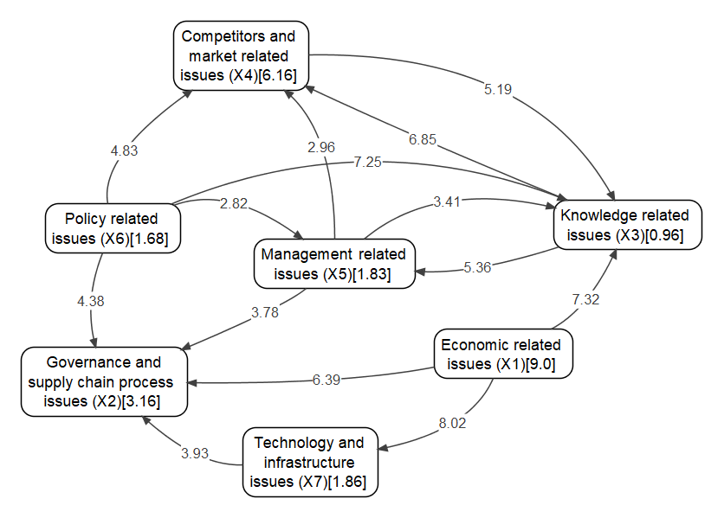
Figure 3. Map of the relations for the main barriers
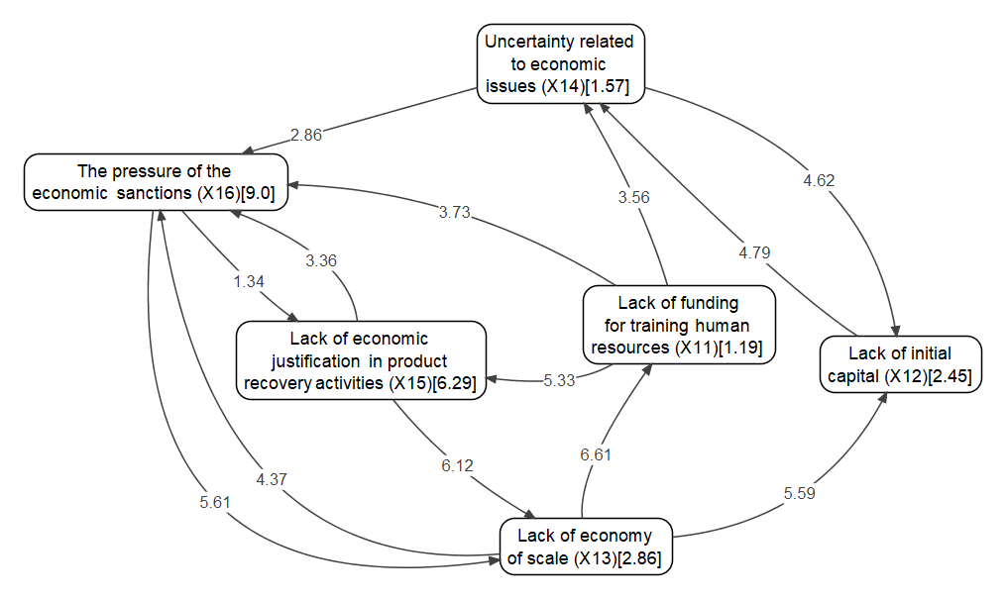
Figure 4. Map of the relations for the sub-barriers in the economic cluster
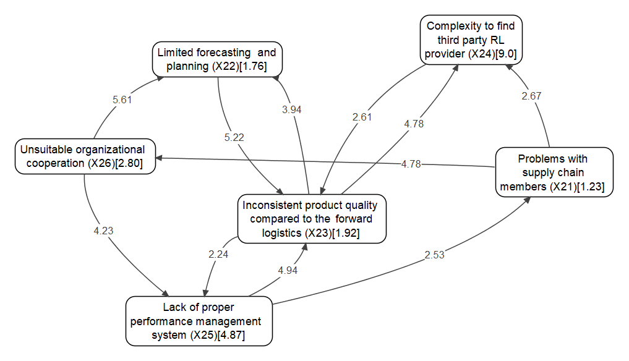
Figure 5. Map of the relations for the sub-barriers in the governance cluster

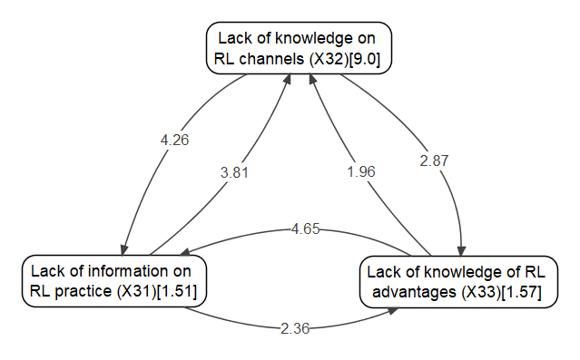
Figure 6. Map of the relations for the sub-barriers in the knowledge cluster

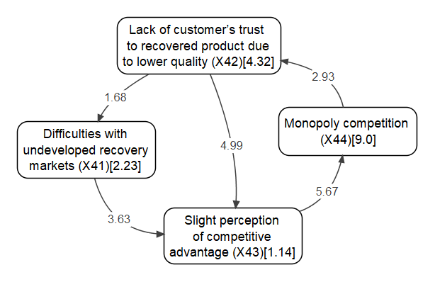
Figure 7. Map of the relations for the sub-barriers in the competitors cluster

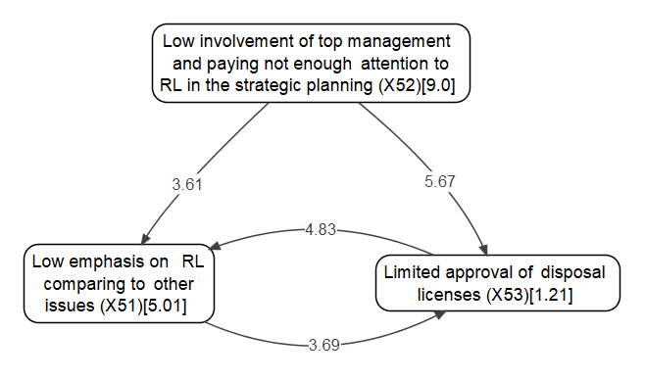
Figure 8. Map of the relations for the sub-barriers in the management cluster

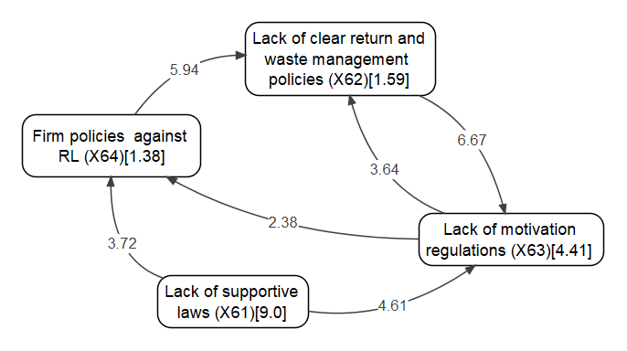
Figure 9. Map of the relations for the sub-barriers in the policy cluster

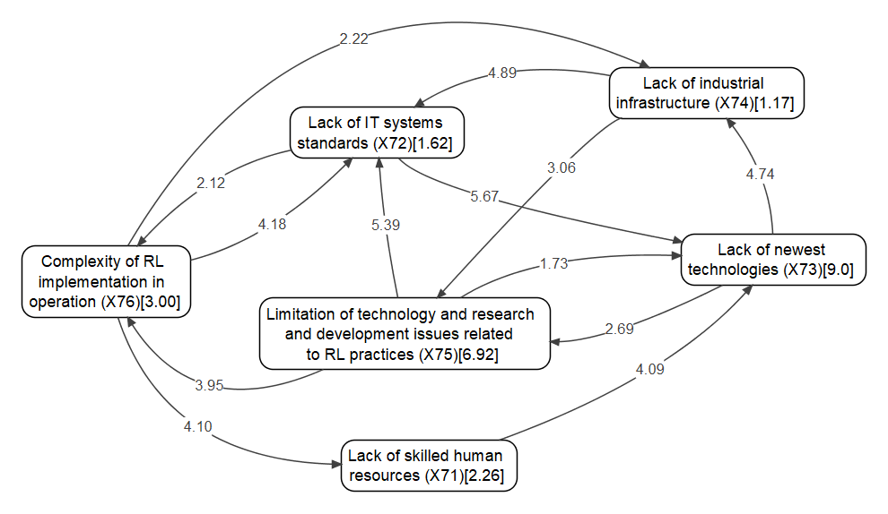
Figure 10. Map of the relations for the sub-barriers in the technology cluster

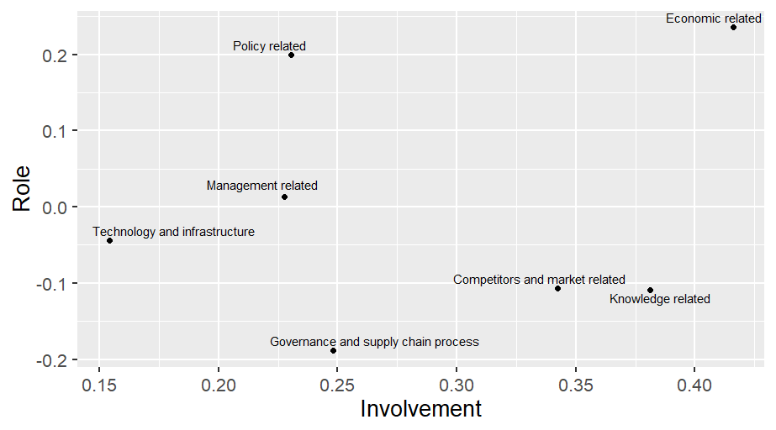
Figure 11. Relationship between role and involvement for the main barriers

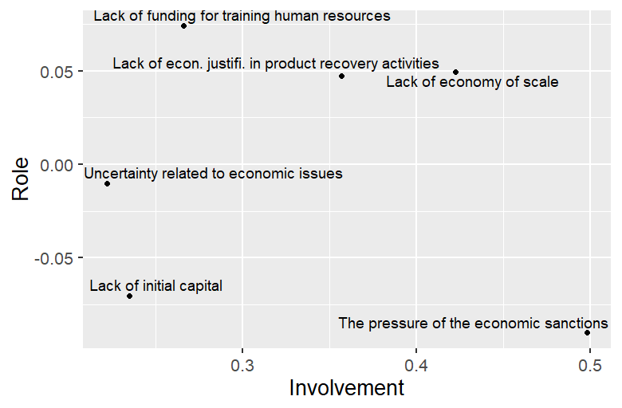
Figure 12. Relationship between role and involvement for the sub-barriers in the economic cluster

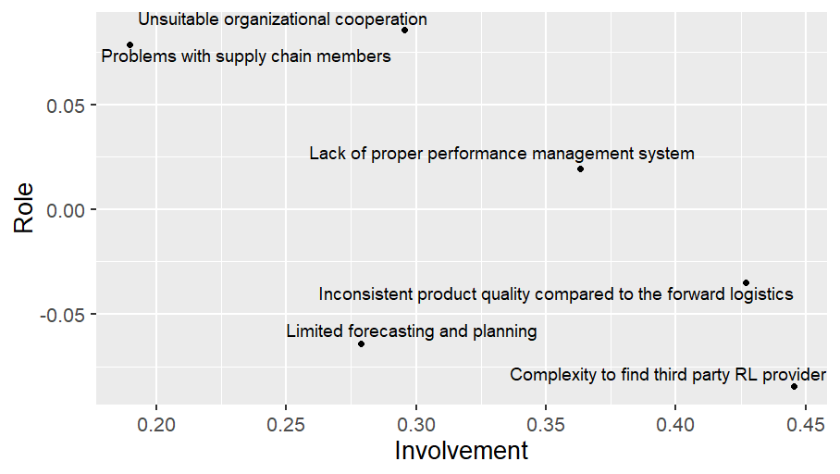
Figure 13. Relationship between role and involvement for the sub-barriers in the governance cluster

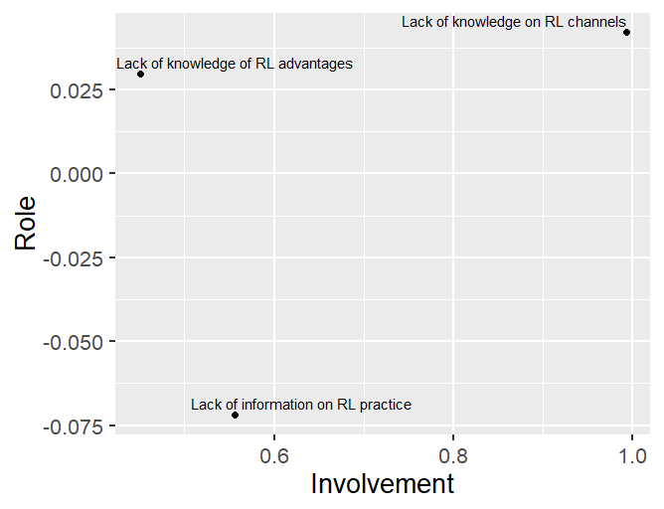
Figure 14. Relationship between role and involvement for the sub-barriers in the knowledge cluster

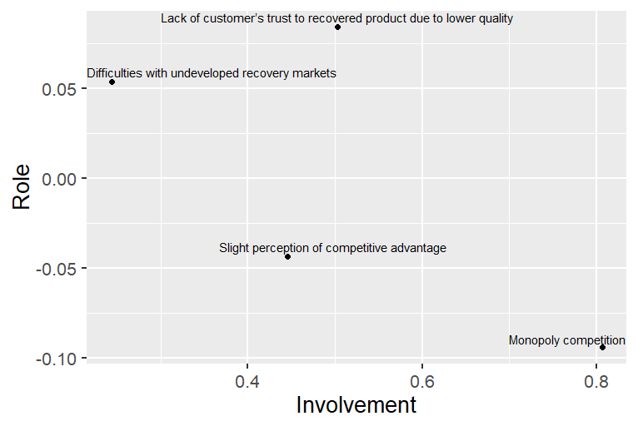
Figure 15. Relationship between role and involvement for the sub-barriers in the competitors cluster

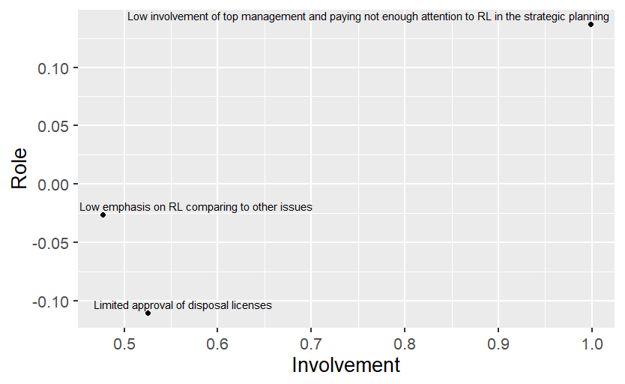
Figure 16. Relationship between role and involvement for the sub-barriers in the management cluster

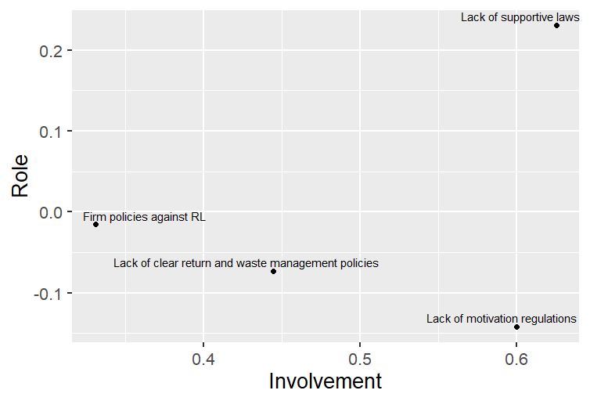
Figure 17. Relationship between role and involvement for the sub-barriers in the policy cluster

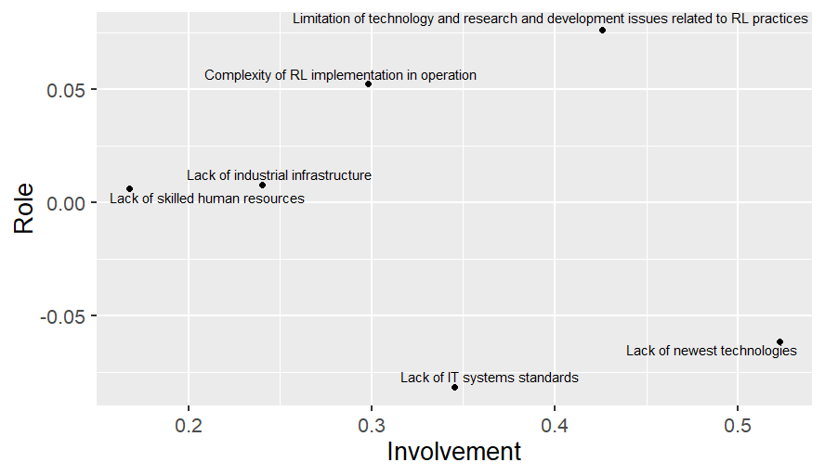
Figure 18. Relationship between role and involvement for the sub-barriers in the technology cluster

Table 1. RL implementation in major industries
Sector | Study
Automotive industry | Ravi & Shankar, 2005; Schultmann et al., 2006; González-Torre et al., 2010; Dhouib, 2014; Mathivathanan et al., 2018; Simic, 2015; Chakraborty et al., 2019; Schneider, 2010; Kuşakcı et al., 2019; Karagoz et al., 2020; Yang et al., 2019; Wang et al., 2020; D’Adamo et al., 2020; and Rosa & Terzi, 2018.
Construction industry | Nunes et al. (2009); Chileshe et al. (2016); Chileshe et al. (2018); Pushpamali, et al. (2019).
Pharmaceutical industry | Kumar et al. (2009); Narayana et al., (2014); Kongar et al., (2015); and Campos et al., (2017).
Electrical and electronics industry | Prakash & Barua (2015); Bouzon et al. (2016); Agrawal et al. (2016); Guarnieri et al. (2016); Caiado et al. (2017); Kumar & Dixit (2018); and Prajapati et al. (2019b).
Fashion industry | Abraham (2011) and Bouzon & Govindan (2015)
Plastic industry | Pohlen & Theodore Farris (1992) and Halabi et al. (2013).

Table 2. Summary of recent MCDM techniques applied to RL implementation
Author(s) | Analysis | Method
Ravi & Shankar (2005) | RL barriers | Interpretive Structural Modelling (ISM)
González‐Torre et al. (2010) | RL barriers | Structural Equation Model
Dhouib (2014) | Reverse manufacturing alternatives | Fuzzy MACBETH
Prakash & Barua (2015) | RL barriers | Fuzzy AHP and Fuzzy TOPSIS
Bouzon & Govindan (2015) | RL drivers | AHP
Agrawal et al. (2016) | RL critical success factors | Fuzzy TOPSIS
Luthra et al. (2017) | RL critical success factors | AHP
Prakash & Barua (2017) | RL barriers | fuzzy AHP and interpretative ranking process
Bouzon et al. (2018) | RL barriers | Grey-based DEMATEL
Sirisawat & Kiatcharoenpol (2018) | RL barriers | Fuzzy AHP and Fuzzy TOPSIS
Abbas (2018) | RL barriers | ISM
Waqas et al. (2018) | RL barriers | Structural equation modelling
Gardas et al. (2018) | RL barriers | ISM and MICMAC
Gardas et al. (2019) | RL critical success factors | TISM and MICMAC
Nakiboglu, G. (2019) | RL barriers | AHP
Prajapati et al. (2019b) | RL barriers | SWARA and WASPAS

Table 3. Internal and external RL barriers adopted from the literature
RL barriers | RL sub-barriers (Internal/External) |  | Reference
Economic-related barriers (X₁) | Lack of funding for training human resources (X₁₁) | Internal | Ravi & Shankar, 2005; González‐Torre et al., 2010; Ho et al., 2012; Subramoniam et al., 2013; Kannan et al., 2014; Abdulrahman et al., 2014; Prakash & Barua, 2015; Bouzon et al., 2015; Govindan & Bouzon, 2018; Nakiboglu, 2019; Lamba et al., 2019; and Schneider, 2010; Xiao et al., 2019; Wang et al., 2020.
 | Lack of initial capital (X₁₂) | Internal
 | Lack of economy of scale (X₁₃) | Internal
 | Uncertainty related to economic barriers (X₁₄) | Internal
 | Lack of economic justification in product recovery activities (X₁₅) | Internal
 | The pressure of the economic sanctions (X₁₆) | Internal
Governance and supply chain process barriers (X2) | Problems with supply chain members (X₂₁) | Internal | Ravi & Shankar, 2005; Govindan et al., 2013; Abdulrahman et al., 2014; Shaharudin et al., 2015; Bouzon et al., 2015; Govindan & Bouzon, 2018; and Lamba et al., 2019).
 | Limited forecasting and planning (X₂₂) | External
 | Inconsistent product quality compared to the forward logistics (X₂₃) | External
 | Complexity to find third-party RL provider (X₂₄) | Internal
 | Lack of proper performance management system (X₂₅) | Internal
Knowledge-related barriers (X₃) | Lack of information on RL practice (X₃₁) | Internal | Rahimifard et al., 2009; González‐Torre et al., 2010; Ho et al., 2012; Wiel et al., 2012; Subramoniam et al., 2013; Bouzon et al., 2015; Govindan & Bouzon, 2018; García-Sánchez et al., 2019; Chileshe et al., 2018; Kuşakcı et al., 2019; Simic, 2015; Chakraborty et al., 2019; and Prajapati et al., 2019a.
 | Lack of knowledge on RL channels (X₃₂) | External
 | Lack of knowledge of RL advantages (X₃₃) | Internal
 | Difficulties with undeveloped recovery markets (X₄₁) | Internal
Competitors- and market-related barriers (X₄) | Lack of customer’s trust in the recovered product due to lower quality (X₄₂) | External | Rahimifard et al., 2009; González‐Torre et al., 2010; Bouzon et al., 2015; Abraham, 2011; Shaharudin et al., 2015; Govindan & Bouzon, 2018; Paula et al., 2019; de Oliveira et al., 2019; and Orji, 2019.
 | Slight perception of competitive advantage (X₄₃) | External
 | Monopoly competition (X₄₄) | Internal
Management-related barriers (X₅) | Low emphasis on RL comparing to other barriers (X₅₁) | Internal | (Ravi & Shankar, 2005; Sarkis et al., 2010; González‐Torre et al., 2010; Abdulrahman et al., 2014; Chan et al., 2012; Govindan & Bouzon, 2018; Lara et al., 2019; Prajapati et al., 2019b; and Orj, 2019.
 | Low involvement of top management and paying not enough attention to RL in strategic planning (X₅₂) | Internal
 | Limited approval of disposal licenses (X₅₃) | Internal
Policy-related barriers (X₆) | Lack of supportive laws (X₆₁) | External | González‐Torre et al., 2010; Govindan et al., 2013; Krikke et al., 2013; Abdulrahman et al., 2014; Bouzon et al., 2015; Govindan & Bouzon, 2018; Lara et al., 2019; Singh & Sharma, 2019; Kuşakcı et al., 2019; Chakraborty et al., 2019; and Wang et al., 2020.
 | Lack of clear return and waste management policies (X₆₂) | External
 | Lack of motivation regulations (X₆₃) | External
 | Firm policies against RL (X₆₄) | External
 | Lack of skilled human resources (X₇₁) | Internal
 | Lack of IT systems standards (X₇₂) | External
Technology and infrastructure barriers (X₇) | Lack of newest technologies (X₇₃) | Internal | Ravi & Shankar, 2005; González‐Torre et al., 2010; Kapetanopoulou & Tagaras, 2011; Govindan et al., 2013; Bouzon et al., 2015; Shaharudin et al., 2015; Govindan & Bouzon, 2018; Nakiboglu, 2019; Lamba et al., 2019; Schneider, 2010; and Wang et al., 2020.
 | Lack of industrial infrastructure (X₇₄) | Internal
 | Limitation of technology and research and  development barriers related to RL practices (X₇₅) | External
 | Complexity of RL implementation in operation (X₇₆) | Internal
 | Lack of initial capital (X₁₂) | Internal/External

Table 4. Information about the Delphi phase of the study
Delphi round | Automotive industry experts | Academic researchers | Government experts | Response rate
First round (35) | 21 | 8 | 6 | 18 (52%)
Second Round (33) | 20 | 8 | 5 | 15 (46%)

Table 5. The first round of the Delphi study for identifying the barriers
Barrier | Sub-barrier | Average score | Accept/Reject
Economic-related barriers (X₁) | Lack of funding for training human resources (X₁₁) | 3.82 | Accept
 | Lack of initial capital (X₁₂) | 3.75 | Accept
 | Lack of economy of scale (X₁₃) | 2.10 | Reject
 | Uncertainty related to economic barriers (X₁₄) | 4.08 | Accept
 | Lack of economic justification in product recovery activities (X₁₅) | 4.46 | Accept
 | The pressure of the economic sanctions (X₁₆) | 3.76 | Accept
Governance and supply chain process barriers (X2) | Problems with supply chain members (X₂₁) | 3.68 | Accept
 | Limited forecasting and planning (X₂₂) | 3.83 | Accept
 | Inconsistent product quality compared to the forward logistics (X₂₃) | 3.66 | Accept
 | Complexity to find third-party RL provider (X₂₄) | 3.78 | Accept
 | Lack of proper performance management system (X₂₅) | 4.07 | Accept
 | Unsuitable organizational cooperation (X₂₆) | 3.65 | Accept
Knowledge-related barriers (X₃) | Lack of information on RL practice (X₃₁) | 3.79 | Accept
 | Lack of knowledge on RL channels (X₃₂) | 3.88 | Accept
 | Lack of knowledge of RL advantages (X₃₃) | 3.83 | Accept
 | Difficulties with undeveloped recovery markets (X₄₁) | 3.46 | Reject
Competitors- and market-related barriers (X₄) | Lack of customer’s trust in the recovered product due to lower quality (X₄₂) | 4.21 | Accept
 | Slight perception of competitive advantage (X₄₃) | 3.65 | Accept
 | Monopoly competition (X₄₄) | 3.71 | Accept
Management-related barriers (X₅) | Low emphasis on RL comparing to other barriers (X₅₁) | 4.07 | Accept
 | Low involvement of top management and paying not enough attention to RL in strategic planning (X₅₂) | 4.05 | Accept
 | Limited approval of disposal licenses (X₅₃) | 3.59 | Accept
Policy-related barriers (X₆) | Lack of supportive laws (X₆₁) | 4.15 | Accept
 | Lack of clear return and waste management policies (X₆₂) | 4.22 | Accept
 | Lack of motivation regulations (X₆₃) | 2.71 | Reject
 | Firm policies against RL (X₆₄) | 3.64 | Accept
 | Lack of skilled human resources (X₇₁) | 3.66 | Accept
 | Lack of IT systems standards (X₇₂) | 3.78 | Reject
Technology and infrastructure barriers (X₇) | Lack of newest technologies (X₇₃) | 3.62 | Accept
 | Lack of industrial infrastructure (X₇₄) | 3.93 | Accept
 | Limitation of technology and research and development barriers related to RL practices (X₇₅) | 4.32 | Accept
 | Complexity of RL implementation in operation (X₇₆) | 3.56 | Accept
 | Lack of funding for training human resources (X₁₁) | 3.64 | Accept
 | Lack of initial capital (X₁₂) | 3.77 | Accept

Table 6. Finalized barriers and sub-barriers to RL implementation after the second round of Delphi
Barrier | Sub-barrier | Reference
Economic-related barriers (X₁) | Lack of funding for training human resources (X₁₁) | Literature
 | Lack of initial capital (X₁₂) | Literature
 | Lack of economy of scale (X₁₃) | Literature
 | Uncertainty related to economic barriers (X₁₄) | Literature
 | Lack of economic justification in product recovery activities (X₁₅) | Literature
 | The pressure of the economic sanctions (X₁₆) | Expert opinion
Governance and supply chain process barriers (X2) | Problems with supply chain members (X₂₁) | Literature
 | Limited forecasting and planning (X₂₂) | Literature
 | Inconsistent product quality compared to the forward logistics (X₂₃) | Literature
 | Complexity to find third-party RL provider (X₂₄) | Literature
 | Lack of proper performance management system (X₂₅) | Literature
 | Unsuitable organizational cooperation (X₂₆) | Literature
Knowledge-related barriers (X₃) | Lack of information on RL practice (X₃₁) | Literature
 | Lack of knowledge on RL channels (X₃₂) | Literature
 | Lack of knowledge of RL advantages (X₃₃) | Literature
Competitors- and market-related barriers (X₄) | Difficulties with undeveloped recovery markets (X₄₁) | Literature
 | Lack of customer’s trust in the recovered product due to lower quality (X₄₂) | Literature
 | Slight perception of competitive advantage (X₄₃) | Literature
 | Monopoly competition (X₄₄) | Expert opinion
Management-related barriers (X₅) | Low emphasis on RL comparing to other barriers (X₅₁) | Literature
 | Low involvement of top management and paying not enough attention to RL in strategic planning (X₅₂) | Literature
 | Limited approval of disposal licenses (X₅₃) | Literature
Policy-related barriers (X₆) | Lack of supportive laws (X₆₁) | Literature
 | Lack of clear return and waste management policies (X₆₂) | Literature
 | Lack of motivation regulations (X₆₃) | Literature
 | Firm policies against RL (X₆₄) | Literature
Technology and infrastructure barriers (X₇) | Lack of skilled human resources (X₇₁) | Literature
 | Lack of IT systems standards (X₇₂) | Literature
 | Lack of newest technologies (X₇₃) | Literature
 | Lack of industrial infrastructure (X₇₄) | Literature
 | Limitation of technology and research and development barriers related to RL practices (X₇₅) | Literature
 | The complexity of RL implementation in operation (X₇₆) | Literature

Table 7. Final weights of the barriers and their respective sub-barriers
Barrier | Weight | Sub-barrier | Local weights | Local  rank | Final  weights | Final  rank
Economic-related barriers (X₁) | 0.365 | Lack of funding for training human resources (X₁₁) | 0.051 | 6 | 0.019 | 17
 |  | Lack of initial capital (X₁₂) | 0.105 | 4 | 0.038 | 8
 |  | Lack of economy of scale (X₁₃) | 0.123 | 3 | 0.045 | 6
 |  | Uncertainty related to economic barriers (X₁₄) | 0.067 | 5 | 0.025 | 14
 |  | Lack of economic justification in product recovery activities (X₁₅) | 0.269 | 2 | 0.098 | 3
 |  | The pressure of the economic sanctions (X₁₆) | 0.385 | 1 | 0.141 | 1
Governance and supply chain process barriers (X₂) | 0.128 | Problems with supply chain members (X₂₁) | 0.057 | 6 | 0.007 | 24
 |  | Limited forecasting and planning (X₂₂) | 0.082 | 5 | 0.010 | 22
 |  | Inconsistent product quality compared to the forward logistics (X₂₃) | 0.089 | 4 | 0.011 | 21
 |  | Complexity to find third party RL provider (X₂₄) | 0.417 | 1 | 0.053 | 5
 |  | Lack of proper performance management system (X₂₅) | 0.226 | 2 | 0.029 | 12
 |  | Unsuitable organizational cooperation (X₂₆) | 0.130 | 3 | 0.017 | 20
Knowledge-related barriers (X₃) | 0.039 | Lack of information on RL practice (X₃₁) | 0.125 | 3 | 0.005 | 31
 |  | Lack of knowledge on RL channels (X₃₂) | 0.745 | 1 | 0.029 | 11
 |  | Lack of knowledge of RL advantages (X₃₃) | 0.130 | 2 | 0.005 | 29
Competitors- and market-related barriers (X₄) | 0.250 | Difficulties with undeveloped recovery markets (X₄₁) | 0.134 | 3 | 0.033 | 10
 |  | Lack of customer’s trust in the recovered product due to lower quality (X₄₂) | 0.259 | 2 | 0.065 | 4
 |  | Slight perception of competitive advantage (X₄₃) | 0.068 | 4 | 0.017 | 19
 |  | Monopoly competition (X₄₄) | 0.539 | 1 | 0.135 | 2
Management-related barriers (X₅) | 0.074 | Low emphasis on RL comparing to other barriers (X₅₁) | 0.329 | 2 | 0.024 | 15
 |  | Low involvement of top management and paying not enough attention to RL in strategic planning (X₅₂) | 0.591 | 1 | 0.044 | 7
 |  | Limited approval of disposal licenses (X₅₃) | 0.079 | 3 | 0.006 | 27
Policy-related barriers (X₆) | 0.068 | Lack of supportive laws (X₆₁) | 0.549 | 1 | 0.037 | 9
 |  | Lack of clear return and waste management policies (X₆₂) | 0.097 | 3 | 0.007 | 26
 |  | Lack of motivation regulations (X₆₃) | 0.269 | 2 | 0.018 | 18
 |  | Firm policies against RL (X₆₄) | 0.084 | 4 | 0.006 | 28
Technology and infrastructure barriers (X₇) | 0.076 | Lack of skilled human resources (X₇₁) | 0.094 | 4 | 0.007 | 25
 |  | Lack of IT systems standards (X₇₂) | 0.067 | 5 | 0.005 | 30
 |  | Lack of newest technologies (X₇₃) | 0.376 | 1 | 0.028 | 13
 |  | Lack of industrial infrastructure (X₇₄) | 0.049 | 6 | 0.004 | 32
 |  | Limitation of technology and research and development barriers related to RL practices (X₇₅) | 0.289 | 2 | 0.022 | 16
 |  | Complexity of RL implementation in operation (X₇₆) | 0.125 | 3 | 0.009 | 23

