**The young people from Plus One, working in collaboration with The Paper Birds Theatre Company, present**

**‘My Space’**

Where are you warm? Where are you safe? Where is your space?

‘My Space’ has been a collaboration between a range of young people and aspiring artists living in the Derby area, with theatre company The Paper Birds, who are recognised as UK leaders in verbatim theatre. This and our humanity, radicalism and boldness are the hallmarks of our work.

‘My Space’ has been co-created with these young artists from the Plus One scheme, who are all looked after young people or care leavers, and who meet regularly at Derby Theatre. Together we have made an original, powerful piece of theatre, asking questions and challenging perceptions about notions of home, social class, ownership, belonging and fairness. The performance is made up of a number of different scenes exploring these ideas from different people’s perspectives and lived experiences: both the young people’s own and those of other key figureheads in Derby, who they interviewed during the course of project.

The performance has been inspired by these interviews and also by the various artforms the young adults like to work with, from poetry, to songwriting, to acting. The soundscape you can hear playing in the S.H.E.D is a mix of all of this work the young people have done.

We invite the people of Derby to come have your voices heard, tell us how you feel about Derby and take up your SPACE.

In addition to the young artists’ live performances in the S.H.E.D, audiences can also go the ‘Listening Pod’ to hear the interviews the young people led with local Derby community leaders and celebrities; watch a film and music video of the young people performing in the ‘Film Pod’; and go to the ‘VR Pod’ to enjoy an experience created especially for them by Curious Monkey Theatre Company.

**About The Paper Birds**

The Paper Birds is a nationally significant, devising theatre company, with a social and political agenda. We’re artists, investigators, entrepreneurs, educators. We pride ourselves on taking complex, multi-faceted and polemical subjects and making them accessible. We have an artistic programme and a creative learning programme and nurture both equally.

We are story collectors and spend time in communities, listening to personal experiences. As UK leaders in verbatim theatre, the words of the people we meet form the backbone of our shows, giving voice to the voiceless, painting powerful and very human alternative social commentaries.

We want our work to be full of other voices, ordinary people sharing their extraordinary stories, in their words, in their accents, because individually those people matter and collectively they make up our world.

**Credits**

Lead Artists for The Paper Birds on ‘My Space’: Shona Cowie and Georgie Coles

Project Management for Derby Theatre: Alix Manning – Jones and Katie Turner

Musician: Zeo Zeonardo

Project Adviser: Professor Alex Nunn

Outside eyes and further directing from The Paper Birds’ Co-Directors: Jemma McDonnell and Kylie Perry.

Producer for ‘My Space’: Charlotte Kalantari-Gregory

Soundscape editing: The Media Workshop

[www.thepaperbirds.com](http://www.thepaperbirds.com)

**Listening Pod Interviews**

1 – Interview with Premier Inn Director of Public Health

2 - Interview with Baby J of Baby People Studios

[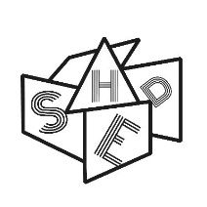](https://pbs.twimg.com/profile_images/1148249465125560320/swNrixmY_400x400.jpg)[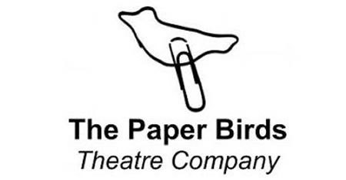](https://www.google.co.uk/url?sa=i&rct=j&q=&esrc=s&source=images&cd=&ved=2ahUKEwiom7z8oq3jAhUn1eAKHR4XATUQjRx6BAgBEAU&url=https%3A%2F%2Fwww.mggs.org%2Flatest-news%2Fthe-paper-birds-theatre-company&psig=AOvVaw0CJYcaJY8wjaBbXfKO-t1h&ust=1562948486590259)3 – Interview Derby University

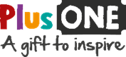4 – Interview with Derby Football Club

**#SHED on Tour**

You can next see S.H.E.D at In Good Company’s Departure Lounge Festival at Derby Theatre on 18th – 20th July 2019. S.H.E.D is Departure Lounge’s intriguing outdoor performance destination. During the festival S.H.E.D will change in configuration and format, to support a diverse range of performance and film works.

Departure Lounge is the arts festival for ground-breaking work in the heart of the country. Every corner of Derby Theatre and beyond will be brought to life by extraordinary performances, workshops and discussion.

@Shed_uk

#shedding

#shed.