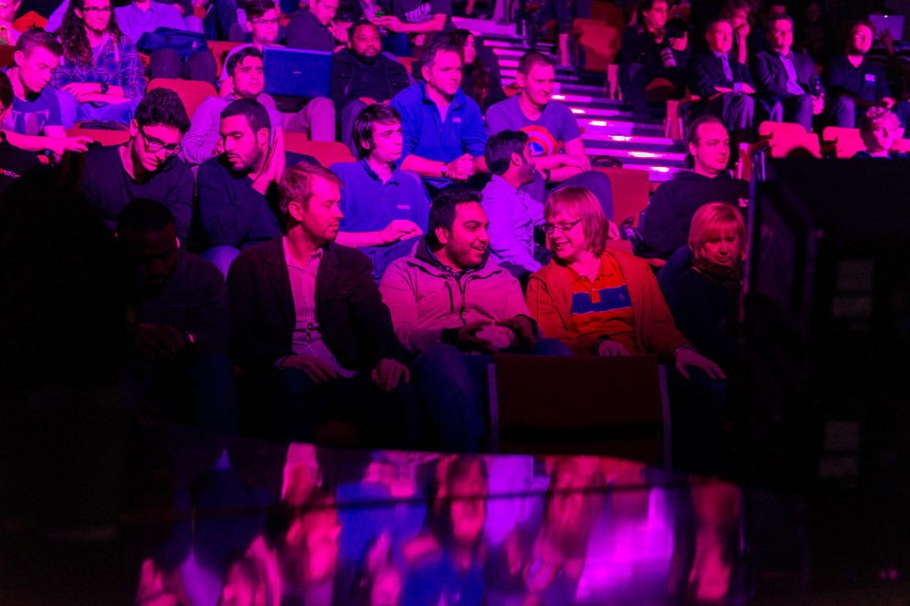

**University of Derby Annual Inclusion Conference**

**3 June 2024**

**Cultural Intelligence: Crossing Boundaries Across Communities**

This year’s conference is focused on Cultural Intelligence (CQ). We will explore how we use cultural intelligence to cross boundaries and engage with communities. We will discover how cultural intelligence enables us to interact in unfamiliar settings with confidence and assurance, recognising cultural differences and assisting us to adapt our behaviour to others.

At the same time, we will be considering how the evolving nature of communication and information technology may provoke or challenge perceptions of CQ. The increasing prevalence of artificial intelligence (AI) and an often-perceived conflict of interests between inclusion and freedom of speech may challenge us to reconsider how we define our own boundaries.

When we enhance our CQ we take a journey of self-reflection that involves understanding why someone responds the way they do and learning how to be a better leader. Loren Rosario-Maldonado (2023) citing Edward T Hall (1977) describes culture like an iceberg. The surface 10% exposes only the visible nature of what culture is and what it is that stirs emotions. Hidden beneath is why culture is like it is, revealing the shapes of reality and the triggers of deeper reactions.

Today, we hope to enrich your CQ, present an insight and thought-provoking day and provide you with networking opportunities.

**Today’s Programme**

|  |  |  |
| --- | --- | --- |
| 9.00am | Registration |  |
| 9.20am | Introduction | **Dr Jo Bishton** |
| 9.25am | Opening | **Vice-Chancellor Professor Kathryn Mitchell, CBE DL** |
| 9.40am | Keynote + Q&A | **Theresa Peltier, DL:** Unity in Community |
| 10.20am | Panel + Q&A: Cultural Intelligence and Diversity | **Dr Rhiannon Jones:** ‘Participatory culture, creative dialogue, and civic practice.’  **Tracy Harrison:** ‘Transforming young lives – overcoming barriers to support those affected by child exploitation.’  **Ruchita Shaikh, DL**: ‘invisible barriers and boundaries of the cultural landscapes.’  **Ameia Jones:** ‘Football as a driving force for inclusion.’ |
| 11.10am | CQ Workshop | Cultural Intelligence and Religion: **Adam Dickens and Dr Ali Akbar** |
| 12.00pm | Lunch |  |
| 12.45pm | Welcome back | **Dr Jo Bishton** |
| 12.50pm | Keynote + Q&A | **Ben Veasey:** Cultural Intelligence as an Enabler of Knowledge Capital. |
| 13.30pm | Panel + Q&A: Cultural Intelligence and Freedoms | **James Fussell:** 'Higher Education (Freedom of Speech) Act 2023 - A New Landscape'  **Oliver Davy:** ‘The Generative Capacity of Artificial Intelligence.’  **Dr Jo Bishton:** ‘Diving with Inclusion.’ |
| 14.10pm | Break |  |
| 14.25pm | Keynote + Q&A | **Mark Hamilton:** ‘Workplace Culture and Psychological Safety’ |
| 14.55pm | CQ Workshop | Cultural Intelligence and Neurodiversity Awareness **Melanie Francis** |
| 15.45pm | Closing Comments | **PVC Dean Professor Kamil Omoteso** |

**About Today’s Presenters**

**Dr Ali Akbar**

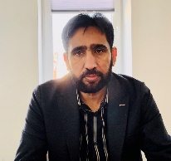 Dr Ali Akbar holds a PhD in teaching the critical interpretation of scriptures and serves as a Muslim chaplain and lecturer in social and community studies at the University of Derby. His research focuses on exploring the intersectionality between faith, belief, and disability. Dr. Akbar is dedicated to promoting inclusive education and has developed curriculum for Muslim places of worship to support diversity and accessibility. His work reflects a commitment to advancing understanding and inclusion within religious communities.

**Dr Jo Bishton**

Dr Jo Bishton is Head of Equity, Inclusion and Wellbeing at the University of Derby and has responsibility for the strategic and operational direction and delivery of Inclusion across the University. Jo has a PhD in gender studies is published in the fields of Queer Theory and Feminism and has taught and presented in the areas of cultural representations of marginalised lived experience, women’s rights, and black civil rights. In her role, Jo has a keen interest on the interplay between inclusion and wellbeing, presenting to the Society of Occupational Medicine and in 2023 was awarded Best Health and Wellbeing Initiative by the University Safety and Health Association for the introduction of the University’s Wellbeing Framework. Jo is passionate about talking about menstrual health in the workplace and has participated in a ministerial roundtable on Menopause.

Jo is a trustee of the Multi Faith Centre at the University and Chair of the HR sub-group. In her work on faith friendly workplaces, Jo has contributed to two reports and presented at an All-Party Parliamentary Group on Faith in the Workplace, launched at the House of Lords. <https://www.linkedin.com/in/dr-joanne-bishton-73644125/?originalSubdomain=uk>

**Oliver Davy**

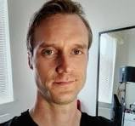Oliver Davy is the Chief Digital Officer at the University of Derby and has responsibility for the strategic development and delivery of the University’s technology Architecture. Oliver has worked in the higher education sector for several years and held corporate IT leadership roles that include the financial services.

Oliver’s areas of interest include the generative capacity of artificial intelligence and what this means for the workplace and society more broadly.

**Adam Dickens**

Adam Dickens is the Anglican Chaplain and Pastoral Services Co-ordinator at the University of Derby and has been co-ordinating the team of Chaplains and Faith Consultants since April 2014. It is a role he combines with his work as Chaplain at Derby Cathedral. Prior to arriving in the East Midlands, he was a member of and latterly Warden of The Pilsdon Community in Dorset, which offers hospitality to those who need refuge at a crisis point in their life. He has also worked in parishes in inner-city Portsmouth and Worcestershire. His decision to work in the world of higher education represents a reluctance to stop being a student, having studied in Manchester, Nottingham, and London.

**Melanie Francis**

Melanie Francis is the founder of Neuroinclusive HR and Director of Neurodiversity at Work at Do-IT Solutions. Mel is a Charter Fellow of CIPD and an accomplished HR Director with a specialism in neurodiversity in the work setting.  
  
Mel has lived with neurodiversity for the past 16 years and has dedicated her career to helping to increase awareness of the brilliance of our neurodiverse brains and how these can make such a difference to organisations. It's fascinating! Everything Mel has learned about neurodiversity has challenged her traditional HR learning, and she applies the same principles in passing this on to others.  
  
Through Neurodiversity at Work at Do-IT Solutions, Mel delivers Neurodiversity Training and Consultancy to a wide variety of clients, who are at varying points on their journey to neuro-inclusion. Mel says, ‘wherever you are in your journey, I'd love to hear from you and to chat all things ND over a virtual coffee.’ <https://www.linkedin.com/in/melaniefrancis1/>

**James Fussell**

James Fussell has been at the University of Derby since 2018 and leads Legal, Governance, Executive and Assurance Services. He qualified as a solicitor in 2008 and has worked in private practice and more recently at a national retailer in an in-house role. James has a particular interest in the legal and regulatory landscape of the HE world.

**Mark Hamilton**

Mark Hamilton is the Director of Talent, Culture and Inclusion at the University of Derby. His passion is driving organisational performance and effectiveness through creating a positive and engaging people experience in cultures where people have purpose, place and belonging. Mark’s career has played out in global roles in corporate, consultancy, academic and business start-up settings based in Asia, Africa, the Middle East and the UK. The international experience has stood him in good stead in complex as well as complicated environments built on diversity of thought and culture and particularly in environments where thought leadership and influence are valued.

Mark describes himself as Scottish by birth, South African raised and matured in Asia and possibly culturally confused! The exposure to different cultures and perspectives on life feeds Mark’s fascination with what makes people tick and what cultural conditions facilitate inclusion while also respecting difference – an endless learning place. Mark believes that a core condition for all healthy workplace cultures is a sense of psychological safety to enable both human potential and the freedom to be fearlessly who we are.

**Tracy Harrison**

Tracy Harrison is a former police Superintendent and, in 2019, was appointed CEO of Derby charity Safe and Sound which protects and supports young people and their families whose lives are affected by child exploitation. Tracy’s drive and passion for improving services has transformed the charity which is widely valued for its vital work in local communities across Derbyshire.

Tracy has received numerous awards for her work in the third sector, including; named as rising star in the Director of the Year award category at the East Midlands Charity awards in 2020, lifetime achievement award Derbyshire live heroes award in December 2020, finalist in the leadership category of the national [Women Who Awards in 2022](https://www.womanwho.co.uk/woman-who-achieves-awards/2022-finalists-winners/) and finalist at the East midlands Leadership Awards as a Public and Third Sector Leader.

Tracy says that in 2023 she was ‘overwhelmed’ to receive an honorary master’s degree from the University of Derby for her work with young people in the community. <https://www.safeandsoundgroup.org.uk/>

**Amelia Jones**

Amelia Jones recently graduated from the University of Sussex last and works as Equality, Diversity and Inclusion lead for Derby County Community Trust and Football Club. Amelia is a strong advocate for the power and presence of sport and believes that football brings people from many different walks of life together. Amelia says that when done correctly, ‘football can be a real driving force for inclusion and togetherness.’

**Dr Rhiannon Jones**

Dr Rhiannon Jones (FRSA) is Associate Professor (Civic Practice), Head of Civic at the University of Derby and runs CivicLAB an Institution-wide centre on participatory culture, creative dialogue, and civic practice. She founded the CIC, Designing Dialogue (S.H.E.D) in 2019 a public arts, touring and innovation space which has received several national honours and funding from partners such as Design Council, UK, CHEAD, Arts Council England, RSA and local trusts and councils.

Rhiannon is involved with many national and international bodies, including Chair of the International Contemporary Working Art Group for Cumulus, the only Global Association in Art and Design, a member of the National Coordinating Centre for Public Engagement, Trustee of New Art Exchange, a ground-breaking, Global Majority, NPO for Arts Council England and an award-winning and internationally recognised Gallery, working with the Council for Higher Education in Art and Design, British Academy and Design Council UK and her research into placemaking is a case study for the National Centre for Academic and Cultural Exchange and presented at the All-Party Parliamentary Design and Innovation Group.

The recipient of numerous accolades and awards, Rhiannon is a published academic author with Intellect, Taylor and Francis and Routledge; most recently a chapter with Intellect Books (2024) and one with Council for Higher Education in Art and Design on Women in Leadership (2024). and frequently provides keynotes Nationally and Internationally within the Creative and Cultural Industry Sector. [www.weareshed.co.uk](http://www.weareshed.co.uk) [www.linkedin.com/in/dr-rhiannon-jones-frsa-a15047258](http://www.linkedin.com/in/dr-rhiannon-jones-frsa-a15047258) <https://www.derby.ac.uk/civic/>

**Theresa Peltier DL**

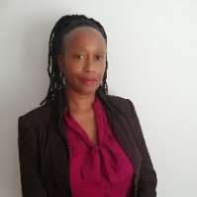Theresa Peltier DL retired as Head of Equality from Derbyshire Police in 2019 after a 27-year policing career across three police forces. She was Chair of the Derbyshire Black Police Association and is a previous Vice-President of the National Black Police Association.

A strong advocate of social justice, fairness and inclusion, Theresa is the recipient of numerous national and local awards, holding positions on various Boards, is Vice-Chair on adoption and fostering panels and the Patron of Friends of Foston Hall.

Theresa was appointed High Sheriff of Derbyshire in 2023, attending just over 370 engagements with her theme of Unity Is Community. In January 2024 she was appointed as a Deputy Lieutenant by His Majesty’s Lord Lieutenant of Derbyshire Elizabeth Fothergill CBE.

**Ruchika Shaikh DL**

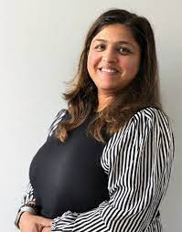 Ruchita Shaikh DL is the CEO of Artcore, an international centre for contemporary art delivering a vibrant programme of cultural and creative activities for Artists and the community.

Ruchita holds a range of leadership roles, shaping diversity and impact in the art, health and community sectors and works with community leaders, practitioners and individuals in under-represented communities enabling access, involvement and participation in arts and local development agenda. She is appointed Deputy Lieutenant of Derbyshire.

Ruchita is passionate about increasing cultural representation for ethnically diverse and under-represented groups in our communities, creating opportunities for influence, growth, learning and participation. As an ethnically diverse female, Ruchita is relatable to the communities Artcore serves, understanding the invisible barriers and boundaries of the cultural landscapes and the challenges within them. In her role at Artcore, Ruchita influences stakeholders to generate change, insight, understanding and commitment to improve opportunities for all. [www.artcoreuk.com](http://www.artcoreuk.com/)

**Benjamin Veasey**

Ben Veasey is the University of Derby's first ever University Librarian and has responsibility for the strategic and operational direction of library services across the institution. Through his role, Ben also leads cross-institutional work focussed on helping students to develop industry-relevant skills. Prior to Joining the University of Derby, Ben held roles at Loughborough University, the University of Nottingham, Nottingham Trent University, and the University of Warwick.

Ben's areas of interest include leadership & culture, human-centred design & inclusion as well as the critical role academic libraries play in education and research.

Photo by [SIMON LEE](https://unsplash.com/@simonppt?utm_content=creditCopyText&utm_medium=referral&utm_source=unsplash) on [Unsplash](https://unsplash.com/photos/a-large-iceberg-floating-in-the-water-qjs2R1lMMcw?utm_content=creditCopyText&utm_medium=referral&utm_source=unsplash)