Consumption and material culture of poverty in early-modern Europe, c.1450-1800
Joseph Harley, University of Derby, j.harley@derby.ac.uk

A number of factors have been used to assess and classify poverty, such as income, the ability to pay taxes, family background and being in receipt of state benefits or charity. Perhaps the most visual and contentious measurement is material wealth and consumption. Even today, in an age when smartphones, televisions, holidays and clothing can be bought relatively cheaply, the issue causes controversy and many people have been ostracised for owning anything beyond basic necessities. Some commentators, for instance, recently looked on in shock and disgust as Syrian refugees entered Europe with smartphones, clearly missing the point that handsets are ubiquitous, indispensable for navigation and communication, and that most of the refugees until recently were settled with regular incomes. Similar examples can be traced through history. Numerous social commentators argued that the poor were consuming too many unnecessary goods during the eighteenth century, leading to immorality and familial and national ruin. Tea was purchased by poorer households in greater amounts over the period and this was often portrayed in a very negative manner by writers. Poor women were depicted as trying to copy their social superiors, often to the detriment of their husbands and children. In 1745 Simon Mason argued that:
Wives are regaling with their Tea... These poor Creatures, to be fashionable and imitate their Superiors, are neglecting their Spinning, Knitting, &c. spending what their Husbands are labouring hard for; their Children are in Rags, gnawing a brown Crust, while these Gossips are canvassing over the Affairs of the whole Town, making free with the good Name and Reputation of their Superiors... And by these Meetings much Gossiping, Lying, Backbiting, is broached and carried on, and proves often destructive to others more sober and industrious.
Just over a decade after this, Jonas Hanway claimed that drinking tea adversely affected mothers’ and wet nurses’ milk, harming the young and creating a future weak military in the process. Meanwhile husbands were apparently becoming emasculated as their wives wasted household incomes on tea and used speech, in which they were well versed from with idle chat at the tea table, to tame and manipulate their partners.
Clearly, consumption and poverty has been a contentious issue for centuries and there are a number of misconceptions about the complexities of the material nature of hardship. This chapter seeks to trace some of these changes in material life in Europe from c.1450 to 1800. It starts by examining some (but by no means all) of the key concepts used by scholars to study the poorer sorts, before discussing their material lives in England and then in wider Europe. The consumption of household goods, clothing, food and drink is the focus, meaning that other aspects including leisure, domestic working items and the physical structures of homes are only discussed briefly. It is argued that despite widespread poverty across Europe, the poor acquired a greater range and quantity of items over the early modern period. From new foods, to more comfortable furniture, to fashionable clothing, to new ‘luxuries’ of the seventeenth and eighteenth centuries, there were considerable changes which transformed the daily lives of people and helped to fundamentally alter what it meant to be ‘poor’. Historians are only beginning to scratch the surface and there is vast potential for new work on consumption and the material state of poverty.
Key ideas and theories
The study of consumption and material culture has become a bedrock of European history in recent decades. We now have a nuanced understanding of the distribution of goods from around the world and of the impact that they had on the daily lives and rites of populations. A number of theories have been proposed to explain how and why myriad people increasingly engaged with new markets and bought novel items. In 1982 Neil McKendrick famously argued that the third quarter of the eighteenth century witnessed a ‘consumer revolution’, which led to Britain becoming the world’s first ‘consumer society’. In an ‘orgy of spending’, McKendrick surmised, the ‘rich, of course, led the way’, and ‘[s]purred on by social emulation and class competition’ the middling sort followed by acquiring more items such as pottery, textiles and metal goods. This spending was ‘unprecedented in the depth to which it penetrated the lower reaches of society’, as the working class had ‘greater personal choice and a greater opportunity to follow their own tastes’. They ‘bought not only necessities, but decencies, and even luxuries’. The book led to huge volumes of research in which academics tried to find the birth of consumer societies earlier or elsewhere, including thirteenth-century England, Renaissance Italy, seventeenth-century Netherlands and Russia in the eighteenth century. Others have adapted the concept to claim that there were alternative revolutions during the early modern period. Maxine Berg argued that the eighteenth century witnessed a ‘product revolution’ as the middling sort increasingly bought new ‘luxury’ goods. Others have focused on the growing ownership of items such as upholstered furniture, window curtains and feather beds to argue that there was a ‘comfort revolution’.
There were certainly major changes in consumption during the eighteenth century and without the initial idea of a ‘consumer society’ or ‘revolution’, the topic would probably not be as important, diverse and interesting as it is today. However, the concept’s flaws are numerous and many academics now avoid framing their work around McKendrick’s terminology. Even one of the contributors to McKendrick’s ground-breaking volume, John Brewer, put the historiographical founding of various consumer societies down to ‘a mixture of national pride and field chauvinism’ and has been at pains to highlight many more ‘errors’ in the literature. The concept was used by some historians almost as if its definition is self-evident, and has been used to mean anything from the buying of goods, to shopping, advertising, or mass production. In fact, the term ‘consumer society’ was first coined in post-war America and used by proponents to emphasise the benefits of capitalism over communism; a far cry from the apparent consumer societies in England during the third quarter of the eighteenth century or Renaissance Italy. The concept has been used to teleologically explain the growth of ‘modernity’, meaning that more ‘traditional’ aspects of consumption such as barter, pawnbroking and charity have been bypassed by some writers. This is particularly unfortunate for the purposes of this chapter, as these facets would have been especially important among those with limited incomes. Consumption is complex and affects everybody differently based on a multitude of factors. It can entail washing, travel or leisure activities, as well as stereotypical visions of buying the latest products and shopping. Therefore, different segments of the population, including the poor, should be assessed with a clearer understanding of the underlying meanings and uses behind the items exchanged, instead of generalising one factor above another in making or sustaining a consumer ‘society’ or ‘revolution’.
Central to McKendrick’s ‘consumer revolution’ are ideas of emulation, conspicuous consumption and ‘trickle down’ theory developed by Thorstein Veblen, Georg Simmel and others. The concepts categorise the wealthy as leaders of consumption who want to show off and protect their wealth and status, while the middling sort and poor continually try to catch up and imitate their social superiors. Women, according to McKendrick, were at the forefront of this game of imitation, with ‘the mill girl who wanted to dress like a duchess’. Contemporaries also often put the poor’s desire to consume new products down to women’s apparent inability to resist new goods. In Fable of the Bees Bernard Mandeville argued that the ‘poorest labourer’s wife… who scorns to wear a strong wholesome frize… will starve herself and her husband to purchase a second hand gown and petticoat… because forsooth it is more genteel’. In 1727 Daniel Defoe applied the idea to all of society: ‘the poorest Citizens strive to live like the Rich, the Rich like the Gentry, the Gentry like the Nobility and the Nobility striving to outshine one another’. It is now more usual for scholars to use ideas related to emulation and conspicuous consumption more carefully and selectively. People had individual choices and personal preferences which are not reliably taken into account in these models. In Switzerland markers of conspicuous consumption are even viewed as ‘vulgar’ among many today. Most individuals only had very limited contact with the elite and simply would not know what they wore and how they furnished their abodes. The poor could also be ‘involuntary’ consumers and have little choice in the items that they owned. Servants, for example, were given uniforms and sometimes cast-off clothing from their masters. Paupers were granted clothing from authorities in charge. Early-modern society is too complex for consumption habits to simply trickle down, and it is important to note that the process can be reversed with customs trickling up. The wealthy increasingly dressed in simpler and plainer clothing in Britain during the eighteenth century, which somewhat mirrored plebeian ways of dressing. Some of the country’s most notable nobles even attended the House of Lords dressed like farmers and graziers at the end of the century.
The study of objects (material culture) was developed by archaeologists and social anthropologists during the second quarter of the twentieth century. It has since become a popular approach taken by historians. There is no universal methodology for how one approaches objects, but advocates tend to take an item or a series of articles and use them to interpret the meanings, uses and importance of those things to people. Objects from the ephemeral to the grandiose are seen to have agency and thus the ability to inform our understanding of past societies and an unquantifiable range of other themes. Studying a single item of clothing, for example, can tell us about identity, warmth, fashion, cost, gender, the senses, emotions, work, trade, social status, sumptuary legislation, manufacture and industry. As Karen Harvey argues, ‘historians are not much interested in things or their thingness for their own sake, but as routes to past experiences’. Owing to the fact that mostly only objects of value, adornment and beauty have tended to have survived to the present day, research on the poor’s material culture is underdeveloped. Some strides have been made in this area following historians’ use of archaeological remains and extant garments, as well as through more creative reading of documentary sources (explored below), yet more is still needed.
Perhaps the most important idea to explain early-modern changes in consumption is the ‘industrious revolution’ developed by Jan de Vries, who argued that households consumed more items during the early modern period owing to changes at the level of the household. In sum, he asserted that households in north-western Europe laboured more intensely in market-orientated lines of work during the long eighteenth century (c.1650-1850), to gather more money which could be used to purchase new consumer goods. Households apparently worked less in domestic production for personal consumption and became more specialised by focusing on wage labour, agriculture, proto-industrial production (such as domestic textile manufacture) or commercial service. The theory is particularly appealing to historians as it allows researchers to analyse society holistically and helps to theorise how and why the poorer sorts consumed more items during the early modern period despite having limited resources. However, it remains to be seen whether the theory holds up to empirical scrutiny. On the one hand, studies such as those of Hans-Joachim Voth show that the length of people’s working year increased by around 23 per cent in London and the north of England between 1760 and 1830. Craig Muldrew argued that English agricultural labourers were consuming more goods during the early modern period and became more industrious, principally through better diets which allowed them to work harder. In contrast, at the time of publication my research has found that as the material lives of English paupers were improving over the long eighteenth century, by-employment and self-provisioning remained common in their households meaning that families were not as market-orientated as de Vries and others have contended.
Economic historians have long used data on wages and the cost of living to measure people’s ability to consume. These quantitative studies have tended to produce pessimistic results. For example, a number of researchers have argued that the living standards of labourers in England were declining during the sixteenth and early seventeenth centuries, as the population doubled, wages stagnated, and food and fuel prices increased. It has also been commonly argued that wages stagnated from 1750 until the nineteenth century in England, meaning material standards barely rose. The wage was undoubtedly the central source of income for most people and cost was an important consideration, but it is important to consider wider factors when studying consumption. People were very creative and used a wide variety of methods to make do, such as credit, theft, inheritance, gifts, charity, common rights, the second-hand market and welfare. These networks tend not to be considered in quantitative studies but they were widely used by the poor to acquire items. With the supply of specie being low across Europe, goods such as clothing also made up an important ‘alternative currency’. During times of relative prosperity people would accumulate possessions which they could enjoy and use, and would then sell them when they had cashflow problems or bills to pay. Furthermore, approaching the topic from a purely economic perspective is difficult when one considers that individuals did not always think in this way. Like today, people would stretch themselves to purchase new possessions even when it did not make financial sense to do so. Unquantifiable cultural and social factors such as appearance, status and display were more important when this happened. As Alexandra Shepard has shown, social identity became increasingly ‘rooted in possession of [a] moveable estate’ during the early modern period, meaning that owning a reasonable collection of belongings was important to everybody, including the labouring sort. The next section will now explore which goods were owned by the poor and how they spread across Europe.
Consumption and Material Culture of the poor in Europe
In the mid-fifteenth century the homes of the poor in Europe were relatively bare and generally contained little other than working goods, some furniture and cooking items. Food and drink were basic, often comprised of bread, vegetables and beer or low-quality wine. Limited resources meant that the impoverished generally dressed in coarse materials and had few changes of clothes. Over the early modern period, the material lives of many people were transformed. This change varied considerably depending upon location. The homes of the poor in more remote areas such as rural Tuscany (Italy), Dorset (England) and Cyclades islands of the Aegean sea, for example, tended to remain traditional in how they were furnished for long periods of time, while those in or around more commercial spaces such as London, the Home Counties, Amsterdam and Paris had better access to new goods and were more open to them. Much of this change accelerated during the eighteenth century, but it is important to remember that there was not a sudden ‘turn’ and that the infiltration of new products and changing domestic structures was often staggered and gradual.
England
The poor are somewhat under-researched compared to the middling sort and elite in England. This is due in part to there being fewer available sources for the lower classes, but there was also once an inherent assumption among some historians that the poor could not own much as they had limited incomes. For Marxist scholars such as E. P. Thompson it was convenient to play down the role of working-class consumers to emphasise how the ‘benefits of economic progress’ and capitalism were limited for the poor. Due to a recent growth in work on peasants, agricultural labourers and paupers we now have a much clearer picture of the relationship between consumption and poverty. Historians have shown that the material lives of the poor gradually improved over the early modern period from a multitude of factors such as new attitudes to consumption, availability of goods and technological changes. Studies indicate that medieval society was more commercial than earlier writers thought and that peasant life was not necessarily bleak. Non-elite homes tended to contain functional items such as working goods, cooking vessels (metal pots, pans, trivets etc.), stools, benches, wooden boxes (chests, coffers etc.) and sheets. The belongings would generally be kept until they were no longer serviceable, meaning that homes could be made up of an array of belongings of varying quality. These items could have important meanings to people. Pewter tableware replaced woodenware in some households during the late medieval period, allowing people to dine with goods that were seen to be decorative and fashionable. Ewers and basins were typically associated to the rituals of handwashing and formal dining in wealthy households, yet they were occasionally found in peasant homes, indicating that they had some disposable income and valued cleanliness. Game pieces and pipes/flutes made from bones and scrap metal have been recovered from excavations. These homemade items would have had little financial value, but they help to illustrate how leisure time was enjoyed with family and friends. Beyond the domestic space, some well-to-do peasants even invested in a horse, resulting in much more efficient and comfortable journeys.
Despite this interest in the domestic sphere most peasants prioritised owning work-related goods such as tools and livestock over new consumer products. As the early modern period progressed this trend gradually reversed. With each generation material goods became more important to the poor and their consumption of a wider range of items correspondingly increased. Probate inventories, which were made to list the possessions of deceased people for the purposes of inheritance and debt, are particularly useful for tracking this shift. Using an impressive sample of nearly 1,000 labourers’ probate inventories, Muldrew quantitatively assessed material wealth from 1550 to 1780. He found that the value of labourers’ belongings approximately doubled over the period and that after 1650 ‘almost all families seem to have benefited from a rise in their standard of living as measured by the accumulation of goods over the life course’. This trend was particularly pronounced after 1700, as the numbers of labourers who owned items such as chests of drawers and looking glasses increased significantly. Ken Sneath used 277 labourers’ probate inventories from Huntingdonshire and Yorkshire in his doctoral work and found similar trends to Muldrew. He used this to argue that the ‘consumer revolution’ was beginning to affect the lower half of society by the later-eighteenth century’. These findings should, however, be considered with some caution. Numerous historians have argued that probate inventories tended to be made of richer households and that the sources capture labourers who were better off than most, since they generally had access to land and appear to have acquired new consumer items sooner than most poorer households.
Pauper inventories were drawn up by officials to document the possessions that people owned while on poor relief. Recipients would then continue to use their belongings but once they died the goods listed in the inventories would revert to parish authorities. They are much harder to find than probate inventories and less abundant, but where available they allow us to study some of the most destitute in society when they turned to the poor law. Using 51 pauper inventories from Essex, Peter King found that goods such as looking glasses, tea-related items and clocks/watches became more prevalent in pauper households by the late eighteenth century. I am currently analysing some 662 pauper inventories alongside thousands of other inventories relating to the poor’s belongings. The results so far indicate that the material lives of the poor improved, particularly during the second half of the eighteenth century and in more urban and commercial spaces such as the Home Counties. A number of interesting and promising approaches have also been adopted by historians who use court records to examine consumption. John Styles, for instance, used theft records from the Old Bailey to investigate the types of items that working people had access to when they rented inexpensive furnished lodgings in London. He found that items such as looking glasses, curtains and tea kettles were more frequently stolen from these dwellings after 1750, suggesting that they had become more commonplace.
The lives of the poor were transformed in myriad ways as new goods entered their homes. Items related to comfort and convenience became especially important. It was once not uncommon for people to sleep on the floor or on a straw pallet, but by the seventeenth century beds were almost ubiquitous. People once invested more in cooking goods over sleeping items, but by the seventeenth century this trend was reversed. Boxes, chests and coffers were slowly replaced by more accessible items of furniture such as chests of drawers from the eighteenth century. Chairs were once connected to power and so were principally used by the heads of households or people in positions of authority. However, these ideas were clearly eroding as chair ownership gradually overtook stool, bench, form and settle possession. By the late seventeenth century tobacco was smoked by large proportions of populations across Europe and was even given to inmates in some English workhouses by the early eighteenth century. Lower-class consumption of ‘luxury’ goods such as timepieces, looking glasses and pictures caused many social commentators worry. In 1835 Alexis de Tocqueville argued that these unnecessary products helped to pauperise generations of Englishmen, since people’s ‘artificial’ material expectations had risen out of control, causing them to seek out more charity and poor relief. For the poor themselves the increase in ownership of these items from the eighteenth century helped to improve their material lives and indicate new priorities and interests. Owning a looking glass, for example, shows that the non-elite became increasingly interested in their appearance, while watches had obvious practical advantages but also acted as status symbols for labouring men. Even in the most desperate abodes, items can be found there by the late eighteenth century that were once well beyond the means of the poor. Thomas Busby’s etching depicts an individual contemplating suicide (figure 1). The man appears to be a lodger living in a garret room – synonymous with low incomes and draughty miserable conditions – alongside broken items and holes in the wall and ceiling. Yet, the space still contains popular consumer items such as a book, looking glass and prints.
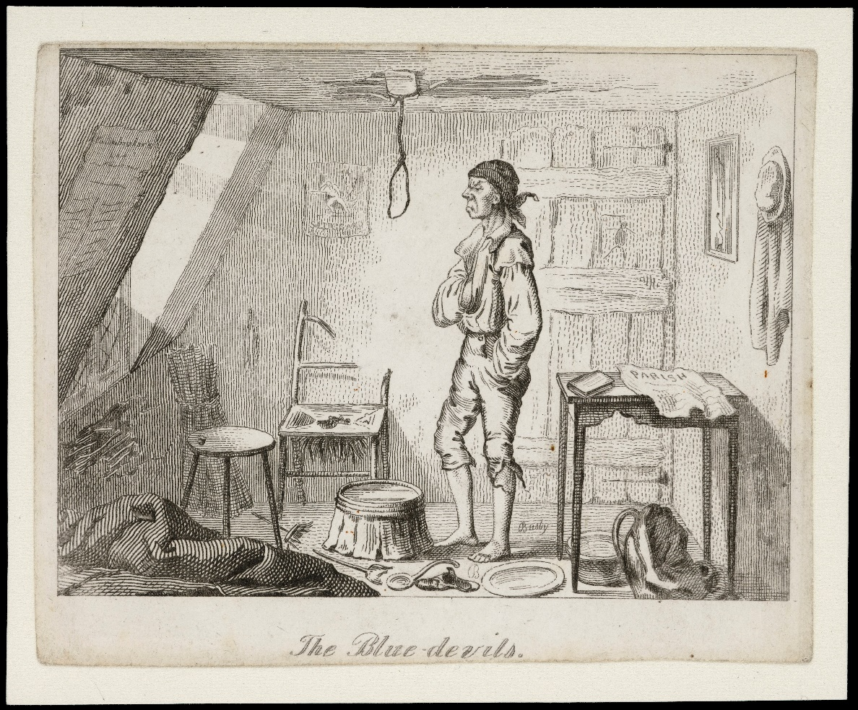
Figure 1: Thomas L. Busby, ‘The blue devils’, c.1826
Source: Wellcome Collection. CC BY. Thomas L. Busby, ‘The blue devils’, c.1826
The early-modern poor were once imagined to be continually dressed in drab and worn-out garments. G. E. Fussell argued that ‘there was a measure of uniformity in the furniture and clothing of the cottager’. He surmised that between the Tudor and Georgian periods the poor owned only ‘the minimum necessary for living’. In a similar manner Pamela Clabburn played down the poor’s consumer behaviour, arguing that they ‘generally wear a very watered-down version of the dress of the rich, with only now and again a special garment appropriate to a particular trade’. These views are no longer widely held following research on the long eighteenth century by Beverly Lemire, John Styles and others. Successive studies have shown how poorer consumers increasingly acquired more fashionable clothing over the century and had more choice. Cotton and readymade clothing grew in availability and the price of textiles broadly declined. The networks that people used to acquire attire also expanded. Street sellers across Britain facilitated the movement of a considerable range of goods among the poorest (figure 2). By the turn of the nineteenth century shops could be found throughout rural and urban Britain. The illicit trade of textiles and second-hand market grew exponentially, meaning that people had even greater access to clothing than they ever did before. Those with very limited resources could still improve their appearance through the addition of inexpensive ribbons, buttons and neckcloths, or could ask parish authorities or masters for clothes.
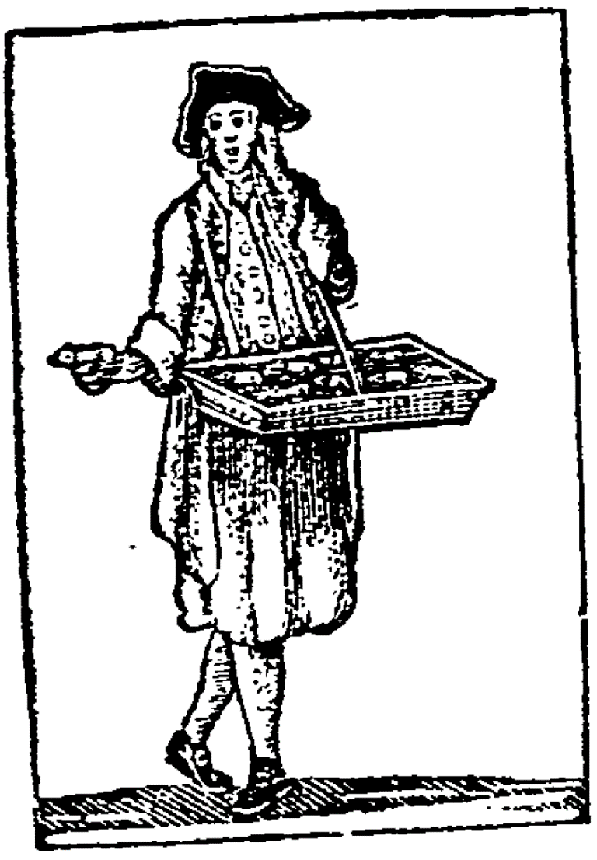
Figure 2: London street seller
Source: The cries of London (London: E. Newbery, 1796), 30.
Clothing is one of the most visible forms of consumption and it plays an important role in denoting one’s identity. Contemporaries were well aware of this fact and from the fourteenth century sumptuary legislation set out the items of clothing that the poor could and could not wear. These laws were often extensive and detailed, outlining the materials, types of garments and colours that were prohibited on the bodies of people with lower incomes. Such policies were seen as necessary for maintaining the social hierarchy and ensuring that the poor were different from the rich. Even after sumptuary legislation lapsed in 1604, attire remained an important visual reminder of poverty. Wearing discoloured or blemished white linen became associated to a lack of cleanliness and a sense of shame in society. Various poor law authorities would make paupers wear badges on their clothing to show the community that they were dependent upon poor relief (Figure 3). Letters sent to overseers from paupers asking for help would often emphasise nakedness and worn-out dress to stress the indigent’s plight and force officials to take action.
Figure 3: Pauper’s badge, Fletching parish, Sussex, c.1815-16.
Source: East Sussex Record Office SPK/P 14 Fletching pauper badges, c.1815-16. Reproduced with the permission of East Sussex Record Office, copyright reserved.
Research on the attire of the poor in the period before 1650 is relatively thin on the ground due to there being fewer surviving sources. Nevertheless, studies tend to show that although the clothing of the poor was generally functional and practical, it was not always made up of the cheapest and plainest items. Archaeological excavations even reveal that during the late medieval period (c.1300-1500) some peasants owned dress accessories such as belt buckles, brooches and rings which were decorative and made from decent-quality metals. Through the wearing of these highly-visible objects, peasants were effectively resisting the modest, servile and industrious identity placed on them by the elite. One of the most common sources for studying early-modern clothing is probate records, including wills and inventories, and probate accounts which detail payments and expenses related to the administration of the deceased’s estate. These studies have generally shown that the ‘common sort’ or ‘lesser rank[s]’ took pride in their clothing and were able to personalise their outfits through the use of neckcloths, ruffs, partlets and wristwear. As explored above, however, probate records should be taken with a pinch of salt as it is debateable whether they extend far enough down the social scale to analyse the poor.
Pessimistic views are commonly found in literature on food consumption, particularly when authors take a quantitative approach. Between the mid-fifteenth and eighteenth centuries food made up approximately half to three-quarters of the poor’s yearly expenditure. Even with such large proportions of money being spent on diet, scholars such as Carole Shammas and Robert Fogel have argued that working people were still not able to consume enough calories to sustain hard labour for very long and that their food often had little nutritional value. The writings of social commentators including Frederick Morton Eden and David Davies also show that labouring diets could be very basic, centring around the consumption of bread, vegetables and beer, alongside small quantities of meat and dairy products. The subject of food consumption has received renewed attention in Muldrew’s work on labourers. The author controversially claimed that labourers consumed more beer and meat, and thus more calories, than early writers such as Shammas and Fogel suggested. Muldrew acknowledged that there were times when labourers struggled to feed themselves, but argued that this ‘was far from constant and incapacitating’. The issue, however, remains contentious. In the same year that Muldrew published his book, Roderick Floud et al. published research which found results that concur more with Shammas and Fogel, despite using similar sources to Muldrew.
In either instance, no historian would argue that there were few changes in food and drink over the early modern period. Around 1450 peasant diets generally revolved around bread and pottage, alongside small quantities of meat, dairy produce and fruit. The variety and availability of various foodstuffs expanded as Europeans explored and made links throughout the world during the so-called ‘age of discovery’. The humble potato was brought to Europe from the New World before the end of the sixteenth century. It evolved from being mistrusted by health professionals, to being an expensive speciality ingredient, to being a staple of the poor in the second half of the eighteenth century, owing to the fact that they could be produced in high quantities and that they were cheap sources of carbohydrates. The range and quantity of implements owned by the poor related to the preparation and eating of food also changed accordingly. Cauldrons and posnets were superseded by saucepans over the eighteenth century, which were more efficient to use and allowed people to create more versatile dishes and sauces. Combined with the growing availability of salt, pepper, nutmeg, mustard and other spices/herbs, more tasty dishes could be prepared. Pewter and wooden eating and drinking vessels were once principally used by people for their functionality and sturdiness. Yet these materials gradually declined in ownership as the poor started to favour new tableware made from earthenware and glassware. These items needed to be replaced more often but they could be made in a variety of designs. Eating habits also changed as people moved away from eating with their hands and/or a spoon, to using personal cutlery from the eighteenth century. Tea became a national drink among the English poor during the eighteenth century and could be consumed alongside a range of paraphernalia such as tea pots, tea caddies and tea tables. Honey, treacle or molasses (a by-product of the sugar refining process) were sometimes used to sweeten tea and other foods, but it was brown sugar that was increasingly used over the eighteenth century as a general sweetener. Coffee and chocolate were occasional treats for some people with low incomes, while in other areas these articles were given to workhouse inmates by the early nineteenth century. The consumption of spirits such as gin, brandy and rum also increased among the poor. Gin was a particular source of dismay among contemporaries during the first half of the eighteenth century and was haphazardly linked to a variety of social problems such as the neglect of children (mother’s ruin) and violence. This is most famously depicted in William Hogarth’s ‘Gin Lane’ (figure 4).
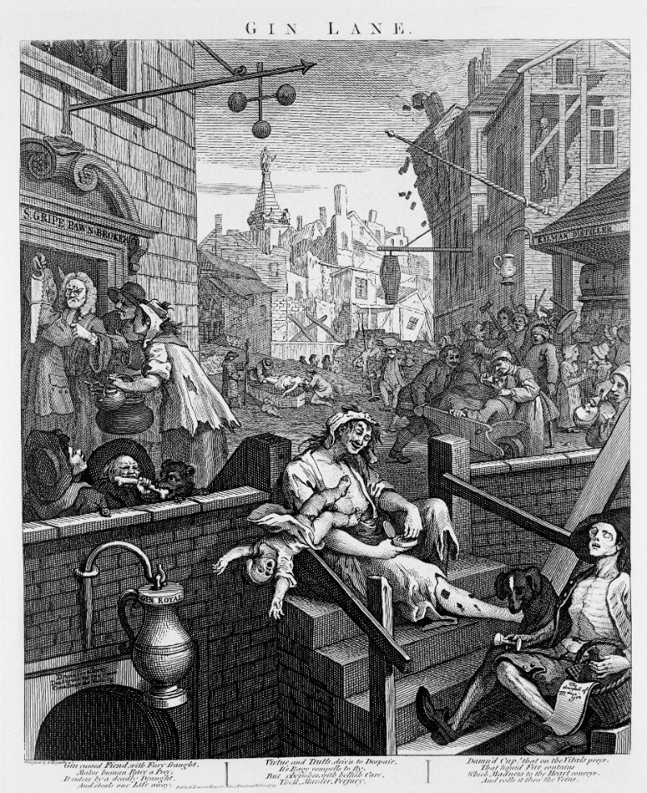
Figure 4: William Hogarth, ‘Gin Lane’, 1751.
Source: Wellcome Collection. CC BY. William Hogarth, ‘Gin Lane’, 1751
Europe
It was once typical for scholars to play down the poor’s capacity to consume goods on the continent. In Fernand Braudel’s seminal three volume history of Europe and the wider world, he stated that it ‘goes almost without saying’ that ‘poor people had few possessions’. Their homes, he claimed, ‘consisted of next to nothing’ apart from a few necessities such as basic clothing, cooking items, seating and a table. For Peter Stearns, the lack of consumerism among the early-modern poor of the world was a simple consequence of their low incomes and lack of desire to engage. He argued that most labouring people were geared to self-sufficiency and were more interested in public good and religion. These views are no longer widely held by historians. The pace of change was generally slower than in England and did not affect the masses in some countries until the nineteenth century, but overall there were some important shifts in material culture especially in north-western Europe.
Inventories taken after death have been used extensively by scholars to study material culture in France. These documents tended to be made of richer residents and only around 10-15 per cent of the population had their goods appraised upon death. Yet, through careful and systematic analysis of these inventories we can see small glimpses into the homes of the poorer sorts. Annik Pardailhé-Galabrun and Daniel Roche have led the way in this research and shown how the homes of diverse groups of people, including those of the non-elite, became better equipped over the early modern period. These changes can be found across France but generally reached people in towns first.
Countless travellers saw the French capital as the centre of fashion and style. In 1736 Voltaire compared the Garden of Eden to Paris. He pointed out that Eden was bare and lacked items such as wine and ‘fine attire’, while in early eighteenth-century France there were the arts, beautiful buildings and music. Modern Paris was Voltaire’s idea of a perfect Eden. This was not, however, the case for all. Two of the most important reasons for the French Revolution of 1789 were people’s lack of bread and their insufficient earnings. Like most cities, overcrowding was common in Paris and many people were reduced to living in single-roomed dwellings where they could only amass a limited number of goods. A number of visible changes in consumption can nevertheless be seen, particularly during the eighteenth century. Chests and coffers were superseded by closets and chests of drawers which permitted users to store and retrieve their possessions in a more convenient manner. Cooking and eating vessels became more specialised and less multifunctional, as items such as saucepans, egg cups and sugar bowls were found in more homes by the end of the century. Almost all social classes had access to colourful home furnishings. Wall tapestries and pictures were omnipresent in Parisian homes, including the abodes of servants, wage earners and floor polishers. Looking glasses became more affordable and came in all shapes and sizes meaning that people with limited budgets could acquire one. Therefore, despite the country’s highly hieratical and socially biased structure, the material lives of the poor improved alongside their peers across the channel.
The Netherlands are perhaps as extensively studied as England, owing to the area’s early commercial and industrial development. Simon Schama argued that this Dutch ‘golden age’ (seventeenth century) saw abundant ‘opulence’ and an ‘embarrassment of riches’, as consumerism accelerated and people sought out more lavish homes and new ‘luxury’ goods. These changes in consumer taste led to considerable retail growth in urban centres, further allowing people to acquire cheap and diverse goods. But what about the poor? To measure more humble consumption, Anne McCants used 912 inventories which record the belongings of either deceased parents who left children to the Amsterdam Municipal Orphanage or orphans who had died with no heirs. Her results indicated that although items such as books, mirrors, chests of drawers and timepieces were more likely to be owned by individuals who were financially stable, these goods nonetheless found their way into the homes of many poorer people during the eighteenth century. Tea and coffee items particularly breeched this divide and became virtually ubiquitous. Wouter Ryckbosch’s careful analysis of probate inventories from Aalst indicated that many items were first consumed by upper quartiles of the population in the seventeenth century, and then ‘trickled down’ to people with lower incomes during the next century.
In recent years scholars have started to move away from studying specific spaces to looking at consumerism from a global perspective. In essence, this involves examining producers, consumers, traders, governments and myriad other agents who were involved in developing trade networks to understand continental, national, regional or even local changes in consumption. Beverly Lemire, for example, examined tobacco, textiles and pepper to illustrate how changes in consumption affected global populations, from the urban elite in leading European cities to the subaltern populations of rural China and India. Much of this work is in its infancy, but it has allowed historians to understand the complex contexts in which goods came to Europe and how they infiltrated the lives of various social strata.
While studies on North Atlantic economies and great trading nations have pointed to growing commercial sensibilities across society, there were numerous parts of Europe where material life appears to have changed much more slowly. In countries that underwent protracted economic development, consumption beyond the necessities of life generally only gained a noticeable foothold among the lower classes in the nineteenth century. Kristina Lilja and Pernilla Jonsson recently argued that for Sweden the ‘consumer revolution’ in mass-produced clothing and textiles only reached ordinary urban households from the 1870s. On the Cyclades islands of the Aegean sea, houses were small, densely built and did not contain many objects over the seventeenth and eighteenth centuries. Material standards only started to gradually improve from the late eighteenth century, when shipping links improved and people could acquire new goods more easily. Sources from Tuscany, Italy indicate that peasants and poor sharecroppers were geared towards self-sufficiency and owned few belongings. On the rare occasions that sharecroppers had surplus income after 1750, they would primarily spend this on textiles and clothing but little else. The priority for destitute households in much of central Europe was to make ends meet, leaving little for discretionary expenditure. Consumer activity, according to Sheilagh Ogilvie, was constrained before the nineteenth century by sumptuary legislation, traditional social norms and the institutions that governed retail exchange such as guilds. In most areas of Spain consumer choice was restricted outside of elite households, but the poor in or around Barcelona could expect to own colonial groceries, mirrors and extra linen by the end of the eighteenth century.
Clothing sumptuary legislation was present across virtually all of Europe at one time or another. In Italy, for instance, over three hundred sumptuary laws were adopted between 1200-1500 and in the German principalities between three to five thousand laws were passed. Implemented by towns, states and/or empires, the legislation restricted the poor’s ownership of certain outfits and materials such as silk, furs and gold/silver adornments. Although these laws were increasingly repealed or ignored from the seventeenth century, many regulations remained in place well into the eighteenth century. They show that early modern legislators, social commentators and religious authorities shared the same concerns about protecting local industries from imports and preserving social hierarchies. Despite these sanctions and evermoving goalposts, the poorer classes in north-western Europe generally appear to have clothed themselves and their families better as the period progressed. Contemporaries grew to be particularly disdainful of this. In 1775 Mrs Hester Thrale noted that the streets of Paris are full of ‘Wenches with umbrellas and Workmen with Muffs’.
The most notable material improvements in clothing occurred during the second half of the eighteenth century, particularly in cities and towns. Using over 1,000 probate inventories, Roche argued that there was a ‘profound transformation’ in France as Parisians increasingly owned greater numbers of garments. The sources indicated that the value of ordinary men’s and women’s wardrobes increased two- and six-fold respectively by the end of the eighteenth century compared to a century earlier. Cissie Fairchilds found that significant numbers of the non-elite owned umbrellas, canes, fans and watches on the eve of the French Revolution. In Amsterdam, the poor’s clothing was manufactured from a variety of local and imported materials and totalled around one-third of their moveable material wealth. Andreas Maisch argued that there were few differences in the dress of the population in Württemberg, Germany except for the very richest and most destitute. The spread of new clothing and textiles was helped immensely by the growing number of shops across much of Europe and the spread of informal sellers such as pedlars. There were areas of the continent where these changes were largely absent and some groups such as beggars and vagrants continued to wear tattered clothing throughout the eighteenth century. However, the overall picture is more positive. Even when people had very limited resources, they could make small changes to appear more fashionable and personalise their appearance using accessories such as ribbons and buckles.
Starvation was a very real fear for the poor and could hit at any time from bad harvests or insufficient earnings. The 1590s, for example, witnessed devastating famines across large parts of Europe. During the crisis one Bolognian man was even found looking through faeces on the street for food as he ‘was dying of hunger’. European diets were generally made up of basic foodstuffs such as bread and vegetables, but new groceries also entered people’s homes during the period. Chillies and peppers came from the New World and quickly became an important part of the Iberian diet. Today tomatoes are seen as virtually synonymous with Mediterranean cuisine. However, they were initially treated with suspicion by medical authors and only slowly became a part of southern European diets from the mid-seventeenth century. Maize (corn) was brought to Europe from Columbus’s first trip to the Americas in 1493. By the eighteenth century it was a staple of peasants owing to its high yields. Rice originated from southern Asia and came to Spain through its Arab population. It later spread to other parts of Europe and became the key ingredient in dishes such as paella and rice pudding. Water and milk were important drinks, but most people also drank beer (especially in northern and eastern Europe) or low-quality wine (particularly in the Mediterranean). Spirits such as brandy and rum also gradually became more commonplace from the sixteenth century. Tea and coffee had become almost ubiquitous in France and the Netherlands by the end of the eighteenth century. The poor could generally only afford low grades of the caffeinated products, but some were able to combine drinking it with sugar and a range of decorative items including tea tables, tea pots, coffee mills and porcelain cups. In less economically developed countries such as Norway, tea, coffee and sugar largely remained the preserve of the wealthy urban elite until the nineteenth century.
Conclusion
Poverty was widespread and difficult to overcome for successive generations. During times of hardship many people could not afford to feed or clothe themselves properly and were often forced to sell off their possessions to make ends meet. In spite of these persistent problems, the material lives of the poor broadly improved across early-modern Europe. Millions of ordinary people strived to better furnish their homes with ‘luxury’ items and better seating and cooking vessels. Many dressed in new materials such as cotton and had access to foods that their ancestors had never heard of. These changes reached those with lower incomes at a much slower rate than the middling sort and elite, however through myriad networks such as the wage and the economy of makeshifts we see a broad shift in what poverty looked like. These changes were staggered and gradual, and they tended to be found first in urban settlements, England and north-western Europe. But as time went on other areas of Europe and the wider world saw many of the same shifts in material culture.
Owing to the work of Craig Muldrew, Anne McCants and others over the past decade, we now have a much clearer picture of the material state of poverty. But further research is still needed. Considerable volumes of research have been written on the importance of respectability, civility and femininity in influencing patterns of middling and elite consumption, however we do not know the extent to which these ideas filtered down the social scale. There is relatively little on material life in some communal or institutional spaces, such as poorhouses, workhouses, almshouses, pesthouses and taverns. Consumption and domestic production have often been studied in isolation of one another, meaning that we have little sense of the relationship between self-provisioning and market participation and the applicability of the industrious revolution concept in poorer households. Historians persistently note that there are fewer written sources for the poor compared to the middling sort and elite. Through more intense study of extant objects owned by the destitute this problem could be bypassed and new questions can be asked. Work on global history and consumption has grown in recent years and has the potential to inform our understanding of consumption outside of national contexts and how new products spread throughout populations. By taking new avenues of research we will be able to get closer to plebeian lives and ultimately further understand what it meant to be ‘poor’ in early-modern Europe.

Marie Gillespie, Souad Osseiran and Margie Cheesman, ‘Syrian refugees and the digital passage to Europe: Smartphone infrastructures and affordances’, Social Media + Society (2018), 1-12.
Simon Mason, The good and bad effects of tea consider’d (London: M. Cooper, 1745), 41-2.
Jonas Hanway, ‘An essay on tea’, in Jonas Hanway, A journal of eight days journey (London: H. Woodfall, 1756), 203-361.
What constituted ‘luxury’ goods can be very subjective and changed over time. Contemporaries and historians have generally used the term to describe items that were unnecessary to life and often linked to decoration, status, vanity, novelty, display and imitation. Typical examples include watches, looking glasses and silverware.
Neil McKendrick, John Brewer and J. H. Plumb, The birth of a consumer society: The commercialisation of eighteenth-century England (London: Hutchison, 1983, reprint of 1982 ed.).
Quotes from: Neil McKendrick, ‘The consumer revolution of eighteenth-century England’, in Neil McKendrick, John Brewer and J. H. Plumb, Birth of a consumer society, 9-12, 24.
This literature is detailed in: Jan de Vries, The industrious revolution: Consumer behavior and the household economy, 1650 to the present (Cambridge: Cambridge University Press, 2008), 37-9.
Maxine Berg, Luxury and pleasure in eighteenth-century Britain (Oxford: Oxford University Press, 2005).
Sara Horrell, Jane Humphries and Ken Sneath, ‘Cupidity and crime: Consumption as revealed by insights from the Old Bailey records of thefts in the eighteenth and nineteenth centuries’, in Mark Casson and Nigar Hashimzade, eds., Large databases in economic history: Research methods and case studies (London: Routledge, 2013), 246-67.
There are numerous exceptions, such as: Jon Stobart, ‘A history of shopping: the missing link between retail and consumer revolutions’, Journal of Historical Research in Marketing, 2 (2010), 342-9; Ken Sneath, ‘Consumption, wealth, indebtedness and social structure in early modern England’, PhD thesis (University of Cambridge, 2008).
John Brewer, ‘The error of our ways’, Lecture to the Cultures of Consumption programme, The Royal Society, 23 Sept 2003, Working Paper No. 12 [From: www.consume.bbk.ac.uk/publications.html. Accessed 26/11/2010].
Ibid., 9; John Styles, ‘Manufacturing, consumption and design in eighteenth-century England’, in John Brewer and Roy Porter, eds., Consumption and the world of goods (London: Routledge, 1993), 535-6; Ben Fine and Ellen Leopold, The world of consumption (London: Routledge, 1993), 64-6.
Brewer, ‘Error of our ways’, 11-18; Lizabeth Cohen, A consumers’ republic: The politics of mass consumption in postwar America (New York: Alfred A. Knopf, 2003).
John Brewer and Frank Trentmann, ‘Introduction: Space, time and value in consuming cultures’, in John Brewer and Frank Trentmann, eds., Consuming cultures, global perspectives: Historical trajectories, transnational exchanges (Oxford: Berg, 2006), 1-17
Thorstein Veblen, The theory of the leisure class: An economic study of institutions (New York: Macmillan, 1899); Georg Simmel, ‘Fashion’, The International Quarterly, X (1904), 130-55.
Neil McKendrick, ‘Home demand and economic growth: a new view of the role of women and children in the industrial revolution’, in Neil McKendrick, ed., Historical perspectives: Studies in English thought and society in honour of J. H. Plumb (London: Europa Publications, 1974), 209.
Bernard Mandeville, The fable of the bees or private vices, publick benefits, Vol. 1, ed. F. B. Kaye (Indianapolis: Liberty Fund, 1988, reprint of 1732 ed.), 132.
Daniel Defoe, The complete tradesman, Vol. 2, Part 2 (London: Charles Rivington, 1727), 167.
For more nuanced studies, see for example: Henry French, The middle sort of people in provincial England 1600-1750 (Oxford: Oxford University Press, 2007), 147-153; Stena Nenadic, ‘Middle-rank consumers and domestic culture in Edinburgh and Glasgow’, Past and Present, 145 (1994), 122-56; Jon Stobart, Sugar & spice: Grocers and groceries in provincial England, 1650-1830 (Oxford: Oxford University Press, 2013).
Jean-Pascal Daloz, The sociology of elite distinction: From theoretical to comparative perspectives (Basingstoke: Palgrave Macmillan, 2010), 76.
Peter N. Stearns, Consumerism in world history: The global transformation of desire (London: Routledge, 2nd ed., 2001), 30
John Styles, The dress of the people: Everyday fashion in eighteenth-century England (New Haven: Yale University Press, 2007), 247-302.
Ibid., 189-93. Also see Daloz, Sociology, 67-8, 132-3, 148-9.
For an accessible introduction to the subject, see: Karen Harvey, ed., History and material culture: A student’s guide to approaching alternative sources (London: Routledge, 2009); Anne Gerritsen and Giorgio Riello, eds., Writing material culture history (London: Bloomsbury, 2015); Leonie Hannan and Sarah Longair, History through material culture (Manchester: Manchester University Press, 2017).
Harvey, History and material culture, 9.
de Vries, Industrious revolution.
Hans-Joachim Voth, ‘The longest years: New estimates of labor input in England, 1760-1830, Journal of Economic History, 61 (2001), 1075, 1077.
Craig Muldrew, Food, energy and the creation of industriousness: Work and material culture in agrarian England, 1550-1780 (Cambridge: Cambridge University Press, 2011).
Such as: Steve Rappaport, Worlds within worlds: Structures of life in sixteenth-century London (Cambridge: Cambridge University Press, 1989), 123-161; Donald Woodward, Men at work: Labourers and building craftsmen in the towns of northern England, 1450-1750 (Cambridge: Cambridge University Press, 1995).
For example, Hans-Joachim Voth, ‘Living standards during the industrial revolution: An economist’s guide’, American Economic Review, 93 (2003), 223-4; R. C. Allen and J. L. Weisdorf, ‘Was there an “industrious revolution” before the industrial revolution? An empirical exercise for England, c.1300-1830’, Economic History Review, 64 (2011), 722.
Steven King and Alannah Tomkins, The poor in England 1700-1850: An economy of makeshifts (Manchester: Manchester University Press, 2003); Laurence Fontaine, ed., Alternative exchanges: Second-hand circulations from the sixteenth century to the present (New York: Berghahn Books, 2008).
Beverly Lemire, The business of everyday life: Gender, practice and social politics in England, c.1600-1900 (Manchester: Manchester University Press, 2005), 82-109.
Alexandra Shepard, Accounting for oneself: Worth, status, and the social order (Oxford: Oxford University Press, 2015), 35.
For instance, G. E. Fussell, The English rural labourer: His home, furniture, clothing & food from Tudor to Victorian times (London: Batchworth Press, 1949); Robert W. Malcolmson, Life and labour in England 1700-1780 (London: Hutchinson, 1981), 149.
E. P. Thompson, The making of the English working class (London: Penguin, 1991, reprint of 1963 ed.), 351.
Christopher Dyer, Standards of living in the later middle age: Social change in England c.1200-1520 (Cambridge: Cambridge University Press, revised edition, 1998); Ben Jervis, ‘Consumption and the “social self” in medieval southern England’, Norwegian Archaeological Review, 50 (2017), 1-29. It is, of course, important not to take this point too far as most trade was local in nature. See: Keith Wrightson, Earthly necessities: Economic lives in early modern Britain (New Haven: Yale University Press, 2000), 108-9.
R. K. Field, ‘Worcestershire peasant buildings, household goods and farming equipment in later middle ages’, Medieval Archaeology, 9 (1965), 105-45; Barbara A. Hanawalt, The ties that bound: Peasant families in medieval England (Oxford: Oxford University Press, 1986), 45-63; Dyer, Standards of living, esp. 151-87; Idem, ‘Living in peasant houses in late medieval England’, Vernacular Architecture, 44 (2013), 19-27; P. J. P. Goldberg, ‘The fashioning of bourgeois domesticity in later medieval England: A material culture perspective’, in Maryanne Kowaleski and P. J. P. Goldberg, eds., Medieval domesticity: Home, housing and household in medieval England (Cambridge: Cambridge University Press, 2008), 124-44; Carole Wheeler, ‘Beyond a “make do and mend” mentality: Repair and reuse of objects from two medieval village sites in Buckinghamshire’, in Ben Jervis and Alison Kyle, eds., Make-do and mend: Archaeologies of compromise, repair and reuse (Oxford: British Archaeological Reports, 2012), 97-106; Ben Jervis, Chris Briggs and Matthew Tompkins, ‘Exploring text and objects: Escheators’ inventories and material culture in medieval English households’, Medieval Archaeology, 59 (2015), 168-92; Chris Briggs, Alice Forward, Ben Jervis and Matthew Tompkins, ‘People, possessions and domestic space in late medieval escheators’ records’, Journal of Medieval History, 45 (2019), 145-61.
Goldberg, ‘Fashioning’, 129; Dyer, ‘Living’, 25; Briggs et al., ‘People possessions’, 158-9.
Muldrew, Food, esp. 163-207.
Ken Sneath, ‘Consumption, wealth’, esp. 231-328.
This issue is discussed at length in: Joseph Harley, ‘Consumption and poverty in the homes of the English poor, c.1670-1834’, Social History, 43 (2018), 81-104.
Peter King, ‘Pauper inventories and the material lives of the poor in the eighteenth and early nineteenth centuries’, in Tim Hitchcock, Peter King and Pamela Sharpe, eds., Chronicling poverty: The voices and strategies of the English poor, 1640-1840 (Basingstoke: Palgrave Macmillan, 1997), 155-91.
Joseph Harley, ‘Material lives of the poor and their strategic use of the workhouse during the final decades of the English old poor law’, Continuity and Change, 30 (2015), 71-103; Joseph Harley, ‘Material lives of the English poor: A regional perspective’, PhD thesis (University of Leicester, 2016); Harley, ‘Consumption and poverty’, 81-104; Joseph Harley, Norfolk pauper inventories, c.1690-1834 (Oxford: British Academy/Oxford University Press, 2020).
John Styles, ‘Lodging at the Old Bailey: Lodgings and their furnishings in eighteenth-century London’, in John Styles and Amanda Vickery, eds., Gender, taste, and material culture in Britain and North America 1700-1830 (New Haven: Yale University Press, 2006), 61-80. Also see: Sara Horrell, Jane Humphries and Ken Sneath, ‘Consumption conundrums unravelled’, Economic History Review, 68 (2015), 830-57; Horrell et al., ‘Cupidity’, 246-67.
John E. Crowley, The invention of comfort sensibilities & design in early modern Britain & early America (Baltimore: Johns Hopkins University Press, 2001).
Such as Simonswood and Bickerstaffe workhouses in Lancashire. Lancashire Record Office (LRO) PR 417, Bickerstaffe overseers’ accounts, 1729-49; LRO PR 123, Simonswood overseers’ accounts, 1720-1839.
Alexis de Tocqueville, Memoir on pauperism, trans. Seymour Drescher, ed. Gertrude Himmelfarb (London: Civitas, 1997).
For further information on these changes, see note 37; Harley, ‘Material lives of the English poor: A regional perspective’, 79-218; Muldrew, Food, esp. 163-207; Sneath, ‘Consumption, wealth’, 231-328; King, ‘Pauper inventories’, 155-91; Carole Shammas, The pre-industrial consumer in England and America (Oxford: Clarendon Press, 1990), 78-81; Beverly Lemire, Global trade and the transformation of consumer cultures (Cambridge: Cambridge University Press, 2018), 190-247.
Fussell, English rural labourer, 18-19, 73.
Pamela Clabburn, ed., Working class costume from sketches of characters by William Johnstone White, 1818 (London: Costume Society, 1971), v.
Among many others, see: Beverly Lemire, Fashion’s favourite: The cotton trade and the consumer in Britain, 1660-1800 (Oxford: Oxford University Press, 1991); Idem, Dress, culture and commerce: The English clothing trade before the factory, 1660-1800 (Basingstoke: Palgrave Macmillan, 1997); Styles, Dress; Carole Shammas, ‘The decline of textile prices in England and British America prior to industrialisation’, Economic History Review, 47 (1994), 483-507.
Margaret Spufford, The great reclothing of rural England: Petty chapmen and their wares in the seventeenth century (London: Hambledon Press, 1984), 146.
Hoh-Cheung Mui and Lorna H. Mui, Shops and shopkeeping in eighteenth-century England (London: McGill-Queen’s University Press, 1989); Alison Toplis, The clothing trade in provincial England 1800-1850 (London: Pickering & Chatto, 2011).
Lemire, Dress; Idem, Business of everyday life; Toplis, Clothing trade; Jon Stobart and Ilja Van Damme, Modernity and the second-hand trade: European consumption cultures and practices, 1700-1900 (Basingstoke: Palgrave Macmillan, 2010).
Styles, Dress; Nancy Cox, Retailing and the language of goods, 1550-1850 (London: Routledge, 2016), 126-32.
Sumptuary laws could also restrict food and furniture consumption.
The literature on English sumptuary legislation is well summarised in: Maria Hayward, ‘“Outlandish superfluities”: Luxury and clothing in Scottish and English sumptuary laws from the fourteenth to the seventeenth century’, in Giorgio Riello and Ulinka Rublack, eds., The right to dress: Sumptuary laws in a global perspective, c.1200-1800 (Cambridge: Cambridge University Press, 2019), 96-120.
Styles, Dress, 78-83.
Steve Hindle, ‘Dependency, shame and belonging: Badging the deserving poor, c.1550-1750’, Cultural and Social History, 1 (2004), 6-35.
Thomas Sokoll, ed., Essex pauper letters, 1731-1837 (Oxford: British Academy/Oxford University Press, 2001).
Danae Tankard, Clothing in 17th-century provincial England (London: Bloomsbury, 2019).
Sally V. Smith, ‘Materializing resistant identities among the medieval peasantry: An examination of dress accessories from English rural settlement sites’, Journal of Material Culture, 14 (2009), 309-32; Jervis et al., ‘Exploring text and objects’, 174-8, 183.
Jane E. Huggett, ‘Rural costume in Elizabethan Essex: A study based on the evidence from wills’, Costume, 33 (1999), 74-88; Anne Buck, ‘Clothing and textiles in Bedfordshire inventories, 1617-1620’, Costume, 34 (2000), 25-38; Margaret Spufford and Susan Mee, The clothing of the common sort (Oxford: Oxford University Press, 2017).
Shammas, Pre-industrial, 123-33; Muldrew, Food, 29.
Shammas, Pre-industrial consumer, 121-56; Robert Fogel, The escape from hunger and premature death 1700-2100: Europe, America and the Third World (Cambridge: Cambridge University Press, 2004).
David Davies, The case of labourers in husbandry (London: G.G. and J. Robinson, 1795); Frederic Morton Eden, The state of the poor, Vols. 1-3 (London: J. Davis, 1797).
Muldrew, Food, esp. 29-162.
Roderick Floud, Robert W. Fogel, Bernard Harris and Sok Chul Hong, The changing body: Health, nutrition, and human development in the western world since 1700 (Cambridge: Cambridge University Press, 2011).
Dyer, Standards of living, 151-60.
C. Anne Wilson, Food and drink in Britain: From the stone age to recent times (Harmondsworth: Penguin, 1984, reprint of 1973 ed.), 197-99; Joan Thirsk, Food in early modern England: Phases, fads and fashions (London: Hambledon Continuum , 2006), 179-82; David Gentilcore, Food and health in early modern Europe: Diet, medicine and society, 1450-1800 (London: Bloomsbury, 2016), 149-53.
Harley, ‘Material lives of the English poor: A regional perspective’, 125-38.
Thirsk, Food; Muldrew, Food, 113-5.
Harley, ‘Material lives of the English poor: A regional perspective’, 147-63; Muldrew, Food, 194; Sneath, ‘Consumption, wealth’, 253-60.
Harley, ‘Material lives of the English poor: A regional perspective’, 163-77.
Eden, State of the poor, Vols 2-3, passim; Sidney W. Mintz, Sweetness and power: The place of sugar in modern history (New York: Penguin, 1985).
Harley, ‘Material lives of the English poor: A regional perspective’, 178-80; King, ‘Pauper inventories’, 162-3.
Such as Lowton, Lancashire workhouse. Wigan Archives Service D/P 17/12/16 Lowton workhouse victual book, 1821-38.
Braudel, Civilization, 241-7; de Vries, Industrious revolution, 165-7.
Fernand Braudel, Civilization and capitalism 15th-18th century, Vol. 1: The structures of everyday life: The limits of the possible, trans. Sian Reynolds (London: William Collins Sons & Co., 1985), 283.
Stearns, Consumerism, 1-14.
Annik Pardailhé-Galabrun, The birth of intimacy: Privacy and domestic life in early modern Paris, trans. Jocelyn Phelps (Cambridge: Polity Press, 1991), 3-7
Ibid; Daniel Roche, The people of Paris: An essay in popular culture in the 18th century, trans. Marie Evans (Leamington Spa: Berg, 1987), 97-233; idem, The culture of clothing: Dress and fashion in the “ancien régime”, trans. Jean Birrell (Cambridge: Cambridge University Press, 1994); idem, A history of everyday things: The birth of consumption in France, 1600-1800, trans. Brian Pearce (Cambridge: Cambridge University Press, 2000); Cissie Fairchilds, ‘The production and marketing of populuxe goods in eighteenth-century Paris’, in Brewer and Porter, World of goods, 228-48.
Voltaire, ‘The Worldling’ (1736), in John Morley and Tobias Smollett, eds., The dramatic works of Voltaire, Vol. X. Part II, trans. William F. Fleming (New York: E. R. Dumont, 1901), 84-8.
Pardailhé-Galabrun, Birth of intimacy, 43-4; Roche, People of Paris, 97-126
On these changes, see note 82.
Simon Schama, The embarrassment of riches: An interpretation of Dutch culture in the golden age (London: Fontana, 1987), 289-379. Also see: Jan de Vries, The Dutch rural economy in the golden age, 1500-1700 (New Haven: Yale University Press, 1974), 214-47; idem, ‘Peasant demand patterns and economic development: Friesland, 1550-1750’, in William N. Parker and Eric L. Jones, eds., European peasants and their markets: Essays in agrarian economic history (Princetown: Princetown University Press, 1975), 305-66.
Bruno Blondé and Ilja Van Damme, ‘Retail growth and consumer changes in a declining urban economy: Antwerp (1650-1750)’, Economic History Review, 63 (2010), 638-63.
Anne McCants, ‘Poor consumers as global consumers: The diffusion of tea and coffee drinking in the eighteenth century’, Economic History Review, 61 (2008), esp. 184-9.
Wouter Ryckbosch, ‘A consumer revolution under strain: Consumption, wealth and status in eighteenth-century Aalst (southern Netherlands)’, PhD thesis (Gent University and University of Antwerp, 2012), esp. 233-71.
Lemire, Global trade.
Kristina Lilja and Pernilla Jonsson, ‘Inadequate supply and increasing demand for textiles and clothing: Second-hand trade at auctions as an alternative source of consumer goods in Sweden, 1830-1900, Economic History Review (forthcoming).
Dimitris Dimitropoulos, ‘Living conditions in the houses of the islands of the Cyclades during the seventeenth and eighteenth centuries’, John Broad and Anton Schuurman, eds., Wealth and poverty in European societies from the sixteenth to nineteenth century (Turnhout: Brepols, 2014), 61-80.
Paolo Malanima, ‘Changing patterns in rural living conditions: Tuscany in the eighteenth century’, in Anton J. Schuurman and Lorena S. Walsh, eds., Material culture: Consumption, life-style, standard of living, 1500-1900 (Milan: Università Bocconi, 1994), 115-24.
Roman Sandgruber: Die Anfänge der Konsumgesellschaft (Vienna: Verlag für Geschichte und Politik, 1982); idem, ‘Leben und lebensstandard im zeitalter des Barock – Quellen und ergebnisse’, in Othmar Pickl and Helmuth Feigl, eds., Methoden und probleme der alltagsforschung im zeitalter des Barock (Vienna: Österreichischen Akademie der Wissenschaften, 1992), 171–89; Janine Maegraith and Craig Muldrew, ‘Consumption and material life’, in Hamish Scott, ed., The Oxford handbook of early modern European history, 1350-1750. Vol. 1: Peoples and place (Oxford: Oxford University Press, 2015), 384-5; Sheilagh Ogilvie, ‘Consumption, social capital, and the “industrious revolution” in early modern Germany, Journal of Economic History, 70 (2010), 287-325.
Bartolomé Yun, ‘Peasant demand in Castile (1750-1900): Some proposals’, in Schuurman and Walsh, Material culture, 125-36; Belén Moreno Claverías, ‘Lugar de residencia y pautas de consume: El penedes y Barcelona, 1770-1790’, Revista de Historia Industrial, 15 (2006), 136-66; Julie Marfany, Land, proto-industry and population in Catalonia, c.1680-1829: An alternative transition to capitalism? (Farnham: Ashgate, 2012), 145-78.
Nevertheless, the application of sumptuary laws could vary considerably. In the Netherlands, for instance, only one sumptuary statute was authorised (in 1497). Schama, Embarrassment, 186-7.
Ulinka Rublack and Giorgio Riello, ‘Introduction’, in Riello and Rublack, Right to dress, 8.
Riello and Rublack, Right to dress.
Quoted from Fairchilds, ‘Production and marketing’, 228.
Roche, Culture of clothing, esp. 86-117. Also see: Roche, People of Paris, 160-94.
Fairchilds, ‘Production and marketing’, 228-48.
Anne McCants, ‘Modest households and globally traded textiles: Evidence from Amsterdam household inventories’, in Laura Cruz and Joel Mokyr, eds., The birth of modern Europe: Culture and economy, 1400-1800. Essays in honor of Jan de Vries (Leiden: Brill, 2010), 122-6.
Andreas Maisch, Notdürftiger unterhalt und gehörige schranken: Lebensbedingungen und lebensstile in Württembergischen dörfern der frühen neuzeit (Stuttgart: Fischer, 1992), 21, 366-8.
Among others, Ogilvie, ‘Consumption, social capital’, 302; Blondé and Van Damme, ‘Retail growth’; Roche, Culture of clothing, 259-363; Fontaine, Alternative exchanges; Stobart and Van Damme, Second-hand trade. Also see figure 2 above.
Roche, Culture of clothing, 87, 107, 179, 503.
Ibid., 219. Also see notes 55 and 63.
Quoted from Raffaella Sarti, Europe at home: Family and material culture 1500-1800, trans. Allan Cameron (New Haven: Yale University Press, 2002), 112.
Ibid., 179.
Gentilcore, Food and health, 153-4.
Sarti, Europe at home, 179-81; Braudel, Civilization, 164-7.
Sarti, Europe at home, 179.
Ibid., 184-6; Braudel, Civilization, 227-41.
Braudel, Civilization, 241-7; de Vries, Industrious revolution, 165-7.
McCants, ‘Poor consumers’, 172–200; Bruno Blondé and Wouter Ryckbosch, ‘Arriving to a set table: The integration of hot drinks in the urban consumer culture of the eighteenth-century southern Low Countries’, in Maxine Berg, Felicia Gottmann, Hanna Hodacs and Chris Nierstrasz, eds., Goods from the east, 1600-1800: Trading Eurasia (Basingstoke: Palgrave Macmillan, 2015), 309-27; Roche, Everyday things, 246-7; Braudel, Civilization, 249-60.
Ragnhild Hutchison, ‘Bites, nibbles, sips and puffs: New exotic goods in Norway in the 18th and first half of the 19th century’, Scandinavian Journal of History, 36 (2011), 156-85.

