Seasonality, DNA degradation and spatial heterogeneity as drivers of eDNA detection dynamics

Christopher R. Troth^{a,b*}, Michael J. Sweet^{a*}, Jen Nightingale^{c,d}, Alfred Burian^{a,e}.
ª Aquatic Research Facility, Environmental Sustainability Research Centre, University of Derby, Derby, DE22 1GB, UK.
^{b} SureScreen Scientifics Ltd, Morley Retreat, Church Lane, Morley, DE7 6DE, UK.
^{c} Bristol Zoological Society, Clifton, Bristol, UK.
^{d} School of Biological Sciences, University of Bristol, Bristol, UK.
^{e} Marine Ecology Department, Lurio University, Nampula, Mozambique.

*Corresponding authors: christopher.troth@sky.com; m.sweet@derby.ac.uk

Abstract
In recent years, eDNA-based assessments have evolved as valuable tools for research and conservation. Most eDNA-based applications rely on comparisons across time or space. However, temporal, and spatial dynamics of eDNA concentrations are shaped by various drivers that can affect the reliability of such comparative approaches. Here, we assessed (i) seasonal variability, (ii) degradation rates and (iii) micro-habitat heterogeneity of eDNA concentrations as key factors likely to inflict uncertainty in across site and time comparisons. In a controlled mesocosm experiment, using the white-clawed crayfish as a model organism, we found detection probabilities of technical replicates to vary substantially and range from as little as 20 to upwards of 80% between seasons. Further, degradation rates of crayfish eDNA were low and target eDNA was still detectable 14-21 days after the removal of crayfish. Finally, we recorded substantial small-scale in-situ heterogeneity and large variability among sampling sites in a single pond of merely 1000m² in size. Consequently, all three tested drivers of spatial and temporal variation have the potential to severely impact the reliability of eDNA-based site comparisons and need to be accounted for in sampling design and data analysis of field-based applications.
Key words: environmental DNA, white-clawed crayfish, seasonal variations, heterogeneity, degradation.
- Introduction
Monitoring approaches based on environmental DNA (eDNA) represent an increasingly popular tool to survey the distribution of endangered and invasive species (Harper et al. 2019). Most eDNA-based assessments rely on across-site comparisons of species occurrence (Mauvisseau et al. 2019a), and/or abundance (Baldigo et al. 2016; Doi et al. 2016). However, eDNA concentrations and detection probabilities depend on a wide range of different environmental factors, which frequently differ across sites. Consequently, the reliable application of eDNA-based approaches critically hinges on a detailed understanding of how key environmental factors drive temporal and spatial variations in eDNA dynamics.
An important determinant of eDNA concentration in natural environments is the degradation rate of target eDNA. Changes in degradation rates influence how long eDNA persists within the environment and can therefore substantially impact species detection and quantification (Goldberg, Strickler and Fremier 2018) affecting the reliability of results (Barnes et al. 2014). Degradation of eDNA is reported to vary across species, habitats, and environmental conditions (Collins et al. 2018; Shogren et al. 2018; Williams et al. 2018). This variability is strongly driven by fluctuations in temperature and UV (Goldberg, Strickler and Fremier 2018), microbial community composition (Barnes et al. 2014), pH (Seymour et al. 2018) and conductivity (Barnes et al. 2014). Time periods until eDNA concentrations fall below detection thresholds, have been shown to range from hours and days (Piaggio et al. 2015; Thomsen et al. 2012a; Barnes et al. 2014; Maruyama et al. 2014; Turner, Uy and Everhart 2015) to weeks and months (Dejean et al. 2011; Goldberg et al. 2013). In sediments, even lower degradation rates have been recorded (Mauvisseau et al. 2018; Turner, Uy and Everhart 2015). It is therefore pivotal to develop a solid base-line knowledge on the degradation of target eDNA, and to consider potential changes in degradation rates resulting from environmental factors across sites in field assessments.
Another important factor inducing temporal variation of eDNA concentrations are seasonal changes in DNA shedding rates of any given target organism. Factors such as changing weather conditions, hydrology and food availability can induce alterations of activity and life cycle patterns. These changes in animal behaviour are tightly linked to DNA shedding rates and thereby impact detection probabilities and across season comparisons of population sizes (Buxton, Groombridge and Griffiths 2018; Erickson et al. 2017; De Souza et al. 2016; Wacker et al. 2019). Seasonal increases in eDNA shedding/release rates have for example been documented during egg production of signal crayfish (Dunn et al. 2017). Further, a 20‐fold increase of freshwater pearl mussel eDNA has coincided with reproduction and spawn of field populations (Wacker et al. 2019). A possible strategy to account for such effects is the restriction of sampling seasons, an approach implemented for eDNA assessments of the great crested newt, Triturus cristatus (Buxton, Groombridge and Griffiths 2018; Rees et al. 2017). However, such regulations of field-sampling seasons require a detailed knowledge of seasonal activity patterns and DNA shedding rates (Bista et al. 2017; Seymour et al. 2020).
Finally, spatial distribution patterns of target eDNA can be strongly heterogenous within sites, a fact that needs to be considered during the design of eDNA-based sampling strategies (Moyer et al. 2014). Potential drivers of heterogeneous eDNA concentrations are habitat preferences of target organisms causing patchy distributions (Lacoursière-Roussel et al. 2016), hydrological dynamics (Deiner and Altermatt 2014; Jane et al. 2015), and water stratification (Moyer et al. 2014). A failure to account for such heterogeneity may lead to false negative results, especially when targeting rare species (Moyer et al. 2014). Modifying the number of locations and natural replicates per location, as well as exploring different methods to collate water samples are possible options to fine-tune sampling design in order to increase the reliability of species detection (Furlan et al. 2016; Goldberg, Strickler and Fremier 2018). However, practical challenges such as financial limitations or limited access to sites, often make it difficult to follow ‘gold-standards’ in sampling design. Regardless of the finalised sampling structure, heterogeneity of eDNA concentrations will undoubtedly determine method performance and therefore needs to be evaluated during eDNA assay development.
Our aim in this study was to assess different factors that potentially affect the reliability of between site comparisons of eDNA-based surveys. In a combination of mesocosms and controlled field experiments, we evaluated the impact of (1) eDNA degradation rates, (2) seasonal changes in shedding rates and (3) spatial heterogeneity of species distribution using the white-clawed crayfish (Autropotamobius pallipes) as a model organism. White-clawed crayfish represent a suitable target species as populations have declined by 50 to 80% across Europe since the year 2000 (Füreder et al. 2010) and low population densities are difficult to detect with conventional sampling approaches (Troth et al. 2020). However, a good understanding of degradation rates is instrumental to eliminate false positives triggered by historic eDNA and assess true current distributions in eDNA-based surveys. Further, low population densities create an urgency to account for small-scale habitat preferences, heterogeneous eDNA distributions and seasonally changing shedding rates, in order to reliably assess occurrence patterns. Therefore, a critical assessment of these factors will help us improve sampling design and increase the reliability of eDNA-based monitoring approaches for this and other threatened species.
- Materials and Methods
  - eDNA degradation experiment
The degradation rates of crayfish eDNA were examined in a controlled mesocosm experiment. Mesocosms were set up as three independent tank systems, each containing a water volume of 52L and a sediment layer consisting of fine gravel and few large pebbles. The three tanks were installed outside, under shelter (giving protection from rain and birds; see Table S1 for temperature profiles) on the roof of the Bristol Zoo Gardens Aquarium building. These tanks housed 16, 14 and 15 adult white-clawed crayfish with a community biomass of 190, 172 and 183g, respectively. Crayfish were kept for two months and removed from the tanks on the 19th October 2017. eDNA samples were then collected 20 hours and 1 hour before crayfish removal and at 18 time points after their removal (0.1h, 1h, 6h, 24h, 32h, 48h, 3d, 4d, 5d, 6d, 7d, 8d, 14d, 21d, 28d, 35d, 42d and 56d). eDNA sampling was based on the ethanol precipitation method outlined in Biggs et al. (2014) and in Troth et al. (2019). In brief, two replicate samples were taken from the system, each containing 20 collated subsamples of 50mL (equating to a total of 1L of mesocosm water). After homogenisation, 90mL of each replicate were distributed among 6 x 50mL tubes containing a pre-mixed molecular grade ethanol and sodium acetate 3M, pH 5.2 solution (Biggs et al. 2014). Samples were stored at -20°C until extraction. At the last sampling event (56 days after the crayfish were removed), the sediment at the bottom of the tank was intentionally disturbed and an additional sample was taken, immediately before the settlement of the sediment. This allowed us to test whether remnant sedimentary DNA (that became undetectable in the water column) was still present in the sediments and sediment disturbance could lead to a positive detection in the absence of the target species.
  - Seasonal dynamics in eDNA concentrations
In our second experiment, we assessed the impact of seasonal changes in crayfish behaviour and physiology on the temporal dynamics of eDNA concentrations under controlled laboratory conditions. The experiment was set up on the 29th September 2017 in a 3000L tank designed for the captive breeding of white-clawed crayfish. Tank design is described in Nightingale et al. (2017) and tanks have proven to be a suitable environment for white-clawed crayfish cultivation. In brief, it consists of 13 interconnected polyurethane tanks, each with a gravel bedded area of 0.46m², set up outdoors with protection against birds and rain. Temperature was controlled (as in Nightingale et al. 2017), in order to reflect in-situ variation, which occurs in their natural habitats (seasonal cycles ranged between 5°C and 20°C). Water quality was maintained through mechanical and biological filtering and UV treatments. Additionally, 25% of the water volume was exchanged with fresh water every week. The tank system contained a large breeding population of 198 adult individuals (75 male, 124 female) with a total initial biomass of 924.75g. Adult mortality rates were below 6% per month throughout the experiment. In order to optimise breeding success, 12 egg carrying females were removed from the system on 6th March 2018. This decrease in biomass was compensated by adding 81 juveniles (39 male, 42 female) resulting in an overall increase in total biomass by 223g (see Table S2 for details on changes in populations sizes). At the end of the experiment (16th October 2018) the population consisted of a mixed adult/juvenile population of 249 individuals with a total biomass of 1263.1g (increase reflects breeding success).
The changes in the life history of the crayfish were recorded throughout the experiment. eDNA samples (n = 3, each pooled across the 13 interconnected tanks), were taken at monthly intervals and additionally during or shortly after specific life-history events (e.g. egg hatching). This resulted in two extra sampling dates in November and December 2017 and one in October 2017 and January 2018.
  - Spatial and temporal in-situ variation
In-situ spatial and temporal variation of eDNA detection and quantification was evaluated throughout the course of a captive breeding ark site release programme. An isolated site, i.e. one which was free of crayfish and crayfish plaque (Aphanomyces astaci), was selected in the South West of England (exact location not disclosed for conservation reasons) and 40 white-clawed crayfish individuals (20 male, 20 female, with a total biomass of 436g) were released into a pond (approximate size 1000m²). Half of the individuals were adults, half of them juveniles. During the release, crayfish were placed at two ends of the pond (sites B and D; Fig. S1) to create a natural population structure.
Samples for eDNA analyses were collected from four, spatially distinct 1m² sampling locations distributed around the pond (sites A, B, C, D; see Supplementary Material, Fig. S1.). Additionally, a pooled sample was taken consisting of sub-samples from the entire pond perimeter (sample P). Samples were collected following the filtration based method outlined in Mauvisseau et al. (2019b). In brief, each sample was collated from 20 individual 50mL scoops and after homogenisation, 250mL of water was pressure-filtered using a syringe through a 0.22µm (Polyethersulfone membrane) enclosed sterile filter (Sterivex™ filter unit, HV with luer-lock outlet, Merck®, Germany). For each sample, three independent replicates were collected. Sampling began on the 20th April 2018 and was performed before release (negative control) and 2 hours, 7 days, 14 days and 35 days after the crayfish release. All water was expelled from filter holders, which were then stored at -20°C prior to analysis. DNA extraction followed protocols outlined in Troth et al. (2020) and (Spens et al. 2017; Tréguier et al. 2014). In addition to eDNA sampling, 40 artificial refuge traps (ARTs) and 12 traditional crayfish traps (Green et al. 2018) were deployed around the pond with at least 1m distances between each trap. Crayfish captures were recorded on after eDNA sampling was conducted on subsequent sampling site visits (traditional crayfish traps were only placed over night and removed after eDNA sampling).
  - Sample analysis and qPCR
A qPCR-based assay with species-specific primers and probe (targeting white-clawed crayfish) was utilised for all eDNA samples across all previously described experiments (Troth et al. 2020). The forward primer WC2302F 5’ – GCTGGGATAGTAGGGACTTCTTT– 3’; reverse primer WC2302R 5’ –CATGGGCGGTAACCACTAC– 3’; and the probe: WC2302P 6-FAM –CTGCCCGGCTGCCCTAATTC– BHQ-1) were used to amplify a 109bp fragment of the white-clawed crayfish mitochondrial COI gene (see Troth et al. 2020). All qPCR assays were performed on an ABI 7500 Real-Time PCR System (Applied Biosystems) with the following protocols: 50ºC for 5 min, denaturation at 95ºC for 8 min, followed by 50 cycles of 95ºC for 30 s and 55ºC for 1 min. Each sample was split into six ‘technical’ qPCR replicates, each consisting of a 25µL qPCR reaction containing: 12.5µL TaqMan® Environmental Master Mix 2.0 (Life Technologies®), 6.5µL DH20, 1µL (10µm) of each primer, 1µL (2.5µm) of probe and 3µL of template DNA. All eDNA samples were analysed with six negative controls (nuclease free distilled water instead of extracted DNA). Further, a duplicated serial dilution of white-clawed crayfish genomic DNA (10⁻¹ to 10⁻³ ng uL⁻¹) was also run for each qPCR plate as a positive control. Extraction negative control samples (nuclease free water) were also analysed to assess for contamination following the same protocol as sample analysis. In terms of analysis, for each of the experiments, cycle threshold values (Ct) were recorded for each technical replicate, and detection probabilities (referred to as eDNA score in Biggs et al. (2015)) were calculated as the fraction of technical replicates which resulted in a positive detection for a given natural replicate. The limit of detection (LOD) was set at a Ct value of 45, with the limit of quantification (LOQ) set at Ct 38 as indicated by previous research (Troth et al. 2020).
  - Statistical analyses
The degradation experiment was analysed using a linear regression to evaluate the relationship between the number of hours elapsed since the beginning of the investigation and (i) detection probability and (ii) Ct. Detection probability was calculated as the percentage of positive technical replicates and averaged across natural replicates. For Ct analyses all technical replicates, which did not amplify target DNA, were assigned a Ct value above the LOD at 45. We tested for potential tank effects by incorporating mesocosm identity into our model. Further, we tested for non-linear relationships between detection probability/Ct and time by log-transforming variables. All possible model combinations were established, and the most parsimonious model was identified using the Akaike Information Criterion (AIC). We visually assessed normal distribution and autocorrelation in residual and found inhomogeneity in the distribution of residuals. In our analysis of Ct, data were analysed at both a technical replicate level (using all data from technical replicates) and natural replicate level (using means of all six technical replicates for each natural replicate). However, analyses resulted in the same fundamental conclusions, and therefore only the analyses at the technical replicate level are presented. In analyses of the ark-release program, spatial differences among sampling locations were assessed using ANOVA analyses, followed by Tukey’s HSD post-hoc tests. Prior to ANOVAs, heteroscedasticity was evaluated, and dependent variables were log-transformed if necessary. All described statistical analyses were performed using R version 3.4.1 (R Core Team 2018).
- Results
  - eDNA degradation experiment
After the removal of crayfish from the mesocosms, eDNA was present in the water column for extended periods of time. Our comparisons between different regression models revealed that a logarithmic relationship best described the decrease of white-clawed crayfish eDNA concentrations (Fig. 1). This was valid for both analyses in detection probability (y=-0.15log(x)+1.05, p<0.001, r² = 0.75) and Ct (log(y)=0.03 log(x) +3.6, p<0.001, r² = 0.64), as models based on log-transformed data resulted in the lowest AIC (Fig. 1A-B). We also assessed whether detection probability differed between the three tanks and found that inclusion of tank effects on the intercepts, marginally improved AIC (decrease of AIC by 1 unit; intercept range: 1.01 to 1.10, increases r² to 0.76). In terms of Ct, tank effects were more substantial and affected both slope (slope range: 0.006 to 0.018) and intercept (intercept range: 3.597 to 3.671), raising model r² to 0.81. It should be noted that the regression lines in Fig. 1 do not reach a detection probability of 0 or a Ct value of 45 (LOD) within the duration of the experiment. This is a direct result of log transformations, which improves the overall fit (especially in the first half of the experiment) but leads to slight deviations between data and model predictions in the second half of the time series.
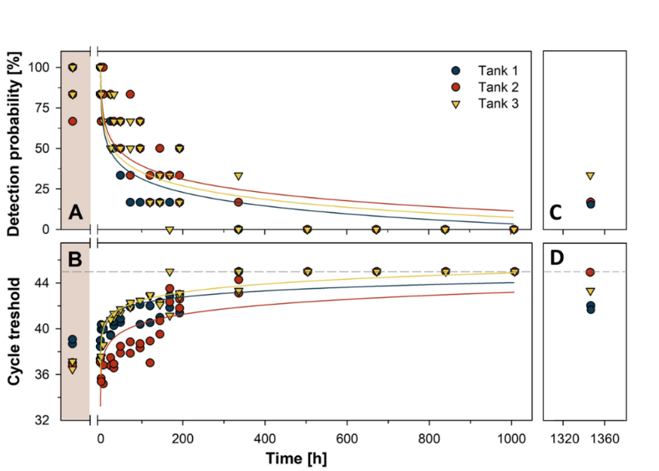
Fig. 1. Temporal changes in detection probability (A) and cycle threshold (B) of white-clawed crayfish eDNA in a mesocosm experiments (three tanks, two natural replicates, six qPCR replicates). The shaded area represents the time before crayfish were removed from the tanks (time 0). The dashed line marks the LOD, i.e. a Ct of 45. All samples that did not result in a detection of white-clawed crayfish DNA were set to a Ct of 45 (LOD). The coloured curves represent the logged trend of Ct and detection probabilities over the duration of the experiment. Although there was an overall better fit of data, the log transformation resulted in an overestimation of the time for detection probability to reach 0 and for the Ct values to reach the LOD, as is highlighted within the curves. (C) Detection probability and (D) Ct values at day 56 when the sediment was manually disturbed and eDNA was re-detected within the water column. Data before the removal of crayfish were not used when creating the linear regression equation.

The last reliable detection of white-clawed crayfish eDNA (i.e. detection in all three experimental replicates) occurred at 14 days post removal of all individuals. Further, there was no eDNA detected at the next time point (21 days), which indicates that eDNA of white-clawed crayfish dropped below detectable levels between 14-21 days post removal. However, the disruption of sediment at day 56, revealed that eDNA was still present and detectable in all of the mesocosms, albeit at low concentrations and detection probabilities. This indicates that sediment disturbance has the potential to result in positive eDNA detection for extensive time periods after the departure of target organisms.
  - Seasonal dynamics in eDNA concentrations
Over the 13-month period of the experiment, both detection probability (Fig. 2A) and Ct values (Fig. 2B) varied substantially in our tank system. In principle, detection probability and Ct values both followed similar but inverted trajectories (Fig. 2). Lowest detection probability (<20% in December) and highest Ct values were recorded during reduced white-clawed crayfish activity and periods of torpor. Highest detection probabilities (>80%) and lowest Ct values were recorded in May during egg hatching. After the end of the hatching period (Fig. 2C), detection probabilities between June and November remained relatively constant, varying around 50%.
Further, it is important to note that during the experiment an egg loss event occurred (2nd March 2018). Premature loss of eggs was triggered by an extreme cold weather event (publicly referred to as the ‘beast from the east’) causing a substantial drop in system temperature and a failure of heating systems (Supplementary Material, Fig. S2). To sustain breeding populations, 12 egg carrying females were permanently removed from the system and protected against further cold spells. The biomass loss in the tanks was compensated by the introduction of 81 juveniles, which resulted in a 26% net increase of crayfish biomass. Both, the egg loss event (which is also likely to occur in natural systems), and the addition of juvenile crayfish resulted in an intermediate peak of detection probabilities and a drop of Ct values on the 6th March 2018 (Fig. 2).

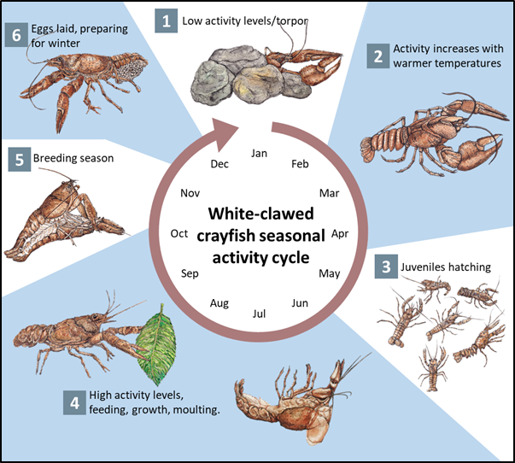
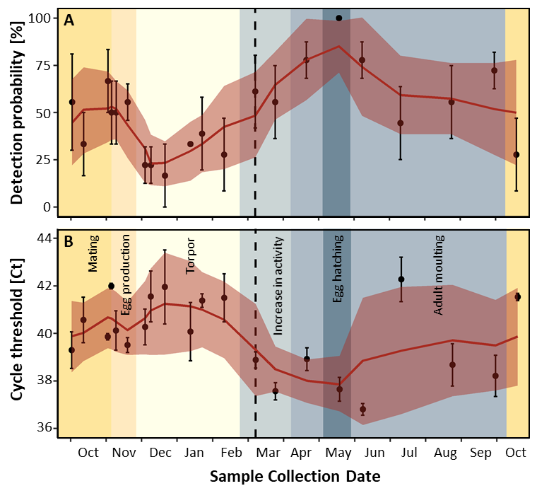
C
Fig. 2. Seasonal variation of white-clawed crayfish eDNA in a mesocosm experiment. Variation in (A) detection probability and (B) Ct values across the 13-month experiment. Each vertical colour section represents a different observed stage in the seasonal cycle of white-clawed crayfish. Error bars represent standard deviation and standard errors for detection probability and Ct, respectively. Solid red lines represent rolling means of three neighbouring sampling time points and the shaded red area represents rolling means of upper and lower range of standard deviation/standard error. The dotted line represents the date of the egg loss event which was triggered by an extreme weather event. (C) Representation of white-clawed crayfish seasonal activity patterns.

3.3. Spatial and temporal in-situ variation
The effect of sampling strategy on detection probability and Ct values, and the degree of small-scale heterogeneity in eDNA distribution was assessed in a pond habitat. Our site comparisons revealed substantial differences in the detection probabilities between sampling locations less than 50m apart (all site data pooled; ANOVA F_{(4,55)} = 3.6, p=0.011; Fig. S3). Pairwise comparisons revealed significant differences between site A and D and between site A and perimeter sample P (p<0.045).
In depth analyses of site-specific detection probability and Ct values showed large temporal (Fig. S4) and spatial variation (Fig. S3), which could partly be explained by the trapping data (Fig. 3). Most sampling events were characterised by detection probabilities below 50%. However, some sites varied substantially over short time periods including changes from 0% detection to 100% in just 14 days at site D (Fig. 3D). This increase over time at site D matched with the increase of trapped crayfish at this site. While crayfish were released at sites B and D, they were exclusively captured at site D (exception is one individual caught on day 7 at site C, see Fig. 3T for temporal patterns of captures). This indicates crayfish migration within the pond after their release. Such migration and micro-habitat preference would also explain the decrease of eDNA concentrations at site B over time (Fig. 3B).
Interestingly, several eDNA samples (conducted at specific sites) were not successful in detecting white-clawed crayfish, despite their presence in the pond. Likewise, the excessive traditional surveys (13 traps per site) did not always achieve positive detection and were mostly successful at site D. The most consistently reliable sampling approach was the perimeter sampling, which almost always resulted in higher detection probabilities than individual sites (Fig. 3P, Fig. S3). Consequently, a pooled sampling approach appears crucial to achieve high method reliability, even in this small scale and seemingly homogenous ecosystem.

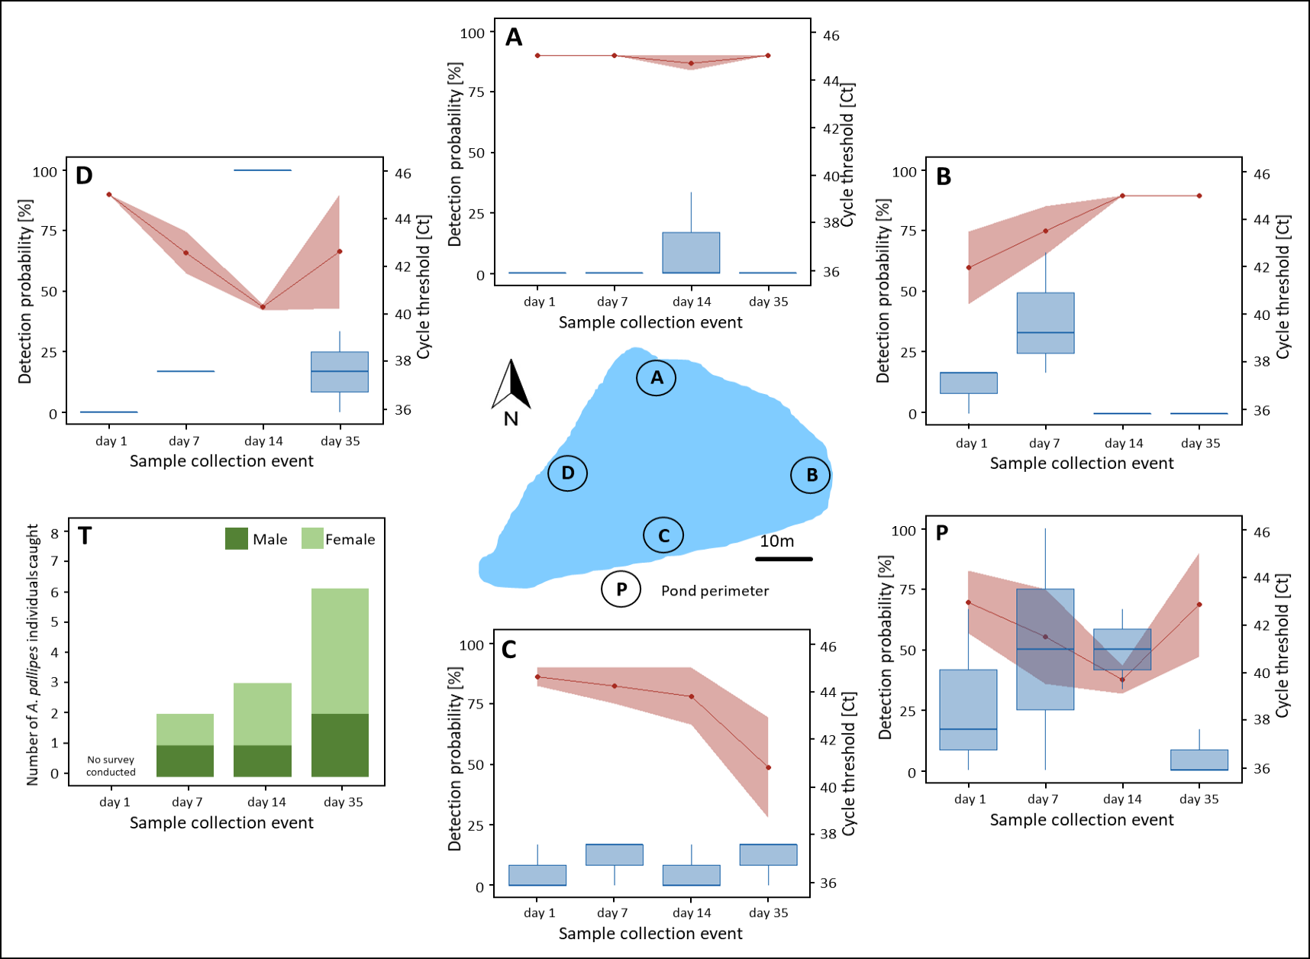
Fig. 3. Detection probability (blue boxplots) and Ct (red points, shaded area indicating standard deviation) of eDNA sampling in a 1000m² pond after the introduction of white-clawed crayfish at each sample collection event after the initial population of the site on 20/04/2018). Each plot overlay (A, B, C, D and P) represents a sample collection site on the map (A-D: 1m² sampling area; P: subsampling from entire perimeter). (T) ‘Traditional’ detection of white-clawed crayfish within the pond using extensive trapping using crayfish traps and ART’s. Each individual crayfish found within a trap or ART was recorded on each visit. A schematic of the pond is also included displaying the location of each of the sampling points.

- Discussion
Comparisons across sites, often sampled at different time points, represent one of the most fundamental applications of eDNA-based methods in research, management and conservation planning (Lacoursière-Roussel et al. 2016). Nevertheless, key factors influencing the accuracy of such comparisons such as seasonality are largely understudied. Here, we demonstrate the impact of various drivers of spatio-temporal variation on the reliability of eDNA-based approaches targeting white-clawed crayfish. Our results clearly highlight that (i) time scales of eDNA degradation, (ii) seasonality in environmental conditions and species behaviour, as well as (iii) within habitat variation of eDNA concentrations can all substantially influence eDNA-based species detection. Based on our findings, we provide suggestions to account for resulting increases of variability in sampling protocols and thereby increase the robustness of eDNA-based surveys.
Our degradation experiment highlighted that crayfish eDNA persisted for 14-21 days post species removal and that slow degradation processes may trigger false positive results in field surveys. Previous measurements of degradation rates show substantial variation between species and studies (e.g. <72hrs for common carp, Barnes et al. (2014); 8 to 18 days for Idaho giant salamander, Pilliod et al. (2014); 21 and 25 days respectively for American bullfrog tadpoles and Siberian sturgeon, Dejean et al. (2011)). Such variations in degradation rates can partly be explained by differences in environmental conditions across studies. Natural sites will tend to show faster eDNA degradation due to water inflow and biotic interaction (Shogren et al. 2018) - a factor that also needs to be incorporated when extrapolating our mesocosm experiments to the field. Further, differences across studies may result from changes in environmental conditions which are known to affect eDNA decay rates including pH (degradation occurs faster in acidic environments; Seymour et al. 2018), temperature (increased degradation at >25°C in Goldberg, Strickler and Fremier 2018) or UV-B radiation (range of 1 to 58 days in Strickler, Fremier and Goldberg 2015).
Long degradation times (as measured in our experiment), increase the risk of false positive results. Such false positives can be induced when; (i) target species migrated or became locally extinct (Stoeckle, Kuehn and Geist 2016) or (ii) eDNA is directionally transported along river networks (Deiner and Altermatt 2014; Jerde et al. 2011). Depending on the survey’s objectives, the effects of low degradation rates can vary (Table 1). We therefore recommend that whenever low degradation rates pose a realistic risk, investigators either combine eDNA-based assessments with classical sampling methods and/or repeat eDNA sampling at an additional point in time.
Further, we illustrated that eDNA persistence was much higher in the sediment than in the water column of our mesocosms. Hence, resuspension of sediment and historic eDNA after extinction or emigration of the target species represent a potential source of error for eDNA-based assessments (Turner, Uy and Everhart 2015). However, measurements of eDNA concentrations in the sediments have been shown to be beneficial when attempting to reconstruct past species occurrences for example (Bálint et al. 2018; Thomsen and Willerslev 2015). In the case of endangered species such as white-clawed crayfish, simultaneous measurements of eDNA in sediments and water columns could represent a valuable tool to assess the impact of environmental threats (e.g. spread of crayfish plaque) on species distributions.
In our second experiment, we demonstrated large seasonal variation of target species detection probability and Ct values in a controlled mesocosm experiment. Compared to eDNA degradation, the impact of seasonal changes in environment and species’ activity patterns on eDNA concentrations is largely underexplored. A number of studies investigate in-situ eDNA concentrations at different times of the year (Buxton, Groombridge and Griffiths 2018; Furlan et al. 2016; Hinlo et al. 2017; Ostberg et al. 2018; Takahashi et al. 2018), revealing e.g. differences of up to 20 times higher eDNA concentrations during spawning seasons (Wacker et al. 2019). However, seasonal variations in the field may also be triggered by changes in population densities and to our knowledge only Buxton et al. (2017) simultaneously measured seasonal cycles in eDNA concentrations and species densities. In our study, we observed substantial changes in eDNA concentrations (Ct values), across the various months of the year and that these changes resulted in a 4-fold increase of detection probability between winter and summer seasons. Variation in detection probability might even be amplified in the field when eDNA concentrations are much lower and close to the limit of detection, with potentially large implications for the choice of sampling design and season.
Table 1. An impact assessment of the drivers of eDNA concentrations and detection probability investigated in this study.
Factor | Explanation | Effect | Recommendations
Temporal
Long term | Seasonal changes in environmental conditions and species activity can influence eDNA concentrations. | Substantial variation in detection probability observed over time. Risk of false negatives during period with lower species activity, or an increase in adverse weather. Complicates eDNA based quantification. | Design sampling strategy to periods of highest species activity, and least weather extremes. If sampling in less reliable time periods or conditions, increase sample replication number.
Short term | Detection probabilities can vary over time due to variation in habitat, environ-mental and/or biological factors. | Short term changes in conditions and species activity could lead to differences in method sensitivity and false negative results. | Combine eDNA-based methods with classical species presence/absence surveys. Repeat sample collection over time.
Degradation of eDNA | eDNA persistence in the environment can lead to false positive or negative detection. | Depending on management objectives consequences can be positive or negative. e.g. past presence of migrating individuals can be detected (positive if objective) but may also wrongly indicate current presence (negative). | Avoid sediment disruption during water sampling. See also short-term recommendations.
Spatial
Sampling location | Environmental factors and species habitat preference can lead to heterogenous distribution of eDNA. | Substantial systematic differences in detection probability across sites in a small ecosystem. Risk of false negatives. | Collect a representative sample for each habitat. Sample several sites in larger ecosystems.

The changes observed in our experiment likely reflect the impact of three main factors. First, an abrupt drop in temperature triggered an egg loss event in early spring and the degradation of disposed eggs most probably contributed to the observed increased eDNA concentration in March 2019 (Fig. 2). Second, while we aimed to keep crayfish biomass constant (coefficient of variation of monthly measurements was 0.14), some changes occurred due to natural mortality, juvenile growth and necessary breeding-related management (Table S2). Finally, white-clawed crayfish show pronounced seasonal activity patterns (Holdich 2003), potentially influencing eDNA shedding rates and consequently, the concentrations of eDNA in the water column. Indeed, there was a strong accordance between torpor and low eDNA concentrations as well as egg hatching and high eDNA concentrations, underlining the potential importance of changing animal physiology and behaviour over seasons.
Seasonal dynamics in eDNA concentrations present a challenge for accurately quantifying and comparing biomass across sites (Buxton et al. 2017; Wacker et al. 2019). One possibility to account for such variation is to standardise time points of sample collection. In accordance with previous research (Dunn et al. 2017), we found that species detection is most reliable before and during egg hatching (the month of May). Consequently, the time from April to June is optimal for field surveys. An extension of this core period to late October seems possible without inflating the risk of false negative detection too much. The timing for quantitative assessments, however, using e.g. ddPCR approaches seems more crucial. Crayfish life history relies strongly on environmental temperature and hence will vary with latitude, altitude and across years. We therefore recommend that investigators who sample sites with different temperature regimes for quantitative assessments make necessary adjustments and ideally confirm similarity of life-history stages in eDNA independent investigations.
Finally, our field surveys demonstrated striking differences in detection probabilities between sites that were less than 50m apart. Sampling at some sites almost always failed to achieve positive detection, despite the presence of the target species in proximity of the sampling site. Stochastic sampling error can be substantial in eDNA surveys, but systematic differences in our assessments highlight substantial small-scale spatial heterogeneity, which was likely caused by micro-habitat preferences. A pooled sampling approach was a suitable measure to account for within habitat variability. While such pooled sampling approaches have been suggested before for both lotic and lentic systems (Biggs et al. 2015; Tréguier et al. 2014), single point sampling procedures are still commonly applied in field studies. Our results clearly demonstrate that these approaches are linked to a high risk of sample bias and that pooled samples are instrumental to increase the robustness of eDNA-based applications.
In-situ eDNA concentrations also showed a high temporal variability at the majority of sites surveyed. In contrast to our tank-system study, released crayfish did not carry any eggs excluding egg hatching as a potential cause of short time variation. However, we observed a large number of moults during and after the release of crayfish, which likely represented a stress response associated with translocation (handling and transport). Degradation of exoskeletons and increased shedding rates of freshly moulted crayfish might have played an important role in the increase of eDNA concentrations over time (Tréguier et al. 2014). Complementary to such effects, variation in environmental conditions and the accumulation of eDNA during the sampling period (reaching dynamic equilibrium between shedding and degradation) may have contributed to observed temporal patterns.
5. Conclusions
Understanding how the distribution of eDNA is effected by temporal dynamics (i.e. short-term degradation and long-term seasonal changes) and spatial heterogeneity of sampled habitats is fundamental for all field-based applications of eDNA-based surveys (Goldberg, Strickler and Fremier 2018; Tillotson et al. 2018). In this study, we demonstrated that all three investigated factors can have considerable effects on detection probabilities of target species and may impact quantitative approaches to an even greater degree. However, drivers of variability can be substantially mitigated by implementing respective mitigation strategies controlling rates of false positive and false negative results (Table 1), at least to some degree. Yet, such mitigation strategies are most effective when site-specific environmental and ecological drivers are considered and consequently require adaptive applications instead of being followed like recipes in a cook book.
Acknowledgements
All work was in collaboration with Bristol Zoological Society and the attached extensive captive breeding and re-introduction program of white-clawed crayfish into conservation ark sites (Nightingale et al. 2017). For assistance with sample collection we would like to thank Holly Thompson and Jacob Ball from Bristol Zoo Gardens. I would also like to thank Quentin Mauvisseau for his assistance with sample collection and analysis, and Mathew Seymour for reviewing this manuscript prior to submission. Funding was provided by the University of Derby and SureScreen Scientifics, UK.
References
Baldigo, B.P., Sporn, L.A., George, S.D., Ball, J.A. (2017). Efficacy of Environmental DNA to Detect and Quantify Brook Trout Populations in Headwater Streams of the Adirondack Mountains, New York. Transactions of the American Fisheries Society. 146, 99–111.
Bálint, M., Pfenninger, M., Grossart, H.P., Taberlet, P., Vellend, M., Leibold, M.A., Englund, G., Bowler, D. (2018). Environmental DNA Time Series in Ecology. Trends in Ecology and Evolution. 33, 945–957.
Barnes, M.A., Turner, C.R., Jerde, C.L., Renshaw, M.A., Chadderton, W.L., Lodge, D.M. (2014). Environmental conditions influence eDNA persistence in aquatic systems. Environmental Science & Technology. 48, 1819–1827.
Biggs, J., Ewald, N., Valentini, A., Gaboriaud, C., Dejean, T., Griffiths, R.A., Foster, J., Wilkinson, J.W., Arnell, A., Brotherton, P., Williams, P., Dunn, F. (2015). Using eDNA to develop a national citizen science-based monitoring programme for the great crested newt (Triturus cristatus). Biological Conservation. 183, 19–28.
Biggs, J., Ewald, N., Valentini, A., Gaboriaud, C., Griffiths, R., Foster, J., Wilkinson, J., Arnett, A., Williams, P., Dunn, F. (2014). Analytical and methodological development for improved surveillance of the Great Crested Newt Appendix 5 . Technical advice note for field and laboratory sampling of great crested newt (Triturus cristatus) environmental DNA. Freshwater Habitats Trust. Oxford.
Bista, I., Carvalho, G. R., Walsh, K., Seymour, M., Hajibabaei, M., Lallias, D., Christmas, M., & Creer, S. (2017). Annual time-series analysis of aqueous eDNA reveals ecologically relevant dynamics of lake ecosystem biodiversity. Nature Communications, 8, 14087.
Buxton, A.S., Groombridge, J.J., Griffiths, R.A. (2018). Seasonal variation in environmental DNA detection in sediment and water samples. PLoS One. 13, e0191737.
Buxton, A.S., Groombridge, J.J., Zakaria, N.B. and Griffiths, R.A. (2017). Seasonal variation in environmental DNA in relation to population size and environmental factors. Scientific Reports. 7: 46294.
Collins, R.A., Wangensteen, O.S., O’Gorman, E.J., Mariani, S., Sims, D.W., Genner, M.J., Mariani, S. (2018). Persistence of environmental DNA in marine systems. Communication Biology. 1, 185.
De Souza, L.S., Godwin, J.C., Renshaw, M.A., Larson, E. (2016). Environmental DNA (eDNA) detection probability is influenced by seasonal activity of organisms. PLOS ONE. 11, 1–15.
Deiner, K., Altermatt, F. (2014). Transport distance of invertebrate environmental DNA in a natural river. PLOS ONE. 9.
Dejean, T., Valentini, A., Duparc, A., Pellier-Cuit, S., Pompanon, F., Taberlet, P., Miaud, C. (2011). Persistence of Environmental DNA in Freshwater Ecosystems. PLOS ONE. 6, e23398.
Doi, H., Inui, R., Akamatsu, Y., Kanno, K., Yamanaka, H., Takahara, T., Minamoto, T. (2016). Environmental DNA analysis for estimating the abundance and biomass of stream fish. Freshwater Biology. 62(1), 30-39.
Dunn, N., Priestley, V., Herraiz, A., Arnold, R., Savolainen, V. (2017). Behavior and season affect crayfish detection and density inference using environmental DNA. Ecology and Evolution. 7, 7777–7785.
Erickson, R.A., Merkes, C.M., Jackson, C.A., Goforth, R.R., Amberg, J.J. (2017). Seasonal trends in eDNA detection and occupancy of bigheaded carps. Journal of Great Lakes Research. 43, 762–770.
Füreder, L., Gherardi, F., Holdich, D., Reynolds, J., Sibley, P., Souty-Grosset, C. (2010). Austropotamobius pallipes. The IUCN Red List of Threatened Species 2010: e.T2430A9438817 Available from: http://www.iucnredlist.org/details/2430/0 [Accessed 02/09/2018].
Furlan, E.M., Gleeson, D., Hardy, C.M., Duncan, R.P. (2016). A framework for estimating the sensitivity of eDNA surveys. Molecular Ecology Resources. 16.
Goldberg, C.S., Sepulveda, A., Ray, A., Baumgardt, J., Waits, L.P. (2013). Environmental DNA as a new method for early detection of New Zealand mudsnails (Potamopyrgus antipodarum). Freshwater Science. 32, 792–800.
Goldberg, C.S., Strickler, K.M., Fremier, A.K. (2018). Degradation and dispersion limit environmental DNA detection of rare amphibians in wetlands: Increasing efficacy of sampling designs. Science of the Total Environment. 633, 695–703.
Green, N., Bentley, M., Stebbing, P., Andreou, D., Britton, R. (2018). Trapping for invasive crayfish: comparisons of efficacy and selectivity of baited traps versus novel artificial refuge traps. Knowledge and Management of Aquatic Ecosystems. 419, 15.
Harper, L.R., Buxton, A.S., Rees, H.C., Bruce, K., Brys, R., Halfmaerten, D., Read, D.S., Watson, H. V., Sayer, C.D., Jones, E.P., Priestley, V., Mächler, E., Múrria, C., Garcés-Pastor, S., Medupin, C., Burgess, K., Benson, G., Boonham, N., Griffiths, R.A., Lawson Handley, L., Hänfling, B., 2019. Prospects and challenges of environmental DNA (eDNA) monitoring in freshwater ponds. Hydrobiologia 826, 25–41. https://doi.org/10.1007/s10750-018-3750-5
Hinlo, Rheyda., Furlan, E., Suitor, L., Gleeson, D. (2017). Environmental DNA monitoring and management of invasive fish: comparison of eDNA and fyke netting. Management of Biological Invasions. 8, 89–100.
Holdich, D.M. (2003). Ecology of the White-clawed Crayfish. Conserving Natura 2000 Rivers Ecology Series No. 1. English Nature, Peterborough.
Jane, S.F., Wilcox, T.M., Mckelvey, K.S., Young, M.K., Schwartz, M.K., Lowe, W.H., Letcher, B.H., Whiteley, A.R. (2015). Distance, flow and PCR inhibition: EDNA dynamics in two headwater streams. Molecular Ecology Resources. 15, 216–227.
Jerde, C.L., Mahon, A.R., Chadderton, W.L., Lodge, D.M. (2011). “Sight-unseen” detection of rare aquatic species using environmental DNA. Conservation Letters. 4, 150–157.
Lacoursière-Roussel, A., Côté, G., Leclerc, V., Bernatchez, L. (2016). Quantifying relative fish abundance with eDNA: a promising tool for fisheries management. Journal of Applied Ecology. 53, 1148–1157.
Maruyama, A., Nakamura, K., Yamanaka, H., Kondoh, M., Minamoto, T. (2014). The Release Rate of Environmental DNA from Juvenile and Adult Fish. PLoS One. 9, e114639. https://doi.org/10.1371/journal.pone.0114639
Mauvisseau, Q., Burian, A., Gibson, C., Brys, R., Ramsey, A., Sweet, M. (2019a). Influence of accuracy, repeatability and detection probability in the reliability of species-specific eDNA based approaches. Scientific Reports. 1–10. https://doi.org/10.1038/s41598-018-37001-y
Mauvisseau, Q., Coignet, A., Delaunay, C., Pinet, F., Bouchon, D., Souty-Grosset, C. (2018). Environmental DNA as an efficient tool for detecting invasive crayfishes in freshwater ponds. Hydrobiologia. 805, 163–175.
Mauvisseau, Q., Tönges, S., Andriantsoa, R., Lyko, F., Sweet, M. (2019b). Early detection of an emerging invasive species: eDNA monitoring of a parthenogenetic crayfish in freshwater systems. Management of Biological Invasions. 10 (3), 461-472.
Nightingale, J., Stebbing, P., Sibley, P., Brown, O., Rushbrook, B., Jones, G. (2017). A review of the use of ark sites and associated conservation measures to secure the long-term survival of White-clawed crayfish Austropotamobius pallipes in the United Kingdom and Ireland. International Zoo Yearbook. 51, 50–68.
Ostberg, C.O., Chase, D.M., Hayes, M.C., Duda, J.J. (2018). Distribution and Seasonal Differences in Pacific Lamprey and Lampetra Spp eDNA across 18 Puget Sound Watersheds. PeerJ. 6: e4496. doi: 10.7717/peerj.4496.
Pilliod, D.S., Goldberg, C.S., Arkle, R.S., Waits, L.P. (2014). Factors influencing detection of eDNA from a stream-dwelling amphibian. Molecular Ecology Resources. 14, 109–116.
Rees, H.C., Baker, C.A., Gardner, D.S., Maddison, B.C., Gough, K.C. (2017). The detection of great crested newts year round via environmental DNA analysis. BMC Research Notes. 10, 1–4.
Seymour, M., Durance, I., Cosby, B.J., Ransom-Jones, E., Deiner, K., Ormerod, S.J., Colbourne, J.K., Wilgar, G., Carvalho, G.R., de Bruyn, M., Edwards, F., Emmett, B.A., Bik, H.M., Creer, S. (2018). Acidity promotes degradation of multi-species environmental DNA in lotic mesocosms. Communications Biology. 1, 1–8.
Seymour, M., Edwards, F., Cosby, J., Scarlet, P., Bista, I., Brailsford, F., Glanville, H., Bruyn, M. de, Carvalho, G., & Creer, S. (2020). Nestedness and turnover of riverine species and functional diversity using eDNA and traditional approaches. Research Square. https://doi.org/10.21203/rs.3.rs-82612/v2
Shogren, A.J., Tank, J.L., Egan, S.P., August, O., Rosi, E.J., Hanrahan, B.R., Renshaw, M.A., Gantz, C.A., Bolster, D. (2018). Water Flow and Biofilm Cover Influence Environmental DNA Detection in Recirculating Streams. Environmental Science and Technology. 52, 8530–8537.
Spens, J., Evans, A.R., Halfmaerten, D., Knudsen, S.W., Sengupta, M.E., Mak, S.S.T., Sigsgaard, E.E., Hellström, M. (2017). Comparison of capture and storage methods for aqueous macrobial eDNA using an optimized extraction protocol: advantage of enclosed filter. Methods in Ecology and Evolution. 8, 635–645.
Stoeckle, B.C., Kuehn, R., Geist, J. (2016). Environmental DNA as a monitoring tool for the endangered freshwater pearl mussel (Margaritifera margaritifera L.): a substitute for classical monitoring approaches? Aquatic Conservation: Marine and Freshwater Ecosystems. 26, 1120–1129.
Strickler, K.M., Fremier, A.K., Goldberg, C.S. (2015). Quantifying effects of UV-B, temperature, and pH on eDNA degradation in aquatic microcosms. Biologial Conservation. 183, 85–92.
Takahashi, M.K., Meyer, M.J., Mcphee, C., Gaston, J.R., Venesky, M.D., Case, B.F. (2018). Seasonal and diel signature of eastern hellbender environmental DNA. Journal of Wildlife Management. 82, 217–225.
Thomsen, P.F., Willerslev, E. (2015). Environmental DNA – An emerging tool in conservation for monitoring past and present biodiversity. Biological Conservation. 183, 4–18.
Tillotson, M.D., Kelly, R.P., Duda, J., Hoy, M., Kralj, J., Quinn, T.P. (2018). Concentrations of environmental DNA ( eDNA ) reflect spawning salmon abundance at fine spatial and temporal scales. Biological Conservation. 220, 1–11.
Tréguier, A., Paillisson, J.-M., Dejean, T., Valentini, A., Schlaepfer, M.A., Roussel, J.-M. (2014). Environmental DNA surveillance for invertebrate species: advantages and technical limitations to detect invasive crayfish Procambarus clarkii in freshwater ponds. Journal of Applied Ecology. 51, 871–879.
Troth, C.R., Burian, A., Mauvisseau, Q., Bulling, M., Nightingale, J., Mauvisseau, C., Sweet, M.J. (In press, 2020) Development and application of eDNA-based tools for the conservation of white-clawed crayfish. Science of the Total Environment. https://doi.org/10.1016/j.scitotenv.2020.141394.
Turner, C.R., Uy, K.L., Everhart, R.C. (2015). Fish environmental DNA is more concentrated in aquatic sediments than surface water. Biological Conservation. 183, 93–102.
Wacker, S., Fossøy, F., Larsen, B.M., Brandsegg, H., Sivertsgård, R., Karlsson, S. (2019). Downstream transport and seasonal variation in freshwater pearl mussel ( Margaritifera margaritifera ) eDNA concentration. Environmental DNA. edn3.10. https://doi.org/10.1002/edn3.10
Williams, K.E., Huyvaert, K.P., Vercauteren, K.C., Davis, A.J., Piaggio, A.J. (2018). Detection and persistence of environmental DNA from an invasive, terrestrial mammal. Ecology and Evolution. 8, 688–695.
Authors’ Contributions
C.T. and M.S. designed the research. C.T., M.S. and J.N. designed the experiment and methodology. CT and J.N. collected field and mesocosm samples and C.T. performed laboratory analysis. C.T. and A.B. analysed the data. The manuscript was written by C.T., A.B. and M.S. and reviewed by all authors.

Table 1. An impact assessment of the drivers of eDNA concentrations and detection probability investigated in this study.
Factor | Explanation | Effect | Recommendations
Temporal
Long term | Seasonal changes in environmental conditions and species activity can influence eDNA concentrations. | Substantial variation in detection probability observed over time. Risk of false negatives during period with lower species activity, or an increase in adverse weather. Complicates eDNA based quantification. | Design sampling strategy to periods of highest species activity, and least weather extremes. If sampling in less reliable time periods or conditions, increase sample replication number.
Short term | Detection probabilities can vary over time due to variation in habitat, environ-mental and/or biological factors. | Short term changes in conditions and species activity could lead to differences in method sensitivity and false negative results. | Combine eDNA-based methods with classical species presence/absence surveys. Repeat sample collection over time.
Degradation of eDNA | eDNA persistence in the environment can lead to false positive or negative detection. | Depending on management objectives consequences can be positive or negative. e.g. past presence of migrating individuals can be detected (positive if objective) but may also wrongly indicate current presence (negative). | Avoid sediment disruption during water sampling. See also short-term recommendations.
Spatial
Sampling location | Environmental factors and species habitat preference can lead to heterogenous distribution of eDNA. | Substantial systematic differences in detection probability across sites in a small ecosystem. Risk of false negatives. | Collect a representative sample for each habitat. Sample several sites in larger ecosystems.

Fig. 1. Temporal changes in detection probability (A) and cycle threshold (B) of white-clawed crayfish eDNA in a mesocosm experiments (three tanks, two natural replicates, six qPCR replicates). The shaded area represents the time before crayfish were removed from the tanks (time 0). The dashed line marks the LOD, i.e. a Ct of 45. All samples that did not result in a detection of white-clawed crayfish DNA were set to a Ct of 45 (LOD). The coloured curves represent the logged trend of Ct and detection probabilities over the duration of the experiment. Although there was an overall better fit of data, the log transformation resulted in an overestimation of the time for detection probability to reach 0 and for the Ct values to reach the LOD, as is highlighted within the curves. (C) Detection probability and (D) Ct values at day 56 when the sediment was manually disturbed and eDNA was re-detected within the water column. Data before the removal of crayfish were not used when creating the linear regression equation.

C
Fig. 2. Seasonal variation of white-clawed crayfish eDNA in a mesocosm experiment. Variation in (A) detection probability and (B) Ct values across the 13-month experiment. Each vertical colour section represents a different observed stage in the seasonal cycle of white-clawed crayfish. Error bars represent standard deviation and standard errors for detection probability and Ct, respectively. Solid red lines represent rolling means of three neighbouring sampling time points and the shaded red area represents rolling means of upper and lower range of standard deviation/standard error. The dotted line represents the date of the egg loss event which was triggered by an extreme weather event. (C) Representation of white-clawed crayfish seasonal activity patterns.
Fig. 3. Detection probability (blue boxplots) and Ct (red points, shaded area indicating standard deviation) of eDNA sampling in a 1000m² pond after the introduction of white-clawed crayfish at each sample collection event after the initial population of the site on 20/04/2018). Each plot overlay (A, B, C, D and P) represents a sample collection site on the map (A-D: 1m² sampling area; P: subsampling from entire perimeter). (T) ‘Traditional’ detection of white-clawed crayfish within the pond using extensive trapping using crayfish traps and ART’s. Each individual crayfish found within a trap or ART was recorded on each visit. A schematic of the pond is also included displaying the location of each of the sampling points.

