ABSTRACT

Rural coastal communities in the global south are mostly natural resource-dependent and their livelihoods are therefore vulnerable to the impacts of climate and environmental changes. Efforts to improve their adaptive capacity often prove mal-adaptive due to misunderstanding the dynamics of the unique socioeconomic factors that shape their vulnerability. By integrating theories from climate change vulnerability and the Sustainable Livelihoods Approach, this study draws upon household survey data from a fishing community in Ghana to assess the vulnerability of fishing households to climate change and explore how their vulnerability is differentiated within the community. The findings suggest that household incomes in the last decade have reduced significantly, attributable to an interaction of both climatic and non-climatic factors. Analysis of the characteristics of three vulnerability groups derived by quantile clustering showed that the most vulnerable household group is not necessarily women or poorer households as expected. Rather, it is dynamic and includes all gender and economic class categories in varying proportions depending on the success or failure of the fishing season. The findings suggest furthermore that the factors that significantly differentiates vulnerability between households differ, depending on whether households are categorised by economic class, gender of household-head or vulnerability group. Consequently, the study highlights the importance of looking beyond existing social categorizations like gender and economic classes when identifying and prioritizing households for climate change adaptive capacity building.
Keywords: Ghana; Fishing; Vulnerability; Adaptive capacity; Climate change
1. INTRODUCTION
In 2018, the Food and Agriculture Organisation (FAO) estimated in its State of the World’s Fisheries and Aquaculture report that about 60 million people globally are engaged in the primary activity of fishing [1]. About 67% of this number, according to the FAO [1] are employed in the capture fisheries sector, with the majority in Asia and Africa. Many of them also live in rural coastal resource-dependent communities [2], [3]. The growing scientific evidence for global climate change and its predicted impacts on the world’s fisheries and fishing livelihoods raises concern about the resilience and ultimate wellbeing of such resource-dependent communities. Rising sea surface temperatures, acidification, and deoxygenation are predicted to affect marine fish production and species distribution thereby affecting maximum catch and revenue potential [4], [5]. Up to 0.77 m predicted rise in global mean sea-level by the end of the century raises the risk of coastal flooding and permanent changes in freshwater ecosystems [5]–[8]. Predicted increases in the frequency and intensity of storms and cyclones are at present causing disruptions to fishing operations and destruction of fishers’ capital assets [5], [9]–[13]. It is generally agreed that these climate change impacts intersect with context-specific non-climatic factors to make rural coastal-resource dependent communities in developing economies disproportionately more vulnerable to climate change impacts [13]–[16].
Studies that have assessed the impact of climate change on rural coastal fishing communities have highlighted their generally weak adaptive capacity [9], despite attempts to diversify their livelihood [10], their high sensitivity to impacts [9] and large intra-community variation in vulnerability [11]. Perhaps the most unanimous of the findings so far is that their vulnerability has more to do with the configuration of local socioeconomic and institutional factors than with prevailing climatic threats [13], [17]–[19], and thus, is context-specific [19]. The problem of context-specificity limits the extent of the generalization that can be made from such studies [20]. As such, more research from a variety of geographical, socioeconomic and stressor contexts are needed to fully elucidate the factors that characterise the vulnerability of rural coastal fishing communities to climate change. In Ghana, some studies have attempted to assess what characterises climate change vulnerability in farming communities [21]. A gap in this knowledge exists for fishing communities [22], [23]. This study makes a contribution using empirical evidence from a coastal fishing community in Ghana, which is involved in beach-seining and faced with declining fish catches. Beach-seining is a fishing method that targets nearshore fishes by deploying a seine net and hauling it to shore by both ends manually. The study addresses three key research questions: does local climate data confirm perceptions of climate change and climate variability?; what is the economic impact of climate change on fishing livelihood?; and who are the most vulnerable to climate change in such communities and why?
2. RESOURCE-DEPENDENT LIVELIHOODS AND VULNERABILITY TO CLIMATE CHANGE
A livelihood is simply the means by which people make an income-related living. A more analytical and widely adopted definition is that it comprises the capabilities, the tangible and intangible resources (assets), and the activities that are required to make a living [24]. Capability refers to what people are able to do or are capable of being [22]. It describes their ability to proactively or reactively make choices by either collaborating, competing, or taking advantage of opportunities to improve their lives [23]. This capability is used to coordinate various material and social resources in activities that transform them into outcomes that are essential for peoples’ wellbeing. A livelihood is therefore naturally vulnerable to both internal and external shocks. Internally, a livelihood can be affected when capability is insufficient, reduced, or limited, as in, for example, the inability to use technology or the demise of a household head. Externally, it can be affected when the amount of resource it depends on is critically reduced (e.g. reducing fish stocks), when access to resources is blocked (e.g. by conservation policies), or when activities are hindered (e.g. by storms). Resource-dependent households have therefore been observed to engage in a portfolio of activities to reduce their vulnerability, and that their capacity to withstand internal and external shocks depends to a large extent on their store of assets [25], [26]. In coastal resource-dependent communities, the interaction of climate change and socioeconomic risk factors can worsen what is already a fragile livelihood system [9], [27], [28]. According to Chambers and Conway [24], the entry point to reducing livelihood vulnerability is investment. That is, personal actions like livelihood diversification, and public actions like support from external agencies, such as Development Non-governmental Agencies (NGOs), to enhance capability and/or improve access to assets [17]. An important first step in investment, particularly for such external agencies which often have limited funds [29], is to understand the factors that shape the vulnerability of fishing households in order to identify who is most at risk and thus identify the appropriate investment entry points.
The sustainable livelihood approach (SLA) [2], [25], [30] offers an analytical framework within which the vulnerability of fishing livelihoods could be systematically assessed. The SLA is a livelihood analysis which asks the question: within a given ecological context, what combination of livelihood assets give people the ability to adopt what livelihood strategy combinations with what outcomes, and which institutional processes mediate their ability to carry out such livelihood strategies? [25]. It recognises that peoples’ ability to reduce their vulnerability to shocks and stresses is dependent on their livelihood assets (financial, physical, social, human and natural) mediated by external factors like policies, institutions and market forces. Besides its holistic analytical appeal, the capital assets component of the SLA offers a host of indicators which can be mathematically combined in an indicator-based vulnerability assessment (IBVA) method to quantify the vulnerability of resource-dependent households. An IBVA is a method that characterises the factors that shape vulnerability to climate change in a particular area and aggregates them into a vulnerability index [9], [14], [31], [32]. In this study, the IBVA is based on the Intergovernmental Panel on Climate Change’s (IPCC) vulnerability framework [33], which defines climate change vulnerability as being a function of a system’s exposure (E) to climatic risks, its sensitivity (the degree to which it is or will be affected by the risk, (S)), and its capacity to adjust to those risks ex-ante or post hoc (adaptive capacity, (AC)). This study thus integrates theories of climate change vulnerability and the sustainable livelihood approach (as detailed in Section 3.2.3) to explore the economic impact of climate change on fishing livelihoods and to understand who in such fishing communities is most vulnerable to that impact.

3. MATERIALS AND METHODS
3.1 Study area
The study was conducted in Winneba, a coastal town in Ghana, West Africa from November 2018 to January 2019. The town lies 56 km west of the capital city, Accra (Figure 1), and has a total population of about 60,331 [23]. The area is within the dry equatorial climatic zone, and the vegetation is characterized by coastal shrubs and grassland [34]. Within Winneba, the study focused specifically on a migrant fishing community, Akosua Village (Table 1), located on the shore between the Gulf of Guinea and the Muni lagoon which is designated as a Ramsar Site – the Muni-Pomadze Ramsar Site (MPRS). The Akosua community migrated from the Volta Region on the eastern coast of Ghana to settle in the current location about a century ago [7]. The economy of the community is based predominately on beach seining by men and fish mongering by women. However, some women engage in petty trading, and some men engage in artisanal and daily wage labour jobs within Winneba town. Farming and livestock rearing are rarely practiced in this community due to the sandy and saline conditions of the land, which limits opportunities for alternative livelihood. Fishing crews are typically made up of the owner of the boat, outboard motor and net (known as the net owner), the net owner’s permanent employees (boat crew) and casual workers, and in some cases women, who haul the net to shore (net draggers). This crew hierarchy delineates households’ economic class as profit is commonly shared in the ratio 4:2:1 amongst the net owner, boat crew and net draggers respectively. Crews range from about 12 – 35 depending on size of boat and net. The major fishing season starts from the end of the major rainy season (August) to its beginning the following year (April).

Table 1: Key characteristics of the study community
Characteristic | Description
Population (2010 census) | 568
Households | 133
Ethnicity | Migrant (Ewe tribe)
Major occupation | Beach seine fishing
Annual rainfall (mm/year)
GSS | 400 - 500
Climate-data | 1046.0 (1982 – 2012)
GMet | 834.3 (1989 – 2018)
Major fishing season | August – April (9 months)
Minor fishing season | May – July (3 months)
Distance to market | 2.4 km
Distance to Hospital | 2.3 km
Electricity | Yes (partially)
Market | No
Sources: Population data were obtained from Ghana’s 2010 population and housing census report (GSS, 2014). Climate-data refers to www.climate-data.org. Distances are straight lines from the centre of each community.
Infrequent fishing activities take place between May and July, the peak of the major rainy seasons. During focus group discussions, the community suggested among other things that, low and erratic rainfalls in the major rainy seasons subsequently result in low fish catches in the major fishing season. Thus, major fishing seasons are considered ‘good season’ when catches are big and incomes are high, and ‘bad season’ when catches are meagre, and incomes are low. The community’s designation of a fishing season as ‘good’ or ‘bad’ is purely subjective. Notwithstanding, it is important because it reflects the community’s perception of their wellbeing in any year. The results and discussion sections are therefore nuanced around this community-based seasonal classification. The community considers rainy and stormy days as hindrances to their livelihood as fishing on such days is dangerous. Moreover, the major fish processing method used in the community is drying in the open fields. Unexpected rainfall, therefore, results in huge losses as the half-dried fishes deteriorate and cannot be re-dried.

3.2 Research Design
3.2.1 Climatic data
To establish local evidence of on-going climate change and/or variability, three decades (1989 – 2018) of available daily temperature and rainfall records for the study area were obtained from the Ghana Meteorological Agency (GMet). A time-series analysis was performed on the data to identify changes in minimum and maximum daily temperature patterns. Rainfall is analysed by comparing the three decades.
3.2.2 Household survey
Forty-five percent of all village households were sampled. Households were selected using a stratified and mixed convenience-snowball sampling method [35]. The strata strategy was based on three local administrative divisions in the community (Figure 1). Beginning from the first household which was nominated by the community leader, household-heads suggested other households that would be willing to participate. About a dozen households were conveniently sampled because their heads expressed interest in participating in the survey.
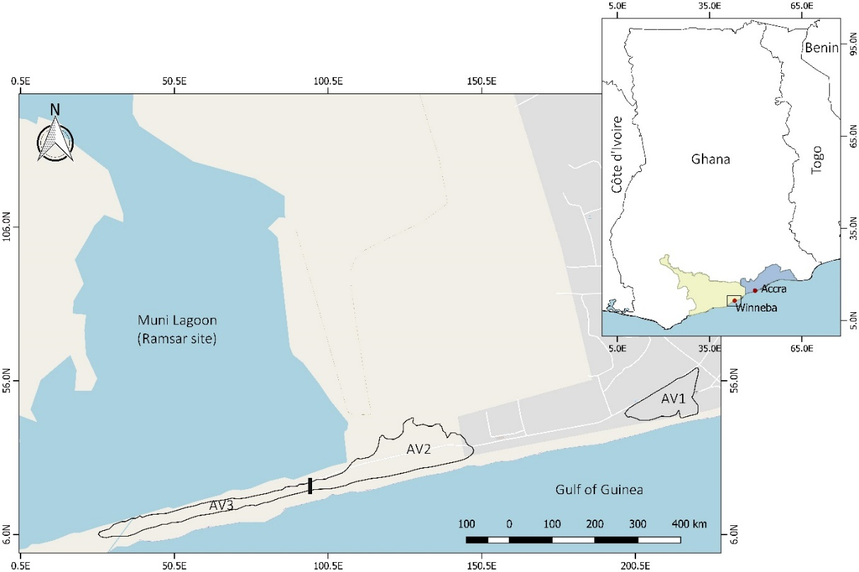
Figure 1: Location of the study area (Akosua village (AV)1, 2 & 3 are local administrative divisions within the community)
A household can be defined in several ways, and the definition adopted determines the boundaries of the unit of analysis. In this study, a household is defined as the total number of people for which the household head surveyed is responsible in terms of daily subsistence [34]. In each surveyed household, the household head (or their next of kin when they were not available) responded to the questionnaire. The questionnaire included questions about household characteristics, livelihood and income, energy needs, health, socio-cultural relations, social integration, perceptions of climate risks and impacts, adaptation strategies and household capital assets. Data collected were used to estimate a vulnerability index for each household using the Statistical Package for Social Sciences (SPSS v25).
3.2.3 Estimating household vulnerability index
According to the IPCC [31], climate change vulnerability is dependent on an entity’s exposure (E), sensitivity (S) and adaptive capacity (AC). Given that the potential impact from climate change hazards, which is a function of an entity’s E and S, may be offset totally or partially by its AC [14], [31], AC is inverted by subtracting a household’s AC from the maximum possible normalised AC, i.e. 10 (see Eq. 3). However, an important question arises. That is whether the model components should be aggregated by addition (Eq. 1) or by multiplication (Eq. 2). Additive aggregation means that the final index is equally dependent on all three model components. This raises the problem of compensability, where a high score on one component may compensate for a low score on another [14]. Multiplicative aggregation lessens this problem [36] and is therefore preferred in this study.
Equation 1:$Vulnerability (V)=(E+S+(10-AC)$)/3
Equation 2:$Vulnerability (V)=(E × S×(10-AC)$)

As there are no objective indicators for exposure, sensitivity and adaptive capacity, indicators that best describe their definition, and consistent with previous studies were chosen (Table 3).

Exposure refers to the presence of people “in places and settings that could be adversely affected” [37]. According to an interview with the local National Disaster Management Organisation (NADMO), there have been undocumented incidences of flooding in the community due to the Muni lagoon (Figure 1) overflowing its banks from heavy rains. Although records of past storms in the community are only anecdotal, the community is located about 4.2 km from another fishing community on the same shoreline that experiences stormy events more frequently [38]. In September 2016, the NADMO reported that a storm event caused damages estimated at US$ 41,330 [38]. The distance between the two communities was therefore taken as an indicator of the exposure of the study community to storms (Table 2). Estimated sea level rise for the Ghanaian shoreline was also considered as an exposure indicator [39]. Finally, the statistical variation in daily minimum and maximum temperature and rainfall records from 1988 to 2018 was computed as uncertainties in key atmospheric elements. Exposure indicators (Table 2) were additively aggregated assuming an equal measuring scale and units. Though the estimated E is considered constant for all households, it is included in the equation in keeping with the adopted IPCC vulnerability definition [31].
Table 2: Indicators of Akosua village’s exposure to climate change impacts
Exposure | Value | SD | Data source
Distance of community from storm hotspot (km) | 4.3 | NA | [38]
Estimated sea level rise by 2060 (cm) | 23.4 | NA | [7], [39]
Variation in max temperature (ºC) | 0.86 | 0.26 | GMet
Variation in min temperature (ºC) | 0.91 | 0.37 | GMet
Variation in rainfall (mm/year) | 6.60 | 6.84 | GMet
GMet (Ghana Meteorological Agency); NADMO (National Disaster Management Organisation). Storm hotspot is another fishing community which is about 4.3 km from Akosua village which is hit more frequently by storms. Variation in temperature and rainfall was estimated from 1988 – 2018 data records obtained from GMet.
Sensitivity is commonly defined as the degree to which a system is or will be affected by shocks and stresses [40]. In the context of this study, which focuses on a resource-dependent fishing community, sensitivity was thought of to be characterised by level of resource dependency, indicated by households’ percentage monthly income from fishing, quality of housing and number of dependents (Table3). Table 3 also details the indicators used to estimate adaptive capacity. Using equation 2, a vulnerability index was estimated for each household based on the E, S and AC indicators listed in Tables 2 and 3. Before inclusion in the vulnerability index model, all the indicators were normalised between 1 and 10 using equation 3:
Equation 3:$Norm (Ii)=1+((Ii-I\left(min\right))×(10-1))/(I(max)-I(min))$
Where Norm (Ii) is the normalised value of an indicator of a household, Ii is the actual value of that indicator and I(min) and I(max) are the minimum and maximum values of the same indicator respectively.
Table 3: Sub-indicators of Akosua village’s sensitivity and adaptive capacity to climate change impacts
Indicator | Explanation | Reference
Sensitivity
Percentage income from fishing | The percentage of respondent’s total monthly income from fishing either in the sea or lagoon | [9]
Quality of house ª | Characteristics of housing the respondent lives in | [9]
Children | Number of children aged 0 – 18 in household
Adaptive capacity
Social capital ^{b} | Aggregate index of the indicators of social capital  (Trust, networks, reciprocity and social integration) | [18], [41]
Financial capital ^{c} | Aggregate index of the indicators of financial capital  (Savings, remittances and investment) | [18], [21], [25]
Monthly household income | Total household monthly income | [9], [21], [42]
Physical capital ^{d} | Aggregate index of the indicators of physical capital  (Landed property, fishing gear and processing kilns) | [25], [43]
Use of Technology ^{e} | Aggregate index of the household’s use of technology  (means of personal transport, electricity, energy-efficient stove, and standing pipe) | [9]
Management  approach ^{f} | Aggregate index of the indicators of management approach  (Risk behaviour, innovation and involvement in alternative livelihood) | [10][41]
Human capital ^{g} | Aggregate index of the indicators of human capital  (Education and number of employable skills) | [11], [21]
Experience | Years of fishing and/or trading experience | [9]
Workforce percentage | The percentage of individuals who are employed/legally employable in the household (i.e. aged 18 - 70)
Possession of health insurance | The percentage of household members possessing a valid national health insurance card | [42]
Natural capital ^{h} | Aggregate index of the indicators of natural capital  (Livestock and land) | [9], [25]
ª Calculated as sum of wall, roof and floor quality and ranges from 0 – 7 (Wall: 3 = Palm leaves, 2 = mud, 1 = wood, 0 = concrete blocks; Roof: 2 = Thatch, 1 = Galvanized sheets, 0 = Fibre cement; 2 = mud, 1 = Screed floor, 0 = Tiled). ^{b} Calculated as sum of indicator score and ranges from 0 – 5 (Trust in community leader: 0 = none, 1 = weak, 2 = high; Social groups joined: 0 = none, 1 = one, 2 = two, 3 = ≥ three; Likelihood to obey laws: 0 = unlikely, 1 = Uncertain, 2 = Likely; Ability to speak Effutu: 0 = no, 1 = partially, 2 = fluently; Ability to understand Effutu: 0 = no, 1 = partially, 2 = Completely). ^{c} Calculated as sum of indicator scores and ranges from 0 – 11 (Have savings in bank: 0 = no, 1 = yes; Joins credit union: 0 = no, 1 = yes; Receive remittances from family: 0 = never, 1 = seldomly, 2 = occasionally, 3 = regularly; Have made some financial investment: 0 = no, 1 = yes). ^{d} Calculated as sum of indicator scores and ranges from 0 – 8 (Have sea fishing gear: 0 = no, 1 = yes; Have lagoon fishing gear: 0 = no, 1 = yes; Current state of fishing gears: 0 = Old, 1 = Nearly new, 2 = New; How many fish kilns: 0 = none; 1 = one; 2 = two; 3 = ≥ three). ^{e} Calculated as sum of responses (No = 0; Yes = 1) to five variables (possession of transportation, use of electricity, have toilet facility, use of energy efficient stove, and have a standing pipe in the house); score ranges from 0 – 5. ^{f} Calculated as sum of indicators scores and ranges from 0 – 5 (Willingness to change livelihood: 0 = no, 1 = uncertain, 2 = yes; Willingness to try new things: 0 = unwilling, 1 = uncertain, 2 = willing; Involvement in alternative livelihood: 0 = no, 1 = yes). ^{g} Calculated as sum of indicator scores and ranges from 0 – 9 (Highest education level in household: 0 = no education, 1 = Primary, 2 = junior high, 3 = senior high, 4 = university; Other employable skills: 0 = none, 1 = one, 2 = two, 3 = three, 4 = four, 5 = ≥ 5). ^{h} Calculates as sum of indicator scores and ranges from 0 – 6 (Livestock types possessed: 0 = none, 1 = one, 2 = two, 3 = three, 4 = ≥ four; Possession of land in Winneba: 0 = no, 1 = yes; Possession of land in hometown: 0 = no, 1 = yes).

Another important question that had to be addressed was whether or not to weight the components of the vulnerability model. Previous studies that have applied weighting determined weights either by expert judgement, by regression and/or principal component analysis. All these techniques have been criticised as being purely subjective or statistically biased [9], [32]. It has been recommended that a more transparent approach is to avoid such weighting altogether [14]. For these reasons, weights were not applied in this study.

3.2.4 Household climate change impact and vulnerability analysis
According to a key informant, 2014 was the most recent ‘good’ season because catches were comparable to a historic one in 1983 [Akosua village elder, 2018]. In addition, all respondents concur that 2018 was the worst of ‘bad’ seasons. The percentage change in self-reported household monthly incomes between 2014 and 2018 was therefore estimated as an indicator of the economic impact of climate change on fishing livelihood. Furthermore, to test the response of households’ vulnerability (as estimated in section 3.2.3) to income fluctuations (all things being equal), an ANOVA analysis was performed to compare household vulnerability in the good and bad seasons.

To understand how vulnerability is differentiated among households and which households are most vulnerable, ANOVA analyses (α = 0.05) were used to compare households under three household categorisations – economic class, gender of household-head and vulnerability group (Tables 5, 7 and 8). Vulnerability groups were derived by a quantile classification technique [9], [14], [44] that grouped the surveyed households into three clusters based on their vulnerability indices. Finally, further ANOVA analyses, and its non-parametric analogues where appropriate, were performed to investigate how each of the indicators of E, S and AC differed between households (Table 9).

4. RESULTS AND DISCUSSION
4.1 Evidence of local temperature and rainfall variability
Figure 2 shows that average daily maximum temperatures have remained largely stable between 1989 and 2018. However, average daily minimum temperatures have increased by 0.65°C during the same period. This local data corroborates the IPCC’s finding that globally, nighttime temperatures are increasing faster than day time temperatures with implications for crop and animal production [33], [45]. Average annual rainfall from 1989 – 2018 is 834.3 mm. This is lower than the amount recorded from 1982 – 2012 (Table 1) but much higher than average annual rainfall for the dry equatorial climatic zone (400 – 500 mm/year) within which the study area lies [23], [34]. Contrary to community perceptions, annual rainfall shows an increasing trend over the last 30 years, although it has indeed been very erratic (Figure 3). Furthermore, from Table 4, the number of ≥ 14 mm/24 hrs rainfall days outside seasons (i.e. 40 days) and the total amount of rainfall outside seasons (1417.1 mm/decade) recorded in the last decade (D3) represent an average increase of 45.5% and 88.6% respectively, compared to the two previous decades (D1 and D2). Thus, the distinctiveness of the major and minor rainy seasons is being blurred with an increasing number of rainfall days and total rainfall outside them. Consequently, the results do no corroborate local perceptions of reducing rainfall. The data also shows some evidence of rainfall intensification. Further analysis revealed that there has been almost a two-fold increase in the number of ≥ 100 mm rainfall days in the last decade compared to the previous two.
Table 4: Number of days in the major and minor rainy seasons in Winneba from 1989 – 2018 recording rainfall greater or equal to 14 mm, and total rainfall in each decade.
Period | Number of ≥ 14 mm/24 hrs rainfall days |  |  |  | Total amount of rainfall (mm/decade)
 | Major seasons | Minor seasons | Outside seasons |  | Major seasons | Minor seasons | Outside seasons
D1 | 107 | 27 | 28 |  | 2535.5 | 520.7 | 646.1
D2 | 120 | 34 | 27 |  | 4265.1 | 1044.1 | 897.2
D3 | 110 | 39 | 40 |  | 4621.2 | 1109.0 | 1417.1
D1 – (1989 - 1998), D2 – (1999 - 2008), D3 – (2009 – 2018). *Data for 2018 is from January to September. 14 mm is chosen as the lower limit for substantial rain because it is the least average rainfall for 10 major seasons in D1.)

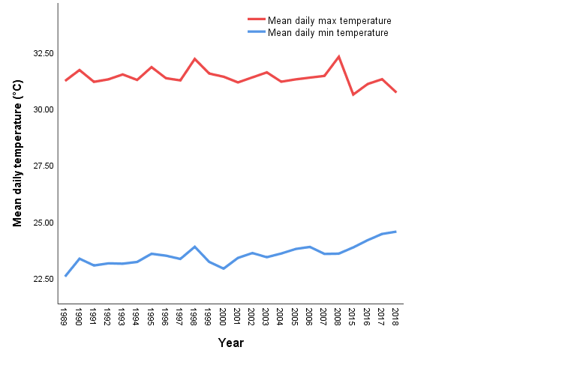
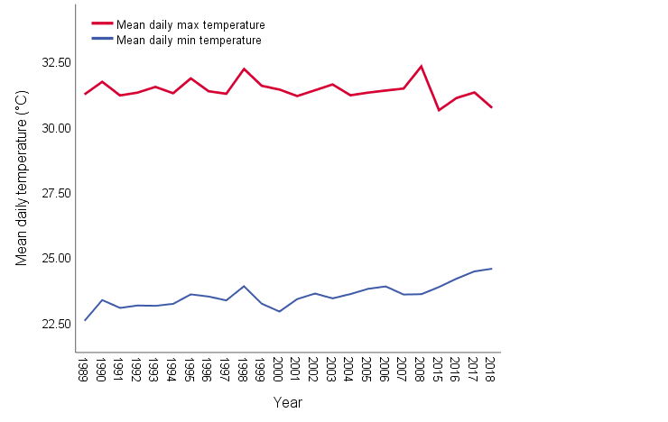

Figure 2: Average daily minimum and maximum temperatures for Winneba from 1989 – 2018. Maximum temperature from 2009 – 2014 is excluded as it was not available from GMet.

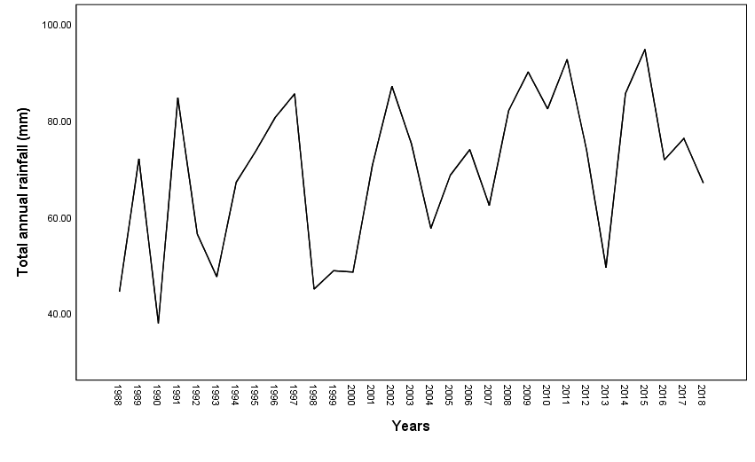
Figure 3: Total annual rainfall for Effutu Municipality from 1989 – 2018.

4.2 Climate change impact on fishing livelihood
A comparison of household monthly incomes between 2014 and 2018 showed that incomes have reduced by about 90% in the last 4 years. In Ghana, artisanal fishing is a significant contributor to food security and poverty alleviation in coastal areas [46], [47] and supports the lives of about 20% of the population [48]. Several studies have observed that climate change interacts with other non-climatic stressors in complex ways to impact fishing livelihoods [15], [16], [19]. The results demonstrate the magnitude of impact that that interaction has on the economy of coastal fishing communities. With such a considerable impact on incomes, food security is threatened, and many households might sink deeper into poverty in the absence of adaptation interventions. Some studies have suggested that climatic stressors are of less importance to natural resource-dependent communities than non-climatic stressors such as limited access to resources and infrastructural deficits [15], [16], [49]. Indeed, vulnerability is understood to be embedded in the political economy of a context [18], [22], [50] and the resilience of the resources upon which peoples’ livelihoods depend [40], [50], [51]. A limited number of studies (e.g. [16], [52]) have attempted to explicate the relative importance of climatic and non-climatic stressors to coastal fishing communities. McCubbin et al. [16] show that non-climatic stressors are priority problems for fishing communities, while Malakar et al. [50] hold that it depends on the regional scale (rural to urban) being considered. More research from a variety of contexts is needed to fully elucidate it.
4.3 Household vulnerability
At the community level, an ANOVA test to compare the vulnerability of all households between good and bad seasons showed a significant increase in bad seasons (ANOVA test, p = 0.01). In the estimation of the vulnerability index, the only variable that is varied between ‘good’ and ‘bad’ seasons is monthly income. Although other contextual socioeconomic and policy factors are important covariates as already acknowledged [13], [17]–[19], they are not explicitly analysed in the study. The significant increase in vulnerability associated with change in monthly incomes therefore demonstrates how contextual socioeconomic factors can latently act in concert with a dwindling resource-base to increase the vulnerability of fishing households [51]. It also reflects previous findings on how local communities are and will be affected by predictions of a global decrease in maximum fish yield and revenue potential due to climate change [4].
At the household level, significant differences in vulnerability were found only amongst the statistically derived vulnerability groups (p = .01 and .01 for good and bad seasons respectively; Table 5). The results suggest that in both ‘good’ or ‘bad’ seasons, all households irrespective of economic class are equally vulnerable (Table 5). An analysis of income distribution showed that there was high income inequality in the community during the ‘good’ season, which is reduced slightly in the ‘bad’ season (Gini index = 0.64 and 0.47 respectively). This is deemed to be the major reason for equality in vulnerability during the ‘bad’ season. Furthermore, following the ANOVA test, a Tukey post hoc test showed a significant vulnerability difference between net owners and their net draggers (p = 0.03) during the ‘good’ but not the ‘bad’ season. Interviews with some net owners revealed that, in ‘bad’ seasons, the dire economic situation often forces them to altruistically bear the responsibility for their boat crews’ and some of their net draggers’ subsistence. This finding has utility in the design and equitable distribution of adaptation interventions. It shows that adaption support interventions should not focus predominantly on the poorest and often most vulnerable [53], [54]. It is equally necessary to bolster the ability of the relatively wealthier, who also often have bigger responsibilities of care within the community.
Table 5: Statistical differences in fishing household vulnerability based on household categorisation
Season |  | Vulnerability (p-value)
 |  | Economic classes | Gender of Household-head | Vulnerability group
Good |  | .07 | .40 | .01
Bad |  | .16 | .50 | .01
Economic classes (net owner, boat crew, net dragger, fish monger, petty trader, other occupation); Gender (male or female household-head); Vulnerability group (Low, Moderate, High) (α = 0.05).
Table 6: Key household characteristics of vulnerable households in the current “bad” season
 | Vulnerability group
Characteristics | Low | Moderate | High
Age range of household head (years) | 28 – 72 | 24 – 70 | 26 – 55
Average length of residence (years) | 33.6 | 35.3 | 30.0
Mean number of children | 2 | 3 | 3
Average monthly income – GS (US$) * | 932.84 | 410.01 | 368.26
Average monthly income – BS (US$) * | 89.17 | 45.95 | 41.48
* At the time of writing this paper US$ 1.00 = GHS 5.50 (www.xe.com). GS – ‘good’ season; BS – ‘bad’ season.

Results in Table 6 shows that the most vulnerable households are those whose heads are the youngest, have lived relatively less longer in the community, have three children and earn on average less than US$ 400.00 and 45.00/month in ‘good’ and ‘bad’ seasons respectively. Tables 7 and 8 show furthermore, that the most vulnerable household group includes both male and female-headed households and all economic classes. This demonstrates that the most vulnerable are not always women and the poorest as argued by some [53]–[56]. Table 7 shows that the majority of female-headed households (66.7%) were in the high vulnerability group during ‘good’ seasons. In the same season, in terms of economic classification, Table 8 shows that all petty traders and up to half of the fish mongers (all women) were in the high vulnerable group. In the ‘bad’ season however, the proportion of female-headed households and petty traders in the high vulnerability group reduced by about 10% (Table 7) and 50% (Table 8) respectively. Conversely, Table 8 shows that the proportion of net owners and boat crew (all men) in the low and moderate vulnerability groups respectively in the ‘good’ season reduced in the ‘bad’ season. This increased their proportions in the moderate and high vulnerability groups respectively. In effect, female-headed households were relatively better off in the ‘bad’ season. To find an explanation for this, households’ involvement in alternative livelihoods (management approach, Table 3) was analysed. This approach was based on the theory that alternative livelihoods are a risk-reduction strategy for resource-dependent households [57], [58]. The results (Table 7) showed that indeed, more women were involved in alternative livelihoods than men, confirming the fact that livelihood diversification is an effective strategy for reducing vulnerability [25], [26], [43].
The observed seasonal dynamics in vulnerability, in relation to gender and economic class classification, highlights the importance of looking beyond gender and adopting an intersectional perspective [59], [60] when searching for and prioritizing vulnerable households. This is because, as the results demonstrate, men and even richer households could at times be relatively more vulnerable. While pre-existing social identities like gender, economic class and ethnicity are good starting points for identifying and prioritizing critically vulnerable households, the target group may not lie within the categories that these social identities singularly characterize. Rather, it may be a unique configuration of households from all categories of the chosen social identities. As such, this unique group must be analytically sought, if adaptation or development interventions will be equitably and efficiently distributed. For example, there is a 100% probability that a woman who is also a petty trader chosen at random is in the high vulnerable group in the good season, while there is only a 50% chance that a fish monger will be in that group (Table 8). An intervention that is fisheries-biased therefore will miss the most vulnerable women. Similarly, while net draggers are a lower economic class compared to boat crew, the latter have 50% probability of being in the high vulnerability group in the bad season, while the former have 35% of being in the same group (Table 8).
4.4 Entry points for adaptive capacity enhancement
Table 9 summarises the factors that significantly differed amongst households depending on which household categorisation is adopted. It shows summarily, that the socioeconomic factors that significantly differentiates households’ vulnerability to climate change are: quality of house (sensitivity indicator); and social, financial, human and natural capitals (adaptive capacity indicators). These can be considered the important entry points through which investment, as noted by Chambers and Conway [24], could be made to enhance the community’s adaptive capacity [48]. In fact, according to FAO [61], there are similar communities involved in beach seining along the West African coastline, particularly in Togo and Benin (Figure 1), where seining contributes 70 – 80 percent of total marine catches. Since the social organisation of beach seining communities in West Africa and even in some East African countries like Mozambique [59] are similar, the suggested entry points could be used as starting points for identifying which aspects of the lives of fishing communities that interventions should be targeted during adaptation planning. Overall, although the results may be considered as being only a snapshot of what is a highly dynamic socioecological and economic system, they do provide fairly generalizable insights into the factors that characterise the vulnerability of rural coastal fishing communities along the Ghanaian and, indeed, the West African coastline.
5. Conclusion
The climatic data analysis shows an overall increase in rainfall in the last decade, which does not corroborate local perceptions of reduced rainfall. In addition, the data shows evidence of rainfall intensification and a 0.65°C increase in minimum temperatures over the last three decades. In terms of economic impact, the findings suggest that household incomes have reduced by about 90% in the last 4 years, attributable to an interaction of climatic and non-climatic factors. The findings show that generally, the most vulnerable households are not necessarily women or poorer households. Rather, they are from all gender and economic group categories, depending on whether a fishing season, according to the community, is ‘good’ (big catches, more income) or ‘bad’ (meagre catches, less incomes). Finally, the findings show that the factors that contribute to shaping the vulnerability of fishing households differ depending on which household categorisation is used. It demonstrates that an intersectional understanding of climate change vulnerability is essential for improving adaptation project design, planning and implementation.

Table 7: Gender composition of household vulnerability classes in good (GS) and bad (BS) seasons
Vulnerability class |  |  |  |  | Male-headed HH (%) |  |  |  |  | Female-headed HH (%)
 |  |  |  |  | GS |  | BS |  |  | GS | BS
 |  | Low |  | 34.0 |  | 34.0 |  |  |  | 22.2 | 22.2
 |  | Moderate |  | 38.0 |  | 36.0 |  |  |  | 11.1 | 22.2
 |  | High |  | 28.0 |  | 30.0 |  |  |  | 66.7 | 55.6
 |  | Involved in alternative livelihood(s)* |  | 30.0 |  |  |  |  |  |  | 55.6
 |  | * is a sub-indicator of management approach (risk behaviour, innovation and involvement alternative livelihood) which differed significantly between male and female-headed households (HH) (ANOVA; p = 0.03; α = 0.05). See Table 9.

Table 8: Economic class composition of household vulnerability group in ‘good’ and ‘bad’ seasons.
Vulnerability (V)  Group |  | Net owner |  | Boat crew |  | Net dragger |  | Fish monger |  | Petty trader |  | Other occupation
 |  | Good | Bad | Good | Bad | Good | Bad | Good | Bad | Good | Bad | Good | Bad
Low | % in V group | 42.1 | 36.8 | 15.8 | - | 15.8 | - | 10.5 | - |  |  | 15.8 | 21.1
 | % in Economic class | 61.5 | 53.8 | 25.0 | - | 15.0 | - | 33.3 | - |  |  | 50.0 | 66.7
Moderate | % in V group | 20.0 | 25.0 | 20.0 | 15.0 | 50.0 | - | 5.0 | - |  | 5.0 | 5.0
 | % in Economic class | 30.8 | 38.5 | 33.3 | 25.0 | 50.0 | - | 16.7 | - |  | 50.0 | 16.7
High | % in V group | 5.0 | - | 25.0 | 30.0 | 35.0 | - | 15.0 | - | 10.0 | 5.0 | 10.0 | -
 | % in Economic class | 7.7 | - | 41.7 | 50.0 | 35.0 | - | 50.0 | - | 100.0 | 50.0 | 33.3 | -
“% in V group” is the percentage of respondents from the different economic classes that make up a vulnerability group. “% in economic class” is the percentage of respondents within a particular economic class in the low, moderate and high vulnerability groups. Rows: percentage totals for each vulnerability group is 100.0 for each of the ‘good’ and ‘bad’ seasons. Columns: percentage totals for each economic class is 100.0 for each of the ‘good’ and ‘bad’ seasons. (-) represent unchanged percentage from ‘good’ to ‘bad’ season.
Table 9: How indicators and indices of household sensitivity and adaptive capacity to climate change are differentiated by economic class, gender and vulnerability group. Values are p-values.
Indices, indicators and sub-indicators | Household categorisation
 | Economic class | Gender of HH-H | Vulnerability group (GS) | Vulnerability group (BS)
Vulnerability index | 0.07 | 0.38 | 0.01 | 0.01
Sensitivity indicators
Percentage income from fishing | 0.70 | 0.67 | 0.35 | 0.35
Quality of house | 0.19 | 0.79 | 0.01* | 0.01*
Number of children | 0.70 | 0.54 | 0.25 | 0.11
Sensitivity | 0.77 | 0.76 | 0.01* | 0.01*
Adaptive capacity indicators
Use of technology | 0.35 | 0.97 | 0.08 | 0.06
Social capital | 0.01* | 0.82 | 0.01* | 0.01*
Financial capital | 0.51 | 0.85 | 0.01* | 0.01*
Monthly income (GS) | 0.01* | 0.03* | 0.14 | 0.62
Monthly Income (BS) | 0.01* | 0.76 | 0.97 | 0.92
Physical capital | 0.13 | 0.95 | 0.04* | 0.17
Management approach | 0.05* | 0.03* | 0.54 | 0.63
Human capital | 0.03* | 0.52 | 0.07 | 0.02*
Workforce | 0.96 | 0.68 | 0.03* | 0.02*
Possession of health insurance | 0.41 | 0.24 | 0.09 | 0.12
Experience (years) | 0.40 | 0.12 | 0.18 | 0.19
Natural capital | 0.02* | 0.99 | 0.01* | 0.01*
Adaptive capacity (GS) | 0.01* | 0.11 | 0.01* | 0.01*
Adaptive capacity (BS) | 0.01* | 0.17 | 0.01* | 0.01*
*Indicates significant difference (normalised values used) between identity categories at α = 0.05. Significant differences in both ‘good’ (GS) and ‘bad’ (BS) seasons are detected by Kruskal-Wallis Test for all indicators/indices except sensitivity, experience, management capital and adaptive capacity which are analysed by ANOVA. HH-H (Household Head).

ACKNOWLEDGEMENTS
Thanks to Andrew Agyekumhene (site manager of Muni-Pomadze Ramsar site), Michael Selorm (field assistant from University of Education, Winneba), and Gideon Ahiabor (Akosua village) for fieldwork support. We also thank two anonymous reviewers for their helpful comments and suggestions. This work was funded by Ph.D. studentship of Environmental Sustainability Research Centre (ESRC), University of Derby.

DECLARATIONS OF INTEREST
None

REFERENCES
[1] FAO, “The State of World Fisheries and Aquaculture 2018,” 2018.
[2] D. Carney, “Sustainable rural livelihoods: what contribution can we make?” DFID, London, p. 213, 1998.
[3] A. Tilley, P. Herrón, S. Espinosa, J. L. Angarita, and S. Box, “Predicting vulnerability to management changes in data-limited, small-scale fisheries,” Mar. Policy, vol. 94, no. May, pp. 39–45, 2018.
[4] V. W. Y. Lam, W. W. L. Cheung, G. Reygondeau, and U. Rashid Sumaila, “Projected change in global fisheries revenues under climate change,” Sci. Rep., vol. 6, pp. 6–13, 2016.
[5] M. C. Badjeck, E. H. Allison, A. S. Halls, and N. K. Dulvy, “Impacts of climate variability and change on fishery-based livelihoods,” Mar. Policy, vol. 34, no. 3, pp. 375–383, 2010.
[6] V. Masson-Delmotte et al., Intergovernmental Panel on Climate Change-Global Warming of 1.5 Degrees Celcius. 2018.
[7] K. S. Davies-Vollum and M. West, “Shoreline change and sea level rise at the Muni-Pomadze coastal wetland (Ramsar site), Ghana,” J. Coast. Conserv., vol. 19, no. 4, pp. 515–525, 2015.
[8] K. S. Davies-Vollum, Z. Zhang, and A. Agyekumhene, “Impacts of lagoon opening and implications for coastal management: case study from Muni-Pomadze lagoon, Ghana,” J. Coast. Conserv., vol. 23, no. 2, pp. 293–301, 2019.
[9] M. M. Islam, S. Sallu, K. Hubacek, and J. Paavola, “Vulnerability of fishery-based livelihoods to the impacts of climate variability and change: Insights from coastal Bangladesh,” Reg. Environ. Chang., vol. 14, no. 1, pp. 281–294, 2014.
[10] C. Béné et al., “Is resilience socially constructed? Empirical evidence from Fiji, Ghana, Sri Lanka, and Vietnam,” Glob. Environ. Chang., vol. 38, pp. 153–170, 2016.
[11] L. T. M. Huynh and L. C. Stringer, “Multi-scale assessment of social vulnerability to climate change: An empirical study in coastal Vietnam,” Clim. Risk Manag., vol. 20, no. February, pp. 165–180, 2018.
[12] Q. Cui, W. Xie, and Y. Liu, “Effects of sea level rise on economic development and regional disparity in China,” J. Clean. Prod., vol. 176, pp. 1245–1253, 2018.
[13] G. Freduah, P. Fidelman, and T. F. Smith, “Adaptive capacity of small-scale coastal fishers to climate and non-climate stressors in the Western region of Ghana,” Geogr. J., vol. 185, no. 1, pp. 96–110, 2019.
[14] E. H. Allison et al., “Vulnerability of national economies to the impacts of climate change on fisheries,” Fish Fish., vol. 10, no. 2, pp. 173–196, Jun. 2009.
[15] H. Nyantakyi-Frimpong and R. Bezner-Kerr, “The relative importance of climate change in the context of multiple stressors in semi-arid Ghana,” Glob. Environ. Chang., vol. 32, pp. 40–56, 2015.
[16] S. McCubbin, B. Smit, and T. Pearce, “Where does climate fit? Vulnerability to climate change in the context of multiple stressors in Funafuti, Tuvalu,” Glob. Environ. Chang., vol. 30, pp. 43–55, 2015.
[17] J. E. Cinner et al., “Building adaptive capacity to climate change in tropical coastal communities,” Nat. Clim. Chang., vol. 8, no. 2, pp. 117–123, 2018.
[18] W. Neil Adger, “Social vulnerability to climate change and extremes in coastal Vietnam,” World Dev., vol. 27, no. 2, pp. 249–269, 1999.
[19] M. Monirul Islam, S. Sallu, K. Hubacek, and J. Paavola, “Limits and barriers to adaptation to climate variability and change in Bangladeshi coastal fishing communities,” Mar. Policy, vol. 43, pp. 208–216, 2014.
[20] T. Cochrane, K., De Young, C., Soto, D., & Bahri, “Climate Change Implications for Fisheries and Aquaculture,” in Climate Change Impacts on Fisheries and Aquaculture, T. Cochrane, K., De Young, C., Soto, D., & Bahri, Ed. Rome: FAO Fisheries and aquaculture technical paper, 530, 2009, p. 212.
[21] P. Antwi-Agyei, A. J. Dougill, E. D. G. Fraser, and L. C. Stringer, “Characterising the nature of household vulnerability to climate variability: Empirical evidence from two regions of Ghana,” Environ. Dev. Sustain., vol. 15, no. 4, pp. 903–926, 2013.
[22] T. Tanner, A. Mensah, E. T. Lawson, C. Gordon, R. Godfrey-Wood, and T. Cannon, “Political Economy of Climate Compatible Development: Artisanal Fisheries and Climate Change in Ghana,” IDS Work. Pap., vol. 2014, no. 446, pp. 1–30, 2014.
[23] J. Ankrah, “Climate change impacts and coastal livelihoods; an analysis of fishers of coastal Winneba, Ghana,” Ocean Coast. Manag., vol. 161, no. May, pp. 141–146, 2018.
[24] R. Chambers and G. R. Conway, “Sustainable rural livelihoods: practical concepts for the 21st century,” IDS Discuss. Pap., vol. 296, 1992.
[25] I. Scoones, “Sustainable Rural Livelihoods: A Framework for Analysis, IDS Working Paper 72,” IDS Work. Pap., vol. 72, no. May, pp. 1–22, 1998.
[26] K. Hussein and J. Nelson, “Sustainable livelihoods and livelihood diversification (No. IDS Working Paper 69),” Bright. IDS, 1998.
[27] J. R. B. Manyena, G. O’Brien, P. O’Keefe, “Disaster resilience: a bounce back or bounce forward ability?,” LOCAL Environ. VO - 16, no. 5, p. 417, 2011.
[28] J. Forster, I. R. Lake, A. R. Watkinson, and J. A. Gill, “Marine dependent livelihoods and resilience to environmental change: A case study of Anguilla,” Mar. Policy, vol. 45, pp. 204–212, 2014.
[29] S. Appe and A. Schnable, “Don’t reinvent the wheel: possibilities for and limits to building capacity of grassroots international NGOs,” in Third world quarterly VO - 40, 2019, no. 10, p. 1832.
[30] E. Apine, L. M. Turner, L. D. Rodwell, and R. Bhatta, “The application of the sustainable livelihood approach to small scale-fisheries: The case of mud crab Scylla serrata in South west India,” Ocean Coast. Manag., vol. 170, no. December 2018, pp. 17–28, 2019.
[31] T. T. X. Nguyen, J. Bonetti, K. Rogers, and C. D. Woodroffe, “Indicator-based assessment of climate-change impacts on coasts: A review of concepts, methodological approaches and vulnerability indices,” Ocean Coast. Manag., vol. 123, pp. 18–43, 2016.
[32] C. Tapia et al., “Profiling urban vulnerabilities to climate change: An indicator-based vulnerability assessment for European cities,” Ecol. Indic., vol. 78, pp. 142–155, 2017.
[33] IPCC, "Summary for Policymakers. In: Climate Change 2014: Impacts, Adaptation, and Vulnerability. Part A: Global and Sectoral Aspects. Contribution of Working Group II to the Fifth Assessment Report of the Intergovernmental Panel on Climate Change [Field, C.B., V.R. Barros, D.J. Dokken, K.J. Mach, M.D. Mastrandrea, T.E. Bilir, M. Chatterjee, K.L. Ebi, Y.O. Estrada, R.C. Genova, B. Girma, E.S. Kissel, A.N. Levy, S. MacCracken, P.R. Mastrandrea, and L.L. White (eds.)]. Cambridge University Press, Cambridge, United Kingdom and New York, NY, USA, pp. 1-32, 2014.
[34] Ghana Statistical Service, “2010 POPULATION & HOUSING CENSUS NATIONAL: NATIONAL ANALYTICAL REPORT,” Accra, Ghana, 2014.
[35] A. Bryman, Social research methods., Fifth edition. Oxford University Press, 2015.
[36] S. Hajkowicz, “Multi-attributed environmental index construction,” Ecol. Econ., vol. 57, no. 1, pp. 122–139, Jan. 2006.
[37] IPCC, “Annex II: Glossary [Mach, K.J., S. Planton and C. von Stechow (eds.)]. In: Climate Change 2014: Synthesis Report. Contribution of Working Groups I, II and III to the Fifth Assessment Report of the Intergovernmental Panel on Climate Change” IPCC, Geneva, Switzerland, 2014.
[38] NADMO, “Report on tidal waves at Winneba beach: September 2016,” Winneba, Central Region, Ghana, 2016.
[39] K. Sagoe-Addy and K. Appeaning Addo, “Effect of predicted sea level rise on tourism facilities along Ghana’s Accra coast,” J. Coast. Conserv., vol. 17, no. 1, pp. 155–166, 2013.
[40] G. C. Gallopín, “Linkages between vulnerability, resilience, and adaptive capacity,” Glob. Environ. Chang., vol. 16, no. 3, pp. 293–303, 2006.
[41] M. Lockwood, C. M. Raymond, E. Oczkowski, and M. Morrison, “Measuring the dimensions of adaptive capacity: A psychometric approach,” Ecol. Soc., vol. 20, no. 1, 2015.
[42] B. Asiedu, F. K. E. Nunoo, P. K. Ofori-Danson, D. B. Sarpong, and U. R. Sumaila, “Poverty Measurements in Small-scale Fisheries of Ghana: A Step towards Poverty Eradication,” Curr. Res. J. Soc. Sci., vol. 5, no. 3, pp. 75–90, 2013.
[43] E. H. Allison and F. Ellis, “The livelihoods approach and management of small-scale fisheries,” Mar. Policy, vol. 25, no. 5, pp. 377–388, 2001.
[44] K. O’Brien et al., “Mapping vulnerability to multiple stressors: Climate change and globalization in India,” Glob. Environ. Chang., vol. 14, no. 4, pp. 303–313, 2004.
[45] Y. H. Fu et al., “Three times greater weight of daytime than of night-time temperature on leaf unfolding phenology in temperate trees,” NEW PHYTOLOGIST, vol. 212, no. 3. pp. 590–597.
[46] D. Belhabib, U. R. Sumaila, and D. Pauly, “Feeding the poor: Contribution of West African fisheries toemployment and food security,” Ocean Coast. Manag., vol. 111, pp. 72–81, 2015.
[47] C. Béné, “SMALL-SCALE FISHERIES_ASSESSING THEIR CONTRIBUTION TO RURAL LIVELIHOODS IN DEVELOPING COUNTRIES,” 2006.
[48] F. K. E. Nunoo et al., “Marine fisheries catches in Ghana: Historic reconstruction for 1950 to 2010 and current economic impacts,” Rev. Fish. Sci. Aquac., vol. 22, no. 4, pp. 274–283, 2014.
[49] P. Tschakert, “Views from the vulnerable: Understanding climatic and other stressors in the Sahel,” Glob. Environ. Chang., vol. 17, no. 3–4, pp. 381–396, 2007.
[50] W. N. Adger, T. P. Hughes, C. Folke, S. R. Carpenter, and J. Rockström, “Social-ecological resilience to coastal disasters,” Science, vol. 309, no. 5737. pp. 1036–1039, 2005.
[51] W. N. Adger, “Social and ecological resilience: Are they related?,” Prog. Hum. Geogr., vol. 24, no. 3, pp. 347–364, 2000.
[52] K. Malakar, T. Mishra, and A. Patwardhan, “Perceptions of multi-stresses impacting livelihoods of marine fishermen,” Mar. Policy, vol. 97, no. 105, pp. 18–26, 2018.
[53] M. Pelling and M. Garschagen, “Put equity first in climate adaptation,” Nature, vol. 569, no. 7756, pp. 327–329, May 2019.
[54] F. Denton, “Climate Change Vulnerability, Impacts, and Adaptation: Why Does Gender Matter?,” Gend. Dev., vol. 10, no. 2, p. 10, 2002.
[55] V. Nelson, K. Meadows, T. Cannon, J. Morton, and A. Martin, “Uncertain Predictions, Invisible Impacts, and the Need to Mainstream Gender in Climate Change Adaptations,” Gend. Dev., vol. 10, no. 2, p. 51, 2002.
[56] M. M. Islam, Poverty Mosaics: Realities and Prospects in Small-Scale Fisheries, no. December 2010. Dordrecht: Springer Netherlands, 2011.
[57] N. Stacey et al., “Enhancing coastal livelihoods in Indonesia: an evaluation of recent initiatives on gender, women and sustainable livelihoods in small-scale fisheries,” Marit. Stud., 2019.
[58] S. Wicander and L. Coad, Learning Our Lessons: A Review of Alternative Livelihoods Projects in Central Africa. ECI, University of Oxford and Gland, Switzerland: IUCN. Switzerland: Oxford, UK, 2015.
[59] M. Thompson-Hall, E. R. Carr, and U. Pascual, “Enhancing and expanding intersectional research for climate change adaptation in agrarian settings,” Ambio, vol. 45, no. S3, pp. 373–382, Dec. 2016.
[60] A. Kaijser and A. Kronsell, “Climate change through the lens of intersectionality,” Environ. Polit. VO - 23, no. 3, p. 417, 2014.
[61] E. Tietze, U. Lee, R. Siar, S. Moth-Poulsen, T. Båge, H.E., “Fishing with beach seines. FAO Fisheries and Aquaculture Technical Paper, (562), I,” Rome, 2011.

