**Increasing timber and declining live plant diversity and volumes in global trade from 2000 to 2020**

Alireza Naqinezhad1,2,3+*, Oscar Morton1,4,5*, David P. Edwards4,5+

1Ecology and Evolutionary Biology, School of Biosciences, University of Sheffield, Sheffield S10 2TN, UK

2Department of Environmental Sciences, College of Science and Engineering, University of Derby, Kedleston Road, Derby, DE22 1GB, UK

**3**Department of Plant Biology, Faculty of Basic Sciences, University of Mazandaran, Babolsar, IRAN.

4Department of Plant Sciences and Centre for Global Wood Security, University of Cambridge, Cambridge, CB2 3EA, UK

5Conservation Research Institute, University of Cambridge, Cambridge, CB2 3EA, UK

+Corresponding authors: dpe29@cam.ac.uk; a.naqinezhad@derby.ac.uk

*Contributed equally to this study

**Editors summary**

More than 8.4 million m3 of wild-sourced CITES-listed timber, 197 million individual live plants, and 4.6 million kg of plant products in trade. We highlight changing spatiotemporal trends and an abundance of poorly understood species in trade.

**Abstract**

Plants are a vast, lucrative portion of global wildlife trade and the most speciose clade listed under the Convention on International Trade in Endangered Species of Wild Fauna and Flora-CITES. Here we assess the diversity and volume of wild-sourced CITES-listed across space and time. Between 2000-2020, over 8.4 million m3 of timber, 197 million individual live plants, and 4.6 million kg of plant products were traded under CITES, comprising 53, 765, and 74 species, respectively. Most species are traded between key exporter and importer nations, especially China, USA, and Europe. Total diversity of timber species and volumes increased over time, whereas live diversity declined, and product diversity and mass fluctuated uncertainly. Most species were not evaluated by the IUCN Red List when first traded, with high volumes of timber and products concentrated among threatened taxa. The high prevalence of poorly understood species necessitates enhanced rigour in ensuring sustainable CITES trade.

**Keywords:**

**Wildlife trade, timber, CITES, sustainable use, plant trade**

**Introduction**

Wildlife trade is a key driver of the biodiversity crisis 1, 2, 3 and crucial income for hundreds of millions of people4, 5, 6. At least 7621 species (23% of those assessed against the Red List criteria by the International Union for Conservation of Nature-IUCN) of tracheophytic plant are estimated to be traded 7, comparable to the ~24% (7638) of extant vertebrates in recent trade 8, with poorly managed trade risking substantial declines in abundance 9. Plants are traded in a diverse array of forms from fibres and root tubers to ornamental live specimens, sawn logs, and processed timbers 10, 11. The timber trade alone was worth over US$1.5 trillion in 2015 12, with 300 million cubic metres of tropical hardwoods harvested annually 13, while global trade in plants for medicinal purposes was valued at over US$3 billion in 201513, with much of the diversity outside of these terms still poorly quantified.

Since 1975, the Convention on International Trade in Endangered Species of Wild Fauna and Flora (CITES) has mandated the protection of Listed wild fauna and flora against overexploitation from international trade14. Species most threatened by international trade are listed in Appendix I (trade largely prohibited), which includes 411 plant taxa; Appendix II species are not necessarily threatened by trade, but may become so without adequate oversight, and includes 33,764 plant taxa, mostly cacti (>1,500 species) and orchids (>27,000) 10. Appendix II species can be traded, but require evidence that the trade will cause no detriment to wild populations, although the sustainability is questionable15. Since CITES’ establishment, plants have been by far the most traded group, with over 1.8 billion traded individuals, more than 10 times the volume of the next most traded clade (reptiles, 152 million individuals), and the aggregate volume of plants traded has increasing rapidly over time 16.

For some heavily traded plant species, exploitation is a major threat. For example, thousands of cubic metres of critically endangered cocobolo rosewood (*Dalbergia* *retusa*) and endangered African teak (*Pericopsis* *elata*) are legally traded annually 17, with the legal trade in African rosewood (*Pterocarpus erinaceus*) persisting at unsustainable levels despite CITES-listing and multiple export bans18. Similarly, many orchids are vulnerable to over-harvest due to their specialized pollination mechanisms, habitat specificity, very localised ranges, and the restricted distribution of mycorrhizal symbionts preventing recolonization 19, 10. Ensuring sustainability for such commercially valuable, threatened species presents a key challenge.

To date much of the research on broad trends in the plant trade has focused on specific species groups, particularly orchids, offered for sale in physical markets. Research in China has highlighted at least 266 species of orchids in trade with hundreds of thousands of individual wild harvested stems offered for sale 20. Similar studies in Mexico and on the cross-border trade in Lao People’s Democratic Republic, Thailand, and Myanmar highlight similarly high levels of orchid diversity in trade, with harvester interviews suggesting it drivers population declines 21, 22. Likewise, there is growing recognition of the online and social media trade and its role in moving illegally harvested plants and/or valuable plant derivatives (e.g. salep – a product made from *Orchidaceae* spp. tubers) 23, 24. However, we currently lack a more holistic overview of the international trade in CITES-listed species across taxa.

Understanding how plants are traded under CITES across space and time is thus a major research challenge. For terrestrial vertebrates, volumes traded under CITES have declined through time and are increasingly dominated by non-threatened species, although a few threatened species remain traded in high volumes and are of conservation concern 25. Here, we tackle the key question of how quantities of CITES-listed plants—spanning timber, live-traded plants, and primary and secondary plant products (e.g. extracts, oil, and fibre)—are traded across space and time. We use the CITES Trade Database of legally, commercially traded, wild-sourced CITES-listed plants containing >420,000 records between 2000 and 2020 to tackle three questions: what is the overall diversity and volume of CITES trade in timber, live plants, and plant products across space; how does overall diversity and volume in trade vary over time; and how does trade volume vary between species?

**Results**

***Diversity and volume in trade across space***

From 2850 timber, 15,991 live, and 2505 product annual importer-species records, legal international trade through CITES spanned 95 exporting and 66 importing Parties between 2000 and 2020. These spanned a total of 855 distinct plant species (892 species-purpose combinations) from 38 families and 27 orders (53 timber, 765 live, and 74 product species, with 34 species traded for two or three purposes), with >8.4 million m3 of timber, >197 million individual live plants, and >4.6 million kg of products traded. Species that were not evaluated (NE) by the IUCN dominate total traded quantities for timber volumes (41.4%), live individuals (98.9%), and product mass (57.2%), and there was also a substantial quantity of IUCN Red-listed (VU, EN and CR) species traded for timber (39.2%, 3,324,327 m3) and products (42.8%, 19,075,454 kg).

Trade in timber, live, and product categories showed distinct spatial patterns of key exporters (Figure 1A,C,E) and importers (Figure 1B,D,F). Of the 72 countries exporting timber, Russia (exporting *Quercus* *mongolica*, *Fraxinus* *mandshurica*, and *Pinus* *koraiensis*) and Nigeria (exporting *Pterocarpus* *erinaceus* and *Dalbergia* *latifolia*) accounted for >50% of the total volume traded (2000-20) (Figure 1A). China and the USA emerged as the top timber importers (Figure 1B). Live plants were exported from 36 countries, with >97% of individuals originating from Turkey and Georgia (exporting only *Galanthus* *elweisii*, *G.* *woronowii*, *Cyclamen* *hederifolium*, *C. coum*, and *C. cilicium*) (Figure 1C). The majority of this comprised of *Galanthus sp*. (snowdrops) now commonly sold around the world. The Netherlands imported more than 99% of live individuals (predominantly snowdrops *Galanthus* *elweisii* and *G.* *woronowii*) (Figure 1E). Of the 45 countries exporting products, Mexico (predominantly *Euphorbia antisyphilitica* and *E. antiquorum*), Cameroon (*Prunus* *africana*), South Africa (predominantly *Aloe* *ferox*, *A. arboresecens*, and *Hoodia qordonii*), and Indonesia (*Aquilaria* *filaria*, *Sphaeropsis* *glauca*, and *A. malaccensis*) accounted for over 75% of all trade (Figure 1E). France, Japan, Spain, and Germany were the biggest importers of products, accounting for almost 70% of all trade (Figure 1F).

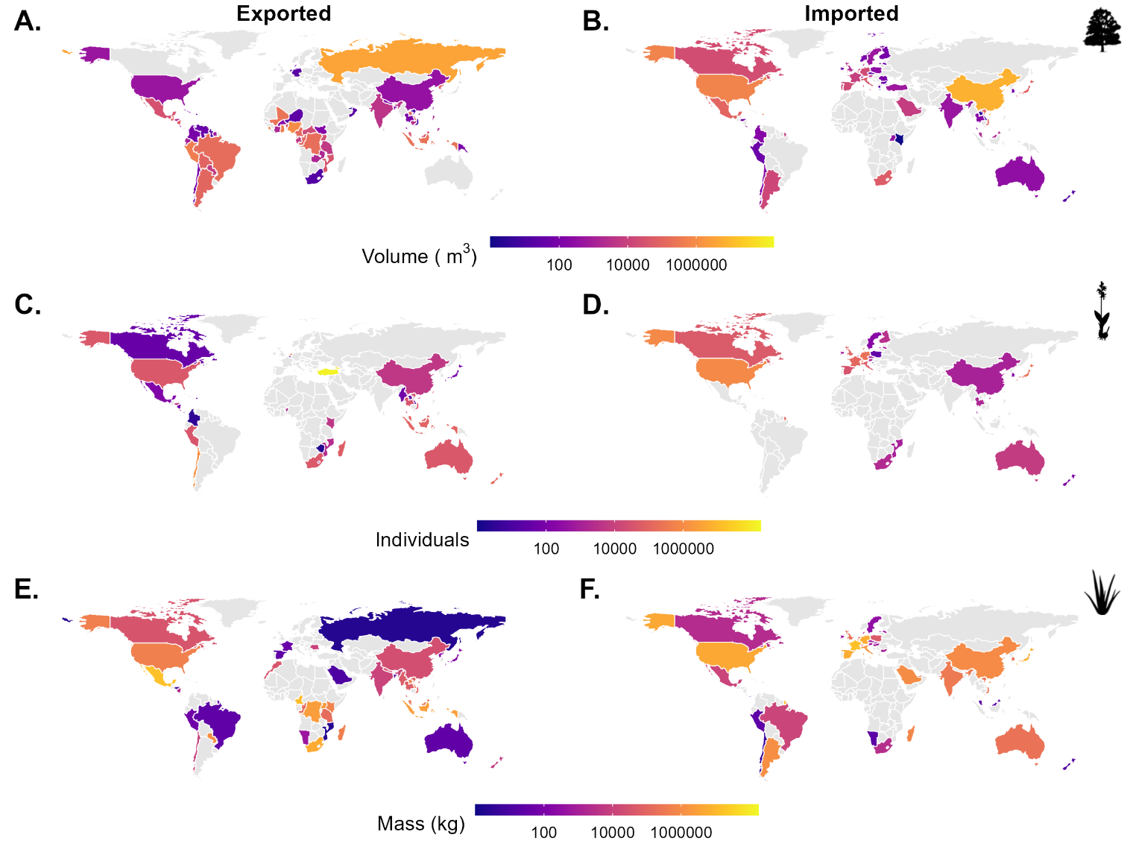

***Diversity and volume in trade over time***

The yearly number of traded timber species steadily increased to a peak of 29 in 2018 (Figure 2A), whereas the annual diversity of traded live plant species steeply declined from 369 in 2003 to 7 in 2020 (Figure 2B). The number of species traded as miscellaneous plant products shows no clear trend, fluctuating continuously between 2000 and 2020 (Figure 2C). Over time, traded species diversity is dominated by taxa not evaluated by the IUCN, with the exception of relatively high numbers of vulnerable and endangered timber species particularly before 2014 (Figure 2, A-C, Supplementary Figure 1, A-C). Most species (92%, 821/892) were traded for the first time as NE, with 5.5% (49/892) classed as threatened (VU, EN, CR) when first traded (Figure 2A-C).

Timber volume in trade increased sharply from 2014 to 2017, before declining (Figure 2D), volumes of live plants fluctuated, but had a marginal reduction over time (Figure 2E), and volumes of products fluctuated because of a sharp decrease between 2006-08 (Figure 2F). Volumes traded over time were predominantly composed of NE species for all types of trade (Figure 2D-F, Supplementary Figure 1, D-F), except for products between 2003-07 in which VU species dominated (Figure 2F, Supplementary Figure 1, F). We note however that while the trade data reported by CITES Parties is curated by the United Nations Environment Programme, sharp increases and decreases may be at least partly attributed to trade being reported in the year after being traded rather than during. Similarly, species addition and removal from the CITES Appendices can contribute to changes in total volume. This is particularly the case for reported timber volumes as the sudden increase in volumes can predominantly be attributed to the novel listing of *Pterocarpus erinaceus*, *Fraxinus mandshurica* and *Quercus mongolica* (2014-2016), and a dramatic increase in traded volumes of *Pericopsis elata*.

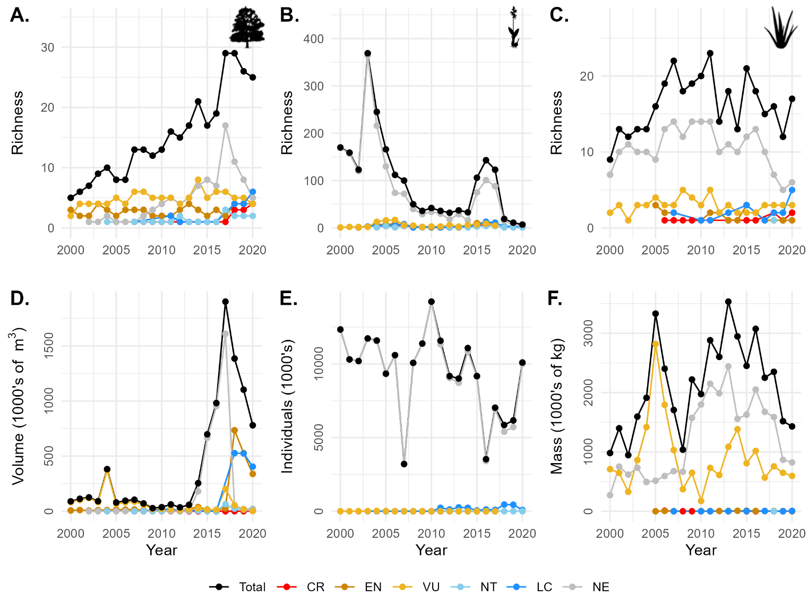

***Variation in trade volume between species***

On average, there has been either decreasing or uncertain trends over the last 21-years for species occurrence in trade and volumes when traded (Figure 3). For the average timber species, there were uncertain temporal trends across all IUCN categories (Figure 3A,B). For the average live-traded NE, LC, VU, EN, and CR species, there were declines in species presence but not quantity when traded, indicating that such species have disappeared from trade rather than their volumes having declined (Figure 3C,D). Conversely, for products, there were no clear increases or decreases in the average species presence in trade, but there are clear decreases in the mass when traded for the average NE and CR species (Figure 3E,F). This sections results are consistent with the exporter-reported dataset, except for an additional clear decline in volume when traded for the average VU timber species, an increasing volume when traded for the average NT live species, and uncertain volume when traded trend for CR species traded as products (Supplementary Figures 2).

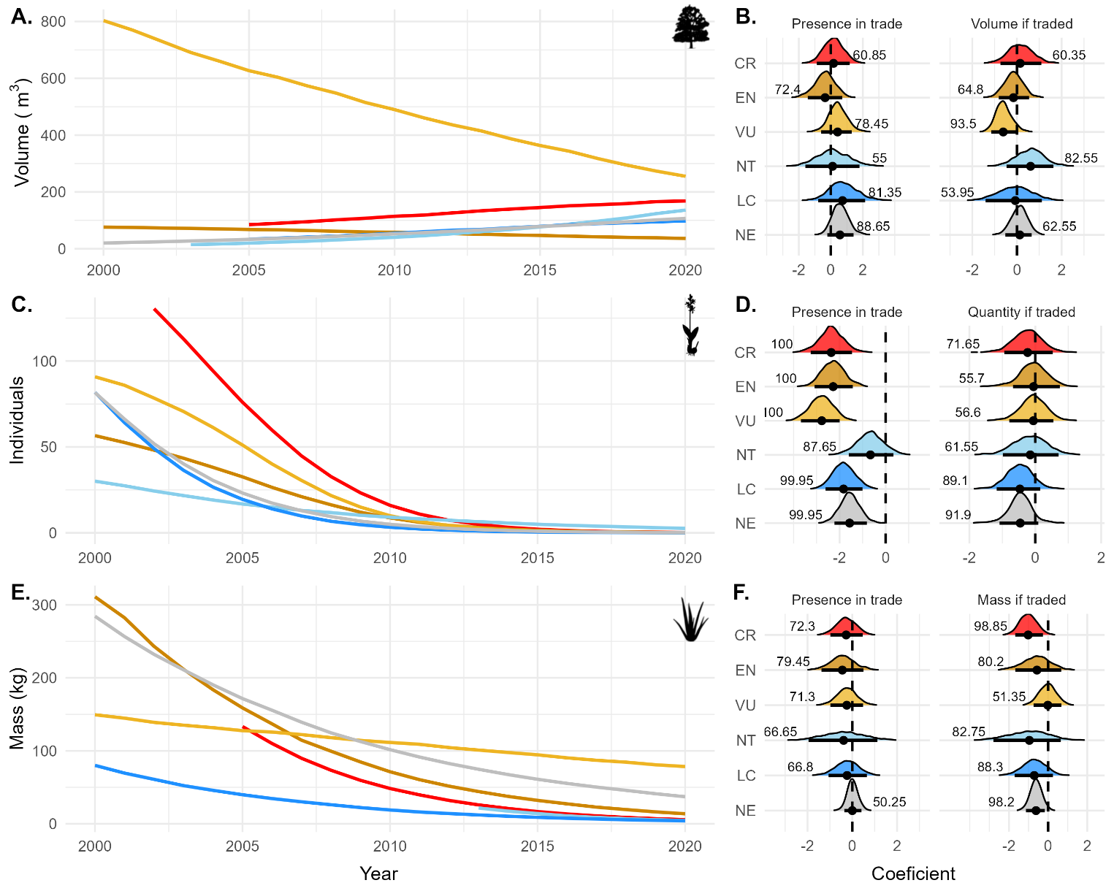

All timber (Figure 4A, Supplementary Figure 7A) and most product (90.1%; Figure 4C, Supplementary Figure 7C) species-level trends for presence in trade over time were uncertain, whereas most live species (71.2%, 545/765) had a declining presence in trade over time (Figure 4B, Supplementary Figure 3B, 6 & 8). Quantities when traded predominantly showed no clear trend over time for timber (95.3%; Figure 4D, Supplementary Figure 3D) and live (96.9%; Figure 4E, Supplementary Figures 3E & 4A), and product (94.4%; Figure 4F, Supplementary Figure 3F & 4C). Just three timber species showed a temporal trend for quantities when traded (Figure 4D, Supplementary Figure 3D & 7A): heavily-traded *Pericopsis* *elata* (EN) had a steadily increasing trend in trade volume from 6781.4 m3 in 2000 to a peak of 78,424 m3 in 2019, whereas heavily-traded *Swietenia* *macrophylla* and *Cedrella* *odorata* (both VU) presented a decreasing trend in traded volumes (Supplementary Figure 5 and 7, A). Many traded timber species that were IUCN Red listed showed no clear trend for presence or volume in trade (Figure 4A,D, Supplementary Figure 3, A,D, Supplementary Figure 4A and 7A).

The large number of live-traded species with declining presence over time were all traded in fewer than 100,000 individuals annually (201/269 species, Figure 4B, Supplementary Figure 3B, 6 & 8). There were 20 species with more than 100,000 live-traded individuals that showed a declining quantity through time (Figure 4E), which included the highly commercial *Cyclamen hederifolium* that had over a million individuals traded annually 2000 – 2003 but current annual traded volumes are more than a magnitude less. Likewise, for the cactus *Eulychnia acida,* over 100,000 individuals were traded annually between 2000 – 2003, whereas recent trade is intermittent and at least two orders of magnitude lower*.* For both presence in trade and quantify if traded, those species showing declines tended not to be in the highest categories of extinction risk (Figure 4B,E). The two live species traded in 10,000,000s per year (*Galanthus* *elwisii* and *G.* *woronowi*, both NE; Supplementary Fig. S4 and 5) had no clear trend in presence (Figure 4B) or quantity (Figure 4E) through time.

Given the large taxonomic diversity in live trade, we also considered how temporal trends varied at the order level. On average, orchids (Asparagales), lily (Liliales), palme (Arecales), gentian (Gentianales), and cycas (Cycadales) orders showed declining trends in trade occurrences while being uncertain for the number of traded individuals, whereas tree fern (Dicksoniales, Cyatheales) orders represent a decreasing trend in both trade presence and number of live individuals (Supplementary Figure 5 and 7). No directional effect was found in primrose (Ericales).

Only five species traded as products showed clear trends for presence in trade (Figure 4C). Four of these species—*Dendrobium* *nobile* (NE), *Hoodia* *gordonii* (NE), *Hydrastis* *canadensis* (VU), and *Rauvolfia* *serpentina* (NE)—had a decreasing presence through time, whereas *Cyathea* *medullaris* (NE) had an increasing presence through time (Supplementary Figure 7C). Only three species showed clear declines in mass when traded (Figure 4F): *Aquilaria* *crassna* (CR), *Dendrobium* *nobile* (NE) and *Rauvolfia* *serpentina* (NE) (Supplementary Figure 4 & 7C). Many species that are IUCN red listed showed no clear trend in presence or quantity over time (Figure 4C,F, Supplementary Figure 3,C,F).

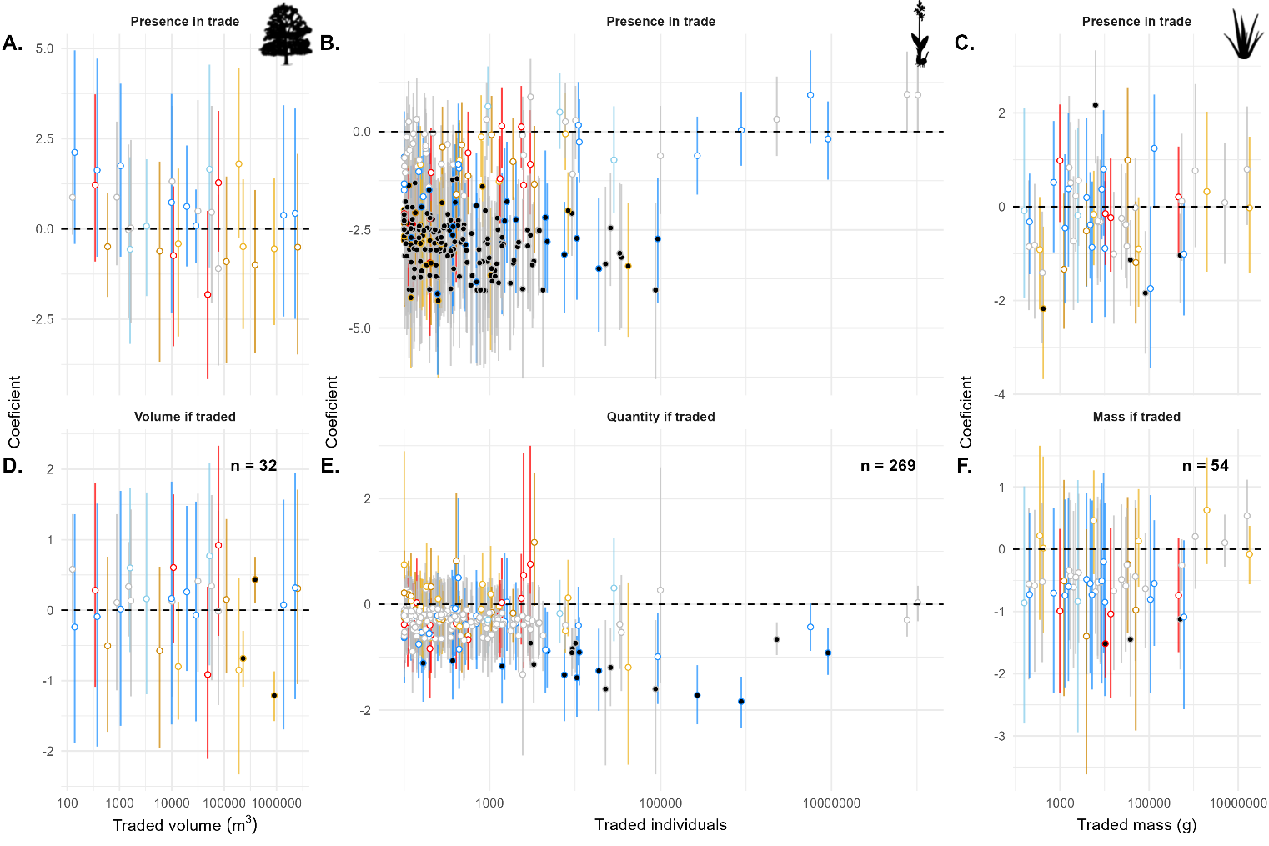

**Discussion**

The international trade in plants remains a critically understudied facet of the wildlife trade26. Our study standardises the diverse array of ways plants can be used and reported in the first spatio-temporal study of CITES-Listed plants. We find the majority of species are traded between a few key exporter and importer nations, in particular China, USA, and Europe (incl. Turkey and Georgia), with a few species dominating total volumes for each trade purpose. Most diversity and quantity traded is from species that are not evaluated by the IUCN, and for the majority of species traded – of which most are traded live - their probability of occurring in trade is decreasing. This high -even if often intermittent – presence of poorly understood species highlights the lack of knowledge we have around the most highly traded taxa globally, and thus the difficulty for trade under CITES to evidence sustainability.

Given growing global populations and wealth, demand for high-value timber products is increasing 27, including for species threatened with extinction (>39% and 3.3 million m3 of all timber traded between 2000-20). We note the more general trends for low and uncertain trade in CITES-listed timber runs contrary to global patterns of increasing timber volumes 28 due to many key genera utilised by the construction industry (e.g. *Pinus* spp.) not being directly threatened by trade and as such not being CITES-listed and reported. The relatively high diversity of species in trade and the pervasive decline in many species’ presence in trade while their volume trends remain more uncertain reflect a similar phenomenon in the vertebrate trade where many species are traded, but most are traded infrequently and not recently, so have a declining probability of occurring and a flat (“uncertain”) volume trend around 0 25. The general decline in live-traded species diversity could be attributed to declining global demand for plant products but is far more likely due to a substantial shift from wild-sourced trade towards artificially-propagated products 16. For example, while wild-sourced volumes remained relatively high because the hyper-abundant *Galanthus* species (>158 million individuals traded) remain predominantly wild-collected 29 between 1996 and 2015, over 99% of >1.1 billion live orchid plants in trade and >31 million kg of stems were from artificially propagated sources 30, 23. However, linking this transition to conservation benefits remains difficult, with a previous study highlighting 82% of artificially propagated species assessed in China relied on the collection of whole wild plants 31.

Trade in threatened species can be substantial, for instance, vulnerable species comprised >42% (19 million kg) of all products traded, almost wholly ofAfrican cherry *Prunus* *africana* traded as bark and powder from Cameroon, Congo, Uganda, and Guinea, with harvest for international trade identified as a key threat 32. However, the majority of traded plant species are yet to be assessed by the IUCN Red List, some of which may be at severe extinction risk 11,33. For example, heavily traded *Pterocarpus* *erinaceus* was not evaluated when initially traded, but has since been categorised as endangered, with timber trade a major driver of its decline 34, 18. Likewise, of the few species with increasing volumes through time, African teak *Pericopsis* *elata* has rapidly increased despite wider concerns that commercial harvest across its range is unsustainable 35 and the CITES Review of Significant Trade process highlighted doubt whether proper non-detriment findings were and are being made for the species 36, 37. The presence of such high volumes of threatened species in trade and of so many species for which we lack even rudimentary understanding of their conservation status highlights the need for greater synergy between commercially important species, our understanding of their abundance and threats, and CITES regulations 38. This points to the need for development in three areas.

First, the sheer number of traded plant species not evaluated by the IUCN limits the easily available information that could inform non-detrimental findings (NDFs) to ensure the sustainable use of wild populations 10, 25. In such cases, ensuring that the legal trade in CITES-listed plants is evidenced to be sustainable – does not lead to the long-term decline of a population – requires robust data sourced from alternate sources. Likewise, despite their abundance and diversity in trade only 14 of 36 publicly available NDFs focus on plants (mainly tree species, n=11) 39, highlighting a lack of attention or available exemplars. The sheer scale of poorly understood and not evaluated plant species in trade necessitate a robust data-based approach to inform sustainable offtake, based upon range or population data, understanding of other threats, and drawing inference from better-known species via phylogenetic and trait-based modelling approaches 40. The NDFs and evidence used to support the labelling of legal and sustainable trade must then be openly available for scrutiny and to contribute to an improved understanding of this abundance of species not evaluated by the IUCN.

Second, given the scale and diversity of species traded, as products or parts identification will continue to present particular problems to customs officials expected to implement trade regulations at border crossings. Non-experts can struggle with even genus-level identification (McGough et al. 2004), and even experts are unable to identify many orchids confidently to species or subgenus level when presented with sterile specimens41. We need improved ability to facilitate the identification of traded species through the use of high-throughput DNA barcoding (e.g. the International Barcode of Life project). Where that is not possible, policy could consider further use of the “lookalike” principle for species commonly traded in unidentifiable parts or derivatives, which has already been applied to all orchids under CITES.

Third, the future risk of laundering illegally sourced plants through CITES remains a potential future threat. Our results highlight the declining and uncertain patterns for many wild-sourced species; in part a shift towards artificially propagated products may be responsible 16. The wider transition to artificially propagated products requires caution since there are risks of wild-collected materials being laundered into the legal trade chain 21, 10. The sheer diversity of plant forms and scope to misuse exemptions or use forged documents remains a barrier to the conservation benefit of artificial propagation 42. More sophisticated traceability techniques, including molecular approaches for determining wild origin 10, combined with more emphasis on importer countries evidencing traceability 40 are needed. Such approaches have been used outside of CITES to identify illegal trade in Russian timber into the EU43. Where a lack of financial resources or weak governance mean exporter countries cannot ensure that trade in threatened species is sustainable and legal, funds could be leveraged from importers ensuring whole supply-chain sustainability or from international resources such as the Global Biodiversity Framework Fund or Global Environment Facility Fund under Target 5 of the Kunming-Montreal Global Biodiversity Framework 44, 41. This funding could then be targeted towards upskilling and developing sustainable offtake protocols in key exporting nations. One possible funding route could be supporting indigenous propagation, a means by which needs of the local population can be met, while reducing the pressure on populations of commercially important wild plants such as *Galanthus* 45.

In conclusion, our study underscores the need for comprehensive assessments of plant species' conservation status combined with improved monitoring of trade across purposes to prevent the overexploitation of vulnerable species and ensure their sustainability. While the implementation of CITES has shifted the international plant trade towards artificially propagated sources, there remains a huge diversity and quantity of wild-sourced plants in trade. Given that weaknesses in the current NDF processes mean that sustainability is not guaranteed, it is crucial to continue developing and implementing cost-effective approaches for identifying and managing the trade in wild plants. This is vital to protect threatened species from over-harvesting and exploitation, and prevent laundering through CITES.

**Acknowledgement**

AN is grateful of support from the University of Sheffield during a research stay. DPE acknowledges funding from the Natural Environment Research Council (grant number NE/R017441/1)

**Author contribution:** DPE, AN, and OM conceived the study. AN and OM collated and analysed the data. AN wrote the first draft and OM and DPE contributed significantly to redrafting.

**Data and code availability**

All raw data used is publicly accessible and linked in the manuscript. Processed data and code are freely accessible at https://github.com/OMorton/Naqinezhad_et_al_PlantsCITES.

**Competing interests**

The authors declare no competing interests.

**References**

1. Santos, A., Satchabut, T. and Vigo Trauco, G. (2011). Do wildlife trade bans enhance or undermine conservation efforts. *Applied Biodiversity Perspective Series*, *1*(3), 1-15.

2. Joppa, L. N., O'Connor, B., Visconti, P., Smith, C., Geldmann, J., Hofmann, M., Watson, J. E. M., Butchart, S. H. M., VirahSawmy, M., Halpern, B. S., Ahmed, S. E., Balmford, A., Sutherland, W. J., Harfoot, M., Hilton-Taylor, C., Foden, W., Di Minin, E., Pagad, S., Genovesi, P., Hutton, J., & Burgess, N. D. (2016). Filling in biodiversity threat gaps. Science, 352(6284), 416-418.

3. IPBES: Intergovernmental Science-Policy Platform on Biodiversity and Ecosystem Services. (2019).

Global Assessment Report on Biodiversity and Ecosystem Services.

4. Liu, J.; Hull, V.; Batistella, M.; DeFries, R.; Dietz, T.; Fu, F.; Hertel, T. W.; Izaurralde, R. C.; Lambin, E. F.; Li, S.; Martinelli, L. A.; McConnell, W. J.; Moran, E. F.; Naylor, R.; Ouyang, Z.; Polenske, K. R.; Reenberg, A.; Rocha, G. M.; Simmons, C. S.; Verburg, P. H.; Vitousek, P. M.; Zhang, F.; Zhu, C. (2013). Framing sustainability in a telecoupled world. *Ecology and Society*, *18*(2).

5. Nielsen, M.R., Pouliot, M., Meilby, H., Smith-Hall, C. & Angelsen, A. (2017). Global patterns and determinants of the economic importance of bushmeat. *Biological Conservation*, 215, 277-287.

6. Díaz, S., Settele, J., Brondízio, E. S., Ngo, H. T., Agard, J., Arneth, A., Balvanera, P., Brauman, K. A., Butchart, S. H. M., Chan, K. M. A., Garibaldi, L. A., Ichii, K., Liu, J., Subramanian, S. M., Midgley, G. F., Miloslavich, P., Molnár, Z., Obura, D., Pfaff, A., Polasky, S., Purvis, A., Razzaque, J., Reyers, B., Roy Chowdhury, R., Shin, Y.-J., Visseren-Hamakers, I., Willis, K. J., & Zayas, C. N. (2019). Pervasive human-driven decline of life on Earth points to the need for transformative change. Science, 366(6471), eaax3100.

7. Fukushima, C. S., Mammola, S., & Cardoso, P. (2020). Global wildlife trade permeates the Tree of Life. *Biological Conservation*, *247*, 108503.

8. Scheffers, B. R., Oliveira, B. F., Lamb, I., & Edwards, D. P. (2019). Global wildlife trade across the tree of life. *Science*, *366*(6461), 71-76.

9. Morton, O., Scheffers, B. R., Haugaasen, T., & Edwards, D. P. (2021). Impacts of wildlife trade on terrestrial biodiversity. *Nature Ecology & Evolution*, *5*(4), 540-548.

10. Hinsley, A., De Boer, H. J., Fay, M. F., Gale, S. W., Gardiner, L. M., Gunasekara, R. S., Kumar, P., Masters, S., Metusala, D.,Roberts, D.L., Veldman, S, Wong, Sh., Phelps, J. (2018). A review of the trade in orchids and its implications for conservation. *Botanical Journal of the Linnean Society*, *186*(4), 435-455.

11. Goettsch, B., Hilton-Taylor, C., Cruz-Piñón, G., Duffy, J. P., Frances, A., Hernández, H. M., Inger, R., Pollock, C., Schipper, J., Superina, M., Taylor, N. P., Tognelli, M., Abba, A. M., Arias, S., Arreola-Nava, H. J., Baker, M. A., Bárcenas, R. T., Barrios, D., Braun, P., Butterworth, C. A., Búrquez, A., Caceres, F., Chazaro-Basañez, M., Corral-Díaz, R., Del Valle Perea, M., Demaio, P. H., Duarte de Barros, W. A., Durán, R., Faúndez Yancas, L., Felger, R. S., Fitz-Maurice, B., Fitz-Maurice, W. A., Gann, G., Gómez-Hinostrosa, C., Gonzales-Torres, L. R., Griffith, M. P., Guerrero, P. C., Hammel, B., Heil, K. D., Hernández-Oria, J. G., Hoffmann, M., Ishihara, M. I., Kiesling, R., Larocca, J., León-de la Luz, J. L., Loaiza S, C. R., Lowry, M., Machado, M. C., Majure, L. C., Martínez Ávalos, J. G., Martorell, C., Maschinski, J., Méndez, E., Mittermeier, R. A., Nassar, J. M., Negrón-Ortiz, V., Oakley, L. J., Ortega-Baes, P., Pin Ferreira, A. B., Pinkava, D. J., Porter, J. M., Puente-Martinez, R., Roque Gamarra, J., Saldivia Pérez, P., Sánchez Martínez, E., Smith, M., Sotomayor M Del C, J. M., Stuart, S. N., Tapia Muñoz, J. L., Terrazas, T., Terry, M., Trevisson, M., Valverde, T., Van Devender, T. R., Véliz-Pérez, M. E., Walter, H. E., Wyatt, S. A., Zappi, D., & Zavala-Hurtado, J. A. (2015). High proportion of cactus species threatened with extinction. *Nature Plants*, *1*(10), 1-7.

12. FAO. (2022). The State of the World’s Forests 2022. Forest pathways for green recovery and building inclusive, resilient and sustainable economies. Rome, FAO.

13. Jenkins, M., Timoshyna, A., & Cornthwaite, M. (2018). Wild at home: Exploring the global harvest, trade and use of wild plant ingredients. Cambridge, UK: TRAFFIC International.

14. CITES. (1973). Text of the Convention: Convention on International Trade in Endangered Species of Wild Fauna and Flora (IUCN).

15.Dutton AJ, Gratwicke B, Hepburn C, Herrera EA, Macdonald DW. 2013. Tackling unsustainable wildlife trade. Pages 74–91 in Macdonald DW, Willis KJ, eds. Key Topics in Conservation Biology, vol. 2. Wiley

16. Harfoot, M., Glaser, S.A.M., Tittensor, D.P., Britten, G.L., McLardy, C., Malsch, K., and Burgess, N.D. (2018). Unveiling the patterns and trends in 40 years of global trade in CITES-listed wildlife. Biological Conservation 223, 47–57.

17. IUCN. (2023). The IUCN Red List of threatened species. Version 2022-2. <https://www.iucnredlist.org>

18. Dumenu, W. K. (2019). Assessing the impact of felling/export ban and CITES designation on exploitation of African rosewood (Pterocarpus erinaceus). *Biological Conservation*, *236*, 124-133.

19. McCormick MK, Jacquemyn H. (2014). What constrains the distribution of orchid populations? *New Phytologist* 202: 392–400.

20. Gale, S. W., Kumar, P., Hinsley, A., Cheuk, M. L., Gao, J., Liu, H., ... & Williams, S. J. (2019). Quantifying the trade in wild-collected ornamental orchids in South China: Diversity, volume and value gradients underscore the primacy of supply. *Biological Conservation*, *238*, 108204.

21. Phelps, J., & Webb, E. L. (2015). ‘Invisible’ wildlife trades: Southeast Asia’s undocumented illegal trade in wild ornamental plants. *Biological Conservation*, *186*, 296–305.

22. Cruz-Garcia, G., Lagunez-Rivera, L., Chavez-Angeles, M. G., & Solano-Gomez, R. (2015). The wild orchid trade in a Mexican local market: diversity and economics. *Economic Botany*, *69*, 291-305.

23. Hinsley, A., Lee, T. E., Harrison, J. R., & Roberts, D. L. (2016). Estimating the extent and structure of trade in horticultural orchids via social media. *Conservation Biology*, *30*(5), 1038-1047.

24. Masters, S., Anthoons, B., Madesis, P., G. Saroja, S., Schermer, M., Gerritsen, W., ... & Gravendeel, B. (2022). Quantifying an online wildlife trade using a web crawler. *Biodiversity and Conservation*, *31*(3), 855-869.

25. Morton, O., Scheffers, B. R., Haugaasen, T., & Edwards, D. P. (2022). Mixed protection of threatened species traded under CITES. *Current Biology*, *32*(5), 999-1009.

26. Margulies, J. D., Bullough, L. A., Hinsley, A., Ingram, D. J., Cowell, C., Goettsch, B., Klitgård, B. B., Lavorgna, A., Sinovas, P., & Phelps, J. (2019). Illegal wildlife trade and the persistence of “plant blindness”. *Plants, People, Planet*, *1*(3), 173-182.

27. Grogan, J., Blundell, A. G., Landis, R. M., Youatt, A., Gullison, R. E., Martinez, M., ... & Rice, R. E. (2010). Over‐harvesting driven by consumer demand leads to population decline: Big‐leaf mahogany in South America. *Conservation Letters*, *3*(1), 12-20.

28. Barua, S. K., Lehtonen, P. & Pahkasalo, T. Plantation vision: potentials, challenges and policy options for global industrial forest plantation development. *International Forestry Review.* **16**, 117–127 (2014).

29. Karchava, T (2019) Snowdrop harvesting and trade in Georgia. CITES and livelihoods case study. Available here: <https://cites.org/sites/default/files/eng/prog/Livelihoods/case_studies/CITES_livelihoods_Fact_Sheet_2019_Georgia_Snowdrops.pdf>

30. UNEP-WCMC. (2017). CITES trade statistics derived from the CITES Trade Database. Cambridge: UNEP World Conservation Monitoring Centre. <https://trade.cites.org>

31. Liu, H., Gale, S. W., Cheuk, M. L., & Fischer, G. A. (2019). Conservation impacts of commercial cultivation of endangered and overharvested plants. *Conservation Biology*, *33*(2), 288-299.

32. Hills, R. & Cheek, M. (2021). Prunus africana. The IUCN Red List of Threatened Species 2021: e.T33631A2837924. <https://dx.doi.org/10.2305/IUCN.UK.2021-3.RLTS.T33631A2837924.en>. Accessed on 10 October 2023.

33. Nic Lughadha, E., Bachman, S. P., Leão, T. C., Forest, F., Halley, J. M., Moat, J., ... & Walker, B. E. (2020). Extinction risk and threats to plants and fungi. *Plants, People, Planet*, *2*(5), 389-408.

34. Barstow, M. (2018). Pterocarpus erinaceus. The IUCN Red List of Threatened Species 2018: e.T62027797A62027800. <https://dx.doi.org/10.2305/IUCN.UK.2018-2.RLTS.T62027797A62027800.en>. Accessed on 10 October 2023.

35. Hills, R. 2020. *Pericopsis elata*. *The IUCN Red List of Threatened Species* 2020: e.T33191A67802601. <https://dx.doi.org/10.2305/IUCN.UK.2020-3.RLTS.T33191A67802601.en>. Accessed on 28 August 2024.

36. Dickson, B., Mathew, P., Mickleburgh, S., Oldfield, S., Pouakouyou, D., & Suter, J. (2005). An assessment of the conservation status, management and regulation of the trade in Pericopsis elata. *Cambridge, UK: Fauna & Flora International*.

37. CITES (2024) Review of Significant Trade in specimens of Appendix-II species. Implication of recommendations for species selected following COP17: Pericopsis elata. Twenty-seventh meeting of the Plants Committee Geneva (Switzerland, July 2024).

38. Frank, E. G., & Wilcove, D. S. (2019). Long delays in banning trade in threatened species. Science, 363(6428), 686-688.

39. CITES. (2020). AC31 Doc. 14.1/PC25 Doc. 17. Interpretation and implementation matters, regulation of trade, non-detriment findings. Report of the Secretariat. In Joint sessions of the 31st meeting of the Animals Committee and the 25th meeting of the Plants Committee, Geneva (Switzerland), 17 July 2020. <https://cites.org/sites/default/files/eng/com/ac-pc/ac31-pc25/E-AC31-14-01-PC25-17.pdf>

40. Hughes, L. J., Massam, M. R., Morton, O., Edwards, F. A., Scheffers, B. R., & Edwards, D. P. (2023). Global hotspots of traded phylogenetic and functional diversity. Nature, 620, 351-357.

41. Phelps, J., Carrasco, L. R., & Webb, E. L. (2013). Framework for assessing supply-side wildlife conservation. *Conservation Biology*, *28*, 244–257.

42. Lavorgna, A., Rutherford, C., Vaglica, V., Smith, M. J., & Sajeva, M. (2018). CITES, wild plants, and opportunities for crime. *European Journal on Criminal Policy and Research*, *24*, 269-288.

43. Mortier, T., Truszkowski, J., Norman, M., Boner, M., Buliga, B., Chater, C., ... & Deklerck, V. (2024). A framework for tracing timber following the Ukraine invasion. *Nature Plants*, *10*(3), 390-401.

44. Hinsley, A., Nuno, A., Ridout, M., John, F. A. S., & Roberts, D. L. (2017). Estimating the extent of CITES noncompliance among traders and end‐consumers; lessons from the global orchid trade. *Conservation Letters*, *10*(5), 602-609.

45. Entwistle, A., Atay, S., Byfield, A., & Oldfield, S. (2002). Alternatives for the bulb trade from Turkey: a case study of indigenous bulb propagation. *Oryx*, *36*(4), 333-341.

46. Robinson, J. E., & Sinovas, P. (2018). Challenges of analyzing the global trade in CITES-listed wildlife. *Conservation Biology*, *32*(5), 1203-1206.

47. Groves, M. and Rutherford, C. (2023). CITES and Timber: A guide to CITES-listed tree species. RutherfordGroves Publishing.

48. Beech, E., Rivers, M., Oldfield, S., & Smith, P. P. (2017). GlobalTreeSearch: The first complete global database of tree species and country distributions. Journal of Sustainable Forestry, 36(5), 454-489.

49. Kattge, J., Diaz, S., Lavorel, S., Prentice, I.C., Leadley, P., Bönisch, G., Garnier, E., Westoby, M., Reich, P.B., Wright, I.J. and Cornelissen, J.H.C. (2011). TRY–a global database of plant traits. *Global change biology*, *17*(9), pp.2905-2935.

50. McGough NH, Groves M, Mustard M, Brodie C. (2004). *CITES and plants: a user’s guide, Version 3*. Kew: Royal Botanic Gardens. Available at: http://www.kew.  
org/conservation/CITES_User_Guides/CITESPlants/EnglishCITESPlantsPack.pdf

51. Chamberlain, S., rOpenSci and Salmon, M. (2020). Package ‘rredlist’. <https://github.com/ropensci/rredlist>.

52. POWO (2019). Plants of the World Online. Facilitated by the Royal Botanic Gardens, Kew Published on the Internet; http://www.plantsoftheworldonline.org/ Retrieved on 08.02.2023.

53. Makowski, D., Ben-Shachar, M. S., Chen, S. A., & Lüdecke, D. (2019). Indices of effect existence and significance in the Bayesian framework. Frontiers in Psychology, 10, 2767.

**Methods**

**CITES data extraction**

The CITES Trade database stores all reported wildlife trade in Listed species by the CITES Parties. These reports are compiled in official annual reports and deposited in the CITES Trade Database. All deposited records were downloaded in bulk (version 2022 v.1, <https://trade.cites.org/>), resulting in a database with 23,680,557 directional trade records. Further details can be found at the point of access.

We adapt established protocols for cleaning and preparing the data 16, 25. For a full summary of the data curation pipeline see Table S1. In summary, all re-exports were removed to avoid double counting because where trade passes through multiple countries it may be reported multiple times, artificially inflating their volume in the data. Similarly, we focused only on importer-reported values in the main text as this reported data concerned more species and volume than the exporter reported data. However, there is not one (‘correct’) standardised approach to analysing CITES trade data, and using only imports could be viewed as an underestimation as Parties are not required to issue import permits for Appendix II species although many do46. Therefore, we include a complete re-analysis using export data (processed identically) using exporter-based values (Supplementary Figures 1 - 5). Importantly, we find no systematic differences between the reporter types that affect our overall conclusions.

We removed all records where species were not traded under any specific Appendix (I, II or III), coded ‘‘N’’. All trades were classed as either wild-sourced or not, using the reported ‘‘Source’’ codes. We follow established criteria defined in Morton et al. (2022)25 and the full list of codes available in CITES website (<https://trade.cites.org/cites_trade_guidelines/en-CITES_Trade_Database_Guide.pdf>). Thus, we only assign records as wild-sourced where the source code is W, X or R (this respectively includes ‘‘Specimens taken from the wild’, ’Specimens taken in the marine environment not under the jurisdiction of any State’’, and ‘‘Ranched specimens: specimens reared in a controlled environment, taken as juveniles/seedlings from the wild, where they would otherwise have had a very low probability of surviving to adulthood’’). Similarly, as species are traded through CITES for a range of reasons including scientific research and reintroduction, we focus only on trade reported as being for a commercial (purpose code ‘T’). Therefore, all subsequent reference to the data or trade data is in reference to the wild-sourced and commercially traded records.

We limit our time frame to 2000 – 2020 to focus on recent trade. Despite data being present in the CITES data for up to 2022, we conservatively only include records up to and including 2020 since subsequent years’ reports may still be being compiled. We removed all records where species were reported as clearly unknown such as *Acineta* spp., Orchidaceae spp. or *Acanthocalycium* spp. and those instances where species were identified as hybrids such as ‘‘*Phalaenopsis* hybrid’’, “*Aloe* hybrid”, or “Orchidaceae hybrid” (15 different hybrid types were removed). Removing these records is essential because including them would introduce uncertainty as they likely represent many different species and indeed variations of hybrid. The outlined filtering and cleaning process does result in the loss of large numbers of records (see Supplementary Table 1), but is necessary to focus on the wild-sourced commercial trade in plants and reduce uncertainty (e.g. records of unknown source, code “U”).

Trade quantities are reported in many ‘‘*Terms’’* (live, powder, cosmetics, medicine, carvings etc.) and “*Units*” (Kg, m3, pieces, boxes, number of specimens, etc), which makes it misleading to compare raw ‘‘*Quantity’’* as reported in the data. We removed the terms “cultures”, “plywood”, “raw corals”, “gall” and “transformed woods” due to ambiguity of the terms. To apply standardised and comparable metrics to the diversity of “*Terms*” and “*Units*”, we split the data into three major categories based on the term and unit combination of trade records. Records were categorised as “timber” (referring to those plants traded for commercial timber), “live” (referring to those plants traded as live) and “products” (referring those plants traded for a various type of products extracted from).

For “timber”, we included “timber”, "chips", "timber pieces", "logs", "sawn wood", "veneer", and "wood product". The terms "transformed wood” and “plywood" were not classified as timber since they are mixed with other materials like glue, etc. in varying proportions rendering conversions to volume based on density flawed. To ensure all species imported with above terms are actually timber-producing trees, firstly we consulted guide to CITES-listed tree species published by Kew Botanical Garden47. Then for those were not specified at species level (*Gonystylus*, *Swietenia, Cedrela, Guibourtia, Diospyros, Guaiacum, Aquilaria* and *Gyrinops*) or were absent in this guide (*Carnegiea gigantea, Cylindropuntia imbricata, Aloe ferox, Cylindropuntia cholla, Paubrasilia echinate, Dalbergia lacteal, Platymiscium parviflorum, Caryocar costaricense*), we used Global tree list 48 (<https://tools.bgci.org/global_tree_search.php>). Initially, a total of 60 species were chosen as the timber species and then using above lists, one liana species (*Dalbergia* *cumingiana*), 2 tree ferns (*Sphaeropteris* *glauca*, *Cyathea* *concinna*), 3 cacti (*Opuntia streptacantha*, *Cylindropuntia* *bigelovii*, *Echinopsis* *pachanoi*) and one *Aloe* species (*A*. *macroclada*) were not considered as trees and removed from further analyses of timber volume (53 species).

To standardize all records to a single volume unit (m3), we only considered the units 'm3', 'cm3', 'kg', 'g', 'mg' and excluded "sets", "m2", "bags", "m", "cartons", "shipments", "l", "pairs", "Number of specimens”, “ft2” and Blank. For the 34 species traded using mass units these were converted to volume using wood density data of each species. Wood densities were obtained from the TRY database 49. No data was available for 11 species, so the R package BIOMASS was used to find wood density at the genus (*Aquilaria filaria, A. crassna, A. microcarpa*), family (*Carnegiea gigantea, Cylindropuntia cholla, Gyrinops caudata, Gyrinops ledermanii, Gyrinops versteegii, Cylindropuntia imbricata*) and dataset level (*Aloe ferox*). *Dalbergia lactea* is only given family level estimates from BIOMASS, however, we calculated a genus level value using TRY database. Volume data were calculated using the formula *volume (m3) = mass/density*.

The second major category of traded plants were “live” individuals. These records were standardized to whole organism equivalents (WOE’s) following the methodologies outlined by Harfoot et al.16. This allows a more robust comparison across trade records as one WOE represents one individual, regardless of taxa or original term. We applied this conversion protocol to records where the ‘‘*Unit’’* term was specified only as either blank or NA denoting ‘‘number of specimens’’. We included three different terms into this group, “live”, “roots” and “stems”. For terms roots and stems, we only take into account those plants that their roots and stems represent the whole organism. For example, roots in *Galanthus* *elwesii* and *Cyclamen* *coum* equate to bulb and corm, respectively, and thus each bulb/corm can be considered the dormant stage for the whole live plants50 represents one individual. Likewise, one stem in *Corryocactus* *brevistylus* (cacti) or *Dicksonia* *antarctica* (tree fern) represents one whole individual. To simplify interpretation of results of live trade, we used taxonomic order levels and classified all live species into 17 orders based on recent taxonomical nomenclature (APG IV). Taxonomic orders with less than 1000 CITES trade records (Fabales, Cucurbitales, Vitales, Cupressales and Lamiales) were removed before fitting the model.

The third category was “products”, which include all the following terms linked to various types of products measured solely in mass units: "powder", "oil", "carvings", "dried plants", "leaves", "derivatives", "extract", "stems", "roots", "medicine", "seeds", "flowers", "fibres", "bark", "wax”, “fruit", "cosmetics”, and “kernel". Mass units were used as this was by far the largest proportion of trade in the terms listed previously (Supplementary Figure 6). This final category aims to capture the diversity of products in trade, but should be used with care as 1 kg of fruit and 1 kg of leaves are not directly comparable in the same way that 1000 individuals or 1000 m3 are as in the previous live and timber categories.

For a full list of species traded under the different purposes used in the analyses see Supplementary Table 2.

Species temporal presence in trade is highly variable with some species appearing consistently each year (2000 – 2020) and others only appearing in certain years. This can be attributed to two distinct processes: 1) the species may genuinely not have been (reported) in trade that year; or 2) the species was not formally CITES listed prior to (or after) a particular date and as such its trade was not recorded. We cross-referenced the historic CITES Listings, which record the year individual species, genera, families, or orders are Listed, and matched this information to the processed CITES trade data. Thus, each species had a custom time series of when it was Listed between 2000 and 2020. For example, if a species was recorded in trade from 2010, but was listed in 2003, we record that species’ time series as beginning in 2003 (not 2000), and its traded volume being 0 for the years 2003 – 2009, and then the reported trade volume from 2010 onwards. Species were marked as absent from trade (a traded volume of 0) if they were not recorded traded but were CITES Listed in that year.

**IUCN data**

We obtained IUCN assessments (including all historical assessments) for all wild-sourced commercially traded plants (2000 – 2020) using the ‘‘rredlist’’ package 51. The pre-2000 codes were converted thusly ‘‘lr’’ (least concern), ‘‘cd’’ (near-threatened), ‘‘nt’’ (near-threatened), ‘‘V’’ (vulnerable), ‘‘E’’ (Endangered), ‘‘R’’ (near-threatened). We also grouped assessments that concluded a species was Data deficient (DD) with not evaluated species as a DD finding infers that there was inadequate information to make an assessment and subsequently refer to this group as ‘‘not evaluated’’ (NE). All species that were returned as not assessed were checked manually for spelling conventions, synonym use, or older classification style using the updated nomenclatural sources given in POWO (2019)52. Species that had genuinely not been assessed were included as not evaluated. As the IUCN assessment data includes the year the assessment was published, species that were in trade preceding a full IUCN assessment were coded as Not Evaluated until the year their assessment was published.

This database of species assessments through time was then incorporated into our database of wild-sourced commercial CITES trade, giving a database of species traded volumes/mass/number or WOEs and presence in trade through time with temporally accurate IUCN assessments (LC, NT, VU, EN, CR and Not evaluated) data for each year. All references to threat categories made in the main text are solely based on the IUCN Red List, i.e., Endangered refers to the Red List category not species classed under the US Endangered Species Act or other authority. Similarly, we explicitly use the term threatened to describe species assessed as Vulnerable, Endangered or Critically Endangered by the IUCN Red List, and non-threatened to include species assessed as Least Concern or Near-threatened.

**Data analysis**

Before analysis, the year variable was mean centred and standardized and an additional factorial Year (FYear) variable was produced. All data across trade categories (timber volume, live plants, product mass) were modelled using hurdle models due to large number of zeros in the dataset and the singular data-generating process for these (species was not in legal international trade that year). We fitted a separate model for each category of trade (a timber model, live model, and product model). All models had a hurdle-gamma error distribution. The hurdle aspect of the model was a Bernoulli model of trade presence, while second part of the model estimated the volume of trade if the species was present in trade. These models estimate the probability of trade occurring and the volume of trade when it occurs as two distinct processes.

Traded presence and volume/number when traded were modelled as distinct functions of covariates. Specifically, we included the effect of year and allowed this to vary by species IUCN Red List assessment. We also included hierarchical varying intercepts of species and allowed the effect of year to vary per species (thus estimating distinct species-level temporal trends). We incorporated an additional hierarchical effect of FYear, allowing yearly estimates to fluctuate distinctly. This was done to account for global temporal shocks. Due to the sheer diversity of species traded live and the potential for correlations between closely related taxa, we nested the hierarchical species effect within the species taxonomic order, therefore also allowing broader order-level temporal trends (live model only).

Zero centred, regularizing priors were specified for each model parameter. All models were run for a total of 1000 iterations, including 500 warm-up iterations, for 4 chains and no thinning. All models were visually assessed to ensure chains were mixing and had achieved stable convergence. All Rhat (potential scale reduction factor) values were checked to be <1.05, indicating between and within chain estimates had converged. Posterior predictive checks using the predictive distribution were used to assess individual model adequacy and check for systemic discrepancies between features of the real and predicted data.

We evaluated the estimated association of year on presence in trade and species volume if traded, both at the broad Red List status level for the average species of that status and at the species-level. Average trends per Red List status allows us to make more general inference on trade across groups of hundreds of threatened and non-threatened species; these were calculated from the fixed-effect parameters posterior distribution. Parameter values were summarised to the median and 90% highest density interval. Effect direction was quantified using the direct probability of direction (*pd*) which indicates what proportion of the posterior draws have the same sign (+/-) as the median. A *pd* of 100% means the entire posterior has the same sign, e.g. it is either fully negative or positive. A *pd* of 50% denotes half the posterior is positive and half is negative. A *pd* > 97.5% can generally be considered with substantial certainty that an effect goes in a certain direction 53. Due to large number of species in our live group, we also estimated the temporal trend for the average species of each of the 12 taxonomic orders traded.

All statistical analyses were carried out using R version 4.2.2. Data curation and processing were carried out using ‘*dplyr’* 1.0.10, ‘*tidyverse’* 1.3.2, ‘*BIOMASS’* 2.1.8, plotting using ‘*ggforce’* 0.4.1, ‘*rredlist’* 0.7.0, ‘*bayesplot’* 1.9.0, figure arrangement using ‘*ggpubr’* 0.4.0 ‘*ggridges’* 0.5.4, Model fitting was done using ‘*brms’* 2.18.0, ‘*bayestestR’* 0.11.5, ‘*tidybayes’* 3.0.2.

**Figure 1. Geographical patterns of traded timber volume.** (A,B), number of live individuals (C,D), and product mass (E,F) from exporter (A,C,E) and importer countries (B,D,F) based upon the CITES importer-reported dataset. Grey countries denote those with no reported trade in units that could be standardized.

**Figure 2. Summary of CITES trends through time based on exporter-reported dataset.** (A-C): Traded species diversity per year for timber, live and products. (D-F): The quantity of trade per IUCN categories for timber, live and products. IUCN categories are coloured in the following manner: Black (total diversity), grey (NE, not assessed or data deficient), red (CR, critically endangered), orange (EN, endangered), yellow (VU, vulnerable), pale blue (NT, near-threatened) and dark blue (LC, least concern).

**Figure 3. Estimates of traded amounts of timber, live plants and products through time for the average traded species based on importer-reported data.** Estimated median timber volumes (A), live plants individuals (C), and product mass (E) through time for the average species per IUCN status. Coefficient values for the average timber species (B), live plant species (D), and plant product species (F) of each IUCN status present in trade through time and volume when traded. Numbers denote the percentage of the coefficient posterior that shares the same sign as the median; points are posterior medians and horizontal bars denote the 90% highest density interval. IUCN categories are coloured in the following manner: grey (NA, not assessed or data deficient), red (CR, critically endangered), orange (EN, endangered), yellow (VU, vulnerable), pale blue (NT, near-threatened) and dark blue (LC, least concern).

**Figure 4. Species-level temporal trends based on importer-reported data.** (A) Timber species trade trends, each point represents a species, the x-axis shows the total trade amount per species and the y-axis shows coefficient values for each species' presence in trade through time. Species were held at their 2020 IUCN status. (B) and (C) show the same but for live-traded plants and plants traded as products, respectively. (D) Timber, (E) live, and (F) product species-level coefficients for species quantity if traded through time. IUCN categories are coloured thus: dark grey (NA, not assessed or data deficient), red (CR, critically endangered), brown (EN, endangered), yellow (VU, vulnerable), pale blue (NT, near-threatened), and dark blue (LC, least concern). Points with black solid centres show clear direction (either increasing or decreasing), those with white centres do not. Only species with a cumulative total trade volume greater than 100 m3, 100 individuals, or 100 kg total are shown, see inset *n*.