Analysing the Barriers to Sustainable Sourcing in the Apparel and Fashion-Luxury Industry

Abstract

The fashion industry’s transition to Sustainable Sourcing (SS) is crucial to address some of the social and environmental problems faced by societies. While previous research has identified SS implementation barriers in the mainstream fashion industry, this article provides a methodical identification, validation, and prioritization of the 20 key SS implementation barriers for the global apparel and fashion-luxury sector. The paper employs a multi-phase research methodology to benchmark the SS implementation barriers in the apparel and fashion-luxury sector. These barriers were analysed through 154 responses received from global SS professionals by employing a survey questionnaire. Through an Exploratory Factor Analysis (EFA), the barriers were categorized into six unique dimensions. To establish their importance, an analytical hierarchy process (AHP) analysis further provided a global ranking of the identified barriers. The results of the study revealed that ‘Management, Government Support, and Infrastructure Barriers’ hold the most significant importance among all barrier dimensions, followed by ‘Material Barriers’, ‘Finance Barriers’, ‘Supplier Barriers’, ‘Certificates and Customer Perceptions’, and ‘Sustainable Packaging and Human Resource Barriers’. Furthermore, the results showed that specific barriers such as ‘Undersupply of Sustainable Raw Materials’, ‘Insufficient Commitment from Top Management’, and ‘Inadequate Awareness’ are the top three barriers according to global ranking. The research theoretically contributes by identifying and ranking the SS barriers that may hinder the efforts of the fashion sector to become more sustainable. This will facilitate researchers, sourcing professionals, fashion retailers, policymakers, and governing bodies in the formulation and deployment of dynamic strategies to overcome them and successfully implement SS practices.
Keywords: Barriers; Fashion Industry; Sustainable Sourcing; Sustainable Supply Chain; Apparel.

1. Introduction

The modern fashion industry began with Charles Fredrick Worth, “commonly acknowledged as the father of modern couture” (Cole, 2011), and after more than one century, we are in the era where fashion clothing has become a key means of one's expression. Even though acknowledging the large environmental, economic, and social issues created by the industry, fashion retailers continuously are moving forward at a tremendous pace to meet the overgrowing demands whilst disregarding sustainability.

In 1987, the UN outlined sustainable development as a framework that serves the requirements and necessities of the present without disrupting the future generation's capabilities to address their necessities (Keeble, 1988, Brundtland and Khalid, 1987). The aim of sustainable development is to attain a balance between social, economic, and environmental sustainability. Considering this definition, sustainable fashion can be defined as a process that involves sourcing, manufacturing, and consumption of the clothes whilst responsible utilization of the resources, which is harmless to our environment. The 1990s could be marked as the beginning of commercial Eco-fashion when Esprit launched their E-collection in November 1991, and Patagonia started using organic cotton in their clothing in 1996 (Henninger et al., 2017), which resembles the current movements related to the environmental aspect of sustainable fashion. A balanced approach to fashion production is key to sustainable fashion as it focuses on transparency, the development of local production, and it enables long term relationships (Ozdamar-Ertekin and Atik 2014). Transparency has gained increased attention after the catastrophic episode of the collapse of Rana Plaza on 24th April 2013, which asked for transparency and improved supply chain check-ups in entire manufacturing processes (Henninger et al., 2016; Jung & Jin 2014). However, the inhuman working conditions in clothing factories and treatment of workers across supply chains have not resulted in changed actions, even though the social sustainability aspect has received increased attention after the incident of Rana Plaza (Henninger et al., 2016).

Sustainable Sourcing (SS) is evolving as a fundamental feature of best practice procurement (Christopher, 2016), where corporate sustainability highly depends upon the practice of SS by the procurement team (Schneider and Wallenburg, 2012). Lambrechts (2021) defines SS as sustainable techniques and a set of practices implemented by an organization when sourcing raw materials, products, and facilities from its suppliers while at the same time focusing on the social and environmental effect of its SC policies and undertakings. The procurement function can enable the attainment of sustainable supply chains (SCs) due to its place at the beginning of the goods and services flow while emphasizing the environmental, economic, and social effects of business activities (Schneider and Wallenburg, 2012). SS emphasizes the application of a universal methodology that deliberately reflects upon the social and environmental circumstances of the sourcing policies and is in synchronization with the triple bottom line approach. Thus, SS surpasses the sustainability formal distinctions enforced by the government and aims to achieve a balance between the three pillars of TBL (Lambrechts, 2021).

The current fashion industry’s whole supply chain has come under the scrutiny of sustainable practices, which denotes those considered to be beneficial for social, economic, and environmental sustainability. However, the change starts with the creation of a strong foundation, and in the SC inclusive of the fashion industry, one of the most important steps is sourcing. The time is ripe for apparel and fashion-luxury companies to shift their current practices dramatically to follow sustainable sourcing methods, whereas apparel companies deal with Koszewska (2018) fittingly argue that businesses operating on the 'take-make-use-dispose' model will cease to exist with ongoing extensive consumption and its harmful impacts on the environment. Embarking upon the implementation of sustainable sourcing and techniques will prove highly beneficial for the sustainable growth of both people and the fashion sector. However, the transformation from traditional business models to sustainable sourcing models poses multiple barriers and challenges that must be identified and contemplated.

Some studies have investigated and highlighted the opportunities, barriers, and models of sustainability in the fashion industry (Todeschini et al., 2017; Barbosa-Póvoa et al., 2018), but they have mainly focused on discussing sustainability as a whole subject in the industry rather than explicitly emphasizing sustainable sourcing. Moreover, earlier research on sustainable sourcing has been focused on specific sectors of the fashion industry such as luxury, fast-fashion, slow fashion, and textile (Brewer, 2019; Chan et al., 2020; Koep et al., 2021). Another focus area has been either a particular global location such as the UK, India, Africa, Vietnam, etc. (Nayak et al., 2019; Galli and Bassanini, 2020; Zhang et al., 2021) or on specific fashion organisations such as Swedish fashion firms, Zara, Burberry and H&M (Aftab et al., 2018; Bae, 2019; Javed et al., 2020).

Similarly, other studies (Moretto et al., 2018; Clarke-Sather and Cobb, 2019; Arrigo, 2020) have aimed at elucidating global fashion industry practices, predominantly debating advantages of sustainable design and models rather than placing more focus on sustainable sourcing, which can be considered the main pre-requisite for achieving sustainability in the fashion industry. To be more concise, multiple advantages of sustainable sourcing implementation in the fashion industry are found in the literature (Joy and Peña, 2017; Islam et al., 2021; Sayed et al., 2021). However, there exists a gap in the sustainability body of knowledge in regard to the barriers that may hinder the effective implementation of SS practices in the apparel and fashion-luxury industry. This paper fills this gap in the extant literature by identifying 20 key SS barriers and analysing them through a survey-based study conducted among SS professionals across the globe and who helped to determine their importance in the apparel and fashion-luxury industry. In this context, the study aims to answer the following research questions:

RQ1: What are the barriers to the implementation of sustainable sourcing in the fashion industry?
RQ2: What is the relative significance of each barrier in the implementation of sustainable sourcing?
RQ3: What are the implications of the barriers to sustainable sourcing implementation for the growth of sustainable manufacturing in the apparel and fashion-luxury industry?
To answer these research questions, this study aimed at fulfilling the following objectives:

- To identify the barriers to sustainable sourcing implementation in the apparel and fashion-luxury industry.
- To conduct an empirical study to develop a structured model of the identified barriers and rank them based on their impact to hinder the implementation of sustainable sourcing.

The rest of the paper addresses the following topics: Section 2 reviews published and peer-reviewed literature on the topic of SS in the apparel and fashion-luxury industry to identify a list of barriers that may hinder its implementation. Section 3 illustrates the research methodology followed by this research; the analysis, validation, and ranking of the barriers along with the results are included in Section 4. Section 5 provides a comprehensive discussion of the results, whereas the conclusions are included in Section 6.

2. Literature Review

2.1 Fashion Supply Chain Management

In the current scenario, the challenges concerning sustainability have become a significant concern in the fashion industry (Macchion et al. 2018). The fashion industry is characterized by global and fragmented supply chains, short product life cycles, and differentiation advantages mainly based on product style (Bruce and Daly 2011). In this regard, the fashion industry is considered a challenging sector in the context of sustainability (Lakhal et al. 2008; Choi and Chiu, 2012; Caniato et al. 2012). The fashion sector is not only constrained to clothing, since fashion spans various sectors comprising clothing, apparel, footwear, lifestyle, jewellery, colognes, and cosmetics, where most of the apparel industry’s products also include shoes, bags, and now even colognes and cosmetics (Macchion et al., 2015). However, apparel companies usually concentrate on a particular category or narrow their product categories (Sen, 2008). Nevertheless, the footwear and baggage industries are expanding their production lines to include apparel and fashion jewellery, with the aim of business expansion while attracting customers with new exclusive brands by shaping their business models based upon sustainable practices (Macchion et al., 2015). Thus, fashion embraces products and markets inclusive of style, elegance, and grandeur as the relevant key elements. Camargo et al. (2020) highlight that the fashion supply chain comprises material procurement by buyers from multi-tier suppliers, production, logistics and transportation, distribution, retailers, and customers. Thus, transparency in supply chains is crucial to validate the source of sustainable materials (Fung et al. 2021). Moreover, the fashion industry comprises other sub-sectors like fast fashion and luxury fashion, which are necessary to discuss for a better understanding of the challenges associated with the fashion sector. Thus, the following sections explain the two different sectors within the fashion industry, namely: fast fashion and luxury fashion.

2.1.1 Fast Fashion

Turker and Altuntas (2014) aptly emphasize that the high street fashion arcade is an energetic and vibrant industry that is a fusion of short product lifecycles, diverse product availability, quick stock turns, low predictability, and a customer magnet for impulse purchasing. Remy et al. (2016) report that the upsurge of fast fashion has allowed apparel producers to regularly introduce new collections, for instance, 24 collections are made public by Zara every year, and H&M aims to offer 12 to 16 collections with prominent variations in sizes and colours for retailers. Thus, Hall (2018) defines fast fashion as a universal phenomenon that emphasizes the capabilities of fashion retailers and organisations to swiftly respond to the ever-changing customer demands at a reasonable price. This requires fashion retailer organisations to be highly responsive, efficient, and flexible to meet the never-ending customer demands (Chan et al., 2017).

Luxury Fashion

Luxury brands encompass a wide range of premium products that offer central benefits of aesthetic pleasures, perceived uniqueness, and quality while connecting emotionally with customers (Kim, 2019). D'Arpizio and Levato (2014) reported amidst the global recession of the 2000s and 2010s that the fashion industry saw luxury as one of the fastest-growing sectors while tripling the number of customers worldwide over the last two decades with a forecast of 400M customers by 2020. Most recently, Ko et al. (2019) defined a luxury brand luxury fashion as a product or a leisure service that consumers desire to (1) be of exceptional standard and quality, (2) provide an authentic value perceiving both emotional and practical advantages, (3) have products that are admired in the market because of exceptional designs, expertise, artistry, and customer service (4) be always associated with a highly superior price as compared to other products, and (5) create an inspiring and profound emotional connect.

2.2 Fashion Sustainable Sourcing (FSS)

The worldwide rapid growth of the awareness concerning ethical obligations to the environment, economy, and society has increased the adaptation of sustainable practices in supply chain networks (Akbari et al. 2017). However, the lack of sustainable sourcing supplies and clothing options is the most prominent constraint reported by fashion companies and manufacturers (Lawless and Medvedev, 2016). The management of environmental, economic, and social aspects of SCs has become the most demanding concern in the current managerial scenarios, where multiple instances of unethical and non-effective administration of resources by the organisations have caused grave repercussions (Guo et al., 2016) and brought forward the heinous truth of the glamorous fashion industry. For instance, Nike faced severe criticism from both public and the media in the 1990s after the disclosure of illegal and non-humanitarian practices observed by their suppliers such as child workers, low remunerations, and extended working hours (Hayhurst and Szto, 2016).

The most catastrophic incident that shook the world and raised numerous inquiries on unsafe social and environmental sourcing practices of the apparel industry was the Rana Plaza collapse in Bangladesh in 2013 (Al-Mahmood et al., 2013). The Rana Plaza building where garment production of prestigious fashion retailers materialized, for instance, Benetton, Primark, Walmart, and El Corte Ingles collapsed, perishing 1,129 people, and injuring over 2,500 (Sinkovics et al., 2016). Berg et al. (2019) stated that 59% of the apparel industry chief procurement officers (CPOs) agreed to responsible SS as a key strategic part of their business and sourcing of sustainable materials as the key area of work for sourcing executives.

2.2.1 Fashion’s Environmental Footprint

Fashion is regarded as one of the most polluting industries in the world, considering the vast and diverse requirement of raw materials that most organisations fail to source sustainably causing a substantial environmental footprint (Brewer, 2019). According to Remy et al. (2016), the environmental footprint of the apparel and clothing industry will be considerably greater by 2025 “if 80% of the emerging nation markets achieve western world per capita consumption levels”.

The World Wildlife Fund (2019) reported that a kilogram of cotton production requires 20,000 litres of water. Aivazidou and Tsolakis (2019) point out that the typical consumptive water footprint of cotton equals “3644 cubic meters per ton of raw material”, whereas it rises to “9359 cubic meters per ton for a finished textile product”. The Ellen Macarthur Foundation (2017) stated that fashion accounted for 1.2 billion tons of carbon dioxide in greenhouse gas emissions, exceeding the total emissions from both global aviation and naval transportation. The Ellen Macarthur Foundation (2017) also estimated that if the fashion industry continues the same treacherous practices, one-quarter of the world’s carbon emissions will be attributed to this industrial sector by 2050. Furthermore, the fashion luxury sector utilizes leather worldwide for diverse products and has been criticized on multiple occasions for the high pollution and environmental degradation as leather sourcing involves animal slaughter and tanning processes inclusive of lethal and dangerous chemicals causing a disastrous impact on both the planet and the people (Brenot et al., 2019).

International fashion retailers like H&M, Patagonia, Stella McCartney, Rent the Runway, Doodlage, Bodice Raw Mango, among others, are highly committed and focused to have long terms initiatives to transform their material sourcing and the downstream supply chains to a more responsible, ethical, and sustainable approach (Khandual and Pradhan, 2019). However, the limited sustainable raw materials availability poses a challenge, and as Berg et al. (2019) indicates, from the 239 virtual shops of giant fashion retailers across France, Germany, the UK, and the US, only 1% of new items marketed during the first half of 2019 was labelled as sustainable. Thus, a steady shift to SS methods by renowned fashion and luxury fashion retailers is needed. However, along the path, the industry faces challenges hindering them to transition to sustainable practices. It is essential for these challenges to be investigated so effective strategies can be formulated and implemented by the industrial sector and fashion retailers. The present research aimed at making this contribution.

2.3 Barriers to SS Implementation in the Fashion Industry

The dynamic customers’ lifestyle and their pressure to launch fashionable products put immense pressure on the fashion retailers to escalate their production lifecycles and maintain a state of art presence in the high street fashion arcade (Macchion et al., 2018). This has coerced the fashion companies to achieve high expectations at short lead times and lower costs, resulting in sourcing goods from suppliers under compromised social and environmental situations (Köksal et al., 2017). Since the supply chains of the apparel and fashion-luxury industry are increasingly becoming global (Bruce et al. 2004), fashion retailers have increased outsourcing from emerging markets. This has steadily put the fashion industry under enormous scrutiny for sustainability (Köksal et al., 2017). For many years, outsourcing has been a widespread practice to remain competitive in the fashion industry (Shen et al. 2016), which represents the “process of knowledge spillover through which firms obtain benefits by decreasing costs and sustaining core competency” (Stanko and Calantone, 2011). Furthermore, the high street and luxurious fashion brands have sourced materials inclusive of animal skins and cashmere wool while concealing the perilous working conditions of their employees (Ozdamar-Ertekin, 2019). Hence, the questions concerning social and environmental sustainability in these situations arise and lead to poor commitment and asymmetric information sharing (Yadav et al. 2020).

Most often, the fashion retailers incinerate unused fabric and unsold inventory to safeguard their elitism and to maintain brand equity (Pinnock, 2018). For instance, H&M in 2017 was unmasked for incinerating 12 tons of unsold products, Burberry’s incinerated stock worth £28.6 million (USD 38 million) in 2017, and Richemont, destroyed watches worth £437 million (USD 572 million) to avoid markdown prices (Pinnock, 2018). The fashion industry that altered its ways to meet uncertain customer demands overlooking sustainability is the foremost victim of irony at the hand of the same customer, who is now more aware and conscious towards sustainability.
The implementation of SS objectives for the apparel and fashion-luxury industry could be risky because the success of any initiative devoted to environmental, social, and economic factors is unpredictable and challenging to forecast (Koep et al., 2021). Koep et al. (2021) further state that these initiatives are attributable to aspects beyond the power of the company’s management such as customer reactions, governing restrictions, and geopolitical actions which subsequently contribute towards the complex nature of sustainable procurement practices adoption. Furthermore, Gong et al. (2018) argue that the application of these green and social practices might not reach the full potential owing to dissimilarity in the welfares and benefits requirement between partners and stakeholders sharing asymmetric information.

Most of the time, one partner is unable to guarantee or certify whether the other partner actions are legitimate, predominantly when underscored events for one partner are beneficial but costly for the other partner (Gong et al., 2018). Such events may result in an upsurge of barriers associated with SS implementation due to the lack of trust and transparency amongst the partners along with increased expenses to rectify faults and inaccuracies throughout a project because of miscommunication and asymmetric information (Oelze, 2017). However, in the fashion industry, supply chain transparency is negligible, which is crucial to ensure (Köksal et al. 2017) that the cooperative relationships with suppliers are improved (Moosmayer and Davis, 2016). Thus, Köksal et al. (2017) define barriers as dimensions that obstructs organisations from implementing and appreciating the numerous benefits of sustainability in the supply chain across their business functions.

SS adoption prioritizes procuring green raw materials while respecting the legal and ethical economic and social reforms where organisations take the availability, quality, and cost of the sustainable materials into account (Sirilertsuwan et al., 2019). These reforms in the current era represent the major bottlenecks causing hindrance for the top management and the buying offices to transition to SS (Sirilertsuwan et al., 2019). Furthermore, the apparel and textile industries' products composition encompass diverse polymers produced from petrochemicals, making the design and structure of the garments highly complex and costly to either extract these non-renewable sources utilizing expensive green technology or to find alternative materials (Koszewska, 2018). Berg et al. (2019) reported for most of the fashion industry CPOs the aforesaid aspects of materials act as the main obstacles to procuring organic or virgin materials. The companies are averse to investing capital in ecological packaging methods because of factors such as time to market, customer acceptance, and strict regulatory policies (Majumdar and Sinha, 2018).

Besides, the high investment capital cost involved in sustainability plans, e.g. employee training, deployment of new technology, and certifications, make top management reluctant to advance as many firms fail to realise the benefits of SS and consider the return of investment as uncertain (Guo et al., 2020). Social responsibility presents further challenges where companies are obliged to invest capital, time, and resources on their welfare and supplier employees’ health and safety, equality, job security, and compensation (Chan et al., 2020). Conversely, organisations’ internal workforce holds back from upskilling to new technologies and adopting innovative ways of working because of the fear of job loss (Phatak and Sople, 2018). Organisations also struggle due to the absence of adequate infrastructure and facilities to accomplish duties and responsibilities linked with SS (Jia et al., 2020). The firms find it inevitable to hire new resources with specialized sustainable technological, essential, or people skills and classify them as financial overheads (Chowdhury et al., 2018).

Moreover, either the firm’s external partners pose an obstruction of unawareness about the advantages associated with sustainable practices and continue to remain wedged in the archaic business models (Filho et al., 2019) or the organization provides no training, incentives, and rewards to their suppliers for adopting SS (Ambekar et al., 2019). The government despite placing effective sustainable rules and regulations provides sporadic support to the organisations for their implementation, causing a blockage (Tumpa et al., 2019). Many customers’ unconstructive perceptions towards sustainable clothing do not derive motivation for the organisations to adopt SS (Mishra et al., 2021). The afore-mentioned discussion shows abundant obstacles that exist for the successful transition of the apparel and fashion-luxury industry to SS.

3. Research Methodology

Figure 1 presents the various stages that the present research involved.
Figure 1. Research methodology process

According to the Mckinsey 2019 Fashion’s must-have: Sustainable sourcing at scale report 56% of the chief procurement officers located across the globe in the fashion industry agreed that SS is of strategic importance for the business (Berg et al., 2019). Thus, literature published from the year 2017 to 2021 was extensively reviewed to evaluate the current state of SS in the fashion industry and identify the main SS implementation barriers in the apparel and fashion-luxury industry and advance further development in the SS field. The identification of the barriers involved searching the literature by inputting diverse keywords such as ‘Barriers’, ‘Obstructions’, ‘Challenges’, ‘Sustainable Sourcing’, ‘Green Procurement’, ‘Sustainable Supply Chain’, ‘Fashion Industry’, ‘Luxury Industry’, ‘Apparel’, Leather’, and ‘Textile’. The publishers' electronic databases inclusive of Emerald (emeraldinsight.com), Elsevier (sciencedirect.com), Springer (springerlink.com), Wiley (onlinelibrary.wiley.com), Taylor & Francis (T&F) (tandfonline.com), Inderscience (inderscience.com), Google Scholar (scholar.google.com), IEEE (ieeexplore.ieee.org), EBSCO (ebscohost.com), and ISI Web of Science (wokinfo.com) were utilized for the literature search. Furthermore, the articles, journals, and research papers examined were published in the English language (the US or/and the UK) and belonged to the critiqued publishers. After that, we developed a questionnaire instrument for data collection, which was validated by industry and academic experts. Convenience sampling was employed for the collection of data. Convenience sampling is a type of non-probability sampling that is commonly used by researchers to collect samples from people who represent an accessible source of data/information for them. Before the collection of data, beta testing and supervision of the questionnaire was done as it allows researchers to beta test the questionnaire as a final step before sending it to the respondents. Table 1 illustrates a summary of barriers identified from the literature with support references.

Table 1. Summary of barriers in the implementation of SS into the Fashion Industry
S/N | Barriers | Barrier Description | Citation/Sources
1 | Undersupply of sustainable raw materials | The scarcity and firm regulations on the limited use of natural resources. Also, a shortage of sustainable raw materials could lead to low reliability of products, high lead time, production cost, etc. | Gadde and Jonsson (2019); Ma et al. (2018); Shirvanimoghaddam et al. (2020)
2 | Shortage of superior quality raw materials | The high-quality organic and renewable materials shortage results in the utilization of techniques that causes more environmental contamination to achieve essential conditions for garment production such as quality, efficiency, and durability throughout the production lifecycle. | De Jesus and Mendonça (2018); Gardas et al. (2018); Raut et al. (2019)
3 | Complex material structure and composition | The complex garment composition comprising of polymers makes such resources extraction difficult to find ecological substitutes for the garment production. | Koszewska (2018); Rathinamoorthy (2019); Jia et al. (2020)
4 | Weak partnerships and integration between SC partners | Absence of trust, mutual targets, and fear of losing competitive advantage perhaps cause SC partners to averse from sustainability programs. | Oelze (2017); Kaur et al. (2019); Tumpa et al. (2019)
5 | Absence of suitable supplier training and reward system | There is a lack of training and rewards for suppliers to adapt sustainability from the customers. | Ambekar et al. (2019); Majumdar and Sinha (2019); Koep et al. (2021)
6 | Poor commitment and asymmetric information sharing from buyer/customer | The absence of knowledge sharing between buyer and supplier firms, and unfair-trade practices severely affects dedication levels from the suppliers. | Todeschini et al. (2017); Vermunt et al. (2019); Yadav et al. (2020)
7 | Cost of sustainable raw materials | The cost of green materials is more than basic materials and reprocessed raw materials require high capital investment. | Moktadir et al. (2018); Wang et al. (2019); Guo et al. (2020)
8 | Rise in cost of investment | Transition to a sustainable business model increases the cost of investment | Pal and Gander (2018); Ranta et al. (2018); Kumar and Suganya (2019)
9 | Uncertain return on investment | Lack of information and uncertainty about the returns from investment in improved sustainability prevent capital spending. | Becker-Leifhold and Iran (2018); Geissdoerfer et al. (2018); McMaster et al. (2020)
10 | Cost of eco-friendly packaging | High investment in eco-packaging technology, time to market, and customer critique. | Majumdar and Sinha (2018); Moktadir et al. (2018); Batista et al. (2019)
11 | Resistance to upskill and knowledge sharing | Employees apathetic response to change, upscaling, and fear of job loss on sharing information. | Kiel et al. (2020); Esposito et al. (2018); Phatak and Sople (2018)
12 | Lack of eco-literate and skilled employees | Implementation of sustainability leads to either staff training or skilled hiring requiring time and money investment. | Govindan and Hasanagic (2018); Xiao et al. (2018); Chowdhury et al. (2018)
13 | Insufficient commitment from top management | Insufficient support and vigour from top management on sustainable programs. | Tura et al. (2019); Majumdar and Sinha (2019); Jia et al. (2020)
14 | Hard transition to new business models | Lack of strategic innovations and decision-making from management block transition to new business models. | Becker-Leifhold and Iran (2018); Kirchherr et al. (2018); Rathinamoorthy (2019)
15 | Certifications | SS operations require regular monitoring of in-house staff and partners through setting up industry and government recognized certifications. | Macchion et al. (2018); Sirilertsuwan et al. (2019); Oelze et al. (2020)
16 | Social responsibility | Additional money, time, and resources are required to be spent to implement ethical and justified norms for employees' benefits and the workplace. | Pedersen et al. (2018); Lehmann et al. (2019); Chan et al. (2020)
17 | Inadequate infrastructure | Lack of dedicated facilities and infrastructure for SS applications such as extraction, reusing and reprocessing of materials and unused fabric. | Vermunt et al. (2019); Kazancoglu et al. (2020); Koep et al. (2021)
18 | Customer perceptions | One faction of customers holds back from transitioning to sustainable clothing that is expensive and recognizes reprocessed goods as low quality. | Oelze (2017); Hur and Cassidy (2019); Mishra et al. (2021)
19 | Limited support from governing authorities | Even though multiple ecological laws are in place; inadequate support is observed from the government for sustainable program implementation. | Majumdar and Sinha, (2018); Raut, et al. (2019); Tumpa et al. (2019)
20 | Inadequate awareness | A lack of awareness of the benefits from SS is observed from several SC partners. | Kirchherr et al. (2018); Moktadir et al. (2018); Filho et al. (2019)

As shown in Figure 1, the present research consisted of three phases. State-of-the-art literature was examined in the first stage to theoretically identify the barriers to SS implementation. The related articles concerning the barriers to SS implementation were identified from the various aforementioned databases. Subsequently, a list of 20 barriers to SS implementation was identified, see Table 1, and concluded to perform a quantitative survey for their validation and categorization with the support of SS industry experts. For this, an empirical study was conducted by collecting data from industry experts, from where a total of 154 responses were obtained for the final analysis. Then, an Exploratory Factor Analysis (EFA) was conducted to reduce the number of barriers and group them into identified categories. In the final stage, Analytical Hierarchy Process (AHP) was employed to rank the barriers.

The further sub-sections illustrate and justify the data collection and analysis techniques utilized in the research methodology followed by the present research.

3.1 Data Collection and Analysis

This research investigates the current barriers in SS implementation in the global fashion industry instead of comparing the barriers across various timelines, which was vital to achieving the current outlook of the experts in this discipline. A survey questionnaire, see the Appendix, served the purpose of gathering the expert’s latest opinion for the validation of the barriers and subsequent categorization through EFA. Considering the time-constrained nature of this research, the data was gathered at a particular time frame. Furthermore, the validated and categorized barriers were ranked utilizing the AHP by gathering responses from a panel of experts. The data was gathered by employing a survey questionnaire developed on Qualtrics as this software platform facilitates secure data processing, the efficient management of respondents, and is convenient to use. Qualtrics allows survey-takers to save their work and edit it later if they want to integrate another data set. Qualtrics is best suited for academic research as it provides statistical significance, unlike Google Forms (Hingaspure and Patil, 2019). The survey was distributed either through electronic mails or by reaching the experts on LinkedIn while self-administering the data. LinkedIn provided a platform inclusive of a multitude of academic and industry experts on this research topic who were contacted for voluntary partaking. There was no exhaustive number of participants required for this research, thus, to attain the recommended 5:1 participant to the variable-ratio for EFA, at least 125 responses were required (Reio Jr. and Shuck, 2015).

Subsequently, the raw data was cleaned and coded to test their reliability and validity, and further processed in SPSS (Version 27) to attain a robust output. Data clearing was highly effective for cleansing and formatting raw data to eliminate any undesirable records such as partially completed or careless rated barriers. The demographic and descriptive analysis of the data was attained using SPSS, and afterwards, SPSS was also utilized to perform the EFA on the clean and coded data to validate and classify the barriers into relevant categories. Successively, AHP, a decision enabling tool developed by Prof. Thomas L Saaty (Luthra and Mangla, 2018), was used for the conversion of the undertaken complex problem into a multi-level hierarchical structure (Mangla et al., 2015). AHP was applied to rank the SS barriers.

3.2 Survey Questionnaire Design

To achieve reliable and valid data, survey-based research requires the development of a well-structured and adaptable questionnaire (Nardi, 2018). Figure 2 represents the survey questionnaire framework.

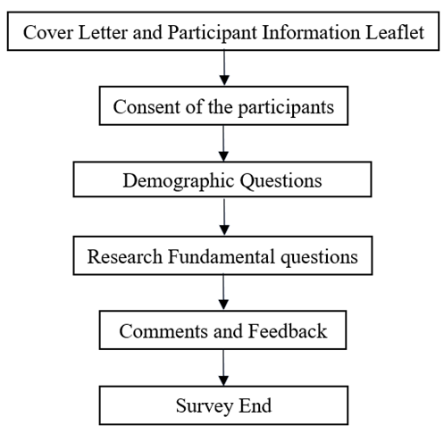

Figure 2. Survey Questionnaire Framework

The questionnaire instrument was distributed, alongside a cover letter, to the participants, detailing the main objective and information regarding the research. Participants’ consent was sought to judiciously utilize their responses for further analysis. The developed questionnaire was divided into two sections. The first section was comprised of questions related to demographic characteristics while the second section consisted of the list of 20 barriers to SS implementation. The demographic questions in the questionnaire contemplated various dimensions associated with the respondents to evaluate the differences to obtain significant results from the research. The significance of demographic characteristics came through the identification of the industrial background of the respondents and their knowledge in the field of the study. Subsequently, the core questions of the research were included in the second section of the questionnaire. For these questions, respondents were advised to rate each of the 20 barriers on a Likert scale from 1 to 5, (1- Not important to 5- Extremely important) to validate the significance of these barriers in SS implementation. Table 2 details the content of the demographic and research fundamental questions. The questionnaire instrument employed by the present research is included in Appendix 1.
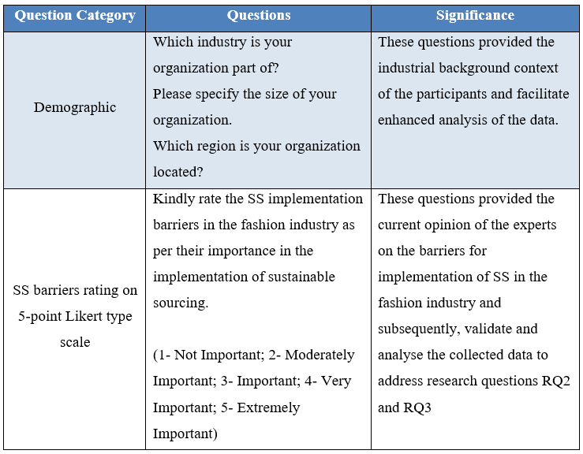
Table 2. Question Category, Questions, and their Significance

4. Analysis and Results

4.1 Demographic Analysis

Demographic analysis was performed on the responses received from the participants for three main criteria, namely: industry, organization size, and region. The selection of these criteria was based upon the expert outlook on the survey face validity and several academic studies (Luthra and Mangla, 2018) with similar research methodologies. Table 3 presents the sorted demographic information (descending order) frequency analysis for demographic variables (DM1 to DM3, for coding, see Section 4.2) attained from the 154 survey responses obtained.
Table 3. Survey Questionnaire Demographic Analysis
Variable | Response Received | Frequency | Percent
DM1: Industry | Apparel Industry | 59 | 38.31
 | Fashion Management and Consulting | 39 | 25.32
 | Textile Industry | 21 | 13.64
 | Other | 35 | 22.73
 | Total | 154 | 100.00
DM2: Organization size | Small (10-49 employees) | 79 | 51.30
 | Large (250 employees and above) | 56 | 36.36
 | Medium (50-249 employees) | 19 | 12.34
 | Total | 154 | 100.00
DM3: Region | Europe | 94 | 61.04
 | Asia Pacific | 38 | 24.68
 | North America | 16 | 10.39
 | Africa | 3 | 1.95
 | Middle East | 2 | 1.30
 | South America | 1 | 0.65
 | Total | 154 | 100.00

4.2 Data Cleaning and Coding

From the 225 gathered responses, and after data inspection for completeness, 154 were deemed useful responses for further analysis, which exceeded the initial target of 125 responses, see Section 3.1. In this case, the sample size of the gathered 154 responses was bigger than the sample size of most studies associated with EFA and even provided a satisfactory response rate to conduct the EFA (Maskey et al., 2018). The demographic questions were denoted by the variable ‘DMa’ where a = 1 to 3 (Table 3), whereas the barriers were denoted by the ‘Ba’ where a = 1 to 20 (Table 4) and the coding was followed as per the Likert Scale that ranged from 1 (Not Important) to 5 (Extremely Important).
Figure 3 shows the step-by-step process followed to finalize the 154 responses data.
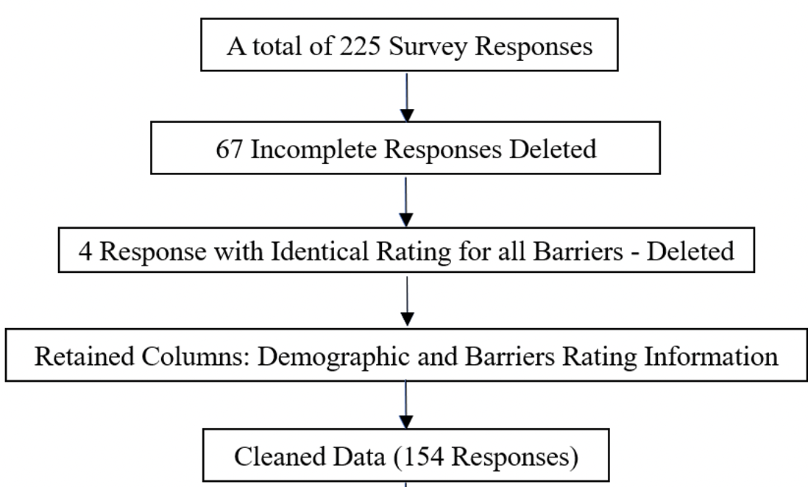
Figure 3. Final section of the response for empirical study

4.3 Reliability and Validity Testing

The reliability and validity of the survey questionnaire are imperative to confirm the consistency and accuracy of the gathered responses and further analyses (Hair et al., 2014). Data reliability comprised of deliberate steps, first, the collection of data was warranted by recording and storing the participants’ responses on a secured real-time survey platform and password encrypted drive. Secondly, the collected data (barrier variables – coded: B1 to B20) were subjected to a Cronbach’s Alpha reliability test. Cronbach’s Alpha is the most common approach to analyze and estimate the reliability and internal consistency of the studied items on a scale (Cronbach and Shavelson, 2004). The reliability test yielded a Cronbach’s Alpha value of 0.885, which was greater than the suggested value of 0.7 and confirmed the internal reliability of the survey data (Taber, 2018). The statistical results from the reliability analysis are shown in Table 4. This cross-sectional research mandated the internal consistency as the solitary measure of reliability, contemplating those participants could answer the survey once and afterwards the response was stored at the same point of time, thus, eliminating other measures of reliability such as stability.

The validity of the survey questionnaire was accomplished by confirming the relevance of all data, facts, and publications employed in this study. Considering the importance of the survey questionnaire validity, it was ensured that questions originated from the problems identified from the published literature. Thus, questionnaire content validity was accomplished. Face validity was ensured through pilot testing the questionnaire among a small panel of experts (i.e., at least 3 experts from industry and 3 from academia), before the distribution of the survey to the focal respondents. Face validity was accomplished once 6 responses were received after distributing the pilot questionnaire to the experts. The pilot study demonstrated an optimistic outlook from the experts regarding the questionnaire, which led to minimal modifications to ensure the removal of plausible errors and prejudice. Finally, the correlation amid the rated barriers was computed to analyze divergent validity through the Pearson Correlation Coefficient as presented in Table 5. All the variables resulted in either weak or moderate correlations amongst each other with an absolute value of 0.6 or less (Akoglu, 2018). This indicated that no barrier variables were similar or had the same measuring criteria, confirming their divergent validity (Chien et al., 2011).

Table 4 also presents the results of the descriptive analysis of the gathered data. All the variables attained mean values were above 3, which indicates that all the barriers identified were under the category of important while supporting the inclusion of all the variables for the EFA analysis and their seamless alignment with the reliability analysis.
Table 4. Reliability Test in SPSS on the Survey Data
Variable | Barrier to implementation of SS in the Fashion Industry | Cronbach's Alpha if Item Deleted | Mean ± SD
B1 | Undersupply of sustainable raw materials | 0.885 | 3.70 ± 1.02
B2 | Shortage of superior quality raw materials | 0.887 | 3.70 ± 1.09
B3 | Complex material structure and composition | 0.884 | 3.29 ± 1.19
B4 | Weak partnerships and integration between SC partners | 0.879 | 3.72 ± 1.04
B5 | Absence of suitable supplier training and reward system | 0.879 | 3.68 ± 1.18
B6 | Poor commitment and asymmetric information sharing from buyer/customer | 0.877 | 3.86 ± 1.09
B7 | Cost of sustainable raw materials | 0.883 | 3.86 ± 1.03
B8 | Rise in cost of investment | 0.879 | 3.51 ± 1.09
B9 | Uncertain return on investment | 0.880 | 3.18 ± 1.16
B10 | Cost of eco-friendly packaging | 0.881 | 3.08 ± 1.12
B11 | Resistance to upskill and knowledge sharing | 0.879 | 3.04 ± 1.23
B12 | Lack of eco-literate and skilled employees | 0.876 | 3.47 ± 1.17
B13 | Insufficient commitment from top management | 0.876 | 4.08 ± 1.11
B14 | Hard transition to new business models | 0.876 | 3.77 ± 1.07
B15 | Certifications | 0.882 | 3.47 ± 1.09
B16 | Social responsibility | 0.876 | 3.76 ± 1.06
B17 | Inadequate infrastructure | 0.880 | 3.94 ± 1.99
B18 | Customer perceptions | 0.882 | 3.62 ± 1.14
B19 | Limited support from governing authorities | 0.878 | 3.92 ± 1.16
B20 | Inadequate awareness | 0.877 | 3.64 ± 1.12

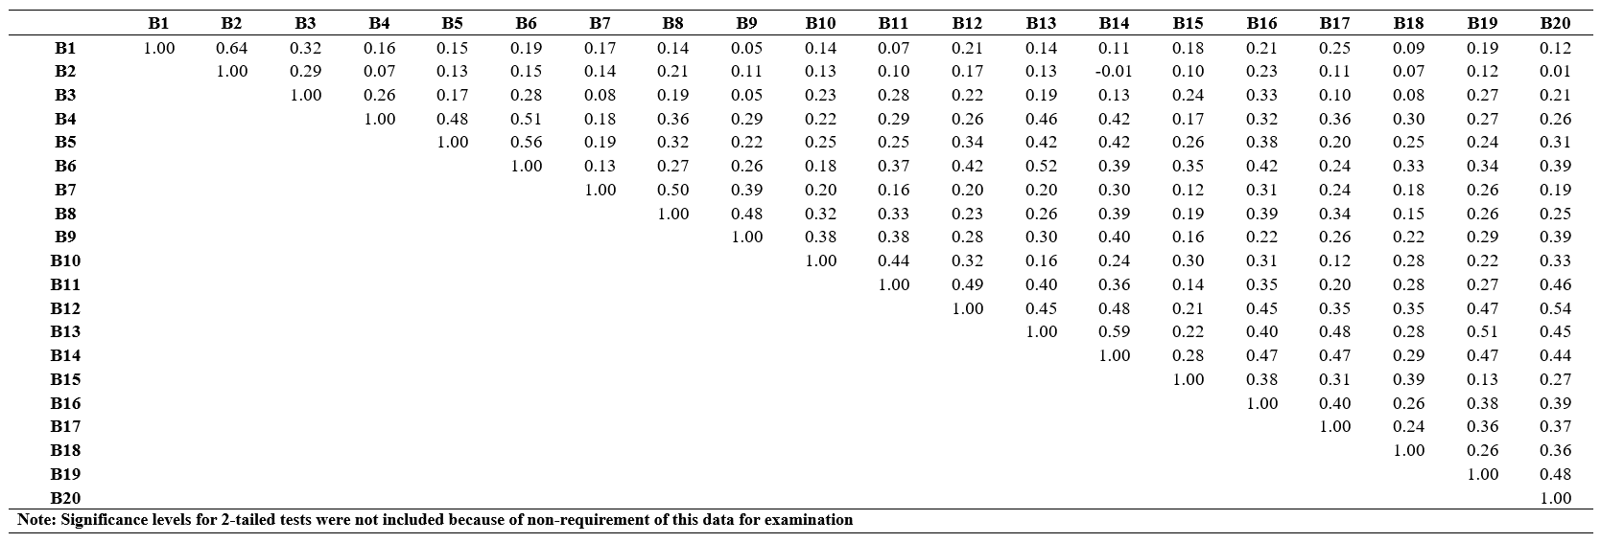
Table 5. Correlation Matrix of the SS Barriers through Pearson Correlation Coefficients

4.4 Factor structure of Sustainable Sourcing Barriers

Firstly, Exploratory Factor Analysis (EFA) involved checking the presence of inter-variable correlations. This validation was conducted through Pearson correlation coefficients, see Section 4.2, which indicated that there were no barriers with strong absolute values of Pearson correlation coefficients. Thus, all the barriers were considered to be unique, and no barrier variables were related to each other confirming their divergent validity (Chien et al., 2011), see Table 4.

The second step involved checking the reliability of all the variables. The Cronbach’s Alpha values attained for all the barriers, see Section 4.2, proved that all barriers were significantly reliable to conduct the EFA. Furthermore, the value of 0.844 attained from the Kaiser-Meyer-Olkin test was greater than the suggested least value of 0.6 (Shrestha, 2021), which positively indicated the adequacy of the gathered survey data for conducting the EFA (Table 6). Additionally, Table 7 also revealed that the significance level of 0.00 was obtained through Bartlett’s Test of Sphericity, which was less than the suggested value of 0.05 (Shrestha, 2021). This validated the hypothesis that the variable correlation matrix and identity matrix were the same and associated with unrelated variables (Shrestha, 2021), which provided acceptance for the conduction of the EFA.
Table 6. Kaiser–Meyer–Olkin (KMO) test, Bartlett’s test of Sphericity, and Cronbach Alpha
Kaiser-Meyer-Olkin Measure of Sampling Adequacy. |  | 0.844
Bartlett's Test of Sphericity | Approx. Chi-Square | 1129.43
 | df | 190
 | Sig. | 0.000
Cronbach's Alpha (No. of items=20) |  | 0.885
df=degrees of freedom, Sig.=Significance

The third step involved the identification of a reduced number of factors and components in the EFA, which indicated the total amount of variance associated with the barriers’ variables (B1 to B20). For this purpose, a principal component analysis was conducted for extracting the factors that best represented the variables. The results of the principal component analysis revealed that out of the 20 barriers’ variables (B1to B20), 6 variables were found to be associated with Eigenvalues above 1 (Luthra and Mangla, 2018) and elucidated a 65.6% of the cumulative total variance. In other words, 6 variables explained 65.6% of the variance and these 6 variables had Eigenvalues of more than 1. Even though this percentage was less than the suggested 75% or above by Yong and Pearce (2013), it was still contemplated satisfactory as the reported average value of 52% conducted on 60 research based on EFA (Henson and Roberts, 2006) and common variance to be above 50% by Williams et al. (2010).
Next, these six factors were recognized as independent from each other, which led towards the utilization of Varimax rotation (orthogonal). The varimax rotation of the factors assisted in the loading of the factors and the creation of a streamlined structure (Osborne, 2015). The barrier variables were mapped to these six unique components and in that process, any factor loading below 0.41 was subjugated considering multiple iteration trials. Table 7 illustrates the structure of the rotated component matrix, which was utilized to create a new model of the EFA factors. Furthermore, these six components resulting from the EFA were utilized to attain the barrier classification into meaningful and comprehensive categories as illustrated in Table 8.
Table 7. EFA Framework Highlighting Six Unique Barrier
Factors
Variable | 1 | 2 | 3 | 4 | 5 | 6
B19 | 0.73
B13 | 0.68
B12 | 0.66
B20 | 0.64
B14 | 0.62
B17 | 0.62
B16 | 0.41
B5 |  | 0.76
B4 |  | 0.75
B6 |  | 0.73
B7 |  |  | 0.77
B8 |  |  | 0.76
B9 |  |  | 0.66
B2 |  |  |  | 0.86
B1 |  |  |  | 0.85
B3 |  |  |  | 0.55
B10 |  |  |  |  | 0.67
B11 |  |  |  |  | 0.71
B15 |  |  |  |  |  | 0.85
B18 |  |  |  |  |  | 0.66

Extraction Method: Principal Component Analysis. Rotation Method: Varimax with Kaiser Normalization. Rotation converged in 6 iterations.

Finally, the cross-loaded items were analysed, and no problems were detected as the difference between the cross-loaded items was greater than 0.10 (Kathuria, 2000; Zhang et al., 2018), and the highest value of the loaded items (barriers) was greater than 0.4 (Samuels, 2017). Furthermore, the EFA resulted in loading two items (B10, B11, and B15, B18) under one factor, which did not cause a problem as scales were identifiable with two items loaded under one factor and all these items (B10, B11, B15, and B18) had communality greater than 0.2 (Samuels, 2017; Baig et al., 2020). These barriers were identified through a thorough literature survey and discussed with industry experts. After conducting the principal component analysis and rotation method, these 20 barriers were placed into different categories based on their similarity and meaning. Finally, they were discussed with industry experts to validate the categories. Table 9 shows the 6 identified categories and their respective barriers to SS implementation.

Table 8. Categorization of SS implementation Barriers in the Fashion Industry
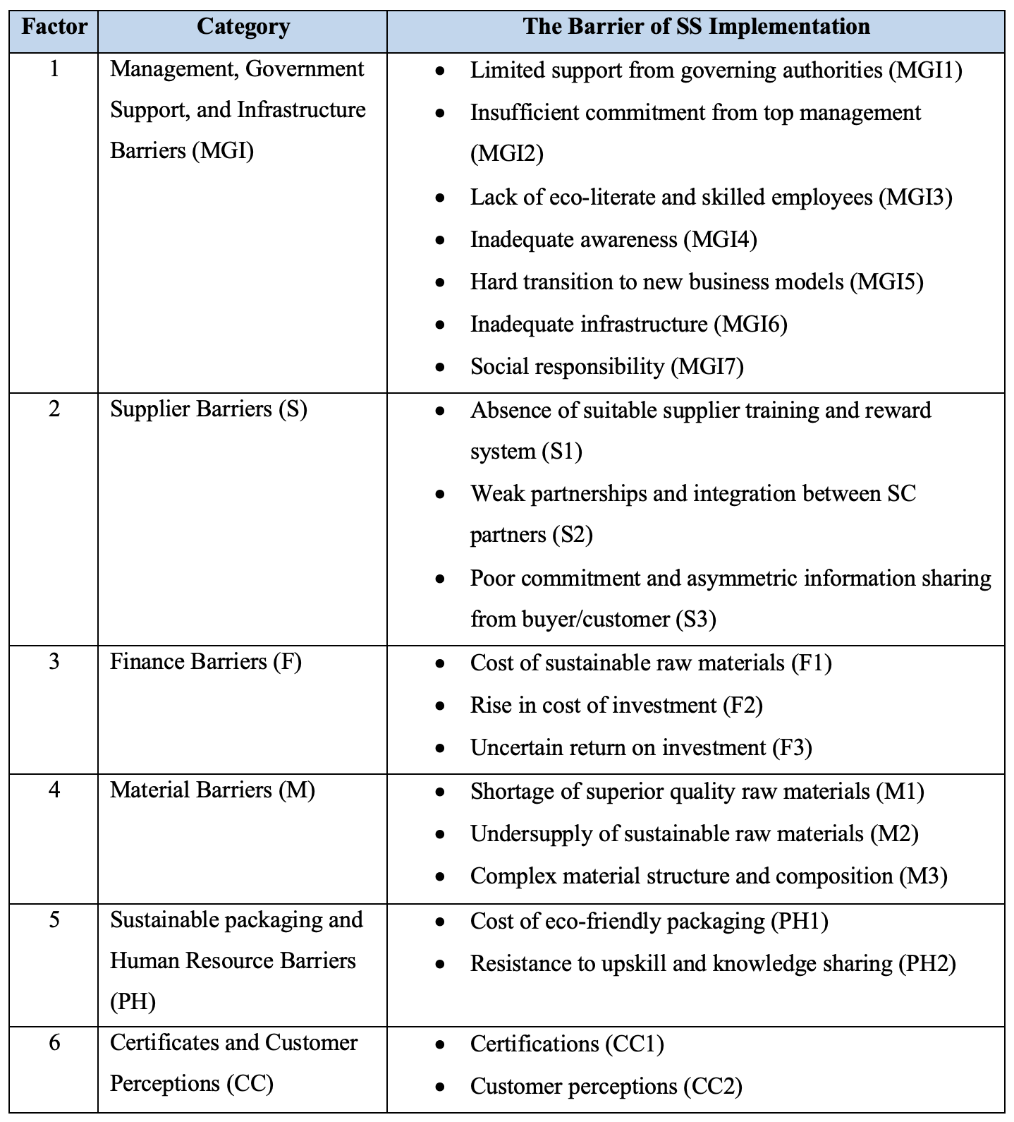

4.5 Ranking of SS Barriers - Analytical Hierarchy Process (AHP)

AHP is a widely utilized decision-making tool that aids in the investigation and organisation of complex problems through a methodical structure that comprises several significant levels such as the aim, the corresponding conditions, and the sub-conditions (Luthra and Mangla, 2018). There are various decision-making methods such as ANP, ELECTRE, and TOPSIS to solve complex hierarchical problems; however, for comparison problems, AHP has been recommended as a better method due to its simplistic use (Luthra et al., 2017). AHP is a widely employed method in distinct multi-criteria decision-making areas and is most frequently used in the application area of manufacturing, logistics, and government (Ho and Ma, 2018). One of the main advantages of AHP is that it breaks down a complex problem into different simple problems. Additionally, the most important part of AHP is its conversion of a problem into a hierarchical structure which simplifies complex problems (Gompf et al. 2021). The subjective elements from a complex problem created through AHP are hierarchically related. After that, these elements are ranked through paired comparisons. The ranks in the paired comparisons of the elements help decision-makers to prioritize the best option. For this reason, it is considered a good approach in facilitating decision-making processes in various fields of research (Saaty, 2008). Some recent studies employed AHP for ranking and weighting processes in different fields like the textile industry (Piprani et al. 2020), social sustainability (Gompf et al. 2021), engineering (Rozga et al. 2021; Mandavgade et al. 2021), tourism (Sahani, 2021), healthcare (Garrido et al. 2021), agriculture (Biswas et al., 2020), etc. Henceforth, this study considered the suitability of the AHP method in ranking the barriers to SS implementation and therefore it employed AHP to compare and rank the barriers that may hinder SS. Figure 4 shows basic data information of the responses used for the final analysis.

4.5.1 Step 1: Design of the research aim

Schmidt et al. (2015) state that AHP does not require a large sample size, so the number of participants could range from 1 to nearly 1300, instead, the quality of the information provided by the experts is more important (Gómez-Romero et al., 2019). Considering earlier similar studies conducted on SSCM, the present study included the input of 5 experts (Luthra et al., 2016) vastly skilled and knowledgeable in the field of fashion sustainable sourcing and supply chain activities. Table 9 illustrates the experts’ panel employed for AHP. The goal of the present AHP analysis was to attain global weights to rank the SS barriers. This resulted in the creation of a 3-level hierarchical structure, see Figure 4, which evaluated the SS implementation barriers based on their relative importance (1st Level), the six dimensions of the barriers identified through EFA (2nd Level), and twenty barriers (3rd Level).
Table 9. SS Expert Panel for AHP
Expert | Position | SS Work Experience (Years) | Location
1 | Sustainability and supply chain strategist | 20+ | Canada
2 | Sustainable sourcing analyst | 15+ | United States
3 | Senior merchandiser | 15+ | Bangladesh
4 | Senior Sourcing Consultant | 15+ | United Kingdom
5 | Senior Sourcing Consultant | 10+ | United Kingdom

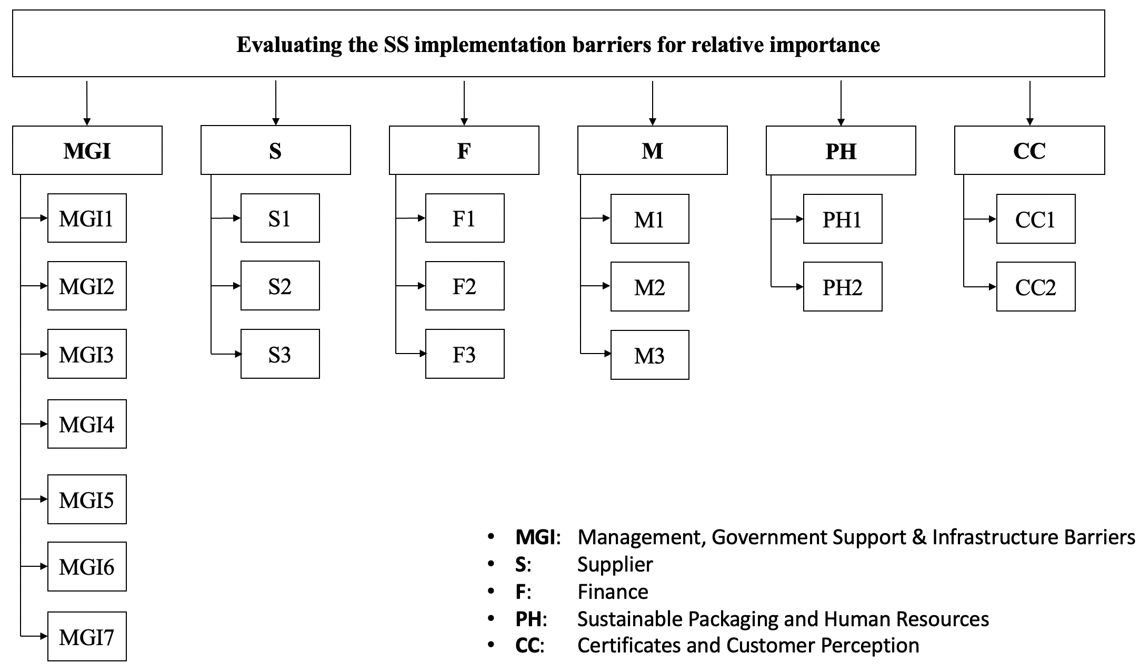
Figure 4. SS barriers decision hierarchy model

4.5.2 Step 2: Pairwise comparisons

Pairwise comparisons were created among barriers based on the five expert’s judgment utilizing the nine-point Saaty’s scale (Saaty, 1987).

4.5.3 Step 3: Computation of relative importance weights and evaluation of consistency ratio

The relative priority weights were calculated aggregating the pairwise comparisons gathered through the five experts, see Table 9. The relative weights can be aggregated through mean or median. However, according to Pauer et al. (2016), aggregation through mean is highly exposed to the outliers that cause serious issues in the statistical analysis. Furthermore, Jose and Winkler (2008) state that aggregation of the data through mean is “less robust” than the median. Thus, in the present analysis, the median was selected as the aggregation method of the relative priority weights. Based on the AHP analysis, the ‘Management, Government Support, and Infrastructure Barriers (MGI) (0.3357)’ dimension was identified as the highest-ranked barrier dimension, followed by ‘Material (M) (0.2790)’; Finance (F) (0.1649)’; Supplier (S) (0.1218)’; Certificates and Customer Perceptions (CC) (0.0541)’ and ‘Sustainable packaging and Human Resource Barriers (PH) (0.0444)’.
Table 10. Pairwise comparison matrix of six main barrier dimensions and their relative weights
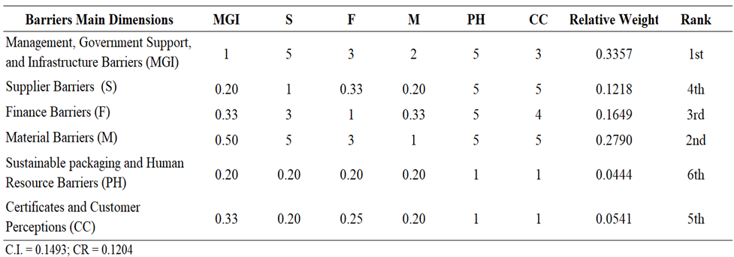
The consistency ratio (CR) was calculated for all the pairwise comparison matrices to determine their consistency, resulting in the CR well under the acceptable value of ≤ 0.2 for all the pairwise matrices (Pauer et al., 2016). The AHP analysis revealed ‘Management, Government Support, and Infrastructure Barriers (MGI) (0.3357)’ and ‘Material (M) (0.2790)’ as the main barriers for the successful transition towards SS in the apparel and fashion luxury industry. Afterwards, the relative and global priority weights of the barriers (3rd Level) were calculated as illustrated in Table 10. According to the global ranking of the barriers, ‘Undersupply of sustainable raw materials (M1)’, ‘Insufficient commitment from top management (MGI2)’, ‘Inadequate awareness (MGI4)’, ‘Uncertain return on investment (F3)’, and ‘Rise in cost of investment’ (F2) were recognized as the top five barriers for SS implementation in the fashion industry.

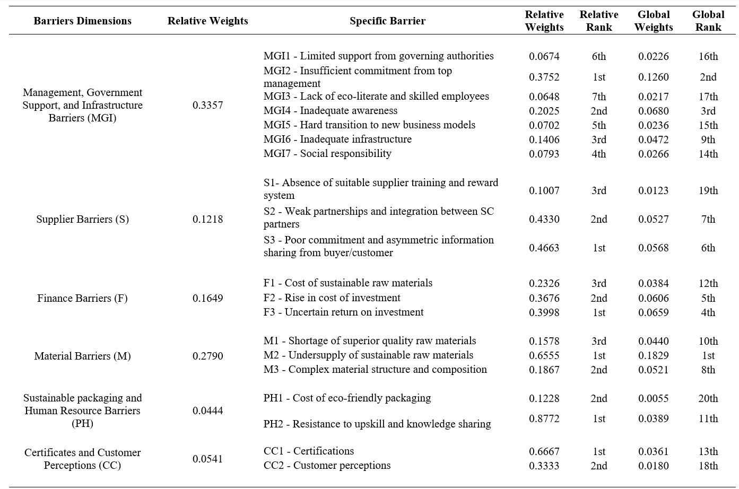
Table 11. Ranking of SS implementation barriers in the apparel and fashion-luxury industry

5. Discussion

Dimension 1: Management, Government Support, and Infrastructure Barriers (MGI)

This study aimed to analyze and rank the barriers to SS implementation. The ranking of the barriers is presented in Table 11, which were placed according to its global weights calculated through the AHP approach. These barriers were identified through a thorough review of the literature and then validated through experts’ opinions based on an empirical study. Following, these barriers were analyzed and ranked using the AHP method and then again validated by the industrial experts. Then, these barriers were grouped in several dimensions based on their similarity and experts’ opinions. The ranking of the barriers will help managers to identify the major issues in the implementation of SS in the fashion industry. It will also contribute to the theoretical knowledge in this field of study by addressing crucial and significant barriers in the field of SS and FSS.

In the first dimension, there are seven specific barriers amongst which ‘Insufficient commitment from top management (MGI2)’ attained the highest relative importance. This finding suggests that a lack of administrative support in an organization hinders the implementation of SS. This result is in line with Govindan et al. (2014), who reported that the involvement and support of management are crucial in implementing green supply chain management. The managerial implication of this result suggests that top management should be dynamic in implementing SS (Moretto et al., 2018). For instance, adapting sustainable industrial practices, managing relevant information, transparency and trust between the business partners, addressing sourcing or manufacturing policies, propagating sustainable practices all across the supply chain, etc. Next in this dimension, ‘Inadequate awareness (MGI4)’ was ranked after (MGI1), which suggests that poor awareness about SS among the management and partners deprives the organization of the benefits of sustainability and takes them towards coercion from the society and government (Kirchherr et al., 2018). In line with this result, Mudgal et al. (2010) reported that a lack of awareness and ignorance of green practices benefits becomes a significant barrier to green supply chain practices. Similarly, ‘Inadequate infrastructure (MGI6)’ was ranked after (MGI4), revealing that without proper IT tools and the latest technology organisations may fail to implement SS (Kazancoglu et al., 2020). These findings suggest that top management should acquire proper knowledge and awareness concerning the implementation of SS and this knowledge and appropriate information must be disseminated to the lower-level administration and employees. In addition to this, organizations must be determined towards infrastructure development for smooth technological growth, which can facilitate SS implementation.

Next, ‘Social responsibility (MGI7)’ was ranked as the following barrier, which suggests that the lack of ethical policies in the company as well as multi-tier employee’s welfare and benefits may act as barriers due to the organisation may regard them as an additional expense (Chan et al., 2020). Hard transition to new business models (MGI5) was categorised as fifth in this dimension, which aligns with Rathinamoorthy (2019) research findings. Rathinamoorthy (2019) suggests that most organisations find it extremely hard to switch from conventional business models to SS as this requires dynamic and strategic planning. ‘Limited support from governing authorities (MGI1)’ came after (MGI5). This elucidates that government must intervene and promote the implementation and enforcement of SS policies across the fashion industry (Raut et al., 2019). Finally, ‘Lack of eco-literate and skilled employees (MGI3)’ was ranked last, as Xiao et al. (2018) validate that there is a lack of employees skilled in sustainable methods and techniques, which causes complications for organisations to implement SS. The managerial implications of these results imply that organizations must focus on strategies concerning social responsibility and sustainability as otherwise the implementation of sustainable practices may be hindered. Also, managers must pay attention to the eco-literacy of the employees and regularly provide proper training and skills development programs to overcome this barrier. It is also suggested that during the recruitment process of the employees, their knowledge of eco-literacy should be given priority. If proper strategic planning regarding sustainable sourcing is formulated and implemented by firms in their entire supply chain it is possible to deal with the industrial barriers.

Dimension 2: Material Barriers (M)

Material Barriers (M) was ranked as the second most important of the six dimensions of the SS barriers. This dimension consists of three specific challenges, wherein ‘Undersupply of sustainable raw materials (M2)’ attained the highest ranking. This implies that it is important to have a robust supply of sustainable raw materials for SS implementation in the fashion industry (Ma et al., 2020). Ma et al. (2020) further state that raw materials undersupply causes an increase in the product's time to market, which increases expenditure in companies. This finding suggests an important implication for managers to address the issue of undersupply of sustainable raw material before finalizing suppliers and collaborative networks so that it will not lead to delayed supply and disruption. Next, ‘Complex material structure and composition (M3)’ came ranked after (M2). Koszewska (2018) supported in their research that garments and fabrics are comprised of diverse polymers that raise the cost of extraction of non-renewable sources and cause hindrance to the implementation of SS. The final barrier under this dimension was ‘Shortage of superior quality raw materials (M1)’. Gardas et al. (2018) consider that renewable and organic materials scarcity leads to non-eco-friendly techniques of sourcing materials to attain high quality and durable garment production lifecycle, which eventually causes more environmental pollution. These findings indicate that the fashion industry deals with several material barriers that disrupt the sustainable practices in the entire supply chain. Hence, managers and policymakers of the industry must focus on the supply of high quality or sustainable raw materials. It is also implied for the industry that it must seek governmental and industrial support in dealing with the high cost of extraction of non-renewable materials and to mitigate the barrier of a complex structure of materials and composition.

Dimension 3: Finance Barriers (F)

The dimension ‘Finance Barriers (F)’ attained the third ranking among all the six dimensions. This barrier consists of three specific challenges, wherein ‘Uncertain return on investment (F3)’ acquires the highest relative importance. Uncertainty on ROI and profits has a direct implication on annual revenue, which results in an obstacle for the organization to invest in SS models (Geissdoerfer et al., 2018). The next barrier was determined to be ‘Rise in cost of investment (F2)’. Ranta et al. (2018) indicate that transition from conventional to sustainable business models increases the expenditure on new technology, equipment, employee and supplier training, and certification, creating a challenge for SS implementation. The final barrier under this dimension is ‘Cost of sustainable raw materials (F1)’. Guo et al. (2020) specified that sustainable raw materials costs are higher than conventional materials and that the reprocessing of used fabrics into quality sustainable raw materials increases the overall costs, which causes reluctance in top management to invest in SS models. These results suggest that financial barriers hinder the adoption of sustainable business models. Although firms must prioritize sustainability initiatives and tackle financial issues, they can take advantage of external funding sources like government subsidies to achieve sustainability goals.

Dimension 4: Supplier Barriers (S)

The ‘Supplier barriers (S)’ dimension acquired the fourth position as per the relative importance among the six dimensions. This dimension is linked to three explicit obstacles. ‘Poor commitment and asymmetric information sharing from buyer/customer (S3)’ attained the first rank. Vermunt et al. (2019) state that lack of fair communication, business, and knowledge sharing from the buyers leads to a poor buyer-supplier relationship, which stops suppliers from upgrading to sustainable policies and consequently leads to a failure of SS implementation. ‘Weak partnerships and integration between SC partners (S2)’ was ranked as the second most important barrier under this dimension. Kaur et al. (2019) indicated that SC partners are averse to collaborating towards sustainable partnerships with the buying company because of lack of trust, common goals, and fear of losing power. Finally, ‘Absence of suitable supplier training and reward system (S1)’ ranked last in this dimension, with Koep et al. (2021) finding out in their study that the lack of adequate incentives and rewards from the buying company limits the adoption of sustainable sourcing models in a company’s suppliers. These findings suggest that firms must adopt a proper decision-making support system to evaluate and select sustainable suppliers. By evaluating and selecting sustainable suppliers, firms can be able to mitigate risks concerning lack of information, weak partnership, transparency, etc.

Dimension 5: Certificates and Customer Perceptions Barriers (CC)

The ‘Certificates and Customer Perceptions (CC)’ dimension acquired the fifth rank among the six dimensions as per its relative importance. This dimension is associated with two specific challenges, where ‘Certifications (CC1)’ was ranked as the first barrier under this dimension. The transition to sustainable business models requires organisations, and their suppliers, to comply and upgrade according to the sustainable certifications that are regularly monitored by the government bodies and occasionally lead to reluctance to implement SS (Oelze et al., 2020). ‘Customer perceptions (CC2)’ ranked second in this dimension. Mishra et al. (2021) suggest that one fraction of the consumers abstain from buying sustainable merchandise because they either perceive reprocessed goods as low-quality or deem sustainable products as more expensive. This perception could lead to hindrance among organisations to implement SS due to lack of market and sales. In this regard, the fashion industry should address the issue of lack of awareness among customers concerning sustainable options in the market. The industry must make use of its promotional strategies to place and promote its product and create awareness among consumers. It is necessary to focus on marketing strategies that can change the perception of consumers towards sustainable products. It is also implied to address the issue of high price associated with such products, so it is suggested that managers and policy makers should seek external funding sources to support the manufacturing of sustainable products that can reduce their price. Also, the fashion industry must emphasize the value proposition of their sustainable products to change the consumer’s perception.

Dimension 6: Sustainable packaging and Human Resource Barriers (PH)
The dimension ‘Sustainable packaging and Human Resource Barriers (PH)’ ranked as the last important SS barrier in the fashion luxury industry. This dimension has two specific barriers, with ‘Resistance to upskill and knowledge sharing (PH2)’ ranking first. Esposito et al. (2018) comment that employees’ unwillingness to upskill to sustainable business models and a lack of knowledge sharing attitude because of fear of losing the job becomes a challenge for an organisation to implement SS. Finally, ‘Cost of eco-friendly packaging (PH1)’ was positioned second in this dimension. Batista et al. (2019) specified that sustainable packaging initial investment, time to market, and consumer response cause organisations to be reluctant to invest in eco-friendly packaging, which becomes a barrier for organisations to transition into SS business models. In this regard, the fashion industry must give importance to environmental sustainability initiatives and propagate eco-friendly messages among consumers to increase their awareness concerning the benefits of sustainable packaging. The industry should also emphasize the negative consequences of plastic and unsustainable packaging on the environment. This will help in creating a positive perception of consumers towards eco-friendly packaging. On the other hand, lack of upskilling and knowledge sharing among employees is a major barrier in the SS implementation by the fashion industry. Hence, appropriate socially and environmentally responsible behaviour must be adopted by firms to facilitate upskilling and knowledge sharing in the industry.

6. Conclusions

This research aimed to determine the challenges of SS implementation in the apparel and fashion-luxury industry. The transition from conventional methods to a new sustainable business model poses obstacles and challenges within organizations and partners involved across their SCs. This study fills the research gap articulated earlier in Section 1 and contributes towards theoretical knowledge in the field of SS and FSS by providing a detailed study concerning the identification and ranking of the barriers to SS implementation. The study also provides practical implications for managers of the fashion sector. This study fills a research gap since a comprehensive study of these barriers in the context of the fashion industry has not been previously conducted. Thus, the study identified 20 major barriers that may hinder the efforts of organizations in the fashion apparel and luxury industry to become more sustainable.

The major finding of this research through a thorough review of the literature and adoption of AHP classified these barriers into six dimensions. Among all dimensions, ‘Management, Government Support, and Infrastructure Barriers’ hold the most significant importance. In this dimension, the ‘Insufficient commitment from top management’ was found to be the foremost barrier to implementing SS in the fashion industry. The other dimensions and respective barriers are explained in the discussion section in detail. This contribution is valuable for the apparel and fashion-luxury industry as it aspires to be more sustainable through the implementation of SS practices across its supply chains. Due to SS practices may share similarities across some sectors including energy, agriculture, transport, food retail, etc., they may also benefit from the present study and its findings. Therefore, the paper offers reliable and responsible evidence for the fashion industry sourcing professionals of the challenges that will be required to be overcome to achieve SS.

Moreover, the study consists of some limitations, the aforementioned claim can only be justified within the resources and time constraints in which this study was conducted. Firstly, this time-constrained research involved convenience sampling for the selection of participants based in various global locations, fashion industry sectors, and organisations, which can lead towards this research general findings being challenged. Therefore, future studies can consider this limitation and eradicate it by the utilization of random sampling, which involves identifying a specific audience for data collection.

Secondly, the barriers identified in this research were associated with insignificant correlations; however, investigating the interrelations of SS barriers in the future such as simulation-based on contingency analysis could further facilitate an in-depth understanding of the interrelated barriers. Such a study could help to build more robust techniques and practices for the fashion industry to implement SS. Undoubtedly, advanced research by considering uncertainty on this area of study supported by the private and public sectors could certainly help the fashion industry to accomplish SS and take further steps towards circular fashion business models.

References

Aftab, M.A., Yuanjian, Q., Kabir, N. and Barua, Z. (2018) Super responsive supply chain: The case of Spanish fast-fashion retailer Inditex-Zara. International Journal of Business and Management, 13 (5): 212-227.
Aivazidou, E. and Tsolakis, N. (2019) Water footprint management in the fashion supply chain: A review of emerging trends and research challenges. Water in Textiles and Fashion, 77-94.
Akbari, M., Clarke, S., Dang, D., & Nkhoma, M. (2017). Empirical social network analysis in sustainable supply chain in Vietnam. In Proceedings of the 31st Annual Australian & New Zealand Academy of Management Conference (ANZAM 2017) (pp. 1-18). RMIT University.
Akoglu, H. (2018) User's guide to correlation coefficients. Turkish journal of emergency medicine, 18 (3): 91-93.
Al-Mahmood, Z. (2013) Nexus of politics, corruption doomed Rana Plaza. [online] Available from: https://www.dhakatribune.com/uncategorized/2013/04/26/nexus-of-politics-corruption-doomed-rana-plaza (Accessed 02 January 2021).
Ambekar, S., Kapoor, R., Prakash, A. and Patyal, V.S. (2019) Motives, processes and practices of sustainable sourcing: a literature review. Journal of Global Operations and Strategic Sourcing, 12 (1): 2-41.
Arrigo, E. (2020) Global sourcing in fast fashion retailers: Sourcing locations and sustainability considerations. Sustainability, 12 (2): 508.
Ayers, J.B. and Odegaard, M.A. (2017) Retail supply chain management. 2nd edn. New York: CRC Press.
Bae, S.Y. (2019) Luxury, sustainability and the future-The case study of Burberry. The Research Journal of the Costume Culture, 27 (1): 64-71.
Baig, S.A., Abrar, M., Batool, A., Hashim, M. and Shabbir, R. (2020) Barriers to the adoption of sustainable supply chain management practices: Moderating role of firm size. Cogent Business & Management, 7 (1): 1841525.
Barbosa-Póvoa, A.P., da Silva, C. and Carvalho, A. (2018) Opportunities and challenges in sustainable supply chain: An operations research perspective. European Journal of Operational Research, 268 (2): 399-431.
Batista, L., Gong, Y., Pereira, S., Jia, F. and Bittar, A. (2019) Circular supply chains in emerging economies–a comparative study of packaging recovery ecosystems in China and Brazil. International Journal of Production Research, 57 (23): 7248-7268.
Becker-Leifhold, C. and Iran, S. (2018) Collaborative fashion consumption – drivers, barriers and future pathways. Journal of Fashion Marketing and Management, 22 (2): 189-208.
Berg, A., Magnus, K.H. and Hedrich, S. (2019) Fashion’s new must-have: Sustainable sourcing at scale. [online] Available from: https://www.mckinsey.com/industries/retail/our-insights/fashions-new-must-have-sustainable-sourcing-at-scale (Accessed 20 Oct 2020).
Biswas, S., Mukhopadhyay, B. P., & Bera, A. (2020). Delineating groundwater potential zones of agriculture dominated landscapes using GIS based AHP techniques: a case study from Uttar Dinajpur district, West Bengal. Environmental Earth Sciences, 79(12), 1-25.
Brenot, A., Chuffart, C., Coste-Manière, I., Deroche, M., Godat, E., Lemoine, L., Ramchandani, M., Sette, E. and Tornaire, C. (2019) Water footprint in fashion and luxury industry. In Muthu, S.S. eds. Water in Textiles and Fashion. Woodhead Publishing: 95-113.
Brewer, M.K. (2019) Slow fashion in a fast fashion world: Promoting sustainability and responsibility. Laws, 8 (4): 24.
Bruce, M., Daly, L., & Towers, N. (2004). Lean or agile: a solution for supply chain management in the textiles and clothing industry?. International journal of operations & production management, 24(2), 151-170.
Brundtland, G. H., & Khalid, M. (1987). Our common future. Oxford University Press, Oxford, GB. United Kingdom.
Camargo, L.R., Pereira, S.C.F. and Scarpin, M.R.S. (2020) Fast and ultra-fast fashion supply chain management: an exploratory research. International Journal of Retail & Distribution Management, 48 (6): 537-553.
Caniato, F., Caridi, M., Crippa, L., & Moretto, A. (2012). Environmental sustainability in fashion supply chains: An exploratory case based research. International journal of production economics, 135(2), 659-670.
Chan, A.T., Ngai, E.W. and Moon, K.K. (2017) The effects of strategic and manufacturing flexibilities and supply chain agility on firm performance in the fashion industry. European Journal of Operational Research, 259 (2): 486-499.
Chan, H.L., Wei, X., Guo, S. and Leung, W.H. (2020) Corporate social responsibility (CSR) in fashion supply chains: A multi-methodological study. Transportation Research Part E: Logistics and Transportation Review, 142: 102063.
Chien, C.W., Brown, T., McDonald, R. and Rodger, S. (2011) Convergent and discriminant validity of a naturalistic observational assessment of children's hand skills. Hong Kong Journal of Occupational Therapy, 21 (2): 64-71.
Choi, T. M., & Chiu, C. H. (2012). Mean-downside-risk and mean-variance newsvendor models: Implications for sustainable fashion retailing. International Journal of Production Economics, 135(2), 552-560.
Chowdhury, M.M.H., Umme, N.J. and Nuruzzaman, M. (2018) Strategies for mitigating supply-side barriers in the apparel supply chain: A study on the apparel industry of Bangladesh. Global Journal of Flexible Systems Management, 19: 41-52.
Clarke-Sather, A. and Cobb, K. (2019) Onshoring fashion: Worker sustainability impacts of global and local apparel production. Journal of Cleaner Production, 208: 1206-1218.
Cole, D.J. (2011) Heritage and Innovation: Charles Frederick Worth, John Redfern, and the Dawn of Modern Fashion. Fashion & Luxury: Between Heritage & Innovation. Paris, France: Institut Français de la Mode (IFM): 173-181.
Cronbach, L. J., & Shavelson, J. R. (2004). My current thoughts on coefficient alpha and successor procedures. Educational and Psychological Measurement, 64, 391–418.
D'Arpizio, C. and Levato, F. (2014) Lens on the worldwide luxury consumer. Available from: https://recursos.anuncios.com/files/598/20.pdf (Accessed 12 December 2020) Boston, MA: Bain Company.
De Jesus, A. and Mendonça, S. (2018) Lost in transition? Drivers and barriers in the eco-innovation road to the circular economy. Ecological economics, 145: 75-89.
Ellen Macarthur Foundation. (2017) A New Textiles Economy: Redesigning Fashion’s Future. Available online: https://www.ellenmacarthurfoundation.org/assets/downloads/publications/A-New-Textiles-Economy_Full-Report_Updated_1-12-17.pdf (Accessed 22 December 2020). Ellen Macarthur Foundation.
Esposito, M., Tse, T. and Soufani, K. (2018) Introducing a circular economy: New thinking with new managerial and policy implications. California Management Review, 60 (3): 5-19.
Filho, W.L., Ellams, D., Han, S., Tyler, D., Boiten, V.J., Paço, A., Moora, H. and Balogun, A.L. (2019) A review of the socio-economic advantages of textile recycling. Journal of cleaner production, 218: 10-20.
Fung, Y. N., Chan, H. L., Choi, T. M., & Liu, R. (2021). Sustainable product development processes in fashion: Supply chains structures and classifications. International Journal of Production Economics, 231, 107911.
Gadde, L.E. and Jonsson, P. (2019) Future changes in sourcing patterns: 2025 outlook for the Swedish textile industry. Journal of Purchasing and Supply Management, 25 (3): 100526.
Galli, D. and Bassanini, F. (2020) Reporting sustainability in China: Evidence from the global powers of luxury goods. Sustainability, 12 (9): 3940.
Gardas, B.B., Raut, R.D. and Narkhede, B. (2018) Modelling the challenges to sustainability in the textile and apparel (T&A) sector: A Delphi-DEMATEL approach. Sustainable Production and Consumption, 15: 96-108.
Gardetti, M.A. and Torres, A.L. (2017) Sustainability in fashion and textiles: values, design, production and consumption. [online]: Taylor & Francis Group. Available from: https://ebookcentral.proquest.com/lib/warw/reader.action?docID=1741728 (Accessed 02 Jan 2021).
Garrido, A., López, L. J. R., & Álvarez, N. B. (2021). A simulation-based AHP approach to analyze the scalability of EHR systems using blockchain technology in healthcare institutions. Informatics in Medicine Unlocked, 24, 100576.
Geissdoerfer, M., Morioka, S.N., de Carvalho, M.M. and Evans, S. (2018) Business models and supply chains for the circular economy. Journal of cleaner production, 190: 712-721.
Gómez-Romero, J.A., Soto Flores, R. and Garduño Román, S. (2019) Determination of the Weightings of Hydroelectric Sustainability Criteria by Combining AHP and GP Extended Methods. Ingeniería, 24 (2): 116-142.
Gompf, K., Traverso, M., & Hetterich, J. (2021). Using Analytical Hierarchy Process (AHP) to Introduce Weights to Social Life Cycle Assessment of Mobility Services. Sustainability, 13(3), 1258.
Gong, M., Simpson, A., Koh, L. and Tan, K.H. (2018) Inside out: The interrelationships of sustainable performance metrics and its effect on business decision making: Theory and practice. Resources, Conservation and Recycling, 128: 155-166.
Govindan, K. and Hasanagic, M. (2018) A systematic review on drivers, barriers, and practices towards circular economy: a supply chain perspective. International Journal of Production Research, 56 (1-2): 278-311.
Govindan, K., Kaliyan, M., Kannan, D., & Haq, A. N. (2014). Barriers analysis for green supply chain management implementation in Indian industries using analytic hierarchy process. International journal of production economics, 147, 555-568.
Guo, R., Lee, H.L. and Swinney, R. (2016) Responsible sourcing in supply chains. Management Science, 62 (9): 2722-2744.
Guo, S., Choi, T.M. and Shen, B. (2020) Green product development under competition: A study of the fashion apparel industry. European Journal of Operational Research, 280 (2): 523-538.
Hair Jr., J.F., Black, W.C., Babin, B.J., Anderson, R.E., Tatham, R.L. (2014) Multivariate Data Analysis. 7th edn. Harlow: Pearson Education Limited.
Hall, J. (2018) Digital kimono: fast fashion, slow fashion?. Fashion Theory, 22 (3): 283-307.
Hayhurst, L.M.C. and Szto, C. (2016) Corporatizating activism through sport-focused social justice? Investigating Nike’s corporate responsibility initiatives in sport for development and peace. Journal of Sport and Social Issues, 40 (6): 522-544.
Henninger, C.E., Alevizou, P.J., Goworek, H. and Ryding, D. (2017) Sustainability in fashion: A cradle to upcycle approach. [online] Cham, Switzerland: Palgrave Macmillan. Available from: https://0-link-springer-com.pugwash.lib.warwick.ac.uk/book/10.1007%2F978-3-319-51253-2#about (Accessed 05 December 2020).
Henninger, C.E., Alevizou, P.J. and Oates, C.J. (2016) What is sustainable fashion? Journal of Fashion Marketing and Management, 20 (4): 400-416.
Henson, R.K. and Roberts, J.K. (2006) Use of exploratory factor analysis in published research: Common errors and some comment on improved practice. Educational and Psychological measurement, 66 (3): 393-416.
Hingaspure, P., & Patil, P. (2019, May). An analysis on choosing a proper survey software. In Proceedings of International Conference on Communication and Information Processing (ICCIP). Pune, India.
Ho, W., & Ma, X. (2018). The state-of-the-art integrations and applications of the analytic hierarchy process. European Journal of Operational Research, 267(2), 399-414.
Hur, E. and Cassidy, T. (2019) Perceptions and attitudes towards sustainable fashion design: challenges and opportunities for implementing sustainability in fashion. International Journal of Fashion Design, Technology and Education, 24 (1): 163-169.
Islam, M.M., Perry, P. and Gill, S. (2021) Mapping environmentally sustainable practices in textiles, apparel and fashion industries: a systematic literature review. Journal of Fashion Marketing and Management, 25 (2): 331-353.
Javed, T., Yang, J., Gilal, W.G. and Gilal, N.G. (2020) The sustainability claims' impact on the consumer's green perception and behavioral intention: A case study of H&M. Advances in Management and Applied Economics, 10 (2): 1-22.
Jia, F., Yin, S., Chen, L. and Chen, X. (2020) The circular economy in the textile and apparel industry: A systematic literature review. Journal of Cleaner Production, 259: 120728.
Jose, V.R.R. and Winkler, R.L. (2008) Simple robust averages of forecasts: Some empirical results. International journal of forecasting, 24 (1): 163-169.
Joy, A. and Peña, C. (2017) Sustainability and the fashion industry: conceptualizing nature and traceability. In: Henninger C., Alevizou P., Goworek H., Ryding D. eds. Sustainability in Fashion. Cham: Palgrave Macmillan: 31-54.
Jung, S., & Jin, B. (2014). A theoretical investigation of slow fashion: sustainable future of the apparel industry. International journal of consumer studies, 38(5), 510-519.
Kathuria, R. (2000) Competitive priorities and managerial performance: a taxonomy of small manufacturers. Journal of operations management, 18 (6): 627-641.
Kaur, J., Sidhu, R., Awasthi, A. and Srivastava, S.K. (2019) A Pareto investigation on critical barriers in green supply chain management. International Journal of Management Science and Engineering Management, 14 (2): 113-123.
Kazancoglu, I., Kazancoglu, Y., Yarimoglu, E. and Kahraman, A. (2020) A conceptual framework for barriers of circular supply chains for sustainability in the textile industry. Sustainable Development, 28: 1477-1492.
Keeble, B.R. (1988) The Brundtland Report: 'Our Common Future'. Medicine and war, 4: 17-25.
Khandual A. and Pradhan S. (2019) Fashion Brands and Consumers Approach Towards Sustainable Fashion. In: Muthu S.S. eds. Fast Fashion, Fashion Brands and Sustainable Consumption. Singapore: Springer: 37-54.
Kiel, D., Müller, J.M., Arnold, C. and Voigt, K.I. (2020) Sustainable industrial value creation: Benefits and challenges of industry 4.0. In: Tidd, J. eds. Digital Disruptive Innovation. London: World Scientific: 1-34.
Kim, J.-H. (2019) Imperative challenge for luxury brands: Generation Y consumers’ perceptions of luxury fashion brands’ e-commerce sites. International Journal of Retail & Distribution Management. 47 (2): 220-244.
Kirchherr, J., Piscicelli, L., Bour, R., Kostense-Smit, E., Muller, J., Huibrechtse-Truijens, A. and Hekkert, M. (2018) Barriers to the circular economy: Evidence from the European Union (EU). Ecological Economics, 150: 264-272.
Ko, E., Costello, J.P. and Taylor, C.R. (2019) What is a luxury brand? A new definition and review of the literature. Journal of Business Research, 99: 405-413.
Koep L., Morris J., Dembski N., Guenther E. (2021) Buying Practices in the Textile and Fashion Industry: Past, Present and Future. In: Matthes A., Beyer K., Cebulla H., Arnold M.G., Schumann A. eds. Sustainable Textile and Fashion Value Chains. Cham: Springer: 55-73.
Köksal, D., Strähle, J., Müller, M. and Freise, M. (2017) Social sustainable supply chain management in the textile and apparel industry—A literature review. Sustainability, 9 (1): 100.
Koszewska, M. (2018) Circular economy—Challenges for the textile and clothing industry. Autex Research Journal, 1-11.
Kumar, P. S., and Suganya, S. (2019) Systems and models for circular economy. In Muthu S. S. eds. Circular Economy in Textiles and Apparel: Processing, Manufacturing, and Design. United Kingdom: Woodhead Publishing: 169–181.
Lakhal, S. Y., Sidibé, H., & H'Mida, S. (2008). Comparing conventional and certified organic cotton supply chains: the case of Mali. International journal of agricultural resources, governance and ecology, 7(3), 243-255.
Lawless, E., & Medvedev, K. (2016). Assessment of sustainable design practices in the fashion industry: Experiences of eight small sustainable design companies in the Northeastern and Southeastern United States. International Journal of Fashion Design, Technology and Education, 9(1), 41-50.
Lehmann, M., Arici, G., Boger, S., Martinez-Pardo, C., Krueger, F., Schneider, M., Carrière-Pradal, B. and Schou, D. (2019) Pulse of the fashion industry. Available from: http://media-publications.bcg.com/france/Pulse-of-the-Fashion-Industry2019.pdf (Accessed 09 January 2021). Global Fashion Agenda, Boston Consulting Group, and Sustainable Apparel Coalition.
Luthra, S. and Mangla, S.K. (2018) Evaluating challenges to Industry 4.0 initiatives for supply chain sustainability in emerging economies. Process Safety and Environmental Protection, 117: 168-179.
Luthra, S., Govindan, K., Kannan, D., Mangla, S.K. and Garg, C.P. (2017) An integrated framework for sustainable supplier selection and evaluation in supply chains. Journal of Cleaner Production, 140: 1686-1698.
Luthra, S., Mangla, S.K., Xu, L. and Diabat, A. (2016) Using AHP to evaluate barriers in adopting sustainable consumption and production initiatives in a supply chain. International Journal of Production Economics, 181: 342-349.
Ma, K., Wang, L. and Chen, Y. (2018) A collaborative cloud service platform for realizing sustainable make-to-order apparel supply chain. Sustainability, 10 (1): 11.
Macchion, L., Da Giau, A., Caniato, F., Caridi, M., Danese, P., Rinaldi, R. and Vinelli, A. (2018) Strategic approaches to sustainability in fashion supply chain management. Production Planning & Control, 29 (1): 9-28.
Macchion, L., Da Giau, A., Caniato, F., Caridi, M., Danese, P., Rinaldi, R., & Vinelli, A. (2018). Strategic approaches to sustainability in fashion supply chain management. Production Planning & Control, 29(1), 9-28.
Macchion, L., Moretto, A., Caniato, F., Caridi, M., Danese, P. and Vinelli, A. (2015) Production and supply network strategies within the fashion industry. International Journal of Production Economics, 163: 173-188.
Majumdar, A. and Sinha, S.K. (2019) Analyzing the barriers of green textile supply chain management in Southeast Asia using interpretive structural modeling. Sustainable Production and Consumption, 17: 176-187.
Majumdar, A. and Sinha, S. (2018) Modeling the barriers of green supply chain management in small and medium enterprises: A case of Indian clothing industry. Management of Environmental Quality, 29 (6): 1110-1122.
Mandavgade, N. K., Kalbande, V. N., Bilawane, R. R., Kanojiya, M. T., & Padole, C. U. (2021). AHP for ranking effect of qualitative factors in uncertainty measurement of material testing. Materials Today: Proceedings, 46(17), 7921-7925.
Mangla, S.K., Kumar, P. and Barua, M.K. (2015) Risk analysis in green supply chain using fuzzy AHP approach: A case study. Resources, Conservation and Recycling, 104: 375-390.
Maskey, R., Fei, J. and Nguyen, H.O. (2018) Use of exploratory factor analysis in maritime research. The Asian journal of shipping and logistics, 34 (2): 91-111.
McMaster, M., Nettleton, C., Tom, C., Xu, B., Cao, C. and Qiao, P. (2020) Risk management: Rethinking fashion supply chain management for multinational corporations in light of the COVID-19 outbreak. Journal of Risk and Financial Management, 13 (8): 173.
Mishra, S., Jain, S. and Malhotra, G. (2021) The anatomy of circular economy transition in the fashion industry. Social Responsibility Journal, 17 (4): 524-542.
Moktadir, M.A., Ali, S.M., Rajesh, R. and Paul, S.K. (2018) Modeling the interrelationships among barriers to sustainable supply chain management in leather industry. Journal of Cleaner Production, 181: 631-651.
Moosmayer, D. C., & Davis, S. M. (2016). Staking cosmopolitan claims: How firms and NGOs talk about supply chain responsibility. Journal of Business Ethics, 135(3), 403-417.
Moretto, A., Macchion, L., Lion, A., Caniato, F., Danese, P. and Vinelli, A. (2018) Designing a roadmap towards a sustainable supply chain: A focus on the fashion industry. Journal of cleaner production, 193: 169-184.
Mudgal, R. K., Shankar, R., Talib, P., & Raj, T. (2010). Modelling the barriers of green supply chain practices: an Indian perspective. International Journal of Logistics Systems and Management, 7(1), 81-107.
Nardi, P.M. (2018) Doing survey research: A guide to quantitative methods.4th edn. New York: Routledge.
Nayak, R., Akbari, M. and Far, S.M. (2019) Recent sustainable trends in Vietnam's fashion supply chain. Journal of Cleaner Production, 225: 291-303.
Oelze, N. (2017) Sustainable supply chain management implementation–enablers and barriers in the textile industry. Sustainability, 9 (8): 1435.
Oelze, N., Gruchmann, T. and Brandenburg, M. (2020) Motivating factors for implementing apparel certification schemes—a sustainable supply chain management perspective. Sustainability, 12 (12): 4823.
Osborne, J.W. (2015) What is rotating in exploratory factor analysis?. Practical Assessment, Research, and Evaluation, 20.
Ozdamar Ertekin, Z., & Atik, D. (2015). Sustainable markets: Motivating factors, barriers, and remedies for mobilization of slow fashion. Journal of Macromarketing, 35(1), 53-69.
Ozdamar-Ertekin, Z. (2019) Can Luxury Fashion Provide a Roadmap for Sustainability?. Markets, Globalization & Development Review, 4 (1).
Pal, R. and Gander, J. (2018) Modelling environmental value: An examination of sustainable business models within the fashion industry. Journal of Cleaner Production, 184: 251-263.
Pauer, F., Schmidt, K., Babac, A., Damm, K., Frank, M. and von der Schulenburg, J.M.G. (2016) Comparison of different approaches applied in analytic hierarchy process–An example of information needs of patients with rare diseases. BMC medical informatics and decision making, 16.
Pedersen, E.R.G., Gwozdz, W. and Hvass, K.K. (2018) Exploring the relationship between business model innovation, corporate sustainability, and organisational values within the fashion industry. Journal of Business Ethics, 149: 267-284.
Phatak, S. and Sople, V. (2018) Drivers and Barriers of Sustainable Supply Chain: A Literature Review on Indian Perspective. International Journal of Business Insights and Transformation, 12 (1): 17-25.
Pinnock, O. (2018) No One in Fashion Is Surprised Burberry Burnt £28 Million of Stock. [online] Available from: https://www.forbes.com/sites/oliviapinnock/2018/07/20/no-one-in-fashion-is-surprised-burberry-burnt-28-million-of-stock/?sh=1da561f74793 (Accessed 07 January 2021).
Piprani, A. Z., Jaafar, N. I., & Ali, S. M. (2020). Prioritizing resilient capability factors of dealing with supply chain disruptions: an analytical hierarchy process (AHP) application in the textile industry. Benchmarking: An International Journal, 27(9), 2537-2563.
Ranta, V., Aarikka-Stenroos, L., Ritala, P. and Mäkinen, S.J. (2018) Exploring institutional drivers and barriers of the circular economy: A cross-regional comparison of China, the US, and Europe. Resources, Conservation and Recycling, 135: 70-82.
Rathinamoorthy, R. (2019) Circular fashion. In: Muthu, S.S. eds. Circular Economy in Textiles and Apparel. Duxford, United Kingdom: Woodhead Publishing: 13-48.
Raut, R., Gardas, B.B. and Narkhede, B. (2019) Ranking the barriers of sustainable textile and apparel supply chains: An interpretive structural modelling methodology. Benchmarking: An International Journal, 26 (2): 371-394.
Reio Jr, T.G. and Shuck, B. (2015) Exploratory factor analysis: implications for theory, research, and practice. Advances in Developing Human Resources, 17 (1): 12-25.
Remy, N, Speelman, E and Swartz, S. (2016) Style that’s sustainable: A new fast-fashion formula. [online] Available from: https://www.mckinsey.com/~/media/McKinsey/Business%20Functions/Sustainability/Our%20Insights/Style%20thats%20sustainable%20A%20new%20fast%20fashion%20formula/Style-thats-sustainable-A-new-fast-fashion-formula-vF.ashx#:~:text=Style%20that%E2%80%99s%20sustainable%3A%20A%20new%20fast-fashion%20formula%20%C2%A9,reduce%20its%20social%20and%20environmental%20costs.%20OCTOBER%202016 (Accessed 02 January 2021). McKinsey & Company.
Rozga, P., Kraslawski, A., Klarecki, A., Romanowski, A., & Krysiak, W. (2021). A New Approach for Decision Support of the Selection of Construction Technology of High-Voltage Substations Based on AHP Method. IEEE Access, 9, 73413-73423.
Saaty, R.W. (1987) The analytic hierarchy process—what it is and how it is used. Mathematical modelling, 9 (3-5): 161-176.
Saaty, T. L. (2008). Decision making with the analytic hierarchy process. International journal of services sciences, 1(1), 83-98.
Sahani, N. (2021). Application of hybrid SWOT-AHP-FuzzyAHP model for formulation and prioritization of ecotourism strategies in Western Himalaya, India. International Journal of Geoheritage and Parks, 9(3), 349-362.
Samuels, P. (2017) Advice on exploratory factor analysis.
Sayed, M., Hendry, L.C. and Zorzini Bell, M. (2021) Sustainable procurement: comparing in-house and outsourcing implementation modes. Production Planning & Control, 32 (2): 145-168.
Schmidt, K., Aumann, I., Hollander, I., Damm, K. and von der Schulenburg, J.M.G. (2015) Applying the Analytic Hierarchy Process in healthcare research: A systematic literature review and evaluation of reporting. BMC medical informatics and decision making, 15.
Sen, A. (2008). The US fashion industry: A supply chain review. International Journal of Production Economics, 114(2), 571-593.
Shen, B., Li, Q., Dong, C., & Quan, V. (2016). Design outsourcing in the fashion supply chain: OEM versus ODM. Journal of the Operational Research Society, 67(2), 259-268.
Shirvanimoghaddam, K., Motamed, B., Ramakrishna, S. and Naebe, M. (2020) Death by waste: Fashion and textile circular economy case. Science of The Total Environment, 718: 137317.
Shrestha, N. (2021) Factor analysis as a tool for survey analysis. American Journal of Applied Mathematics and Statistics, 9 (1): 4-11.
Sinkovics, N., Hoque, S.F. and Sinkovics, R.R. (2016) Rana Plaza collapse aftermath: are CSR compliance and auditing pressures effective? Accounting, Auditing & Accountability Journal, 29 (4): 617-649.
Sirilertsuwan, P., Hjelmgren, D. and Ekwall, D. (2019) Exploring current enablers and barriers for sustainable proximity manufacturing. Journal of Fashion Marketing and Management, 23 (4): 551-571.
Stanko, M. A., & Calantone, R. J. (2011). Controversy in innovation outsourcing research: review, synthesis and future directions. R&d Management, 41(1), 8-20.
Taber, K.S. (2018) The use of Cronbach’s alpha when developing and reporting research instruments in science education. Research in science education, 48: 1273-1296.
Todeschini, B.V., Cortimiglia, M.N., Callegaro-de-Menezes, D. and Ghezzi, A. (2017) Innovative and sustainable business models in the fashion industry: Entrepreneurial drivers, opportunities, and challenges. Business Horizons, 60 (6): 759-770.
Tumpa, T.J., Ali, S.M., Rahman, M.H., Paul, S.K., Chowdhury, P. and Khan, S.A.R. (2019) Barriers to green supply chain management: An emerging economy context. Journal of Cleaner Production, 236: 117617.
Tura, N., Hanski, J., Ahola, T., Ståhle, M., Piiparinen, S. and Valkokari, P. (2019) Unlocking circular business: A framework of barriers and drivers. Journal of Cleaner Production, 212: 90-98.
Turker, D. and Altuntas, C. (2014) Sustainable supply chain management in the fast fashion industry: An analysis of corporate reports. European Management Journal, 32 (5): 837-849.
Vermunt, D.A., Negro, S.O., Verweij, P.A., Kuppens, D.V. and Hekkert, M.P. (2019) Exploring barriers to implementing different circular business models. Journal of Cleaner Production, 222: 891-902.
Wang, H., Liu, H., Kim, S.J. and Kim, K.H. (2019) Sustainable fashion index model and its implication. Journal of Business Research, 99: 430-437.
Williams, B., Onsman, A. and Brown, T. (2010) Exploratory factor analysis: A five-step guide for novices. Australasian journal of paramedicine, 8 (3).
World Wildlife Fund. (2019) Sustainable Agriculture Cotton. [online] Available from: https://www.worldwildlife.org/industries/cotton (Accessed on 10 January 2021).
Xiao, S., Dong, H., Geng, Y. and Brander, M. (2018) An overview of China’s recyclable waste recycling and recommendations for integrated solutions. Resources, Conservation and Recycling, 134: 112-120.
Yadav, G., Luthra, S., Jakhar, S.K., Mangla, S.K. and Rai, D.P. (2020) A framework to overcome sustainable supply chain challenges through solution measures of industry 4.0 and circular economy: An automotive case. Journal of Cleaner Production, 254: 120112.
Yong, A.G. and Pearce, S. (2013) A beginner’s guide to factor analysis: Focusing on exploratory factor analysis. Tutorials in quantitative methods for psychology, 9 (2): 79-94.
Zhang, B., Zhang, Y. and Zhou, P. (2021) Consumer attitude towards sustainability of fast fashion products in the UK. Sustainability, 13 (4): 1646.
Zhang, M., Tse, Y.K., Doherty, B., Li, S. and Akhtar, P. (2018) Sustainable supply chain management: Confirmation of a higher-order model. Resources, Conservation and Recycling, 128: 206-221.

Appendix 1 - Supplementary Information

Questionnaire for the Quantitative Survey
Section A: Demographic Information
Please select one of the options in the following questions.
1. Which industry is your organization part of?
a. Apparel Industry
b. Textile Industry
c. Fashion Management and Consulting
d. If other, please specify……
2. Please specify your Organization Size.
a. Small (10-49 employees)
b. Medium (50-249 employees)
c. Large (250 employees and above)
3. Which region is your organization located?
a. Africa
b. Asia Pacific
c. Europe
d. Middle East
e. North America
f. South America
Section D: Sustainable sourcing has become a significant priority for the apparel fashion and luxury industry with constant pressure from the government, stakeholders, and the customers; however, organizations observe various barriers while transitioning to sustainable sourcing business model as illustrated in the following questionnaire.

Kindly rate these barriers as per their importance in the implementation of sustainable sourcing (1- Not Important; 2- Moderately Important; 3- Important; 4- Very Important; 5- Extremely Important) (Key: SC - Supply Chain, SS - Sustainable Sourcing)

S. No | Barriers | Barriers Description | Rating
 |  |  | 1 | 2 | 3 | 4 | 5
1 | Undersupply of sustainable raw materials | The scarcity and firm regulations on the limited use of natural resources.
2 | Shortage of superior quality raw materials | The shortage of high-quality organic and renewable materials results in the utilization of techniques that causes more environmental contamination to achieve essential conditions for garment production such as quality, efficiency, and durability throughout the production lifecycle.
3 | Complex material structure and composition | The complex garment composition comprising of  polymers make such resources extraction difficult  to find ecological substitutes for the garment  production.
4 | Weak partnerships and integration between SC partners | Absence of trust, mutual targets, and fear of losing  competitive advantage perhaps cause SC partners to averse from sustainability programs.
5 | Absence of suitable supplier training and reward system | There is a lack of training and rewards for suppliers to adapt sustainability from the customers.
6 | Poor commitment and asymmetric information sharing from buyer/customer | The absence of knowledge sharing between buyer  and supplier firms, and unfair-trade practices  severely affects dedication levels from the  suppliers.
7 | Cost of sustainable raw materials | The cost of green materials is more than basic  materials and reprocessed raw materials require  high capital investment.
8 | Rise in cost of investment | Transition to a sustainable business model increases the cost of investment
9 | Uncertain return on investment | Lack of information and uncertainty about the  returns from investment in improved sustainability  prevent capital spending.
10 | Cost of eco-friendly packaging | High investment in eco-packaging technology, time to market, and customer critique.
11 | Resistance to upskill and knowledge sharing | Employees apathetic response to change, upscaling, and fear of job loss on sharing information.
B12 | Lack of eco-literate and skilled employees | Implementation of sustainability leads to either  staff training or skilled hiring requiring time and  money investment.
13 | Insufficient commitment from top management | Insufficient support and vigour from top  management on sustainable programs.
14 | Hard transition to new business models | Lack of strategic innovations and decision-making  from management block transition to new business  models.
15 | Certifications | SS operations require regular monitoring of in  house staff and partners through setting up industry and government recognized certifications.
16 | Social responsibility | Additional money, time, and resources are required to be spent to implement ethical and justified norms for employee's benefits and the workplace.
17 | Inadequate infrastructure | Lack of dedicated facilities and infrastructure for  SS applications such as extraction, reusing and  reprocessing of materials and unused fabric.
18 | Customer perceptions | Customers hold back from transitioning to  sustainable clothing that is expensive and  recognizes reprocessed goods as low quality.
19 | Limited support from governing authorities | Even though multiple ecological laws are in place;  inadequate support is observed from the  government for sustainable program implementation.
20 | Inadequate awareness | A lack of awareness of the benefits from SS is  observed from several SC partners.

If case of any comments or feedback regarding this survey, please let us know by typing in the box below, otherwise please click/tap on the button below to end the survey.

