Assessment of Nominal and Off-nominal Parameters of a Soluble Boron Free Small Modular Reactor Design
Bright Madinka Mweetwaª*, Marcus Dahlfors^{b}, and Marat Margulis^{a,c}
ª School of Computer Science and Engineering, Bangor University, Dean Str., Gwynedd, Bangor LL57 1UT, UK
^{b} TVO, Mikonkatu 7 FI-00100 Helsinki, Finland
^{c} College of Science and Engineering, University of Derby, Kedleston Rd., Derby DE22 1GB, UK
*E-mail: brm22kcj@bangor.ac.uk
Assessment of Nominal and Off-nominal Parameters of a Soluble Boron Free Small Modular Reactor Design
Boric acid is traditionally used for reactivity control in pressurised water reactors. However, it increases the rate at which reactor components corrode. This leads to increased operational radioactive waste produced through neutron-activation of corrosion fragments. During reactor operation, radioactive corrosion product deposits, or so-called crud, accumulate on fuel cladding in regions of high burnup. Boron compounds have been detected in such deposits, and they cause axial-offset anomaly, i.e. deviation in axial power prediction. Accumulation of boron-laden deposits can reduce plant efficiency to about 70 % over time. This work presents the design process and analysis of nominal and off-nominal parameters of a soluble boron-free small modular reactor core. The design, and analyses were carried out using CASMO4e, CMSLINK, and SIMULATE3 codes. In addition, a borated variant of the target boron-free core was designed and used as reference. Equilibrium cycles were achieved for both the reference and the boron-free core. The limiting F∆H during the transition to equilibrium was found to be 1.754 and 1.638 for the reference and boron-free cores. The equilibrium F∆H were found to be 1.524 and 1.57 compared to the design limit of 1.7. The hot zero power MTC for the boron-free core at beginning of cycle was found to be -22.67 pcm/K compared to -3.64 pcm/K for the reference. The removal of boron made the MTC coefficients more negative and the F∆H higher compared to the reference. The boron-free core had enough rod-worth for power and isothermal defect counteraction and reactor shut down.
Keywords: power defect; isothermal defect; hot channel factor; enthalpy rise; axial-offset anomaly

INTRODUCTION
The current fleet of pressurised water reactors (PWR) that are in operation predominantly employ boric acid for reactivity control in addition to control rods and burnable poisons. The use of boric acid has its advantages and disadvantages. In terms of advantages, boric acid exerts global reactivity control over the entire core. Its homogenous distribution in the core through the coolant helps control reactivity effectively, thus reducing power peaking. A reduction in power peaking has a flattening effect on the core radial power profile [1]. A flatter radial power profile is desired as it contributes to efficient utilisation of fuel and enhanced safety by reducing power peaking [2]. The shared reactivity control between control rods, burnable poisons, and boric acid ensures optimal core operation and reduces the number of control rods to be used. It also minimises the use of regulating control rods during operation[3]. Despite these advantages, using boron for reactivity control has its disadvantages.
The addition of soluble boron (boric acid) to the coolant causes boric acid-induced corrosion in the primary system. Some of the corrosion fragments find themselves in a neutron-rich environment where they become radioactive due to neutron activation. This contributes to operational radioactive waste and the potential for radiation exposure to workers [4]. In addition, during operation, there is an accumulation of crud on the clad in regions of high burnup [5]. These deposits have been found to contain compounds of boron. These boron compounds absorb neutrons, thus causing a phenomenon called axial offset anomaly (AOA). This manifests as deviation in the prediction of core axial power distribution during operation [6]. Accumulation of crud causing subsequent AOA has in some cases been documented to drop plant power output to about 70% of rated power.
Furthermore, the concentration of boric acid is usually high at beginning of cycle (BOC) conditions due to the high excess reactivity that requires significant suppression. Higher concentrations of boric acid at BOC tends to make the Moderator Temperature Coefficient (MTC) less negative thereby raising safety concerns [7]. The MTC’s less negative tendency is influenced by a temperature dependent coolant expansion. As the reactor operates and the temperature increases, the coolant, which contains boric acid, expands, and moves away from the centre of the core. Expansion of the coolant causes a reduction in neutron absorption, which subsequently makes MTC slightly positive which is not desirable for reactor safety [8]. In addition, using boric acid for reactivity control adds to the complexity of the chemical and volume control system (CVCS), which is a cost element in the design [9]. Finally, the dilution process of boric acid takes long and as such it is slow in responding to load follow or other requirements for rapid core reactivity manoeuvres.
Considering the aforementioned advantages and disadvantages, this paper presents a 1,430 MWth boron-free SMR design concept and an analysis of associated nominal and off-nominal characteristics. This work provides insights on challenges associated with operations similar to those targeted by Rolls-Royce SMR. Removal of boric acid has a substantial effect on various safety parameters, such as the coolant temperature coefficient and shutdown margins provided by the control rods. The obtained design has the potential for enhancing regulatory criteria for SMRs designs seeking to operate free of boric acid. The core design is based on proven traditional PWR technology and embraces the UK-SMR philosophy, which does not constrain reactor type by power output but rather qualifies SMRs based on their delivery strategy. In its definition of SMRs and Micro-reactors, the IAEA makes an exception of the UK-SMR which has an electric power output above the 300 MWe SMR definition threshold [10] [11]. These analyses required a reference core for validation purposes. However, it was difficult to find a suitable reference core with the same power rating as the design under discussion. It should, however, be noted that the quest for boron-free reactor designs is not entirely new. Several pre-existing attempts are found in the literature [12] [13] [14] [15]. However, these referenced designs are relatively small (typically in the range of 50 - 300 MWth) compared to the concept design under discussion. Further, due to proprietary reasons, most proposed designs are conservative in provision of data that would be relevant for use as reference for the design concept discussed in this paper. To address this, a borated variant of the target boron-free SMR core was designed as a reference core. The borated variant had enough resource for its validation.

THEORY

II.A. Burnable Poison Dopped Fuel Enrichment
The removal of boron from the reactor core requires increased use of burnable poisons and control rods. Various burnable absorbers (BA) are already in use or currently under study for use in commercial PWRs. The most promising are, erbium oxide $({Er}_{2}O_{3}$), zirconium diboride ${(ZrB}_{2}$), and gadolinium oxide (${Gd}_{2}O_{3}$) [8]. Despite being under study, gadolinium oxide is already being used as a burnable absorber in commercial nuclear power plants. The isotope of gadolinium that is used is Gd-157 and has a cross-section of 259,000 bans [16]. Despite having such a favourable cross-section, the compound ${Gd}_{2}O_{3}$ has poor thermal conductivity compared to uranium oxide. Because of this poor thermal conductivity, most of the heat generated by fission will be retained in the carrier fuel pellet once gadolinium depletes. This needs to be addressed by stricter thermal load limitations for Gd-containing fuel rods, which leads to additional complexity in the nuclear fuel design stage – unless considered, these reduced thermal conductivity properties of the pellets could cause overheating of the pellet subsequently leading to cladding failure. To avoid overheating of the pellet, the enrichment and density of the carrier pellet are typically reduced. In addition, there is an 8% regulatory set limit on the amount of gadolinium that can be used as a dopant. In order to determine the enrichment and density of the carrier pellet, Equations 1 and 2 are used. Equation 1 shows the enrichment of the carrier as a function of gadolinium enrichment and Equation 2 shows the density of the carrier pellet [17].
${En}_{{{UO}_{2}-Gd}_{2}O_{3}}={En}_{{{UO}_{2 }}_{ }}-{En}_{{{UO}_{2 }}_{ }}0.05({Gd}_{2}O_{3} \%)$ (1)

$ρ_{{{UO}_{2}-Gd}_{2}O_{3}}=ρ_{{UO}_{2}}-0.033({Gd}_{2}O_{3} \%)$ (2)
Where ${En}_{{{UO}_{2}-Gd}_{2}O_{3}}$ is enrichment for the carrier pellet, ${En}_{{{UO}_{2 }}_{ }}$is enrichment of pellets without gadolinium within the fuel assembly. The 0.05 is the 5% cut back on gadolinium, and 0.033 is the gradient for the density model obtained experimentally.

II.B. Core Design Constraints
During the design process of a core, several parameters important to safety are calculated and compared against predetermined constraints highlighted in the design criteria. This is done to guarantee that the final design concept complies with the design criteria [18]. In addition, the final design would require assessment of various parameters at most limiting operating state points. Table 1 shows some limiting operating conditions against which various parameters are typically examined [19].
Table 1 Core parameters requiring evaluation and associated conditions[18].
Parameter |  | Condition
Max All Rods Out (ARO) Hot Full Power (HFP) F∆H | Cycle Max, HFP, ARO
Max ARO HFP FQ | Cycle Max, HFP, ARO
Peak Linear Heat Generation Rate (kW/m) | Cycle Max, HFP, ARO
Peak Rod Burnup (GWd/MTU) | Cycle Max, HFP, ARO
Maximum HFP Boron Concentration (ppm) | Cycle Max, HFP, ARO
Minimum Refuelling Boron Concentration (ppm) | BOC
Most Positive MTC at HZP (pcm/K) | BOC, HZP
Most Positive MTC at multiple power levels (pcm/K) | BOC, startup
Most Positive MTC at HFP (pcm/K) | Cycle Max, HFP, ARO
Most Negative MTC at HFP (pcm/K) | EOC, HFP, ARO
Minimum HFP Shutdown Margin | N-1, HFP
Minimum HZP Shutdown Margin | N-1, HZP

The enthalpy rise hot channel factor (F∆H) is defined as the ratio of the maximum integrated fuel rod power to the average fuel rod power. The design limit is imposed by the fuel assembly design specifications [20]. The limit aids in ensuring that the design basis for the critical heat flux (CHF) is not violated during normal, transient, or accident conditions.
The heat flux hot channel factor (F_{Q} or F_{Q}(z)) is the maximum local heat flux ratio in the hot channel to the average fuel rod heat flux, i.e. gives a measure of power peaking in the core. The F_{Q} is imposed to ensure that the integrity of the fuel design criteria is maintained during operation or during accident conditions [21].
The dynamic behaviour of a reactor during transient, power manoeuvres or accident conditions is described by reactivity coefficients. Reactivity coefficients represent the change in reactivity caused by a change in a reactor parameter, such as power, moderator density, fuel temperature, or boron concentration [22]. These coefficients are core exposure dependent, and as such, they are calculated at multiple exposure points during the cycle lifetime. The state at which reactivity coefficients are evaluated is chosen to ensure that the design conditions or assumptions made in a particular transient or accident analysis remain within acceptable limits [23]. When analysing the safety of a design relative to transient conditions, reactivity coefficients are evaluated under the most limiting conditions such as all rods out (ARO), hot full power (HFP), hot zero power (HZP), beginning of cycle (BOC) or end of cycle (EOC).
Safety analysis (e.g., parameters such as shutdown margin or core re-criticality with RCCA ejection) for a core that is loaded with burnable poisons, such as ${Gd}_{2}O_{3}$, has to be performed at BOC, EOC, and most reactive point in the cycle which is associated with the limiting F∆H. In those loading patterns, the limiting F∆H occurs later in the cycle when the burnable poison depletes and there is a reactivity swing due to increase in neutron multiplication.
The shutdown margin (SDM) is the instantaneous amount of reactivity by which a reactor is subcritical or would be subcritical from its present condition, assuming all rod cluster control assemblies (RCCAs) are fully inserted with the highest reactivity worth RCCA assumed stuck out of the core [24]. Typically, a minimum of 1 per cent shutdown margin is required up to 473.15 K for a PWR [25]. However, in other literature, a conservative 3 percent shutdown margin requirement has been reported[26].

MATERIALS AND METHODS

III.A. Core Parameters (Particle Swarm Optimisation)
The amount of thermal energy to be produced by the core is an important consideration during core design. The core thermal output is influenced by many parameters, such as the number of fuel assemblies and their dimensions, active core height, equivalent core diameter, power density, and pressure [27]. These parameters require optimisation to achieve the desired equilibrium cycle length and rated thermal energy output. To achieve this, various optimisation methods are used. In this work, Particle Swarm Optimisation (PSO) was used.
Particle Swarm Optimisation (PSO) method was first introduced by James Kennedy and Russell Eberhart in 1995. It is widely used in solving design optimisation problems because of its competitive running time [28] [29]. The aim of PSO is to find an optimal solution out of an array of possible solutions (referred to as particles). Particles traverse a search space to find an optimal solution. Each particle in the search space has a definite position and a velocity at each time step. A potential solution to the optimisation problem is represented by the position of the particle. The direction moved and the distance covered by the particle in the search space is represented by velocity. Equations 3 and 4 show the position and the particle velocity respectively.

$x_{k+1}^{i}=x_{k}^{i}+v_{k+1}^{i}$ (3)
$v_{k+1}^{i}=w_{k}v_{k}^{i}+c_{1}r_{1}\left(p_{k}^{i}+x_{k}^{i}\right)+c_{2}r_{2}\left(p_{k}^{g}+x_{k}^{g}\right)$ (4)
Where $x_{k}^{i}$ is the particle position, $v_{k}^{i}$ is particle velocity, $p_{k}^{i}$ is best individual position, $p_{k}^{g}$ is best swarm position, $w_{k}$ is inertia weighting constant, $c_{1}, and c_{2}$are cognitive and social parameters, $r_{1}{, and r}_{2}$ are random numbers between 0 and 1, and $k, and k+1$ are the current and next iteration.
In this work, a Python-based PSO code was developed to provide optimisation of power density (PDE), number of fuel assemblies, and active core height. The relationship between these parameters was evaluated using Equation 5.
$PDE=\frac{P_{th}}{f_{n}xf_{h}x{(f_{p})}^{2}}$ (5)
Where $PDE$ is the power density in kW/l, $P_{th}$ is projected thermal power in kW, $f_{n}$ is the number of fuel assemblies, $f_{h}$ is the fuel assembly height, and $f_{p}$ is the fuel assembly pitch.
Fuel assembly height and number of fuel assemblies defined the boundaries for the search space. Because of it competitive run time and accuracy, a swarm population of 5,000 with 150 iterations was sufficient for global convergence of the swarm. Increasing the swarm population had less effect on the solution. The parameters that were used for the PSO case are presented in Table 2.
Table 2 Particle Swarm Optimisation parameters
Parameter | Value | Boundary/Constraint Conditions
Power Density (kW/l) | PSO Search | Objective Function (Minimal)
Fuel Assembly Height (cm) | PSO Search | 350 – 370
Number of Fuel Assemblies | PSO Search | 80 - 90
Thermal Power (MWth) | 1,430 | Fixed
Fuel Assembly Pitch (cm) | 21.504 | Fixed
Core Equivalent Diameter (cm) | >226 | Constraint
Height/Equivalent Diameter Ratio | >1.0 | Constraint
Swarm Population | 5,000 | -
Number of iterations | 150 | -

III.B. Design Criteria
Table 3 presents the design criteria for the borated and boron-free SMR cores. The conditions in the design criteria are imposed by the fuel assembly manufacturer and the core should be designed to operate within the set design limits. Nominal and off-nominal core calculations should be performed in the context of the design criteria.
Table 3 Design criteria for the core
Parameter | Limiting Value
Hot Channel Factor Enthalpy Rise (F∆H) | 1.7
Heat Flux Hot Channel Factor (FQ) | 2.6
Peak Pin Exposure | 62 MWd/kg
HZP Boron Concentration (ppm) | < 1,700
Reactivity Coefficients (pcm/K) | < 0
Shutdown Margin (pcm) | > 3000
Cycle length (months) | 18
Thermal Power (MWth) | 1,430

III.C. Fuel Assembly Parameters
Table 4 presents the fuel assembly geometry and design parameters that were used in designing the borated and boron-free cores. The standard 17 × 17 Westinghouse fuel assembly type was used in the design. Each fuel assembly comprised 24 guide tubes and one instrumentation thimble at the centre. The fuel material used was $UO_{2}$ with other fuel rods loaded with gadolinium oxide ${Gd}_{2}O_{3}$ as a burnable absorber.
Table 4 Fuel assembly geometry and core design parameters
Parameter | Value
Fuel rod lattice arrangement | 17 x 17
Active fuel length (cm) | 365.76
Fuel radius (cm) | 0.47498
Natural Zr clad radius (cm) | 0.513
Fuel pin pitch (cm) | 1.26
Fuel enrichment (wt%) | 3.0 - 6.0
Gadolinium oxide | 8.0 %
Fuel density (g/cm3) | 10.289
Average power density (kW/l) | 95
Pressure (MPa) | 15.5
Fuel temperature (K) | 850
Moderator temperature (K) | 600

IV.D. Core Design Codes
The core design process, and calculation of various nominal and off-nominal parameters was performed using Studsvik Scandpower codes, CASMO4, CASMO-4E, CMSlink and SIMULATE-3.
      - CASMO4 is a multigroup two-dimensional transport code for burnup calculations of BWR and PWR fuel assemblies or simple pin cells. The code handles geometries consisting of cylindrical fuel rods of varying composition in a square pitch array with various fuel rod compositions and burnable absorbers (e.g., gadolinium, erbium), Integral Fuel Burnable Absorber (IFBA), burnable absorber rods, cluster control rods, in-core instrument channels, water gaps, and cruciform control rods in the regions separating fuel assemblies. [30].
      - CASMO-4E is an extended version of the lattice physics code CASMO-4, which has additional, optional capabilities beyond the base version. Some of these capabilities offer extensive functionality beyond the standard CASMO-4, e.g., the MxN model, which can perform entire core 2D transport theory calculations. Reflector/baffle calculations and simple fuel storage rack calculations can also be performed. Both CASMO-4 and CASMO-4e utilise the ENDF/B- VI library[31].
      - CMS-LINK is a linking code that processes CASMO-4/4E Card Image files into a binary formatted nuclear data library for SIMULATE-3, S3K and XIMAGE use. The code is used to generate cross-section data from the CASMO output files for use in SIMULATE [32].
      - SIMULATE-3 is an advanced two-group nodal code used for analysing BWRs and PWR reactors. The code uses the QPANDA neutronics, which employs fourth-order polynomial representations of the intranodal flux distribution for fast and thermal groups [33].
The interplay between codes is based on each code’s functionality and contribution to the entire system of codes. The fuel assembly model results from CASMO4 are used in CMSlink to generate various branched cross-section matrix. The fuel assembly models from CASMO4 are then used for core loading in Simulate-3 with specific cross-section data, generated by CMSlink.

III.E. CASMO4 Model for Fuel Assemblies
Two sets of fuel assemblies were modelled using CASMO4 in accordance with the parameters provided in Table 4 and the design criteria in Table 3. Fuel assembly boundary conditions were modelled using the default option. In CASMO4, the default is defined by an infinite fuel assembly in the z-direction with reflective boundary in x, y direction. The first set of fuel assemblies was modelled with the coolant/moderator containing 800 ppm of boric acid, and the second set was modelled with the coolant containing 2.0 ppm of boric acid. It is important to note that CASMO4 does not perform critical boron search in its calculations. The other parameters were kept constant for both sets of fuel assemblies. Table 5 shows fuel enrichments and densities used in modelling fuel assemblies dopped with ${Gd}_{2}O_{3}$ and those free of ${Gd}_{2}O_{3}$. Both sets of fuel assemblies, whether borated or boron-free, used the parameters presented in Table 5 respectively.
The coolant containing 2.0 ppm, and not 0 ppm of boric acid was used in the fuel assembly models as the available university version of CMSlink cannot produce cross-section data for fuel assemblies modelled with the coolant containing 0 ppm of boric acid. The lowest concentration of boric acid for which cross-section data can be generated by CMSlink is 2.0 ppm. Thus, in this work a coolant containing 2.0 ppm boric acid was used to model boron free fuel assemblies. A comparison of the criticality curve as a function of burnup for 0 ppm and 2.0 ppm boric acid concentration in the coolant is presented in Section IV.
Table 5 Fuel assembly enrichments and densities for clean and ${Gd}_{2}O_{3}$ dopped fuel pins for the borated and boron-free cores
Type-ID | Enr’ of U235 (%) | Density of U235 (g/cm³) | Number of BA | Conc’ of BA  (%) | Enr’ of Carrier  (%) | Density of BA  (g/cm³)
Fuel Assemblies used in the Initial Cycle
E05 (BV/BF) | 3.0 | 10.28929 | - | - | - | -
E06 (BV/BF) | 3.6 | 10.28929 | - | - | - | -
E07 (BV/BF) | 4.8 | 10.28929 | - | - | - | -
EG*08 (BV/BF) | 4.2 | 10.28929 | 16 | 8 | 3.76 | 10.16329
EG*09 (BV/BF) | 4.5 | 10.28929 | 16 | 8 | 2.70 | 10.04929
Fuel Assemblies used in Transition Cycles to Equilibrium
EXX**/E07 (BV/BF) | 4.8 | 10.28929 | - | - | - | -
EGXX** (BV/BF) | 6.0 | 10.28929 | 16 | 8 | 3.6 | 10.10329
Burnable Absorber Free Fuel Assembly Surrogates for ${Gd}_{2}O_{3}$ Doped Fuel Assemblies
4.2 - BF/BV | 4.2 | 10.28929 | - | - | - | -
4.5 - BF/BV | 4.5 | 10.28929 | - | - | - | -
6.0 - BF/BV | 6.0 | 10.28929 | - | - | - | -
* G denotes ${Gd}_{2}O_{3}$doping
** XX refers, cycle number for transition to equilibrium cycle

Figure 1 shows two fuel assembly layouts (a), and (b). The layout (a) is clean and has no ${Gd}_{2}O_{3}$ fuel pins, whereas layout (b) shows the distribution of ${Gd}_{2}O_{3}$ dopped fuel pins. The fuel assembly contained 16 fuel pins dopped with 8% ${Gd}_{2}O_{3}$.

Rod | # of Pins | Rod Description |  | Rod | # of Pins | Rod Description
Type |  |  |  | Type
 | 25 | Guide tube (Water) |  |  | 25 | Guide tube (Water)
 | 0 | Gadolinium Pin |  |  | 16 | Gadolinium Pin
 | 264 | Fuel Pin |  |  | 248 | Fuel Pin
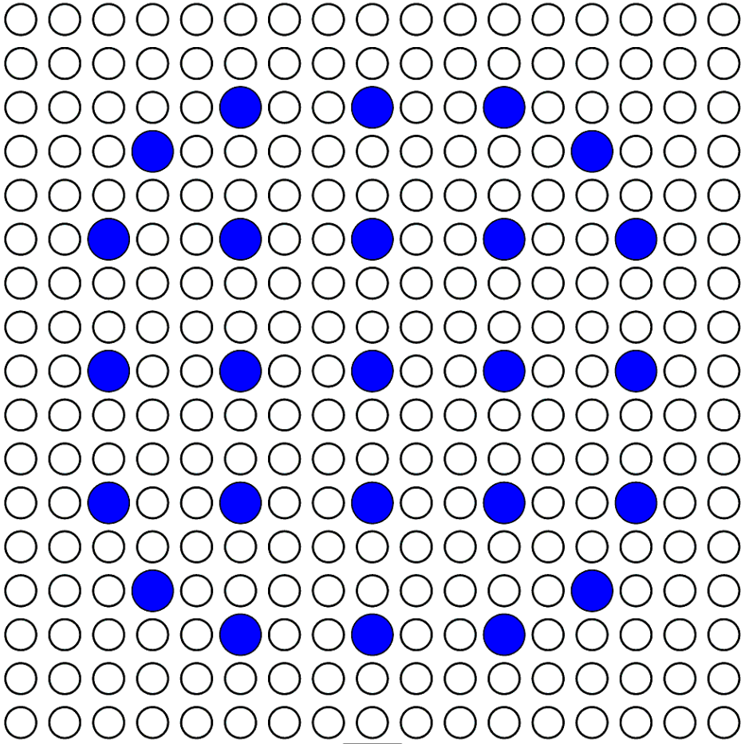 |  |  |  | 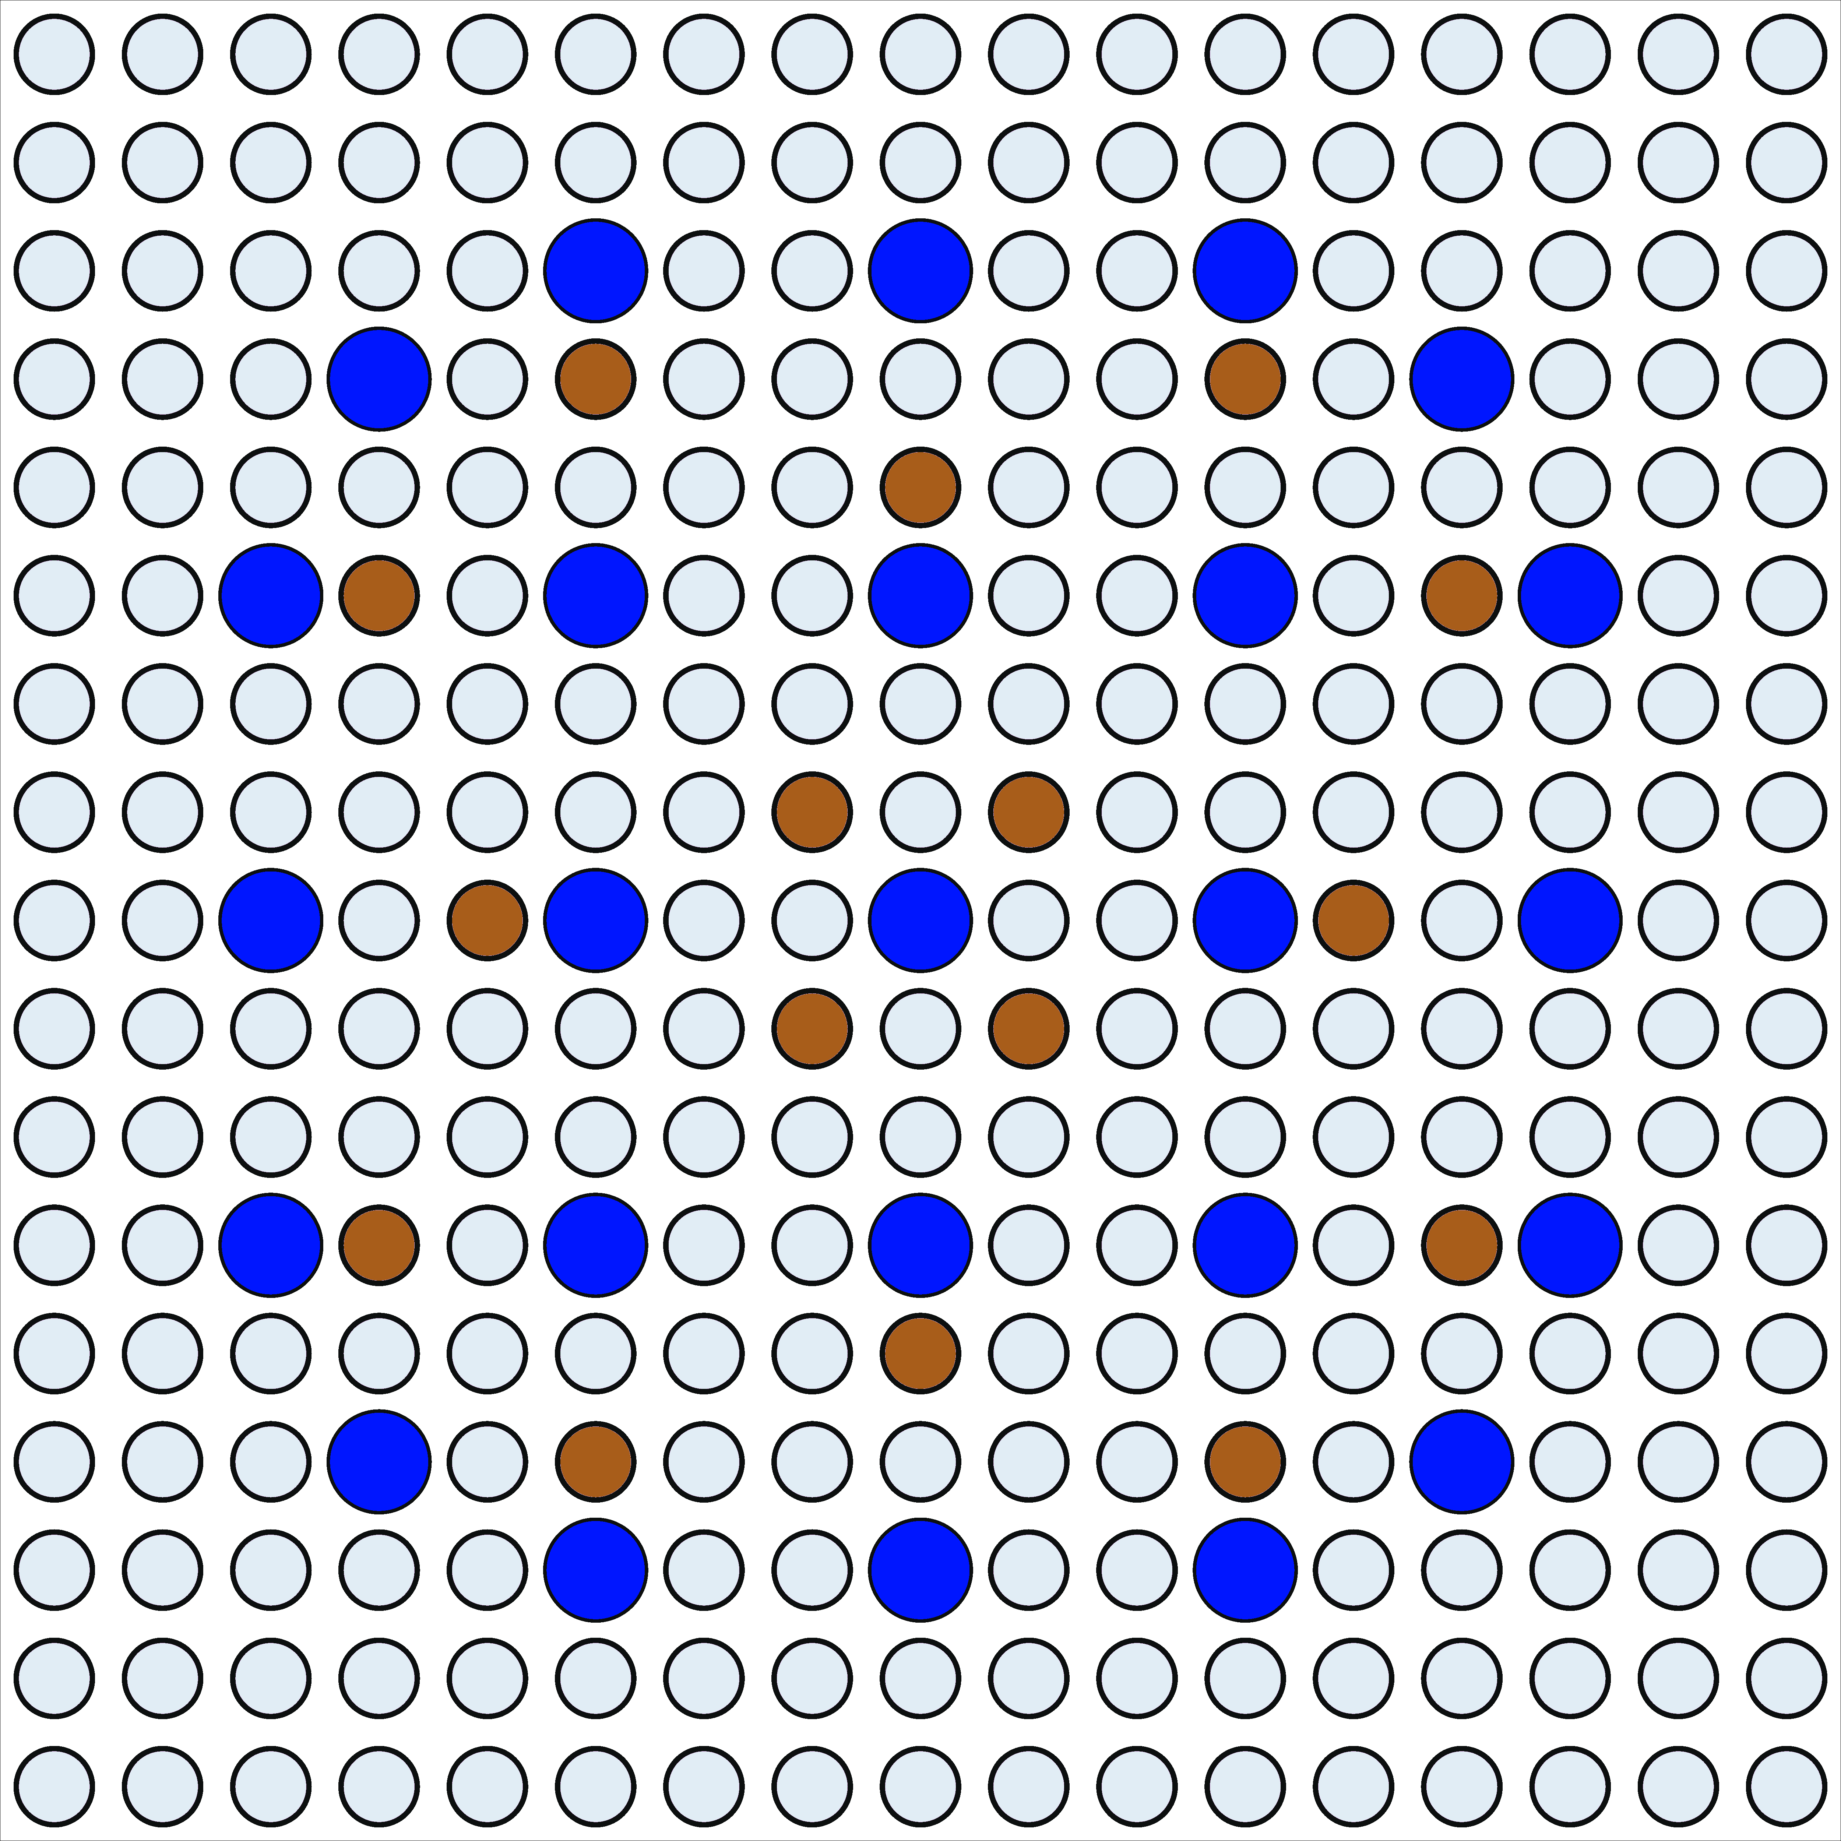
(a) |  |  |  | (b)
Figure 1 Lattice layout of fuel pins, type (a) fuel assemblies without Gd₂O₃, and type (b) fuel assemblies with Gd₂O₃ dopped fuel pins.

III.F. Core Design
The core design and analysis of various nominal and off-nominal parameters were performed using SIMULATE-3. The parameters presented in Table 4 and results from the PSO case were used in the core design process. The core was designed to have 89 fuel assemblies with an active core height of 365.76 cm, an equivalent core diameter of 228.91 and a height to diameter (H/D) ratio of 1.6.

III.G. Core Loading and Layout
The core was loaded with 89 fuel assemblies. Figure 2 shows the equilibrium Out-in loading pattern that was used. Fresh fuel was loaded in the periphery of the core with more gadolinium-dopped fuel assemblies around the corners of the core. Twice and thrice burned fuel assemblies were loaded in a checkerboard pattern towards the centre of the core. A three-batch loading pattern was adopted where fuel assemblies would be in the core for three cycles. At any equilibrium cycle, there would be 32 fresh fuel assemblies, 32 twice burned, 24 thrice burned, and one centre fuel assembly obtained from the four times burned fuel batch with the lowest exposure. An equilibrium cycle is reached when the cycle length and power distribution converge to a value that does not change with subsequent shuffling and depleting of the core using the loading pattern adopted.
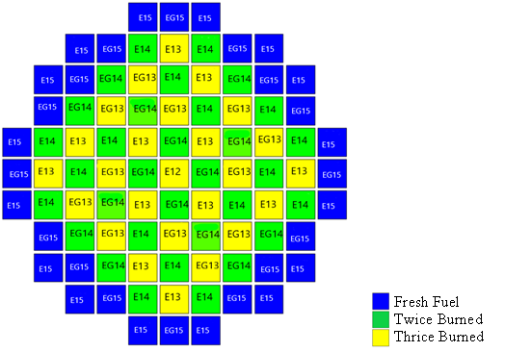
Figure 2 Equilibrium core loading for gadolinium dopped (EG) and clean (E) fuel assemblies from cycles 12, 13, 14, and 15.
Figure 3 shows the CASMO-4E MxN-generated core layout. Fuel assemblies are surrounded by a reflector (baffle). The space between baffle and the barrel is filled with water that functions as a coolant and moderator. The barrel is complemented by four reflector pads.
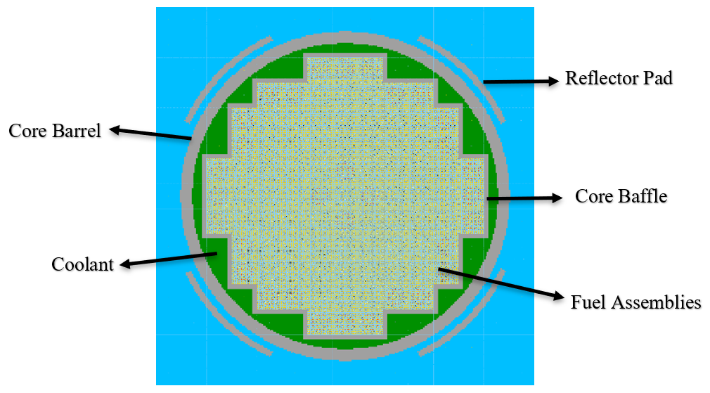 Figure 3 Core layout of fuel assemblies, baffle, heavy reflector, and pads.

III.H. Rod Cluster Control Assemblies
The core was designed to have 37 Silver-Indium-Cadmium (Ag-In-Cd) rod cluster control assemblies (RCCAs) divided into six (6) groups. The first four banks (A, B, C, D) are regulating rods, and banks (SA, SB) are shutdown rods. The shutdown banks are always in a withdrawn position during reactor operation. Figure 4 shows the layout of RCCAs.
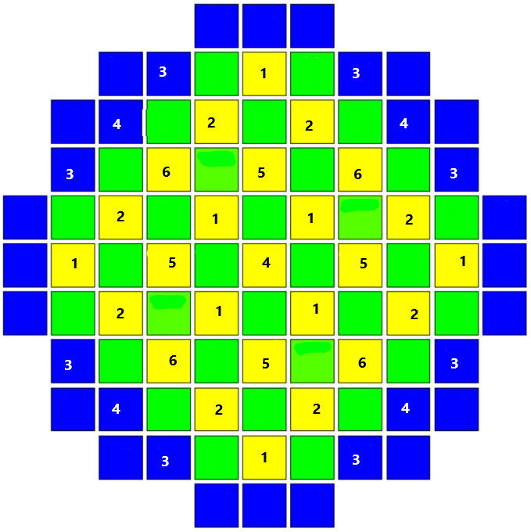
D | C | B | A | S_{A} | S_{B} | S_{B} | 37 RCCA
1 | 2 | 3 | 4 | 5 | 6 | S_{B}
8 | 8 | 8 | 5 | 4 | 4 | S_{B}
Figure 4 Layout and rod cluster control assembly positions.

III.I. Design Strategy and Process
As stated in Section I, most boron-free SMR designs available in literature, have lower thermal power output compared to the design presented in this paper. Their nominal and off-nominal characteristics may not be adequate for reference and validation of the boron-free design under consideration. Because of this challenge, a design strategy was adopted that sought to address the lack of a reference core. The strategy involved designing a borated variant of the target boron-free core design using Simulate-3 code. Both the borated variant and the target boron-free core had the same number of fuel assemblies, used the same fuel assemblies in terms of enrichments and the amount of ${Gd}_{2}O_{3}$ doping. The only difference was the concentration of boric acid used in the coolant during assembly modelling. The design approach is described in steps 1 and 2 below.

Step-1 – A core that utilises boron for reactivity control was designed and utilised 37 RCCA. This core is designated as the borated variant and identified as BV37RCCA. The BV37RCCA core was designed to use the 1st set of fuel assemblies that were modelled with 800 ppm boron concentration in the coolant.
Step-2 – Design of a boron-free core. This was achieved by modifying the design in Step-1 (BV37RCCA). Boron was removed from the core while keeping the other parameters constant. The removal of boric acid from the core was achieved by using the 2nd set of fuel assemblies that were modelled with 2.0 ppm of boric acid in the coolant. This core is designated as the boron-free core and identified as BF37RCCA.
In modelling the boron-free core using Simulate-3, the boric acid concentration in the coolant was set to 0 ppm in the input script. The nominal and off-nominal calculations for the boron-free core were performed with the k_{eff} iteration card, not the boron iteration card used in the borated case.
Further, from the design criteria presented in Table 3, only the hot channel factor enthalpy rise (F_{∆H}), and the heat flux hot channel factor (F_{Q}) limits were applied in the design process. The values obtained for the fuel assembly discharge burnup and peak pin burnup will be fine-tuned to achieve criteria limits in the next steps of the design process.

RESULTS

VI.A. Particle Swarm Optimisation
Figure 5 shows the PSO plot for the power density, number of fuel assemblies, and fuel assembly height. The PDE, number of fuel assemblies and fuel height were found to be 95.16 kW/l, 89.05, and 364.91 cm. These results were fine-tuned to acceptable values suitable for the core loading configuration that was adopted. The PDE was fine-tuned from 95.16 kW/l to 95 kW/l, the number of fuel assemblies was fine-tuned from 89.05 to 89, and the fuel assembly length from 364.91 cm to the standard 365.76 cm, respectively. These fine-tuned parameters were used as input for the fuel assembly model in Casmo4 and core model in Simulate-3. The thermal power output of for these fine-tuned parameters was found to be 1,429.51 MWth compared to the 1,430 MWth that was projected in the PSO optimisation problem.
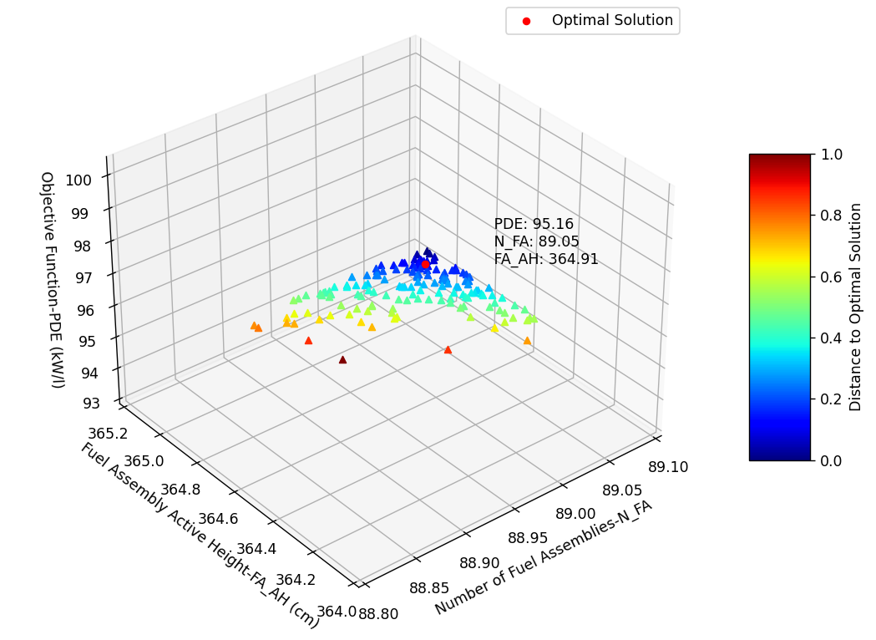
Figure 5 Power density, number of fuel assembly, and fuel height particle swarm optimisation 3D plot.

VI.B. Fuel Assembly Models
Figure 6 compares criticality as a function of burnup for fuel assemblies that were modelled with the coolant containing boric acid concentrations of 0, 2, and 800 ppm. The graph shows an overlap in data sets for the 0 ppm and 2 ppm boric acid concentration curves, with a 9.6 pcm reactivity difference between the curves. This shows that the 2.0 ppm threshold for producing cross-section data using CMS-link is sufficient to represent a 0-ppm boron-free fuel assembly model. It can also be observed that removing boric acid from the fuel assembly model shifts the criticality curve by about 3,678 pcm. This amounts to a fuel assembly boron worth of about 4.6 pcm/ppm.

Figure 6 A Comparison of criticality with burnup for fuel assemblies modelled with 0 ppm, 2 ppm and 800 ppm.

Figure 7 shows criticality curves for the different fuel assemblies (the 1st set of fuel assemblies) that were used in the core design for the borated variant BV37RCCA. The fuel enrichment of the various assemblies was determined based on the target cycle length, power peaking, and power distribution within the core. The procedure applied for fuel enrichment choice and core design is presented in reference [34]. As can be observed from the curves, the fuel assemblies that were dopped with ${Gd}_{2}O_{3}$ have a hold-down on excess reactivity. However, the rate at which the ${Gd}_{2}O_{3}$ depletes in different fuel assemblies is a function of the average fuel assembly enrichment. Fuel assemblies that are dopped with ${Gd}_{2}O_{3}$ have a slightly short burnup compared to clean assemblies. This is due to residual amounts of ${Gd}_{2}O_{3}$ that are present in the fuel at the end of the fuel depletion process. Residual reactivity hold-down is due to the self-shielding of ${Gd}_{2}O_{3}$. The reactivity hold-down for fuel assemblies with enrichments of 4.2, 4.5, and 6.0 were determined to be 11,760 pcm of 22,913 pcm, 11,137 pcm of 23,815 pcm, and 8,867 pcm, of 26,987 pcm respectively.
Figure 7 Criticality as a function of burnup for fuel assemblies used in the borated core (BV37RCCA).
The effect of boric acid removal from the coolant in the fuel assembly models can be observed in Figure 8. The Figure shows criticality curves for fuel assemblies (the 2nd set of fuel assemblies) that were used in the boron-free core BF37RCCA design. The ${Gd}_{2}O_{3}$ reactivity hold-down for fuel assemblies with enrichment of 4.2, 4.5, and 6.0 was determined to be 11,697 pcm of 27,956 pcm, 11,080 pcm of 28,560 pcm, and 8,829 pcm, 30,665 pcm respectively.
Figure 8 Criticality as a function of burnup for fuel assemblies used in the boron-free core (BF37RCCA).

Borated fuel assemblies with enrichments of 4.2, 4.5, and 6.0 were found to have ${Gd}_{2}O_{3}$ reactivity hold-down efficiencies of 0.33, 0.47 and 0.51, whereas boron-free assemblies were found to have efficiencies of 0.28, 0.39, and 0.42. The high reactivity hold-down efficiency for the borated fuel assemblies is due to the presence of boron, which reduces criticality, thus decreasing the criticality margin between the ${Gd}_{2}O_{3}$dopped fuel assemblies and clean assemblies, thus increasing the percentage of hold down.
Figure 9 compares the criticality curves for borated and boron-free fuel assemblies. Fuel assemblies modelled with boric acid in the coolant have a shorter burnup compared to the boron-free fuel assemblies. The short burnup of borated fuel assemblies is caused by the boron concentration being kept constant throughout depletion. No boron iteration is accounted for during the CASMO4 depletion. However, the SIMULATE-3 core model accounts for boron iteration when using borated fuel assemblies and cross-section data generated by CMSlink.
Figure 9 Effect of boron removal on reactivity hold-down due to ${Gd}_{2}O_{3}$.

VI.C. Core Loading and Equilibrium Cycle (Nominal Calculations)

Figure 10 compares the F∆H values for the BV37RCCA and the BF37RCCA cores from the initial loading (first cycle) to the equilibrium cycle. As observed, equilibrium cycles were achieved for both the reference core BV36RCCA and the boron-free core BF37RCCA. The most limiting F∆H during transition from the initial loading to equilibrium was found to be 1.754 for the BV37RCCA and 1.638 for the BF37RCCA. The equilibrium F∆H was found to be 1.524 and 1.57 for the BV37RCCA and BF37RCCA, respectively. The 1.754 F∆H values for the BV37RCCA transition cycle was observed to be above the design limit of 1.7 but within the 5% uncertainty. The implication of exceeding the design limit on FΔH is increased probability for critical heat flux (CHF). In order to ascertain the safety of the reactor with respect to the 1.754 F∆H value, another safety limit (heat flux hot channel factor (FQ)) was assessed. The FQ was found to be 1.878 which was below the design limit of 2.6. This showed that the BV37RCCA complied with the CHF limit. Adherence to design limits with respect to F∆H and FQ ensures that core power distribution does not violet local conditions in the fuel rods and coolant channels [19]. This guarantees core integrity at any location during normal operations, anticipated operational occurrences (AOOs), and postulated accidents. The F∆H and FQ values for the BV37RCCA core were within acceptable limits and as such, it qualified to be used as a reference for the boron-free core.
The equilibrium cycle length for the BV37RCCA and the BF37RCCA were determined to be 511.8 and 512.5 EFPDs (effective full power days) and burnup of 17.867 and 17.89 MWd/Kg, respectively.
The nominal and off-nominal results presented in this work are based on the equilibrium cycles of 511.8 and 512.5 EFPDs.
Figure 10 Comparison of F∆H for BV37RCCA and BF37RCCA with transition from initial loading to equilibrium cycles.

IV.D. Power Distribution

Figure 11 shows the radial power distribution highlighting the fuel assembly average burnup (2EXP), relative power fraction (2RPF), and pin power density (2PIN). As can be observed, fuel assemblies near the centre of the core have high exposure compared to those between the centre and the periphery of the core. Burnup decreases towards the periphery of the core depending on the respective fuel cycle. However, fuel assemblies around the corners of the core show an increase in burnup and pin power. These fuel assemblies are close to the barrel and reflector pads that reflect fast neutrons back into the core. The reflected fast neutrons eventually get thermalised and contribute to increased fuel burnup in these corner regions [34]. There is agreement in the 2EXP, 2RPF, and 2PIN values for the BF37RCCA and reference BV37RCCA. The 2EXP from the thrice burned fuel assembly was 61.21 MWd/Kg and 60.12 MWD/kg for the BV37RCCA and BF37RCCA. Associated average rod burnup for the BV37RCCA and BF37RCCA were determined to be 65.04 MWd/Kg and 65.32 MWd/Kg from the third cycle. The 2EXP for the central fuel assemblies obtained from the fourth cycle of BV37RCCA and BF37RCCA were determined to be 63.44 MWd/Kg and 63.83 MWd/Kg respectively. Their rod burnup was found to be 66.89 MWd/Kg and 67.11 MWd/Kg respectively. These values are above the 62 MWd/kg licensing limit for the standard Westinghouse 17x17 fuel assembly whose specifications are presented in Table 3 but below the accident tolerant fuels (ATF) being considered with enrichments greater than 5% and burnup of 66-68 MWd/kg. In addition, high burnup fuels with 75 MWd/kg limit are also currently being examined by the nuclear industry and other nuclear regulators like Nuclear Regulatory Commission (NRC) as a near-term viable limit [35] [36] [37]. The expectation is that this proposed limit could provide improved fuel cycle economics and would be viable for near term deployment [38].
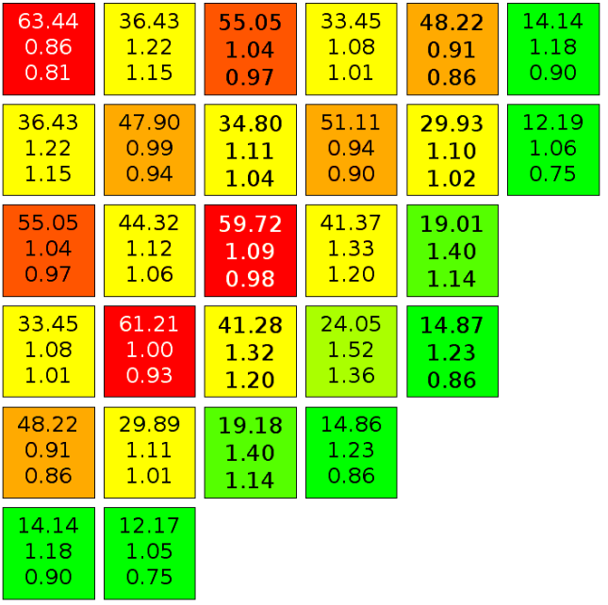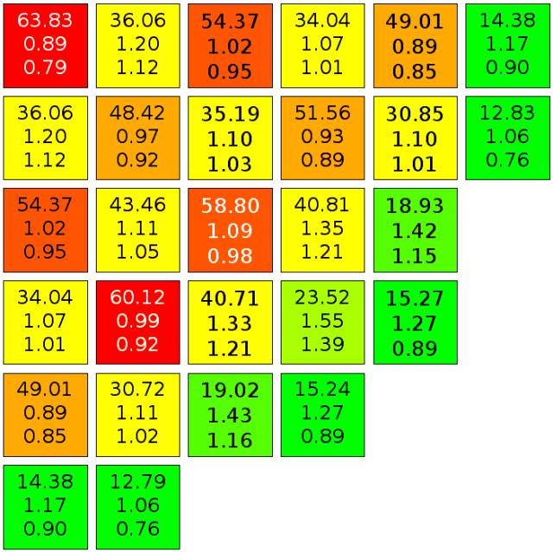
64.00 -

45.59 -

30.76 -

8.93 -

0.00 -
EXP
2EXP
2RPF
2PIN
2EXP
2RPF
2PIN
BV37RCCA BF37RCCA

Figure 11 Fuel assembly average burnup (2EXP) relative power fraction (2RPF), and pin power density(2PIN) for equilibrium cycles of BV37RCCA and BF37RCCA.

Figure 12 compares the 3D axil relative power distribution for the BV37RCCA, and BF37RCCA, at BOC, MOC, and EOC. The BF64RCCA core has the same power profile at HFP as the BF37RCCA and is not discussed under this section. At BOC, the relative power of the BV37RCCA, was observed to be skewed towards the top of the core with an axial off-set (A-O) of 0.035 forming a top-centered chopped cosine shape. The relative power for the BF37RCCA is skewed towards the bottom of the core with an A-O of -0.111 forming a bottom-centered chopped cosine shape.
The observed top-skewed power profile for the BV37RCCA core could be attributed to the difference in coolant temperature, with the bottom part of the core being at a lower temperature and the top part being at a higher temperature. Without the presence of boric acid, the bottom part of the core would have had increased power resulting from increased thermalisation of neutrons due to higher coolant density. However, due to the presence of boric acid, the effect of having more thermal neutrons is suppressed by increased absorption in the coolant. This causes reduced fission and power, thus the observed lower power profile in the bottom part of the core. The opposite happens in the top part of the core where the temperature is slightly higher, and the coolant density is reduced. This manifests in the top of the core having a higher power profile.
The opposite of the BV37RCCA core is observed for the BF37RCCA core. The power profile is skewed towards the bottom of the core. As indicated, in the foregoing discussion of the BV37RCCA, the bottom part of the core is at a lower temperature compared to the top part of the core. As such, the bottom part of the core has a higher coolant density which causes increased thermalisation of neutrons and leads to increased fission and power compared to the top part which has a higher temperature and a lower coolant density.

At MOC, and EOC the relative power profile for both the BV37RCCA, and BF37RCCA show a plateau around the core center with two maxima, one towards the lower end of the core and the other towards the upper end of the core. At MOC the BV37RCCA showed an A-O of -0.024, and at EOC an A-O of -0.026. The BF37RCCA showed an A-O of -0.002 at MOC, and at EOC an A-O of 0.011. The plateau observed in the center of the core is a result of increased fuel burnup in the center of the core.

Figure 12 3D relative power distribution comparison at HFP for BV37RCCA, and BF37RCCA at BOC, MOC, and EOC

VI.E. Rod Cluster Control Assembly Analysis
Figure 13 compares the criticality of the borated variant BV37RCCA and boron-free BF37RCCA cores as a function of cumulative number of steps for insertion of RCCAs. The comparison was made at the beginning of cycle (BOC), middle of cycle (MOC) and end of cycle (EOC). The Figure shows that the borated variant BV37RCCA with 37 RCCAs could be shut down at BOC, MOC, and EOC. However, for the boron-free core BF37RCCA with 37 RCCAs, the core could only be shut down at MOC and EOC. The reactor could not be shut down at the BOC with all RCCAs inserted in the core. There was still an excess reactivity of 4,401 pcm.
The core could be shut down at MOC and EOC because the RCCAs had enough worth over the core reduced reactivity due to fuel depletion and build-up of fission products of which some are parasitic neutron absorbers. However, at BOC the core had high excess reactivity as the fuel was fresh. In addition, the excess reactivity was greater compared to the worth of the 37 RCCAs and as such the reactor could not be shut down. To address this problem, the number of RCCAs was increased from 37 to 64, and the boron-free reactor core was able to shut down at BOC. The boron free core with 64 RCCAs was denoted as BF64RCCA. The behaviour of the core with respect to the most reactive RCCA stuck is analysed later in the paper.
In addition, it can also be observed that for the borated variant BV37RCCA, the cumulative RCCA position curves at BOC, MOC, and EOC are clustered, whereas the curves for the boron-free core BF37RCCA are spread apart. The clustering of the curves is due to the presence of boron, whose excess reactivity hold-down effect lowers the k_{inf} value. The higher the boron concentration, the lower the cumulative RCCA worth curve. This is consistent with what was observed in the comparison of boric acid concentration for 0, 2, and 800 ppm under Figure 6. The reduction in boric acid concentration relative to burnup is observed through an upward shift of the curves at MOC and EOC. However, the opposite is observed for the boron-free core BF37RCCA. The cumulative rod worth curves shift downwards with burnup, and the EOC curves for the BV37RCCA and BF37RCCA converge. The convergence is due to the reduction of boric acid concentrations to 10 ppm for the BV37RCCA core, which is close to the 0 ppm of the BF37RCCA. This was further amplified through a comparison of the EOC k_{eff} values for the BV37RCCA and BF37RCCA which were found to be 1.05441 and 1.0534, respectively.

Figure 13 Comparison of criticality vs cumulative number of steps for RCCA insertion for the borated core (BV37-RCCA) and the boron-free core (BF37-RCCA)

The problem of the BF37RCCA reactor core not being able to shut down, as observed in Figure 13, was resolved by increasing the number of RCCAs from 37 to 64. The layout of the 64 RCCA is presented in Figure 14.
Figure 15 compares the criticality of BF37RCCA and BF64RCCA as a function of cumulative number of steps for RCCA insertion. Each RCCA step has a length of 1.62 cm. The addition of 27 RCCAs provided an additional - 6,148 pcm worth, which was enough to counteract the excess positive reactivity present with all rods in (ARI). Each RCCA had an average worth of 227.7 pcm at BOC. The 64 RCCAs provided an additional 1,747 pcm negative reactivity below the critical value with ARI. The BF64RCCA core is taken as the boron-free core for further analysis and comparison with the borated variant BV37RCCA for the rest of this work.

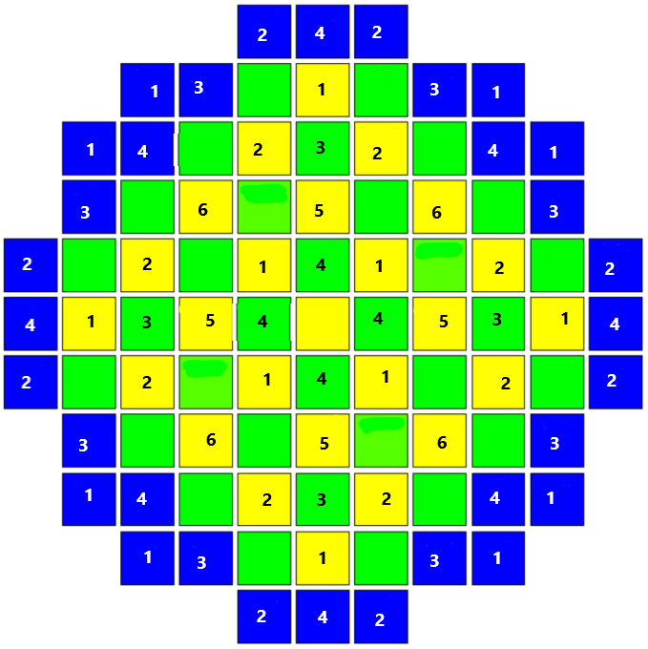

D | C | B | A | S_{A} | S_{B} | S_{B} | 64 RCCA
1 | 2 | 3 | 4 | 5 | 6
16 | 16 | 12 | 12 | 4 | 4

Figure 14 Layout and rod cluster control assembly positions.

Figure 15. Comparison of criticality vs cumulative number of steps for RCCA insertion for the initial boron-free (BV37-RCCA) and the RCCA increased boron-free core (BF64-RCCA)

VI.F. Reactivity Coefficients (Nominal Calculations)
Table 6 compares the various reactivity coefficients for the BV37RCCA, BF37RCCA, and BF64RCCA at hot zero power (HZP) for BOC. As reported in literature [39], removing soluble boron from the core makes the moderator temperature coefficient (MTC) more negative. Both the BF37RCCA and BF64RCCA had the same MTC value at BOC. However, the uniform doppler coefficient (UDP) becomes less negative, and the isothermal temperature coefficient (ITC) becomes more negative.

Table 6. Beginning of cycle (BOC) hot zero power (HZP) reactivity coefficients for an All-Rods-Out condition
Parameter | Borated Core  BV37RCCA | Boron Free  BF37RCCA | Boron Free  BF64RCCA
ARO – MTC (pcm/K) | -3.76 | -22.67 | -22.67
ARO – UDC (pcm/K) | -1.68 | -1.48 | -1.48
ARO – ITC (pcm/K) | -5.45 | -24.15 | -24.15
ARO – BOR (pcm/ppm) | -5.83 | - | -

Table 7 shows the ARO condition with the most reactive RCCA inserted at HZP, BOC. This data is required for startup testing of the core. As can be observed, the MTC for the BV37RCCA becomes more negative, whereas that of the BF37RCCA and BF64RCCA becomes less negative. A comparison of the MTC for BF37RCCA and the BF64RCCA shows that with an increase in the number of RCCA, the MTC becomes less negative. However, the core would still be safe to operate in the event of an accident where the most reactive RCCA dropped as the MTC, UDC and ITC were still found to be negative. It would be of concern if the coefficients became positive with the drop in the most reactive RCCA.
Table 7. Beginning of cycle (BOC) hot zero power (HZP) reactivity coefficients for an All-Rods-Out with most reactive rod in condition
Parameter | BV37RCCA | BF37RCCA | BF64RCCA
Bank D-in MTC (pcm/K) | -9.03 | -7.19 | -6.64
Bank D-in UDC (pcm/K) | -1.67 | -1.79 | -1.73
Bank D-in ITC (pcm/K) | -10.71 | -8.98 | -8.38
Bank D-in BOR (pcm/ppm) | -5.81 | - | -

Table 8 shows CZP conditions with respect to RCCA ejection at BOC, EOC, and at the burnup when Gd₂O₃ depletes in the core. The burnup at which Gd₂O₃ depleted was preferred against MOC for analysis as it provided a higher potential for core re-criticality with a RCCA ejection. This burnup was found to be 15.5 MWd/Kg. Analyses were performed to determine if re-criticality of the BF64RCCA core at CZP would occur under an All-Rod-In minus one (ARI-1) condition. One RCCA (most reactive) from each of the 6 Banks was used for the analysis. Two cases were used for RCCA ejection analysis - the first case considered suppression of the emergency boron injection (EBI) with each RCCA ejection analysis, and the second considered unsuppressed EBI for each RCCA ejection.
As can be observed from Table 8, at BOC, ejection of each RCCA with suppressed EBI, resulted in re-criticality of the core. However, the core remained in a subcritical condition for the case where the EBI was not suppressed (ARI-1 + EBI). At a burnup of 15.5 MWd/Kg, ejection of RCCAs (9, 9) and (8, 8) from control rod Banks 4, and 6 with EBI suppressed, resulted in re-criticality of the core. The rest of the RCCAs from Banks 1, 2, 3, and 5 remained in a subcritical condition. For the unsuppressed EBI, ejection of the RCCAs (9, 9) and (8, 8) resulted in the core remaining in a subcritical condition like the other RCCAs. At EOC, only the RCCA (9, 9) caused re-criticality of the core for the case of EBI suppression. However, for the unsuppressed EBI case, all the core remained in a subcritical condition for each of the RCCA ejection.
The boric acid concentration of the EBI system was determined to be 2,451 ppm giving a negative worth of 14,240 pcm considering the -5.81 pcm/ppm boron coefficient for the borated variant. It can also be observed from Table 8 that the most reactive RCCA was RCCA (9, 9) from Bank 4 followed by RCCA (8, 8) from Bank number 6. The most reactive RCCA (9, 9) at BOC inserted the highest positive reactivity of 9,725 pcm from the ARI K_{eff} of 0.98297 to the ARI-1 K_{eff} of 1.0957. However, EBI suppression system had enough worth to counteract this positive reactivity insertion.
If RCCAs were to be used to overcome re-criticality of the core, with the highest reactivity insertion of 9,725 pcm at BOC with the EBI suppressed, an addition of 43 RCCAs would be required. However, the remaining spaces on the BF64RCCA core would be 24 excluding the center fuel assembly. The additional 24 RCCAs would give an average worth of 5,464.8 pcm and the remaining 4,260.2 pcm would still require the EBI system. This entails the core would be loaded with a total of 88 RCCAs. The downside of this would be a compromise on pressure vessel integrity. As such, the BF64RCCA core with 64 RCCAs would be preferable compared to one that would utilise 88 RCCAs.
Despite the BF64RCCA core being boron free for duty operation, an independent EBI system (tanks) is proposed in the design to assure cold shutdown of the core. This requirement of having an independent means for assuring shutdown is highlighted in references [40], [41] as: ‘The control of the core reactivity shall be accomplished by means of at least two independent and diverse systems for the shutdown’. This is amplified in reference [42]; that two independent control systems of different designs should be provided, and that each system should have the capability to control the rate of reactivity response from planned normal power manoeuvres. One of the systems must be capable of reliably controlling anticipated operational occurrences. In addition, one of the systems must be capable of holding the reactor core subcritical under cold conditions.

Table 8 Cold Zero Power (CZP) Core Criticality with respect to a RCCA ejection for the BF64RCCA Core
Bank  (No.)/RCCA | BOC |  |  | At K_{eff} for Limiting F∆H (15.5 MWd/Kg) |  |  | EOC
Bank  (No.)/RCCA | ARI (K_{eff}) 0.9829 |  |  | ARI (K_{eff}) 0.9755 |  |  | ARI (K_{eff}) 0.9620
Bank  (No.)/RCCA | ARI-1  (K_{eff} ) | EBI  (ppm) | ARI-1 + EBI  (K_{eff} ) | ARI-1  (K_{eff} ) | EBI  (ppm) | ARI-1 + EBI  (K_{eff} ) | ARI-1  (K_{eff} ) | EBI  (ppm) | ARI-1 + EBI  (K_{eff} )
1 (7,7) | 1.0793 | 2,451 | 0.8981 | 0.9879 | 0 | - | 0.9733 | 0 | -
2 (9,7) | 1.0789 | 2,451 | 0.8929 | 0.9934 | 0 | - | 0.9796 | 0 | -
3 (9,6) | 1.0652 | 2,451 | 0.8884 | 0.9782 | 0 | - | 0.9646 | 0 | -
4 (9,9) | 1.0957 | 2,451 | 0.9039 | 1.0153 | 2,451 | 0.8735 | 1.0034 | 2,451 | 0.892
5 (8,6) | 1.0658 | 2,451 | 0.8773 | 0.9785 | 0 | - | 0.9648 | 0 | -
6 (8,8) | 1.0908 | 2,451 | 0.9030 | 1.0041 | 2,451 | 0.8861 | 0.9898 | 0 | -

VI.G. Shutdown Margin (Off-Nominal Calculations)
The shutdown margin calculation and applied criteria for BV37RCCA, BF37RCCA and BF64RCCA cores are presented in Table 9. The shutdown margin was calculated at HZP for BOC, 15.5 MWd/Kg, and EOC. The CZP behaviour of the core is presented in the preceding section. A 10 per cent uncertainty is applied on available RCCA to account for engineering uncertainty on RCCA design. The shutdown margin for the BF37RCCA had a deficit of 2,738.5 pcm at BOC, indicating that the reactor core did not have enough rod worth to shut down the reactor and to keep it in shutdown condition. The keff at BOC for BV37RCCA, BF37RCCA and BF64RCCA with all control rods inserted (ARI) was found to be 0.90622, 1.046226, and 0.98253.

Table 9 Comparison of shutdown margins for different numbers of RCCAs for the borated and boron-free cores
 | Parameter | BOC |  |  | At K_{eff} for Limiting F∆H  (15.5 MWd/Kg) |  |  | EOC
 |  | BV37RCCA  (pcm) | BF37RCCA  (pcm) | BF64RCCA  (pcm) | BV37RCCA  (pcm) | BF37RCCA  (pcm) | BF64RCCA  (pcm) | BV37RCCA  (pcm) | BF37RCCA  (pcm) | BF64RCCA  (pcm)
1. | Control Rod Assembly Worth (pcm)
a. | Total Available RCCA Worth | 10,232 | 9,753 | 15,933 | 11,019 | 10,956 | 17,820 | 11,061 | 11,066 | 18,271
b. | ARI reactivity above criticality | 0 | 4,401.36 | 0 | 0 | 0 | 0 | 0 | 0 | 0
c. | Worst Rod Stuck Out | 2,330 | 2,236 | 2,733 | 2,726 | 2,680 | 3,176 | 2,875 | 2,806 | 4,244
d. | 10 % engineering uncertainty (1σ) | 1,023.2 | 975.3 | 1593.3 | 1,101.9 | 1,095.6 | 1,782 | 1,106.1 | 1,106.6 | 1,827.1
f. | Subtotal  (a-b-c-d) | 6,878.8 | 2,737.34 | 11,606.7 | 7,191 | 7,180 | 12,862 | 7,079.9 | 7,153.5 | 12,199.9
2 | Power
a. | Power Defect | 1,357.32 | 1,875.83 | 1,875.83 | 2,290.32 | 2,415.23 | 2,415.23 | 2,454.25 | 2,502.45 | 2,502.45
c. | Subtotal | 1,357.32 | 1,875.83 | 1,875.83 | 2,290.32 | 2,415.23 | 2,415.23 | 2,454.25 | 2,502.45 | 2,502.45
3. | Worth Balance
a. | Required Shutdown Margin | 3,000 | 3,000 | 3,000 | 3,000 | 3,000 | 3,000 | 3,000 | 3,000 | 3,000
4. | Gross Margin (1f-2c) | 5,521.48 | 261.51 | 9,730.87 | 4,900.68 | 4,764.77 | 10,446.77 | 4,625.65 | 4,651.05 | 9,697.45
5. | Net Margin to Shutdown  Margin (4-3a) | 2,521.48 | -2,738.5 | 6,730.87 | 1,900.68 | 1,764.77 | 7,446.77 | 1,625.65 | 1,651.05 | 6,697.45

Figure 16 shows a comparison of the MTC as a function of temperature for BV37RCCA and BF64RCCA. The MTC curve for the BF64RCCA core shifts to lower values compared to the MTC for the BV37RCCA. For both variants, the MTC curves at EOC are close because of the boron concentration values that are close to each other. At EOC, the boron concentration for the BV37RCCA is 10 ppm, whereas that of the BF64RCCA is 0 ppm.

Figure 17 also shows the same trend as observed in the case of Figure 16, where the curves for the BF64RCCA power defect shift to lower values. This shows that the removal of boron makes the power defect more negative. This is consistent with the discussion on the MTC, UDC, and ITC being more negative with removal of boron. In the same way, the combined MTC and UDC feedback effects, which are summed up in the power defect, also show a more negative defect. This implies the RCCA should have enough worth to be able to counteract the power and isothermal defects.
Figure 16 Comparison of the MTC as a function of temperature for BV37RCCA and the BF64RCCA

Figure 17 Comparison of the Power Defect as a function of power for BV37RCCA and the BF64RCCA

CONCLUSIONS
A 1,429.51 MWth boron-free small modular reactor core has been designed. The boron-free SMR was designed to address the disadvantages associated with the use of boric acid for reactivity control during duty operations of a reactor. Further, this piece of work is part of a broad pursuit to address challenges faced by industry in the quest to understand the effects of boric acid removal from a core duty operation. A myriad of assertions associated with boron free SMRs that are usually highlighted in literature without enough data have been analysed, and data has been provided. In the design process of the boron-free SMR, design limits imposed by the fuel assembly manufacturer were adhered to. All parameters were within design limits.
A design strategy was adopted where a borated variant of the target boron-free SMR was first designed and used as a reference core for the target boron-free SMR design. Equilibrium cycles were achieved for both the reference core (BV36RCCA) and the target boron-free core (BF64RCCA). The most limiting FΔH during the transition from the initial loading to equilibrium was found to be 1.693 for the BV37RCCA and 1.754 for the BF64RCCA. The equilibrium FΔH was obtained to be 1.513 and 1.623 for the BV37RCCA and BF64RCCA, respectively. These values were found to be below the design limit of 1.7.
The removal of boron made reactivity coefficients more negative. The MTC for the BF64RCCA (boron-free) was found to be about -22.67 pcm/K compared to -3.64 pcm/K for the BV37RCCA (borated variant). The excess shutdown for the BF64RCCA at HZP was found to be 6,697 pcm at EOC. Despite having a high negative MTC, the reactor had enough excess reactivity to overcome the isothermal power defect during startup. A negative MTC is desirable as it makes the core self-regulating. However, further studies are required to understand how the reactor would behave under anticipated operational occurrences (AOOs) and postulated accidents (PAs) conditions, such as those that cause a drop in the inlet coolant temperature.
Further, removal of boric acid from the core caused the core to lose its capability to shut down at BOC. It is imperative to ensure that a boron-free core has enough RCCA worth to shut down the reactor at every state point during operation. The reactor’s capability to shut down should be guaranteed despite reactivity balance between burnable poisons and RCCA. This is because RCCAs are variable, whereas burnable poisons are typically fixed and cannot be varied to shut down the reactor. Thus, the number of RCCAs and the absorber material used are important for reactivity control and reactor shutdown. The most limiting state point for reactor shutdown was observed to be the BOC, due to high excess reactivity compared to other state points.
A conservative analysis of the BF64RCCA core with respect to ARI-1 condition at CZP showed that a return to power of the core could occur. To avert this, the number of RCCAs needed to be increased from 64 to 88. However, this number of RCCA would compromise the integrity of the pressure vessel. In addition, availability of space for RCCA drive mechanism would also be of concern. In light of these concerns, despite the core being boron free in terms of duty operations, an emergency boron injection system (tanks) would be maintained to assure cold shutdown of the core.
The next steps in the design process will involve finetuning fuel enrichment, burnable poison loading, and fuel assembly discharge burnup through improved fuel loading. Fuel management that removes the need for fuel assemblies from the fourth cycle will be adopted. Further, stability analysis of the reactor as a response to various dynamic conditions (e.g. control rod movement, cold leg injection) will also be carried out.
It is evident from the results obtained that changes in different safety coefficients due to boric acid removal can potentially alter operational limits set for a variant borated system. This understanding is important in defining regulatory criteria for SMRs that seek to operate free of boric acid. Further, depending on the design configuration, the need for EBI system to guarantee CZP shutdown with respect to RCCA ejection may be justified as it would be need for postulated accidents and not duty operation.

ACKNOWLEDGEMENTS
The authors of this paper extend their gratitude to the International Atomic Energy Agency (IAEA), and Bangor University’s Nuclear Futures Institute (NFI) for financial support. Further, many thanks are extended to the Nuclear Research and Consultancy group of Netherlands (NRG) for their technical support and guidance. This research work could not have been done successfully without the use of Studsvik’s codes, and as such many thanks are in order for Studsvik Scandpower, Inc.

REFERENCES
[1] L. van der Merwe and C. J. Hah, “Reactivity balance for a soluble boron-free small modular reactor,” Nuclear Engineering and Technology, vol. 50, no. 5, pp. 648–653, Jun. 2018, doi: 10.1016/j.net.2018.01.019.
[2] J.-J. Ingremeau and M. Cordiez, “ Flexblue ® core design: optimisation of fuel poisoning for a soluble boron free core with full or half core refuelling ,” EPJ Nuclear Sciences & Technologies, vol. 1, p. 11, 2015, doi: 10.1051/epjn/e2015-50025-3.
[3] L. Van Der Merwe and C. J. Hah, “Control Rod Worth Requirement Based on Reactivity Balance for a Soluble Boron Free Small Modular Reactor.”
[4] M. H. Rabir, C. J. Hah, and C. S. Ju, “Feasibility study on nuclear core design for soluble boron free small modular reactor,” in AIP Conference Proceedings, American Institute of Physics Inc., Apr. 2015. doi: 10.1063/1.4916858.
[5] D.Knott, A. Yamamoto, and D.G. Cacuci, Handbook of Nuclear Engineering-Reactor Design, vol. 2. LLC 233 Spring Street, New York, NY 10013, USA: Springer Science+Business Media, , 2010. doi: 10.1007/978-0-387-98149-9_9.
[6] G. F. Stephens et al., “The accommodation of lithium in bulk ZrO2,” Solid State Ion, vol. 373, Dec. 2021, doi: 10.1016/j.ssi.2021.115813.
[7] X. H. Nguyen, S. Jang, and Y. Kim, “Truly-optimized PWR lattice for innovative soluble-boron-free small modular reactor,” Sci Rep, vol. 11, no. 1, Dec. 2021, doi: 10.1038/s41598-021-92350-5.
[8] J. R. Mart, “Title: Feasibility Study on a Soluble Boron-Free Small Modular Reactor,” Oregon, Apr. 2014.
[9] S. Bahauddin Alam, D. Kumar, B. Almutairi, P. K. Bhowmik, C. Goodwin, and G. T. Parks, “Small modular reactor core design for civil marine propulsion using micro-heterogeneous duplex fuel. Part I: Assembly-level analysis,” Nuclear Engineering and Design, vol. 346, pp. 157–175, May 2019, doi: 10.1016/j.nucengdes.2019.03.005.
[10] IAEA, “Small Modular Reactors: A new nuclear energy paradigm,” 2022. Accessed: Aug. 15, 2024. [Online]. Available: https://nucleus.iaea.org/sites/
[11] Rolls-Royce and Partners, “Status Report-UK SMR (Rolls-Royce and Partners),” 2019. [Online]. Available: https://www.rolls-royce.com/products-
[12] “Advances in Small Modular Reactor Technology Developments A Supplement to: IAEA Advanced Reactors Information System (ARIS) 2022 Edition.” [Online]. Available: http://aris.iaea.org
[13] “ADVANCES IN SMALL MODULAR REACTOR TECHNOLOGY DEVELOPMENTS 2020 Edition A Supplement to: IAEA Advanced Reactors Information System (ARIS) http://aris.iaea.org.” [Online]. Available: http://aris.iaea.org
[14] X. H. Nguyen, C. H. Kim, and Y. Kim, “An advanced core design for a soluble-boron-free small modular reactor ATOM with centrally-shielded burnable absorber,” Nuclear Engineering and Technology, vol. 51, no. 2, pp. 369–376, Apr. 2019, doi: 10.1016/j.net.2018.10.016.
[15] NuScale Power, “Status Report – NuScale SMR,” 2020. [Online]. Available: www.nuscalepower.com
[16] M. J. Bolukbasi, S. C. Middleburgh, and W. E. Lee, “In-reactor behaviour and economic assessment of enriched gadolinia burnable absorbers,” Progress in Nuclear Energy, vol. 164, Oct. 2023, doi: 10.1016/j.pnucene.2023.104873.
[17] IAEA TECHDOC-844, “Characteristics and use of urania-gadolinia fuels,” Vienna, 1995.
[18] “NuScale Power, LLC, Submittal of Topical Report TR-0616-48793, ‘Nuclear Analysis Codes and Methods Qualification,’ Revision 0 (NRC Project No. 0769).,” 2016. [Online]. Available: www.nuscalepower.com
[19] “NuScale Power, LLC, Submittal of Topical Report TR-0616-48793, ‘Nuclear Analysis Codes and Methods Qualification,’ Revision 0 (NRC Project No. 0769).,” 2016. [Online]. Available: www.nuscalepower.com
[20] General Nuclear System Ltd. HPR/GDA/PSR/0005, “UK HPR1000 GDA Preliminary Safety Report Chapter 5 Reactor Core UK Protective Marking: Not Protectively Marked DISTRIBUTION LIST,” 2017.
[21] C. Hsu NUREG-0544-Rev. 5, “Westinghouse Technology Systems Manual Section 2.2 Power Distribution Limits,” 2016.
[22] W.M. Stacey, Nuclear Reactor Physics, 2nd ed. John Wiley & Sons, 2007.
[23] R. J. Lamarsh and J. B. Anthony, Introduction to Nuclear Engineering, 3rd ed. Prentice-Hall, 2001.
[24] NuScale Power LLC, “Part 02 - Final Safety Analysis Report (Rev. 5) - Part 02 - Tier 02 - Chapter 04 - Reactor - Sections 04.01 - 04.06,” 2020.
[25] IAEA-TECDOC-1332, Safety margins of operating reactors : analysis of uncertainties and implications for decision making : [presented at Technical Committee Meeting on Safety Margins of Operating Reactors and Implications for Decision Making including Considerations of Uncertainties of Analysis, 15-19 October 2001, Vienna]. IAEA, 2003. Accessed: Jun. 24, 2024. [Online]. Available: https://www-pub.iaea.org/MTCD/publications/PDF/te_1332_web.pdf
[26] J. Jang, J. Choe, S. Choi, J. Park, and D. Lee, “Optimization of Control Rod Operation for Soluble-Boron Free SMPWR with Zircaloy Reflector.” Accessed: Jun. 24, 2024. [Online]. Available: https://www.kns.org/files/pre_paper/41/19S-691-%EC%9E%A5%EC%9E%AC%EB%A6%BC.pdf
[27] A. S. Digiovine and H.-N. M. Gheorghiu, “Studsvik Scandpower Generic CMS PWR Equilibrium Model Revision 3,” 1999.
[28] S. Zheng, Q. Pan, D. He, and X. Liu, “Reactor lightweight shielding optimization method based on parallel embedded genetic particle-swarm hybrid algorithm,” Progress in Nuclear Energy, vol. 168, Mar. 2024, doi: 10.1016/j.pnucene.2023.105040.
[29] M. Margulis, P. Blaise, and E. Gilad, “Modeling representative Gen-IV molten fuel reactivity effects in the ZEPHYR ZPR - LFR analysis,” Int J Energy Res, vol. 43, no. 2, pp. 829–843, Feb. 2019, doi: 10.1002/er.4313.
[30] Studsvic Scandpower, “CASMO-4 A FUEL ASSEMBLY BURNUP PROGRAM User’s Manual,” 2009.
[31] Studsvic Scandpower, “CASMO-4E Extended Capability CASMO-4 User’s Manual,” 2009.
[32] Studsvik Scandpower SSP-09/444-U Rev 0, “Restricted Distribution-University Release CMS-LINK User’s Manual,” 2009.
[33] Studsvik Scandpower, “SIMULATE-3 Advanced Three-Dimensional Two-Group Reactor Analysis Code,” 2009.
[34] D. Ingersoll and M. Carelli, Handbook of Small Modular Nuclear Reactors. Elsevier, 2020. doi: 10.1016/B978-0-12-823916-2.09991-4.
[35] B. Holtzman, “NRC Project Plan Fuel Burnup and Enrichment Appendix,” 2019.
[36] R. Stewart, C. Blakely, and H. Zhang, “Investigation of a two-year cycle pressurized water reactor core design with increased enrichment and extended burnup limits,” Nuclear Engineering and Design, vol. 376, May 2021, doi: 10.1016/j.nucengdes.2021.111132.
[37] Westinghouse, “Submittal of Topical Report WCAP-18446-P / WCAP-18446-NP, Revision 0, ‘Incremental Extension of Burnup Limit for Westinghouse and Combustion Engineering Fuel Designs,’” 2020. Accessed: Jun. 26, 2024. [Online]. Available: https://www.nrc.gov/docs/ML2035/ML20350B834.pdf
[38] H. Zhang, R. Szilard, L. Zou, and H. Zhao, “Sensitivity Analysis of LB-LOCA in Response to Proposed 10 CFR 50.46c New Rulemaking,” Nucl Technol, vol. 205, no. 1–2, pp. 174–187, Jan. 2019, doi: 10.1080/00295450.2018.1496694.
[39] Jin Sun Kim, Tae Sik Jung, and Jooil Yoon, “Reactor core design with practical gadolinia burnable absorbers for soluble boron-free operation in the innovative SMR,” 2024, Accessed: Jun. 24, 2024. [Online]. Available: https://doi.org/10.1016/j.net.2024.03.015
[40] IAEA Safety Standards, “IAEA Safety Standards for protecting people and the environment Safety of Nuclear Power Plants: Design.” [Online]. Available: http://www-ns.iaea.org/standards/
[41] IAEA safety glossary, IAEA safety glossary multilingual 2007 edition [and] Fundamental safety principles. International Atomic Energy Agency, 2008.
[42] United States Nuclear Regulatory Commission, “Appendix A to Part 50—General Design Criteria for Nuclear Power Plants.” Accessed: Aug. 21, 2024. [Online]. Available: https://www.nrc.gov/reading-rm/doc-collections/cfr/part050/part050-appa.html

