**#Main part (anonymous)#**

**Special Collection:** Grasslands of Asia

**Type:** Research Paper

**Vegetation of the southern slopes of Mt. Damavand, Iran: a comprehensive phytosociological classification**

**Running head**: Vegetation classification of Mt. Damavand

Amir Talebi1, Denys Vynokurov2,3,4, Farideh Attar1, Jürgen Dengler5,6,*, Alireza Naqinezhad7,8*

1School of Biology and Center of Excellence in Phylogeny of Living Organisms, College of Science, University of Tehran, Tehran, Iran

2Institute of Biology/Geobotany and Botanical Garden, Martin Luther University Halle-Wittenberg, Halle, Germany

3German Centre for Integrative Biodiversity Research (iDiv) Halle-Jena-Leipzig, Leipzig, Germany

4M.G. Kholodny Institute of Botany, National Academy of Sciences of Ukraine, Kyiv, Ukraine

5Vegetation Ecology Research Group, Institute of Natural Resource Management (IUNR), Zurich University of Applied Sciences (ZHAW), Wädenswil, Switzerland

6Bayreuth Center of Ecology and Environmental Research (BayCEER), University of Bayreuth, Bayreuth, Germany

7Department of Environmental Sciences, College of Science and Engineering University of Derby, Kedleston Road, Derby, DE22 1GB, United Kingdom

8Department of Plant Biology, Faculty of Basic Sciences, University of Mazandaran, Babolsar, Iran

Corresponding author: Amir Talebi (Email: [amirtalebi@ut.ac.ir](mailto:amirtalebi@ut.ac.ir))

*Jürgen Dengler and Alireza Naqinezhad shall be considered as joint last authors

# Abstract

**Aims**: To provide the first syntaxonomical scheme of the main natural and semi-natural steppic vegetation types along a 3000-m elevational gradient. **Location**: South-facing slopes Mt. Damavand of the central Alborz Mts., Iran, which is a volcano and the highest peak in SW Asia (5,671 m a.s.l.). **Methods**: A dataset of 330 phytosociological plots of 25 m2 sampled in all main vegetation types of the region was subjected to unsupervised classification with TWINSPAN. After some manual adjustments to maximise the floristic distinctness of clusters, the resulting units were translated into syntaxa at the class, order, alliance and association level. Diagnostic species were determined with phi values as measure of fidelity in a hierarchical manner. The differences in abiotic and vegetation parameters among associations/communities was visualised with boxplots and the environmental gradients associated with the community differentiation via detrended correspondence analysis (DCA). **Results**: We found four main groups that are ecologically well interpretable and considered at the level of phytosociological classes: rocky habitats (*Tanacetalia kotschyi*, class unknown), scree habitats(*Didymophyso aucheri-Dracocephaletea aucheri*), snow-beds (*Salicetea herbaceae*) and grasslands (*Astragalo-Brometea*). We distinguished six orders, nine alliances and 18 association-level communities, which were floristically well separated. Many of these syntaxa were new to science. We thus describe two alliances (*Artemision aucheri*, *Cousinion petrocauli*) and seven associations formally according to the International Code of Phytosociological Nomenclature. Elevation was the main driver of species composition and formation of the major vegetation groups. **Conclusions**: This study contributes to advancing the syntaxonomical understanding of the vegetation of Iran and placing it within the international phytosociological classification system. It is particularly valuable as it covers the complete elevational gradient of 3000 m and thus included comprehensively also the vegetation types of the lower elevations that previously had hardly been studied syntaxonomicaly in Iran. Furthermore, this study is the first to examine mown (semi-natural) tall herb rich grasslands in Iran, which were assigned to the new alliance *Cousinion petrocauli*, probably belonging to an undescribed order within the *Astragalo-Brometea*. Since our study was based on a large, but regionally constrained dataset, we could not solve all syntaxonomic issues conclusively. This underscores the need for more comprehensive studies of the vegetation in the entire Alborz Mts. as well as other Iranian mountain ranges in the future.

**Taxonomic reference:** Catalogue of Life (Bánki et al. 2024).

# Abbreviations: DCA = detrended correspondence analysis, ICPN = International Code of Phytosociological Nomenclature (Theurillat et al. 2021), TWINSPAN = two-way indicator species analysis.

# Keywords

Alborz Mts., alpine, *Astragalo-Brometea,* grassland, Iran, montane steppe, phytosociology, rock vegetation, scree vegetation, snowbed vegetation, syntaxonomy, vegetation classification

# Introduction

Iran is one of the richest countries in terms of floristic diversity in SW Asia. Plant diversity, geographic complexity, climatic diversity and history of anthropogenic activities have led to diverse vegetation types in the country. Most of the country is covered with various mountain ranges, of which the Alborz range is the second longest. Having a wide elevational range of over 5000 m, high heterogeneity and contrasting climatic conditions, it is considered a centre of endemism in Iran (Noroozi et al. 2019, Noroozi 2020) and part of Irano-Anatolian biodiversity hotspot (Mittermeier et al. 2005). Mt. Damavand, with 5671 m a.s.l., the highest summit in SW Asia, is located in the eastern parts of the Central Alborz Mts., representing one of the richest parts of the Alborz centre of endemism (Noroozi et al. 2019).

Due to relatively easier accessibility for vegetation scientists, the Alborz Mts. in general and the Central Alborz and Mt. Damavand in particular have been subject of various floristic and vegetation studies over the past few decades. The first high-rank syntaxonomical units in the study area were outlined by M. Zohary (1973), who distinguished in the Alborz Mts. two vegetation classes: *Artemisietea herbae-albae iranica* Zohary 1973 nom. inval. (Art. 2b ICPN), *Artemisia* wormwood steppe grasslands, and *Astragaletea iranica* Zohary 1973 nom. inval. (Art. 2b ICPN), subalpine tragacanthic vegetation. The alpine and subalpine vegetation of Central Alborz was intensively studied by Klein (1982, 1987, 1999), who classified the vegetation into three invalidly published classes, *Prangetea ulopterae* Klein 1987 nom. inval. (Art. 2b ICPN), *Onobrychidetea cornutae* Klein 1987 nom. inval. (Art. 2b ICPN), and *Oxytropidetea persicae* Klein 1982 nom. inval. (Art. 2b ICPN). Furthermore, the vegetation of alpine to nival scree habitats of Central Alborz was assigned to the *Didymophysetea aucheri* Klein et Lacoste 1999 nom. inval. (Art. 3b ICPN) (Klein and Lacoste 1999). Noroozi et al. (2010, 2014, 2017) studied specifically the alpine and nival habitats of Alborz and NW Iran and revised/validated some previously described vegetation units, leading to a new syntaxonomic scheme, including a new class of nival scree communities *Didymophyso aucheri-Dracocephaletea aucheri* Noroozi et al. 2013 with two new orders. Additionally, juniper woodlands of the Alborz Mts., which are not in the scope of our study, were phytosociologically classified (Ravanbakhsh et al. 2015). Moreover, a general overview of plant communities existing on a 3000-m elevational transect of Mt. Tuchal, Central Alborz was represented by Akhani et al. (2013), classifying the vegetation into five “elevational zones”, without assigning them to syntaxa. Despite the mentioned efforts and considering the vast area, high heterogeneity and diverse flora of the Alborz Mts., the formal phytosociological classification in the area is still far from complete, particularly for the lower elevations and semi-natural stands. Moreover, many of the higher syntaxa currently have only invalid or provisional names, and the geographic range of many associations is largely unknown.

Mt. Damavand harbours high vascular plant species richness both at the regional scale (more than 700 species in the south-facing parts alone (Talebi et al. unpublished) and locally, with the highest known richness (61 species) values at the plot scale (25 m2) known from Iran (Talebi et al. 2021). Klein (1999) and Klein and Lacoste (1994) published only one plot from grasslands and scree habitats of Mt. Damavand, each. In a study of the subnival-nival vegetation of the Alborz range and other mountain ranges of NW Iran, Noroozi et al. (2017) published two associations from scree habitats of Mt. Damavand. Moreover, a modern pollen rain-vegetation study was conducted on a transect of vegetation from the alpine belt of Damavand down to lowlands (Dehghani et al. 2017). Apart from these minimal efforts, a comprehensive phytosociological study of this region was still lacking.

Therefore, in our paper we aim at a comprehensive documentation of the vegetation patterns of the southern slopes of Mt. Damavand, covering a 3000-m elevational gradient. Our four main aims were to (1) to characterise and differentiate the occurring plant communities; (2) to place them into a formal hierarchical syntaxonomic classification system; (3) to describe the main environmental drivers affecting community assemblages and (4) to compare the vegetation of the study area with other areas in the Irano-Turanian region.

# Study area

The study was conducted on the southern slopes of Mt. Damavand (Figure 1), in the Central Alborz Mts., N Iran. The study area covers around 100 km and extends from 35.83°–35.93° N, 51.99°–52.25° E and 1500–4800 m a.s.l. The closest cities to the region are Polur to the Southwest and Reneh-Larigan to the Southeast. This mountain is the highest summit of Iran and entire SW Asia, and includes the most elevated stands of vascular plants in Iran (Noroozi et al. 2011).

Mt. Damavand is a large inter-plate composite cone representing an accumulation of more than 400 km3 of trachyandesite lavas and pyroclastic material overlying the active fold and thrust belt of the Alborz Mts. The immediate basement to Damavand volcano is a sedimentary sequence of carbonate, siliciclastic and volcanic rocks (Davidson et al. 2004). The most important soil types in the Damavand area are Lithosols (from igneous rocks) and Brown soils (Dewan and Famouri 1964).

#Figure 1 approximately here#

The higher elevations of the Alborz Mts. are affected by north-westerly flows of polar air masses (Khalili 1973). There continental climate with relatively dry summers and extremely cold snowy winters prevails. Based on the global bioclimatic classification system, the study area belongs to pluviseasonal-continental bioclimate regime (Djamali et al. 2011), which is characterised by the concentration of precipitation in winter and early spring. Climatic data of the Ab-Ali station (2450 m a.s.l.) show a mean annual precipitation of 548 mm, most of which occurs in April, with a mean of 85 mm. (Figure 2).

#Figure 2 approximately here#

Based on paleopalynological studies, the region has been totally dominated with semi-arid steppes since the Quaternary period with some less arid phases that resulted in moderate expansion of woodlands (Sharma et al. 2014). Except for valleys and some rocky slopes (up to 2500 m a.s.l.) which partly covered with shrubs, and the highest limit of vegetation above 4000 m a.s.l. which is covered with scree communities (Noroozi et al. 2014), the region is mostly dominated with different types of grasslands. Grazing is the dominant land use in the region that mostly starts from mid-spring and lasts until early autumn. Other human activities include mowing of herbs, mining and tourism (ecotourism and mountaineering).

# Methods

## Sampling

A total of 330 relevés of 25 m2 (including 7 relevés taken from Noroozi et al. 2014) were collected in all major vegetation types of the study region between 2010 and 2017. This includes different xeric *Stipa-Artemisia* grassland, tall herb grassland (secondary pseudo-steppes), subalpine-alpine thorn-cushion grasslands, rocky and scree vegetation. Our sampling covered the complete southern slopes of Mt. Damavand from 1500 m a.s.l. to 4800 m a.s.l. (the highest limit of plant growth in the region).

Relevés were sampled in homogenous stands. In each plot, all vascular plants were recorded and total cover and cover values of each species estimated as percentage (Dengler and Dembicz 2023). All vascular plants were identified using Flora Iranica (Rechinger 1968-2015) and Flora of Iran (Assadi et al. 1989-2018). Environmental variables including, elevation , slope inclination, aspect, percentage of stone and rocks, gravel and fine soil at the soil surface (estimated visually to sum up to 100%; see Dengler et al. 2016) have been recorded for each plot.

Plant nomenclature was standardised to the Catalogue of Life (Bánki et al. 2024). For data storage we used the TURBOVEG program (Hennekens and Schaminée 2001). The vegetation-plot data are provided in Suppl. materials 1 and 2 and are also stored in and available from the IranVeg database (Ramzi et al. subm.).

## Vegetation classification

We used the TWINSPAN algorithm (Hill 1972), embedded in the JUICE program (Tichý 2002), with four cut-level values of 0, 5, 25, 50 and with a minimum group size of 32 for initial unsupervised classification. To achieve floristically well-characterised syntaxonomic units, we modified the delimitation and hierarchy of the TWINSPAN clusters in a few places manually, as documented in Suppl. material 1.

Diagnostic species (here and further used also for diagnostic subspecies) for all syntaxonomic ranks were based on phi values (Chytrý et al. 2002), standardised to equal plot number per association (Tichý and Chytrý 2006). We determined phi values hierarchically at all four syntaxonomic levels (class, order, alliance, association), adopting the approach used by García-Mijangos et al. (2021), Vassilev et al. (2024) and Vynokrov et al. (2024). We used thresholds of phi > 0.5 for highly diagnostic and phi > 0.25 for diagnostic species. Moreover, we required that the phi value in the target syntaxon must be at least 0.25 higher than in the syntaxon of the same rank with the next higher frequency of this species to support clear differentiation between similar syntaxa (see Tsiripidis et al. 2009, Vassilev et al. 2024). Since this approach of phivalues (i.e. hierarchical phi values and comparison of phi values to the next similar syntaxon) is not implemented in JUICE yet, we did the calculations in MS Excel, which did not allow testing for statistical significance (see Vassilev et al. 2024). To exclude spurious results, we used relatively high phi value thresholds and excluded species that had only one occurrence in the target vegetation.

Species were primarily considered diagnostic at the hierarchical level where they reached the highest phi value. If this was a lower rank, but they additionally met all criteria at a higher rank and they on average also had positive phi values in the other included lower-rank syntaxa, the species was considered as diagnostic also at the higher rank (named as transgressive diagnostic species and marked in pale grey) (see Table 2). Species that did not meet the criteria for being diagnostic in the entire dataset, but only within the next higher syntaxon were considered differential species (see Dengler et al. 2005) and marked with a frame (Table 2). In the description of the syntaxa, highly diagnostic species are highlighted in bold and differential species with “(D)”.

## Phytosociological nomenclature

We carefully searched the phytosociological literature of Iran and neighbouring regions for syntaxa matching our concepts (Klein 1982, 1987, 1999; Parolly 2004; Noroozi et al. 2010, 2014, 2017; Mucina et al. 2016; Nowak et al. 2016, 2018, 2020; Świerszcz 2020; Vynokurov et al. 2024). If there were matching concepts of validly published names we used the names validly published. Syntaxa, not validly published before, were formally described according to the International Code of Phytosociological Nomenclature (ICPN; Theurillat et al. 2021), provided our data were comprehensive enough to allow such a step. For association-level units with less than 10 plots in our study, we refrained from a formal description (see ICPN Recommendation 7A), and kept them as informal “communities”.

## Statistical analyses

All statistical analyses and visualisations were carried out in R, version 4.3.3 (R Core Team 2024). We used boxplots to visualise the differences in biodiversity, structural and ecological parameters among communities. To test for differences of these variables between syntaxa, we used one-way ANOVA. Where ANOVA revealed a significant pattern, Tukey’s post-hoc test at *p* < 0.05 was used to identify homogeneous groups of syntaxa. Results are presented as box-whisker plots. The floristic relationships among the plots and syntaxa and the underlying environmental variables were assessed using detrended correspondence analysis (DCA), computed in the ‘vegan’ package (Oksanen et al. 2013).

# Results

## General floristic features

A total of 416 vascular plant taxa were recorded in the 330 plots. The most constant taxa were *Festuca valesiaca* (49%), *Bromus paulsenii* (34%), *Thymus kotschyanus* (31%), *Bromus tectorum* (30%), *Erysimum caespitosum* (29%), *Poa araratica* (29%), *Artemisia chamaemelifolia* (28%), *Draba pulchella* (27%), *Achillea aucheri* (27%) and *Alopecurus textilis* (26%). Species richness in 25 m2 varied from 4 to 61 taxa (average 21) depending on the vegetation type. The lowest values were found in alpine scree vegetation and the highest values in subalpine grasslands.

**TWINSPAN classification and its interpretation**

The TWINSPAN classification showed a separation of the studied plots into two major groups of alpine-nival (above ca. 3000 m a.s.l.) and montane-subalpine (up to ca. 3000 m a.s.l.) plots (see Suppl. mat. 1 and relevant raw data). In the alpine-nival group, the subsequent division was into screes, snowbeds and alpine thorn-cushion grasslands. The montane-subalpine group was split by TWINSAPN into natural grasslands vs. semi-natural pseudo-steppes. The communities of rocky habitats occur in both subgroups of alpine-nival and montane-subalpine**.**

**Syntaxonomic overview**

We distinguished 18 associations and association-rank communities, grouped into nine alliances, seven orders and four classes (Table 1). The classification is supported by the synoptic table showing the diagnostic species at all levels (abbreviated version in Table 2, full version in Suppl. mat. 2)

**Table 1.** Syntaxonomic scheme of the plant communities of Mt. Damavand. The full descriptions of the new syntaxa are given in the text and Appendix 1.

**1. Rocky communities – Unclear class**

**Order 1.1 *Tanacetalia kotschyi* Klein 1982**

Allliance 1.1.1 *Campanulion lauricae* Klein 1982

1.1.1.1 *Veronica aucheri-Corydalis rupestris* community

1.1.1.2 *Iranecio oligolepis* community

Alliance 1.1.2 Undescribed

1.1.2.1 *Salvia xanthocheila* community

1.1.2.2. *Rosa iberica* community

**2. Scree communities – *Didymophyso aucheri-Dracocephaletea aucheri* Noroozi et al. 2013**

**Order 2.1 *Didymophysetalia aucheri* Noroozi et al. 2013**

Alliance 2.1.1 *Didymophysion aucheri* Noroozi et al. 2013

2.1.1.1 *Dracocephaletum aucheri* Noroozi et al. 2013

2.1.1.2 *Myosotidis olympicae-Lamietum tomentosi* Talebi et al. 2024 (see Appendix 1)

**3. Snow-bed communities – *Salicetea herbaceae* Br.-Bl. 1948**

**Order 3.1** Undescribed

Alliance 3.1.1 *Taraxaco brevirostris-Polygonion serpyllacei* Noroozi et al. 2010

3.1.1.1 *Ranunculo crymophili-Oxyrietum digynae* Noroozi et al. 2017

**4. Irano-Turanian grassland communities – *Astragalo-Brometea* Quézel 1973**

**Order 4.1 *Drabetalia pulchellae* Noroozi et al. ex Noroozi in Talebi et al. 2024 (see** Appendix 1**)**

Alliance 4.1.1 *Acantholimion demavendici* Noroozi et al. 2010

4.1.1.1 *Senecioni iranici-Astragaletum macrosemii* Noroozi et al. ex Noroozi inTalebi et al. 2024 (see Appendix 1)

4.1.1.2 *Cousinietum harazensis* Talebi et al. 2024 (see Appendix 1)

Alliance 4.1.2 *Astragalion iodotropidis* Noroozi et al. 2010

4.1.2.1 *Astragalus iodotropis-Bromus paulsenii* community

4.1.2.2 *Astragaletum iodotropidis* Noroozi et al. 2010

4.1.2.3 *Astragaletum ochrochlori* Talebi et al. 2024 (see Appendix 1)

**Order 4.2 *Astragalo-Brometalia* Quézel 1973**

Alliance 4.2.1 Undescribed

4.2.1.1 *Astragalo lilacini-Astragaletum microcephali* Talebi et al. 2024 (see Appendix 1)

Alliance 4.2.2 *Artemision aucheri* Talebi et al. 2024 (see below)

4.2.2.1 *Astragalo compacti-Feruletum persicae* Talebi et al. 2024 (see Appendix 1)

4.2.2.2 *Artemisietum aucheri* Talebi et al. 2024 (see Appendix 1)

4.2.2.3 *Caccinio strigosae-Oreosalsoletum montanae* Talebi et al. 2024 (see Appendix 1)

**Order 4.3** Undescribed

Alliance 4.3.1 *Cousinion petrocauli* Talebi et al. 2024 (see Appendix 1)

4.3.1.1 *Astragaletum retamocarpi* Talebi et al. 2024 (see Appendix 1)

4.3.1.2 *Heracleo anisactidis-Prangetum ferulaceae* Talebi et al. 2024 (see Appendix 1)

**Table 2.** Abridged synoptic table of the plant communities of the southern slopes of Mt. Damavand. All syntaxa from association to class rank are shown. For the meaning of the syntaxon codes, see Table 1. The table was shortened by only showing the 10 most diagnostic species per syntaxon plus all species with at least 5% frequency in the overall dataset. “[..]” indicates places where species lists have been shortened. The full table together with the individual relevés and the precise phi values is available in Suppl. mat. 2. Diagnostic species are listed by decreasing fidelity in the respective syntaxon; companion species are sorted by decreasing overall frequency. Diagnostic species are highlighted in dark grey, transgressive diagnostic species in light grey and differential species with a frame. This symbology is always copied to all subordinate syntaxa.

## #Table 2 is provided as Excel sheet#

## Vegetation-environment relationships

DCA showed a considerable floristic variation between the 18 plant communities, which were mostly well separated on the first ordination plain (Figure 3). The first ordination axis was mainly governed by elevation, whereas the second reflected variation in inclination and soil features. Vegetation units of the alpine-nival zones were located on the right side of the diagram, those of the montane-subalpine zones on the left. The communities of the alpine zone were well separated, but some in the nival zone scree, rocky and thorn-cushion associations were not that clearly separated because they share some common species. Aspect particularly differentiated three associations (4.1.2.1, 4.1.2.2 and 4.1.2.3) belonging to wind-protected and depression areas that occurred in the upper part of the diagram.

## #Figure 3 approx. here#

Except for the associations developing on mown sites (4.3.1.1 and 4.3.1.2), which prefer soils with fine structure, all other associations showed high content of rocks in these habitats (Figure 4). The highest vegetation cover was recorded in the mown associations while the lowest values were found in the rocks, scree and snowbed associations (Figure 4).

## #Figure 4. Boxplots approx. here##

# The individual syntaxa in the regional context

**1. Class: unknown – Chasmophytic communities**

Diagnostic species: *Pimpinella tragium*, *Valeriana sisymbrifolia, Veronica aucheri* (D)

**1.1. *Tanacetalia kotschyi***

Diagnostic species: *Pimpinella tragium*, *Valeriana sisymbrifolia*

This order comprises vegetation of subalpine and alpine rocky habitats of Iran, east of Anatoli, Transcaucasus and north of Iraq (Klein 1982).

**1.1.1. *Campanulion lauricae***

Diagnostic species:*Galium delicatulum, Helichrysum psychrophilum* (D), *Lamium tomentosum* (D) (central alliance)

The alliance was introduced for subalpine-alpine rocky habitats of central Alborz Mts. *Campanula* *laurica* is an endemic species of Mts. Alborz and mostly recorded in montane and subalpine elevations. It was observed sparsely in rocky outcrops of our study region, up to 3000 m a.s.l., but was not recorded in our relevé.

**1.1.1.1*. Veronica aucheri-Corydalis rupestris* community (Figure 5a)**

Diagnostic species: *Artemisia chamaemelifolia* (D),***Asperula glomerata* subsp*. bracteosa, Corydalis rupestris***

This association predominated west-ward exposed steep rocks (mean of 75°) in high alpine zone and elevationally ranged between 3700-4100 m a.s.l. The average species richness of the plots was 4 (Figure 4). Except for *Corydalis rupestris* which is an obligatory chasmophyte species, other character species can also be observed in scree and grassland habitats. *Veronica* *aucheri*, a restricted endemic of central Alborz Mts. (Fischer 1981) is characterised as the main species of the community, and a frequent species in rocky habitats above 3000 m elevation. *Corydalis* *rupestris* is an obligate rocky species distributed in subalpine-alpine rocky habitats of Iran and Afghanistan (Wendelbo 1974) and mostly observed between 2250 and 4000 m a.s.l. in the study area.

***1.1.1.2. Iranecio oligolepis* community (Figure 5b)**

Diagnostic species: *Alopecurus textilis* (D),***Iranecio oligolepis, Nepeta racemosa***

This association occupied gentle leeward-exposed rocky slopes in the high alpine zone of the study area, ranging elevationally between 3700 and 3900 m a.s.l. Contrary to *Veronica aucheri-Corydalis rupestris* community, soil is deeper and mean species richness is higher (ca. 10 species per relevé) (Figure 4). *Iranecio oligolepis* is a strictly local endemic in the alpine zone of Mt. Damavand (Dittrich et al. 1989).

**1.1.2.Alliance unknown**

Diagnostic species**: *Cervaria cervariifolia, Dianthus orientalis,*** *Dracocephalum kotschyi***,** *Eremogone polycnemifolia****, Gypsophila aretioides,*** *Minuartia lineata* (D)*,* ***Parietaria judaica, Pimpinella tragium,*** *Poa pratensis* (D)***, Prunus pseudoprostrata, Scrophularia variegata,*** *Stipa arabica* (D)***, Tanacetum polycephalu*m**

This group comprised rocky habitats of the subalpine elevational zone of the region.

**1.1.2.1. *Salvia xanthocheila* community (Figure 5c)**

Diagnostic species: *Bromus tectorum* (D), ***Dielsiocharis kotschyi****, Ephedra major, Fibigia suffruticosa, Galium hyrcanicum, Lappula barbata* (D), ***Pseudosedum multicaule****, Rosa canina, Rumex scutatus,* ***Salvia xanthocheila****, Silene commelinifolia,* ***Sisymbrium gaubae***

This community was observed on exposed rocky outcrops of subalpine zone, ranging elevationally between 2000 and 2300 m a.s.l. The community occupies slopes with average inclination of 80˚ and mean species richness is 20 species per relevé (Figure 4). *Salvia xanthocheila* isasub-endemic element of the Iranian highlands and mostly growing on rocky habitats (Rechinger 1989)*.*

**1.1.2.2*. Rosa iberica* community (Figure 5d)**

Diagnostic species: *Allium capitellatum, Arabis caucasica,* ***Rosa iberica, Rhamnus pallasii****, Poa sterilis,* ***Sempervivum iranicum****, Silene aucheriana,* ***Tanacetum parthenium****,* ***Ziziphora clinopodioides* subsp*. rigida***

This community mostly occupied shaded and leeward rocky slopes with available soil that mostly occurred in valleys where condition is more suitable for growth of shrubs and nano-phanerophytes. It was observed in the elevational range of 2100 and 2500 m a.s.l. Mean species richness is almost 19 species per relevé (Figure 4) and accompanied with shrub species of *Rosa iberica, Rhamnus pallasii,* and *Lonicera iberica.*

**2. *Didymophyso aucheri-Dracocephaletea aucheri* - Scree communities**

Diagnostic species: ***Achillea aucheri, Didymophysa aucheri****, Veronica aucheri* (D)

This class comprises open plant communities on unstable or stable screes in the alpine and subnival–nival zones of Alborz and North-West mountains of Iran. The communities of this class are distinguished from alpine snowbed and thorn cushion grasslands by low vegetation cover, high proportion of open scree cover and distinctive species composition (Noroozi et al. 2014).

**2.1. *Didymophysetalia aucheri***

Diagnostic species: ***Achillea aucheri, Didymophysa aucheri***

**2.1.1. *Didymophysion aucheri***

Diagnostic species: ***Achillea aucheri, Didymophysa aucheri***

This alliance includes open communities at the upper limit of vascular plant species in the subnival–nival zone of Central Alborz. Very low cover–abundance of grasses, absence of thorn- cushions, low species richness, sparse plant cover and a high percentage of open scree are the main features of this alliance (Noroozi et al. 2014).

**2.1.1.1*. Dracocephaletum aucheri* (Figure 5e)**

Diagnostic species: ***Didymophysa aucheri*** (central association)

This association was located on the highest elevation in the study area and has been also recorded as the highest association in the Iranian mountains (Noroozi et al. 2014). The elevational range for the association was between 4200 to 4800 with the optimum range of 4300-4600 m a.s.l. The association was mainly covered by scree (60-90%) with a mean vegetation cover of 20% and located on slopes of 20-40 percent inclination. Mean species richness is 5 species per relevé (Figure 4). The diagnostic species of the association is sub-endemic of the alpine region of Iran.

**2.1.1.2*. Myosotido olympicae-Lamietum tomentosi* (Figure 5f)**

Diagnostic species: *Crepis multicaulis*, *Elymus longearistatus, Lamium tomentosum,* ***Myosotis olympica* subsp*. demawendica***

This association was mainly recorded on scree habitats in lower elevations ranging between 3700 to 4070 m and occupied the moraines with gentle leeward slope (5-35 ̊) on bottom of the valleys, where average of stone and rocks is 70% and mean vegetation cover is 20%. There is a high snow accumulation particularly in winter. Mean species richness is 10 species per relevé (Figure 4). *Myosotis* *olympica* subsp*. demawendica* is an endemic species for the alpine zone of central Alborz Mts. (Riedl 1967), *Lamium* *tomentosum* is distributed from Alborz Mts. to Caucasus region (Rechinger et al. 1982) and *Elymus longearistatus* and *Crepis multicaulis* are widespread Irano-Turanian elements (Bor 1970).

**3. *Salicetea herbaceae* - Snowbed communities**

Diagnostic species:***Artemisia melanolepis*, *Catabrosella parviflora,*** *Cerastium purpurascens****, Dichodon cerastoides, Erigeron uniflorus, Ranunculus crymophilus***

**3.1. Order unknown**

Diagnostic species:***Artemisia melanolepis*, *Catabrosella parviflora,*** *Cerastium purpurascens****, Dichodon cerastoides, Erigeron uniflorus, Ranunculus crymophilus***

**3.1.1. *Taraxaco brevirostris-Polygonion serpyllacei***

Diagnostic species:***Catabrosella parviflora,*** *Cerastium purpurascens****, Dichodon cerastoides, Erigeron uniflorus, Ranunculus crymophilus***

This alliance includes snow-bed and meltwater communities, where snow accumulates in depressions and runnels during winter and persists until mid-summer and mostly dominated by small herbs. The growth period is too short to allow the occurrence of chamaephytes and large hemicryptophytes (Noroozi et al. 2010, 2017).

**3.1.1.1. *Ranunculo crymophili-Oxyrietum digynae* (Figure 6a)**

Diagnostic species:***Dichodon cerastoides, Erigeron uniflorus, Ranunculus crymophilus***

This association occurred in only one restricted location in high elevations, between 3950 and 4100 m, of south-eastern parts of the study area. It is a snow-bed, formed on a gentle depression with low degree of inclination (5–15°), where snow accumulates and persists till mid-summer. Mean species richness is almost 10 species per relevé (Figure 4). This association was firstly reported from NW of Iran, Sahand mountain (Noroozi 2017) in the same habitat type and floristic composition which shows wider geographic range of this association.

**4. *Astragalo-Brometea* – Irano-Turanian grasslands**

Diagnostic species:*Astragalus modestus*,*Papaver bracteatum, Polygonum alpestre, Polygonum rottboellioides, Silene bupleuroides, Taraxacum syriacum, Thymus kotschyanus, Veronica biloba,*

This class includes high mountain grasslands, xerophytic dwarf-shrub and thorn-cushion communities of Anatolia, the Levant and NW Iran (Parolly 2004).

**4.1. *Drabetalia pulchellae***

Diagnostic species: ***Alopecurus* *textilis****, Artemisia chamaemelifoliamifolia***, *Blitum virgatum,*** *Campanula stevenii,* ***Carex pseudo-foetida*,** *Cousinia harazensis,**Draba pulchella,* ***Onobrychis cornuta,*** *Veronica kurdica*

This order comprises all thorn-cushion associations in the alpine zone of the study region. The order was firstly proposed as provisional based on insufficient vegetation data from a local study site (Noroozi et al. 2010). Due to high similarity in ecological attributes and species composition in the alpine zone, we validated this order in this study. The association of this order was classified in two alliances arranged based on gradient of humidity and five associations/communities.

**4.1.1. *Acantholimion demavendici***

Diagnostic species:*Acantholimon demawendicum*, *Astragalus macrosemius* (central alliance)

The physiognomy of this alliance is dominated by thorn-cushion species. It occupies dry and wind exposed habitats in the alpine region (Noroozi 2010).

**4.1.1.1*. Senecio iranici-Astragaletum macrosemii* (Figure 6b)**

Diagnostic species: *Artemisia melanolepis* (D), ***Astragalus macrosemius****, Catabrosella parviflora* (D), *Cerastium purpurascens* (D), *Draba siliquosa, Potentilla polyschista, Senecio iranicus*

This association is typical for the nival zone vegetation ranging elevationally between 4000 to 4200 m a.s.l. Vegetation cover ranges from 40 to 80 % and mean stone cover reaches to 55 %. Mean species richness is 12 species per relevé (Figure 4). *Astragalus macrosemius,* *Bromus paulsenii* and *Alopecurus textilis* predominated the association. This association was originally classified within scree vegetation units of *Didymophysetea aucheri and Physoptychio gnaphalodis-Brometalia tomentosi* (Noroozi et al. 2014). However, due to high plant coverage and physiognomy which mostly is dominated by thorn-cushion and grasses, we believe it should be classified in a grassland class.

**4.1.1.2. *Cousinietum harazensis* (Figure 6c, 8)**

Diagnostic species: ***Acantholimon demawendicum****, Acantholimon erinaceum,* ***Campanula stevenii, Cousinia harazensis****, Silene palinotricha*

This association featured the main vegetation formation of the alpine belt and was mainly confined on southern and south-eastern slopes of the Mt. Damavand The association covers southward and exposed habitat of the study area in an elevation ranging of 3000 to 4000 m a.s.l. The average vegetation cover is 60% and mean species richness is 25 species in 25 m2 (Figure 4). *Cousinia harazensis* is an alpine species, and geographically distributed in Central Alborz particularly in Mt. Damavand and surrounding highlands (Rechinger 1972). *Acantholimon demawendicum* as an endemic of the Alborz rangeand *Acantholimon erinaceum* central and SW Asian element are among other important diagnostic species of this association(Rechinger and Schimann-Czeika 1974).

**4.1.2. *Astragalion iodotropidis***

Diagnostic species: ***Astragalus iodotropis****,* ***Cirsium lappaceum,*** *Helichrysum psychrophilum* (D), *Herniaria glabra, Leonuurus cardiaca, Minuartia lineata* (D)*,* ***Piptatherum laterale,*** *Polygonum patulum,* ***Potentilla argyroloma*, *Taraxacum brevirostre, Tragopogon kotschyi***

This alliance comprises alpine grasslands with good soil and water supply. These communities provide excellent habitats for summer grazing and are probably endemic in Central Alborz (Noroozi et al. 2010).

**4.1.2.1*. Bromus paulsenii-Astragalus iodotropis* community (Figure 6d, 8)**

Diagnostic species: none of its own

This association showed an intermediate status in composition and ecological condition between *Cousinietum harazensis* and *Astragaletum iodotropidis.* This community was clearly separated on the DCA ordination (Figure 3). It forms on mid slopes between depressions and exposed lands and usually surrounds A*stragaletum iodotropidis*. This community distributed between 3450 to 3900 m a.s.l. Mean species richness is almost 14 species per relevés (Figure 4). *Bromus paulsenii* and *Astragalus iodotropidis* are dominant and constant species of this community. This community shows the same structure (ecologically and to some extent floristically) as *Galio decumbentis-Thymetum pubescentis* in Tuchal Mt. (Noroozi et al. 2010) but with different *Galium* and *Thymus* species (*Thymus kotschyanus* and *Gallium delicatulum* in our study). Due to its intermediate state and lack of appropriate number of strictly characteristic species we proposed it as a community.

**4.1.2.2. *Astragaletum iodotropidis* (Figure 6e, 8)**

Diagnostic species:*Hordeum violaceum,* ***Tragopogon kotschyi*** (central association)

*Astragaletum iodotropidis*occurred on leeward slopes, depressions and margin of snow-beds where snow cover and soil humidity remain for a longer time. This association was distributed between 3450 to 4000 m a.s.l. on steep to moderate slopes (average 25°). The community is characterized with a low percentage of rock cover (average 3%) and high plant cover percentage (average 85%) of predominantly short and creeping hemicryptophytes. Mean species richness is almost 13 species per relevé (Figure 4). Other important characteristic species of the association are *Helichrysum psychrophilum* with its main distribution from Iran to Turkey (Georgiadou et al. 1980). *Hordeum violaceum* is widely distributed in SW Asia (Bor 1970) and *Tragopogon kotschyi* distributed from Alborz to eastern Anatolia (Rechinger 1977)

**4.1.2.3. *Astragaletum ochrochlori* (Figure 6f)**

Diagnostic species:*Astragalus ochrochlorus*,*Bromus tometellus* (D), *Cousinia multiloba, Plantago atrata, Taraxacum syriacum* (D)

The *Astragaletum**ochrochlori* is ecologically and physiognomically close tothe *Astragaletum iodotropidis*, but located mainly in lower elevation (2500 to 3500 m a.s.l., with optimum range between 2900 and 3400 m a. s. l.). This association occurred on leeward gentle slopes and depressions with relatively low stone cover (average 35%). Mean of total vegetation cover was between 70% and average species richness was 21 per relevés (Figure 4). Grazing is an important management regime in this vegetation type, leading to a higher presence of *Papaver bracteatum* as an opportunistic species. The most important characteristic species is *Astragalus ochrochlorus* which is an endemic thorn-cushion species in Alborz Mts. (Zarre et al. 2008) and elevationally ranges between 2300 to 3700 m a.s.l.

**4.2. *Astragalo-Brometalia***

Diagnostic species: *Acinos graveolens*, *Adonis aestivalis, Alyssum dessertorum, Alyssum marginatum, Arenaria serpyllifolia,* ***Artemisia aucheri,*** *Asperula arvensis,* ***Bassia prostrata,*** *Bilacunaria microcarpa,* ***Bromus tectorum, Bromus danthoniae, Alyssum minus,*** *Callipeltis cucullaris, Camelina rumelica, Eryngium billardieri, Consolida teheranica, Callicephalus nitens,* ***Ferula persica, Galium spurium****, Galium verticillatum, Haplophyllum acutifolium****,*** *Herniaria incana, Lamium amplexicaule, Lappula barbata, Linaria simplex, Meniocus linifolius, Minuartia meyeri, Orobanche mutelii, Psathyrostachys fragilis, Scariola orientalis,* ***Senecio glaucus****, Sisymbrium altissimum, Sophora alopecuroides, Stipa arabica, Teucrium polium,* ***Taeniatherum caput-medusae,*** *Trigonella monantha, Verbascum cheiranthifolium, Tragopogon collinum, Viola occulta, Ziziphora tenuior*

The order represents xerophytic mountain vegetation dominated with thorn-cushion communities and dwarf shrublands of subalpine zone (Parolly 2004).

**4.2.1. Alliance unknown**

Diagnostic species: *Agropyron cristatum, Astragalus laricus, Astragalus lilacinus,* ***Astragalus microcephalus****, Bromus tomentellus,* ***Ceratocephala testiculata****, Delphinium aquilegifolium, Draba nemorosa, Draba nuda, Euphorbia cheiradenia, Geranium persicum, Iris barnumiae, Rochelia persica*

**4.2.1.1 *Astragalo lilacini-Astragaletum microcephali* (Figure 7a)**

Diagnostic species: *Agropyron cristatum, Astragalus laricus, Astragalus lilacinus,* ***Ceratocephala testiculata****, Delphinium aquilegifolium, Draba nemorosa, Draba nuda, Euphorbia cheiradenia, Geranium persicum, Iris barnumiae, Poa bulbosa* (D), *Rochelia persica, Tanacetum polycephalum* (D)*, Taraxacum syriacum* (D), *Thinopyrum intermedium* (D)

This group covers subalpine zones of the region with a wide range of habitat and vegetation features. It is distributed in elevational range from 2300 to 3000 m a.s.l., on grounds with average inclination of 20˚. The mean total vegetation cover is 70% and the mean species richness of almost 25 in 25 m2 (Figure 4). *Astragalus lilacinus* is a herbaceous species, endemic of Iran and mostly distributed in steppes of Alborz range and NW Iran (Zarre et al. 2008). Dominant species of this community include *Thinopyrum intermedium, Agropyron cristatum, Campeiostachys elongatiformis, Thymus kotschyanus, Tanacetum polycephalum* and *Festuca valesiaca*.

**4.2.2. *Artemision aucheri***

Diagnostic species: *Aegilops triuncialis, Allium rubellum, Asparagus persicus,* ***Atriplex aucheri,*** *Caccinia strigosa, Conringia persica,* ***Cousinia eryngioides, Crepis sancta, Eremopyrum bonaepartis,*** *Erodium cicutarium, Hordeum glaucum, Krascheninnikovia ceratoides, Lappula spinocarpa, Malabaila secacul,* ***Malcolmia africana,*** *Medicago monspeliaca,* ***Nitrosalsola dendroides, Noaea mucronata,*** *Onosma microcarpa,* ***Stachys inflate,*** *Turgenia latifolia*

This new alliance comprises communities of xeric habitats in drier condition of the lower elevations (montane zone) of the study area. Extensive presence of annual life form and xerophytic taxa feature this vegetation unit. Most of the main taxa are also widespread across the Irano-Turanian phytogeographical region. This alliance is also called as “*Stipa-Artemisia* steppes” (Akhani 1998) widely distributed in the most montane zones of Iran. However, various *Artemisia* species predominate in various mountains. *Artemisia aucheri*, an important sub-montane and montane steppe element in Iran and Afghanistan (Podelch 1986), reached up to 2800 m in Damavand Mts. Most of the diagnostic species of this community are widespread elements of the montane zone of Iranian plateau and are expected to occur over a large territory of Iran.

**4.2.2.1*. Astragalo compacti-Feruletum persicae* (Figure 7b)**

Diagnostic species: ***Acinus graveolens,*** *Allium stamineum****, Arenaria serpyllifolia,*** *Arrhenatherum kotschyi,* ***Astragalus caragana, Astragalus compactus,*** *Astragalus demavendicola, Astragalus microcephalus* (D)*,* ***Bufonia oliveriana****, Carduus transcaspicus, Centaurea virgata, Cousinia behboudiana, Crupina crupinastrum, Heteropappus altaicus, Henrardia persica,* ***Minuartia meyeri,*** *Papaver argemone, Phlomis olivieri, Phalaris minor,* ***Pimpinella aurea,*** *Prunus pseudoprostrata* (D), *Salvia chloroleuca, Salvia hypoleuca, Sanguisorba minor,* ***Scariola orientalis,*** *Sedum rubens, Trigonella coerulescens,* ***Valerianella plagiostephana***

This community, ranging elevationally from 1900 to 2400 m a.s.l., is located in transition from montane to subalpine zone. The habitat is relatively steep (approximate mean of 25°) and stone cover is high (average 45%). This community is characterised with the richest number of species, with the mean species richness of 42 species per relevé (Figure 4). Compared to other associations in the alliance, this community is located in a higher elevational range, receiving more precipitation and showing higher vegetation cover (average 80%) particularly dominant hemicryptophytes. *Ferula persica* is an endemic species of Iran and mostly recorded from Alborz Mts., and *Astragalus compactus* is an Irano-Anatolian species (Zarre et al. 2008). High cover value was recorded for some tall herbs such as *Ferula persica* and *Bilacunaria microcarpa*, and some annual taxa, especially *Taeniatherum caput-medusae*. There are scattered shrubs of *Berberis integerrima, Rhamnus pallasii*, *Prunus divaricata* and *Cotoneaster nummularioides* in many parts of this community. It should be mentioned that the community is in the potential zone of *Juniperus* *excelsa* steppe woodlands with some transitional species with *Junipero exelsae-Rhamnetum pallasii* (Ravanbakhsh et al. 2015). In our study region, *Juniperus* *excelsa* stands are mostly restricted to rocky outcrops or cliffs, likely due to long-term anthropogenic activities. Moreover, the *Astragalo compacti-Feruletum persicae* shows some similarity to the *Astragalus compactus-Stipa arabica* community proposed in the same elevational zone of Tuchal Mt. (Akhani et al. 2013).

**4.2.2.2*. Artemisietum aucheri* (Figure 7c)**

Diagnostic species: *Aegilops tauschii, Anchusa arvensis*, ***Artemisia aucheri,*** *Astragalus**oxyglotis****,*** *Dysphania botrys****,*** *Clypeola jonthlaspi, Conringia persica,**Euphorbia bungei****, Euphorbia szovitsii, Glaucium elegans****, Heliotropium europaeum, Hyoscyamus pusillus,* ***Koelpinia linearis,*** *Marrubium cuneatum****, Nonea caspica,*** *Papaver dubium, Salsola tragus, Saponaria orientalis,* ***Stipa arabica,*** *Trigonella monspeliaca*

This association comprises steppe vegetation in the lowermost limit of elevational range of the study region, from 1530 to 1800 m a.s.l. Probably it also occurs even lower, where we did not sample. The average species richness is almost 25 taxa in 25 m2 (Figure 4). Due to the high elevation barrier of Damavand peak, lower elevations including this association receive less precipitation and humidity, leading to drier climatic conditions. Xeric climatic conditions resulted in the presence of a high number of annuals, xerophytic and spinose taxa. Scattered stands of *Celtis caucasica* is one of the physiognomic features of this vegetation type. In many places the ground is covered with gravel and sandy soil. All of the characteristic species are widespread elements over the Irano-Turanian region, indicating the wide geographic range of the association.

**4.2.2.3. *Caccinio strigosae-Oreosalsoletum montana* (Figure 7d)**

Diagnostic species: ***Acanthophyllum microcephalum, Atraphaxis spinosa, Caccinia strigosa, Capparis spinosa,*** *Hordeum glaucum, Krascheninnikovia ceratoides****, Malabaila secacul, Oreosalsola montana, Tragopogon coelesyriacus***

This species-poor association was recorded in the elevation range of 1500 to 1700 m a.s.l. It is mainly well developed on steep slopes (average 45°) with high cover of rock and stone (up to 70% and average 50%) and calcareous substrates. Vegetation cover is low (between 45 and 60% and an average 50%) and dominance of dwarf shrubs taxa is remarkable and existence of bare ground created a suitable habitat for some ruderal species. Average species richness is 20 taxa in 25 m2 (Figure 4). The main characteristic species of the association, *Oreosalsola montana*, is a dwarf shrub distributed from North-west of Iran to Tien-shan and Pamir. This species is recorded from mountainous regions of Azerbaijan, Alborz, Kopet-Dagh and Kerman Mts. of Iran, and in habitats characterised by rocky and steep inclination (Hedge et al. 1997). *Caccinia strigosa* is an endemic species, known from the montane zone of the Alborz Mts. and mostly observed in waste soils or steep and bare soils (Riedl 1967).

**4.3*.* Order: unknown**

Diagnostic species: ***Achillea arabica, Achillea millefolium,*** *Campeiostachys elongatiformis,* ***Chaerophyllum macrospermum,*** *Chondrilla juncea,* ***Cousinia pterocaulos, Dactylis glomerata,*** *Echinops pungens,* ***Eremogone gypsophiloides, Galium verum, Medicago sativa,*** *Orobanche crenua, Poa bulbosa,* ***Potentilla canescens, Rumex elbursensis,*** *Salvia atropatana,* ***Taraxacum syriacum, Thinopyrum intermedium, Tragopogon buphthalamoides,*** *Veronica orientalis****, Verbascum oreophylum, Vicia canescens***

**4.3.1*.* Alliance*: Cousinion petrocauli***

Diagnostic species: ***Achillea arabica, Achillea millefolium,*** *Campeiostachys elongatiformis,* ***Chaerophyllum macrospermum,*** *Chondrilla juncea,* ***Cousinia pterocaulos, Dactylis glomerata,*** *Echinops pungens,* ***Eremogone gypsophiloides, Galium verum, Medicago sativa,*** *Orobanche crenua, Poa pratensis* (D)***, Potentilla canescens, Rumex elbursensis,*** *Salvia atropatana,* ***Tragopogon buphthalamoides,*** *Veronica orientalis****, Verbascum oreophylum, Vicia canescens***

Plant communities belonging to this alliance cover the grasslands in the subalpine elevational zone that are under a mowing management regime, situated between 2300 and 3000 m a.s.l. Fine-textured soil, protection against early grazing and mowing activity, has resulted in a dense and tall plant cover dominated by hemicryptophytes. Due to the high productivity and palatability of the forbs, mowing is a common practice in this vegetation type, and its formation may be the result of long-term management. *Cousinia petrocaulos* distributes from central Alborz to the Talish region of Azerbaijan Republic.

**4.3.1.1*. Astragaletum retamocarpi* (Figure 7e)**

Diagnostic species: ***Astragalus retamocarpus, Chaerophyllum macrospermum****,* ***Convolvolus arvensis, Cephalaria macrocarpa****, Chondrilla juncea, Coronilla varia, Lalemanthia peltata, Medicago sativa,* ***Orobanche alba, Salvia nemorosa****, Scabiosa argentea*

This association is a natural or semi-natural vegetation unit and its expansion is probably a result of long term management activities including protection against early grazing and mowing in the middle of the growing season. Elevational range for this association was between 2300 and 2700 m a.s.l., Inclination was between 0 and 30, often formed on leeward or flat slopes. Soil is deep and well developed and with a low cover of stone and rock (average 10%) and mostly on moderate slopes (average 10°). Total vegetation cover was mostly 100% and plant canopy reached more than 2 m. Average species richness is 24 taxa in 25 m2 (Figure 4). Tall hemicryptophytes particularly *Astragalus* *retamocarpus* and *Chaerophyllum macrospermum* were the main species forming the physiognomy of the association in spring and summer, respectively. *Astragalus retamocarpus* distributes from central Alborz of Iran to central Asia whereas *Chaerophyllum macrospermum* is distributed from Anatoli to central Asia. Physiognomy of the association is dominated by *Astragalus* *retamocarpus* in spring but replaced with late flowering species specially *Chaerophyllum* *macrospermum* in summer.

**4.3.1.2. *Heracleo anisactidis-Prangetum ferulacea* (Figure 7f)**

Diagnostic species: ***Achillea millefolium***, ***Astragalus modestus, Heracleum anisactis, Isatis cappadocica, Muscari caucasica, Prangos ferulacea****, Ranunculus elbursensis,* ***Trifolium repens, Salvia atropatana****,*

This community was observed on mown sites in the higher elevations, in range of 2900-3000 m a.s.l., where the grasslands are protected by stony borders against grazing. Habitat features are the same as the previous association. Average species richness is almost 22 species in 25 m2 (Figure 4). The main characteristic species, *Heracleum anisactis*, and *Astragalus modestus* are endemic elements of Iran. *Prangos ferulacea* and *Trifolium repens* are widely distributed over Europe and SW Asia, and *Salvia atropatana* is sub-endemic of Iran (SE Turkey, N Iraq, Iran and Turkmenistan) (Rechinger et al. 1982).

# Discussion

**Syntaxonomy of the studied communities in the supraregional context**

Our study represents the first detailed syntaxonomical analysis of the vegetation along the 3000-m elevational gradient of Mt. Damavand. Four major vegetation types, rocky, scree, snow-beds and grasslands reflecting four phytosociological classes were identified in this elevational gradient. However, uncertainties remain, particularly in the classification of some montane-subalpine grasslands. Certain vegetation units have been provisionally assigned as communities due to the need for further sampling to confirm their status. Specifically, we call for more extensive sampling in other parts of the Alborz Mountains and adjacent ranges to validate and more precisely define higher syntaxa. Notably, the high endemism in these mountains leads to significant differences from nearby regions such as the Caucasus, Anatolia and Central Asia (Noroozi et al. 2010; Nowak et al. 2020, 2021), emphasizing the uniqueness of the flora in this area.

Rocky or chasmophytic habitat features a dominant physiognomy of most mountain and alpine belts of Irano-Turanian region (Noroozi 2020, Nowak et al. 2021), yet they have been poorly studied in Iran. The exception is the alpine rock habitats of the central Alborz, classified under the order *Tanacetalia kotschyi* Klein 1982, which are a vicariant of the *Silenetalia odontopetalae* Quézel 1973 from the Taurus Mountains (Southern Turkey) (Quézel 1973, Klein 1982). This habitat serves as a refuge for a large number of neo- and paleo-endemics as well as monotypic genera (Akhani and Ziegler 2002; Naqinezhad et al. 2017; Nowak et al. 2021). The rocky communities in Damavand can be divided into two groups: alpine, and montane-subalpine. We have assigned the alpine group to *Campanulion louricae*, although many diagnostic species of this alliance also occur at lower elevations. However, we believe that the communities at lower elevations should be classified under a separate alliance, which requires further plot data.

The scree vegetation of the Alborz range is differentiated from two other alpine vegetation types, snowbed and thorn cushion grasslands, by their low vegetation cover and distinctive species composition, with a high rate of local endemism (Noroozi et al., 2014). This led to comparatively easier syntaxonomical assignment in this alpine habitat compared to syntaxonomincal complexity in other alpine or montane vegetation. Due to local endemism in this unique habitat, we assume that relevant association and higher ranks can be described in every local mountain area of Iran and Irano-Turanian region (see Nowak et al. 2015, 2021; Vynokurov et al. 2024).

The snowbed vegetation, characterised by low species diversity and limited spatial extent, has posed challenges for classification. Klein (1982) proposed two orders uniting high-mountain chionophilous communities of the Central Alborz, *Catabroselletalia parviflorae* Klein 1982 nom. inval. (Art. 2b ICPN) and *Trachydietalia depressae* Klein 1982 nom. inval. (Art. 2b ICPN), belonging to the class *Oxytropidetea persicae* Klein 1982 nom. inval. (Art. 2b ICPN), and highlighted their ecological and physiognomic affinities with the class *Salicetea herbaceae*. However, proposed high-rank units represented features of the snowbed vegetation and high-mountain thorn-cushion communities (Noroozi et al. 2010). Noroozi et al. (2010) suggested modifying this concept and to classify the real snow-bed communities into a new order *Taraxaco brevirostris*-*Polygonetalia serpyllacei* nom. inval. (Art. 3b ICPN). The class-level unit was undefined until now. Based on the presence of widespread Holarctic species in both our dataset and other studies (Noroozi et al. 2017), such as *Dichodon cerastioides*, *Oxyria digyna*, *Gnaphalium supinum*, and *Erigeron uniflorus*, we assign the syntaxa of these snowbed communities to the class *Salicetea herbaceae*. This placement is provisional, pending more extensive sampling across different regions of the Alborz range and other high-elevation environments in Iran.

The majority parts of the studied mountains are covered by steppes and grasslands ranging from lowland to alpine areas. These major vegetation types represent a diversity of physiognomy and floristic composition, including lowland *Stipa*-*Artemisia* semi-deserts, montane-subalpine to alpine thorn-cushion communities, and semi-natural grasslands. Classification of the alpine thorn-cushion communities, which dominate much of the alpine areas of the Alborz, has been challenging. Klein (1982) considered the alpine thorn-cushion communities as part of the chionophilous class *Oxytropidetea persicae*, mostly within the order *Trachydetalia depressae*, and partly *Catabroselletalia parviflorae*. Noroozi et al. (2010) suggested splitting the alpine snow-bed communities and alpine thorn-cushion communities into two distinct orders, and proposed an order *Drabetalia pulchellae* Noroozi et al. nom. inval. (Art. 3b ICPN) to unite the latter ones. Using a larger number of collected plots, we validated this order in this study and placed therein the *Senecioni iranici-Astragaletum macrosemii* community, previously classified within the scree class *Didymophyso aucheri-Dracocephaletea* aucheri (Noroozi et al. 2014). While no class has been established for this order, we tentatively place the alpine grasslands of Damavand in the class *Astragalo*-*Brometea*, given their ecological, floristic (in generic level), and physiognomic similarities.

The classification of montane-subalpine vegetation remains particularly challenging. Zohary (1973) proposed for the first time a class-level unit for the tragacanthic vegetation of the subalpine belt in this region, *Astragaletea iranica* Zohary 1973 nom. inval. (Art. 2b ICPN). Later, Klein (1987) suggested two new classes for lower alpine and subalpine belts of Alborz: *Onobrychidetea cornutae* Klein 1987 nom. inval. (Art. 2b ICPN) uniting tragacanthic communities, and *Prangetea ulopterae* Klein 1987 nom. inval. (Art. 2b ICPN), comprising tall-herb communities dominated by large *Apiaceae* species. Parolly (2004) suggested to synonimize them and to consider within the class *Astragalo-Brometea* Quézel 1973, which was originally described from the Taurus Mountains, Southern Turkey (Quézel 1973), due to a high number of shared taxa, such as *Astragalus microcephalus, Bromus tomentellus*, *Festuca valesiaca*, *Teucrium polium*, *Stipa holosericea*, etc.

In Central Asia, feather-grass steppes have been classified under the provisional order *Carici stenophylloidis-Stipetalia arabicae* within *Astragalo-Brometea* (Nowak et al. 2016, 2018) and newly assigned these units to *Carici stenophylloidis-Stipetalia drobovii* which classified in *Artemisio persicae-Stipetea drobovii* (Nowak et al. 2024). Despite the significant distance from Central Asia, there are notable similarities in species composition (at both the species and generic levels) as well as habitat conditions between these units and those in our study. Many characteristic species of the proposed order, including *Carex stenophylla*, are also found in the montane steppes of Iran. Furthermore, the *Bromus tectorum-Stipa arabica* community proposed from western Pamir (Nowak et al. 2016), shows considerable overlap in floristic composition and habitat features with the Damavand vegetation. Recently, it has been shown, that Irano-Turanian vegetation of Armenia, Transcaucasia, is significantly distinct from the original concept of *Astragalo-Brometea*, and it was classified within an order *Cousinio brachypterae-Stipetalia arabicae* Vynokurov et al. 2024, within a potential new class, preliminarily called “*Ziziphora tenuior-Stipa arabica* grasslands” (Vynokurov et al. 2024). As the question with class-level units for this vegetation type cannot be solved without a broad-scale comparison involving all available data from the South-Western Asia, we decided to keep the name *Astragalo-Brometea* so far in the current study. Order-level classification remains unclear as well.

Damavand vegetation has some close similarities with newly described *Cousinio brachypterae-Stipetalia arabicae*, which unites Armenian dry grasslands and xeric thorn-cushion communities. In particular, numerous species of Irano-Turanian distribution are in common, such as *Achillea arabica*, *Bromus danthoniae*, *Onobrychis cornuta*, *Stipa arabica*, *S. holosericea*, *Thymus kotschyanus*, *Ziziphora tenuior*, as well as more widely distributed annual species like *Asperula arvensis*, *Meniocus linifolius*, *Taeniatherum caput-medusae*, etc. However, *Cousinio brachypterae-Stipetalia arabicae* united Irano-Turanian vegetation exclusively from the lower elevations of Armenia, whereas subalpine communities belonged to Euro-Siberian class *Festuco-Brometea*. In the Central Alborz, the presence of Euro-Siberian species in the subalpine zone was much lower, and the similarities between montane and subalpine grasslands and thorn-cushion communities were significantly increased. This prompted us to merge them into a single order-level unit, preliminary classified as *Astragalo-Brometalia*, pending broader-scale comparisons. It should be noted that features such as high rock cover and steep inclination as well as presence of large *Apiaceae* species (e.g. *Ferula persica, Bilacunaria microcarpa* and *Pimpinella aurea*) might suggest to assign some communities of this group, particularly *Astragalo compacti-Feruletum persicae*,to the invalidly-published class *Prangetea ulopterae* (Klein, 1999). More systematic sampling is needed to achieve a more definitive classification of these grasslands.

A notable contribution of our study is the classification of semi-natural, mown tall-forb grasslands, which had not been previously examined in Iran. These grasslands, shaped by long-term grazing and mowing practices, are dominated by tall hemicryptophytes, leading to the decline of annuals and thorn-cushion species. The mown communities were assigned to the new alliance *Cousinion petrocauli*, probably belonging to an undescribed order within the *Astragalo-Brometea*. Despite their wide geographic range, we did not find closely related communities described elsewhere. Floristic similarities with Central Asian communities (Nowak et al. 2020; Świerszcz et al. 2020) were weak, although *Astragalus* *retamocarpus* appears as a shared species. Our findings emphasize the uniqueness of these mown communities and call for more research to establish their broader regional significance.

***Biodiversity and ecological patterns of the communities***

Elevation emerged as the primary environmental gradient shaping vegetation patterns along the study transect, as expected given its influence on temperature, humidity, and other ecological factors (Körner 2007; Odland 2009). The percentage of rock and fine soil were other influential factors shaping plant communities on a gradient from tall herb grasslands of mowing sites on one side to cliff and scree communities on the other side (Figure 3). The species richness of tall herb communities is partly lower than other communities in the same elevational belt. This pattern might be attributed to the negative impact of mowing on all growth forms except for hemicryptophytes (Talebi et al. 2021). On the contrary, the transition zone between montane and subalpine grasslands, exemplified by *Astragalo compacti-Feruletum persicae*, displayed the highest plot-scale species richness. This elevational zone is the richest in Mt. Damavand (Talebi et al. 2021) and the whole of Iran (Noroozi et al. 2019). The elevational zone around 2400 m, with its steep slopes and high rock cover, had the highest species richness recorded in our study (61 taxa in a 25 m² plot) (see also Ramzi et al. submitted), although this is lower than species richness observed in other regions of the Palaearctic (Biurrun et al. 2021; Vynokurov et al. 2024). The comparatively lower richness in Iran, despite the high gamma diversity, warrants further macroecological investigation, which could benefit from the use of databases like GrassPlot (Dengler et al. 2018).

## *Conclusions and outlook*

Large-scale phytosociological studies in Iran have often relied on sparse sampling across different regions or vegetation units. This highlights the need for detailed studies to address existing gaps and introduce new units to build comprehensive vegetation databases (see Ramzi et al. submitted). We studied vegetation patterns in a unique mountain setting along one of the longest elevational gradients found in Iran and Southwest Asia. We have identified vegetation units primarily at the levels of alliance and association, aligning them with existing syntaxa at higher classification levels. Given the length of the gradient, elevation emerged as the most influential factor shaping species composition across the vegetation units. However, the current database is insufficient for fully clarifying the syntaxonomical complexity, particularly concerning *Stipa* grasslands at lower elevations, which cover vast areas of the Iranian Plateau. To achieve a consistent and comprehensive classification system for the wider region, extensive and systematic sampling across the Alborz Mountains and other mountain systems in Iran is essential.

# Appendix 1: Formal descriptions of all new syntaxa

The new syntaxa are sorted by their number in the text, irrespective of their rank.

## 2.1.1.2 *Myosotido olympicae-Lamietum tomentosi* ass. nov. hoc loco

Holotypus hoc loco: Type relevé: 309, 27 July 2018, 35.9247° N, 52.1085° E, elevation: 3900 m a.s.l., aspect: 180°, slope: 35˚, plot size: 25 m2, vascular plant species richness: 19, vegetation cover: 30%, author of the relevé: Amir Talebi.

Vascular plant composition: *Achillea aucheri* 6%*, Elymus longearistatus* 4%*, Artemisia chamaemelifolia* 5%, *Astragalus macrosemius* 0*.*5%*, Bromus paulsenii* 10%*, Cerastium purpurascens* 0.8%*, Cirsium lappaceum* 3%*, Crepis multicaulis* 0.6%*, Dracocephalum aucheri* 0.8%*, Erysimum caespitosum* 2%*, Festuca valesiaca* 1%*, Helichrysum psychrophilum* 1%*, Lamium tomentosum* 3%*, Myosotis olympica* 1%*, Nepeta racemosa* 5%*, Polygonum serpyllaceum* 0.5%

**4.1 *Drabetalia pulchellae* Noroozi et al. ex Noroozi in Talebi et al. 2024 ord. nov. hoc loco**

Holotypus hoc loco: *Acantholimion demavendici* Noroozi et al. 2010

Diagnostic species: ***Alopecurus* *textilis****, Artemisia chamaemelifoliamifolia***, *Blitum virgatum,*** *Campanula stevenii,* ***Carex pseudo-foetida*,** *Cousinia harazensis,**Draba pulchella,* ***Onobrychis cornuta,*** *Veronica kurdica*

Note: The order has been provisionally published by Noroozi et al. (2010). Since our current study supported this concept, J. Noroozi agreed to validate his concept in the paper at hand.

## 4.1.1.1 *Senecio iranici-Astragaletum macrosemii* Noroozi et al. ex Noroozi ass. nov. hoc loco

Holotypus hoc loco: Type relevé: 271, 20 July 2016, 35.9309°N 52.1084°E, elevation: 4216 m a.s.l., aspect: 180°,slope: 15˚, plot size: 25 m2,vascular plant species richness: 16, vegetation cover: 75%, author of the relevé: Amir Talebi

Vascular plant composition: *Achillea aucheri* 3%*, Artemisia melanolepis* 10%*, Astragalus macrosemius* 55%*, Carex pseudo-foetida* 4%*, Cerastium purpurascens* 3%*, Chenopodium foliosum 2*%*, Colpodium parviflorum* 3*,*% *Draba siliquosa* 1%*, Dracocephalum aucheri* 3%*, Erysimum caespitosum* 3%*, Poa araratica* 1%*, Senecio iranicus* 3%*, Potentilla polyschista* 3%*, Veronica aucheri* 0.5%*, Veronica biloba* 0.2%*, Veronica kurdica* 0.5%

Note: Due to the low number of collected plots (3), Noroozi et al. (2014) had described the association only provisionally. We now could confirm the concept with a larger dataset.

## 4.1.1.2 *Cousinietum harazensis* ass. nov. hoc loco

Holotypus hoc loco: Type relevé: 224, 30 June 2016, 35.9165°N 52.1053°E, elevation: 3495 m a.s.l., aspect: 240°, slope: 35˚, plot size: 25 m2, vascular plant species richness: 14, vegetation cover: 80%, author of the relevé: Amir Talebi

Vascular plant composition: *Acantholimon demawendicum* 6%*, Acantholimon erinaceum* 13%, *Alopecurus textilis* 5%*, Astragalus modestus* 0.5%*, Bromus paulsenii* 5%*, Campanula stevenii* 1%*, Cousinia harazensis* 8%*, Draba pulchella* 0.7%*, Erysimum caespitosum 0.5*%*, Festuca valesiaca* 20%*, Onobrychis cornuta* 10%*, Poa araratica* 3%*, Silene palinotricha* 0.2%*, Veronica kurdica* 0.8%

## 4.1.2.3 *Astragaletum ochrochlori* ass. nov. hoc loco

Holotypus hoc loco: Type relevé: 73, 27 July 2018, 35.9233°N 52.0326°E, elevation: 3100 m a.s.l., aspect: 220°, slope: 12˚, plot size: 25 m2, vascular plant species richness: 27, vegetation cover: 85%, author of the relevé: Amir Talebi

Vascular plant composition: *Alopecurus textilis* 3%*, Eremogone gypsophiloides* 3%*, Astragalus iodotropis* 3%*, Astragalus modestus* 3%*, Astragalus ochrochlorus* 12%*, Bromus tomentellus* 3%*, Cirsium lappaceum 1*2%, *Cousinia multiloba* 3%*, Draba pulchella* 3%, *Eremopoa persica* 0.6%, *Erysimum caespitosum* 3%, *Filago arvensis* 0.6%, *Herniaria glabra* 3%*, Noccaea stenocarpa* 3%*, Onobrychis cornuta 1*2%, *Papaver bracteatum* 3%*, Plantago atrata* 3%*, Piptatherum laterale* 3%*, Poa bulbosa* 3%*, Polygonum alpestre* 0.6%*, Polygonum patulum* 0.6%, *Polygonum rottboellioides* 0.6%*, Silene bupleuroides* 3%, *Taraxacum syriacum* 3%*, Thymus kotschyanus* 3%, *Veronica biloba* 0.6%, *Veronica* *kurdica* 3%

## 4.2.1.1 *Astragalo lilacini-Astragaletum microcephali* ass. nov. hoc loco

Holotypus hoc loco: Type relevé: 113, 10 June 2017, 35.89°N 52.10917°E, elevation: 2798 m a.s.l., aspect: 170°, slope: 15˚, plot size: 25 m2, vascular plant species richness: 27, vegetation cover: 75%, author of the relevé: Amir Talebi

Vascular plant composition: *Achillea arabica* 5%*, Alyssum desertorum 0.5*%*, Alyssum marginatum 0.1*%*, Astragalus bounophilus* 0.5%, *Astragalus lilacinus* 0.2%*, Astragalus microcephalus* 35%*, Bromus tomentellus* 7%*, Carex divisa* 2%*, Ceratocephala testiculata* 0.2%*, Dianthus orientalis* 0.2%*, Draba nemorosa* 0.2%*, Draba nuda* 1%*, Thinopyrum intermedium* 7%*, Elymus repens* 8%*, Festuca valesiaca 25*%*, Filago arvensis* 0.1%*, Galium spurium* 0.1%*, Geranium persicum* 0.2%*, Herniaria incana* 0.5%, *Ixiolirion tataricum* 0.1%, *Muscari caucasica* 0.2%*, Poa bulbosa* 8%*, Rochelia persica* 0.2%*, Stipa arabica* 2%*, Taraxacum syriacum* 1%*, Thymus kotschyanus* 5%*, Tragopogon reticulatus* 0.1%

**4.2.2 *Artemision aucheri* all. nov. hoc loco**

Holotypus hoc loco: *Artemisietum aucheri* Talebi et al. 2024 (this paper)

Diagnostic species: *Aegilops triuncialis, Allium rubellum, Asparagus persicus,* ***Atriplex aucheri,*** *Caccinia strigosa, Conringia persica,* ***Cousinia eryngioides, Crepis sancta, Eremopyrum bonaepartis,*** *Erodium cicutarium, Hordeum glaucum, Krascheninnikovia ceratoides, Lappula spinocarpa, Malabaila secacul,* ***Malcolmia africana,*** *Medicago monspeliaca,* ***Nitrosalsola dendroides, Noaea mucronata,*** *Onosma microcarpa,* ***Stachys inflate,*** *Turgenia latifolia,*

## 4.2.2.1 *Astragalo compacti-Feruletum persicae* ass. nov. hoc loco

Holotypus hoc loco: Type relevé: 90, 10 May 2017, 35.87556°N 52.13833°E, elevation: 2210 m a.s.l., aspect: 160°, slope: 25˚, plot size: 25 m2, vascular plant species richness: 51, vegetation cover: 85%, author of the relevé: Amir Talebi

Floristic composition: *Acanthophyllum microcephalum* 1%*, Acinus graveolens* 0.05%*, Alyssum desertorum* 0.01%, *Alyssum marginatum* 0.01%*, Alyssum minus* 0.2%, *Arenaria serpyllifolia* 0.1%, *Arrhenatherum kotschyi* 0.1%*, Artemisia aucheri* 0.5%*, Artemisia scoparia* 0.5%*, Astragalus caragana* 1%*, Astragalus compactus* 6%*, Astragalus microcephalus 5*%*, Bromus danthoniae* 2%*, Bromus tectorum* 10%*, Bupleurum exaltatum* 0.1%*, Callipeltis cucullaris* 0.01%*, Carduus transcaspicus* 4%*, Cerastium dichotomum* 0.05%*, Cerasus pseudoprostrata* 1%*, Crupina crupinastrum* 0.1%, *Dianthus orientalis* 5%*, Erodium cicutarium* 0.5%*, Ferula persica* 5%*, Filago arvensis* 0.01%*, Galium spurium* 0.01%*, Galium verticillatum* 0.05%*, Helichrysum plicatum* 0.2%, *Heteropappus altaicus 0.1*%*, Hypericum scabrum* 0.2%*, Bassia prostrata* 6%*, Linaria simplex* 0.1%, *Melica jacquemontii* 0.1%*, Minuartia meyeri 0.01*%*, Noaea mucronata* 0.01%, *Nonea caspica* 0.05%*, Orobanche mutelii* 0.01%*, Phlomis olivieri 0.2*%*, Psathyrostachys fragilis* 5%*, Salvia chloroleuca* 1%*, Scariola orientalis* 2%*, Senecio glaucus* 0.1%*, Silene conoidea* 0.01%*, Silene swertiaefolia* 0.5%, *Sisymbrium altissimum* 0.1%*, Stipa arabica* 1%*, Sophora alopecuroides* 0.5%*, Taeniatherum caput-medusae* 17%*, Tanacetum polycephalum* 0.5%*, Trigonella monantha* 1%*, Valerianella plagiostephana* 0.1%, *Verbascum cheiranthifolium* 0.2%*, Viola occulta* 0.01%

## 4.2.2.2 *Artemisietum aucheri* ass. nov. hoc loco

Holotypus hoc loco: Type relevé: 207, 35.8713°N 52.1695°E, elevation: 1761 m a.s.l., aspect: 120°, slope: 30˚, plot size: 25 m2, vascular plant species richness: 36, vegetation cover: 65%, author of the relevé: Amir Talebi

Vascular plant composition: *Aegilops tauschii* 2%*, Alyssum desertorum* 0.2%*, Meniocus linifolius* 0.1%*, Alyssum marginatum* 0.1%, *Alyssum meniocoides* 0.1%*, Alyssum minus* 1%*, Artemisia aucheri* 12%*, Artemisia scoparia* 0.5%, *Bromus danthoniae* 0.1%*, Bromus tectorum* 0.2%*, Centaurea benedicta 0.5*%*, Caccinia strigosa* 1%*, Camelina rumelica* 0.2%*, Consolida teheranica* 0.2%*, Cousinia eryngioides* 0.1%, *Crepis sancta* 1%, *Eremopyrum bonaepartis* 0.2%*, Euphorbia szovitsii* 0.01%*, Koelpinia linearis* 0.2%*, Galium* spurium 0.3%*, Krascheninnikovia ceratoides* 5%*, Lappula barbata* 0.1%*, Lappula spinocarpa* 0.2%*, Linaria simplex* 0.1%*, Malabaila secacul* 0.5%*, Medicago sativa* 2%, *Noaea mucronata* 0.5%*, Nonea caspica* 0.1%*, Senecio glaucus* 0.1%*, Sisymbrium altissimum* 0.2%, *Sophora alopecuroides* 0.3%, *Stipa arabica* 5%*, Taeniatherum caput-medusae* 20%*, Turgenia latifolia* 0.5%*, Viola occulta* 0.1%*, Ziziphora tenuior* 0.1%

## 4.2.2.3 *Caccinio strigosae-Oreosalsoletum montanae* ass. nov. hoc loco

Holotypus hoc loco: Type relevé: 286, 35.8739°N 52.1752°E, elevation: 1735 m a.s.l., aspect: 150°, slope: 45˚, plot size: 25 m2, vascular plant species richness: 24, vegetation cover: 50%, author of the relevé: Amir Talebi

Vascular plant composition: *Alyssum minus* 0.2%, *Artemisia aucheri* 8%*, Atraphaxis spinosa* 10%*, Atriplex aucheri* 1%*, Bromus brachystachys* 2%*, Bromus danthoniae 0.2*%*, Bromus tectorum* 4%*, Bupleurum exaltatum* 3%*, Caccinia strigosa* 1%, *Cousinia eryngioides* 2%*, Eryngium billardieri* 5%*, Ferula persica* 7%*, Galium spurium* 0.3%, *Bilacunaria microcarpa* 1%*, Malabaila secacul* 2%*, Onosma microcarpa* 2%*, Oreosalsola montana* 15%*, Psathyrostachys fragilis* 3%*, Scariola orientalis* 0.2%*, Sophora alopecuroides* 1%, *Stachys inflata* 3%*, Tragopogon coelesyriacus* 0.5%

**4.3.1 *Cousinion petrocauli* all. nov. hoc loco**

Holotypus hoc loco: *Astragaletum retamocarpi* Talebi et al. 2024 (this paper)

Diagnostic species: ***Achillea arabica, Achillea millefolium,*** *Campeiostachys elongatiformis,* ***Chaerophyllum macrospermum,*** *Chondrilla juncea,* ***Cousinia pterocaulos, Dactylis glomerata,*** *Echinops pungens,* ***Eremogone gypsophiloides, Galium verum, Medicago sativa,*** *Orobanche crenua, Poa pratensis* (D)***, Potentilla canescens, Rumex elbursensis,*** *Salvia atropatana,* ***Tragopogon buphthalamoides,*** *Veronica orientalis****, Verbascum oreophylum, Vicia canescens***

**4.3.1.1*. Astragaletum retamocarpi* ass. nov. hoc loco**

Holotypus hoc loco: Type relevé: 265, 35.8727°N 52.1008°E, elevation: 2548 m a.s.l., aspect: 120°, slope: 10˚, plot size: 25 m2, vascular plant species richness: 17, vegetation cover: 100%, author of the relevé: Amir Talebi

Floristic composition: *Achillea arabica* 4%, *Astragalus retamocarpus* 55%, *Chaerophyllum macrospermum* 50%, *Cousinia pterocaulos* 3%, *Dactylis glomerata* 5%, *Echinops pungens* 3%, *Eremogone gypsophiloides* 5%, *Ferula ovina* 5%, *Galium verum* 3%, *Papaver bracteatum* 3%, *Poa bulbosa* 5%, *Polygonum alpestre* 2%, *Potentilla canescens* 5%, *Taraxacum syriacum* 2%, *Thinopyrum intermedium* 10%, *Tragopogon buphthalamoides* 2%, *Vicia canescens* 7%

**4.3.1.2. *Heracleo anisactidis-Prangetum ferulaceae* ass. nov. hoc loco**

Holotypus hoc loco: Type relevé: 179, 35.9017° N 52.1122° E, elevation: 2977 m a.s.l., aspect: 150°, slope: 7˚, plot size: 25 m2, vascular plant species richness: 21, vegetation cover: 100%, author of the relevé: Amir Talebi

Vascular plant composition: *Achillea millefolium* 30%, *Astragalus modestus* 5%, *Chaerophyllum macrospermum* 5%, *Cousinia pterocaulos* 3%, *Dactylis glomerata* 4%, *Elymus repens* 20%, *Eremogone gypsophiloides* 6%, *Galium verum* 5%, *Heracleum anisactis* 7%, *Isatis cappadocica* 7%, *Muscari caucasica* 2%, *Poa pratensis* 10%, *Prangos ferulacea* 3%, *Potentilla canescens* 20%, *Rumex elbursensis* 10%, *Silene bupleuroides* 4%, *Solenanthus stamineus* 3%, *Taraxacum syriacum* 4%, *Thinopyrum intermedium* 20%, *Verbascum oreophylum* 3%, *Vicia canescens* 30%

**Data availability**

The original data from Mt. Damavand (species composition and header data of the plots) are provided in the Supplementary materials of this article

**Author contributions**

AT, AN and FA conceived the idea, AT conducted field sampling, AT, AN and JD performed the statistical analyses and syntaxonomic classification, while DV led the interpretation of the syntaxa in the international context. The manuscript was mainly written by AT and AN and smaller parts by JD, while all authors critically revised and approved it.

**Acknowledgements**

We would like to thank Azad Rastegar, Herbarium of Kurdistan Agricultural and Natural Resources Research and Education Center, for the preparation of the map.

**E-mail and ORCID**

Amir Talebi (Corresponding author, amirtalebi@ut.ac.ir): https://orcid.org/0000-0002-5065-1368

Denys Vynokurov (denys.vynokurov@idiv.de): https://orcid.org/0000-0001-7003-6680

Farideh Attar (fattar@khayam.ut.ac.ir): <https://orcid.org/0000-0002-7320-2098>

Alireza Naqinezhad (a.naqinezhad@derby.ac.uk): <https://orcid.org/0009-0000-4512-729X>

Jürgen Dengler (dr.juergen.dengler@gmail.com):  <https://orcid.org/0000-0003-3221-660X>

References

Akhani H, Ziegler H (2002). Photosynthetic pathways and habitats of grasses in Golestan National Park (NE Iran), with an emphasis on the C4-grass dominated rock communities. Phytocoenologia 32: 455-501.

Akhani H, Mahdavi P, Noroozi J, Zarrinpour V (2013) Vegetation pattern of Irano-Turanian steppes along a 3000 m altitudinal gradient in the Alborz Mountains (Iran). Folia Geobotanica 2: 229–255.

Assadi M, Khatamsaz M, Maassoumi AA, Mozaffarian V (Eds.) (1989–2018) Flora of Iran. Research Institute of Forests and Rangelands, Tehran, IR.

Bánki O, Roskov Y, Döring M, Ower G, Hernández Robles DR, Plata Corredor CA, Stjernegaard Jeppesen T, Örn A, Vandepitte L, Pape T et al. (2024) Catalogue of Life (Version 2024-08-29). Catalogue of Life, Amsterdam, NL. URL: <https://doi.org/10.48580/dgdwl>

Biurrun I, Pielech R, Dembicz I, Gillet F, Kozub L, Marcenò C, Reitalu T, Van Meerbeek K, Guarino R, … Dengler J (2021) Benchmarking plant diversity of Palaearctic grasslands and other open habitats. Journal of Vegetation Science 32: e13050.

Browicz K (1969) *Rosaceae* I. In: Rechinger KH (Ed.) Flora Iranica 66. Akademische Druck- u. Verlagsanstalt, Graz, AT. 217 pp.

Chytrý M, Tichý L, Holt J, Botta-Dukát, Z (2002) Determination of diagnostic species with statistical fidelity measures. Journal of Vegetation Science 13: 79–90.

Davidson J, Hassanzadeh J, Berzins R, Stockli D, Bashukooh B, Turrin B (2004) The geology of Damavand volcano, Alborz Mountains, northern Iran. Geological Society of America Bulletin 116: 16–29.

Dehghani M, Djamali M, Gandouin E, Akhani H (2017) A pollen rain-vegetation study along a 3600 m mountain-desert transect in the Irano Turanian region; implications for the reliability of some pollen ratios as moisture indicators. Review of Palaeobotany and Palynology 247: 133–148.

Dengler J, Dembicz I (2023) Should we estimate plant cover in percent or on ordinal scales? Vegetation Classification and Survey 4: 131–138.<https://doi.org/10.3897/VCS.98379>

Dengler J, Berg C, Jansen F (2005) New ideas for modern phytosociological monographs. Annali di Botanica Nuova Serie 5: 193–210.

Dengler J, Chytrý M, Ewald J (2008) Phytosociology. In: Jørgensen SE, Fath BD (Eds.) Encyclopedia of ecology. Elsevier, Oxford, UK, 2767–2779.

Dengler J, Boch S, Filibeck G, Chiarucci A., Dembicz I, Guarino R, Henneberg B, Janišová M, Marcenò C, … Biurrun I (2016) Assessing plant diversity and composition in grasslands across spatial scales: the standardised EDGG sampling methodology. Bulletin of the Eurasian Dry Grassland Group 32: 13−30.

Dewan ML, Famouri J (1964) The soil map of Iran. Food and Agriculture Organization of the United Nations, Rome, IT. 299 pp.

Djamali M, Akhani H, Khoshravesh R, Andrieu-Ponel V, Ponel P, Brewer S (2011) Application of the Global Bioclimatic Classification to Iran: Implications for understanding modern vegetation and biogeography. Ecologia Mediterranea 37: 91–114. https://doi. org/10.3406/ecmed.2011.1350

Dittrich M, Nordestam B, Rechinger KH (1989) *Asteraceae*. In: Rechinger KH (Ed.) Flora Iranica 164. Akademische Druck- u. Verlagsanstalt, Graz, AT. 125 pp.

Fischer MA (1981) *Scrophulariaceae* In: Rechinger KH (Ed.) Flora Iranica 147. Akademische Druck- u. Verlagsanstalt, Graz, AT. 298 pp.

García-Mijangos I, Berastegi A, Biurrun I, Dembicz I, Janišová M, Kuzemko A, Vynokurov D, Ambarlı D, Etayo J … Dengler J (2021) Grasslands of Navarre (Spain), focusing on the *Festuco-Brometea*: classification, hierarchical expert system and characterisation. Vegetation Classification and Survey 2: 195–231.

Georgiadou E, Lack W, Merxmüller H, Rechinger KH (1980) *Compositae-Inuleae*. In: Rechinger KH (Ed.) Flora Iranica 145. Akademische Druck- u. Verlagsanstalt, Graz, AT. 140 pp.

Guijarro JA (2019) climatol: climate tools (Series Homogenization and Derived Products). R package version 3.1.2. URL: [https://CRAN.R-project.org/package=climatol](https://cran.r-project.org/package=climatol).

Karger DN, Conrad O, Böhner J, Kawohl T, Kreft H, Soria-Auza RW, Zimmermann NE, Linder P, Kessler M (2017) Climatologies at high resolution for the Earth land surface areas. Scientific Data 4: e170122. <https://doi.org/10.1038/sdata.2017.122>

Karger DN, Conrad O, Böhner J, Kawohl T, Kreft H, Soria-Auza RW, Zimmermann NE, Linder HP, Kessler M (2018) Data from: Climatologies at high resolution for the earth’s land surface areas. EnviDat. <https://doi.org/10.16904/envidat.228.v2.1>

Khalili A (1973) Precipitation patterns of central Alborz. Archive fϋr Meteorologie, Geophysik und Bioklimatologie, Serie B, 21: 215–232.

Klein JC (1982) Les groupements chionophiles de l’Alborz central (Iran). Comparaison avec leurs homologues d’ Asie centrale. Phytocoenologia 10: 463–486.

Klein JC (1987) Les pelouses xérophiles d’elevation du flanc sud de l’Alborz central (Iran). Phytocoenologia 15: 253–280.

Klein JC, Lacoste, A (1999) Observation sur la végétation des éboulis dans les massifs irano-touraniens: le *Galietum aucheri* ass. nov. de l’Alborz central (N-Iran). Documents Phytosociologiques 19: 219–228.

Körner C (2007) The use of ‘altitude’ in ecological research. Trends in Ecology and Evolution 22: 569–574. [https://doi.org/10.1016/j. tree.2007.09.006](https://doi.org/10.1016/j.%20tree.2007.09.006).

Kürschner H, Parolly G (2012) The Central Anatolian steppe, In: Marinus MJA, Van Staalduinen MA (Eds) Eurasian steppes. Ecological problems and livelihoods in a changing world. Springer, NL, 149–171. [https://doi.org/](https://doi.org/10.16904/envidat.228.v2.1)10.1007/978-94-007-3886-7_4

Hedge IC, Akhani H, Freitag H, Podlech D, Rilke S, Uotila P (1997) *Chenopodiaceae* In: Rechinger KH (Ed.) Flora Iranica 172. Akademische Druck- u. Verlagsanstalt, Graz, AT, 371 pp.

Hennekens SM, Schaminée JHJ (2001) Turboveg, a comprehensive database management system for vegetation data. Journal of Vegetation Science 12: 589–591.

Hill MO (1979) TWINSPAN – A FORTRAN program for arranging multivariate data in an ordered two-way table by classification of the individuals and attributes. Cornell University, Ithaca, NY, US, 90 pp.

Mittermeier RA, Robles GP, Hoffman M, Pilgrim J, Brooks T, Mittermeier CG (2005) Hotspots revisited: Earth's biologically richest and most endangered terrestrial ecoregions. Conservation International, Washington, DC, US.

Mucina L, Bültmann H, Dierßen K, Theurillat JP, Raus T, Čarni A, Šumberová K, Willner W, Dengler J, … Tichý L (2016) Vegetation of Europe: Hierarchical floristic classification system of vascular plant, bryophyte, lichen, and algal communities. Applied Vegetation Science 19, Supplement 1: 3−264.

Naqinezhad A, Esmailpoor A (2017) Flora and vegetation of rocky outcrops/cliffs near the Hyrcanian forest timberline in the Mazandaran mountains, northern Iran. Nordic Journal of Botany 35: 449-466.

Noroozi J, Akhani H, Breckle SW (2008) Biodiversity and phytogeography of the alpine flora of Iran. Biodiversity and Conservation 17: 493–521. https://doi.org/10.1007/s10531-007-9246-7

Noroozi J, Akhani H, Willner W (2010) Phytosociological and ecological study of the high alpine vegetation of Tuchal Mountains (Central Alborz, Iran). Phytocoenologia 40: 293–321.

Noroozi J, Pauli H, Grabherr G, Breckle SW (2011) The subnival–nival vascular plant species of Iran: a unique high-mountain flora and its threat from climate warming. Biodiversity and Conservation 20: 1319–1338.

Noroozi J, Willner W, Pauli H, Grabherr G (2014) Phytosociology and ecology of the high alpine to subnival scree vegetation of N and NW Iran (Alborz and Azerbaijan Mts.). Applied Vegetation Science 17: 142–161.

Noroozi J, Hülber K, Willner W (2017) Phytosociological and ecological description of the high alpine vegetation of NW Iran. Phytocoenologia 47: 233–259.

Noroozi J, Naqinezhad A, Talebi A, Doostmohammadi M, Plutzar Ch, Rumpf SB (2019) Hotspots of vascular plant endemism in a global biodiversity hotspot in Southwest Asia suffer from significant conservation gaps. Biological Conservation 237: 299–307.

Noroozi J (2020) Plant biogeography and vegetation of high mountains of Central and South-West Asia. Springer, Cham, CH.

Nowak A, Nowak S, Nobis M, Nobis A (2015) Vegetation of taluses and screes of the high montane and alpine zone in the Pamir Alai Mountains (Tajikistan, Middle Asia). Phytocoenologia 45: 299–324.

Nowak A, Nowak S, Nobis A, Nobis M (2016) Vegetation of feather grass steppes in the western Pamir Alai Mountains (Tajikistan, Middle Asia). Phytocoenologia 46: 295–315. https://doi.org/10.1127/ phyto/2016/0145

Nowak A, Nobis A, Nowak S, Nobis M (2018) Classification of steppe vegetation in the eastern Pamir Alai and southwestern Tian-Shan Mountains (Tajikistan, Kyrgyzstan). Phytocoenologia 48: 369–391.<https://doi.org/10.1127/phyto/2018/0237>

Nowak A, Świerszcz S, Nowak S, Nobis M (2020) Classification of tall-forb vegetation in the Pamir-Alai and western Tian Shan Mountains (Tajikistan and Kyrgyzstan, Middle Asia). Vegetation Classification and Survey 1: 191–217. doi: 10.3897/VCS/2020/60848

Nowak A, Świerszcz S, Nowak S, Nobis M (2021) Vegetation diversity of screes and taluses of the Pamir and south-western Tian Shan in Middle Asia. Folia Geobotanica 56: 43-67.

Nowak A, Świerszcz S, Nowak S, Nobis A, Klichowska E, Nobis M (2024) Conspectus of the vegetation types of Tajikistan and adjacent areas with special focus on phytosociological classes. Acta Societatis Botanicorum Poloniae 93: e 191675

Odland A (2009) Interpretation of altitudinal gradient in south Central Norway based on vascular plants as environmental indicators. Ecological Indicators 9: 409–421. [https://doi.org/10.1016/j.ecoli nd.2008.05.012](https://doi.org/10.1016/j.ecoli%20nd.2008.05.012)

Oksanen J, Blanchet F, Friendly M, Kindt R, Legendre P, McGlinn D, Minchin P, O’Hara R, Simpson G … Wagner H (2017) Vegan: community ecology package. R package version 2.4-3. URL: https://cran.r-project.org, https://github. com/vegandevs/vegan.

Parolly G (2004) The high mountain vegetation of Turkey – a state of the art report, including a first annotated conspectus of the major syntaxa. Turkish Journal of Botany 28: 39–63.

Podelch D (1986) *Artemisia*, (*Compositae-Anthemideae*). In: Rechinger KH (Ed.) Flora Iranica 158. Akademische Druck- u. Verlagsanstalt, Graz, AT. 234 pp.

Quézel P (1973) Contribution à l’ étude phytosociologique du massif du Taurus. Phytocoenologia 1: 131–222.

R Core Team (2024) R: A language and environment for statistical computing. Vienna, AT.URL: [https://www.R-project.org/](https://www.r-project.org/)

Ramzi S, Noroozi J, Hamzeh'ee B, Asri Y, Gholizadeh H, Talebi A, Mahdavi P, Moradi H, Ghorbanalizadeh A … Naqinezhad A (2024) The National Vegetation Database of Iran, current status and the way forward. Vegetation Survey and Classification 5: [in press]

Ravanbakhsh H, Hamzeh'ee B, Etemad V, Marvie Mohadjer MR, Assadi M (2015) Phytosociology of *Juniperus excelsa* M. Bieb. forests in Alborz mountain range in the north of Iran. Plant Biosystems 150: 987-1000.

Rechinger KH (Ed.) (1963–2015) Flora Iranica Vol. 1–180. Akademische Druck- und Verlagsanstalt, Graz & Naturhistorisches Museum, Vienna, AT.

Rechinger KH (1972) *Cousinia*, (*Compositae-Cynereae* I). In: Rechinger KH (Ed.) Flora Iranica 90. Akademische Druck- u. Verlagsanstalt, Graz, AT. 329 pp.

Rechinger KH (1984): *Onobrychis* (387–464) (*Papilionaceae* II). In: Rechinger KH (Ed.) Flora Iranica 157. Akademische Druck- u. Verlagsanstalt, Graz, AT. 499 pp.

Rechinger KH, Schimann-Czeika H (1974) *Plumbaginaceae* In: Rechinger KH (Ed.) Flora Iranica 108. Akademische Druck- u. Verlagsanstalt, Graz, AT. 158 pp.

Rechinger KH (1977): *Lactuceae* (*Compositae* II). In Rechinger KH (Ed.) Flora Iranica 122. – Akademische Druck- u. Verlagsanstalt, Graz, AT. 351 pp.

Rechinger KH (1989) *Labiateae* In: Rechinger KH (Ed.) Flora Iranica 150. – Akademische Druck- u. Verlagsanstalt, Graz, AT. 597 pp.

Riedl H (1967) *Boraginaceae*. In: Rechinger KH (Ed.) Flora Iranica 48. Naturhistorisches Museum Wien, AT. 281 pp.

Sharma J, Alimohammadian H, Bhattacharyya A, Ranhotra PS, Djamali M, Scharrer S, Bruch AA (2014) Explanatory palynological analysis of quaternary lacustrine deposits around Damavand volcano, Northern Iran. Geopersia 4: 1–10.

Świerszcz S, Nobis M, Swacha G, Kącki Z, Dembicz I, Waindzoch K, Nowak S, Nowak A (2020) Pseudosteppes and related grassland vegetation in the Pamir-Alai and western Tian Shan Mts – the borderland of the Irano-Turanian and Euro-Siberian regions. Tuexenia 40: 147–173.<https://doi.org/10.14471/2020.40.004>

Talebi A, Attar F, Naqinezhad A, Dembicz I, Dengler J (2021) Scale-dependent patterns and drivers of plant diversity in the steppe grasslands of the Central Alborz Mts., Iran. Journal of Vegetation Science 32: e13005.

Theurillat J, Willner W, Fernández‐González F, Bültmann H, Čarni A, Gigante D, Mucina L, Weber H (2021) International Code of Phytosociological Nomenclature. 4th edition. Applied Vegetation Science 24: e12491.<https://doi.org/10.1111/avsc.12491>

Tichý L (2002) JUICE, software for vegetation classification. Journal of Vegetation Science 13: 451–453

Tichý L, Chytrý M (2006) Statistical determination of diagnostic species for site groups of unequal size. Journal of Vegetation Science 17: 809–818.

Tsiripidis I, Bergmeier E, Fotiadis G, Dimopoulos P (2009) A new algorithm for the determination of differential taxa. Journal of Vegetation Science 20: 233–240.

Vassilev K, Bergmeier E, Boch S, Pedashenko H, Sopotlieva D, Tsiripidis I, Apostolova I, Fotiadis G, Ganeva A … Dengler J (2024) Classification of the high-rank syntaxa of the Balkan dry grasslands with a new hierarchical expert system approach. Applied Vegetation Science 27: e12779.<https://doi.org/10.1111/avsc.12779>

Vynokurov D, Aleksanyan A, Becker T, Biurrun I, Borovyk D, Fayvush G, García-Mijangos I, Magnes M, Palpurina S … Dengler J (2024) Dry grasslands and thorn-cushion communities of Armenia: a first syntaxonomic classification. Vegetation Classification and Survey 5: 39–73.<https://doi.org/10.3897/VCS.119253>

Wendelbo P (1974) *Fumariaceae*. In: Rechinger KH (Ed) Flora Iranica 110. Naturhistorisches Museum Wien, Vienna, AT, 33 pp.

Zarre S, Massoumi AA, Podlech D (2008) *Papilionaceae* V, *Astragalus* III. In: Rechinger KH (Ed) Flora Iranica 177. Naturhistorisches Museum Wien, Vienna, AT, 124 pp.

Zohary M (1973) Geobotanical foundations of the Middle East. Gustav Fischer, Stuttgart, DE, 765 pp.

# Supplementary material

**Supplementary material 1**

Header and raw percentage data of all 330 vegetation plots (*.xlsx)

**Supplementary material 2**

Complete relevé and synoptic table (*.xlsx)

# Figures

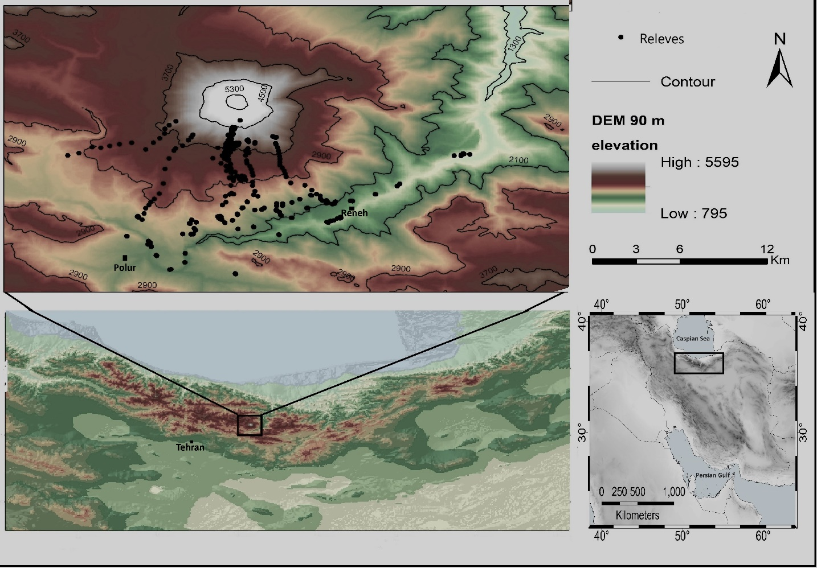

**Figure 1.** Map of the study region and distribution of the plots.

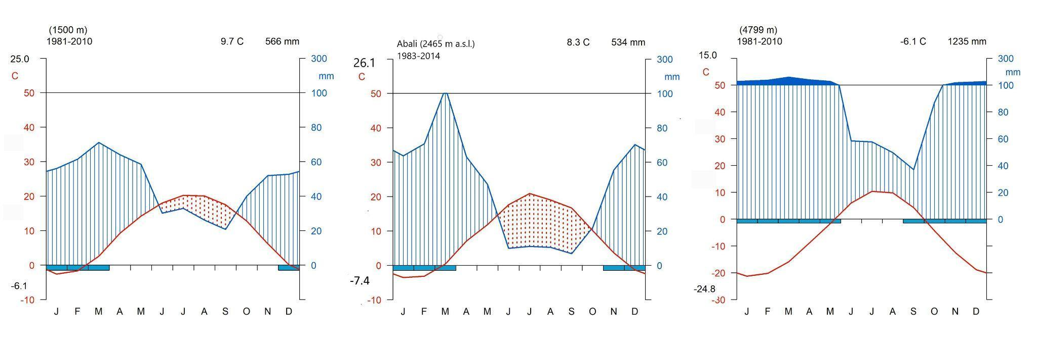

**Figure 2.** Climatic diagrams of the different elevations: a and c extracted from the CHELSA database (Karger et al. 2017, 2018), b: based on data of the Ab-Ali weather station. The diagrams were produced with the ‘climatol’ package (Guijarro 2019).

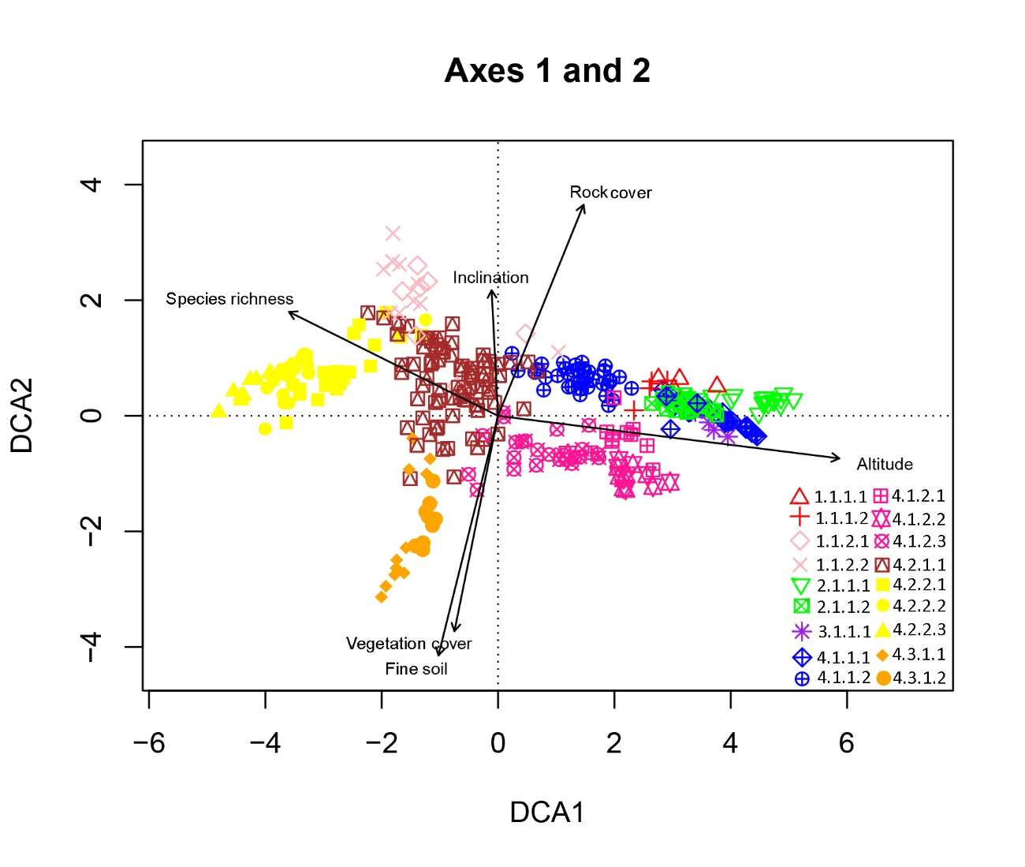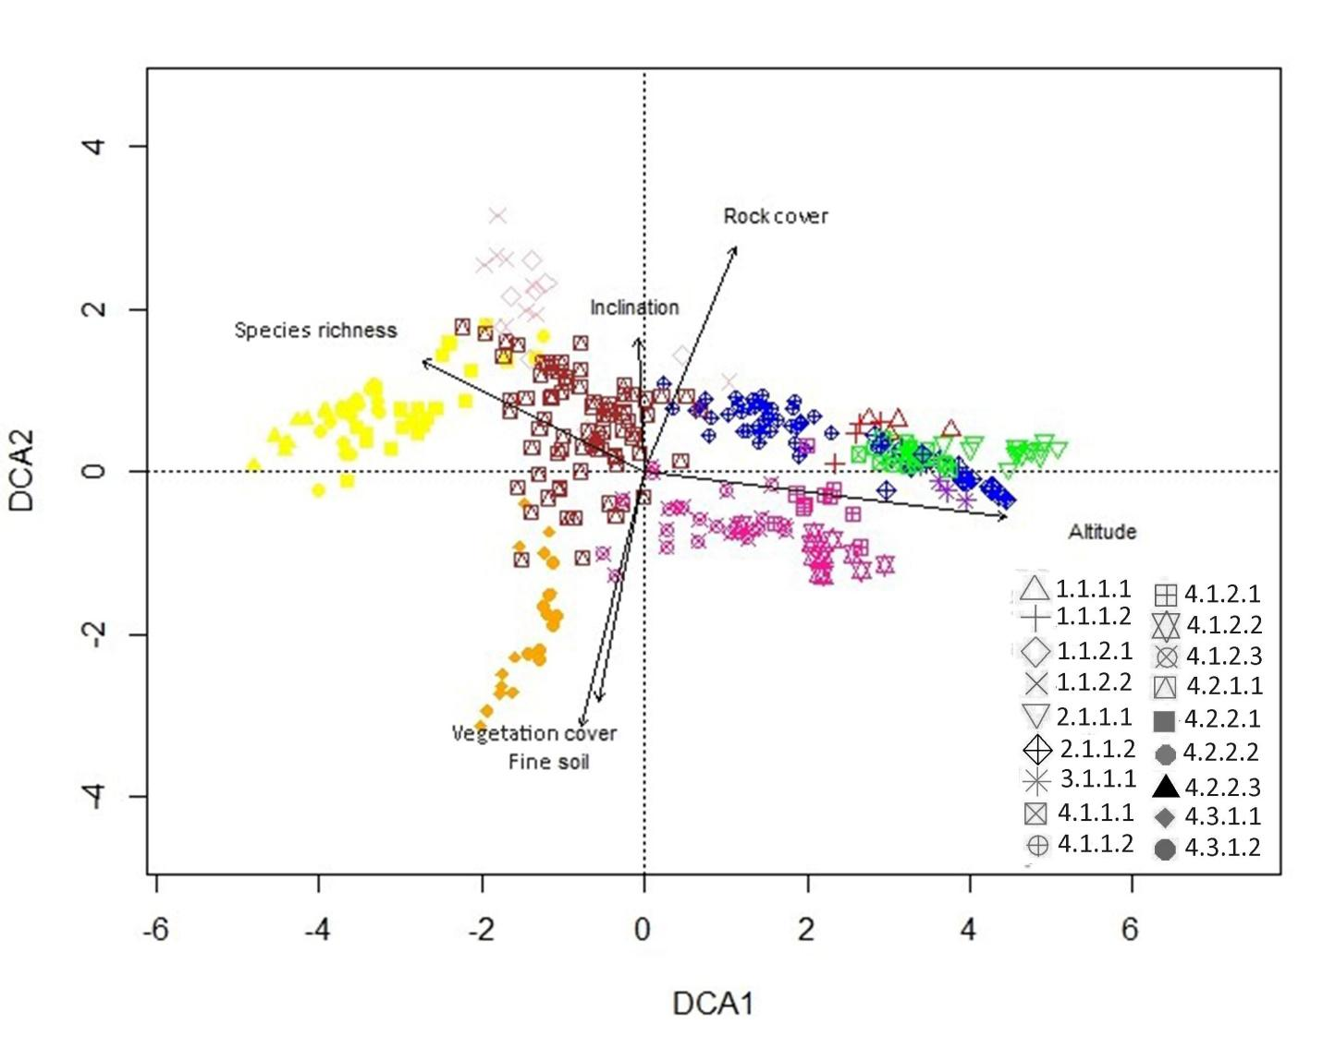

**Figure 3.** DCA ordination of the relevés and underlying environmental and vegetation features (eigenvalues and gradient lengths of axis 1: 0.8621/9.8786/7.806487, axis 2: 0.5872/6.2621). The colors correspond to the nine alliances*.* 1.1.1.1. *Veronica aucheri-Corydalis rupestris* community*;* 1.1.1.2. *Iranecio oligolepis* community*;* 1.1.2.1. *Salvia xanthocheila* community*;* 1.1.2.2. *Rosa iberica community;* 2.1.1.1. *Dracocephaletum aucheri;* 2.1.1.2. *Myosotido olympicae-Lamietum tomentosi*; 3.1.1.1. *Ranunculo crymophili-Oxyrietum digynae;* 4.1.1.1. *Senecio iranici-Astragaletum macrosemius;* 4.1.1.2. *Cousinietum harazensis;* 4.1.2.1. *Astragalus iodotropis-Bromus paulsenii;* 4.1.2.2*. Astragaletum iodotropidis; Astragaletum ochrochlori;* 4.2.1.1. *Astragalo lilacini-Astragaletum microcephali;* 4.2.1.2 *Astragalo compacti-Feruletum persicae;* 4.2.2.2*. Artemisietum aucheri;* 4.2.2.3. *Caccinio strigosae-Oreosalsoletum montanae;* 4.3.1.1*. Astragaletum retamocarpi;* 4.3.1.2. *Heracleo anisactidi-Prangetum ferulaceae.*

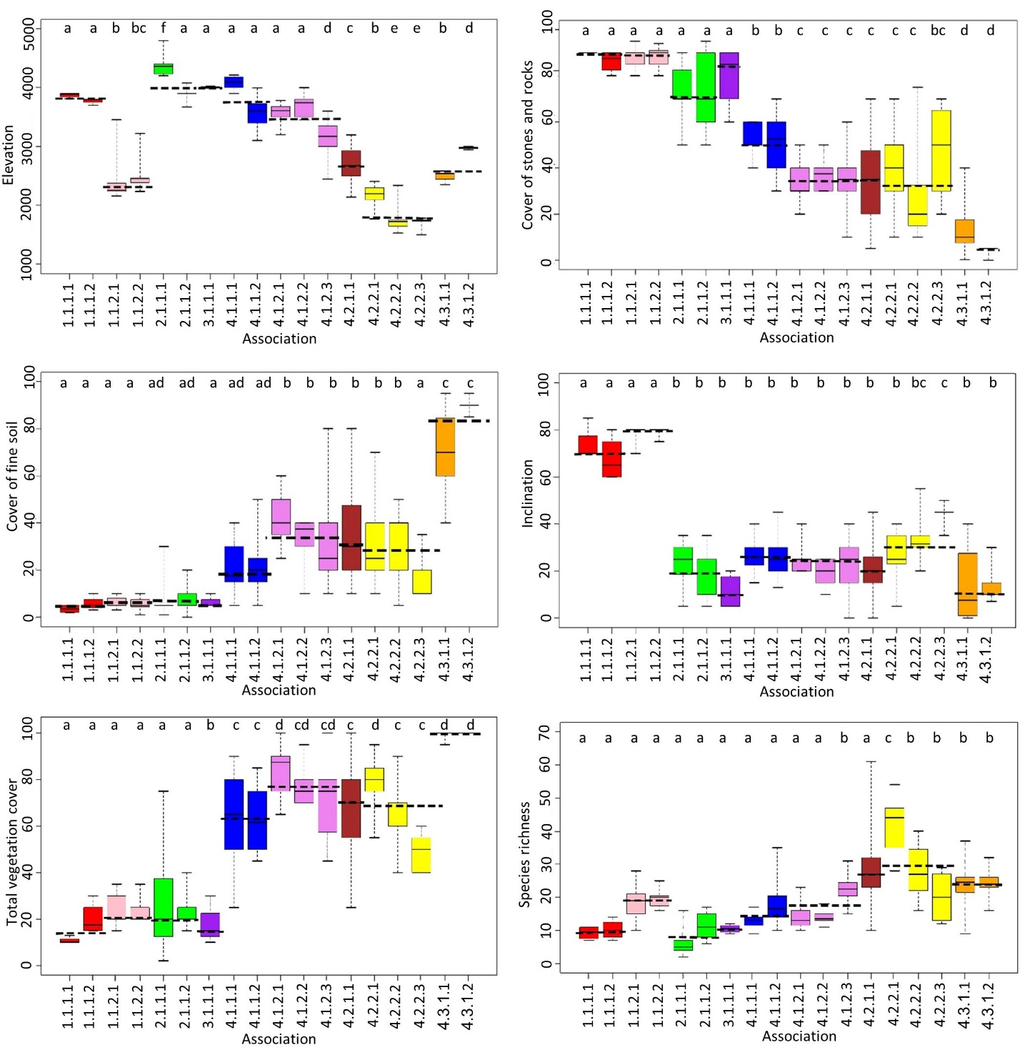

**Figure 4.** Boxplots showing the range of elevation, stone and rocks, fine soil, inclination, total vegetation cover, richness of syntaxonomical units. Dashed line shows the mean value for each alliance. Different letters within one syntaxonomic level indicate significant differences at *p* < 0.05 according to Tukey’s test

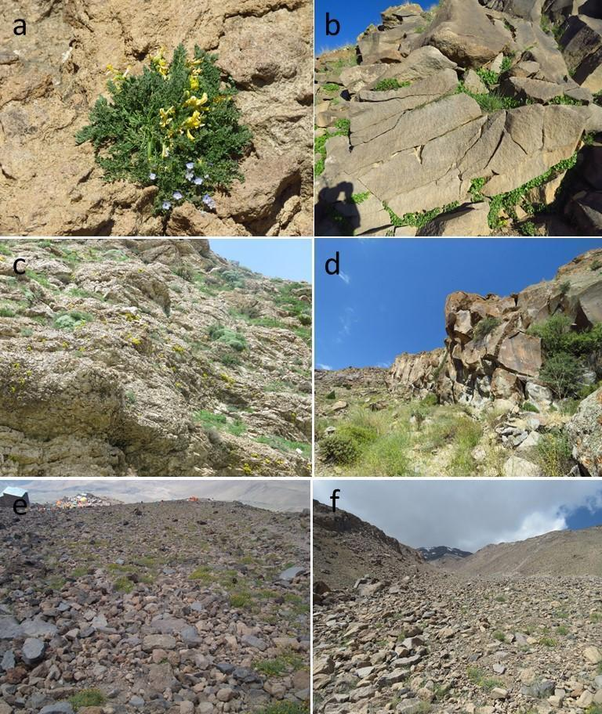

**Figure 5.** Photos of vegetation units belonging to the *Tanacetalia kotschyi* (a-d) and *Didymophyso aucheri-Dracocephaletea aucheri* (e and f): a. *Veronica aucheri-Corydalis rupestris* community (1.1.1.1); b. *Iranecio oligolepis* community (1.1.1.2); c. *Salvia xanthocheila* community (1.1.2.1); d. *Rosa iberica* community (1.1.2.2); e. *Dracocephaletum aucher* (2.1.1.1)*i*; f. *Myosotido olympicae-Lamietum tomentosi* (2.1.1.2) (Photos: Amir Talebi).

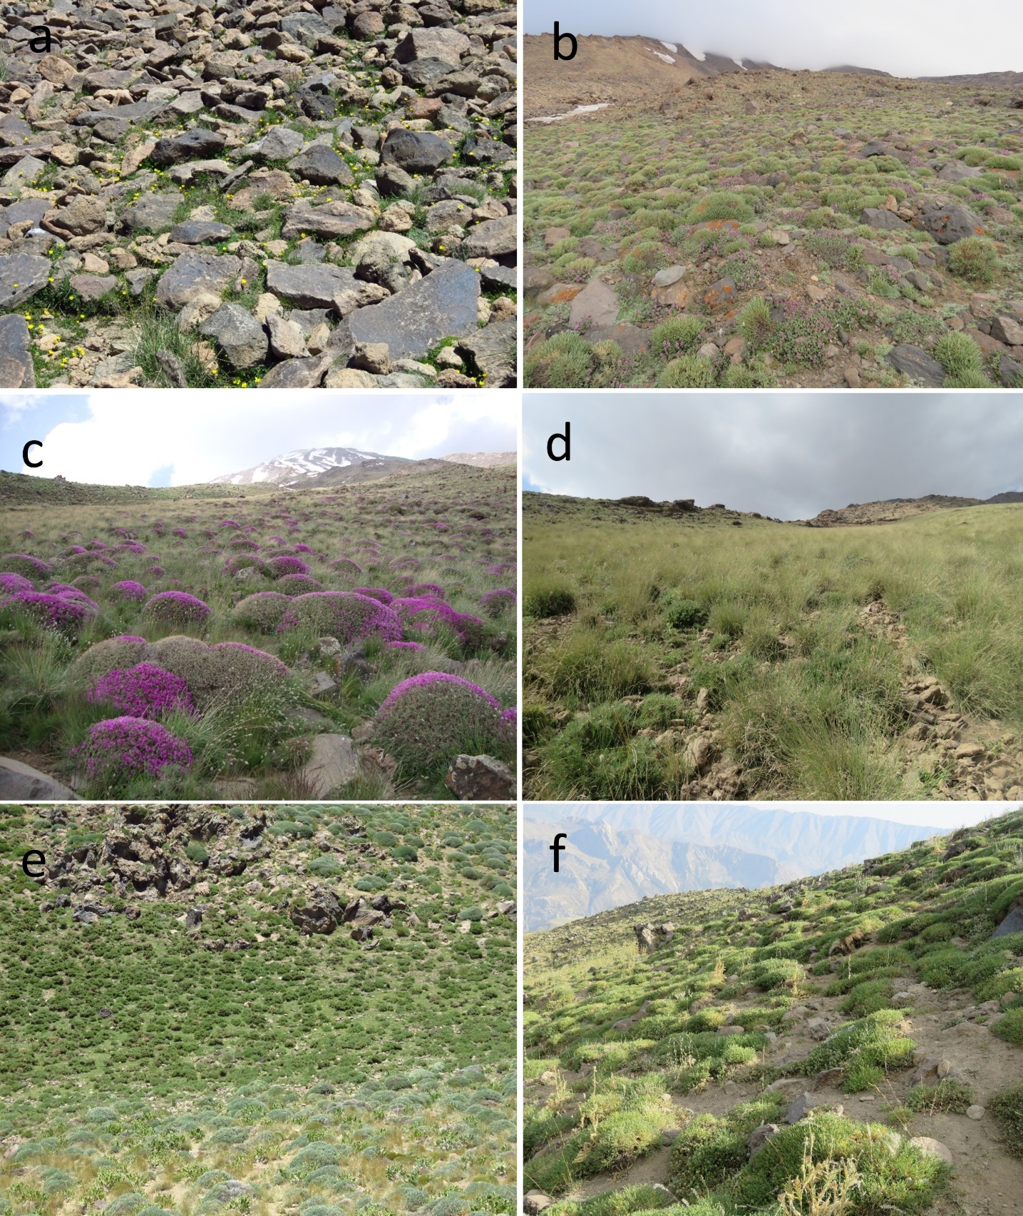

**Figure 6.** Photos of vegetation units belonging to *Salicetea herbaceae* (a) and *Astragalo-Brometea* (b-f): a. *Ranunculo crymophili-Oxyrietum digynae* (3.1.1.1); b. *Senecio iranici-Astragaletum macrosemii* (4.1.1.1); c. *Cousinietum harazensis* (4.1.1.2); d. *Astragalus iodotropis-Bromus paulsenii* community (4.1.2.1); e. *Astragaletum iodotropidis* (4.1.2.2); f. *Astragaletum ochrochlori* (4.1.2.3)(Photos: Amir Talebi)

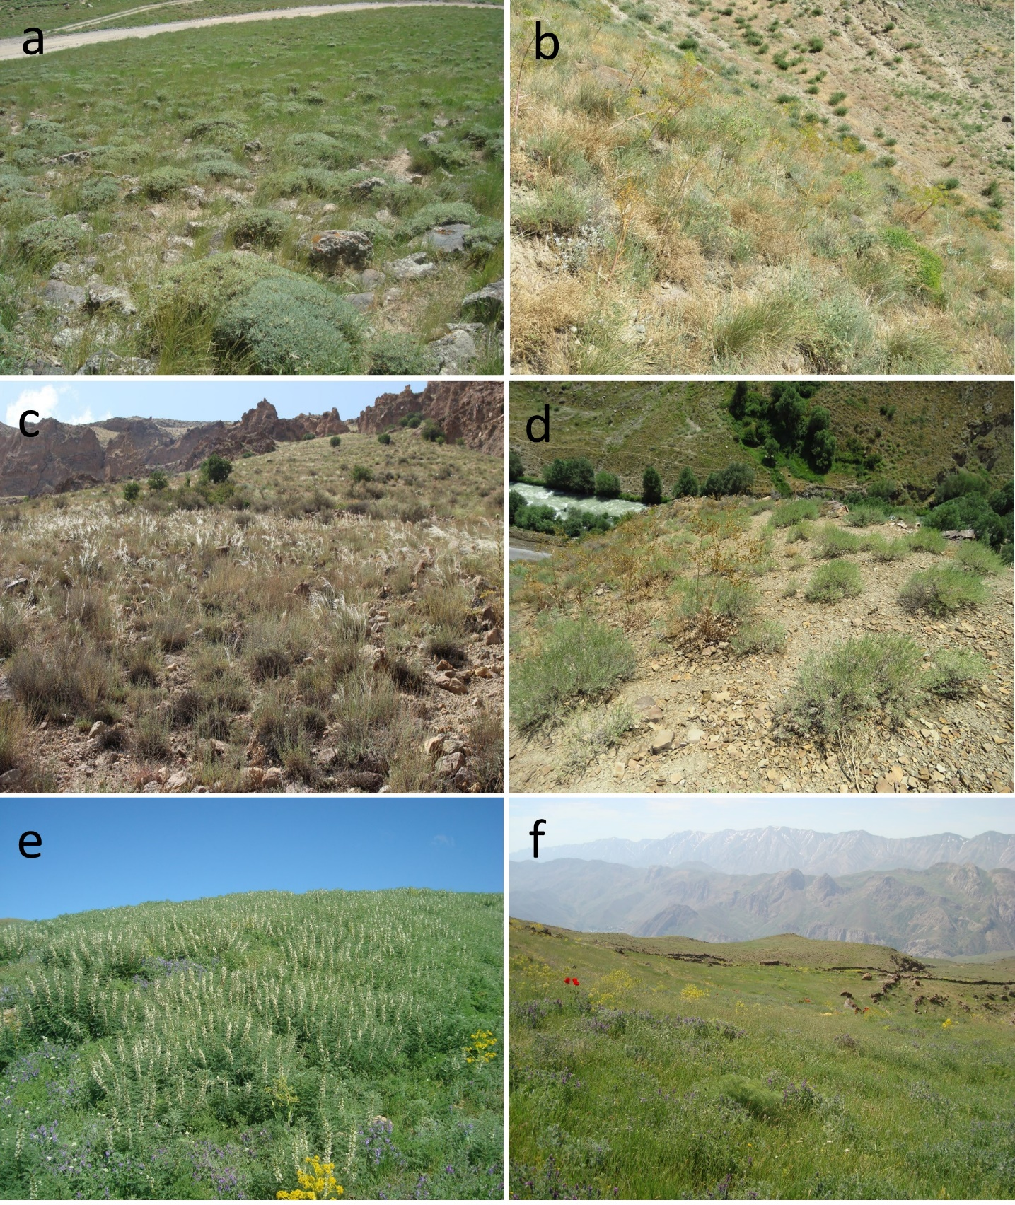

**Figure 7.** Photos of vegetation units belonging to *Astragalo-Brometea*: a. *Astragalo lilacini-Astragaletum microcephali* (4.2.1.1); b. *Astragalo compacti-Feruletum persicae* (4.2.2.1); c. *Artemisietum aucheri* (4.2.2.2); d. *Caccinio strigosae-Oreosalsoletum montanae* (4.2.2.3); e. *Astragaletum retamocarpi* (4.3.1.1); f. *Heracleo anisactidis-Prangetum ferulaceae* (4.3.1.2)(Photos: Amir Talebi) *.*

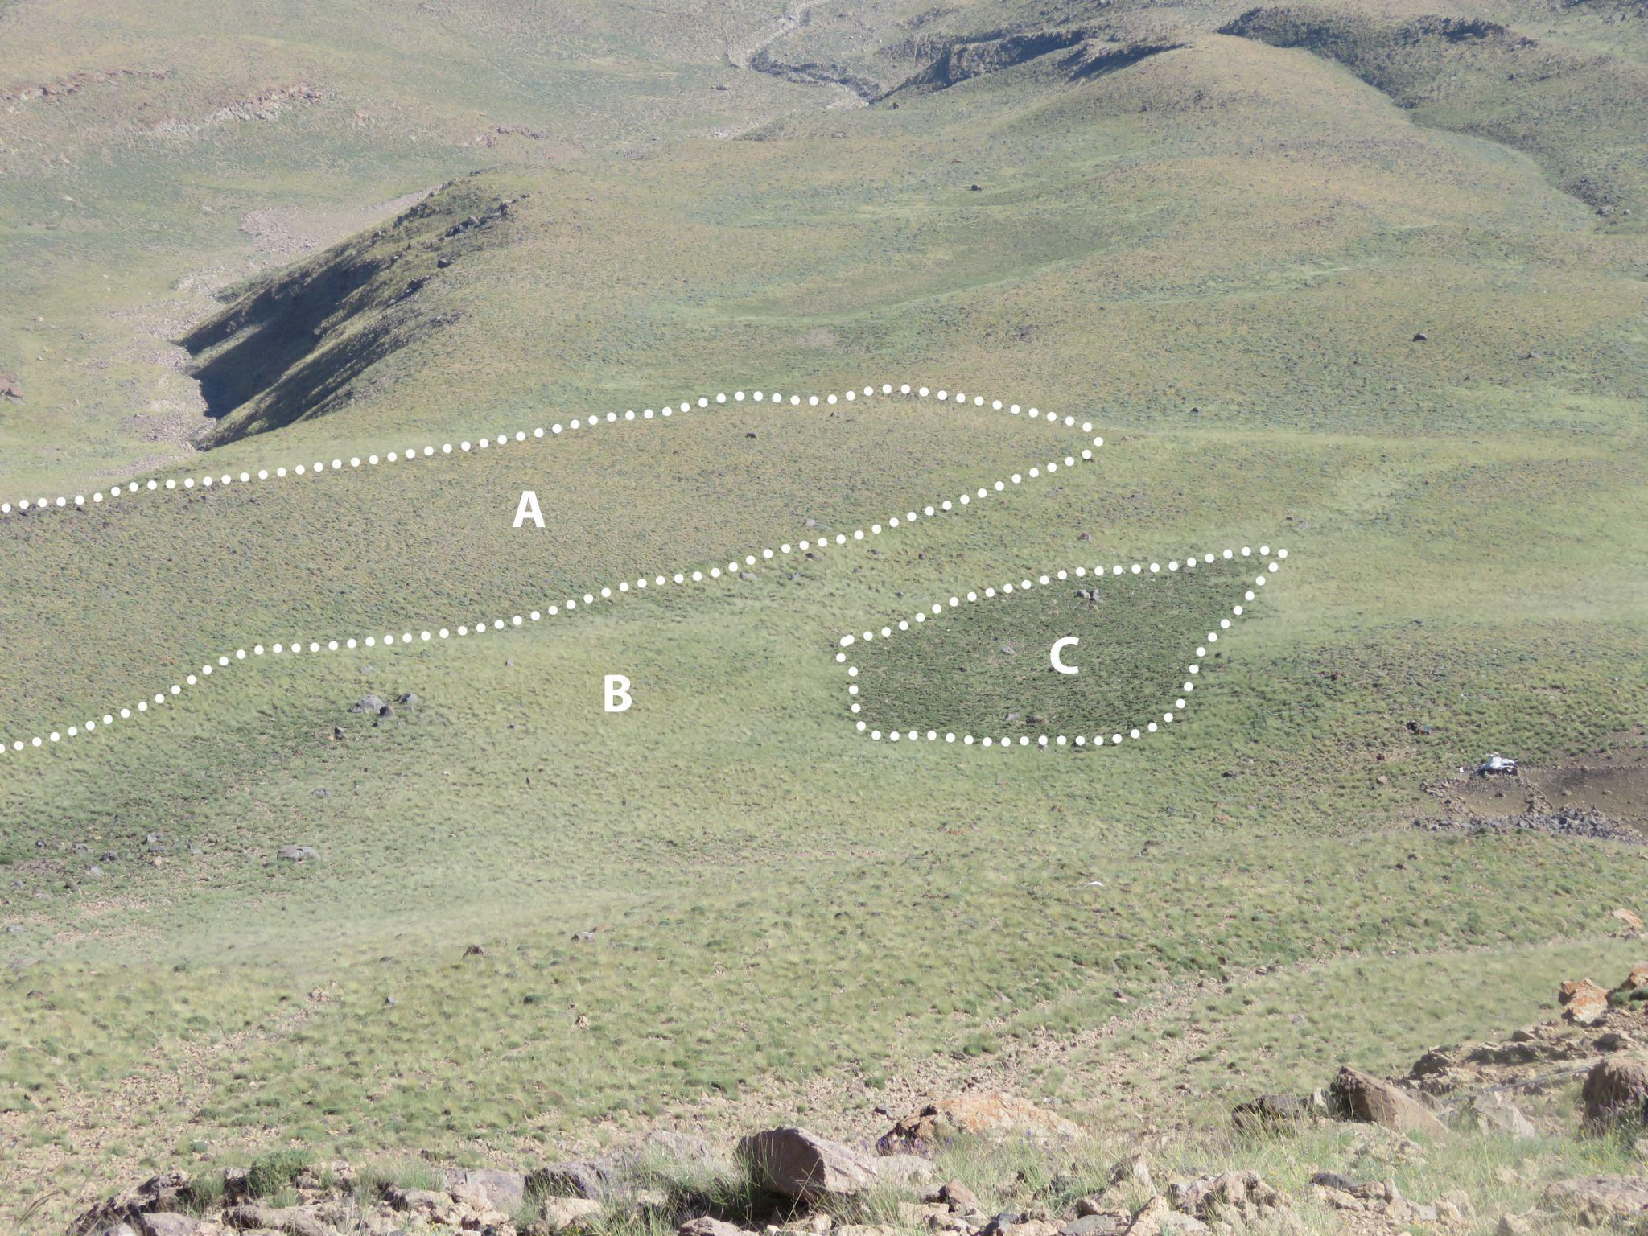

**Figure 8.** Spatial distribution of three associations in alpine zone. A. *Cousinietum harazensis*; B. *Bromus paulsenii-Astragalus iodotropis* community; C. *Astragaletum iodotropidis.* (Photo: Amir Talebi).