**Lean Manufacturing and Internet of Things – A Synergetic or Antagonist Relationship?**

**Abstract**

This paper explores the relationship between five LM methods (JIT, TPM, Autonomation, VSM and Kaizen) and three IoT technologies (RFID, WSN and Middleware) and the implications that arise from their combination. Four hypotheses and four complimentary research questions were formulated and tested. 136 responses were obtained through a questionnaire survey and analysed using descriptive statistics, 2-Sample proportion, Kruskal-Wallis, ANOVA and Pairwise comparison tests. The findings indicate that IoT can significantly improve the operational performance of manufacturing organisations. The findings advocate that all LM methods, apart from Kaizen, benefit from improved effectiveness by combining them with IoT. The results suggest that this can be attributed to the general perception about IoT, which despite the support and benefits it provides to people, is seen to be reducing human involvement whereas Kaizen is seen to be more people-focused. Improvements in information flow, decision-making and productivity were also found to be the most important motivations and benefits of combining LM methods with IoT. The findings of this research can be used by LM organisations that wish to embark into the new digitalised manufacturing era and businesses seeking to improve their performance through the combination of traditional efficiency-based methods and I4.0 technologies.

**Keywords** Lean Manufacturing; Internet of Things; Industry 4.0.

**Paper Type:** Research paper

## 1. Introduction

In recent years, Industry 4.0 (I4.0) has received significant attention due to its potential to bring about substantial transformation to manufacturing strategies (Yin et al., 2018). Its vision integrates and deploys advanced Information and Communication Technologies (ICTs) within manufacturing environments to enable autonomous and highly dynamic production systems for significant performance improvement (German Frank et al., 2019). Internet of Things (IoT) has been characterised as a key technology and major enabler of I4.0 (Garrido-Hidalgo et al., 2019). IoT can be described as a technological concept that utilises sensors, microcontrollers and other embedded terminal devices through which real-time data can be collected from manufacturing machinery and facilities. This data can then be shared among relevant manufacturing resources such as machines and humans, enabling the transformation of the manufacturing system into a more intelligent and responsive system (Mrugalska and Wyrwicka, 2017). Whereas IoT is seen as a general terminology, IIoT (Industrial Internet of Things) is emerging as a new terminology for IoTs that are focused on industrial systems (Gilchrist, 2016; Pivoto et al., 2021, HPE, 2019). A more stringent perspective of IIoT by GE Digital, 2019, sees IIoT as being applicable to higher stake industrial systems, where system failures and unplanned downtime may result in life-threatening or high-risk situations. As a result, this research views IoTs from a broader perspective.

On the other hand, Lean Manufacturing (LM) is a widely recognized and accepted concept which is considered to be the most effective and successful approach that has been implemented in the manufacturing sector over the last few decades (Sauring et al., 2020). LM focuses on the elimination of wastes and non-value added activities, aiming to enhance operations’ productivity and efficiency, leading to a competitive advantage (Tortorella and Fettermann, 2018). LM consists of numerous techniques, methods and tools, which if integrated and appropriately implemented constitutes a crucial requirement for success (Möldner et al., 2020).

The first attempt at combining LM with advanced ICT-based systems for the automation of manufacturing processes occurred in the mid-1990s, and it was described with the term Lean Automation (Mrugalska and Wyrwicka, 2017). According to Kolberg et al. (2017), Lean Automation did not receive much support from the research community, which contrasts the current scenario where the combination of I4.0 and LM has been explored considerably (Garza-Reyes, 2020). Given the proven success of LM in various industries, coupled with the potential transformative capabilities of IoT, there is a high expectation regarding the effects that could arise from their potential synergies and combination (Yin et al., 2018; Wagner et al., 2017). This expectation is related to the significant performance improvements in productivity, responsiveness and decision-making that is potentially achievable by uplifting LM methods and tools with the real-time data and information collection capabilities of IoT (Buer et al., 2018; Ma et al., 2017).

Despite these potentially significant improvements accruable from the combination of LM and IoT, limited research has been reported in regards to their degree of compatibility, the challenges, and the implications of combining them. The majority of the work has focused on holistically investigating the potential combination of LM and I4.0. For instance, Tortorella and Fettermann, (2018) attempted to empirically investigate the relationship between I4.0 technologies and LM practices in an emerging economy context, i.e. the Brazilian manufacturing environment. By examining the role and efficiency benefits within a Lean environment of technologies such as 3D printing, big data and machine to machine communication, Tortorella and Fettermann (2018) highlighted the high degree of association between them and other traditional LM practices. They argue that the concurrent implementation of those technologies along with LM tools will produce an improved digitalised version of LM. Similarly, Rüttimann and Stöckli (2016) conducted a detailed study on LM and I4.0 and argue that although their integration can transform a manufacturing system into a Cyber-Physical Production System (CPPS) with advanced productivity capabilities, the relative immaturity of the bulk of I4.0 technologies makes it challenging to integrate the two concepts. Other researches have also explored the combination of I4.0 and LM, including the works of Rosin et al. (2020), Ghobakhloo and Fathi (2019), Buer et al. (2018) and Kaspar and Schneider (2015). However, similar to the aforementioned studies, these are also focused on I4.0 as an overreaching concept, rather than focusing on specific technologies and aspects of I4.0 in combination with LM.

The work of Sanders et al. (2016) did centre on IoT and LM, but in this case, it explored how the utilisation of IoT could achieve similar results as the implementation of LM. In particular, the research investigated the impact of IoT on some key aspects of manufacturing organisations such as suppliers, customers, processes as well as control and human factors (Sanders et al., 2016). Based on improvements found in these areas, Sanders et al. (2016) suggested that through the utilisation of IoT-based technologies, organisations can achieve results that conform to the LM philosophy, without actually consciously implementing the traditional LM methods and tools.

Unlike the previously discussed researches, this paper fills a gap in the scholarly literature by investigating the relationship between IoT and LM, the implications that can arise from their simultaneous deployment as well as ways through which the core LM methods can be enhanced by the use of IoT technologies. Therefore, to complement and expand the limited body of knowledge in the I4.0 and LM subject field, this paper addresses the following research questions (RQs):

*RQ 1. What are the benefits and limitations of IoT utilisation within manufacturing organisations?*

*RQ 2. How compatible are LM methods with IoT technologies?*

*RQ 3. What are the impacts of LM & IoT on the Continuous Improvement Philosophy?*

*RQ 4. What LM methods are mostly supported through IoT technologies and how?*

The paper is structured as follows: this introductory section contextualizes the research and presents the research questions. Section 2 presents the literature review and the formulation of hypotheses and complementary research questions (CRQs). The 3rd section presents the research methodology, and the analyses and discussions are provided in sections 4 and 5 respectively. Finally, section 6 presents the conclusions, limitations and future research directions.

## 2. Literature review and formulation of hypotheses

***2.1 IoT effect on the performance of manufacturing organisations***

Despite the high expectation in regards to the positive effect of I4.0 technologies (German Frank et al., 2019) and IoT (Zhou et al., 2015) on the performance of manufacturing companies and supply chains (German Frank et al., 2019), Ehie and Chilton (2020), Rüttimann and Stöckli (2016), Schumacher et al. (2016) and Xu et al. (2014) argue that IoT technologies are still in their ‘infancy’. As a result, they consider that IoT is not yet in a position to deliver a significant positive impact on the operational performance of manufacturing organisations. IoT technologies experience a range of technical challenges such as increased heterogeneity and scalability as well as vulnerability to privacy and security issues (Xu et al., 2014). In addition, it is argued that there is a high financial investment and huge risk associated with the implementation of advanced ICT systems to support the decentralisation requirements of IoT as this increases the complexity of systems (Sanders et al., 2016). Furthermore, Rüttimann and Stöckli (2016) consider that the current high expectations about IoT impacts on manufacturing are unrealistic as IoT implementation may introduce new problems. For instance, the improvement of flexibility within manufacturing due to IoT implementation would naturally introduce the issue of variability, which has to be dealt with and may lead to frustration.

Hence, it can be concluded that there are still some doubts regarding the extent to which IoT technologies are currently able to positively impact the performance of manufacturing organisations, mainly due to their early-stage nature. Considering that the bulk of the doubts are related to production and operations issues, the following hypothesis was formulated:

*H1: Despite its infant nature, IoT can significantly improve the operational performance of manufacturing organisations.*

To complement H1 and investigate the expectations of IoT utilisation, as well as the factors that affect IoT’s performance or lead organisations to avoid its implementation, the following complimentary research questions (CRQs) were developed:

*CRQ1: What are the most important motives that lead manufacturing organisations to implement IoT technologies and what are the features that had the most effect on the performance of these technologies?*

*CRQ2: What are the main barriers that lead manufacturing organisations not to implement IoT technologies?*

***2.2 Compatibility of LM and IoT***

Marodin and Saurin (2013) argue that the benefits of LM implementation are similar to those of IoT, and according to Sanders et al. (2016), those benefits are related to productivity and flexibility improvement, waste and cost reduction, worker’s safety and customers’ satisfaction as well as economic growth. Researchers also highlight that the key success factor for those improvements is the decentralised control structure that both IoT and LM utilise, which enables the integration of small modules in IoTs, and facilitates autonomy for LM (Buer et al., 2018; Kaspar and Schneider, 2015; Kolberg and Zühlke, 2015).

The aforementioned synergies have led a number of researchers to support the compatibility of the two and argue that the effectiveness of LM can be enhanced through the adoption of IoT (Buer et al., 2018; Sanders et al., 2017; Rüttimann and Stöckli, 2016; Sanders et al., 2016). Focusing on the adoption process of IoT, the transformation into a more digitalised manufacturing era can be more successful if the organisation had implemented LM practices prior to IoT implementation (Mrugalska and Wyrwicka, 2017; Kaspar and Schneider, 2015; Khanchanapong et al., 2014). This is supported by the results of a research survey of 179 companies that was conducted by Staufen AG (2018). It found that the experience on LM implementation was the most common similarity amongst key pioneers of I4.0 implementation. Researchers argue that is because IoT has the capability to further enable LM’s focus on transparency and visual control (Buer et al., 2018). This evidence suggests that an organisation that has already implemented LM is more likely to successfully implement IoT technologies. This led to the development of the second hypothesis:

*H2: Organisations that have already implemented LM are more likely to implement IoT technologies successfully.*

In order to identify which LM methods assist the most the IoT implementation process, the following CRQ is derived:

*CRQ3: Which of the LM methods assist more in the implementation process of IoT technologies?*

***2.3 Impact of LM and IoT combination on the Continuous Improvement Philosophy***

Researchers agree that there is a range of implications of LM and IoT combination. Roy et al. (2015) argue that the utilisation of IoT in a LM organisation will make the organisation more advanced and mature. In a similar view, Wang et al. (2016) suggest that the combination of IoT with LM can lead to a digitalised version of LM, which may be easier to be adopted by organisations. Also, Tortorella and Fettermann (2017) argue that improved information sharing amongst processes can assist in improving the competitiveness of the organisation. For instance, the utilisation of identification and monitoring sensors and actuators can strengthen LM’s capability of detecting and solving production problems, thus, higher productivity targets can be achieved (Behrendt et al., 2017). Furthermore, Rϋttimann and Stöckli (2016) estimate that the availability of accurate real-time data from the shop-floor can improve the flexibility of the operation, and facilitate a more continuous flow (Kolberg and Zühlke, 2015), thus leading to waste elimination (Wang et al., 2016).

However, the most challenging aspect of the LM and IoT combination is related to the degree to which IoT applications are able to support the LM philosophy of continuous improvement wherein humans are the major enabler (Rüttimann and Stöckli, 2016). The significant possibility that humans will not be needed in the future in a totally automated “smart” manufacturing environment provokes doubts about the extent to which the systems will continuously improve their performance without human involvement. Hence, the following hypothesis is developed:

*H3: The introduction and establishment of IoT into Lean manufacturing methods and practices will not affect Lean’s philosophy of continuous improvement.*

***2.4 LM and IoT enhancement synergies***

Belekoukias et al. (2014) consider Just-in-Time (JIT), autonomation, kaizen, total productive maintenance (TPM) and value stream mapping (VSM) as essential LM methods. Regarding JIT, IoT’s capability for providing real-time data about products’ locations and characteristics can play a considerably important role in the further optimisation of inventory levels (Zheng et al., 2020). IoT utilisation can enhance traceability and minimise delays and waiting times, leading to more effective inventory management (Rafique et al., 2016), and consequently a reduction in production lead times (Sanders et al., 2016). Kolberg and Zühlke (2015) suggest the replacement of the traditional Kanban cards with IoT-enabled ones to improve JIT inventory control.

TPM is another LM method that scholars argue will benefit from IoT (Sanders et al., 2017; Sanders et al., 2016). The establishment of a network of interconnected devices across the production shop-floor can provide real-time data collection that enables quick response to breakdowns or potential breakdowns. According to Hutton (2016), the adequate utilisation of those data can assist organisations to achieve the TPM target of zero breakdowns as the gathered data can be analysed using other technologies such as big data analytics. However, even in the event of a failure, these analytics could also be utilised for solution finding by linking the occurred failure with past patterns and causes, providing potential solutions without any human involvement. The Single-Minute Exchange of Dies (SMED), a part of TPM, can also benefit from IoT with the requisite SMED knowledge embedded in IoT enabled machinery, which can be accessed readily by personnel rather than relying on their knowledge (Keller et al., 2014). As a result, accurate SMED procedures can be consistently adhered to.

The LM approach of autonomation is also naturally aligned to benefit from IoT (Sanders et al., 2016). Through the provision of real-time data and the establishment of the machine to machine communication, machines capabilities are greatly enhanced.

Data collection is a crucial and challenging aspect of VSM (Buer et al., 2018). IoT’s capability to provide real-time data and information about several aspects of the shop-floor is a characteristic that can enhance VSM’s effectiveness to a great extent (Meudt et al., 2017; Mrugalska and Wyrwicka, 2017). Improvements in information flow and waste elimination have also been mentioned as benefits of IoT integration with VSM (Meudt et al., 2017; Mrugalska and Wyrwicka, 2017).

For completeness, it is also essential to explore the potential benefits to specific IoT technologies on the continuous improvement philosophy, i.e. Kaizen, which was explored in Section 2.3 with regards to IoT in general rather than specific IoT technologies. In this research, the specific IoT technologies considered are RFID, WSN and Middleware as they are the most commonly discussed and used IoT technologies in manufacturing environments.

This research argues that the potential enhancement of *JIT, TPM, autonomation, VSM* and Kaizen through specific IoT technologies has been solely theoretically in the literature. Thus, in order to investigate these potential enhancements empirically, the following hypothesis was formulated:

*H4: The utilisation of IoT technologies (RFID, WSN and Middleware) can improve the efficiency of five essential LM methods (i.e. JIT, TPM, autonomation, VSM and Kaizen).*

Furthermore, there are discussions in the literature regarding the outcomes that could be realised by the combination of LM and IoT. Roy et al. (2015) argue that the utilisation of IoT in a LM organisation will make it more advanced and mature. Similarly, Wang et al. (2016) suggest that the combination of IoT with LM can lead to a digitalised version of LM, which may be easier to be adopted by organisations. Tortorella and Fettermann (2018) comment that improved information sharing amongst processes can enable the increase of an organisation’s competitiveness.

The argument in the literature is that these outcomes are realisable through the impacts of IoT on some lean objectives such as facilitating continuous flow (Kolberg and Zühlke, 2015), improving the flexibility of operations (Rüttimann and Stöckli, 2016), minimising waste (Wang et al., (2016), thus leading to higher productivity (Behrendt et al., 2017).

Overall, Womack and Jones (1996), articulate four LM objectives namely: enabling ‘bespoke requirements’; eliminating ‘non-value added’ activities and ‘waste’; improving ‘information flow’; and deploying ‘pull production system’. In order to investigate whether IoT can support the achievement of these four LM objectives, the following CRQ was developed:

*CRQ4: To what extent does the utilisation of IoT in the shop-floor support the LM objectives of enabling ‘bespoke requirements’, eliminating ‘non-value added’ activities and ‘waste’, improving ‘information flow’, and deploying a ‘pull production system’?*

## 3. Research methodology

***3.1 Questionnaire survey design***

A degree of subjectivity may be incorporated, due to natural ontological deliberations, in researches such as the present one. Due to the study’s positivistic epistemological nature and to balance subjective variability, a relatively large scale quantitative approach was followed. In this line, a remote and self-administered survey was used as a data collection tool. This data collection method (1) ensured the separation of the research subject and researcher, and eliminated interviewer research bias that could distort results (Bryman, 2016), (2) aimed at generating quantifiable data from a relatively large scale sample while at the same time being efficient (i.e. quick, convenient and cheap), (3) offered anonymity for respondents, (4) produced results with a certain degree of generalisation (Bryman, 2016; Forza, 2016), and (5) provided statistically analysable data for reliable inferential conclusions to test the hypotheses and CRQs formulated.

The questionnaire was developed in a web-based survey design software, Qualtrics. Web-based questionnaire software enables faster responses and easier data translation (Sivo et al., 2006). The questionnaire consisted of twenty questions which were divided into five sections as presented in Table 1. Figure 1 further illustrates Table 1 by demonstrating the systematic thinking process used as the basis for the development of the questionnaire.

Table 1. Questionnaire overview and structure

|  |  |
| --- | --- |
| **Questions** | **Reasons for inclusion** |
| **Part 1** | |
| **QQ1.** Please indicate the size of your organisation.  **QQ2.** Please indicate the region of your organisation.  **QQ3.** Please indicate the manufacturing sector of your organisation.  **QQ4.** Which is your current job position? | Questions 1-4 were posed to identify general information about the respondents’ organisations, in terms of size, region, sector and position within their organisation. |
| **Part 2** | |
| **QQ5.** How would you describe your awareness of thefundamental elements of the Internet of Things (IoT)?  **QQ6.** Please indicate if your organisation (current or previous) has implemented any of the Internet of Things technologies such as Radio Frequency Identification Devices, Wireless Sensor Networks, Middleware software or others.  **QQ7.** (Follows up from Q6) If no, please indicate which of the following barriers prevented your organisation from implementing IoT technologies.  **QQ8.** Please rate up to what extent your organisation has implemented the mentioned IoT technologies.  **QQ9.** Please indicate what the motives are for the implementation of IoT technologies on behalf of your organisation.  **QQ10.** Based on your opinion, to what extent have the IoT technologies improved your organisation's operational performance?  **QQ11.** Please indicate which of the following features affected more negatively the performance of the IoT technologies in your organisation. | Questions asked to test H1 and answer CRQ1 and CRQ2. |
| **Part 3** | |
| **QQ12.** Do you have any experience working with **Lean** Manufacturing?  **QQ13.** Please indicate if, prior to the utilisation of IoT technologies, your organisation (current or previous) has implemented any of the following Lean Manufacturing methods.  **QQ14.** Please indicate the extent to which theimplementation of IoT technologies in your organisation was assisted from the prior implementation of Lean methods. | Questions asked to test H2 and answer CRQ3. |
| **Part 4** | |
| **QQ15.** Please indicate the extent to which your organisation has attempted to combine some of the IoT technologies with Lean methods.  **QQ16.** Based on your experience (or expectations), ratethe extent to which the following factors were (or will be) improved after the initial combination of IoT technologies and Lean Manufacturing.  **QQ17.** Based on your experience (or expectations), **rate** the extent to which the aforementioned factors continued (or will continue) to improve after a certain time period from the initial combination of IoT and Lean manufacturing? | Questions asked to test H3. |
| **Part 5** | |
| **QQ18.** Based on your experience (or expectations), which of the Lean methods improved (or will improve) their efficiency by each one of the IoT technologies.  **QQ19.** Based on your experience (or expectations), indicate the IoT technologies that had affected (or will affect) positively each one of the features.  **QQ20.** Based on your opinion, rate the extent towhich the utilisation of Cyber-Physical Systems (e.g. connected microcontrollers with communication interfaces such as sensors and actuators), supports the following features. | Questions asked to test H4 and answer CRQ4. |

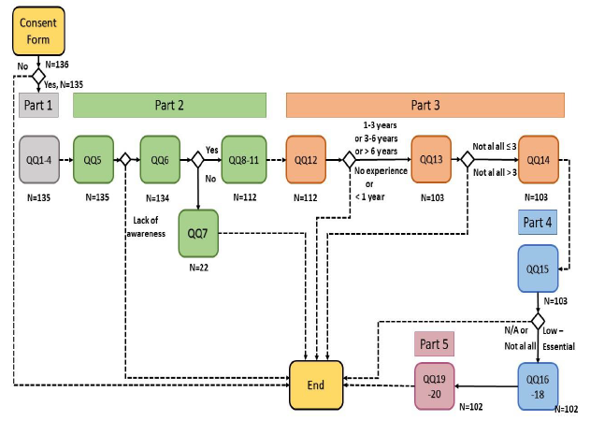

Figure 1. Questionnaire’s logic

***3.2 Questionnaire reliability and validity***

A questionnaire’s reliability is related to its measure of accuracy and consistency, whereas its validity refers to the extent to which the questionnaire succeeds in measuring its initial concept (Bell and Bryman, 2015). Robson (2011) highlights four reliability threats, i.e. participant’s error and bias, and observer error and bias. To address these, a small-scale pilot test of the questionnaire was conducted, prior to its distribution, involving six credible individuals, three experienced academics and three experienced industrialists. Based on their feedback and to eliminate participants’ bias and errors, the questionnaire was amended to (1) provide further comprehensiveness and clarification in some of the questions, (2) add some extra profile questions to obtain more correlations among the results, and (3) make minor changes to recording values of the questions to achieve an effective testing capability of the instrument. Finally, the questionnaires skip logic illustrated in Figure 1 also ensured reliability as only respondents with sufficient experience and expertise were considered in the research.

***3.3 Questionnaire distribution***

The central research questions did not restrict the target population and sample to certain company characteristics, e.g. region, sector or size. Thus, and due to the exploratory nature of the research, the questionnaires were administrated to experts in any manufacturing sector worldwide. This was done through the professional social network platform Linkedln, which is nowadays considered a reliable platform for the fast collection of research data (Papacharissi, 2009). Postings were accompanied by a cover letter that introduced the research and its objectives. LinkedIn postings were made via either Inmail messages directly to individuals or through group societies. For Inmail messages, numerous individuals with job description relative to IoT, IIoT (Industrial IoT), Digital Manufacturing, Smart Manufacturing, I4.0, Lean manufacturing, TPS and Lean specialists were contacted. For groups, over 10 relevant group societies with just less than a million members were also contacted. Direct e-mails were also used to target individuals in specific companies.

Random probability sample was not possible due to the unknown size of the population targeted (Saunders et al., 2016), and it was self-selected as randomly as possible among potential respondents matching the criteria within the target population (i.e. industrial experts from multiple company regions, sizes and sectors). Following the aforementioned distribution strategies, 136 usable responses were gathered from team members, team leaders, managers, senior managers, directors and managing directors. For large and unknown populations such as the one targeted, the size of the sample does not unswervingly rest on the population as Hair et al. (2016) suggest that for pragmatic reasons it can be estimated based on best practice from the related literature. Thus, based on comparative studies in similar fields (e.g. Andreadis et al., 2017; Binti Aminuddin et al., 2016; Kirkham et al. 2014.), a response size of 136 was considered adequate.

The data collected were analysed using a combination of descriptive statistics, 2-Sample proportion, Kruskal-Wallis, ANOVA and Pairwise comparison tests.

**4. Results**

***4.1 Respondents and company’s demographics***

Table 2 presents the profiles of the respondents, and their companies, in regards to the companies’ size, geographic region and manufacturing sector as well as respondent’s job position and level of IoT awareness and implementation.

Table 2. Respondents and companies demographics

|  |  |  |  |
| --- | --- | --- | --- |
| **Company Size** |  | **Job Position of Respondents** |  |
| Large (>250 employees) | 59.55% | Senior Manager | 38.23% |
| Medium (50-250 employees) | 25.74% | Director | 27.20% |
| Small (<50 employees) | 14.71% | Manager | 16.18% |
|  |  | Team Member | 8.09% |
| **Region** |  | Team Leader | 6.62% |
| Europe | 43.38% | Other | 3.70% |
| Asia | 30.15% |  |  |
| North America | 21.32% | **IoT Awareness** |  |
| Africa | 2.94% | High | 43.70% |
| Australia | 2.21% | Essential | 25.93% |
|  |  | Medium | 17.04% |
| **Manufacturing Sector** |  | Low | 12.59% |
| Automotive | 19.11% | None | 0.74% |
| Electronics | 16.18% |  |  |
| Fast Moving Consumer Goods | 15.44% | **IoT Implementation in Respondents’ Organisation** |  |
| Metal and Machinery Manufacturing | 11.03% | Yes | 82.96% |
| Chemical | 9.56% | No | 17.04% |
| Aerospace | 8.09% |  |  |
| Other | 6.62% | **Level of RFID Implementation** |  |
| Miscellaneous Manufacturing | 5.15% | Fully | 20.72% |
| Paper | 2.21% | Partially | 52.25% |
| Textiles, Leather and Apparel | 2.21% | None | 27.03% |
| Petroleum, Coal and Plastics | 1.47% |  |  |
| Transportation | 1.47% | **Level of Wireless Sensor Networks Implementation** |  |
| Defence | 0.73% | Fully | 40.54% |
| Steel | 0.73% | Partially | 41.44% |
|  |  | None | 18.02% |
|  |  |  |  |
|  |  | **Level of Middleware Implementation** |  |
|  |  | Fully | 43.75% |
|  |  | Partially | 53.57% |
|  |  | None | 2.68% |

***4.2 Results - Hypotheses and CRQs***

***4.2.1 IoT application to manufacturing organisations***

*H1: Despite its infant nature, IoT can significantly improve the operational performance of manufacturing organisations.*

Respondents were asked, on a Likert scale 1-Not at all, 2-Slightly, 3-Moderately, 4-Very, 5-Extremely, to what extent IoT technologies had improved the performance of the operations of their organisations (QQ10, N= 112, see Figure 1). The results are presented in Figure 2.

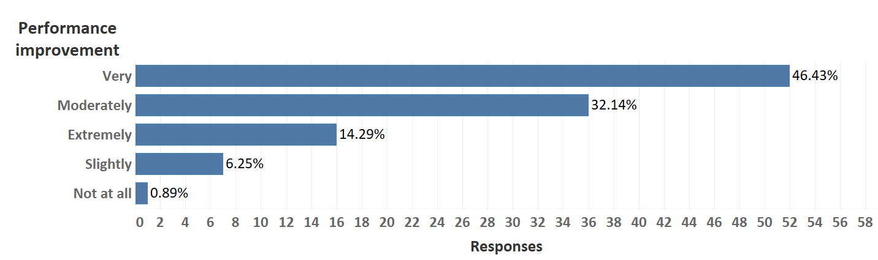Figure 2. Improvement in performance through IoT

In order to assess the significance of the difference between the two most common answers, i.e. “Very” and “Moderately”, a 2-Sample Proportion test at a significance level of α=5% was performed, the results are shown in Figure 3(a). As can be seen in this figure, the P-Value (0.029) is lower than 0.05, indicating that a statistically significant difference existed between the answers “Very” and “Moderately”. Furthermore, in order to identify the tendency of the responses, a second 2-Sample Proportion test, after clustering the data, was performed. Considering that both “Very” and “Extremely” indicate significant improvement, the two data groups that were tested included “Very” + “Extremely” and “Not at all” + “Slightly” + “Moderately”, the results are shown in Figure 3(b).



1. (b)

Figure 3. (a) 2-Sample proportion test for H1 and (b) 2-Sample proportion test with clustered data for H1

Figure 3(b) indicates that the P-Value (0.001) was less than the significance level (0.05). Thus, H1 was accepted as it seemed to exist a statistically significant difference between the two groups, which suggested that the use of IoT technology significantly improves the operational performance of manufacturing organisations.

*CRQ 1: What are the most important motives that led manufacturing organisations to implement IoT technologies and which are the features that affected most the performance of these technologies?*

In regards to the reasons that led manufacturing companies to implement IoT (QQ09), the improvement of operational performance was the main motive (29.93%), followed by the optimisation of decision-making (24.01%), gain of competitive advantage against competitors (24.01%), communication improvement (14.14%) and financial optimisation through the achievement of a high-wage economy (11.51%). Furthermore, 0.99% of the respondents stated other reasons that included improving predictive maintenance and entering the digital era. On the other hand, issues that affected the performance of the IoT technology included, in the order of importance, lack of standardisation, lack of IT infrastructure, high heterogeneity, poor interoperability, complexity of cyber-physical systems, inadequate data analysis and vulnerability to privacy and security.

*CRQ2: What are the main barriers that lead manufacturing organisations not to implement IoT technologies?*

This CRQ was addressed by using data from those participants whose companies had not implemented IoT (N= 23). The lack of awareness regarding the potentials benefits of IoT utilisation (25%), as well as the lack of standardisation for implementing IoT technologies (22.92%), constituted the most important barriers. Furthermore, the maturity of IoT technologies (12.50%) and the insufficient IT infrastructure (12.50%) were also found to create a barrier to implement IoT technologies. Finally, the lack of financial resources and no fit with organisations’ objectives (8.33%) and insufficient privacy and security protection of IoT technologies (6.25%) also presented a barrier for implementing IoT.

***4.2.2 Compatibility of Lean manufacturing and Internet of Things***

*H2: Organisations that have already implemented LM are more likely to implement IoT technologies successfully.*

H2 investigated the extent to which the implementation process of IoT can be assisted, from the pre-existed implementation of Lean methods (QQ14, N= 103), the results are shown in Figure 4.

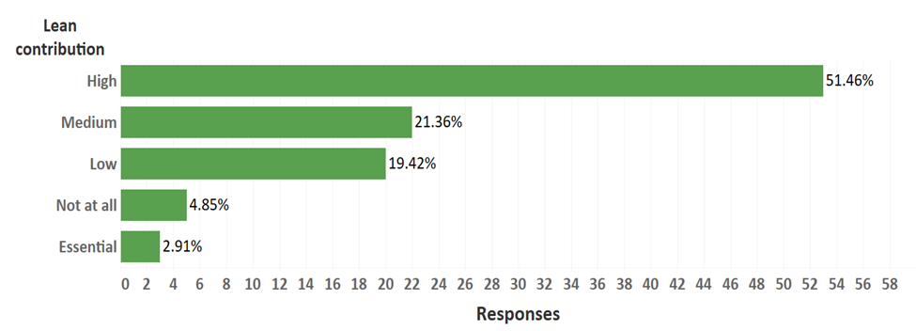

Figure 4. Lean contribution to IoT implementation

As suggested by Figure 4, there is a clear indication (51.46%) that the prior implementation of lean methods assists to a high extent the implementation process of IoT. However, in order to statistically assess the significance of the difference with the second most frequent answer, i.e. medium with a percentage of 21.36%, a 2-Sample Proportion test at a significance level of α=5% was performed, the results are shown in Figure 5.

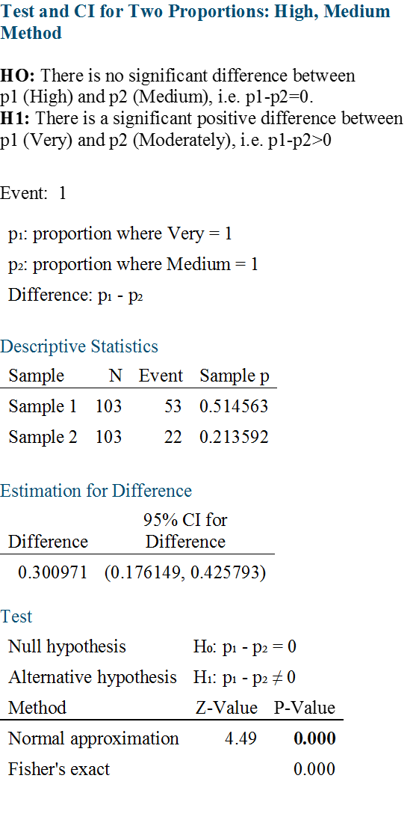

Figure 5. 2-Sample proportion test for H2

As indicated by Figure 5, P-Value was <0.001, which was represented as 0.000 by the statistical software used. Thus, the null hypothesis was rejected, indicating that the IoT implementation process was assisted to a high extent, rather than a medium one, from prior lean implementation. This suggested the acceptance of H2, which further suggests that organisations that have already implemented LM are more likely to implement IoT technologies successfully.

*CRQ3: Which of the LM methods assist more in the implementation process of IoT technologies?*

To address this CRQ, the participants (N= 52) who considered that the previous implementation of Lean assisted in a ‘high’ or ‘essential’ manner the successful implementation of IoT technologies, see Figure 4, were initially asked about the degree of implementation of JIT, TPM, Autonomation, VSM and Kaizen in the operations of their companies. The results are illustrated in Figure 6.

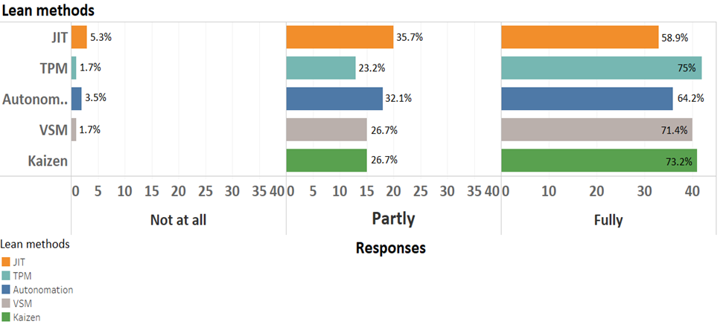

Figure 6. Degree of implementation of Lean methods

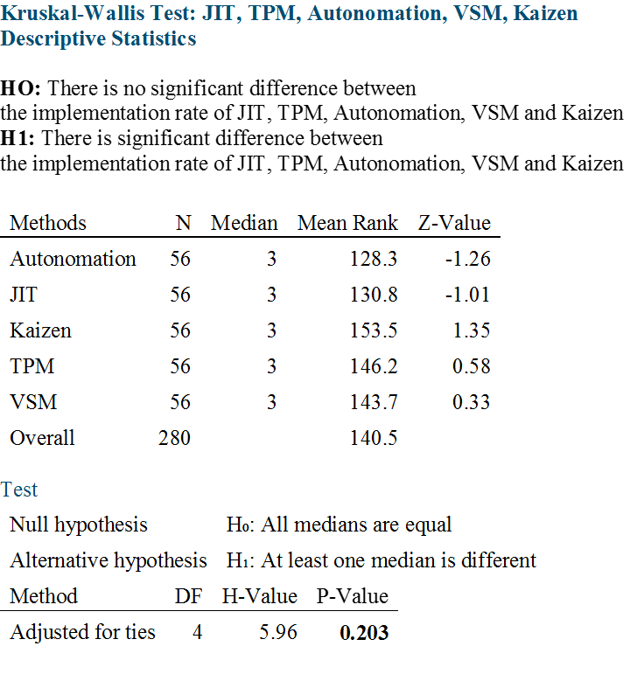

Figure 7. Non-parametric Kruskal-Wallis analysis for CRQ3

In order to assess the significance of the difference regarding the implementation extent of these Lean methods, a non-parametric Kruskal-Wallis analysis was conducted due to the relatively small sample and thus lack of normality in the distribution of the data, see Figure 7. As shown by this figure, since the P-value was bigger than the significance level (α=0.05), H0 was accepted, suggesting that no significant difference between the Lean methods existed, indicating in turn that all the methods had the same aiding effect in the successful implementation of IoT.

***4.2.3 Lean and IoT combination implications on Continuous Improvement***

*H3: The implementation of IoT in LM environments will not affect Lean’s philosophy of continuous improvement.*

To test H3, a two steps approach was followed. First, an investigation was conducted to determine which crucial organisational performance factors, see Figure 8, are improved after the initial combination of LM and IoT. This assessment contrasts with the assessment in 4.2.1 which dealt with the motives for the combination of LM and IoT (QQ09) whereas the focus in this first step of H3 is on realisable benefits after the initial combination (QQ16). In the second step, an exploration of the extent to which these factors continued to improve over time was conducted. For Step 1, Figure 8 shows the factors that, according to the respondents, are improved by combining Lean and IoT technology. These were measured on a Likert scale from 1 (“not at all”) to 5 (“extremely”).

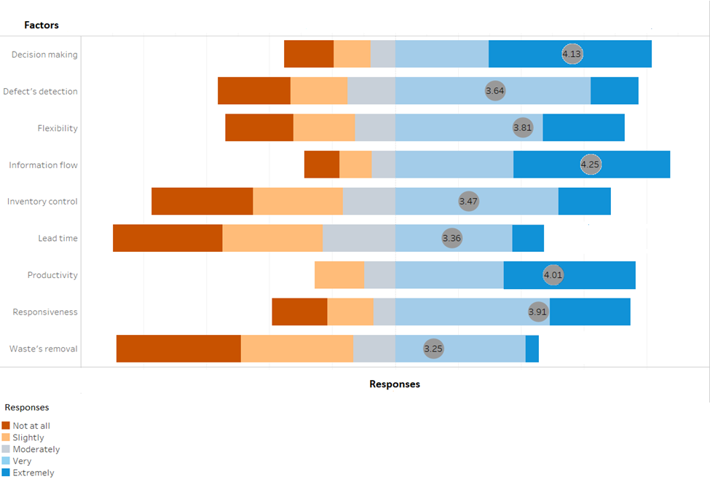

Figure 8. Performance factors improved through the combination of Lean & IoT – Step 1

To statistically assess the significance of the difference in the improvement of the factors, a one-way ANOVA test at a significance level of 5% was conducted. Since an N=102 sample size with a 1-5 Likert scale employed, assumptions of normality and equal variances of the responses were expected to be true (McClave et al., 2008). Figure 9 shows the results of the one-way ANOVA. Since the P-value was less than 0.001 at a significance level of α=0.05, the null hypothesis was rejected, indicating that the organisational performance factors were impacted differently by the combination of Lean and IoT. Thus, a Tukey-Pairwise Comparison test was applied to statistically determine which of these factors were the most impacted by the combination of Lean and IoT, the results are depicted in Figure 10. The results indicated that the improvement of information flow is the most important benefit achieved by combining Lean and IoT, closely followed by the decision-making, productivity and responsiveness factors. Lead time reduction and wastes removal are the factors that would benefit the least according to the respondents.



Figure 9. One-way ANOVA for H3 – Step 1

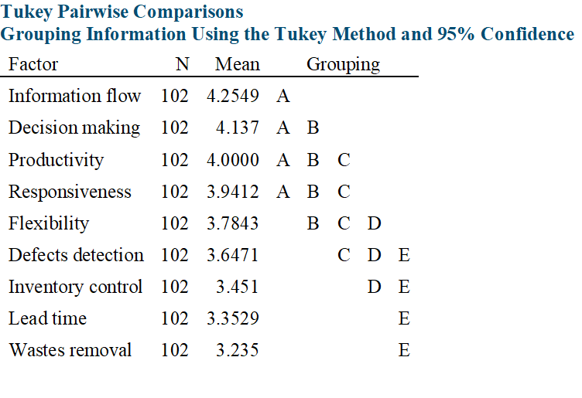

Figure 10. Tukey-Pairwise Comparison for H3 – Step 1

For Step 2, an exploration of the extent to which these factors continued to improve over time was conducted through QQ17, see Table 1. The results are shown in Figure 11. They indicate that the bulk of the responses considered that the organisational performance factors continued to improve to a high and moderate extent.

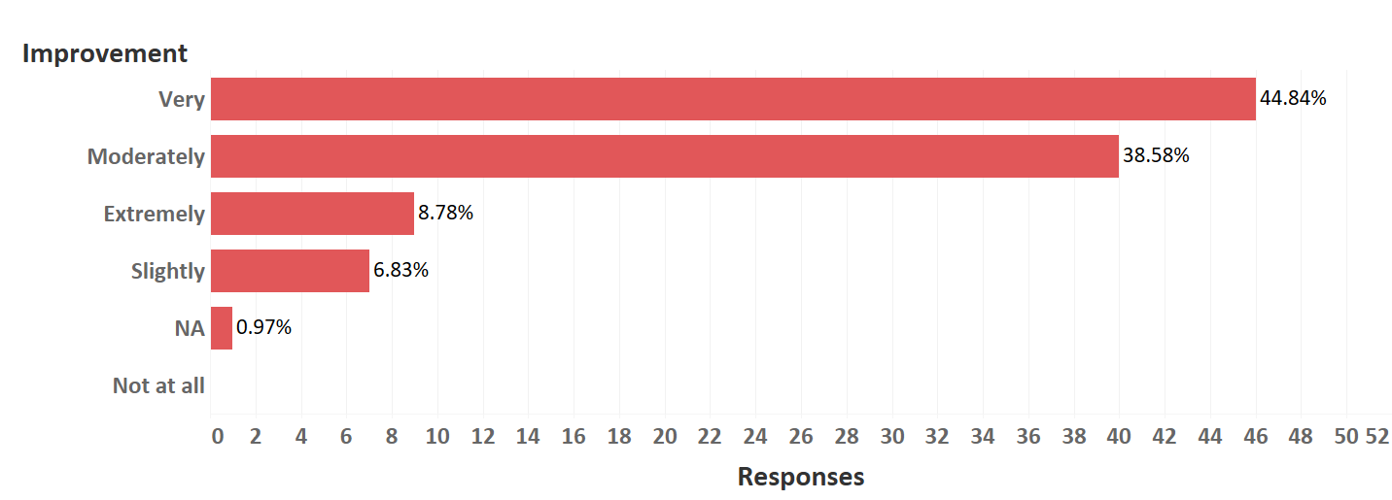

Figure 11. Continuation of improvement over time

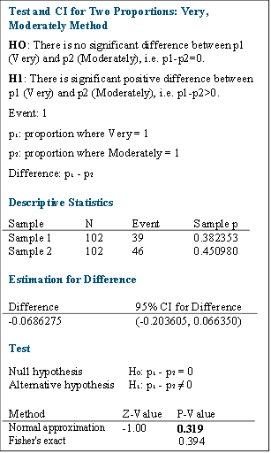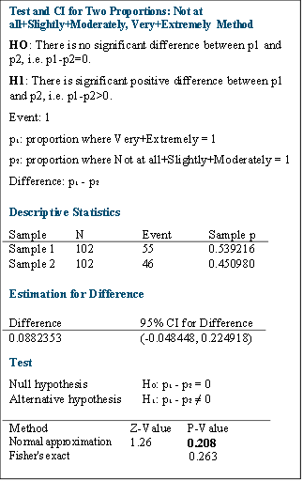

Figure 12. (a) 2-Sample Proportion test for H3 and (b) 2-Sample Proportion Test with clustered data for H3

In order to assess the significance of the difference between the two most common answers, i.e. “Very” and “Moderately”, a 2-Sample Proportion test at a significance level of α=5% was performed, the results are shown in Figure 12(a). The Figure shows that the P-value is 0.319 which is considerably higher than the significance level of 0.05, therefore, the Null hypothesis is accepted. Furthermore, in order to identify the tendency of the responses, a second 2-Sample Proportion test, after clustering the data, was performed. Considering that both “Very” and “Extremely” indicate significant improvement, the two data groups that were tested included “Very” + “Extremely” and “Not at all” + “Slightly” + “Moderately”, the results are shown in Figure 12(b). This figure shows that although the P-value decreased, it is still considerably bigger than the significance level, thus, the null hypothesis is again accepted. This suggests that although IoT implementation supports the improvement on the factors of continuous improvement, i.e. QQ16 as shown in Figure 10, a continuation of improvement on these factors over time is not likely (QQ17).

***4.2.4 Improvements in Lean methods with IoT***

*H4: The utilisation of IoT technologies (RFID, WSN and Middleware) can improve the efficiency of the five essential LM methods (JIT, TPM, Autonomation, VSM and Kaizen).*

Figure 13 presents the data regarding the improvement of LM methods by the three IoT technologies (QQ18). It can be seen that JIT (29.8%) and Autonomation (28.4%) are the LM methods that are most improved by RFID. WSN enhances Autonomation (32.8%), TPM (26.9%) and JIT (20.1%). However, the impact of Middleware is more balanced to the LM methods, as it has similar levels of improvement i.e. VSM (22.6%), Autonomation (22.3%) and TPM (22%).

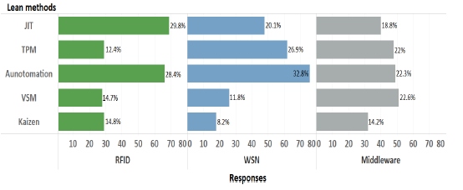

Figure 13. Improvements in Lean methods through IoT technologies for H4

Figure 14, where the bars are scaled horizontally, shows the outcome of QQ19. The figure indicates that management decision is vastly improved by Middleware (60.21) in comparison with WSN and RFID (25.8%, 22.58% respectively). Communication is also mostly improved by Middleware (46.32%) followed by WSN and RFID (35.29% and 22.05%). Similar results can be seen for data gathering. On the other hand, RFID leads to higher improvement for inventory control (49.69%) followed by WSN and Middleware (32.12% and 18.18%), whereas WSN mostly improves the reduction of machines breakdowns (48.06%), identification of shop-floor defects (42.66%) and Lead time (40%) followed by Middleware and RFID.

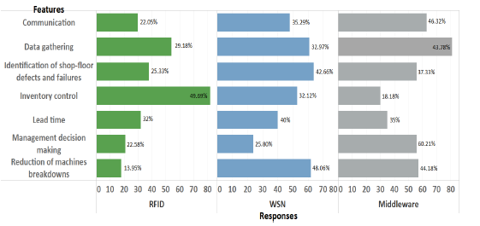

Figure 14. Improvements in some crucial features via LM and IoT

*CRQ4: To what extent does the utilisation of IoT in the shop-floor support the LM objectives of enabling ‘bespoke customer requirements’, improving ‘information and material flow’, eliminating ‘non-value added activities’ and ‘waste’, and deploying a ‘pull production system’?*

CRQ4 was explored using QQ20, see Table 1, based on a Likert scale from 1 (“not at all”) to 5 (“extremely”). The results, presented in figure 15, indicate that lean objectives, represented as features, are improved by IoTs as there is a higher tendency for IoT support for Information and material flow (4.01), and similar tendencies for the other features.

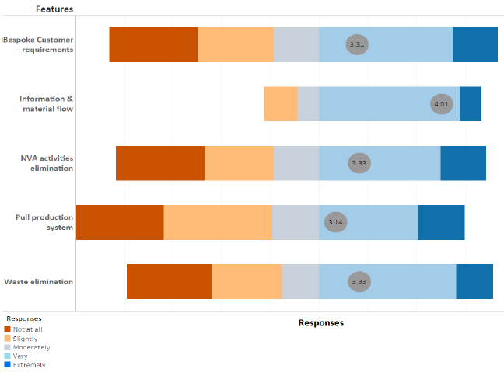

Figure 15. Lean Objectives improved by utilising IoTs

To statistically assess the significance of the difference in the improvement of the objectives, a one-way ANOVA test at a significance level of 5% was conducted (Figure 16). Since an N=102 sample size with a 1-5 Likert scale was employed, assumptions of normality and equal variances of the responses were expected to be true (McClave et al., 2008). Since the P-value in Figure 16 is less than 0.001 at a significance level of α=0.05, the null hypothesis is rejected, indicating that the lean objectives were impacted differently by utilising IoTs. Thus, a Tukey-Pairwise Comparison test was applied to statistically determine which of these objectives were the most impacted by utilising IoTs. The results, which are depicted in Figure 17, indicate that the improvement of information and material flow is the Lean objective that benefits most from utilising IoTs, whilst the remaining Lean objectives receive similar levels of benefits.

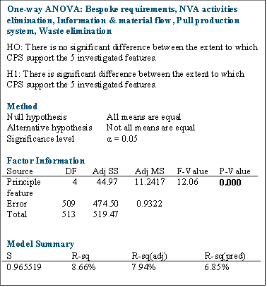

Figure 16. One-way ANOVA test for CRQ4

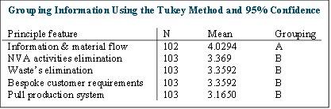

Figure 17. Tukey Pairwise comparison for CRQ4

## 5. Discussion

*RQ1: What are the benefits and limitations of IoT utilisation within manufacturing organisations?*

The findings concerning RQ1, which was addressed through H1, CRQ1 & CRQ2, suggest that IoT significantly improves the operational performance of manufacturing organisations, despite the early stage of the technology. This view is supported by a range of literature that has explored the potential benefits of IoT in the manufacturing sector (Rymaszewska et al., 2017; McKinsey Global Institute, 2016; Alvarez and Marsal, 2016). Furthermore, the improved decision-making resulting from improved data capture using IoTs coupled with communication were found to be the main motivations for IoT utilisation. This supports the views of Bauer et al. (2015) and Wang et al. (2016) regarding IoT’s capability to improve visibility.

The findings also indicate that the lack of standardisation, lack of proper IT infrastructure and high heterogeneity are, in that order of significance, the features that mostly affect IoT performance. This is also in line with the cautions from researchers such as Xu et al. (2014), who argue that technical-based challenges of IoT limit IoT’s capability to achieve a positive impact on manufacturing organisations. Also, Rüttimann and Stöckli (2016) argue that the high variability that IoT technologies introduce into a manufacturing environment impacts the potential to achieve significant performance improvements.

*RQ2: How compatible are LM methods with IoT technologies?*

RQ2 was addressed through H2 and CRQ3. The outcome indicates that that Lean manufacturing methods are compatible with IoT technologies as it was found that organisations that have already implemented LM are more likely to successfully implement IoT technologies. The results also suggest that JIT, TPM, Autonomation, VSM and Kaizen have a similar aiding effect in the successful implementation of IoT. In the literature, the main area of concern with regards to compatibility is the different basis of operation of the two concepts, i.e. LM is managerial whilst IoT is technological (Bauer et al., 2015; Rüttimann and Stöckli, 2016). Schumacher et al. (2016) argue that the increased IT requirements for IoT deployment can increase the complexity of shop-floor operations, in contrast to the simplicity that LM provides to organisations.

The findings derived from this research seem to alleviate these concerns to an extent, and it may be argued that the decentralised nature of both concepts, which facilitate flexibility and customizability, seems to be a synergy that supports their implementation compatibility (Kaspar and Schneider, 2015; Kolberg and Zühlke, 2015). Furthermore, the argument that IoT technologies are more easily implemented in repetitive manufacturing organisations, in which LM methods are highly applicable, supports their compatibility (Strandhagen et al., 2017).

*RQ3: What are the impacts of Lean & IoT on the Continuous Improvement Philosophy*

RQ3, which was explored through H3, found that improvements in information flow, decision- making, productivity and responsiveness constitute, in that order of significance, the most important benefits after the initial combination of LM and IoT. It is interesting but not surprising to see that the outcome of H3, which focused on the benefits accruable after the initial combination of LM and IoT, also aligns with the outcome of CRQ1, which focused on the motivation for such combination. However, there were no improvements in these factors over time, suggesting that the combination of IoT with LM does not enhance the continuous improvement philosophy. This could be attributed to the perception that IoT reduces human involvement despite the support and benefits that IoT provides to people. This aligns with the concerns that have been raised in literature regarding the extent to which the combination of Lean practices with IoT technologies will support the continuous improvement philosophy (Rüttimann and Stöckli, 2016),.

*RQ4: What LM methods are mostly supported through IoT technologies and how?*

RQ4 was explored through H4 and CR4 to identify which LM methods (JIT, TPM, Autonomation, VSM & Kaizen) are mostly supported by specific IoT technologies (RFID, WSN and Middleware). Based on the outcome of RQ3 discussed above, it was not surprising to establish that Kaizen is the least supported with the remaining four methods improved to a high extent.

The RFID technology has the most impact on JIT, followed by Autonomation. For JIT, the impact is mainly by facilitating data gathering for inventory control and lead time management. These are consistent with the literature, for example, Zheng et al. (2020) argue that the real-time data about locations and product’s characteristics that can be obtained through RFID, can contribute significantly to the optimisation of the inventory. Rafique et al. (2016) and Wan et al. (2014) also argue that improvements in lead time can result from the reduction of waiting times and delays within the shop floor through RFIDs capability to improve the traceability of products. For Autonomation, RFID’s capability of gathering real-time data can be seen as its main driver of improvement, as this data can provide information that will enhance the detection of defects within processes, which could interrupt operations (Ma et al., 2017).

For WSN, however, the most impact was on Autonomation, again through interconnectivity and information gathering as supported by Ma et al. (2017), followed by TPM and JIT, where it enables reduction of machines breakdowns, enhanced identification of shop-floor defects and failures, as well as improvements in lead time. Regarding JIT, WSN and RFID have a similar impact on inventory control and lead time. This can be attributed to the capabilities of both technologies to capture data that enhance process flow (Munir et al., 2007).

The results of the study indicate that Middleware produces similar levels of improvements on VSM, Autonomation and TPM. For VSM, this is by enabling improvements in decision-making and communication. Zhong et al. (2016) argue that Middleware can improve decision-makers visibility, thus providing a more holistic view of operations due to its capability to provide access to different business applications that enables integration and holistic data analysis. For Autonomation and TPM, Middleware’s capability for data integration and analysis facilitates the reduction in machines breakdown (Bandyopadhyay et al., 2011).

## 6. Conclusions

This research presents and reflects upon the available literature regarding common and contrasting characteristics and synergies of LM and IoT. Four hypothesis and four complimentary research questions were formulated and investigated. The findings suggest that (1) LM methods are compatible with IoT technologies; (2) improvements in information flow, decision-making, productivity and responsiveness constitute, in that order of significance, the most important benefits of LM and IoT combination; (3) although JIT, TPM, Autonomation and VSM are improved to a high extent by utilising IoT, the continuous improvement philosophy does not receive similar support. It was demonstrated in the discussion that there are consistencies between these findings and the results of previous studies. Therefore, this paper extends our knowledge in the concurrent deployment of LM and I4.0 technologies and addresses a research gap as previously established in Section 1 by:

* Determining the benefits and limitations of IoT utilisation within manufacturing organisations;
* Investigating whether LM, and some of its methods and tools, and the IoT technology are compatible;
* Establishing the impacts of LM and IoT on the Continuous Improvement Philosophy; and
* Determining what LM methods are mostly supported through IoT technologies and how.

The contribution of the research and its findings are highly relevant for businesses and practitioners who are interested in implementing IoT technologies in environments where LM has already been deployed, or vice versa. These are also highly relevant for researchers as the findings are expected to motivate further research in this very significant and current topic. For example, although this research focused on three technologies of IoT (i.e. RFID, WSN and Middleware) as they are more prevalent in industry, further research could also be conducted considering other relevant technologies such as Near Field Communication, Bluetooth and Satellite communication technologies. Additionally, future studies can also consider studying the relationship of LM with a key factor in future IoT development, i.e. network technologies (Peker et al., 2020). This can be considered part of the future research agenda derived from the present study and we encourage researchers to address that research gap.

Due to the current digitalisation trend present in all industrial sectors, organisations in other sectors, besides manufacturing, such as logistics and transport, healthcare, services, among others, and the wider applicability of LM, these other industries can also benefit from this study. Similarly as the manufacturing industry, all these sectors are under extreme pressure to modernise their operations by adopting digital technologies to make sure that they remain competitive and are more sustainable. The effective implementation of IoT and other efficiencies–based approaches such as LM can offer them a prospect to achieve this endeavour.

This study’s extent and scope were limited by some constraining factors that should be considered when defining a future research agenda. Firstly, this research was conducted within the manufacturing industry’s context only. For this reason, future research is required to understand the interaction of LM and IoT technology in other industrial sectors. This will provide evidence of the role that industry characteristics may have on the interaction of these. Additionally, future research can also be underpinned considering academic and research experts as the current research only involved industry experts, resulting in the investigation of

LM and IoT’s interaction only from a pragmatic standpoint. Furthermore, the research and data collection employed as part of the present research limited the ability of the industry experts to express opinions other than those pre-set answers and intensity established by the Likert scale. To address this limitation, qualitative interviews with selected companies can be conducted and combined with the quantitative approach followed by the present research. In this research, the interaction of combining LM and IoT has been investigated. Future research can also focus on such combination but in this case, exploring their combined effect on the operational and sustainability performance of companies.

## References

Alvarez and Marsal (2016), “Lean Takes A Leap with IoT How Companies Are Already Turning the Promise of Tiny Sensors into Massive Efficiency Gains”, Available at: https://www.alvarezandmarsal.com/sites/default/files/am-lean_takes_a_leap_with_iot.pdf (accessed on 15 April 2020).

Bandyopadhyay, S., Sengupta, M., Maiti, S., & Dutta, S. (2011). Role of Middleware for

Internet of Things: a Study. International Journal of Computer Science & Engineering Survey (IJCSES), 2(3), 94–105.

Andreadis, L., Garza-Reyes, J.A., Kumar, V. (2017). Towards a conceptual framework for Value Stream Mapping (VSM) implementation: An investigation of managerial factors. International Journal of Production Research. 55(23), 7073-7095.

Behrendt, A., Muller, N., Odenwalder, P., Schmitz, C. (2017). Industry 4.0 demystified—lean’s next level. McKinsey.

Belekoukias, I., Garza-Reyes, J. A., Kumar, V. (2014). The impact of lean methods and tools on the operational performance of manufacturing organisations. International Journal of Production Research, 52(18), 5346–5366.

Bell, E., Bryman, A. (2007). The ethics of management research: An exploratory content analysis. British Journal of Management, 18(1), 63–77.

Binti Aminuddin, N.A., Garza-Reyes, J.A., Kumar, V., Antony, J. (2016). An analysis of managerial factors affecting the implementation and use of Overall Equipment Effectiveness. International Journal of Production Research, 54(15), 4430-4447.

Bryman, A. (2016). Social research methods. 5th ed., Oxford University Press, Oxford, UK.

Buer, S.V., Strandhagen, J.O., Chan, F.T.S. (2018). The link between Industry 4.0 and lean manufacturing: mapping current research and establishing a research agenda. International Journal of Production Research, 56(8), 2924-2940.

Forza, C. (2016). Surveys. In C. Karlsson (Ed.). Research methods for operations management (pp. 79-164) (2nd Ed.), Routledge, NY.

Garza-Reyes, J.A., 2020. The future of manufacturing: lean 4.0. The Future Factory. Available at: https://www.thefuturefactory.com/blog/47. (Accessed 06 February 2021).

Garrido-Hidalgo,C., Olivares, T., Ramirez, F.J., Roda-Sanchez, L. (2019). An end-to-end Internet of Things solution for Reverse Supply Chain Management in Industry 4.0. Computers In Industry, 112, 103127.

GE Digital (2019) Everything you need to know about the industrial internet of things. Available at: https://www.ge.com/digital/blog/everything-you-need-know-about-industrial-internet-things (Accessed 31/03/2021).

German Frank, A., Santos Dalenogare, L., Fabian Ayala, N. (2019). Industry 4.0 technologies: Implementation patterns in manufacturing companies. International Journal of Production Economics, 210, 15-26.

Ghobakhloo, M., Fathi, M., Corporate survival in Industry 4.0 era: the enabling role of lean-digitized manufacturing. Journal of Manufacturing Technology Management, 31, 1, 1-30.

Gilchrist A. (2016) Introduction to the Industrial Internet. In: Industry 4.0 - The Industrial Internet of Things. Apress, Berkeley, CA. https://doi.org/10.1007/978-1-4842-2047-4_1

Hair, J.F., Risher, J.J., Sarstedt, M., Ringle, C.M. (2019). When to use and how to report the results of PLS-SEM. European Business Review, 31, 1, 2-24.

Ehie, I.C., Chilton, M.A. (2020). Understanding the influence of IT/OT Convergence on the adoption of Internet of Things (IoT) in manufacturing organizations: An empirical investigation, 115, 103166.

HPE Hewlett Packard Enterprise (2019) O que é a Internet das Coisas Industrial (IIoT)? Available at: https://www.hpe.com/br/pt/what-is/industrial-iot.html (Accessed 31/03/2021).

Hutton, W. (2016). Stepping up to the Factory of the Future. Quality, 44–47.

Kaspar, S., Schneider, M. (2015). Lean Und Industrie 4.0 in Der Intralogistik: Effizienzsteigerung Durch Kombination Der Beiden Ansätze. Intralogistik. Available at: https://www.pull-beratung.de/wp-content/uploads/2016/05/KasparS.SchneiderM._Lean-und-Industrie4.0-in-der-Intralogistik-Effizienzsteigerung-durch-Kombination-der-beiden-Anstze.pdf (accessed on 02 July 2019).

Keller, M., Rosenberg, M., Brettel, M., Friederichsen, N. (2014). How Virtualization, Decentrazliation and Network Building Change the Manufacturing Landscape: An Industry 4.0 Perspective. International Journal of Mechanical, Aerospace, Industrial, Mechatronic and Manufacturing Engineering, 8(1), 37–44.

Khanchanapong, T., Prajogo, D., Sohal, A.S., Cooper, B.K., Yeung, A.C.L., Cheng, T. C.E. (2014). The unique and complementary effects of manufacturing technologies and lean practices on manufacturing operational performance. International Journal of Production Economics, 153, 191-203.

Kirkham, L., Garza-Reyes, J.A., Kumar, V., Antony, J. (2014). Prioritisation of operations improvement projects in the European manufacturing industry*.* International Journal of Production Research, 52(18), 5323-5345.

Kolberg, D., Knobloch, J., Zühlke, D. (2017). Towards a lean automation interface for workstations. International Journal of Production Research, 55(10), 2845–2856.

Kolberg, D., Zühlke, D. (2015). Lean Automation enabled by Industry 4.0 Technologies. IFAC-PapersOnLine, 28(3), 1870–1875.

Ma, J., Wang, Q., Zhao, Z. (2017). SLAE–CPS: Smart lean automation engine enabled by cyber-physical systems technologies. Sensors (Switzerland), 17(7).

Marodin, G.A., Saurin, T.A. (2013). Implementing lean production systems: Research areas and opportunities for future studies. International Journal of Production Research, 51(22), 6663-6680.

McClave, J., Benson, G., Sincich, T., (2008). A First Course in Business Statistics (2nd ed.)., Pearson College, London.

McKinsey Global Institute. (2016). Industry 4.0 after the initial hype – Where

manufacturers are finding value and how they can best capture it. McKinsey Global

Institute.

Meudt, T., Metternich, J., Abele, E. (2017). Value stream mapping 4.0: Holistic examination of value stream and information logistics in production. CIRP Annals, 66(1), 413-416.

Möldner, A.K., Garza-Reyes, J.A., Kumar, V. (2020). Exploring Lean Manufacturing Practices' Influence on Process Innovation Performance. Journal of Business Research, 106, 233-249.

Mrugalska, B., Wyrwicka, M. K. (2017). Towards Lean Production in Industry 4.0. Procedia Engineering, 182, 466–473.

Munir, S. A., Ren, B., Jiao, W., Wang, B., Xie, D., & Ma, J. (2007). Mobile wireless sensor network: Architecture and enabling technologies for ubiquitous computing. Proceedings - 21st International Conference on Advanced Information Networking and Applications Workshops/Symposia, AINAW’07, 1, 113–120. https://doi.org/10.1109/AINAW.2007.257

Papacharissi, Z. (2009). The Virtual Geographies of Social Networks: A Comparative Analysis of Facebook, LinkedIn and ASmallWorld. New Media & Society 11(1–2), 199–220.

Pekar, A., Mocnej, J., Seah, W.K.G., Zolotova, I. (2020), “Application Domain-Based Overview of IoT Network Traffic Characteristics”, ACM Computers Survey, 53(4), 87:1-87-33.

Pivoto, D.G.S; de Almeida, L.F.F; da Rosa Righi, R.; Rodrigues, J.J.P.C; Lugli, A.B.; Alberti, A.M. (2021) Cyber-physical systems architectures for industrial internet of things applications in Industry 4.0: A literature review. Journal of Manufacturing Systems 58(2021)176-192.

Rafique, M.Z., Ab Rahman, M.N., Saibani, N., Arsad, N., Saadat, W. (2016). RFID impacts on barriers affecting lean manufacturing. Industrial Management and Data Systems, 116(8), 1585–1616. Robson, C. (2011). Real world research. Edition. Blackwell Publishing. Malden.

Robson, C. (2011). Real World Research. 3rd ed., John Wiley, Chichester.

Rosin, F. Forget, P., Lamouri, S., Pellerin, R. (2020). Impacts of Industry 4.0 technologies on Lean principles. International Journal of Production Research, 58,6, 1644-1661.

Roy, D., Mittag, P., Baumeister, M. (2015). Industrie 4.0 – Einfluss der Digitalisierung auf die fünf Lean-Prinzipien - Schlank vs. Intelligent. Productivity Management, 20, 27-30.

Rüttimann, B.G., Stöckli, M.T. (2016). Lean and Industry 4.0—Twins, Partners, or Contenders? A Due Clarification Regarding the Supposed Clash of Two Production Systems. Journal of Service Science and Management, 9, 485–500.

Rymaszewska, A., Helo,P., Gunasekaran, A. (2017). IoT powered servitization of manufacturing – an exploratory case study. International Jurnal of Production Economics, 192, 92-105.

Sanders, A., Elangeswaran, C., and Wulfsberg, J. (2016). Industry 4.0 Implies Lean Manufacturing: Research Activities in Industry 4.0 Function as Enablers for Lean Manufacturing. Journal of Industrial Engineering and Management, 9(3), 811–833.

Sanders A., Subramanian K.R., Redlich T., Wulfsberg J.P. (2017) Industry 4.0 and Lean Management – Synergy or Contradiction?. In: Lödding H., Riedel R., Thoben KD., von Cieminski G., Kiritsis D. (eds) Advances in Production Management Systems. The Path to Intelligent, Collaborative and Sustainable Manufacturing. APMS 2017. IFIP Advances in Information and Communication Technology, 514. Springer.

Saunders, M., Lewis, P., Thornhill, A. (2016). Research methods for business students (7th ed). Pearson Education, Harlow, UK.

Saurin, T., Tortorella, G., Soliman, M., Garza-Reyes, J.A. (2020). Lean production myths: An exploratory study. Journal of Manufacturing Technology Management – in press.

Schumacher, A., Erol, S., Sihn, W. (2016). A maturity model for assessing Industry 4.0 The readiness and maturity of manufacturing enterprises. Procedia CIRP, 52, 161–166.

Sivo, S.A., Saunders, C., Chang, Q., Jiang, J.J. (2006). How Low Should You Go? Low Response Rates and the Validity of Inference in IS Questionnaire Research. Journal of the Association for Information Systems, 7(6), 351–413.

Staufen, A.G. (2018). Deutscher Industrie 4.0 Index 2018. Available at: <https://www.staufen.ag/fileadmin/HQ/02-Company/05-Media/2-Studies/STAUFEN.-Studie-Industrie-4.0-Index-2018-Web-DE-de.pdf> (Accessed on 3 June 2019).

Strandhagen, J.W., Alfnes, E., Strandhagen, J.O., Vallandingham, L.R. (2017). The fit of Industry 4.0 applications in manufacturing logistics: a multiple case study. Advances in Manufacturing, 5(4), 344-358.

Tortorella, G.L., Fettermann, D. (2018). Implementation of Industry 4.0 and lean production in Brazilian manufacturing companies. International Journal of Production Research, 56(8), 2975-2987.

Wagner, T., Herrmann, C., Thiede, S. (2017). Industry 4.0 Impacts on Lean Production Systems. Procedia CIRP, 63, 125–131.

Wang, B., Zhao, J., Wan, Z., Ma, J., Li, H., Ma, J. (2016). Lean Intelligent Production System and Value Stream Practice. 3rd International Conference on Economics and Management (ICEM 2016), Suzhou, Jiangsu, China, 2-3 July.

Womack, J. P., & Jones, D. T. (1996). Lean Thinking: Banish Waste and Create Wealth

in your Corporation. (New York: Free Press, Ed.). Rawson associates.

Xu, L. Da, He, W., Li, S. (2014). Internet of things in industries: A survey. IEEE Transactions on Industrial Informatics, 10(4), 2233–2243.

Yin, Y., Stecke, K.E., Li, D. (2018). The evolution of production systems from Industry 2.0 through Industry 4.0. International Journal of Production Research, 56(1–2), 848–861.

Zheng,Y., Qiu,S., Shen,F., He, C. (2020). RFID-based material delivery method for mixed-model automobile assembly. Computers & Industrial Engineering, 139, 106023.

Zhou, L., Chong, A.Y.L., Ngai, E.W.T. (2015). Supply chain management in the era of the Internet of Things. International Journal of Production Economics, 159, 1-3.