Optimal design of cold roll formed steel channel sections under bending considering both geometry and cold work effects
S.J. Qadir¹, V.B. Nguyen¹*, I. Hajirasoulih², B. Cartwright³, M.A. English³
¹ Department of Mechanical and Built Environment, University of Derby, Markeaton Street, Derby, DE22 3AW, United Kingdom
² Department of Civil and Structural Engineering, Sir Frederick Mappin Building, Mappin Street, Sheffield, S1 3JD, United Kingdom
³ Hadley Industries plc, PO Box 92, Downing Street, Smethwick, West Midlands, B66 2PA, United Kingdom
* Corresponding author.
Tel: +44 1332 593587 1330.
Email: VB.Nguyen@derby.ac.uk (V.B. Nguyen)

Abstract
Optimal design of a structural member is a design process of selecting alternative forms to obtain its maximum strength while maintaining the same weight, leading to the most economical and efficient structure. Amongst steel structures, cold rolled steel ones can effectively gain this requirement as they are thin-walled structures that offer the high ratio of strength over weight. However, the design is very challenging as these members are prone to buckling and failure at low loads. In this paper, the buckling and ultimate strength of cold rolled channel sections was studied using numerical modelling. In order to improve the section strength, the development of various alternative cold rolled formed sections included additional bends such as intermediate stiffeners. The section strength was optimised through a practical approach which altered the stiffener’s position and shape and searched for maximum buckling and ultimate strength under bending. In this approach, a nonlinear Finite Element model was first developed for an industrial channel beam subjected to four-point bending tests and this model was validated against experimental test data. The verified model was then used to conduct a parametric study in which the effects of a stiffener’s properties on the section strength including its position, shape, size and material properties by the cold work at bends were investigated in detail. Several different cold rolled channel sections having intermediate stiffeners at web and flanges with and without the cold work effect on material properties at the stiffener’s bends were considered for this investigation. In addition, a design method, the Direct Strength Method (DSM), was utilised to take into account the effects of a stiffener’s properties on the section strength and results were compared with the Finite Element modelling results. It was found that some significant improvements were obtained for the section strength of the optimised sections in comparison to the original sections. An optimal shape for the channel section with maximum ultimate strength in distortional buckling could be obtained with both the stiffeners’ position, shape, size and quantity, and the cold work effect. The cold work effect was found most significant in the cases of changing the width of the web stiffeners and the position of the flange stiffeners. It also revealed that, the currently available DSM beam design curve for distortional buckling provided good agreement in predicting buckling load and ultimate strength capacity for most of the considered sections with and without the cold work effect included; however, the DSM provided overestimate results compared to the Finite Element model results in the sections with web intermediate stiffeners, in particular, when the tip of web intermediate stiffener moved away from the web-flange junction in the horizontal direction.
Keywords
Optimal design; cold rolled steel channel; distortional buckling; ultimate bending moment; Finite Element modelling; cold work influence

Introduction
Cold-formed steel (CFS) members largely produced by cold rolled forming or press braking processes that have been widely used in various applications in building construction. Traditionally, they have been primarily used as secondary members such as framing members, purlin, lintels, side rail, gable systems etc. However, in the past decade, there has seen a dramatic expansion in their applications as primary members in primary structure in low to mid-rise buildings where they can be available in a choice of systems to suit virtually any requirement in terms of span, load, and complexity compared to hot-rolled steel structure counterparts [1]. Generally, the most economic method of manufacturing cold-formed sections is the cold rolled forming process, and most advanced profile systems for almost every cross-section types have been produced and made construction faster and easier [2]. This advancement in the manufacturing process also requires seeking optimal design solutions that minimize the initial steel strip of the section to a minimum while maintaining the structural performance, hence reducing the major financial outlay in the process which is the material cost. Cold-formed steel sections are thin-walled structures that have high ratios of strength-to-weight; however, they are prone to local or distortional buckling at low loads. There have been different solutions to increase the strength of cold-formed sections including buckling and ultimate strengths. This could be done through applying the mechanical work (or cold work) to enhance the material strength by imparting a dimpled surface deformation to the whole steel strip prior to the forming process [3]. However, the most popular development has been the inclusion of additional bends in the cross-section such as intermediate stiffeners [4-8]. These stiffeners subdivide the plate elements into smaller sub-elements and hence can considerably increase the local buckling of cold-formed sections subjected to compressive stresses due to the smaller width-to-thickness ratio of the sub-elements.
Many researchers have previously carried out the optimisation of predefined orthodox CFS cross-sections including channel, zed and sigma sections so as to optimise the relative dimensions of the sections. A neural network methodology for the optimal cross-sectional design of CFS steel beam members was developed for the hat- and I-sections [9]. Other studies [10, 11] also optimised the geometry of CFS channel beams subjected to uniformly distributed load and columns under a compressive axial load using Micro Genetic Algorithms, respectively. Various load levels were considered in the studies to obtain an optimum design curve from numerical results. A theoretical study on the optimisation of lipped channel beams under uniformly distributed transverse load was presented to maintain the local, distortional, and global buckling strength as well as yielding, in combination with allowable deflection limits while minimising the coil width [12]. The shape optimisation of CFS channel beams with closed drop flange and open flange was also described in [13]. They observed that the closed drop flanges can provide better structural performance compared to standard lips or open drop flanges. However, the efficiency of the optimised sections may not provide significant improvements of the ultimate strength of the members due to the fact that CFS sections are highly susceptible to local, distortional, global, and the interaction between these buckling modes. Several investigations have been conducted which aimed at enhancing the buckling load by including ribs and stiffeners to the web and flanges of the predefined cross-sections [4-8]. Other researchers investigated the effect of cold work on the ultimate load of the structural column [14] and beam members [15] by including the enhanced stress-strain curve to ribs and stiffeners of the orthodox cross-sections.
The development of zed section with longitudinal stiffeners in the web, introduced during the cold roll forming using an analytical method [16] suggested that when the stiffeners were placed about one fifth of the web width from each flange, the problem of local buckling in the web was eliminated. The channel section with longitudinal stiffeners in the web was later developed in an attempt to incorporate the innovative web stiffener configuration used in the new zed, into a channel shape [17]. These new sections have a considerably improved bending strength to weight ratio considerably by using the web stiffener types. Additional stiffeners in channel and zed sections that have large width-to-thickness ratios were added to introduce a greater degree of work hardening, which raised the material yield strength in these regions, increased further advantage of eliminating the local and distortional buckling. In addition to bending strength, comprehensive experimental studies [18, 19] were conducted to provide test data on complex C-sections and stiffened web channels with various stiffener sizes subjected to pure bending, shear and combined bending and shear. These studies showed that the longitudinal intermediate stiffeners in the web could considerably improve the bending and the shear strength of the channel sections. Recent investigations by Nguyen et al. [20, 21] using Finite Element analysis and optimisation techniques have proved that when the two symmetrical stiffeners on the web were placed as much closely as possible to each flange, maximum buckling and ultimate strengths for the section were achieved. The effects of both edge and intermediate stiffeners in the compression and tension flange of the cold-formed steel zed sections were investigated [22]. They found out that the flexural strength capacity increased when the intermediate stiffeners moved towards the web and flange junction. A study using Particle Swarm Optimisation method to enhance the maximum bending capacity of different cross-sectional prototypes was also carried out [23]. It was observed that using two stiffeners in a symmetrical arrangement reduced the strength capacity of the section compared to other optimised sections. Mojtabaei et al. [24] developed an optimum CFS beam using Big Bang-Big Crunch optimisation. The study concluded that using intermediate stiffeners at web did not increase the bending strength capacity and stiffness of the section, which confirmed the study carried out by the previous study results [23]. Most recently, a new approach was developed by Nguyen et al. [25] for optimal design of structural profiles by cold roll forming using a combined approach of Finite Element modelling and optimisation utilising Design Of Experiment method. In this approach, the dimensions of the product were defined as geometric parameters in the Finite Element modelling; in the design of experiments, these parameters were automatically assigned a range of values and a response surface model was used to determine parameter values that achieved the target optimised performance. This was used for the development of a channel section with longitudinal stiffeners in the web, considering the maximum buckling load as the target for the optimisation.
In addition to analytical and numerical studies on optimisation of cold-formed steel sections with intermediate stiffeners, design methods including the Direct Strength Method (DSM) has also been used which was capable of obtaining the nominal strength of structural column and beam members with arbitrary cross-section geometries provided the engineer specifies the elastic buckling instabilities and its yield strength (i.e. local, distortional and global buckling with the load at yield determined with the aid of the open source software CUFSM [26]). The Bayesian classification optimisation technique implemented into DSM and CUFSM by Liu et al. [27] to search for an enhanced cross-section strength of columns. The authors also investigated the lip stiffeners and the shape of one stiffener at mid height of channel section. They found that the addition of lip stiffeners and web stiffeners increased the local buckling stress remarkably and made distortional buckling mode dominant the behaviour. Leng et al. [28] also used DSM and CUFSM and simulation of annealing algorithm to seek for cross-section with maximum axial strength. The symmetry and antisymmetric cross-sections with stiffeners at the mid height of the section (channel and zed sections) were part of the investigation. They found that complex stiffeners provided improved ultimate strength compared to simple stiffeners.
It should be noted that, however, the majority of these above studies were for columns under compression or hat sections under bending and there have been limited investigations on channel and zed sections with web stiffeners subjected to bending stresses. Regarding optimisation, there has been a limited study on the stiffener’s geometric effects including shape and position of the stiffeners to the section strength under bending. In these numerical studies, it was all assumed that the material properties at corner and bends of the intermediate stiffeners were the same with those at flat sections. On the other words, the effect of the cold work by the cold roll forming manufacturing process in enhancing the material properties at the stiffener’s corners was not considered, which was not realistic. This meant that there have been not available any optimal design studies that took into account the effect of both the stiffeners’ geometry and the cold work effect on the strength of the section.
Therefore, this study aims to explore the effect of both the stiffeners’ geometry and the cold work effect on the buckling and ultimate strength of channel sections with longitudinal stiffeners under bending. A Finite Element model was first developed to replicate four-point bending tests of an industrial channel and zed sections and the results were validated against the experimental data. A comprehensive parametric study was then conducted to investigate the effects of stiffeners’ shapes, sizes, positions and cold work induced from the cold roll forming process on the section’s buckling and ultimate strengths, which eventually led to the optimal design of the channel section. The Finite Element results were also compared with those obtained from the Direct Strength Method, which was utilised to take into account the effect of the cold work on the section’s material properties. Alongside the Direct Strength Method, many of the current design codes including the European standard Eurocode 3 [29] use the traditional Effective Width Method to determine the strength of cold formed steel members. However, the design of the channel and zed sections with complex folded-in stiffeners used in this study using this method was very complicated and impractical. In addition, the incorporation of computing buckling modes such as distortional buckling could be difficult for these sections. Therefore, it has not yet a suitable method to be used for the purposes of optimisation in this research.

Reference test programme
This section summarises the key information of the reference testing programme reported previously [30] and the data which was used to validate the FE simulations. The cold roll formed steel channel and zed beams, commonly used in industrial roof systems, were used in this study. The beam specimens were channel and zed sections which were the industrial UltraBEAMTM2 and UltraZEDTM2 sections (Hadley Industries plc.), respectively; they were cold roll formed along the rolling direction on steel coils. Fig. 1 shows the overall view of the test setup which replicated the configuration of a four-point bending test. Cleats were bolted to the web of the specimens at the loading points and the end supports which were fixed to the beam webs to avoid web crippling problems at these locations. Half round blocks were used to ensure that the load applied to cleats was a point load. A rotating end station was provided to model the pin end condition of the beams at the end supports. Small steel angles 45x45 mm were periodically attached to the top and bottom flanges of two specimens.
The tests were carried out using a calibrated 220-kN capacity load cell and an electric machine screw jack. Four electrical strain gauges were used (one in the top flange, two in the large part of the web, and one in the bottom flange) to measure the axial strains along with the web and flanges of the cross-section of the beam specimens. The vertical displacements from the top and bottom of the beam specimens were also determined using LVDTs or displacement transducers. A downward load was symmetrically applied via the load cell which moved vertically down at two support cleats at the position of one-third of the main span. The specimens were loaded using the electric screw jack and the displacement control used to reach the load cell actuator at a constant rate of 2.5 mm/min. The specimens were loaded to failure and the test stopped at a load about 90% of the ultimate load. The test data including load, displacement and strain gauge readings provided the user plots load-displacement curve was recorded by the DASYLab data acquisition software. Failure modes were also recorded by photos and deformations and locations were measured. Four duplicated tests were performed for each section referenced to take into consideration the testing conditions and variation in samples. A total of 20 different sections of UltraBEAM™2 and UltraZED™2 sections were investigated. Each section with the same depth had three different thicknesses that ranged from 1.20 mm to 3.05 mm in order to cover a wide popular range of section slenderness used in building construction. Four duplicated tests were carried out for each section so there were 116 tests in total for both sections.
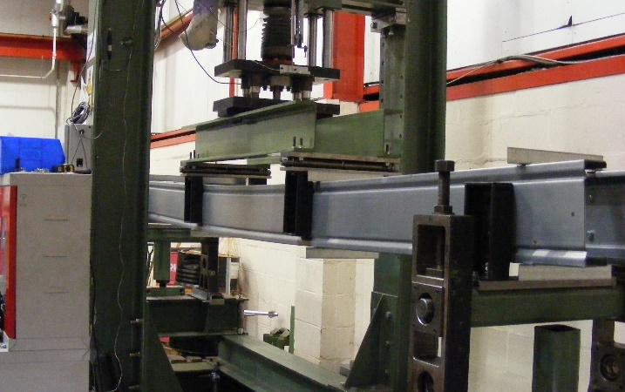
Fig. 1. A typical four-point bending test setup with channel sections.

The tested UltraBEAMTM2 and UltraZEDTM2 sections was used for validation and later referred as the reference section for the parametric study of the Finite Element models and the Direct Strength Method. It had cross section and general dimensions as shown in Fig. 2. The test configuration for these sections consisted of a pair of 2920 mm long channel or zed sections placing in parallel with a central span of 2691 mm. The four-point bending testing setup including the lateral braces was conducted approximately reflecting their configurations in real applications. The steel angles 45x45 mm were attached to the top and bottom flanges of two specimens symmetrical to the mid-span. The practical bracing length was about 900 mm as shown in the test setup in Fig. 1. This length was also examined in the FE model and showed that in general it was sufficient to determine the minimum length required to generate distortional buckling results that were not boundary condition dependent. Hence, the FE model developed and validated against this four-point bending testing setup as presented in Section 3, was utilized for the parametric study.

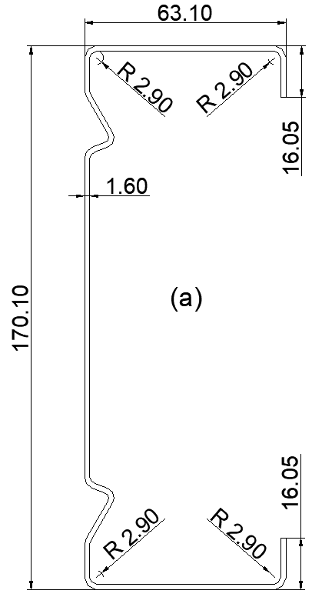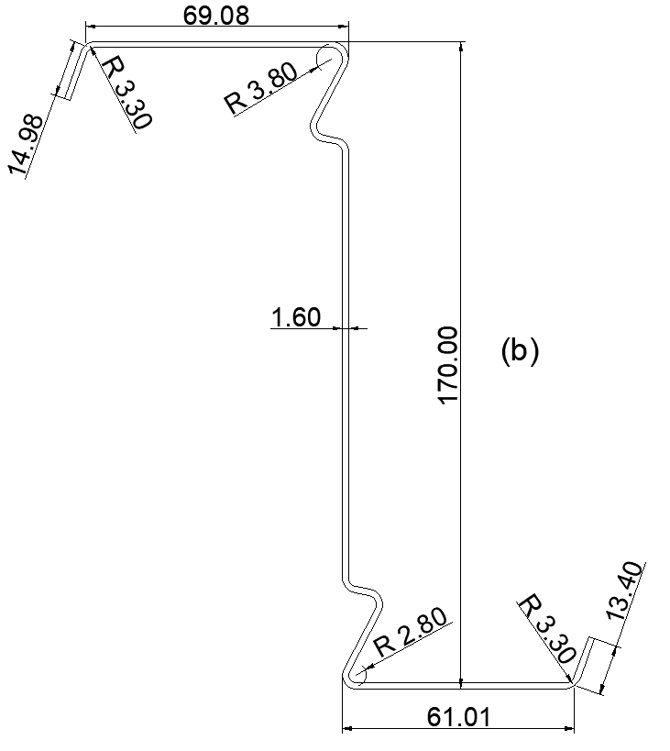
Fig. 2. Cross section and dimensions (in mm) of the beam specimens used in experimental tests: (a) channel section, and (b) zed section.

Finite Element modelling

General modelling setup
Finite Element (FE) model was conducted using ANSYS (Version 18.1, ANSYS, Inc.) [31] to simulate the four-point bending test of the beams. In the simulation validation, the channel section had a total length of 2920 mm, a span of 2691 mm, a load centre of 897 mm, thickness of 1.60 mm, flange width of 63 mm, web width of 170 mm, and lip length of 16 mm. The zed section had a total length of 2920 mm, a span of 2691 mm, a load centre of 897 mm, thickness of 1.60 mm, top flange width of 69 mm and bottom flange width 61 mm, web width of 170 mm and lip length of 15 mm.
In the FE models, two different arrangements were considered for the purpose of validation: (1) a full model in which the two beam specimens were modelled similar to the actual setup in the experimental test, and (2) a half model in which only one beam specimen was modelled and appropriate boundary conditions were used to model the symmetry about the longitudinal axis of the full system. The full model had the same arrangement with the laboratory test setup. The two channel specimens (flanges faced inwards) were modelled with 180 mm distance between their webs. The 45x45 mm angle braces connecting the top and bottom flanges were modelled using shell element, which only provide lateral restraints. The results obtained from full models were compared to those of the half model with symmetry conditions for verification purpose (results not shown). It was found that the difference in maximum load capacity was very small, 0.07%, which could be negligible. However, the full model required considerable computational time (3 times in comparison to the half model). Therefore, the half model setup was used to conduct all numerical investigations in this study.
Fig. 3 displays the overall arrangement for the half model with symmetry conditions. To model the lateral braces corresponding to the connection positions of the angle-to-beam screws in the actual test, tie nodes at the central of the connection were used to rigidly connected to three nodes from the compression / tension flanges and these tie nodes were restricted against the transverse direction. Similarly, sets of nodes at supports and loading points were tied together by reference points at the centre of the nodes using rigid connections to model the connections of cleats attached to the web of the section (by bolted connections). These reference points were restricted against the transverse and vertical movement as well as out-of-plane movements including torsional rotations. The beams were also restricted against the longitudinal movement by adding additional longitudinal restraints at nodes in their tension flanges at the mid-span line. The vertical loads were applied at the reference points at one-third of the beams.
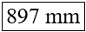
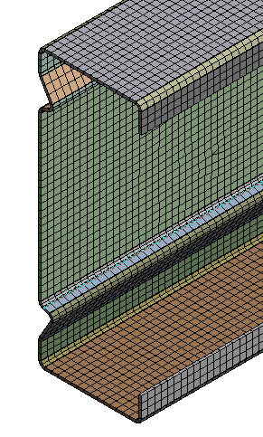
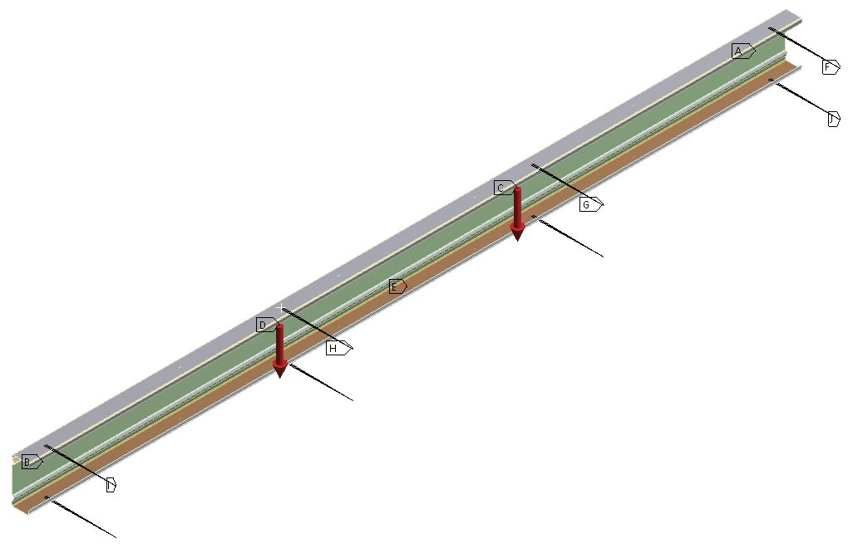

Fig. 3. Finite Element symmetry model with boundary conditions and closer view of the mesh of the channel section (in the box).
The general-purpose 4-noded quadrilateral, shell elements with reduced integration namely SHELL181, were selected. The shell element SHELL181 was defined with two layers through the thickness of the section. Each layer had three integration points. Therefore, there were 6 integration points through the thickness of the section. These elements had three translational and three rotational degrees of freedom at each node that take finite membrane and large rotations into account that are suitable for large-deformation and geometrically non-linear issues in this study.
Four different mesh sizes were used to study the influence of the mesh parameter on the accuracy of the simulation results. They included sizes of 20x20 mm, 8x8 mm, 4x4 mm, and 2x2 mm, these corresponded to a total number of elements of 5694, 21900, 70810 and 233600, respectively. The results showed that maximum difference between the ultimate loads of the 20x20 mm and the 2x2 mm was less than 5%, and when the mesh size was smaller than 4x4 mm the difference in slopes and ultimate loads was so small that could be neglected. The difference in ultimate load was less than 0.5% compared to the 2x2 mm mesh, whereas it was substantially more computationally efficient. Therefore, the 4x4 mm mesh was selected in this study as it could guarantee that the simulation results agreed well with the experimental ones as well as it was small enough to accurately model the corners and stiffener’s bends of the section.
The measured material properties obtained in Nguyen et al. [30] were used for flat regions in the FE models. An elastic plastic material model was used as input material for steel for FE modelling. The material had Young’s modulus (E) of 205 GPa and Poisson’s ratio (ѵ) of 0.3. The FE model requires the input of the material stress-strain data in the form of the true stress $σ_{true}$ and the plastic strain $ε_{true}^{pl}$ obtained from the engineering stress-strain data ($σ_{eng}$ ,${ ε}_{eng}$) as follows:
$σ_{true}= σ_{eng} \left(1+ { ε}_{eng}\right)$ $(1)$
$ε_{true}^{pl}= ln \left(1+ { ε}_{eng}\right) - \frac{σ_{eng}}{E}$ $(2)$
The engineering stress and strain data of the steel material from the flat parts of the channel section were obtained from the tensile tests and shown in Fig. 4.

Fig. 4. Engineering stress-strain data of the flat steel material of the channel section [30].
The material properties of steel material at the section bends (corners and intermediate stiffeners) had significantly higher yield stress and tensile strength than the flat parts of the section since the material in the bends was cold worked to a considerably higher degree than the material in the flat parts. In this study, the material properties of steel material at the section bends influenced by the cold work were obtained by using formulae from the North America specification [32] for cold formed structural members. The specification permits the utilization of the increased yield strength at corner and bend regions of the section, $f_{yc },$ which was originally developed by Karren [33]. In addition, for the plastic region of stress-strain curve, the equation developed by Hadarali and Nethercot [34] was used to model the slope of the inelastic region, which was E/50.
Geometric and material nonlinearity that occurred within the model were taken into account, thereby effectively modelling large strains and rotations. The displacement was increased in successive increments until the beams failed. In the nonlinear analysis, a full Newton-Raphson method was used for the iterative procedure and an implicit, static analysis was employed. The following values and criteria ranges were set for the force convergence (values = 2024 to 0.4272E+05 and criterion = 28.10 to 139.8), moment convergence (values = 0.9254 to 11.99 and criterion = 0.3074E-01 to 0.5385) and displacement convergence (values = 0.9592E-04 to 0.3157E-03 and criterion = 0.1265E-03 to 0.2688E-03). The line search was activated in order to select constant stabilization. The energy method was selected with energy dissipation ratio of 1e⁻⁰⁰⁴ and stabilization force limit of 0.2. This allowed to accurately model the load displacement response.

Determination of buckling modes and geometric imperfections
Two different methods were used to model the first step, elastic buckling step, of the analysis in order to take the shape and distribution of initial imperfections for FE models of beam bending tests: (1) conducting elastic buckling analysis with the conventional Finite Element Model (FEM) via ANSYS, and (2) conducting elastic buckling analysis with Finite Strip Method (FSM) using CUFSM [26]. A linear elastic buckling analysis was carried out with FEM to obtain appropriate buckling modes (Eigenmodes) including distortional buckling modes for this study. These buckling modes were fed into the nonlinear analysis to include the shape and distribution of initial imperfections. Fig. 5 shows the distortional buckling mode obtained from the elastic buckling analysis in FEM. This distortional buckling mode was the first mode with two half-waves along the constant moment span. The FEM first buckling mode was compared to experimental ones and the mode shape deemed to be similar to the mode observed in the tests. Therefore, the first buckling mode shape was selected to generate imperfections. The maximum amplitude of the buckling mode shape was generally used as a degree of initial imperfection. Using the first buckling mode shape derived from the elastic buckling analysis for the nonlinear analysis, together with appropriate initial geometric imperfections could result in an accurate failure mode and strength capacity for the FE model. There have been several methods proposed to determine appropriate magnitudes for initial geometric imperfections. Schafer and Peköz [35] suggested the cumulative distribution function (CDF) values for the maximum imperfections be used for type 1 (local buckling d₁) and type 2 (distortional buckling d₂). Other researchers also defined the imperfection values in term of the plate thickness t [36, 37]. Table 1 displays the initial geometric imperfection values considered in the FE models and the results were compared with the test result as shown in Fig. 6.
Table 1 Initial geometric imperfection values proposed by different studies.
Studies | Local buckling | Distortional buckling
Schafer and Peköz [35] | 25% CDF magnitude = d₁/t = 0.14 | 25% CDF magnitude = d₁/t = 0.64
 | 50% CDF magnitude = d₁/t = 0.34 | 50% CDF magnitude = d₁/t = 0.64
 | 75% CDF magnitude = d₁/t = 0.66 | 75% CDF magnitude = d₁/t = 1.55
Chou et al. [36] | 0.1t, 0.5t, and 1t | 0.1t, 0.5t, and 1t
Yap and Hancock [37] | 0.15t and 0.64t | 0.15t and 0.64t
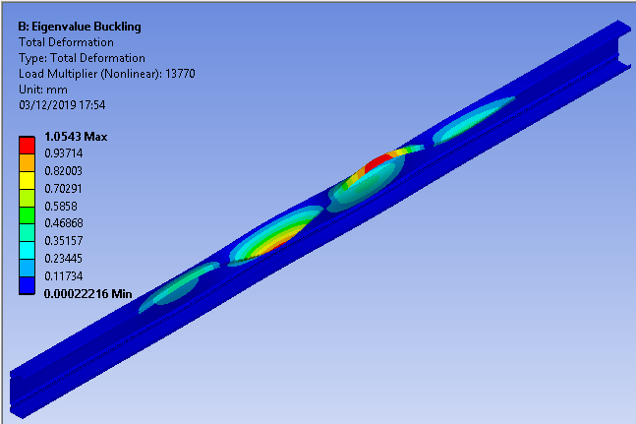
Fig. 5. Distortional buckling mode obtained from the FE model for the channel section.

Fig. 6. Load-displacement curves of different initial imperfections used in the FEM for the channel section.
The use of buckling modes from linear buckling analysis conducted with the conventional method, FEM, has some challenging issues. First of all, it was time consuming and computationally expensive to obtain the required pure buckling modes: local, distortional or global buckling modes as the derived buckling modes by FEM were often a combination of different buckling modes [34]. It was also very subjective as the controlling buckling mode needs to be selected by visual inspection; as the mode has to be identified through mode by mode visual inspection, it is difficult to select pure local, distortional and global buckling modes among many mixed buckling modes. Alternatively, the desired linear buckling mode obtained from FSM using CUFSM were then transferred to the FEM via the software ANSYS to conduct the nonlinear buckling analysis. This method has been already implemented by other researchers [34]. The entire elastic buckling modes of a simply supported members were calculated using the Finite Strip software CUFSM, which used polynomial functions for the deformed shape in the transverse direction and a single half sine-wave for the longitudinal shape function. The same material properties, nodes, elements of the section were used in both CUFSM and ANSYS. The buckling curve obtained in CUFSM for the channel section is shown in Fig. 7(a). The minima of the buckling curve were representative of the critical half-wavelengths and load factors. The second minimum was associated with the distortional buckling mode and half-wave length for the channel section, as shown in Fig. 7(b). The buckling mode shape was similar to that of FEM as obtained in Fig. 5. It was for simplicity, therefore, decided that the linear elastic buckling analysis was used with CUFSM to generate the shape and then applied the distribution of initial imperfections. The results showed that the channel beams failed in distortional buckling modes so the use of local buckling and global buckling initial imperfections might not affect the results. Therefore, it deemed that it was reasonable to consider only distortional buckling initial imperfections for the sections used in this study. The magnitude of initial imperfections was applied fully to the whole section including the intermediate web and flange stiffeners as shown in Fig. 7, using different CDF values proposed for imperfection amplitudes as shown in Table 1.
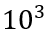
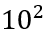
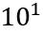
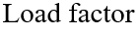
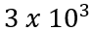
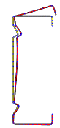
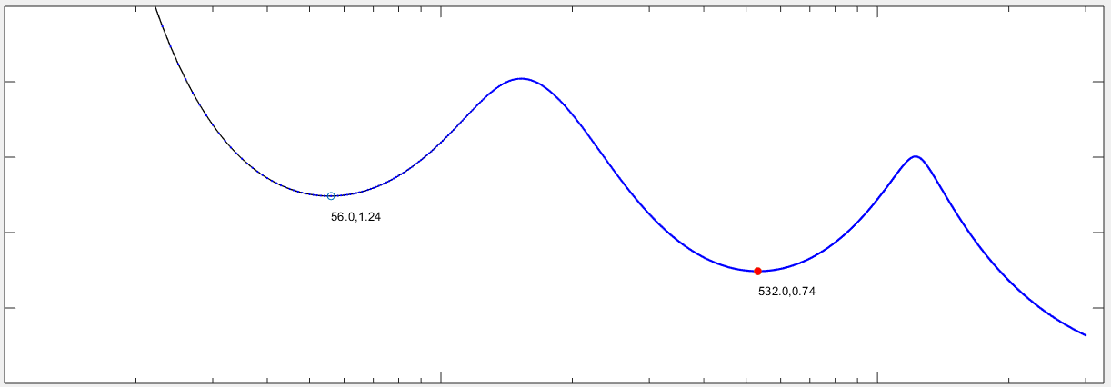(a)
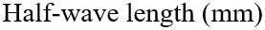
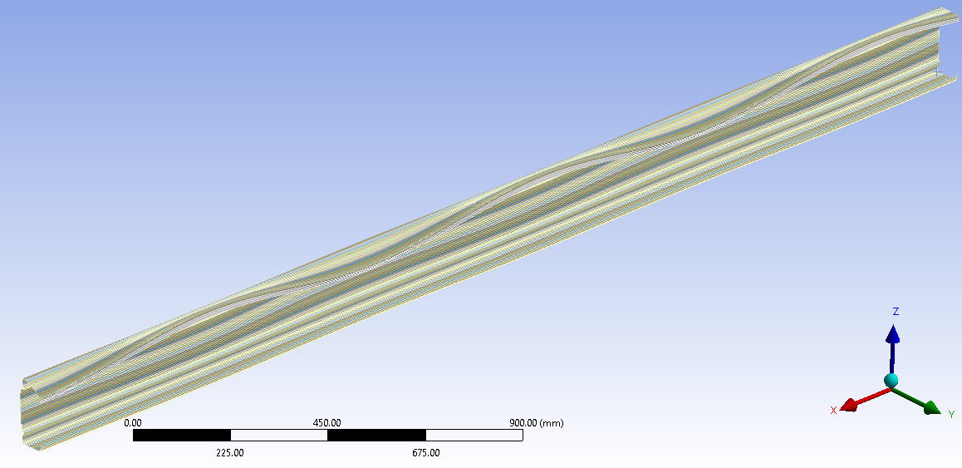 (b)
Fig. 7. Distortional buckling curve and modes for the channel section obtained from (a) CUFSM and (b) Distortional buckling mode obtained from the FE model after importing the buckling modes from CUFSM.
Fig. 8 shows the load-displacement curves of the channel sections obtained by this method with different imperfection amplitudes; it also includes the experimental result for comparison. The slope of the load-displacement curve and ultimate strength of the channel beams were found to be quite sensitive to the magnitude of initial imperfections; this reflected through significant differences between the slopes and ultimate loads of the FE model for different cases: with zero imperfection (amplitude of 0.0t) and with significant imperfections (amplitudes in the range of 0.64t to 4.47t). Overall, the ultimate load obtained from the FE model with zero imperfection 0.00t was 5% greater than the experimental result while those with 4.47t imperfection was 8% smaller than the experimental one. Other FE simulations with two different imperfections in between these extreme values, one with 0.64t and one with 1.55t imperfection amplitudes to cover the middle of 0.94t, were also studied. It was observed that the FE results with the imperfection value of 1.55t were the closest in agreement with the experimental results with less than 1% difference in the slope and strength values. The 75% CDF amplitude corresponded to an initial imperfection amplitude of 1.55t was, therefore, adopted for the parametric study in this research.

Fig. 8. Load-displacement curves of different initial imperfections used in the CUFSM-FEM for the channel section.

Determination of cold work effect to the material properties at corners and stiffeners
The cold rolling process of the channel sections resulted in an enhancement of the yield strength and ultimate tensile strength in the corners and in the bends of the stiffeners in comparison to those in the flat regions of the section. While the material properties of flat regions were obtained from tensile tests [30], the material properties of corners and bends were not available from the tests for this section. However, the current study focused upon the effect of geometric shape and cold work by the cold roll forming manufacturing process on the buckling and ultimate strengths of channel sections to search for the optimal design shapes. Previous studies by Mojtabaei et al. [24] and Ye at al. [38] indicated that the measured imperfections and enhanced material properties of the corners obtained from coupon tests did not considerably affect the optimum shape of the sections. Therefore, in the current study, other widely accepted methods were used to estimate the geometric imperceptions and the enhanced material properties of the corners and stiffeners’ bends, without loss of generality. In particular, the material properties at corners and stiffener’s bends affected by the cold work could be obtained from the material properties of flat regions by using formulae from the North American specification [32] for Cold-formed steel structural members. The equation for determining the tensile yield strength, $f_{yc },$ of the corner was based on the Equation (3) which was empirically derived from tests by Karren [33] and Chajes et al. [39].
$F_{yc}$= $\frac{B_{c} F_{yv}}{{\left(\frac{R}{t}\right)}^{m}}$ $(3)$
In which
$m=0.192\frac{F_{uv}}{F_{yv }}-0.068$and$B_{c}=3.69\frac{F_{uv}}{F_{yv}} -0.819 {\left(\frac{F_{uv}}{F_{yv}}\right)}^{2}-1.79$
Where:$F_{yv} and F_{uv}$ are yield stress and ultimate strength of the flat region material, R is inside corner/bend radius and t is the plate thickness. For cold roll formed sections, modest levels of strength enhancement of around 2.5% over the virgin coil material were observed in samples taken from web and flange elements [3]. These were consistent with other studies [40, 41] despite that these were developed for stainless steel. Therefore, the changes of the mechanical properties of the material in the flat parts of the cold roll formed sections were considered to be negligible in this study. In addition, Bonada et al. [14] compared the yield strength increase for corner material predicted from different methods namely EC3, AISI and Karren’ theoretical model (used in the North American specification [32]) and found out that the Karren’ theoretical model provides the best agreement with the experimental results. Therefore, this model is adopted in the current study (Equation (3)) to investigate the effect of geometric shape and cold work by the cold roll forming manufacturing process on the buckling and ultimate strengths of channel sections and search for the optimal design shapes.
The flat region material of the channel section had a Young’s modulus (E) of 205 $Gpa$, Poison’s ratio (ѵ) of 0.3 and yield stress and ultimate strength of 519.40 $N/{mm}^{2}$ and 550.00$N/{mm}^{2}$, respectively. The channel section was defined with 12 corners and bends, as shown in Fig. 10, but only material properties at six corners and bends in the upper part of the section were considered as the others in the lower part were assumed to be the same due to symmetry. Six increased yield stresses were calculated as the sections had a different radius at corners and bends and results were shown in Table 2, which also shows the calculated $m, B_{c} , F_{yv}$and various corners radius yield strength $F_{ycR}$.
Table 2 Yield stresses and tensile strengths at corners and stiffener’s bends using the North American specification [32].
$$m$$ | $$B_{c}$$ | $F_{yv}$ $\left(N/{mm}^{2}\right)$ | $F_{ycR}$ $\left(N/{mm}^{2}\right)$ | $F_{ycR}$ $\left(N/{mm}^{2}\right)$ | $F_{ycR}$ $\left(N/{mm}^{2}\right)$ | $F_{ycR}$ $\left(N/{mm}^{2}\right)$ | $F_{ycR}$ $\left(N/{mm}^{2}\right)$
 |  |  | R = 2.5 mm | R = 2.6 mm | R = 2.9 mm | R = 5 mm | R = 7.5 mm
0.14 | 1.20 | 519.40 | 586.29 | 583.19 | 573.57 | 533.8 | 519.40
The constitutive stress-strain model proposed by Hadarali and Nethercot [34] was employed, in which the plastic region of the stress-strain curve was modelled with a straight line with a constant slope of E/50, where E is the elastic modulus obtained from material tests. Therefore, different stress-strain models of corners and stiffeners’ bends were used for the channel section in the FE simulations, as illustrated in Fig. 9. FE simulations were carried out to with stress-strain data obtained from the tensile test [30] and with the proposed stress-strain models and the results revealed that the maximum differences in the slope and ultimate load capacity was very small 0.8% and 0.0%, respectively, indicating the validation of the proposed stress-strain model. Therefore, the stress-strain model proposed in Fig. 9 was used in this paper for the parametric study.
Residual stresses were not directly included in the FE models but indirectly considered through the stress-strain data obtained from the material tests. In particular, the membrane residual stresses could be safely ignored in the open sections [35, 42], whereas the longitudinal flexural residual stresses reported being implicitly presented in the stress-strain behaviour of the coupon tensile test results as long as the coupons were cut from the final sections. Cutting a coupon might release the flexural residual stresses that caused the coupon to curl [43], whilst these stresses were re-introduced when the coupon is straightened during the initial stages of tensile loading. Thus, the effects of residual stresses were not separately implemented into the FE models but assumed to be included with the stress-strain data.
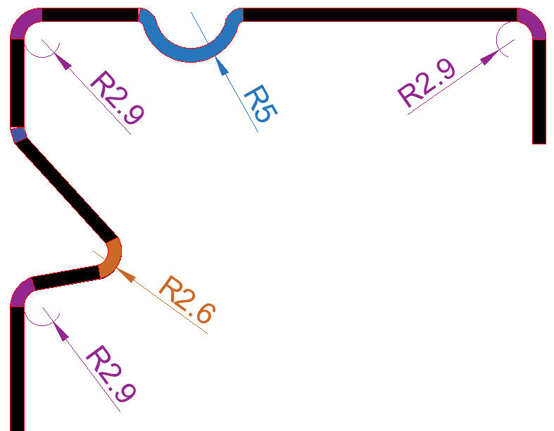
Fig. 9. Stress-strain models for materials at different corners and stiffeners’ bends of the channel section used in FEM.
It should be noted that the term “cold-working” in this study is used to represent the effect of the cold roll forming manufacturing process in enhancing the material properties at the section corners and the stiffeners’ bends [44, 45]. Therefore, from now on in this paper, it is called as “the cold work effect” in short.

Direct Strength Method
The Direct Strength Method specified in the North American Specification [32] was used in this study to determine the bending moment capacities of the channel sections. In this method, elastic buckling loads could be identified from a numerical analysis. In this study, the Finite Strip software CUFSM was used to identify the elastic buckling values for the channel sections. They were performed for systematically increasing half-wavelengths to obtain the shapes and load factors for the buckling modes of the sections. The ultimate strength capacity was calculated based on the section yield stress and elastic critical buckling stresses (local, distortional and global buckling stresses). Due to lateral restraints to the top and bottom flanges, the sections were regarded as fully braced beams. Thus, the nominal flexural strength ${(M}_{ne})$for lateral-torsional buckling was taken as yield moment $(M_{y})$ for the fully braced beams and allowing for only local and distortional buckling to occur. The current DSM for beams that considered inelastic reserve capacities for local buckling and distortional buckling in the North American Specification were summarized as follows.
The nominal flexural strength $M_{nl}$ for local buckling is calculated in accordance with the following:
$For λ_{l}≤0.776 M_{nl}=M_{y}$ $(4)$
$For λ_{l}>0.776 M_{nl}=\left(1-0.15{\left(\frac{M_{crl}}{M_{y}}\right)}^{0.4}\right){\left(\frac{M_{crl}}{M_{y}}\right)}^{0.4} M_{y}$ $(5)$
$$Where λ_{l}= \sqrt{\frac{M_{y}}{M_{crl} } } , M_{y}=S_{f}f_{y} and M_{crl}= S_{f}σ_{crl}$$
${S_{f}}_{f}$is the gross section modulus referenced to the extreme fiber at first yield
$f_{y}$ is the yield stress which is the 0.2% proof stress (σ_{0.2}) obtained from the tensile coupon test
$σ_{crl}$is the critical elastic local buckling stress
The nominal flexural strength $M_{nd}$ for distortional buckling is calculated in accordance with the following:
$For λ_{d}≤0.673 M_{nd}=M_{y}$ $(6)$
$For λ_{d}>0.673 M_{nd}=\left(1-0.22{\left(\frac{M_{crd}}{M_{y}}\right)}^{0.5}\right){\left(\frac{M_{crd}}{M_{y}}\right)}^{0.5} M_{y}$ $(7)$
$$Where λ_{d}= \sqrt{\frac{M_{y}}{M_{crd} } } , M_{y}= S_{f}f_{y} and M_{crd}= S_{f}σ_{crd}$$
$S_{f}$is the gross section moduls referenced to the extreme fiber at first yield
$f_{y}$ is the yield stress which is the 0.2% proof stress (σ_{0.2}) obtained from the tensile coupon test
$σ_{crd}$is the critical elastic distortional buckling stress
The effect of cold work to material properties of the channel section was also calculated to be used in the DSM following the North American Specification, which approximated the yield strength of the whole sections using the weighted average as follows:
$f_{ya}=Cf_{yc}+\left(1-C\right) f_{yf}$ $(8)$
Where
$f_{ya}$ is the average yield strength of the whole section
$f_{yf}$ is the average yield strength of the flat parts
$C$ is the ratio of corner area to the total section area
$f_{yc}$ is the average yield strength of corners = $\frac{B_{c} F_{yv}}{{\left(\frac{R}{t}\right)}^{m}}$

Table 3 The average yield stresses of different cross sections obtained using the North American Specification [32].
Cross-Sections
$f_{ya} ({N/{mm}}^{2})$ | 522.74 | 526.40 | 529.37 | 527.76 | 527.08 | 526.40
Cross-Sections |  | 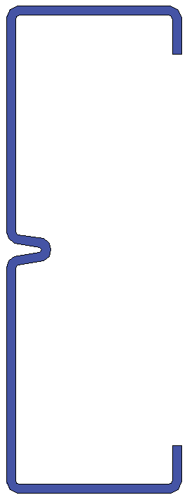 |  | 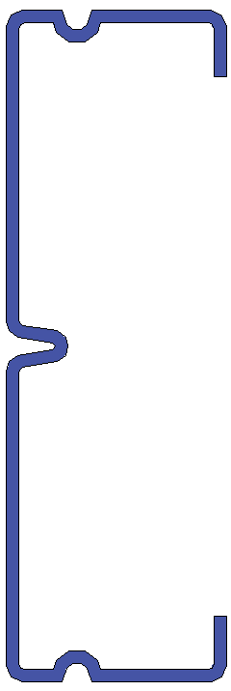
$$f_{ya} ({N/{mm}}^{2})$$ | 524.09 | 525.30 | 527.85 | 526.65 | 529.21

These yield stress values obtained from Table 3 were used in the Direct Strength Method for the calculation of ultimate moment capacity of the sections to include the effect of cold work from cold roll forming of the manufacturing process on material properties of the sections.
In this study, the influence of the cold work on material properties to the section strength was considered with the Direct Strength Method. Therefore, the yield stress of the virgin material $f_{y}$in Equations $\left(5\right)$ and $(7)$ was replaced by a new yield stress enhanced by the cold work. This yield stress could be reasonably approximated as the average yield stress of the whole cross section $f_{ya}$, as shown in Table 3.

Parametric study and optimisation
A comprehensive parametric study was carried out to investigate the influence of both the web and flange stiffeners’ positions, shapes, sizes, and enhanced material properties at corners and stiffeners’ bends on the section’s buckling and ultimate strengths. The FE model developed and validated in Section 3 was utilised for the parametric study. The number of the parametric studies and their results were arranged in orders so that all the maximum positive effects on the section strengths when changing parameter values were obtained, leading to an optimal design of the channel section. The channel section together with its bending setup used in the experimental testing in Section 2 were defined as “reference section”. The section height $h$, thickness $t$, internal radius $R$ and lip length $c$ were fixed in the parametric study. The total length of the channel cross section was kept unchanged for the optimisation target, that was “obtaining maximum strength of the section while maintaining the same weight”. Changes in parameters relating to the stiffeners’ shapes, sizes, positions while considering enhanced material properties at corners and bends by the cold work effect resulted in new channel sections. The material properties at the flat regions, corners and at the stiffeners’ bends were assumed to be the same in these new sections. In summary, the reference section had an initial imperfection of 1.55$t$, an elastic modulus $E$ of 205 GPa, a Poisson’s ratio of 0.3 and the stress-strain data determined in Section 3.3 for the flat, corners and stiffener’s bends.
The section without flange stiffeners is shown in Fig. 10(a), in which all dimension parameters are also shown and the section with flange stiffeners is shown in Fig. 10(b). The values for $h$, $t$, $R$, and $c$ were taken of the reference section as 170.10 mm, 1.60 mm, 2.00 mm and 16.05 mm, respectively. $h_{1}$ is the position of the web stiffener from the web-flange junction, $h_{2}$ is the depth of the web stiffener, $h_{3}$ is the position of the peak of the web stiffener in vertical direction from the web-flange junction, $b_{1}$ is the width of the web stiffener, $b_{2}$ is the position of the flange stiffener, $d$ is the width and depth of the flange stiffener (assuming the flange stiffener had a circular shape), $R$ is the radius of the section corners and it was assumed that they had the same radius. For the channel section shown in Fig. 10(a), a total of 50 combinations with and without cold work between $h_{1}/h$, $h_{2}/h$, $h_{3}/h$and $b_{1}/b$ were considered with $h_{1}/h$ varying from 0.00 to 0.17, $h_{2}/h$ varying from 0.07 to 0.24, $h_{3}/h$ varying from 0.11 to 0.19 and $b_{1}/b$ varying from 0.00 to 0.39. The reference section had $h_{1}/h=$ 0.08, $h_{2}/h=$ 0.13, $h_{3}/h=$ 0.17, and $b_{1}/b=$ 0.12. Hence, the buckling, ultimate moment capacity with and without cold work for each change were obtained and compared.
For the channel section shown in Fig. 10(b), the position of flange intermediate stiffener $b_{2}$, size of flange intermediate stiffener $d$ and flange width $b$ were changed. A total of 22 combinations with and without cold work between $b_{2}/b$ and $d/b$ were considered with $b_{2}/b$ varying from 0.06 to 0.63 and $d/b$ varying from 0.08 to 0.40. In total, 72 combinations with and without cold work effect were generated through FE models, for different positions ${h_{1}}/h$, different shapes ${h_{2}}/h$ and ${h_{3}}/h$, and different sizes ${b_{1}}/b$ of the web stiffeners as well as different positions ${b_{2}}/b$ and different sizes $d/b$ of the flange stiffeners. Hence, the buckling, ultimate moment capacity with and without cold work for each change were obtained and compared to evaluate the effect of these changes.
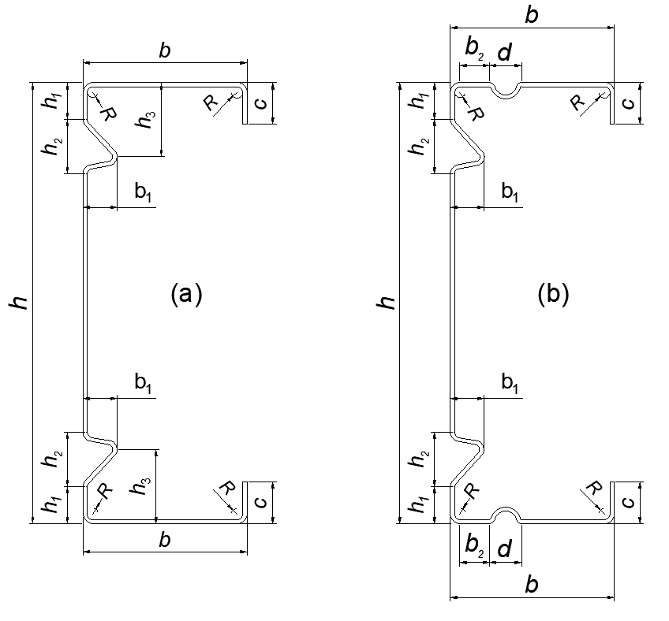
Fig. 10. Dimension parameters of the channel cross section (a) without flange stiffeners, and (b) with flange stiffeners.

Results and discussion

FE and DSM result validation
The four-point bending simulation showed that the channel sections had distortional buckling mode. However, for this particular setup the test did not clearly show elastic buckling prior to failure, but around the failure point. It was noted that the buckling load obtained from the FE analysis was even greater than the ultimate load. The main reason for this could be the fact that the tested channels deformed in plastic region while the FE buckling loads were evaluated by means of linear elastic analysis. Fig. 11 shows the load-displacement curves for both experimental test and FE model of the channel section. It can be seen that the slope (stiffness) and ultimate strength of the sections obtained by the FE model agreed very well with those of the experimental test. Overall, the FE model showed a slightly higher stiffness in comparison to the experimental one before peak load. The maximum load carrying capacity and the maximum displacement of the beam at peak load of the section, however, displayed slightly lower strength and displacement compared with the experimental one. The maximum difference in the peak load was 1% conservative while in the displacement was 4% unconservative. It was found that cold work influence on stiffness and strength of the channel beam was insignificant due to the fact that the distortional buckling slenderness in the section was very high and the beam failed by distortional buckling stress before it reached its yield strength capacity. If the failure stresses reached the yield and ultimate strength region then the cold work would be significant.
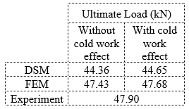
Fig. 11. Load-displacement curves for the channel sections from FEM, DSM and experimental results.
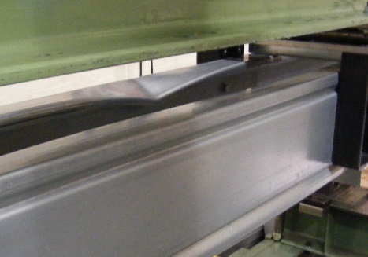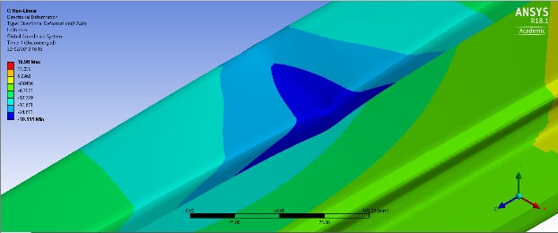
(a)
(b)
(d)
(c)
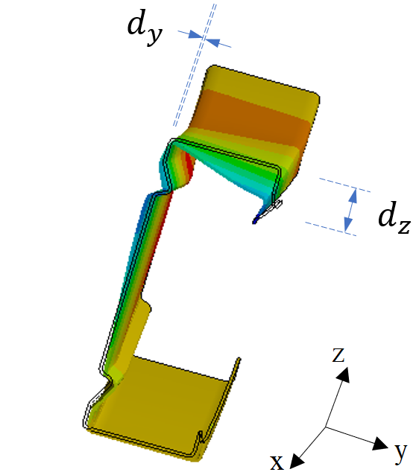
(e)
Fig. 12. Deformed shapes at failure for the channel sections obtained by experimental tests (a), and FE modelling results isometric view (b), front view (c), back view (c), and un-deformed and deformed cross sections (e). Deformation values associated with colour contour ranged from green to blue with highest values in blue region.
It was observed that the zed beams failed with full strength capacity of the sections. The load-displacement curves of the zed sections under the four-point bending tests obtained by FE simulation and experiment are shown in Fig. 13. It can be seen that both the stiffness and strength of the sections obtained by the FE model were in excellent agreement with experimental results, especially for the FE results when the cold work effect was included. The maximum difference in the peak load was 2% conservative whilst in the stiffness was 2% unconservative. However, the maximum difference in the peak load was 5% when the cold work effect was not taken into account in the FE model. As the sections gained their full strength, the generated stresses were in the inelastic region, the cold work effect was significant for the zed sections.
Fig. 12 and Fig. 14 illustrate the experimental and FE failure shapes of the channel and zed sections, respectively, for comparison. It was observed that the distortional buckling mode shape of the failed specimens was well represented by the FE models. In particular, the horizontal movement of the compressed web-flange corner $d_{y}$ and the inward compressed flange-lip motion $d_{z}$ in post buckling state of the channel cross section were 0 mm and 11 mm at failure, respectively; this clearly indicated the distortional buckling mode of failure of the section. The contours represented the displacement occurred in the beam and noted that the dark blue colour represented the maximum displacement, whereas as the colour became lighter the displacement became smaller values.
It was concluded that the developed FE model was an efficient way of representing the experimental tests and the FE results were in an excellent agreement with the experimental results in achieving accurate load-displacement curves and deformed shapes as well.
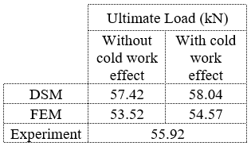
Fig. 13. Load-displacement curves for the zed sections from FEM, DSM and experimental.
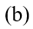
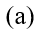
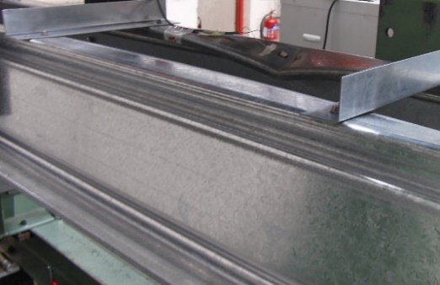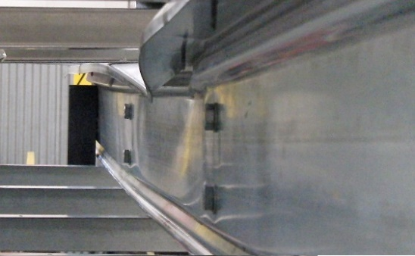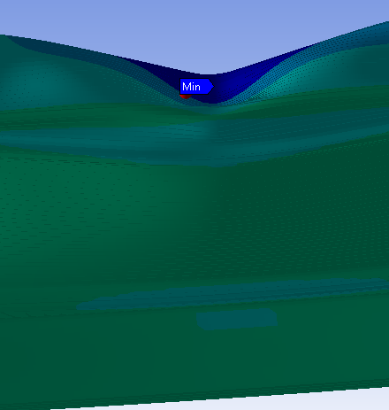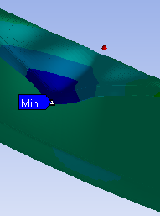
Fig. 14. Deformed shapes at failure for the zed sections obtained by (a) experimental tests, and (b) FE modelling results. Deformation values associated with colour contour ranged from green to blue with highest values in blue region.

Parametric study and optimisation results
This section presents the results of investigating the influence of both the web and flange intermediate stiffeners’ positions, shapes, sizes and cold work effect at corners and stiffeners’ bends on the section ultimate strengths.

Effect of the position of the web stiffener $h_{1}/h$
Fig.15 shows a graph of variation of the dimensionless ultimate bending moment capacities obtained by FE analysis $M/{M_{y}}$with variation of the stiffener position on the web ${h_{1}}/h$. In which $M_{y}$ is the yield bending moment of the whole cross section and when the cold work effect is not included $M$ equals $M_{u}$, when the cold work effect is included $M$ equals $M_{uc}$. The results obtained by DSM are also presented for comparison. Moving down the stiffeners towards the centre of the cross section was the same with increasing ${h_{1}}/h$. The detailed values are shown in Table 4. For this first parameter, the stress distributions on the sections without and with the cold work effect are made available for use in discussions, as shown in Fig. 16.
For the same value of ${h_{1}}/h$, $M_{uc}$ was generally greater than $M_{u}$, as also reflected in the greater stresses developed in the sections with the cold work effect (Fig. 16), indicating the cold work effect on ultimate bending strength of the section, despite the insignificant increase for some values of ${h_{1}}/h$. For different values of ${h_{1}}/h$, it was found that the ultimate bending moments $M_{u}$ and $M_{uc}$ reduced by increasing the ratio ${h_{1}}/h$. The maximum reduction in flexural strength resistance was 5% and 6% for the ultimate moment without cold work and with the cold work effect, respectively. When increasing ${h_{1}}/h$, it generated new cross sections with a reduction in the section modulus: the sectional modulus $S_{xx}$ decreased from 27.60 cm³ for ${h_{1}}/h=0.00$ to 26.97 cm³ for ${h_{1}}/h=0.17$, as shown in Table 4, and this led to a decrease in the ultimate bending moment. In the same time, the new cross sections had an increase in the buckling distortional slenderness: the distortional buckling slenderness ${}_{d}$ increased from 1.148 for ${h_{1}}/h=0.00$ to 1.162 for ${h_{1}}/h=0.17$ as illustrated in Table 4, and this also led to a decrease in the ultimate bending moment. In combination, the ultimate bending moment gradually reduced when increasing the ratio ${h_{1}}/h$ due to a product of the increasing effect by the buckling slenderness ${}_{d}$ and the decreasing effect of the sectional modulus $S_{xx}$ (referred to Eqn. (7)). Therefore, increasing the ratio ${h_{1}}/h$ ultimately reduced the ultimate bending moments $M_{u}$ and $M_{uc}$, and dimensionless values ${M_{u}}/{M_{y}}$and ${M_{uc}}/{M_{y}}$, as illustrated in Fig. 15, indicating the sensitivity of the sections to distortional buckling. This suggested that if the stiffeners were placed on the web close to the flange, the buckling and ultimate strengths of the section would increase, and maximum strength could be obtained for this case.
The ultimate bending moments $M_{u}$ and $M_{uc}$ obtained by the DSM had the same trends with the FE results that increasing the ratio ${h_{1}}/h$ reduced $M_{u}$ and $M_{uc}$, with a clear gap between them, as shown in Fig. 15. This was due to the assumption of using an average enhanced yield stress for the entire section to take into account the cold work effect, which might not entirely realistic but clearly showed the trend. However, for the same value of ${h_{1}}/h$, the values obtained by the DSM were smaller than those of the FE analysis with a maximum difference of 7% for both the ultimate bending moments, without the cold work effect and with the cold work effect. It should be noted that the DSM’s ultimate bending moments $M_{u}$ and $M_{uc}$ were obtained from the semi-empirical formulae which were derived based on an extensive amount of testing has been performed on laterally braced beams with geometric limitations for channel sections. In addition, the channel sections with intermediate stiffeners used in this paper did not specify having pre-qualified for use with the DSM, and the assumption of using an average enhanced yield stress for the entire section to take into account the cold work effect was very approximate. Therefore, the ultimate bending moments $M_{u}$ and $M_{uc}$ obtained by the DSM were approximate values whilst those obtained by the FE analysis could be more accurate and insightful of the section behaviour and the cold work effect.

Fig. 15. Variation in the ultimate moment capacity for different positions of web stiffeners $h1/h$ without the cold work effect and with the cold work effect.

Table 4 Variation in ultimate bending moment capacity for different positions of web stiffeners. $M_{u}$, $M_{uc}$ stand for ultimate moment capacity without and with the cold work effect, respectively. $f_{ya}$ is the average yield strength of the whole section.
$${h_{1}}/h$$ | Section properties |  | DSM |  |  |  |  | FEM |  |  | $$\frac{M_{u}^{FEM}}{M_{u}^{DSM}}$$ | $$\frac{M_{uc}^{FEM}}{M_{uc}^{DSM}}$$
 | $S_{xx}$ (cmᶟ) | ${}_{d}$ | $M_{y}$ (kNm) | $M_{yc}$ (kNm) | $M_{u}$ (kNm) | $M_{uc}$ (kNm) | $M_{uc}$/$M_{u}$ | $M_{u}$ (kNm) | $M_{uc}$ (kNm) | $M_{uc}$/$M_{u}$
0.00 | 27.60 | 1.148 | 14.35 | 14.53 | 10.10 | 10.23 | 1.01 | 10.79 | 10.86 | 1.01 | 1.07 | 1.06
0.05 | 27.44 | 1.151 | 14.27 | 14.44 | 10.03 | 10.18 | 1.01 | 10.76 | 10.76 | 1.00 | 1.07 | 1.06
0.08 | 27.31 | 1.155 | 14.20 | 14.38 | 9.95 | 10.01 | 1.01 | 10.64 | 10.69 | 1.01 | 1.07 | 1.06
0.11 | 27.19 | 1.159 | 14.14 | 14.31 | 9.88 | 9.97 | 1.01 | 10.60 | 10.60 | 1.00 | 1.07 | 1.06
0.14 | 27.07 | 1.161 | 14.08 | 14.25 | 9.83 | 9.92 | 1.01 | 10.52 | 10.52 | 1.00 | 1.07 | 1.07
0.17 | 26.97 | 1.162 | 14.02 | 14.20 | 9.79 | 9.86 | 1.01 | 10.28 | 10.47 | 1.02 | 1.05 | 1.06

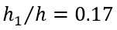
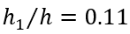
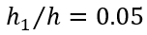
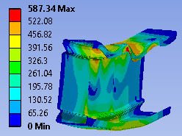 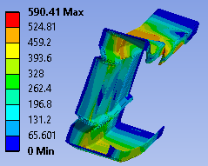 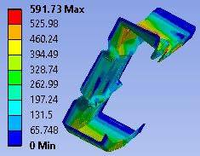 (a)
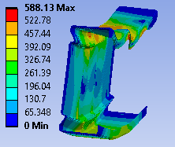 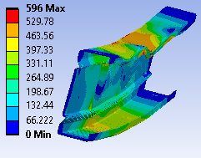 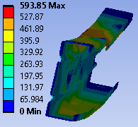 (b)
Fig. 16. Von Mises stress distribution at failure for different web stiffener positions (a) without the cold work effect and (b) with the cold work effect.

Effect of the depth of the web stiffener $h_{2}/h$
Fig. 17 shows the variation of ${M_{u}}/{M_{y}}$ and ${M_{uc}}/{M_{y}}$ with the variation of the web stiffener’s depth ${h_{2}}/h$. The ${M_{u}}/{M_{y}}$ and ${M_{uc}}/{M_{y}}$ values obtained by DSM are also presented for comparison. The detailed values are shown in Table 5.
For the same value of ${h_{2}}/h$, $M_{uc}$ was generally greater than $M_{u}$, confirming the cold work effect on enhancing the section’s ultimate bending strength. However, there were small effects at some values of ${h_{2}}/h$ with a maximum difference of 3%, especially it was insignificant with ${h_{2}}/h$ from $0.15$ to $0.18$. When increasing ${h_{2}}/h$ from $0.07$ to $0.13$, the ultimate bending moment $M_{u}$ and $M_{uc}$ reduced. It was because the distortional buckling slenderness ${}_{d}$ increased from 1.142 to 1.155 as illustrated in Table 5, and this induced a decrease in the ultimate bending moment. Although, at the same time the ultimate bending moment increased due to an increase in the sectional modulus $S_{xx}$, the decreasing effect by the buckling slenderness ${}_{d}$ was more significant (as a difference of squares as interpreted from Eqn. (7)). When increasing ${h_{1}}/h$${h_{2}}/h$ from 0.10 to 0.24, $S_{xx}$ decreased from 27.32 cm³ to 26.93 cm³, as shown in Table 5, and this led to a decrease in the ultimate bending moment. In addition, ${}_{d}$ slightly decreased from 1.155 to 1.153, and this led to an insignificant increase in the ultimate bending moment. As the decreasing effect by the sectional modulus $S_{xx}$ was more noticeable, the ultimate bending moment slightly increased, as can be seen in Table 5 and in Fig. 17 for ${M_{u}}/{M_{y}}$ and ${M_{uc}}/{M_{y}}$. The maximum ultimate bending moment increased by the cold work effect was about 1% at ${h_{2}}/h$ = 0.24. The results obtained by the DSM had the same trends with the FE results when increasing the ratio ${h_{2}}/h$, with a maximum difference of 9%. It is therefore suggested that the web stiffener to have a longer depth than that of the reference section in order to obtain greater bending moment capacity.
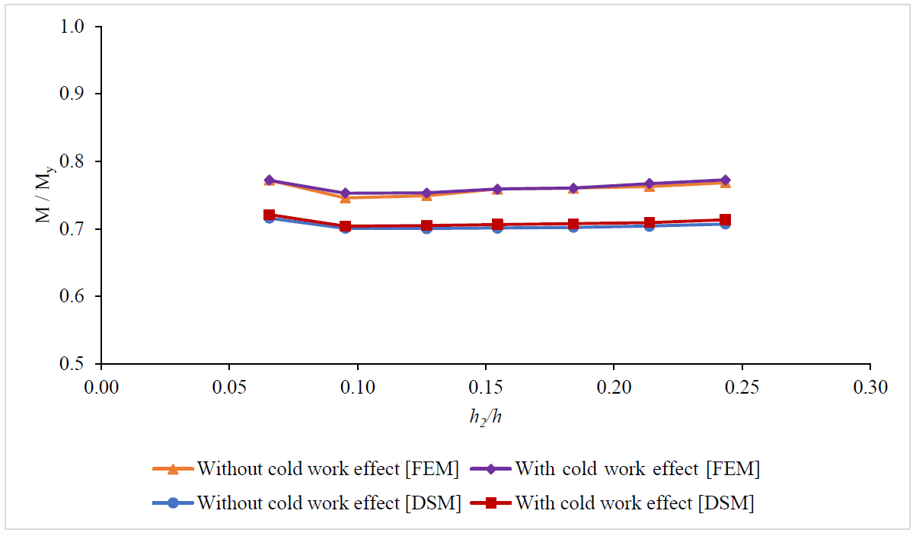
Fig. 17. Variation in the ultimate moment capacity for different shapes of web stiffeners ${h_{2}}/h$ without and with the cold work effect.

Table 5 Variation in ultimate bending moment capacity for different depths of the web stiffener.
$${h_{2}}/h$$ | Section properties |  | DSM |  |  |  |  | FEM |  |  | $$\frac{M_{u}^{FEM}}{M_{u}^{DSM}}$$ | $$\frac{M_{uc}^{FEM}}{M_{uc}^{DSM}}$$
 | $S_{xx}$ (cmᶟ) | $${}_{d}$$ | $M_{y}$ (kNm) | $M_{yc}$ (kNm) | $M_{u}$ (kNm) | $M_{uc}$ (kNm) | $M_{uc}$/$M_{u}$ | $M_{u}$ (kNm) | $M_{uc}$ (kNm) | $M_{uc}$/$M_{u}$
0.07 | 26.89 | 1.142 | 13.98 | 14.15 | 10.01 | 10.08 | 1.01 | 10.76 | 10.76 | 1.00 | 1.08 | 1.07
0.10 | 27.32 | 1.155 | 14.21 | 14.38 | 9.95 | 10.00 | 1.01 | 10.59 | 10.69 | 1.01 | 1.06 | 1.07
0.13 | 27.31 | 1.155 | 14.20 | 14.38 | 9.95 | 10.01 | 1.01 | 10.64 | 10.69 | 1.01 | 1.07 | 1.07
0.15 | 27.27 | 1.155 | 14.18 | 14.35 | 9.94 | 10.02 | 1.01 | 10.76 | 10.76 | 1.00 | 1.08 | 1.07
0.18 | 27.22 | 1.152 | 14.15 | 14.33 | 9.94 | 10.01 | 1.01 | 10.76 | 10.76 | 1.00 | 1.08 | 1.07
0.21 | 27.13 | 1.151 | 14.11 | 14.28 | 9.93 | 10.01 | 1.01 | 10.76 | 10.82 | 1.01 | 1.08 | 1.08
0.24 | 26.93 | 1.153 | 14.00 | 14.18 | 9.90 | 9.99 | 1.01 | 10.76 | 10.82 | 1.01 | 1.09 | 1.08

Effect of the position of the peak of the web stiffener $h_{3}/h$
Fig. 18 shows the variation of ${M_{u}}/{M_{y}}$ and ${M_{uc}}/{M_{y}}$ with the variation of the web stiffener’s peak ${h_{3}}/h$ in the vertical direction${h_{2}}/h$. Moving down the stiffener’s peak away from web-flange junction of the section was the same with increasing ${h_{3}}/h$${h_{1}}/h$. The ${M_{u}}/{M_{y}}$ and ${M_{uc}}/{M_{y}}$ values obtained by DSM are also presented for comparison. The detailed values are shown in Table 6.
For the same value of ${h_{3}}/h$, $M_{uc}$ was greater than $M_{u}$ with a maximum increase of 1%, confirming the cold work effect on enhancing the section’s ultimate bending strength. When increasing ${h_{3}}/h$, from 0.11 to 0.19, the ultimate bending moment $M_{u}$ and $M_{uc}$ decreased and the rate of decreasing was significantly increased for ${h_{3}}/h$, from 0.14 to 0.19. It was found that even though increasing ${h_{3}}/h$ reduced the distortional buckling slenderness of the sections (i.e. ${}_{d}$ reduced from 1.164 to 1.118), the ultimate moment capacity of the sections still reduced due to a more significant reduction in the sectional modulus (i.e. $S_{xx}$ reduced from 27.51 cm³ to 26.55 cm³), as shown in Table 6. The ultimate bending moments $M_{u}$ and $M_{uc}$ obtained by the DSM had the same trends with the FE results, as shown in Fig. 18 and Table 6. However, for the same value of ${h_{3}}/h$, the values for both the ultimate bending moments, without the cold work effect and with the cold work effect, obtained by the DSM were smaller than those of the FE analysis with a maximum difference of 8%. The reasons were explained previously. It is therefore recommended that the web stiffener’s peak should be placed near the web-flange junction in vertical direction in order to have significant strength enhancement, including the case of the cold work effect.

Fig. 18. Variation in the ultimate moment capacity for different positions of the web stiffener’s peak in vertical direction ${h_{3}}/h$ without the cold work effect and with the cold work effect.

Table 6 Variation in ultimate bending moment capacity for different positions of the web stiffener’s peak in vertical direction.
$${h_{3}}/h$$ | Section properties |  | DSM |  |  |  |  | FEM |  |  | $$\frac{M_{u}^{FEM}}{M_{u}^{DSM}}$$ | $$\frac{M_{uc}^{FEM}}{M_{uc}^{DSM}}$$
 | $S_{xx}$ (cmᶟ) | ${}_{d}$ | $M_{y}$ (kNm) | $M_{yc}$ (kNm) | $M_{u}$ (kNm) | $M_{uc}$ (kNm) | $M_{uc}$/$M_{u}$ | $M_{u}$ (kNm) | $M_{uc}$ (kNm) | $M_{uc}$/$M_{u}$
0.19 | 26.55 | 1.118 | 13.81 | 13.98 | 9.92 | 10.01 | 1.01 | 10.52 | 10.52 | 1.00 | 1.06 | 1.05
0.18 | 27.02 | 1.142 | 14.05 | 14.22 | 9.93 | 10.01 | 1.01 | 10.52 | 10.64 | 1.01 | 1.06 | 1.06
0.17 | 27.31 | 1.156 | 14.20 | 14.38 | 9.95 | 10.01 | 1.01 | 10.64 | 10.69 | 1.01 | 1.07 | 1.07
0.14 | 27.51 | 1.164 | 14.31 | 14.48 | 9.97 | 10.05 | 1.01 | 10.76 | 10.88 | 1.01 | 1.08 | 1.08
0.12 | 27.49 | 1.155 | 14.29 | 14.47 | 10.02 | 10.10 | 1.01 | 10.76 | 10.88 | 1.01 | 1.07 | 1.07
0.11 | 27.42 | 1.143 | 14.26 | 14.43 | 10.08 | 10.15 | 1.01 | 10.76 | 10.88 | 1.01 | 1.07 | 1.07

Effect of the width of the web stiffener $b_{1}/b$
The variation of the dimensionless ultimate bending moment capacities obtained by FE analysis, without the cold work effect ${M_{u}}/{M_{y}}$ and with the cold work effect${M_{uc}}/{M_{y}}$, with variation of the width of the web stiffener ${b_{1}}/b$ is shown in Fig. 19. Increasing ${b_{1}}/b$ was the same with moving the stiffener’s peak away from web in horizontal direction${h_{1}}/h$. The ${M_{u}}/{M_{y}}$ and ${M_{uc}}/{M_{y}}$ values obtained by DSM are also presented. The detailed values are shown in Table 7.
With the same value of ${b_{1}}/b$, $M_{uc}$ was generally greater than $M_{u}$ but the enhancement was very small when ${b_{1}}/b$ was less than 0.05 but was noticeable when ${b_{1}}/b$ increased from 0.05 to 0.32 with a maximum increase of 1%. These were associated with an increase in the stresses in the sections or a decrease in sectional moduli, with a maximum increase of 4% for ${b_{1}}/b$ = 0.21, as can be seen in Table 7. Overall, the ultimate moment capacity increased up to certain limit but beyond that the ultimate moment capacity was reduced and the maximum change was 4% and 5% for the ultimate moment without the cold work effect and with the cold work effect, respectively. Detailed values of the ultimate bending moments $M_{u}$ and $M_{uc}$ for different types of sections with different values of ${b_{1}}/b$ are also displayed in bar charts in Fig. 20. It was observed that $M_{u}$ and $M_{uc}$ increased when the values of ${b_{1}}/b$ increased from 0.00 to 0.21.
When ${b_{1}}/b$ increased from 0.21 to 0.39, however, the FE results showed that sections failed in distortional-global interactive buckling modes as the ultimate bending moment capacities $M_{u}$ and $M_{uc}$ decreased. This reflected through the decreasing values of $M_{u}$ and $M_{uc}$ as shown in Table 7 and Fig. 19. It means that, for this particular range of ${b_{1}}/b$, the practical bracing length of 900 mm was not sufficient to exhibit pure distortional buckling modes in the sections. It was because the FE results showed that when values of ${b_{1}}/b$ increased from 0.21 to 0.32, 0.39 and 0.47 (for information only, results not shown), the horizontal movement of the compressed web-flange corner $d_{y}$ and the outward compressed flange-lip motion $d_{z}$ in post buckling state ($d_{y} , d_{z}$) changed from (0 mm, 20 mm) to (0.50 mm, 21 mm), (1 mm, 25 mm) and (2 mm, 26 mm), respectively. In addition, the significant reduction of the sectional modulus $S_{zz}$ in the minor axis by 70% (i.e. $S_{zz}$ reduced significantly from 16.81 cm³ for ${b_{1}}/b$ = 0.00 to 11.07 cm³ for ${b_{1}}/b$ = 0.32 and 9.92 cm³ for ${b_{1}}/b$ = 0.39). The noticeable reduction in $S_{zz}$ from ${b_{1}}/b$ = 0.21 could make the sections prone to fail by lateral/global buckling. These clearly indicated the distortional-global buckling interactive failure and consequently led to lower ultimate moment capacities for the beam sections, as confirmed by the FE results shown in Fig. 19.
For the values of ${b_{1}}/b$ from 0.00 to 0.21, the ultimate bending moments $M_{u}$ and $M_{uc}$ obtained by the DSM had the same trends with the FE results. However, when ${b_{1}}/b$ increased from 0.21 to 0.39, the DSM results showed an increase in the bending moment capacities as shown in Fig. 19 as they were based on the critical distortional buckling half-wave lengths. For comparison purposes, the FE models with the bracing length the same as the critical distortional buckling half-wave length were developed to model the condition of “fully restrained” for critical distortional buckling failure for values of ${b_{1}}/b$ from 0.21 to 0.39. The ultimate moment capacities $M_{u}$ and $M_{uc}$ are also shown in dash lines in Fig. 19. The results of these models are compared with the DSM results obtained using the critical distortional buckling modes. It can be seen that the ultimate bending moments $M_{u}$ and $M_{uc}$ obtained by the DSM had the same trends with the FE results. However, for the same value of ${b_{1}}/b$, $M_{u}$ and $M_{uc}$ values obtained by the DSM were less than those of the FE analysis with a maximum difference of 8%.
It is therefore suggested that the web stiffener’s peak should be placed further away from the web in horizontal direction to a certain position (up to 20% of the section width) in order to have significant strength enhancement, including the case of the cold work effect.

Fig. 19. Variation in ultimate moment capacity for different widths of the web stiffener ${b_{1}}/b$ of web stiffeners without the cold work effect and with the cold work effect. FEM* are FEM results with bracing lengths the same with the critical distortional buckling half-wave length.

Table 7 Variation in ultimate bending moment capacity for different widths of the web stiffeners.
$${b_{1}}/b$$ | Section properties |  | DSM |  |  |  |  | FEM |  |  | $$\frac{M_{u}^{FEM}}{M_{u}^{DSM}}$$ | $$\frac{M_{uc}^{FEM}}{M_{uc}^{DSM}}$$
 | $S_{xx}$ (cmᶟ) | ${}_{d}$ | $M_{y}$ (kNm) | $M_{yc}$ (kNm) | $M_{u}$ (kNm) | $M_{uc}$ (kNm) | $M_{uc}$/$M_{u}$ | $M_{u}$ (kNm) | $M_{uc}$ (kNm) | $M_{uc}$/$M_{u}$
0.00 | 28.19 | 1.247 | 14.66 | 14.85 | 9.68 | 9.70 | 1.00 | 10.34 | 10.34 | 1.00 | 1.07 | 1.07
0.05 | 27.98 | 1.223 | 14.55 | 14.68 | 9.76 | 9.82 | 1.01 | 10.52 | 10.52 | 1.00 | 1.08 | 1.07
0.12 | 27.31 | 1.156 | 14.20 | 14.38 | 9.95 | 10.01 | 1.01 | 10.64 | 10.69 | 1.01 | 1.07 | 1.07
0.21 | 26.42 | 1.055 | 13.74 | 13.91 | 10.31 | 10.43 | 1.01 | 10.72 | 10.86 | 1.01 | 1.04 | 1.04
0.32 | 25.44 | 0.923 | 13.23 | 13.39 | 10.91 | 10.98 | 1.01 | 10.76 | 10.86 | 1.01 | 0.99 | 0.99
0.39 | 24.94 | 0.874 | 12.97 | 13.13 | 11.25 | 11.34 | 1.01 | 10.52 | 10.76 | 1.02 | 0.94 | 0.95
0.32* | 25.44 | 0.923 | 13.23 | 13.39 | 10.91 | 10.98 | 1.01 | 10.76 | 11.91 | 1.01 | 1.08 | 1.08
0.39* | 24.94 | 0.874 | 12.97 | 13.13 | 11.25 | 11.34 | 1.01 | 11.99 | 12.18 | 1.02 | 1.07 | 1.07
* FE models with bracing lengths the same with the critical distortional buckling half-wave length

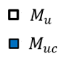
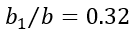
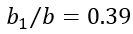
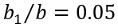
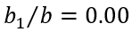
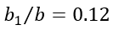
Fig. 20. Comparison of the ultimate bending moment capacity for different widths of the web stiffeners (when ${b_{1}}/{b=0.32}$ and $0.39$ the sections failed in distortional-global interactive buckling modes).

Effect of the position of the flange stiffeners $b_{2}/b$
Fig. 21 shows the variation of ${M_{u}}/{M_{y}}$ and ${M_{uc}}/{M_{y}}$ with the variation of the position of the flange stiffener${h_{2}}/h$. Moving the flange stiffeners away from web-flange junction of the section was the same with increasing ${b_{2}}/b$${h_{1}}/h$. The ${M_{u}}/{M_{y}}$ and ${M_{uc}}/{M_{y}}$ values obtained by DSM are also presented for comparison. The detailed values are shown in Table 8.
With the same value of ${b_{2}}/b$, $M_{uc}$ was significantly greater than $M_{u}$ with a maximum increase of 2%. These were associated with an increase in the stresses in the sections or a decrease in sectional moduli, as can be seen in Table 8, with a maximum increase of 5% for ${b_{2}}/b$ = 0.63. When increasing ${b_{2}}/b$, from 0.06 to 0.63, the ultimate bending moment $M_{u}$ and $M_{uc}$ decreased and the rate of decreasing was not significant with ${b_{2}}/b$ from 0.06 to 0.24, but was significant with ${b_{2}}/b$ from 0.24 to 0.63. It was observed that within the range of ${b_{2}}/b$ = 0.06 to 0.63, the sections failed by distortional buckling modes. Values of $M_{u}$ and $M_{uc}$ obtained by the DSM had the same trends with the FE results. This was due to the increase in the distortional buckling slenderness of the sections (i.e. values of ${}_{d}$ increased from 1.070 for ${b_{2}}/b$ = 0.06 to 1.1581 for ${b_{2}}/b$ =0.63) whilst the sectional modulus was unchanged (i.e. values of $S_{xx}$ were the same for all the sections) as shown in Table 8. The increase in the distortional buckling slenderness had an inverse effect that reduced the ultimate moment capacity of the sections. It was finally concluded that in the sections with flange stiffeners, distortional buckling failure was more severe when the flange stiffeners shifted away in horizontal direction from the web-flange junction. It is, therefore, suggested that the flange stiffeners need to be placed near the web-flange junction in order to gain maximum bending strength capacity.

Fig. 21. Variation in ultimate moment capacity for different positions of flange stiffeners ${b_{2}}/b$ without the cold work effect and with the cold work effect.

Table 8 Variation in ultimate bending moment capacity for different positions of flange-intermediate stiffeners.
$${b_{2}}/b$$ | Section properties |  | DSM |  |  |  |  | FEM |  |  | $$\frac{M_{u}^{FEM}}{M_{u}^{DSM}}$$ | $$\frac{M_{uc}^{FEM}}{M_{uc}^{DSM}}$$
 | $S_{xx}$ (cmᶟ) | ${}_{d}$ | $M_{y}$ (kNm) | $M_{yc}$ (kNm) | $M_{u}$ (kNm) | $M_{uc}$ (kNm) | $M_{uc}$/$M_{u}$ | $M_{u}$ (kNm) | $M_{uc}$ (kNm) | $M_{uc}$/$M_{u}$
0.06 | 27.01 | 1.070 | 14.05 | 14.25 | 10.43 | 10.52 | 1.01 | 10.91 | 11.03 | 1.01 | 1.05 | 1.05
0.15 | 27.01 | 1.072 | 14.05 | 14.25 | 10.42 | 10.51 | 1.01 | 10.91 | 11.03 | 1.01 | 1.05 | 1.05
0.24 | 27.01 | 1.077 | 14.05 | 14.25 | 10.38 | 10.47 | 1.01 | 10.88 | 10.88 | 1.00 | 1.05 | 1.04
0.33 | 27.01 | 1.088 | 14.05 | 14.25 | 10.30 | 10.40 | 1.01 | 10.76 | 10.81 | 1.01 | 1.04 | 1.04
0.42 | 27.01 | 1.102 | 14.05 | 14.25 | 10.20 | 10.29 | 1.01 | 10.52 | 10.69 | 1.02 | 1.03 | 1.04
0.51 | 27.01 | 1.123 | 14.05 | 14.25 | 10.06 | 10.16 | 1.01 | 10.28 | 10.47 | 1.02 | 1.02 | 1.03
0.63 | 27.01 | 1.158 | 14.05 | 14.25 | 9.81 | 10.90 | 1.01 | 10.10 | 10.28 | 1.02 | 1.03 | 1.04

Effect of the size of the flange stiffeners $d/b$
Fig. 22 shows the influence of changing the size of the flange stiffeners $d/b$ on the dimensionless ultimate moment capacity ${M_{u}}/{M_{y}}$ and ${M_{uc}}/{M_{y}}$ of the sections. The ${M_{u}}/{M_{y}}$ and ${M_{uc}}/{M_{y}}$ values obtained by DSM are also presented for comparison. The detailed values are shown in Table 9.
With the same value of $d/b$, $M_{uc}$ was significantly greater than $M_{u}$ with a maximum increase of 2%. The ultimate moment capacity increased when values of $d/b$ increased up to certain limit ($d/b$ ≈ 0.28) beyond which it was slightly reduced. The maximum change in the ultimate moment capacity, for changes in the size of the flange stiffeners, was 7% and 8% in the cases of without the cold work and with the cold work effect, respectively. It was observed that the ultimate moment capacities $M_{u}$ and $M_{uc}$ increased up to certain values because the distortional buckling slenderness ${}_{d}$ reduced significantly when $d/b$ increased up to a certain limit ($d/b$ = 0.28). Even though the sectional modulus in the major axis $S_{xx}$ and minor axis $S_{zz}$ reduced that could reduce the ultimate moment capacities, the influence of the distortional buckling slenderness ${}_{d}$ on the ultimate moment capacities were more significant. However, beyond the limit of $d/b$ = 0.28, the ultimate moment capacities reduced because of the significant reduction of section modulus in the minor axis $S_{zz}$ (i.e. $S_{zz}$ reduced significantly from 14.30 cmᶟ for $d/b$ = 0.08 to 11.87 cmᶟ for $d/b$ = 0.40, which was about 20% in reduction). The reduction in the sectional modulus in the minor axis $S_{zz}$ caused the sections with values of $d/b$ greater than 0.28 to fail by distortional-global buckling interaction and that reduced the ultimate moment capacities. This phenomenon was already discussed with FE models and results in Section 6.2.4.The DSM predicted the same trends with FE results for the ultimate moment capacities for the values of $d/b$ from 0.06 to 0.28, where the FE models also predicted that the sections were failed by the distortional buckling modes. It is therefore suggested that the flange stiffeners should have an increasing diameter up to a certain size (up to 28% of the section width) in order to have maximum bending strength, including the case of the cold work effect. It is also suggested that design guidelines for distortional-global interaction buckling modes need to be included in the DSM procedure.

Fig. 22. Variation in ultimate moment capacity for different sizes of flange stiffeners without the cold work effect and with the cold work effect.

Table 9 Variation in ultimate moment capacity for different sizes of flange stiffeners.
$$d/b$$ | Section properties |  | DSM |  |  |  |  | FEM |  |  | $$\frac{M_{u}^{FEM}}{M_{u}^{DSM}}$$ | $$\frac{M_{uc}^{FEM}}{M_{uc}^{DSM}}$$
 | $S_{xx}$ (cmᶟ) | ${}_{d}$ | $M_{y}$ (kNm) | $M_{yc}$ (kNm) | $M_{u}$ (kNm) | $M_{uc}$ (kNm) | $M_{uc}$/$M_{u}$ | $M_{u}$ (kNm) | $M_{uc}$ (kNm) | $M_{uc}$/$M_{u}$
0.08 | 27.24 | 1.118 | 14.16 | 14.42 | 10.17 | 10.29 | 1.01 | 10.66 | 10.91 | 1.02 | 1.05 | 1.06
0.18 | 27.01 | 1.072 | 14.05 | 14.25 | 10.42 | 10.48 | 1.01 | 10.88 | 11.12 | 1.02 | 1.04 | 1.06
0.28 | 26.63 | 1.009 | 13.85 | 14.04 | 10.73 | 10.82 | 1.01 | 11.36 | 11.49 | 1.01 | 1.06 | 1.06
0.40 | 26.16 | 0.971 | 13.60 | 13.77 | 10.89 | 10.98 | 1.01 | 11.37 | 11.37 | 1.00 | 1.04 | 1.04

Effect of the number of stiffeners
The influence of different number of longitudinal stiffeners at the web and the flange on ultimate moment capacities of the sections without and with the cold work effect, was investigated by FE modelling. In this study, there were 6 different cross-section types depending upon different number of longitudinal stiffeners at the web and the flange: (1) the cross-section had no web and flange stiffeners, (2) the cross-section had flange stiffeners, (3) the cross-section had one web stiffener, (4) the cross-section had one web and flange stiffeners, (5) the cross-section had two web stiffeners, and (6) the cross-section had two web and flange stiffeners. Fig. 23 shows variation of ultimate moment capacities of the sections without and with the cold work effect. These cross-sections were designed to be symmetrical about the major axis for practical purpose and stiffeners had identical shape and size at web and flanges. Overall, the ultimate moment capacities for both cases, without and with the cold work effect, increased in comparison to the cross-section of no web and flange stiffeners, type (1),when the number of stiffeners increased in both the web and/or the flange as shown in the cross-section types (2), (4), (5) and (6), except type (3) where the cross-section had one web stiffener at the mid-height of the web, there was no influence of the web stiffener on the ultimate moment capacity. The maximum enhancement in the ultimate moment capacity without the cold work effect obtained for type (6) in comparison to the standard lipped channel type (1) was 5%. Similarly, the maximum enhancement in the ultimate moment capacity with the cold work effect obtained for type (6) was 7%. For each section type, the cold work effect on ultimate moment capacity was varied between 0% to 1% for most of the cross-sections depending on both distortional buckling slenderness and area percentage of stiffener bends in the cross-sectional types. For instance, the maximum the cold work effect for type (6) was 1%, in which the section had ${}_{d}$ of 1.070 and the area percentage of bends of 23% while the cold work effect was insignificant on for type (1) which had ${}_{d}$ of 1.247 and the area percentage of bends of 5%. Thus, it was concluded that having two symmetrical web stiffeners and one symmetrical flange stiffeners enhanced the ultimate moment capacity of the sections and the cold work effect on the ultimate moment capacity was maximum as in this case the section had the smallest distortional buckling slenderness and the highest area percentage of the stiffener bends.
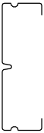
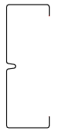
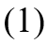
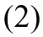
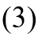
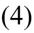
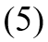
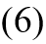
Fig. 23. Variation in ultimate moment capacity for different numbers of web and flange stiffeners for sections without and with the cold work effect.

Table 10 Variation in ultimate moment capacities for different numbers of web and flange stiffeners.
Section types | Section properties |  | DSM |  |  |  |  | FEM |  | $$\frac{M_{u}^{FEM}}{M_{u}^{DSM}}$$ | $$\frac{M_{uc}^{FEM}}{M_{uc}^{DSM}}$$
 | $S_{xx}$ (cmᶟ) | $${}_{d}$$ | $M_{y}$ (kNm) | $M_{u}$ (kNm) | $M_{uc}$ (kNm) | $M_{uc}$/$M_{u}$ | $M_{u}$ (kNm) | $M_{uc}$ (kNm) | $M_{uc}$/$M_{u}$
Lipped channel (1) | 28.19 | 1.247 | 14.66 | 9.68 | 9.70 | 1.00 | 10.34 | 10.34 | 1.00 | 1.07 | 1.07
One stiffener at flanges (2) | 27.90 | 1.165 | 14.51 | 10.10 | 10.17 | 1.01 | 10.84 | 10.84 | 1.00 | 1.07 | 1.07
One stiffener at web (3) | 25.79 | 1.095 | 13.41 | 9.79 | 9.82 | 1.00 | 10.28 | 10.28 | 1.00 | 1.05 | 1.05
One stiffener at web and one at flanges (4) | 25.49 | 1.013 | 13.25 | 10.25 | 10.33 | 1.01 | 10.76 | 10.76 | 1.00 | 1.05 | 1.05
Two symmetrical stiffeners at web (5) | 27.60 | 1.148 | 14.35 | 10.10 | 10.23 | 1.01 | 10.79 | 10.82 | 1.00 | 1.07 | 1.06
Two symmetrical stiffeners at web and one stiffener at flanges (6) | 27.01 | 1.070 | 14.05 | 10.43 | 10.52 | 1.01 | 10.91 | 11.03 | 1.01 | 1.05 | 1.04

Optimisation results
Based on the above parametric studies of all geometric parameters and the cold work effect, all the maximum positive effects on the section strengths were obtained for the reference section with two web stiffeners and two flange stiffeners (Fig. 10(b)). Fig. 24 shows the maximum % increase in the ultimate bending moment capacities for distortional buckling, without and with the cold work effect, against the investigated parameters. It was observed that the maximum percentage of increase in the ultimate moment capacities of the sections without the cold work effect was almost up to 5% when the position of the web stiffeners ${h_{1}}/h$ = 0.00 whilst it was about 6% for the ultimate moment capacity with the cold work effect, indicating the cold work effect was noticeable. The maximum percentage of increase in the ultimate moment capacities without and with the cold work effect was about 2% and 3%, respectively, when the depth of the web stiffeners ${h_{2}}/h$ = 0.24, indicating the cold work effect. Similar trends were observed for the maximum percentage of increase in the ultimate moment capacities without and with the cold work effect when changing the position of the peak of the web stiffeners to ${h_{3}}/h$ = 0.14. The maximum percentage of increase in the ultimate moment capacities without and with the cold work effect was about 4% and 5%, respectively, for changing the width of the web stiffeners to the certain value ${b_{1}}/b$ = 0.21, showing that both the stiffeners’ shape and the cold work effect were very significant. In terms of changing the positions of the flange stiffeners ${b_{2}}/b$, the maximum percentage of increase in the ultimate moment capacities without and with the cold work effect was about 8% and 9% at ${b_{2}}/b$ = 0.06, respectively, confirming that both the flange stiffeners’ position and the cold work effect were very significant. The maximum percentage of increase in the ultimate moment capacities without and with the cold work effect was about 7% and 8% with the flange stiffeners’ size at the certain values $d/b$ = 0.28, respectively, indicating that both the flange stiffeners’ size and the cold work effect were noticeable. Therefore, it was suggested that the optimal shape for the channel section to gain the maximum ultimate moment capacity in distortional buckling had ${h_{1}}/h$ of 0.00 or as much close as possible to the web-flange junction, ${h_{2}}/h$ of at least 0.15 or above, ${h_{3}}/h$ of at least 0.14, ${b_{1}}/b$ of the certain value 0.21, ${b_{2}}/b$ = 0.06 or as much close as possible to the web-flange junction, and $d/b$ of the certain value of 0.28. In addition, the cold work effect had to be included in the FE models for accurately obtaining enhancement in the ultimate moment capacity of the section.
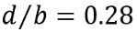
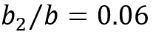
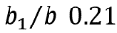
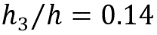
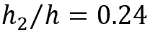
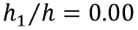
Fig. 24. The maximum % increase in the ultimate moment capacities without and with the cold work effect, of the channel sections with two web stiffeners and two flange stiffeners, against the geometric parameters.

Conclusions
This paper numerically investigated the effect of both the stiffeners’ geometry and cold work on the buckling and ultimate bending strength of channel sections with longitudinal web and flange stiffeners. Numerical simulations using Finite Element analysis and design calculations using the Direct Strength Method were developed to replicate four-point bending tests of the channel sections. An optimal shape of the channel section was then achieved through a comprehensive parametric study of all geometric parameters of the stiffeners and their maximum positive effects on the section strengths. The goal was to find the optimum position, shape and size of web stiffeners as well as the position and size of flange stiffeners while considering the influence of cold work in the section corners and stiffeners’ bends; this aimed to ultimately enhance the distortional buckling and ultimate strength capacities of the channel sections while keeping the same amount of material and the same height of the sections as required by practical applications. A total of 72 combinations of FE and DSM analyses was performed and results of ultimate moment capacities, without and with the cold work effect, for different stiffeners’ shapes, sizes, positions and the cold work effect on the section’s distortional buckling moment capacities were obtained. The results obtained from FE analysis and DSM were compared and evaluated on the capability of modelling the buckling and ultimate strengths of the sections, considering the cold work effect from the cold roll forming process. Based on the results, the following conclusions could be drawn:
- The FE results of four-points bending tests of the channel and zed sections were in excellent agreement with the experimental and DSM results, indicating that the buckling and nonlinear buckling behaviour of cold roll formed sections, considering the imperfections and the cold work effect, was accurately represented by the FE models.
- The extent of strength benefit obtained by including variation of stiffeners’ position, shape, size and quantity, and the cold work effect induced from the cold roll manufacturing process was found to be dependent on the cross-section shape, the percentage area of the section corners and stiffeners’ bends and the distortional buckling slenderness. The lower the distortional buckling slenderness the greater the tendency for the section strength to be influenced by the cold work effect. For the same percentage area of the corners and bends, the sections with lower distortional buckling slenderness gained more strength benefit from the cold work effect.
- The buckling and ultimate strength capacity of the section were changed by moving the position of the web and flange stiffeners. The stiffener’s position provided the maximum buckling and ultimate strength capacity at the compression flange was found to be near the web- flange-junction, whereas the stiffener’s position at the web was found to be dependent on the shape and size of the stiffeners. The following changes also increased the section’s ultimate strength capacity: moving up the web stiffeners towards the web-flange junction; expanding the depth of the web stiffeners beyond a certain value; moving the peak of the web stiffeners towards the cross-section centre in vertical direction; expanding the width of the web stiffeners to a certain value in horizontal direction away from the web; moving the flange stiffeners towards the web-flange junction; increasing the size of the flange stiffeners to a certain value; and allocating two web stiffeners and two flange stiffeners for the channel section. For the same value of each parameter, the section’s ultimate strength capacity with the cold work effect was generally greater than that of not including the cold work effect.
- It was revealed that in order to achieve the maximum ultimate strength in distortional buckling, considering both the stiffeners’ position, shape, size and quantity, and the cold work effect, an optimal shape for the channel section could have: (i) the position of the web stiffener (${h_{1}}/h$) was placed as much close as possible to the web-flange junction, (ii) the depth of the web stiffener (${h_{2}}/h$) was at least 15% of the section height, (iii) the position of the peak of the web stiffener (${h_{3}}/h$) was at least 14% of the section height, (iv) the width of the web stiffener (${b_{1}}/b$) was of the certain value of 21% of the flange width and not more than that (as the ultimate strength would reduce due to the distortional-global buckling failure), (v) the position of the flange stiffener ${b_{2}}/b$ was placed as much close as possible to the web-flange junction, (vi) the size of the flange stiffener ($d/b$) was of the certain value of 28% of the flange width and not more than that (as the ultimate strength would reduce due to the distortional-global buckling failure), and (vii) the sections needed to have two web stiffeners and two flange stiffeners. In addition, the cold work effect had to be included in the FE models for accurately obtaining enhancement in the ultimate moment capacity of the section. The cold work effect was most significant when changing the width of the web stiffeners and the position of the flange stiffeners, especially in the sections that are less prone to buckling.
- The DSM results were in good agreement with the FE results and followed the same trends in the sections that failed by distortional buckling. However, the DSM was found to predict lesser distortional buckling slenderness in the sections where the tip of web stiffeners shifted away from the web in horizontal direction, and in the sections where the size (diameter) of the flange stiffeners was large. In fact, there were significant reductions of the sectional modulus in the minor axis that caused the sections failed by distortional-global interaction buckling but it was not captured in DSM. These resulted in overestimate predictions for the ultimate moment capacities of the sections. It was, therefore, concluded that a modification in the DSM design guideline for distortional buckling with web intermediate stiffener is needed in the case of cross-sections with large web intermediate stiffeners.
On-going work includes measuring the actual cold work applied at the section’s corners and stiffeners bends to accurately predict the strength of channel and zed sections under bending. This involves the use of Finite Element analysis and further experimental work.

Acknowledgements
We acknowledge the University of Derby for sponsoring this work [PGTA Studentship - E&T_14_PGTA_0717]. The experiments were carried out at Hadley Industries plc.

References
[1] R. Scharff, Residential steel framing handbook, McGraw-Hill Professional, 1996.
[2] J. Rhodes, Design of cold formed steel members, Elsevier Applied Science London and New York, 1991.
[3] V.B. Nguyen, C. Wang, D. Mynors, M. English, M. Castellucci, Compression tests of cold-formed plain and dimpled steel columns, Journal of Constructional Steel Research 69(1) (2012) 20-29.
[4] T. Desmond, T. Pekoz, G. Winter, Local and overall buckling of cold formed compression members, Department of Structural Engineering Report, Cornell University, 1978.
[5] R. Papazian, R. Schuster, M. Sommerstein, Multiple stiffened deck profiles, Proceedings of the 12th International Specialty Conference on Cold-Formed Steel Structures, 1994, pp. 217-228.
[6] B. Schafer, T. Peköz, The behavior and design of longitudinally stiffened thin-walled compression elements, Thin-Walled Structures 27(1) (1997) 65-78.
[7] B. Young, J. Chen, Design of cold-formed steel built-up closed sections with intermediate stiffeners, Journal of Structural Engineering 134(5) (2008) 727-737.
[8] J.-H. Zhang, B. Young, Compression tests of cold-formed steel I-shaped open sections with edge and web stiffeners, Thin-Walled Structures 52 (2012) 1-11.
[9] H. Adeli, A. Karim, Neural network model for optimization of cold-formed steel beams, Journal of Structural Engineering 123(11) (1997) 1535-1543.
[10] J. Lee, S.-M. Kim, H.S. Park, Optimum design of cold-formed steel columns by using micro genetic algorithms, Thin-Walled Structures 44(9) (2006) 952-960.
[11] J. Lee, S.-M. Kim, H.-S. Park, B.-H. Woo, Optimum design of cold-formed steel channel beams using micro Genetic Algorithm, Engineering Structures 27(1) (2005) 17-24.
[12] T. Tran, L.-y. Li, Global optimization of cold-formed steel channel sections, Thin-Walled Structures 44(4) (2006) 399-406.
[13] K. Magnucki, P. Paczos, Theoretical shape optimization of cold-formed thin-walled channel beams with drop flanges in pure bending, Journal of Constructional Steel Research 65(8-9) (2009) 1731-1737.
[14] J. Bonada, M. Pastor, F. Roure, M. Casafont, Influence of the cold work effects in perforated rack columns under pure compression load, Engineering Structures 97 (2015) 130-139.
[15] F. Wang, Numerical studies of residual stress in cold formed steel sigma sections, University of Birmingham, 2015.
[16] J. Rhodes, J. Zaras, Development and design analysis of a new purlin system, Proceedings of the 9th International Specialty Conference on Cold-Formed Steel Structures, 1988, pp. 215-228.
[17] M. Castellucci, I. Pillinger, P. Hartleya, G. Deeley, The optimisation of cold rolled formed products, Thin-Walled Structures 29(1-4) (1997) 159-174.
[18] C.H. Pham, G.J. Hancock, Experimental investigation and direct strength design of high-strength, complex C-sections in pure bending, Journal of Structural Engineering 139(11) (2013) 1842-1852.
[19] C.H. Pham, L.A. Bruneau, G.J. Hancock, Experimental study of longitudinally stiffened web channels subjected to combined bending and shear, Journal of Structural Engineering 141(11) (2015) 04015018.
[20] V.B. Nguyen, M. English, M. Castellucci, FE simulation techniques for new process and product developments in metal forming industry, Proceedings of the 13th International Cold Forming Congress, 2015, pp. 178-185.
[21] V.B. Nguyen, P. Wood, M. English, M. Castellucci, The Design and Development of New Cold Roll Formed Products by Finite Element Modeling and Optimisation, Proceedings of the 23rd International Specialty Conference on Cold-formed Steel Structures, 2016, pp. 29-40.
[22] M.R. Haidarali, D.A. Nethercot, Local and distortional buckling of cold-formed steel beams with both edge and intermediate stiffeners in their compression flanges, Thin-Walled Structures 54 (2012) 106-112.
[23] J. Ye, I. Hajirasouliha, J. Becque, A. Eslami, Optimum design of cold-formed steel beams using Particle Swarm Optimisation method, Journal of Constructional Steel Research 122 (2016) 80-93.
[24] S.M. Mojtabaei, J. Ye, I. Hajirasouliha, Development of optimum cold-formed steel beams for serviceability and ultimate limit states using Big Bang-Big Crunch optimisation, Engineering Structures 195 (2019) 172-181.
[25] V.B. Nguyen, M. English, The optimization of thin-walled cold rolled products using Finite Element modelling and Design of Experiments, The 8th International Conference on Thin-Walled Structures (ICTWS 2018), Lisbon, Portugal, 2018.
[26] CUFSM Version 5.04, Department of Civil Engineering, Johns Hopkins University, 2020. URL: 〈http://www.ce.jhu.edu/bschafer/cufsm/〉
[27] H. Liu, T. Igusa, B. Schafer, Knowledge-based global optimization of cold-formed steel columns, Thin-Walled Structures 42(6) (2004) 785-801.
[28] J. Leng, Z. Li, J.K. Guest, B.W. Schafer, Shape optimization of cold-formed steel columns with fabrication and geometric end-use constraints, Thin-Walled Structures 85 (2014) 271-290.
[29] BS EN 1993-1-3:2006. Eurocode 3 – Design of steel structures. Part 1–3: General rules – Supplementary rules for cold-formed members and sheeting, 2006.
[30] V.B. Nguyen, C.H. Pham, B. Cartwright, M. English, Design of new cold rolled purlins by experimental testing and Direct Strength Method, Thin-Walled Structures 118 (2017) 105-112.
[31] ANSYS 18.1, ANSYS Inc., 2017.
[32] AISI S100-2012. North American Speciﬁcation for the Design of Cold-Formed Steel Structural Members. 2012 Edition. American Iron and Steel Institute, Washington, D.C.
[33] K.W. Karren, Corner properties of cold-formed shapes, Journal of the Structural Division 93(1) (1967) 401-433.
[34] M.R. Haidarali, D.A. Nethercot, Finite element modelling of cold-formed steel beams under local buckling or combined local/distortional buckling, Thin-Walled Structures 49(12) (2011) 1554-1562.
[35] B. Schafer, T. Peköz, Computational modeling of cold-formed steel: characterizing geometric imperfections and residual stresses, Journal of Constructional Steel Research 47(3) (1998) 193-210.
[36] S. Chou, G. Chai, L. Ling, Finite element technique for design of stub columns, Thin-Walled Structures 37(2) (2000) 97-112.
[37] D.C. Yap, G.J. Hancock, Post-buckling in the distortional mode and buckling mode interaction of cold-formed thin-walled sections with edge stiffeners, Proceedings of the 18th International Specialty Conference on Cold-Formed Steel Structures, 2006, pp. 71-88.
[38] J. Ye, S.M. Mojtabaei, I. Hajirasouliha, Local-flexural interactive buckling of standard and optimised cold-formed steel columns, Journal of Constructional Steel Research 144 (2018) 106-118.
[39] A. Chajes, S. Britvec, G. Winter, Effects of cold-straining on structural sheet steels, Journal of the Structural Division 89(2) (1963) 1-32.
[40] M. Ashraf, L. Gardner, D. Nethercot, Strength enhancement of the corner regions of stainless steel cross-sections, Journal of Constructional Steel Research 61(1) (2005) 37-52.
[41] R.B. Cruise, L. Gardner, Strength enhancements induced during cold forming of stainless steel sections, Journal of Constructional Steel Research 64(11) (2008) 1310-1316.
[42] B.W. Schafer, Z. Li, C.D. Moen, Computational modeling of cold-formed steel, Thin-Walled Structures 48(10-11) (2010) 752-762.
[43] M. Jandera, L. Gardner, J. Machacek, Residual stresses in cold-rolled stainless steel hollow sections, Journal of Constructional Steel Research 64(11) (2008) 1255-1263.
[44] G.J. Hancock, T. Murray, D.S. Ellifritt, Cold-formed steel structures to the AISI specification, Marcel Dekker, Inc., New York, 2001.
[45] W.-W. Yu, R.A. LaBoube, Cold-formed steel design, 4th Edition, John Wiley & Sons, Inc., Hoboken, New Jersey, 2010.

